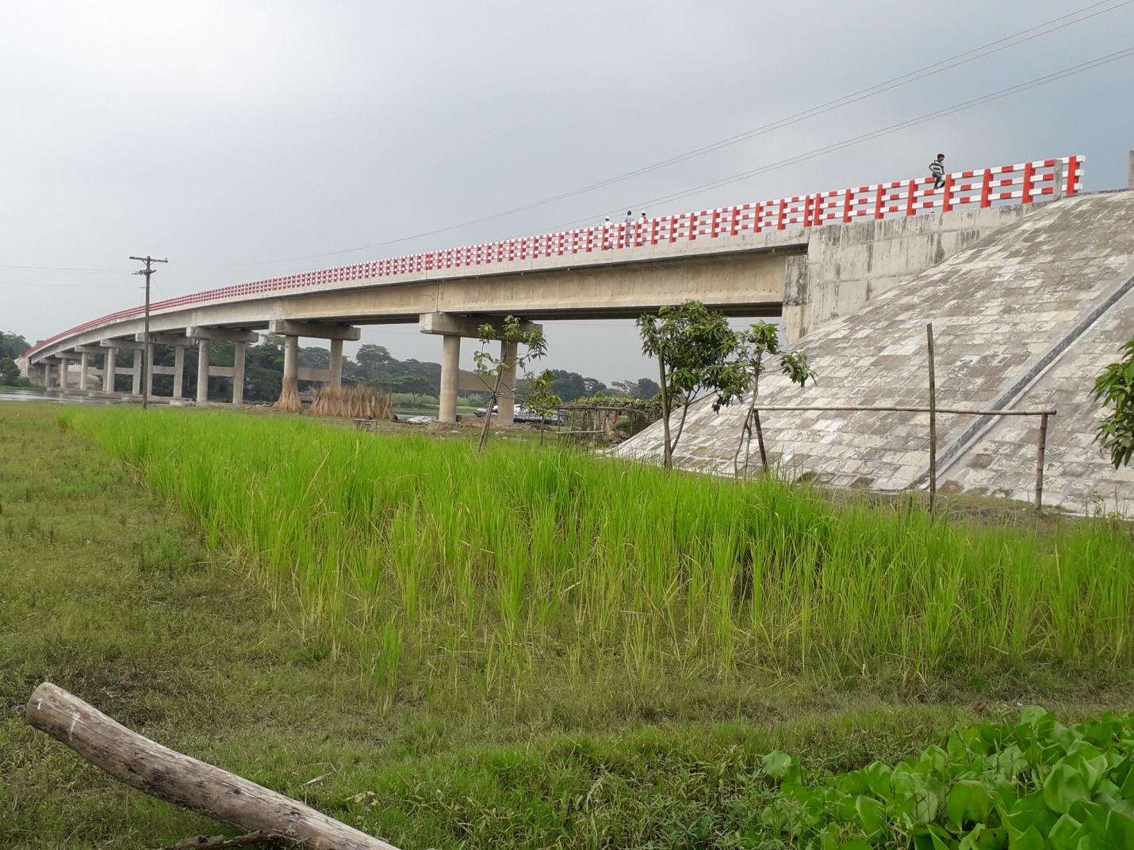

306.40 m long Joynagar Bridge at Zajira, Shariatpur