Name of Road: Barakpur-Polerhat-Chulkati R&H road; at Ch. 00-7880m
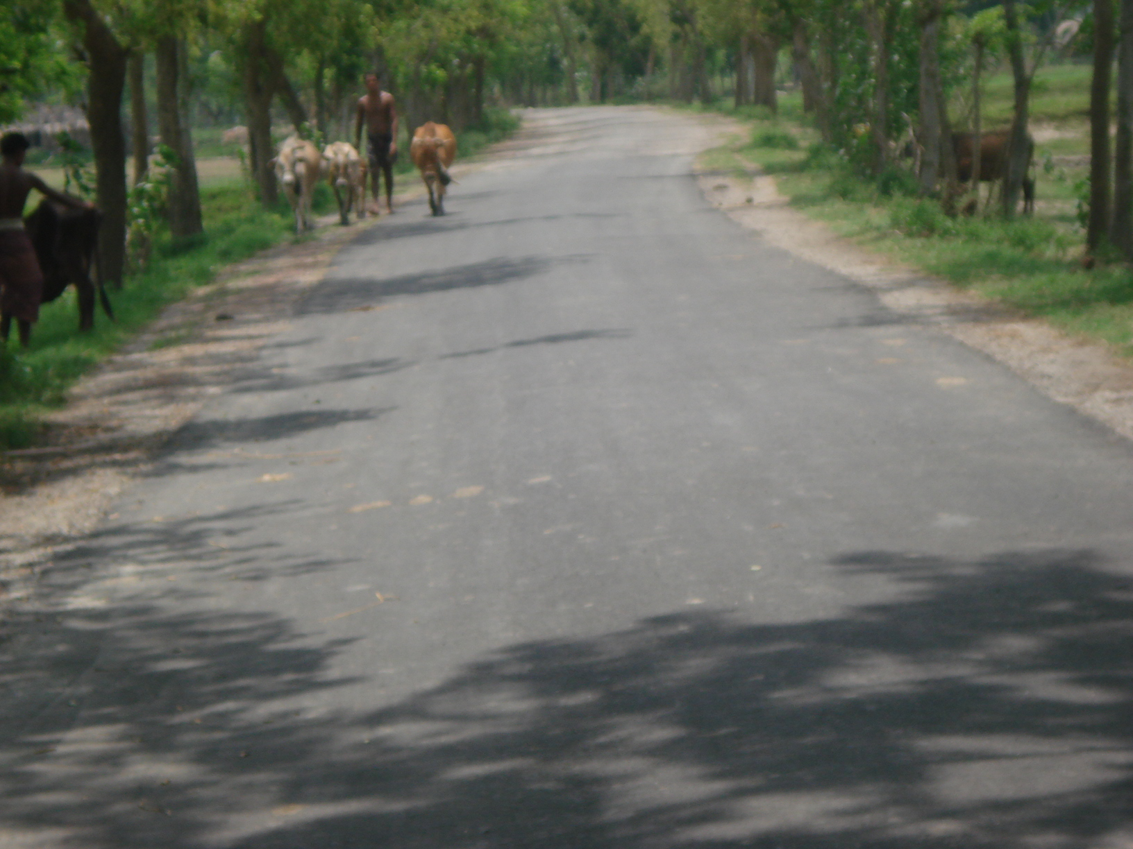
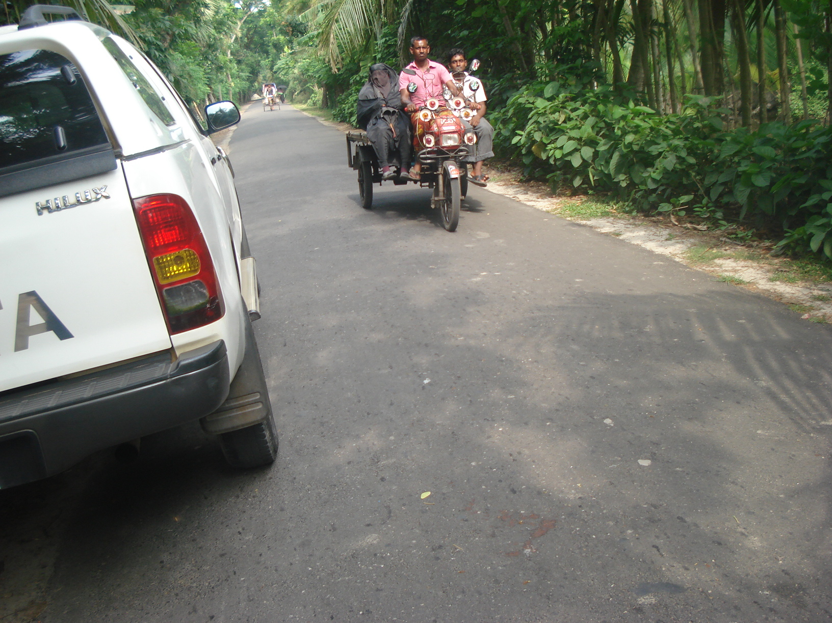

ID No: 201082004 (RAILA/BGT/W-07) District : Bagerhat, Upazila – SADAR

