.

Page-
Appendix-I

Location of The Project
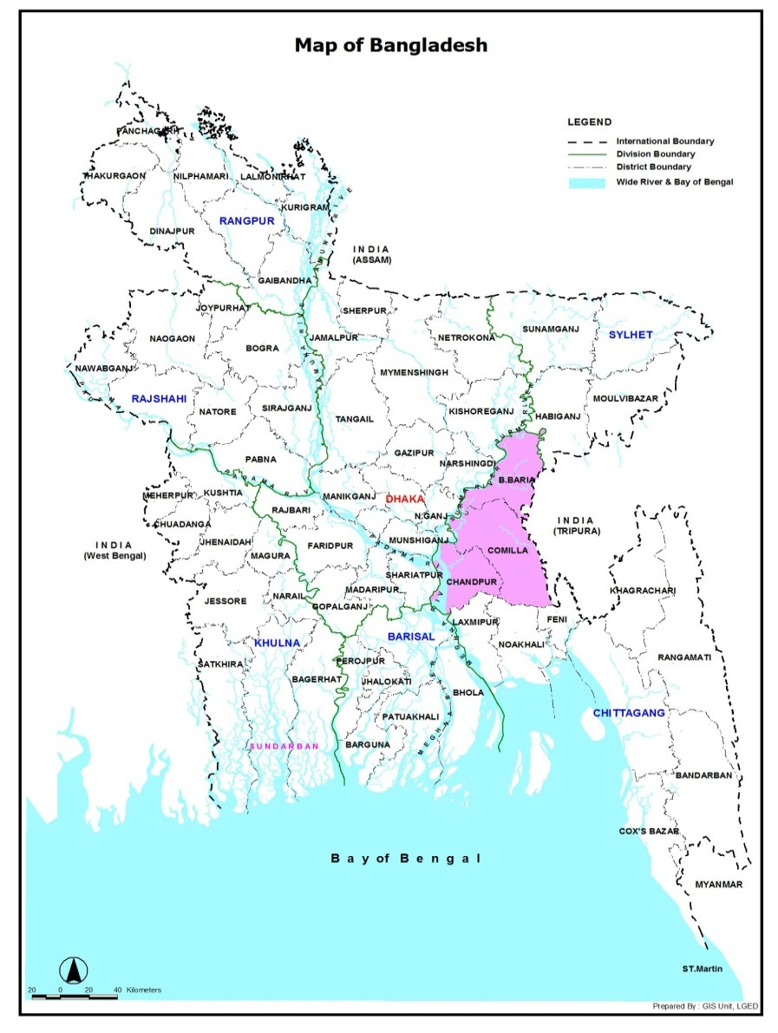
Project
Area

