Introduction

Subproject Background
Bhairab Pourashava is located at Bhairab Upazila under Kishoreganj District. At present, Bhairab Pourashava is ‘A’ type Pourashava which was declared as a Pourashava in the year of 1958. The Pourashava covers an area of 15.81 sq. km having population of 118,992 as per BBS census 2011. Presently, Bhairab Pourashava has 40 km paved roads and 27.5 km earthen roads. The drainage network includes 17.09 km drains.
The urbanization process in the municipality area and increasing population necessitates continuous development of road and drain. Hence, this subproject under the Municipal Governance Services Project (MGSP) is actively contributing infrastructures development of Bhairab Pourashava.

This subproject includes the following components: RCC Road, BC Road, RCC Drain with cover slab and Street lights. The significant features of the subproject are stated below:
Name of the Subproject : | a) Construction of RCC Road at Bhairabpur Uttarpara Road (Ch.00+00 – 0+815Km);  b) Construction of RCC Drain at Bhairabpur Uttarpara Road (Ch.00+00 – 0+875Km & Link -170m);  c) Construction of RCC Drain at Chandiber Road (Ch. 00+00 – 1+050m);  d) Construction of BC Road at Chandiber Road (Ch. 00+00 – 1+050m).
Package No. : | MGSP/BHB/2017-2018/W-06
District Name : | Kishoreganj
ULB Name : | Bhairab Pourashava
Jurisdiction Area : | Wards nos. 7 and 9
Design Option/Key Subproject Components : | BC Road, RCC Road, RCC Drain with Cover Slab and Street Light
Beneficiary Population : | About 20,000 as per information by the Pourashava Officials
Tribal People : | No tribal people settlement found in the subproject area
Land Acquisition : | Land acquisition is not required.
Estimated Cost : | 82.07 million BDT
Subproject Duration : | 12 months
Tentative Start Date : | 25 March, 2018
Tentative Completion Date : | 24 March, 2019

Objectives of the Study

The general objective of this study is to determine the major environmental impacts succeeding from execution of the subproject and to recommend mitigation measures to avoid or reduce adverse environmental impacts and to enhance positive impacts. The specific objectives include:
- To assess the existing environmental conditions of the subproject site and its influence area;
- To identify and assess impacts resulting from the subproject during its construction phase and operation phase;
- To develop an environmental management plan with recommendations for mitigating impacts and enhance positive impacts;
- To summarize environmental monitoring requirements.

Scope and Methodology of the Study

The subproject appraisal is included environmental screening for all the subproject components. According to that screening, no further environmental assessment is required for the lighting works. Nevertheless, environmental assessment is required to fulfill the regulatory requirement for Road and Drain. Hence, this report is mainly included RCC Road and RCC Covered Drain. However, in the EMP anticipated impacts and mitigation measures for the street light are also included. The study methodology comprised the following activities:

Desktop Study

The desktop study involved:

- Initial meetings with client and stakeholders to discuss about the proposed subproject and subproject activities;
- Collection and review of the baseline data, maps, reports and other relevant information on the existing environmental and social conditions of the subproject area;
- Review of the relevant existing legislation, regulation and policies;
- Understand the anticipated technical processes that may affect the environment.

Field Investigation and Data Collection

A team of the consultants made a field investigation to the proposed site. Field investigations involved mainly site walks within the subproject area and the neighboring areas that may be affected by the subproject. The following key tasks were performed during the field visit:
- Taking photographs of the significant aspects to describe the baseline environmental conditions of the subproject area;
- Interviews with representatives of the Pourashava Officials, within the subproject area and interested and affected people within the subproject influence zone;
- Verifying information and data collected during the desktop study and to collect new information that may have been important in the assessment of the impacts and design of the mitigation measures.

Data Analysis and Report Writing
The data and information collected from all the sources (literature review, secondary and primary data, public consultation) were analyzed to describe the existing environmental setting of the subproject area, to identify the potential positive and negative impacts of the proposed subproject, as well as to provide preliminary suggestions for mitigation measures. Finally, this environmental assessment report has been prepared.

SUBPROJECT DESCRIPTION

The Study Area

The subproject covers the jurisdiction area of the Wards nos. 7 and 9 of Bhairab Pourashava. The Location Map and Topographical View of this subproject are shown in Figure 2.1.1 and 2.1.2.
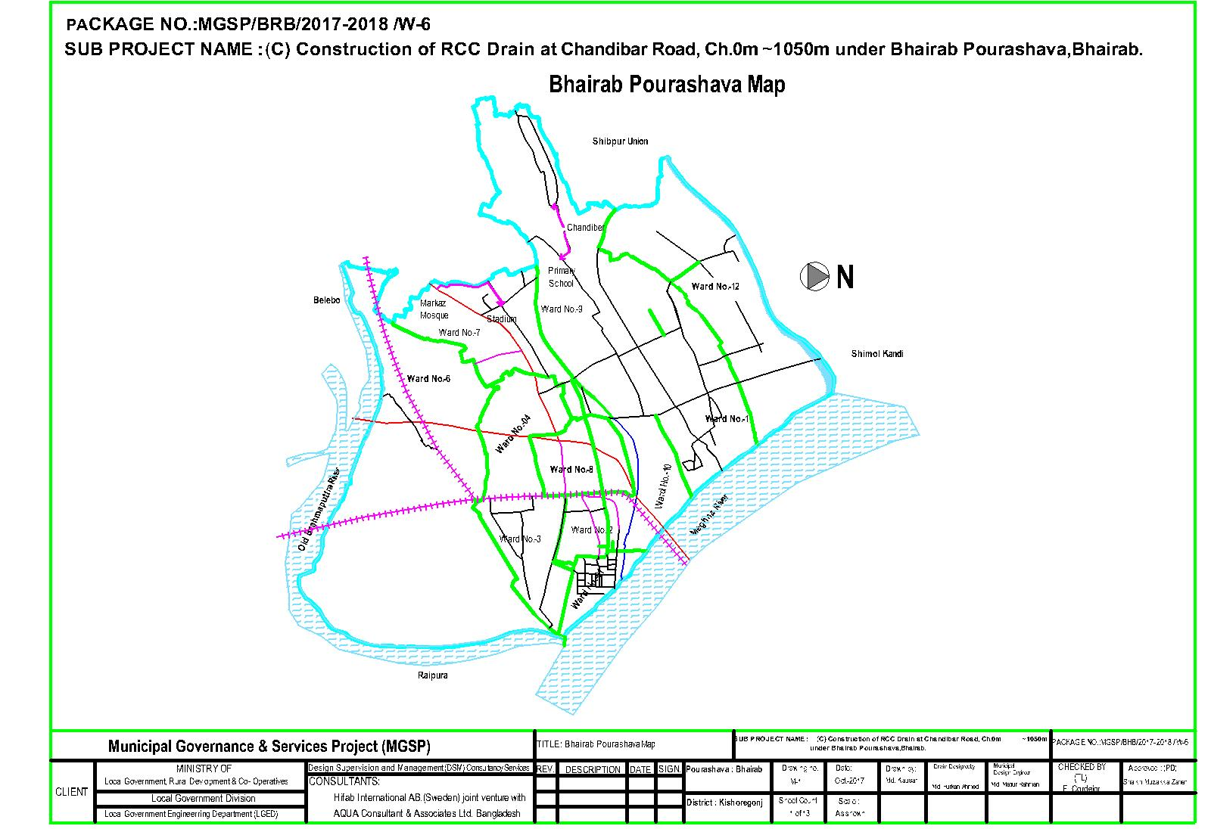
Figure 2.1.1: Location Map of the Subproject
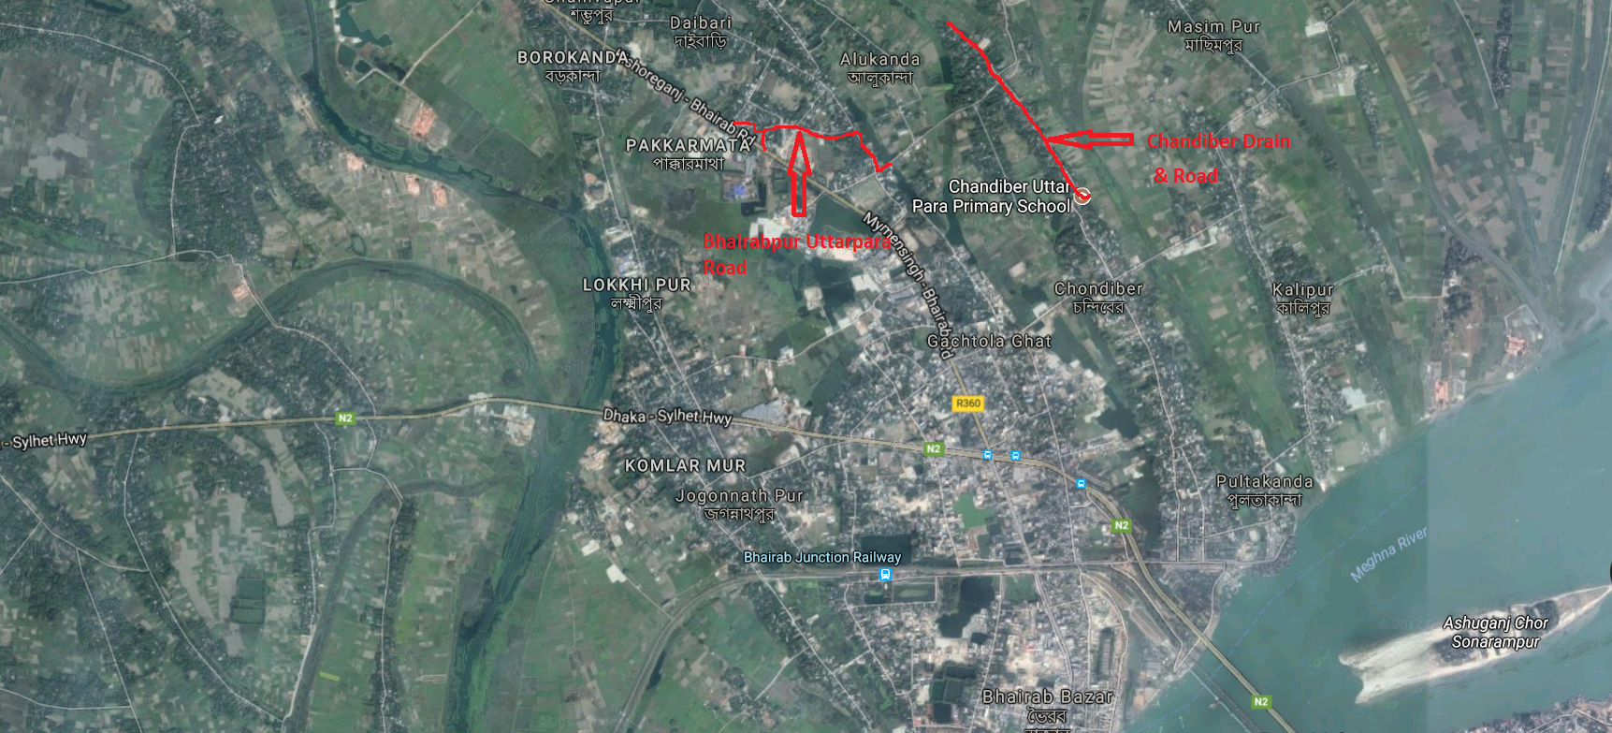
Figure 2.1.2: Topographic View of the Subproject

Current Situation, Proposed Intervention and Need for the Subproject

The existing Bhairabpur Uttarpara RCC Road is badly damaged and completely scraped at most of the sections. In addition, the existing road is narrow where average road width varies from 3.4 m to 4.2 m. The damaged and narrow road interrupts the normal traffic operation. Therefore, this road will be improved by new RCC road with 6m width (Ch. 0 to 815m) starts from Bhairab-Kishoreganj Highway and connects another Pourashava road.

At present, drainage facility in the subproject area is completely absent. Consequently, storm water retains on the road and creates severe water logging problem. Water stagnation on the road surface makes this road unusable. Hence, the existing situation interrupts pedestrians and traffic movement. Local people have been suffering heavily due to water logging problem due to absent of the drainage facilities. To improve the situation, RCC drain with cover slab has been proposed at right side of the road from Ch. 0-815 m. From Ch. 815-875 m, RCC drain with cover slab will be constructed at the left side of the road. This 60m RCC drain will be constructed to connect with culvert at Ch.875m. There is a link drain at Ch. 115 m near a primary school. The length of the link drain is 170 m at the right side of the road. The proposed drain will be connected with Balla Bill Khal. Finally, storm water will discharge into the Meghna River.

From Ch. 0 to 700m, the existing Chandiber Road (BC Road) is narrow (average road width 3.5 m) and badly damaged. From Ch. 700 to 1050m, the existing CC road is also narrow (average road width 2.5m) and damaged. The pot holes and worn-out road surface retain storm water during rain which creates water logging problem in the subproject area. Water logging problem also enhances damaging of the existing road. Both the existing CC and BC road needs to be improved. Hence, new BC road will be constructed at Chandibar Road from (Ch. 0-1050m) with 6m road width which is the extended part of the Chandiber Main Road and connects another Pourashava Road. Currently, there is no drainage facility in the Chandiber Road. During monsoon period after heavy rainfall storm water retains on the road and creates severe water logging in the subproject area. Hence, RCC drain will be constructed at right side of the Chandibar Road, (from Ch.0-1070m). The drain water will be discharged into a canal which ultimately discharges into the Meghna River.

Furthermore, absence of the street light hampers the normal traffic operation at night time. Hence, fixing of the street light is also required for safe traffic operation at night. 12 nos. of street light will be fixed at single side of the Bhairabpur Uttarpara Road from Ch. 0-815 m. The existing site condition is further exhibited in the following Photographs 2.2.1.

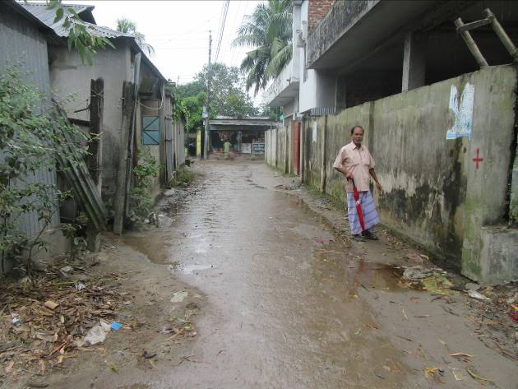
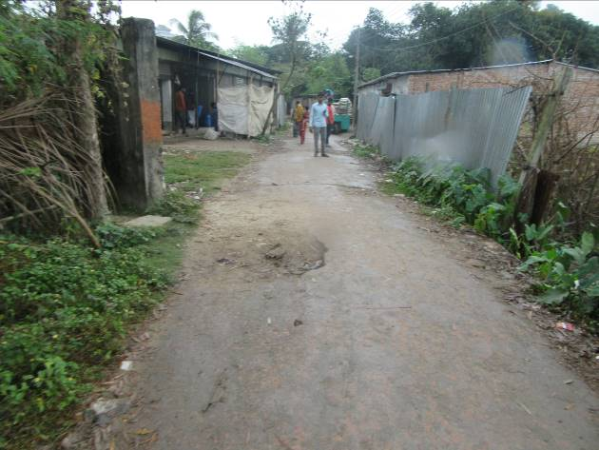
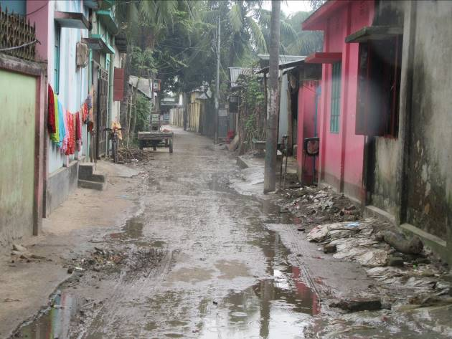
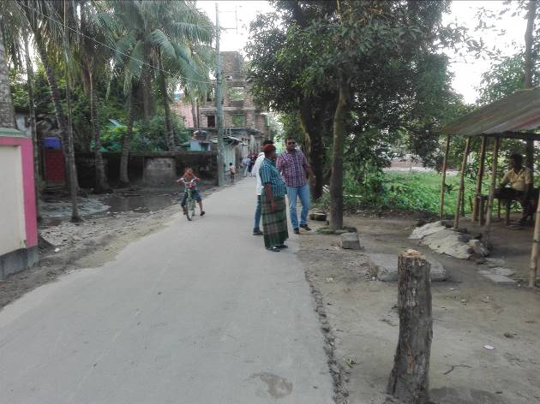

Photographs 2.2.1: Current Situation of the Subproject Site
Storm water from the Bhairabpur Uttarpara drain will be discharged into Balla Bill khal which ultimately discharges into the Meghna River. While, storm water from the Chandiber drain will be discharged into a canal near Chandiber Uttarpara Primary School. This canal is connected with the Meghna River.

Justification of Selection of this Subproject

The subproject has significant importance because it is connected with Bhairab-Kishoreganj Regional Highway. Hence, this subproject has been considered as priority subproject in the CIP. The subproject is located mostly in the right of way. Since the Bhairab Pourashava is owned the subproject. Hence, land acquisition is not an issue for implementation of this subproject. The roadside built-up infrastructural and environmental features will not be severely affected by the implementation of the subproject.
After completion, the road subproject will provide uniform width. By eliminating pot holes and providing smooth road surface it will provide better, easy and safe movement facilities for the travelers. Furthermore, street light will ensure safe movement of the pedestrians and non-motorized vehicles. It will provide streetscape enhancements i.e. municipal beautification work and stimulation of the night-time trade. The drain will reduce water logging problem. Thus, the subproject area will get better environment. The subproject has significant benefit to the community people. Hence, considering the benefits that will derive, the subproject is selected for implementation.

Envisaged Subproject Activities and Implementation Process

The general activities for the subproject includes: Construction of the semi-pucca site office, construction of the labor shed, relocation of the electric poles and site clearing works. The key activities of the RCC Drain include:

- Earth work in excavation of the foundation;
- Pumping and bailing out of water as per requirement;
- Sand filling for the preparing foundation bed;
- Laying of polythene sheet;
- Plain cement concrete work in foundation;
- Manufacturing CC blocks;
- Fabrication of the ribbed or deformed bar;
- Reinforced cement concrete work.

The key activities of the RCC Road include:

- Dismantling of the damaged sub-base and base course works;
- Earth work in box cutting;
- Sand filling on the road bed;
- Sand and brick chips mix in the sub-base;
- Mechanical compaction;
- Polythene sheet laying work;
- Fabrication of the ribbed or deformed bar reinforcement;
- Reinforced cement concrete work.

The key activities for BC Road include:

- Dismantling of the damaged sub-base and base course works;
- Clearing and grubbing works;
- Earth work in box cutting;
- Earth filling work;
- Sand filling on the road bed;
- Mechanical compaction;
- Brick on edging;
- Compacted stone aggregate base course;
- Providing prime coat;
- Laying pre-mixed dense bituminous surfacing wearing course.
The key activities for Street Light:
- Assembling, fitting, fixing, installation, testing and commissioning of the GI pole;
- Erection of tubular pole;
- Earthing the electrical installation;
- Fixing of the wire rack and overhead conductor;
- Providing, fixing and fitting of the water tight street light;
- Fitting and fixing main and sub-main switch with fuse;
- Supplying and fitting of sub-distribution board.

The materials and resources to be used for the key activities: soil in earth work, sand, stone chips, cement, reinforcement, diesel, MS sheet, steel shutter, electricity and water. The major equipment to be used for the implementation of the subproject: hydraulic excavator, concrete mixer machine, steel cutter, mechanical vibrator machine, mechanical compactor, dump truck, water tanker, pump, and steel drum roller.

Category of the Subproject

BC Road, RCC Road and RCC drain:
- According to ECR 1997: Green □ Orange A □ Orange B □ √ Red □ Not Listed □
- According to WB classification: Category B □ √ Category C □

Considering the environmental impacts, the road and drain can be considered as Orange B as per ECR-97. According to the WB classification, it can be classified as Category B.

Street Light
- According to ECR 1997: Green □√ Orange A □ Orange B □ Red □ Not Listed □
- According to WB classification: Category B □ Category C □ √
Considering the environmental impacts, the street light can be considered as Green category as per ECR-97. According to the WB classification, it can be classified as Category C.

Subproject Schedule

The tentative schedule of the construction of the subproject is:
(a) Subproject Duration (Months) : 12 Months
(b) Tentative Start Date : 25 March, 2018
(c) Tentative Completion Date : 24 March, 2019
The daily construction hours will normally include regular working time. However, daily working hours may vary based on the on-site condition. The detailed work program will be prepared by the contractor with the assistance of the PIU. Then it will be shared with the PMU, LGED and DSM consultants. In addition, the detailed work program will also be shared with the Bank as per requirement.

Baseline ANALYSIS OF THE ENVIRONMENTAL CONDITION

Physical Environment

Important Environmental and Infrastructural Features

During site visit the environmental and infrastructural features within the subproject area were collected. Conditional survey has also been conducted for designing the subproject. Hence, the survey data is also used for preparing the report. The environmental and infrastructural features listed within 100 m of the both sides of the road from the center line considering 100 m longitudinal interval.
Table 3.1.1: Major Environmental and Infrastructural Features of the Bhairabpur Uttarpara road (Ch. 0-875 m) and the Link Drain (Ch. 0-170 m)
Chainage (m) | Left | Right | Major Environmental and Infrastructural Features
0-100 | √ |  | Markaz Mosque, Pucca, semi pucca and tin-shed structures
0-100 |  | √ | Tin-shed structures, pucca and semi pucca structures, boundary walls
100-200 | √ |  | Pucca and semi pucca structures, tin-shed structures, link drain at Ch. 115 m, boundary walls
100-200 |  | √ | Pucca and semi pucca structures, tin-shed structures
200-300 | √ |  | Pucca and semi pucca structures, tin-shed structures
200-300 |  | √ | Pucca and semi pucca structures, tin-shed structures, boundary walls
300-400 | √ |  | Pucca, semi pucca and tin-shed structures, trees
300-400 |  | √ | Pucca, semi pucca and tin-shed structures, trees
400-500 | √ |  | Pucca and semi pucca structures, tin-shed structures, boundary walls
400-500 |  | √ | Pucca, semi pucca and tin-shed structures, trees
500-600 | √ |  | Pucca buildings, bamboo bushes, boundary walls, Mosque
500-600 |  | √ | Pucca and semi pucca structures, tin-shed structures
600-700 | √ |  | Pucca and semi pucca structures, tin-shed structures
600-700 |  | √ | Pucca and semi pucca structures, tin-shed structures, shops
700-800 | √ |  | Pucca and semi pucca structures, tin-shed structures, open space with vegetation
700-800 |  | √ | Pucca and semi pucca structures, tin-shed structures, trees
800-875 | √ |  | Pucca and semi pucca structures, shops
800-875 |  | √ | Shahid Ivy Rahman Poura Stadium, Pucca and semi pucca structures, shops
Link drain (Ch. 0-170 m)
0-100 | √ |  | Pucca and semi pucca structures, tin-shed structures, trees
0-100 |  | √ | Pucca and semi pucca structures, tin-shed structures, trees
100-170 | √ |  | Pucca and semi pucca structures, tin-shed structures, trees
100-170 |  | √ | Pucca and semi pucca structures, tin-shed structures, trees

Table 3.1.1: Major Environmental and Infrastructural Features of the Chandiber road (Ch. 0-1070 m)
Chainage (m) | Left | Right | Major Environmental and Infrastructural Features
0-100 | √ |  | Pucca, semi pucca and tin-shed structures, trees
0-100 |  | √ | Pucca, semi pucca and tin-shed structures, trees
100-200 | √ |  | Pucca buildings, bamboo bushes, boundary walls
100-200 |  | √ | Pucca and semi pucca structures, boundary walls
200-300 | √ |  | Chandiber Uttar Para Forkania Hafizia Madrassa, Pucca, semi pucca and tin-shed structures, low land, vegetation
200-300 |  | √ | Pucca, semi pucca and tin-shed structures, trees
300-400 | √ |  | Pucca, semi pucca and tin-shed structures, trees
300-400 |  | √ | Pucca, semi pucca and tin-shed structures, trees
400-500 | √ |  | Pucca, semi pucca and tin-shed structures, trees, low land, vegetation
400-500 |  | √ | Pucca, semi pucca and tin-shed structures, trees
500-600 | √ |  | Pucca and semi pucca structures, boundary walls, trees
500-600 |  | √ | Vegetation, trees, low land
600-700 | √ |  | Baitul Mamur Jame Mosque, Ivy Chattar, Pucca, semi pucca and tin-shed structures, trees, low land, vegetation
600-700 |  | √ | Tin-shed structures, boundary walls, pucca and semi pucca structures
700-800 | √ |  | Pucca, semi pucca and tin-shed structures, trees
700-800 |  | √ | Pucca, semi pucca and tin-shed structures, trees
800-900 | √ |  | Pucca, semi pucca and tin-shed structures, trees
800-900 |  | √ | Pucca, semi pucca and tin-shed structures, trees
900-1000 | √ |  | Pucca, semi pucca and tin-shed structures, trees
900-1000 |  | √ | Pucca, semi pucca and tin-shed structures, trees
1000-1050 | √ |  | Pucca, semi pucca and tin-shed structures, trees
1000-1050 |  | √ | Pucca, semi pucca and tin-shed structures, trees
1050-1070 | √ |  | Pucca, semi pucca and tin-shed structures, trees
 |  | √ | Pucca, semi pucca and tin-shed structures, trees

Geology, Topography and Soils

The subproject area is situated near Meghna River-Bank. The soil of Bhairab Pourashava typically is non-calcareous dark grey floodplain soils (FAO-UNDP, 1988-History of Soil Research in Bangladesh). The geology of the study area consists of Quaternary Deltaic sediments, which have been strongly influenced by the tectonic movements on deep-seated faults. The area lies on a tectonic block, which has been uplifted relative to the surrounding areas. The area lies in the earthquake Zone II (moderate seismic zone) according to the seismic map of Bangladesh is shown in Figure 3.1.1. The soil profile of the study area consists of about 12m thick clay deposit followed by sand, clay and progressively coarser sand as depth increases (APSCL, 2011-EIA Study).
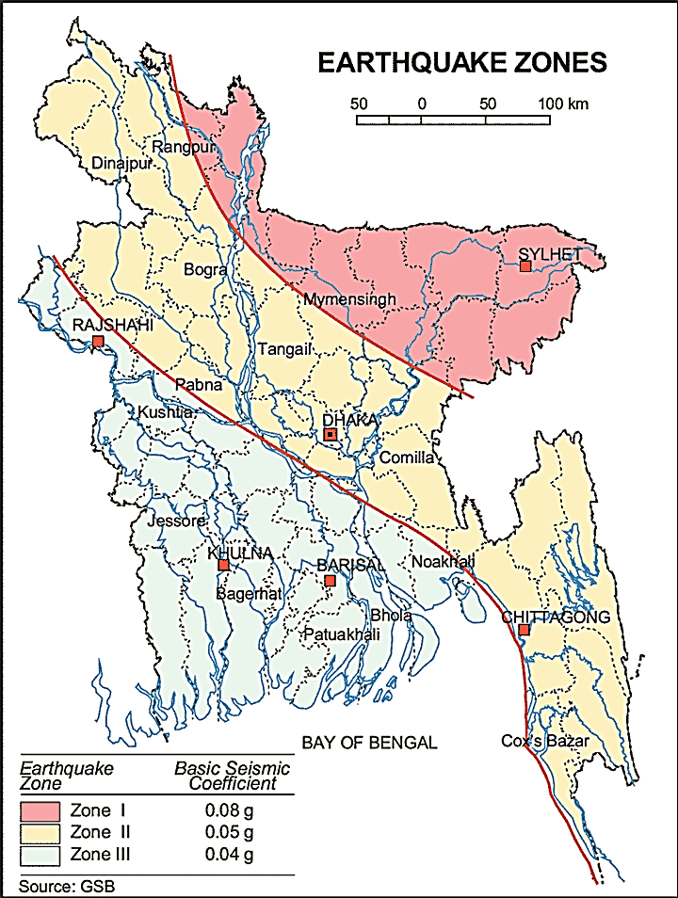

Figure 3.1.1: Earthquake zones of Bangladesh

Climate and Meteorology

The subproject area belongs to a semi-arid region characterized by temporal drought. The climate is sub-tropical with summer, monsoon and winter seasons. Rainfall is monsoonal, inter-monsoonal or cyclonic in origin. The maximum annual rainfall in the area as recorded was 4127mm in the year 1952 and minimum yearly rainfall is 1439mm in year 1989 with peak rainfalls occurring in July and August (APSCL, 2011-EIA Study). Furthermore, from mid-November to February is the coolest and driest period. April to May is the hottest period with periodic heavy thunderstorms. June to mid-September is the rainiest and humid period. Mid-September to early November is a transitional period with decreasing rainfall, often with association of thunder but with relatively high temperature and humidity (APSCL, 2011-EIA Study). Mean annual rainfall is about 2000 mm over most of the Bhairab Area. However, it exceeds 2500 mm in the north-east and exceeds 3000 mm in the south-east (Bhairab Pourashava Master Plan). Figure 3.1.2 shows the wind rose pattern of the Bhairab Pourashava. From the figure, it can be observed that wind mostly blows from the south-eastern and north-eastern direction. Wind speed is mild and mostly below 20 km/hr.
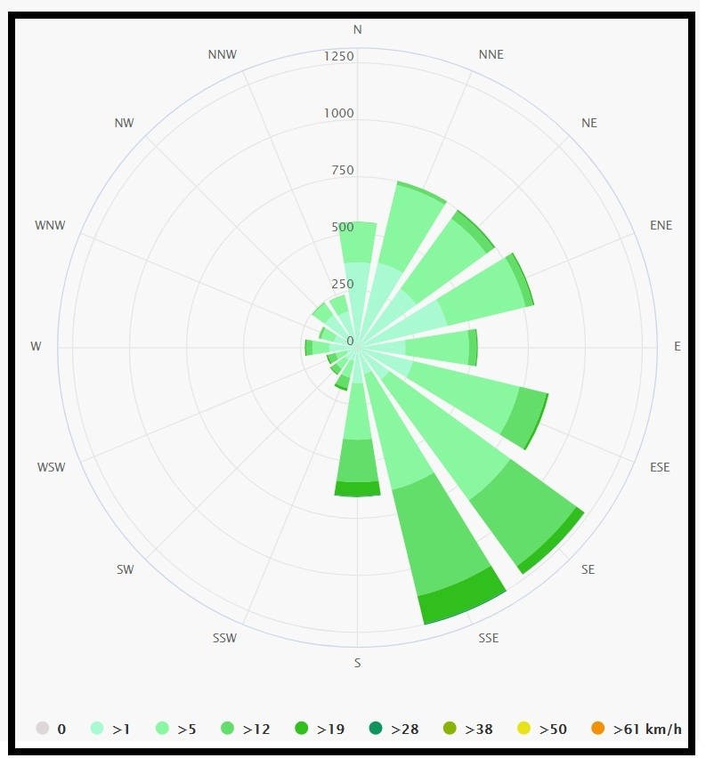
Figure 3.1.2: Wind-rose of Bhairab Pourashava
The construction works can be influenced by the climatic condition and meteorological components like humidity, temperature, sudden rainfall, and wind speed. During high winds, dust generated from the construction activities may spread quickly. It is very risky to work under rain and in high winds because the possibility of getting injury increases. Furthermore, work under high temperature and excess humidity may create health hazards like dehydration problem.

Hydrology (Surface Water, Ground Water and Rain Water Harvesting)

The subproject is located within the influence area of Meghna River. Groundwater is the main source of potable water in the subproject area. Ground water is available in plenty and water table does not go beyond suction limit throughout the year. According to the BADC groundwater zoning map, groundwater table in the Bhairab region varies from 0 to 5.3 meter below ground level. Arsenic concentration is not reported as higher level in both deep and shallow aquifer. Local people typically use deep tube-well water for drinking and other domestic purposes. Salinity problems are not visible. Rain water harvesting system is not common in and around the subproject area.

Flooding, Water Logging and Drainage Pattern

As per flood zoning map of Bangladesh (Figure 3.1.3), Bhairab Pourashava is located in the flood free area. According to previous data, this area is affected in historical severe flood events such as 1988, 1998, 2004 and 2007. In normal situation, the subproject area is free from flush flood. However, due to flood and high windy period such as during Tornado, the subproject area may be inundated by the external flood. In rainy season, due to inadequate and non-functional drain, the subproject area faces water logging problem.
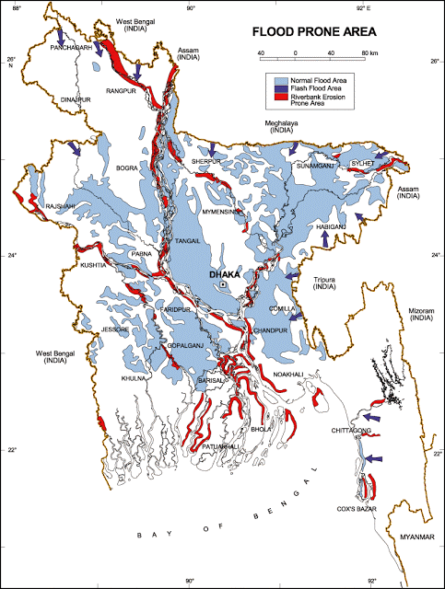

Figure 3.1.3: Location of Bhairab Pourashava in the Flood Zoning Map of Bangladesh
Air Quality and Dust
Ambient air quality data have not been found. Dust is generated during the movement of the vehicles in dry season and windblown dust cause air pollution. Additionally, black smoke emission from the vehicles degrades the air quality. In addition, open dumping of the waste materials make objectionable odor in the nearby area.

Noise Level
Noise is generated mainly from the vehicles movement and hydraulic horn. Noise is also generated due to public gathering. During construction phase, concrete mixer machine, vibrator machine, hydraulic excavator and vehicles used for transportation activities may create temporary noise nuisance within the subproject boundary.
Solid Waste Management
During site visit and information from the local people, it is evident that there is no structured solid waste management system in the Pourashava area. The people of this Pourashava are not habituated to dispose their garbage and kitchen waste into dustbins. Instead they throw their wastes into road side drains, open space or road adjacent to their houses. The Pourashava has no solid waste disposal site of its own.

Biotic Environment
Flora and Fauna
The subproject influence area is full of vegetation coverage which consists of rich floral and faunal diversity. The major road side planted trees include - Mango, Jackfruit, Jam, Koroi, Debdaru, Bokul, Neem, Betel nut, Coconut, Mahogany, Sajna, Burum, Mera etc. There are common local birds (Crow, Sparrow, and Shalik) were found during the site visit. There are no real historical sites in the subproject influence area.

Socio-economic and Socio-cultural Environment

Land Use, Status of Housing and Built-up Infrastructure

Like other Pourashava in Bangladesh, the land use pattern in the subproject area consists of mixed land-use pattern. The major roadside built-up infrastructures of Bhairabpur Uttarpara Road include Markaz Mosque, Pucca, semi pucca and tin-shed structures, primary school, Shahid Ivy Rahman Poura Stadium, shops, and boundary walls. The major roadside built-up infrastructures of Chandibar Road include Baitul Mamur Jame Mosque, Ivy Chattar, Chandibar Uttar Para Forkania Hafizia Madrassa, pucca, semi pucca and tin shed structures.

Beneficiary Population
The subproject coves the jurisdiction area of the wards number 7 and 9. As per information by the municipality, considering the wards’ population about 20,000 people will benefit directly and many others indirectly.

Education

In the subproject area, literacy among the population is about 53.6 % [BBS, 2011]. Literacy rate among males (55%) is still higher than females (52.2%). (Ref: Population and Housing Census 2011).

Tribal Communities

There is no indigenous or tribal people settlement in the subproject area. Therefore, there are no measures needed for indigenous peoples’ safeguard.

Land Acquisition and Resettlement

Private land acquisition is not needed for Bhairabpur Uttarpara Road and Chandibar Road. Existing road width of Bhairabpur Uttarpara Road is 3.4 m to 4.2 m on average. To widen the carriageway up to 6m, adjacent roadside boundary walls need to be removed at both sides of both roads for site clearing work at different chainage. The Pourashava Authority has consulted with the owners of these boundary walls. The Pourashava will clear the site by amicable understanding with the owners of these structures. However, as per amicable settlement the Pourashava Authority will re-construct 292 m boundary wall at Bhairabpur Uttarpara Road and 219 m boundary wall at Chandibar Road with the funding of the Project. An agreement has already been signed between Pourashava Authority and the affected persons regarding this issue. However, in case of any objection from the affected persons, DSM will investigate the actual situation. Then, measures will be taken as per rules.

Principal Livelihoods and Economic Activities
The subproject area is inhabited by the people of mixed occupations. In the Pourashava area, major income comes from business, enterprises, small trades, private sector jobs, and government jobs in the town.

Cultural Heritage and Protected Areas
During site visit it was observed that there is no protected and important cultural or historical site in the subproject influence area.
Social Conflicts and Development Activities
The local people welcome the subproject and there is no conflicts between the local communities regarding subproject implementation.

ENVIRONMENTAL SCREENING

Environmental Screening Checklist, as adopted in Appendix C of the Environmental Management Framework (EMF) of the MGSP, was administered for identifying the impacts and their extents.
The screening data and information for the BC Road, RCC Road and RCC Drain have been formulated and are shown below:
1) Potential Environmental Impact during Construction Phase:

(a) Ecological Impacts:
135
- Felling of trees Significant □ Moderate □ √ Minor □ Number of trees
- Clearing of vegetation Significant □ Moderate □ Minor □ √
- Potential impact on species of
aquatic (i.e., water) environment Significant □ Moderate □ Minor □ √

The subproject site is situated in a sub-urban area. So, some roadside naturally grown and planted trees need to be cut down to implement the subproject. Major trees to be cut down are: Mango, Jackfruit, Koroi, Neem, Debdaru, Betel nut, Coconut, Mahogany, Sajna, Burum, Mera etc. But there is no tree to be felled down has religious and cultural importance. Amount of vegetation to be cleared due to the project is insignificant. In addition, anticipated impact on species of aquatic environment is minor because except throwing of the wastes materials into the lowlands and ditches, the subproject does not have any impact on the aquatic environment. Considering number of trees to be felled down, ecological impact is considered as moderate.

- Physicochemical Impacts:

- Noise pollution Significant □ Moderate □ √ Insignificant □
- Air pollution Significant □ Moderate □ √ Insignificant □
- Drainage congestion Very likely □ Likely □ Unlikely □ √
- Water pollution Significant □ Moderate □ Insignificant □ √
- Pollution from solid/ construction wastes Significant □ Moderate □ √ Insignificant □
- Water logging Significant □ Moderate □ Insignificant □ √

The subproject will have temporary and localized negative impacts on noise and air quality during construction phase due to dismantle works, subproject vehicles movement for the transportation of the materials and using of hydraulic excavator, mechanical compaction machine, paver, asphalt plant, concrete mixer machine and vibrator. The construction work will be performed section wise. Hence, it is anticipated that the overall impacts on noise and air quality will be moderate, temporary and limited within the subproject boundary. The generated dust and black smoke emission from the equipment during construction activities may disturb the local people. The generated construction wastes, un-suitable materials and solid wastes may degrade the surrounding environment if not properly collected and disposed of. The anticipated water logging problem during construction period is insignificant because construction activities will be performed during dry season. Nevertheless, pumping facilities will be provided at subproject site for pumping-out of the storm water if required.

- Socio-economic Impacts:

- Traffic congestion Very likely □ Likely □ √ Unlikely □
- Health and safety Significant □ Moderate □ √ Insignificant □
- Impact on archaeological and historical Significant □ Moderate □ Insignificant □ √
- Employment generation Significant □ Moderate □ √ Insignificant □

Though it is temporary and site specific; however, the construction activities will have likely negative impact on local traffic system. However, during construction work, the existing road width will permit movement of pedestrians, bicycles and rickshaws. In addition, construction work will be performed section wise to minimize traffic congestion. The construction work will follow simple procedure with commonly used equipment. Hence, anticipated impact on health and safety is moderate. There is no archaeological and historical site within the influence area. The subproject will have positive impacts by generating employment opportunities for the local people and creating business opportunity of supplying construction materials, equipment, food and other necessary stuffs to the work camp.

2) Potential Environmental Impact during Operational Phase:

(d) Ecological Impacts:

- Potential impact on species of aquatic Significant □ Moderate □ √ Minor □
(i.e., water) environment

The road components do not have any impact on the aquatic environment during operation. As the drains are designed only for the storm water primarily it is anticipated that there will not be any impact on the aquatic environment if the drain only carries storm water. However, dumping of solid wastes and household wastewater into the drains and illegal toilets connection may create pollution in the aquatic environment.

(e) Physicochemical Impacts:

- Potential air quality Improvement □ No-improvement □ Deterioration □ √
- Noise Level Improvement □ No-improvement □ Deterioration □ √
- Drainage congestion Improvement □ √ Minor Improvement □ No Impact □
- Risk of water pollution Significant □ Moderate □ √ Minor □
- Pollution from solid waste Improvement □ Minor-improvement □ √ Minor □

During operation phase, improved and widened road may increase traffic volume. This may degrade the air quality and noise level due to black smoke emission and un-due use of hydraulic horn from the vehicles. The wastewater to be discharged may degrade the water quality of the outfall, if it carries pollutants. The new drains after construction will reduce water logging problem. The covered drains also will reduce throwing of the waste materials in to the drain. This will reduce drain water pollution. Consequently, spreading of the bad odor will be minimized.
(f) Socio-economic Impacts:

- Traffic Improvement □ √ No-improvement □ Adverse □
- Safety Improvement □ √ No-improvement □ Adverse □
- Employment generation Significant □ Moderate □ Minor □ √

After completion, the roads will improve the transport facilities. By providing uniform pavement, these will also enhance traffic safety. Newly constructed drains will improve drainage facilities and prevent the accumulation of the stagnant water on the road surface. Consequently, it will enhance traffic safety.

(3) Summary of Possible Environmental Impacts of the Subproject

The ecological impact due to the subproject implementation is mainly due to cutting down of the 65 trees at Bhairabpur Uttarpara Road and 70 trees at Chandiber Road. Though, it is limited; however, the possible disturbances of the aquatic environment due to the discharge of the waste water may have ecological impact. There will be temporary negative impacts on air and noise quality during construction. Solid wastes generated from the construction activities should be disposed in a designated dump site. Some earthwork will be involved; however, no agricultural productive soil will be used for the purpose. The inputs will be mainly at construction phase and limited within the subproject boundary. Moreover, mitigation measures will be taken according to the EMP for minimizing the air, dust, and noise pollution.
During the operational phase, Black smoke emission and hydraulic horn from the motorized vehicles may increase due to increase in traffic in the newly constructed wide and smooth road. This will have negative impacts on air and noise quality. There may be impacts on the outfall aquatic environment as the drains might carry pollutants and solid wastes especially plastics and polyethins which don’t degrade easily and may create severe pollution and blockage of the outfall environment.
The socio-economic component mainly includes health and safety and employment generation. Safety concern is an important issue during both the construction and operation phases. This subproject will have positive impacts in terms of the generation of the employment and business activities by supplying construction materials and equipment.

Specific impact, mitigation, AND enhancement measures

From the environmental study, the probable impacts of the subproject are mainly caused by the key activities required for the implementation of the subproject, raw materials and equipment to be used for the execution of the activities. This section describes some specific impacts due to the subproject activities and their mitigation measures.

Dismantle Work, Site Clearing, Excavation Work and Earth Work
The road improvement and drain construction work consists of dismantle works, site clearing, earth excavation, earth filling, back filling and removal of the unsuitable materials. These works lead dust blowing, construction waste generation, noise and vibration which disturb the local people.
Mitigation Measures

- Proper care will be taken by the contractor as well as Bhairab Pourashava, during dismantle works, site clearing works, excavation, soil work and back filling so that this activity does not disturb the nearby establishment.
- Cover the exposed dry loose soil with fabric to avoid any dust generation;
- Disposal of unused soil and construction wastes to designated dump site at the existing Pourashava dumping site at Shahid Ivy Rahman Poura Stadium.

Tree Felling and Ecological Impact
55 numbers of trees are to be felled down during implementation of the project.
Mitigation Measures

- 225 nos. of trees will be planted to compensate the felled down trees (preferably local fruits, flowers, medicinal and ornamental trees- Mango, Jackfruit, Jam, Neem, Arjun, Jarul, Krisnachura, Radhachura, Debdaru, Palm Tree, Mahogany, Segun, Koroi (including protection, fencing and conservation during project defect liability period-fencing as per drawing) at Bhairabpur Uttar Para Road from Ch. 0 to 815 m at both sides where space is available and at Chandiber Road from Ch. 0 to 650m at both sides where space is available;
- Planting trees will enhance the ecological balance of the subproject area after their successful growth.

Pollution from the Construction Materials
Dumping of the construction spoils, including accidental leakage of the oil, grease and fuel in equipment yards is a significant hazard. Storm water may carry these substances during rain. Thus, both surface and groundwater might be polluted from these contaminants. Air pollution and dust may affect the nearby settlement which is generated from fine aggregate such as sand and loose dry soil.
Mitigation Measures

- Safe transport, storage, and disposal of the construction materials, and the equipment have to be carried out in order to avoid the accidental spillage and loss;
- Maintain adequate moisture content of soil and sand during transportation, compaction and handling;
- Use tarpaulins or polythene to cover sand and loose soil when carried on trucks;
- Fuels, lubricants, and other hazardous materials should be stored over raised platforms and not directly on the ground.

Air Quality and Dust
During the construction phase, air pollutants will be emitted from the equipment and construction vehicles are expected to remain low. Local residents in the vicinity of the work sites will be temporarily disturbed by the limited dust pollution. The overall impacts, however, are expected to remain low.
Mitigation Measures

- Water should be sprayed to control the dust, which is the main way to suppress dust at the worksite. Ensure sprinkle and cover stockpiles of loose materials (e.g., fine aggregates);
- Maintain adequate moisture content of soil and sand for transportation, compaction, bed preparation, backfilling and handling;
- Avoid use of dust generating equipment which produce significant amount of particulate matter far from the local residents;
- Ensure that all subproject vehicles are in good operating condition.

Noise and Vibration
Noise and vibration caused by the equipment and movement of the construction vehicles may temporarily disturb nearby residents. In this subproject, sensitive areas like roadside houses, educational institutes, religious institutions and shops are likely to be affected from the noise, though the impacts are anticipated to be limited.
Mitigation Measures

- Transportation of the construction materials have to be carried during the scheduled times, and mainly during the day;
- If needed, all powered mechanical equipment such as hydraulic excavator and machineries will be fitted with noise abating gear such as mufflers for effective sound reduction;
- Avoid using of the steel cutter at night;
- Avoid using of the concrete mixer and vibrator machine at night and schooling time.

Water Quality
The water quality may deteriorate if the construction materials such as loose soil, sand, construction waste, effluent from work camps and food wastes are dumped in roadside water body and low land.
Mitigation Measures

- Proper construction management including waste management as well as training of the operators and other workers should be provided to avoid pollution of the water bodies;
- Construction wastes should be disposed off properly (not in the ditch, water bodies or lowland), for which contractor will be responsible;
- Regular cleaning of the drains is required to prevent drain water pollution. Dumping of solid wastes into the drains directly should be prevented by creating awareness among the local people.

Occupational Health and Safety
The most important risks associated with the construction activities are listed below:
- Exposure to the sunlight- workers are being exposed to the sun for long hours;
- Exposure to the high temperature, and humidity for a long time resulting in dehydration;
- Contact with the hazardous substances and wastes pose risks of the infections and diseases;
- Risk from the traffic collision or accidents during operation of the equipment such as hydraulic excavator and vehicles movement for the transportation activities of the subproject;
- Risks from head loads for carrying soil, construction materials and construction equipment;
- Risk associated to the sudden bad weather working conditions such as storm, thunder storm and earth quake etc.
General Requirements for the Workers’ Health and Safety
The key salient features of the general requirements for the workers’ health and safety stated are presented in Table 5.7.1.

Table 5.7.1: General Requirements for the Workers Health and Safety
Issues | Requirements
Health and Hygiene | - Cleanliness at the site premises and workers living places and at the Labor Shed;  - Arrangement of the proper ventilation and temperature at the Labor Shed;  - Protection against dust by using of the nose masks and covering of the head and body;  - Proper disposal of the wastes and effluents;  - Provision of the adequate latrines and separate toilets for the women;  - Sufficient dustbins for the solid waste management system.
Safety and First Aid Box | - Using of the personal protective equipment (helmet, gloves, goggles, nose mask, safety boots);  - Precautions during work on or near machineries in motion;  - Head loads are prohibited;  - First aid facilities should be provided and maintained;  - Ensure one first aid box for every one hundred workers;  - The first aid kit should include adhesive bandages, regular strength pain medication, and gauze and low grade disinfectant.
Compensation for Accidents at Work | - Contractors will bear medical treatment costs. If any severe accidents such as loss of hands, legs or loss of working ability or any case of death needs compensation-(the amount of the compensation should be fixed considering the type of accidents).
Dust and Fumes | - For any dust, fumes, or other impurities likely to be injurious to the workers, effective measures shall be taken to prevent their accumulation and its inhalation by the workers.
Overcrowding | - No labor room should be overcrowded.
Latrines and Urinals | - Sufficient latrines shall be provided;  - Latrines shall be maintained in clean and sanitary condition;  - Latrines shall be adequately lighted and ventilated.
Disposal of Wastes and Effluents | - Proper disposal system for the solid waste and effluent is required.  - Waste bins must be provided by the contractor at labor shed.

Impacts on Social Environment and Common Property Resources
Through comprehensive study, it is revealed that impacts are expected not to be severe and to be largely manageable. The following Table 5.8.1 presents impacts on socio-economic environment and common property resources.
Table 5.8.1: Impacts on Social Environment and Common Property Resources
Social Components | Impacts on IECs | Impact Significance
Community Perception | The local community people welcome this subproject and there is no visible objection from them. | Significant (+ve)
Employment and Business Opportunity | Community feels happy because generally the local contractor will be engaged for the construction works which will create work opportunity for the skilled and non-skilled labor. The subproject will create business opportunity for the equipment and materials suppliers’. | Significant (+ve)
Community Order and Security | This subproject activity does not create any severe security problems to the local community and community people. | Minor  (-ve)
Possible damage to infrastructure and facilities | Possible damage of the existing road infrastructure by the construction equipment and vehicles used in this subproject. | Minor  (-ve)
New infrastructure and facilities | Improvement of the existing drain will enhance infrastructure facilities. | Moderate  (+ve)
Agriculture and Land Use | No direct impact on agriculture however, it could affect the adjacent land to a very limited extent. | Minor  (-ve)
Landscape and Aesthetics | This subproject activity temporarily will degrade landscape and aesthetics values of the subproject area to a limited extent. | Minor  (-ve)
Labor Habitat | Most of the laborers will stay at the Labor sheds which will have impacts on the environment relates to the generation of the solid wastes, effluent, and water consumption. | Moderate  (-ve)
Health Care | Workers may suffer from the dehydration problems, respiratory problem, and other health hazards. | Minor  (-ve)
Accident | Road accidents by the vehicles to be used for the transportation may have serious negative impact. | Significant  (-ve)

Mitigation Measures

- Conduct dissemination with the local community about the subproject details;
- Continue liaison with the community leaders in order to maintain the community support;
- Engage local contractor and local people as much as possible for positive perception of the local community;
- Follow traffic rules to avoid any accidents;
- Transportation and mobilization of the equipment and construction materials avoiding peak hours and scheduled time;
- Ensure first aid facilities and effective use of personal protective equipment where applicable.

Labor Influx and Anticipated Impacts

The labor force and associated goods and services required for the construction of infrastructure civil works under this subproject cannot be fully supplied locally. The migration to and temporary settlement of laborers in the subproject, referred to as labor influx, carries an array of potentially positive and negative impacts in terms of demands on public infrastructure, utilities, housing and sustainable resource management and the strain on social dynamics.
Labor influx effects on host communities include positive impacts such as:

- The subproject activities will generate work opportunities for the local people and supplying of the construction materials, equipment, food and other necessary stuffs to the campsite;
- Improved infrastructure and public service access and availability whereby subproject investment catalyzes larger allocation of resources to a region, stimulating the development or expansion of infrastructure and public services.

Critical negative social risks include:

- Increase in criminal activity and alcohol and drug abuse, domestic violence, political attachment and violence, smuggling and robbery etc;
- Increase in gender-based violence, including eve teasing, sexual harassment etc;
- Increases in contagious diseases, including respiratory problems, diarrheal diseases, vector-borne diseases (e.g., malaria), and sexually transmitted infections (e.g., HIV/AIDS, syphilis, gonorrhea, hepatitis B);
- Conflicts arising from increased demand on existing infrastructure, services, and utilities, including transportation, health, education, water and sanitation, waste management, public utilities and community, religious, and recreational facilities and loss of land for access routes.

The general environmental impacts of labor influx include pressure on the natural resources such as using of the water, electricity, other fuel for cooking, loss of land for the labor establishment, depletion of the water supply, sewage and waste water generation, degradation of the air quality, waste generation, increased demands on the local energy and resources and noise pollution effects. The number of local and migrated people involved in the subproject activities can be only identified in the construction phase. Hence, these specific impacts will be quantified during construction work and environmental assessment report will be modified accordingly. However, the following safeguard measures are recommended to avoid any risk of labor influx:

- Inform local people about the subproject activities;
- Liaison with the community leaders in order to get community support;
- Engage local people as much as possible to minimize workers from outside;
- Monitor workers attitude and behavioral matter;
- Monitor the workers movement for avoiding any unexpected social activities (robbery, crime, political attachment and conflicts, drugs abuse);
- Inform and use local administration to get support if needed;
- Inform local utilities service providers (such as for new electricity connection REB or any other department);
- Ensure effective use of natural resources such as water, electricity, fuel, wood etc.

Impacts on Traffic Movement

Under this subproject, drain will be constructed firstly. After completion of the drain construction work, road construction work will be started.
The traffic congestion due to drain construction is less because it does not require closing of the entire road. The pedestrians, cycle rider, biker can use the road during drain construction work. During drain construction work, generally motorized vehicles will be likely affected due the activities. However, the existing road width is adequate for the movement of the motorized vehicles during drain construction work. In addition, the volume of the motorized vehicles is less. Hence, the diversion and connecting road in the influence area of the subproject will diversify the motorized traffic. Hence, the subproject activities will not cause any severe adverse impact on the traffic congestion. In addition, to minimize the restriction of the traffic movement, construction work will be performed section wise.
During construction phase, interruption of the traffic movement due to the subproject activities will be monitored closely. Then separate traffic management plan will be provided if required. However, the following safeguard measures are recommended to minimize the impacts associated to the traffic movement:

- Inform local people about the subproject activities;
- Inspire local people to use connecting and diversion roads;
- Ensure schedule deliveries of material/ equipment during off-peak hours;
- Place traffic sign/cautionary sign to avoid undue traffic congestion and associated traffic control measures to limit possible disruption.

The place of construction works should be fenced off with fences if required and should be isolated from general public access and marked with signs to ensure safe movement.

Environmental Management Plan (EMP)

The purpose of the Environmental Management Plan (EMP) is to ensure that the activities are undertaken in a responsible and non-detrimental manner. The EMP will guide the environmentally sound construction of the subproject and ensure efficient lines of communication between the PMU (LGED), PIU (Bhairab Pourashava), DSM, and the contractors.

Access to Information
The environmental assessment report should be translated into Bengali and disseminated locally. The copies of the report (both in English and Bengali) will be sent to all the concerned personnel responsible for subproject implementation. It will also be made available to the public. The final assessment report will also be uploaded in the LGED website and World Bank website after approval.

Grievance Redress Mechanism
The project-specific Grievance Redress Mechanism (GRM) has been established at Bhairab Pourashava to receive, evaluate, and facilitate the solution of APs concerns, complaints, and grievances concerning the social and environmental performance of the subproject. The GRM aimed to provide a time-bound and transparent mechanism to voice and resolve social and environmental concerns linked to the subproject.
The grievance mechanism is related to resolve the risks and adverse impacts of the subproject. It addresses APs’ concerns and complaints promptly, using an understandable and transparent process that is also gender responsive, and culturally appropriate. It is readily accessible to all segments of the affected people at no costs and without retribution. The mechanism should not impede access to the country’s judicial or administrative remedies. The affected people will be appropriately informed about the mechanism.
LGED has its own Grievance Redress Procedure (GRP), which it operates to address any dissatisfaction and complaints by the local people regarding its activities. This procedure is being applied to address any complaints or grievances through negotiations with the community leaders and representatives of the APs during implementation of the MGSP.

Grievance Redress Committee (GRC)
The discussions and negotiations will be conducted by the Project Implementation Unit (PIU) of Bhairab Pourashava, and will involve the APs and Grievance Redress Committee (GRC) headed by the Mayor. With the facilitation of DSM, the Mayor nominated the GRC members and included representative from Government Agencies, local NGO and Civil Society. The GRC has been formed and established at Bhairab Pourashava. A complaints box will be provide at the Pourashava Office. The grievance response Focal Point is available at Pourashava for instant response to an aggrieved person. The Focal Point will receive written complaints or suggestions, and produce them to the GRC for hearing and resolution. The GRC members are as follows:
Table 6.2.1: List of GRC committee members
SL. No. | GRC Members Name | GRC Designation | Position
1. | Mr. Adv. Fakhrul Alam Akkas | Chairman | Mayor, Bhairab Pourashava, Kishoreganj.
2. | Mr. Md. Badsha Alamgir | Member Secretary and Focal Point | Executive Engineer, Bhairab Pourashava, Kishoreganj.
3. | Mr. Sattajit Das Dhruba | Member | Asstt. Prof. Rafiqul Islam Women College, Bhairab, Kishoreganj.
4. | Mr. Motiur Rahman Sagar | Member | Exec. Director, Sad Bangladesh, Bhairab.
5. | Mr. Mosarrof Hossain Azad | Member | Civil Society Representative
6 | Mrs. Lovely Akther, | Member | Women Councilor, Bhairab Pourashava.
7 | Mrs. Arefin Jalal | Member | Elected Women Councilor, Bhairab Pourashava

Grievance Resolution Process
All complaints and suggestions will be received formally in the Pourashava Office by the GRC Member Secretary. A sample Grievance Redress Form has been prepared and sent to Bhairab Pourashava prior to the implementation of the subproject.
An intake register will be maintained at the office of the Member Secretary. Member Secretary will record the details of the grievances in the intake register for documentation and ensure impartiality, fairness, and transparency. The intake register will have data and information columns including (i) Case no., (ii) Date of receipt, (iii) name, type of complaint, grievance, (iv) father’s name, husband’s name, (v) sex, (vi) complete address of the person raising the complaint, grievance, (vii) main objection (loss of land, property, or entitlement), (viii) detailed complaint story, (ix) expectation with documentary evidence and previous records of similar grievances, etc.
No GRC members are allowed to contact the aggrieved persons in advance. Rather, the concerned persons are informed to attend the formal hearings at an appointed date. The GRC committee will sit for hearing the complaints of the aggrieved persons. The GRC will record salient points presented by the aggrieved person and will examine documentary evidence submitted during informal hearings. A resolution register will be maintained by the Member Secretary at Pourashava Office. The resolution register will contain (i) serial no., (ii) case no., (iii) name of complaint, (iv) complaint story and expectation, (v) date of hearing, (vi) date of field investigation (if any), (vii) results of hearing and field investigation, (viii) decision of GRC, (ix) progress (pending, solved) and (x) agreement or commitments. Closing register will keep records such as, (i) serial no., (ii) case no., (iii) name of complaint, (iv) decision and response to complaints, (v) mode and medium of communication, (vi) date of closing, (vi) confirmation of complainant’s satisfaction, and (vii) management actions to avoid recurrence.

The GRC will decide within 30 days of receiving a complaint. There will also be an appeals procedure where, if a person is dissatisfied with the ruling of the GRC, he or she or a representative may attend their next meeting to present the case again. The committee will then reconsider the case in private, after which their decision is final. If the appellant is still not satisfied, then GRC will refer the complaint with the minutes of the hearings to the PD-LGED for further review. If the case at this level is again found unacceptable by the aggrieved person/s, PD, LGED will advise the Pourashava to drop the subproject. Bhairab Pourashava should publish the outcome of cases on public notice boards. All costs involved in resolving the complaints (meetings, consultations, communication, and information dissemination) will be borne by Bhairab Pourashava.
Based on consensus, this procedure will help to resolve issues or conflicts amicably and quickly, saving the aggrieved persons from having to resort to expensive, time consuming legal action. The procedure will however, not pre-empt a person’s right to go to the courts of law.

Institutional Arrangement for Safeguard Compliance
In the institutional arrangement procedure, Project Director, Team Leader/Deputy Team Leader will directly involve. The PD, TL/DTL would be supported by DSM Environmental Safeguard Specialist and Social Management Specialist. The Pourashava Officials, especially engineers, would be responsible for supporting the construction supervision as well as environmental and social management with the facilitation of DSM consultants. The civil works contractors will implement these environmental mitigation measures.
The PMU, with the help of Environmental Safeguard Specialist and Social Management Specialist, will submit the monthly and quarterly progress reports on Environmental and Social Compliances to World Bank.

PD-MGSP
TL/DTL-DSM
Environmental Safeguard Specialist-DSM
Social Management Expert-DSM
Senior Municipal Engineer-DSM
Junior Environmental Specialist-DSM
Assistant Municipal Engineer-DSM
Social Management Officer-DSM
Focal Point/Asst. Engr.
Contractor

Figure 6.3.1: Environmental and Social Management Team (Tentative)

Capacity Building
A series of training program has already been conducted by PMU (LGED) and DSM Consultants at Comilla City Corporation for Comilla region and LGED Headquarter including participants from 26 ULBs. Separate capacity building workshop will also be conducted by PMU and DSM Consultants in the Sylhet region. The participants from the Bhairab Pourashava along with other ULBs under Sylhet Zone will attend this training program. Under this training program, PMU and DSM will organize a refresher training and preparing the participants on: (i) Environmental Screening, (ii) EMP Implementation, including environmental monitoring requirements related to mitigation measures; and (iii) taking immediate action to remedy unexpected adverse impacts or ineffective mitigation measures found during the course of the implementation. The contractor should be also included in the training program to enhance the Environmental awareness and orientation among the workers before deploying to the work sites in order to achieve the expected standards. A detailed training manual has already been developed by the Environmental Safeguard Specialist and Social Management Specialist. Hence, the existing manual will be reviewed and modification will be done as per requirement.

Emergency Response and Disaster Management
Disaster management can be defined as the organization and management of
resources and responsibilities for dealing with all humanitarian aspects of emergencies, in particular the preparedness, response, and recovery to lessen the impact of disasters. Emergency Preparedness Planning (EPP) and Contingency Planning (CP) are the processes of disaster management plan for developing strategies, arrangements, and procedures to address the humanitarian needs of those adversely affected by the crisis. There are four main types of disasters, namely: Natural disasters, Environmental Emergencies, Complex Emergencies, and Pandemic Emergencies.
For MGSP activities, Bhairab Pourashava would identify the immediate needs, prioritize the tasks, and identify resource requirements to address the humanitarian needs of those adversely affected by the crisis. The indication of disaster and post-disaster impacts and their management have been shown in this report in the relevant impacts and mitigation section.

Environmental Management Action Plan
The activity wise anticipated environmental impacts and corresponding mitigation measures have been outlined in Table 6.6.1 and 6.6.2.

Table 6.6.1: Anticipated Environmental Impacts during Construction Phase and Corresponding Mitigation and Enhancement Measures
Activity/Issues | Potential Impacts | Proposed Mitigation and Enhanced Measures | Responsible Parties
Construction and operation of labor shed for the workers | - Generation of sewage and solid waste may cause water/environmental pollution | - Construction of sanitary latrine/septic tank system at the labor shed (consider 15 persons for one toilet and separate toilet for male and female);  - Erection of ‘no litter’ sign, provision of waste bins/cans at the labor shed (separate waste bins for organic and inorganic wastes);  - Ensure wastes (solid wastes and other forms of the waste) disposal at the existing Pourashava dumping site near Bhairab Kishoreganj Highway. | Contractor  Monitoring-  Primarily by the  Pourashava  Secondarily by the PMU, LGED and DSM
Construction and operation of labor shed for the workers | - Health of workers | - Conduct formal and unofficial discussion to increase awareness about hygiene practices among the workers;  - Ensure availability and access to first-aid equipment and medical supplies for the workers.
Construction and operation of labor shed for the workers | - Possible development of labor camp into permanent settlement | - Contractor to remove labor camp at the completion of contract.
Construction and operation of labor shed for the workers | - Outside labor force causing negative impact on health and social well-being of local people | - Ensure that contractor employ local work force to provide work opportunity to the local people and conduct formal and unofficial awareness program for the health and social well-being of the local people.
General construction works | - Drainage congestion and flooding | - Ensure provision for pumping out of storm water if needed to avoid any drainage congestion and water logging problem.  - Ensure adequate monitoring of drainage effects, especially if construction works are carried out during the wet season. | Contractor  Monitoring-  Primarily by the  Pourashava  Secondarily by the PMU, LGED and DSM
General construction works | - Air pollution | - Check regularly and ensure that all the subproject vehicles are in good operating condition;  - Ensure contractor spray water on dry surfaces regularly to reduce dust generation;  - Maintain adequate moisture content of soil and sand for transportation, backfilling and handling;  - Ensure contractor sprinkle and cover stockpiles of loose materials (e.g. fine aggregates)
General construction works | - Traffic congestion, effect on traffic and pedestrian safety | - Ensure schedule deliveries of material/equipment during off peak hours;  - Place traffic sign/cautionary sign to avoid undue traffic congestion and associated traffic control measures to avoid possible disruption;  - Inform the local people about the subproject activities and inspire them to use of alternative roads.
General construction works | - Noise pollution | - Check and maintain the equipment properly;  - Avoid using of construction equipment producing excessive noise at night;  - Regulate use of horns and avoid undue use of hydraulic horns in the subproject vehicles;  - Avoid prolonged exposures to noise (produced by equipment) by the workers.
General construction works | - Accidents | - Conduct formal and informal discussion for creating awareness about the accident;  - Provide personal protective equipment (PPEs) as per provision made in the environmental management budget and ensure using of the PPEs by the workers where applicable.
General construction works | - Spills and leaks of oil, toxic chemicals | - Proper handling of lubricating oil and fuel so that it does spill on the soil;  - Collection and proper disposal of spills.
General construction works | - Water and soil pollution | - Prevent discharge of fuel, lubricants, chemicals, and solid wastes into adjacent low land and soil.
General construction works | - Felling of trees, clearing of vegetation and ecological disturbances | - To compensate the felling down of trees, 225 nos of tress will be planted at Bhairabpur Uttarpara Road from Ch.0-815m (both side of the road) and Chandibar road from Ch.0-650m (both side of the road) to enhance the ecological condition.
All construction works | - Beneficial impact on employment generation | - Employ local people in the subproject activities as much as possible;  - Give priority to poor people living within subproject area in subproject related works (e.g., excavation and other works, which do not require skilled manpower).
All construction works | - General degradation of the environment | - Ensure environmental enhancement measures, such as plantation, and cautionary signs.
Environmental impacts due to the key construction activities and corresponding mitigation measures for the BC road
Dismantle work/ Excavation/ Earth work/ | - Generation of solid and construction wastes due to the dismantle works;  - Generation of loose soil due to the earth excavation work. | - Cover exposed earth works with fabric;  - Disposal of soil and construction wastes at the existing dumping site near Bhairab-Kishoreganj Highway. | Contractor  Monitoring-  Primarily by Pourashava  Secondarily by PMU, LGED and DSM
Dismantle work/ Excavation/ Earth work/ | - Accident due to dismantle of the existing road | - Careful operation of the hammer and hydraulic excavator if used.
ISG (Improved Sub grade)/ Sand filling | - Air and dust pollution affecting nearby settlements | - Maintain adequate moisture content of soil during transportation, compaction and handling;  - Carry the materials especially loose soil and sand with adequate cover.
Setting up and operation of asphalt plant | - Possible degradation of air quality by the suspended particles and increase in noise level from asphalt plant affecting nearby settlements; | - Locate plant away from residential settlements;  - Consider use of emulsified bitumen.
Setting up and operation of asphalt plant | - Possible water pollution by bitumen and solvents; | - Avoid spills and proper collection and disposal of the generated spills.
Setting up and operation of asphalt plant | - Possible preparation of the bitumen in open air and using of charcoal and wood as fuel | - Strictly prohibit bitumen preparation in the open air and use of charcoal and wood as fuel.
Environmental impacts due to the key construction activities and corresponding mitigation measures for the RCC road
Dismantle work /Excavation/ Earth work | - Generation of solid & construction wastes due to the dismantle works;  - Generation of loose soil due to the earth excavation work. | - Cover exposed earth works with much fabric ;  - Disposal of soil and construction wastes at the existing Pourashava dumping site near Bhairab Kishoreganj Highway. | Contractor  Monitoring-  Primarily by the  Pourashava  Secondarily by the PMU, LGED and DSM
Sand filling and compaction for sub-base | - Air and dust pollution affecting nearby settlements | - Maintain adequate moisture content of soil during transportation, compaction and handling;  - Carry the materials especially loose soil and sand with adequate cover.
Cutting and welding of the reinforcement | - Noise pollution due to steel cutter and welding machine if any | - Avoid using of steel cutter and welding machine at night;  - Avoid prolonged exposure to noise (produced by equipment) by workers.
Cutting and welding of the reinforcement | - Potential health and safety risks from steel cutter and welding machine if any | - Ensure use of the personal protective equipment’s (helmet, goggles, gloves, safety boot);  - Availability and access to first-aid equipment and medical supplies in case of any accidents.
RCC (reinforcement  concrete) work | - Air pollution due to black smoke emission from concrete mixer machine and vibrator machine | - Regular maintenance of the concrete mixer and vibrator machine to avoid any black smoke emission.
RCC (reinforcement  concrete) work | - Noise nuisance from concrete mixer machine and vibrator machine | - Avoid operation of the concrete mixer and vibrator machine at night;  - RCC work should be avoided at schooling time;  - Inform local people about casting work and potential impacts.
Environmental impacts due to the key construction activities and corresponding mitigation measures for the RCC drain with cover slab
Earth excavation work | - Generation of debris & sediments/ clay due to the earth excavation. | - Disposal of soil at the existing Pourashava dumping site near Bhairab Kishoreganj Highway.  - Cover exposed dry loose soil with fabric. | Contractor  Monitoring-  Primarily by the  Pourashava  Secondarily by the PMU, LGED and DSM
Earth excavation work | - Accidents | - Operate the hydraulic excavator carefully;
Earth excavation work | - Air pollution | - Regular maintenance of the equipment to avoid black smoke emission.
Earth excavation work | - Possible damage of road side infrastructure due to earth excavation for drain construction | - Ensure drum sheet palisading work for shallow depth to stabilize the structure;  - Ensure plunk palisading work for shallow depth to stabilize the structure;  - Ensure bolly drive or similar protective works to stabilize the structure.
Sand Filling/Back filling | - Air and dust pollution affecting nearby settlements | - Maintain adequate moisture content of soil during transportation, compaction and handling;  - Carry the materials specially loose soil and sand with adequate cover;
Cutting & welding of the reinforcement | - Noise Pollution | - Avoid using of steel cutter and welding machine at night;
Cutting & welding of the reinforcement | - Health and Safety | - Ensure use of the PPEs (helmets, goggles, gloves, safety boots);  - Availability and access to first-aid equipment and medical supplies.
RCC (reinforcement concrete) work | - Air pollution due to black emission | - Regular maintenance of the concrete mixer and vibrator machine.
RCC (reinforcement concrete) work | - Noise pollution | - Avoid operation of the concrete mixer and vibrator machine at night.
Environmental impacts due to the key construction activities and corresponding mitigation measures for the street light
Setting up the pole and electrical connection | - Potential health and safety risks; | - Inform the local authority to switch off power during connection;  - Ensure use of the PPEs.
Source of electricity and equipment | - Depletion of resources i.e. use of electricity; | - Provision of renewable energy (solar panel electrification) and use of environmental friendly equipment (LED bulb rather than CFL bulb).

Table 6.6.2: Anticipated Environmental Impacts during Operational Phase and Corresponding Mitigation and Enhancement Measures
Activity / Issues | Potentials Impacts | Proposed Mitigation and Enhancement Measures | Responsible Parties
Operation of the BC road | - Increase in traffic speed and accidents;  - Increased traffic congestion due to movement of increased number of vehicles. | - Better traffic management. | Monitoring  Primarily by  Bhairab Pourashava
Operation of the BC road | - Increased air and noise pollution affecting surrounding areas. | - Better traffic management;  - Regular maintenance of the vehicles. | Monitoring  Primarily by  Bhairab Pourashava
Operation of the RCC road | - Increase in traffic speed and accidents;  - Increased traffic congestion due to movement of increased number of vehicles;  - Damage to road by movement of heavy vehicles | - Better traffic management and avoid movement of heavy loaded vehicles that may exceed the load carrying capacity of the road;  - Ensure better traffic management. | Monitoring  Primarily by  Bhairab Pourashava
Operation of the RCC road | - Increased air and noise pollution affecting surrounding areas | - Traffic management, increased vehicle inspection | Monitoring  Primarily by  Bhairab Pourashava
Operation of RCC drain | - Pollution of downstream water body due to disposal of polluted water from the drain | - Ensure installation of septic tank by the household people in all establishment;  - Stop connecting sanitation facilities to storm drain directly. | Monitoring  Primarily by  Bhairab Pourashava
Operation of RCC drain | - Possible backflow of water through drainage canal causing water logging | - Proper maintenance and cleaning of the drain and outfall on regular basis;  - Regular maintenance / cleaning the drain. | Monitoring  Primarily by  Bhairab Pourashava
Operation of RCC drain | - Possible degradation of the water quality | - Raising awareness among the beneficiaries, "Do not through solid waste, plastics and sanitary waste into the water body". | Monitoring  Primarily by  Bhairab Pourashava
Operation and maintenance of street light | - Accident due to collapse of the arms, electric bulbs and poles. | - Monthly checking and maintenance of the arms, switch box, electric bulbs; if needed;  - Provision of automatic shut-down the switch, lamps during thunder storm and other natural disasters. | Monitoring  Primarily by  Bhairab Pourashava

Environmental Monitoring Plan

Environmental Monitoring Plan for this subproject will help to evaluate the extent and severity of environmental impacts against the predicted impact and the performance of environmental protection measures. The following Table 6.7.1 has been prepared for the key environmental indicators.
Table 6.7.1: Matrix Table of Monitoring Plan (Visual and observation during construction phase)
Monitored Parameter/ Issues | Monitoring method/ Key aspects | Location of monitoring | Period & Monitoring Frequency
Safety orientation & training of workers | Frequency of training & orientation of workers for safety | Subproject site | - Once in a month  - Reporting: Once in a month
Personal Protective Equipment and safety equipment | Ensure every single person involved in the activities wear and use safety equipment | Subproject site | - Daily  - Reporting: Once in a month
Worker’s health | Monitoring process of worker’s health | Subproject site | - Daily  - Reporting: Once in a month
Sanitation & drinking water facility to the workers | Availability of safe drinking water and sanitation to the workers | Subproject site | - Daily  - Reporting: Once in a month
Incident record & reporting | Documented record of all incident, accident, near misses and its remedial process | Subproject site | - Daily  - Reporting: Once in a month
Site security | Isolation of site from general access | Subproject site | - Daily  - Reporting: Once in a month
Bulletin/ announcement boards/ prohibition signs | Visible in good condition or not | Subproject site | - Daily  - Reporting: Once in a month
Equipment /vehicles | Switched-off diesel engines when not in use;  Search any possible leakage;  Fuelling. | Subproject site | - Daily  - Reporting: Once in a month
Dust | Dust is visible or not | Subproject site | - Daily  - Reporting: Once in a month
Oil waste generation and disposal | Quantity of oily waste, storage and disposal | Subproject site | - Daily  - Reporting: Once in a week
Solid waste generation | Quantity of solid wastes and disposal | Subproject site | - Daily  - Reporting: Once in a month
Drainage facilities | Provision of open /closed surface drainage | Subproject site | - Monthly  - Reporting: Once in a month
Gender equity | No discrimination regarding payment | Subproject site | - Daily  - Reporting: Once in a month
Child labor | No child will be engaged in the activities | Subproject site | - Daily  - Reporting: Once in a month
Handling of hazardous materials | Fuelling, storage, operation | Subproject site | - Daily  - Reporting: Once in a month
In addition, a comprehensive Environmental Compliance Monitoring checklist has been prepared and is enclosed in Appendix-II.

Environmental Management Budget

Considering the environmental impacts and their mitigation measures for this subproject, several items are included in the BOQ to address these issues. The estimated cost for implementing the EMP is elaborated in Table 6.8.1.
Table 6.8.1: Environmental Measurement Budget
Item No. | Description of the Items | Costs (Tk)
eme-1 | Dust suppression measures by water spraying throughout the construction period in and around the subproject sites, uncovered aggregates and loose materials such as stockpiles of the sand, excavated earth etc. (Lump sum) | 30,000.00
eme-5 | Prevention of the spillage, leakage of the polluting materials (Lump sum) | 5,000.00
eme-6 | Campsite wastes disposal facility for the Labor shed during the construction period (collection, transportation, and dumping of the wastes) at authorized dumping site near Bhairab Kishoreganj High way (J.I no.324, Plot no. 2925): 2 nos. (1 no. for the organic wastes and 1 no. for the inorganic wastes disposal facility) | 40,000.00
eme-7 | Campsite water supply facilities: Preferably 1 no. of tube well at the labor campsite (Depending on the site condition, DSM consultant will assist the contractor for selecting the option) | 20,000.00
eme-8 | Campsite sanitation facilities: 2 nos. of the toilets preferably sanitary toilets at the labor campsite (1 no. for women and 1 no. for men) | 40,000.00
eme-9 | Providing safety gear packages like hand gloves, goggles for eye protection, helmets, masks, visible jacket, safety shoes for at least 30 persons (20 workers and 10 visitors) and one first aid box | 92,500.00
eme-11 | Tree plantation at Bhairabpur Uttar Para Road from Ch. 0 to 815 m at both sides where space is available and at Chandiber Road from Ch. 0 to 650m at both sides where space is available-preferably local fruits, flowers, medicinal and ornamental trees- Mango, Jackfruit, Jam, Neem, Arjun, Jarul, Krisnachura, Radhachura, Debdaru, Palm Tree, Mahogany, Segun, Koroi (including protection, fencing and conservation during project defect liability period-fencing as per drawing) 225 nos. of the trees | 225,000.00
eme-14 | Cautionary signs (detailed design will be given prior to the works)- 5 nos. | 12,500.00
 | Total | 465,000.00

After approval to revise the cost estimate has lengthy complex procedure. Hence, as per project EMF, PMU suggestion and experience from other LGED projects, adequate budget has been allocated for the environmental management for the mitigation and enhancement measures. The subproject activities such as earth work, sand filling, black smoke emission from the subproject vehicles & equipment etc. may degrade the air quality in the subproject area. In addition, mechanical compactors, hydraulic excavator, drum truck and subproject vehicles generate noise nuisance to the surrounding area.
For this subproject, there is no provision of the analytical monitoring because air, noise and waste water quality data from the previous subproject (MGSP/BHB/2015-2016/W3) can be used as a baseline data to evaluate the impacts.
To compensate the felled trees and to enhance the ecological condition, adequate budget for tree plantation is also included. The budget for labor shed and site office construction is included in the civil works items. Therefore, it is not included in the environmental budget. It should be noted that the contractor will be paid as per actual work done.

Environmental Codes of Practice

- ECoP-1 (Overall Environmental Protection): Contractor shall take all steps to protect environment and avoid causing all types of public nuisances during implementation;
- ECoP-3 (Labor shed Management): Contractor shall maintain the work camp and construction sites in clean and tidy conditions and shall ensure standard facilities;

- ECop-4 (Workforce Environment): Contractor shall engage local people as much as possible where applicable and ensure prohibition of the child labor (less than 18 years) and aged labor (more than 65 years) in heavy works;
- ECoP-5 (Waste Management): Contractor shall be responsible for the safe transportation and disposal of the wastes generated due to the subproject activities;

- ECoP- 6 (Workers Health and Safety): Contractor shall be responsible for providing personal protective equipments and first aid facilities as per requirements;

- ECoP-7 (Compensation for Accidents): Contractor shall bear medical treatment costs for any accidents. If any severe accidents such as loss of hands, legs or loss of working ability or any case of death needs compensation- (the amount of the compensation should be fixed considering the type of accidents);

- ECoP-8 (Implementation of the Mitigation Measures): Contractor shall responsible for the implementation of the mitigation measures mentioned in the EMP;

- ECoP-9 (Spill Prevention, Fuels and Hazardous Substances Management): Contractor shall take preventive measures for spill prevention and fuels and hazardous substances management;

- ECoP-10 (Restoration of the Facilities): The contractor on completion of the contract shall remove the equipment, surplus materials, and rubbish and temporary structures of all types and shall leave sites in clean condition to the satisfaction of Pourashava and local people.

Public Consultation and participation

Methodology

In the context of preparing the Environmental Assessment (EA), participatory public consultation was conducted in the subproject site. The Pourashava Mayor, Officials, Engineers, and local individuals as well as LGED and Consultant participants participated. Informal Focus Group Discussions (FGD) and a formal CIP were conducted involving the participants. In addition, walk-through informal group consultations were also held. The local populations were informed about subproject interventions including their benefits. Recommendations made by the participants were listed and amalgamated in the EMP accordingly.
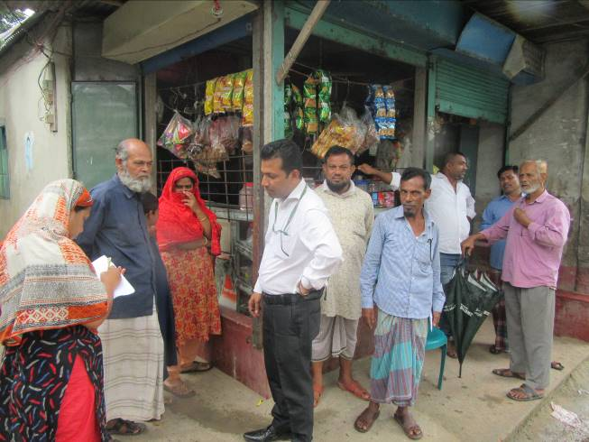
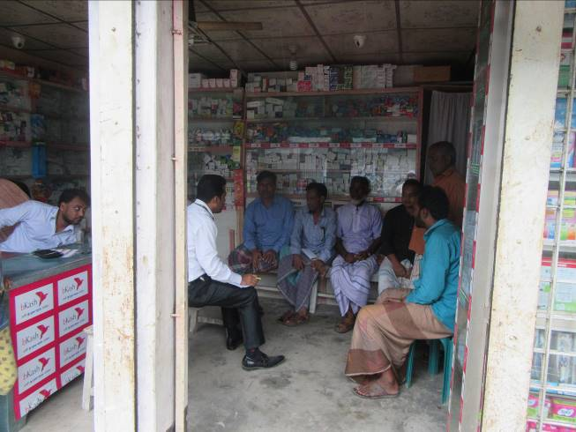
Photographs 7.1.1: Consultant Team Visited the Sites with the Pourashava Representatives

Issues Raised by the Participants

The participants raised the issues related to the infrastructure development of Bhairab Pourashava. They emphasized on the subproject selection for the future development and also discussed about the procedure for the quality construction work. In the FGD, the participants discussed the requirements of the infrastructure development of Bhairab Pourashava through a list of the subprojects.

Feedback, Suggestions, and Recommendations of the Participants

The participants were presented with feedback, suggestions, and recommendations listed below:
- The local participants emphasized on minimization of the impacts during construction work;
- The participants discussed about the environmental and social issues to be raised during the subproject implementation;
- The local people also stated that the Pourashava Officials should inspire the contractor for the effective implementation of the safeguard measures;
- The FGD results confirmed that an improved communication network, drainage facility, solid waste management, water treatment plant and sewerage treatment plant is needed for future development of Bhairab Pourashava;
- Most of the participants stated that the subproject should be inclusive i.e. road with drain and street light;
- The participants stated that public water supply facilities, sanitation facilities, drainage congestion and access road is not adequate;
- The participants stated that construction works should be scheduled properly to minimize the impacts.

Conclusions and Recommendations

The environmental impacts of all the elements of the subproject have been assessed. All potential impacts were identified in relation to design and location, construction, and operation phases. The overall conclusion is that if the mitigation, compensation and enhancement measures are entirely implemented, there will be no considerable negative environmental impacts as a result of location, design, construction and or operation of the proposed subproject.

A few key recommendations are outlined below:
- EMP should be available in the site during construction phase;
- Regular field visit by PMU, DSM and Pourashava is needed for the effective implementation of the EMP;
- Equipment should be checked by the Pourashava engineer and DSM consultant prior to work;
- Proper maintenance is needed for the planted trees by the contractor during project defect liability period;
- To minimize occupational health and safety risks, it is highly recommended to adapt mechanical system where appropriate;
- First aid box with relevant medicine should be available at site;
- The contractor is responsible for the proper disposal of the generated wastes materials from the subproject sites and campsite;
- Contractor will ensure availability of the PPEs to the workers;
- Contractor will monitor behavioral matter of the workers to avoid any undue risks related to labor influx;
- The EMP shall be made binding on contractor operating the site, and will be included in the contractual clauses.

It should be noted that environmental assessment report is a live document. Hence, due to changing circumstances during the construction phase if any, there might be minor adaptation needed for environmental, health and safety issues.

References

Bhairab Pourashava Master Plan: 2011-2031 Urban Area Plan;

FAO-UNDP, 1988-History of Soil Research in Bangladesh;

Asuganj Power Supply Company Limited (APSCL), 2011. Detailed EIA report on 450MW power plant;

Environmental Assessment Volume 1: Overall Environmental Assessment [Draft Final Report], September 2013. Municipal Governance and Services Project (MGSP), Local Government Engineering Department (LGED) and Bangladesh Municipal Development Fund (BMDF), Ministry of Local Government, Rural Development and Cooperatives, Government of the People's Republic of Bangladesh;

Environmental Assessment Volume 2: Environmental Management Framework (EMF) [Draft Final Report], September 2013. Municipal Governance and Services Project (MGSP), Local Government Engineering Department (LGED) and Bangladesh Municipal Development Fund (BMDF), Ministry of Local Government, Rural Development and Cooperatives, Government of the People's Republic of Bangladesh;

Geological Survey of Bangladesh, 1978-Earthquake Zoning Map;

Bangladesh Meteorological Department, Flood Zoning Map;

Population and Housing Census, 2011, National Volume-II: Union Statistics.

APPENDIX

Appendix- I: Environmental Monitoring Checklist

