
GOVERNMENT OF THE PEOPLE’S REPUBLIC OF BANGLADESH
Local Government Engineering Department (LGED)

Local Government Division

Ministry of Local Government, Rural Development and Cooperatives

Environmental Assessment (EA) REPORT

Name of the Subproject: Construction of RCC Drain at Bhairab Bazar internal road, Construction of BC Road and RCC Drain at Yousuf Ali High School Road, Construction of RCC Road and RCC Drain at Tatarkandi, Construction of RCC Road and RCC Drain at Kandar Hati and Construction of RCC drain at Bangabandhu Road

Package No: MGSP/BHB/2018-2019/W-10

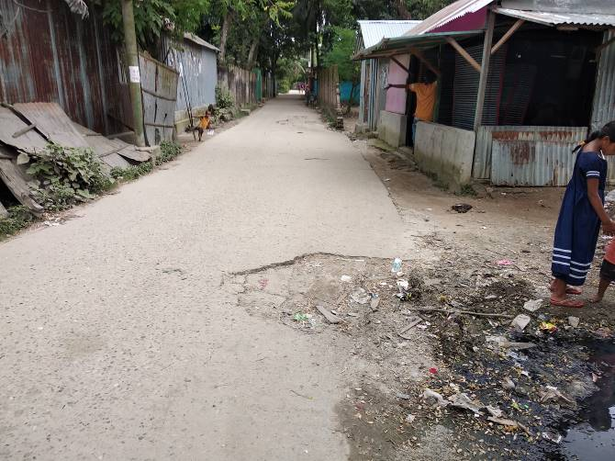
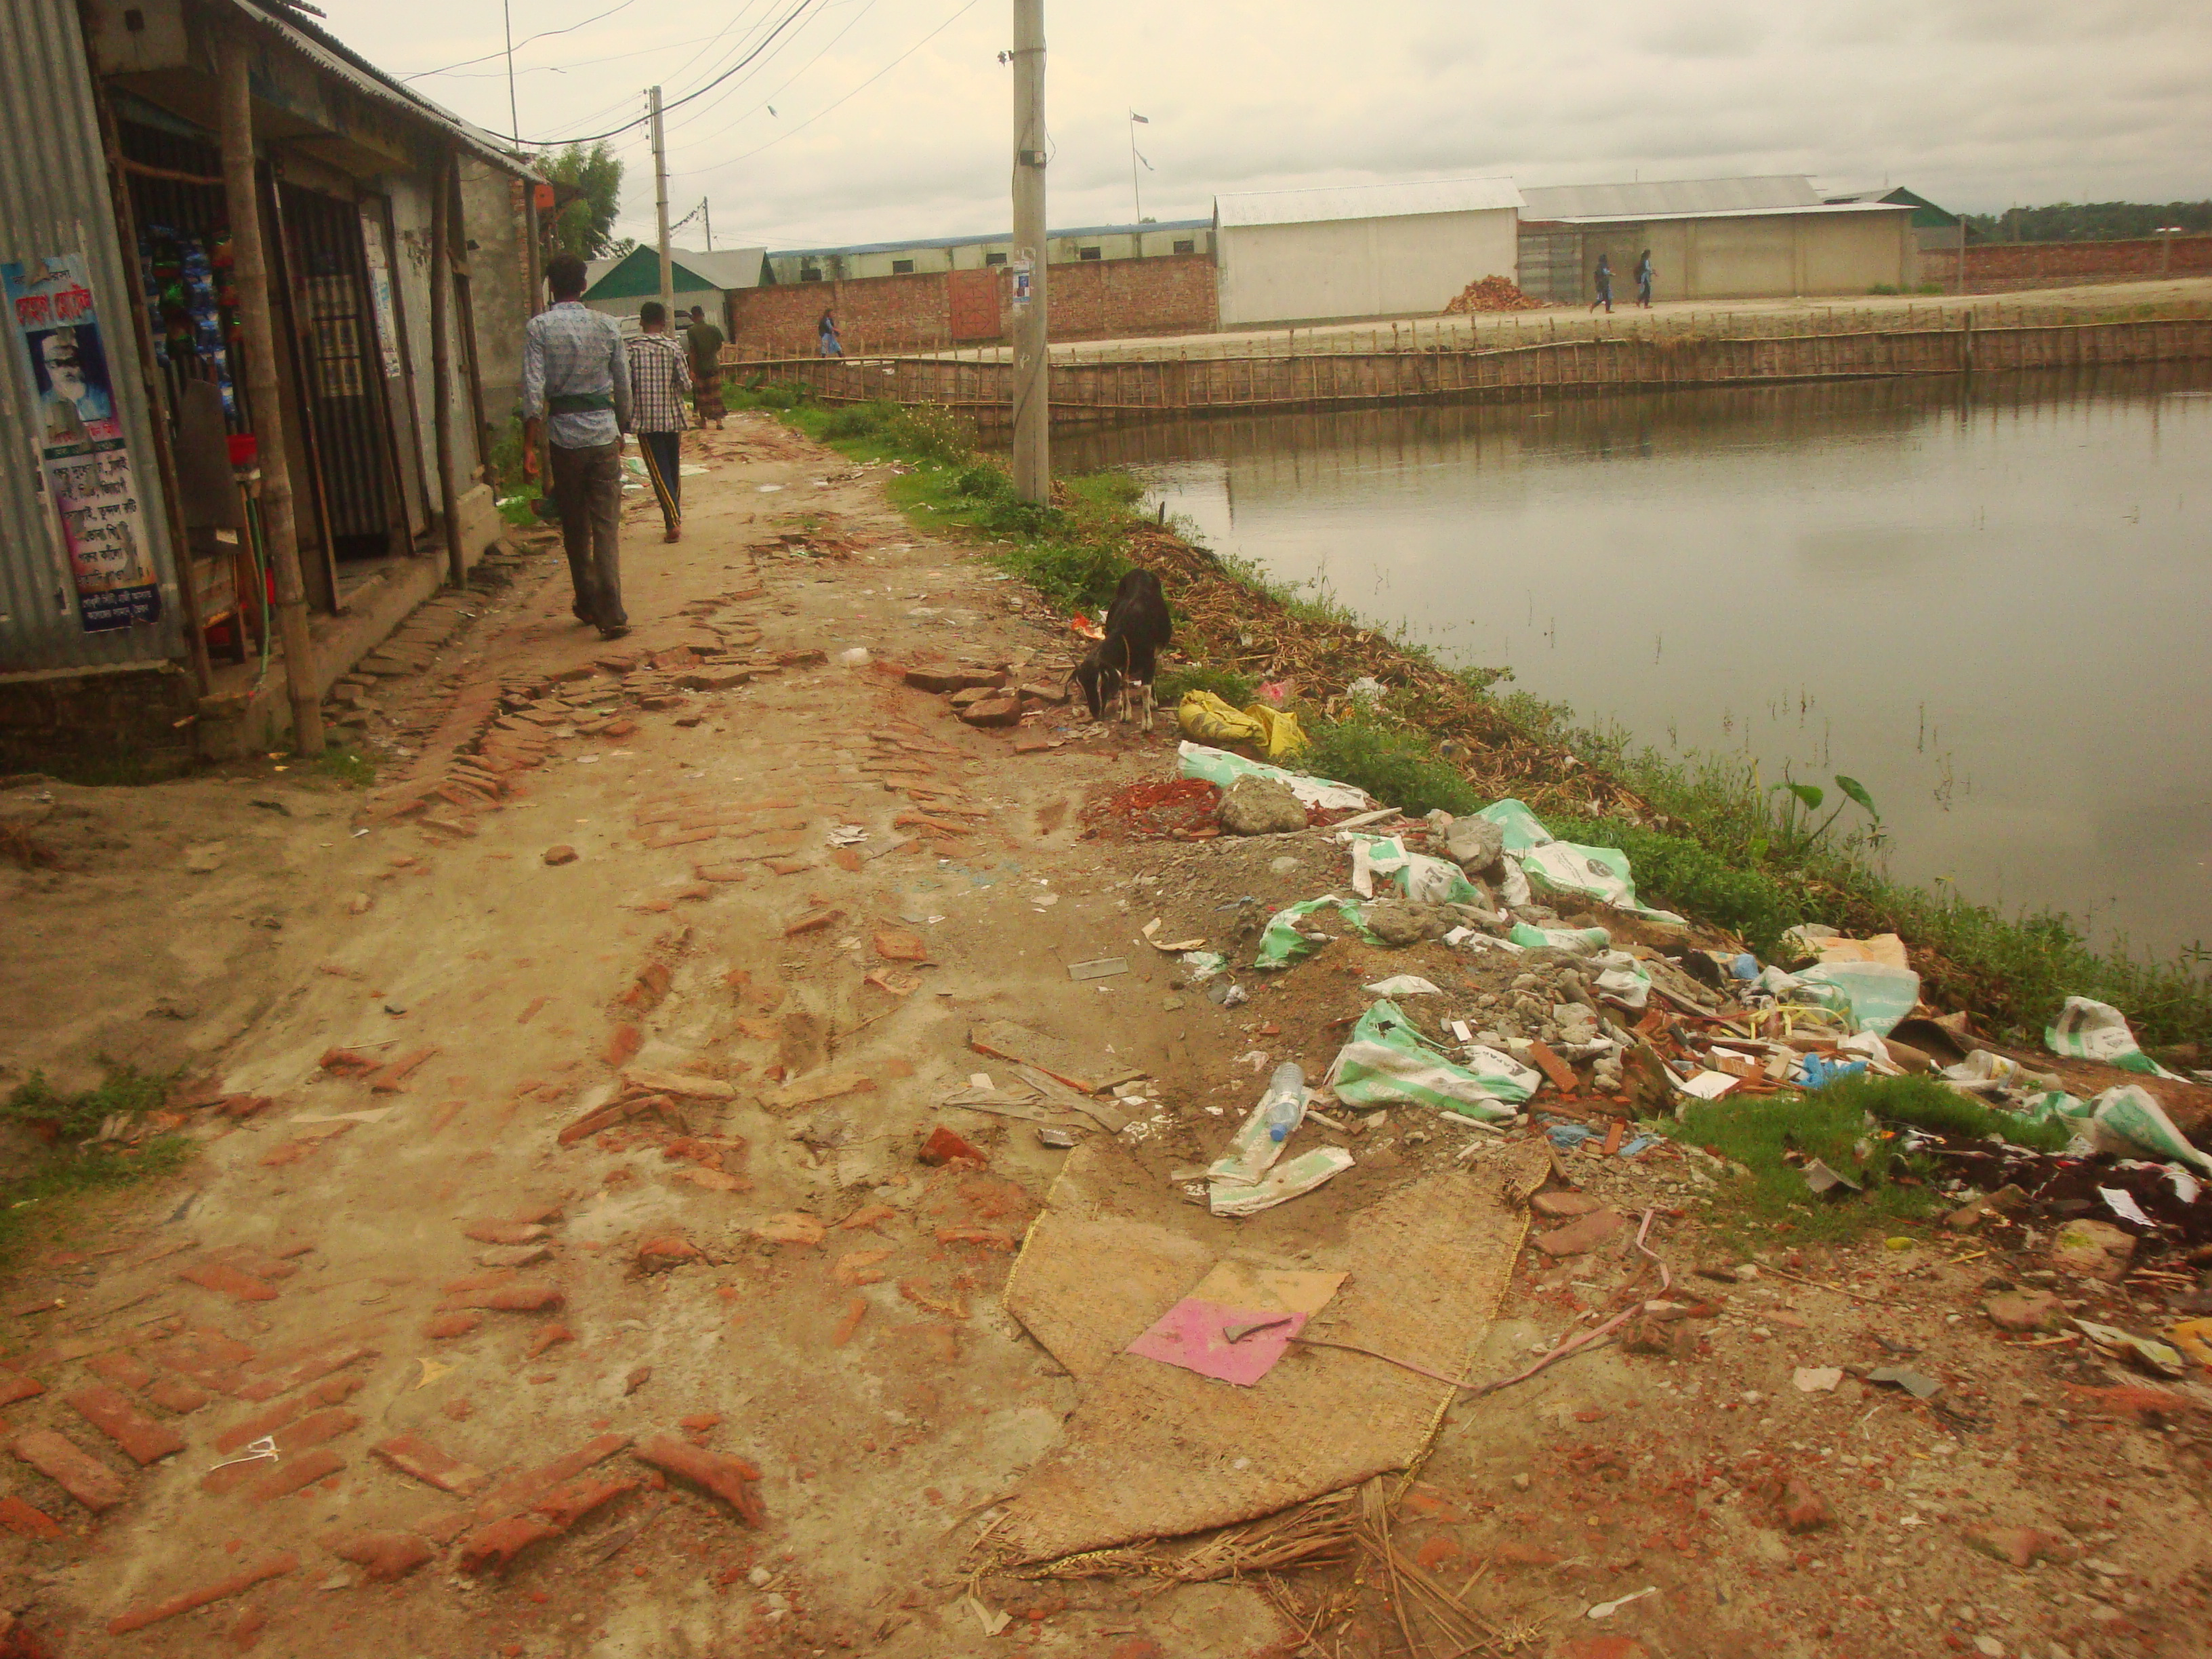
Bhairab Pourashava, Kishoreganj

Municipal Governance and Services Project (MGSP)
Design, Supervision, and Management (DSM) Consultancy Services
Joint Venture of  Hifab International AB, Sweden  AQUA Consultant and Associates Ltd., Bangladesh |   

TABLE OF CONTENTS

 |  |  |  | Page No.
1.0 |  | INTRODUCTION |  | 1-3
 | 1.1 | Subproject Background |  | 1
 | 1.2 | Objectives of the Study |  | 2
 | 1.3 | Scope and Methodology of the Study |  | 2
2.0 |  | SUBPROJECT DESCRIPTION |  | 4-11
 | 2.1 | The Study Area |  | 4
 | 2.2 | Current Situation, Proposed Intervention and Need for the Subproject |  | 7
 | 2.3 | Justification of Selection of the Subproject |  | 10
 | 2.4 | Envisaged Subproject Activities and Implementation Process |  | 10
3.0 |  | BASELINE ANALYSIS OF ENVIRONMENTAL CONDITION |  | 12-18
 | 3.1 | Physical Environment |  | 12
 | 3.2 | Biotic Environment |  | 19
 | 3.3 | Socio-economic and Socio-cultural Environment |  | 20
4.0 |  | ENVIRONMENTAL SCREENING |  | 21-23
5.0 |  | SPECIFIC IMPACT, MITIGATION AND ENHANCEMENT MEASURES |  | 24-30
 | 5.1 | Dismantle Work, Site Clearing, Excavation Work and Earth Work |  | 24
 | 5.2 | Tree Felling, Clearing of Vegetation and Ecological Impact |  | 24
 | 5.3 | Pollution from the Construction Materials |  | 24
 | 5.4 | Air Quality and Dust |  | 25
 | 5.5 | Noise and Vibration |  | 25
 | 5.6 | Water Quality |  | 26
 | 5.7 | Occupational Health and Safety |  | 26
 | 5.8 | Impacts on Social Environment and Common Property Resources |  | 27
 | 5.9 | Labor Influx and Anticipated Impacts |  | 28
 | 5.10 | Impacts on Traffic Movement |  | 30
6.0 |  | ENVIRONMENTAL MANAGEMENT PLAN |  | 31-
 | 6.1 | Access to Information |  | 31
 | 6.2 | Grievance Redress Mechanism |  | 31
 |  | 6.2.1 | Grievance Redress Committee (GRC) | 31
 |  | 6.2.2 | Grievance Resolution Process | 32
 | 6.3 | Institutional Arrangement for Safeguard Compliances |  | 33
 | 6.4 | Capacity Building |  | 34
 | 6.5 | Emergency Response and Disaster Management |  | 34
 | 6.6 | Environmental Management Action Plan |  | 35
 | 6.7 | Environmental Monitoring Plan |  | 41
 | 6.8 | Environmental Management Budget |  | 42
7.0 |  | PUBLIC CONSULTATION AND PARTICIPATION |  | 44-45
 | 7.1 | Methodology |  | 44
 | 7.2 | Issues Raised by the Participants |  | 45
 | 7.3 | Feedback, Suggestions and Recommendations of the Participants |  | 45
8.0 |  | CONCLUSIONS AND RECOMMENDATIONS |  | 46
9.0 |  | REFERENCES |  | 47
APPENDIX 48-67
Appendix I: Environmental Monitoring Checklist |  |  |  | 48-67

LIST OF TABLES
Table 3.1.1 | Major Environmental and Infrastructural Features at Bhairab Bazar Internal Road (Ch. 0-400m)
Table 3.1.2 | Major Environmental and Infrastructural Features at Yousuf Ali High School Road at Laxmipur (Ch. 0-1286m)
Table 3.1.3 | Major Environmental and Infrastructural Features at Tatarkandi Road (Ch. 0-775m)
Table 3.1.4 | Major Environmental and Infrastructural Features at Kandar Hati Road (Ch. 0-563m)
Table 3.1.5 | Major Environmental and Infrastructural Features at Bangabandhu Road Side Drain (Ch. 0-50m and 550-750m)
Table 5.7.1 | General Requirements for the Workers Health and Safety
Table 5.8.1 | Impacts on Social Environment and Common Property Resources
Table 6.2.1. | List of GRC committee members
Table 6.6.1 | Anticipated Environmental Impacts during Construction Phase and Corresponding Mitigation and Enhancement Measures
Table 6.6.2 | Anticipated Environmental Impacts during Operational Phase and Corresponding Mitigation and Enhancement Measures (EMP Table)
Table 6.7.1 | Matrix Table of Monitoring Plan (Visual and observation during construction phase)
Table 6.8.1 | Environmental Measurement Budget

LIST OF FIGURES
Figure 2.1.1 | Location Map of the Subproject
Figure 2.1.2 | Layout Plan of the Subproject components
Figure 2.1.3 | Topographical View of the Subproject
Figure 3.1.1 | Earthquake Zones of Bangladesh
Figure 3.1.2 | Wind-rose of Bhairab Pourashava
Figure 3.1.3 | Location of Bhairab Pourashava in Flood Zone Map of Bangladesh
Figure 6.3.1 | Environmental and Social Management Team (Tentative)

LIST OF PHOTOGRAPHS
Photographs 2.2.1 | Current Situation of the Subproject Sites
Photographs 2.2.2 | Current Situation of the Outfall
Photographs 7.1.1 | Consultation Meeting with Pourashava Officials and Local Individuals at Subproject Sites

ABBREVIATIONS
AP (AP’s) | Affected Person
BDT | Bangladeshi Taka
BOQ | Bill of Quantity
CC | Cement Concrete
CIP | Capital Investment Plan
CP | Contingency Planning
DSM | Design, Supervision, and Management
EA | Environmental Assessment
ECR | Environmental Conservation Rules
EMP | Environmental Management Plan
EPP | Emergency Preparedness Planning
ES | Environmental Screening
FGD | Focal Group Discussion
GoB | Government of Bangladesh
GRC | Grievance Redress Committee
GRM | Grievance Redress Mechanism
GRP | Grievance Redress Procedure
IIS | Infrastructure Improvement Section
LGED | Local Government Engineering Department
MGSP | Municipal Governance and Services Project
PD | Project Director
PMU | Project Management Unit
RCC | Reinforcement Cement Concrete
RP | Relevant Reports
TL | Team Leader
ULB | Urban Local Body
WB | World Bank
XEN | Executive Engineer

Introduction

Subproject Background
Bhairab Pourashava is located at Bhairab Upazila under Kishoreganj District. Bhairab Pourashava is ‘A’ type Pourashava which was declared as a Pourashava in the year of 1958. The Pourashava covers area of 15.81 sq. km having population of 118,992 as per BBS census 2011. Presently, Bhairab Pourashava has 40 km paved roads and 27.5 km earthen roads. The drainage network includes 17.09 km drains.
The urbanization process in the Pourashava and increasing population necessitates continuous development of roads and drains. Hence, this subproject under the Municipal Governance Services Project (MGSP) is actively contributing infrastructures development of the Bhairab Pourashava.

This subproject includes the following components: BC Road, RCC Road and RCC drain. The significant features of the subproject are stated below:
+Name of the Subproject: | (a) Construction of RCC drain at Bhairab Bazar internal road side drain (00+00-0+400);  (b) Construction of RCC drain at Yousuf Ali High School Road at Laxmipur (Ch. 0+00m to 1+286m);  (c) Construction of RCC drain at Tatarkandi internal road & drain Ch. 0+00m to 0+775m, Length=1470m (both side);  (d) Construction of RCC drain at Kandar Hati internal road & drain (Ch. 0+00m to 0+420m), length=420m;  (e) Construction of RCC drain at Bangabandhu Road side with foot path (Ch. 00+00-00+050 & 00+582-00+727) to complete the drainage network including cross drain;  (f) Construction of Yousuf Ali High School Road at Laxmipur (Ch. 0+00m to 1+286m);  (g) Construction of Tatarkandi road Ch. 0+00m to 0+775m.
Package No. : | MGSP/BHB/2018-2019/W-10
District Name : | Kishoreganj
ULB Name : | Bhairab Pourashava
Jurisdiction area : | Wards nos. 1, 2, 5, 6, 7, 8, 10
Design Option : | BC Road, RCC Road and RCC Drain
Beneficiary Population : | About 43,000
Tribal People : | No tribal people settlement found in the subproject area
Land Acquisition : | Land acquisition is not required.
Estimated Cost : | BDT 82.18 Million
Subproject Duration : | 12 Months
Tentative Start Date : | 7 December, 2018
Tentative Completion Date : | 6 December, 2019

Objectives of the Study

The general objective of this study is to determine the major environmental impacts succeeding from execution of the subproject and to recommend mitigation measures to avoid or reduce adverse environmental impacts and to enhance positive impacts. The specific objectives include:
- To assess the existing environmental conditions of the subproject site and its influence area;
- To identify and assess impacts resulting from the subproject during its construction phase and operation phase;
- To develop an environmental management plan with recommendations for mitigating impacts and enhance positive impacts;
- To summarize environmental monitoring requirements.

Scope and Methodology of the Study

The subproject appraisal included environmental screening for all the subproject components. According to that screening, environmental assessment is required to fulfill the regulatory requirement for BC Road, RCC Road and RCC Drain. The study methodology comprised the following activities:

Desktop Study

The desktop study involved:

- Initial meetings with client and stakeholders to discuss about the proposed subproject including subproject activities;
- Collection and review of the baseline data, maps, reports and other relevant information on the existing environmental and social conditions of the subproject area;
- Review of the relevant existing legislation, regulation and policies;
- Understanding the anticipated technical processes that may affect the environment.

Field Investigation and Data Collection

A team of the consultants made a field investigation to the proposed site. Field investigations involved mainly site walks within the subproject area and the neighboring areas that may be affected by the subproject. The following key tasks were performed during the field visit:
- Taking photographs of the significant aspects to describe the baseline environmental conditions of the subproject area;
- Interviews with representatives of the Pourashava Officials, within the subproject area and interested and affected people within the subproject influence zone;
- Verifying information and data collected during the desktop study and to collect new information that may be important in the assessment of the impacts and design of the mitigation measures.

Data Analysis and Report Writing
The data and information collected from all the sources (literature review, secondary and primary data, public consultation) were analyzed to describe the existing environmental setting of the subproject area, to identify the potential positive and negative impacts of the proposed subproject, as well as to provide preliminary suggestions for mitigation measures. Finally, after analyzing all the data, this environmental assessment report has been prepared.

SUBPROJECT DESCRIPTION

The Study Area

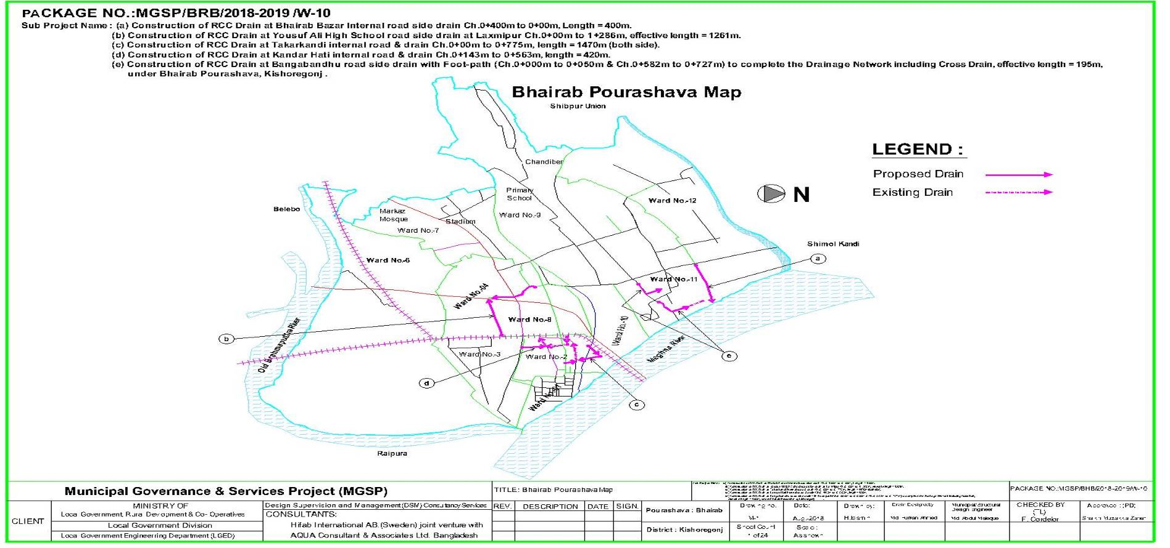
The subproject covers the jurisdiction area of the Ward number 1, 2, 5, 6, 7, 8 and 10 of Bhairab Pourashava. The Location Map, Lauout Plan and Topographical View of this subproject are shown in Figure 2.1.1, 2.1.2 and 2.1.3

Figure 2.1.1: Location Map of the Subproject

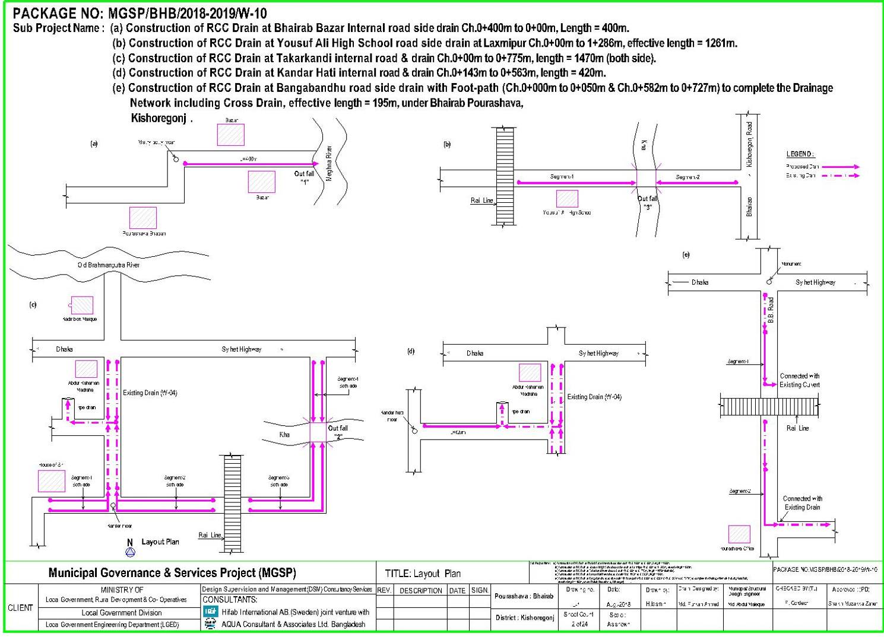

Figure 2.1.2: Layout Plan of the Subproject components
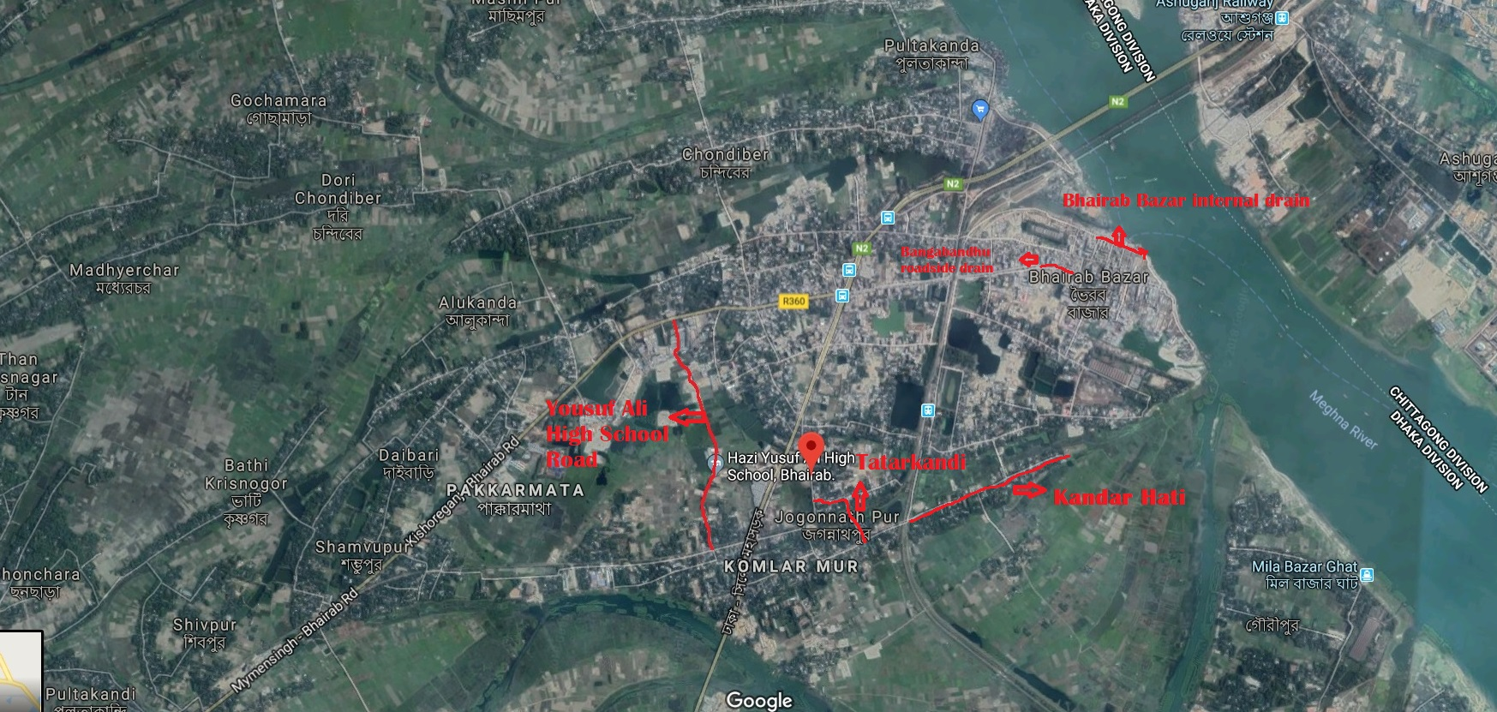
Figure 2.1.3: Topographic View of the Subproject

Current Situation, Proposed Intervention and Need for the Subproject

The subproject components are located in residential area as well as commercial area.
Proposed Bhairab Bazar internal road will start from Misty Potti and will directly discharge into the River Meghna. Existing drain is narrow and insufficient dimension to drain out the storm water. Consequently, during rainy season severe water logging occurs in the Bazar area. Stagnated water interrupts the market activity and businesses and creates disturbing condition for the shoppers. Roadside shops are sometimes entirely flooded after severe rainfall. Therefore, to minimize the water logging and drainage problem, RCC drain at the right side of the road with road level cover slab has been proposed from Ch. 0 m to Ch. 400 m.
At present, there is an existing HBB road from Ch. 360m to Ch. 1286m at the Yousuf Ali High School road. From Ch. 0m to 360m there is an existing road is in good condition. This HBB road is extensively damaged and very narrow. Existing width of the HBB road is 2.5 to 3 m on average. Bricks are missing at many places on the road. There are deep depressions at several places due to poor compaction. Consequently, rainwater collects on these depressions during rainy season and water logging occurs. On several point, the road becomes hazardous due to broken and missing bricks. Undulation due to depressions makes movement of light vehicles very difficult and hazardous. Exposed earth surface due to missing bricks becomes muddy during rainy season. Moreover, two large vehicles cannot pass side by side due to narrow width of the road. To mitigate these problems, a Bituminous Carpeting road has been proposed in place of the existing HBB road. There is no drain existing on the road. Water logging occurs regularly from Ch. 0 to Ch. 360m as congested residential houses block rainwater from runoff to the adjacent beel. So, to mitigate the existing condition construction of RCC drain with footpath is proposed along the right side of the road from Ch. 0 m to Ch. 1286 m.
At present, there is an existing CC pavement at Tatarkandi. The CC pavement is damaged and very narrow. Average width of the existing pavement is between 3.5 m and 4.5 m. The narrow pavement is unable to meet the increasing number of traffics. There are also uneven settlements of the CC pavements at various places which has made the road unsafe for vehicles. Moreover, two large vehicles cannot pass side by side due to narrow width of the road. So, an RCC pavement has been proposed from Jaman Road (Ch. 0 m) to Dhaka-Sylhet Highway (Ch. 775 m). RCC drain at both sides of the road with footpath has also been proposed making the effective length of the proposed drain 1470 m.
At Kandarhati, there is also an existing CC pavement which is narrow. The narrow pavement is unable to meet the increasing number of traffics. Currently, there are no drains at the road. Consequently during rainy season, severe water logging occurs in the subproject area. So, an RCC pavement has been proposed from Ch. 143 m to Ch. 563 m and an RCC drain has also been proposed at right side of the road with footpath from Ch. 0 m to Ch. 420 m.
Currently, at Bangabandhu road there is an existing footpath without drain in a localized portion. But both side of that portion has continuous drains. The lack of drain in that portion creates discontinuity in the drainage system. This creates severe water logging during rainy season and water stagnates on the road. Stagnated water hinders vehicle and pedestrian movement and local people suffers. So, to mitigate these problems, RCC drain will be constructed from Ch. 0 m to Ch. 50 m and from Ch. 582 m to Ch. 727 m. Effective length of the drain will be 195 m. The existing site condition is further exhibited in the following Photographs 2.2.1.
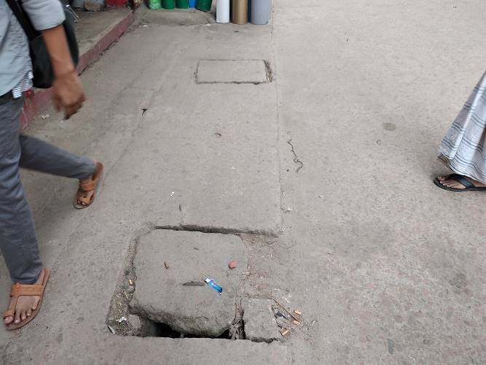
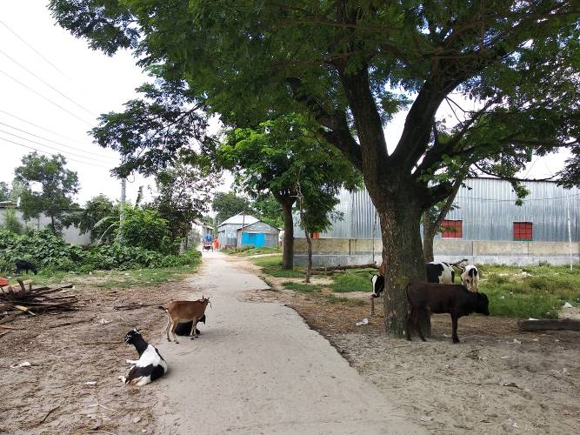
Photographs 2.2.1: Current Situation of the Subproject Sites
Bhairab Bazar internal drain will be discharged directly into the Meghna River. Satmukhi Beel will act as the outfall for the Yousuf Ali high School drain which is connected to the River Meghna. Tatarkandi drain will be discharged into an adjacent khal. Kandarhati drain will be discharged into an under construction pipe drain from package W4 of MGSP. The pipe drain will ultimately discharge into the Meghna River. The existing condition of the outfalls are shown in the Photographs 2.2.2.
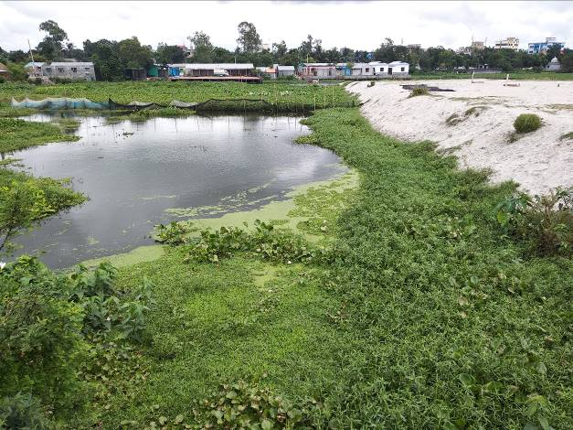
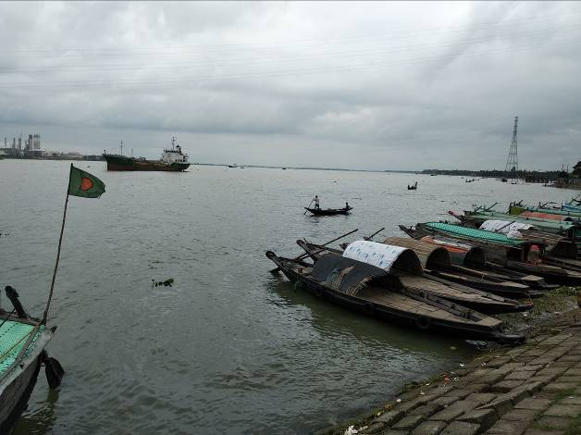
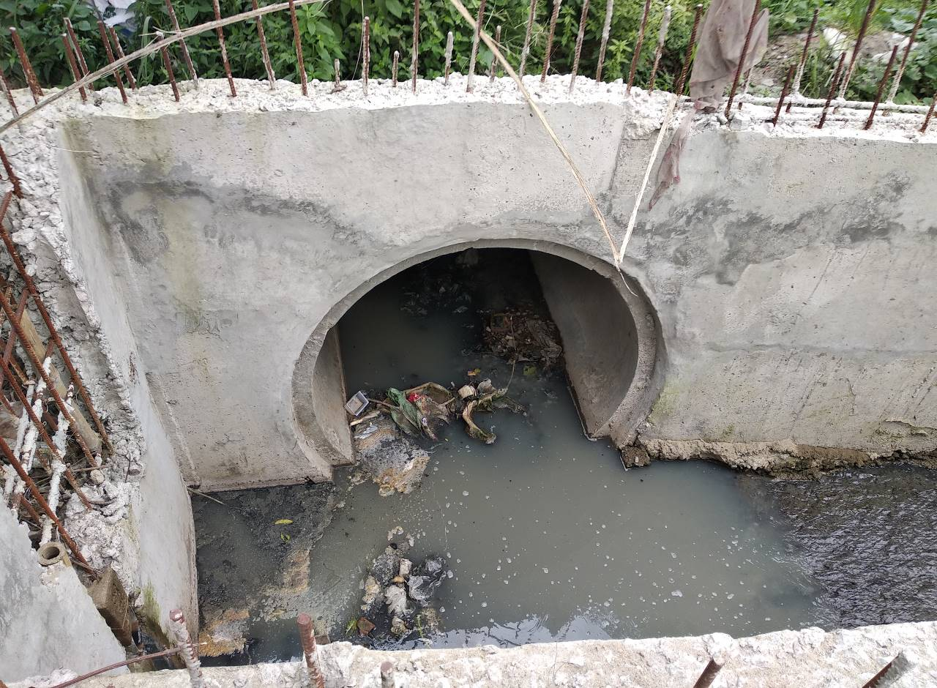

Photographs 2.2.2: Current Situation of the outfalls

Justification of Selection of this Subproject

According to the CIP list, Bhairab Pourashava prepared the priority list of the subprojects considering the demand and requirement. As a part of the reconnaissance survey, PMU Officials and DSM consultants’ visited and evaluated the existing site condition of the subproject.
From the environmental screening it is revealed that the ecological impacts due to this subproject will be moderate. The subproject has adverse impacts on the physicochemical environment. However, it is anticipated that the adverse impact is not significant and limited in the subproject boundary. The Pourashava authority has consulted with the beneficiaries. The beneficiaries have no objection regarding the implementation of the subproject. Considering the significant potential benefits that will derive after completion, the local community demands and welcome this subproject.

Envisaged Subproject Activities and Implementation Process

The general activities of the subproject includes: construction of the semi-pucca site office, construction of the labor shed and relocation of the electrical poles.

Specific activities for BC Road:
- Site clearing work;
- Preparation of the hard bed by scarifying and loosening of the existing top;
- Earth work in box cutting;
- Sand filling on the road bed;
- Brick on end edging;
- Compacted aggregates and sub-base course;
- Providing prime coat;
- Lying pre-mixed dense bituminous surfacing.

Specific activities of the RCC Road:
- Dismantling of the damaged sub-base and base course works;
- Earth work in box cutting;
- Sand filling on the road bed;
- Sand and brick chips mix in the sub-base;
- Mechanical compaction;
- Polythene sheet laying work;
- Fabrication of the ribbed or deformed bar reinforcement;
- Reinforced cement concrete work.
Specific activities of the RCC Drain with Cover Slab and Footpath include:
- Earth work in excavation for the foundation;
- Pumping and bailing out of water as per requirement;
- Sand filling for the preparation of foundation bed;
- Plain cement concrete work in foundation;
- Manufacturing CC blocks;
- Fabrication of the ribbed or deformed bar;
- Reinforced cement concrete work.

The materials to be used for the key activities: bricks, brick chips, stone chips, reinforcement bar, admixture, sand, cement, concrete.
The major equipment to be used for the implementation of the subproject: Brick breaking machine, concrete mixer machine, vibrator machine, MS sheet, steel cutter, steel shutter, steel drum rollers, pneumatic multiple tire roller, dump truck, water tanker, pump, generator and measuring device. The tentative schedule of construction of the subproject is:
(a) Subproject Duration (Months) : 12 Months
(b) Tentative Start Date : 7 December, 2018
(c) Tentative Completion Date : 6 December, 2019

The daily construction hours will normally include regular working time. However, daily working hours may vary based on the on-site condition.

Baseline ANALYSIS OF THE ENVIRONMENTAL CONDITION

Physical Environment

Important Environmental and Infrastructural Features

During site visit the environmental and infrastructural features within the subproject area were collected. Conditional survey has also been conducted for designing the subproject. Hence, survey data is also used for preparing the report. The environmental and infrastructural features listed within 100 m of the both sides of the roads from the center line considering 100 m longitudinal interval. The major environmental and infrastructural features of the subproject are shown in table 3.1.1, 3.1.2, 3.13, 3.14 and 3.15
Table 3.1.1: Major Environmental and Infrastructural Features at Bhairab Bazar Internal Road (Ch. 0-400m)
Chainage | Left | Right | Major Environmental and Infrastructural Features at Bhairab Bazar Internal Road (Ch. 0-400m)
0-100 | √ |  | Pucca and semi-pucca shops
0-100 |  | √ | Pucca and semi-pucca shops
100-200 | √ |  | Pucca and semi-pucca shops
100-200 |  | √ | Pucca and semi-pucca shops
200-300 | √ |  | Pucca and semi-pucca shops
200-300 |  | √ | Pucca and semi-pucca shops
300-400 | √ |  | Pucca and semi-pucca shops
300-400 |  | √ | Pucca and semi-pucca shops

Table 3.1.2: Major Environmental and Infrastructural Features at Yousuf Ali High School Road at Laxmipur (Ch. 0-1286m)
Chainage | Left | Right | Major Environmental and Infrastructural Features at Yousuf Ali High School Road at Laxmipur (Ch. 0-1286m)
0-100 | √ |  | Railgate, boundary walls, trees, pucca and semi-pucca residential buildings,
0-100 |  | √ | Railgate, tinshed structures, boundary walls, pucca and semi-pucca residential buildings,
100-200 | √ |  | Boundary walls, trees, pucca and semi-pucca residential buildings, swamp
100-200 |  | √ | Boundary walls, trees, pucca and semi-pucca residential buildings, semi-pucca shops, trees
200-300 | √ |  | Open filled land, semi-pucca residential buildings, tin-shed shops, land being filled
200-300 |  | √ | Open filled land, boundary walls, vegetation, yousuf ali high school boundary
300-400 | √ |  | Land being filled, tin-shed shops, open filled land, beel,
300-400 |  | √ | Yousuf Ali high school, vegetation, open filled land
400-500 | √ |  | Jamiatul Ulum Al Islamiya Bhairab Madrassa, tinshed shops,
400-500 |  | √ | Open land with vegetation, beel
500-600 | √ |  | Semi-pucca structures, pucca shops under construction, beel
500-600 |  | √ | Open plot with boundary, beel
600-700 | √ |  | Beel
600-700 |  | √ | Beel
700-800 | √ |  | Beel, filled land with vegetation, canal
700-800 |  | √ | Beel, filled land with vegetation, canal
800-900 | √ |  | Beel, land being filled,
800-900 |  | √ | Beel, land being filled
900-1000 | √ |  | Tinshed shops, filled land, beel,
900-1000 |  | √ | Semi-pucca shops, open land with vegetation,
1000-1100 | √ |  | Tinshed and semipucca shops
1000-1100 |  | √ | Tinshed and semipucca shops
1100-1200 | √ |  | Tinshed and semipucca shops, open plot with tin-plate boundary
1100-1200 |  | √ | Tinshed and semipucca shops
1200-1286 | √ |  | Haji Karim Miya Market, Jaman Paduka Market
1200-1286 |  | √ | Mijan Market, Vegetation bounded by tin boundary

Table 3.1.3: Major Environmental and Infrastructural Features at Tatarkandi Road (Ch. 0-775m)

Chainage | Left | Right | Major Environmental and Infrastructural Features at Tatarkandi Road (Ch. 0-775m)
0-100 | √ |  | Tin-shed structures, trees, culvert, pucca buildings,
0-100 |  | √ | Tin-shed structures, trees, culvert, pucca buildings
100-200 | √ |  | Connecting road, mosque, open space, tin-shed structures, trees, ,
100-200 |  | √ | Tin-shed structures, trees, boundary walls, workshops,
200-300 | √ |  | Household yard, Madrassa, Tin-shed structures, trees
200-300 |  | √ | Tin-shed structures, trees,
300-400 | √ |  | Society for Social Service Office, household yard, boundary walls
300-400 |  | √ | Swamp, pucca residential buildings, boundary walls
400-500 | √ |  | Eidgah, rail-line, Pucca residential buildings, boundary walls
400-500 |  | √ | Trees, rail-line, tin-shed structures, Asha Bhairab Branch,
500-600 | √ |  | Pucca residential buildings, boundary walls
500-600 |  | √ | Pucca residential buildings, boundary walls
600-700 | √ |  | Tin-shed structures
600-700 |  | √ | Tin-shed structures
700-775 | √ |  | Tin-shed structures
700-775 |  | √ | Tin-shed structures

Table 3.1.4: Major Environmental and Infrastructural Features at Kandar Hati Road (Ch. 0-563m)

Chainage | Left | Right | Major Environmental and Infrastructural Features at Kandar Hati Road (Ch. 0-563m)
0-100 | √ |  | Open Space, tinshed structures, pucca and semi-pucca residential buildings
0-100 |  | √ | Tinshed structures, pucca and semi-pucca residential buildings, boundary walls
100-200 | √ |  | Tinshed structures, pucca and semi-pucca residential buildings, boundary walls, Coil Factories, open space
100-200 |  | √ | Tinshed structures, pucca and semi-pucca residential buildings, boundary walls, low land with vegetation
200-300 | √ |  | Tinshed structures, open space, pucca and semi-pucca residential buildings and shops, tinplate boundary
200-300 |  | √ | Tinshed structures, low land, pucca and semi-pucca residential buildings and shops
300-400 | √ |  | Tinshed structures, open space, pucca and semi-pucca residential buildings, open space with vegetation
300-400 |  | √ | Tinshed structures, open space, pucca and semi-pucca residential buildings, boundary walls,
400-500 | √ |  | Open space with vegetation, tinshed structures, low land, pucca buildings
400-500 |  | √ | Open space with vegetaion, pucca building, tinshed structures, boundary walls
500-563 | √ |  | Semi-pucca and pucca buildings, Open space with vegetation, boundary walls, tinplate boundary
500-563 |  | √ | Pucca buildings with boundary walls, tinplate boundary

Table 3.1.5: Major Environmental and Infrastructural Features at Bangabandhu Road Side Drain (Ch. 0-50m and 550-750m)

Chainage | Left | Right | Major Environmental and Infrastructural Features at Bangabandhu Road Side Drain (Ch. 0-50m and 550-750m)
0-100 | √ |  | Pucca and semi-pucca shops, pucca buildings
0-100 |  | √ | Pucca and semi-pucca shops, pucca buildings
550-650 | √ |  | Pucca and semi-pucca shops, pucca buildings
550-650 |  | √ | Pucca and semi-pucca shops, pucca buildings
650-750 | √ |  | Pucca and semi-pucca shops, pucca buildings
650-750 |  | √ | Pucca and semi-pucca shops, pucca buildings

Geology, Topography, and Soils

The subproject area is situated near Meghna River-Bank. The soil of Bhairab Pourashava typically is non-calcareous dark grey floodplain soils (FAO-UNDP, 1988-History of Soil Research in Bangladesh). The geology of the study area consists of Quaternary Deltaic sediments, which have been strongly influenced by the tectonic movements on deep-seated faults. The area lies on a tectonic block, which has been uplifted relative to the surrounding areas. The area lies in the earthquake Zone II (moderate seismic zone) according to the seismic map of Bangladesh is shown in Figure 3.1.1. The soil profile of the study area consists of about 12m thick clay deposit followed by sand, clay and progressively coarser sand as depth increases (APSCL, 2011-EIA Study).

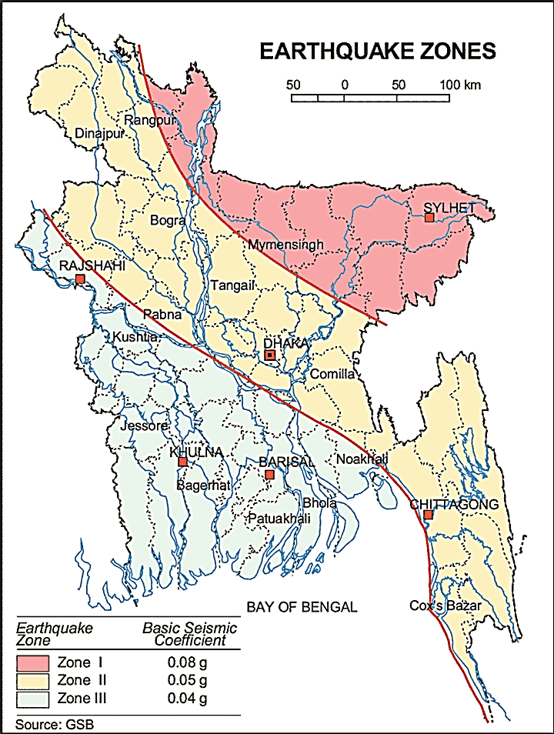

Figure 3.1.1: Earthquake zones of Bangladesh

Climate and Meteorology

The subproject area belongs to a semi-arid region characterized by temporal drought. The climate is sub-tropical with summer, monsoon and winter seasons. Rainfall is monsoonal, inter-monsoonal or cyclonic in origin. The maximum annual rainfall in the area as recorded was 4127 mm in the year 1952 and minimum yearly rainfall is 1439 mm in year 1989 with peak rainfalls occurring in July and August (APSCL, 2011-EIA Study). Furthermore, from mid-November to February is the coolest and driest period. April to May is the hottest period with periodic heavy thunderstorms. June to mid-September is the rainiest and humid period. Mid-September to early November is a transitional period with decreasing rainfall, often with association of thunder but with relatively high temperature and humidity (APSCL, 2011-EIA Study). Mean annual rainfall is about 2000 mm over most of the Bhairab Area. However, it exceeds 2500 mm in the north-east and exceeds 3000 mm in the south-east (Bhairab Pourashava Master Plan). Figure 3.1.2 shows the wind rose pattern of the Bhairab Pourashava. From the figure, it can be observed that wind mostly blows from the south-eastern and north-eastern direction. Wind speed is mild and mostly below 20 km/hr.
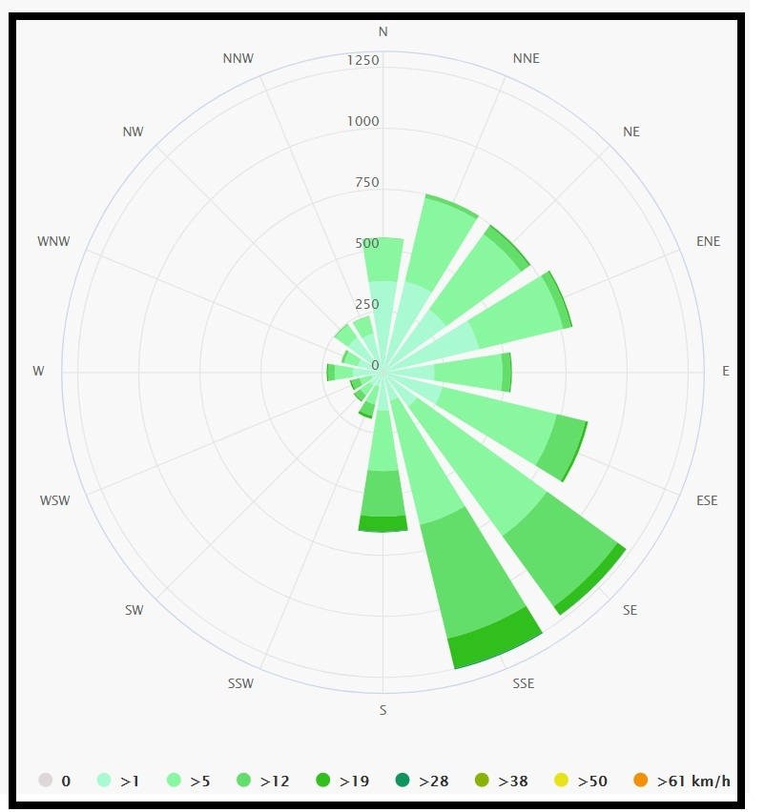
Figure 3.1.2: Wind-rose of Bhairab Pourashava
The construction works can be influenced by the climatic condition and meteorological components like humidity, temperature, sudden rainfall, and wind speed. During high winds, dust generated from the construction activities may spread quickly. It is very risky to work under rain and in high winds because the possibility of getting injury increases. Furthermore, work under high temperature and excess humidity may create health hazards like dehydration problem.

Hydrology (Surface Water, Ground Water and Rain Water Harvesting)

The subproject is located within the influence area of Meghna River. Groundwater is the main source of potable water in the subproject area. Ground water is available in plenty and water table does not go beyond suction limit throughout the year. According to the BADC groundwater zoning map, groundwater table in the Bhairab region varies from 0 to 5.3 meter below ground level. Arsenic concentration is not reported as higher level in both deep and shallow aquifer. Local people typically use deep tube-well water for drinking and other domestic purposes. Salinity problems are not visible. Rain water harvesting system is not common in and around the subproject area.

Flooding, Water Logging and Drainage Pattern

As per flood zoning map of Bangladesh (Figure 3.1.3), Bhairab Pourashava is located in the flood free area. According to previous data, this area is affected in historical severe flood events such as 1988, 1998, 2004 and 2007. In normal situation, the subproject area is free from flash flood. However, due to flood and high windy period such as during Tornado, the subproject area may be inundated by the external flood. In rainy season, due to inadequate and non-functional drain, the subproject area faces water logging problem.
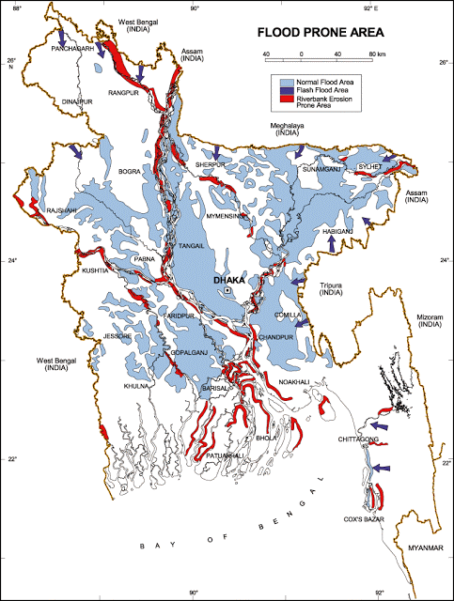

Figure 3.1.3: Location of Bhairab Pourashava in the Flood Zoning Map of Bangladesh
Air Quality and Dust
Ambient air quality data have not been found. Dust is generated during the movement of the vehicles in dry season and windblown dust cause air pollution. Additionally, black smoke emission from the vehicles degrades the air quality. In addition, open dumping of the waste materials make objectionable odor in the nearby area.

Noise Level
Noise is generated mainly from the vehicles movement and hydraulic horn. Noise is also generated due to public gathering. During construction phase, concrete mixer machine, vibrator machine, hydraulic excavator and vehicles used for transportation activities may create temporary noise nuisance within the subproject boundary.
Solid Waste Management
During site visit and information from the local people, it is evident that there is no structured solid waste management system in the Pourashava area. The people of this Pourashava are not habituated to dispose their garbage and kitchen waste into dustbins. Instead they throw their wastes into road side drains, open space or road adjacent to their houses.
3.2 Biotic Environment
Flora and Fauna
There are some planted and naturally grown trees in the influence area of the subproject that include Mango, Jackfruit, Banana, Jam, Mahgoni, Koroi, Coconut, Sajina, Dumur etc. The common local birds such as Choroi, Crow, Shalik etc. were found in the subproject area.

Socio-economic and Socio-cultural Environment

Land Use, Status of Housing and Built-up Infrastructure

The subproject is located in commercial as well as residential area. The built-up infrastructure in the subproject influence area mainly includes pucca, semi-pucca and tin-shed houses and shops.

Beneficiary Population

The subproject coves the jurisdiction area of the ward number 1, 2, 5, 6, 7, 8 and 10. As per information by the municipality, considering the wards’ population about 43,000 people will be benefitted directly and many others indirectly.

Education

In the subproject area, literacy among the population is about 42.7 % [BBS, 2011]. Literacy rate among males (55%) is still higher than females (52.2%). (Ref: Population and Housing Census 2011).

Tribal Communities

There is no indigenous or tribal people settlement in the subproject area. Therefore, there are no measures needed for indigenous peoples’ safeguard.

Land Acquisition and Resettlement

Private land acquisition is not needed.
Principal Livelihoods and Economic Activities
The subproject area is inhabited by the people of mixed occupations. In the Pourashava area, major income comes from business, govt. and private jobs, enterprises, small trades, and agriculture in the town.

Cultural Heritage and Protected Areas
During site visit it was observed that there is no protected and important cultural or historical site in the subproject influence area.
Social Conflicts and Development Activities
The local people welcome the subproject and there is no conflicts between the local communities regarding subproject implementation.

ENVIRONMENTAL SCREENING

Environmental Screening Checklist, as adopted in Appendix C of the Environmental Management Framework (EMF) of the MGSP, was administered for identifying the impacts and their extents.
The screening data for the BC Roads, RCC Roads and RCC Drains have been formulated and are shown in below:
(1) Potential environmental impact during construction phase:

- Ecological impacts:
226
- Felling of trees Significant □ Moderate □ √ Minor □ Number of trees
- Clearing of vegetation Significant □ Moderate □ √ Minor □
- Potential impact on species of Significant □ Moderate □ √ Minor □
aquatic (i.e., water) environment

Some roadside naturally grown and planted trees need to be cut down to construct new BC roads, RCC roads and RCC drains at the Yousuf Ali School road, Tatarkandi road, Kandar Hati road. Major trees to be cut down are: Mango, Jackfruit, Banana, Jam, Mahgoni, Koroi, Coconut, Sajina, Dumur etc. But, there is no tree to be felled down has religious and cultural importance. Lots of vegetation is needed to be cleared at the Kandarhati road. In addition, anticipated impact on species of aquatic environment is moderate because of throwing of the wastes materials into the ditches and filling up of the swamps to make way for the road at the Yousuf Ali High scool. Considering the effects, ecological impact can be considered as moderate.
- Physicochemical impacts:

- Noise pollution Significant □ Moderate □ √ Insignificant □
- Air pollution Significant □ Moderate □ √ Insignificant □
- Drainage congestion Very likely □ Likely □ Unlikely □√
- Water pollution Significant □ Moderate □ √ Insignificant □
- Pollution from solid/ construction wastes Significant □ Moderate □ √ Insignificant □
- Water logging Significant □ Moderate □ Insignificant □ √

The subproject will have impacts on noise and air quality during construction phase due to mobilization of the equipment, vehicles movement for the transportation of the materials, using of hydraulic excavator, mechanical compaction machine, paver, asphalt plant, concrete mixer machine, vibrator machine etc. The construction work will be performed section wise. Hence, it is anticipated that the overall impacts on noise and air quality will be moderate, temporary and limited within the subproject boundary. The generated dust and black smoke emission from the equipment during construction activities may disturb the local people. Improper collection and disposal of the generated wastes materials may degrade the quality of the surrounding environment and degrade the aesthetic value. Dumping of waste materials into the surrounding wetlands of the Yousuf Ali High School Road may pollute the swamp water and harm the aquatic lives. Anticipated water logging and drainage congestion at the Yousuf Ali High School during construction period is minor because of the surrounding wet land. Pumping facilities at other roads will be provided for pumping out of the storm water if required.
- Socio-economic impacts:

- Traffic congestion Very likely □ Likely □√ Unlikely □
- Health and safety Significant □ Moderate □√ Insignificant □
- Impact on archaeological and historical Significant □ Moderate □ Insignificant □√
- Employment generation Significant □ Moderate □ √ Insignificant □

Though it is temporary and site specific; however, the construction activities will have likely negative impact on local traffic system. However, during construction work, the existing road width will permit movement of pedestrians, bicycles and rickshaws. In addition, construction work will be performed section wise to minimize traffic congestion. The construction work will follow simple procedure with commonly used equipment. Hence, anticipated impact on health and safety is moderate. There is no archaeological and historical site within the influence area. The subproject will have positive impacts by generating employment opportunities for the local people and creating business opportunity of supplying construction materials, equipment, food and other necessary stuffs to the work camp.
(2) Potential Environmental Impact during Operational Phase:
- Ecological impacts:

- Potential impact on species of aquatic Significant □ Moderate □ √ Minor □
(i.e., water) environment
The road components do not have any likely impact on the aquatic environment during operation. Though, the drains are designed for storm water; however, the storm water may carry washed-out materials, pollutants from any sources that may disturb the aquatic environment of the outfalls.
- Physicochemical impacts:

- Potential air and noise quality Improvement □ No-improvement □ Deterioration □√
- Drainage congestion Improvement □ √ No Improvement □ Deterioration □
- Risk of Water pollution Significant □ Moderate □ √ Minor □
- Pollution from solid waste Improvement □ Minor improvement □ √ Minor □

During operation phase, improved and widened roads may increase traffic volume. This may degrade the air quality and noise level due to black smoke emission and un-due use of hydraulic horn from the vehicles. The wastewater to be discharged may degrade the water quality of the outfall, if the drains carry pollutants. The new drains after construction will reduce water logging problem. The covered drains also will reduce throwing of the waste materials in to the drains. This will reduce drain water pollution. Consequently, spreading of the bad odor will be minimized.
- Socio-economic impacts:

- Traffic Improvement □√ No-improvement Adverse □
- Safety Improvement □√ No-improvement Adverse □
- Employment generation Significant □ Moderate □ Minor □ √

After completion, these roads will improve the transport facilities. By providing uniform pavement, these will also enhance traffic safety. Newly constructed drains will improve drainage facilities and prevent the accumulation of the stagnant water on the road surfaces. This will reduce wearing of the BC road surfaces. Consequently, it will enhance traffic safety. Footpaths will provide safety to the pedestrians.
(3) Summary of Possible Environmental Impacts of the Subproject

The ecological impact for implementation of this subproject is minor. There will be temporary negative impacts on physico-chemical environment (air and noise quality) during construction for using of construction equipment. Nevertheless, these impacts are manageable if mitigation measures are taken according to EMP.
The wastes generated due to the construction activities should be properly collected and disposed in a designated dumping site. Some earthwork will be involved for the construction work; however, no agricultural productive soil will be used for the purpose. The inputs that may affect the environment will be mainly at construction phase. Moreover, mitigation measures will be taken according to the EMP for minimizing the environmental pollution.
Using of the excavator, cutter machine and any other mechanical equipment may cause potential safety risks. Safety concern is an important issue for both the construction and operation phases that should be considered properly. This subproject will have positive impacts in terms of the generation of the employment and business activities by supplying construction materials and equipment. However, it has significant positive social impacts.

Specific impact, mitigation, AND enhancement measures

From the environmental study, the probable impacts of the subproject are mainly caused by the key activities required for the implementation of the subproject, raw materials and equipment to be used for the execution of the activities. This section describes some specific impacts due to the subproject activities and their mitigation measures.

Dismantle Work, Site Clearing, Excavation Work and Earth Work
The road improvement and drain construction work consists of dismantle works, site clearing, earth excavation, earth filling, back filling and removal of the unsuitable materials. These works lead dust blowing, construction waste generation, noise and vibration which disturb the local people.
Mitigation Measures

- Proper care will be taken by the contractor as well as Bhairab Pourashava, during dismantle works, site clearing works, excavation, soil work and back filling so that this activity does not disturb the nearby establishment.
- Cover the exposed dry loose soil with fabric to avoid any dust generation;
- Disposal of unused soil and other construction wastes to designated dump site near Bhairab-Kishoreganj Highway.

Tree Felling, Clearing of Vegetation and Ecological Impact
226 numbers of trees are to be felled down during implementation of the project. However, tree plantation beside the Anandi More to Fulltola Road (where space is available) will enhance ecological condition of the subproject area.
Mitigation Measures

- 500 nos. of trees will be planted to enhance the ecological condition (preferably local fruits, flowers, medicinal and ornamental trees-Mango, Jackfruit, Jam, Kathbadam, Palm Tree, Krisnachura, Bokul, Jarul, Polash, Kadom, Shimul, Neem, Arjun, Amloki, Horitoki, Bohera, Mahogany, Chambal, Rain Tree, Shil koroi at both sides of the Yusuf Ali High School Road where space is available.
- Planting trees will enhance the ecological balance of the subproject area after their successful growth.

Pollution from the Construction Materials
Dumping of the construction spoils, including accidental leakage of the oil, grease and fuel in equipment yards is a significant hazard. Storm water may carry these substances during rain. Thus, both surface and groundwater might be polluted from these contaminants. Air pollution and dust may affect the nearby settlement which is generated from fine aggregate such as sand and loose dry soil.
Mitigation Measures

- Safe transport, storage, and disposal of the construction materials, and the equipment have to be carried out in order to avoid the accidental spillage and loss;
- Maintain adequate moisture content of soil and sand during transportation, compaction and handling;
- Use tarpaulins or polythene to cover sand and loose soil when carried on trucks;
- Fuels, lubricants, and other hazardous materials should be stored over raised platforms and not directly on the ground.

Air Quality and Dust
During the construction phase, air pollutants will be emitted from the equipment and construction vehicles are expected to remain low. Local residents in the vicinity of the work sites will be temporarily disturbed by the limited dust pollution. The overall impacts, however, are expected to remain low.
Mitigation Measures

- Water should be sprayed to control the dust, which is the main way to suppress dust at the worksite;
- Ensure sprinkle and cover stockpiles of loose materials (e.g., fine aggregates);
- Maintain adequate moisture content of soil and sand for transportation, compaction, bed preparation, backfilling and handling;
- Avoid use of dust generating equipment which produce significant amount of particulate matter far from the local residents;
- Ensure that all subproject vehicles are in good operating condition.

Noise and Vibration
Noise and vibration caused by the equipment and movement of the construction vehicles may temporarily disturb nearby residents. In this subproject, sensitive areas like roadside houses, educational institutes and shops are likely to be affected from the noise, though the impacts are anticipated to be limited.
Mitigation Measures

- Transportation of the construction materials have to be carried during the scheduled times, and mainly during the day;
- If needed, all powered mechanical equipment such as hydraulic excavator and machineries will be fitted with noise abating gear such as mufflers for effective sound reduction;
- Avoid using of the steel cutter at night;
- Avoid using of the concrete mixer and vibrator machine at night and schooling time.

Water Quality
The water quality may deteriorate if the construction materials such as loose soil, sand, construction waste, effluent from work camps and food wastes are dumped in roadside water body and low land.
Mitigation Measures

- Proper construction management including waste management as well as training of the operators and other workers should be provided to avoid pollution of the water bodies;
- Construction wastes should be disposed of properly (not in the ditch, water bodies or lowland), for which contractor will be responsible;
- Regular cleaning of the drains is required to prevent drain water pollution. Dumping of solid wastes into the drains directly should be prevented by creating awareness among the local people.

Occupational Health and Safety
The most important risks associated with the construction activities are listed below:
- Exposure to the sunlight- workers are being exposed to the sun for long hours;
- Exposure to the high temperature, and humidity for a long time resulting in dehydration;
- Contact with the hazardous substances and wastes pose risks of the infections and diseases;
- Risk from the traffic collision or accidents during operation of the equipment such as hydraulic excavator and vehicles movement for the transportation activities of the subproject;
- Risks from head loads for carrying soil, construction materials and construction equipment;
- Risk associated to the sudden bad weather working conditions such as storm, thunder storm and earth quake etc.

General Requirements for the Workers’ Health and Safety
The key salient features of the general requirements for the workers’ health and safety stated are presented in Table 5.7.1.

Table 5.7.1: General Requirements for the Workers Health and Safety
Issues | Requirements
Health and Hygiene | - Cleanliness at the site premises and workers living places and at the Labor Shed;  - Arrangement of the proper ventilation and temperature at the Labor Shed;  - Protection against dust by using of the nose masks and covering of the head and body;  - Proper disposal of the wastes and effluents;  - Provision of the adequate latrines and separate toilets for the women;  - Sufficient dustbins for the solid waste management system.
Safety and First Aid Box | - Using of the personal protective equipment (helmet, gloves, goggles, nose mask, safety boots);  - Precautions during work on or near machineries in motion;  - Head loads are prohibited;  - First aid facilities should be provided and maintained;  - Ensure one first aid box for every one hundred workers;  - The first aid kit should include adhesive bandages, regular strength pain medication, and gauze and low grade disinfectant.
Compensation for Accidents at Work | - Contractors will bear medical treatment costs. If any severe accidents such as loss of hands, legs or loss of working ability or any case of death needs compensation-(the amount of the compensation should be fixed considering the type of accidents).
Dust and Fumes | - For any dust, fumes, or other impurities likely to be injurious to the workers, effective measures shall be taken to prevent their accumulation and its inhalation by the workers.
Overcrowding | - No labor room should be overcrowded.
Latrines and Urinals | - Sufficient latrines shall be provided;  - Latrines shall be maintained in clean and sanitary condition;  - Latrines shall be adequately lighted and ventilated.
Disposal of Wastes and Effluents | - Proper disposal system for the solid waste and effluent is required.  - Waste bins must be provided by the contractor at labor shed.

Impacts on Social Environment and Common Property Resources
Through comprehensive study, it is revealed that impacts are expected not to be severe and to be largely manageable. The following Table 5.8.1 presents impacts on socio-economic environment and common property resources.

Table 5.8.1: Impacts on Social Environment and Common Property Resources
Social Components | Impacts on IECs | Impact Significance
Community Perception | The local community people welcome this subproject and there is no visible objection from them. | Significant (+ve)
Employment and Business Opportunity | Community feels happy because generally the local contractor will be engaged for the construction works which will create work opportunity for the skilled and non-skilled labor. The subproject will create business opportunity for the equipment and materials suppliers’. | Significant (+ve)
Community Order and Security | This subproject activity does not create any severe security problems to the local community and community people. | Minor  (-ve)
Possible damage to infrastructure and facilities | Possible damage of the existing road infrastructure by the construction equipment and vehicles used in this subproject. | Minor  (-ve)
New infrastructure and facilities | Improvement of the existing road and drain will enhance infrastructure facilities. | Moderate  (+ve)
Agriculture and Land Use | No direct impact on agriculture however, it could affect the adjacent land to a very limited extent. | Minor  (-ve)
Landscape and Aesthetics | This subproject activity temporarily will degrade landscape and aesthetics values of the subproject area to a limited extent. | Minor  (-ve)
Labor Habitat | Most of the laborers will stay at the Labor sheds which will have impacts on the environment relates to the generation of the solid wastes, effluent, and water consumption. | Moderate  (-ve)
Health Care | Workers may suffer from the dehydration problems, respiratory problem, and other health hazards. | Minor  (-ve)
Accident | Road accidents by the vehicles to be used for the transportation may have serious negative impact. | Significant  (-ve)

Mitigation Measures

- Conduct dissemination with the local community about the subproject details;
- Continue liaison with the community leaders in order to maintain the community support;
- Engage local contractor and local people as much as possible for positive perception of the local community;
- Follow traffic rules to avoid any accidents;
- Transportation and mobilization of the equipment and construction materials avoiding peak hours and scheduled time;
- Ensure first aid facilities and effective use of personal protective equipment where applicable.

Labor Influx and Anticipated Impacts

The labor force and associated goods and services required for the construction of infrastructure civil works under this subproject cannot be fully supplied locally. The migration to and temporary settlement of laborers in the subproject, referred to as labor influx, carries an array of potentially positive and negative impacts in terms of demands on public infrastructure, utilities, housing and sustainable resource management and the strain on social dynamics.
Labor influx effects on host communities include positive impacts such as:

- The subproject activities will generate work opportunities for the local people and supplying of the construction materials, equipment, food and other necessary stuffs to the campsite;

- Improved infrastructure and public service access and availability whereby subproject investment catalyzes larger allocation of resources to a region, stimulating the development or expansion of infrastructure and public services.

Critical negative social risks include:

- Increase in criminal activity and alcohol and drug abuse, domestic violence, political attachment and violence, smuggling and robbery etc;
- Increase in gender-based violence, including eve teasing, sexual harassment etc;
- Increases in contagious diseases, including respiratory problems, diarrheal diseases, vector-borne diseases (e.g., malaria), and sexually transmitted infections (e.g., HIV/AIDS, syphilis, gonorrhea, hepatitis B);
- Conflicts arising from increased demand on existing infrastructure, services, and utilities, including transportation, health, education, water and sanitation, waste management, public utilities and community, religious, and recreational facilities and loss of land for access routes.

The general environmental impacts of labor influx include pressure on the natural resources such as using of the water, electricity, other fuel for cooking, loss of land for the labor establishment, depletion of the water supply, sewage and waste water generation, degradation of the air quality, waste generation, increased demands on the local energy and resources and noise pollution effects. The number of local and migrated people involved in the subproject activities can be only identified in the construction phase. Hence, these specific impacts will be quantified during construction work and environmental assessment report will be modified accordingly. However, the following safeguard measures are recommended to avoid any risk of labor influx:

- Inform local people about the subproject activities;
- Liaison with the community leaders in order to get community support;
- Engage local people as much as possible to minimize workers from outside;
- Monitor workers attitude and behavioral matter;
- Monitor the workers movement for avoiding any unexpected social activities (robbery, crime, political attachment and conflicts, drugs abuse);
- Inform and use local administration to get support if needed;
- Inform local utilities service providers (such as for new electricity connection REB or any other department);
- Ensure effective use of natural resources such as water, electricity, fuel, wood etc.

Impacts on Traffic Movement

Under this subproject, drain will be constructed firstly. After completion of the drain construction work, road construction work will be started.
The traffic congestion due to drain construction is less because it does not require closing of the entire road. The pedestrians, cycle rider, biker can use the road during drain construction work. During drain construction work, generally motorized vehicles will be likely affected due the activities. However, the existing road width is adequate for the movement of the motorized vehicles during drain construction work. In addition, the volume of the motorized vehicles is less. Hence, the diversion and connecting road in the influence area of the subproject will diversify the motorized traffic. Hence, the subproject activities will not cause any severe adverse impact on the traffic congestion. In addition, to minimize the restriction of the traffic movement, construction work will be performed section wise.
During construction phase, interruption of the traffic movement and impact on the local traffic system due to the subproject activities will be monitored closely. Then separate traffic management plan will be provided if required. However, the following safeguard measures are recommended to minimize the impacts associated to the traffic movement:

- Inform local people about the subproject activities;
- Inspire local people to use connecting and diversion roads;
- Ensure schedule deliveries of material/ equipment during off-peak hours;
- Place traffic sign/cautionary sign to avoid undue traffic congestion and associated traffic control measures to limit possible disruption;
- The place of construction works should be fenced off with fences if required and should be isolated from general public access and marked with signs to ensure safe movement.

Environmental Management Plan (EMP)

The purpose of the Environmental Management Plan (EMP) is to ensure that the activities are undertaken in a responsible and non-detrimental manner. The EMP will guide the environmentally sound construction of the subproject and ensure efficient lines of communication between the PMU (LGED), PIU (Bhairab Pourashava), DSM and the contractors.

Access to Information
The environmental assessment report should be translated into Bengali and disseminated locally. The copies of the report (both in English and Bengali) will be sent to all the concerned personnel responsible for subproject implementation. It will also be made available to the public. The final assessment report will also be uploaded in the LGED website and World Bank website after approval.

Grievance Redress Mechanism
The project-specific Grievance Redress Mechanism (GRM) has been established at Bhairab Pourashava to receive, evaluate and facilitate the solution of APs concerns, complaints, and grievances concerning the social and environmental performance of the subproject. The GRM aimed to provide a time-bound and transparent mechanism to voice and resolve social and environmental concerns linked to the subproject.
The grievance mechanism is related to resolve the risks and adverse impacts of the subproject. It addresses APs’ concerns and complaints promptly, using an understandable and transparent process that is also gender responsive, and culturally appropriate. It is readily accessible to all segments of the affected people at no costs and without retribution. The mechanism should not impede access to the country’s judicial or administrative remedies. The affected people will be appropriately informed about the mechanism.
LGED has its own Grievance Redress Procedure (GRP), which it operates to address any dissatisfaction and complaints by the local people regarding its activities. This procedure is being applied to address any complaints or grievances through negotiations with the community leaders and representatives of the APs during implementation of the MGSP.

Grievance Redress Committee (GRC)
The discussions and negotiations will be conducted by the Project Implementation Unit (PIU) of Bhairab Pourashava, and will involve the APs and Grievance Redress Committee (GRC) headed by the Mayor. With the facilitation of DSM, the Mayor nominated the GRC members and included representative from Government Agencies, local NGO and Civil Society. The GRC has been formed and established at Bhairab Pourashava. A complaints box has been provided at the Pourashava Office. The grievance response Focal Point is available at Pourashava for instant response to an aggrieved person. The Focal Point will receive written complaints or suggestions from the box, and produce them to the GRC for hearing and resolution. The GRC members are as follows:
Table 6.2.1: List of GRC committee members
SL. No. | GRC Members Name | GRC Designation | Position
1. | Mr. Adv. Fakhrul Alam Akkas | Chairman | Mayor, Bhairab Pourashava, Kishoreganj.
2. | Mr. Md. Badsha Alamgir | Member Secretary and Focal Point | Executive Engineer, Bhairab Pourashava, Kishoreganj.
3. | Mr. Sattajit Das Dhruba | Member | Asstt. Prof. Rafiqul Islam Women College, Bhairab, Kishoreganj.
4. | Mr. Motiur Rahman Sagar | Member | Exec. Director, Sad Bangladesh, Bhairab.
5. | Mr. Mosarrof Hossain Azad | Member | Civil Society Representative
6 | Mrs. Lovely Akther, | Member | Women Councilor, Bhairab Pourashava.
7 | Mrs. Arefin Jalal | Member | Elected Women Councilor, Bhairab Pourashava

Grievance Resolution Process
All complaints and suggestions will be received formally in the Pourashava Office by the GRC Member Secretary. A sample Grievance Redress Form has been prepared and sent to Bhairab Pourashava prior to the implementation of the subproject.
An intake register will be maintained at the office of the Member Secretary. Member Secretary will record the details of the grievances in the intake register for documentation and ensure impartiality, fairness, and transparency. The intake register will have data and information columns including (i) Case no., (ii) Date of receipt, (iii) name, type of complaint, grievance, (iv) father’s name, husband’s name, (v) sex, (vi) complete address of the person raising the complaint, grievance, (vii) main objection (loss of land, property, or entitlement), (viii) detailed complaint story, (ix) expectation with documentary evidence and previous records of similar grievances etc.
No GRC members are allowed to contact the aggrieved persons in advance. Rather, the concerned persons are informed to attend the formal hearings at an appointed date. The GRC committee will sit for hearing the complaints of the aggrieved persons. The GRC will record salient points presented by the aggrieved person and will examine documentary evidence submitted during informal hearings. A resolution register will be maintained by the Member Secretary at Pourashava Office. The resolution register will contain (i) serial no., (ii) case no., (iii) name of complaint, (iv) complaint story and expectation, (v) date of hearing, (vi) date of field investigation (if any), (vii) results of hearing and field investigation, (viii) decision of GRC, (ix) progress (pending, solved) and (x) agreement or commitments. Closing register will keep records such as, (i) serial no., (ii) case no., (iii) name of complaint, (iv) decision and response to complaints, (v) mode and medium of communication, (vi) date of closing, (vi) confirmation of complainant’s satisfaction, and (vii) management actions to avoid recurrence.
The GRC will decide within 30 days of receiving a complaint. There will also be an appeals procedure where, if a person is dissatisfied with the ruling of the GRC, he or she or a representative may attend their next meeting to present the case again. The committee will then reconsider the case in private, after which their decision is final. If the appellant is still not satisfied, he or she has the right to take the case to the Project Director. Bhairab Pourashava should also publish the outcome of cases on public notice boards. All costs involved in resolving the complaints (meetings, consultations, communication, and information dissemination) will be borne by the Bhairab Pourashava.
Based on consensus, this procedure will help to resolve issues or conflicts amicably and quickly, saving the aggrieved persons from having to resort to expensive, time consuming legal action. The procedure will however, not pre-empt a person’s right to go to the courts of law.

Institutional Arrangement for Safeguard Compliance
In the institutional arrangement procedure, Project Director, Team Leader/Deputy Team Leader will be involved directly. The PD, TL/DTL would be supported by DSM Environmental Safeguard Specialist and Social Management Expert. The Pourashava Officials, especially engineers, would be responsible for supporting the construction supervision as well as environmental and social management with the facilitation of DSM consultants. The civil works contractors will implement these environmental mitigation measures.
The PMU, with the help of Environmental Safeguard Specialist and Social Management Expert, will submit the monthly and quarterly progress reports on Environmental and Social Compliances to World Bank.

PD-MGSP
TL/DTL-DSM
Environmental Safeguard Specialist-DSM
Social Management Expert-DSM
Senior Municipal Engineer-DSM
Junior Environmental Specialist-DSM
Assistant Municipal Engineer-DSM
Social Management Officer-DSM
Focal Point/Asst. Engineer
Contractor

Figure 6.3.1: Environmental and Social Management Team (Tentative)

Capacity Building
A demonstration training program has already been conducted by PMU (LGED) and DSM Consultants at Comilla City Corporation on 16 May 2016. Similar capacity building workshop will also be conducted by PMU and DSM Consultants in the Sylhet region for the capacity building. This workshop will be conducted by the PMU (LGED) and DSM Consultants. The participants from the Bhairab Pourashava will attend this training program. Under this training program, PMU and DSM will organize an introductory course for the training and preparing the participants on: (i) Environmental Screening, (ii) EMP Implementation, including environmental monitoring requirements related to mitigation measures; and (iii) taking immediate action to remedy unexpected adverse impacts or ineffective mitigation measures found during the course of the implementation. The contractor should be also included in the training program to enhance the Environmental awareness and orientation among the workers before deploying to the work sites in order to achieve the expected standards.
A detailed training manual has already been developed by the Environmental Safeguard Specialist and Social Management Specialist prior to the demonstration training program in Comilla Region. Hence, the existing manual will be reviewed and modification will be done as per requirement.

Emergency Response and Disaster Management
Disaster management can be defined as the organization and management of
resources and responsibilities for dealing with all humanitarian aspects of emergencies, in particular the preparedness, response, and recovery to lessen the impact of disasters. Emergency Preparedness Planning (EPP) and Contingency Planning (CP) are the processes of disaster management plan for developing strategies, arrangements, and procedures to address the humanitarian needs of those adversely affected by the crisis. There are four main types of disasters, namely: Natural disasters, Environmental Emergencies, Complex Emergencies and Pandemic Emergencies.
For MGSP activities, Bhairab Pourashava would identify the immediate needs, prioritize the tasks and identify resource requirements to address the humanitarian needs of those adversely affected by the crisis.

Environmental Management Action Plan
The activity wise anticipated environmental impacts and corresponding mitigation measures have been outlined in Table 6.6.1.

Table 6.6.1: Anticipated Environmental Impacts during Construction Phase and Corresponding Mitigation and Enhancement Measures
Activity / Issues |  | Potentials Impacts |  | Proposed Mitigation and Enhancement Measures |  | Responsible Parties
Construction and operation of labor shed for the workers (Workforce and labor shed management ) |  | - Generation of sewage and solid waste may cause environmental pollution in the surrounding area |  | - Construction of sanitary latrine at the labor shed (consider 15 person for one toilet, separate toilet for male and female);  - Erection of “no litter” sign, provision of waste bins/cans (separate waste bins for organic and inorganic wastes );  - Ensure wastes (solid wastes and other forms of the waste) disposal at the existing dumping site near Bhairab-Kishoreganj highway. |  | Contractor  Monitoring-  Primarily by Pourashava  Secondarily by PMU,LGED  and DSM  Contractor  Monitoring-  Primarily by Pourashava  Secondarily by PMU,LGED  and DSM  Contractor  Monitoring-  Primarily by Pourashava  Secondarily by PMU,LGED  and DSM  Contractor  Monitoring-  Primarily by Pourashava  Secondarily by PMU,LGED  and DSM
 |  | - Health of workers |  | - Conduct formal and unofficial discussion to increase awareness about hygiene practices among the workers;  - Ensure availability and access to first-aid equipment and medical supplies for the workers.
 |  | - Possible development of labor camp into permanent settlement |  | - Contractor to remove labor camp at the completion of contract.
General construction work |  | - Drainage congestion and flooding |  | - Ensure provision for adequate drainage of storm water if needed;  - Ensure provision for pumping of congested water if needed;  - Ensure adequate monitoring of drainage effects, especially if construction works are carried out during the wet season.
 |  | - Air pollution |  | - Check regularly and ensure that all the subproject vehicles and equipment are in good operating condition;  - Ensure contractor spray water on dry surfaces/ unpaved surfaces regularly to reduce dust generation;  - Maintain adequate moisture content of soil and sand for transportation, backfilling and handling;  - Ensure contractor sprinkle water and cover stockpiles of loose materials (e.g., fine aggregates);  - Inform local people about the subproject activities and potential impact;  - Cover loaded truck used for carrying sand with tarpaulin/other suitable material to prevent the spreading by wind.
 |  | - Traffic congestion, effect on traffic and pedestrian safety |  | - Ensure schedule deliveries of materials/ equipment during off-peak hours;  - Place traffic sign/cautionary sign to avoid undue traffic congestion if required;
 |  | - Outside labor force causing negative impact on health and social well-being of local people |  | - Ensure that contractor employ local work force to provide work opportunity to the local people and conduct formal and unofficial awareness program for the health and social well-being of the local people.
 |  | - Noise pollution |  | - Check and maintenance the equipment properly;  - Avoid using of construction equipment such as concrete mixer machine, vibrator machine that produce excessive noise at night;  - Avoid prolonged exposure to noise (produced by equipment) by the workers;  - Regulate use of horns and avoid un-due use of hydraulic horns by subproject vehicles;  - Inform local people about the subproject activities and potential impact.
 |  | - Felling of trees, clearing of vegetation and ecological disturbances |  | - 500 nos. of the trees will be planted at the Yusuf Ali High School Road to enhance the ecological condition.
 |  | - Accidents |  | - Conduct formal and informal discussion for creating awareness about the accident;  - Provides PPEs and ensure using of the personal protective equipment by the workers.
 |  | - Spills and leaks of oil, toxic chemicals |  | - Proper handling of lubricating oil and fuel so that it does not spill on the soil;  - Collection and proper disposal of spills;  - Refueling and fuel tank should not be placed on the ground directly.
All construction works |  | - Beneficial impact on employment generation |  | - Employ local people in the subproject activities as much as possible;  - Give priority to poor people living within subproject area in subproject related works (e.g., excavation and other works, which do not require skilled manpower).
 |  | - General degradation of the environment |  | - Ensure environmental enhancement measures- tree plantation and cautionary signs will be provided.
Environmental impacts due to the key construction activities and corresponding mitigation measures for the construction of BC road
Dismantle works/Excavation/Earth work |  | - Generation of solid and construction wastes due to the dismantle works;  - Generation of loose soil due to the earth excavation work. |  | - Cover exposed earth works with fabric;  - Disposal of soil and construction wastes near Bhairab-Kishoreganj highway.
 |  | - Accidents due to careless use of hydraulic excavator |  | - Operate the hydraulic excavator carefully.
 |  | - Air pollution |  | - Regular maintenance of the equipment to avoid black smoke emission.
ISG (Improved Sub grade)/ Sand filling |  | - Air and dust pollution affecting nearby settlements |  | - Maintain adequate moisture content of soil during transportation, compaction and handling;  - Carry the materials especially loose soil and sand with adequate cover.
Setting up and operation of asphalt plant |  | - Possible degradation of the air quality by the suspended particles and increase of the noise level from asphalt plant affecting nearby settlements; |  | - Locate plant away from residential settlements;  - Consider use of emulsified bitumen.
 |  | - Possible water pollution (surface and groundwater) by bitumen and solvents; |  | - Avoid spills and proper collection and disposal of the generated spills.
 |  | - Possible preparation of the bitumen in open air and using of charcoal and wood as fuel |  | - Strictly prohibit bitumen preparation in the open air and use of charcoal and wood as fuel.
Environmental impacts due to the key construction activities and corresponding mitigation measures for the RCC road
Dismantle work /Excavation/ Earth work |  | - Generation of solid & construction wastes due to the dismantle works;  - Generation of loose soil due to the earth excavation work. |  | - Cover exposed earth works with fabric;  - Disposal of soil and construction wastes at dumping site near Bhairab-Kishoreganj highway.
Sand filling and compaction for sub-base |  | - Air and dust pollution affecting nearby settlements |  | - Maintain adequate moisture content of soil during transportation, compaction and handling;
Cutting and welding of the reinforcement |  | - Noise pollution due to steel cutter and welding machine if any |  | - Avoid using of steel cutter and welding machine at night;  - Avoid prolonged exposure to noise (produced by equipment) by workers.
RCC (reinforcement  concrete) work |  | - Air pollution due to black smoke emission from concrete mixer machine and vibrator machine |  | - Regular maintenance of the concrete mixer and vibrator machine to avoid any black smoke emission.
 |  | - Noise nuisance from concrete mixer machine and vibrator machine |  | - Avoid operation of the concrete mixer and vibrator machine at night;  - RCC work should be avoided at schooling time;  - Inform local people about casting work and potential impacts.
Environmental impacts due to the key construction activities and corresponding mitigation measures for the RCC drains
Activity/Issues | Potential Impacts |  | Proposed Mitigation and Enhancement Measures
Excavation work for RCC drain | - Generation of solid & construction wastes due to the dismantle works;  - Generation of debris & sediments/ clay due to the earth excavation. |  | - Disposal of soil and construction wastes at designated dumping site near Bhairab-Kishoreganj Highway;  - Cover exposed dry loose soil with fabric.
Excavation work for RCC drain | - Accidents |  | - Operate the hydraulic excavator carefully;
Excavation work for RCC drain | - Air pollution |  | - Regular maintenance of the equipment to avoid black smoke emission.
Back filling/Sand filling | - Air and dust pollution affecting nearby settlements |  | - Maintain adequate moisture content of soil during transportation, compaction and handling;  - Carry the materials especially loose soil and sand with adequate cover.
Cutting & welding of the reinforcement | - Noise Pollution |  | - Avoid using of steel cutter and welding machine at night;
Cutting & welding of the reinforcement | - Health and Safety |  | - Ensure use of the PPEs (helmets, goggles, gloves, safety boots);  - Availability and access to first-aid equipment and medical supplies.
RCC (reinforcement concrete) work | - Air pollution due to black emission |  | - Regular maintenance of the concrete mixer and vibrator machine.
RCC (reinforcement concrete) work | - Noise pollution |  | - Avoid operation of the concrete mixer and vibrator machine at night;  - RCC work should be avoided at schooling time;  - Inform local people about casting work and potential impacts.

Table 6.6.2: Anticipated Environmental Impacts during Operational Phase and Corresponding Mitigation and Enhancement Measures (EMP Table)

Activity/Issues | Potential Impacts | Proposed Mitigation and Enhancement Measures | Responsible Parties
Operation of the BC road | - Increase in traffic speed and accidents;  - Possible traffic congestion due to movement of increased traffic vehicles;  - Possible road damage due to movement of heavy vehicles. | - Better traffic management;  - Control heavy traffic movement that may exceed load carrying capacity of the road. | Monitoring  Primarily by  Bhairab Pourashava
Operation of the BC road | - Increased air and noise pollution affecting surrounding areas | - Better traffic management is needed. | Monitoring  Primarily by  Bhairab Pourashava
Operation of the RCC road | - Increase traffic speed and accidents;  - Increased traffic congestion due to movement of increased number of vehicles;  - Damage to road by movement of heavy vehicles | - Better traffic management and avoid movement of heavy loaded vehicles that may exceed the load carrying capacity of the road;  - Ensure better traffic management. | Monitoring  Primarily by  Bhairab Pourashava
Operation of RCC drain | - Pollution of downstream water body due to disposal of polluted water from the drain | - Ensure installation of septic tank by the household people in all establishment;  - Stop connecting sanitation facilities to storm drain directly. | Monitoring  Primarily by  Bhairab Pourashava
Operation of RCC drain | - Possible backflow of water through drainage canal causing water logging | - Proper maintenance and cleaning of the drain and outfall on regular basis;  - Regular maintenance/cleaning the drain. | Monitoring  Primarily by  Bhairab Pourashava
Operation of RCC drain | - Possible degradation of the water quality | - Raising awareness among the beneficiaries, "Do not through solid waste, plastics and sanitary waste into the water body". | Monitoring  Primarily by  Bhairab Pourashava

Environmental Monitoring Plan

Environmental Monitoring Plan for this subproject will help to evaluate the extent and severity of environmental impacts against the predicted impact and the performance of environmental protection measures. The following Table 6.7.1 has been prepared for the key environmental indicators.

Table 6.7.1: Matrix Table of Monitoring Plan (Visual and observation during construction phase)
Monitored Parameter/ Issues | Monitoring method/ Key aspects | Location of monitoring | Period & Monitoring Frequency
Safety orientation & training of workers | Frequency of training & orientation of workers for safety | Subproject site | - Once in a month  - Reporting: Once in a month
Personal Protective Equipment and safety equipment | Ensure every single person involved in the activities wear and use safety equipment | Subproject site | - Daily  - Reporting: Once in a month
Worker’s health | Monitoring process of worker’s health | Subproject site | - Daily  - Reporting: Once in a month
Sanitation & drinking water facility to the workers | Availability of safe drinking water and sanitation to the workers | Subproject site | - Daily  - Reporting: Once in a month
Incident record & reporting | Documented record of all incident, accident, near misses and its remedial process | Subproject site | - Daily  - Reporting: Once in a month
Site security | Isolation of site from general access | Subproject site | - Daily  - Reporting: Once in a month
Bulletin/ announcement boards/ prohibition signs | Visible in good condition or not | Subproject site | - Daily  - Reporting: Once in a month
Equipment /vehicles | Switched-off diesel engines when not in use;  Search any possible leakage;  Fuelling. | Subproject site | - Daily  - Reporting: Once in a month
Dust | Dust is visible or not | Subproject site | - Daily  - Reporting: Once in a month
Oil waste generation and disposal | Quantity of oily waste, storage and disposal | Subproject site | - Daily  - Reporting: Once in a week
Solid waste generation | Quantity of solid wastes and disposal | Subproject site | - Daily  - Reporting: Once in a month
Drainage facilities | Provision of open /closed surface drainage | Subproject site | - Monthly  - Reporting: Once in a month
Gender equity | No discrimination regarding payment | Subproject site | - Daily  - Reporting: Once in a month
Child labor | No child will be engaged in the activities | Subproject site | - Daily  - Reporting: Once in a month
Handling of hazardous materials | Fuelling, storage, operation | Subproject site | - Daily  - Reporting: Once in a month
In addition, a comprehensive Environmental Compliance Monitoring checklist has been prepared and is enclosed in Appendix-I.

Environmental Management Budget

Considering the environmental impacts and their mitigation measures for this subproject, several items are included in the BOQ to address these issues. The estimated cost for environmental management is elaborated in Table 6.8.1.
Table 6.8.1: Environmental Measurement Budget
Item No. | Description of the Works | Unit Rate (BDT) | Qty (Number) | Amount  (BDT)
eme-1 | (a) Dust suppression measures by water spraying throughout the construction period in and around the subproject site, uncovered aggregates and loose materials such as stockpiles of the sand, excavated earth, construction wastes etc. and overall construction works as per requirement | LS |  | 20,000.00
eme-1 | (b) Dust suppression measures for BC road by water sprinkling (it includes water sprinkling for overall BC road construction works that includes-ISG, WBM, ASG and sub-grade) | LS |  | 10,000.00
eme-5 | Prevention of the spillage and leakage of the polluting materials (Detailed procedure will be given in the EMP) | LS |  | 5,000.00
eme-6 | Campsite water supply facilities: Preferably 1 no. of tube well at the labor campsite (Depending on the site condition, DSM consultant will assist the contractor for selecting the option) | 20,000.00 | 2.00 | 40,000.00
eme-7 | Campsite sanitation facilities: 2 nos. of the toilets preferably sanitary toilets at the labor campsite (1 no. for women and 1 no. for men) | 20,000.00 | 1.00 | 20,000.00
eme-8 | Campsite sanitation facilities: 2 nos. of the toilets preferably sanitary toilets at the labor campsite (1 no. for women and 1 no. for men) | 20,000.00 | 2.00 | 40,000.00
eme-9 | Providing safety gear packages like hand gloves, spectacles for eye protection, ear plug, helmets, masks, visible jacket, safety shoes for at least 35 persons (25 workers and 10 visitors) | 3,000.00 | 35.00 | 105,000.00
eme-9 | One first aid box with necessary accessories (contractor is responsible for providing necessary medicines, saline as per requirement during construction period) | 2,500.00 | 1.00 | 2,500.00
eme-11 | Tree plantation to compensate the felled down trees and enhance the ecological condition in the subproject area- preferably local fruits, flowers, medicinal and ornamental trees-Mango, Jackfruit, Jam, Kathbadam, Palm Tree, Krisnachura, Bokul, Jarul, Polash, Kadom, Shimul, Neem, Arjun, Amloki, Horitoki, Bohera, Mahogany, Chambal, Rain Tree, Shil koroi (including protection, fencing and conservation during project defect liability period): Preferably at both sides of the Yusuf Ali High School Road where space is available -500 nos. of the trees (fencing as per LGED rate schedule 5.26.14) (Tree plantation and fencing detailed will be given in the EMP. Contractors will also be instructed by the consultant and PIU prior to the tree plantation work) | 750.00 | 500.00 | 375,000.00
eme-14 | Cautionary signs-10 nos. (Detailed specifications will be given in the EMP and as per drawing) | 2,500.00 | 10.00 | 25,000.00
 | Total |  |  | 642,500.00

After approval to revise the cost estimate has lengthy complex procedure. Hence, as per project EMF, PMU (LGED) suggestion and experience from other LGED projects, adequate budget has been allocated for the environmental management for the mitigation and enhancement measures. For this subproject, there is no provision of the analytical monitoring for air quality and noise level because air quality and noise data from the previous subproject can be used as a baseline data to evaluate the impacts.
To enhance the ecological condition adequate budget for tree plantation is included. The budget for labor shed and site office construction is included in the civil works items. Therefore, it is not included in the environmental budget. It should be noted that the contractor will be paid as per actual work done.

Public Consultation and participation

Methodology

In the context of preparing the Environmental Assessment (EA), participatory public consultation was conducted in the subproject site. The Pourashava Mayor, Officials, Engineers, and local individuals as well as LGED and Consultant participants participated. Informal Focus Group Discussions (FGD) and a formal CIP were conducted involving the participants. In addition, walk-through informal group consultations were also held. The local populations were informed about subproject interventions including their benefits. Recommendations made by the participants were listed and incorporated in the EMP accordingly.
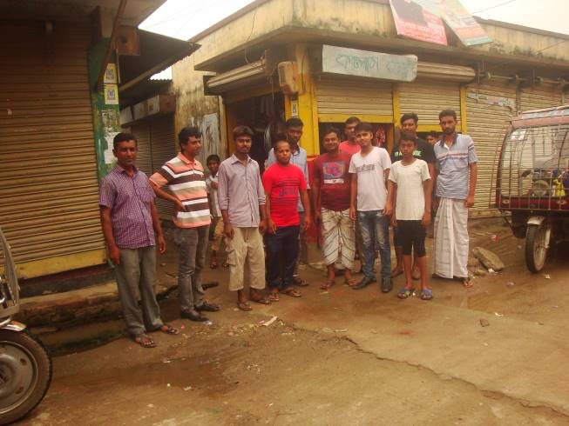
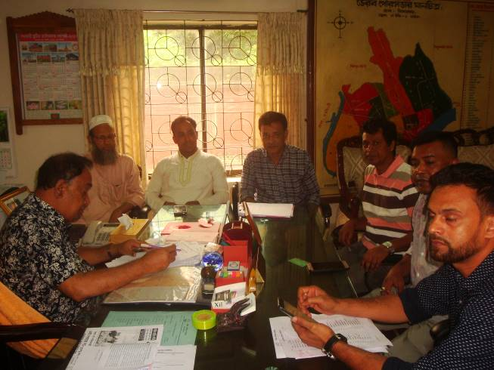
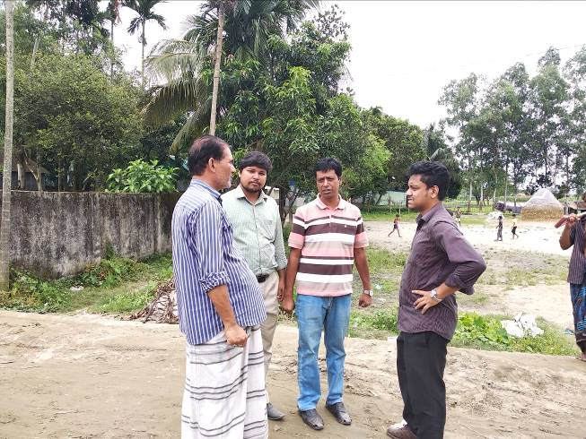
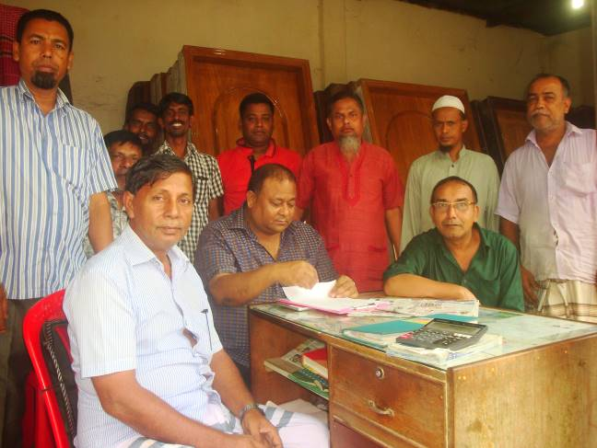
Photographs 7.1.1: Consultation Meeting with Pourashava Officials and Local Individuals at Subproject Sites

Issues Raised by the Participants

The participants raised the issues related to the infrastructure development of Bhairab Pourashava. In the CIP and FGD, the participants discussed about the infrastructure requirements for the future development of Bhairab Pourashava.

Feedback, Suggestions and Recommendations of the Participants

The participants were presented with feedback, suggestions, and recommendations listed below:
- The FGD results confirmed that an improved communication network, drainage facility, solid waste management, water treatment plant and sewerage treatment plant is needed for future development of Bhairab Pourashava;
- The participants stated that public water supply facilities, sanitation facilities, drainage congestion and access road is not adequate;
- The participants stated that construction works should be scheduled properly;
- The participants discussed about the environmental and social issues to be addressed prior to the subproject implementation.
To encourage participation, regular consultations are recommended with beneficiary communities to share subproject related information and to provide a feedback mechanism for these communities to voice their concerns and issues in all stages of the subproject. The DSM consultants and PMU, LGED will be responsible to carry out continued consultation with and information dissemination to the key stakeholders.

Conclusions and Recommendations

The subproject intervention has moderate impacts on ecological environment. In addition, the subproject intervention has impacts on physicochemical components and socio-economic environment. However, from the study it is revealed that the anticipated impacts on physicochemical components and socio-economic environment are not significant. Most of the individual elements of the subproject involve simple construction and operation, so impacts will be mainly localized and limited within the subproject boundary. Most of the predicted impacts are associated with the construction process which is invasive. Hence, the impacts are largely manageable through mitigation measures. Mitigation will be assured by a program of environmental monitoring to ensure that all measures are implemented, and will determine whether the environment is protected. It will include observations on and off-site, document checks and interviews with workers and beneficiaries. Any requirements for corrective action will be reported to the PMU, LGED and WB.
This study formulates well-structured EMP. This EMP will assist Pourashava Officials, PMU-LGED, contractor and DSM personnel in mitigating the environmental impacts, and guide them in the environmentally sound execution of the proposed subproject. A copy of the EMP shall be kept on-site during the construction period at all times. The EMP shall be made binding on contractor operating the site, and will be included in the contractual clauses.
It should be noted that environmental assessment report is a live document. Hence, due to changing circumstances during the construction phase if any, there might be minor adaptation needed for environmental, health and safety issues.

References

Bhairab Pourashava: At a glance

Bangladesh Meteorological Department (BMD)

Environmental Assessment Volume 1: Overall Environmental Assessment [Draft Final Report], September 2013. Municipal Governance and Services Project (MGSP), Local Government Engineering Department (LGED) and Bangladesh Municipal Development Fund (BMDF), Ministry of Local Government, Rural Development and Cooperatives, Government of the People's Republic of Bangladesh

Environmental Assessment Volume 2: Environmental Management Framework (EMF) [Draft Final Report], September 2013. Municipal Governance and Services Project (MGSP), Local Government Engineering Department (LGED) and Bangladesh Municipal Development Fund (BMDF), Ministry of Local Government, Rural Development and Cooperatives, Government of the People's Republic of Bangladesh

Geological Survey of Bangladesh, 1978: Earthquake Zoning Map

Bangladesh Meteorological Department (BMD), Flood zoning Map

Bangladesh Soil Resource Development Institute: Map of Bangladesh Soil Region

BBS, 2011: Population and housing census, National Volume-II: Union Statistics
- Ashuganj Power Station Company Ltd., 2011-EIA Study
- FAO-UNDP, 1988-History of Soil Research in Bangladesh

APPENDIX

Appendix- I: Environmental Monitoring Checklist
Local Government Engineering Department

Municipal Governance Services Project (MGSP)

Environmental Compliance Monitoring Form
Part A: General Subproject Information

Subproject Name | (a) Construction of RCC drain at Bhairab Bazar internal road side drain (00+00-0+400);  (b) Construction of RCC drain at Yousuf Ali High School Road at Laxmipur (Ch. 0+00m to 1+286m);  (c) Construction of RCC drain at Tatarkandi internal road & drain Ch. 0+00m to 0+775m, Length=1470m (both side);  (d) Construction of RCC drain at Kandar Hati internal road & drain (Ch. 0+00m to 0+420m), length=420m;  (e) Construction of RCC drain at Bangabandhu Road side with foot path (Ch. 00+00-00+050 & 00+582-00+727) to complete the drainage network including cross drain;  (f) Construction of Yousuf Ali High School Road at Laxmipur (Ch. 0+00m to 1+286m);  (g) Construction of Tatarkandi road Ch. 0+00m to 0+775m.
Package No. | MGSP/BHB/2018-2019/W-10
ULB Name | Bhairab Pourashava
Approved Estimated Cost in BDT
Contract Amount in BDT
Contractor Name
Date of Commencement
Target Date of Completion
Physical Progress (%)
Financial Progress (%)
Person Responsible (PIU)
(Name, Designation &Phone) for the Overall Subproject Management

Person Responsible (DSM)
(Name, Designation &Phone) for the Overall Subproject Management

Form Completed by
(Name, Designation &Phone)
Overall Environmental Description of the Subproject

Part B: Design, Preparation, and Legal Requirements
Environmental Concerns (PMU, PIU & DSM)  (Name, Designation & Phone) | PMU-
 | PIU-
 | DSM-
Subproject Category | DoE-BD- | WB-
Environmental Clearance Received? | Yes | No
EA Required? | Yes | No
EA Prepared and Delivered? | Yes | No
EMP Prepared & Delivered Separately? | Yes | No
Items and Cost of EMP Implementation Included in the Contract? | Yes | No
EMP Included in the Procurement Documents? | Yes | No
Inspection Schedule/Last Inspection/Monitoring by  PMU Environmental Concerns | Date-
 | Key findings-
Inspection Schedule/Last Inspection/Monitoring by  PIU Environmental Concerns | Date-
 | Key findings-
Inspection Schedule/Last Inspection/Monitoring by  DSM Environmental Safeguard Specialist/Jr. Environmental Specialist | Date-
 | Key findings-

Part C: Key Environmental Impacts
The Subproject Results in any of the following Impacts? | Yes | No | NA | If yes, is the impact (give observation)
 |  |  |  | Significant | Moderate | Minor
Felling of the trees
Clearing of the vegetation that increase the risk of increased soil degradation or erosion
Disturbance of the terrestrial and or aquatic specifies
Noise pollution
Air pollution
Adverse effects on the quantity or quality of the surface water or groundwater
Production or increase the production of the solid waste

Drainage congestion
Water logging that increases the risk of the water related diseases

Traffic congestion
Public safety

Part D: Work Place Environment and Gender Equity
The Subproject Results in any of the following Impacts? | Yes | No | NA | Observations
Does the contractor pay to the workers regularly?

Is there any discrepancy between the male and female workers regarding the wages or salary for the same works?

Is the contractor complying with the GOB labor law concerning the hiring of the workers?

Does the contractor engage women labors and does the project have suitable works for them?

Does the contractor engage child labor (less than 18 years) and aged people (more than 65 years old)?

Does the contractor force to the workers for the completion of the works?

Do the workers involve with the political activities, crime, drugs addiction and other forms of unwanted activities?

Are construction camps adequately equipped with water supply, sanitary toilets, washing facilities and facilities for waste collection and storage?

Has separate sanitation facilities been provided for women at work camps and the construction site?
Do the laborers load heavy items on their heads or shoulders?

Has the contractor undertaken an awareness program for the sexually transmitted diseases especially for HIV-AIDS and other infectious diseases like TB?

Are first aid kits readily available for the workers at the job site along with the instructions for use?

Are supervisors or other site personnel trained in the basic first aid emergency response measures?

Has the contractor provided necessary safety equipment to the workers and training for use?

Part E: Potential Impacts, Mitigation Measures, and Monitoring Indicator Mentioned in the EMP
Activity/  Issues | Potential Impacts | Proposed Mitigation and Enhancement Measures | Monitoring Method | Monitoring Frequency | Implementation Status (Yes/No /NA) |  | Impact significance if not implemented |  |  |  |  |  |  | Remarks
 |  |  |  |  |  |  | Major | Moderate |  | Minor |  | No
Construction and operation of labor shed for the workers (Workforce and labor shed management ) | - Generation of sewage and solid waste may cause water/ environmental pollution | - Construction of sanitary latrine at the labor shed (consider 15 person for one toilet, separate toilet for male and female);  - Erection of “no litter” sign, provision of waste bins/cans (separate waste bins for organic and inorganic wastes );  - Ensure wastes (solid wastes and other forms of the waste) disposal at the designated dumping site near Bhairab-Kishoreganj Highway.
 | - Health of workers | - Conduct formal and unofficial discussion to increase awareness about hygiene practices among the workers;  - Ensure availability and access to first-aid equipment and medical supplies for the workers.
 | - Possible development of labor camp into permanent settlement | - Contractor to remove labor camp at the completion of contract.
 | - Outside labor force causing negative impact on health and social well-being of local people | - Ensure that contractor employ local work force to provide work opportunity to the local people and conduct formal and unofficial awareness program for the health and social well-being of the local people.
General construction works | - Drainage congestion and flooding | - Ensure provision for adequate drainage of storm water if needed;  - Ensure provision for pumping of congested water if needed;  - Ensure adequate monitoring of drainage effects, especially if construction works are carried out during the wet season.
General construction works | - Air pollution | - Check regularly and ensure that all the subproject vehicles and equipment are in good operating condition;  - Ensure contractor spray water on dry surfaces/ unpaved to reduce dust generation;  - Maintain adequate moisture content of the sand;  - Ensure contractor sprinkle water and cover stockpiles of loose materials (e.g., fine aggregates);  - Inform local people about the subproject activities and potential impact;  - Cover loaded truck used for carrying sand with tarpaulin/other suitable material to prevent spreading by air blown.
General construction works | - Traffic congestion, effect on traffic and pedestrian safety | - Ensure schedule deliveries of materials/ equipment during off-peak hours;  - Place traffic sign/cautionary sign to avoid undue traffic congestion if required;  - Construction of temporary earthen diversion road so that local people can cross the river during construction period.
General construction works | - Noise pollution | - Check and keep maintenance of the equipment properly;  - Avoid using of construction equipment such as concrete mixer machine, pile driving equipment (pile rig, winch machine), vibrator machine that produce excessive noise at night;  - Avoid prolonged exposure to noise (produced by equipment) by the workers;  - Regulate use of horns and avoid un-due use of hydraulic horns by subproject vehicles;  - Inform local people about the subproject activities and potential impact.
General construction works | - Water and soil pollution | - Prevent discharge of fuel, lubricants, chemicals, and wastes into adjacent water bodies (ponds and low land ditches) and soil.
General construction works | - Accidents | - Conduct formal and informal discussion for creating awareness about the accident;  - Provides PPEs and ensure using of the personal protective equipment by the workers.
General construction works | - Felling of trees, clearing of vegetation and ecological disturbances | - 500 nos. of the trees will be planted at the Yusuf Ali High School Road to enhance the ecological condition.
General construction works | - Spills and leaks of oil, toxic chemicals | - Proper handling of lubricating oil and fuel so that it does not fall on the soil;  - Collection and proper disposal of spills;  - Refueling and fuel tank should not be placed on the ground directly.
All construction works | - Beneficial impact on employment generation  - General degradation of the environment | - Employ local people in the subproject activities as much as possible;  - Give priority to poor people living within subproject area in subproject related works (e.g., excavation and other works, which do not require skilled manpower);  - Ensure environmental enhancement measures- plantation and cautionary signs will be provided.
Specific activities for BC Road
- Dismantle works/Excavation/Earth work | - Generation of loose soil due to the earth excavation work. | - Cover exposed earth works with fabric;  - Disposal of soil and construction wastes near Bhairab-Kishoreganj Highway.
- Dismantle works/Excavation/Earth work | - Accidents due to careless use of hydraulic excavator | - Operate the hydraulic excavator carefully.
- Dismantle works/Excavation/Earth work | - Air pollution | - Regular maintenance of the equipment to avoid black smoke emission.
- ISG (Improved Sub grade)/ Sand filling | - Air and dust pollution affecting nearby settlements | - Maintain adequate moisture content of soil during transportation, compaction and handling;  - Carry the materials especially loose soil and sand with adequate cover.
- Setting up and operation of asphalt plant | - Possible degradation of the air quality by the suspended particles and increase of the noise level from asphalt plant affecting nearby settlements; | - Locate plant away from residential settlements;  - Consider use of emulsified bitumen.
- Setting up and operation of asphalt plant | - Possible water pollution (surface and groundwater) by bitumen and solvents; | - Avoid spills and proper collection and disposal of the generated spills.
- Setting up and operation of asphalt plant | - Possible preparation of the bitumen in open air and using of charcoal and wood as fuel | - Strictly prohibit bitumen preparation in the open air and use of charcoal and wood as fuel.
Specific activities for RCC Road
Dismantle work /Excavation/ Earth work | - Generation of solid & construction wastes due to the dismantle works;  - Generation of loose soil due to the earth excavation work. | - Cover exposed earth works with much fabric;  - Disposal of soil and construction wastes at the designated dumping site near Bhairab-Kishoreganj Highway.
Sand filling and compaction for sub-base | - Air and dust pollution affecting nearby settlements | - Maintain adequate moisture content of soil during transportation, compaction and handling;
Cutting and welding of the reinforcement | - Noise pollution due to steel cutter and welding machine if any | - Avoid using of steel cutter and welding machine at night;  - Avoid prolonged exposure to noise (produced by equipment) by workers.
RCC (reinforcement  concrete) work | - Air pollution due to black smoke emission from concrete mixer machine and vibrator machine | - Regular maintenance of the concrete mixer and vibrator machine to avoid any black smoke emission.
RCC (reinforcement  concrete) work | - Noise nuisance from concrete mixer machine and vibrator machine | - Avoid operation of the concrete mixer and vibrator machine at night;  - RCC work should be avoided at schooling time;  - Inform local people about casting work and potential impacts.
Specific activities for RCC Drain
- Excavation and Dismantle work | - Generation of debris & sediments/ clay due to the dismantle works and earth excavation. | - Disposal of soil and construction wastes at the designated dumping site near Bhairab-Kishoreganj Highway;  - Cover exposed dry loose soil with fabric.
- Excavation and Dismantle work | - Accidents | - Operate the hydraulic excavator carefully;
- Excavation and Dismantle work | - Air pollution | - Regular maintenance of the equipment to avoid black smoke emission.
- Back filling/Sand filling | - Air and dust pollution affecting nearby settlements | - Maintain adequate moisture content of soil during transportation, compaction and handling;  - Carry the materials especially loose soil and sand with adequate cover.
- Cutting & welding of the reinforcement | - Noise Pollution | - Avoid using of steel cutter and welding machine at night;
- Cutting & welding of the reinforcement | - Health and Safety | - Ensure use of the PPEs (helmets, goggles, gloves, safety boots);
- RCC (reinforcement concrete) work | - Air pollution due to black emission | - Regular maintenance of the concrete mixer and vibrator machine.
- RCC (reinforcement concrete) work | - Noise pollution | - Avoid operation of the concrete mixer and vibrator machine at night;  - RCC work should be avoided at schooling time;  - Inform local people about casting work and potential impacts.

Prepared by- Signature- Date-
Copies to 1. Bhairab Pourashava
2. SME
3. AME
4. Jr. ES

