INTRODUCTION

Subproject Background

Bhaluka Pourashava is located at Bhaluka Upazila under Mymensingh District. It is established as a Pourashava in the year of 1998. Presently, this is A Type Pourashava. Bhaluka Pourashava covers an area of 10.42 sq. km area with present population of 63,773. The Pourashava consists of 18.85 km pucca pavement and 62.00 km earthen road. Currently, 550 number of street light only covers 20% of the entire demand. The existing infrastructure facilities are not adequate to meet the present demand. Therefore, this subproject will directly contribute infrastructure development of Bhaluka Pourashava.

In Bhaluka Pourashava, traffic volume is increasing day by day with the increase in population and demand. The substandard road network cannot cope with the growing demand. Hence, planned development of road network with street light is essential to meet the emergent demand.

This subproject includes the following components: BC Road, RCC Drain, Road Protection Wall, Cross Drain and Street Light. The significant features of the subproject are mentioned below:
Name of the Subproject : | Construction of BC Road (Ch. 00-2500m) from Dhaka-Mymensingh Highway to Betiashangun Khal via Khana Market including RCC Drain and Street Light (CIP-07) under Bhaluka Pourashava, Mymensingh.
Package No. : | MGSP/BLK/2016-2017/W-04
District Name : | Mymensingh
ULB Name : | Bhaluka Pourashava
Jurisdiction Area : | Ward number 09
Structural Design Option : | BC Road, RCC Drain, Road Protection Wall, Cross Drain and Street Light
Beneficiary Population : | About 30,000 as per information by the Pourashava
Tribal People : | No tribal people settlement found in the subproject area
Land Acquisition : | No private land acquisition is needed
Estimated Cost : | 49.24 million in BDT
Subproject Duration : | 12 Months
Tentative Start Date : | October 20, 2017
Tentative Completion Date : | October 19, 2017

Objectives of the Study

The general objective of this study is to determine the major environmental impacts succeeding from execution of the subproject and to recommend mitigation measures to avoid or reduce adverse environmental impacts and to enhance positive impacts. The specific objectives include:
- To assess the existing environmental conditions of the subproject site and its influence area;
- To identify and assess impacts resulting from the subproject during its construction phase and operation phase;
- To develop a environmental management plan with recommendations for mitigating impacts and enhance positive impacts;
- To summarize environmental monitoring requirements.

Scope and Methodology of the Study

The subproject appraisal is included environmental screening for all the subproject components. According to that screening, no further environmental assessment is required for the street light. Nevertheless, environmental assessment is required to fulfill the regulatory requirement for BC Road, RCC Drain and associated works. Hence, this report is mainly included BC Road, RCC Surface Drain, Cross Drain and RCC Road Protection Work. However, in the EMP table mitigation measures for street light are also included. The study methodology comprised the following activities:

Desktop Study
The desktop study involved:
- Initial meetings with client and stakeholders to discuss about the proposed subproject, including subproject activities;
- Collection and review of the baseline data, maps, reports and other relevant information on the existing environmental and social conditions of the subproject area;
- Review of the relevant existing legislation, regulation and policies;
- Understand the anticipated technical processes that may affect the environment.

Field Investigation and Data Collection
A team of the consultants made a field investigation to the proposed site. Field investigations involved mainly site walks within the subproject area and the neighboring areas that may be affected by the subproject. The following key tasks were performed during the field visit:
- Taking photographs of the significant aspects to describe the baseline environmental conditions of the subproject area;
- Interviews with representatives of the Pourashava Officials, and interested and affected people within the subproject influence zone;
- Verifying information and data collected during the desktop study and to collect new information that may have been important in the assessment of the impacts and design of the mitigation measures.

Data Analysis and Report Writing
The data and information collected from all the sources (literature review, secondary and primary data, public consultation) were analyzed to describe the existing environmental setting of the subproject area, to identify the potential positive and negative impacts of the proposed subproject, as well as to provide preliminary suggestions for mitigation measures. Finally, this environmental assessment report has been prepared.

Subproject Description

The Study Area
The subproject is situated within the jurisdiction of the ward number 09. The starting point of the Unilon Road is at Dhaka-Mymensingh Highway with 24°23'8.49"N (Latitude) and 90°22'40.42"E (Longitude).The end point of this road is at Betiashangun Khal with 24°22'1.46"N (Latitude) and 90°23'29.85"E (Longitude).The location map and topographic view of the subproject are shown in Figure 2.1.1 and Figure 2.1.2.
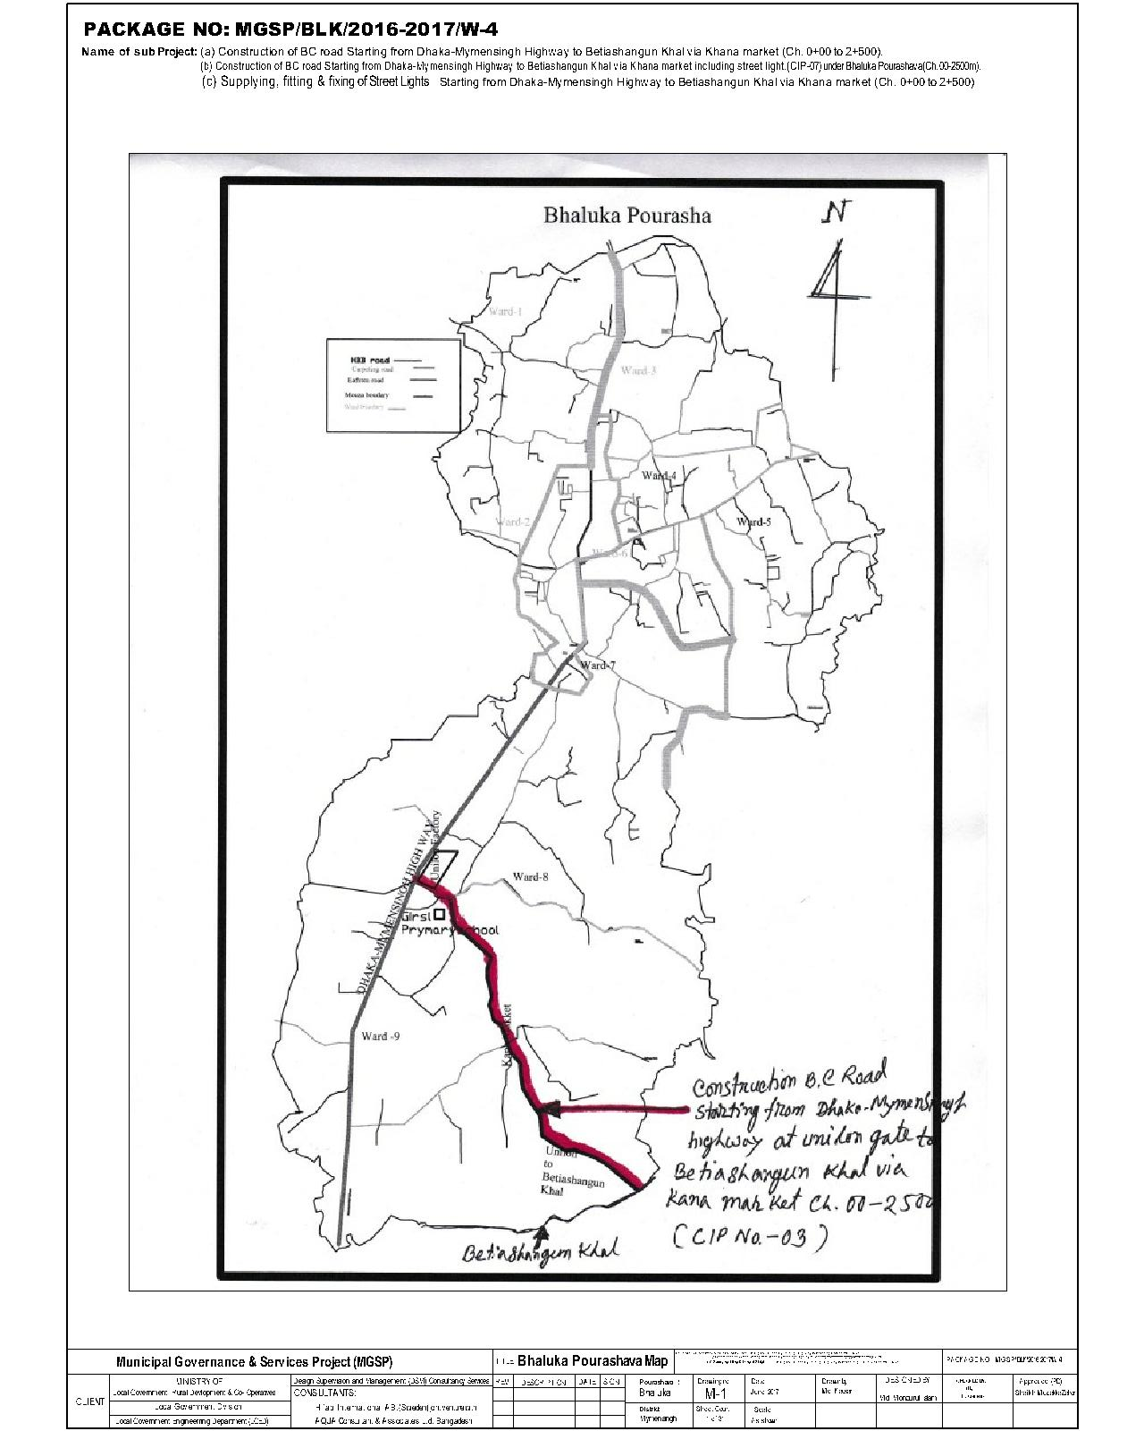

Figure 2.1.1: Location Map of the Subproject
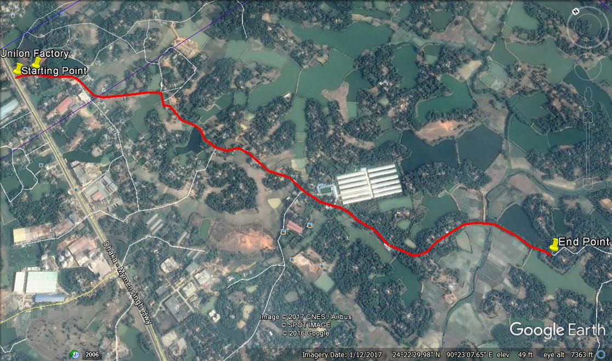
Figure 2.1.2: Topographic View of the Subproject

Current Situation, Proposed Intervention and Need for the Subproject

From Ch. 0 to 2500 m, the major roadside built-up infrastructures include Unilon Factory, Square Garments Factory, New Hope Factory, Rupali Hatchery, semi pucca and tin shed shops, semi-pucca, earthen and tin-shed residential houses, primary school, under Construction Park, boundary wall, Mosque. In addition, scattered home stead area, Grave yard, pond and open space with trees was found during site visit. At last section, agricultural land at both sides of the road dominates other features.
The existing road is very narrow (average road width is 2.80 m) and not adequate to meet the traffic demand. Additionally, the existing road is badly damaged in most of the sections which hampers the normal traffic operation. From the site investigation, it is revealed that motorized vehicles are increasing day by day which demands improved and widened road. Hence, from Ch. 0 to 2500 m, the existing HBB (Ch. 0 - 430 m, Ch. 765 m - 2210 m), BC (Ch.430-765 m) and Earthen (Ch. 2210 - 2500 m) road will be replaced by the new BC pavement.
On the contrary, road side ponds necessitate road protection work. Road protection work is needed at left side of the road (Ch. 265-310 m, Ch. 662-737 m and Ch. 2420-2441m) and at right side of the road (Ch. 662-812 m, Ch.980-1045 and Ch.2400 -2441 m).
In the subproject area, there is no drainage facility. Hence, storm water creates water logging problem at different segments. Stagnant storm water on the road surface damages the road. As a result, smooth traffic flow is hampered. For proper drainage facility, RCC drain and cross drains are needed. Therefore, RCC drain will be constructed at different chainage of the road (Ch. 265 - 340 m, Ch. 770 - 840 m and Ch. 1600 - 1680 m). The storm water will be discharged in the low land and road side ditches. At Ch. 310 m, 700 m, 770 m, 980 m and 1680 m, five cross drains will be constructed to divert storm water from one side to another side in order to proper functioning of the drain.
Furthermore, absent of the street light hampers the normal traffic operation at night time. Hence, fixing of the street light is also required for safety traffic operation at night. The street light will be fixed at single side of the road from Ch. 0-2500 m at 30m interval. This subproject has significant benefit to the community people after completion. The existing scenario of the proposed road is further elaborated from the following Photographs 2.2.1.
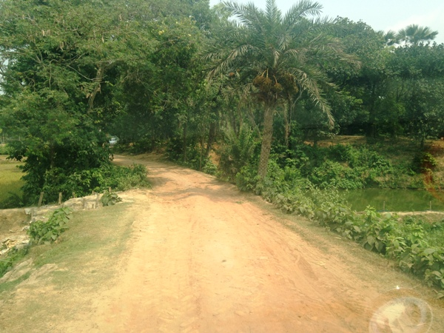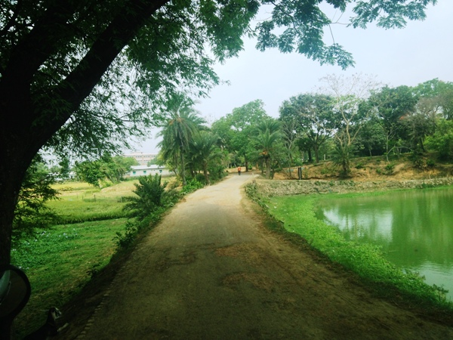

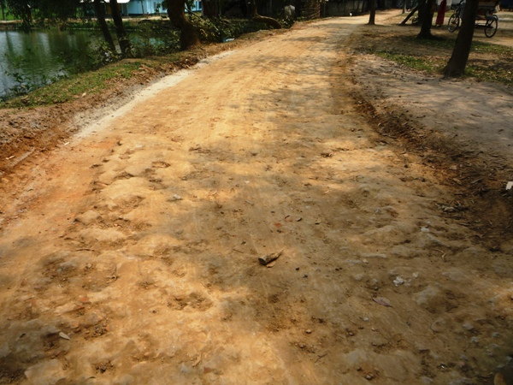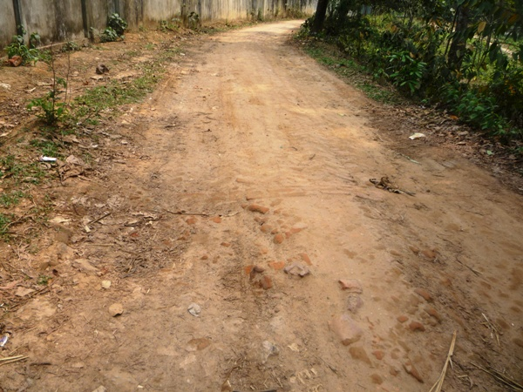

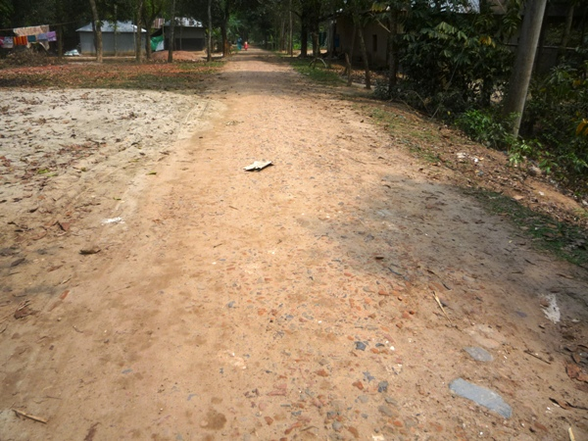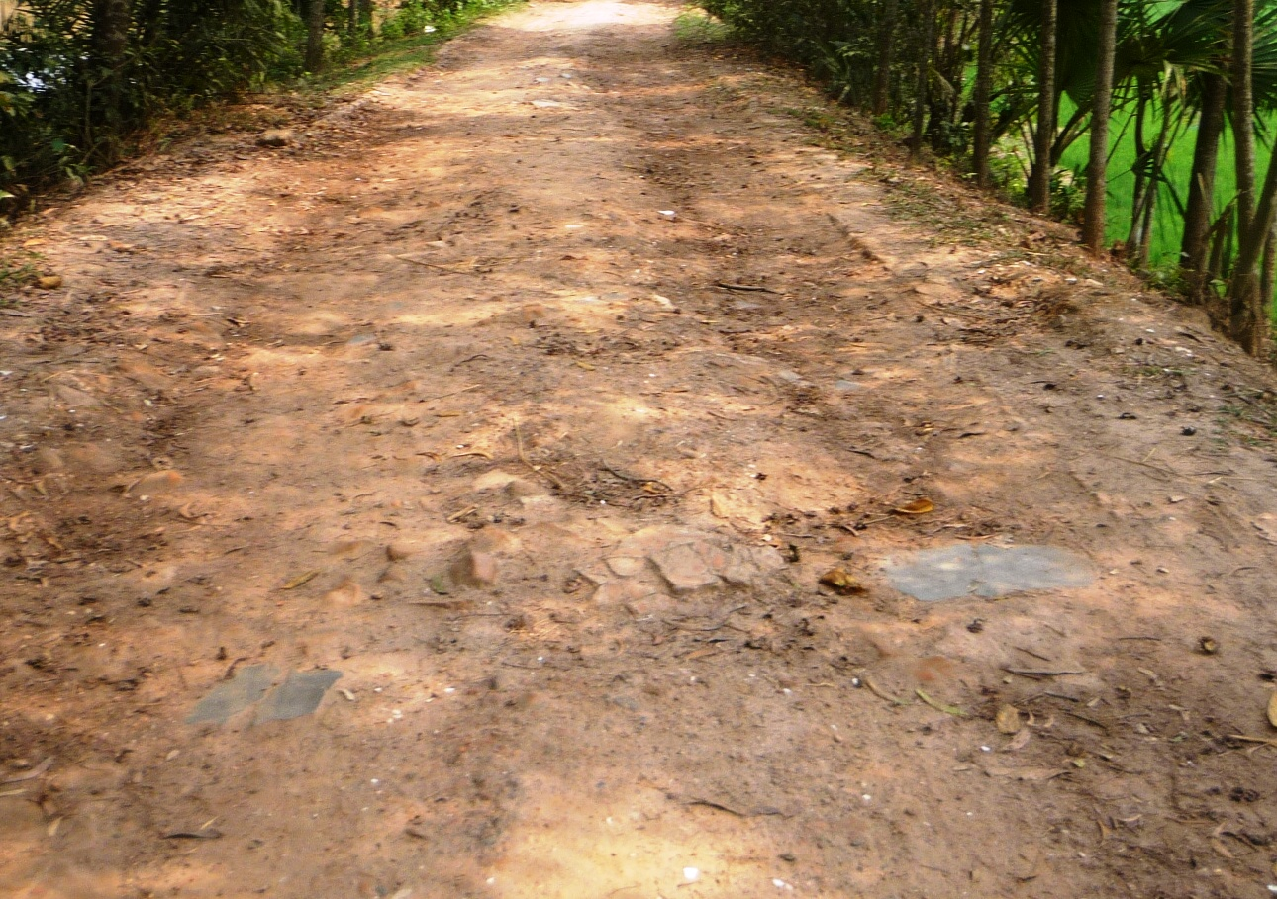

Photograph 2.2.1: Present Situation of the Subproject Site

Justification of Selection of the Subproject

The subproject has significant importance because it is connected with Dhaka-Mymensingh Highway. Hence, this subproject has been considered as priority subproject in the CIP. PMU representative, and DSM consultant visited the subproject site to assess the site condition. From the site visit, it is revealed that this road is very much inconvenience for the movement of the motorized vehicles. The subproject is located mostly on the right of way. Adequate space is available at both sides of the road which is owned by Pourashava. Hence, private land acquisition is not an issue for implementation of this subproject. From the site inspection, it is also revealed that roadside built-up infrastructure will not be severely affected due to the implementation of the subproject.
The subproject has significant benefit to the community people. After completion, the road subproject will provide uniform width. By eliminating pot holes and providing smooth road surface it will provide better, easy and safe movement facilities for the travelers. On the contrary, the road protection wall will increase the stability of the road. Furthermore, street lighting will ensure safe movement of the pedestrians and non-motorized vehicles. It will provide streetscape enhancements i.e. municipal beautification work and stimulation of the night-time trade. Hence, considering the benefits that will derive, the subproject is selected for implementation.

Envisaged Subproject Activities and Implementation Process

The general activities for the subproject includes: construction of the semi-pucca site office, construction of the labor shed, relocation of the electric poles, telephone poles and GI poles and site clearing & grubbing works.
The key activities of the RCC Drain include:
- Earth work in excavation of the foundation;
- Pumping and bailing out of water as per requirement;
- Sand filling for the preparing foundation bed;
- Laying of polythene sheet;
- Plain cement concrete work in foundation;
- Manufacturing CC blocks;
- Fabrication of the ribbed or deformed bar;
- Reinforced cement concrete work.

The key activities for BC Road include:

- Dismantling of the damaged sub-base and base course works;
- Clearing and grubbing works;
- Earth work in box cutting;
- Earth filling work;
- Sand filling on the road bed;
- Mechanical compaction;
- Brick on edging;
- Compacted stone aggregate base course;
- Providing prime coat;
- Laying pre-mixed dense bituminous surfacing wearing course.
The key activities of the RCC Road Protection Wall include:
- Clearing and grubbing;
- Earth work in excavation;
- Sand filling;
- Pumping and bailing out of water as per requirement;
- Fabrication of the ribbed or deformed bar;
- Reinforcement cements concrete work.

The key activities for Street Light:

- Assembling, fitting, fixing, installation, testing and commissioning of the GI pole;
- Erection of tubular pole;
- Earthing the electrical installation;
- Fixing of the wire rack;
- Fixing of the overhead conductor;
- Providing, fixing and fitting of the water tight street light;
- Fitting and fixing main and sub-main switch with fuse;
- Supplying and fitting of sub-distribution board.

The materials and resources to be used for the key activities: soil in earth work, sand, stone chips, cement, reinforcement, diesel, MS sheet, steel shutter, electricity and water.
The major equipment to be used for the implementation of the subproject: hydraulic excavator, concrete mixer machine, steel cutter, mechanical vibrator machine, mechanical compaction machine, steel drum rollers, pneumatic multiple tire roller, dump truck, water tanker, pump, asphalt plant, rubber tire roller, paver.

Baseline ANALYSIS OF THE ENVIRONMENTAL CONDITION

Physical Environment

Important Environmental and Infrastructural Features

During site visit the environmental and infrastructural features within the subproject area were collected. Conditional survey has also been conducted for designing the subproject. Hence, the survey data is also used for preparing the report. The environmental and infrastructural features listed within 100 m of the both sides of the road from the center line considering 100 m longitudinal interval from Dhaka-Mymensingh Highway to Betiashangun Khal of the Pourashava (Chainage 0 to 2500 m) Table 3.1.1.
Table 3.1.1: Major Environmental and Infrastructural Features
Chainage (m) | Left | Right | Major Environmental Features(adjacent to the road edge and within 30 m from the edge of the road)
Dhaka-Mymensingh Highway to Betiashangun Khal (Ch. 0 to 2500 m)
0-100 | √ |  | Open space, Unilon Factory, trees, boundary wall (within adjacent to the road edge -0.5 m from the edge of the road)
0-100 |  | √ | Furniture shop, pond, semi-pucca houses, trees(within 0.5-1.5 m from the edge of the road)
100-200 | √ |  | Boundary wall, open place with trees(within adjacent to the road edge -20 m from the edge of the road)
100-200 |  | √ | Open space, trees (within adjacent to the road edge -0.5 m from the edge of the road)
200-300 | √ |  | Pond, trees, boundary wall, fence of tin(within 0.5 m -15 m from the edge of the road)
200-300 |  | √ | Open space, tin-shed houses, trees(within 0.5 m -15 m from the edge of the road)
300-400 | √ |  | Link road, semi pucca houses, trees(within 0.5 m -15 m from the edge of the road)
300-400 |  | √ | Open space, trees, school, Square Garments Factory, shop (within 0.5 m -15 m from the edge of the road)
400-500 | √ |  | Semi pucca houses, link roads, shop, open space, trees (within 0.5 m - 2 m from the edge of the road)
400-500 |  | √ | Under construction building, link road, trees, houses (within 0.5 m – 15 m from the edge of the road)
500-600 | √ |  | Tree garden (within 1 m – 20 m from the edge of the road)
500-600 |  | √ | Open space, bushes, trees (within 0.5 m – 15 m from the edge of the road)
600-700 | √ |  | Open space with trees, pond, link road (within 1 m – 20 m from the edge of the road)
600-700 |  | √ | Trees, pond(within 1 m – 3 m from the edge of the road)
700-800 | √ |  | Link road, houses with tin shed and semi pucca structures, trees(within 1 m – 20 m from the edge of the road)
700-800 |  | √ | Open space, trees(within adjacent to the road edge -3 m from the edge of the road)
800-900 | √ |  | Semi-pucca houses, trees, link road, soil structure(within 3 m – 20 m from the edge of the road)
800-900 |  | √ | Mosque, tin shed house, trees(within 1 m – 20 m from the edge of the road)
900-1000 | √ |  | Open space with trees (within 1 m from the edge of the road)
900-1000 |  | √ | Trees, agricultural field (within 0.5 m – 3 m from the edge of the road)
1000-1100 | √ |  | Trees, bushes, low land(within adjacent to the road edge -20 m from the edge of the road)
1000-1100 |  | √ | Trees, bushes, pond, boundary wall (within adjacent to the road edge -2.5 m from the edge of the road)
1100-1200 | √ |  | Open space with trees (within 1 m – 3 m from the edge of the road)
1100-1200 |  | √ | Tin shed houses, trees(within 1 m – 3 m from the edge of the road)
1200-1300 | √ |  | Trees, houses, open space(within 1 m – 30 m from the edge of the road)
1200-1300 |  | √ | Open space, trees(within 0.5 m – 3 m from the edge of the road)
1300-1400 | √ |  | Houses, trees, open space(within 1 m from the edge of the road)
1300-1400 |  | √ | Semi-pucca houses, shops, fence, trees(within 1 m from the edge of the road)
1400-1500 | √ |  | Trees, houses with soil, tin shed and semi pucca structures(within 1 m – 7 m from the edge of the road)
1400-1500 |  | √ | Trees, link road, houses with various structures(within 1 m – 5 m from the edge of the road)
1500-1600 | √ |  | Shops, trees, link road (within adjacent to the road edge)
1500-1600 |  | √ | Shops, trees, link road(within adjacent to the road edge)
1600-1700 | √ |  | Tin shed structures, trees(within adjacent to the road edge)
1600-1700 |  | √ | Tin shed structures, link road, trees(within adjacent to the road edge)
1700-1800 | √ |  | Newhope Factory, trees(within 0.5 m – 6 m from the edge of the road)
1700-1800 |  | √ | Grave yard, houses, trees (within 0.5 m – 3 m from the edge of the road)
1800-1900 | √ |  | Houses, part of factory, trees(within 0.5 m – 6 m from the edge of the road)
1800-1900 |  | √ | Houses with various structures, trees(within 0.5 m – 6 m from the edge of the road)
1900-2000 | √ |  | Open space with trees (within 0.5 m – 6 m from the edge of the road)
1900-2000 |  | √ | Houses, trees(within 0.5 m – 6 m from the edge of the road)
2000-2100 | √ |  | Boundary wall, Rupali Hatchery, houses, trees (within 3 m from the edge of the road)
2000-2100 |  | √ | Tin shed houses, Grave yard, trees(within 0.5 m – 25 m from the edge of the road)
2100-2200 | √ |  | Boundary wall, houses, trees(within 0.5 m – 20 m from the edge of the road)
2100-2200 |  | √ | Link road, under construction park, trees, (within 0.5 m – 15 m from the edge of the road)
2200-2300 | √ |  | Open places with trees, houses (within 0.5 m – 6 m from the edge of the road)
2200-2300 |  | √ | Open space with trees, houses, agricultural field (within 0.5 m – 20 m from the edge of the road)
2300-2400 | √ |  | Link road, Khal, trees(within adjacent to the road edge -20 m from the edge of the road)
2300-2400 |  | √ | Open space with trees, agricultural land(within adjacent to the road edge - 20 m from the edge of the road)
2400-2500 | √ |  | Khal, open space, trees(within adjacent to the road edge - 20 m from the edge of the road)
2400-2500 |  | √ | Agricultural land, trees(within adjacent to the road edge - 20 m from the edge of the road)
** Note: There are 10 numbers of the electrical poles at different chainage to be re-located for the implementation of the subproject

Geology, Topography and Soils

Bhaluka Pourashava belongs to Madhupur tract. Surface geology is consisted of sedimentary rocks originated by riverine processes. The Pourashava is located on the bank of the River Kheru. Topographically, Bhaluka Pourashava is plain land. The plain land mainly consists of fluvio-deltaic sediments deposited by the Ganges, Brahmaputra and the Meghna River Systems. Geomorphologically, Bhaluka Pourashava falls under the Floodplains of the Old Brahmaputra and Jamuna rivers having distinguishing character. Soils in the valleys are dark grey heavy clays. They are strongly acidic in reaction with low status of organic matter, low moisture holding capacity and low fertility level. According to BNBC (2006), Bangladesh has three seismic zones with moderate and low seismic activity. The Pourashava falls in Zone II.
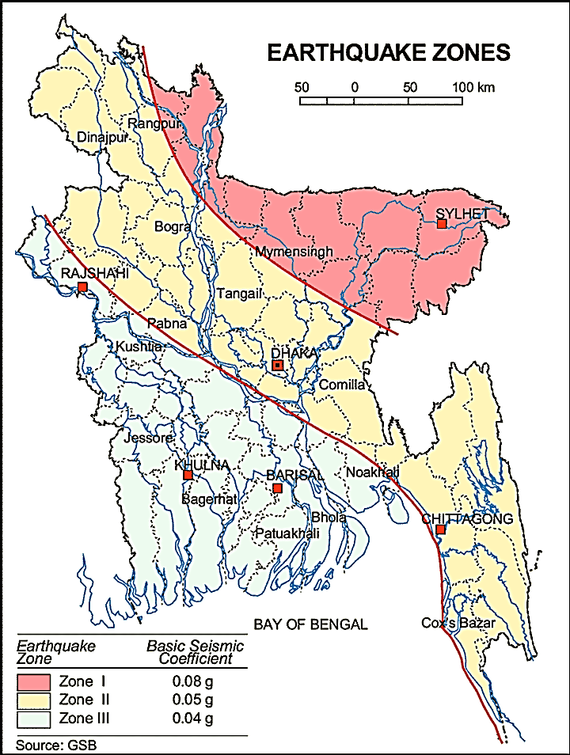

Figure 3.1.1: Location of Bhaluka in Earthquake Zone Map of Bangladesh (Source: GSB)

Climate and Meteorology

The area specific meteorological data is not available. Hence, meteorological data of Muktagacha can use for Bhaluka Pourashava in order to get idea. The climate is moderate with the maximum and minimum mean monthly temperature 32.3ºC and 24.7ºC respectively observed in April and January. Mean annual rainfall is 2253 mm occurs between May to September during monsoon period. During 82% of the aggregate precipitation occurs during five months of the monsoon period. In the winter months of December-January, temperature comes down substantially.

The construction works can be influenced by the climatic condition and meteorological components like humidity, temperature, sudden rainfall, and wind speed. High winds can enhance quick spreading of the generated dust. It is very risky working under rain and in high winds because the possibility of getting injury increases. Furthermore, work under high temperature and excess humidity may create health hazards like dehydration problem.

Water Resources (Surface Water, Ground Water and Rain Water Harvesting)

Some water bodies like ponds and ditches are located adjacent to the subproject area. Kheru River and Bakchatra Khal are major surface water sources in the Pourashava. Consequently, Kheru River and Bakchatra Khal influences the regional hydrology.
Ground water is the only sources of drinking water to the habitats of Bhaluka Pourashava. The Pourashava inhabitants use tube-well for the drinking water. The ground water table of the Bhaluka Pourashava varies from minimum 16 ft during rainy season and to the maximum 44 ft during dry season. During dry season when the ground water table goes down at this depth contents excess iron. Within the Pourashava, any arsenic contaminated hand tube-well is not yet identified. In the Pourashava area, rain water harvesting is not visible.
Flooding, Water Logging and Drainage Pattern
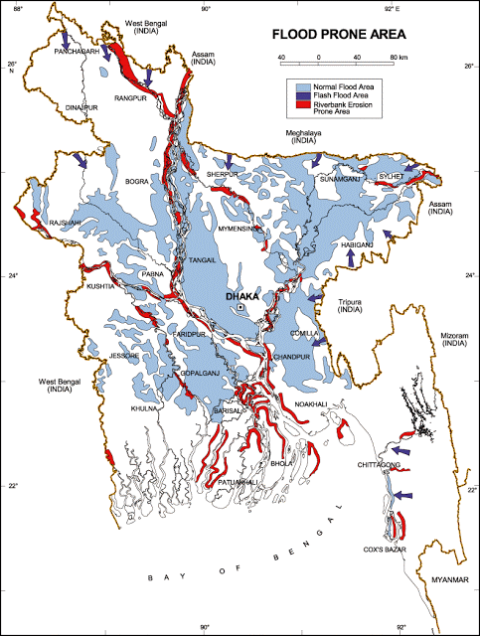
Bhaluka Pourashava is free from external flooding. In the subproject area, the water logging problem is acute in built-up areas than bare land. In the built-up area, the houses are lower than the road level. During heavy rain, the remaining water after infiltration retains on the ground where water logging occurs. Due to lack of adequate and functional drainage facilities water retains there until dries-up. Generally, water logging problems starts in June and continues till October. The subproject area falls on the normal flooding zone as per flood zoning map of Bangladesh.

Figure 3.1.2: Location of Bhaluka Pourashava in Flood Zone Map of Bangladesh
Air Quality and Dust
The degradation of the air quality is mainly from windblown dust and emission from the vehicles. The rough surfaces of the road generate dust during vehicles movement in dry season. Improper disposal of the solid wastes also spread bad odor which causes air quality degradation. During construction phase black smoke emission from asphalt plant, paver, concrete mixer machine, vibrator machine, hydraulic excavator and vehicles used for transportation activities may degrade the air quality.

Noise Level

Noise is generated mainly from the vehicles movement and hydraulic horn. Noise is also generated due to public gathering. During construction phase, asphalt plant, paver, concrete mixer machine, vibrator machine, hydraulic excavator and vehicles used for transportation activities may create temporary noise nuisance within the subproject boundary.
Solid Waste Management

The Pourashava has not any structured dumping yard of its own. The Pourashava people normally dump the collected solid wastes at roadside open spaces. Currently, the vacant place near bus stand is used as a dumping ground by the Pourashava. This is simply open dumping to a specific location. In recent times, the municipalities provide services for household waste collection from door to door and dump at the vacant place near bus stand. The generated wastes due to construction activities will be dumped at the designated vacant place near bus stand beside Haq Market.

Biotic Environment

Flora and Fauna

In the subproject area, major roadside tree includes: Jackfruit, Akashi, Mahogany, Boroi, Coconut, Banana, Mango, Palm, Date, Koroi, Rain Tree and Papaya. The common local birds such as Crow, Tuntuni, Shalik, Chil, Doel and Choroi were found during the site visit.

Socio-economic and Socio-cultural Environment

Land Use, Status of Housing and Built-up Infrastructure
The land use pattern in the subproject area consists of mixed land-use pattern (residential and commercial). From Ch. 0 to 2500 m, the major roadside built-up infrastructures include Unilon Factory, Square Garments Factory, Newhope Factory, Rupali Hatchery, semi pucca and tin shed structures shops, semi-pucca soil and tin-shed residential houses, primary school, under Construction Park, boundary wall, Mosque. Despite the subproject road goes through rural area where home stead area scattered, Grave yard, pond, trees and open space with trees was found during site visit, some other factories and projected factory land are present within the influence area of the subproject site which would be the industrial zone of the Pourashava after developing this road near future. On the other hand, agricultural land is available at both sides of the last segments of the road.
Beneficiary Population

The subproject is situated within the jurisdiction of the ward number 09. Considering the ward population about 30,000 people will benefit directly and many others indirectly.

Education
In the municipality, literacy among the population is about 73.8%. This is higher than the national average (51.8%). The literacy rate among males (76.5%) is still more than females (70.8%). (Ref: Population and Housing Census 2011).

Tribal Communities
There is no indigenous or tribal people settlement in the subproject area. Hence, no measures needed for the indigenous peoples’ safeguard.

Land Acquisition

Private land acquisition is not needed. Adequate space is available at the both sides of the road for widening work. However, from Ch.0 -100 m demolishing of the road side (outer edge of furniture shop) shop and houses is needed. In addition, from Ch.1570 – 1665 m outer edge of the few road side tin shed shops at Kana Market need to be removed for site clearing works. The Pourashava will clear the site amicably with the owners of these structures prior to the construction work. However, in case of any objection from the affected persons, DSM will investigate the actual situation. Then, measures will be taken as per rules.
Principal Livelihoods and Economic Activities
The subproject area is inhabited by the mixed occupational people. In the Pourashava area, major income comes from business, enterprises, small trades, private sector jobs, and government jobs in the town.
Cultural Heritage and Protected Areas
During site visit it was observed that there is no protected and important cultural or historical site in the subproject influence area.
Social Conflicts and Development Activities

The local people welcome the subproject and there is no conflicts between the local communities regarding subproject implementation.

ENVIRONMENTAL SCREENING

Environmental Screening Checklist, as adopted in Appendix C of the Environmental Management Framework (EMF) of the MGSP, was administered for identifying the impacts and their extents.
The screening data and information for the BC road, RCC drain and allied works have been formulated and are shown in below.
(1) Potential environmental impact during construction phase:
- Ecological impacts:
805
- Felling of trees Significant □√ Moderate □ Minor □ Number of trees
- Clearing of vegetation Significant □ Moderate □ Minor □√
- Potential impact on species of Significant □ Moderate □ Minor □√
aquatic (i.e., water) environment
Major trees to be felled down are: Jackfruit, Akashi, Mahogany, Boroi, Coconut, Banana, Mango, Pulm, Date, Koroi, Rain Tree and Papaya etc. There is no tree to be felled down bring religious and heritage importance. However, the trees to be felled down have significant economic value because most of them are big to medium size in terms of length and diameter. Clearing of the road side vegetation has also ecological impacts. Intensity of the vegetation coverage at both sides of the road is not uniform. So clearing of the road side vegetation is considered as minor. In addition, anticipated impact on species of aquatic environment is minor because except throwing of the wastes materials in to the ponds and ditches, the subproject does not have any impact on the aquatic environment. Considering the number of trees to be felled down, the ecological impact is considered as significant.
- Physicochemical impacts:

- Noise pollution Significant □ Moderate □√ Insignificant □
- Air pollution Significant □ Moderate □√ Insignificant □
- Drainage congestion Very likely □ Likely □ Unlikely □√
- Water pollution Significant □ Moderate □ Insignificant □√
- Pollution from solid/ construction wastes Significant □ Moderate □√ Insignificant □
- Water logging Significant □ Moderate □ Insignificant □√

The subproject will have impacts on noise and air quality during construction phase due to mobilization of the equipment, vehicles movement for the transportation of the materials, using of hydraulic excavator, brick breaking machine, mechanical compaction machine, paver, asphalt plant, concrete mixer machine, vibrator machine etc. The construction work will be performed section wise. Hence, it is anticipated that the overall impacts on noise and air quality will be moderate, temporary and limited within the subproject boundary. There are road side Mosque, school, residents, college etc. Hence, anticipated impacts on noise and air quality will be significant for this particular section if measures are not taken properly. The generated dust during construction activities may disturb the local people during construction period. The generated construction wastes, un-suitable materials and solid wastes may degrade the adjacent pond water if not properly collected and disposed and thrown in to the pond. Improper collection and disposal of the generated wastes materials also may degrade the quality of the surrounding environment and degrade the aesthetic value. The anticipated water logging and drainage congestion during construction period is minor because space is available at most sections of the road for drain-out the storm water. In addition, provision will be there for pumping out of the storm water if required.
- Socio-economic impacts:

- Traffic congestion Very likely □ Likely □√ Unlikely □
- Health and safety Significant □ Moderate □√ Insignificant □
- Impact on archaeological and historical Significant □ Moderate □ Insignificant □√

The existing connecting and diversion roads are inadequate. Hence, the subproject activities have negative impact on the motorized traffic in the subproject area. In addition, the subproject activities will interrupt free movement of the pedestrians. Since the volume of the motorized traffic is not huge for this road. Hence, it is anticipated that the subproject activities do not have any severe impact on the traffic congestion. The construction work will follow simple procedure with commonly used equipments. Hence, anticipated impact on health and safety is moderate. There is no archaeological and historical site within the influence area. The subproject has positive impact by generating work opportunities for the local people and supplying of the construction materials, equipments, food and other necessary stuffs to the campsite.
(2) Potential environmental impact during operational phase:
- Ecological impacts:

- Potential impact on species of aquatic Significant □ Moderate □√ Minor □
(i.e., water) environment
The anticipated impact on the aquatic environment is insignificant due to operation of the road. Though, the drain is designed for storm water only. However, the storm water may carry washed-out materials, pollutants from any sources that may disturb the aquatic environment of the outfall. Hence, the anticipated impact on the aquatic environment due to operation of the drain is considered as moderate.
- Physicochemical impacts:

- Potential air quality Improvement □ No-improvement □ Deterioration □√
- Noise level Improvement □ No-improvement □ Deterioration □√
- Drainage congestion Improvement □ Minor Improvement □ No Impact □√
- Risk of Water pollution Significant □ Moderate □ No Impact □√
- Pollution from solid waste Improvement □ No-improvement □ Minor □√

During operation phase, improved road may increase traffic volume which may degrade the air quality and noise level due to black smoke emission and un-due use of hydraulic horn from the vehicles. The new drain will minimize drainage congestion and water logging problem. The storm water to be discharged through the drain may degrade the water quality of the outfall if carry pollutants from any sources. The new drain will minimize throwing of the wastes materials in to the drain and spreading of the bad odor.
- Socio-economic impacts:

- Traffic Improvement □√ No-improvement □ Adverse □
- Safety Improvement □√ No-improvement □ Adverse □
- Employment generation Significant□ Moderate □ Minor □√

After completion, this road will improve the transport facilities. By providing uniform pavement, it will also enhance traffic safety. The new drain will reduce water logging problem. By reducing environmental hazards caused by water logging problem, it will provide better environment to the community people. The new subproject will minimize the frequency of the maintenance for first three to five years after completion. However, the new road with street light will enhance business activities and pedestrians’ safety at night. In addition, new roadside shops will be developed which contributes local economy.
(3) Summary of Possible Environmental Impacts of the Subproject
The subproject site is not located any environmentally sensitive area though it has significant ecological impact due to felling of the 805 trees. The subproject activities will have adverse impacts on physicochemical impacts. However, it is anticipated that the impact is not severe and limited within the subproject boundary. The wastes generated due to the construction activities should be properly collected and disposed in a designated dumping site. Some earthwork will be involved for the road construction work; however, no agricultural productive soil will be used for the purpose. The inputs that may affect the environment will be mainly at construction phase. Moreover, mitigation measures will be taken according to the EMP for minimizing the environmental pollution. Safety concern is an important issue for both the construction and operation phases that should be considered properly. This subproject will have positive impacts in terms of the generation of the employment and business activities by supplying construction materials and equipment. The anticipated environmental impact for the installation of the street light is insignificant. However, it has significant positive social impacts. Short circuit and improper electrical connection of the street light may cause potential health and safety risk.

Specific impact, mitigation AND enhancement measures
From the environmental study, the probable impacts of the subproject are mainly caused by the key activities required for the implementation of the subproject, raw materials and equipment to be used for the execution of the activities. This section describes some specific impacts due to the subproject activities and their mitigation measures.

Dismantle Work, Excavation Work and Earth Work

The road improvement work includes dismantle of the existing bituminous pavement, clearing of the wastes materials due to dismantle work, earth excavation and earth filling work. The drain construction work consists of earth excavation, earth filling, back filling, cutting and removal of the unsuitable materials. These works lead dust blowing, improper disposal of the wastes, noise and vibration which may disturb the local people.

Mitigation Measures

- Careful operation of the hydraulic excavator if used to avoid any undue disturbances to the roadside residents;
- Cover the exposed earth with fabric;
- Quick disposal of the wastes at the Pourashava designated dumping site near bus stand beside Haq Market.

Tree Felling and Ecological Impact

The subproject has adverse impacts on the ecological components due to felled down of the 805 numbers of trees and clearing of the roadside vegetation and bushes.
Mitigation Measures

- 2500 nos. of trees will be planted to compensate the felled down trees (preferably local fruits, flowers, medicinal and ornamental trees-Mango, Jackfruit, Jam, Bokul, Polash, Shimul, Sonalu, Krisnachura, Neem, Amloki, Horitoki, Bohera, Arjun, Debdaru, Mahogany, Rain Tree, Akashi, Segun, Banyan Tree and Palm Tree) at both sides of the proposed road from Ch. 0 to 2500 m and any other Pourashava owned suitable places in the influence area of the subproject;
- Planting trees will enhance the ecological balance of the subproject area after their successful growth.

Pollution from the Construction Materials

Dumping of the construction spoils, including accidental leakage of the oil, grease, and fuel in equipment yards is a significant hazard. Surface water and soil quality might be polluted from these contaminants. Even the people to be engaged for the construction activities might endanger the physical and human habitats of the area.

Mitigation Measures

- Safe transport, storage, and disposal of the construction materials, and the equipment have to be carried out in order to avoid the accidental spillage and loss;
- Fuels, lubricants, and other hazardous materials should store over raised platforms and not directly on the ground;
- The playgrounds of the educational institutions should not use as a stockyard or work camp.

Air Quality and Dust

During construction phase, air pollutants will be emitted from the equipment and construction vehicles are expected to remain low. Local residents in the vicinity of the work sites will be temporarily disturbed by the limited dust pollution. The overall impacts, however, are expected to remain low.

Mitigation Measures

- Water should be sprayed at the work site for dust control. Ensure sprinkle and cover stockpiles of loose materials (e.g., fine aggregates);
- Maintain adequate moisture content of soil and sand for transportation, compaction and handling;
- Avoid use of dust generating equipment which produce significant amount of particulate matter far from the local residents;
- Ensure all subproject vehicles are in good operating condition.

Noise and Vibration

Noise and vibration caused by the equipment and movement of the construction vehicles may temporarily disturb nearby residents. In this subproject, sensitive areas like roadside houses, educational institutes and shops are likely to be affected from the noise, though the impacts are anticipated to be limited.

Mitigation Measures

- Transportation of the construction materials have to be carried during the scheduled times, and mainly during the day;
- If needed and possible, all powered mechanical equipment and machineries will be fitted with noise abating gear such as mufflers for effective sound reduction.

Water Quality

The water quality may deteriorate if the construction materials, construction wastes, effluent from work camps, and food waste are dumped in the roadside water body and low land.

Mitigation Measures

- Proper construction management including waste management as well as training of the operators and other workers should provide to avoid pollution of the water bodies;
- Construction waste will dispose properly (not in the ditch, water bodies or lowland), for which contractor will be responsible.

Occupational Health and Safety
The most important risks associated with the construction activities are listed below:

- Exposure to the sunlight- workers are being exposed to the sun for long hours;
- Exposure to the high temperature, and humidity for a long time resulting in dehydration;
- Contact with the hazardous substances and wastes pose risks of the infections and diseases;
- Risk from the traffic collision or accidents during operation of the equipment such as hydraulic excavator and vehicles movement for the transportation activities of the subproject;
- Risks from head loads for carrying soil, construction materials and construction equipment;
- Risk associated to the sudden bad weather working conditions such as storm, thunder storm and earth quake etc.
General Requirements for the Workers’ Health and Safety
The key salient features of the general requirements for the workers’ health and safety stated are presented in Table 5.7.1.
Table 5.7.1: General Requirements for the Workers Health and Safety
Issues | Requirements
Health and Hygiene | - Cleanliness at the site premises and workers living places and at the Labor Shed;  - Arrangement of the proper ventilation and temperature at the Labor Shed;  - Protection against dust and furnace by using of the nose masks and covering of the head and body;  - Proper disposal of the wastes and effluents;  - Provision of the adequate latrines and separate toilets for the women;  - Sufficient dustbins for the solid waste management system.
Safety and First Aid Box | - Using of the personal protective equipment (helmet, gloves, goggles, nose mask, safety boots);  - Precautions during work on or near machineries in motion;  - Head loads are prohibited;  - First aid facilities should be provided and maintained;  - Ensure first aid box;  - The first aid kit should include adhesive bandages, regular strength pain medication, gauze, and low grade disinfectant.
Compensation for Accidents at Work | - Contractors will bear medical treatment costs. If any severe accidents such as loss of hands, legs or loss of working ability or any case of death needs compensation-(the amount of the compensation should be fixed considering the type of accidents).
Dust and Fumes | - For any dust, fumes, or other impurities likely to be injurious to the workers, effective measures shall be taken to prevent their accumulation and its inhalation by the workers.
Overcrowding | - No labor room should be overcrowded.
Latrines and Urinals | - Sufficient latrines shall be provided;  - Latrines shall be maintained in clean and sanitary condition;  - Latrines shall be adequately lighted and ventilated.
Disposal of Wastes and Effluents | - Proper disposal system for the solid waste and effluent is required.

Impacts on Social Environment and Common Property Resources

The anticipated social impacts are expected not to be severe and to be largely manageable. The following Table 5.8.1 presents impacts on socio-economic environment and common property resources.
Table 5.8.1: Impacts on Social Environment and Common Property Resources
Social Components | Impacts on IECs | Impact Significance
Community Perception | The local community people welcome this subproject and there is no visible objection from them. | Significant (+ve)
Employment and Business Opportunity | Community feels happy because generally the local contractor will be engaged for the construction works which will create work opportunity for the skilled and non-skilled labor. The subproject will create business opportunity for the equipment and materials suppliers’. | Significant (+ve)
Community Order and Security | This subproject activity does not create any severe security problems to the local community and community people. | Minor  (-ve)
Possible damage to infrastructure and facilities | Possible damage of the existing road infrastructure by the construction equipment and vehicles used in this subproject. | Minor  (-ve)
New infrastructure and facilities | Improvement of the existing road will enhance infrastructure facilities. | Moderate (+ve)
Agriculture and Land Use | No direct impact on agriculture however, it could affect the adjacent land to a very limited extent. | Minor  (-ve)
Landscape and Aesthetics | This subproject activity temporarily will degrade landscape and aesthetics values of the subproject area to a limited extent. | Minor  (-ve)
Labor Habitat | Most of the labors will stay at the Labor Shed which will have impacts on the environment relates to the generation of the solid wastes, effluent, and water consumption. | Moderate  (-ve)
Health Care | Workers may suffer from the dehydration problems, respiratory problem, and other health hazards. | Minor  (-ve)
Accident | In case of road accidents by the vehicles to be used for the transportation may have serious negative impact. | Significant  (-ve)

Mitigation Measures

- Conduct dissemination with the local community about the subproject details;
- Continue liaison with the community leaders in order to maintain the community support;
- Engage local contractor and local people as much as possible for positive perception of the local community;
- Follow traffic rules to avoid any accidents;
- Transportation and mobilization of the equipments and construction materials avoiding peak hours and scheduled time;
- Ensure first aid facilities and effective use of personal protective equipments where applicable.

Labor Influx and Anticipated Impacts

The labor force and associated goods and services required for the construction of infrastructure civil works under this subproject cannot be fully supplied locally. The migration to and temporary settlement of laborers in the subproject, referred to as labor influx, carries an array of potentially positive and negative impacts in terms of demands on public infrastructure, utilities, housing and sustainable resource management and the strain on social dynamics.
Labor influx effects on host communities include positive impacts such as:

- The subproject activities will generate work opportunities for the local people and supplying of the construction materials, equipments, food and other necessary stuffs to the campsite;

- Improved infrastructure and public service access and availability whereby subproject investment catalyzes larger allocation of resources to a region, stimulating the development or expansion of infrastructure and public services.

Critical negative social risks include:

- Increase in criminal activity and alcohol and drug abuse, domestic violence, political attachment and violence, smuggling and robbery etc;
- Increase in gender-based violence, including eve teasing, sexual harassment etc;
- Increases in communicable diseases, including respiratory problems, diarrheal diseases, vector-borne diseases (e.g., malaria), and sexually transmitted infections (e.g., HIV/AIDS, syphilis, gonorrhea, hepatitis B);
- Conflicts arising from increased demand on existing infrastructure, services, and utilities, including transportation, health, education, water and sanitation, waste management, public utilities and community, religious, and recreational facilities and loss of land for access routes.

The general environmental impacts of labor influx include pressure on the natural resources such as using of the water, electricity, other fuel for cooking, loss of land for the labor establishment, depletion of the water supply, sewage and waste water generation, degradation of the air quality, waste generation, increased demands on the local energy and resources and noise pollution effects. The number of local and migrated people involved in the subproject activities can be only identified in the construction phase. Hence, these specific impacts will be quantified during construction work and environmental assessment report will be modified accordingly. However, the following safeguard measures are recommended to avoid any risk of labor influx:

- Inform local people about the subproject activities;
- Liaison with the community leaders in order to get community support;
- Engage local people as much as possible to minimize workers from outsiders;
- Monitor workers attitude and behavioral matter;
- Monitor the workers movement for avoiding any unexpected social activities (robbery, crime, political attachment and conflicts, drugs abuse);
- Inform and use local administration to get support if needed;
- Inform local utilities service providers (such as for new electricity connection REB or any other department);
- Ensure effective use of natural resources such as water, electricity, fuel, wood etc.

Impacts on Traffic Movement

The subproject activities will interrupt free movement of the pedestrians and non-motorized vehicles during construction phase. Since the volume of the motorized traffic is not huge for this road. Hence, the subproject activities do not have any severe impact on the motorized vehicles. However, the subproject activities have negative impact on the local traffic during construction phase due to inadequate connecting and diversion roads.
During construction phase, interruption of the traffic movement and impact on the local traffic system due to the subproject activities will be monitored closely. Then separate traffic management plan will be provided if required. However, the following safeguard measures are recommended to minimize the impacts associated to the traffic movement:

- Inform local people about the subproject activities;
- Inspire local people to use connecting and diversion roads;
- Ensure schedule deliveries of material/ equipment during off-peak hours;
- Place traffic sign/cautionary sign to avoid undue traffic congestion and associated traffic control measures to limit possible disruption;
- The place of construction works should be fenced off with fences if required and should be isolated from general public access and marked with signs to ensure safe movement.

Environmental Management Plan (EMP)

The purpose of the Environmental Management Plan (EMP) is to ensure that the activities are undertaken in a responsible and non-detrimental manner. The EMP will guide the environmentally sound construction of the subproject and ensure efficient lines of communication between the PMU (LGED), PIU (Bhaluka Pourashava), DSM, and the contractors.

Access to Information

The environmental assessment report should be translated into Bengali and disseminated locally. The copies of the report (both in English and Bengali) will be sent to all the concerned personnel responsible for subproject implementation. It will also be made available to the public. The final assessment report will also be uploaded in the LGED website and the World Bank website after approval.

Grievance Redress Mechanism

The project-specific Grievance Redress Mechanism (GRM) has been established at Bhaluka Pourashava to receive, evaluate, and facilitate the solution of APs concerns, complaints, and grievances concerning the social and environmental performance of the subproject. The GRM aimed to provide a time-bound and transparent mechanism to voice and resolve social and environmental concerns linked to the subproject.
The grievance mechanism is related to resolve the risks and adverse impacts of the subproject. It addresses APs’ concerns and complaints promptly, using an understandable and transparent process that is also gender responsive, and culturally appropriate. It is readily accessible to all the segments of the affected people at no costs and without retribution. The mechanism should not impede access to the country’s judicial or administrative remedies. The affected people will be appropriately informed about the mechanism.
LGED has its own Grievance Redress Procedure (GRP), which it operates to address any dissatisfaction and complaints by the local people regarding its activities. This procedure is being applied to address any complaints or grievances through negotiations with the community leaders and representatives of APs during implementation of the MGSP.

6.2.1 Grievance Redress Committee (GRC)

The discussions and negotiations will be conducted by the Project Implementation Unit (PIU) of Bhaluka Pourashava, and will be involved the APs and Grievance Redress Committee (GRC) headed by the Pourashava Mayor. With the facilitation of DSM, the Pourashava Mayor nominated the GRC members and included representative from Government Agencies, local NGO, and Civil Society. The GRC has been formed and established at Bhaluka Pourashava. A complaints box has already been provided in the Pourashava Office. The grievance response focal point is available at Bhaluka Pourashava for instant response to an aggrieved person. The Focal Point will collect the written complaints or suggestions from the box, and produce them to the GRC for hearing and resolution. The GRC members are as follows:

Table 6.2.1.1: Grievance Redress Committee (GRC) Member List
No | GRC Member Name | GRC Designation | Position
1 | Dr. A. K. M Mezbah Uddin | Chairman | Mayor, Bhaluka Pourashava
2 | A.K.M Fazlul Haque | Member Secretary | Executive Engineer, Bhaluka Pourashava
3 | Md. Shahiduzzaman | Member | Upazila Education Officer, Bhaluka
4 | Md. Abdur Rauf | Member | Principal, Bhaluka Degree college
5 | Md. Abdur Rashid | Member | Executive Director, ASPADA, Bhaluka
6 | A.B.M Zia Uddin | Member | Civil Society Representative
7 | Female Ward Councilor | Member | Related Female Ward Councilor (Reserved Seat)
8 | Ward Councilor | Member | Related Ward Councilor
9 | Mannur Ahmed | Focal Point | Assistant Engineer Bhaluka Pourashava

6.2.2 Grievance Resolution Process

All complaints and suggestions will be received formally in the Pourashava Office by the GRC Member Secretary. A sample Grievance Redress Form has been prepared and sent to Bhaluka Pourashava prior to the implementation of the subproject.
An intake register will be maintained at the office of the Member Secretary. Member Secretary will record the details of the grievances in the intake register for documentation and ensure impartiality, fairness, and transparency. The intake register will have data and information columns including (i) Case no., (ii) Date of receipt, (iii) name, type of complaint, grievance, (iv) father’s name, husband’s name, (v) sex, (vi) complete address of the person raising the complaint, grievance, (vii) main objection (loss of land, property, or entitlement), (viii) detailed complaint story, (ix) expectation with documentary evidence and previous records of similar grievances, etc.
No GRC members are allowed to contact the aggrieved persons in advance. Rather, the concerned persons are informed to attend the formal hearings at an appointed date. The GRC committee will sit for hearing the complaints of the aggrieved persons. The GRC will record salient points presented by the aggrieved person and will examine documentary evidence submitted during informal hearings. A resolution register will be maintained by the Member Secretary at the Bhaluka Pourashava Office. The resolution register will contain (i) serial no., (ii) case no., (iii) name of complaint, (iv) complaint story and expectation, (v) date of hearing, (vi) date of field investigation (if any), (vii) results of hearing and field investigation, (viii) decision of GRC, (ix) progress (pending, solved) and (x) agreement or commitments. Closing register will keep records such as, (i) serial no., (ii) case no., (iii) name of complaint, (iv) decision and response to complaints, (v) mode and medium of communication, (vi) date of closing, (vi) confirmation of complainant's satisfaction, and (vii) management actions to avoid recurrence.
The GRC will decide within 30 days of receiving a complaint. There will also be an appeals procedure where, if a person is dissatisfied with the ruling of the GRC, he or she or a representative may attend their next meeting to present the case again. The committee will then reconsider the case in private, after which their decision is final. If the appellant is still not satisfied, he or she has the right to take the case to the public courts. LGED and Bhaluka Pourashava should also publish the outcome of cases on public notice boards. All costs involved in resolving the complaints (meetings, consultations, communication, and information dissemination) will be borne by Bhaluka Pourashava.
Based on consensus, this procedure will help to resolve issues or conflicts amicably and quickly, saving the aggrieved persons from having to resort to expensive, time consuming legal action. The procedure will however, not pre-empt a person’s right to go to the courts of law.

Institutional Arrangement for the Safeguard Compliances
In the institutional arrangement procedure, Project Director, and Team Leader/ Deputy Team Leader will directly involve. The PD, TL/DTL would be supported by DSM Environmental Safeguard Specialist and Social Management Specialist. The Pourashava Officials, especially engineers, would be responsible for supporting the construction supervision with the help of DSM consultants. The civil works contractors will implement the environmental mitigation measures.
The PMU (LGED), with the help of Environmental Safeguard Specialist and Social Management Specialist, will submit the monthly and quarterly progress reports on Environmental and Social Compliances to World Bank.
PD-MGSP
TL/DTL-DSM
Environmental Safeguard Specialist-DSM
Social Management Specialist-DSM
Senior Municipal Engineer-DSM
Junior Environmental Specialist-DSM
Assistant Municipal Engineer-DSM
Social Management Officer-DSM
Pourashava Representative/ Focal Point/ Asst. Engineer

Contractor
Figure 6.3.1: Environmental and Social Management Team (Tentative)

Capacity Building
A demonstration training program has already been conducted by PMU (LGED) and DSM Consultants at Comilla City Corporation on 16 May 2016. Similar capacity building workshop will also be conducted by PMU and DSM Consultants in the Narayanganj region for the capacity building. This workshop will be conducted by the PMU (LGED) and DSM Consultants. The participants from the Bhaluka Pourashava will attend this training program. Under this training program, PMU and DSM will organize an introductory course for the training and preparing the participants on: (i) Environmental Screening, (ii) EMP Implementation, including environmental monitoring requirements related to mitigation measures; and (iii) taking immediate action to remedy unexpected adverse impacts or ineffective mitigation measures found during the course of the implementation. The contractor should be also included in the training program to enhance the Environmental awareness and orientation among the workers before deploying to the work sites in order to achieve the expected standards. A detailed training manual has already been developed by the Environmental Safeguard Specialist and Social Management Specialist prior to the demonstration training program in Comilla Region. Hence, the existing manual will be reviewed and modification will be done as per requirement.

Emergency Response and Disaster Management

Disaster management can be defined as the organization and management of
resources and responsibilities for dealing with all humanitarian aspects of emergencies, in particular the preparedness, response, and recovery to lessen the impact of disasters. Emergency Preparedness Planning (EPP) and Contingency Planning (CP) are the processes of disaster management plan for developing strategies, arrangements, and procedures to address the humanitarian needs of those adversely affected by the crisis. There are four main types of disasters, namely: Natural disasters, Environmental Emergencies, Complex Emergencies, and Pandemic Emergencies.
For MGSP activities, Bhaluka Pourashava would identify the immediate needs, prioritize the tasks, and identify resource requirements to address the humanitarian needs of those adversely affected by the crisis.

Environmental Management Action Plan

The activity wise anticipated environmental impacts and corresponding mitigation measures have been outlined in Table 6.6.1 and Table 6.6.2.
Table 6.6.1.Anticipated Environmental Impacts during Construction Phase and Corresponding Mitigation and Enhancement Measures (EMP Table)
Activity / Issues | Potentials Impacts | Proposed Mitigation and Enhancement Measures | Responsible Parties
Construction and operation of labor shed for the workers (Workforce and labor shed management) | - Generation of sewage and solid waste may cause water/ environmental pollution | - Construction of sanitary latrine considering 15 persons for one toilet at the labor shed and separate toilet for male and female;  - Erection of “no litter” sign, provision of waste bins/cans (introduce separate waste bins for organic and inorganic wastes);  - Ensure wastes (solid wastes and other forms of the waste) disposal at the Pourashava designated vacant place near bus stand beside Haq market. | Contractor  Monitoring-  Primarily by Pourashava  Secondarily by PMU, LGED and DSM
 | - Health of workers | - Conduct formal and unofficial discussion to increase awareness about hygiene practices among the workers;  - Ensure availability and access to first-aid equipment and medical supplies for the workers.
 | - Possible development of labor camp into permanent settlement | - Contractor to remove labor camp at the completion of contract.
 | - Outside labor force causing negative impact on health and social well-being of local people | - Ensure that contractor employ local work force to provide work opportunity to the local people and conduct formal and unofficial awareness program for the health and social well being of the local people.
General construction works | - Drainage congestion and flooding | - Ensure provision for adequate drainage of storm water, if needed;  - Ensure provision for pumping of congested water, if needed;  - Ensure adequate monitoring of drainage effects, especially if construction works are carried out during the wet season. | Contractor  Monitoring-  Primarily by Pourashava  Secondarily by PMU, LGED and DSM
General construction works | - Air pollution | - Check regularly and ensure that all the subproject vehicles are in good operating condition;  - Ensure contractor spray water on dry surfaces regularly to reduce dust generation;  - Maintain adequate moisture content of soil and sand for transportation, compaction, bed preparation, backfilling and handling;  - Ensure contractor sprinkle and cover stockpiles of loose materials (e.g., fine aggregates);
General construction works | - Traffic congestion, effect on traffic and pedestrian safety | - Ensure schedule deliveries of materials/ equipment during off-peak hours;  - Place traffic sign to avoid undue traffic congestion and associated traffic control measures to limit possible disruption;  - Inform the local people about the subproject activities.
General construction works | - Noise pollution | - Check and maintenance the equipment properly;  - Avoid using of construction equipment producing excessive noise at night;  - Avoid prolonged exposure to noise (produced by equipment) by the workers;  - Regulate use of horns and avoid un-due use of hydraulic horns by subproject vehicles.
General construction works | - Water and soil pollution | - Prevent discharge of fuel, lubricants, chemicals, and wastes into adjacent water bodies, low lands and soil.
General construction works | - Felling of trees, clearing of vegetation and ecological disturbances | - 2500 nos. of preferably local fruits, flowers, medicinal and ornamental trees will be replanted to compensate the felling trees.
General construction works | - Accidents | - Conduct formal and informal discussion for creating awareness about the accidents;  - Provide PPEs (personal protective equipment) and ensure using of the PPEs by the workers.
General construction works | - Spills and leaks of oil, toxic chemicals | - Proper handling of lubricating oil and fuel so that it does not fall on the soil and adjacent pond;  - Collection and proper disposal of the spills.
All construction works | - Beneficial impact on employment generation | - Employ local people in the subproject activities as much as possible;  - Give priority to poor people living within subproject area in subproject related works (e.g., excavation and other works, which do not require skilled manpower).
All construction works | - General degradation of the environment | - Ensure environmental enhancement measures, such as tree plantation, traffic and cautionary signs.
Environmental impacts due to the key construction activities and corresponding mitigation measures for the BC road
Excavation/ Earth work/ Dismantle work | - Generation of solid and construction wastes due to the dismantle works;  - Generation of loose soil due to the earth excavation work. | - Cover exposed earth works with fabric;  - Disposal of soil and construction wastes at the Pourashava designated vacant place near bus stand beside Haq market. | Contractor  Monitoring-  Primarily by Pourashava  Secondarily by PMU, LGED and DSM
Excavation/ Earth work/ Dismantle work | - Accident due to dismantle of the existing road | - Careful operation of the hammer and hydraulic excavator if used.
ISG (Improved Sub grade)/ Sand filling | - Air and dust pollution affecting nearby settlements | - Maintain adequate moisture content of soil during transportation, compaction and handling;  - Carry the materials especially loose soil and sand with adequate cover.
Setting up and operation of asphalt plant | - Possible degradation of air quality by the suspended particles and increase noise level from asphalt plant affecting nearby settlements; | - Locate plant away from residential settlements;  - Consider use of emulsified bitumen.
Setting up and operation of asphalt plant | - Possible water pollution by bitumen and solvents; | - Avoid spills and proper collection and disposal of the generated spills.
Setting up and operation of asphalt plant | - Possible preparation of the bitumen in open air and using of charcoal and wood as fuel | - Strictly prohibit bitumen preparation in the open air and use of charcoal and wood as fuel.
Environmental impacts due to the key construction activities and corresponding mitigation measures for the RCC drain, cross drain and road protection wall
Excavation and site clearing & grubbing work | - Generation of loose and clay soil due to the earth excavation work | - Disposal of soil and construction wastes at the Pourashava designated vacant place near bus stand beside Haq market;  - Cover exposed earth works with fabric. | Contractor  Monitoring-  Primarily by Pourashava  Secondarily by PMU, LGED and DSM
Excavation and site clearing & grubbing work | - Accidents | - Carefully handle of the hydraulic excavator.
Excavation and site clearing & grubbing work | - Air pollution | - Regular maintenance of the equipment.
Sand filling/Back filling for RCC Surface Drain, Cross Drain And Road Protection Wall | - Air and dust pollution affecting nearby settlements | - Maintain adequate moisture content of soil during transportation, compaction and handling;  - Carry the materials especially loose soil and sand with adequate cover.
Cutting & welding of the reinforcement for RCC Surface Drain, Cross Drain And Road Protection Wall | - Noise Pollution | - Avoid using of rod cutter and wielding machine at night;
 | - Health and Safety | - Ensure use of the PPEs;  - Availability and access to first-aid equipment and medical supplies.
RCC (reinforcement concrete) work for RCC Surface Drain, Cross Drain And Road Protection Wall | - Air pollution due to black emission | - Regular maintenance of the concrete mixer and vibrator machine.
 | - Noise pollution | - Avoid operation of the concrete mixer and vibrator machine at night.
Environmental impacts due to the key construction activities and corresponding mitigation measures for the street light
Setting up the pole and electrical connection | - Potential health and safety risks; | - Inform the local authority to switch off power during connection;  - Ensure use of the PPEs.
Source of electricity and equipment | - Reduce of resource i.e. use of electricity; | - Provision of renewable energy (solar panel electrification) and use of environmental friendly equipment (LED bulb rather than CFL bulb).

Table 6.6.2.Anticipated Environmental Impacts during Operation Phase and Corresponding Mitigation and Enhancement Measures (EMP Table)
Activity / Issues | Potentials Impacts | Proposed Mitigation and Enhancement Measures | Responsible Parties
Operation of the BC road | - Increase traffic speed and accidents;  - Increased traffic congestion due to movement of increased number of vehicles. | - Better traffic management. | Monitoring-  Primarily by Pourashava  Secondarily by PMU, LGED
Operation of the BC road | - Increased air and noise pollution affecting surrounding areas. | - Better traffic management;  - Regular maintenance of the vehicles.
Operation of RCC drain | - Pollution of downstream water body due to disposal of polluted water from the drain. | - Ensure installation of septic tank by the household people in all establishment;  - Stop connecting sanitation facilities to storm drain directly.
Operation of RCC drain | - Possible backflow of water due to blockage in the drain. | - Proper maintenance and cleaning of the drain and outfall on regular basis.
Operation of RCC drain | - Possible degradation of the water quality and minimize blockage. | - Raising awareness among the beneficiaries, "Do not through solid waste into the water body and road side area’’.
Operation and maintenance for street light | - Accident due to collapse of the arms, electric bulbs and poles. | - Monthly checking and maintenance of the arms, switch box, electric bulbs; if needed;  - Provision of automatic shut-down the switch, lamps during thunder storm and other natural disasters.

Environmental Monitoring Plan

Environmental Monitoring Plan will help to evaluate the extent and severity of environmental impacts against the predicted impact and the performance of environmental protection measures. The following Table 6.7.1 has been prepared for the key environmental indicators.
Table 6.7.1: Matrix Table of Monitoring Plan (Visual and observation during construction phase)
Monitored Parameter/ Issues | Monitoring method/ Key Aspects | Location of Monitoring | Period & Monitoring Frequency
Safety orientation & training of workers | Frequency of training & orientation of workers for safety | Subproject site | - Once in a month  - Reporting: Once in a month
Personal Protective Equipment and safety equipment | Ensure every single person involved in the activities wear and use safety equipment | Subproject site | - Daily  - Reporting: Once in a month
Worker’s health | Monitoring process of worker’s health | Subproject site | - Daily  - Reporting: Once in a month
Sanitation & drinking water facility to the workers | Availability of safe drinking water and sanitation to the workers | Subproject site | - Daily  - Reporting: Once in a month
Incident record & reporting | Documented record of all incident, accident, and its remedial process | Subproject site | - Daily  - Reporting: Once in a month
Site security | Isolation of site from general access | Subproject site | - Daily  - Reporting: Once in a month
Bulletin/ announcement boards/ prohibition signs | Visible in good condition or not | Subproject site | - Daily  - Reporting: Once in a month
Equipment /vehicles | Switched-off diesel engines when not in use;  Search any possible leakage;  Fuelling. | Subproject site | - Daily  - Reporting: Once in a month
Dust | Dust is visible or not | Subproject site | - Daily  - Reporting: Once in a month
Oil waste generation and disposal | Quantity of oily waste, storage and disposal | Subproject site | - Daily  - Reporting: Once in a week
Solid waste generation | Quantity of solid wastes and disposal | Subproject site | - Daily  - Reporting: Once in a month
Drainage facilities | Provision of open /closed surface drainage at the labor shed | Subproject site | - Monthly  - Reporting: Once in a month
Gender equity | No discrimination regarding payment | Subproject site | - Daily  - Reporting: Once in a month
Child labor | No child will be engaged in the activities | Subproject site | - Daily  - Reporting: Once in a month
Handling of hazardous materials | Fuelling, storage, operation | Subproject site | - Daily  - Reporting: Once in a month
In addition, a comprehensive Environmental Compliance Monitoring checklist has been preparing that is enclosed in Appendix-I.

Environmental Management Budget

Considering the environmental impacts and their mitigation measures for this subproject, several items are included in the BOQ for environmental management. The estimated cost for environmental management is elaborated in Table 6.8.1.
Table 6.8.1: Environmental Management Budget

Item No. | Description of the Items | Costs (Tk)
eme-1 | a) Dust suppression measures by water spraying throughout the construction period in and around the subproject site, uncovered aggregates and loose materials such as stockpiles of the sands, excavated earth etc. | 15,000.00
eme-1 | b) Dust suppression measures for BC road by water sprinkling (it includes water sprinkling for overall BC road construction works that includes-ISG, WBM, ASG and sub-grade) | 5,000.00
eme-5 | Prevention of the spillage and leakage of the polluting materials | 5,000.00
eme-6 | Wastes disposal facility from the labor shed and camp site during construction period (collection, transportation, and dumping of the wastes preferably at the Pourashava designated dumping site near bus stand beside Haq Market: 2 nos (1no. for the organic wastes and 1 no. for the inorganic wastes disposal facility) | 40,000.00
eme-7 | Water supply facilities (for the labor shed and work site):1 no. of tube well at the labor shed (Depending on the site condition the contractor will select the option) | 20,000.00
eme-8 | Sanitation facilities (at the labor shed): 2 nos. of the toilets preferably sanitary toilets (1 no. for women and 1 no. for men) | 40,000.00
eme-9 | Providing safety gear packages like hand gloves, spectacles for eye protection, helmets, masks, visible jacket, rubber shoes for at least 16 person and one first aid box | 50,000.00
eme-11 | Tree plantation to compensate the felled down trees preferably local fruits, flowers, medicinal and ornamental trees-Mango, Jackfruit, Jam, Bokul, Polash, Shimul, Sonalu, Krisnachura, Neem, Amloki, Horitoki, Bohera, Arjun, Debdaru, Mahogany, Rain Tree, Akashi, Segun, Banyan Tree and Palm Tree (including protection, fencing and conservation during project defect liability period): at both sides of the proposed road from Ch. 0 to 2500 m and any other Pourashava owned suitable places in the influence area of the subproject- 2500 nos. of the trees @ 3m c/c | 2,500,000.00
eme-14 | Cautionary signs (detailed design will be given prior to the works) - 4 nos. | 10,000.00
 | Total | 2,685,000.00

After approval to revise the cost estimate has lengthy complex procedure. Hence, as per subproject EMF, PMU (LGED) suggestion and experience from other LGED projects, adequate budget has been allocated for the environmental management for the mitigation and enhancement measures. The subproject activities such as earth work, sand filling, black smoke emission from the subproject vehicles and equipment, preparation of bitumen mix etc. may degrade the air quality in the subproject area. In addition, mechanical compactor, hydraulic excavator, asphalt plant, drum truck, paver, concrete mixer machine, vibrator and subproject vehicles may generate noise nuisance to the surrounding area.

For this subproject, there is no provision of the analytical monitoring for air quality and noise level because air quality and noise data from the previous subproject (MGSP/BLK/2016-2017/W3) can be used as a baseline data to evaluate the impacts.

To compensate the felled down trees and to enhance the ecological condition adequate budget for tree plantation is included. The budget for labor shed and site office construction is included in the civil works items. Therefore, it is not included in the environmental budget. It should be noted that the contractor will be paid as per actual work done.

Public Consultation and participation

Methodology

In the context of preparing the Environmental Assessment (EA), participatory public consultation was conducted. The Pourashava Mayor, Officials, Engineers and Local Individuals as well as LGED and Consultant Participants participated. Informal Focus Group Discussions (FGD) and a formal CIP were conducted involving the participants. In addition, walk-through informal group consultations were also held. The local communities were informed about subproject interventions including their benefits. Suggestions made by the participants were listed and incorporated in the EMP accordingly.
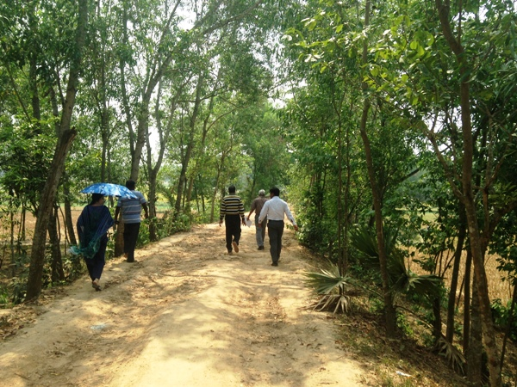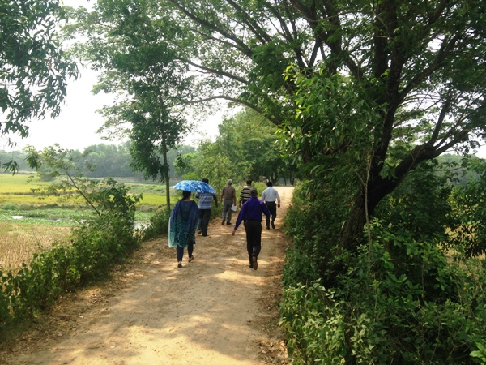
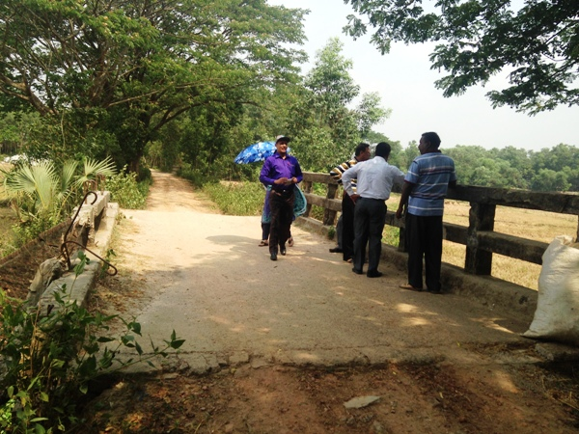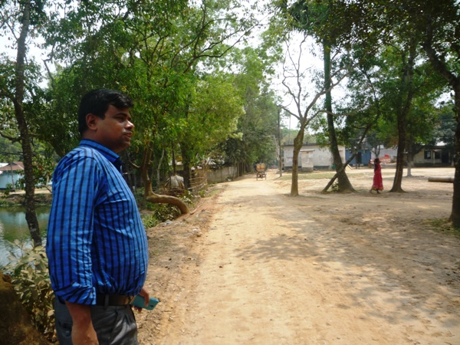
Photograph 7.1.1: Consultant Team visited the site with Bhaluka Pourashava Officials
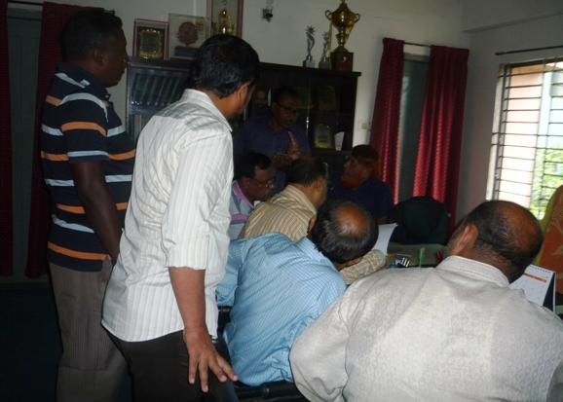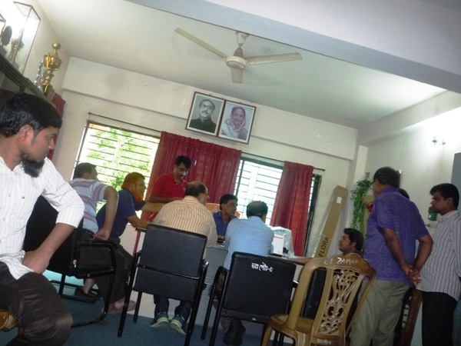
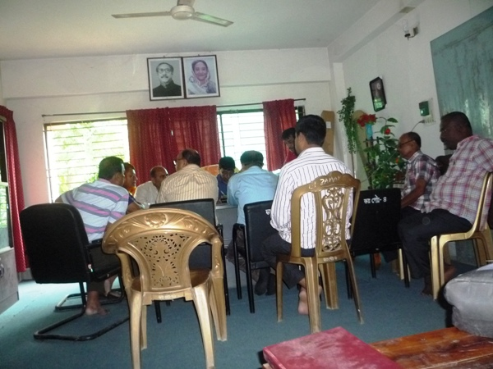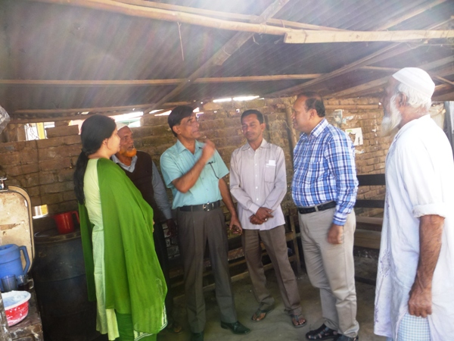
Photograph 7.1.2: Consultation Meeting at Bhaluka Pourashava with Pourashava Officials and Consultants Participants

Issues Raised by the Participants

The participants raised the issues related to the infrastructure development of Bhaluka Pourashava. They emphasized on the subproject selection for the future development and also discussed about the procedure for the quality construction work. In the FGD, the participants discussed the requirements of the infrastructure development of Bhaluka Pourashava through a list of the subprojects.

Feedback, Suggestions, and Recommendations of the Participants

The participants’ feedback, suggestions, and recommendations listed below:
- The participants suggested that quality and schedule of the construction work should be maintained properly;
- The FGD results confirmed that an improved communication network by various road construction for future development of Bhaluka Pourashava is needed;
- The participants addressed the infrastructural facility like Poura Super Market for multipurpose using at the front of Poura Bhabon and Kitchen market with slaughter house at Bhaluka Bazaar;
- The participants proposed that public toilets construction is needed;
- Construction of road beautification under Kheru River Bridge is proposed which will be the connecting road of the Bhaluka Bazaar.
To encourage participation, regular consultations are recommended with beneficiary communities to share subproject related information and to provide a feedback mechanism for these communities to voice their concerns and issues in all stages of the subproject. The DSM consultants and PMU, LGED will be responsible to carry out continued consultation with and information dissemination to the key stakeholders.

Conclusions and Recommendations

The subproject intervention has significant impacts on ecological environment due to felling of the trees. In addition, the subproject intervention has impacts on physicochemical components and socio-economic environment. However, from the study it is revealed that the anticipated impacts on physicochemical components and socio-economic environment are not significant. Most of the individual elements of the subproject involve simple construction and operation, so impacts will be mainly localized and limited within the subproject boundary. Most of the predicted impacts are associated with the construction process which is invasive. Hence, the impacts are largely manageable through mitigation measures. Mitigation will be assured by a program of environmental monitoring to ensure that all measures are implemented, and will determine whether the environment is protected. It will include observations on and off-site, document checks and interviews with workers and beneficiaries. Any requirements for corrective action will be reported to the WB.
This study formulates well structured EMP. This EMP will assist Pourashava Officials, PMU-LGED, contractor and DSM personnel in mitigating the environmental impacts, and guide them in the environmentally sound execution of the proposed subproject. A copy of the EMP shall be kept on-site during the construction period at all times. The EMP shall be made binding on contractor operating the site, and will be included in the contractual clauses.
It should be noted that environmental assessment report is a live document. Hence, due to changing circumstances during the construction phase if any, there might be minor adaptation needed for environmental, health and safety issues.

APPENDIX

Appendix- I: Environmental Monitoring Checklist

