
GOVERNMENT OF THE PEOPLE’S REPUBLIC OF BANGLADESH
Local Government Engineering Department (LGED)

Local Government Division

Ministry of Local Government, Rural Development, and Cooperatives

Environmental Assessment (EA) REPORT

Name of the Subproject: 1. Improvement of Bhaluka-Birunia Road by RCC Casting starting from Thana Moor to Dakkhin Bhaluka Primary School (L=570 m) under Bhaluka Pourashava.
2. Construction of RCC Drain start from Altu Mia House to Golashangun Khal on Bhaluka-Birunia Road ( Ch. 00 to 380 m) under Bhaluka Pourashava.
3. Construction of RCC Drain on T & T Road starting from Major Vita to Golashangun Khal effective length = 1025 m, under Bhaluka Pourashava

MGSP/BLK/2018-19/W-08

Bhaluka Pourashava, Mymensingh

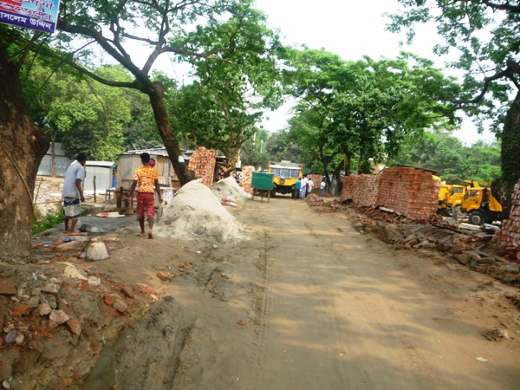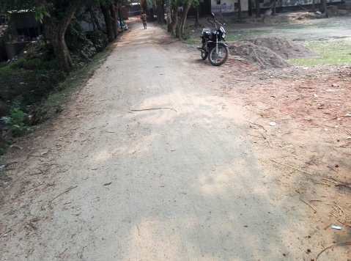

Municipal Governance and Services Project (MGSP)

Design, Supervision, and Management (DSM) Consultancy Services
Joint Venture of  Hifab International AB, Sweden  AQUA Consultant and Associates Ltd., Bangladesh |   

TABLE OF CONTENTS
 |  |  |  | Page
1.0 |  | INTRODUCTION |  | 1-3
 | 1.1 | Subproject Background |  | 1
 | 1.2 | Objectives of the Study |  | 2
 | 1.3 | Scope and Methodology of the Study |  | 2
2.0 |  | SUBPROJECT DESCRIPTION |  | 4-10
 | 2.1 | The Study Area |  | 4
 | 2.2 | Current Situation, Proposed Intervention and Need for the Subproject |  | 7
 | 2.3 | Envisaged Subprojects Activities and Implementation Process |  | 9
 | 2.4 | Category of the Subproject |  | 9
 | 2.5 | Subproject Schedule |  | 10
3.0 |  | BASELINE ANALYSIS OF ENVIRONMENTAL CONDITION |  | 11-16
 | 3.1 | Physical Environment |  | 11
 | 3.2 | Biotic Environment |  | 15
 | 3.3 | Socio-economic and Socio-cultural Environment |  | 15
4.0 |  | ENVIRONMENTAL SCREENING |  | 17-19
5.0 |  | SPECIFIC IMPACT, MITIGATION AND ENHANCEMENT MEASURES |  | 20-25
 | 5.1 | Site Clearing, Excavation and Earth Work |  | 20
 | 5.2 | Ecological Impact and Enhancement Work |  | 20
 | 5.3 | Pollution from the Storage of Construction Materials |  | 20
 | 5.4 | Air Quality and Dust |  | 21
 | 5.5 | Noise and Vibration |  | 21
 | 5.6 | Water Quality |  | 22
 | 5.7 | Occupational Health and Safety |  | 22
 | 5.8 | Impacts on Social Environment and Common Property Resources |  | 23
 | 5.9 | Labor Influx and Anticipated Impacts |  | 24
 | 5.10 | Impacts on Traffic Movement |  | 25
6.0 |  | ENVIRONMENTAL MANAGEMENT PLAN |  | 26-37
 | 6.1 | Access to Information |  | 26
 | 6.2 | Grievance Redress Mechanism |  | 26
 |  | 6.2.1 | Grievance Redress Committee (GRC) | 26
 |  | 6.2.2 | Grievance Resolution Process | 27
 | 6.3 | Institutional Arrangement for Safeguard Compliances |  | 28
 | 6.4 | Capacity Building |  | 29
 | 6.5 | Emergency Response and Disaster Management |  | 29
 | 6.6 | Environmental Management Action Plan |  | 30
 | 6.7 | Environmental Monitoring Plan |  | 34
 | 6.8 | Environmental Management Budget |  | 35
 | 6.9 | Environmental Codes of Practice |  | 36
7.0 |  | PUBLIC CONSULTATION AND PARTICIPATION |  | 38-40
 | 7.1 | Methodology |  | 38
 | 7.2 | Issues Raised by the Participants |  | 39
 | 7.3 | Feedback, Suggestions and Recommendations of the Participants |  | 39
8.0 |  | CONCLUSIONS AND RECOMMENDATIONS |  | 41
9.0 |  | Reference |  | 42
APPENDIX
 |  | Appendix I: Environmental Monitoring Checklist |  | 43

LIST OF TABLES
Table 3.1.1 | Major Environmental and Infrastructural Features
Table 5.7.1 | General Requirements for the Workers Health and Safety
Table 5.8.1 | Impacts on Social Environment and Common Property Resources
Table 6.2.1.1 | List of GRC Committee Members
Table 6.6.1 | Anticipated Environmental Impacts during Construction Phase and Corresponding Mitigation and Enhancement Measures
Table 6.6.2 | Anticipated Environmental Impacts during Operational Phase and Corresponding Mitigation and Enhancement Measures
Table 6.7.1 | Matrix Table of Monitoring Plan (Visual observation during construction phase)
Table 6.8.1 | Environmental Management Budget in Bill of Quantity

LIST OF FIGURES
Figure 2.1.1 | Location Map of the Birunia Road
Figure 2.1.2 | Location Map of the T & T Road
Figure 2.1.3 | Lay-Out Plan of the Birunia Road
Figure 2.1.4 | Lay-Out Plan of the T & T Road
Figure 2.1.5 | Topographic Features of Birunia and T &T Road

LIST OF PHOTOGRAPHS
Photographs 2.2.1 | Current Situation of the Birunia Road
Photographs 2.2.1 | Current Situation of the T & T Road
Photographs 2.2.1 | Starting Point of the Outfall
Photographs 7.1.1 | DSM Consultant Team with Pourashava Representatives Inspected the Proposed Road
Photographs 7.1.2 | Consultation Meeting at subproject sites with Pourashava Officials and Consultants Participants

ABBREVIATIONS

AP persons (AP’s) | Affected Person
BDT | Bangladeshi Taka
BOQ | Bill of Quantity
CC | Cement Concrete
CIP | Capital Investment Plan
CP | Contingency Planning
DSM | Design, Supervision, and Management
EA | Environmental Assessment
ECR | Environmental Conservation Rules
EMP | Environmental Management Plan
EPP | Emergency Preparedness Planning
ES | Environmental Screening
FGD | Focal Group Discussion
GoB | Government of Bangladesh
GRC | Grievance Redress Committee
GRM | Grievance Redress Mechanism
GRP | Grievance Redress Procedure
LGED | Local Government Engineering Department
MGSP | Municipal Governance and Services Project
PD | Project Director
PMU | Project Management Unit
RCC | Reinforcement Cement Concrete
RP | Relevant Reports
TL | Team Leader
WB | World Bank
XEN | Executive Engineer

1 INTRODUCTION

1.1 Subproject Background

Bhaluka Pourashava is located at Bhaluka Upazila under Mymensingh District. It is established as a Pourashava in the year of 1998. Presently, this is A Type Pourashava. Bhaluka Pourashava covers an area of 10.42 sq. km area with present population of 63,773. The Pourashava consists of 18.85 km pucca pavement and 62.00 km earthen road. Currently, 550 number of street light only covers 20% of the entire demand. (At a glance Bhaluka Pourashava).The existing infrastructure facilities are not adequate to meet the present demand. Therefore, this subproject will directly contribute infrastructure development of Bhaluka Pourashava.

In Bhaluka Pourashava, traffic volume is increasing day by day with the increase in population and demand. The substandard road network cannot cope with the growing demand. Hence, planned development of road network with street light is essential to meet the emergent demand.

This subproject includes the following components: RCC Road and RCC Cross Drain. The significant features of the subproject are mentioned below:
Name of the Subproject : | 1. Improvement of Bhaluka-Birunia Road by RCC Casting starting from Thana Moor to Dakkhin Bhaluka Primary School (L=570 m) under Bhaluka Pourashava.  2. Construction of RCC Drain start from Altu Mia House to Golashangun Khal on Bhaluka-Birunia Road (Ch. 00 to 380 m) under Bhaluka Pourashava.  3. Construction of RCC Drain on T & T Road starting from Major Vita to Golashangun Khal effective length = 1025 m, under Bhaluka Pourashava
Package No. : | MGSP/BLK/2018-19/W-08
District Name : | Mymensingh
ULB Name : | Bhaluka Pourashava
Jurisdiction Area : | Ward number 1,2 and 3
Structural Design Option : | RCC Road and RCC Drain
Beneficiary Population : | About 10,985 as per information of Bhaluka Pourashava
Tribal People : | No tribal people settlement found in the subproject area
Land Acquisition : | No land acquisition is required
Estimated Cost : | 45.314 million BDT
Subproject Duration : | 12 Months
Tentative Start Date : | November 23, 2018
Tentative Completion Date : | November 22, 2019

Objectives of the Study

The general objective of this study is to determine the major environmental impacts succeeding from execution of the subproject and to recommend mitigation measures to avoid or reduce adverse environmental impacts and to enhance positive impacts. The specific objectives include:
- To assess the existing environmental conditions of the subproject site and its influence area;
- To identify and assess impacts resulting from the subproject during its construction phase and operation phase;
- To develop a environmental management plan with recommendations for mitigating impacts and enhance positive impacts;
- To summarize environmental monitoring requirements.

Scope and Methodology of the Study

The subproject appraisal is included environmental screening for all the subproject components. According to that screening, environmental assessment is required to fulfill the regulatory requirement for RCC Road and RCC Drain. Hence, this environmental assessment is prepared to meet the regularity requirement of this subproject. The study methodology covered the following activities:

- Desktop Study;
- Field Investigations and Data Collection;
- Data Analysis and Report Writing.

Desktop Study
The desktop study involved:
- Initial meetings with client, stakeholders to discuss the proposed subproject;
- Collection and review of the baseline data, maps, reports and other relevant information;
- Review of the relevant existing legislation, regulation and policies;
- Understand the anticipated technical processes that may affect the environment.

Field Investigation and Data Collection
A team of the consultants made a field investigation to the proposed site. Field investigations involved mainly site walks at the subproject areas for identification of the environmental components to be affected due to the subproject intervention.
The following key tasks were performed during the field visit:
- Taking photographs of the significant aspects to assist in describing the baseline environmental conditions of the subproject area;
- Interviews with representatives of the relevant Pourashava officials and beneficiary and affected people within the subproject influence zone;
- Obtaining relevant documents from Pourashava and local people within the subproject influence zone;
- Verifying information and data collected during the desktop study and to collect new information.

Data Analysis and Report Writing
The data and information collected from all the sources (literature review, secondary and primary data, public consultation) were analyzed to describe the existing environmental setting of the subproject area, to identify the potential positive and negative impacts of the proposed subproject, as well as to provide preliminary suggestions for mitigation measures. Finally, this environmental assessment report has been prepared.

SUBPROJECT DESCRIPTION

The Study Area

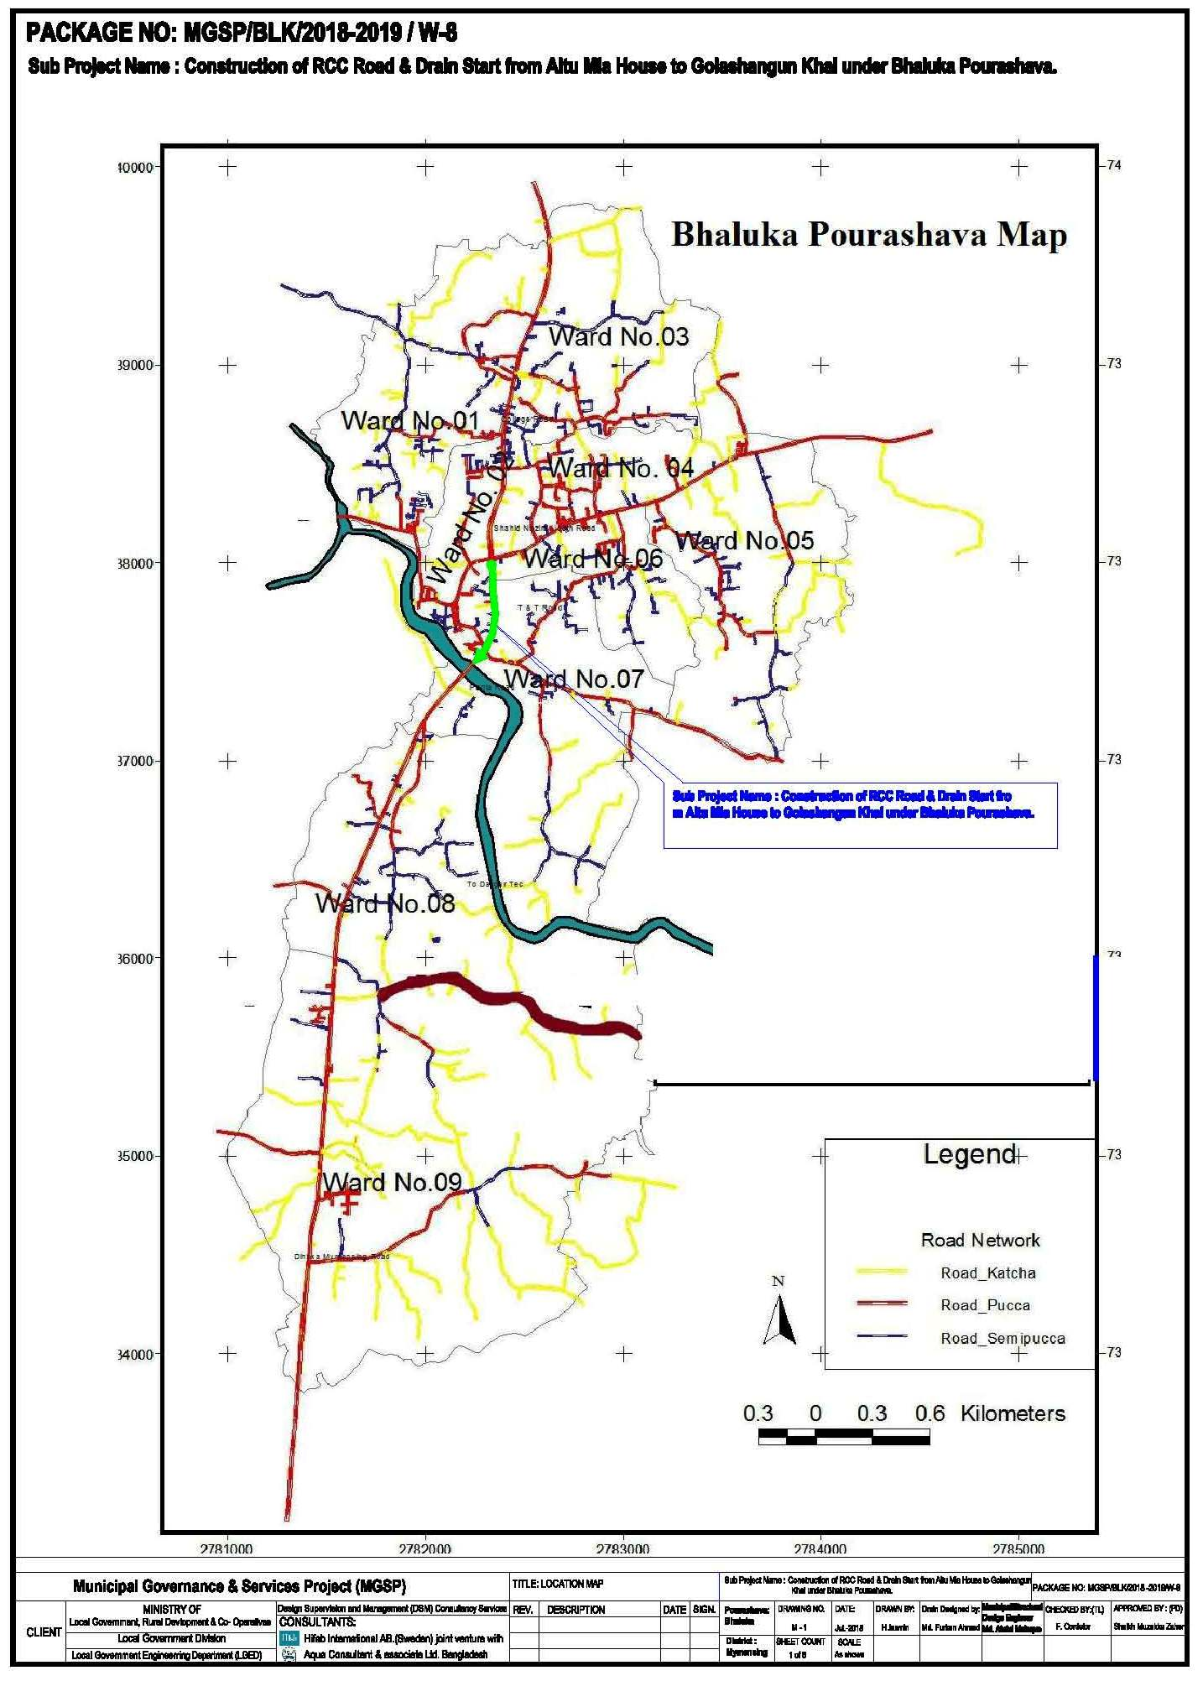
The subproject site is situated within the jurisdiction area of the Bhaluka Pourashava Ward no. 06, and 07. The starting point of Birunia Road is located at 24°24'1.57"N (Latitude) and 90°23'8.55"E (Longitude).The end point of this road is located at 24°23'53.66"N (Latitude) and 90°23'26.62"E (Longitude). The starting point of T & T Road is located at 24°24'25.10"N (Latitude) and 90°23'33.70"E (Longitude).The end point of this road is located at 24°23'59.61"N (Latitude) and 90°23'11.51"E (Longitude). The location map, lay-out plans and topographic features of the subproject are shown in Figure 2.1.1, Figure 2.1.2, Figure 2.1.3, Figure 2.1.4 and Figure 2.1.5.

Figure 2.1.1: Location Map of the Birunia Road

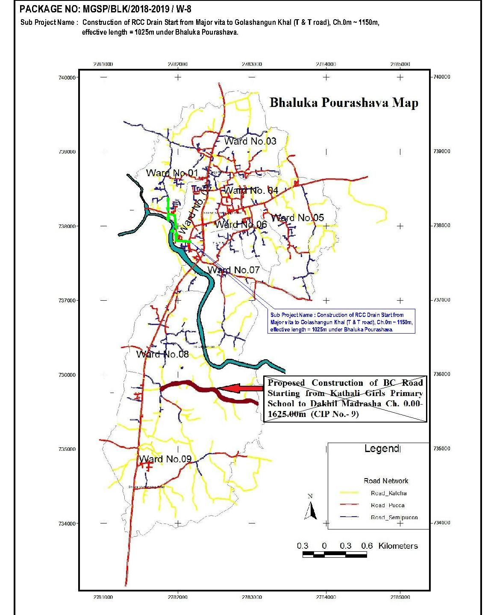
Figure 2.1.2: Location Map of the T &T Road

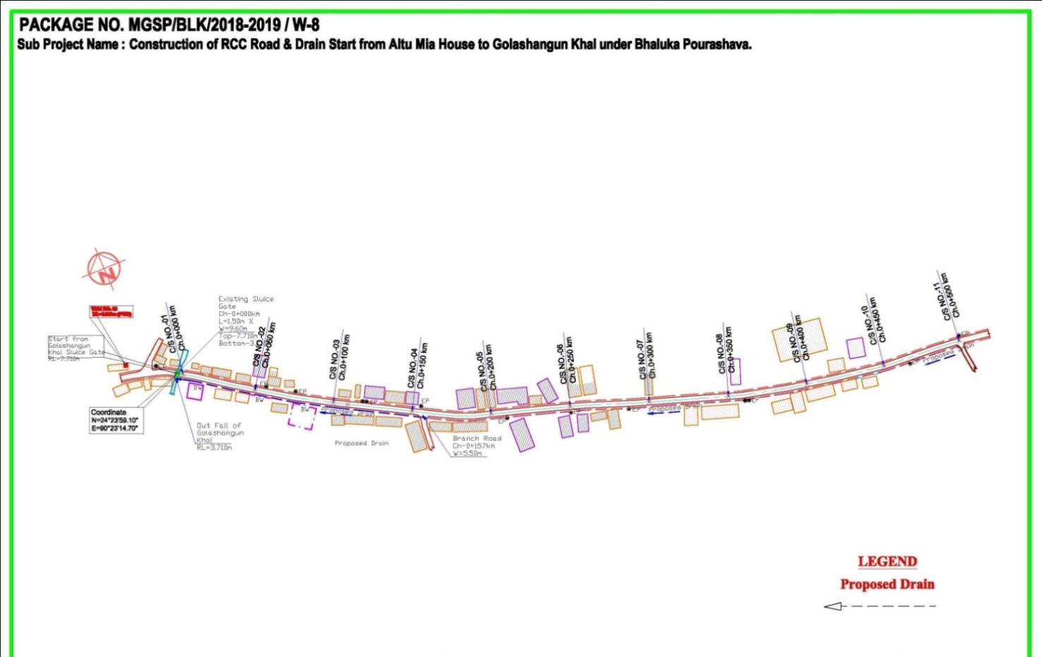

Figure 2.1.3: Lay-Out Plan of the Birunia Road

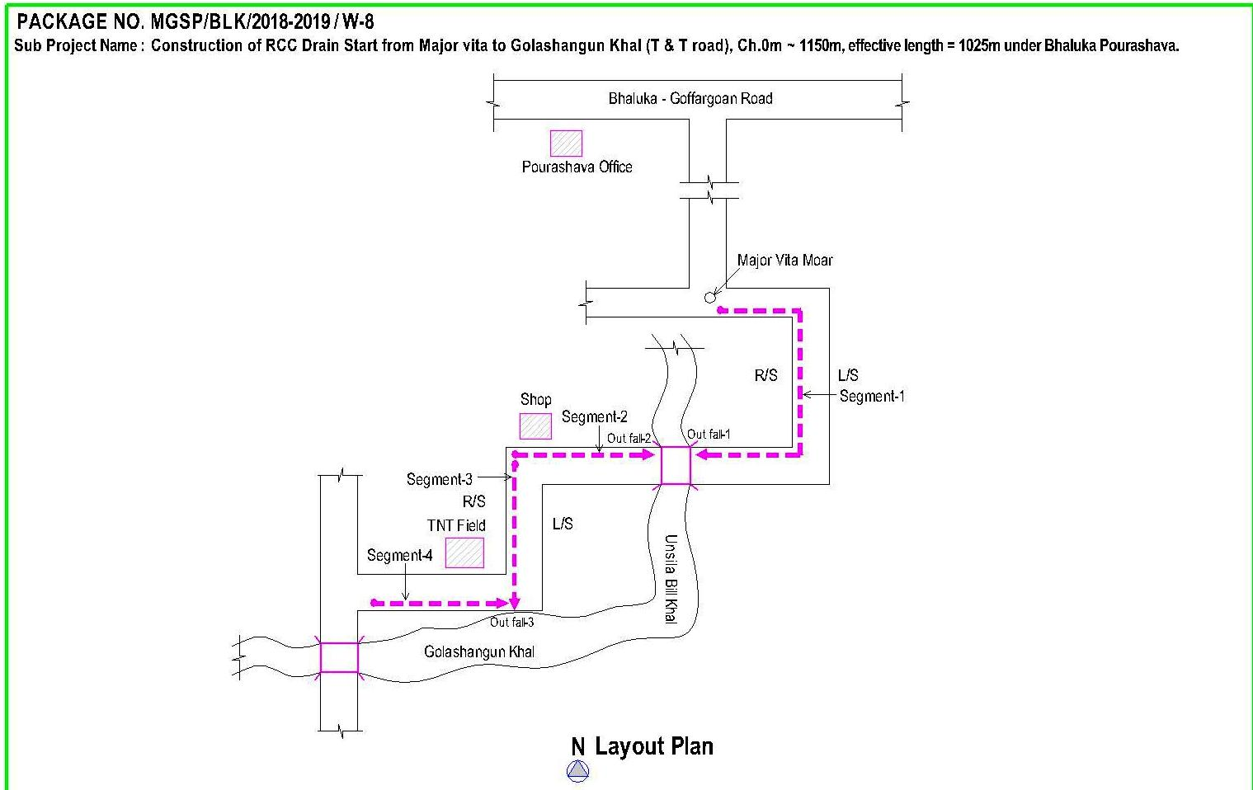
Figure 2.1.4: Lay-Out Plan of the T & T Road
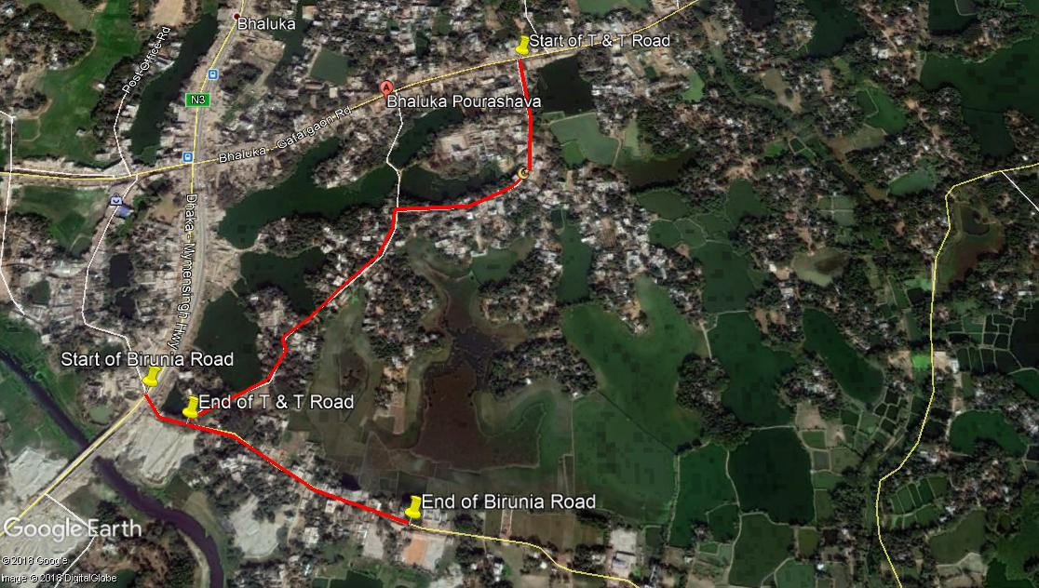

Figure 2.1.5: Topographic Features of the Birunia and T& T Road

Current Situation, Proposed Intervention and Need for the Subproject

At present, Bhaluka is category A type Pourashava. The subproject is located at wards no 6, and 7 under Bhaluka Pourashava. From Ch. 0 to 570 m at Birunia Road, the existing HBB and BFS pavement will be demolished and replaced by the new RCC pavement. Presently, the existing road is damaged which hamper the normal traffic operation. The existing and proposed average pavement width is 5.750 m. From the site investigation, it is revealed that damaged road interrupts normal traffic operation. Hence, road improvement is necessary for the normal traffic operation.
In the subproject area, there is no drainage facility. Hence, storm water creates water logging problem at different sections of the road especially during monsoon. Stagnation of water on the road surface damages the road. As a result, smooth traffic flow is hampered. To improve the situation, RCC drain is needed for drainage facility. Therefore, RCC drain with cover slab at left side of the Birunia Road (Ch. 0 – 380 m) will be constructed. Moreover, RCC drain with cover slab at left side of the T & T Road (effective length= 1025 m) will be constructed. The storm water through the proposed drain will be discharged primarily in the main drain of the Pourashava and finally in the Golashangun Khal. The existing condition and inspection of the proposed site is further elaborated in the following Photographs 2.2.1, 2.2.2 and 2.2.3.
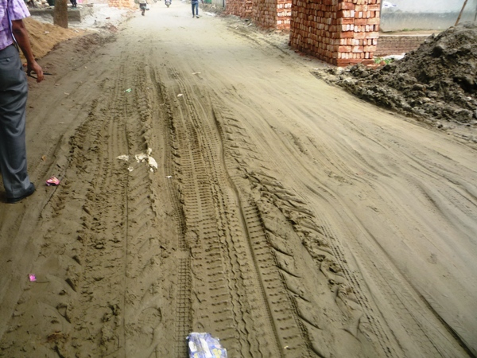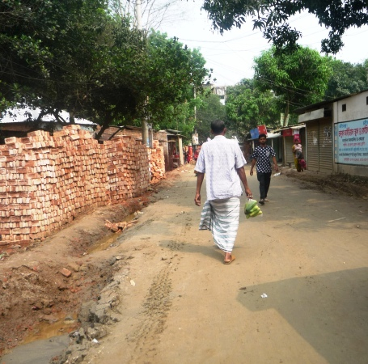

Photographs 2.2.1: Current Situation of the Birunia Road

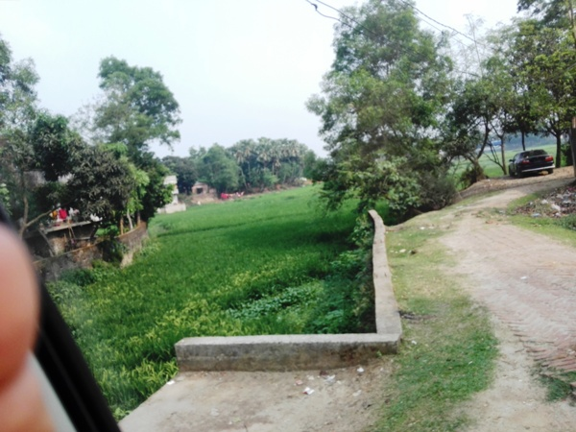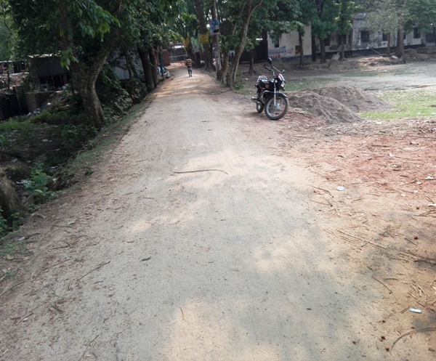

Photographs 2.2.2: Current Situation of the T & T Road

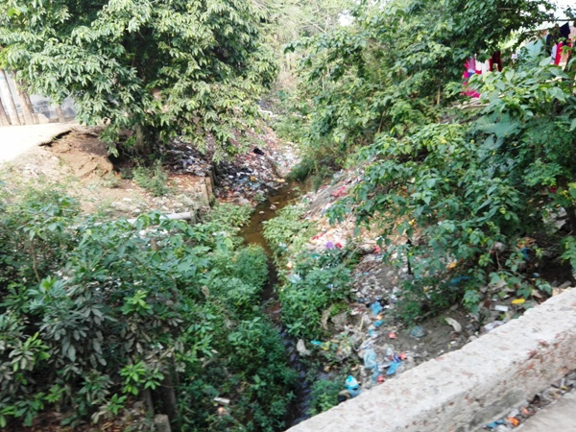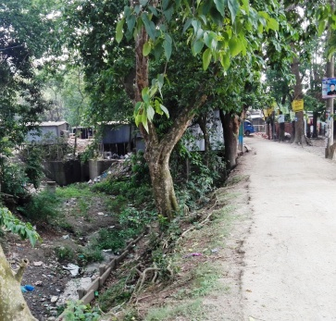

Photographs 2.2.3: Starting Point of the Outfall

Envisaged Subproject Activities and Implementation Process

The general activities of the subproject includes: construction of the semi-pucca site office, construction of the labor shed and relocation of the electrical poles for access road.
Specific activities for RCC Drain:
- Earth work in excavation of the foundation;
- Pumping and bailing out of water as per requirement;
- Sand filling for the preparing foundation bed;
- Laying polythene sheet;
- Plain cement concrete work in foundation;
- Manufacturing CC blocks;
- Fabrication of the ribbed or deformed bar;
- Reinforced cement concrete work.

Specific activities for RCC Road:
- Dismantling of the damaged sub-base and base course works;
- Earth work in box cutting;
- sand filling on the road bed;
- sand and brick chips mix in the sub-base;
- Mechanical compaction;
- Polythene sheet laying work;
- Fabrication of the ribbed or deformed bar reinforcement;
- Reinforced cement concrete work.

The materials to be used for the key activities: bricks, brick chips, stone chips, reinforcement bar, admixture, bearing pad, sand, cement, concrete, paint etc.
The major equipment to be used for the implementation of the subproject: long-boom hydraulic excavator, brick breaking machine, pile rig for boring, concrete mixer machine, vibrator machine, MS sheet, steel cutter, steel shutter, steel drum rollers, pneumatic multiple tire roller, dump truck, water tanker, pump, generator and measuring device.

Category of the Subproject
For RCC Road and RCC Drain
- According to ECR 1997: Green □ Orange□ A Orange B □√ Red □ Not Listed □
- According to WB classification: Category B □√ Category C □
The overall anticipated adverse impact due to the subproject intervention is limited and site specific. Considering the environmental impact which is anticipated as insignificant, this subproject can be considered as Orange B as per ECR-97. According to the WB classification, it can be classified as Category B.

Subproject Schedule
The tentative schedule of construction of the subproject is:
(a) Subproject Duration (months) :12 months
(b) Tentative Start Date : 23 November 2018
(c) Tentative Completion Date : 22 November 2019

The daily construction hours will normally include regular working time. However, daily working hours may vary based on the on-site condition. The detailed work program will be prepared by the contractor with the assistance of the PIU-Pourashava. Then it will be shared with the PMU, LGED and DSM consultants. In addition, the detailed work program will also be shared with the Bank as per requirement.

Baseline ANALYSIS OF THE ENVIRONMENTAL CONDITION

Physical Environment

Important Environmental and Infrastructural Features

During site visit the environmental and infrastructural features within the subproject area were collected. Conditional survey has also been conducted for designing the subproject. Hence, the survey data is also used for preparing the report. Effort has been given for getting major environmental and infrastructural features within 100 m of both sides from the centre of the road at 100 m longitudinal intervals from Altu Mia House to Golashangun Khal and from Major Vita to Golashangun Khal of proposed subproject in Table 3.1.1.
Table 3.1.1: Major Environmental and Infrastructural Features
Chainage (m) | Left | Right | Major Environmental and Infrastructural Features
Altu Mia House to Golashangun Khal (Ch. 0 to 570 m)
0-100 | √ |  | Open space, trees, khal, residential houses with different structures
0-100 |  | √ | Open space, trees, pond, residential houses with different structures
100-200 | √ |  | Houses, trees, ditch, agricultural field
100-200 |  | √ | Houses, Mosque, trees, open space, electric pole, agricultural field
200-300 | √ |  | Agricultural field, trees
200-300 |  | √ | Agricultural field, trees
300-400 | √ |  | Agricultural field, trees, open space
300-400 |  | √ | Agricultural field, trees
400-500 | √ |  | Agricultural field, trees
400-500 |  | √ | Agricultural field, trees
500-570 | √ |  | Agricultural field, khal, trees
500-570 |  | √ | Agricultural field, trees, houses, khal
Major Vita to Golashangun Khal (Ch. 0 to 1025 m)
0-100 | √ |  | Shop, boundary wall, residential houses, trees
0-100 |  | √ | Boundary wall, residential houses, trees
100-200 | √ |  | Boundary wall, residential houses, Baytul Mamur Jame Mosque, Graveyard, trees
100-200 |  | √ | House boundary wall, residential houses, electric poles, trees
200-300 | √ |  | Houses with different structures, trees, boundary wall
200-300 |  | √ | Houses with various structures, tin fence, trees
300-400 | √ |  | Residential houses, open field, trees
300-400 |  | √ | Pond, trees, electric pole, boundary wall, houses
400-500 | √ |  | House boundary, residential houses, trees
400-500 |  | √ | Bhaluka Ideal School and Coatching Center, trees, houses, tin fence, electric pole
500-600 | √ |  | Residential houses, open field, trees
500-600 |  | √ | Trees, electric pole, boundary wall, houses
600-700 | √ |  | Residential area, trees
600-700 |  | √ | Homestead area, trees
700-800 | √ |  | Residential houses, boundary wall, trees
700-800 |  | √ | Boundary wall, residential houses, trees
800-900 | √ |  | Residential houses, open field, trees
800-900 |  | √ | Trees, electric pole, boundary wall, houses
900-1000 | √ |  | Residential area, trees
900-1000 |  | √ | Homestead area, trees
1000-1025 | √ |  | Trees, residential houses, khal, bridge, electric pole
1000-1025 |  | √ | Open field, T and T office, trees, houses
** Note: There are 3 no. electrical poles to be re-located for the implementation of the subproject.

Geology, Topography and Soils

Bhaluka Pourashava belongs to Madhupur tract. Surface geology is consisted of sedimentary rocks originated by riverine processes. The Pourashava is located on the bank of the River Kheru. Topographically, Bhaluka Pourashava is plain land. The plain land mainly consists of fluvio-deltaic sediments deposited by the Ganges, Brahmaputra and the Meghna River Systems. Geomorphologically, Bhaluka Pourashava falls under the Floodplains of the Old Brahmaputra and Jamuna rivers having distinguishing character. Soils in the valleys are dark grey heavy clays. They are strongly acidic in reaction with low status of organic matter, low moisture holding capacity and low fertility level. According to BNBC (2006), Bangladesh has three seismic zones with moderate and low seismic activity. The Pourashava falls in Zone II.

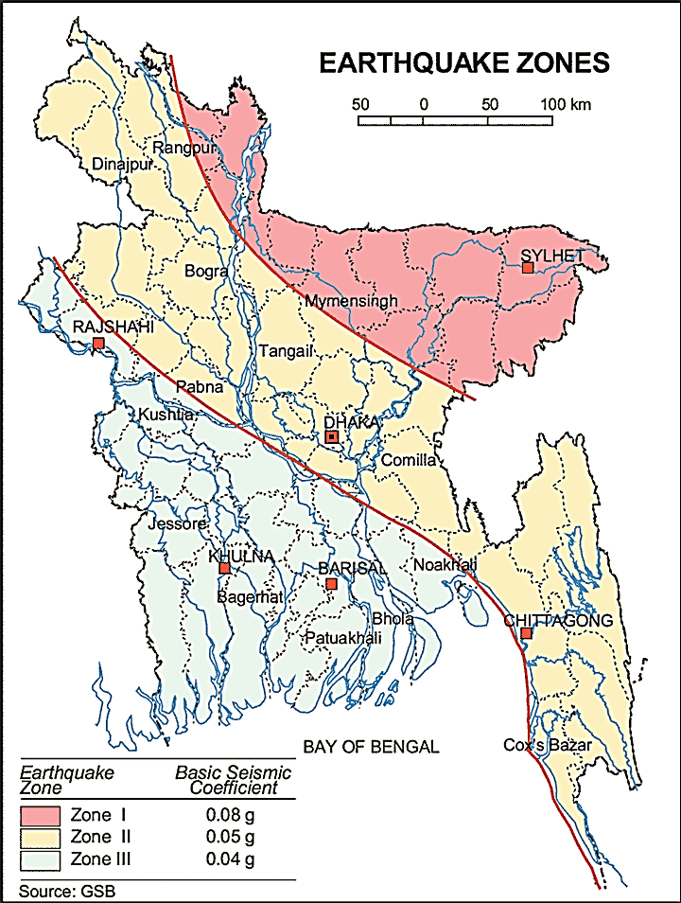

Figure 3.1.1: Location of Bhaluka in Earthquake Zone Map of Bangladesh

Climate and Meteorology

The area specific meteorological data is not available. Hence, meteorological data of Muktagacha can use for Bhaluka Pourashava in order to get idea. The climate is moderate with the maximum and minimum mean monthly temperature 32.3ºC and 24.7ºC respectively observed in April and January. Mean annual rainfall is 2253 mm occurs between May to September during monsoon period. During 82% of the aggregate precipitation occurs during five months of the monsoon period. In the winter months of December-January, temperature comes down substantially.

The construction works can be influenced by the climatic condition and meteorological components like humidity, temperature, sudden rainfall, and wind speed. High winds can enhance quick spreading of the generated dust. It is very risky working under rain and in high winds because the possibility of getting injury increases. Furthermore, work under high temperature and excess humidity may create health hazards like dehydration problem.

Water Resources (Surface Water, Ground Water and Rain Water Harvesting)

A khal, pond and ditch are situated adjacent to the subproject area. These are major surface water sources in the Pourashava. Consequently, these ponds influence the regional hydrology.
Ground water is the only sources of drinking water to the habitats of Bhaluka Pourashava. The Pourashava inhabitants use tube-well for the drinking water. The ground water table of the Bhaluka Pourashava varies from minimum 16 ft during rainy season and to the maximum 44 ft during dry season. During dry season when the ground water table goes down at this depth contents excess iron. Within the Pourashava, any arsenic contaminated hand tube-well is not yet identified. In the Pourashava area, rain water harvesting is not visible.
Flooding, Water Logging and Drainage Pattern
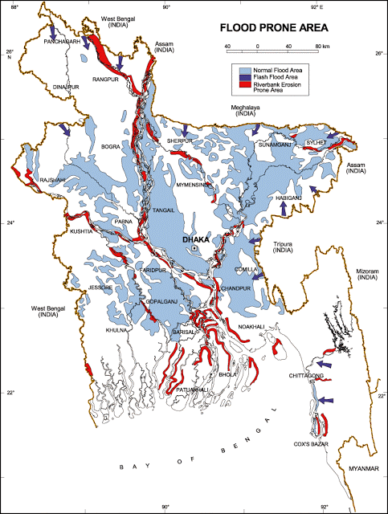
Bhaluka Pourashava is free from external flooding. In the subproject area, the water logging problem is acute in built-up areas than bare land. In the built-up area, the houses are lower than the road level. During heavy rain, the remaining water after infiltration retains on the ground where water logging occurs. Due to lack of adequate and functional drainage facilities water retains there until dries-up. Generally, water logging problems starts in June and continues till October. The subproject area falls on the normal flooding zone as per flood zoning map of Bangladesh.

Figure 3.1.2: Location of Bhaluka Pourashava in Flood Zone Map of Bangladesh
Air Quality and Dust
The degradation of the air quality is mainly from windblown dust and emission from the vehicles. The rough surfaces of the road generate dust during vehicles movement in dry season. Improper disposal of the solid wastes also spread bad odor which causes air quality degradation. During construction phase black smoke emission from asphalt plant, paver, concrete mixer machine, vibrator machine, hydraulic excavator and vehicles used for transportation activities may degrade the air quality.

Noise Level

Noise is generated mainly from the vehicles movement and hydraulic horn. Noise is also generated due to public gathering. During construction phase, asphalt plant, paver, concrete mixer machine, vibrator machine, hydraulic excavator and vehicles used for transportation activities may create temporary noise nuisance within the subproject boundary.
Solid Waste Management

The Pourashava has not any structured dumping yard of its own. The Pourashava people normally dump the collected solid wastes at roadside open spaces. Currently, the vacant place beside Dhaka-Mymensingh Highway is used as a dumping ground by the Pourashava. This is simply open dumping to a specific location. In recent times, the municipalities provide services for household waste collection from door to door and dump at the vacant place beside Dhaka-Mymensingh Highway. The generated wastes due to construction activities will be dumped at the vacant place beside Dhaka-Mymensingh Highway.

Biotic Environment

Flora and Fauna

In the subproject area, the floral species includes: Koroi, Mehagany, Betel-nut, Mango, Mehagany, Betel-nut, Mango, Coconut, Jackfruit, Papaya etc. The common local birds such as Crow, Sparrow, Bulbuli, Tuntuni, Shalik etc. were found during the site visit. There are no wild animals and endangered faunal species in the subproject area.

Socio-economic and Socio-cultural Environment

Land Use, Status of Housing and Built-up Infrastructure
Like other Pourashava in Bangladesh, the land use pattern in the subproject area consists of mixed land-use pattern. For T& T Road, the major roadside built-up infrastructures include Baytul Mamur Jame Mosque, Bhaluka Ideal School and Coaching Center, Residential Houses and boundary wall. In addition, Graveyard, pond, khal and open field were found during site visit. At Birunia Road, the major roadside built-up infrastructures include residential houses with different structures, Mosque and khal. In addition, khal, agricultural field, trees and open space were found during site visit.
Beneficiary Population

The subproject is situated within the jurisdiction of the Ward number 06 and 07. Considering the ward population about 7,230 people will benefit directly and many others indirectly.

Education

In the municipality, literacy among the population is about 73.8%. This is higher than the national average (51.8%). The literacy rate among males (76.5%) is still more than females (70.8%). (Ref: Population and Housing Census 2011).

Tribal Communities
There is no indigenous or tribal people settlement in the subproject area. Hence, no measures needed for the indigenous peoples’ safeguard.

Land Acquisition and Resettlement

Private land acquisition is not needed. Adequate space is available for road widening work. However, four tin shed temporary shops need to be removed for site clearing works. The Pourashava will clear the site amicably with the owners of these structures prior to the construction work. However, in case of any objection from the affected persons, DSM will investigate the actual situation. Then, measures will be taken as per rules.
Principal Livelihoods and Economic Activities
The subproject area is inhabited by the mixed occupational people. In the Pourashava area, major income comes from business, enterprises, small trades, private sector jobs, and government jobs in the town.
Cultural Heritage and Protected Areas
During site visit it was observed that there is no protected and important cultural or historical site in the subproject influence area.
Social Conflicts and Development Activities

The local people welcome the subproject and there is no conflicts between the local communities regarding subproject implementation.

ENVIRONMENTAL SCREENING

Environmental Screening Checklist, as adopted in Appendix C of the Environmental Management Framework (EMF) of the MGSP, was administered for identifying the impacts and their extents.
The screening data and information for the RCC Road and RCC Drain have been formulated and are shown in below.
1) Potential environmental impact during construction phase:
(a) Ecological impacts:
- Felling of trees Significant □ Moderate □√ Minor □√ Number of trees
31
- Clearing of vegetation Significant □ Moderate □ Minor □√
- Potential impact on species of
aquatic (i.e., water) environment Significant □ Moderate □ Minor □√

Major trees to be felled down are: Koroi, Mehagany, Betel-nut, Mango, Coconut, Jackfruit, Papaya etc. There is no tree to be felled down bring religious and heritage importance. However, the trees to be felled down have moderate economic value because most of them are medium to small size considering the length and diameter. However, clearing of the road side tree and vegetation is considered as minor. The aquatic environment of the road side pond and khal may degrade due to throwing of any kinds of waste materials or accidental spillage or leakage of oil. Considering the number of trees to be felled down, the overall ecological impact is considered as minor.
- Physicochemical impacts:

- Noise pollution Significant □ Moderate □√ Insignificant □
- Air pollution Significant □ Moderate □√ Insignificant □
- Drainage congestion Very likely □ Likely □ Unlikely □√
- Water pollution Significant □ Moderate □ Insignificant □√
- Pollution from solid/ construction wastes Significant □ Moderate □√ Insignificant □
- Water logging Significant □ Moderate □√ Insignificant □

The subproject will have impacts on noise and air quality during construction phase due to mobilization of the equipment, vehicles movement for the transportation of the materials, using of hydraulic excavator, brick breaking machine, mechanical compaction machine, concrete mixer machine, vibrator machine etc. The construction work will be performed section wise. Hence, it is anticipated that the overall impacts on noise and air quality will be moderate, temporary and limited within the subproject boundary. There are road side residents, and religious institution. Hence, anticipated impacts on noise and air quality will be significant for this particular section if measures do not take properly. The generated dust during construction activities may disturb the local people during construction period. The generated construction wastes, un-suitable materials and solid wastes may degrade the adjacent surface water if not properly collected and disposed and thrown in to the khal. Improper collection and disposal of the generated wastes materials also may degrade the quality of the surrounding environment and degrade the aesthetic value. The anticipated water logging and drainage congestion during construction period is minor because space is available at most sections of the road for drain-out the storm water. In addition, provision will be there for pumping out the storm water if required.

- Socio-economic impacts:

- Traffic congestion Very likely □ Likely □ Unlikely □√
- Health and safety Significant □ Moderate □√ Insignificant □
- Impact on archaeological and historical Significant □ Moderate □ Insignificant □√
- Employment generation Significant □ Moderate □ √ Insignificant □

Firstly, the proposed drain will be constructed. The traffic congestion due to drain construction is comparatively less because it does not require closing of the entire road. The pedestrians, cycle rider, biker can use the road during drain construction. The local people will use existing connecting and diversion road during road construction work. Furthermore, to minimize traffic disturbances, construction work will be performed section wise. Hence, the subproject activities will not have any severe impact on the local traffic system due to diversify of the traffic in the connecting and other roads. The construction work will follow simple procedure with commonly used equipments. Hence, anticipated impact on health and safety is moderate. The construction work adjacent to the residents and religion institutes may cause safety risks to the public. Therefore, construction activities adjacent to the Mosque should be performed within very short time considering safety issues/site fencing. There is no archaeological and historical site will be affected due to the subproject activities. The subproject has positive impact by generating work opportunities for the local people and supplying of the construction materials, equipments, food and other necessary stuffs to the campsite.
3) Potential environmental impact during operational phase:
(d) Ecological impacts:
- Potential impact on species of aquatic Significant □ Moderate □√ Minor □
(i.e., water) environment
The anticipated impact on the aquatic environment is insignificant due to operation of the road. Though, the drain is designed for storm water only. However, the storm water may carry washed-out materials, pollutants from any sources that may disturb the aquatic environment of the outfall. Hence, the anticipated impact on the aquatic environment due to operation of the drain is considered as moderate.
(e) Physicochemical impacts:
- Potential air quality Improvement □ No-improvement □ Deterioration □√
- Noise level Improvement □ No-improvement □ Deterioration □√
- Drainage congestion Improvement □√ Minor Improvement □ No Impact □
- Risk of Water pollution Significant □ Moderate □√ Minor □
- Pollution from solid waste Improvement □ No-improvement □ Minor □√

During operation phase due to road component, increased traffic volume may degrade the air quality and noise level due to black smoke emission and un-due use of hydraulic horn from vehicles. The new drain will minimize drainage congestion and water logging problem. The storm water to be discharged through the drain may degrade the water quality of the outfall if carry pollutants from any sources. The new covered drain will minimize throwing of the wastes materials in to the drain and spreading of the bad odor.
(f) Socio-economic impacts:
- Traffic Improvement □√ No-improvement □ Adverse □
- Safety Improvement □√ No-improvement □ Adverse □
- Employment generation Significant □ Moderate □√ Minor □

After completion, this road will improve the transport facilities. By providing uniform pavement, it will also enhance traffic safety and will enhance traffic operation. The new road will minimize the frequency of the maintenance for first three to five years after completion. After completion of the drain, the drain will enhance the existing drainage network. The new drain will reduce water logging problem. By reducing environmental hazards caused by water logging problem, it will provide better environment to the community people.

(4) Summary of the possible environmental impacts of the subproject:
The ecological impact due to the subproject implementation is mainly due to tree felling. However, the ecological imbalance to be caused due to cut down of the trees will be compensated by the plantation of the trees.
The overall impact due to implementation of the subproject is not severe. The physicochemical components will be disturbed during the construction phase. However, the anticipated impacts will be mainly within the subproject boundary. The wastes generated due to the construction activities should be properly collected and disposed in a designated site. There is also some adverse impact at operational stage. Due to improved road, motorized traffic volume may increase. Thus, air quality and noise level may be deteriorated due to vehicles emission and horns by the vehicles. The storm water to be discharged through the drain may degrade the water quality of the outfall and adjacent water bodies if carry pollutants from any sources.

Safety concern is an important issue for both the construction and operation phases that should be considered properly. The socio-economic aspect mainly includes health and safety and employment generation. This subproject will have positive impacts in terms of the generation of the employment and business activities by supplying construction materials and equipment.

Specific impact, mitigation AND enhancement measures

The likely impacts of the subproject are mainly caused by the activities required for the implementation of the subproject, and materials, resources and equipment to be used to perform the activities. This section describes some specific impacts due to the subproject activities and their mitigation measures.

The likely impacts of the subproject are mainly caused by the activities required for the implementation of the subproject, materials, resources and equipment to be used to perform the activities. This section describes some specific impacts due to the subproject activities and their mitigation measures.

Dismantle Work, Excavation Work and Earth Work

The drain construction work consists of earth excavation, earth filling, back filling and cutting and removal of the unsuitable materials. These works lead dust blowing, improper disposal of the wastes, noise and vibration which may disturb the local people.

Mitigation Measures

- Careful operation of the hydraulic excavator if used to avoid any undue disturbances to the roadside residents;
- Cover the exposed earth with fabric;
- Quick disposal of the wastes at the vacant place beside Dhaka-Mymensingh Highway

Tree Felling and Ecological Impact

The subproject has adverse impacts on the ecological components due to felled down of the
31 numbers of trees and clearing of the roadside vegetation and bushes.
Mitigation Measures

- 65 nos. of trees will be planted to compensate the felled down trees-preferably local fruits, flowers, medicinal and ornamental trees- Kadom, Neem, Kathbadam, Chalta, Mahogany, Rain Tree, Shil Koroi, Palm Tree (Preferably at the road side area of Major Vita to Golashangun Khal where space is available and or any other suitable places in the subproject area).

Pollution from the Construction Materials

Dumping of the construction spoils, including accidental leakage of the oil, grease, and fuel in equipment yards is a significant hazard. Surface water and soil quality might be polluted from these contaminants. Even the people to be engaged for the construction activities might endanger the physical and human habitats of the area.

Mitigation Measures

- Safe transport, storage, and disposal of the construction materials, and the equipment have to be carried out in order to avoid the accidental spillage and loss;
- Fuels, lubricants, and other hazardous materials should store over raised platforms and not directly on the ground;
- The playgrounds of the educational institutions should not use as a stockyard or work camp.

Air Quality and Dust

During construction phase, air pollutants will be emitted from the equipment and construction vehicles are expected to remain low. Local residents in the vicinity of the work sites will be temporarily disturbed by the limited dust pollution. The overall impacts, however, are expected to remain low.

Mitigation Measures

- Water should be sprayed at the work site for dust control. Ensure sprinkle and cover stockpiles of loose materials (e.g., fine aggregates).
- Maintain adequate moisture content of soil and sand for transportation, compaction and handling;
- Avoid use of dust generating equipment (which produce significant amount of particulate matter) far from the local residents;
- Ensure that all project vehicles are in good operating condition.

Noise and Vibration

Noise and vibration caused by the equipment and movement of the construction vehicles may temporarily disturb nearby residents. In this subproject, sensitive areas like roadside houses, educational institutes and shops are likely to be affected from the noise, though the impacts are anticipated to be limited.

Mitigation Measures

- Transportation of the construction materials have to be carried during the scheduled times, and mainly during the day;
- If needed, all powered mechanical equipment and machineries will be fitted with noise abating gear such as mufflers for effective sound reduction.

Water Quality

The water quality may deteriorate if the construction materials, construction wastes, effluent from work camps, and food waste are dumped in the roadside water body and low land.

Mitigation Measures

- Proper construction management including waste management as well as training of the operators and other workers should provide to avoid pollution of the water bodies;
- Construction waste will dispose properly (not in the ditch, water bodies or lowland), for which contractor will be responsible.

Occupational Health and Safety
The most important risks associated with the construction activities are listed below:
- Exposure to the sunlight- workers are being exposed to the sun for long hours;
- Exposure to the high temperature, and humidity for a long time resulting in dehydration;
- Contact with the hazardous substances and wastes pose risks of the infections and diseases;
- Risk of the poor air quality due to the dust;
- Risk of the collision (traffic);
- Risks from head loads for carrying soil, construction materials and construction equipment;
- Risks of the using of the machineries in motion;
- Risk associated to the sudden bad weather working conditions.
General Requirements for the Workers’ Health and Safety
The key salient features of the general requirements for the workers’ health and safety stated are presented in Table 5.7.1.
Table 5.7.1: General Requirements for the Workers Health and Safety
Issues | Requirements
Health and Hygiene | - Cleanliness at the site premises and workers living places and at the Labor Shed;  - Arrangement of the proper ventilation and temperature at the Labor Shed;  - Protection against dust and furnace by using of the nose masks and covering of the head and body;  - Proper disposal of the wastes and effluents;  - Introduce waste bins for the solid waste management system.
Safety and First Aid Box | - Using of the personal protective equipment (helmet, gloves, goggles, nose mask, safety boots);  - Precautions during work on or near machineries in motion;  - Head loads are prohibited;  - First aid facilities should be provided and maintained;  - The first aid kit should include adhesive bandages, regular strength pain medication, gauze, and low grade disinfectant.
Compensation for Accidents at Work | - Contractors will bear medical treatment costs. If any sever accidents such as loss of hands, legs or loss of working ability or any case of death needs compensation-(the amount of the compensation should be fixed considering the type of accidents).
Dust and Fumes | - For any dust, fumes, or other impurities likely to be injurious to the workers, effective measures shall be taken to prevent their accumulation and its inhalation by the workers.
Overcrowding | - No labor room should be overcrowded.
Latrines and Urinals | - Sufficient latrines shall be provided;  - Latrines shall be maintained in clean and sanitary condition;  - Latrines shall be adequately lighted and ventilated.
Disposal of Wastes and Effluents | - Proper disposal system for the solid waste and effluent is required;  - Waste bins must be provided by the contractor at labor shed.

Impacts on Social Environment and Common Property Resources
Through comprehensive study, it is revealed that impacts are expected not to be severe and to be largely manageable. The following Table 5.8.1 presents impacts on socio-economic environment and common property resources.
Table 5.8.1: Impacts on Social Environment and Common Property Resources
Social Components | Impacts on IECs | Impact Significance
Community Perception | The local community people welcome this subproject and there is no visible objection from them. | Significant (+ve)
Employment and Business Opportunity | Community feels happy because the construction works will create work opportunity for the local people for the skilled and non-skilled labor. The subproject will create business opportunity for the equipment and materials suppliers’. | Significant (+ve)
Community Order and Security | This subproject activity does not create any severe security problems to the local community and community people. | Minor  (-ve)
Possible damage to existing infrastructure and facilities | Degradation of the existing road infrastructure by the construction equipment/vehicles used in this subproject. | Minor  (-ve)
New infrastructure and facilities | Construction of the new drains will improve the drainage facilities in the subproject area. | Moderate  (+ve)
Labor Habitat | Most of the labors will stay at the Labor sheds which will have impacts on the environment relates to the generation of the solid wastes, effluent, and water consumption. | Moderate  (-ve)
Health Care | Workers may suffer from the dehydration problems, respiratory problem, and other health hazards. | Minor  (-ve)
Accident | In case of road accidents by the vehicles to be used for the transportation may have serious negative impact. | Significant  (-ve)

Mitigation Measures

- Conduct dissemination with the local community about the subproject details;
- Continue liaison with the community leaders in order to maintain the community support;
- Engage local contractor and local people as much as possible for positive perception of the local community;
- Follow traffic rules to avoid any accidents;
- Transportation and mobilization of the equipments and construction materials avoiding peak hours and scheduled time;
- Ensure first aid facilities and effective use of personal protective equipments where applicable.

Labor Influx and Anticipated Impacts
The labor force and associated goods and services required for the construction of infrastructure civil works under this subproject cannot be fully supplied locally. The migration to and temporary settlement of laborers in the subproject, referred to as labor influx, carries an array of potentially positive and negative impacts in terms of demands on public infrastructure, utilities, housing and sustainable resource management and the strain on social dynamics.
Labor influx effects on host communities include positive impacts such as:

- The subproject activities will generate work opportunities for the local people and supplying of the construction materials, equipment, food and other necessary stuffs to the campsite;
- Improved infrastructure and public service access and availability whereby subproject investment catalyzes larger allocation of resources to a region, stimulating the development or expansion of infrastructure and public services.

Critical negative social risks include:
- Increase in criminal activity and alcohol and drug abuse, domestic violence, political attachment and violence, smuggling and robbery etc;
- Increase in gender-based violence, including eve teasing, sexual harassment etc;
- Increases in communicable diseases, including respiratory problems, diarrheal diseases, vector-borne diseases (e.g., malaria), and sexually transmitted infections (e.g., HIV/AIDS, syphilis, gonorrhea, hepatitis B);
- Conflicts arising from increased demand on existing infrastructure, services, and utilities, including transportation, health, education, water and sanitation, waste management, public utilities and community, religious, and recreational facilities and loss of land for access routes.

The general environmental impacts of labor influx include pressure on the natural resources such as using of the water, electricity, other fuel for cooking, loss of land for the labor establishment, depletion of the water supply, sewage and waste water generation, degradation of the air quality, waste generation, increased demands on the local energy and resources and noise pollution effects. The number of local and migrated people involved in the subproject activities can be only identified in the construction phase. Hence, these specific impacts will be quantified during construction work and environmental assessment report will be modified accordingly. However, the following safeguard measures are recommended to avoid any risk of labor influx:

- Inform local people about the subproject activities;
- Liaison with the community leaders in order to get community support;
- Engage local people as much as possible to minimize workers from outsiders;
- Monitor workers attitude and behavioral matter;
- Monitor the workers movement for avoiding any unexpected social activities (robbery, crime, political attachment and conflicts, drugs abuse);
- Inform and use local administration to get support if needed;
- Inform local utilities service providers (such as for new electricity connection REB or any other department);
- Ensure effective use of natural resources such as water, electricity, fuel, wood etc.

Impacts on Traffic Movement
The subproject activities will interrupt free movement of the pedestrians and non-motorized vehicles during construction phase. Since the volume of the motorized traffic is not huge for this road. Hence, the subproject activities do not have any severe impact on the motorized vehicles. However, the subproject activities have negative impact on the local traffic during construction phase due to inadequate connecting and diversion roads.
During construction phase, interruption of the traffic movement and impact on the local traffic system due to the subproject activities will be monitored closely. Then separate traffic management plan will be provided if required. However, the following safeguard measures are recommended to minimize the impacts associated to the traffic movement:

- Inform local people about the subproject activities;
- Inspire local people to use connecting and diversion roads;
- Ensure schedule deliveries of material/ equipment during off-peak hours;
- Place traffic sign/cautionary sign to avoid undue traffic congestion and associated traffic control measures to limit possible disruption;
- The place of construction works should be fenced off with fences if required and should be isolated from general public access and marked with signs to ensure safe movement.

Environmental Management Plan (EMP)

The purpose of the Environmental Management Plan (EMP) is to ensure that the activities are undertaken in a responsible and non-detrimental manner. The EMP will guide the environmentally sound construction of the subproject and ensure efficient lines of communication between the PMU (LGED), PIU (Bhaluka Pourashava), DSM, and the contractors.

Access to Information

The environmental assessment report should be translated into Bengali and disseminated locally. The copies of the report (both in English and Bengali) will be sent to all the concerned personnel responsible for subproject implementation. It will also be made available to the public. The final assessment report will also be uploaded in the LGED website and the World Bank website after approval.

Grievance Redress Mechanism

The project-specific Grievance Redress Mechanism (GRM) has been established at Bhaluka Pourashava to receive, evaluate, and facilitate the solution of APs concerns, complaints, and grievances concerning the social and environmental performance of the subproject. The GRM aimed to provide a time-bound and transparent mechanism to voice and resolve social and environmental concerns linked to the subproject.
The grievance mechanism is related to resolve the risks and adverse impacts of the subproject. It addresses APs’ concerns and complaints promptly, using an understandable and transparent process that is also gender responsive, and culturally appropriate. It is readily accessible to all the segments of the affected people at no costs and without retribution. The mechanism should not impede access to the country’s judicial or administrative remedies. The affected people will be appropriately informed about the mechanism.
LGED has its own Grievance Redress Procedure (GRP), which it operates to address any dissatisfaction and complaints by the local people regarding its activities. This procedure is being applied to address any complaints or grievances through negotiations with the community leaders and representatives of APs during implementation of the MGSP.

6.2.1 Grievance Redress Committee (GRC)

The discussions and negotiations will be conducted by the Project Implementation Unit (PIU) of Bhaluka Pourashava, and will be involved the APs and Grievance Redress Committee (GRC) headed by the Pourashava Mayor. With the facilitation of DSM, the Pourashava Mayor nominated the GRC members and included representative from Government Agencies, local NGO, and Civil Society. The GRC has been formed and established at Bhaluka Pourashava. A complaints box will be provided in the Pourashava Office. The grievance response focal point is available at Bhaluka Pourashava for instant response to an aggrieved person. The Focal Point will collect the written complaints or suggestions from the box, and produce them to the GRC for hearing and resolution. The GRC members are as follows:

Table 6.2.1.1: Grievance Redress Committee (GRC) Member List

No | GRC Member Name | GRC Designation | Position
1 | Dr. A. K. M Mezbah Uddin | Chairman | Mayor, Bhaluka Pourashava
2 | A.K.M Fazlul Haque | Member Secretary | Executive Engineer, Bhaluka Pourashava
3 | Md. Shahiduzzaman | Member | Upazila Education Officer, Bhaluka
4 | Md. Abdur Rauf | Member | Principal, Bhaluka Degree college
5 | Md. Abdur Rashid | Member | Executive Director, ASPADA, Bhaluka
6 | A.B.M Zia Uddin | Member | Civil Society Representative
7 | Female Ward Councilor | Member | Related Female Ward Councilor (Reserved Seat)
8 | Ward Councilor | Member | Related Ward Councilor
9 | Mannur Ahmed | Focal Point | Assistant Engineer Bhaluka Pourashava

6.2.2 Grievance Resolution Process

All complaints and suggestions will be received formally in the Pourashava Office by the GRC Member Secretary. A sample Grievance Redress Form has been prepared and sent to Bhaluka Pourashava prior to the implementation of the subproject.
An intake register will be maintained at the office of the Member Secretary. Member Secretary will record the details of the grievances in the intake register for documentation and ensure impartiality, fairness, and transparency. The intake register will have data and information columns including (i) Case no., (ii) Date of receipt, (iii) name, type of complaint, grievance, (iv) father’s name, husband’s name, (v) sex, (vi) complete address of the person raising the complaint, grievance, (vii) main objection (loss of land, property, or entitlement), (viii) detailed complaint story, (ix) expectation with documentary evidence and previous records of similar grievances, etc.
No GRC members are allowed to contact the aggrieved persons in advance. Rather, the concerned persons are informed to attend the formal hearings at an appointed date. The GRC committee will sit for hearing the complaints of the aggrieved persons. The GRC will record salient points presented by the aggrieved person and will examine documentary evidence submitted during informal hearings. A resolution register will be maintained by the Member Secretary at the Bhaluka Pourashava Office. The resolution register will contain (i) serial no., (ii) case no., (iii) name of complaint, (iv) complaint story and expectation, (v) date of hearing, (vi) date of field investigation (if any), (vii) results of hearing and field investigation, (viii) decision of GRC, (ix) progress (pending, solved) and (x) agreement or commitments. Closing register will keep records such as, (i) serial no., (ii) case no., (iii) name of complaint, (iv) decision and response to complaints, (v) mode and medium of communication, (vi) date of closing, (vi) confirmation of complainant's satisfaction, and (vii) management actions to avoid recurrence.
The GRC will decide within 30 days of receiving a complaint. There will also be an appeals procedure where, if a person is dissatisfied with the ruling of the GRC, he or she or a representative may attend their next meeting to present the case again. The committee will then reconsider the case in private, after which their decision is final. If the appellant is still not satisfied, he or she has the right to take the case to the public courts. LGED and Bhaluka Pourashava should also publish the outcome of cases on public notice boards. All costs involved in resolving the complaints (meetings, consultations, communication, and information dissemination) will be borne by Bhaluka Pourashava.
Based on consensus, this procedure will help to resolve issues or conflicts amicably and quickly, saving the aggrieved persons from having to resort to expensive, time consuming legal action. The procedure will however, not pre-empt a person’s right to go to the courts of law.

Institutional Arrangement for the Safeguard Compliances
In the institutional arrangement procedure, Project Director, and Team Leader/ Deputy Team Leader will directly involve. The PD, TL would be supported by DSM Environmental Safeguard Specialist and Social Management Expert. The Pourashava Officials, especially engineers, would be responsible for supporting the construction supervision with the help of DSM consultants. The civil works contractors will implement the environmental mitigation measures.
The PMU (LGED), with the help of Environmental Safeguard Specialist and Social Management Expert, will submit the monthly and quarterly progress reports on Environmental and Social Compliances to World Bank.
PD-MGSP
TL/DTL-DSM
Environmental Safeguard Specialist-DSM
Social Management Specialist-DSM
Senior Municipal Engineer-DSM
Junior Environmental Specialist-DSM
Assistant Municipal Engineer-DSM
Social Management Officer-DSM
Pourashava Representative/ Focal Point/ Asst. Engineer

Contractor
Figure 6.3.1: Environmental and Social Management Team (Tentative)

Capacity Building
A demonstration training program has already been conducted by PMU (LGED) and DSM Consultants at Comilla City Corporation on 16 May 2016. Similar capacity building workshop will also be conducted by PMU and DSM Consultants in the Narayanganj region for the capacity building. This workshop will be conducted by the PMU (LGED) and DSM Consultants. The participants from the Bhaluka Pourashava will attend this training program. Under this training program, PMU and DSM will organize an introductory course for the training and preparing the participants on: (i) Environmental Screening, (ii) EMP Implementation, including environmental monitoring requirements related to mitigation measures; and (iii) taking immediate action to remedy unexpected adverse impacts or ineffective mitigation measures found during the course of the implementation. The contractor should be also included in the training program to enhance the Environmental awareness and orientation among the workers before deploying to the work sites in order to achieve the expected standards. A detailed training manual has already been developed by the Environmental Safeguard Specialist and Social Management Specialist prior to the demonstration training program in Comilla Region. Hence, the existing manual will be reviewed and modification will be done as per requirement.

Emergency Response and Disaster Management

Disaster management can be defined as the organization and management of
resources and responsibilities for dealing with all humanitarian aspects of emergencies, in particular the preparedness, response, and recovery to lessen the impact of disasters. Emergency Preparedness Planning (EPP) and Contingency Planning (CP) are the processes of disaster management plan for developing strategies, arrangements, and procedures to address the humanitarian needs of those adversely affected by the crisis. There are four main types of disasters, namely: Natural disasters, Environmental Emergencies, Complex Emergencies, and Pandemic Emergencies.
For MGSP activities, Bhaluka Pourashava would identify the immediate needs, prioritize the tasks, and identify resource requirements to address the humanitarian needs of those adversely affected by the crisis.

Environmental Management Action Plan

The activity wise anticipated environmental impacts and corresponding mitigation measures have been outlined in Table 6.6.1 and Table 6.6.2.

Table 6.6.1: Anticipated Environmental Impacts during Construction Phase and Corresponding Mitigation and Enhancement Measures

Activity / Issues | Potentials Impacts | Proposed Mitigation and Enhancement Measures | Responsible Parties
Construction and operation of labor shed for the workers (Workforce and labor shed management) | - Generation of sewage and solid waste may cause water/ environmental pollution | - Construction of sanitary latrine considering 15 persons for one toilet at the labor shed and separate toilet for male and female;  - Erection of “no litter” sign, provision of waste bins/cans (introduce separate waste bins for organic and inorganic wastes);  - Ensure wastes (solid wastes and other forms of the waste) disposal at the vacant place beside Dhaka-Mymensingh Highway. | Contractor  Monitoring-  Primarily by Pourashava  Secondarily by PMU, LGED and DSM
 | - Health of workers | - Conduct formal and unofficial discussion to increase awareness about hygiene practices among the workers;  - Ensure availability and access to first-aid equipment and medical supplies for the workers.
 | - Possible development of labor camp into permanent settlement | - Contractor to remove labor camp at the completion of contract.
 | - Outside labor force causing negative impact on health and social well-being of local people | - Ensure that contractor employ local work force to provide work opportunity to the local people and conduct formal and unofficial awareness program for the health and social well being of the local people.
General construction works | - Drainage congestion and flooding | - Ensure provision for adequate drainage of storm water, if needed;  - Ensure provision for pumping of congested water, if needed;  - Ensure adequate monitoring of drainage effects, especially if construction works are carried out during the wet season. | Contractor  Monitoring-  Primarily by Pourashava  Secondarily by PMU, LGED and DSM  Contractor  Monitoring-  Primarily by Pourashava  Secondarily by PMU, LGED and DSM
General construction works | - Air pollution | - Check regularly and ensure that all the subproject vehicles are in good operating condition;  - Ensure contractor spray water on dry surfaces regularly to reduce dust generation;  - Maintain adequate moisture content of soil and sand for transportation, compaction, bed preparation, backfilling and handling;  - Ensure contractor sprinkle and cover stockpiles of loose materials (e.g., fine aggregates);
General construction works | - Traffic congestion, effect on traffic and pedestrian safety | - Ensure schedule deliveries of materials/ equipment during off-peak hours;  - Place traffic sign to avoid undue traffic congestion and associated traffic control measures to limit possible disruption;  - Inform the local people about the subproject activities.
General construction works | - Noise pollution | - Check and maintenance the equipment properly;  - Avoid using of construction equipment producing excessive noise at night;  - Avoid prolonged exposure to noise (produced by equipment) by the workers;  - Regulate use of horns and avoid un-due use of hydraulic horns by subproject vehicles.
General construction works | - Water and soil pollution | - Prevent discharge of fuel, lubricants, chemicals, and wastes into adjacent water bodies, low lands and soil.
General construction works | - Felling of trees, clearing of vegetation and ecological disturbances | - 65 nos. of timber, medicinal and beatification trees will be replanted to compensate the felling trees.
General construction works | - Accidents | - Conduct formal and informal discussion for creating awareness about the accidents;  - Provide PPEs (personal protective equipment) and ensure using of the PPEs by the workers.
General construction works | - Spills and leaks of oil, toxic chemicals | - Proper handling of lubricating oil and fuel so that it does not fall on the soil and adjacent pond;  - Collection and proper disposal of the spills.
All construction works | - Beneficial impact on employment generation | - Employ local people in the subproject activities as much as possible;  - Give priority to poor people living within subproject area in subproject related works (e.g., excavation and other works, which do not require skilled manpower).
All construction works | - General degradation of the environment | - Ensure environmental enhancement measures, such as tree plantation, and cautionary signs.
All construction works | - Accident due to dismantle of the existing road | - Carefully operation of the hammer.
Environmental impacts due to the key construction activities and corresponding mitigation measures for the RCC road and RCC drain
Excavation and site clearing & grubbing work | - Generation of loose and clay soil due to the earth excavation work | - Disposal of soil and construction wastes at the vacant place beside Dhaka-Mymensingh Highway.  - Cover exposed earth works with fabric. | Contractor  Monitoring-  Primarily by Pourashava  Secondarily by PMU, LGED and DSM
Excavation and site clearing & grubbing work | - Accidents | - Carefully handle of the hydraulic excavator.
Excavation and site clearing & grubbing work | - Air pollution | - Regular maintenance of the equipment.
Precast RCC pile driving work | - Accident due to careless driving of pile. | - Carefully operate the pile driving equipment  - Ensure the use of PPEs.
Sand filling/Back filling for RCC Road and RCC Drain | - Air and dust pollution affecting nearby settlements | - Maintain adequate moisture content of soil during transportation, compaction and handling;  - Carry the materials especially loose soil and sand with adequate cover.
Cutting & welding of the reinforcement for RCC Road and RCC Drain | - Noise Pollution | - Avoid using of rod cutter and wielding machine at night;
 | - Health and Safety | - Ensure use of the PPEs;  - Availability and access to first-aid equipment and medical supplies.
RCC (reinforcement concrete) work for RCC Road and RCC Drain | - Air pollution due to black emission | - Regular maintenance of the concrete mixer and vibrator machine.
RCC (reinforcement concrete) work for RCC Road and RCC Drain | - Noise pollution | - Avoid operation of the concrete mixer and vibrator machine at night;

Table 6.6.2: Anticipated environmental Impacts during operation phase and corresponding mitigation and enhancement measures
Activity / Issues | Potentials Impacts | Proposed Mitigation and Enhancement Measures | Responsible Parties
Operation of the road | - Increase traffic speed and accidents;  - Increased traffic congestion due to movement of increased number of vehicles. | - Better traffic management. | Monitoring  by Pourashava
Operation of the road | - Increased air and noise pollution affecting surrounding areas. | - Better traffic management;  - Conduct awareness program to minimize undue use of hydraulic horns. | Monitoring  by Pourashava
Operation of RCC drain | - Pollution of downstream water body due to disposal of polluted water from the drain. | - Ensure installation of septic tank by the household people in all establishment;  - Stop connecting sanitation facilities to storm drain directly. | Monitoring  by Pourashava
Operation of RCC drain | - Possible backflow of water due to blockage in the drain. | - Proper maintenance and cleaning of the drain and outfall on regular basis. | Monitoring  by Pourashava
Operation of RCC drain | - Possible degradation of the water quality and minimize blockage. | - Raising awareness among the beneficiaries, "Do not through solid waste into the water body and road side area’’. | Monitoring  by Pourashava

6.7 Environmental Monitoring Plan

Environmental Monitoring Plan for this subproject will help to evaluate the extent and severity of environmental impacts against the predicted impact and the performance of environmental protection measures. The following Table 6.7.1 has been prepared for the key environmental indicators.

Table 6.7.1: Matrix Table of Monitoring Plan (Visual observation during construction phase)
Monitored Parameter/ Issues | Monitoring Method/ Key Aspects | Location of Monitoring | Period & Monitoring Frequency
Safety orientation and training of workers | Frequency of training & orientation of workers for safety | Subproject site | - Once in a month  - Reporting: Once in a month
Personal Protective Equipment | Ensure every single person involved in the activities wear and use safety equipment | Subproject site | - Daily  - Reporting: Once in a month
Worker’s health | Monitoring process of worker’s health | Subproject site | - Daily  - Reporting: Once in a month
Sanitation & drinking water facility to the workers | Availability of safe drinking water and sanitation to the workers | Subproject site | - Daily  - Reporting: Once in a month
Incident record and reporting | Documented record of all incident, accident, its remedial process | Subproject site | - Daily  - Reporting: Once in a month
Site security/ Fencing at the site | Isolation of site from general access by fencing, restriction of the un-authorized entry in the site. | Subproject site | - Daily  - Reporting: Once in a month
Bulletin/ announcement boards/ prohibition signs | Visible in good condition or not | Subproject site | - Daily  - Reporting: Once in a month
Equipment /vehicles | Switched-off diesel engines when not in use;  Search any possible leakage;  Fuelling. | Subproject site | - Daily  - Reporting: Once in a month
Dust | Dust is visible or not | Subproject site | - Daily  - Reporting: Once in a month
Oily waste generation and disposal | Quantity of oily waste, storage and disposal | Subproject site | - Daily  - Reporting: Once in a week
Solid waste generation | Quantity of solid wastes and disposal | Subproject site | - Daily  - Reporting: Once in a month
Gender equity | No discrimination regarding payment | Subproject site | - Daily  - Reporting: Once in a month
Child labor | No child will be engaged in the activities | Subproject site | - Daily  - Reporting: Once in a month
Handling of hazardous materials | Fuelling, storage, operation | Subproject site | - Daily  - Reporting: Once in a month

In addition, a comprehensive Environmental Compliance Monitoring checklist has been enclosed in Appendix-I.

6.8 Cost of Environmental Enhancement Works in BOQ

Considering the environmental impacts and their mitigation measures for this subproject, several items are included in the BOQ to address these issues. The estimated cost for implementing the EMP is elaborated in Table 6.8.1.
Table 6.8.1: Environmental Management Budget in Bill of Quantity
Item No. | Description of the Works | Unit | Qty | Unit Rate (BDT) | Amount (BDT)
eme-1 | Dust suppression measures by water spraying throughout the construction period in and around the subproject site, uncovered aggregates and loose materials such as stockpiles of the sand, excavated earth, construction wastes etc. and overall construction works as per requirement | LS | − | − | 25,000.00
eme-5 | Prevention of the spillage and leakage of the polluting materials (Detailed procedure will be given in the EMP) | LS | − | − | 5,000.00
eme-6 | Campsite wastes disposal facility during the construction period (collection, transportation, and dumping of the wastes at Pourashava recommended dumping ground beside Dhaka-Mymensingh Highway: 2 nos. (1 no. for the organic wastes and 1 no. for the inorganic wastes disposal facility) | Nos. | 2.00 | 20,000.00 | 40,000.00
eme-7 | Campsite water supply facilities: Preferably 1 no. of tube well at the labor campsite (Depending on the site condition, DSM consultant will assist the contractor for selecting the option) | Nos. | 1.00 | 20,000.00 | 20,000.00
eme-8 | Campsite sanitation facilities: 2 nos. of the toilets preferably sanitary toilets at the labor campsite (1 no. for women and 1 no. for men) | Nos. | 2.00 | 20,000.00 | 40,000.00
eme-9 | Providing safety gear packages like hand gloves, spectacles for eye protection, ear plug, helmets, masks, visible jacket, safety shoes for at least 25 persons (20 workers and 5 visitors) | Set | 25.00 | 3,000.00 | 75,000.00
eme-9 | One first aid box with necessary accessories (contractor is responsible for providing necessary medicines, saline as per requirement during construction period) | Set | 1.00 | 2,500.00 | 2,500.00
eme-11 | Tree plantation to compensate the felled down trees and enhance the ecological condition- preferably local fruits, flowers, medicinal and ornamental trees- Mango, Jackfruit, Jam, Krisnachura, Bokul, Polash, Kadom, Neem, Kathbadam, Chalta, Mahogany, Rain Tree, Shil Koroi, Palm Tree (including protection and conservation during project defect liability period) - 65 nos. of the trees at the road side area of Major Vita to Golashangun Khal where space is available and or any other suitable places in the subproject area (fencing as per LGED rate schedule 5.26.14) (Tree plantation and fencing detailed will be given in the EMP. Contractors will also be instructed by the consultant and PIU prior to the tree plantation work) | Nos. | 65.00 | 750.00 | 48,750.00
eme-14 | Cautionary signs-5 nos. (Detailed specifications will be given in the EMP) | Nos. | 5.00 | 2,500.00 | 12,500.00
 | Total |  |  |  | 268,750.00

After approval to revise the cost estimate has lengthy complex procedure. Hence, as per project EMF, PMU suggestion and experience from other LGED projects, adequate budget has been allocated for the environmental management for the mitigation and enhancement measures. The subproject activities have temporary and localized negative impact on noise level during construction phase due to movement of the subproject vehicles and equipments. Hence, budget includes analytical monitoring for noise level. For solid waste management adequate waste bins will be installed. The budget for labor shed, and site office construction is included in the civil works items. Therefore, it is not included in the environmental budget. It should be noted that the contractor will be paid as per actual work done.

6.9 Environmental Codes of Practice

This section identifies and specifies environmental management guidelines and practices to be followed by the contractor for sustainable management of all environmental issues. The Contractor shall carry out the subproject related activities as specified in contract agreement. Bhaluka Pourashava shall ensure that contractor take due responsibility to mitigate those negative impacts. Environmental awareness creation, particularly about the direct construction impacts and for the health, pollution and safety issues will be Contractor’s responsibility. Clauses that may be incorporated in the tender documents are:
- ECoP-1 (Overall Environmental Protection): Contractor shall take all steps to protect environment and avoid causing all types of public nuisances during implementation;
- ECoP-2 (Labor shed Management): Contractor shall maintain the work camp and construction sites in clean and tidy conditions and shall ensure standard facilities;

- ECop-3 (Workforce Environment): Contractor shall engage local people as much as possible where applicable and ensure prohibition of the child labor (less than 18 years) and aged labor (more than 65 years) in heavy works;
- ECoP-4 (Waste Management): Contractor shall be responsible for the safe transportation and disposal of the wastes generated due to the subproject activities;

- ECoP- 5 (Workers Health and Safety): Contractor shall be responsible for providing personal protective equipments and first aid facilities as per requirements;

- ECoP-6 (Compensation for Accidents): Contractor shall bear medical treatment costs for any accidents. If any severe accidents such as loss of hands, legs or loss of working ability or any case of death needs compensation- (the amount of the compensation should be fixed considering the type of accidents);

- ECoP-7 (Implementation of the Mitigation Measures): Contractor shall responsible for the implementation of the mitigation measures mentioned in the EMP;

- ECoP-8 (Spill Prevention, Fuels and Hazardous Substances Management): Contractor shall take preventive measures for spill prevention and fuels and hazardous substances management;

- ECoP-9 (Restoration of the Facilities): The contractor on completion of the contract shall remove the equipment, surplus materials, and rubbish and temporary structures of all types and shall leave sites in clean condition to the satisfaction of Pourashava and local people.

7 PUBLIC Consultation and participation

7.1 Methodology

In the context of preparing the Environmental Assessment (EA), participatory public consultation was conducted for this subproject. The Pourashava Mayor, Officials, Engineers and local individuals as well as LGED and Consultant participants participated. Informal Focus Group Discussions (FGD) and a formal CIP were conducted involving the participants. In addition, walk-through informal group consultations and individual interviews were also held. The local communities were informed about the subproject intervention including their benefits. Suggestions made by the participants were listed and incorporated in the EMP accordingly.
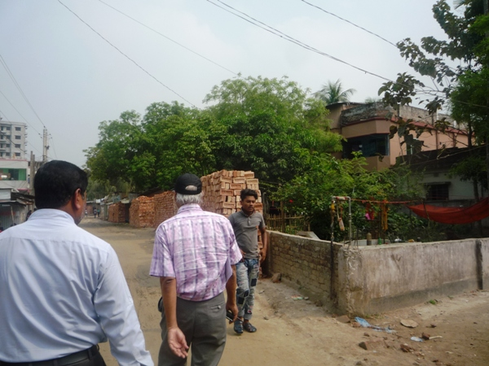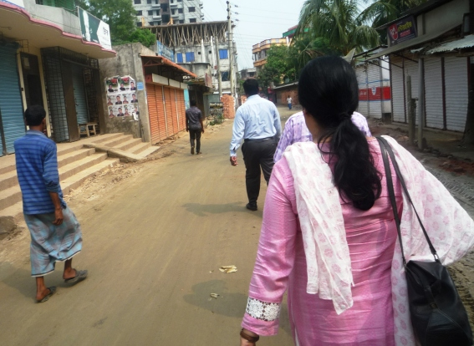
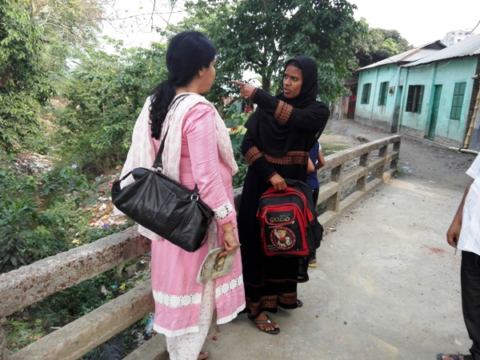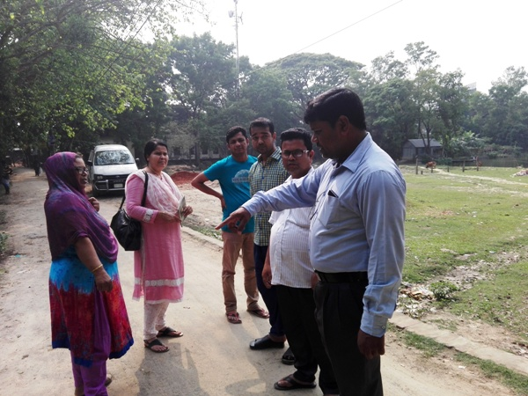

Photographs 7.1.1: DSM Consultant Team with Pourashava Representatives Inspected the Proposed Road

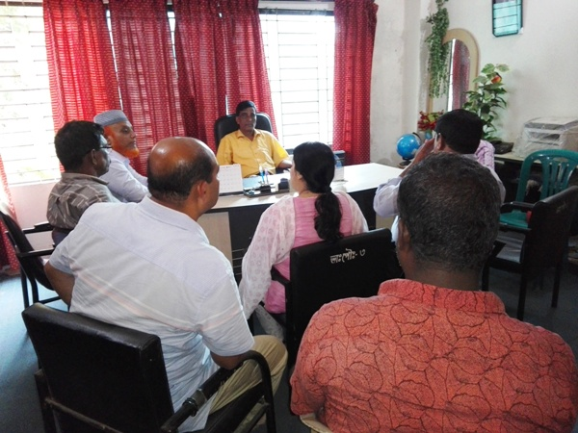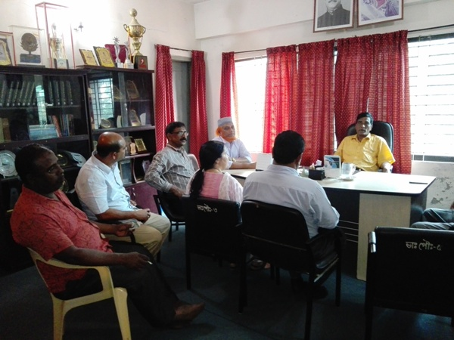

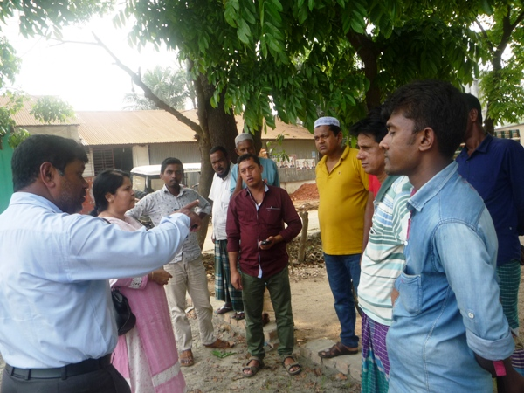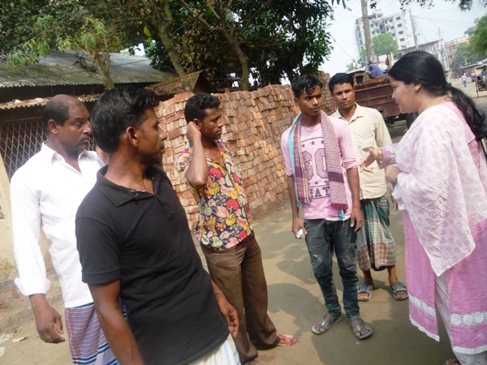

Photographs 7.1.2: Consultation Meeting at subproject sites with Pourashava Officials and Consultants Participants

Issues Raised by the Participants

The participants raised the issues related to the infrastructure development of Bhaluka Pourashava. They emphasized on the subproject selection for the future development and also discussed about the procedure for the quality construction work. In the FGD, the participants discussed the requirements of the infrastructure development of Bhaluka Pourashava through a list of the subprojects.

Feedback, Suggestions, and Recommendations of the Participants

The participants’ feedback, suggestions, and recommendations listed below:
- The participants suggested that quality and schedule of the construction work should be maintained properly;
- The FGD results confirmed that an improved communication network by various road construction for future development of Bhaluka Pourashava is needed;
- The participants addressed the infrastructural facility like Kitchen Market with slaughter house at Bhaluka Bazaar;
- The participants proposed that public toilets construction is needed;
- Construction of road beautification under Kheru River Bridge is proposed which will be the connecting road of the Bhaluka Bazaar.
To encourage participation, regular consultations are recommended with beneficiary communities to share subproject related information and to provide a feedback mechanism for these communities to voice their concerns and issues in all stages of the subproject. The DSM consultants and PMU, LGED will be responsible to carry out continued consultation with and information dissemination to the key stakeholders.

8 Conclusions and Recommendations

This study assists to understand the initial environmental impacts due to the subproject as well as to formulate the applicable mitigation and monitoring plans. Based on the environmental assessment, all possible environment aspects have been adequately assessed and necessary mitigation measures have been formulated to minimize the adverse impacts.
The overall conclusion is that if the mitigation, compensation, and enhancement measures are entirely implemented, there will be no significant negative environmental impacts as a result of location, design, construction, and or operation of the proposed subproject.
The conclusions of the environmental assessment can be summarized as follows:
- The short-term negative impacts that may come such as air quality, noise, solid waste, occupational health and safety will be minimized through the mitigation measures;
- The subproject will create employment for the workforce who live in the vicinity of the construction site and will provide them a short-term economic gain.
A few key recommendations are outlined below:
- All mitigation, compensation, and enhancement measures proposed in this report should be followed by the concern authorities for implementing the subproject;
- The environmental management and monitoring plan proposed in this report also needs to be followed;
- Regular monitoring by Pourashava, PMU (LGED) and DSM consultants is needed;
- The contractor will ensure using of the PPEs by the workers where applicable;
- The contractor is responsible for the proper disposal of the generated wastes materials from the subproject sites and campsite;
- The EMP shall be made binding on contractor operating the site, and will be included in the contractual clauses;
- Due to changing circumstances during the construction phase if any, there might be minor adaptation needed for environmental, health and safety issues.

9 REFERENCE

Bhaluka Pourashava Master Plan: 2011-2031 Urban Area Plan

Bhaluka Pourashava at a glance

Environmental Assessment Volume 1: Overall Environmental Assessment [Draft Final Report], September 2013. Municipal Governance and Services Project (MGSP), Local Government Engineering Department (LGED) and Bangladesh Municipal Development Fund (BMDF), Ministry of Local Government, Rural Development and Cooperatives, Government of the People's Republic of Bangladesh.

Environmental Assessment Volume 2: Environmental Management Framework (EMF) [Draft Final Report], September 2013. Municipal Governance and Services Project (MGSP), Local Government Engineering Department (LGED) and Bangladesh Municipal Development Fund (BMDF), Ministry of Local Government, Rural Development and Cooperatives, Government of the People's Republic of Bangladesh.

Appendix
Appendix 1: Environmental Monitoring Checklist

Local Government Engineering Department

Municipal Governance Services Project (MGSP)

Environmental Compliance Monitoring Form
Part A: General Subproject Information

Subproject Name | 1. Improvement of Bhaluka-Birunia Road by RCC Casting starting from Thana Moor to Dakkhin Bhaluka Primary School (L=570 m) under Bhaluka Pourashava.  2. Construction of RCC Drain start from Altu Mia House to Golashangun Khal on Bhaluka-Birunia Road ( Ch. 00 to 380 m) under Bhaluka Pourashava.  3. Construction of RCC Drain on T & T Road starting from Major Vita to Golashangun Khal effective length = 1025 m, under Bhaluka Pourashava
Package No. | MGSP/BLK/2018-19/W-08
ULB Name | Bhaluka Pourashava
Approved Estimated Cost in BDT
Contract Amount in BDT
Contractor Name
Date of Commencement
Target Date of Completion
Physical Progress (%)
Financial Progress (%)
Person Responsible (PIU)
(Name, Designation &Phone) for the Overall Subproject Management

Person Responsible (DSM)
(Name, Designation &Phone) for the Overall Subproject Management

Form Completed by
(Name, Designation &Phone)
Overall Environmental Description of the Subproject

Part B: Design, Preparation, and Legal Requirements
Environmental Concerns (PMU, PIU & DSM)  (Name, Designation & Phone) | PMU-
 | PIU-
 | DSM-
Subproject Category | DoE-BD- | WB-
Environmental Clearance Received? | Yes | No
EA Required? | Yes | No
EA Prepared and Delivered? | Yes | No
EMP Prepared & Delivered Separately? | Yes | No
Items and Cost of EMP Implementation Included in the Contract? | Yes | No
EMP Included in the Procurement Documents? | Yes | No
Inspection Schedule/Last Inspection/Monitoring by  PMU Environmental Concerns | Date-
 | Key findings-
Inspection Schedule/Last Inspection/Monitoring by  PIU Environmental Concerns | Date-
 | Key findings-
Inspection Schedule/Last Inspection/Monitoring by  DSM Environmental Safeguard Specialist/Jr. Environmental Specialist | Date-
 | Key findings-

Part C: Key Environmental Impacts
The Subproject Results in any of the following Impacts? | Yes | No | NA | If yes, is the impact (give observation)
 |  |  |  | Significant | Moderate | Minor
Felling of the trees
Clearing of the vegetation that increase the risk of increased soil degradation or erosion
Disturbance of the terrestrial and or aquatic specifies
Noise pollution
Air pollution
Adverse effects on the quantity or quality of the surface water or groundwater
Production or increase the production of the solid waste
Drainage congestion
Water logging that increases the risk of the water related diseases
Traffic congestion
Public safety

Part D: Work Place Environment and Gender Equity
The Subproject Results in any of the following Impacts? | Yes | No | NA | Observations
Does the contractor pay to the workers regularly?
Is there any discrepancy between the male and female workers regarding the wages or salary for the same works?
Is the contractor complying with the GOB labor law concerning the hiring of the workers?
Does the contractor engage women labors and does the project have suitable works for them?
Does the contractor engage child labor (less than 18 years) and aged people (more than 65 years old)?
Does the contractor force to the workers for the completion of the works?
Do the workers involve with the political activities, crime, drugs addiction and other forms of unwanted activities?
Are construction camps adequately equipped with water supply, sanitary toilets, washing facilities and facilities for waste collection and storage?
Has separate sanitation facilities been provided for women at work camps and the construction site?

Part E: Potential Impacts, Mitigation Measures, and Monitoring Indicator Mentioned in the EMP
Activity / Issues | Potentials Impacts | Proposed Mitigation and Enhancement Measures | Responsible Parties
Construction and operation of labor shed for the workers (Workforce and labor shed management) | - Generation of sewage and solid waste may cause water/ environmental pollution | - Construction of sanitary latrine considering 15 persons for one toilet at the labor shed and separate toilet for male and female;  - Erection of “no litter” sign, provision of waste bins/cans (introduce separate waste bins for organic and inorganic wastes);  - Ensure wastes (solid wastes and other forms of the waste) disposal at the vacant place beside Dhaka-Mymensingh Highway. | Contractor  Monitoring-  Primarily by Pourashava  Secondarily by PMU, LGED and DSM
 | - Health of workers | - Conduct formal and unofficial discussion to increase awareness about hygiene practices among the workers;  - Ensure availability and access to first-aid equipment and medical supplies for the workers.
 | - Possible development of labor camp into permanent settlement | - Contractor to remove labor camp at the completion of contract.
 | - Outside labor force causing negative impact on health and social well-being of local people | - Ensure that contractor employ local work force to provide work opportunity to the local people and conduct formal and unofficial awareness program for the health and social well being of the local people.
General construction works | - Drainage congestion and flooding | - Ensure provision for adequate drainage of storm water, if needed;  - Ensure provision for pumping of congested water, if needed;  - Ensure adequate monitoring of drainage effects, especially if construction works are carried out during the wet season. | Contractor  Monitoring-  Primarily by Pourashava  Secondarily by PMU, LGED and DSM  Contractor  Monitoring-  Primarily by Pourashava  Secondarily by PMU, LGED and DSM
General construction works | - Air pollution | - Check regularly and ensure that all the subproject vehicles are in good operating condition;  - Ensure contractor spray water on dry surfaces regularly to reduce dust generation;  - Maintain adequate moisture content of soil and sand for transportation, compaction, bed preparation, backfilling and handling;  - Ensure contractor sprinkle and cover stockpiles of loose materials (e.g., fine aggregates);
General construction works | - Traffic congestion, effect on traffic and pedestrian safety | - Ensure schedule deliveries of materials/ equipment during off-peak hours;  - Place traffic sign to avoid undue traffic congestion and associated traffic control measures to limit possible disruption;  - Inform the local people about the subproject activities.
General construction works | - Noise pollution | - Check and maintenance the equipment properly;  - Avoid using of construction equipment producing excessive noise at night;  - Avoid prolonged exposure to noise (produced by equipment) by the workers;  - Regulate use of horns and avoid un-due use of hydraulic horns by subproject vehicles.
General construction works | - Water and soil pollution | - Prevent discharge of fuel, lubricants, chemicals, and wastes into adjacent water bodies, low lands and soil.
General construction works | - Felling of trees, clearing of vegetation and ecological disturbances | - 65 nos. of timber, medicinal and beatification trees will be replanted to compensate the felling trees.
General construction works | - Accidents | - Conduct formal and informal discussion for creating awareness about the accidents;  - Provide PPEs (personal protective equipment) and ensure using of the PPEs by the workers.
General construction works | - Spills and leaks of oil, toxic chemicals | - Proper handling of lubricating oil and fuel so that it does not fall on the soil and adjacent pond;  - Collection and proper disposal of the spills.
All construction works | - Beneficial impact on employment generation | - Employ local people in the subproject activities as much as possible;  - Give priority to poor people living within subproject area in subproject related works (e.g., excavation and other works, which do not require skilled manpower).
All construction works | - General degradation of the environment | - Ensure environmental enhancement measures, such as tree plantation, and cautionary signs.
All construction works | - Accident due to dismantle of the existing road | - Carefully operation of the hammer.
Environmental impacts due to the key construction activities and corresponding mitigation measures for the RCC road and RCC drain
Excavation and site clearing & grubbing work | - Generation of loose and clay soil due to the earth excavation work | - Disposal of soil and construction wastes at the vacant place beside Dhaka-Mymensingh Highway.  - Cover exposed earth works with fabric. | Contractor  Monitoring-  Primarily by Pourashava  Secondarily by PMU, LGED and DSM
Excavation and site clearing & grubbing work | - Accidents | - Carefully handle of the hydraulic excavator.
Excavation and site clearing & grubbing work | - Air pollution | - Regular maintenance of the equipment.
Precast RCC pile driving work | - Accident due to careless driving of pile. | - Carefully operate the pile driving equipment  - Ensure the use of PPEs.
Sand filling/Back filling for RCC Road and RCC Drain | - Air and dust pollution affecting nearby settlements | - Maintain adequate moisture content of soil during transportation, compaction and handling;  - Carry the materials especially loose soil and sand with adequate cover.
Cutting & welding of the reinforcement for RCC Road and RCC Drain | - Noise Pollution | - Avoid using of rod cutter and wielding machine at night;
 | - Health and Safety | - Ensure use of the PPEs;  - Availability and access to first-aid equipment and medical supplies.
RCC (reinforcement concrete) work for RCC Road and RCC Drain | - Air pollution due to black emission | - Regular maintenance of the concrete mixer and vibrator machine.
RCC (reinforcement concrete) work for RCC Road and RCC Drain | - Noise pollution | - Avoid operation of the concrete mixer and vibrator machine at night;
Prepared by- Signature- Date-
Copies to 1. PIU
2. SME
3. AME
4. Jr. ES

