Subproject Background

Bhaluka Pourashava is situated at Mymensingh District. It is established as a Pourashava in the year of 1998. This is A Type Pourashava with present population of 63,773. The Pourashava covers area of 10.42 Sq. km. The total pucca drain is 3.20 km and 8.50 km earthen. The existing infrastructure facilities are not adequate to meet the present demand. Hence, this subproject directly will contribute for the infrastructure development of the Pourashava.

This subproject includes the following components: Construction of the RCC Drain with Footpath and Street Light. Under this subproject, the RCC Drain will be constructed from Dhaka-Mymensingh Highway to Bhaluka East End at the left side of the road which length is 795 m for reducing the drainage congestion. The length of the existing drain is 250 m which is not enough for proper drainage system in this area. The significant features of the subproject are mentioned below:

Name of the Subproject | RCC Drain with Footpath and Street Light at Gafargaon Road
Package No. | MGSP/BLK/2015-2016/W-02
District Name | Mymensingh
Pourashava Name | Bhaluka Pourashava
Ward Number | 02, 04 and 06
Structural Design  Option | RCC Drain and Street Light
Ward Population | About 30,000
Tribal People | No tribal people found in the subproject area
Land Acquisition | RHD owned (RHD has given permission to the Bhaluka Pourashava for the development works). Again any anticipated social issues are measured by Social safeguard team and measures should be taken accordingly
Estimated Cost | 18.15 million BDT
Subproject Duration | 12 months
Tentative Start Date | September 04, 2016
Tentative Completion Date | September 03, 2017

Objectives of the Study

The general objective of this study is to determine the major environmental impacts succeeding from execution of the subproject and to recommend mitigation measures to avoid or reduce adverse environmental impacts and to enhance positive impacts. The specific objectives include:
- To assess the existing environmental conditions of the subproject site and its influence area;
- To identify and assess impacts resulting from the subproject during its construction phase and operation phase;
- To develop a environmental management plan with recommendations for mitigating impacts and enhance positive impacts;
- To summarize environmental monitoring requirements.

Scope and Methodology of the Study
During the preparation of the subproject appraisal, environmental screening has been performed. According to that screening, environmental assessment is required to fulfill the regulatory requirement of the subproject. Hence, this environmental study has been prepared to meet the regulatory requirements. The study methodology comprised the following activities:
Desktop Study
The desktop study involved:
- Initial meetings with client and stakeholders to discuss about the proposed subproject, including subproject activities;
- Collection and review of the baseline data, maps, reports and other relevant information on the existing environmental and social conditions of the subproject area;
- Review of the relevant existing legislation, regulation and policies;
- Understand the anticipated technical processes that may affect the environment.

Field Investigation and Data Collection
A team of the consultants made a field investigation to the proposed site. Field investigations involved mainly site walks within the subproject area and the neighboring areas that may be affected by the subproject. The following key tasks were performed during the field visit:
- Taking photographs of the significant aspects to describe the baseline environmental conditions of the subproject area;
- Interviews with representatives of the Pourashava Officials, within the subproject area and interested and affected people within the subproject influence zone;
- Verifying information and data collected during the desktop study and to collect new information that may have been important in the assessment of the impacts and design of the mitigation measures.

Data Analysis and Report Writing
The data and information collated from all the sources (literature review, secondary and primary data, public consultation) were analyzed to describe the existing environmental setting of the subproject area, to identify the potential positive and negative impacts of the proposed subproject, as well as to provide preliminary suggestions for mitigation measures. Finally, this environmental assessment report has been prepared.

Subproject Description

The Study Area
The subproject is situated within the jurisdiction of the ward numbers 2, 4 and 6. The starting point of the Gafargaon Drain is located at Dhaka-Mymensingh Highway with 24°24'17.40"N (Latitude) and 90°23'10.28"E (Longitude).The end point of this drain is located at Bhaluka East End with 24°24'20.05"N (Latitude) and 90°23'18.43"E (Longitude).The location map and topographic features of the subproject are shown in Figure 2.1.1, Figure 2.1.2.

Figure 2.1.1: Location Map of the Subproject

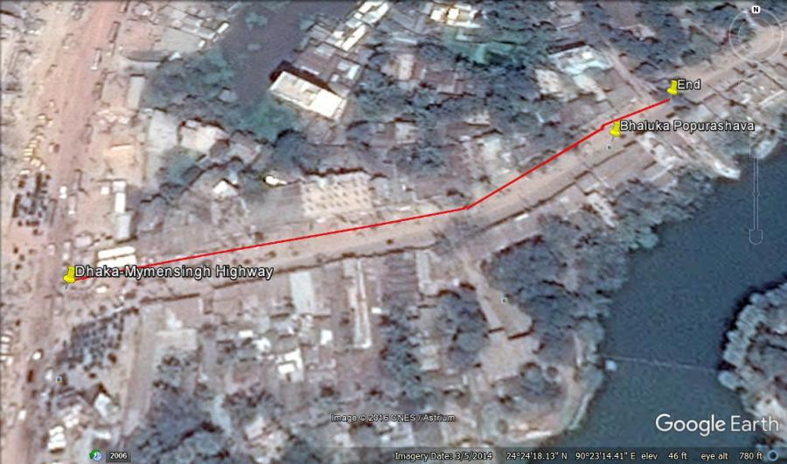

Figure 2.1.2: Topographic Features of the Subproject

Current Situation and Need for the Subproject

The subproject passes through the built-up area with the roadside semi-pucca, pucca and tin-shed shops and houses, various outlet (Walton, Hitachi, Konka), Monument, Pourashava Office, Upazila Parishad, Bhaluka BM College, Morning Sun Model High School and College, Janata bank, Bhaluka Eye Hospital, Sapla Bidda Niketon, University Coatching Centre.
The existing drainage system is not enough in the subproject area. For this reason, the drain subproject is essential for proper drainage facilities in the municipality. Seeing that drainage system is one of the key components of the urban infrastructure, therefore, this drain subproject will also indirectly accelerate the rapid urbanization of the municipality. This subproject will reduce public health hazards and odor pollution by reducing water logging problems. As a result, the people of the surrounding area will get better environment. This drain will serve the most established areas of the municipality. Hence, the area of the population served will be significantly large.
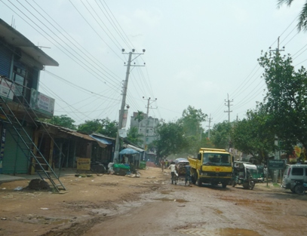
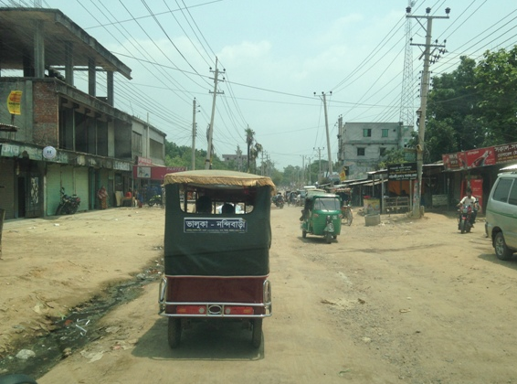
On the contrary, absent of street light hampers normal traffic operation and pedestrian movement at night. In addition, probability of crime and road accident increases at night time. Therefore, fixing of street light will improve the quality of life; crime and accident will also be minimized. The existing scenario of the proposed road is further elaborated from the following Photographs 2.2.1.

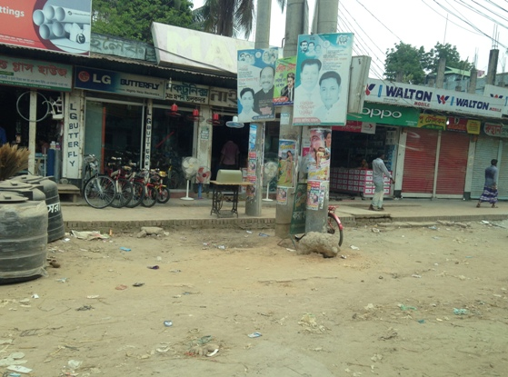
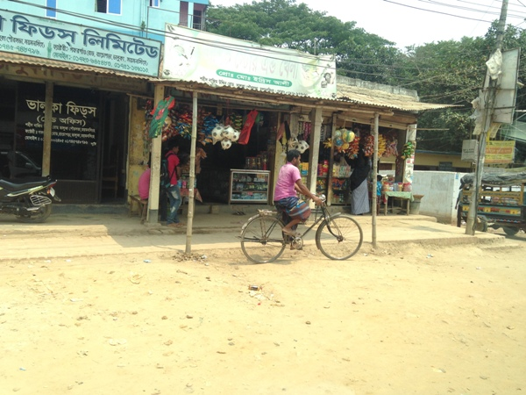

Photograph 2.2.1: Current Situation of Subproject Site

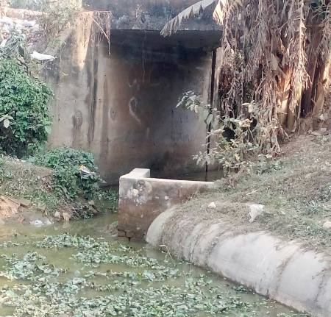
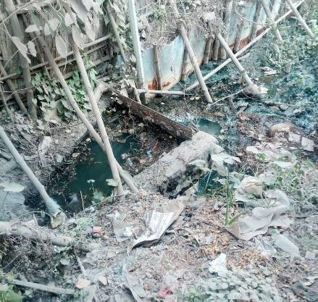
The drain finally connects with the Kheru River (starting point of Dhaka-Mymensingh Highway) via crossed culvert and Bakchatra Khal which will act as outfalls. The existing condition of the outfalls is further elaborated by the Photographs 2.2.2.

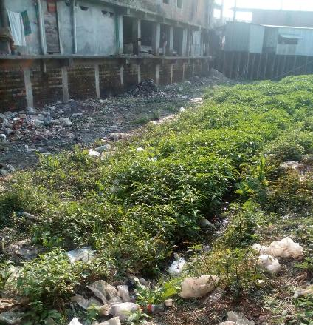
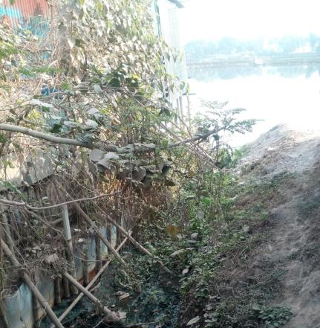

Photographs 2.2.2: Present Situation of the Outfalls

Justification of Selection of the Subproject

CIP list was prepared with several subprojects by WB team, PMU (LGED), DSM and Bhaluka Pourashava Officials as per Pourashava requirement. After that, Bhaluka Pourashava Officials proposed the subproject based on priority list among CIP list. After investigating the subproject site by DSM team and PMU (LGED), the subproject is selected for implementation. Generally, investigating team consider the positive and negative impacts of the subproject if the negative impacts in all sectors is minor than positive impacts, the subproject is selected for development. For this subproject, road side trees and built-up infrastructures will not be severely affected. Hence, land acquisition is not an issue for implementation of this subproject because it is RHD owned (RHD has given permission to the Bhaluka Pourashava for the development works). Specially, this subproject is selected considering the benefits of the operation of the subproject including drain and street lights.

Envisaged Subproject Activities and Implementation Process

For RCC Drain:
- Clearing and grubbing;
- Earth work in excavation of the foundation trenches;
- Sand filling in foundation trenches and inside plinth with sand;
- Mass concrete work in foundation or floor
- Reinforced cement concrete work
- Plain cement concrete work
- Polythene sheet laying work
- Fabrication of the ribbed or deformed bar reinforcement;
- PVC pipe fitting work;
- Brick masonry work
Electrification (Street Light) work:
- Assembling, fitting, fixing, installation, testing and commissioning of the GI pole;
- Erection of tubular pole,
- Earthing the electrical installation with 38mm dia GI pipe;
- Fixing of the wire rack;
- Fixing of the overhead aluminum stranded conductor,
- Providing, fixing and fitting of the water tight street light with aluminum reflector.
- Fitting and fixing main and sub-main switch with fuse;
- Supplying and fitting 250 volt, 50HZ grade concealed sub-distribution board made of 18 SWG mild steel sheet

The materials and resources to be used for the key activities: soil in earth work, sand, stone chips, cement, reinforcement, diesel, kerosene, MS sheet, steel cutter, steel shutter, boulders, electricity and water.
The major equipment to be used for the implementation of the subproject: hydraulic excavator, brick breaking machine, concrete mixer machine, mechanical vibrator machine, mixture machine, mechanical compaction machine, pneumatic dump truck, water tanker, pump.

Baseline ANALYSIS OF THE ENVIRONMENTAL CONDITION

Physical Environment

Important Environmental and Infrastructural Features

There are various environmental and infrastructural features in the subproject area. These environmental and infrastructural features have been collected by field investigation. The conditional survey has also been performed for designing of the subproject. The conditional survey data is also used for preparing the report. The findings of the site inspection and investigation from Dhaka-Mymensingh Highway to Bhaluka East End (Chainage 0 to 430 m and 0 to 610 m of the Layout Plan) in Table 3.1.1 and Table 3.1.2.
Table 3.1.1: Major Environmental and Infrastructural Features for Chainage 0 to 430 m

Chainage (m) | Left | Right | Key Environmental Features
0-100 | √ |  | Sapla Bidda Niketon, trees, electric poles, tin-shed shops
0-100 |  | √ | Tin-shed shops, open space, houses, trees, Connecting Road, electric poles
100-200 | √ |  | Semi-pucca and tin-shed shops, open space, houses, trees, multistoried building
100-200 |  | √ | Trees, shops, houses, Connecting Road, electric poles
200-300 | √ |  | Pucca and semi-pucca shops, trees, electric poles
200-300 |  | √ | Bhaluka BM College, Bhaluka Eye Hospital, market, varieties electronic outlet, pucca & semi-pucca structures, electric poles
300-430 | √ |  | Monument, electric and telephone poles, tree, shops
300-430 |  | √ | Multistoried Building, shops, Janata Bank, electric poles

Table 3.1.2: Major Environmental and Infrastructural Features for Chainage 0 to 610 m

Chainage (m) | Left | Right | Major Environmental Features
000-100 | √ |  | Upazila Parishad, electric poles, trees
000-100 |  | √ | Pourashava Office, Morning Sun Model High School and College, Sanchita University Admission Coaching Centre, Bonoful Manshon, Grameen Bank, tin-shed shops, trees, electric poles
100-200 | √ |  | Multistoried building, shops, Padakhep Manushik Unnoyon Center, electric poles
100-200 |  | √ | pucca and semi-pucca shops, multi storied building, electric poles
200-300 | √ |  | Semi-pucca shops, trees, electric poles
200-300 |  | √ | Semi-pucca shops, trees, electric poles
300-400 | √ |  | Shops with various structures, electric poles
300-400 |  | √ | Shops, electric poles
400-500 | √ |  | Various shops, trees, electric poles
400-500 |  | √ | Saw mills, electric poles, trees
500-610 | √ |  | Saw mill, trees, open place, pucca, semi-pucca and tin-shed structures
500-610 |  | √ | Low land, trees, Connecting Road, open place, tin-shed structures, electric poles

Geology, Topography, and Soils

Bhaluka Pourashava area is almost fIat. The Pourashava is located on the bank of the Khiru River. The maximum elevation is 14.53 m PWD and the minimum elevation is 2.22 m PWD. Eleven general soil types exist in the area of which deep red brown terrace, shallow red brown terrace soils and Acid Basin Clays are the major ones. Soils in the valleys are dark grey heavy clays. They are strongly acidic in reaction with low status of organic matter, low moisture holding capacity and low fertility level. Bhaluka Pourashava belongs to Madhupur Tripura Threshold. Surface geology is consisted of sedimentary rocks originated by riverine processes. According to BNBC (2006), Bangladesh has three seismic zones with moderate and low seismic activity. The Pourashava falls in Zone I.
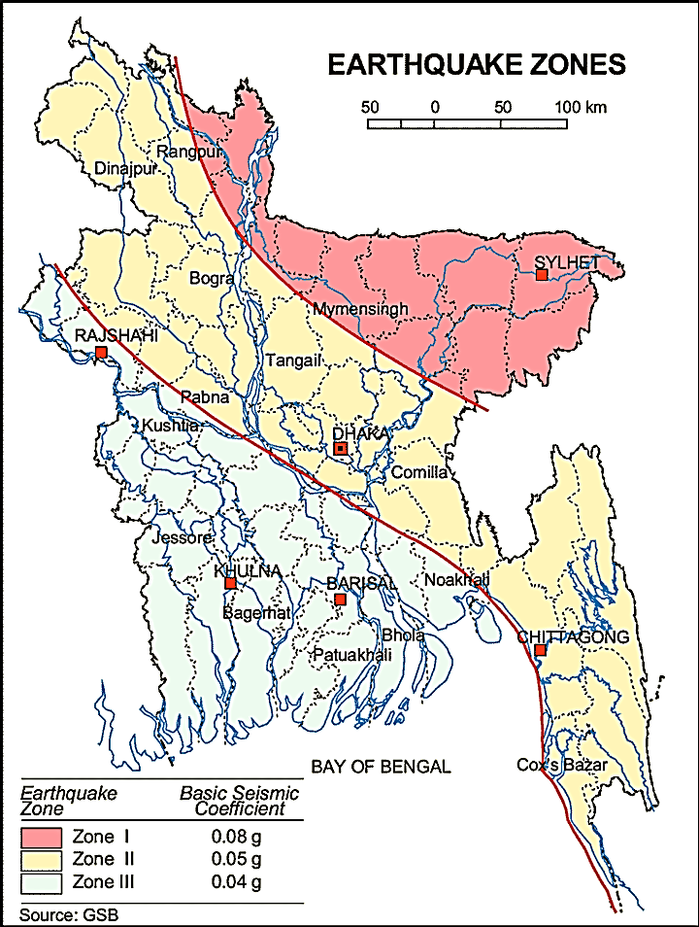

Figure 3.1.1: Location of Bhaluka in Earthquake Zone Map of Bangladesh

Climate and Meteorology

The climate of the subproject area can be described as Tropical Monsoon. It is characterized by warm, humid summers and cool, dry winters. The climate is tropical in Bhaluka. When compared with winter, the summers have much more rainfall. This location is classified as Aw by Köppen and Geiger. The average temperature in Bhaluka is 25.5 °C. About 2110 mm of precipitation falls annually. The driest month is December. There is 3 mm of precipitation in December. In June, the precipitation reaches its peak, with an average of 429 mm.
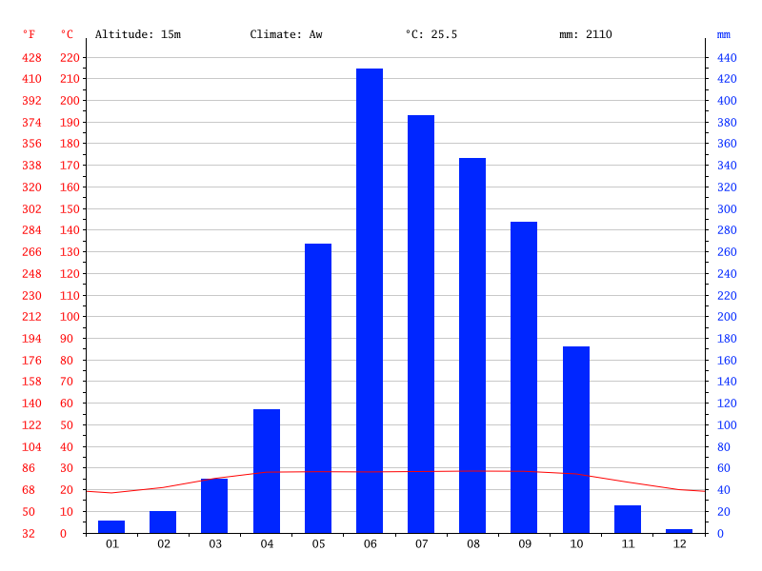

Figure 3.1.2: Climate Graph of Bhaluka Pourashava

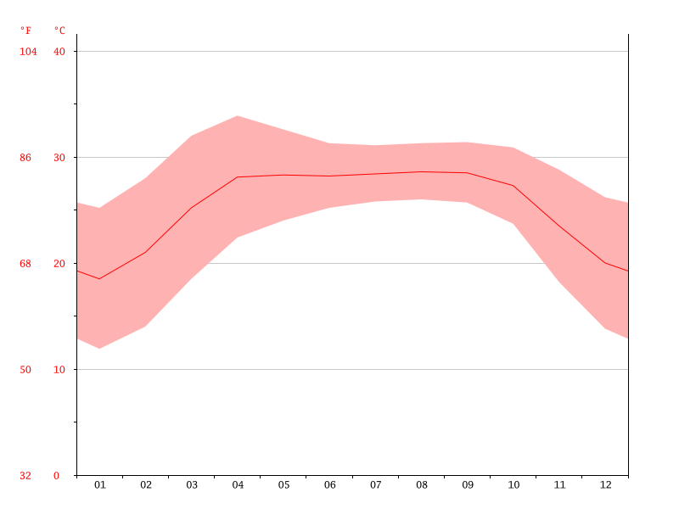
With an average of 28.6 °C, August is the warmest month. At 18.5 °C on average, January is the coldest month of the year.

Figure 3.1.3: Temperature Graph of Bhaluka Pourashava

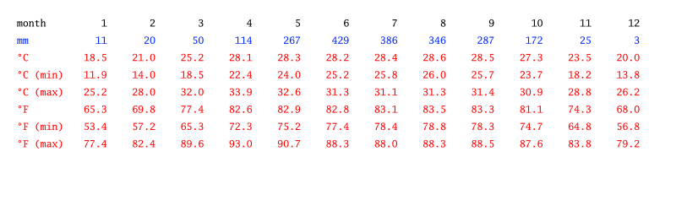

Table 3.1.3: Climate Table of Bhaluka Pourashava

The precipitation varies 426 mm between the driest month and the wettest month. The variation in annual temperature is around 10.1 °C. Useful hints about reading the climate table: For every month, you will find data about precipitation (mm), average, maximum and minimum temperature (degrees Celcius and Fahrenheit). Meaning of the first line: (1) January, (2) February, (3) March, (4) April, (5) May, (6) June, (7) July, (8) August, (9) September, (10) October, (11) November, (12) December. The average wind speed as recorded at Mymensingh Met Station is in the range of 2 – 7.8 knots/ hr. But in the winter months it remains in the range of 1-4.5 knots/hour.

Water Resources

Bakchatra Khal and Kheru River are adjacent to the subproject area. This river and khal influence the hydrology of the Pourashava. Bhaluka Pourashava belongs the hydrogeological unit II of Holocene deltaic and floodplains. Ground water is available here in plenty and water table does not go beyond suction limit throughout the year. Ground water is available at shallow depth. Groundwater is the main source of potable water in the subproject area. Groundwater is not saline and normally arsenic and iron free.

Flooding, Water Logging and Drainage Pattern
According to previous data, this area is not affected in historical severe flood events such as 1988, 1998, 2004 and 2007. Flooding in the monsoon season normally lasts from June to September. High water level is caused by the combination of heavy local rainfall.

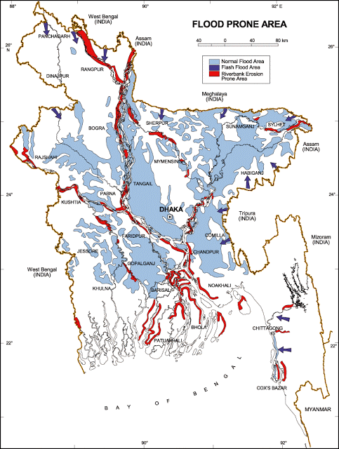

Figure 3.1.4: Location of Bhaluka Pourashava in Flood Zone Map of Bangladesh
Air Quality and Dust
The degradation of the air quality is mainly from windblown dust and emission from the vehicles. The rough surfaces of the road generate dust during vehicles movement. Improper disposal of the solid wastes also spread bad odor which causes air quality degradation. During construction phase black smoke emission from mechanical compactor, hydraulic excavator and vehicles used for transportation activities may degrade the air quality.

Noise Level

Noise is generated mainly from the vehicles movement and hydraulic horn. As it central area of the Pourashava, the noise is generated due to public gathering. During construction phase mechanical compactor, hydraulic excavator and vehicles used for transportation activities may create temporary noise nuisance within the subproject boundary.
Solid Waste Management

The Pourashava has a dump site at the vacant place near Kheru River. The municipality provide service for household waste collection from door to door and dump at the vacant place near Kheru River. Also, the generated wastes due to construction activities will be dumped at this same place of the Pourashava.

Biotic Environment

Flora and Fauna

The floral species at road side are Coconut (Cocos nucifera), Akashi (Acacia auriculiformis), Mango (Mangifera indica), Jackfruit (Atrocarpus heterophy), Banana (Musa acuminata), Eucaliptus (Eucalyptus globulus), Date (Phoenix dactylifera) and Palm (Borassus flabellifer).

The common local birds such as Doel, Shalik, Kite, Owl, Crow, Tuntuni and Cuckoo in Bengali were found during the site visit. There are no wild animals and endangered fauna species in this area.

Socio-economic and Socio-cultural Environment

Land Use

The subproject area is basically commercial area. The land use of built-up area with road side shops, various electronic outlets, Govt. offices (Pourashava and Upazilla Parishad Offices), clinic, hospital, banks, coaching center, school, college and few houses.
Beneficiary Population

The subproject is situated within the jurisdiction of the Ward number 02, 04 and 06. Considering the ward population about 30,000 people will benefit directly and many others indirectly.

Education
In the municipality, literacy among the population is about 73.8%. This is higher than the national average (51.8%). The literacy rate among males (76.5%) is still more than females (70.8%). (Ref: Population and Housing Census 2011).

Tribal Communities
There is no indigenous or tribal people settlement in the subproject area. Hence, no measures needed for the indigenous peoples’ safeguard.

Land Acquisition and Resettlement

Gafargaon Road is RHD Road. Bhaluka Pourashava Authority has taken permission from RHD department for constructing drain. However, in case of this matter, the Social safeguard team will investigate the actual situation. For developing drain, road side structures will not be affected. That is why, demolition work is no need. Then, measures will be taken as per rules.

Status of Housing and Built-up Infrastructure
The road side’s built-up infrastructure mainly includes pucca, semi-pucca, few multistoried buildings and very few tin-shed shops are shown in the subproject area. In recent years, due to improvement of the economic conditions people are constructing multistoried buildings.
Principal Livelihoods and Economic Activities
Like other municipality, the subproject area is now inhabited by the mixed occupational people. The major income comes from farm activities and the non-farm such as business, enterprises and jobs. Presently, a significant number of people work in the small trades, transport operations, private sector and government jobs. Increased awareness of the social issues and NGO activities has changed the poverty scenarios.
Cultural Heritage and Protected Areas
The historical site named Marks of the War of Liberation Memorial monument is present at Bhaluka Bus Stand which is situated at the subproject area. The local important institutes include Bhaluka BM College, Bhaluka Eye Hospital, Sapla Bidda Niketon, Morning Sun Model High School and College.

Social Conflicts and Development Activities

The local community welcomes this subproject. There are some ongoing subprojects under Pourashava funded by government and other donor agencies. However, there is no visible conflict between the donors and agencies reported by the local community.

ENVIRONMENTAL SCREENING

Environmental Screening for the subproject has been conducted with the purpose of fulfilling the requirements of Government (GOB) and World Bank (WB) for the preparation of subproject appraisal. Environmental Screening Checklist, as adopted in Appendix C of the Environmental Management Framework (EMF) of the MGSP, was administered for identifying the impacts and their extents.
The screening data and information for the Drain have been formulated and are shown in below.
(1) Potential Environmental Impact during Construction Phase:
(a) Ecological Impacts:
15

- Felling of trees Significant □ Moderate □ Minor □√ Number of trees
- Clearing of vegetation Significant □ Moderate □ Minor □√
- Potential impact on species of Significant □ Moderate □ Minor □√
Aquatic (i.e., water) environment
Ecological impacts mainly due to felling of the trees and clearing of the road sides’ natural vegetation which is not significant.
(b) Physicochemical Impacts:
- Noise pollution Significant □ Moderate □√ Insignificant □
- Air pollution Significant □ Moderate □√ Insignificant □
- Drainage congestion Very likely □ Likely □ Unlikely □√
- Water pollution Significant □ Moderate □ Insignificant □√
- Pollution from solid/construction wastes Significant □ Moderate □√ Insignificant □
- Water logging Significant □ Moderate □ Insignificant □√
The subproject will have temporarily negative impact on noise level and air quality, pollution from solid waste/construction waste during construction phase. The subproject will have no adverse impact on the topography, climate and soil, water quality and regional hydrology.
- Socio-economic Impacts:
- Traffic congestion Very likely □ Likely □√ Unlikely □
- Health and safety Significant □ Moderate □√ Insignificant □
- Impact on archaeological and historical Significant □ Moderate □ Insignificant □√
- Employment generation Significant □ Moderate □√ Insignificant □
The subproject will have temporarily negative impact in traffic congestion, health and safety. But positive impact by employment generation during construction phase.
(2) Potential Environmental Impact during Operation Phase:
(d) Ecological Impacts:
- Potential impact on species of aquatic Significant □ Moderate □ Minor □√
(i.e., water) environment
(e) Physicochemical Impacts:
- Potential air quality Improvement □ No-improvement □ Deterioration □√
- Potential noise level Improvement □ No-improvement □ Deterioration □√
- Drainage congestion Improvement □√ No-Improvement □ No Impact □
- Risk of Water pollution Significant □ Moderate □ Insignificant □√
- Pollution from solid waste Improvement □ No-improvement □ Minor □√
Increased traffic volume due to the improved road facilities may degrade the air quality and noise level from vehicles emission and horn.
(f) Socio-economic Impacts:
- Traffic Improvement □√ No-improvement □ Adverse □
- Safety Improvement □√ No-improvement □ Adverse □
- Employment generation Significant □ Moderate □√ Minor □
This road will improve the road network system in the Pourashava area and enhanced transportation system.

3) Summary of Possible Environmental Impacts of the Subproject
From the screening, it seems that the subproject is not going to create any significant adverse environmental impacts. Felling of the trees and clearing of the road sides’ vegetation has negative ecological impact. Some earthwork will be involved; however, no agricultural productive soil will be used for the purpose. The dismantle works, site clearing and grubbing works will generate solid wastes, construction debris, and other wastes materials that should be disposed properly. The inputs that may affect the environment mainly will be at construction phase and limited within the subproject boundary. Moreover, mitigation measures will be taken according to the EMP for minimizing the air, dust, and noise pollution. Nevertheless, this subproject will have positive social impacts in terms of the generation of the employment during construction phase. In addition, tree plantation will enhance the ecological condition.

Specific impact, mitigation AND enhancement measures

The subproject includes construction of the 795 m RCC Drain with Street Light. The possible impacts are mainly caused by the activities required for the implementation of the subproject and materials, resources and equipments to be used to perform the activities. This section describes some specific impacts due to the subproject activities and their mitigation measures.

Dismantle Work/Earthwork

The drain improvement work consists of dismantle of the damaged sub-base and base course works, earth excavation, earth filling and cutting, and removal of the unsuitable materials. These works lead dust blowing, noise and vibration which disturb the local people.
Mitigation

- Careful operation of the hydraulic excavator during excavation and earth filling so that this activity does not disturb the roadside area;
- Avoid loss of topsoil for the earth work;
- Cover the exposed earth with mulch fabric;
- Quick disposal of the wastes to the selected dumping site at the vacant place near Kheru River;

Tree plantation

There are about 15 planted trees will be felled down and natural herbs and shrubs along the roadsides will be cleared for implementing of the subproject.
Mitigation

- 50 nos. of trees will be planted to compensate the ecological imbalance to be caused due to cutting of the existing trees;
- The trees (Akashi, Mango , Jackfruit or any kind of the local fruits and flowers) will be planted at suitable place both sides of the road. Planting trees will enhance the ecological balance of the subproject area after their successful growth.

Pollution from the Construction Materials

Dumping of the construction spoils, including accidental leakage of the oil, grease, and fuel in equipment yards is a significant hazard. Surface water and soil quality might be polluted from these contaminants. Even the people to be engaged for the construction activities might endanger the physical and human habitats of the area.

Mitigation

- Safe transport, storage, and disposal of the construction materials, and the equipment have to be carried out in order to avoid the accidental spillage and loss;
- Fuels, lubricants, and other hazardous materials should store over raised platforms and not directly on the ground;
- The playgrounds of the educational institutions should not use as a stockyard or work camp.

Air Quality and Dust

During construction phase, air pollutants will be emitted from the equipment and construction vehicles are expected to remain low. Local residents in the vicinity of the work sites will be temporarily disturbed by the limited dust pollution. The overall impacts, however, are expected to remain low.
Mitigation

- Water should be sprayed at the work site for dust control. Ensure sprinkle and cover stockpiles of loose materials (e.g., fine aggregates).
- Maintain adequate moisture content of soil and sand for transportation, compaction and handling;
- Avoid use of dust generating equipment far from the local residents;
- Ensure that all project vehicles are in good operating condition.

Noise and Vibration

Noise and vibration caused by the equipment and movement of the construction vehicles may temporarily disturb nearby residents. In this subproject, sensitive areas like roadsides’ houses and shops are likely to be affected from the noise, though the impacts are anticipated to be limited.
Mitigation

- Transportation of the construction materials have to be carried during the scheduled times, and mainly during the day;
- If needed, all powered mechanical equipment and machineries will be fitted with noise abating gear such as mufflers for effective sound reduction.

Water Quality

The water quality may deteriorate if the construction materials, construction wastes, effluent from work camps, and food waste are dumped in the canal, pond, and low land adjacent to the subproject site.
Mitigation

- Proper construction management including waste management as well as training of the operators and other workers should provide to avoid pollution of the water bodies;
- Construction waste will dispose properly (not in the ditch, water bodies or lowland), for which contractor will be responsible.

Occupational Health and Safety
The most important risks associated with the construction activities are listed below:
- Exposure to the sunlight- workers are being exposed to the sun for long hours;
- Exposure to the high temperature, and humidity for a long time resulting in dehydration;
- Contact with the hazardous substances and wastes pose risks of the infections and diseases;
- Risk from the traffic collision or accidents during operation of the equipment such as hydraulic excavator and vehicles movement for the transportation activities of the subproject;
- Risks from head loads for carrying soil, construction materials and construction equipment;
- Risks from poisonous reptiles such as snakes;
- Risk associated to the sudden bad weather working conditions such as storm, thunder storm and earth quake etc.
General Requirements for the Workers’ Health and Safety
The key salient features of the general requirements for the workers’ health and safety stated are presented in Table 5.7.1.
Table 5.7.1: General Requirements for the Workers Health and Safety
Issues | Requirements
Health and Hygiene | - Cleanliness at the site premises and workers living places and at the Labor Shed;  - Arrangement of the proper ventilation and temperature at the Labor Shed;  - Protection against dust and furnace by using of the nose masks and covering of the head and body;  - Proper disposal of the wastes and effluents;  - Provision of the adequate latrines and separate toilets for the women;  - Sufficient dustbins for the solid waste management system.
Safety and First Aid Box | - Using of the personal protective equipment (helmet, gloves, goggles, nose mask, safety boots);  - Precautions during work on or near machineries in motion;  - Head loads are prohibited;  - First aid facilities should be provided and maintained;  - Ensure first aid box;  - The first aid kit should include adhesive bandages, regular strength pain medication, gauze, and low grade disinfectant.
Compensation for Accidents at Work | - Contractors will bear medical treatment costs. If any severe accidents such as loss of hands, legs or loss of working ability or any case of death needs compensation-(the amount of the compensation should be fixed considering the type of accidents).
Dust and Fumes | - For any dust, fumes, or other impurities likely to be injurious to the workers, effective measures shall be taken to prevent their accumulation and its inhalation by the workers.
Overcrowding | - No labor room should be overcrowded.
Latrines and Urinals | - Sufficient latrines shall be provided;  - Latrines shall be maintained in clean and sanitary condition;  - Latrines shall be adequately lighted and ventilated.
Disposal of Wastes and Effluents | - Proper disposal system for the solid waste and effluent is required.

Impacts on Social Environment and Common Property Resources

The anticipated social impacts are expected not to be severe and to be largely manageable. The following Table 5.8.1 presents impacts on socio-economic environment and common property resources.
Table 5.8.1: Impacts on Social Environment and Common Property Resources
Social Components | Impacts on IECs | Impact Significance
Community Perception | The local community people welcome this subproject and there is no visible objection from them. | Significant (+ve)
Employment and Business Opportunity | Community feels happy because generally the local contractor will be engaged for the construction works which will create work opportunity for the skilled and non-skilled labor. The subproject will create business opportunity for the equipment and materials suppliers’. | Significant (+ve)
Community Order and Security | This subproject activity does not create any severe security problems to the local community and community people. | Minor  (-ve)
Possible damage to infrastructure and facilities | Possible damage of the existing road infrastructure by the construction equipment and vehicles used in this subproject. | Minor  (-ve)
New infrastructure and facilities | Improvement of the existing road will enhance infrastructure facilities. | Moderate  (+ve)
Agriculture and Land Use | No direct impact on agriculture however, it could affect the adjacent land to a very limited extent. | Minor  (-ve)
Landscape and Aesthetics | This subproject activity temporarily will degrade landscape and aesthetics values of the subproject area to a limited extent. | Minor  (-ve)
Labor Habitat | Most of the labors will stay at the Labor shed which will have impacts on the environment relates to the generation of the solid wastes, effluent, and water consumption. | Moderate  (-ve)
Health Care | Workers may suffer from the dehydration problems, respiratory problem, and other health hazards. | Minor  (-ve)
Accident | In case of road accidents by the vehicles to be used for the transportation may have serious negative impact. | Significant  (-ve)

Specific Measures and Guidelines for the Key Social Issues
The primary objective of these guidelines is to ensure social compliances and requirements required for the subproject. The social guidelines required for the subproject as appeared in this report is given in below.
- Conduct dissemination with details about the subproject to the local community;
- Continue liaison with the community leaders in order to maintain the community support;
- Engage and ensure local contractor and local people for positive perception of the local community;
- Ensure no child workers (less than 18 years) and aged worker (more than 65 years) at the site;
- Ensure no discrimination between the male and female in terms of the wages and getting work opportunity;
- Consult with the local people for restriction of the unnecessary entrance to the site by the children and others;
- Monitor the contractor to ensure regular payment to the workers;
- Consult with the workers for the feeling of any health problems and take measures accordingly;
- Monitor the workers movement for avoiding any unexpected social activities (robbery, crime, political attachment and conflicts, taking drugs);
- Monitor contractor behavior and attitude to the workers.

Environmental Management Plan (EMP)

The purpose of the Environmental Management Plan (EMP) is to ensure that the activities are undertaken in a responsible and non-detrimental manner. The EMP will guide the environmentally sound construction of the subproject and ensure efficient lines of communication between the PMU (LGED), Bhaluka Pourashava, DSM, and the contractors.

Access to Information

The environmental assessment report should be translated into Bengali and disseminated locally. The copies of the report (both in English and Bengali) will be sent to all the concerned personnel responsible for subproject implementation. It will also be made available to the public. The final assessment report will also be uploaded in the LGED website and the World Bank website after approval.

Grievance Redress Mechanism

The project-specific Grievance Redress Mechanism (GRM) has been established at Bhaluka Pourashava to receive, evaluate, and facilitate the solution of APs concerns, complaints, and grievances concerning the social and environmental performance of the subproject. The GRM aimed to provide a time-bound and transparent mechanism to voice and resolve social and environmental concerns linked to the subproject.
The grievance mechanism is related to resolve the risks and adverse impacts of the subproject. It addresses APs’ concerns and complaints promptly, using an understandable and transparent process that is also gender responsive, and culturally appropriate. It is readily accessible to all the segments of the affected people at no costs and without retribution. The mechanism should not impede access to the country’s judicial or administrative remedies. The affected people will be appropriately informed about the mechanism.
LGED has its own Grievance Redress Procedure (GRP), which it operates to address any dissatisfaction and complaints by the local people regarding its activities. This procedure is being applied to address any complaints or grievances through negotiations with the community leaders and representatives of APs during implementation of the MGSP.

6.2.1 Grievance Redress Committee (GRC)

The discussions and negotiations will be conducted by the Project Implementation Unit (PIU) of Bhaluka Pourashava, and will be involved the APs and Grievance Redress Committee (GRC) headed by the Pourashava Mayor. With the facilitation of DSM, the Pourashava Mayor nominated the GRC members and included representative from Government Agencies, local NGO, and Civil Society. The GRC has been formed and established at Bhaluka Pourashava. A complaints box will be provided in the Pourashava Office. The grievance response focal point is available at Bhaluka Pourashava for instant response to an aggrieved person. The Focal Point will collect the written complaints or suggestions from the box, and produce them to the GRC for hearing and resolution. The GRC members are as follows:

Table 6.2.1.1: Grievance Redress Committee (GRC) Member List
No | GRC Member Name | GRC Designation | Self Position
1 | Dr. A.K. M Mezbah Uddin | Chairman | Mayor, Bhaluka Pourashava
2 | A.K.M Fazlul Haque | Member Secretary | Executive Engineer, Bhaluka Pourashava
3 | Md. Shahiduzzaman | Member | Upazila Education Officer, Bhaluka
4 | Md. Abdur Rauf | Member | Principal, Bhaluka Degree college
5 | Md.Abdur Rashid | Member | Executive Director, ASPADA, Bhaluka
6 | A.B.M Zia Uddin | Member | Civil Society Representative
7 | Female Ward Councilor | Member | Related Female Ward Councilor (Reserved Seat)
8 | Ward Councilor | Member | Related Ward Councilor
9 | Mannur Ahmed | Focal Point | Assistant Engineer Bhaluka Pourashava

6.2.2 Grievance Resolution Process

All complaints and suggestions will be received formally in the Pourashava Office by the GRC Member Secretary. A sample Grievance Redress Form has been prepared and sent to Bhaluka Pourashava prior to the implementation of the subproject.
An intake register will be maintained at the office of the Member Secretary. Member Secretary will record the details of the grievances in the intake register for documentation and ensure impartiality, fairness, and transparency. The intake register will have data and information columns including (i) Case no., (ii) Date of receipt, (iii) name, type of complaint, grievance, (iv) father’s name, husband’s name, (v) sex, (vi) complete address of the person raising the complaint, grievance, (vii) main objection (loss of land, property, or entitlement), (viii) detailed complaint story, (ix) expectation with documentary evidence and previous records of similar grievances, etc.
No GRC members are allowed to contact the aggrieved persons in advance. Rather, the concerned persons are informed to attend the formal hearings at an appointed date. The GRC committee will sit for hearing the complaints of the aggrieved persons. The GRC will record salient points presented by the aggrieved person and will examine documentary evidence submitted during informal hearings. A resolution register will be maintained by the Member Secretary at the Bhaluka Pourashava Office. The resolution register will contain (i) serial no., (ii) case no., (iii) name of complaint, (iv) complaint story and expectation, (v) date of hearing, (vi) date of field investigation (if any), (vii) results of hearing and field investigation, (viii) decision of GRC, (ix) progress (pending, solved) and (x) agreement or commitments. Closing register will keep records such as, (i) serial no., (ii) case no., (iii) name of complaint, (iv) decision and response to complaints, (v) mode and medium of communication, (vi) date of closing, (vi) confirmation of complainant's satisfaction, and (vii) management actions to avoid recurrence.
The GRC will decide within 30 days of receiving a complaint. There will also be an appeals procedure where, if a person is dissatisfied with the ruling of the GRC, he or she or a representative may attend their next meeting to present the case again. The committee will then reconsider the case in private, after which their decision is final. If the appellant is still not satisfied, he or she has the right to take the case to the public courts. LGED and Bhaluka Pourashava should also publish the outcome of cases on public notice boards. All costs involved in resolving the complaints (meetings, consultations, communication, and information dissemination) will be borne by Bhaluka Pourashava.
Based on consensus, this procedure will help to resolve issues or conflicts amicably and quickly, saving the aggrieved persons from having to resort to expensive, time consuming legal action. The procedure will however, not pre-empt a person’s right to go to the courts of law.

Institutional Arrangement for the Safeguard Compliances
In the institutional arrangement procedure, Project Director, and Team Leader/ Deputy Team Leader will directly involve. The PD, TL/DTL would be supported by DSM Environmental Safeguard Specialist and Social Management Expert. The Pourashava Officials, especially engineers, would be responsible for supporting the construction supervision with the help of DSM consultants. The civil works contractors will implement the environmental mitigation measures.
The PMU (LGED), with the help of Environmental Safeguard Specialist and Social Management Expert, will submit the monthly and quarterly progress reports on Environmental and Social Compliances to World Bank.
PD-MGSP
TL/DTL-DSM
Environmental Safeguard Specialist-DSM
Social Management Specialist-DSM
Senior Municipal Engineer-DSM
Junior Environmental Specialist-DSM
Assistant Municipal Engineer-DSM
Social Management Officer-DSM
Bhaluka
Pourashava Representative/ Focal Point/ Asst. Engineer

Contractor
Figure 6.3.1: Environmental and Social Management Team (Tentative)

Capacity Building
A demonstration training program has already been conducted by PMU (LGED) and DSM for the Comilla region on 16th May, 2016 for capacity building of PMU (LGED), PIU and DSM field staffs. The participants from Bhaluka Pourashava were attended in the training program. Under this training program, PMU(LGED) and DSM organized an introductory course for training the Bhaluka Pourashava officials and DSM field staffs, preparing them on: (i) Environmental Screening, (ii) EMP Implementation, including environmental monitoring requirements related to mitigation measures; and (iii) taking immediate action to remedy unexpected impacts or ineffective mitigation measures found during construction phase. From the demonstration training program, it is revealed that single workshop is not adequate for capacity building of the people responsible for subproject implementation. The contractor should be also included in the training program to enhance the environmental awareness and orientation. A detailed training manual has already been developed by the Environmental Safeguard Specialist and Social Management Specialist prior to the demonstration training program. Hence, the existing manual will be reviewed and modification will be done as per requirement for the next training program.

Emergency Response and Disaster Management

Disaster management can be defined as the organization and management of
resources and responsibilities for dealing with all humanitarian aspects of emergencies, in particular the preparedness, response, and recovery to lessen the impact of disasters. Emergency Preparedness Planning (EPP) and Contingency Planning (CP) are the processes of disaster management plan for developing strategies, arrangements, and procedures to address the humanitarian needs of those adversely affected by the crisis. There are four main types of disasters, namely: Natural disasters, Environmental Emergencies, Complex Emergencies, and Pandemic Emergencies.
For MGSP activities, Bhaluka Pourashava would identify the immediate needs, prioritize the tasks, and identify resource requirements to address the humanitarian needs of those adversely affected by the crisis. The indication of disaster and post-disaster impacts and their management have been shown in this report in the relevant impacts and mitigation section.

Environmental Management Action Plan

The activity wise anticipated environmental impacts and corresponding mitigation measures have been outlined in Table 6.6.1 and Table 6.6.2.

Table 6.6.1.Anticipated Environmental Impacts during Construction Phase and Corresponding Mitigation and Enhancement Measures (EMP Table)
Activity / Issues |  | Potentials Impacts |  | Proposed Mitigation and Enhancement Measures |  | Responsible Parties
Construction and operation of labor shed for the workers (Workforce and labor shed management ) |  | - Generation of sewage and solid waste may cause water/ environmental pollution |  | - Construction of sanitary latrine/septic tank system at the labor shed;  - Erection of “no litter” sign, provision of waste bins/cans;  - Ensure wastes (solid wastes and other forms of the waste) disposal at the dumping site which is the vacant place near Kheru River |  | Contractor  Monitoring-  Primarily by the Pourashava  Secondarily by the LGED and DSM
 |  | - Health of workers |  | - Conduct formal and unofficial discussion to increase awareness about hygiene practices among the workers;  - Ensure availability and access to first-aid equipment and medical supplies for the workers.
 |  | - Possible development of labor camp into permanent settlement |  | - Contractor to remove labor camp at the completion of contract.
 |  | - Outside labor force causing negative impact on health and social well-being of local people |  | - Ensure that contractor employ local work force to provide work opportunity to the local people and conduct formal and unofficial awareness program for the health and social well-being of the local people.
General construction works |  | - Drainage congestion and flooding |  | - Ensure provision for adequate drainage of storm water, if needed;  - Ensure provision for pumping of congested water, if needed;  - Ensure adequate monitoring of drainage effects, especially if construction works are carried out during the wet season. |  | Contractor  Monitoring-  Primarily by the Pourashava  Secondarily by the LGED and DSM
 |  | - Air pollution |  | - Check regularly and ensure that all the subproject vehicles are in good operating condition;  - Ensure contractor spray water on dry surfaces regularly to reduce dust generation;  - Maintain adequate moisture content of soil and sand for transportation, compaction, bed preparation, backfilling and handling;  - Ensure contractor sprinkle and cover stockpiles of loose materials (e.g., fine aggregates);  - Avoid use of equipment such as stone crushers at site, which produce significant amount of particulate matter and noise;  - Place stone crushers at site far from the local residents.
 |  | - Traffic congestion, effect on traffic and pedestrian safety |  | - Ensure schedule deliveries of material/ equipment during off-peak hours;  - Place traffic sign to avoid undue traffic congestion.
 |  | - Noise pollution |  | - Check and maintenance the equipment properly;  - Avoid using of construction equipment producing excessive noise at night;  - Avoid prolonged exposure to noise (produced by equipment) by the workers;  - Regulate use of horns and avoid use of hydraulic horns in project vehicles.
 |  | - Water and soil pollution |  | - Prevent discharge of fuel, lubricants, chemicals, and wastes into adjacent water bodies and soil;  - Install sediment basins to trap/grating in the outfall of the drain prior to discharge to the surface water;  - Regular checking and maintenance of sediment basins/grating.
 |  | - Accidents |  | - Conduct formal and informal discussion for creating awareness about the accident;  - Provides PPEs and ensure using of the personal protective equipment by the workers.
 |  | - Spills and leaks of oil, toxic chemicals |  | - Proper handling of lubricating oil and fuel so that it does not fall on the soil and adjacent water bodies;  - Collection and disposal of spills.
All construction works |  | - Beneficial impact on employment generation |  | - Employ local people in the project activities as much as possible;  - Give priority to poor people living within project area in subproject related works (e.g., excavation and other works, which do not require skilled manpower).
 |  | - General degradation of the environment |  | - Ensure environmental enhancement measures-50 trees will be planted to compensate the felled trees and traffic signs will be provided.
Imparting training on environmental issues to labors of the drain |  | Labor can create harmful situation at the subproject site |  | - Environmental related training should be organized by the authority to  train the labor about environmental issues
Environmental impact due to the key construction activities and corresponding mitigation measures for the RCC Drain
Excavation/ /Dismantle work/site clearing |  | - Generation of solid & construction wastes;  - Generation of loose soil. |  | - Exposed earth works with mulch fabric and cover;  - Disposal of soil and construction wastes at the dumping site which is the vacant place near Kheru River |  | Contractor  Monitoring-  Primarily by the Pourashava  Secondarily by the LGED and DSM
 |  | - Accidents |  | - Operate the hydraulic excavator carefully;  - Operate the hammer carefully for the dismantle work.
Soil using for the drain |  | - Fertility of the soil may be reduced |  | - Collection of soil/earth to be done from less fertile land uniformly, so that land topography/ changes uniformly  - Soil/earth can be taken by re-excavation of river required for proposed road construction  - Check control of disruption or denudation of earth surface |  | Contractor  Monitoring-  Primarily by the Pourashava  Secondarily by the LGED and DSM
Sand filling/Back filling work for the drain |  | - Air and dust pollution affecting nearby settlements |  | - Maintain adequate moisture content of soil and sand during transportation, compaction and handling;  - Carry the materials especially loose soil and sand with adequate cover. |  | Contractor  Monitoring-  Primarily by the  Pourashava  Secondarily by the LGED and DSM
Cutting & welding of the reinforcement for drain |  | - Noise Pollution |  | - Avoid using of rod cutter and wielding machine at night;  - Avoid prolonged exposure to noise (produced by equipment) by workers.
 |  | - Health and Safety |  | - Ensure use of the PPEs;  - Availability and access to first-aid equipment and medical supplies.
RCC (reinforcement concrete) work for drain |  | - Air pollution due to black emission |  | - Regular maintenance of the concrete mixer and vibrator machine.
 |  | Noise pollution |  | - Avoid operation of the concrete mixer and vibrator machine at night;  - RCC work should be avoided at schooling time.
Cutting trees for drain |  | Climate may be changed of the Pourashava |  | - Tree cleaning to be done as per requirement for construction activities and/or to reduce accidents  - All vegetated areas cleared will be replaced by plantation of suitable trees as approved by LGED and Department of Forest |  | Contractor  Monitoring-  Primarily by the Pourashava  Secondarily by the LGED and DSM
Constructing temporary drain |  | Drainage congestion, water logging and flooding |  | - Provide proper surface drainage to drain site  - Proper alternative drainage to be facilitated  - Proposed drain alignment should be provided enough opening for surface drainage  - Careful disposal of construction materials/equipment and construction of  labor shade so that they do not interrupt the local drainage |  | Contractor  Monitoring-  Primarily by the Pourashava  Secondarily by the LGED and DSM
Table 6.6.2.Anticipated Environmental Impacts during Operation Phase and Corresponding Mitigation and Enhancement Measures (EMP Table)
Activity/Issues | Potential Impacts |  | Proposed Mitigation and Enhancement Measures |  | Responsible Parties
Operation and maintenance for drain | Pollution of downstream water body due to disposal of polluted water from the drain. |  | - Ensure installation of septic tank in all establishments;  - Stop direct connecting sanitation facilities to storm drain. |  | Primarily by the  Pourashava  Secondarily by the LGED
Operation and maintenance for drain | Blockage in the drain due to disposal of solid waste/debris. |  | - Creation of awareness, introduce SWM system and install cover in open manholes if any;  - Regular maintenance/cleaning of the drain

Environmental Monitoring Plan

Environmental Monitoring Plan will help to evaluate the extent and severity of environmental impacts against the predicted impact and the performance of environmental protection measures. The following Table 6.7.1 and Table 6.7.2 have been prepared for the key environmental indicators.
Table 6.7.1: Matrix Table of Monitoring Plan (Visual and observation during construction phase)
Monitored Parameter/ Issues | Monitoring method/ Key Aspects | Location of Monitoring | Period & Monitoring Frequency
Safety orientation & training of workers | Frequency of training & orientation of workers for safety | Subproject site | - Once in a month  - Reporting: Once in a month
Personal Protective Equipment and safety equipment | Ensure every single person involved in the activities wear and use safety equipment | Subproject site | - Daily  - Reporting: Once in a month
Worker’s health | Monitoring process of worker’s health | Subproject site | - Daily  - Reporting: Once in a month
Sanitation & drinking water facility to the workers | Availability of safe drinking water and sanitation to the workers | Subproject site | - Daily  - Reporting: Once in a month
Incident record & reporting | Documented record of all incident, accident, and its remedial process | Subproject site | - Daily  - Reporting: Once in a month
Site security | Isolation of site from general access | Subproject site | - Daily  - Reporting: Once in a month
Bulletin/ announcement boards/ prohibition signs | Visible in good condition or not | Subproject site | - Daily  - Reporting: Once in a month
Equipment /vehicles | Switched-off diesel engines when not in use;  Search any possible leakage;  Fuelling. | Subproject site | - Daily  - Reporting: Once in a month
Dust | Dust is visible or not | Subproject site | - Daily  - Reporting: Once in a month
Oil waste generation and disposal | Quantity of oily waste, storage and disposal | Subproject site | - Daily  - Reporting: Once in a week
Solid waste generation | Quantity of solid wastes and disposal | Subproject site | - Daily  - Reporting: Once in a month
Drainage facilities | Provision of open /closed surface drainage at the labor shed | Subproject site | - Monthly  - Reporting: Once in a month
Gender equity | No discrimination regarding payment | Subproject site | - Daily  - Reporting: Once in a month
Child labor | No child will be engaged in the activities | Subproject site | - Daily  - Reporting: Once in a month
Handling of hazardous materials | Fuelling, storage, operation | Subproject site | - Daily  - Reporting: Once in a month

Table 6.7.2: Matrix Table of Monitoring Plan (Analytical Monitoring during construction phase)
Monitored Parameter/ Issues | Monitoring method/Key aspects | Location of monitoring | Period & Monitoring Frequency
Ambient air quality | - Visually-black smoke;  - Sampling;  - Analysis at laboratory;  - Data analysis of merits determination by using quality standards;  - Through digital instruments. | Project site | - Twice at construction phase;  - Reporting: Once in a month and immediately after measurement
Noise level | - Through digital instruments. | Project site | - Six times during construction phase;  - Reporting: Once in a month and immediately after measurement

In addition, a comprehensive Environmental Compliance Monitoring checklist has been preparing that is enclosed in Appendix-II.

Environmental Management Budget

Considering the environmental impacts and their mitigation measures for this subproject, several items are included in the BOQ for environmental management. The estimated cost for environmental management is elaborated in Table 6.8.1.
Table 6.8.1: Environmental Management Budget
Item No. | Description of Item | Costs (Tk)
Item No. | ENVIRONMENTAL MITIGATION AND ENHANCEMENT WORKS | Costs (Tk)
eme-1 | a) Dust suppression measures by water spraying in and around the site (Lump sum)  b) Dust suppression measures like water sprinkling on aggregates and unpaved roads at the work site (Lump sum) | 10,000.00
eme-3 | Noise level measurement. It can be measured from the pre-approved public institute/ university two times during construction phase @Tk. 5,000.00 per measurement (2*5,000.00 Tk) | 10,000.00
eme-4 | Water quality (pH, BOD5/COD, NH3) measurement. It can be measured from the pre-approved public institute/ university during construction period for waste water at source and waste water at outfall @Tk. 10,000.00 per sample (2*3*10,000.00 Tk). | 60,000.00
eme-5 | Prevention of the spillage, leakage of the polluting materials (Lump sum) | 5,000.00
eme-6 | Temporary camp site/work site waste disposal facility improvement (1no. of the organic waste and 1no. of the inorganic waste disposal facility) @Tk.20,000.00 (2*20,000.00 Tk) | 40,000.00
eme-7 | Water supply facilities (at the labor shed and work site):1no of tube well @ Tk 20,000.00 per tube well (1* 20,000.00Tk) | 20,000.00
eme-8 | Sanitation facilities (at the labor shed and work site): 2nos. of toilets preferably portable toilets (1 no. for women and 1no. for men) @ 20,000.00 (2* 20,000.00 Tk) | 40,000.00
eme-9 | Providing safety gear packages like hand gloves, spectacles for eye protection, helmets, masks, visible jacket, rubber shoes for at least 10 person (10*3,000.00Tk. ) and one first aid box (1*2,500.00Tk) | 32,500.00
eme-11 | Tree plantation at the roadside if possible or anywhere suitable places in the ULB area -Akashi, Gamari or any kinds of the local fruits and flowers (including protection, fencing and conservation during project defect liability period-fencing 1.0m dia 125 mm thick 1.50 m hieight with foundation perforated 1st class brick wall ) 50 nos.of tree @Tk 1,000.00 per tree (50* 1,000.00) | 50,000.00
 | Total | 267,500.00

After approval to revise the cost estimate has lengthy complex procedure. Hence, as per project EMF, PMU (LGED) suggestion and experience from other LGED projects, adequate budget has been allocated for the environmental management for the mitigation and enhancement measures. The subproject activities such as earth work, sand filling, black smoke emission from the subproject vehicles & equipment, preparation of bitumen mix in open place etc. may degrade the air quality in the subproject area. In addition, mechanical compactors, hydraulic excavator, drum truck and subproject vehicles generate noise nuisance to the surrounding area. Hence, the budget includes analytical monitoring for air quality and noise level. To enhance the ecological condition budget for tree plantation is included.
The budget for labor shed, site office construction and installation of cautionary sign/traffic sign is included in the civil works items. Therefore, it is not included in the environmental budget. It should be noted that the contractor will be paid as per actual work done.

Public Consultation and participation

Methodology

Public consultation and participation is a tool for managing two-way communication between the subproject sponsor and the public. Its goal is to improve decision-making and build understanding by actively involving individuals, groups and organizations with stakeholders of the subproject. This involvement will increase a subproject’s long term viability and enhance its benefits to locally affected people and other stakeholders. The information and feedback from the Pourashava people through consultation, participation and disclosure will ensure the proposed subproject design is right so that the views or preferences of stakeholders including potential beneficiaries and affected people can be adequately considered in subproject design, and continue at each stage of subproject preparation, processing, and implementation.
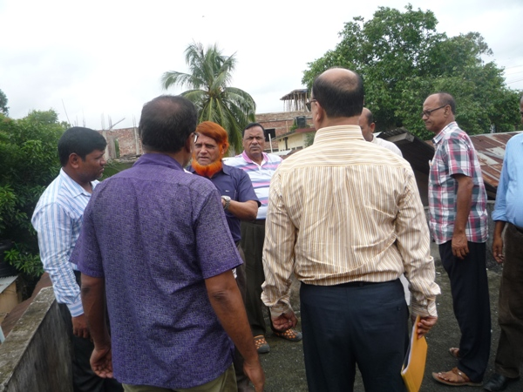
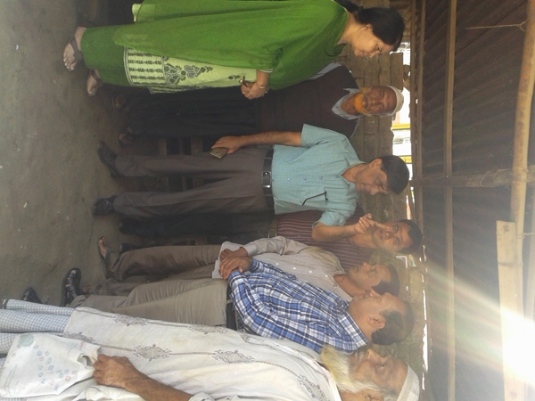
As part of the preparation of Environmental Assessment (EA) Report, participatory public consultations were organized and conducted with the Pourashava Mayor, Officials, Engineers, and local individuals as well as consultant participants at several locations covering the subproject site of the Pourashava and participatory meeting in the Pourashava office. Informal Focus Group Discussions (FGD) and a formal CIP were conducted involving the participants (Participant list is shown in Appendix-I). In addition, walk-through informal group consultations were also held. The local communities were informed about subproject interventions including their benefits. Suggestions made by the participants were listed and incorporated in the study where appropriate.

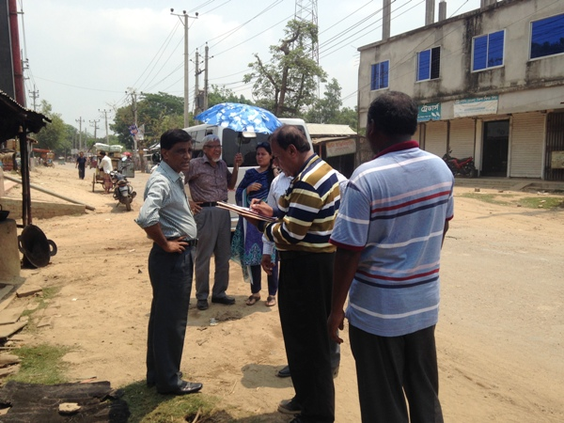
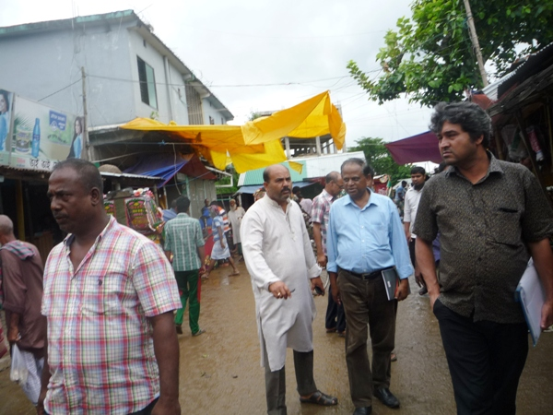

Photograph 7.1.1: Consultant Team visited the sites with Bhaluka Pourashava Officials

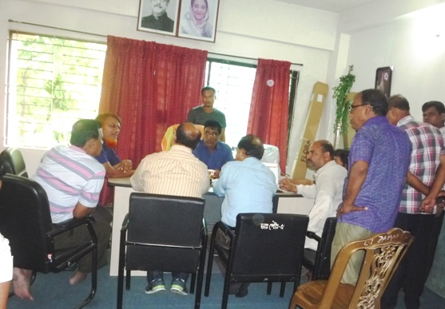
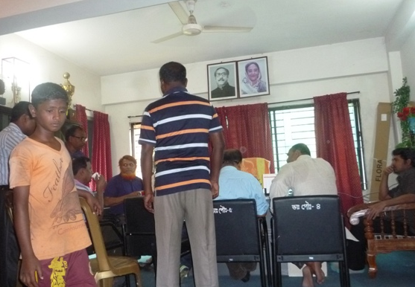

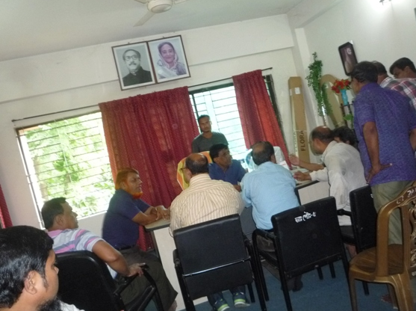
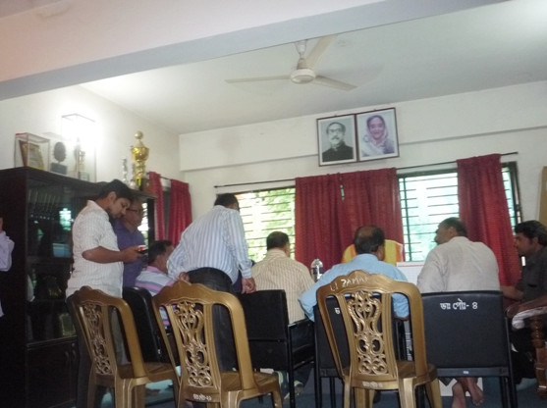

Photograph 7.1.2: Consultation Meeting at Bhaluka Pourashava with Pourashava Officials and Consultants Participants

Issues Raised by the Participants

The participants raised the issues related to infrastructure development of Bhaluka Pourashava. In the CIP and FGD, the participants discussed about the requirements for the future development through a list of the subprojects.

Feedback, Suggestions, and Recommendations of the Participants

The participants’ feedback, suggestions, and recommendations listed below:
- The FGD results confirmed that an improved communication network is fill up by various road construction for future development of Bhaluka Pourashava;
- The participants addressed the important infrastructural facility like Poura Super Market for multipurpose using at the front of Poura Bhabon.
- Kitchen market with slaughter house at Bhaluka Bazaar is necessary for this Pourashava.
- The participants proposed that public toilets construction is needed for this Pourashava.
- Construction of road beautification under Kheru River Bridge is proposed by the Bhaluka Pourashava which will be the connecting road of the Bhaluka Bazaar.
To encourage participation, regular consultations are recommended with beneficiary communities to share subproject related information and to provide a feedback mechanism for these communities to voice their concerns and issues in all stages of the project. The PMU (LGED) will be responsible to carry out continued consultation with and information dissemination to the key stakeholders.

Conclusions and Recommendations

Based on the environmental assessment, all possible environment features have been effectively assessed and necessary control measures have been formulated to meet with statutory requirements.
The overall conclusion is that if the mitigation, compensation and enhancement measures are implemented in full, there will be no significant negative environmental impacts as a result of location, design, construction, and/or operation of the proposed subproject. There will in fact be tremendous benefits from recommended mitigation and enhancement measures and major improvements in quality of life and individual, education, job and public health once the subproject is in operation.

The conclusions of the Environmental Assessment can be summarized as follows:

- A comprehensive Environmental Management and Monitoring Plan (EMP) has been prepared to mitigate and reduce the adverse impacts that will come out from the subproject activities. The EMP mainly focuses on managing, mitigating and reducing the impacts exhibited from design, construction and operation phase.
- The short-term negative impacts that may come such as air quality, noise, solid waste, occupational health and safety will be minimized through the mitigation plan;
- The communities will receive large benefits in terms of quality of life, particularly with improved health and safety, infrastructure, transportation and communication etc.
- The project will create employment for the workforce who live in the vicinity of the construction site and will provide them a short-term economic gain.
- The green belt development with large-growing trees at the periphery of the site will give the places a more natural and pleasing appearance.

Two straight recommendations which are listed below need to be followed by the concern authority to ensure sound environmental and socio-economic condition:

- All mitigation, compensation and enhancement measures proposed in this report need to be followed.
- The Environmental Management and Monitoring Plan proposed in this report also need to be followed.

APPENDIX

Appendix I: List of the Participants

Appendix II: Environmental Monitoring Checklist

