INTRODUCTION

Subproject Background

Bhaluka Pourashava is A Type Pourashava situated at Mymensingh District established as a Pourashava in the year of 1998. Bhaluka Pourashava covers 10.42 Sq. km area with present population of 63,773. The Pourashava consist of 18.85 km pucca pavement and 62.00 km earthen road. Currently, 550 number of street light only covers 20% of the entire demand. The existing infrastructure facilities are not adequate to meet the present demand. Therefore, this subproject will directly contribute infrastructure development of Bhaluka Pourashava.

This subproject includes the following components: Construction of BC Road including Box Culverts, Cross Drains, Retaining Walls and Street Light from Dhaka-Mymensingh Highway (Proshika Moar) to Bania-vita via Chaporbari Dakhil Madrasa and Bakshathra Moar. Under this subproject, the existing HBB (Ch. 0 -1130m), BC (Ch. 1130 - 1930m) and Earthen (Ch. 1930 - 2080m) road will be improved by new bituminous carpeting. This subproject also includes five box culverts at Ch. 30 m, 425 m, 1090 m, 1340 m and 1940 m and two cross drains at Ch. 640m and 1240m for diverting storm water from one side to another side. Under this subproject, retaining wall will be constructed at Ch. 0-30m, Ch. 400-500m, Ch. 1000-1100m and Ch. 1130-1280m and at Ch. 800-900m (one side). The significant features of the subproject are mentioned below:
Name of the Subproject | Construction of BC Road including Box Culverts, Cross Drains, Retaining Walls and Street Light from Dhaka-Mymensingh Highway (Proshika Moar) to Bania-vita via Chaporbari Dakhil Madrasa and Bakshathra Moar.
Package No. | MGSP/BLK/2016-2017/W-03
District Name | Mymensingh
Pourashava Name | Bhaluka Pourashava
Jurisdiction Area | 03
Structural Design Option | BC Road, Box Culvert, Cross Drain and Retaining wall
Beneficiary Population | About 15,000
Tribal People | No tribal people settlement found in the subproject area
Land Acquisition | No land acquisition is needed
Estimated Cost | 38.035 million BDT
Subproject Duration | 12 Months
Tentative Start Date | 03 March 2017
Tentative Completion Date | 02 March 2018

Objectives of the Study

The general objective of this study is to determine the major environmental impacts succeeding from execution of the subproject and to recommend mitigation measures to avoid or reduce adverse environmental impacts and to enhance positive impacts. The specific objectives include:
- To assess the existing environmental conditions of the subproject site and its influence area;
- To identify and assess impacts resulting from the subproject during its construction phase and operation phase;
- To develop a environmental management plan with recommendations for mitigating impacts and enhance positive impacts;
- To summarize environmental monitoring requirements.

Scope and Methodology of the Study

The subproject appraisal is included environmental screening for all the subproject components. According to that screening, no further environmental assessment is required for the street light. Nevertheless, environmental assessment is required to fulfill the regulatory requirement for BC Road. Hence, this report is mainly included BC Road. However, in the EMP table mitigation measures for street light are also included. The study methodology comprised the following activities:

- Desktop Study;
- Field Investigations and Data Collection;
- Data Analysis and Report Writing.

Desktop Study

The desktop study involved:
- Collection and review of the baseline data, maps, reports and other relevant information on the existing environmental and social conditions of the subproject area;
- Initial meetings with client and stakeholders to discuss about the proposed subproject, including subproject activities;
- Review of the relevant existing legislation, regulation and policies;
- Understand the anticipated technical processes that may affect the environment.

Field Investigation and Data Collection

The consultant team made a field investigation to the proposed site. Field investigations involved mainly site walks within the subproject area and the neighboring areas that may be affected by the subproject. The following key tasks were performed during the field visit:
- Taking photographs of the significant aspects to describe the baseline environmental conditions of the subproject area;
- Interviews with representatives of the Pourashava Officials, within the subproject area and beneficiary and affected people within the subproject influence zone;
- Verifying information and data collected during the desktop study and to collect new information that may have been important in the assessment of the impacts and design of the mitigation measures.

Data Analysis and Report Writing
The data and information collected from all the sources (literature review, secondary and primary data, public consultation) were analyzed to describe the existing environmental setting of the subproject area, to identify the potential positive and negative impacts of the proposed subproject, as well as to provide preliminary suggestions for mitigation measures. Finally, this environmental assessment report has been prepared.

Subproject Description

The Study Area
The subproject is situated within the jurisdiction of the ward number 03. The subproject starts at Dhaka-Mymensingh Highway (Proshika More) and ends at Bania-vita near Bhaluka Degree College. The location map of the subproject is shown in Figure 2.1.1.
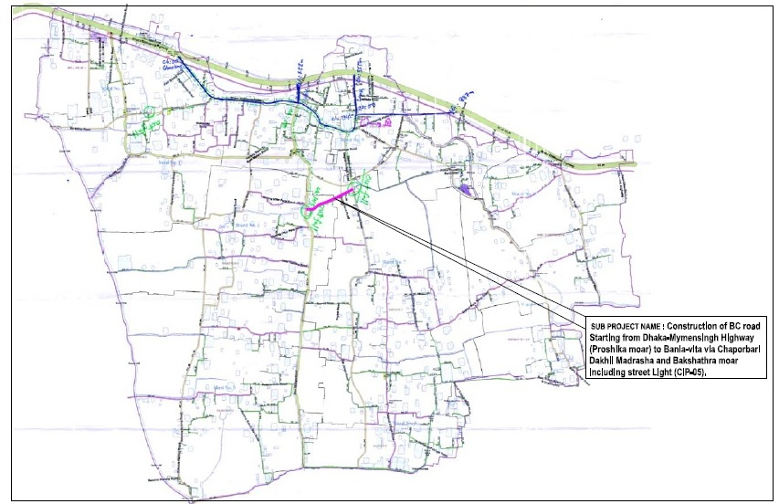
Figure 2.1.1: Location Map of the Subproject

Current Situation and Need for the Subproject

Major roadside built-up infrastructure includes educational institutions (Bhaluka Degree College, Primary schools, Chaporbari Dakhil Madrasa, Sun Flower and Sarker Kindergarten), NGO Office, religious centers (Mosques, Grave yard), and residential areas. Presently, the exiting HBB and earthen road is badly damaged. The existing BC road is partially damaged in various sections. The existing road condition is not suitable for the normal traffic movement. This road plays an important role to make a road network between Dhaka-Mymensingh Highway (Proshika More) and different link roads of the Pourashava. Furthermore, traffic volume is increasing day by day which requires improved road.
The roadside water bodies exist in few sections necessitates retaining wall for the road stability. Besides, retaining wall can manage storm water runoff and establish functional landscape beds for vertical landscaping. Therefore, road protection work is necessary for this subproject. Moreover, for providing better and functional storm water drainage facility, culvert and cross drain is essential.
On the contrary, absent of street light is hampering normal traffic operation and pedestrian movement at night. In addition, possibility of crime and road accident may increase at night time. Therefore, fixing of street light will improve the quality of life; crime and accident will also be minimized. The existing scenario of the proposed road is further elaborated from the following Photographs 2.2.1.
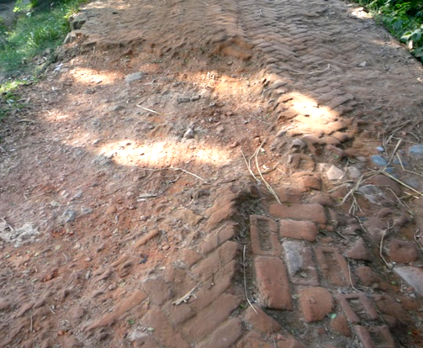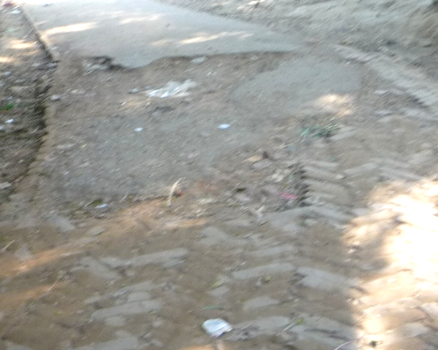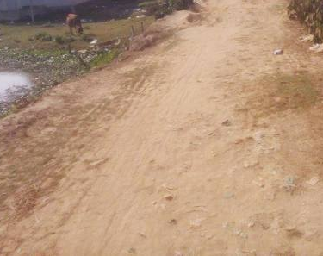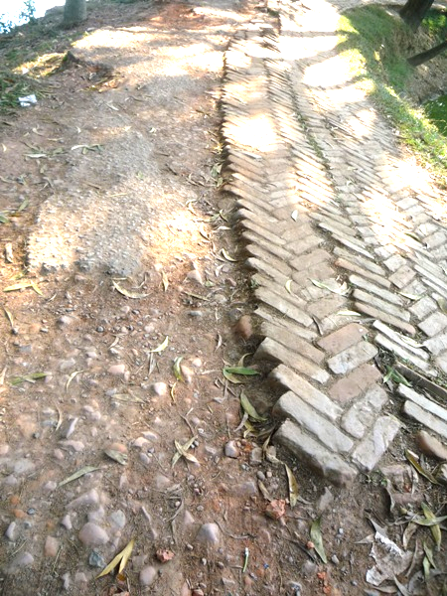

Photograph 2.2.1: Current Situation of Subproject Site

Justification of Selection of the Subproject

The proposed road is in the CIP and priority subprojects list. PMU representative, and DSM consultant visited the subproject site to assess the site condition. From the site visit, it is revealed that this road is very much inconvenience for the movement of the motorized vehicles. From the site inspection it is also revealed that roadside built-up infrastructure will not be severely affected by the implementation of the subproject. In addition, there is no need of private land acquisition. Moreover, the ecological impact due to felled down of the trees and clearing of the vegetation will be compensated by tree plantation. Consequently, it will enhance the ecological condition of the subproject area. The subproject has significant benefit to the community people. Hence, in considering the benefit that will derive after construction, this subproject selected for the implementation.

Envisaged Subproject Activities and Implementation Process

The key activities of BC road include:
- Construction of the temporary semi-pucca site office;
- Relocation of the telephone and electric post;
- Dismantling of the damaged sub-base and base course works;
- Clearing and grubbing works;
- Earth work in box cutting;
- Earth filling work;
- Sand filling on the road bed;
- Mechanical compaction;
- Brick on edging;
- WBM base course;
- Providing prime coat;
- Laying pre-mixed dense bituminous surfacing wearing course.

Key activities of the Box Culvert, Cross Drain and Retaining Wall include:
- Clearing and grubbing;
- Earth work in excavation;
- Sand filling;
- Pumping and bailing out of water as per requirement;
- Fabrication of the ribbed or deformed bar;
- Reinforcement cements concrete work.
Electrification (Street Light) work:
- Assembling, fitting, fixing, installation, testing and commissioning of the GI pole;
- Erection of tubular pole;
- Earthing the electrical installation with GI pipe;
- Fixing of the wire rack;
- Fixing of the overhead aluminum stranded conductor;
- Providing, fixing and fitting of the water tight street light;
- Fitting and fixing main and sub-main switch with fuse;
- Supplying and fitting concealed sub-distribution board.

The materials and resources to be used for the key activities: soil in earth work, sand, stone chips, cement, reinforcement, diesel, MS sheet, steel cutter, steel shutter, boulders, electricity and water. The major equipment to be used for the implementation of the subproject: hydraulic excavator, brick breaking machine, concrete mixer machine, mechanical vibrator machine, mixture machine, mechanical compaction machine, pneumatic dump truck, water tanker, pump.

Baseline ANALYSIS OF THE ENVIRONMENTAL CONDITION

Physical Environment

Important Environmental and Infrastructural Features

There are various environmental and infrastructural features in the subproject area. These environmental and infrastructural features have been collected by field investigation. The conditional survey has been performed for designing of the subproject. Hence, the conditional survey data is also used for preparing the report. The findings of the site inspection and investigation Dhaka-Mymensingh Highway (Proshika More) to Bania-vita (Ch. 00 to 2080 m) are listed in Table 3.1.1.
Table 3.1.1: Major Environmental and Infrastructural Features
Chainage (m) | Left | Right | Major Environmental and Infrastructural Features
Dhaka-Mymensingh Highway (Proshika More) to Bania-vita (Ch. 00 to 2080 m)
0-100 | √ |  | Ditch, Inactive Proshika Office, open place, electric pole, trees
0-100 |  | √ | Ditch, trees, electric poles, open place, tin-shed structures
100-200 | √ |  | Trees, semi-pucca house, boundary wall, mobile tower, electric pole, house connecting road, trees
100-200 |  | √ | Grave yard, Sun Flower Kindergarten School, fence of tin, tin-shed houses, trees
200-300 | √ |  | Semi-pucca houses, open place, trees
200-300 |  | √ | Pond, trees, houses, bamboo bushes, Grave yard
300-400 | √ |  | Open place with trees, soil structure, houses, bushes
300-400 |  | √ | Open place with trees, bamboo bushes, houses
400-500 | √ |  | Trees, tin-shed houses, HH connecting road, connecting road toward Chaporbari Dakhil Madrasa with Mosque, ponds
400-500 |  | √ | Bushes, pond, trees
500-600 | √ |  | Semi-pucca houses, trees, agricultural field, houses
500-600 |  | √ | Fence of tin, trees, ditch, vacant place
600-700 | √ |  | Houses with various structures, agricultural field, electric poles, fence of tin
600-700 |  | √ | Tin-shed and semi-pucca houses, trees
700-800 | √ |  | Earthen link road, trees, primary school, Mosque, vacant place with trees, tin-shed and semi-pucca houses
700-800 |  | √ | Boundary wall, electric pole, houses, Khan Bari with three storied building, trees
800-900 | √ |  | Pond, trees, houses, boundary wall of houses, electric pole, fence of tin
800-900 |  | √ | Boundary wall, electric pole, houses with different structures, vacant place
900-1000 | √ |  | Connecting road, electric pole, semi-pucca and tin-shed houses, trees, fence of tin, Grave yard
900-1000 |  | √ | Subed Ali Gang shop, houses, trees
1000-1100 | √ |  | Houses, trees, electric pole
1000-1100 |  | √ | Pond, trees, houses
1100-1200 | √ |  | Trees, pond, electric pole
1100-1200 |  | √ | Trees, pond, electric pole
1200-1300 | √ |  | Pond, trees, tin-shed and semi-pucca houses, shops
1200-1300 |  | √ | Earthen link road, pond, trees, houses with soil structure, vacant place, trees
1300-1400 | √ |  | Pond, trees, houses with various structures, RCC open drain, various shops, electric pole
1300-1400 |  | √ | Khal, tree, houses with different structures
1400-1500 | √ |  | Houses, electric poles, various shops, RCC cover drain
1400-1500 |  | √ | Shops, trees, open drain, electric pole, houses
1500-1600 | √ |  | Various shops, electric poles
1500-1600 |  | √ | Various shops, drain, electric poles
1600-1700 | √ |  | Sarker Kindergarten with Mosque, connecting road, trees, electric pole, shops, open place
1600-1700 |  | √ | Trees, Mosque, shops
1700-1800 | √ |  | Houses with various structures, trees
1700-1800 |  | √ | Trees, houses, electric poles
1800-1900 | √ |  | Homestead area with semi-pucca, tin-shed and soil structures, electric poles, shops, trees
1800-1900 |  | √ | Bhaluka Degree College, Mosque, trees, boundary wall
1900-2080 | √ |  | Residential houses, trees, electric poles
1900-2080 |  | √ | Houses, electric poles, trees

Geology, Topography, and Soils

Bhaluka Pourashava belongs to Madhupur tract. Surface geology is consisted of sedimentary rocks originated by riverine processes. The Pourashava is located on the bank of the River Kheru. Topographically, Bhaluka Pourashava is plain land. The plain land mainly consists of fluvio-deltaic sediments deposited by the Ganges, Brahmaputra and the Meghna River Systems. Geomorphologically, Bhaluka Pourashava falls under the Floodplains of the old Brahmaputra and Jamuna rivers having distinguishing character. Soils in the valleys are dark grey heavy clays. They are strongly acidic in reaction with low status of organic matter, low moisture holding capacity and low fertility level. According to BNBC (2006), Bangladesh has three seismic zones with moderate and low seismic activity. The Pourashava falls in Zone II.

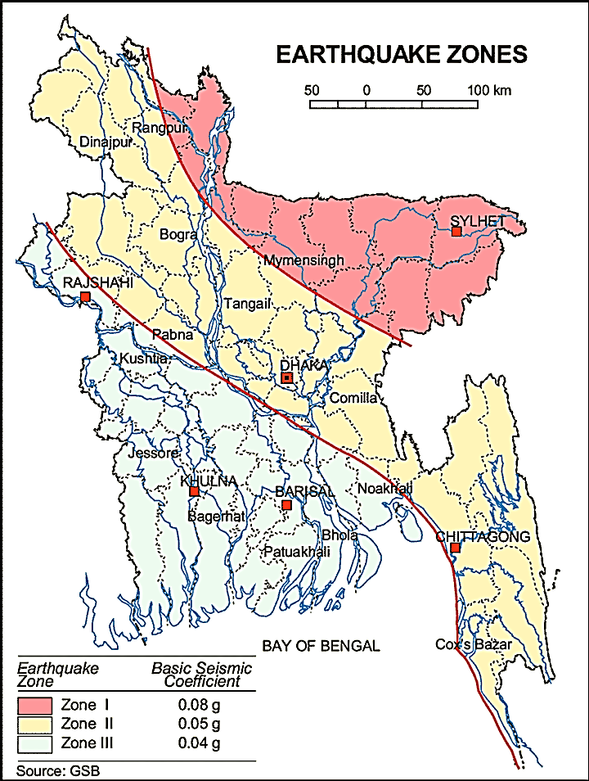

Figure 3.1.1: Location of Bhaluka in Earthquake Zone Map of Bangladesh

Climate and Meteorology

The area specific meteorological data is not available. Hence, meteorological data of Muktagacha can use for Bhaluka Pourashava in order to get idea. The climate of the Pourashava area is moderate with the maximum and minimum mean monthly temperature 32.3ºC and 24.7ºC respectively observed in April and January. Mean annual rainfall is 2253 mm occurs between May to September during monsoon period. During 82% of the aggregate precipitation occurs during five months of the monsoon period. In the winter months of December-January, temperature comes down substantially.

The construction works can be influenced by the climatic condition and meteorological components like humidity, temperature, sudden rainfall, and wind speed. High winds can enhance quick spreading of the generated dust. It is very risky working under rain and in high winds because the possibility of getting injury increases. Furthermore, work under high temperature and excess humidity may create health hazards like dehydration problem.

Water Resources (Ground water, surface water and rain water harvesting)

Some water bodies like ponds and ditches are adjacent to the subproject area. Kheru River and Bakchatra Khal are major surface water sources in the Pourashava. Consequently, Kheru River and Bakchatra Khal influences the regional hydrology.
Ground water is the only sources of drinking water to the habitats of Bhaluka Pourashava. The Pourashava inhabitants use tube-well for the drinking water. The ground water table of the Bhaluka Pourashava varies from minimum 16 ft during rainy season and to the maximum 44 ft during dry season. During dry season when the ground water table goes down at this depth contents excess iron. Within the Pourashava, any arsenic contaminated hand tube-well is not yet identified. In the Pourashava area, rain water harvesting is not visible.

Flooding, Water Logging and Drainage Pattern

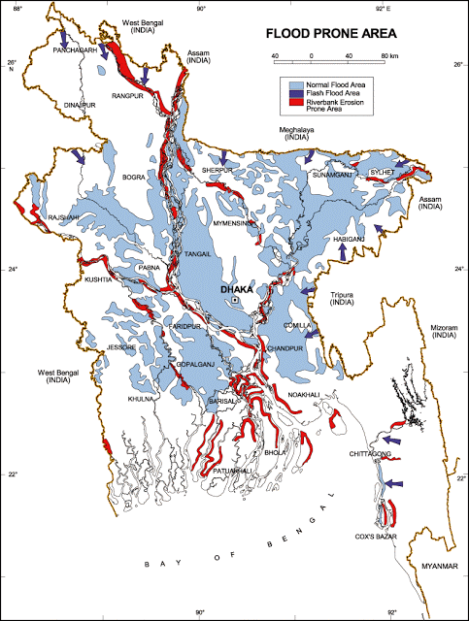
Bhaluka Pourashava is free from external flooding. In the subproject area, the water logging problem is acute in built-up areas than bare land. In the built-up area, the houses are lower than the road level. During heavy rain, the remaining water after infiltration retains on the ground where water logging occurs. Due to lack of adequate and functional drainage facilities water retains there until dries-up. Generally, water logging problems starts in June and continues till October. The subproject area falls on the normal flooding zone as per flood zoning map of Bangladesh.

Figure 3.1.4: Location of Bhaluka Pourashava in Flood Zone Map of Bangladesh

Air Quality and Dust

The degradation of the air quality is mainly from windblown dust and emission from the vehicles. The rough surfaces of the road generate dust during vehicles movement in dry season. Improper disposal of the solid wastes also spread bad odor which causes air quality degradation. During construction phase black smoke emission from asphalt plant, paver, concrete mixer machine, vibrator machine, hydraulic excavator and vehicles used for transportation activities may degrade the air quality.

Noise Level

Noise is generated mainly from the vehicles movement and hydraulic horn. Noise is also generated due to public gathering. During construction phase, asphalt plant, paver, concrete mixer machine, vibrator machine, hydraulic excavator and vehicles used for transportation activities may create temporary noise nuisance within the subproject boundary.
Solid Waste Management

The Pourashava has not any structured dumping yard of its own. The Pourashava people normally dump the collected solid wastes to open spaces by the roadside. Currently, at the vacant place near bus stand is used as a dumping ground by the Pourashava. This is simply open dumping to a specific location. In recent times, the municipalities provide services for household waste collection from door to door and dump at the vacant place near bus stand. The generated wastes due to construction activities will be dumped at this place.

Biotic Environment

Flora and Fauna

The road side floral species are Coconut, Akashi, Mango, Jackfruit, Banana, Eucalyptus, Date Juice tree and Palm. The common local birds such as Doel, Shalik, Kite, Owl, Crow, Tuntuni and Cuckoo were found during the site visit. There are no wild animals and endangered faunal species in this area.

Socio-economic and Socio-cultural Environment

Land Use

The road side built-up infrastructure includes shops, school, college, madrasa, mosques, and few residents. Hence, the land-use pattern is mixed with residential area, commercial area and educational institutes.
Beneficiary Population

The subproject is situated within the jurisdiction of the Ward number 03. Considering the ward population about 15,000 people will benefit directly and many others indirectly.

Education
In the municipality, literacy among the population is about 73.8%. This is higher than the national average (51.8%). The literacy rate among males (76.5%) is still more than females (70.8%). (Ref: Population and Housing Census 2011).

Tribal Communities
There is no indigenous or tribal people settlement in the subproject area. Hence, no measures needed for the indigenous peoples’ safeguard.

Land Acquisition

The proposed subproject road is owned by Bhaluka Pourashava. In addition, additional land required for road widening is also available at both sides of the road. Hence, land acquisition is not needed.
Status of Housing and Built-up Infrastructure
In the subproject area, the road side’s major built-up infrastructure includes pucca, semi-pucca, tin-shed residential houses, tin-shed shops, school, college, madrasa, mosques. In recent years, due to improvement of the economic conditions people are constructing multistoried buildings.
Principal Livelihoods and Economic Activities
Like other municipality, the subproject area is now inhabited by the mixed occupational people. The major income comes from farm activities and the non-farm such as business, enterprises and jobs. Presently, a significant number of people work in the small trades, transport operations, private sector and government jobs.
Cultural Heritage and Protected Areas
From the site inspection it is revealed that there is no cultural heritage and protected areas within the influence area.

Social Conflicts and Development Activities

The local community welcomes this subproject. There are some ongoing subprojects under Pourashava funded by government and other donor agencies. However, there is no visible conflict between the donors and agencies reported by the local community.

ENVIRONMENTAL SCREENING

Environmental Screening for the subproject has been conducted with the purpose of fulfilling the requirements of Government (GOB) and World Bank (WB) for the preparation of subproject appraisal. Environmental Screening Checklist, as adopted in Appendix C of the Environmental Management Framework (EMF) of the MGSP, was administered for identifying the impacts and their extents.
The screening data and information for the BC Road with allied works have been formulated and are shown in below.
(1) Potential Environmental Impact during Construction Phase:
(a) Ecological Impacts:
256

- Felling of the trees Significant □√ Moderate □ Minor □ Number of trees
- Clearing of the vegetation Significant □ Moderate □√ Minor □
- Potential impact on species of Significant □ Moderate □ Minor □√
aquatic (i.e., water) environment
Ecological impacts mainly due to felling of the trees and clearing of the road side vegetation.
(b) Physicochemical Impacts:
- Noise pollution Significant □ Moderate □√ Insignificant □
- Air pollution Significant □ Moderate □√ Insignificant □
- Drainage congestion Very likely □ Likely □ Unlikely □√
- Water pollution Significant □ Moderate □ Insignificant □√
- Pollution from solid/ construction wastes Significant □ Moderate □√ Insignificant □
- Water logging Significant □ Moderate □ Insignificant □√
The subproject will have temporarily and localized negative impact on noise and air quality during construction phase due to movement of the vehicles, using of the asphalt plant, concrete mixer, vibrator etc. Primarily, the subproject will have no adverse impact on the other physicochemical components. The generated solid wastes may degrade the quality of the surrounding environment.
(c) Socio-economic Impacts:
- Traffic congestion Very likely □ Likely □√ Unlikely □
- Health and safety Significant □ Moderate □√ Insignificant □
- Impact on archaeological and historical Significant □ Moderate □ Insignificant □√
- Employment generation Significant □√ Moderate □ Insignificant □
The subproject will have temporarily negative impact in traffic congestion, health and safety during construction phase due to storage of the materials, mobilization of the equipment, vehicles and restriction of the free movement. However, it has positive impact by generating employment opportunity for the local people.
(2) Potential Environmental Impact during Operation Phase:
(d) Ecological Impacts:
- Potential impact on species of aquatic Significant □ Moderate □ Minor □√
(i.e., water) environment
(e) Physicochemical Impacts:
- Potential air quality and noise level Improvement □ No-improvement □ Deterioration□√
- Drainage congestion Improvement □√ Minor Improvement □ No Impact □
- Risk of water pollution Significant □ Moderate □ Minor □√
- Pollution from solid waste Improvement □ No-improvement □ Minor □√
Increased vehicles due to the improved road will deteriorate the air quality and noise level of the adjacent area.
(f) Socio-economic Impacts:
- Traffic Improvement □√ No-improvement □ Adverse □
- Safety Improvement □√ No-improvement □ Adverse □
- Employment generation Significant □ Moderate □ √ Minor □
The improved road will enhance the quality of the municipality road network.

3) Summary of Possible Environmental Impacts of the Subproject
Felling of the trees and clearing of the road side vegetation has negative ecological impact. Some earthwork will be involved for the construction work; however, no agricultural productive soil will be used for the purpose. The dismantle works, site clearing works and construction activities will generate solid wastes, construction debris, and other wastes materials. These wastes materials may degrade environment if properly not disposed-off.
The inputs that may affect the environment mainly will be at construction phase and limited within the subproject boundary. It is also anticipated that the subproject is not going to create any significant adverse environmental impacts. However, mitigation measures will be taken according to the EMP for minimizing the air, dust, and noise pollution. Nevertheless, this subproject will have positive social impacts in terms of the generation of the employment during construction phase. In addition, tree plantation will enhance the ecological condition.

Specific impact, mitigation AND enhancement measures

The subproject includes construction of the BC Road including Box culverts, Cross drains, Retaining walls and Street light. The possible impacts are mainly caused by the activities required for the implementation of the subproject and materials, resources and equipments to be used to perform the activities. This section describes some specific impacts due to the subproject activities and their mitigation measures.

Dismantle Work, Site Clearing and Earthwork

The road improvement work consists of dismantle of the damaged sub-base and base course works, earth excavation, earth filling and cutting, and removal of the unsuitable materials. These works may lead dust blowing, noise and vibration which disturb the local people.

Mitigation Measures

- Careful operation of the hydraulic excavator if used for excavation and earth filling to avoid any undue disturbances to the roadside residents;
- Cover the exposed earth with mulch fabric;
- Quick disposal of the wastes to the selected dumping site near bus stand (beside Haq market).

Tree plantation

There are 256 planted trees will be felled down and road side vegetation will be cleared for implementing of the subproject.

Mitigation Measures

- 1400 nos. of trees will be planted to compensate the ecological imbalance to be caused due to felled down of the tress. Planting trees (Amloki, Horitoki, Bohera, Neem, Bokul, Jam, Arjun, and Rain tree, Debdaru, Polash, Shimul, Sonalu, Krisnachura, Madar, Shewra, Bokaine, Gamari and Mahogany) at both sides of the road (from Ch. 0 to 2080 m) will enhance the ecological balance of the subproject area after their successful growth.

Pollution from Construction Materials

Dumping of the construction spoils, including accidental leakage of the oil, grease, and fuel in equipment yards is a significant hazard. Surface water and soil quality might be polluted from these contaminants. Even the people to be engaged for the construction activities might endanger the physical and human habitats of the area.

Mitigation Measures

- Safe transport, storage, and disposal of the construction materials, and the equipment have to be carried out in order to avoid the accidental spillage and loss;
- Fuels, lubricants, and other hazardous materials should store over raised platforms and not directly on the ground;
- The playgrounds of the educational institutions should not use as a stockyard or work camp.

Air Quality and Dust

During construction phase, air pollutants will be emitted from the equipment and construction vehicles are expected to remain low. Local residents in the vicinity of the work sites will be temporarily disturbed by the limited dust pollution. The overall impacts, however, are expected to remain low.

Mitigation Measures

- Water should be sprayed at the work site for dust control. Ensure sprinkle and cover stockpiles of loose materials (e.g., fine aggregates).
- Maintain adequate moisture content of soil and sand for transportation, compaction and handling;
- Avoid use of dust generating equipment (which produce significant amount of particulate matter) far from the local residents;
- Ensure that all project vehicles are in good operating condition.

Noise and Vibration

Noise and vibration caused by the equipment and movement of the construction vehicles may temporarily disturb nearby residents. In this subproject, sensitive areas like roadside houses, educational institutes and shops are likely to be affected from the noise, though the impacts are anticipated to be limited.

Mitigation Measures

- Transportation of the construction materials have to be carried during the scheduled times, and mainly during the day;
- If needed, all powered mechanical equipment and machineries will be fitted with noise abating gear such as mufflers for effective sound reduction.

Water Quality

The water quality may deteriorate if the construction materials, construction wastes, effluent from work camps, and food waste are dumped in the roadside water body and low land.

Mitigation Measures

- Proper construction management including waste management as well as training of the operators and other workers should provide to avoid pollution of the water bodies;
- Construction waste will dispose properly (not in the ditch, water bodies or lowland), for which contractor will be responsible.

Occupational Health and Safety
The most important risks associated with the construction activities are listed below:
- Exposure to the sunlight- workers are being exposed to the sun for long hours;
- Exposure to the high temperature, and humidity for a long time resulting in dehydration;
- Contact with the hazardous substances and wastes pose risks of the infections and diseases;
- Risk from the traffic collision or accidents during operation of the equipment such as hydraulic excavator and vehicles movement for the transportation activities of the subproject;
- Risks from head loads for carrying soil, construction materials and construction equipment;
- Risk associated to the sudden bad weather working conditions such as storm, thunder storm and earth quake etc.
General Requirements for the Workers’ Health and Safety
The key salient features of the general requirements for the workers’ health and safety stated are presented in Table 5.7.1.
Table 5.7.1: General Requirements for the Workers Health and Safety
Issues | Requirements
Health and Hygiene | - Cleanliness at the site premises and workers living places and at the Labor Shed;  - Arrangement of the proper ventilation and temperature at the Labor Shed;  - Protection against dust and furnace by using of the nose masks and covering of the head and body;  - Proper disposal of the wastes and effluents;  - Provision of the adequate latrines and separate toilets for the women;  - Sufficient dustbins for the solid waste management system.
Safety and First Aid Box | - Using of the personal protective equipment (helmet, gloves, goggles, nose mask, safety boots);  - Precautions during work on or near machineries in motion;  - Head loads are prohibited;  - First aid facilities should be provided and maintained;  - Ensure first aid box;  - The first aid kit should include adhesive bandages, regular strength pain medication, gauze, and low grade disinfectant.
Compensation for Accidents at Work | - Contractors will bear medical treatment costs. If any severe accidents such as loss of hands, legs or loss of working ability or any case of death needs compensation-(the amount of the compensation should be fixed considering the type of accidents).
Dust and Fumes | - For any dust, fumes, or other impurities likely to be injurious to the workers, effective measures shall be taken to prevent their accumulation and its inhalation by the workers.
Overcrowding | - No labor room should be overcrowded.
Latrines and Urinals | - Sufficient latrines shall be provided;  - Latrines shall be maintained in clean and sanitary condition;  - Latrines shall be adequately lighted and ventilated.
Disposal of Wastes and Effluents | - Proper disposal system for the solid waste and effluent is required.

Impacts on Social Environment and Common Property Resources

The anticipated social impacts are expected not to be severe and to be largely manageable.
The following Table 5.8.1 presents impacts on socio-economic environment and common property resources.
Table 5.8.1: Impacts on Social Environment and Common Property Resources
Social Components | Impacts on IECs | Impact Significance
Community Perception | The local community people welcome this subproject and there is no visible objection from them. | Significant (+ve)
Employment and Business Opportunity | Community feels happy because generally the local contractor will be engaged for the construction works which will create work opportunity for the skilled and non-skilled labor. The subproject will create business opportunity for the equipment and materials suppliers’. | Significant (+ve)
Community Order and Security | This subproject activity does not create any severe security problems to the local community and community people. | Minor  (-ve)
Possible damage to infrastructure and facilities | Possible damage of the existing road infrastructure by the construction equipment and vehicles used in this subproject. | Minor  (-ve)
New infrastructure and facilities | Improvement of the existing road will enhance infrastructure facilities. | Moderate  (+ve)
Agriculture and Land Use | No direct impact on agriculture however, it could affect the adjacent land to a very limited extent. | Minor  (-ve)
Landscape and Aesthetics | This subproject activity temporarily will degrade landscape and aesthetics values of the subproject area to a limited extent. | Minor  (-ve)
Labor Habitat | Most of the labors will stay at the Labor shed which will have impacts on the environment relates to the generation of the solid wastes, effluent, and water consumption. | Moderate  (-ve)
Health Care | Workers may suffer from the dehydration problems, respiratory problem, and other health hazards. | Minor  (-ve)
Accident | In case of road accidents by the vehicles to be used for the transportation may have serious negative impact. | Significant  (-ve)

Specific Measures and Guidelines for the Key Social Issues
The primary objective of these guidelines is to ensure social compliances and requirements required for the subproject. The social guidelines required for the subproject as appeared in this report is given in below.
- Conduct dissemination with details about the subproject to the local community;
- Continue liaison with the community leaders in order to maintain the community support;
- Engage and ensure local contractor and local people for positive perception of the local community;
- Ensure no child workers (less than 18 years) and aged worker (more than 65 years) at the site;
- Ensure no discrimination between the male and female in terms of the wages and getting work opportunity;
- Monitor the contractor to ensure regular payment to the workers;
- Consult with the workers for the feeling of any health problems and take measures accordingly;
- Monitor the workers movement for avoiding any unexpected social activities (robbery, crime, political attachment and conflicts, taking drugs);
- Monitor contractor behavior and attitude to the workers.

Environmental Management Plan (EMP)

The purpose of the Environmental Management Plan (EMP) is to ensure that the activities are undertaken in a responsible and non-detrimental manner. The EMP will guide the environmentally sound construction of the subproject and ensure efficient lines of communication between the PMU (LGED), Bhaluka Pourashava, DSM, and the contractors.

Access to Information

The environmental assessment report should be translated into Bengali and disseminated locally. The copies of the report (both in English and Bengali) will be sent to all the concerned personnel responsible for subproject implementation. It will also be made available to the public. The final assessment report will also be uploaded in the LGED website and the World Bank website after approval.

Grievance Redress Mechanism

The project-specific Grievance Redress Mechanism (GRM) has been established at Bhaluka Pourashava to receive, evaluate, and facilitate the solution of APs concerns, complaints, and grievances concerning the social and environmental performance of the subproject. The GRM aimed to provide a time-bound and transparent mechanism to voice and resolve social and environmental concerns linked to the subproject.
The grievance mechanism is related to resolve the risks and adverse impacts of the subproject. It addresses APs’ concerns and complaints promptly, using an understandable and transparent process that is also gender responsive, and culturally appropriate. It is readily accessible to all the segments of the affected people at no costs and without retribution. The mechanism should not impede access to the country’s judicial or administrative remedies. The affected people will be appropriately informed about the mechanism.
LGED has its own Grievance Redress Procedure (GRP), which it operates to address any dissatisfaction and complaints by the local people regarding its activities. This procedure is being applied to address any complaints or grievances through negotiations with the community leaders and representatives of APs during implementation of the MGSP.

6.2.1 Grievance Redress Committee (GRC)

The discussions and negotiations will be conducted by the Project Implementation Unit (PIU) of Bhaluka Pourashava, and will be involved the APs and Grievance Redress Committee (GRC) headed by the Pourashava Mayor. With the facilitation of DSM, the Pourashava Mayor nominated the GRC members and included representative from Government Agencies, local NGO, and Civil Society. The GRC has been formed and established at Bhaluka Pourashava. A complaints box will be provided in the Pourashava Office. The grievance response focal point is available at Bhaluka Pourashava for instant response to an aggrieved person. The Focal Point will collect the written complaints or suggestions from the box, and produce them to the GRC for hearing and resolution. The GRC members are as follows:

Table 6.2.1.1: Grievance Redress Committee (GRC) Member List
No | GRC Member Name | GRC Designation | Position
1 | Dr. A. K. M Mezbah Uddin | Chairman | Mayor, Bhaluka Pourashava
2 | A.K.M Fazlul Haque | Member Secretary | Executive Engineer, Bhaluka Pourashava
3 | Md. Shahiduzzaman | Member | Upazila Education Officer, Bhaluka
4 | Md. Abdur Rauf | Member | Principal, Bhaluka Degree college
5 | Md. Abdur Rashid | Member | Executive Director, ASPADA, Bhaluka
6 | A.B.M Zia Uddin | Member | Civil Society Representative
7 | Female Ward Councilor | Member | Related Female Ward Councilor (Reserved Seat)
8 | Ward Councilor | Member | Related Ward Councilor
9 | Mannur Ahmed | Focal Point | Assistant Engineer Bhaluka Pourashava

6.2.2 Grievance Resolution Process

All complaints and suggestions will be received formally in the Pourashava Office by the GRC Member Secretary. A sample Grievance Redress Form has been prepared and sent to Bhaluka Pourashava prior to the implementation of the subproject.
An intake register will be maintained at the office of the Member Secretary. Member Secretary will record the details of the grievances in the intake register for documentation and ensure impartiality, fairness, and transparency. The intake register will have data and information columns including (i) Case no., (ii) Date of receipt, (iii) name, type of complaint, grievance, (iv) father’s name, husband’s name, (v) sex, (vi) complete address of the person raising the complaint, grievance, (vii) main objection (loss of land, property, or entitlement), (viii) detailed complaint story, (ix) expectation with documentary evidence and previous records of similar grievances, etc.
No GRC members are allowed to contact the aggrieved persons in advance. Rather, the concerned persons are informed to attend the formal hearings at an appointed date. The GRC committee will sit for hearing the complaints of the aggrieved persons. The GRC will record salient points presented by the aggrieved person and will examine documentary evidence submitted during informal hearings. A resolution register will be maintained by the Member Secretary at the Bhaluka Pourashava Office. The resolution register will contain (i) serial no., (ii) case no., (iii) name of complaint, (iv) complaint story and expectation, (v) date of hearing, (vi) date of field investigation (if any), (vii) results of hearing and field investigation, (viii) decision of GRC, (ix) progress (pending, solved) and (x) agreement or commitments. Closing register will keep records such as, (i) serial no., (ii) case no., (iii) name of complaint, (iv) decision and response to complaints, (v) mode and medium of communication, (vi) date of closing, (vi) confirmation of complainant's satisfaction, and (vii) management actions to avoid recurrence.
The GRC will decide within 30 days of receiving a complaint. There will also be an appeals procedure where, if a person is dissatisfied with the ruling of the GRC, he or she or a representative may attend their next meeting to present the case again. The committee will then reconsider the case in private, after which their decision is final. If the appellant is still not satisfied, he or she has the right to take the case to the public courts. LGED and Bhaluka Pourashava should also publish the outcome of cases on public notice boards. All costs involved in resolving the complaints (meetings, consultations, communication, and information dissemination) will be borne by Bhaluka Pourashava.
Based on consensus, this procedure will help to resolve issues or conflicts amicably and quickly, saving the aggrieved persons from having to resort to expensive, time consuming legal action. The procedure will however, not pre-empt a person’s right to go to the courts of law.

Institutional Arrangement for the Safeguard Compliances
In the institutional arrangement procedure, Project Director, and Team Leader/ Deputy Team Leader will directly involve. The PD, TL/DTL would be supported by DSM Environmental Safeguard Specialist and Social Management Expert. The Pourashava Officials, especially members of infrastructure improvement section, would be responsible for supporting the construction supervision with the facilitation of DSM consultants. The civil works contractors will implement the environmental mitigation measures.
The PMU (LGED), with the facilitation of Environmental Safeguard Specialist and Social Management Expert, will submit the monthly and quarterly progress reports on Environmental and Social Compliances to World Bank.

PD-MGSP
TL/DTL-DSM
Environmental Safeguard Specialist-DSM
Social Management Specialist-DSM
Senior Municipal Engineer-DSM
Junior Environmental Specialist-DSM
Assistant Municipal Engineer-DSM
Social Management Officer-DSM
Pourashava Representative/ Focal Point/ Asst. Engineer

Contractor
Figure 6.3.1: Environmental and Social Management Team (Tentative)

Capacity Building
A demonstration training program has already been conducted by the PMU and DSM in Comilla region to build the capability of the PMU, PIUs and DSM field staffs. Similar capacity building workshop will also be conducted by PMU and DSM Consultants in the Narayanganj region for the capacity building. The participants from the Bhaluka Pourashava will attend this training program. Under this training program, PMU and DSM will organize an introductory course for the training and preparing the participants on: (i) Environmental Screening, (ii) EMP Implementation, including environmental monitoring requirements related to mitigation measures; and (iii) taking immediate action to remedy unexpected adverse impacts or ineffective mitigation measures found during the course of the implementation. The contractor should be also included in the training program to enhance the Environmental awareness and orientation among the workers before deploying to the work sites in order to achieve the expected standards. A detailed training manual has already been developed by the Environmental Safeguard Specialist and Social Management Specialist prior to the demonstration training program in Comilla region. Hence, the existing manual will be reviewed and modification will be done as per requirement.

Emergency Response and Disaster Management

Disaster management can be defined as the organization and management of
resources and responsibilities for dealing with all humanitarian aspects of emergencies, in particular the preparedness, response, and recovery to lessen the impact of disasters. Emergency Preparedness Planning (EPP) and Contingency Planning (CP) are the processes of disaster management plan for developing strategies, arrangements, and procedures to address the humanitarian needs of those adversely affected by the crisis. There are four main types of disasters, namely: Natural disasters, Environmental Emergencies, Complex Emergencies, and Pandemic Emergencies.
For MGSP activities, Bhaluka Pourashava would identify the immediate needs, prioritize the tasks, and identify resource requirements to address the humanitarian needs of those adversely affected by the crisis.

Environmental Management Action Plan

The activity wise anticipated environmental impacts and corresponding mitigation measures have been outlined in Table 6.6.1 and Table 6.6.2.

Table 6.6.1: Anticipated Environmental Impacts during Construction Phase and Corresponding Mitigation and Enhancement Measures (EMP Table)
Activity / Issues | Potentials Impacts | Proposed Mitigation and Enhancement Measures | Responsible Parties
Construction and operation of labor shed for the workers (Workforce and labor shed management) | Generation of sewage and solid waste may cause water/ environmental pollution | - Construction of sanitary latrine/septic tank system at the labor shed;  - Erection of “no litter” sign, provision of waste bins/cans;  - Ensure wastes (solid wastes and other forms of the waste) disposal at the Pourashava designated dumping site near bus stand beside Haq Market. | Contactor  Monitoring-  Primarily by Pourashava  Secondarily by PMU, LGED and DSM
 | Health of workers | - Conduct formal and unofficial discussion to increase awareness about hygiene practices among the workers;  - Ensure availability and access to first-aid equipment and medical supplies for the workers.
 | Possible development of labor camp into permanent settlement | - Contractor to remove labor camp at the completion of contract.
 | Outside labor force causing negative impact on health and social well-being of local people | - Ensure that contractor employ local work force to provide work opportunity to the local people and conduct formal and unofficial awareness program for the health and social well-being of the local people.
General construction works | Drainage congestion and flooding | - Ensure provision for adequate drainage of storm water, if needed;  - Ensure adequate monitoring of drainage effects, especially if construction works are carried out during the wet season. | Contactor  Monitoring-  Primarily by Pourashava  Secondarily by PMU, LGED and DSM  Contactor  Monitoring-  Primarily by Pourashava  Secondarily by PMU, LGED and DSM
General construction works | Air pollution | - Check regularly and ensure that all the subproject vehicles are in good operating condition;  - Ensure contractor spray water on dry surfaces regularly to reduce dust;  - Maintain adequate moisture content of soil and sand for transportation, compaction, bed preparation, and handling;  - Ensure contractor sprinkle and cover stockpiles of loose materials (e.g., fine aggregates).
General construction works | Traffic congestion, effect on traffic and pedestrian safety | - Ensure schedule deliveries of material/ equipment during off-peak hours;  - Ensure alternative routes for vehicle movement at construction period;  - Place traffic sign to avoid undue traffic congestion.
General construction works | Noise pollution | - Check and maintenance the equipment properly;  - Avoid using of construction equipment producing excessive noise at night;  - Avoid prolonged exposure to noise (produced by equipment) by the workers;  - Regulate use of horns and avoid use of hydraulic horns in project vehicles.
General construction works | Water and soil pollution | - Prevent discharge of fuel, lubricants, chemicals, and wastes into adjacent water bodies and soil;
General construction works | Accidents | - Conduct formal and informal discussion for creating awareness about the accident;  - Provides PPEs and ensure using of the personal protective equipment by the workers.
General construction works | Felling of trees, clearing of vegetation and ecological disturbances | - 1400 nos of trees (Amloki, Horitoki, Bohera, Neem, Bokul, Jam, Arjun, Rain Tree, Debdaru, Polash, Shimul, Sonalu, Krisnachura, Madar, Shewra, Bokaine, Debdaru, Gamari and Mahogany) will be planted at both sides of the road (from Ch. 0 to 2080 m) to compensate the ecological imbalance and to compensate the felling trees.
General construction works | Spills and leaks of oil, toxic chemicals | - Proper handling of lubricating oil and fuel so that it does not fall on the soil and adjacent water bodies;  - Collection and disposal of spills.
All construction works | Beneficial impact on employment generation | - Employ local people in the project activities as much as possible;  - Give priority to poor people living within project area in subproject related works (e.g., excavation and other works, which do not require skilled manpower).
All construction works | General degradation of the environment | - Ensure environmental enhancement measures and traffic signs will be provided.
Environmental impacts due to construction activities and corresponding mitigation measures for BC Road
Dismantle work/clearing and grubbing works and earth work | Generation of solid and construction wastes due to the dismantle works;  Generation of loose soil due to the earth work. | - Exposed earth works with mulch fabric and cover;  - Disposal of soil and construction wastes at Pourashava designated dumping site near bus stand beside Haq Market. | Contactor  Monitoring-  Primarily by Pourashava  Secondarily by PMU, LGED and DSM
ISG (Improved Sub grade)/ Sand filling | - Air and dust pollution affecting nearby settlements | - Maintain adequate moisture content of soil during transportation, compaction and handling;  - Carry the materials specially loose soil and sand with adequate cover;
Setting up and operation of asphalt plant | Possible degradation of the air quality by the suspended particles and increase of the noise level from asphalt plant affecting nearby settlements; | - Locate plant away from the home stead, and bazar area;  - Consider use of emulsified bitumen.
Setting up and operation of asphalt plant | Possible water pollution (surface and groundwater) by bitumen and solvents. | - Avoid spills and proper collection and disposal of the generated spills.
Setting up and operation of asphalt plant | Possible preparation of the bitumen in open air and using of charcoal and wood as fuel | - Strictly prohibit bitumen preparation in the open air and use of charcoal and wood as fuel.
Environmental impacts due to the key construction activities and corresponding mitigation measures for RCC Culvert, Cross Drain and Retaining Wall
Earth excavation work, site clearing and grubbing work | Generation of loose and clay soil due to the earth excavation work. | - Exposed earth works with mulch fabric and cover;  - Disposal of soil and construction wastes at Pourashava designated dumping site near bus stand beside Haq Market. | Contactor  Monitoring-  Primarily by Pourashava  Secondarily by PMU, LGED and DSM
Earth excavation work, site clearing and grubbing work | Accidents | - Carefully handle of the equipments;
Earth excavation work, site clearing and grubbing work | Air pollution | - Regular maintenance of the equipment.
Sand filling/ Back filling work | Air and dust pollution affecting nearby settlements | - Maintain adequate moisture content of soil during transportation, compaction and handling;  - Carry the materials especially loose soil and sand with adequate cover.
Cutting & welding of the reinforcement | Noise Pollution | - Avoid using of rod cutter and wielding work at night;  - Avoid prolonged exposure to noise (produced by equipment) by workers.
Cutting & welding of the reinforcement | Health and Safety | - Ensure use of the PPEs;  - Availability and access to first-aid equipment and medical supplies
RCC work for culvert, cross drain and retaining Wall | Air pollution due to black smoke emission | - Regular maintenance of the concrete mixer and vibrator machine.
RCC work for culvert, cross drain and retaining Wall | Noise pollution | - Avoid operation of the concrete mixer and vibrator machine at night;  - RCC work/casting work should be avoided at schooling time.
Environmental impacts due to the key construction activities and corresponding mitigation measures for the street light
Setting up the pole and electrical connection | Potential health and safety risks | - Inform the local authority to switch off power during connection;  - Ensure use of the PPEs.
Source of electricity and equipment | Reduce of resource i.e. use of electricity | - Provision of renewable energy (solar panel electrification) and use of environmental friendly equipment (LED bulb rather than CFL bulb).

Table 6.6.2: Anticipated Environmental Impacts during Operational Phase and Corresponding Mitigation and Enhancement Measures (EMP Table)
Activity / Issues | Potentials Impacts | Proposed Mitigation and Enhancement Measures | Responsible Parties
Operation of the road | Increased air and noise pollution affecting surrounding areas | - Improved road may increase the traffic volume. Hence, effective traffic management to be needed;  - Better traffic management and avoid movement of heavy loaded vehicles that may exceed the load carrying capacity of the road; | Primarily by  Pourashava  Secondarily by PMU, LGED
Operation of the road | Possible road damage by movement of heavy vehicles |  | Primarily by  Pourashava  Secondarily by PMU, LGED
Operation of the road | Increase traffic speed and accidents |  | Primarily by  Pourashava  Secondarily by PMU, LGED
Operation of the road | Increased traffic congestion due to increased traffic volume |  | Primarily by  Pourashava  Secondarily by PMU, LGED
Operation and maintenance for street light | Accident due to collapse of the arms, electric bulbs and poles; | - Monthly checking and maintenance of the arms, switch box, electric bulbs; if needed;  - Provision of automatic shut-down the switch, lamps during thunder storm and other natural disasters. | Primarily by  Pourashava  Secondarily by PMU, LGED

Environmental Monitoring Plan

Environmental Monitoring Plan will help to evaluate the extent and severity of environmental impacts against the predicted impact and the performance of environmental protection measures. The following Table 6.7.1 and Table 6.7.2 have been prepared for the key environmental indicators.
Table 6.7.1: Matrix Table of Monitoring Plan (Visual and observation during construction phase)
Monitored Parameter/ Issues | Monitoring method/ Key Aspects | Location of Monitoring | Period & Monitoring Frequency
Safety orientation & training of workers | Frequency of training & orientation of workers for safety | Subproject site | - Once in a month  - Reporting: Once in a month
Personal Protective Equipment and safety equipment | Ensure every single person involved in the activities wear and use safety equipment | Subproject site | - Daily  - Reporting: Once in a month
Worker’s health | Monitoring process of worker’s health | Subproject site | - Daily  - Reporting: Once in a month
Sanitation & drinking water facility to the workers | Availability of safe drinking water and sanitation to the workers | Subproject site | - Daily  - Reporting: Once in a month
Incident record & reporting | Documented record of all incident, accident, and its remedial process | Subproject site | - Daily  - Reporting: Once in a month
Site security | Isolation of site from general access | Subproject site | - Daily  - Reporting: Once in a month
Bulletin/ announcement boards/ prohibition signs | Visible in good condition or not | Subproject site | - Daily  - Reporting: Once in a month
Equipment /vehicles | -Switched-off diesel engines when not in use;  -Search any possible leakage;  -Fuelling. | Subproject site | - Daily  - Reporting: Once in a month
Dust | Dust is visible or not | Subproject site | - Daily  - Reporting: Once in a month
Oil waste generation and disposal | Quantity of oily waste, storage and disposal | Subproject site | - Daily  - Reporting: Once in a week
Solid waste generation | Quantity of solid wastes and disposal | Subproject site | - Daily  - Reporting: Once in a month
Drainage facilities | Provision of open /closed surface drainage at the labor shed | Subproject site | - Monthly  - Reporting: Once in a month
Gender equity | No discrimination regarding payment | Subproject site | - Daily  - Reporting: Once in a month
Child labor | No child will be engaged in the activities | Subproject site | - Daily  - Reporting: Once in a month
Handling of hazardous materials | Fuelling, storage, operation | Subproject site | - Daily  - Reporting: Once in a month

Table 6.7.2: Matrix Table of Monitoring Plan (Analytical Monitoring during construction phase)
Monitored Parameter/ Issues | Monitoring Method/Key Aspects | Location of Monitoring | Period & Monitoring Frequency
Ambient air quality | - Visually-black smoke;  - Sampling;  - Analysis at laboratory;  - Data analysis of merits determination by using quality standards;  - Through digital instruments. | Project site | - Once at construction phase;  - Reporting: Once in a month and immediately just after measurement.
Waste Water quality | - Sampling;  - Analysis at laboratory;  - Data analysis of merits determination by using quality standards. | Project site | - Once at construction phase;  - Reporting: Once in a month and immediately just after measurement
Noise level | - Through digital instruments. | Project site | - Four times at construction phase;  - Reporting: Once in a month and immediately just after measurement
In addition, a comprehensive Environmental Compliance Monitoring checklist has been preparing that is enclosed in Appendix-II.

Environmental Management Budget

Considering the environmental impacts and their mitigation measures for this subproject, several items are included in the BOQ for environmental management. The estimated cost for environmental management is elaborated in Table 6.8.1.
Table 6.8.1: Environmental Management Budget
Item No. | Description of the Items | Costs (Tk)
eme-1 | a) Dust suppression measures by water spraying throughout the construction period in and around the subproject site, uncovered aggregates and loose materials such as stockpiles of the sands, excavated earth etc. (Lump sum) | 5,000.00
eme-1 | b) Dust suppression measures for BC road by water sprinkling (it includes water sprinkling for overall BC road construction works that includes-ISG, WBM, ASG and subgrade) @ Tk. 2.00 per meter (2080 m *Tk. 2.00) | 4,160.00
eme-2 | Air quality (SPM, PM₁₀, PM_{2.5}) measurement. It can be measured from the pre-approved public institute/ university once during construction phase for BC road @Tk. 10,000.00 per sample (3*10,000.00Tk) | 30,000.00
eme-3 | Noise level measurement. It can be measured from the pre-approved public institute/ university four times during construction phase for BC road and overall subproject construction activities @Tk. 5,000.00 per measurement (4*5,000.00 Tk) | 20,000.00
eme-4 | Waste water quality (pH, BOD₅, NH₃) measurement. It can be measured from the pre-approved public institute/ university during construction period at the place of the construction and a location downstream of the work area for culvert @Tk. 10,000.00 per sample (2*3*10,000.00 Tk). | 60,000.00
eme-5 | Prevention of the spillage, leakage of the polluting materials (Lump sum) | 5,000.00
eme-6 | Temporary camp site waste disposal facility (collection, transportation, and dumping of the wastes at authorized dumping site: 2 nos (1 no. for the organic wastes and 1 no. for the inorganic wastes disposal facility) @Tk.20,000.00 (2*20,000.00 Tk) | 40,000.00
eme-7 | Water supply facilities (for the labor shed and work site):1 no of tube well at the labor shed @ Tk 20,000.00 per tube well (1* 20,000.00Tk) | 20,000.00
eme-8 | Sanitation facilities (at the labor shed): 2 nos. of the toilets preferably portable toilets if possible (1 no. for women and 1no. for men) @ 20,000.00 (2* 20,000.00 Tk) | 40,000.00
eme-9 | Providing safety gear packages like hand gloves, spectacles for eye protection, helmets, masks, visible jacket, rubber shoes for at least 15 person (15*3,000.00Tk.) and one first aid box (1*2,500.00Tk) | 47,500.00
eme-11 | Tree plantation: Both sides of the road (from Ch. 0 to 2080 m) - Amloki, Horitoki, Bohera, Neem, Bokul, Jam, Arjun, Rain Tree, Debdaru, Polash, Shimul, Sonalu, Krisnachura, Madar, Shewra, Bokaine, Debdaru, Gamari and Mahogany (including protection, fencing and conservation during project defect liability period-fencing as per drawing) 1400 nos. of the trees @ 3m c/c @Tk 1,000.00 per trees (1400* 1,000.00) | 1,400,000.00
 | Total | 1,671,660.00

After approval to revise the cost estimate has lengthy complex procedure. Hence, as per project EMF, PMU (LGED) suggestion and experience from other LGED projects, adequate budget has been allocated for the environmental management for the mitigation and enhancement measures. The subproject activities such as earth work, sand filling, black smoke emission from the subproject vehicles & equipment, preparation of bitumen mix etc. may degrade the air quality in the subproject area. In addition, mechanical compactor, hydraulic excavator, asphalt plant, drum truck, paver and subproject vehicles generate noise nuisance to the surrounding area. Hence, the budget includes analytical monitoring for air quality and noise level. The budget also includes provision for laboratory analysis of waste water in order to assess the quality of waste water. To compensate the felled trees and to enhance the ecological condition, adequate budget for tree plantation is also included.
The budget for labor shed, site office construction and installation of cautionary sign/traffic sign is included in the civil works items. Therefore, it is not included in the environmental budget. It should be noted that the contractor will be paid as per actual work done.

Public Consultation and participation

Methodology

In the context of preparing the Environmental Assessment (EA), participatory public consultation was conducted. The Pourashava Mayor, Officials, Engineers, and local individuals as well as LGED and Consultant participants participated. Informal Focus Group Discussions (FGD) and a formal CIP were conducted involving the participants (Participant list is shown in Appendix-I). In addition, walk-through informal group consultations were also held. The local populations were informed about subproject interventions including their benefits. Recommendations made by the participants were listed and amalgamated in the EMP accordingly.
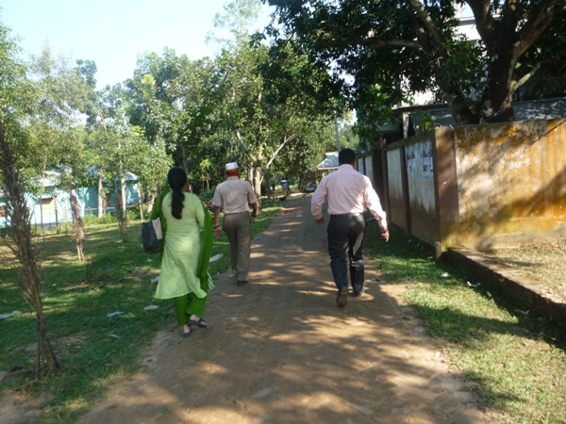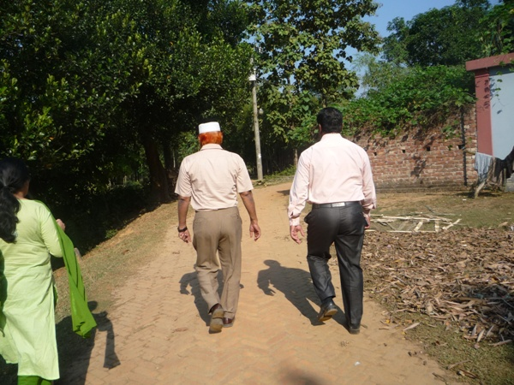
Photograph 7.1.1: Consultant Team visited the sites with Bhaluka Pourashava Officials
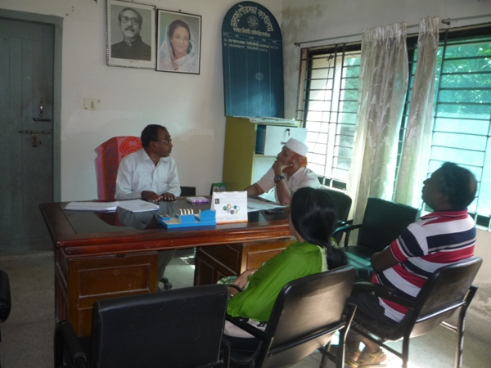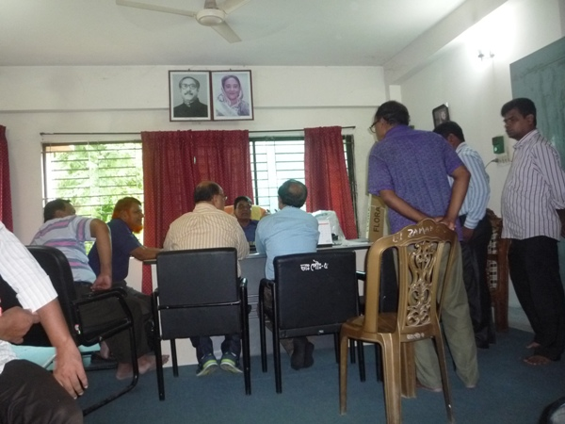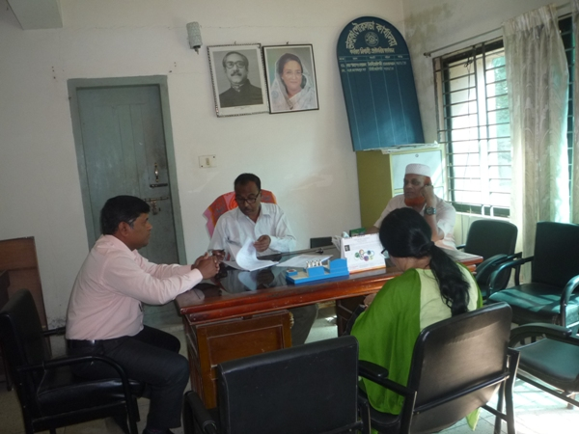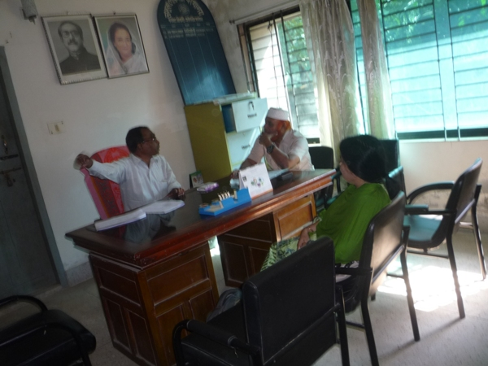
Photograph 7.1.2: Consultation Meeting at Bhaluka Pourashava with Pourashava Officials and Consultants Participants

Issues Raised by the Participants

The participants raised the issues related to infrastructure development of Bhaluka Pourashava. In the CIP and FGD, the participants discussed about the requirements for the future development through a list of the subprojects.

Feedback, Suggestions, and Recommendations of the Participants

The participants’ feedback, suggestions, and recommendations listed below:
- The participants suggested that quality and schedule of the construction work should be maintained properly;
- The FGD results confirmed that an improved communication network by various road construction for future development of Bhaluka Pourashava is needed;
- The participants addressed the important infrastructural facility like Poura Super Market for multipurpose using at the front of Poura Bhabon;
- Kitchen market with slaughter house at Bhaluka Bazaar is necessary;
- The participants proposed that public toilets construction is needed;
- Construction of road beautification under Kheru River Bridge is proposed by the Bhaluka Pourashava which will be the connecting road of the Bhaluka Bazaar.
To encourage participation, regular consultations are recommended with beneficiary communities to share subproject related information and to provide a feedback mechanism for these communities to voice their concerns and issues in all stages of the subproject. The DSM consultants and PMU, LGED will be responsible to carry out continued consultation with and information dissemination to the key stakeholders.

Conclusions and Recommendations

The subproject intervention has impacts on ecology, physicochemical components and socio-economic environment. However, from the study it is revealed that the anticipated impacts are not significant. Most of the individual elements of the subproject involve simple construction and operation, so impacts will be mainly localized. Most of the predicted impacts are associated with the construction process which is invasive. Hence, the impacts are largely manageable through mitigation measures. Mitigation will be assured by a program of environmental monitoring to ensure that all measures are implemented, and will determine whether the environment is protected. It will include observations on and off-site, document checks and interviews with workers and beneficiaries. Any requirements for corrective action will be reported to the WB.
This study formulates well structured EMP. This EMP will assist infrastructure improvement section of the Pourashava, PMU-LGED, contractor and DSM personnel in mitigating the environmental impacts, and guide them in the environmentally sound execution of the proposed subproject. A copy of the EMP shall be kept on-site during the construction period at all times. The EMP shall be made binding on contractor operating the site, and will be included in the contractual clauses.
It should be noted that environmental assessment report is a live document. Hence, due to changing circumstances during the construction phase if any, there might be minor adaptation needed for environmental, health and safety issues.

APPENDIX

Appendix I: List of the Participants

Appendix II: Environmental Monitoring Checklist

