Table of Contents
ABBREVIATIONS AND ACRONYMS vi
GLOSSARY viii
EXECUTIVE SUMMARY xi
A. Introduction xi
B. Policy, Legal Administrative and Regulatory Framework xi
C. Project Description xi
E. Initial Screening and Scoping of Environmental Impacts xii
F. Environmental Assessment xii
G. Alternative Analysis xii
H. Stakeholder and Public Consultation xii
I. Environmental Management and Monitoring Plan xiii
J. Institutional Arrangements xiv
CHAPTER -1: INTRODUCTION xv
1. Introduction 1
1.1 Background 1
1.2 Brief Description of the Project 2
1.3 Objective of the Study 2
1.4 Scope of EA Study 3
1.5 EA Study Methodology 3
1.6 EA Team 4
1.7 Structure of the EA Report 4
CHAPTER-2: POLICY AND REGULATORY FRAMEWORK 5
2 Policy and Regulatory Framework 6
2.1 Introduction 6
2.2 Applicable Environmental Legislation and Policies in Bangladesh 6
2.2.1 Implication of GoB legal and regulations on the Proposed Project 7
2.3 International Treaties signed by Bangladesh 8
2.4 World Bank Safeguard Policies 9
2.4.1 Environmental Assessment (OP/BP 4.01) 10
2.4.2 Projects on International Waterways (OP 7.50) 11
2.4.3 Involuntary Resettlement (OP/BP 4.12) 11
2.4.4 Environment, Health and Safety Guidelines 11
2.4.5 Applicable World Bank Policies to the Subproject 12
2.5 Compliance Status with Bangladesh and World Bank Requirements 13

CHAPTER -3: PROJECT DESCRIPTION 15
3 Project Description 16
3.1 Description of the Project 16
3.2 Justification on Selection of Project Location 16
3.3 Location of the Project 16
3.4 Project Category 22
3.5 Project Component 22
3.6 Construction Materials 22
3.7 Resource and Utilities Require 23
3.8 Project Schedule 23
CHAPTER -4: BASELINE ENVIRONMENT 26
4. Baseline Environment 27
4.1 Physical Environment 27
4.1.1 Geology 27
4.1.2 Topology 28
4.1.3 Climate 29
4.1.4 Hydrology 32
4.1.5 Drainage System 33
4.1.6 Flood in the Project Area 34
4.1.7 Landscape 35
4.1.8 Seismology 35
4.1.9 Navigation 37
4.2 Ecological Perspective of the Study Area 38
4.2.1 Approach and Methodology 38
4.3 Floral and Faunal Diversity 38
4.3.1 Floral Diversity 38
4.3.2 Faunal Diversity 40
4.4 Threatened Flora and Fauna 42
4.5 Protected Areas, Wildlife Sanctuaries, Game Reserves 43
4.5.1 Protected Area (PA) 43
4.5.2 National Park (NP) 43
4.5.3 Game Reserve (GR) 43
4.5.4 Ecologically Critical Area (ECA) 43
4.5.5 Wildlife Sanctuary (WS) 44
4.6 Environment Quality 44
4.6.1 Air Quality 44
4.6.2 Noise 45
4.6.3 Water Quality 46
4.6.4 Soil Quality of Canal Bed Sediment 48
4.6.5 Solid Waste 49
4.7 Socio Economic Environment 50
4.7.1 Population 50
4.7.2 Demography 50
4.7.3 Settlement and housing 51
4.7.4 Traffic and Transport 51
4.7.5 Public Utilities 51
4.7.6 Education 52
4.7.7 Electricity 52
4.7.8 Economy and Employment 52
4.7.9 Fisheries 52
4.7.10 Transportation 52
54
CHAPTER-5: POTENTIAL IMPACTS AND MITIGATION MEASURES 55
5.1 Impact Identification 56
5.2 Pre-Construction Stage 56
5.2.1 Resettlement & land acquisition 56
5.2.2 Trees and Vegetation 56
5.3 Construction and Operation stage 60
5.3.1 Physical Impact 60
5.3.2 Regional Hydrology and Flooding 60
5.3.3 Drainage 60
5.3.4 Erosion and Siltation 61
5.3.5 Water Pollution 61
5.3.6 Air Quality 62
5.3.7 Noise Pollution 62
5.3.8 Disposal of Soil 63
5.3.9 Solid waste 63
5.3.10 Impact on Human Interest 63
5.3.11 Quality of Life Values 65
5.3.12 Positive socio-economic 65
5.3.13 Community and worker health and safety 66
5.3.14 Recreational facilities 66
5.4 Environmental Impact Evaluation 66
CHAPTER -6: ANALYSIS OF ALTERNATIVE 70
6.1 The ‘No Project’ Scenario 71
6.2 Site Alternatives 71
CHAPTER-7: OUTLINE ENVIRONMENT MANAGEMENT PLANS 72
7.1 Environmental Management Plan 73
7.2 Inclusion of Relevant Components of EMP in Contract Documents 73
7.3 Environmental and Social Management 73
7.3.1 Environmental Codes of Practice 75
7.3.2 Mitigations and Compliance Monitoring Plans 76
7.3.3 Construction Stage Site Specific Management Plans 76
7.4 Monitoring Program 84
7.4.1 Compliance Monitoring 84
7.4.2 Effects Monitoring 84
7.5 Performance Indicators 89
7.6 Grievance Redress Mechanism 90
7.7 Capacity Building 90
7.8 Documentation 92
7.9 EMP Implementation Cost 92
7.10 EIV without EMP and with EMP 95
7.11 Responsibility of the Contractor 99
CHAPTER - 8: INSTITUTIONAL ARRANGEMENT 102
8.1 Institutional Arrangements 103
8.2 Environmental and Social Management 106
CHAPTER -9: CONSULTATIONS AND DISCLOSURE 109
Public Participation & Stakeholder Assessment 110
9.1 Introduction 110
9.2 Approach and Methodology for Consultation 110
9.3 Stakeholder Assessment 110
9.4 Focus Group Discussion 114
9.5 Public Consultations Meeting and Disclosure 123
9.6 Access to Information 127
CHAPTER -10: CONCLUSION AND RECOMMENDATION 128
10.1 Conclusion 129
10.2 Recommendation 130
11. REFERENCES 132

ANNEXURE
Annex 1 Environmental Screening
Annex 2 Environmental Standard
Annex 3 Tree Plantation
Annex 4 Change Find procedure
Annex 5 Public Consultation and FGD & attendance
Annex 6 Environmental Code of practice
Annex 7 Leaflet and poster

List of Tables

Table 2.1 Triggering the World Bank Policies for Sub projects……………………………………………………….. 12

Table 3.1 Basic Information of the Project 17

Table 4.1 SHWL and SLWL of Dhaleshawari, Lakhya, Buriganga River 33
Table 4.2 Flood Levels under different scenario 34
Table 4.3 Seismic Zones of Bangladesh 36
Table 4. 4: List of Tree Species with Socio-economic & Ecological Value, Size and Number of Trees along the Project location of Baburail Canal Restoration Project: 40
Table 4.5: Fish Species in the Study Area 41
Table 4.6: Threatened wildlife and fish in the study area with their status in Bangladesh 43
Table 4.7: Air Quality Monitoring Locations 45
Table 4.8: Ambient Air Quality 45
Table 4.9: Noise Monitoring Locations 46
Table 4.10: Ambient Noise Quality 46
Table 4.11: Surface Water (SW) Quality 47
Table 4.12: Ground Water Quality of Baburail Mosque, Douvough and Nimtola Bazar 48
Table 4.13: Canal Bed Sediment Material of Gymkhana Lake and Baburail Canal 49
Table 4.14 : Demographic Information at a Glance 50

Table 5.1: Environmental Impact Valuation (EIV) of the proposed project during Construction 67
Table 5.2: Environmental Impact Valuation (EIV) of the proposed project during Operation stage 68

Table 7. 1: Management Plans/ Additional Tasks for the Project 74
Table 7. 2: Mitigation and Compliance Monitoring Plan – Pre-Construction/Design Phase 78
Table 7. 3: Effects Monitoring Plan 84
Table 7. 4: Environmental and Social Trainings 91
Table 7. 5: Environmental Management Cost (Mitigation) of Restoration of Baburail Canal 92
Table 7. 6: Environmental Monitoring Costs during Construction of Restoration of Baburail Canal 94
Table 7. 7: Environmental Monitoring Costs during O&M Phase of Restoration of Baburail Canal 95
Table 7. 8: Environmental Impact Value (EIV) with and without EMP for the Proposed Baburail Canal in Construction Period 96
Table 7. 9: Environmental Impact Value (EIV) with and without EMP for the Proposed Baburail Canal in Operation Period 97

Table 8.1: Roles and Responsibilities for EMF Implementation 105
Table 8.2: Management Plans/ Additional Tasks for the Project 107
Table 9.1: Stakeholder Assessment for the Project ………….. 112
Table 9.2: Details of FGD Meetings 114
Table 9.3: Summary of Focus Group Discussion (FGD) Meeting 114
Table 9.4: Details of Consultation Meetings 123
Table 9.5: Summary of Consultation 123

List of Figures

Figure 2. 1 Process of obtaining Clearance certificate from DoE 8

Figure 3.1: Location of the 2.8 km Baburail Canal Restoration Project 18
Figure 3.2: The location of Baburail Canal with Catchment Area 19
Figure 3.3: Location of the 2.8 km Baburail Canal Restoration Project 20
Figure 3.4 : Existing Pictures of Baburail Canal at (Dhaleswari River) Portion 20
Figure 3.5: Proposal of Baburail Canal beside R. K. Mitra Road 20
Figure 3.6: Proposal of Jimkhana Lake 21
Figure 3.7: Design of the enter Project overview of Baburail Canal Restoration. 21
Figure 3.8 Existing structure type of Map of Baburail Canal with Catchment area 24

Figure 4. 1: Geological Map of Bangladesh 28
Figure 4. 2: Topographic view of Bangladesh and the Project area. 29
Figure 4. 3: Monthly Average Maximum, Minimum and Mean Temperature during 2006-2016 30
Figure 4. 4: Monthly Average Rainfall Pattern during 2006-2016 31
Figure 4. 5: Monthly Average Humidity of the Project Site during 2006-2016 32
Figure 4. 6: Hydrological Measurement Network 33
Figure 4. 7:Drainage elevation and sub-catchment of Dhaka-Narayanganj-Demra area 34
Figure 4. 8: Seismic Zoning Map of Bangladesh 37
Figure 4. 9: Aquatic Flora at the proposed project site 39
Figure 4. 10: Terrestrial flora (tree) close to the project site 39
Figure 4. 11: Fish trader with native aquatic fauna (fish)in the study area 42
Figure 4. 12: Terrestrial fauna (Pegion at the project site) 42
Figure 4. 13: Air, Water and Noise Sampling locations 44
Figure 4. 14: Ambient Air Quality Monitoring 44
Figure 4. 15: Ambient Noise Quality Monitoring 46
Figure 4. 16: Surface water sampling 47
Figure 4. 17: Ground water sampling 47
Figure 4. 18: Canal Bed sediment sample collection from Gymkhana Lake 49
Figure 4. 19: Existing Road network. 53
Figure 4. 20: Existing road network surrounding the Baburail Canal 54

Figure 5. 1: Existing Landuse Plan of Baburail Canal with Catchment area 59

Figure 8. 1: Organogram for Environmental and Social Management of the Project 104

Figure 9.1: FGD Meeting with Local People at Deobhog, Banglabazar 117
Figure 9 2: FGD Meeting with Local People at RK Mitra Road 117
Figure 9 3: FGD Meeting with Local People at RK Mitra Road 118
Figure 9 4: FGD Meeting with Local People at RK Mitra Road 118
Figure 9 5: FGD Meeting with Local People at RK Mitra Road 119
Figure 9 6: FGD Meeting with Local People at RK Mitra Road 119
Figure 9 7: FGD Meeting with Local People at RK Mitra Road 120
Figure 9 8: FGD Meeting with Local People at RK Mitra Road 120
Figure 9 9: Individual discussion with Local People at RK Mitra Road 121
Figure 9 10: Individual discussion with Local People at Community Clinic SK Biswas Sarak, Bangla Bazar 121
Figure 9 11: Individual discussion with Local People at SK Biswas Sarak, Bangla Bazar 122
Figure 9 12: Individual discussion with Local People at SK Biswas Sarak, Bangla Bazar 122
Figure 9 13: Public Consultation Meeting with Local People at NCC Auditorium 126
Figure 9 14: Public Consultation Meeting with Local People at NCC Auditorium 126

ABBREVIATIONS AND ACRONYMS

CSC Construction Supervision Consultant
DoE Department of Environment
EA Environmental Assessment
ECA Environmental Conservation Act; Ecologically Critical Areas
ECC Environmental Clearance Certificate
ECoP Environmental Code of Practice
ECR Environment Conservation Rules
EHS Environmental Health and Safety
EIA Environmental Impact Assessment
EA Environmental Assessment
EMF Environmental Management Framework
EMP Environmental Management Plan
ESIA Environmental and Social Impact Assessment
E&S Environmental and Social
FGD Focus Group Discussions
GoB Government of Bangladesh
GRM Grievances Redress Mechanism
GRC Grievances Redress Committee
IEE Initial Environmental Examination
IUCN International Union for Conservation of Nature
MOEF Ministry of Environment and Forest
NOC No Objection Certificate
NGO Nongovernmental Organization
OP Operational Policy
O&M Operation and Maintenance
PD Project Director
PIU Project Implementation Unit
PM Particulate Matter
RPF Resettlement Policy Framework
SRDI Soil Resources Development Institute
t Metric ton or tonnne
ToR Terms of Reference
USD US Dollars
VOC Volatile Organic Compounds
WB World Bank
WBG World Bank Group
WHO World Health Organization

GLOSSARY

Adverse impact: An impact that is considered undesirable.
Ambient air: Surrounding air.
Aquatic: Growing or living in or near water.
Baseline (or existing) conditions : The “baseline‟ essentially comprises the factual understanding and interpretation of existing environmental, social and health conditions of where the business activity is proposed. Understanding the baseline shall also include those trends present within it, and especially how changes could occur regardless of the presence of the project, i.e. the “No-development Option‟.
Beneficial impacts: Impacts, which are considered to be desirable and useful.
Biological diversity: The variety of life forms, the different plants, animals and microorganisms, genes they contain and the ecosystems they form. It is usually considered at three levels: genetic diversity, species diversity and ecological diversity.
Ecosystem: A dynamic complex of plant, animal, fungal and microorganism communities and associated non-living environment interacting as an ecological unit.
Emission: The total amount of solid, liquid or gaseous pollutant emitted into the atmosphere from a given source within a given time, as indicated, for e.g., in miligrams per cubic meter of gas or by a relative measure, upon discharge from the source.
Endangered species: Species in danger of extinction and whose survival is unlikely if the existing conditions continue to operate. Included among those are species whose numbers have been reduced to a critical level or whose habitats have been so drastically reduced that they are deemed to suffer from immediate danger of extinction.
Environmental effects: The measurable changes, in the natural system of productivity and environmental quality, resulting from a development activity.
Environmental Impact: An estimate or judgment of the significance and value of environmental effects for natural, socio-economic and human receptors.
Environment Management Plan (EMP): A Plan to undertake an array of follow-up activities which provide for the sound environmental management of a project/ intervention so that adverse environmental impacts are minimized and mitigated; beneficial environmental effects are maximized; and sustainable development is ensured.
Environmental Management: Managing the productive use of natural resources without reducing their productivity and quality.
Fauna: A collective term denoting the animals occurring in a particular region or period.
Field Reconnaissance: A field activity that confirms the information gathered through secondary sources. This field study is essentially a rapid appraisal.
Flora: All of the plants found in a given area.
Habitat: The natural home or environment for a plant or animal.
Household: A household is identified as a dwelling unit where one or more persons live and eat together with common cooking arrangement. Persons living in the same dwelling unit having separate cooking arrangements constitute separate household.
Important Environmental Component (IEC): These are environmental components of biophysical or socio-economic importance to one or more interested parties. The use of important environmental components helps to focus the environmental assessment.
Khal: Small Channel, Canal
River: A large natural stream of water flowing in a channel to the sea, a lake, or another such stream.
Land use: Types include agriculture, horticulture, settlement, pisciculture and industries.
Mouza: A Bangla word for the smallest government administrative area corresponding to village revenue unit.
Mitigation: An action, which may prevent or minimize adverse impacts and enhance beneficial impacts.
Public involvement / Focus Group Discussion/ Public Consultation: A range of techniques that can be used to inform, consult or interact with stakeholders‟ affected / to be affected by a proposal.
Stakeholders: Those who may be potentially affected by a proposal, e.g. Local people, the proponent, government agencies, NGOs, donors and others, all parties who may be affected by the project or to take an interest in it.
Terrestrial: Living on land.
Union: Smallest unit of local self-government comprising several villages.
City Corporation: A city corporation is the legal term for a local governing body, including (but not necessarily limited to) cities, counties, towns, townships, charter townships, villages, and boroughs.

Executive Summary

Introduction
The proposed development of Restoration of Baburail canal reshaping, Landscapping, Beautification, along with Lighting of Shitalakhya-Dhaleswari River via Baburail in NCC Connecting Canal will be a visionary of unique urban and waterways project. Narayanganj, acquiring the status of City Corporation in 2011, is facing the demand to address various issues for city dwellers, such as recreation, leisure and urban breathing facilities. The project is carrying a very important intention to restore the existing canals of the city with the appropriate restoration of the environment as well as ensuring the recreation and amusement for all age group of city dwellers. Identifying an appropriate design concept and pragmatic visualization will, no doubt is the pre-requisites for the development intervention for undertaking of such a sizeable project.
This Environmental Assessment Report (EA) presents the environmental assessment of the proposed Baburail Canal. A Social Impact Assessment (SIA) and Resettlement Action Plan (RAP) will be prepared for the Restoration of Baburail Canal and are presented in separate covers.
The above-mentioned project activities will impact environment. The project authority intended to develop and implement the project with sustainable manner as per DoE and WB guideline.

Policy, Legal Administrative and Regulatory Framework
The Environmental Conservation Act (ECA, 1995) is the main legislative framework related to environmental protection in Bangladesh. This umbrella Act includes laws for conservation of the environment, improvement of environmental standards, and control and mitigation of environmental pollution. In accordance with this Act, the proposed Project will need to be cleared by DoE before commencing the project following procedures given in the Environment Conservation Rules (ECR) 1997 amended on 2010. ECR classify the projects in to various categories (Green, Orange A, Orange B and Red) for the purpose of environmental clearances. Restoration of canal is not included in the classification of different industrial units or projects list in ECR. However, based on the component of the project activities mainly on landscaping, beautification and lighting, it falls under Orange B category.
Among the World Bank Safeguards, from an environmental perspective, the Environmental Assessment (OP/BP 4.01) is triggered. Since most of these impacts are site specific and can be mitigated with standard mitigation measures, hence the proposed project falls under category B. This Environmental Assessment (EA) report prepared for Baburail Canal in compliance with the WB policy. Stakeholder and Public consultation and disclosure of requirements have been performed on 11th April 17.

Project Description
The proposed canal is locally termed as ‘Baburail & Jhelepara Bangla Bazaar Canal’, which is 2.8 km long and 15-30m wide in different sections connecting Shitalakhya River at the East and Dhaleshwari River at the West. At present, the canal is disconnected with earth fill and unauthorized inhabitant occupying the canal area. The canal is situated under ward no 15 and 16 of NCC. While connected with the rivers, the canal would flow East to West at monsoon and West to East at the lean period. Jimkhana Lake is also connected perpendicularly to the canal and approximately 405 m long and 75 m wide surrounded by Deobogh Pucca Road and Bangabandhu Road. The canal is adjacent to RK Mitra Road at South and Mubarak Shah Road at North; crossed the Bangabandhu Road at Mondal Para Intersection, the SM Maleh Road at Hangsha Cinema Hall Bridge, Deobogh Pucca Road at Zallerpar Bridge and Dhaka-Munshiganj Highway at Jhelepara Bridge (Kashipur).

- Category of the Project
According to the Environmental Conservation Rule (ECR, 1997) the proposed restoration of Baburail canal is fall under Orange B Category. According to World Bank Safeguard policy the project falls under Category B, since most of these impacts are site specific and can be mitigated with standard mitigation measures.

E. Initial Screening and Scoping of Environmental Impacts
The Baburail Canal is to be restored as in previous navigation way. A summary of the screening of potential impacts has been associated with the proposed restoration of the canal development is provided along with the potential mitigation measures.

F. Environmental Assessment
Environmental Assessment (EA) of the Project has been carried out using Environmental Management Framework (EMF) provided by World Bank. The studies ensured all relevant environmental issues are mainstreamed into the design and implementation of the proposed project, ensure compliance of the Project with national and World Bank requirements, and conducting EA for the Restoration of Baburail Canal project.
The following environmental issues were considered baseline survey of during EA study.
- Silted soil disposal
- Hydrology of the project area
- Biological species study (Flora and fauna, endangered species)
- Climatic condition (Temperature, rainfall, humidity)
- Environmental quality (Air, water, noise)
- Socio economic condition (Population, demography, archeology, economy and culture, indigenous people, water supply and sanitation and affected person)
Mitigation measure developed as per impact identified.

G. Alternative Analysis
The alternate analysis found that the restoration of Baburail canal is the only better option since it exists with unacceptable condition. The cost of restoration, time, will be less than any other option.

H. Stakeholder and Public Consultation
The stakeholder and public consultation program is an essential part of the environmental assessment process and has been undertaken both formally and informally throughout the study to ensure that the knowledge, experience and views of stakeholders and the general public are taken into account during the study. The information shared and recorded where relevant, has been applied to justify design, construction methodology and timing changes, in order to reduce predicted negative effects. This approach satisfies statutory consultation requirements of the DoE.
The primary methods followed in the consultation process are:
- Individual level consultation/discussion;
- Key Informant Interview
- Focus group discussion;
A public consultation meeting on draft environmental and social assessment study held on 11th April 17 at NCC Seminar Room at Narayanganj. Photographs of this consultation meeting have been provided at the end of report. During these consultations, leaflets on key environmental and social issues were distributed to the participants (these were prepared in local language, Bangla) and posters were also displayed focal places and also at the venue. Power point presentations were made by environmental expert and participants were encouraged to ask questions on the environmental issues.
Before the commencement of the EMP meetings the following materials were disseminated and invite all stakeholder and affected person, postering in important place one day before the consultation meeting, with the aim of developing positive and constructive relationships with stakeholders and improving their knowledge about the project and therefore enhance their ability to ask informed questions and to provide useful input and advice.
These materials were:
- Summary of the mitigations proposed during Project Disclosure meetings
- Written and visual information, including leaflet/brochure in Bangla, maps, drawings and diagrams, detailing the Project activities; and
- Identification of environmental impact of reshaping of Canal in order to make beautification of the canal
- The draft EMP
- Grievance Redress Mechanism (GRM)
General findings of the public consultation: Some issues, as described by those who attended in the consultation are summarized below:
The silted earth material will be used for filling up NCC own lowland. Affected structures, shops, income loss, compensation for structure and loss of income, Socio-Economic Benefit, Job facility and Communication, drainage, solid waste management, water supply and toilet at the Canal shops, Accident, Noise pollution, Air pollution, Traffic congestion, Contribution of improvement of traffic communication system also discussed.

I. Environmental Management and Monitoring Plan
The basic objective of the EMP is to manage adverse impacts of proposed project interventions in a way that minimizes the adverse impact on the environment and people at the subproject sties. The specific objectives of the EMP are to:
- Facilitate the implementation of the mitigation measures discussed earlier in the document.
- Maximize potential project benefits and control negative impacts;
- Draw responsibilities for NCC, contractors, consultants, and other members of the project team for the environmental and social management of the Project;
- Define a monitoring mechanism and identify monitoring parameters in order to:
- Ensure the complete implementation of all mitigation measures,
- Ensure the effectiveness of the mitigation measures;
- Maintain essential ecological process, preserving biodiversity and where possible restoring degraded natural resources; and
- Assess environmental training requirements for different stakeholders at various levels.
- Ensure Contractor Code of conduct.
The EMP will be managed through a number of tasks and activities and site specific management plans. One purpose of the EMP is to record the procedure and methodology for management of mitigation identified for each negative impacts of the subproject. The management will clearly delineate the responsibility of various participants and stakeholders involved in planning, implementation and operation of the subproject.

J. Institutional Arrangements
The Project implementation will be led by the Project Implementation Unit (PIU) that will be established within NCC. The PIU will be responsible for procurement of consultants for carrying out the EA and engineering designs for the proposed sub components. The PIU will be headed by the Project Director (PD). The E&S Cell will also provide trainings to the NCC field personnel responsible for monitoring of environmental compliance including waste management call during both construction and O&M phases of the project. In addition, NCC will recruit a permanent Environmental, Health and Safety Specialist in the entire proposed project, who will be responsible for overseeing the environmental mitigation measures during operation and maintenance period.
The overall responsibility of environmental performance including EMP implementation of the Project will rest with the project management of MGSP.

CHAPTER -1: INTRODUCTION

Introduction

Background
The proposed development as Restoration and Shitalakhya- Dhaleshwari River Connecting Canal will be a visionary and unique urban and waterways project in the context of Bangladesh. Narayanganj, acquiring the status of City Corporation in 2011, is facing the demand to address various issues for city dwellers, such as recreation, leisure and urban breathing facilities. The project is carrying an important intention to restore the existing canal of the city with the appropriate restoration of the environment as well as ensuring the recreation and amusement for all age group of city dwellers. Identifying an appropriate design concept and pragmatic visualization will, no doubt is the pre-requisites for the development intervention for undertaking of such a sizeable project.
Due to neglect for long time of sewage openings in the canal it had become a dumping garbage ditch & an eyesore to the people of city because of emitting foul odors. Several sewerage canals regularly drop huge amount of polluted water. The canal is now disconnected from the river Shitalakhya at east by filling it with earth. Once upon a time it was a navigated canal. Various types of country boats with jute, jute products and essential goods come from different places to Narayanganj through this canal for different trade & commerce as it is the commercial & industrial old town & famous for business center. So, the authority of Narayanganj City Corporation intends to take up the task to restore & beautify the canal and provide the public with recreational space by constructing Landscape around the belt of it in order to relieve the people. This project will include the cleaning of the canal by removing the dumped garbage & excavating the slushy earth.

The overall vision for the Baburail Canal Restoration Project as expressed by the Mayor of NCC aims in 2011 is to restore the Canals to full navigation in the interests of conservation, biodiversity and local quality of life, and to use the restoration as a catalyst for wider social, economic and environmental regeneration in areas neighboring the canal. A fundamental aim of the Restoration Project is to balance the need for restoration with the need to conserve the historic environment and protect biodiversity. The NCC is determined to carry out the restoration of the canals in an exemplary manner, according to recognized principles of sustainability. The project will thus demonstrate good practice in waterway regeneration, protecting and enhancing both the built heritage and the natural environment, and this conservation-led approach will underpin all aspects of the work.

In addition to the conservation of the waterway heritage and ecology, the restoration of the canals is intended to deliver significant social and economic regeneration. The intention is that it will make a substantial contribution to local community development and quality of life by increasing opportunities for recreational and amenity use of the canal and their immediate environs. A vitally important aspect of this will be improved access for all, including people with disabilities. The project authority is intend to conserve and improve the quality of Environment and implements the project with environmentally sustainable manner to comply the national environmental law.

Brief Description of the Project
Narayanganj city is a historical place of the country. The city is of great importance from the commercial & industrial point of view. Several rivers are there in and around the city namely the Shitalakhya, the Balu, the Dhaleshwari and the Buriganga rivers. There are several internal canals also in it. As such, it has got a unique natural landscaping. The River Shitalakhya bisects the city into two parts and it is flowing through the elongated direction of it and the river Dhaleshwari is flowing at the western part of the city corporation. The Buriganga and the Balu are contributing the Dhaleshwari and the Shitalakhya respectively from the up. Most of the internal canals have been encroached by the nearby habitants and have become too much polluted because of the sewage disposal and to some extent by the industrial pollutants. It has become very essential for restoration of all these canals to get rid of further environmental degradation and to make the city a beautiful and habitable one.
The proposed Baburail Canal Restoration Project is an ambitious plan at present to restore to full navigation of two historic inland waterways, the Shitalakhya-Dhaleshwari River connecting Canal. The existing Baburail canal with most of its part filled up with earth, dumping garbage and sewage pit which cause nuisance and foul odors. There are other 4 canals carries household wastewater and rain water enter into the Baburail canal. Finally, all the wastewater carries through Baburail canal and discharge to the Dhaleshwari River. At present NCC intend and taken initiative to restore the Baburail canal only connecting Shitalakhya and Dhaleshwari River. Other canals also restore subsequently. But the canal joining with the two rivers without purifying water will not fulfill the aim of the project. Shitalakhya and Dhaleshwari river water is highly contaminated with huge volume of industrial waste as well as domestic waste and the water quality is degrading day by day. At this moment, the canal water should be protected from the contaminated river water by installing water control device at the both end of the river. When both of the river water will be purified and become non-contaminated, only then the control device can be opened for river water flow through the canal.
The canal restoration and along with appropriate conservation of the environment as well as ensuring the recreation and amusement for all age group of city dwellers.

Objective of the Study
- The major objective of Environmental Assessment of Baburail Canal as follows. The objectives of the study are to identify potential environmental risks and minimize adverse environmental impacts of the proposed restoration and strengthening of the Baburail Canal works in their area of influence and to ensure that impacts are minimized.
- To reshaping of canal, landscapping, beautification, along with lighting of Shitalakhya-Dhaleswari River via Baburail connecting canal.
- To restore the Baburail Canal with proper Navigation of boating through the canal
- To improve the social, economic and environmental regeneration in areas neighbouring the canal
- Local community development and quality of life by increasing opportunities for recreational and amenity use of the canal and their immediate environs.
- To restore the Jimkhana Lake, slope protection and amusement facilities
- Save the valuable land from land grabbers and improve this encroached area as an open space/ breathing place for retention area of water for avoiding artificial water logging within the City Corporation.

Scope of EA Study

- Detailed field reconnaissance of the proposed alignment, with strip maps presenting all the environmental features and sensitive receptors (trees and structures in the Right of Way (ROW), Ponds, Religious Structures, Archaeological monuments, Natural Habitats, Schools, Utility Lines, other sensitive structures) along the corridor of the canal
- Conduct a base line Environmental Monitoring of various Environmental Attributes such as ambient air quality, noise levels, water quality (surface water and groundwater), ecological profile, etc.
- Carry out an assessment of environmental impacts of the Project, including analysis of alternatives for both “with the Project” and “without the Project” scenarios.
- Draw Environmental Management and post Project Monitoring Plan with associated detailed cost estimates,
- The EMP will also provide key criteria for environmental quality monitoring in the project
- Implementation area and suggest an institutional framework for the implementation and monitoring of the recommended measures.

EA Study Methodology
This EA has been conducted by a team of expert prepared by the NCC and submitted to the World Bank for the project.
The methodology followed in preparing the EA consists of the following steps:
- Review of available details of the Baburail Canal and meeting/discussions with various stakeholders including local communities
- Review of the policy and regulatory requirements; and EMF
- Reconnaissance field visit and initial scoping and screening of the identified proposed investment sites to determine the key environmental parameters and aspects that are likely to be impacted by the project activities. The purpose of such screening is to get a preliminary idea about the degree and extent of potential environmental impacts of a particular sub-project, which would subsequently be used to assess the need for and the scope of further detailed environmental assessment.
- Field investigations to collect baseline data using structured questionnaires, and sampling and analysis for air, water and noise
- A detailed assessment of potential impacts of the Project activities and prepare detailed mitigation measures.
- Consultations at both local and national level with various stakeholders including affected communities

EA Team
Vitti Sthapati Brindo has prepared this report under the guidance and Supervision of Dr. J C Saha. The other members of the team are Garibel Ripon Peris, Zisan Binte Walid, Md. Mahin Rahman, Mrinmoy Roy, Shampa Saha, Md. Humayun Kabir, Md. Nazmur Rahman, Amarseh Chandra Biswas, Bekash Chandra Sutradhar. The team leader is an Environmental Engineer having PhD in Environmental Engineering. The other members are Chemist, Ecology/biologist, Environmentalist, Civil Engineer, Zoologist, Sociologist and Field officer respectively with the specialization in EA.

Structure of the EA Report
Chapter 1 of the Final EA Report presents the background information of the Project. This chapter also presents the objectives of the EA Study, scope of work and the methodology adopted for the Study.
Chapter 2 presents a critical discussion on the policy, legal and administrative framework applicable for this Project.
Chapter 3 presents description of the project and other salient information relevant for environmental assessment.
Chapter 4 presents the assessment of the baseline environmental status of the Study Area. It describes in detail the surveys / field studies carried out as part of the Project. The outcome of the surveys / field studies is presented in this Chapter.
Chapter 5 identify and Assessment of potential environmental Impacts issues as well as the appropriate mitigation measures to address these negative impacts have been discussed.
Chapter 6 analysis of alternative present in this Chapter
Chapter 7 presents the proposed EMP. This includes the proposed measures needed to prevent, minimize and mitigate the adverse impacts and improve environmental performance, along with the proposed Implementation Mechanism for the EMP and financial estimates for the implementation of environmental measures proposed in the EMP.
Chapter 8 institutional capacity described in this Chapter
Chapter 9 describes the consultations that have been carried out with the stakeholders and details of disclosure.
Chapter 10 described the conclusion and recommendation

CHAPTER-2: POLICY AND REGULATORY FRAMEWORK

Policy and Regulatory Framework

2.1 Introduction
To address the environmental and social risks of any proposed project and its associated components; any protect and conserve the environment from any adverse impacts, the GOB has specified regulations, policy and guidelines. The activities of proposed restoration of Baburail Canal project of Bangladesh Government fall under the Orange B category according to the Bangladesh Environment Conservation Rules (ECR) 1997 and therefore, need to conduct IEE with EMP studies to obtain environmental clearance from the DoE.

Applicable Environmental Legislation and Policies in Bangladesh
Bangladesh Environmental Conservation Act, 1995 and amended in 2010: The Environmental Conservation Act (ECA) of 1995 is the main legislative framework related to environmental protection in Bangladesh. This umbrella Act includes laws for conservation of the environment, improvement of environmental standards, and control and mitigation of environmental pollution. This Act has established the Department of Environment (DoE), and empowers its Director General to take measures that he considers necessary which includes conducting inquiries, preventing probable accidents, advising the Government, coordinating with other authorities or agencies, and collecting and publishing information about environmental pollution. According to this act (Section 12), no industrial unit or project shall be established or undertaken without obtaining, in a manner prescribed by the accompanying Rules, an Environmental Clearance Certificate (ECC) from the Director General of DoE. In accordance with this Act, the proposed Project will need to be cleared by DoE before commencing the project following procedures given in the Environment Conservation Rules (ECR) 1997 (discussed below).
Other Relevant Acts, Laws and Rules in Bangladesh: Other legislation relevant to the proposed project are listed below.

- Bangladesh Environment Conservation Rules (ECR), 1997 empowers the GoB to declare ecologically critical areas, classification of industries and projects into various categories, procedures for issuing the environmental clearance certificate, and determination of environmental standards. According to the Rule 7 (1) of the Environmental Conservation Rules 1997; for the purpose of issuance of Environmental Clearance Certificate (ECC), every industrial units or projects, in consideration of their site and impact on the environment, will be classified into the four categories and they are: Category I (green), Category II (Orange-A), Category III (Orange B) and Category IV (Red). Development or restoration or upgradation of Canal are not included in any of these categories.

- Bangladesh Wildlife (Protection and Safety) Act 2012 protects 1,307 species of plants and animals; and mandates imprisonment and fines for wildlife poaching, capturing, trapping, and trading. There is a risk that construction workers will kill the wildlife. Mitigation measures to address these risks are covered in EMF.

- Bangladesh Wildlife (Preservation) Order (1973) and Act (1974) regulates the hunting, killing, capture, trade and export of wild life and wild life products. It designates a list of protected species and game animals. It empowers the Government to declare areas as game reserves, wildlife sanctuaries, and national parks to protect the country’s wildlife. Mitigation measures to address impacts on wildlife are covered in EMF.
- The Bangladesh Labor Act, 2006 provides the guidance of employer’s extent of responsibility and workmen’s extent of right to get compensation in case of injury by accident while working. Mitigation measures to address workers’ health and safety are included in the EMF.

Implication of GoB legal and regulations on the Proposed Project
The legislations relevant for environmental assessment for development of Canal are the Environmental Conservation Act 1995 (ECA'95) and the Environmental Conservation Rules 1997 (ECR'97). Department of Environment (DoE), under the Ministry of Environment and Forest (MoEF), is the regulatory body responsible for enforcing the ECA'95 and ECR'97.
It is the responsibility of the NCC as a proponent to conduct an environmental assessment of development proposal, the responsibility to review this assessment for the purpose of issuing Environmental Clearance Certificate rests on DoE. The Environmental Negative Impact of the proposed Restoration project of Baburail Canal with Landscaping, Beautification & Lighting is found insignificant and falls under Orange B category. The environmental clearance procedure for both Orange B and Red Category projects can be summarized in the Figure 2.1.
Figure 2. 1 Process of obtaining Clearance certificate from DoE
Applicant agency will conduct EIA study for the proposed project
Obtaining Environmental Clearance
Renewal of the clearance after each one-year period

Obtaining Site Clearance and approved ToR for EIA
Application for Environmental Clearance
Application should enclose:
- Prescribed application form
- EIA report of the proposed project including EMP
- Outline of relocation, rehabilitation plan, if applicable
- Feasibility Study Report of the proposed project, if available
Application for site clearance
Application should enclose:
- Prescribed application form
- Application fee
- IEE report of the proposed project (including ToR for EIA)
- Location map/ layout plan, etc.
- No Objection Certificate (NOC) from local government authority
- Preliminary Feasibility Study Report/ DPP of the proposed project, if available
Presentation on the EIA and EMP by the applicant agency to DOE

Red Category

Orange Category

Source: Developed by Consultants

International Treaties signed by Bangladesh
Bangladesh is a signatory to a number of international environment-related treaties, conventions, declarations and protocols. The following are the relevant international treaties and conventions to which Bangladesh is a party:
- Convention of Biological Diversity, 1992 (Biodiversity convention – Rio de Janeiro). The Convention has three objectives: the conservation of biological diversity, the sustainable use of its components, and the fair and equitable sharing of the benefits arising out of the utilization of generic resources. All parties are required to cooperate for the conservation of biodiversity, in respect of areas beyond national jurisdiction and other matters of regional interests, and must develop national strategies for the conservation and sustainable use of biodiversity and integrate this into sectional or cross-sectional guidelines.
- 1974 Convention on Wetlands of International Importance especially as Waterfowl Habitat (RAMSAR). The Convention requires states to designate at least one wetland site on the basis of its ecology, biology, zoology, limnology or hydrology and requires the conservation of wetlands by establishing nature reserves. There is also a requirement that any loss of wetland should be compensated for by creating new habitat.

- United Nations Framework Convention on Climate Change, Rio de Janeiro (1992). The convention is broadly applicable due to project construction and operation activities. Mitigation measures to address greenhouse gases emissions are covered in the EMF;
- Vienna Convention for the Protection of the Ozone Layer, Montreal (1987). Mitigation measures to address greenhouse gases emissions are covered in the EMF;
- Convention on Conservation of Migratory Species of Wild Animals (1979). Migratory birds visit the project areas and mitigation measures to address impacts on migratory birds are included in the EMF;
- Convention on International Trade in Endangered Species of Wild Fauna and Flora (CITES), Washington (1973). This is not directly relevant to the project since the project does not involve in any international trade of endangered species of wild fauna and flora. General restrictions have however been included in the Environmental Code of Practice;
- Convention concerning the Protection of World Culture and Natural Heritage (World Heritage Convention) (1972). Though directly not applicable to the project since there are no such known sites are located in the project area – measures to address chance finds are included in the EMF;
- Kyoto Protocol (1997) and Copenhagen Accord (2009) on climate change. Mitigation measures to address greenhouse gases emissions from the project activities are included in the EMF.
- The Minamata Convention on Mercury (2013) to protect human health and the environment from anthropogenic emissions and releases of mercury and mercury compounds. This Convention was a result of three years of meeting and negotiating, after which the text of the Convention was signed by delegates from 140 countries on 19 January 2013. According to this convention, the trade related to mercury containing products will not be allowed through the canal.
- The Paris Agreement (2015) is an agreement on climate change dealing with greenhouse gases emissions mitigation, adaptation for holding the increase in the global average temperature to well below 2 °C above pre-industrial levels and to pursue efforts to limit the temperature increase to 1.5 °C above pre-industrial levels, recognizing that this would significantly reduce the risks and impacts of climate change. This agreement may be applicable to the project because use of emissions related to the construction and operation of canal.

World Bank Safeguard Policies
The World Bank has developed a number of Safeguard Policies to ensure that all possible impacts are considered and mitigation measures are spelled out prior to the implementation of any proposed project. These policies ensure that the quality of operations is uniform across different settings worldwide. If the decision is taken that a Safeguard Policy should be applied, mitigation measures and plans must be developed and should be in place before the implementation of a proposed project.
The Bank requires environmental screening and classification for all investment projects proposed for Bank financing, to help ensure that they are environmentally and socially sound and sustainable. Screening and classification take into account the natural environment (air, water, and land); human health and safety; social aspects (including especially involuntary resettlement and presence of Indigenous Peoples); cultural property; and trans-boundary and global environmental aspects.
The objectives of environmental screening and classification are: to evaluate the environmental risks associated with a proposed operation; to determine the depth and breadth of Environmental Assessment (EA); and to recommend an appropriate choice of EA instrument(s) suitable for a given project. The Bank recognizes that environmental screening and classification is not absolute and involves professional Judgment on a case by case basis. When screening, careful consideration needs to be given to potential environmental impacts and risks associated with the proposed project. Judgment is exercised with reference to the policy expectations and guidance; real impacts on the ground; and established regional and Bank-wide precedence and good practice. The environmental screening is shown in Annex 1.
The applicable WB safeguard policies are described below. In the following section, a table is provided indicating how each policy applies to the proposed investments.

Environmental Assessment (OP/BP 4.01)
EA requirement. The World Bank requires environmental assessment (EA) of projects proposed for Bank support to ensure that they are environmentally sound and sustainable, and thus to improve decision making. The Bank Policy OP/BP 4.01 considers that EA is a process whose breadth, depth, and type of analysis depend on the nature, scale, and potential environmental impact of the proposed project. EA evaluates a project's potential environmental risks and impacts in its area of influence; examines project alternatives; identifies ways of improving project selection, sitting, planning, design, and implementation by preventing, minimizing, mitigating, or compensating for adverse environmental impacts and enhancing positive impacts; and including the process of mitigating and managing adverse environmental impacts throughout project implementation. EA takes into account the natural environment (air, water and land); human health and safety; social aspects (involuntary resettlement, indigenous peoples and physical cultural resources); and trans-boundary and global environmental aspects. The Bank Policy also envisages that the borrower Government is responsible for carrying out the EA and the Bank advises the borrower on the Bank's EA requirements.
EA classification. The World Bank classifies the proposed project into one of the four categories, depending on the type, location, sensitivity, and scale of the project and the nature and magnitude of its potential environmental impacts. These categories are defined below.
- Category A: A proposed project is classified as Category A if it is likely to have significant adverse environmental impacts that are sensitive, diverse, or unprecedented. These impacts may affect an area broader than the sites or facilities subject to physical works.
- Category B: A proposed project is classified as Category B if its potential adverse environmental impacts on human populations or environmentally important areas--including wetlands, forests, grasslands, and other natural habitats are less adverse than those of Category A projects.
- Category C: A proposed project is classified as Category C if it is likely to have minimal or no adverse environmental impacts. Beyond screening, no further EA action is required for a Category C project.
- Category FI: A proposed project is classified as Category FI if it involves investment of Bank funds through a financial intermediary (FI), in subprojects that may result in adverse environmental impacts.

Projects on International Waterways (OP 7.50)
Projects on international waterways may affect the relations between the World Bank and its borrowers, and between riparian states. Therefore, the Bank attaches great importance to the riparian making appropriate agreements or arrangements for the entire waterway, or parts thereof, and stands ready to assist in this regard. A borrower must notify other riparian of planned projects that could affect water quality or quantity, sufficiently far in advance to allow them to review the plans and raise any concerns or objections.

Involuntary Resettlement (OP/BP 4.12)
The WB’s experience indicates that involuntary resettlement under development projects, if unmitigated, often gives rise to severe economic, social, and environmental risks: production systems are dismantled; people face impoverishment when their productive assets or income sources are lost; people are relocated to environments where their productive skills may be less applicable and the competition for resources greater; community institutions and social networks are weakened; kin groups are dispersed; and cultural identity, traditional authority, and the potential for mutual help are diminished or lost. This policy includes safeguards to address and mitigate these impoverishment risks.
The overall objectives of the Policy are given below.
- Involuntary resettlement should be avoided where feasible, or minimized by exploring all viable alternative project designs.
- Where it is not feasible to avoid resettlement, resettlement activities should be conceived and executed as sustainable development programs, providing sufficient investment resources to enable the persons displaced by the project to share in project benefits. Displaced persons should be meaningfully consulted and should have opportunities to participate in planning and implementing resettlement programs.
- Displaced persons should be assisted in their efforts to improve their livelihoods and standards of living or at least to restore them, in real terms, to pre-displacement levels or to levels prevailing prior to the beginning of project implementation, whichever is higher.

Environment, Health and Safety Guidelines
The Environment, Health, and Safety (EHS) Guidelines contain the performance levels and measures that are generally considered to be achievable in new facilities or project by existing technology at reasonable costs. In addition, there are also industry specific EHS guidelines.

Applicable World Bank Policies to the Subproject
The applicable World Bank policies for the development of Baburail Canal are given in Table 2.1.
Table 2.1 Triggering the World Bank Policies for Sub projects
Directive | Policy | Applicability for the Subproject | Explanation
Environmental Assessment | OP/BP 4.01 | Triggered. | Restoration and operation of Baburail canal expected to cause impact on natural environment (air, water and noise quality) and health and safety of local community and workforce. This project falls into Category B since most of these impacts are site specific and can be mitigated with standard mitigation measures.
Natural Habitats | OP/BP 4.04 | Not Triggered. | No natural habitats are located in near the subproject
Pest Management | OP 4.09 | Not triggered. | The subproject will not procure any pesticides, nor will they induce an increased use of pesticides.
Physical Cultural Resources (PCR) | OP 4.11 | Not triggered. | No PCRs located in the proposed subproject
Indigenous Peoples | OP/BP 4.10 | Not triggered | There are no indigenous people near the subproject
Involuntary Resettlement | OP/BP 4.37 | Triggered | 19.5 acres of Land is required for project infrastructure facilities. A Resettlement Action Plan (RAP) has been prepared under separate cover, detailing the relevant requirements to ensure compliance with this policy.
Forests | OP/BP 4.36 | Not triggered. | No forests are located in the proposed port area
Safety of Dams | OP/BP 4.37 | Not triggered | No dam are located near the project.
Projects in International Waterways | OP/BP/GP 7.50 | Not triggered | No international waterways are located near the project. The Shitalakhya-Dhaleshwari river is connected with the canal.
Projects in Disputed Areas | OP/BP 7.60 | Not triggered | The subproject is not located in a disputed area
Child labour |  | Not Triggered. | National laws on child labour will be strictly followed. No child labour will be hired by the contractors or subcontractors in any of the project activities.
Access to Information |  | Applicable to the project. | EA will be disclosed in country (on NCC website) and will be sent to WB InfoShop. Public consultations with local community held on at NCC Poura Auditorium (Old) on 11th April 2017. The executive summary of the EA will be translated to Bangla and which will be available in hard copy in locally accessible locations in the project area, including NCC offices.
Source: Prepared by consultant based on assessment

Compliance Status with Bangladesh and World Bank Requirements
The present compliance status of the project with Bangladesh legislation and World Bank safeguard policies is indicated in Table 2.2.

Table 2.2 Compliance of the Project with GOB Legislation and World Bank Safeguard Policies
Policy | Legislation/Policy | Actions Taken to Comply
GoB  requirements | Environmental  Conservation Rules | NCC will submit EA with EMP to DoE for environmental clearance certificate
 | International treaties | Verification of protected sites, Red List and protection of vulnerable habitats in environmental screenings and assessments of the Baburail Canal. No such protected or vulnerable sites are noticed in the project area.
 | Public information and disclosure | The draft EA report will be disclosed on NCC website. Public consultations meetings held on 11th April 2017 at NCC Poura Auditorium (Old) (500 m from the Baburail Canal) and to solicit stakeholder feedback.
World Bank  requirements | Early Screening and Scoping | Screening using structured questionnaires was carried out during the assessment study of the Project. (Annex-1)
 | Participatory approach | Key informant interviews, consultation meetings and focus group discussions were held between March and April 2017.
 | Integrate environmental and social assessment | Natural environment, public health, and social aspects are incorporated into EA.
 | Natural Habitats | Verification of protected sites and ecosystems, Red List and endangered flora and fauna has been done for Baburail Canal. No protected ecosystems are located in the project area.
 | Risk assessment | Health and safety risks for population and workers are identified in the EA and management measures will be included in tender documents. NCC capacity will also be strengthened on health and safety risk management.
 | Climate Change and Floods | Impact of floods and climate change effects are considered for design of the Baburail Canal .
 | Alternatives | Alternatives has been considered for location of proposed restoration of Baburail facilities in the selected area.
 | Pollution | Baseline survey of air, noise and water quality has been carried out. Environmental Code of Practices (ECoPs) are included in contractors‟ bidding documents
 | Physical Cultural Resources | No physical, cultural resources which warrant special treatment under the World Bank OP 4.11 were identified in the proposed restoration of area. One mosque and no graveyard is located in the proposed canal area.
 | Social impacts | For negative social impacts on land/assets/livelihood/access to resources etc. mitigation plans will be prepared in keeping with the Bank’s Operational policies triggered.
 | Gender | Women participated in the consultation meetings. In the project design, female waiting rooms and toilets are included.
 | Public Health | Public health aspects were studied and public health impacts are covered in EA
 | Consultation and access to information | The EA will be disclosed on NCC website and will also be sent to WB InfoShop. The executive summary of the EA has been translated to Bangla and was circulated to local community. Public consultations held on 11th April 2017 at NCC Poura Auditorium (Old).
Source: Prepared by consultant

CHAPTER -3: PROJECT DESCRIPTION

Project Description

Description of the Project
Narayanganj City Corporation is growing to become one of the urban giant in Bangladesh. Its area is now 73.42 sq.km with a population projection of 1.5 million. Considering the recent national policy on equal development as well as the economic growth of the country and due to benefit of proposed Padma bridge and Jatrabari flyover, it is expected that Narayanganj will become important in generating its own economic and demographic pull in the south-east district and will be the dominant city adjacent to Dhaka, the capital city of Bangladesh. Considering good communication system, peaceful atmosphere and availability of trade & commerce, Industries are being grown up along with the rapid urbanization.
Due to rapid urbanization, industrialization and population growth, Narayanganj is facing pressure to address the various issues i.e. severely aggravate the management of essential urban services and impede the existing facilities providing for the citizen.

Justification on Selection of Project Location
The existing canal with most of its part filled up with earth, dumping garbage and sewage pit which causes nuisance and foul odors. Due to years of negligence and sewage dumping in the canal it had become a dumping ditch & an eyesore to the people of city. The canal is now disconnected from the river Shitalakhya and Dhaleshwari. The environment of the surrounding area is heavily polluted. Hence economic activities become slow, lifestyle become poor and aesthetic values reduces significantly.
Restoration of Baburail canal with navigate facilities will ensure easy, pleasant and safe time, money and movement of traffics in the city; reduce traffic jam, save the fuel cost as well as working hour against existing communication network, and will make an easier way of communication within city area.
So, the restoration of the 2.8 Km Baburail canal is very important and justified at the existing Baburail canal location in order to increase the economic and social development of the City in a wider scope and benefit.

Location of the Project
The proposed canal is locally termed as ‘Baburail & Jhelepara Bangla Bazaar Canal’, which is 2.8 km long and 15-30m wide in different sections connecting Shitalakhya River at the East and Dhaleshwari River at the West. At present the canal is disconnected with earth fill and unauthorized inhabitant occupying the canal area. The canal is situated under word no 15 and 16 of NCC. While connected with the rivers, the canal would flow East to West at monsoon and West to East at the lean period. Jimkhana Lake is also connected perpendicularly to the canal and approximately 405 m long and 75 m wide surrounded by Deobogh Pucca Road and Bangabandhu Road. The canal is adjacent to RK Mitra Road at South and Mubarak Shah Road at North; crossed the Bangabandhu Road at Mondal Para Intersection, the SM Maleh Road at Hangsha Cinema Hall Bridge, Deobogh Pucca Road at Zallerpar Bridge and Dhaka-Munshiganj Highway at Jhelepara Bridge (Kashipur). The Basic Information of the Project is shown in Table 3.1. Location of the 2.8 km Baburail Canal Restoration Project is shown in Figure 3.1 The location of Baburail Canal with Catchment area is shown in Figure 3.2. Existing location of Baburail canal is shown in Figure 3.3 and Figure 3.4 and proposed canal is shown in Figure 3.5, proposed Gymkhana lake is shown in Figure 3.6 and entire project overview is shown in Figure 3.7.

Table 3.1 Basic Information of the Project
Name of Information | Description of Information
Name of Project | Reshaping of canal, landscaping, beautification, and lighting of Shitalakhya to Dhaleshwari River via Baburail in Narayanganj City Corporation
Implementation agency | NCC/LGED
Finance by | World Bank
Project Consultants | Vitti Sthapati Brindo Ltd.
Nature of traffic pass through | Light boat
Length of Canal | 2.8 km
Width of Canal | 15-30 m
Number of Bridge | 18 nos, Width 3-7 m
Number of Overpass | 3
Source: Project data sheet

Figure 3.1: Location of the 2.8 km Baburail Canal Restoration Project
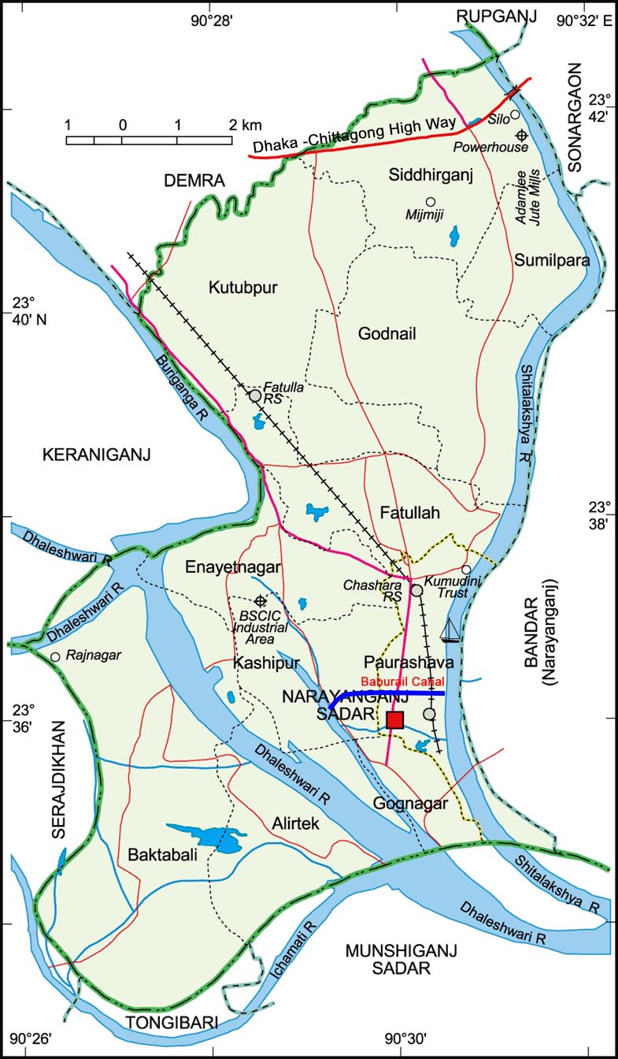
Source: Banglapedia

Figure 3.2: The location of Baburail Canal with Catchment Area
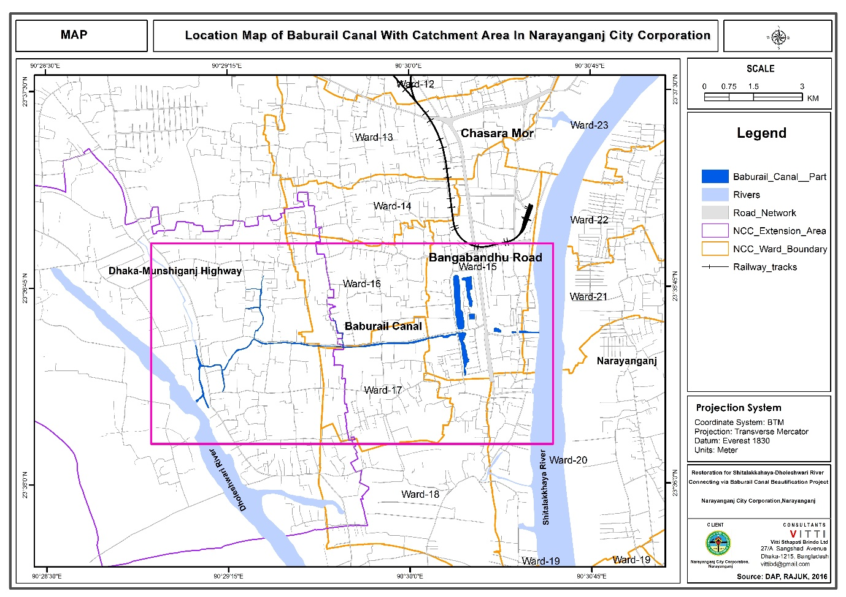
Source: Prepared by the consultant

Figure 3.3: Location of the 2.8 km Baburail Canal Restoration Project
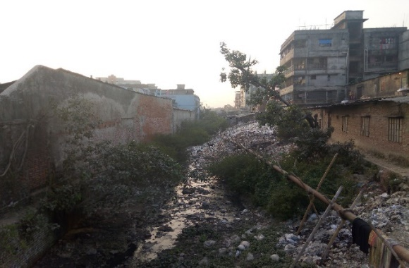
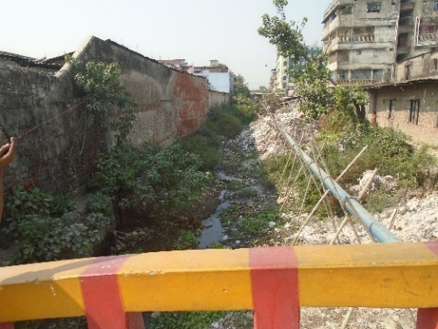
Figure 3.4 : Existing Pictures of Baburail Canal at (Dhaleswari River) Portion

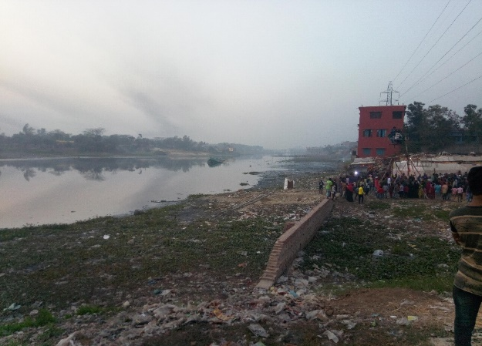
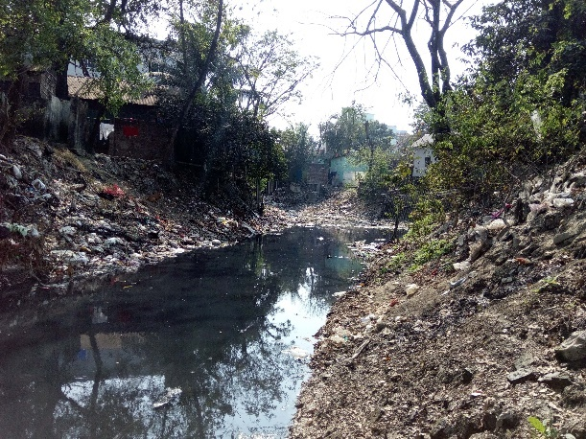

Figure 3.5: Proposal of Baburail Canal beside R. K. Mitra Road
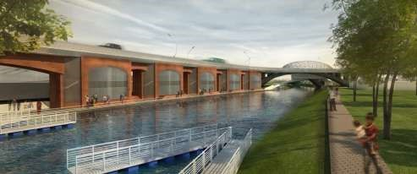

Figure 3.6: Proposal of Jimkhana Lake
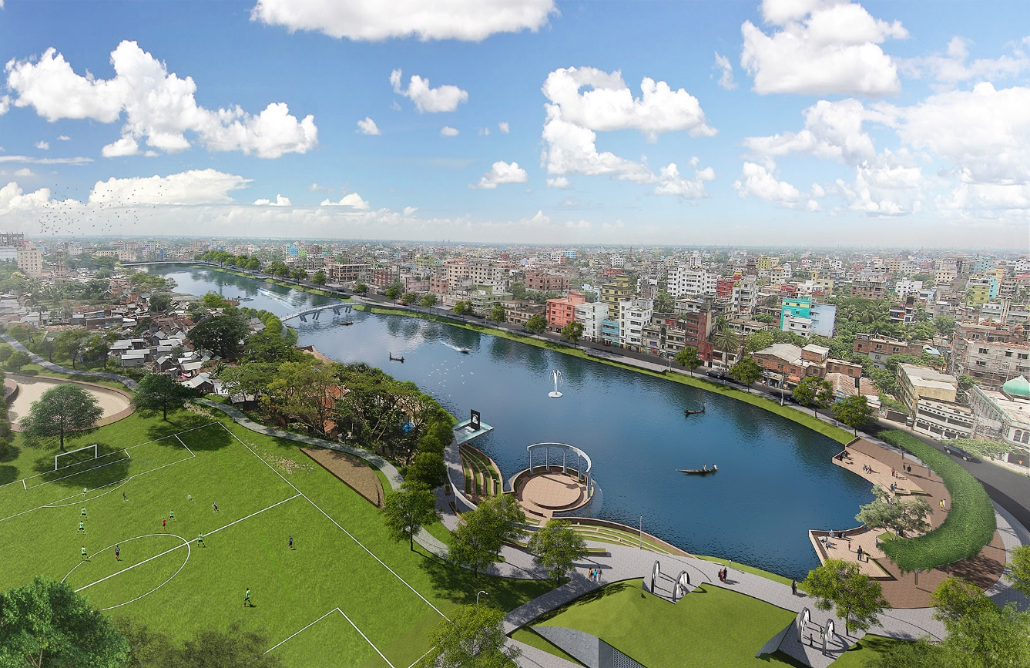

Figure 3.7: Design of the enter Project overview of Baburail Canal Restoration.
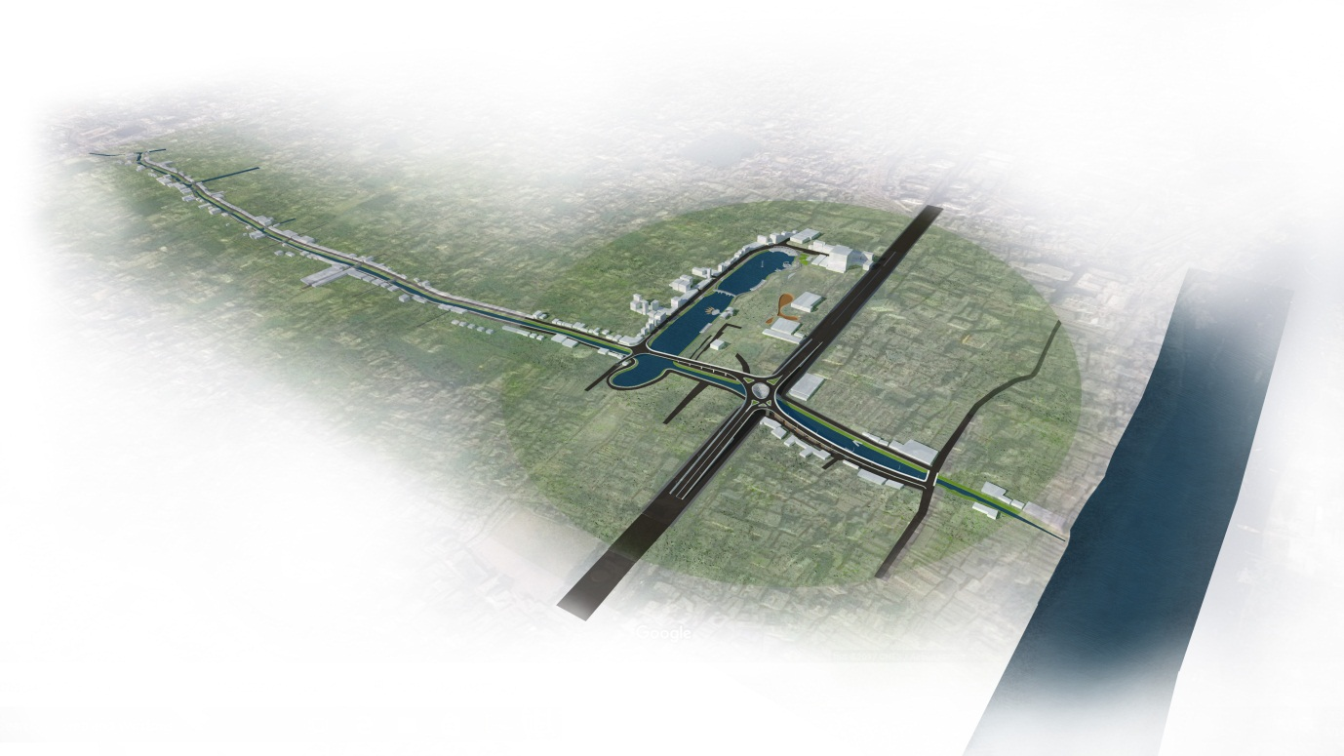

Project Category
According to the Environmental Conservation Rule (ECR, 1997) the proposed Restoration of Baburail Canal fall under Orange B Category that requires an Initial Environmental Examination study to obtained environmental clearance certificate from DoE.
According to the EIA guideline of DoE, it is mandatory to carry out Initial Environmental Examination (IEE) for Red Category projects prior to conducting EIA. For the proposed project the IEE report with EMP should be submitted to obtain environmental clearance.

Project Component
The following are the major component of the project
- Approx. 3 km long Both side open drain
- 07 Nos Foot Bridges
- 09 Nos Road Bridges
- Recreational facility
- Footpath/ Walkway
- Overpass
- Landscaping
- Water Control Devices at both end of the river side
- Canal slope protection
- Ghat
- Viewing Deck
- Floating Folded Deck
- Lighting
- Public Toilet

Construction Materials
Construction materials for restoration of Baburail Canal are following. These will be procured from different markets.

- Soil
- Bitumen
- Asphalt
- Cement
- Sand
- Stone chips
- MS rod
- Water
- PVC pipe
- G.I Pipe
- Wood
- Bricks
- Hollow block
- Gunny Bag
- Stone
- Geo Textile
- Clay soil

Resource and Utilities Require
- Land reshaping
- Construction material
- Utilities (water, electricity, sewerage, waste disposal and others
- Other infrastructure road, drain, electricity to support the project
The location of construction camps and stack yards will be used in the vacant place of the East of the Gymkhana Lake of proposed project site.
During construction, the site for the proposed restoration of Baburail Canal will be used for establishing construction camps and stack yards facilities. About 22,936.62 cubic meters of earth need to be reshaped to be required for restoration of canal. The silted earth material will be used for filling up NCC own lowland. The existing structure of the NCC is shown in Figure 3.8

Project Schedule
The project has already been started and will complete in 2019. The detail of project work schedule is shown in Figure 3.9.

3.9 Present Status of the Project

The project is now in initial stage. Physical development and construction works has not yet started which was observed during site visit on 1st March 2017. The project proponent has applied for issuing environmental clearance certificate from DoE and No Objection Certificate (NOC) from local body has already been obtained.

Figure 3.8 Existing structure type of Map of Baburail Canal with Catchment area
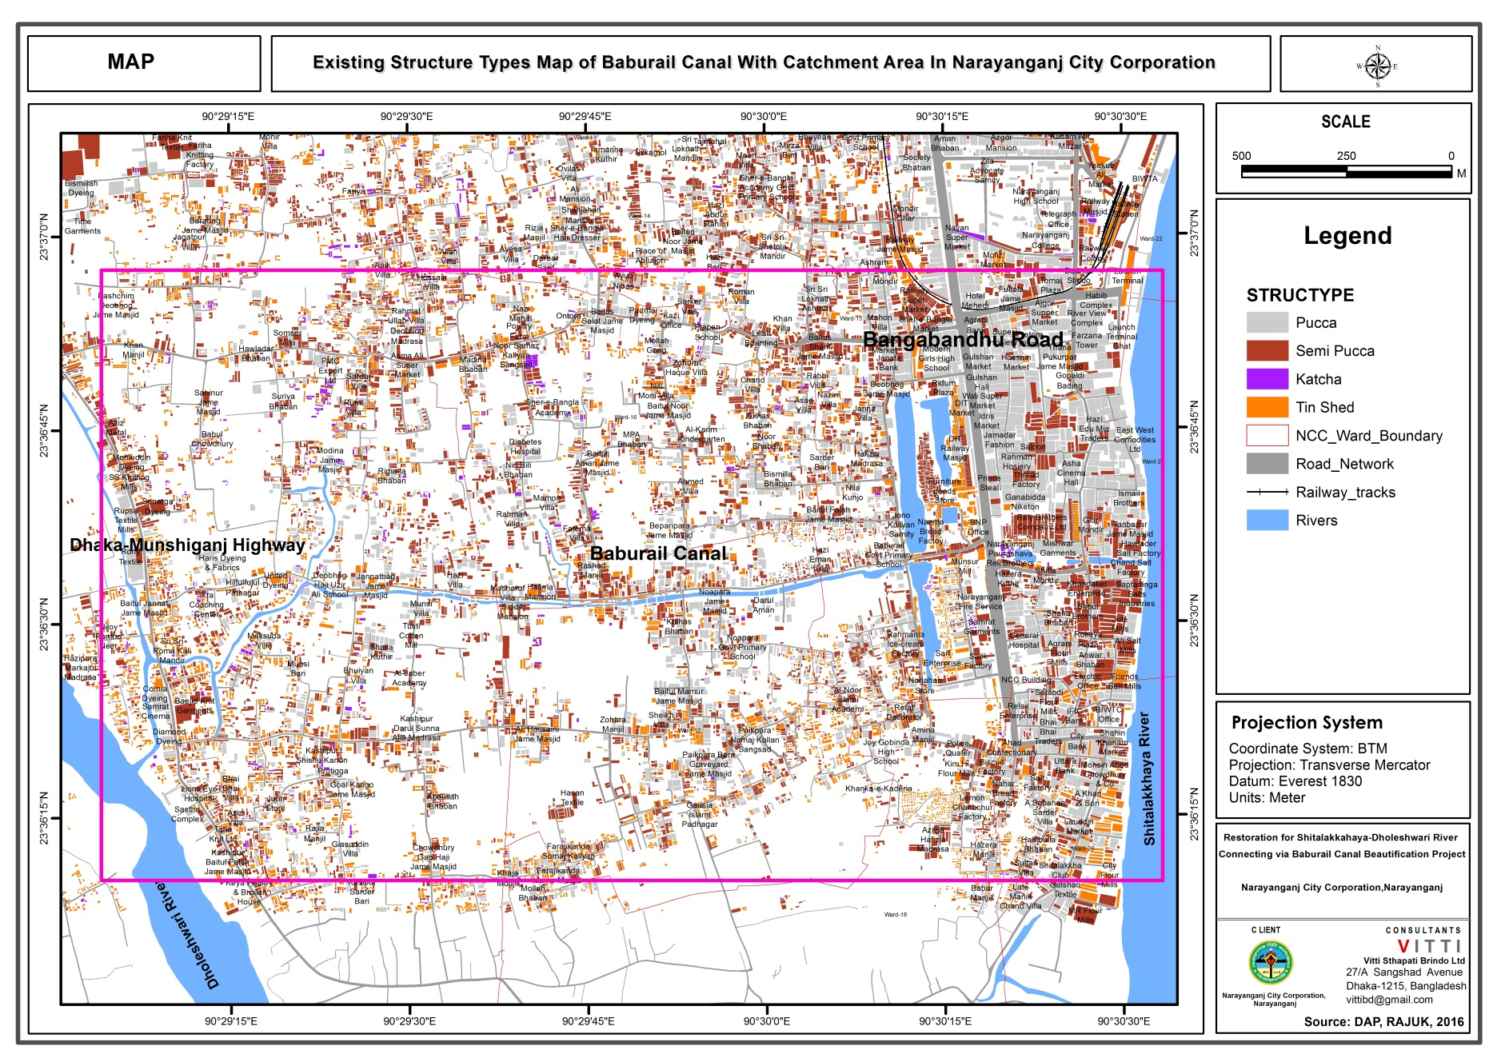

Source: Prepared by the consultant
Figure 3.9 Detail of Project Schedule
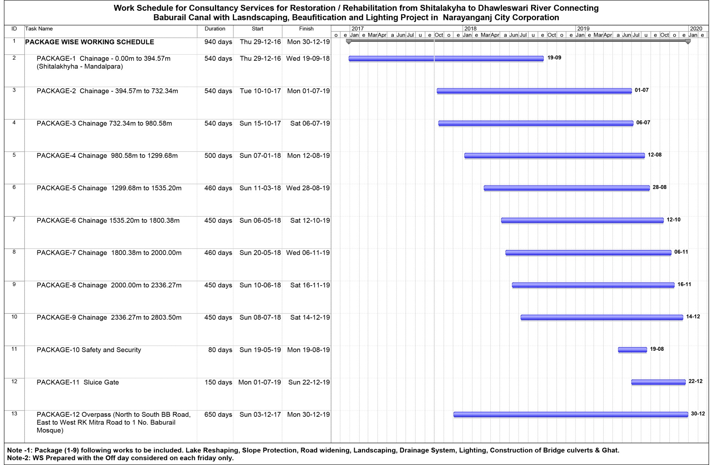

CHAPTER -4: BASELINE ENVIRONMENT

Baseline Environment

Physical Environment

Geology
Bangladesh covers a major part of the Bengal delta, one of the largest in the world. The Ganges-Brahmaputra delta basin or the Bengal basin includes part of the Indian state of West Bengal in the west and Tripura in the east. Narayanganj is situated on the southern tip of a Pleistocene terrace, the Madhupur Tract. Two characteristic geological units cover the Narayanganj city and surrounding areas; the Madhupur Clay of the Pleistocene age and alluvial deposits of recent age. The Madhupur Clay is the oldest sediment exposed in and around the city area and characterized by reddish plastic clay with silt and very fine sand particles. This Madhupur Clay unconformable overlies the Dupi Tila Sand of Plio-Pleistocene age, which is composed of medium to coarse yellowish-brown sand and occasional gravel.
The channels and depressions within the city are floored by recent alluvial floodplain deposits and are subdivided into Lowland Alluvium and Highland Alluvium. The alluvial deposits are composed of fine sand, silt and clay in different combinations.
The area of the proposed restoration Baburail Canal at the city centre will cross the Shitalakhya River. This river has had a significant impact on the geology and geotechnical properties of the soils because they cover the whole investigation area with alluvial deposits related to the floodplains
The alluvial soils of these floodplains mainly consist of ridges of loamy material like silty clays and silty sands with large areas of shallow clays in the basins. The soil pattern can become more irregular close to river channels due to more recent deposits. With regard to the youngest activities (natural as well as anthropogenic) organic soils of swamps may be found locally as well as areas where the ground level has been raised using loose sands (hydraulic sand filling) dredged and pumped from nearby rivers. Figure 4.1 shows the geological formation of Bangladesh as well as the project area.

Figure 4. 1: Geological Map of Bangladesh
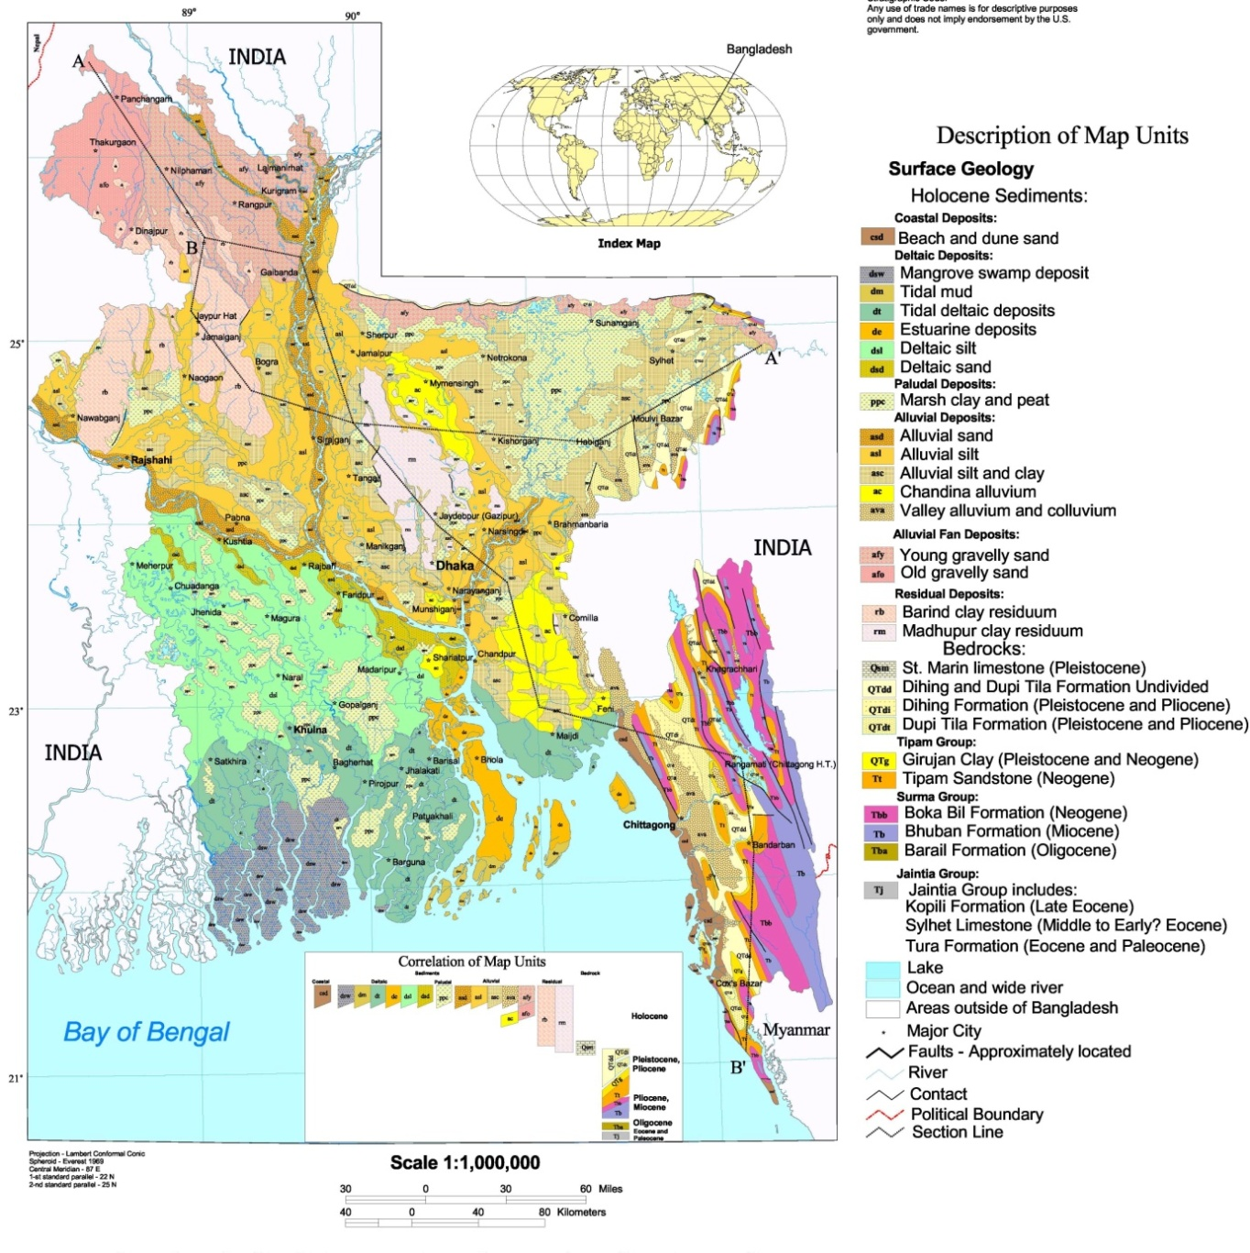
Project Location
(Source: Geological Survey of Bangladesh)

Topology
Narayanganj is located mostly on river deposits at the southern fringe of the Madhupur Tract, which is an elevated Pleistocene inlier. Large parts of the city are located on this inlier, which is surrounded by very young riverine sediments occupying the surrounding valleys. The elevation of the inlier tract varies from 2 to 14 m above mean sea level, and the drainage patterns within can be either dendritic or trellis. The terraces are surrounded by the Ganges-Meghna floodplain in the south, the old Brahmaputra floodplain in the east, and the Jamuna floodplain in the west.
The topographic elevation in the project area is reflected in specific landforms as “high” lands, lowlands, depressions, and abandoned channels. Around the outskirts of Narayanganj, the rivers Shilakhya and Dhaleswari drain a complex of low areas, which are a system of low-lying alluvial plains. The average elevation here is less than 2 m above mean sea level. Broad streams cut through the central high area and fall into this unit. The broad streams are locally known as khals, and the broad depressions are called bils.
The project area is spread over the Madhupur tract and old Brahmaputra Flood plain. Topographic view of Bangladesh and the project area shown in Figure 4.2.
Figure 4. 2: Topographic view of Bangladesh and the Project area.
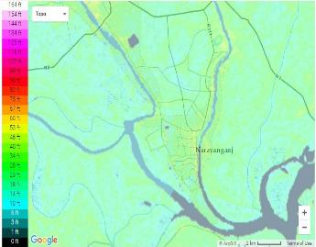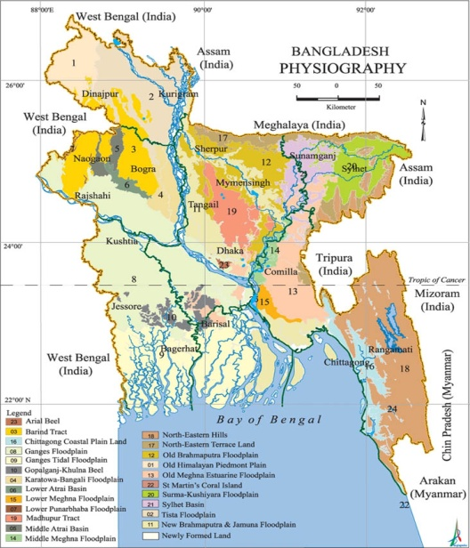
Project Location
(Source: Geological Survey of Bangladesh)

Climate
Bangladesh is located in the tropical monsoon region and its climate is characterized by high temperature, heavy rainfall, often excessive humidity, and fairly marked seasonal variations. The most striking feature of its climate is the reversal of the wind circulation between summer and winter, which is an integral part of the circulation system of the South Asian subcontinent. From the climatic point of view, three distinct seasons can be recognized in Bangladesh - the cool dry season from November through February, the pre-monsoon hot season from March through May, and the rainy monsoon season which lasts from June through October. The month of March may also be considered as the spring season, and the period from mid-October through mid-November may be called the autumn season.
As there is no meteorological station available in Narayanganj, the climatic variables monitored at the Dhaka station (approx. 20 km from the site) have been assumed to represent the climatic condition of the project area. Different meteorological data like rainfall, temperature, relative humidity and wind speeds monitored at the meteorological station in Agargaon, Dhaka are described in the following sub-sections.

Temperature
January is the coldest month in Bangladesh. Average temperatures in January vary from about 17'C in the northwestern and northeastern parts to 20°-21°C in the coastal areas. As the winter season progresses into the pre-monsoon hot season, temperature rises, reaching the maximum in April, which is the middle of the pre-monsoon hot season. Maximum temperature in summer season rises up to 40°C or more. After April, temperature decreases slightly during the summer months, which coincides with the rainy season. Widespread cloud covers causes dampening of temperature during the later part of the pre-monsoon season. Average temperatures in July vary from about 27°C in the southeast to 29°C in the northwestern part of the country.

From the previous 10 years monthly temperature data it can be observed that the minimum temperature was observed 17.3 degree centigrade in January of 2011 and maximum temperature 30.7 degree centigrade was observed in April 2014. The Monthly Average Maximum, Minimum and Mean Temperature during 2006-2016 is shown in Figure 4.3.

Figure 4. 3: Monthly Average Maximum, Minimum and Mean Temperature during 2006-2016

Source: Bangladesh Meteorological Department (BMD)
Rainfall
The single most dominant element of the climate of Bangladesh is the rainfall. Because of the country's location in the tropical monsoon region, the amount of rainfall is very high. However, there is a distinct seasonal pattern in the annual cycle of rainfall, which is much more pronounced than the annual cycle of temperature.

From the previous 10 years monthly rainfall data it can be observed that the minimum average rainfall was observed 2.32mm in January and maximum average rainfall was observed 302.66mm in July. The Monthly Average Rainfall Pattern during 2006-2016 is shown in Figure 4.4.
Figure 4. 4: Monthly Average Rainfall Pattern during 2006-2016

Source: Bangladesh Meteorological Department (BMD)
Humidity

March and April are the least humid months over most of the western part of the country. The lowest average relative humidity (57%) has been recorded in Dinajpur in the month of March. The least humid months in the eastern areas are January to March. Here the lowest monthly average of 58.5% has been recorded at Brahmanbaria in March. The relative humidity is everywhere over 80% during June through September. The average relative humidity for the whole year ranges from 78.1% at Cox's Bazar to 70.5% at Pabna.

From the previous 10 years monthly humidity data it can be observed that the minimum average humidity was observed 56.18mm in March and maximum average humidity was observed 78.00mm in June. The Monthly Average Humidity of the Project Site during 2006-2016 is shown in Figure 4.5.

Figure 4. 5: Monthly Average Humidity of the Project Site during 2006-2016

Source: Bangladesh Meteorological Department (BMD)

Hydrology
From the hydrological study discharge data of Shilakhya, Balu, Dhaleswari and Buriganga River has been observed. There are several internal canal also in it. As such, it has got a unique natural landscaping. The river Shitalakhya bisects the city into two parts and it is flowing through the elongated direction of it and the river Dhaleshwari is flowing at the western part of the city corporation. The Buriganga River and the Balu River are contributing the Dhaleshwari and the Shitalakhya respectively from the up. Most of the internal canals have been encroached by the nearby habitants and have become too much polluted because of the sewage disposal and to some extent by the industrial pollutants. And it has become very essential for restoration of all these canals to get rid of further environmental degradation and to make the city a beautiful and habitable one. According to Hydrological study data Table (Hydrological Report, 2017) In Balu River maximum and minimum discharge at Demra station was observed 744.10 cumec in 1998 and 159.58 cumec in 2011 respectively. In Lakhya River maximum and minimum discharge at demra station was observed 2742.2 cumec in 1998 and 755.57 cumec in 2006 respectively. Combined maximum and minimum discharge at demra station was observed 3486.3 cumec in 1998 and 877.18 cumec in 2012 respectively.

Again water level data of five stations of Dhaleshwari, Lakhya, Buriganga Rivers were observed. Table 4.1 shows the Standard high water level (SHWL) and standard low water level of the five stations. The Hydrological Measurement Network is shown in Figure 4.6. The detail of hydrology study is presented in Separate report.

Table 4.1 SHWL and SLWL of Dhaleshawari, Lakhya, Buriganga River
River Name | Station | SHWL | SLWL
Buriganga | Dhaka (Mill Barrack) | 7.06 mPWD | 0.37mPWD
Dhaleswari | Rekabi Bazar | 6.62 mpWD | 0.47 mPWD
Dhaleswari | Kalagachia | 6.14 mPWD | 0.36 mPWD
Lakhya | Demra | 6.88 mPWD | 0.60 mPWD
Lakhya | Narayanganj | 6.75 mPWD | 0.43 mPWD
Source: Hydrological study by the consultant

Figure 4. 6: Hydrological Measurement Network
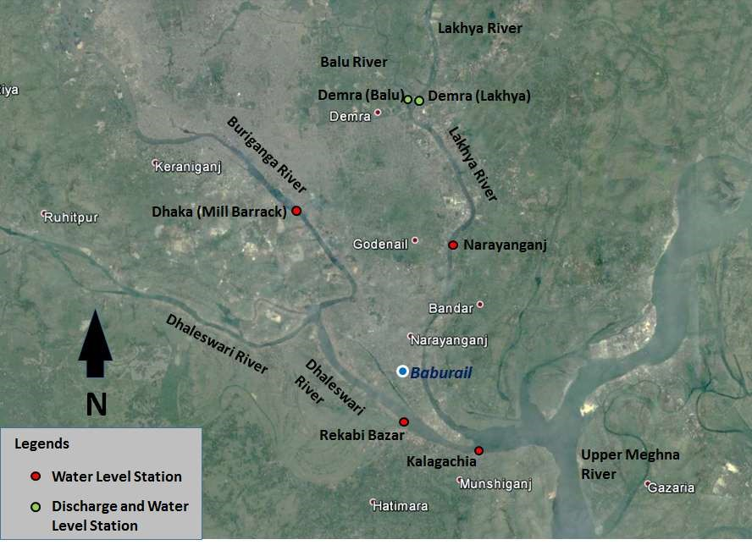
Source: Prepared by the consultant

Drainage System
The most significant feature of Bangladesh landscape is provided by the rivers. Rainwater and wastewater are discharge to the nearby canal and finally into the river. Rainwater and wastewater will not connected into the Baburail Canal. Wastewater will be discharge through the pipeline and finally to the nearby rivers through regulated side surface drainage system of the proposed project. There are existing 229.44 km of surface drain in the city corporation area in order to quick discharge of water. Out of 229.44 km of drain 112.2 km of brick, 49.85 km of RCC, 2.89 km of pipe, and 45.50 km of Katcha drain. Drainage elevation and sub-catchment of Dhaka-Naryanganj-Demra area is shown in Figure 4.7.
Figure 4. 7:Drainage elevation and sub-catchment of Dhaka-Narayanganj-Demra area
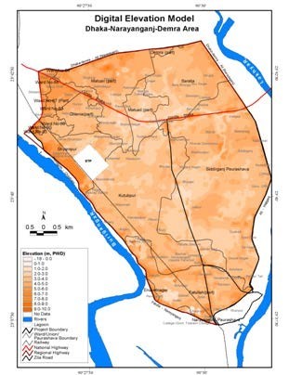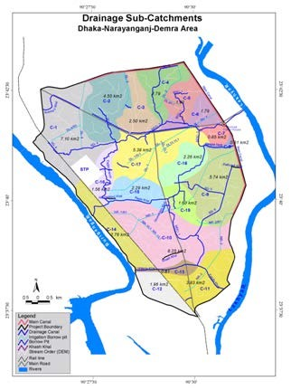

Source: International Journal of Scientific & Engineering Research, Volume 4, Issue 10, October-2013

Flood in the Project Area
Floods are more or less a recurring phenomenon in Bangladesh and often have been within tolerable limits. But occasionally they become devastating. From the hydrological study following (Table 4.2) flood scenario can be observed.
Table 4.2 Flood Levels under different scenario
Flood Level (in mPWD) At Different Scenario
Location | Q_100yr freq | Q_50yr freq | HWL | WL_100yr freq | SHWL | NFL/  Avg. FL | SLWL | LWL
Baburail Canal_ Lakhya end | 7.27 | 6.95 | 6.76 | 6.72 | 6.36 | 5.44 | 0.39 | 0.30
Baburail Canal_ Dhaleshwari end | - | - | 6.92 | 7.46 | 6.92 | 5.59 | 0.45 | 0.45
Flood Level(in mMSL) At Different Scenario
Location | Q_100yr freq | Q_50yr freq | HWL | WL_100yr freq | SHWL | NFL/Avg.FL | SLWL | LWL
Baburail Canal_ Lakhya end | 6.81 | 6.49 | 6.30 | 6.26 | 5.90 | 4.98 | -0.07 | -0.16
Baburail Canal_ Dhaleshwari end | - | - | 6.46 | 7.00 | 6.46 | 5.13 | -0.01 | 0.00
Flood Level(in mMSL) At Different Scenario with 1m freeboard
Location | Q_100yr freq | Q_50yr freq | HWL | WL_100yr freq | SHWL | NFL/Avg.FL | SLWL | LWL
Baburail Canal_ Lakhya end | 7.81 | 7.49 | 7.30 | 7.26 | 6.90 | 5.98 | -0.07 | -0.16
Baburail Canal_ Dhaleshwari end | - | - | 7.46 | 8.00 | 7.46 | 6.13 | -0.01 | 0.00
Source: Base data from WDB and Prepared by the consultant

Landscape
The surrounding Landscape of the proposed project site is mainly residential area along both side. The proposed canal is locally termed as ‘Baburail & Jhelepara Bangla Bazaar Canal’, which is 2.8 Km long and averagely 15-30m wide in different sections connecting Shitalakhya River at the East, which is disconnected with earth fill and Dhaleshwari River at the west under ward no- 15 & 16, of Narayanganj City Corporation. While connected with the rivers, the canal would flow east to west at monsoon and west to east at the lean period. Jimkhana Lake is connected to the canal and approximately 405 m long and 75 m wide surrounded by Deobogh Pucca Road and Bangabandhu Road. The canal is adjacent to RK Mitra Road at south and Mubarak Shah Road at north; crossed the Bangabandhu Road at Mondal Para Intersection, the SM Maleh Road at Hangsha Cinema Hall Bridge, Deobogh Pucca Road at Zallerpar Bridge and Dhaka-Munshiganj Highway at Jhelepara Bridge (Kashipur).

Seismology
The intent of the seismic zoning map is to give an indication of the Maximum Considered Earthquake (MCE) at different parts of the country. In probabilistic terms, the maximum considered earthquake motion may be considered to correspond to having a 2% probability of exceedance within a period of 50 years. The country has been divided into four seismic zones with different levels of ground motion. Table 4.3 includes a description of the four seismic zones. Figure 4.8 presents the boundaries of the four seismic zones. According to seismic zone map of Bangladesh, The proposed sub-project is located in seismic zone 2 is 0.20 and seismic zone coefficient of Narayanganj is 0.20, which is a moderate seismic zone.
Table 4.3 Seismic Zones of Bangladesh
Seismic Zone | Location | Seismic Intensity | Seismic Zone Coefficient, Z
1 | Southwestern part including Barisal, Khulna, Jessore, Rajshahi | Low | 0.12
2 | Lower central and Northwestern part including Noakhali, Dhaka, Narayanganj, Pabna, Dinajpur as wel as southwestern corner including sundarbans | Moderate | 0.20
3 | Upper central and northwestern part including Brahmanbaria, Sirajganj, Rangpur | Severe | 0.28
4 | Northwestern part including Sylhet, Mymensingh, Kurigram | Very Severe | 0.36

Figure 4. 8: Seismic Zoning Map of Bangladesh
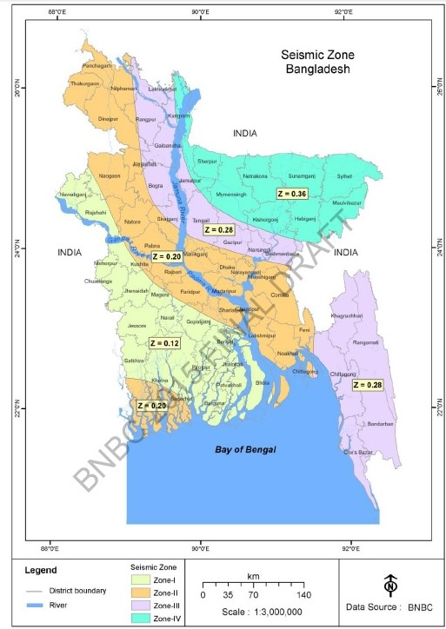
Project Location

Navigation

In the project area navigation facility will be available in the nearby Dhaleswari River at the West side and Shitalakhya River in the East Side. After the completion of the proposed restoration of Baburail Canal project boat service will be started within the Canal for recreation facilities and navigation, navigation facility will be started after the Shitalakhya and Dhaleshwari River water will be cleaned and pollution free.

Ecological Perspective of the Study Area

Approach and Methodology
An ecological survey was carried out as a part of the EA in order to assess the floral and faunal diversity in areas surrounding the proposed restoration of Baburail canal project 2.8 km long starting from Shitalakhya to Dhaleshwari River.
The main purposes of the ecological survey were (i) to enlist the plant and wild life species with their national and international status, (ii) to enlist keystone, rare and threatened flora and fauna, (iii) to investigate the distribution and abundance of flora and fauna including fish species, and (iv) to make an assessment of the impacts for the proposed project activities on the ecological environment.
Floral and faunal diversity fluctuate seasonally due to environmental reasons. Seasonal survey (spanning over a year) could provide detailed information on ecological diversity for the study area. However, in the present study, a rapid survey was conducted in March 2017 during daytime. The Ecologist of the EA team visited areas surrounding the project site (approximately 3.5km surrounding the project site) to collect firsthand information on floral and faunal diversity.
Field visit, Literature review and informal interviews with local people were also conducted as a part of the study. Hereto-faunal and mammalian survey was done through visual search and also through discussion with local people. Aural and visual search were the main survey method for ornithological survey. Fish and fishery information were collected through field study, fishermen interview as well as local fish market survey. Floral survey was conducted through visual and rapid field surveys.
Bio-ecologically the study area falls under Brahmaputra-Jamuna Floodplain (IUCN-Bangladesh, 2002). On the other hand, agro-ecologically it falls under Old Meghna Estuarine Floodplain (BARC/UNDP/FAO, 1995).

  - Floral and Faunal Diversity

Floral Diversity
Plant species that grows in the wild inhabitant for a particular period is known as flora. It plays vital socio-economic and ecological roles for a particular type of habitat or ecosystem. On the basis of habitat, the floral species are divided into two major categories viz.(a) aquatic flora, and (b) terrestrial flora. This Section describes the floral diversity in areas within and surrounding the project site with their status in Bangladesh.

      - Aquatic flora
Aquatic flora is divided into three major types-tree, shrub and herb. Aquatic floral species grow in rivers, canals, ditches, seasonal wetland and low lying agricultural lands in submerged, free-floating, or rooted floating states.
The proposed restoration of Baburial Canal is filled up with earth for long and remained unused for many years. During this time some adaptive floral species have grown at western site, which in turn are being utilized as habitat by some adaptive faunal species. Within the project site, most of the floral species are primarily planted and these are also used by adaptive faunal species as a part of their habitat.
Field visits indicate that the proposed project site and adjacent areas have been significantly altered. Domestic wastewater, river water has been polluted seriously which ultimately causes a decline in the aquatic flora.
Changes in the physical characteristics of river bank land and aquatic environment have direct impacts on its dependent flora. Most of the river-bank areas have well established industrial structures and current ecological feature of these areas seems to be very minimal.

Figure 4. 9: Aquatic Flora at the proposed project site

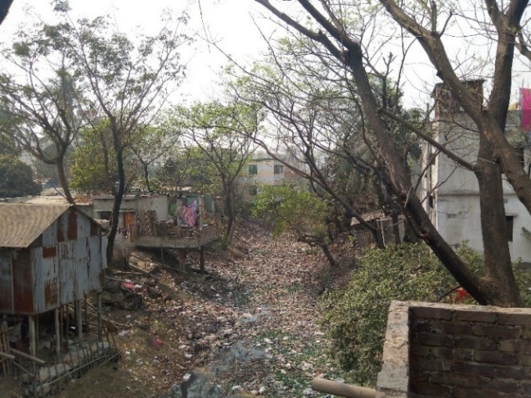

      - Terrestrial flora
The study area supports various terrestrial floras, some of which of these grow naturally, while most have been planted. Generally, terrestrial flora makes a complex ecosystem; with which wild life develop direct relationship through their ecological niche. Terrestrial flora in the study area presented in Table 4.4.
Figure 4. 10: Terrestrial flora (tree) close to the project site
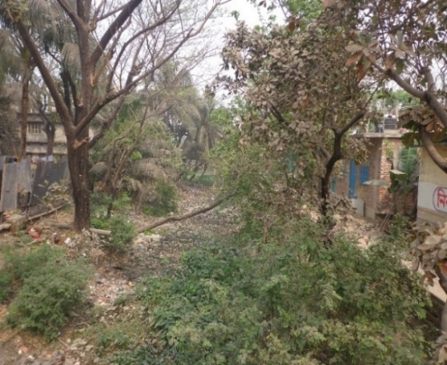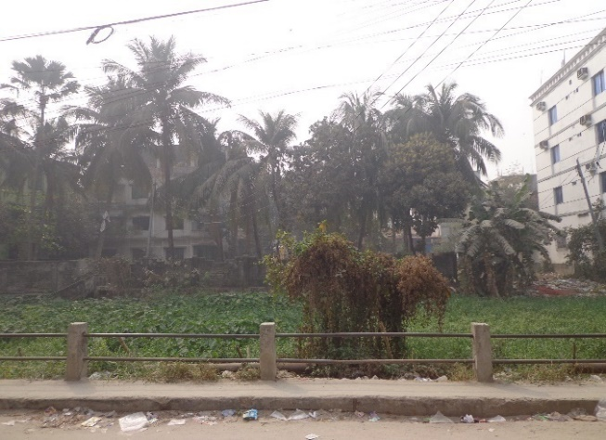

Table 4. 4: List of Tree Species with Socio-economic & Ecological Value, Size and Number of Trees along the Project location of Baburail Canal Restoration Project:

SI No | Name of Tree (Local/English) | Scientific Name | Size |  |  | Total no. | Remarks
 |  |  | Large | Medium | Small
01 | Akashi |  | 10 |  |  | 10
02 | Papaya | Carica papaya |  | 02 |  | 2
03 | Chalta | Dilleniaindica |  |  | 01 | 1
04 | Kadam | Neolamarckiacadamba | 17 | 10 |  | 27
05 | Bot (Banyan) | Ficusbenghalensis | 09 | 10 |  | 19
06 | Koroi | Albizialebbeck | 43 | 01 | 02 | 46
07 | Coconut | Cocos nucifera | 28 | 07 | 07 | 42
08 | Mango | Mangiferaindica | 11 | 11 | 01 | 23
09 | Tamarind | Tamarindusindica | 02 |  |  | 2
10 | Dumur (Fig) | Ficusracemosa | 10 |  |  | 10
11 | Gab | Diospyros blancoi | 01 | 02 |  | 3
12 | Jia |  | 01 | 04 |  | 5
13 | Mehegony | Swieteniamacrophylla | 12 | 20 |  | 32
14 | Hijol | Barringtoniaacutangula |  | 01 |  | 1
15 | khoi | Streblus asper | 02 | 01 |  | 3
16 | Supari (Betal Nut) | Areca catechu | 01 | 06 |  | 7
17 | Jackfruit | Artocarpusheterophyllus | 01 | 06 |  | 7
18 | Jam (Black Palm) | Syzygiumcumini | 01 |  |  | 1
19 | Neem | Azadirachtaindica |  | 02 |  | 2
20 | Tal (Pulm) | Arecaceae | 05 |  |  | 5
21 | Unidentified Tree |  | 10 |  |  | 10
Total |  |  |  |  |  | 258

Faunal Diversity
Animal and fish which grow in the wild are known as fauna. The study areas have various assemblages of animal communities; some species use the areas as permanent habitat, while others as temporary habitat. Based on habitat, faunal species are divided into two major categories viz.(a) aquatic fauna, and (b) terrestrial fauna.

      - Aquatic fauna
Aquatic fauna refers to wildlife and fish species that fully or partially depend on aquatic environment to live or to get food, shelter, nest, and breed and produce off spring.

Since there is no water in the Baburail Canal hence no fish found. Fish is still reasonably available in the nearby Shitalakhya side and Dhaleshwari River, given the overall and increasing scarcity of fish in the country. Small fishes, which are very popular also in overall Bangladesh, are available and caught and used widely, particularly during early monsoon and pre-winter season. Among reptiles, narrow headed soft-shell turtle deserves special mention. Among birds, Bok, Finge, Machranga etc. deserve special mention. Currently no fishes are available in the Baburail Canal. A total of 21 faunal species have been identified in the study area, which include 2 amphibia, 4 reptile, 1 aves, 1 mammal, and the rest are fresh water fish.

The fishes include catfishes (Magur and Shing), major carps (Katla, Rui and Mrigal), minor carps (Puti), Telapia, other (Tengra, Boal, Mola, Taki, Shol). Also prawn, particularly the popular small prawns, locally known as Ichha. The Fish Species in the Study is shown in Table 4.5.

Table 4.5: Fish Species in the Study Area
Fish Group | Scientific Name | Local Name
Cat Fish  Major Carps  Minor Carps  Snakehead  Eel  Others | Macrobrachiummalcolmsoni  Mystusvittatus  Mystusvittatus  Wallago attu  Labeorohita  Catlacatla  Cirrhinusmrigala  Puntius sophore  Channa punctatus  Mastacembelusarmatus  Amblypharyngodonmola  Pscudeutropicusatberinoides | Icha  Tengra  GolishaTengra  Boal, Pangash, Telapia  Rui  Catla  Mrigel  Puti  Taki  Bain  Mola  Batasi

Figure 4. 11: Fish trader with native aquatic fauna (fish)in the study area

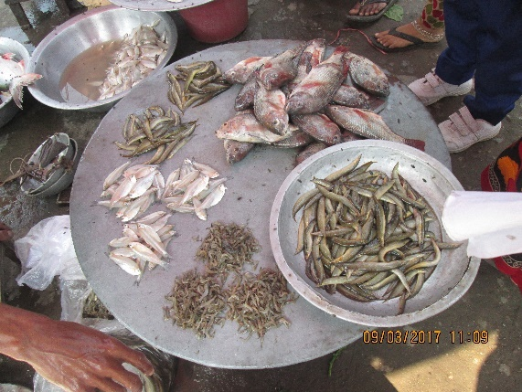

      - Terrestrial fauna
Wild animal that depend on terrestrial habitat is known as terrestrial fauna. Several species of amphibia, reptile, bird and mammal are the main components of terrestrial fauna. Areas surrounding the project site have different types of land, including agricultural dry land/ seasonal wet land, homestead land, fallow land, ditches, which provide typical environment for terrestrial fauna. Terrestrial wild life is divided into 4 major group viz. mammal, bird, reptile and amphibia. A total of 33 faunal species have been identified in the study area which include 3 amphibia, 3 reptiles, 22 aves and 5 mammals. During the site visit only Terrestrial fauna (Peason at the project site) found and is shown in Figure 4.12).
Figure 4. 12: Terrestrial fauna (Pegion at the project site)

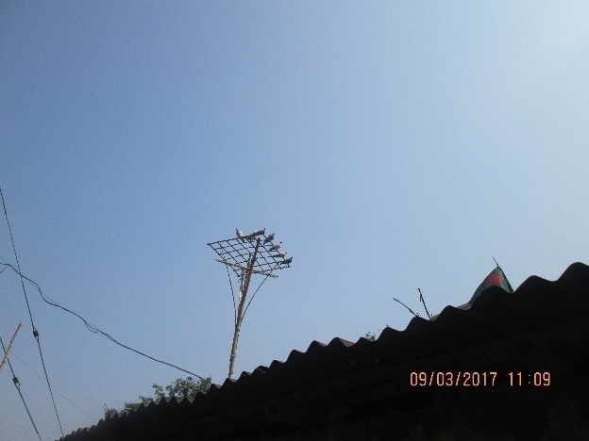

Threatened Flora and Fauna

Floral and faunal species that exist as threatened (endangered, critically endangered, etc.) condition are known as threatened species. There are specific criteria to declare a species as threatened. A total of 54 fresh water fish and 147 inland wildlife species are threatened species in Bangladesh. Tentative list of 40 plant species are also threatened in Bangladesh. No threatened floral species has been identified in the study areas. A couple of threatened wildlife species have been identified in the study area, and these are listed in Table 4.6. A systematic research work in different seasons may provide a more complete status of flora and fauna within the project areas.

Table 4.6: Threatened wildlife and fish in the study area with their status in Bangladesh
Class (Zoological) | English Name | Scientific Name | CE | E | V
Mammalia | G.Riverolphin | P.gangetica |  | Y
Reptilia | YellowMonitor | Varanussalvator |  | Y
[Legend: O=Observed, CE=CriticallyEndangered, E=Endangered, V=Vulnerable]

Protected Areas, Wildlife Sanctuaries, Game Reserves

Protected Area (PA)
Protect Area (PA) refers to an area of land and/or sea especially dedicated to the protection and maintenance of biological diversity, and of natural and associated cultural resources, and managed through legal or other effective means i.e. PA is predominantly a natural area established and managed in perpetuity, through legal or customary regimes, primarily to conserve their natural resources (IUCN, 1990). No PA exists at or near any of the study areas.

National Park (NP)
It is a reserved land, usually declared and owned by a national government, protected from most human development and pollution. No NP exists at or near the proposed project sites.

Game Reserve (GR)
It is an area of land set aside for maintenance of wildlife for tourism or hunting purposes. No GR exists at or near the study areas.

Ecologically Critical Area (ECA)
It is an environmental protection zone, defined by the Government of Bangladesh under the Bangladesh Environment Conservation Act, 1995, where ecosystem is considered to be threatened to reach a critical state. In September 2009, the Bangladesh Government declared Shitalakhya River and its foreshore areas as “ecologically critical areas”, according to the provisions of the environmental Conservation Act 1995 and the Environmental Conservation Rules 1997. The Gazette notification to this effect (see Appendix IX) imposes restrictions on a number of activities in these rivers and their foreshores. These include all types of hunting, collection of all types of aquatic species living in the rivers, all activities that could result in the destruction of floral or faunal habitats, all activities that could destroy natural characteristics of water and soil, activities detrimental to fishery, installation of polluting industrial units, and discharge of domestic/ industrial liquid waste. Water intake and discharge from the Shitalakhya River for the proposed project will depend on the permission of the respective authority (e.g. DoE/GoB). However, it is expected that the respective authority will allow NCC to connect both the river through Baburail Canal. The river water will flow through Baburail Canal will improve the current ecosystem degradation process. In Chapter7, efforts have been made to assess possible changes in ecological characteristics of the project areas due to project implementation.

Wildlife Sanctuary (WS)
It is an area that assures the natural conditions necessary to protect nationally significant species, groups of species, biotic communities, or physical features of the environment, where these require specific human manipulation for their perpetuation. No WS exists at or near the study areas.

Environment Quality
Sampling and analysis is carried out for air, noise and water quality. The locations of sampling sites are shown in Figure 4.13. The standard of environmental quality is shown in Annex-2.
Figure 4. 13: Air, Water and Noise Sampling locations
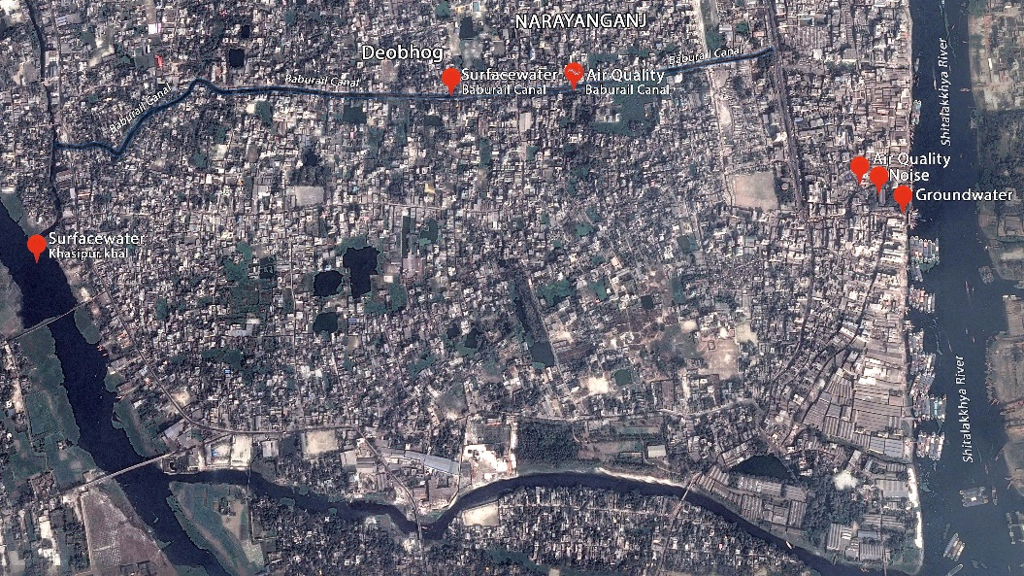

Air Quality
Ambient air quality in the project area was monitored in two locations whose GPS reading area tabulated as below. In Baburail road ambient air quality parameter SPM, PM_{10 ,} PM_{2.5}, SO₂, NO_{X} and CO are within the DOE standards but concentration of SPM exceeds DOE standard. In Nimtola bazar all ambient air quality parameter exceeds DOE standard except CO. Air Quality Monitoring Locations shown in Figure 4.14 and GPS location is shown in Table 4.7. and ambient air quality in Table 4.8.

Figure 4. 14: Ambient Air Quality Monitoring
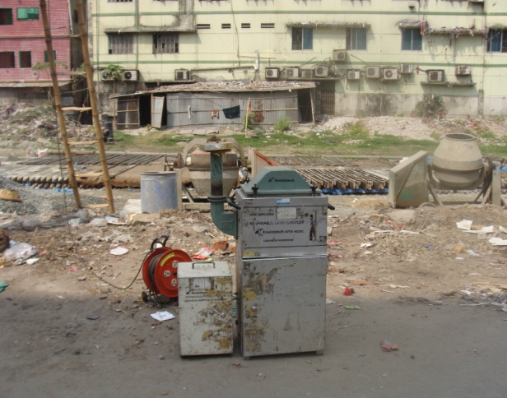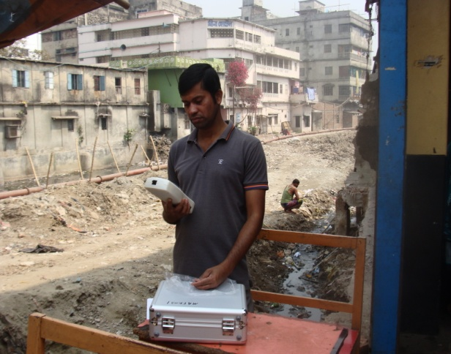

Table 4. 7: Air Quality Monitoring Locations
Sample Type | Place of GPS | GPS Coordinate
Air Quality Monitoring | Nimtoli Bazar | 23°36’22.31”N, 90º30’17.60”E
 | Baburail Road | 23°36’35.38”N, 90º29’45.35”E

Table 4.8: Ambient Air Quality
SN | Location | Ambient Air Pollutants Concentration in µg/m³ |  |  |  |  | CO  ppm
 |  | SPM | PM₁₀ | PM_{2.5} | SO₂ | NO_{X}
01 | Baburail Road | 436.66 | 81.11 | 35.98 | 36.41 | 246.74 | Nil
02 | Nimtolla Bazar | 530.55 | 211.66 | 78.76 | 72.83 | 373.75 | 0.9
Duration (hrs) |  | 8 | 8 | 8 | 8 | 8 | 1
DoE (Bangladesh) Standard |  | 200 | 150 | 65 | 365 | 100 | 35
Method of Analysis |  | Gravimetric | Gravimetric | Luminous Flux Scatter sensor | West-Geake | Jacob &Hochheiser | CO  Meter
Source: Enviro Quality Lab under Enviro Consultants Ltd.

Noise
As a part of EA, baseline noise level measurements were conducted at few different locations within the project complex during day and nighttime’s. Noise level was also measured continuously at the Baburail road and Nimtola bazar located near the proposed site. At Nimtola Bazar both day and night readings exceeds DOE standard but in Baburail road noise readings are within DOE standards. GPS readings of the sampling locations are provided below. Ambient Noise Quality Monitoring location is shown in Figure 4.15 and GPS location Table 4.9 and Ambient Noise Quality results in shown in Table 4.10.

Figure 4. 15: Ambient Noise Quality Monitoring


Table 4.9: Noise Monitoring Locations
Sample Type | Place of GPS | GPS Coordinate
Noise | Nimtola Bazar | 23°36’22.23”N, 90º30’18.17”E
 | Baburail Road | 23°36’35.41”N, 90º29’46.04”E

Table 4.10: Ambient Noise Quality
SN | Location | Results in dB – A Weighted
 |  | Time
 |  | 11:00 AM – 3:00 PM  1.03.2017 | 9:30 PM – 11:30 PM  1.03.2017
01 | Baburail Road | 69.0 | 60.3
02 | Nimtola Bazar | 74.1 | 66.5
DoE (Bangladesh) Noise Standard for Commercial Area (Schedule-4) |  | 70  Day Time  (6 am-9 pm) | 60  Night Time  (9 pm-6 am)
Methods/Instruments |  | Sound Level Meter (DT-8850)  Calibration at 94dB
Source: Enviro Quality Lab under Enviro Consultants Ltd.

Water Quality
Analysis of surface water carried out in this study show that the measured parameters satisfy the Bangladesh drinking water standard. Surface water collected from three locations and BOD₅ of all sample do not satisfy DOE standard. The Surface Water of Baburail Canal, Kashipur Khal and Shitalakhya River are shown in Table 4.11 and sampling location is shown in Figure 4.16.
Figure 4. 16: Surface water sampling
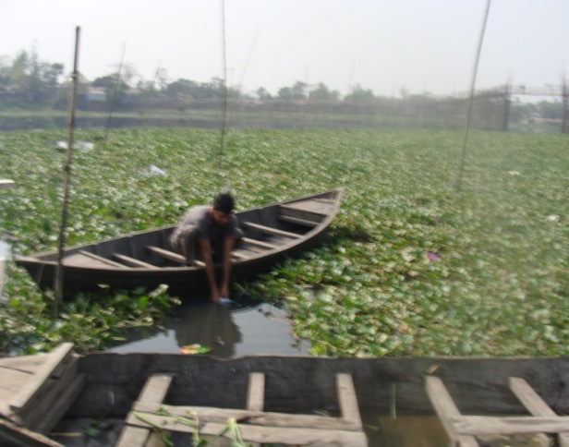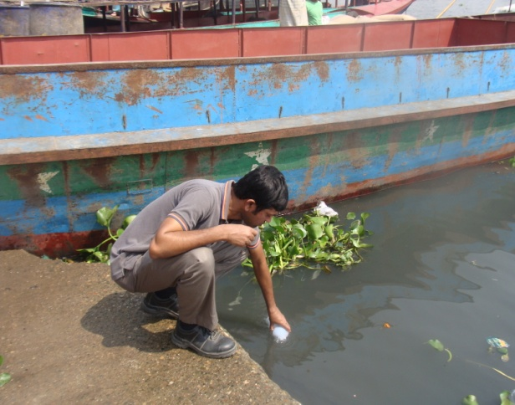

Table 4.11: Surface Water (SW) Quality
SN | Parameter | Unit | Concentration  of SW Baburail Canal | Concentration of Kashipur Khal | Concentration of Shitalakhya River | Bangladesh (DoE) Standard for Surface Water (Schedule- 3-A)
01 | pH |  | 7.3 | 8.1 | 7.8 | 6.5 – 8.5
02 | DO | mg/l | 0.6 | 0.9 | 1.7 | ≥5
03 | BOD₅ | mg/l | 28.2 | 24.6 | 21.6 | ≤10
04 | COD | mg/l | 80 | 75 | 56 | NYS
05 | TDS | mg/l | 696 | 553 | 696 | NYS
06 | EC | µS/cm | 1478 | 1099 | 1478 | 2250
07 | TSS | mg/l | 368 | 274 | 234 | NYS
Source: Enviro Quality Lab under Enviro Consultants Ltd.
Note:
NYS | - Not Yet Set
Ground Water:
Analysis of ground water samples collected from three locations within the project area was made. From the analysis it can be observed that the ground water parameters are within allowable limit. The Ground Water of Baburail Mosque, Deobogh Area and Nimtola Bazar is shown in Table 4.12 and sampling location is shown in Figure 4.17.
Figure 4. 17: Ground water sampling

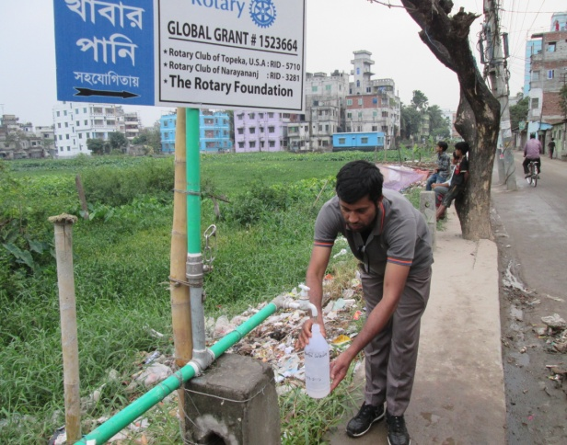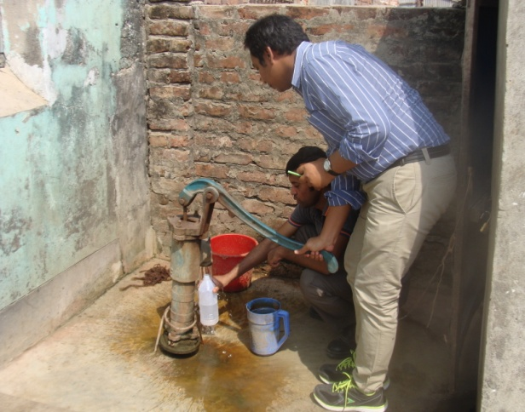
Table 4.12: Ground Water Quality of Baburail Mosque, Deobogh and Nimtola Bazar
SN | Parameter | Unit | Concentration  of Baburail Mosque | Concentration of Deobogh | Concentration of Nimtola | Bangladesh (DoE) Standard for Ground Water (Schedule-3-B)
01 | pH |  | 7.5 | 7.6 | 7.6 | 6.5 – 8.5
02 | DO | mg/l | 6.8 | 6.6 | 6.5 | 6
03 | COD | mg/l | 3.0 | 3.4 | 2.9 | 4
04 | TDS | mg/l | 146 | 144 | 160 | 1000
05 | EC | µS/cm | 370 | 306 | 387 | NYS
06 | Fe | mg/l | 0.17 | 0.16 | 0.19 | 0.3-1
07 | As | mg/l | < LOD | < LOD | < LOD | 0.05
Source: Enviro Quality Lab under Enviro Consultants Ltd.
Note:
NYS -Not Yet Set
LOD - 0.01 mg/L for Iron
LOD - 0.001 mg/L for Arsenic

Soil Quality of Canal Bed Sediment
A hand auger was used to collect the soil from Gymkhana Lake and Baburail Canal at Bowbazar area. Pre-cleaned zipper bags were used to store the canal bed sediment samples and the samples were kept in a cooler box which was sent to Soil Resources Development Institute (SRDI) laboratory. Hand gloves were used during sampling of soil materials collection. Canal Bed sediment sample collection from Gymkhana Lake is shown in Figure 4.18. The test results of canal bed sediment sample are provided in Table 4.13. The test results of Canal Bed Sediment were compared with EU Directive 86/278/EEC for land Application. The test result of Pb, Cd, Cr and Zn parameters of sediment samples was found less than EU Directive and hence it is suitable for land application.
Figure 4. 18: Canal Bed sediment sample collection from Gymkhana Lake
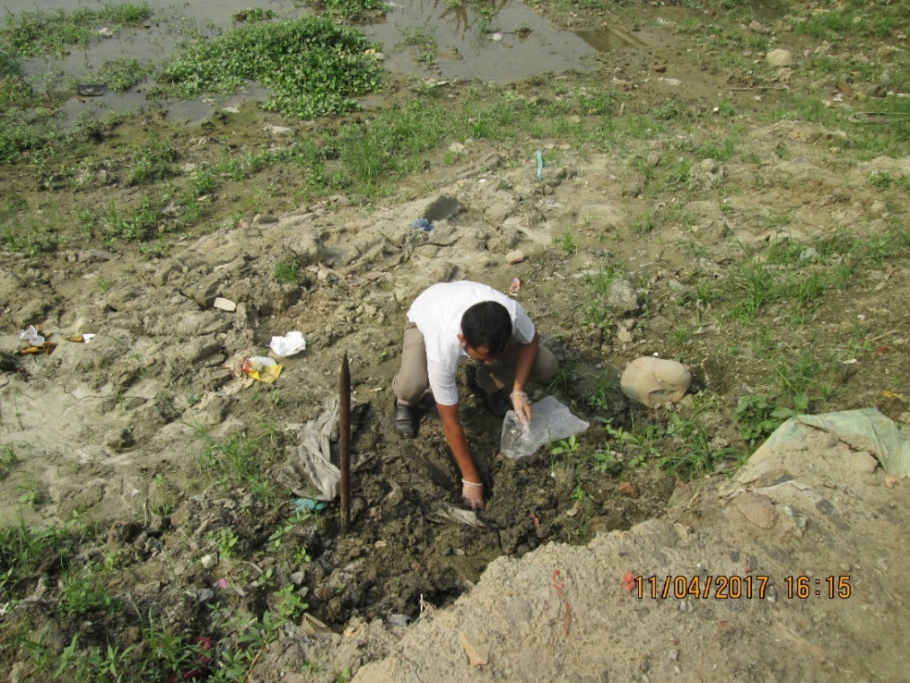

Table 4.13: Canal Bed Sediment Material of Gymkhana Lake and Baburail Canal
SI No. | Parameter | Unit | Concentration of Gymkhana Lake | Concentration of Baburail Canal | Bangladesh (DoE) Standard for Soil | EU Directive  86/278/EEC for land Application
1 | pH |  | 5.9 | 6.1 | NYS | NYS
2 | Lead (Pb) | PPM | 17.08 | 2.45 | NYS | 1200
3 | Cadmium (Cd) | PPM | 0.05 | 0.03 | NYS | 40
4 | Chromium (Cr) | PPM | 22.40 | 18.20 | NYS | NYS
5 | Zinc (Zn) | PPM | 7.51 | 4.50 | NYS | NYS

Solid Waste
The major solid waste is municipal waste, construction waste, metal chips, waste plastic, wood shavings, waste glass and waste oil, can bottle, paper, cartoon, rubbish, kitchen waste, food waste which impact the environment. Such waste is inadequately handled, underground water and River water are contaminated, and sanitation problems will arise.
Measures should be taken include adequate classification of waste and adequate disposal at the disposal site for each type of waste. To reduce the amount of solid waste discarded by the workers during the construction work, efforts will be made to employ the local workers wherever possible, so that the amount of household solid waste will be minimized. The aforementioned measures will be taken to ensure that water pollution or sanitary problems resulting from waste do not arise.
About 350 Tons of solid waste generates every day from the city. Most of them are inorganic 80% (280 ton) and organic 20% (70 ton). At present, there is no specific dumping station for disposal of solid waste. Most of the solid waste are dumping at Charukala low land and also found low land available nearby solid waste collection places. NCC authority has been proposed a dumping station for inorganic waste an at Jalkuri area which is now under approval process. Recently there is a project completed in June 2016, implemented by Department of Environment (DoE) named CDM program using organic waste under climate change trust fund. Under this project organic fertilizer are producing through composting of organic waste. In this project about 22 ton of organic waste mainly from kitchen market are collected after separation and segregation and send to the Panchabati composting site.

From the house hold solid waste till not started collection. 3000 bin with green and red color received from DoE for collection of waste from the household. Organic waste will collect from next month in the green bin and inorganic waste will collect in red bin. After collection of all bin only green bin containing organic waste only will be send to the composting site. The whole composting project was leased to a third party through tender process for management of the composting plant. The awarded third party name is Mati organic is a Joint Venture Company who will perform the total activities. NCC responsibility is to provide the separated organic waste to the site only. The rest part will be responsibility of the Mati Organic company.

Socio Economic Environment

Population
Narayanganj Municipality was established on 8 September 1876 to control an area of 4.5 square miles with a population of 27,876. Now, it is densely populated area near Dhaka. The total area of Narayanganj City Corporation is 72.43 sq.km (including the river Shitalakhya) The total population of Narayanganj City Corporation is 7,09,381. (Source: www.ncc.org.bd). No ethnic people are affected by the proposed project. A detail of social study was performed for this project and separate report prepared.

Demography
Demographical data analysis of any area is a crucial part of any plan preparation process of any area. Any planning decisions have been taken based on the population and economy of any area. Population is also necessary to calculate the demand and future need of the city. This section is attempts to analyze the population to calculate future population on the basis of socio-economic data. At a glance demographic information for NCC area is given below in Table 4.14.

Table 4.14 : Demographic Information at a Glance
Criteria Description
Census Population | - Total population in 2011 is 709380 with 51.49% male  - Population in the Narayanganj Zone is 37.48% with population density of 137 persons per acre  - Population in the Siddhirganj Zone is 39.08% with population density of 43 persons per acre  - Population in the Kadam Rasul Zone is 23.44% with population density of 50 persons per acre
Age Structure | - 38.15% people are within 25 – 49 age range  - 21.02% people are within 15 – 29 age range  - 11.13% people are within 50 – 65+ age range  - 20.52% people are within 5 – 14 age range
Household Size | 4.28
Marital Status | 49.75% people are married
Educational Status | - Literacy rate is about 57.52%
Religious Status | - 91.19% Muslim  - 8.71% Hindu
Source: Bangladesh Bureau of Statistics (BBS), 2011

Settlement and housing
Total affected land is 2.8 km long and 15-30 m wide in different sections connecting Shitalakkha River at the East and Dhaleswari River at the West. A resettlement action plan has been developed and total resettlement budget is Tk. 290056795.

Traffic and Transport
Bangabandhu Road is the major artery of Narayanganj which connected the important localities with each another. At Mondolpara point, there is another important connector- Mobarak Shah road which connected the city with Dhaka-Munshiganj Highway. The canal is parallel to this road and situated at the south side of this road. At Mondolpara Point, the canal crossed Bangabandhu Road. So, this project will have an impact on the most important transport corridors of Narayanganj. Beside these, R. K. Mitra Road, S. M. Maleh Road, B. Dash Road, Majar Road, Jimkhana Road, Deovogue Pucca Road, Jollarpar Road, Bhuianpara (Boubazar) Road and Beparipara Road are the roads within this transport network which would be affected by this development. For traffic impact analysis, the roads of this area has been segmented to have a better understanding about the present scenario as different segments of this transport network have different characteristics. The segments and intersections are shown on the following figure in green and red.

Public Utilities

Water Supply
The main source of water supply in NCC area for civic people is Dhaka WASA. It is found that tube-well is the major source of drinking water in the zila, urban and rural areas. Tube-well as a source of drinking water of the general household has decreased from 83.98% to 78.86%, from 76.66% to 58.72% and from 94.00% to 89.38% in the zila, urban and rural areas respectively during the decade.

Sanitation
It is observed that general household availing sanitary facilities have 100% in the project area. 78.10% in the zila and, 85.31% in urban area and 74.33% in rural area. Household in the non-sanitary group have 20.20% in the zila, 14.00% in urban and 23.45% in rural area. The ‘none’ group is 1.70% in the zila, 0.69% in urban area and 2.22% in rural area.

Education
Average literacy 57.10%; male 59.48%, female 54.56%. Educational institutions: college 16, technical college 2, marine technology centre 1, vocational school 2, secondary school 127, primary school 458, kindergarten 76, collegiate school 1, madrasa 56.

Electricity
According to population and housing census 2011, general household reported to have electricity connection in the zila are 95.25% in 2011 compared to 82.78% in 2001 which shows an increase of 12.47 percentage point during the decade 2001-2011.

Economy and Employment
Main sources of income Agriculture 14.38%, non-agricultural labourer 3.91%, industry 7.33%, commerce 23.87%, transport and communication 6.34%, service 23.13%, construction 2.52%, religious service 0.19%, rent and remittance 3.77% and others 14.56%.

Fisheries
In the river, canal, beels, and ponds there are various kinds of fish, but because of water pollution, it is very hard to see fish in the river.

Transportation
The major transportation mode of the city is Rickshaw, CNG, Tempo, Private car. Now-a-days, all the Upazilas are connected to the zila headquarters by paved roads. Bus, minibus and three wheelers ply over the zila. The city is connected with Dhaka by Railway and Road. Bus, Minibus, country boat ply, and other Upazila is ply by Bus, Minibus, country boat etc. The road network is shown in Figure 4.19. The existing road network surrounding the Baburail Canal is shown in Figure 4.20. The detail of transport study is perform in separate transport study report.

Figure 4. 19: Existing Road network
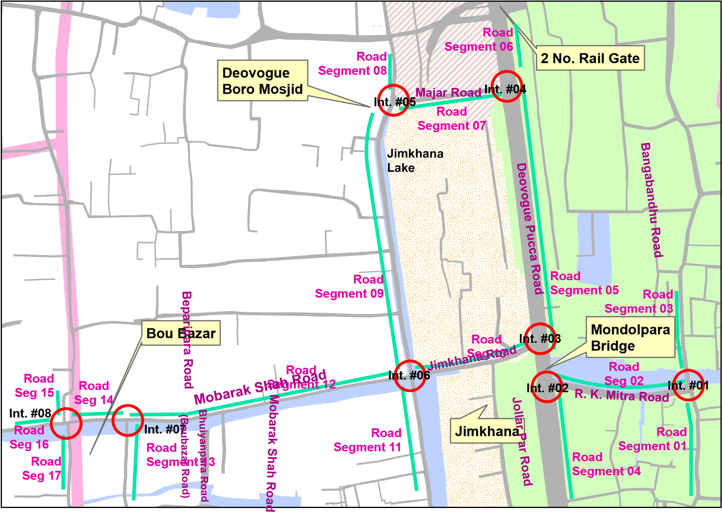
Source: Developed by the consultant

Figure 4. 20: Existing road network surrounding the Baburail Canal

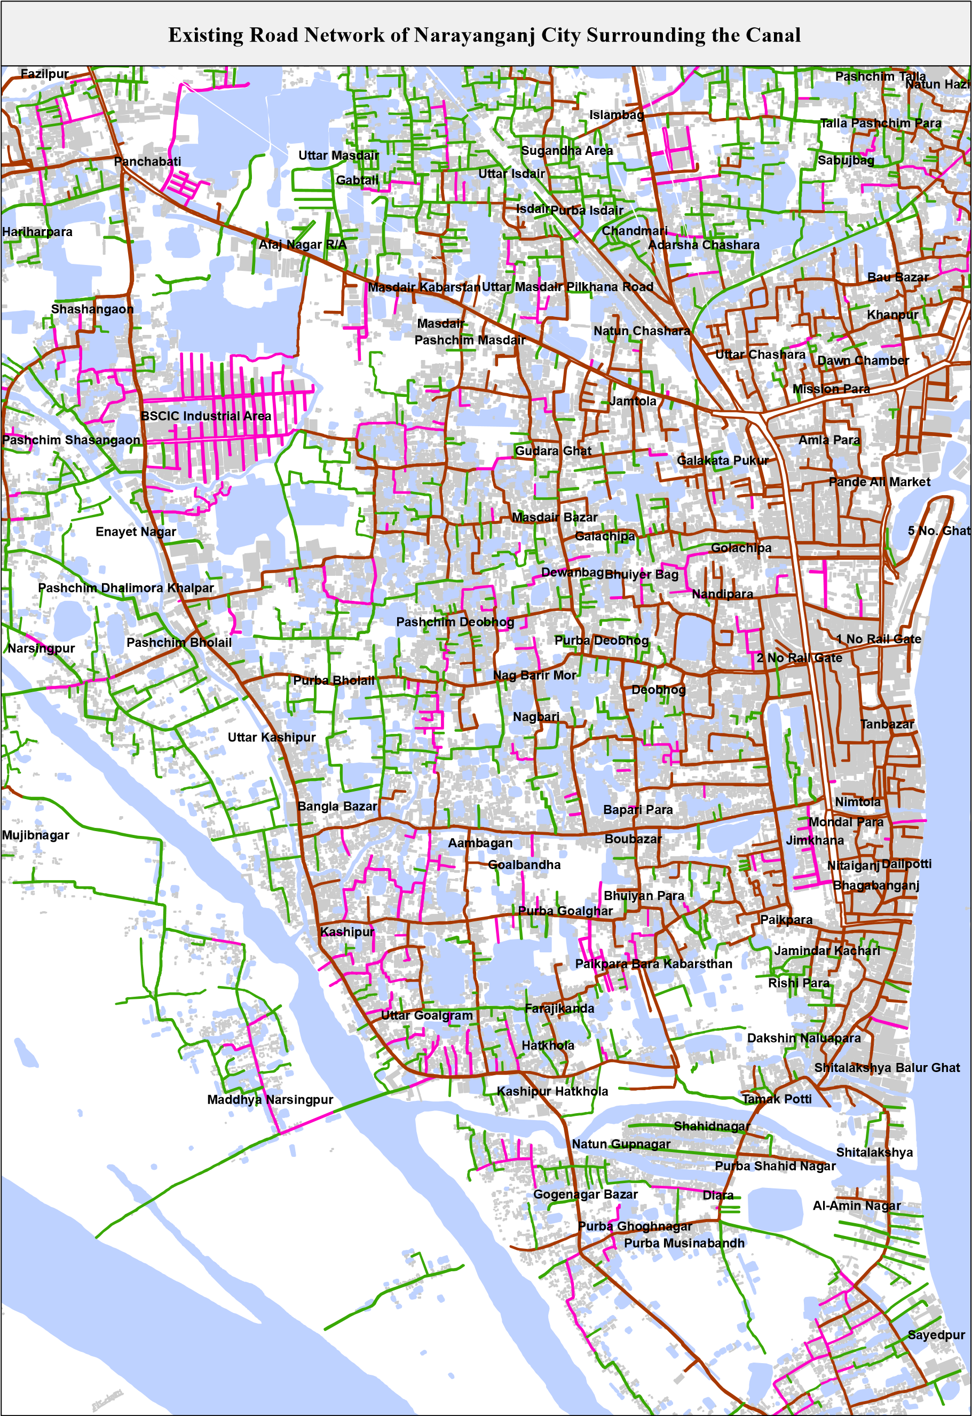
Source: Developed by the consultant

4.7.11 Indigenous people
In the project are there is no indigenous people found.

CHAPTER-5: POTENTIAL IMPACTS AND MITIGATION MEASURES

  - Impact Identification
An environmental impact is defined as any change to an existing condition of the environment. Findings of the assessment are presented according to site preparation, construction and operation phases.
The EA study, based on the review of similar environmental assessment reports, baseline monitoring and stakeholder consultations, has identified some major environmental and social concerns that are expected from the project.
The impacts are broadly classified into following 4 rating during construction and operation stage:
    - Physical Impact
    - Ecological Impact
    - Impact on Human Interest
    - Quality of Life Values
This chapter describes the rating and environmental impacts caused by the project both tentatively during construction and permanently during operation.

  - Pre-Construction Stage

    - Resettlement & land acquisition
The existing Baburail canal restoration project will implement on the NCC own land. No land acquisition will be required and there is no scope for resettlement. No loss of land will occur. Only compensation will be made to affected persons for removal of structure and temporary business and trees loss.

    - Trees and Vegetation
During Implementation Phase
There are 258 numbers of trees and vegetation throughout the length of the Canal. Among of which around 258 number of trees need to be cut down during reshaping of the canal. Due to cutting of trees and removal of vegetation will cause significant soil erosion. The degree of impact has been assessed to be -3. [Table 5.1].
Mitigation:
Tree plantation and re-vegetation program should be taken during implementation of the project. A total of 1150 tree shall be planted both side of the canal with 6 meters interval. At the end of the implementation of the project tree plantation should starts. Detail of tree plantation is presented in Annex 3.

During Operation Phase
During operation of the project tree plantation will be done and lot of tress will be planted for aesthetic view and increase scenic beauty of the area. The degree of impact has been assessed to be +2. [Table 5.2].

      - Ecological Impacts
Restoration of proposed Baburail Canal would have some impacts on the existing ecological environment. Activities such as land clearing and alteration, movement of people and vehicle, material placement, reshaping, accident, etc. have direct or indirect impacts on the existing ecological environment. During construction phase, small scale impacts could be identified by studying or monitoring the associated flora and fauna. Large scale impact, if any, could be identified after completion of the proposed project through careful long-term study and monitoring. In this study, at first possible general impacts of project activities on 3F (flora, fauna and fish) have been assessed, which has been followed by more specific evaluation of ecological impacts and risk assessment.

      - Impact on Flora
Restoration of Baburail canal has negligible impacts on the existing aquatic and terrestrial flora. Within the project sites, magnitude/ intensity of these impacts may vary from place to place, and some could easily be identified, while others require long-term study / monitoring. However, general impacts on project works on flora are briefly described below.
Aquatic Flora
The proposed Baburail restoration project site has no aquatic habitat which supports few common aquatic floral species and none of them are threatened in Bangladesh. All aquatic floral species are grown in the wild within the proposed project site. Due to proposed project activities, all aquatic flora inside the proposed project would not affected. During clearing the site vegetation may cause damage or may uproot from the ground.
Terrestrial Flora
The proposed project site has terrestrial habitat which supports diversified terrestrial floral species, and none of them are threatened in Bangladesh. During site preparation, some naturally grown floral species (herb and shrub) would have to be cleared; but cutting or clearing of trees would be required, as there Table 4.4. 258 trees within the project site. These herbs and shrubs within the project site are used by certain adaptive wildlife as habitat for certain time, and therefore, removal of these would have some potential impact. Terrestrial undergrowth has great contribution to the existing ecosystem, and clearing or removal of the undergrowth would also have some adverse impacts.

      - Impact on Fauna including Fish
Restoration of Baburail canal has no impact on fish since there is no water in the canal.
Faunal species that are sensitive to direct (human activity and traffic) or indirect disturbance (noise) would be impacted most. Habitat disturbance would reduce habitat availability and effectiveness for a certain period for mammals, reptiles, amphibians, birds and their predators. Quantification of these losses is difficult; however, the impact is expected to be low and short-term in nature. However, fish habitat is not likely to be affected during the construction phase of the project. No Impact.

    - Removal of House, Structure and Shop
Restoration of Baburail Canal will require 349 temporary houses, shop which need to be remove. Most of them are illegally constructed on the Baburail canal. The degree of impact has been assessed to be -3. [Table 5.1].
Mitigation:
Proper compensation will be provided to the affected people for loss of structure, business and income.

    - Land Use Change

Since it is a restoration project of a natural water body which has been encroached, there will be no change of land use. The degree of impact thus, has been assigned a value in Table 5.1 and Table 5.2 of “0‟ (i.e., no impact). Contractors to follow the chance find procedures in the EMP table and Annex 4. The existing land plan of Baburail Canal with Catchment area of NCC is shown in Figure 5.1.

Figure 5. 1: Existing Landuse Plan of Baburail Canal with Catchment area
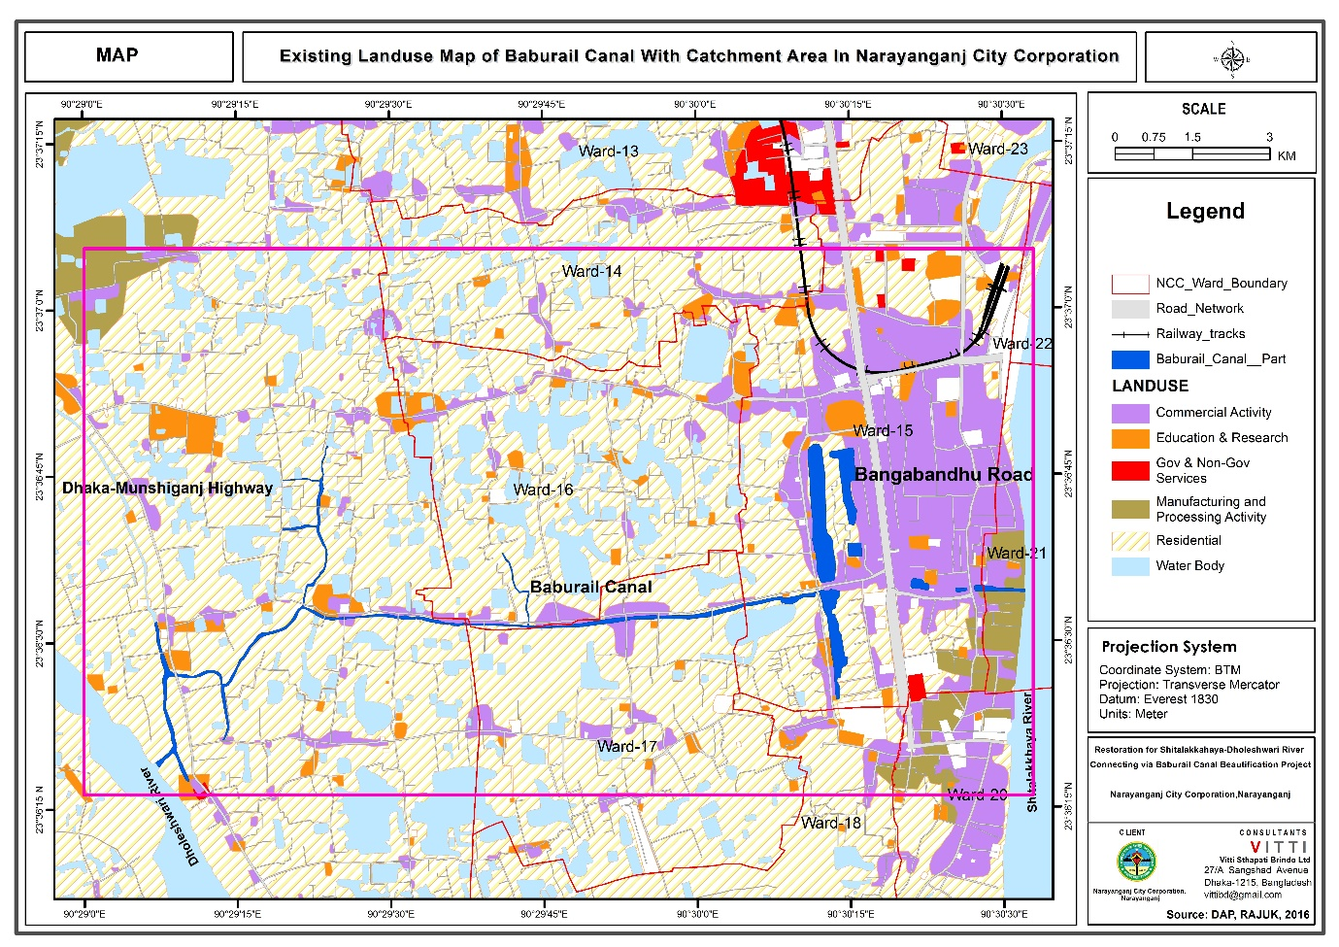

    - Reshaping of Canal
The existing Baburail canal is filled up with earth. The earth need to be remove to a suitable place during reshaping of the canal. The total volume of excavated earth of Package 1 to Package 7 and Gymkhana is 22,936.62 cum and total earth filling for canal bank is 35,261.93 cum. Major part of excavated earth shall be used for filling of canal bank. The remaining part of filling the canal bank shall be collected form the contractor. A minimum quantity of excavated earth need to be dispose. The location of disposal of earth is Panchabati more which is 5 km away from the city. Transportation of earth shall be done by truck with cover the earth material by tarpaulin so that no dust emits in the road. During disposal on the land fill site it should compact every layer of disposal. The area of the land fill site is about one acre. The filled-up earth quality was tested for various parameters mainly heavy metal in the Laboratory.
The degree of impact thus, has been assigned a value in Table 5.1 of “-4‟

Mitigation:
During reshaping of Canal, the machineries which produce less sound and emit less air pollutant will be involved. Water will be spray to suppress the dust pollution.

  - Construction and Operation stage

    - Physical Impact
Impacts from land cutting and filling during Construction Phase
Reshaping of canal andfilling the banks of Baburail Khal will be needed for the proposed Baburail Khal restoration projects. During soil reshaping erosion and land slide may happen during monsoon period. The degree of impact thus, has been assigned a value in Table 5.1 of “-4‟ (i.e., high impact).
Mitigation:
After reshaping of canal and filling the banks, grass and trees should be plant on the banks. Drains in the nearby roads should be constructed properly for quick and controlled discharge of the rain water into the canal so that it could not cause soil erosion.

During Operation Phase
It has estimated that during operational stage the project will not cause any soil erosion and land slide due to proper protection measure. The table also shows that there would not be any significant change in soil erosion and land slide. The degree of impact thus, has been assigned a value of ‘0’ (i.e., no impact). (Table 5.2).

    - Regional Hydrology and Flooding
During Implementation Phase
It has been estimated that during implementation of the project will not cause rise in flood level. The degree of impact thus, has been assigned a value of “0‟ (i.e., no impact).

During Operation Phase
It has been estimated that during operation the project will not cause rise in flood level. The degree of impact thus, has been assigned a value of “0‟ (i.e., no impact).
    - Drainage
During Construction Phase
During construction phase, some extend of drainage problem in the surrounding area will occur. Therefore, impact (-2) is foreseen.

Mitigation:
During construction, temporary drainage facilities will be constructed.

During Operation Phase
As the proposed project will connect the two rivers as well as being fully operated the Khal will play very important role in the drainage network of the project area. The degree of impact thus, has been assigned a value of ‘4’ (Table 5.2).

Mitigation:
Waste water and rain water of the surrounding area will not directly fall into the Canal. Rather waste and rain water will be controlled and transported to the rivers.

    - Erosion and Siltation
It was identified that unstable slopes will have soil erosion during rain and consequently increase sedimentation. Careful monitoring will be required to estimate both soil erosion and siltation impacts. The degree of impact thus, has been assigned a value of “-3”

Mitigation:
Properly designed slope protection works will be adopted for erosion and siltation protection.

    - Water Pollution
During Construction Phase
Construction activities of Khal restoration project will make the available water turbid hence there will be major water pollution. During reshaping of canal soil become loose, mud and soil which may increase turbidity of the existing water bodies. Solid waste and effluents generated from the construction site may not create pollution during dry season. The net impact therefore has been assigned a value of (-1). [Table 5.1]

Mitigation:
Construction activities will be performed so that less water will be turbid.
During Operation Phase
After construction during operational phase the impact on water quality will be negligible. Some pollution may occur from the oil leaching of the water transportation facilities. Thus a value of -1 can be assigned. [Table 5.2].

Mitigation:
Proper monitoring of the transportation facilities will be performed.

    - Air Quality
During construction
The project site is located in urban area which is densely populated area. This population will be exposed to dusts that will be generated during construction activities. The degree of impact has been assessed to be “-3‟, which is low. [Table 5.1].

Mitigation:
For controlling the dust pollution water will be sprayed over the loose soil.

During Operation Phase
After construction, the level of air pollution will decrease. But there will be a rush of vehicles which will emit dust to the nature which will create air pollution producing particulate matter, CO, NO_{x}, SO₂. So, therefore the degree of impact during operation phase has been assessed to be “2‟, which is very low. [Table 5.2].

Mitigation:
During operation phase necessary cleaning and water spraying will control air pollution.

    - Noise Pollution
During Construction Phase
The noise generated during construction activities may cause problem in the project area as the project area is highly populated. Because of reshaping of canal and others construction activities many machineries and vehicles need to be operated, which in terms may cause noise pollution. So, the degree of impact during construction has been assessed to be “-2‟, which is very low. [Table 5.1].

Mitigation:
Less noise producing machineries will be involved in excavating soil.
During Operation Phase
The noise generated from the engine operated boats after completion of the proposed project may also cause problem in the project area. As the Khal will link the two rivers and create navigation facilities, some noise pollution will occur from the water transportation vehicles. The degree of impact has been assessed to be ”2‟, which is very low. [Table 5.2].
Mitigation:
During operation phase for controlling noise pollution proper imposition of laws and regulations for vehicle will be made.

    - Disposal of Soil
During Implementation Phase
The reshaping of canal, soil from Baburail Canal may cause impact during transportation and disposal. During reshaping of canal major part of excavated earth shall be used for filling of canal bank. A minimum quantity of excavated earth need to be dispose. The location of disposal of earth is Panchabati more which is 5 km away from the city. Transportation of earth shall be done by truck with cover the earth material by tarpaulin, so that no dust particle emits in the road. The degree of impact is -4.

Mitigation:
During transportation of reshaping of loose soil by truck it should be cover by triple and dispose in Panchabati more 5 km away from the city center.

During Operation Phase
The operation phase there is no impact.

    - Solid waste
During Construction Phase
During construction lot of solid waste will generate. The degree of impact has been assessed to be “-2”. [Table 5.1].
During Operation Phase
Solid waste should collect by 15 dust bin and disposal through NCC regular disposal system. The degree of impact has been assessed to be ”0‟, which is very low. [Table 5.2].

    - Impact on Human Interest
      - Loss of Lands

Since it is a canal restoration project there will be no loss of land. the degree of impact has been assessed to be ‘0’ (no impact).
      - Industrial Activities
During Construction Phase
There are no industries in the project site area. So, the degree of impact has been assessed to be ‘0’ (no impact).
During Operation Phase
The proposed project will significantly improve the communication facilities and therefore the project is very likely to spur more industrial activities in the project site area. An impact of “+1‟ has been assigned.
      - Employment Opportunity
During Construction Phase
The restoration of the canal itself will generate some employment. So, it will be helpful for the unemployed people of project site area. The net impact has been assessed as “+4”.

During Operation Phase
The operation of the Canal will generate some employment. As a result of increasing industrial activities, there will be more employment opportunities in project site area. The net impact has been assessed as ‘+2’.

      - Transportation and Communication
During Construction Phase
During construction period, there will be some problem in the communication in the side roads along the bank of the Khal. So, the net impact has been assessed as ‘-1’

Mitigation:
Proper construction safety signs will be installed for safety of the passengers.

During Operation Phase
During operation phase the project will be important for communication between the two rivers. The impact has been assessed to be positive (18).

      - Navigation and Boat Communication
During construction
The proposed project will connect two rivers named Shitalakhya and Dhaleshawari. At present, there is no navigation and boat communication. Therefore, the negative impact has been assessed to be zero (0).

During Operation Phase
During operation phase the project will be important for communication between the two rivers. The impact has been assessed to be positive (3).

    - Quality of Life Values

      - Travel Safety
During Construction Phase
During construction stage there may be accident due to construction material and also accident may occur because of the vehicles working on the construction site. So, the impact has been assessed to be very low (-1).

Mitigation:
Construction vehicle will be operated by trained operators. Proper safety will be provided to the construction workers. Also proper and sufficient safety signs will be installed in the construction sites.

During Operation Phase
Due to local traffic, many accidents occur like accidents, robbery. Therefore, travel safety is a major concern of the local population. Impact has been assessed to be moderately positive (+2).

      - Education and Literacy
During Construction Phase
During construction communication, will be hampered but it will not create problem for the students studying around the project. So, the degree of impact has been assessed to be ‘-0’.

During Operation Phase
As the Communication will increase having the road, so it will increase the education rate around the project site. The degree of impact has been assessed to be ‘+3’.

    - Positive socio-economic
This project will have both positive as well as negative impacts on the socio-economic environment of the area. During construction phase, many allied activities will increase rapidly in the project area. During the construction phase a large labour force, including skilled, semi-skilled and un-skilled labour force is expected from local area. Preference will be given to employ local labour. Although some labour force would come from other parts of the nearby area, locals would also be employed to work as semi- skilled or unskilled workers in the project. Labour camp will be used for day time for taking rest and taking food water etc. A sanitary toilet should be install within the camp site.
Besides the direct employment, the opportunities will also be generated for indirect employment and this will provide an impetus to the economy of the local area.
The locals will avail these opportunities arising from the project and increase their income levels. The degree of impact has been assessed to be ‘+2’.

    - Community and worker health and safety
Influx of construction work-force to project area will lead to sanitation, health and hygiene related issues and their impacts on the laborers and the local people. Untreated effluent disposal from labour camps will lead to increased incidences of water borne diseases already prevalent in the local population in the area. Transmission of diseases by immigrant labour population. Unscientific solid waste disposal from construction / labour camps may contaminate the groundwater and impact the existing bird population in the vicinity. The degree of impact has been assessed to be ‘-4’.

Mitigation:
Healthy and hygienic Labour camps will be made for the construction workers. Temporary medical camps will also be made at the camps of construction workers.

    - Recreational facilities
The proposed project will increase the recreational facilities of the City Corporation. People of the project area will be able to pass their leisure time in a healthy fresh environment. The project also involve sitting sufficient sitting facilities, playground, walkway etc. The degree of impact has been assessed to be ‘3’.

  - Environmental Impact Evaluation
Table 5.1 and Table 5.2 present the environmental impact valuation (EIV) against various environmental parameters during construction and operation period respectively. The assigned importance values are in line with proposed values in guideline of Narayanganj City Corporation, while impact values are assigned using expert judgment on the expected impacts. It is seen that during construction negative impact (-49) and positive impact is +24. The EIV during construction stage is -25. During operation stage, positive impact is +73 whereas negative impact is -9. Total EIV during operation is +64.

Table 5.1: Environmental Impact Valuation (EIV) of the proposed project during Construction
Parameters | Relative Importance Value | Degree of Impact | Relative Impact |  | EIV
 |  |  | Positive | Negative
1. Physical |  |  |  |  | -31
Loss of land | 2 | 0
Vegetation, shrub and trees removal | 4 | -3 |  | -4
Structure removal | 4 | -3 |  | -3
Soil removal | 6 | -4 |  | -4
Soil transport and disposal of soil in low land filling | 6 | -4 |  | -4
Regional Hydrology and Flooding | 2 | 0 |  | -2
Drainage Congestion/ Water Logging | 4 | -3 |  | -3
Air Quality | 3 | -3 |  | -3
Water Quality | 1 | 0 |  | -1
Drainage | 4 | -2 |  | -3
Noise Pollution | 2 | -2 |  | -4
2. Ecological |  |  |  |  | -7
Fish | 1 | 0 |  | 0
Forest | 4 | -2 |  | -2
Wildlife and Biodiversity | 4 | 0
Solid Wastes | 2 | 0 |  | -2
Nuisance Plant/ Eutrophication | 1 | -2 |  | -1
Wetland and Wetland Habitat | 4 | 0
Terrestrial Habitat | 2 | 0
Trees and Vegetation | 2 | -2 |  | -2
Wastewater | 1 | 0
3. Human Interest |  |  |  |  | +20
Loss of Lands | 6 | 0
Loss of Top Soil of Agricultural Lands | 2 | 0
Employment Opportunities | 6 | +4 | +24
Industrial Activities | 3 | 0
Irrigation Facilities | 2 | 0
Navigation | 2 | 0
Transportation and Communication | 4 | -1 |  | -4
Agricultural Development | 2 | 0
Landscape | 2 | 0
4. Quality of life |  |  |  |  | -7
Travel Safety | 3 | -1 |  | -3
Aesthetic view & recreational facilities | 4 | -2 |  | -4
Education and Literacy | 3 | 0
Sanitation & pure water supply
Cultural Heritage and Recreation
Total EIV |  |  | 24 | -49 | -25

Table 5.2: Environmental Impact Valuation (EIV) of the proposed project during Operation

Parameters | Relative Importance Value | Degree of Impact | Relative Impact |  | EIV
 |  |  | Positive | Negative
1. Physical |  |  |  |  | 3
Tree Plantation | 4 | +2 | +4
Soil Erosion | 4 | 0
Regional Hydrology and Flooding | 4 | 0
Drainage Congestion/ Water Logging | 2 | 0
Canal Bank Erosion | 2 | 0
Water Pollution | 4 | 0 |  | -1
Water scarcity in canal | 4 | -2 |  | -8
Drainage | 2 | 0 | +4
Air Quality | 2 | -1 | +2
Noise Pollution | 2 | 1 | +2
2. Ecological |  |  |  |  | 6
Fish | 1 | 0 | +2
Forest | 4 | 0 | +2
Wildlife and Biodiversity | 4 | 0
Solid Wastes | 2 | 0
Wetland and Wetland Habitat | 2 | 0
Terrestrial Habitat | 2 | 0
Trees and Vegetation | 2 | +1 | +2
Wastewater | 1 | 0
3. Human Interest |  |  |  |  | +40
Loss of Lands | 6 | 0
Employment Opportunities | 6 | +2 | +12
Departmental Store | 4 | +1 | +4
Industrial Activities | 3 | +1
Transportation and Communication | 6 | +3 | +18
Irrigation facility/ Agricultural Development | 2 | 0
Navigation
Landscape | 2 | +3 | +6
4. Quality of life |  |  |  |  | +15
Travel Safety | 3 | +2 | +6
Aesthetic view & recreational facilities | 3 | +2 | +6
Education and Literacy | 3 | +1 | +3
Sanitation & pure water supply
Cultural Heritage and Recreation
Total EIV |  |  | 73 | -9 | 64

CHAPTER -6: ANALYSIS OF ALTERNATIVE

  - The ‘No Project’ Scenario
From a purely physical environmental point of view, the ‘do-nothing` is preferable to any project implementation, since it would avoid creation of any of the adverse impacts associated with the project. However, the potential socio-economic benefits to the nation would be foregone and recreational, improvement of life style and industrial and transportation growth would be hampered.
It is concluded that the ‘No build’ alternative is unacceptable, and the potential socio-economic benefits of implementation of such project far outweigh the adverse impacts, all of which can be controlled and minimized to an allowable level.

  - Site Alternatives
During identification of project site it was consider the following four factors. These are i) The land for canal reshaping is already available, ii) the canal is existing but not operational. iii) River connection is possible for flow of water iv) Infrastructure facility available to tourist (Road, Rail, River transport, telecommunication, etc). All the above mentioned four major facilities are fulfilled and available at this Baburail canal restoration project site.

Based on the above factors earlier that the project site is finalized for the proposed project. Baburail project is located in an area, which have every scope for all types of recreation facilities. The canal aesthetic looks are modern and environment compatible, the site is environmentally acceptable, site clearance certificate received from DoE, and the plant is under construction and the IEE carried out earlier concluded about the suitability of the project location. So, there is no logical need to look into alternative sites. Hence this has not been done in the present EA.

CHAPTER-7: OUTLINE ENVIRONMENT MANAGEMENT PLANS

Environmental Management Plan
The basic objective of the EMP is to manage adverse impacts of proposed project interventions in a way that minimizes the adverse impact on the environment and people at the project sties. The Canal will be developed into next two years and the canal will open for operation in 2019. The specific objectives of the EMP are to:
- Facilitate the implementation of the mitigation measures discussed earlier in the document.
- Maximize potential project benefits and control negative impacts;
- Draw responsibilities for NCC, contractors, consultants, and other members of the project team for the environmental and social management of the Project;
- Define a monitoring mechanism and identify monitoring parameters in order to:
- Ensure the complete implementation of all mitigation measures,
- Ensure the effectiveness of the mitigation measures;
- Maintain essential ecological process, preserving biodiversity and where possible restoring degraded natural resources; and
- Assess environmental training requirements for different stakeholders at various levels.
The EMP will be managed through a number of tasks and activities and site specific management plans. One purpose of the EMP is to record the procedure and methodology for management of mitigation identified for each negative impacts of the Project. The management will clearly delineate the responsibility of various participants and stakeholders involved in planning, implementation and operation of the Project.

Inclusion of Relevant Components of EMP in Contract Documents
The EA to be prepared for Projects should include a section on special environmental clauses to be incorporated in the Tender Document under General/Particular Specification. These clauses are aimed at ensuring that the Contractor carries out his responsibility of implementing the environment management plan (EMP), monitoring plan as well as other environmental and safety measures. Such clauses may specify, for example, penalties for non-compliance as well as incentives to promote strong compliance. The various contractors must be made accountable to implement the plans and mitigation measures which pertain to them through contract documents and/or other agreements of the obligations and importance of the environmental and social components of the project.

Environmental and Social Management
Details of further tasks to be carried out and various plans to be prepared during the course of implementation and operation of the project are given in the
.

Table 7. 1: Management Plans/ Additional Tasks for the Project
 | Plan/Task | Responsibility |  |  | Timing
 |  | Plan Preparation | Plan Approval | Review/ Implementation
 | Environmental Codes of Practice (ECPs) | EA Consultants | NCC /WB | NCC through contractors | Already prepared (Annex 6)
 | Inclusion of environmental clauses in bid documents for various contracts | EA Consultants | NCC /WB | NCC through contractors | 2017-2019
 | Plans to be prepared by contractors for construction phase
 | OHS Plan | All contractors | CSC and PIU | All contractors | Before mobilization of each contractor
 | Pollution Prevention Plans (related to air, noise, soil, water resources) | All contractors | CSC and PIU | All contractors | Before mobilization of each contractor
 | Waste Disposal and Wastewater Management Plan | All contractors | CSC and PIU | All contractors | Before mobilization of each contractor
 | Drinking Water Supply and Sanitation Plan | All contractors | CSC and PIU | All contractors | Before mobilization of each contractor
 | Traffic Management Plan | All Contractors | CSC and PIU | All contractors | Before mobilization of each contractor
 | Construction Camp Management Plan | All contractors | CSC and PIU | All contractors | Before mobilization of each contractor
 | Fuels and hazardous substances management plan | All contractors | CSC and PIU | All contractors | Before mobilization of each contractor
 | Emergency and contingency Preparedness Plan (for construction phase) | All contractors | CSC and PIU | All contractors | Before mobilization of each contractor
 | Plans to be prepared for O&M Phase
 | O&M Phase Environmental Code of Practices | CSC | NCC/WB | NCC | Prior to completion of construction
 | Environmental Management System (waste disposal, air and noise quality, etc.) | NCC (through consultants) | - | NCC | Prior to completion of construction
 | Safety Management Systems (OHS Management) | NCC (through consultants) | - | NCC | Prior to completion of construction
 | Land use planning around the canal facilities | NCC (through consultants) |  | NCC | Prior to completion of construction

Environmental Codes of Practice

The environmental codes of practice (ECoPs) are generic, non-site-specific guidelines. The ECoPs consist of environmental management guidelines and practices to be followed by the contractors for sustainable management of all environmental issues. The contractor will be required to follow them and also use them to prepare site-specific management plans (discussed later in the Section). The ECoPs are listed below and attached in Annex 6.
- ECoP 1: Waste Management
- ECoP 2: Fuels and Hazardous Substances Management
- ECoP 3: Water Resources Management
- ECoP 4: Drainage Management
- ECoP 5: Soil Quality Management
- ECoP 6: Erosion and Sediment Control
- ECoP 7: Top Soil Management
- ECoP 8: Topography and Landscaping
- ECoP 9: Borrow Areas Management
- ECoP 10: Air Quality Management
- ECoP 11: Noise and Vibration Management
- ECoP 12: Protection of Flora
- ECoP 13: Protection of Fauna
- ECoP 14: Protection of Fisheries
- ECoP 15: Road Transport and Road Traffic Management
- ECoP 16: Construction Camp Management
- ECoP 17: Cultural and Religious Issues
- ECoP 18: Workers Health and Safety

Mitigations and Compliance Monitoring Plans
The mitigation and compliance monitoring plans are the key element of EMP to be prepared on the basis of impact assessment described in Chapter 5. The plans describe the potentially negative impacts of each Project activity, lists mitigation and control measures to address the negative impacts, and assigns responsibilities for implementation and monitoring of these measures. Mitigation and Compliance Monitoring Plan – Pre-Construction/Design Phase, Construction Phase, and operation phase shown in Table 7.2.

Construction Stage Site Specific Management Plans
Pollution Prevention Plan will be prepared and implemented by the contractors on the basis of the ECoPs and WBG EHS Guidelines (2007) that will be part of the bidding documents. The Plan will be submitted to the CSC for their review and approval before contractor mobilization.
Waste Disposal and Effluent Management Plan will be prepared and implemented by the Contractor on the basis of the EMP, ECoP, and WBG EHS Guidelines (2007), which will be part of the bidding documents. The Plan will be submitted to the CSC for their review and approval before contractor mobilization.
Storm water Drainage: Storm water will be discharge through internal drainage system of the area and connected to pipeline of the both sides of the Baburail canal.
Drinking Water Supply and Sanitation Plan: Separate water supply and sanitation provisions will be needed for the temporary facilities including offices, labor camps and workshops so that it does not shortages and/or contamination of existing drinking water sources. The plan will be submitted to the CSC for their review and approval before contractor mobilization.
Occupational Health and Safety (OHS) Plan will be prepared and implemented by each contractor on the basis of the WBG EHS Guidelines (2007), ECoPs, and other relevant standards. The Plan will be submitted to the CSC for their review and approval before contractor mobilization.
Borrow Area Management Plan will be prepared and implemented by each contractor on the basis of the WBG EHS Guidelines (2007), ECoPs, and other relevant standards. The Plan will be submitted to the CSC for their review and approval before contractor mobilization
Construction Camp Management Plan will be prepared by each contractor. The Plan will include the camp layout, details of various facilities including supplies, storage, and disposal. The plan will be submitted to the CSC for their review and approval before camp establishment.
Fuel and Hazardous Substances Management Plan will be prepared by each contractor in accordance with the standard operating procedures, relevant guidelines, and where applicable, material safety data sheets (MSDS). The plan will include the procedures for handling the oils and chemical spills. The plan will be submitted to the CSC for their review and approval before contractor mobilization.
An Emergency and Contingency Preparedness Plan will be prepared by each contractor after assessing potential risks and hazards that could be encountered during construction. The plan will be submitted to the CSC/NCC for their review and approval before contractor mobilization.

    - Traffic Management Plan
Traffic Management Plan will be prepared by each contractor after discussion with NCC and authorities responsible for roads and traffic. The plan will be submitted to the CSC for their review and approval before contractor mobilization. The plan will identify the routes to be used by the contractors, procedures for the safety of the local community particularly pedestrians, and monitoring mechanism to avoid traffic congestion.

Table 7. 2: Mitigation and Compliance Monitoring Plan – Pre-Construction/Design Phase
Environmental and sustainability issue |  | Issues/Impacts/impact sources | Mitigation Measures/Action Plan | Responsibility
 |  |  |  | Execution | Monitoring
Canal facilities and land use planning and canal components |  | Issues with existing Canals include  - Unregulated development around Baburail Canal facilities  - Lack of Transport facilities  These above issues are also relevant to the proposed Canal sites when designing the project facilities | - Design and provide adequate facilities in the Canal designs.  - As a part of the engineering designs, a long-term master plan will be developed for planning of Canal facilities with adequate buffer areas around the canal facilities. In addition, the project will support creation and/or updating of land use plans around the Canal areas during project implementation, to help address challenges related to unregulated but anticipated development around the Canal facilities that falls outside the scope of the Canal’s jurisdiction and immediate buffer zone. | Consultant  NCC | NCC
Hydrology |  | Baburail Canal is located in main city connect with Shitalakhya and Dhaleshwari River | - Design of Canals will consider flood fore casting and if necessary will construct embankments (or filling the lands above flood levels) for protection of Canals from flooding  - Canal edge protection measures to control the erosion of the rainwater drain | Consultant | NCC
Noise |  | Noise from Canal facilities and road junction | - Design Plantation development around the Canal to create buffer area. | Consultant | NCC
Environmental assessment of proposed Canal |  | The current environmental assessment is based on framework approach; | - Carry out EA studies for proposed Canals in compliance with this EMF, and World Bank and GoB requirements  - Submission of EA documents for DOE and World Bank clearance. | Consultants | NCC
- Mitigation and Compliance Monitoring Plan – Construction Phase
Clearing the vegetation, shrub, and trees |  | Loss of biodiversity and ecological values | - Plantation program should be taken for vegetation, and trees. Plant atleast three trees for one trees cut. | Contractor  NCC | NCC
Remove house, shop and structure |  | Loss of income, loss of house | - Compensate proper compensation for loss of house/shop/structure and loss of income. | Contractor  NCC | NCC
Reshaping of existing filled up canal |  | - Dust pollution  - Create nuisance  - Road damage | - Excavate the canal in dry season  - If transported by truck, then Cover the soil by tipple of the truck during transportation  - Spray of water is suggested in the road and construction sites  - As per capacity of road use the below capacity of truck load | Contractor | CSC, PIU
Construction of component of the project (Bridge, overpass, sluice gate, elevated walkway, floating folded bridge and lighting. |  | - Construction related impact  - Dust emission  - Noise pollution  Pedestrian and vehicle movement | - Implement measures related all in ECoPs. | Contractor | CSC, PIU
Air Quality |  | - Emissions from construction related traffic and machinery.  - Dust from works, other machinery, concrete mixing, and traffic from trucks and vehicles. | - Implement measures in ECoP 10 Air Quality Management. Dust generation will be restricted as much as possible and water sprinkling carried out as appropriate, especially where earth moving, and reshaping of canal are carried out.  - Emissions from construction equipment and traffic will comply with World Bank EHS guidelines and will be monitored. | Contractor | CSC, PIU
Surface and ground water |  | - Waste water from construction camps, offices and houses.  - Spillage of fuels, oils, and other chemicals, and wastewater from market, shops  Erosion from construction works | - Implement measures in ECoPs 3, 4 and 6  - Manage wastewater from labour camp properly  - Maintain proper slope to prevent erosion | Contractor | CSC, PIU
Noise |  | During construction on the canal, noise levels produced by vehicles, machinery, concrete mixing, and other construction activities will exceed the applicable standards and may cause nuisance to local community | - Limit the noisy construction activities to daylight hours  - Maintain the equipment and vehicles as per manufacturer guidelines | Contractor | CSC, PIU
Solid Waste Management |  | May create nuisance and odor | - Place adequate dust bin along the canal for collection of solid waste.  - NCC conservancy department shall collect the solid waste every day, and put in the NCC SWM system and dispose properly. | Contractor | CSC, PIU
Health and Safety |  | - Workers health and safety hazards associated with construction activities  Community health and safety hazards at the construction sites, including exposure to sexually transmitted diseases such as HIV/AIDS | - Implement ECoP 18 pm Workers Health and Safety, ECoP 16: Construction Camp Management  - Require all contractors to specify a code of conduct for expectations of worker behavior at site and with local communities  - Separation of people from vehicles and making vehicle passageways one-way, to the extent practical  - Traffic management  - Require personal protective equipment (PPE), as well as required health and safety awareness orientation and training, for all workers.  - To ensure the works contract incorporate minimum health and safety provisions and is being monitor by NCC with the support from CSC during construction. | Contractor | CSC, PIU
Child labour |  | Risk of contractors or subcontractors hiring child labour in the construction activities. | - National laws on child labour will be strictly followed. No child labour will be hired by the contractors or subcontractors in any of the project activities. | Contractor | CSC, PIU
Mitigation and Compliance Monitoring Plan – Operation Phase
Air Quality | Dust from the access roads and Canal facilities |  | - Regularly sweeping the overpass yards | E&S Cell | NCC
Noise | Noise sources from moving vehicle around the canal and increase vehicular traffic. |  | - Consideration should also be given in the planning stage for developing vegetation and walls around the Canal facilities to reduce noise levels.  - Alter operations schedules to avoid noise pollution during nights and weekends  - Provide awareness signboard to restrict the noise level | E&S Cell | NCC
Occupational health and safety | - Physical hazards associated with handling and use of associated machinery and vehicles.  - Noise from vehicular traffic |  | - Development of Safety System. This safety system should include procedures to regulate the safe movement of vehicle within the Canal facilities, protect the general public from dangers arising from traffic, and prevent events that may result in injury to workers, the public, or the environment. The Safety Management System should include comprehensive emergency and contingency preparedness and response plans that provide a coordinated response | Terminal Operator | NCC with support from CSC
Trash | Trash from Canal/outside Canal by visitors, service providers, employees, others; |  | - Conduct a reduce/recycle/reuse (waste minimization) study to identify sources of current waste streams and alternatives to disposal; include a perimeter (and beyond) survey of trash to identify its origins;  - Place marked trash containers at locations convenient to visitors, vehicle operators and employees; | Canal Operator, E&S Cell | NCC
Solid Waste Management | May create nuisance and odor |  | - Place adequate 15 dust bin along the canal for collection of solid waste collection.  - NCC conservancy department shall collect the solid waste every day, and put in the NCC SWM system and dispose properly. | Canal Operator, E&S Cell | NCC

Monitoring Program
As one of the key elements of the EMP, a two-tier monitoring program has been proposed comprising compliance monitoring and effects monitoring. The main purpose of this monitoring program is to ensure that the various tasks detailed in the EMP particularly the mitigation measures are implemented in an effective manner, and also to evaluate program impacts on the key environment and social parameters. Various types of EMP monitoring are discussed below.

Compliance Monitoring
The purpose of the compliance monitoring is to ensure that the contractor implements the mitigation measures given in the EMP are effectively and timely implemented. This monitoring will generally be carried out by the CSC with the help of checklists prepared on the basis of the mitigation measures given in Chapter 5.

Effects Monitoring
Effects monitoring is a very important aspect of environmental management to safeguard the protection of environment. The effects monitoring plan proposed for the Projects is presented in which will be revisited and revised during EA studies. The monitoring will comprise surveillance to check whether the contractor is meeting the provisions of the contract during construction and operation of the project including the responsible agencies for implementation and supervision. Compliance indicators or threshold limits for the monitoring are also given in Table 7.3.

Table 7. 3: Effects Monitoring Plan
Parameter/ Activity | Location | Means of Monitoring | Compliance indicator/ threshold limits | Frequency | Responsible Agency
 |  |  |  |  | Impleme-ntation | Super-vision
During Construction
Traffic Safety | Access Roads and overpass | Visual inspection to see whether proper traffic signs are placed and flag-men for traffic management are engaged | Smooth flowing of traffic; and placement of traffic signs and flag-men | Monthly | Contractor | CSC
Dust | Construction sites | Visual inspection to ensure good standard equipment is in use and dust suppression measures (e.g., spraying of waters) are in place. | No dust generation from the construction activities | Daily | Contractor | CSC
 | Material storage sites | Visual inspection to ensure dust suppression work plan is being implemented | No dust generation from the material storage sites | Monthly | Contractor | CSC
Air quality (SPM, PM_{2.5}, PM₁₀, CO₂, SOx, NOx) | Near the Canal | 24 hours continuous monitoring with the help of appropriate instruments and analyzers | Compliance with the DOE standards | Quarterly during the construction phase | Contractor | CSC
Water Pollution | During Construction | Measurement of pH, EC, Turbidity, DO, Coli form, BOD, NH₄N Oil and Grease. Sampling point is outlet of open drain. | Compliance with the DOE standards | Quarterly during the construction phase | Contractor | CSC
Noise | Construction sites | Noise measurement using noise meter; Ensure work restriction between 21:00-06:00 close to the residential areas | Compliance with DOE standards | Monthly | Contractor | CSC
Water quality (For all drinking water parameters including arsenic, iron and coliforms) | Locations of tube-well installation installed for each Canal | Depth of tube well should be more than 30m. Test water for arsenic and iron before installing of casing. If the quality is found not suitable further deepening will be done. | Compliance with DOE drinking water standards | During drilling of wells | Contractor trough a nationally recognized laboratory | CSC
 | Water wells to be used by contractors for drinking | Laboratory analysis of all drinking water parameters specified in national standards | Compliance with DOE drinking water standards | After development of wells | Contractor trough a nationally recognized laboratory | CSC
Solid Waste Management | Construction camps and construction sites | Visual inspection that solid waste collection facilities are in place and waste is disposed at designated site | Facilities are clean and waste collection and disposal facilities are in place | Monthly | Contractor | CSC
Drinking water and sanitation | Camps, offices | Ensure the construction workers are provided with safe water and sanitation facilities in the site | Availability of safe drinking water and sanitation facilities | Monthly | Contractor | CSC
Cultural and archeological Sites | At all work sties | Visual observation for chance finds | Indication of chance finds | Daily | Contractor | CSC, NCC
Restoration of Work Sites | All Work Sites | Visual Inspection | The facilities are clean with no waste at the works sties | After completion of all works | Contractor | CSC, M&E Consultant, NCC
Safety of workers Monitoring and reporting accidents | At work sites | Usage of Personal Protective equipment and implementation of contractor OHS plan | All workers should use necessary PPEs | Monthly | Contractor | CSC, NCC
Grievances | In the project area | Number of grievances registered and addressed | Minutes of grievance redress meetings | Monthly | PIU | CSC, NCC
Reporting on Environmental Monitoring | During Construction | All parameters | To meet the compliance requirement | Quarterly | PIU | NCC
During Operation and Maintenance
Dust | At all Canal facilities and access roads | Visual inspection | No visible dust | Weekly | EHS Officer of respective Canal | NCC
Traffic safety | At all Canal facilities and access roads | Visual inspection | NO traffic congestion | Weekly | EHS Officer of Canal | NCC
Cleanliness | At all Canals | Visual Inspection | Facilities are clean with no garbage | Weekly | EHS Officer of respective Canal | NCC
Solid waste collection | At tall Canals | Visual inspection that waste collection facilities are in use | Waste collection and disposal facilities are in place | Weekly | EHS Officer of respective Canal | NCC
Workers and community health and safety | At all Canals | Visual inspection on health and safety issues | Use of necessary PPEs by workers | Monthly | EHS Officer of respective Canal | NCC
Accidents | At all Canals | Visual assessment and Interviews with involved people | Accident reports | As and when happened | EHS Officer of respective Canal | NCC
Drinking water and sanitation facilities | At all Canals | Visual inspection and interviews | Availability of safe drinking water and sanitation facilities | Monthly | EHS Officer of respective Canal | NCC
Air quality (SPM, PM_{2.5}, PM₁₀, CO₂, SOx, NOx) | Near the Canal | 24 hours continuous monitoring with the help of appropriate instruments and analyzers | Compliance with the DOE standards | Quarterly | EHS Officer of respective Canal | NCC
Water Pollution | During Operation | Measurement of pH, EC, Turbidity, DO, Coli form, BOD, NH₄N Oil and Grease | Compliance with the DOE standards. As per Annex 2. | Quarterly | EHS Officer of respective Canal | NCC
Noise | During Operation | Noise measurement using noise meter; Ensure work restriction between 21:00-06:00 close to the residential areas | Compliance with DOE standards | Monthly | EHS Officer of respective Canal | NCC
Waste Management | Operation of the Canal | Visual inspection that solid waste collection facilities are in place and waste is disposed at designated site | Facilities are clean and waste collection and disposal facilities are in place | Monthly | EHS Officer of respective Canal | NCC

Performance Indicators
For evaluating the performance of the environmental management and monitoring plan, performance indicators are identified for efficient and timely implementation of measures/actions proposed in EMP. The indicators are defined both for implementation phase and for operation phase. CSC will be responsible for compiling the information on these indicators and report to NCC.
To measure the overall environmental performance of the project, a list of performance indicators is given below; however a detailed list of indicators will be prepared by EA studies
- Number of inspections carried out by CSC per month
- Number of non-compliances observed by CSC or E&S.
- Availability of environmental specialists in E&S.
- Availability of environmental specialists in CSC.
- Availability of environmental specialists with contractors.
- Timely reporting of documents (as defined in EMP and monitoring plan)
- Number of trainings imparted to stakeholders/other capacity building initiatives
- Timely disbursement of compensation/ timely resettlement of project affected
- Timely implementation of resettlement schedule.
- Number of grievances received.
- Number of grievances resolved.
- Number of construction related accidents.

Grievance Redress Mechanism
NCC will establish a project level Grievance Redress Mechanism (GRM) based on its existing institutional mechanism and Social Management Framework (SMF). Generally, the grievance redress committee (GRC) are of two types (i) formal courts of appeal and (ii) a locally constitutes GRC for dispute resolution. The second may not totally avoid but may reduce the problem significantly.
As suggested in the Social Management Framework (SMF), a locally constitutes Grievance Redress Committee (GRC) should be formed. The GRC shall ensure proper presentation of complaints and grievances, as well as impartial hearings and transparent decisions. The following the structure of the committee, in line with the proposition contained in the SMF.
The redress committee will be formed with five members. The committee will solve the grievances which have been raised by the PAPs and Project community. The members of the committee are Representative of NCC (1), NGO representative (1), LGED representative (1), Affected persons’ representatives (2). From the affected persons’ representatives, one will be a male and the other one be female. The Grievance Redress committee (GRC) headed by an officer of Resettlement Unit (RU)/Social Development Unit of project area equivalent to Assistant Director in the NCC.
The committee will receive the application from the affected stakeholders about their grievances and they will solve the grievances every month other than disputes relating to ownership rights under the court of law. The GRC will review grievances involving all resettlement benefits, relocation, other assistance and social issues.

The project affected persons can register their grievances at the complaint cell. All cases will be registered, categorized and prioritized by the NCC authority and by the Environmental Specialist at central level. The GRCs will meet periodically to discuss the merit of each case and fix a date for hearing and notify the PAP to submit necessary documents in proof of her/his claim/case and resolve grievances within one month of receipt of complain. Additional details regarding the functioning of GRC is presented in the separated SMF.

Capacity Building
Capacity building for effective implementation of the environmental and social safeguard requirements based on Environmental Management Framework (EMF) and Social Management Framework (SMF) which is a key element of the EMP and SMP. Capacity building for environmental and social safeguard management will need to be carried out at all tiers of the project, including NCC, E&S Cell, CSC, and contractors. At the construction site, CSC will take the lead in implementing the capacity building plan, though the contractors will also be responsible to conduct trainings for their own staff and workers. The various aspects that are covered under the capacity building will include general environmental and social awareness, key environmental and social sensitivities of the area, and key environmental and social impacts of the project, EMP requirements, OHS aspects, and waste disposal. Table 7.4 provides a summary of various aspects of the environmental and social trainings to be conducted at the construction site. E&S Cell may revise the plan during the project implementation as required.
During the O&M phase of the project, these trainings will continue to be conducted by NCC staff for all relevant O&M personnel and community.

Table 7. 4: Environmental and Social Trainings
Contents | Participants | Responsibility | Schedule
General environmental and socioeconomic awareness;  Environmental and social sensitivity of the project influence area;  Mitigation measures;  Community issues and workers’ code of conduct;  Grievance Mechanism;  EMP  Awareness of transmissible diseases  Social and cultural values. | PIU;  CSC; selected contractors’ crew | CSC | Prior to the start of the field activities.  (To be repeated as needed.)
EMP;  Waste disposal;  List of Acronyms. | Construction crew | Contractors | Prior to the start of the construction activities.  (To be repeated as needed.)
Road/waterway safety;  Defensive driving/  Waste disposal;  Cultural values and social sensitivity. | Drivers; boat/launch crew | Contractors | Before and during the field operations.  (To be repeated as needed.)
Camp operation;  Waste disposal;  OHS  Natural resource conservation;  Housekeeping. | Camp staff | Contractors | Before and during the field operations.  (To be repeated as needed.)
Restoration requirements;  Waste disposal. | Restoration teams | Contractors | Before the start of the restoration activities.

Documentation
The E&S Cell with assistance from CSC and contractors will produce the following environmental reporting documentation:
Environmental Monitoring Reports: The environmental monitoring reports will include environmental mitigation measures undertaken, environmental monitoring activities undertaken, details of monitoring data collected, analysis of monitoring results particularly the non-compliances, recommended mitigation and corrective measures, environmental training conducted, and environmental regulatory violations observed. The environmental monitoring reports will be submitted quarterly during the construction period and annually for two years after completion of construction.
Project Completion Environmental Monitoring Report: One year after completion of construction, the E&S Cell will submit a Project Completion Environmental Monitoring Report which will summarize the overall environmental impacts from the project.
For the Canals that will be identified and designed during implementation, EA and RAP will be submitted by the NCC for World Bank review and clearance.

EMP Implementation Cost
The mitigation measures that are already part of the design such as drainage, canal slope areas have already been included in the construction cost. The cost of establishing E&S Cell in the PMU and environmental staff of the CSC consultants have also been included the overall Project’s EMF. Detailed cost estimates for environmental mitigation is given in Table 7.5 for 2 years) and costs for monitoring during construction are given in Table 7.6. Environmental Monitoring Cost during O&M Phase of Baburail Canal is shown in Table 7.7.

Total costs of EMP implementation for Baburail Canal will be (USD 0.0675 million).

Table 7. 5: Environmental Management Cost (Mitigation) of Restoration of Baburail Canal
Sl. No. | Description of Item | Unit | Quantity | Unite Rate  (BDT) | Item Total  (BDT)
01 | During excavated earth/soil carrying for low land filling for dust management by water sprayer | List of Acronym | 100 | 2000- | 200,000
02 | Low land filling management | LS | 100 | 2000 | 200,000
03 | Maintenance and protection of traffic including construction of diversion road, warning signs, posting of signboard detaining project activities | LS | 4 | 25000 | 100,000
04 | Campsite solid waste disposal facilities | Nos. | 1 | 25,000 | 25,,000
05 | Tree plantation and green area development plan | LS | 300 | 200 | 60,000
06 | Water quality protection measures: soil erosion at the construction site, wastewater discharge and prevention of spillages, leakages of polluting materials, etc. to be satisfaction of the engineer. | LS | 2 | 100000- | 200,000
07 | Stripping topsoil from borrowed agricultural lands, stockpiling and replacing the same to rehabilitate the land to the entire satisfaction of the owner and the engineer. | LS | 4 | 50000 | 200,000
08 | Rehabilitation of ancillary sites including stockpile sites, brick crushing sites, borrow areas, work force camps/ site office, etc and turfing to the entire satisfaction of Engineer. | Sq. m | 10 | 20000 | 200,000
09 | Orientation to the technical personnel/ construction worker associated with the Canal about the key issues of EMP & Environmental Monitoring |  | 2 | 100000 | 200,000
10 | Capacity building of NCC staff for general and cumulative impact mitigation |  | 2 | 150000 | 300,000
 | Total in Tk. Twenty-One lac only |  |  |  | 1,685,000

Table 7. 6: Environmental Monitoring Costs during Construction of Restoration of Baburail Canal
Component | Stage | Item | Unit Cost  (BDT) | Quantity  (Yearly) | Total Costs  (BDT)
Awareness, Warning signs, labels and signals Accident | During Construction | Ensuring that HSMP works right on the track | -- | -- | 50,000
Campsite waste disposal facilities | During Construction | Avoid disease | 25,000 | 2 | 50,000
First aid box, PPE | During Construction | Avoid accident | 25,000 | LS | 25,000
Air Pollution | During Construction | Measurement of SPM, PM₁₀, PM_{2.5}, NO_{X}, SO₂, CO. | 75,000 | 4 | 300,000
Water Pollution | During Construction | Measurement of pH, EC, Turbidity, DO, Coli form, BOD, NH₄N Oil and Grease | 20,000 | 4 | 80,000
Waste | During Construction | Collection, transportation and dumping of waste at authorized dumping sites. Minimization of volume and recycling. | -- | -- | 50,000
Noise | During Construction | Periodical maintenance of construction vehicles and installation of sound insulation cover | 5,000 | 4 | 20,000
Drinking Water supply and sanitation | During Construction | Arsenic free water/ Treatment and test cost | 1,000 | 12 | 12,000
Reporting on Environmental Monitoring | During Construction | Quarterly Monitoring Report | 100,000 | 4 | 400,000
Grand Total | In Word Tk. Thirteen lac twenty thousand only |  |  |  | 987,000

Table 7. 7: Environmental Monitoring Costs during O&M Phase of Restoration of Baburail Canal
Component | Stage | Item | Unit Cost  (BDT) | Quantity  (Yearly) | Total Costs  (BDT)
Road side drain Cleaning | During operation | Avoid clogging of drain | 10,000 | 12 | 120,000
Over all cleaning of Lake water and its surrounding area and structure | During operation | Keep cleaning of the lake water as well as surrounding area. | 10,000 | 12 | 120,000
Air Quality  Monitoring | During operation | PM₁₀, PM_{2.5}, NO_{X}, SO₂, CO. | 75,000 | 2 | 150,000
Water Quality Monitoring | During operation | pH, EC, Turbidity, DO, BOD, COD, NH₄N, Phosphate. | 10000 | 4 | 40,000
Reporting on Environmental Monitoring | During Operation | Semi-annual Monitoring Report | 100,000 | 2 | 200,000
Grand Total | In Word Tk. Nineteen lac eighty thousand only |  |  |  | 870,000

EIV without EMP and with EMP

Environmental impact assessment of the Baburail canal has been carried out as per DoE and WB guideline. The environmental impact valuation shows that positive impacts out weight the negative impacts. The EIV of the Canal stands at -33 and -11 without EMP during construction and operation phase respectively. The valuation can be further improved to up to +14 and +41 during construction and operation phase by undertaking mitigation measures for negative measures and enhancement measures for positive impacts as outlined in the environmental management plan for the Canal restoration project. NCC will have to monitor important environmental variables and compliance to ensure environmental quality during and after the project. Environmental Impact Value (EIV) with and without EMP for the Proposed Canal in Construction Period is shown in Table 7.8

Table 7. 8: Environmental Impact Value (EIV) with and without EMP for the Proposed Baburail Canal in Construction Period
Parameters | Relative  Importance  Value | Degree of Impact EIV
 |  | Without  EMP | With  EMP | Without  EMP | With  EMP
1. Physical |  |  |  | -18 | -2
Loss of land | 4 | 0 | 0
Vegetation, shrub & trees removal | 2 | -1 | 0
Structure removal | 4 | -3 | 0
Reshaping of Canal bed material | 4 | -2 | 0
Transport of reshaping of canal bed material to low land filling | 4 | -2 | 0
Regional Hydrology and Flooding | 4 | 0 | 0
Drainage congestion/ water logging | 2 | 0 | 0
Air Quality | 2 | -2 | -1
Water Quality | 2 | -4 | 0
Drainage | 4 | -2 | 0
Noise Pollution | 2 | -2 | -1
2. Ecological Impact |  |  |  | -7 | 0
Fish | 2 | 0 | 0
Forest | 2 | 0 | 0
Wildlife and Biodiversity | 2 | 0 | 0
Solid Wastes | 4 | -2 | 0
Nuisance plant/ Eutrophication | 1 | -1 | 0
Wetland and wetland Habitat | 2 | 0 | 0
Terrestrial Habitat | 2 | -1 | 0
Trees and Vegetation | 2 | -1 | 0
Wastewater | 2 | -2 | 0
3. Impact on Human Interest |  |  |  | -1 | +10
Loss of Lands | 4 | 0 | 0
Employment Opportunities | 6 | +2 | +4
Industrial Activities | 2 | 0 | +2
Irrigation Facilities | 2 | 0 | 0
Navigation | 2 | -1 | +4
Transportation and Communication | 4 | -2 | 0
Agricultural Development | 4 | 0 | 0
Land scape | 2 | 0 | 0
4. Quality of life |  |  |  | -7 | +6
Travel Safety | 3 | -1 | +2
Aesthetic view & recreational facilities | 3 | -2 | +2
Education and Literacy | 3 | 0 | 0
Sanitation & pure water supply | 3 | -2 | 0
Cultural Heritage and Recreation | 3 | -2 | +2
Total EIV |  |  |  | -33 | +14

Table 7. 9: Environmental Impact Value (EIV) with and without EMP for the Proposed Baburail Canal in Operation Period
Parameters | Relative  Importance  Value | Degree of Impact |  | EIV
 |  | Without  EMP | With  EMP | Without  EMP | With  EMP
1. Physical |  |  |  | -21 | +6
Tree Plantation | 4 | -2 | +4
Canal Edge Erosion | 4 | -3 | 0
Regional Hydrology and Flooding | 2 | -2 | +2
Drainage Congestion/ Water Logging | 4 | -2 | +2
Water Pollution | 2 | -1 | 0
Water scarcity in canal | 4 | -4 | 0
Drainage | 4 | -3 | 0
Air Quality | 2 | -2 | -1
Noise Pollution | 2 | -2 | -1
2. Ecological Impact |  |  |  | -5 | +3
Fish | 4 | 0 | 0
Forest | 4 | 0 | 0
Wildlife and Biodiversity | 2 | 0 | 0
Solid Wastes | 2 | -2 | 0
Nuisance plant/ Eutrophication | 2 | -1 | 0
Wetland and wetland Habitat | 4 | 0 | 0
Terrestrial Habitat | 2 | 0 | 0
Trees and Vegetation | 2 | -2 | +3
Wastewater | 1 | 0 | 0
3. Impact on Human Interest |  |  |  | +3 | +15
Loss of Lands | 4 | 0 | 0
Employment Opportunities | 4 | +2 | +4
Department store | 2 | 0 | +2
Industrial Activities | 3 | +2 | +2
Transportation and Communication | 4 | +2 | +3
Irrigation Facilities | 2 | 0 | 0
Agricultural Development | 2 | 0 | 0
Navigation | 4 | -2 | +2
Landscape | 4 | -1 | +2
4. Quality of life |  |  |  | +12 | +17
Travel Safety | 3 | +3 | +4
Aesthetic view & recreational facilities | 3 | +3 | +4
Education and Literacy | 3 | +3 | +3
Sanitation & pure water supply | 3 | +1 | +2
Cultural Heritage and Recreation | 3 | +2 | +4
Total EIV |  |  |  | -11 | +41

Responsibility of the Contractor

The Contractor shall carry out the project related activities as specified in contract agreement. NCC shall ensure that contractors take due responsibility to mitigate those negative impacts. Environmental awareness creation, particularly about the direct construction impacts and for the health, pollution and safety issues will be Contractor’s responsibility. Consultants’ supervisory roles will be in conformity to relevant Clauses incorporated in road construction contracts and national legislation. Clauses that may be incorporated with tender documents are:
- The Contractor shall take all steps to protect environment and avoid causing damages of water bodies, and public nuisances of all types during implementation operations.
- Contractor shall be responsible for safe transportation and disposal of all types wastes generated out of his activities in a manner so that no environmental pollution or hazard to health is caused to the workers and local people. In case any third party is employed to dispose of wastes, Contractor shall even in such case be considered as if he has discharged the responsibilities himself under this Clause until the wastes leave the site under his control. He remains legally bound to exercise due diligence to ascertain that the proposed transport and disposal mechanism do not cause pollution or public health hazards.
- Contractor shall comply with the existing statutes and regulations concerning the execution of works as per requirements of DoE and donor’s environmental guidelines
- Contractor shall be responsible for familiarizing himself with the legislation relating to environmental protection that is relevant to his activities. Reference to rational environmental quality guidelines should be made.
- Contractor shall be responsible for bearing the costs of cleaning up any environmental pollution resulting from his activities if methods for doing that are available and effective.
- Precautionary signboards /danger signals/ propitiatory billboards shall be placed in appropriate places to notify people about the possible dangers.
- Contractor in case of surface water pollution from his activities, shall take adequate prevention measures not to pollute water and in case pollution of surface water occurred he shall be liable to revert the original quality of water particularly so where surface water has potential use. Cost both for tests and purification shall be borne by Contractor.
- Contractor shall at all times maintain the camp and construction sites under his control in clean and tidy conditions and shall provide appropriate and adequate facilities for temporary dumping all types of wastes before disposed properly.
- Remove equipment, surplus material, rubbish and temporary works and leave the site in a clean condition to the satisfaction of the company’s representatives after completion of construction activities.
- Be responsible to pay compensation upon the appropriate monetary evaluation applicable to the local market if any damage is incurred to agricultural land or surrounding homesteads outside of the requisitioned land

- Contractor shall not allow waste oil, lubricant or other petroleum derivatives to be used as dust suppressants and shall take all reasonable precautions to prevent accidental spillage of petroleum products, contact of such materials with soil or water course through discharge, run-off and seepage.
- Contractor shall be responsible for provision of adequate sanitary facilities to the construction workers (including those employed under subcontract) at construction sites, office and camp sites. He shall not knowingly allow discharge of any untreated sanitary waste to the ground or surface water. Before mobilization of construction workforce, Contractor shall provide details of sanitary and drainage arrangements to the Engineering Representative (ER) for approval. The detail should include maintenance and operation plans and sufficient other information to allow the ER to assess whether or not the proposed facilities are adequate.
- All vehicles and plant operated by the Contractor (including subcontractor) shall be maintained according to manufacturers’ specification and their original manual, particularly regarding control of noise and/or smoke emission. The ER shall reserve the right to ask the Contractor for replacement or rectification of any vehicle or plant within 48 hours that he believes emits excessive noise and/or smoke by serving a notice in writing.
- Contractor shall make every reasonable effort to reduce noise pollution caused by construction activities including relocation of crusher and ancillary plant at new site where the distance between these plants and residential sites is safer for attenuation of noise in the existing residential areas.
- Contractor shall take all reasonable measures to minimize dust-blowing from sites under his control by spraying water on stockpile, bare soil, haul road, un-surfaced traffic route and any other source of dust when conditions require dust suppression. If the ER considers dust suppression measures adopted by Contractor ineffective, Contractor shall in that case take further measure to minimize dust blowing at construction site as per his direction.
- In case any traffic disruption is caused due to construction activities of the Contractor (or subcontractors), Contractor shall in that case be responsible to provide alternative road access to for operational use by vehicles. The facilities provided shall be such that neither of the parties are disturbed by the arrangement.
- In case of any road damage by Contractor (or subcontractor), the Contractor shall notify the ER of it and shall repair the road to its original condition at his own cost.
- In case of any damage caused to agriculture or to the surrounding homesteads outside the RoW either permanently or temporarily by the Contractor or Subcontractor’s activities, Contractor shall in such case remain responsible to pay monetary compensation for the damage appropriate to the local market value.

The Contractor on completion of the Contract shall remove the equipment, surplus materials, and rubbish and temporary structures of all types and shall leave sites in clean condition to the satisfaction of local people and the ER.

CHAPTER - 8: INSTITUTIONAL ARRANGEMENT

Institutional Arrangements
The Project implementation will be led by the Project Implementation Unit (PIU) that will be established within NCC. The PIU will be responsible for procurement of consultants for carrying out the EA and engineering designs for the proposed components. The PIU will be headed by the Project Director (PD). The PIU will consists of an Environment and Social (E&S) monitoring Cell with qualified staff. This E&S Cell will assist the PIU on issues related to environmental and social management and oversee the Construction Supervision Consultant (CSC) and contractors and will compile quarterly monitoring reports on EMP compliance, to be sent to the Project Director and also shared with the World Bank, throughout the construction period. The E&S Cell will also provide trainings to the NCC field personnel responsible for monitoring of environmental compliance during both construction and O&M phases of the project. The organogram PIU is shown in Figure 8.1.In addition; NCC will recruit a permanent Environmental, Health and Safety Specialist in all the proposed NCC project, who will be responsible for overseeing the environmental mitigation measures during operation and maintenance period.

The overall responsibility of environmental performance including EMP implementation of the Project will rest with the PIU. Aside from their in-house environmental and social specialists, the PIU will engage construction supervision consultants (CSC) to supervise the contractors including on their execution of construction-related environmental and social management requirements and measures. The CSC will ensure adherence to the design parameters including quality requirements, as well as all EMP measures related to construction.

The E&S Cell will have adequate numbers of environmental and social scientists/specialists and maintain coordination and liaison with CSC for effective EMP implementation. Similarly, the CSC will also have environmental and social monitors who will supervise and monitor the contractors for effective EMP implementation. The contractors in turn will also have HSE supervisors who will ensure EMP implementation during construction activities and will be tasked to develop necessary detailed HSE plans as per this EMP, and oversee their implementation. Organogram for Environmental and Social Management and monitoring cell of the Project is shown in Figure 8.1

Figure 8. 1: Organogram for Environmental and Social Management of the Project

GRM Officer

Project Director (PIU)
Design Consultant for Preparation of Designs and EIA reports for canal
Construction Supervision Consultant (Environmental and Social Specialists)
E&S Cell
(Environmental Specialist, Social Specialist, Communication Specialist, and other specialists as needed)

M&E Consultants (Social and Resettlement)
Contractors
(Environmental Health and Safety Specialists)
EHS Officer at Canal Restoration during O&M Stage

The PIU will also engage an independent organization to carry out external monitoring and evaluation on implementation of RAP; however, this component will not involve monitoring and evaluation of EMP due to limited nature of impacts. The roles and responsibilities of PIU and its consultants are presented in Table 8.1.

Table 8.1: Roles and Responsibilities for EMF Implementation
Organizations | Responsibilities
PIU/NCC | - Ensure that all project activities are well-managed and coordinated.  - Recruitment of consultants for EA and engineering designs; and approval of EA by the DOE  - Procurement of works and goods.  - Payment of compensation to the project affectees  - Recruitment and supervision of Construction Supervision Consultants (CSC)  - Recruitment and supervision of external monitor and independent Panel of Experts  - Carry out environmental assessment of projects in Component in compliance with the World Bank and Government of Bangladesh requirements
E&S Cell within PIU/ NCC | - Responsible for assisting PD with developing TORs and hiring of consultants to carry out any required environmental assessment work for subprojects and also for preparatory studies in Component, reviewing consultant deliverables related to environmental assessment, reviewing bid documents for inclusion of EMP measures, supervising construction activities, producing periodic monitoring reports,  - Ensuring inclusion of EMP in bidding documents  - Providing training on EMP principles and requirements to CSC, contractors, NCC field staff, and others as needed to ensure effective implementation of EMP  - Supervising CSC for the implementation of EMP  - Closely coordinate with other concerned agencies, local governments and communities to support implementation of EMP  - Preparation of progress reports on implementation of EMP.  - Ensure effective implementation of EMP components not directly tasked to the contractor including components dealing with indirect, induced and cumulative effects, as well as operations and maintenance stage plans and measures.  - Commissioning and oversight/review of consultant reports for EAs/EMPs to be developed for the subcomponents of the Project  - Ensure compliance of the studies on Component comply with World Bank and Government of Bangladesh requirements.  - Responsible for developing standard environmental code of practices during operation stage of Canal
EHS Officer at Canal | - Responsible for implementing standard environmental code of practices during operation stage of Canal  - Implementation of mitigation and monitoring measures during operation stage of the canal (monitoring of dust, traffic, solid waste collection and disposal, OHS issues, etc.)
Design and EA Consultants | - Carrying out EA studies in compliance with the GoB and World Bank guidelines following the EMF  - Preparing EMP for inclusion in the bid documents
CSC | - Supervise civil works, ensuring compliance with all design parameters including quality requirements  - Supervising contractors for EMP implementation  - Prepare monthly reports and submit to PIU  - CSC will have dedicated environmental and social staff
Contractor | - Responsible for implementation of mitigation and monitoring measures proposed in the EMP  - Each contractor will recruit an Environmental, Health, and Safety (EHS) Manager, who will be responsible for implementing the contractors’ environmental, health and safety responsibilities, and liaising with government agencies. S/he will have adequate number of staff to support him/her for these tasks.
M&E Consultant | - External Monitoring and evaluation of Resettlement Action Plan

8.2 Environmental and Social Management
Details of further tasks to be carried out and various plans to be prepared during the course of implementation and operation of the project are given in the Table 8.2.

Table 8.2: Management Plans/ Additional Tasks for the Project
SI | Plan/Task | Responsibility |  |  | Timing
 |  | Plan Preparation | Plan Approval | Review/ Implementation
 | Environmental Codes of Practice (ECPs) | ESIA Consultants | NCC /WB | NCC through contractors | Already prepared (Annex 6)
 | Inclusion of environmental clauses in bid documents for various contracts | ESIA Consultants | NCC /WB | NCC through contractors | 2017-2020
 | Plans to be prepared by contractors
 | OHS Plan | All contractors | CSC and PIU | All contractors | Before mobilization of each contractor
 | Pollution Prevention Plans (related to air, noise, soil, water resources) | All contractors | CSC and PIU | All contractors | Before mobilization of each contractor
 | Waste Disposal and Effluent Management Plan | All contractors | CSC and PIU | All contractors | Before mobilization of each contractor
 | Drinking Water Supply and Sanitation Plan | All contractors | CSC and PIU | All contractors | Before mobilization of each contractor
 | Traffic Management Plan | All Contractors | CSC and PIU | All contractors | Before mobilization of each contractor
 | Construction Camp Management Plan | All contractors | CSC and PIU | All contractors | Before mobilization of each contractor
 | Fuels and hazardous substances management plan | All contractors | CSC and PIU | All contractors | Before mobilization of each contractor
 | Emergency and contingency Preparedness Plan (for construction phase) | All contractors | CSC and PIU | All contractors | Before mobilization of each contractor
 | Plans to be prepared for O&M Phase
 | O&M Phase Environmental Code of Practices | CSC | NCC /WB | NCC | Prior to completion of construction
 | Environmental Management System (waste disposal, air and noise quality, etc.) | NCC (through consultants) | - | NCC | Prior to completion of construction
 | Safety Management Systems (OHS Management) | NCC (through consultants) | - | NCC | Prior to completion of construction
 | Land use planning around the port facilities | NCC  (through consultants) |  | Local government with the support of NCC | Prior to completion of construction

CHAPTER -9: CONSULTATIONS AND DISCLOSURE

Public Participation & Stakeholder Assessment

9.1 Introduction
Participation is a process, through which stakeholders influence and share control over development initiatives, the decisions and the resources, which affects them. The effectiveness of environment and social management plan is directly related to the degree of continuing involvement of stakeholders in the project development process. Participation of stakeholders in the projects is also a primary requirement in developing an appropriate EMP that addresses project’s requirement and suited to the need so the stakeholders. Stakeholder’s involvement is also vastly increases the probability of successful implementation of management plan. In order to make consultation and disclosure process effective and fruitful, comprehensive planning is required to assure that local government, host population and project staff interacts regularly and purposefully, throughout all stages of the project and contribute toward a common goal.

9.2 Approach and Methodology for Consultation
The approach undertaken for information disclosure and consultation involved the following key processes.
    - Mapping and Identification of key stakeholders such as primary (direct project influence) and secondary (indirect project influence) stakeholders;
    - Undertaking expert consultations, interviews and focus group discussions (FGD) with the respective stakeholders;
    - Undertaking structured on field consultations, interviews and focus group discussions (FGD) with the respective stakeholders;
    - Assessing the influence and impact of the project on these stakeholder groups;
    - Summarizing of key findings and observations from the consultations; and
    - Preparing a future stakeholder engagement strategy consultation plan for a more detailed assessment at a microscopic level taking into account the various project lifecycle phases and their implications on the stakeholder.

9.3 Stakeholder Assessment
A stakeholder is defined as “a person, group, or organization that has direct or indirect stake in a project/organization because it can affect or be affected by the Project or its Proponent’s actions, objectives, and policies”. Stakeholders vary in terms of degree of interest, influence and control they have over the Project or the proponent. In the present study, all the stakeholders have been primarily categorized into two categories that have been identified as:
    - Primary Stakeholders: include people, groups, institutions that either have a direct influence on the project or are directly impacted (positively or adversely) by the project and its activities; and

- Secondary stakeholders: are those that have a bearing on the project and its activities by the virtue of their being closely linked or associated with the primary stakeholders and due to the influence they have on the primary stakeholder groups.
- Apart from categorization, the stakeholders have also been classified in accordance with the level of influence they have over the project as well as their priority to the project proponent in terms of importance.
- The influence and priority have both been primarily rates as:

  - High Influence/Priority: This implies a high degree of influence of the stakeholder on the project in terms of participation and decision making or high priority for project proponent to engage that stakeholder.
  - Medium Influence/Priority: This implies a moderate level of influence and participation of the stakeholder in the project as well as a priority level for project proponent to engage the stakeholder who are neither highly critical nor are insignificant in terms of influence.
  - Low Influence/Priority: This implies a low degree of influence of the stakeholder on the project in terms of participation and decision making or low priority for project proponent to engage that stakeholder.
Based on the above attributes, the following Table 9.1 delineates the detail of stakeholders relevant to Baburail canal identified for the proposed project and their analysis.

Table 9.1: Stakeholder Assessment for the Project
Sl.No. | Stakeholders | Category of stakeholder |  | Brief profile | Overall influence on the project | Basis of Influence Rating
Project Management
1 | Narayanganj City Corporation (NCC) | Primary | - NCC is the primary project proponent own a controlling stake of 100% in the project | Highest | - Are the primary project proponents  - Responsible for establishment and operation of this project  - Primary financial beneficiaries  - Responsible for all the project related risks and impact liabilities
Community
2 | Vulnerable Groups (poor, old aged, and destitute) | Primary | - The marginal groups within the project area primarily comprises of landless households as a result of acquisition, households below poverty threshold, women headed households, old aged & destitute | Low | - Employment opportunity during construction.  - Job prospect for their children  - Compensation paid to male member of family  - Little control over compensation amount  - Employment opportunities
3 | Local Community | Primary | - Primarily includes adjacent community to the project site | Medium | - Project will bring development to the area  - Increase in employment opportunities and preference in job  - Improvement in infrastructure in the area
Regulatory/Administrative Authorities & Agencies
4 | Dept. of Environment, | Primary | - The Department of Environment is the primary | High | - Government Regulatory agency to provide Environmental Clearance (EC) to the

 | Stakeholders | Category of stakeholder | Brief profile | Overall influence on the project | Basis of Influence Rating
 | Bangladesh |  | government regulatory authority for Environmental protection in Bangladesh. |  | project based on evaluation and approval of Environmental Assessment (EA) study  - Responsible for monitoring project’s Environmental compliance throughout the project lifecycle
5 | Other Regulatory & Permitting Authorities | Primary |  | High | - Agencies required for obtaining permits and licenses for establishment and operation of the project  - Primary involvement during pre- construction and operation phases
Political Administration
6 | Ward leaders & local representatives | Secondary | - Elected representative at ward level i.e. village level for a fixed tenure | Medium | - Plays important role in providing public opinion and sentiment on the project  - Empowered to provide consent and authorization for establishment of project on behalf of the community

Other Institutional Stakeholders Groups
7 | Local NGOs and Community & Social Welfare Groups (CSWG) | Secondary | - Microfinance agencies, social welfare groups and charitable organizations working in the area | Low | - No major involvement in the project as per today  - Possible inclusion during future stages of the project with respect to project related community welfare activities

9.4 Focus Group Discussion
Field surveys and consultations with different stake holders including affected communities were carried out to throughout EA studies. Consultation meetings were held through focus group discussions, individual meetings and public consultations. A questionnaire survey was performed during individual discussion done.
Discussion was held with the local people at Baburail Canal. Date, location and the number of participants of each discussion is listed in Table 9.2. The local people attended the focused group discussion meeting include Shop owners, Businessman, Farmer etc. The summary of focused group meeting (FGD) is shown in Table 9.3. Attendances of Focus Group Discussion meeting are provided in Annex 5. Photographs of focus group discussion are given in Figure 9.1-9.12.

Table 9.2: Details of FGD Meetings
Sl. | Date | Location of the meeting | Total  Participants | Category of participants
1 | 1.04.17 3.04.17 and 9.04.17 | Nimtali Bazar, RK Mitra Road, SK Biswas road, Bangla Bazar, B Das Road, | 31 | Shop owners and Businessman

Table 9.3: Summary of Focus Group Discussion (FGD) Meeting
Sl. No |  | Issues discussed | Participant’s Opinion, comments and Suggestions | Response to Questions/Action Point
1 |  | General perception about the project and the awareness about the proposed project. | Most of the participants are in favor of the project and have been made aware of the proposed project through the various surveys that have taken place | Acceptance of the project
2 |  | Do you Support for the proposed project? | Everybody said that they will support the project and advise the Consultants to take precautions in the environmental mitigation to avoid the various impacts anticipated during the preconstruction, construction and operation stages of the project and to ensure protection of the natural water bodies of the areas. | The Consultants informed that during the study, the design and layout of all infrastructures have been considered the anticipated adverse impacts. EMP covers specific measures to follow during the construction process in protecting natural water bodies
3 |  | Does the proposed Project create any problem with ambient air, noise quality or water quality? | Waste water discharge, Noise, vibration and dust will be major issues during construction and operation | Impact of the project upon ambient air, noise quality, water quality has been assessed during EA study. EMP will be provided instructions limiting environmental qualities to comply with the standards and penalties for violations.
4 |  | Does the proposed project going to provide better traffic system? | All the participants felt that the proposed road construction project will facilitate a better traffic system. Participants mentioned that safety measures are especially important for social institutions like schools, hospitals etc. | Some concerns over safety, supporting design measures such as increased number of sign board, road mark, bump etc.
5 |  | Protected areas (national parks protected forest, religiously sensitive sites, historical or archaeological sites), if any | The proposed Baburail canal restoration construction projects do not pass any protected or ecological critical area. | No concerns over the park, the nearest sites with terms of cultural or religious significance are far from the proposed canal.
 | 6 | Employment Status: Percentage of employment/  unemployment/ underemployment | Unemployment is expected in the project area | Job chance and employment will be enhanced and promoted once the construction has been stared.
 | 7 | Impact of the project on the aquatic environment | The livelihood of the fishermen community should be taken into consideration | As a conclusion of impact prediction, fishery is not affected and aquatic diversity remains same since water quality or hydrological condition is not affected (or worsen) by the project.
 | 8 | If this canal is restore, there may be large groups of workers living temporarily in the area, and construction operations that generate noise and dust. Are there any other issues about construction, including noise and dust that might worry you? | The respondents strongly welcome the link road construction activities. Many observed that the measures are temporary and besides there will be more chances for local communities to be employed during construction, providing both skilled and unskilled labor. Participants did not mention any other problems which might bother them other then following basic safety rules. | Residents understand that construction impacts can be expected and do not have an issue with these, provided safety measures are taken.

Figure 9.1: FGD Meeting with Local People at Deobhog, Banglabazar
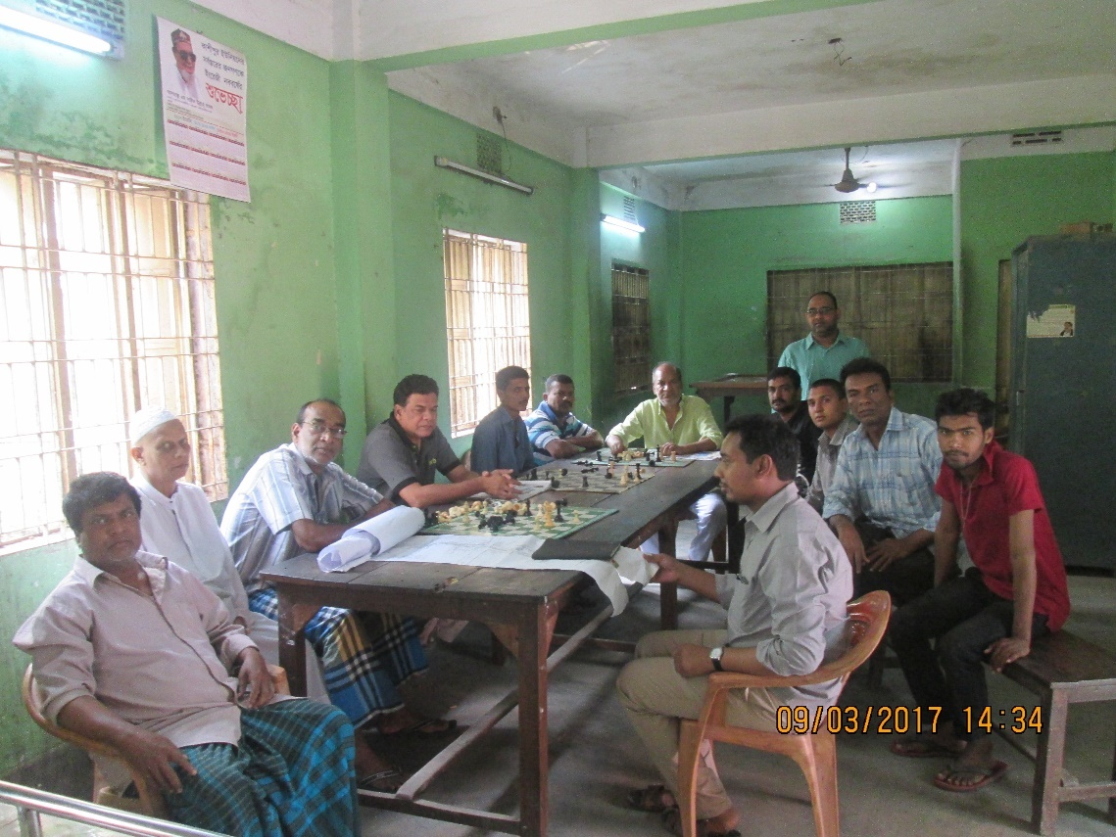

Figure 9 2: FGD Meeting with Local People at RK Mitra Road
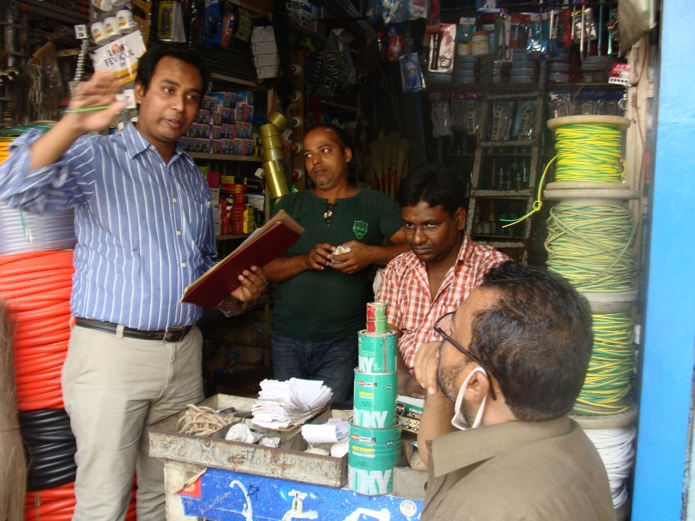

Figure 9 3: FGD Meeting with Local People at RK Mitra Road
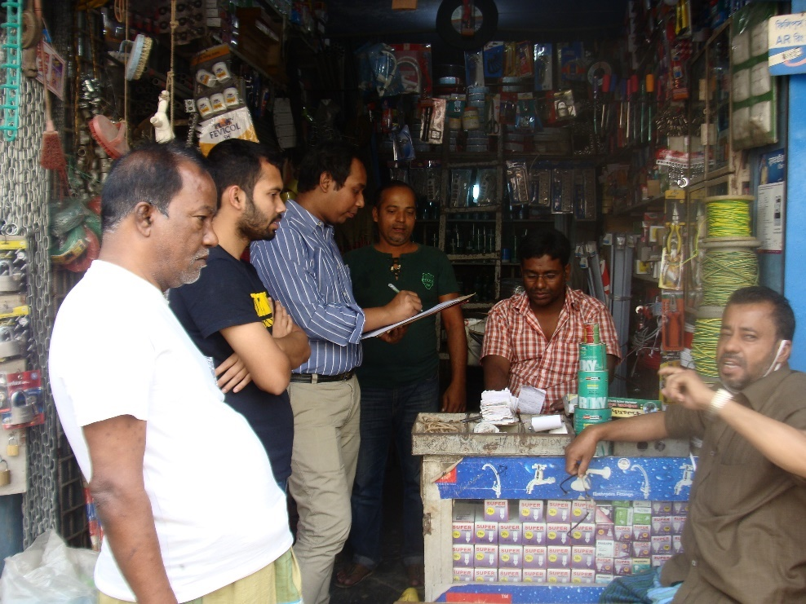
Figure 9 4: FGD Meeting with Local People at RK Mitra Road
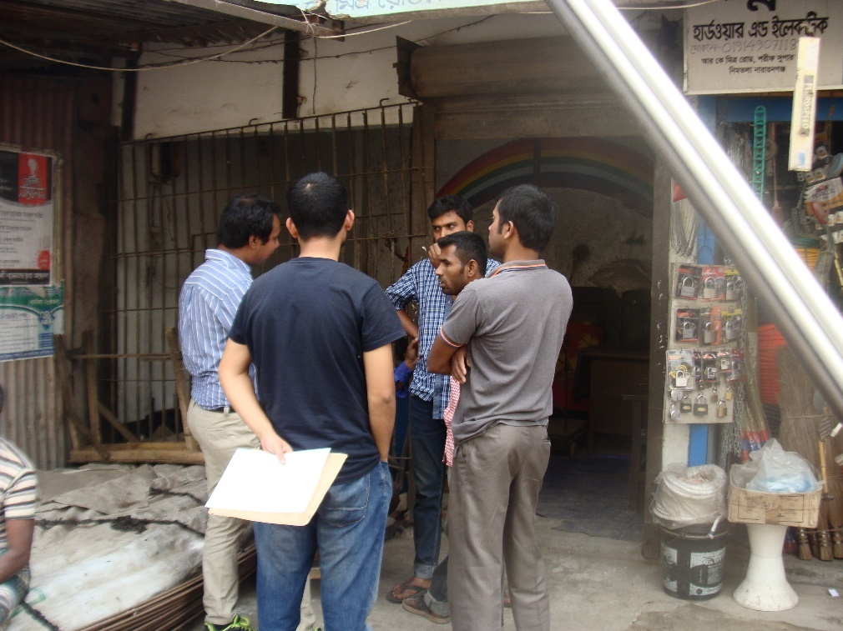

Figure 9 5: FGD Meeting with Local People at RK Mitra Road
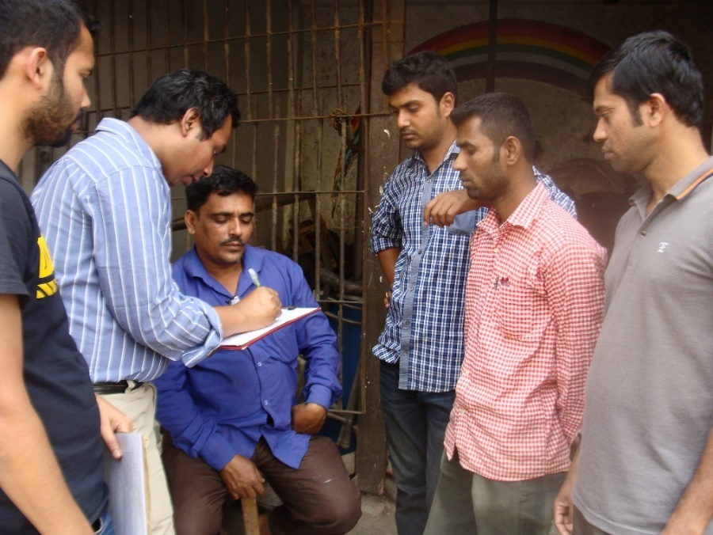
Figure 9 6: FGD Meeting with Local People at RK Mitra Road
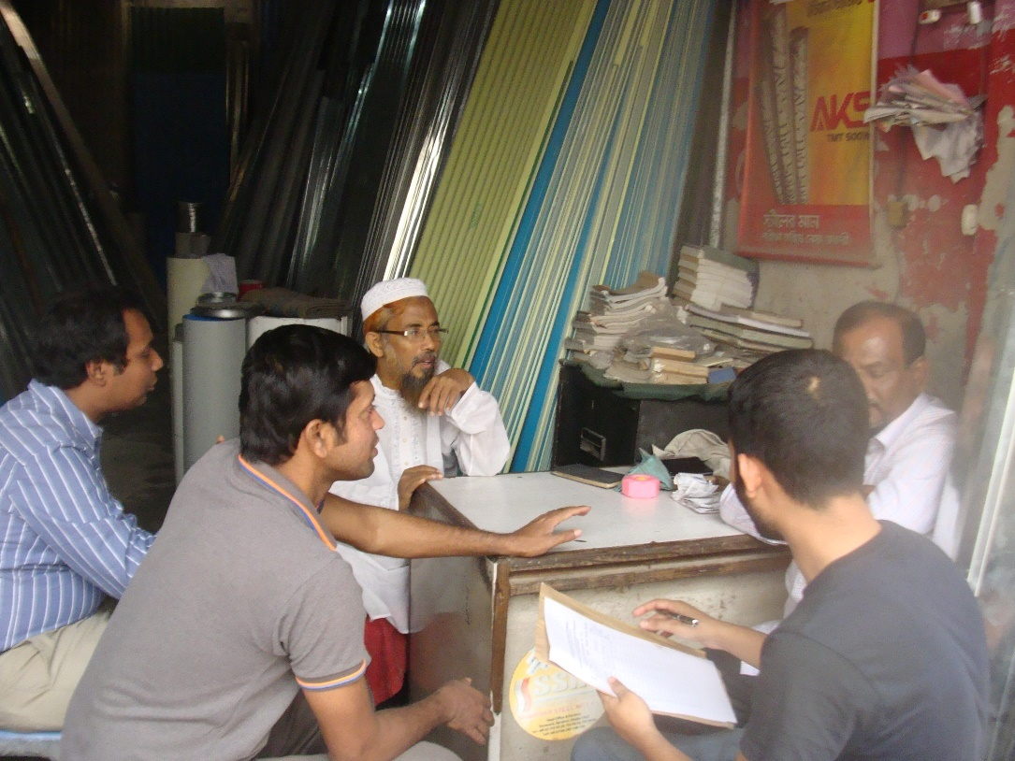

Figure 9 7: FGD Meeting with Local People at RK Mitra Road
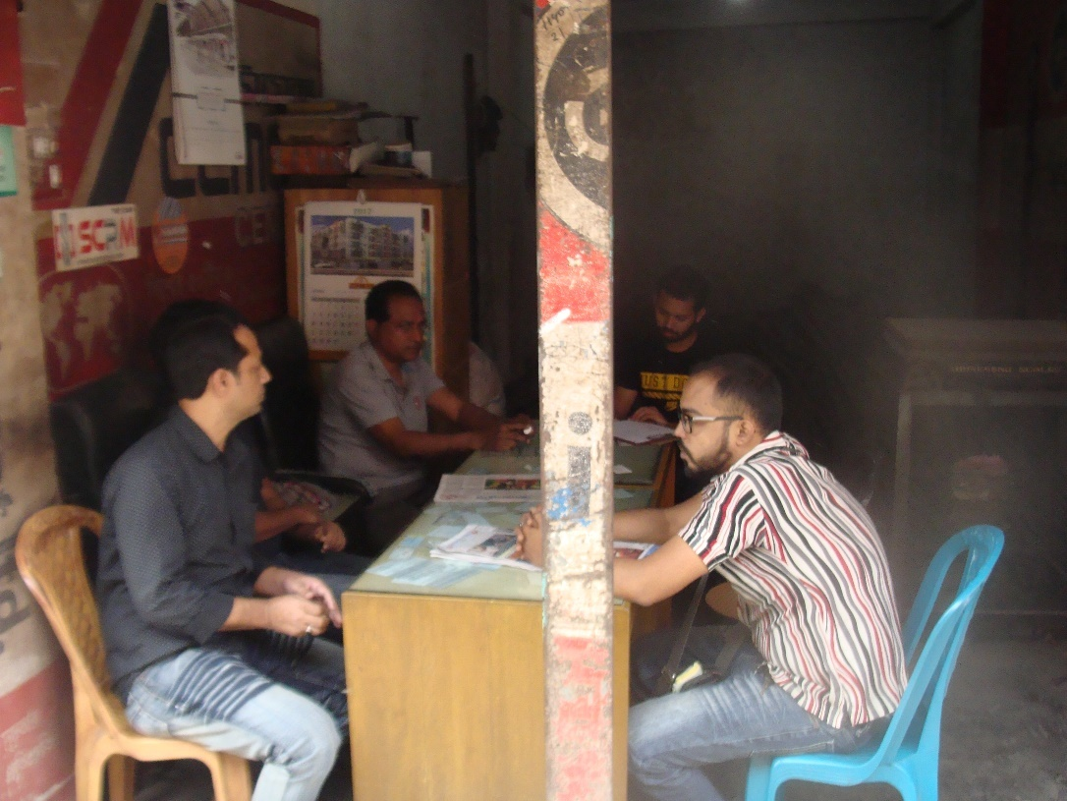
Figure 9 8: FGD Meeting with Local People at RK Mitra Road
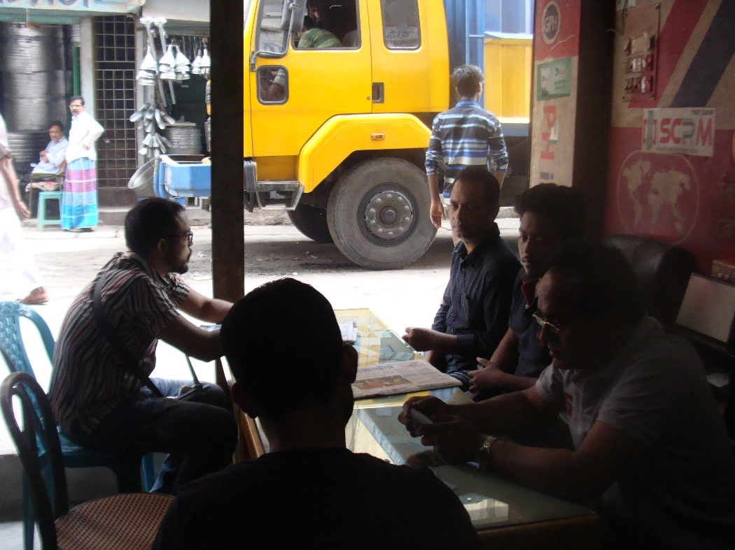

Figure 9 9: Individual discussion with Local People at RK Mitra Road
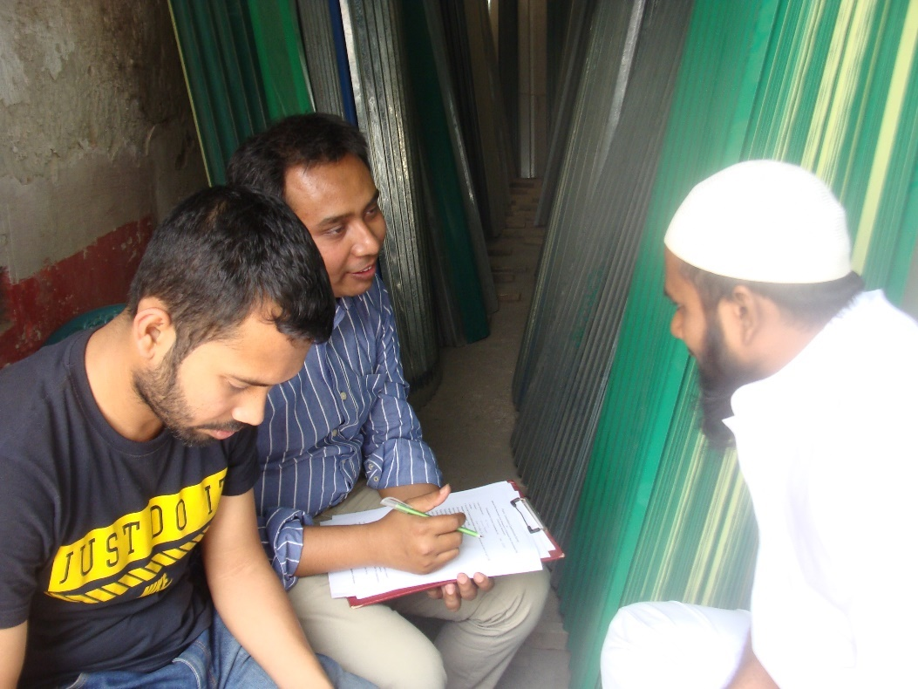
Figure 9 10: Individual discussion with Local People at Community
Clinic SK Biswas Sarak, Bangla Bazar

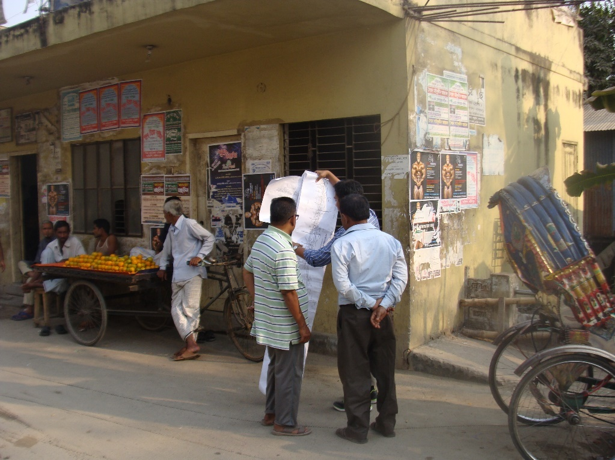

Figure 9 11: Individual discussion with Local People at SK Biswas Sarak, Bangla Bazar
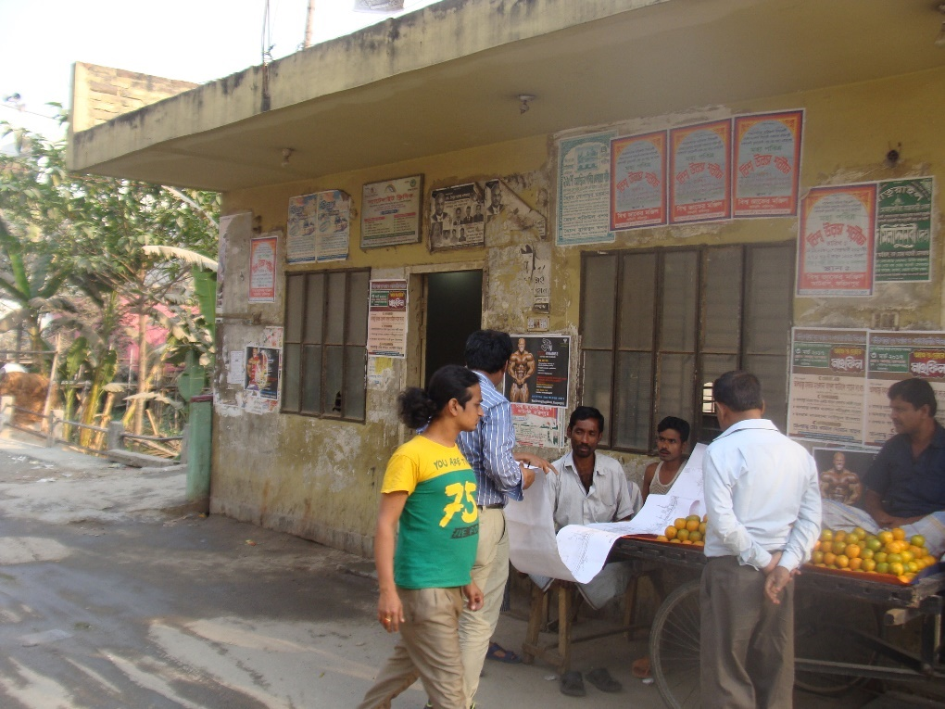
Figure 9 12: Individual discussion with Local People at SK Biswas
Sarak, Bangla Bazar
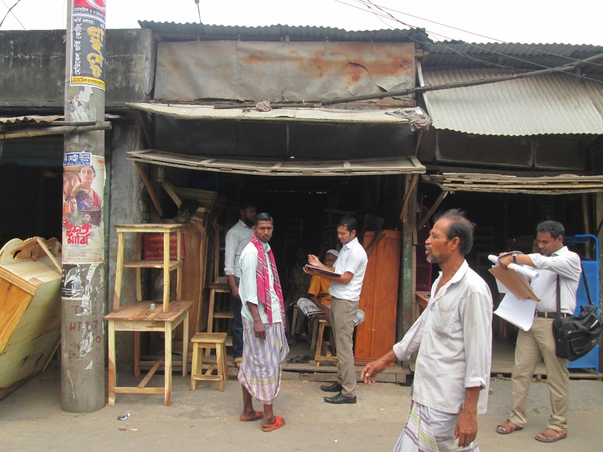

9.5 Public Consultations Meeting and Disclosure
Public Consultation meeting was held at NCC Conference room during project preparation and to share the draft EA and SIA reports. A public consultation meeting was held on 11th April 2017 with the local communities. Notices about the consultation meeting were circulated to the local communities through leaflets one week in advance of the meeting. Posters were also displayed at public places at City Corporation gate, market and bus stand and railway station). Additionally, meetings were also held with NCC officials.
Photographs of public consultation is given in Figure 9.13 and 9.14. During these consultations, leaflets on key environmental and social issues were distributed to the participants (these were prepared in local Bangla language) and posters were also displayed at the venue. Power point presentations were made by the environmental and social experts. Participants were encouraged to ask questions on the environmental and social issues. Detail of consultation meeting and participation were presented in Table 9.4. The Summary of Consultation meeting were presented in Table 9.5. The leaflet of presentation material for public consultation meeting were presented in Annex-7.
Table 9.4: Details of Consultation Meetings
Date | Meeting |  | Male | Female | Total
1st March 2017 | Focus group discussions |  | 31 | - | 31
3rd March 2017 | Individual Interview |  | 8 | 1 | 9
11th April 2017 | NCC auditorium |  | 65 | 7 | 72
Total |  |  | 104 | 8 | 112

Table 9.5: Summary of Consultation
S.N. | Comment | Response/Action Plan
1 | Can we make an Auto-stand for the Padel Chalito Autos?  Nuruddin Ahmed (President, Narayanganj bashi Shonggothon) | To provide a sustainable solution to transport problem we thought about promoting Public Transport like Buses. The road should be widen up to 7m. Then buses will start running on these roads. It will be an environment friendly solution.
2 | How to manage the waste materials that accumulate beside the drains? Where to dump these wastes?  Advo. AB Siddique (President, BAPA) | After collection of solid waste in bins, the solid waste will be disposed outside the city about 30 km away, this process will be implemented through tender which is now under process. An Environmental Monitoring cell will be formed and local people will also involve to monitor as well as involve in the solid waste management work. There will be fixed dustbins beside Gymkhana Lake.
3 | Have the consultants considered the existence of Gas line and WASA line (Utility Lines) during the designing/planning? Will the Utility lines be interrupted/ disturbed by the development works? Will there be any walkway/road beside the canal if all the private bridges get demolished?  Obaidullah (Ex-Panel Mayor) | Yes, we have. If there appears any kind of obstacle of the utility lines then it will be removed. There will be walkways beside the water bodies. Project’s social survey is on-going and the decision for road connectivity will be taken after the findings from the social and traffic surveys are received.
4 | When will the project start and what is the total duration of the project?  Nazmul Alam (Councilor 16 No. Ward) | The project is already running and total duration of the project is about 2 years. Hopefully within 2019 the whole project will complete.
5 | Will the Canal be filled with water ever (as consultant proposed dams/sluice gate)?  Abdus Salam (President, Narayanganj Press Club) | Three internal khals are also connected to Baburail Khal and their polluted water should not contaminate Baburail Khal. We are thinking about providing either Rubber Dam or any other kind of Dam whichever seems suitable to save Baburail’s water.  It is noteworthy that, the underground water level is in good condition and water level will always be 4.5 m from the bed level of the khal.
6 | Is there any provision of potable water? Is there provision of maintenance of trees? Is there any provision of Public Toilet? | Thanks for your suggestion. We will try to incorporate it in our plan and designs. There is provision for public toilet in Jimkhana Lake, but due to lack of space there is no provision for public toilet in Baburail Canal. We shall try to incorporate the club house for the provision of Public Toilet.
7 | Is there any provision of water treatment plant? After provision of dams will this turn Baburail Canal/Lake into a pond? Will this water body be pollution free?  Afzal Hossain (General Secretary, Narayanganj Press Club) | We are not treating the Lake water. We will preserve the rainwater in it which will be clean. We are putting dams so that this clean water does not get mixed with the polluted water that comes from river branches.
8 | Will there be any resettlement plan of the settlements along R.K. Mitro road?  Abdur Rahman Liton (Secretary, Shop Owners Union)  Liton: We have shifted our shops in our own initiatives for the betterment of the project. | Honorable Mayor has got some creative ideas about the resettlement and that will definitely happen.
9 | Will there be any development of other Lakes, bridges outside the Narayanganj City Corporation area (From Dhaleshwari to Shitalakkhya River)? Is it possible to come to NCC office directly from Chasara by rickshaw?  Sharifuddin Shobuj (Narayanganj Press Club) | I will try to work for the development works along Shitalakhya River to Dhaleshwari River.  Vitti: Honorable Mayor has taken the ownership of working in the Union Level by developing partnership with LGED. In Bangladesh LGED is the only Engineering Department to work with Union Parishad.  Some person wanted all of the Survey Data of TIA and SIA. But he was assured that these data are confidential so those won’t be provided. But the entire planning of Baburail Khal Project will be available online within very short time.
10 | Will there be any katcha bazar (Organic food store) inside the plan? (He was concerned because famous Kacha bazar of Meenabazar/Boubazar was being demolished)  Ranjit Kumar Das (SM Malik Road) | Kachha Bazar is unhygienic. So, modern Grocery stores (Departmental store) will come to the area instead. However, if people still want a traditional kacha bazar then I will try to think of it. There is no provision for Katcha bazar along the Canal because of environmental concern.
11 | Is there any provision of public toilet in the plan? How many and where?  Mizanur Rahman Tulu (Businessman, R K Mitra Road) | We have thought of creating a recreational space surrounding the water bodies. In Gymkhana lake there will be 2 public toilets. However, as per your concern we will try to make arrangements for drinking water beside the water bodies also
12 | How long is this project going to take to become a reality? Can we bring Shitalakhya River inside the realm of this project? (He also wants that river to be pollution free)  Md. Shofiuddin Prodhan (Ward Councilor of Ward 14) | It’s a two years’ project. We have already started the work for segment one. One tender is passed. Now it’s time for the other segments. Eventually, the project will be done by the end of 2018 or the beginning of 2019.  We all want to save Shitalakhya. This is now a national problem. If government wants to do it, then it might be possible to save our rivers. We have to find it out from the Rainfall data. We considered the increase of traffic flow in the project. We have to check it back in our TIA. DAP is on-going. So, plan for a building will not pass if it does not have a road that is 7m wide.
Concluding Note
Mayor: In conclusion note Mayor expressed her gratitude to all for attending in the meeting and making it successful. She informed the audience that a portion (package-1) of the project is already on-going and tender for package-2 will be prepared very soon. Narayanganj is a city of Canal and Rivers and connected by seven rivers directly and indirectly. Government is now taking positive initiatives to save the rivers and agricultural land with proper law and order. Mayor has an agenda to save the playground, doing tree plantation and she has already given directions to new elected councilors to provide her with a list of Khals and water bodies that need to be restored.

Figure 9 13: Public Consultation Meeting with Local People at NCC Auditorium
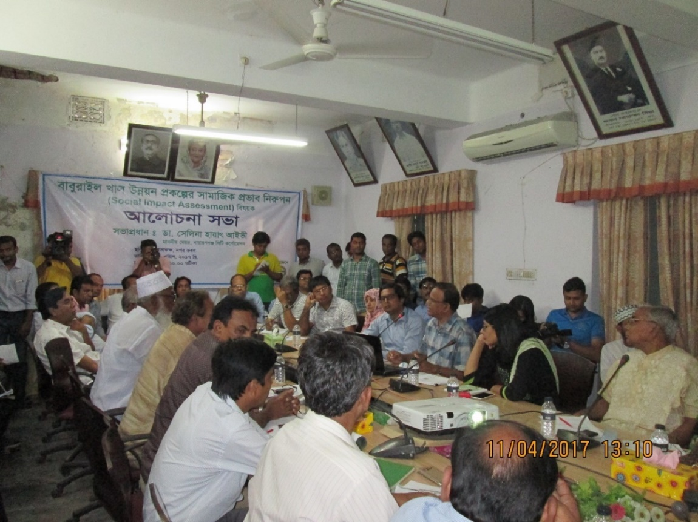
Figure 9 14: Public Consultation Meeting with Local People at NCC Auditorium
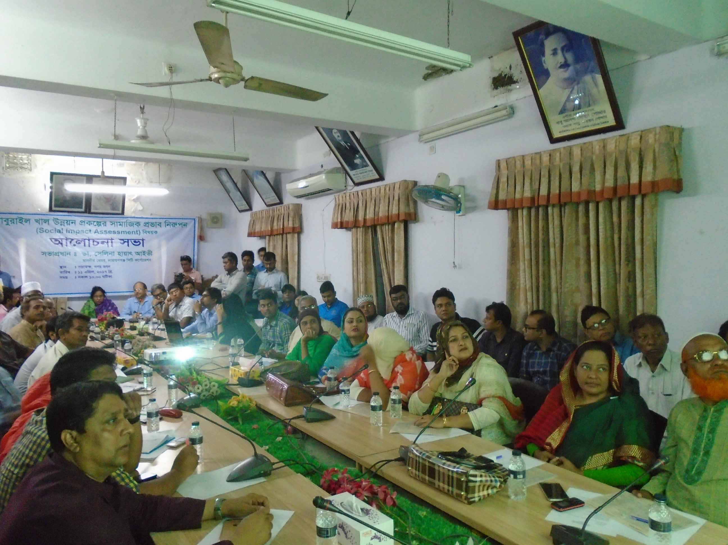

9.6 Access to Information
The EA, SIA and RAP reports will be disclosed in the NCC website. Consultation workshops were held on 11th April 17 at NCC auditorium to share and disclose the results of the draft EA report. Invitations were sent to relevant stakeholders including local government officials and local community. The documents will also be sent to the World Bank info shop. The executive summaries of EA, SIA and RAP documents will also be translated and will be made available to the local communities by placing them at NCC offices.

CHAPTER -10: CONCLUSION AND RECOMMENDATION

  - Conclusion

An EA has been carried out for the proposed Baburail Canal restoration project according to the requirement of DOE for necessary environmental clearances as it is made mandatory in ECA’ 95, for any new project set up and the subsequent ECA ’97 and also World Bank Guideline. An EA report has been prepared through identifying the potential impacts, assessing them and recommending possible mitigating and enhancing measure for negative and positive impacts, respectively.
An outline of EMP has been given in the present report to mitigate/enhance the impacts, which are expected to occur during construction and operation phase of the project.
The findings of this EA suggest that the Baburail Canal Restoration project involves potential socio-economic benefit, restore old heritage of Narayanganj, economic development of the area, reduce wastage of valuable time, fuel and air pollution, black smoke, dust emission and cost of travel. Environmental pollution will be reduced. Area will be clean and free from waste dumping. The canal will have clean water and the water flow will upsurge.

The major negative impact may arise from reshaping of canal of filled up earth of the existing Baburail canal and dispose to a safer place in environmentally sustainable way, clear the vegetation, shrub and trees, removal of both legal and illegal structure from the right of way of the Canal. Total 349 temporary structure need to be remove and 258 Nos of small to medium trees need to cut.
Construction 2.8 long canal, 7 km (3.5x2) long both side drain along the canal, 18 bridges, shops, three over pass, sluice gate/ rubber dam at both end of the river side, elevated walkway and canal slope protection need special care during construction. Proper stabilization of soil of the canal slope should be done during preparation of canal.
The negative impacts are temporary mainly during construction of canal and other structure dust, noise, water and solid waste will generate. Pedestrian and vehicle movement will the hampered during construction period. Once the construction work is completed the dust, noise, water and solid waste pollution drastically reduce. Once the project completed it will become a recreation place for the local and tourist people.
NCC will fully implement the EA’s environmental management plan and monitoring plan to comply the monitoring program defined in the EA.
The limited environmental impacts to which further careful attention should be given using the construction, operation and maintenance of the project in order to minimize and offset the adverse effects. The possible negative impacts are not severe, and the adverse impacts if duly addressed could be minimized without much effort, though they would require attention and positive commitment from the Project Management.
Positive Impacts of the Proposed Project Interventions
- Positive impacts on terrestrial ecology are expected post project completion due to the increase in vegetation, tree plantation and landscaping. The NCC should coordinate with the local communities to maintain and enhance the trees planted along the roads.
- The proposed project will conserve and regenerate old lost heritage of the city
- Transportation facilities will improve which reduces uses of fuel, black smoke, dust emission, time of travel and cost due three over pass will constructed.
- Increase recreational facilities with environmental aesthetics with scenic beauty change the as clean city.
- Due to infrastructure and transportation improvement the life style will change of the city dwellers significantly.
- Economic activity and business will increase and hence employment also increase
- Improved public safety
- Improve drainage and solid waste management
- Improved land use protection
- Navigation facilities will start when the river water become pollution free. Before that only boat will ply in the closed canal.
- Create social benefits by providing temporary jobs for unskilled workers/labourers during the construction phase
- Provide protection of the Baburail Canal slope and protect of canal edge, thus preventing risks of floods in future
The overall finding of the EA is that the proposed Baburail canal restoration project will not cause any significant adverse environmental impacts during constriction period, provided that adequate mitigation measures are implemented. The proposed mitigation measures are prescribed conceptually in the EA, as an outline EMP. This will be developed by the contractor in the construction phase.
Thus, it can be concluded that the proposed project is environmentally acceptable and will bring economic, social and environmental benefits to the land users and local community in the area.

10.2 Recommendation
The canal water should be free from domestic wastewater, sewage or storm runoff pollution. The storm water and sewage connection to the canal is suggested to be stopped. However, both side open drain has been proposed with sufficient capacity so that these can take care of the storm runoff cum house hold flow generated from the household.

The 4 other existing canals which carries household wastewater and rain water enter directly to the Baburail canal is a major problem and spoil the aim of the project. The following suggestion are made for sole the problem.
It is suggested that in the next 2 years all the other 4 canals should improve and connect with Baburail.
In order to keep the Baburail canal clean a sewage treatment plant (STP) is require to treat the wastewater. So that wastewater will not be contaminated other canals.
One drain should be constructed which carry all the wastewater from the cities and discharge to river.
Before construction of STP to discharge the wastewater into the Baburail canal after simple treatment like, screening for removing leaves, tree buckle, cloth, other rubbish and floating material, sedimentation of grit removal through grit chamber can be perform temporarily. Overflow from the supernatant may be allow to Baburail canal. This will help to maintain the water level of the Baburail canal.
Or divert the wastewater directly to the Shitalakhya and Dhaleshwari River.

The boundary of the reshaping of canal and slope of the canal should be maintained properly to avoid disturbance to the ambient natural system. The reshaping time of canal, should be minimized. The sands/earth used for canal dam should be compacted properly as early as possible. Plantation of tees is a must and at least three new trees would be planted for each cut-down tree.
Satisfactory compensation should be given to the affected people who lost the structures and trees and loss of income. Specially, assets removed from the canal sides should be compensated for at the appropriate level. Minor negative impacts like clearing of vegetation and cutting of trees at the pre-construction and construction phases should be taken care of by taking proper mitigation measures.
Local people should be employed as much as possible during the pre-construction and construction phases. The contractor should be specifically instructed to employ local laborers as much as possible. The health and safety issues of workers should be taken care of under the specific order of the contractor and client. The construction labour camps should be provided with water supply and sanitation facilities. The workers should be apprised of hygienic practices.
The transportation of materials should be done by feasible routes in order to minimize the existing road. The stores and equipment yards should be properly guarded so that all equipment remains safe.
From an overall assessment, it is observed that the proposed project could be implemented in an environment friendly manner, but subject strictly to the implementation of an environmental management plan. So, it is recommended that the project may be cleared to proceed with its work.

NCC concludes that this EA is complete and addresses all relevant likely impacts and proposes a full set of time-bounded mitigate and monitoring actions, including assignment of responsibility. The application of the detailed EMP will insure that the nature and socio-cultural environmental are not unduly affected by the work or the operation of the canal. Therefore, NCC recommends that an environmental clearance may be granted by DoE, there are no uncertainties in the analysis, and no additional work is required to comply with National Law.

REFERENCES

- Metcalf & Eddy (1991), “Wastewater Engineering”, McGraw-Hill Inc., Singapore.
- Peavy & Rowe (1985), “Environmental Engineering”, McGraw-Hill Inc., Singapore.
- Eckenfelder (1989), “Industrial Water Pollution Control”, McGraw-Hill Inc., Singapore
- Sawyer & McCarty (1994), Chemistry for Environmental Engineers”, McGraw-Hill Inc., Singapore.
- S.S Dara (1995), “Environmental Chemistry and Pollution Control”, S. Chand & Company Ltd., New Delhi, India.
- A.K De (1989), “Environmental Chemistry”, Wiley Eastern Ltd., New Delhi, India.
- Arceivala (1994), Wastewater Treatment for Pollution Control”, Tata McGraw-Hill Publishing Co. Ltd., New Delhi, India.
- Sincero & Sincero (1999), “Environmental Engineering”, Prentice Hall of India Private Ltd., New Delhi.
- Kudesia (1996), “Industrial Pollution”, Pragati Prakashani, Meerut, India.
- BBS (2012), "The Statistical Yearbook of Bangladesh." Bangladesh Bureau of Statistics, Dhaka, Bangladesh.
- Bangladesh Population Census, Bangladesh Bureau of Statistics; Cultural survey report of Tangail Sadar Upazila.
- Canter, G. T. (1983), “Environmental Impact Assessment Handbook”. McGraw Hill, England
- DOE (1997) "Environmental Conservation Rules", Department of Environment, Govt. of Bangladesh.
- DOE (1995) "Environmental Conservation Act", Department of Environment, Govt. of Bangladesh.
- GOB, (1992), “Bangladesh Environmental Policy”.
- GOB, (1995), “National Environmental Management Action Plan (NEMAP)”.
- Munn, R.E. (1979), "Environmental Impact Assessment : Principal and Procedures." Jhon Wiley & Sons.
- Nemerow, N. L. (1979) "Industrial Water Pollution" Addision- Wesley publishing Co

CHAPTER -12: ANNEXURE

Annex 1 Environmental Screening of Potential Impacts
An environmental screening checklist was used to assess the potential environmental impacts in construction and operation period of the propose project. The screening of potential impact is given in Below.

Table 5.1 Environmental Screening Checklist of Proposed Baburail restoration Project
Screening Questions | Yes / No /?. Briefly describe | Is this likely to result in a significant effect? Yes/No/? – Why?
1. Will construction, operation or decommissioning of the Project involve actions which will cause physical changes in the locality (topography, land use, changes in water bodies, etc.)? | Yes, the proposed land is a filled up Canal and excavation to restore the canal as before. | Yes, the drainage pattern will be changed due to excavation the existing canal.
2. Will construction or operation of the Project use natural resources such as land, water, materials or energy, especially any resources which are non-renewable or in short supply? | No. Beside excavated canal bed material need to be dispose in the low land. | Yes, due to extensive land excavation and filling up low land and construction activities are involved.
3. Will the Project involve use, storage, transport, handling or production of substances or materials which could be harmful to human health or the environment or raise concerns about actual or perceived risks to human health? | No. No products need to be stored at the Canal facilities during construction work. | No.
4. Will the Project produce solid wastes during construction or operation or decommissioning? | Yes. Both solid and liquid waste will be produced by the canal construction during construction (construction related waste) and operation (Solid waste). | Yes. Solid waste will be generated at the canal area. Proper collection and disposal of solid waste will be required.
5. Will the Project release pollutants or any hazardous, toxic or noxious substances to air? | Yes. Dust and emissions from construction equipment and vehicular traffic will be a concern both during construction and operation. | No, dust control measures will be adopted in the design and will be regularly maintained (e.g. regular sweeping or water spraying).
6. Will the Project cause noise and vibration or release of light, heat energy or electromagnetic radiation? | Yes. Construction and operation works generate noise levels from machinery and traffic | No, adequate buffer zone will be established around the canal facilities to control the noise levels.
7. Will the Project lead to risks of contamination of land or water from releases of pollutants onto the ground or into surface waters, groundwater, coastal wasters or the sea? | Yes. There is a risk of contamination from construction; and also from excavated soil may contain heavy metal pollution. | Yes, the risk contamination is more due to dispose of excavated soil in the low land
8. Will there be any risk of accidents during construction or operation of the Project which could affect human health or the environment? | Yes. Construction works may pose health and safety hazards to the workers and nearby community. During operation, major sources are dust and emissions from with activities associated with Baburail Canal and related facilities and traffic. | Yes. There are risks of physical hazards and chemical hazards (dust and emissions form fuels. There are also risks of safety hazards due to non-use of personal protective equipment (e.g. safety shoes and helmets) during manual handling of cargo.  Safe drinking and sanitation facilities are to be provided for both the office staff and working labourers.
9. Will the Project result in social changes, for example, in demography, traditional lifestyles, employment? | Yes. The project will generate employment opportunities for the local community both during construction and operation phases. The local communities and people and their life style could be impacted by increasing of their exposure to outside communities. | Yes, several employment opportunities will be generated in and around the canal facilities, and in the associated activities.
10. Are there any other factors which should be considered such as consequential development  which could lead to environmental effects or the potential for cumulative impacts with other existing or planned activities in the locality? | Yes. Wastewater treatment plan need to be constructed for keep the environmental clean. | No.
11. Are there any areas on or around the location which are protected under international or national or local legislation for their ecological, landscape, cultural or other value, which could be affected by the project? | No. The proposed canal are located in a human disturbed land. No areas that are protected under international and national legislation are located around the canal facilities. | No.
12. Are there any other areas on or around the location which are important or sensitive for reasons of their ecology e.g. wetlands, watercourses or other waterbodies, the coastal zone, mountains, forests or woodlands, which could be affected by the project? | Yes, The project is located about 3.5 km Baburail canal connecting Sitalakhya and daleshari | No
13. Are there any areas on or around the location which are used by protected, important or sensitive species of fauna or flora e.g. for breeding, nesting, foraging, resting, overwintering, migration, which could be affected by the project? | No. | No
14. Are there any inland, coastal, marine or underground waters on or around the location which could be affected by the project? | No. | No.
15. Are there any areas or features of high landscape or scenic value on or around the location which could be affected by the project? | No | No
16. Are there any routes or facilities on or around the location which are used by the public for access to recreation or other facilities, which could be affected by the project? | No | No
17. Are there any transport routes on or around the location which are susceptible to congestion or which cause environmental problems, which could be affected by the project? | No. | No
18. Is the project in a location where it is likely to be highly visible to many people? | Yes. The canal facilities will be visible to many people | No
19. Are there any areas or features of historic or cultural importance on or around the location which could be affected by the project? | No. | No.
20. Is the project located in a previously undeveloped area where there will be loss of greenfield land? | Yes, the proposed facilities are located in a existing Baburail Canal which was recently damages. | Yes, the drainage pattern would be affected if adequate drainage measures were not taken in the design
21. Are there existing land uses on or around the location e.g. homes, gardens, other private property, industry, commerce, recreation, public open space, community facilities, agriculture, forestry, tourism, mining or quarrying which could be affected by the project? | Yes, there are many feature will be constructed in this project. Like bridges, overpass, shops, play ground, walkway. | No
22. Are there any plans for future land uses on or around the location which could be affected by the project? | No. | No
23. Are there any areas on or around the location which are densely populated or built-up, which could be affected by the project? | Yes. | No
24. Are there any areas on or around the location which are occupied by sensitive land uses e.g. hospitals, schools, places of worship, community facilities, which could be affected by the project? | No | No
25. Are there any areas on or around the location which contain important, high quality or scarce resources e.g. groundwater, surface waters, forestry, agriculture, fisheries, tourism, minerals, which could be affected by the project? | No. | No.
26. Are there any areas on or around the location which are already subject to pollution or environmental damage e.g. where existing legal environmental standards are exceeded, which could be affected by the project? | No | No.
27. Is the project location susceptible to earthquakes, subsidence, landslides, erosion, flooding or extreme or adverse climatic conditions e.g. temperature inversions, fogs, severe winds, which could cause the project to present environmental problems? | Yes, risk of earth quake is a concern in the Project area. | No, the design of canal facilities will consider adequate building standards.

Annex 2 DoE Standard
Schedule - 2
Air Quality Standards
[vide Clause 12]

Density in micrograms per m³
Sl. No. | Area | Suspended  Particulate  Matter (SPM) | Sulfur  dioxide | Carbon  monoxide | Nitrogen  oxides
a) | Industrial & mixed | 500 | 120 | 5000 | 100
b) | Commercial & mixed | 400 | 100 | 5000 | 100
c) | Residential & Rural | 200 | 80 | 2000 | 80
d) | Sensitive | 100 | 30 | 1000 | 30

Note:- 1) National monuments, Health-center/Hospital, Archeological site, Educational Institute and area declared by government (if applicable) are included under Sensitive Are.
2) Industrial units not located in designated industrial area shall not discharge or emit any pollutant which may deteriorate the air quality in the areas (c) & (d) of above Table.
3) Suspended Particulate Matter (SPM) means airborne particles of diameter of 10 microns or less.

Schedule - 3
Water Quality Standards
[vide Rule 12]
- Inland Surface Water Quality Standard

 | Best Practice based classification | pH | BOD mg/l | Dissolved  Oxygen  (DO), mg/l | Total Coliform  Bacteria  quantity/ml
(a) | Potable Water Source supply after bacterial freeing only | 6.5-8.5 | 2 or less | 6 or above | 50 or less
(b) | Water used for recreation purpose | 6.5-8.5 | 2 or less | 5 or above | 200 or less
(c) | Potable Water Source supply after conventional processing | 6.5-8.5 | 2 or less | 6 or above | 5000 or less
(d) | Water used for pisciculture | 6.5-8.5 | 2 or less | 5 or above | 5000 or less
(e) | Industrial use water including chilling & other processes | 6.5-8.5 | 2 or less | 5 or above
(f) | Water used for irrigation | 6.5-8.5 | 2 or less | 5 or above | 1000 or less

Note:- 1) Maximum amount of ammonia presence in water are 1.2 mg/l (as nitrogen molecule) which is used for pisciculture.
2) For water used in irrigation Electrical Conductivity-2250 microh mho/cm (at 25°C).
Sodium less than 26 mg/l*
Boron less than 2 mg/l*

- Potable Water Quality Standard
Sl. No. | Parameter | Unit | Standard limit
1. | Aluminium | mg/l | 0.2
2. | Ammonia (NH₃) | " | 0.5
3. | Arsenic | " | 0.05
4. | Barium | " | 0.01
5. | Benzene | " | 0.01
6. | BOD₅ 20°C | " | 0.2
7. | Boron | " | 1.0
8. | Cadmium | " | 0.005
9. | Calcium | " | 75
10. | Chloride | " | 150-600**
11. | Chlorinated alkanes  Carbon tetrachloride  1,1 Dichloroethylene  1,2 "  Tetrachloroethylene  Trichloroethylene | "  "  "  "  "  " | 0.01  0.001  0.03  0.03  0.09
12. | Chlorinated phenols  Pentachlorophenol  2,4,6 Trichlorophenol | "  "  " | 0.03  0.03
13. | Chlorine (residual) | " | 0.2
14. | Chloroform | " | 0.09
15. | Chromium (hexavalent) | " | 0.05
16. | Chromium (total) | " | 0.05
17. | COD | " | 4
18. | Coliform (fecal) | n/100 ml | 0
19. | Coliform (total) | " | 0
20. | Color | Huyghens unit | 15
21. | Copper | mg/l | 1
22. | Cyanide | " | 0.1
23. | Detergents | mg/l | 0.2
24. | DO | " | 6
B. Potable Water Quality Standard (continued)

Sl. No. | Parameter | Unit | Standard limit
25. | Fluoride | " | 1
26. | Alkalinity (as CaCo₃) | " | 200-500
27. | Iron | " | 0.3
28. | Nitrogen (total) | " | 1
29. | Lead | " | 0.05
30. | Magnesium | " | 30-35
31. | Manganese | " | 0.1
32. | Mercury | " | 0.001
33. | Nickel | " | 0.1
34. | Nitrate | " | 10
35. | Nitrite | " | Less than 1
36. | Odor | " | Odorless
37. | Oil & Grease | mg/l | 0.01
38. | pH | " | 6.5-8.5
39. | Phenolic compounds | " | 0.002
40. | Phosphate | " | 6
41. | Phosphorus | " | 0
42. | Potassium | " | 12
43. | Radioactive Materials total alpha radiation | Bq/l | 0.01
44. | Radioactive Materials total beta radiation | " | 0.1
45. | Selenium | mg/l | 0.01
46. | Silver | " | 0.02
47. | Sodium | mg/l | 200
48. | Suspended solid particles | " | 10
49. | Sulfide | " | 0
50. | Sulfate | " | 400
51. | Total soluble matter | " | 1000
52. | Temperature | C | 20-30
53. | Tin | mg/l | 2
54. | Turbidity | J.T.U | 10
55. | Zinc | mg/l | 5

Schedule - 4
Noise Quality Standards
[vide Rule 12]
Sl. No. | Zone Class | Limits in dB_{a}
 |  | Day | Night
a) | Silent Zone | 45 | 35
b) | Residential Zone | 50 | 40
c) | Mixed Zone (this area is used combinedly as residential, commercial and industrial purposes) | 60 | 50
d) | Commercial Zone | 70 | 60
e) | Industrial Zone | 75 | 70

Note:- 1) The day time is considered from 6 an to 9 pm. The night time is considered from 9 pm to 6 am.
2) From 9 at night to 6 in morning is considered night time.
3) Area within 100 meters of hospital or education institution or educational institution or government designated/to be designated/specific institution/establishment are considered Silent Zones. Use of motor vehicle horn or other signals and loudspeaker are forbidden in Silent Zone.

Schedule - 5
Noise Quality Standard for Motor Vehicle or Mechanised Vessel
[vide Rule 12]
Unit in dB_{a}
Vehicle Type | Standard Limit | Remark
Motor Vehicle
(all types)* | 85 | Measured at 7.5m from exhaust pipe.
 | 100 | Measured at 0.5m from exhaust pipe.
Mechanised Vessel | 85 | Measured at rest and empty at 2.3 of maximum rotation speed at 7.5m from vessel
 | 100 | Measured in same position at 0.5 from vessel
- During measurement, the motor vehicle should be at rest and the condition of engine as follows:

- Diesel Engine at maximum rotation speed.
- Gasoline Engine at 2/3 o maximum rotation speed and weightless acceleration.
- Motor Cycle - 2/3 of Maximum speed for above 5000 rpm. 3/4 of Maximum speed upto 5000 rpm.
Schedule - 6
Motor Vehicle Exhaust Quality Standards
[vide Rule 12]

Parameter | Unit | Standard Limit
Black Smoke | Hartridge Smoke Unit (HSU) | 65
Carbon | grams/km | 24
Monoxide | in percent volume | 4
Hydrocarbon | grams/km  ppm | 2  180
Nitrogen oxides | grams/km  ppm | 2  600

Measured at 2.3 of maximum rotation speed.
Schedule - 7
Quality Standards for Mechanised Vessel Exhaust
[vide Rules 4 & 12]

Parameter | Unit | Standard Limit
Black Smoke | Hartridge Smoke Unit (HSU) | 65

Measured at 2.3 of maximum speed.

Schedule - 8
Quality Standards for Odor
[vide Rule 12]
Parameter | Unit | Standard Limit
Acetaldehyde | ppm | 0.5-5
Ammonia | " | 1-5
Hydrazine Sulfide | " | 0.02-0.2
Methyl disulfide | " | 0.009-0.1
Methyl mercaptan | " | 0.02-0.2
Methyl sulfide | " | 0.01-0.2
Styrene | " | 0.4-2.0
Tri Methyl amine | " | 0.005-0.07

Note:- 1) Following measurement is generally application for discharge or exhaust pipes of over 5m height -
Q = 0.108 x He² Cm
Here,
Q = gas exhaust rate in Nm³ / hour
He = height of exhaustal pipe in meter
Cm = standard limit mentioned above (ppm)
2) In cases where limits of quality standard have been specified, the lower limit for purpose of warning and the higher for legal proceedings or penal action shall be used.

Schedule - 9
Sewer Discharge Quality Standards
[vide Rule 13]
Parameter | Unit | Standard Limit
BOD | mg/l | 40
Nitrate | " | 250
Phosphate | " | 35
Suspended Solid (SS) | " | 100
Temperature | Degree Centigrade | 30
Coliform | Quantity/100 ml | 1000

Note:- 1) The limits are applicable for disposal into surface / inland water stream.
2) The sewer discharge must be decontaminated with chlorine before final disposal.

Schedule - 10
Waste Discharge Quality Standards for Industrial
Units and Projects
[vide Rule 13]
Quality Standard at Discharge Point
Sl. No. | Parameter | Unit | Inland  Surface  Water | Public  Sewer at  secondary  treatment  plant |  | Irrigated  Land
1. | Ammoniacal Nitrogen (N molecule) | mg/l | 50 | 75 |  | 75
2. | Ammonia (free ammonia) | " | 5 | 5 |  | 15
3. | Arsenic (As) | " | 0.2 | .05 |  | 0.2
4. | BOD₅ 20°C | " | 50 | 250 |  | 100
5. | Boron | " | 2 | 2 |  | 2
6. | Cadmium (Cd) | " | 0.05 | 0.5 |  | 0.5
7. | Chloride | " | 600 | 600 |  | 600
8. | Chromium (total Cr) | " | 0.5 | 1.0 |  | 1.0
9. | COD | " | 200 | 400 |  | 400
10. | Chromium (hexavalent Cr) | " | 0.1 | 1.0 |  | 1.0
11. | Copper 9Cu) | " | 0.5 | 3.0 |  | 3.0
12. | Dissolved Oxyzen (DO) | " | 4.5-8 | 4.5-8 |  | 4.5-8
13. | Electrical Conductivity | micro mho/cm | 1200 | 1200 |  | 1200
14. | Total Dissolved solids (TDS) | mg/l | 2,100 | 2,100 |  | 2,100
15. | Fluoride (F) | " | 7 | 15 |  | 10
16. | Sulfide (S) | " | 1 | 2 |  | 2
17. | Iron (Fe) | " | 2 | 2 |  | 2
18. | Total Kjeldahl Nitrogen (N) | " | 100 | 100 |  | 100
19. | Lead (Pb) | " | 0.1 | 1.0 |  | 0.1
20. | Manganese (Mn) | " | 5 | 5 |  | 5
21. | Mercury (Hg) | " | 0.01 | 0.01 |  | 0.01
22. | Nickel (Ni) | " | 1.0 | 2.0 |  | 1.0
23. | Nitrate (N molecule) | " | 10.0 | undetermined |  | 10.0
24. | Oil & grease | " | 10 | 20 |  | 10
25. | Phenol compounds (C₆H₅OH) | " | 1.0 | 5 |  | 1
26.  27. | Dissolved Phosphorus (P)  Radioactive materials: | "  By BAEC | 8 | 8 |  | 10
Quality Standard at Discharge Point (continued)
Sl. No. | Parameter | Unit | Inland  Surface  Water | Public  Sewer at  secondary  treatment  plant | Irrigated  Land
28. | pH |  | 6-9 | 6-9
29. | Selenium | mg/l | 0.05 | 0.05 | 0.05
30. | Zn (Zn) | " | 5.0 | 10.0 | 10.0
31. | Total dissolved solid | " | 2,100 | 2,100 | 2,100
32. | Temperature  Summer  Winter | Centi-grade | 40  45 | 40  45 | 40  45
33. | Total Suspended Solid (TSS) | mg/l | 150 | 500 | 200
34. | Cyanide (CN) | ” | 0.1 | 2.0 | 0.2

Note:- 1) These standards shall be applicable to industrial units or projects other than those given under Quality Standards for Classified Industries (Schedule 12).
2) These quality standards must be ensured at the moment of going into trial production for industrial units and at the moment of going into operation for other projects.
3) The value must not exceed the quality standard during spot check at any time; if required, the quality standards may be more strict to meet the environment terms in certain areas.
4) Inland Surface Water shall mean drain, pond, tank, water body or water hole, canal, river, spring and estuary.
5) Public sewer shall mean sewer connected with fully combined processing plant including primary and secondary treatment.
6) Irrigated land shall mean appropriately irrigated plantation area of specified crops based on quantity and quality of waste water.
7) Inland Surface Quality Standards (Schedule 13) shall be applicable for any discharge taking place in public sewer or land not defined in Notes 5 & 6.

Schedule - 11
Gaseous Discharge Quality Standards for Industrial
Units or Project
[vide Rule 13]
Sl. No. | Parameter
1. | - Electric Power Station of 200 Megawatts & above  - Electric Power Station less than 200 megawatts | 150 mg/Nm³  350 "
2. | Chlorin | 150 "
3. | Hydrochloric Acid gas & mist | 350 "
4. | Total Fluoride (F) | 25 "
5. | Sulfuric Acid mist | 50 "
6. | Lead particle | 10 "
7. | Mercury particle | 0.2 "
8. | Sulfur Dioxide  - Sulfuric Acid manufacture (DCDA process)  - Sulfuric Acid manufacture (SCSA process)  Minimum Stack height for Sulfuric Acid emission  - Coal Fired Electric Power Station  - 500 Megawatts & above  - 200-500 Megawatts  - Below 200 Megawatts  - Boiler  - For steam @ 15 tons/hour  - For steam above 15 tons/hour | 4 kg/ton  10 "  275 "  220 "  14(Q)⁰³ *  11 kg/ton  14(Q)⁰³ *
9. | Nitrogen Oxides  - Nitric Acid manufacture  - Gas Fired Electric Power Station **  - 500 Megawatts & above  - 200-500 Megawatts  - Less than 200 Megawatts  - Metal Treatment Furnace | 3 kg/ton  50 ppm  40 "  30 "  200 "
10. | Soot & Dust Particles  - Air Ventilated Furnace  - Brick-field  - Cooking Furnace  - Limestone Furnace | 500 gm/Nm³  1000 "  500 "  250 "
* Q = Sulfur Dioxide emission (kg/hour)

Schedule 2
Air Quality standard
National Ambient Air Quality Standards
Published in the Bangladesh Gazette (19 July 2005)

Pollutant | Objective | Averaging Time
PM_{2.5} | 15 µg /m3 | Annual (f)
 | 65 µg /m3 | 24-hour (h)
PM₁₀ | 50 µg /m3 | Annual (b)
 | 150 µg /m3 | 24-hours(g)
SPM | 200 µg /m3 | 8-hours
SO₂ | 80 µg /m3; (0.03 ppm) | Annual
 | 365 µg / m3; (0.14 ppm) | 24-hour (a)
NO_{x} | 100 µg /m3; (0.053 ppm) | Annual
CO | 10mg/m3; (9 ppm) (a) | 8-hours (a)
 | 40mg/m3; (35 ppm) (a) | 1-hour (a)
Lead | 0.5 µg/m3 | Annual (i)
Ozone | 157 µg /m3; (0.08 ppm) | 8-hour (e)
 | 235 µg /m3; (0.12 ppm) | 1-hour(d)

a) Not to be exceeded more than once per year
b) The objective is attained when the annul arithmetic mean is less then or equal to 50µg/m3.
c) The objective is attained when the expected number of days per calendar year with a 24-hour average of 150µg/m3 is equal to or than 1.
d) The objective is attained when the expected number of days per calendar year with the maximum hourly average of 0.12 ppm is equal to or less then 1.
e) 3-year average of annual 4th highest concentration
f) Spatially averaged over designated monitors
g) The from the 99th percentile.
h) The from is the 98th percentile
i) Annual arithmetic average based on lead analysis of TSP samples operated on an every 6th day schedule.

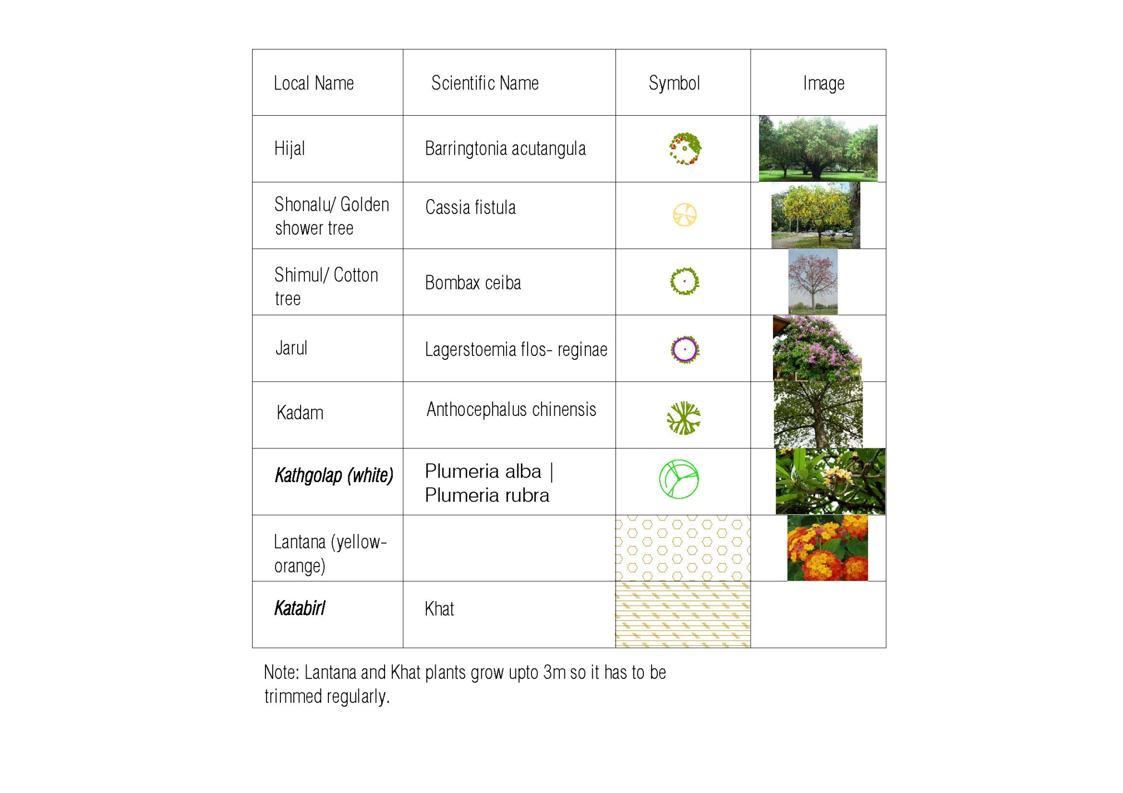

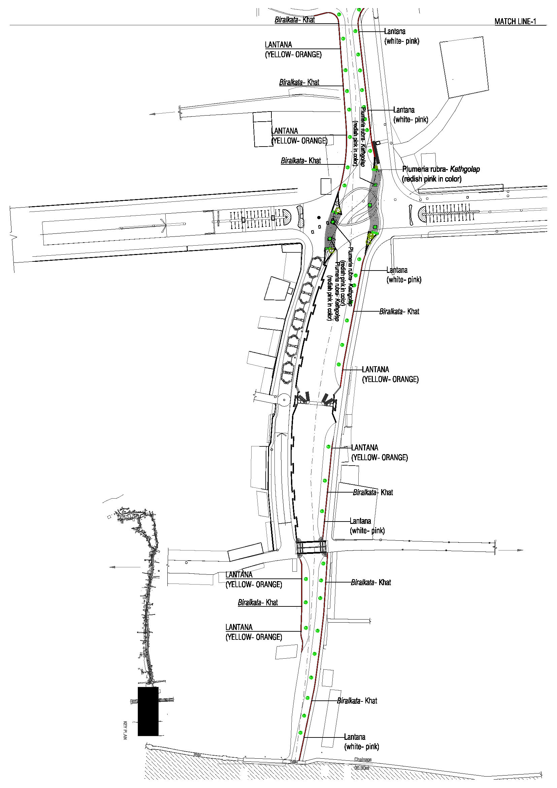

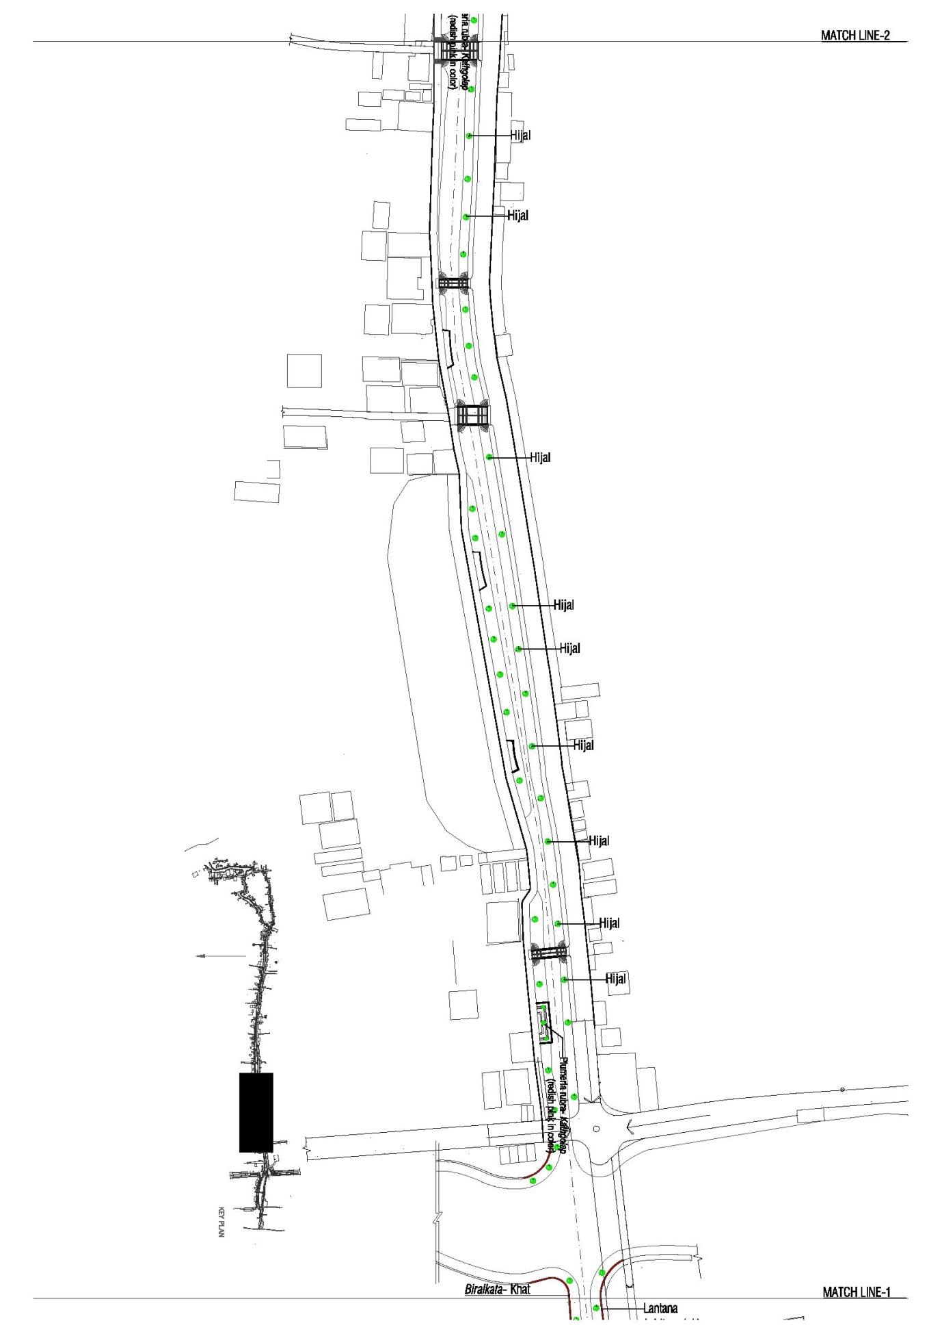

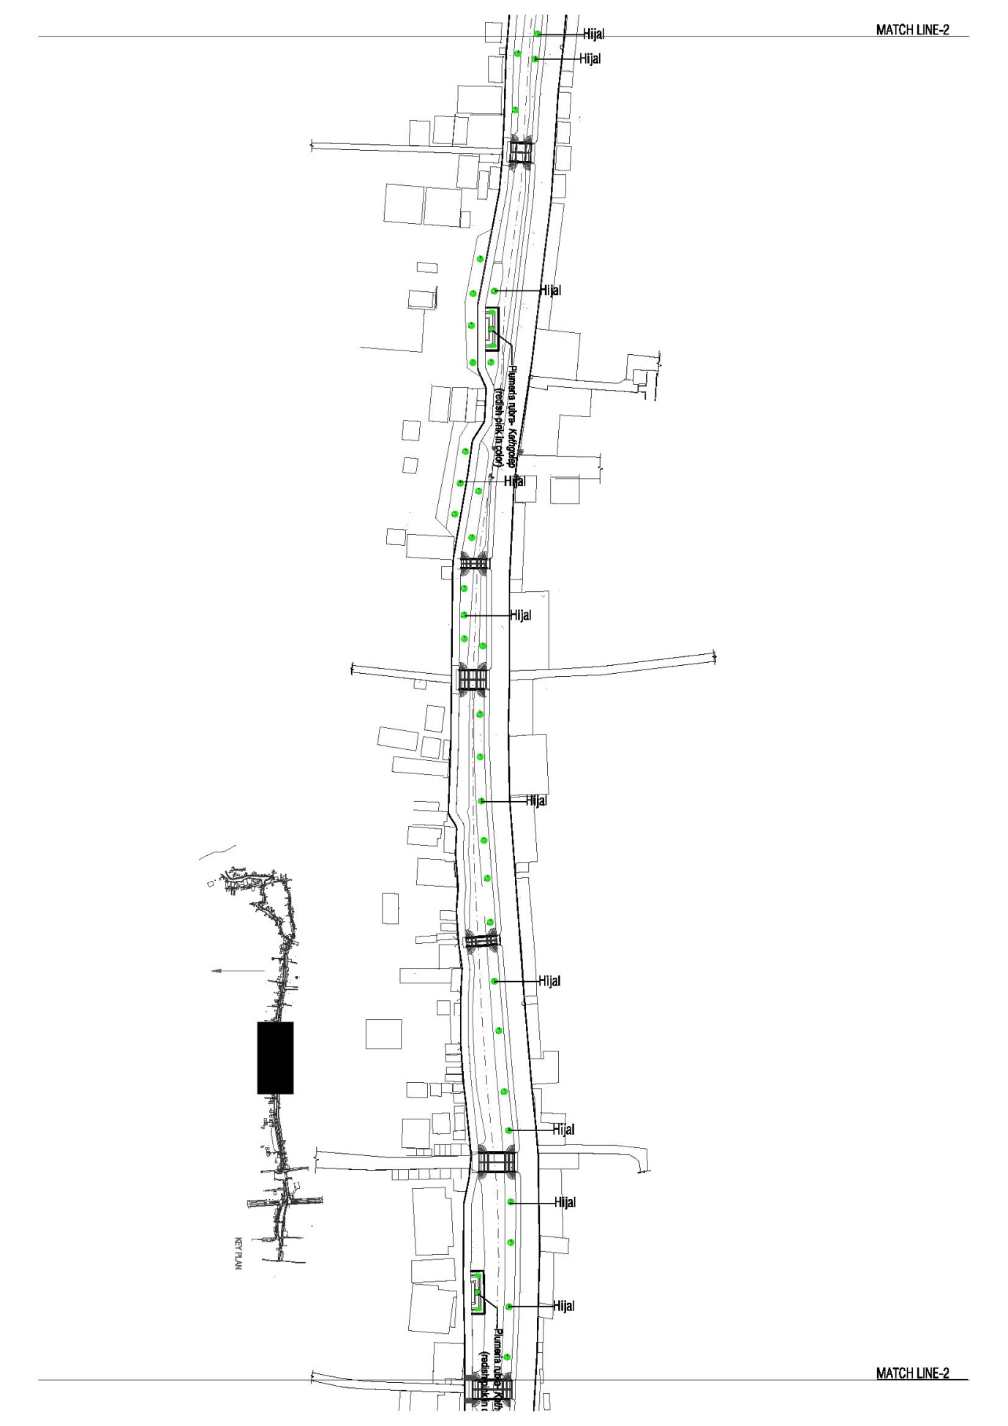

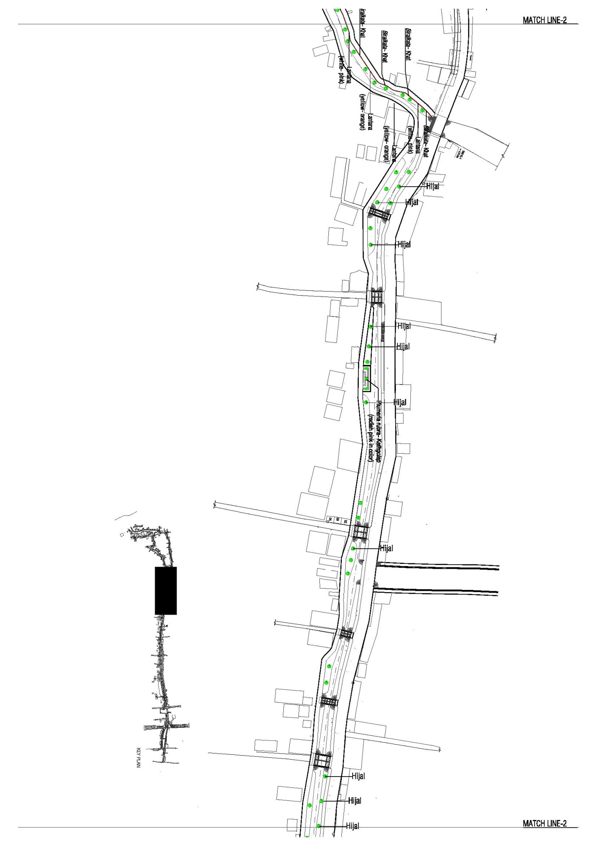

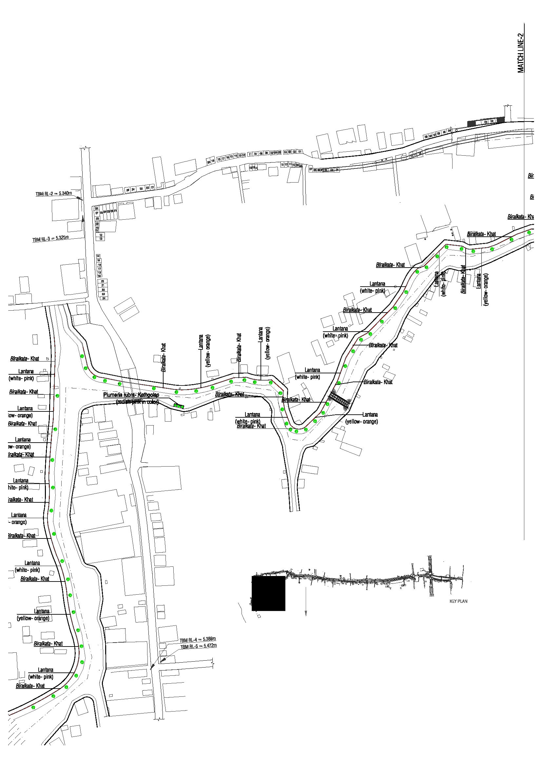

ANNEX 4: Chance Find Procedures
(Ref: The World Bank Operational Manual, 1999 OP4.11)

Works could impact sites of social, sacred, religious, or heritage value. “Chance find” procedures would apply when those sites are identified during the design phase or during the actual construction period and the related activity will not be eligible for financing under the project.

- Cultural property includes monuments, structures, works of art, or sites of significant points of view, and are defined as sites and structures having archaeological, historical, architectural, or religious significance, and natural sites with cultural values. This includes cemeteries, graveyards and graves.
- The list of negative project attributes which would make a project ineligible for support includes any activity that would adversely impact cultural property.
- In the event of finding of properties of cultural value during construction, the following procedures for identification, protection from theft, and treatment of discovered artifacts should be followed and included in standard bidding document.
(a) Stop the construction activities in the area of the chance find;
(b) Delineate the discovered site or area;
(c) Secure the site to prevent any damage or loss of removable objects.
(d) Notify the supervisory Engineer who in turn will notify the responsible local authorities;
(e) Responsible local authorities and the relevant Ministry would be in charge of protecting and preserving the site before deciding on subsequent appropriate procedures.
(f) Decisions on how to handle the finding shall be taken by the responsible authorities and the relevant Ministry. This could include changes in the layout (such as when finding an irremovable remain of cultural or archeological importance), conservation, restoration and salvage.
(g) Implementation of the authority decision concerning the management of the finding shall be communicated in writing by the relevant Ministry.
(h) Construction work could resume only after permission is given from the responsible local authorities and the relevant Ministry concerning safeguard of the heritage.
- These procedures must be referred to as standard provisions in construction contracts. During project supervision, the Site Engineer shall monitor the above regulations relating to the treatment of any chance find encountered.
- Relevant findings will be recorded in World Bank Supervision Reports and Implementation Completion Reports will assess the overall effectiveness of the project’s cultural property mitigation, management, and activities, as appropriate.

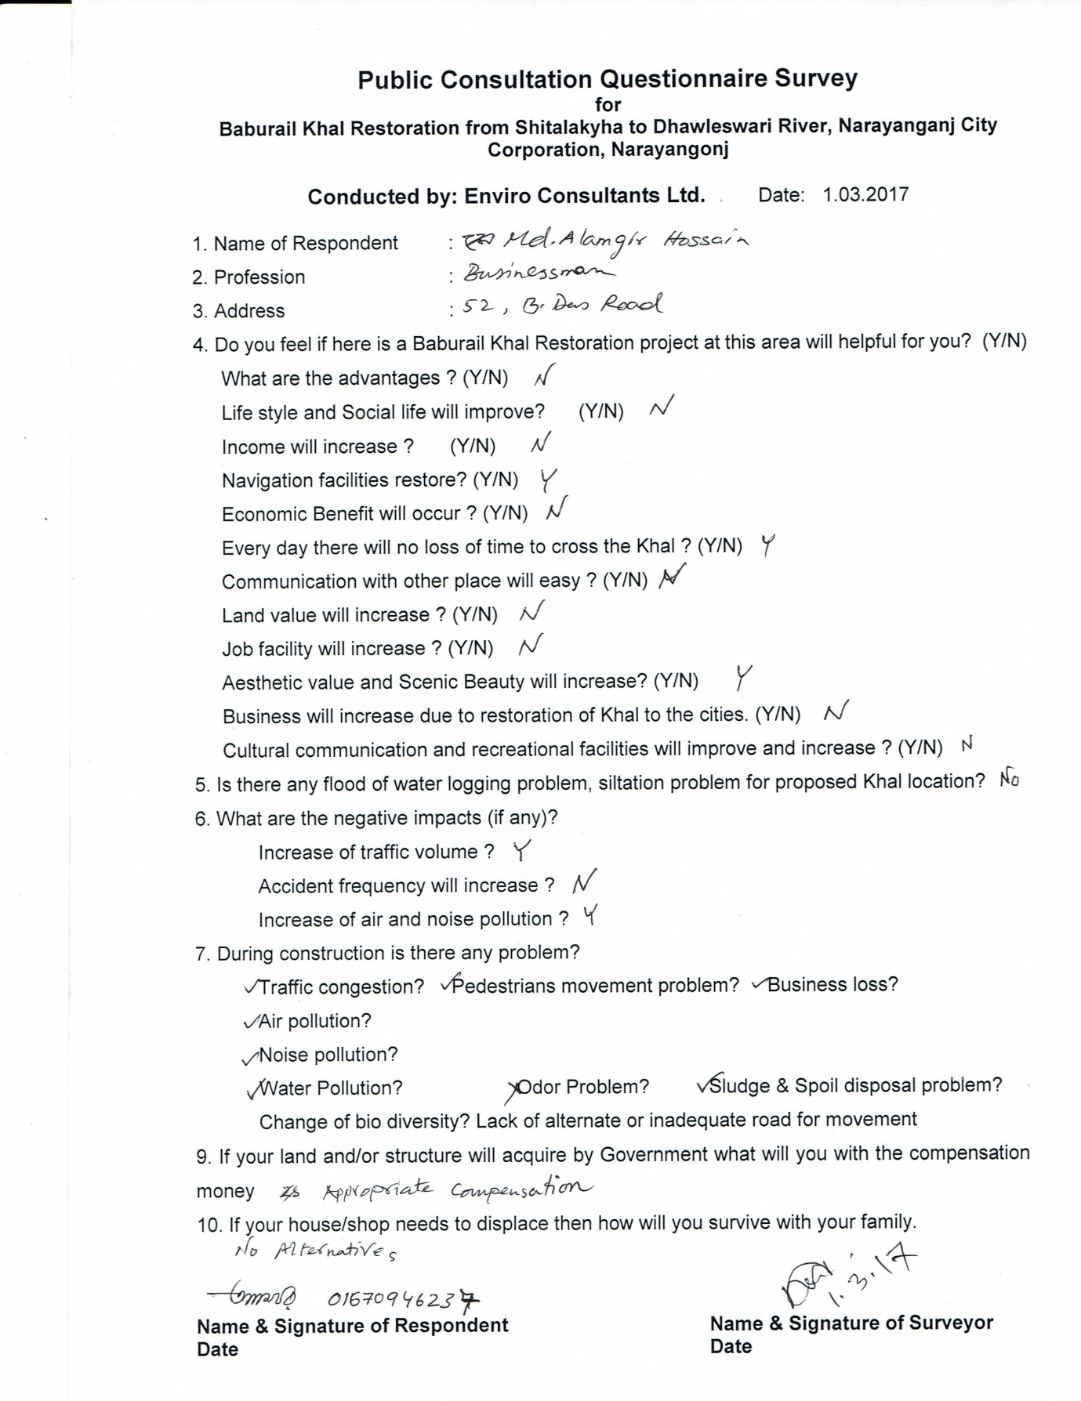

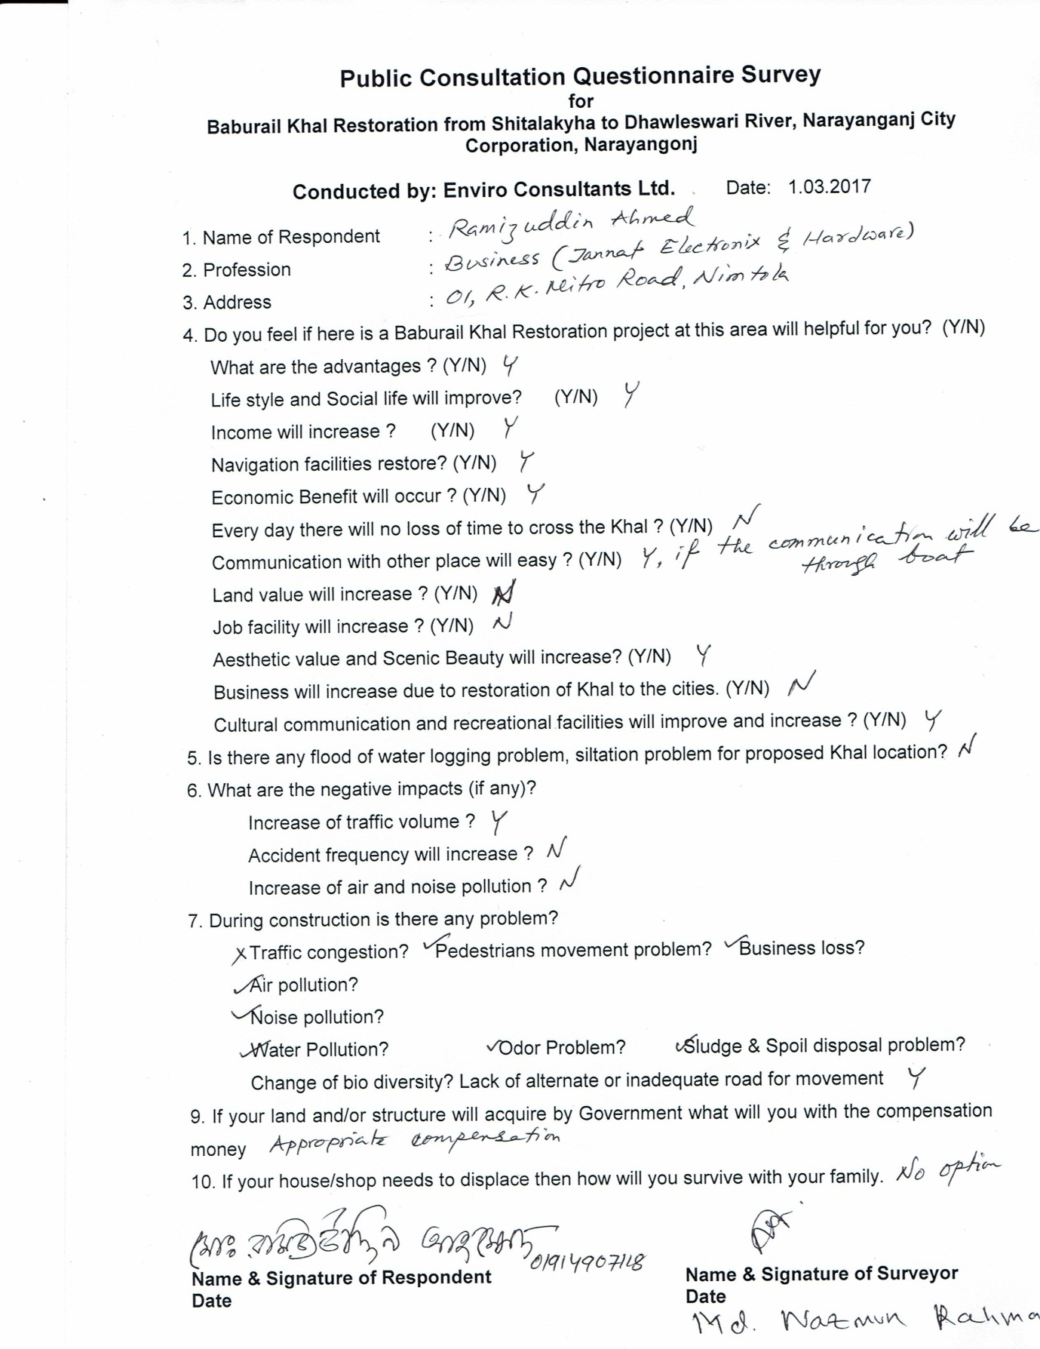

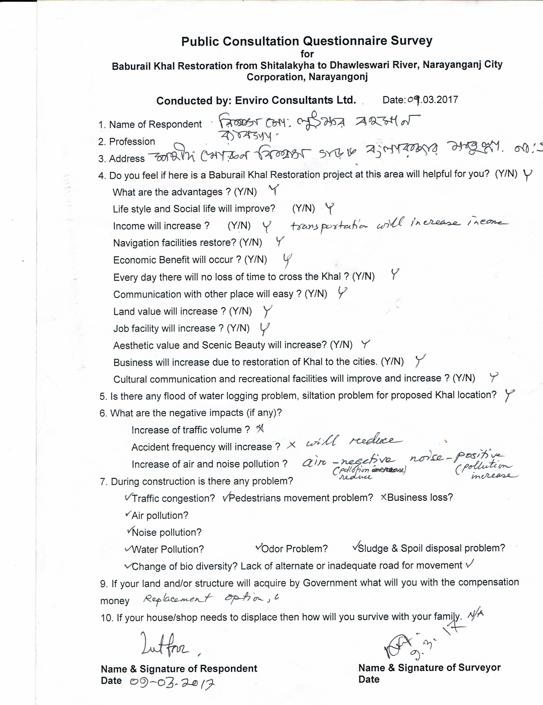

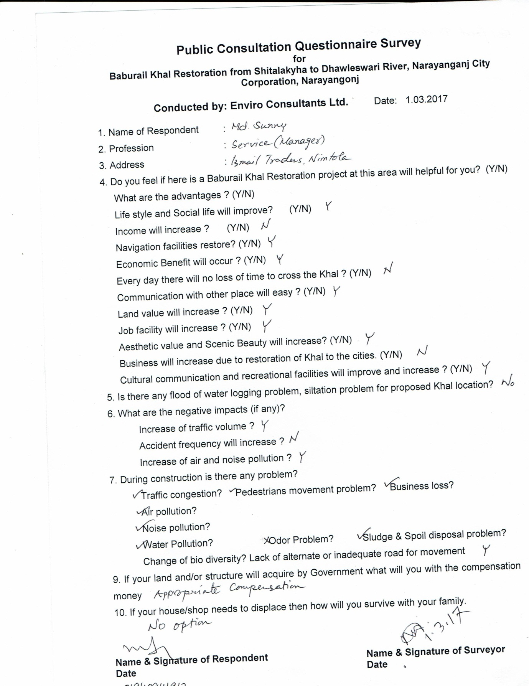

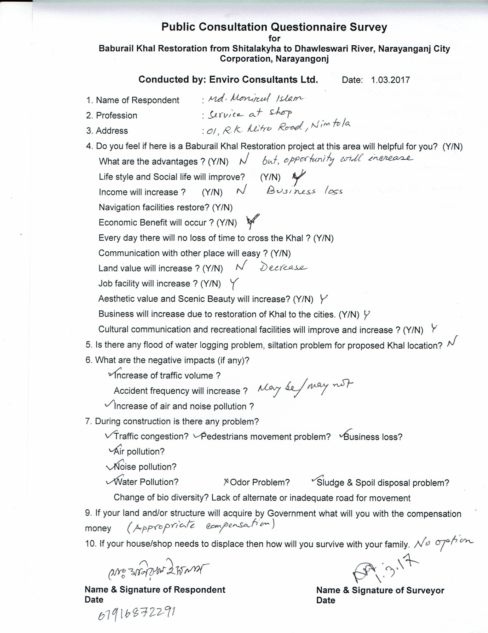

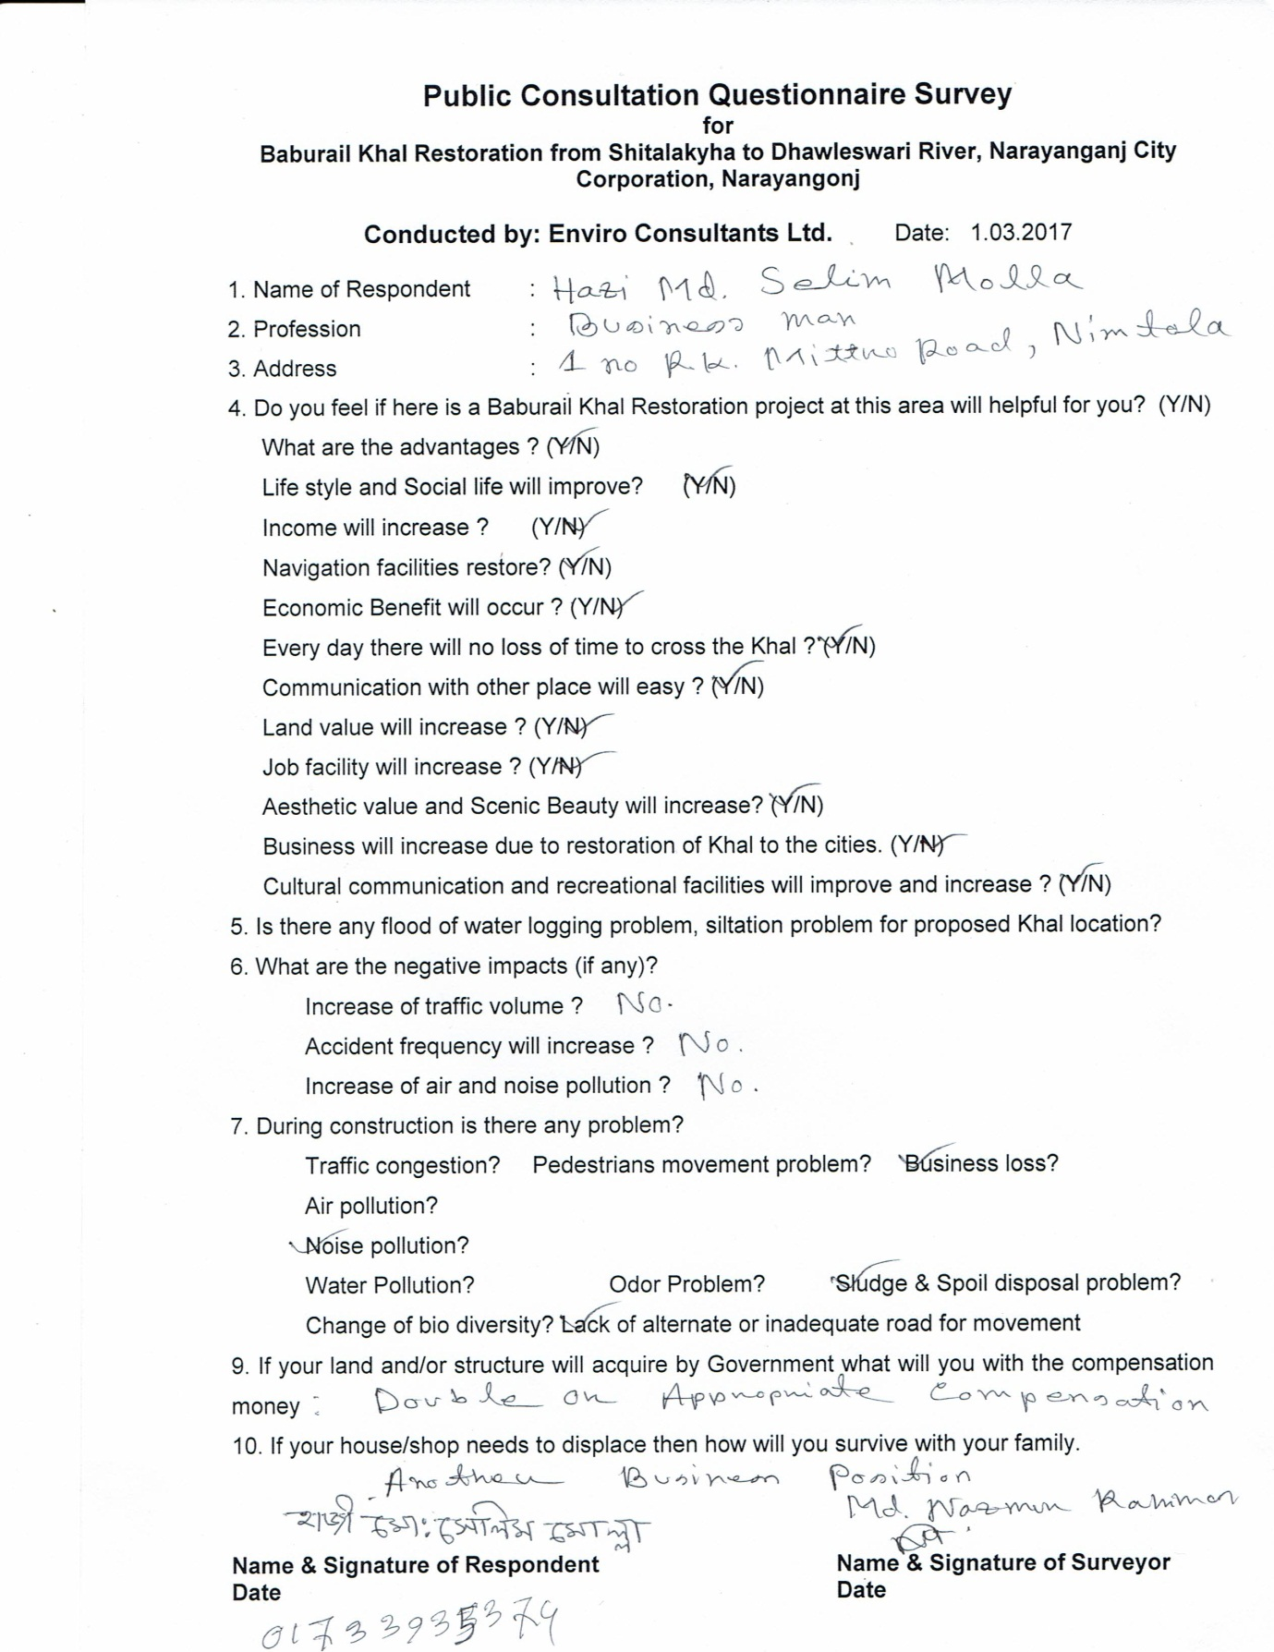

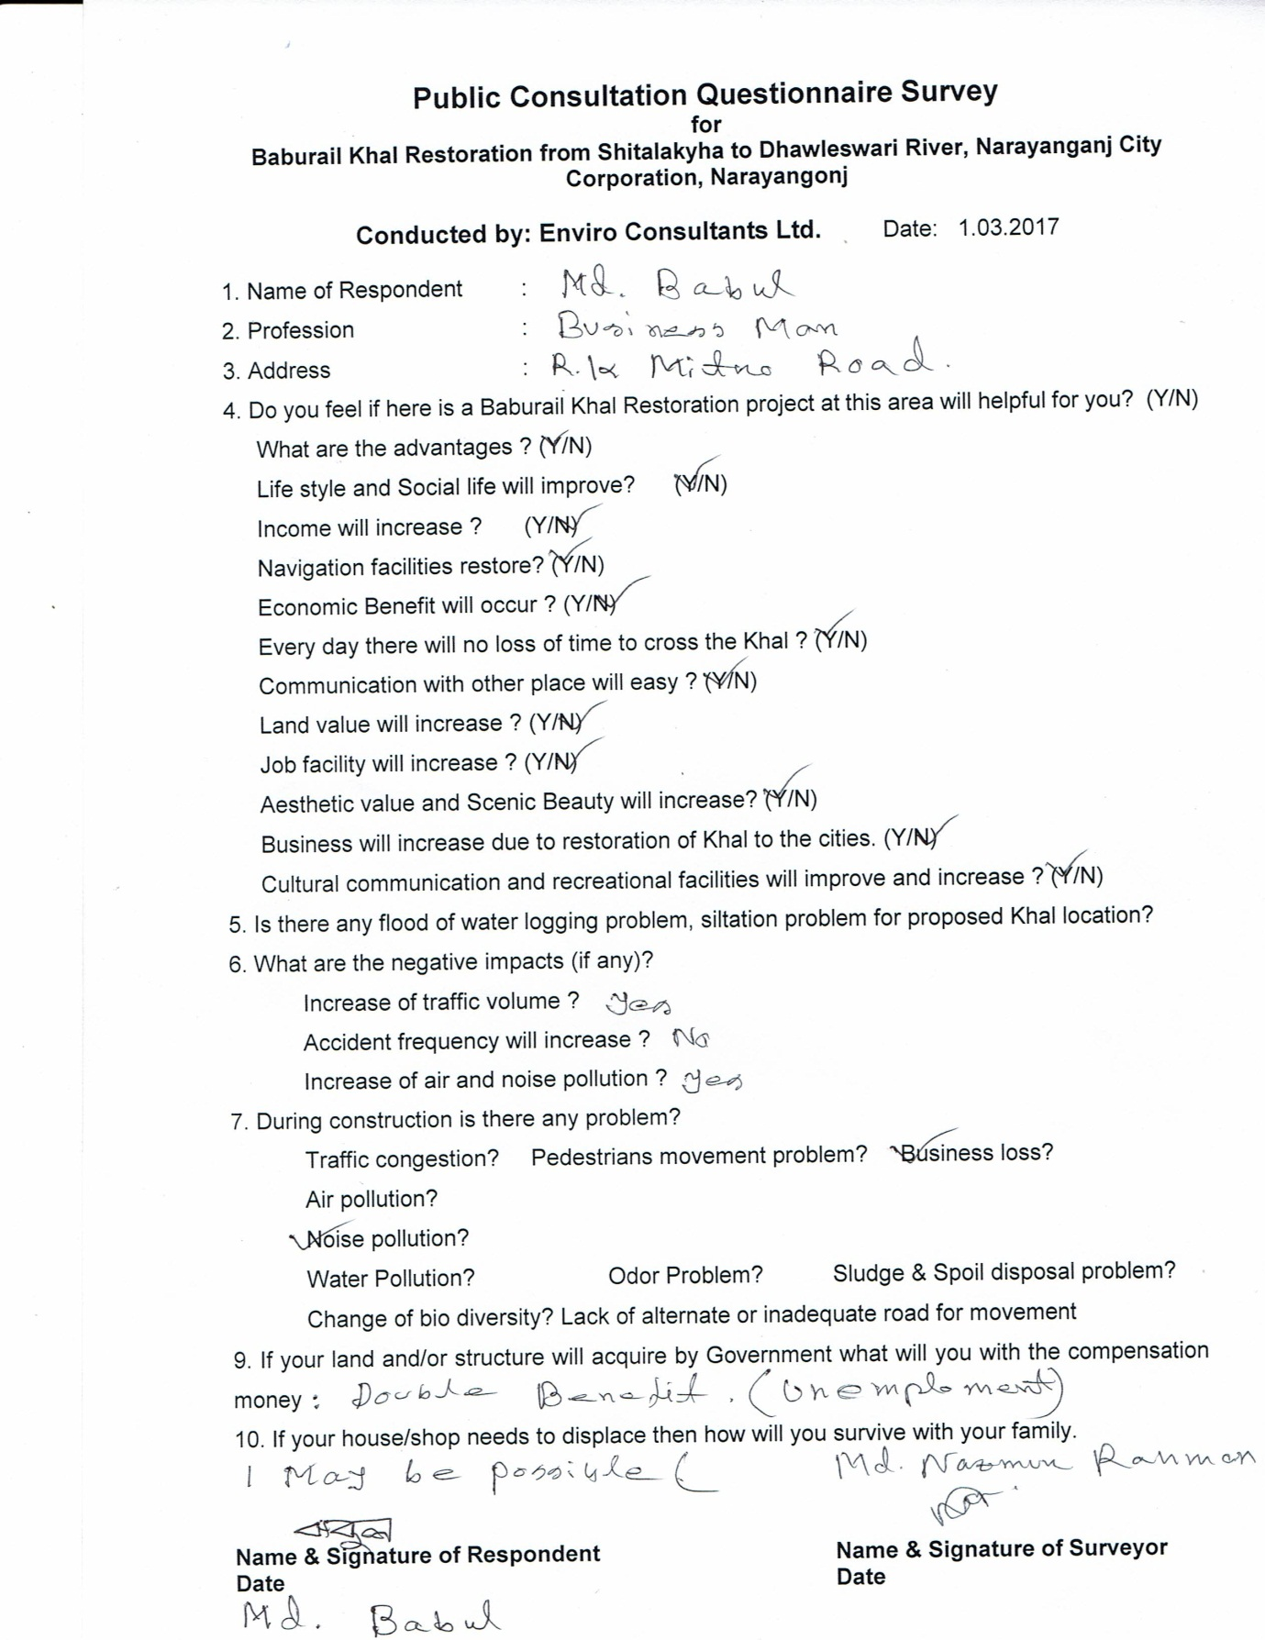

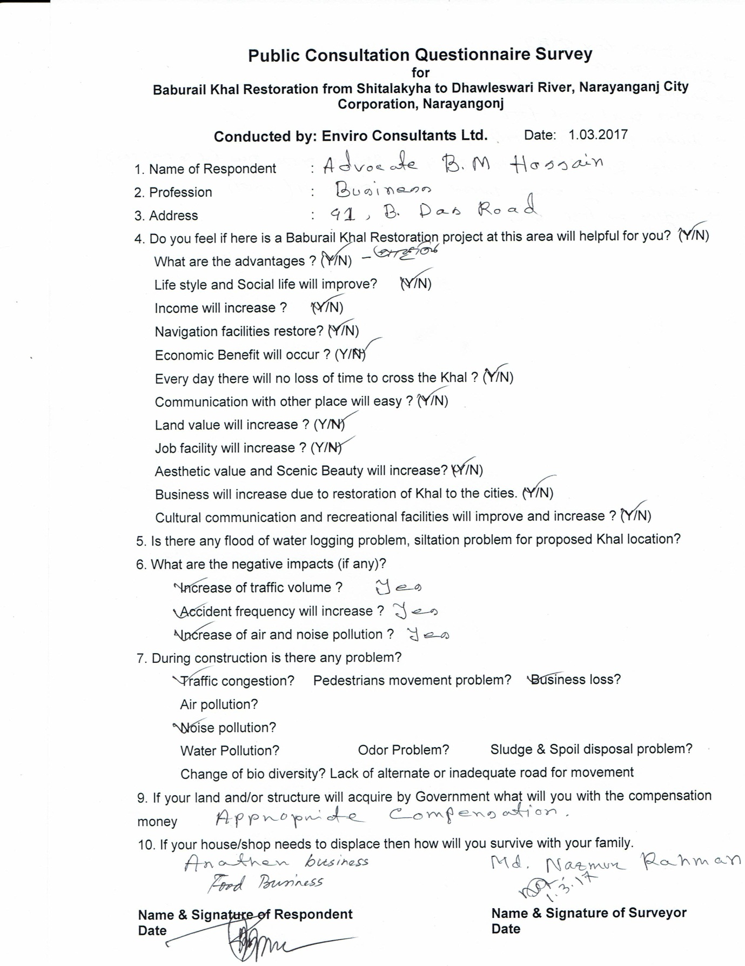

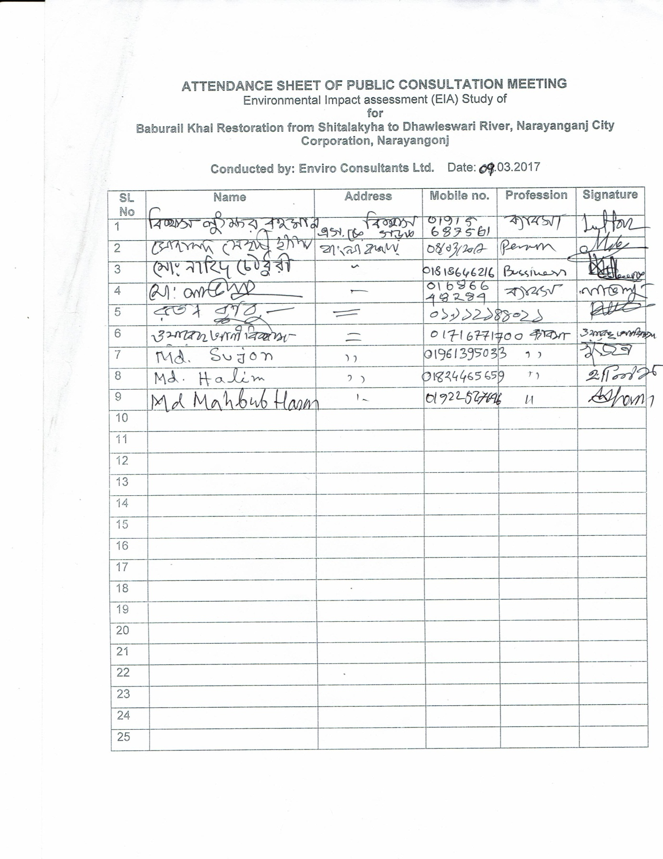

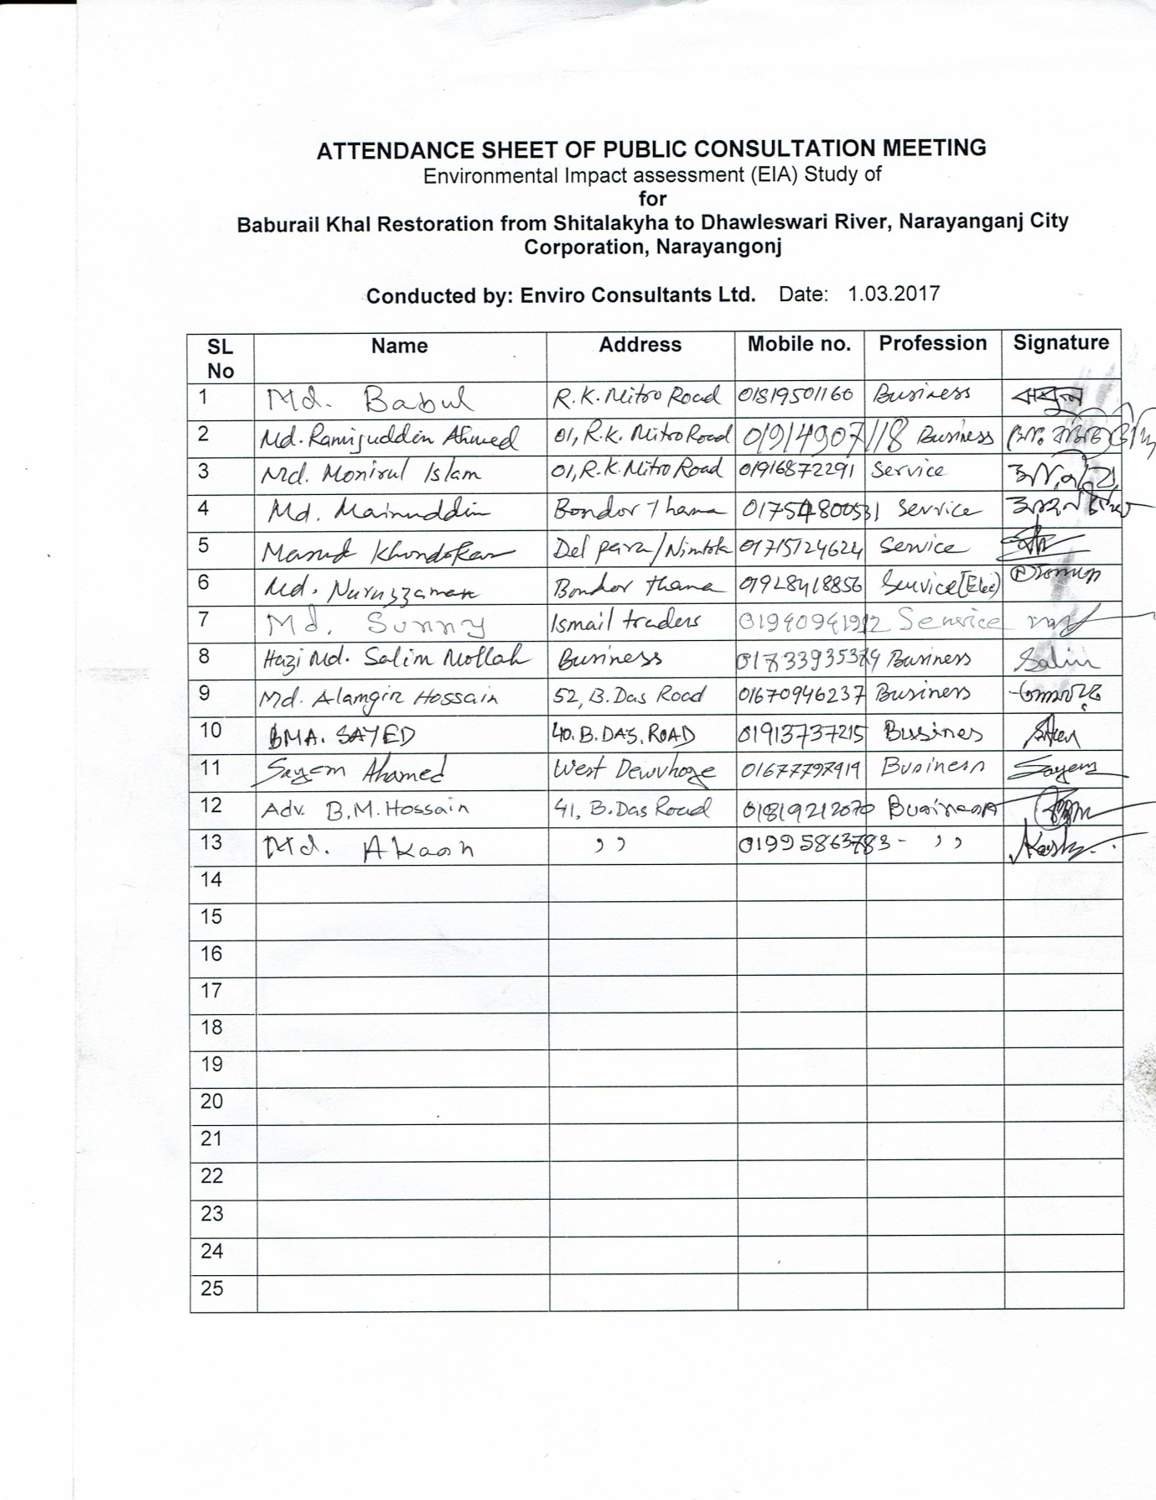

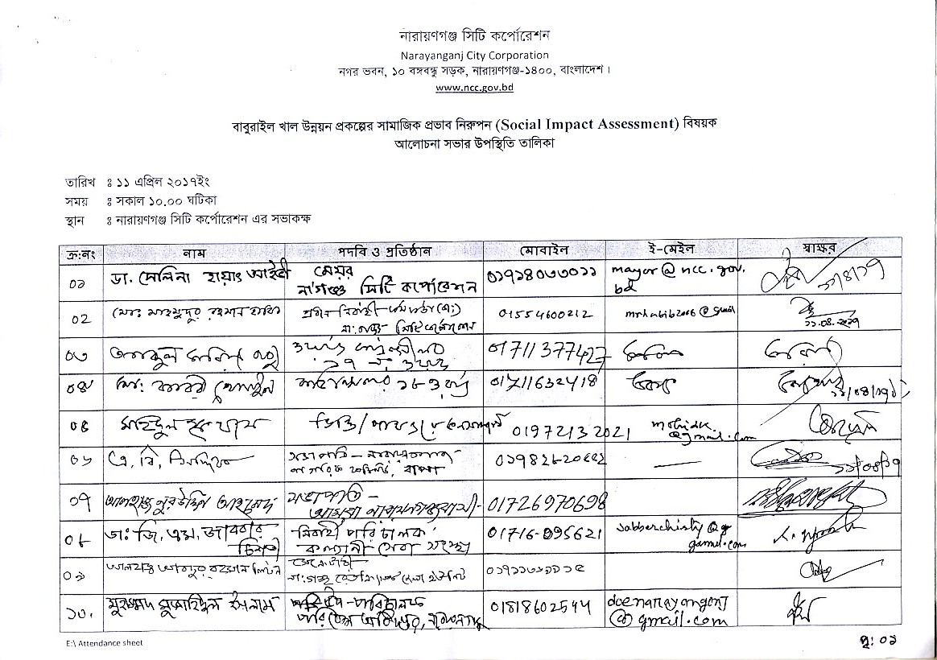
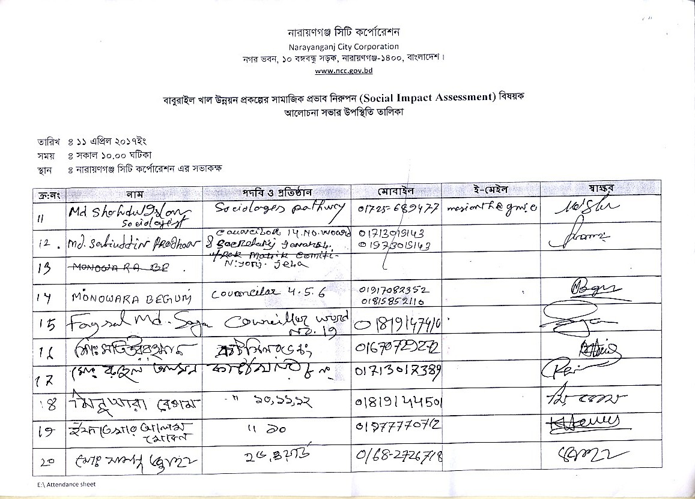
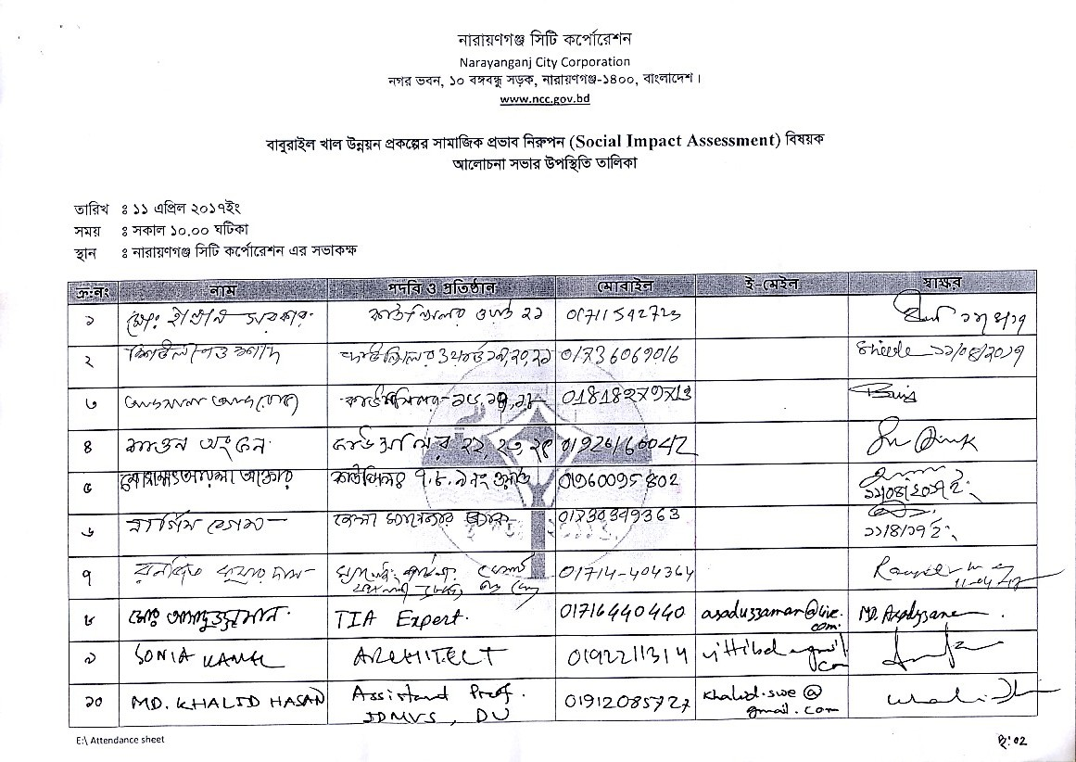
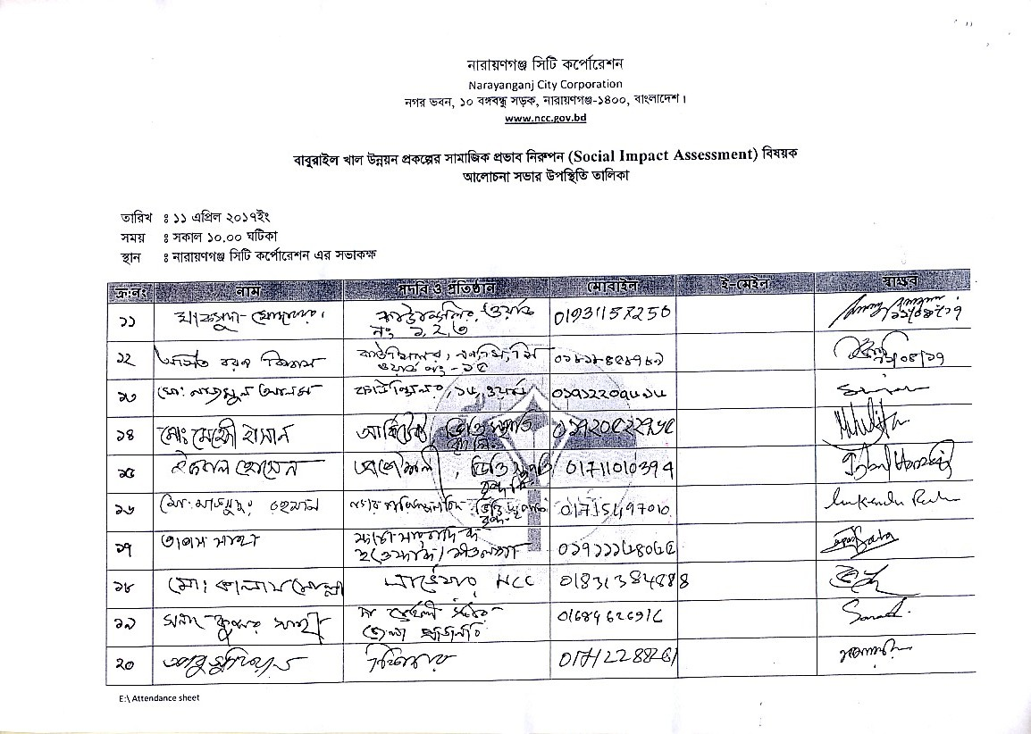
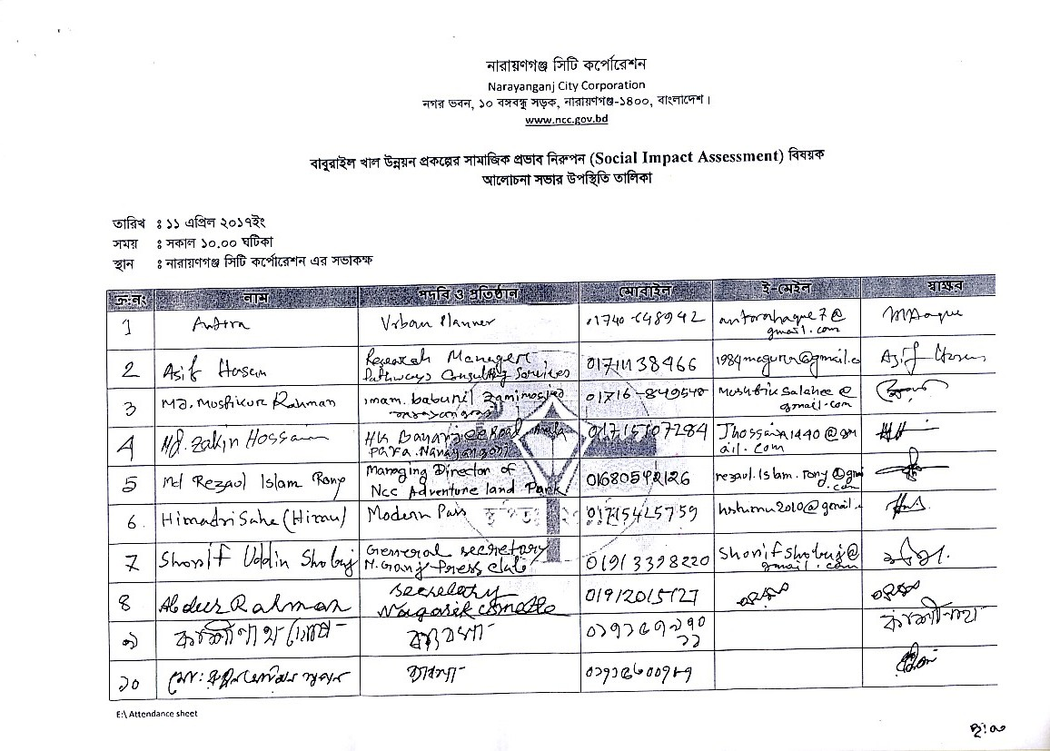
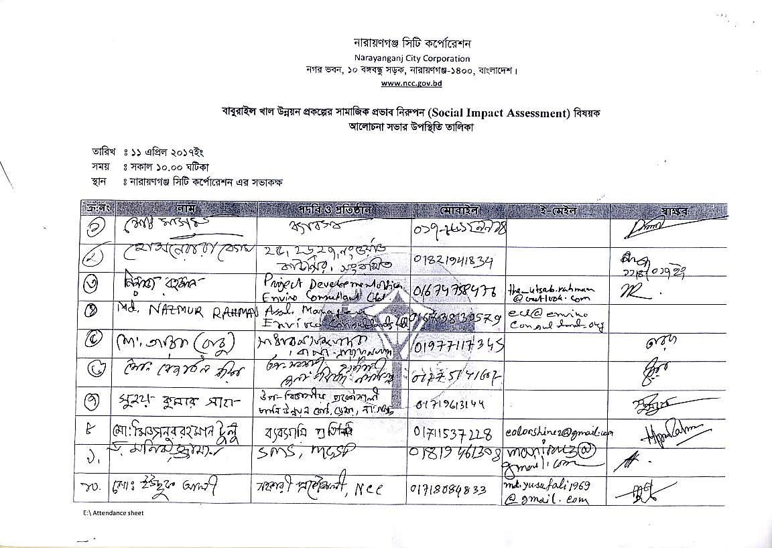
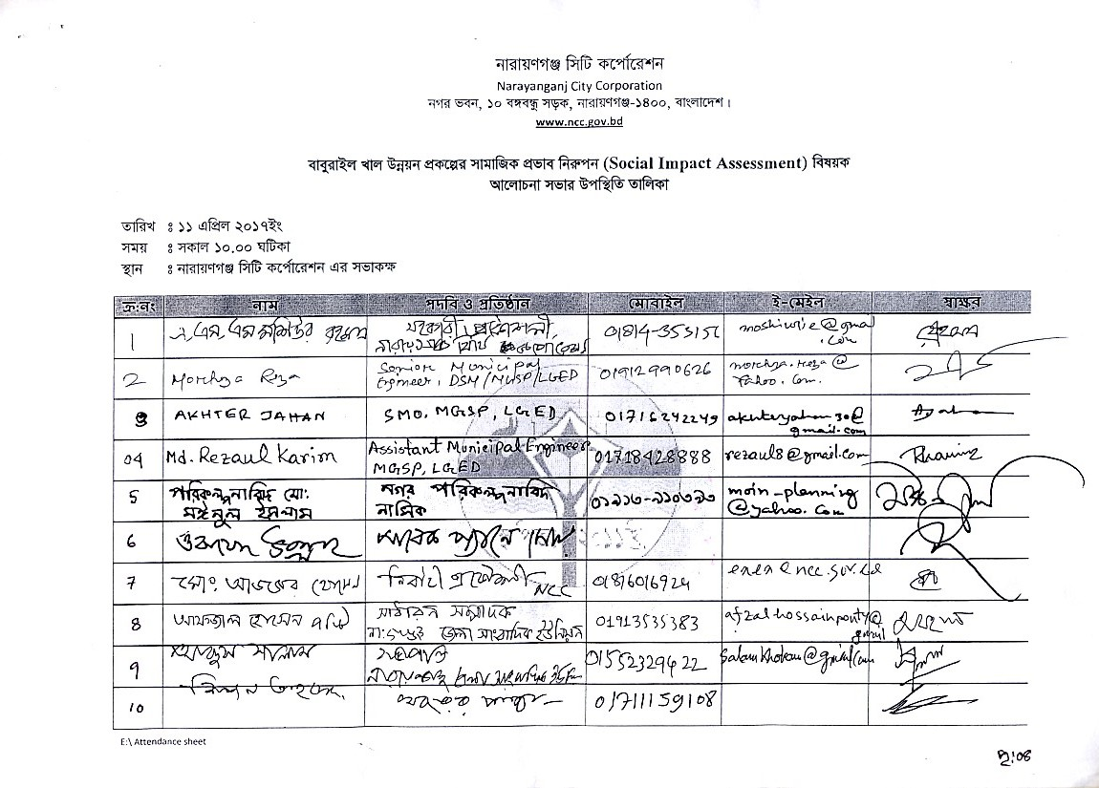
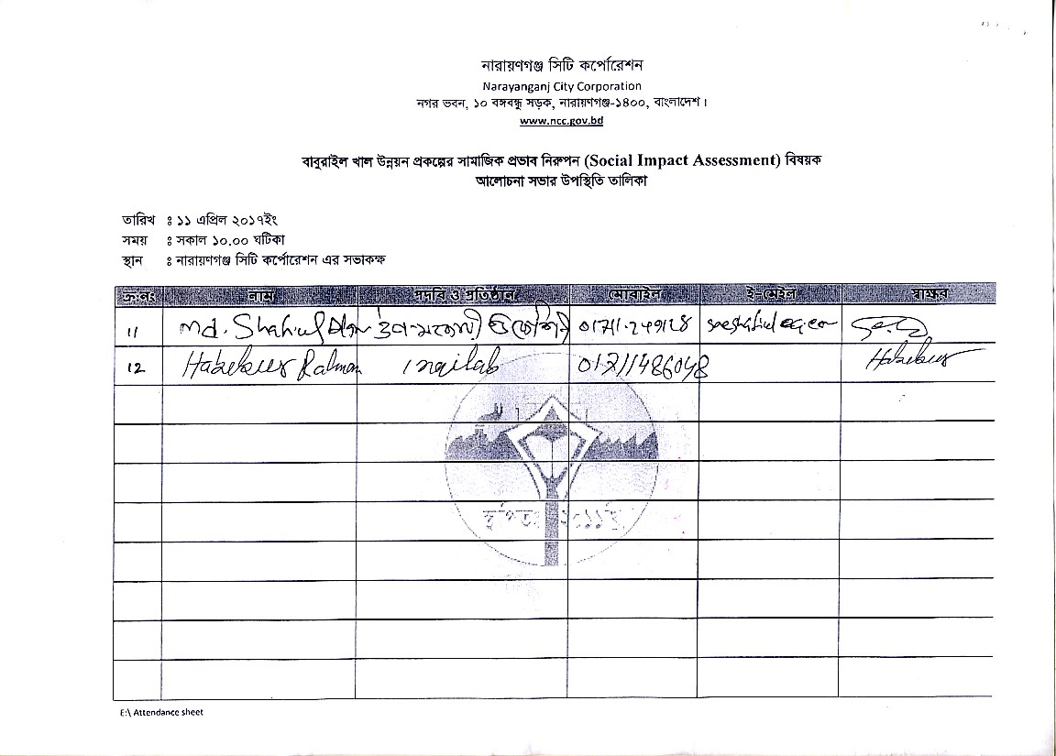

ANNEX 6: Environmental Code of Practices
ECoP 1: Waste Management
Project Activity/ Impact Source | Environmental Impacts | Mitigation Measures/ Management Guidelines
General Waste | Soil and water pollution from the improper management of wastes and excess materials from the construction sites. | The Contractor shall  - Develop waste management plan for various specific waste streams (e.g., reusable waste, flammable waste, construction debris, food waste etc.) prior to commencing of construction and submit to CSC for approval.  - Organize disposal of all wastes generated during construction in an environmentally acceptable manner. This will include consideration of the nature and location of disposal site, so as to cause less environmental impact.  - Minimize the production of waste materials by 3R (Reduce, Recycle and Reuse) approach.  - Segregate and reuse or recycle all the wastes, wherever practical.  - Prohibit burning of solid waste  - Collect and transport non-hazardous wastes to all the approved disposal sites. Vehicles transporting solid waste shall be covered with tarps or nets to prevent spilling waste along the route  - Train and instruct all personnel in waste management practices and procedures as a component of the environmental induction process.  - Provide refuse containers at each worksite.  - Request suppliers to minimize packaging where practicable.  - Place a high emphasis on good housekeeping practices.  - Maintain all construction sites in a clean, tidy and safe condition and provide and maintain appropriate facilities as temporary storage of all wastes before transportation and final disposal.
Hazardous Waste | Health hazards and environmental impacts due to improper waste management practices | The Contractor shall  - Collect chemical wastes in 200 liter drums (or similar sealed container), appropriately labeled for safe transport to an approved chemical waste depot.  - Store, transport and handle all chemicals avoiding potential environmental pollution.  - Store all hazardous wastes appropriately in bounded areas away from water courses.  - Make available Material Safety Data Sheets (MSDS) for hazardous materials on-site during construction.  - Collect hydrocarbon wastes, including lube oils, for safe transport off-site for reuse, recycling, treatment or disposal at approved locations.  - Construct concrete or other impermeable flooring to prevent seepage in case of spills

ECoP 2: Fuels and Hazardous Goods Management
Project Activity/ Impact Source | Environmental Impacts | Mitigation Measures/ Management Guidelines
Fuels and hazardous goods. | Materials used in construction have a potential to be a source of contamination. Improper storage and handling of fuels, lubricants, chemicals and hazardous goods/materials on-site, and potential spills from these goods may harm the environment or health of construction workers. | The Contractor shall  - Prepare spill control procedures and submit the plan for CSC approval.  - Train the relevant construction personnel in handling of fuels and spill control procedures.  - Store dangerous goods in bounded area on a top of a sealed plastic sheet away from watercourses.  - Refueling shall occur only within bounded area.  - Make available MSDS for chemicals and dangerous goods on-site.  - Transport waste of dangerous goods, which cannot be recycled, to a designated disposal site approved by DoE.  - Provide absorbent and containment material (e.g., absorbent matting) where hazardous material are used and stored.  - Provide protective clothing, safety boots, helmets, masks, gloves, and goggles to the construction personnel which are appropriate to materials in use.  - Make sure all containers, drums, and tanks that are used for storage are in good condition and are labeled with expiry date. Any container, drum, or tank that is dented, cracked, or rusted might eventually leak Check for leakage regularly to identify potential problems before they occur.  - Store hazardous materials above flood plain level.  - Put containers and drums in temporary storages in clearly marked areas, where they will not be run over by vehicles or heavy machinery. The area shall preferably slope or drain to a safe collection area in the event of a spill.  - Put containers and drums in permanent storage areas with an impermeable floor that slopes to a safe collection area in the event of a spill or leak.  - Take all precautionary measures when handling and storing fuels and lubricants, avoiding environmental pollution.  - Avoid the use of material with greater potential for contamination by substituting them with more environment friendly materials.  - Return the gas cylinders to the supplier. However, if they are not empty prior to their return, they must be labeled with the name of the material they contained or contain, information of the supplier, cylinder serial number, pressure, their last hydrostatic test date, and any additional identification marking that may be considered necessary.

ECoP 3: Water Resources Management
Project Activity/ Impact Source | Environmental Impacts | Mitigation Measures/ Management Guidelines
Hazardous Material and Waste | Water pollution from the storage, handling and disposal of hazardous materials and general construction waste, and accidental spillage | The Contractor shall  - Follow the management guidelines proposed in ECPs 1 and 2.  - Minimize the generation of sediment, oil and grease, excess nutrients, organic matter, litter, debris and any form of waste (particularly petroleum and chemical wastes). These substances must not enter waterways, storm water systems or underground water tables
Discharge from construction sites | During construction both surface and groundwater quality may be deteriorated due to construction activities in the river, sewerages from construction sites and work camps. The construction works will modify groundcover and topography changing the surface water drainage patterns of the area including infiltration and storage of storm water. These changes in hydrological regime lead to increased rate of runoff, increase in sediment and contaminant loading, increased flooding, groundwater contamination, and effect habitat of fish and other aquatic biology. | The Contractor shall  - Install temporary drainage works (channels and bunds) in areas required for sediment controlerosion control and around storage areas for construction materials  - Install temporary sediment basins, where appropriate, to capture sediment-laden run-off from site  - Divert runoff from undisturbed areas around the construction site  - Stockpile materials away from drainage lines  - Prevent all solid and liquid wastes entering waterways by collecting solid waste, oils, chemicals, bitumen spray waste and wastewaters from brick, concrete and asphalt cutting where possible and transport to an approved waste disposal site or recycling depot  - Wash out ready-mix concrete agitators and concrete handling equipment at washing facilities off site or into approved bounded areas on site. Ensure that tires of construction vehicles are cleaned in the washing bay (constructed at the entrance of the construction site) to remove the mud from the wheels. This shall be done in every exit of each construction vehicle to ensure the local roads are kept clean.
Soil Erosion and siltation | Soil erosion and dust from the material stockpiles will increase the sediment and contaminant loading of surface water bodies. | The Contractor shall  - Stabilize the cleared areas not used for construction activities with vegetation or appropriate surface water treatments as soon as practicable following earthwork to minimize erosion  - Ensure that roads used by construction vehicles are swept regularly to remove sediment.  - Water the material stockpiles, access roads and bare soils on an required basis to minimize dust. Increase the watering frequency during periods of high risk (e.g. high winds)
Construction activities in water bodies | Construction works in the water bodies will increase sediment and contaminant loading, and effect habitat of fish and other aquatic biology. | The Contractor Shall  - Dewater sites by pumping water to a sediment basin prior to release off site – do not pump directly off site  - Protect water bodies from sediment loads by silt screen or bubble curtains or other barriers  - Minimize the generation of sediment, oil and grease, excess nutrients, organic matter, litter, debris and any form of waste (particularly petroleum and chemical wastes). These substances must not enter waterways, storm water systems or underground water tables.  - Use environment friendly and nontoxic slurry during construction of piles to discharge into the river.  - Reduce infiltration of contaminated drainage through storm water management design  - Do not discharge cement and water curing used for cement concrete directly into water courses and drainage inlets.
Drinking water | Groundwater at shallow depths is contaminated with arsenic and hence not suitable for drinking purposes. | The Contractor Shall  - Pumping of groundwater shall be from deep aquifers of more than 300 m to supply arsenic free water. Safe and sustainable discharges are to be ascertained prior to selection of pumps.  - Tube wells will be installed with due regard for the surface environment, protection of groundwater from surface contaminants, and protection of aquifer cross contamination  - All tube wells, test holes, monitoring wells that are no longer in use or needed shall be properly decommissioned
 | Depletion and pollution of groundwater resources | - Install monitoring wells both upstream and downstream areas near construction yards and construction camps to regularly monitor the water quality and water levels.  - Protect groundwater supplies of adjacent lands

ECoP 4: Drainage Management
Project Activity/ Impact Source | Environmental Impacts | Mitigation Measures/ Management Guidelines
Excavation and earth works, and construction yards | Lack of proper drainage for rainwater/liquid waste or wastewater owing to the construction activities harms environment in terms of water and soil contamination, and mosquito growth. | The Contractor shall  - Prepare a program for preventing/avoid standing waters, which CSC will verify in advance and confirm during implementation  - Provide alternative drainage for rainwater if the construction works/earth-fillings cut the established drainage line  - Establish local drainage line with appropriate silt collector and silt screen for rainwater or wastewater connecting to the existing established drainage lines already there  - Rehabilitate road drainage structures immediately if damaged by contractors’ road transports.  - Build new drainage lines as appropriate and required for wastewater from construction yards connecting to the available nearby recipient water bodies. Ensure wastewater quality conforms to the relevant standards provided by DoE, before it is being discharged into the recipient water bodies.  - Ensure the internal roads/hard surfaces in the construction yards/construction camps that generate storm water drainage to accommodate high runoff during downpour and that there is no stagnant water in the area at the end of the downpour.  - Construct wide drains instead of deep drains to avoid sand deposition in the drains that require frequent cleaning.  - Provide appropriate silt collector and silt screen at the inlet and manholes and periodically clean the drainage system to avoid drainage congestion  - Protect natural slopes of drainage channels to ensure adequate storm water drains.  - Regularly inspect and maintain all drainage channels to assess and alleviate any drainage congestion problem.  - Reduce infiltration of contaminated drainage through storm water management design
Ponding of water | Health hazards due to mosquito breeding | - Do not allow ponding of water especially near the waste storage areas and construction camps  - Discard all the storage containers that are capable of storing of water, after use or store them in inverted position

ECoP 5: Soil Quality Management
Project Activity/ Impact Source | Environmental Impacts | Mitigation Measures/ Management Guidelines
Filling of Sites with soil | Soil contamination will occur from filled material | The Contractor shall  - Fill the land in dry season  - If transported by truck then Cover the soil by tipple of the truck during transportation  - Spray of water is suggested in the construction sites  - Ensure that filled soil used for land filling shall be free of pollutants. Prior to filling, soil quality shall be tested to confirm whether soil is pollution free. Soil shall be properly compacted. Side Slope of Filled Land of 1:2 shall be constructed by suitable soils with proper compaction as per design. Slope surface shall be covered by top soils/ cladding materials (0.5m thick) and grass turfing with suitable grass.  - No sediment laden water in the adjacent lands near the construction sites, and/or wastewater of suspended materials excessive of 200mg/l from soil storage/use area in the adjacent agricultural lands.
Storage of hazardous and toxic chemicals | Spillage of hazardous and toxic chemicals will contaminate the soils | The Contractor shall  - Strictly manage the wastes management plans proposed in ECP1 and storage of materials in ECP2  - Construct appropriate spill contaminant facilities for all fuel storage areas  - Establish and maintain a hazardous materials register detailing the location and quantities of hazardous substances including the storage, use of disposals  - Train personnel and implement safe work practices for minimizing the risk of spillage  - Identify the cause of contamination, if it is reported, and contain the area of contamination. The impact may be contained by isolating the source or implementing controls around the affected site  - Remediate the contaminated land using the most appropriate available method to achieve required commercial/industrial guideline validation results
Construction material stock piles | Erosion from construction material stockpiles may contaminate the soils | The Contractor shall  - Protect the toe of all stockpiles, where erosion is likely to occur, with silt fences, straw bales or bunds

ECoP 6: Erosion and Sediment Control
Project Activity/ Impact Source | Environmental Impacts | Mitigation Measures/ Management Guidelines
Clearing of construction sites | Cleared areas and slopes are susceptible to erosion of top soils, that affects the growth of vegetation which causes ecological imbalance. | - Reinstate and protect cleared areas as soon as possible.  - Mulch to protect batter slopes before planting  - Cover unused area of disturbed or exposed surfaces immediately with mulch/grass turfings/tree plantations
Construction activities and material stockpiles | The impact of soil erosion are (i) Increased run off and sedimentation causing a greater flood hazard to the downstream, (ii) destruction of aquatic environment in nearby lakes, streams, and reservoirs caused by erosion and/or deposition of sediment damaging the spawning grounds of fish, and (iii) destruction of vegetation by burying or gullying. | The Contractor shall  - Locate stockpiles away from drainage lines  - Protect the toe of all stockpiles, where erosion is likely to occur, with silt fences, straw bales or bunds  - Remove debris from drainage paths and sediment control structures  - Cover the loose sediments and water them if required  - Divert natural runoff around construction areas prior to any site disturbance  - Install protective measures on site prior to construction, for example, sediment traps  - Control drainage through a site in protected channels or slope drains  - Install ‘cut off drains’ on large cut/fill batter slopes to control water runoff speed and hence erosion  - Observe the performance of drainage structures and erosion controls during rain and modify as required.

ECoP 7: Top Soil Management
Project Activity/ Impact Source | Environmental Impacts | Mitigation Measures/ Management Guidelines
Land clearing and earth works | Earthworks will impact the fertile top soils that are enriched with nutrients required for plant growth or agricultural development. | The Contractor shall  - Strip the top soil to a depth of 15 cm and store in stock piles of height not exceeding 2m.  - Remove unwanted materials from top soil like grass, roots of trees and similar others.  - The stockpiles will be done in slopes of 2:1 to reduce surface runoff and enhance percolation through the mass of stored soil.  - Locate topsoil stockpiles in areas outside drainage lines and protect from erosion.  - Construct diversion channels and silt fences around the topsoil stockpiles to prevent erosion and loss of topsoil.  - Spread the topsoil to maintain the physico-chemical and biological activity of the soil. The stored top soil will be utilized for covering all disturbed area and along the proposed plantation sites  - Prior to the re-spreading of topsoil, the ground surface will be ripped to assist the bonding of the soil layers, water penetration and revegetation
Transport | Vehicular movement outside ROW or temporary access roads will affect the soil fertility of the agricultural lands | - Limit equipment and vehicular movements to within the approved construction zone  - Construct temporary access tracks to cross concentrated water flow lines at right angles  - Plan construction access to make use, if possible, of the final road alignment  - Use vehicle-cleaning devices, for example, ramps or wash down areas

ECoP 8: Topography and Landscaping
Project Activity/ Impact Source | Environmental Impacts | Mitigation Measures/ Management Guidelines
Land clearing and earth works | Flood plains of the existing Project area will be affected by the construction of various project activities. Construction activities especially earthworks will change topography and disturb the natural rainwater/flood water drainage as well as change the local landscape. | The Contractor shall  - Ensure the topography of the final surface of all raised lands (construction yards, approach roads, access roads, bridge end facilities, etc.) are conducive to enhance natural draining of rainwater/flood water;  - Keep the final or finished surface of all the raised lands free from any kind of depression that insists water logging  - Undertake mitigation measures for erosion control/prevention by grass-turfing and tree plantation, where there is a possibility of rain-cut that will change the shape of topography.  - Cover immediately the uncovered open surface that has no use of construction activities with grass-cover and tree plantation to prevent soil erosion and bring improved landscaping

ECoP 9: Borrow Areas Management
Project Activity/ Impact Source | Environmental Impacts | Mitigation Measures/ Management Guidelines
Development and operation of borrow areas | Borrow areas will have impacts on local topography, landscaping and natural drainage. | The Contractor shall  - Use only approved quarry and borrow sites  - Not use agriculture areas or ecologically sensitive areas as borrow sites  - Identify new borrow and quarry areas in consultation with Project Director, if required.  - Reuse excavated or disposed material available in the project to the maximum extent possible.  - Store top soil for reinstatement and landscaping.  - Develop surface water collection and drainage systems, anti-erosion measures (berms, revegetation etc.) and retaining walls and gabions where required. Implement mitigation measures in ECoP 3: Water Resources Management, ECoP 6: Erosion and Sediment Control  - The use of explosive should be used in as less in quantity as possible to reduce noise, vibration and dust.  - Control dust and air quality deterioration by application of watering and implementing mitigation measures proposed in ECoP 10: Air Quality Management  - Noise and vibration control by ECoP 11: Noise and Vibration Management.
Soil placement at temporary locations prior to shifting or direct placement on the proposed site for filling | Dispersion of sediments and release of high sediment laden runoff from the placement sites. | The Contractor  - To the extent possible, shall directly place the soil for filling the proposed disposal areas. Prior to filling commencing, the areas being filled will be subdivided into compartments by construction of temporary containment bunds of suitable material.

ECoP 10: Air Quality Management
Project Activity/ Impact Source | Environmental Impacts | Mitigation Measures/ Management Guidelines
Construction vehicular traffic | Air quality can be adversely affected by vehicle exhaust emissions and combustion of fuels. | The Contractor shall  - Fit vehicles with appropriate exhaust systems and emission control devices. Maintain these devices in good working condition.  - Operate the vehicles in a fuel efficient manner  - Cover haul vehicles carrying dusty materials moving outside the construction site  - Impose speed limits on all vehicle movement at the worksite to reduce dust emissions  - Control the movement of construction traffic  - Water construction materials prior to loading and transport  - Service all vehicles regularly to minimize emissions  - Limit the idling time of vehicles not more than 2 minutes
Construction machinery | Air quality can be adversely affected by emissions from machinery and combustion of fuels. | The Contractor shall  - Fit machinery with appropriate exhaust systems and emission control devices. Maintain these devices in good working condition in accordance with the specifications defined by their manufacturers to maximize combustion efficiency and minimize the contaminant emissions. Proof or maintenance register shall be required by the equipment suppliers and contractors/subcontractors  - Focus special attention on containing the emissions from generators  - Machinery causing excess pollution (e.g. visible smoke) will be banned from construction sites  Service all equipment regularly to minimize emissions  - Provide filtering systems, duct collectors or humidification or other techniques (as applicable) to the concrete batching and mixing plant to control the particle emissions in all its stages, including unloading, collection, aggregate handling, cement dumping, circulation of trucks and machinery inside the installations
Construction activities | Dust generation from construction sites, material stockpiles and access roads is a nuisance in the environment and can be a health hazard. | - Water the material stockpiles, access roads and bare soils on an as required basis to minimize the potential for environmental nuisance due to dust. Increase the watering frequency during periods of high risk (e.g. high winds). Stored materials such as gravel and sand shall be covered and confined to avoid their being wind-drifted  - Minimize the extent and period of exposure of the bare surfaces  - Reschedule earthwork activities or vegetation clearing activities, where practical, if necessary to avoid during periods of high wind and if visible dust is blowing off-site  - Restore disturbed areas as soon as possible by vegetation/grass-turfing  - Store the cement in silos and minimize the emissions from silos by equipping them with filters.  - Establish adequate locations for storage, mixing and loading of construction materials, in a way that dust dispersion is prevented because of such operations  - Crushing of rocky and aggregate materials shall be wet-crushed, or performed with particle emission control systems

ECoP 11: Noise and Vibration Management
Project Activity/ Impact Source | Environmental Impacts | Mitigation Measures/ Management Guidelines
Construction vehicular traffic | Noise quality will be deteriorated due to vehicular traffic | The Contractor shall  - Maintain all vehicles in order to keep it in good working order in accordance with manufactures maintenance procedures  - Make sure all drivers will comply with the traffic codes concerning maximum speed limit, driving hours, etc.  - Organize the loading and unloading of trucks, and handling operations for the purpose of minimizing construction noise on the work site
Construction machinery | Noise and vibration may have an impact on people, property, fauna, livestock and the natural environment. | The Contractor shall  - Appropriately site all noise generating activities to avoid noise pollution to local residents  - Use the quietest available plant and equipment  - Modify equipment to reduce noise (for example, noise control kits, lining of truck trays or pipelines)  - Maintain all equipment in order to keep it in good working order in accordance with manufactures maintenance procedures. Equipment suppliers and contractors shall present proof of maintenance register of their equipment.  - Install acoustic enclosures around generators to reduce noise levels.  - Fit high efficiency mufflers to appropriate construction equipment  - Avoid the unnecessary use of alarms, horns and sirens
Construction activity | Noise and vibration may have an impact on people, property, fauna, livestock and the natural environment. | The Contractor shall  - Notify adjacent landholders prior any typical noise events outside of daylight hours  - Educate the operators of construction equipment on potential noise problems and the techniques to minimize noise emissions  - Employ best available work practices on-site to minimize occupational noise levels  - Install temporary noise control barriers where appropriate  - Notify affected people if major noisy activities will be undertaken, e.g. pile driving  - Plan activities on site and deliveries to and from site to minimize impact  - Monitor and analyze noise and vibration results and adjust construction practices as required.  - Avoid undertaking the noisiest activities, where possible, when working at night near the residential areas

ECoP 12: Protection of Flora
Project Activity/ Impact Source | Environmental Impacts | Mitigation Measures/ Management Guidelines
Vegetation clearance | Local flora are important to provide shelters for the birds, offer fruits and/or timber/fire wood, protect soil erosion and overall keep the environment very friendly to human-living. As such damage to flora has wide range of adverse environmental impacts. | The Contractor shall  - Reduce disturbance to surrounding vegetation  - Use appropriate type and minimum size of machine to avoid disturbance to adjacent vegetation.  - Get approval from supervision consultant for clearance of vegetation.  - Make selective and careful pruning of trees where possible to reduce need of tree removal.  - Control noxious weeds by disposing of at designated dump site or burn on site.  - Clear only the vegetation that needs to be cleared in accordance with the plans. These measures are applicable to both the construction areas as well as to any associated activities such as sites for stockpiles, disposal of fill and construction of diversion roads, etc.  - Do not burn off cleared vegetation – where feasible, chip or mulch and reuse it for the rehabilitation of affected areas, temporary access tracks or landscaping. Mulch provides a seed source, can limit embankment erosion, retains soil moisture and nutrients, and encourages re-growth and protection from weeds.  - Return topsoil and mulched vegetation (in areas of native vegetation) to approximately the same area of the roadside it came from.  - Avoid work within the drip-line of trees to prevent damage to the tree roots and compacting the soil.  - Minimize the length of time the ground is exposed or excavation left open by clearing and re-vegetate the area at the earliest time possible.  - Ensure excavation works occur progressively and re-vegetation done at the earliest  - Provide adequate knowledge to the workers regarding nature protection and the need of avoiding trees felling during construction  - Supply appropriate fuel in the work caps to prevent fuel wood collection

ECoP 13: Protection of Fauna
Project Activity/ Impact Source | Environmental Impacts | Mitigation Measures/ Management Guidelines
Construction activities | The location of construction activities can result in the loss of wild life habitat and habitat quality,. | The Contractor shall  - Limit the construction works within the designated sites allocated to the contractors  - check the site for animals trapped in, or in danger from site works and use a qualified person to relocate the animal
 | Impact on migratory birds, its habitat and its active nests | The Contractor shall  - Not be permitted to destruct active nests or eggs of migratory birds  - Minimize the tree removal during the bird breeding season. If works must be continued during the bird breeding season, a nest survey will be conducted by a qualified biologist prior to commence of works to identify and located active nests  - Minimize the release of oil, oil wastes or any other substances harmful to migratory birds or water or any areas frequented by migratory birds.
Vegetation clearance | Clearance of vegetation may impact shelter, feeding and/or breeding and/or physical destruction and severing of habitat areas | The Contractor shall  - Restrict the tree removal to the minimum required.  - Retain tree hollows on site, or relocate hollows, where appropriate  - Leave dead trees where possible as habitat for fauna  - Fill the hollow bearing trees in a manner which reduces the potential for fauna mortality. Felled trees will be inspected after felling for fauna and if identified and readily accessible will be removed and relocated or rendered assistance if injured. After felling, hollow bearing trees will remain unmoved overnight to allow animals to move of their own volition.
Construction camps | Illegal poaching | - Provide adequate knowledge to the workers regarding protection of flora and fauna, and relevant government regulations and punishments for illegal poaching.

ECoP 14: Protection of Fisheries
Project Activity/ Impact Source | Environmental Impacts | Mitigation Measures/ Management Guidelines
Construction activities in River | The main potential impacts to fisheries are hydrocarbon spills and leaks from riverine transport and disposal of wastes into the river | The Contractor shall  - Ensure the riverine transports, vessels and ships are well maintained and do not have oil leakage to contaminate river water.  - Contain oil immediately on river in case of accidental spillage from vessels and ships and in this regard, make an emergency oil spill containment plan to be supported with enough equipment, materials and human resources  - Do not dump wastes, be it hazardous or non-hazardous into the nearby water bodies or in the river
Construction activities on the land | The main potential impacts to aquatic flora and fauna River are increased suspended solids from earthworks erosion, sanitary discharge from work camps, and hydrocarbon spills | The Contractor shall  - follow mitigation measures proposed in ECoP 3 : Water Resources Management and EC4: Drainage Management
 | Filling of ponds for site preparation will impact the fishes. | The Contractor shall  - Inspect any area of a water body containing fish that is temporarily isolated for the presence of fish, and all fish shall be captured and released unharmed in adjacent fish habitat  - Install and maintain fish screens etc. on any water intake with drawing water from any water body that contain fish

ECoP 15: Road Transport and Road Traffic Management
Project Activity/ Impact Source | Environmental Impacts | Mitigation Measures/ Management Guidelines
Construction vehicular traffic | Increased traffic use of road by construction vehicles will affect the movement of normal road traffics and the safety of the road-users. | The Contractor shall  - Prepare and submit a traffic management plan to the CSC for his approval at least 30 days before commencing work on any project component involved in traffic diversion and management.  - Include in the traffic management plan to ensure uninterrupted traffic movement during construction: detailed drawings of traffic arrangements showing all detours, temporary road, temporary bridges temporary diversions, necessary barricades, warning signs / lights, and road signs.  - Provide signs at strategic locations of the roads complying with the schedules of signs contained in the Bangladesh Traffic Regulations.  - Install and maintain a display board at each important road intersection on the roads to be used during construction, which shall clearly show the following information in Bangla:  - Location: chainage and village name  - Duration of construction period  - Period of proposed detour / alternative route  - Suggested detour route map  - Name and contact address/telephone number of the concerned personnel  - Name and contact address / telephone number of the Contractor  - Inconvenience is sincerely regretted.
 | Accidents and spillage of fuels and chemicals | - Restrict truck deliveries, where practicable, to day time working hours.  - Restrict the transport of oversize loads.  - Operate road traffics/transport vehicles, if possible, to non-peak periods to minimize traffic disruptions.  - Enforce on-site speed limit

ECoP 16: Construction Camp Management
Project Activity/ Impact Source | Environmental Impacts | Mitigation Measures/ Management Guidelines
Siting and Location of construction camps | Campsites for construction workers are the important locations that have significant impacts such as health and safety hazards on local resources and infrastructure of nearby communities. | The Contractor shall  - Locate the construction camps at areas which are acceptable from environmental, cultural or social point of view.  - Consider the location of construction camps away from communities in order to avoid social conflict in using the natural resources such as water or to avoid the possible adverse impacts of the construction camps on the surrounding communities.  - Submit to the CSC for approval a detailed layout plan for the development of the construction camp showing the relative locations of all temporary buildings and facilities that are to be constructed together with the location of site roads, fuel storage areas (for use in power supply generators), solid waste management and dumping locations, and drainage facilities, prior to the development of the construction camps.  - Local authorities responsible for health, religious and security shall be duly informed on the set up of camp facilities so as to maintain effective surveillance over public health, social and security matters.  - National laws on child labour will be strictly followed. No child labour will be hired by the contractors or subcontractors in any of the project activities.
Construction Camp Facilities | Lack of proper infrastructure facilities , such as housing, water supply and sanitation facilities will increase pressure on the local services and generate substandard living standards and health hazards. | Contractor shall provide the following facilities in the campsites  - Adequate housing for all workers  - Safe and reliable water supply. Water supply from deep tube wells of 300 m depth that meets the national standards  - Hygienic sanitary facilities and sewerage system. The toilets and domestic waste water will be collected through a common sewerage. Provide separate latrines and bathing places for males and females with total isolation by wall or by location. The minimum number of toilet facilities required is one toilet for every ten persons.  - Treatment facilities for sewerage of toilet and domestic wastes  - Storm water drainage facilities. Both sides of roads are to be provided with shallow v drains to drain off storm water to a silt retention pond which shall be sized to provide a minimum of 20 minutes retention of storm water flow from the whole site. Channel all discharge from the silt retention pond to natural drainage via a grassed swale at least 20 meters in length with suitable longitudinal gradient.  - Paved internal roads. Ensure with grass/vegetation coverage to be made of the use of top soil that there is no dust generation from the loose/exposed sandy surface. Pave the internal roads with at least haring-bond bricks to suppress dusts and to work against possible muddy surface during monsoon.  - Provide child crèches for women working construction site. The crèche shall have facilities for dormitory, kitchen, indoor and outdoor play area. Schools shall be attached to these crèches so that children are not deprived of education whose mothers are construction workers  - Provide in-house community/common entertainment facilities. dependence of local entertainment outlets by the construction camps to be discouraged/prohibited to the extent possible.
Disposal of waste | Management of wastes is crucial to minimize impacts on the environment | The Contractor shall  - Ensure proper collection and disposal of solid wastes within the construction camps  - Insist waste separation by source; organic wastes in one pot and inorganic wastes in another pot at household level.  - Store inorganic wastes in a safe place within the household and clear organic wastes on daily basis of waste collector. Establish waste collection, transportation and disposal systems with the manpower and equipments/vehicles needed.  - Dispose organic wastes in a designated safe place on daily basis. At the end of the day cover the organic wastes with a thin layer of sand so that flies, mosquitoes, dogs, cats, rats, are not attracted. One may dig a large hole to put organic wastes in it; take care to protect groundwater from contamination by leachate formed due to decomposition of wastes. Cover the bed of the pit with impervious layer of materials (clayey or thin concrete) to protect groundwater from contamination.  - Locate the garbage pit/waste disposal site min 500 m away from the residence so that people are not disturbed with the odor likely to be produced from anaerobic decomposition of wastes at the waste dumping places. Encompass the waste dumping place by fencing and tree plantation to prevent children to enter and play with.  - Do not establish site specific landfill sites. All solid waste will be collected and removed from the work camps and disposed in approval waste disposal sites.
Fuel supplies for cooking purposes | Illegal sourcing of fuel wood by construction workers will impact the natural flora and fauna | The Contractor shall  - Provide fuel to the construction camps for their domestic purpose, in order to discourage them to use fuel wood or other biomass.  - Made available alternative fuels like natural gas or kerosene on ration to the workforce to prevent them using biomass for cooking.  - Conduct awareness campaigns to educate workers on preserving and protecting the biodiversity and wildlife of the project area, and relevant government regulations and punishments on wildlife protection.
Health and Hygiene | There will be a potential for diseases to be transmitted including malaria, exacerbated by inadequate health and safety practices. There will be an increased risk of work crews spreading sexually transmitted infections and HIV/AIDS. | The Contractor shall  - Provide adequate health care facilities within construction sites.  - Provide first aid facility round the clock. Maintain stock of medicines in the facility and appoint fulltime designated first aider or nurse.  - Provide ambulance facility for the laborers during emergency to be transported to nearest hospitals.  - Initial health screening of the laborers coming from outside areas  - Train all construction workers in basic sanitation and health care issues and safety matters, and on the specific hazards of their work  - Provide HIV awareness programming, including STI (sexually transmitted infections) and HIV information, education and communication for all workers on regular basis  - Complement educational interventions with easy access to condoms at campsites as well as voluntary counseling and testing  - Provide adequate drainage facilities throughout the camps to ensure that disease vectors such as stagnant water bodies and puddles do not form. Regular mosquito repellant sprays during monsoon.  - Carryout short training sessions on best hygiene practices to be mandatorily participated by all workers. Place display boards at strategic locations within the camps containing messages on best hygienic practices
Safety | In adequate safety facilities to the construction camps may create security problems and fire hazards | The Contractor shall  - Provide appropriate security personnel (police / home guard or private security guards) and enclosures to prevent unauthorized entry in to the camp area.  - Maintain register to keep a track on a head count of persons present in the camp at any given time.  - Encourage use of flameproof material for the construction of labor housing / site office. Also, ensure that these houses/rooms are of sound construction and capable of withstanding wind storms/cyclones.  - Provide appropriate type of firefighting equipments suitable for the construction camps  - Display emergency contact numbers clearly and prominently at strategic places in camps.  - Communicate the roles and responsibilities of laborers in case of emergency in the monthly meetings with contractors.
Site Restoration | Restoration of the construction camps to original condition requires demolition of construction camps. | The Contractor shall  - Dismantle and remove from the site all facilities established within the construction camp including the perimeter fence and lockable gates at the completion of the construction work.  - Dismantle camps in phases and as the work gets decreased and not wait for the entire work to be completed  - Give prior notice to the laborers before demolishing their camps/units  - Maintain the noise levels within the national standards during demolition activities  - Different contractors shall be hired to demolish different structures to promote recycling or reuse of demolished material.  - Reuse the demolition debris to a maximum extent. Dispose remaining debris at the designated waste disposal site.  - Handover the construction camps with all built facilities as it is, agreement between both parties (contactor and land-owner) has been made so.  - Restore the site to its condition prior to commencement of the works or to an agreed condition with the landowner.  - Not make false promises to the laborers for future employment in O&M of the project.

ECoP 17: Cultural and Religious Issues
Project Activity/ Impact Source | Environmental Impacts | Mitigation Measures/ Management Guidelines
Construction activities near religious and cultural sites | Disturbance from construction works to the cultural and religious sites, and contractors lack of knowledge on cultural issues cause social disturbances. | The Contractor shall  - Communicate to the public through community consultation and newspaper announcements regarding the scope and schedule of construction, as well as certain construction activities causing disruptions or access restriction.  - Do not block access to cultural and religious sites, wherever possible  - Restrict all construction activities within the foot prints of the construction sites.  - Stop construction works that produce noise (particularly during prayer time) shall there be any mosque/religious/educational institutions close to the construction sites and users make objections.  - Take special care and use appropriate equipment when working next to a cultural/religious institution.  - Stop work immediately and notify the site manager if, during construction, an archaeological or burial site is discovered. It is an offence to recommence work in the vicinity of the site until approval to continue is given by the CSC/PMU.  - Provide separate prayer facilities to the construction workers.  - Show appropriate behavior with all construction workers especially women and elderly people  - Allow the workers to participate in praying during construction time  - Resolve cultural issues in consultation with local leaders and supervision consultants  - Establish a mechanism that allows local people to raise grievances arising from the construction process.  - Inform the local authorities responsible for health, religious and security duly informed before commencement of civil works so as to maintain effective surveillance over public health, social and security matters

ECoP 18: Worker Health and Safety
Project Activity/ Impact Source | Environmental Impacts | Mitigation Measures/ Management Guidelines
Best practices | Construction works may pose health and safety risks to the construction workers and site visitors leading to severe injuries and deaths. The population in the proximity of the construction site and the construction workers will be exposed to a number of (i) biophysical health risk factors, (e.g. noise, dust, chemicals, construction material, solid waste, waste water, vector transmitted diseases etc), (ii) risk factors resulting from human behavior (e.g. STD, HIV etc) and (iii) road accidents from construction traffic. | The Contractor shall  - Implement suitable safety standards for all workers and site visitors which shall not be less than those laid down on the international standards (e.g. International Labor Office guideline on ‘Safety and Health in Construction; World Bank Group’s ‘Environmental Health and Safety Guidelines’) and contractor’s own national standards or statutory regulations, in addition to complying with the national standards of the Government of Bangladesh (e.g. `The Bangladesh Labor Code, 2006’)  - Provide the workers with a safe and healthy work environment, taking into account inherent risks in its particular construction activity and specific classes of hazards in the work areas,  - Provide personal protection equipment (PPE) for workers, such as safety boots, helmets, masks, gloves, protective clothing, goggles, full-face eye shields, and ear protection. Maintain the PPE properly by cleaning dirty ones and replacing them with the damaged ones.  - Safety procedures include provision of information, training and protective clothing to workers involved in hazardous operations and proper performance of their job  - Appoint an environment, health and safety manager to look after the health and safety of the workers  - Inform the local authorities responsible for health, religious and security duly informed before commencement of civil works and establishment of construction camps so as to maintain effective surveillance over public health, social and security matters  - To ensure the works contract incorporate minimum health and safety provisions and is being monitor by BLPA with the support from CSC during construction.
 | Child and pregnant labor | The Contractor shall  - not hire children of less than 14 years of age and pregnant women or women who delivered a child within 8 preceding weeks, in accordance with the Bangladesh Labor Code, 2006
Accidents | Lack of first aid facilities and health care facilities in the immediate vicinity will aggravate the health conditions of the victims | - Provide health care facilities and first aid facilities are readily available. Appropriately equipped first-aid stations shall be easily accessible throughout the place of work  - Document and report occupational accidents, diseases, and incidents.  - Prevent accidents, injury, and disease arising from, associated with, or occurring in the course of work by minimizing, so far as reasonably practicable, the causes of hazards. In a manner consistent with good international industry practice.  - Identify potential hazards to workers, particularly those that may be life-threatening and provide necessary preventive and protective measures.  - Provide awareness to the construction drivers to strictly follow the driving rules  Provide adequate lighting in the construction area and along the roads
Construction Camps | Lack of proper infrastructure facilities, such as housing, water supply and sanitation facilities will increase pressure on the local services and generate substandard living standards and health hazards. | The Contractor shall provide the following facilities in the campsites to improve health and hygienic conditions as mentioned in ECoP 17 Construction Camp Management  - Adequate ventilation facilities  - Safe and reliable water supply. Water supply from deep tube wells that meets the national standards  - Hygienic sanitary facilities and sewerage system. The toilets and domestic waste water will be collected through a common sewerage.  - Treatment facilities for sewerage of toilet and domestic wastes  - Storm water drainage facilities.  - Recreational and social facilities  - Safe storage facilities for petroleum and other chemicals in accordance with ECoP 2  - Solid waste collection and disposal system in accordance with ECP1.  - Arrangement for trainings  - Paved internal roads.  - Security fence at least 2 m height.  - Sick bay and first aid facilities
Water and sanitation facilities at the construction sites | Lack of Water sanitation facilities at construction sites cause inconvenience to the construction workers affect their personal hygiene. | The contractor shall provide portable toilets at the construction sites, if about 25 people are working the whole day for a month. Location of portable facilities shall be at least 6 m away from storm drain system and surface waters. These portable toilets shall be cleaned once a day and all the sewerage shall be pumped from the collection tank once a day and shall be brought to the common septic tank for further treatment.  Contractor shall provide bottled drinking water facilities to the construction workers at all the construction sites.
Other ECPs | Potential risks on health and hygiene of construction workers and general public | The Contractor shall follow the following ECPs to reduce health risks to the construction workers and nearby community  ECoP 2: Fuels and Hazardous Goods Management  ECoP 4: Drainage Management  ECoP 10: Air Quality Management  ECoP 11: Noise and Vibration Management  ECoP15: Road Transport and Road Traffic Management  ECoP 16: River Transport management
Trainings | Lack of awareness and basic knowledge in health care among the construction workforce, make them susceptible to potential diseases. | The Contractor shall  - Train all construction workers in basic sanitation and health care issues (e.g., how to avoid malaria and transmission of sexually transmitted infections (STI) HIV/AIDS.  - Train all construction workers in general health and safety matters, and on the specific hazards of their work Training shall consist of basic hazard awareness, site specific hazards, safe work practices, and emergency procedures for fire, evacuation, and natural disaster, as appropriate.  - Commence the malaria, HIV/AIDS and STI education campaign before the start of the construction phase and complement it with a strong condom marketing, increased access to condoms in the area as well as to voluntary counseling and testing.  - Implement malaria, HIV/AIDS and STI education campaign targeting all workers hired, international and national, female and male, skilled, semi- and unskilled occupations, at the time of recruitment and thereafter pursued throughout the construction phase on ongoing and regular basis. This shall be complemented by easy access to condoms at the workplace as well as to voluntary counseling and testing.

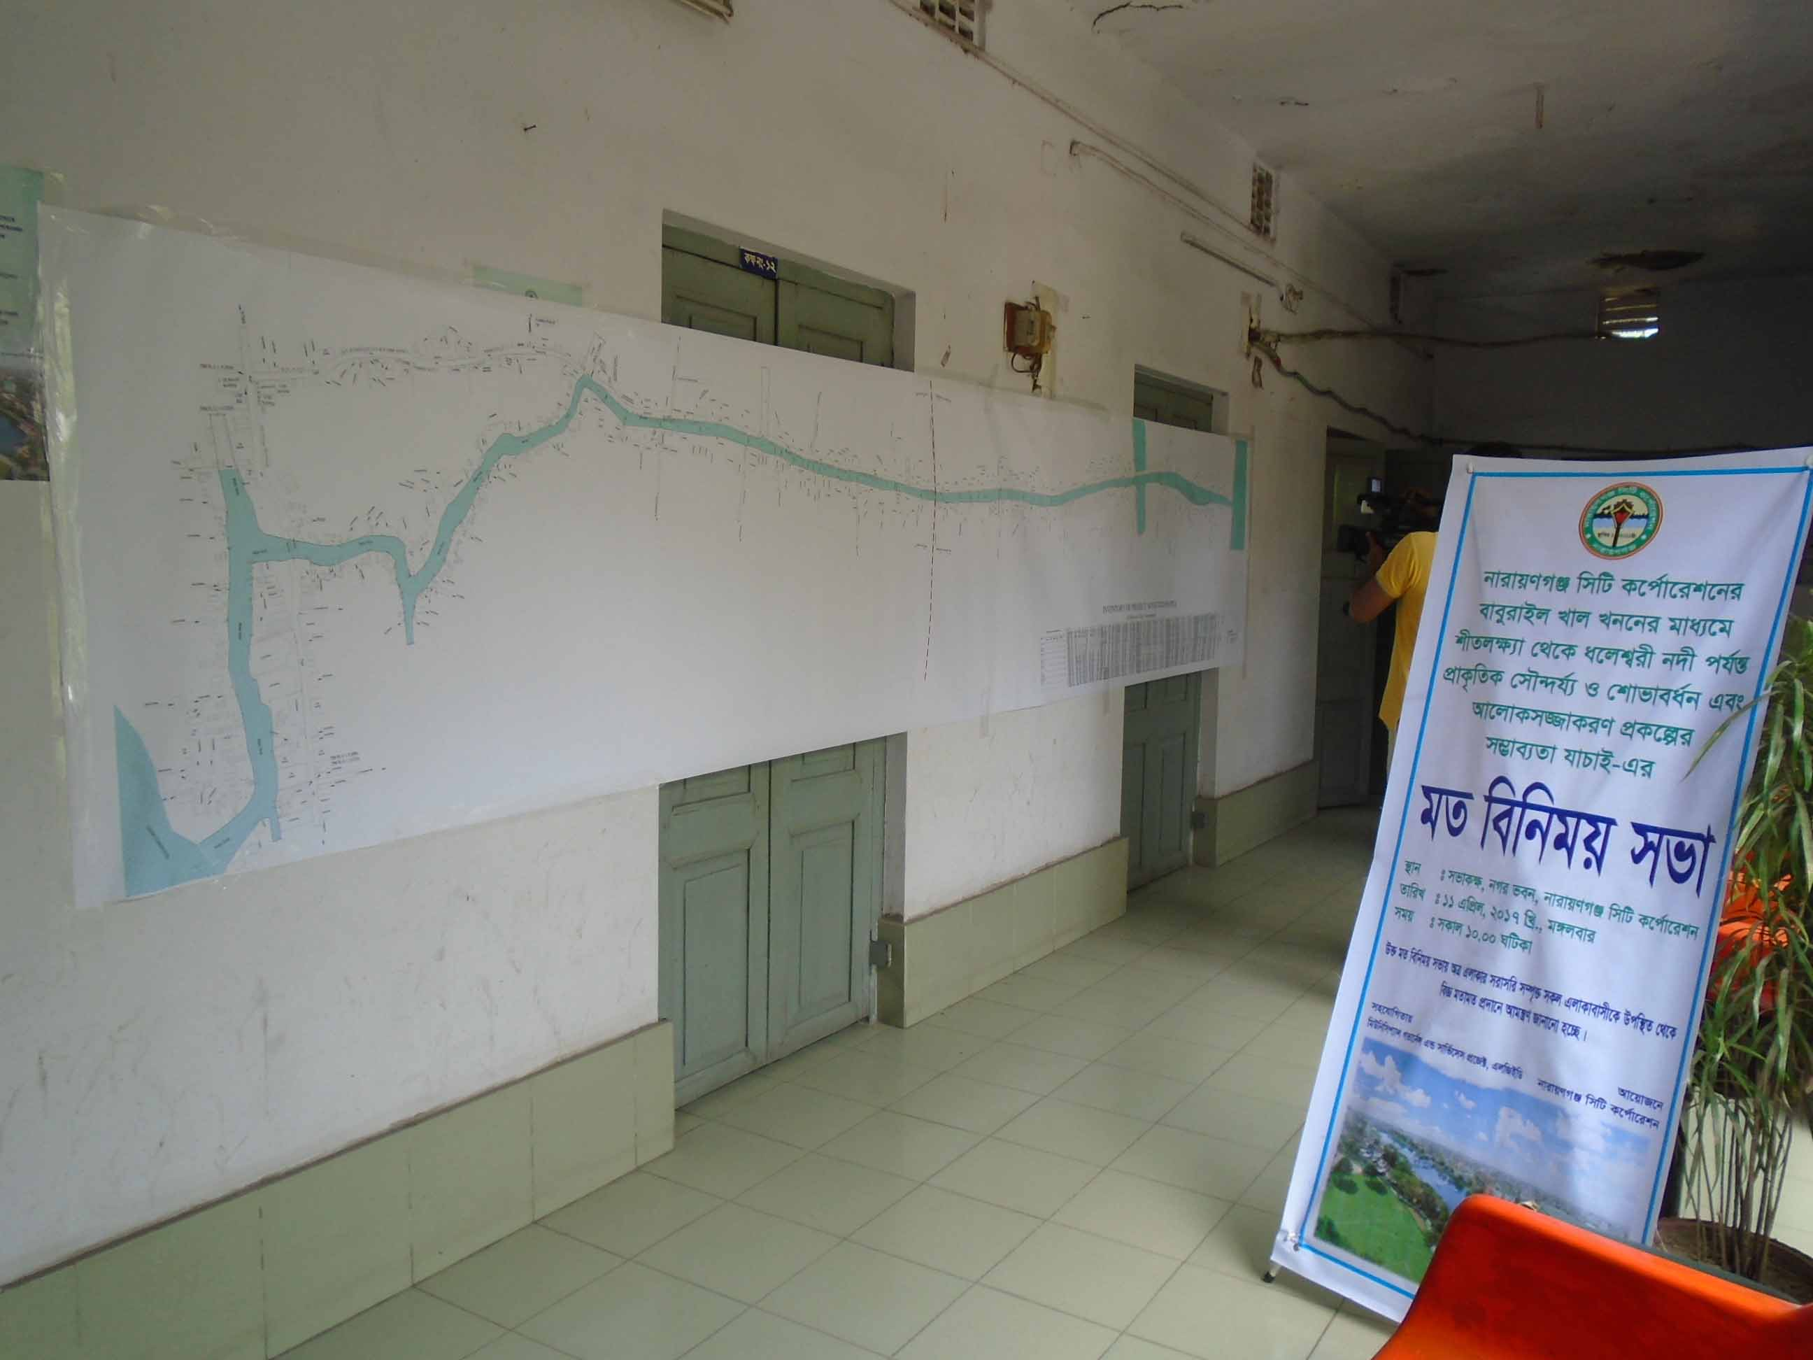
Figure : Poster for Public Consultation meeting on Babuirail Canal Restoration Project


Feasibility Study of Shithalakhya-Daleshwari river connecting Canal beautification project in Narayangonj City Corporation

eveyivBj Lvj Lbb, cybt¯’vcb †mŠ›`h©ea©b I kxZj¶¨v I a‡jk¦¦ix b`x ms‡hvM ¯’vcb cÖK‡íi m¤¢ve¨Zv hvPvB |

AbymÜvb, gZvgZ Ges civg‡k©i Rb¨ `qv K‡i wb¤œwjwLZ Kvh©vj‡q †hvMv‡hvM Kiæb|

e½eÜ– moK, cyivZb ‡cŠi feb, bvivqYMÄ bMi feb

`yivjvcbt (+880) 1920-812202
GB cÖKíwU cybt¯’vcb Kvjxb mg‡q m„ó ¯’vbxq RbM‡Yi †h †Kv‡bv mgm¨v mgvav‡bi j‡¶¨ GKwU cÖwZKvi e¨e¯’vcbv KwgwU M‡o †Zvjv n‡e| GB KwgwUi m`m¨iv n‡eb - bvivqYMÄ bMi feb KZ©„c¶, mswkøó IqvW© Kwgkbvi/m`m¨/gwnjv m`m¨, ¯’vbxq GbwRI cÖwZwbwa, cwi‡ek Awa`ß‡ii †Rjv ch©v‡qi m`m¨ Ges Awf‡hvM GjvKvi GKRb ¯’vbxq m`m¨|
wb¤èewY©Z Dcv‡q ¯’vbxq RbM‡Yi †h †Kv‡bv mgm¨v mgvav‡bi †Póv Kiv n‡e|
avc 1- Awf‡hvMKvix mgm¨vwU mivmwi/†Uwj‡dv‡bi gva¨‡g †hvMv‡hvM K‡i mgm¨vwU mgvav‡bi †Póv Ki‡eb| hw` Awf‡hvMKvixi mgm¨vwU GK mßv‡ni g‡a¨ cÖwZKvi bv nq Zvn‡j wØZxq avc Aej¤^b Ki‡Z cvi‡eb|
avc 2- Awf‡hvMKvix Dc‡Rjv ch©v‡q ¯’vwcZ wR.Avi.wm KwgwUi gva¨‡g mgm¨vwUi mgvav‡bi †Póv Ki‡eb|
avc 3- hw` mgm¨vwU `yB mßv‡ni g‡a¨ mgvavb bv nq Zvn‡j Dc‡Rjv ch©v‡q ¯’vwcZ wR.Avi.wm KwgwU GKwU AvbyôvwbK ïbvwbi e¨e¯’v Ki‡e| G ch©v‡q GKwU mywbw`©ó wm×všÍ MÖnY Kiv n‡e Ges cuvP w`‡bi g‡a¨ Zv Kvh©Ki Kiv n‡e|
avc 4- avc 3 Gi M„nxZ wm×všÍwU Awf‡hvMKvixi gbtcyZ bv n‡j Awf‡hvMKvix AvBwb mvwjk-wb®úwË c×wZ MÖnY Ki‡Z cvi‡eb|
cÖK‡íi myweavmg~n t
- AZxZ HwZn¨ i¶v|
- e¨emvq-evwYR¨i myweav I Rxebgvb DbœZ n‡e|
- cwienb e¨e¯’v I R¡vjvwb mvkªq|
- Kv‡jv †auvqv n«vm|
- cwi‡ek-evÜe bMi hv‡Z AšÍf~©³ _vK‡e Lvj Lbb I cybt ¯’vcb, e„wói cvwb msi¶Y e¨e¯’v, meai‡Yi bMi Dc‡hvMx my‡hvM myweav|
অভিযোগ প্রতিকার প্রক্রিয়া (Grievance Redress Mechanism/জিআরএম)

11B GwcÖj, 2017Bs
¯’vb : mfvKÿ, bMi feb, bvivqYMÄ wmwU K‡c©v‡ikb
mgq : mKvj : 10:00 NwUKv

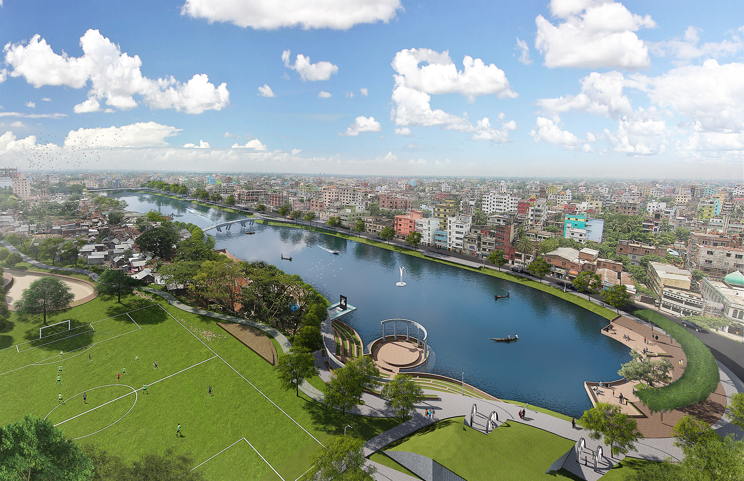

প্রকল্প কার্যক্রম এবং
প্রধান পরিবেশগত বিষয় সমূহ

cÖK‡íi Kvh©µg wb¤œiƒc t
1| fivUK…Z Lvj Lbb I cybt¯’vcb
2| LbbK…Z gvwU AcmviY
3| Lvj msjMœ cvo evavB
4| 15 wU weªR wbg©vY
5| 3 wU Ifvicvm wbg©vY
6| Lvj msjMœ cªk¯Í iv¯Ív wbg©vY
7| ‡`vKvb I wewfbœ ¯’vcbv wbg©vY
8| ‡bŠ PjvPj e¨e¯’v
9| cqtwb¯‹vkb e¨e¯’v

cÖK‡íi cwi‡ekMZ welqmg~n t
1| wewfbœ ¯’vcbv AcmviY
2| M¨vm I ayjvevwj wbM©gb
3| AwZwi³ kã I K¤úb
4| f~-c„ô I f~-Mf©¯’ cvwb `~lY
5| †ckvMZ ¯^v¯’¨SuzwK
6| eR©¨ e¨e¯’vcbv

cÖavb mvgvwRK welqmg~n t
1| A‰ea ¯’vcbv AcmviY
2| mvgwqK e¨emvwqK I A_©‰bwZK ¶wZ

cÖwZKvi t
1| GjvKvi Rxeb hvÎvi gvb Dbœqb
2| GjvKvi A_©‰bwZK I mvgvwRK Dbœqb
3| Kg©ms¯’vb
4| KvwiMix cÖwk¶Y
5| cwi‡e‡ki Dbœqb
cÖK‡íi m¤¢ve¨ cwi‡ekMZ
cÖfve I cÖwZKvi

- Lv‡ji LbbK…Z gvwU cwi‡ek-evÜe Dcv‡q AcmviY |

2) cÖK‡íi Kvh©µ‡gi d‡j ayjvevwj †hb evZv‡m bv Qovq †mRb¨ cÖKí GjvKvq cÖPzi cvwb wQwU‡q ayjvevwj `wg‡q ivLv n‡e| eQ‡i `yBevi cÖKí GjvKvi evZvm cix¶v K‡i Zvi MÖnY‡hvM¨Zv hvPvB Kiv n‡e|

3) cÖK‡íi wewfbœ Kvh©µ‡gi d‡j cÖKí GjvKvq kã `~lY n‡Z cv‡i| cÖK‡íi GjvKvq we‡kl K‡i agx©q, wk¶v cÖwZôvb I nvmcvZv‡j miKv‡ii RvwiK…Z k‡ãi MÖnY‡hvM¨ gvÎvi g‡a¨ mxwgZ ivL‡Z n‡e|

4) cÖKí GjvKvi wewfbœ Kvh©µ‡gi d‡j f~-c„ô I f~-Mf©¯’ cvwb `~lY †iv‡a f~wgKv Kvh©µg cÖ¯ÍvweZ bKkv Ges wb‡`©kbv Abyhvqx Kiv n‡e|

5) GB cÖKíwU ev¯ÍevqbKvjxb †ckvMZ ¯^v¯’¨ SuywKi m¤¢vebv i‡q‡Q| †mRb¨ wbg©vY kªwgK‡`i Rb¨ weï× cvwb, ¯^v¯’¨m¤§Z Uq‡jU I Avevmb e¨e¯’v M‡o †Zvjv n‡e| wbg©vYKvjxb myi¶v miÁvg e¨envi eva¨Zvg~jK Kiv n‡e|

6) AcÖZzj eR©e¨e¯’vcbvi Kvi‡Y `xN©¯’vqxfv‡e f~-c„ô I f~-Mf©¯’ cvwb `~wlZ n‡Z cv‡i| †mRb¨ mKj cÖKvi wbg©vY eR©¨c`v_© wba©vwiZ RvqMvq †dj‡Z n‡e|

7) KwVb eR©¨c`v_© wba©vwiZ RvqMvq †dj‡Z n‡e| ZijeR©¨ ‡Wªbi gva¨‡g AcmviY Kiv n‡e|

প্রকল্পের ভূমিকা
m¤§vwbZ myax,
Avcbviv AeMZ Av‡Qb †h, eveyivBj Lvj Lbb I cybt¯’vcb cÖKí kyyiy n‡Z hv‡”Q| bvivqYMÄ bMi feb KZ„©c‡¶i cwiKíbv Abyhvqx LvjwUi Lbb I cybt¯’vcb I AvaywbKxKiY n‡j ïay cwi‡ek Dbœqb n‡e ZvB bq, bvivqYMÄ kni GKwU DbœZ cwi‡ek-evÜe I bv›`wbK bMi wn‡m‡e AvZ¥cÖKvk Ki‡e| bvivqYMÄ GKwU cwi”Qbœ kn‡i iƒcvšÍwiZ n‡e Ges GjvKvi RbM‡Yi Rxeb gvb e„w× cv‡e| iv¯Ív-NvU eZ©gv‡bi Zzjbvq A‡bK DbœZ n‡e Ges DbœZ hvb PjvPj mn bvMwiK mKj my‡hvM myweav e„w× cv‡e| A_©‰bwZK Kg©KvÐ e„w× cv‡e Ges AwaK †jv‡Ki Kg©ms¯’vb m„wó n‡e| Gi djkÖæwZ‡Z e¨emvq-evwYR¨ e„w× cv‡e| cªv_wgKfv‡e kxZj¶¨v I a‡jk¦¦ix b`xi cvwb `ylY gy³ bv nIqv ch©šÍ 2 wU ¯øyBm ‡M‡Ui gva¨‡g LvjwU c…_K _vK‡e| b`xi cvwb `ylY gy³ n‡j Lv‡ji mv‡_ ms‡hvM n‡e|

mywcÖq myax,
†h †Kvb Dbœqb Kv‡R RbM‡Yi mn‡hvwMZv cÖ‡qvRb| cÖ¯ÍvweZ eveyivBj Lvj Lbb I cybt¯’vcb cÖK‡íi Rb¨ Rwg AwaMÖn‡Yi cÖ‡qvRb n‡e bv| wKš‘ cÖKí mxgvbvq Aew¯’Z A‰ea ¯’vcbv Acmvi‡Yi cÖ‡qvRb n‡e| d‡j AvcvZ`„wó‡Z wKQy mgm¨v m„wó n‡jI Zv cywk‡q wb‡Z bMi KZ„©c¶ e×cwiKi| D‡”Q`K…Z e¨emv cyb©evmb Kiv n‡e| ¯’vbxqfv‡e †eKvi hyeK‡`i Kg©ms¯’v‡bi j‡¶¨ Avcbv‡`i civgk© †gvZv‡eK cÖwk¶Ymn ev¯Íe Kg©m~wP MÖnY Kiv n‡e|

cÖK‡íi Rb¨ Lvj Lbb, ‡Wªb, weªR, d¬vBIfvi, cvK© wbg©vY, Lvj Dbœqb, I Ab¨vb¨ As‡ki wbg©vY msµvšÍ wewea Kg© m¤úv`b Kv‡j cwi‡ekMZ mgm¨v cwinv‡ii j‡¶¨ B.G. cÖwZ‡e`‡b GKwU cwi‡ekMZ cÖwZKvi Ges ch©‡e¶Y cwiKíbv AšÍf©~³ _vK‡e| cÖK‡íi wel‡q gZvgZ †`qvmn cÖK‡íi Kvi‡Y m¤¢ve¨ weiƒc cÖfve cÖkg‡b Kvh©Ki civgk© cÖ`v‡b DØy× Kivi j‡¶¨ GB cwiKíbv msµvšÍ Kvh©µg A_v©r cwi‡ek e¨e¯’vcbv cwiKíbv (B.Gg.wc) eZ©gvb civgk©K mfvq AskMÖnYKvix‡`i g‡a¨ weZiY Kiv n‡e|
Dc‡iv³ gZvgZ I civgk© Øviv mg„× B.G. Ges B.Gg.wc. cÖwZ‡e`b Gfv‡eB ˆZwi n‡e Ges wek¦e¨vsK I evsjv‡`k miKv‡ii Kv‡Q `vwLj Kiv n‡e| cieZ©x ch©v‡q B.Gg.wc. mn B.G. cÖwZ‡e`b mswkøó I me©¯Í‡ii Rbmvavi‡Yi AeMwZi Rb¨ Db¥y³ Kiv n‡e| GQvovI cwic~Y© B.G cÖwZ‡e`b wek¦e¨vsK Gi I‡qemvB‡U cÖKvk Kiv mn wb‡¤œv³ Kvh©vjq ¸‡jv‡Z mn‡R `„k¨gvb ¯’v‡b cÖ`wk©Z n‡e|

1| bvivqYMÄ bMi feb Kvh©vjq |
2| cÖavb Kvh©vjq, cwi‡ek Awa`ßi, XvKv I bvivqYMÄ ‡Rjv cwi‡ek Kvh©vjq|

w

Excerpts from WB OP 4.12 WB Operational Manual. December 2001.
EHS Guidelines available at: http://www.ifc.org/wps/wcm/connect/554e8d80488658e4b76af76a6515bb18/Final%2B-%2BGeneral%2BEHS%2BGuidelines.pdf?MOD=AJPERES
Further details on GRM are available in RPF.
The screening checklist is developed by European Commission and is available at http://ec.europa.eu/environment/archives/eia/eia-guidelines/g-screening-full-text.pdf

