# CHAPTER1: SUBPROJECTS DESCRIPTION

## Subprojects Background

These are subprojects under the Municipal Governance Services Project (MGSP) which are continuation of the Narayanganj City Corporation’s infrastructures development. Under these subprojects, the existing canal is entirely silted-up and blocked by solid wastes, polyethylene, debris, construction chips which will be replaced by excavation, landscaping, beautification and lighting of this canal. This package is also included RCC pipe drain. The name of the subprojects are (1) Excavation, Landscaping, Beautification and Lighting of the Shitalkya-Dholeswary River via Baburail (Ch.0+00-395m) in Ward No 15 (Sub Package-01), Part-01 *(*RCC Pipe Drain*)*. (2) Excavation, Landscaping, Beautification and Lighting of Shitalkya-Dholeswary River via Baburail (Ch.0+00-395m) in Ward No 15 (Sub Package-01) Part-02 (Excavation, Landscaping and Beautification). (3) Excavation, Landscaping, Beautification and Lighting of the Shitalkya-Dholeswary River via Baburail (Ch.0+00-395m) in Ward No 15. (Sub.Package-01), Part-03: (Street Lights)

The significant features of these subprojects are mentioned below:

|  |  |
| --- | --- |
| Name of the Subprojects | Excavation, Landscaping, Beautification and Lighting of the Baburail Khal with RCC Pipe Drain |
| Package No. | MGSP/NCC/2015-16/W-07 |
| District Name | Narayanganj |
| ULB Name | Narayanganj City Corporation |
| Ward Number | 15 |
| Structural Design  Option | RCC Pipe Drain and Tiles Work, Ceramic Brick Work, CC Work, RCC Work, and Electrification Work |
| Wards Population | About 40,000 |
| Tribal People | No tribal people found in the subprojects area |
| Land Acquisition | Mostly ULB owned; No land acquisition is needed |
| Estimated Cost | 174,200,089.22 in BDT |
| Subproject Duration | 18 months |
| Tentative Start Date | August 1, 2016 |
| Tentative Completion Date | January 1, 2018 |

During the project preparation, preliminary environmental screening has been performed for all the subprojects. According to the screening, no further environmental assessment is required for the street light. Therefore, this environmental assessment report only includes Excavation, Landscaping, Beautification of Baburail Khal and RCC Pipe Drain.

## Location of the Subprojects

Baburail Khal is situated at the jurisdiction of Ward number 15. The starting point of this khal is located at  [23°36'37.15"N (Latitude) and 90°30'21.92"E](http://tools.wmflabs.org/geohack/geohack.php?pagename=Tangail_Sadar_Upazila&params=24.2500_N_89.9167_E_) (Longitude) and connect to the Shitalkya-Dholeswary River. The end point of this khal in the first package is located at 23°36'37.99"N (Latitude) and 90°30'8.55"E (Longitude) connect to the Bangabandhu Bridge. The length of the existing khal is about 3 km. The whole work (Excavation, Landscaping, Beautification and Lighting of the Shitalkya-Dholeswary River via Baburail) is sub-divided into 5 packages and each sub package will cover about 395m.The Location Map and Topographic View of the Baburail Khal are shown in ***Figure 1.2.1 and 1.2.2****.*

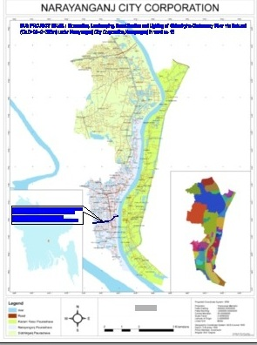

**Figure 1.2.1: Location Map of the Baburail Khal**

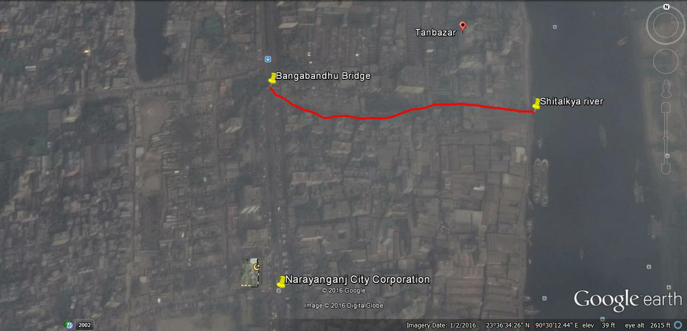

**Figure 1.2.2: Topographic View of the Baburail Khal (Sub Package-01)**

## Present Status of the Subprojects Sites

This canal is very important because it connects the Shitaalkyha-Dholeswary River. The main features along the whole alignment of the canal are the built environment includes residential area with various structures, various shops, String Factory, Sonargaon Twisting Mill, kitchen bazaar, Garments, market and so on. A busy Bongshal Road is passing through parallel to the first portion of the canal. The road side area adjacent to the canal is entirely encroached by people’s house, various shops with various structures by the local residents.

Presently, the canal condition is very bad which is entirely silted-up and blocked. In fact, the people throw all kinds of the materials and resulting in silted-up the natural canal which tremendously reduces the drainage facilities and navigation of the natural canal. Only from Ch 0 to 70 m among 395 m of the canal has slight waste water and rest portion of the first part of the canal is used for the various shops of the roadside market.

The site inspection revealed that the canal is itself a water body which is blocked by the wastes materials. The sediments and sludge seems polluted. As this canal connects two rivers therefore there might be possibility of the degradation of the river water quality due to the discharge of the polluted surface run-off to the rivers. The following ***photographs 1.3.1*** present the existing condition of the Baburail Khal.

### 

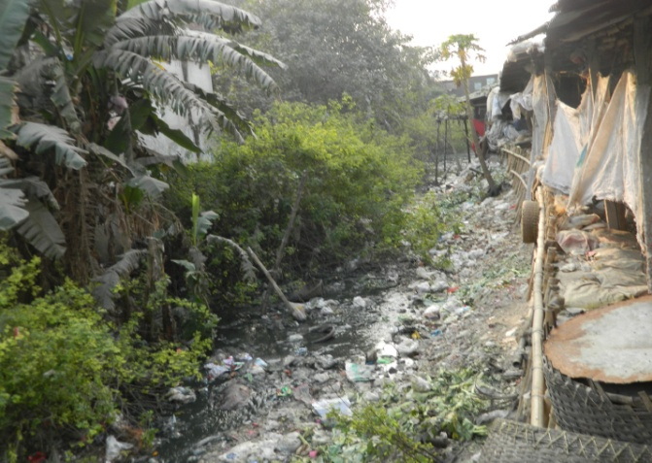

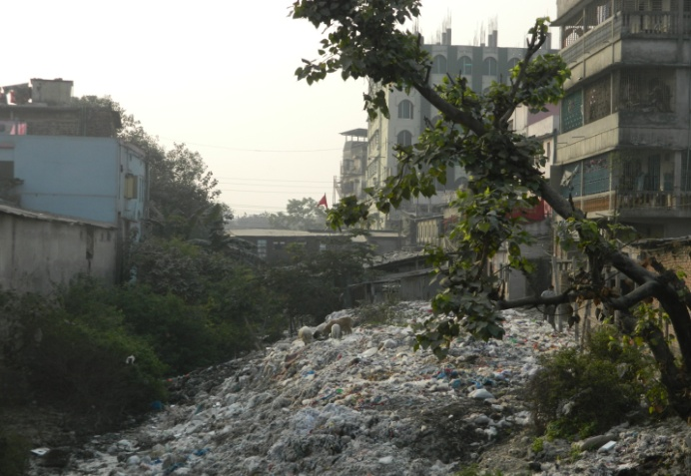

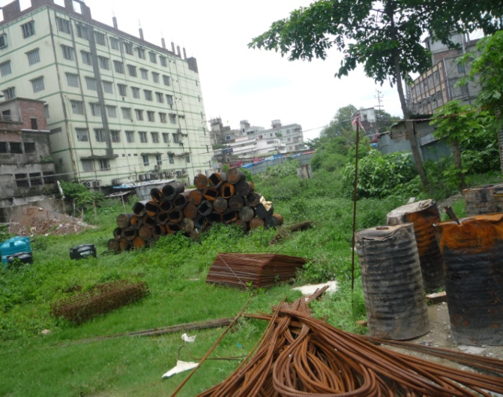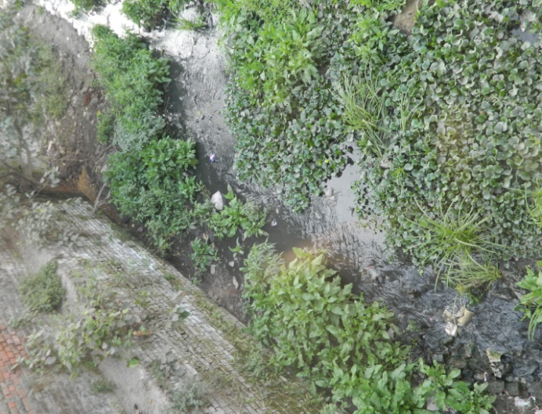

### Photographs 1.3.1: Present Situation of the Baburail Khal

## Objectives and Justification of Selection of these Subprojects

There are several subprojects in the CIP lists. The consultant team inspected and evaluated existing site conditions of all the subprojects. Based on the environmental and social conditions which are not complex and have low environmental and social negative impacts, the ULB priority subprojects list have been specified. For quick preparation of the subprojects, meeting with the ULB about their demand and requirement is very necessary. In this way, Excavation, Landscaping, Beautification and Lighting of the Baburail Khal with RCC Pipe Drain have been selected. Furthermore, land acquisition is not an issue for implementation of these subprojects. The khal side’s some trees will be cut down and some built-up infrastructures be demolished which will not be severely affected by the implementation of these subprojects.

In fact, after completion of the pipe drain subproject, it will reduce water logging problem and also will help to divert waste water because the RCC pipe drain will carry waste water and will provide drainage facilities for this area.

### Furthermore, there is no other significant recreational center, for instance park in the subprojects area. Also, there are no historical or culturally important sites adjacent to the subprojects area. Hence, of course it will provide recreational facilities for the local people. The subprojects will also accelerate economic activities and living standard may also increase. Moreover, it will help to boost different types of commercial facilities.

Street lighting is a vital element in creating navigable, safe and successful cities. There are number of benefits to street lighting. It will be used to promote security in urban areas and to increase the quality of life. Street lighting also improves safety for drivers, riders, and pedestrians. It will reduce on-street accidents and crime and will provide a feeling of warmth and security. It will provide streetscape enhancements i.e. city beautification work, and stimulation of the night-time trade. This street light will provide personal safety, security of property, ease of access, road safety, possible reduced use of personal lighting, less intrusion of the light into residential homes.

These subprojects have no adverse environmental and social impacts. However, after implementation they will provide tremendous benefit to the community people. Therefore, as a priority basis, these subprojects selected for the implementation for the financial year 2015-16.

## Key Subprojects Activities and Implementation Process

The key activities of the RCC pipe drain includes earthwork in excavation of canals, ponds, drains, etc, sand filling in foundation trenches and inside plinth, single layer brick flat soling, brick work with 1st class bricks in cement mortar, mass concrete work in foundation or floor with cement, sand, brick chips, providing and laying reinforced, cement concrete pavement over a prepared sub-base with crushed stone chips, fabrication of M.S High strength Ribbed or deformed bar reinforcement, fitting fixing MS shoe at RCC pre-cast pile tip, earth filling work with specified soil, mechanical compaction of earthworks, clearing and disposing of excavated earth from the construction site and placing the polythene sheet.

The key activities of excavation, landscaping, beautification of the khal includes earthwork in excavation of canals, ponds, drains, etc, earth filling work with specified soil, mechanical compaction of earthworks, pumping and bailing out water from the interior, removing sludge or semi-liquid clay and substances, clearing and disposing of excavated earth from the construction site, construction of temporary cross dam, sand filling in foundation trenches and inside plinth, manufacturing and supplying CC blocks with cement, sand and shingles, supplying and placing including embedment along the toe line or under the PVC water stopper properly ,non-woven needle punched type geo-textile filter of different grades, specifications for effective erosion protection ,inverted filter in hydraulic structures or river training works, single layer brick flat soling, brick work with 1st class bricks in cement mortar, mass concrete work in foundation or floor with cement, sand, brick chips, providing and laying polythene sheet, demolition of existing semi pucca and tin-shed structures, cleaning hyacinth, laying, installation, fitting and bending of uPVC pipes of different diameter and wall thickness, tree plantation, leveling and dressing the embankment crown, road flanks, turfing on embankment top and slope.

The key activities of the electrification work includes- assembling, fitting, fixing, installation, testing and commissioning of GI pole, fitting and fixing energy meter with cut-out teak wood board, earthling the electrical installation with 38mm dia GI pipe, fixing 500 volt grade porcelain shackle type insulator, erection of tubular pole, fixing of over head aluminum stranded conductor, fixing of wire rack, fixing and installation of almirah type 18 SWG metal switch board, fixing of water tight street light with aluminum reflector.

# CHAPTER 2: DETAILED ENVIRONMENTAL FEATURES

During the site visit effort has been given for getting the detailed environmental features within the subprojects area. Therefore, the detailed environmental features listed considering the 100 m Chainage starting from Shitaalkyha River to Mondal Para Bridge over Bangabandhu Road (Chainage 0 to 395 m). The key findings of the site visit are given in ***Table 2.1*.**

**Table 2.1: Major Environmental Features for Baburail Khal Subproject**

|  |  |  |  |
| --- | --- | --- | --- |
| **Chainage (m)** | **Left** | **Right** | **Major Environmental Features** |
| 0-100 | √ |  | String Factory, bushes, shrubs, trees |
|  | √ | Sonargaon Twisting Mill, kitchen bazaar, trees, bushes, dumping site, public toilet |
| 100-200 | √ |  | Market, tin-shed & pucca shops, Bongshal Road, fence of the tin, electric poles |
|  | √ | Garments, market, multistoried building, bushes, trees, shrubs |
| 200-300 | √ |  | Bongshal Road, electric poles, semi-pucca & tin-shed shops |
|  | √ | Pucca& tin-shed structures, trees, bushes, shrubs |
| 300-395 | √ |  | Bongshal Road, electric poles, Bangabandhu Road, semi-pucca furniture shops |
|  | √ | Trees, shops, pucca structures, trees, Bangabandhu Road, shrubs |

There are 8 electrical and telephone poles to be relocated prior to the implementation of these subprojects.

# CHAPTER 3: Baseline ANALYSIS OF THE ENVIRONMENTAL CONDITION

## 3.1 Physical Environment

### Geology, Topography, and Soils

NCC is a land of mixed topography. The present urbanized areas and the levees of the Sitalakhya, the Buriganga and the Old Brahmaputra Rivers are of comparatively higher elevation.

Geologically NCC lies on the edge of the Madhupur Tract and the Holocene floodplain deposits from the aquifers. Geologically it is a terrace from one to ten meters above the adjacent floodplains. Two characteristic geological units cover NCC, namely, Madhupur Clay of the Pleistocene age and alluvial deposits of recent age. The Madhupur Clay is the oldest sediment exposed in the area having characteristic topography and drainage. The major geographic units of the city are: the high land or terrace, the low land or floodplain, depressions, and abandoned channels. Low lying swamps and marshes located in and around the area are other major topographic features. Modhupur Clay overlies the aquifer with a thickness of 8 m to 45 m. Map and other details of soil condition are not available for this city corporation.

### Climate and Meteorology

The climate of the subprojects area can be described as Tropical Monsoon. It is characterized by the warm, humid summers and cool and dry winters. However, generally the weather is sub-tropical, with a warm climate all year round. The annual average temperature varies maximum 36°C to minimum 12.7°C and the average annual rainfall is 2376 mm. ***Figure 3.1.1*** *shows* the annual distribution of the temperature of NCC.



**Figure 3.1.1: Annual Distribution of the Temperature in NCC** *(Source: BMD)*

Monthly precipitation records clearly show a distinct dry and rainy season in ***Figure 3.1.2****.*



**Figure 3.1.2: Monthly Average Rainfall in NCC** *(Source: BMD)*

According to the statistics of the wind data from the Bangladesh Meteorological Department Climate Division, wind direction changes by month. Nevertheless, the northwest, south, and northeast winds are predominant.

The construction works can be influenced by the climatic condition and meteorological components like humidity, temperature, sudden rainfall, and wind speed. During high winds, there might be possibility of quick spreading of the dust generated from the construction activities. It is very risky to work during rain and in high winds because the possibility of getting injury increases. Furthermore, work under high temperature and excess humidity is extremely difficult, and may create dehydration problem.

### Hydrology (Surface Water, Ground Water, and Rain Water)

River Sitalakhya and Dholeswary are flowing along the two different sides of the Narayanganj City Corporation where water is available round the year. The Baburail Khal is the connecting water body of these rivers which are the main source of the surface water for the subprojects areas. These rivers and khal influence the hydrology of the city corporation. Presently, Baburail Khal is nearly dried out. It is found from the observation that surface water quality result of few parameters like pH, TSS, COD and BOD exceeds allowable limit of Bangladesh standard. It requires treatment before supply.

Narayanganj City Corporation belongs to the hydro-geological unit II Holocene Deltaic and Flood Plains. Ground water is available here in plenty and water table does not go beyond suction limit throughout the year. Groundwater is the main source of potable water in the subprojects area. Deep groundwater is not saline and normally arsenic and iron free. Local people typically use deep tube-well water for drinking and other domestic purposes. Salinity problems are not commonly visible. Rain water harvesting system is not common in around the subprojects area.

The construction period is normally in summer season. During the summer, generally the ground water and surface water level goes down. Therefore, ensuring the water requirements for the construction works and domestic uses are the key issue in dry summer. On the contrary, if the construction period includes wet summer, there might be less complexity for ensuring the water requirements. Also there might be possibility of using the surface water from nearby River Sitalakhya for the construction purposes.

**Flooding, Water Logging, and Drainage Pattern**

According to previous data, this area is not affected in severe flood events in the last decade. Due to continuous heavy rain, temporarily this area is subjected to water logging problems. Structured and functional drainage system in this area is basically absent. The existing drainage system is not functional because people throw and dispose wastes in the drains. Therefore, the drain is being filled up and the land floods when it rains heavily.

**Seismic Effects**

According to BNBC (1993), Bangladesh has three seismic zones with moderate and low seismic activity. Narayanganj City Corporation area falls in Zone II, i.e. medium intensity seismic zone of the country. The intensity of the earthquake of the area is medium.

**Erosion**

The Baburail Khal (Shitalkya-Dholeswary River) passed inside the subproject area which is nearly dry. The subproject area is free from erosion. Also, there is no significant erosion in the city corporation area due to the low current of the Shitalkya River.

### Air Quality and Dust

Ambient air quality data have not been found. Air seems to be clean in the subproject area. However, due to poor condition of the road dust is generated during the movement of the vehicles, windblown dust and indiscriminate dumping of garbage to open place and baburail khal cause air pollution. There are no remarkable sources of air pollution such as heavy industries observed in the subprojects area except Sonargaon Twisting Mill, garments and string factory.

### Noise Level

Noise is not a major impediment for the quality of the environment in the subprojects area. Vehicles such as rickshaws, trolleys, pick-up, trucks, motor cycles, mini trucks, and private cars generally move on the road during day and night. These vehicles generate noise in the subprojects area. However, they are tolerable limits in most cases. There are three factories such as Sonargaon Twisting Mill, garments and string factory near the subprojects area which are not perceptible sources of noise generation.

**Solid Waste Management**

The vacant place of Zim Khana is used as a dumping site. All types of wastes are disposed in this place by the Pourashava officially. Basically, it is not structured solid waste management system in this area. Most of the people of the subproject area dispose their wastes in the darkness of the night and throw their solid wastes in the neighbourhood. Therefore, improper solid waste disposal by the community people creates severe public health hazards and environmental degradation to a great extent.

## 3.2 Biotic Environment

### Flora and Fauna

There are planted trees along the khal include Kadam (Neolamarckia Cadamba), Jackfruit (Atrocarpus Heterophy), Banana (Musa Acuminata), Papya (Carica Papaya), Coconut (Cocos Nucifera), Koroi (Albizia Lebbeck), and many others. The common local birds such as Doel, Shalik, Kite, Owl, Crow, Tuntuni, Bulbuli, and Cuckoo in Bengali were found. Wild animals and endangered fauna species were not found. Inside the proposed subproject area, no fauna species except some local birds were found.

**Biodiversity Status**

There are no special or site specific terrestrial and aquatic ecosystems heavily disturbed by the development activities of this area. However, the populations of the floral and faunal species have declined generally due to the regional and national climate change (low rainfall, high temperature, high humidity, short winter period, and long dry season) due to the over exploitation, poor management, demographic pressure, natural calamities, and deterioration of the law and order.

According to available and non-available of the plants there are four possible conditions such as available, vulnerable, endangered, critically endangered and extinct. The vulnerable, extinct, endangered and critically endangered plants of the Pourashava are Alas Lebu (vulnerable), Koromcha (vulnerable), Deshi Gab (vulnerable), Nim (vulnerable), Ban Boroi (vulnerable), Daufal (vulnerable), Lalim (critically endangered), Pani Jam (critically endangered), Khudi Jam (critically endangered),Tin Kora (critically endangered),Uri Am ( critically endangered), Deshi Amra (endangered), Kaju Badam (endangered), Sishu (extinct), Babla (extinct), Dumur (extinct), Buti Jam (extinct), Hijol (extinct), Uri Gab ( extinct), Arjun (extinct),Jaytun (extinct) etc.

## 3.3 Socio-economic and Socio-cultural Environment

### Land Use

These subprojects are within the City Corporation area. There is no agricultural activity in this area. These subprojects basically pass through the commercial area. There are tin shed temporary shops, semi-pucca markets and floating people’s house, furniture shops and kitchen bazaar, trees and shrubs, bushes in the subprojects area. There are Sonargaon Twisting Mill, garments and string factory in this area. Starting point of the first package of this subproject is Shitalkya River. Two busy roads named Bangshal Road and Bangabandhu Road is present in this portion of the subproject area.

### Beneficiary Population

### 

This khal goes through Ward number 15. As per information by the municipality, considering the wards’ population about 40,000 people will benefit directly and many others indirectly.

### Education

In the subprojects area, literacy among the population is about 62.7%. This is higher than the national average (51.8%). The literacy rate among males 65.3% is still more than females 60%. (Ref: Population and Housing Census 2011).

### Tribal Communities

There are no indigenous or tribal people live in the subprojects area. Therefore, there are no measures needed for the indigenous peoples’ safeguard.

### Land Acquisition and Resettlement

This khal is owned by the Narayanganj City Corporation. Hence, there is no administrative obligation, land acquisition and resettlement issue involved in the subprojects intervention. For clearing the sites, ULB needs low scale demolition works especially for the middle portion of the khal near Bangabandhu Road (Ch. 200-395 m). The MGSP social experts evaluate the social issues regarding the subprojects intervention and measures will be given accordingly.

**Status of Housing and Built-up infrastructure**

The built infrastructure includes mainly commercial area, pucca-semi-pucca and tin-shed structures, tin shed temporary shops, semi-pucca markets and floating people’s house, furniture shops and kitchen bazaar. In recent years, due to improvement of the economic conditions people are constructing multistoried buildings instead of the semi pucca structures. Multistoried buildings are manifestation of the better economic status and higher occupational class.

**Principal Livelihoods and Economic Activities**

Narayanganj City is basically the suitable place for business because communication facilities with different areas via road and water are better. Also this city especially city corporation area is well known for various industries. However, the subprojects area of the city corporation is now inhabited by the mixed occupational people where with the major income comes from non-farm activities such as business, enterprises, jobs, transport vehicle ownership, and operation. Presently, a significant number of people work in the small trades, private sector jobs, and government jobs in the town, and transport operations. Increased awareness of the social issues and NGO activities has changed the poverty scenarios of the subprojects area.

**Cultural Heritage and Protected Areas**

There are no protected areas and no important cultural or historical sites identified in the subprojects area.

**Social Conflicts, Development Activities, and Political Condition**

There are no visible conflicts between the local communities regarding the subprojects implementation. There are some ongoing subprojects at the City Corporation area under MGSP, JICA and other agencies. However, there is no visible conflict between these donors and agencies are not found. Political instability has been found in recent years in Bangladesh. However, from the middle of the 2015, the political situation seems stable. This creates a positive situation for the development activities.

# Chapter 4: ENVIRONMENTAL SCREENING

Environmental Screening (ES) for the subprojects have been conducted with the purpose of fulfilling the requirements of GoB and WB. ES ensures that environmental issues are properly identified in terms of extent of the impacts. The field visit for preparing the ES was carried out on 04 May 2016 and 13 July 2016, in the subprojects area. Environmental Screening Checklist, as adopted in Appendix C of the Environmental Management Framework of the MGSP, was administered for identifying the impacts and their extents. The screening data and information for the **Pipe Drain of the Baburail Khal** have been formulated and are shown in below.

**1) Potential Environmental Impact during Construction Phase:**

**(a) Ecological Impacts:**

Nil

* Felling of trees Significant □ Moderate □ Minor □√ Number of trees
* Clearing of vegetation Significant □ Moderate □ Minor □√
* Potential impact on species of

aquatic (i.e., water) environment Significant □ Moderate □ Minor□√

**Ecological impact is minor.**

1. **Physicochemical Impacts:**

* Noise pollution Significant □ Moderate □√ Insignificant □
* Air pollution Significant □ Moderate □√ Insignificant □
* Drainage congestion Very likely □ Likely □ Unlikely □√
* Water pollution Significant □ Moderate □ Insignificant □√
* Pollution from solid/ construction wastes Significant □ Moderate □ Insignificant □√
* Water logging Significant □ Moderate □ Insignificant □√

**The scheme will have temporarily negative impact on noise and air quality during construction phase.** **The scheme will have no adverse impact on the topography, climate, soils, hydrology and water quality and drainage congestion.**

1. **Socio-economic Impacts:**

* Traffic congestion Very likely □ Likely □√ Unlikely □
* Health and safety Significant □ Moderate □√ Insignificant □
* Impact on archaeological and historical Significant □ Moderate □ Insignificant □√
* Employment generation Significant □ Moderate □√ Insignificant □

**The schemes will have temporarily negative impact in traffic congestion, health and safety during construction phase. However, it will generate employment opportunity.**

**2) Potential Environmental Impact during Operational Phase:**

**(d) Ecological Impacts:**

* Potential impact on species of aquatic Significant □ Moderate □ Minor □√

(i.e., water) environment

**(e) Physicochemical Impacts:**

* Potential air quality Improvement □√ No-improvement □ Deterioration□
* Potential noise level Improvement □ No-improvement □ No impact □√
* Drainage congestion Improvement □√ Minor Improvement □ No Impact □
* Risk of Water pollution Significant □ Moderate □√ Minor □
* Pollution from solid waste Improvement □√ No-improvement □ Deterioration□

**(f) Socio-economic Impacts:**

* Traffic Improvement □√ No-improvement □ Adverse □
* Safety Improvement □√ No-improvement □ Adverse □
* Employment generation Significant □ Moderate □ Minor□√

**The scheme will have considerable positive impact by providing better environment.**

The screening data and information for the **Excavation, Landscaping, Beautification and Lightingofthe Baburail Khal** have been formulated and are shown in below.

**1) Potential Environmental Impact during Construction Phase:**

**(a) Ecological Impacts:**

* Felling of trees Significant □ Moderate □ Minor □√ Number of trees

15

* Clearing of vegetation Significant □ Moderate □ Minor □√
* Potential impact on species of

aquatic (i.e., water) environment Significant □ Moderate □ Minor □√

**Ecological impact is minor.**

**(b) Physicochemical Impacts:**

* Noise pollution Significant □ Moderate □ Insignificant □√
* Air pollution Significant □ Moderate □ Insignificant □√
* Drainage congestion Very likely □ Likely □ Unlikely □√
* Water pollution Significant □ Moderate □ Insignificant □√
* Pollution from solid/ construction wastes Significant □ Moderate □ Insignificant □√
* Water logging Significant □ Moderate □ Insignificant □√

**(c) Socio-economic Impacts:**

* Traffic congestion Very likely □ Likely □ Unlikely □√
* Health and safety Significant □ Moderate □ Insignificant □√
* Impact on archaeological and historical Significant □ Moderate □ Insignificant □√
* Employment generation Significant □ Moderate □ Insignificant □√

**2) Potential Environmental Impact during Operational Phase:**

**(d) Ecological Impacts:**

* Potential impact on species of aquatic Significant □ Moderate □ Minor□√

(i.e., water) environment

**(e) Physicochemical Impacts:**

* Potential air quality Improvement □ No-improvement □√ Deterioration □
* Potential noise level Improvement □ No-improvement □ Deterioration □√
* Drainage congestion Improvement □ Minor Improvement □ No Impact □√
* Risk of Water pollution Significant □ Moderate □ Minor□√
* Pollution from solid waste Improvement □ No-improvement □√ Deterioration □

**(f) Socio-economic Impacts:**

* Traffic Improvement □ No-improvement □√ Adverse □
* Safety Improvement □ No-improvement □√ Adverse □
* Employment generation Significant □ Moderate □ Minor □√

**The negative impacts for the Landscaping, Beautification and Lightingare insignificant. However, it has significant positive social impacts.**

**3) Summary of Possible Environmental Impacts of the Subprojects**

From the above study, it seems that there is no adverse impact on the environment due to these subprojects implementation. Ecological components primarily include trees, and vegetation, other terrestrial and aquatic inhabitants. For trees and vegetation, the scheme will have insignificant negative impact. In addition, physico-chemical components include air quality, noise and vibration, drainage congestion, water quality, regional hydrology and flooding. The scheme will have no adverse impacts on the physico-chemical. However, the scheme will have considerable positive impact on the social environment. Some earthwork will be involved; however, no agricultural productive soil will be used for the purpose. The inputs will be mainly at construction phase and limited within the subprojects boundary. Moreover, mitigation measures will be taken according to the EMP for minimizing the air, dust, and noise pollution.

For site clearing, the subprojects need low scale demolition works which will have socio-economic impacts. This demolition works will generate solid wastes, construction debris, and other wastes materials. This demolition works will raise social issues as well which should be investigated and examined by the social experts and guidelines should be given as per requirements. Safety concern is an important issue for both the construction and operation phases. Nevertheless, these subprojects will have positive impacts in terms of the generation of the employment and business activities.

There are no adverse impacts to be caused by the implementation of these subprojects. Hence, considering the environmental impacts, these subprojects can consider as Orange-B category as per ECR-97. According to the WB classification, these subprojects can classify as Category B. As per ECR-97, an IEE will fulfill the requirements for getting the environmental clearance certificate from DoE.

# CHAPTER 5: Specific impact, mitigation, AND enhancement measures

The subprojects involve the Pipe drain, excavation, landscaping, beautification and lightingwork of the 395m Baburail Khal, which pass through different types of environmental features like tin shed temporary shops, semi-pucca markets and floating people’s house, kitchen bazaar, factory, garments, bushes, shrubs and trees.

From the environmental study, the possible impacts of the works are mainly caused by the key activities of the subprojects- earth work, reinforcement cement work, cement concrete work, dismantle works, clearing and grubbing, construction of the temporary semi-pucca site office, relocation of the telephone and electric post, and electrification works. This section describes some specific impacts due to the subprojects activities and their mitigation measures.

## 5.1 Earthwork

This subproject consists of more and more earth excavation; dismantle work and cutting, and removal of sludge materials. These works lead dust blowing, noise and vibration, odour which disturb the local people. As no massive earthwork is involved at any specific location, several small volumes of earth from different areas will be arranged by the contractor. However, measures should be taken for the earthwork.

**Mitigation**

## Proper care will be taken by the contractor during excavation so that this activity does not disturb the roadside area

## 5.2 Tree Plantation

There are about 15 planted trees along the khal (Koroi, Mango, Jackfruit, Coconut, Papaya and others) and largest number of shrubs and bushes that will cut down for subprojects activities.

**Mitigation**

* At least 250 trees should be planted at the khalside if possible and or at any suitable places at the ULB area to compensate the ecological imbalance to be caused due to cutting of the existing trees.
* Planting some shrubs like Jhao along the khal and both sides of the footpath will help the beautification work of the khal. Also, planting grass at the slope side of the khal can protect the erosion of the khal during heavy rainfall.

## 5.3 Pollution from the Construction Materials

Dumping of the construction wastes, including accidental leakage of the oil, grease, and fuel in the equipment yards is a significant hazard. Both surface and groundwater might be polluted from these contaminants. Even the people to be engaged for the construction activities might endanger the physical and human habitats of the area.

**Mitigation**

* Safe transport, storage, and disposal provisions for the construction materials, and the equipment have to be carried out in order to avoid accidental spillage and loss;
* Fuels, lubricants, and other hazardous materials should store over raised platforms and not directly on the ground;
* Disposal of un-used soils and construction wastes at the dumping site near Izdair which is the own land of Narayanganj City Corporation.
* The playgrounds of the educational institutions should not use as a stockyard or work campsite.

## 5.4 Air Quality and Dust

During the construction phase, air pollutants will be emitted from the equipment and construction vehicles are expected to remain low. Local residents in the vicinity of the work sites will be temporarily disturbed by the limited dust pollution. The overall impacts, however, are expected to remain low.

**Mitigation**

* Water should be sprayed to control the dust, which is the main way to suppress dust at the worksite. At the operational phase, there is no real risk of pollution, since the current traffic volume of motor vehicles is not high to cause severe air pollution.

## 5.5 Noise and Vibration

Noise and vibration caused by the equipment and movement of the construction vehicles may temporarily disturb nearby residents and the sensitive areas. In these subprojects, sensitive areas like roadsides houses and shops are likely to be affected from the roadside noise, though the impacts are limited.

**Mitigation**

* Transportation of the construction materials have to be carried during the scheduled times, and mainly during the day;
* If needed, all powered mechanical equipment and machinery will be fitted with noise abating gear such as mufflers for effective sound reduction.

## 5.6 Water Quality

There is no remarkable sources of the water pollution have been found. The water quality may deteriorate if the construction materials, including borrow and fill materials, sand, construction wastes, effluent from the work camps, and food wastes are dumped in the River Shitalkya and Baburail Khal.

**Mitigation**

* Proper construction management including waste management as well as training of the operators and other workers should provide to avoid pollution of the water bodies;
* Construction waste should be disposed in the dumpsite near near Izdair which is the own land of Narayanganj City Corporation. (Not in the water bodies or lowland), for which contractor will be responsible.

## 5.7 Occupational Health and Safety

The most important risks associated with the construction activities are listed below:

* Exposure to the sunlight- workers are being exposed to the sun for long hours;
* Exposure to the high temperature, and humidity for a long time resulting in dehydration;
* Contact with the hazardous substances and wastes pose risks of the infections and diseases;
* Risk of the poor air quality due to dust;
* Risk of the collision (traffic);
* Risks from the head loads for carrying soil and construction equipment;
* Risks of using of the machinery in motion;
* Risk associated to the sudden bad weather working conditions;
* Risk associated from the welding work for RCC pipe drain;
* Risk associated due to haphazard work by the workers.
* Risk from poisonous species like snake because the existing khal is full with bushes.
* Risk from manual excavation

**General Requirements for the Workers’ Health and Safety**

The key salient features of the general requirements for the workers’ health and safety stated is presented in ***Table 5.7.1****.*

**Table 5.7.1: General Requirements for the Workers Health and Safety**

| **Issues** | **Requirements** |
| --- | --- |
| Health and Hygiene | * Cleanliness at the site premises and workers living places and at the Labor sheds; * Arrangement of the proper ventilation and temperature at the labor sheds; * Protection against dust and furnace by using of the nose masks and covering of the head and body; * Proper disposal of the wastes and effluents; * Provision of the adequate latrines and separate toilets for the women; * Sufficient dustbins for the solid waste management system. |
| Safety and first aid | * Using of the personal protective equipment (helmet, gloves, goggles, nose mask, safety boots); * Precautions during work on or near machinery in motion; * Head loads are prohibited and monitoring against carrying of excessive weights; * First aid facilities should be provided and maintained; * Ensure one first aid box for every one hundred workers; * The first aid kit should include adhesive bandages, regular strength pain medication, gauze, and low grade disinfectant. |
| Compensation for Accidents at Work | * Contractors will bear medical treatment costs. If any sever accidents such as loss of hands, legs or loss of working ability or any case of death needs compensation-(the amount of the compensation should be fixed considering the type of accidents). |
| Dust and Fumes | * For any dust, fumes, or other impurities likely to be injurious to the workers, effective measures shall be taken to prevent their accumulation and its inhalation by the workers. |
| Overcrowding | * No labor room should be overcrowded. |
| Latrines and urinals | * Sufficient latrines shall be provided; * Latrines shall be maintained in clean and sanitary condition; * Latrines shall be adequately lighted and ventilated. |
| Disposal of wastes and effluents | * Proper disposal system for solid waste and effluent is required. |

## 5.8 Impacts on Social Environment and Common Property Resources

Through comprehensive study, it is revealed that impacts are expected not to be severe and to be largely manageable. The following ***Table 5.8.1*** presents impacts on socio-economic environment and common property resources.

**Table 5.8.1: Impacts on Social Environment and Common Property Resources**

| Social Components | Impacts on IECs | Impact Significance |
| --- | --- | --- |
| Community Perception | The local community people welcome these subprojects and there is no visible objection from them. | Significant |
| Employment and business opportunity | Community feels happy because generally the local contractor will be engaged for the construction works which will create work opportunity for skilled and non-skilled labor. The subproject will create business opportunity for the equipments and materials suppliers’. | Moderate |
| Community order and security | These subprojects activities do not create any severe security problems to the local community and community people. | Moderate |
| Infrastructure and facilities | Degradation of the existing road infrastructure by transport vehicles used in these subprojects. | Minimal |
| Agriculture and land use | No impact on agriculture. | Minimal |
| Landscape and aesthetics | These subprojects activities will degrade landscape and aesthetics values of the subprojects area to a limited extent during the construction period. | Minimal |
| Labor habitat | Most of the labors will stay at the Labor sheds which will have impacts on environment relates to the generation of the solid wastes, effluent, and water consumption. | Significant |
| Health care | Workers may suffer from dehydration problems, respiratory problem, and other health hazards. | Moderate |
| Accident | Road accidents by the vehicles to be used for the transportation have serious negative impact. | Significant |

**Specific Measures and Guidelines for the Key Social Issues**

The primary objective of these guidelines is to ensure social compliances and requirements required for these subprojects. The social guidelines required for the subprojects as appeared in this report are given in below.

* Conduct dissemination with details about the subprojects to the local community;
* Continue liaison with the community leaders in order to maintain the community support;
* Engage local contractor and local people for the positive perception of the local community;
* Do not exceed number of trucks and trips for the transportation of the equipments and construction materials that exceed capacity of the access road;
* Avoid peak hours for transportation of the equipment and construction materials because some sensitive place like residential area are situated near the existing khal;
* Avoid throwing of any forms of materials in the River Shitalkya and the existing Baburail khal;
* Avoid storage of the construction materials here and there; dump the wastes at the dumping site Izdair which is the own land of Narayanganj City Corporation.
* Ensure no child workers (less than 18 years) and aged worker (more than 65 years);
* Ensure no discrimination between the male and female in terms of the wages and getting work opportunity;
* Ensure regular payment to the workers;
* Consult with the workers for feeling of any health problems and take measures accordingly;
* Monitor the workers movement for avoiding any unexpected social activities (robbery, crime, political attachment and conflicts, taking drugs);
* Control the speed of the vehicles carrying equipments and construction materials;
* Follow traffic rules and regulation during transportation activities;
* Monitor contractor behavior and attitude to the workers.
* Ensure the proper resettlement of the demolishing shops which is presented over khal.
* Monitor the disturbance limit of the residents in the subproject area during construction period.

# CHAPTER 6: Environmental ManagementPlan (EMP)

The purpose of the Environmental Management Plan (EMP) is to ensure that the activities are undertaken in a responsible and non-detrimental manner. The EMP will guide the environmentally sound construction of the subprojects and ensure efficient lines of communication between the PMU (LGED), DSM, and the contractors.

## 6.1 Access to Information

The environmental assessment report should be translated into Bengali and disseminated locally. The copies of the report (both in English and Bengali) will be sent to all the concerned field offices of the LGED and ULB. It will also be made available to the public. The final assessment report will also be uploaded in the LGED website and the World Bank website after approval.

## 6.2 Grievance Redress Mechanism

The project-specific Grievance Redress Mechanism (GRM) will be established by the PMU to receive, evaluate, and facilitate the solution of APs concerns, complaints, and grievances concerning the social and environmental performance of the subprojects. The GRM will aim to provide a time-bound and transparent mechanism to voice and resolve social and environmental concerns linked to the subprojects.

The grievance mechanism should be related to the risks and adverse impacts of the subprojects. It should address APs’ concerns and complaints promptly, using an understandable and transparent process that is gender responsive, and culturally appropriate. It should be readily accessible to all the segments of the affected people at no costs and without retribution. The mechanism should not impede access to the country’s judicial or administrative remedies. The affected people will be appropriately informed about the mechanism.

LGED has its own Grievance Redress Procedure (GRP), which it operates to address any dissatisfaction and complaints by the local people regarding its activities. This procedure will be applied to address any complaints or grievances through negotiations with the community leaders and representatives of APs during implementation of the MGSP.

### 6.2.1 Grievance Redress Committee (GRC)

The discussions and negotiations will be conducted by the Project Implementation Unit (PIU), and will involve the APs and Grievance Redress Committee (GRC) lead by the Project Director of Project Management Unit (PMU) of LGED and Chaired by The City Mayor. With the discussion of the Head of the PMU, the City Mayor should nominate the GRC members who will also seek advice from DC Office, local NGO, and Civil Society. The GRC will be formed and established at Narayanganj City Corporation. The grievance response focal point will be available at City Corporation for instant response to an aggrieved person. It will receive written complaints or suggestions, and produce them to the GRC for hearing and resolution. The GRC should have the following key members. However, this is tentative structure of the GRC which may change as per the need prior to the project implementation.

### Table 6.2.1: Grievance Redress Committee (GRC) Member List

|  |  |  |  |
| --- | --- | --- | --- |
| **No** | **GRC Members Name** | **GRC Designation** | **Position** |
| 1 | Dr.Selina Hayat Aivi | Chairman | Mayor, Narayanganj City Corporation |
| 2 | Md.Abdul Aziz | Member Secretary | SE, Narayanganj City Corporation |
| 3 | Ms.Nahida Sultana | Member | Asst. Commissioner, ICT Section, DC Office, Narayanganj. |
| 4 | Mr.Zibon Krishna Modok | Member | Asstt. Prof. Dept. of Philosophy, Govt.Tolaram University College, Narayanganj. |
| 5 | Quashem Zaman | Member | Civil Society Representative |
| 6 | Relevant Ward councilor  Female | Member | Women Councilor, Narayanganj City Corporation |
| 7 | Relevant Ward Councilor | Member | Elected Ward Councilor, Narayanganj City Corporation |
| 8 | Sarkar Hasan Waise | Member | BRAC ,Narayanganj |
| 9 | Md.Abul Bashar | Focal point | Asstt. Secratery,  Narayanganj City Corporation. |

### 6.2.2 Grievance Resolution Process

All complaints and suggestions will be received formally in the City Corporation Office by the GRC Member Secretary. A sample Grievance Redress Form will be prepared and will be sent to the GRC and ULB prior to the implementation of the subprojects.

An intake register will be maintained at the Office of the Member Secretary. Assistant Engineer (Member Secretary) will record the details of the grievances in the intake register for documentation and ensure impartiality, fairness, and transparency. The intake register will have data and information columns including (i) Case no., (ii) date of receipt, (iii) name, type of complaint, grievance, (iv) father’s name, husband’s name, (v) sex, (vi) complete address of the person raising the complaint, grievance, (vii) main objection (loss of land, property, or entitlement), (viii) detailed complaint story, (ix) expectation with documentary evidence and previous records of similar grievances, etc.

No GRC members are allowed to contact the aggrieved persons in advance. Rather, the concerned persons are informed to attend the formal hearings at an appointed date. The GRC committee will sit for hearing the complaints of the aggrieved persons. The GRC will record salient points presented by the aggrieved person and will examine documentary evidence submitted during informal hearings. A resolution register will be maintained by the Member Secretary at the ULB office. The resolution register will contain (i) serial no., (ii) case no., (iii) name of complaint, (iv) complaint story and expectation, (v) date of hearing, (vi) date of field investigation (if any), (vii) results of hearing and field investigation, (viii) decision of GRC, (ix) progress (pending, solved) and (x) agreement or commitments. Closing register will keep records such as, (i) serial no., (ii) case no., (iii) name of complaint, (iv) decision and response to complaints, (v) mode and medium of communication, (vi) date of closing, (vi) confirmation of complaintant’s satisfaction, and (vii) management actions to avoid recurrence.

The GRC will decide within 30 days of receiving a complaint. There will also be an appeals procedure where, if a person is dissatisfied with the ruling of the GRC, he or she or a representative may attend their next meeting to present the case again. The committee will then reconsider the case in private, after which their decision is final. If the appellant is still not satisfied, he or she has the right to take the case to the public courts. A person will also be responsible in the PMU to record of all the grievance cases and examine these for recurring complaints and solutions, as well as to incorporate these complaintants in the relevant reports (RPs, and IEEs or EAs). LGED and ULB should also publish the outcome of the cases on the public notice boards. All costs involved in resolving the complaints (meetings, consultations, communication, and information dissemination) will be borne by the PMU. The cost estimates for the grievance redress are included in the cost estimates in the report.

Based on consensus, this procedure will help to resolve issues or conflicts amicably and quickly, saving the aggrieved persons from having to resort to expensive, time consuming legal action. The procedure will however, not pre-empt a person’s right to go to the courts of the law.

## 6.3 Institutional Arrangement for the Safeguard Compliances

In the institutional arrangement procedure, Project Director and Team Leader will directly involve. The PD and TL would be supported by an environment safeguard specialist and social management expert. The City Corporation Officials, especially engineers, would be responsible for supporting the construction supervision as well as environment and social management with the help of the DSM consultants. The civil works contractors will implement these environmental mitigation measures.

The PMU, with the help of environment and social management specialist, will submit the monthly and quarterly progress reports on environmental and social compliances to the World Bank.

PD-MGSP

TL-DSM

ULB Representative/Engineer

Senior Municipal Engineer-DSM

Social Management Specialist-DSM

Environmental Safeguard Specialist-DSM

Contractor

Assistant Municipal Engineer-DSM

Social Management Officer-DSM

Junior Environmental Specialist-DSM

**Figure 6.3.1: Environmental and Social Management Team (Tentative)**

## 6.4 Capacity Building

A training program will be developed by the PMU to build the capability of PMU and PIU. This will be conducted by the PMU and DSM Consultants. PMU and the DSM will organize an introductory course for the training the ULBs officials, preparing them on: (i) Environmental screening, (ii) EMP implementation, including environmental monitoring requirements related to the mitigation measures; and (iii) taking immediate action to remedy unexpected adverse impacts or ineffective mitigation measures found during the course of the implementation. The contractor will be required to conduct Environmental awareness and orientation of the workers and other support staff before deploying to the work sites in order to achieve the expected standards. A detailed training manual will be developed by the Environmental Safeguard Specialist and Social Management Specialist prior to the training program.

## 6.5 Emergency Response and Disaster Management

Disaster management can be defined as the organization and management of  
the resources and responsibilities for dealing with all humanitarian aspects of the emergencies, in particular the preparedness, response, and recovery to lessen the impact of disasters. Emergency Preparedness Planning (EPP) and Contingency Planning (CP) are the processes of the disaster management plan for developing strategies, arrangements, and procedures to address the humanitarian needs of those adversely affected by the crisis. There are four main types of disasters, namely: Natural disasters, Environmental Emergencies, Complex Emergencies, and Pandemic Emergencies.

For MGSP activities, ULB would identify the immediate needs, prioritize the tasks, and identify resource requirements to address the humanitarian needs of those adversely affected by the crisis. The indication of disaster and post-disaster impacts and their management have been shown in this report in the relevant impacts and mitigation section.

## 6.6 Environmental Management Action Plan

The environmental management action plan has been outlined in ***Table 6.6.1***.

**Table 6.6.1.Anticipated Environmental Impacts during Construction Phase and Corresponding Mitigation and Enhancement Measures (EMP Table)**

| **Activity / Issues** | **Potentials Impacts** | **Proposed Mitigation and Enhancement Measures** | **Responsible Parties** |
| --- | --- | --- | --- |
| Construction and operation of labor shed for the workers (Workforce and labor shed management ) | * Generation of sewage and solid waste may cause water/ environmental pollution | * Construction of sanitary latrine/septic tank system at the labor shed; * Erection of “no litter” sign, provision of waste bins/cans; * Ensure wastes (solid wastes and other forms of the waste) disposal at the dumping site near Izdair which is the own land of Narayanganj City Corporation. | Contractor  Monitoring-  Primarily by the ULB  Secondarily by the LGED and DSM |
| * Health of workers | * Conduct formal and unofficial discussion to increase awareness about hygiene practices among the workers; * Ensure availability and access to first-aid equipment and medical supplies for the workers. |
| * Possible development of labor camp into permanent settlement | * Contractor to remove labor camp at the completion of contract. |
| * Outside labor force causing negative impact on health and social well-being of local people | * Ensure that contractor employ local work force to provide work opportunity to the local people and conduct formal and unofficial awareness program for the health and social well-being of the local people. |
| General construction works | * Drainage congestion and flooding | * Ensure provision for adequate drainage of storm water, if needed; * Ensure provision for pumping of congested water, if needed; * Ensure adequate monitoring of drainage effects, especially if construction works are carried out during the wet season. | Contractor  Monitoring-  Primarily by the ULB  Secondarily by the LGED and DSM |
| * Air pollution | * Check regularly and ensure that all the subproject vehicles are in good operating condition; * Ensure contractor spray water on dry surfaces regularly to reduce dust generation; * Maintain adequate moisture content of soil and sand for transportation, compaction, bed preparation, backfilling and handling; * Ensure contractor sprinkle and cover stockpiles of loose materials (e.g., fine aggregates); * Avoid use of equipment such as stone crushers at site, which produce significant amount of particulate matter and noise; * Place stone crushers at site far from the local residents. |
| * Traffic congestion, effect on traffic and pedestrian safety | * Ensure schedule deliveries of material/ equipment during off-peak hours; * Place traffic sign to avoid undue traffic congestion. |
| * Noise pollution | * Check and maintenance the equipment properly; * Avoid using of construction equipment producing excessive noise at night; * Avoid prolonged exposure to noise (produced by equipment) by the workers; * Regulate use of horns and avoid use of hydraulic horns in project vehicles. |
| * Water and soil pollution | * Prevent discharge of fuel, lubricants, chemicals, and wastes into adjacent water bodies and soil; * Install sediment basins to trap/grating in the outfall of the drain prior to discharge to the surface water; * Regular checking and maintenance of sediment basins/grating. |
| * Felling of trees, clearing of vegetation and ecological disturbances | * 500 trees will be replanted to compensate the felling trees--replant the trees in the place of the felled down (mainly on the Baburail Khal- bank). For the canal-bank protection, landscaping & beautification the ornamental herbs and shrubs should be planted. |
| * Accidents | * Conduct formal and informal discussion for creating awareness about the accident; * Provides PPEs and ensure using of the personal protective equipment by the workers. |
| * Spills and leaks of oil, toxic chemicals | * Proper handling of lubricating oil and fuel so that it does not fall on the soil and adjacent water bodies; * Collection and disposal of spills. |
| All construction works | * Beneficial impact on employment generation | * Employ local people in the project activities as much as possible; * Give priority to poor people living within project area in subproject related works (e.g., excavation and other works, which do not require skilled manpower). |
| * General degradation of the environment | * Ensure environmental enhancement measures-250 trees will be planted to compensate the felled trees and traffic signs will be provided. * Ornamental vegetation coverage for beautification and green landscaping. |
| **Environmental Impact due to the Key Construction Activities and Corresponding Mitigation Measures for the RCC Pipe Drain** | | | |
| Excavation/ /Dismantle work/site clearing | * Generation of solid & construction wastes; * Generation of loose soil. | * Exposed earth works with mulch fabric and cover; * Disposal of soil and construction wastes at the dumping site near Izdair which is the own land of Narayanganj City Corporation. | Contractor  Monitoring-  Primarily by the  ULB  Secondarily by the LGED and DSM |
| * Accidents | * Operate the hydraulic excavator carefully; * Operate the hammer carefully for the dismantle work. |
| Sand filling/Back filling work for the drain | * Air and dust pollution affecting nearby settlements | * Maintain adequate moisture content of soil and sand during transportation, compaction and handling; * Carry the materials especially loose soil and sand with adequate cover. |
| Cutting & welding of the reinforcement for RCC Pipe fabrication | * Noise Pollution | * Avoid using of rod cutter and wielding machine at night; * Avoid prolonged exposure to noise (produced by equipment) by workers. |
| * Health and Safety | * Ensure use of the PPEs; * Availability and access to first-aid equipment and medical supplies. |
| RCC (reinforcement concrete) work for RCC Pipe fabrication | * Air pollution due to black emission | * Regular maintenance of the concrete mixer and vibrator machine. |
| * Noise pollution | * Avoid operation of the concrete mixer and vibrator machine at night; * RCC work should be avoided at schooling time. |
| **Environmental Impacts due to the Key Construction Activities and Corresponding Mitigation Measures for the Excavation, Landscaping and Beautification** | | | |
| Excavation/ Earth work/Dismantle work for dressing and leveling the embankment crown | * Generation of solid & construction wastes; * Generation of loose soil due to the earth excavation work. | * Exposed earth works with much fabric and cover; * Disposal of soil and construction wastes at the dumping site near Izdair which is the own land of Narayanganj City Corporation. | Contractor  Monitoring-  Primarily by the  ULB  Secondarily by the LGED and DSM |
| Sand filling/ Earth filling with specified soil | * Air and dust pollution affecting nearby settlements | * Maintain adequate moisture content of soil during transportation, compaction and handling; * Carry the materials specially loose soil and sand with adequate cover; * Operate the mechanical compaction carefully and avoid use of equipment such as brick breaking machine at site, which produce significant amount of particulate matter and dust. |
| Setting up and operation of crusher and mixer for landscaping and beautification work | * Possible degradation of the air quality by the suspended particles and increasing of the noise level from crusher and mixer affecting nearby settlements; | * Locate plant away from residential settlements; * Low emission equipment should be used wherever feasible; * Construction areas should be restricted, wherever possible. |
| * Health and Safety | * Ensure use of the PPEs; * Availability and access to first-aid equipment and medical supplies. |

**Anticipated Environmental Impacts during Operation Phase and Corresponding Mitigation and Enhancement Measures (EMP Table)**

| **Activity/Issues** | **Potential Impacts** | **Proposed Mitigation and Enhancement Measures** | **Responsible Parties** |
| --- | --- | --- | --- |
| Operation and maintenance of the beautification work | -Solid waste like water bottle, can, packet, polythene can be thrown by the people/ visitors  -Sitting arrangement may be damaged  -Canal bank may be collapsed by heavy rainfall  -Beatified trees and vegetation may be hampered  -Unhealthy sanitation | -Creation proper awareness about SWM and install dustbin with limited distance;  -Camping about beautification of the canal for creating consciousness among local people;  -Regular maintenance of all beautified things;  -Proper arrangement of healthy sanitation;  -Permanent slope protection;  -Herbs & shrubs (bushy type vegetation) should be planted for edge protection, if possible. | Primarily by the  ULB  Secondarily by the LGED |
| Operation and maintenance for RCC pipe drain | -Pollution of downstream water body due to disposal of polluted water from the drain. | -Ensure installation of septic tank in all establishments;  -Stop direct connecting sanitation facilities to storm drain. |
| -Blockage in the drain due to disposal of solid waste/debris. | -Creation of awareness, introduce SWM system and install cover in open manholes if any;  -Regular maintenance/cleaning of the drain |
| Operation and maintenance for street light | -Accidents due to collapse of the arms, electric bulbs and pole | -Monthly checking and maintenance of the arms, switch box, electric bulbs if needed;  - Provision of automatic shut-down the switch, lamps during thunder storm and other natural disasters. |
| -Traffic congestion, traffic problems for maintenance works | -Schedule deliveries of materials/ equipment during off-peak hours |
| -Beneficial impact on employment generation for maintenance works | -Engage local people for the maintenance activities. |

**6.7 Environmental Monitoring Plan**

Environmental Monitoring Plan will help to evaluate the extent and severity of environmental impacts against the predicted impact and the performance of environmental protection measures. The environmental monitoring plan has been outlined in ***Table 6.7.1***.

|  |  |  |  |  |  |
| --- | --- | --- | --- | --- | --- |
| **Environmental Parameters** | **Means of Monitoring/Methods** | **Frequency / Duration Standards** | **Responsible Parties** | | **Estimated Cost** |
| **Implementation** | **Supervision** |  |
| Air Quality | Inspection | Once | Contractor under guidance of the ULB, PMU and DSM | Primarily ULB  Secondary-LGED, DSM | As shown in BOQ |
| Dust Control | Visual | Daily | Contractor under guidance of the ULB, PMU and DSM | Primarily ULB  Secondary-LGED, DSM | As shown in BOQ |
| Water Quality | Laboratory analysis | Twice | Contractor under guidance of the ULB, PMU and DSM | Primarily ULB  Secondary-LGED, DSM | As shown in BOQ |
| Noise Control | Inspection | Three times | Contractor under guidance of the ULB, PMU and DSM | Primarily ULB  Secondary-LGED, DSM | As shown in BOQ |
| Waste management | Inspection | Daily | Contractor under guidance of the ULB, PMU and DSM | Primarily ULB  Secondary-LGED, DSM | As shown in BOQ |
| Health and safety | Inspection | Daily | Contractor under guidance of the ULB, PMU and DSM | Primarily ULB  Secondary-LGED, DSM | As shown in BOQ |

A comprehensive monitoring checklist has been prepared and approved by WB which is included in ***Appendix-III***.

## 6.8 Cost of Environmental Enhancement Works in BOQ

Considering the environmental impacts and their mitigation measures for these subprojects, several items are included in the BOQ to address these issues. ***Table 6.8.1*** presents the estimated cost to implement the EMP.

**Table 6.8.1**: Cost of Environmental Enhancement Works in BOQ

Considering the environmental impacts and their mitigation measures for these subprojects, several items are included in the BOQ to address these issues. ***Table 6.8.1*** presents the estimated cost to implement the EMP.

|  |  |  |
| --- | --- | --- |
| **Table 6.8.1: Cost of environmental enhancement works in BOQ** | |  |
| **Item No.** | **Description of Item** | **Costs (Tk)** |
| **ENVIRONMENTAL MITIGATION AND ENHANCEMENT WORKS** |
|  | **Overall environmental management in addition to compliance to the clauses 27 and 28 of GCC to the entire satisfaction of E-I-C** |  |
| 1 | a) Dust suppression measures like water spraying in and around the site (lump sum) | 50,000.00 |
| b) Dust suppression measures like water sprinkling on aggregates and unpaved roads in the work site (lump sum) |
| c) Air quality (SPM, PM 10, and PM 2.5) Measurement. It can be measured from the pre-approved public institute/ university twice during construction phase @Tk. 10,000.00 per sample (2*3*10,000.00 Tk) | 60,000.00 |
| d) Noise level measurement. It can be measured from the pre-approved public institute/ university three times during construction phase @Tk. 5,000.00 per measurement (3*5,000.00 Tk) | 15,000.00 |
| e) Physical, chemical and bacteriological analysis of the waste water (pH, BOD5, COD, NH3, As, Ag, Ba, Cd, Cu, Cr, Hg, Ni, Pb, Zn, DO). It can be measured from the pre-approved public institute/ university once during construction period@average Tk.7000.00 per sample (15*7,000.00Tk) | 105,000.00 |
| f) Toxicity characteristics of the sludge sample (TCLP of the sludge sample- As, Ba, Cd, Cu, Cr, Hg, Ni, Pb, Zn, Ag, OC, H2S, NH3). It can be measured from the pre-approved public institute/ university once during construction period @ average Tk. 8,500.00 per sample (1*13*8,500.00 Tk) | 110,500.00 |
| g) Prevention of spillage, leakage of polluting materials (Lump sum) | 30,000.00 |
| h) Temporary camp site waste disposal facility improvement 2nos (1no of organic waste and 1no of inorganic waste disposal facility) @Tk.20,000.00 (2*20000.00 Tk) | 40,000.00 |
|  | **Providing and maintaining adequate potable water supply and sanitation facilities at camp site and work site to the entire satisfaction of E-I-C.** |  |
| 2 | a)Water supply:1no of tube well @ Tk 20,000.00 per tube well (1* 20,000.00Tk) | 20,000.00 |
| b) Sanitation facilities: 2nos. of toilets preferably portable toilets (1 no. for women and 1 no for men) @ 20,000.00 (2* 20,000.00 Tk) | 40,000.00 |
| c) Providing safety gear package like hand gloves, spectacles for eye protection, helmets, rubber shoes, first aid boxes (lump sum) | 30,000.00 |
| 3 | Clearing and grubbing (lump sum) | 50,000.00 |
| 4 | Tree plantation (including protection, fencing and conservation during project period-preferably Debdaru tree ) 250 nos.of tree @Tk 1,000.00 per tree (250* 1,000.00) | 250,000.00 |
|  | **Total** | **800,500.00** |

# CHAPTER 7: Public Consultation and participation

## 7.1 Methodology

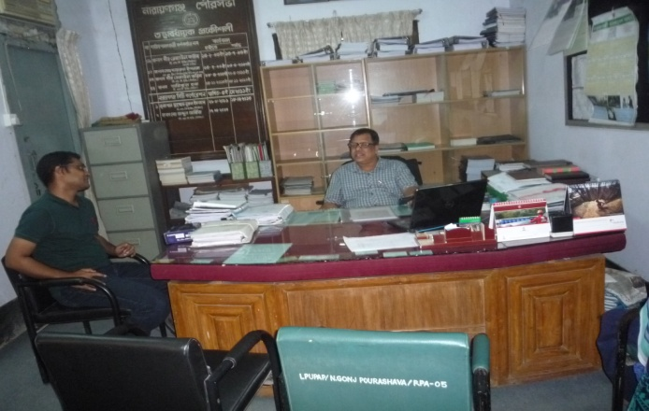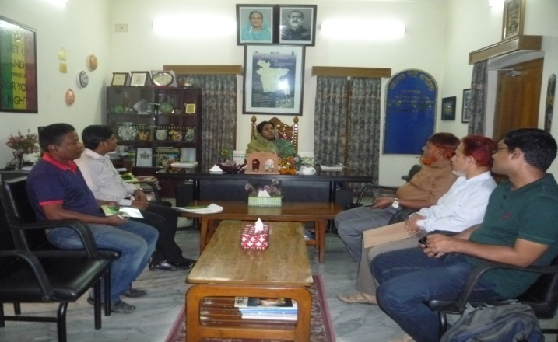In the context of preparing the Environmental Assessment (EA), participatory public consultation was conducted in the subprojects sites. The City Corporation Mayor, Officials, Engineers, and local individuals as well as LGED and Consultant participants participated. Informal Focus Group Discussions (FGD) and a formal CIP were conducted involving the participants (Participant list is shown in ***Appendix-1***). In addition, walk-through informal group consultations were also held. The local communities were informed about subprojects interventions including their benefits. Suggestions made by the participants were listed and incorporated in the EMP accordingly.

**Photographs 7.1.1: Consultation Meeting at Narayanganj City Corporation with Mayor, Superintending Engineer, other ULB Officials and Consultants Participants**

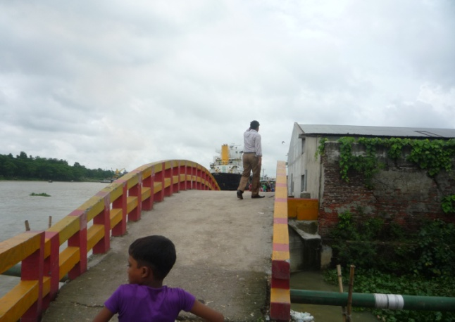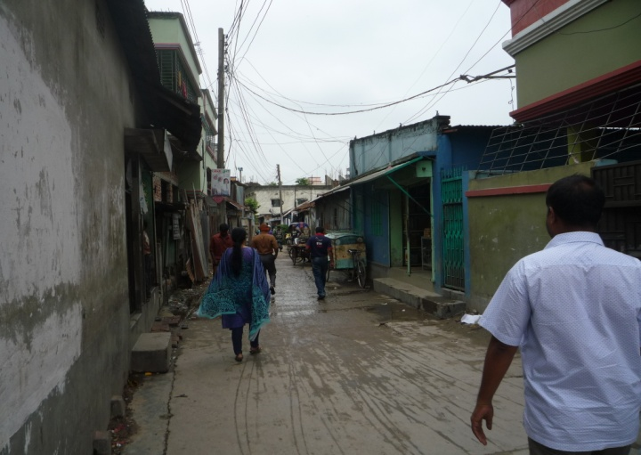

**Photographs 7.1.2: Consultant team visited the sites with the ULB representatives**

## 7.2 Issues Raised by the Participants

The participants raised the issues related to infrastructure development of Narayanganj City Corporation which mainly includes beautification of pond and khal, roads and drains. They also discussed about the quality of the construction works that already implemented. In the CIP and FGD, the participants discussed about the requirements for the ULB’s future development through a list of the subprojects that is included in ***Appendix-II****.*

## 7.3 Feedback, Suggestions, and Recommendations of the Participants

The participants were presented with feedback, suggestions, and recommendations listed below:

* The FGD results confirmed that an improved communication network is needed for future development of Narayanganj City;
* Most of the participants expressed that the number of subprojects that have been selected for each financial year is insufficient;
* The authorities discussed for starting the beautification work of the Baburail Khal as early as possible.
* The city corporation mayor said that the structured solid waste management facilities are not available in this city, she proposed for the construction of landfill and modern dumping station. The participants addressed the solid waste management issue to reduce environmental and public health hazards.
* Most of the participants illustrate that the overpass from Chashara to Mandol Para Bridge is very essential for the people of the Narayanganj City Corporation.
* The participants stated that the public water supply facilities, sanitation facilities, and access road are not adequate;
* Construction works should be scheduled properly and the quality of the construction work should be improved;

# 8 Conclusions and Recommendations

This study enables the MGSP to understand the initial environmental impacts for the subprojects as well as to formulate the applicable mitigation and monitoring plans. Based on the environmental assessment, all possible environment aspects have been adequately assessed and necessary control measures have been formulated to meet with statutory requirements.

The overall conclusion is that if the mitigation, compensation, and enhancement measures are entirely implemented, there will be no significant negative environmental impacts as a result of location, design, construction, and or operation of the proposed subprojects. In fact, there will be tremendous benefits from the recommended mitigation and enhancement measures and major improvements in quality of the life that enhance economic activities, education, job creation and public health once the scheme is in operation.

The conclusions of the environmental assessment can be summarized as follows:

* The short-term negative impacts of the beautification of the Baburail Khal of this city corporation may come such as air quality, noise, solid waste, occupational health and safety will be minimized through the mitigation plan;
* Basically noise, occupational health and safety health and safety issue come from the cutting & welding of the reinforcement, brick breaking machine and mechanical vibrator for RCC pipe drain and solid waste come from excavation work, dismantle work and site clearing;
* Air quality will be affected by the dust due to sand filling and back filling work for the slope of the khal;
* The subproject will create employment for the workforce who live in the vicinity of the construction site and will provide them a short-term economic gain.

A few key recommendations are outlined below:

* All mitigation, compensation, and enhancement measures proposed in this report should be followed by the concern authorities for implementing these subprojects;
* The environmental management and monitoring plan proposed in this report also needs to be followed;
* A training program should be carried out for City Corporation staffs to deliver overall knowledge for environmental safeguards;
* Natural resources such as water, wood, and fuel should properly use.

### Appendix 1: List of the Participants

### Appendix 2: CIP Details

### Appendix 3: Monitoring Checklist