Introduction

Subproject Background
Sylhet City Corporation was declared as a City Corporation in the year of 2002. At present, Sylhet City Corporation covers an area of 26.50 square kilometers. The present population of Sylhet City Corporation is about 500,000. (Source: Sylhet City Corporation Website)

At present, Sylhet City Corporation has 329.30 km drains. However, the urbanization process in the City Corporation and increasing population necessitates continuous development of the physical infrastructures. Hence, as a continuation of the infrastructure development, this subproject includes the following components: RCC drains with cover slab and footpath, culvert, RCC retaining wall and slope beautification works. The significant features of the subproject are stated below:
Name of the Subproject : | a) Construction of RCC Drain from Undal Hotel Zindabazar to Jalalabad Pump to Surma River (Ch. 0~1030 m, effective length=895m);  b) Construction of RCC Drain at Terorotan (Ch. 0~1615 m, effective length=773m);  c) Construction of RCC Drain at Kolapara to Surma River (Ch. 0m~1326m, effective length=1105 m);
Package No. : | MGSP/SCC/2017-2018/W-07
District Name : | Sylhet
ULB Name : | Sylhet City Corporation
Jurisdiction area : | Wards nos. 10, 14, 15, 16, 21, 22 and 24
Design Option : | RCC drains with cover slab and footpath, culvert, RCC retaining wall and slope beautification works
Beneficiary Population : | About 27,000
Tribal People : | No tribal people settlement found in the subproject area
Land Acquisition : | Land acquisition is not required.
Estimated Cost : | 102.84 million BDT
Subproject Duration : | 12 months
Tentative Start Date : | 25th March, 2018
Tentative Completion Date : | 24th March, 2019

Objectives of the Study

The general objective of this study is to determine the major environmental impacts succeeding from execution of the subproject and to recommend mitigation measures to avoid or reduce adverse environmental impacts and to enhance positive impacts. The specific objectives include:
- To assess the existing environmental conditions of the subproject sites and its influence area;
- To identify and assess impacts resulting from the subproject during its construction phase and operation phase;
- To develop an environmental management plan with recommendations for mitigating impacts and enhance positive impacts;
- To summarize environmental monitoring requirements.

Scope and Methodology of the Study

The subproject appraisal included environmental screening for the drain components. According to the screening environmental assessment is required to fulfill the regulatory requirement for RCC Drains with cover slab, Culvert, RCC retaining wall and Slope beautification works. The study methodology comprised the following activities:

Desktop Study

The desktop study involved:
- Initial meetings with client and stakeholders to discuss about the proposed subproject including subproject activities;
- Collection and review of the baseline data, maps, reports and other relevant information on the existing environmental and social conditions of the subproject area;
- Review of the relevant existing legislation, regulation and policies;
- Understanding the anticipated technical processes that may affect the environment.

Field Investigation and Data Collection

A team of the consultants made a field investigation to the proposed sites. Field investigations involved mainly site walks within the subproject area and the neighboring areas that may be affected by the subproject. The following key tasks were performed during the field visit:
- Taking photographs of the significant aspects to describe the baseline environmental conditions of the subproject area;
- Interviews with representatives of the City Corporation Officials, within the subproject area and interested and affected people within the subproject influence zone;
- Verifying information and data collected during the desktop study and to collect new information that may be important in the assessment of the impacts and design of the mitigation measures.

Data Analysis and Report Writing
The data and information collected from all the sources (literature review, secondary and primary data, public consultation) were analyzed to describe the existing environmental setting of the subproject area, to identify the potential positive and negative impacts of the proposed subproject, as well as to provide preliminary suggestions for mitigation measures. Finally, after analyzing the data, this environmental assessment report has been prepared.

SUBPROJECT DESCRIPTION

The Study Area

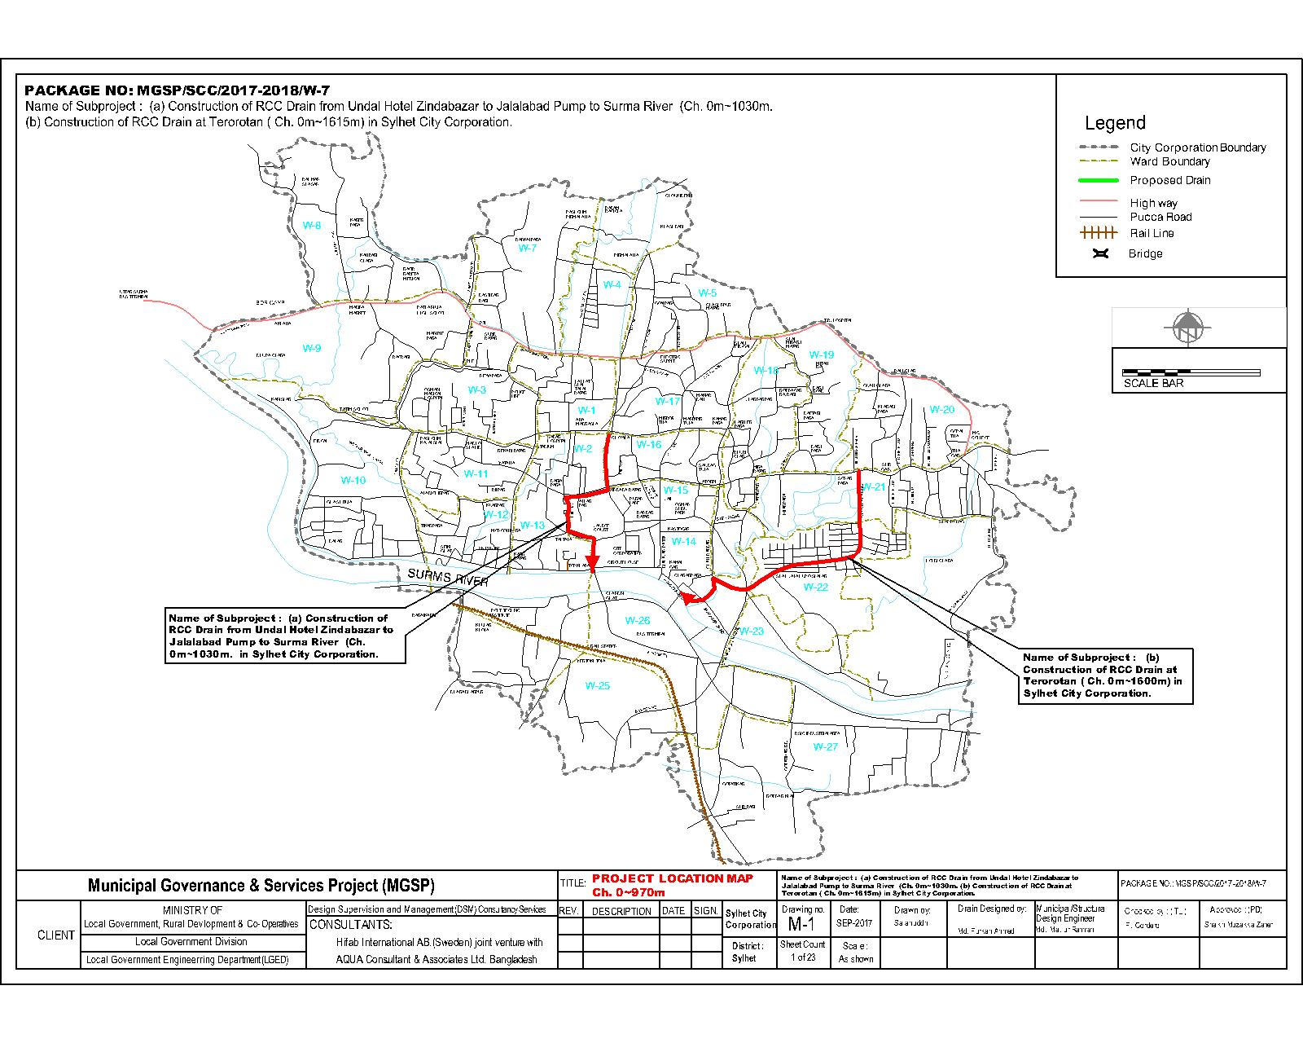
The subproject covers the jurisdiction area of the Ward number 10, 14, 15, 16, 21, 22 and 24 of Sylhet City Corporation. The Location Maps of this subproject are shown in Figure 2.1.1 and 2.1.2.

Figure 2.1.1: Location Map of the Undal drain and Terorotan Drain
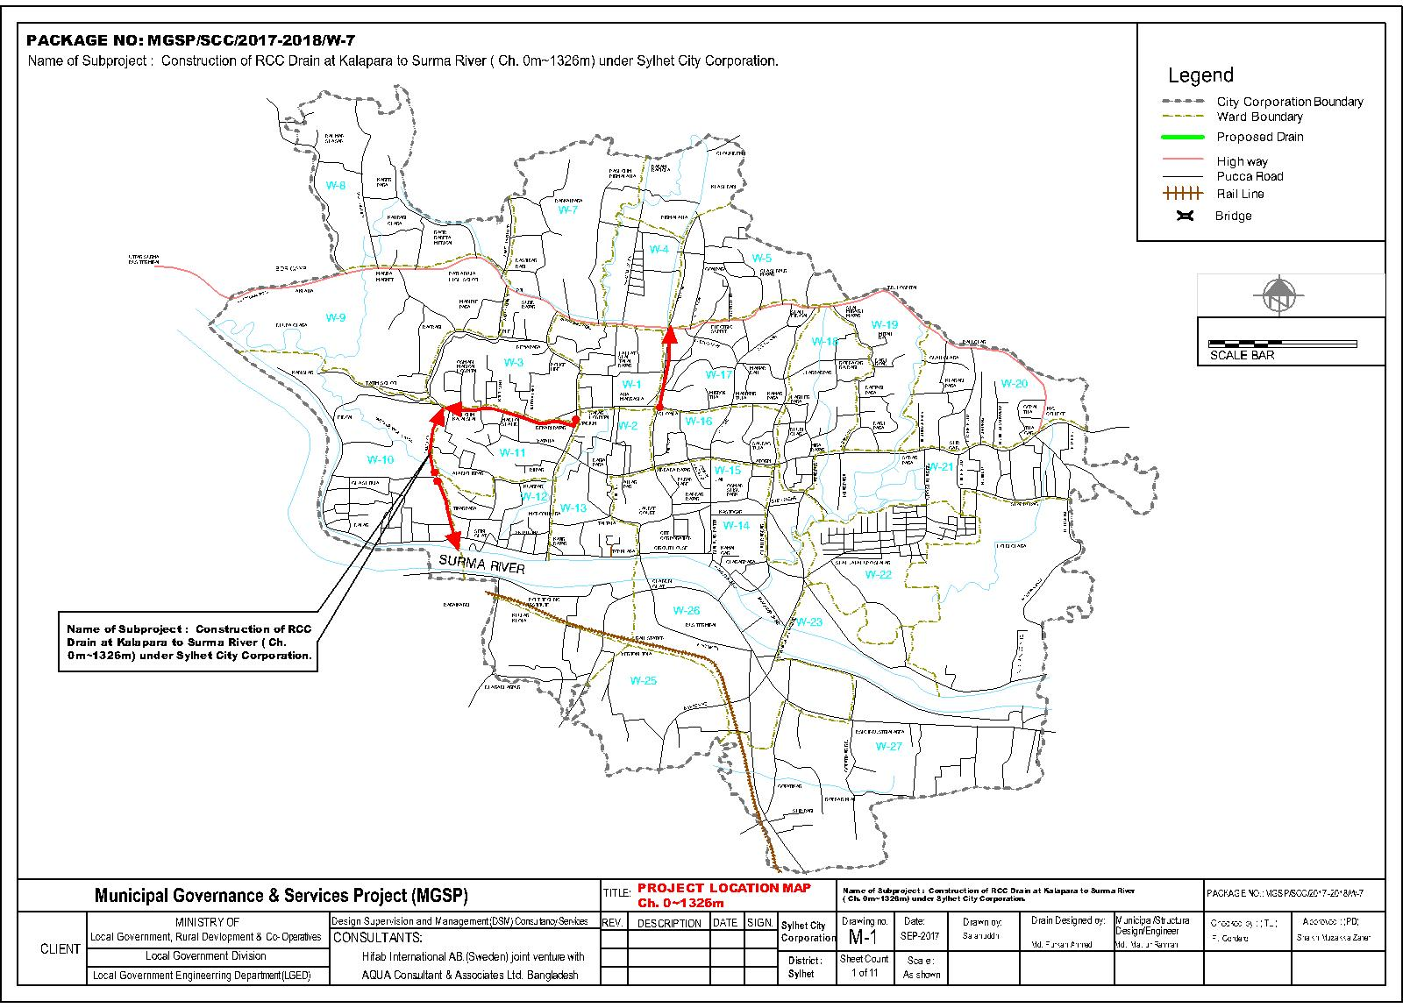

Figure 2.1.2: Location Map of the Kolapara Drain

Current Situation, Proposed Intervention and Need for the Subproject

The subproject sites are situated within the jurisdiction of the Ward no. 10, 14, 15, 16, 21, 22 and 24 of the Sylhet City Corporation. The subproject areas vary from commercial area to residential area. The major roadside built-up infrastructures are pucca residential buildings, boundary walls, pucca commercial buildings, semi-pucca and tin-shed shops etc.
Most portions of the existing drain from Undal Hotel, Zindabazar to Surma River via Jalalabad Pump is earthen with different width and shape. Existing drain at the downstream section is silted up, narrow and insufficient to drain out the storm water. Consequently, the drain overflows during heavy rain and floods the adjacent houses, roads and the market. Moreover, many tertiary drains are also connected to this drain which aggravates the condition. Hence, this subproject includes construction of RCC U-type Drain (from Ch. 15~95 m, Ch. 107~485 m and 675~810 m), RCC drain with road level cover slab (from Ch. 485~540 m), Box Culvert (Ch. 540~558 m), and RCC Retaining Wall (Ch. 810~1030 m) to provide proper drainage facility.
Existing earthen drain at Terorotan from Ch. 319-785 m and 1086-1615 m is silted up. The brick drain connected with this earthen drain at Ch. 168-319 m is damaged and insufficient to drain out the storm water. Many tertiary drains are also connected with the existing earthen drain. Consequently, the drain overflows during the rainy season at some places and floods the adjacent houses and roads. Moreover, decomposing solid wastes in the earthen drain are polluting the drain water and emitting bad odors. Bad odors are polluting the surrounding air quality and creating health hazards for the local people. To improve the situation, construction of RCC drain with cover slab and footpath, culverts, RCC retaining wall and slope beautification works at the earthen drain have been proposed.
At Kolapara, existing brick drains are mostly discontinuous, narrow, badly damaged and insufficient to drain out the storm water. This creates severe water-logging and drainage congestion during rainy season. Roadside houses and shops get flooded during monsoon period. Hence, RCC drain with cover slab will be constructed at left side of the road from Ghashitula graveyard of Kolapara to Surma River near Hia-Boron Mosque (Ch. 0-1326 m).

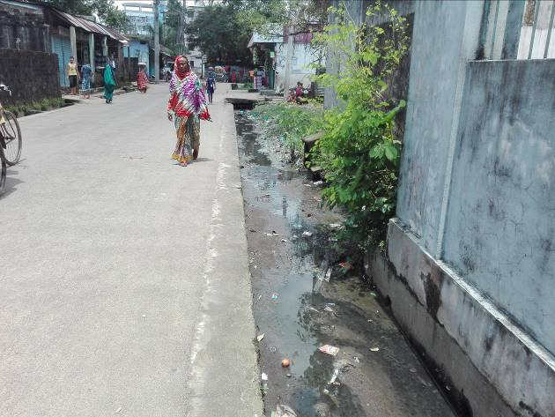
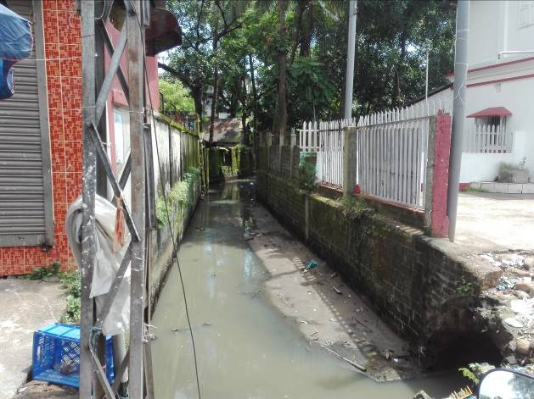
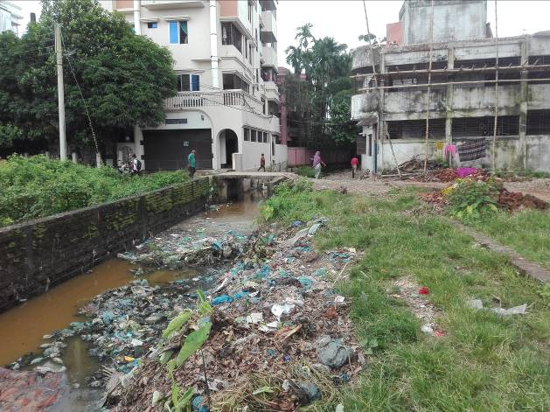
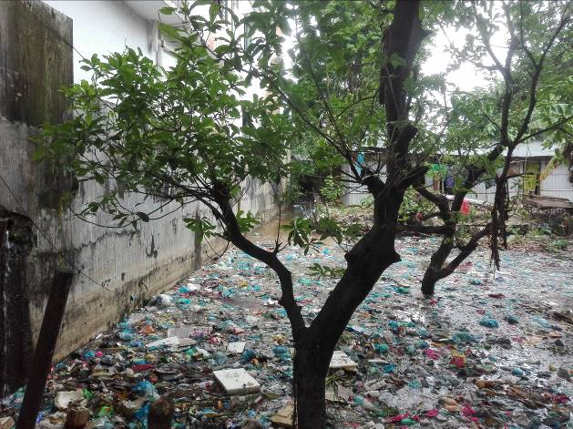
The existing site condition is further exhibited in the following Photographs 2.2.1.

Photographs 2.2.1: Current Situation of the Subproject Site
The storm water from the Undal and Kolapara drain will be discharged directly into the Surma River. While, stormwater from the Terorotan drain will be discharged into the Haldi Chara which ultimately discharges into the Surma River. The existing condition of the outfalls is shown in the Photographs 2.2.2.

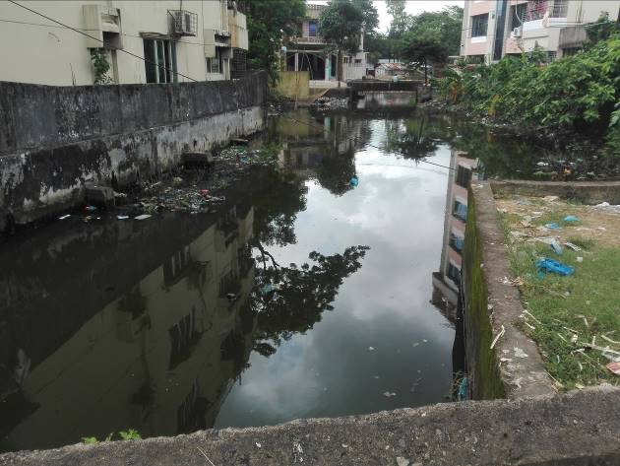
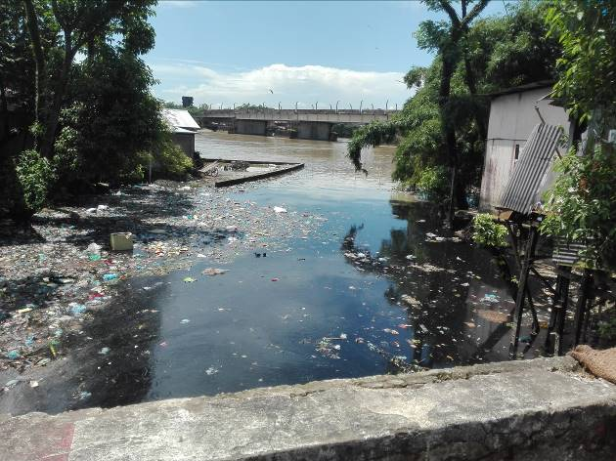
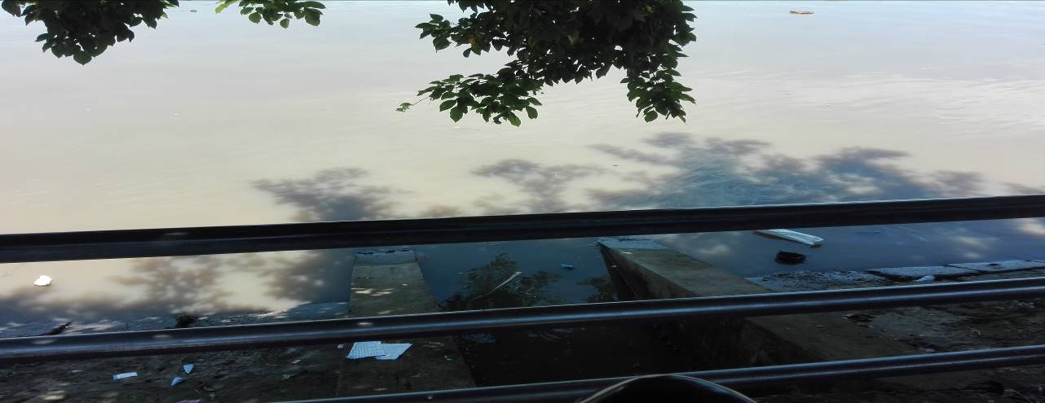

Photographs 2.2.2: Current Situation of different outfalls

Justification of Selection of this Subproject

According to the CIP list, Sylhet City Corporation prepared the priority list of the subprojects considering the demand and requirement. As a part of the reconnaissance survey, PMU Officials and DSM consultants’ visited and evaluated the existing site condition of the subproject.
From the environmental screening it is revealed that the ecological impacts due to this subproject will not be significant, though 84 numbers of trees to be felled down. The subproject has adverse impacts on the physicochemical environment. However, it is anticipated that the adverse impact is not significant and limited in the subproject boundary. The City Corporation authority has consulted with the beneficiaries. The beneficiaries have no objection regarding the implementation of the subproject. Considering the significant potential benefits that will derive after completion, the local community demands and welcome this subproject.

Envisaged Subproject Activities and Implementation Process

The general activities of the subproject: construction of the semi-pucca site office, construction of the labor shed, and relocation of the electric poles and site clearing works.

Key activities of the RCC Drain with cover slab:

- Earth work in excavation of the foundation;
- Pumping and bailing out of water as per requirement;
- Lying of polythene sheet;
- Sand filling for the preparing foundation bed;
- Plain cement concrete work in foundation;
- Manufacturing and placing of CC blocks;
- Fabrication of the ribbed or deformed bar;
- Reinforced cement concrete work.

Key activities of RCC Retaining Wall:
- Earth work in excavation;
- Sand filling for construction of heel and toe;
- Laying of polythene sheet;
- Plain cement concrete work for construction of heel and toe;
- Manufacturing and placing of CC blocks;
- Fabrication of the ribbed or deformed bar;
- Reinforced cement concrete work;
- Backfilling of earth.

Key activities of Slope Beautification Works:
- Compacted earth filling;
- Brick work on end edging;
- Sand filling;
- Compacted stone aggregate filling;
- Manufacturing and placing of CC blocks;

The materials and resources to be used for the key activities: soil in earth work, sand, brick chips, stone chips, cement, reinforcement, diesel, MS sheet, steel shutter, electricity and water.

The major equipment to be used for the implementation of the subproject: hydraulic excavator, concrete mixer machine, steel cutter, mechanical vibrator machine, mechanical compactor, dump truck, water tanker, pump etc.

Baseline ANALYSIS OF THE ENVIRONMENTAL CONDITION

Physical Environment

Important Environmental and Infrastructural Features

During site visit the environmental and infrastructural features within the subproject area were collected. Conditional survey has also been conducted for designing the subproject. Hence, survey data is also used for preparing the report. The environmental and infrastructural features listed within 100 m of the both sides of the drains from the center line considering 100 m longitudinal interval. The major environmental and infrastructural features of the Undal Drain, Terorotan Drain, and Kolapara Drain are shown in table 3.1.1, 3.1.2 and 3.1.3.

Table 3.1.1: Major Environmental and Infrastructural Features of Undal Hotel Zindabazar via Jalalabad Pump to Surma River Drain
Chainage  (m) | Left | Right | Major Environmental and Infrastructural Features
0-100 | √ |  | Pucca residential buildings
0-100 |  | √ | Vacant land, vegetation, Woondal restaurant, Westernboy clothing store
100-200 | √ |  | Residential buildings, boundary walls
100-200 |  | √ | Residential buildings, boundary walls
200-300 | √ |  | Puran Lane road, Residential buildings
200-300 |  | √ | Residential buildings, boundary walls
300-400 | √ |  | Residential buildings, Jalalabad Traders
300-400 |  | √ | Residential semi-pucca structures, boundary walls
400-500 | √ |  | Commercial pucca structures, boundary walls
400-500 |  | √ | Commercial pucca structures, boundary walls
500-600 | √ |  | Commercial pucca structures, boundary walls
500-600 |  | √ | Commercial pucca structures, boundary walls
600-700 | √ |  | Commercial pucca structures
600-700 |  | √ | Pucca structures
700-800 | √ |  | Commercial pucca structures, boundary walls, road
700-800 |  | √ | Pucca structures
800-900 | √ |  | Pucca and semi-pucca structures, boundary walls
800-900 |  | √ | Pucca and semi-pucca structures, boundary walls
900-1030 | √ |  | Pucca and semi-pucca structures, boundary walls
900-1030 |  | √ | Pucca and semi-pucca structures, boundary walls

Table 3.1.2: Major Environmental and Infrastructural Features of the Terorotan Drain

Chainage (m) | Left | Right | Major Environmental and Infrastructural Features
0-100 | √ |  | Pucca structures, shops
0-100 |  | √ | Pucca structures, shops
100-200 | √ |  | Pucca shops, pucca residential buildings, Lamapara mosque, connecting road
100-200 |  | √ | Pucca shops, pucca residential buildings
200-300 | √ |  | Pucca structures, shops
200-300 |  | √ | Pucca structures, shops, vacant land, bamboo bush
300-400 | √ |  | Slums, pucca residential buildings, connecting road
300-400 |  | √ | Pucca residential buildings, vacant land
400-500 | √ |  | Pucca residential buildings, boundary walls, vegetation
400-500 |  | √ | Pucca residential buildings, boundary walls, vegetation
500-600 | √ |  | Pucca residential buildings, boundary walls, vegetation
500-600 |  | √ | Pucca residential buildings, boundary walls, vegetation
600-700 | √ |  | Pucca residential buildings, boundary walls, vegetation
600-700 |  | √ | Pucca residential buildings, boundary walls, vegetation
700-800 | √ |  | Pucca residential buildings, boundary walls, vegetation
700-800 |  | √ | Road, Pucca residential buildings, boundary walls, vegetation
800-900 | √ |  | Pucca residential buildings, boundary walls, vegetation
800-900 |  | √ | Road, Pucca residential buildings, boundary walls, vegetation, Zonal settlement office
900-1000 | √ |  | Road, pucca and semi pucca structures, Syedani Bag culvert
900-1000 |  | √ | Pucca residential buildings, boundary walls, Syedani Bag culvert
1000-1100 | √ |  | Slums, pucca residential buildings, culvert
1000-1100 |  | √ | Pucca residential buildings, boundary walls, culvert
1100-1200 | √ |  | Pucca and semi pucca structures, boundary walls, vacant land, vegetation
1100-1200 |  | √ | Pucca and semi pucca structures, boundary walls
1200-1300 | √ |  | Pucca and semi pucca structures, boundary walls, Teroratan mosque
1200-1300 |  | √ | Pucca and semi pucca structures, boundary walls
1300-1400 | √ |  | Pucca and semi pucca structures, boundary walls, slums, vegetation, bamboo bush, vacant land
1300-1400 |  | √ | Vacant land, vegetation slums, pucca and semi pucca structures, boundary walls
1400-1500 | √ |  | Slums, vegetation, Pucca residential buildings, boundary walls,
1400-1500 |  | √ | Pucca residential buildings, boundary walls
1500-1615 | √ |  | Pucca residential buildings, boundary walls, vegetation
1500-1615 |  | √ | Pucca residential buildings, boundary walls

Table 3.1.3: Major Environmental and Infrastructural Features of the Kolapara Drain
Chainage  (m) | Left | Right | Major Environmental and Infrastructural Features
0-100 | √ |  | Swamp, Slums
0-100 |  | √ | Swamp, Slums
100-200 | √ |  | Graveyard
100-200 |  | √ | Graveyard, Swamp
200-300 | √ |  | Swamp
200-300 |  | √ | Graveyard, Swamp
300-400 | √ |  | Tin-shed shops, pucca residential structures, ditch, Lamapara mosque
300-400 |  | √ | Tin-shed shops, pucca residential structures
400-500 | √ |  | Bush of trees (Koroi, bamboo bushes), pucca houses, open space with trees, house yard with trees
400-500 |  | √ | Connecting road, boundary walls, tin-shed shops, bamboo bushes, residential buildings
500-600 | √ |  | Pucca buildings, bamboo bushes, boundary walls
500-600 |  | √ | Pucca and semi pucca structures, boundary walls
600-700 | √ |  | Pucca and semi pucca structures, boundary walls
600-700 |  | √ | Pucca and semi pucca structures, boundary walls
700-800 | √ |  | Pucca and semi pucca structures, shops, boundary walls, connecting road, bamboo bushes
700-800 |  | √ | Pucca and semi pucca structures, shops, connecting road, yard garden, Ghashitula govt. primary school
800-900 | √ |  | Tin shed shops, bamboo bushes
800-900 |  | √ | Tin-shed shops
900-1000 | √ |  | Tin-shed shops, boundary walls, open yard
900-1000 |  | √ | Tin-shed shops, boundary walls
1000-1100 | √ |  | Pucca and semi pucca structures, open space with vegetation
1000-1100 |  | √ | Pucca and semi pucca structures
1100-1200 | √ |  | Pucca and semi pucca structures, electric poles, connecting road
1100-1200 |  | √ | Pucca and semi pucca structures, electric poles
1200-1300 | √ |  | Pucca and semi pucca structures, boundary walls
1200-1300 |  | √ | Pucca and semi pucca structures, boundary walls, Hia-Boron mosque
** Note: There are 61 numbers of electrical poles to be re-located for the implementation of the subproject.

Geology, Topography, and Soils

Sylhet City is located within the Surma-Kushiyara floodplain region where there are hills and basins which constitute one of the most distinctive regions in Bangladesh. Surma-Kushiyara floodplain comprises the floodplain of the rivers draining from the eastern border towards the Sylhet Basin (Haor Basin). The relief generally is smooth, comprising broad ridges and basins, but it is locally irregular alongside river channels. The soils are mainly heavy silts on the ridges and clays in the basins. The physiography of Sylhet consists mainly of hill soils, encompassing a few large depressions known locally as "beels".

This area is subject to flash floods in the pre-monsoon, monsoon and post-monsoon seasons, so the extent and depth of flooding can vary greatly within a few days. Normal flooding is mainly shallow on the ridges and deep in the basins, with flood depths tending to the Haor Basin. The basin centers (Haors) stay wet in the dry season. According to Soil Resource Development Institute (SRDI), soil of the Sylhet region is classified as Calcareous and Non-calcareous brown. Calcareous brown soils comprise pale brown to olive brown, friable, loamy and clay soils. According to earthquake zone classifications, Sylhet lies on zone-1 which is the most vulnerable earthquake region of Bangladesh. Sylhet inhabits nature-on-the-move. Tectonic shifts continue to lift the highlands and depress the deepest-flooding ‘haor’ basins. The general soil classification of Bangladesh is given in the Figure 3.1.1.
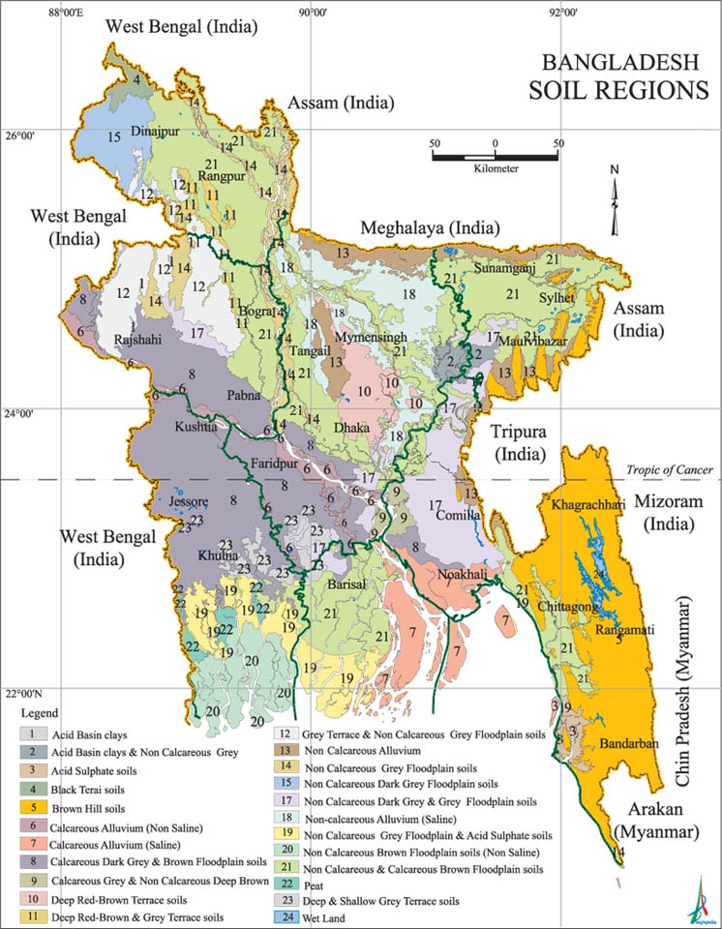

Figure 3.1.1: General Soil Classification of Bangladesh

According to earthquake zone classifications, Sylhet lies on zone-1 which is the most vulnerable earthquake region of Bangladesh. Sylhet inhabits nature-on-the-move. Tectonic shifts continue to lift the highlands and depress the deepest-flooding ‘haor’ basins (GSB, 1978). The earthquake zoning map of Bangladesh is shown in Figure 3.1.2.

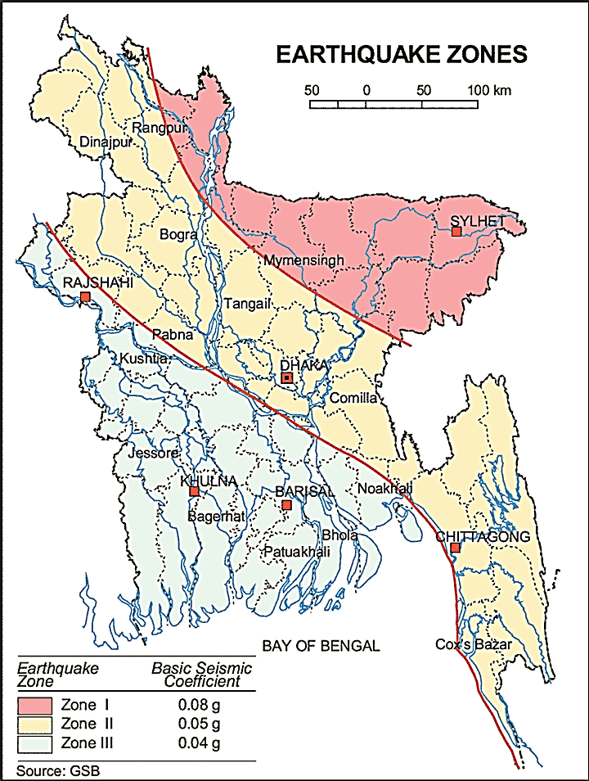

Figure 3.1.2: Earthquake Zones of Bangladesh

Climate and Meteorology
Sylhet has a typical Bangladeshi tropical monsoon climate (Köppen Am) bordering on a humid subtropical climate (Cwa) at higher elevations. Rainfall is significant in most months of the year, and the short dry season has little effect. The rainy season from April to October is hot and humid with heavy showers and thunderstorms almost every day. Whilst the short dry season from November to February is very warm and fairly clear. The average annual temperature is 24.8⁰C and average annual rainfall is 3876 mm. About 80% of annual average rainfall occurs between May and September. The months January, February, November and December have a nice average temperature. On average, the temperatures are always high. On average, the warmest month is April and the coolest month is January. Table 3.1.5 shows the climate data up to the year long.
Table 3.1.4: Climate data for Sylhet City Corporation, Bangladesh
Month |  | Jan | Feb | Mar | Apr | May | Jun | Jul | Aug | Sep | Oct | Nov | Dec | Year
Average high Temp | °C  (°F) | 25.2  (77.4) | 27.1  (80.8) | 30.4  (86.7) | 30.8  (87.4) | 30.8  (87.4) | 30.9  (87.6) | 30.9  (87.6) | 31.6  (88.9) | 31.2  (88.2) | 30.9  (87.6) | 29.2  (84.6) | 26.3  (79.3) | 29.6  (85.3)
Average low Temp | °C  (°F) | 12.9  (55.2) | 14.2  (57.6) | 18.1  (64.6) | 20.8  (69.4) | 22.6  (72.7) | 24.4  (75.9) | 24.9  (76.8) | 25.0  (77) | 24.3  (75.7) | 22.5  (72.5) | 18.4  (65.1) | 14.0  (57.2) | 20.2  (68.4)
Average rainfall | mm  (inches) | 8  (0.31) | 31  (1.22) | 146  (5.75) | 372  (14.65) | 569  (22.4) | 796  (31.34) | 834  (32.83) | 621  (24.45) | 548  (21.57) | 232  (9.13) | 30  (1.18) | 13  (0.51) | 4,200  (165.34)
Source: WMO
The construction works can be influenced by the climatic condition and meteorological components like humidity, temperature, sudden rainfall, and wind speed. High winds can enhance quick spreading of the generated dust. It is very risky working under rain and in high winds because the possibility of incurring injury increases. Furthermore, work under high temperature and excess humidity may create health hazards like dehydration problem.

Hydrology (Surface Water and Ground Water)

Groundwater with Deep Tube Well (DTW) is the main source of the present water supply system in Sylhet City Corporation. The dwellers mainly depend on the City Corporation water supply system. In addition, some people use individual deep tube well. Water quality parameters like pH, total hardness (TH), total dissolved solids (TDS), chloride, iron, arsenic, total coliform, fecal coliform’s values are within the limit of WHO, and BD standards (Sylhet City Corporation: Master Plan).
The Surma River is located within the influence area of the subproject site. There is an existing Surface Water Treatment Plant (SWTP) at Sylhet which is also functioning as a potable water source.

Flooding, Water Logging and Drainage Pattern

According to previous data from BMD, this area is affected in historical severe flood events such as 1988, 1998, 2004, 2007 and 2012. Due to River Surma, this area is susceptible to flash flood when river water rises up and cross the normal level. Due to continuous heavy rain and delay discharge of storm water, the subproject area is subjected to water logging problem. As per flood zone map in Bangladesh, Sylhet City Corporation lies in the normal flood area. The location of the Sylhet City Corporation in the flood zoning map of Bangladesh is shown in Figure 3.1.3.
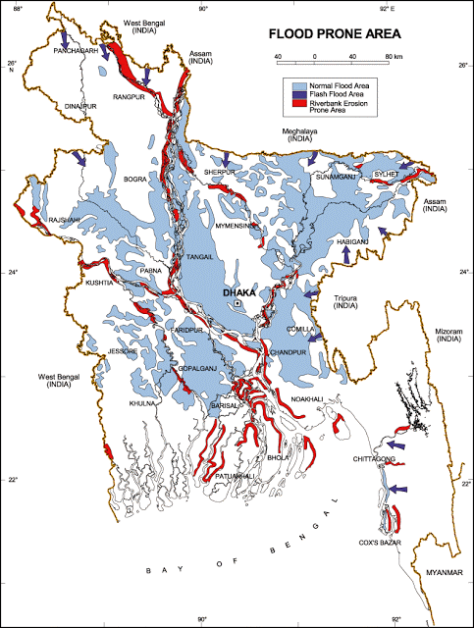

Figure 3.1.3: Location of Sylhet City Corporation in Flood Zone Map of Bangladesh
Air Quality and Dust
Ambient air quality data have not been found. Dust is generated during the movement of the vehicles in dry season and windblown dust cause air pollution. Additionally, black smoke emission from the vehicles degrades the air quality. In addition, open dumping of the waste materials in the existing drains make objectionable odor.
Noise Level
Noise level data is not available. From the field visit it was found that, noise is generated from moving vehicles. Vehicles such as buses, trolleys, pick-up, trucks, motor cycles, CNG, rickshaws and private cars frequently pass through the road and use horns. There are no other perceptible sources of noise generation such as factories or industries were found near the subproject area. In the subproject activities, movement of the subproject vehicles, using of the equipments such as concrete mixer machine, steel cutter, vibrator machine, mechanical compactor etc. may create noise nuisance for the road side establishment.
Solid Waste Management
The City Corporation has a dump site at Lalmatiya area near Fenchuganj Road. Sylhet City Corporation faces challenges to ensure effective solid waste management system. The local people informed that due to lack of awareness and habitual problem they throw their solid wastes into vacant lowland, khals and drains. The people of residential houses beside the drains throw their wastes directly into the drains. In the subproject activities generated wastes will be disposed-off at the City Corporation recommended dumping ground at Lalmatiya.

Biotic Environment
Flora and Fauna
There are some road side planted trees that include Mango, Jackfruit, Coconut, Banana, Betel nut, Amra, Mahogany, Koroi, Debdaru, Guava, Dumur, Banana, Bamboo bushes, Shimul, Koroi, Jam, Banyan, Neem, Boroi, and Baganbilash etc. The common local birds such as Choroi, Crow, and Shalik etc. were found in the subproject area.

Socio-economic and Socio-cultural Environment

Land Use, Status of Housing and Built-up Infrastructure

The subproject is situated in the urban residential and commercial area. Most of the built up infrastructures beside the existing drains are pucca residential buildings, semi-pucca and tin-shed shops. There are small to large scale business facilities such as shops, markets, and bazaar in the subproject influence area.

Beneficiary Population

The subproject covers the jurisdiction area of the Wards nos. 10, 14, 15, 16, 21, 22 and 24. As per information by the municipality, considering the wards’ population about 27,000 people will get benefit directly and about 42,000 indirectly.

Education

In the subproject area, literacy among the population is about 73% [Source: Sylhet City Corporation Website]

Tribal Communities

There is no indigenous or tribal people settlement in the subproject area. Therefore, there are no measures needed for the indigenous peoples’ safeguard.

Land Acquisition and Resettlement

Existing width of the Undal Drain is 1 m to 1.5 m on average and the width of the Terorotan Drain is 2 m to 2.5m on average. To widen these drains some boundary walls need to be removed at both sides of the drains for site clearing work at different Chainages. The City Corporation Authority has consulted with the owners of these boundary walls. Owners of these boundary walls have agreed to remove the boundary walls for the benefit of the City. The City Mayor has already provides a declaration letter which states that the owners agreed and has given permission to the City Corporation for removing of the boundary walls. So, the City Corporation authority will remove these boundary walls by amicable understanding with the owners of these structures. On the other hand, in the case of Kolapara Drain, from Ch. 0 to 135m, the proposed drain will be constructed on the privately owned land. The City Corporation Officials have already discussed with the owners of the land. The City Corporation Officials verbally confirmed that the owners have agreed to donate their land for the infrastructure development of the City Corporation. The City Mayor also ensured about amicable settlement with the owners regarding this issue. However, in case of any objection from the affected persons, DSM will investigate the actual situation. Then, measures will be taken as per rules.

Principal Livelihoods and Economic Activities
The subproject area is inhabited by the people of mixed occupations. In the City Corporation area, major income comes from business, enterprises, small trades, private sector jobs and government jobs.

Cultural Heritage and Protected Areas
During site visit it was observed that there is no protected and important cultural or historical site in the subproject influence area.

Social Conflicts and Development Activities
The local people welcome the subproject and there is no conflicts between the local communities regarding subproject implementation.

ENVIRONMENTAL SCREENING

Environmental Screening Checklist, as adopted in Appendix C of the Environmental Management Framework (EMF) of the MGSP, was administered for identifying the impacts and their extents.
The screening data and information for the RCC drains with cover slab and footpath, culvert, RCC retaining wall and slope beautification works have been formulated and are shown below:
1) Potential Environmental Impact during Construction Phase:

(a) Ecological Impacts:
107
- Felling of trees Significant □ Moderate □ √ Minor □ Number of trees
- Clearing of vegetation Significant □ Moderate □ √ Minor □
- Potential impact on species of
aquatic (i.e., water) environment Significant □ Moderate □ Minor □ √

Major trees to be cut down are: Mango, Jackfruit, Coconut, Banana, Bamboo bushes, Koroi, Mahogany, Debdaru, Dumur, Banyan, Jam etc. Most of the trees to be cut down are medium to small sizes in both Undal and Terorotan drain. There is a small amount of large Koroi trees to be felled down at Kolapara drain. Moderate amount of vegetation is to be cleared at the Terorotan drain. Some ditches and swamps are situated beside the Koapara Drain. But, anticipated impact on species of aquatic environment is minor because except throwing of the wastes materials into the ponds and ditches, the subproject does not have any impact on the aquatic environment. Hence, the drain construction activities do not have any impact on the aquatic environment during construction phase. The overall impact on ecological environment is anticipated as minor.

- Physicochemical Impacts:

- Noise pollution Significant □ Moderate □ √ Insignificant □
- Air pollution Significant □ Moderate □ √ Insignificant □
- Drainage congestion Very likely □ Likely □ Unlikely □ √
- Water pollution Significant □ Moderate □ Insignificant □ √
- Pollution from solid/ construction wastes Significant □ Moderate □ √ Insignificant □
- Water logging Significant □ Moderate □ Insignificant □ √

The subproject will have temporary and localized negative impacts on noise and air quality during construction phase due to dismantle works, subproject vehicles movement for the transportation of the materials and using of hydraulic excavator, concrete mixer machine and vibrator. Since the drain will be constructed section wise; hence, it is anticipated that the overall impacts on noise and air quality will be moderate. It is also noted that effective measures will minimize the impacts on noise and air quality if properly implemented. Though it is limited; however, local residents may get affected due to generated dust if proper measures are not taken. The anticipated water logging problem during construction period is insignificant because the RCC drain will be constructed mostly in the dry season. However, pumping facilities will be provided for pumping out the storm water if required. The generated construction wastes, un-suitable materials and solid wastes collected from the existing drains for clearing works may pollute the surrounding environment if not disposed properly.

- Socio-economic Impacts:

- Traffic congestion Very likely □ Likely □ √ Unlikely □
- Health and safety Significant □ Moderate □ √ Insignificant □
- Impact on archaeological and historical Significant □ Moderate □ Insignificant □ √
- Employment generation Significant □ Moderate □ √ Insignificant □

The subproject will have temporary negative impact in health & safety. But impacts on traffic movement will be insignificant at Undal and Terorotan because there is no roadside construction work. If there is no material storage as well as excavated materials on the road, the impact on the local traffic system will be minimal at these places. At Kolapara, roadside construction work may hamper traffic movement. However, during construction period pedestrians, bicycle riders and motor bikers can use the road. As the construction work will follow simple procedure with commonly used equipment, moderate impact on health and safety is anticipated. There is no archaeological and historical site within the influence area. The subproject will have positive impacts by generating employment opportunities for the local people and creating business opportunity of supplying construction materials, equipment, food and other necessary staffs to the work camp.

2) Potential Environmental Impact during Operational Phase:

(d) Ecological Impacts:

- Potential impact on species of aquatic Significant □ Moderate □ √ Minor □
(i.e., water) environment

As the drains are designed only for the storm water, there will not be any impact on the aquatic environment if the drains are to be used properly. However, dumping of solid wastes and household wastewater directly into the drains from the households beside the drains may create pollution in the aquatic environment by the discharge water through these drains.

(e) Physicochemical Impacts:

- Potential air quality Improvement □ √ No-improvement □ Deterioration □
- Noise level Improvement □ No Improvement □ No Impact □ √
- Drainage congestion Improvement □ √ Minor Improvement □ No Impact □
- Risk of water pollution Significant □ Moderate □ √ Minor □
- Pollution from solid waste Improvement □ Minor-improvement □ Minor □ √

The wastewater to be discharged may degrade the water quality of the outfall, if it carries pollutants. The new drains after construction will reduce drainage congestion. People living in the households beside the Undal and Terorotan drains may dump solid wastes directly into the open drain. This may pollute the storm water to be discharged by the drains. However, covered drain at Kolapara will reduce throwing of the waste materials in to the drain.
(f) Socio-economic Impacts:

- Traffic Improvement □ √ No-improvement □ Adverse □
- Safety Improvement □ √ No-improvement □ Adverse □
- Employment generation Significant □ Moderate □ Minor □ √

After construction, these drains will provide better drainage facilities and prevent the accumulation of the stagnant water on the road surface. These will reduce wearing of the existing BC road surface. Consequently, traffic safety will be enhanced. Road level cover slab at Kolapara will provide extra width added to the existing road for vehicle use. Footpath will provide safety to the pedestrians from speeding vehicles.

(3) Summary of Possible Environmental Impacts of the Subproject

The ecological impact due to the subproject implementation is mainly due to falling down of the 25 trees at Undal Drain, 62 trees at Terorotan Drain and 20 trees at Kolapara Drain. Ecological impacts of the subproject are moderate. The subproject activities may degrade the air quality and noise level temporarily. The wastes generated due to the construction activities should be properly collected and disposed-off in a designated dumping site. The inputs of the subproject activities will be mainly at construction phase and limited within the subproject boundary. Moreover, mitigation measures will be taken according to the EMP for minimizing the air, dust and noise pollution.
During operational phase, the waste water to be discharged may disturb the aquatic environment of the outfalls as the drains may carry pollutants and solid wastes especially plastics and polythene which can block the outfalls. Slope protection works at Terorotan drain will reduce soil erosion.
The socio-economic component mainly includes health and safety and employment generation. Safety concern is an important issue for both the construction and operation phases. This subproject will have positive impacts in terms of the generation of the employment and business activities by supplying construction materials and equipment.

Specific impact, mitigation AND enhancement measures

From the environmental study, the probable impacts of the subproject are mainly caused by the key activities required for the implementation of the subproject, raw materials and equipment to be used for the execution of the activities. This section describes some specific impacts due to the subproject activities and their mitigation measures.

Dismantle Work, Site Clearing, Excavation Work and Earth Work
The drain construction work consists of removal of the unsuitable materials, dismantle works, earth excavation, earth filling and back filling. The existing drains need to be dismantled prior to the construction works. These works lead dust blowing, construction waste generation, noise and vibration which disturb the local people. Moreover, excavated decomposed solid wastes may pollute air if not properly disposed of.
Mitigation Measures

- Proper care will be taken by the contractor as well as City Corporation Officials, during dismantle, excavation, and back filling so that this activity does not disturb the nearby establishment;
- Cover the exposed dry loose soil with fabric to avoid any dust generation;
- Disposal of unused soil and construction wastes to designated dump site at Lalmatiya;
- Disposal of decomposed solid wastes and unsuitable materials to designated dump site at Lalmatiya.

Tree Felling and Ecological Impact
There are 25, 62 and 20 numbers of planted trees are to be felled down consecutively at Undal Drain, Terorotan Drain and Kolapara Drain due to implementation of the subproject.
Mitigation Measures

- 215 nos. of the trees will be planted to compensate the felled down trees and to enhance the ecological condition-preferably local fruits, flowers, medicinal and ornamental trees-Mango, Jackfruit, Jam, Palm Tree, Neem, Krisnachura, Bokul, Banyan Tree, Mahogany, Koroi (including protection, fencing and conservation during project defect liability period): As per Chainage direction from Ch. 0 to 1600m at both sides of the Teroratan Khal where space is available and from Ch. 0 to 1326m at both sides of the Kolapara Road where space is available.
- Planting trees will enhance the ecological balance of the subproject area after their successful growth.

Pollution from the Construction Materials
Dumping of the construction spoils, including accidental leakage of the oil, grease and fuel in equipment yards is a significant hazard. Storm water may carry these substances during rain. Thus, both surface and groundwater might be polluted from these contaminants. Air pollution and dust may affect the nearby settlement which is generated from fine aggregate such as sand and loose dry soil.
Mitigation Measures

- Safe transport, storage, and disposal of the construction materials, and the equipment have to be carried out in order to avoid the accidental spillage and loss;
- Maintain adequate moisture content of soil and sand during transportation, compaction and handling;
- Use tarpaulins or polythene to cover sand and loose soil when carried on trucks;
- Fuels, lubricants and other hazardous materials should be stored over raised platforms and not directly on the ground.

Air Quality and Dust
During the construction phase, air pollutants will be emitted from the equipment and construction vehicles are expected to remain low. Local residents in the vicinity of the work sites will be temporarily disturbed by the limited dust pollution. The overall impacts, however, are expected to remain low.
Mitigation Measures

- Water should be sprayed to control the dust, which is the main way to suppress dust at the worksite. Ensure sprinkle and cover stockpiles of loose materials (e.g., fine aggregates);
- Maintain adequate moisture content of soil and sand for transportation, compaction, bed preparation, backfilling and handling;
- Avoid use of dust generating equipment which produce significant amount of particulate matter far from the local residents;
- Ensure that all subproject vehicles are in good operating condition.

Noise and Vibration
Noise and vibration caused by the equipment and movement of the construction vehicles may temporarily disturb nearby residents. In this subproject, sensitive areas like roadside houses, educational institutes and shops are likely to be affected from the noise, though the impacts are anticipated to be limited.
Mitigation Measures

- Transportation of the construction materials have to be carried during the scheduled times, and mainly during the day;
- If needed, all powered mechanical equipment such as hydraulic excavator and machineries will be fitted with noise abating gear such as mufflers for effective sound reduction;
- Avoid using of the steel cutter at night;
- Avoid using of the concrete mixer and vibrator machine at night and schooling time.

Water Quality
The water quality may deteriorate if the construction materials such as loose soil, sand, construction waste, effluent from work camps and food wastes are dumped here and there. The storm water may carry these substances in to the water bodies. In addition, if the drains carry washed out pollutants, the outfalls water quality may be degraded.
Mitigation Measures

- Proper construction management including waste management as well as training of the operators and other workers should be provided to avoid pollution of the water bodies;
- Construction wastes should be disposed off properly (not in the ditch, water bodies or lowland), for which contractor will be responsible;
- Regular cleaning of the drains is required to prevent drain water pollution. Dumping of solid wastes into the drains directly should be prevented by creating awareness among the local people.

Occupational Health and Safety
The most important risks associated with the construction activities are listed below:

- Exposure to the sunlight- workers are being exposed to the sun for long hours;
- Exposure to the high temperature, and humidity for a long time resulting in dehydration;
- Contact with the hazardous substances and wastes pose risks of the infections and diseases;
- Risk from the traffic collision or accidents during operation of the equipment such as hydraulic excavator and vehicles movement for the transportation activities of the subproject;
- Risks from head loads for carrying soil, construction materials and construction equipment;
- Risk associated to the sudden bad weather working conditions such as storm, thunder storm and earth quake etc.
General Requirements for the Workers’ Health and Safety
The key salient features of the general requirements for the workers’ health and safety stated are presented in Table 5.7.1.
Table 5.7.1: General Requirements for the Workers Health and Safety
Issues | Requirements
Health and Hygiene | - Cleanliness at the site premises and workers living places and at the Labor Shed;  - Arrangement of the proper ventilation and temperature at the Labor Shed;  - Protection against dust by using of the nose masks and covering of the head and body;  - Proper disposal of the wastes and effluents;  - Provision of the adequate latrines and separate toilets for the women;  - Sufficient dustbins for the solid waste management system.
Safety and First Aid Box | - Using of the personal protective equipment (helmet, gloves, goggles, nose mask, safety boots);  - Precautions during work on or near machineries in motion;  - Head loads are prohibited;  - First aid facilities should be provided and maintained;  - Ensure one first aid box for every one hundred workers;  - The first aid kit should include adhesive bandages, regular strength pain medication, gauze and low grade disinfectant.
Compensation for Accidents at Work | - Contractors will bear medical treatment costs. If any severe accidents such as loss of hands, legs or loss of working ability or any case of death needs compensation-(the amount of the compensation should be fixed considering the type of accidents).
Dust and Fumes | - For any dust, fumes, or other impurities likely to be injurious to the workers, effective measures shall be taken to prevent their accumulation and its inhalation by the workers.
Overcrowding | - No labor room should be overcrowded.
Latrines and Urinals | - Sufficient latrines shall be provided;  - Latrines shall be maintained in clean and sanitary condition;  - Latrines shall be adequately lighted and ventilated.
Disposal of Wastes and Effluents | - Proper disposal system for the solid waste and effluent is required.  - Waste bins must be provided by the contractor at labor shed.

Impacts on Social Environment and Common Property Resources
Through comprehensive study, it is revealed that impacts are expected not to be severe and to be largely manageable. The following Table 5.8.1 presents impacts on socio-economic environment and common property resources.
Table 5.8.1: Impacts on Social Environment and Common Property Resources
Social Components | Impacts on IECs | Impact Significance
Community Perception | The local community people welcome this subproject and there is no visible objection from them. | Significant (+ve)
Employment and Business Opportunity | Community feels happy because generally the local contractor will be engaged for the construction works which will create work opportunity for the skilled and non-skilled labor. The subproject will create business opportunity for the equipment and materials suppliers’. | Significant (+ve)
Community Order and Security | This subproject activity does not create any severe security problems to the local community and community people. | Minor  (-ve)
Possible damage to infrastructure and facilities | Possible damage of the existing road infrastructure by the construction equipment and vehicles used in this subproject. | Minor  (-ve)
New infrastructure and facilities | Improvement of the existing drainage network will enhance infrastructure facilities. | Moderate  (+ve)
Landscape and Aesthetics | This subproject activity temporarily will degrade landscape and aesthetics values of the subproject area to a limited extent. | Minor  (-ve)
Labor Habitat | The labors will stay at the Labor sheds which will have impacts on the environment relates to the generation of the solid wastes, effluent and water consumption. | Moderate  (-ve)
Health Care | Workers may suffer from the dehydration problems, respiratory problem, and other health hazards. | Minor  (-ve)
Accident | Road accidents by the vehicles to be used for the transportation may have serious negative impact. | Significant  (-ve)
Mitigation Measures

- Conduct dissemination with the local community about the subproject details;
- Continue liaison with the community leaders in order to maintain the community support;
- Engage local contractor and local people as much as possible for positive perception of the local community;
- Follow traffic rules to avoid any accidents;
- Transportation and mobilization of the equipment and construction materials avoiding peak hours and scheduled time;
- Ensure first aid facilities and effective use of personal protective equipment where applicable.

Labor Influx and Anticipated Impacts

The labor force and associated goods and services required for the construction of infrastructure civil works under this subproject cannot be fully supplied locally. The migration to and temporary settlement of laborers in the subproject, referred to as labor influx, carries an array of potentially positive and negative impacts in terms of demands on public infrastructure, utilities, housing and sustainable resource management and the strain on social dynamics.

Labor influx effects on host communities include positive impacts such as:

- The subproject activities will generate work opportunities for the local people and supplying of the construction materials, equipment, food and other necessary stuffs to the campsite;

- Improved infrastructure and public service access and availability whereby subproject investment catalyzes larger allocation of resources to a region, stimulating the development or expansion of infrastructure and public services.

Critical negative social risks include:

- Increase in criminal activity and alcohol and drug abuse, domestic violence, political attachment and violence, smuggling and robbery etc;
- Increase in gender-based violence, including eve teasing, sexual harassment etc;
- Increases in contagious diseases, including respiratory problems, diarrheal diseases, vector-borne diseases (e.g., malaria), and sexually transmitted infections (e.g., HIV/AIDS, syphilis, gonorrhea, hepatitis B);
- Conflicts arising from increased demand on existing infrastructure, services, and utilities, including transportation, health, education, water and sanitation, waste management, public utilities and community, religious, and recreational facilities and loss of land for access routes.

The general environmental impacts of labor influx include pressure on the natural resources such as using of the water, electricity, other fuel for cooking, loss of land for the labor establishment, depletion of the water supply, sewage and waste water generation, degradation of the air quality, waste generation, increased demands on the local energy and resources and noise pollution effects. The number of local and migrated people involved in the subproject activities can be only identified in the construction phase. Hence, these specific impacts will be quantified during construction work and environmental assessment report will be modified accordingly. However, the following safeguard measures are recommended to avoid any risk of labor influx:

- Inform local people about the subproject activities;
- Liaison with the community leaders in order to get community support;
- Engage local people as much as possible to minimize workers from outside;
- Monitor workers attitude and behavioral matter;
- Monitor the workers movement for avoiding any unexpected social activities (robbery, crime, political attachment and conflicts, drugs abuse);
- Inform and use local administration to get support if needed;
- Inform local utilities service providers (such as for new electricity connection REB or any other department);
- Ensure effective use of natural resources such as water, electricity, fuel, wood etc.

Impacts on Traffic Movement

Generally, traffic congestion due to drain construction is comparatively less than road construction because drain construction work does not require closing of the entire road. Moreover, there is minimal construction beside road at Terorotan and Undal drain. So, traffic congestion will not be an issue during construction period at these two places. The connecting roads in Kolapara are not adequate to create proper diversion facilities during construction work. Hence, it may affect the movement of the motorized vehicles such as private car, pick-up etc. However, pedestrians, cycle rider, biker can use the road during construction work.
During construction phase, interruption of the traffic movement and impact on the local traffic system due to the subproject activities will be monitored closely. Then separate traffic management plan will be provided if required. However, the following safeguard measures are recommended to minimize the impacts associated to the traffic movement:

- Inform local people about the subproject activities;
- Inspire local people to use connecting and diversion roads;
- Ensure schedule deliveries of material/ equipment during off-peak hours;
- Place traffic sign/cautionary sign to avoid undue traffic congestion and associated traffic control measures to limit possible disruption;
- The place of construction works should be fenced off with fences if required and should be isolated from general public access and marked with signs to ensure safe movement.

Environmental Management Plan (EMP)

The purpose of the Environmental Management Plan (EMP) is to ensure that the activities are undertaken in a responsible and non-detrimental manner. The EMP will guide the environmentally sound construction of the subproject and ensure efficient lines of communication between the PMU (LGED), PIU (Sylhet City Corporation), DSM and the contractors.

Access to Information
The environmental assessment report should be translated into Bengali and disseminated locally. The copies of the report (both in English and Bengali) will be sent to all the concerned personnel responsible for subproject implementation. It will also be made available to the public. The final assessment report will also be uploaded in the LGED website and World Bank website after approval.

Grievance Redress Mechanism
The project-specific Grievance Redress Mechanism (GRM) has been established at Sylhet City Corporation to receive, evaluate and facilitate the solution of APs concerns, complaints and grievances concerning the social and environmental performance of the subproject. The GRM aimed to provide a time-bound and transparent mechanism to voice and resolve social and environmental concerns linked to the subproject.
The grievance mechanism is related to resolve the risks and adverse impacts of the subproject. It addresses APs’ concerns and complaints promptly, using an understandable and transparent process that is also gender responsive, and culturally appropriate. It is readily accessible to all segments of the affected people at no costs and without retribution. The mechanism should not impede access to the country’s judicial or administrative remedies. The affected people will be appropriately informed about the mechanism.
LGED has its own Grievance Redress Procedure (GRP), which it operates to address any dissatisfaction and complaints by the local people regarding its activities. This procedure is being applied to address any complaints or grievances through negotiations with the community leaders and representatives of the APs during implementation of the MGSP.

Grievance Redress Committee (GRC)
The discussions and negotiations will be conducted by the Project Implementation Unit (PIU) of Sylhet City Corporation, and will involve the APs and Grievance Redress Committee (GRC) headed by the Mayor. With the facilitation of DSM, the Mayor nominated the GRC members and included representative from Government Agencies, local NGO and Civil Society. The GRC has been formed and established at Sylhet City Corporation. A complaints box has been provide at the City Corporation Office. The grievance response Focal Point is available at City Corporation for instant response to an aggrieved person. The Focal Point will receive written complaints or suggestions from the box, and produce them to the GRC for hearing and resolution. The GRC members are as follows:
Table 6.2.1: List of GRC Committee Members
Sl No. | GRC Members Name | GRC Designation | Position
1. | Ariful Haque Chowdhury | Chairman | Mayor, Sylhet City Corporation.
2. | Concerned Ward Councilor | Member | Concerned Ward Councilor
3. | Concerned Ward Councilor (Reserved) | Member | Concerned Ward Councilor (Reserved)
4. | Nur Azizur Rahman Azad | Member Secretary | Chief Engr. Sylhet City Corporation.
5. | Mr. Md. Shahidul Alam | Member | Asst. Commissioner DC office, Sylhet.
6. | Mr. Adv. Emadullah Shahidul Islam | Member | Lawyer. B/8, Noyapara, Lamabazar, Sylhet.
7. | Head Master | Member | Head Master. Biresh Chandra School, Sylhet.
8. | Mr. Shah Shaid Ahmed | Member | Sr. Prog. Officer, Islamic Relief, Bangladesh.
9. | Aurobindo Dev | Focal Person | Asst. Engr. Sylhet City Corporation.

Grievance Resolution Process
All complaints and suggestions will be received formally in the City Corporation Office by the GRC Member Secretary. A sample Grievance Redress Form has been prepared and sent to Sylhet City Corporation prior to the implementation of the subproject.
An intake register will be maintained at the office of the Member Secretary. Member Secretary will record the details of the grievances in the intake register for documentation and ensure impartiality, fairness, and transparency. The intake register will have data and information columns including (i) Case no., (ii) Date of receipt, (iii) name, type of complaint, grievance, (iv) father’s name, husband’s name, (v) sex, (vi) complete address of the person raising the complaint, grievance, (vii) main objection (loss of land, property, or entitlement), (viii) detailed complaint story, (ix) expectation with documentary evidence and previous records of similar grievances etc.
No GRC members are allowed to contact the aggrieved persons in advance. Rather, the concerned persons are informed to attend the formal hearings at an appointed date. The GRC committee will sit for hearing the complaints of the aggrieved persons. The GRC will record salient points presented by the aggrieved person and will examine documentary evidence submitted during informal hearings. A resolution register will be maintained by the Member Secretary at City Corporation Office. The resolution register will contain (i) serial no., (ii) case no., (iii) name of complaint, (iv) complaint story and expectation, (v) date of hearing, (vi) date of field investigation (if any), (vii) results of hearing and field investigation, (viii) decision of GRC, (ix) progress (pending, solved) and (x) agreement or commitments. Closing register will keep records such as, (i) serial no., (ii) case no., (iii) name of complaint, (iv) decision and response to complaints, (v) mode and medium of communication, (vi) date of closing, (vi) confirmation of complainant’s satisfaction, and (vii) management actions to avoid recurrence.
The GRC will decide within 30 days of receiving a complaint. There will also be an appeals procedure where, if a person is dissatisfied with the ruling of the GRC, he or she or a representative may attend their next meeting to present the case again. The committee will then reconsider the case in private, after which their decision is final. If the appellant is still not satisfied, he or she has the right to take the case to the public courts. Sylhet City Corporation should also publish the outcome of cases on public notice boards. All costs involved in resolving the complaints (meetings, consultations, communication, and information dissemination) will be borne by the Sylhet City Corporation.
Based on consensus, this procedure will help to resolve issues or conflicts amicably and quickly, saving the aggrieved persons from having to resort to expensive, time consuming legal action. The procedure will however, not pre-empt a person’s right to go to the courts of law.

Institutional Arrangement for Safeguard Compliance
In the institutional arrangement procedure, Project Director, Team Leader/Deputy Team Leader will directly involve. The PD, TL/DTL would be supported by DSM Environmental Safeguard Specialist and Social Management Specialist. The City Corporation Officials, especially engineers, would be responsible for supporting the construction supervision as well as environmental and social management with the facilitation of DSM consultants. The civil works contractors will implement these environmental mitigation measures.
The PMU, with the help of Environmental Safeguard Specialist and Social Management Specialist, will submit the monthly and quarterly progress reports on Environmental and Social Compliances to World Bank.

PD-MGSP
TL/DTL-DSM
Environmental Safeguard Specialist-DSM
Social Management Expert-DSM
Senior Municipal Engineer-DSM
Junior Environmental Specialist-DSM
Assistant Municipal Engineer-DSM
Social Management Officer-DSM
Focal Point/Asst. Engr.
Contractor

Figure 6.3.1: Environmental and Social Management Team (Tentative)

Capacity Building
A demonstration training program has already been conducted by PMU and DSM at Comilla City Corporation on 16 May 2016. Similar capacity building workshop will also be conducted in the Sylhet region by PMU and DSM Consultants. The participants from Sylhet City Corporation will also attend this training program. Under this training program, PMU and DSM will organize an introductory course for training the City Corporation officials, preparing them on: (i) Environmental Screening, (ii) EMP Implementation, including environmental monitoring requirements related to mitigation measures; and (iii) taking immediate action to remedy unexpected adverse impacts or ineffective mitigation measures found during the course of the implementation. The contractor should be also included in the training program to enhance the Environmental awareness and orientation among the workers. A detailed training manual has already been developed by the Environmental Safeguard Specialist and Social Management Specialist prior to the demonstration training program in Comilla region. Hence, the existing manual will be reviewed and modification will be done as per requirement.

Emergency Response and Disaster Management
Disaster management can be defined as the organization and management of
resources and responsibilities for dealing with all humanitarian aspects of emergencies, in particular the preparedness, response, and recovery to lessen the impact of disasters. Emergency Preparedness Planning (EPP) and Contingency Planning (CP) are the processes of disaster management plan for developing strategies, arrangements, and procedures to address the humanitarian needs of those adversely affected by the crisis. There are four main types of disasters, namely: Natural disasters, Environmental Emergencies, Complex Emergencies and Pandemic Emergencies.
For MGSP activities, Sylhet City Corporation would identify the immediate needs, prioritize the tasks, and identify resource requirements to address the humanitarian needs of those adversely affected by the crisis.

Environmental Management Action Plan
The activity wise anticipated environmental impacts and corresponding mitigation measures have been outlined in Table 6.6.1.

Table 6.6.1: Anticipated Environmental Impacts during Construction Phase and Corresponding Mitigation and Enhancement Measures
Activity / Issues | Potentials Impacts | Proposed Mitigation and Enhancement Measures | Responsible Parties
Construction and operation of labor shed for the workers (Workforce and labor shed management ) | - Generation of sewage and solid waste may cause environmental pollution in the surrounding area | - Construction of sanitary latrine considering 15 persons for one toilet at the labor shed;  - Introduce separate waste bins for organic and inorganic waste materials at labor shed (one bin for organic and one for inorganic);  - Ensure wastes (solid wastes and other forms of the waste) disposal at City Corporation existing dumping site at Lalmatiya dumping site. | Contractor  Monitoring-  Primarily by City Corporation  Secondarily by PMU,LGED  and DSM  Contractor  Monitoring-  Primarily by  City Corporation  Secondarily by PMU,LGED  and DSM
 | - Health of workers | - Conduct formal and unofficial discussion to increase awareness about hygiene practices among the workers;  - Ensure availability and access to PPEs, first-aid equipment (at least one first aid box for one labor shed) and medical supplies for the workers.
 | - Possible development of labor camp into permanent settlement | - Contractor to remove labor camp at the completion of contract.
 | - Outside labor force causing negative impact on health and social well-being of local people | - Ensure that contractor employ local work force to provide work opportunity to the local people and conduct formal and unofficial awareness program for the health and social well-being of the local people.
General Construction Works | - Drainage congestion and flooding | - Ensure provision for adequate drainage of storm water, if needed;  - Ensure provision for pumping of congested water, if needed;  - Ensure adequate monitoring of drainage effects, especially if construction works are carried out during the wet season.
General Construction Works | - Air pollution | - Check regularly and ensure that all the subproject vehicles are in good operating condition;  - Ensure contractor spray water on dry surfaces regularly to reduce dust generation;  - Maintain adequate moisture content of soil and sand for transportation, compaction, bed preparation, backfilling and handling;  - Ensure contractor sprinkle and cover stockpiles of loose materials (e.g., fine aggregates);
General Construction Works | - Traffic congestion, effect on traffic and pedestrian safety | - Ensure schedule deliveries of material/ equipment during off-peak hours;  - Place traffic sign to avoid undue traffic congestion;  - Inform the local people about the subproject activities;  - Inspire local people for using of the connecting roads during construction period.
General Construction Works | - Noise pollution | - Check and maintain the equipment properly;  - Avoid using of construction equipment producing excessive noise at night;  - Regulate use of horns and avoid un-due use of hydraulic horns by subproject vehicles.
General Construction Works | - Water and soil pollution | - Prevent discharge of fuel, lubricants, chemicals, and wastes into adjacent water bodies, low lands and soil.
General Construction Works | - Accidents | - Conduct formal and informal discussion for creating awareness about the accidents;  - Provide personal protective equipment (PPEs) as per provision made in the environmental management budget and ensure using of the PPEs by the workers where applicable;
General Construction Works | - Felling of trees, clearing of vegetation and ecological disturbances | - 215 nos. of trees will be planted to compensate the felled down trees from Ch. 0 to 1600m at both sides of the Terorotan Khal where space is available and from Ch. 0 to 1326m at both sides of the Kolapara Road where space is available.
General Construction Works | - Spills and leaks of oil, toxic chemicals | - Proper handling of lubricating oil and fuel so that it does not fall on the soil and drain water;  - Collection and proper disposal of spills.
All construction works | - Beneficial impact on employment generation  - General degradation of the environment | - Employ local people in the subproject activities as much as possible;  - Give priority to poor people living within subproject area in subproject related works (e.g., excavation and other works, which do not require skilled manpower);  - Ensure environmental enhancement measures- plantation and traffic signs will be provided.
Environmental impacts due to the key construction activities and corresponding mitigation measures for the RCC drains with footpath and cover slab, Culverts, RCC retaining wall and Slope beautification works
Dismantling work for site clearing and excavation work | - Generation of loose and clay soil due to the earth excavation work. | - Cover exposed loose dry soil and wastes materials before disposal;  - Disposal of soil and construction wastes at existing dumping site at Lalmatiya. | Contractor  Monitoring-  Primarily by  City Corporation  Secondarily by PMU,LGED  and DSM
Dismantling work for site clearing and excavation work | - Accidents from careless use of hydraulic excavator and hammer if needed. | - Carefully handle of the hydraulic excavator and hammer if needed.
Dismantling work for site clearing and excavation work | - Possible damage of road side infrastructure due to earth excavation for drain construction. | - Ensure drum sheet palisading work for shallow depth to stabilize the structure;  - Ensure plunk palisading work for shallow depth to stabilize the structure;  - Bolly drive for deep depth construction works.
Dismantling work for site clearing and excavation work | - Air pollution due to black smoke emission from excavator. | - Regular maintenance of the equipment.
Sand filling /Back filling work | - Air and dust pollution affecting nearby settlement | - Maintain adequate moisture content of soil and sand during transportation, compaction and handling;  - Carry the materials especially loose soil and sand with adequate cover.
Cutting & welding of the reinforcement for RCC work | - Noise pollution due to using of rod cutter and welding machine | - Avoid using of rod cutter and welding machine at night;  - Avoid prolonged exposure to noise (produced by equipment) by workers.
Cutting & welding of the reinforcement for RCC work | - Potential health and safety risks from rod cutter and welding machine if any | - Ensure use of the personal protective equipments (helmet, goggles, gloves, safety boot);  - Availability and access to first-aid equipment and medical supplies in case of any accidents.
RCC (reinforcement cement concrete) work | - Air pollution due to black smoke emission from concrete mixer machine and vibrator machine | - Regular maintenance of the concrete mixer and vibrator machine to avoid any black smoke emission.
RCC (reinforcement cement concrete) work | - Noise nuisance from concrete mixer machine and vibrator machine | - Avoid operation of the concrete mixer and vibrator machine at night;  - RCC work should be avoided at schooling time;  - Inform local people about casting work and potential impacts.

Table 6.6.2: Anticipated Environmental Impacts during Operational Phase and Corresponding Mitigation and Enhancement Measures
Activity / Issues | Potentials Impacts | Proposed Mitigation and Enhancement Measures | Responsible Parties
Operation of the RCC drain | - Pollution of downstream water body due to disposal of polluted water from the drain. | - Ensure installation of septic tank in all establishment;  - Stop direct connection of sanitation facilities to storm drain;  - Ensure proper insulation of the drainage system so that litters by people don’t have access to the drains;  - Provide adequate solid waste bins, so that people don’t dispose solid wastes into the drains;  - Create awareness program among the community people about the harms of littering. | Monitoring  Primarily by  City Corp.  Secondarily by PMU, LGED (LGED Engineers and Sr. Officials at local Office and Head Office & as well as PMU, LGED Officials during their official visit in the City Corp. are informally responsible as a part of their regular work)
Operation of the RCC drain | - Possible backflow of water due to blockage in the drain and outfall. | - Regular cleaning and maintenance of the drain and outfall on regular basis.
Operation of the RCC drain | - Possible degradation of the water quality. | - Raising awareness among the beneficiaries, "Do not through solid waste into the water body".

Environmental Monitoring Plan

Environmental Monitoring Plan for this subproject will help to evaluate the extent and severity of environmental impacts against the predicted impact and the performance of environmental protection measures. The following Table 6.7.1 has been prepared for the key environmental indicators.

Table 6.7.1: Matrix Table of Monitoring Plan (Visual and observation during construction phase)
Monitored Parameter/ Issues | Monitoring method/ Key aspects | Location of monitoring | Period & Monitoring Frequency
Safety orientation & training of workers | Frequency of training & orientation of workers for safety | Subproject site | - Once in a month  - Reporting: Once in a month
Personal Protective Equipment and safety equipment | Ensure every single person involved in the activities wear and use safety equipment | Subproject site | - Daily  - Reporting: Once in a month
Worker’s health | Monitoring process of worker’s health | Subproject site | - Daily  - Reporting: Once in a month
Sanitation & drinking water facility to the workers | Availability of safe drinking water and sanitation to the workers | Subproject site | - Daily  - Reporting: Once in a month
Incident record & reporting | Documented record of all incident, accident, near misses and its remedial process | Subproject site | - Daily  - Reporting: Once in a month
Site security | Isolation of site from general access | Subproject site | - Daily  - Reporting: Once in a month
Bulletin/ announcement boards/ prohibition signs | Visible in good condition or not | Subproject site | - Daily  - Reporting: Once in a month
Equipment /vehicles | Switched-off diesel engines when not in use;  Search any possible leakage;  Fuelling. | Subproject site | - Daily  - Reporting: Once in a month
Dust | Dust is visible or not | Subproject site | - Daily  - Reporting: Once in a month
Oil waste generation and disposal | Quantity of oily waste, storage and disposal | Subproject site | - Daily  - Reporting: Once in a week
Solid waste generation | Quantity of solid wastes and disposal | Subproject site | - Daily  - Reporting: Once in a month
Drainage facilities | Provision of open /closed surface drainage | Subproject site | - Monthly  - Reporting: Once in a month
Gender equity | No discrimination regarding payment | Subproject site | - Daily  - Reporting: Once in a month
Child labor | No child will be engaged in the activities | Subproject site | - Daily  - Reporting: Once in a month
Handling of hazardous materials | Fuelling, storage, operation | Subproject site | - Daily  - Reporting: Once in a month
In addition, a comprehensive Environmental Compliance Monitoring checklist has been preparing that is enclosed in Appendix-I.

Environmental Management Budget

Considering the environmental impacts and their mitigation measures for this subproject, several items are included in the BOQ to address these issues. The estimated cost for environmental management is elaborated in Table 6.8.1.
Table 6.8.1: Environmental Measurement Budget
Item No. | Description of the Items | Costs (Tk)
eme-1 | Dust suppression measures by water spraying throughout the construction period in and around the subproject sites, uncovered aggregates and loose materials such as stockpiles of the sand, excavated earth etc. | 30,000.00
eme-5 | Prevention of the spillage and leakage of the polluting materials (Detailed procedure will be given in the EMP) | 7,000.00
eme-6 | Campsite wastes disposal facility during the construction period-collection, transportation, and dumping of the wastes at designated dumpsite at Lalmatiya near Sylhet-Sunamganj Highway: 2 nos. (1 no. for the organic wastes and 1 no. for the inorganic wastes disposal facility) | 40,000.00
eme-7 | Campsite water supply facilities: Preferably 1 no. of tube well at the labor campsite (Depending on the site condition, DSM consultant will assist the contractor for selecting the option) | 20,000.00
eme-8 | Campsite sanitation facilities: 2 nos. of the toilets preferably sanitary toilets at the labor campsite (1 no. for women and 1 no. for men) | 40,000.00
eme-9 | Providing safety gear packages like hand gloves, spectacles for eye protection, helmets, masks, visible jacket, safety shoes for at least 30 persons (20 workers and 10 visitors) | 90,000.00
eme-9 | One first aid box with necessary accessories | 2,500.00
eme-11 | Tree plantation to compensate the felled down trees and to enhance the ecological condition-preferably local fruits, flowers, medicinal and ornamental trees-Mango, Jackfruit, Jam, Palm Tree, Neem, Krisnachura, Bokul, Banyan Tree, Mahogany, Koroi (including protection, fencing and conservation during project defect liability period): As per Chainage direction from Ch. 0 to 1600m at both sides of the Teroratan Khal where space is available and from Ch. 0 to 1326m at both sides of the Kolapara Road where space is available- 215 nos. of the trees | 215,000.00
eme-14 | Cautionary signs- 6 nos. | 15,000.00
 | Total | 459,500.00

After approval to revise the cost estimate has lengthy complex procedure. Hence, as per subproject EMF, PMU (LGED) suggestion and experience from other LGED projects, adequate budget has been allocated for the environmental management for the mitigation and enhancement measures. For this subproject, there is no provision of the analytical monitoring for air quality and noise level because air quality and noise data from the previous subprojects (MGSP/SYL/2015-16/W-02, MGSP/SCC/2015-16/W-03, and MGSP/SCC/2016-2017/W4) can be used as a baseline data to evaluate the impacts.

To compensate the felled down trees and to enhance the ecological condition adequate budget for tree plantation is included. The budget for labor shed and site office construction is included in the civil works items. Therefore, it is not included in the environmental budget. It should be noted that the contractor will be paid as per actual work done.

Public Consultation and participation

Methodology

In the context of preparing the Environmental Assessment (EA), participatory public consultation was conducted in the subproject site. The City Corporation Mayor, Officials, Engineers, and local individuals as well as LGED and Consultant participants participated. Informal Focus Group Discussions (FGD) and a formal CIP were conducted involving the participants. In addition, walk-through informal group consultations were also held. The local populations were informed about subproject interventions including their benefits. Recommendations made by the participants were listed and incorporated in the EMP accordingly.
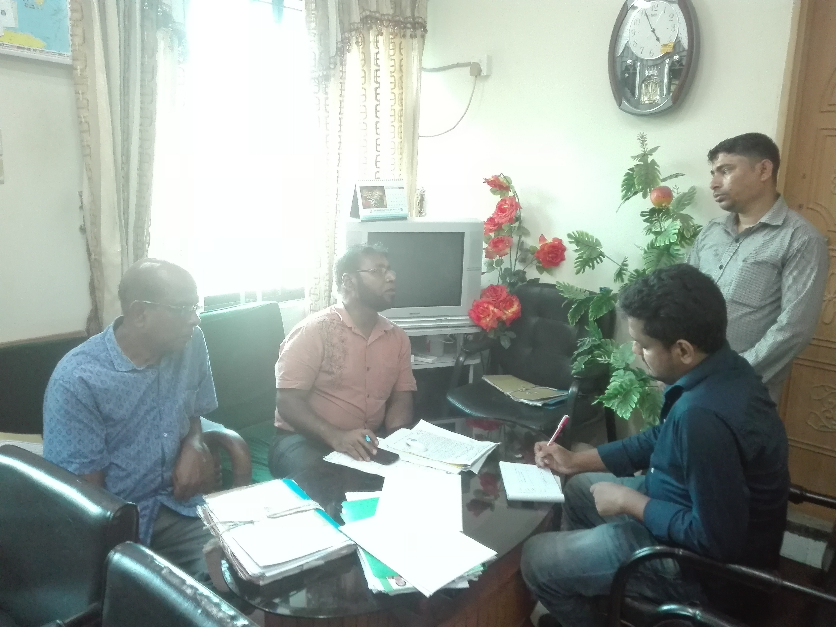
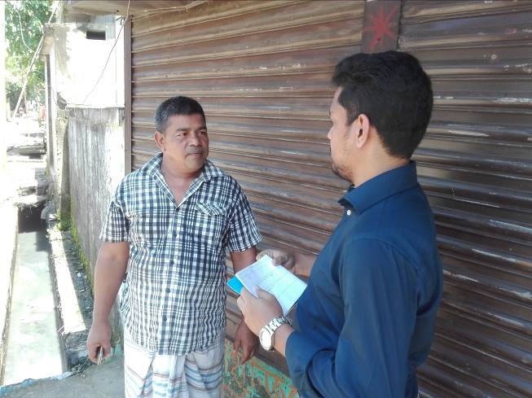
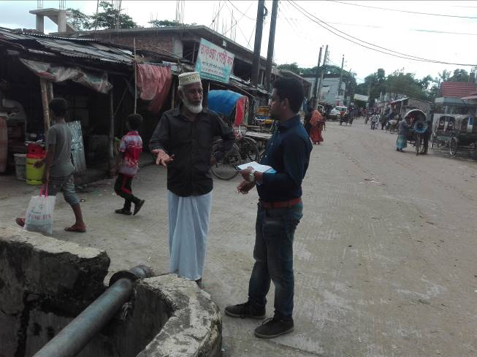
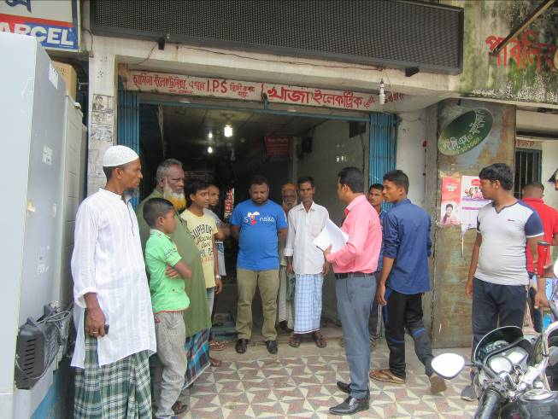

Photographs 7.1.1: Consultation Meeting at City Corporation with City Corporation Officials and at Subproject Site with Local Individuals and Consultants Participants

Issues Raised by the Participants

The participants raised the issues related to the infrastructure development of Sylhet City Corporation. In the CIP and FGD, the participants discussed about the infrastructure requirements for the future development of Sylhet City Corporation.

Feedback, Suggestions, and Recommendations of the Participants

The participants were presented with feedback, suggestions, and recommendations listed below:
- The FGD results confirmed that an improved communication network, drainage facility, solid waste management, water treatment plant and sewerage treatment plant is needed for future development of Sylhet City Corporation;
- The participants stated that public water supply facilities, sanitation facilities, drainage congestion and access road is not adequate;
- The participants stated that construction works should be scheduled properly;
- The participants discussed about the environmental and social issues to be addressed prior to the subproject implementation.
To encourage participation, regular consultations are recommended with beneficiary communities to share subproject related information and to provide a feedback mechanism for these communities to voice their concerns and issues in all stages of the subproject. The DSM consultants and PMU, LGED will be responsible to carry out continued consultation with and information dissemination to the key stakeholders.

Conclusions and Recommendations

From the study, it is revealed that the anticipated impacts on physicochemical components and socio-economic environment are not significant. Most of the individual elements of the subproject involve simple construction and operation, so impacts will be mainly localized and limited within the subproject boundary. Most of the predicted impacts are associated with the construction process which is invasive. Hence, the impacts are largely manageable through mitigation measures. Mitigation will be assured by a program of environmental monitoring to ensure that all measures are implemented, and will determine whether the environment is protected. It will include observations on and off-site, document checks and interviews with workers and beneficiaries. Any requirements for corrective action will be reported to the PMU, LGED and WB.
This study formulates well structured EMP. This EMP will assist City Corporation Officials, PMU-LGED, contractor and DSM personnel in mitigating the environmental impacts, and guide them in the environmentally sound execution of the proposed subproject. A copy of the EMP shall be kept on-site during the construction period at all times. The EMP shall be made binding on contractor operating the site, and will be included in the contractual clauses.
It should be noted that environmental assessment report is a live document. Hence, due to changing circumstances during the construction phase if any, there might be minor adaptation needed for environmental, health and safety issues.

REFERENCES

- Sylhet City Corporation Website

GoB (1997), Environmental Conservation Rules 1997.

Environmental Assessment Volume 1: Overall Environmental Assessment [Draft Final Report], September 2013. Municipal Governance and Services Project (MGSP), Local Government Engineering Department (LGED) and Bangladesh Municipal Development Fund (BMDF), Ministry of Local Government, Rural Development and Cooperatives, Government of the People's Republic of Bangladesh.

Environmental Assessment Volume 2: Environmental Management Framework (EMF) [Draft Final Report], September 2013. Municipal Governance and Services Project (MGSP), Local Government Engineering Department (LGED) and Bangladesh Municipal Development Fund (BMDF), Ministry of Local Government, Rural Development and Cooperatives, Government of the People's Republic of Bangladesh.

Geological Survey of Bangladesh, 1978. Earthquake Zoning Map.

Bangladesh Meteorological Department, Flood Zoning Map.

Population and Housing Census, 2011, National Volume-II: Union Statistics.
- Word Meteorological Organization (WMO)

APPENDIX

Appendix- I: Environmental Monitoring Checklist

