INTRODUCTION

Subproject Background

Trishal Pourashava is located in the core of Trishal Upazila under Mymensingh District. Trishal Pourashava was established in the year of 1998. Currently, Trishal is A type Pourashava. It has an area of 15.49 sq.km. The present population of Trishal Pourashava is about 38,507. The Pourashava has 45 km pucca road and 30 km earthen road. It has 4 km pucca drain and 4 km canal (source: Pourashava website).

In Trishal Pourashava, the current infrastructure situation is in vulnerable state. Drains are mostly clogged that cannot properly drain out waste water during heavy rains. Natural drainage systems have either been filled up or occupied by land grabbers creating water logging during monsoon. Traffic volume is increasing day by day with the increase in population and demand. The substandard road network cannot cope with the growing demand; consequently, traffic congestion becomes a common problem. Hence, planned development of road and drain network is essential to meet the emergent demand.

This subproject includes the following components: (a) BC and RCC Road with Culverts, Retaining Wall and Street Light; and (b) RCC Drain with footpath at Jatiya Kabi Kazi Nazrul Islam University Road.

The significant features of the subproject are stated below:
Name of the Subproject : | BC and RCC Road with RCC Drain, Culverts, Retaining Wall and Street Lights at Jatiya Kabi Kazi Nazrul Islam University Road
Package No. : | MGSP/TRI/2016-17/W-03
District Name : | Mymensingh
ULB Name : | Trishal Pourashava
Road Side Wards Number : | 01, 02 and 03
Structural Design Option : | BC and RCC Road, RCC Drain, Culvert, Retaining Wall and Street Lights
Wards Population : | About 11,000
Tribal People : | No tribal people settlement found in the subproject area
Land Acquisition : | ULB owned; land acquisition is not required.
Estimated Cost : | 80.41 million BDT
Subproject Duration : | 12 months
Tentative Start Date : | December 09, 2016
Tentative Completion Date: | December 08, 2017

Objectives of the Study

The general objective of this study is to determine the major environmental impacts succeeding from execution of the subproject and to recommend mitigation measures to avoid or reduce adverse environmental impacts and to enhance positive impacts. The specific objectives include:
- To assess the existing environmental conditions of the subproject site and its influence area;
- To identify and assess impacts resulting from the subproject during its construction phase and operation phase;
- To develop a environmental management plan with recommendations for mitigating impacts and enhance positive impacts;
- To summarize environmental monitoring requirements.

Scope and Methodology of the Study

The subproject appraisal is included environmental screening for all the subproject components. According to that screening, no further environmental assessment is required for the street light. Nevertheless, environmental assessment is required to fulfill the regulatory requirement for BC Road, RCC Road, RCC Drain and allied works. Hence, this report is mainly included BC Road, RCC Road, RCC Drain and allied works. However, in the EMP table mitigation measures for street light are also included. The study methodology comprised the following activities:
- Desktop Study;
- Field Investigations and Data Collection;
- Data Analysis and Report Writing.

Desktop Study
The desktop study involved:
- Initial meetings with client, stakeholders to discuss the proposed subproject;
- Collection and review of the baseline data, maps, reports and other relevant information;
- Review of the relevant existing legislation, regulation and policies;
- Understand the anticipated technical processes that may affect the environment.

Field Investigation and Data Collection
A team of the consultants made a field investigation to the proposed site. Field investigations involved mainly site walks within the subproject area and the neighboring areas that may be affected by the subproject. The following key tasks were performed during the field visit:
- Taking photographs of the significant aspects to assist in describing the baseline environmental conditions of the subproject area;
- Interviews with representatives of the relevant Pourashava officials and interested and affected people within the subproject influence zone;
- Verifying information and data collected during the desktop study and to collect new information that may have been important in the assessment of the impacts and design the mitigation measures.

Data Analysis and Report Writing
The data and information collated from all the sources (literature review, secondary and primary data, public consultation) were analyzed to describe the existing environmental setting of the subproject area, to identify the potential positive and negative impacts of the proposed subproject, as well as to provide preliminary suggestions for mitigation measures. Finally, this environmental assessment report has been prepared.

SUBPROJECT DESCRIPTION

The Study Area

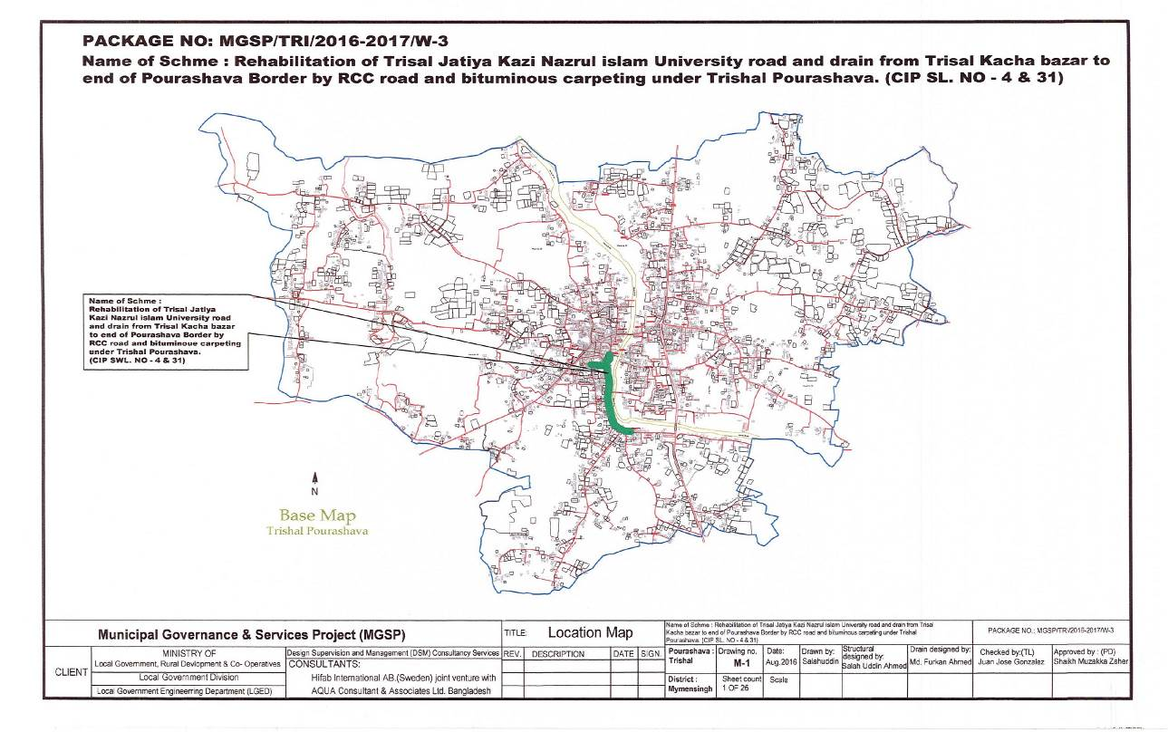
The subproject site is located at Trishal Pourashava within the jurisdiction of ward no 1, 2 and 3. The starting point of Jatiya Kabi Kazi Nazrul Islam University Road is located at 24°34'1.44"N (Latitude) and 90°23'50.04"E (Longitude).The end point of this road is located at 24°35'5.22"N (Latitude) and 91°0'31.09"E (Longitude). The location map and topographic view of this subproject is shown in Figure 2.1.1 and Figure 2.1.2.

Figure 2.1.1: Location Map of the Subproject

Figure 2.1.1: Location Map of the Subproject
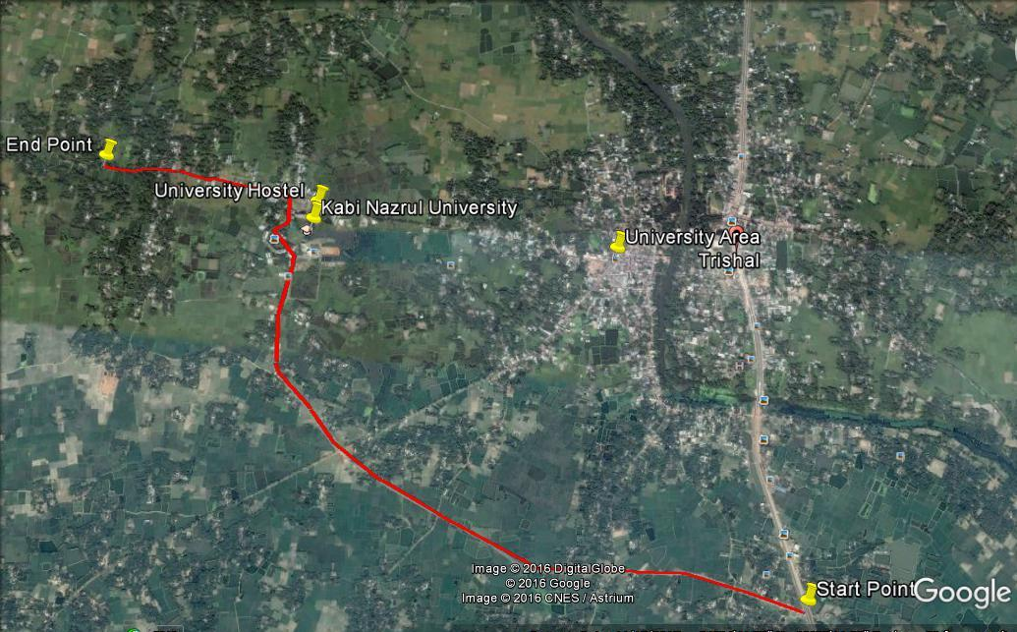

Figure 2.1.2: Topographic View of the Subproject

Current Situation and Need for the Subproject

The major road side built-up infrastructure includes Pourashava Office, shops, kitchen market, Cattle Market, Mosque, Mohila Madrasa, Jatiya Kabi Kazi Nazrul University, residential houses, Kazi Nazrul Institute etc. First portion of the subproject area is commercial area. Second portion of the road goes through the residential area and rest portion is mainly rural area. From Ch. 0 to 260 m and Ch.1400 to 1600m, the existing road is badly damaged. The rest portion of the road is partially damaged. The rough surfaces and pot holes interrupt normal traffic movement. After rainfall, the stagnant water in the pot holes aggravates the road damaged and traffic congestion. In fact, the bituminous carpeting is mostly disappeared in most of the road sections. Consequently, it creates dusty surfaces and generates dust during vehicle movement in the dry season. In addition, the average width of the existing road is 3.66 m which is not adequate to meet the increasing traffic demand. Hence, the damaged road necessitates improvement of the existing bituminous carpeting with widening works.

The existing drainage system does not function as an integrated drainage system. Most of the existing drains, as identified from field visit, remain inoperative due to blockage from disposal of the solid waste into the drains. Hence, the existing drains are inadequate and incapable of drain out the storm runoff generated in the catchment area. Consequently, water logging occurs after heavy rainfall which makes inconvenient to the people. The water congestion also degrades the surrounding environment and causes public health hazards. Therefore, construction of the new drain is essential to improve the water logging problem.

On the contrary, absent of street light hampers the normal traffic operation and pedestrian safety at night. Therefore, fixing of street light is also required for the better traffic management at night. The existing condition of the subproject road is further exhibited in the following Photographs 2.2.1.
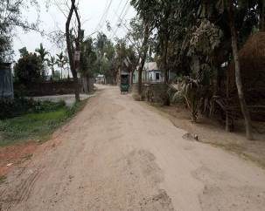
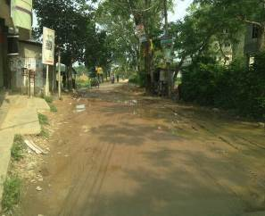

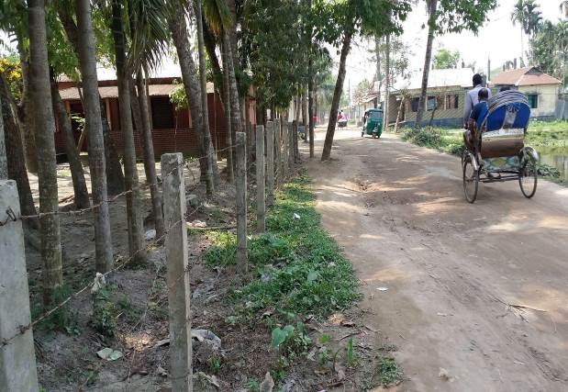
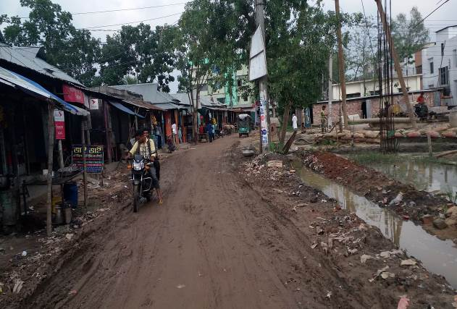

Photographs 2.2.1: Present Situation of the Subproject Road
The existing condition of the culvert is further exhibited in the following Photographs 2.2.2.
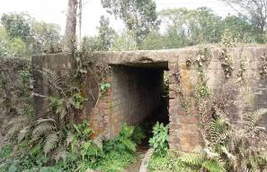
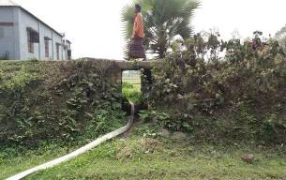

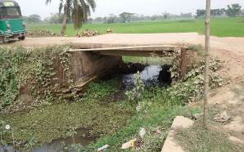
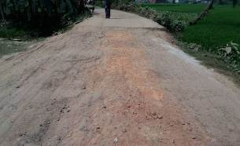

Photographs 2.2.2: Present Situation of the Culverts
The damaged culvert also necessitates construction of the new culverts for safely traffic movement and as well as to divert storm water.
The proposed drain will connect with the existing drain at main road and Sukni Khal which will use as outfall. The drain will be connected with the outfall by cross drain. Sukni Khal is a natural water body and connected with the Sutia River. The current situation of the outfall is further elaborated from the following Photographs 2.2.3.

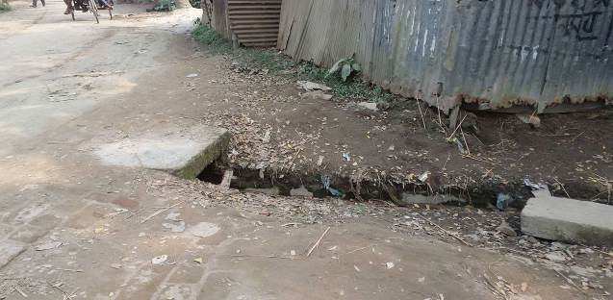
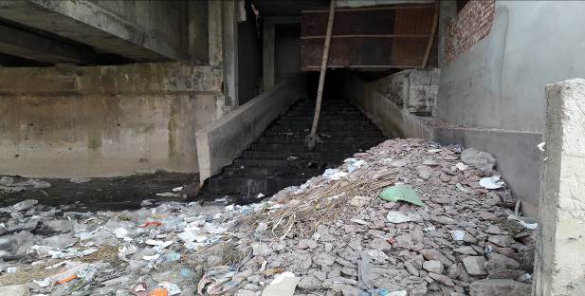

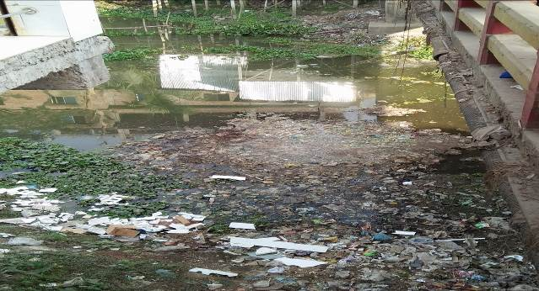
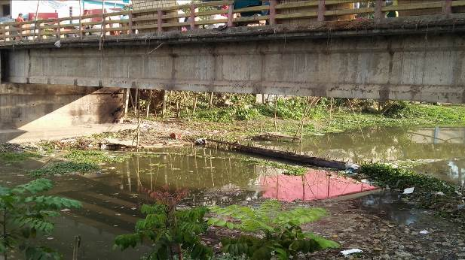

Photographs 2.2.3: Present Situation of the Outfall

Justification of Selection of this Subproject

The Pourashava prepared the priority subprojects list as per CIP. The consultant team has evaluated the site condition of the priority subprojects. After site assessment, the consultant recommended the subproject having low environmental and social negative impacts. The subproject road is owned by Trishal Pourashava. Hence, private land acquisition is not an issue for implementation of this subproject. In addition, the roadside built-up infrastructure will not be severely affected by the implementation of the subproject.
Kabi Kazi Nazrul Islam Road connects major and important areas like bazar and major establishments of the Pourashava area. The proposed road also connects Jatiya Kabi Kazi Nazrul Islam University. Hence, after construction the subproject road has significant positive impacts by providing improved transport facilities. After construction, the proposed drain will reduce water logging problem. On the contrary, after construction the proposed culverts will provide proper drainage of water and smooth traffic operation. In addition, the road protection wall will increase the stability of the road. Furthermore, street lighting also improves the general security and safety for drivers, riders, and pedestrians at night. Hence, considering the expected benefits that will derive, the subproject is selected for implementation.

Envisaged Subproject Activities and Implementation Process
The key activities of the RCC Drain include:
- Construction of Labor shed and semi-pucca site office;
- Relocation of the telephone and electrical poles;
- Dismantle, clearing and grubbing works;
- Earth work in excavation of the foundation;
- Pumping and bailing out of water as per requirement;
- Sand filling for the preparing foundation bed;
- Single layer brick flat soling;
- Plain cement concrete work in foundation;
- Manufacturing CC blocks;
- Fabrication of the ribbed or deformed bar;
- Reinforced cement concrete work.

The key activities for BC road include:

- Dismantling of the damaged sub-base and base course works;
- Clearing and grubbing works;
- Earth work in box cutting;
- Earth filling work;
- Sand filling on the road bed;
- Mechanical compaction;
- Brick on edging;
- WBM base course;
- Providing prime coat;
- Laying pre-mixed dense bituminous surfacing wearing course;
Key activities for RCC Road:
- Clearing and grubbing;
- Earth work in box cutting;
- Preparation of bed by cutting and filling;
- Mechanical compaction of the earth work;
- Sand filling on the road bed;
- Fabrication of the ribbed or deformed bar reinforcement;
- Reinforced cement concrete.

For RCC Retaining Wall and Culvert:

- Clearing and grubbing;
- Earth work in excavation of the foundation;
- Sand filling in foundation trenches;
- Mass concrete work in foundation or floor;
- Fabrication of the ribbed or deformed bar reinforcement
- Reinforced cement concrete work;
- Fabrication of the ribbed or deformed bar reinforcement.
Key activities for Street light:
- Assembling, fitting, fixing, installation, testing and commissioning of the GI pole;
- Erection of tubular pole;
- Earthing the electrical installation;
- Fixing of the wire rack;
- Fixing of the overhead aluminum stranded conductor;
- Providing, fixing and fitting of the water tight street light;
- Fitting and fixing main and sub-main switch with fuse;
- Supplying and fitting 250 volt, 50HZ grade concealed sub-distribution board.

The materials and resources to be used for the key activities: soil in earth work, sand, stone chips, cement, reinforcement, diesel, kerosene, MS sheet, steel shutter, boulders, electricity and water.
The major equipment to be used for the implementation of the subproject: hydraulic excavator, concrete mixer machine, steel cutter, mechanical vibrator machine, mechanical compaction machine, steel drum rollers, pneumatic multiple tire roller, dump truck, water tanker, pump, asphalt plant, rubber tire roller, paver.

Under this subproject, the existing bituminous pavement (from Ch. 260 to 1400 m and Ch. 1600 to 2500 m) will be demolished and replaced by the new BC pavement. The existing bituminous surface will be replaced by RCC pavement at Bazar area (Ch. 0 to 260 m) and Ch.1400-1600. From Ch.0 -75 m, 260-500 m, 1125-1226 m and 1229-1400 m, the proposed RCC drain will be constructed at the left side of the road. From Ch.75 - 115 m, 122-260 m, 1400-1700 m, the proposed drain will be constructed at the both sides of the road. Moreover, two RCC Culverts Size 1*3.00m *2.00m at Ch. 1226-1229m and 1*2.00m *2.00m at Ch. 2029-2031 m will be reconstructed. From Ch. 0 +280m~0+482m, Ch. 0+358~0+383m and Ch. 0+445~0+482m, the road needs road protection work.

Baseline ANALYSIS OF THE ENVIRONMENTAL CONDITION

Physical Environment

Important Environmental and Infrastructural Features

The important environmental features have been identified during the site visit within the influence area of the subproject. Moreover, the conditional survey has been performed for designing the subproject. Hence, the survey data is also used for identification of the major environmental and infrastructural features. The environmental and infrastructural features listed considering the 100 m Chainage from Trishal Kacha Bazarr to End of the Pourashava Border (Chainage 0 to 2500 m) are given in Table 3.1.1
Table 3.1.1: Major Environmental and Infrastructural Features

Chainage (m) | Left | Right | Major Environmental Features
Trishal Kacha Bazar to End of the Pourashava Border (Ch. 00 to 2500m)
0-100 | √ |  | Pourashava Office, electric poles, Trishal Bazar Go-Hat(Cattle Market)
0-100 |  | √ | Kitchen Market, Go-Hata Mosque
100-200 | √ |  | Electric poles, tin-shed shops, trees
100-200 |  | √ | Three Storied Building with Sanchita Coaching Centre and Stationary Shops, Semi-pucca Stationary and Sanitary Shops
200-300 | √ |  | Three storied building with electronic shops and library, semi-pucca shops
200-300 |  | √ | Various semi-pucca shops, trees, electric poles, workshops
300-400 | √ |  | Ponds, trees
300-400 |  | √ | Tin-shed structures, trees, agricultural land, electric poles
400-500 | √ |  | Open place, trees, electric poles, Mosque, boundary wall, semi-pucca houses
400-500 |  | √ | Semi-pucca houses, pond, electric pole, bushes, trees
500-600 | √ |  | Tin-shed houses, bushes, trees
500-600 |  | √ | Two storied and semi-pucca houses, boundary wall, trees
600-700 | √ |  | Ditch, butches, trees, electric pole, semi-pucca houses
600-700 |  | √ | Fence, boundary wall, semi-pucca and tin-shed houses, trees
700-800 | √ |  | Pond, trees, electric pole, houses
700-800 |  | √ | Trees, electric pole, houses
800-900 | √ |  | Open field, trees, electric pole
800-900 |  | √ | Pond, bushes, tin-shed houses, trees
900-1000 | √ |  | Pond, bushes, electric poles
900-1000 |  | √ | Agricultural field, bushes, electric poles
1000-1100 | √ |  | Houses, trees
1000-1100 |  | √ | Pond, shrubs, agricultural field, electric poles
1100-1200 | √ |  | Agricultural land, bushes
1100-1200 |  | √ | Agricultural Land, bushes
1200-1300 | √ |  | Agricultural land, trees, pond, electric pole, bushes
1200-1300 |  | √ | Agricultural Land, trees, bushes
1300-1400 | √ |  | Ponds, trees
1300-1400 |  | √ | Grave yard, trees, open place, tin-shed structure
1400-1500 | √ |  | Houses, open space, trees
1400-1500 |  | √ | Agricultural land, trees
1500-1600 | √ |  | Jatiya Kabi Kazi Nazrul University
1500-1600 |  | √ | Multistoried building, various shops
1600-1700 | √ |  | Jatiya Kabi Kazi Nazrul University Mosque and Area
1600-1700 |  | √ | School, University Area
1700-1800 | √ |  | Various semi-pucca shops
1700-1800 |  | √ | Various semi-pucca shops, trees
1800-1900 | √ |  | Low land, houses, electric poles
1800-1900 |  | √ | Four-storied build, shops, trees
1900-2000 | √ |  | Agricultural Land, trees
1900-2000 |  | √ | Houses, trees, electric poles, agricultural land
2000-2100 | √ |  | Connecting road, open field, trees, bushes
2000-2100 |  | √ | Jannatul Ferdous Mohila Madrasa, trees, electric poles, open field, trees
2100-2200 | √ |  | Trees, open space, bamboo bushes
2100-2200 |  | √ | Semi-pucca structures, trees, electric poles
2200-2300 | √ |  | Trees, boundary wall, electric poles, houses
2200-2300 |  | √ | Connecting road towards Nazrul Institute, open space, trees, tin-shed structures
2300-2400 | √ |  | Trees, ditch, bamboo bushes
2300-2400 |  | √ | Trees, pond, electric poles, bushes
2400-2500 | √ |  | Low land, trees, bushes
2400-2500 |  | √ | Low land, trees, houses, electric poles

Geology, Topography and Soils

Topographically, Trishal Pourashava is a plain land. The plain land mainly consists of fluvio-deltaic sediments deposited by the Ganges, the Brahmaputra and the Meghna River Systems. Geomorphologically, Trishal Pourashava falls under the Floodplains of the Old Brahmaputra and Jamuna Rivers having distinguishing character. Surface geology is consisted of sedimentary rocks originated by riverine processes. Eleven general soil types exist in the area of which deep red brown terrace, shallow red brown terrace soils and Acid Basin Clays are the major ones. They are strongly acidic in reaction with low status of organic matter, low moisture holding capacity and low fertility level.

Climate and Meteorology

The climate of the subproject area can be described as Tropical Monsoon. It is characterized by warm, humid summers and cool, dry winters. From November to March, it is dry and cool while from April to May it is extremely hot during the pre-monsoon season. From June to October, the monsoon season is warm, cloudy, and wet. The warmest month is April, the coolest is January, the wettest is July and the driest is January.

The minimum temperature was 10.8°C in 2011 and maximum temperature was 34.2°C in 2008. The minimum humidity was 66.3% in 2010 and the maximum humidity was 80 % in 2009. The peak rainfall months in Trishal are June, and July. About 90% of the total annual rainfall occurs in the period from May to October. The highest annual rainfall during the last four years (2008–11) was 2235 mm in 2008, and the lowest was 1653 mm in 2009.

According to the statistics of wind data from the Bangladesh Meteorological Department Climate Division, wind direction changes by month. Nevertheless, the northwest, south, and northeast winds are predominant. The average wind speed as recorded at Mymensingh Met Station is in the range of 2 – 7.8 knots/ hr. But in the winter months it remains in the range of 1-4.5 knots/hour. Table 3.1.2 shows the key meteorological data from 2008 to 2011.

Table 3.1.2: Temperature, rainfall, humidity during 2008-2011
Years | Temperature(centigrade) |  | Rainfall (millimeter) | Humidity (%)
Years | Maximum | Minimum | Rainfall (millimeter) | Humidity (%)
2008 | 34.2 | 12.5 | 2235 | 79.0
2009 | 33.0 | 13.2 | 1653 | 80.0
2010 | 32.4 | 11.7 | 1811 | 66.3
2011 | 32.2 | 10.8 | 2153 | 79.3
The construction works can be influenced by the climatic condition and meteorological components like humidity, temperature, sudden rainfall, and wind speed. High winds can enhance quick spreading of the generated dust. It is very risky working under rain and in high winds because the possibility of getting injury increases. Furthermore, work under high temperature and excess humidity may create health hazards like dehydration problem.

Water Resources (Surface Water, Ground Water and Rain Water Harvesting)

Sukni Khal passes through the subproject area which connects with the Sutia River. There are some other water bodies like ponds and ditches are present in the subproject area.

Ground water is available in plenty and water table does not go beyond suction limit throughout the year. The water of shallow layer contains lot of iron, while water of deep layer does not contain excessive iron. Arsenic concentration is not reported as higher level in both deep and shallow aquifer. Local people typically use deep tube-well water for drinking and other domestic purposes. Salinity problems are not visible. Rain water harvesting system is not common in and around the subproject area.

During construction period, water will be used both for the construction work and domestic purposes. Therefore, ensuring the water requirements is one of the key issues.

Flooding, Water Logging and Drainage Pattern
Trishal Pourashava is free from external flooding. However, Trishal Pourashava is subjected to internal water logging problem due to delay discharge of the storm water during monsoon season. Flooding in the monsoon season normally starts from June to October. As per flood zoning map, Trishal Pourashava falls under normal flood zone.
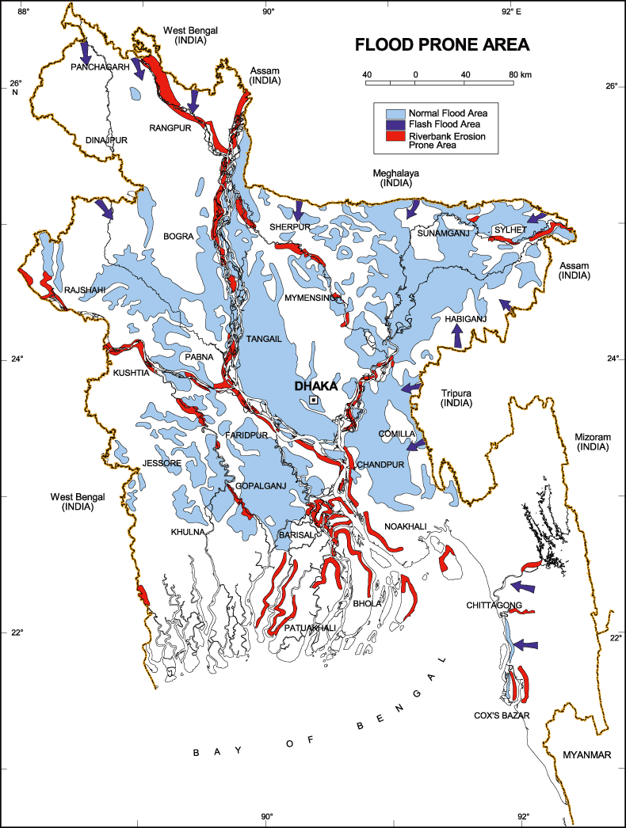

The black circle denotes the Trishal Pourashava area

Figure 3.1.1: Location of Trishal in Flood zone Map of Bangladesh
Erosion

Erosion of land surface is already causing a problem for Trishal. The erosion plays an important role in the siltation process. The River Sutia is passing through Trishal Pourashava. Suknai Khal is also passing through the subproject area. Usually, there is no strong current in the River Sutia and Sukni Khal; as such there is no erosion in the Pourashava. However, sudden heavy rainfall increases the surface erosion of land.
Seismic Effects
According to BNBC (1993), Bangladesh has three seismic zones with moderate and low seismic activity. From source GSB, the Trishal Pourashava area falls in Zone I, i.e. high intensity seismic zone of the country.
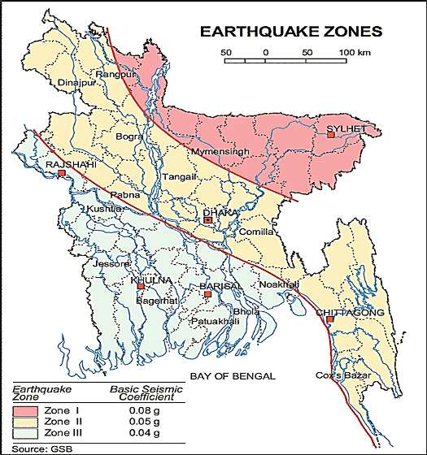

The green circle denotes the subproject area

Figure 3.1.2: Earthquake zones of Bangladesh (Source: GSB)

Air Quality and Dust
Ambient air quality data have not been found. The subproject road generates dust during movement of the vehicles during dry season. The windblown dust also causes air pollution. Due to rapid urbanization of Trishal Pourashava the total number of motorized vehicles including bus, truck, tempo, three-wheeler has been increased. These motorized vehicles are old and poorly maintained. Consequently, black smoke emission from the vehicles degrades the quality of the air. Improper disposal of the solid wastes from Trishal Bazar Go-Hat and household wastes to open land and ditches allows spreading of objectionable bad odor in air. There are no remarkable sources of the air pollution such as heavy and small industries in the subproject area. There is no brick field observed in the subproject area during site visit.

Noise Level

Noise is not a major impediment for the quality of the environment in the subproject area. The motorized and non-motorized vehicles such as rickshaws, trolleys, pick-up, motor cycles, mini trucks, and private cars etc. produce noise. However, they are within the tolerable limits in most cases. There are no other perceptible sources of noise generation such as heavy factories or industries in the subproject area.
Solid Waste Management
The local people normally dump their solid wastes in the road side drains, open space or roads adjacent to their houses, low lying areas, in khals and ditches. Therefore, improper solid waste disposal by the community people creates severe public health hazards and degrading the quality of living environment. Currently, the vacant place near Naodhar Lake beside Dhaka-Mymensingh Highway is used as a Pourashava designated dumping site. Basically, it is not structured solid waste management system in this area.

Biotic Environment
Flora and Fauna
In the subproject area, the floral species includes: Coconut, Betel Nut, Koroi, Mango, Jackfruit, Banana, Amra, Date and Palm.

The common local birds such as Doel, Shalik, Kite, Owl, Crow, Tuntuni, Bulbuli, and Cuckoo were found during the site visit. There are no wild animals and endangered faunal species in the subproject area.

Socio-economic and Socio-cultural Environment

Land Use, Status of Housing and Built-up Infrastructure

From Ch. 0 to 260 m, the subproject road goes through bazar and commercial area. Second portion of the subproject road goes through the residential area. There are Pourashava Office, shops, kitchen market, Go-Hat, Mosque, Mohila Madrasa, Jatiya Kabi Kazi Nazrul University, residential houses, Kazi Nazrul Institute etc are major road side built-up infrastructure. The last portion of the subproject road goes through rural area. Agricultural activity was found there during site visit. There is no industrial activity in the subproject area.

Beneficiary Population

This drain goes through the wards number 01, 02 and 03. As per information by the municipality, considering the wards’ population about 11,000 people will benefit directly and many others indirectly.

Education

In the Pourashava area, literacy among the population is about 61.0%. This is higher than the national average (51.8%). The literacy rate among males (62.4%) is more than females (59.6%). (Ref: Population and Housing Census 2011).

Tribal Communities

There is no indigenous or tribal settlement in the subproject area. Therefore, there are no measures needed for indigenous peoples’ safeguard.

Land Acquisition and Resettlement

The Pourashava is the owner of the land. Hence, land acquisition is not required. For site clearing, few road side structures such as fencing, boundary wall, and tin-shed shops will be removed. The Pourashava will clear the site by amicable understanding with the owners of these structures. However, in case of any objection from the affected person, the DSM will investigate the actual situation. Then, measures will be taken as per guidelines.
Principal Livelihoods and Economic Activities
The subproject area is now inhabited by the mixed occupational people. Most of the people are engaged in the traditional professional activities relate to agriculture, land ownership, small business. Presently, some people are engaged in private sector and government jobs in the town.
Cultural Heritage and Protected Areas
Except Kabi Nazrul Institute and Kabi Nazrul University, there are no protected areas and no important cultural or historical sites identified in the subproject area.
Social Conflicts and Development Activities
The local people welcome the subproject and there is no visible conflict between the local communities regarding the subproject implementation.

ENVIRONMENTAL SCREENING

Environmental Screening (ES) for the subproject have been conducted with the purpose of fulfilling the requirements of Government (GOB) and World Bank (WB) for the preparation of subproject appraisal. ES ensures that environmental issues are properly identified in terms of the extent of the impacts. The field visits for preparing the Environmental Screening were carried out on April 30, May 10 and August 10, 2016 in the subproject area. Environmental Screening Checklist, as adopted in Appendix C of the Environmental Management Framework (EMF) of the MGSP, was administered for identifying the impacts and their extents.
The screening data and information for the RCC Road, BC Road, RCC Culverts and Road Protection Work have been formulated and are shown in below.
1) Potential Environmental Impact during Construction Phase:
(a) Ecological Impacts:
250
- Felling of the trees Significant □√ Moderate □ Minor □ Number of trees
- Clearing of the vegetation Significant □ Moderate □√ Minor □
- Potential impact on species of
aquatic (i.e., water) environment Significant □ Moderate □ Minor □√
The overall ecological impact is significant due to fell down of the trees and clearing of the road side bushes.
- Physicochemical Impacts:
- Noise pollution Significant □ Moderate □√ Insignificant □
- Air pollution Significant □ Moderate □√ Insignificant □
- Drainage congestion Very likely □ Likely □ Unlikely □√
- Water pollution Significant □ Moderate □√ Insignificant □
- Pollution from solid/ construction wastes Significant □ Moderate □√ Insignificant □
- Water logging Significant □ Moderate □ Insignificant □√

The subproject has localized and temporarily negative impact on noise, dust, and black smoke from asphalt plants and subproject vehicles. No adverse impact on the topography, climate, soils, regional hydrology and water quality is anticipated.
- Socio-economic Impacts:

- Traffic congestion Very likely □ Likely □√ Unlikely □
- Health and safety Significant □ Moderate □√ Insignificant □
- Impact on archaeological and historical Significant □ Moderate □ Insignificant □√
- Employment generation Significant □ Moderate □√ Insignificant □

The subproject has localized temporarily negative impact in traffic congestion, health and safety during construction. However, it has positive impact on the generation of the employment.
2) Potential Environmental Impact during Operational Phase:
(d) Ecological Impacts:
- Potential impact on species of the aquatic (i.e., water) environment Significant □ Moderate □ Minor □√
(e) Physicochemical Impacts:
- Potential air quality and noise level Improvement □ No-improvement □ Deterioration□√
- Drainage congestion Improvement □√ Minor Improvement □ No Impact □
- Risk of water pollution Significant □ Moderate □ Minor □√
- Pollution from solid waste Improvement □ No-improvement □ Minor □√

Increased vehicles from improved road will deteriorate the air quality and noise level in the subproject area.
(f) Socio-economic Impacts:
- Traffic Improvement □√ No-improvement □ Adverse □
- Safety Improvement □√ No-improvement □ Adverse □
- Employment generation Significant □ Moderate □ Minor □ √

The road will be a part of the Pourashava Road Network System. Hence, the quality of the Road Network will be improved.
The screening data and information for the Drain have been formulated and are shown in below.
3) Potential Environmental Impact during Construction Phase:
- Ecological Impacts:
The subproject site will be cleared prior to the construction work to be started. The drain will be constructed at the similar road. Hence, ecological impact has already been assessing in the road component. Therefore, a separate ecological impact for the drain component is not necessary.
- Physicochemical Impacts:

- Noise pollution Significant □ Moderate □√ Insignificant □
- Air pollution Significant □ Moderate □√ Insignificant □
- Drainage congestion Very likely □ Likely □ Unlikely □√
- Water pollution Significant □ Moderate □ Insignificant □√
- Pollution from solid/ construction wastes Significant□ Moderate □√ Insignificant □
- Water logging Significant □ Moderate □ Insignificant □√

The subproject has localized and temporarily negative impact on noise, dust, and black smoke from concrete mixer machine, vibrator machine and subproject vehicles. No adverse impact on the topography, climate, soils, regional hydrology and water quality is anticipated.
- Socio-economic Impacts:

- Traffic congestion Very likely □ Likely □√ Unlikely □
- Health and safety Significant □ Moderate □√ Insignificant □
- Impact on archaeological and historical Significant □ Moderate □ Insignificant □√
- Employment generation Significant □ Moderate □√ Insignificant □

The subproject has localized temporarily negative impact in traffic congestion, health and safety during construction. However, it has positive impact on the generation of the employment.
4) Potential Environmental Impact during Operational Phase:
- Ecological Impacts:

- Potential impact on species of aquatic Significant □ Moderate □√ Minor □
(i.e., water) environment
The waste water to be discharged may degrade the aquatic environment of the outfall if the waste water carries pollutants.
- Physicochemical Impacts:

- Potential air quality Improvement □√ No-improvement □ Deterioration □
- Potential noise level Improvement □ No-improvement □ No Impact □√
- Drainage congestion Improvement □√ No- Improvement □ No Impact □
- Risk of Water pollution Significant □ Moderate□√ Minor □
- Pollution from solid waste Improvement □√ No-improvement □ Insignificant □

The new drain will reduce water congestion and reduce bad odor. Consequently, it will improve better environment.

- Socio-economic Impacts:

- Traffic Improvement □√ No-improvement □ Adverse □
- Safety Improvement □√ No-improvement □ Adverse □
- Employment generation Significant □ Moderate □ Minor □√

The subproject has considerable positive impact by reducing drainage congestion and by providing better environment.
Summary of Possible Environmental Impacts of the Subproject
From the above study, it seems that there is no adverse impact on the environment due to the subproject implementation. The overall ecological impact is significant due to fell down of the trees and clearing of the road side bushes. Hence, measures will be taken to compensate the ecological imbalance to be caused due to the subproject implementation. The subproject will have no adverse impacts on the physico-chemical parameters. In fact, the impacts are site specific and limited within the subproject boundary. However, mitigation measures will be formulated to minimize the adverse impacts and to enhance the positive impacts.
The drain is designed for storm water only. There is no provision for household toilets connection to the drain. During operation phase, the Pourashava is responsible to avoid any illegal household toilets connection to the drain. If the drainage water carried pollutants that come from any sources, it may affect the aquatic environment of the Sukni Khal and Sutia River. Safety concern and proper disposal of the generated wastes materials are important issue for the construction phase. Hence, these issues should consider properly. The subproject will have positive impacts in terms of the generation of the employment and business activities.

Specific impact, mitigation, AND enhancement measures

This subproject includes construction of 2.5 km Jatiya Kabi Kazi Nazrul Islam BC and RCC Road including RCC drain, culvert, retaining wall and street light. The possible impacts are mainly caused by the key activities to be performed for the implementation of the subproject, raw materials and equipment to be needed for execution of the subproject activities. This section describes some specific impacts due to the subproject activities and their mitigation measures.

Dismantle Work, Excavation Work and Earth Work

The road improvement work includes dismantle of existing bituminous pavement, clearing of the wastes materials due to dismantle work, earth excavation and earth filling work. The drain construction work consists of earth excavation, earth filling, back filling and cutting and removal of the unsuitable materials. Construction of culverts, retaining wall and allied works also includes earth excavation, earth filling and clearing of the unsuitable materials. These works lead dust blowing, improper disposal of the wastes, noise and vibration which may disturb the local people.

Mitigation
- Proper care will be taken by the contractor during dismantle work, excavation work, earth work and disposal work to avoid any undue disturbances to the nearby people;
- Avoid loss of the topsoil for the earth filling work;
- Cover the exposed earth works with much fabric;
- Disposal of soil and construction wastes at the designated dump site at vacant place near Naodhar beside Dhaka-Mymensingh Highway.

Tree Plantation

The subproject has adverse impacts on the ecological components due to felled down of the 250 numbers of trees and clearing of the roadside vegetation and bushes.
Mitigation

- 1362 nos. of trees will be planted to compensate the ecological imbalance to be caused due to felled down of the trees;
- Tree plantation at both sides of the BC road (Ch. 260 to 1400 m and Ch.1600 m to 2500 m )-Debdaru, Shal, Akashi, Gamari, Bokaine, or any kinds of the local fruits and flowers are recommended. Planting trees will enhance the ecological balance of the subproject area after their successful growth.

Pollution from the Construction Materials
Dumping of the construction spoils, including accidental leakage of the oil, grease, and fuel in equipment yards is a significant hazard. Both surface and groundwater might be polluted from these contaminants. Air pollution and dust may affect the nearby settlement which is generated from fine aggregate particles and vehicles.
Mitigation
- Safe transport, storage, and disposal provisions for the construction materials, and the equipment have to be carried out in order to avoid the accidental spillage and loss;
- Maintain adequate moisture content of soil and sand during transportation, compaction and handling;
- Carry the materials especially loose soil and sand with adequate cover;
- Fuels, lubricants, and other hazardous materials should store over raised platforms and not directly on the ground;
- Disposal of soil and construction wastes at the designated dump site at vacant place near Naodhar beside Dhaka-Mymensingh Highway;
- The playgrounds of the educational institutions should not use as a stockyard or work campsite.

Air Quality and Dust
During the construction phase, air pollutants will be emitted from the equipment and construction vehicles are expected to remain low. Local residents in the vicinity of the work sites will be temporarily disturbed by the limited dust pollution. The overall impacts, however, are expected to remain low.
Mitigation
- When dust is visible water should be sprayed to control the dust;
- Maintain adequate moisture content of soil and sand for transportation, compaction, bed preparation, backfilling and handling;
- Avoid use of dust generating equipment which produce significant amount of particulate matter far from the local residents;
- Ensure that all project vehicles are in good operating condition.

Noise and Vibration
Noise and vibration caused by the equipment and movement of the construction vehicles may temporarily disturb nearby people. In this subproject, sensitive areas like roadside shops, markets, residents and educational institutes to be affected from the roadside noise, though the impacts are anticipated to be limited.
Mitigation
- Transportation of the construction materials have to be carried during the scheduled times, and mainly during the day;
- If needed, all powered mechanical equipment and machineries will be fitted with noise abating gear such as mufflers for effective sound reduction.

Water Quality
The water quality may deteriorate if the construction materials, sand, construction wastes, effluent from the work camps, and food wastes are dumped in the roadside ditches, pond and in the Sukni Khal and Sutia River.
Mitigation
- Proper construction management including waste management as well as training of the operators and other workers should provide to avoid pollution of the water bodies;
- Construction waste will dispose properly (not in water bodies or lowland), for which contractor will be responsible.
- Construction waste will dispose properly at the designated dumping site at vacant place near Naodhar beside Dhaka-Mymensingh Highway (not in the water bodies or lowland), for which contractor will be responsible.

Occupational Health and Safety

The most important risks associated with the construction activities are listed below:
- Exposure to the sunlight- workers are being exposed to the sun for long hours;
- Exposure to the high temperature, and humidity for a long time resulting in dehydration;
- Contact with the hazardous substances and wastes pose risks of the infections and diseases;
- Risk of the poor air quality due to dust;
- Risk of the collision (traffic);
- Risks from the head loads for carrying materials;
- Risks of using of the machinery in motion such as rod cutter;
- Risk associated to the sudden bad weather working conditions;
- Risk associated due to haphazard work by the workers.
General Requirements for the Workers’ Health and Safety
The key salient features of the general requirements for the workers’ health and safety stated are presented in Table 5.7.1.
Table 5.7.1: General Requirements for the Workers Health and Safety
Issues | Requirements
Health and Hygiene | - Cleanliness at the site premises and workers living places and at the Labor Sheds;  - Arrangement of the proper ventilation and temperature at the Labor Sheds;  - Protection against dust and furnace by using of the nose masks and covering of the head and body;  - Proper disposal of the wastes and effluents;  - Provision of the adequate latrines and separate toilets for the women;  - Sufficient dustbins for the solid waste management system.
Safety and First Aid Box | - Using of the personal protective equipment (helmet, gloves, goggles, nose mask, safety boots);  - Precautions during work on or near machineries in motion;  - Head loads are prohibited;  - First aid facilities should be provided and maintained;  - Ensure first aid box with the necessary medicine at the labor shed;  - The first aid kit should include adhesive bandages, regular strength pain medication, gauze, and low grade disinfectant.
Compensation for Accidents at Work | - Contractors will bear medical treatment costs. If any severe accidents such as loss of hands, legs or loss of working ability or any case of death needs compensation-(the amount of the compensation should be fixed considering the type of accidents).
Dust and Fumes | - For any dust, fumes, or other impurities likely to be injurious to the workers, effective measures shall be taken to prevent their accumulation and its inhalation by the workers.
Overcrowding | - No labor room should be overcrowded.
Latrines and Urinals | - Sufficient latrines shall be provided;  - Latrines shall be maintained in clean and sanitary condition;  - Latrines shall be adequately lighted and ventilated.
Disposal of Wastes and Effluents | - Proper disposal system for the solid waste and effluent is required;  - Waste bins must be provided by the contractor at labor shed.

Impacts on Social Environment and Common Property Resources
Through comprehensive study, it is revealed that impacts are expected not to be severe and to be largely manageable. The following Table 5.8.1 describes impacts on socio-economic environment and common property resources.
Table 5.8.1: Impacts on Social Environment and Common Property Resources
Social Components | Impacts on IECs | Impact Significance
Community Perception | The local community people welcome this subproject and there is no visible objection from them. | Significant (+ve)
Employment and Business Opportunity | Community feels happy because generally the local contractor will be engaged for the construction works which will create work opportunity for the skilled and non-skilled labor. The subproject will create business opportunity for the equipment and materials suppliers’. | Significant (+ve)
Community Order and Security | This subproject activity does not create any severe security problems to the local community and community people. | Minor  (-ve)
Possible damage to existing infrastructure and facilities | Degradation of the existing road infrastructure by the construction equipment/vehicles used in this subproject. | Minor  (-ve)
New infrastructure and facilities | Construction of new drain will enhance municipality infrastructure facilities. | Moderate  (+ve)
Labor Habitat | Most of the labors will stay at the Labor shed which will have impacts on the environment relates to the generation of the solid wastes, effluent, and water consumption. | Moderate  (-ve)
Health Care | Workers may suffer from the dehydration problems, respiratory problem, and other health hazards. | Minor  (-ve)
Accident | In case of road accidents by the vehicles to be used for the transportation may have serious negative impact. | Significant  (-ve)

Specific Measures and Guidelines for the Key Social Issues
The primary objective of these guidelines is to ensure social compliances and requirements required for the subproject. The social guidelines required for the subproject as appeared in this report are given in below.
- Conduct dissemination with details about the subproject to the local community;
- Continue liaison with the community leaders in order to maintain the community support;
- Engage local contractor and local people for the positive perception of the local community;
- Avoid peak hours for transportation of the equipment and construction materials to avoid any undue disturbance to the roadside people;
- Ensure no child workers (less than 18 years) and aged worker (more than 65 years);
- Ensure no discrimination between the male and female in terms of the wages and getting work opportunity;
- Ensure regular payment to the workers;
- Consult with the workers for feeling of any health problems and take measures accordingly;
- Monitor the workers movement for avoiding any unexpected social activities (robbery, crime, political attachment and conflicts, taking drugs);
- Monitor contractor behavior and attitude to the workers.

Environmental Management Plan (EMP)

The purpose of the Environmental Management Plan (EMP) is to ensure that the activities are undertaken in a responsible and non-detrimental manner. The EMP will guide the environmentally sound construction of the subproject and ensure efficient lines of communication between the PMU (LGED), Trishal Pourashava, DSM, and the contractors.

Access to Information
The environmental assessment report should be translated into Bengali and disseminated locally. The copies of the report (both in English and Bengali) will be sent to all the concerned personnel responsible for subproject implementation. It will also be made available to the public. The final assessment report will also be uploaded in the LGED website and the World Bank website after approval.

Grievance Redress Mechanism
The project-specific Grievance Redress Mechanism (GRM) has been established at Trishal Pourashava to receive, evaluate, and facilitate the solution of APs concerns, complaints, and grievances concerning the social and environmental performance of the subproject. The GRM aimed to provide a time-bound and transparent mechanism to voice and resolve social and environmental concerns linked to the subproject.
The grievance mechanism is related to the risks and adverse impacts of the subproject. It addresses APs’ concerns and complaints promptly, using an understandable and transparent process that is also gender responsive, and culturally appropriate. It should be readily accessible to all segments of the affected people at no costs and without retribution. The mechanism should not impede access to the country’s judicial or administrative remedies. The affected people will be appropriately informed about the mechanism.
LGED has its own Grievance Redress Procedure (GRP), which it operates to address any dissatisfaction and complaints by the local people regarding its activities. This procedure is being applied to address any complaints or grievances through negotiations with the community leaders and representatives of the APs during implementation of the MGSP.

6.2.1 Grievance Redress Committee (GRC)
The discussions and negotiations will be conducted by the Project Implementation Unit (PIU), and will be involved the APs and Grievance Redress Committee (GRC) headed by the Pourashava Mayor. With the facilitation of DSM, the Pourashava Mayor nominated the GRC members and included representative from govt. agencies, local NGO, and Civil Society. The GRC has been formed and established at Trishal Pourashava. A complaints box will be provided in the Pourashava Office. The grievance response focal point is available at Pourashava Office for instant response to an aggrieved person. The Focal Point will collected written complaints or suggestions from the box, and produces them to the GRC for hearing and resolution. The GRC members are as follows:
Table 6.2.1.1: List of GRC Committee Members
No. | GRC Member Name | GRC Designation | Self-Position
1 | Md. A.B.M Anisuzzaman | Chairman | Mayor, Trishal Pourashava
2 | Subbroto Tarafdar | Member Secretary | Executive Engineer, Trishal  Pourashava
3 | Md. Mozaharul Haque | Member | Upazila Project Implementation  officer, Trishal Pourashava
4 | Md. Rafiqul Islam | Member | Head Teacher, Trishal Nazrul Girls High School. Trishal, Mymensingh
5 | Md. Zahirul Islam | Member | Executive Director, Sheba, Trishal Pourashava
6 | ANM Shova Mia Akonda | Member | Civil Society Representative
7 | Female Ward Councilor | Member | Related Female Ward Councilor (Reserved Seat)
8 | Ward Councilor | Member | Related Ward Councilor
9 | Md. Nazrul Islam | Focal Point | Secretary Trishal Pourashava

6.2.2 Grievance Resolution Process
All complaints and suggestions will be received formally in the Trishal Pourashava Office by the GRC Member Secretary. A sample Grievance Redress Form has been prepared and sent to Trishal Pourashava prior to the implementation of the subproject.
An intake register will be maintained at the office of the Member Secretary. Member Secretary will record the details of the grievances in the intake register for documentation and ensure impartiality, fairness, and transparency. The intake register will have data and information columns including (i) Case no., (ii) Date of receipt, (iii) name, type of complaint, grievance, (iv) father’s name, husband’s name, (v) sex, (vi) complete address of the person raising the complaint, grievance, (vii) main objection (loss of land, property, or entitlement), (viii) detailed complaint story, (ix) expectation with documentary evidence and previous records of similar grievances, etc.
No GRC members are allowed to contact the aggrieved persons in advance. Rather, the concerned persons are informed to attend the formal hearings at an appointed date. The GRC committee will sit for hearing the complaints of the aggrieved persons. The GRC will record salient points presented by the aggrieved person and will examine documentary evidence submitted during informal hearings. A resolution register will be maintained by the Member Secretary at the Pourashava Office. The resolution register will contain (i) serial no., (ii) case no., (iii) name of complaint, (iv) complaint story and expectation, (v) date of hearing, (vi) date of field investigation (if any), (vii) results of hearing and field investigation, (viii) decision of GRC, (ix) progress (pending, solved) and (x) agreement or commitments. Closing register will keep records such as, (i) serial no., (ii) case no., (iii) name of complaint, (iv) decision and response to complaints, (v) mode and medium of communication, (vi) date of closing, (vi) confirmation of complainant’s satisfaction, and (vii) management actions to avoid recurrence.
The GRC will decide within 30 days of receiving a complaint. There will also be an appeals procedure where, if a person is dissatisfied with the ruling of the GRC, he or she or a representative may attend their next meeting to present the case again. The committee will then reconsider the case in private, after which their decision is final. If the appellant is still not satisfied, he or she has the right to take the case to the public courts. LGED and Trishal Pourashava should also publish the outcome of cases on public notice boards. All costs involved in resolving the complaints (meetings, consultations, communication, and information dissemination) will be borne by the Trishal Pourashava.
Based on consensus, this procedure will help to resolve issues or conflicts amicably and quickly, saving the aggrieved persons from having to resort to expensive, time consuming legal action. The procedure will however, not pre-empt a person’s right to go to the courts of law.

Institutional Arrangement for Safeguard Compliance
In the institutional arrangement procedure, Project Director, and Team Leader/Deputy Team Leader will directly involve. The PD, TL/DTL would be supported by DSM Environmental Safeguard Specialist and Social Management Expert. The Pourashava Officials, especially engineers, would be responsible for supporting the construction supervision as well as environment and social management with the facilitation of the DSM consultants. The civil works contractors will implement the environmental mitigation measures.
The PMU, with the facilitation of Environmental Safeguard Specialist and social Management Specialist, will submit the monthly and quarterly progress reports on Environmental and Social Compliances to World Bank.

PD-MGSP
TL/DTL-DSM
Environmental Safeguard Specialist-DSM
Social Management Specialist-DSM
Senior Municipal Engineer-DSM
Junior Environmental Specialist-DSM
Assistant Municipal Engineer-DSM
Social Management Officer-DSM
Pourashava
Engineer
Contractor
Figure 6.3.1: Environmental and Social Management Team (Tentative)

Capacity Building
A demonstration training program has already been conducted by PMU and DSM Consultants at Comilla City Corporation on 16 May 2016. Similar capacity building workshop will also be conducted in the other Pourashava of Narayanganj zone to develop the capability of the PMU, Pourashava Officials and DSM field staffs. This workshop will be conducted by the PMU and DSM Consultants. The participants from the Trishal Pourashava will also attend this training program. The training program will include introductory course for the training the Pourashava Officials and DSM field staffs, preparing them on: (i) Environmental screening, (ii) EMP implementation, including environmental monitoring requirements related to the mitigation measures; and (iii) taking immediate action to remedy unexpected adverse impacts or ineffective mitigation measures found during the course of the implementation. The contractor should be also included in the training program to enhance the Environmental awareness and orientation among the workers.
A detailed training manual has already been developed by the Environmental Safeguard Specialist and Social Management Expert prior to the demonstration training program in Comilla region. Hence, the existing manual will be reviewed and modification will be done as per requirement.

Emergency Response and Disaster Management
Disaster management can be defined as the organization and management of
resources and responsibilities for dealing with all humanitarian aspects of emergencies, in particular the preparedness, response, and recovery to lessen the impact of disasters. Emergency Preparedness Planning (EPP) and Contingency Planning (CP) are the processes of disaster management plan for developing strategies, arrangements, and procedures to address the humanitarian needs of those adversely affected by the crisis. There are four main types of disasters, namely: Natural disasters, Environmental Emergencies, Complex Emergencies, and Pandemic Emergencies.
For MGSP activities, Trishal Pourashava would identify the immediate needs, prioritize the tasks, and identify resource requirements to address the humanitarian needs of those adversely affected by the crisis. The indication of disaster and post-disaster impacts and their management have been shown in this report in the relevant impacts and mitigation section.

Environmental Management Action Plan
The activity wise anticipated environmental impacts and corresponding mitigation measures have been outlined in Table 6.6.1 and 6.6.2.

Table 6.6.1: Anticipated Environmental Impacts during Construction Phase and Corresponding Mitigation and Enhancement Measures (EMP Table)
Activity / Issues |  | Potentials Impacts | Proposed Mitigation and Enhancement Measures | Responsible Parties
Construction and operation of labor shed for the workers (Workforce and labor shed management ) |  | - Generation of sewage and solid waste may cause water/ environmental pollution | - Construction of sanitary latrine/septic tank system at the labor shed;  - Erection of “no litter” sign, provision of waste bins/cans;  - Ensure wastes (solid wastes and other forms of the waste) disposal at  the designated dump site at vacant place near Naodhar beside Dhaka-Mymensingh Highway. | Contractor  Monitoring-  Primarily by Pourashava  Secondarily by PMU, LGED and DSM
 |  | - Health of workers | - Conduct formal and unofficial discussion to increase awareness about hygiene practices among the workers;  - Ensure availability and access to first-aid equipment and medical supplies for the workers.
 |  | - Possible development of labor camp into permanent settlement | - Contractor to remove labor camp at the completion of contract.
 |  | - Outside labor force causing negative impact on health and social well-being of local people | - Ensure that contractor employ local work force to provide work opportunity to the local people and conduct formal and unofficial awareness program for the health and social well-being of the local people.
General construction works |  | - Drainage congestion and flooding | - Ensure provision for adequate drainage of storm water, if needed;  - Ensure provision for pumping of congested water, if needed;  - Ensure adequate monitoring of drainage effects, especially if construction works are carried out during the wet season. | Contractor  Monitoring-  Primarily by Pourashava  Secondarily by PMU, LGED and DSM
 |  | - Air pollution | - Check regularly and ensure that all the subproject vehicles are in good operating condition;  - Ensure contractor spray water on dry surfaces regularly to reduce dust generation;  - Maintain adequate moisture content of soil and sand for transportation, compaction, bed preparation, backfilling and handling;  - Ensure contractor sprinkle and cover stockpiles of loose materials (e.g., fine aggregates).
 |  | - Traffic congestion, effect on traffic and pedestrian safety | - Ensure schedule deliveries of material/ equipment during off-peak hours;  - Place traffic sign to avoid undue traffic congestion.
 |  | - Noise pollution | - Check and maintenance the equipment properly;  - Avoid using of construction equipment producing excessive noise at night;  - Avoid prolonged exposure to noise (produced by equipment) by the workers;  - Regulate use of horns and avoid use of hydraulic horns in subproject vehicles.
 |  | - Water and soil pollution | - Prevent discharge of fuel, lubricants, chemicals, and wastes into adjacent water bodies and soil.
 |  | - Accidents | - Conduct formal and informal discussion for creating awareness about the accident;  - Provides PPEs and ensure using of the personal protective equipment by the workers.
 |  | - Felling of trees, clearing of vegetation and ecological disturbances | - 1362 nos of trees (Debdaru, Shal, Akashi, Gamari, Bokaine, or any kinds of the local fruits and flowers) will be planted both sides of the BC road (Ch. 260 to 1400 m and Ch.1600 m to 2500 m) to compensate the ecological imbalance.
 |  | - Spills and leaks of oil, toxic chemicals | - Proper handling of lubricating oil and fuel so that it does not fall on the soil and adjacent water bodies;  - Collection and disposal of spills.
All construction works |  | - Beneficial impact on employment generation | - Employ local people in the subproject activities as much as possible;  - Give priority to poor people living within subproject area for subproject works (e.g., excavation and other works, which do not require skilled manpower).
 |  | - General degradation of the environment | - Ensure environmental enhancement measures to compensate the felled trees;  - Provide traffic and cautionary signs.
Environmental Impacts due to the key Construction Activities and Corresponding Mitigation Measures for the BC road
Excavation/ Earth work/Dismantle work | - Generation of solid & construction wastes;  - Generation of loose soil due to the earth excavation work. |  | - Cover exposed earth works with much fabric;  - Disposal of soil and construction wastes at the designated dump site at vacant place near Naodhar beside Dhaka-Mymensingh Highway. | Contractor  Monitoring-  Primarily by Pourashava  Secondarily by PMU, LGED and DSM
ISG (Improved Sub grade)/ Sand filling | - Air and dust pollution affecting nearby settlements |  | - Maintain adequate moisture content of soil during transportation, compaction and handling;  - Carry the materials specially loose soil and sand with adequate cover;  - Operate the mechanical compaction carefully.
Setting up and operation of asphalt plant for BC road | - Possible degradation of the air quality by the suspended particles and increase of the noise level from asphalt plant affecting nearby settlements; |  | - Locate plant away from residential settlements;  - Consider use of emulsified bitumen.
Setting up and operation of asphalt plant for BC road | - Possible water pollution (surface and groundwater) by bitumen and solvents; |  | - Avoid spills and proper collection and disposal of the generated spills.
Setting up and operation of asphalt plant for BC road | - Possible preparation of the bitumen in open air and using of charcoal and wood as fuel |  | - Strictly prohibit bitumen preparation in the open air and use of charcoal and wood as fuel.
Environmental impact due to the key construction activities and corresponding mitigation measures for the RCC Road, Drain, Culvert and Retaining Wall
Excavation/ Dismantle work/Site clearing |  | - Generation of solid & construction wastes;  - Generation of loose soil. | - Exposed earth works with mulch fabric and cover;  - Disposal of soil and construction wastes at the dumping site which is the vacant place near Naodhar Lake beside Dhaka-Mymensingh | Contractor  Monitoring-  Primarily by Pourashava  Secondarily by PMU, LGED and DSM
 |  | - Accidents | - Operate the hydraulic excavator carefully;  - Operate the hammer carefully for the dismantle work.
Sand filling/ Back filling work for the road, drain, culvert and retaining wall |  | - Air and dust pollution affecting nearby settlements | - Maintain adequate moisture content of soil and sand during transportation, compaction and handling;  - Carry the materials especially loose soil and sand with adequate cover.
Cutting & welding of the reinforcement for RCC road, drain, culvert and retaining wall |  | - Noise Pollution | - Avoid using of rod cutter and wielding machine at night;  - Avoid prolonged exposure to noise (produced by equipment) by workers.
 |  | - Health and Safety | - Ensure use of the PPEs;  - Availability and access to first-aid equipment and medical supplies.
RCC (reinforcement concrete) work for RCC road, drain, culvert and retaining wall |  | - Air pollution due to black emission | - Regular maintenance of the concrete mixer and vibrator machine.
 |  | - Noise pollution | - Avoid operation of the concrete mixer and vibrator machine at night;  - RCC work/casting work should be avoided at schooling time.

Table 6.6.2: Anticipated Environmental Impacts during Operation Phase and Corresponding Mitigation and Enhancement Measures (EMP Table)
Activity / Issues |  | Potentials Impacts |  | Proposed Mitigation and Enhancement Measures |  | Responsible Parties
Operation and maintenance of the road | - Increase traffic speed and accidents;  - Increased traffic congestion due to movement of increased number of vehicles;  - Damage to road by movement of heavy vehicles; spillage of water. |  | - Better traffic management;  - Avoiding spillage of water and other substances on road through monitoring, and creation of awareness. |  | Primarily by Pourashava  Secondarily by PMU, LGED
Operation and maintenance of the road | - Increased air and noise pollution affecting surrounding areas. |  | - Better traffic management;
Operation and maintenance of the drain | - Pollution of downstream water body due to disposal of polluted water from the drain. |  | - Ensure installation of septic tank in all establishments;  - Prevent direct connection of toilet/sanitation facilities to storm drain.
Operation and maintenance of the drain | - Blockage in the drain due to disposal of solid waste/debris. |  | - Creation of awareness, and introduce SWM system;  - Regular maintenance/cleaning of the drain.

Environmental Monitoring Plan

Environmental Monitoring Plan will help to evaluate the extent and severity of environmental impacts against the predicted impact and the performance of environmental protection measures. The following Table 6.7.1 and Table 6.7.2 have been prepared for the key environmental indicators.

Table 6.7.1: Matrix Table of Monitoring Plan (Visual and Observation during Construction phase)
Monitored Parameter/ Issues | Monitoring method/ Key aspects | Location of monitoring | Period & Monitoring Frequency
Safety orientation & training of workers | Frequency of training & orientation of workers for safety | Subproject site | - Once in a month  - Reporting: Once in a month
Personal protective equipment and safety equipment | Ensure workers wear and use safety equipment | Subproject site | - Daily  - Reporting: Once in a month
Worker’s health | Monitoring process of worker’s health | Subproject site | - Daily  - Reporting: Once in a month
Sanitation & drinking water facility to the workers | Availability of safe drinking water and sanitation to the workers | Subproject site | - Daily  - Reporting: Once in a month
Incident record & reporting | Documented record of all incident, and accident | Subproject site | - Daily  - Reporting: Once in a month
Site security | Isolation of site from general access | Subproject site | - Daily  - Reporting: Once in a month
Bulletin/ announcement boards/ prohibition signs | Visible in good condition or not | Subproject site | - Daily  - Reporting: Once in a month
Equipment /vehicles | - Switched-off diesel engines/ equipment when not in use;  - Search any possible leakage. | Subproject site | - Daily  - Reporting: Once in a month
Dust | Dust is visible or not | Subproject site | - Daily  - Reporting: Once in a month
Oil waste generation and disposal | Quantity of oily waste, storage and disposal | Subproject site | - Daily  - Reporting: Once in a week
Solid waste generation | Quantity of solid wastes and disposal | Subproject site | - Daily  - Reporting: Once in a month
Drainage facilities at labor shed | Provision of open /closed surface drainage at camp site and stack yard | Subproject site | - Monthly  - Reporting: Once in a month
Gender equity | No discrimination regarding payment between male and female workers | Subproject site | - Daily  - Reporting: Once in a month
Child labor | No child will be engaged in the activities | Subproject site | - Daily  - Reporting: Once in a month
Handling of hazardous materials | Fuelling, storage, and operation | Subproject site | - Daily  - Reporting: Once in a month
Table 6.7.2: Matrix Table of Monitoring Plan (Analytical Monitoring during construction and operation phase)
Monitored Parameter/ Issues | Monitoring method/Key aspects | Location of monitoring | Period & Monitoring Frequency
Air quality | - Visually-black smoke;  - Sampling;  - Analysis at laboratory;  - Data analysis of merits determination by using quality standards;  - Through digital instruments. | Subproject site | - Twice during construction period;  - Reporting: Once in a month based on field inspection and immediately after laboratory analysis.
Waste Water quality | - Sampling;  - Analysis at laboratory;  - Data analysis and merits determination by using quality standards. | Subproject site | - Once during construction period;  - Reporting: Once in a month based on field inspection and immediately after laboratory analysis.
Noise level | - Through digital instruments | Subproject site | - Four times during construction period  - Reporting: Once in a month based on field inspection and immediately after noise level measurement.
In addition, a comprehensive Environmental Compliance Monitoring checklist has been preparing that is enclosed in Appendix-II.

Cost of Environmental Enhancement Works in BOQ

Considering the environmental impacts and their mitigation measures, several items are included in the BOQ for environmental management. The estimated cost for implementing the EMP is elaborated in Table 6.8.1
Table 6.8.1: Environmental Measurement Budget
Item No. | Description of the Items | Costs (Tk)
eme-1 | a) Dust suppression measures by water spraying in and around the subproject site, uncovered aggregates and loose materials such as stockpile of the roadside excavated earth etc. during the construction period (Lump sum) | 10,000.00
eme-1 | b) Dust suppression measures by water sprinkling for ISG, WBM, ASG and sub-grade @ Tk. 8.00 per meter (2040 m *Tk. 8.00) for BC Road | 16,320.00
eme-2 | Air quality (SPM, PM₁₀, and PM_{2.5}) measurement. It can be measured from the pre-approved public institute/ university twice during construction phase for BC Road @Tk. 10,000.00 per sample (2*3*10,000.00Tk) | 60,000.00
eme-3 | Noise level measurement. It can be measured from the pre-approved public institute/ university four times during construction phase @Tk. 5,000.00 per measurement(4*5,000.00 Tk) | 20,000.00
eme-4 | Waste water quality (pH, BOD5/COD, NH3) measurement particularly for drain. It can be measured from the pre-approved public institute/ university once during construction period for waste water at source and waste water at outfall @Tk. 10,000.00 per sample (2*3*10,000.00 Tk). | 60,000.00
eme-5 | Prevention of the spillage, leakage of the polluting materials (Lump sum) | 5,000.00
eme-6 | Temporary camp site wastes disposal facility (Collection, transportation and disposal of the wastes at the designated dump site at vacant place near Naodhar beside Dhaka-Mymensingh Highway): 2 nos. (1 no. for the organic wastes and 1no. for the inorganic wastes disposal facility) @Tk.20,000.00 (2*20,000.00 Tk) | 40,000.00
eme-7 | Water supply facilities (for the labor shed and work site):1no. of tube well at the labor shed @ Tk 20,000.00 per tube well (1* 20,000.00Tk) | 20,000.00
eme-8 | Sanitation facilities (at the labor shed): 2nos. of the toilets preferably portable toilets (1 no. for women and 1 no. for men) @ 20,000.00 (2* 20,000.00 Tk) | 40,000.00
eme-9 | Providing safety gear packages like hand gloves, spectacles for eye protection, helmets, masks, visible jacket, rubber shoes for at least 15 person (15*3,000.00Tk. ) and one first aid box (1*2,500.00Tk) | 47,500.00
eme-11 | Tree plantation at both sides of the BC road (Ch. 260 to 1400 m and Ch.1600 m to 2500 m )-Debdaru, Shal, Akashi, Gamari, Bokaine, or any kinds of the local fruits and flowers (including protection, fencing and conservation during project defect liability period-fencing as per drawing) 1362 nos. of the trees @ 3m c/c at both sides of the road @Tk 1,000.00 per tree (1362* 1,000.00) | 1,362,000.00
 | Total | 1,680,820.00

After approval to revise the cost estimate has lengthy complex procedure. Hence, as per project EMF, PMU suggestion and experience from other LGED projects, adequate budget has been allocated for the environmental management for the mitigation and enhancement measures. The subproject activities such as earth work, sand filling, black smoke emission from the subproject vehicles & equipment, preparation of bitumen mix etc. may degrade the air quality in the subproject area. In addition, mechanical compactor, hydraulic excavator, asphalt plant, drum truck, paver and subproject vehicles generate noise nuisance to the surrounding area. Hence, the budget includes analytical monitoring for air quality and noise level. The budget also includes provision for laboratory analysis of waste water in order to assess the quality of waste water to be discharged. To compensate the felled trees and to enhance the ecological condition, adequate budget for tree plantation is also included.
The budget for labor shed, site office construction and installation of cautionary sign/traffic sign is included in the civil works items. Therefore, it is not included in the environmental budget. The contractor will be paid as per actual work done. For effective implementation of the EMP, DSM Environmental Safeguard personnel will provide instructions to the Pourashava Officials and contractors as per requirement.

Public Consultation and participation

Methodology

In the context of preparing the Environmental Assessment (EA), participatory public consultation was conducted. The Pourashava Mayor, Officials, Engineers, and local individuals as well as LGED and Consultant participants participated. Informal Focus Group Discussions (FGD) and a formal CIP were conducted involving the participants (Participant list is shown in Appendix-I). In addition, walk-through informal group consultations were also held. The local populations were informed about subproject interventions including their benefits. Recommendations made by the participants were listed and amalgamated in the EMP accordingly.
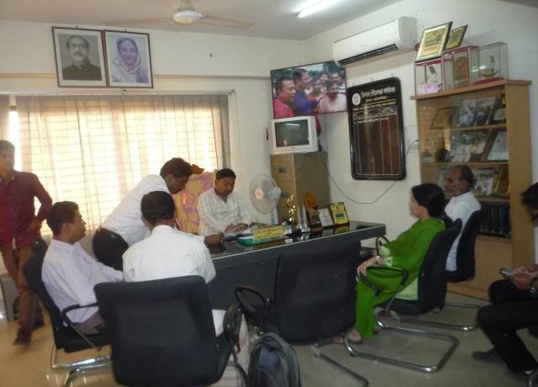
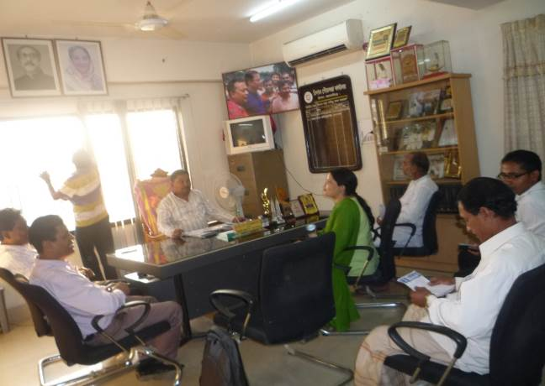

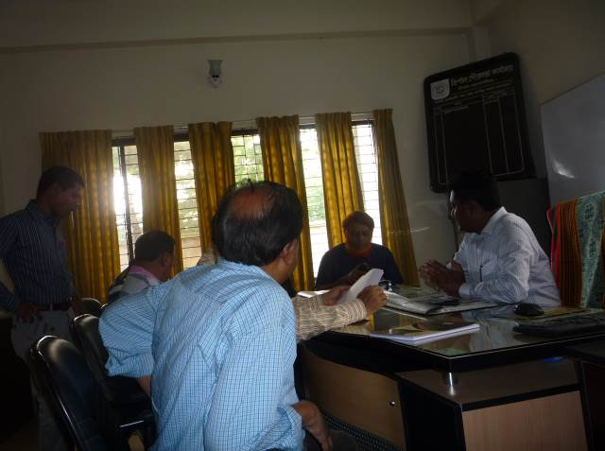
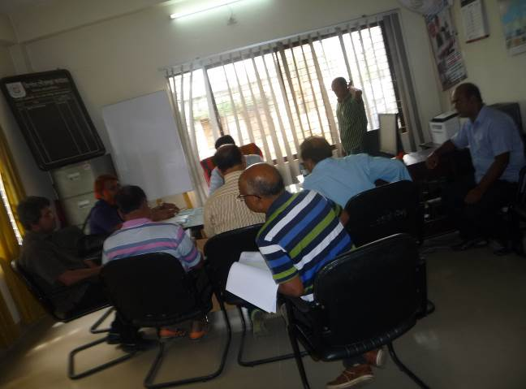

Photographs 7.1.1: Consultation Meeting at Trishal Pourashava with Pourashava Officials and Consultants Participants

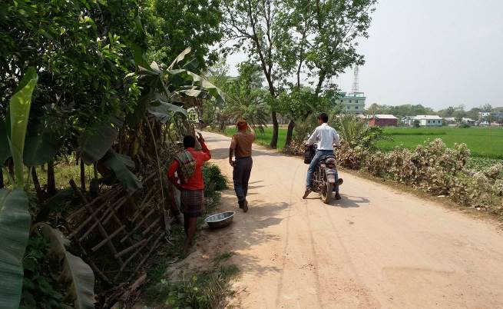
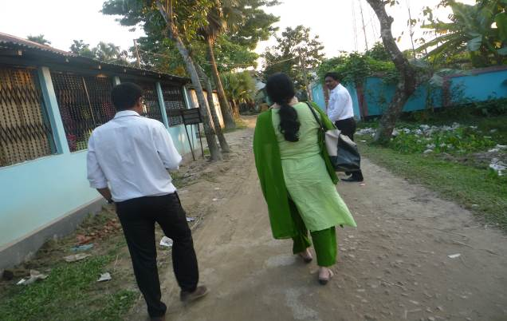

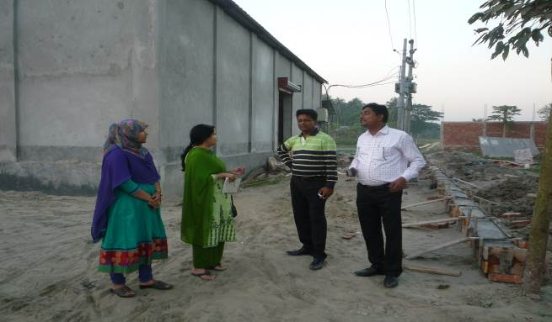
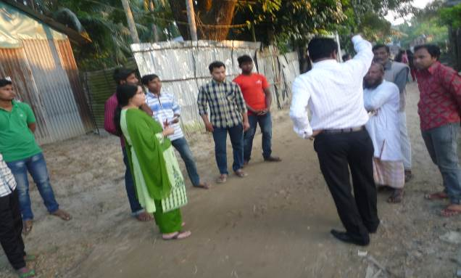

Photographs 7.1.2: Consultant Team Visited the Sites with the Pourashava Representatives

Issues Raised by the Participants

The participants raised the issues related to the infrastructure development of Trishal Pourashava. The issue on anticipated impacts due to construction works has also been raised. The participants also discussed how the subproject will provide benefit to the comuunity.

Feedback, Suggestions, and Recommendations of the Participants

The participants were presented with feedback, suggestions, and recommendations listed below:
- The participants emphasis to take necessary actions to minimize the adverse impact due to implementation of the subproject;
- The participants suggested to include provision of tree plantation in the bill of quantity;
- The participants proposed that training program and or workshop can be conducted by the consultant at Pourashava to enhance knowledge on environmental issues;
- The Pourashava Mayor stated that recreation centre like Poura Park, beautification beside Sutia River and re-excavation of Sutia River and Sukni Khal is necessary for this Pourashava.
- The participants explained necessity of the construction of bus and truck terminal.

Conclusions and Recommendations

This study serves to examine the potential environmental impacts of the subproject. This study has been conducted based on a review of the relevant documents, engineering design, field visits to the subproject location with a view to reconnaissance survey and detailed investigation, FGDs and screening of baseline environmental parameters. Through this process an assessment has been undertaken of the potential environmental impacts attributable to the construction and operation phases of the subproject.
Findings of the study reveal that no major adverse environmental impacts are likely to occur due to construction and operation of the subproject. The potential negative environmental impacts associated with the construction activities are relatively minor in comparison to the significant environmental benefits resulting from subproject operation.
A few key recommendations are outlined below:
- As a part of the contract documents, the contractor is responsible to implement the EMP;
- DSM consultant and Pourashava Officials will supervise the implementation of the EMP;
- The contractor will follow mitigation measures and monitoring plan for the effective implementation of the subproject;
- First aid box with the necessary medicine and PPEs should be available;
- The consultant will provide site specific instruction to the Pourashava Officials and Contractor during field visit.

APPENDIX

Appendix- I: List of the Participants

Appendix - II: Monitoring Checklist

