INTRODUCTION

Subproject Background

Trishal Pourashava is located in the core of Trishal Upazila under Mymensingh District. Trishal Pourashava was established in the year of 1998. Currently, Trishal is A type Pourashava. It has an area of 15.49 sq.km. The present population of Trishal Pourashava is about 38,507. The Pourashava has 45 km pucca road and 30 km earthen road. It has 4 km pucca drain and 4 km canal (source: Pourashava website).
In Trishal Pourashava, the current infrastructure situation is in vulnerable state. Drains are mostly clogged that cannot properly drain out waste water during heavy rains. Natural drainage systems have either been filled up or occupied by land grabbers creating water logging during monsoon. Traffic volume is increasing day by day with the increase in population and demand. The substandard road network cannot cope with the growing demand; consequently, traffic congestion becomes a common problem. Hence, planned development of road and drain network is essential to meet the emergent demand.

This subproject includes the following components: Improvement of Kakchar Road from Dhaka-Mymensingh Highway to End Point of Pourashava Boundary by BC and RCC Road, RCC Covered Drain and Street Light. The significant features of the subproject are mentioned below:
Name of the Subproject : | Improvement of the Road at Kakchar Road including Footpath, Drain and Street Light
Package No. : | MGSP/TRI/2016-2017/W-04
District Name : | Trishal
ULB Name : | Trishal Pourashava
Jurisdiction Area : | 08 and 09
Structural Design Option : | BC and RCC Road, RCC Drain with Footpath, Cross Drain and Street Light
Beneficiary Population : | About 20,000
Tribal People : | No tribal people settlement found in the subproject area
Land Acquisition : | No land acquisition is needed
Estimated Cost : | 68.36 million in BDT
Subproject Duration : | 12 months
Tentative Start Date : | August 09, 2017
Tentative Completion Date : | July 08, 2018

Objectives of the Study

The general objective of this study is to determine the major environmental impacts succeeding from execution of the subproject and to recommend mitigation measures to avoid or reduce adverse environmental impacts and to enhance positive impacts. The specific objectives include:
- To assess the existing environmental conditions of the subproject site and its influence area;
- To identify and assess impacts resulting from the subproject during its construction phase and operation phase;
- To develop a environmental management plan with recommendations for mitigating impacts and enhance positive impacts;
- To summarize environmental monitoring requirements.

Scope and Methodology of the Study

The subproject appraisal is included environmental screening for all the subproject components. According to that screening, no further environmental assessment is required for the street light. Nevertheless, environmental assessment is required to fulfill the regulatory requirement for BC Road, RCC Road and RCC Drain. Hence, this report is mainly included BC Road, RCC Road, RCC Drain and RCC Drain. However, in the EMP table mitigation measures for street light are also included. The study methodology comprised the following activities:

Desktop Study
The desktop study involved:
- Initial meetings with client and stakeholders to discuss about the proposed subproject, including subproject activities;
- Collection and review of the baseline data, maps, reports and other relevant information on the existing environmental and social conditions of the subproject area;
- Review of the relevant existing legislation, regulation and policies;
- Understand the anticipated technical processes that may affect the environment.

Field Investigation and Data Collection
A team of the consultants made a field investigation to the proposed site. Field investigations involved mainly site walks within the subproject area and the neighboring areas that may be affected by the subproject. The following key tasks were performed during the field visit:
- Taking photographs of the significant aspects to describe the baseline environmental conditions of the subproject area;
- Interviews with representatives of the Pourashava Officials, and interested and affected people within the subproject influence zone;
- Verifying information and data collected during the desktop study and to collect new information that may have been important in the assessment of the impacts and design of the mitigation measures.

Data Analysis and Report Writing
The data and information collated from all the sources (literature review, secondary and primary data, public consultation) were analyzed to describe the existing environmental setting of the subproject area, to identify the potential positive and negative impacts of the proposed subproject, as well as to provide preliminary suggestions for mitigation measures. Finally, this environmental assessment report has been prepared.

Subproject Description

The Study Area
The subproject is situated within the jurisdiction of the ward numbers 08 and 09. The starting point of the Kakchar Road is located at Dhaka-Mymensingh Highway with 24°35'4.51"N (Latitude) and 90°23'43.14"E (Longitude).The end point of this road is located at Pourashava Boundary with 24°34'57.73"N (Latitude) and 90°24'47.45"E (Longitude).The location map and topographic view of the subproject are shown in Figure 2.1.1 and Figure 2.1.2.

Figure 2.1.1: Location Map of the Subproject
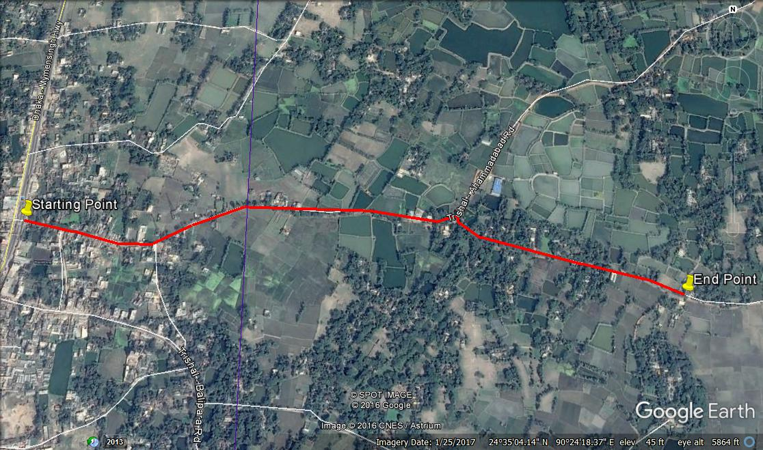

Figure 2.1.2: Topographic View of the Subproject

Current Situation and Need for the Subproject

From Ch. 0 to 396m, the major roadside built-up infrastructures includes Madrasa, Post Office, non-government agencies, educational institutes, Mosques, various shops and pucca, semi-pucca and tin-shed residential houses and Graveyard. From Ch. 396 m to 2216m, the subproject road mostly goes through rural area where scattered home stead area was found during site visit. In fact, agricultural land at both sides of the road dominates other physical features in the Ch. 0 to 396m.
Presently, the existing road is mostly damaged in most of the sections which hampers the normal traffic operation. After rainfall, the stagnant water in the pot holes aggravates the road damaged. In fact, the bituminous carpeting is mostly disappeared in most of the road sections. Consequently, it creates dusty surfaces and generates dust during vehicle movement in the dry season. In addition, the existing road is also narrow (road width varies from 3.05 – 3.50 m) which is not adequate to meet the increasing traffic demand. Hence, the damaged road necessitates improvement of the existing bituminous carpeting with widening works.
In the subproject area, there is no drainage facility. Consequently, storm water creates water logging problem. From Ch. 0 to 396 m, stagnation of water on the road surface damages the road. As a result, smooth traffic flow is hampered. The water congestion also degrades the surrounding environment and causes public health hazards. To improve the situation, new RCC U-type drain and RCC Cross Drain is needed for proper drainage facility. Therefore, RCC drain with footpath will be constructed at right side of the road (Ch. 0-865 m) and at left side of the road (865-962 m).
At present, there are existing street lights in different segments of the proposed road. However, the existing street light is not sufficient. Hence, adequate fixing of the street light at single side of the road from Ch. 0-2216 m at 30m interval is needed for improved safety of the pedestrian and traffic. This subproject has significant benefit to the community people after completion. The existing scenario of the proposed road is further elaborated from the following Photographs 2.2.1.
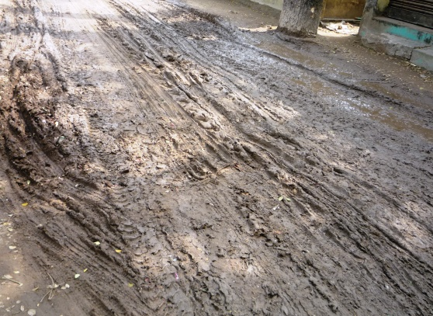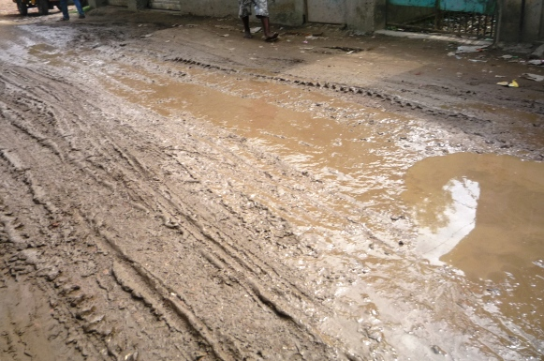

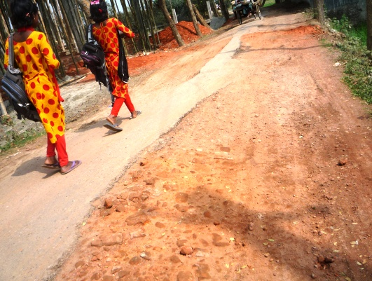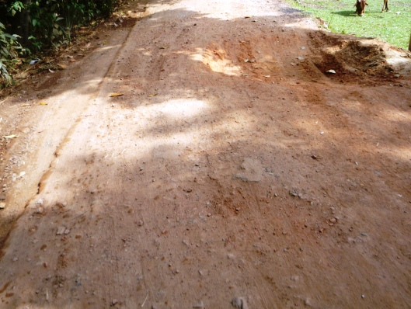

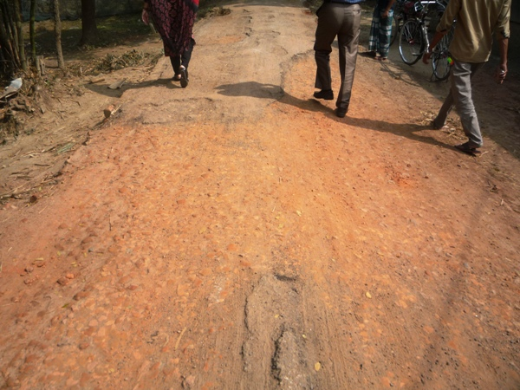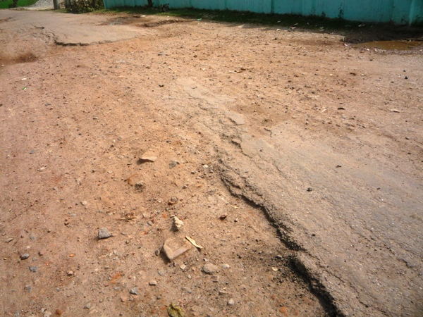

Photograph 2.2.1: Present Situation of the Subproject Site

There are two outfalls in the drain subproject such as manmade khal and Kulin Khal. Initially, the storm water will be discharged in the manmade khal which will be the primary outfall. Finally, storm water will be discharged in the Kulin Khal via earthen drain. As a result, the water quality of this khal will be degraded in the near future. The following Photographs 2.2.2 present the existing conditions of the outfall.

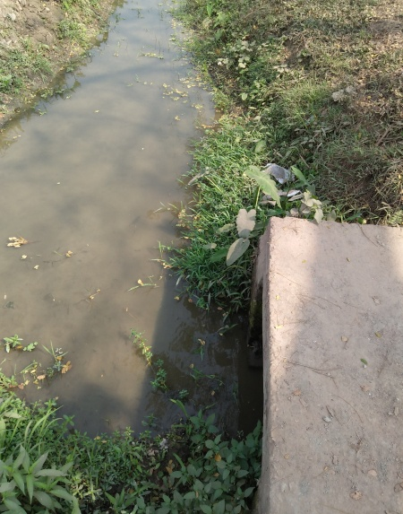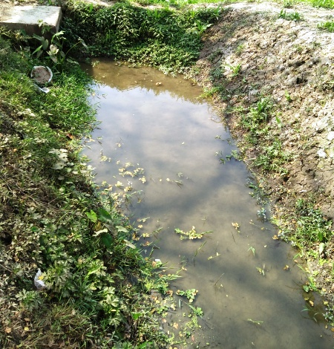

Photograph 2.2.2: Present Situation of the Outfall

Justification of Selection of the Subproject

The subproject has significant importance because it is connected with Dhaka-Mymensingh Road. Hence, this subproject has been considered as priority subproject in the CIP. PMU representative, and DSM consultant visited the subproject site to assess the site condition. From the site visit, it is revealed that this road is very much inconvenience for the movement of the motorized vehicles. The subproject is located mostly in the right of way. Since the Trishal Pourashava is owned the subproject. Hence, land acquisition is not an issue for implementation of this subproject. From the site inspection, it is also revealed that roadside built-up infrastructure will not be severely affected by the implementation of the subproject.
After completion, the road subproject will provide uniform width. By eliminating pot holes and providing smooth road surface it will provide better, easy and safe movement facilities for the travelers. The drain will reduce water logging problem. Thus, the subproject area will get better environment. The subproject has significant benefit to the community people. Hence, considering the benefits that will derive, the subproject is selected for implementation.

On the contrary, after construction the proposed culverts will provide proper drainage of water and smooth traffic operation. In addition, the road protection wall will increase the stability of the road. Furthermore, street lighting will ensure safe movement of the pedestrians and non-motorized vehicles. It will provide streetscape enhancements i.e. municipal beautification work and stimulation of the night-time trade.

Envisaged Subproject Activities and Implementation Process

The key activities of the RCC Drain include:
- Construction of labor shed and semi-pucca site office;
- Relocation of the electrical poles, telephone poles and GI poles;
- Clearing and grubbing works;
- Earth work in excavation of the foundation;
- Pumping and bailing out of water as per requirement;
- Sand filling for the preparing foundation bed;
- Plain cement concrete work in foundation;
- Manufacturing CC blocks;
- Fabrication of the ribbed or deformed bar;
- Reinforced cement concrete work.

The key activities for BC Road include:

- Dismantling of the damaged sub-base and base course works;
- Clearing and grubbing works;
- Earth work in box cutting;
- Earth filling work;
- Sand filling on the road bed;
- Mechanical compaction;
- Brick on edging;
- Compacted stone aggregate base course;
- Providing prime coat;
- Laying pre-mixed dense bituminous surfacing wearing course.

The key activities of the RCC Road include:

- Dismantling of the damaged sub-base and base course works;
- Earth work in box cutting;
- Mechanical compaction;
- Polythene sheet laying work;
- Fabrication of the ribbed or deformed bar reinforcement;
- Reinforced cement concrete work.
The key activities for Street Light:
- Assembling, fitting, fixing, installation, testing and commissioning of the GI pole;
- Erection of tubular pole;
- Earthing the electrical installation;
- Fixing of the wire rack;
- Fixing of the overhead conductor;
- Providing, fixing and fitting of the water tight street light;
- Fitting and fixing main and sub-main switch with fuse;
- Supplying and fitting of sub-distribution board.

The materials and resources to be used for the key activities: soil in earth work, sand, stone chips, cement, reinforcement, diesel, MS sheet, steel shutter, electricity and water.
The major equipment to be used for the implementation of the subproject: hydraulic excavator, concrete mixer machine, steel cutter, mechanical vibrator machine, mechanical compaction machine, steel drum rollers, pneumatic multiple tire roller, dump truck, water tanker, pump, asphalt plant, rubber tire roller, paver.

Baseline ANALYSIS OF THE ENVIRONMENTAL CONDITION

Physical Environment

Important Environmental and Infrastructural Features

During site visit the environmental and infrastructural features within the subproject area were collected. Conditional survey has also been conducted for designing the subproject. Hence, the survey data is also used for preparing the report. The environmental and infrastructural features listed within 100 m of the both sides of the road from the center line considering 100 m longitudinal interval from Dhaka-Mymensingh Highway to End Point of Pourashava (Chainage 0 to 2216 m) Table 3.1.1
Table 3.1.1: Major Environmental and Infrastructural Features
Chainage (m) | Left | Right | Major Environmental Features(Adjacent to the road edge and within 30 m from the edge of the road)
Dhaka-Mymensingh Highway to End Point of Pourashava (Ch. 0 to 2216 m)
0-100 | √ |  | Semi-pucca and tin-shed shops, trees, house (within 2-3.70 m from the edge of the road)
0-100 |  | √ | Semi-pucca structures, Awami League Office, trees, Markajut Tahfij Girls Madrasa (within 1.5-3.30 m from the edge of the road)
100-200 | √ |  | Boundary wall, various shops, trees, Graveyard, houses and Seed Foundation (within 1.7 m to 2.5 m of the road edge)
100-200 |  | √ | Post office, BASA NGO office, open place, shops, houses, trees (within 1.7 m to 2.4 m of the road edge)
200-300 | √ |  | Ali Akbar Bhuiya Girls High School, Trishal Krishi Technology Institute, Rahela Hazrat Model School, Suktara School, boundary wall, trees (within 2.2 m to 6m of the road edge)
200-300 |  | √ | Various shops, trees (within 1.5 m to 2.5 m of the road edge)
300-400 | √ |  | Open field, trees (within 1.5 m to 2.5 m of the road edge)
300-400 |  | √ | Open place, houses, connecting road, (within 1.5 m to 2.5 m of the road edge)
400-500 | √ |  | Mobile Tower, agricultural field, trees, Graveyard (within 1.50-30 m from the edge of the road)
400-500 |  | √ | Bamboo bushes, fence of tin, boundary wall, houses, open space trees (within 1.50 m from the edge of the road)
500-600 | √ |  | Pucca residential house, trees, construction work of building, boundary wall, vacant place, trees (within 1.5 m to edge of the road)
500-600 |  | √ | Agricultural land, house, boundary wall, trees (within 1.50 m from the edge of the road)
600-700 | √ |  | Houses with various structures, agricultural field, trees (within 1.5 m to 3 m of the road edge)
600-700 |  | √ | Agricultural field, trees (adjacent to the road edge)
700-800 | √ |  | Vacant place, houses, trees (adjacent to the road edge)
700-800 |  | √ | Agricultural field, trees (adjacent to the road edge)
800-900 | √ |  | Manmade khal, bushes, agricultural field, trees, pond (within 0.5 m to 2.5 m of the road edge)
800-900 |  | √ | Agricultural field, pond, trees (within adjacent to the road edge to 2.5 m of the road edge)
900-1000 | √ |  | Pond, bushes, trees, agricultural field (within adjacent to the road edge to 1.5 m of the road edge)
900-1000 |  | √ | Ponds, bushes, trees, tin-shed structure (within adjacent to the road edge to 1.5 m of the road edge)
1000-1100 | √ |  | Feed mill, construction work of building, bamboo bushes, tree garden (within adjacent to the road edge to 0.5 m of the road edge)
1000-1100 |  | √ | Fence, trees, pond, open space, Haq Kindergarten, house (within adjacent to the road edge to 0.5 m of the road edge)
1100-1200 | √ |  | Open space, house, trees (within adjacent to the road edge to 0.5 m of the road edge)
1100-1200 |  | √ | Trees, pond, open space (within adjacent to the road edge to 0.5 m of the road edge)
1200-1300 | √ |  | Mosque, trees, open place, house (within adjacent to the road edge to 6 m of the road edge)
1200-1300 |  | √ | Ponds, trees, house, (within adjacent to the road edge to 0.5 m of the road edge)
1300-1400 | √ |  | House, tree, open place (within adjacent to the road edge to 2.5 m of the road edge)
1300-1400 |  | √ | Pond, trees, house within adjacent to the road edge to 1.5 m of the road edge), electric pole
1400-1500 | √ |  | Open space, houses, trees (within adjacent to the road edge to 6 m of the road edge)
1400-1500 |  | √ | Open space, houses, trees Open space, houses, trees (within adjacent to the road edge to 6 m of the road edge)
1500-1600 | √ |  | Houses, trees, (within adjacent to the road edge to 6 m of the road edge)
1500-1600 |  | √ | Ponds, trees, house (within adjacent to the road edge to 6 m of the road edge)
1600-1700 | √ |  | Graveyard, houses, trees (within 0.50 to 10 m from the edge of the road)
1600-1700 |  | √ | Trees, open space (within 0.50 to 1.5 m from the edge of the road)
1700-1800 | √ |  | Houses, trees (within 0.50 to 6 m from the edge of the road)
1700-1800 |  | √ | Graveyard (adjacent to the road edge), trees, open space(within adjacent to the road edge to 2.5 m of the road edge)
1800-1900 | √ |  | Bushes, semi-pucca houses, trees, open space (adjacent to the road edge)
1800-1900 |  | √ | Agricultural field, trees (adjacent to the road edge)
1900-2000 | √ |  | Residential houses, cultivated land, trees (within adjacent to the road edge to 1.5 m of the road edge)
1900-2000 |  | √ | Agricultural land, trees (within 0.50 to 1.5 m from the edge of the road)
2000-2100 | √ |  | Open space, houses (within 0.50 to 1.5 m from the edge of the road)
2000-2100 |  | √ | Houses with different structures, open space, trees (within adjacent to the road edge to 15 m of the road edge)
2100-2216 | √ |  | Cultivated land, open space, Houses with different structures, trees (within adjacent to the road edge to 15 m of the road edge)
2100-2216 |  | √ | Agricultural field, trees, Mosque, Graveyard (within adjacent to the road edge to 20 m of the road edge)
** Note: There are 36 numbers of the electrical poles and GI poles at different chainage to be re-located for the implementation of the subproject

Geology, Topography and Soils

Topographically, Trishal Pourashava is a plain land. The plain land mainly consists of fluvio-deltaic sediments deposited by the Ganges, the Brahmaputra and the Meghna River Systems. Geomorphologically, Trishal Pourashava falls under the Floodplains of the Old Brahmaputra and Jamuna Rivers having distinguishing character. Surface geology is consisted of sedimentary rocks originated by riverine processes. Eleven general soil types exist in the area of which deep red brown terrace, shallow red brown terrace soils and Acid Basin Clays are the major ones. They are strongly acidic in reaction with low status of organic matter, low moisture holding capacity and low fertility level. According to BNBC, Bangladesh has three seismic zones with moderate and low seismic activity. The Trishal Pourashava area falls in Zone I, i.e. high intensity seismic zone of the country.
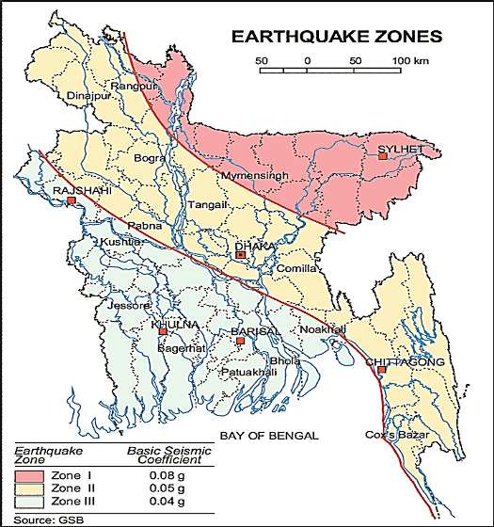

Figure 3.1.1: Location of Trishal in Earthquake Zone Map of Bangladesh (source: GSB)

Climate and Meteorology

The climate of the subproject area can be described as Tropical Monsoon. It is characterized by warm, humid summers and cool, dry winters. From November to March, it is dry and cool while from April to May it is extremely hot during the pre-monsoon season. From June to October, the monsoon season is warm, cloudy, and wet. The warmest month is April, the coolest is January, the wettest is July and the driest is January.

The minimum temperature was 10.8°C in 2011 and maximum temperature was 34.2°C in 2008. The minimum humidity was 66.3% in 2010 and the maximum humidity was 80 % in 2009. The peak rainfall months in Trishal are June, and July. About 90% of the total annual rainfall occurs in the period from May to October. The highest annual rainfall during the last four years (2008–11) was 2235 mm in 2008, and the lowest was 1653 mm in 2009.

According to the statistics of wind data from the Bangladesh Meteorological Department Climate Division, wind direction changes by month. Nevertheless, the northwest, south, and northeast winds are predominant. The average wind speed as recorded at Mymensingh Met Station is in the range of 2 – 7.8 knots/ hr. But in the winter months it remains in the range of 1-4.5 knots/hour. Table 3.1.2 shows the key meteorological data from 2008 to 2011.

Table 3.1.2: Temperature, rainfall, humidity during 2008-2011
Years | Temperature(centigrade) |  | Rainfall (millimeter) | Humidity (%)
Years | Maximum | Minimum | Rainfall (millimeter) | Humidity (%)
2008 | 34.2 | 12.5 | 2235 | 79.0
2009 | 33.0 | 13.2 | 1653 | 80.0
2010 | 32.4 | 11.7 | 1811 | 66.3
2011 | 32.2 | 10.8 | 2153 | 79.3
The construction works can be influenced by the climatic condition and meteorological components like humidity, temperature, sudden rainfall, and wind speed. High winds can enhance quick spreading of the generated dust. It is very risky working under rain and in high winds because the possibility of getting injury increases. Furthermore, work under high temperature and excess humidity may create health hazards like dehydration problem.

Water Resources (Surface Water, Ground Water and Rain Water Harvesting)

In the subproject area, there are some ponds used for fish cultivation. There are some other water bodies like ditches along the road alignment.

Ground water is available in plenty and water table does not go beyond suction limit throughout the year. The water of shallow layer contains lot of iron, while water of deep layer does not contain excessive iron. Arsenic concentration is not reported as higher level in both deep and shallow aquifer. Local people typically use deep tube-well water for drinking and other domestic purposes. Salinity problems are not visible. Rain water harvesting system is not common in and around the subproject area.

During construction period, water will be used both for the construction work and domestic purposes. Therefore, ensuring the water requirements is one of the key issues.

Flooding, Water Logging and Drainage Pattern
Trishal Pourashava is free from external flooding. However, Trishal Pourashava is subjected to internal water logging problem due to delay discharge of the storm water during monsoon season. In the subproject area, delay discharge of the storm water causes water logging problem. As per information by the local people the intensity of water logging problem is increasing due to siltation of natural canal and lack of functional and adequate drainage system.
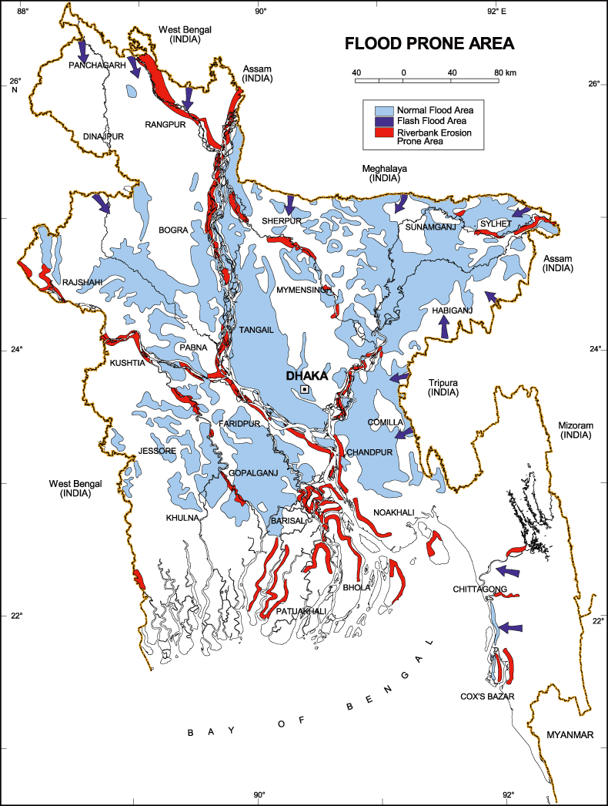
.However, a flood zoning map and location of the Trishal Pourashava provided here in Figure 3.1.2.

Figure 3.1.2: Location of Trishal Pourashava in Flood Zone Map of Bangladesh
Air Quality and Dust
Ambient air quality data have not been found. The subproject road generates dust during movement of the vehicles during dry season. The windblown dust also causes air pollution. Due to rapid urbanization of Trishal Pourashava the total number of motorized vehicles including bus, truck, tempo, three-wheeler has been increased. These motorized vehicles are old and poorly maintained. Consequently, black smoke emission from the vehicles degrades the quality of the air. There are no remarkable sources of the air pollution such as heavy and small industries in the subproject area. There is no brick field observed in the subproject area during site visit.

Noise Level

Noise is not a major impediment for the quality of the environment in the subproject area. The motorized and non-motorized vehicles such as rickshaws, trolleys, pick-up, motor cycles, mini trucks, and private cars etc. produce noise. However, they are within the tolerable limits in most cases. There are no other perceptible sources of noise generation such as heavy factories or industries in the subproject area.
Solid Waste Management

The local people normally dump their solid wastes in the road side drains, open space or roads adjacent to their houses, low lying areas, in khals and ditches. Therefore, improper solid waste disposal by the community people creates severe public health hazards and degrading the quality of living environment. Currently, the vacant place at Naodhar beside Dhaka-Mymensingh Highway is used as a Pourashava designated dumping site. Basically, it is not structured solid waste management system in this area.

Biotic Environment

Flora and Fauna

In the subproject area, the floral species includes: Rain Tree, Mahogany, Akashi, Shishu, Jam, Neem, Jackfruit, Korai, Pitraj, Kadam, Coconut, Papaya, Mango, Date Tree, Palm, Beatle-nut, Jagadambura.

The common local birds such as Crow, Chil, Shalik, and Choroi were found during the site visit. There are no wild animals and endangered faunal species in the subproject area.

Socio-economic and Socio-cultural Environment

Land Use, Status of Housing and Built-up Infrastructure
Like other Pourashava in Bangladesh, the land use pattern in the subproject area consists of mixed land-use pattern. From Ch. 0 to 396 m, the subproject road goes through, residential business and educational area. Last portion from Ch. 396 m to 2216m, the subproject road goes through the rural area where scattered home stead area was found during site visit. There are Madrasa, Post Office, non-government agencies, educational institutes, Mosques, various shops and pucca, semi-pucca and tin-shed residential houses and Graveyard etc are major road side built-up infrastructures. In fact, agricultural land at both sides of the road from Ch. 0 to 396m. There is no industrial activity in the subproject area.
Beneficiary Population

The subproject is situated within the jurisdiction of the Ward number 08 and 09. Considering the ward population about 20,000 people will benefit directly and many others indirectly.

Education
In the Pourashava area, literacy among the population is about 61.0%. This is higher than the national average (51.8%). The literacy rate among males (62.4%) is more than females (59.6%). (Ref: Population and Housing Census 2011).

Tribal Communities
There is no indigenous or tribal people settlement in the subproject area. Hence, no measures needed for the indigenous peoples’ safeguard.

Land Acquisition

Private land acquisition is not needed. From Ch. 396 m to 2216m, adequate space is available on both sides of the road for widening work. From Ch. 186m to 216m, removing of the few road side boundary walls, outer edge of the few shops and houses are needed due to site clearing and road widening work. The Pourashava will clear the site amicably with the owners of these structures. However, in case of any objection from the affected persons, DSM will investigate the actual situation. Then, measures will be taken as per rules.
Principal Livelihoods and Economic Activities
The subproject area is inhabited by the mixed occupational people. In the Pourashava area, major income comes from business, enterprises, small trades, private sector jobs, and government jobs in the town.
Cultural Heritage and Protected Areas
During site visit it was observed that there is no protected and important cultural or historical site in the subproject influence area.
Social Conflicts and Development Activities

The local people welcome the subproject and there is no conflicts between the local communities regarding subproject implementation.

ENVIRONMENTAL SCREENING

Environmental Screening Checklist, as adopted in Appendix C of the Environmental Management Framework (EMF) of the MGSP, was administered for identifying the impacts and their extents.
The screening data and information for the BC and RCC Road, RCC drain, Cross Drain, and RCC road protection work have been formulated and are shown in below:
(1) Potential environmental impact during construction phase:
- Ecological impacts
136
- Felling of trees Significant □√ Moderate □ Minor □ Number of trees
- Clearing of vegetation Significant □ Moderate □√ Minor □
- Potential impact on species of Significant □ Moderate □ Minor □√
aquatic (i.e., water) environment
Major trees to be felled down are: Rain Tree, Mahogany, Akashi, Shishu, Jam, Neem, Jackfruit, Korai, Pitraj, Kadam, Coconut, Papaya, Mango, Date, Palm, Beetle-nut, Jagadambura etc. There is no tree to be felled down bring religious and heritage importance. However, the trees to be felled down have significant economic value because most of them are big to moderate size in terms of length and diameter. From Ch. 0 to 400 m, there is no road side vegetation. From Ch. 400 to 2216 m, vegetation coverage on both sides of the road is not similar in terms of the intensity. Few sections vegetation coverage is significant. In few sections, vegetation coverage is not significant. So clearing of the road side vegetation is considered as moderate. In addition, anticipated impact on species of aquatic environment is minor because except throwing of the wastes materials in to the ponds & ditches, the aquatic environment will not be affected due to the subproject works. Considering the number of trees to be felled down, the ecological impact is considered as significant.
- Physicochemical impacts:
- Noise pollution Significant □ Moderate □√ Insignificant □
- Air pollution Significant □ Moderate □√ Insignificant □
- Drainage congestion Very likely □ Likely □ Unlikely □√
- Water pollution Significant □ Moderate □ Insignificant □√
- Pollution from solid/ construction wastes Significant □ Moderate □√ Insignificant □
- Water logging Significant □ Moderate □ Insignificant □√

The subproject will have impacts on noise and air quality during construction phase due to mobilization of the equipment, vehicles movement for the transportation of the materials, using of hydraulic excavator, brick breaking machine, mechanical compaction machine, paver, asphalt plant, concrete mixer machine, vibrator machine etc. The construction work will be performed section wise. Hence, it is anticipated that the overall impacts on noise and air quality will not be severe, temporarily and limited within the subproject boundary. From Ch. 0 to 396m, there are road side Madrasa, School, residents, NGO Office etc. Hence, anticipated impacts on noise and air quality will be significant for this particular section if measures will not be taken properly. The generated dust during construction activities may temporarily disturb the local people if measures will not be taken. The generated construction wastes, un-suitable materials and solid wastes may degrade the adjacent pond water if not properly collected and disposed and thrown in to the pond. Improper collection and disposal of the generated wastes materials also may degrade the quality of the surrounding environment and degrade the aesthetic value. The anticipated water logging and drainage congestion during construction period is minor because space is available at most sections of the road for drain-out the storm water. In addition, provision will be there for pumping out the storm water if required.
- Socio-economic impacts:
- Traffic congestion Very likely □ Likely □√ Unlikely □
- Health and safety Significant □ Moderate □√ Insignificant □
- Impact on archaeological and historical Significant □ Moderate □ Insignificant □√
- Employment generation Significant □√ Moderate □ Insignificant □

Firstly, the proposed drain will be constructed at right side of the road from Ch. 0 to 865 m and at left side of the road (865-962 m). The traffic congestion due to drain construction is comparatively less because it does not require closing of the entire road. The pedestrians, cycle rider, biker can use the road during drain construction work. There is no sufficient existing connecting and diversion road. Hence, traffic movement will be severely affected during construction work of the proposed road. The construction work will follow simple procedure with commonly used equipments. Hence, anticipated impact on health and safety is moderate. There is no archaeological and historical site within the influence area. The subproject has positive impact by generating work opportunities for the local people and supplying of the construction materials, equipments, food and other necessary stuffs to the campsite.
(2) Potential environmental impact during operational phase:
- Ecological impacts:
- Potential impact on species of aquatic Significant □ Moderate □√ Minor □
(i.e., water) environment
The anticipated impact on the aquatic environment is insignificant due to operation of the road. Though, the drain is designed for storm water only. However, the storm water may carry washed-out materials, pollutants from any sources that may disturb the aquatic environment of the outfall. Hence, the anticipated impact on the aquatic environment due to operation of the drain is considered as moderate.
- Physicochemical impacts:
- Potential air quality Improvement □ No-improvement □ Deterioration □√
- Noise level Improvement □ No-improvement □ Deterioration □√
- Drainage congestion Improvement □√ Minor Improvement □ No Impact □
- Risk of Water pollution Significant □ Moderate □√ Minor □
- Pollution from solid waste Improvement □ No-improvement □ Minor □√

During operation phase due to road component, increased traffic volume may degrade the air quality and noise level due to black smoke emission and un-due use of hydraulic horn from vehicles. The new drain will minimize drainage congestion and water logging problem. The storm water to be discharged through the drain may degrade the water quality of the outfall if carry pollutants from any sources. The new covered drain will minimize throwing of the wastes materials in to the drain.
- Socio-economic impacts:
- Traffic Improvement □√ No-improvement □ Adverse □
- Safety Improvement □√ No-improvement □ Adverse □
- Employment generation Significant □ Moderate □ Minor □√

After completion, this road will improve the transport facilities. By providing uniform pavement, it will also enhance traffic safety. The new drain will reduce water logging problem. By reducing environmental hazards caused by water logging problem, it will provide better environment to the community people. The new subproject will minimize the frequency of the maintenance for first three-five years after completion. However, the new road with street light will enhance business activities and pedestrians’ safety at night. In addition, new roadside shops will be developed which contributes local economy.
3) Summary of Possible Environmental Impacts of the Subproject
The subproject site is not located any environmentally sensitive area though it has significant ecological impact due to the felling down of the 136 trees. The subproject activities will have adverse impacts on physicochemical impacts. However, it is anticipated that the impacts will not be severe and limited within the subproject boundary. The wastes generated due to the construction activities should be properly collected and disposed in a designated dumping site. Some earthwork will be involved for the road construction work; however, no agricultural productive soil will be used for the purpose. The inputs that may affect the environment will be mainly at construction phase. Moreover, mitigation measures will be taken according to the EMP for minimizing the environmental pollution. Safety concern is an important issue for both the construction and operation phases that should be considered properly. This subproject will have positive impacts in terms of the generation of the employment and business activities by supplying construction materials and equipment. The anticipated environmental impact for the installation of the street light is insignificant. However, it has significant positive social impacts. Short circuit and improper electrical connection of the street light may cause potential health and safety risk.

Specific impact, mitigation AND enhancement measures
From the environmental study, the probable impacts of the subproject are mainly caused by the key activities required for the implementation of the subproject, raw materials and equipment to be used for the execution of the activities. This section describes some specific impacts due to the subproject activities and their mitigation measures.

Dismantle Work, Excavation Work and Earth Work

The road improvement work includes dismantle of existing bituminous pavement, clearing of the wastes materials due to dismantle work, earth excavation and earth filling work. The drain construction work consists of earth excavation, earth filling, back filling and cutting and removal of the unsuitable materials. These works lead dust blowing, improper disposal of the wastes, noise and vibration which may disturb the local people.

Mitigation Measures

- Careful operation of the hydraulic excavator if used for excavation and earth filling to avoid any undue disturbances to the roadside residents;
- Cover the exposed earth with mulch fabric;
- Quick disposal of the wastes to the selected dumping site at Naodhar beside Dhaka-Mymensingh Highway

5.2 Tree Plantation
The subproject has adverse impacts on the ecological components due to felled down of the 136 numbers of trees and clearing of the roadside vegetation and bushes.
Mitigation Measures

- 700 nos. of trees will be planted to compensate the ecological imbalance to be caused due to felled down of the tress. Planting trees from Ch. 336m to 396m (left side as per Chainage Direction) and from Ch. 396 m to 2216 m (both sides) -preferably local fruits, flowers, medicinal and ornamental trees- Mango, Jackfruit, Jam, Coconut, Palm Tree, Krisnachura, Bokul, Kadam, Polash, Shimul, Sonalu, Jarul, Neem, Arjun, Amloki, Bohera, Horitoki, Rain Tree, Akashi, Mahogany, Sishu, Koroi, Shal, Gorjon, Babla, Ashot, Banyan Tree are recommended. Planting trees will enhance the ecological balance of the subproject area after their successful growth.

Pollution from the Construction Materials

Dumping of the construction spoils, including accidental leakage of the oil, grease, and fuel in equipment yards is a significant hazard. Surface water and soil quality might be polluted from these contaminants. Even the people to be engaged for the construction activities might endanger the physical and human habitats of the area.

Mitigation Measures

- Safe transport, storage, and disposal of the construction materials, and the equipment have to be carried out in order to avoid the accidental spillage and loss;
- Fuels, lubricants, and other hazardous materials should store over raised platforms and not directly on the ground;
- The playgrounds of the educational institutions should not use as a stockyard or work camp.

Air Quality and Dust

During construction phase, air pollutants will be emitted from the equipment and construction vehicles are expected to remain low. Local residents in the vicinity of the work sites will be temporarily disturbed by the limited dust pollution. The overall impacts, however, are expected to remain low.

Mitigation Measures

- Water should be sprayed at the work site for dust control. Ensure sprinkle and cover stockpiles of loose materials (e.g., fine aggregates).
- Maintain adequate moisture content of soil and sand for transportation, compaction and handling;
- Avoid use of dust generating equipment (which produce significant amount of particulate matter) far from the local residents;
- Ensure that all project vehicles are in good operating condition.

Noise and Vibration

Noise and vibration caused by the equipment and movement of the construction vehicles may temporarily disturb nearby residents. In this subproject, sensitive areas like roadside houses, educational institutes and shops are likely to be affected from the noise, though the impacts are anticipated to be limited.

Mitigation Measures

- Transportation of the construction materials have to be carried during the scheduled times, and mainly during the day;
- If needed, all powered mechanical equipment and machineries will be fitted with noise abating gear such as mufflers for effective sound reduction.

Water Quality

The water quality may deteriorate if the construction materials, construction wastes, effluent from work camps, and food waste are dumped in the roadside water body and low land.
Mitigation Measures

- Proper construction management including waste management as well as training of the operators and other workers should provide to avoid pollution of the water bodies;
- Construction waste will dispose properly (not in the ditch, water bodies or lowland), for which contractor will be responsible.

Occupational Health and Safety
The most important risks associated with the construction activities are listed below:
- Exposure to the sunlight- workers are being exposed to the sun for long hours;
- Exposure to the high temperature, and humidity for a long time resulting in dehydration;
- Contact with the hazardous substances and wastes pose risks of the infections and diseases;
- Risk from the traffic collision or accidents during operation of the equipment such as hydraulic excavator and vehicles movement for the transportation activities of the subproject;
- Risks from head loads for carrying soil, construction materials and construction equipment;
- Risk associated to the sudden bad weather working conditions such as storm, thunder storm and earth quake etc.
General Requirements for the Workers’ Health and Safety
The key salient features of the general requirements for the workers’ health and safety stated are presented in Table 5.7.1.
Table 5.7.1: General Requirements for the Workers Health and Safety
Issues | Requirements
Health and Hygiene | - Cleanliness at the site premises and workers living places and at the Labor Shed;  - Arrangement of the proper ventilation and temperature at the Labor Shed;  - Protection against dust and furnace by using of the nose masks and covering of the head and body;  - Proper disposal of the wastes and effluents;  - Provision of the adequate latrines and separate toilets for the women;  - Sufficient dustbins for the solid waste management system.
Safety and First Aid Box | - Using of the personal protective equipment (helmet, gloves, goggles, nose mask, safety boots);  - Precautions during work on or near machineries in motion;  - Head loads are prohibited;  - First aid facilities should be provided and maintained;  - Ensure first aid box;  - The first aid kit should include adhesive bandages, regular strength pain medication, gauze, and low grade disinfectant.
Compensation for Accidents at Work | - Contractors will bear medical treatment costs. If any severe accidents such as loss of hands, legs or loss of working ability or any case of death needs compensation-(the amount of the compensation should be fixed considering the type of accidents).
Dust and Fumes | - For any dust, fumes, or other impurities likely to be injurious to the workers, effective measures shall be taken to prevent their accumulation and its inhalation by the workers.
Overcrowding | - No labor room should be overcrowded.
Latrines and Urinals | - Sufficient latrines shall be provided;  - Latrines shall be maintained in clean and sanitary condition;  - Latrines shall be adequately lighted and ventilated.
Disposal of Wastes and Effluents | - Proper disposal system for the solid waste and effluent is required.

Impacts on Social Environment and Common Property Resources

The anticipated social impacts are expected not to be severe and to be largely manageable. The following Table 5.8.1 presents impacts on socio-economic environment and common property resources.
Table 5.8.1: Impacts on Social Environment and Common Property Resources
Social Components | Impacts on IECs | Impact Significance
Community Perception | The local community people welcome this subproject and there is no visible objection from them. | Significant (+ve)
Employment and Business Opportunity | Community feels happy because generally the local contractor will be engaged for the construction works which will create work opportunity for the skilled and non-skilled labor. The subproject will create business opportunity for the equipment and materials suppliers’. | Significant (+ve)
Community Order and Security | This subproject activity does not create any severe security problems to the local community and community people. | Minor  (-ve)
Possible damage to infrastructure and facilities | Possible damage of the existing road infrastructure by the construction equipment and vehicles used in this subproject. | Minor  (-ve)
New infrastructure and facilities | Improvement of the existing road will enhance infrastructure facilities. | Moderate  (+ve)
Agriculture and Land Use | No direct impact on agriculture however, it could affect the adjacent land to a very limited extent. | Minor  (-ve)
Landscape and Aesthetics | This subproject activity temporarily will degrade landscape and aesthetics values of the subproject area to a limited extent. | Minor  (-ve)
Labor Habitat | Most of the labors will stay at the Labor Shed which will have impacts on the environment relates to the generation of the solid wastes, effluent, and water consumption. | Moderate  (-ve)
Health Care | Workers may suffer from the dehydration problems, respiratory problem, and other health hazards. | Minor  (-ve)
Accident | In case of road accidents by the vehicles to be used for the transportation may have serious negative impact. | Significant  (-ve)

Specific Measures and Guidelines for the Key Social Issues
The primary objective of these guidelines is to ensure social compliances and requirements required for the subproject. The social guidelines required for the subproject as appeared in this report is given in below.
- Conduct dissemination with details about the subproject to the local community;
- Continue liaison with the community leaders in order to maintain the community support;
- Engage and ensure local contractor and local people for positive perception of the local community;
- Ensure no child workers (less than 18 years) and aged worker (more than 65 years) at the site;
- Ensure no discrimination between the male and female in terms of the wages and getting work opportunity;
- Monitor the contractor to ensure regular payment to the workers;
- Consult with the workers for the feeling of any health problems and take measures accordingly;
- Monitor the workers movement for avoiding any unexpected social activities (robbery, crime, political attachment and conflicts, taking drugs);
- Monitor contractor behavior and attitude to the workers.

Environmental Management Plan (EMP)

The purpose of the Environmental Management Plan (EMP) is to ensure that the activities are undertaken in a responsible and non-detrimental manner. The EMP will guide the environmentally sound construction of the subproject and ensure efficient lines of communication between the PMU (LGED), PIU (Trishal Pourashava), DSM, and the contractors.

Access to Information

The environmental assessment report should be translated into Bengali and disseminated locally. The copies of the report (both in English and Bengali) will be sent to all the concerned personnel responsible for subproject implementation. It will also be made available to the public. The final assessment report will also be uploaded in the LGED website and the World Bank website after approval.

Grievance Redress Mechanism

The project-specific Grievance Redress Mechanism (GRM) has been established at Trishal Pourashava to receive, evaluate, and facilitate the solution of APs concerns, complaints, and grievances concerning the social and environmental performance of the subproject. The GRM aimed to provide a time-bound and transparent mechanism to voice and resolve social and environmental concerns linked to the subproject.
The grievance mechanism is related to resolve the risks and adverse impacts of the subproject. It addresses APs’ concerns and complaints promptly, using an understandable and transparent process that is also gender responsive, and culturally appropriate. It is readily accessible to all the segments of the affected people at no costs and without retribution. The mechanism should not impede access to the country’s judicial or administrative remedies. The affected people will be appropriately informed about the mechanism.
LGED has its own Grievance Redress Procedure (GRP), which it operates to address any dissatisfaction and complaints by the local people regarding its activities. This procedure is being applied to address any complaints or grievances through negotiations with the community leaders and representatives of APs during implementation of the MGSP.

6.2.1 Grievance Redress Committee (GRC)

The discussions and negotiations will be conducted by the Project Implementation Unit (PIU) of Trishal Pourashava, and will be involved the APs and Grievance Redress Committee (GRC) headed by the Pourashava Mayor. With the facilitation of DSM, the Pourashava Mayor nominated the GRC members and included representative from Government Agencies, local NGO, and Civil Society. The GRC has been formed and established at Trishal Pourashava. A complaints box will be provided in the Pourashava Office. The grievance response focal point is available at Trishal Pourashava for instant response to an aggrieved person. The Focal Point will collect the written complaints or suggestions from the box, and produce them to the GRC for hearing and resolution. The GRC members are as follows:

Table 6.2.1.1: Grievance Redress Committee (GRC) Member List
No. | GRC Member Name | GRC Designation | Self-Position
1 | Md. A.B.M Anisuzzaman | Chairman | Mayor, Trishal Pourashava
2 | Subbroto Tarafdar | Member Secretary | Executive Engineer, Trisal  Pourashava
3 | Md. Mozaharul Haque | Member | Upazila Project Implementation  officer, Trishal Pourashava
4 | Md.Rafiqul Islam | Member | Head Teacher, Trishal Nazrul Girls  High School.Trishal, Mymensingh
5 | Md.Zahirul Islam | Member | Executive Director, Sheba, Trishal Pourashava
6 | ANM Shova Mia Akonda | Member | Civil Socity Reprasentive
7 | Female Ward Councilor | Member | Related Female Ward Councilor (Reserved Seat)
8 | Ward Councilor | Member | Related Ward Councilor
9 | Md. Nazrul Islam | Focal Point | Secretary Trisal Pourashava

6.2.2 Grievance Resolution Process

All complaints and suggestions will be received formally in the Pourashava Office by the GRC Member Secretary. A sample Grievance Redress Form has been prepared and sent to Trishal Pourashava prior to the implementation of the subproject.
An intake register will be maintained at the office of the Member Secretary. Member Secretary will record the details of the grievances in the intake register for documentation and ensure impartiality, fairness, and transparency. The intake register will have data and information columns including (i) Case no., (ii) Date of receipt, (iii) name, type of complaint, grievance, (iv) father’s name, husband’s name, (v) sex, (vi) complete address of the person raising the complaint, grievance, (vii) main objection (loss of land, property, or entitlement), (viii) detailed complaint story, (ix) expectation with documentary evidence and previous records of similar grievances, etc.
No GRC members are allowed to contact the aggrieved persons in advance. Rather, the concerned persons are informed to attend the formal hearings at an appointed date. The GRC committee will sit for hearing the complaints of the aggrieved persons. The GRC will record salient points presented by the aggrieved person and will examine documentary evidence submitted during informal hearings. A resolution register will be maintained by the Member Secretary at the Trishal Pourashava Office. The resolution register will contain (i) serial no., (ii) case no., (iii) name of complaint, (iv) complaint story and expectation, (v) date of hearing, (vi) date of field investigation (if any), (vii) results of hearing and field investigation, (viii) decision of GRC, (ix) progress (pending, solved) and (x) agreement or commitments. Closing register will keep records such as, (i) serial no., (ii) case no., (iii) name of complaint, (iv) decision and response to complaints, (v) mode and medium of communication, (vi) date of closing, (vi) confirmation of complainant's satisfaction, and (vii) management actions to avoid recurrence.
The GRC will decide within 30 days of receiving a complaint. There will also be an appeals procedure where, if a person is dissatisfied with the ruling of the GRC, he or she or a representative may attend their next meeting to present the case again. The committee will then reconsider the case in private, after which their decision is final. If the appellant is still not satisfied, he or she has the right to take the case to the public courts. LGED and Trishal Pourashava should also publish the outcome of cases on public notice boards. All costs involved in resolving the complaints (meetings, consultations, communication, and information dissemination) will be borne by Trishal Pourashava.
Based on consensus, this procedure will help to resolve issues or conflicts amicably and quickly, saving the aggrieved persons from having to resort to expensive, time consuming legal action. The procedure will however, not pre-empt a person’s right to go to the courts of law.

Institutional Arrangement for the Safeguard Compliances
In the institutional arrangement procedure, Project Director, and Team Leader/ Deputy Team Leader will directly involve. The PD, TL/DTL would be supported by DSM Environmental Safeguard Specialist and Social Management Expert. The Pourashava Officials, especially engineers, would be responsible for supporting the construction supervision with the help of DSM consultants. The civil works contractors will implement the environmental mitigation measures.
The PMU (LGED), with the help of Environmental Safeguard Specialist and Social Management Expert, will submit the monthly and quarterly progress reports on Environmental and Social Compliances to World Bank.
PD-MGSP
TL/DTL-DSM
Environmental Safeguard Specialist-DSM
Social Management Specialist-DSM
Senior Municipal Engineer-DSM
Junior Environmental Specialist-DSM
Assistant Municipal Engineer-DSM
Social Management Officer-DSM
Pourashava Representative/ Focal Point/ Asst. Engineer

Contractor
Figure 6.3.1: Environmental and Social Management Team (Tentative)

Capacity Building
A demonstration training program has already been conducted by PMU (LGED) and DSM Consultants at Comilla City Corporation on 16 May 2016. Similar capacity building workshop will also be conducted by PMU and DSM Consultants in the Narayanganj region for the capacity building. This workshop will be conducted by the PMU (LGED) and DSM Consultants. The participants from the Trishal Pourashava will attend this training program. Under this training program, PMU and DSM will organize an introductory course for the training and preparing the participants on: (i) Environmental Screening, (ii) EMP Implementation, including environmental monitoring requirements related to mitigation measures; and (iii) taking immediate action to remedy unexpected adverse impacts or ineffective mitigation measures found during the course of the implementation. The contractor should be also included in the training program to enhance the Environmental awareness and orientation among the workers before deploying to the work sites in order to achieve the expected standards. A detailed training manual has already been developed by the Environmental Safeguard Specialist and Social Management Specialist prior to the demonstration training program in Comilla Region. Hence, the existing manual will be reviewed and modification will be done as per requirement.

Emergency Response and Disaster Management

Disaster management can be defined as the organization and management of
resources and responsibilities for dealing with all humanitarian aspects of emergencies, in particular the preparedness, response, and recovery to lessen the impact of disasters. Emergency Preparedness Planning (EPP) and Contingency Planning (CP) are the processes of disaster management plan for developing strategies, arrangements, and procedures to address the humanitarian needs of those adversely affected by the crisis. There are four main types of disasters, namely: Natural disasters, Environmental Emergencies, Complex Emergencies, and Pandemic Emergencies.
For MGSP activities, Trishal Pourashava would identify the immediate needs, prioritize the tasks, and identify resource requirements to address the humanitarian needs of those adversely affected by the crisis.

Environmental Management Action Plan

The activity wise anticipated environmental impacts and corresponding mitigation measures have been outlined in Table 6.6.1 and Table 6.6.2.
Table 6.6.1.Anticipated Environmental Impacts during Construction Phase and Corresponding Mitigation and Enhancement Measures (EMP Table)
Activity / Issues | Potentials Impacts | Proposed Mitigation and Enhancement Measures | Responsible Parties
Construction and operation of labor shed for the workers (Workforce and labor shed management) | - Generation of sewage and solid waste may cause water/ environmental pollution | - Construction of sanitary latrine considering 15 persons for one toilet at the labor shed and separate toilet for male and female;  - Erection of “no litter” sign, provision of waste bins/cans (introduce separate waste bins for organic and inorganic wastes);  - Ensure wastes (solid wastes and other forms of the waste) disposal at the dumping site at Naodhar beside Dhaka-Mymensingh Highway. | Contractor  Monitoring-  Primarily by Pourashava  Secondarily by PMU, LGED and DSM
 | - Health of workers | - Conduct formal and unofficial discussion to increase awareness about hygiene practices among the workers;  - Ensure availability and access to first-aid equipment and medical supplies for the workers.
 | - Possible development of labor camp into permanent settlement | - Contractor to remove labor camp at the completion of contract.
 | - Outside labor force causing negative impact on health and social well-being of local people | - Ensure that contractor employ local work force to provide work opportunity to the local people and conduct formal and unofficial awareness program for the health and social well being of the local people.
General construction works | - Drainage congestion and flooding | - Ensure provision for adequate drainage of storm water, if needed;  - Ensure provision for pumping of congested water, if needed;  - Ensure adequate monitoring of drainage effects, especially if construction works are carried out during the wet season. | Contractor  Monitoring-  Primarily by Pourashava  Secondarily by PMU, LGED and DSM  Contractor  Monitoring-  Primarily by Pourashava  Secondarily by PMU, LGED and DSM
General construction works | - Air pollution | - Check regularly and ensure that all the subproject vehicles are in good operating condition;  - Ensure contractor spray water on dry surfaces regularly to reduce dust generation;  - Maintain adequate moisture content of soil and sand for transportation, compaction, bed preparation, backfilling and handling;  - Ensure contractor sprinkle and cover stockpiles of loose materials (e.g., fine aggregates);
General construction works | - Traffic congestion, effect on traffic and pedestrian safety | - Ensure schedule deliveries of materials/ equipment during off-peak hours;  - Place traffic sign to avoid undue traffic congestion and associated traffic control measures to limit possible disruption;  - Inform the local people about the subproject activities.
General construction works | - Noise pollution | - Check and maintenance the equipment properly;  - Avoid using of construction equipment producing excessive noise at night;  - Avoid prolonged exposure to noise (produced by equipment) by the workers;  - Regulate use of horns and avoid un-due use of hydraulic horns by subproject vehicles.
General construction works | - Water and soil pollution | - Prevent discharge of fuel, lubricants, chemicals, and wastes into adjacent water bodies, low lands and soil.
General construction works | - Felling of trees, clearing of vegetation and ecological disturbances | - 700 nos. of timber, medicinal and beatification trees will be replanted to compensate the felling trees.
General construction works | - Accidents | - Conduct formal and informal discussion for creating awareness about the accidents;  - Provide PPEs (personal protective equipment) and ensure using of the PPEs by the workers.
General construction works | - Spills and leaks of oil, toxic chemicals | - Proper handling of lubricating oil and fuel so that it does not fall on the soil and adjacent pond;  - Collection and proper disposal of the spills.
All construction works | - Beneficial impact on employment generation | - Employ local people in the subproject activities as much as possible;  - Give priority to poor people living within subproject area in subproject related works (e.g., excavation and other works, which do not require skilled manpower).
All construction works | - General degradation of the environment | - Ensure environmental enhancement measures, such as tree plantation, traffic and cautionary signs.
Environmental impacts due to the key construction activities and corresponding mitigation measures for the BC road
Excavation/ Earth work/ Dismantle work | - Generation of solid and construction wastes due to the dismantle works;  - Generation of loose soil due to the earth excavation work. | - Cover exposed earth works with fabric;  - Disposal of soil and construction wastes at the dumping site at Naodhar beside Dhaka-Mymensingh Highway. | Contractor  Monitoring-  Primarily by Pourashava  Secondarily by PMU, LGED and DSM
Excavation/ Earth work/ Dismantle work | - Accident due to dismantle of the existing road | - Careful operation of the hammer and hydraulic excavator if used.
ISG (Improved Sub grade)/ Sand filling | - Air and dust pollution affecting nearby settlements | - Maintain adequate moisture content of soil during transportation, compaction and handling;  - Carry the materials especially loose soil and sand with adequate cover.
Setting up and operation of asphalt plant | - Possible degradation of air quality by the suspended particles and increase noise level from asphalt plant affecting nearby settlements; | - Locate plant away from residential settlements;  - Consider use of emulsified bitumen.
Setting up and operation of asphalt plant | - Possible water pollution by bitumen and solvents; | - Avoid spills and proper collection and disposal of the generated spills.
Setting up and operation of asphalt plant | - Possible preparation of the bitumen in open air and using of charcoal and wood as fuel | - Strictly prohibit bitumen preparation in the open air and use of charcoal and wood as fuel.
Environmental impacts due to the key construction activities and corresponding mitigation measures for the RCC road, RCC U-type drain, RCC cross drain and road protection wall
Excavation and site clearing & grubbing work | - Generation of loose and clay soil due to the earth excavation work | - Disposal of soil and construction wastes at the dumping site at Naodhar beside Dhaka-Mymensingh Highway.  - Cover exposed earth works with fabric. | Contractor  Monitoring-  Primarily by Pourashava  Secondarily by PMU, LGED and DSM  Contractor  Monitoring-  Primarily by Pourashava  Secondarily by PMU, LGED and DSM
Excavation and site clearing & grubbing work | - Accidents | - Carefully handle of the hydraulic excavator.
Excavation and site clearing & grubbing work | - Possible damage of road side infrastructure due to earth excavation for drain construction from Ch. 0 to 396m | - Ensure drum sheet palisading work for shallow depth to stabilize the structure;  - Ensure plunk palisading work for shallow depth to stabilize the structure;  - Bolly drive for deep depth construction works.
Excavation and site clearing & grubbing work | - Air pollution | - Regular maintenance of the equipment.
Sand filling/Back filling for RCC road, RCC drain, RCC Cross Drain and road protection wall | - Air and dust pollution affecting nearby settlements | - Maintain adequate moisture content of soil during transportation, compaction and handling;  - Carry the materials especially loose soil and sand with adequate cover.
Cutting & welding of the reinforcement for RCC road, RCC drain, RCC Cross Drain and road protection wall | - Noise Pollution | - Avoid using of rod cutter and wielding machine at night;
 | - Health and Safety | - Ensure use of the PPEs;  - Availability and access to first-aid equipment and medical supplies.
RCC (reinforcement concrete) work for RCC road, RCC drain, RCC Cross Drain and road protection wall | - Air pollution due to black emission | - Regular maintenance of the concrete mixer and vibrator machine.
 | - Noise pollution | - Avoid operation of the concrete mixer and vibrator machine at night;
Environmental impacts due to the key construction activities and corresponding mitigation measures for the street light
Setting up the pole and electrical connection | - Potential health and safety risks; | - Inform the local authority to switch off power during connection;  - Ensure use of the PPEs.
Source of electricity and equipment | - Reduce of resource i.e. use of electricity; | - Provision of renewable energy (solar panel electrification) and use of environmental friendly equipment (LED bulb rather than CFL bulb).

Table 6.6.2.Anticipated Environmental Impacts during Operation Phase and Corresponding Mitigation and Enhancement Measures (EMP Table)
Activity / Issues | Potentials Impacts | Proposed Mitigation and Enhancement Measures | Responsible Parties
Operation of the BC road | - Increase traffic speed and accidents;  - Increased traffic congestion due to movement of increased number of vehicles. | - Better traffic management. | Contractor  Monitoring-  Primarily by Pourashava  Secondarily by PMU, LGED and DSM
Operation of the BC road | - Increased air and noise pollution affecting surrounding areas. | - Better traffic management;  - Regular maintenance of the vehicles.
Operation of RCC drain | - Pollution of downstream water body due to disposal of polluted water from the drain. | - Ensure installation of septic tank by the household people in all establishment;  - Stop connecting sanitation facilities to storm drain directly.
Operation of RCC drain | - Possible backflow of water due to blockage in the drain. | - Proper maintenance and cleaning of the drain and outfall on regular basis.
Operation of RCC drain | - Possible degradation of the water quality and minimize blockage. | - Raising awareness among the beneficiaries, "Do not through solid waste into the water body and road side area’’.
Operation and maintenance for street light | - Accident due to collapse of the arms, electric bulbs and poles. | - Monthly checking and maintenance of the arms, switch box, electric bulbs; if needed;  - Provision of automatic shut-down the switch, lamps during thunder storm and other natural disasters.

Environmental Monitoring Plan

Environmental Monitoring Plan will help to evaluate the extent and severity of environmental impacts against the predicted impact and the performance of environmental protection measures. The following Table 6.7.1 has been prepared for the key environmental indicators.
Table 6.7.1: Matrix Table of Monitoring Plan (Visual and observation during construction phase)
Monitored Parameter/ Issues | Monitoring method/ Key Aspects | Location of Monitoring | Period & Monitoring Frequency
Safety orientation & training of workers | Frequency of training & orientation of workers for safety | Subproject site | - Once in a month  - Reporting: Once in a month
Personal Protective Equipment and safety equipment | Ensure every single person involved in the activities wear and use safety equipment | Subproject site | - Daily  - Reporting: Once in a month
Worker’s health | Monitoring process of worker’s health | Subproject site | - Daily  - Reporting: Once in a month
Sanitation & drinking water facility to the workers | Availability of safe drinking water and sanitation to the workers | Subproject site | - Daily  - Reporting: Once in a month
Incident record & reporting | Documented record of all incident, accident, and its remedial process | Subproject site | - Daily  - Reporting: Once in a month
Site security | Isolation of site from general access | Subproject site | - Daily  - Reporting: Once in a month
Bulletin/ announcement boards/ prohibition signs | Visible in good condition or not | Subproject site | - Daily  - Reporting: Once in a month
Equipment /vehicles | Switched-off diesel engines when not in use;  Search any possible leakage;  Fuelling. | Subproject site | - Daily  - Reporting: Once in a month
Dust | Dust is visible or not | Subproject site | - Daily  - Reporting: Once in a month
Oil waste generation and disposal | Quantity of oily waste, storage and disposal | Subproject site | - Daily  - Reporting: Once in a week
Solid waste generation | Quantity of solid wastes and disposal | Subproject site | - Daily  - Reporting: Once in a month
Drainage facilities | Provision of open /closed surface drainage at the labor shed | Subproject site | - Monthly  - Reporting: Once in a month
Gender equity | No discrimination regarding payment | Subproject site | - Daily  - Reporting: Once in a month
Child labor | No child will be engaged in the activities | Subproject site | - Daily  - Reporting: Once in a month
Handling of hazardous materials | Fuelling, storage, operation | Subproject site | - Daily  - Reporting: Once in a month

In addition, a comprehensive Environmental Compliance Monitoring checklist has been preparing that is enclosed in Appendix-II.

Environmental Management Budget

Considering the environmental impacts and their mitigation measures for this subproject, several items are included in the BOQ for environmental management. The estimated cost for environmental management is elaborated in Table 6.8.1.
Table 6.8.1: Environmental Management Budget
Item No. | Description of the Items | Costs (Tk)
eme-1 | a) Dust suppression measures by water spraying throughout the construction period in and around the subproject site, uncovered aggregates and loose materials such as stockpiles of the sands, excavated earth etc. (Lump sum) | 10,000.00
eme-1 | b) Dust suppression measures for BC road by water sprinkling. It includes water sprinkling for overall BC road construction works (Lump sum) | 15,000.00
eme-5 | Prevention of the spillage, leakage of the polluting materials (Lump sum) | 2,500.00
eme-6 | Temporary camp site wastes disposal facility (Collection, transportation and disposal of the wastes at the designated dump site at vacant place of Naodhar beside Dhaka-Mymensingh Highway): 2 nos. (1 no. for the organic wastes and 1no. for the inorganic wastes disposal facility) | 40,000.00
eme-7 | Water supply facilities (for the Labor shed and work site):1 no. of tube well at the Labor shed | 20,000.00
eme-8 | Sanitation facilities (at the Labor shed): 2 nos. of the sanitary toilets (1 no. for women and 1 no. for men) | 40,000.00
eme-9 | Providing safety gear packages like hand gloves, spectacles for eye protection, helmets, masks, visible jacket, rubber shoes for at least 15 person and one first aid box | 47,500.00
eme-11 | Tree plantation from Ch. 336m to 396m (left side as per Chainage Direction) and from Ch. 396 m to 2216 m (both sides) -preferably local fruits, flowers, medicinal and ornamental trees- Mango, Jackfruit, Jam, Coconut, Palm Tree, Krisnachura, Bokul, Kadam, Polash, Shimul, Sonalu, Jarul, Neem, Arjun, Amloki, Bohera, Horitoki, Rain Tree, Akashi, Mahogany, Sishu, Koroi, Shal, Gorjon, Babla, Ashot, Banyan Tree (including protection, fencing and conservation during project defect liability period-fencing as per drawing) 700 nos. of the trees (minimum spacing @ 3m c/c) | 700,000.00
eme-14 | Cautionary signs (detailed design will be given prior to the works)- 4 nos. | 10,000.00
MGSP-22 | 1 no. of labor shed near Post Office approximately at Ch. 100 m to 200m (according to the specifications in the EMP) | 50,000.00
 | Total | 935,000.00

After approval to revise the cost estimate has lengthy complex procedure. Hence, as per subproject EMF, PMU (LGED) suggestion and experience from other LGED projects, adequate budget has been allocated for the environmental management for the mitigation and enhancement measures. The subproject activities such as earth work, sand filling, black smoke emission from the subproject vehicles and equipment, preparation of bitumen mix in open place etc. may degrade the air quality in the subproject area. In addition, mechanical compactor, hydraulic excavator, asphalt plant, drum truck, paver and subproject vehicles generate noise nuisance to the surrounding area. Hence, the budget includes analytical monitoring for air quality and noise level. To enhance the ecological condition budget for tree plantation is included. The budget for labor shed, site office construction and installation of cautionary sign or traffic sign is included in the civil works items. Therefore, it is not included in the environmental budget. It should be noted that the contractor will be paid as per actual work done.

Public Consultation and participation

Methodology

In the context of preparing the Environmental Assessment (EA), participatory public consultation was conducted in the subproject site. The Pourashava Mayor, Officials, Engineers and Local Individuals as well as LGED and Consultant Participants participated. Informal Focus Group Discussions (FGD) and a formal CIP were conducted involving the participants (Participant list is shown in Appendix-I). In addition, walk-through informal group consultations were also held. The local communities were informed about subproject interventions including their benefits. Suggestions made by the participants were listed and incorporated in the EMP accordingly.
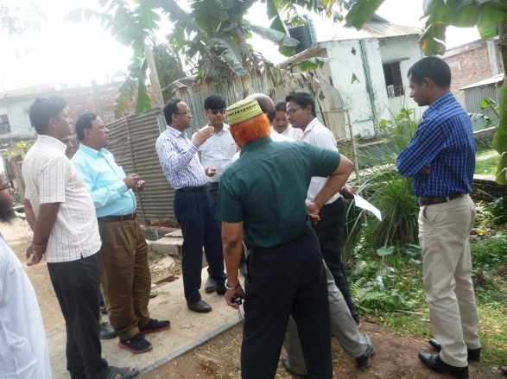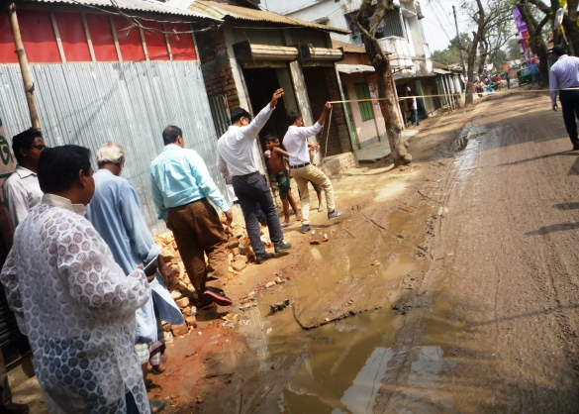
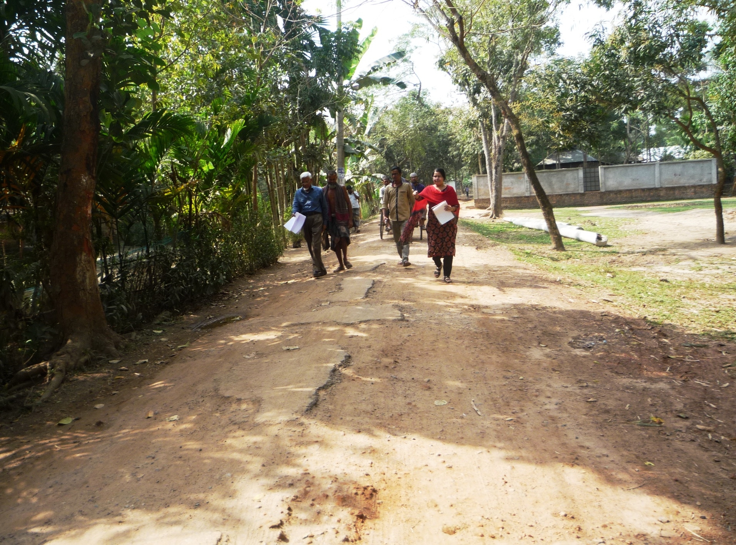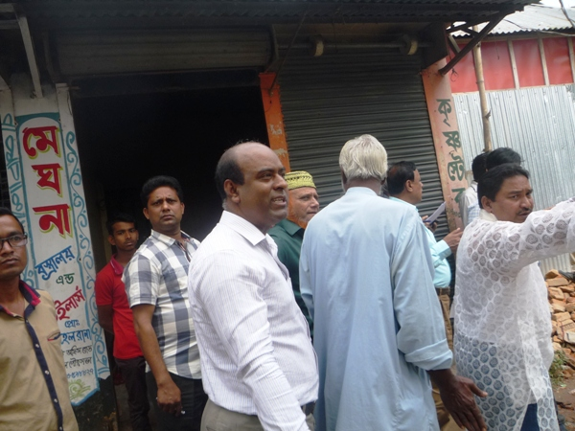
Photograph 7.1.1: Consultant Team visited the sites with Trishal Pourashava Officials

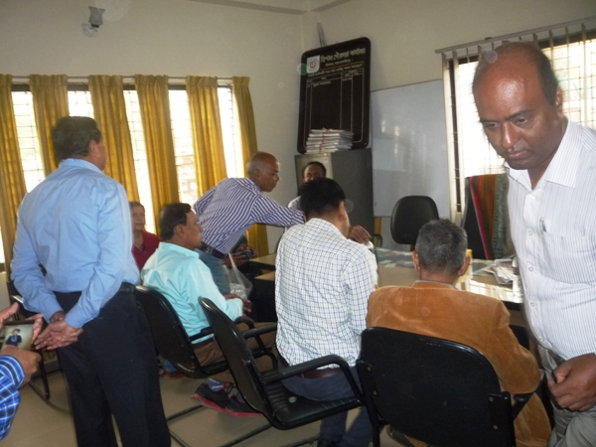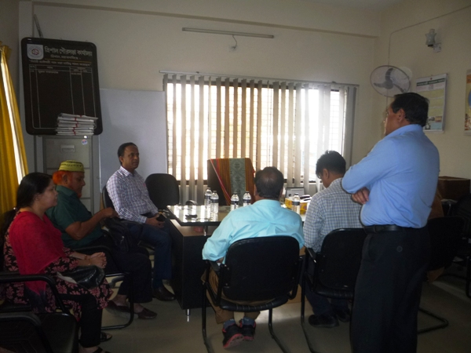
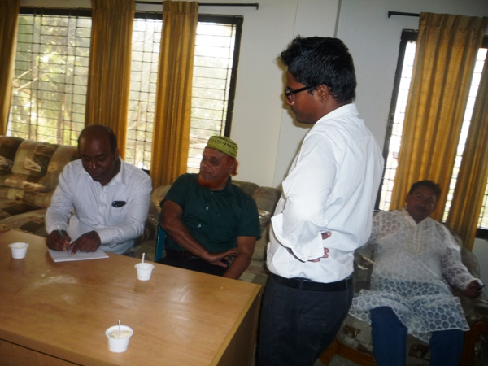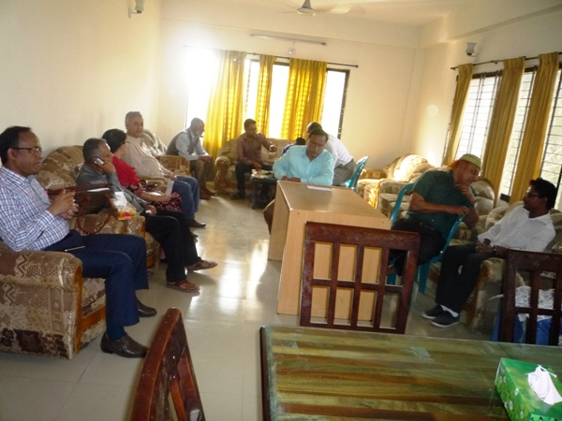

Photograph 7.1.2: Consultation Meeting at Trishal Pourashava with Pourashava Officials and Consultants Participants

Issues Raised by the Participants

The participants raised the issues related to the infrastructure development of Trishal Pourashava. They emphasized on the subproject selection for the future development and also discussed about the procedure for the quality construction work. In the FGD, the participants discussed the requirements for the Pourashava future development through a list of the subprojects.

Feedback, Suggestions, and Recommendations of the Participants

The participants’ feedback, suggestions, and recommendations listed below:
- The FGD results confirmed that an improved communication network, drainage facility, solid waste management, water treatment plant and sewerage treatment plant is needed for future development of Trishal Pourashava;
- The participants also discussed about the quality of the construction materials like cement, rod and sand of ongoing subprojects;
- Rod testing institution of ongoing subprojects was the important topic of the FGD discussion;
- They discussed about the perfect operational procedure and trouble of the construction equipments which LGED gave to Trishal Pourashava. The authority of PMU (LGED) described the solution to remove the equipment’s trouble;
- Accurate curing process was the another issue of the discussion;
- The participants emphasis to construct five storied foundation up to two storied multipurpose commercial building including kitchen market, convention centre and business space etc. at Trishal Bazaar;
- Participants addressed that cconstruction works should be scheduled properly and the quality of the construction work should be improved;

Conclusions and Recommendations

The environmental impacts of all the elements of the subproject have been assessed. All potential impacts were identified in relation to design and location, construction, and operation phases. The overall conclusion is that if the mitigation, compensation and enhancement measures are entirely implemented, there will be no considerable negative environmental impacts as a result of location, design, construction and or operation of the proposed subproject.
The conclusions of the environmental assessment can summarize as follows:
- Most of the predicted impacts are associated with the construction process, and are produced because that process is invasive, involving trenching and other excavation. Mitigation measures have been developed to reduce all negative impacts to acceptable levels.
- The EMP will assist the concerned personnel responsible for subproject implementation in mitigating the environmental impacts, and guide them in the environmentally sound execution of the proposed project.
- The EMP will also ensure efficient lines of communication between the implementing unit, project management unit, and contractors.

A few key recommendations are outlined below:
- A copy of the EMP shall be kept on-site during the construction period at all times
- The environmental management and monitoring plan proposed in this report also needs to be followed;
- A specific training program should be carried out for Pourashava staffs to deliver overall facts for environmental safeguards;
- Equipment should be checked by the Pourashava engineer and DSM consultant prior to work.

It should be noted that environmental assessment report is a live document. Hence, due to changing circumstances during the construction phase if any, there might be minor adaptation needed for environmental, health and safety issues.

APPENDIX

Appendix- I: List of the Participants

Appendix II: Environmental Monitoring Checklist

