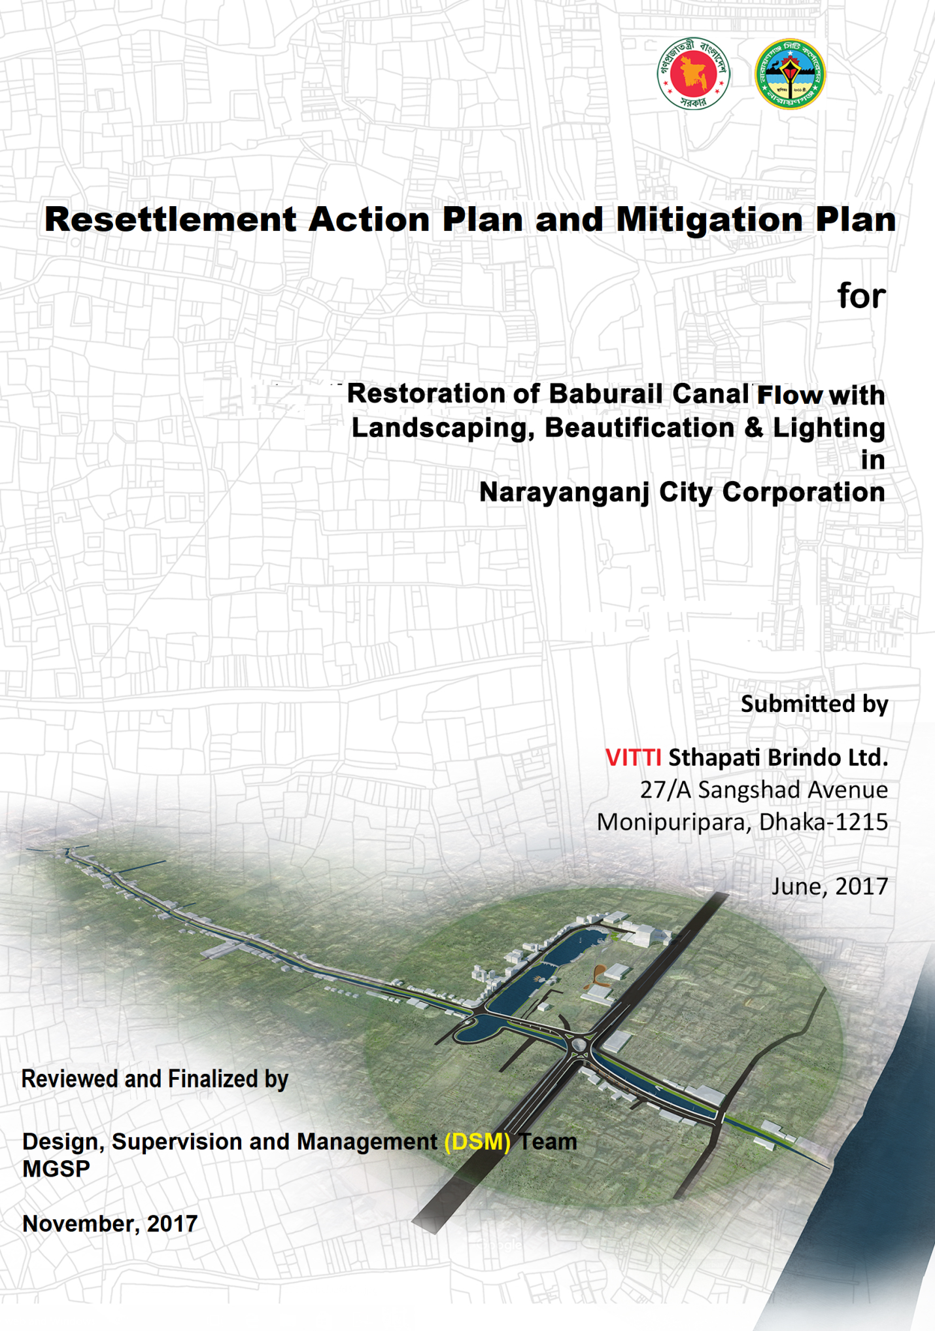

Abbreviations
AME  ARIPO | Assistant Municipal Engineer  Acquisition and Requisition of Immovable Property Ordinance of 1982
BBS | Bangladesh Bureau of Statistics
BR | Bangladesh Railway
BWDB  CEO | Bangladesh Water Development Board  Chief Executive Officer
CSR | Corporate Social Responsibility
COI | Corridor of Impact
CUL | Compensation Under the Law
CSC | Construction Supervision Consultants
DC | Deputy Commissioner (Head of district level bureaucracy)
DSM | Design Supervision and Management
EMP | Environmental Management Plan
EMF  EOP | Environmental Management Framework  End of Project
EIA | Environmental Impact Assessment
FGD | Focus Group Discussion
GAP | Gender Action Plan
GRC | Grievance Redress Committee
GTL | Grant to cover temporary loss of income
HH | Household
HCG | House Construction Grant
HAD  HSC | Homestead Development Allowance  Higher Secondary Certificate
IEE | Initial Environmental Evaluation
IGA | Income Generating Activities
IDA | International Development Association
IPDP | Indigenous People’s Development Plan
KII | Key Informant Interview
LGED  MGSP | Local Government and Engineering Department  Municipal Governance and Services Project
MOL  MPAC | Ministry of Land  Market Price Assessment Committee
M&E | Monitoring and evaluation
NCC | Narayanganj City Corporation
NGO | Non-Government Organization
OPs  O & M | Operational Policies  Operation and Maintenance
PAPs | Project Affected Persons
PAHs | Project Affected Households
PD | Project Director
PRA | Participatory Rural Appraisal
PIU | Project Implementation Unit (at City Level)
PMU | Project Management Unit (at LGED headquarters)
PM | Project Manager
RAP | Resettlement Action Plan
RP | Resettlement Plan
RRA | Rapid Rural Appraisal
RS | Resettlement Site
RU | Resettlement Unit
SIA  SIMP | Social Impact Assessment  Social Impact Mitigation Plan
SMF | Social Management Framework
SMP | Social Management Plan
SP  SSC | Superintendent of Police  Secondary School Certificate
STD | Sexually Transmitted Disease
STG | Structure Transfer Grant
TOR | Terms of Reference
UNO  UP | Upazila Nirbahi Officer  Union Parishad (grassroots local government council in Bangladesh)
TL | Team Leader
WB  Glossary  Zila  BDT  Khal  Kutcha  Semi-pucca  Pucca  Madrasa | World Bank  District  Bangladesh Taka  Canal  Structures constructed with CI sheet, wood and bamboo etc.  Structures constructed with brick wall but roof with CI sheet, wood and bamboo etc.  Structures constructed with brick wall and RCC roof  Educational Institutions teaching Islam along with basic general education

TABLE OF CONTENTS
Abbreviations ……………………………………………………………………………………………… ii
Table of Contents ………………………………………………………………………………….…..………. v
Executive Summary …………………………………………………………………………….……………. ix
Chapter 1: Introduction
  - Project Background …………………………………………………………….………….1
  - Subproject Location …………………………………………………………………… 1
  - Subproject Physical Interventions ……………………………………….. 2
  - Scope of Land Acquisition and Resettlement ……………………..…… 3
  - Measures to Mitigating Resettlement …………………………………….. 4
  - The Resettlement Action Plan (RAP) ……………………………………. 4
Chapter 2: Project Impacts and Inventory of Losses
2.1 Subproject Impacts on Affected Households and Communities …. 6
2.2 Project Affected Persons ………………………………………………… 6
2.3 Floor Area of Affected Structures ………………………………………………. 8
2.4 Loss of Income of Affected Persons …………………………………….. 9
2.5 Affected Wage Employee ………………………………………………… 10

Chapter 3: Socio-Economic Information of Impact Area People
3.1 Background ………………………………………………………………..……….. 12
3.2 Demographic Profile ……………………………………………….……………. 12
3.3 Housing Status …………………………………………………………………….……. 16
3.4 Income, Savings and Borrowing ………………………………..……………….. 18
3.5 Migration Status of Respondents …………………………………….. 20
3.6 Water and Sanitation ……………………………………………………..……… 21
3.7 Environmental Waste Management and Pollution Control ……… 29
3.8 Social Environment, Relevant Facilities and Problems ………………….. 32

Chapter 4: Legal and Policy Framework and Entitlement
4.1 Legal Framework ………………………………………….…………….…... 37
4.2 NCC Practices in Taking Land for Development Projects …..……….. 37
4.3 World Bank Policy Requirements …………………………………….. 38
4.4 Subproject Resettlement Policy ………………………………………………... 38
4.5 Eligibility for Compensation and Assistance ……………………………. 42
4.6 Implementation Schedule ………………………………………………… 46

Chapter 5: Stakeholder Consultation
5.1 Consultation ………………………………………………………………………….. 48
5.2 Focus Group Discussion ……………………………………………………………… 48
5.3 Consultation and Participation Plan …………………………………….. 49

Chapter 6: Institutional Arrangement
6.1 Institutional Setup …………………………………………………………….. 51
6.2 Grievance Redress Mechanism ………………………………………………… 53

Chapter 7: Resettlement Budget
7.1 Compensation and Resettlement …………………………………..….. 57
7.2 Replacement Cost Rates for Demolished Structures …..……….. 57
7.3 Livelihoods and Vulnerability …………………………………………..……. 58
7.4 Proposed Budget for Resettlement ………………………………………. 58
7.5 Financing Resettlement Cost ……………………………………………………... 59
7.6 Resettlement Support in Kind: Shop for Shop …………………………….. 59

Chapter 8: Monitoring and Evaluation
8.1 RAP Supervision, Monitoring and Evaluation ……………………..… 62
8.2 Internal Monitoring ……………………………………………………………… 62
8.3 Measurable Social Indicators ……………………………………………..….. 63
8.4 Compliance Monitoring …………………………………………………………….. 64
8.5 Verification of Monitoring ………………………………………..……….. 64
8.6 External Monitoring and Evaluation ……………………………………. 64

List of Tables
Table 1.1 Physical Interventions …………………….………….……………….. 3
Table 1.2 Summary of Population Displaced …………………………….. 3
Table 2.1 Project Affected Households and Persons ……………………. 6
Table 2.2 Affected Installations by Location and Type of PAPs ….. 6
Table 2.3 Type of PAPs by Location ……………………………………………. 7
Table 2.4 Number of Affected Community Facilities ……………………. 8
Table 2.5 Number of Affected Crossover Bridges ………………..……… 8
Table 2.6 Affected Persons by Gender …………………………………….. 8
Table 2.7 Average Floor Area of Affected Structures ……………………. 9
Table 2.8 Main Source of Income of Affected Households …….…….. 10
Table 2.9 Number of Affected Wage Employee of Shops … ……….. 10
Table 3.1 Age Distribution of Respondents ……………………………. 14
Table 3.2 Marital Status of Respondents ……………………………………. 14
Table 3.3 Educational Status of Respondents ……………………………. 14
Table 3.4 Occupation of Respondents …………………………………….. 15
Table 4.1 Categorization of PAPs …………………………………………………. 39
Table 4.2 Compensation and Entitlement Matrices ………………….. 42
Table 5.1 Public Consultation Summary ……………………………….…… 48
Table 5.2 FGD Summary …………………………………………………………….. 49
Table 6.1 Roles and Responsibilities in RAP Implementation…………. 52
Table 7.1 Estimated Loss of PAPs …………………………………………………. 57
Table 7.2 Resettlement Cost and Financing Source ……………………….. 60
Table 8.1 Potential Monitoring Indicators for RAP …………………..……. 63
Table 8.2 Measurable Social Indicators ………………………………….… 64

List of Figures
Fig 1.1 Location Map ……………………………………………………………………………. 2
Fig 1.2 Layout Plan ……………………………………………………………………….………. 2
Fig 3.1 Land use Map of Catchment Area ………………………………………. 12
Fig 3.2 Sex Distribution of Catchment Area People ……………………………… 13
Fig 3.3 Religion of Catchment Area People ….…………………………………… 13
Fig 3.4 Ethnicity of Respondents ……………………………………………………….…….. 15
Fig 3.5 Tenancy of Dwelling Houses ………………………………..……………….. 16
Fig 3.6 Construction Type of Dwelling Houses …………………………….……… 17
Fig 3.7 Floor Area of Dwelling Houses …………………………………………………. 17
Fig 3.8 Monthly Expenditure of Respondent Households ………….………. 18
Fig 3.9 Monthly Income of Respondent Households …………………………… 18
Fig 3.10 Household Savings of Respondents ………………………………..…… 19
Fig 3.11 Current Loan of Respondent Households …………………………… 19
Fig 3.12 Length of Living at Present Location of Respondents ……………. 20
Fig 3.13 Whether Respondents are Migrants to Present Location ……………. 20
Fig 3.14 Origin of Migrant Households …………………………………………………. 21
Fig 3.15 Main Source of Drinking Water …………………………………………………. 21
Fig 3.16 Alternate Source of Drinking Water ……………………………………. 22
Fig 3.17 Main Source of Cooking Water …………………………………………………. 23
Fig 3.18 Alternate Source of Cooking Water ……………………………………. 23
Fig 3.19 Main Source of Bathing Water …………………………………………………. 24
Fig 3.20 Alternate Source of Bathing Water ……………………………………. 24
Fig 3.21 Water Source of Toilets …………………………………………………………….. 25
Fig 3.22 Type of Toilet Facilities Availed ……………………………………………..…. 25
Fig 3.23 Drainage of Waste Water of Toilets ……………………………………………. 26
Fig 3.24 Condition of Latrine ……………………………………………………………… 27
Fig 3.25 Hygienic Status of Latrine …………………………………………………. 27
Fig 3.26 Suitability of Latrine for Children and Disabled …………..……………. 28
Fig 3.27 Disposal of Excreta ………………………………….…………………………..……. 28
Fig 3.28 Drainage Connection ……………………………………………………….……….. 29
Fig 3.29 Pathway of Storm Water Disposal ………………….………………….. 29
Fig 3.30 Waterlogging Problem of Households ………………………….…………. 30
Fig 3.31 Duration of Waterlogging ………………………………….……………… 30
Fig 3.32 Disposal of Kitchen Waste ………………………………….……………… 31
Fig 3.33 Air Pollution Status of the Catchment Area …………………………. 31
Fig 3.34 Sound Pollution of the Catchment Area ………………………….…………. 32
Fig 3.35 Membership of Social Organizations ……………………………………. 32
Fig 3.36 Playground Facilities for Children …………………………………….. 33
Fig 3.37 Open Space and Parks …………………………………………………………..… 33
Fig 3.38 Facilities for Cultural Events and Movie House ………………………… 34
Fig 3.39 Drug Addiction Problem ………………………………………….……… 34
Fig 3.40 Security Related Problems ……………………………………….………… 35
Fig 3.41 Social Network of Respondents ……………………………………………..….. 35
Fig 6.1 Institutional Framework ……………………………………..………….. 51

Annexes
Annex 1/A: Inventory of PAPs and Affected Installations- NCC Tenants (Vitti List) 64
Annex 1/B: Inventory of PAPs and Affected Installations- BR Claimants …… 68
Annex 1/C: Inventory of PAPs and Affected Installations- Mondalpara Slum …. 71
Annex 1/D: Inventory of PAPs and Affected Installations- Baburail- Bottola …… 73
Annex 1/E: Inventory of PAPs and Affected Installations- Kashipur UP Area …. 74
Annex 1/F: Inventory of Crossover Bridges Affected …………………………….. 79
Annex 1/G: Inventory of Social Organizations Affected …………………………….. 88

Annex 2: FGD Findings ………………………………………………..……………. 81
Annex 3: Public Consultation Findings ……………………………………… 107
Annex 4: Lease Agreement of NCC with Tenant Shopkeepers …… 117
Annex 5: Notice of NCC Served to Tenants …………………………….. 121
Annex 6: Undertaking of PAPs on Vacating NCC/Public Land……………… 123
Annex 7: Format for Acknowledging Receipt of Commitment Letter…… 126
Annex 8: Format for Declaring Willingness to Voluntary Dispossession
Without Compensation …………………………………………………. 127
Annex 9: Format for Declaring Willingness to Voluntary Dispossession
With Compensation ……………………….……………….…………. 128
Annex 10: Format for NCC Commitment Letter on Allocating Shop ……. 129
Annex 11: Guidelines for Validation of Voluntary Dispossession of Land 130
Annex 12: Implementation Schedule ………………………………………. 132
Annex 13: List of 101 NCC Leaseholders as per NCC record ……………… 134

Executive Summary

Executive Summary
Decades ago, Baburail canal was one of the crucial waterways that carried goods and passengers to the city heart, because it connected Shitalakhya and Dhaleshwari Rivers. The canal is now disconnected from the river Shitalakhya in the east by filling it with earth. In the west part also, it is now narrowed to a drain, still flowing and carrying waste water to the river Dhaleshwari but is no longer navigable.
The proposed development as restoration of water flow through this canal to the river Dhaleshwari aims mainly to improve drainage. However, reestablishing navigability between Shitalakhya and Dhaleshwari Rivers by this canal is a dream to be materialized when the two rivers will have cleaner water which is now highly polluted. However, the re-excavation works will open up opportunity for plying of boats in side of the canal area.
Project Location
The proposed canal is about 3.5 Kms long and average 15-30m wide in different sections. The canal area falls under ward no- 15 & 16 of Narayanganj City Corporation and Kashipur Union Parishad of Fatulla Thana of Narayanganj district. Baburail khal was connected to Jimkhana Lake which is approximately 405 m long and 75 m wide. The Jimkhana Lake is being developed under another project of the NCC and it will again be connected with the re-excavated Baburail canal.
Sub Project Interventions
The subproject proposes to execute 15 different types of physical work including demolishing structures from the canal land, re-excavation of the canal, slope protection, construction of walkways on both sides, widening of road, construction of ghat for boat rowing, demolishing un-necessary private bridges, reconstruction of bridges at selected locations, lightening, beautification, public toilet, sluice gate and traffic safety.
Scope of the RAP and its Approach
The RAP took into account of the World Bank’s Operational Policy 4.12 (OP 4.12) on Involuntary Resettlement and OP 4.10 on Indigenous People triggered to the MGSP. The RAP assessed if there is need for acquisition of private land or taking back of the public land from private uses for the subproject works. The RAP includes consultations with a wide range of local stakeholders who are likely to be affected positively by the sub project interventions. In addition, it contains a detailed inventory of the installations likely to be affected along with the identification of the PAPs, the type of losses, perceived value of the losses (to be demolished or moved) and monthly income from the structure to be affected.
Based on the study findings, the RAP includes an estimate of resettlement cost and other support to be provided for livelihoods restoration of the vulnerable groups such as women, disabled and squatters.
The Affected Installations and the PAPs

No private land is needed for the subproject. However, due to taking back of public land from private uses, a total of about 302 Installations(mostly shops) and 10 community facilities (2 mosques, 1 temple and 7 clubs) are likely to be affected in the NCC and Kashipur Union Parishad areas excluding 34 RCC cross over bridges and 10 wooden/ bamboo footbridges. All affected structures are located on public land or NCC land. About one third of the PAPs are NCC leaseholders and all others are unauthorized occupants. About 10% of the PAPs are slum dwellers who built temporary hut on NCC land. About 8% of the PAPs are women including a beggar and seven slum dwellers and one of the PAPs is a disabled person.

About 75% of the PAPs are engaged in business 13% in public sector services, 2% in private service and 2% are housewife. About 7% did not provide information on occupation and only 1% engaged in other occupations like journalism and law.
Monthly income of PAP from the affected installations was high (over BDT 25,000) for the NCC tenants and south of Gymkhana area traders while it was only about BDT. 5,000 for the Mondalpara slum dwellers as calculated on the basis of Vitti’s report. Average value of the affected installation as reported by the PAPs is highest (BDT 500,000) and second highest for the NCC tenants (BDT 374,000). It is low at BDT 94,000 for the Mondalpara slum dwellers. Thus reported loss is roughly equal to 20 month’s income of the PAPs but the reported value of affected property seems inflated by the PAPs to more than double. So, actual loss is about 10 month’s income of the PAPs.
Legal and Policy Framework
The project civil works boundary is well within the existing land of NCC or public land and is not affecting interest of any private owner. However, there are 101 leaseholders of theNCC which is governed by the lease agreement executed with the individual lease holders allowing establishment and operation of temporary shops on paying monthly rent for the land. The lease agreement specifically mentions that the NCC can terminate the lease agreement and evict the tenants any time at 15 days’ notice without any compensation but the NCC notified them more than one month before eviction which is really practiced by the NCC.
This is in conformity with the Easements Act 1882 (Act V of 1882) and subject to eviction under the “Government and Local Authority Lands and Buildings (Recovery of Possession) Ordinance, 1970”. Any unauthorized occupants of public land can also be evicted under this recovery of possession ordinance on expiry of notice period.
Since no private land will need to be acquired for this subproject, the law on acquisition of land “The Acquisition and Requisition of Immovable Property Act 2017” will not be applicable. However, there is need for voluntary dispossession by authorized lease holders and unauthorized informal settlers. The legislatives and regulatory framework are not adequate to deal with the adverse impacts associated with the involuntary displacement or voluntary dispossession. The law does not cover project-affected persons without title to be compensated and does not ensure replacement cost of assets acquired. The law also does not initiate any measure for restoration of livelihoods of the affected persons.
NCC prefers voluntary dispossession of public land without compensation by the encroachers and well-off informal settlers. The City Corporation has also executed declaration by some of the encroachers and squatters of voluntary dispossession of NCC’s land without any compensation or claims what so ever. The NCC however, also committed due compensation to some others (the NCC leaseholder shopkeepers) who have already cleared a section of the Baburail Khal for the first phase construction.
Given the involuntary displacement of people involved in the subproject, the World Bank policy on involuntary resettlement (OP/BP 4.12) applies. The policy requirements and the project’s compliance are following:
- Involuntary resettlement from resume of public land and acquisition of private land should be avoided, minimized or mitigated where feasible; - No private land acquired and involuntary resettlement minimized.
- Unavoidable impacts should be assessed and compensated at full replacement cost; - Impact assessed and compensation modality worked out.
- Relocation of housing and businesses should be assisted at no cost to the affected persons; - Relocation of private houses not required and compensation package worked out for rehabilitating shopkeepers and slum dwellers.
- If income and livelihoods are affected, measures to be taken for restoration of the livelihoods at the pre-project level; - The shop allottees will be better-off and those not getting shop allocation will be provided cost for rebuilding shops elsewhere and additional support to rent shop will be provided.
- Affected households will be meaningfully consulted at all stages of project cycle and their concerns and choices will be reflected in project design and implementation approach; - The PAPs have been consulted and their views incorporated in the RAP.
- A workable grievance redress mechanism will be in place for addressing any grievances and complains related to compensation and resettlement. – GRM is already established in the NCC and it is functioning.
The subproject resettlement policy is that all PAPs will be compensated either by the NCC or by the MGSP at replacement cost and budget is kept for this purpose. Replacement costs will be based on the current market prices of various building materials, labor and other cost items in the local markets at time. The costs of building materials, such as bricks, cement, steel, sand, bamboo, timber, CI sheet, etc., and labor cost at prevailing wage rate. The NCC will form a
Replacement costs of any other items will be determined based on the current prices of materials, labor, etc. As and when required, NCC may also seek technical assistance of Executive Engineer of LGED in the district and the project consultants for estimates of materials and labor for structures. The NCC will form a Market Price Assessment Committee (MPAC) constituted with representatives from the LGED and Zila Parishad which will be headed by the CEO and Executive Engineer of NCC will be the Member Secretary.
Entitlement and Payment of Compensation
Compensation in cash or kind and cash resettlement assistance will be paid directly by NCC to the affected persons with or without legal easements documents, such as, lessees, squatters and encroachers, as well as business owners and employees. NCC will ensure that the properties (structures and non-structure assets) to be cleared for civil works construction under the subproject will be subject to compensation as agreed between the concerned affected persons and the NCC. The PAP may seek compensation to the extent of full replacement cost or may agree in writing to vacate without compensation or partial compensation. The full replacement cost will be determined by the MPAC following the guideline of the SMF and this RAP.
Stakeholder Consultation
Stakeholder consultation under for the preparation of the RAP comprised holding of public consultation meeting at the NCC conference room and five focus group discussions held with various categories of primary stakeholders living in proximity of the proposed canal site. These are in addition to detailed door to door consultation to identify locations of proposed interventions, their likely positive and negative impacts and to prepare an inventory of the PAPs. The consultation outcomes are described here.
Before conducting stakeholder consultations, the consultants ensured having prior informed consent of the stakeholders and stakeholder meetings were held at community level to prepare a comprehensive Resettlement Action Plan (RAP) for this Project. Consultation meetings were held during the field visits to identify issues and problems to enable the involved institutions (the NCC and LGED) to take corrective measures during the designing and implementation stages.

Both qualitative and quantitative methods were used to assess the social impact of the project as well as to make a plan for social mitigation and resettlement. A quantitative survey was conducted to collect 384 respondents’ data by using electronic semi-structure questionnaire whereas 5 FGDs and a central level public consultation also held to know the details of social impacts and to device social mitigation and resettlement mechanisms of the project (Annex-2 and Annex-3 for details of FGD and consultation meeting outcomes).

Suggestions and comments of the five FGD are summarized below:
- Effective compensation should be given to those who will be affected by the project. The project will have positive impact to beautify the city.
- There should be excellent quality of drainage system.
- This project will have positive impact enhancing economic activities.
- Environment pollution will be reduced.
- The canal will be an entertainment center.
- Once again, connection will be established in future between two rivers which is a dream now.
- Development of Narayanganj city and the Kashipur areas will be enhanced.
- Local shop and local trade will be improved.
- The city will be neat and clean.
- Both sides will have wide road to walk beside the canal while one side will have wide road for vehicular traffic.

Conclusion on Resettlement Assistance
As for abovementioned comments and suggestions, the NCC ensures that the project will have positive impacts, be inclusive and will compensate the PAPs as entitled by the GOB as well as World Bank policies. The compensation may be cash or kind (such as shop for shop). The will follow another strategy of voluntary dispossession with or without compensation under which the poor and vulnerable ones will definitely be compensated to the extent of full replacement cost and in addition will be provided special assistance. Only the non-poor encroachers who built temporary structures built on the canal side will be approached to vacate without compensation by voluntary dispossession but those losing livelihoods will be compensated either with shop for shop or transition allowance and shifting cost.
Institutional Arrangement
The NCC will establish a Project Implementation Unit (PIU) that will lead the project implementation including implementation of the RAP. The PIU responsibilities include procurement of consultants for carrying out the SIA and preparing RAP. The PIU is headed by the head of engineering section of the NCC. The PIU has an Environment and Social Support Cell with qualified staff. This Cell assists the PIU on issues related to social management.
The PIU will compile quarterly monitoring reports on social compliance for submission to the Project Director and also shares the report with the World Bank. The PIU with the support of the PMU will also provide trainings to the NCC field personnel responsible for monitoring of social compliance during both construction and O&M phases of the project. To execute the social management activities, the PIU will have adequate manpower comprising social scientists/specialists for implementing the RAP under the guidance of the PMU and the DSM. For this purpose, the NCC will engage competent experts on short term basis with the consent of the PMU, LGED.
The Grievance Redress Committee (GRC) has already been formed with seven members. The committee will solve the grievances which have been raised by the PAPs and Project community. The members of the committee are Representative of NCC (1), NGO representative (1), LGED representative (1), Affected persons’ representatives (2).From the affected persons’ representatives, one will be a male and the other one be female. As per the project SMF, there is a focal point in the GRC who is Assistant Secretary of the NCC.
The GRC will receive the application from the affected stakeholders about their grievances and they will solve the grievances every month other than disputes relating to ownership rights under the court of law. The GRC will review grievances involving all resettlement benefits, relocation and other assistance and resolving relevant social issues including resettlement issues.
Resettlement Budget and Financing
Overall resettlement cost of the subproject will be BDT 22.34 million (USD 0.28 million) of which BDT 11.93 million (USD 0.15 million) is the cost of rebuilding affected structures. The remaining amount of about BDT 10.41 million (USD 0.13 million) include cash assistance to slum dwellers, the affected shopkeepers, special assistance to women and disabled PAPs, support for reimbursement of repair expenses, further consultation, awareness campaign, motivational work and administration and monitoring of RAP implementation.
Table E-1 Overall Resettlement Budget(Taka)
SL | Cost Items | Number of PAPs | Av Unit Cost | Total Cost | NCC | MGSP
1 | Compensation in kind (shop for shop) against demolished structures (NCC/ public land Tenants) | 162 (101+61)
2 | Compensation against demolishing temporary shops Baburail Mosque to Bangla Bazar (71 UP area + 17 NCC) | 88 | 57,396 | 5,050,850 | 0 | 5,050,850
3 | Compensation against demolition of slum houses | 31 | 70,000 | 2,170,000 | 0 | 2,170,000
4 | Compensation against partial demolition of non-slum houses (NCC 3+ UP 17) | 21 | 125,000 | 2,625,000 | 2,625,000 | 0
5 | Compensation to affected community facilities (10) | 10 | 208,025 | 2,080,250 | 1,176,000 | 904,250
 | Sub Total: Compensation for demolishing and rebuilding structures |  |  | 11,926,100 | 3,801,000 | 8,125,100
6 | Transition cost and shifting support to slum dwellers for rented accommodation | 31 | 19,000 | 589,000 | 0 | 589,000
7 | Transition & shifting support for shopkeepers not allocated shops | 50 | 30,000 | 1,500,000 | 0 | 1,500,000
8 | Tenants & employee of shops, excluding NCC/ public land tenants | 50 | 11,000 | 550,000 | 0 | 550,000
9 | Special assistance to women and disabled PAPs | 25 | 10,000 | 250,000 | 0 | 250,000
10 | Reimbursement of Repair Expenses of | 21 | 20,000 | 420,000 | 0 | 420,000
11 | Leaflets/ posters/ Bill Board | LS |  | 200,000 | 0 | 200,000
12 | Stakeholder consultation, awareness campaign during implementation | 8 events | 50,000 | 400,000 | 0 | 400,000
13 | Infrastructure user/ operator training | 5 events | 100,000 | 500,000 | 0 | 500,000
14 | IT capacity building of NCC, and administration and Monitoring of RAP | One office-PIU |  | 1,000,000 | 0 | 1,000,000
15 | Transition support to NCC/BR leaseholder shopkeepers | 162 | 30,000 | 4,860,000 | 0 | 4,860,000
16 | Other contingent support to NCC |  |  | 140,000 | 0 | 140,000
 | Sub Total: Other Resettlement Supports |  |  | 10,409,000 | 0 | 10,409,000
 | TOTAL in BDT |  |  | 22,335,100 | 3,801,000 | 18,534,100
 | TOTAL in USD |  |  | 283,000 | 48,000 | 234,000

Of the total resettlement budget, NCC will contribute BDT 3.8 million (USD 48,114) to compensate affected shopkeepers not allocated shops by the NCC and the project will finance BDT 13.5 million (USD 171,317).
In addition, the NCC will allocate 101 shops to the affected NCC tenants at Padma -3 market at Tan Bazar area which is already tendered for construction in about one year. Another 61 affected tenants having shops south of Gymkhana Lake will be allocated SI sheet roof shops at the new sand-fill site near Gymkhana Park. Estimated market value of each shop to be constructed by the NCC in Tan Bazar are Gymkhana area is BDT 3,000,000 and 800,000 respectively which will be allocated to PAPs at concessional rate of aboutBDT1,500,000 and free of charge respectively. This rebate is far above the estimated value of the damaged structures of BDT 168,000 and 263,000 respectively. So, each PAP gains about BDT 1.3 million and 0.5 million respectively. The shops in both markets will be allocated by June 2019 and commitment letter issued by March 2018 with approval of NCC council.
Monitoring and Evaluation
NCC as implementing agency will establish an RAP Implementation Unit headed by the CEO and supported by the head of the engineering section. The Social Welfare Officer, NCC will be the responsible desk officer. The councilors of the concerned wards will ensure that the RAP is implemented as planned. The Mayor will oversee the implementation of RAP ensuring its compliance as per the SMF of the MGSP.
The RAP implementation and compliance will be monitored within NCC by a committee headed by the RAP implementation Unit as per directives of the PMU and guidance of the DSM. The RAP implementation unit will be responsible to monitor the progress of all aspects of resettlement activities including payment of compensation and livelihood restoration support as provided in the RAP budget. The RIU will report to the NCC and the PMU on resettlement and the PMU will forward such reports to the World Bank.
Monitoring of the RAP implementation will be executed internally to provide feedback to NCC upon M&E reports and other relevant data to identify problems and issues and recommend any action needed to improve resettlement performance or respond to the changing circumstances. Evaluation of the resettlement activities will be undertaken during and after implementation of the RAP to assess (i) whether the resettlement objectives are met, and (ii) more specifically, whether livelihoods and living standards of the PAPs have been restored or enhanced.

A qualified independent consultant (individual or group) will be engaged as third-party monitor during RAP implementation by the PMU. In the absence of the third party, the DSM will monitor the RAP compliance. By the EOP, an evaluation will assess the resettlement efficiency, effectiveness, impact and sustainability, drawing lessons as a guide to future resettlement planning. Budgetary provision has been kept in this RAP for RAP implementation and monitoring.

Chapter 1: Introduction

Chapter 1: Introduction

Project Background
Narayanganj City Corporation (NCC) has undertaken the ‘Restoration and Beautification of Baburail Khal Subproject’ for restitution of the historical Baburail Khal flowing through the Narayanganj City between Dhaleshwari and Shitalakhya rivers. NCC is requesting funds from the Municipal Government and Services Project (MGSP) under implementation by the Local Government Engineering Department (LGED) with financing from the International Development Association (IDA) of the World Bank Group (WBG). Baburail Khal was one of the significant waterway routes to carry goods and passengers to the city heart from the neighboring Shitalakhya and Dhaleshwari rivers. The 3.5 km Khal is now disconnected from the river Shitalakhya in the east by gradual earth deposition over time. In the west part, the Khal is now narrowed to a drain connected to the river Dhaleshwari near Munshiganj highway and this is no longer navigable. The Khal has lost its usual form and flow, and encroached by neighboring residents as well by squatters. Most of its land has long being raised and used for commercial purposes by NCC itself and many informal settlers. Community structures have also been constructed on the naturally and artificially filled up land of the Khal. The Khal is indiscriminately being used by local area people for solid and liquid waste dumping and sewerage disposal.
The proposed development for restoration of water flow through this Khal to the river Dhaleshwari aims mainly to improve drainage. Reestablishing navigability in this Khal and opening it to Shitalakhya and Dhaleshwari rivers on both sides is a dream of the NCC residents expectedly when the two rivers will have cleaner water, now highly polluted. However, the re-excavation works will open-up opportunity for plying of small boats in some sections of the Khal but not connecting the two rivers.
Narayanganj, an important and historic town very close to Dhaka acquired the status of City Corporation in 2011. The city is growing fast and is facing difficulty to address various problems like garbage disposal, drainage and intra-town road network. It lacks open public space, children’s area, green parks and recreation facility for the city dwellers.
Due to increasing demand of Narayanganj city dwellers, it is a vision of the city Mayor, Dr. Selina Hayat Ivy to reopen the old waterway through this Khal. She has a visionary ambition to restore the Khal to full navigation in the interest of conservation of biodiversity and improving physical and social environment of the area as well as for creating opportunities for recreational facilities and enhanced livelihoods opportunities for the poor among the city dwellers.
1.2 Subproject Location
The Khal proposed for restoration and beautification is locally known as ‘Baburail & Jelepara Bangla Bazaar Khal’, which is 3.5 Km long with an average width of 15-30m, connecting Shitalakhya River in the East and to Dhaleshwari River in the West. The Khal falls under ward no- 15 & 16 of Narayanganj City Corporation and Kashipur Union Parishad of Fatulla Thana of Narayanganj District. When connected to the rivers, the Khal flew east to west in the monsoon and west to east in the lean period. Presently, Shitalakhya side is closed by earth deposition. In the west, there is still some flow like a drain, connected to river Dhaleshwari. Baburail Khal was connected to Gymkhana Lake which is approximately 405 m long and 75 m wide. The Gymkhana Lake is being developed under another project by NCC and it will again be connected with the Baburail Khal, when re-excavated.
Location map of the Baburail Khal and the Layout Plan of the proposed re-excavation works are provided in figures 1.1 1nd 1.2 respectively.

Figure 1.1: Location Map of Baburail Canal 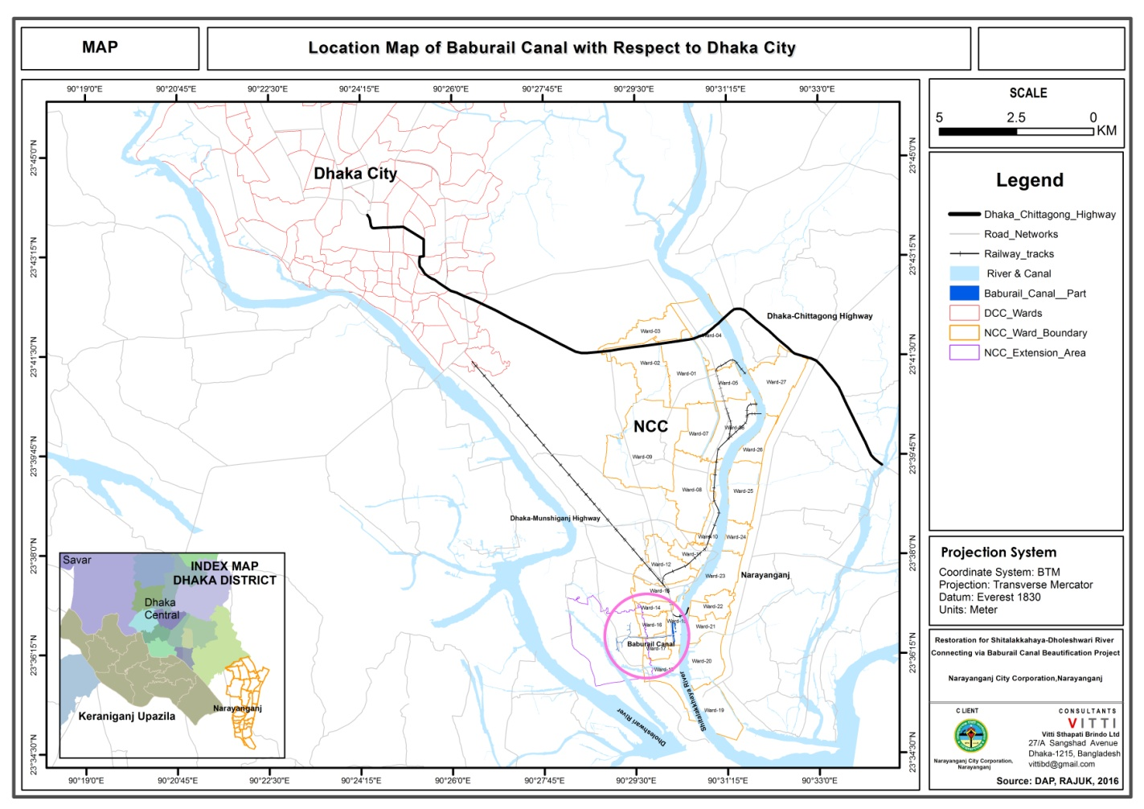

Figure 1.2: Layout Plan of Baburail Canal Re-excavation and other interventions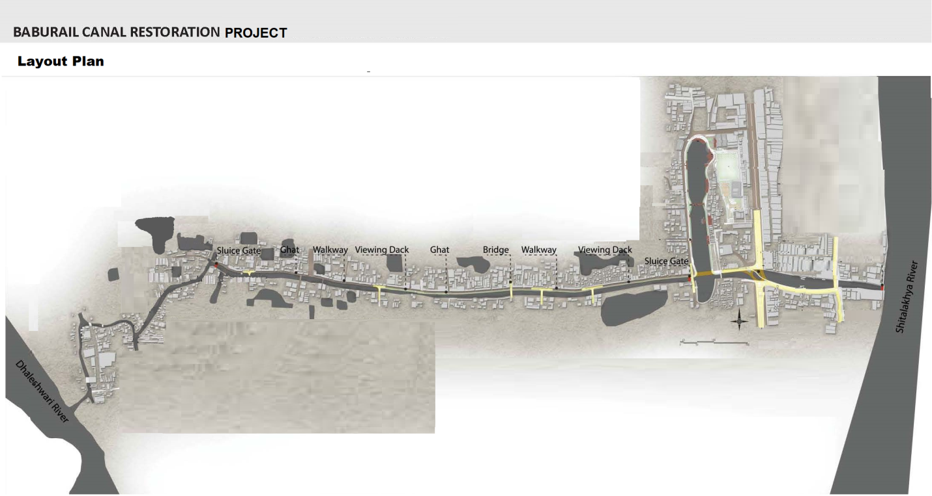

1.3 Subproject physical interventions

The subproject physical interventions include demolition of about 366 structures (250 shops, 31 slum houses, 10 community facilities, partial demolition of 21 temporary dwelling houses, 34 RCC bridges including 9 road crossing bridges and 25 cross over private bridges and 10 wooden/ bamboo foot bridges) and construction of 15 types of installations. The physical works are described briefly in Table 1.1. This is however tentative and the MGSP is modifying it.

Table 1.1 Major Physical Interventions to be implemented under the subproject
SL | Broader heads of investment | Unit | Quantity
1 | Demolition of existing structures  a. Shops and temporary housing,  b. Community facilities and  c. Crossover bridges  (all as per RAP estimate) | Number | - 302  - 9  - 32
2 | Sludge removal | CuM | 21,242
3 | Slope protection | SqM | 42,169
4 | Walkway, Bicycle lane etc. | M | 5,608
5 | Construction of Ghat | No. | 5
6 | Widening existing road | M | 1,605
7 | Viewing deck | No. | 3
8 | Bridges (RCC) | No. | 9
9 | Foot Bridges (Metal) | No. | 8
10 | Drainage improvement | M | 5,608
11 | Landscaping/ beautification | M | 5,213
12 | Electrical work/ lightening | M | 5,213
13 | Construction of Sluice Gate | No. | 2
14 | Public Toilet | No. | 1

1.4 Scope of Land Acquisition and Resettlement

Land acquisition for rehabilitation of the Baburail Khal is limited to resume of existing land reserve from the private users under formal and informal occupation like lessees, encroachers and squatters. No private land is required for the subproject physical works. However, resumption of existing land occupied by encroachers and squatters will involve involuntary displacement of people resulting in loss of housing, businesses and sources of income. A total of 302 affected households and shops and 10 social units will be displaced fully or partially and 34 private crossover bridges as shown in the Table 1.2 below.
Table 1.2 Summary of Population Displacement
Type of structures unit by use | Affected under NCC | Affected under Kashipur Union | Total
Residential structures (31+3) | 34 | 18 | 52
Business structures | 179 | 71 | 250
Common/community structures | 4 | 6 | 10
RCC Cross Over Bridges | 19 | 15 | 34
Total | 236 | 110 | 346

Land requirements have been determined following the subproject layouts and reviewing the ownership and tenures. The displaced households and persons include lessees, encroachers and squatters for residential, business and community property. According to the MGSP Social Management Framework (SMF), the subproject triggers Bank’s social safeguards policy on involuntary resettlement (OP/BP 4.12).
1.5 Measures to Minimize Resettlement
The project design has considered using only available public land under the Baburail and Jelepara Bangla Bazaar Khal (Baburail Khal) connecting the Dhaleshwari and Shitalakhya Rivers through the City of Narayanganj. Demolition of permanent installations and installations located on private land has been fully avoided. Communities and likely affected persons have been consulted for their broader consent and support to the Subproject. Right of way for civil works has been defined taking into consideration of available width of the Khal, existing road beside the Khal, traffic flow on the existing roads, drainage of waste water disposal, garbage disposal and restoration of partial navigability of the Khal. Existing infrastructures and public spaces have been integrated in the subproject design to avoid any private land acquisition. Public consultation and their participation will be continued in the subproject implementation process as well.
1.6 The Resettlement Action Plan
This Resettlement Action Plan (RAP) has been prepared for the subproject undertaken by the Narayanganj City Corporation (NCC) for restoration of the Baburail Khal and its beautification with landscaping, roads, bridges and re-excavation works. The RAP provides guidance for identification of adverse social impacts and mitigation of those in compliance with the Bank policy on involuntary resettlement (OP 4.12) and in the spirit of the Constitution of Bangladesh related to the rights of the common citizen of Bangladesh. Acquisition of private land for private or public purposes for wider public good is governed by the Acquisition and Requisition of Immovable Property Act 2017 (this law has replaced the earlier Ordinance on land acquisition namely the Acquisition and Requisition of Immovable Property Ordinance, 1982). Identified impacts include partial demolition of structures by the encroachers, and displacement of formal and informal users of the land from their housing, businesses, community structures and sources of income. This RAP has the provisions of resettlement assistance for the displaced households (DH) and commercial enterprises (CE) and income restoration assistance to the poor and vulnerable households irrespective of legal tenure status to the land. The primary objective of this RAP is to identify impacts of the project interventions and implement measures to mitigate them. The RAP presents (i) type and extent of loss of assets; (ii) principles and legal framework applicable for mitigation of these losses; (iii) the entitlement matrix, and (iv)resettlement and rehabilitation budget; (v) institutional and implementation arrangement of the plan, including monitoring and evaluation.
This RAP has been prepared following the MGSP SMF based on census of affected persons, inventory of assets, valuation of assets and consultation with affected persons and their community. The census was carried out during June 2017and verified in November 2017.
The affected persons and their communities were consulted through open consultation meetings and focused group discussions (FGD) to obtain their views on subproject design to avoid or minimize impacts and on mitigation of adverse social impacts. Market survey was carried out to determine current market price of structures, trees and other assets.
The inventory of assets affected by the Subproject was prepared following the subproject layout plans along with the mauza maps showing the land reserve of the Baburail Khal. An experienced social survey firm was engaged by NCC for carrying out the surveys and preparation of the RAP. The RAP was reviewed by the LGED Design and Supervision Consultant (DSC) and updated based on verified information and comments from the World Bank. The RAP was shared with the Bank on May 09, 2018 for review and clearance before disclosure and implementation. The World Bank has officially cleared the RAP on May 16, 2018.

Chapter 2: Project Impacts and Inventory of Losses

Chapter 2: Project Impacts and Inventory of Losses
2.1 Subproject Impacts on Affected Households and Communities
Restoration of the Baburail Khal through the Narayanganj City back to its original status for navigability and flow of water between the Dhaleshwari and Shitalakhya rivers requires no acquisition of private land but resume of existing land from authorized and unauthorized private uses. A Census of affected persons (households, businesses and social structure units) recorded 52 residential households, 250 business shops and 10 social establishments and 34 mostly private crossovers within the proposed construction boundary of the 3.5 km long Baburail Khal. The census also assessed the inventory of assets affected by the Subproject interventions. The inventory however did not count 10 bamboo and wooden footbridges which are already damaged. Out of the 250 business shops, 101 are lessees of NCC, 38 are formal lessees of Bangladesh Railway (BR) and the rest are squatters and encroachers.
2.2 Project Affected Persons

Subproject works in restoration of the Baburail Khal will displace 302 households including 52 households affected by partial or full demolition of housing structures and 250 economically displaced households for demolishing shops. Considering average household size to be 5, total number of affected persons in the 302 affected households comes to about 1510 persons. Table 2.1 provides the details of the displaced households persons identified in census of affected persons.
Table 2.1 Project Affected Households and Persons
Type of structures unit by use | Affected HH under NCC | Affected HH under Kashipur Union | Total Affected HHs | Project Affected Persons
Residential structures | 34 | 18 | 52 | 260
Business structures | 179 | 71 | 250 | 1250
Total | 210 | 89 | 302 | 1510
Source: Vitti Census of Affected Households June 2017, revised by LGED DS Consultant, Nov 2017

In addition to the displaced households, the community groups will be affected due to impact on 10 community and social installations. The community and individual level private households will also be affected due to demolition of 34 reinforced cement concrete and 10 wooden/bamboo bridges used for crossing over the Khal at different locations.

2.2.1 Leaseholder Affected Households

Due to taking back of public land from private uses, a total of about 302shops and dwelling houses and 10 community facilities are likely to be affected in the NCC and Kashipur Union Parishad areas excluding 34 RCC cross over bridges and 10 wooden/ bamboo footbridges. All affected structures are located on public land or NCC land. About one third of the PAPs are NCC leaseholders, 31 are slum dwellers on NCC land and all others are unauthorized occupants.

Table 2.2: Affected Installations by Location and Type of PAPs
Impact category by use of land | NCC Lessee/ NCC slum | Claimed to be BR Lessee | Babrail Mosque – Bot Tola Unauthorized | In Kashipur U/P area Unauthorized | Total
Residential households | 31 |  | 3 | 18 | 52
Business shops | 101 | 61 | 17 | 71 | 250
Total | 132 | 61 | 20 | 89 | 302

About 10% of the PAPs are slum dwellers who built temporary hut on NCC land. About the tenancy of railway, there is confusion whether the land really belongs to the railway or it is owned by the NCC. About 61 installations are shops built on land claimed to be leased from the railway but the land revenue map (called mouza map) and record of ownership (called porcha) reveal that the land is a canal area and the NCC is the current title holder of the land.

2.2.2 Affected Squatters and Encroachers

Table 2.3provides an inventory of affected installations by location, type of PAPs and use of affected structures. The figures are number of affected installations.

Table 2.3: Type of PAP (squatter/ encroacher) by location and use of structures
Impact category by use of land | Number in the NCC area | Number in Kashipur U/P area | Total number

Residential households:
Slum dwellers/ squatters on NCC Land | 31 |  | 31
Encroachers | 3 | 18 | 21

Business shops:
NCC leaseholder | 101 |  | 101
Claimed Railway leaseholders | 61 |  | 61
Squatters | 17 | 71 | 88
Total | 213 | 89 | 302

2.2.3 Affected Tenants

The affected residential and business structures had also tenants including sub-lessees of formal lessees of NCC and BR. However, census of affected persons could not reach the tenants and sub-lessees who were already terminated before the cut-off date. Rental arrangements are private between Lessor and lessee and there is no requirement of NCC’s prior permission or authorization. However, lease agreements between tenants and NCC bars any onward sub-lease. It was, however understood that termination moves were done due diligently between the parties: Lessor and Lessee.

The terminated tenants have reportedly reengaged in the same or other ventures at alternative sites. However, NCC PIU will remain vigilant to the tenant and sub-lessee and any report on incomplete termination deal between lessor and lessee will be attended due diligently. Grievance Redress Committee (GRC) for the Subproject will receive any complaint from the terminated tenants anytime during the subproject implementation period and take resolution of all valid claims. The PIU will implement the verdicts of GRC agreed by the aggrieved lessees.

2.2.4 Affected Community and Social Installations

Table 2.4 below shows number of community facilities affected partially or fully. The fully affected community facilities are 6 clubs and a dead body keeping room for the preparation of funeral. Partially affected community facilities are extended veranda of two mosques and damaged structure of a temple shifted elsewhere and requesting access walkway.

Table 2.4: Number of Affected Community Facilities by Location
Area/Location | Fully affected (No.) | Partially affected (No.) | Total (No.)
NCC Area | 1 | 3 | 4
Kashipur UP | 6 | 5 | 6
Total | 7 | 8 | 10

2.2.5 Affected Cross Over Bridges

Vitti inventory (June 2017) supplemented by observation of the DSM Team in November 2017 revealed that a total of 44 cross over bridges are affected of which 34 are RCC bridges. Of the RCC bridges, 9 are road connecting and others are house connecting. The wooden/bamboo bridges are all house connecting.

Table 2.5: Number of Affected Cross Over Bridges
Area/Location | In NCC Area (No.) | In Kashipur UP Area (No.) | Total (No.)
RCC Bridge | 19 | 15 | 34
Wooden Bridge | 3 | 3 | 6
Bamboo Bridge | 2 | 2 | 4
Total | 24 | 20 | 44

2.2.6 Affected Households by Gender of Head of Households

Table 2.6 below provides distribution of affected households by gender of household head. On the whole, 7.6% of the PAP households are female headed. Female headed households are limited among the affected traders (2.8%) but it is quite high among those with affected dwelling houses (30.8%). This is so; mainly because of the Mondalpara Slum Dwellers have high concentration of female headed households.

Table 2.6: Affected Households by Gender of Head of Households
Use of affected structures | Total number of affected households | Number of female headed households | Proportion of female headed households (%)
Residential | 52 | 16 | 30.8
Business | 250 | 7 | 2.8
Total | 302 | 23 | 7.6

2.3 Floor Area of Affected Structures by Type of Structure

Table 2.7 shows floor area of affected structure by type of use and construction category of the structures. It reveals that average business structures are 246 sft in area while residential structures affected has average area of 325 sft. Floor area varies considerably by location and this is found in Table 2.7.

Table 2.7: Average Floor Area of Affected Installations by Location
Location | Type | Business Installations |  |  | Residential Dwellings
 |  | Number | Av area | Total Area | Number | Av area | Total Area
RK Mitra Road/ Mondal Para | Semi pucca | 91 | 242 | 22,022 | - | - | -
 | Kutcha | 9 | 218 | 1,962 | 31 | 193 | 5,983
 | Pucca | 1 | 214 | 214 | - | - | -
Gymkhana | Semi pucca | 49 | 392 | 19,208 | - | - | -
 | Kutcha | 12 | 310 | 3,720 | - | - | -
 | Pucca | - | - | - | - | - | -
 | NA | - | - | - | - | - | -
Bot Tola | Semi pucca | 1 | 189 | 189 | 2 | 120 | 240
 | Kutcha | 16 | 189 | 3,024 | 1 | 64 | 64
 | Pucca | - | - | - |  |  | -
 | NA | - | - | - |  |  | -
Kashipur | Semi pucca | - | - | - | 1 | 1,200 | 1,200
 | Kutcha | 71 | 158 | 11,218 | 10 | 656 | 6,560
 | Pucca | - | - | - | 7 | 409 | 2,863
All Area | Semi-pucca | 141 | 294 | 41419 | 3 | 480 | 1440
 | Kutcha | 108 | 184 | 19924 | 42 | 300 | 12607
 | Pucca | 1 | 214 | 214 | 7 | 409 | 2863
 |  | 250 | 246 | 61557 | 52 | 325 | 16910

2.4 Occupation and Income of Affected Households
Table 2.8 shows main source of income of PAP households by location. It reveals that, on the whole, 74% of the 302 PAPs receive income from small or medium business and they are largely concentrated among the NCC lease holders, south of Gymkhana and Kashipur UP areas. All of the 31 slum dwellers of Mondalpara are low-paid government employee or NCC sweeper/ cleaner. Other occupations are rare in the case of PAPs.

Table 2.8 Occupation and Main Source of Income of PAPs
Occupations | RKMitra Road | South of Gymkhana | Mondal para slum | Baburail Mosque to Bot Tola | Kashipur | Total
Small Business | 16 |  |  | 13 | 68 | 97
Medium Business | 50 | 61 |  |  | 16 | 127
Government Service/ Retired | 5 |  | 31 | 3 | 1 | 40
Private Service | 3 |  |  |  | 3 | 6
Lawyer/ Journalist | 2 |  |  |  |  | 2
Housewife/ income of other member of household | 4 |  |  | 1 | 1 | 6
Disabled/ Beggar | 1 |  |  | 1 |  | 2
Not Specified | 20 |  |  | 2 |  | 22
 | 101 | 61 | 31 | 20 | 89 | 302

Box 1 below shows average income from installation per month of NCC tenants and of BR lease claimants of around BDT 25,000 as the businesses are centrally located in the city. Mondalpara slum dwellers did not have any cash income from the installation but they saved average BDT 5,000 per month which would otherwise be needed as house rent. Average monthly income of PAP from the installations is BDT. 17,385 against average value of installation of around Tk. 142,000. This means that the PAPs would lose about BDT. 5,282,584 per month or BDT 63,391,008annually. This may be compared to average value of installations lost is BDT. 338,968. This means that average value of installation is equivalent to 8.4 month’s income from such installation.
Box-1
Estimated Value of Affected Installations (BDT)
Type of PAPs Number Av Value of Installation (BDT) Av Income from Installation/month
NCC lease shops 101 168,000 25,297
BR claimants shops 61 263,000 25,232
Mondalpara Slum houses 31 ` 70,000 5,000
Non-Sum Houses 21 140,000 5,780
Squatting shops 88 55,000 9,996
TOTAL 302 142,255 17,385

Table 2.9 provides average value of installation by location along with average income from such installations. Vitti’s estimate in the SIA revealed that 45% of the income of the PAPs is derived from the affected installations. So, average monthly income of PAP households would be around BDT 35,000 varying from BDT 10,000 for the poor to BDT. 150,000 for the rich.
2.5 Affected Wage Employees
The subproject affects 52 residential installations. A total of about 31 installations are fully affected and 21 installations are partially affected. The residential installations do not have any wage employee or caretaker hence no worker is affected. Majority of the 250 business installations do not employ any wage employee. Only about 100 of them have an additional wage employee apart from the business owner and all workers are male.

Table 2.9: Number of employee affected
Place of employment | Number of employees (Male) | Number of employees (Female) | Total number of affected employees
Residential unit | 0 | 0 | 0
Business unit | 100 | 0 | 100
Total | 100 | 0 | 100

Chapter 3: Socio-Economic Information

of the Impact Area People

3. Socio-economic Information of the Impact Area People

3.1 Background
While a brief description of the affected installations and the PAPs is provided in Chapter 1, this chapter provides a description of socio-economic information of the impact area people who live within half km north or south of the Baburail Canal. Information provided here is based on interviewing a sample of 384 respondent household heads selected randomly.
Figure 3.1 below shows immediate catchment area of Baburail khal (half km north and south). The household survey of 384 respondents was carried out in this area.

Figure 3.1: Existing land use map of Baburail canal with catchment area
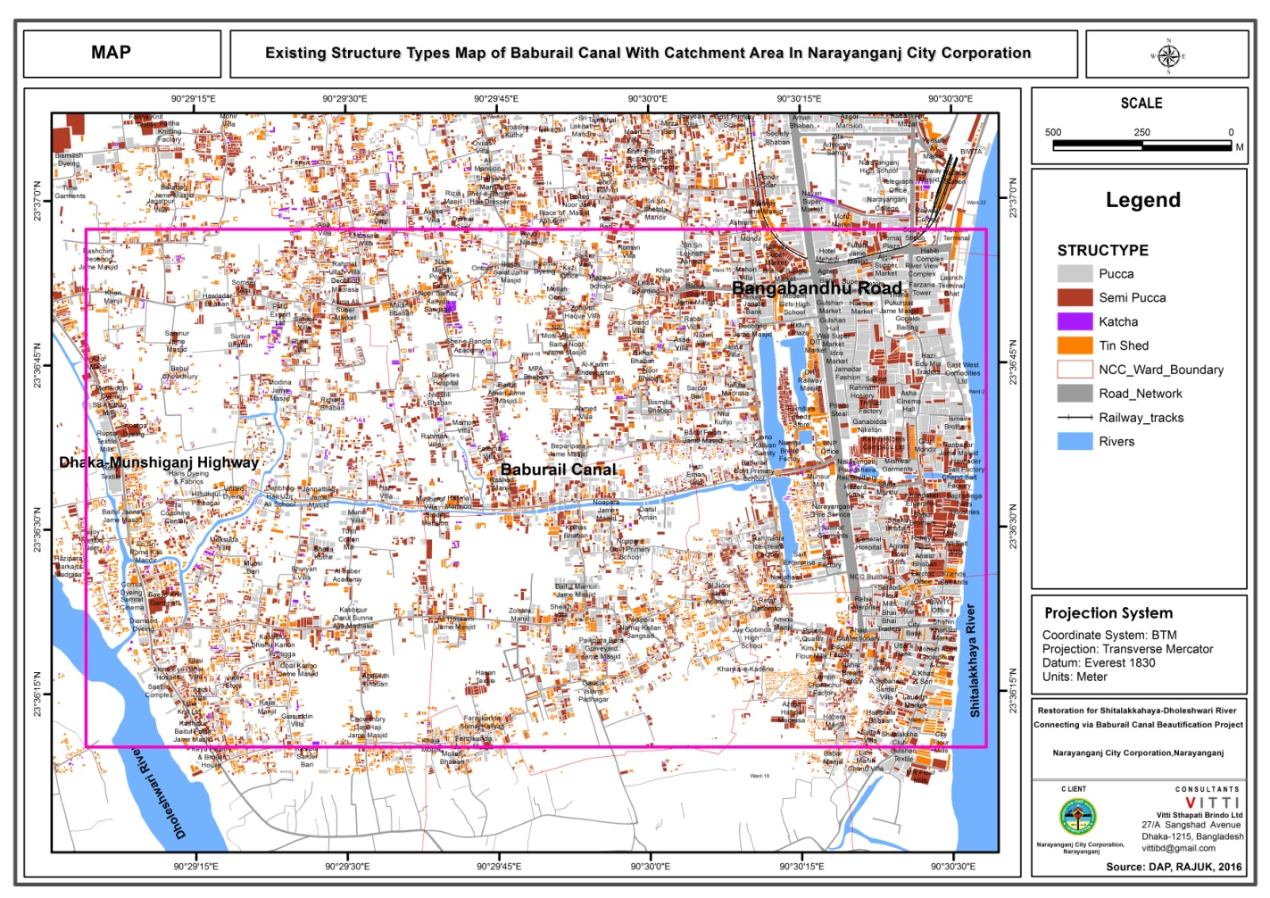
Source: Prepared by the Consultant VITTI

3.2 Demographic Profile
Sex distribution of the respondents shown in Figure 3.2indicates that one half of the respondents are female and the other half are male. In the south side canal 56.1% respondents are male compared to north side only 44.3% male. In the same way, 55.7% respondents are female in north side compared to south side 43.6% female meaning that more urbanized and thickly populated north has lower percentage of women, may be for the migrant population who tend to be male in higher percentage.

Figure 3.2: Sex Distribution of the Respondents

Figure 3.3 below shows distribution of sample households by religion. On the whole 89.3% sample households are Muslim by faith and the remaining 10.7% are Hindu. This is similar to national level data. Within the sample area, north south difference is very little.

Figure 3.3: Religion of the Respondents

Source: Field Survey, 2017

Table 3.1 shows age distribution of 384 respondents. The mean age of the respondents is 41 years. The mean age of male respondents is higher than the mean age of female respondents. Moreover, in both NCC and Union Parishad areas, the most of the male respondents are in between 46 to 60 years old whereas, the most of the female respondents are in between 26 to 35 years old.

Table3.1: Age of the Respondents
Age (Years) |  | Major Area |  |  |  | Total |  | Total
 |  | NCC |  | Union Parishad |  | Male | Female
 |  | Male | Female | Male | Female
16-20 |  | 2.4 | 5.5 | 2.8 | 2.4 | 2.6 | 4.1 | 3.4
21-25 |  | 3.6 | 17.3 | 6.6 | 9.4 | 5.3 | 13.8 | 9.6
26-35 |  | 20.5 | 38.2 | 17 | 41.2 | 18.5 | 39.5 | 29.2
36-45 |  | 27.7 | 23.6 | 22.6 | 25.9 | 24.9 | 24.6 | 24.7
46-60 |  | 33.7 | 11.8 | 38.7 | 18.8 | 36.5 | 14.9 | 25.5
60+ |  | 12 | 3.6 | 12.3 | 2.4 | 12.2 | 3.1 | 7.6
Total | N= | 83 | 110 | 106 | 85 | 189 | 195 | 384
Total | Avg. age | 45 | 35 | 45 | 37 | 45 | 36 | 41
Table3.2: Marital Status of the Respondents (% of respondent)
Type | Major Area |  |  |  | Total |  | Total
 | NCC |  | Union Parishad |  | Male | Female
 | Male | Female | Male | Female
Unmarried | 9.6 | 1.8 | 9.4 |  | 9.5 | 1 | 5.2%
Married | 88 | 87.3 | 88.7 | 88.2 | 88.4 | 87.7 | 88.0%
Widow/widower | 2.4 | 6.4 | 1.9 | 9.4 | 2.1 | 7.7 | 4.9%
Separated/Deserted |  | 4.5 |  | 2.4 |  | 3.6 | 1.8%
Total Respondents | 83 | 110 | 106 | 85 | 189 | 195 | 384
Source: Field Survey,2017

The marital status of the respondents has been shown on Table 3.2. About 88% of total respondents are 88% married followed by unmarried members 5.2%, widowed 4.9%, divorced and separated is 1.8%.
Table3.3: Educational status of the Respondents (%)
Education |  | Major Area |  |  |  | Total |  | Total
 |  | NCC |  | Union Porishad |  | Male | Female
 |  | Male | Female | Male | Female
No formal education |  | 27.7 | 30.9 | 11.3 | 30.6 | 18.5 | 30.8 | 24.7
Class 1 to 5 |  | 25.3 | 29.1 | 27.3 | 28.4 | 26.5 | 28.7 | 27.6
Class 6 to 9 |  | 20.4 | 22.8 | 20.8 | 24.7 | 20.7 | 23.6 | 22.1
SSC pass |  | 7.2 | 3.6 | 14.2 | 5.9 | 11.1 | 4.6 | 7.8
HSC pass |  | 10.8 | 4.5 | 14.2 | 3.5 | 12.7 | 4.1 | 8.3
Graduate |  | 6 | 5.5 | 6.6 | 3.5 | 6.3 | 4.6 | 5.5
Masters or above |  | 2.4 | 3.6 | 2.8 | 3.5 | 2.6 | 3.6 | 3.1
Madrassa |  |  |  | 0.9 |  | 0.5 |  | 0.3
Vocational Institute |  |  |  | 1.9 |  | 1.1 |  | 0.5
Total | N | 83 | 110 | 106 | 85 | 189 | 195 | 384
Source: Field Survey,2017

Most of the respondents (25 percent) have no formal education in the project area and one- fourth of the respondents have only class 1 to 5 level of education. The percent of uneducated female is significantly higher than the percent of uneducated male respondents. The percent of uneducated male respondents is higher in NCC than in Union parishad area while female illiteracy is similar in the two areas. Only about 8.6 percent of the respondents have a graduate or higher degree (Table 3.3).
Table 3.4: Occupation of the Respondents
Occupation | Major Area |  |  |  | Total |  | Total
 | NCC |  | Union Parishad |  | Male | Female
 | Male | Female | Male | Female
Student (no work) | 2.4 | 1.8 | 4.7 |  | 3.7 | 1 | 2.3
Housewife |  | 81.8 |  | 85.9 |  | 83.6 | 42.4
Emigrant |  |  | 0.9 |  | 0.5 |  | 0.3
Unskilled labor / House maid | 7.2 | 7.3 | 2.8 | 1.2 | 4.8 | 4.6 | 4.7
Rickshaw / Van/ Cart puller | 3.6 |  | 1.9 |  | 2.6 |  | 1.3
Service/ Garment worker | 30.1 | 5.5 | 22.6 | 5.9 | 25.9 | 5.6 | 15.6
Skilled labor/ Driver | 8.4 | 0.9 | 7.5 |  | 7.9 | 0.5 | 4.2
Small Business/ Vendor | 24.1 | 2.7 | 32.1 | 5.9 | 28.6 | 4.1 | 16.1
Medium Business | 14.5 |  | 11.3 |  | 12.7 |  | 6.3
Unemployed | 1.2 |  | 4.7 |  | 3.2 |  | 1.6
Retired/ Old person | 6 |  | 11.3 | 1.2 | 9 | 0.5 | 4.7
Unable to work/ Disable | 1.2 |  |  |  | 0.5 |  | 0.3
Teacher | 1.2 |  |  |  | 0.5 |  | 0.3
Total (N=) | 83 | 110 | 106 | 85 | 189 | 195 | 384

Table 3.4 shows the occupations of the respondents. Among female respondents, most of them are housewife and 5.6 percent are garment workers. Among male respondents, 28 percent are small businessperson or vendor and another 26 percent male respondent’s main occupation is garment work.
Figure 3.4: Ethnicity of the Respondents
Source: Field Survey, 2017
Figure 3.4shows ethnicity of the respondents who are living within 0.5 km of Baburail Canal. The figure displays that the most 99.6% of the respondents are Bengali and only one of the respondents are Ethnic community people, who are not directly affected people of this project, lived in the north side of the canal. However, 100% of the respondents are Bengali lived in the south side of the canal.

3.3 Housing Status
Figure 3.5 depicts the graphical representation of tenancy of the dwelling houses of the respondents. It shows that one half (44.6%) of the respondents live in rented houses, 31.6% of the respondents are living in their own houses and 23.8% of the respondents’ houses are built on the government land in the NCC. In Union Porishad, one of the half (50.3%) of the respondents live at their own houses and 49.7% of the respondents are living on rent. For total respondents, the most percentage (47.1%) of the respondents are living on rent where as 40.9% of the respondents are living at their own house whereas the low percentage (12%) of the respondents’ houses are built on government land.
Figure3.5: Tenancy of Dwelling Houses

Source: Field Survey,2017
Figure 3.6: Type of Houses of the Area

Source: Field Survey, 2017

Figure 3.6 depicts the graphical representation of type of houses of the respondents. It shows that 45.3% of the respondents’ houses construct by all over brick and cement where as 38.5% of respondents’ houses partially construct by brick and cement. It has seen from the figure that the lowest percentage (1%) of the houses are constructed by shanty /jhupri .
Figure3.7: Total Area of the Floor of the Houses
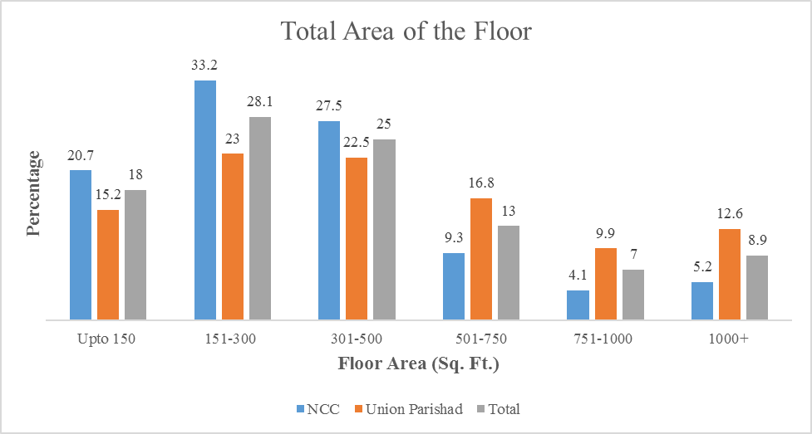
Source: Field Survey, 2017

Figure 3.7 represents the area of the floor of the houses. It shows in the figure that the most (28.1%) of the respondents are using 151-300 sq. ft. household floor whereas in NCC 33.2% of the respondents and in union porishad 23% of the respondents are using the same size. Moreover, the second highest (25%) of the respondents are using 301-500 sq.ft floor whereas in NCC 27.5% of the respondents and in union porishad 22.5% of the respondents are using the same size.

Figure 3.8: Monthly Expenditure of the Respondents
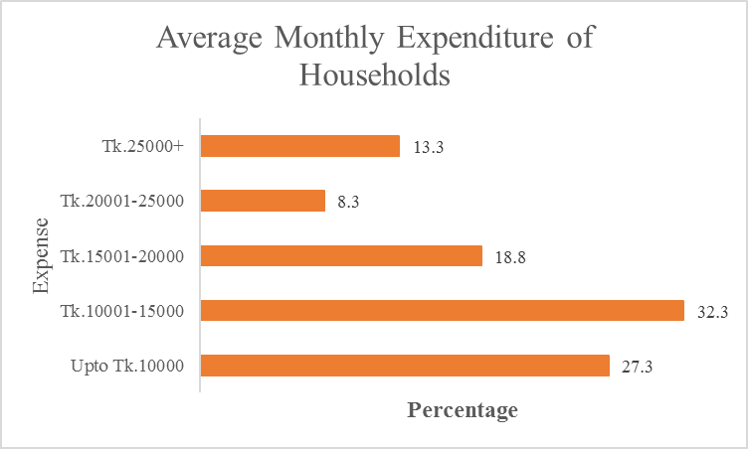
Source: Field Survey, 2017
Figure 3.8 shows the average monthly expenditure of the household of the respondents. It shows that one third (32.3%) of the respondents’ average monthly expense is BDT 10001-150000 where as 27.3% of the respondents’ average monthly expense Is up to BDT 10000. Moreover, the figure shows that the lowest percentage (8.3%) of the respondent’s average monthly expense is BDT20001-25000.
3.4 Income, Savings and Borrowing
Figure 3.9 denotes the monthly income of the households. It shows in the figure that the most (28.4%) of the respondents’ average monthly income is BDT 10001-15000 where as 24.5% of the respondents’ average monthly income is BDT 25000+. It has seen from the figure that the lowest percentage (10.9%) of the respondents’ average monthly income is BDT 20001-25000.
Figure3.9: Monthly Income of the Households
Source: Field Survey, 2017

Figure 3.10: Households Saving at Present
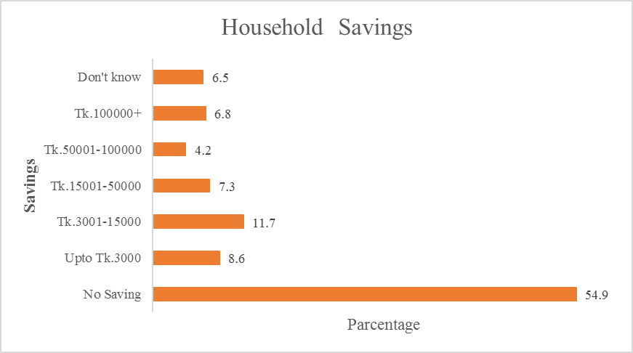
Source: Field Survey, 2017
Figure 3.10 denotes the HH saving at all present. It shows that the most (54.9%) of the respondents have no any HH savings where as 11.7% of the respondents have saved up to BDT 3001-15000 HH savings. The lowest (4.2%) of the respondents have saved BDT 50,001- 100,000 HH savings.
Figure3.11: HH Loan at All Present
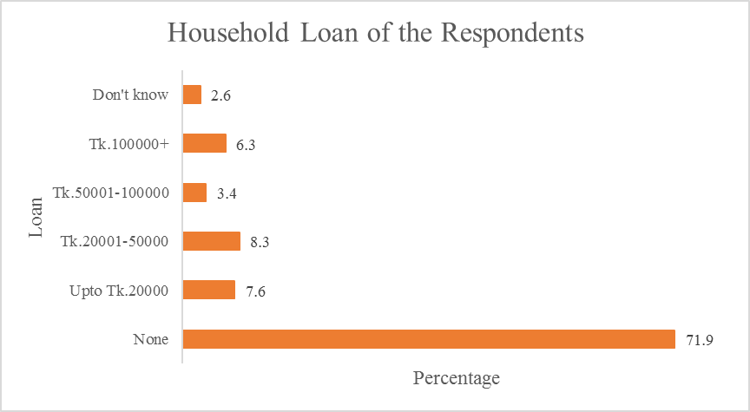
Source: Field Survey, 2017
Figure 3.11 denotes the HH loan at all present. It shows in the figure that the most (71.9%) of the respondents have taken no any HH loan was as 2.6% of the respondents do not know anything. In the second highest (7.6%) of the respondents have taken loan up to BDT 20000.

3.5 Migration Status of the Respondents
Figure 3.12: Duration of Staying in the Present Residence
Source: Field Survey, 2017
Figure 3.12 represents the duration of staying in the present residence within half a kilometer from Baburail Canal. The figure shows that the most (55.5%) of the respondents have been living in that area since birth where as 15.1% of the respondent are staying from 61 to 120 months. It has seen from the figure that the lowest percentage (4.4%) of the respondents are staying up to 60 months.
Figure 3.13: Household Migration from other Area to SP Area
Source: Field Survey, 2017
Figure 3.13 illustrates the graphical representation of household migration from other area. It shows that one half (53.5%) of the respondents have non- migrant, meaning local inhabitants and (46.5%) of the respondents have migrated from outside of the city to the north side of the canal. It shows that one half (56.4%) of the respondents have non- migrant and (43.6%) of the respondents have migrated from outside of the city to the south side of the canal. It is seen from the figure that overall 45.3 % of the respondents have migrated from other areas to the city.

Figure 3.14: Origin of the In-Migrants
Source: Field Survey, 2017
Figure 3.14 illustrates the graphical representation of households’ migration from other area. The figure shows that most 75% of the male respondents are migrated from district other than Narayanganj, 16.3 % of the male respondents are migrated from other union around the city and 8.8% of the male respondents are migrated from other Upazila of Narayanganj. The figure shows that most 75.5% of the female respondents are migrated from district other than Narayanganj, 12.8 % of the female respondents are migrated from other union around the city and 11.7% of the female respondents are migrated from other Upazila of Narayanganj. It shows that most (75.3%) of the respondents have migrated from district other than Narayanganj whereas 14.4 % of the respondents have migrated from other union around the city. It has seen from the figure that the lowest 45.3 % of the respondents have migrated from other areas.

3.6 Water and Sanitation Status of the Household of the Respondents
Figure 3.15: Main Sources of Drinking Water for HH
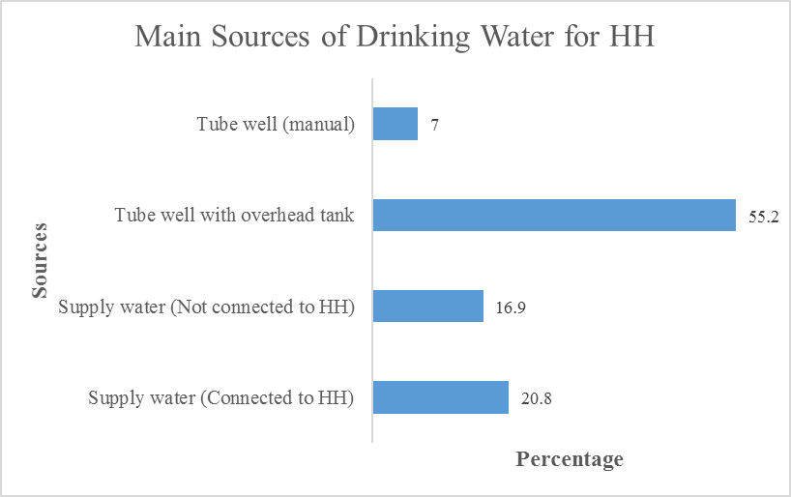
Source: Field Survey, 2017

Figure 3.15 represents the main sources of the drinking water of the respondents who are living within 0.5 km of Baburail Canal. The figure displays that the most 55.2% of the respondents are taking drinking water from tube well with overhead tank and motor operated pump and only 7% of the respondents are taking drinking water from manually operated tube well. Municipal water supply house connection is available for 20.8% respondents and another16.9% collect water from municipal supply line but not having house connection.

Figure 3.16: Second Sources of Drinking Water
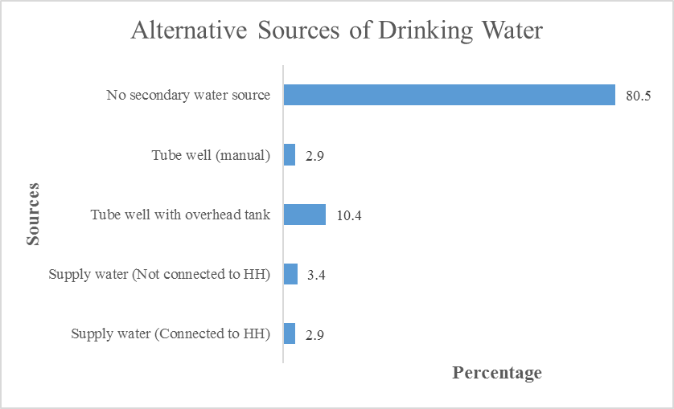
Source: Field Survey, 2017
Figure 3.16shows second source of the drinking water. The figure displays that the most 80.5% of the respondents have no second source, 10.4% use overhead tank as second source. Surprisingly, 2.9% respondents despite having house connection use it as second source and rely mainly on other source, probably overhead tank.

Figure 3.17: Main Sources of Cooking Water
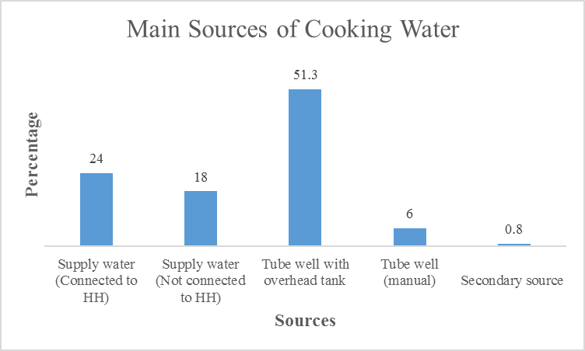
Source: Field Survey, 2017

Figure 3.17 represents the main sources of the cooking water. The figure displays that the most 51.3% of the respondents are using water for cooking from tube well with overhead tank and second highest 24% respondents are using water for cooking from municipal house connection.
Figure 3.18: Alternative Sources of Cooking Water

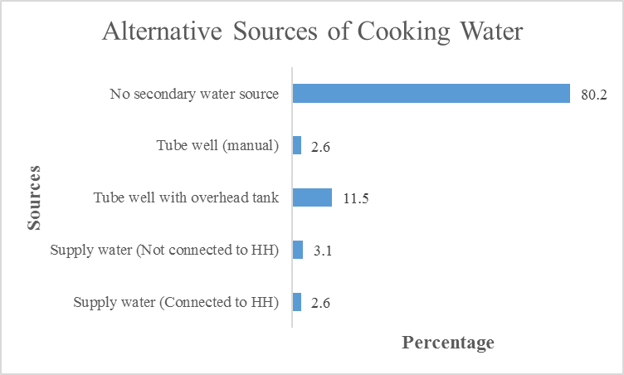
Source: Field Survey, 2017

Figure 3.18 represents the alternative sources of the cooking water for households who are living within 0.5 km of Baburail Canal. The figure displays that the most 80.2% of the respondents are not using any second source for cooking water while 11.5% use tube well with overhead tank as second source.

Figure 3.19: Main Sources of Water for Bathing and Washing
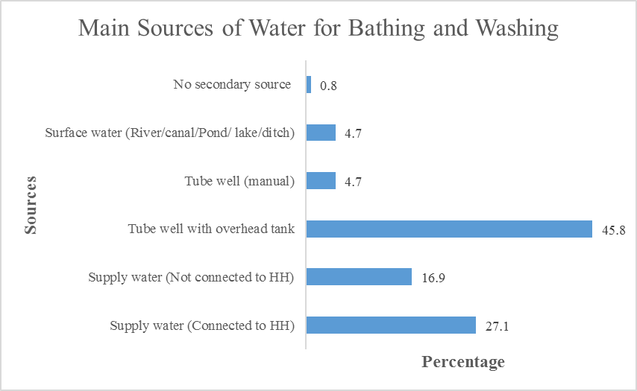
Source: Field Survey, 2017
Figure 3.19 represents the main sources of the water for bathing and washing clothes. The figure displays that the most 45.8% of the respondents are using water for bathing and washing clothes from tube well with overhead tank and the lowest 0.8% of the respondents are not using water from any secondary source.

Figure 3.20: Alternative Sources of Water for bathing and Washing
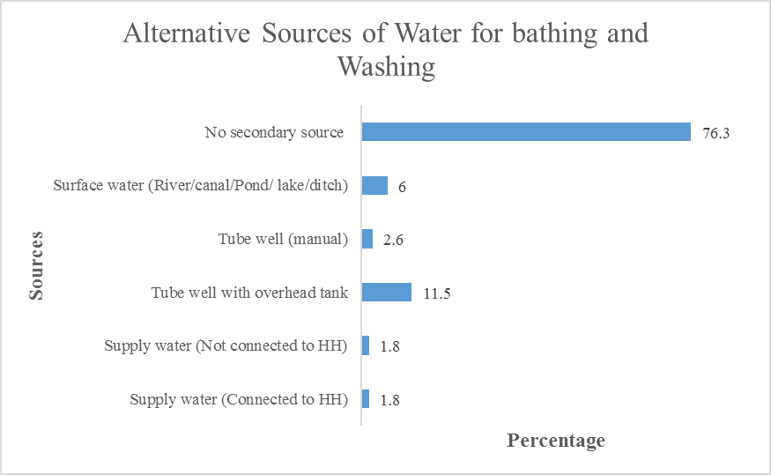
Source: Field Survey, 2017

Figure 3.20 represents the alternative source of the water for bathing and washing clothes. The figure displays that the most 76.3% of the respondents are not using water for bathing and washing clothes from any alternative secondary source and the lowest 1.8% of the respondents are using alternative sources by supply water.

Figure 3.21: Main Sources of Water for Latrine
Source: Field Survey, 2017
Figure 3.21 represents the main sources of the water for latrine. The figure displays that the most 45.3% of the respondents are using water for latrine from tube well with overhead tank and the lowest 1.3% of the respondents are not using water for latrine from any secondary source.

Figure 3.22: Types of Latrine Used by the Respondents
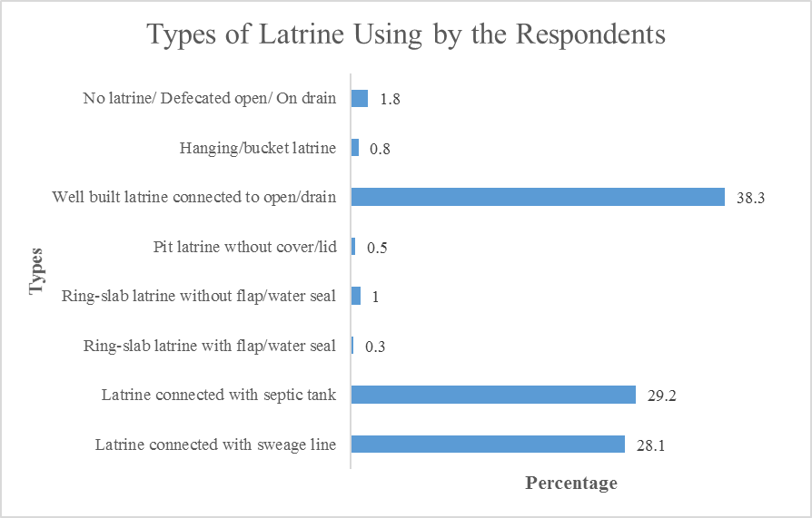
Source : Field Survey, 2017

Figure 3.22 represents the types of latrine using by the respondents. The figure displays that the most 38.3 %of the respondents are using well-built latrine connected with drain and the lowest 0.3% of the respondents are using ring slab latrine with flap.

Figure3.23: Drainage of Latrine Water
Source: Field Survey,2017
Figure 3.23 represents the destination of the latrine water. The figure shows that 88.5% of the respondents said that the flow of latrine water goes to the canal and 11.5 % of the respondents said that the flow of latrine water goes to the other place in the north side of the canal. In the same graph, it has shown that 81.5% of the respondents said that the flow of latrine water goes to the canal and 18.5% of the respondents said that the flow of latrine water goes to using the other place. It has shown that the most (87.3%) of the respondents said that the flow of latrine water goes to the canal and the only 12.7% of the respondents said that the flow of latrine water goes to the other place.

Figure3.24: Condition of the Latrines of HH
Source: Field Survey, 2017
Figure 3.24 represents the condition of the latrines. The figure shows that 57.2% of the respondents said that the condition of the latrine is good in the north side of the canal, 51.3 % of the respondents said that the condition of the latrine is good in the south side of the canal and total 54.8% of the respondents said that the condition of the latrine is good condition. In the same graph it has shown that 0.7% of the respondents said that the condition of the latrine is bad in the south side of the canal, 2.3 % of the respondents said that the condition of the latrine is bad in the north side of the canal and total 1.6% of the respondents said that the condition of the latrine is bad condition.
Figure3.25: Observed Status of the Latrines
Source: Field Survey, 2017

Figure 3.25 illustrates the graphical representation of observed status of the latrines. The figure shows that most 56.2% of the female respondents said that the situation of the latrines is hygienic and 43.8% of the female respondents are said the situation of the latrines is unhygienic. In the same figure shows the most 74.3% of the male respondents said that the situation of the latrines is hygienic and 25.7% of the male said that the situation of the latrines is unhygienic. The most 58.8% of the respondents said that the situation of the latrines is unhygienic and 41.2% of the respondents said the situation of the latrines is hygienic.
Figure 3.26: Suitability of Latrine for Children under 5 or Disabled
Source: Field Survey, 2017
Figure 3.26 portrays the graphical representation of under 5 or disable member in the households who cannot use latrine. It shows that for 43.9% respondents the question does not arise as they do not have children under 5 or disabled members. For 35.3% of the respondents the facility available is not suitable for children and disabled and 20.1% respondents said that the facility is suitable for children under 5 or disabled.
Figure 3.27: Disposal of the Excreta
Source: Field Survey, 2017
Figure3.27 represents the dispose of the excreta of the HH. The figure displays that the most 65.4% of the respondents said that they dispose the excreta in latrine whereas 12.8% of the respondents said they dispose the excreta in drain or open space. In the same graph, it has shown that the lowest 1.3% of the respondents dispose the excreta in no specific place.

3.7 Environmental and Waste Management and Pollution Condition
Figure 3.28: Drainage Connection of HH
Source: Field Survey, 2017
Figure 3.28 represents the drainage connection among the household of the respondents. It shows that existing drainage connection is almost surface drain of that area. As 33.3% of the respondents in north, 54.5% respondents from south and 31.3% respondents in total agreed with the statement that there were surface drainage connection.
Figure 3.29: Pathway of Storm Water
Source : Field Survey, 2017
Figure 3.29 shows the pathway of rain or wastewater of the HH. It presents that 27.6% of the respondents said that the water goes to outside through pipes while most of the (46.9%) respondents said that the water goes direct to Baburail canal though pipes. Only a few respondents are agreed that less amount stagnates around the community.
Figure 3.30: Water Logging Problems of the HH
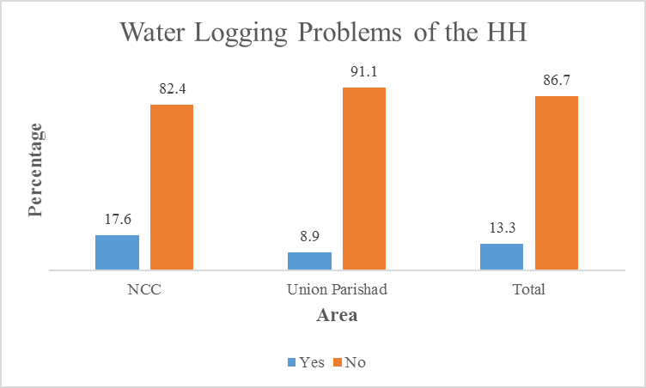
Source: Field Survey, 2017
Figure 3.30 shows the percentage of water logging problem among the households. Most of the respondents (82.4%) said that they did not face any water logging problem in Narayanganj City Corporation. In addition, 91.1% of the respondent from Union Parishad said so. While a few 13.3% of the respondent among the total respondent said, they faced water logging problem.
Figure3.31: Duration of Water Logging in a Year

Source: Field Survey, 2017
Figure 3.31 shows the duration of water logging in year of the area. According to NCC respondents, half (50%) of them in NCC said that they faced water logging problem for at least 5 to 10 days. While 35.29% of them said that, they faced water logging problem for at least 5 to 10 days.

Figure3.32: Disposal of Kitchen Waste
Source: Field Survey, 2017
Figure 3.32 shows the system, which is used for disposal of kitchen waste of the HH. Most of the respondents around 41.4% said that the kitchen wastes are thrown to the canal. Only 4.9% of the respondents said that they disposed those waste to specific dustbin.
Figure3.33: Air pollution Status of the Area

Source: Field Survey, 2017
Figure 3.33 shows the percentage of facing Air Pollution in the project area. In North side 44.3% of the respondents said that they faced some air pollution in their area, while 18.9% of them said they are in highly air-polluted area.

Figure 3.34: Sound Pollution Status of the Area
Source: Field Survey, 2017
Figure 3.34 shows sound pollution percentage according to respondents’ response. Here more than half of the respondent (51.8%) said that there was no existing sound pollution problem while rest of them responded yes about sound pollution.
3.8 Social Environment, Facilities and Problems
Figure 3.35: Membership of the Respondents in Social Organization
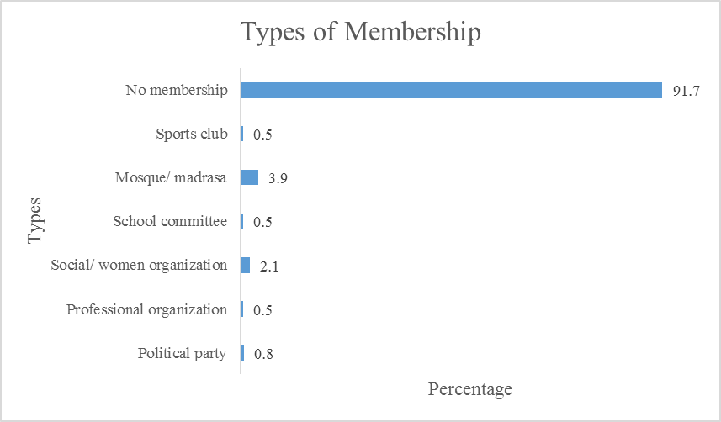
Source: Field Survey, 2017
Figure 3.36 represents the types of membership among the respondents. Among the respondents, 91.7% are not member of any organization. While a few 0.8% of the respondents are the active member of the political party.

Figure 3.36: Play Grounds or Facilities for the Children

Source: Field Survey, 2017
Figure 3.36 represents the playgrounds or facilities for the children to play in the field. It shows the playgrounds proportion is not at all around 95.8% respondents from Union Parishad, 68.9% respondents from NCC area and the total percentage shows 82.3%.
Figure 3.37: Open Space of Parks for the Residents to Walk or Socialize

Source: Field Survey, 2017
Figure 3.37 illustrates the open space of parks for the residents to walk or socialize. In this figure, 96.9% respondent of Union Parishad said there are no open space park whereas 2.6% people of Union Parishad said inadequate and 2.5% respondents people agreed.

Figure 3.38: Facilities for Cultural Events, Movie Houses etc.

Source: Field Survey, 2017
Figure 3.38 displays facilities for the residents to enjoy cultural events, movie, and drama. In the figure where 90.6% female respondents said there are no facilities for cultural events, movie, drama although 9.4% female respondents said about inadequate facilities and no one said yes about there are no any facilities.
Figure 3.39: Drug Addiction Problem of the Area

Source: Field Survey, 2017
Figure 3.39 represents about the serious problems of drug addiction. It displays the percentage of very serious 17.1% in north side, 10.3% in south area and the total is about 14.1%. Whereas 42.3% south people said, this is serious and 25.4% of north people and 32.3% is about total people.

Figure 3.40: Security Related Problem in the Area

Source : Field Survey, 2017
Figure 3.40 shows the percentage of security related problems in the area. According to NCC areas’ 48.7%, respondents said medium. It has also shown in Union Parishad 36.6% respondents said medium and the total is about 42.7%. In the same graph shown that 7.3% respondents of NCC said security problem is very low, 27.7% is from Union Parishad and the total is about 17.4%.
Figure 3.41: Social Network of Respondent Population

Source : Field Survey, 2017
Figure 3.41 reflects how much people are socially connected to each other. The figure displays that the high 37.8% of the respondents from south area said they are connected, 27.2% from north area and the total is 31.5%. On the same graph the medium 61.5% from south area, 62.3 from north area and 62 is the total.

Chapter 4: Legal and Policy Framework and Entitlement

4. Legal and Policy Framework and Entitlement

4.1 Legal Framework
The project civil works boundary is well within the existing land of NCC or public land and it is not affecting interest of any private owner. However, there are some lease holders understandably under NCC which is governed by the lease agreement executed with the individual lease holders by NCC allowing establishment and operation of temporary shops and paying monthly rent for the land. The lease agreement specifically mentions that the NCC can vacate the lease agreement and evict the tenants any time at 15 days’ notice without any compensation. This is in conformity with the Easements Act 1882 (Act V of 1882) and subject to eviction under the “Government and Local Authority Lands and Buildings (Recovery of Possession) Ordinance, 1970”. Any unauthorized occupants of public land can also be evicted under this recovery of possession ordinance. The law requires an eviction notice to the outgoing leaseholders, tenants or unauthorized occupiers allowing a thirty days’ time for vacating the land in question. This notification should be done under due protocol and authority, in this case, by the NCC for land belonging to the NCC or the Deputy Commissioner for the khas or public land in the Kashipur Union Parishad part.
Although Article 15 of the Constitution of Bangladesh provides the responsibility to the state for ensuring safe housing for the citizens (as a fundamental state policy but not as a fundamental right providing legal protection by the court, if not complied) the slums dwellers and informal settlers face frequent eviction without any measures for their permanent resettlement in any alternative site. However, there is practice of providing rehabilitation support by the government as well as local bodies in some cases of eviction.
Since no private land will need to be acquired for this subproject, the law on acquisition of land “The Acquisition and Requisition of Immovable Property Act 2017” will not be applicable. However, there is need for voluntary dispossession by authorized lease holders and unauthorized informal settlers. The legislatives and regulatory framework are not adequate to deal with the adverse impacts associated with the involuntary displacement or voluntary dispossession for public interest. The law does not cover project-affected persons without title and does not ensure replacement cost of assets acquired. The law also does not initiate any measure for restoration of livelihoods of the affected persons.

4.2 NCC Practices in Taking Land for Development
The NCC, like other ULBs develops critical infrastructures using voluntary dispossession or land for land approach, where unavoidable. In this case, private land is not acquired. Hence land to land approach will not be applied. For the tenants of NCC evicted from shops build on land leased from NCC, the NCC intends to follow an approach of shop for shop. However, the NCC does not practice paying compensation for illegal occupiers of its own land when vacating for development purpose and provides alternative business sites for the leaseholders, if evicted for any development project, to continue business income. The NCC wishes to provided alternative shops at developed market complexes, where and when available.
NCC prefers voluntary dispossession of public land without compensation by the encroachers and well-off informal settlers. The City Corporation has also executed declaration by some of the encroachers and squatters of voluntary dispossession of NCC’s land without any compensation or claims what so ever. NCC however, also committed due compensation to some others (NCC tenants) who have already cleared a section of the Baburail Khal for the first phase construction.

4.3 World Bank Policy Requirements
Given the involuntary displacement of people involved in the subproject, the World Bank policy on involuntary resettlement (OP/BP 4.12) applies. The policy requires the following:
- Involuntary resettlement from resume of public land and acquisition of private land should be avoided, minimized or mitigated where feasible;
- Unavoidable impacts should be assessed and compensated at full replacement cost;
- Relocation of housing and businesses should be assisted at no cost to the affected persons;
- If income and livelihoods are affected, measures to be taken for restoration of the livelihoods at the pre-project level;
- Affected households will be meaningfully consulted at all stages of project cycle and their concerns and choices will be reflected in project design and implementation approach;
- A workable grievance redress mechanism will be in place for addressing any grievances and complains related to compensation and resettlement.

4.4 Subproject Resettlement Policy
The physically and economically displaced households and persons and affected community establishments for clearing the public lands within the construction boundary of the Baburail Khal have been recognized as affected persons due to the subproject. Measures have been taken to minimize resettlement by exploring design options. In compliance with the Bank OP 4.12 on Involuntary Resettlement and following the project SMF, NCC has adopted the following resettlement policy for this subproject:

4.4.1 Affected Persons by Impact Category
All activities for restoration of the Baburail Khal and beatification of its view will be limited to the existing available land of the khal available as per land records. However, civil works activities will displace several residential quarters, commercial and business structures and community establishments developed on both sides of the Khal. As per census of affected persons and inventory of assets within the canal boundary demarcated for civil works, the affected persons can be categorized for tenancy type and use of the land. Affected persons by impact category are identified as follows:

Table 4.1: Categorization of PAPs in Babural Canal Area
Sl.No. | PAP by use category | Tenancy category | Full/Partial Relocation
1. | Residential households | 1.1 Informal settler | Full/ Partial
 |  | 1.2 Encroacher | Partial
 |  | 1.3 Temporary public staff quarter  1.4 Tenant | Full  Minor impact
2. | Commercial/Business Owner | 2.1 NCC Lessee | Full
 |  | 2.2 BR Lessee | Full
 |  | 2.3 Squatter/ informal settler  2.4 Tenant | Full  Full
3. | Common/community structures | 3.1 Social club | Full
 |  | 3.2 Mosque | Partial
4. | Cross Over Bridges | 3.3 Temple  4.1 House connecting  4.2 Road Connecting | Abandoned  Full  Full
Most of the NCC leaseholders operate shops themselves while some sub-leased the shops to other tenants on monthly rent basis. In the claimed railway part, the lease-holding is doubtful and most of the claimant leaseholders subleased shops to other tenants on monthly rent basis.
The NCC part already cleared the informal settlers who are lower grade government employees or lower grade NCC employees like sweeper, cleaner etc. They have already vacated the land on request of the NCC. Other owners of the houses in the NCC part are encroachers who built permanent structure on own land and temporary structure on encroached land. In the Kashipur Union part the khas land is occupied by both encroachers and informal settlers and the houses are all temporary construction. In both NCC and Kashipur areas the houses are used by owners and tenants. The tenants of private houses are not affected and do not require compensation or assistance in changing the rented houses with one month notice by owner or tenant. Some of the house owners including informal settlers are poor, particularly in the Kashipur Union part west and south of Bangla Bazar School.

4.4.2 Policy Principles
a. Land Acquisition and Resettlement
NCC will undertake necessary process activities associated with compensation and resettlement of the affected persons associated with vacating of the public land within the construction boundary along the Khal before the start of civil works construction. Compensation funds will be placed with the project for payment. The payment process will be coordinated to ensure timely disbursement to the affected persons. In addition, NCC will use the following principles to minimize adverse impacts on affected persons and their community:
- Avoid acquisition of private lands and use only public lands, unless the other way is unavoidable and feasible within project life;
- Avoid or minimize displacement of people either physically or economically;
- Stretches of the khal will be re-designed where it is necessary to meet the accessibility inclusive of groups and individuals, or to avoid affecting concentrations of commercial activities;
- Where the portion of a structure unit affected and becomes unviable for continued current use, the owner will be compensated for full structures.
- Maximize community benefits where appropriate with additional infrastructural measures;

b. Voluntary Dispossession of Land of the Khal (Public Land)
NCC will limit its activities for restoration and beautification of the Baburail Khal within the existing land reserve partly owned by the NCC itself (public land) within the city corporation area and the rest is khas land (public land) in Kashipur Union that is legally controlled by the Deputy Commissioner (DC). Part of the land in the Khal boundary for civil works has been encroached and part has been occupied by NCC lessees and informal settlers for residential and business use. As per the Bank OP 4.12 on Involuntary Resettlement, the lessees, encroachers and informal settlers affected due to the subproject are required to be compensated and assisted for their relocation and livelihood restoration. However, NCC would adopt a policy of voluntary dispossession for rich encroachers and compensate the legal lessees as well as the poor and vulnerable informal settlers (squatters) displaced due to undertaking of the subproject. The rich encroachers (who extended small part of their residential or business structures into the land of the Khal) and well-off persons squatting the land in the Khal for non-residential purposes will be approached to vacate the land voluntarily but will receive compensation to repair the affected installation, when they are solvent and their livelihood is not dependent on the land they occupy. For all of those with livelihoods affected will be compensated. Further to this, the voluntary dispossession of public/NCC land will be guided by the following principles:
- Physical relocation of people will be avoided. In case of physical relocation, people not having alternative living place in the NCC area will be compensated.
- There will be no loss of livelihoods or income;
- Affected persons are free to say no to voluntary dispossession without any fear of coercion.
NCC has identified a total of 162 leaseholder businesses on public land leased from the NCC and other public bodies, 88 business squatters, 31 slum houses and 21 non-slum encroachers. Of these 302 PAPs 63 business squatters and residential/business encroachers who are well-off persons and do not depend on the land they are occupying have agreed on voluntary dispossession. However, the RAP has kept budget provision to compensate all 88 affected business squatters (Table 7.2 row 3). All 31 slum dwellers requiring relocation will be compensated at replacement cost with shifting and transitional allowance. The 21 non-slum houses partially affected will also be compensated. The 162 leaseholder businesses (including 101 already demolished) will be provided permanent shop for the lost temporary shop and in addition will receive transitional support of BDT 30,000 each which is equivalent to 3 to 4 month’s rents of similar shops. The affected shopkeepers will be able to start business in the rented shop initially with project support and after 3-4 months they will be able to pay rent from the business.
Stoppage of further use of the encroached or squatted land will not be socioeconomically consequential to them. The persons dispossessing the Khal land will be given the estimates of the compensation to be provided before he/she signs off the declaration of the dispossession (form attached at Annex-8).
The acts of voluntary dispossession will be validated by a third party or by the DSC, in absence of an independent third party. The validation report will be attached to Subproject Appraisal Report (SPAR) and shared with the Bank for review and acceptance. If there is no convincing justification to distinguish between rich and poor squatters/encroachers, all such persons will be compensated. However, the GRM to be established under the subproject will be accessible for anybody affected, including those signed off voluntary dispossession, for justified assistance as per the RAP during implementation. Annex-11 provides guidelines for third party validation of voluntary dispossession of public land.

c. Impact Mitigation Principles
Where adverse social impacts are found unavoidable, NCC will plan to mitigate them in accordance with the following principles:
- Resettlement of the PAPs will be planned and developed as an integral part of the subproject design.
- Absence of legal land use rights documents by current land users will not be considered a bar to resettlement and rehabilitation assistance, especially for the socio-economically vulnerable groups.
- Vulnerability, in terms of socio-economic characteristics of the PAPs/ households, will be identified and mitigated according to the provisions in the RAP.
- Persons displaced from their housing, including the poor and vulnerable households squatting on lands within the Khal reserve and other public lands, will be compensated for their affected physical assets on the lands and assisted with physical and economic relocation.
- The informal settlers and business squatters will be encouraged for self-relocation and assisted in the process of finding out alternative lands, where necessary. NCC will assist the affected households/squatters in self-relocation and resettlement on a more permanent place.
- The owners of affected assets like tong dokan (movable kiosks), equipment, machinery or parts/components thereof that can be dismantled and moved away intact will not be eligible for compensation, but they will be paid the actual costs of dismantling and moving them.
- No compensation will be paid for temporary inconveniences faced by business operators and traders, unless they are required to stop completely their operations during the construction period. However, to ensure sustenance of their income streams, NCC will undertake the following measures in consultation with the concerned communities and design supervision and management consultant:
  - Plan and implement the construction works in a manner to avoid/minimize inconvenience and disruption to the adjacent residents, and to business/trading activities where applicable.
  - Ensure spaces for all temporarily displaced business/trading activities in the vicinities of their present locations, or allow them to relocate temporarily spots they find suitable.
- Where the project activities cause community-wide impacts affecting community facilities, access to common property resources, etc., NCC will rebuild them with project finance or provide alternatives in consultation with the user communities.
- NCC will approach the encroachers and economically well-off squatters/ informal settlers for voluntary dispossession without compensation in a manner acceptable by the community following the SMF procedures.

4.5 Eligibility for Compensation and Assistance

a. Eligibility Criteria
Eligibility of affected persons for compensation and assistance by impact category is limited by cut-off date. Affected persons those were present within the Khal boundary demarcated for civil works construction at the time of conducting census and inventory of assets on or before 11 November 2017. All affected persons identified by impact category on or before the eligibility cut-off date irrespective of their tenancy to the land will get compensation, unless otherwise agreed between NCC and the affected persons, for their assets and assistance for relocation and livelihood restoration based on loss and impact categories identified through census as per the MGSP Social Management Framework (SMF). The absence of legal rights on the use of land will not bar any of the affected persons (except the rich and non-vulnerable squatters and encroachers) from compensation and assistance, as specified in the entitlement matrices.
Affected persons with legal use rights to land (leaseholder) will receive compensation and assistance commensurate to the conditions of lease agreement including notification and costs associated with relocation. Particularly, they will be entitled to get allocation of shop in other location constructed by/ under the management of the NCC. Informal settlers, encroachers and squatters will receive compensation and grants as per compensation and entitlement policy presented in this RAP. Affected vulnerable household (e.g., physically handicapped and old aged household head, female headed households) will be eligible for one-time special subsistence allowance. Non-vulnerable households with structures affected will be entitled to compensation for structures and assistance for shifting and reconstruction of the same.
Lease claimants of stated Bangladesh Railway (BR) land (which is the property of the NCC as per survey record of the government) will be negotiated for compensation and assistance (if required, in agreement with Bangladesh Railway). No civil works will proceed unless an agreement is reached, documented and compensations paid to the lease claimers of the controversial land. Compensation can be in cash or kind as agreed between the lease claimers/ traders and the NCC. Tenants of the BR lessees (sub-tenants) have been terminated by the lessees following the sub-lease conditions.
Affected community and community structures including the private cross over bridges will be attended in varied approaches. The cross over bridges constructed by community groups or individual households will all be demolished and commensurate access will be reestablished through access roads, properly located cross over bridges and walkways. However, compensation for affected structures by other community organizations (clubs, mosque, temple committees) will be provided at replacement cost. Project will also review the demand for a road by the Hindu community to their new temple.

b. Compensation and Entitlements
Entitlement for each category of impacts has been prepared following the Resettlement Policy Framework (RPF) of the MGSP SMF. The entitlement matrices identify the categories of impact based on the census carried out during subproject preparation and provides the entitlements for each type of loss following the SMF. The following matrices define the specific entitlements for different types of losses, entitled persons (EP), and the institutional responsibility to implement them.

Table 4.2: Compensation and Entitlement Matrices
Loss and impacts | Entitled Persons | Entitlements | Application Guidelines and responsibilities
1. Structures on land leased from NCC | - 101 Displaced leaseholders of NCC | - Transition allowance, if vacated before maturity of the lease contact;  - Transfer/shifting allowance of BDT. 5,000, if vacated before maturity of the lease contact;  - Compensation for structures at replacement cost; or  - Allocation of shop in other market to be developed or already developed. | - NCC will notify (already notified) the displaced persons to vacate the land as per lease conditions of vacating the lease;  - NCC will pay transition allowance equivalent to three months’ wages of a person/ 3 month’s profit of the affected business and transfer cost of BDT 5,000 per shop.  - NCC will allocate shop in new shopping centre to be constructed by June 2019.  - DSM and PMU will review and supervises the whole process.
- Structures on land claimed to be leased from other GOB agencies (Railway) | - Valid leaseholders of 61 business structures claimed to be built on land leased from Bangladesh Railway to be demolished | - Transition allowance, if vacated before maturity of the valid lease contact;  - Transfer/shifting allowance. BDT 5,000 per shop  - Compensation for structures at replacement cost; or  - Allocation of shop in other market to be developed or already developed. | - NCC/BR will notify the PAPs to vacate the land at least one month ahead of demolition;  - NCC will pay transition (BDT 30,000) allowance equivalent to three months’ wages of a person/ 3 month’s profit of the affected business and transfer cost of BDT 5,000 per shop.  - NCC will allocate shop at Gymkhana new sand-fill area where a CI sheet-roof market will be constructed by June 2019.  - DSM and PMU will review and supervise the whole process.
- Informal settlers/ of squatters/ encroachers | - (a) 31 Displaced third/ fourth class Govt/ NCC employee slum houses | - Replacement cost structure (av BDT 70,000)  - Transition allowance equivalent to 3 month’s rent of similar house (BDT 18,000) and Transfer/shifting allowance of BDT. 1,000 | - NCC will notify the displaced persons to vacate, OR  - NCC will pay replacement cost of structures; transition allowance equivalent to three month’s rent of similar housing in nearby location and shifting allowance of BDT. 1000 per PAP households.  - DSM and PMU review and supervises the whole process
 | - (b) Tenants of private business structures/ shop employees | - Transfer/ shifting allowance BDT 11,000 per shop for 50 private shops | - Owners of affected structures will notify the displaced tenants at least one month before demolition.  - NCC will pay transfer/ shifting allowance or amicably settle between tenant & occupants.
 | - (c) Tenants of NCC and public land lease holders | - No compensation from project. These informal lease agreements have been terminated by the respective lessors as per lease conditions. | - NCC will notify the displaced tenants at least one month before demolition.  - NCC will amicably settle any disputes between occupier and tenant at GRC
- Structures on squatted/ encroached land other than 1, 2 and 3 noted above. | - (a) 21 Informal settlers (residential squatter);  - (b) 88 Business squatters/ shops;  - (c) 10 Community property structures. | - Compensation for 21 residential (BDT 125,000 each) and 88 business structures (BDT 57,396 each) at replacement cost, and BDT 20,000 as RRE.  - Transition and shifting allowance BDT30,000 per shop for 3 months for 50 of the 88 shops.  - Replacement cost for community property relocated/ repair cost for partial demolition or alternative walkway for already shifted structures. | - Economically vulnerable households dependent on the squatted land for livelihoods will be paid compensation;  - Current market price of structures will be determined through market price survey under the guidance of the MPAC of NCC  - Transition allowance will be for individual business loss to the poor not having other occupation or place of trading equivalent to equivalent to three months’ rents of similar structure in the same vicinity plus shifting cost of the affected shop. Budget 5000/m
- Structures on encroached land | - Adjacent residential units affected  - Economically well-off squatters who are not dependent on the squatted land  - Private cross over bridges  - Road crossing bridges | - Voluntary dispossession at negotiated compensation or without compensation;  - Reimbursement of repairing expenses (RRE) caused for partial demolition of affected structure (21 residential units @ BDT 20,000included under 4a).  - Demolition and removal of debris.  - All 88shops are shifted and covered by replacement cost and poorest 50 will get additional transition and shifting allowance of BDT. 30,000 each.  - Accessibility related to dismantling of existing cross over bridges will be restored under project. | - Early notice on the demolition;  - Technical advice in demolition, relocation and repairing/ reconstruction of affected structures including bridges.  - RRE will be applied only for repairing those damages to structure resulting from demolition.  - The encroachers and any non-vulnerable squatters will be approached for voluntary dispossession without compensation or negotiate on compensation for vacating the land  - Voluntary dispossession or negotiated settlement will be validated by a third party.  - Contractor liability and will be borne out of demolition cost of bid document.
- Business, income and employment | - Business squatter  - Physically relocated residential household  - Wage employee | - Transition allowance for the permanent loss of business, incomes & wages (50 shops @BDT 30,000 included above) and all 88 shops to get replacement cost.  - 31 slum houses provided replacement cost and transition & shifting allowance.  - 162 shops will have re-allocation of shops after construction new NCC markets.  - Employment in reconstructed enterprise or package for re-employment or starting business for affected employee (Transitional support of BDT 11,000 included above). | - Transition allowance for the permanent loss of business, incomes & wages equivalent to the loss of income/wages for a period of 3 months for each affected traders each BDT 30,000x50) and employees BDT 11,000x50 per employee.  - In case of temporary relocation and temporary loss of business incomes, compensation will be wages equivalent to closure period up to 3 months OR Alternative business site for continued income stream.
- Vulnerability | - Poor women and disabled headed households | - Additional financial assistance equivalent to 2 months’ subsistence cost (BDT 5000/ month) for the incumbent household.  - Employment opportunities project civil works and O&M. | - Vulnerability will be determined following the data on income, gender and disability of the household heads;  - NCC will facilitate priority of the vulnerable household members for employment in civil works and future O&M.  - NCC will pay cash assistance of BDT. 10,000 per vulnerable PAP household in addition to replacement cost.
- Construction related impact | - Anybody impacted by civil works/ contractor’s activity | - Compensation as per Resettlement Policy Framework (RPF) | - The affected persons will approach NCC notifying the impacts in writing with copy to the contractor;  - GRC will facilitate and assist the affected persons;  - Contractor will pay the compensation determined by MPAC.  - Contractor’s bid document will have a clause incorporating this as contractor’s liability.

c. Determining Compensation and Entitlements
Replacement costs will be based on the current market prices of various building materials, labor and other cost items in the local markets at time. The costs of building materials, such as bricks, cement, steel, sand, bamboo, timber, GI sheet, roofing materials like straw, etc., and labor will be based on:
- Survey of current prices of different types of materials with five or so dealers/manufacturers in the local markets.
- The replacement cost of the house/structure will be based on the lowest quoted price for each type of material, plus their carrying costs to the sites.
- The current costs of labor with different skills will be determined by interviewing local contractors, LGED Executive Engineer, NCC or local construction workers.
Replacement costs of any other items will be determined based on the current prices of materials, labor, etc. As and when required, NCC may also seek technical assistance of Executive Engineer of LGED in the district and the project consultants for estimates of materials and labor for structures.
NCC will form and operationalize a Market Price Assessment Committee (MPAC) constituted with representatives from the LGED and Zila Parishad which will be headed by the CEO and Executive Engineer of NCC will be the Member Secretary. The MPAC will make estimate of likely loss and needed compensation for various types of structures affected and will provide such estimates to the NCC PIU. The methods of market price survey designed by the consultant will be approved by the MPAC. The consultant will carry out survey and compute current market price (CMP) of physical structures by construction materials (pucca, semi-pucca and katcha) recommend CMP and replacement cost rates by types of structures (pucca, semi-pucca and katcha). The rates will be reviewed and approved by NCC in due process for preparation of compensation and resettlement budget. The MPAC will also assist the GRC to settle any complaints coming from the PAPs regarding implementation of the RAP and payment of compensation in cash or kind. The NCC will form the MPAC comprising following persons:
a. Chief Executive Officer, NCC – Convener
b. Executive Engineer, LGED, Narayanganj district or his/her representative- Member
c. Executive Engineer, PWD, Narayanganj- Member
d. Executive Engineer, NCC- Member Secretary

d. Entitlements, Payment of Compensation and Financing Arrangement
Compensation and cash for resettlement assistance will be paid directly by NCC to the affected persons identified under this RAP with or without legal easement documents, such as, lessees, squatters and encroachers, as well as business owners and employees.
Compensations/entitlements due to the PAPs will be paid in full or as per agreement before they are evicted from the right of way of the Baburail Khal and/or before start of civil works. According to the review a number of affected persons have already been removed from the area before preparation of this RAP. NCC has the list of such removed households and persons with contact details and will be tracked for making payment of compensation before civil works. NCC will make sure that compensation has been paid in full for all households and persons before commencement of civil works under the proposed subproject including those already relocated. Any ongoing activities under the MGSP finance will be suspended until payment to the displaced persons have been completed. NCC may consider 10% increase of assessed compensation and paid to the affected persons, in cases where civil works construction has already been started and persons displaced before payment of compensation. In the case of compensation in kind (such as allocation of shop), the NCC will issue a commitment letter to the relocated business lessees, which is legally binding on the NCC.
NCC will ensure that the properties (structures and non-structure assets) to be cleared for civil works under the subproject will be subject to compensation as agreed between the concerned affected persons and the NCC. The PAPs are entitled to compensation to the extent of full replacement cost or they may agree in writing to vacate without compensation or partial compensation. The full replacement cost will be determined by the MPAC following the guideline of the SMF and this RAP.
The NCC has already initiated signing of agreement with the PAPs which will be continued. In the case of PAPs receiving compensation (allocation of shop, onetime cash assistance), the NCC will provide money receipt/ letter of commitment on the allocation of shop and acknowledgement of receipt of the notice specifying what compensation will be given and when and these should be signed by the concerned PAPs. The NCC will also provide list of PAPs agreeing to vacate with and without compensation and this should be completed for all PAPs listed before the cut-off date so that no other person can claim any compensation and thus hinder implementation of the project. A third-party validation will be carried out on the act of voluntary dispossession and signing of the commitment letters by the NCC to ensure that all commitments signed by the NCC associated with compensation in cash or kind are legally binding on NCC. Guidelines for the validation is proposed in Annex-11.

4.6 Implementation Schedule

Implementation schedule of the RAP including verification of the inventory, formation of the MPAC, carryout further information and awareness campaign where necessary, notifying the PAPs who are not notified already, obtaining acknowledgement of the receipt of the notice and commitment letter on allocating shops, taking clearance of the DC on the use of public land in the adjoining UP area for the compensation needs, making agreement as to voluntary dispossession with or without compensation and payment of compensation etc. is provided in the Annex 12. It should be noted here that some activities like making Social Impact Assessment and preparation of draft RAP have been implemented and the RAP prepared by a consulting firm has been reviewed and finalized by the DSM team of the MGSP. Implementation of other activities will begin in about one month and completed by about 3 months except physical handing over of shops to affected Lessees which will be implemented by June 2019.

Chapter 5:StakeholderConsultation

Chapter 5: Stakeholder Consultation
Stakeholder consultation under for the preparation of the RAP comprised holding of public consultation meeting at the NCC conference room and five focus group discussions held with various categories of primary stakeholders living in proximity of the proposed canal site. These are in addition to detailed door to door consultation to identify locations of proposed interventions, their likely positive and negative impacts and to prepare an inventory of the PAPs. The consultation outcomes are described here.

5.1 Consultations
Before conducting stakeholder consultations, the consultants ensured having prior informed consent of the stakeholders and meetings were held at community level to prepare a comprehensive Resettlement Action Plan (RAP) for this Project. Consultation meetings were held during the field visits to identify issues and problems to enable the involved institutions (the NCC and LGED) to take corrective measures during the designing and implementation stages.

Table 5.1 provides a glance look of the comments and suggestions offered by the participants in the consultation meeting held at the NCC. Details are provided in the Annex-2 and Annex-3.

Table 5.1: public consultation summary
Serial No | Date | Place of the Meeting | Participants | Comments and Suggestion
1. | 11th April, 2017 | NCC Seminar Room, NCC, Narayanganj | Participants 100- Local elites, PAPs, Local government representatives, NGOs, World Bank, Consultants | - Alternative livelihood support for the PAPs now operating shops but will be negatively impacted,  - Economic support, IGA training and loan very poor and vulnerable among the PAPs,  - Technical training needed for IGA support  - Some participants remarked that the project will have no negative social impacts.  - Training for livelihood and staff training for capacity building,  - Employment opportunity for local people during construction and post construction period.

5.2 Focus Group Discussion (FGD)
Both qualitative and quantitative methods were used to assess the social impact of the project as well as to make a plan for social mitigation and resettlement. A quantitative survey was conducted to collect 384 respondents’ data by using electronic semi-structure questionnaire whereas 5 FGDs and a public consultation also done to know the details of social impacts and to device social mitigation and resettlement mechanisms of the project. Summary of FGD comments and suggestions are shown in Table 5.2 below (Details at Annex-2).
Table 5.2: FGD Findings.
 | Date | Participants | Comments and Suggestion
FGDs | 11th to 20th April, 2017 | Local people of Narayanganj, PAPs | - Effective compensation should be given to those who will be affected by this project.  - Income opportunities should be createdfor those who will lose job (shop employee and owner) due to this project.  - This project will have positive impact to increase the beauty of city.  - There should be excellent quality of drainage system.  - This project will have positive impact enhancing economic activities.  - Environment pollution will be reduced.  - The canal will be an entertainment center.  - Once again, connection will be established in future between two rivers.  - Development of Narayanganj city and rural areas will be increased.  - Local shop and local trade will be improved.  - The city will be neat and clean.  - Both sides have wide road to walk along the sidewalk.
5.3 Consultation and Participation Plan
While stakeholder consultation was a crucial activity during project preparation and making of RAP, the NCC will continue the consultation process throughout implementation period of the RAP. Resettlement related brochures, leaflets and other communication materials will be published in the local language (Bangla) and distributed among the affected people and other stakeholders. Further, measures will be taken to (i) keep the affected people informed about land acquisition voluntary dispossession and compensation policies of the project, resettlement plan, schedules and process of payments, and (ii) ensure that project affected persons are involved in making decisions concerning their self-relocation and implementation of the RAP. The consultation and participation will be facilitated through individual contacts, FGDs, open meetings and workshops. The larger goal of this plan is to ensure that adequate and timely information is made available to the project affected people and communities and sufficient opportunities are provided to them to voice their opinions and concerns and participate in influencing upcoming project decisions.

During the implementation stage, MPAC will be formed to reassess loss of various categories of PAPs and concerned civil society organizations will be involved in the resettlement process. All of the entitled persons will be brought under focus groups based on homogeneity and/or nearness (proximity of living or trading). Focus Group Discussion with entitled persons will be conducted as and when required throughout the RAP implementation period. The FGDs will cover all of the issues related to compensation payment by the NCC. Photography of the entitled persons will be obtained before preparation and issuance of EP vouchers, bank account opening and issuance of cheque, providing allotment letter of shops and assistance for livelihoods restoration etc. The NCC together with DSM consultants and PMU will provide assistance to PAPs in lodging their grievances over social, resettlement and environmental issues to the respective GRCs following set guidelines adopted in this document.

Chapter 6: Institutional Arrangements

Chapter 6: Institutional Arrangements

Institutional Set-up
The NCC has established a Project Implementation Unit (PIU) leading the subproject implementation including implementation of this RAP. The PIU responsibilities include procurement of consultants for carrying out the SIA and preparing RAP. The PIU is headed by the head of engineering section of the NCC. The PIU staff are mainly engineers. It includes one Social Welfare Officer and a Surveyor who will assist in implementing and monitoring activities. The PIU will compile quarterly monitoring reports on social compliance for submission to the Project Director and also will share the report with the World Bank. The PIU with the support of PMU will provide training to the NCC field personnel and concerned councilors on monitoring of social compliance during both construction and O&M phases of the project. The NCC will hire competent short-term resettlement expert with the consent of the PMU as and when required.
The institutional framework of implementing RAP by the NCC is shown in Figure 6.1 and the roles and responsibilities of PIU and its consultants are presented in Table 6.1.

Table 6.1: Roles and Responsibilities of Involved Authorities in RAP Implementation
Organizations | Responsibilities
NCC/ PIU of NCC | - Ensure that all project activities are well managed and coordinated.  - Recruit consultants for RAP implementation, reviewed by the DSM and approved by the PMU  - Procurement of works and goods.  - Payment of compensation to the PAPs  - Recruitment and supervision of Construction Supervision Consultants (CSC)  - Recruitment and supervision of external monitor and independent Panel of Experts  - Carry out environmental assessment of projects in compliance with the World Bank and Government of Bangladesh requirements
PMU/ DSM | - Responsible for assisting PD with developing TORs and hiring of consultants to carry out any required environmental assessment work for subprojects and also for preparatory studies in Component, reviewing consultant deliverables related to environmental assessment, reviewing bid documents for inclusion of SMP measures, supervising construction activities, producing periodic monitoring reports,  - Ensuring inclusion of RAP requirements in bidding documents  - Providing training on RAP principles and requirements to CSC, contractors, NCC field staff, and others as needed to ensure effective implementation of RAP  - Supervising CSC for the implementation of RAP  - Closely coordinate with other concerned agencies, local governments and communities to support implementation of SMP  - Preparation of progress reports on implementation of RAP.  - Ensure effective implementation of RAP components not directly tasked to the contractor including components dealing with indirect, induced and cumulative effects, as well as operations and maintenance stage plans and measures.  - Commissioning and oversight/review of consultant reports for SIAs/SMPs to be developed for the subcomponents of the Project  - Ensure compliance of the studies on Component comply with World Bank and Government of Bangladesh requirements.  - Responsible for developing standard environmental code of practices during operation stage of Canal
RAP implementation Consultants/ NCC PIU | - Check inventory of PAPs, categorize them, make estimate of compensation and execute RAP including payment of compensation as approved by the NCC and PMU.
CSC (Construction Supervision Consultant)/ NCC PIU&AME | - Supervise civil works, ensuring compliance with all design parameters including quality requirements  - Supervising contractors for SMP and EMP implementation  - Prepare monthly reports and submit to PIU and copy to PMU  - CSC/ NCC PMU will have dedicated environmental and social staff
Contractor/NGOs/ Consultants | Responsible for implementation of mitigation and monitoring measures proposed in the SMP, RAP, SMF and EMP.

6.2 Grievance Redress Mechanism (GRM)
The objective of a grievance procedure is to ensure all comments and complaints from any project stakeholder, including local/regional authorities, residents of nearby residential areas, NCC employee and other interested parties, are acknowledged and responded to within a reasonable timeframe.
NCC will accept all comments and complaints associated with the project. The comments and complaints will be summarized and listed in a Complaints/Comments record book. Any person or organization may send comments and/or complaints in person or via post, email or facsimile using the contact information. The MGSP has grievance redress mechanism and the NCC has GRC for this purpose which will be utilized to resolve the conflicts/ complaints.
All comments and complaints will be responded to either verbally or in writing, in accordance with preferred method of communication specified by the complaint in the Comments and Complaints Form. All grievances will be registered and acknowledged within 5 days and responded to within 20 working days. The PAPs/community can appeal the decision of the GRC in the appropriate court of law, which mainly depends on the nature of the grievance. NCC will keep a grievance log and report on grievance management, as part of half-yearly project progress reports, available at NCC website and NGO office.
The GRC will receive application from the affected stakeholders about their grievances and they will solve the grievances every month other than disputes relating to ownership rights under the court of law. The GRC will review grievances involving all resettlement benefits, relocation, other assistance and social issues.
As per directive of the SMF of the project, the NCC has formed a GRC headed by the honorable Mayor and represented by six other members as follows:
- One Elected Female Ward Councilor of the Subproject Area
- One Elected Ward Councilor of the Subproject Area
- One Representative of Local Administration
- Teacher of an Educational Institution
- Representative of an NGO working in the area
- Head of Engineering Section of NCC – Member Secretary

6.2.1 Scope of the GRM
At the initial stage of the project, NCC will focus on establishing protocol and procedures for GRM related to safeguards as required per Bank policies. Bank-financed projects that trigger the OP 4.12 on Involuntary Resettlement require projects to establish a GRM in order to collect grievances related to the resettlement process which applies to this project. The scope of such GRM is relatively narrow, as it only solicits complaints from project beneficiaries that are affected by project activities and covered by dedicated Resettlement Action Plans (RAPs) thus the project protocol will be extended and expanded later to cover all project related grievances throughout project cycle.
The GRM will directly focus on and seek to resolve complaints (and requests for information or clarification) that pertain to outputs, activities and processes undertaken by the Project, i.e., those which (i) are described in the Project Implementation Manual; (ii) are funded through the Project (including counterpart funds); and (iii) are carried out by staff or consultants of the organization, or by their partners and sub-contractors, directly or indirectly supporting the project. It is envisaged that such cases would fall under (but are not limited to) the following categories:
- request for information, comment or suggestion, e.g., request for clarification as to the delay in reimbursing expenses of participants in a given training event;
- violation of rights or non-performance of obligations, e.g., complaint by consultant or firm whose contract is suspended as a result of presumed poor performance or non-delivery of agreed-upon outputs;
- grievances or offenses involving a violation of law, e.g., allegations of corruption; and
- complaints against project staff, members of project committees, consultants, and subcontractors involved in project implementation
GRM will be implemented in two phases: 1) Phase 1 to support safeguards implementation, 2) Phase two of GRM will cover all components and overall project implementation. A formal grievance redress process for phase two will be outlined in the project operation manual and a protocol will be set up and distributed to project staff and implementers. The project level protocol will build on experience of the initial GRM protocol, which supports implementation of the safeguards explained below.

6.2.2 Phase One - GRM under Safeguard Issues
- Receive compliant through the toll-free number.
- Register Case no. by issuing a complaint number to the complainant; Date and channel of receipt, name of complainant, nature of the complaint, gender, father or husband’s name and complete address.
- Nature of complaint should be clearly addressed (e.g., loss of land/property or entitlements)
- Forward the complaint to the concerned person immediately via SMS.
- Within five days complain will be examined, resolved and reported.
- If not resolved within five days, SMS alert is sent out by the system to senior management.
- Complaint will be investigated and resolved within seven days from the date of receiving the complaint.
- Confirmation will be received from complainant on grievance redress and ticket number closed.
- Monthly reports will be generated from the system that provides feedback to improve the process of implementation of RPE.

6.2.3 Phase Two – Non-Safeguards Project Issues under GRM
- Experience from the phase 1 of GRM implemented to support social and environment safeguards will be used to extend the protocol and inform the project wide GRM.
- PIU needs to identify groups of users that are likely to use the GRM and assess the resources- human, financial and technological.
- PIU needs to develop standard operating procedure and flowcharts to define how GRM involves within the project’s operating structures.
- The whole procedure should be monitored and reported on time.
- The whole process will be overseen by NCC Mayor.

6.2.4 Legal Options to Aggrieved Parties
The aggrieved parties will have two kinds of options for addressing their grievances. One is the grievance redress mechanism incorporate in this framework as above. The other is the general legal environment consisting of court of law to address their grievances. These options will be disclosed to the communities during the public consultation process.

6.2.5 Grievance Redress Service of the World Bank
In addition to seeking to resolve their grievances through the GRM established at the government level, “communities and individuals who believe that they are adversely affected by a World Bank (WB) supported project such as this operation may also submit complaints to the Grievance Redress Service (GRS) established by the World Bank. The GRS ensures that complaints received are promptly reviewed in order to address project-related concerns. Project affected communities and individuals may also submit their complaint to the WB’s independent Inspection Panel, after having brought the complaint to the World Bank's attention through its GRS. Information on how to submit complaints to the World Bank’s Grievance Redress Service is available at http://www.worldbank.org/GRS. Information on how to submit complaints to the World Bank Inspection Panel is available at www.inspectionpanel.org.

Chapter 7: Resettlement Budget

Chapter 7: Resettlement Budget

7.1 Compensation and Resettlement
Resettlement of displaced households and businesses along with community and social structures constitutes compensation for affected structures at replacement cost and other allowances associated with relocation and livelihood restoration as well as community enhancement measures. Compensation rates for affected structures have been determined by the DSM Consultants based on current market price. Other allowances have been proposed following the SMF provisions matched with current market price of goods and services.
7.2 Replacement Cost Rates for Demolished Structures
The DSM Consultant made an estimate of financial loss of the project affected persons for demolishing structures based on the replacement cost rates for each category of structures by construction materials. Considering the current market price of construction materials and labor cost for new construction, the civil engineers with the DSM Consultant team has determined the unit cost rate of structures following basic method prescribed in the project SMF. The replacement cost rate was determined as BDT 700 for semi-pucca structures and BDT 350 for kutcha structures for budget purpose while the MPAC will have opportunity to reassess, if required at the RAP implementation level. Cost of pucca structures has not been considered as those belong to the very rich households (encroachers) approached for voluntary dispossession. The NCC will allows alvaged materials of demolished structures. The replacement cost rates are understood to be sufficient for building similar new structures using new materials.
Table 7.1below provides an estimate of the loss of PAPs for demolishing the structures. This is based on construction cost of various categories of structures at current market price of construction materials including brick, MS Rod, CI sheet, timber wood, bamboo and wage rate of mason and construction labor.
Table 7.1: Estimated Loss of PAPs
Particulars | Construction Type | Number | Av area sft | Unit Cost BDT/ SFT | Total Loss BDT | Total Loss USD | Remarks
NCC Tenants | Semi-pucca | 101 | 240 | 700 | 16,968,000 | 214,785 | Table 4.2 Row 1
Mondal para slum | Kutcha | 31 | 200 | 350 | 2,170,000 | 27,468 | Table 4.2 Row 3
Opposite Gymkhana | Semi-pucca | 61 | 376 | 700 | 16,055,200 | 203,230 | Table 4.2 Row 2
Baburail-Bot Tola House | Semi-pucca | 3 | 100 | 350 | 105,000 | 1,319 | Table 4.2 Row 4a
Baburail-Bot Tola Shop | Kutcha | 17 | 189 | 350 | 1,124,550 | 14,235 | Table 4.2 Row 4b
Kashipur Shops | Kutcha | 71 | 158 | 350 | 3,926,300 | 49,700 | Table 4.2 Row 4b
Kashipur House | Kutcha | 18 | 400 | 350 | 2,520,000 | 31,899 | Table 4.2 Row 4a
Temple | 50 sqm | 1 |  |  | 64,250 | 813 | Table 4.2 Row 4c
Mosque |  | 2 | 600 | 700 | 840,000 | 10,631 | Table 4.2 Row 4c
Clubs |  | 7 | 240 | 700 | 1,176,000 | 14,886 | Table 4.2 Row 4c
TOTAL |  | 312 |  |  | 44,949,300 | 568,978

Table 7.1 shows that re-building cost of about 312 demolished structures will be about BDT 45 million (USD 568,978) at full replacement cost against which compensation other resettlement support in cash will be about Tk. 17.4 million (USD 219,000). In addition, NCC will allocate shops to 162 PAPs worth Tk. 160 million (Tk 1.3 millon each of 101 shops in Tan Bazar area and Tk 500,000 each of 61 shops in Gymkhana area). The PAP’s net gain by getting allocation of shop will be about USD 2.03 million. This is far above full replacement cost of 162 shops of BDT 33 million (USD 128,000).
7.3 Livelihoods and Vulnerability
Of the about 302 PAPs 31 are low-paid employees of a public hospital and sweepers/ cleaners of the NCC. They do not receive any housing allowance with pay and they lived in the NCC land before their kutcha structures were removed for the project. They now live in rented house spending BDT 4,000 to 7,000 per month. So, their real income has reduced to that extent. Average rent is about BDT. 6,000. As per SMF, they deserve assistance of BDT 18,000 per PAP household which is equivalent to three month’s rents. This will cost BDT 558,000.
Baburail mosque to Bot tola and Bot tola to Bangla Bazar area have a total of 88 shops of which 50 shops were demolished for the subproject construction will be provided one-time support of BDT 25,000 each to find alternative shop at rent (BDT 15,000 as rent for 3 months and BDT 10,000 as initial advance). In addition, each of them will be provided shifting cost of BDT 5,000. This will cost BDT 1,500,000.
The 101 NCC tenants will be allocated shop at other shopping centers of the NCC subject to verification of valid lease. The PAPs have been duly notified by the NCC to vacate as per lease agreement and the PAPs have already removed their shops from the NCC land. This follows shop for shop policy of the NCC and shop rebuilding cost provided in the above estimate in Table 7.1 will be considered down payment against allocating the shop in the case of 101 NCC tenants and 61 affected shopkeepers on land reportedly leased from Bangladesh Railway. The PAPs of both types will be highly benefited for getting allocation of permanent shop in place of temporary shops. NCC has formally issued advance allotment/commitment letters to the displaced lessees of NCC and of BR.
The shopkeepers of disputed railway land will be notified at least one month before demolishing the structures. Therefore, they will be able to find alternative shop on rent in suitable area and the replacement cost included in the estimate will be enough to pay down payment and three month’s rents of even better shop in the adjoining area. Subject to proof of valid lease holding of public land, they will be entitled to get allocation of shop at NCC market to be constructed in 2018 near Gymkhana park.
The 21 dwelling houses will not need relocation. They need move back a few meters. Only partial demolishing will be needed and the PAPs will be able to reuse the old materials. The rebuilding cost provided in Table 7.2 will help them rebuilding the structure immediately.
The 88 shops other than those operated by the NCC and claimed BR leaseholders will get compensation against demolition of shops at full replacement cost. In addition, 50 of the 88 shopkeepers will receive transitional support and shifting cost plus 50 tenants or employees will get income support for two months.
7.4 Proposed Budget for Resettlement
Table 7.2 below provides cost of re-building the affected structures of the PAPs and other expenses related to resettlement. Total resettlement budget is estimated BDT17,335,100 of whichBDT11,926,100 is needed to rebuild affected structures (88 squatting shops, 31 slum houses, 21 encroached residential structures and 10 community facilities).
In addition to compensation against damaged structures of BDT11,926,100 (items 1 to 6), the project will provide cash assistance to affected slum dwellers which will cost BDT 589,000 (item 7) and BDT. 2,050,000 (items 8, 9) to affected shopkeepers who are not allocated alternative shop. Other resettlement cost will include special assistance to vulnerable women of BDT. 250,000 and disabled among the PAPs (item 10), reimbursement of repair expenses of 21 encroached housing structures of BDT 420,000 (item 11), continuing stakeholder consultation during implementation BDT. 600,000, printing and distribution of poster/leaflets and installation of bill board (items 12, 13), infrastructure user training on O&M BDT 500,000 (item 14), and PIU IT capacity, and administration and monitoring of RAP implementation BDT. 1,000,000 (item 15). Cost of resettlement other than replacement cost of affected structures (items 7 to 15) will be BDT5,409,000.

7.5 Financing Resettlement Cost

Total resettlement budget is estimated BDT 22,335,100 of which about BDT 18,534,100 will be paid by the MGSP and the remaining amount of BDT 3,801,000 will be paid by the NCC. Please note that compensation against demolition of structures at full replacement cost basis of 88 shops and 31 slum houses (items 3, 4) and 3 of the 10 community facilities (part of item 6) will be borne by the MGSP while compensation against demolition of structures at full replacement cost basis of 21 partially affected residential structures (item 5) and 7 community facilities (clubs- part of item 6) will be borne by the NCC. Also, please note that all resettlement cost of items 7 to 17 will be borne by the MGSP.

7.6 Resettlement Support in Kind: Shop for Shop
In addition to above financing arrangement, the NCC will allocate 101 shops to the affected NCC tenants at Padma -3 market at Tan Bazar area which is already tendered for construction. It is expected to be constructed in about one year and handed over to the PAPs by June 2019 after completing construction of the basement to level 3. Another 61 affected tenants having shops south of Gymkhana Lake will be allocated CI sheet roof shops at the new sand-fill site near Gymkhana Park. The CI sheet-roofed market near Gymkhana will also be constructed in about one year and handed over by June 2019. Market value of each shop to be constructed by the NCC in Tan Bazar and Gymkhana area is BDT 3,000,000 and 800,000 respectively which will be allocated to the PAPs at concessional rate of about BDT 1,500,000 and free of charge respectively. The rebate is far above the estimated value of the damaged structures of BDT 168,000 and 263,000 respectively. So, each PAP gains about BDT 1.3 million and 0.5 million respectively. The shops in both markets will be allocated by June 2019 and commitment letter issued by March 2018 with approval of NCC council.
Cost of providing shop for shop is not included in the resettlement budget (Table 7.2) but note is provided in the remark column and description in the items column. It is estimated that providing compensation against 101 affected shops of NCC leaseholders is BDT 16,968,000 at full replacement cost basis (101 shops, average floor space 240 sft and cost BDT 700 (semi-pucca structure). Similarly, providing compensation against 61 affected shops of Bangladesh Railway lease claimers is BDT 16,055,200 at full replacement cost basis (61 shops, average floor space 376 sft and cost BDT 700 (semi-pucca structure).
The NCC has already issued notice to the NCC leaseholders indicating that they will be compensated. For the BR lease claimers, notice is yet to be issued. The NCC is required to obtain acknowledgement of receipt of the compensation from both NCC tenants and BR lease claimers and then sign agreement with individual PAPs on vacating the concerned land and agreed compensation with timeline of handing over the shops, location of the shop, required down payment, discount on down payment for the PAPs and other terms and condition. Since handing over of shops to the PAPs will take more than one-year time, it is required that the NCC provides at least a commitment letter of allocation shop with the indication of shop location and timing of handover. Acknowledgement of the commitment letter must be obtained before the start of demolishing and awarding work to the contractor in the case of segment 2 onward (work not yet contracted) and committing further work in the case of segment 1 (work already started).
Leaseholders, who have already been relocation, have got alternative employment except those, who were not dependent entirely on the income from the displaced shops. Displaced leaseholders having alternative income source already, are just waiting for the replacement shops. NCC will however, assist the displaced leaseholders with their effort in livelihood restoration through institutional support. Any transitional gaps in business continuation or alternative livelihoods have been assessed and will be compensated as business restoration allowances to each lease holder, which is equivalent to three months’ rent of similar shop in the vicinity. A sum of BDT 5.00 million have been kept as income subsistence contingency for addressing such business transitional gaps.

Table 7.2 Resettlement Cost and Funding Source
SL | Cost Items | Number of PAPs | Av Unit Cost BDT | Total Cost (000 Taka / USD) | NCC (000 Taka/ USD) | MGSP (000 Taka / USD) | Total Cost (Thousand USD) | Remarks
1 | Compensation in Kind: 101 shop for Shop for NCC tenants (market value of new shop at Taan Bazar is BDT 3 million but the PAPs will require paying only about one half of it. Row 1 of Table 4.2 | 101 |  |  |  | 0 | 0 | Estimated value of the demolished shop is BDT 168,000 each, so the PAPs gain about 1.3 million Taka.
2 | Compensation in Kind:: 61 Shop for Shop for tenants of other GOB agencies Gymkhana Park (estimated value of new shop is BDT 800,000 for PAPs its free ) Row 2 of Table 4.2 | 61 |  |  |  |  | 0 | Est val of demolishes shop is BDT 263,000. So, each PAP gains over BDT. 500,000.
3 | Compensation against demolishing temporary shops Baburail Mosque to Bangla Bazar. Row 4 (b) of Table 4.2 | 88 | 57,396 | 5,051 |  | 5,051 | 64 | Voluntary dispossession with compensation
4 | Compensation against demolition of slum houses Row 3 (a) of Table 4.2 | 31 | 70,000 | 2,170 |  | 2,170 | 27 | Cash Compensation
5 | Compensation against partial demolition of non-slum houses NCC. Row 4 (a) of Table 4.2 | 21 | 125,000 | 2,625 | 2,625 |  | 33 | Voluntary dispossession with compensation
6 | Compensation to affected community facilities (10). Row 4 (c) of Table 4.2 | 10 | 208,025 | 2,080 | 1,176 | 904 | 26 | Voluntary dispossession with compensation
 | Sub Total: Compensation for demolishing and rebuilding structures |  |  | 11,926 | 3,801 | 8,125 | 151
7 | Transition cost and shifting support to slum dwellers for rented accommodation (3 month’s rent+1000). Row 3 (a) of Table 4.2 | 31 | 19,000 | 589 | 0 | 589 | 7 | Assistance to PAP through NCC
8 | Transition & shifting support for shopkeepers not allocated shops by NCC. Row 4 (b) of Table 4.2 | 50 | 30,000 | 1,500 | 0 | 1,500 | 19 | Assistance to PAP through NCC
9 | Tenants & employee of shops, excluding NCC/ public land tenants. Row 3 (b) of Table 4.2 | 50 | 11,000 | 550 | 0 | 550 | 6 | Assistance to PAP through NCC
10 | Special assistance to women and disabled PAPs. Row 7 of Table 4.2 | 25 | 10,000 | 250 | 0 | 250 | 3 | Assistance to PAP through NCC
11 | Reimbursement of Repair Expenses of residential units. Row 4 (a) of Table 4.2 | 21 | 20,000 | 420 | 0 | 420 | 5
12 | Leaflets/ posters/ Bill Board | LS |  | 200 | 0 | 200 | 3 | Assistance to NCC
13 | Continuing stakeholder consultation, awareness campaign during implementation | 8 events | 50,000 | `400 | 0 | 400 | 5 | Assistance to NCC
14 | Infrastructure user/ operator training on O&M (NCC staff etc) | 5 events | 100,000 | 500 | 0 | 500 | 6 | Assistance to NCC
15 | IT capacity building of NCC, and administration and Monitoring of RAP | One office-PIU |  | 1,000 | 0 | 1,000 | 13 | Assistance to NCC
16 | Transition support to 162 leaseholder shopkeepers on NCC/ other public land | 162 (101 +61) | 30,000 | 4,860 | 0 | 4,860 | 61 | Assistance to PAP through NCC
17 | Other contingent support to NCC |  |  | 240 | 0 | 240 | 3 | Assistance to NCC
 | Sub Total: Other Resettlement Support |  |  | 10,409 | 0 | 10,409
 | GRAND TOTAL (BDT) |  |  | 22,335 | 3,801 | 18,534 | 283
 | GRAND TOTAL ( Thousand USD) |  |  | 283 | 48 | 235 | 283

Chapter 8: Monitoring and Evaluation

Chapter 8: Monitoring and Evaluation
8.1 RAP Supervision, Monitoring and Evaluation
NCC as implementing agency will establish a RAP Implementation Unit headed by the CEO and supported by the head of the engineering section. The Social Welfare Officer, NCC will be the responsible desk officer. The councilors of the concerned wards will ensure that the RAP is implemented as planned. The Mayor will oversee the implementation of RAP ensuring its compliance as per the SMF of the MGSP.
The RAP implementation and compliance will be monitored within NCC by a committee headed by the RAP implementation Unit as per directives of the PMU and guidance of the DSM. The RAP implementation unit will be responsible to monitor the progress of all aspects of resettlement activities including payment of compensation and livelihood restoration support as provided in the RAP budget. The RIU will report to the NCC and the PMU on resettlement and the PMU will forward such reports to the World Bank.
Payment of compensation to be made by project through NCC will be properly recorded as per existing rules and practice of the NCC and the LGED. The NCC, on demand of the PMU, will provide updated information periodically as and when required. The RAP unit will preserve photocopy of the NCC’s cheque of making payment to PAPs, acknowledgement of receiving commitment letter on shop allotment and agreement of the PAPs on voluntary dispossession etc. The RAP unit will ensure error- free database and payment to PAPs using Computerized MIS. Payment procedure at all level will be recorded as hard copy and soft copy as well.

Monitoring of the RAP implementation will be done internally to provide feedback to NCC upon M&E reports and other relevant data to identify problems and issues and recommend any action needed to improve resettlement performance or respond to the changing circumstances. Evaluation of the resettlement activities will be undertaken during and after implementation of the RAP to assess (i) whether the resettlement objectives were met, and (ii) more specifically, whether livelihoods and living standards of the PAPs have been restored or enhanced. A qualified independent monitor will be engaged as third party monitor during RAP implementation by the PMU. In the absence of the third party, the DSM will monitor the RAP compliance. By the EOP, an evaluation will assess the resettlement efficiency, effectiveness, impact and sustainability, drawing lessons as a guide to future resettlement planning. Budgetary provision has been kept in this RAP for RAP implementation and monitoring.

8.2 Internal Monitoring
Internal monitoring will be undertaken by the NCC with the involvement of competent consultant hired by the NCC with the consent of the PMU. The internal monitoring team will gather information on RAP implementation covering relevant activities as per the schedule. All activities listed will be illustrated in Gantt Charts showing the target dates for completing resettlement activities. Monitoring reports on RAP implementation will be included in the quarterly Project Progress Report (PPR). The NCC will make semi-annual reporting to WB through the PMU on monitoring of project implementation including social safeguards. The report of the evaluation team will contain: (i) accomplishment to-date, (ii) objectives attained and not attained during the period, (iii) challenges encountered, and (iv)targets for the next quarter. The internal monitoring report will then be integrated by the PMU with the overall PPR submitted to WB. Table 8.1 below shows the potential monitoring indicators.

Table 8.1: Potential Monitoring Indicators
Monitoring Issues | Monitoring Indicators | Monitoring Questions
Mobilization of staff | Assignment of RAP related tasks to concerned NCC officials | Whether resettlement staffhave been mobilized, tasks assigned, orientation held and logistics arranged.
Financing | Agreeing on budget and financing | Whether RAP budget agreed by the NCC, PMU and the WB.  Whether fund allocated and released.
Authentication of PAP list | Consultation with PAPs for confirming list and informing budgeted compensation, livelihoods restoration and rehabilitation packages and of special assistance to the poor, vulnerable, women and disabled. | Whether consultation held by location and result of consultation documented.  Whether the PAPs of all categories are informed of the budgeted compensation packages, entitlement, mode of payment, timing of payment and getting allocation of shops etc.  Whether the PAPs of all categories are aware of the voluntary dispossession policy of the MGSP including their right to disagree on voluntary dispossession.
Voluntary dispossession | Agreement on voluntary dispossession | Number of PAPs by type of loss (housing, business and community facilities) signed agreement to vacate without compensation.  Number of PAPs by type of loss (housing, business and community facilities) signed agreement to vacate with compensation.  Number of receipt of getting compensation in cash or kind preserved and reporting whether some agreeing to vacate with compensation have not received full compensation as agreed.
Livelihoods restoration/ rehabilitation of affected traders by allocation of shop | Notifying affected leaseholders.  Support to other affected traders. | Whether all of the 101 NCC leaseholders acknowledged receipt of notice.  Number of commitment letter of the NCC issued to the NCC leaseholders on allocation of shop.  Number of other affected traders identified for allocating shops with the issuance of commitment letter of NCC on allocating shop.
Special assistance | Special assistance to affected slum dwellers, women and disabled. | Number of slum dwellers, women and disabled PAPs provided special support for renting accommodation in addition to compensation against demolishing structures.
Consultation and participation | Preparation of resettlement information brochure in Bangla. | Whether resettlement information brochure prepared in Bangla and distributed among the stakeholders.
Grievance redress and conflict resolution related to RAP | Functioning of the GRC and its documentation | Whether GRC meetings held at least quarterly and whether minutes of the GRC meeting preserved and reported to the PMU  Whether complaint book kept at the NCC, frequency of opening it, recording in the registers, involved parties invited to hearing, number of hearing, number of complaints recorded and resolved by quarter.

8.3. Measurable Social Monitoring Indicators
While Table 8.1 described the relevant process monitoring indictors to assess internally by the NCC what activities have been implemented and measures are needed to ensure proper and timely implementation of the RAP, Table 8.2 below describes the measurable social monitoring indicators to assess in further details to how much has been achieved against specific targets.

Table 8.2: Measureable social monitoring indicators
Social Monitoring Indicators
Monitoring Indicators | Frequency | Agency
- Payment of compensation as per entitlement and agreement before implementation of works/ awarding contract  - Number of grievances registered and resolved  - Number of court cases, if any  - Number of PAPs compensated and type of compensation and other resettlement assistance  - Number of shopkeepers reestablished in business with or without compensation and income earned compared to pre-project level.  - Number of evicted affected slum dwellers accommodated in rented house within city and average rent par month and amount of compensation/ resettlement assistance received  - Number of affected shop employees getting new employment or self-employed and average income compared to pre-project level  - Changes in occupations of affected shop owners  - Number of road-connecting crossover bridges reconstructed  - Number of house-connecting crossover bridges reconstructed  - Journey time between Baburail Mosque and Bangla Bazar points and status of traffic congestion  - No. of training programs conducted on RAP  - No. of personnel trained in RAP  - Garbage disposal system improved or deteriorated as perceived by local residents.  - Drainage system improved or deteriorated as perceived by local residents.  - Water retention in canal during dry season (feet), water flow (H, M, L) and plying of boats (number).  - Absence of inconvenience and nuisance during implementation  - Adherence to RAPprovisions/ guidelines during sub-project preparation and implementation | - Quarterly by Monitoring Consultant  - Annually by PMU  - Six-monthly by the Independent Monitoring Panel in the project’s 1st year and once a year all through the remaining duration of the project. | - PMU& DSM guiding the collection of information on indicators  - M&E Consultants  - Implementing NGO/ consultant

8.4 Compliance Monitoring
Compliance monitoring of RAP implementation will cover (i) project compensation and entitlement policies, (ii) adequacy of organizational mechanism for implementing the RAP, (iii) restoration of PAP’s livelihood and incomes, (iv) settling and redressing complaints and grievances, and (v) provisions for adequate budgetary support by NCC for implementing the RAP. The NCC together with the DSM consultants will assess if the PAPs: (i) have been paid proper compensation, grants, resettlement benefits and assistance; (ii) have reconstructed the affected structures; (iii) have reestablished their business; and (iii) were extended assistance to restore their incomes from pre-project levels. It will also appraise the accounting documents used in recording the payments of compensation to PAPs by the NCC.

8.4 Verification of Monitoring

In order to implement the RAP properly, independent monitoring by third party or in its absence, by the DSM, the NCC will provide needed information and short term consultancy input. It will be possible to identify bottlenecks, problems and issues through independent verification of monitoring so that the NCC and the PMU can take corrective measures.

8.5 External Monitoring and Evaluation
This will be implemented by the end of project with the engagement of external evaluators by the PMU and the World Bank.This is not included in the RAP and its budget.

ANNEXES
Annex 1/A
Inventory of PAPs and Installations of Baburail Khal Subproject, NarayanganjNCC Tenants
SL No | Installation ID of Vitti | Name | Father/Husband Name | Loss Type | Structure Area (Sq.Ft.) | Installation Category | Value of Installation (BDT) | Income from Installation (BDT/month) | Occupation of PAP | Tenancy
1 | 1 | Md.Israfil | Md.Mojibor Rahman | Business | 180 | Semi pucca | 600,000 | 12000 | Medium Business | Lease from NCC
2 | 2 | Aftab Hossain Sukkur | Late. Mojaffor Ali | Business | 360 | Semi pucca | 1,400,000 | 45000 | Medium Business | Lease from NCC
3 | 3 | Shah Emtiyaj Ahmed (Rajib) | Shabuddin Ahmed | Business | 96 | Semi pucca | 650,000 | 20000 | Lawyer | Lease from NCC
4 | 4 | Md.Salim Molla | Late. Juonouddin Molla | Business | 96 | kutcha | 75,000 | 30000 | Medium Business | Lease from NCC
5 | 5 | Liton Ghosh | Chittaronjon Ghosh | Business | 140 | kutcha | 26,000 | 10000 | Small Business/ Vendor | Lease from NCC
6 | 6 | Kashi Nath Ghosh | Late. Jogesh Chandra Ghosh | Business | 280 | Semi pucca | 600,000 | 17000 | Medium Business | Lease from NCC
7 | 8 | Md Aklak Siddiki | Late Mostak Siddiki | Business | 127 | Semi pucca | 450,000 | 5000 | Disable | Lease from NCC
8 | 9 | Motiur Rahman | Late Suleman Mia | Business | 326 | Semi pucca | 500,000 | 80000 | Small Business/ Vendor | Lease from NCC
9 | 10 | Mobarok Hossain | Late. Romijuddin Master | Business | 360 | Semi pucca | 600,000 | 15000 | Medium Business | Lease from NCC
10 | 11 | Mobarok Hossain | Late. Romijuddin Master | Business | 214 | Semi pucca | 400,000 | 4000 | Medium Business | Lease from NCC
11 | 20 | Md Khairuzzaman | Late Khobiruddin Ahmed | Business | 364 | Semi pucca | 1,500,000 | 35000 | Medium Business | Lease from NCC
12 | 22 | Md Goribullah | Late Montaz Uddin | Business | 621 | Semi pucca | 1,200,000 | 30000 | Medium Business | Lease from NCC
13 | 25 | Aminur Rahman | Late Khabir Uddin Ahmed | Business | 294 | Semi pucca | 600,000 | 8000 | Retired | Lease from NCC
14 | 28 | Rouf Mia | Late Lalu Prodhan | Business | 455 | Semi pucca | 800,000 | 30000 | Small Business/ Vendor | Lease from NCC
15 | 30 | Md Sumon Bepari | Md Ruhul Amin | Business | 147 | Semi pucca | 300,000 | 30000 | Medium Business | Lease from NCC
16 | 32 | Romiz Uddin | Late Samsuddin Mia | Business | 219 | Semi pucca | 500,000 | 15000 | Small Business/ Vendor | Lease from NCC
17 | 33 | Nd Nurul Haque | Late Mozaffore Ali | Business | 385 | Semi pucca | 900,000 | 50000 | Medium Business | Lease from NCC
18 | 34 | Sahida Begum | Kamrul Jamal Pradhan | Business | 211 | Semi pucca | 200,000 | 7000 | Skilled worker | Lease from NCC
19 | 35 | Rezaul Kabir Milon | Late Abdur Rashid Mia | Business | 322 | Semi pucca | 300,000 | 6000 | Medium Business | Lease from NCC
20 | 36 | Muhammad Liton | Muhammad Hussain | Business | 286 | Semi pucca | 200,000 | 30000 | Medium Business | Lease from NCC
21 | 37 | Sakhawat Hussain | Late Anwar Hussein | Business | 290 | Semi pucca | 20,000 | 15000 | Medium Business | Lease from NCC
22 | 38 | Anamul Hoque Rashel | Late Nizamuddin | Business | 345 | Semi pucca | 350,000 | 5000 | Medium Business | Lease from NCC
23 | 39 | Muhammad Nurul Islam | Late Darbesh Munshi | Business | 227 | Semi pucca | 200,000 | 8000 | Medium Business | Lease from NCC
24 | 40 | Hazi Muhammad Iqbal Hussein | Late Fazlul Haque Prodhan | Business | 455 | Semi pucca | 200,000 | 30000 | Medium Business | Lease from NCC
25 | 41 | Hazi Muhammad Iqbal Hussein | Late Fazlul Haque Prodhan | Business | 217 | Semi pucca | 200,000 | 15000 | Medium Business | Lease from NCC
26 | 42 | Hazi Muhammad Iqbal Hussein | Late Fazlul Haque Prodhan | Business | 175 | Semi pucca | 200,000 | 15000 | Medium Business | Lease from NCC
27 | 43 | Montu Chandra Dey | Anil Chandra Dey | Business | 224 | Semi pucca | 200,000 | 15000 | Medium Business | Lease from NCC
28 | 44 | Muhammad Babul | Late Intazuddin Mulla | Business | 224 | Semi pucca | 300,000 | 30000 | Medium Business | Lease from NCC
29 | 45 | Jasim Uddin | Late Habibulla Mia | Business | 224 | Semi pucca | 250,000 | 25000 | Medium Business | Lease from NCC
30 | 46 | Komor Uddin Ahmed Selim | Late Romiz Uddin Ahmed | Business | 224 | Semi pucca | 250,000 | 6000 | Medium Business | Lease from NCC
31 | 47 | Musfik Siddiki | Akhlak Siddiki | Business | 224 | Semi pucca | 450,000 | 5000 | Medium Business | Lease from NCC
32 | 48 | Hannan Mia | Samsul Haque | Business | 217 | Semi pucca | 150,000 | 30000 | Medium Business | Lease from NCC
33 | 49 | Abdullah Al Yunus | Late Md. Abul Bashar | Business | 159 | Semi pucca | 250,000 | 40000 | Medium Business | Lease from NCC
34 | 50 | Fokruzzaman Khukon | Late Rustom Ali | Business | 159 | Semi pucca | 600,000 | 50000 | Medium Business | Lease from NCC
35 | 51 | Jannatul Ferdous Sumi | Shahidul Islam Shuhel | Business | 248 | Semi pucca | 450,000 | 15000 | House wife | Lease from NCC
36 | 52 | Shohidul Islam Shohel | Late Hazi Shiraj Uddin | Business | 264 | Semi pucca | 500,000 | 70000 | Medium Business | Lease from NCC
37 | 53 | Razia Khatun | Monir Sardar | Business | 294 | Semi pucca | 550,000 | 6000 | House wife | Lease from NCC
38 | 54 | Harun Ar Rashid | Late Tahazuddin | Business | 240 | Semi pucca | 150,000 | 20000 | Medium Business | Lease from NCC
39 | 55 | Anwar Hussain | Late Fazlul Hoque Prodhan | Business | 201 | Semi pucca | 200,000 | 20000 | Medium Business | Lease from NCC
40 | 56 | Md Wasiq Siddique | Late Mustak Siddiki | Business | 154 | Semi pucca | 300,000 | 5000 | Medium Business | Lease from NCC
41 | 57 | Nd Mohiuddin | Late Lokman Mia | Business | 154 | kutcha | 100,000 | 25000 | Small Business/ Vendor | Lease from NCC
42 | 58 | Happy Begum | Saifuddin Mulla | Business | 198 | kutcha | 300,000 | 3000 | House wife | Lease from NCC
43 | 59 | Sufia Jakir | Jakir Hossain | Business | 261 | Semi pucca | 500,000 | 4000 | Small Business/ Vendor | Lease from NCC
44 | 60 | Md Jakir Hossain | Late Toffazel Hossain Chowdury | Business | 270 | Semi pucca | 550,000 | 4500 | Small Business/ Vendor | Lease from NCC
45 | 61 | Habibur Rahman Shemol | Late Hazi Muhammad Shahidulla | Business | 310 | kutcha | 400,000 | 8000 | Photo journalist | Lease from NCC
46 | 62 | Md Ataur Rahman | Late Abdur Rashid Mia | Business | 146 | Pucca | 200,000 | 14500 | Private employee | Lease from NCC
47 | 63 | Maksuda Aktar Mukti | Aminul Islam Ikbal | Business | 190 | Semi pucca | 400,000 | 6000 | House wife | Lease from NCC
48 | 64 | Shibnath Roy | Late. Rayhoron Roy | Business | 133 | Semi pucca | 600,000 | 4000 | Private employee | Lease from NCC
49 | 65 | Raj Kumar Roy | Biswa Nath Roy | Business | 152 | Semi pucca | 350,000 | 3500 | Student | Lease from NCC
50 | 66 | Abdur Rahman Liton | Late Nurul Islam | Business | 350 | Semi pucca | 700,000 | 13000 | Medium Business | Lease from NCC
51 | 67 | Abdur Rahman Liton | Late Nurul Islam | Business | 316 | Semi pucca | 800,000 | 40000 | Medium Business | Lease from NCC
52 | 68 | Giyas Uddin Ahmed | Late Abdul Mozid | Business | 125 | Semi pucca | 500,000 | 4000 | Small Business/ Vendor | Lease from NCC
53 | 69 | Muhammad Selim | Late Shukur Ali | Business | 317 | Semi pucca | 700,000 | 11000 | Govt. employee | Lease from NCC
54 | 70 | Jesmin Akter Lipi | Molchhel Uddin | Business | 105 | Semi pucca | 300,000 | 8000 | Private employee | Lease from NCC
55 | 71 | Sofiuddin Mia | Late Hazi Riaz Uddin | Business | 330 | Semi pucca | 400,000 | 18000 | Medium Business | Lease from NCC
56 | 72 | Nd Abdur Raman Liton | Late Nurul Islam | Business | 193 | Semi pucca | 400,000 | 5000 | Small Business/ Vendor | Lease from NCC
57 | 73 | Md Abul Hasem | Late Abdul Jabber | Business | 189 | Semi pucca | 150,000 | 5500 | Small Business/ Vendor | Lease from NCC
58 | 74 | Md Abul Hasem | Late Abdul Jabber | Business | 189 | Semi pucca | 150,000 | 5500 | Small Business/ Vendor | Lease from NCC
59 | 75 | Md Aslam | Late Aftab Uddin Sarder | Business | 196 | Semi pucca | 300,000 | 5000 | Small Business/ Vendor | Lease from NCC
60 | 76 | Fakir Chan | Late. Abdul Sattar | Business | 119 | Semi pucca | 150,000 | 15000 | Small Bus/ Vendor | Lease from NCC
61 | 77 | Md Al Amin | Late Khorsed Alam | Business | 147 | Semi pucca | 120,000 | 20000 | Medium Business | Lease from NCC
62 | 78 | Md Abdul Hannan Bhuiyan | Late Momtaj Uddin Bhuiya | Business | 152 | Semi pucca | 200,000 | 50000 | Medium Business | Lease from NCC
63 | 79 | Asik | Md Mia Chan | Business | 140 | Semi pucca | 55,000 | 12000 | Small Business/ Vendor | Lease from NCC
64 | 80 | Md.Sohel | Late. Shukur Ali | Business | 112 | Semi pucca | 66,000 | 20000 | Small Business/ Vendor | Lease from NCC
65 | 81 | Ramjan | Late. Jabbar Mia | Business | 195 | Semi pucca | 70,000 | 20000 | Small Business/ Vendor | Lease from NCC
66 | 82 | Dil Mohomad | Late. Sher Ali | Business | 100 | Semi pucca | 350,000 | 50000 | Medium Business | Lease from NCC
67 | 83 | Md.Jabed | Late. Jasimuddin | Business | 520 | Semi pucca | 400,000 | 40000 | Medium Business | Lease from NCC
68 | 84 | Nurul Haque Chowdhari Dipu | Late. Bakul Chowdhari | Business | 80 | kutcha | 60,000 | 25000 | Medium Business | Lease from NCC
69 | 85 | Mahabub Hossain | Late. Jasimuddin | Business | 858 | Semi pucca | 550,000 | 45000 | Medium Business | Lease from NCC
70 | 86 | Abul Kalam | Late. Tofajjel Monsi | Business | 250 | Semi pucca | 320,000 | 15000 | Medium Business | Lease from NCC
71 | 87 | Md.Liyakot Hossain | Late. Abdul Rashid | Business | 288 | Semi pucca | 500,000 | 70000 | Medium Business | Lease from NCC
72 | 88 | Md.Liyakot Hossain | Late. Abdul Rashid | Business | 264 | Semi pucca | 300,000 | 40000 | Medium Business | Lease from NCC
73 | 89 | Md.Liyakot Hossain | Late. Abdul Rashid | Business | 336 | kutcha | 100,000 | 20000 | Medium Business | Lease from NCC
74 | 90 | Md.Liyakot Hossain | Late. Abdul Rashid | Business | 90 | Semi pucca | 50,000 | 120000 | Medium Business | Lease from NCC
75 | 91 | Md.Monir Hossain | Late. Korban Ali Bepari | Business | 142 | kutcha | 60,000 | 100000 | Medium Business | Lease from NCC
76 | 92 | Md.Lalon | Liyakot Hossain | Business | 70 | Semi pucca | 125,000 | 30000 | Medium Business | Lease from NCC
77 | 93 | Md.Lalon | Liyakot Hossain | Business | 225 | kutcha | 40,000 | 50000 | Medium Business | Lease from NCC
78 | 94 | Md.Najmul Islam | Late. Abdul Lotif | Business | 60 | Semi pucca | 110,000 | 20000 | Medium Business | Lease from NCC
79 | 95 | Ruhul Amin Sopon | Late Asoke Ali Bapari | Business | 380 | Semi pucca | 425,000 | 145000 | Large Business | Lease from NCC
Note: Vitti list provides detailed inventory of 79 NCC leaseholders but the NCC list shows a total of 101 leaseholders.

Annex 1/B
Inventory of PAPs and Installations of Baburail Khal Subproject, Narayanganj BR Lease Claimants
 | SL No | Installation ID of Vitti |  |  | Name |  | Father/Husband Name |  | Loss Type |  | Structure Area (Sq.Ft.) | Installaion Category |  | Value of Installation (BDT) |  | Income from Installation (BDT/month) |  | Occupation of PAP |  |  | Tenancy
 | 1 | 128 |  |  | S M Samraz Sumon |  | Late Yunus |  | Business |  | 252 | Semi pucca |  | 150,000 |  | 2800 |  | Medium Business |  |  | Lease from Railway claimed
 | 2 | 129 |  |  | Md Potol Mia |  | Late Shohid Mia |  | Business |  | 107 | Semi pucca |  | 105,000 |  | 15000 |  | Small Business/ Vendor |  |  | Lease from Railway claimed
 | 3 | 130 |  |  | Md Nazmul Hossain |  | Md Nurul Haque |  | Business |  | 280 | Semi pucca |  | 700,000 |  | 50000 |  | Medium Business |  |  | Lease from Railway claimed
 | 4 | 131 |  |  | Muhammad Shahin |  | Late Bodoruddin Bhuiya |  | Business |  | 320 | Semi pucca |  | 300,000 |  | 17000 |  | Small Business/ Vendor |  |  | Lease from Railway claimed
 | 5 | 132 |  |  | Md Rofiqul Islam |  | Late Ali Bapari |  | Business |  | 160 | Semi pucca |  | 300,000 |  | 20000 |  | Medium Business |  |  | Lease from Railway claimed
 | 6 | 133 |  |  | Md Jasim Uddin |  | Late Habibur Rahaman |  | Business |  | 408 | Semi pucca |  | 250,000 |  | 25000 |  | Medium Business |  |  | Lease from Railway claimed
 | 7 | 134 |  |  | Md.Mokbul Hossain |  | Keramot Ali |  | Business |  | 300 | Semi pucca |  | 1,000,000 |  | 55000 |  | Medium Business |  |  | Lease from Railway claimed
 | 8 | 135 |  |  | Masudul Hasan |  | Late Hazi Fazal Karim |  | Business |  | 300 | Semi pucca |  | 500,000 |  | 30000 |  | Medium Business |  |  | Lease from Railway claimed
 | 9 | 136 |  |  | Ismail Hossain |  | Late. Afiruddin |  | Business |  | 400 | Semi pucca |  | 500,000 |  | 50000 |  | Medium Business |  |  | Lease from Railway claimed
 | 10 | 137 |  |  | Emdadul Haque |  | Hazi Shamsul Haque |  | Business |  | 560 | Semi pucca |  | 600,000 |  | 20000 |  | Medium Business |  |  | Lease from Railway claimed
 | 11 | 138 |  |  | Md Tarik Chowduri |  | Md Abdur Rauf Choudhury |  | Business |  | 320 | Semi pucca |  | 300,000 |  | 25000 |  | Medium Business |  |  | Lease from Railway claimed
 | 12 | 139 |  |  | Md Mozibur Rahman |  | Late Abdul Aziz |  | Business |  | 280 | Semi pucca |  | 120,000 |  | 15000 |  | Small Business/ Vendor |  |  | Lease from Railway claimed
 | 13 | 141 |  |  | Md Mahfuz Alam |  | Mowlana Abul Basar |  | Business |  | 280 | Semi pucca |  | 1,100,000 |  | 22000 |  | Medium Business |  |  | Lease from Railway claimed
 | 14 | 142 |  |  | Rofiqul Islam |  | Late. Nannu Mia |  | Business |  | 220 | Semi pucca |  | 600,000 |  | 105000 |  | Medium Business |  |  | Lease from Railway claimed
 | 15 | 143 |  |  | Rofiqul Islam |  | Late. Nannu Mia |  | Business |  | 220 | Semi pucca |  | 600,000 |  | 6000 |  | Medium Business |  |  | Lease from Railway claimed
 | 16 | 144 |  |  | Muhammad Ahad Islam |  | Muhammad Tajul Islam |  | Business |  | 40 | Semi pucca |  | 70,000 |  | 15000 |  | Small Business/ Vendor |  |  | Lease from Railway claimed
 | 17 | 145 |  |  | Tajul Islam |  | Late Roushan Ali |  | Business |  | 25 | Semi pucca |  | 100,000 |  | 15000 |  | Small Business/ Vendor |  |  | Lease from Railway claimed
 | 18 | 146 |  |  | Muhammad Shahjahan |  | Late Belayet Kazi |  | Business |  | 20 | Se pucca |  | 70,000 |  | 15000 |  | Small Busi/ Vendor |  |  | Railway Lease claimed
 | 19 | 147 |  |  | Muhammad Arif |  | Fozlur Rahman |  | Business |  | 20 | Semi pucca |  | 80,000 |  | 15000 |  | Small Business/ Vendor |  |  | Lease from Railway claimed
 | 20 | 148 |  |  | Tajul Islam |  | Jolil Gazi |  | Business |  | 54 | Semi pucca |  | 150,000 |  | 16000 |  | Small Business/ Vendor |  |  | Lease from Railway claimed
 | 21 | 149 |  |  | Muhammad Rahad Ali |  | Muhammad Hazrat Ali |  | Business |  | 54 | Semi pucca |  | 120,000 |  | 17000 |  | Small Business/ Vendor |  |  | Lease from Railway claimed
 | 22 | 150 |  |  | Forhad Mia |  | Md Hozrat Ali Baccu |  | Business |  | 200 | Kutcha |  | 75,000 |  | 20000 |  | Small Business/ Vendor |  |  | Lease from Railway claimed
 | 23 | 153 |  |  | Md Ripon |  | Md Nuru Bapary |  | Business |  | 185 | Kutcha |  | 200,000 |  | 14000 |  | Small Business/ Vendor |  |  | Lease from Railway claimed
 | 24 | 154 |  |  | Md Firoze |  | Md Abdul Karim Bhuiya |  | Business |  | 300 | Kutcha |  | 120,000 |  | 14500 |  | Small Business/ Vendor |  |  | Lease from Railway claimed
 | 25 | 155 |  |  | Md Nur Hossain |  | Late Fokir Chand Bapari |  | Business |  | 32 | Kutcha |  | 60,000 |  | 12000 |  | Small Business/ Vendor |  |  | Lease from Railway claimed
 | 26 | 156 |  |  | Hazi Md Mainuddin |  | Late Moznu Bapari |  | Business |  | 320 | Kutcha |  | 620,000 |  | 5100 |  | Medium Business |  |  | Lease from Railway claimed
 | 27 | 157 |  |  | Md Alamin Islam |  | Late Monjur Kader |  | Business |  | 1000 | Semi pucca |  | 3,000,000 |  | 30000 |  | Medium Business |  |  | Lease from Railway claimed
 | 28 | 158 |  |  | Md Alamin Islam |  | Late Monjur Kader |  | Business |  | 175 | Semi pucca |  | 1,000,000 |  | 15000 |  | Medium Business |  |  | Lease from Railway claimed
 | 29 | 159 |  |  | Hazi Abul Kalam Munsi |  | Late Toffazol Munsi |  | Business |  | 5850 | Semi pucca |  | 4,500,000 |  | 50000 |  | Large Business |  |  | Lease from Railway claimed
 | 30 | 160 |  |  | Md Mainuddin Ahmed Hiron |  | Late Giasuddin |  | Business |  | 151 | Semi pucca |  | 370,000 |  | 24000 |  | Small Business/ Vendor |  |  | Lease from Railway claimed
 | 31 | 161 |  |  | Md.Hossain |  | Late. Mojnu Bepari |  | Business |  | 225 | Semi pucca |  | 1,200,000 |  | 60000 |  | Medium Business |  |  | Lease from Railway claimed
 | 32 | 162 |  |  | Md.Harun |  | Late. Tomijuddin Bepari |  | Business |  | 185 | Semi pucca |  | 300,000 |  | 70000 |  | Medium Business |  |  | Lease from Railway claimed
 | 33 | 163 |  |  | Md.Harun |  | Late. Tomijuddin Bepari |  | Business |  | 185 | Semi pucca |  | 300,000 |  | 4000 |  | Medium Business |  |  | Lease from Railway claimed
 | 34 | 164 |  |  | Md.Nadim |  | Late. Kalachan Mia |  | Business |  | 350 | Semi pucca |  | 400,000 |  | 6000 |  | Private employee |  |  | Lease from Railway claimed
 | 35 | 165 |  |  | Abdul Motaleb |  | Late. Abul Hasem |  | Business |  | 360 | Semi pucca |  | 400,000 |  | 60000 |  | Medium Business |  |  | Lease from Railway claimed
 | 36 | 166 |  |  | Abdul Motaleb |  | Late. Abul Hasem |  | Business |  | 140 | Semi pucca |  | 100,000 |  | 3000 |  | Medium Business |  |  | Lease from Railway claimed
 | 37 | 167 |  |  | Muhammad Badal |  | Late Ruhul Amin |  | Business |  | 1050 | Semi pucca |  | 200,000 |  | 20000 |  | Medium Business |  |  | Lease from Railway claimed
 | 38 | 168 |  |  | Nur E Alam Jitu |  | Late Abdur Rahman |  | Business |  | 200 | Semi pucca |  | 700,000 |  | 10000 |  | Small Business/ Vendor |  |  | Lease from Railway claimed
 | 39 | 169 |  |  | Md Roni Uddin Sarder |  | Late Kamaluddin Sarder |  | Business |  | 200 | Semi pucca |  | 250,000 |  | 30000 |  | Small Business/ Vendor |  |  | Lease from Railway claimed
 | 40 | 170 |  |  | Abdur Rahman Liton |  | Late Nurul Islam |  | Business |  | 460 | Semi pucca |  | 800,000 |  | 40000 |  | Medium Business |  |  | Lease from Railway claimed
 | 41 | 171 |  |  | Md.Rasel |  | Late. Abul Basar |  | Business |  | 96 | Semi pucca |  | 300,000 |  | 30000 |  | Medium Business |  |  | Lease from Railway claimed
 | 42 | 172 |  |  | Toslim Mahajan |  | Late. Khalek Mahajan |  | Business |  | 50 | Semi pucca |  | 80,000 |  | 30000 |  | Small Business/ Vendor |  |  | Lease from Railway claimed
 | 43 | 173 |  |  | Muhammad Latif Hussein |  | Nzrur Islam Dewan |  | Business |  | 450 | Semi pucca |  | 1,100,000 |  | 70000 |  | Medium Business |  |  | Lease from Railway claimed
 | 44 | 174 |  |  | Md Ekbal Hossain |  | Late Keramot Ali |  | Business |  | 260 | Semi pucca |  | 1,000,000 |  | 11500 |  | Medium Business |  |  | Lease from Railway claimed
 | 45 | 175 |  |  | Md Anwar Hussain |  | Nazrul Islam Dewan |  | Business |  | 550 | Semi pucca |  | 220,000 |  | 20000 |  | Medium Business |  |  | Lease from Railway claimed
 | 46 | 176 |  |  | Md Lutfor Rahman |  | Late Shek Mondol |  | Business |  | 420 | Semi pucca |  | 350,000 |  | 30000 |  | Small Business/ Vendor |  |  | Lease from Railway claimed
 | 47 | 177 |  |  | Md.Abbas |  | Abdul Kadir |  | Business |  | 100 | Semi pucca |  | 200,000 |  | 15000 |  | Small Business/ Vendor |  |  | Lease from Railway claimed
 | 48 | 178 |  |  | Mahmuda Jahan |  | Md. Shahjahan Choudhuri |  | Business |  | 300 | Semi pucca |  | 800,000 |  | 3000 |  | House wife |  |  | Lease from Railway claimed
 | 49 | 180 |  |  | Muhammad Hussain |  | Late Ali Hussein |  | Business |  | 357 | Semi pucca |  | 1,000,000 |  | 17000 |  | Small Business/ Vendor |  |  | Lease from Railway claimed
 | 50 | 182 |  |  | Jashim Uddin |  | Late Jabed Ali |  | Business |  | 660 | Semi pucca |  | 1,200,000 |  | 12000 |  | Medium Business |  |  | Lease from Railway claimed
 | 51 | 184 |  |  | Md Amin Ripon |  | Late Ashok Ali Bepari |  | Business |  | 800 | Semi pucca |  | 500,000 |  | 70000 |  | Medium Business |  |  | Lease from Railway claimed
 | 52 | 189 |  |  | Md Ziauddin Milton |  | Late Zabed Ali |  | Business |  | 350 | Semi pucca |  | 500,000 |  | 15000 |  | Medium Business |  |  | Lease from Railway claimed
 | 53 | 190 |  |  | Md. Iqbal Hussein |  | Rustom Ali |  | Business |  | 150 | Kutcha |  | 200,000 |  | 20000 |  | Small Business/ Vendor |  |  | Lease from Railway claimed
 | 54 | 192 |  |  | Md Tara Mia |  | Late Lal Mia |  | Business |  | 150 | Kutcha |  | 80,000 |  | 12000 |  | Small Business/ Vendor |  |  | Lease from Railway claimed
 | 55 | 194 |  |  | Setu |  | Mizanur Rahman |  | Business |  | 40 | Kutcha |  | 200,000 |  | 15000 |  | Small Business/ Vendor |  |  | Lease from Railway claimed
 | 56 | 195 |  |  | Md. Ujjal Hussain |  | Akkas Ali |  | Business |  | 80 | Kutcha |  | 100,000 |  | 15000 |  | Small Busi Vendor |  |  | Railway Lease claimed
 | 57 | 196 |  |  | Md Monju Mia |  | Late Mohiuddin |  | Business |  | 250 | Kutcha |  | 100,000 |  | 18000 |  | Small Busi/ Vendor |  |  | Railway Lease claimed
 | 58 | 197 |  |  | Abu Sufian |  | Md Muslim Dhali |  | Business |  | 120 | Kutcha |  | 40,000 |  | 12000 |  | Small Busi/ Vendor |  |  | Railway Lease claimed
 | 59 | 198 |  |  | Arif Hussain Tuhin |  | Late Shah Alam |  | Business |  | 800 | Kutcha |  | 400,000 |  | 30000 |  | Medium Business |  |  | Railway Lease claimed
 | 60 | 199 |  |  | Md Masum |  | Late Abdus Sattar |  | Business |  | 360 | Sempucca |  | 400,000 |  | 30000 |  | Medium Business |  |  | Railway Lease claimed
 | 61 | 200a |  |  | Unnamed business |  |  |  | Business |  |  |  |  |  |  |  |  |  |  |  | Railway Lease claimed
 |  |  | Annex 1/C: Inventory of PAPs and Installations of Baburail Khal Subproject, Narayanganj. MONDAL PARA SLUM
SL No |  |  | ID of Vitti | Name |  | Father/Husband Name |  | Loss Type |  | Structure Area (Sq.Ft.) |  |  | Installation Category |  | Value of Installation (BDT) |  | Occupation of PAP |  |  | Tenancy Vittti
1 |  |  | 96 | Moni Begum |  | Late Almes |  | House |  | 300 |  |  | kutcha |  | 150,000 |  | Govt. employee |  |  | Occupied slum
2 |  |  | 97 | Ojufa |  | Fazla Mia |  | House |  | 280 |  |  | kutcha |  | 125,000 |  | Govt. employee |  |  | Occupied slum
3 |  |  | 98 | Fazore Ali Kha |  | Late Oijoddi Kha |  | House |  | 350 |  |  | kutcha |  | 150,000 |  | Govt. employee |  |  | Occupied slum
4 |  |  | 99 | Md Shahjahan |  | Late Otun Mia |  | House |  | 220 |  |  | kutcha |  | 110,000 |  | Govt. employee |  |  | Occupied slum
5 |  |  | 100 | Md Babul |  | Late Amir Hossain |  | House |  | 300 |  |  | kutcha |  | 100,000 |  | Govt. employee |  |  | Occupied slum
6 |  |  | 101 | Alimun Begum |  | Late Joinal Kha |  | House |  | 380 |  |  | kutcha |  | 150,000 |  | Govt. employee |  |  | Occupied slum
7 |  |  | 102 | Dukhini |  | Nurzaman |  | House |  | 120 |  |  | kutcha |  | 75,000 |  | Govt. employee |  |  | Occupied slum
8 |  |  | 103 | Rubel Dom |  | Vim Dom |  | House |  | 150 |  |  | kutcha |  | 70,000 |  | Govt. employee |  |  | Occupied slum
9 |  |  | 104 | Shohel Dom |  | Vim Dom |  | House |  | 300 |  |  | kutcha |  | 120,000 |  | Govt. employee |  |  | Occupied slum
10 |  |  | 105 | Vim Dom |  | Late Tufani Dom |  | House |  | 120 |  |  | kutcha |  | 50,000 |  | Govt. employee |  |  | Occupied slum
11 |  |  | 106 | Masum Das |  | Late Ronjit Das |  | House |  | 144 |  |  | kutcha |  | 50,000 |  | Govt. employee |  |  | Occupied slum
12 |  |  | 107 | Mst Renu Mia |  | Late Ajaher Ali |  | House |  | 250 |  |  | kutcha |  | 85,000 |  | Govt. employee |  |  | Occupied slum
13 |  |  | 108 | Ahmed Mia |  | Late Tara Mia |  | House |  | 150 |  |  | kutcha |  | 70,000 |  | Govt. employee |  |  | Occupied slum
14 |  |  | 109 | Mohi Madbor |  | Late Nur Haque |  | House |  | 250 |  |  | kutcha |  | 75,000 |  | Govt. employee |  |  | Occupied slum
15 |  |  | 110 | Borhan |  | Mowlabi Pear Ali Sorder |  | House |  | 220 |  |  | kutcha |  | 120,000 |  | Govt. employee |  |  | Occupied slum
16 |  |  | 111 | Md Shohidul |  | Late Samsul Haque |  | House |  | 180 |  |  | kutcha |  | 60,000 |  | Govt. employee |  |  | Occupied slum
17 |  |  | 112 | Md Bilal Hussein |  | Aynal Bepari |  | House |  | 113 |  |  | kutcha |  | 90,000 |  | Govt. employee |  |  | Occupied slum
18 |  |  | 113 | Md Selim |  | Md Mozibur Rahman |  | House |  | 120 |  |  | kutcha |  | 60,000 |  | Govt. employee |  |  | Occupied slum
19 |  |  | 114 | Golam Mustofa |  | Suruj Mia |  | House |  | 84 |  |  | kutcha |  | 45,000 |  | Govt. employee |  |  | Occupied slum
20 |  |  | 115 | Mojibur 1 |  | Late Arab Ali |  | House |  | 192 |  |  | kutcha |  | 150,000 |  | Govt. employee |  |  | Occupied slum
21 |  |  | 116 | Rumiya Begum |  | Aynal Bepari |  | House |  | 336 |  |  | kutcha |  | 100,000 |  | Govt. employee |  |  | Occupied slum
22 |  |  | 117 | Md Emran Kalu |  | Md Ainal |  | House |  | 84 |  |  | kutcha |  | 40,000 |  | Govt. employee |  |  | Occupied slum
23 |  |  | 118 | Sanu Mia |  | Late Kanchon Ali Sikdar |  | House |  | 96 |  |  | kutcha |  | 80,000 |  | Govt. employee |  |  | Occupied slum
24 |  |  | 119 | Md Abul Hussein |  | Late Fokir Chan |  | House |  | 220 |  |  | kutcha |  | 120,000 |  | Govt. employee |  |  | Occupied slum
25 |  |  | 120 | Abdul Halim |  | Late Suna Mia |  | House |  | 190 |  |  | kutcha |  | 80,000 |  | Govt. employee |  |  | Occupied slum
26 |  |  | 121 | Joynal Mia |  | Mokbul Hussein |  | House |  | 96 |  |  | kutcha |  | 70,000 |  | Govt. employee |  |  | Occupied slum
27 |  |  | 122 | Mojibur Mia |  | Late Lal Mia |  | House |  | 240 |  |  | kutcha |  | 120,000 |  | Govt. employee |  |  | Occupied slum
28 |  |  | 123 | Jahangir Hussein 1 |  | Late Tara Mia |  | House |  | 84 |  |  | kutcha |  | 45,000 |  | Govt. employee |  |  | Occupied slum
29 |  |  | 124 | Parvin Begum |  | Jolil Boyati |  | House |  | 128 |  |  | kutcha |  | 100,000 |  | Govt. employee |  |  | Occupied slum
30 |  |  | 125 | Monir Hussein |  | Late Ashraf Ali Sardar |  | House |  | 128 |  |  | kutcha |  | 120,000 |  | Govt. employee |  |  | Occupied slum
31 |  |  | 126 | Mohammad Ali |  | Late Noaab Ali |  | House |  | 144 |  |  | kutcha |  | 130,000 |  | Govt. employee |  |  | Occupied slum

 |  |  | Annex1/D: Inventory of PAPs and Installations of Baburail Khal Subproject, Narayanganj. Baburail mosque- Bottola
 |  | SL No |  | Installation ID of Vitti |  | Name |  | Father/Husband Name |  | Loss Type |  | Structure Area (Sq.Ft.) |  | Installation Category |  | Value of Installation (BDT) |  | Income from Installation (BDT/month) |  | Occupation of PAP |  | Tenancy
 |  | 1 |  | 208 |  | Masud Hussein |  | Late Azhar Hussein |  | Business |  | 600 |  | Semi pucca |  | 600,000 |  | refuse to answer |  | Large Business |  | Occupied
 |  | 2 |  | 210 |  | Md Polash |  | Md Shohed Mia (Sohijan) |  | Business |  | 100 |  | kutcha |  | 80,000 |  | 2000 |  | Skilled worker |  | Occupied
 |  | 3 |  | 211 |  | Md Selim |  | Late Abdul Hai |  | Business |  | 90 |  | kutcha |  | 85,000 |  | 2000 |  | Private employee |  | Occupied
 |  | 4 |  | 212 |  | Kurban Ali |  | Md Sohizan Mia |  | Business |  | 70 |  | kutcha |  | 85,000 |  | 2000 |  | Small Business/ Vendor |  | Occupied
 |  | 5 |  | 213 |  | Md Sukur Mia |  | Late Md Mozibur Mia |  | Business |  | 80 |  | kutcha |  | 60,000 |  | 1500 |  | Disable |  | Occupied
 |  | 6 |  | 214 |  | Md Julhas Mia |  | Late Abdul Mozid |  | Business |  | 100 |  | kutcha |  | 50,000 |  | 3000 |  | Small Business/ Vendor |  | Occupied
 |  | 7 |  | 215 |  | Abdul Hamid |  | Late Abdul Majid |  | Business |  | 70 |  | kutcha |  | 60,000 |  | 10000 |  | Small Business/ Vendor |  | Occupied
 |  | 8 |  | 216 |  | Md Mainuddin |  | Late Abdul Jobber |  | Business |  | 81 |  | kutcha |  | 80,000 |  | 1200 |  | Private employee |  | Occupied
 |  | 9 |  | 217 |  | Md Dhonu Mia |  | Late Surujjamal |  | Business |  | 96 |  | Semi pucca |  | 50,000 |  | 12000 |  | Small Business/ Vendor |  | Occupied
 |  | 10 |  | 218 |  | Md Chan Sorif |  | Late Surujjaman |  | Business |  | 96 |  | kutcha |  |  |  | 2000 |  | Small Business/ Vendor |  | Occupied
 |  | 11 |  | 222 |  | Delowar Hussein |  | Late Suruj Mia |  | Business |  | 150 |  | kutcha |  | 100,000 |  | 20000 |  | Small Bus/ Vendor |  | Occupied
 |  | 12 |  | 223 |  | Monju Begum |  | Md Didar Hussein |  | Business |  | 180 |  | kutcha |  | 100,000 |  | No answer |  | House wife |  | Occupied
 |  | 13 |  | 224 |  | Bisnu Priya |  | Late Bolai Chandra |  | House |  | 64 |  | kutcha |  | 10,000 |  | No answer |  | Beggar |  | Occupied
 |  | 14 |  | 227 |  | Md Sobuj Ahmed (Jony) |  | Md Josimuddin |  | Business |  | 42 |  | kutcha |  | 20,000 |  | 10000 |  | Small Busi/ Vendor |  | Occupied
 |  | 15 |  | 229 |  | Mukul Hossain |  | Late Asad Mia |  | Business |  | 600 |  | Semi pucca |  | 150,000 |  | 5500 |  | Small Busi/ Vendor |  | Occupied
 |  | 16 |  | 233 |  | Mukul Hussein |  | Late Asad Mia |  | House |  | 120 |  | kutcha |  | 100,000 |  | 3000 |  | Medium Business |  | Occupied
 |  | 17 |  | 234 |  | Md. Jewel |  | Abdur Razzak |  | House |  | 120 |  | kutcha |  | 250,000 |  | 7500 |  | Medium Business |  | Occupied
 |  | 18 |  | 255 |  | Tuta Mia |  | Late A Samad Bepari |  | Business |  | 480 |  | kutcha |  | 150,000 |  | 5000 |  | Retired |  | Occupied
 |  | 19 |  | 196 |  | Monju Mia |  |  |  | Business |  |  |  |  |  |  |  |  |  |  |  | Occupied
 |  | 20 |  | 199 |  | Masum Das |  |  |  | Business |  |  |  |  |  |  |  |  |  |  |  | Occupied
 |  | Note: 3 houses and others shops
 | Annex 1/E: Inventory of PAPs and Installations of Baburail Khal Subproject, Narayanganj KASHIPUR
SL No | Installation ID of Vitti |  |  |  | Name |  | Father/Husband Name |  | Loss Type |  | Structure Area (Sq.Ft.) |  | Installaion Category |  | Value of Installation (BDT) |  | Income from Installation (BDT/month) |  | Occupation of PAP |  |  |  | Tenancy Vittti
1 | 237 |  |  |  | Junu Begum |  | Md Kamal Mia |  | Business |  | 225 |  | Kutcha |  | 120,000 |  | 3000 |  | Small Business/ Vendor |  |  |  | Occupied
2 | 238 |  |  |  | Md. Nadim Hussain |  | Late Suja Uddin Mia |  | Business |  | 80 |  | Kutcha |  | 100,000 |  | 2000 |  | Small Business/ Vendor |  |  |  | Occupied
3 | 239 |  |  |  | Md. Nadim Hussain |  | Late Suja Uddin Mia |  | Business |  | 407 |  | Semi pucca |  | 350,000 |  | 0 |  | Small Business/ Vendor |  |  |  | Occupied
4 | 240 |  |  |  | Saiful Islam |  | Late Rashid Bepari |  | Business |  | 100 |  | Kutcha |  | 100,000 |  | 2200 |  | Small Business/ Vendor |  |  |  | Occupied
5 | 241 |  |  |  | Md Farid Ahmed |  | Late Afseruddin Akond |  | Business |  | 170 |  | Kutcha |  | 150,000 |  | 15000 |  | Small Business/ Vendor |  |  |  | Occupied
6 | 242 |  |  |  | Md Eusuf |  | Late Khorsed Alam |  | Business |  | 450 |  | Kutcha |  | 70,000 |  | 20000 |  | Small Business/ Vendor |  |  |  | Occupied
7 | 243 |  |  |  | Md Eusuf |  | Late Khorsed Alam |  | Business |  | 100 |  | Kutcha |  | 30,000 |  | 2000 |  | Small Business/ Vendor |  |  |  | Occupied
8 | 244 |  |  |  | Md Moinuddin |  | Late Sahed Ali |  | Business |  | 120 |  | Kutcha |  | 60,000 |  | 1500 |  | Small Business/ Vendor |  |  |  | Occupied
9 | 245 |  |  |  | Md Sofiuddin Mia |  | Late Shaved Mia |  | Business |  | 240 |  | Kutcha |  | 150,000 |  | 10000 |  | Small Business/ Vendor |  |  |  | Occupied
10 | 246 |  |  |  | Md Shuhrab |  | Late Noyon Kha |  | Business |  | 100 |  | Kutcha |  | 150,000 |  | 25000 |  | Small Business/ Vendor |  |  |  | Occupied
11 | 247 |  |  |  | Md Harunor Rashid |  | Late Abul Hasem |  | Business |  | 100 |  | Kutcha |  | 75,000 |  | 8000 |  | Small Business/ Vendor |  |  |  | Occupied
12 | 248 |  |  |  | Md Sukur Howlader |  | Late Hussain Howlader |  | Business |  | 80 |  | Kutcha |  | 75,000 |  | 10000 |  | Small Business/ Vendor |  |  |  | Occupied
13 | 249 |  |  |  | Giasuddin Mia |  | Late Sahed Ali Mia |  | Business |  | 300 |  | Kutcha |  | 300,000 |  | 6000 |  | Medium Business |  |  |  | Occupied
14 | 251 |  |  |  | Md Esmail Hossain |  | Late Abdul Hakim |  | Business |  | 80 |  | Kutcha |  | 40,000 |  | 3000 |  | Small Business/ Vendor |  |  |  | Occupied
15 | 252 |  |  |  | Dipok Chokroborti |  | Late Opendro Chokroborti |  | Business |  | 216 |  | Kutcha |  | 120,000 |  | 20000 |  | Small Business/ Vendor |  |  |  | Occupied
16 | 256 |  |  |  | Md Faridul Islam |  | Late Hormuj Ali Bhuiya |  | Business |  | 220 |  | Kutcha |  | 150,000 |  | 20000 |  | Small Business/ Vendor |  |  |  | Occupied
17 | 257 |  |  |  | Md Faridul Islam |  | Late Hormuj Ali Bhuiya |  | Business |  | 150 |  | Kutcha |  | 100,000 |  | 6000 |  | Small Business/ Vendor |  |  |  | Occupied
18 | 258 |  |  |  | Md Faridul Islam |  | Late Hormuj Ali Bhuiya |  | Business |  | 200 |  | Kutcha |  | 120,000 |  | 6000 |  | Small Business/ Vendor |  |  |  | Occupied
19 | 259 |  |  |  | Md Faridul Islam |  | Late Hormuj Ali Bhuiya |  | Business |  | 96 |  | Kutcha |  | 100,000 |  | 15000 |  | Small Business/ Vendor |  |  |  | Occupied
20 | 260 |  |  |  | Mehedi Hasan Liton |  | Late Asad Mia |  | Business |  | 400 |  | Kutcha |  | 250,000 |  | 6000 |  | Medium Business |  |  |  | Occupied
21 | 261 |  |  |  | Mehedi Hasan Liton |  | Late Asad Mia |  | Business |  | 180 |  | kutcha |  | 90,000 |  | 3000 |  | Medium Business |  |  |  | Occupied
22 | 262 |  |  |  | Mehedi Hasan Liton |  | Late Asad Mia |  | Business |  | 180 |  | Kutcha |  | 90,000 |  | 3000 |  | Medium Business |  |  |  | Occupied
23 | 263 |  |  |  | Mehedi Hasan Liton |  | Late Asad Mia |  | Business |  | 190 |  | Kutcha |  | 120,000 |  | 3000 |  | Medium Business |  |  |  | Occupied
24 | 264 |  |  |  | Mehedi Hasan Liton |  | Late Asad Mia |  | Business |  | 180 |  | Kutcha |  | 120,000 |  | 3000 |  | Medium Business |  |  |  | Occupied
25 | 265 |  |  |  | Sopon Mia |  | Md Abdul Lotif |  | Business |  | 100 |  | Kutcha |  | 38,000 |  | 15000 |  | Small Business/ Vendor |  |  |  | Occupied
26 | 266 |  |  |  | Md Mukul Hossain |  | Late Asad Mia |  | Business |  | 180 |  | Kutcha |  | 450,000 |  | 40000 |  | Small Business/ Vendor |  |  |  | Occupied
27 | 267 |  |  |  | Mazharul Islam |  | Monir Hussein |  | Business |  | 150 |  | Kutcha |  | 80,000 |  | 8000 |  | Small Business/ Vendor |  |  |  | Occupied
28 | 268 |  |  |  | Md Ali Hossain |  | Late Alauddin Mia |  | Business |  | 40 |  | Kutcha |  | 50,000 |  | 12000 |  | Small Business/ Vendor |  |  |  | Occupied
29 | 270 |  |  |  | Md Moksed Bokul |  | Late Kosir Bapari |  | Business |  | 150 |  | Kutcha |  | 50,000 |  | 6500 |  | Small Business/ Vendor |  |  |  | Occupied
30 | 271 |  |  |  | Md Nur Hossain |  | Late Sorif Mia |  | Business |  | 150 |  | Kutcha |  | 135,000 |  | 8500 |  | Small Business/ Vendor |  |  |  | Occupied
31 | 272 |  |  |  | Sattar Mia |  | Late Sheikh Ramiz |  | Business |  | 120 |  | Kutcha |  | 100,000 |  | 10000 |  | Small Business/ Vendor |  |  |  | Occupied
32 | 273 |  |  |  | Md. Shimul |  | Late Kalu Mia |  | Business |  | 150 |  | Kutcha |  | 250,000 |  | 30000 |  | Small Business/ Vendor |  |  |  | Occupied
33 | 275 |  |  |  | Shiraj Mia |  | Late Md Ali Bepari |  | Business |  | 56 |  | Kutcha |  | 50,000 |  | 5000 |  | Small Business/ Vendor |  |  |  | Occupied
34 | 276 |  |  |  | Md Shohrab |  | Late Ahmed Ali |  | Business |  | 150 |  | Kutcha |  | 80,000 |  | 30000 |  | Small Business/ Vendor |  |  |  | Occupied
35 | 277 |  |  |  | Md Aslam |  | Late Kholilur Rahman |  | Business |  | 84 |  | Kutcha |  | 100,000 |  | 1500 |  | Medium Business |  |  |  | Occupied
36 | 278 |  |  |  | Md Aslam |  | Late Kholilur Rahman |  | Business |  | 84 |  | Kutcha |  | 110,000 |  | 1500 |  | Medium Business |  |  |  | Occupied
37 | 279 |  |  |  | Md Aslam |  | Late Kholilur Rahman |  | Business |  | 84 |  | Kutcha |  | 75,000 |  | 1500 |  | Medium Business |  |  |  | Occupied
38 | 280 |  |  |  | Md Aslam |  | Late Kholilur Rahman |  | Business |  | 84 |  | Kutcha |  | 75,000 |  | 1500 |  | Medium Business |  |  |  | Occupied
39 | 282 |  |  |  | Md. Ismail |  | Late Afir Uddin Sardar |  | Business |  | 168 |  | Kutcha |  | 350,000 |  | 10000 |  | Medium Business |  |  |  | Occupied
40 | 283 |  |  |  | Md Jamal |  | Nurul Islam |  | Business |  | 165 |  | Kutcha |  | 100,000 |  | 20000 |  | Small Business/ Vendor |  |  |  | Occupied
41 | 284 |  |  |  | Md Kamal Hossain |  | Late Ronju Mia |  | Business |  | 210 |  | Kutcha |  | 150,000 |  | 12000 |  | Small Business/ Vendor |  |  |  | Occupied
42 | 285 |  |  |  | Md Nasir |  | Late Abul Hossain Bapari |  | Business |  | 96 |  | Kutcha |  | 100,000 |  | 12000 |  | Small Business/ Vendor |  |  |  | Occupied
43 | 286 |  |  |  | Md Ahsanullah |  | Late Chan Mia |  | Business |  | 80 |  | Kutcha |  | 50,000 |  | 3000 |  | Small Business/ Vendor |  |  |  | Occupied
44 | 289 |  |  |  | Md Abdul Haque |  | Late Abdul Sather Sorder |  | Business |  | 145 |  | kutcha |  | 50,000 |  | 6000 |  | Small Business/ Vendor |  |  |  | Occupied
45 | 291 |  |  |  | Md Moazzem Hossain |  | Late Md Shorab Ali |  | Business |  | 200 |  | Kutcha |  | 75,000 |  | 1500 |  | Small Business/ Vendor |  |  |  | Occupied
46 | 292 |  |  |  | Md Moazzem Hossain |  | Late Md Shorab Ali |  | Business |  | 200 |  | Kutcha |  | 75,000 |  | 1500 |  | Small Business/ Vendor |  |  |  | Occupied
47 | 293 |  |  |  | Habibur Rahman Choudhury |  | Late Abdul High Choudhury |  | Business |  | 180 |  | Kutcha |  | 50,000 |  | 2000 |  | Medium Business |  |  |  | Occupied
48 | 295 |  |  |  | Mojibur Rahman Choudhury |  | Late Abdul High Choudhury |  | Business |  | 336 |  | Kutcha |  | 250,000 |  | 4000 |  | Small Business/ Vendor |  |  |  | Occupied
49 | 298 |  |  |  | Md Limon |  | Late Abdus Satter |  | Business |  | 120 |  | Kutcha |  | 75,000 |  | 1500 |  | Private employee |  |  |  | Occupied
50 | 299 |  |  |  | Md Limon |  | Late Abdus Satter |  | Business |  | 120 |  | Kutcha |  | 75,000 |  | 1500 |  | Private employee |  |  |  | Occupied
51 | 303 |  |  |  | Md Faruk Hasan |  | Late Tara Mia |  | Business |  | 140 |  | Kutcha |  | 82,000 |  | 1800 |  | Small Business/ Vendor |  |  |  | Occupied
52 | 304 |  |  |  | Md Faruk Hasan |  | Late Tara Mia |  | Business |  | 140 |  | Kutcha |  | 85,000 |  | 1800 |  | Small Business/ Vendor |  |  |  | Occupied
53 | 305 |  |  |  | Md Faruk Hasan |  | Late Tara Mia |  | Business |  | 80 |  | Kutcha |  | 70,000 |  | 4000 |  | Small Business/ Vendor |  |  |  | Occupied
54 | 306 |  |  |  | Shorab Hossain |  | Md Abdul Ohab Sarker |  | Business |  | 30 |  | Kutcha |  | 20,000 |  | 6000 |  | Small Business/ Vendor |  |  |  | Occupied
55 | 307 |  |  |  | Unnamed business |  |  |  | Business
56 | 309 |  |  |  | Md Jalal Uddin |  | Late Md Pear Ali |  | Business |  | 120 |  | Kutcha |  | 70,000 |  | 20000 |  | Small Business/ Vendor |  |  |  | Occupied
57 | 310 |  |  |  | Md Sultan |  | Late Abdul Karin |  | Business |  | 324 |  | Kutcha |  | 150,000 |  | 15000 |  | Small Business/ Vendor |  |  |  | Occupied
58 | 312 |  |  |  | Unnamed business |  |  |  | Business
59 | 313 |  |  |  | Unnamed business |  |  |  | Business
60 | 314 |  |  |  | Unnamed business |  |  |  | Business
61 | 315 |  |  |  | Badsha Mia |  | Late Bodiuzzaman |  | Business |  | 64 |  | Kutcha |  | 40,000 |  | 10000 |  | Small Business/ Vendor |  |  |  | Occupied
62 | 317 |  |  |  | Sanjit Chandra Das |  | Late Kolok Chandra Das |  | Business |  | 16 |  | Kutcha |  | 10,000 |  | 6000 |  | Small Business/ Vendor |  |  |  | Occupied
63 | 318 |  |  |  | Md Sanaulla |  | Late Hafez Elahi |  | Business |  | 96 |  | Kutcha |  | 150,000 |  | 15000 |  | Small Business/ Vendor |  |  |  | Occupied
64 | 319 |  |  |  | Md Jhony |  | Late Md Alauddin |  | Business |  | 289 |  | Kutcha |  | 200,000 |  | 3200 |  | Small Business/ Vendor |  |  |  | Occupied
65 | 320 |  |  |  | Ali Hussein |  | Late Suruj Mia |  | Business |  | 120 |  | Kutcha |  | 120,000 |  | 2000 |  | Medium Business |  |  |  | Occupied
66 | 321 |  |  |  | Md Salam |  | Late Ataur Rahman |  | Business |  | 144 |  | Kutcha |  | 200,000 |  | 20000 |  | Small Business/ Vendor |  |  |  | Occupied
67 | 322 |  |  |  | Md Asraful Islam Shohel |  | Md Hossain Foyas |  | Business |  | 120 |  | Kutcha |  | 230,000 |  | 15000 |  | Small Business/ Vendor |  |  |  | Occupied
68 | 323 |  |  |  | Md Joynal |  | Md Kanchon |  | Business |  | 238 |  | kutcha |  | 700,000 |  | 50000 |  | Small Business/ Vendor |  |  |  | Occupied
69 | 324 |  |  |  | Chunno Mulla |  | Late Shah Jahan Mulla |  | Business |  | 192 |  | Kutcha |  | 250,000 |  | 6200 |  | Small Business/ Vendor |  |  |  | Occupied
70 | 325 |  |  |  | Md Munsur Ali |  | Late Mia Chan |  | Business |  | 49 |  | Kutcha |  | 60,000 |  | 15000 |  | Small Business/ Vendor |  |  |  | Occupied
71 | 328 |  |  |  | Md Robiulla |  | Late Lal Mia |  | Business |  | 300 |  | Kutcha |  | 350,000 |  | 25000 |  | Small Business/ Vendor |  |  |  | Occupied
72 | 329 |  |  |  | Abul Hussein |  | Late Abdul Aziz |  | Business |  | 100 |  | Kutcha |  | 180,000 |  | 15000 |  | Small Business/ Vendor |  |  |  | Occupied
73 | 336 |  |  |  | Jahangir Alom |  | Late Kalu Mia |  | Business |  | 144 |  | Kutcha |  | 100,000 |  | 10000 |  | Small Business/ Vendor |  |  |  | Occupied
74 | 235 |  |  |  | Azhar Hussein Badal |  | Hazi Fazal Karim |  | House |  | 1200 |  | Kutcha |  | 600,000 |  | 15000 |  | Large Business |  |  |  | Occupied
75 | 253 |  |  |  | Dipok Chokroborti |  | Late Opendro Chokroborti |  | House |  | 1526 |  | Semi pucca |  | 2,200,000 |  | 0 |  | Small Business/ Vendor |  |  |  | Occupied
76 | 269 |  |  |  | Nur Hossain |  | Late Surun Mia |  | House |  | 200 |  | Kutcha |  | 150,000 |  | 2400 |  | Small Business/ Vendor |  |  |  | Occupied
77 | 334 |  |  |  | Liyakat |  | Late Abdul Rashid Choudhury |  | House |  | 2100 |  | Kutcha |  | 500,000 |  | 15000 |  | Medium Business |  |  |  | Occupied
78 | 335 |  |  |  | Arjuda Begum |  | Late Nazir Uddin |  | House |  | 300 |  | Kutcha |  | 120,000 |  | refuse to answer |  | Unskilled worker |  |  |  | Occupied
79 | 337 |  |  |  | Raima Begum |  | Father : Rafik Sardar |  | House |  | 120 |  | Kutcha |  | 50,000 |  | refuse to answer |  | House wife |  |  |  | Occupied
80 | 338 |  |  |  | Abdul Halim |  | Late Idris Ali Madbor |  | House |  | 300 |  | Pucca |  | refuse |  | refuse to answer |  | Small Business/ Vendor |  |  |  | Occupied
81 | 339 |  |  |  | Md Siraj |  | Alek Chan |  | House |  | 200 |  | Kutcha |  | 200,000 |  | refuse to answer |  | Small Business/ Vendor |  |  |  | Occupied
82 | 340 |  |  |  | Md Mokter Hossain |  | Late Fokir Chan |  | House |  | 435 |  | Kutcha |  | 700,000 |  | refuse to answer |  | Small Business/ Vendor |  |  |  | Occupied
83 | 341 |  |  |  | Al Badsha |  | Late Sahed Ali Bepari |  | House |  | 180 |  | Pucca |  | 200,000 |  | refuse to answer |  | Small Business/ Vendor |  |  |  | Occupied
84 | 342 |  |  |  | Masuda Begum |  | Late Edrish Ali |  | House |  | 220 |  | Kutcha |  | 350,000 |  | refuse to answer |  | Small Business/ Vendor |  |  |  | Occupied
85 | 343 |  |  |  | Md Lal Mia |  | Late Abdus Sattar |  | House |  | 500 |  | Pucca |  | 4,200,000 |  | refuse to answer |  | Small Business/ Vendor |  |  |  | Occupied
86 | 344 |  |  |  | Md Mosiur Rahman Pavel |  | Late Abul Hossain |  | House |  | 100 |  | Pucca |  | 400,000 |  | refuse to answer |  | Small Business/ Vendor |  |  |  | Occupied
87 | 345 |  |  |  | Asia |  | Sobuj |  | House |  | 240 |  | Kutcha |  | 80,000 |  | refuse to answer |  | Small Business/ Vendor |  |  |  | Occupied
88 | 346 |  |  |  | Hazi Mukhlesur Rahman |  | Late Abdul Jolil |  | House |  | 1200 |  | Pucca |  | 4,000,000 |  | 38000 |  | Retired |  |  |  | Occupied
89 | 347 |  |  |  | Mst Mahmuda |  | Late Samsan Uddin |  | House |  | 300 |  | Kutcha |  | 150,000 |  | refuse to answer |  | Small Business/ Vendor |  |  |  | Occupied
90 | 348 |  |  |  | Mst Rahima |  | Late Mohammad Ali |  | House |  | 300 |  | Pucca |  | 1,000,000 |  | refuse to answer |  | Small Business/ Vendor |  |  |  | Occupied
91 | 349 |  |  |  | Mamun Hasan |  | Late Fojol Haque |  | House |  | 1200 |  | Pucca |  | ,300,000 |  | 13000 |  | Small Business |  |  |  | Occupied

Annex 1/F List of Crossover Bridges
SL | Vitti Inst. ID number | Const. Type | Use of Bridge | Use Type/ adjoining house owner
1 | New Foot Bridge | RCC | Road Connecting | Foot bridge
2 | Taan Bazar Bridge | RCC | Road Connecting | Car, Jeep, Lorries
3 | Mondalpara Brigde | RCC | Road Connecting | Car, Jeep, Bus, Lorries
4 | 200 | RCC | Road Connecting | Car, Jeep, Lorries
5 | Baburail | RCC | Road Connecting | Car, Jeep, Lorries
6 | 201 | RCC | House Connecting | Shah Alam
7 | 202 | RCC | House Connecting | A. Rahman
8 | 203 | RCC | House Connecting | Syed Ahmed
9 | 204 | RCC | House Connecting | Manik Mia
10 | 205 | RCC | House Connecting | M. Mohosin
11 | 206 | RCC | House Connecting | Nurul Hoq
12 | 207 | RCC | House & garage | Masud Hassan
13 | 209 | RCC | Road Connecting | Car/ Jeep
14 | 219 | RCC | House Connecting | Abul Kalam
15 | 220 | RCC | House Connecting | Firoz Mia
16 | 221 | RCC | Temple/ Slum Connecting | Hori Das
17 | 226 | RCC | House Connecting | Prof. Salahuddin
18 | 230 | RCC | House Connecting | Mukul Hossain
19 | 232 | RCC | House Connecting | Tofazzal Hossain
20 | 250 | RCC | House Connecting | Mamunul Hoq
21 | 254 | RCC | House Connecting | Ashraful Alam
22 | 274 | RCC | Hakimbag R/A Connecting | Mohd. Zakir
23 | 281 | RCC | House Connecting | M. Ali Bepari
24 | 290 | RCC | House Connecting | Monir Hossain
25 | 296 | RCC | House Connecting | Abdul Motin
26 | 297 | RCC | House Connecting | Mosaraf Sarder
27 | 300 | RCC | House Connecting | Hazi Firoz
28 | 301 | RCC | House Connecting | Zillur Rahman
29 | 302 | RCC | Road Connecting | Kashipur UP
30 | 308 | RCC | House Connecting | Kashipur UP
31 | 311 | RCC | House Connecting | Zahidul Hoq Khokon
32 | 327 | RCC | Mosque Connecting | Azizullah
33 | 332 | RCC | House Connecting | Mrs. Runa Laila Abul Hossain
34 | 333 | RCC | Road Connecting | Kashipur UP
Note: In addition, there are 10 wooden/ bamboo foot bridges, all from Baburail Mosque to Bot Tola.

Annex 1/G:
List of Social Organizations – 10
SL | Installation ID number | Type of Organization 1 Mosque 2 Temple 3 Club | Construction Type: 1 Pucca 2 Semi-pucca 3 Kutcha
1 | 189 (Ziauddin) | Club | Semi-pucca
2 | 225 (Monosh C. Das) | Temple | Kutcha
3 | 228 (Tofazzal Hossain) | Mosque | Pucca
4 | 231 (Abul Hossain) | Club | Semi-Pucca
5 | 236 (Manik Mia) | Madrasa & Khanka | Semi-pucca
6 | 287 (Osman Gani) | Club | Pucca
7 | 316 (Abdul Latif) | Club | Pucca
8 | 326 (Azizullah) | Mosque Baitul Wasik | Pucca
9 | 330 (Dula Mia) | Burial Committee | Pucca
10 | 331 (Kashipur UP) | Passenger Shed
Note: Compiled from Vitti Inventory
Annex-2: FGD Findings

FGD- 1
General Information:
Sub-group: Household Owners
Place of conducting FGD: Narayanganj City Corporation Hall Room
District: Narayanganj
Date: 18/04/2017
Time: 11.15 AM- 12.45 PM
FGD Facilitator: Shahidul Islam
Name of the Participants:
Sl. | Name | Age (Year) | Education | Occupation | Phone Number | Ownership  1= Own Property  2= Lease Holder  3= Illegal Owner | Number of Worker in Shops
01 | Md. Jewel | 40 | HSC | Business | 01631665263 | 1+3 | -
02 | Haji Mukhlesur Rahman | 54 | - | Retired | 01845008673 | 1 | -
03 | Dipok Chakraborty | 57 | HSC | Business | 01719277775 | 1 | -
04 | Md. Mizanur Rahman | 33 | HSC | Service | 01712993392 | 1 | -
05 | Al Badsha | 57 | Class 6 | Business | 01715733925 | 1+3 | -
06 | Lal Mia | 58 | Class 3 | Business | 01930183768 | 1 | -
07 | Asia Begum | 35 | Honors | Service | 01792145778 | 1 | -
Introduction:
A meeting was held with the affected house owners at the beautiful environment of Narayanganj City Corporation Auditorium. In this meeting 7 house owners participated and gave their important opinion.

The description of FGD response:
1.The respondents were asked if they know details about the Baburail Canal Project.
They said that this canal is known as Banglabazar Canal in their area. The canal starts from the Shitolokkha River and finishes in the Dholesshori River. In its route it is known by different names in different areas. One participant said that many Hindu people lived on the bank of the canal many years ago. And the canal was named after the Hindu gentleman’s (Babu) canal bank (Ail), which constitutes Baburail as its name. There was a good water flow in the canal many years ago. They also said that the water of the canal was very clean and clear. There was movement of boats on the canal and people used to do bath and swim in the canal. They also said that even the women used to do bath with the canal water. Women used the canal water for cooking and in the rainy season, the fishermen used to catch fish in the canal. One respondent said that there were ‘Hijol’ trees on the canal at one time.
Another respondent said that the canal water had been used for irrigation for many years.
Then all the respondents said that they all know about the Baburail Canal Restoration Program.
- The dead canal will be given life by re-excavating.
- There will be walkways in the both sides of the canal.
- An overpass will be built here.
- There will be a park and a flower garden.
- Beautification will be done around the canal.
2. Then the participants were asked how they are affected due to Baburail Canal project.
They all replied that none of them exactly knew how much part of their houses will have to be broken. They told that it’s true that the canal will be restored but it will be done only in the City Corporation area and they had known so from the last few months. They never thought that they would be affected due to this canal. But now they are more or less confirmed that some part of their houses will be broken.
- Some said that the edge of their houses will have to be broken.
- Some told that the bridge made by their own expense will be broken.
- Some said that the beauty of their houses will be decreased.
The house owners don’t know specifically which part of their houses will have to break. They are all in tension for that.
3. The participants were asked if their houses were legal or not. To give the reply of the question number 3, they said that,
They are living legally in their houses and they all have legal papers. 2 participants said that they have small cottages on the land of the canal and they will break them.
4. Then the participants were asked when they first came to know that they have to break or move away from their houses.
5 participants said that when the City Corporation did the survey work, the house owners heard little about the canal restoration. Everyone thought that only the areas under the Narayanganj City Corporation would be affected. The Chairman and the Members of the Union Council did not pay heed to the news.
6 participants said that about 2-2.5 months ago they first heard that if any part of anyone’s house or part of house could found on the land of the canal, the house owners have to remove that part.
One participant said that, 15 years ago, when the Union Council Election was held, the Chairman candidates promised them that if they would elect, they would fill up the canal and make more land for the people. The participant said that, different people said different things regarding the canal but now they are sure that they have to remove the part of their houses which are on the land of the Baburail Canal.
All the participants agreed that, they will break the part of their houses which are on the land of the canal.
5. At that stage, the participants were asked if they ever thought that the Baburail Canal Re-excavation Program would not be successful.
All the participants said that they all believe that this project will be implemented nicely. They have no doubt about the implementation of the project. Many shops and buildings have been broken which are on the land of the canal, in the City Corporation area. The respondents are sure that they have to break their houses very soon, which are on the land of the Baburail Canal.
6. The participants were asked when they became sure that they have to remove their houses from the land of the canal.
About 1 month ago, when the survey work was started, that time they first heard about the Baburail Canal Restoration Project. 3 respondents said that they heard about the restoration program but it was not believable.
7. The participants were asked if they had talked to the City Corporation and organized any meeting with them.
The participants said that, they have not arranged any meeting jointly yet. The Chairman and the Members of the Union Council also didn’t tell anything about this thing. They said that, as their area is not under the City Corporation, they have to arrange meeting with the Union Council first. The house owners were thinking that they would arrange meeting with the Union Council very soon.
5 respondents said that, at first they have to know which and how much parts of their houses have to be broken. This should be marked as soon as possible and after that they will go for meeting with the City Corporation.
8. The respondents were asked if they have got any assurance to get compensation from the authority and what these are.
The house owners said that they had not given any assurance for compensation. They think that if the government takes away their houses, they will get double of the market price of the acquired land. Because they know that if the government takes anyone’s land for public development purpose, the affected people get double of the market price of the land as compensation.
9-11 no. questions are not applicable for the house owners.
12. The participants were asked what they expect from the Mayor or from the City Corporation.
The participants want the restoration of the canal. But they expect proper compensation from the Mayor of the City Corporation for the people whose houses or parts of houses have to be broken. If half of anyone’s house is on the land of canal, he should be given market price of his whole house as compensation.
13. At this stage they were asked if they support the Baburail Canal Re-excavation Program or not. And what is their logic behind their opinion
All the participants said that they support the project from their mind. This canal will be a pride to the inhabitants of Narayanganj. This project will create an entertainment center and will make Narayanganj beautiful, they said. Their opinions behind it:
- The environment will be better.
- A social gathering center will be created.
- The canal will get its life.
- The children will be mentally developed.
- The city will be modernized.
- Business will be expanded in Narayanganj.
14. At last, the businessmen were asked if they had any comment or advice regarding the Baburail Canal Re-excavation Program. They said:
- The project should be done properly.
- The project will have to be finished in time.
- The design of the canal should be same in City Corporation and Union area.
- Tree plantation should be done in extreme level on the bank of the canal
- Local people should be included in maintenance of the canal.
Conclusion:
It can be seen from the FGD that all the participants were agreed about the development and restoration of Baburail Canal. None of them is against the project and they are supporting to the project from their own side.
Summary:
1. They are still not sure how much of their buildings will be removed/affected.
2. They first knew about the project about 2-3 months ago while people came to do survey in this area.
3. Initially they thought that their area is under the Union Council, so Mayor’s project won’t affect. But now they know that Mayor will implement the project in their area too.
4. The house owners are not against the project. Rather, they support it. Because:
- The environment will be better.
- A social gathering center will be created.
- The canal will get its life.
- The children will be mentally developed.
- The city will be modernized.
- Business will be expanded in Narayanganj.
5. They suggested that:
- The project work should be done properly.
- The project will have to be finished in time.
- The design of the canal should be same in City Corporation and Union area.
- Tree plantation should be done in extreme level on the bank of the canal
- Local people should be included in maintenance of the canal.

FGD- 2
General Information:
Place of conducting FGD: Bash Bazar (Mondol Para Pool)
Ward: 15
District: Narayanganj
Date: 12/04/2017
FGD Facilitator: Shahidul Islam
FGD Scribe: Farhad
Union FG Type (Name of committee): RAP
Name of the Participants:
Sl. | Name | Age (Year) | Education | Occupation | Phone Number
01 | Liakat | 48 | Class 9 | Business | 01715079325
02 | Lalon | 38 | B.A | Business | 01715888781
03 | Monir | 53 | Class 7 | Business | 01727772425
04 | Shahid | 54 | Class 9 | Business | 01715102293
05 | Apu | 39 | Class 6 | Business | 01671738914
06 | Nazmul | 52 | S.S.C | Business | 01711664537
07 | Mamun | 38 | Class 8 | Business | 01755330075
08 | Mojammel | 59 | S.S.C | Business | 0171258……
09 | Nure Alam |  |  | Business | 01993047756
10 | Dil Mohammad |  |  | Business | 01925515590
1.The respondents were asked if they know details about the Baburail Canal Project. They have said:
- Illegal occupant of Baburail Canal will be evicted.
- The canal will be re-excavated.
- An overpass will be constructed over the canal.
- The bank of the canal will be strengthened by block.
- Wide roads will be constructed in the two sides of the canal.
- A stage will be built beside the canal for entertainment.
- A bridge will be constructed.
- The water of the canal will be made suitable for using for different purposes.
- There will be arrangement of boat riding on the canal.
2. The participants were asked how they are affected due to Baburail Canal project. They replied:
- Due to the Baburail Canal Re-excavation Program, their business is going to be stopped.
- It has become hard to get owing money which they have given as loan to other people.
- The businessmen, who took loans from banks, now they are unable to repay their loans.
- Many of the people used to give shop rent; it has been stopped now.
- Those who did furniture business, they gave the carpenters advance money. Now it is impossible to get that money back.
- There were 115 (NCC list total 101) furniture shops. 2-5 workers were working in each shop. Now all of them have become unemployed.
- If they cannot start their business newly, they will fail to run their family.
3. The participants were asked if their businesses were legal or not. They said:
- All the 115 shops of this place took their shops as lease from the City Corporation and they were doing their businesses legally. Many of them were doing businesses for about 30-40 years. Each of them invested from 1 lac to as much as 12-14 lacs for each shop.
4. The participants were asked when they first came to know that they have to move away from their shops and businesses:
- In 2011 the City Corporation announced that they would build a high-rise market here. So they wanted 1 lac taka from each businessman. Then about 50 businessmen gave them 1 lac taka each. After some days the businessmen heard that there would be no market in this place. And the City Corporation did not return back their money. One year ago, they heard that a canal was here and the government will rescue and re-excavate the canal. So, no market will be built here.
5. Then the participants were asked if they ever thought that the Baburail Canal Re-excavation Program would not be successful. They said:
- We had dream to continue our business here. We gave money to the City Corporation as advance, so it was beyond our expectation that the market would not be built. It was the biggest furniture market of the Narayanganj City. People know it as ‘Bash Bazar’.
6. Then the participants were asked that when they became sure that they have to move away from here. They replied:
- The City Corporation gave them oral order to remove their shops from here two months ago. Then the employee of City Corporation evicted them from here. Some shops were broken by the businessmen themselves.
7. The participants were asked if they had talked to the City Corporation and organized any meeting with them. They replied:
- The Merchant Association sat for meetings with the City Corporation. The City Corporation has ensured them to rehabilitate. They will give the businessmen land in another place for continuing their business. The businessmen told them that they cannot continue their business at any place. For example: It’s totally impossible to do furniture business at the 1st/2nd floor of any market. It needs ground floor and in the front side of market. They businessmen also said that they have no other option of business without furniture business. If it takes time for the rehabilitation, the businessmen will lose their capital.
8. The respondents were asked if they have got any assurance to get compensation from the authority and what these are. They were also asked if they do believe that they would get any compensation.
In the reply the respondents said that they got assurance from the authority but they haven’t got any compensation yet. They said that the authority hasn’t told time, place and other information on getting compensation. For that reason, they can’t rely on the authority.
9. Then the respondents were asked to tell the number of businessmen who had shops here. They were also asked how many of the businessmen had only one income source of doing business here. The businessmen replied:
There were 115 shops and 115 businessmen/shop owners. There were different types of business but most of these were furniture business. They used to run their family on depending on these businesses. They have no substitute source of business.
10. At this stage, the participants who had only one income source, was asked if they could manage another source of income. If not, why they couldn’t manage another business and how many days they would need to improve their condition. They said:
Those who did their business here as only one income source, they have not been able to manage another source of income. They haven’t found other places to set up their shops. If the City Corporation don’t allocate other places for setting up shops, it’s totally impossible for them to continue their businesses. The businessmen don’t know that when they can start their businesses newly.
11. Then the participants were asked how many workers were working in their shops. They replied:
Here in every shop there were at least 2 workers in average.
12. The participants were asked what they expect from the Mayor or from the City Corporation. And what else they expect excluding the assured compensation. They replied that,
They have demanded their rehabilitation from the mayor of City Corporation. Their shops should set up in convenient places as early as possible. They said that allocation of land for market/shops should be nearer of this place. And it would be the best for them if the City Corporation allocates the place for their shops at the west of Tan Bazar where there is a garage of the City Corporation beside the Polli Bidyut Somitee.
13. At this stage they were asked if they support the Baburail Canal Re-excavation Program or not. And what is their logic behind their opinion. The replied that,
Most of the businessmen don’t support the Baburail Canal Re-excavation Project; because, if there would be a market in lieu of park, a great employment opportunity would have been created. If a park would be built here, anti-social activities will be increased and youths will be addicted to drug for its availability.
14. At last, the businessmen were asked if they had any comment or advice regarding the Baburail Canal Re-excavation Program. They said:
If the canal can be excavated small in size, the shops will be survived. This will help the businessmen to continue their businesses and the water flow in the canal will also be normal.
Summary of FGD 2:
1. The participants know well about the project.
2. All of them are leaseholders of land from the Narayanganj city Corporation. Each of them invested 1-4 lac taka of their own for constructing building. They are doing business here for 30-40 years.
3. The type of business is such that it is difficult to shift it. Most of the participants had only one business.
4. They said that the present canal plan is new. Earlier 50 of them deposited one lac taka each to Narayanganj City Corporation for constructing market in the same place they are doing business.
5. They feel that such a big beautification project is not necessary. For this project, business and employment will be suffered. Moreover, it may invite anti-social activities and drug problem. Only restoring the canal was enough, they feel.
6. As a particular demand to the Mayor, they proposed to get shop in the City Corporation garage market which is west to Tanbazar.

FGD- 3
General Information:
Sub-group: A group of affected businessmen (Railway Market)
Place of conducting FGD: Cement Shop of Mr. Ratan
District: Narayanganj
Date: 17/04/2017
Time: 10.45 AM- 12.14 PM
FGD Facilitator: Shahidul Islam
Name of the Participants:
Sl. | Name | Age (Year) | Education | Occupation | Ownership1= Lease Holder  2= Tenant3= Illegal Owner | Number of Worker in Shops
01 | Rahim | 42 | - | Business | 1 | 01
02 | Afzal Hossain (Potol) | 65 | Class 3 | Business | 1 | 02
03 | Md. Rony Uddin Sarder | 35 | Class 10 | Business | 1 | 07
04 | Md. Hossain | 54 | Class 10 | Business | 1 | 04
05 | Ratan | 44 | Class 10 | Business | 1 | 16
06 | Ekhlas Mia | 50 | Class 10 | Business | 1 | 16
07 | Emdadul Haque | 55 | Class 5 | Business | 1 | 07
08 | Joynal Abedin | 70 | Class 10 | Business | 1 | 10
About 61 shop owners of Railway Market have been affected due to the Baburail Canal Restoration Program. They have been doing their business for the last many years. All of themhave been affected more or less for the re-excavation and beautification program. An FGD was conducted with 8 businessmen who had shops in Railway Market.
1.The respondents were asked if they know details about the Baburail Canal Project.
AllofthemsaidthattheyknowallthethingsregardingtheBaburailCanal.Itwaslinkedwith the Shitolokkha in one side and the Dholesshori in another side. But now the canal is not linked with the Shitolokkha River.
- 6 of the participants said that there was a good flow of water in previous years.
- 4 of the respondents said that they had used the water of the canal.
- 3 of the respondents said that they used to do bath with the canal water.
- All of the respondents told that there was boat movement on the canal many years ago. They said that this canal is now a death trap to them. 8 of the respondents said that if the canal would be re-excavated, all of the businessmen will be in great loss.
The businessmen said that as far as they know the water flow of the canal will be created, there will be boat movement on the canal, both the sides of the canal will be furnished by concrete block and there will be a flyover over the canal.
2. The participants were asked how they are affected due to Baburail Canal project.
In the reply of question 2 they said that they all have been doing business here for the last 50 years. They took the land/shops as lease from the City Corporation and have been giving tax, 78 taka for a square foot. If they and the shops are evicted by the authority:
- The workers of their shops will be unemployed. So, they will face economic problem.
- Many of them will lose their business.
- They won’t get any shop in anywhere of Narayanganj at low price.
- Many of them will lose their good workers.
- Some will have to go to abroad for earning money.
- And some of them won’t be able to send their children in good schools or colleges.
3. The participants were asked if their businesses were legal or not. To give the reply of the question number 3, they said that,
They all have been living in the land of the railway by taking lease and it’s legally. They pay all the taxes of the government regularly and they all have legal papers. They have been living here and doing business from the time of their ancestors. They pay 78 taka per square foot as lease money. 6 of them said that they paid all the tax money of the last year. 2 of the respondents said that if they can’t pay the money timely, they give fine for that. 1 respondent said that none of them live here illegally. So, it’s their right to do business here as all of the procedures have been done by them legally.
4. The participants were asked when they first came to know that they have to move away from their shops and businesses.
All of the participants said that they did not know that they have to move away from this place. City Corporation did not give any notice regarding it and it should not be as they are living here legally. They are sure that the canal was 12 feet away from their shops. So, they don’t want to leave their business place.
5. Then the participants were asked if they ever thought that the Baburail Canal Re-excavation Program would not be successful.
In the reply of question 5 they said that, they know about Baburail Canal Restoration Program but this program won’t evict them from their place as the canal was never in the place of railway. Some of them again said that they have been doing business in this place from the time of their ancestors.
5 of the participants said that they heard about the canal restoration a few years ago but they never thought that this program will bound them to move away from this place. All of the participants want to continue their business in Railway Market.
6. Then the participants were asked that when they became sure that they have to move away from here.
To reply the question 6, they said that they are not sure yet. City Corporation sent officers a month ago. From them, the businessmen heard that the canal will be re-excavated. But they never thought that they would be affected by this program. But now they are afraid of leaving the place.
7. The participants were asked if they had talked to the City Corporation and organized any meeting with them.
They said that as they did not get any notice to move away from this place, they have not sat for meeting with the City Corporation or the Railway Authority. A few years ago they had heard that there would be a market beside of the canal. The secretary of the committee of the Jhimkhana Monika Market, Mr Almas, sat for a meeting with them about getting shops if any market is built anywhere. All the businessmen said that they never thought of doing any meeting regarding the market as they never knew that they would be evicted. One said that the Mayor of the City Corporation is very powerful. If the Mayor wants them to move away, the businessmen have nothing to do.
8. The respondents were asked if they have got any assurance to get compensation from the authority and what these are. They were also asked if they do believe that they will get compensation.
All of the businessmen said that they never heard anything about eviction. For that reason they had not sit for any meeting and they knew nothing about compensation. They said that they have trust on the Mayor. One told, the businessmen may get compensation but they are not much hopeful.
9. They were asked how many of the businessmen had only one income source of doing business here. The businessmen replied:
All of them run their families by doing business in Railway Market. 2 participants said that they have other shops, but comparatively the bigger shops are in the Railway Market. And for that reason, they are dependent on the shops of Railway Market.
10. At this stage, the participants who had only one income source, was asked if they could manage another source of income. If not, why they couldn’t manage another business and how many days they would need to improve their condition. They said:
As they are not confirmed and have not got any notice from the authority, they have not taken any substitute arrangement yet. They said that if the railway authority or the City Corporation evicts them, they will try to manage other income activities.
11. Then the participants were asked how many workers are working in their shops.
They replied that, in average every shop has 5-6 workers and there are about 52 shops. If they consider all the businessmen of the market, there will be 3 workers for each shop in average. Then the businessmen said that, all the workers will be unemployed and they will lose the good workers.
12. The participants were asked what they expect from the Mayor or from the City Corporation.
They said that they have to be confirmed if they have to move away or not. It they move from the market, they want allocated shops by the City Corporation on other places. And the City Corporation or the Railway Authority has to give them compensation. They also said that,
- They are doing business here for the last 50 years by taking lease from the Railway Authority.
- They pay all types of taxes.
- The canal was about 12 feet away from the market.
- They even didn’t see any canal beside the market 25-30 years ago.
- They also haven’t seen the genuine map of the canal yet.
13. At this stage they were asked if they support the Baburail Canal Re-excavation Program or not. And what is their logic behind their opinion.
After asking the question, some of the businessmen became angry and said that they never want that type of canal which harms the business and job of thousands of people. Then 3 of the respondents also supported the Baburail Canal Restoration Program. Those who don’t support the canal restoration, they said that,
- All of their businesses will be harmed and they will be unemployed.
- They won’t be able to continue their business.
- They will not be able to continue the tradition of their businesses.
And those who support the canal restoration, said that,
- The local environment will be good.
- There will be water flow in the canal.
- The boat movement will help the local people.
- People will get a new source of entertainment.
14. At last, the businessmen were asked if they had any comment or advice regarding the Baburail Canal Re-excavation Program. They said:
- They want the canal to move in another direction.
- The restoration work should be finished in scheduled time.
- Boundaries of the canal should be marked with red flags.
- The people should be informed about the program.
So, it can be said that, the businessmen of the Railway Market have not been given notice officially to move away from the market. No meeting has been held yet with the City Corporation or the Railway Authority. A lot of people will be affected due to the canal restoration program.
All the people know that the Baburail Canal will be restored. They demand compensation for their upcoming loss.
Summary of FGD 3:
1. As the leaseholders have been taking lease from the railway for long time, they do not know officially that they will have to leave the place.
2. Majority of them do not support this project as it will affect many people’s living. Others support it as a good project.
3. Lease money has been paid up to last year.
4. They suggested that:
- The canal to move in another direction.
- The restoration work should be finished in scheduled time.
- Boundaries of the canal should be marked with red flags.
- The people should be informed about the program by miking or other ways.

FGD- 4
General Information:
Place of conducting FGD: Merchant Association, R.K Mitra Road
Ward: 15
District: Narayanganj
Date: 12/04/2017
FGD Facilitator: Farhad
FGD Scribe: Shahidul Islam
Name of the Participants:
Sl. | Name | Age (Year) | Education | Occupation | Phone Number
01 | Abdur Rahman Litu | 55 | MSS | Business | 01711369915
02 | Khokan | 60 | Class 8 | Business | 01716068553
03 | Al-Amin | 32 | Class 9 | Business | 01778840736
04 | Hamid | 34 | Class 9 | Business | 01923684837
05 | Jasim | 38 | M.A | Business | 01815709110
06 | Masud | 33 | B.Com | Business | 01715733837
07 | Billal | 32 | Class 7 | Business | 01746835805
08 | Mahbub | 39 |  | Business | 01755330755
Introduction:
The meeting on the re-excavation and restoration of Baburail Canal has pleased all of us and the video clip seems to be a great innovation to us. This hundreds years old canal has been being filled illegally from the last 35-40 years and at one stage the canal has been going to be dead. Now the government has taken initiative to re-excavate this 4 km canal.
1. 3 respondents said that about 90 shops have been facing loss from the last 70 years which are situated at the 3 sides of this canal. Some said that most of the people are suffering economically a lot for the re-excavation of Baburail Canal but few people are okay.
One said that the selling price of his shop and goods has become only 50,000 taka where the actual price is 400,000 taka. He also said that:
- Some have lost their leased or occupied lands.
- Some have lost brick-build shops and normal shops.
- There is no initiative to sell the goods of their shops.
- Many people have taken the opportunity of their helplessness.
- The people, who were the managers and salesmen in the shops, have become unemployed.
- Some people are stricken with the loads of loan.
- There is uncertainty of the starting time of re-excavation.
- Many shop owners and salesmen will go back to their villages.
- Many people were being gradually developed, they are helpless.
- Some people sold their lands for investing in their shops. Now they have nothing.
- 2-4 families were economically dependent on some shop owners. Now these families are facing economic difficulties.
- The shop owners and some salesmen don’t know how they will repay their ban loan and co-operative society loan.
- The social status of the businessmen is decreasing.
- There were some people who used to take lease of the land of the canal. Now they are in great loss.
- One of the sons of a businessman would have gone to abroad for study but now he can’t go.
- Some women have been divorced because of family problems.
- The businessmen are now depending on their luck.
- Some businessmen will change their type of business.
- Some people won’t be able to send their children to good schools.
- The business chain has been broken.
2.Two respondents said that they won’t be able to overcome the problems they are facing now. Only Almighty can help them.
They also have said that they don’t have the opportunity to take their goods of the shops to other places. Some of them also said that they even can’t sell the goods. Some people are seeking shops in other places to set up.
- Some people have a little money, with which they can run their families for few days.
- Some also have said that they are taking necessary arrangement to set up new shops in other places.
- Some will loan money from their relatives.
- Some businessmen have said that this is like a disaster to them. Everything of them has been destroyed like cyclone SIDR did to the coastal people.
- Mayor of Narayanganj City Corporation has assured them to give compensation. So, they are optimistic.
- They will reduce the family expense.
- One has said that he will send his son to Singapore for earning money rather than sending him abroad for higher education.
- Some will spend their saved money.
- They will reduce expense during any festival.
3.The people were asked about what they want now:
- They want rehabilitation of their business now.
- They want compensation for losing their business. Some have said that if they get one third of the price of their goods, it will also help them a lot.
- They want interest free loan.
- Some people are taking opportunity on the helplessness of the businessmen. That is why the businessmen want interference of government administration.
- The businessmen are unable to give advanced money while renting any shop. For that reason they want interference of government administration.
- There is an open space in front of power plan which is situated near of the Baburail Canal. The businessmen want a market there.
- They want jobs and free education for their children.
- If they are rehabilitated, they want their rehabilitation place nearer; so that they can run their business nicely.
4.The victims don’t know if they will get compensation from the government. They were asked if they get compensation, how they will spend that:
- If they get new place for setting up shops, they will open new business there.
- If they get small amount of compensation, they will start small business.
- Some will provide their sons small business.
- Some will go to their villages and will start business there.
5. Some issues said by the respondents:
- They will take new places for business considering their types of business.
- One respondent has said that he had machinery business but if the government gives him place for grocery shop, he won’t do that business.
- The businessmen can’t give enough money as advance for their new business.
- Some of the businessmen are agreed to give the token money while getting their places for business.
- They want interest free loan.
- The government has to take the responsibility of the maintenance of the Baburail Canal.
- The local people must not be given duty for the maintenance of the canal.
- The government should take initiative to ensure water flow in the canal.
- There must be connection between the canal and the river.
- People should aware, so that they don’t throw garbage on the canal.
6.The respondents were asked to do comments. They said:
- There is no scope to keep water on the canal whole the year
- It will be tough maintaining the canal. And it will not meet people’s expectation.
- Those who have been affected for the re-excavation of the Baburail Canal, their names should be hung in a board beside the canal.
So, it can be said that while re-excavating and restoration of the Baburail Canal, it will be tough to rehabilitate the businessmen who had shops in the canal area. And it is certain that, it will be tough to maintain the natural condition of the canal after re-excavating it.
Summary of FGD 4:
1. All of the businessmen were established.
2. Years ago, some of them were workers. Then they become shop owners by their own hard labor. They had to take loan for establishing their shops. The sudden decision of the Narayanganj City Corporation has made them frustrated. It will be very tough for them to tackle the emerged situation. They were running their businesses well. Many people bought things from their shops in credit. Now it will be tough to get that money. Moreover, they have to sell their goods in very cheap price.
3. Different participants said different things to face the problems. Many of them emphasized on reducing their cost.
4. They have some demands:
- They want rehabilitation of their business now.
- They want compensation for losing their business. Some have said that if they get one third of the price of their goods, it will also help them a lot.
- They want interest free/easy condition loan.
- Some people are taking opportunity on the helplessness of the businessmen. That is why the businessmen want interference of government administration.
- The businessmen are unable to give advanced money while renting any shop. For that reason they want interference of government administration.
- There is an open space in front of power plan which is situated near of the Baburail Canal. The businessmen want a market there.
- They want jobs and free education for their children.
5. Some suggestions from the participants:
- Those who have been affected for the re-excavation of the Baburail Canal, their names should be hung in a board beside the canal.
- Awareness program on ‘keeping the canal clean’ should be conducted.

FGD- 5
General Information:
Sub-group: Affected Shop Owners (Area 7)
Place of conducting FGD: Bangla Bazar Club
District: Narayanganj
Date: 17/04/2017
Time: 03.15 PM- 4.30 PM
FGD Facilitator: Shahidul Islam
Name of the Participants:
Sl. | Name | Age (Year) | Education | Occupation | Phone Number | Ownership: 1= Lease Holder  2= Tenant3= Illegal Owner | Number of Worker in Shops
01 | Biswas M. Lutfor | 54 | - | Business | 01915687561 | 3 | -
02 | Sanjit Chandra Das | 45 | - | Business | 01954399453 | 3 | -
03 | Chunnu Molla | 34 | - | Business | 01819450042 | 3 | 02
04 | Md. Sanaullah | 35 | - | Business | 01924979791 | 3 | 02
05 | Badsha Mia | 62 | - | Business | 01625493494 | 3 | 01
06 | Sopon Mia | 35 | - | Business | 01959535958 | 3 | -
Introduction:
The FGD was conducted in Bangla Bazar Club which is situated on the Baburail Canal of Bangla Bazar, in 8 no. ward of Kashipur Union. 6 affected shop owners attended the FGD. They answered all the questions:
1.The respondents were asked if they knew details about the Baburail Canal Project.
All of them know about the Baburail Canal Restoration Program. They said that this canal connects Shitolokkha River with Dholesshori River. The people of their area know it as ‘Bangla Bazar Khal’. The canal was bigger and the water was clean and clear. People used to bath and swim in the canal. Boats were plying on the canal many years ago.
They said that gradually the people started to grab the land of the canal and the canal was filling up. People made their houses, buildings on the land of the canal.
They also said that:
- The canal will be re-excavated by the government.
- Two walk-ways will be constructed in the both sides of the canal.
- It will be an entertainment center for the people of Narayanganj.
- The environment will be better.
2. Then the shop owners were asked how they are affected due to Baburail Canal project.
All the 6 participants are more or less affected due to the project. All of them confessed that their shops are on the canal. But none of them have been informed from the Union Council or government yet that they are illegal and they have to move away from this place. They all know that they have to leave the place but they don’t know that where they will go.
3. The participants were asked if their shops were legal or not.
All the 6 participants said that they were doing their business in the government land. They know nothing if it is legal or illegal. There was open space, they took lease from the government and made their shops.
But 2 of the respondents said they were doing their business here illegally. They will move away from this place if the government people give them notice.
About 6 months ago, they first knew that the canal will be restored but they never heard about eviction.
4. Then the participants were asked when they first came to know that they have to break or move away from their shops.
About 6 months ago, they first knew that the canal will be restored but they never heard about eviction.
5. At that stage, the participants were asked if they ever thought that the Baburail Canal Re-excavation Program would not be successful.
All of them said that they sure that the project will be implemented. The present Mayor is a good person and she always keeps her words. They said that, they will do their business here until they get any notice from the City Corporation or Union Council.
6. The shop owners were asked when they became sure that they have to remove their shops from the land of the canal.
5 of them told that they were not sure as they did not get any notice. But all of them think that they have to leave when the restoration work begins.
7. The participants were asked if they had talked to the City Corporation and organized any meeting with them.
They said that they have not arranges any meeting yet. They strongly support the project and they think that going to the Mayor of the City Corporation won’t help them as all of them are illegal.
8. The respondents were asked if they have got any assurance to get compensation from the authority and what these are.
They have not been assured that they will get any compensation. But they think that they won’t get any compensation as they are illegal.
9. They were asked how many of the businessmen had only one income source of doing business here. The businessmen replied:
All the 6 respondents said that they are businessmen. 3 of them told that their shops were the only earning source for them. If they lose the shops, they won’t be able to run their families.
10. At this stage, the participants who had only one income source, was asked if they could manage another source of income. If not, why they couldn’t manage another business and how many days they would need to improve their condition.
2 participants said that they haven’t managed other income sources yet. They said that they have to make arrangement for other income sources.
11. Then the participants were asked how many workers are working in their shops.
Some of them have 2 or some of them have 3 workers. In average 2-3 workers.
12. The participants were asked what they expect from the Mayor or from the City Corporation.
Some of the participants want compensation from the City Corporation while some of them said that if the City Corporation or Union Council can give them shops in other areas, it will be the best for them. 2 respondents said that they want to set up shops on the bank of the canal. They want priority if there is any chance of rehabilitation.
13. At this stage they were asked if they support the Baburail Canal Re-excavation Program or not. And what is their logic behind their opinion
All of them strongly support the project. They are not against the project. The reasons are:
- The environment of the area will be better.
- Air and water will be free of pollution.
- People will get scope of entertainment.
- The social environment will also be good.
14. At last, the shop owners were asked if they had any comment or advice regarding the Baburail Canal Re-excavation Program. They said:
- The environment around the canal should be protected.
- The local people and the public representative should take the responsibility of maintenance of the canal.
- Trees should be planted in the both sides of the canal.
- The water flow should be created in the canal.
Conclusion of FGD 5:
At last, it can be said that, all the participants will be affected. But they all are agreed to leave their shops for the betterment of people.
Summary:
1. All of the participants know about the Baburail Canal Restoration Program. The canal water was clean and clear and it was connected with the Shitolokkha and the Dholesshori River.
2. The Union Council part of the Canal is known as Bangla Bazar Canal.
3. 6 persons were attended and all of them know that they are illegal.
4. They first knew about the re-excavation program of the Baburail Canal about 6 months ago. Naryanganj City Corporation area will also extend to this union part as the union part is also on the land of canal.
5. They did not go to the Mayor in group as they felt that they have no legal right because they are illegal. They said that whatever happens to them, they will accept that. All of them are confused about getting compensation from the City Corporation or from the Union Council.
6. All of them said that they are still to think about substitute earning source. They said that something will be arranged. They propose to get priority in allocation of shops beside the canal. Beside of this, they want financial assistance.
7. All of them support the project. They suggested that:
- The environment around the canal should be protected.
- The local people and the public representative should take the responsibility of maintenance of the canal.
- Trees should be planted in the both sides of the canal.
- The water flow should be created in the canal.

Annex -3
PUBLIC CONSULTATION MEETING
Public Consultation Checklist
Baburail Canal Restoration Project
Narayanganj City Corporation
Bangladesh
- Date:
1. Name of Respondent :
2. Post and Profession :
3. Address and Contact :
4. Do you think that Baburail canal restoration project will helpful be for you?
Social life will be improved? (Y/N)
Income will be increased? (Y/N)
Economic Benefit will occur? (Y/N)
Transport and communication will be better (Y/N)
Land value will be increased? (Y/N)
Job facility will be increased? (Y/N)
Business will increase (Y/N)
Cultural communication will be improved? (Y/N)
Environmental quality will be improved? (Y/N)

5. Description of impacts
Negative Impacts |  |  | Positive Impacts
Pre-Implementation | During-Implementation | Post-Implementation | Pre-Implementation | During-Implementation | Post-Implementation

6. Are there any common natural disasters here of which the impact might get intensified due to the implementation of the project?

7.Will there be any positive/negative impact on biodiversity or ecosystem due the implementation of the project?

8. If your property/business/livelihood got impacted due the project, how you plan to cope with the situation?

9. Do you have any particular suggestion(s) to improve the resettlement strategy?

10. Do you have any other comment(s) regarding the overall implementation of Baburail canal restoration project?

Stakeholder List

Narayanganj City Corporation

SL No. | Stakeholders’ List | Designation
1. | NCC
 | Dr. Salina Hayat Ivy | 1. Mayor
 |  | 2. CEO
 |  | 3. Secretary
 | Md. Asgor Hossin | 4. XEN
 | Md. Moinul Islam | 5. Town Planner
 | All other staffs
2. | LGED
 |  | 6. Chief Engineer
 | Md.Mozzaka Zaker | 7. PD
 |  | 8. DPD
 |  | 9. Engineers
 |  | 10. Urban Planners
3 | Vitti Sthapati Brindo Ltd.
 | Md. Ishtiaque Zahir | 11. Managing Directors
 | Md. Mehedi Hasan | 12. Project Architect
 | Sonia Kamal Emmy | 13. Architects
 | Sukumer Chandra Roy | 14. Engineers
 | Md.Mohidul Khan | 15.Social Expert
 | Md.Izazul Haq | 16. Resettlement Expert
 | Md.Khalid Hasan | 17. Social Survey Expert
 | Md.Asif Hasan | 18. Research Manager
 | Dr.J C Saha | 19. Environmental Expert
 | Md.Salim Bhuyian | 20. Hydrologist
 | Md. Asaduzzaman | 21. Traffic Expert
 | Md.Maksudur Rahman | 22. Urban Planner
4. | World Bank
 | Christopher T. Pablo | 23. Senior Urban Specialist/  Team Leader
 | Ishita Alam Abonee | 24. Architect/Consultant
 | Huraera Jabeen | 25. Architect/Consultant
 | Ahmed Bin Parvez | 26. Architect/Consultant
 | Iqbal Ahmed | 28. Environmental Specialist
 | Aktar Zaman | 29. Social Specialist
5 | DoE
6 | Water Development Board
7 | Railway Department
8 | Zila Parishad
9 | Union Parishad
10 | Bus, Truck Owner’s Association
11 | Business & Trade Owner’s Association
12 | Imam (Mosque)+Mandir+ Church
13 | Head Masters’ of Schools & Colleges
14 | Narayanganj Press Club
15 | Local NGO
16 | Local Elite

Project : NCC Baburail Canal Restoration

Agenda : Public Consultation Meeting

Venue : NCC Seminar Room, NCC, Narayanganj
The following Discussion & Decisions has been taken in the Meeting :
Presentation Brief
The meeting of 11th April, 2017 in Narayanganj City Corporation Mayor’s office was the last consultation meeting. LGED is helping Mayor Selina Hayat Ivy to build the project with the fund of World Bank. So it’s an ongoing process. During the meeting, the overview of the project, present status of the project area, results of the SIA, TIA and EIA were presented in front of the stakeholders.
The main intention of this project is to save the water bodies inside and surrounding Narayanganj so that navigation through these water bodies become possible again just like the old times. The objectives are to save these water bodies, preserve them and create recreational spaces around them so that people can enjoy them. For this, eviction of illegal settlements along the existing water bodies and their resettlement is a major issue of concern for the authority. Other issues are the impact of this project on the environment, society, hydrology and traffic.
From TIA, traffic volume of the roads came up and it was found that non-motorized vehicles form the major portion of the traffic volume on the roads of Narayanganj. Level of service was found to be of “F grade” in many local roads of Narayanganj. So when traffic volume will increase after project completion, people will suffer. For this reason intersection designs and widening of roads have been suggested in the plan.
From Hydrology Survey it was found that Narayanganj is located 20’ above the flood level and the project will make sure it does not inundate during floods. 50 years flood level data was collected in this regard.
EIA revealed some alarming facts, like the amount of Dissolved Oxygen (DO) is far below the standard and the Bio-Chemical Oxygen Demand of waste water during decomposition occurring over a 5 year period, BOD₅ was way too high in the water bodies of Narayanganj. So to save the lakes we have to preserve the clean water first by keeping it separate from the river water by giving dams.
During SIA, an interactive Google Earth Image was presented which showed that highest number of illegal settlements is present along Baburail to Munshiganj road. Among all the settlements, 73% are business related and 53% are illegally occupied. Questions were raised regarding the force eviction plan and resettlement plan to address this issue.
Question /Answer Session
Q.1 | Can we make an Auto-stand for the Padel Chalito Autos?  Nuruddin Ahmed (President, Narayanganj bashi ShongGothon)  VITTI: To provide a sustainable solution to transport problem we thought about promoting Public Transport like Buses. There is a grid given in the Action Area Plan. We will widen the roads up to 7m. Then buses will start running on these roads. It will be an environment friendly solution.
Q.2 | How to manage the waste materials that accumulate beside the drains? Where to dump these wastes?  Advo. AB Siddique (President, BAPA)  VITTI: Solid waste will be dumped outside the city about 30 km away, this process will be indicated in tender processing. A Monitoring cell will be formed and local people will monitor the work. There will be fixed dustbins beside Gymkhana Lake.
Q.3 | Have the consultants considered the existence of Gas line and WASA line (Utility Lines) during the designing/planning? Will the Utility lines be interrupted/ disturbed by the development works? Will there be any walkway/road beside the canal if all the private bridges get demolished?  Obaidullah (Ex-Panel Mayor)  VITTI: Yes we have. If there appears any kind of obstacle in the utility lines then it will be removed. There will be walkways beside the water bodies. Project’s social survey is on-going and the decision for road connectivity will be taken after the findings from the social and traffic surveys are received.
Q.4 | When will the project start and what is the total duration of the project?  Nazmul Alam (Councilor 16 No.Ward)  Vitti: The project is already running and total duration of the project is about 2 years. Hopefully within 2019 the whole project will complete.
Q.5 | Will the Canal be filled with water ever (as consultant proposed dams/sluice gate)?  Abdus Salam (President, Narayanganj Press Club)  VITTI: Three internal khals are also connected to Baburail Khal and their polluted water should not contaminate Baburail Khal. We are thinking about providing either Rubber Dam or any other kind of Dam whichever seems suitable to save Baburail’s water.  It is noteworthy that, the underground water level is in good condition and water level will always be 4.5 m from the bed level of the khal.
Q.6 | Is there any provision of potable water? Is there provision of maintenance of trees? Is there any provision of Public Toilet?  VITTI: Thanks for your suggestion. We will try to incorporate it in our plan and designs. There is provision for public toilet in Jimkhana Lake but due to lack of space there is no provision for public toilet in Baburail Canal. We shall try to incorporate the club house for the provision of Public Toilet.
Q.7 | Is there any provision of water treatment plant? After provision of dams will this turn Baburail Canal/Lake into a pond? Will this water body be pollution free?  Afzal Hossain (General Secretary, Narayanganj Press Club)  VITTI: We are not treating the Lake water. We will preserve the rainwater in it which will be clean. We are putting dams so that this clean water does not get mixed with the polluted water that comes from river branches.
Q.8 | Will there be any resettlement plan of the settlements along R.K. Mitro road?  Abdur Rahman Liton (Secretary, Shop Owners Union)  Liton: We have shifted our shops in our own initiatives for the betterment of the project.  VITTI: Honorable Mayor has got some creative ideas about the resettlement and that will definitely happen.
Q.9 | Will there be any development of other Lakes, bridges outside the Narayanganj City Corporation area (From Dhaleshwari to Shitalakkhya River)? Is it possible to come to NCC office directly from Chasara by rickshaw?  Sharifuddin Shobuj (Narayanganj Press Club)  Mayor: I will try to work for the development works along Shitalakhya River to Dhaleshwari River.  Vitti: Honorable Mayor has taken the ownership of working in the Union Level by developing partnership with LGED. In Bangladesh LGED is the only Engineering Department to work with Union Parishad.  ***Some person wanted all of the Survey Data of TIA and SIA. But he was assured that these data are confidential so those won’t be provided. But the entire planning of Baburail Khal Project will be available online within very short time.
Q.10 | Will there be any katcha bazar (Organic food store) inside the plan? (He was concerned because famous Kacha bazar of Meenabazar/Boubazar was being demolished)  Ranjit Kumar Das (SM Malik Road)  Mayor: Kachha Bazar is unhygienic. So, modern Grocery stores (Departmental store) will come to the area instead. However if people still want a traditional kacha bazar then I will try to think of it. There is no provision for Katcha bazar along the Canal because of environmental concern.
Q.11 | Is there any provision of public toilet in the plan? How many and where?  Mizanur Rahman Tulu (Businessman, R K Mitra Road)  VITTI: We have thought of creating a recreational space surrounding the water bodies. In Gymkhana lake there will be 2 public toilets. However, as per your concern we will try to make arrangements for drinking water beside the water bodies also.
Q.12 | How long is this project going to take to become a reality? Can we bring Shitalakhya River inside the realm of this project? (He also wants that river to be pollution free)  Md Shofiuddin Prodhan (Ward Councilor of Ward 14)  VITTI and Mayor: It’s a two years project. We have already started the work for segment one. One tender is passed. Now it’s time for the other segments. Eventually, the project will be done by the end of 2018 or the beginning of 2019.  VITTI: We all want to save Shitalakhya. This is now a national problem. If government wants to do it, then it might be possible to save our rivers. We have to find it out from the Rainfall data. We considered the increase of traffic flow in the project. We have to check it back in our TIA.DAP is on-going. So plan for a building will not pass if it does not have a road that is 7m wide.
Concluding Note
Mayor: In conclusion note Mayor expressed her gratitude to all for attending in the meeting and making it successful. She informed the audience that a portion (package-1) of the project is already on-going and tender for package-2 will be prepared very soon. Narayanganj is a city of Canal and Rivers and connected by seven rivers directly and indirectly. Government is now taking positive initiatives to save the rivers and agricultural land with proper law and order. Mayor has an agenda to save the playground, doing tree plantation and she has already given directions to new elected councilors to provide her with a list of Khals and water bodies that need to be restored.

ANNEX 4:
Lease Agreement of NCC with Tenant Shopkeepers
The lease agreement in Bangla says that:
This is a lease agreement between a tenant and the NCC allocating a plot for shop at RK Mitra Road.
The lease agreement was signed by Mr. Nurul Hoq, tenant and Chairman, Narayangenj Pourashava on 26th February, 1987.
As per agreement NCC allows the leaseholder to construct temporary structure to establish shop.
The leaseholder agreed to vacate the place in 15 day notice without compensation if the land is needed for development purpose.

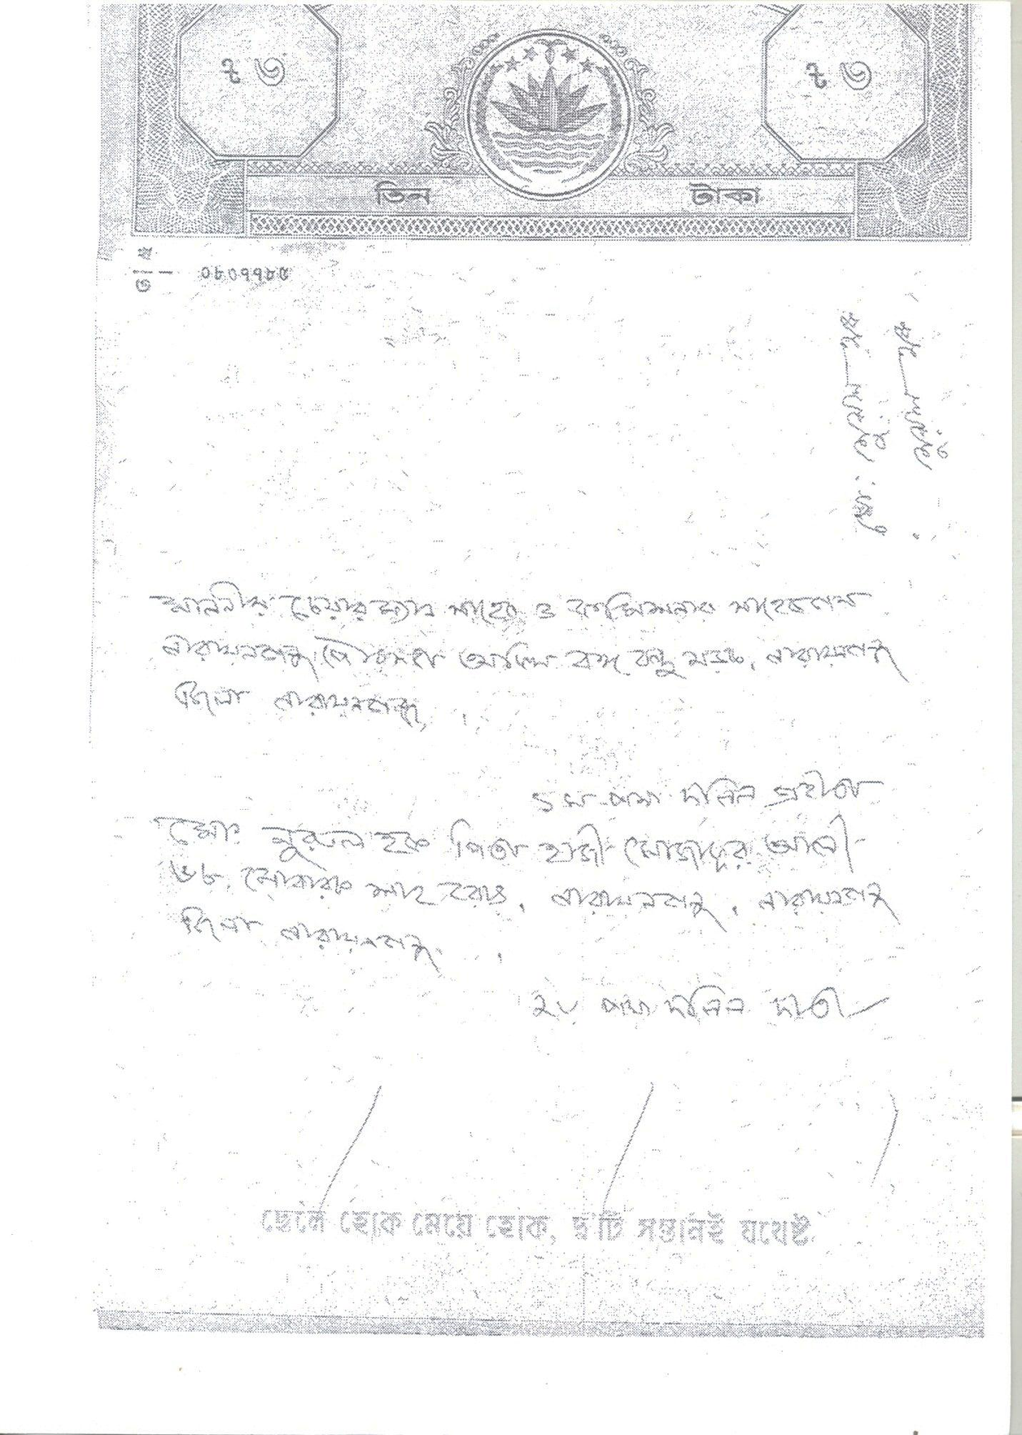
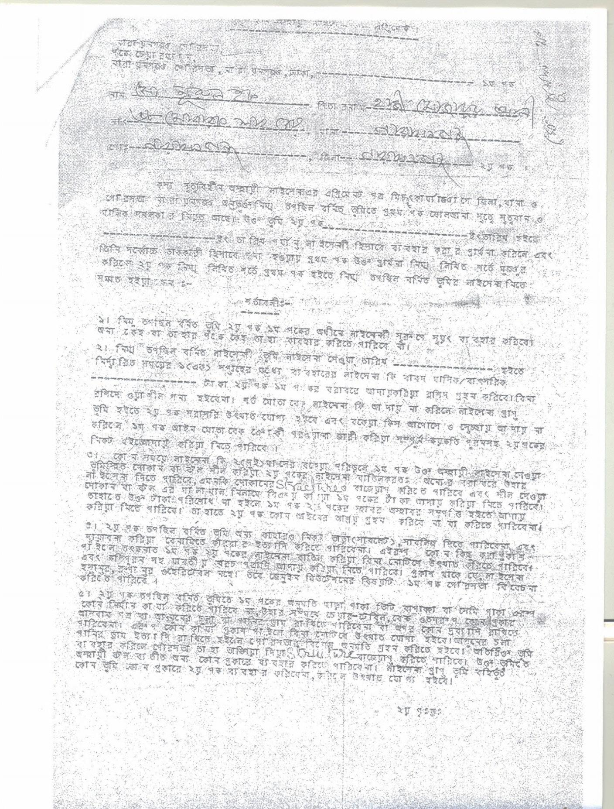
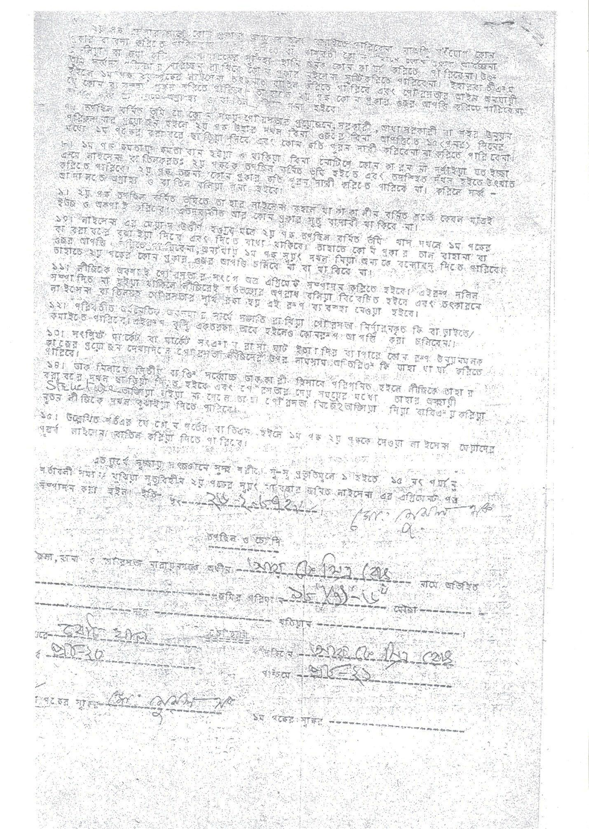
ANNEX 5
Notice of NCC served to the PAPs who are NCC Leaseholders
The attached one page document in Bangla is a notice served to 101 affected tenants of NCC asking them to vacate the place as it is required for the development work of the NCC. The notice was issued on PAPs 17 September 2017 by Chief Executive Officer of the NCC.
The notice specifically mentions that the NCC will compensate the PAP for the loss.

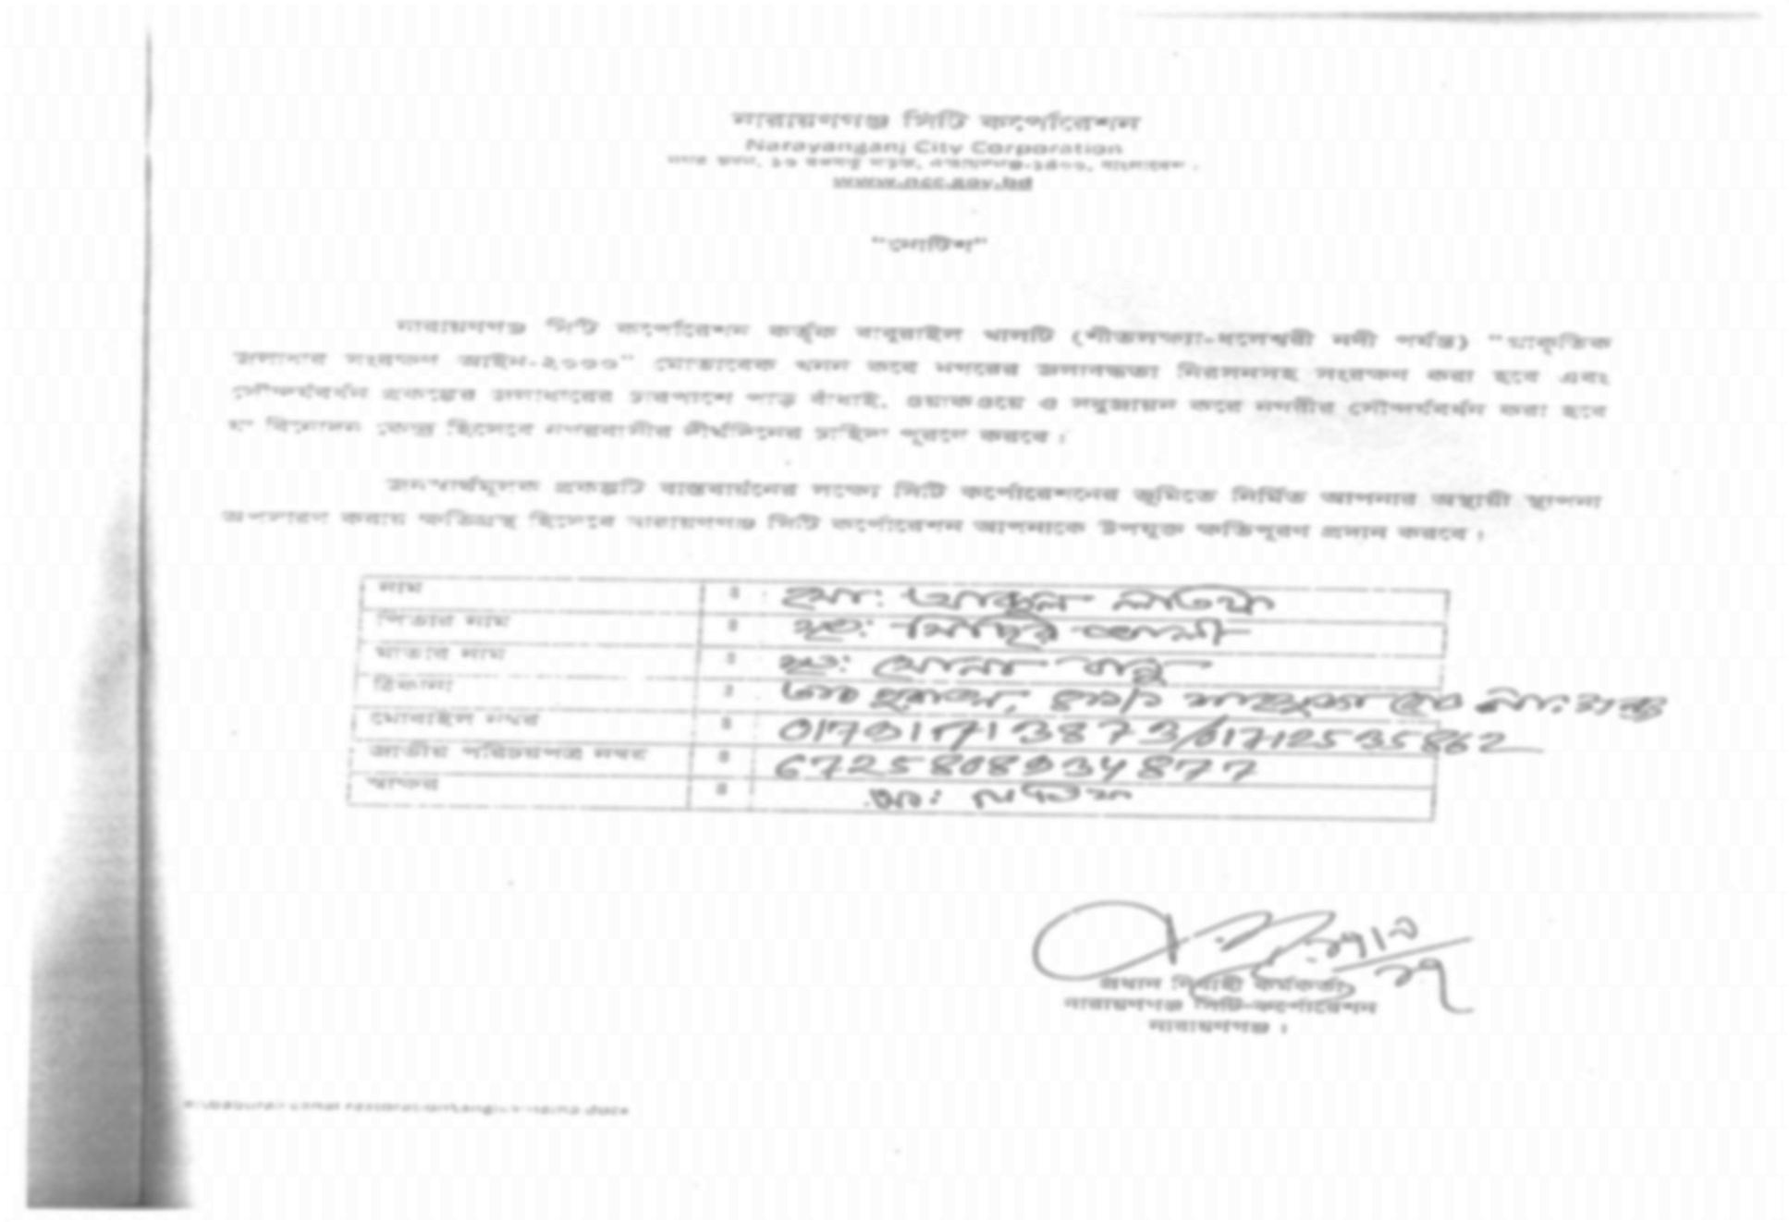

ANNEX 6
Undertaking of PAP to the NCC saying that the PAP will vacate the occupiedpublic or NCC land for the development work of the NCC.

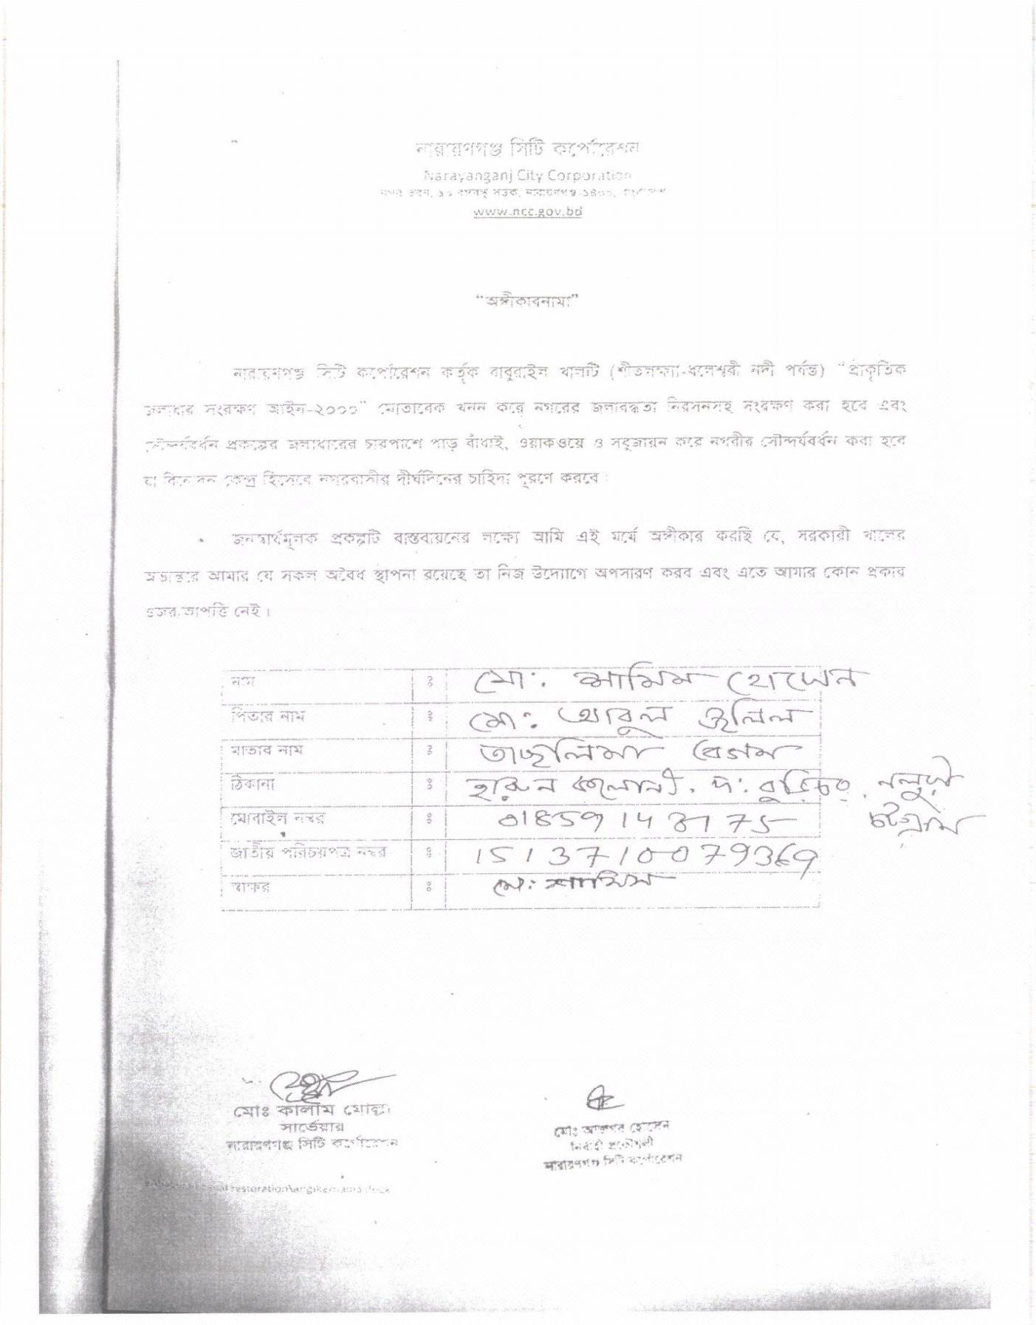
Annex 7
Format for receiving acknowledgement of NCC/ Other public land Tenants of receiving notice/ commitment letter on PAPs the allocation of shop at NCC market when constructed and agreeing to voluntary dispossession:

I / We ……………………………………………………………………………………..S/O ……………………………………………….
D/O ………………………………………………………………………………………….. W/O ……………………………………………………
of (address) ………………………………………………………….. road, …………………………………………………., Narayanganj has been a tenant of a piece of NCC/ ……………………………… using an NCC/ other public land located at ……………………………….. R K Mitra Road. ……………………………………………………………….. of the NCC.
I / We have been notified by the NCC that I/ We have to vacate the land as it is required for implementing the Baburail Khal re-excavation and beautification project, an important development work of the NCC. I / We hereby agree to vacate the land in the interested of the NCC and of the local people and as per condition of the lease.
I /we hereby declare gratitude to the NCC for committing allocation of a permanent shop at the NCC market to be developed. I / We do not have any claim for transitional allowance or shifting allowance.

Signed by …………………………………….
Date ………………………………
Cell Phone NID Number

Annex 8
Format for declaring willingness to vacate NCC/ Other public land on voluntary dispossession basis without compensation:
Declaration of Voluntary Dispossession
I / We ……………………………………………………………………………………..S/O ……………………………………………….
D/O ………………………………………………………………………………………….. W/O ……………………………………………………
of (address) ………………………………………………………….. road, …………………………………………………., Narayanganj has been living on/ operating shop/ having other structure on a piece of NCC/ public land at ……………………………….. Road. ……………………………………………………………….. of the NCC/ Kashipur UP.
I / We understand that NCC has been planning to reopen the Baburail Khal to natural flow and for beatification of its fronts as desired by the communities. NCC did several rounds of consultation with us and other community peoples, it is obvious that many of us are unknowingly occupying part of the Khal.
I/We hereby recognize that the subproject is for a better Narayanganj improving livability for us and our future generations.
I/We am/are not however, dependent on the land I/we occupy and relinquishing access to the strip/piece of land will not induce any negative social or economic consequence to my/our family(ies).
I / We hereby voluntarily agree to vacate the land in the interest of the city and of the local people without compensation.
Signed by …………………………………….
Date ………………………………
Cell Phone NID Number
Witnesses

Annex 9
Format for declaring willingness to vacate NCC/ Other public land on voluntary dispossession basis with compensation:

I / We ……………………………………………………………………………………..S/O ……………………………………………….
D/O ………………………………………………………………………………………….. W/O ……………………………………………………
of (address) ………………………………………………………….. road, …………………………………………………., Narayanganj has been living on/ operating shop/ having other structure on a piece of NCC/ public land at ……………………………….. Road. ……………………………………………………………….. of the NCC/ Kashipur UP.
I / We have been notified by the NCC that I/ We have to vacate the land as it is required for implementing the Baburail Khal re-excavation and beautification project, an important development work of the NCC. I / We hereby agree to vacate the land in the interested of the NCC and of the local people.
I /we hereby declare gratitude to the NCC for committing assistance to help me /us overcoming the inconvenient situation. I / We do not have any other claim to the NCC in this regard.
I / we acknowledge that I / we have received financial support of BDT.
(Taka the NCC.
Cheque Number (if applicable) Dated
Signed by …………………………………….
Date ………………………………
Cell Phone NID Number

Annex 10
Format for NCC Commitment Letter on Allocating Shop.
TO:
Mr./ Ms. ………………………………………………………………………………….
S/O or D/O or W/O ………………………………………………………………………………………………………………………………
of (address) ………………………………………………………….. road, …………………………………………………., Narayanganj
If NCC/ Other public land tenant
Shop Number Location ……………………………………………..
------------------------------------ Road …………………………………………. Mohalla, NCC
As the abovementioned piece of land you were/ are using for business is needed for the re-excavation and beautification of the Baburail Khal, an important project of the NCC, you are required to vacate the land. Although the NCC has no legal binding to provide any compensation, the NCC pledges to allocate you a shop at the NCC(Padma-3) market at Taan Bazar area / new sand-fill site near Gymkhana Park of the NCC by June 2020.
Signed by …………………………………….
Date ………………………………
Name of NCC executive
Designation
Acknowledge receipt of the letter Signed by PAP ……………………………… Date ………………………………

Annex 11
Guidelines for Third Party Validation of Voluntary Dispossession of Public Land
Baburail Khal Rehabilitation and Beautification Subproject has been planned to be implemented using existing available land of the Khal through the city between Shitalakhya and Dhaleshwari Rivers. Involuntary displacement of people will be avoided to the extent feasible. Where the existing lands are in use by well-off persons and stoppage of further use would be socioeconomically inconsequential, NCC may persuade the users to relinquish occupancy of the lands and look for alternative lands, if they refuse. The current users will have the option to refuse to relinquish occupation of the lands without the fear of any adverse consequences. Where these lands are currently used for living and/or livelihood by the poor and vulnerable persons, NCC can obtain them by offering socioeconomic rehabilitation measures acceptable to the affected persons.

The acts of voluntary dispossession will, however be validated by a third party or in absence of a third party, by the Design and Supervision Consultant. The validation of the voluntary dispossession of existing land will be carried out against the following principles.
- Physical relocation of people will be avoided. In case of physical relocation, people not having alternative living place in the NCC area will be compensated.
- There will be no loss of livelihoods or income;
- Affected persons are free to say no to voluntary dispossession without any fear of coercion.
The objective of the validation is to confirm that the above principles have been complied with in the process of voluntary dispossession of land of the Khal without compensation from the Project or from NCC.
The validation will also cover signing of the commitment letters by the NCC to ensure that all commitments signed by the NCC associated with compensation in cash or kind are legally binding upon NCC. The third-party or the DS Consultant will be using the template of validation statement outlined here under.

Third Party Validation Statement
Voluntary Dispossession of Public Land
By Well-Off Persons Encroached into and/or Squatting on Public Land
Names and address with contact number of the persons signing off Declaration of Voluntary Dispossession are as stated in Annex-1 of this Validation Statement.
We provide the independent verification of the process of Voluntary Dispossession through the individual declarations signed on _____________[insert date] by the voluntary dispossessors (attached at Annex-1 herewith) and accepted by the Narayanganj City Corporation (NCC) on the resume of existing public land from private uses within the___km Baburail Khal through the City between Shitalakhya and Dhaleshwari Rivers for rehabilitation of the Khal and beautification of its fronts under the Municipal Governance and Services Project (MGSP) that (i) the affected well-off encroachers and squatters have agreed to remove their structures from the right of way land; (ii) consultations with the encroachers and squatters has been undertaken meaningfully, freely and in good faith and the affected persons have made informed decisions on use of land, and (iii) terms and conditions of the voluntary dispossession declaration have been explained to and understood and agreed by the affected persons. The verification is based on our independent:
- Review of the documentation on the identification of affected well-off encroachers and squatters and the consultation process leading to the signing of the declarations;
- Validation that consultations with the affected persons have been undertaken and that they were provided with relevant information as per the voluntary dispossession requirements as per the SMF;
- Validation that the declarations were voluntary (free of coercion) and that the affected persons has fully understood and agreed to the declarations’ terms and conditions;
- Validation that the affected persons are not physically displaced because of the voluntary dispossession and that they are not dependent on the land they have occupied for their livelihoods;
- Validation that the dispossession of the affected encroachers and squatters did not lead to loss of employment by any individuals;
- Validation that the voluntarily dispossessed encroachers and squatters are socially and economically well-off and they recognize themselves; and
- Validation that the declaration follows the requirements stipulated in the SMF, October 2017 and the Resettlement Action Plan.

Signature:
Date:
Name of the Validator:

Annex 12 RAP Implementation Schedule
Serial | Items | Months  (June 2017-June2018) |  |  |  |  |  |  |  |  |  |  |  |  | Up to June 2019
 |  | 1 | 2 | 3 | 4 | 5 | 6 | 7 | 8 | 9 | 10 | 11 | 12 | 13
1 | Socio Economic Survey and prepare SIA report
2 | Preparation IEE,EIA,RAP
3 | Authorization of DC on using khas land for the project in Kashipur UP.
4 | Issuance of notice to PAPs
5 | Obtaining acknowledgement of receipt of notice, commitment letter of NCC by the PAP
6 | Payment of Compensation to PAPs in cash and kind
7 | Set UP PMIC at NCC
8 | Information Dissemination, Awareness Campaign during Inmplementation of RAP
9 | Payment of Grant to most vulnerable affected persons
10 | Capacity Building Training of PIU staff involved in RAP
11 | IT Capacity building on RAP
12 | Quarterly Monitoring Report
13 | Handing over of shop to the affected leaseholdrers as per agreement

Annex 13
List of 101 Tenants of NCC affected by the Subproject
They will be allocated shops 81 shops are allocated in RK Mitra Road area, 14 in Mondalpara area (sheet 4) and 6 in Tan Bazar Bridge area (last sheet).

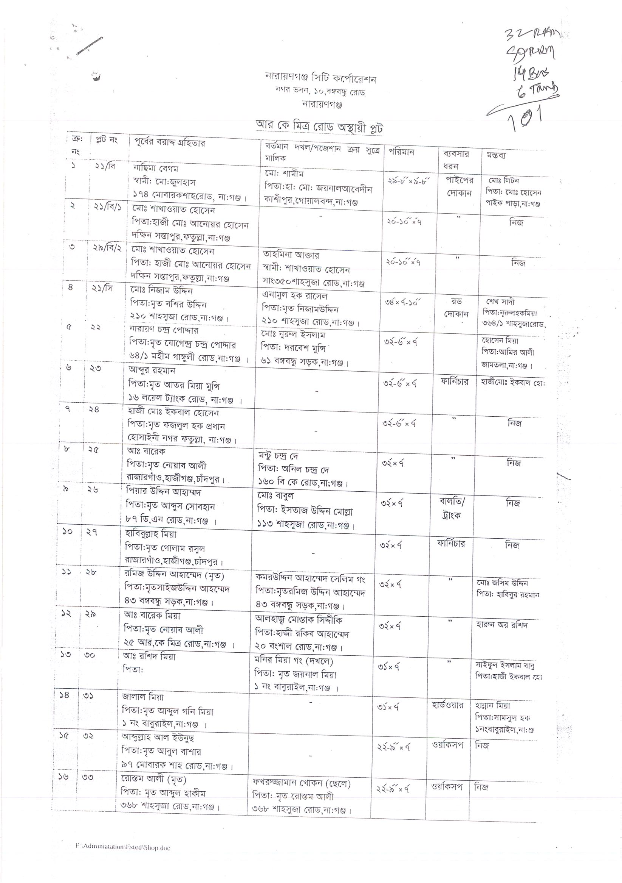
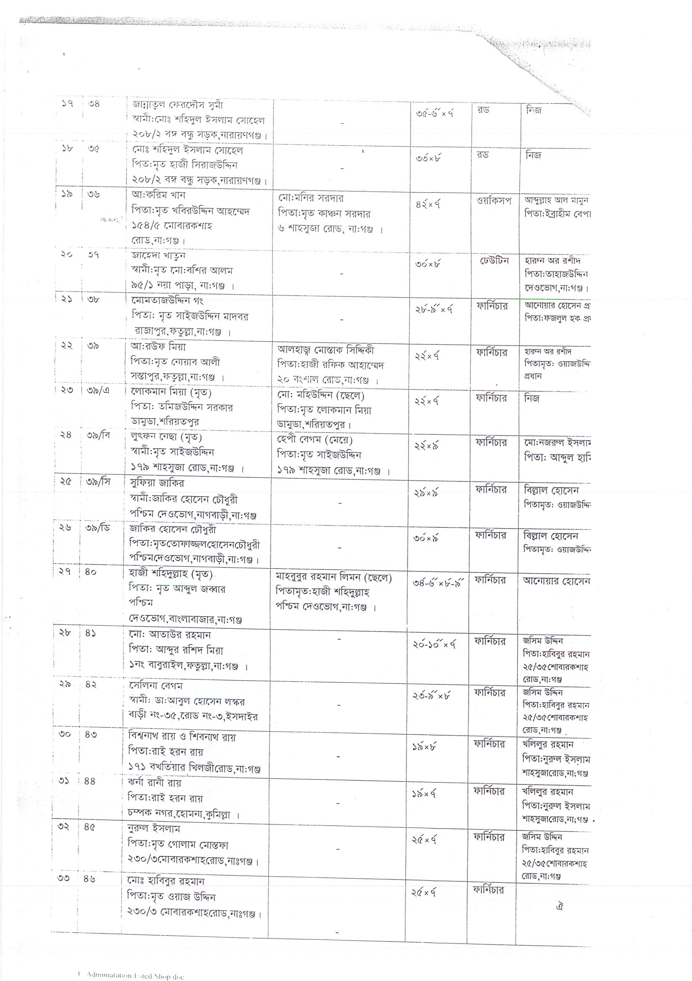

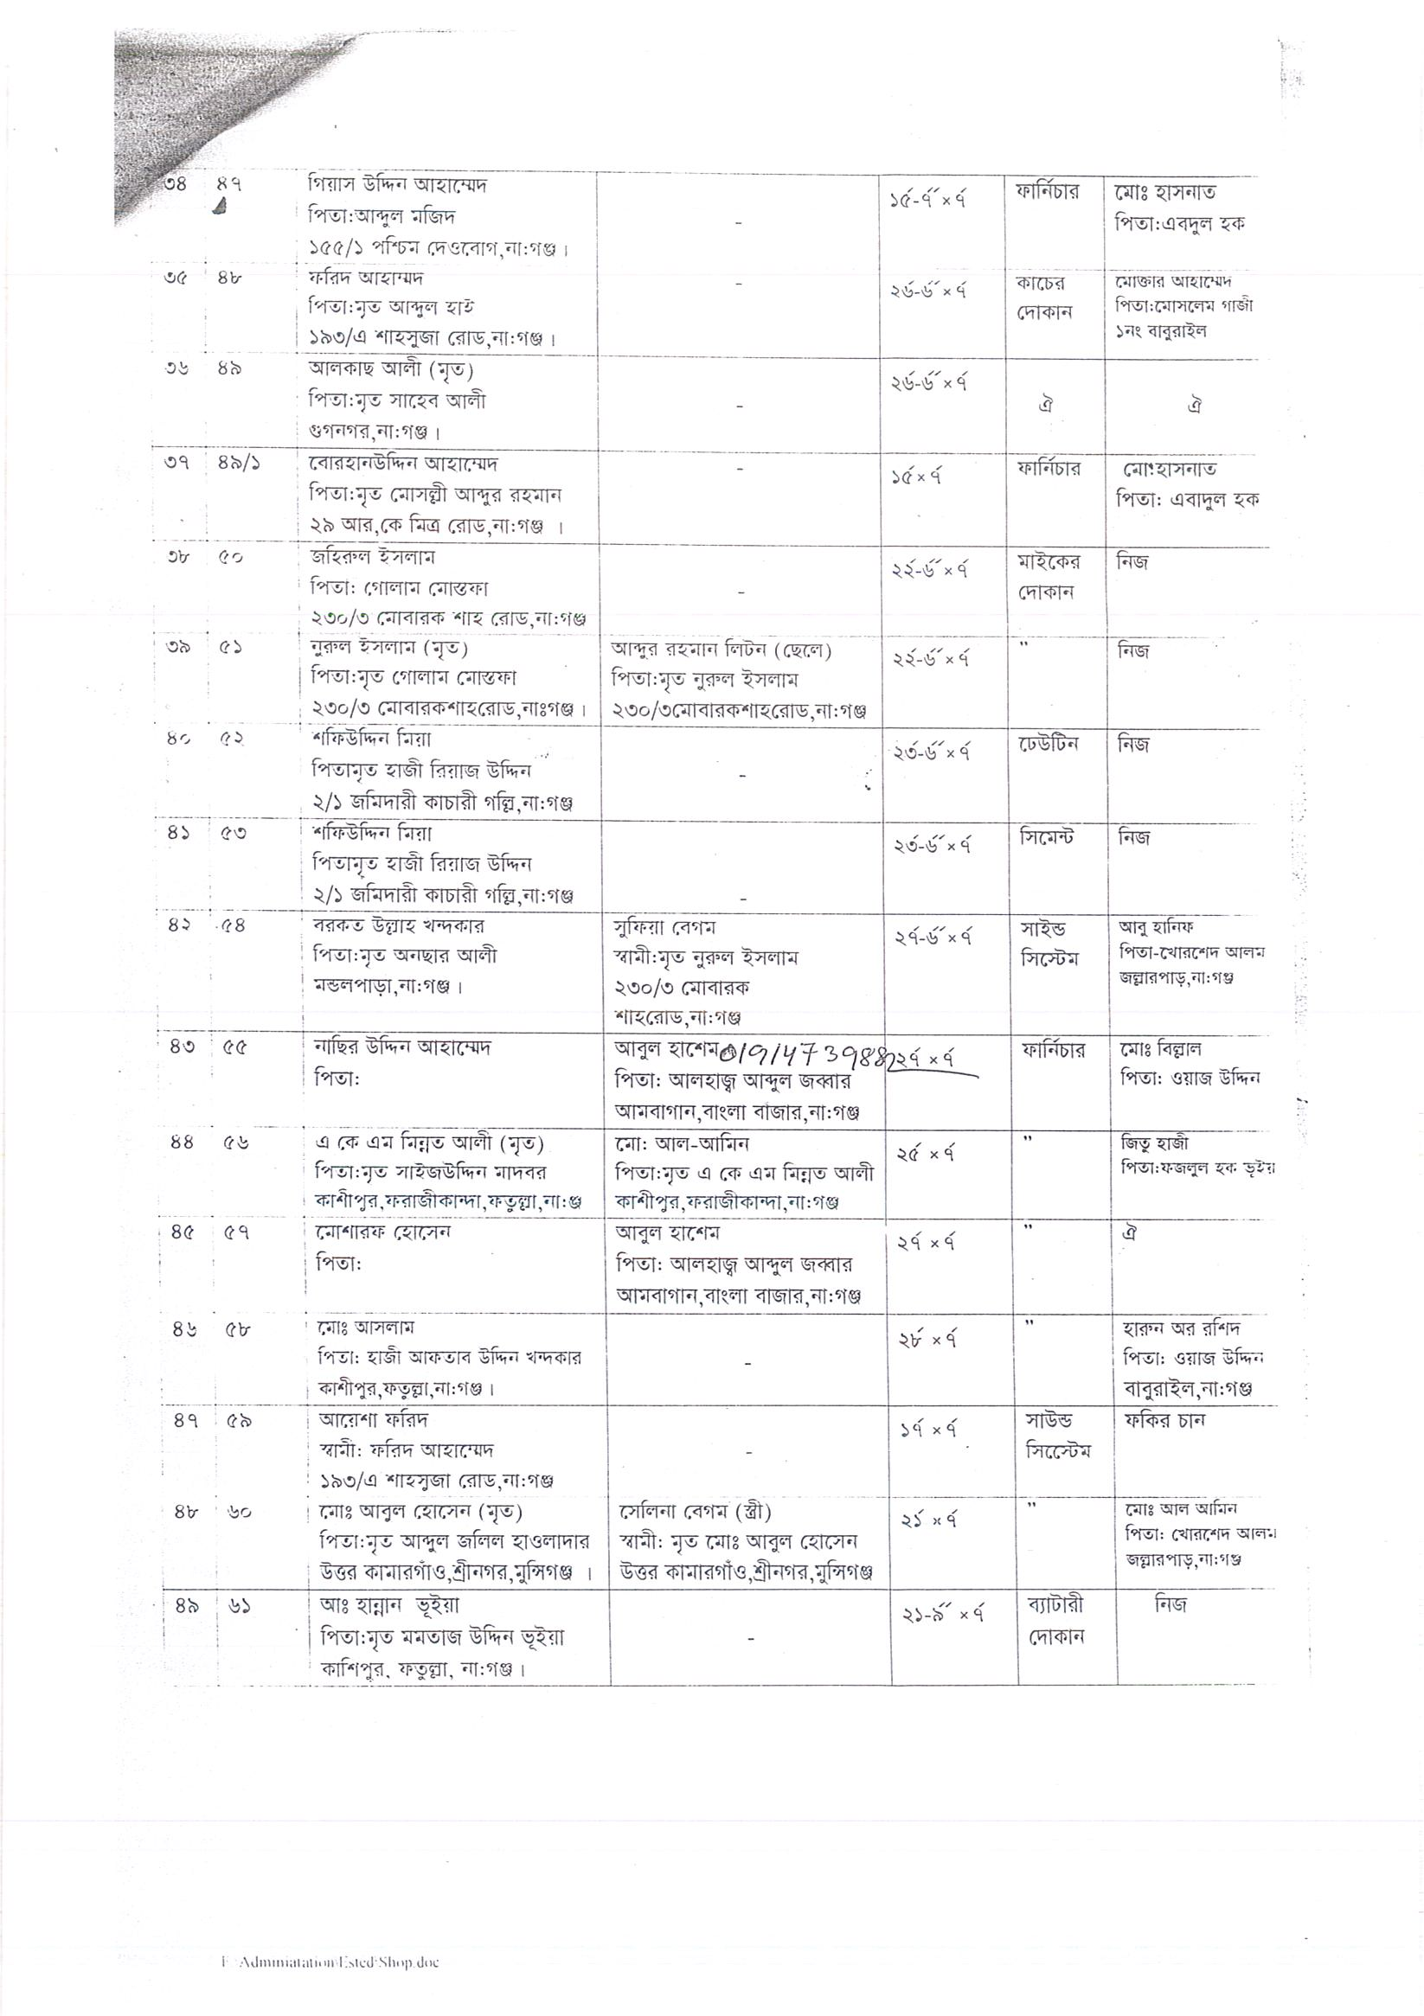
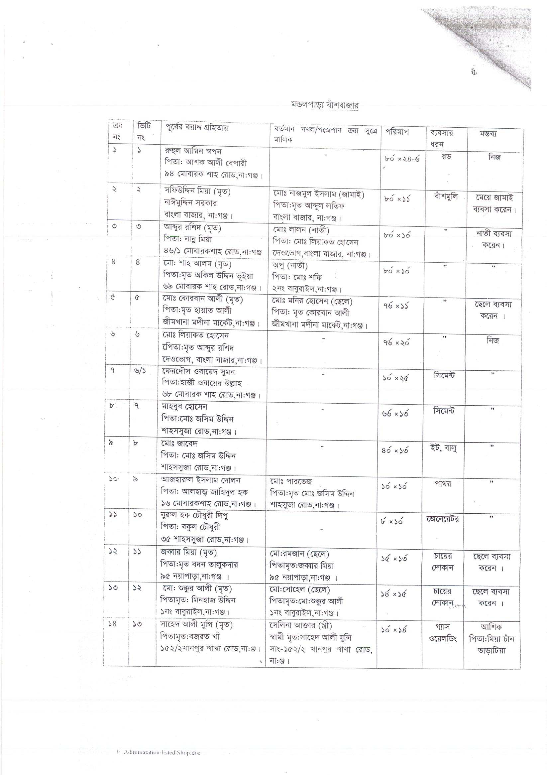
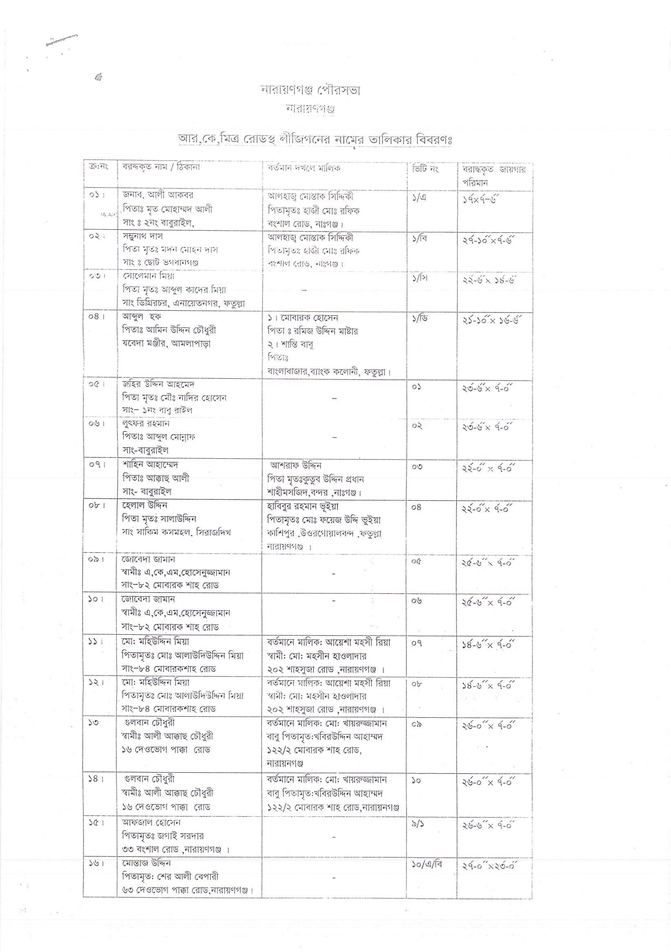
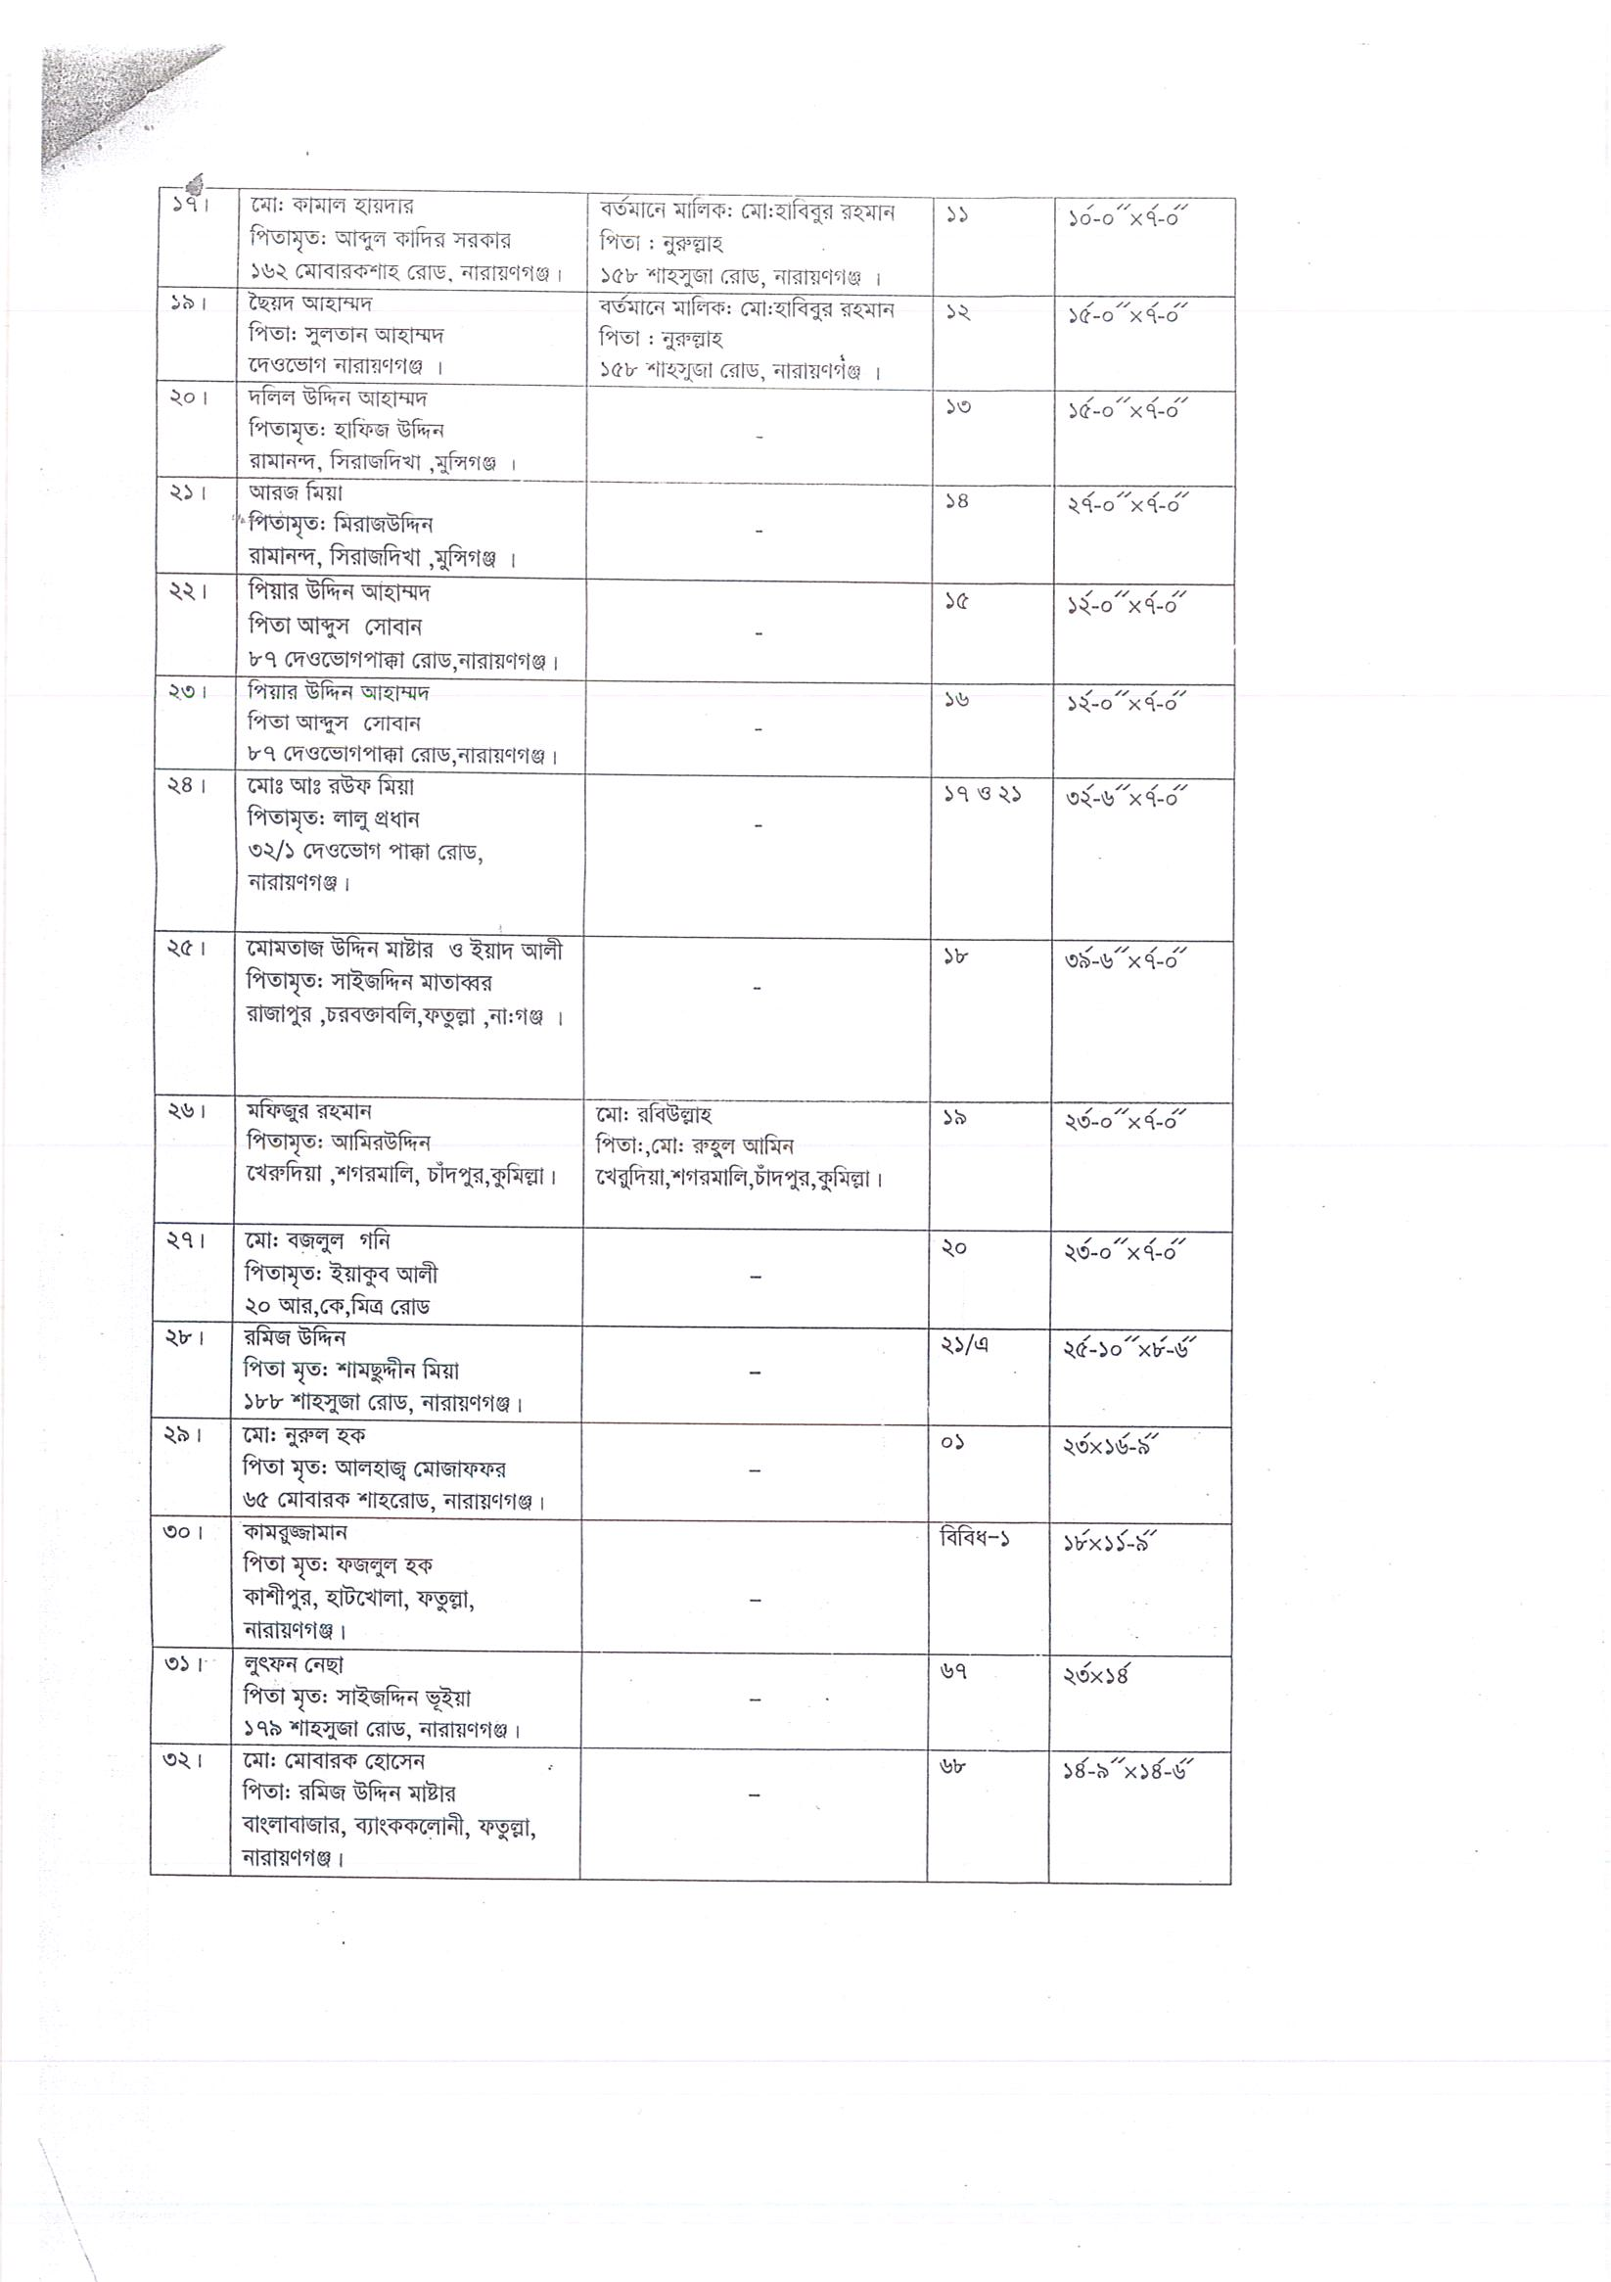
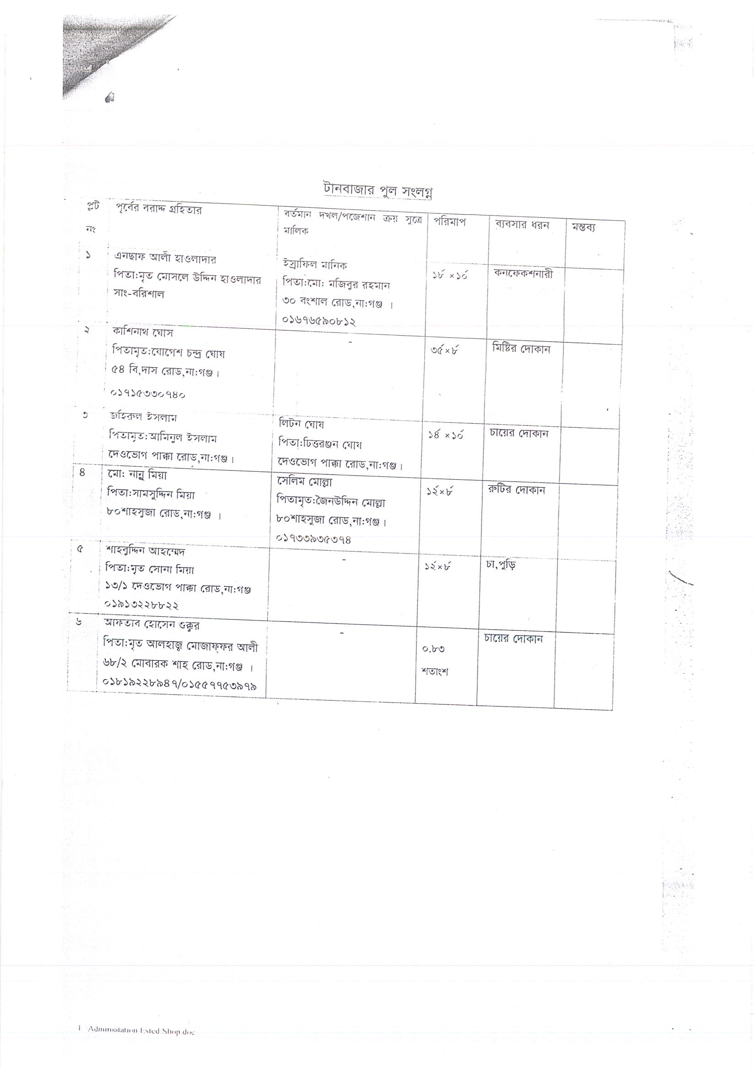

This new act replaced the former law on land acquisition titled “The Acquisition and Requisition of Immovable Property Ordinance, 1982.
VITTI Sthapati Brinto Ltd., 27/A Sangshad Avenue, Monipuripara, Dhaka 1215.
This new act replaced the former law on land acquisition titled “The Acquisition and Requisition of Immovable Property Ordinance, 1982.

