** Government of the People’s Republic of Bangladesh**

**Ministry of Local Government, Rural Development & Co-operatives**

**Local Government Division**

**Local Government Engineering Department**

**Municipal Governance and Services Project (MGSP)**

**IDA Credit No: 5339-BD**

**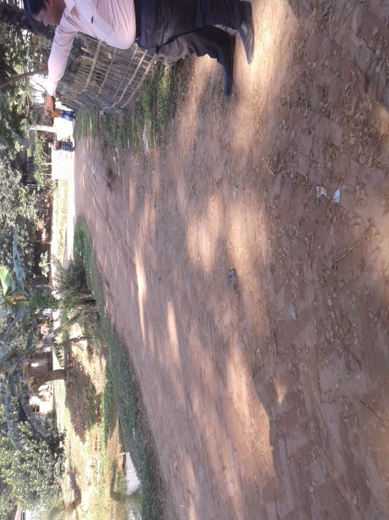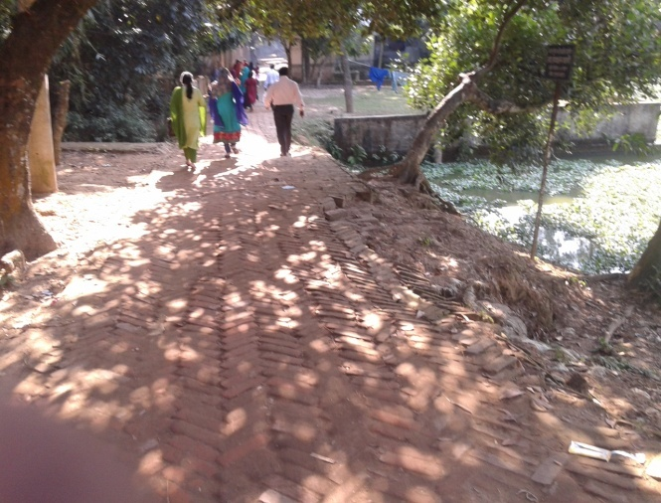Name of Subproject:** Construction of BC road starting from Dhaka Mymensingh highway (Proshika More) to Bania-vita via Chaporbari Dakhil Madrasa and Bakshathra More including street light (CIP-05) under Bhaluka Pourashava ( Ch.0-2080m)

**Social Management Plan**

**Package No:** MGSP/BLK/2016-17/W-03,

Bhaluka Pourashava,

Mymensingh

**Design, Supervision, and Management (DSM) Consultancy Services**

Joint Venture of

*Hifab International AB, Sweden*

*AQUA Consultant & Associates Ltd., Bangladesh*

**January 2017**

**Social Management Plan**

|  |  |  |
| --- | --- | --- |
| **No** | **Contents** | **Page No** |
|  | **Abbreviations** | **3** |
| 1. | Introduction | 5 |
| 1.1 | Project Background | 5 |
| 1.2 | Legal and Policy Framework | 5 |
| 1.3 | Subproject Description | 5 |
| 1.4 | Social Management Plan | 6 |
| 2. | Description of Subproject Area | 7 |
| 2.1 | Brief Profile of Bhaluka Pourashava | 7 |
| 2.2 | Historical and Cultural Heritage Sites | 9 |
| 2.3 | The Subproject Location and Area Profile | 9 |
| 2.4 | Beneficiary Communities and Affected Persons | 10 |
| 2.5 | Gender and Vulnerability | 10 |
| 3. | Social Impact Assessment | 11 |
| 3.1 | Benefits of the Subproject | 11 |
| 3.2 | Social Screening and Safeguard Compliance Issue | 12 |
| 4. | Consultation and Community Participation | 12 |
| 4.1 | Stakeholder Analysis | 12 |
| 4.2 | Consultation and Participation Process | 13 |
| 4.3 | Consultation Outcomes – Issues, Concerns and Recommendations | 14 |
| 5. | Social Management Plan (SMP) | 14 |
| 5.1 | Subproject Selection Process | 14 |
| 5.2 | Subproject Design Process | 15 |
| 5.3 | Implementation | 15 |
| 5.3.1 | Institutional Arrangement | 15 |
| 5.3.2 | Consultation and Participation | 15 |
| 5.3.3 | Grievance Redress Mechanism (GRM) | 15 |
| 5.3.4 | Problem During Implementation and Mitigation | 16 |
| 5.3.5 | Labor Management | 16 |
| 6. | Monitoring and Evaluation Framework | 16 |
| 7. | Conclusions on Social Management Plan (SMP) | 18 |
| **FIGURE** | |  |
| 1. | Present Condition of Subproject Area | 10 |
| 2. | Participation and Consultation Meeting | 14 |
| **ANNEXURE** | |  |
| 1. | Social Screening Report | 19 |
| 2. | Layout Plan | 30 |
| 3. | Land ownership document | 31 |
| 4. | CIP Minutes of Meeting | 32 |

**Abbreviations**

|  |  |
| --- | --- |
| ARP | Abbreviated Resettlement Plan |
| BMDF | Bangladesh Municipal Development Fund |
| CBO | Community Based Organization |
| CC | Cement Concrete |
| CIP | Capital Investment Plan |
| CUL | Compensation-Under-Law |
| DC | Deputy Commissioner |
| DLAC | District Land Acquisition Committee |
| DUTP | Dhaka Urban Transport Project |
| GoB | Government of Bangladesh |
| GRC | Grievance Redress Committee |
| GRM | Grievance Redress Mechanism |
| HCG | House Construction Grant |
| HTG | House Transfer Grant |
| IDA | International Development Association |
| IP | Indigenous People |
| IPP | Indigenous Peoples Plan |
| KII | Key Informant Interviews |
| FGD | Focus Group Discussion |
| LGD | Local Government Division |
| LGED | Local Government Engineering Department |
| M & S | Management &Supervision |
| MGSP | Municipal Governance and Services Project |
| MOLGRDC | Ministry of Local Government, Rural Development & Cooperatives |
| MSP | Municipal Services Project |
| MSL | Mean sea Level |
| NGO | Non-governmental Organization |
| PAH | Project Affected Household |
| PAP | Project Affected Person |
| RAP | Resettlement Action Plan |
| PMU | Project Management Unit |
| RCC | Reinforced Concrete Cement |
| RP | Resettlement Pan |
| SIA | Social Impact Assessment |
| SMP | Social Management Plan |
| SSS | Social Safeguards Specialist |
| TLCC | Town Level Coordination Committee |
| ULB | Urban Local Body |
| WB | World Bank |
| WC | Ward Committee |
| DSM | Design, Supervision, and Management |

**1. INTRODUCTION**

***1.1 Project Background***

The Government of Bangladesh, through the Local Government Engineering Department (LGED) and Bangladesh Municipal Development Fund (BMDF) is implementing the Municipal Governance and Services Project (MGSP). The project aims to improve municipal governance and basic urban services in participating ULBs. Two physical components of the project include (i) Municipal Governance and Basic Urban Services Improvement (Component 1) to provide financial support to 26 pre-identified urban local bodies (ULBs) including municipalities and city corporations, and demand-based sub-credits to eligible ULBs for basic urban services improvement investment costs, at an 80:20 grant to loan ratio (Component 2). LGED is implementing the Component 1 while BMDF is implementing component 2 of the project.

LGED is supporting the 26 pre-selected ULBs for investments in development and rehabilitation of Road, Bridge, Box-culvert, Pedestrians bridge, street light, Traffic Control, Bus terminal, Truck terminal, Boat landing Jetty, Drain, Retaining wall, Kitchen market, Cattle market, slaughter house, Public toilet, Solid waste management, Sweeper colony, Park, Community Centre and Whole sale market. LGED is financing through (i) base allocation based on population category of ULBs; (ii) performance-based allocation and (iii) operations and maintenance support on a declining basis over the project period. The component interventions have largely been developed for construction and rehabilitation within existing available land owned by the ULBs. However, acquisition of land and displacement of people may be involved for unavoidable circumstances as critical requirements. Subprojects may also be undertaken in areas inhabited by tribal peoples. The ULBs will, however, address the land acquisition, population displacement and tribal people’s issues following the country’s legal framework and the World Bank policy on social safeguards.

***1.2 Legal and Policy Framework***

Given the approach of subproject preparation and implementation, the World Bank’s Operational Policy (OP) on Involuntary Resettlement (OP 4.12) and on Indigenous Peoples (OP 4.10) triggered to the project. A Social Management Framework (SMF) has been adopted by LGED for the project that meets the requirements of the country’s legal frameworks in Bangladesh “The Acquisition and Requisition of Immovable Property, Ordinance, 1982” and the Bank requirements including OP 4.12 and OP 4.10. The SMF also requires that subprojects are prepared ensuring inclusion, participation, transparency, and social accountability. Subprojects are prepared by respective ULBs in a process complying with the SMF requirements. LGED reviews the subproject proposals for technical, engineering, environmental, social development, and safeguards compliance before allocation of the financing to the ULBs.

Social Management Plans (SMP) will be prepared and implemented for subprojects with no land acquisition or involuntary displacement of people, while Resettlement Action Plans (RAP) and Tribal Peoples Plans (TPP) ) will be prepared for implementation for subprojects involving population displacement and tribal peoples’ issues.

***1.3 Subproject Description***

The subproject is located in ward no. 03. BC road and street light are the main component of the subproject. The proposed road construction will start from Dhaka Mymensingh highway (proshika more) to Baniavita. In this subproject, 2080m-road, 2nos of RCC Box culverts, 5 nos. of RCC cross drains and some retaining walls will have to construct. .This road connects a large locality (West Chaporbari, South Chaporbari, North Chaporbari, Dhailavita. Baniavita, Mocharvita, etc) with Dhaka Mymensingh Highway. The proposed road is partially damaged. Some segments of the road are HBB, BC, and earthen. As the road is damaged so the local residents are facing problem to move, especially the vehicle movement is being seriously hampered. Many residential houses, some shops, two kindergarten schools, five mosques, two NGO offices are located beside the road. Existing width/right of way of the road is 2.5m-3m and the proposed width is 6m. It is mentioned here that widening of the road up to 6m will be possible due to availability of land of pourashava at both sides of road. Within this 6m available land, there are some small trees beside the road. The Pourashava will take necessary action in consultation with the communities for the improvement of the road. With the proposed development of the road, the socio economic condition of this area will eventually increase.

The residents of the area are facing serious problem while moving at night time for insufficient light in the road. Under the circumstances, it is proposed to install street light for this subproject. 72 numbers of street light with poles will have to install. About 40 numbers of streetlight will have to remove.

Description of Subproject components are as follows:

|  |  |  |
| --- | --- | --- |
| **Description** | **Length/Number** | **Total Cost in BDT** |
| 1.Construction of Road Starting from Dhaka-Mymensingh Highway (proshika more) to Bania-vita via Chaporbari Dakhil Madrasha and Bakshathra more by Bituminous Carpeting (Ch.0+000 to 2+080m) under Bhaluka Pourashava, Bhaluka. | 2080m-Road | 38,025,924.44 |
| 2.-Construction of 2 nos. RCC BOX Culvert (2.600mx1.600m) at ch.30m & Ch.425m respectively on that roar, under Bhaluka Pourashava Bhaluka. | 2-Box culvert, |
| 3. Construction of RCC cross drain (0.600mx0.600m) at ch.655m,1090m,1300m,1340m &1540m respectively on that roar, under Bhaluka Pourashava Bhaluka. | Cross Drain-5 nos |
| 4. Supplying, fitting and fixing of street light starting from Dhaka-Mymensingh Highway (Proshika mor) to Baniavita Chaporbari Madrasha and Bakshatra more under Bhaluka Pourashava, Bhaluka. (Ch.0+000 to 2+080m) | Street light-72 nos |
| 5.Environmental budget for management on constructing of road starting from Dhaka Mymensingh highway (Proshika More) to Bania-vita via Chaporbari Dakhil Madrasa and Bakshathra More by Bituminus Carpeting (ch.0+000 to 2+080m) under Bhaluka Pourashava, Bhaluka. | Environment cost |

***1.4 Social Management Plan***

Initially, the subproject proposal includes a social screening report along with impact assessment. This Social Management Plan (SMP) has been prepared for the identification of subproject and managing social concerns in the process of subproject design and implementation. After reviewing the social screening report by Social Unit of DSM, this subproject proposal is submitted to the PMU office. Social team of the DSM has carried out a site visit and consulted with the Bhaluka Pourashava officials, stakeholders and a section of the beneficiary communities through interview and participation & consultation meeting. The social screening findings and consultation method and proceedings were validated through the social survey and consultation.

The purpose of preparing this SMP is to demonstrate the all-inclusive consultative process in selection and design of the subproject as well as to provide guidance for social development and safeguards compliance in the implementation process.

The SMP contains a description of the subproject areas, social screening and impacts, consultation process adopted during identification and design, and consultation plan for implementation stage, impact mitigation measures, grievance resolution process, and implementation arrangements, and monitoring and evaluation.

Pourashava will ensure participation of the communities and grievance resolution in the process of implementation of the subproject through GRC.

**2. DESCRIPTION OF SUBPROJECT AREA**

***2.1 Brief Profile of Bhaluka Pourashava***

Bhaluka Pourashava is almost centrally located in Bhaluka Upazila under Mymensingh district. Dhaka Mymensingh Highway passes through the pourashava. Distance from Dhaka is about 82.00 km and about 38 km from Mymensingh. It was established in 1998. This is a class “A” pourashava. The pourashava consists of 9 wards. The area of the pourashava is 10.92sq.km. The Pourashava is consists of 6 mouzas. It covers part/full mouza of Bhaluka, Kathali, Kharwali, Bandab, Dhamsur, and Purora.

According to the BBS 2011, the population of Bhaluka Pourashava is 38,774 of which 20,239 are males and 18535 are females. According to 2011, at present the density of population is 3551 per sq.km.

The Pourashava is bounded by Bharadoba union in the North, Habir Bari union in the South, Ragai/Birunia union in the east and Mallikbari union in the West. Besides, Khiru River runs North/South direction and passes by the east of Bhaluka union.

According to latest population census report (2011), 92.91% of the population of this pourashava belongs to Muslim community, 6.87% to Hindu community, 0.16% to Christian population and 0.04% to other religion.

According to BBS 2001,the main source of household income in Bhaluka pourashava are as: business 33.11%, service 28.27%,cropping,livestock,forestry and fishery 11.25% agricultural labour 2.67%, industry 0.99%,hawker 0.81%,rent and remitence1.73%,religious service 0.67%,non agriculture labour 3.95%,transport and communication 5.59%,hand loom o.21%, construction 3.27% and others 8.93%.

The Pourashava covers 09 industries, 04 auto rice milll, 05 rice mills and16 saw mills. Total agricultural land is 180 acre. (Master Plan of Bhaluka Pourashava 2011-2031 and Bhaluka pourashava,)

**At a glance of Bhaluka Pourashava**

|  |  |  |
| --- | --- | --- |
| Name of the Pourashava | : | Bhaluka Pourashava |
| Date of Establishment | : | 8 September 1998 |
| Area | : | 10.42 sq km (present area) |
| Class of pourashava | : | “A” Class |
| No. of Wards | : | 9 |
| Councilor | : | 12 (male-9, female -3) |
| **Population** |  |  |
| Present Population | : | 63,773 (Male-32,525 and Female-31,248) |
| Holding no. | : | 5148 |
| Family | : | 12,454 |
| **Information on Education** |  |  |
| College | : | 1 (Non Govt-2) |
| High School | : | 2 |
| Kamil Madrasha | : | 1 |
| Govt. Primary School | : | 6 |
| Private Primary School | : | 2 |
| **Religious Center** |  |  |
| Mosque | : | 41 |
| Temple | : | 4 |
| Church | : | 1 |
| Idgah | : | 6 |
| **Communication** |  |  |
| Pacca Road | : | 18.85 Km |
| Earthen Road  Other Roads | :  : | 62.00 Km  21 |
| Bridge | : | 2 |
| **Hospital** | : |  |
| Govt. Hospita | : | 1 (Bed-150) |
| Non Govt. Hospital | : | 4 |
| Clinic  Community Clinic  Upozila health complex  NGO Health Centre | :  :  :  : | 3  1  1  1 |
| **Social Institution** |  |  |
| Co Operative society | : | 1 |
| Orphanage | : | 1 |
| Graveyard | : | 1 |
| **Public Health** |  |  |
| Earthen Drain | : | 8.50km |
| Pucca Drain | : | 3.20 km |
| Pipe line | : | 12km |
| Dustbin  Public Toilet | :  : | 10  2 |
| **Financial institute** |  |  |
| Hut Bazar | : | 1 |
| Bank | : | 8 |
| Food Godown | : | 1 (Capacity 500 tons) |
| Industry | : | 9 |
| Auto rice mill | : | 4 |
| Rice mill | : | 5 |
| Saw mill | : | 16 |
| Cinema hall | : | 2 |
| Club | : | 3 |
| Play Ground | : | 3 |

**Others:**NGO : Grameen Bank, BRAC, ASPADA, ASA, Protisruti, Podokkhep, World vision.

Bhaluka Pourashava is headed by the Mayor. It is run by a joint staff of elected public representatives and government officials. This Pourashava is mainly responsible to provide services like waste management, maintenance of drainage system, street lighting, water supply, communication, birth and death registration, issuing of trade license, non-motorized vehicle license and recreation.

***2.2 Historical and Cultural Heritage Sites***

Archaeological heritage and relics Ruins of Neel kuthi at Birunia, Neshaiganj Mosque, Mosque at Bhaluka Bazar on the bank of River Khiru. This subject is far away from the existing historical and cultural heritage so there is no question of affected of heritage

**Historical events**

During the reign of Pal and Sen dynasty, Mymenshing and Bhaluka region was under the administration of Samanta ruler. This region came under the Muslim rule during the reign of Alauddin Hossain Shah in the fourteenth century. During the British period Mymenshing region was divided into a number of sub divisions. Bhaluka Thana, now an upazila, was included into Mymenshing sadar subdivision. During the [war of liberation](http://en.banglapedia.org/index.php?title=War_of_Liberation,_The) Afsar Uddin Ahmed, Sub Sector Commander of Sector 11, locally trained the freedom fighters and collected arms and ammunitions to challenge the Pak army. The Pak army established military camps at Mallikbari, Ashka, Tamat, and Bhaluka. They conducted mass killing, torture and plundering in the upazila; the Pak army also burnt many houses of the upazila.

**Noted religious institutions**

Uthura Jami Mosque, Mallikbari Jami Mosque, Neshaiganj Jami Mosque, Bhaluka Bazar Jami Mosque, Harirbari Mandir.

Due to subproject implementation historical place or site will not be affected.

***2.3 The Subproject Location and Area Profile***

The subproject covers ward no 3 under Bhaluka Pourashava. The subproject is construction of BC road starting from Dhaka Mymensingh Highway to Baniavita via Chaporbari Dakhil Madrasha and Bacsatramore including street light (ch.0+000 to 2+080m). The subproject area is densely populated. There are important structures like shops, schools, offices, clinic, mosque located beside the road. Population of ward no 03 was 4266 out of it Males-2210, Females-2056 **(BBS, 2011).**

Ward no 03 is located at the Northern part of Bhaluka Pourashava. The area of the ward is 228.196 acres.

The main features of the roadside area are Bhaluka degree college, primary school, Chaporbari Dakhil Madrasa, Sunflower Kindergarten, Sarker Kindergarten School, coaching center, NGO office, five mosques, grave yard, residential areas and trees.

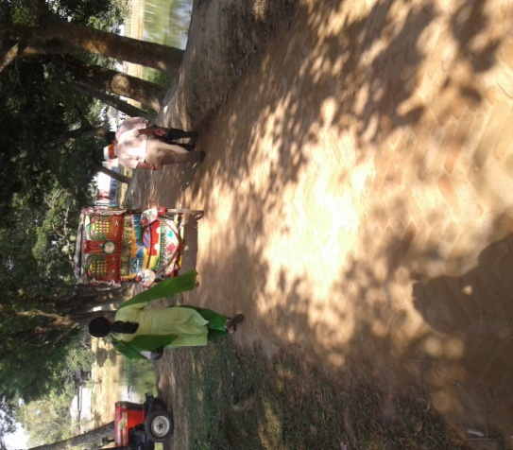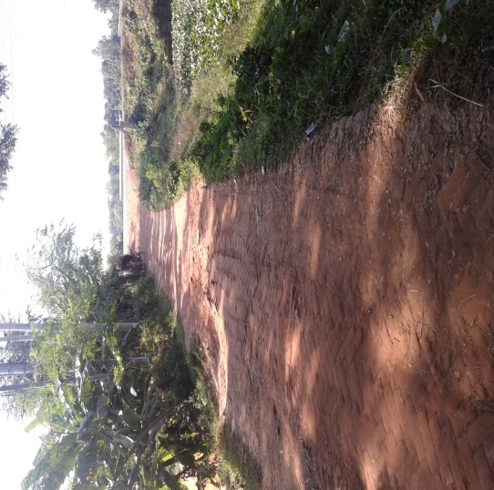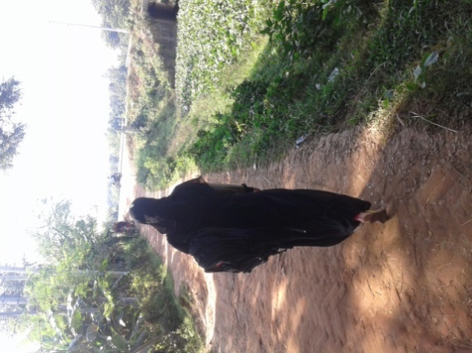

Figure2: Present condition of the subproject area

***2.4 Beneficiary Communities and Affected Persons***

The subproject covers one ward under Bhaluka Pourashava. According to the BBS 2011, the population of Bhaluka Pourashava is 38,774 of which 20,239 are males and 18,535 are females. Due to implementation of the subproject, total population (4266) of the Ward no 03 will directly benefit. The other people who live in the Sadar Upazila as well as the people who travel by using this road will indirectly be benefited, saving travel time and avoiding traffic congestion. There is no presence of tribal people in the subproject influence areas.

Different professions at communities are living in the subproject areas who are engaged in service, industry, business sector. A few people engage in agriculture sector in Pourashava. In addition, some people are rickshaw pullers, carpenters, skilled and semi skilled labors, poor people etc. People of this subproject will directly be benefitted and no people will be affected due to anticipated improvement of the subproject as found out through the social screening.

***2.5 Gender and Vulnerability***

In compliance with LGED’s gender strategy, Gender Action Plan (GAP) and Bank policy on gender, this subproject proposed the following principles, guidelines and procedures to identify gender actions in respect of subproject interventions and include those actions in subproject SMP (Social Management Plan). To mainstream gender in the subproject process, MGSP has applied the following basic principles in selection, design, implementation and monitoring of the subproject.

Gender analyses for the subproject has taken into account of general and specific gender concerns and social vulnerabilities and identified specific actions in term of religious and age which are as follows:

* 1. **Promote women’s participation in subproject planning and implementation**

For the preparation of subproject planning, women participation has been ensured through group discussions and hot-pot consultation. Moreover, vulnerable women have also been involved in subproject planning preparation during the outset stage of the subproject preparation.(Participation and Consultation meeting, Figure:)

* 1. **Maximize women’s access to subproject benefits**

During implementation of the subproject, women will have scope to move easily from one place to other places for their household activities, sending their children to school and they can easily do their small business which will generate income and change their livelihoods which has been understood through discussion with the community people.

* 1. **Minimize social vulnerability.**

In this subproject, there are approximately vulnerable men and women who are identified through the public consultation and participation meeting. This subproject will give more emphasis to reduce the social vulnerability in terms of socio-economic development.

* 1. **Ensure that women are involved in selection, design, implementation, and monitoring and evaluation of the subproject activities including resettlement issues.**

In this subproject, women will be involved in the implementation and monitoring through disclosure meeting which will contribute for the quality improvement of the subproject.

* 1. **Identify appropriate actions to ensure and maximize subproject benefits to women through the consultative process.**

During implementation of the subproject, women communities will easily have a scope of new job opportunities in the road construction and also sell their homestead products in the nearby urban market.

* 1. **Women are involved in civil works construction of this subproject, ensure: (i) equal pay for equal work; (ii) gender friendly work environment; and (iii) work place safety for women and children.**

During construction of the subproject, the project authority will ensure equal pay for equal work and ensure work place safety for women, create gender friendly work environment.

Bhaluka Pourashava is responsible for managing social issues including gender and vulnerability issues in the subproject area. Moreover, after implementation of the subproject, women movement and income generation activities will increase because vehicle movement will also increase due to improved road condition.

**3. SOCIAL IMPACT ASSESSMENT**

***3.1 Benefits of the Subproject***

After implementation of the subproject, people will use this road for inter-town and intra-town movement because of the higher accessibility. The increase in property and land value of nearby areas essentially represents a capitalization of the access cost savings and travel time savings associated with those locations, including this value in a regional or national economy. From a view of social benefits, it increases the public transport trips per day and additional regional employment generation is expected. After construction of this road including street lights, people will move easily and safely. The business activities will increase as the micro entrepreneurs covering men and women will bring the commodities from the town easily and sell the necessary goods at reasonable prices (outcome of interview with subproject communities). Even vulnerable women will have new scopes for the employment opportunities with required income generating activities.

After construction of the road, this will open new scopes of jobs for local people. More people will be engaged in the transportation sector.

***3.2 Social Screening and Safeguard Compliance Issue***

After selection of the subproject from the CIP list, the Pourashava with the assistance of DSM Consultants has completed a social screening for the subproject using an inclusive and participatory approach.

Bhaluka Pourashava has ensured the implementation of subproject following socially inclusive and gender friendly. According to engineering design, implementation of the subproject will be carried out within the existing right-of-way. There is no resettlement issue.

Results from the social screening are given below.

* No additional public or private lands will be required for the subproject outside the existing right of way.
* No private, public, community, or cultural property of any kind of service delivery facilities as well as commercial activities will be affected.
* Preparation of RAP will not be required for implementing the subproject.
* Agricultural or industrial productivity will not be hampered by the proposed subproject areas because the area is almost rural area surrounded by agricultural field.

The outcomes of social screening also confirm that local people across the subproject are positive about its implementation.

**4. CONSULTATION AND COMMUNITY PARTICIPATION**

***4.1 Stakeholder Analysis***

As a part of the overall assessment, the subproject identified the key stakeholders of the proposed subproject areas and assessed the power relationships as well as influence and interests of stakeholders involved in the development work of the subproject. Key stakeholders for subproject were identified in consultation with the Mayor and officials of Bhaluka Pourashava, local administration, civil society and local people of towns, representatives of business associations, local contractors for infrastructure development, road users, vulnerable communities etc. Both males and females will benefit directly and indirectly by the improvement of this subproject. Stakeholder analysis are shown billow.

| **Stakeholder** | **How** | **ULB/Local people** | **Analysis** |
| --- | --- | --- | --- |
| Rickshaw pullers | Road users. | During meeting with pourashava officials and local people it is informed that about 300 rickshaw pullers are driving in the pourashava areas. | Rickshaw pullers are directly benefited by the subproject. After implementation of the subproject, rickshaw pulling will be easier and safer to them. |
| Women | Road users. | - | Women movement will be easier due to vehicle movement will increase and street light will ensure to move the road safer. |
| Vulnerable persons | Road users. | During meeting with pourashava officials and local people it is informed that about 50 nos of vulnerable people are living in the subproject area. | They can easily move for their work even in the night time. |
| Service holders | Road users. | - | Service holders will reach their offices easily by using vehicle or walking on foot. Even night movement will be easier to them. |
| Students | Road users | Consultation meeting with the communities | Through the consultation with the communities, students can easily reach to their educational institutions by using rickshaws and also walking on foot. |
| Business men/traders | Road users | - | Micro, small, medium and large business entrepreneurs will increase the scopes for doing better business. |

In addition, many professions of people will use the road for their day to day normal activities and also increase their livelihood.

***4.2 Consultation and Participation Process***

The participatory public consultations were conducted in the subproject areas. Key Informant Interviews (KII) and group discussions were conducted involving the participants of the Bhaluka Pourashava Mayor, Councilors, Pourashava Officials, representatives of local Communities and civil society members as well as the representative of local LGED office and the consultant team. A walk-through informal group consultation with the local communities was also held. Through this participation and consultation meeting, the local communities were disclosed about subproject implementation and benefits. Suggestions and recommendations made by the participants are incorporated in the SMP accordingly. The photographs of the consultation meetings may be seen below.

|  |  |
| --- | --- |
| F:\All ULB Pic\BLK\Proshika mor Via Baniavita to degree college\20161122_133451.jpg | F:\All ULB Pic\BLK\Proshika mor Via Baniavita to degree college\20161122_134545.jpg |
| *Figure 3: Participation and consultation meeting at Dhalavita, dated:22/11/16* | *Figure 3:Meeting at Chapar Bari Dakhil Madrasha More, Dated: 22/11/16* |

***4.3 Consultation Outcomes – Issues, Concerns, and Recommendations***

The participants raised their issues related to subprojects improvement which mainly includes roads, drains, street light. Feedback, suggestions and recommendations by the participants are listed below.

* Scheduled of Construction works should be ensured properly and the quality of construction work should be improved as per tender specification;
* By engaging active women, gender issues has been ensured
* Social safeguard compliance issues has been ensured through the inclusive participation of subproject beneficiaries in subproject implementation

**5. SOCIAL MANAGEMENT PLAN (SMP) FOR IMPLEMENTATION**

SMP will ensure the compliance of social management requirements including social safeguards for the subproject implementation of Bhaluka Pourashava in a participatory process. This plan will assist Project Implementation Unit (PIU) of the Pourashava by ensuring technical assistance covering subproject selection, design, and institutional arrangement using participation and consultation process and grievance resolution process for implementation and also giving involvement of labor in the project implementation activities. PMU, DSM and the Pourashava will also ensure monitoring and supervision of the subproject implementation etc.

***5.1 Subproject Selection Process***

According to the opinions and views of the Bhaluka Pourashava Mayor, civil society and community people, the subproject is important for the easy and safer movement of engine driven transport and electric battery driven taxi, rickshaws and vans as well as pedestrians like students, officials, villagers, and farmers to enter into the town. Farmers and women are selling their homestead garden vegetables with reasonable prices. Accordingly, MGSP in coordination with concerned Bhaluka Pourashava elected representatives, local administration, relevant stakeholders, and civil society members following the participatory approach in different stages of subproject selection, inclusion, consultation and participation methods. Female Ward Councilors participated actively in the selection process. Moreover, the representatives of TLCC and WC from the Pourashava have contributed in the subproject selection process with an analysis of the inclusiveness of the selection process.

At the time of selecting this subproject, Social screening with Bhaluka Pourashava urban communities, local administration, traders, buyers, and sellers were conducted by the Bhaluka Pourashava officials and Consultants from DSM. Views and opinions of these consultations were to explain the subproject objectives and sought feedback from the participants to maximize the social and economic benefits as well as to minimize the adverse impacts of the subproject.

***5.2 Subproject Design Process***

After final selection of the subproject, the DSM Consultant designed the proposed subproject (road, street light) under Bhaluka Pourashava. This subproject will be constructed over the Pourshava’s own land. Despite the inclusion and participatory consultations, if any person reports any grievance relating to the implementation of the subproject, the Pourashava will mitigate it.

The Consultant interviewed stakeholders and beneficiaries of the subproject areas before the design. The Consultant and Pourashava officials conducted a number of consultation meetings in the subproject areas discussing the implementation procedures and mitigation measures, if any, required to be taken in implementing the proposed subproject.

***5.3. Implementation***

**5.3.1. Institutional Arrangement**

DSM has initially completed social screening for the subproject and there is no problem for the improvement of subproject in regard to social safeguard issues. Accordingly, PMU, MGSP has processed following procurement procedures. After finalization of award letter for this subproject, Bhaluka Pourashava is responsible for implementation of the subproject intime in close coordination with the PMU of the project and also with the technical assistance of DSM. Engineering section of Pourashava and local representative of Consultancy team will ensure the quality construction work of the subproject. In addition, Consultant team from Head Quarter DSM will ensure the close monitoring of the implementation of subproject. In these implementation procedures, Social safeguard Team will ensure the monitoring of social safeguard management before civil works start. During construction, the communities will not be affected following avoid and minimize the loss of communities. In addition, before civil works start, the Pourashava will make the video film and also social screening. Afterwards, DSM will ensure close social management monitoring during the implementation of the subproject.

**5.3.2. Consultation and Participation Plan**

The objectives of consultation and participation process for this subproject will be disclosed, informed, consulted, engaged, collaborated and empowered the communities and other local stakeholders from the planning to implementation at the Bhaluka pourashava. Consultation and participation has been undertaken to achieve specific objectives at subproject identification, planning, design, implementation and evaluation stages.

**5.3.3. Grievance Redress Mechanism (GRM)**

GRM has already operationalized for Bhaluka Pourashava. Accordingly, this Pourashava has formed Grievance Redress Committee (GRC) to handle any grievance raised due to implementation of the subproject. The committee will be headed by the Mayor of the Pourashava and consist of 7 members. The committee will answer to subproject-related queries and address complaints and grievances about any irregularities in application of the guidelines adopted for assessment and mitigation of social and environmental impacts. Based on consensus, the procedure will help to resolve issues/conflicts amicably and quickly without resorting to any expensive, time-consuming legal actions. It will ensure proper presentation of complaints and grievances, as well as impartial hearings and transparent decisions.

Bhaluka Pourashava has already appointed Focal Point of GRC who is at the level of Assistant Engineer. But he will also act Social Development Officer for the MGSP subproject implementation in their pourashava. The Mayor of the Bhaluka Pourashava is the Chairman of the GRC. This GRC at the Pourashava level is responsible to disclose the subproject implementation before civil works start.

**5.3.4. Problem During Implementation and Mitigation**

During the subproject implementation, different kind of problem may arise in terms of social safeguard issues and quality. PIU of the Bhaluka Pourashava will mitigate the problem with the assistance of PMU and DSM by ensuringCommunity participation. But the PIU of the Pourashava will ensure to minimize adverse social effects and maximize subproject benefits to the community. The project also ensures transparency and social accountability at each stage of the subproject execution through engaging communities in the process of suggestion and complaint and grievance redress mechanism (GRM). As a continued process of participation, the Pourashava has included consultation and Participation Plan and Grievance Redress Mechanism for further inclusion, participation, transparency and social accountability in the implementation process.

**5.3.5.** **Labor Management**

The Pourashava is responsible to inform contractors to engage the skill and semi-skilled labor during the construction of the subproject from the subproject site. Moreover, the pourashava will also oversee the equal pay for equal works for the labors and will look into consideration for the safety and security of working labor in the subproject areas. Even, the pourashava will see whether labor will be paid in due time or not. The pourashava management will avoid the child labor and elder labor(less than 18 years and more than 65 years) for implementation work of the subproject through the Contractors. PMU will monitor the labor management issues with the assistance of DSM Consultants.

**6. MONITORING AND EVALUATION FRAMEWORK**

**A. Monitoring Strategy**

Monitoring in the MGSP will be done in a participatory manner and will be a bottom up process. The participants in monitoring and evaluation particularly in reporting the grassroots level activities on social management in subproject planning and implementation will be the beneficiary communities including the residents of ULBs, traders, marketers, pedestrians and visitors in the ULB areas. Self-monitoring by communities through WLCCs will be a main input to both internal and external monitoring.

**B. Internal Monitoring**

LGED will carry out internal monitoring with the assistance from their respective DSM Social Management Officer and the Social Development (SD) Specialist. The Executive Engineer of the ULBs will be responsible for internal monitoring of the social management actions. The SD Specialist will develop monitoring formats which will be filled in by the social development officer (SDO) at ULB. The SDOs will be thoroughly briefed about the SMF and any RAP and the Bank’s Policy on social safeguards. The SDOs will visit the subproject areas routinely at both planning and implementation stages. The internal monitoring will broadly involve:

* Administrative monitoring
* Social management issues
* Impact evaluation

**C. External Review and Evaluation**

External review and evaluation will be carried out to assess how effectively and efficiently social development and social safeguards issues have been identified, management and mitigation measures planned and implemented. An independent consultant (individual expert of MGSP) will be employed by LGED for carrying out independent evaluation. The external review and evaluation will specifically assess

* Whether the broader social management objectives of the subproject are met, what difficulties are there and suggest corrective measures.
* Whether the subproject impacts on key social, economic and environmental indicators show positive trend, what difficulties are there and suggest corrective measures.
* Whether the project strategy of inclusiveness, participation, transparency, social accountability and equity are followed specifically in rehabilitation and improvement of urban infrastructures.

**D. Indicators for Social Management**

**1. Social Development Process**

Social development processes have several intricacies. Social development will be monitored using following indicators. Data regarding these indicators will be collected periodically and will be analyzed to find the outcomes of the processes. However, these indicators will be reviewed at the subproject preparation stage and customized for specific subprojects.

|  |  |
| --- | --- |
| Inclusiveness | 1. Access to vulnerable communities considered in subproject identification for improved urban infrastructure services  2. Subproject budget and components, construction time table and contractors information are discussed in TLCC meetings |
| Participation | 3. Representation of women and vulnerable groups in WLCCs and (pilot) CBOs  4. Representation of women and vulnerable groups in GRCs  5. Representation of women, tribal and vulnerable groups, occupational groups, men and women in consultation process,  6. Beneficiary options reflected in subproject design and implementation |
| Transparency | 7. Disclosure of project information SMF/RAP  8.Community awareness about the subproject and the social management issues and policies |
| Social accountability | 9. Feedback from communities carried for design and implementation support by ULBs  10. Grievance petitions received at WLCCs and at GRCs  11. Grievance cases resolved at the entry level at WLCC  12. Representation of community peoples in monitoring process |
| Social Safeguards Compliance issues | 13.Ensure social screening and impact assessment  14.Ensure land acquisition if necessary  15. Prepare Resettlement Action plan and implementation  16. Develop relocation strategy  17. Prepare compensation plan and cash payment process. |

**E. Reporting**

The Pourashava will provide monthly progress reports to the PMUs at LGED on progress and achievements in social management and resettlement of project affected persons. The PMUs at LGED will provide IDA with the following information for review of performance and compliance with the SMF and the Bank’s OP 4.12 and other requirements.

* Quarterly Progress Report indicating progress on social development issues, and social safeguards including land acquisition and implementation of any impact mitigation plans (with and without land acquisition) adopted by the individual ULB;
* ULB-wise updates on compensation payment for land acquisition (where ULBs decide to acquire) and other impacts as and when the Bank requests them for work- package clearance and disbursement; and
* Updates for formal supervision missions, if the report produced for the current quarter is deemed not sufficiently informative.

The independent social review and evaluation consultant will produce a baseline, a mid-term review and an end-term evaluation report.

**7. CONCLUSIONS ON SOCIAL MANAGEMENT PLAN (SMP)**

PMU in the specific field site consultation with the elected representatives of Bhaluka Pourashava has selected subproject. Accordingly, Social Management Officer of DSM in close coordination and consultations with Bhaluka Pourashava has conducted social screening and subsequently prepared the Social Management Plan (SMP) for subproject. According to SMP, PMU plans to disclose the vulnerable communities and subproject users in the subproject locations on Social Safeguard Issues for their empowerment and ability to mitigate the complaints amicably and successfully. To protect their livelihoods, daily trading, income, dropout of education of their children, and other income generating activities, this Social Management Plan will be followed strictly and carefully for subproject implementation

**Local Government Engineering Department (LGED)**

**Municipal Governance and Services Project (MGSP)**

**Agaragaon, Dhaka-1207**

**SOCIAL SAFEGUARDS SCREENING OF SUBPROJECTS**

**REVIEW and EVALUATION**

**Social Screening Report**

**Package No**: MGSP/BLK/2016-17/W-03

**Name of Subproject**: Construction of BC road starting from Dhaka Mymensingh highway (Proshika More) to Bania-vita via Chaporbari Dakhil Madrasa and Bakshathra More including street light (CIP-05) under Bhaluka Pourashava ( Ch. 0-2080m.).

**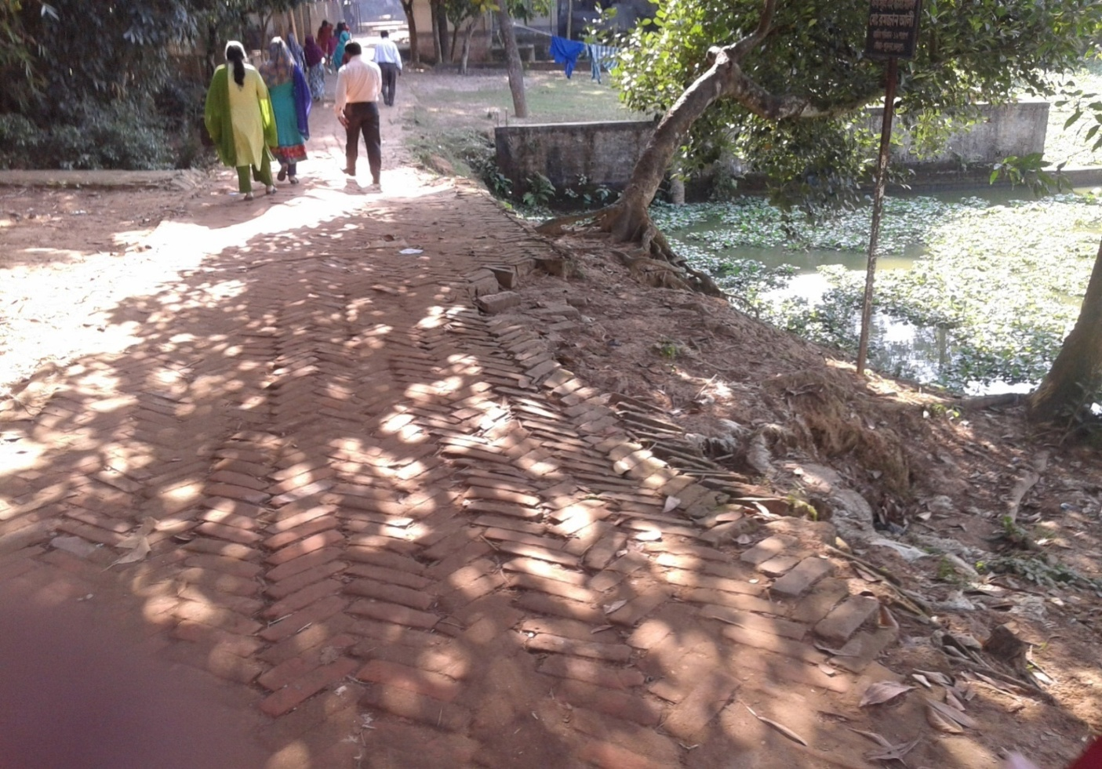**

**November 2016**

**Bhaluka Pourashava  
Bhaluka**

***Annex 8.A***

**FORM 1: SOCIAL SAFEGUARDS SCREENING OF SUBPROJECTS**

**REVIEW and EVALUATION**

**Name of Subproject:** Construction of BC road starting from Dhaka Mymensingh highway (Proshika More) to Bania-vita via Chaporbari Dakhil Madrasa and Bakshathra More including streetlight (CIP-05) under Bhaluka Pourashava (Ch.0-2080m.)

**Description of subproject**: The subproject is located in ward no. 03.BC road and street light are the main component of the subproject. The proposed road construction will start from Dhaka Mymensingh highway (Proshika more) to Baniavita. Total length of the proposed road is 2080m.This road connects a large locality (West Chaporbari, South Chaporbari, North Chaporbari, Dhailavita. Baniavita, Mocharvita, etc) with Dhaka Mymensingh High way. The proposed road is damaged. Some segments of the road are HBB, BC, and earthen. As the road is damaged so the local residents are facing problem to move, especially the vehicle movement is being seriously hampered. Many residential houses, some shops, two kindergarten schools, five mosques, two NGO offices are located beside the road. Existing width of the road is 2.5m and the proposed width is 6m. It is mentioned here that extension of the road up to 6m will be possible due to available land of pourashava’s boundary beside the both sides of road. In this subproject, 2nos of RCC Box culverts, 5 nos. of RCC cross drains and some retaining walls will have to construct. If the road is developed then the socio economic condition of this area will improve significantly.

The residents of the area are facing serious problem while moving night time for insufficient light. Under this circumstance, it is proposed to install street light for this subproject. 72 no of street light with poles will have to install. 40 nos. of streetlight will have to relocate.

**Date of Social Screening: 22/11/2016**

**2. INTRODUCTION:**

This questionnaire is designed to facilitate the assessment of the current situation of social issues related subprojects in 22 Municipalities and 4 City Corporations under Municipal Governance and Services Project (MGSP). The information collected by this questionnaire will help to assess the initial Social Management needs quickly and ensure related subprojects are approved in the earliest possible time.

This screening will enable the best effective assessment of social matters in Bhaluka Pourashava and it should be completed as accurately as possible based on factual material.

**3. OBJECTIVES AND GOALS:**

The primary objective of this Social Screening is to improve urban accessibility in project areas and strengthen institutional capacity for sustainable subprojects and ensure potential social safeguards compliance issues and social impacts associated with the quality construction and improvement works in order to determine applicability of the World Bank OP 4.12, 4.11 and OP 4.10 and establish “Social Management Plans” for the urban community members.

**4. STRATEGY OF SOCIAL SCREENING:**

The Social Screening is based on a collection of primary data and information while conducting field survey for the subproject. A well-structured questionnaire was already designed in the Social Management Framework and given to the field officials for obtaining necessary primary data relating to social issues in connection with losses of land and any kind of assets for the subproject implementation. Further information was obtained through field visits and interviews with relevant stakeholders to capture collective opinions and feedback by using “Group Discussion” and “Key Informant Interviews (KII)”.

**5. TEAM COMPOSITION:**

The Social Screening analysis based on the received documents on subproject related social safeguards aspects from the ULB was conducted by following members:

1. Mr. Mortuza Reza, Senior Municipal Engineer, DSM, Narayangonj Zone.
2. Akhter Jahan, Social Management Officer, DSM, Narayangonj Zone.
3. Mr. Munnur Ahmad, Assistant Engineer, Bhaluka, Pourashava.

**6. SOCIAL SCREENING REPORT ON SUBPROJECT:**

Subproject screening was carried out as per Social Management Framework of MGSP prescribed social screening format by the concerned Social Management Officer and Senior Municipal Engineer, Social Management Specialist with the direct assistance of officials of the Bhaluka Pourashava followed by participatory consultation with the local people using Group Discussions including Hot Spot consultation with different categories of people who are aware about local situation and needs such as subproject users.

The Social Screening is based on a collection of primary data and information duly conducting field surveys. Well-structured questionnaires are already designed in the Social Management Framework of MGSP and have been supplied to the field officials for obtaining necessary primary data relating to social issues in connection with social safeguard compliance issues such as losses of land, displacement of population, income, gender and vulnerability, tribal peoples, and any kind of assets. The field visit reports on social screening were prepared by the Social Management Officer and the Social Management Specialist has reviewed the reports. We are concerned and ensured that anybody in the subproject area will not be legally affected or deprived due to the implementation of the subproject.

Bhaluka Pourashava and Consultants have jointly ensured the consultation with urban communities, road users including elected public representatives, local administration, teachers, businessmen, NGOs, social workers, and civil society members.

**7. SUBPROJECT INTERVENTIONS**

Subproject Interventions will take necessary steps regarding improvement of the subproject. Based on design, settlement of LAPs (Land Acquisition Proposal) as well as identification of PAPs (Project Affected Persons) including payment for PAPs will be completed. If necessary, completion of resettlement action plan (RAP) preparation for displaced population or any other losses of the community members as per Social Safeguard Policy will be ensured. After completion of these procedures, then PMU will authorize physical work of the subproject. In this subproject, there is no need of LAP and RAP preparation and no question of compensation issues.

Response from the community is absolutely positive for implementation of this subproject widely due to better communication and economic growth.

**8. KEY FINDINGS**

**8.1 LAND REQUIREMENTS:**

Based on the Social Screening, there is no need of alignment of the selected subproject and no question of widening and rising of the height shifting of the road. This means that subproject is acceptable in geometric dimensions. Therefore, they do not require additional lands to carry out the intended subproject works.

**8.2 HOMESTEAD AND OTHER NON-LAND ASSETS:**

It is noticed that no land belongs to private citizens and no lease agreements with any government agencies will be required under this subproject. Social Screening results demonstrated that no private homesteads or business premises and buildings are expected to be affected. Even public land will not be affected entirely or partially for this subproject. Similarly, the business premises on the Bhaluka Pourashava’ own and other public lands will not be affected entirely or partially for this subproject.

**8.3 INCOME LOSS/ BUSINESS LOSS:**

It has been observed that no businesses or trading activities would be displaced from make-shift structures on the road, and other areas. The proposed subproject works are not expected to affect any community groups’ access to any resources that are used for livelihood purposes. None of the community facilities like schools, cemeteries, mosques, hospitals, temples, or other religious, cultural and historical properties are going to be affected.

**8.4 INDIGENOUS PEOPLE (IP), ADHIBASHI, and MARGINALIZED POPULATION:**

There is no Indigenous, Adhibashi and marginalized population that will be affected during subproject intervention and implementation. The survey team could not identify any Indigenous, Adhibashi or marginalized population. If identified, they will be informed about the proposed interventions and their feedback and inputs will be noted. Finally, the survey team has reached broad-based community common consensus on the proposed subproject which could be seen under:

* IPs, Adhibashi, and marginalized population will be given preferences to engage them as laborers during subproject implementation works.
* Local IPs and Adhibashi organizations need to be involved in the participatory process where applicable.

**9. CONCLUSIONS AND RECOMMENDATIONS:**

It is safely confirmed for the marginalized population that no land will be required and no private, public, community, or cultural property as well as mini-commercial activities will be affected for the implementation of this subproject. The proposed interventions are not expected to pose significant negative social impact. The transportation system may have positive impact on employment, agricultural development, creation of better business environment, marketing of agricultural products and promoting education facilities. All these factors have incremental value on socio-economic aspects in general and social aspects in particular. Sheet of attendance is available with Social Screening Reports. Therefore, implementations of the proposed subprojects are safely and highly recommended.

This report has been prepared following filled up questionnaire and checklist which follow.

**FORM1: SOCIALSAFEGUARDSCREENINGOFSUBPROJECTS**

**REVIEW and EVALUATION**

Name of Subproject: Construction of BC road starting from Dhaka Mymensingh highway (Proshika More) to Bania-vita via Chaporbari Dakhil Madrasa and Bakshathra More including street light (CIP-05) under Bhaluka Pourashava (Ch.0-2080m.)

Name of District: Mymensingh Name of ULB: Bhaluka Pourashava

**I. Checklist for Exclusion**

|  |  |  |
| --- | --- | --- |
| 1) Subproject requires land acquisition and/or population displacement that can be compensated for or resettled | [ ]Yes | [√] No |
| 2) Subproject affects mosques, temples, graveyards and cremation grounds, and other places/objects of religious, cultural and historical significance. | [ ] Yes | [√]No |
| 3) Subproject threatens cultural tradition and ways of life of tribal peoples; severely restrict their access to common property resources and livelihood activities. | [ ] Yes | [√] No |
| 4) Communities have objections on subproject interventions on social and environmental issues those cannot be resolved through design alternatives. | [ ] Yes | [√] No |
| **II. Resettlement Impacts** | | |
| In respect of the social impacts and community concerns, is there a need to,  Undertake an in-depth social impact assessment study? | [ ] Yes | [√ ] No |
| Prepare a Resettlement Action Plan? | [ ]Yes | [√]No |
| **III. Impacts on Tribal Peoples** | | |
| In respect of the social impacts on tribal peoples and their concerns, is there a need to, Undertake an in-depth impact assessment study? | [ ] Yes | [√] No |
| Prepare a Tribal Peoples Plan? | [ ]Yes | [√]No |

**On behalf of the DSM Consultant, the attached filled out format has been reviewed and evaluated by:**

**Decision on selection**: **[**√**] recommended for selection [ ] recommended for exclusion**

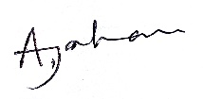

**Prepared by*:*** Designation: Social Management Officer, MGSP, LGED

Signature: Date: 27/11/16

**Reviewed by*:*** Tofayel Hossain Boshunia Designation: Social Management Specialist, MGSP, LGED

  
Signature: Date: 27/11/16

A social screening report will be prepared for each subproject covering methodology, participants’ analysis, community agreements &their concerns/suggestions, & summary of impacts and mitigation requirement.

**FORM 1: SCREENING FORM FOR SOCIAL SAFEGUARDS ISSUES**

1. **Identification**
2. *Name of ULB: Bhaluka Pourashava District: Mymensingh*

*Ward/Mahalla: Ward no.03*

1. *Name of subproject / spot screened:*

Construction of BC road starting from Dhaka Mymensingh highway (Proshika More) to Bania-vita via Chaporbari Dakhil Madrasa and Bakshathra More including street light (CIP-05) under Bhaluka Pourashava( Ch.0-2080m)

1. *Project component: BC road, Street Light*
2. **Brief description of the physical works**: Construction of BC road starting from Dhaka Mymensingh highway (Proshika More) to Bania-vita via Chaporbari Dakhil Madrasa and Bakshathra More including streetlight (CIP-05) under Bhaluka Pourashava ( Ch.0-2080m)

The subproject is located in ward no. 3. The road will connect to South Chaporbari, North Chaporbari, West Chaporbari, Dhailavita Baniavita etc localities with Dhaka Mymensingh High way. The proposed length of the road is 2080m.The existing road varies segment to segment. Some portion of the road is damaged BC, some portion is earthen and some portion is damaged HBB. The current width of the road is 2.5m which will increase to 6m due to available land of pourashava beside the both sides of road. There are two kindergarten schools, a madrasa, five mosques, Proshika and World vision NGO offices, primary school, Degree College, some shops, residential houses are located by the side of the road. It is badly damaged road. As a result, vehicle movement has become difficult and local residents face problems while moving. If the road is developed then the socio-economic condition of the area will increase to a great extent.2 nos. of RCC Box culverts (Ch.30m,Ch.425m) and 5 nos. of RCC cross Drains(ch.655m,1090m, 1300m, 1340m, 1540m respectively on that road) are proposed to be constructed. Some retaining wall will have to construct.

Local people face problems to move at the night time due to absence of sufficient street light. Considering this problem, it is proposed to install 72 poles with street light. 40 nos. of poles with street light will have to relocate.

**5. Screening Date(s):** 22/11/.2016

**B.** Participation in Screening:

**6. Names of Consultants’ representatives who screened the subproject:**  
*1.* Mr.Mortuza Reza Sr. Municipal Engineer, MGSP,LGED,

*2.* Ms. Akhter Jahan, Social Management Officer, MGSP, LGED,

*3.* Mst. Tasrima Sultana, Jr. Environmental Specialist, MGSP LGED.

7. **Names of ULB officials participated in screening**:

(1) Mr. Munnur Ahmad, Assistant Engineer, Bhaluka Pourashava

(2) Mr. Saiful Islam, Work Assistant, Bhaluka Pourashava

*8. WLCC members, NGOs, community groups/CBOs participated in screening: Yes, copy enclosed for information.*

*9. Would-be affected persons participated in screening: N/A*

**C. Land Requirements & Ownership:**

|  |  |  |
| --- | --- | --- |
| *10. Will there be a need for additional lands to carry out the intended works under this contract?* | [ ] yes | [√ ] No |

*11. If ‘Yes’, what will the additional lands be used for? (Indicate all that apply): N/A*

[ ]road widening [ ] curve correction [ ] construction/expansion of physical structure

[ ] strengthening narrow eroding road section between high and low lands [ ] others (Mention):

*12. If ‘Yes’, the required lands presently belong to (Indicate all that apply): N/A*

[ ] ULB [ ] Government Land

[ ] Private Citizens [ ] Others (Mention):

**D. Current Land Use & Potential Impacts**

*13. If the required lands belong to Private Citizens, they are currently used for (Indicate all that apply): N/A*

[ ] Agriculture Number of households using the lands:

[ ] Residential purposes Number of households using them:

[ ] Commercial purposes Number of persons using them: Shops:

[ ] Other Uses (Mention): fewUsers:

Land does not belong to private citizen.

*14. If the required lands belong to ULB and/or other Government agencies, they are currently used for (Indicate all that apply): N/A*

[ ] Agriculture Number of persons/households using the lands:

[ ] Residential purposes Number of households living on them:

[ ] Commercial purposes Number of persons using them: No. of shops:

[ ] Other Uses (Mention):

*15. How many of the present users have lease agreements with any government agencies? None*

*16. Number of private homesteads that would be affected on private lands: None*

*Entirely requiring relocation……………………. Partially but can still live on present homestead*

*17. Number of business premises/buildings that would be affected on private lands: None.*

Entirely and will require relocation: # Of businesses housed in them:

Partially, but can still use the premises: # Of businesses housed in them:

*18. Residential households will be affected on ULB’s own and & public lands: None*

*Entirely affected* and will require relocation: No. of these structures:

No. of structures built with brick, RCC, & other expensive and durable materials:

No. of structures built with inexpensive salvageable materials (bamboo, GI sheets, etc:

*Partially affected*, but can still live on the present homestead: No. of these structures

No. of structures built with brick, RCC, & other expensive and durable materials:

No. of structures built with inexpensive salvageable materials (bamboo, GI sheets, etc):

*19. No. of business premises that would be affected on ULB’s own & other public lands: None*

*Entirely affected* and will require relocation: No. of these structures:

No. of businesses housed in these structures:

No. of persons presently employed in the above businesses.

No. of these structures built with brick, RCC, & other durable materials:

No. of structure built with inexpensive salvageable materials (bamboo, GI sheets, etc):

*Partially affected*, but can still stay in the present no. of these structures:

No. of businesses housed in these structures:

No. of persons presently employed in these businesses:

No. of these structures built with brick, RCC, & other durable materials:

No. of structure built with inexpensive salvageable materials (bamboo, GI sheets, etc):

*20.No of businesses/trading activities that would be displaced from make-shift structures on the road, and other areas/spots: None*

*21. Do the proposed subproject works affect any community groups’ access to any resources that are used for livelihood purposes? [ ] Yes [√] No*

*22. If ‘Yes’, description of the resources: N/A*

*23.Do the proposed works affect community facilities like school, cemetery, mosque, temple, or others that are of religious, cultural and historical significance? [ ] Yes [√] No.  
24. If ‘Yes’, description of the facilities: N/A.  
25. Describe any other impacts that have not been covered in this questionnaire? No.  
26. Describe alternatives, if any, to avoid or minimize use of additional lands: N/A*

**E. ADDITIONAL INFORMATION ON TRIBAL PEOPLE**

(This section must be filled in if subprojects are located in areas that are also inhabited by tribal peoples)

*27. Names of tribal community members and organizations who participated in screening: N/A*

*28. Have the tribal community and the would-be affected TPs been made aware of the potential positive and negative impacts and consulted for their feedback and inputs?*

[ ] Yes [√] No

Has there been a broad-based community consensus on the proposed works?

[ ] Yes [√] No

*29. Total number of would-be affected tribal households: N/A****.***

*30. The would-be affected tribal households have the following forms of rights to the required lands: N/A*

[ ] Legal: No. of households:

[ ] Customary: No. of households:

[ ] Lease agreements with any GOB agencies: No. of households:

[ ] Others (Mention): No. of households:

*31. Does the subproject affect any objects that are of religious and cultural significance to the IPs?*

[ ] Yes [√] No

**G.32. If ‘Yes’, description of the objects:** N/A.

*33. The following are the three main economic activities of the would-be affected tribal households:*

a. N/A

b. N/A

c. N/A

*34. Social concerns expressed by tribal communities/organizations about the works proposed* under the subproject: N/A

*35. The tribal community and organizations perceive the social outcomes of the subproject: N/A*

**On behalf of the DSM Consultant, the attached filled out format has been reviewed and evaluated by:**

**Decision on selection [**√**] recommended for selection [] recommended for exclusion**

***Prepared by:*** Designation: Social Management Officer, MGSP, LGED



Signature: Date: 27/11/16

***Reviewed by:*** Tofayel Hossain Boshunia *Designation*: Social Mangement Specialist MGSP, LGED

Signature: Date: 27/11/16

**Participation and Consultation meeting for subprojects**:

A Participation and Consultation meeting was held in the subproject site to carry out the feasibility of the specific subproject. Consultations with communities and other stakeholders have been used as a two-way communication to provide information about the subproject and obtain feedback from the communities on subproject approach, design and implementation. Consultations were carried out through open meetings, group discussions and key informant interviews (KII). From the meeting, this specific subproject is very important for the economic development of the communities which in turn will be implemented. The consultation process was carried out with distinct groups at urban areas. Key informants were ULB Mayors, Ward Commissioners, Engineers, and Businessmen.

**\

