
Government of the People’s Republic of Bangladesh
Ministry of Local Government, Rural Development & Co-operatives
Local Government Division
Local Government Engineering Department
Municipal Governance and Services Project (MGSP)

IDA Credit No: 5339-BD

SOCIAL MANAGEMENT PLAN

Bhaluka Pourashava

Name of Subproject: Construction of mixed used building in front of Bhaluka poura bhabon,Bhaluka.

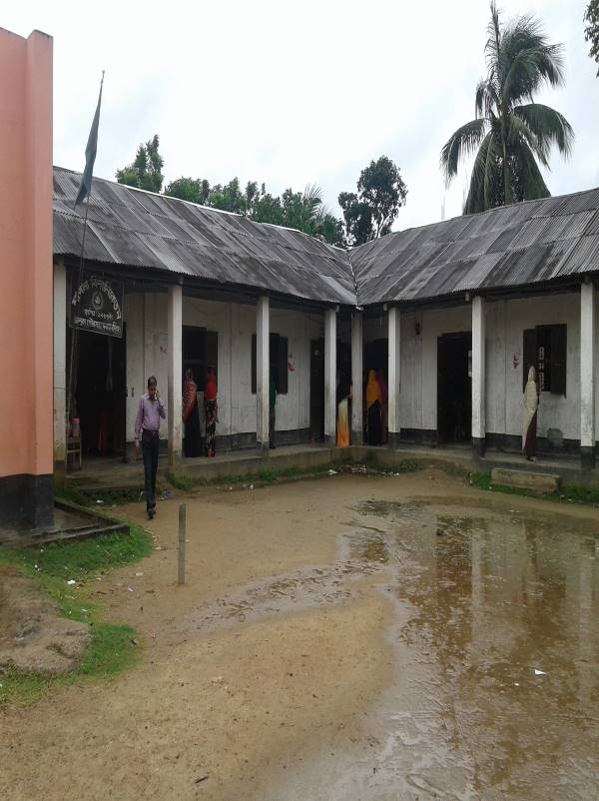
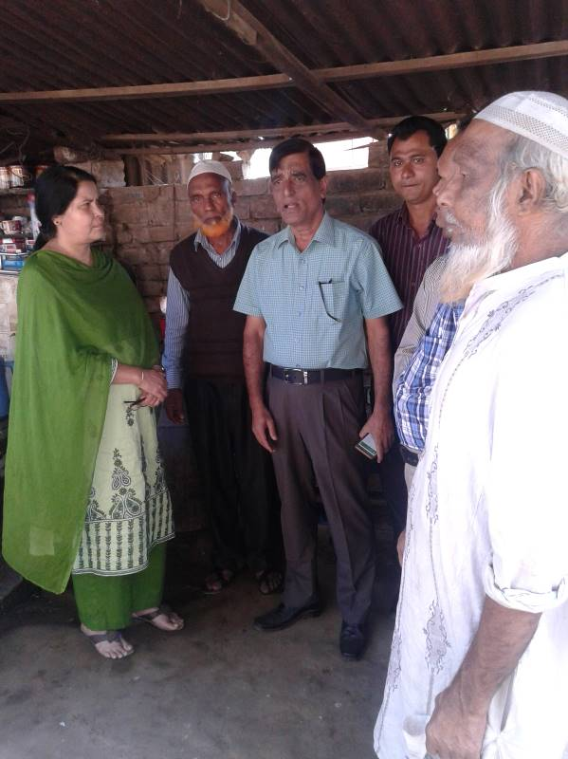

Package No: MGSP/BLK/2017-18/W-07

Design, Supervision, and Management (DSM) Consultancy Services

March 2018

Joint Venture of

Hifab International AB, Sweden
AQUA Consultant & Associates Ltd., Bangladesh

Social Management Plan

No | Contents | Page. No
 | Abbreviations | 3
 | Executive Summary | 5
1. | Introduction | 5
1.1 | Project Background | 5
1.2 | Legal and Policy Framework | 6
1.3 | Subproject Description | 6
1.4 | Social Management Plan | 7
2. | Description of Subproject Area | 8
2.1 | Brief Profile of Bhaluka Pourashava | 8
2.2 | Historical and Cultural Heritage Sites | 11
2.3 | The Subproject Location and Area Profile | 11
2.4 | Beneficiary Communities and Affected Persons | 12
2.5 | Gender and Vulnerability | 12
3. | Social Impact Assessment | 13
3.1 | Benefits of the Subproject | 13
3.2 | Social Screening and Safeguard Compliance Issue | 13
4. | Consultation and Community Participation | 14
4.1 | Stakeholder Analysis | 14
4.2 | Consultation and Participation Process | 14
4.3 | Consultation Outcomes – Issues, Concerns and Recommendations | 15
5. | Social Management Plan (SMP) | 15
5.1 | Subproject Selection Process | 15
5.2 | Subproject Design Process | 16
5.3 | Implementation | 16
5.3.1 | Institutional Arrangement | 16
5.3.2 | Consultation and Participation Plan | 16
5.3.3 | Grievance Response Mechanism (GRM) | 16
5.3.4 | Problem during implementation and mitigation | 17
5.3.5 | Labor Management | 17
6. | Monitoring and Evaluation Framework | 17
7. | Conclusions on Social Management Plan (SMP) | 19
FIGURE
1. | Area map of Bhaluka Pourashava | 9
2. | Present Condition of Subproject Area | 12
3. | Participation and Consultation Meeting | 15
ANNEXURE
1. | Social Screening Report | 20
2. | Layout Plan | 31
3. | Document from Press Club | 32
4. | Document of House Rent Agreement | 33
5. | CIP Minutes of Meeting | 36

Abbreviations

ARP | Abbreviated Resettlement Plan
BMDF | Bangladesh Municipal Development Fund
CBO | Community Based Organization
CC | Cement Concrete
CIP | Capital Investment Plan
CUL | Compensation-Under-Law
DC | Deputy Commissioner
DLAC | District Land Acquisition Committee
DUTP | Dhaka Urban Transport Project
GoB | Government of Bangladesh
GRC | Grievance Redress Committee
GRM | Grievance Redress Mechanism
HCG | House Construction Grant
HTG | House Transfer Grant
IDA | International Development Association
IP | Indigenous People
IPP | Indigenous Peoples Plan
KII | Key Informant Interviews
FGD | Focus Group Discussion
LGD | Local Government Division
LGED | Local Government Engineering Department
M & S | Management &Supervision
MGSP | Municipal Governance and Services Project
MOLGRDC | Ministry of Local Government, Rural Development & Cooperatives
MSP | Municipal Services Project
MSL | Mean sea Level
NGO | Non-governmental Organization
PAH | Project Affected Household
PAP | Project Affected Person
RAP | Resettlement Action Plan
PMU | Project Management Unit
RCC | Reinforced Concrete Cement
RP | Resettlement Pan
SIA  SIMP | Social Impact Assessment  Social Impact Management Plan
SMP | Social Management Plan
SSS | Social Safeguards Specialist
TLCC | Town Level Coordination Committee
ULB | Urban Local Body
WB | World Bank
WC | Ward Committee
DSM | Design, Supervision, and Management

Executive Summary

Social Management Plan-SMP contains the major social screening outcomes, anticipated impacts consultation process adopted during identification and design & consultation plan for implementation stage, impact mitigation measures, grievance resolution process, and implementation arrangements, and monitoring and evaluation. SMP demonstrates an all-inclusive consultative process in selection and design of the subproject as well as to provide guidance for social development and safeguards compliance in the implementation process.

The Social management Plan (SMP) of the Subproject under Bhaluka Pourashava was developed through inclusive participation of all levels stakeholders and using participatory approach. The subproject comprises interventions proposed as per CIP 3 of the Pourashava. The ULB Bhaluka Pourashava consists of 9 administrative wards among which the proposed subproject is located at ward number 6 but will benefit the whole pourashava. Bhaluka is an A Category Pourashava having 10.92sq.km area.

The subproject comprises following physical interventions:

Construction of one four storied multipurpose building at the Pourashava premise.
It comprises: Demolishing an existing tin-shed Construction of four storied building with basement.

Main Purposes of the subproject

The subproject is located in ward number 6 under Bhaluka Pourashava of Mymensingh District. It will improve trading facilities, provide opportunity of women’s shopping, enhancing income earning opportunity for both male and female traders, improve event management facility and increase revenue earning for the pourashava.

Anticipated Impacts:

Improve trading facility, income earning opportunity of men and women traders, more comfortable shopping and attending various social and cultural gatherings, and increase revenue earning for the pourashava helping it becoming financially solvent.

.Results of the social screening

- No additional public or private lands will be required for the subproject outside the existing right of way;
- No threats to cultural tradition and way of life of tribal peoples; or restriction of their access to common property resources and livelihood activities are involved.

The local stakeholders are supportive of this subproject, no tribal community is affected and there is no need for resettlement. Hence; it is recommended to implement the project under the MGSP.

1. INTRODUCTION
1.1 Project Background
The Government of Bangladesh, through the Local Government Engineering Department (LGED) and Bangladesh Municipal Development Fund (BMDF) is implementing the Municipal Governance and Services Project (MGSP). The project aims to improve municipal governance and basic urban services in participating ULBs. Two physical components of the project include (i) Municipal Governance and Basic Urban Services Improvement (Component 1) to provide financial support to 26 pre-identified urban local bodies (ULBs) including municipalities and city corporations, and demand-based sub-credits to eligible ULBs for basic urban services improvement investment costs. Total project cost is BDT 247093.92 lakh, financed at 80:20 IDA loan to GOB contribution. LGED is implementing the Component 1 while BMDF is implementing component 2 of the project.

LGED is supporting the 26 pre-selected ULBs for investments in development and rehabilitation of Road, Bridge, Box-culvert, Pedestrians bridge, street light, Traffic Control, Bus terminal, Truck terminal, Boat landing Jetty, Drain, Retaining wall, Kitchen market, Cattle market, slaughter house, Public toilet, Solid waste management, Sweeper colony, Park, Community Centre and Whole sale market. LGED is financing through (i) base allocation based on population category of ULBs; (ii) performance-based allocation and (iii) operations and maintenance support on a declining basis over the project period. The component interventions have largely been developed for construction and rehabilitation within existing available land owned by the ULBs. However, acquisition of land and displacement of people may be involved for unavoidable circumstances as critical requirements. Subprojects may also be undertaken in areas inhabited by tribal peoples. The ULBs will, however, address the land acquisition, population displacement and tribal people’s issues following the country’s legal framework and the World Bank policy on social safeguards.

1.2 Legal and Policy Framework
Given the approach of subproject preparation and implementation, the World Bank’s Operational Policy (OP) on Involuntary Resettlement (OP 4.12) and on Indigenous Peoples (OP 4.10) is triggered to the project. A Social Management Framework (SMF) has been adopted by LGED for the project that meets the requirements of the country’s legal frameworks “The Acquisition and Requisition of Immovable Property, Ordinance, 1982” and the Bank requirements including OP 4.12 and OP 4.10. The SMF also requires that subprojects are prepared ensuring inclusion, participation, transparency, and social accountability. The subprojects are prepared by respective ULBs in a process complying with the SMF requirements. The LGED reviews the subproject proposals for technical, engineering, environmental, social development, and safeguards compliance before allocation of the financing to the ULBs.

Social Management Plans (SMP) will be prepared and implemented for subprojects with no land acquisition or involuntary displacement of people, while Resettlement Action Plans (RAP) and Tribal Peoples Plans (TPP) ) will be prepared for implementation for subprojects involving population displacement and tribal peoples’ issues. The sub projects requiring removal of obstacles with compensation will prepare SIMP.

1.3 Subproject Description
The subproject is located in ward # 6 under Bhaluka Pourashava. Proposed physical intervention is construction of four storied building which will be used as market and event management. The building will be constructed in front of Poura Bhabon having varying floor space at different levels. Proposed area of the ground floor and 1st floor will be 6475 sft. 2nd floor area will be 6841 sft and 3rd floor area will be 6461 sft. Basement of the building will be used as parking zone. Ground floor, 1st floor, 2nd floor will be used as market and 3rd floor will be used as different event management. The ground floor will have 17 shops, 1st floor will have 19 shops, and 2nd floor will have 23 shops. Adequate toilet facility will be available at each floor. Lift facility will be available at all floors.
Proposed mixed used building will be constructed in front of Poura Bhabon and the land belongs to pourashava. The existing structure front of the Poura bhaban is a semi pucca building. This building will be demolished and the proposed multistoried building will be constructed at that place. Now the semi pucca building is being used as Shapla Bidda Niketan School, Bhaluka Press Club and poura karmachari Sangsad (employee association) office. The school (Shapla Bidda Niketon) and Poura karmochari sangsad have no agreement with pourashava. They are operating their programmes on the basis of mayor’s verbal consent. They do not pay any rent to pourashava. Press club pays nominal rent to pourashava.
The school teaches student of grade one to four. Pourashava issued a notice to the school authority, press club and poura karmachari sangsad to vacate the place. They are agreed to vacate the place without compensation for sub project implementation. The press club authority has given in writing by an official letter to the Mayor to vacate the place when construction wark will be started. The school authority has already rented a house named Bonoful Mansion to continue their school program. Bonoful Mansion is situated on Gafargaon Bhaluka road (100m east of Poura Bhabon). Agreement has been signed between the school authority and the house owner (document attached at the annexure). Pourashava will pay rent of the new school premise.
After implementation of the subproject, town dwellers will have better environment of shopping and attending various events more comfortably. The ULB will have opportunity to raise revenue earning from the community center and shops rented to citizens and shopkeepers.

Women will be benefited as some shops will be allocated to women traders (woman tailors and crafts women etc.) which will contribute to enhancing income earning opportunities for women and their economic empowerment. Further, the multipurpose building will have woman-friendly environment with separate toilet facility, breast feeding area and children area etc.

Outlets of several electronics companies like Walton, Konka and Hitachi are located near the Poura bhaban. Also, a liberation war monument, Pourashava office, Upazila parishad office, Bhaluka B.M College, Morning Sun Model High School and College, Janata Bank, Bhaluka Eye Hospital, Shapla Bidda Niketan, University Coaching Center are located beside the sub project area.
1.4 Social Management Plan
The purpose of preparing this SMP is to demonstrate an all-inclusive consultative process in selection and design of the subproject as well as to provide guidance for social development and safeguards compliance in the implementation process

Initially, the subproject proposal includes a social screening report along with impact assessment. This Social Management Plan (SMP) has been prepared for the identification of subproject and managing social concerns in the process of subproject design and implementation. After reviewing the social screening report by Social Unit of DSM, this subproject proposal is submitted to the PMU office. Social team of the DSM has carried out a site visit and consulted with the Pourashava officials, stakeholders and a section of the beneficiary communities through interview and participation & consultation meeting. The social screening findings and consultation method and proceedings were validated through the social survey and consultation.

The SMP contains a description of the subproject areas, social screening and impacts, consultation process adopted during identification and design, and consultation plan for implementation stage, impact mitigation measures, grievance resolution process, and implementation arrangements, and monitoring and evaluation.

Pourashava will ensure participation of the communities and grievance resolution in the process of implementation of the subproject through GRC.

2. DESCRIPTION OF SUBPROJECT AREA
2.1 Brief Profile of Bhaluka Pourashava
Bhaluka Pourashava is almost centrally located in Bhaluka Upazila under Mymensingh district. Dhaka Mymensingh Highway passes through the Pourashava. Distance from Dhaka is about 82.00 km and about 38 km from Mymensingh. It was established in 1998. This is a class “A” Pourashava. The Pourashava consists of 9 wards. The area of the Pourashava is 10.92sq.km. The Pourashava is consists of 6 mouzas. It covers part/full mouza of Bhaluka, Kathali, Kharwali, Bandab, Dhamsur, and Purora.

According to the BBS 2011, the population of Bhaluka Pourashava is 38,774 of which 20,239 are males and 18,535 are females. According to 2011, at present the density of population is 3551 per sq.km.

The Pourashava is bounded by Bharadoba union in the North, Habir Bari union in the South, Ragai/ Birunia union in the east and Mallikbari union in the West. Besides, Khiru River runs North/South direction and passes by the east of Bhaluka union.

According to latest population census report (2011), 92.91% of the population of this Pourashava belongs to Muslim community, 6.87% to Hindu community, 0.16% to Christian population and 0.04% to other religion.

According to BBS 2001,the main source of household income in Bhaluka Pourashava are as: business 33.11%, service 28.27%,cropping,livestock,forestry and fishery 11.25% agricultural labour 2.67%, industry 0.99%,hawker 0.81%,rent and remitence1.73%,religious service 0.67%,non-agriculture labor 3.95%,transport and communication 5.59%,hand loom o.21%, construction 3.27% and others 8.93%.

The Pourashava covers 09 industries, 04 auto rice mill, 05 rice mills and16 saw mills. Total agricultural land is 180 acre. (Master Plan of Bhaluka Pourashava 2011-2031 and Bhaluka Pourashava,)

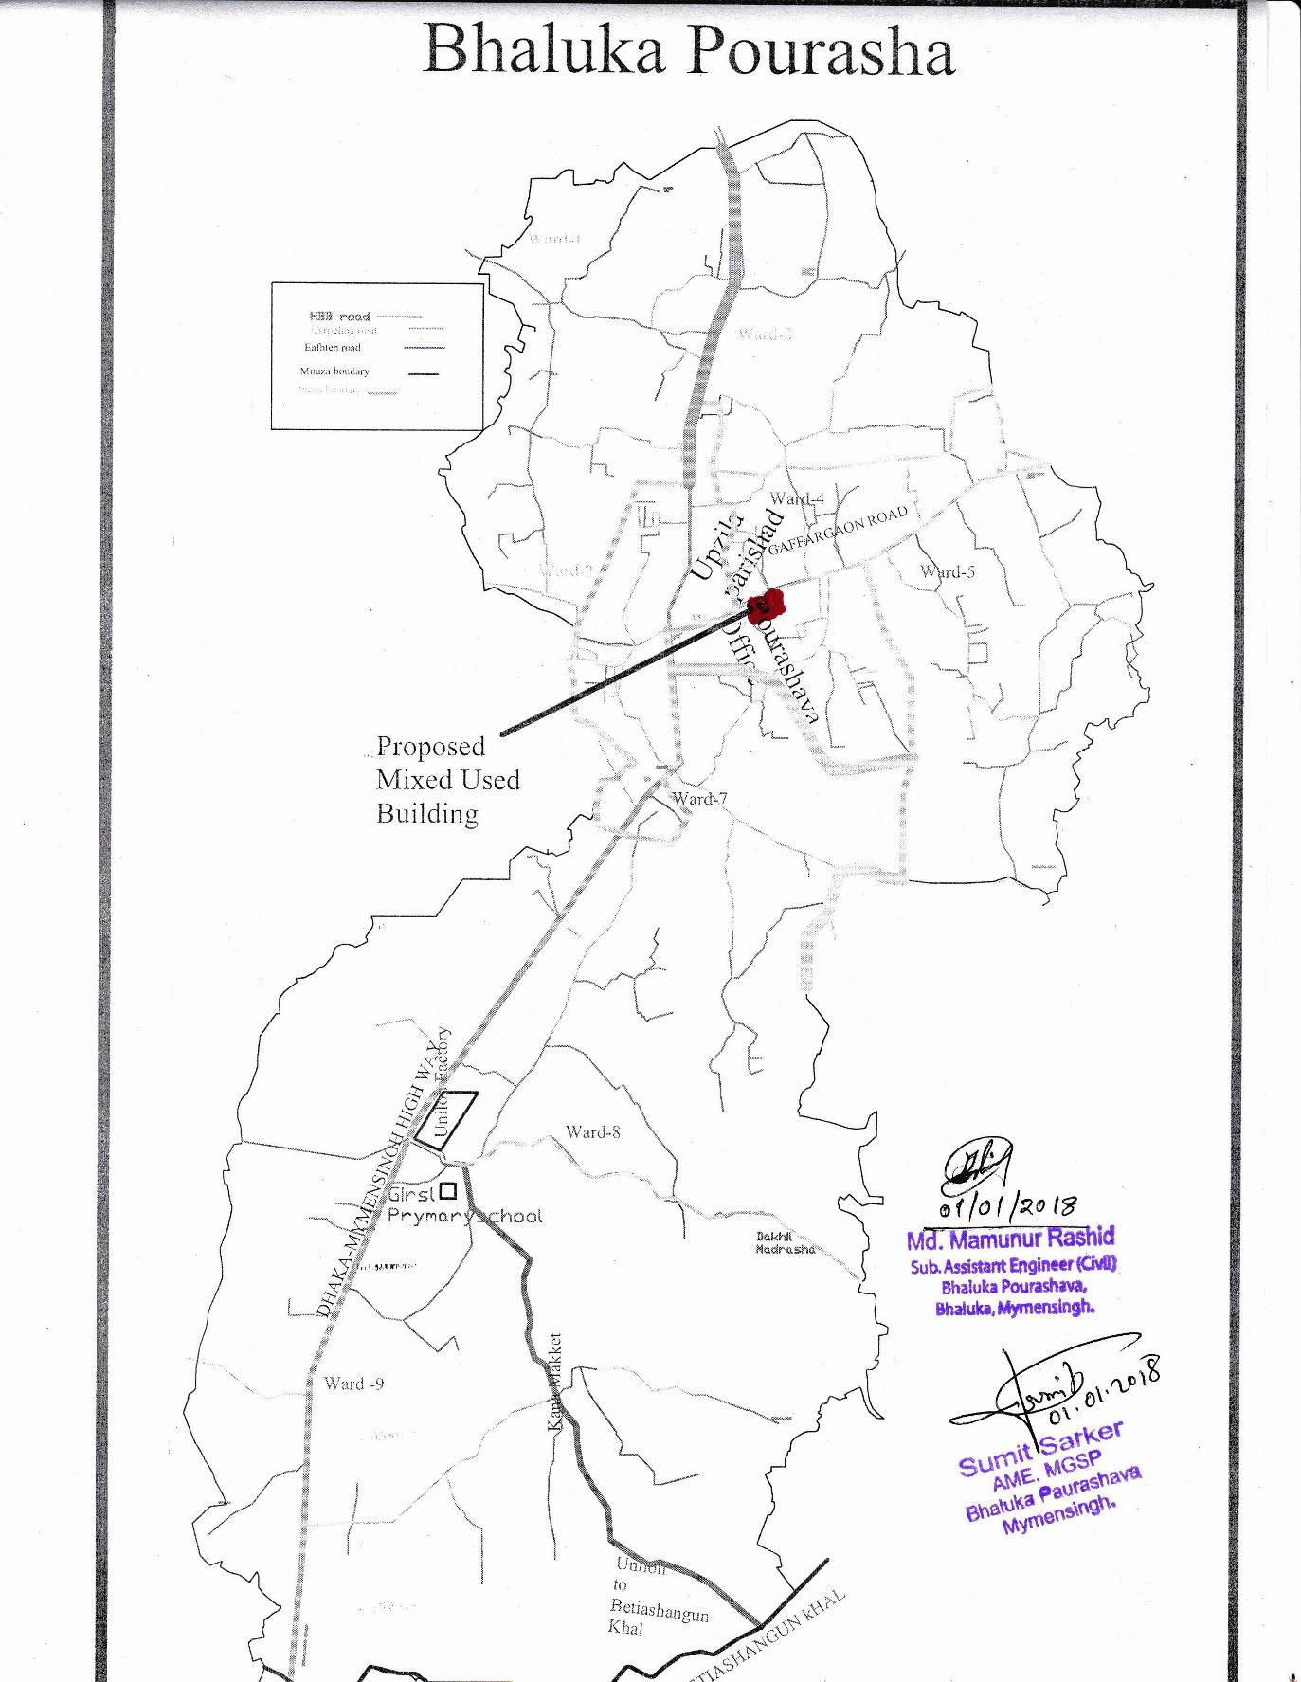
Figure 1: Area Map of Bhaluka Pourashava

At a glance of Bhaluka Pourashava
Name of the Pourashava | : | Bhaluka Pourashava
Date of Establishment | : | 8 September 1998
Area | : | 10.42 sq km (present area)
Class of Pourashava | : | “A” Class
No. of Wards | : | 9
Councilor | : | 12 (male-9, female -3)
Population
Population | : | 38,774 (Male-2o,239 and Female-18,535),BBS,2011.
Holding no. | : | 5148
Family | : | 12,454
Information on Education
College | : | 1 (Non Govt-2)
High School | : | 2
Kamil Madrasha | : | 1
Govt. Primary School | : | 6
Private Primary School | : | 2
Religious Center
Mosque | : | 41
Temple | : | 4
Church | : | 1
Idgah | : | 6
Communication
Pacca Road | : | 18.85 Km
Earthen Road  Other Roads | :  : | 62.00 Km  21
Bridge | : | 2
Hospital | :
Govt. Hospita | : | 1 (Bed-150)
Non Govt. Hospital | : | 4
Clinic  Community Clinic  Upozila health complex  NGO Health Centre | :  :  :  : | 3  1  1  1
Social Institution
Co Operative society | : | 1
Orphanage | : | 1
Graveyard | : | 1
Public Health
Earthen Drain | : | 8.50km
Pucca Drain | : | 3.20 km
Pipe line | : | 12km
Dustbin  Public Toilet | :  : | 10  2
Financial institute
Hut Bazar | : | 1
Bank | : | 8
Food Godown | : | 1 (Capacity 500 tons)
Industry | : | 9
Auto rice mill | : | 4
Rice mill | : | 5
Saw mill | : | 16
Cinema hall | : | 2
Club | : | 3
Play Ground | : | 3

Other Actors:
Apart from the ULB following are actors involved in providing services to town dwellers- these are Grameen Bank, BRAC, ASPADA, ASA, Protisruti, Podokkhep, World vision.

Bhaluka Pourashava is headed by the Mayor. It is run by a joint staff of elected public representatives and government officials. This Pourashava is mainly responsible to provide services like waste management, maintenance of drainage system, street lighting, water supply, communication, birth and death registration, issuing of trade license, non-motorized vehicle license and recreation.

2.2 Historical and Cultural Heritage Sites

During the reign of Pal and Sen Dynasty, Mymensingh and Bhaluka region was under the administration of Samanta rule. This region came under the Muslim rule during the reign of Alauddin Hossain Shah in the fourteenth century. During the British period Mymensingh region was divided into a number of sub divisions. Bhaluka Thana, now an upazila, was included into Mymensingh sadar subdivision. During the war of liberation Afsar Uddin Ahmed, Sub Sector Commander of Sector 11, locally trained the freedom fighters and collected arms and ammunitions to challenge the Pak army. The Pak army established military camps at Mallikbari, Ashka, Tamat, and Bhaluka. They conducted mass killing, torture and plundering in the upazila; the Pak army also burnt many houses of the upazila.
Noted religious institutions
Uthura Jami Mosque, Mallikbari Jami Mosque, Neshaiganj Jami Mosque, Bhaluka Bazar Jami Mosque, Harirbari Mandir.

By reason of subproject implementation historical place or site will not be affected.

2.3 The Subproject Location and Area Profile
The subproject covers ward no 6 under Bhaluka Pourashava of Mymensingh district. Construction of four storied mixed used building in the front of Bhaluka Poura bhabon. According to BBS 2011, total population of the ward is 3477. Out of it, male are 1764 and female are 1713.

Ward no 06 is located at the center of northern part of Bhaluka Pourashava. The area of the ward is 112.12 acres.

Ward 06 area is densely populated area. The proposed multipurpose building is located in front of pourashava bhabon. Outlets of several electronics companies like Walton, Konka and Hitachi are located near the poura bhaban. Also, a liberation war monument, pourashava office, upazila parishad office, Bhaluka B.M College, Morning Sun Model High School and College, Janata Bank, Bhaluka Eye Hospital, Shapla Bidda Niketan, University Coaching Center are located beside the sub project area.

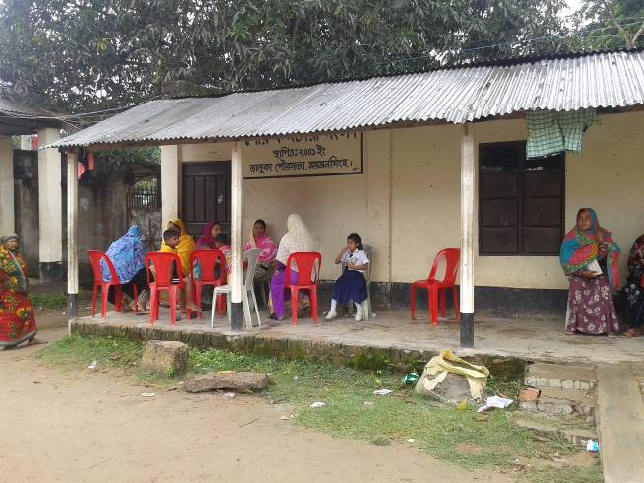 | 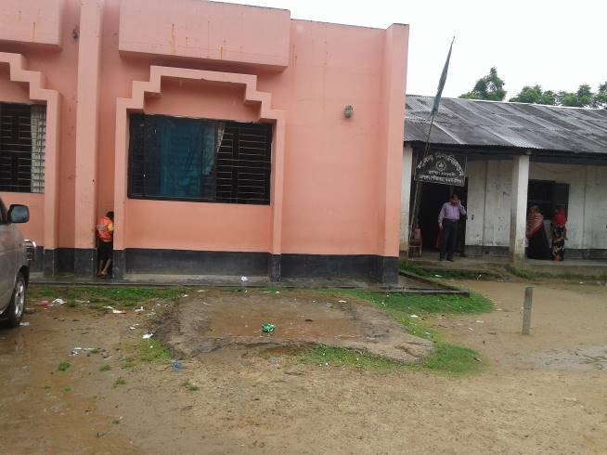
Figure2: Present condition of the subproject.
2.4 Beneficiary Communities and Affected Persons
The subproject is located at ward number 6 under Bhaluka Pourashava will benefit the whole pourashava ultimately. According to the BBS 2011, the population of Bhaluka Pourashava is 38774 of which 20,229 (52.20%) are male and 18,535 (47.80%) are female. Due to implementation of the subproject, total population of the pourashava will be benefited There is no presence of tribal people in the subproject influence area.

People of this subproject will be directly benefitted and nobody will be affected for the improvement of the subproject as was found through the identification of social screening.
2.5 Gender and Vulnerability
In compliance with LGED’s gender strategy, Gender Action Plan (GAP) and World Bank policy on gender, this subproject proposed the following principles, guidelines and procedures to identify gender actions in respect of subproject interventions and include those actions in subproject SMP. To mainstream the gender in the subproject process, MGSP has applied the following basic principles in selection, design, implementation and monitoring of the subproject.

Gender analyses for the subproject has taken into account of general and specific gender concerns and social vulnerabilities and identified specific actions in term of religious, age and persons with special needs which are as follows:

  - Promote women’s participation in subproject planning and implementation
For the preparation of subproject planning, women participation has been ensured through group discussions and hot-spot consultation. Moreover, women have also been involved in subproject planning preparation during the outset stage of the subproject preparation.

  - Maximize women’s access to subproject benefits
After implementation of the subproject, women will have better environment of shopping and attending various events more comfortably. Also some shops will be allocated to women traders woman tailors and crafts women which will contribute to enhancing income earning opportunities for women and their empowerment. Further, the multipurpose building will have woman-friendly environment with separate toilet facilities and breast-feeding area etc.

  - Minimize social vulnerability.
This subproject will give more emphasis to reduce the social vulnerability and impact in terms of Socio-economic development through taking required measures.

  - Ensure that women are involved in selection, design, implementation, and monitoring and evaluation of the subproject activities including resettlement issues.
In this subproject, women will be involved in the implementation to monitoring & evaluation through disclosure meeting which will contribute for the quality improvement of the subproject.

- Identify appropriate actions to ensure and maximize subproject benefits to women through the consultative process.
During implementation of the subproject, women communities will easily have a scope of new job opportunities in trading in the women shopping area.

- Women are involved in civil works construction of this subproject, ensure: (i) equal pay for equal work; (ii) gender friendly work environment; and (iii) work place safety for women and children.

During construction of the subproject, the project authority will ensure work and equal pay for equal work and ensure work place safety for women, create gender friendly work environment.

Bhaluka Pourashava is responsible for managing social issues including gender and vulnerability issues in the subproject area. Moreover, after implementation of the subproject, women movement and income generation activities will increase to meet up their necessities.

3. SOCIAL IMPACT ASSESSMENT
3.1 Benefits of the Subproject
As a result of implementation of the subproject, total population of the pourashava will be benefited. The benefits include (a) trading facilities in three of the four floors- grocery shops in the ground floor, readymade dress, tailoring shops, food corner, women’s area etc. in the first floor and electronics and cell phone shops in the second floor; and (b) event management (cultural program, matrimony, holding seminar etc.) in the third floor. There is no presence of tribal people in the subproject influence area.
People of this subproject will be directly benefitted and nobody will be affected for the improvement of the subproject as was found through the identification of social screening.

3.2 Social Screening and Safeguard Compliance Issue
After selection of the subproject from the CIP list, the Pourashava with the assistance of DSM Consultants has completed a social screening for the subproject using an inclusive and participatory approach.

Bhaluka Pourashava has ensured the implementation of subproject following socially inclusive and gender friendly. There is no resettlement issue.

Results from the social screening are given below.
- No additional public or private lands will be required for the subproject outside the existing right of way.
- No private, public, community, or cultural property of any kind of service delivery facilities as well as commercial activities will be affected.
- Preparation of RAP will not be required for implementing the subproject.
- Agricultural or industrial productivity will not be hampered by the proposed subproject.

The outcomes of social screening also confirm that local people across the subproject are positive about its implementation.

4. CONSULTATION AND COMMUNITY PARTICIPATION
4.1 Stakeholder Analysis
As a part of the overall assessment, the subproject identified the key stakeholders of the proposed subproject areas and assessed the power relationships as well as influence and interests of stakeholders involved in the development work of the subproject. Key stakeholders for subproject were identified in consultation with the Mayor and officials of Bhaluka Pourashava, local administration, civil society and local people of towns, representatives of business associations, local contractors for infrastructure development, road users, vulnerable communities etc. Both males and females will benefit directly and indirectly by the improvement of this subproject. Stakeholder analysis are shown bellow.

Stakeholder | How | Interest & Influence
Citizens- consumers, shopping area and community center users | Better shopping and event management environment | Interest-High and influence low.
Women consumers, shopping area and community center users | Better shopping and event management environment | Interest-High and influence low.
Traders | Getting allocation of shop | Interest-High and influence high
Women shopkeeper | Getting allocation of shop | Interest-High and influence high.
Service holders, Students | Better shopping and event management environment | Interest-medium and Influence-medium

4.2 Consultation and Participation Process
The participatory public consultations were conducted in the subproject areas. Key Informant Interviews (KII) and group discussions were conducted involving the participants of the Bhaluka Pourashava Mayor, Councilors, Pourashava Officials, representatives of local Communities and civil society members and the consultant team. A walk-through informal group consultation with the local communities was also held. Through this participation and consultation meeting, the local communities were disclosed about subproject implementation and benefits. Suggestions and recommendations made by the participants are incorporated in the SMP accordingly. The photographs of the consultation meetings may be seen below.

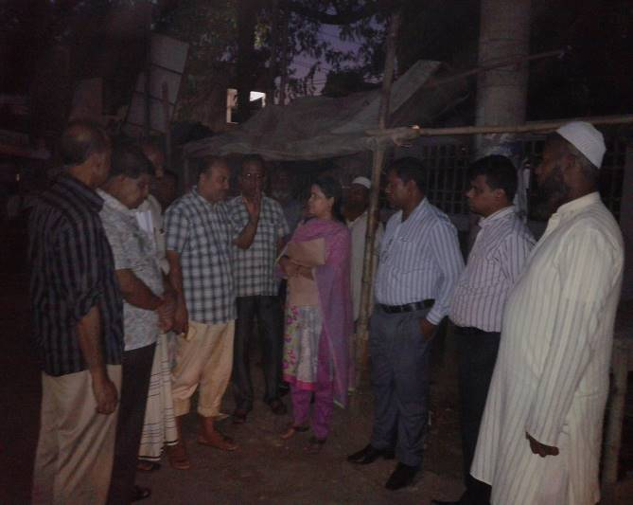 | 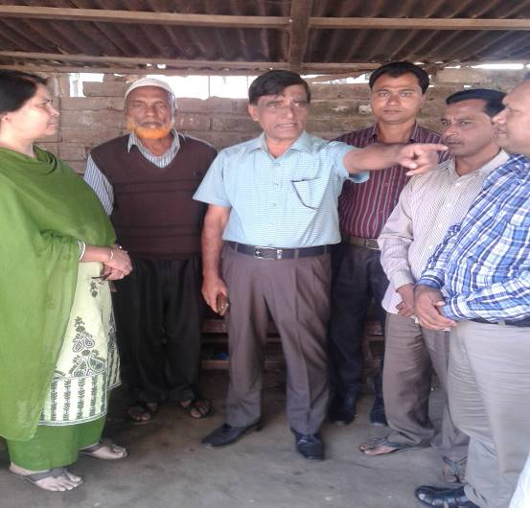
Figure 3:Participation meeting | Figure 3:Participation meeting
4.3 Consultation Outcomes – Issues, Concerns, and Recommendations
The participants raised their issues related to subprojects improvement which mainly includes multipurpose building. Feedback, suggestions and recommendations by the participants are listed below.

- Scheduled of Construction works should be ensured properly and the quality of construction work should be improved as per tender specification;
- Addressing gender issues will include consultation and participation of women, allocating shops to women traders and ensuring woman-friendly environment in the proposed subproject.
- Social safeguard compliance issues has been ensured through the inclusive participation of subproject beneficiaries in subproject implementation

5. SOCIAL MANAGEMENT PLAN FOR IMPLIMENTATION

SMP will ensure the compliance of social management requirements including social safeguards for the subproject implementation of Bhaluka Pourashava in a participatory process. This plan will assist Project Implementation Unit (PIU) of the Pourashava by ensuring technical assistance covering subproject selection, design, and institutional arrangement using participation and consultation process and grievance resolution process for implementation and also giving involvement of labor in the project implementation activities. PMU, DSM and the Pourashava will also ensure monitoring and supervision of the subproject implementation etc.

5.1 Subproject Selection Process
According to the opinions and views of the Bhaluka Pourashava Mayor, civil society and community people, the subproject is important for improving trading, shopping and event management facilities for all citizens including men, women & children. The MGSP in coordination with concerned Bhaluka Pourashava elected representatives, local officials, civil society members and other relevant stakeholders, and following participatory approach has selected the subproject. The consultation involved Female Ward Councilors who participated actively in the selection process. Moreover, the representatives of TLCC and WC from the Pourashava have contributed in the subproject selection process with an analysis of the inclusiveness of the selection process.

During the consultation, the DSM team explained the subproject objectives and sought feedback from the participants to maximize the social and economic benefits as well as to minimize the adverse impacts of the subproject. Views and opinions of these consultations incorporated in the subproject planning and in the SMP.
5.2 Subproject Design Process
After final selection of the subproject, the DSM Consultant designed the proposed subproject (multipurpose building) under Bhaluka Pourashava. This subproject will be constructed under the Pourshava’s own land. Despite the inclusion and participatory consultations, if any person has a grievance relating to the implementation of the subproject, the Pourashava has mitigated it.

The Consultant interviewed stakeholders and beneficiaries of the subproject areas before the design. The Consultant and Pourashava officials conducted a number of consultation meetings in the subproject areas discussing the implementation procedures and mitigation measures, if any, required to be taken in implementing the proposed subproject.

5.3. Implementation
5.3.1. Institutional Arrangement:
DSM has initially completed social screening for the subproject and there is no problem for the improvement of subproject in regard to social safeguard issues. Accordingly, PMU, MGSP has processed for procurement procedures. After finalization of award letter against this subproject, Bhaluka Pourashava is responsible for implementation of the subproject timely in close coordination with the PMU of the project and also with the technical assistance of DSM. Engineering section of Pourashava and local representative of Consultancy team will ensure the quality construction work of the subproject. In addition, Consultant team from Head Quarter DSM will ensure the close monitoring of the implementation of subproject. In these implementation procedures, Social safeguard Team will ensure the monitoring of social safeguard management before civil works start. During construction, the communities will not be affected.

5.3.2. Consultation and Participation Plan:
The objectives of consultation and participation process for this subproject will be disclosed, informed, consulted, engaged, collaborated and empowered the communities and other local stakeholders from the planning to implementation at the Bhaluka Pourashava. Consultation and participation will be undertaken to achieve specific objectives at subproject identification, planning, design, implementation and evaluation stages.

5.3.3. Grievance Response Mechanism (GRM):
GRM has already operationalized for Bhaluka Pourashava. Accordingly, this Pourashava has formed Grievance Redress Committee (GRC) to handle any grievance raised due to implementation of the subproject. The committee will be headed by the Mayor of the Pourashava and consist of 7 members. The committee will answer to subproject-related queries and address complaints and grievances about any irregularities in application of the guidelines adopted for assessment and mitigation of social and environmental impacts. Based on consensus, the procedure will help to resolve issues/conflicts amicably and quickly without resorting to any expensive, time-consuming legal actions. It will ensure proper presentation of complaints and grievances, as well as impartial hearings and transparent decisions.

Bhaluka Pourashava has already appointed Focal Point of GRC who is the Assistant Engineer. But he will also act Social Development Officer for the MGSP subproject implementation in their Pourashava. The Mayor of the Bhaluka Pourashava is the Chairman of the GRC. This GRC at the Pourashava level is responsible to disclose the subproject implementation before civil works start.

5.3.4. Problem during implementation and mitigation
During the subproject implementation, different kind of problem may arise in terms of social safeguard issues and quality. PIU of the Bhaluka Pourashava will mitigate the problem with the assistance of PMU and DSM by ensuring Community participation. But the PIU of the Pourashava will ensure to minimize adverse social effects and maximize subproject benefits to the community. The project also ensures transparency and social accountability at each stage of the subproject execution through engaging communities in the process of suggestion and complaint and grievance redress mechanism (GRM). As a continued process of participation, the Pourashava has included consultation and Participation Plan and Grievance Redress Mechanism for further inclusion, participation, transparency and social accountability in the implementation process.

5.3.5. Labor Management
The Pourashava is responsible to inform contractors to engage the skill and semi-skilled labor during the construction of the subproject from the subproject site. Moreover, the Pourashava will also oversee the equal pay for equal works for the labors and will look into consideration for the safety and security of working labor in the subproject areas. Even, the Pourashava will see whether labor will be paid in due time or not. The Pourashava management will avoid the child labor and elder labor(less than 18 years and more than 65 years) for implementation work of the subproject through the Contractors. PMU will monitor the labor management issues with the assistance of DSM Consultants.

6. MONITORING AND EVALUATION FRAMEWORK
A. Monitoring Strategy
Monitoring in the MGSP will be done in a participatory manner and will be a bottom up process. The participants in monitoring and evaluation particularly in reporting the grassroots level activities on social management in subproject planning and implementation will be the beneficiary communities including the residents of ULBs, traders, marketers, pedestrians and visitors in the ULB areas. Self-monitoring by communities through WLCCs will be a main input to both internal and external monitoring.

B. Internal Monitoring

LGED will carry out internal monitoring with the assistance from their respective DSM Social Management Officer and the Social Development (SD) Specialist. The Executive Engineer of the ULBs will be responsible for internal monitoring of the social management actions. The SD Specialist will develop monitoring formats which will be filled in by the social development officer (SDO) at ULB. The SDOs will be thoroughly briefed about the SMF and any RAP and the Bank’s Policy on social safeguards. The SDOs will visit the subproject areas routinely at both planning and implementation stages. The internal monitoring will broadly involve:

- Administrative monitoring
- Social management issues
- Impact evaluation
C. External Review and Evaluation
External review and evaluation will be carried out to assess how effectively and efficiently social development and social safeguards issues have been identified, management and mitigation measures planned and implemented. An independent consultant (individual expert of MGSP) will be employed by LGED for carrying out independent evaluation. The external review and evaluation will specifically assess

- Whether the broader social management objectives of the subproject are met, what difficulties are there and suggest corrective measures.
- Whether the subproject impacts on key social, economic and environmental indicators show positive trend, what difficulties are there and suggest corrective measures.
- Whether the project strategy of inclusiveness, participation, transparency, social accountability and equity are followed specifically in rehabilitation and improvement of urban infrastructures.

D. Indicators for Social Management
1. Social Development Process
Social development processes have several intricacies. Social development will be monitored using following indicators. Data regarding these indicators will be collected periodically and will be analyzed to find the outcomes of the processes. However, these indicators will be reviewed at the subproject preparation stage and customized for specific subprojects.

INDICATOR | Results/Outcomes
Inclusiveness | 1. Access to vulnerable communities considered in subproject identification for improved urban infrastructure services  2. Subproject budget and components, construction time table and contractors information are discussed in TLCC meetings
Participation | 3. Representation of women and vulnerable groups in WLCCs and (pilot) CBOs  4. Representation of women and vulnerable groups in GRCs  5. Representation of women, tribal and vulnerable groups, occupational groups, men and women in consultation process,  6. Beneficiary options reflected in subproject design and implementation
Transparency | 7. -Disclosure of project information SMF/RAP  8. -Community awareness about the subproject and the social management issues and policies
Social accountability | - Feedback from communities carried for design and  implementation support by ULBs  - Grievance petitions received at WLCCs and at GRCs  - Grievance cases resolved at the entry level at WLCC  - Representation of community peoples in monitoring process
Social Safeguards Compliance issues | 13.-Ensure social screening and impact assessment  14.-Ensure land acquisition if necessary  15.- Prepare Resettlement Action plan and implementation  16.-Develop relocation strategy  17.- Prepare compensation plan and cash payment process.

E. Reporting

The Pourashava will provide monthly progress reports to the PMUs at LGED on progress and achievements in social management and resettlement of project affected persons. The PMUs at LGED will provide IDA with the following information for review of performance and compliance with the SMF and the Bank’s OP 4.12 and other requirements.

- Quarterly Progress Report indicating progress on social development issues, and social safeguards including land acquisition and implementation of any impact mitigation plans (with and without land acquisition) adopted by the individual ULB;
- ULB-wise updates on compensation payment for land acquisition (where ULBs decide to acquire) and other impacts as and when the Bank requests them for work- package clearance and disbursement; and
- Updates for formal supervision missions, if the report produced for the current quarter is deemed not sufficiently informative.

The independent social review and evaluation consultant will produce a baseline, a mid-term review and an end-term evaluation report.

7. CONCLUSION
The PMU has selected the sub-project after extensive field visits and consultation with the guardians of Shapla Bidda Niketon, elected representatives, potential beneficiaries, NGOs, civil society representatives and other local stakeholders. Accordingly, Social Management Officer of DSM in close coordination and consultations with Pourashava has conducted social screening and subsequently prepared the Social Management Plan (SMP) for subproject. According to SMP, PMU plans to disclose the local communities and subproject users in the subproject locations on Social Safeguard Issues.

The sub project does not require land acquisition and preparing RAP. There is no indigenous community in the Pourashava area and no such people will be affected by the proposed sub project.

Local Government Engineering Department (LGED)
Municipal Governance and Services Project (MGSP)
Agargaon, Dhaka-1207

SOCIAL SAFEGUARDS SCREENING OF SUBPROJECTS
REVIEW and EVALUATION

Social Screening Report

Package No: MGSP/BLK/2017-18/W-07

Name of Subproject: Construction of mixed used building at the front of poura bhabon, Bhaluka.

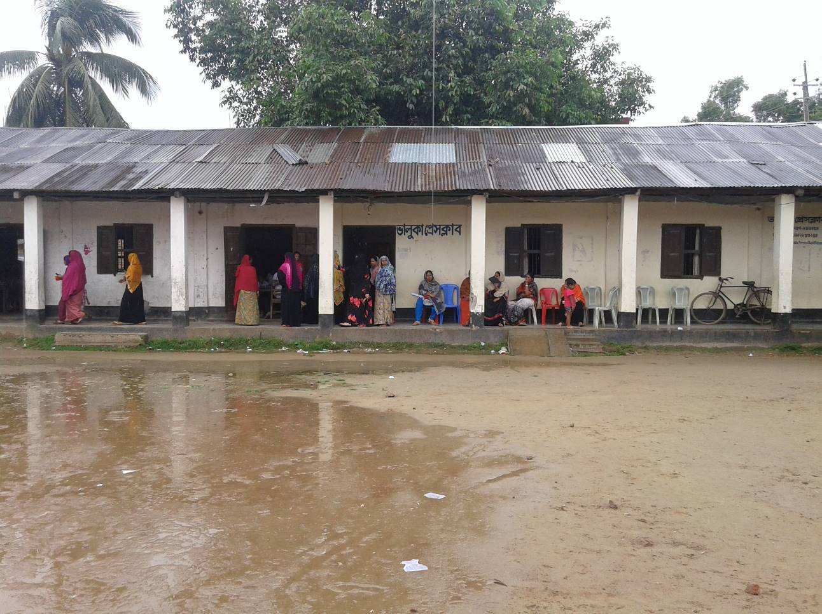

February, 2018
Bhaluka Pourashava, Bhaluka.

Annex 8.A
FORM 1: SOCIAL SAFEGUARDS SCREENING SUBPROJECTS
REVIEW and EVALUATION
1. Name of Subproject: Construction of mixed used building in front of Pourabhabon, Bhaluka.

Description of subproject:
The subproject is located in ward no. 06 under Bhaluka Pourashava. Proposed physical intervention is construction of four storied building which will be used as market and event management. The building will be constructed in front of poura bhabon having varying floor space at different levels. Proposed area of the ground floor and 1st floor will be 6475 sft. 2nd floor area will be 6841 sft and 3rd floor area will be 6461 sft. Basement of the building will be used as parking zone. Ground floor, 1st floor, 2nd floor will be used as market and 3rd floor will be used as different event management. The ground floor will have 17 shops, 1st floor will have 19 shops, and 2nd floor will have 23 shops. Adequate toilet facility will be available at each floor. Lift facility will be available at all floors.

Proposed mixed used building will be constructed in front of poura bhabon and the land belongs to pourashava. The existing structure front of the poura bhaban is a semi pucca building. This building will be demolished and the proposed multistoried building will be constructed at that place. Now the semi pucca building is used as Shapla Bidda Niketan School, Bhaluka Press Club and poura karmachari Sangsad (employee association) office. The school (Shapla Bidda Niketon) and Poura karmochari sangsad have no agreement with pourashava. They are operating their programs on the basis of mayor’s verbal consent. They do not pay any rent to pourashava. Press club pays nominal rent to the pourashava.

The school teaches student of grade one to four. Pourashava issued a notice to the school authority, press club and poura karmachari sangsad to vacate the place. They are agreed to vacate the place without compensation for sub project implementation. The press club authority has given in writing by an official letter to the Mayor to vacate the place when construction wark will be started. The School authority has already rented a house named Bonoful Mansion to continue their school program. Bonoful Mansion is situated on Gafargaon Bhaluka road (100m east of poura bhabon). Agreement has been signed between the school authority and the house owner (doccument attached at the annexure). Pourashava will pay rent of the new school premise.

Outlets of several electronics companies like Walton, Konka and Hitachi are located near the poura bhaban. Also, a liberation war monument, pourashava office, upazila parishad office, Bhaluka B.M college, Morning Sun Model High School and College, Janata Bank, Bhaluka Eye Hospital, Shapla Bidda Niketan, University Coaching Center are located beside the sub project area.

Date of Social Screening: 28/12/2017

2. INTRODUCTION:
The DSM used a questionnaire designed to facilitate assessment of the current situation and social issues related the subproject. This was applied for this screening exercise in case of this sub project also comprising one component – construction of four storied multipurpose used building. This screening enabled the best effective assessment of social matters in Bhaluka Pourashava and it is prepared based on factual material.

3. OBJECTIVES AND GOALS:
The primary objective of this Social Screening is to check that relevant social issues are properly identified and remedial measures indicated so that sub project involving unmanageable social risks are screened, hence the PMU can decide which ones to include or exclude which ones should have further documents prepared like SIMP.

4. STRATEGY OF SOCIAL SCREENING:
The Social Screening is based on a collection of primary data and information while conducting field survey for the subproject. A well-structured questionnaire was already designed in the Social Management Framework and given to the field officials for obtaining necessary primary data relating to social issues in connection with losses of land and any kind of assets for the subproject implementation. Further information was obtained through field visits and interviews with relevant stakeholders to capture collective opinions and feedback by using “Group Discussion” and “Key Informant Interviews (KII)”.

5. TEAM COMPOSITION:
The Social Screening analysis based on the received documents on subproject related social safeguards aspects from the ULB was conducted by following members:

a) Mr. Mortuza Reza, Senior Municipal Engineer, DSM,MGSP, LGED.
b) Ms. Akhter Jahan, Social Management Officer, DSM,MGSP, LGED.
c) Mr. Monnur Ahamed, Executive Engineer (In charge), Bhaluka, Pourashava.

6. SOCIAL SCREENING REPORT ON SUBPROJECT:
Subproject screening was carried out as per Social Management Framework of MGSP prescribed social screening format by the concerned Social Management Officer and Senior Municipal Engineer, Social Management Specialist with the direct assistance of officials of the Bhaluka Pourashava following a participatory consultation with the local people using Group Discussions including Hot Spot consultation with different categories of people and KIIs with people who are aware of local situation and the needs of the subproject users.

The Social Screening is based on a collection of primary data and information duly conducting field surveys. Well-structured questionnaires are already designed in the Social Management Framework of MGSP and this has been supplied to the field officials for obtaining necessary primary data relating to social issues in connection with social safeguard compliance issues such as losses of land, displacement of population, income, gender and vulnerability, tribal peoples, and loss of any kind of assets.

The field visit reports on social screening were prepared by the Social Management Officer and the Social Management Specialist has reviewed the reports. The DSM has ensured that nobody in the subproject area is adversely affected and that the benefits accrue to all concerned people equitably and nobody is deprived of such benefits. .

Bhaluka Pourashava and Consultants have jointly ensured consultation with local communities, infrastructure users, elected public representatives, local administration, teachers, businessmen, NGOs, social workers, and civil society members.

7. SUBPROJECT INTERVENTIONS
Subproject Interventions are noted under description of the sub project. No component of the sub project involves land acquisition.

8. KEY FINDINGS
8.1 LAND REQUIREMENTS
Subproject implementation does not require any private lands to carry out the intended works. The land being used belongs entirely to the pourashava.

8.2 HOMESTEAD AND OTHER NON-LAND ASSETS
It is noticed that no land belonging to private citizens will be required for the sub project. Proposed subproject will not require any homestead land any other non-land assets.

8.3 INCOME LOSS/ BUSINESS LOSS
It has been observed that no businesses or trading activities will be hampered from make-shift structures on the poura bhabon area and other intervention during four storied building construction.

The proposed subproject works are not expected to affect any community groups’ access to any resources that are used for livelihood purposes. None of the community facilities like cemeteries, mosques, hospitals, temples, or other religious, cultural and historical properties are going to be affected. One KG school and the press club will need to be relocated.

8.4 INDIGENOUS PEOPLE (IP), ADHIBASHI, and MARGINALIZED POPULATION
There is no Indigenous, Adhibashi and marginalized population that will be affected by the subproject interventions. The survey team did not find any Indigenous, Adhibashi or marginalized population to be affected by the sub project. Hence preparing IPDP is not required.

9. CONCLUSIONS AND RECOMMENDATIONS
The subproject will have contribution to increased revenue earning for the pourashava. It will provide improved shopping facility for the citizens and trading opportunity for the shop operators. All these factors will have incremental value on socio-economic aspects in general and social aspects in particular. The proposed intervention is not expected to pose any significant negative social impact.

There is no obstruction at the multipurpose building site and no adverse social impacts are foreseen. Nobody will be affected due to subproject implementation. School authority already signed agreement for rent a house to continue the program. Pourashava will pay the fair.

The stakeholders attending the consultation are highly positive of the implementation of the sub project. Attendance sheet is provided.
FORM1: SOCIAL SAFEGUARD SCREENING OF SUBPROJECTS
REVIEW and EVALUATION
Name of Subproject: Construction of mixed used building in front of poura bhabon,Bhaluka.

Name of District: Mymensingh Name of ULB: Bhaluka Pourashava
I. Checklist for Exclusion
1) Subproject requires land acquisition and/or population displacement that can be compensated for or resettled | [ ]Yes | [√] No
2) Subproject affects mosques, temples, graveyards and cremation grounds, and other places/objects of religious, cultural and historical significance. | [ ] Yes | [√]No
3) Subproject threatens cultural tradition and ways of life of tribal peoples; severely restrict their access to common property resources and livelihood activities. | [ ] Yes | [√] No
4) Communities have objections on subproject interventions on social and environmental issues those cannot be resolved through design alternatives. | [ ] Yes | [√] No
II. Resettlement Impacts
In respect of the social impacts and community concerns, is there a need to,  Undertake an in-depth social impact assessment study? | [ ] Yes | [√ ] No
Prepare a Resettlement Action Plan? | [ ]Yes | [√]No
III. Impacts on Tribal Peoples
In respect of the social impacts on tribal peoples and their concerns, is there a need to, Undertake an in-depth impact assessment study? | [ ] Yes | [√] No
Prepare a Tribal Peoples Plan? | [ ]Yes | [√]No
On behalf of the DSM Consultant, the attached filled out format has been reviewed and evaluated by:
Decision on selection: [√] recommended for selection [ ] recommended for exclusion

Prepared by:Akhter Jahan Designation: Social Management Officer, MGSP, LGED
Signature: Date: 15/02/2018


Reviewed by: Dr. M. Maniruzzaman Designation: Social Management Specialist, MGSP, LGED
Signature: Date: 15/02/2018

A social screening report will be prepared for each subproject covering methodology, participants’ analysis, community agreements &their concerns/suggestions, & summary of impacts and mitigation requirement.
FORM 1: SCREENING FORM FOR SOCIAL SAFEGUARDS ISSUES
Additional Information
- Identification
- Name of ULB: Bhaluka Pourashava District: Mymensingh
Ward/Mahalla: Ward no.06

2. Name of subproject / spot screened: Construction of mixed used building in front of poura bhaban, Bhaluka.

3. Project component: Four storied building.
4. Brief description of the physical works: The subproject is located in ward no. 06 under Bhaluka Pourashava. Proposed physical intervention is construction of four storied building which will be used as market and event management. The building will be constructed in front of poura bhabon having different floor area. Proposed area of the ground floor and 1st floor will be 6475.00sft. 2nd floor area will be 6841.00sft and 3rd floor area will be 6461.00sft. Basement of the building will be used as parking zone. Ground floor, 1st floor, 2nd floor will be used as market and 3rd floor will be used as different event management. The ground floor will have 17 shops, 1st floor will have 19 shops, and 2nd floor will have 23 shops. Adequate toilet facility will be available at each floor. Lift facility will be available at all floors.

Proposed mixed used building will be constructed in front of poura bhabon and the land belongs to pourashava. The existing structure front of the poura bhaban is a semi pucca building. This building will be demolished and the proposed multistoried building will be constructed on that place.

5. Date of Social Screening: 28/12/2017
6. Names of Consultants’ representatives who screened the subproject:
1. Mr. Mortuza Reza Sr. Municipal Engineer, MGSP,LGED,
2. Ms. Akhter Jahan, Social Management Officer, MGSP, LGED,
3. Mst. Tasrima Sultana, Jr. Environmental Specialist, MGSP, LGED.
4. Mr. Sumit Sarkar Assistant Municipal Engineer, Bhaluka Pourashava.

7. Names of ULB officials participated in screening:

1. Mr. Md. Monnur Ahamed, Executive Engineer (In charge), Bhaluka Pourashava
2. Mr. Md. Harunur Rashid, Sub Assistant Engineer, Bhaluka Pourashava
3. Mr.Md.Saiful Islam, Work Assistant, Bhaluka Pourashava.

8. WLCC members, NGOs, community groups/CBOs participated in screening: Yes, copy enclosed for information.

9. Would-be affected persons participated in screening: N/A.

C. Land Requirements & Ownership:
10. Will there be a need for additional lands to carry out the intended works under this contract? [ ] yes [√] No
11. If ‘Yes’, what will the additional lands be used for? (Indicate all that apply):N/A
[] road widening [ ] curve correction [ ] construction/expansion of physical structure
[ ] strengthening narrow eroding road section between high and low lands [ ] others (Mention):
12. If ‘Yes’, the required lands presently belong to (Indicate all that apply):
[] ULB [ ] Government Land
[ ] Private Citizens [ ] Others (Mention):

D. Current Land Use & Potential Impacts

13. If the required lands belong to Private Citizens, they are currently used for (Indicate all that apply): N/A
[ ] Agriculture Number of households using the lands:
[ ] Residential purposes Number of households using them:
[ ] Commercial purposes Number of persons using them:
[ ] Other Uses (Mention): few Users:
Land does not belong to private citizen.
14. If the required lands belong to ULB and/or other Government agencies, they are currently used for (Indicate all that apply):
[ ] Agriculture Number of persons/households using the lands:
[] Residential purposes Number of households living on them:
[ ] Commercial purposes Number of persons using them: No. of shops:
[√ ] Other Uses (Mention): School, Press club, Poura Karmochari Sangshad.
15. How many of the present users have lease agreements with any government agencies? N/A
16. Number of private homesteads that would be affected on private lands: None
Entirely requiring relocation……………………. Partially but can still live on present homestead
17. Number of business premises/buildings that would be affected on private lands: None.
Entirely and will require relocation: # Of businesses housed in them:
Partially, but can still use the premises: # Of businesses housed in them:
18. Residential households will be affected on ULB’s own and & public lands: None
Entirely affected and will require relocation: No. of these structures: None.
No. of structures built with brick, RCC, & other expensive and durable materials:
No. of structures built with inexpensive salvageable materials (bamboo, GI sheets, etc:
Partially affected, but can still live on the present homestead: No. of these structures.
No. of structures built with brick, RCC, & other expensive and durable materials:
No. of structures built with inexpensive salvageable materials (bamboo, GI sheets, etc):
19. No. of business premises that would be affected on ULB’s own & other public lands: None
Entirely affected and will require relocation: No. of these structures: None
No. of businesses housed in these structures:
No. of persons presently employed in the above businesses.
No. of these structures built with brick, RCC, & other durable materials:
No. of structure built with inexpensive salvageable materials (bamboo, GI sheets, etc):
Partially affected, but can still stay in the present no. of these structures: None
No. of businesses housed in these structures:
No. of persons presently employed in these businesses:
No. of these structures built with brick, RCC, & other durable materials:
No. of structure built with inexpensive salvageable materials (bamboo, GI sheets, etc):
20.No of businesses/trading activities that would be displaced from make-shift structures on the road, and other areas/spots: None
21. Do the proposed subproject works affect any community groups’ access to any resources that are used for livelihood purposes? [ ] Yes [√] No
22. If ‘Yes’, description of the resources: N/A
23.Do the proposed works affect community facilities like school, cemetery, mosque, temple, or others that are of religious, cultural and historical significance? [√ ] Yes [] No.
24. If ‘Yes’, description of the facilities: One KG school will be relocated.
25. Describe any other impacts that have not been covered in this questionnaire? No.
26. Describe alternatives, if any, to avoid or minimize use of additional lands: N/A
E. ADDITIONAL INFORMATION ON TRIBAL PEOPLE
(This section must be filled in if subprojects are located in areas that are also inhabited by tribal peoples)
27. Names of tribal community members and organizations who participated in screening: N/A
28. Have the tribal community and the would-be affected TPs been made aware of the potential positive and negative impacts and consulted for their feedback and inputs?
[ ] Yes [√] No
Has there been a broad-based community consensus on the proposed works?
[ ] Yes [√] No
29. Total number of would-be affected tribal households: N/A.

30. The would-be affected tribal households have the following forms of rights to the required lands: N/A
[ ] Legal: No. of households:
[ ] Customary: No. of households:
[ ] Lease agreements with any GOB agencies: No. of households:
[ ] Others (Mention): No. of households:
31. Does the subproject affect any objects that are of religious and cultural significance to the IPs? [ ] Yes [√] No
G.32. If ‘Yes’, description of the objects: N/A.
33. The following are the three main economic activities of the would-be affected tribal households:
a. N/A
b. N/A
c. N/A
34. Social concerns expressed by tribal communities/organizations about the works proposed under the subproject: N/A
35. The tribal community and organizations perceive the social outcomes of the subproject: N/A
On behalf of the DSM Consultant, the attached filled out format has been reviewed and evaluated by:
Decision on selection [√] recommended for selection [] recommended for exclusion
Prepared by: Akhter Jahan Designation: Social Management Officer, MGSP, LGED
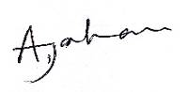
Signature: Date: 15/02/2018

Reviewed by: Dr. M. Maniruzzaman Designation: Social Management Specialist MGSP, LGED
Signature: Date: 15/02/2018

Participation and Consultation meeting for subprojects:
Participation and Consultation meetings were held in the subproject site to carry out the feasibility of the specific subproject. Consultations with communities and other stakeholders have been used as a two-way communication to provide information about the subproject and obtain feedback from the communities on subproject approach, design and implementation. Consultations were carried out through open meetings, group discussions and key informant interviews (KII). From the meeting, this specific subproject is very important for the economic development of the communities which in turn will be implemented. The consultation process was carried out with distinct groups at urban areas. Key informants were ULB Mayor, Ward Commissioners, Engineers, and Businessmen.

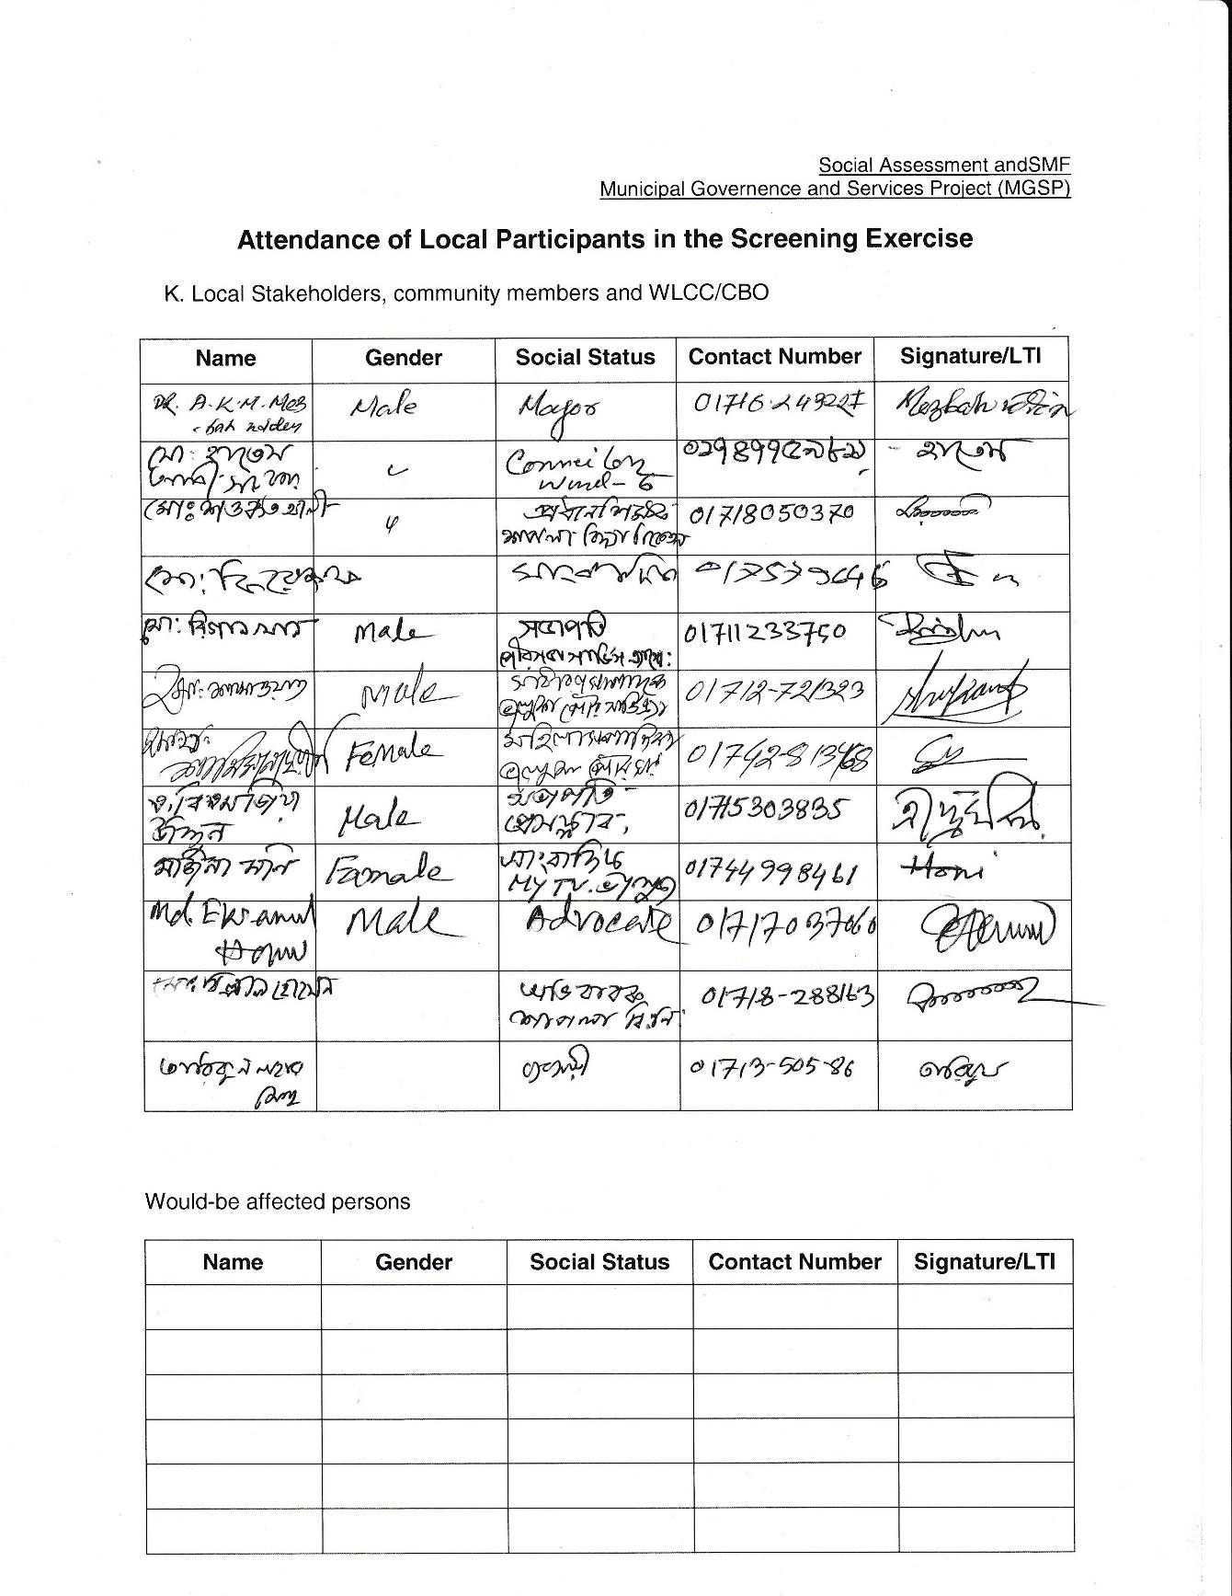

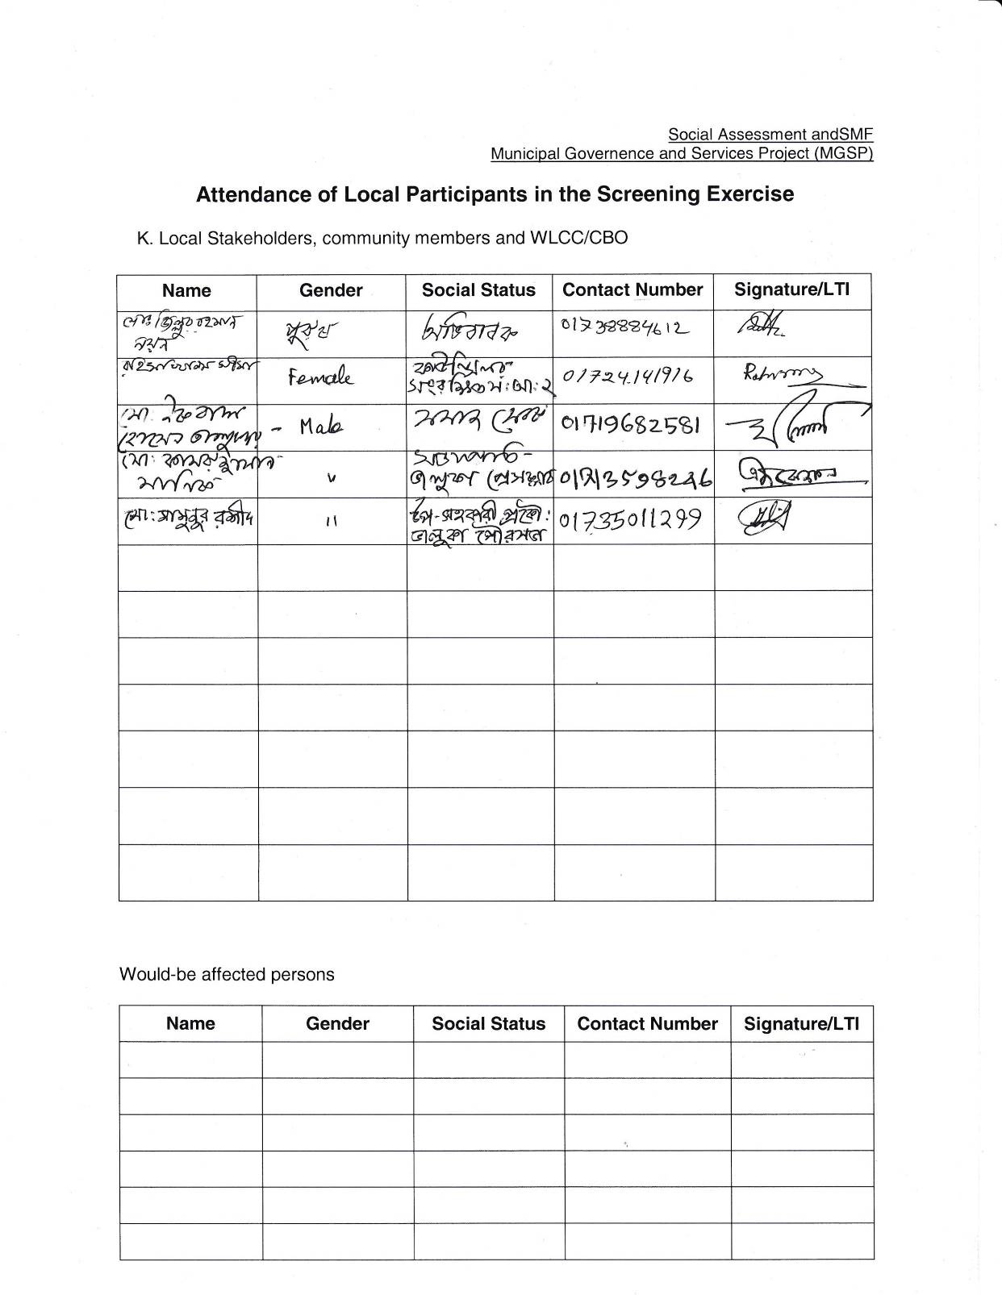

Layout Plan:

