**Government of the People’s Republic of Bangladesh  
Ministry of Local Government, Rural Development & Co-operatives  
Local Government Division  
Local Government Engineering Department  
Municipal Governance and Services Project ( MGSP)  
Agargaon, Dhaka-1207, Bangladesh**

**IDA Credit No: 5339-BD**

**Report on Social Management Plan**

**Package No: MGSP/NCC/2015-16/W-06**

**Name of Subproject:**

1. Construction of Kazi Nazrul Road with Drain Under Narayangonj City Corporation, Narayangonj(Ch .0.00-700.00m) In Ward No. 24
2. Beautification of NCC Own Pond with Coffee Shop and Electrification at North Lakhyankhola Under Narayangonj City Corporation, Narayangonj in Ward No. 25

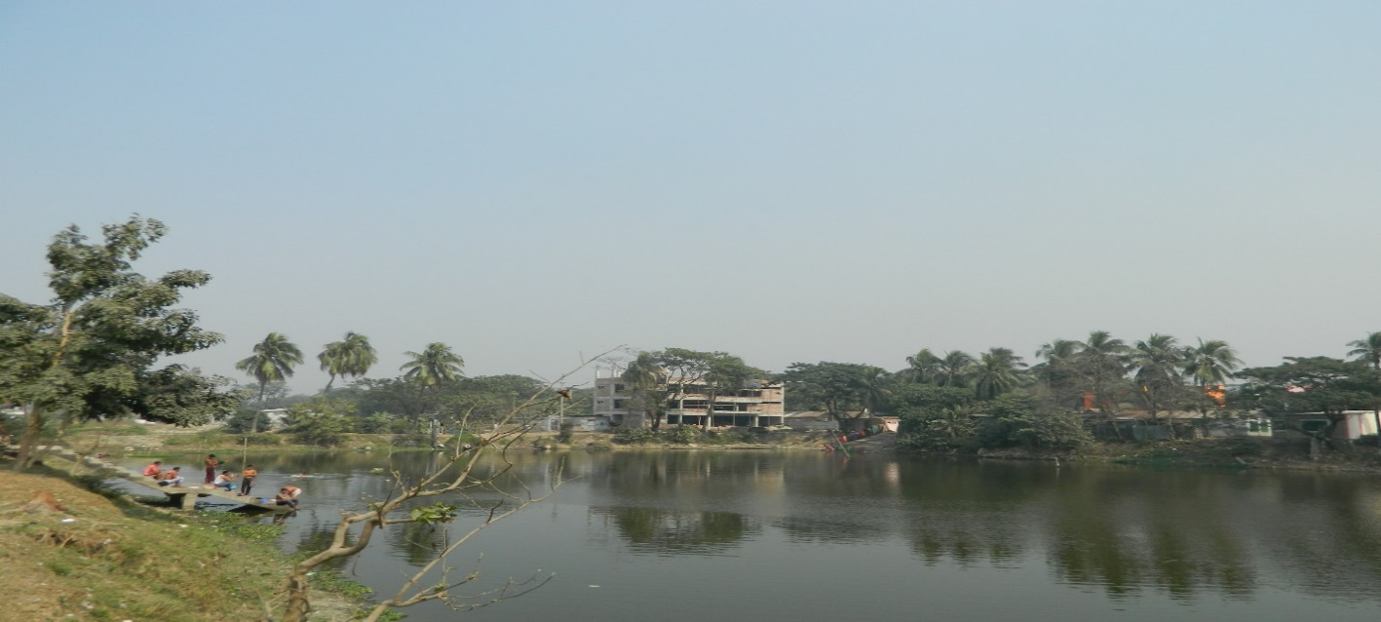

**February 2016**

**Narayangonj City Corporation, Narayangonj**

**Package No: MGSP/NCC/2015-16/W-06**

**Name of Subproject:**

1. Construction of Kazi Nazrul Road with Drain under Narayangonj City Corporation, Narayangonj (Ch. 0.00-700.00 m) in ward no.-24.

**Table of Contents**

**Social Management Plan:**

|  |  |  |
| --- | --- | --- |
| **Sl. No.** | **Description** | **Page No** |
| 1. | Project Background | 4 |
| 2. | Brief Description of Subproject | 4 |
| 3. | Description of Subproject Area | 4 |
| 4. | Stakeholder Analysis, Beneficiary Community Mix, Gender Analysis | 5 |
| 5. | Site Selection and Design | 5 |
| 6. | Social Screening and Safeguard Compliance Issue | 5 |
| 7. | Inclusion, Participation and Grievance Redress | 5 |
| 8. | Social Management Budget | 6 |
| 9. | Monitoring & Evaluation | 6 |
| 10. | Social Screening Report | 8 |
| 11. | Attendance of Local Participants in The Screening Exercise | 23 |
| 12. | Site Location Map | 24 |

**Social Management Plan**

**Project Background**

The Municipal Governance and Service Project is being implemented by the Government of Bangladesh with the financial support from the World Bank. The main objective of the Project is to enhance the basic urban services and capacity building in selected Urban Local Bodies (ULBs) of Bangladesh. Financial accountability and sustainability, municipal planning, and social inclusiveness are the basic ingredients to fulfill the objectives. Depending on the needs of ULBs, the subprojects will include roads, drains, sanitation systems, street lights, and beatification of proposed premises. These tasks could create both positive and negative social impacts like land acquisition, loss of livelihoods to some individuals, and resettlement.

**Brief Description of Subproject**

Package no: MGSP/NCC/2015-16/W-06

The subproject is located in Ward No. 24 of Narayangonj City Corporation. One RCC road with an RCC drain cum footpath will be implemented under the proposed subproject.

The present road is bituminous carpeting and the drainage system of this area is insufficient. As a result, people of wards 24 and 25 always face severe water logging problems. Construction of the proposed RCC road will provide connectivity with the RHD road. The proposed drain will be used as the primary drain, connect with secondary drain of this area, and ultimately discharge in the River Shitalaksha. If this drain is constructed, the rate of discharge will be increase. Consequently, the water logging problem within the area will be reduced significantly. After implementing this subproject, the land prices will be increase. This will accelerate the urbanization of the city. The proposed length of the road with drain and the estimated cost are given in the following table.

|  |  |  |
| --- | --- | --- |
| **Subprojects** | **Length (Km)** | **Estimated Cost (BDT)** |
| Construction of Kazi Nazrul Road with Drain under Narayangonj City Corporation, Narayangonj (ch.0.00-700.00m) in ward no 24. | 0.700 | 2,51,95,847 |

The total length of the proposed RCC road and RCC drain is 0.7 km with an estimated cost of BDT 2,51,95,847.

Hence, this road with drain needs to be constructed. It will improve the water congestion problem and it will provide advanced transport facilities for the buyers, wholesalers, local people of different professions, and students.

**Description of Subproject Area**

Narayangonj City Corporation is well-known for its commercial and industrial activities. Recently the City Corporation has been established with three adjacent Municipalities, Narayangonj, Shiddhirganj, and Kadamrasul Municipalities. It is very close to the capital city of Dhaka. Narayangonj is one of the biggest river ports in Bangladesh. The port is situated inside the City Corporation area. This area is very famous for jute and knit trading and numerous mills and factories are located within the City Corporation area. Consequently, a huge number of workers live in this area. Narayangonj City Corporation is connected with other parts of the country by river, railway and highway. It is a very big and important commercial place for trade and business. Many people come to this City Corporation from nearby areas every day as well as from other districts for trade and business.

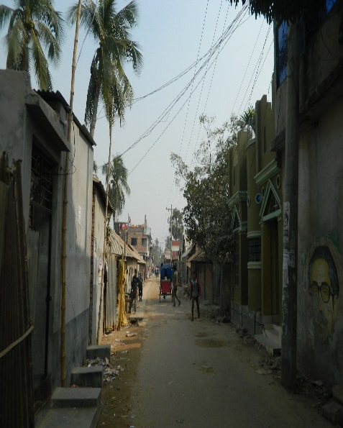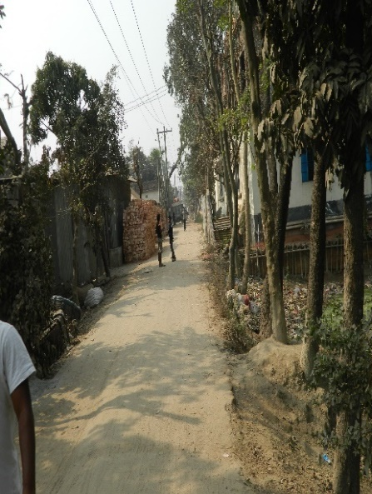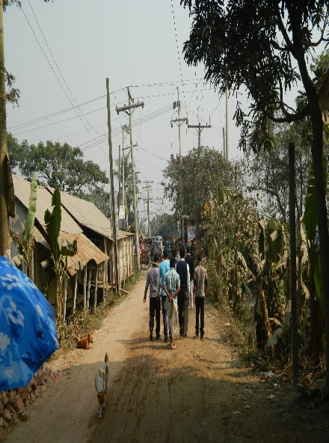

**Stakeholder Analysis, Beneficiary Community Mix, Gender Analysis**

According to BBS 2011, the total population of Narayangonj City Corporation was 709,381. In the context of present demographic composition of Narayangonj City Corporation, there are higher income, higher-middle income, lower-middle income, and lower income groups of people living in the City Corporation.

Both males and females living in the Narayangonj City Corporation, in general, and adjacent to the subproject area, in particular, will directly be benefited by the improvement of roads and drains.

**Site Selection and Design**

The DSM consultants designed the proposed roads and drains for construction and rehabilitation. No additional land will be required. The consultant interviewed stakeholders and beneficiaries of the subproject area before the design. The city conducted a number of consultation meetings in the subproject area to discuss the implementation procedure and mitigation measures, if any, required for implementing the proposed subproject. LGED HQ engineers in the PMU reviewed and approved the subproject.

**Social Screening and Safeguard Compliance Issue**

The Consultant screened the subproject under Narayangonj City Corporation using an inclusive and participatory approach. No land acquisition will be required for implementing the subproject. As such, no resettlement is necessary. Hence, no Resettlement Action Plan (RAP) is needed. No business premises will be affected. No private, public, community or cultural property, any kind of service delivery facilities as well as commercial activities will be affected. No tribal people will be affected because there are no tribal communities living in the subproject area.

**Inclusion, Participation and Grievance Redress**

The mayor, councilors (including Female Ward Councilors) and senior City Corporation officials (including female staff of Narayangonj City Corporation) were actively involved in the selection process of the scheme. While selecting the subproject, the City Corporation ensured women’s participation in the scheme selection process through monthly general meetings of the City Corporation. Female Ward Councilors participated actively in the selection process.

The city will form a Grievance Redress Committees (GRC) according to the social assessment guidelines. The Mayor of the City Corporation will bethe head of the GRC. GRC and ward level GRMs will establishfocal points and disclose them to the community.

Despite the inclusion and participatory consultations, if any grievance relating to the implementation of the subproject is brought to the notice of the City Corporation, it will address it.

**Social Management Budget**

No budget for Social Management will be required for this subproject because no Resettlement and Land acquisition issues are involved. However,MGSP will provide the budget for GRM and GRC according to the requirements.

**Monitoring and Evaluation**

The PMU will monitor the Social Management Plan of this proposed subproject during the implementation phase. The PMU will evaluate the subprojectafter its completion.

The PMU will monitor and address social issues if some social issues are raised during implementation.

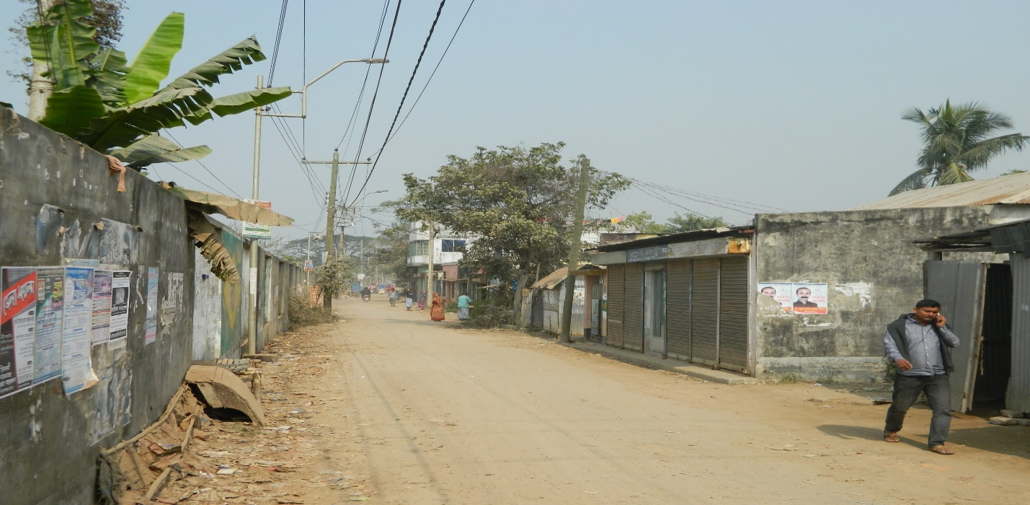

**Social Management Framework for (a) Construction of KaziNazrul Road with Drain under Narayangonj City Corporation, Narayangonj (Ch. 0.00-700.00m) in Ward No. 24.**

1. **Form-1: Social Safeguards Screening of Sub-Project (Review and Evaluation)**
2. **Form-1: Screening form for Social Safeguards Issues Screening**

**Annex 8.A**

**FORM 1: SOCIAL SAFEGUARDS SCREENING OF SUBPROJECTS**

**REVIEW and EVALUATION**

**Name of Subproject: (a) Construction of Kazi Nazrul Road With Drain under Narayangonj City Corporation, Narayangonj (Ch. 0.00-700.00 m) in ward no.-24.**

**Name of District: Narayangonj**

Village/Mouza:24 No.Ward, Upazila: Bondor

**I. Checklist for Exclusion**

|  |  |  |
| --- | --- | --- |
| 1) Subproject requires land acquisition and/or population displacement that can be compensated for or resettled | [ ] Yes | [√] No |
| 2) Subproject affects mosques, temples, graveyards and cremation grounds, and other places/objects of religious, cultural and historical significance. | [ ] Yes | [√]No |
| 3) Subproject threatens cultural tradition and ways of life of tribal peoples; severely restrict their access to common property resources and livelihood activities. | [ ] Yes | [√] No |
| 4) Communities have objections on subproject interventions on social and environmental issues those cannot be resolved through design alternatives. | [ ] Yes | [√] No |
| **II. Resettlement Impacts** | | |
| In respect of the social impacts and community concerns, is there a need to,  Undertake an in-depth social impact assessment study? | [ ] Yes | [√ ] No |
| Prepare a Resettlement Action Plan? | [ ] Yes | [√]No |
| **III. Impacts on Tribal Peoples** | | |
| In respect of the social impacts on tribal peoples and their concerns, is there a need to,  Undertake an in-depth impact assessment study? | [ ] Yes | [√] No |
| Prepare a Tribal Peoples Plan? | [ ] Yes | [√] No |

**On behalf of the DSM Consultant, the attached filled out format has been reviewed and evaluated by:**

**Decision on selection: [1] recommended for selection [√] [2] recommended for**

**exclusion**

**Prepared by:** Akhter Jahan, Designation: Social Management Officer, MGSP, LGED,

Signature: 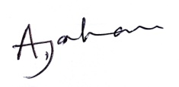 Date: 07.02.2016

**Reviewed by:** M Faridul Islam Designation: Social Management Specialist, MGSP, LGED,



Signature: Date: 07.02.2016

**_________________________________________________________________________**

A social screening report prepared for each subproject covering methodology, participants’ analysis, community agreements & their concerns/suggestions, & summary of impacts and mitigation requirements.

**FORM 1: SCREENING FORM FOR SOCIAL SAFEGUARDS ISSUES**

**SCREENING**

**A. Identification**

1. Name of ULB: Narayangonj City Corporation District: Narayangonj

Ward / Mahalla: 24 Upazila: Bondor

2. Subproject/spot screened: (a) Construction of Kazi Nazrul Road With Drain under Narayangonj City Corporation, Narayangonj (Ch. 0.00-700.00 m) in Ward No. 24.

3. Project component: Road and Drain

4. Brief description of the physical works: The proposed road with drain is located at ward no.24.The road connects Madanpur-Madanganj to Lakkhonkhola Road. The present condition of this road is damaged which interrupts normal traffic operation. There is no improved communication and drainage system. During the rainy season stagnation of storm water on the road surface aggravates the situation. The length of the proposed road is 700m (Ch.0.00-700m). The average width of the road is 4.50m. The proposed width of the road is 6.05m including drain. Proposed width of the drain is 1.05m.From the field visit, it is shown that in some places land is available but some where pourashava need some demolishing works for widening the road.

.

**5. Screening Date(s):** 26/01/16

**B. Participation in Screening:**

6. Names of Consultants’ representatives who screened the subproject:

1. Mr. M Faridul Islam, Social Management Specialist, MGSP, LGED,
2. Mr. Mortuza Reza Sr. Municipal Engineer, MGSP,LGED,
3. Ms. Akhter Jahan, Social Management Officer, MGSP, LGED,
4. Mr. Md.Rezaul Karim, Assistant Municipal Engineer, MGSP, LGED,
5. Mr. Md.Monjurul Islam, Pavement Design Engineer, MGSP, LGED&
6. Mr. Md.Mahbubur Rahman, Environment Safeguard Specialist, MGSP, LGED.

7. Names of ULB officials participated in screening:

(1) Mr.Abdul Aziz, Superintending Engineer,Narayangonj City Corporation,

(2) Mr.Ismail Chowdhury, Executive Engineer, Narayangonj City Corporation,

(3) Mr. A S M Moshiur Rahman, Assistant Engineer, Narayangonj City Corporation&

(4) Mr.ShafiulAlam Chowdhury, Sub-Assistant Engineer, Narayangonj City Corporation

8. WLCC members, NGOs, community groups/CBOs participated in screening: Copy attached.

9. Would-be affected persons participated in screening: N/A

**C. Land Requirements & Ownership:** ULB.

|  |  |  |
| --- | --- | --- |
| 10. Will there be a need for additional lands to carry out the intended works under this contract? | [√ ] yes | [] No |

11. If ‘Yes’, what will the additional lands be used for? (Indicate all that apply):

[√] road widening

[ ] curve correction

[ ] construction/expansion of physical structure

[ ] strengthening narrow eroding road section between high and low lands

[√] others (Mention): Drain Construction

12. If ‘Yes’, the required lands presently belong to (Indicate all that apply):

[√] ULB

[] Government – RHD’s ROW & other GOB agencies

[ ] Private Citizens

[ ] Others (Mention): N/A.

D. Current Land Use & Potential Impacts:

**13**. If the required lands belong to Private Citizens, they are currently used for (Indicate all that apply):

[ ] Agriculture Number of households using the lands: N/A

[ ] Residential purposes Number of households using them: N/A

[ ] Commercial purposes Number of persons using them: N/A,

No. of shops: N/A

[ ] Other Uses (Mention): N/A No. of users: N/A

Land does not belong to private citizen.

14. If the required lands belong to ULB and/or other Government agencies, they are currently used for (Indicate all that apply): No.

[ ] Agriculture Number of persons/households using the lands: N/A

[ ] Residential purposes Number of households living on them: N/A

[ ] Commercial purposes Number of persons using them: N/A, No. of shops: N/A

[ ] Other Uses (Mention): N/A No. of users: N/A

15. How many of the present users have lease agreements with any government agencies? : N/A

16. Number of private homesteads that would be affected on private lands:

Entirely, requiring relocation: N/A.

Partially, but can still live on present homestead: N/A.

Additional lands’ mean lands beyond the carriageways and shoulders in case of roads and outside currently used space for: N/A.

17. Number of business premises/buildings that would be affected on private lands: N/A

Entirely and will require relocation: N/A………# Of businesses housed in them…N/A Partially, but can still use the premises: N/A…..#Of businesses housed in them….N/A

18. Residential households will be affected on ULB’s own and & public lands:

Entirely affected and will require relocation:

No. of these structures: N/A

No. of structures built with brick, RCC, & other expensive and durable materials: N/A.

No. of structures built with inexpensive salvageable materials (bamboos, GI sheets, etc: N/A.

No whole house shall be broken down.

Partially affected, but can still live on the present homestead: No. of structures.

No. of structures built with brick, RCC, & other expensive and durable materials: N/A.

No. of structures built with inexpensive salvageable materials (bamboo, GI sheets, etc): N/A.

19. No of business premises that would be affected on ULB’s own & other public lands: N/A.

Entirely affected and will require relocation: N/A.

No. of these structures: N/A.

No. of businesses housed in these structures: N/A.

No. of persons presently employed in the above businesses: N/A.

No. of these structures built with brick, RCC, & other durable materials: N/A

No. of structure built with inexpensive salvageable materials (bamboo, GI sheets, etc N/A.

Partially affected, but can still stay in the present no of these structures: Premises: N/A

No. of businesses houses in these structures: N/A

No. of persons presently employed in these businesses: N/A

No. of these structures built with brick, RCC, & other durable materials: N/A

No. of structure built with inexpensive salvageable materials (bamboo, GI sheets, etc): N/A.

20. None of businesses/trading activities that would be displaced from make-shift structures on the road, and other areas/spots: Sufficient free spaces available.

21. Do the proposed subproject works affect any community groups’ access to any resources that are used for livelihood purposes? [ ] Yes [√] No

22. If ‘Yes’, description of the resources: N/A.

23. Do the proposed works affect community facilities like school, cemetery, mosque, temple, or others that are of religious, cultural and historical significance? [ ] Yes [√ ] No.  
 24. If ‘Yes’, description of the facilities: N/A.  
25. Describe any other impacts that have not been covered in this questionnaire? No.

26. Describe alternatives, if any, to avoid or minimize use of additional lands: N/A

**E. ADDITIONAL INFORMATION ON TRIBAL PEOPLES**

(This section must be filled in if subprojects are located in areas that are also inhabited by tribal peoples)

27. Names of tribal community members and organizations who participated in screening:

N/A

28. Have the tribal community and the would-be affected TPs been made aware of the potential positive and negative impacts and consulted for their feedback and inputs?

[ ] Yes [√] No

Has there been a broad-based community consensus on the proposed works?

[ ] Yes [√] No

29. Total number of would-be affected tribal households: N/A.

30. The would-be affected tribal households have the following forms of rights to the required lands: N/A

[ ] Legal: No. of households:

[ ] Customary: No. of households:

[ ] Lease agreements with any GOB agencies: No. of households:

[ ] Others (Mention): No. of households:

31. Does the subproject affect any objects that are of religious and cultural significance to the IPs? [ ] Yes [√] No

32. If ‘Yes’, description of the objects: N/A.

33. The following are the three main economic activities of the would-be affected tribal households:

a. N/A

b. N/A

c. N/A

34. Social concerns expressed by tribal communities/organizations about the works proposed under the subproject: N/A

35. The tribal community and organizations perceive the social outcomes of the subproject:

[ ] Positive [ ] Negative [√ ] Neither positive nor negative

**On behalf of the DSM Consultant, this Screening Form has been filled in by:**

**Prepared by:**

Name: Akhter Jahan, Designation: Social Management Officer, MGSP, LGED.

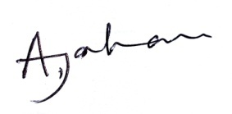

Signature: SMO, MGSP, LGED Date: 07.02.2016

**Reviewed by:**

Name: M Faridul Islam Designation: Social Management Specialist, MGSP, LGED,

Signature:  Date: 07.02.2016

**Package No: MGSP/NCC/2015-16/W-06**

**Name of Subproject:**.

1. Beautification of NCC Own Pond with Coffee Shop and Electrification at North Lakhyankhola under Narayangonj City Corporation, Narayangonj in ward no.-25.

**Table of Contents**

**Social Management Plan:**

|  |  |  |
| --- | --- | --- |
| **Sl. No.** | **Description** | **Page No** |
| 1. | Project Background | 15 |
| 2. | Brief Description of Subproject | 15 |
| 3. | Description of Subproject Area | 15 |
| 4. | Stakeholder Analysis, Beneficiary Community Mix, Gender Analysis | 16 |
| 5. | Site Selection and Design | 16 |
| 6. | Social Screening and Safeguard Compliance Issue | 16 |
| 7. | Inclusion, Participation and Grievance Redress | 17 |
| 8. | Social Management Budget | 17 |
| 9. | Monitoring & Evaluation | 17 |
| 10. | Social Screening Report | 18-22 |
| 11. | Attendance of Local Participants in The Screening Exercise | 23 |
| 12. | Site Location Map | 24 |
| 13. | Design |  |
| 14. | CIP List |  |
| 15. | Minutes of Meetings |  |
| 16. | List of Participants |  |

**Social Management Plan**

**Project Background**

The Municipal Governance and Service Project is being implemented by the Government of Bangladesh with the financial support from the World Bank. The main objective of the Project is to enhance the basic urban services and capacity building in selected Urban Local Bodies (ULBs) of Bangladesh. Financial accountability and sustainability, municipal planning, and social inclusiveness are the basic ingredients to fulfill the objectives. Depending on the needs of ULBs, the subprojects will include roads, drains, sanitation systems, street lights, and beatification of proposed premises. These tasks could create both positive and negative social impacts like land acquisition, loss of livelihoods to some individuals, and resettlement.

**Brief Description of Subproject**

Package no: MGSP/NCC/2015-16/W-06

The subproject is located in Ward no. 25 of Narayangonj City Corporation. This area is not densely populated. A bituminous carpeting road with drain passes through this area. This pond is itself a water body. It is presently used for bathing and washing by some local people. There is a low possibility low of moderate degradation of the water quality due to surface run-off and domestic activities. The pond is not used for fish culture. After implementation of the subproject, it will preserve the water body, increase the recreational area, develop pollution free environment, improve the socio economic condition and it will increase the city revenue.

The proposed area of the beautification and electrification work under the subproject and the estimated cost are given in the following table.

|  |  |  |
| --- | --- | --- |
| **Subprojects** | **Area(Sqm)** | **Estimated Cost (BDT)** |
| Beautification of NCC own pond with Coffee Shop & Electrification at North Lakhyankhola, Narayangonj City Corporation, Narayangonj in ward no.25 | 10,496 | 1,97,82,976.00 |

The total area of the proposed beautification and electrification is 10,496sqm with an estimated cost of BDT 1,97,82,976.

**Description of Subproject Area**

Narayangonj City Corporation is well-known for its commercial and industrial activities. Recently the City Corporation has been established with three adjacent Municipalities, Narayangonj, Shiddhirganj, and Kadamrasul Municipalities. It is very close to the capital city of Dhaka. Narayangonj is one of the biggest river ports in Bangladesh. The port is situated inside the City Corporation area. This area is very famous for jute and knit trading and numerous mills and factories are located within the City Corporation area. Consequently, a huge number of workers live in this area. Narayangonj City Corporation is connected with other parts of the country by river, railway and highway. It is a very big and important commercial place for trade and business. Many people come to this City Corporation from nearby areas every day as well as from other districts for trade and business.

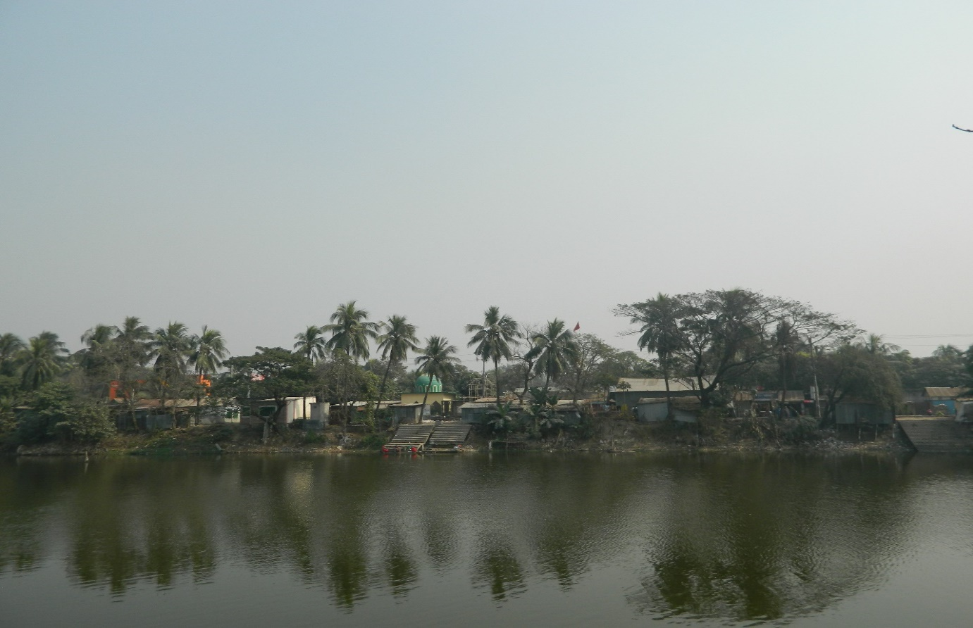

**Stakeholder Analysis, Beneficiary Community Mix, Gender Analysis**

According to BBS 2011, the total population of Narayangonj City Corporation was 709,381. In the context of present demographic composition of Narayangonj City Corporation, there are higher income, higher-middle income, lower-middle income, and lower income groups of people living in the City Corporation.

Both males and females living in the Narayangonj City Corporation, in general, and adjacent to the subproject area, in particular, will directly be benefited by the beautification and electrification of the pond.

**Site Selection and Design**

The DSM consultants designed the proposed roads and drains for construction and rehabilitation. No additional land will be required. The consultant interviewed stakeholders and beneficiaries of the subproject area before the design. The city conducted a number of consultation meetings in the subproject area to discuss the implementation procedure and mitigation measures, if any, required for implementing the proposed subproject. LGED HQ engineers in the PMU reviewed and approved the subproject.

**Social Screening and Safeguard Compliance Issue**

The Consultant screen of the subproject under Narayangonj City Corporation using an inclusive and participatory approach. No land acquisition will be required for implementing the subproject as, no resettlement is necessary. Hence, no Resettlement Action Plan (RAP) is needed. No business premises will be affected. No private, public, community or cultural property, any kind of service delivery facilities as well as commercial activities will be affected. No tribal people will be affected because there are no tribal communities living in the subproject area.

**Inclusion, Participation and Grievance Redress**

The mayor, councilors (including Female Ward Councilors) and senior City Corporation officials (including female staff of Narayangonj City Corporation) were actively involved in the selection process of the scheme. While selecting the subproject, the City Corporation ensured women’s participation in the scheme selection process through monthly general meetings of the City Corporation. Female Ward Councilors participated actively in the selection process.

The city will form a Grievance Redress Committees (GRC) according to the social assessment guidelines. The Mayor of the City Corporation will be the head of the GRC. GRC and ward level GRMs will establish focal points and disclose them to the community.

Despite the inclusion and participatory consultations, if any grievance relating to the implementation of the subproject is brought to the notice of the City Corporation, it will addressed it.

**Social Management Budget**

No budget for Social Management will be required for this subproject because no Resettlement and Land acquisition issues are involved. However, MGSP will provide the budget for GRM and GRC according to the requirements.

**Monitoring and Evaluation**

The PMU will monitor the Social Management Plan of this proposed subproject during the implementation phase, the PMU will evaluate the subproject after its completion.

The PMU will monitor and address social issues if some social issues are raised during implementation.

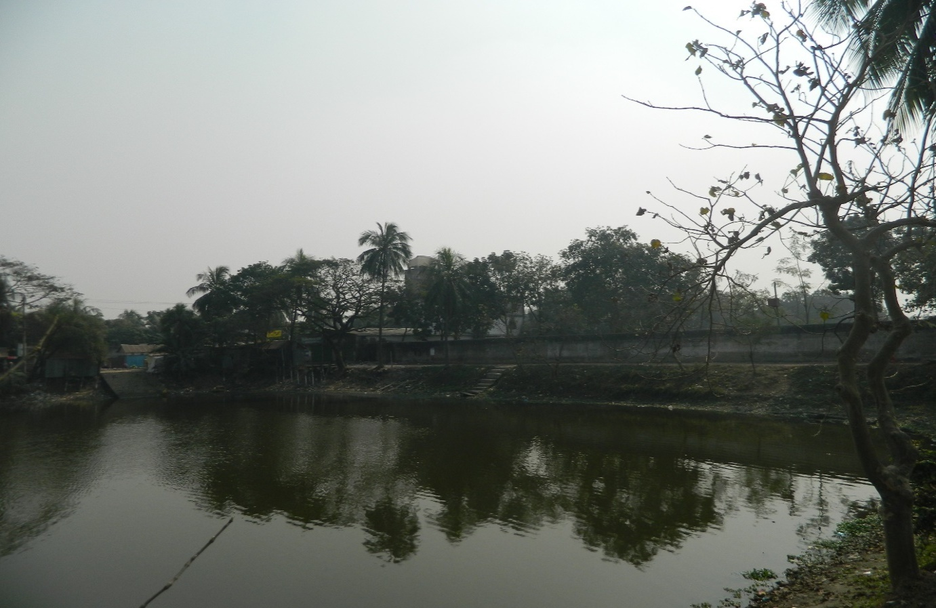

**Annex 8.A**

**FORM 1: SOCIAL SAFEGUARDS SCREENING OF SUBPROJECTS**

**REVIEW and EVALUATION**

**Name of Subproject:** b) Beautification of NCC Own Pond with Coffee Shop and Electrification at North Lakhyankhola under Narayangonj City Corporation, Narayangonj in Ward No. 25.

Name of District :Narayangonj, Village/Mouza :25No. Ward,

Upazila : Bondor.

**I. Checklist for Exclusion**

|  |  |  |
| --- | --- | --- |
| 1) Subproject requires land acquisition and/or population displacement that can be compensated for or resettled | [ ] Yes | [√] No |
| 2) Subproject affects mosques, temples, graveyards and cremation grounds, and other places/objects of religious, cultural and historical significance. | [ ] Yes | [√]No |
| 3) Subproject threatens cultural tradition and ways of life of tribal peoples; severely restrict their access to common property resources and livelihood activities. | [ ] Yes | [√] No |
| 4) Communities have objections on subproject interventions on social and environmental issues those cannot be resolved through design alternatives. | [ ] Yes | [√] No |
| **II. Resettlement Impacts** | | |
| In respect of the social impacts and community concerns, is there a need to,  Undertake an in-depth social impact assessment study? | [ ] Yes | [√ ] No |
| Prepare a Resettlement Action Plan? | [ ] Yes | [√]No |
| **III. Impacts on Tribal Peoples** | | |
| In respect of the social impacts on tribal peoples and their concerns, is there a need to,  Undertake an in-depth impact assessment study? | [ ] Yes | [√] No |
| Prepare a Tribal Peoples Plan? | [ ] Yes | [√] No |

**On behalf of the DSM Consultant, the attached filled out format has been reviewed and evaluated by: Decision on selection: [1] recommended for selection [√] [2] recommended for exclusion**

**Prepared by:** Akhter Jahan, Designation: Social Management Officer, MGSP, LGED,

Signature: 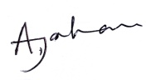 Date: 07.02.2016

**Reviewed by:** M Faridul Islam Designation: Social Management Specialist, MGSP,LGED



Signature: Date: 07.02.2016

**_________________________________________________________________________**

A social screening report prepared for each subproject covering methodology, participants’ analysis, community agreements & their concerns/suggestions, & summary of impacts and mitigation requirements.

**FORM 1: SCREENING FORM FOR SOCIAL SAFEGUARDS ISSUES**

**SCREENING**

**A. Identification**

1. Name of ULB: Narayangonj City Corporation District:Narayangonj

Ward / Mahalla: 25 Upazila: Bondor

2. Subproject/spot screened: (b) Beautification of NCC own Pond with Coffee shops & electrification at North Lakhyankhola in ward no-25

3. Project component: a) Earth work in excavation, b) Sand filling, c) Soling, d) C.C work, e) RCC work, f) Tiles, g) Brick work h) M.S. rod, &i) Electrification, Semi Pucca Building.

4. Brief description of the physical works:This pond is located at 25 no. ward and owned by NCC. As a part of beautification, electrification, lighting and coffee shops are required. This will enhance the recreational facilities and social benefit.

.

**5. Screening Date(s):** 26/01/16

**B. Participation in Screening:**

6. Names of Consultants’ representatives who screened the subproject:

1. Mr. M Faridul Islam, Social Management Specialist, MGSP, LGED,
2. Mr.Mortuza Reza, Senior Municipal Engineer,MGSP,LGED,
3. Ms.AkhterJahan, Social Management Officer, MGSP, LGED,
4. Mr. Md.Rezaul Karim, Assistant Municipal Engineer, MGSP, LGED,
5. Mr. Md.Monjurul Islam, Pavement Design Engineer, MGSP, LGED&
6. Mr. Md.Mahbubur Rahman, Environment Safeguard Specialist, MGSP, LGED.

7. Names of ULB officials participated in screening:

(1) Mr.Abdul Aziz, Superintending Engineer,Narayangonj City Corporation,

(2) Mr.Ismail Chowdhury, Executive Engineer, Narayangonj City Corporation,

(3) Mr. A S M Moshiur Rahman, Assistant Engineer, Narayangonj City Corporation&

(4) Mr.ShafiulAlam Chowdhury, Sub-Assistant Engineer, Narayangonj City Corporation.

8. WLCC members, NGOs, community groups/CBOs participated in screening:Copy attached.

9. Would-be affected persons participated in screening: N/A

**C. Land Requirements & Ownership:** ULB.

|  |  |  |
| --- | --- | --- |
| 10. Will there be a need for additional lands to carry out the intended works under this contract? | [ ] yes | [√] No |

11. If ‘Yes’, what will the additional lands be used for? (Indicate all that apply): N/A

[ ] road widening

[ ] curve correction

[ ] construction/expansion of physical structure

[ ] strengthening narrow eroding road section between high and low lands

[ ] others (Mention): Drain Construction

12. If ‘Yes’, the required lands presently belong to (Indicate all that apply):N/A

[ ] ULB

[] Government – RHD’s ROW & other GOB agencies

[ ] Private Citizens

[ ] Others (Mention): N/A.

D. Current Land Use & Potential Impacts:

13. If the required lands belong to Private Citizens, they are currently used for (Indicate all that apply):

[ ] Agriculture Number of households using the lands: N/A

[ ] Residential purposes Number of households using them: N/A

[ ] Commercial purposes Number of persons using them: N/A,

No. of shops: N/A

[ ] Other Uses (Mention): N/A No. of users: N/A

Land does not belong to private citizen.

14. If the required lands belong to ULB and/or other Government agencies, they are currently used for (Indicate all that apply):

[ ] Agriculture Number of persons/households using the lands: N/A

[ ] Residential purposes Number of households living on them: N/A

[ ] Commercial purposes Number of persons using them: N/A, No. of shops: N/A

[√] Other Uses (Mention): Bathing and washing No. of users: Few

15. How many of the present users have lease agreements with any government agencies? : N/A

16. Number of private homesteads that would be affected on private lands:

Entirelyrequiring relocation: N/A.

Partially, but can still live on present homestead: N/A.

Additional lands’ mean lands beyond the carriageways and shoulders in case of roads and outside currently used space for: N/A

17. Number of business premises/buildings that would be affected on private lands: N/A

Entirely and will require relocation: N/A…….#of businesses housed in them…..N/A

Partially, but can still use the premises: N/A….# Of businesses housed in them..N/A

18. Residential households will be affected on ULB’s own and & public lands: N/A

Entirely affected and will require relocation:

No. of these structures: N/A

No. of structures built with brick, RCC, & other expensive and durable materials: N/A.

No. of structures built with inexpensive salvageable materials (bamboo, GI sheets, etc: N/A

Partially affected, but can still live on the present homestead: No. of structures: N/A

No. of structures built with brick, RCC, & other expensive and durable materials: N/A

No. of structures built with inexpensive salvageable materials (bamboo, GI sheets, etc): N/A

19. No of business premises that would be affected on ULB’s own & other public lands: Yes

Entirely affected and will require relocation:

No. of these structures: N/A.

No. of businesses housed in these structures: N/A

No. of persons presently employed in the above businesses: N/A

No. of these structures built with brick, RCC, & other durable materials: N/A

No. of structure built with inexpensive salvageable materials (bamboo, GI sheets, etc): N/A

Partially affected, but can still stay in the present no. of these structures……. N/A

No. of businesses housed in these structures: N/A

No. of persons presently employed in these businesses: N/A

No. of these structures built with brick, RCC, & other durable materials: N/A

No. of structure built with inexpensive salvageable materials (bamboo, GI sheets, etc): N/A

20. None of businesses/trading activities that would be displaced from make-shift structures on the road, and other areas/spots: sufficient free spaces available.

21. Do the proposed subproject works affect any community groups’ access to any resources that are used for livelihood purposes? [ ] Yes [√] No

22. If ‘Yes’, description of the resources: N/A

23. Do the proposed works affect community facilities like school, cemetery, mosque, temple, or others that are of religious, cultural and historical significance? [ ] Yes [√ ] No.

24. If ‘Yes’, description of the facilities: N/A.  
25. Describe any other impacts that have not been covered in this questionnaire? N/A.

26. Describe alternatives, if any, to avoid or minimize use of additional lands: N/A

**E. ADDITIONAL INFORMATION ON TRIBAL PEOPLES** (This section must be filled in if subprojects are located in areas that are also inhabited by tribal peoples)

27. Names of tribal community members and organizations who participated in screening:

N/A

28. Have the tribal community and the would-be affected TPs been made aware of the potential positive and negative impacts and consulted for their feedback and inputs?

[ ] Yes [√] No

Has there been a broad-based community consensus on the proposed works?

[ ] Yes [√] No

29. Total number of would-be affected tribal households: N/A.

30. The would-be affected tribal households have the following forms of rights to the required lands: N/A

[ ] Legal: No. of households:

[ ] Customary: No. of households:

[ ] Lease agreements with any GOB agencies: No. of households:

[ ] Others (Mention): No. of households:

31. Does the subproject affect any objects that are of religious and cultural significance to the IPs? [ ] Yes [√] No

32. If ‘Yes’, description of the objects: N/A.

33. The following are the three main economic activities of the would-be affected tribal households:

a. N/A

b. N/A

c. N/A

34. Social concerns expressed by tribal communities/organizations about the works proposed under the subproject: N/A

35. The tribal community and organizations perceive the social outcomes of the subproject:

[ ] Positive [ ] Negative [√ ] Neither positive nor negative

**On behalf of the DSM Consultant, this Screening Form has been filled in by:**

**Prepared by:**

Name:AkhterJahan, Designation: Social Management Officer, MGSP, LGED.

Signature: 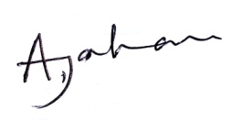 Date: 07.02.2016

**Reviewed by:** M Faridul Islam Designation: Social Management Specialist, MGSP, LGED,

Signature:  Date: 07.02.2016.

