** Government of the People’s Republic of Bangladesh**

**Ministry of Local Government, Rural Development & Co-operatives**

**Local Government Division**

**Local Government Engineering Department**

**Municipal Governance and Services Project (MGSP)**

**IDA Credit No: 5339-BD**

**Name of Subproject Name of Subproject** A) Construction of RCC/BC Road and Street light starting from Trishal Jatio Kobi Kazi Nazrul Islam University Road from Trishal Kacha Bazar to End of Pourashava Border by RCC & Bituminus Carpeting road under Trishal Pourashava (Ch 00-2500m) and Construction of RCC Box Culvert Size 1\*3.00m\*2.00m atCh.1226-1229m and 1\*2.00m\*2.00 at Ch2029m-2031m.

(B) Rehabilitation of RCC drain with footpath starting from Trishal Jatiya Kabi Kazi Nazrul Islam University road, Trishal Kacha bazar to End of pourashova border by RCC drain under Trishal Pourashova (Ch 00 - 1740m).

**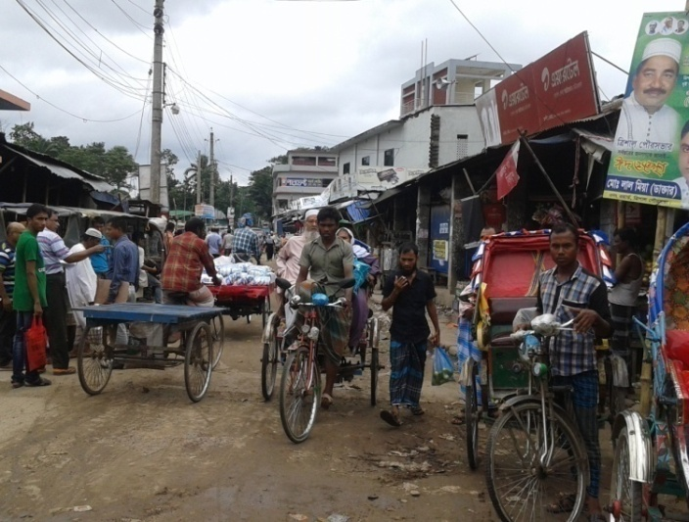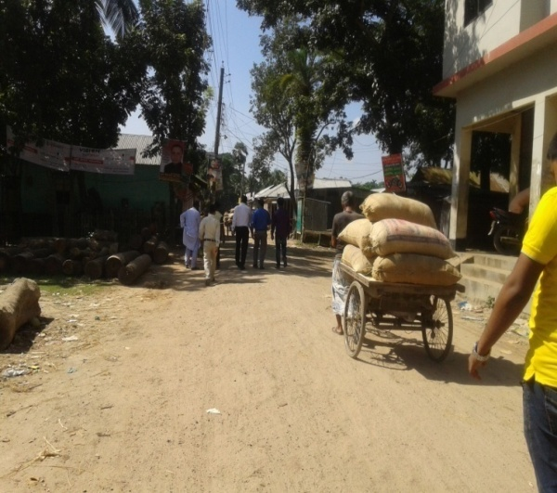**

**Social Management Plan**

**Package No:** MGSP/TRI/2016-17/W-03,

Trishal Pourashava,

Mymensingh

**Design, Supervision, and Management (DSM) Consultancy Services**

Joint Venture of

*Hifab International AB, Sweden*

*AQUA Consultant & Associates Ltd., Bangladesh*

**January 2017**

**Social Management Plan**

|  |  |  |
| --- | --- | --- |
| **No** | **Contents** | **Page No** |
|  | **Abbreviations** | **3** |
| 1. | Introduction | 5 |
| 1.1 | Project Background | 5 |
| 1.2 | Legal and Policy Framework | 5 |
| 1.3 | Subproject Description | 5 |
| 1.4 | Social Management Plan | 7 |
| 2. | Description of Subproject Area | 7 |
| 2.1 | Brief Profile of Bhaluka Pourashava | 7 |
| 2.2 | Historical and Cultural Heritage Sites | 10 |
| 2.3 | The Subproject Location and Area Profile | 11 |
| 2.4 | Beneficiary Communities and Affected Persons | 11 |
| 2.5 | Gender and Vulnerability | 12 |
| 3. | Social Impact Assessment | 13 |
| 3.1 | Benefits of the Subproject | 13 |
| 3.2 | Social Screening and Safeguard Compliance Issue | 13 |
| 4. | Consultation and Community Participation | 13 |
| 4.1 | Stakeholder Analysis | 13 |
| 4.2 | Consultation and Participation Process | 14 |
| 4.3 | Consultation Outcomes – Issues, Concerns and Recommendations | 15 |
| 5. | Social Management Plan (SMP) | 15 |
| 5.1 | Subproject Selection Process | 15 |
| 5.2 | Subproject Design Process | 16 |
| 5.3 | Implementation | 16 |
| 5.3.1 | Institutional Arrangement | 16 |
| 5.3.2 | Consultation and Participation | 16 |
| 5.3.3 | Grievance Redress Mechanism (GRM) | 16 |
| 5.3.4 | Problem During Implementation and Mitigation | 17 |
| 5.3.5 | Labor Management | 17 |
| 6. | Monitoring and Evaluation Framework | 17 |
| 7. | Conclusions on Social Management Plan (SMP) | 19 |
| **FIGURE** | |  |
| 1. | Area map of Bhaluka Pourashava | 8 |
| 2. | Present Condition of Subproject Area | 11 |
| 3. | Participation and Consultation Meeting | 15 |
| **ANNEXURE** | |  |
| 1. | Social Screening Report | 20 |
| 2. | Layout Plan | 41 |
| 3. | Land ownership document | 42 |
| 4. | CIP Minutes of Meeting | 43 |

**Abbreviations**

|  |  |
| --- | --- |
| ARP | Abbreviated Resettlement Plan |
| BMDF | Bangladesh Municipal Development Fund |
| CBO | Community Based Organization |
| CC | Cement Concrete |
| CIP | Capital Investment Plan |
| CUL | Compensation-Under-Law |
| DC | Deputy Commissioner |
| DLAC | District Land Acquisition Committee |
| DUTP | Dhaka Urban Transport Project |
| GoB | Government of Bangladesh |
| GRC | Grievance Redress Committee |
| GRM | Grievance Redress Mechanism |
| HCG | House Construction Grant |
| HTG | House Transfer Grant |
| IDA | International Development Association |
| IP | Indigenous People |
| IPP | Indigenous Peoples Plan |
| KII | Key Informant Interviews |
| FGD | Focus Group Discussion |
| LGD | Local Government Division |
| LGED | Local Government Engineering Department |
| M & S | Management &Supervision |
| MGSP | Municipal Governance and Services Project |
| MOLGRDC | Ministry of Local Government, Rural Development & Cooperatives |
| MSP | Municipal Services Project |
| MSL | Mean sea Level |
| NGO | Non-governmental Organization |
| PAH | Project Affected Household |
| PAP | Project Affected Person |
| RAP | Resettlement Action Plan |
| PMU | Project Management Unit |
| RCC | Reinforced Concrete Cement |
| RP | Resettlement Pan |
| SIA | Social Impact Assessment |
| SMP | Social Management Plan |
| SSS | Social Safeguards Specialist |
| TLCC | Town Level Coordination Committee |
| ULB | Urban Local Body |
| WB | World Bank |
| WC | Ward Committee |
| DSM | Design, Supervision, and Management |

**1. INTRODUCTION**

***1.1 Project Background***

The Government of Bangladesh, through the Local Government Engineering Department (LGED) and Bangladesh Municipal Development Fund (BMDF) is implementing the Municipal Governance and Services Project (MGSP). The project aims to improve municipal governance and basic urban services in participating ULBs. Two physical components of the project include (i) Municipal Governance and Basic Urban Services Improvement (Component 1) to provide financial support to 26 pre-identified urban local bodies (ULBs) including municipalities and city corporations, and demand-based sub-credits to eligible ULBs for basic urban services improvement investment costs, at an 80:20 grant to loan ratio (Component 2). LGED is implementing the Component 1 while BMDF is implementing component 2 of the project.

LGED is supporting the 26 pre-selected ULBs for investments in development and rehabilitation of Road, Bridge, Box-culvert, Pedestrians bridge, street light, Traffic Control, Bus terminal, Truck terminal, Boat landing Jetty, Drain, Retaining wall, Kitchen market, Cattle market, slaughter house, Public toilet, Solid waste management, Sweeper colony, Park, Community Centre and Whole sale market. LGED is financing through (i) base allocation based on population category of ULBs; (ii) performance-based allocation and (iii) operations and maintenance support on a declining basis over the project period. The component interventions have largely been developed for construction and rehabilitation within existing available land owned by the ULBs. However, acquisition of land and displacement of people may be involved for unavoidable circumstances as critical requirements. Subprojects may also be undertaken in areas inhabited by tribal peoples. The ULBs will, however, address the land acquisition, population displacement and tribal people’s issues following the country’s legal framework and the World Bank policy on social safeguards.

***1.2 Legal and Policy Framework***

Given the approach of subproject preparation and implementation, the World Bank’s Operational Policy (OP) on Involuntary Resettlement (OP 4.12) and on Indigenous Peoples (OP 4.10) triggered to the project. A Social Management Framework (SMF) has been adopted by LGED for the project that meets the requirements of the country’s legal frameworks in Bangladesh “The Acquisition and Requisition of Immovable Property, Ordinance, 1982” and the Bank requirements including OP 4.12 and OP 4.10. The SMF also requires that subprojects are prepared ensuring inclusion, participation, transparency, and social accountability. Subprojects are prepared by respective ULBs in a process complying with the SMF requirements. LGED reviews the subproject proposals for technical, engineering, environmental, social development, and safeguards compliance before allocation of the financing to the ULBs.

Social Management Plans (SMP) will be prepared and implemented for subprojects with no land acquisition or involuntary displacement of people, while Resettlement Action Plans (RAP) and Tribal Peoples Plans (TPP) ) will be prepared for implementation for subprojects involving population displacement and tribal peoples’ issues.

***1.3 Subproject Description***

This package is located at ward no 1, 2, and 3 at Trishal Pourashava. This package (MGSP/TRI/2016-17/W-03) also includes BC and RCC road, drain, streetlight and footpath.

A) Construction of RCC/BC Road and Street light starting from Trishal Jatio Kobi Kazi Nazrul Islam University Road from Trishal Kacha Bazar to End of Pourashava Border by RCC & Bituminus Carpeting road under Trishal Pourashava (Ch 00-2500m) and Construction of RCC Box Culvert Size 1\*3.00m\*2.00m atCh.1226-1229m and 1\*2.00m\*2.00 at Ch2029m-2031m.

2500m RCC/BC road will be constructed under the subproject. The existing average pavement width of the road is 3.65m.The proposed pavement width of the road will be 6m. Some portion of the road will be RCC and some portion of the road will be BC. Length of BC portion is 2040m (Ch 0+260m to 1+400m=1140m and Ch 1+600m to 2+500m=900m). Rest part will be RCC. Damage 2 nos Box culverts will be replaced by new RCC box culverts. Some protective works also proposed for the subproject. Several types of shops, houses, market, mosque, female madrasha, Jatio Kobi Kazi Nazrul University, residential houses, Nazrul Institute, Nazrul Academy, agricultural land etc. are situated beside the both sides of road. The first portion of the subproject area is being used as business purpose. The second portion is as household purpose and the third portion is being used as agricultural land. This one is an important road of Trishal Pourashava. As the road is badly damaged, it hampers the normal traffic. All types of vehicles and padestrians face problems due to pot holes and rough surfaces in various segments. For meeting up the traffic load, improvement of the road is required. For implementation of this subproject, 34 electric poles will be required to removed .

Street lighting is a vital element in creating safe town. In absence of sufficient street light at this area, is hampering the normal traffic and security at night time. Street light will improve safety for drivers, riders, and pedestrians. Under the circumstances, street light is proposed for this subproject (Ch 0+000 to 1+700km).Sixty no of street light with poles will have to be installed. During the road condition survey, it is observed that at Ch.0+280-0+325m,Ch 0+358-0+383m and Ch.0+445-0+482m need protective work for road protection.

(B) Rehabilitation of RCC drain with footpath starting from Trishal Jatiya Kabi Kazi Nazrul Islam University road, Trishal Kacha bazar to End of pourashova border by RCC drain under Trishal Pourashova (Ch 00 - 1740m).

Trishal is a category “A” type pourashova. This subproject is located at word no 1, 2 and 3. The subproject area is basically built up area used for both residential and commercial purposes. Trishal Pourashova is a densely populated area. In the municipality area, insufficient, damaged, and inadequate drainage system causes severe drainage congestion especially during the rainy season. This proposed drain will improve the drainage facilities of the municipality. The proposed drain connects with the existing drain of the main road and Sukni Beel which will use as outfall. In rainy season, water accumulates on top of the road which causes severe damage to the road top and many cracks, depressions; potholes appeared due to logging of water, because there is no drain beside the road. For this reason, all type of vehicles face problems. There will be cover slab on the drain which will work as footpath. To remove water logging from top of the road and protect the road from damage, it is necessary to provide RCC drain with adequate section of the proposed RCC drain is divided into five segments. Segments which are 1: Ch 0+585 m. segment -2: 0+260m. Segment -3: Ch 0+110 m. Segment -4: Ch 0+475 m and segment -5: Ch 0+310m. The length of the proposed drain will be 1740m.

Proposed length of the road, drain and number of street light are given in the following table.

|  |  |
| --- | --- |
| **Name of component** | **Length/Number** |
| Rehabilitation of road. | 2500m |
| Rehabilitation of drain | 1740m |
| Construction of Box culvert. | 2 nos |
| Street Light | 60 nos |
| Environmental work | 2500m |

This road and drains need to be constructed and street light will be placed. These will improve the water logging problem and it will provide safe and easy movement for the buyers, wholesalers, local people of different professions, and students.

***1.4 Social Management Plan***

Initially, the subproject proposal includes a social screening report along with impact assessment. This Social Management Plan (SMP) has been prepared for the identification of subproject and managing social concerns in the process of subproject design and implementation. After reviewing the social screening report by Social Unit of DSM, this subproject proposal is submitted to the PMU office. Social team of the DSM has carried out a site visit and consulted with the Trishal Pourashava officials, stakeholders and a section of the beneficiary communities through interview and participation & consultation meeting. The social screening findings and consultation method and proceedings were validated through the social survey and consultation.

The purpose of preparing this SMP is to demonstrate the all-inclusive consultative process in selection and design of the subproject as well as to provide guidance for social development and safeguards compliance in the implementation process.

The SMP contains a description of the subproject areas, social screening and impacts, consultation process adopted during identification and design, and consultation plan for implementation stage, impact mitigation measures, grievance resolution process, and implementation arrangements, and monitoring and evaluation.

Pourashava will ensure participation of the communities and grievance resolution in the process of implementation of the subproject through GRC.

**2. DESCRIPTION OF SUBPROJECT AREA**

**2.1 Brief Profile of Trishal Pourashava**

Trishal Pourashava is located in the core of Trishal Upazila under Mymensingh District.Trishal Pourashava is surrounded ` Mathbari union and Fulbaria Upazila at the west Balipara union at the east, Baliar union at the north and Horirampur union at the south. Dhaka- Mymensingh Highway passes through the heart of the Pourashava. The Pourashava was established in 1998.According to BBS 2011, the total population of Trishal is 34747 (BBS sensuous 2011) in which 17943 are male and 16804 are female. The male female ratio is 111:100; density of population is 1,642 per sq.km.

It has a very good connection with Dhaka by road. The Pourashava is well-linked with the district headquarters of Mymensingh, Sherpur, Netrokona by road network. The Pourashava has also good transportation linkage with Bhaluka, Fulbaria and Goforgaon Upazilas of Mymensingh district. This town can contribute towards transportation of agrarian economy as an industrial one. Trishal Pourashava is a class “A” Pourashava. Its area is 15.49 sqkm.

Part of Ward no.1, Ward no.8 and Ward no 3 rank high in terms of agricultural use of land. These areas have distinct rural character. Residential uses are spread over mainly along the roads. Residential use mostly covered the part of Ward No 8, 9 and 3. Residential uses are mostly concentrated on central part of Pourashava area.

The commercial activities are mostly developed along the roads i.e. Dhaka-Mymensingh road and concentrated highly on core area of the town.

Among the industries, rice mills cover the major part. Significant number of saw mill and bakery are also situated here. Industry is distributed scatter all over the Pourashava area.

The Pourashava is headed by the Mayor. It is run by a joint staff of elected public representatives and government official. The Pourashava has 9 councilors and 3 elected women councilors from 9 wards.

**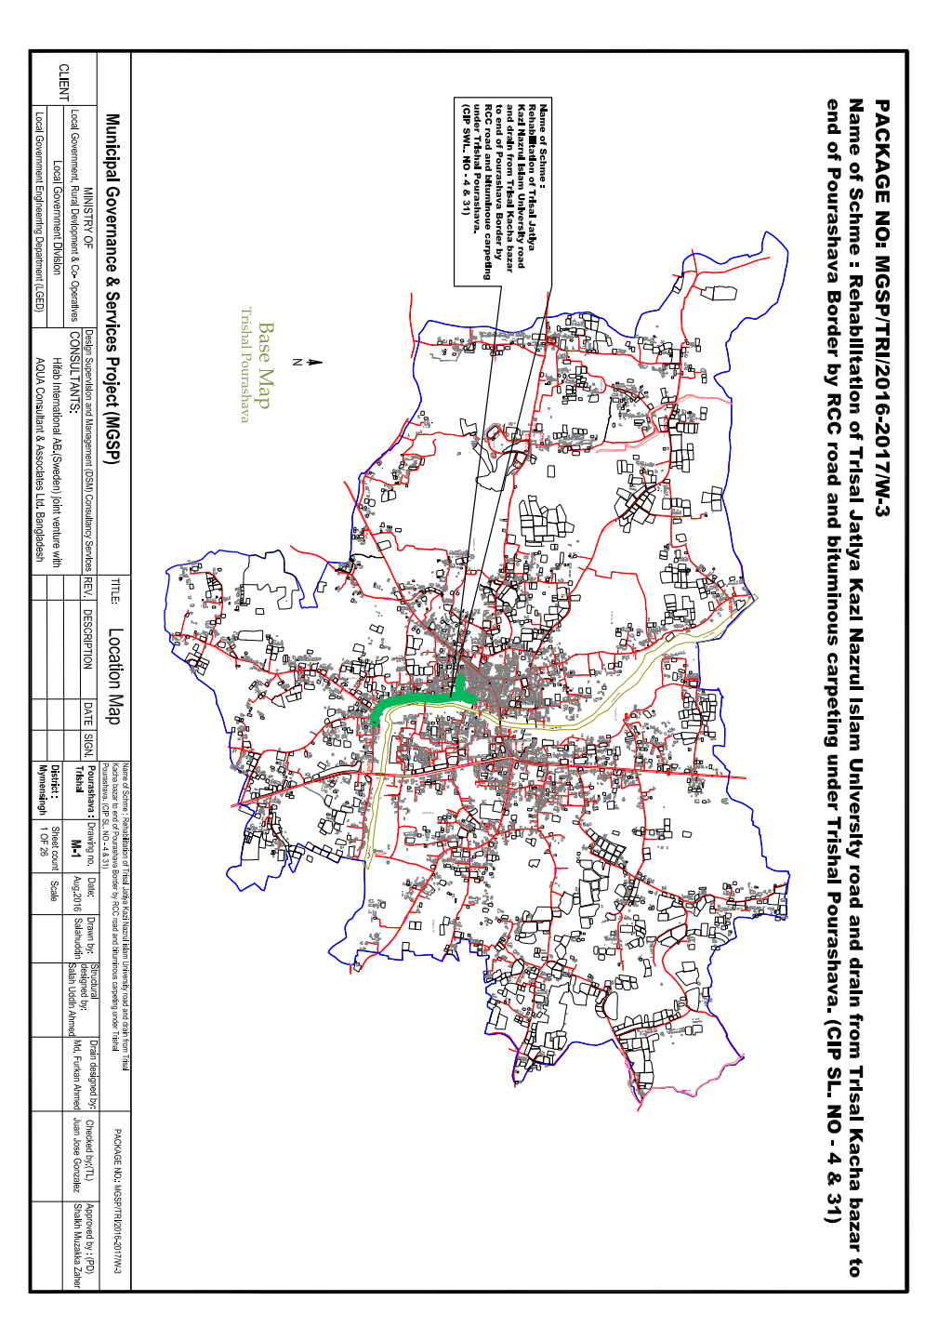**

**Figure 1: Area Map of Trishal Pourashava**

**At a glance Trishal Pourashava**

|  |  |  |
| --- | --- | --- |
| ***General Information*** | | |
| *Area* | *:* | 15.49 Sqm. |
| *Wards* | *:* | 9 Nos. |
| *Population*  *Population Growth Rate*  *Households*  *Population Density*  *Major Status*  *Main Income Sources* | *:*  *:*  *:*  *:*  *:*  *:* | 34,747 Nos.  1.04  22.61 Nos.  Business.  Service, Business, Agriculture etc. |

|  |  |  |
| --- | --- | --- |
| ***Tax*** | | |
| *Holding Tax (People Property)* | *:* | 5378 |

|  |  |  |
| --- | --- | --- |
| ***Market*** | | |
| *Markets* | *:* | 2 Nos. |
| *Private Shops* | *:* | 1092 Nos. |

|  |  |  |
| --- | --- | --- |
| ***License*** | | |
| *Trade Licenses* | *:* | 1472 Nos. |
| *Rickshaw Licenses* | *:* | 220 Nos. |

|  |  |  |
| --- | --- | --- |
| ***Communication Infrastructure*** | | |
| *Road* | *:* | 85.00Km. |
| *a) Bituminous* | *:* | 25.00 Km. |
| *b) CC* | *:* | 8.00 Km |
| *c) RCC* | *:* | 4.00 Km. |
| *d) Brick Flat Soling* | *:* | 7.50 Km. |
| *e) Non-paved Roads* | *:* | 40.50 Km. |
| *Culverts* | *:* | 24 Nos. |
| *Bridges* | *:* | 4 Nos. |

|  |  |  |
| --- | --- | --- |
| ***Water Supply*** | | |
| *Capacity* | *:* | - |
| *Deep Tube wells* | *:* | 5 Nos. |
| *Pipe Lines* | *:* | 13.90 Km. |
| *House Connection* | *:* | 520 Nos. |
| *Street Hydrant* | *:* | 6 Nos. |
| *Pump Station/ house* | *:* | 3 Nos. |
| *Pumping Hour* | *:* | 4.50 Hour per day. |

|  |  |  |
| --- | --- | --- |
| ***Street Lighting*** | | |
| *Electricity Line* | *:* | 35 Km. |
| *Light Posts* | *:* | 835 |
| *Energy Savings Light Point s* | *:* | 835 |
| *Meter or Switch Points* | *:* | 10 Nos. |

|  |  |  |
| --- | --- | --- |
| ***Vehicle*** | | |
| *Garbage Trucks* | *:* | 3 Nos. |
| *Jeeps* | *:* | 1 Nos. |
| *Motorcycles* | *:* | 3 Nos. |
| *Hydraulic Beam Lifters* | *:* | 1 Nos. |
| *Road Rollers (4 ton – 6 ton)* | *:* | 3 Nos. |

|  |  |  |
| --- | --- | --- |
| ***Drainage System*** | | |
| *Drain* | *:* | 11.75 Km. |
| *a) RCC or Brick Lined Drains* | *:* | 7.75 Km. |
| *b) Earthen Drains* | *:* | 4.20 Km. |
| *Canal* | *:* | 4.00 Km. |

|  |  |  |
| --- | --- | --- |
| ***Public Health*** | | |
| *Public Toilets* | *:* | 4 Nos. |
| *Sanitary Latrines* | *:* | 4032 Nos. |
| *Dustbins* | *:* | 8 Nos. |
| *EPI Centre Permanents* | *:* | 13 Nos. |
| *Hospitals* | *:* | 1 No. |
| *Maternity Clinics* | *:* | 1 No. |
| *Private Clinics* | *:* | 4 Nos. |

|  |  |  |
| --- | --- | --- |
| *Mosques* | *:* | 36 Nos. |
| *Eidghahs* | *:* | 8 Nos. |
| *Temples* | *:* | 6 Nos. |
| *Graveyards* | *:* | 1 No. |
| *Burning Ghats* | *:* | 1 No. |

|  |  |  |
| --- | --- | --- |
| ***Law &Order*** | | |
| *Police Stations* | *:* | 1 |

|  |  |  |
| --- | --- | --- |
| ***Education*** | | |
| *Public University* | *:* | 1 |
| *Govt Colleges* | *:* | 1 No. |
| *Private Colleges* | *:* | 5 Nos. |
| *Madrashas* | *:* | 3 Nos. |
| *Govt High Schools* | *:* | 1 Nos. |
| *Non-Govt High Schools* | *:* | 5 Nos. |
| *Govt Primary Schools* | *:* | 8 Nos. |

|  |  |  |
| --- | --- | --- |
| ***Recreation*** | | |
| *Cinema Halls* | *:* | 1 No. |

|  |  |  |
| --- | --- | --- |
| ***Communication*** | | |
| *Bus Stations* | *:* | 1 No |
| *T & T Office* | *:* | 1 No. |
| *Post Offices* | *:* | 1 No. |

***2.2 Historical and Cultural Heritage Sites***

**Historical events**: The reminiscences of national poet Kazi Nazrul Islam’s boyhood are still visible at different places under Trishal Pourashava in Mymensingh district. Jatioyo Kobi Kazi Nazrul University, Nazrul Academy, Nazrul Museum are situated at the Pourashava area on his memory. It is the place where innumerable boyhood memories of our national poet Kazi Nazrul Islam are found around. It is situated 20 km. away from Mymensingh town. This place is Trishal. He was born in Burdwan district (presently in West Bengal, India, in 1899) Nazrul was a student of Darrirumpur High School under Trisal police station. Here a cultural organization title as Nazrul Academy has been established in memory of the great poet. Rebel poet Kazi Nazrul, the Shelley of Bangladesh is in eternal sleep besides Dhaka University Central Mosque.

Nazrul Academy and Nazrul Museum are also situated at the Pourashava area. Subproject implementation will not hamper these structures. Once the subproject is implemented people can visit these places easily.

***2.3 The Subproject Location and Area Profile***

The subproject cover1, 2, 3 wards under Trishal pourashava.

The subproject connect Trishal Bazar,Trishal Charpara, Trishal Nowapara localities with the main town. There are 4 mosques, Muktijoddha complex, Madrasha, High School, primary school, 2 kindergarten Schools, Nazrul museum, Nazrul Academy located beside the road. Jatiya Kabi Kazi Nazrul Islam University is also situated beside the road.

It is observed that the first portion of the subproject is used for business purpose, second portion is used for household purpose and third portion is mainly agricultural land.

There is no drainage system at the proposed subproject area. In absence of a proper drainage system, traffic load and rainy season water accumulates on top of the road which causes severe damage to the road top and many cracks, depressions, potholes appeared due to logging of water, because there is no drain beside the road.

Population of ward no 1 is 3001 (male-1541, female-1460), ward no 2 is 4606 (male-2374, female-2232), ward no 3 is 4288 (male-2172, female-2116). (BBS, 2011).

|  |  |  |
| --- | --- | --- |
| F:\All ULB Pic\TRI\trishal kazi nazul road\20160810_144737.jpg | F:\All ULB Pic\TRI\trishal kazi nazul road\20160810_144551.jpg | F:\All ULB Pic\TRI\trishal kazi nazul road\20160810_144539.jpg |
| Figure1: : Present condition of the subproject area, Trishal.Dated:10.08.2016 | | |

***2.4 Beneficiary Communities and Affected Persons***

The subproject components cover ward no.01, 02 and 03. The total population of Pourashava as enumerated in 2011 Census is 34,747 of which 17,943 are males and 16,804 are females. Due to implementation of these subprojects, total no of 11,895 populations of these 3 Wards will directly be benefitted. The other people who live in the Trishal Pourashava as well as the people who travel by using this road will be indirectly benefited, saving travel time and avoiding traffic congestion. There is no presence of tribal people in the subproject influence areas in these wards.

The subproject components are road development (2500m), streetlight (60 nos), and drain construction (1740m). It is noted here that there is no affected person in these subprojects.

According to BBS, 2001, the main source of household income in Trishal Pourashava are as: Business 29.99%, agriculture, livestock, forestry 16.88%, Service 14.42%, fishery 0.14%, agricultural labor 10.40%, industry 0.75%, hawker 0.18%, rent 0.16%, religious service 0.14% nonagricultural labor 4.98%, transport 7.31% and others 23.85%.In addition, there are some people who are rickshaw pullers, semi and skilled laborers, carpenters, small traders and poor people. It is also noted here that above mentioned people will be benefited from these subprojects.

***2.5 Gender and Vulnerability***

In compliance with LGED’s gender strategy, Gender Action Plan (GAP) and Bank policy on gender, this subproject proposed the following principles, guidelines and procedures to identify gender actions in respect of subproject interventions and include those actions in subproject SMP (Social Management Plan). To mainstream gender in the subproject process, MGSP has applied the following basic principles in selection, design, implementation and monitoring of the subproject.

Gender analyses for the subproject has taken into account of general and specific gender concerns and social vulnerabilities and identified specific actions in term of religious and age which are as follows:

* 1. **Promote women’s participation in subproject planning and implementation**

For the preparation of subproject planning, women participation has been ensured through group discussions and hot-pot consultation. Moreover, vulnerable women have also been involved in subproject planning preparation during the outset stage of the subproject preparation.(Participation and Consultation meeting list attached with social screening)

* 1. **Maximize women’s access to subproject benefits**

During implementation of the subproject, women will have scope to move easily from one place to other places for their household activities, sending their children to school and they can easily do their small business which will generate income and change their livelihoods which has been understood through discussion with the community people.

* 1. **Minimize social vulnerability.**

In this subproject, there are approximately vulnerable men and women who are identified through the public consultation and participation meeting. This subproject will give more emphasis to reduce the social vulnerability in terms of socio-economic development.

* 1. **Ensure that women are involved in selection, design, implementation, and monitoring and evaluation of the subproject activities including resettlement issues.**

In this subproject, women will be involved in the implementation and monitoring through disclosure meeting which will contribute for the quality improvement of the subproject.

* 1. **Identify appropriate actions to ensure and maximize subproject benefits to women through the consultative process.**

During implementation of the subproject, women communities will easily have a scope of new job opportunities in the road construction and also sell their homestead products in the nearby urban market.

* 1. **Women are involved in civil works construction of this subproject, ensure: (i) equal pay for equal work; (ii) gender friendly work environment; and (iii) work place safety for women and children.**

During construction of the subproject, the project authority will ensure equal pay for equal work and ensure work place safety for women, create gender friendly work environment.

Trishal Pourashava is responsible for managing social issues including gender and vulnerability issues in the subproject area. Moreover, after implementation of the subproject, women movement and income generation activities will increase because vehicle movement will also increase due to improved road condition.

**3. SOCIAL IMPACT ASSESSMENT**

***3.1 Benefits of the Subproject***

After implementation of the subproject components, people will use this road for inter-town and intra-town movement because of the higher accessibility. The increase in property and land value of nearby areas essentially represents a capitalization of the access cost savings and travel time savings associated with those locations, including this value in a regional or national economy. From a view of social benefits, it increases the public transport trips per day and additional regional employment generation is expected. After construction of this road including street lights, people will move easily and safely. The business activities will increase as the micro entrepreneurs covering men and women will bring the commodities from the town easily and sell the necessary goods. (outcome of interview with subproject communities). Even vulnerable women will have new scopes for the employment opportunities with required income generating activities.

After construction of the road, this will open new scopes of jobs for local people. More people will be engaged in the transportation sector.

***3.2 Social Screening and Safeguard Compliance Issue***

After selection of the subproject from the CIP list, the Pourashava with the assistance of DSM Consultants has completed a social screening for the subproject using an inclusive and participatory approach.

Trishal Pourashava has ensured the implementation of subproject following socially inclusive and gender friendly. According to engineering design, implementation of the subproject will be carried out within the existing right-of-way. There is no resettlement issue.

Results from the social screening are given below.

* No additional public or private lands will be required for the subproject outside the existing right of way.
* No private, public, community, or cultural property of any kind of service delivery facilities as well as commercial activities will be affected.
* Preparation of RAP will not be required for implementing the subproject.
* Agricultural or industrial productivity will not be hampered by the proposed subproject areas because the area is almost rural area surrounded by agricultural field.

The outcomes of social screening also confirm that local people across the subproject are positive about its implementation.

**4. CONSULTATION AND COMMUNITY PARTICIPATION**

***4.1 Stakeholder Analysis***

As a part of the overall assessment, the subproject identified the key stakeholders of the proposed subproject areas and assessed the power relationships as well as influence and interests of stakeholders involved in the development work of the subproject. Key stakeholders for subproject were identified in consultation with the Mayor and officials of Bhaluka Pourashava, local administration, civil society and local people of towns, representatives of business associations, local contractors for infrastructure development, road users, vulnerable communities etc. Both males and females will be benefitted directly and indirectly by the improvement of this subproject. Stakeholder analysis are shown billow.

| **Stakeholder** | **How** | **ULB/Local people** | **Analysis** |
| --- | --- | --- | --- |
| Rickshaw pullers | Road users. | During meeting with pourashava officials and local people it is informed that about 250 rickshaw pullers are driving in the pourashava areas. | Rickshaw pullers are directly benefited by the subproject. After implementation of the subproject, rickshaw pulling will be easier and safer to them. |
| Women | Road users. | During meeting with community people | Women movement will be easier due to vehicle movement will increase and street light will ensure to move the road safer. |
| Vulnerable persons | Road users. | During meeting with pourashava officials and local people. | They can easily move for their work even in the night time. |
| Service holders | Road users. | During meeting with community people | Service holders will reach their offices easily by using vehicle or walking on foot. Even night movement will be easier to them. |
| Students | Road users | Consultation meeting with the communities | Through the consultation with the communities, students can easily reach to their educational institutions by using rickshaws and also walking on foot. |
| Business men/traders | Road users | During consultation meeting with community. | Micro, small, medium and large business entrepreneurs will increase the scopes for doing better business. |

In addition, many professions of people will use the road for their day to day normal activities and also increase their livelihood.

***4.2 Consultation and Participation Process***

The participatory public consultations were conducted in the subproject areas. Key Informant Interviews (KII) and group discussions were conducted involving the participants of the Trishal Pourashava Mayor, Councilors, Pourashava Officials, representatives of local Communities and civil society members as well as the representative of local LGED office and the consultant team. A walk-through informal group consultation with the local communities was also held. Through this participation and consultation meeting, the local communities were disclosed about subproject implementation and benefits. Suggestions and recommendations made by the participants are incorporated in the SMP accordingly. The photographs of the consultation meetings may be seen below.

|  |  |
| --- | --- |
| F:\All ULB Pic\TRI\trishal kazi nazul road\20161016_131517.jpg | F:\All ULB Pic\TRI\trishal kazi nazul road\20161016_131559.jpg |
| *Figure 2:Participation and consultation meeting at Trishal. Dated: 10.08.2016* | |

***4.3 Consultation Outcomes – Issues, Concerns, and Recommendations***

The participants raised their issues related to subprojects improvement which mainly includes road, drain, street light. Feedback, suggestions and recommendations by the participants are listed below.

* Scheduled of Construction works should be ensured properly and the quality of construction work should be improved as per tender specification;
* By engaging active women, gender issues has been ensured
* Social safeguard compliance issues has been ensured through the inclusive participation of subproject beneficiaries in subproject implementation

**5. SOCIAL MANAGEMENT PLAN (SMP) FOR IMPLEMENTATION**

SMP will ensure the compliance of social management requirements including social safeguards for the subproject implementation of Trishal Pourashava in a participatory process. This plan will assist Project Implementation Unit (PIU) of the Pourashava by ensuring technical assistance covering subproject selection, design, and institutional arrangement using participation and consultation process and grievance resolution process for implementation and also giving involvement of labor in the project implementation activities. PMU, DSM and the Pourashava will also ensure monitoring and supervision of the subproject implementation etc.

***5.1 Subproject Selection Process***

According to the opinions and views of the Trishal Pourashava Mayor, civil society and community people, the subproject is important for the easy and safer movement of engine driven transport and electric battery driven taxi, rickshaws and vans as well as pedestrians like students, officials, villagers, and farmers to enter into the town. Farmers and women are selling their homestead garden vegetables with reasonable prices. Accordingly, MGSP in coordination with concerned Trishal Pourashava elected representatives, local administration, relevant stakeholders, and civil society members following the participatory approach in different stages of subproject selection, inclusion, consultation and participation methods. Female Ward Councilors participated actively in the selection process. Moreover, the representatives of TLCC and WC from the Pourashava have contributed in the subproject selection process with an analysis of the inclusiveness of the selection process.

At the time of selecting this subproject, Social screening with Trishal Pourashava urban communities, local administration, traders, buyers, and sellers were conducted by the Trishal Pourashava officials and Consultants from DSM. Views and opinions of these consultations were to explain the subproject objectives and sought feedback from the participants to maximize the social and economic benefits as well as to minimize the adverse impacts of the subproject.

***5.2 Subproject Design Process***

After final selection of the subproject, the DSM Consultant designed the proposed subproject (road, street light,drain,footpath) under Trishal Pourashava. This subproject will be constructed over the Pourshava’s own land. Despite the inclusion and participatory consultations, if any person reports any grievance relating to the implementation of the subproject, the Pourashava will mitigate it.

The Consultant interviewed stakeholders and beneficiaries of the subproject areas before the design. The Consultant and Pourashava officials conducted a number of consultation meetings in the subproject areas discussing the implementation procedures and mitigation measures, if any, required to be taken in implementing the proposed subproject.

***5.3. Implementation***

**5.3.1. Institutional Arrangement**

DSM has initially completed social screening for the subproject and there is no problem for the improvement of subproject in regard to social safeguard issues. Accordingly, PMU, MGSP has processed following procurement procedures. After finalization of award letter for this subproject, Trishal Pourashava is responsible for implementation of the subproject in time in close coordination with the PMU of the project and also with the technical assistance of DSM. Engineering section of Pourashava and local representative of Consultancy team will ensure the quality construction work of the subproject. In addition, Consultant team from Head Quarter DSM will ensure the close monitoring of the implementation of subproject. In these implementation procedures, Social safeguard Team will ensure the monitoring of social safeguard management before civil works start. During construction, the communities will not be affected and tried to minimize the loss of communities. In addition, before civil works start, the Pourashava will make the video film and also social screening. Afterwards, DSM will ensure close social management monitoring during the implementation of the subproject.

**5.3.2. Consultation and Participation Plan**

The objectives of consultation and participation process for this subproject will be disclosed, informed, consulted, engaged, collaborated and empowered the communities and other local stakeholders from the planning to implementation at the Trishal pourashava. Consultation and participation has been undertaken to achieve specific objectives at subproject identification, planning, design, implementation and evaluation stages.

**5.3.3. Grievance Redress Mechanism (GRM)**

GRM has already operationalized for Trishal Pourashava. Accordingly, this Pourashava has formed Grievance Redress Committee (GRC) to handle any grievance raised due to implementation of the subproject. The committee will be headed by the Mayor of the Pourashava and consist of 7 members. The committee will answer to subproject-related queries and address complaints and grievances about any irregularities in application of the guidelines adopted for assessment and mitigation of social and environmental impacts. Based on consensus, the procedure will help to resolve issues/conflicts amicably and quickly without resorting to any expensive, time-consuming legal actions. It will ensure proper presentation of complaints and grievances, as well as impartial hearings and transparent decisions.

Trishal Pourashava has already appointed Focal Point of GRC who is at the level of Assistant Engineer. But he will also act Social Development Officer for the MGSP subproject implementation in their pourashava. The Mayor of the Trishal Pourashava is the Chairman of the GRC. This GRC at the Pourashava level is responsible to disclose the subproject implementation before civil works start.

**5.3.4. Problem during Implementation and Mitigation**

During the subproject implementation, different kind of problem may arise in terms of social safeguard issues and quality. PIU of the Trishal Pourashava will mitigate the problem with the assistance of PMU and DSM by ensuringCommunity participation. But the PIU of the Pourashava will ensure to minimize adverse social effects and maximize subproject benefits to the community. The project also ensures transparency and social accountability at each stage of the subproject execution through engaging communities in the process of suggestion and complaint and grievance redress mechanism (GRM). As a continued process of participation, the Pourashava has included consultation and Participation Plan and Grievance Redress Mechanism for further inclusion, participation, transparency and social accountability in the implementation process.

**5.3.5.** **Labor Management**

The Pourashava is responsible to inform contractors to engage the skill and semi-skilled labor during the construction of the subproject from the subproject site. Moreover, the pourashava will also oversee the equal pay for equal works for the labors and will look into consideration for the safety and security of working labor in the subproject areas. Even, the pourashava will see whether labor will be paid in due time or not. The pourashava management will avoid the child labor and elder labor(less than 18 years and more than 65 years) for implementation work of the subproject through the Contractors. PMU will monitor the labor management issues with the assistance of DSM Consultants.

**6. MONITORING AND EVALUATION FRAMEWORK**

**A. Monitoring Strategy**

Monitoring in the MGSP will be done in a participatory manner and will be a bottom up process. The participants in monitoring and evaluation particularly in reporting the grassroots level activities on social management in subproject planning and implementation will be the beneficiary communities including the residents of ULBs, traders, marketers, pedestrians and visitors in the ULB areas. Self-monitoring by communities through WLCCs will be a main input to both internal and external monitoring.

**B. Internal Monitoring**

LGED will carry out internal monitoring with the assistance from their respective DSM Social Management Officer and the Social Development (SD) Specialist. The Executive Engineer of the ULBs will be responsible for internal monitoring of the social management actions. The SD Specialist will develop monitoring formats which will be filled in by the social development officer (SDO) at ULB. The SDOs will be thoroughly briefed about the SMF and any RAP and the Bank’s Policy on social safeguards. The SDOs will visit the subproject areas routinely at both planning and implementation stages. The internal monitoring will broadly involve:

* Administrative monitoring
* Social management issues
* Impact evaluation

**C. External Review and Evaluation**

External review and evaluation will be carried out to assess how effectively and efficiently social development and social safeguards issues have been identified, management and mitigation measures planned and implemented. An independent consultant (individual expert of MGSP) will be employed by LGED for carrying out independent evaluation. The external review and evaluation will specifically assess

* Whether the broader social management objectives of the subproject are met, what difficulties are there and suggest corrective measures.
* Whether the subproject impacts on key social, economic and environmental indicators show positive trend, what difficulties are there and suggest corrective measures.
* Whether the project strategy of inclusiveness, participation, transparency, social accountability and equity are followed specifically in rehabilitation and improvement of urban infrastructures.

**D. Indicators for Social Management**

**1. Social Development Process**

Social development processes have several intricacies. Social development will be monitored using following indicators. Data regarding these indicators will be collected periodically and will be analyzed to find the outcomes of the processes. However, these indicators will be reviewed at the subproject preparation stage and customized for specific subprojects.

|  |  |
| --- | --- |
| Inclusiveness | 1. Access to vulnerable communities considered in subproject identification for improved urban infrastructure services  2. Subproject budget and components, construction time table and contractors information are discussed in TLCC meetings |
| Participation | 3. Representation of women and vulnerable groups in WLCCs and (pilot) CBOs  4. Representation of women and vulnerable groups in GRCs  5. Representation of women, tribal and vulnerable groups, occupational groups, men and women in consultation process,  6. Beneficiary options reflected in subproject design and implementation |
| Transparency | 7. Disclosure of project information SMF/RAP  8.Community awareness about the subproject and the social management issues and policies |
| Social accountability | 9. Feedback from communities carried for design and implementation support by ULBs  10. Grievance petitions received at WLCCs and at GRCs  11. Grievance cases resolved at the entry level at WLCC  12. Representation of community peoples in monitoring process |
| Social Safeguards Compliance issues | 13.Ensure social screening and impact assessment  14.Ensure land acquisition if necessary  15. Prepare Resettlement Action plan and implementation  16. Develop relocation strategy  17. Prepare compensation plan and cash payment process. |

**E. Reporting**

The Pourashava will provide monthly progress reports to the PMUs at LGED on progress and achievements in social management and resettlement of project affected persons. The PMUs at LGED will provide IDA with the following information for review of performance and compliance with the SMF and the Bank’s OP 4.12 and other requirements.

* Quarterly Progress Report indicating progress on social development issues, and social safeguards including land acquisition and implementation of any impact mitigation plans (with and without land acquisition) adopted by the individual ULB;
* ULB-wise updates on compensation payment for land acquisition (where ULBs decide to acquire) and other impacts as and when the Bank requests them for work- package clearance and disbursement; and
* Updates for formal supervision missions, if the report produced for the current quarter is deemed not sufficiently informative.

The independent social review and evaluation consultant will produce a baseline, a mid-term review and an end-term evaluation report.

**7. CONCLUSIONS ON SOCIAL MANAGEMENT PLAN (SMP)**

PMU in the specific field site consultation with the elected representatives of Trishal Pourashava has selected subproject. Accordingly, Social Management Officer of DSM in close coordination and consultations with Trishal Pourashava has conducted social screening and subsequently prepared the Social Management Plan (SMP) for subproject. According to SMP, PMU plans to disclose the vulnerable communities and subproject users in the subproject locations on Social Safeguard Issues for their empowerment and ability to mitigate the complaints amicably and successfully. To protect their livelihoods, daily trading, income, dropout of education of their children, and other income generating activities, this Social Management Plan will be followed strictly and carefully for subproject implementation.

**Local Government Engineering Department (LGED)**

**Municipal Governance and Services Project (MGSP)**

**Agaragaon, Dhaka-1207**

**SOCIAL SAFEGUARDS SCREENING OF SUBPROJECTS**

**REVIEW and EVALUATION**

**Social Screening Report**

**Package No**: MGSP/TRI/2016-17/W-03

**Name of Subproject**:

A)Construction of RCC/BC Road and Street light starting from Trishal Jatio Kobi Kazi Nazrul Islam University Road from Trishal Kacha Bazar to End of Pourashava Border by RCC & Bituminus Carpeting road under Trishal Pourashava (Ch 00-2500m) and Construction of RCC Box Culvert Size 1\*3.00m\*2.00m atCh.1226-1229m and 1\*2.00m\*2.00 at Ch2029m-2031m.

**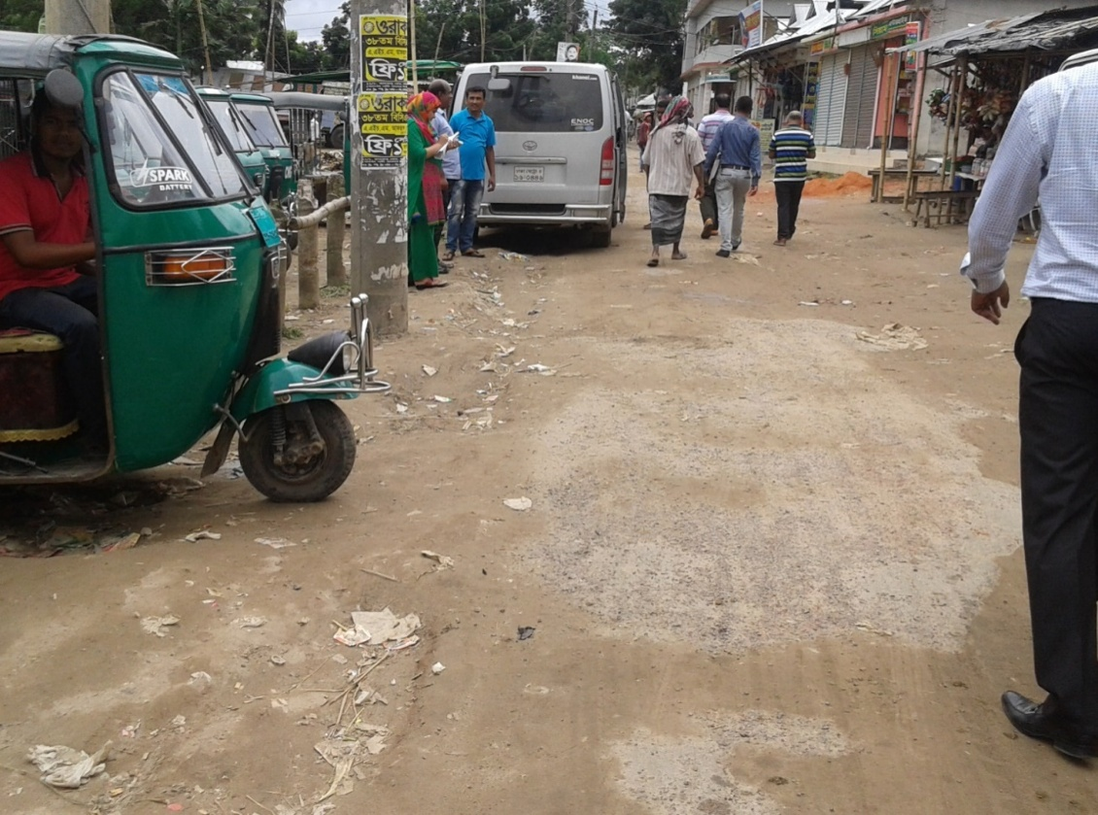**

**August 2016**

**Trishal Pourashava**

**Mymensingh**

***Annex 8.A***

**FORM 1: SOCIAL SAFEGUARDS SCREENING OF SUBPROJECTS**

**REVIEW and EVALUATION**

**1. Name of Subproject:**

A)Construction of RCC/BC Road and Street light starting from Trishal Jatio Kobi Kazi Nazrul Islam University Road from Trishal Kacha Bazar to End of Pourashava Border by RCC & Bituminus Carpeting road under Trishal Pourashava (Ch 00-2500m) and Construction of RCC Box Culvert Size 1\*3.00m\*2.00m atCh.1226-1229m and 1\*2.00m\*2.00 at Ch2029m-2031m.

**Description of subproject:**

This subproject is located at ward no 1, 2, and 3 at Trishal Pourashava. This package (MGSP/TRI/2016-17/W-03) includes BC and RCC road. A 2500m RCC/BC road will be constructed under the subproject. The proposed pavement width of the road will be 6m.The existing average width of the road is 3.65m.Some portion of the road will be RCC and some portion of the road will be BC. Length of BC portion is 2040m (Ch 0+260m to 1+400m=1140m and Ch 1+600m to 2+500m=900m). Rest part will be RCC. Protective walk is proposed for ch.0+280m- 0+325m, ch.0+358m-0+383m, ch.0+445m-482m and ch.2+337m-2+371m. Damaged 2 nos box culvert will replace by new RCC Box culverts. Several types of shops, market, mosque, female madrasha, Jatio Kobi Kazi Nazrul University, residential houses, Kazi Nazrul Institute, agricultural land etc. are situated on this road side. The first portion of the subproject area is being used as business purpose. The second portion is as household purpose and the third portion is being used as agricultural land. This one is an important road of Trishal Pourashava. As the road is badly damaged, it hampers the normal traffic. All types of vehicles and pedestrians face problems due to pot holes and rough surfaces in various segments. For meeting up the traffic load, improvement of the road is required. For implementation of this subproject, 34 electric poles will be required to relocate.

Street lighting is a vital element in creating safer town. In absence of street light in this area, is hampering the normal traffic and security at night time. Street light will improve safety for drivers, riders, and pedestrians. Under the circumstances, street light is proposed for this subproject (Ch 0+000 to 1+700km).Sixty no of street light with poles will have to be installed.

.

**Date of Social Screening: 10.08.2016**

**2. INTRODUCTION:**

This questionnaire is designed to facilitate the assessment of the current situation of Social Management related subprojects in 22 Municipalities and 4 City Corporations under Municipal Governance and Services Project (MGSP). The information collected by this questionnaire will help to assess the initial Social Management needs quickly and ensure related subprojects are approved in the earliest possible time.

This screening will enable the best effective assessment of social matters in any ULB and it should be completed as accurately as possible based on factual material.

**3. OBJECTIVES AND GOALS:**

The primary objective of this Social Screening is to improve urban accessibility in Project areas and strengthen institutional capacity for sustainable subprojects and ensure potential social safeguards compliance issues and social impacts associated with the quality construction and improvement works in order to determine applicability of the World Bank OP 4.12, 4.11 and OP 4.10 and establish “Social Management Plans” for the urban community members.

**4. STRATEGY OF SOCIAL SCREENING:**

The Social Screening is based on a collection of primary data and information while conducting field survey for the subproject. A well-structured questionnaire was already designed in the Social Management Framework and given to the field officials for obtaining necessary primary data relating to social issues in connection with losses of land and any kind of assets for the subproject implementation. Further information was obtained through field visits and interviews with relevant stakeholders to capture collective opinions and feedback by using “Focus Group Discussion (FGD)”and “Key Informant Interviews (KII)”.

**5. TEAM COMPOSITION:**

The Social Screening analysis based on the received documents on subproject related social safeguards aspects from the ULB was conducted by following members:

1. Mr. Tofayel Hossain Basunia, Social Management Specialist, MGSP, LGED
2. Mr. Mortuza Reza, Senior Municipal Engineer, DSM, Narayanganj Zone
3. Shubroto Tarafdar, Executive Engineer, Trishal Pourashava
4. Akhter Jahan, Social Management Officer, DSM, Narayanganj Zone

**6. SOCIAL SCREENING REPORT ON SUBPROJECT:**

Subproject screening was carried out as per Social Management Framework of MGSP prescribed social screening format by the concerned Social Management Officer and Senior Municipal Engineer, Social Management Specialist with the direct assistance of officials of the pourashava followed by participatory consultation with the local people using Focus Group Discussion (FGD) including Hot Spot consultation with different categories of people who are aware about local situation and needs such as subproject users.

The Social Screening is based on a collection of primary data and information duly conducting field surveys. Well-structured questionnaires are already designed in the Social Management Framework of MGSP and have been supplied to the field officials for obtaining necessary primary data relating to social issues in connection with social safeguard compliance issues such as losses of land, displacement of population, income, gender and vulnerability, tribal peoples, and any kind of assets. The field visit reports on social screening were prepared by the Social Management Officer and the Social Management Specialist has reviewed the reports. We are concerned and ensured that anybody in the subproject area will not be legally affected or deprived due to the implementation of the subproject.

Trishal Pourashava and Consultants jointly ensured the consultation with urban communities, users including elected public representatives, local administrations, teachers, businessmen, NGOs, social workers, and civil society members.

**7. Subproject Interventions** will take necessary steps regarding improvement of the subproject. Based on design and settlement of LAPs (Land Acquisition Proposal) as well as identification of PAPs (Project Affected Persons), payment for PAPs, if necessary, and completion of resettlement for displaced population living beside the facilities and compensation issues and for any other losses of the community members as per Social Safeguard Policy. After completion this procedure, then PMU will authorize physical work of the subproject.

Response from the community is absolutely positive for implementation of this subproject widely due to better communication and economic growth.

**8. KEY FINDINGS**

**8.1 LAND REQUIREMENTS:**

Based on the Social Screening form from the field, there is no needed of alignment of the selected all subprojects and no question of any widening and rising of the height of the road. This means that subproject is acceptable in geometric dimensions. Therefore, they do not require additional lands to carry out the intended subproject works.

**8.2 HOMESTEAD AND OTHER NON-LAND ASSETS:**

It is noticed that no land belongs to private citizens, Trishal Pourashava land and/or other Government agencies, or lease agreements with any government agencies will be required. Social Screening results demonstrated that no private homesteads or business premises and buildings are expected to be affected. The residential households on ULB’ ownland and public land will not be affected entirely or partially. Similarly, the business premises on the Trishal Pourashava’ own and other public lands will not be affected entirely or partially.

**8.3 INCOME LOSS/ BUSINESS LOSS:**

It has been observed that no businesses or trading activities would be displaced from make-shift structures on the road, and other areas. The proposed subproject works are not expected to affect any community groups’ access to any resources that are used for livelihood purposes. None of the community facilities like schools, cemeteries, mosques, hospitals, temples, or other religious, cultural and historical properties are going to be affected.

**8.4 INDIGENOUS PEOPLE (IP), ADHIBASHI, and MARGINALIZED POPULATION:**

There is no Indigenous, Adhibashi and marginalized population that will be affected during subproject intervention and implementation.The survey team could not identify any Indigenous, Adhibashi or marginalized population. If identified, they will be informed about the proposed interventions and their feedback and inputs will be noted. Finally, the survey team has reached broad-based community common consensus on the proposed subproject which may be seen as folows:

* IPs, Adhibashi, and marginalized population will be given preferences to engage them as laborers during subproject implementation works.
* Local IPs and Adhibashi organizations need to be involved in the participatory process where applicable.

**9. CONCLUSIONS AND RECOMMENDATIONS:**

It is safely confirmed for the marginalized population that no land will be required and no private, public, community, or cultural property as well as mini-commercial activities will be affected. The proposed interventions are not expected to pose significant negative social impact. The transportation system may have positive impact on employment, agricultural development, creation of better business environment, marketing of agricultural products and promoting education facilities. All these factors have incremental value on socio-economic aspects in general and social aspects in particular. FGD (Focus Group Discussion) and sheet of attendance are available with Social Screening Reports. Therefore, implementations of the proposed subprojects are safely and highly recommended.

This report has been prepared following filled up questionnaire and checklist which follow.

**FORM1:SOCIAL SAFEGUARDS SCREENING OF SUBPROJECTS**

**REVIEW and EVALUATION**

**Name of Subproject** :A)Construction of RCC/BC Road and Street light starting from Trishal Jatio Kobi Kazi Nazrul Islam University Road from Trishal Kacha Bazar to End of Pourashava Border by RCC & Bituminous Carpeting road under Trishal Pourashava (Ch 00-2500m) and Construction of RCC Box Culvert Size 1\*3.00m\*2.00m atCh.1226-1229m and 1\*2.00m\*2.00 at Ch2029m-2031m.

Name of District: Mymensingh

Name of ULB: Trishal Pourashava

**I. Checklist for Exclusion**

|  |  |  |
| --- | --- | --- |
| 1) Subproject requires land acquisition and/or population displacement that can be compensated for or resettled | [ ] Yes | [√] No |
| 2) Subproject affects mosques, temples, graveyards and cremation grounds, and  other places/objects of religious, cultural and historical significance. | [ ] Yes | [√]No |
| 3) Subproject threatens cultural tradition and ways of life of tribal peoples; severely restrict their access to common property resources and livelihood activities. | [ ] Yes | [√] No |
| 4) Communities have objections on subproject interventions on social and environmental issues those cannot be resolved through design alternatives. | [ ] Yes | [√] No |
| **II. Resettlement Impacts** | | |
| In respect of the social impacts and community concerns, is there a need to,  Undertake an in-depth social impact assessment study? | [ ] Yes | [√ ] No |
| Prepare a Resettlement Action Plan? | [ ] Yes | [√]No |
| **III. Impacts on Tribal Peoples** | | |
| In respect of the social impacts on tribal peoples and their concerns, is there a need to,  Undertake an in-depth impact assessment study? | [ ] Yes | [√] No |
| Prepare a Tribal Peoples Plan? | [ ] Yes | [√]No |

**On behalf of the DSM Consultant, the attached filled out format has been reviewed and evaluated by:**

**Decision on selection**: **[**√**] recommended for selection [ ] recommended for exclusion**

**Prepared by*: Akhter Jahan*** Designation: Social Management Officer, MGSP, LGED

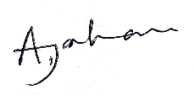

Signature: Date: 24.08.16

**Reviewed by *: Tofayel Hossain Basunia*** Designation: Social Management Specialist, MGSP, LGED



Signature: Date: 24.08.16

A social screening report will be prepared for each subproject covering methodology, participants’ analysis, community agreements &their concerns/suggestions, &summary of impacts and mitigation requirement.

**FORM 1: SCREENING FORM FOR SOCIAL SAFEGUARDS ISSUES**

1. **Identification**
2. *Name of ULB: Trishal Pourashava District: Mymensingh*

*Ward/Mahalla: Ward No. 01, 02, 03*

1. *Name of subproject / spot screened:*
2. Construction of RCC/BC Road and Street light starting from Trishal Jatio Kobi Kazi Nazrul Islam University Road from Trishal Kacha Bazar to End of Pourashava Border by RCC &Bituminous Carpeting road under Trishal Pourashava (Ch 00-2500m) and Construction of RCC Box Culvert Size 1\*3.00m\*2.00m atCh.1226-1229m and 1\*2.00m\*2.00 at Ch2029m-2031m.
3. Project Component :Road Construction, Street light, Box Culvert
4. **Brief description of the physical works**:

This subproject is located at ward no1,2 and 3 under Trishal Pourashava. This subproject is connected with Jatio Kobi Kazi Nazrul Islam University at Trishal. This is an important road of Trishal town which is giving access to important features like Banks Bazar, Clinic, College and School. But in the rainy season water accumulates on top of the road which causes severe damage to the road top and many cracks, depressions, and potholes appeared due to logging of water because there is no drain beside the road. For this, all types of vehicles and pedestrians face problems. To reduce the maintenance cost of the road and to accommodate high loaded traffic, it is necessary to improve the road. Ch 0+260m to Ch0+1400=1140m, 1600-2500=900m.Total=2040m by BC Road and rest part will RCC. It is proposed for Protective work ch.0+280m-0+325m, ch.0+358m-0+383m,ch.0+445m-482m and ch.2+337m-2+371m. Damage box culvert will be replaced by new RCC Box Culvert at Ch 1226-1229m and 2029-2031m. After implementation of the subproject people, industrial workers, businessmen, fisher men, farmers and university, college students will be able to use the road smoothly even in the rainy season. Due to sufficient street lights, safety at night will be ensured.

**5. Screening Date(s):** 10.08.2016

**B.** Participation in Screening:

1. **Names of Consultants’ representatives who screened the subproject:**
2. Mr. Mortuza Reza Sr. Municipal Engineer, MGSP,LGED,
3. Ms. Akhter Jahan, Social Management Officer, MGSP, LGED,
4. Ruhul Alam, Municipal Engineer,MGSP,LGED,
5. Mst. Tasrima Sultana, Jr. Environmental Specialist, MGSP,LGED
6. Mr. Tofayel Hossain Basunia, Social Management Specialist, MGSP, LGED

7. **Names of ULB officials participated in screening**:

(1) Mr. Shubroto Tarafdar, Executive Engineer, Trishal Pourashava

(2) Mr. Prodip Kumar Debnath, Assistant Engineer, Trishal Pourashava

(3) Md. Rabiul Alam, Sub-Assistant Engineer, Trishal Pourashava

*8. WLCC members, NGOs, community groups/CBOs participated in screening: Yes, copy enclosed for information.*

*9. Would-be affected persons participated in screening: N/A*

**C. Land Requirements & Ownership:** No.

|  |  |  |
| --- | --- | --- |
| *10. Will there be a need for additional lands to carry out the intended works under this contract?* | [ ] yes | [√ ] No |

*11. If ‘Yes’, what will the additional lands be used for? (Indicate all that apply): N/A*

[ ]road widening [ ] curve correction [ ] construction/expansion of physical structure

[ ] strengthening narrow eroding road section between high and low lands [ ] others (Mention):

*12. If ‘Yes’, the required lands presently belong to (Indicate all that apply): N/A*

[ ] ULB [ ] Government Land

[ ] Private Citizens [ ] Others (Mention):

**D. Current Land Use & Potential Impacts**

*13. If the required lands belong to Private Citizens, they are currently used for (Indicate all that apply):N/A*

[ ] Agriculture Number of households using the lands:

[ ] Residential purposes Number of households using them:

[ ] Commercial purposes Number of persons using them: Shops:

[ ] Other Uses (Mention): few **U**sers:

Land does not belong to private citizen.

*14. If the required lands belong to ULB and/or other Government agencies, they are currently used for (Indicate all that apply): N/A*

[ ] Agriculture Number of persons/households using the lands:

**[ ]** Residential purposes Number of households living on them:

**[ ]** Commercial purposes Number of persons using them: No. of shops:

**[ ] Other Uses (Mention):**

*15. How many of the present users have lease agreements with any government agencies? None*

*16. Number of private homesteads that would be affected on private lands: None*

*Entirely requiring relocation……………………. Partially but can still live on present homestead*

*17. Number of business premises/buildings that would be affected on private lands: None.*

Entirely and will require relocation: # Of businesses housed in them: **.**

Partially, but can still use the premises: # Of businesses housed in them:

*18. Residential households will be affected on ULB’s own and & public lands: None*

*Entirely affected* and will require relocation: No. of these structures:

No. of structures built with brick, RCC, & other expensive and durable materials:

No. of structures built with inexpensive salvageable materials (bamboo, GI sheets, etc:

*Partially affected*, but can still live on the present homestead: No of these structures

No. of structures built with brick, RCC, & other expensive and durable materials:

No. of structures built with inexpensive salvageable materials (bamboo, GI sheets, etc):

*19. No. of business premises that would be affected on ULB’s own & other public lands: None*

*Entirely affected* and will require relocation: No. of these structures:

No. of businesses housed in these structures:

No. of persons presently employed in the above businesses.

No. of these structures built with brick, RCC, & other durable materials:

No. of structure built with inexpensive salvageable materials (bamboo, GI sheets, etc):

*Partially affected*, but can still stay in the present no. of these structures:

No. of businesses housed in these structures:

No. of persons presently employed in these businesses:

No. of these structures built with brick, RCC, & other durable materials:

No. of structure built with inexpensive salvageable materials (bamboo, GI sheets, etc):

*20. No of businesses/trading activities that would be displaced from make-shift structures on the road, and other areas/spots: None*

*21. Do the proposed subproject works affect any community groups’ access to any resources that are used for livelihood purposes? [ ] Yes [√] No*

*22. If ‘Yes’, description of the resources: N/A*

*23. Do the proposed works affect community facilities like school, cemetery, mosque, temple, or others that are of religious, cultural and historical significance? [ ] Yes [√ ] No.  
 24. If ‘Yes’, description of the facilities: N/A.  
 25. Describe any other impacts that have not been covered in this questionnaire? No.  
 26. Describe alternatives, if any, to avoid or minimize use of additional lands: N/A*

**E. ADDITIONAL INFORMATION ON TRIBAL PEOPLE**

(This section must be filled in if subprojects are located in areas that are also inhabited by tribal peoples)

*27. Names of tribal community members and organizations who participated in screening: N/A*

*28. Have the tribal community and the would-be affected TPs been made aware of the potential positive and negative impacts and consulted for their feedback and inputs?*

[ ] Yes [√] No

Has there been a broad-based community consensus on the proposed works?

[ ] Yes [√] No

*29. Total number of would-be affected tribal households: N/A****.***

*30. The would-be affected tribal households have the following forms of rights to the required lands: N/A*

[ ] Legal: No. of households:

[ ] Customary: No. of households:

[ ] Lease agreements with any GOB agencies: No. of households:

[ ] Others (Mention): No. of households:

*31. Does the subproject affect any objects that are of religious and cultural significance to the IPs?*

[ ] Yes [√] No

**G.32. If ‘Yes’, description of the objects:** N/A.

*33. The following are the three main economic activities of the would-be affected tribal households:*

a. N/A

b. N/A

c. N/A

*34. Social concerns expressed by tribal communities/organizations about the works proposed under the subproject: N/A*

*35. The tribal community and organizations perceive the social outcomes of the subproject: N/A***On behalf of the DSM Consultant, the attached filled out format has been reviewed and evaluated by:**

**Decision on selection [**√**] recommended for selection [] recommended for exclusion**

***Prepared by:Akhter Jahan*** Designation: Social Management Officer, MGSP, LGED

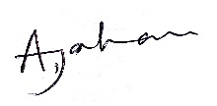

Signature: Date: 24.08.16

***Reviewed by: Tofayel Hossain Basunia*** Designation: Social Management Specialist, MGSP, LGED

Signature: Date: 24.08.16

**Participation and Consultation meeting for subprojects**: A Participation and Consultation meeting was held in the subproject site to carry out the feasibility of the specific subproject. Consultations with communities and other stakeholders have been used as a two-way communication to provide information about the subproject and obtain feedback from the communities on subproject approach, design and implementation. Consultations were carried out through open meetings and key informant interviews (KII). From the meeting, this specific subproject is very important for the economic development of the communities which in turn will be implemented.

The consultation process was carried out with distinct groups at urban areas.

Key informants were ULB Mayors, Ward Commissioners, Engineers, and Businessmen.

Social Screening Participants list are given bellow:

**Local Government Engineering Department (LGED)**

**Municipal Governance and Services Project (MGSP)**

**Agaragaon, Dhaka-1207**

**SOCIAL SAFEGUARDS SCREENING OF SUBPROJECTS**

**REVIEW and EVALUATION**

**Social Screening Report**

**Package No**: MGSP/TRI/2016-17/W-03

**Name of Subproject**:

(B) Rehabilitation of RCC drain with footpath starting from Trishal Jatiya Kabi Kazi Nazrul Islam University road, Trishal Kacha bazar to End of pourashava border by RCC drain under Trisha Pourashava (Ch 00 - 1740m).

**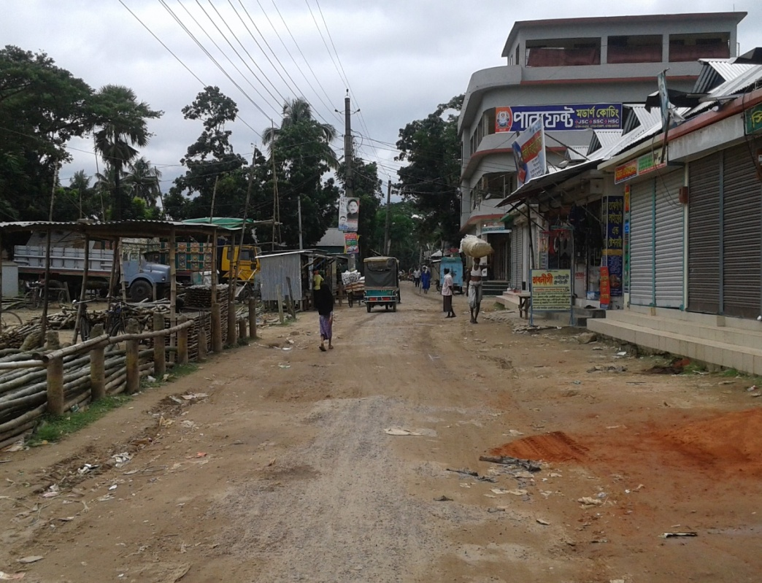**

**August 2016**

**Trishal Pourashava**

**Mymensing**

***Annex 8.A***

**FORM 1: SOCIAL SAFEGUARDS SCREENING OF SUBPROJECTS**

**REVIEW and EVALUATION**

**1. Name of Subproject:**

(B) Rehabilitation of RCC drain with footpath starting from Trishal Jatiya Kabi Kazi Nazrul Islam University road, Trishal Kacha bazar to End of pourashova border by RCC drain under Trishal Pourashava (Ch 00 - 1740m).

**Description of subproject**: Trishal is a category A type pourashava. This subproject is located at word no 1, 2 and 3. The subproject area is basically built up area used for both residential and commercial purposes. Trishal Pourashova is a densely populated area. In the municipality area, insufficient, damaged, and inadequate drainage system causes severe drainage congestion especially during the rainy season. This proposed drain will improve the drainage facilities of the municipality and subproject area. The proposed drain connects with the existing drain of the main road and Sukni Beel which will use as outfall. In rainy season water accumulates on top of the road which causes severe damage to the road top and many cracks, depressions, potholes appeared due to logging of water, because there is no drain beside the road. For this reason all type of vehicles and pedestrians face problems. There will be cover slab on the drain which will work as footpath. To remove water congestion from top of road and protect the road from damage it is necessary to provide RCC drain with adequate section. the proposed RCC drain is divided into five segments. Segment – 1: Ch 0+585 m. segment -2: 0+260m. Segment -3: Ch 0+110 m. Segment -4: Ch 0+475 m. And segment -5: Ch 0+310m. The length of the proposed drain will be 1740 m.

According to Project guidelines, LGED has adopted “Social Management Framework (SMF)” and “Grievance Redress Mechanisms (GRM)” following WB’s Operational Policy (OP 4.12, 4.10 and 4.11) and the Acquisition and Requisition of Immovable Property Ordinance, 1982 (Ordinance II of 1982) including Pourashava Act 2009 and City Corporation Act 2009 and the Chittagong Hill Tracts Regulation 1900. The SMF and GRM contain detailed guidelines and Principles for mitigating losses of different types of property (land and non-land) that might have been caused by the programme of land acquisition. In this subproject, there is no question of land acquisition, which in turn there is no question of resettlement issues. In fact, there is no kind of disorder and displacement of the population.

**Date of Social Screening: 10.08.2016**

**2. INTRODUCTION:**

This questionnaire is designed to facilitate the assessment of the current situation of Social Management related subprojects in 22 Municipalities and 4 City Corporations under Municipal Governance and Services Project (MGSP). The information collected by this questionnaire will help to assess the initial Social Management needs quickly and ensure related subprojects are approved in the earliest possible time.

This screening will enable the best effective assessment of social matters in any ULB and it should be completed as accurately as possible based on factual material.

**3. OBJECTIVES AND GOALS:**

The primary objective of this Social Screening is to improve urban accessibility in Project areas and strengthen institutional capacity for sustainable subprojects and ensure potential social safeguards compliance issues and social impacts associated with the quality construction and improvement works in order to determine applicability of the World Bank OP 4.12, 4.11 and OP 4.10 and establish “Social Management Plans” for the urban community members.

**4. STRATEGY OF SOCIAL SCREENING:**

The Social Screening is based on a collection of primary data and information while conducting field survey for the subproject. A well-structured questionnaire was already designed in the Social Management Framework and given to the field officials for obtaining necessary primary data relating to social issues in connection with losses of land and any kind of assets for the subproject implementation. Further information was obtained through field visits and interviews with relevant stakeholders to capture collective opinions and feedback by using “Focus Group Discussion (FGD)”and “Key Informant Interviews (KII)”.

**5. TEAM COMPOSITION:**

The Social Screening analysis based on the received documents on subproject related social safeguards aspects from the Trishal Pourashava was conducted by following members:

1. Mr. Tofayel Hossain Basunia, Social Management Specialist, MGSP, LGED
2. Mr. Mortuza Reza, Senior Municipal Engineer, DSM, Narayanganj Zone
3. Shubroto Tarafdar, Executive Engineer, Trishal Pourashava
4. Akhter Jahan, Social Management Officer, DSM, Narayanganj Zone

**6. METHODOLOGY OF SOCIAL SCREENING REPORT ON SUBPROJECT:**

Subproject screening was carried out as per Social Management Framework of MGSP prescribed social screening format by the concerned Social Management Officer and Senior Municipal Engineer, Social Management Specialist with the direct assistance of officials of the Trishal Pourashava followed by participatory consultation with the local people using Focus Group Discussion (FGD) including Hot Spot consultation with different categories of people who are aware about local situation and needs such as subproject users.

The Social Screening is based on a collection of primary data and information duly conducting field surveys. Well-structured questionnaires are already designed in the Social Management Framework of MGSP and have been supplied to the field officials for obtaining necessary primary data relating to social issues in connection with social safeguard compliance issues such as losses of land, displacement of population, income, gender and vulnerability, tribal peoples, and any kind of assets. The field visit reports on social screening were prepared by the Social Management Officer and the Social Management Specialist has reviewed the reports. We are concerned and ensured that anybody in the subproject area will not be legally affected or deprived due to the implementation of the subproject.

Trishal Pourashava and Consultants jointly ensured the consultation with urban communities, users including elected public representatives, local administrations, teachers, businessmen, NGOs, social workers, and civil society members.

**7. Subproject Interventions:** Trishal Pourashava will take necessary steps regarding improvement of the subproject. Based on design and settlement of LAPs (Land Acquisition Proposal) as well as identification of PAPs (Project Affected Persons), payment for PAPs, if necessary, and completion of resettlement for displaced population living beside the facilities and compensation issues and for any other losses of the community members as per Social Safeguard Policy. After completion this procedure, then PMU will authorize physical work of the subproject.

Response from the community is absolutely positive for implementation of this subproject widely due to better communication and economic growth.

**8. KEY FINDINGS**

**8.1 LAND REQUIREMENTS:**

Based on the Social Screening form from the field, there is no need of alignment of the selected all subprojects and no question of any widening and rising of the height of the road. This means that subproject is acceptable in geometric dimensions. Therefore, they do not require additional lands to carry out the intended subproject works.

**8.2 HOMESTEAD AND OTHER NON-LAND ASSETS:**

It is noticed that no land belongs to private citizens, Trishal Pourashava land and/or other Government agencies, or lease agreements with any government agencies will be required. Social Screening results demonstrated that no private homesteads or business premises and buildings are expected to be affected. The residential households on Trishal Pourashava own land and public land will not be affected entirely or partially. Similarly, the business premises on the Trishal Pourashava own and other public lands will not be affected entirely or partially.

**8.3 INCOME LOSS/ BUSINESS LOSS:**

It has been observed that no businesses or trading activities would be displaced from make-shift structures on the road, and other areas. The proposed subproject works are not expected to affect any community groups’ access to any resources that are used for livelihood purposes. None of the community facilities like schools, cemeteries, mosques, hospitals, temples, or other religious, cultural and historical properties are going to be affected.

**8.4 INDIGENOUS PEOPLE (IP), ADHIBASHI, and MARGINALIZED POPULATION:**

There is no Indigenous, Adhibashi and marginalized population that will be affected during subproject intervention and implementation. The survey team could not identify any Indigenous, Adhibashi or marginalized population. If identified, they will be informed about the proposed interventions and their feedback and inputs will be noted. Finally, the survey team has reached broad-based community common consensus on the proposed subproject which could be seen under:

* IPs, Adhibashi, and marginalized population will be given preferences to engage them as laborers during subproject implementation works.
* Local IPs and Adhibashi organizations need to be involved in the participatory process where applicable.
* They will be involved in the tree plantation and caretaking program where possible.

**9. CONCLUSIONS AND RECOMMENDATIONS:**

It is safely confirmed for the marginalized population that no land will be required and no private, public, community, or cultural property as well as mini-commercial activities will be affected. The proposed interventions are not expected to pose significant negative social impact. The transportation system may have positive impact on employment, agricultural development, creation of better business environment, marketing of agricultural products and promoting education facilities. All these factors have incremental value on socio-economic aspects in general and social aspects in particular. FGD (Focus Group Discussion) and sheet of attendance are available with Social Screening Reports. Therefore, implementations of the proposed subprojects are safely and highly recommended.

This report has been prepared following filled up questionnaire and checklist which follow.

**FORM1:SOCIAL SAFEGUARDS SCREENING OF SUBPROJECTS**

**REVIEW and EVALUATION**

Name of Subproject

(B) Rehabilitation of RCC drain with footpath starting from Trishal Jatiya Kabi Kazi Nazrul Islam University road, Trishal Kacha bazar to End of pourashova border by RCC drain under Trishal pourashava (Ch 00 - 1740m).

Name of District: Mymensingh

Name of ULB: Trishal Pourashava

**I. Checklist for Exclusion**

|  |  |  |
| --- | --- | --- |
| 1) Subproject requires land acquisition and/or population displacement that can be compensated for or resettled | [ ] Yes | [√] No |
| 2) Subproject affects mosques, temples, graveyards and cremation grounds, and  other places/objects of religious, cultural and historical significance. | [ ] Yes | [√]No |
| 3) Subproject threatens cultural tradition and ways of life of tribal peoples; severely restrict their access to common property resources and livelihood activities. | [ ] Yes | [√] No |
| 4) Communities have objections on subproject interventions on social and environmental issues those cannot be resolved through design alternatives. | [ ] Yes | [√] No |
| **II. Resettlement Impacts** | | |
| In respect of the social impacts and community concerns, is there a need to,  Undertake an in-depth social impact assessment study? | [ ] Yes | [√ ] No |
| Prepare a Resettlement Action Plan? | [ ] Yes | [√]No |
| **III. Impacts on Tribal Peoples** | | |
| In respect of the social impacts on tribal peoples and their concerns, is there a need to,  Undertake an in-depth impact assessment study? | [ ] Yes | [√] No |
| Prepare a Tribal Peoples Plan? | [ ] Yes | [√]No |

**On behalf of the DSM Consultant, the attached filled out format has been reviewed and evaluated by:**

**Decision on selection**: **[**√**] recommended for selection [ ] recommended for exclusion**

**Prepared by*: Akhter Jahan*** Designation: Social Management Officer, MGSP, LGED



Signature: Date: 24.08.16

**Reviewed by*: Tofayel Hossain Basunia*** Designation: Social Management Specialist, MGSP, LGED



Signature: Date: 24.08.16

A social screening report will be prepared for each subproject covering methodology, participants’ analysis, community agreements & their concerns/suggestions, &summary of impacts and mitigation requirement.

**FORM 1: SCREENING FORM FOR SOCIAL SAFEGUARDS ISSUES**

1. **Identification**

*1.Name of ULB: Trishal Pourashava District: Mymensingh*

*Ward/Mahalla: Ward No. 01,02,03*

*2.Name of subproject / spot screened*

(B) Rehabilitation of RCC drain with footpath starting from Trishal Jatiya Kabi Kazi Nazrul Islam University road, Trishal Kacha bazar to End of pourashava border by RCC drain under Trishal pourashova (Ch 00 - 1740m).

1. Project Component :Drain Construction
2. **Brief description of the physical works**: This subproject is under Ward No.01, 02, 03 of Trishal Pourashava. RCC drain with cover slab will be constructed under this subproject. So, the top of the drain can be used as footpath. The subproject area includes Shops, Kitchen Market, Go-Hat, Mosque, Mohila Madrasa, Jatiyo Kobi Kazi Nazrul University, Residential Houses, Kazi Nazrul Institute, Agricultural land and different business organizations on the road adjacent to this drain. Therefore, it is an important road of Trishal Pourashava. At present there is no drain beside the existing damage BC Road as such water logging exists during rainy season and even after moderate rainfall, household waste water and water logging create problems for the dwellers of the city. So a well-designed drainage network is essential for carrying rain and waste water generated from surrounding. The proposed drain will connect with the existing drain of the main road and Sukni Beel which will be used as out fall .the proposed RCC drain is divided into five segments. Segment-1: Ch. 0+585m, Segment-2: Ch.0+260m, Segment-3: Ch.0+110m, Segment-4: Ch.0+475m and Segment-5: 0+310m. Total length of the proposed drain is 1740m. If the subproject is implemented, the whole Pourashava will be benefited by the drainage system.

**5. Screening Date(s):** 10. 08.2016

**B.** Participation in Screening:

**6.Names of Consultants’ representatives who screened the subproject:**

1.Mr. Mortuza Reza Sr. Municipal Engineer, MGSP, LGED,

2.Ms. Akhter Jahan, Social Management Officer, MGSP, LGED,

3.Ruhul Alam, Municipal Engineer, MGSP, LGED,

4.Mst. Tasrima Sultana, Jr. Environmental Specialist, MGSP,LGED

5.Mr. Tofayel Hossain Basunia, Social Management Specialist, MGSP, LGED

7. **Names of ULB officials participated in screening**:

1) Mr. Shubroto Tarafdar, Executive Engineer, Trishal Pourashava

(2) Mr. Prodip Kumar Debnath, Assistant Engineer, Trishal Pourashava

(3) Md. Rabiul Alam, Sub-Assistant Engineer, Trishal Pourashava

*8. WLCC members, NGOs, community groups/CBOs participated in screening: Yes, copy enclosed for information.*

*9. Would-be affected persons participated in screening: N/A*

**C. Land Requirements & Ownership:** No.

|  |  |  |
| --- | --- | --- |
| *10. Will there be a need for additional lands to carry out the intended works under this contract?* | [ ] yes | [√ ] No |

*11. If ‘Yes’, what will the additional lands be used for? (Indicate all that apply): N/A*

[ ]road widening [ ] curve correction [ ] construction/expansion of physical structure

[ ] strengthening narrow eroding road section between high and low lands [ ] others (Mention):

*12. If ‘Yes’, the required lands presently belong to (Indicate all that apply): N/A*

[ ] ULB [ ] Government Land

[ ] Private Citizens [ ] Others (Mention):

**D. Current Land Use & Potential Impacts**

*13. If the required lands belong to Private Citizens, they are currently used for (Indicate all that apply):N/A*

[ ] Agriculture Number of households using the lands:

[ ] Residential purposes Number of households using them:

[ ] Commercial purposes Number of persons using them: Shops:

[ ] Other Uses (Mention): few **U**sers:

Land does not belong to private citizen.

*14. If the required lands belong to ULB and/or other Government agencies, they are currently used for (Indicate all that apply): N/A*

[ ] Agriculture Number of persons/households using the lands:

**[ ]** Residential purposes Number of households living on them:

**[ ]** Commercial purposes Number of persons using them: No. of shops:

**[ ] Other Uses (Mention):**

*15. How many of the present users have lease agreements with any government agencies? None*

*16. Number of private homesteads that would be affected on private lands: None*

*Entirely requiring relocation……………………. Partially but can still live on present homestead*

*17. Number of business premises/buildings that would be affected on private lands: None.*

Entirely and will require relocation: # Of businesses housed in them: **.**

Partially, but can still use the premises: # Of businesses housed in them:

*18. Residential households will be affected on ULB’s own and & public lands: None*

*Entirely affected* and will require relocation: No. of these structures:

No. of structures built with brick, RCC, & other expensive and durable materials:

No. of structures built with inexpensive salvageable materials (bamboo, GI sheets, etc:

*Partially affected*, but can still live on the present homestead: No. of structures

No. of structures built with brick, RCC, & other expensive and durable materials:

No. of structures built with inexpensive salvageable materials (bamboo, GI sheets, etc):

*19. No. of business premises that would be affected on ULB’s own & other public lands: None*

*Entirely affected* and will require relocation: No. of these structures:

No. of businesses housed in these structures:

No. of persons presently employed in the above businesses.

No. of these structures built with brick, RCC, & other durable materials:

No. of structure built with inexpensive salvageable materials (bamboo, GI sheets, etc):

*Partially affected*, but can still stay in the present no. of these structures:

No. of businesses housed in these structures:

No. of persons presently employed in these businesses:

No. of these structures built with brick, RCC, & other durable materials:

No. of structure built with inexpensive salvageable materials (bamboo, GI sheets, etc):

*20.No of businesses/trading activities that would be displaced from make-shift structures on the road, and other areas/spots: None*

*21. Do the proposed subproject works affect any community groups’ access to any resources that are used for livelihood purposes? [ ] Yes [√] No*

*22. If ‘Yes’, description of the resources: N/A*

*23.Do the proposed works affect community facilities like school, cemetery, mosque, temple, or others that are of religious, cultural and historical significance? [ ] Yes [√ ] No.  
 24. If ‘Yes’, description of the facilities: N/A.  
 25. Describe any other impacts that have not been covered in this questionnaire? No.  
 26. Describe alternatives, if any, to avoid or minimize use of additional lands: N/A*

**E. ADDITIONAL INFORMATION ON TRIBAL PEOPLE**

(This section must be filled in if subprojects are located in areas that are also inhabited by tribal peoples)

*27. Names of tribal community members and organizations who participated in screening: N/A*

*28. Have the tribal community and the would-be affected TPs been made aware of the potential positive and negative impacts and consulted for their feedback and inputs?*

[ ] Yes [√] No

Has there been a broad-based community consensus on the proposed works?

[ ] Yes [√] No

*29. Total number of would-be affected tribal households: N/A****.***

*30. The would-be affected tribal households have the following forms of rights to the required lands: N/A*

[ ] Legal: No. of households:

[ ] Customary: No. of households:

[ ] Lease agreements with any GOB agencies: No. of households:

[ ] Others (Mention): No. of households:

*31. Does the subproject affect any objects that are of religious and cultural significance to the IPs?*

[ ] Yes [√] No

**G.32. If ‘Yes’, description of the objects:** N/A.

*33. The following are the three main economic activities of the would-be affected tribal households:*

a. N/A

b. N/A

c. N/A

*34. Social concerns expressed by tribal communities/organizations about the works proposed under the subproject: N/A*

*35. The tribal community and organizations perceive the social outcomes of the subproject: N/A***On behalf of the DSM Consultant, the attached filled out format has been reviewed and evaluated by:**

**Decision on selection [**√**] recommended for selection [] recommended for exclusion**

***Prepared by : Akhter Jahan*** Designation: Social Management Officer, MGSP, LGED



Signature: Date: 24.08.16

***Reviewed by: Tofayel Hossain Basunia*** Designation: Social Management Specialist, MGSP, LGED

Signature: Date: 24.08.16

**Participation and Consultation meeting for subprojects**: A Participation and Consultation meeting was held in the subproject site to carry out the feasibility of the specific subproject. Consultations with communities and other stakeholders have been used as a two-way communication to provide information about the subproject and obtain feedback from the communities on subproject approach, design and implementation. Consultations were carried out through open meetings, and key informant interviews (KII). From the meeting, this specific subproject is very important for the economic development of the communities which in turn will be implemented.

The consultation process was carried out with distinct groups at urban areas.

Key informants were ULB Mayors, Ward Commissioners, Engineers, and Businessmen.

Social Screening Participants list are given bellow:

