**Annex: Social Screening Report.**

**Local Government Engineering Department (LGED)**

**Municipal Governance and Services Project (MGSP)**

**Agaragaon, Dhaka-1207**

**SOCIAL SAFEGUARDS SCREENING OF SUBPROJECTS**

**REVIEW and EVALUATION**

**Social Screening Report**

**Package No**: **MGSP/BHB/2018-19/W-08**

**Name of Subproject**:

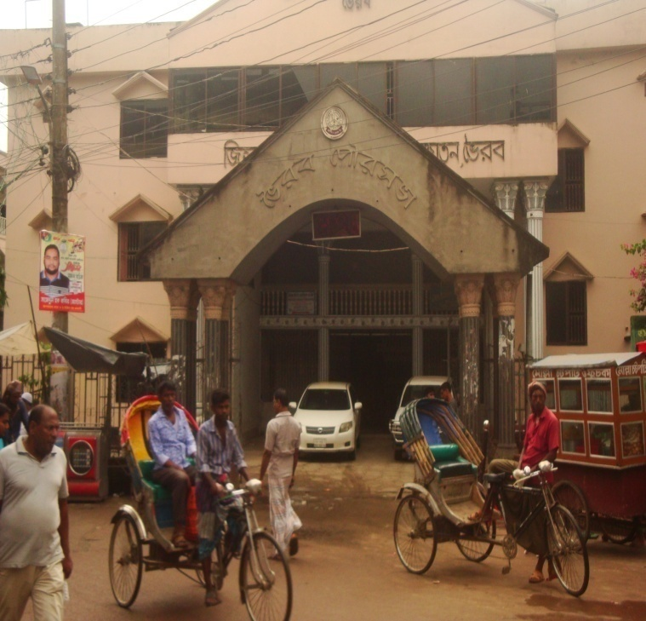**a)Construction of Foot Bridge(Light Vehicular) between Malgudam and Chandibar Muskillar Hatti with approach road. (CIP-road-35)**

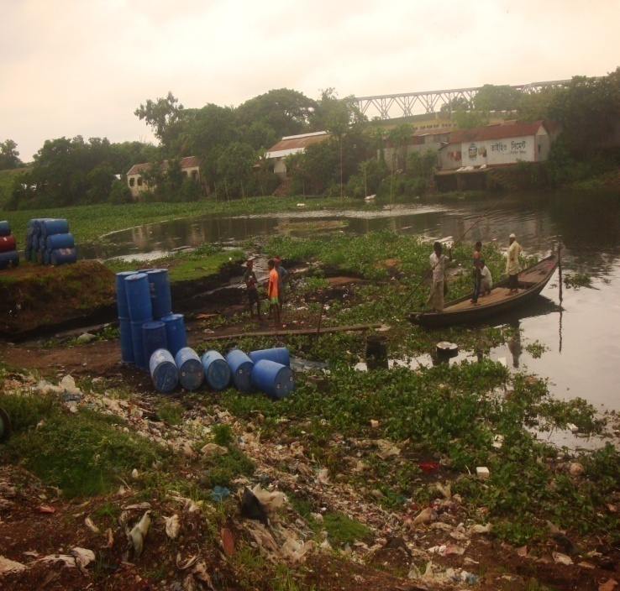



**Design, Supervision, and Management (DSM) Consultancy Services**

AQUA **Joint Venture of**

***Hifab International AB, Sweden and***

***AQUA Consultant & Associates Ltd., Bangladesh***

***AUGUST 2018***

***BHAIRAB POURASHAVA***

***KISHOREGONJ.***

**FORM 1: SOCIAL SAFEGUARDS SCREENING OF SUBPROJECTS**

**REVIEW and EVALUATION**

**1. Name of Subproject:**

**a) Construction of Foot Bridge (Light Vehicular) between Malgudam and Chandibar Muskillar Hatti with approach road. (CIP-road-35)**

**Description of subproject**:

This subproject is an important construction work of Bhairab Pourashava to be implemented in the ward numbers 2 & 11. The proposed foot bridge will be constructed on the Monamara Khal adjacent to the Meghan River for establishing better communication two wards of Bhairab Pourashava located two sides of the khal. There is no bridge crossing Monamara khal and present connectivity is small country boat ferry. The ferry ghat is leased out to private operators by the pourashava. The required land for bridge construction along with 225 m approach road belongs to the Bhairab Pourashava. In the west bank of existing khal there is 10 m earthen pedestrian road with steep slope. It is a sleepy and risky walkway. The bank has similar type of earthen walkway of 215 m length.

In the rainy season & flood time it is difficult & risky to cross the khal for women, children, elderly peoples, students, traders, farmers and sick persons. Due to not having a bridge, peoples & their goods/materials coming from the Aganagor, Radanagar, Chandpur, Lonadia, Sreenagar and people of two wards cross the khal by boat in risky situation. In the morning & evening time, heavy onrush of people cause pedestrian congestion killing valuable time. So this proposed foot bridge with facility to cross light vehicle will remove the difficulty of people.

Considering the difficulty the bridge has been designed as 60 m length RCC simply supported bridge of parabolic shape 2.4 m clear width of foot bridge. It has 3 spans of 20 m length each. In design calculation H10 loading is considered for light vehicle. Railing of the bridge is SS rail and post for beautiful appearance. Six number of 12 m length cast-in situ piles under both abutment and 6 nos of length 16 m length cast-in situ piles under both pier have been considered.

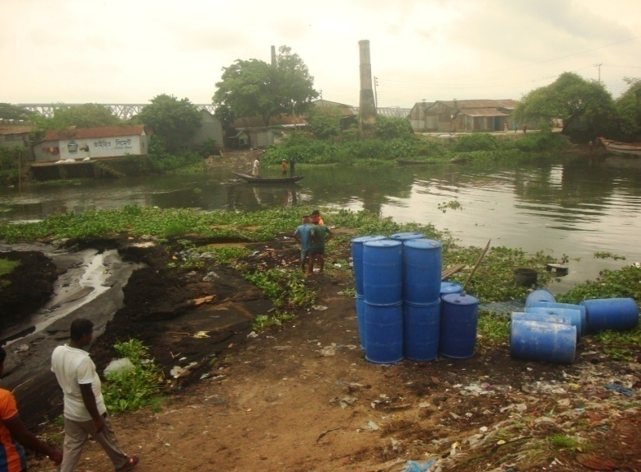This subproject connects rural and commercial areas. The east bank of the khal is town areas (Malgudam) and there is concentration of various warehouses – food, fuel, oil, whole sale trade, transport agents (Truck, Lorries and covered van), hotel, restaurant, residential areas and retail shops. The west has rice mills, retail shops, working peoples’ residence and is connected with rural areas.

Photographs: .Exiting condition of subproject areas

Considering the subproject features this bridge will be used as foot bridge by pedestrians and as light vehicle bridge by bicycle, motorbike, rickshaw and auto rickshaw. Barrier will be provided so that heavy vehicle like truck and bus cannot enter bridge approach.

During the screening work the DSM and ULB team noted all existing facts & features of proposed subproject areas including difficulties as well as scopes and opportunities and seen. There is no obstacles were founded in the subproject areas.

After construction of this bridge with 225 m approach roads, the wards 2 & 11 of Bhairab Pourashava will have better transport network. It will minimize difficulties in movement for peoples and local small vehicle will save travel time and cost and reduce passenger’s congestion for working as a localized by pass movement opportunities and easily enterer in to the town and rural areas . It will improve market linkage, rural-urban link and therefore will provide opportunity to market agricultural and other produce. At the one side, the producers will get better price and consumers will get commodities of better quality at lower price. Further it will contribute to increased business opportunities, employment, income, living standard and reduced poverty. For the bridge, movement will be safer for all categories of people including women, children, elderly persons and disabled. Besides economic the subproject will improve access to education, health and administrative services.

The sub project bridge and linked approaches are all located on ULB’s own land there is no need for land acquisition. So it is not necessary to prepare RAP. Also there is no need for voluntary dispossession as no property is affected

**Date of Social Screening: 5/09/2018**

**2. INTRODUCTION:**

Screening of the subproject was execution with the use of pre-designed formats to facilitate the assessment of the current situation of social issues related subprojects in 22 Municipalities and 4 City Corporations under Municipal Governance and Services Project (MGSP). The information collected by the formats will helped to assessing the initial Social Management needs quickly and provided necessary information to the subproject intervention in the earliest possible time.

This screening will enable the best effective assessment of social matters in Bhairab Pourashava and it has been completed as accurately as possible based on factual materials.

**3. OBJECTIVES AND GOALS Of Social Screening :**

The primary objective of Social Screening is to address social concerns and pertinent issues such as need for LA, RAP, and removing obstacles with or without compensation, livelihoods restoration, impact on indigenous peoples and women etc. and distributing project benefits equitably. This also checks applicability of the World Bank OP 4.12, 4.11 and OP 4.10.

**4. STRATEGY OF SOCIAL SCREENING:**

The Social Screening is based on a collection of primary data and information while conducting field survey for the subproject. A well-structured questionnaire was already designed in the Social Management Framework and given to the field officials for obtaining necessary primary data relating to social issues in connection with losses of land and any kind of assets for the subproject implementation. Further information was obtained through field visits and interviews with relevant stakeholders to capture collective opinions and feedback by using Group Discussions (GDs) and “Key Informant Interviews (KII)”.

**5. TEAM COMPOSITION:**

The Social Screening analysis based on the received documents on subproject related social safeguards aspects from the ULB was conducted by following members:

1. Md .A. B.Siddique. SMO, Rangpur and Sylhet Zone, MGSP, LGED
2. Ranajit Kumar Paul, Snr. Municipal Engineer, DSM, Sylhet Zone, MGSP,LGED
3. Mr. Md. Badsha Alamagir, XEN, Bhairab Pourashava.
4. Mr. Mr.Arif Sarwar,Assistant . Engr. Bhairab Pourashava.
5. Mr. Tonoy Kumar Day, Assistant. Municipal Engineer, Bhairab Pourashava.

**6. METHODOLOGY OF SOCIAL SCREENING REPORT ON SUBPROJECT:**

Subproject screening was carried out as per Social Management Framework of MGSP prescribed social screening format .It was implemented by the concerned Social Management Officer, Senior Municipal Engineer and Social Management Specialist with the assistance of officials of the Bhairab Pourashava.The social screening followed participatory methods for consultation with the local people. The method applied Group Discussions (GDs) including Hot Spot consultations and KII with different categories of people who are aware about local situation and needs the such as subproject area and its probable impacts .

The Social Screening was based on a collection of primary data by field surveys. Well-structured questionnaires are already designed in the Social Management Framework of MGSP and supplied to the field officials for obtaining necessary primary data relating to social safeguards and issues compliance. Relevant areas of investigation included likely loss of land displacement of people, impact on livelihoods, income, gender and vulnerability, tribal people etc The field visit reports on social screening were prepared by the Social Management Officer and the Social Management Specialist has reviewed the reports. The DSM social team ensured that the affected people are properly consulted and nobody is evicted unless one agrees t to vacate the involved land with or without compensation and this is properly documented.

Bhairab Pourashava and Consultants have jointly ensured the consultation with the communities, including bridge users including elected public representatives, local administration, teachers, businessmen, NGOs, social workers, and civil society members are held and their views are honored and reflected in the concerned SMP/SIMP/RAPas applicable . Also,it is ensured that the subproject design and implementation into account of the screening report findings.

**7. Subproject Interventions**

**The subproject intervention comprise construction of of Foot Bridge(Light Vehicular)**  the bridge has been designed as 60 m length RCC simply supported bridge of parabolic shape 2.4 m clear width of foot bridge .The 3 span bridge is of 20 m span. In design calculation H10 loading considered for light vehicle .Railing of the bridge is as SS rail and post for beautiful appearance .6 (six) numbers of 12 m length cast-in situ piles under both abutment and 6 nos of length 16 m length cast-in situ piles under both pier have been considered

The ULB will take necessary steps regarding implementation of the subprojects. The subproject does not require land acquisition -LA and there is no need to prepare RAP. So, the PMU will authorize physical works of the subproject after completing design, cost estimates and tender procedure.

**8. KEY FINDINGS**

**8.1 LAND REQUIREMENTS:**

Based on the Social Screening, it is confirmed that there is no need of land acquisition in the alignment of the selected subproject hence there is no issue of resettlement.

8**.2 HOMESTEAD AND OTHER NON-LAND ASSETS:**

Social Screening results demonstrated that no privately owned homestead land is affected and nobody will be displaced.

**8.3 INCOME LOSS/ BUSINESS LOSS:**

It has been observed that no businesses or trading activities will be displaced from make-shift structures on the road. The proposed subproject works are not expected to affect one community property requiring rebuilding of a boundary wall. The proposed subproject works are not expected to affect any community property or access to common property resources for livelihoods purpose.

**8.4 INDIGENOUS PEOPLE (IP), ADHIBASHI, and MARGINALIZED POPULATION:**

There is no Indigenous, Adhibashi and marginalized population that will be affected during subproject intervention and implementation. The survey team did not find any Indigenous, Adhibashi or marginalized population.

**9. CONCLUSIONS AND RECOMMENDATIONS:**

The sub project will directly benefit about 50,000 inhabitants of ward number 2 & 11 and created tremendous positive impact on the construction of bridge, approach road on the Monamara khal/canal. The proposed bridge will be connected between to the Bhairab town and rural areas net works of Bhairab Pourashava and will reduce dwellers travels time. So implementation of the proposed subproject is highly recommended. In this proposed subproject areas there are no obstacles were seen and entire land belongs to the Bhairab Pourashava. The local stakeholders are all positive of implementing the foot bridge and therefore it is recommended to include it under the MGSP

This report has been prepared following filled up questionnaire and checklist which follow

**FORM1: SOCIAL SAFE GUARDS SCREENING OF SUBPROJECTS**

**REVIEW and EVALUATION**

**Name of Subproject:**

1. **Construction of Foot Bridge (Light Vehicular) between Malgudam and Chandibar Muskillar Hatti with approach road. (CIP-road-35**)

Name of District: Kishoregonj, Name of ULB: Bhairab Pourashava

I. Checklist for Exclusion

|  |  |  |
| --- | --- | --- |
| 1) Subproject requires land acquisition and/or population displacement that can be compensated for or resettled | [ ]Yes | [√] No |
| 2) Subproject affects mosques, temples, graveyards and cremation grounds, and other places/objects of religious, cultural and historical significance. | [ ] Yes | [√]No |
| 3) Subproject threatens cultural tradition and ways of life of tribal peoples; severely restrict their access to common property resources and livelihood activities. | [ ] Yes | [√] No |
| 4) Communities have objections on subproject interventions on social and environmental issues those cannot be resolved through design alternatives. | [ ] Yes | [√] No |
| II. Resettlement Impacts | | |
| In respect of the social impacts and community concerns, is there a need to Undertake an in-depth social impact assessment study? | [ ] Yes | [√ ] No |
| Prepare a Resettlement Action Plan? | [ ]Yes | [√]No |
| III. Impacts on Tribal Peoples | | |
| In respect of the social impacts on tribal peoples and their concerns, is there a need to, Undertake an in-depth impact assessment study? | [ ] Yes | [√] No |
| Prepare a Tribal Peoples Plan? | [ ]Yes | [√]No |

On behalf of the DSM Consultant, the attached filled out format has been reviewed and evaluated by: Decision on selection: [√] recommended for selection [ ] recommended for exclusion

Prepared by*:*

*Md.A.B.Siddique*  Designation: Social Management Officer, MGSP, LGED

Signature: Date: 25/07/18

Reviewed by*:*

*Dr. M. Maniruzzaman* Designation: Social Management Specialist, MGSP, LGED

Signature: Date: 25/07/18

A social screening report will be prepared for each subproject covering methodology, participants’ analysis, community agreements &their concerns/suggestions, &summary of impacts and mitigation requirement.

**FORM 1: SCREENING FORM FOR SOCIAL SAFEGUARDS ISSUES**

1. **Identification**

**Name of ULB: Bhairab Pourashava District: Kishoregonj. Ward/Mahalla: 1.**

**Name of subproject / spot screened:**

**a)Construction of Foot Bridge(Light Vehicular) between Malgudam and Chandibar Muskillar Hatti with approach road. (CIP-road-35)**

**Project component:** Foot Bridge

1. **Brief description of the physical works**: **Package: MGSP/BHB/2018-19/W-08**

The above mentioned foot bridge **(**Light Vehicular**)** has been proposed for construction on Monamara khal/canal ward numbers 2 & 11 of Bhairab Pourashava Under this subproject 60 m length RCC simply supported bridge will be construction . This subproject is one the most important constructions of the Bhariab Pourashava. Both banks of khal are commercial and rural area .The proposed subproject land belongs to the Bhariab Pourashava

3. Screening Date(s): 25/07/2018

B. Participation in Screening:

**4. Names of Consultants’ representatives who screened the subproject:**

a. Md.A.B. Siddique, SMO, DSM,Rangpur ? Sylhet Zone, MGSP, LGED

b. Ranajit Kumar Paul, Snr. Municipal Engineer, DSM, Sylhet Zone, MGSP,LGED

**5. Names of ULB officials participated in screening**:

a. Mr. Md. Badsha Alamagir, XEN, Bhairab Pourashava

b. Mr. Arif Sarwar, Assistant. Engr. Bhairab Pourashava

c. Mr. Tonoy Kumar Dey, Assistant. Municipal Engr. Bhairab Pourashava.

6. WLCC members, NGOs, community groups/CBOs participated in screening: Yes, copy enclosed for information.

*8. Would-be affected persons participated in screening: N/A*

**C. Land Requirements & Ownership:** No.

|  |  |  |
| --- | --- | --- |
| 9. Will there be a need for additional lands to carry out the intended works under this contract? | [ ]yes | [√ ] No |

10. If ‘Yes’, what will the additional lands be used for? (Indicate all that apply): N/A

[ ]road widening [ ] curve correction [ ] construction/expansion of physical structure

[ ] strengthening narrow eroding road section between high and low lands [ ] others (Mention):

*11. If ‘Yes’, the required lands presently belong to (Indicate all that apply): N/A*

[ ] ULB [ ] Government Land [ ] Private Citizens [ ] Others (Mention):

**D. Current Land Use & Potential Impacts**

*12. If the required lands belong to Private Citizens, they are currently used for (Indicate all that apply):N/A*

[ ] Agriculture Number of households using the lands:

[ ] Residential purposes Number of households using them:

[ ] Commercial purposes Number of persons using them: Shops:

[ ] Other Uses (Mention): few **U**sers:

*13. If the required lands belong to ULB and/or other Government agencies, they are currently used for (Indicate all that apply): N/A*

[ ] Agriculture Number of persons/households using the lands:

**[ ]** Residential purposes Number of households living on them:

**[ ]** Commercial purposes Number of persons using them: No. of shops:

**[ ] Other Uses (Mention):**

*14. How many of the present users have lease agreements with any government agencies? None*

*15. Number of private homesteads that would be affected on private lands: None*

*Entirely requiring relocation ........ Partially but can still live on present homestead*

*16. Number of business premises/buildings that would be affected on private lands: None.*

Entirely and will require relocation: # Of businesses housed in them: **.**

Partially, but can still use the premises: # Of businesses housed in them:

*17. Residential households will be affected on ULB’s own and & public lands: None*

*Entirely affected* and will require relocation: No. of these structures:

No. of structures built with brick, RCC, & other expensive and durable materials:

No. of structures built with inexpensive salvageable materials (bamboo, GI sheets, etc:

*Partially affected*, but can still live on the present home stead: No of these structures N/A

No. of structures built with brick, RCC, & other expensive and durable materials: Brick wall

No. of structures built with inexpensive salvageable materials (bamboo, GI sheets, etc): None

*18. No. of business premises that would be affected on ULB’s own & other public lands: None*

*Entirely affected* and will require relocation: No. of these structures: NIL

No. of businesses housed in these structures:

No. of persons presently employed in the above businesses.

No. of these structures built with brick, RCC, & other durable materials:

No. of structure built with inexpensive salvageable materials (bamboo, GI sheets, etc):

*Partially affected*, but can still stay in the present no. of these structures:

No. of businesses housed in these structures:

No. of persons presently employed in these businesses:

No. of these structures built with brick, RCC, & other durable materials:

No. of structure built with inexpensive salvageable materials (bamboo, GI sheets, etc):

*19. None of businesses/trading activities that would be displaced from make-shift structures on the road, and other areas/spots: None*

*20. Do the proposed subproject works affect any community groups’ access to any resources that are used for livelihood purposes? [ ] Yes [√] No*

*21. If ‘Yes’, description of the resources: N/A*

*22. Do the proposed works affect community facilities like school, cemetery, mosque, temple, or others that are of religious, cultural and historical significance? [ ] Yes [√ ] No.  
 23. If ‘Yes’, description of the facilities: N/A.  
 24. Describe any other impacts that have not been covered in this questionnaire? No.  
 25. Describe alternatives, if any, to avoid or minimize use of additional lands: N/A*

**E. ADDITIONAL INFORMATION ON TRIBAL PEOPLE** (This section must be filled in if subprojects are located in areas that are also inhabited by tribal peoples)

*26. Names of tribal community members and organizations who participated in screening: N/A*

*27. Have the tribal community and the would-be affected TPs been made aware of the potential positive and negative impacts and consulted for their feedback and inputs?*[ ] Yes [√] No

Has there been a broad-based community consensus on the proposed works? [ ] Yes [√] No

*28. Total number of would-be affected tribal households: N/A****.***

*29. The would-be affected tribal households have the following forms of rights to the required lands: N/A.*  [ ] Legal: No. of households:

[ ] Customary: No. of households:

[ ] Lease agreements with any GOB agencies: No. of households:

[ ] Others (Mention): No. of households:

*30. Does the subproject affect any objects that are of religious and cultural significance to the IPs?*  [ ] Yes [√] No

**G.31. If ‘Yes’, description of the objects:** N/A.

*32. The following are the three main economic activities of the would-be affected tribal households:*  a. N/A b. N/A c. N/A

*33.* Social concerns expressed by tribal communities/organizations about the works proposed under the subproject: N/A

*34. The tribal community and organizations perceive the social outcomes of the subproject: N/A***On** behalf of the DSM Consultant, the attached filled out format has been reviewed and evaluated by:

Decision on selection [√] recommended for selection [] recommended for exclusion

Prepared by:

Md.A.B.Siddique Designation: Social Management Officer, MGSP, LGED

Signature: Date: 25/07/18

Reviewed by:

Dr. M. Maniruzzaman, Designation: Social Management Specialist, MGSP, LGED

Signature: Date: 25/07/18

**Participation and Consultation meeting for subprojects**:

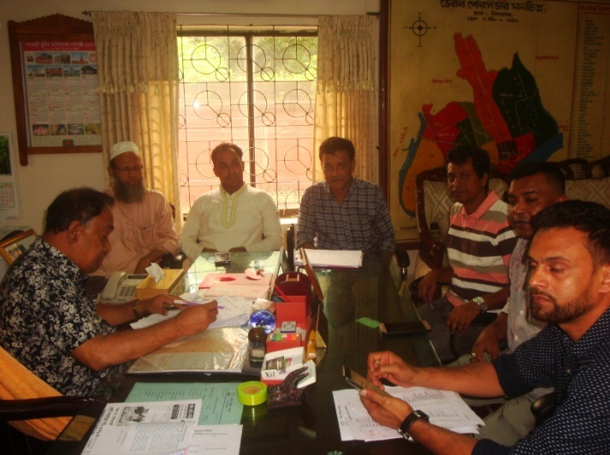 A Participation and Consultation meeting was held in the subproject site to carry out the feasibility of the specific subproject. Consultations with communities and other stakeholders have been used as a two-way communication to provide information about the subproject and obtain feedback from the communities on subproject approach, design and implementation.

Figure 1. Consultation meeting at ULB office

Consultations we recurred out through open meetings, Group Discussions (GDs) and key informant interviews (KII). From the meeting, this specific subproject is very important for the economic development of the communities which in turn will be implemented. Key informants were ULB Mayors, Ward Commissioners, (both male and female) Engineering, Businessmen, Subproject users and Local people.

**Local participants attendance Sheath (One page)**

