
GOVERNMENT OF THE PEOPLE’S REPUBLIC OF BANGLADESH
Local Government Engineering Department (LGED)

Local Government Division

Ministry of Local Government, Rural Development and Cooperatives

Environmental Assessment (EA) REPORT

Name of the Subproject: Development of Road from Hasanpur College to Khalpar Bridge (Ch. 1465 to 3950 m) and from R&H to Nagerkandi Government Primary School via Anarkhal Bridge (Ch. 0 to 593 m)

Package No: MGSP/DAD/2017-18/W-06

Daudkandi Pourashava, Comilla

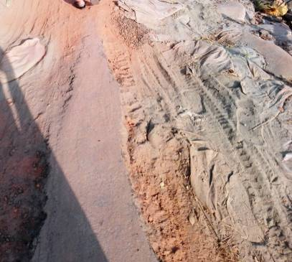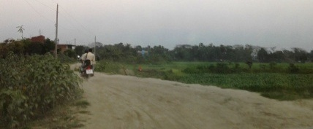

Municipal Governance and Services Project (MGSP)

Design, Supervision, and Management (DSM) Consultancy Services
Joint Venture of  Hifab International AB, Sweden  AQUA Consultant and Associates Ltd., Bangladesh |   
TABLE OF CONTENTS
 |  |  |  | Page
1.0 |  | INTRODUCTION |  | 1-3
 | 1.1 | Subproject Background |  | 1
 | 1.2 | Objectives of the Study |  | 2
 | 1.3 | Scope and Methodology of the Study |  | 2
2.0 |  | SUBPROJECT DESCRIPTION |  | 4-12
 | 2.1 | The Study Area |  | 4
 | 2.2 | Current Situation, Proposed Intervention and Need for the Subproject |  | 10
 | 2.3 | Envisaged Subprojects Activities and Implementation Process |  | 11
 | 2.4 | Category of the Subproject |  | 12
 | 2.5 | Subproject Schedule |  | 12
3.0 |  | BASELINE ANALYSIS OF ENVIRONMENTAL CONDITION |  | 13-21
 | 3.1 | Physical Environment |  | 13
 | 3.2 | Biotic Environment |  | 20
 | 3.3 | Socio-economic and Socio-cultural Environment |  | 20
4.0 |  | ENVIRONMENTAL SCREENING |  | 22-24
5.0 |  | SPECIFIC IMPACT, MITIGATION AND ENHANCEMENT MEASURES |  | 25-31
 | 5.1 | Site Clearing, Excavation and Earth Work |  | 25
 | 5.2 | Ecological Impact and Enhancement Work |  | 25
 | 5.3 | Pollution from the Storage of Construction Materials |  | 26
 | 5.4 | Air Quality and Dust |  | 26
 | 5.5 | Noise and Vibration |  | 27
 | 5.6 | Water Quality |  | 27
 | 5.7 | Occupational Health and Safety |  | 28
 | 5.8 | Impacts on Social Environment and Common Property Resources |  | 29
 | 5.9 | Labor Influx and Anticipated Impacts |  | 30
 | 5.10 | Impacts on Traffic Movement |  | 31
6.0 |  | ENVIRONMENTAL MANAGEMENT PLAN |  | 32-44
 | 6.1 | Access to Information |  | 32
 | 6.2 | Grievance Redress Mechanism |  | 32
 |  | 6.2.1 | Grievance Redress Committee (GRC) | 32
 |  | 6.2.2 | Grievance Resolution Process | 33
 | 6.3 | Institutional Arrangement for Safeguard Compliances |  | 34
 | 6.4 | Capacity Building |  | 35
 | 6.5 | Emergency Response and Disaster Management |  | 35
 | 6.6 | Environmental Management Action Plan |  | 36
 | 6.7 | Environmental Monitoring Plan |  | 41
 | 6.8 | Environmental Management Budget |  | 42
 | 6.9 | Environmental Codes of Practice |  | 43
7.0 |  | PUBLIC CONSULTATION AND PARTICIPATION |  | 45-47
 | 7.1 | Methodology |  | 45
 | 7.2 | Issues Raised by the Participants |  | 46
 | 7.3 | Feedback, Suggestions and Recommendations of the Participants |  | 46
8.0 |  | CONCLUSIONS AND RECOMMENDATIONS |  | 48
9.0 |  | Reference |  | 49
APPENDIX
 |  | Appendix I: Environmental Monitoring Checklist |  | 50

LIST OF TABLES
Table 3.1.1 | Major Environmental and Infrastructural Features for Hasanpur College Road
Table 3.1.2 | Major Environmental and Infrastructural Features for Nagerkandi Road
Table 3.1.3 | Occurrences of Flood Hazard and Duration
Table 5.7.1 | General Requirements for the Workers Health and Safety
Table 5.8.1 | Impacts on Social Environment and Common Property Resources
Table 6.2.1.1 | List of GRC Committee Members
Table 6.6.1 | Anticipated Environmental Impacts during Construction Phase and Corresponding Mitigation and Enhancement Measures
Table 6.6.2 | Anticipated Environmental Impacts during Operational Phase and Corresponding Mitigation and Enhancement Measures
Table 6.7.1 | Matrix Table of Monitoring Plan (Visual observation during construction phase)
Table 6.8.1 | Environmental Management Budget in Bill of Quantity

LIST OF FIGURES
Figure 2.1.1 | Location Map of the Subproject Roads
Figure 2.1.2 | Lay-Out Plan of the Proposed Hasanpur College Road
Figure 2.1.3 | Lay-Out Plan of the Proposed Nagerkandi Road
Figure 2.1.4 | Topographic Features of the Hasanpur College Road
Figure 2.1.5 | Topographical Features of the Nagerkandi Road
Figure 3.1.1 | Location of Daudkandi Pourashava in Earthquake Zone Map of Bangladesh
Figure 3.1.2 | Location of Daudkandi Pourashava in Flood Zone Map of Bangladesh

LIST OF PHOTOGRAPHS
Photographs 2.2.1 | Current Situation of the Hasanpur College Road
Photographs 2.2.2 | Current Situation of the Nagerkandi Road
Photographs 7.1.1 | DSM Consultant Team with Pourashava Representatives Inspected the Proposed Road
Photographs 7.1.2 | Consultation Meeting at Pourashava Office with Pourashava Officials and Consultants Participants

ABBREVIATIONS

AP persons (AP’s) | Affected Person
BDT | Bangladeshi Taka
BOQ | Bill of Quantity
CC | Cement Concrete
CIP | Capital Investment Plan
CP | Contingency Planning
DSM | Design, Supervision, and Management
EA | Environmental Assessment
ECR | Environmental Conservation Rules
EMP | Environmental Management Plan
EPP | Emergency Preparedness Planning
ES | Environmental Screening
FGD | Focal Group Discussion
GoB | Government of Bangladesh
GRC | Grievance Redress Committee
GRM | Grievance Redress Mechanism
GRP | Grievance Redress Procedure
LGED | Local Government Engineering Department
MGSP | Municipal Governance and Services Project
PD | Project Director
PMU | Project Management Unit
RCC | Reinforcement Cement Concrete
RP | Relevant Reports
TL | Team Leader
WB | World Bank
XEN | Executive Engineer

1 INTRODUCTION

1.1 Subproject Background

Daudkandi Pourashava is located in the core of Daudkandi Upazila under Comilla District. Daudkandi Pourashava was established in the year of 1995. Currently, Daudkandi is B type Pourashava.It has an area of 12.17 sq.km. The present population of Daudkandi Pourashava is about 48,445. The Pourashava has 20 km RCC road, 2 km CC, 7 km BC, 1 km BFS, 8 km WBM road and 17 km earthen road. (Source: Daudkandi Pourashava)
Like other fast growing towns, Daudkandi Pourashava also demonstrates similar symptoms of ills of urbanization. In Daudkandi Pourashava, traffic volume is increasing day by day with the increase in population and demand. The substandard road network cannot cope with the growing demand; consequently, traffic congestion becomes a common problem. Hence, planned development of road network with street light is essential to meet the emergent demand.

This subproject includes BC Road and Road Protection Wall. The significant features of the subproject are mentioned below:
Name of the Subproject: | (1) Development of Road from Hasanpur College to Khalpar Bridge (Ch. 1465 to 3950 m);  (2) Development of Road from R&H to Nagerkandi Government Primary school via Anarkhal Bridge Ch (0 to 593 m).
Package No.: | MGSP/DAD/2017-18/W-06
District Name: | Comilla
ULB Name: | Daudkandi Pourashava
Jurisdiction Area: | Ward 01, 03 and 09
Structural Design Option: | BC Road and Road Protection Wall
Wards Population: | About 10,561 as per information by the Pourashava
Tribal People: | No tribal people settlement found in the subproject area
Land Acquisition: | No private land acquisition is needed
Estimated Cost: | 42.802 Million in BDT
Subproject Duration: | 12 Months
Tentative Start Date: | 16 September 2018
Tentative Completion Date: | 15 September 2019

Objectives of the Study

The general objective of this study is to determine the major environmental impacts succeeding from execution of the subproject and to recommend mitigation measures to avoid or reduce adverse environmental impacts and to enhance positive impacts. The specific objectives include:
- To assess the existing environmental conditions of the subproject site and its influence area;
- To identify and assess impacts resulting from the subproject during its construction phase and operation phase;
- To develop a environmental management plan with recommendations for mitigating impacts and enhance positive impacts;
- To summarize environmental monitoring requirements.

Scope and Methodology of the Study

The subproject appraisal is included environmental screening for all the subproject components. According to that screening, environmental assessment is required to fulfill the regulatory requirement for BC Road and Road Protection Wall. Hence, this environmental assessment is prepared to meet the regularity requirement of this subproject. The study methodology covered the following activities:

- Desktop Study;
- Field Investigations and Data Collection;
- Data Analysis and Report Writing.

Desktop Study
The desktop study involved:
- Initial meetings with client, stakeholders to discuss the proposed subproject;
- Collection and review of the baseline data, maps, reports and other relevant information;
- Review of the relevant existing legislation, regulation and policies;
- Understand the anticipated technical processes that may affect the environment.

Field Investigation and Data Collection

A team of the consultants made a field investigation to the proposed site. Field investigations involved mainly site walks at the subproject areas for identification of the environmental components to be affected due to the subproject intervention.
The following key tasks were performed during the field visit:

- Taking photographs of the significant aspects to assist in describing the baseline environmental conditions of the subproject area;
- Interviews with representatives of the relevant Pourashava officials and beneficiary and affected people within the subproject influence zone;
- Obtaining relevant documents from Pourashava and local people within the subproject influence zone;
- Verifying information and data collected during the desktop study and to collect new information.

Data Analysis and Report Writing
The data and information collected from all the sources (literature review, secondary and primary data, public consultation) were analyzed to describe the existing environmental setting of the subproject area, to identify the potential positive and negative impacts of the proposed subproject, as well as to provide preliminary suggestions for mitigation measures. Finally, this environmental assessment report has been prepared.

SUBPROJECT DESCRIPTION

The Study Area

The subproject site is situated within the jurisdiction area of the Daudkandi Pourashava Ward no. 01, 03 and 09. The starting point of the Hasanpur College Road with 23°32'18.78"N (Latitude) and 90°44'14.82"E (Longitude).The end point of this road is at Lalpur Gomoti Bridge with 23°33'1.58"N (Latitude) and 90°45'12.16"E (Longitude).The starting point of the Nagerkandi Road at R & H Road of Dowlodi Boro Bridge More with 23°31'3.06"N (Latitude) and 90°46'54.97"E (Longitude).The end point of this road is at Anarkhal Bridge with 23°31'9.71"N (Latitude) and 90°47'11.80"E (Longitude).The location map, lay-out plans, and topographic features of the subproject are shown in Figure 2.1.1, Figure 2.1.2, Figure 2.1.3, Figure 2.1.4 and Figure 2.1.5.
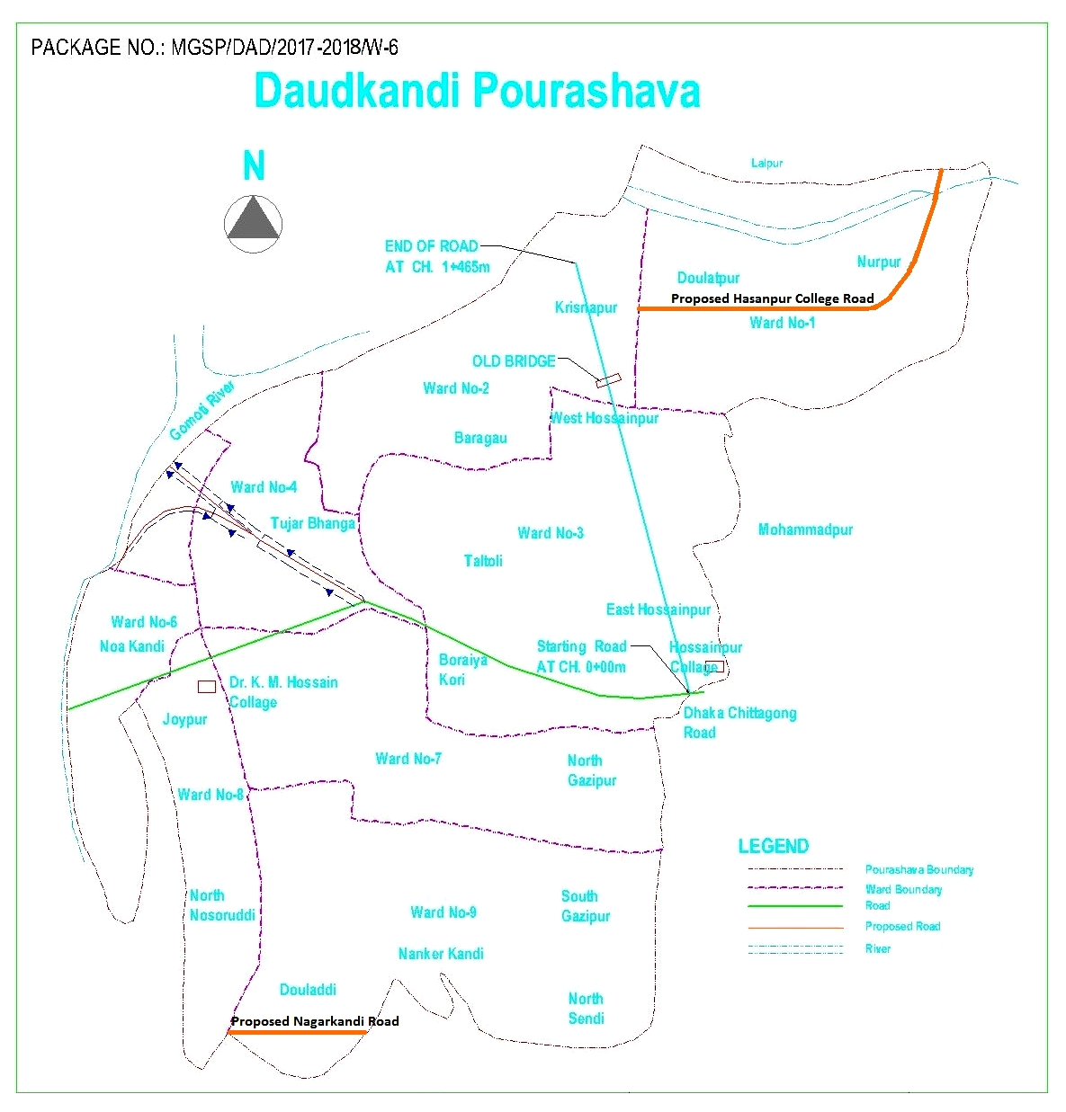
Figure 2.1.1: Location Map of Subproject Roads
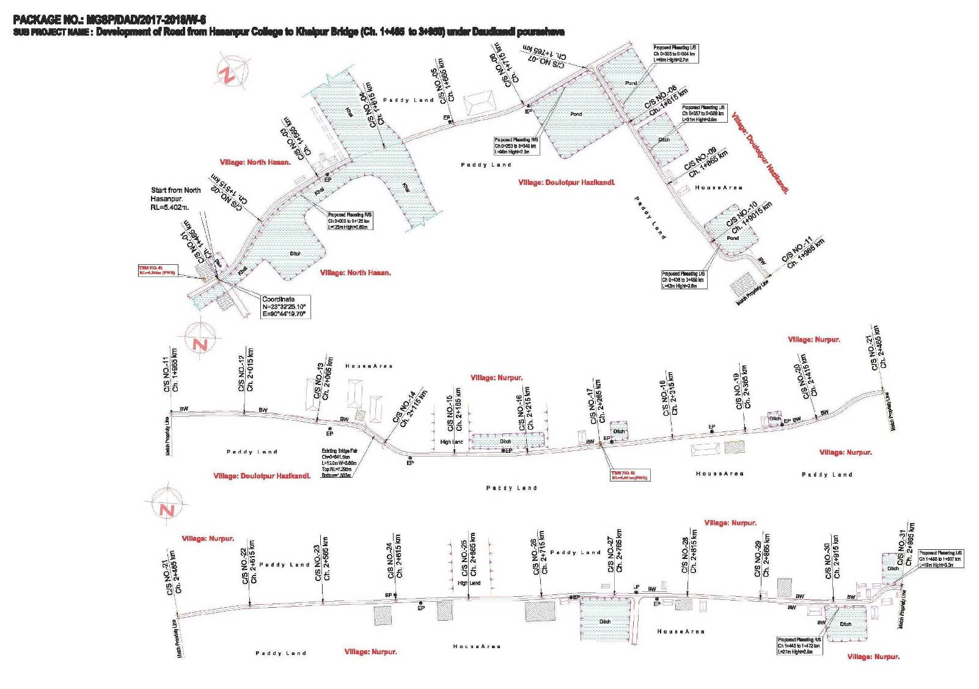

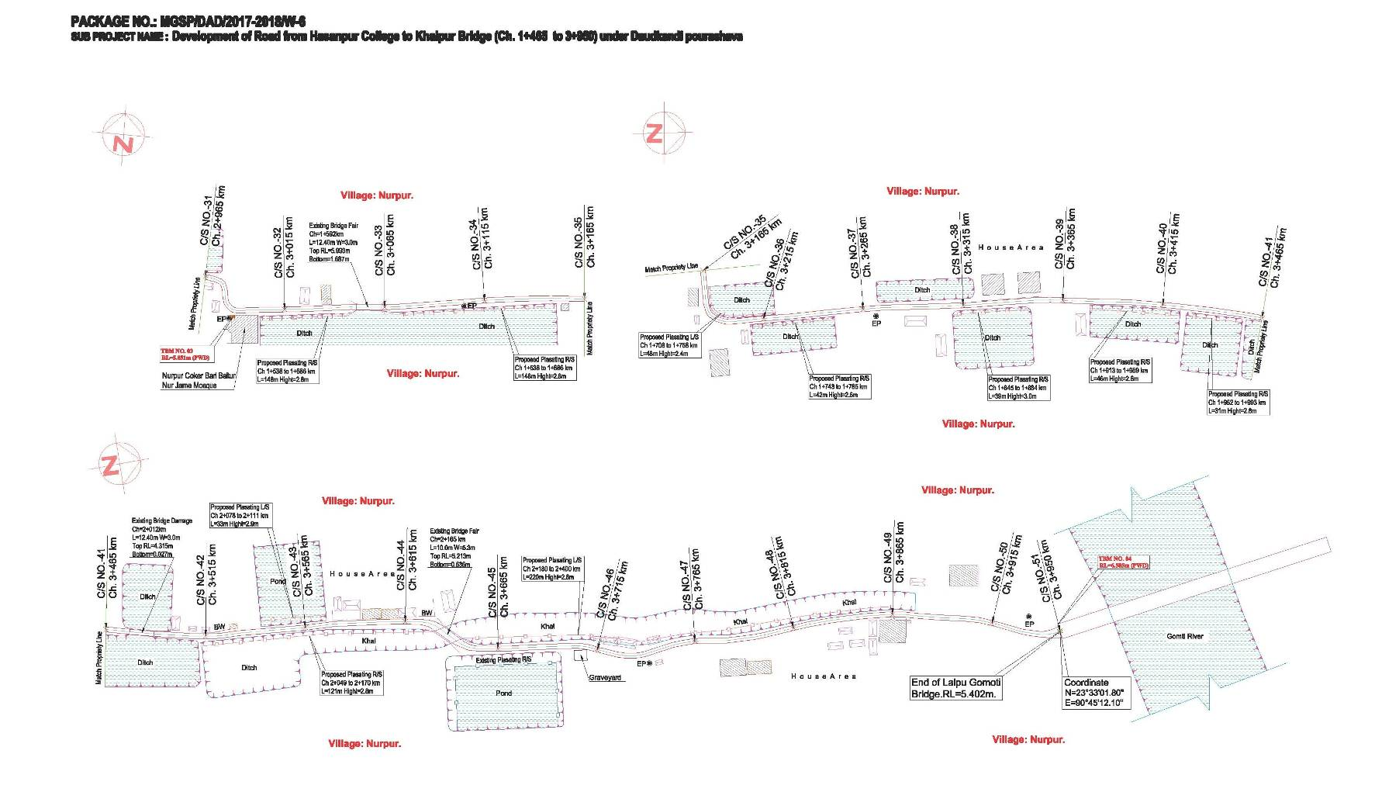
Figure 2.1.2: Lay-Out Plan of the Proposed Hasanpur College Road

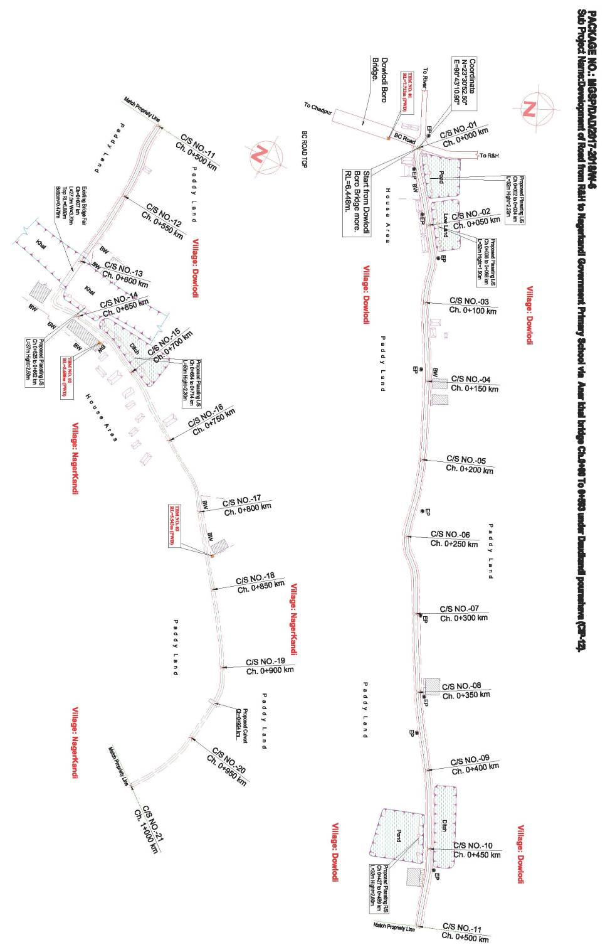
Figure 2.1.3: Lay-Out Plan of the Proposed Nagerkandi Road
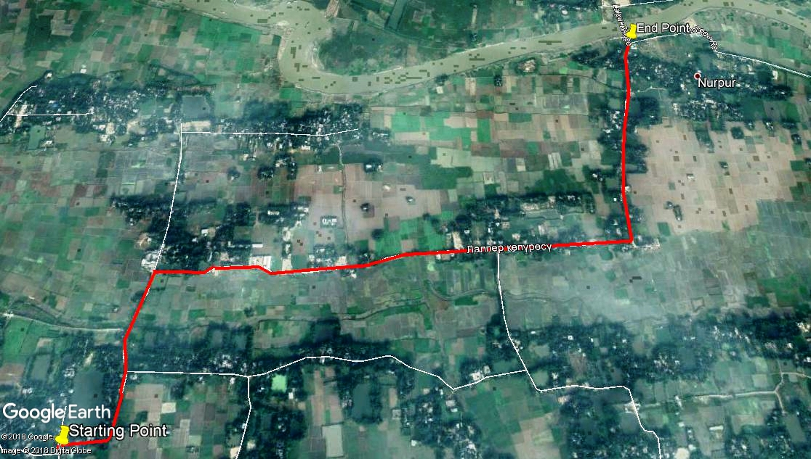

Figure 2.1.4: Topographic Features of the Hasanpur College Road
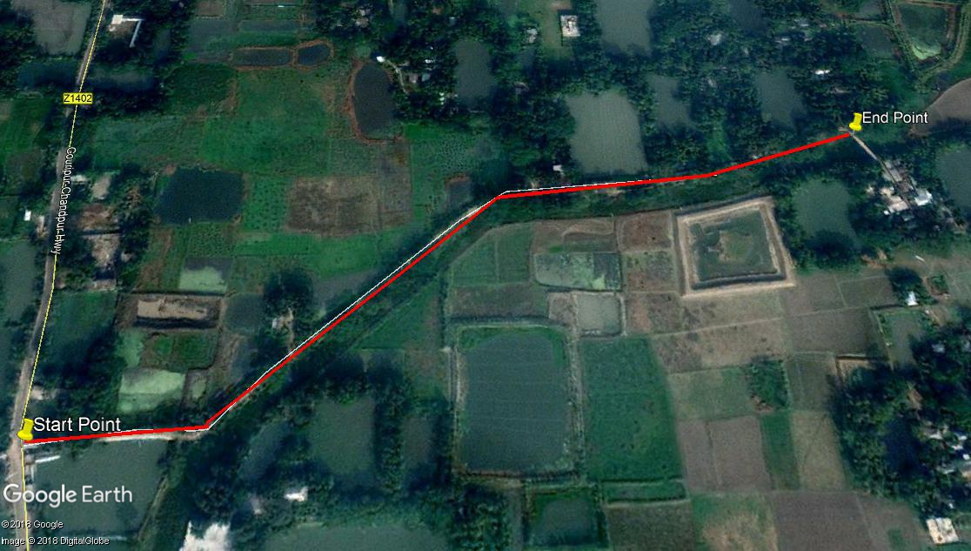
Figure 2.1.5: Topographical Features of the Nagerkandi Road

Current Situation, Proposed Intervention and Need for the Subproject

Presently, Hasanpur College Road is partially damaged in different sections which hamper the normal traffic operation. The existing road is also narrow (average pavement width is 2.3 m. On the contrary, some road side ditches, ponds and khal exist, which necessitates road protection work. Road protection work is needed at right side of the road (total 610 m, at 9 different Chainage with different lengths). On the other hand, from Ch. 0 to 593 m, the existing RCC pavement will be demolished and replaced by the new BC pavement. Presently, the existing road is badly damaged at most of the sections. From the site investigation, it is revealed that damaged road interrupts traffic operation. Hence, widening and road improvement is necessary. The existing condition of the subproject road is further elaborated in the following Photographs 2.2.1 and 2.2.2.
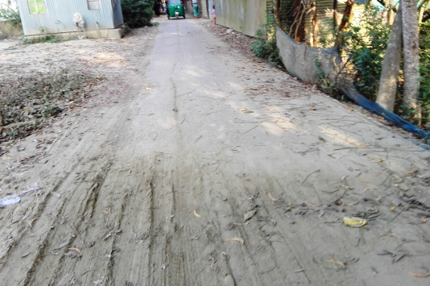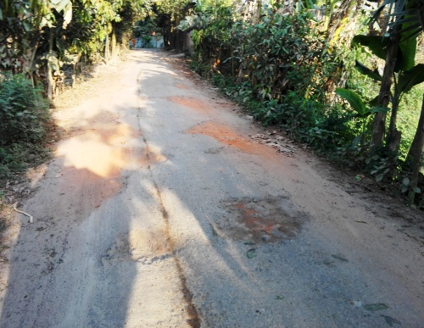

Photographs 2.2.1: Current Situation of the Hasanpur College Road

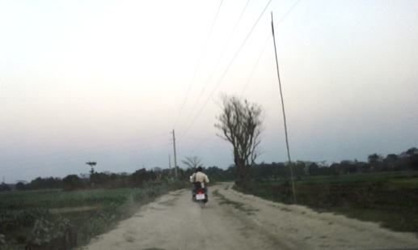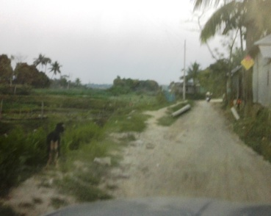

Photographs 2.2.2: Current Situation of the Nagerkandi Road

Envisaged Subproject Activities and Implementation Process

The general activities of the subproject includes: construction of the semi-pucca site office, construction of the labor shed and relocation of the electrical poles for access road.
Specific activities for RCC Road Protection Wall:

- Earth work in excavation;
- Earth filling;
- Polythene sheet laying work;
- Cement concrete work;
- Brick masonry work;
- Fabrication of the ribbed or deformed bar;
- Reinforced cement concrete work;
- Pile driving work.

Specific activities for BC Road:
- Site clearing work;
- Preparation of the hard bed by scarifying and loosening of the existing top;
- Earth work in box cutting;
- Sand filling on the road bed;
- Brick on end edging;
- Compacted aggregates and sub-base course;
- Providing prime coat;
- Lying pre-mixed dense bituminous surfacing.

The materials to be used for the key activities: bricks, brick chips, stone chips, reinforcement bar, admixture, bearing pad, sand, cement, concrete, paint, laying pre-mixed dense bituminous surfacing and installation of street light etc.
The major equipment to be used for the implementation of the subproject: long-boom hydraulic excavator, brick breaking machine, concrete mixer machine, vibrator machine, MS sheet, steel cutter, steel shutter, steel drum rollers, pneumatic multiple tire roller, dump truck, water tanker, pump, asphalt plant, rubber tire roller, paver, generator and measuring device.

Category of the Subproject
- According to ECR 1997: Green □ Orange□ A Orange B □√ Red □ Not Listed □
- According to WB classification: Category B □√ Category C □

Considering the anticipated environmental impacts, primarily BC road is considered as Orange B as per ECR-97. According to the WB classification, it can classify as Category B.

Subproject Schedule
The tentative schedule of construction of the subproject is:

(a) Subproject Duration (months) :12 months
(b) Tentative Start Date : 16 September 2018
(c) Tentative Completion Date : 15 September 2019

The daily construction hours will normally include regular working time. However, daily working hours may vary based on the on-site condition. The detailed work program will be prepared by the contractor with the assistance of the PIU-Pourashava. Then it will be shared with the PMU, LGED and DSM consultants. In addition, the detailed work program will also be shared with the Bank as per requirement.

Baseline ANALYSIS OF THE ENVIRONMENTAL CONDITION

Physical Environment

Important Environmental and Infrastructural Features

The detailed environmental and infrastructural features have been collected during the site visit. The conditional survey has also been performed for designing of the subproject. Hence, data from conditional survey is also incorporated in the screening report. Effort has been given for getting major environmental and infrastructural features within 100 m of both sides from the centre of the road at 100 m longitudinal intervals from North Hasanpur to Gomoti Bridge and from R & H Road at Dowlodi Boro Bridge More to Anarkhal Bridge of proposed subproject.The key environmental and infrastructural features are given in the following Table 3.1.1 and Table 3.1.2.
Table 3.1.1: Major Environmental and Infrastructural Features for Hasanpur College Road
Chainage (m) | Left | Right | Major Environmental and Infrastructural Features
North Hasanpur to Gomoti Bridge (Ch. Ch. 1465 to 3950 m)
1465-1565 | √ |  | Agricultural field, trees (Dumur, Boroi, Jackfruit, Mango, Koroi), RM Ideal Home Coaching Center, electric pole
1465-1565 |  | √ | Trees (Dumur, Boroi, Mango), khal, ditch, electric pole
1565-1665 | √ |  | Agricultural field, khal, bushes, trees (Dumur, Amra, Boroi), tin shed shops
1565-1665 |  | √ | Pond, khal, bushes, trees (Dumur, Koroi )
1665-1765 | √ |  | Pond, trees (Jackfruit, Mango, Koroi, Coconut, Black Berry), bunch of banana, bushes, tin fence, house
1665-1765 |  | √ | Pond, trees (Dumur, Mango, Pulm, Arjun, Date), bushes, open field
1765-1865 | √ |  | Fence, trees (Mango, Jackfruit, Betel Nut), house, pond, ditch
1765-1865 |  | √ | Agricultural field, trees ( Dumur, Mango, Coconut),pond
1865-1965 | √ |  | Boundary wall of Sanaullah Mayor Saheb, trees (Koroi, Mahogany), poultry farm, house area
1865-1965 |  | √ | Agricultural field, trees ( Meagan ,Boroi, Koroi), bushes
1965-2065 | √ |  | Open Space, boundary wall, house, bushes, trees (Boroi, Jackfruit, Mango)
1965-2065 |  | √ | Agricultural field, electric pole, trees (Dumur, Mahogany, Banana, Coconut), bushes
2065-2165 | √ |  | Open space, bushes, trees (Dumur, Boroi, Mango), poultry farm, boundary wall, house, bunch of banana
2065-2165 |  | √ | Agricultural field, trees ( Dumur, Pulm), bushes, electgric pole
2165-2265 | √ |  | Open space, trees (Mango, Koroi, Dumur, Mahogany), bushes, electric pole, tin shed structure, bunch of banana, ditch
2165-2265 |  | √ | Agricultural field, trees (Pulm, Mango), bushes, bunch of banana, electric pole
2265-2365 | √ |  | Agricultural field, bushes, trees ( Mahogany, Mango, Koroi), ditch, electric pole
2265-2365 |  | √ | Agricultural field, bushes, trees (Eucalyptus, Mahogany, Mango), houses
2365-2465 | √ |  | Electric pole, open space, bushes, trees ( Mango, Dumur), bunch of banana, boundary wall, ditch
2365-2465 |  | √ | Tin fence, residential houses, electric pole, common planted trees (Boroi,Mango,Jackfruit)
2465-2565 | √ |  | Agricultural field, bushes, trees (Mahogany, Mango, Koroi), ditch, electric pole
2465-2565 |  | √ | Agricultural field, bushes, trees (Eucalyptus, Mahogany, Mango), houses
2565-2665 | √ |  | Electric pole, open space, bushes, trees ( Mango, Dumur), bunch of banana
2565-2665 |  | √ | Tin fence, homestead area, electric pole, common planted trees (Boroi,Mango,Jackfruit)
2665-2765 | √ |  | Agricultural field, open space, bushes, trees ( Mango, Dumur), bunch of banana
2665-2765 |  | √ | Tin fence, homestead area, electric pole, common planted trees (Boroi, Mango, Jackfruit), ditch, connecting road
2765-2865 | √ |  | Homestead area, common planted trees (Coconut, Date, Mango, Jackfruit), bunch of banana, bushes
2765-2865 |  | √ | Residential area, trees (Coconut, Date, Mango, Jackfruit), bunch of banana, bushes
2865-2965 | √ |  | Residential houses, boundary wall, trees (Coconut, Date, Mango, Jackfruit), ditch
2865-2965 |  | √ | Houses, boundary wall, ditch, trees (Coconut, Date, Mango, Jackfruit)
2965-3065 | √ |  | Homestead area, house fence,bunch of banana, common planted trees
2965-3065 |  | √ | Nurpur Chaker Bari Baytur Nur Jame Mosque, ditch, trees (Coconut, Mango, Date, Dumur, Koroi), bunch of banana, Agricultural field
3065-3165 | √ |  | Residential houses, bunch of banana, trees (Mango, Coconut, Pulm, Koroi)
3065-3165 |  | √ | Ditch, bunch of banana, trees (Mango, Coconut, Pulm, Koroi)
3165-3265 | √ |  | Houses, common planted trees, bunch of banana, ditch
3165-3265 |  | √ | Houses, electric pole, common planted trees, bunch of banana, ditch
3265-3365 | √ |  | House area, ditch, trees (Mango, Coconut, Jackfruit), bunch of banana
3265-3365 |  | √ | Ditch, residential houses, house fence, trees (Mango, Coconut, Jackfruit), bunch of banana
3365-3465 | √ |  | House boundary, residential area, ditches, bunch of banana, bushes, trees (Dumur, Mango, Coconut, Mahogany, Pulm)
3365-3465 |  | √ | Ditches, houses, bunch of banana, bushes, trees (Dumur, Mango, Coconut, Mahogany, Pulm)
3465-3565 | √ |  | House boundary, residential area, ditches, pond, bunch of banana, bushes, trees (Dumur, Mango, Coconut, Mahogany, Pulm)
3465-3565 |  | √ | Ditches, houses, bunch of banana, bushes, trees (Dumur, Mango, Coconut, Mahogany, Nim, Pulm)
3565-3665 | √ |  | House fence with tin, houses, residential area, boundary wall, common planted trees, khal
3565-3665 |  | √ | Pond,khal, bunch of banana, common planted area
3665-3765 | √ |  | Khal,houses, common planted trees, bunch of banana, bushes
3665-3765 |  | √ | Pond, graveyard, electric pole, trees (Jackfruit, Mango, Coconut, Papaya), bunch of banana, bushes, residential area
3765-3865 | √ |  | Khal,houses, common planted trees, bushes, bunch of banana, temporary shops
3765-3865 |  | √ | House area, common planted area, bushes, tin shed shops, open space
3865-3950 | √ |  | Bunch of banana, bushes, residential houses, trees
3865-3950 |  | √ | Temporary shops, houses, Mosque, bunch of banana, common planted trees, bushes
**Note: There are 11 no. electrical poles to be re-located for the implementation of the subproject.

Table 3.1.2: Major Environmental and Infrastructural Features for Nagerkandi Road
Chainage (m) | Left | Right | Major Environmental and Infrastructural Features
R & H Road at Dowlodi Boro Bridge More to Anarkhal Bridge (Ch. 0 to 593 m)
0-100 | √ |  | Temporary shop, pond, low land, electric pole
0-100 |  | √ | House area, boundary wall, trees, electric poles
100-200 | √ |  | Houses, common planted trees, agricultural field
100-200 |  | √ | Agricultural field, electric pole
200-300 | √ |  | Agricultural field, electric pole, bushes
200-300 |  | √ | Agricultural field, trees
300-400 | √ |  | Bushes, electric pole, agricultural field, house
300-400 |  | √ | Agricultural field, electric pole
400-500 | √ |  | Agricultural field, ditch, electric pole
400-500 |  | √ | Common planted trees, houses, pond, agricultural field
500-593 | √ |  | Houses, boundary wall,open space
500-593 |  | √ | Paddy land, trees
**Note: There are 16 no. electrical poles to be re-located for the implementation of the subproject.

Geology, Topography and Soils

The soil class of the Pourashava falls under Non Calcareous Grey Flood Plain Soil: this soil type is characterized by having as grey (often olive grey) topsoil with and a cambic B horizon which either has a grey matrix or grey gleyans. The subsoil is generally 15-50 cm thick. Most sub-soils are near neutral or slightly alkaline. Stratified alluvium in the substratum varies in texture but commonly it is sandier than the overlying soil. Geology of Daudkandi Pourashava, which is in Comilla District, belongs to Barisal Gravity High but adjacent to Modhupur Tripura Threshold. The characteristic of the thresh hold is that the depth of the bedrock is gradually becomes shallow as it approaches the Tripura Region of India. (Source: Metrological Data of Comilla District). According to BNBC (1993), Bangladesh has three seismic zones with moderate and low seismic activity. Daudkandi Pourashava area falls in Zone II, i.e. medium intensity seismic zone of the country.

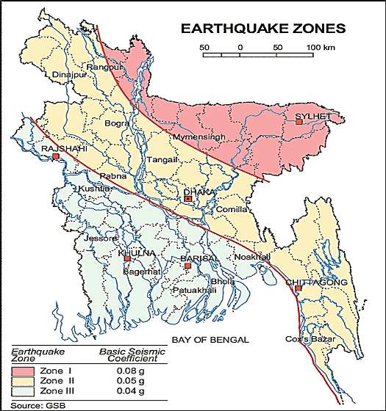

Figure 3.1.1: Location of Daudkandi in Earthquake Zone Map of Bangladesh

Climate and Meteorology

The climate of the subprojects area can be described as Tropical Monsoon. It is characterized by warm, humid summers and cool, and dry winters. From November to March, it is dry and cool while from April to May it is extremely hot during the pre-monsoon season. From June to October, the monsoon season is warm, cloudy, and wet. The warmest month is April, the coolest is January, the wettest is July and the driest is January.
The maximum mean temperature observed in Daudkandi Pourashava is about 25-32°C between May-August, with the minimum temperatures of between 12-15°C in January as shown in Figure 3.1.1. Monthly precipitation records clearly show a distinct dry and rainy season in Figure 3.1.2. (Source: Metrological Data of Comilla District)
Figure 3.1.2: Average Minimum and Maximum Temperate in Daudkandi Pourashava (Source: Bangladesh Meteorological Department)
Figure 3.1.3: Average Rainfall in Daudkandi Pourashava (Source: BMD)
According to the statistics of the wind data from the Bangladesh Meteorological Department Climate Division, wind direction changes by month, Nevertheless, the northwest, south, and northeast winds are predominant.
The construction works can be influenced by the climatic condition and meteorological components like humidity, temperature, sudden rainfall, and wind speed. During high winds, there might be possibility of quick spreading of the dust generated from the construction activities. It is very risky to work during rain and in high winds because the possibility of getting injury increases. Furthermore, work under high temperature and excess humidity is extremely difficult, and may create dehydration problem.

Water Resources (Surface Water, Ground Water and Rain Water Harvesting)

In the subproject area, there are some ponds. There are some other water bodies like khals along the road alignment.

Ground water is available in plenty and water table does not go beyond suction limit throughout the year. The water of shallow layer contains lot of iron, while water of deep layer does not contain excessive iron. Arsenic concentration is not reported as higher level in both deep and shallow aquifer. Local people typically use deep tube-well water for drinking and other domestic purposes. Salinity problems are not visible. Rain water harvesting system is not common in and around the subproject area.

During construction period, water will be used both for the construction work and domestic purposes. Therefore, ensuring the water requirements is one of the key issues.

Flooding, Water Logging and Drainage Pattern
According to previous data, this area is not affected in severe flood events. Flood mainly occurs from April to September in this area. From the field survey it is observed that 18.18% people are affected by normal yearly flooding. Local people reported that 75% of the households are moderately affected by periodic flood which occurs at 2 to 5 years interval. Such flood events are generally concentrated in the months of June and August. (Source: Survey Report of Preparation Master Plan).There are some surface water bodies along the road alignment. The subproject area is not generally subjected to water logging problems. However, due to continuous heavy rain, delay discharge of storm water sometimes creates water logging problems.
Table 3.1.3: Occurrences of Flood Hazard and Duration
Period/ Interval | Month
Period/ Interval | Jan | Feb | Mar | Apr | May | Jun | Jul | Aug | Sep | Oct | Nov | Dec
Yearly | 0 | 0 | 0 | 0 | 0 | 9.08 | 0 | 4.55 | 4.55 | 0 | 0 | 0
2-5 years | 0 | 0 | 0 | 2.27 | 0 | 13.64 | 9.08 | 47.73 | 2.27 | 0 | 0 | 0
Other | 0 | 0 | 0 | 2.27 | 0 | 0 | 2.27 | 2.27 | 0 | 0 | 0 | 0
Total | 0 | 0 | 0 | 4.55 | 0 | 22.72 | 11.35 | 54.55 | 0 | 0 | 0 | 0
Source: Environment Survey by NPR 2008

A flood zoning map and location of the Daudkandi Pourashava is provided in Figure 3.1.4.
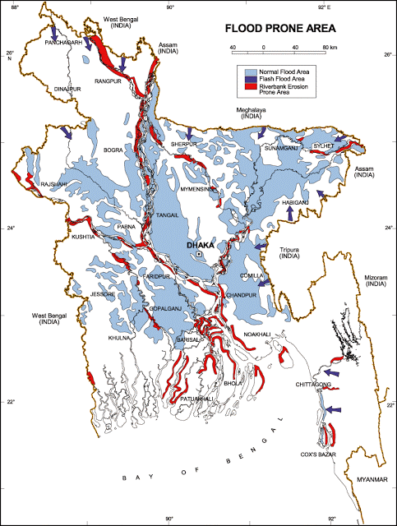

Figure 3.1.4: Location of Daudkandi Pourashava in Flood Zone Map of Bangladesh
Air Quality and Dust
Ambient air quality data have not been found. The subproject road generates dust during movement of the vehicles during dry season. The windblown dust also causes air pollution. Due to rapid urbanization of Daudkandi Pourashava the total number of motorized vehicles including bus, truck, tempo, three-wheeler has been increased. These motorized vehicles are old and poorly maintained. Consequently, black smoke emission from the vehicles degrades the quality of the air. There are no remarkable sources of the air pollution such as heavy and small industries in the subproject area. There is no brick field observed in the subproject area during site visit.

Noise Level

Noise is not a major impediment for the quality of the environment in the subproject area. The motorized and non-motorized vehicles such as rickshaws, trolleys, pick-up, motor cycles, mini trucks, and private cars etc. produce noise. However, they are within the tolerable limits in most cases. There are no other perceptible sources of noise generation such as heavy factories or industries in the subproject area.

Solid Waste Management

Daudkandi Pourashava does not possess a well managed system for managing solid wastes generated in the Pourashava area. The Pourashava has no well managed dustbin. Generally inhabitants throw their wastes in roadside drains, opens space or road adjacent to their houses. The Pourashava has no solid waste disposal site of its own. It normally dumps the solid waste into low lying areas, canals. The municipal authority could not take any measures to prohibit its inhabitant from indiscriminate dumping of solid wastes into the canals which results in blocking of drainage system. (Source: Survey Report of Preparation Master Plan). Construction wastes (solid wastes and other forms of the waste) will be disposed at the vacant place near Lalpur Gomoti Bridge and near Anarkhal Bridge.

Biotic Environment

Flora and Fauna

In the subproject area, the floral species includes: Coconut, Mahogany, Mango, Koroi, Bunch of Banana, Bushes, Jackfruit, Black Berry, Date, Dumur, Papya, Pulm, Boroi, Nim, Arjun, Eucalyptus, and Amra. The common local birds such as Crow, Chil, Shalik, and Choroi were found during the site visit. There are no wild animals and endangered faunal species in the subproject area.

Socio-economic and Socio-cultural Environment

Land Use, Status of Housing and Built-up Infrastructure
The land use pattern in the subproject area mostly consists of residential area. The important features of the Hasanpur Road area includes: RM Ideal Home Coatching Center, Sanaullah Mayor Saheb House, poultry farm, homestead area, Nurpur Chaker Bari Baytur Nur Jame Mosque, local mosque, boundary wall, fence and graveyard. In addition, khal, ponds, ditches, common planted trees, bunch of banana, shrubs, bushes, agricultural field, and low land and open space. The important features of the Nagerkandi Road area includes: residential houses, temporary shop and boundary wall.
Beneficiary Population
The subproject is situated within the jurisdiction of the ward number 01, 03, and 09. Considering the ward population about 10,561 people will benefit directly and many others indirectly.

Education
In the Pourashava area, literacy among the population is about 57.4%. This is higher than the national average (51.8%). The literacy rate among males (59.3%) is more than females (55.5%). (Ref: Population and Housing Census 2011).

Tribal Communities
There is no indigenous or tribal people settlement in the subproject area. Hence, no measures needed for the indigenous peoples’ safeguard.

Land Acquisition

Private land acquisition is not needed in Hasanpur Road area. But, removing of the road side boundary walls, outer edge of houses are needed at different Chainage due to site clearing and road widening work. The Pourashava will clear the site amicably with the owners of these structures prior to the construction work. An agreement has already been signed by the Pourashava with the owners of these structures. However, in case of any objection from the affected persons, DSM will investigate the actual situation. Then, measures will be taken as per rules. On the other hand, in the Nagerkandi Road area, private land acquisition and removing of the road side structures are not needed.
Principal Livelihoods and Economic Activities
The subproject area is inhabited by the mixed occupational people. In the Pourashava area, major income comes from business, enterprises, small trades, private sector jobs, agriculture, and government jobs in the town.
Cultural Heritage and Protected Areas
There are no protected areas and no important cultural or historical sites identified in the subproject area.
Social Conflicts and Development Activities

The local people welcome the subproject and there is no conflicts between the local communities regarding subproject implementation.

ENVIRONMENTAL SCREENING

Environmental Screening (ES) for the subproject has been conducted with the purpose of fulfilling the requirements of Government (GOB) and World Bank (WB) for the preparation of subproject appraisal. Environmental Screening Checklist, as adopted in Appendix C of the Environmental Management Framework (EMF) of the MGSP, was administered for identifying the impacts and their extents.
The screening data and information for the BC Road and RCC Road Protection Work have been formulated and are shown in below.
1) Potential environmental impact during construction phase:
(a) Ecological impacts:
287
- Felling of trees Significant □ √ Moderate □ Minor □ Number of trees
- Clearing of vegetation Significant □ Moderate □√ Minor □
- Potential impact on species of
aquatic (i.e., water) environment Significant □ Moderate □ Minor □√

Major trees to be felled down are: Coconut, Mahogany, Mango, Koroi, Bunch of Banana, Bushes, Jackfruit, Black Berry, Date, Dumur, Papaya, Pulm, Boroi, Neem, Arjun, Eucalyptus, Amra etc. 280 trees at Hasanpur College Road and 7 trees at Nagerkandi Road to be felled down. There is no tree to be felled down bring religious and heritage importance. In addition, the trees to be felled down are mostly small to medium size in terms of length and diameter. Vegetation coverage on both sides of the road is not similar in terms of the intensity. So clearing of the road side vegetation is considered as moderate. In addition, anticipated impact on species of aquatic environment is minor because except throwing of the wastes materials in to the khals, ponds and ditches, the subproject does not have any impact on the aquatic environment. Considering the number of trees and vegetation to be felled down, the ecological impact is considered as significant.
- Physicochemical impacts:

- Noise pollution Significant □ Moderate □√ Insignificant □
- Air pollution Significant □ Moderate □√ Insignificant □
- Drainage congestion Very likely □ Likely □ √ Unlikely □
- Water pollution Significant □ Moderate □ Insignificant □√
- Pollution from solid/ construction wastes Significant □ Moderate □√ Insignificant □
- Water logging Significant □ Moderate □ Insignificant □√
The subproject will have impacts on noise and air quality during construction phase due to mobilization of the equipment, vehicles movement for the transportation of the materials, using of hydraulic excavator, brick breaking machine, mechanical compaction machine, paver, asphalt plant, concrete mixer machine, vibrator machine etc. The construction work will be performed section wise. Hence, it is anticipated that the overall impacts on noise and air quality will be moderate, temporary and limited within the subproject boundary. There are road side residents, educational and religious institutions. Hence, anticipated impacts on noise and air quality will be significant for this particular section if measures do not take properly. The generated dust during construction activities may disturb the local people during construction period. The generated construction wastes, un-suitable materials and solid wastes may degrade the adjacent khal water if not properly collected and disposed and thrown in to the khal, pond and ditch. Improper collection and disposal of the generated wastes materials also may degrade the quality of the surrounding environment and degrade the aesthetic value. The anticipated water logging and drainage congestion during construction period is minor because space is available at most sections of the road for drain-out the storm water. In addition, provision will be there for pumping out the storm water if required.
- Socio-economic impacts:

- Traffic congestion Very likely □ Likely □ √ Unlikely □
- Health and safety Significant □ Moderate □√ Insignificant □
- Impact on archaeological and historical Significant □ Moderate □ Insignificant □√
- Employment generation Significant □ Moderate □ √ Insignificant □
The subproject activities will interrupt free movement of the pedestrians during construction work. Due to narrow width and bad condition of the road, the volume of the motorized traffic is few for this road. Hence, it is anticipated that the subproject activities do not have any severe impact on the local traffic system. The Pourashava will inspire the local people for using of the alternative roads to minimize any impact due to construction of this road. The construction work will follow simple procedure with commonly used equipments. Hence, anticipated impact on health and safety is moderate. There is no archaeological and historical site within the influence area. The subproject has positive impact by generating work opportunities for the local people and supplying of the construction materials, equipments, food and other necessary stuffs to the campsite.
2) Potential environmental impact during operational phase:
(d) Ecological impacts:
- Potential impact on species of aquatic Significant □ Moderate □ Minor □√
(i.e., water) environment

In operation phase, there is no likely adverse impact on the ecological environment. On the other hand, roadside tree plantation will enhance the ecological condition in the subproject area.
(e) Physicochemical impacts:
- Potential air quality Improvement □ No-improvement □ Deterioration □√
- Noise level Improvement □ No-improvement □ Deterioration □√
- Drainage congestion Improvement □ Minor Improvement □ No Impact □√
- Risk of Water pollution Significant □ Moderate □ No Impact □√
- Pollution from solid waste Improvement □ No-improvement □ Minor □√

During operation phase, improved road may increase traffic volume which may degrade the air quality and noise level due to black smoke emission and un-due use of hydraulic horn from the vehicles. During operation phase, there is no likely impact on the water pollution and drainage congestion.
(f) Socio-economic impacts:
- Traffic Improvement □√ No-improvement □ Adverse □
- Safety Improvement □√ No-improvement □ Adverse □
- Employment generation Significant □ Moderate □ Minor □√

After completion, this road will improve the transport facilities. By providing uniform pavement, it will also enhance traffic safety. The new subproject will minimize the frequency of the maintenance for first three to five years after completion.
(3) Summary of the possible environmental impacts of the subproject:

The ecological impact due to the subproject implementation is mainly due to tree felling. However, the ecological imbalance to be caused due to cut down of the trees will be compensated by the plantation of the trees.
The overall impact due to implementation of the subproject is not severe. The physicochemical components will be disturbed during the construction phase. However, the anticipated impacts will be mainly within the subproject boundary. The wastes generated due to the construction activities should be properly collected and disposed in a designated site. There is also some adverse impact at operational stage. Due to improved road, motorized traffic volume may increase. Thus, air quality and noise level may be deteriorated due to vehicles emission and horns by the vehicles.

Safety concern is an important issue for both the construction and operation phases that should be considered properly. The socio-economic aspect mainly includes health and safety and employment generation. This subproject will have positive impacts in terms of the generation of the employment and business activities by supplying construction materials and equipment.

Specific impact, mitigation AND enhancement measures

The likely impacts of the subproject are mainly caused by the activities required for the implementation of the subproject, and materials, resources and equipment to be used to perform the activities. This section describes some specific impacts due to the subproject activities and their mitigation measures.

The likely impacts of the subproject are mainly caused by the activities required for the implementation of the subproject, materials, resources and equipment to be used to perform the activities. This section describes some specific impacts due to the subproject activities and their mitigation measures.

  - Site Clearing, Excavation and Earth Work

The subproject works includes earth excavation and earth filling especially for approach roads. These works lead dust blowing, improper disposal of the wastes, noise and vibration which may disturb the local people.

Mitigation Measures

- Proper care will be taken by the contractor during site clearing work, excavation work, earth work and disposal work to avoid any undue disturbances to the nearby people;
- Cover exposed earth works and other wastes materials with fabric;
- Disposal of soil and construction wastes to designated dump site at the vacant place near Nurpur Gomoti Bridge and near Anarkhal Bridge;
- Avoid loss of the topsoil for the earth work.

  - Ecological Impact and Enhancement Work

There are 287 nos. of planted and naturally grown trees such as Mahogany, Papaya, Koroi, Banana, Date, Banyon, Kadom etc. trees will be felled down and roadside vegetation will be cleared due to implementation of this subproject.
Mitigation Measures
- Depending on the space and budget availability, 600 nos. of the trees will be planted to compensate the felled down trees and ecological disturbance and also for beautification work;
- Tree plantation - preferably local fruits, flowers, medicinal and ornamental trees- Mango, Jam, Jackfruit, Kathbadam, Krisnachura, Shimul, Polash, Jarul, Kadom, Satim, Neem, Arjun, Amloki, Horitoki, Bohera, Mahogany, Shil Koroi, Rain Tree, Gamari, Babla, Chambal, Palm Tree at the periphery of the proposed subproject site;
- Planting many trees will enhance the ecological condition of the area after their successful growth.
  - Pollution from the Storage of Construction Materials
Dumping of the construction spoils, including accidental leakage of the oil, grease, and fuel in equipment yards is a significant hazard. Storm water may carry these substances during rain. Thus, both surface and groundwater might be polluted from these contaminants. Air pollution and dust may affect the nearby settlement which is generated from fine aggregate such as sand and loose dry soil.

Mitigation Measures

- Safe transport, storage, and disposal provisions for the construction materials, and the equipment have to be carried out in order to avoid the accidental spillage and loss;
- Maintain adequate moisture content of soil and sand during transportation, compaction and handling;
- Carry the materials especially loose soil and sand with adequate cover;
- Fuels, lubricants, and other hazardous materials should store over raised platforms and not directly on the ground;
- Disposal of un-used soils and construction wastes designated dump site at the vacant place near Nurpur Gomoti Bridge and near Anarkhal Bridge;
- The playgrounds of the educational institutions should not use as a stockyard or work campsite.

  - Air Quality and Dust
During the construction phase, air pollutants will be emitted from the equipment and construction vehicles are expected to remain low. There are few residential houses located near subproject site. Hence, it will have very limited impacts in the nearby residential area. Limited dust generation and black smoke emission from the equipment and construction vehicles may temporarily disturb the workers. The overall impacts, however, are expected to remain low.
Mitigation Measures

- When dust is visible water should be sprayed to control the dust;
- Maintain adequate moisture content of sand for handling, transportation, and compaction;
- Avoid use of dust generating equipment which produce significant amount of particulate matter far from the local residents;
- Ensure that all subproject vehicles are in good operating condition.

  - Noise and Vibration

Dumping of the construction spoils, including accidental leakage of the oil, grease, and fuel in equipment yards is a significant hazard. Storm water may carry these substances during rain. Thus, both surface and groundwater might be polluted from these contaminants. Air pollution and dust may affect the nearby settlement which is generated from fine aggregate such as sand and loose dry soil.

Mitigation Measures

- Safe transport, storage, and disposal provisions for the construction materials, and the equipment have to be carried out in order to avoid the accidental spillage and loss;
- Maintain adequate moisture content of soil and sand during transportation, compaction and handling;
- Carry the materials especially loose soil and sand with adequate cover;
- Fuels, lubricants, and other hazardous materials should store over raised platforms and not directly on the ground;
- Disposal of un-used soils and construction wastes designated dump site at the vacant place near Nurpur Gomoti Bridge and near Anarkhal Bridge;
- The playgrounds of the educational institutions should not use as a stockyard or work campsite.

  - Water Quality

There are some sources of the water pollution have been found at the subproject area. The water quality may deteriorate if the construction materials, sand, construction wastes, effluent from the work camps, and food wastes are dumped in the low land and khal.
Mitigation Measures

- Proper construction management including waste management as well as training of the operators and other workers should provide to avoid pollution of the water bodies;
- Construction wastes will dispose properly (not in water bodies or lowland), for which contractor will be responsible;
- Construction wastes will dispose properly at the designated dumping site at the vacant place near Nurpur Gomoti Bridge and near Anarkhal Bridge, for which contractor will be responsible.

  - Occupational Health and Safety

The most important risks associated with the construction activities are listed below:
- Exposure to the sunlight- workers are being exposed to the sun for long hours;
- Exposure to the high temperature, and humidity for a long time resulting in dehydration;
- Contact with the hazardous substances and wastes pose risks of the infections and diseases;
- Risk of the poor air quality due to dust;
- Risk of the collision (traffic);
- Risks from the head loads for carrying materials;
- Risks of using of the machinery in motion such as rod cutter;
- Risk associated to the sudden bad weather working conditions;
- Risk associated due to haphazard work by the workers.
General Requirements for the Workers’ Health and Safety

The key salient features of the general requirements for the workers’ health and safety stated is presented in Table 5.7.1.
Table 5.7.1: General Requirements for the Workers Health and Safety

Issues | Requirements
Health and Hygiene | - Cleanliness at the site premises and workers living places and at the Labor Shed;  - Arrangement of the proper ventilation and temperature at the Labor Shed;  - Protection against dust and furnace by using of the nose masks and covering of the head and body;  - Proper disposal of the wastes and effluents;  - Provision of the adequate latrines and separate toilets for the women;  - Sufficient dustbins for the solid waste management system;  - The labor shed shall be with the facilities like; mosquito nets, cooking arrangement, water supply, waste bins, lighting etc.  - Potable water supply for drinking and other purposes.
Safety and First Aid Box | - Using of the personal protective equipment (helmet, gloves, ear plug, goggles, nose mask, safety boots);  - Precautions during work on or near machineries in motion;  - Head loads are prohibited;  - First aid facilities should be provided and maintained;  - Ensure first aid box with the necessary medicine at the labor shed;  - The first aid kit should include adhesive bandages, regular strength pain medication, gauze, and low grade disinfectant.
Compensation for Accidents at Work | - Contractors will bear medical treatment costs. If any severe accidents such as loss of hands, legs or loss of working ability or any case of death needs compensation-(the amount of the compensation should be fixed considering the type of accidents).
Dust and Fumes | - For any dust, fumes, or other impurities likely to be injurious to the workers, effective measures shall be taken to prevent their accumulation and its inhalation by the workers.
Overcrowding | - No labor room should be overcrowded.
Latrines and Urinals | - Sufficient latrines shall be provided;  - Latrines shall be maintained in clean and sanitary condition;  - Latrines shall be adequately lighted and ventilated.
Disposal of Wastes and Effluents | - Proper disposal system for the solid waste and effluent is required;  - Waste bins must be provided by the contractor at labor shed.

  - Impacts on Social Environment and Common Property Resources

Through comprehensive study, it is revealed that impacts are expected not to be severe and to be largely manageable. The following Table 5.8.1 presents impacts on socio-economic environment and common property resources.
Table 5.8.1: Impacts on Social Environment and Common Property Resources
Social Components | Impacts on IECs | Impact Significance
Community Perception | The local community people welcome this subproject and there is no visible objection from them. | Significant (+ve)
Employment and Business Opportunity | Community feels happy because generally the local contractor will be engaged for the construction works which will create work opportunity for the skilled and non-skilled labor. The subproject will create business opportunity for the equipment and materials suppliers’. | Significant (+ve)
Community Order and Security | This subproject activity does not create any severe security problems to the local community and community people. | Minor  (-ve)
Possible damage to existing infrastructure and facilities | Degradation of the existing road by the construction equipment/vehicles used in this subproject. | Minor  (-ve)
New infrastructure and facilities | Construction of new road will enhance municipality infrastructure facilities. | Significant (+ve)
Labor Habitat | Most of the labors will stay at the Labor shed which will have impacts on the environment relates to the generation of the solid wastes, effluent, and water consumption. | Moderate  (-ve)
Health Care | Workers may suffer from the dehydration problems, and other health hazards. | Minor  (-ve)
Accident | In case of road accidents by the vehicles to be used for the transportation may have serious negative impact. | Significant  (-ve)

Mitigation Measures

- Conduct dissemination with the local community about the subproject details;
- Continue liaison with the community leaders in order to maintain the community support;
- Engage local contractor and local people as much as possible for positive perception of the local community;
- Follow traffic rules to avoid any accidents;
- Transportation and mobilization of the equipments and construction materials avoiding peak hours and scheduled time;
- Ensure first aid facilities and effective use of personal protective equipments where applicable.

  - Labor Influx and Anticipated Impacts

The labor force and associated goods and services required for the construction of infrastructure civil works under this subproject cannot be fully supplied locally. The migration to and temporary settlement of laborers in the subproject, referred to as labor influx, carries an array of potentially positive and negative impacts in terms of demands on public infrastructure, utilities, housing and sustainable resource management and the strain on social dynamics.
Labor influx effects on host communities include positive impacts such as:

- The subproject activities will generate work opportunities for the local people and supplying of the construction materials, equipment, food and other necessary stuffs to the campsite;
- Improved infrastructure and public service access and availability whereby subproject investment catalyzes larger allocation of resources to a region, stimulating the development or expansion of infrastructure and public services.

Critical negative social risks include:
- Increase in criminal activity and alcohol and drug abuse, domestic violence, political attachment and violence, smuggling and robbery etc;
- Increase in gender-based violence, including eve teasing, sexual harassment etc;
- Increases in communicable diseases, including respiratory problems, diarrheal diseases, vector-borne diseases (e.g., malaria), and sexually transmitted infections (e.g., HIV/AIDS, syphilis, gonorrhea, hepatitis B);
- Conflicts arising from increased demand on existing infrastructure, services, and utilities, including transportation, health, education, water and sanitation, waste management, public utilities and community, religious, and recreational facilities and loss of land for access routes.

The general environmental impacts of labor influx include pressure on the natural resources such as using of the water, electricity, other fuel for cooking, loss of land for the labor establishment, depletion of the water supply, sewage and waste water generation, degradation of the air quality, waste generation, increased demands on the local energy and resources and noise pollution effects. The following safeguard measures are recommended to avoid any risk of labor influx:

- Inform local people about the subproject activities;
- Liaison with the community leaders in order to get community support;
- Engage local people as much as possible to minimize workers from outsiders;
- Monitor workers attitude and behavioral matter;
- Monitor the workers movement for avoiding any unexpected social activities (robbery, crime, political attachment and conflicts, drugs abuse);
- Inform and use local administration to get support if needed;
- Inform local utilities service providers (such as for new electricity connection REB or any other department);
- Ensure effective use of natural resources such as water, electricity, fuel, wood etc.

  - Impacts on Traffic Movement

The subproject activities will interrupt free movement of the pedestrians and non-motorized vehicles during construction phase. Since the volume of the motorized traffic is not huge for this road. Hence, the subproject activities do not have any severe impact on the motorized vehicles. However, the subproject activities have negative impact on the local traffic during construction phase by restricting the free movement.
During construction phase, interruption of the traffic movement and impact on the local traffic system due to the subproject activities will be monitored closely. Then separate traffic management plan will be provided if required. However, the following safeguard measures are recommended to minimize the impacts associated to the traffic movement:

- Inform local people about the subproject activities;
- Inspire local people to use connecting and diversion roads;
- Ensure schedule deliveries of material/ equipment during off-peak hours;
- Place traffic sign/cautionary sign to avoid undue traffic congestion and associated traffic control measures to limit possible disruption;
- The place of construction works should be fenced off with fences if required and should be isolated from general public access and marked with signs to ensure safe movement.

Environmental Management Plan (EMP)

The purpose of the Environmental Management Plan (EMP) is to ensure that the activities are undertaken in a responsible and non-detrimental manner. The EMP will guide the environmentally sound construction of the subproject and ensure efficient lines of communication between the Project Management Unit (PMU, LGED), Project Implementation Unit (PIU) of Daudkandi Pourashava, DSM, and the contractors.

Access to Information
The environmental assessment report should be translated into Bengali and disseminated locally. The copies of the report (both in English and Bengali) will be sent to all the concerned personnel responsible for subproject implementation. It will also be made available to the public. The final assessment report will also be uploaded in the LGED website and the World Bank website after approval.

Grievance Redress Mechanism
The project-specific Grievance Redress Mechanism (GRM) has been established by the PIU of Daudkandi Pourashava to receive, evaluate, and facilitate the solution of APs concerns, complaints and grievances concerning the social and environmental performance of the subproject. The GRM is aimed to provide a time-bound and transparent mechanism to voice and resolve social and environmental concerns linked to the subproject.
The grievance mechanism is related to resolve the risks and adverse impacts of the subproject. It addresses APs’ concerns and complaints promptly, using an understandable and transparent process that is also gender responsive, and culturally appropriate. It is readily accessible to all segments of the affected people at no costs and without retribution. The mechanism should not impede access to the country’s judicial or administrative remedies. The affected people will be appropriately informed about the mechanism.
LGED has its own Grievance Redress Procedure (GRP), which it operates to address any dissatisfaction and complaints by the local people regarding its activities. This procedure is being applied to address any complaints or grievances through negotiations with the community leaders and representatives of the APs during implementation of the MGSP.

Grievance Redress Committee (GRC)
The discussions and negotiations will be conducted by the PIU of Daudkandi Pourashava and will be involved the APs and Grievance Redress Committee (GRC) headed by The Mayor. With the facilitation of DSM, the Mayor nominated the GRC members and included representative from the Government Agencies, local NGO, and Civil Society. The GRC has been formed and established at Daudkandi Pourashava. The grievance box has already been delivered to the Pourashava to receive complaints. The grievance response focal point is available at Pourashava for instant response to an aggrieved person. It will receive written complaints or suggestions, and produce them to the GRC for hearing and resolution. The GRC includes the following key members.
Table 6.2.1.1: List of GRC Committee Members
No | GRC Member Name | GRC Designation | Self Position
1 | Md. Naim Yousuf | Chairman | Mayor, Daudkandi Pourashava
2 | Md. Amzad Hossain | Member Secretary | Assistant Engineer, Daudkandi Pourashava
3 | Md.A.H.M Mahfuzur Rahman | Member | Assistant Commissioner (land), Daudkandi, Comilla
4 | Md. Zasim Uddin | Member | Head Teacher, Daudkandi Ideal High School, Daudkandi, Comilla
5 | Md.Rafiqul Islam | Member | Manager, C.C.D.A Daudkandi, Comilla
6 | S M Kamruzzaman | Focal Point | Assistant Engineer, Daudkandi Pourashava

Grievance Resolution Process
All complaints and suggestions will be received formally in the Pourashava Office by the GRC Member Secretary. A sample Grievance Redress Form has been prepared and sent to the GRC and Daudkandi Pourashava prior to the implementation of the subproject.
An intake register has been maintained at the office of the Member Secretary of Daudkandi Pourashava. Member Secretary takes the details of the grievances in the intake register for documentation and ensures impartiality, fairness, and transparency. The intake register has data and information columns including (i) Case no., (ii) Date of receipt, (iii) name, type of complaint, grievance, (iv) father’s name, husband’s name, (v) sex, (vi) complete address of the person raising the complaint, grievance, (vii) main objection (loss of land, property, or entitlement), (viii) detailed complaint story and (ix) expectation with documentary evidence and previous records of similar grievances, etc.
No GRC members are allowed to contact the aggrieved persons in advance. Rather, the concerned persons are informed to attend the formal hearings at an appointed date. The GRC committee will sit for hearing the complaints of the aggrieved persons. The GRC will record salient points presented by the aggrieved person and will examine documentary evidence submitted during informal hearings. A resolution register will be maintained by the Member Secretary at the Daudkandi Pourashava Office. The resolution register will contain (i) serial no., (ii) case no., (iii) name of complaint, (iv) complaint story and expectation, (v) date of hearing, (vi) date of field investigation (if any), (vii) results of hearing and field investigation, (viii) decision of GRC, (ix) progress (pending, solved) and (x) agreement or commitments. Closing register will keep records such as, (i) serial no., (ii) case no., (iii) name of complaint, (iv) decision and response to complaints, (v) mode and medium of communication, (vi) date of closing, (vi) confirmation of complainant’s satisfaction and (vii) management actions to avoid recurrence.
The GRC will decide within 30 days of receiving a complaint. There will also be an appeals procedure where, if a person is dissatisfied with the ruling of the GRC, he or she or a representative may attend their next meeting to present the case again. The committee will then reconsider the case in private, after which their decision is final. If the appellant is still not satisfied, then GRC will refer the complaint with the minutes of the hearings to the PD-LGED for further review. If the case at this level is again found unacceptable by the aggrieved person/s, PD, LGED will advise the Pourashava to drop the subproject. Daudkandi Pourashava should also publish the outcome of cases on public notice boards. All costs involved in resolving the complaints (meetings, consultations, communication, and information dissemination) will be borne by the Pourashava.
Based on consensus, this procedure will help to resolve issues or conflicts amicably and quickly, saving the aggrieved persons from having to resort to expensive, time consuming legal action. The procedure will however, not pre-empt a person’s right to go to the courts of law.

Institutional Arrangement for Environmental Safeguard Compliance
In the institutional arrangement procedure, Project Director, Team Leader/Deputy Team Leader will directly involve. The PD and TL/DTL would be supported by DSM Environmental Safeguard Specialist and Social Management Specialist. The Pourashava Officials, especially engineers, would be responsible for supporting the construction supervision with the facilitation of DSM consultants. The civil works contractors will implement the environmental mitigation measures.
The PMU, with the help of Environmental Safeguard Specialist and Social Safeguard Specialist will submit the monthly monitoring reports on Environmental and Social Compliances to the World Bank.

PD-MGSP

TL/DTL-DSM

Environmental Safeguard Specialist-DSM

Social Management Specialist-DSM

Senior Municipal Engineer-DSM

Junior Environmental Specialist-DSM

Assistant Municipal Engineer-DSM

Social Management Officer-DSM
Pourashava Representative/ Focal Point/ Engineer

Contractor
Figure 6.3.1: Environmental and Social Management Team (Tentative)

Capacity Building
A series of training program has already been conducted by the PMU and DSM to build the capability of the PMU, PIUs and DSM field staffs. Under this training program, PMU and DSM will organize an introductory course for training the participants on: (i) Environmental Screening, (ii) EMP Implementation, including environmental monitoring requirements related to mitigation measures; and (iii) taking immediate action to remedy unexpected adverse impacts or ineffective mitigation measures found during the course of the implementation. A separate training program for the contractor has also been conducted to enhance the Environmental awareness. A detailed training manual has already been developed by the Environmental Safeguard Specialist. Hence, the existing manual will be reviewed and modification will be done as per requirement for the next training program.

Emergency Response and Disaster Management
Disaster management can be defined as the organization and management of
resources and responsibilities for dealing with all humanitarian aspects of emergencies, in particular the preparedness, response and recovery to lessen the impact of disasters. Emergency Preparedness Planning (EPP) and Contingency Planning (CP) are the processes of disaster management plan for developing strategies, arrangements, and procedures to address the humanitarian needs of those adversely affected by the crisis. There are four main types of disasters, namely: Natural disasters, Environmental Emergencies, Complex Emergencies, and Pandemic Emergencies.
For MGSP activities, Daudkandi Pourashava would identify the immediate needs, prioritize the tasks, and identify resource requirements to address the humanitarian needs of those adversely affected by the crisis.

Environmental Management Action Plan
The activity wise anticipated environmental impacts and corresponding mitigation measures have been outlined in Table 6.6.1 and Table 6.6.2.

Table 6.6.1: Anticipated Environmental Impacts during Construction Phase and Corresponding Mitigation and Enhancement Measures
Activity / Issues | Potentials Impacts | Proposed Mitigation and Enhancement Measures | Responsible Parties
Construction and operation of labor shed for the workers (Workforce and labor shed management) | - Generation of sewage and solid waste may cause water/ environmental pollution | - Construction of sanitary latrine considering 15 persons for one toilet at the labor shed and separate toilet for male and female;  - Ensure provision of waste bins/cans (introduce separate waste bins for organic and inorganic wastes);  - Ensure wastes (solid wastes and other forms of the waste) disposal at the vacant place near Lalpur Gomoti Bridge and near Anarkhal Bridge. | Contractor  Monitoring-  Primarily by Pourashava  Secondarily by PMU, LGED and DSM
 | - Health of workers | - Conduct formal and unofficial discussion to increase awareness about hygiene practices among the workers;  - Ensure availability and access to first-aid equipment and medical supplies for the workers.
 | - Possible development of labor camp into permanent settlement | - Contractor to remove labor camp at the completion of contract.
 | - Outside labor force causing negative impact on health and social well-being of local people | - Ensure that contractor employ local work force to provide work opportunity to the local people and conduct formal and unofficial awareness program for the health and social well being of the local people.
General construction works | - Drainage congestion and flooding | - Ensure provision for adequate drainage of storm water, if needed;  - Ensure provision for pumping of congested water, if needed;  - Ensure adequate monitoring of drainage effects, especially if construction works are carried out during the wet season. | Contractor  Monitoring-  Primarily by Pourashava  Secondarily by PMU, LGED and DSM  Contractor  Monitoring-  Primarily by Pourashava  Secondarily by PMU, LGED and DSM
General construction works | - Air pollution | - Check regularly and ensure that all the subproject vehicles are in good operating condition;  - Ensure contractor spray water on dry surfaces regularly to reduce dust generation;  - Maintain adequate moisture content of soil and sand for transportation, compaction, bed preparation, backfilling and handling;  - Ensure contractor sprinkle and cover stockpiles of loose materials (e.g., fine aggregates);
General construction works | - Traffic congestion, effect on traffic and pedestrian safety | - Ensure schedule deliveries of materials/ equipment during off-peak hours;  - Place traffic sign to avoid undue traffic congestion and associated traffic control measures to limit possible disruption;  - Inform the local people about the subproject activities.
General construction works | - Noise pollution | - Check and maintenance the equipment properly;  - Avoid using of construction equipment producing excessive noise at night;  - Avoid prolonged exposure to noise (produced by equipment) by the workers;  - Regulate use of horns and avoid un-due use of hydraulic horns by subproject vehicles.
General construction works | - Water and soil pollution | - Prevent discharge of fuel, lubricants, chemicals, and wastes into adjacent water bodies, low lands and soil.
General construction works | - Felling of trees, clearing of vegetation and ecological disturbances | - 600 nos. of timber, medicinal and beatification trees will be replanted to compensate the felling trees and to enhance the ecological condition.
General construction works | - Accidents | - Conduct formal and informal discussion for creating awareness about the accidents;  - Provide PPEs (personal protective equipment) and ensure using of the PPEs by the workers.
General construction works | - Spills and leaks of oil, toxic chemicals | - Refueling and fuel tank should not be placed on the ground directly;  - Proper handling of lubricating oil and fuel so that it does not fall on the soil;  - Place plane sheet/dry wood and polythene beneath the fuel tank, diesel engine used for vibrator machine, concrete mixer machine etc.
All construction works | - Beneficial impact on employment generation | - Employ local people in the subproject activities as much as possible;  - Give priority to poor people living within subproject area in subproject related works (e.g., excavation and other works, which do not require skilled manpower).
All construction works | - General degradation of the environment | - Ensure environmental enhancement measures, such as tree plantation, and cautionary signs.  - In cautionary signs-text should be written in Bengali and English;  - In cautionary signs-front size should be big so that it can be visible from at least 200m distance;  - Cautionary signs should be placed at strategic points such as road intersection.
Environmental impacts due to the key construction activities and corresponding mitigation measures for the BC road
Dismantle work/ Excavation/ Earth work/ | - Generation of solid and construction wastes due to the dismantle works;  - Generation of loose soil due to the earth excavation work. | - Cover exposed earth works with fabric;  - Disposal of soil and construction wastes at the vacant place near Lalpur Gomoti Bridge and near Anarkhal Bridge. | Contractor  Monitoring-  Primarily by Pourashava  Secondarily by PMU, LGED and DSM
Dismantle work/ Excavation/ Earth work/ | - Accident due to dismantle of the existing road | - Carefully operation of the hammer.
ISG (Improved Sub grade)/ Sand filling | - Air and dust pollution affecting nearby settlements | - Maintain adequate moisture content of soil during transportation, compaction and handling;  - Carry the materials especially loose soil and sand with adequate cover.
Setting up and operation of asphalt plant | - Possible degradation of air quality by the suspended particles and increase noise level from asphalt plant affecting nearby settlements; | - Locate plant away from residential settlements;  - Consider use of emulsified bitumen.
Setting up and operation of asphalt plant | - Possible water pollution by bitumen and solvents; | - Avoid spills and proper collection and disposal of the generated spills.
Setting up and operation of asphalt plant | - Possible preparation of the bitumen in open air and using of charcoal and wood as fuel | - Strictly prohibit bitumen preparation in the open air and use of charcoal and wood as fuel.
Environmental impacts due to the key construction activities and corresponding mitigation measures for the RCC road protection wall
Excavation and site clearing & grubbing work | - Generation of loose and clay soil due to the earth excavation work | - Disposal of soil and construction wastes at the vacant place near Lalpur Gomoti Bridge and near Anarkhal Bridge.  - Cover exposed earth works with fabric. | Contractor  Monitoring-  Primarily by Pourashava  Secondarily by PMU, LGED and DSM
Excavation and site clearing & grubbing work | - Accidents | - Carefully handle of the hydraulic excavator.
Excavation and site clearing & grubbing work | - Air pollution | - Regular maintenance of the equipment.
Precast RCC pile driving work | - Accident due to careless driving of pile. | - Carefully operate the pile driving equipment  - Ensure the use of PPEs.
Sand filling/Back filling for Road Protection Wall | - Air and dust pollution affecting nearby settlements | - Maintain adequate moisture content of soil during transportation, compaction and handling;  - Carry the materials especially loose soil and sand with adequate cover.
Cutting & welding of the reinforcement for RCC Protection Wall | - Noise Pollution | - Avoid using of rod cutter and wielding machine at night;
 | - Health and Safety | - Ensure use of the PPEs;  - Availability and access to first-aid equipment and medical supplies.
RCC (reinforcement concrete) work for RCC Road Protection Wall | - Air pollution due to black emission | - Regular maintenance of the concrete mixer and vibrator machine.
 | - Noise pollution | - Avoid operation of the concrete mixer and vibrator machine at night.

Table 6.6.2: Anticipated environmental Impacts during operation phase and corresponding mitigation and enhancement measures
Activity / Issues | Potentials Impacts | Proposed Mitigation and Enhancement Measures | Responsible Parties
Operation of the road | - Increase traffic speed and accidents;  - Increased traffic congestion due to movement of increased number of vehicles. | - Better traffic management. | Monitoring  by Pourashava
Operation of the road | - Increased air and noise pollution affecting surrounding areas. | - Better traffic management;  - Conduct awareness program to minimize undue use of hydraulic horns. | Monitoring  by Pourashava

6.7 Environmental Monitoring Plan

Environmental Monitoring Plan for this subproject will help to evaluate the extent and severity of environmental impacts against the predicted impact and the performance of environmental protection measures. The following Table 6.7.1 has been prepared for the key environmental indicators.

Table 6.7.1: Matrix Table of Monitoring Plan (Visual observation during construction phase)
Monitored Parameter/ Issues | Monitoring Method/ Key Aspects | Location of Monitoring | Period & Monitoring Frequency
Safety orientation and training of workers | Frequency of training & orientation of workers for safety | Subproject site | - Once in a month  - Reporting: Once in a month
Personal Protective Equipment | Ensure every single person involved in the activities wear and use safety equipment | Subproject site | - Daily  - Reporting: Once in a month
Worker’s health | Monitoring process of worker’s health | Subproject site | - Daily  - Reporting: Once in a month
Sanitation & drinking water facility to the workers | Availability of safe drinking water and sanitation to the workers | Subproject site | - Daily  - Reporting: Once in a month
Incident record and reporting | Documented record of all incident, accident, its remedial process | Subproject site | - Daily  - Reporting: Once in a month
Site security/ Fencing at the site | Isolation of site from general access by fencing, restriction of the un-authorized entry in the site. | Subproject site | - Daily  - Reporting: Once in a month
Bulletin/ announcement boards/ prohibition signs | Visible in good condition or not | Subproject site | - Daily  - Reporting: Once in a month
Equipment /vehicles | Switched-off diesel engines when not in use;  Search any possible leakage;  Fuelling. | Subproject site | - Daily  - Reporting: Once in a month
Dust | Dust is visible or not | Subproject site | - Daily  - Reporting: Once in a month
Oily waste generation and disposal | Quantity of oily waste, storage and disposal | Subproject site | - Daily  - Reporting: Once in a week
Solid waste generation | Quantity of solid wastes and disposal | Subproject site | - Daily  - Reporting: Once in a month
Gender equity | No discrimination regarding payment | Subproject site | - Daily  - Reporting: Once in a month
Child labor | No child will be engaged in the activities | Subproject site | - Daily  - Reporting: Once in a month
Handling of hazardous materials | Fuelling, storage, operation | Subproject site | - Daily  - Reporting: Once in a month

In addition, a comprehensive Environmental Compliance Monitoring checklist has been enclosed in Appendix-I.

6.8 Environmental Management Budget

Considering the environmental impacts and their mitigation measures for this subproject, several items are included in the BOQ to address these issues. The estimated cost for implementing the EMP is elaborated in Table 6.8.1.
Table 6.8.1: Environmental Management Budget in Bill of Quantity
Item No. | Description of the Works | Unit Rate (BDT) | Qty (Number) | Amount (BDT)
eme-1 | a) Dust suppression measures by water spraying throughout the construction period in and around the subproject sites, uncovered aggregates and loose materials such as stockpiles of the sand, excavated earth etc. | Lumpsum | - | 10,000.00
eme-1 | b) Dust suppression measures for BC road by water sprinkling (it includes water sprinkling for overall BC road construction works that includes-ISG, WBM, ASG and sub-grade) | Lumpsum | - | 15,000.00
eme-5 | Prevention of the spillage and leakage of the polluting materials | Lumpsum | - | 5,000.00
eme-6 | Campsite wastes disposal facility during the construction period (collection, transportation and dumping of the wastes at authorized dumping site at vacant place near Lalpur Gomoty Bridge and at vacant place near Anarkhal Bridge: 2 nos. (1 no. for the organic wastes and 1 no. for the inorganic wastes disposal facility) | 20,000.00 | 2.00 | 40,000.00
eme-7 | Campsite water supply facilities: Preferably 1 no. of tube well at the labor campsite (Depending on the site condition, DSM consultant will assist the contractor for selecting the option) | 20,000.00 | 1.00 | 20,000.00
eme-8 | Campsite sanitation facilities: 2 nos. of the toilets preferably sanitary toilets at the labor campsite (1 no. for women and 1 no. for men) | 20,000.00 | 2.00 | 40,000.00
eme-9 | a) Providing safety gear packages like hand gloves, spectacles for eye protection, ear plug, helmets, masks, visible jacket, safety shoes for at least 30 persons (20 workers and 10 visitors) | 3,000.00 | 30.00 | 90,000.00
eme-9 | b) One first aid box with necessary accessories (contractor is responsible for providing necessary medicines, saline as per requirement during construction period) | 2,500.00 | 1.00 | 2,500.00
eme-11 | Tree plantation to compensate the felled down trees and enhance the ecological condition in the subproject area- preferably local fruits, flowers, medicinal and ornamental trees-Mango, Jam, Jackfruit, Kathbadam, Krisnachura, Shimul, Polash, Jarul, Kadom, Satim, Neem, Arjun, Amloki, Horitoki, Bohera, Mahogany, Shil Koroi, Rain Tree, Gamari, Babla, Chambal, Palm Tree (including protection, fencing and conservation during project defect liability period): Preferably at both sides of the Hasanpur College to Khalpar Bridge and R & H Road to Anarkhal Bridge where space is available -600 nos. of the trees (DSM consultant and PIU Official will assist contractor prior to the tree plantation) | 750.00 | 600.00 | 450,000.00
eme-14 | Cautionary signs-7 nos. | 2,500.00 | 7.00 | 17,500.00
 | Total |  |  | 690,000.00

After approval to revise the cost estimate has lengthy complex procedure. Hence, as per project EMF, PMU suggestion and experience from other LGED projects, adequate budget has been allocated for the environmental management for the mitigation and enhancement measures. The budget for labor shed, and site office construction is included in the civil works items. Therefore, it is not included in the environmental budget. It should be noted that the contractor will be paid as per actual work done.

6.9 Environmental Codes of Practice

This section identifies and specifies environmental management guidelines and practices to be followed by the contractor for sustainable management of all environmental issues. The Contractor shall carry out the subproject related activities as specified in contract agreement. Daudkandi Pourashava shall ensure that contractor take due responsibility to mitigate those negative impacts. Environmental awareness creation, particularly about the direct construction impacts and for the health, pollution and safety issues will be Contractor’s responsibility. Clauses that may be incorporated in the tender documents are:
- ECoP-1 (Overall Environmental Protection): Contractor shall take all steps to protect environment and avoid causing all types of public nuisances during implementation;
- ECoP-2 (Labor shed Management): Contractor shall maintain the work camp and construction sites in clean and tidy conditions and shall ensure standard facilities;

- ECop-3 (Workforce Environment): Contractor shall engage local people as much as possible where applicable and ensure prohibition of the child labor (less than 18 years) and aged labor (more than 65 years) in heavy works;
- ECoP-4 (Waste Management): Contractor shall be responsible for the safe transportation and disposal of the wastes generated due to the subproject activities;

- ECoP- 5 (Workers Health and Safety): Contractor shall be responsible for providing personal protective equipments and first aid facilities as per requirements;

- ECoP-6 (Compensation for Accidents): Contractor shall bear medical treatment costs for any accidents. If any severe accidents such as loss of hands, legs or loss of working ability or any case of death needs compensation- (the amount of the compensation should be fixed considering the type of accidents);

- ECoP-7 (Implementation of the Mitigation Measures): Contractor shall responsible for the implementation of the mitigation measures mentioned in the EMP;

- ECoP-8 (Spill Prevention, Fuels and Hazardous Substances Management): Contractor shall take preventive measures for spill prevention and fuels and hazardous substances management;

- ECoP-9 (Restoration of the Facilities): The contractor on completion of the contract shall remove the equipment, surplus materials, and rubbish and temporary structures of all types and shall leave sites in clean condition to the satisfaction of Pourashava and local people.

7 PUBLIC Consultation and participation

7.1 Methodology

In the context of preparing the Environmental Assessment (EA), participatory public consultation was conducted for this subproject. The Pourashava Mayor, Officials, Engineers and local individuals as well as LGED and Consultant participants participated. Informal Focus Group Discussions (FGD) and a formal CIP were conducted involving the participants. In addition, walk-through informal group consultations and individual interviews were also held. The local communities were informed about the subproject intervention including their benefits. Suggestions made by the participants were listed and incorporated in the EMP accordingly.
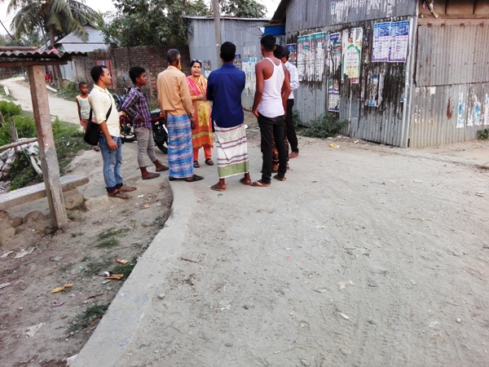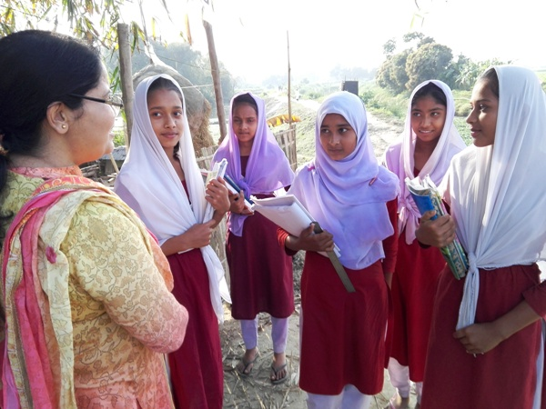

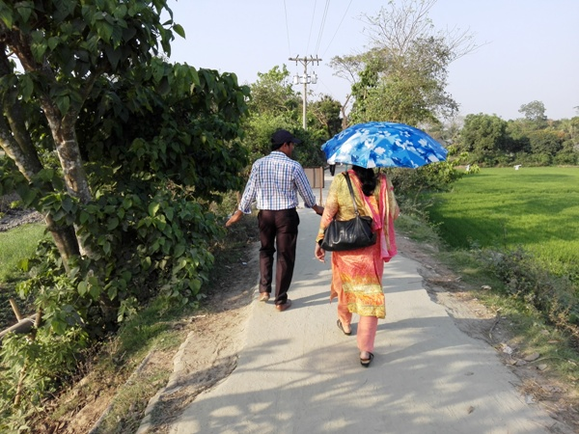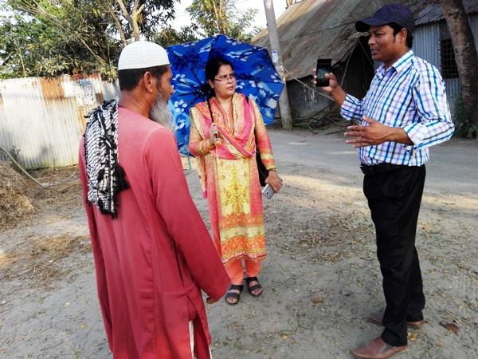

Photographs 7.1.1: DSM Consultant Team with Pourashava Representatives Inspected the Proposed Road

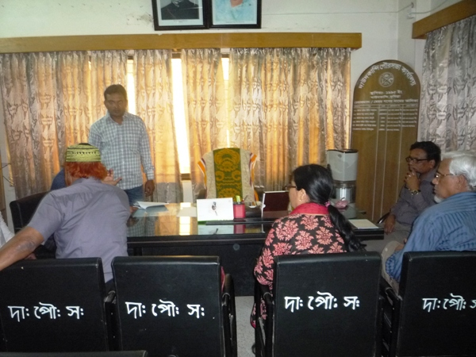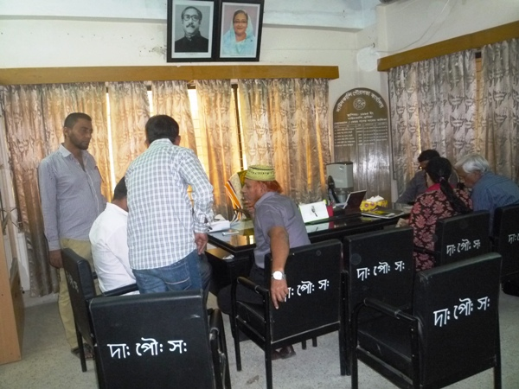

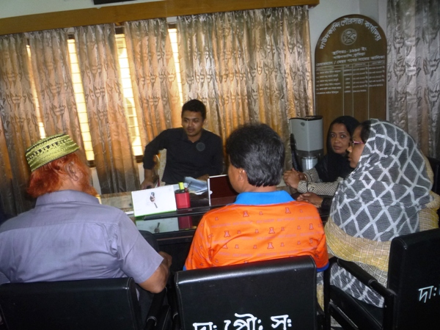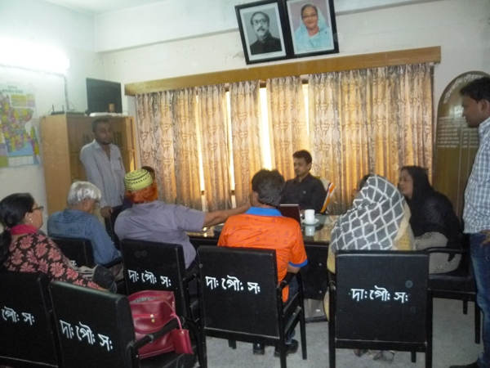

Photographs 7.1.2: Consultation Meeting at Pourashava Office with Pourashava Officials and Consultants Participants

7.2 Issues Raised by the Participants

The participants raised the issues related to the infrastructure development of Daudkandi Pourashava. The anticipated environmental and social impacts due to construction works have also been raised and discussed. The participants also discussed about the potential benefit from the subproject.

7.3 Feedback, Suggestions, and Recommendations of the Participants

The participants’ feedback, suggestions, and recommendations listed below:
- The participants discussed about the quality of the construction works and construction materials like cement, rod and sand of the subprojects;
- The FGD results confirmed that an improved communication network is needed for future development of Daudkandi Pourashava;
- Participants of the Daudkandi Pourashvava also proposed the construction of foot over bridge in various section of the Pourashava (in front of Daudkandi RHD Road, in front of Hasnpur College, in front of Daudkandi Tol Plaza, in front of West Maizpara)
- Participants also illustrate the importance of the Bus Terminal near North Gajipurn.
- Recreation facilities like park and stadium are not enough for the citizen of the Daudkandi Pourashava which is indicated by the participants.
- The participants stated that the public water supply facilities, sanitation facilities, solid waste management are not adequate;
- The participants stated that construction work should be performed within the scheduled time and following environmental measures.

8 Conclusions and Recommendations

The subproject intervention has significant ecological impact due to felling of the 287 number of the trees. However, 600 trees will be planted to compensate the felled down trees and to enhance the ecological condition in the subproject area. The adverse impacts on the physicochemical components will be localized and limited within the subproject boundary. It is also anticipated that the adverse impacts are largely manageable if proper mitigation, compensation and enhancement measures will be entirely implemented. In fact, the anticipated impacts due to the subproject activities are relatively minor in comparison to the significant benefits that will derive due to the implementation of the subproject.

A few key recommendations are outlined below:
- EMP should be available in the site during construction phase;
- Regular field visit by PMU, DSM and Pourashava is needed for the effective implementation of the EMP;
- Equipment should be checked by the Pourashava engineer and DSM consultant prior to work;
- Proper maintenance is needed for the planted trees by the contractor during project defect liability period;
- To minimize occupational health and safety risks, it is highly recommended to adapt mechanical system where appropriate;
- First aid box with relevant medicine should be available at site;
- The contractor is responsible for the proper disposal of the generated wastes materials from the subproject sites and campsite;
- Contractor will ensure availability of the PPEs to the workers;
- Contractor will monitor behavioral matter of the workers to avoid any undue risks related to labor influx.

It should be noted that environmental assessment report is a live document. Hence, due to changing circumstances during the construction phase if any, there might be minor adaptation needed for environmental, health and safety issues.

9 REFERENCE

Daudkandi Pourashava Master Plan: 2011-2031 Urban Area Plan

Daudkandi Pourashava at a glance

Environmental Assessment Volume 1: Overall Environmental Assessment [Draft Final Report], September 2013. Municipal Governance and Services Project (MGSP), Local Government Engineering Department (LGED) and Bangladesh Municipal Development Fund (BMDF), Ministry of Local Government, Rural Development and Cooperatives, Government of the People's Republic of Bangladesh.

Environmental Assessment Volume 2: Environmental Management Framework (EMF) [Draft Final Report], September 2013. Municipal Governance and Services Project (MGSP), Local Government Engineering Department (LGED) and Bangladesh Municipal Development Fund (BMDF), Ministry of Local Government, Rural Development and Cooperatives, Government of the People's Republic of Bangladesh.

Appendix
Appendix 1: Environmental Monitoring Checklist

Local Government Engineering Department

Municipal Governance and Services Project (MGSP)

Environmental Compliance Monitoring Form
Part A: General Subproject Information

Subproject Name | (a) Development of Road from Hasanpur College to Khalpar Bridge ( Ch. 1465 to 3950 m) under Daudkandi Pourashava;  (b) Development of Road from R&H to Nagerkandi Government Primary school via Anarkhal Bridge Ch (0 to 593 m) under Daudkandi Pourashava.
Package No. | MGSP/DAD/2017-18/W-06
ULB Name | Daudkandi Pourashava
Approved Estimated Cost in BDT
Contract Amount in BDT
Contractor Name
Date of Commencement
Target Date of Completion
Physical Progress (%)
Financial Progress (%)
Person Responsible (PIU)
(Name, Designation &Phone) for the Overall Subproject Management

Person Responsible (DSM)
(Name, Designation &Phone) for the Overall Subproject Management

Form Completed by
(Name, Designation &Phone)
Overall Environmental Description of the Subproject

Part B: Design, Preparation, and Legal Requirements

Environmental Concerns (PMU, PIU & DSM)  (Name, Designation & Phone) | PMU-
 | PIU-
 | DSM-
Subproject Category | DoE-BD- | WB-
Environmental Clearance Received? | Yes | No
EA Required? | Yes | No
EA Prepared and Delivered? | Yes | No
EMP Prepared & Delivered Separately? | Yes | No
Items and Cost of EMP Implementation Included in the Contract? | Yes | No
EMP Included in the Procurement Documents? | Yes | No
Inspection Schedule/Last Inspection/Monitoring by  PMU Environmental Concerns | Date-
 | Key findings-
Inspection Schedule/Last Inspection/Monitoring by  PIU Environmental Concerns | Date-
 | Key findings-
Inspection Schedule/Last Inspection/Monitoring by  DSM Environmental Safeguard Specialist/Jr. Environmental Specialist | Date-
 | Key findings-

Part C: Key Environmental Impacts
The Subproject Results in any of the following Impacts? | Yes | No | NA | If yes, is the impact (give observation)
 |  |  |  | Significant | Moderate | Minor
Felling of the trees
Clearing of the vegetation that increase the risk of increased soil degradation or erosion
Disturbance of the terrestrial and or aquatic specifies
Noise pollution
Air pollution
Adverse effects on the quantity or quality of the surface water or groundwater
Production or increase the production of the solid waste
Drainage congestion
Water logging that increases the risk of the water related diseases
Traffic congestion
Public safety

Part D: Work Place Environment and Gender Equity
The Subproject Results in any of the following Impacts? | Yes | No | NA | Observations
Does the contractor pay to the workers regularly?
Is there any discrepancy between the male and female workers regarding the wages or salary for the same works?
Is the contractor complying with the GOB labor law concerning the hiring of the workers?
Does the contractor engage women labors and does the project have suitable works for them?
Does the contractor engage child labor (less than 18 years) and aged people (more than 65 years old)?
Does the contractor force to the workers for the completion of the works?
Do the workers involve with the political activities, crime, drugs addiction and other forms of unwanted activities?
Are construction camps adequately equipped with water supply, sanitary toilets, washing facilities and facilities for waste collection and storage?
Has separate sanitation facilities been provided for women at work camps and the construction site?

Part E: Potential Impacts, Mitigation Measures, and Monitoring Indicator Mentioned in the EMP
Activity / Issues | Potentials Impacts | Proposed Mitigation and Enhancement Measures | Responsible Parties
Construction and operation of labor shed for the workers (Workforce and labor shed management) | - Generation of sewage and solid waste may cause water/ environmental pollution | - Construction of sanitary latrine considering 15 persons for one toilet at the labor shed and separate toilet for male and female;  - Erection of “no litter” sign, provision of waste bins/cans (introduce separate waste bins for organic and inorganic wastes);  - Ensure wastes (solid wastes and other forms of the waste) disposal at the vacant place near Lalpur Gomoti Bridge and near Anarkhal Bridge. | Contractor  Monitoring-  Primarily by Pourashava  Secondarily by PMU, LGED and DSM
 | - Health of workers | - Conduct formal and unofficial discussion to increase awareness about hygiene practices among the workers;  - Ensure availability and access to first-aid equipment and medical supplies for the workers.
 | - Possible development of labor camp into permanent settlement | - Contractor to remove labor camp at the completion of contract.
 | - Outside labor force causing negative impact on health and social well-being of local people | - Ensure that contractor employ local work force to provide work opportunity to the local people and conduct formal and unofficial awareness program for the health and social well being of the local people.
General construction works | - Drainage congestion and flooding | - Ensure provision for adequate drainage of storm water, if needed;  - Ensure provision for pumping of congested water, if needed;  - Ensure adequate monitoring of drainage effects, especially if construction works are carried out during the wet season. | Contractor  Monitoring-  Primarily by Pourashava  Secondarily by PMU, LGED and DSM  Contractor  Monitoring-  Primarily by Pourashava  Secondarily by PMU, LGED and DSM
General construction works | - Air pollution | - Check regularly and ensure that all the subproject vehicles are in good operating condition;  - Ensure contractor spray water on dry surfaces regularly to reduce dust generation;  - Maintain adequate moisture content of soil and sand for transportation, compaction, bed preparation, backfilling and handling;  - Ensure contractor sprinkle and cover stockpiles of loose materials (e.g., fine aggregates);
General construction works | - Traffic congestion, effect on traffic and pedestrian safety | - Ensure schedule deliveries of materials/ equipment during off-peak hours;  - Place traffic sign to avoid undue traffic congestion and associated traffic control measures to limit possible disruption;  - Inform the local people about the subproject activities.
General construction works | - Noise pollution | - Check and maintenance the equipment properly;  - Avoid using of construction equipment producing excessive noise at night;  - Avoid prolonged exposure to noise (produced by equipment) by the workers;  - Regulate use of horns and avoid un-due use of hydraulic horns by subproject vehicles.
General construction works | - Water and soil pollution | - Prevent discharge of fuel, lubricants, chemicals, and wastes into adjacent water bodies, low lands and soil.
General construction works | - Felling of trees, clearing of vegetation and ecological disturbances | - 450 nos. of timber, medicinal and beatification trees will be replanted to compensate the felling trees.
General construction works | - Accidents | - Conduct formal and informal discussion for creating awareness about the accidents;  - Provide PPEs (personal protective equipment) and ensure using of the PPEs by the workers.
General construction works | - Spills and leaks of oil, toxic chemicals | - Proper handling of lubricating oil and fuel so that it does not fall on the soil and adjacent pond;  - Collection and proper disposal of the spills.
All construction works | - Beneficial impact on employment generation | - Employ local people in the subproject activities as much as possible;  - Give priority to poor people living within subproject area in subproject related works (e.g., excavation and other works, which do not require skilled manpower).
All construction works | - General degradation of the environment | - Ensure environmental enhancement measures, such as tree plantation, and cautionary signs.
Environmental impacts due to the key construction activities and corresponding mitigation measures for the BC road
Dismantle work/ Excavation/ Earth work/ | - Generation of solid and construction wastes due to the dismantle works;  - Generation of loose soil due to the earth excavation work. | - Cover exposed earth works with fabric;  - Disposal of soil and construction wastes at the vacant place near Lalpur Gomoti Bridge and near Anarkhal Bridge. | Contractor  Monitoring-  Primarily by Pourashava  Secondarily by PMU, LGED and DSM
Dismantle work/ Excavation/ Earth work/ | - Accident due to dismantle of the existing road | - Carefully operation of the hammer.
ISG (Improved Sub grade)/ Sand filling | - Air and dust pollution affecting nearby settlements | - Maintain adequate moisture content of soil during transportation, compaction and handling;  - Carry the materials especially loose soil and sand with adequate cover.
Setting up and operation of asphalt plant | - Possible degradation of air quality by the suspended particles and increase noise level from asphalt plant affecting nearby settlements; | - Locate plant away from residential settlements;  - Consider use of emulsified bitumen.
Setting up and operation of asphalt plant | - Possible water pollution by bitumen and solvents; | - Avoid spills and proper collection and disposal of the generated spills.
Setting up and operation of asphalt plant | - Possible preparation of the bitumen in open air and using of charcoal and wood as fuel | - Strictly prohibit bitumen preparation in the open air and use of charcoal and wood as fuel.
Environmental impacts due to the key construction activities and corresponding mitigation measures for the RCC road protection wall
Excavation and site clearing & grubbing work | - Generation of loose and clay soil due to the earth excavation work | - Disposal of soil and construction wastes at the vacant place near Lalpur Gomoti Bridge and near Anarkhal Bridge.  - Cover exposed earth works with fabric. | Contractor  Monitoring-  Primarily by Pourashava  Secondarily by PMU, LGED and DSM
Excavation and site clearing & grubbing work | - Accidents | - Carefully handle of the hydraulic excavator.
Excavation and site clearing & grubbing work | - Air pollution | - Regular maintenance of the equipment.
Precast RCC pile driving work | - Accident due to careless driving of pile. | - Carefully operate the pile driving equipment  - Ensure the use of PPEs.
Sand filling/Back filling for Road Protection Wall | - Air and dust pollution affecting nearby settlements | - Maintain adequate moisture content of soil during transportation, compaction and handling;  - Carry the materials especially loose soil and sand with adequate cover.
Cutting & welding of the reinforcement for RCC Protection Wall | - Noise Pollution | - Avoid using of rod cutter and wielding machine at night;
 | - Health and Safety | - Ensure use of the PPEs;  - Availability and access to first-aid equipment and medical supplies.
RCC (reinforcement concrete) work for RCC Road Protection Wall | - Air pollution due to black emission | - Regular maintenance of the concrete mixer and vibrator machine.
 | - Noise pollution | - Avoid operation of the concrete mixer and vibrator machine at night;

Prepared by- Signature- Date-

Copies to 1. PIU
2. SME
3. AME
4. Jr. ES

