INTRODUCTION

Subproject Background

At the British era (April, 1875), for providing urban facilities to the citizen who is living in the Madaripur Town on the North side bank of the River Kumar, Madaripur District Town was turned as Madaripur Pourashava. The Pourashava covers an area of 14.05 sq. km. Now it is “A” type Pourashava with present population of 105,000 (Madaripur Pourashava web site). The Pourashava has 54.59% Pucca Road, 27.70% Semi-pucca and 17.71% Katcha Road. The total pucca drain is 20.69 km and 0.84 km earthen (Madaripur Pourashava: at a glance).

Urbanization is considered to be closely and positively associated process, with complex and mutually reinforcing links. In sustained economic growth, it is essential to develop urban areas. Urban centers are the places of agglomeration of economic activities, important hubs of production, processing, innovation and employment. In recent days, there has been a trend of growing importance of urban areas. This subproject emphasizes on the planning to address the problems and to guide future planning of Madaripur Pourashava. (Master Plan for Madaripur Pourashava, 2013) The present urban planning exercises for Madaripur Pourashava with the subproject introduced plans of different nature and styles. A well-integrated spatial and sectoral plan with sound financial and institutional policies facilitates refurbish urban environment not only healthy and better but also efficient and safer. Without adequate infrastructure and services provision, it would be difficult to turn urban centers as environmentally congenial livable places. Hence, this subproject directly will contribute for the infrastructure development of the Pourashava.

This subproject includes the following components: BC Road, RCC Drain, RCC Cross Drains, RCC Road Protection Wall and Water Supply Pipe Line. The significant features of the subproject are mentioned below:
Name of the Subproject : | Improvement of T.B. Clinic Sarak starting from Lake View Sarak to Kulpuddi Bazar (Ch. 0 - 2025 m) including BC Road, RCC Drain, Road Protective Wall, Cross Drain and Water Supply Pipe Line under Madaripur Pourashava, Madaripur
Package No. : | MGSP/MAD/2017-2018/W-07
District Name : | Madaripur
ULB Name : | Madaripur Pourashava
Jurisdiction Area : | Ward number 04 and 05
Structural Design Option : | BC Road, RCC Drain, RCC Cross Drains, RCC Road Protection Wall and Water Supply Pipe Line networking
Beneficiary Population : | About 35,000 as per information by the Pourashava officials
Tribal People : | No tribal people settlement found in the subproject area
Land Acquisition : | No private land acquisition is needed
Estimated Cost : | 71.45 million in BDT
Subproject Duration : | 12 Months
Tentative Start Date : | January 13, 2018
Tentative Completion Date : | January 12, 2019

Objectives of the Study

The general objective of this study is to determine the major environmental impacts succeeding from execution of the subproject and to recommend mitigation measures to avoid or reduce adverse environmental impacts and to enhance positive impacts. The specific objectives include:
- To assess the existing environmental conditions of the subproject site and its influence area;
- To identify and assess impacts resulting from the subproject during its construction phase and operation phase;
- To develop a environmental management plan with recommendations for mitigating impacts and enhance positive impacts;
- To summarize environmental monitoring requirements.

Scope and Methodology of the Study

The subproject appraisal is included environmental screening for all the subproject components. According to that screening, environmental assessment is required to fulfill the regulatory requirement for BC Road, RCC Drain, RCC Cross Drains, RCC Road Protection Wall and Water Supply Pipe Line. Therefore, this report focused on BC road, RCC drain, cross drains and road protection wall and water supply pipe networking. The study methodology comprised the following activities:

Desktop Study

The desktop study involved:
- Initial meetings with client and stakeholders to discuss about the proposed subproject, including subproject activities;
- Collection and review of the baseline data, maps, reports and other relevant information on the existing environmental and social conditions of the subproject area;
- Review of the relevant existing legislation, regulation and policies;
- Understand the anticipated technical processes that may affect the environment.

Field Investigation and Data Collection

A team of the consultants made a field investigation to the proposed site. Field investigations involved mainly site walks within the subproject area and the neighboring areas that may be affected by the subproject. The following key tasks were performed during the field visit:
- Taking photographs of the significant aspects to describe the baseline environmental conditions of the subproject area;
- Interviews with representatives of the Pourashava Officials, and interested and affected people within the subproject influence zone;
- Verifying information and data collected during the desktop study and to collect new information that may have been important in the assessment of the impacts and design of the mitigation measures.

Data Analysis and Report Writing

The data and information collected from all the sources (literature review, secondary and primary data, public consultation) were analyzed to describe the existing environmental setting of the subproject area, to identify the potential positive and negative impacts of the proposed subproject, as well as to provide preliminary suggestions for mitigation measures. Finally, this environmental assessment report has been prepared.

Subproject Description

The Study Area
The subproject is situated within the jurisdiction of the ward number 04 and 05. The T.B. Clinic Sarak is started from Lake View Sarak with 23° 9'54.58"N (Latitude) and 90°12'37.78"E (Longitude) and ended at Kulpuddi Bazar with 23° 9'45.31"N (Latitude) and 90°13'28.21"E (Longitude).The location map and topographic view of the subproject are shown in Figure 2.1.1 and Figure 2.1.2.
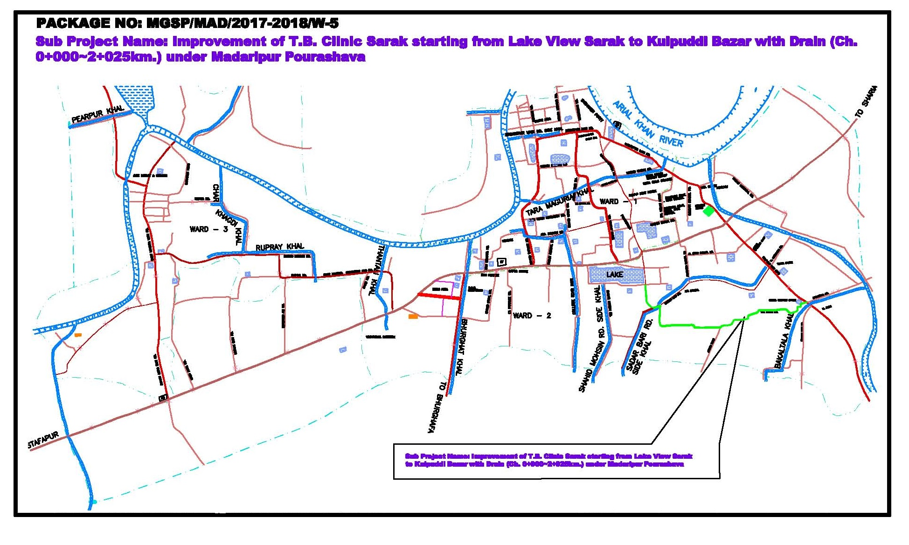
Figure 2.1.1: Location Map of the Subproject
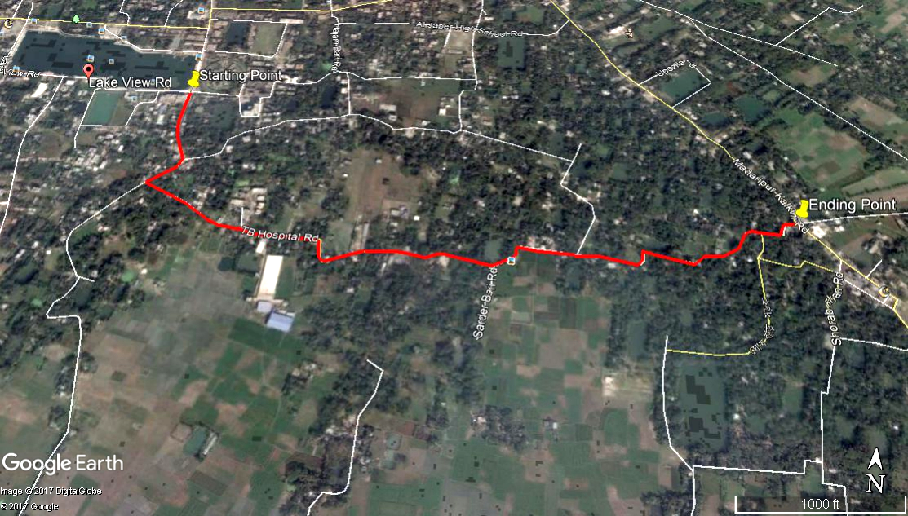
Figure 2.1.2: Topographic View of the Subproject

Current Situation, Proposed Intervention and Need for the Subproject

The existing BC road will be demolished, replaced and widening by the new BC pavement. The current road condition is badly damaged and narrow in width (pavement width varies from 2-3 m) in most of the sections. From the site investigation, it is revealed that normal traffic operation is interrupted due to warned-out and narrow road. Hence, widening and current road renovation is necessary for the normal traffic operation at Ch. 0-2025m with 6m width. On the contrary, some ponds are along the road side, which necessitates road protection work. Road protection work is needed at different segments with different lengths of the proposed road [at left side: Ch. 612-648m, Ch.664-714m, Ch. 780-828m, Ch. 1162-1212m, Ch. 1355-1380m, Ch. 1496-1521m, Ch. 1599-1657m, Ch. 1852-1914m, Ch. 1993-2010m and at right side: Ch. 1421-1496m].
In the subproject area, from Ch.0-200 m, the existing brick drain is partially damaged and silted with various waste materials. Therefore, rest of the portion of road, there is no drain. Due to discontinuation of the existing drain, it is not functioning properly and cannot develop a complete drainage network. Hence, storm water creates water logging problem. Water logging problem is one of the key issues in the subproject area during monsoon period. In the rainy season, due to heavy rainfall the drain water overflows to the road and road side houses from the low land. As a result, smooth traffic flow is hampered. To improve the situation, RCC U-type drain and cross drains are needed for proper drainage facility. Therefore, RCC drain with cover slab will be constructed at left side of the road (Ch. 0 -1050 m). The storm water will be discharged in the Soidar Bali Khal via cross drain (at Ch.200 m) and Mubarakdi Khal (Hijotola Moar at Ch. 1050 m) which will be used as outfall. At Ch.290-300 m, 530m, 613m, 630m,1050m, 1200m and 1350m seven cross drains will be constructed to divert storm water from one side to another side in order to proper functioning of the drain.
There is an existing water supply line at one side of the road. After road widening, the location of the water supply line will be almost at middle of the road. Hence, the existing water supply line needs to be shifted. For continuous water supply, firstly new water supply line by UPVC pipe lying work will be performed. Then, the utility service i.e. water supply facilities will be given to the consumers after fixing household connection. The new water supply line by UPVC pipe lying work will be performed at the opposite site of the proposed drain. When the new water supply line will be in operation, then the existing water supply line will be shifted to the edge of the road where the drain will be constructed. The Pourashava Authority will shift the existing water supply pipe line at the edge of the road which is opposite side from the new water supply line with their own expenses. There is a surface water treatment plant in the Pourashava. Hence, the treated water will be supplied to the consumers through these pipe lines.
The existing scenario of the proposed road is further elaborated from the following Photographs 2.2.1.
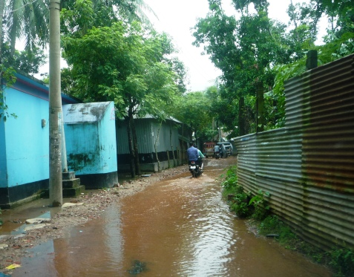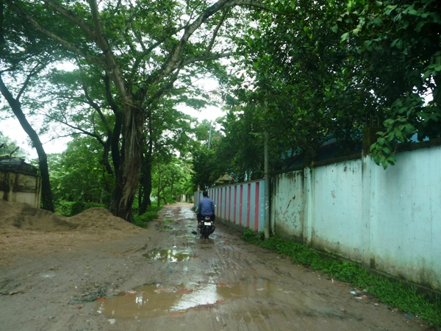

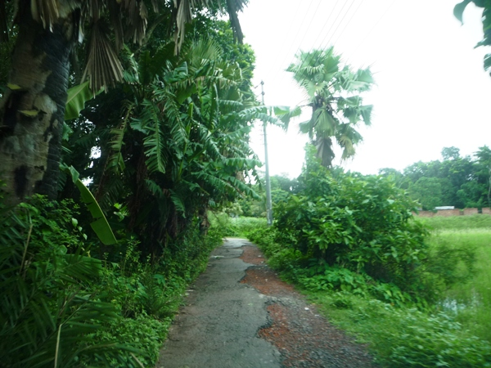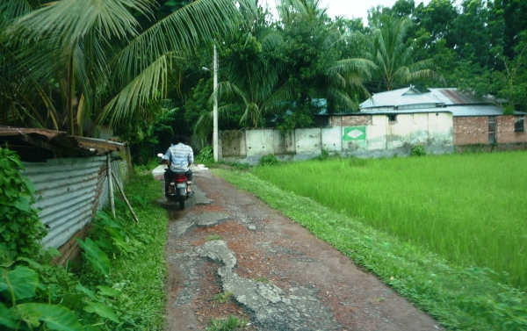

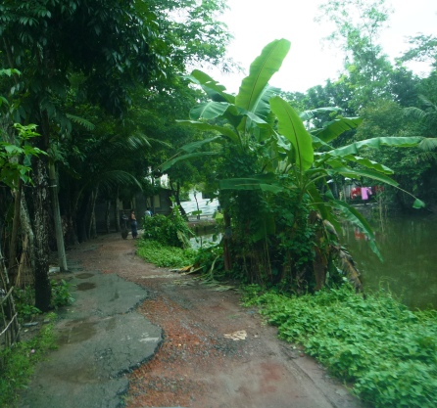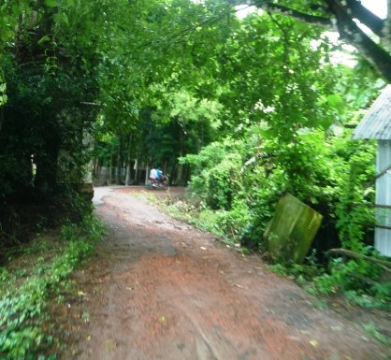

Photograph 2.2.1: Present Situation of the Subproject Site

Justification of Selection of the Subproject

The proposed subproject has significant importance for the Pourashava. The proposed road will make safe, easy and smooth connection with Lake View Sarak and Madaripur- Kalkini Road. Hence, this subproject has been considered as priority subproject in the CIP. PMU representative, and DSM consultant visited the subproject site to assess the site condition.
From the site visit, it is revealed that this road is very much inconvenience for the movement of the motorized vehicles. The subproject is located mostly on the right of way. Adequate space is available at both sides of the road which is owned by Pourashava. Hence, private land acquisition is not an issue for implementation of this subproject. From the site inspection, it is also revealed that roadside built-up infrastructure will not be severely affected due to the implementation of the subproject.
The subproject has significant benefit to the community people. After completion, the road subproject will provide uniform width. By eliminating pot holes and providing smooth road surface it will provide better, easy and safe movement facilities for the travelers. On the contrary, the road protection wall will increase the stability of the road. Furthermore, the cross drain will divert water from one side to the other side for proper functioning of the drain. Also, after completion the water supply pipe line will improve the water supply facilities at the subproject area. Hence, considering the benefits that will derive, the subproject is selected for implementation.

Envisaged Subproject Activities and Implementation Process

The general activities for the subproject includes: construction of the semi-pucca site office, construction of the labor shed, relocation of the electric poles, telephone poles and GI poles, site clearing and grubbing works and tree plantation.
The key activities of the RCC Drain and RCC cross drains include:
- Earth work in excavation of the foundation;
- Pumping and bailing out of water as per requirement;
- Sand filling for the preparing foundation bed;
- Laying of polythene sheet;
- Plain cement concrete work in foundation;
- Manufacturing CC blocks;
- Fabrication of the ribbed or deformed bar;
- Reinforced cement concrete work.

The key activities for BC Road include:

- Dismantling of the damaged wearing surface;
- Earth work in box cutting;
- Earth filling work;
- Sand filling on the road bed;
- Mechanical compaction;
- Brick on edging;
- Compacted aggregate sub-base course;
- Providing prime coat;
- Laying pre-mixed dense bituminous surfacing wearing course.

The key activities of the RCC Road Protection Wall include:

- Pile driving work.
- Earth work in excavation;
- Back filling;
- Cement concrete work;
- Fabrication of the ribbed or deformed bar;
- Reinforced cement concrete work.

The key activities of the Water Supply Pipe Line include:

- Trench for pipe laying
- Earth filling/ sand filling
- Placing uPVC pipe
- Pipe fitting & joining
- Household water supply connection with pipe as per requirement.

The materials and resources to be used for the key activities: soil in earth work, sand, stone chips, cement, reinforcement, diesel, MS sheet, steel shutter, electricity and water.
The major equipment to be used for the implementation of the subproject: hydraulic excavator, concrete mixer machine, steel cutter, mechanical vibrator machine, mechanical compaction machine, steel drum rollers, pneumatic multiple tire roller, dump truck, water tanker, pump, asphalt plant, rubber tire roller, paver, uPVC pipe with necessary accessories.

Baseline ANALYSIS OF THE ENVIRONMENTAL CONDITION

Physical Environment

Important Environmental and Infrastructural Features

During site visit the environmental and infrastructural features within the subproject area were collected. Conditional survey has also been conducted for designing the subproject. Hence, the survey data is also used for preparing the report. The environmental and infrastructural features listed within 100 m of the both sides of the road from the center line considering 100 m longitudinal interval from Lake View Sarak to Kulpuddi Bazar of the Pourashava (Ch. 0-2025m) at flowing Table 3.1.1.
Table 3.1.1: Major Environmental and Infrastructural Features
Chainage (m) | Left | Right | Major Environmental and Infrastructural Features
0-100 | √ |  | Two storied building, various shops with semi pucca structure (within adjacent to the road edge to 0.5 m of the road edge)
0-100 |  | √ | Four storied building, various shops with semi pucca structure, boundary wall (within adjacent to the road edge to 0.5 m of the road edge)
100-200 | √ |  | Boundary wall, semi pucca shops, trees (within adjacent to the road edge to 5 m of the road edge)
100-200 |  | √ | Connecting with lake road, boundary wall, Mosque, trees (within adjacent to the road edge to 5 m of the road edge)
200-300 | √ |  | Tin shed temporary shops, houses, fence of tin, trees, Soidarbali Khal, connecting road towards Azomkandi, semi pucca structure (within adjacent to the road edge to 10 m of the road edge)
200-300 |  | √ | Connecting road towards Hazir Howla, boundary wall, trees, houses (within adjacent to the road edge to 3 m of the road edge)
300-400 | √ |  | Boundary wall, Graveyard, Soidarbali Jame Mosque, ditch, tin shed houses, trees (within adjacent to the road edge to 2 m of the road edge)
300-400 |  | √ | Boundary wall, fence of tin, trees, houses with various structures, pond (within adjacent to the road edge to 1 m of the road edge)
400-500 | √ |  | Semi pucca and tin shed houses, trees (within adjacent to the road edge)
400-500 |  | √ | Fence of tin, boundary wall, houses with various structures, connecting road towards village (within adjacent to the road edge)
500-600 | √ |  | Ditch, tin shed structures, boundary wall, T.B Clinic, bushes, trees (within adjacent to the road edge to 15 m of the road edge)
500-600 |  | √ | Semi pucca and tin shed structures, boundary wall, Mosque, fence of tin boundary wall, trees (within adjacent to the road edge)
600-700 | √ |  | Ponds, bushes, trees (within adjacent to the road edge to 1 m of the road edge)
600-700 |  | √ | Boundary wall, tin shed and semi pucca structures, fence of tin, Haider Kazi Jute Mill (within adjacent to the road edge to 0.5 m of the road edge)
700-800 | √ |  | Tin shed houses, connecting road towards village, fence of tin, pond, trees (adjacent to the road edge)
700-800 |  | √ | Connecting road towards village, semi pucca and tin shed houses, boundary wall, fence of tin, trees (adjacent to the road edge)
800-900 | √ |  | Pond, bushes, boundary wall, Madrasa (within adjacent to the road edge to 0.5 m of the road edge)
800-900 |  | √ | Graveyard, boundary wall, semi pucca and tin shed houses, trees (within adjacent to the road edge to 0.5 m of the road edge)
900-1000 | √ |  | Semi pucca and tin shed houses, house connecting road, open space, trees, fence of tin (within adjacent to the road edge to 0.5 m of the road edge)
900-1000 |  | √ | Semi pucca and tin shed houses, boundary wall, open space, trees (within adjacent to the road edge to 0.5 m of the road edge)
1000-1100 | √ |  | Semi pucca and tin shed houses, open space, Hijotola Jame Mosque, house connecting road, borrow-pit, trees (within adjacent to the road edge to 5 m of the road edge)
1000-1100 |  | √ | Borrow-pit, connecting road towards Jowdi, rice mill, semi pucca and tin shed houses, trees (within adjacent to the road edge to 5 m of the road edge)
1100-1200 | √ |  | Bushes, pond, trees, house (within adjacent to the road edge)
1100-1200 |  | √ | Trees, house connecting road, house (within adjacent to the road edge)
1200-1300 | √ |  | Pond, bushes, trees, tin shed structures (within adjacent to the road edge)
1200-1300 |  | √ | Trees, fence of tin, house (within adjacent to the road edge)
1300-1400 | √ |  | Boundary wall, house connecting road, semi pucca and tin shed houses, ditch, trees, bushes (within adjacent to the road edge)
1300-1400 |  | √ | Trees, bushes, open field (within adjacent to the road edge to 3 m of the road edge)
1400-1500 | √ |  | Tin shed structures, bushes, trees (within adjacent to the road edge)
1400-1500 |  | √ | Pond, bushes, trees (within adjacent to the road edge)
1500-1600 | √ |  | Ponds, bushes, trees, Mosque, house connecting road, houses, abundant Kulpuddi Jomidar House, open space (within adjacent to the road edge to 10 m of the road edge)
1500-1600 |  | √ | Graveyard, Semi pucca and tin shed houses, house connecting road, open space, trees, fence of tin, houses (within adjacent to the road edge to 5 m of the road edge)
1600-1700 | √ |  | Pond, houses, trees (within adjacent to the road edge to 5 m of the road edge)
1600-1700 |  | √ | House connecting road, trees, fence of tin, temporary tin shed shops, houses (within adjacent to the road edge to 5 m of the road edge)
1700-1800 | √ |  | Weather station’s boundary wall, semi pucca house, tree, fence of tin, pond (within adjacent to the road edge)
1700-1800 |  | √ | Trees, semi pucca house, fence of tin (within adjacent to the road edge)
1800-1900 | √ |  | Ponds, Abundant Temple, fence of tin, house, boundary wall, trees (adjacent to the road edge to 0.5 m of the road edge)
1800-1900 |  | √ | Semi pucca house, house connecting road, trees (adjacent to the road edge)
1900-2025 | √ |  | Fence of tin, ponds, trees, houses, shops (within adjacent to the road edge to 2 m of the road edge)
1900-2025 |  | √ | Boundary wall, semi pucca houses, Ashrom, semi pucca shops, trees (within adjacent to the road edge to 3 m of the road edge)
** Note: There are 50 numbers of the electrical poles at different chainage to be re-located for the implementation of the subproject

Geology, Topography, and Soils

Topographically Madaripur Pourashava is flat and gentle sloping. Geology of Madaripur Pourashava is composed of Tidal Deltaic Floodplain. Madaripur Pourashava lays the active floodplain of the Ganges and the adjoining meander floodplain. Soil developed in seasonally flooded alluvium containing lime in part or all of the upper 125 cm and with dark grey topsoil, usually there are continuous dark grey gleans as well. Generally these soils are well oxidized within subsoil pads and below the upper dark layers, usually pale brown or olive brown with few too many mottles. The town may be considered to contain land comprised of soil on artificially slightly raised platform. (DPHE, 2013). According to GSB (1978), Bangladesh has three seismic zones with moderate and low seismic activity. The Pourashava falls in Zone III.
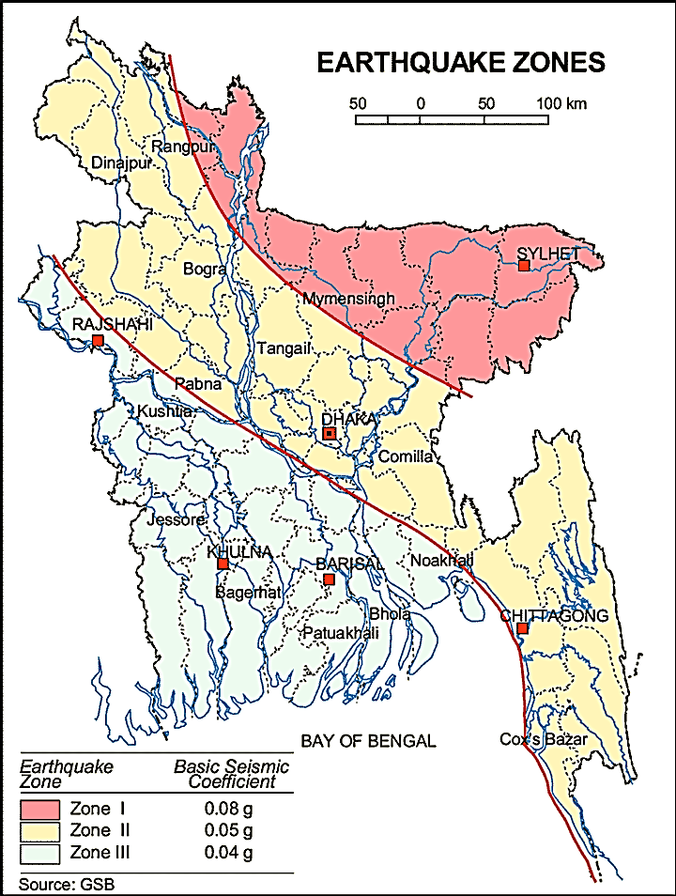
Figure 3.1.1: Location of Madaripur in Earthquake Zone Map of Bangladesh

Climate and Meteorology

The climate here is tropical. In winter, there is much less rainfall in Madaripur than in summer. This climate is considered to be Aw according to the Köppen-Geiger climate classification. In Madaripur, the average annual temperature is 25.9 °C. Precipitation here averages 1849 mm. The driest month is December, with 7 mm of rain. With an average of 341 mm, the most precipitation falls in July (Climate-Data.org).
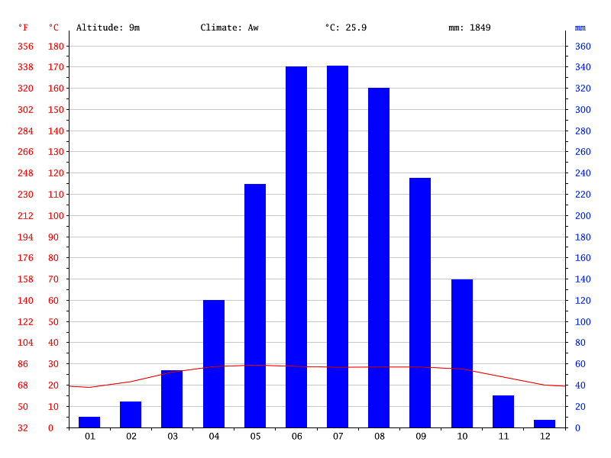
Figure 3.1.2: Climate Graph of Madaripur Pourashava
May is the warmest month of the year. The temperature in May averages 29.4 °C. January has the lowest average temperature of the year. It is 18.9 °C.

Table 3.1.2: Climate Table of Madaripur Pourashava
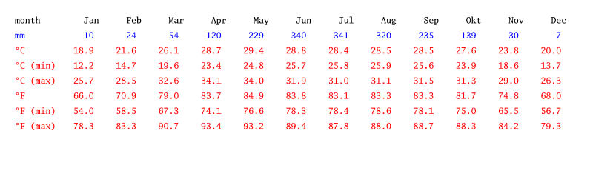

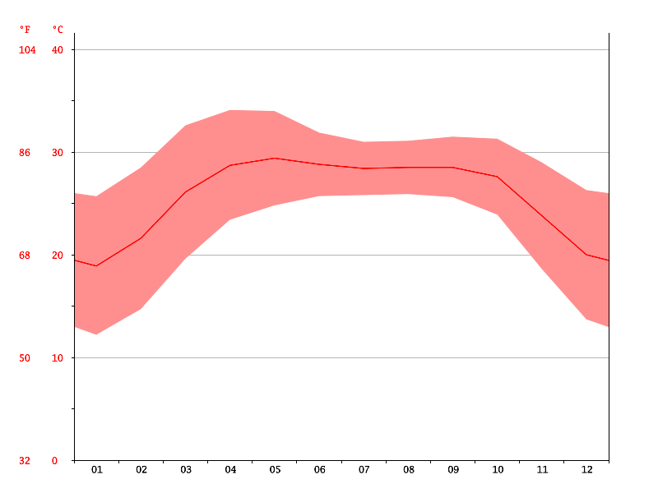
Figure 3.1.3: Temperature graph of Madaripur Pourashava
There is a difference of 334 mm of precipitation between the driest and wettest months. During the year, the average temperatures vary by 10.5 °C. Useful hints about reading the climate table: For every month, you will find data about precipitation (mm), average, maximum and minimum temperature (degrees Celsius and Fahrenheit). Meaning of the first line: (1) January, (2) February, (3) March, (4) April, (5) May, (6) June, (7) July, (8) August, (9) September, (10) October, (11) November and (12) December.

The construction works can be influenced by the climatic condition and meteorological components like humidity, temperature, sudden rainfall, and wind speed. High winds can enhance quick spreading of the generated dust. It is very risky working under rain and in high winds because the possibility of getting injury increases. Furthermore, work under high temperature and excess humidity may create health hazards like dehydration problem.

Water Resources (Surface Water, Ground Water and Rain Water Harvesting)

Soidarbali Khal, ponds ditches and borrow pit are located adjacent to the subproject site where water is available round the year. It is the main source of the surface water for the subproject area. This khal, ponds and ditches influence the hydrology of the municipality. Madaripur Pourashava belongs to the hydro-geological unit II - Holocene Deltaic and Flood Plains (DPHE, 2013). Ground water is available at shallow depth. Groundwater is the main source of potable water in the subproject area. Groundwater is not saline and normally arsenic and iron free (Master Plan for Madaripur Pourashava, 2013). The local people do not use rain water harvesting system.

Flooding, Water Logging and Drainage Pattern

According to previous data of this area, this area is affected in severe flood events of 1988, 1998, 2004 and 2007. There are surface water sources such as Soidarbali Khal, ponds and ditch close to the subproject area. According to “Flood Prone Area Map” of Bangladesh, this Pourashava is normal flood prone area (BMD, 2012).The subproject area temporarily has subjected to water logging problems. Due to continuous heavy rain, this area is affected by major water logging problems, in absence of non-structured and non-functional drainage system. Most of the existing drain is being filled up by different types of wastes.
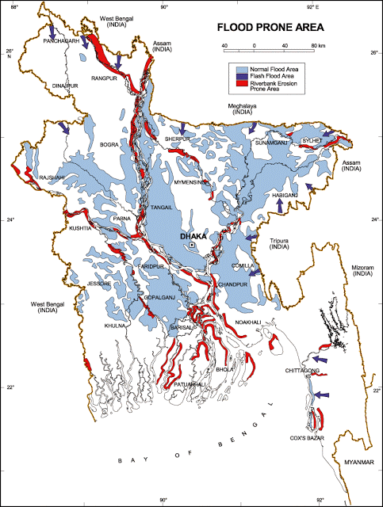
Figure 3.1.4: Location of Madaripur Pourashava in Flood Zone Map of Bangladesh

Air Quality and Dust
The degradation of the air quality is mainly from windblown dust and emission from the vehicles. The rough surfaces of the road generate dust during vehicles movement in dry season. Improper disposal of the solid wastes also spread bad odor which causes air quality degradation. During construction phase black smoke emission from asphalt plant, paver, concrete mixer machine, vibrator machine, hydraulic excavator and vehicles used for transportation activities may degrade the air quality.

Noise Level

Noise is generated mainly from the vehicles movement and hydraulic horn. Noise is also generated due to public gathering. During construction phase, asphalt plant, paver, concrete mixer machine, vibrator machine, hydraulic excavator and vehicles used for transportation activities may create temporary noise nuisance within the subproject boundary.

Solid Waste Management

The Pourashava has not any structured solid waste management system. The Pourashava people normally dump the collected solid wastes at roadside open spaces. Currently, the vacant place near Jatrar Mat- Bottola is used as a dumping ground by the Pourashava. This is simply open dumping to a specific location. In recent times, the municipalities provide services for household waste collection from door to door and dump at the vacant place near Jatrar Mat- Bottola. The generated wastes due to construction activities will be dumped at the designated vacant place near Jatrar Mat- Bottola.

Biotic Environment

In the subproject area, major roadside tree includes: Rain Tree, Mahogany, Akashi, Koroi, Coconut, Papaya, Mango, Betel-Nut, Palm, Jackfruit and Amra. The common local birds such as Crow, Chil, Shalik, and Choroi were found during the site visit.

Socio-economic and Socio-cultural Environment

Land Use, Status of Housing and Built-up Infrastructure
The land use pattern in the subproject area consists of mixed land-use pattern (residential and commercial). The major roadside built-up infrastructures includes pucca, semi-pucca and tin-shed residential houses, shops, religious centers (Soidarbali Jame Mosque, Hijotola Jame Mosque, Abundant Temple, Ashrom, Madrasa and Graveyard), Health care center (T.B Clinic), Industrial and commercial activities (Haider Kazi Jute Mill, rice mill, various shops), abundant Kulpuddi Jomidar House, Weather station etc. In addition, ponds, Soidar Bali Khal, ditches, barren land, open space, trees and vegetation coverage represent the land-use pattern of the subproject and its influence area.
Beneficiary Population

The subproject is situated within the jurisdiction of the ward number 04 and 05. Considering the ward population about 35,000 people will benefit directly and many others indirectly.

Education
In the municipality, literacy among the population is about 73.1%. This is higher than the national average (51.8%). The literacy rate among males (76%) is still more than females (70.3%). (Population and Housing Census 2011).

Tribal Communities
There is no indigenous or tribal people settlement in the subproject area. Hence, no measures needed for the indigenous peoples’ safeguard.

Land Acquisition

Private land acquisition is not needed. Removing of the road side boundary walls and fences, road side edge of the shops and houses are needed in different chainages (Ch. 0-200 m, Ch. 300 – 600, Ch. 700- 1000, Ch. 1300, Ch. 1700 - 1780 and Ch. 2000) due to site clearing and road widening work. On the other hand, Mehrab of the Soidarbali Jame Mosque (Ch. 350 m), Abundant Memorial (Ch. 1820 m) need to be removed for road development work. Therefore, it is recommended that Pourashava Authority should change the alignment at this particular section to save Mehrab of the Soidarbali Jame Mosque and abandoned Temple. In addition, the Pourashava will clear the site amicably with the owners of the structures prior to the construction work. However, in case of any objection from the affected persons, DSM will investigate the actual situation. Then, measures will be taken as per rules.
Principal Livelihoods and Economic Activities
The subproject area is inhabited by the mixed occupational people. In the Pourashava area, major income comes from business, enterprises, small trades, private sector jobs, and government jobs in the town.
Cultural Heritage and Protected Areas
During site visit it was observed that abundant Kulpuddi Jomidar House is situated in the subproject influence area. There is no other protected and important cultural or historical site in the subproject influence area.
Social Conflicts and Development Activities

The local people welcome the subproject and there is no conflicts between the local communities regarding subproject implementation.

ENVIRONMENTAL SCREENING

Environmental Screening Checklist, as adopted in Appendix C of the Environmental Management Framework (EMF) of the MGSP, was measured for identifying the impacts and their extents. The screening data and information for the BC road, RCC drain and allied works have been formulated and are shown in below.
(1) Potential environmental impact during construction phase:
- Ecological impacts:
- Felling of trees Significant □√ Moderate □ Minor □ Number of trees
355
- Clearing of vegetation Significant □ Moderate □ Minor □√
- Potential impact on species of Significant □ Moderate □ Minor □√
aquatic (i.e., water) environment
Major trees to be felled down are: Rain Tree, Mahogany, Akashi, Koroi, Coconut, Papaya, Mango, Betel-Nut, Palm, Jackfruit, Amra etc. There is no tree to be felled down bring religious and heritage importance. However, the trees to be felled down have significant economic value because most of them are moderate to small size in terms of length and diameter. Vegetation coverage on both sides of the road is not similar in terms of the intensity. So clearing of the road side vegetation is considered as minor. In addition, anticipated impact on species of aquatic environment is minor because except throwing of the wastes materials in to the ponds and ditches, the subproject does not have any impact on the aquatic environment. Considering the number of trees to be felled down, the ecological impact is considered as significant.
- Physicochemical impacts:
- Noise pollution Significant □ Moderate □√ Insignificant □
- Air pollution Significant □ Moderate □√ Insignificant □
- Drainage congestion Very likely □ Likely □√ Unlikely □
- Water pollution Significant □ Moderate □√ Insignificant □
- Pollution from solid/ construction wastes Significant □ Moderate □√ Insignificant □
- Water logging Significant □ Moderate □√ Insignificant □
The subproject will have impacts on noise and air quality during construction phase due to mobilization of the equipment, vehicles movement for the transportation of the materials, using of hydraulic excavator, brick breaking machine, mechanical compaction machine, paver, asphalt plant, concrete mixer machine, vibrator machine etc. The construction work will be performed section wise. Hence, it is anticipated that the overall impacts on noise and air quality will be moderate, temporary and limited within the subproject boundary. There are road side residents and religious institutions. Hence, anticipated impacts on noise and air quality will be significant for this particular section, if measures are not taken properly. The generated dust during construction activities may disturb the local people during construction period. The generated construction wastes, un-suitable materials and solid wastes may degrade the adjacent pond water if not properly collected and disposed and thrown in to the roadside ponds and ditches. Improper collection and disposal of the generated wastes materials also may degrade the water quality as well as quality of the surrounding environment and degrade the aesthetic value. The anticipated water logging and drainage congestion during construction period is moderate because of inadequate space for drain-out storm water at most of the sections of the proposed road. In addition, provision will be there for pumping out the storm water if required.
- Socio-economic impacts:
- Traffic congestion Very likely □√ Likely □ Unlikely □
- Health and safety Significant □ Moderate □√ Insignificant □
- Impact on archaeological and historical Significant □ Moderate □ Insignificant □√
- Employment generation Significant □√ Moderate □ Insignificant □
Firstly, the proposed drain will be constructed. The traffic congestion due to drain construction is comparatively less because it does not require closing of the entire road. The pedestrians, cycle rider, biker can use the road during drain construction work. There is no sufficient existing connecting and diversion road. Hence, traffic movement may be severely affected during construction work of the proposed road. The construction work will follow simple procedure with commonly used equipments. Hence, anticipated impact on health and safety is moderate. There is no archaeological and historical site except abundant Kulpuddi Jamidar House within the influence area, but it will be free from the anticipated impact due to construction activities and measures need not taken for protecting it. The subproject has positive impact by generating work opportunities for the local people and supplying of the construction materials, equipments, food and other necessary stuffs to the campsite.
(2) Potential environmental impact during operational phase:
- Ecological impacts:
- Potential impact on species of aquatic Significant □ Moderate □√ Minor □
(i.e., water) environment
The anticipated impact on the aquatic environment is insignificant due to operation of the road. Though, the drain is designed for storm water only. However, the storm water may carry washed-out materials, pollutants from any sources that may disturb the aquatic environment of the outfall. Furthermore, the road protection wall may be disturb the aquatic species (distribution and abundance). Hence, the anticipated impact on the aquatic environment due to operation of the drain is considered as moderate.
- Physicochemical impacts:
- Potential air quality Improvement □ No-improvement □ Deterioration □√
- Noise level Improvement □ No-improvement □ Deterioration □√
- Drainage congestion Improvement □√ Minor Improvement □ No Impact □
- Risk of Water pollution Significant □ Moderate □√ Minor □
- Pollution from solid waste Improvement □√ No-improvement □ Minor □
During operation phase due to road component, increased traffic volume may degrade the air quality and noise level due to black smoke emission and un-due use of hydraulic horn from vehicles. The new drain will minimize drainage congestion and water logging problem. The storm water to be discharged through the drain may degrade the water quality of the outfall if carry pollutants from any sources. The new covered drain will minimize throwing of the wastes materials in to the drain and spreading of the bad odor.
- Socio-economic impacts:
- Traffic Improvement □√ No-improvement □ Adverse □
- Safety Improvement □√ No-improvement □ Adverse □
- Employment generation Significant □ Moderate □ Minor □ √
After completion, this road with associated works will improve the transport facilities. By providing uniform, protected and widen pavement, it will also enhance traffic safety. After completion of the drain, the drain will complete the Pourashava existing drainage network. The new drain will reduce water logging problem. By reducing environmental hazards caused by water logging problem, it will provide better environment to the community people. The piped networking system for water supplying to the citizen of the subproject area will ensure safe portable water for domestic uses. The new subproject will minimize the frequency of the maintenance for first three to five years after completion. However, the new road with drains and road protection works will enhance traffic operation, business activities and pedestrians’ safety. In addition, new roadside shops will be developed which contributes local economy.
(3) Summary of Possible Environmental Impacts of the Subproject
The subproject site is not located any environmentally sensitive area though it has significant ecological impact due to felling of the 355 trees. The subproject activities will have adverse impacts on physic-chemical impacts. However, it is anticipated that the impact is not severe and limited within the subproject boundary. The wastes generated due to the construction activities should be properly collected and disposed in a designated dumping site. Some earthwork will be involved for the road construction work; however, no agricultural productive soil will be used for the purpose. The inputs that may affect the environment will be mainly at construction phase. Moreover, mitigation measures will be taken according to the EMP for minimizing the environmental pollution.
Safety concern is an important issue for both the construction and operation phases that should be considered properly. Using of the cutter machine, hammer and any other machine in motion may cause potential safety risks. This subproject will have positive impacts in terms of the generation of the employment and business activities by supplying construction materials and equipment. However, it has significant positive social impacts.

Specific impact, mitigation AND enhancement measures
From the environmental study, the probable impacts of the subproject are mainly caused by the key activities required for the implementation of the subproject, raw materials and equipment to be used for the execution of the activities. This section describes some specific impacts due to the subproject activities and their mitigation measures.

Dismantle Work, Site clearing, Excavation Work and Earth Work

The road improvement work includes dismantle of the existing bituminous pavement, clearing of the wastes materials due to dismantle work, earth excavation and earth filling work. The drain construction and road protection work consists of earth excavation, earth filling, back filling, cutting and removal of the unsuitable materials. The water supply pipe line work also needed earth excavation, earth filling, back filling, cutting and removal of the unsuitable materials. These works lead dust blowing, improper disposal of the wastes, health and safety risk, noise and vibration which may disturb the local people.

Mitigation Measures

- Careful operation of the hydraulic excavator and hammer, if used to avoid any undue disturbances to the roadside residents;
- Cover the exposed earth with fabric;
- Quick disposal of the wastes at the Pourashava designated dumping site near Jatrar Mat- Bottola.

Tree Felling, Clearing of the Vegetation and Ecological Impact

The subproject has adverse impacts on the ecological components due to felled down of the 355 numbers of trees and clearing of the roadside vegetation and bushes.

Mitigation Measures

- 800 nos. of trees will be planted to compensate the felled down trees and to enhance the ecological condition - preferably local fruits, flowers, medicinal and ornamental trees-Mango, Jackfruit, Jam, Palm Tree, Neem, Amloki, Horitoki, Arjun, Bohera, Krisnachura, Bokul, Shimul, Debdaru, Mahogany, Rain Tree, Shil Koroi, Segun, Babla: As per Chainage direction from Ch. 270-300m, Ch. 450-600m and Ch. 1500-1600m at left side, Ch. 800-1000m at right side and Ch. 900-1100m, Ch. 1200-1900m and Ch. 1800-1850m at both sides of the proposed road and any suitable places where space is available;
- Planting trees will enhance the ecological balance of the subproject area after their successful growth.

Pollution from the Construction Materials

Dumping of the construction spoils, including accidental leakage of the oil, grease, and fuel in equipment yards is a significant hazard. Surface water and soil quality might be polluted from these contaminants. Even the people to be engaged for the construction activities might endanger the physical and human habitats of the area.

Mitigation Measures

- Safe transport, storage, and disposal of the construction materials, and the equipment have to be carried out in order to avoid the accidental spillage and loss;
- Fuels, lubricants, and other hazardous materials should store over raised platforms and not directly on the ground;
- The playgrounds of the educational institutions should not use as a stockyard or work camp.

Air Quality and Dust

During construction phase, air pollutants will be emitted from the equipment and construction vehicles are expected to remain low. Local residents in the vicinity of the work sites will be temporarily disturbed by the limited dust pollution. The overall impacts, however, are expected to remain low.

Mitigation Measures

- Water should be sprayed at the work site for dust control. Ensure sprinkle and cover stockpiles of loose materials (e.g., fine aggregates);
- Maintain adequate moisture content of soil and sand for transportation, compaction and handling;
- Avoid use of dust generating equipment which produce significant amount of particulate matter far from the local residents;
- Ensure all subproject vehicles are in good operating condition.

Noise and Vibration

Noise and vibration caused by the equipment and movement of the construction vehicles may temporarily disturb nearby residents. In this subproject, sensitive areas like roadside houses, educational institutes and shops are likely to be affected from the noise, though the impacts are anticipated to be limited.

Mitigation Measures

- Transportation of the construction materials have to be carried during the scheduled times, and mainly during the day;
- If needed and possible, all powered mechanical equipment and machineries will be fitted with noise abating gear such as mufflers for effective sound reduction.

Water Quality

The water quality may deteriorate if the construction materials, construction wastes, effluent from work camps, and food waste are dumped in the roadside water body and low land.

Mitigation Measures

- Proper construction management including waste management as well as training of the operators and other workers should provide to avoid pollution of the water bodies;
- Construction waste will dispose properly (not in the ditch, water bodies or lowland), for which contractor will be responsible.

Occupational Health and Safety

The most important risks associated with the construction activities are listed below:

- Exposure to the sunlight- workers are being exposed to the sun for long hours;
- Exposure to the high temperature, and humidity for a long time resulting in dehydration;
- Contact with the hazardous substances and wastes pose risks of the infections and diseases;
- Risk from the traffic collision or accidents during operation of the equipment such as hydraulic excavator and vehicles movement for the transportation activities of the subproject;
- Risks from head loads for carrying soil, construction materials and construction equipment;
- Risk associated to the sudden bad weather working conditions such as storm, thunder storm and earth quake etc.

General Requirements for the Workers’ Health and Safety

The key salient features of the general requirements for the workers’ health and safety stated are presented in Table 5.7.1.
Table 5.7.1: General Requirements for the Workers Health and Safety
Issues | Requirements
Health and Hygiene | - Cleanliness at the site premises and workers living places and at the Labor Shed;  - Arrangement of the proper ventilation and temperature at the Labor Shed;  - Protection against dust and furnace by using of the nose masks and covering of the head and body;  - Proper disposal of the wastes and effluents;  - Provision of the adequate latrines and separate toilets for the women;  - Sufficient dustbins for the solid waste management system.
Safety and First Aid Box | - Using of the personal protective equipment (helmet, gloves, goggles, nose mask, safety boots);  - Precautions during work on or near machineries in motion;  - Head loads are prohibited;  - First aid facilities should be provided and maintained;  - Ensure first aid box;  - The first aid kit should include adhesive bandages, regular strength pain medication, gauze, and low grade disinfectant.
Compensation for Accidents at Work | - Contractors will bear medical treatment costs. If any severe accidents such as loss of hands, legs or loss of working ability or any case of death needs compensation-(the amount of the compensation should be fixed considering the type of accidents).
Dust and Fumes | - For any dust, fumes, or other impurities likely to be injurious to the workers, effective measures shall be taken to prevent their accumulation and its inhalation by the workers.
Overcrowding | - No labor room should be overcrowded.
Latrines and Urinals | - Sufficient latrines shall be provided;  - Latrines shall be maintained in clean and sanitary condition;  - Latrines shall be adequately lighted and ventilated.
Disposal of Wastes and Effluents | - Proper disposal system for the solid waste and effluent is required.

Impacts on Social Environment and Common Property Resources

The anticipated social impacts are expected not to be severe and to be largely manageable. The following Table 5.8.1 presents impacts on socio-economic environment and common property resources.
Table 5.8.1: Impacts on Social Environment and Common Property Resources
Social Components | Impacts on IECs | Impact Significance
Community Perception | The local community people welcome this subproject and there is no visible objection from them. | Significant (+ve)
Employment and Business Opportunity | Community feels happy because generally the local contractor will be engaged for the construction works which will create work opportunity for the skilled and non-skilled labor. The subproject will create business opportunity for the equipment and materials suppliers’. | Significant (+ve)
Community Order and Security | This subproject activity does not create any severe security problems to the local community and community people. | Minor  (-ve)
Possible damage to infrastructure and facilities | Possible damage of the existing road infrastructure by the construction equipment and vehicles used in this subproject. | Minor  (-ve)
New infrastructure and facilities | Improvement of the existing road will enhance infrastructure facilities. | Moderate (+ve)
Agriculture and Land Use | No direct impact on agriculture however, it could affect the adjacent land to a very limited extent. | Minor  (-ve)
Landscape and Aesthetics | This subproject activity temporarily will degrade landscape and aesthetics values of the subproject area to a limited extent. | Minor  (-ve)
Labor Habitat | Most of the labors will stay at the Labor Shed which will have impacts on the environment relates to the generation of the solid wastes, effluent, and water consumption. | Moderate  (-ve)
Health Care | Workers may suffer from the dehydration problems, respiratory problem, and other health hazards. | Minor  (-ve)
Accident | In case of road accidents by the vehicles to be used for the transportation may have serious negative impact. | Significant  (-ve)

Mitigation Measures

- Conduct dissemination with the local community about the subproject details;
- Continue liaison with the community leaders in order to maintain the community support;
- Engage local contractor and local people as much as possible for positive perception of the local community;
- Follow traffic rules to avoid any accidents;
- Transportation and mobilization of the equipments and construction materials avoiding peak hours and scheduled time;
- Ensure first aid facilities and effective use of personal protective equipments where applicable.

Labor Influx and Anticipated Impacts

The labor force and associated goods and services required for the construction of infrastructure civil works under this subproject cannot be fully supplied locally. The migration to and temporary settlement of laborers in the subproject, referred to as labor influx, carries an array of potentially positive and negative impacts in terms of demands on public infrastructure, utilities, housing and sustainable resource management and the strain on social dynamics.

Labor influx effects on host communities include positive impacts such as:

- The subproject activities will generate work opportunities for the local people and supplying of the construction materials, equipments, food and other necessary stuffs to the campsite;
- Improved infrastructure and public service access and availability whereby subproject investment catalyzes larger allocation of resources to a region, stimulating the development or expansion of infrastructure and public services.

Critical negative social risks include:

- Increase in criminal activity and alcohol and drug abuse, domestic violence, political attachment and violence, smuggling and robbery etc;
- Increase in gender-based violence, including eve teasing, sexual harassment etc;
- Increases in communicable diseases, including respiratory problems, diarrheal diseases, vector-borne diseases (e.g., malaria), and sexually transmitted infections (e.g., HIV/AIDS, syphilis, gonorrhea, hepatitis B);
- Conflicts arising from increased demand on existing infrastructure, services, and utilities, including transportation, health, education, water and sanitation, waste management, public utilities and community, religious, and recreational facilities and loss of land for access routes.

The general environmental impacts of labor influx include pressure on the natural resources such as using of the water, electricity, other fuel for cooking, loss of land for the labor establishment, depletion of the water supply, sewage and waste water generation, degradation of the air quality, waste generation, increased demands on the local energy and resources and noise pollution effects. The number of local and migrated people involved in the subproject activities can be only identified in the construction phase. Hence, these specific impacts will be quantified during construction work and environmental assessment report will be modified accordingly. However, the following safeguard measures are recommended to avoid any risk of labor influx:

- Inform local people about the subproject activities;
- Liaison with the community leaders in order to get community support;
- Engage local people as much as possible to minimize workers from outsiders;
- Monitor workers attitude and behavioral matter;
- Monitor the workers movement for avoiding any unexpected social activities (robbery, crime, political attachment and conflicts, drugs abuse);
- Inform and use local administration to get support if needed;
- Inform local utilities service providers (such as for new electricity connection REB or any other department);
- Ensure effective use of natural resources such as water, electricity, fuel, wood etc.

Impacts on Traffic Movement

The subproject activities will interrupt free movement of the pedestrians and non-motorized vehicles during construction phase. Since the volume of the motorized traffic is not huge for this road. Hence, the subproject activities do not have any severe impact on the motorized vehicles. However, the subproject activities have negative impact on the local traffic during construction phase due to inadequate connecting and diversion roads.
During construction phase, interruption of the traffic movement and impact on the local traffic system due to the subproject activities will be monitored closely. Then separate traffic management plan will be provided if required. However, the following safeguard measures are recommended to minimize the impacts associated to the traffic movement:

- Inform local people about the subproject activities;
- Inspire local people to use connecting and diversion roads;
- Ensure schedule deliveries of material/ equipment during off-peak hours;
- Place traffic sign/cautionary sign to avoid undue traffic congestion and associated traffic control measures to limit possible disruption;
- The place of construction works should be fenced off with fences if required and should be isolated from general public access and marked with signs to ensure safe movement.

Environmental Management Plan (EMP)

The purpose of the Environmental Management Plan (EMP) is to ensure that the activities are undertaken in a responsible and non-detrimental manner. The EMP will guide the environmentally sound construction of the subproject and ensure efficient lines of communication between the PMU (LGED), PIU (Madaripur Pourashava), DSM, and the contractors.

Access to Information

The environmental assessment report should be translated into Bengali and disseminated locally. The copies of the report (both in English and Bengali) will be sent to all the concerned personnel responsible for subproject implementation. It will also be made available to the public. The final assessment report will also be uploaded in the LGED website and the World Bank website after approval.

Grievance Redress Mechanism

The project-specific Grievance Redress Mechanism (GRM) has been established at Madaripur Pourashava to receive, evaluate, and facilitate the solution of APs concerns, complaints, and grievances concerning the social and environmental performance of the subproject. The GRM aimed to provide a time-bound and transparent mechanism to voice and resolve social and environmental concerns linked to the subproject.
The grievance mechanism is related to resolve the risks and adverse impacts of the subproject. It addresses APs’ concerns and complaints promptly, using an understandable and transparent process that is also gender responsive, and culturally appropriate. It is readily accessible to all the segments of the affected people at no costs and without retribution. The mechanism should not impede access to the country’s judicial or administrative remedies. The affected people will be appropriately informed about the mechanism.
LGED has its own Grievance Redress Procedure (GRP), which it operates to address any dissatisfaction and complaints by the local people regarding its activities. This procedure is being applied to address any complaints or grievances through negotiations with the community leaders and representatives of APs during implementation of the MGSP.

6.2.1 Grievance Redress Committee (GRC)

The discussions and negotiations will be conducted by the Project Implementation Unit (PIU) of Madaripur Pourashava, and will be involved the APs and Grievance Redress Committee (GRC) headed by the Pourashava Mayor. With the facilitation of DSM, the Pourashava Mayor nominated the GRC members and included representative from Government Agencies, local NGO, and Civil Society. The GRC has been formed and established at Madaripur Pourashava. A complaints box has already been provided in the Pourashava Office. The grievance response focal point is available at Madaripur Pourashava for instant response to an aggrieved person. The Focal Point will collect the written complaints or suggestions from the box, and produce them to the GRC for hearing and resolution. The GRC members are as follows:

Table 6.2.1.1: Grievance Redress Committee (GRC) Member List
No | GRC Member Name | GRC Designation | Position
1 | Md. Khalid Hossain Yead | Chairman | Mayor, Madaripur Pourashava.
2 | Sheikh Abul Kalam | Member Secretary | Executive Engineer, Madaripur, Pourashava
3 | Fatima Azrin Tanni | Member | Assistant Commissioner, Madaripur.
4 | Dilowara Begum | Member | Head Teacher, Poura Model Govt. Primary School, Madaripur.
5 | Homayra Lotib Panna | Member | Executive Director, Somota Manob Unnoyon Prochesta.
6 | Khan Md. Shohid | Member | Civil Society Representative
7 | Ward Councilor (Female) | Member | Related Female Ward Councilor (Reserved Seat)
8 | Ward Councilor (Male) | Member | Related Male Ward Councilor
9 | Rajib Bhakta | Focal Point | Assistant Engineer, Madaripur Pourashava

6.2.2 Grievance Resolution Process

All complaints and suggestions will be received formally in the Pourashava Office by the GRC Member Secretary. A sample Grievance Redress Form has been prepared and sent to Madaripur Pourashava prior to the implementation of the subproject.
An intake register will be maintained at the office of the Member Secretary. Member Secretary will record the details of the grievances in the intake register for documentation and ensure impartiality, fairness, and transparency. The intake register will have data and information columns including (i) Case no., (ii) Date of receipt, (iii) name, type of complaint, grievance, (iv) father’s name, husband’s name, (v) sex, (vi) complete address of the person raising the complaint, grievance, (vii) main objection (loss of land, property, or entitlement), (viii) detailed complaint story, (ix) expectation with documentary evidence and previous records of similar grievances, etc.
No GRC members are allowed to contact the aggrieved persons in advance. Rather, the concerned persons are informed to attend the formal hearings at an appointed date. The GRC committee will sit for hearing the complaints of the aggrieved persons. The GRC will record salient points presented by the aggrieved person and will examine documentary evidence submitted during informal hearings. A resolution register will be maintained by the Member Secretary at the Madaripur Pourashava Office. The resolution register will contain (i) serial no., (ii) case no., (iii) name of complaint, (iv) complaint story and expectation, (v) date of hearing, (vi) date of field investigation (if any), (vii) results of hearing and field investigation, (viii) decision of GRC, (ix) progress (pending, solved) and (x) agreement or commitments. Closing register will keep records such as, (i) serial no., (ii) case no., (iii) name of complaint, (iv) decision and response to complaints, (v) mode and medium of communication, (vi) date of closing, (vi) confirmation of complainant's satisfaction, and (vii) management actions to avoid recurrence.
The GRC will decide within 30 days of receiving a complaint. There will also be an appeals procedure where, if a person is dissatisfied with the ruling of the GRC, he or she or a representative may attend their next meeting to present the case again. The committee will then reconsider the case in private, after which their decision is final. If the appellant is still not satisfied, he or she has the right to take the case to the public courts. LGED and Madaripur Pourashava should also publish the outcome of cases on public notice boards. All costs involved in resolving the complaints (meetings, consultations, communication, and information dissemination) will be borne by Madaripur Pourashava.
Based on consensus, this procedure will help to resolve issues or conflicts amicably and quickly, saving the aggrieved persons from having to resort to expensive, time consuming legal action. The procedure will however, not pre-empt a person’s right to go to the courts of law.

Institutional Arrangement for the Safeguard Compliances
In the institutional arrangement procedure, Project Director (PD) and Team Leader (TL) will directly involve. The PD and TL would be supported by DSM Environmental Safeguard Specialist and Social Management Specialist. The Pourashava Officials, especially engineers, would be responsible for supporting the construction supervision with the help of DSM consultants. The civil works contractors will implement the environmental mitigation measures.
The PMU (LGED), with the help of Environmental Safeguard Specialist and Social Management Specialist, will submit the monthly and quarterly progress reports on Environmental and Social Compliances to World Bank.
PD-MGSP
TL-DSM
Environmental Safeguard Specialist-DSM
Social Management Specialist-DSM
Senior Municipal Engineer-DSM
Junior Environmental Specialist-DSM
Assistant Municipal Engineer-DSM
Social Management Officer-DSM
Pourashava Representative/ Focal Point/ Asst. Engineer

Contractor
Figure 6.3.1: Environmental and Social Management Team (Tentative)

Capacity Building
A demonstration training program has already been conducted by PMU (LGED) and DSM Consultants at Comilla City Corporation on 16 May 2016. Similar capacity building workshop will also be conducted by PMU and DSM Consultants in the Narayanganj region for the capacity building. This workshop will be conducted by the PMU (LGED) and DSM Consultants. The participants from the Madaripur Pourashava will attend this training program. Under this training program, PMU and DSM will organize an introductory course for the training and preparing the participants on: (i) Environmental Screening, (ii) EMP Implementation, including environmental monitoring requirements related to mitigation measures; and (iii) taking immediate action to remedy unexpected adverse impacts or ineffective mitigation measures found during the course of the implementation. The contractor should be also included in the training program to enhance the Environmental awareness and orientation among the workers before deploying to the work sites in order to achieve the expected standards. A detailed training manual has already been developed by the Environmental Safeguard Specialist and Social Management Specialist prior to the demonstration training program in Comilla Region. Hence, the existing manual will be reviewed and modification will be done as per requirement.

Emergency Response and Disaster Management

Disaster management can be defined as the organization and management of
resources and responsibilities for dealing with all humanitarian aspects of emergencies, in particular the preparedness, response, and recovery to lessen the impact of disasters. Emergency Preparedness Planning (EPP) and Contingency Planning (CP) are the processes of disaster management plan for developing strategies, arrangements, and procedures to address the humanitarian needs of those adversely affected by the crisis. There are four main types of disasters, namely: Natural disasters, Environmental Emergencies, Complex Emergencies, and Pandemic Emergencies.
For MGSP activities, Madaripur Pourashava would identify the immediate needs, prioritize the tasks, and identify resource requirements to address the humanitarian needs of those adversely affected by the crisis.

Environmental Management Action Plan

The activity wise anticipated environmental impacts and corresponding mitigation measures have been outlined in Table 6.6.1 and Table 6.6.2.
Table 6.6.1.Anticipated Environmental Impacts during Construction Phase and Corresponding Mitigation and Enhancement Measures (EMP Table)
Activity / Issues |  | Potentials Impacts | Proposed Mitigation and Enhancement Measures | Responsible Parties
Construction and operation of labor shed for the workers (Workforce and labor shed management) |  | - Generation of sewage and solid waste may cause water/ environmental pollution | - Construction of sanitary latrine considering 15 persons for one toilet at the labor shed and separate toilet for male and female;  - Erection of “no litter” sign, provision of waste bins/cans (introduce separate waste bins for organic and inorganic wastes);  - Ensure wastes (solid wastes and other forms of the waste) disposal at the dumping site near Jatra’r Mat- Bottola. | Contractor  Monitoring-  Primarily by Pourashava  Secondarily by PMU, LGED and DSM
 |  | - Health of workers | - Conduct formal and unofficial discussion to increase awareness about hygiene practices among the workers;  - Ensure availability and access to PPEs, first-aid equipment and medical supplies for the workers.
 |  | - Possible development of labor camp into permanent settlement | - Contractor to remove labor camp at the completion of contract.
 |  | - Outside labor force causing negative impact on health and social well-being of local people | - Ensure that contractor employ local work force to provide work opportunity to the local people and conduct formal and unofficial awareness program for the health and social well being of the local people.
General construction works |  | - Drainage congestion and flooding | - Ensure provision for adequate drainage of storm water, if needed;  - Ensure provision for pumping of congested water, if needed;  - Ensure adequate monitoring of drainage effects, especially if construction works are carried out during the wet season. | Contractor  Monitoring-  Primarily by Pourashava  Secondarily by PMU, LGED and DSM  Contractor  Monitoring-  Primarily by Pourashava  Secondarily by PMU, LGED and DSM
 |  | - Air pollution | - Check regularly and ensure that all the subproject vehicles are in good operating condition;  - Ensure contractor spray water on dry surfaces regularly to reduce dust generation;  - Maintain adequate moisture content of soil and sand for transportation, compaction, bed preparation, backfilling and handling;  - Ensure contractor sprinkle and cover stockpiles of loose materials (e.g., fine aggregates).
 |  | - Traffic congestion, effect on traffic and pedestrian safety | - Ensure schedule deliveries of materials/ equipment during off-peak hours;  - Place traffic sign to avoid undue traffic congestion and associated traffic control measures to minimize possible disruption;  - Inform the local people about the subproject activities;  - Inspire the local people using of the connecting and diversion road to diversify the traffic.
 |  | - Noise pollution | - Check and maintenance the equipment properly;  - Avoid using of construction equipment producing excessive noise at night;  - Avoid prolonged exposure to noise (produced by equipment) by the workers;  - Regulate use of horns and avoid un-due use of hydraulic horns by the subproject vehicles.
 |  | - Water and soil pollution | - Prevent discharge of fuel, lubricants, chemicals, and wastes into adjacent water bodies, low lands and soil.
 |  | - Felling of trees, clearing of vegetation and ecological disturbances | - 800 nos. of local fruits, flowers, medicinal and ornamental trees will be replanted to compensate the felling trees and to enhance the ecological condition in the subproject area.
 |  | - Accidents | - Conduct formal and informal discussion for creating awareness about the accidents;  - Provide PPEs (personal protective equipment) and ensure using of the PPEs by the workers.
 |  | - Spills and leaks of oil, toxic chemicals | - Proper handling of lubricating oil and fuel so that it does not fall on the soil and adjacent pond;  - Collection and proper disposal of the spills.
All construction works |  | - Beneficial impact on employment generation | - Employ local people in the subproject activities as much as possible;  - Give priority to poor people living within subproject area in subproject related works (e.g., excavation and other works, which do not require skilled manpower).
 |  | - General degradation of the environment | - Ensure environmental enhancement measures, such as tree plantation, traffic and cautionary signs.
Environmental impacts due to the key construction activities and corresponding mitigation measures for the BC road
Excavation/ Earth work/ Dismantle work |  | - Generation of solid and construction wastes due to the dismantle works;  - Generation of loose soil due to the earth excavation work. | - Cover exposed earth works with fabric;  - Disposal of soil and construction wastes at the dumping site near Jatra’r Mat- Bottola. | Contractor  Monitoring-  Primarily by Pourashava  Secondarily by PMU, LGED and DSM  Contractor  Monitoring-  Primarily by Pourashava  Secondarily by PMU, LGED and DSM
 |  | - Accident due to dismantle of the existing road | - Careful operation of the hammer if used.
ISG (Improved Sub grade)/ Sand filling |  | - Air and dust pollution affecting nearby settlements | - Maintain adequate moisture content of soil during transportation, compaction and handling;  - Carry the materials especially loose soil and sand with adequate cover.
Setting up and operation of asphalt plant |  | - Possible degradation of air quality by the suspended particles and increase noise level from asphalt plant affecting nearby settlements; | - Locate plant away from residential settlements;  - Consider use of emulsified bitumen.
 |  | - Possible water pollution by bitumen and solvents; | - Avoid spills and proper collection and disposal of the generated spills.
 |  | - Possible preparation of the bitumen in open air and using of charcoal and wood as fuel | - Strictly prohibit bitumen preparation in the open air and use of charcoal and wood as fuel.
Environmental impacts due to the key construction activities and corresponding mitigation measures for the RCC Drain, Cross Drains and Road Protection Wall
Excavation and site clearing & grubbing work |  | - Generation of loose and clay soil due to the earth excavation work | - Disposal of soil and construction wastes at the dumping site near Jatra’r Mat- Bottola.  - Cover exposed earth works with fabric. | Contractor  Monitoring-  Primarily by Pourashava  Secondarily by PMU, LGED and DSM  Contractor  Monitoring-  Primarily by Pourashava  Secondarily by PMU, LGED and DSM
 |  | - Accidents | - Carefully handle of the hydraulic excavator.
 |  | - Possible damage of road side infrastructure due to earth excavation for drain construction from Ch. 0 to 1050 m | - Ensure drum sheet palisading work for shallow depth to stabilize the structure;  - Ensure plunk palisading work for shallow depth to stabilize the structure;  - Bolly drive for deep depth construction works.
 |  | - Air pollution | - Regular maintenance of the equipment.
Sand filling/Back filling for RCC drain, Cross Drains and Road Protection Wall |  | - Air and dust pollution affecting nearby settlements | - Maintain adequate moisture content of soil during transportation, compaction and handling;  - Carry the materials especially loose soil and sand with adequate cover.
Cutting & welding of the reinforcement for RCC drain, Cross Drains and Road Protection Wall |  | - Noise Pollution | - Avoid using of steel cutter and wielding machine at night;
 |  | - Health and Safety | - Ensure use of the PPEs;  - Availability and access to first-aid equipment and medical supplies.
RCC (reinforcement concrete) work for RCC drain, Cross Drains and Road Protection Wall |  | - Air pollution due to black emission | - Regular maintenance of the concrete mixer and vibrator machine.
 |  | - Noise pollution | - Avoid operation of the concrete mixer and vibrator machine at night.
Environmental impacts due to the key construction activities and corresponding mitigation measures for the Water Supply Pipe Line
Excavation Works for Trenching (2025m*0.45m*1m), sand filling (300m thick) and compaction | - Increased dust;  - Waste generation;  - Interruption to the local traffic system;  - Possible damage to any underlying utilities;  - Health and Safety |  | - The work force involved in trenching work shall be provided with personnel protective equipment (PPEs) mandatorily;  - The dust levels should be controlled, through water spraying;  - Ensure wastes (solid wastes and other forms of the wastes) disposal at designated dump site near Jatra’r Mat- Bottola.  - Any damage to pre-existing utilities is to be restored within shortest possible period.
uPVC (160mm dia) pipe lowering, jointing and utility connection to the consumers by fixing T-section, coupling, dresser, flange, chamber, switch bulb etc. | - Disruptions to both pedestrians and vehicular traffic;  - Safety risks to both workforces as well as to public. |  | - Once the trench excavation is completed to required dimensions, uPVC pipe will be laid as per specification;  - Once the uPVC pipe lowered into trenches as per design requirements, jointing of the pipe are to be completed as per specifications;  - The uPVC pipe lowering, jointing operations and household connection can pose safety concerns; all work force deployed in operations shall be properly trained, and provided with all required PPEs mandatorily;  - Pipe line work should be performed section wise. 50-100m section should be considered to minimize disruptions to both pedestrians and vehicular traffic.
Backfilling of Pipe line Trenches by excavated soil and sand | - Increased dust and noise levels;  - Waste generation;  - Interruption to the local traffic system. |  | - All workforces shall be properly trained and provided with all required PPEs mandatorily;  - All excess materials including debris generated from the trench backfilling operations are to be collected and reused in other segments, if found suitable or disposed off at designated dump site or locations for disposal of construction debris;  - Dust levels during backfilling can be controlled by water spray;  - Ensure section wise work to minimize interruption to the local traffic system;  - Inspire local people for using of the diversion and connecting roads;  - Construction work should be completed with the minimum duration;  - Place traffic sign to avoid undue traffic congestion and associated traffic control measures to minimize possible disruption.

Table 6.6.2.Anticipated Environmental Impacts during Operation Phase and Corresponding Mitigation and Enhancement Measures (EMP Table)

Activity / Issues | Potentials Impacts | Proposed Mitigation and Enhancement Measures | Responsible Parties
Operation of the road | - Increase traffic speed and accidents;  - Increased traffic congestion due to movement of increased number of vehicles. | - Better traffic management. | Contractor  Monitoring-  Primarily by Pourashava  Secondarily by PMU, LGED and DSM
Operation of the road | - Increased air and noise pollution affecting surrounding areas. | - Better traffic management;  - Conduct awareness program to minimize undue use of hydraulic horns.
Operation of RCC drain | - Pollution of downstream water body due to disposal of polluted water from the drain. | - Ensure installation of septic tank by the household people in all establishment;  - Stop connecting sanitation facilities to storm drain directly.
Operation of RCC drain | - Possible backflow of water due to blockage in the drain. | - Proper maintenance and cleaning of the drain and outfall on regular basis.
Operation of RCC drain | - Possible degradation of the water quality and minimize blockage. | - Raising awareness among the beneficiaries, "Do not through solid waste into the water body and road side area’’.
Operation of the water supply line | - Possible failure of the system due to low pressure and fluctuation of the pressure;  - Possible failure of the system due to pipe leakage. | - Conduct pressure test just before the operation of the water supply line;  - Use good quality of the uPVC pipe to avoid any leakage;  - Use good quality materials and accessories for pipe joining, and utility connection to the consumers.

Environmental Monitoring Plan

Environmental Monitoring Plan will help to evaluate the extent and severity of environmental impacts against the predicted impact and the performance of environmental protection measures. The following Table 6.7.1 has been prepared for the key environmental indicators.
Table 6.7.1: Matrix Table of Monitoring Plan (Visual and observation during construction phase)
Monitored Parameter/ Issues | Monitoring method/ Key Aspects | Location of Monitoring | Period & Monitoring Frequency
Safety orientation and training of workers | Frequency of training & orientation of workers for safety | Subproject site | - Once in a month  - Reporting: Once in a month
Personal Protective Equipment and safety equipment | Ensure every single person involved in the activities wear and use safety equipment | Subproject site | - Daily  - Reporting: Once in a month
Worker’s health | Monitoring process of worker’s health | Subproject site | - Daily  - Reporting: Once in a month
Sanitation and drinking water facility to the workers | Availability of safe drinking water and sanitation to the workers | Subproject site | - Daily  - Reporting: Once in a month
Incident record and reporting | Documented record of all incident, accident, and its remedial process | Subproject site | - Daily  - Reporting: Once in a month
Site security | Isolation of site from general access | Subproject site | - Daily  - Reporting: Once in a month
Bulletin/ announcement boards/ prohibition signs | Visible in good condition or not | Subproject site | - Daily  - Reporting: Once in a month
Equipment /vehicles | - Switched-off diesel engines when not in use;  - Search any possible leakage;  - Fuelling. | Subproject site | - Daily  - Reporting: Once in a month
Dust | Dust is visible or not | Subproject site | - Daily  - Reporting: Once in a month
Oil waste generation and disposal | Quantity of oily waste, storage and disposal | Subproject site | - Daily  - Reporting: Once in a week
Solid waste generation | Quantity of solid wastes and disposal | Subproject site | - Daily  - Reporting: Once in a month
Drainage facilities | Provision of open /closed surface drainage at the labor shed | Subproject site | - Monthly  - Reporting: Once in a month
Gender equity | No discrimination regarding payment | Subproject site | - Daily  - Reporting: Once in a month
Child labor | No child will be engaged in the activities | Subproject site | - Daily  - Reporting: Once in a month
Handling of hazardous materials | Fuelling, storage, operation | Subproject site | - Daily  - Reporting: Once in a month

In addition, a comprehensive Environmental Compliance Monitoring checklist has been preparing that is enclosed in Appendix-I.

Environmental Management Budget

Considering the environmental impacts and their mitigation measures for this subproject, several items are included in the BOQ for environmental management. The estimated cost for environmental management is elaborated in Table 6.8.1.
Table 6.8.1: Environmental Management Budget
Item No. | Description of the Items | Costs (Tk)
eme-1 | a) Dust suppression measures by water spraying throughout the construction period in and around the subproject sites, uncovered aggregates and loose materials such as stockpiles of the sands, excavated earth etc. | 20,000.00
eme-1 | b) Dust suppression measures for BC road by water sprinkling (it includes water sprinkling for overall BC road construction works) | 10,000.00
eme-5 | Prevention of the spillage and leakage of the polluting materials (Detailed procedure will be given in the EMP) | 5,000.00
eme-6 | Campsite wastes disposal facility during the construction period (collection, transportation, and dumping of the wastes at Pourashava recommended dumping site near Jatra’r Math Bottola: 2 nos (1 no. for the organic wastes and 1 no. for the inorganic wastes disposal facility) | 40,000.00
eme-7 | Campsite water supply facilities: Preferably 1 no. of tube well at the labor campsite (Depending on the site condition, DSM consultant will assist the contractor for selecting the option) | 20,000.00
eme-8 | Campsite sanitation facilities: 2 nos. of the toilets preferably sanitary toilets at the labor campsite (1 no. for women and 1 no. for men) | 40,000.00
eme-9 | Providing safety gear packages like hand gloves, spectacles for eye protection, helmets, masks, visible jacket, rubber shoes for at least 20 person and one first aid box with necessary medicines and accessories | 62,500.00
eme-11 | Tree plantation to compensate the felled down trees and to enhance the ecological condition-preferably local fruits, flowers, medicinal and ornamental trees-Mango, Jackfruit, Jam, Palm Tree, Neem, Amloki, Horitoki, Arjun, Bohera, Krisnachura, Bokul, Shimul, Debdaru, Mahogany, Rain Tree, Shil Koroi, Segun, Babla (including protection, fencing and conservation during project defect liability period-fencing as per drawing): As per Chainage direction from Ch. 270m to 300m (left side), from 450m to 600 m (left side), from 800 m to 1000m (right side), from 1500 m to 1600m (left side), from 900 m to 1100m (both sides), from 1200 m to 1900m (both sides) and from 1800 m to 1850 m (both sides) of the road where space is available - 800 nos. of the trees | 800,000.00
eme-14 | Cautionary signs- 5 nos. | 12,500.00
 | Total | 1,010,000.00

After approval to revise the cost estimate has lengthy complex procedure. Hence, as per subproject EMF, PMU (LGED) suggestion and experience from other LGED projects, adequate budget has been allocated for the environmental management for the mitigation and enhancement measures. The subproject activities such as earth work, sand filling, black smoke emission from the subproject vehicles and equipment, preparation of bitumen mix etc. may degrade the air quality in the subproject area. In addition, mechanical compactor, hydraulic excavator, asphalt plant, drum truck, paver, concrete mixer machine, vibrator and subproject vehicles may generate noise nuisance to the surrounding area. For this subproject, there is no provision of the analytical monitoring for air and water quality and noise level because air and water quality and noise data from the previous subproject (MGSP/MAD/2016-2017/W-04) can be used as a baseline data to evaluate the impacts.

To compensate the felled down trees and to enhance the ecological condition adequate budget for tree plantation is included. The budget for labor shed and site office construction is included in the civil works items. Therefore, it is not included in the environmental budget. It should be noted that the contractor will be paid as per actual work done.

Public Consultation and participation

Methodology

In the context of preparing the Environmental Assessment (EA), participatory public consultation was conducted. The Pourashava Mayor, Officials, Engineers and Local Individuals as well as LGED and Consultant Participants participated in public consultation meeting. Informal Focus Group Discussions (FGD) and a formal CIP were conducted involving the participants. In addition, walk-through informal group consultations were also held. The local communities were informed about subproject interventions including their future benefits. Suggestions made by the participants were listed and incorporated in the EMP accordingly.
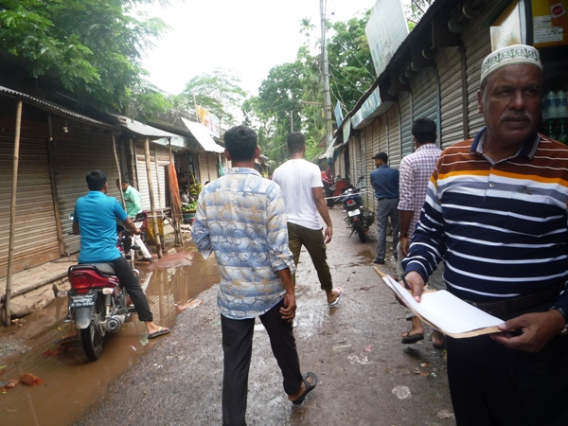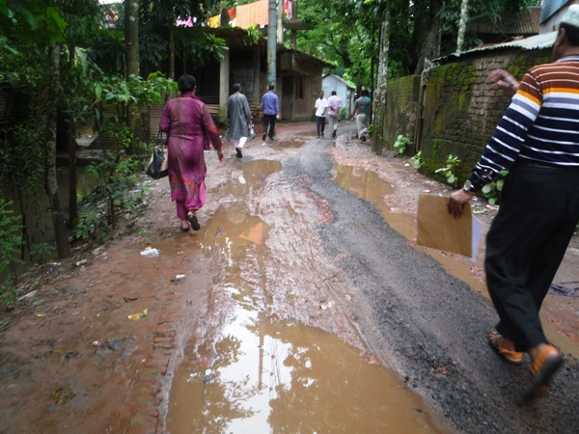
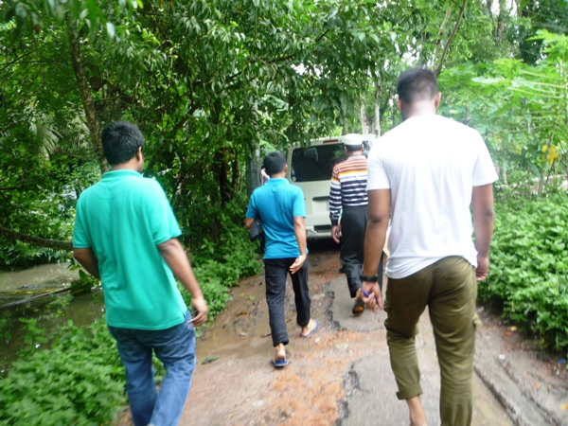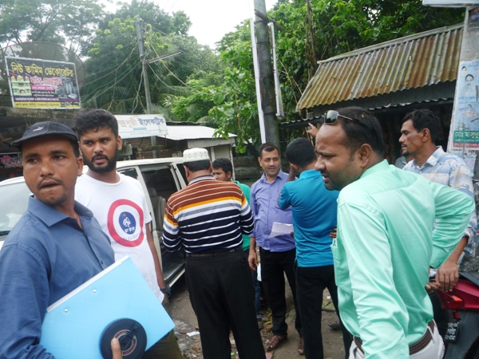
Photograph 7.1.1: Consultant Team visited the site with Madaripur Pourashava Officials
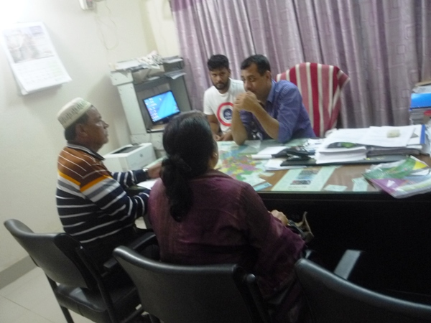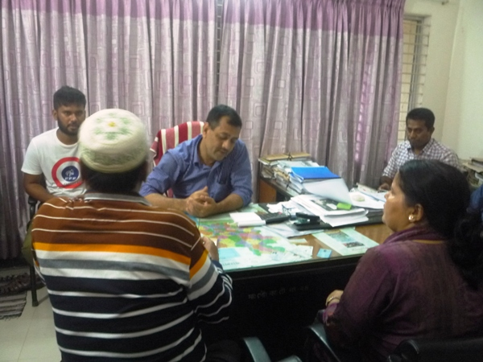
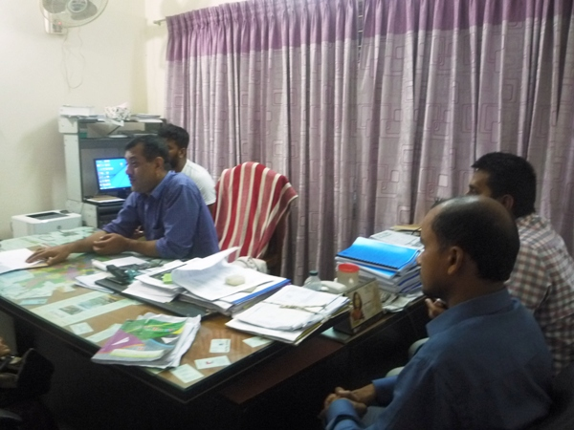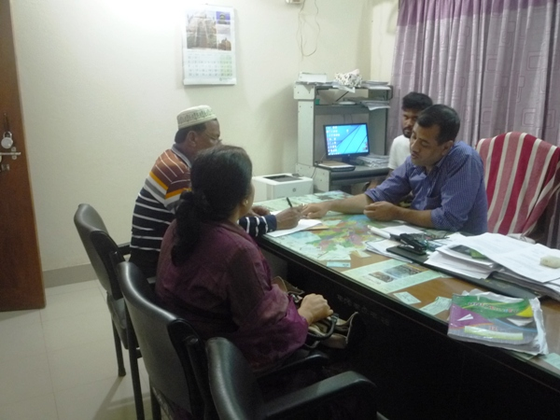
Photograph 7.1.2: Consultation Meeting at Madaripur Pourashava with Pourashava Officials and Consultants Participants

Issues Raised by the Participants

The participants raised the issues related to the infrastructure development of Madaripur Pourashava. They emphasized on the subproject selection for the future development and also discussed about the procedure for the quality construction work. In the FGD, the participants discussed the requirements of the infrastructure development of Madaripur Pourashava through a list of the subprojects.

Feedback, Suggestions, and Recommendations of the Participants

The participants’ feedback, suggestions, and recommendations listed below:
- The FGD results confirmed that an improved communication network is needed for future development of Madaripur Pourashava;
- Construction works should be scheduled properly and the quality of the construction work should be improved;
- The participants stated that the public water supply facilities, sanitation facilities, solid waste management issue and access road are not adequate;
- They also discussed about Charmuguria and Gani Bepari Road which is another priority basis roads in the Pourashava;
- Participants also illustrate the importance of the Bus Terminal at Madaripur Sadar because the condition of the existing bus terminal is badly damaged;
- Participants of the Madaripur Pourashava also proposed the construction of market at Charmuguria;
- Slaughter house is proposed for this PPourashava by the participants at Charmuguria.
To encourage participation, regular consultations are recommended with beneficiary communities to share subproject related information and to provide a feedback mechanism for these communities to voice their concerns and issues in all stages of the subproject. The DSM consultants and PMU, LGED will be responsible to carry out continued consultation with and information dissemination to the key stakeholders.

Conclusions and Recommendations

The subproject intervention has significant impacts on ecological environment due to felling of the trees. In addition, the subproject intervention has impacts on physicochemical components and socio-economic environment. However, from the study it is revealed that the anticipated impacts on physicochemical components and socio-economic environment are not significant. Most of the individual elements of the subproject involve simple construction and operation, so impacts will be mainly localized and limited within the subproject boundary. Most of the predicted impacts are associated with the construction process which is invasive. Hence, the impacts are largely manageable through mitigation measures. Mitigation will be assured by a program of environmental monitoring to ensure that all measures are implemented, and will determine whether the environment is protected. It will include observations on and off-site, document checks and interviews with workers and beneficiaries. Any requirements for corrective action will be reported to the WB.
This study formulates well structured EMP. This EMP will assist Pourashava Officials, PMU-LGED, contractor and DSM personnel in mitigating the environmental impacts, and guide them in the environmentally sound execution of the proposed subproject. A copy of the EMP shall be kept on-site during the construction period at all times. The EMP shall be made binding on contractor operating the site, and will be included in the contractual clauses.
It should be noted that environmental assessment report is a live document. Hence, due to changing circumstances during the construction phase if any, there might be minor adaptation needed for environmental, health and safety issues.

References

Master Plan for Madaripur Pourashava (2010-2030), June 2013.

Madaripur Pourashava: At a glance.

Madaripur Pourashava Web site. http://www.paurainfo.gov.bd/

DPHE, 2013. Groundwater Management Project.

Geological Survey of Bangladesh (GSB), 1978. Earthquake Zoning Map of Bangladesh.

Bangladesh Meteorological Department (BMD), 2012. Flood Zoning Map of Bangladesh.

Population and Housing Census, 2011, National Volume-II: Union Statistics.

Climate-Data.org. http://Climate%20of%20Bangladesh%20%20Temperature,%20Climograph,%20Climate%20table%20for%20Bangladesh%20-%20Climate-Data.org.html

Environmental Assessment Volume 1: Overall Environmental Assessment [Draft Final Report], September 2013. Municipal Governance and Services Project (MGSP), Local Government Engineering Department (LGED) and Bangladesh Municipal Development Fund (BMDF), Ministry of Local Government, Rural Development and Cooperatives, Government of the People's Republic of Bangladesh.

Environmental Assessment Volume 2: Environmental Management Framework (EMF) [Draft Final Report], September 2013. Municipal Governance and Services Project (MGSP), Local Government Engineering Department (LGED) and Bangladesh Municipal Development Fund (BMDF), Ministry of Local Government, Rural Development and Cooperatives, Government of the People's Republic of Bangladesh.

APPENDIX

Appendix- I: Environmental Monitoring Checklist

