
GOVERNMENT OF THE PEOPLE’S REPUBLIC OF BANGLADESH
Local Government Engineering Department (LGED)

Local Government Division

Ministry of Local Government, Rural Development, and Cooperatives

Environmental MaNAGEMENT PLAN

Name of the Subproject: Supplying, Fitting, Fixing and Installation of Street Light with Pole on of RHD Main Road starting from DC Bridge to Khagdi Bridge at Madaripur Pourashava under the Project of MGSP FY 2018-19

Package No: MGSP/MAD/2018-19/W-10

Madaripur Pourashava, Madaripur

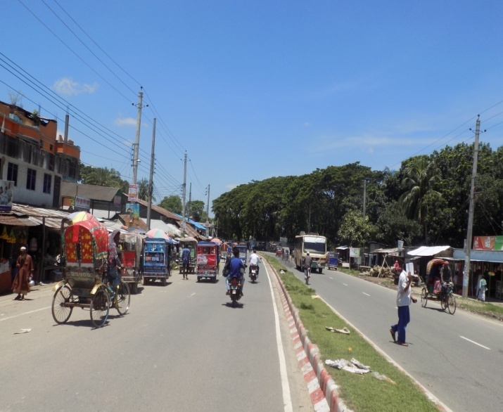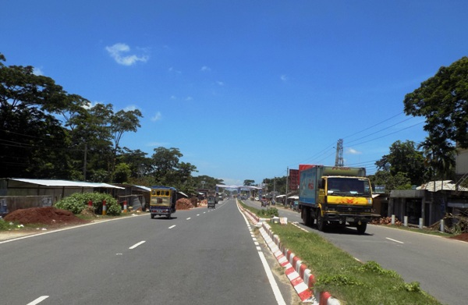

Municipal Governance and Services Project (MGSP)
Design, Supervision, and Management (DSM) Consultancy Services

Joint Venture of  Hifab International AB, Sweden  AQUA Consultant and Associates Ltd., Bangladesh |   
TABLE OF CONTENTS
 |  |  | Page
1.0 |  | SUBPROJECT DESCRIPTION | 1-8
 | 1.1 | Subproject Background | 1
 | 1.2 | Subproject Setting | 2
 | 1.3 | Current Situation, Proposed Intervention and Need for the Subproject | 6
 | 1.4 | Envisaged Subproject Activities and Implementation Process | 8
 | 1.5 | Category of the Subproject | 8
 | 1.6 | Subproject Schedule | 8
2.0 |  | ENVIRONMENTAL SCREENING | 9-10
3.0 |  | SPECIFIC IMPACT, MITIGATION AND ENHANCEMENT MEASURES | 11-15
 | 3.1 | Air Quality and Dust | 11
 | 3.2 | Noise and Vibration | 11
 | 3.3 | Occupational Health and Safety | 11
 | 3.4 | Impacts on Social Environment and Common Property Resources | 13
 | 3.5 | Labor Influx and Anticipated Impacts | 14
 | 3.6 | Impacts on Traffic Movement | 15
4.0 |  | RECOMMENDED MITIGATION AND ENHANCEMENT MEASURES | 16-17
5.0 |  | ENVIRONMENTAL MONITORING PLAN | 18
6.0 |  | ENVIRONMENTAL CODES OF PRACTICE | 19
7.0 |  | CONCLUSIONS AND RECOMMENDATIONS | 20
8.0 |  | REFERENCES | 21
APPENDIX
Appendix 1: Environmental Monitoring Checklist |  |  | 22

LIST OF TABLES
Table 3.3.1 | General Requirements for the Workers Health and Safety
Table 3.4.1 | Impacts on Social Environment and Common Property Resources
Table 4.1 | Anticipated Environmental Impacts during Construction Phase and Corresponding Mitigation and Enhancement Measures
Table 4.2 | Anticipated Environmental Impacts during Operation Phase and Corresponding Mitigation and Enhancement Measures
Table 5.1 | Matrix Table of Monitoring Plan (Visual observation during construction phase)

LIST OF FIGURES
Figure 1.2.1 | Location Map of the Subproject Site
Figure 1.2.2 | Lay-out Plan of the Subproject Site
Figure 1.2.3 | Topographic Features of the Subproject Site with Influence Area

LIST OF PhotoGraphs
Figure 1.3.1 | Current Situation of the Subproject Site
Figure 1.3.2 | DSM Consultant Team with Pourashava Representatives

ABBREVIATIONS

BDT | Bangladeshi Taka
BOQ | Bill of Quantity
CC | Cement Concrete
DSM | Design, Supervision, and Management
EA | Environmental Assessment
ECR | Environmental Conservation Rules
EMP | Environmental Management Plan
EPP | Emergency Preparedness Planning
ES | Environmental Screening
GoB | Government of Bangladesh
LGED | Local Government Engineering Department
MGSP | Municipal Governance and Services Project
PD | Project Director
PMU | Project Management Unit
RCC | Reinforcement Cement Concrete
WB | World Bank

SUBPROJECT DESCRIPTION

Subproject Background

Madaripur Pourashava is situated at Madaripur District. It is established as a Pourashava in the year of 1875. This is A type Pourashava with present population of 62,690. The Pourashava covers area of 13.99 sq. km. The Pourashava has 54.59% pucca road, 27.70% semi-pucca road and 17.71% katcha road (Source: At a glance Madaripur Pourashava).

Urbanization is considered to be closely and positively associated process, with complex and mutually reinforcing links. In sustained economic growth, it is essential to develop urban areas. Urban centers are the places of agglomeration of economic activities, important hubs of production, processing, innovation and employment. In recent days, there has been a trend of growing importance of urban areas. This subproject emphasizes on the planning to address the problems and to guide future planning of Madaripur Pourashava. The present urban planning exercises for Madaripur Pourashava with the subproject introduced plans of different nature and styles. A well-integrated spatial and sectoral plan with sound financial and institutional policies facilitates refurbish urban environment not only healthy and better but also efficient and safer. Without adequate infrastructure and services provision, it would be difficult to turn urban centers as environmentally congenial livable places. Hence, this subproject directly will contribute for the infrastructure development of the Pourashava. (Master Plan of Madaripur Pourashava)

The significant features of the subproject are stated below:

Name of the Subproject: | Supplying, Fitting, Fixing and Installation of Street Light with Pole on of RHD Main Road starting from DC Bridge to Khagdi Bridge at Madaripur Pourashava under the Project of MGSP FY 2018-19
Package No.: | MGSP/MAD/2018-19/W-10
District Name: | Madaripur
ULB Name: | Madaripur Pourashava
Jurisdiction Area: | Ward number 06, 07 and 09
Structural Design Option: | Street Light
Wards Population: | About 21,850 as per as per Pourashava information
Tribal People: | No tribal people settlement found in the subproject area
Land Acquisition: | No private land acquisition is required
Estimated Cost: | 15.159 million BDT
Subproject Duration: | 6 Months
Tentative Start Date: | 28 October 2018
Tentative Completion Date: | 27 April 2019
For the preparation of the subproject appraisal, environmental screening has been performed. According to that screening, an environmental management plan is required. Hence, this environmental management plan is prepared to meet the regularity requirement. This plan simplifies the anticipated impacts and corresponding mitigation measures for easy understanding of the personnel responsible for the subproject implementation. Therefore, this study only includes key contents that are appropriate.

Subproject Setting

The subproject site is situated within the jurisdiction area of the Madaripur Pourashava Ward no. 06, 07 and 09. The starting point of the street light at DC Bridge is located at 23°10'1.42"N (Latitude) and 90°12'15.74"E (Longitude).The end point of Khagdi Bridge is located at 23° 9'30.51"N (Latitude) and 90° 9'57.67"E (Longitude). The location map, lay-out plan, and topographic features of the subproject are shown in Figure 1.2.1, Figure 1.2.2, and Figure 1.2.3.
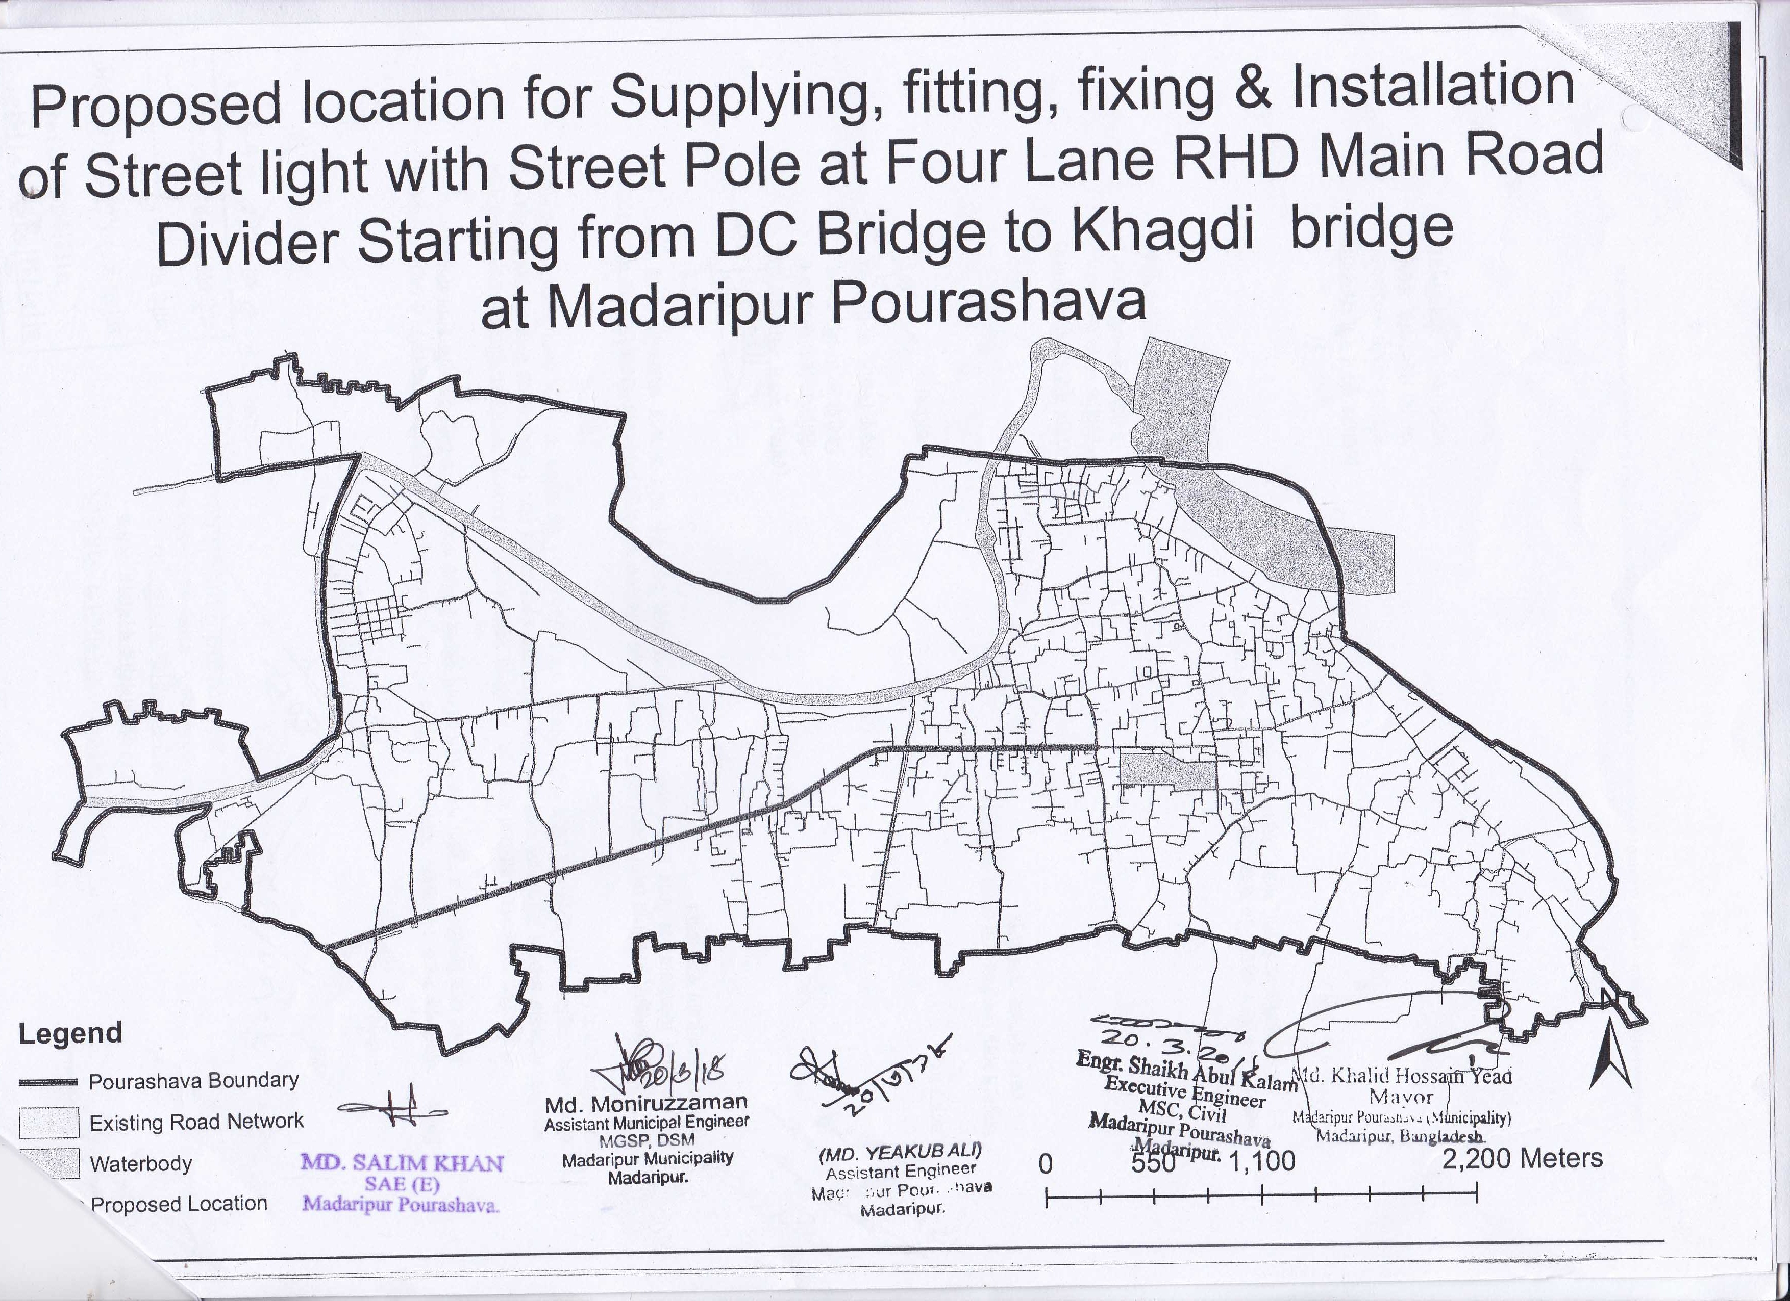

Figure 1.2.1: Location Map of the Subproject Site
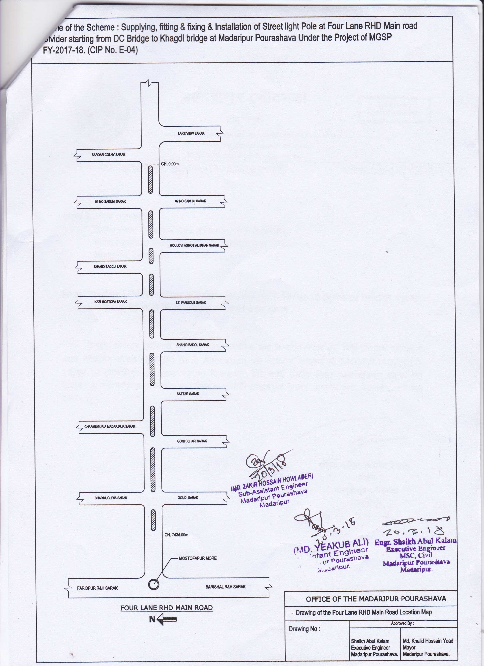

Figure 1.2.2: Lay-out Plan of the Subproject Site

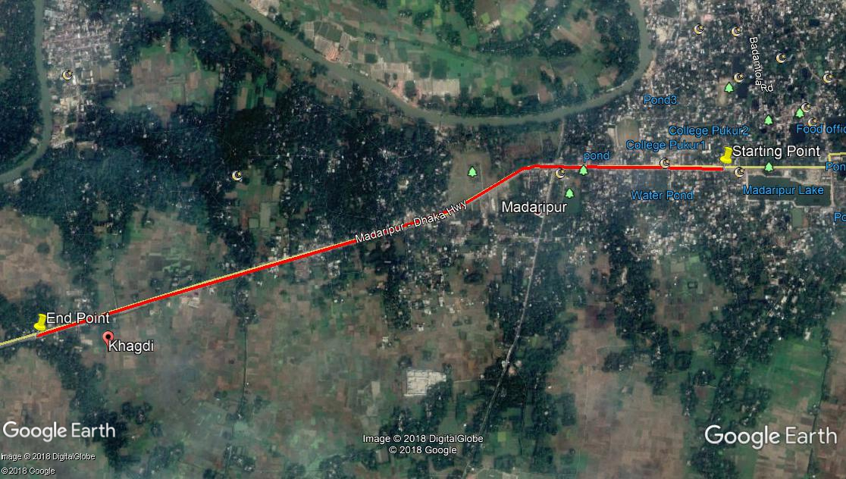

Figure 1.2.3: Topographic Features of the Subproject Site with Influence Area

The subproject site is situated at the built-up and central area of the municipality. During the site visit, the detailed environmental and infrastructural features listed around the subproject site. The major findings of the site visit are given below:
Chainage (m) | Left | Right | Major Environmental and Infrastructural Features
DC Bridge to Khagdi Bridge (Ch. 0 to 4734 m)
0-100 | √ |  | Shops with various structures, house
0-100 |  | √ | Miraz Restora, Samsung Showroom, multistoried building
100-200 | √ |  | Shops and houses with different structures
100-200 |  | √ | Shops and houses with different structures
200-300 | √ |  | Connecting road, Hotel Sarbick International, Sarbick Bus Counter, various shops
200-300 |  | √ | Connecting college road, mutual trust bank ATM booth, shops
300-400 | √ |  | Chandmari Mosque, Shahid Baschu Road, National Bank LTD, Selina Complex
300-400 |  | √ | Residential houses, shops
400-500 | √ |  | Connecting Stadium Road, Motel Mati, trees
400-500 |  | √ | Connecting road, Molla Bari,houses
500-600 | √ |  | Walton Plaza-2,residendial area, shops
500-600 |  | √ | Old Bus stand,shops
600-700 | √ |  | Connecting road,Hotel Alinas Kitchen,Hotel Matrivumi, La Vida Boutiques, shops
600-700 |  | √ | Connecting road, Madaripur Fire Station, shops
700-800 | √ |  | Yousuf Filling Station,Patakkandi Road,Rofiq Super Market, trees
700-800 |  | √ | Wapda Green Field, Jonoganer Hotel, Connecting Wapda Road
800-900 | √ |  | Alam Market, trees,khal
800-900 |  | √ | Various shops, khal, houses
900-1000 | √ |  | Circle Network Pop Office, trees, different structures, connecting road
900-1000 |  | √ | Connecting Madaripur-Pathuria Par Road,Iterpur Jame Mosque, Iterpul Bazaar,Iterpul Fish Market
1000-1100 | √ |  | Trees, open space, water body
1000-1100 |  | √ | Food Godawns Jame Mosque,connecting road,shops, open space
1100-1200 | √ |  | Open space, trees, water body
1100-1200 |  | √ | Trees, open space, connecting road
1200-1300 | √ |  | Open space, trees, water body
1200-1300 |  | √ | Trees, open space, connecting road
1300-1400 | √ |  | Shahid Baschu School Road, trees, open space
1300-1400 |  | √ | Jute Mills Jame Mosque,open space
1400-1500 | √ |  | DC office, houses, trees
1400-1500 |  | √ | Residential houses, open space, connecting road, Eastern Mobile City Plaza, trees
1500-1600 | √ |  | Residential houses, trees
1500-1600 |  | √ | Homestead area, trees
1600-1700 | √ |  | Residential houses, trees
1600-1700 |  | √ | Old Truck Stand, trees
1700-1800 | √ |  | Connecting road, residential houses with various structures, trees
1700-1800 |  | √ | Connecting road, trees, open space
1800-1900 | √ |  | Madaripur Government Polytechnic Institute, open space, trees
1800-1900 |  | √ | Trees, connecting road, Madaripur Ideal Polytechnic Institute
1900-2000 | √ |  | Connecting road, trees, open space
1900-2000 |  | √ | Houses and shops with various structures, trees
2000-2100 | √ |  | Madaripur Zila Markaz Mosque, trees, houses
2000-2100 |  | √ | Residential area, trees
2100-2200 | √ |  | Trees, connecting road, houses
2100-2200 |  | √ | Hazi Nur Mohammad Road, trees
2200-2300 | √ |  | Homestead area, ticket counter, houses, trees
2200-2300 |  | √ | Residential area
2300-2400 | √ |  | Madaripur Bus Terminal, open field
2300-2400 |  | √ | Nabila Motors, different shops
2400-2500 | √ |  | Open field, houses
2400-2500 |  | √ | Residential houses
2500-2600 | √ |  | Open space, residential houses, trees
2500-2600 |  | √ | Residential houses, trees, connecting road
2600-2700 | √ |  | Connecting road, trees, open space
2600-2700 |  | √ | Residential houses, trees, open space
2700-2800 | √ |  | Open field, trees
2700-2800 |  | √ | Open field, trees
2800-2900 | √ |  | Residential houses, trees, open space
2800-2900 |  | √ | Agricultural field, trees
2900-3000 | √ |  | Residential houses, trees, open space
2900-3000 |  | √ | Agricultural field, trees
3000-3100 | √ |  | Residential houses, trees, open space
3000-3100 |  | √ | Agricultural field, trees
3100-3200 | √ |  | Open field, trees
3100-3200 |  | √ | Open field, trees
3200-3300 | √ |  | Residential houses, trees, open space
3200-3300 |  | √ | Agricultural field, trees
3300-3400 | √ |  | Filling station, open space
3300-3400 |  | √ | Khal, trees
3400-3500 | √ |  | Filling station, khal, open space
3400-3500 |  | √ | Connecting road, trees,khal
3500-3600 | √ |  | Ditch, trees, open space
3500-3600 |  | √ | Agricultural field, trees
3600-3700 | √ |  | Trees, open space
3600-3700 |  | √ | Agricultural field, trees
3700-3800 | √ |  | Agricultural field, trees
3700-3800 |  | √ | Agricultural field, trees
3800-3900 | √ |  | Residential houses, trees, open space
3800-3900 |  | √ | Agricultural field, trees
3900-4000 | √ |  | Homestead area, trees
3900-4000 |  | √ | Residential area, trees
4000-4100 | √ |  | Khagdi Bus stand, houses, trees
4000-4100 |  | √ | Open field, trees, houses
4100-4200 | √ |  | Residential houses, trees,open space
4100-4200 |  | √ | Open field, trees, houses
4200-4300 | √ |  | Connecting road, residential area, trees
4200-4300 |  | √ | Houses with different structures, trees, open space
4300-4400 | √ |  | Trees, different houses
4300-4400 |  | √ | Ditch, houses, trees
4400-4500 | √ |  | Low land, connecting road, trees, agricultural field
4400-4500 |  | √ | Office space, open field, trees
4500-4600 | √ |  | Low land, connecting road, trees, agricultural field
4500-4600 |  | √ | Open field, trees
4600-4700 | √ |  | Residential area, trees, low land, open space
4600-4700 |  | √ | Office, open field
4700-4734 | √ |  | Residential area, trees, low land, connecting road
4700-4734 |  | √ | Connecting road, residential area

Current Situation, Proposed Intervention and Need for the Subproject

The proposed site is located in the prime and valuable developed area. The land use pattern consists of commercial and residential areas. The subproject site is situated within the jurisdiction of the ward no. 6, 7 and 9 of Madaripur Pourashava. The major roadside built-up infrastructures includes Hotel Sarbick International, Sarbick Bus Counter, Miraz Restora, Samsung Showroom, National Bank LTD, Selina Complex, Motel Mati, Walton Plaza-2, Old Bus stand, Hotel Alinas Kitchen, Hotel Matrivumi, La Vida Boutiques, Madaripur Fire Station, Yousuf Filling Station, Patakkandi Road, Rofiq Super Market, Wapda Green Field, Jonoganer Hotel, Alam Market, Iterpur Jame Mosque, Iterpul Bazaar, Iterpul Fish Market, Food Godawns Jame Mosque, Jute Mills Jame Mosque, DC office, Eastern Mobile City Plaza, Old Truck Stand, Madaripur Government Polytechnic Institute, Madaripur Ideal Polytechnic Institute, Madaripur Zila Markaz Mosque, Madaripur Bus Terminal, Nabila Motors, Filling Station, houses with various structures, house boundary, residential houses and Khagdi Bus stand. In addition, khal, ditch, common planted trees, agricultural field, low land and open space were found during site visit.

From Ch. 0 to 4734 m at four lane divider of RHD Main Road, absent of the street light hampers the normal traffic operation at night time. Hence, fixing of the street light is also required for improved transport facilities. The street light will be fixed at divider of the road at 30m interval. The existing condition and consultation of the proposed site is further elaborated in the following Photographs 1.3.1 and 1.3.2.

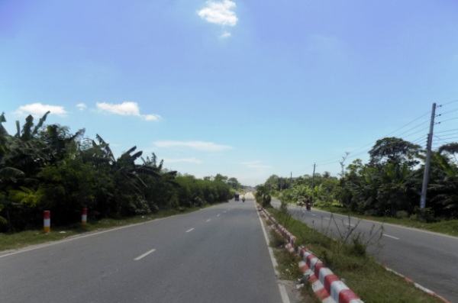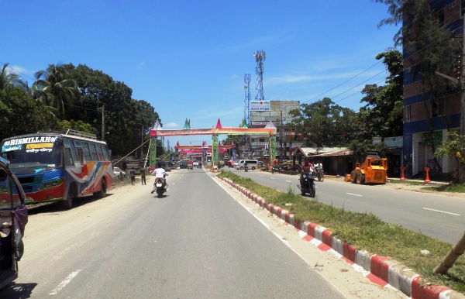

Photographs 1.3.1: Current Situation of the Subproject Site

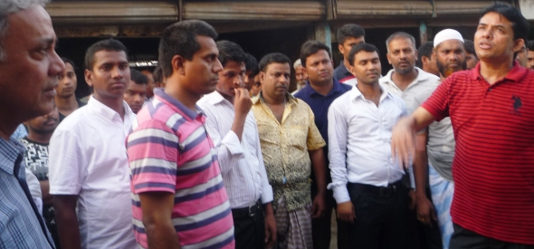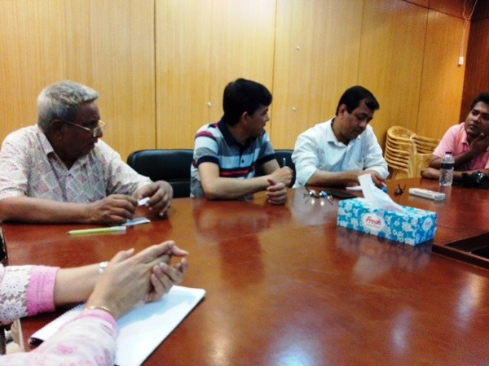

Photographs 1.3.2: DSM Consultant Team with Pourashava Representatives

Envisaged Subproject Activities and Implementation Process
The general activities for the subproject includes: construction of the semi-pucca site office and construction of the labor shed. The major specific activities include:

Specific activities for Street Light:

- Assembling, fitting, fixing, installation,
- Testing and commissioning of the GI pole;
- Fitting and fixing energy meter board;
- Earthling the electrical installation with GI pipe;
- Fixing insulator,
- Erection of tubular pole;
- Fixing of the overhead conductor;
- Fixing of the wire rack;
- Fixing and installation of the switch board;
- Fixing of the water tight street light with aluminum reflector.

The materials and resources to be used for the key activities of the subproject implementation includes: GI pole, energy meter board, insulator, tubular pole, overhead conductor, wire rack, aluminum reflector. The major equipment to be used for the implementation of the subproject: steel cutter, drill machine, tester and screw driver.

Category of the Subproject

- According to ECR 1997 : Green □√ Orange A □ Orange B □ Red □ Not Listed □

- According to WB classification: Category B □ Category C □ √
Considering the environmental impacts, the street light can be considered as Green category as per ECR-97. According to the WB classification, it can be classified as Category C.

Subproject Schedule
The tentative schedule of construction of the subproject is:
(a) Subproject Duration (months) : 6 months
(b) Tentative Start Date : 28 October 2018
(c) Tentative Completion Date : 27 April 2019

The daily construction hours will normally include regular working time. However, daily working hours may vary based on the on-site condition. The detailed work program will be prepared by the contractor with the assistance of the PIU-Pourashava. Then it will be shared with the PMU, LGED and DSM consultants. In addition, the detailed work program will also be shared with the Bank as per requirement.

ENVIRONMENTAL SCREENING

Environmental Screening (ES) for the subproject has been conducted with the purpose of fulfilling the requirements of Government (GOB) and World Bank (WB) for the preparation of subproject appraisal. Environmental Screening Checklist, as adopted in Appendix C of the Environmental Management Framework (EMF) of the MGSP, was administered for identifying the impacts and their extents.
The screening data and information for the Street Light have been formulated and are shown in below.
1) Potential environmental impact during construction phase:
(a) Ecological impacts:
Nil
- Felling of trees Significant □ Moderate □ Minor □√ Number of trees
- Clearing of vegetation Significant □ Moderate □ Minor □ √
- Potential impact on species of
aquatic (i.e., water) environment Significant □ Moderate □ Minor □√

No major trees to be felled down. Also, there is no tree to be felled down bring religious and heritage importance. Clearing of vegetation is not needed for this subproject. So clearing of the vegetation is considered as minor. In addition, anticipated impact on species of aquatic environment is minor because except throwing of the wastes materials in to the khal and ditch, the subproject does not have any impact on the aquatic environment. Considering the number of trees and vegetation to be felled down, the ecological impact is considered as minor.
- Physicochemical impacts:
- Noise pollution Significant □ Moderate □ Insignificant □√
- Air pollution Significant □ Moderate □ Insignificant □√
- Drainage congestion Very likely □ Likely □ Unlikely □√
- Water pollution Significant □ Moderate □ Insignificant □√
- Pollution from solid/ construction wastes Significant □ Moderate □ Insignificant □√
- Water logging Significant □ Moderate □ Insignificant □√

The subproject will have no major impacts on noise and air quality during construction phase due to mobilization of the equipment and vehicles movement for the transportation of the materials. The construction work will be performed section wise. Hence, it is anticipated that the overall impacts on noise and air quality will be insignificant, temporary and limited within the subproject boundary. The generated dust and the generated construction wastes, un-suitable materials and solid wastes may not degrade the quality of the surrounding environment and degrade the aesthetic value because this subproject construction work will have not huge amount of dust and construction wastes.The anticipated water logging and drainage congestion during construction period is minor because this construction work will have no any option to create water logging and drainage congestion.
- Socio-economic impacts:

- Traffic congestion Very likely □ Likely □ Unlikely □√
- Health and safety Significant □ Moderate □√ Insignificant □
- Impact on archaeological and historical Significant □ Moderate □ Insignificant □√
- Employment generation Significant □ Moderate □ √ Insignificant □
Firstly, the proposed street light will be installed. The traffic congestion due to street light installation is comparatively less because it does not require closing of the entire road. All vehicles and local people can use the road easily during street light installation. Hence, anticipated impact on health and safety is moderate. The construction work adjacent to the residents and religion institutes may cause safety risks to the public especially for school going kids. Therefore, construction activities adjacent to the Mosque should be performed within very short time considering safety issues/site fencing. There is no archaeological and historical site will be affected due to the subproject activities. The subproject has positive impact by generating work opportunities for the local people and supplying of the construction materials, equipments, food and other necessary stuffs to the campsite.
2) Potential environmental impact during operational phase:
(d) Ecological impacts:
- Potential impact on species of aquatic Significant □ Moderate □ Minor □√
(i.e., water) environment
The anticipated impact on the aquatic environment is insignificant due to operation of the street light.
(e) Physicochemical impacts:
- Potential air quality Improvement □ No-improvement □ No Impact □√
- Noise level Improvement □ No-improvement □ No Impact □√
- Drainage congestion Improvement □ Minor Improvement □ No Impact □√
- Risk of Water pollution Significant □ Moderate □ Minor □√
- Pollution from solid waste Improvement □ No-improvement □ Minor □√

The anticipated impact on air, noise, water, solid waste, drainage congestion is insignificant due to absence of direct connection during operation period of street light.
(f) Socio-economic impacts:
- Traffic Improvement □√ No-improvement □ Adverse □
- Safety Improvement □√ No-improvement □ Adverse □
- Employment generation Significant □ Moderate □√ Minor □

After completion of the street light at RHD road divider will improve the transport facilities at night. However, the street light will enhance business activities and pedestrians’ safety at night. In addition, new roadside shops will be developed which contributes local economy, it will provide better environment to the community people.
(3) Summary of the possible environmental impacts of the subproject:

From the above study, the overall impact due to implementation of the subproject is not severe during the construction and operational phases. However, the anticipated impacts will be mainly within the subproject boundary. The wastes generated due to the construction activities should be properly collected and disposed in a designated site.

Safety concern is an important issue for both the construction and operation phases that should be considered properly. The socio-economic aspect mainly includes health and safety and employment generation. This subproject will have positive impacts in terms of the generation of the employment and business activities by supplying construction materials and equipment.

Specific impact, mitigation AND enhancement measures

The likely impacts of the subproject are mainly caused by the activities required for the implementation of the subproject, materials, resources and equipment to be used to perform the activities. This section describes some specific impacts due to the subproject activities and their mitigation measures.

Air Quality and Dust

During construction phase, air pollutants will be emitted from the equipment, subproject activities and construction vehicles are expected to remain low. Local residents in the vicinity of the work sites will be temporarily disturbed by the limited dust pollution. The overall impacts, however, are expected to remain low.
Mitigation Measures
- Water should be sprayed at the work site and camp site area for dust control.
- Avoid use of dust generating equipment (which produce significant amount of particulate matter) far from the local residents;
- Ensure that all subproject vehicles are in good operating condition.

Noise and Vibration

Noise and vibration caused by the equipment, subproject activities and movement of the construction vehicles may temporarily disturb nearby environment though the impacts are anticipated to be limited within the subproject boundary.
Mitigation Measures

- Transportation of the construction materials have to be carried during the scheduled times, and mainly during the day in off-peak time;
- If needed and applicable, all powered mechanical equipment and machineries will be fitted with noise abating gear such as mufflers for effective sound reduction.

Occupational Health and Safety

The most important risks associated with the construction activities are listed below:
- Risks of using of the machineries;
- Risk of falling from the height;
- Risk from mechanical failure of the equipments;
- Risk from the traffic collision or accidents during operation of the equipment such as welding machine and vehicles movement for the transportation activities of the subproject;
- Risk associated to the sudden bad weather working conditions such as storm, thunder storm and earth quake etc.
- Exposure to the sunlight- workers are being exposed to the sun for long hours;
- Exposure to the high temperature, and humidity for a long time resulting in dehydration;

Requirements for the Workers’ Health and Safety
The key salient features of the general requirements for the workers’ health and safety stated are presented in Table 3.3.1.
Table 3.3.1: General Requirements for the Workers Health and Safety
Issues | Requirements
Site fencing, ladder, scaffolding and pulley | - Site should be fenced and screened to protect site from strong winds and to contain dust;  - Ladder should be placed if needed and scaffolding should be provided for the site protection work and for chipping, plastering, painting etc;  - Provide jute netting for avoiding any drop down of the materials to the ground;  - Use mechanical equipments such as pulley for the lifting of the materials to the roof and other floors.
Health and Hygiene | - Cleanliness at the site premises and workers living places and at the Labor Shed;  - Arrangement of the proper ventilation and temperature at the Labor Shed;  - Protection against dust and furnace by using of the nose masks and covering of the head and body;  - Proper disposal of the wastes and effluents;  - Provision of the adequate latrines and separate toilet for the women;  - Sufficient dustbins for the solid waste management system.
Safety and First Aid Box | - Using of the personal protective equipment (helmet, gloves, ear plug, goggles, nose mask, safety boots);  - Precautions during work on or near machineries in motion;  - Head loads are prohibited;  - Ensure first aid box;  - First aid facilities should be provided and maintained;  - The first aid kit should include adhesive bandages, regular strength pain medication, gauze, and low grade disinfectant.
Compensation for Accidents at Work | - Contractors will bear medical treatment costs. If any severe accidents such as loss of hands, legs or loss of working ability or any case of death needs compensation-(the amount of the compensation should be fixed considering the type of accidents).
Dust and Fumes | - For any dust, fumes, or other impurities likely to be injurious to the workers, effective measures shall be taken to prevent their accumulation and its inhalation by the workers.
Overcrowding | - No labor room should be overcrowded.
Latrines and Urinals | - Sufficient latrines shall be provided;  - Latrines shall be maintained in clean and sanitary condition;  - Latrines shall be adequately lighted and ventilated.
Disposal of Wastes and Effluents | - Proper disposal system for the solid waste and effluent is required.

Impacts on Social Environment and Common Property Resources

Through comprehensive study, it is revealed that impacts are expected not to be severe and to be largely manageable. The following Table 3.4.1 presents impacts on socio-economic environment and common property resources.
Table 3.4.1: Impacts on Social Environment and Common Property Resources
Social Components | Impacts on IECs | Impact Significance
Community Perception | The local community people welcome this subproject and there is no visible objection from them. | Significant (+ve)
Employment and Business Opportunity | Community feels happy because generally the local contractor will be engaged for the construction works which will create work opportunity for the skilled and non-skilled labor. The subproject will create business opportunity for the equipment and materials suppliers. | Significant (+ve)
Community Order and Security | This subproject activity does not create any severe security problems to the local community and community people. | Minor  (-ve)
Labor Habitat | It is anticipated that the outsider workers will stay at the Labor shed which will have impacts on the environment relates to the generation of the solid wastes, effluent, and water consumption. | Moderate  (-ve)
Health Care | Workers may suffer from the dehydration problems, respiratory problem, and other health hazards. | Minor  (-ve)
Accident | In case of road accidents by the vehicles to be used for the transportation and possible accidents from subproject activities may have serious negative impact. | Significant  (-ve)

Mitigation Measures
- Conduct dissemination with the local community about the subproject details;
- Continue liaison with the community leaders in order to maintain the community support;
- Engage local contractor and local people as much as possible for positive perception of the local community;
- Follow traffic rules to avoid any accidents;
- Transportation and mobilization of the equipment and construction materials avoiding peak hours and scheduled time;
- Ensure first aid facilities and effective use of personal protective equipment where applicable.

Labor Influx and Anticipated Impacts

The labor force and associated goods and services required for the construction of infrastructure civil works under this subproject cannot be fully supplied locally. The migration to and temporary settlement of laborers in the subproject, referred to as labor influx, carries an array of potentially positive and negative impacts in terms of demands on public infrastructure, utilities, housing and sustainable resource management and the strain on social dynamics.
Labor influx effects on host communities include positive impacts such as:

- The subproject activities will generate work opportunities for the local people and supplying of the construction materials, equipment, food and other necessary stuffs to the campsite;
- Improved infrastructure and public service access and availability whereby subproject investment catalyzes larger allocation of resources to a region, stimulating the development or expansion of infrastructure and public services.

Critical negative social risks include:
- Increase in criminal activity and alcohol and drug abuse, domestic violence, political attachment and violence, smuggling and robbery etc;
- Increase in gender-based violence, including eve teasing, sexual harassment etc;
- Increases in communicable diseases, including respiratory problems, diarrheal diseases, vector-borne diseases (e.g., malaria), and sexually transmitted infections (e.g., HIV/AIDS, syphilis, gonorrhea, hepatitis B);
- Conflicts arising from increased demand on existing infrastructure, services, and utilities, including transportation, health, education, water and sanitation, waste management, public utilities and community, religious, and recreational facilities and loss of land for access routes.

The general environmental impacts of labor influx include pressure on the natural resources such as using of the water, electricity, other fuel for cooking, loss of land for the labor establishment, depletion of the water supply, sewage and waste water generation, degradation of the air quality, waste generation, increased demands on the local energy and resources and noise pollution effects. The number of local and migrated people involved in the subproject activities can be only identified in the construction phase. Hence, these specific impacts will be quantified during construction work and environmental management plan will be modified accordingly. However, the following safeguard measures are recommended to avoid any risk of labor influx:

- Inform local people about the subproject activities;
- Liaison with the community leaders in order to get community support;
- Engage local people as much as possible to minimize workers from outsiders;
- Monitor workers attitude and behavioral matter;
- Monitor the workers movement for avoiding any unexpected social activities (robbery, crime, political attachment and conflicts, drugs abuse);
- Inform and use local administration to get support if needed;
- Inform local utilities service providers (such as for new electricity connection REB or any other department);
- Ensure effective use of natural resources such as water, electricity, fuel, wood etc.

Impacts on Traffic Movement

Due to transportation of the materials and equipments, the subproject will have temporary negative impact in traffic congestion during movement of the vehicles and equipment. However, it is anticipated that the subproject activities do not have any severe impact on the local traffic system because movement of the vehicles and equipment will be only for a short time and as per requirement. The on-site subproject activities do not have any impact on the local traffic system during construction phase. Furthermore, the subproject is situated on the road divider of four lane main highway, that’s why traffic congestion is not a major issue.
The following safeguard measures are recommended to minimize the impacts associated to the traffic movement:

- Inform local people about the subproject activities;
- Inspire local people to use connecting and diversion roads;
- Ensure schedule deliveries of material/ equipment during off-peak hours;
- Place traffic sign/cautionary sign to avoid undue traffic congestion and associated traffic control measures to limit possible disruption;
- The stack yards and at the place of construction works should be fenced off with fences and should be isolated from general public access and marked with signs to ensure safe movement;
- Avoid any material storage and any work on the road side area.

RECOMMENDED MITIGATION AND ENHANCEMENT MEASURES

The activities wise anticipated environmental impacts and corresponding mitigation measures have been outlined in Table 4.1 and Table 4.2.

Table 4.1: Anticipated environmental impacts during construction phase and corresponding mitigation and enhancement measures
Activity / Issues | Potentials Impacts | Proposed Mitigation and Enhancement Measures | Responsible Parties
Construction and operation of labor shed for the workers (Workforce and labor shed management) | - Generation of sewage and solid waste may cause water/ environmental pollution | - Construction of sanitary latrine considering 15 persons for one toilet at the labor shed and separate toilet for male and female;  - Erection of “no litter” sign, provision of waste bins/cans (introduce separate waste bins for organic and inorganic wastes);  - Ensure wastes (solid wastes and other forms of the waste) disposal at the dumping site beside Madaripur-Shariatpur Highway. | Contractor  Monitoring-  Primarily by Pourashava  Secondarily by PMU, LGED and DSM
 | - Health of workers | - Conduct formal and unofficial discussion to increase awareness about hygiene practices among the workers;  - Ensure availability and access to first-aid equipment and medical supplies for the workers.
 | - Possible development of labor camp into permanent settlement | - Contractor to remove labor camp at the completion of contract.
 | - Outside labor force causing negative impact on health and social well-being of local people | - Ensure that contractor employ local work force to provide work opportunity to the local people and conduct formal and unofficial awareness program for the health and social well being of the local people.
General construction works | - Traffic congestion, effect on traffic and pedestrian safety | - Ensure schedule deliveries of materials/ equipment during off-peak hours;  - Place traffic sign to avoid undue traffic congestion and associated traffic control measures to limit possible disruption;  - Inform the local people about the subproject activities. | Contractor  Monitoring-  Primarily by Pourashava  Secondarily by PMU, LGED and DSM  Contractor  Monitoring-  Primarily by Pourashava  Secondarily by PMU, LGED and DSM
General construction works | - Noise pollution | - Check and maintenance the equipment properly;  - Avoid using of construction equipment producing excessive noise at night;  - Avoid prolonged exposure to noise (produced by equipment) by the workers;  - Regulate use of horns and avoid un-due use of hydraulic horns by subproject vehicles.
General construction works | - Water and soil pollution | - Prevent discharge of fuel, lubricants, chemicals, and wastes of subproject vehicles into adjacent water bodies, low lands and soil.
General construction works | - Accidents | - Conduct formal and informal discussion for creating awareness about the accidents;  - Provide PPEs (personal protective equipment) and ensure using of the PPEs by the workers.
All construction works | - Beneficial impact on employment generation | - Employ local people in the subproject activities as much as possible;  - Give priority to poor people living within subproject area in subproject related works (e.g., excavation and other works, which do not require skilled manpower).
All construction works | - General degradation of the environment | - Ensure environmental enhancement measures, such as tree plantation, and cautionary signs.
Environmental impacts due to the key construction activities and corresponding mitigation measures for the street light
Setting up the pole and electrical connection | - Potential health and safety risks; | - Inform the local authority to switch off power during connection;  - Ensure use of the PPEs.
Source of electricity and equipment | - Reduce of resource i.e. use of electricity; | - Provision of renewable energy (solar panel electrification) and use of environmental friendly equipment (LED bulb rather than CFL bulb).

Table 4.2: Anticipated Environmental Impacts during Operational Phase and Corresponding Mitigation and Enhancement Measures

Activity / Issues | Potentials Impacts | Proposed Mitigation and Enhancement Measures | Responsible Parties
Operation and maintenance for street light | - Accidents due to collapse of the arms, electric bulbs and pole | - Monthly checking and maintenance of the arms, switch box, electric bulbs if needed;  - Provision of automatic shut-down the switch, lamps during thunder storm and other natural disasters.

Environmental Monitoring Plan

Environmental Monitoring Plan for this subproject will help to evaluate the extent and severity of environmental impacts against the predicted impact and the performance of environmental protection measures. The following Table 5.1 has been prepared for the key environmental indicators.

Table 5.1: Matrix Table of Monitoring Plan (Visual observation during construction phase)
Monitored Parameter/ Issues | Monitoring Method/ Key Aspects | Location of Monitoring | Period & Monitoring Frequency
Safety orientation and training of workers | Frequency of training & orientation of workers for safety | Subproject site | - Once in a month  - Reporting: Once in a month
Personal Protective Equipment | Ensure every single person involved in the activities wear and use safety equipment | Subproject site | - Daily  - Reporting: Once in a month
Worker’s health | Monitoring process of worker’s health | Subproject site | - Daily  - Reporting: Once in a month
Sanitation & drinking water facility to the workers | Availability of safe drinking water and sanitation to the workers | Subproject site | - Daily  - Reporting: Once in a month
Incident record and reporting | Documented record of all incident, accident, its remedial process | Subproject site | - Daily  - Reporting: Once in a month
Site security/ Fencing at the site | Isolation of site from general access by fencing, restriction of the un-authorized entry in the site. | Subproject site | - Daily  - Reporting: Once in a month
Bulletin/ announcement boards/ prohibition signs | Visible in good condition or not | Subproject site | - Daily  - Reporting: Once in a month
Equipment /vehicles | Switched-off diesel engines when not in use;  Search any possible leakage;  Fuelling. | Subproject site | - Daily  - Reporting: Once in a month
Dust | Dust is visible or not | Subproject site | - Daily  - Reporting: Once in a month
Oily waste generation and disposal | Quantity of oily waste, storage and disposal | Subproject site | - Daily  - Reporting: Once in a week
Solid waste generation | Quantity of solid wastes and disposal | Subproject site | - Daily  - Reporting: Once in a month
Gender equity | No discrimination regarding payment | Subproject site | - Daily  - Reporting: Once in a month
Child labor | No child will be engaged in the activities | Subproject site | - Daily  - Reporting: Once in a month
Handling of hazardous materials | Fuelling, storage, operation | Subproject site | - Daily  - Reporting: Once in a month

In addition, a comprehensive Environmental Compliance Monitoring checklist has been enclosed in Appendix-I.

Environmental Codes of Practice

This section identifies and specifies environmental management guidelines and practices to be followed by the contractor for sustainable management of all environmental issues. The Contractor shall carry out the subproject related activities as specified in contract agreement. Madaripur Pourashava shall ensure that contractor take due responsibility to mitigate those negative impacts. Environmental awareness creation, particularly about the direct construction impacts and for the health, pollution and safety issues will be Contractor’s responsibility. Clauses that may be incorporated in the tender documents are:
- ECoP-1 (Overall Environmental Protection): Contractor shall take all steps to protect environment and avoid causing all types of public nuisances during implementation;
- ECoP-2 (Labour shed Management): Contractor shall maintain the work camp and construction sites in clean and tidy conditions and shall ensure standard facilities;

- ECop-3(Workforce Environment): Contractor shall engage local people as much as possible where applicable and ensure prohibition of the child labour (less than 18 years) and aged labor (more than 65 years) in heavy works;
- ECoP-4 (Waste Management): Contractor shall be responsible for the safe transportation and disposal of the wastes generated due to the subproject activities;

- ECoP- 5 (Workers Health and Safety): Contractor shall be responsible for providing personal protective equipments and first aid facilities as per requirements;

- ECoP-6 (Compensation for Accidents): Contractor shall bear medical treatment costs for any accidents. If any severe accidents such as loss of hands, legs or loss of working ability or any case of death needs compensation- (the amount of the compensation should be fixed considering the type of accidents);

- ECoP-7 (Implementation of the Mitigation Measures): Contractor shall responsible for the implementation of the mitigation measures mentioned in the EMP;

- ECoP-8 (Spill Prevention, Fuels and Hazardous Substances Management): Contractor shall take preventive measures for spill prevention and fuels and hazardous substances management;

- ECoP-9 (Restoration of the Facilities): The contractor on completion of the contract shall remove the equipment, surplus materials, and rubbish and temporary structures of all types and shall leave sites in clean condition to the satisfaction of Pourashava and local people.

CONCLUSIONS and Recommendations

This study assists to understand the initial environmental impacts due to the subproject as well as to formulate the applicable mitigation and monitoring plans. Based on the environmental management plan, all possible environment aspects have been adequately assessed and necessary mitigation measures have been formulated to minimize the adverse impacts.
The overall conclusion is that if the mitigation, compensation, and enhancement measures are entirely implemented, there will be no significant negative environmental impacts as a result of location, design, construction, and or operation of the proposed subproject.
A few key recommendations are outlined below:
- All mitigation, and enhancement measures proposed in this report should be followed by the concern authorities for implementing the subproject;
- The environmental management and monitoring plan proposed in this report also needs to be followed;
- Regular monitoring by Pourashava, PMU (LGED) and DSM consultants is needed;
- The contractor will ensure using of the PPEs by the workers where applicable;
- The contractor is responsible for the proper disposal of the generated wastes materials from the subproject sites and campsite;
- The EMP shall be made binding on contractor operating the site, and will be included in the contractual clauses.

REFERENCE

Madaripur Pourashava Master Plan: 2011-2031 Urban Area Plan

Madaripur Pourashava at a glance

Environmental Assessment Volume 1: Overall Environmental Assessment [Draft Final Report], September 2013. Municipal Governance and Services Project (MGSP), Local Government Engineering Department (LGED) and Bangladesh Municipal Development Fund (BMDF), Ministry of Local Government, Rural Development and Cooperatives, Government of the People's Republic of Bangladesh.

Environmental Assessment Volume 2: Environmental Management Framework (EMF) [Draft Final Report], September 2013. Municipal Governance and Services Project (MGSP), Local Government Engineering Department (LGED) and Bangladesh Municipal Development Fund (BMDF), Ministry of Local Government, Rural Development and Cooperatives, Government of the People's Republic of Bangladesh.

Appendix
Appendix 1: Environmental Monitoring Checklist

Local Government Engineering Department

Municipal Governance Services Project (MGSP)

Environmental Compliance Monitoring Form

Part A: General Subproject Information

Subproject Name | Supplying, Fitting, Fixing and Installation of Street Light with Pole on of RHD Main Road starting from DC Bridge to Khagdi Bridge at Madaripur Pourashava under the Project of MGSP FY 2018-19
Package No. | MGSP/MAD/2018-19/W-10
ULB Name | Madaripur Pourashava
Approved Estimated Cost in BDT
Contract Amount in BDT
Contractor Name
Date of Commencement
Target Date of Completion
Physical Progress (%)
Financial Progress (%)
Person Responsible (PIU)
(Name, Designation &Phone) for the Overall Subproject Management

Person Responsible (DSM)
(Name, Designation &Phone) for the Overall Subproject Management

Form Completed by
(Name, Designation &Phone)
Overall Environmental Description of the Subproject

Part B: Design, Preparation, and Legal Requirements
Environmental Concerns (PMU, PIU & DSM)  (Name, Designation & Phone) | PMU-
 | PIU-
 | DSM-
Subproject Category | DoE-BD- | WB-
Environmental Clearance Received? | Yes | No
EA Required? | Yes | No
EA Prepared and Delivered? | Yes | No
EMP Prepared & Delivered Separately? | Yes | No
Items and Cost of EMP Implementation Included in the Contract? | Yes | No
EMP Included in the Procurement Documents? | Yes | No
Inspection Schedule/Last Inspection/Monitoring by  PMU Environmental Concerns | Date-
 | Key findings-
Inspection Schedule/Last Inspection/Monitoring by  PIU Environmental Concerns | Date-
 | Key findings-
Inspection Schedule/Last Inspection/Monitoring by  DSM Environmental Safeguard Specialist/Jr. Environmental Specialist | Date-
 | Key findings-

Part C: Key Environmental Impacts
The Subproject Results in any of the following Impacts? | Yes | No | NA | If yes, is the impact (give observation)
 |  |  |  | Significant | Moderate | Minor
Felling of the trees
Clearing of the vegetation that increase the risk of increased soil degradation or erosion
Disturbance of the terrestrial and or aquatic specifies
Noise pollution
Air pollution
Adverse effects on the quantity or quality of the surface water or groundwater
Production or increase the production of the solid waste
Drainage congestion
Water logging that increases the risk of the water related diseases
Traffic congestion
Public safety

Part D: Work Place Environment and Gender Equity
The Subproject Results in any of the following Impacts? | Yes | No | NA | Observations
Does the contractor pay to the workers regularly?
Is there any discrepancy between the male and female workers regarding the wages or salary for the same works?
Is the contractor complying with the GOB labor law concerning the hiring of the workers?
Does the contractor engage women labors and does the project have suitable works for them?
Does the contractor engage child labor (less than 18 years) and aged people (more than 65 years old)?
Does the contractor force to the workers for the completion of the works?
Do the workers involve with the political activities, crime, drugs addiction and other forms of unwanted activities?
Are construction camps adequately equipped with water supply, sanitary toilets, washing facilities and facilities for waste collection and storage?
Has separate sanitation facilities been provided for women at work camps and the construction site?

Part E: Potential Impacts, Mitigation Measures, and Monitoring Indicator Mentioned in the EMP
Activity / Issues | Potentials Impacts | Proposed Mitigation and Enhancement Measures | Responsible Parties
Construction and operation of labor shed for the workers (Workforce and labor shed management) | - Generation of sewage and solid waste may cause water/ environmental pollution | - Construction of sanitary latrine considering 15 persons for one toilet at the labor shed and separate toilet for male and female;  - Erection of “no litter” sign, provision of waste bins/cans (introduce separate waste bins for organic and inorganic wastes);  - Ensure wastes (solid wastes and other forms of the waste) disposal at the dumping site beside Madaripur-Shariatpur Highway. | Contractor  Monitoring-  Primarily by Pourashava  Secondarily by PMU, LGED and DSM
 | - Health of workers | - Conduct formal and unofficial discussion to increase awareness about hygiene practices among the workers;  - Ensure availability and access to first-aid equipment and medical supplies for the workers.
 | - Possible development of labor camp into permanent settlement | - Contractor to remove labor camp at the completion of contract.
 | - Outside labor force causing negative impact on health and social well-being of local people | - Ensure that contractor employ local work force to provide work opportunity to the local people and conduct formal and unofficial awareness program for the health and social well being of the local people.
General construction works | - Traffic congestion, effect on traffic and pedestrian safety | - Ensure schedule deliveries of materials/ equipment during off-peak hours;  - Place traffic sign to avoid undue traffic congestion and associated traffic control measures to limit possible disruption;  - Inform the local people about the subproject activities. | Contractor  Monitoring-  Primarily by Pourashava  Secondarily by PMU, LGED and DSM  Contractor  Monitoring-  Primarily by Pourashava  Secondarily by PMU, LGED and DSM
General construction works | - Noise pollution | - Check and maintenance the equipment properly;  - Avoid using of construction equipment producing excessive noise at night;  - Avoid prolonged exposure to noise (produced by equipment) by the workers;  - Regulate use of horns and avoid un-due use of hydraulic horns by subproject vehicles.
General construction works | - Water and soil pollution | - Prevent discharge of fuel, lubricants, chemicals, and wastes of subproject vehicles into adjacent water bodies, low lands and soil.
General construction works | - Accidents | - Conduct formal and informal discussion for creating awareness about the accidents;  - Provide PPEs (personal protective equipment) and ensure using of the PPEs by the workers.
All construction works | - Beneficial impact on employment generation | - Employ local people in the subproject activities as much as possible;  - Give priority to poor people living within subproject area in subproject related works (e.g., excavation and other works, which do not require skilled manpower).
All construction works | - General degradation of the environment | - Ensure environmental enhancement measures, such as tree plantation, and cautionary signs.
Environmental impacts due to the key construction activities and corresponding mitigation measures for the street light
Setting up the pole and electrical connection | - Potential health and safety risks; | - Inform the local authority to switch off power during connection;  - Ensure use of the PPEs.
Source of electricity and equipment | - Reduce of resource i.e. use of electricity; | - Provision of renewable energy (solar panel electrification) and use of environmental friendly equipment (LED bulb rather than CFL bulb).
Prepared by- Signature- Date-
Copies to 1. PIU
2. SME
3. AME
4. Jr. ES

