
GOVERNMENT OF THE PEOPLE’S REPUBLIC OF BANGLADESH
Local Government Engineering Department (LGED)

Local Government Division

Ministry of Local Government, Rural Development, and Cooperatives

Environmental Assessment (EA) REPORT

Name of the Subproject: 1. a) Construction of RCC Box Culvert on Palong School to Premtala Road, at Ch 0+200m under Shariatpur Pourashava.CIP NO-11
1. b) Construction of RCC Box Culvert on Palong School to Premtala Road, at Ch 0+300m under Shariatpur Pourashava. CIP NO-11
2. a) Construction of RCC Box Culvert on Bus Stand to Kurashi Balakhana Road, at Ch 0+700m under Shariatpur Pourashava. CIP NO-09
2. b) Construction of RCC Box Culvert on Bus stand to Kurashi Balakhana Road, at Ch 1+250m under Shariatpur Pourashava. CIP NO-09
3. a) Construction of RCC Box Culvert on Chowrongi to Shornogosh Dighir Par Road, at Ch 0+400m under Shariatpur Pourashava. CIP NO-19
3. b) Construction of RCC Box Culvert on Chowrongi to Shornogosh Dighir Par Road, at Ch 1+500m under Shariatpur Pourashava. CIP NO-19
4. a) Construction of 21m RCC Bridge at Charpalong School Road, under Shariatpur Pourashava. CIP NO-43
4.b) Construction of 21m RCC Bridge approach road at Charpalong School Road
5. a) Construction of 5 vent 3.6x4.0 RCC Box Culvert at PTI Complex Connecting Road under Shariatpur Pourashava.
5. b) Construction of 5 vent 4.0x3.6 RCC Box Culvert at Brikhatala under Shariatpur Pourashava.
5. c) Construction of 2 vent 3.6x 4.0 RCC Box Culvert at Angaria Bazar to Rajganj Bazar Road at 2250 m under Shariatpur Pourashava.
5.d) Street light for 21m RCC Bridge at Charpalong School Road, under Shariatpur Pourashava

Package No: MGSP/SHA/2017-18/W-05

Shariatpur Pourashava, Shariatpur

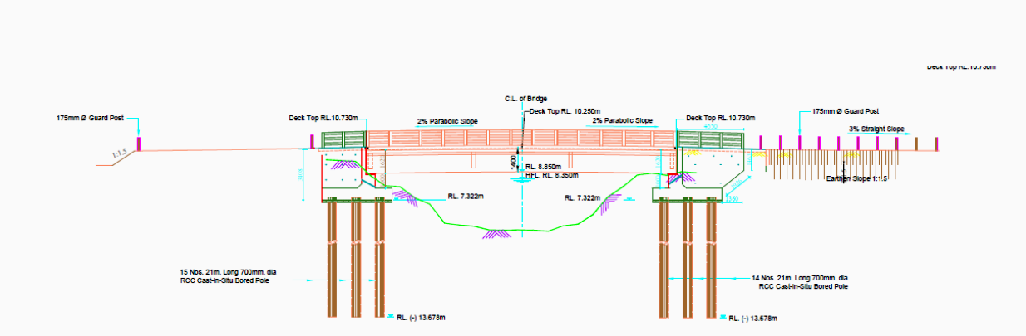

Municipal Governance and Services Project (MGSP)

Design, Supervision, and Management (DSM) Consultancy Services
Joint Venture of  Hifab International AB, Sweden  AQUA Consultant and Associates Ltd., Bangladesh |   
TABLE OF CONTENTS
 |  |  |  | Page
1.0 |  | INTRODUCTION |  | 1-3
 | 1.1 | Subproject Background |  | 1
 | 1.2 | Objectives of the Study |  | 2
 | 1.3 | Scope and Methodology of the Study |  | 2
2.0 |  | SUBPROJECT DESCRIPTION |  | 4-15
 | 2.1 | The Study Area |  | 4
 | 2.2 | Current Situation, Proposed Intervention and Need for the Subproject |  | 10
 | 2.3 | Envisaged Subprojects Activities and Implementation Process |  | 13
 | 2.4 | Category of the Subproject |  | 15
 | 2.5 | Subproject Schedule |  | 15
3.0 |  | BASELINE ANALYSIS OF ENVIRONMENTAL CONDITION |  | 16-23
 | 3.1 | Physical Environment |  | 16
 | 3.2 | Biotic Environment |  | 22
 | 3.3 | Socio-economic and Socio-cultural Environment |  | 22
4.0 |  | ENVIRONMENTAL SCREENING |  | 24-26
5.0 |  | SPECIFIC IMPACT, MITIGATION AND ENHANCEMENT MEASURES |  | 27-33
 | 5.1 | Site Clearing, Excavation and Earth Work |  | 27
 | 5.2 | Ecological Impact and Enhancement Work |  | 27
 | 5.3 | Pollution from the Storage of Construction Materials |  | 28
 | 5.4 | Air Quality and Dust |  | 28
 | 5.5 | Noise and Vibration |  | 29
 | 5.6 | Water Quality |  | 29
 | 5.7 | Occupational Health and Safety |  | 29
 | 5.8 | Impacts on Social Environment and Common Property Resources |  | 30
 | 5.9 | Labor Influx and Anticipated Impacts |  | 31
 | 5.10 | Impacts on Traffic Movement |  | 33
6.0 |  | ENVIRONMENTAL MANAGEMENT PLAN |  | 34-46
 | 6.1 | Access to Information |  | 34
 | 6.2 | Grievance Redress Mechanism |  | 34
 |  | 6.2.1 | Grievance Redress Committee (GRC) | 34
 |  | 6.2.2 | Grievance Resolution Process | 35
 | 6.3 | Institutional Arrangement for Safeguard Compliances |  | 36
 | 6.4 | Capacity Building |  | 37
 | 6.5 | Emergency Response and Disaster Management |  | 37
 | 6.6 | Environmental Management Action Plan |  | 38
 | 6.7 | Environmental Monitoring Plan |  | 43
 | 6.8 | Environmental Management Budget |  | 44
 | 6.9 | Environmental Codes of Practice |  | 45
7.0 |  | PUBLIC CONSULTATION AND PARTICIPATION |  | 47-49
 | 7.1 | Methodology |  | 47
 | 7.2 | Issues Raised by the Participants |  | 48
 | 7.3 | Feedback, Suggestions and Recommendations of the Participants |  | 48
8.0 |  | CONCLUSIONS AND RECOMMENDATIONS |  | 50
9.0 |  | Reference |  | 51
APPENDIX
 |  | Appendix I: Environmental Monitoring Checklist |  | 52

LIST OF TABLES
Table 3.1.1 | Major Environmental and Infrastructural Features
- Table 3.1.2 | Temperature, Rainfall and Humidity during 2008-2011
Table 5.7.1 | General Requirements for the Workers Health and Safety
Table 5.8.1 | Impacts on Social Environment and Common Property Resources
Table 6.2.1.1 | List of GRC Committee Members
Table 6.6.1 | Anticipated Environmental Impacts during Construction Phase and Corresponding Mitigation and Enhancement Measures
Table 6.6.2 | Anticipated Environmental Impacts during Operational Phase and Corresponding Mitigation and Enhancement Measures
Table 6.7.1 | Matrix Table of Monitoring Plan (Visual observation during construction phase)
Table 6.8.1 | Environmental Management Budget in Bill of Quantity

LIST OF FIGURES
Figure 2.1.1 | Location Map of the Subproject Site
Figure 2.1.2 | Lay Out Plan of the Proposed Culvert at Angaria Bazar to Rajganj Bazar Road
Figure 2.1.3 | Lay-Out Plan of the Proposed Culvert at Brikhatala
Figure 2.1.4 | Lay-Out Plan of the Proposed Culvert at PTI Complex Connecting Road
Figure 2.1.5 | Lay-Out Plan of the Proposed RCC Bridge at Charpalong School Road
Figure 2.1.6 | Topographic Features of the Culverts at Bus Stand and Palong School Road
Figure 2.1.7 | Topographical Features of the of the Culverts at Chowrongi Road
Figure 3.1.1 | Location of Shariatpur Pourashava in Earthquake Zone Map of Bangladesh
Figure 3.1.2 | Location of Shariatpur Pourashava in Flood Zone Map of Bangladesh

LIST OF PHOTOGRAPHS
Photographs 2.2.1 | Current Situation of the Bamboo Bridge at Brikhatala and Bridge at Char Palong School Road
Photographs 2.2.2 | Current Situation of the Culverts at PTI Complex Connecting Road and Angaria Bazar to Rajgonj Bazar Road
Photographs 2.2.3 | Current Situation of the Culverts at Palong School to Premtala Road
Photographs 2.2.4 | Current Situation of the Culverts at Bus Stand to Kurashi Balakhana Road
Photographs 2.2.5 | Current Situation of the Culverts at Chowrongi to Shornogosh Dighir Par Road
Photographs 7.1.1 | DSM Consultant Team with Pourashava Representatives inspected the proposed Culverts and Bridge
Photographs 7.1.2 | Consultation Meeting at subproject sites with Pourashava Officials and Consultants Participants

ABBREVIATIONS

AP persons (AP’s) | Affected Person
BDT | Bangladeshi Taka
BOQ | Bill of Quantity
CC | Cement Concrete
CIP | Capital Investment Plan
CP | Contingency Planning
DSM | Design, Supervision, and Management
EA | Environmental Assessment
ECR | Environmental Conservation Rules
EMP | Environmental Management Plan
EPP | Emergency Preparedness Planning
ES | Environmental Screening
FGD | Focal Group Discussion
GoB | Government of Bangladesh
GRC | Grievance Redress Committee
GRM | Grievance Redress Mechanism
GRP | Grievance Redress Procedure
LGED | Local Government Engineering Department
MGSP | Municipal Governance and Services Project
PD | Project Director
PMU | Project Management Unit
RCC | Reinforcement Cement Concrete
RP | Relevant Reports
TL | Team Leader
WB | World Bank
XEN | Executive Engineer

1 INTRODUCTION

1.1 Subproject Background

Shariatpur Pourashava is situated at Shariatpur District. It is established as a Pourashava in the year of 1985. This is A type Pourashava with present population of 49535 (BBS 2011). The Pourashava covers area of 24.75 sq. km. The Pourashava has Poura Bridge 37, Poura Culvert 60. (At a glance Shariatpur Pourashava)

Urbanization is considered to be closely and positively associated process, with complex and mutually reinforcing links. In sustained economic growth, it is essential to develop urban areas. Urban centers are the places of agglomeration of economic activities, important hubs of production, processing, innovation and employment. In recent days, there has been a trend of growing importance of urban areas. This subproject emphasizes on the planning to address the problems and to guide future planning of Shariatpur Pourashava.

This subproject includes the following components: 9 Culverts and 1 Bridge. The significant features of the subproject are mentioned below:
Name of the Subproject: | 1. a) Construction of RCC Box Culvert at Palong School to Premtala Road at Ch. 0+200m (CIP NO-11);  1. b) Construction of RCC Box Culvert at Palong School to Premtala Road at Ch. 0+300m (CIP NO-11);  2. a) Construction of RCC Box Culvert at Bus Stand to Kurashi Balakhana Road at Ch. 0+700m (CIP NO-09);  2. b) Construction of RCC Box Culvert at Bus Stand to Kurashi Balakhana Road at Ch. 1+250m (CIP NO-09);  3. a) Construction of RCC Box Culvert at Chowrongi to Shornogosh Dighir Par Road at Ch. 0+400m (CIP NO-19);  3. b) Construction of RCC Box Culvert at Chowrongi to Shornogosh Dighir Par Road at Ch. 1+500m (CIP NO-19);  4. a) Construction of 21m RCC Bridge at Char Palong School Road (CIP NO-43);  4.b) Construction of 21m RCC Bridge Approach road at Char Palong School Road;  5. a) Construction of 5 vent 3.6x4.0 RCC Box Culvert at PTI Complex Connecting Road;  5. b) Construction of 5 vent 4.0x3.6 RCC Box Culvert at Brikhatala;  5. c) Construction of 2 vents 3.6x 4.0 RCC Box Culvert at Angaria Bazar to Rajganj Bazar Road at Ch. 2250m;  5. d) Street light for 21m RCC Bridge at Char Palong School Road.
Package No.: | MGSP/SHA/2017-18/W-05
District Name: | Shariatpur
ULB Name: | Shariatpur Pourashava
Jurisdiction Area: | Ward number 01, 02, 03, 04, 05, 06 and 08
Structural Design Option: | RCC Box Culverts, RCC Bridge with street light and Two Approach Roads
Wards Population: | About 38,000 as per information by the Pourashava
Tribal People: | No tribal people settlement found in the subproject area
Land Acquisition: | No private land acquisition is needed
Estimated Cost: | 53.52 Million in BDT
Subproject Duration: | 12 Months
Tentative Start Date: | July 22, 2018
Tentative Completion Date: | July 21, 2019

Objectives of the Study

The general objective of this study is to determine the major environmental impacts succeeding from execution of the subproject and to recommend mitigation measures to avoid or reduce adverse environmental impacts and to enhance positive impacts. The specific objectives include:
- To assess the existing environmental conditions of the subproject site and its influence area;
- To identify and assess impacts resulting from the subproject during its construction phase and operation phase;
- To develop a environmental management plan with recommendations for mitigating impacts and enhance positive impacts;
- To summarize environmental monitoring requirements.

Scope and Methodology of the Study

The subproject appraisal is included environmental screening for all the subproject components. According to that screening, environmental assessment is required to fulfill the regulatory requirement for RCC culverts and bridge, BC Road and street light. Hence, this environmental assessment is prepared to meet the regularity requirement of this subproject. The study methodology covered the following activities:

- Desktop Study;
- Field Investigations and Data Collection;
- Data Analysis and Report Writing.

Desktop Study
The desktop study involved:
- Initial meetings with client, stakeholders to discuss the proposed subproject;
- Collection and review of the baseline data, maps, reports and other relevant information;
- Review of the relevant existing legislation, regulation and policies;
- Understand the anticipated technical processes that may affect the environment.

Field Investigation and Data Collection
A team of the consultants made a field investigation to the proposed site. Field investigations involved mainly site walks at the subproject areas for identification of the environmental components to be affected due to the subproject intervention.
The following key tasks were performed during the field visit:
- Taking photographs of the significant aspects to assist in describing the baseline environmental conditions of the subproject area;
- Interviews with representatives of the relevant Pourashava officials and beneficiary and affected people within the subproject influence zone;
- Obtaining relevant documents from Pourashava and local people within the subproject influence zone;
- Verifying information and data collected during the desktop study and to collect new information.

Data Analysis and Report Writing
The data and information collected from all the sources (literature review, secondary and primary data, public consultation) were analyzed to describe the existing environmental setting of the subproject area, to identify the potential positive and negative impacts of the proposed subproject, as well as to provide preliminary suggestions for mitigation measures. Finally, this environmental assessment report has been prepared.

SUBPROJECT DESCRIPTION

The Study Area

The subproject site is situated within the jurisdiction area of the Shariatpur Pourashava Ward no. 01, 02, 03, 04, 05, 06 and 08. The location map, lay-out plans, and topographic features of the subproject are shown in Figure 2.1.1, Figure 2.1.2, Figure 2.1.3, Figure 2.1.4, Figure 2.1.5, Figure 2.1.6 and Figure 2.1.7.
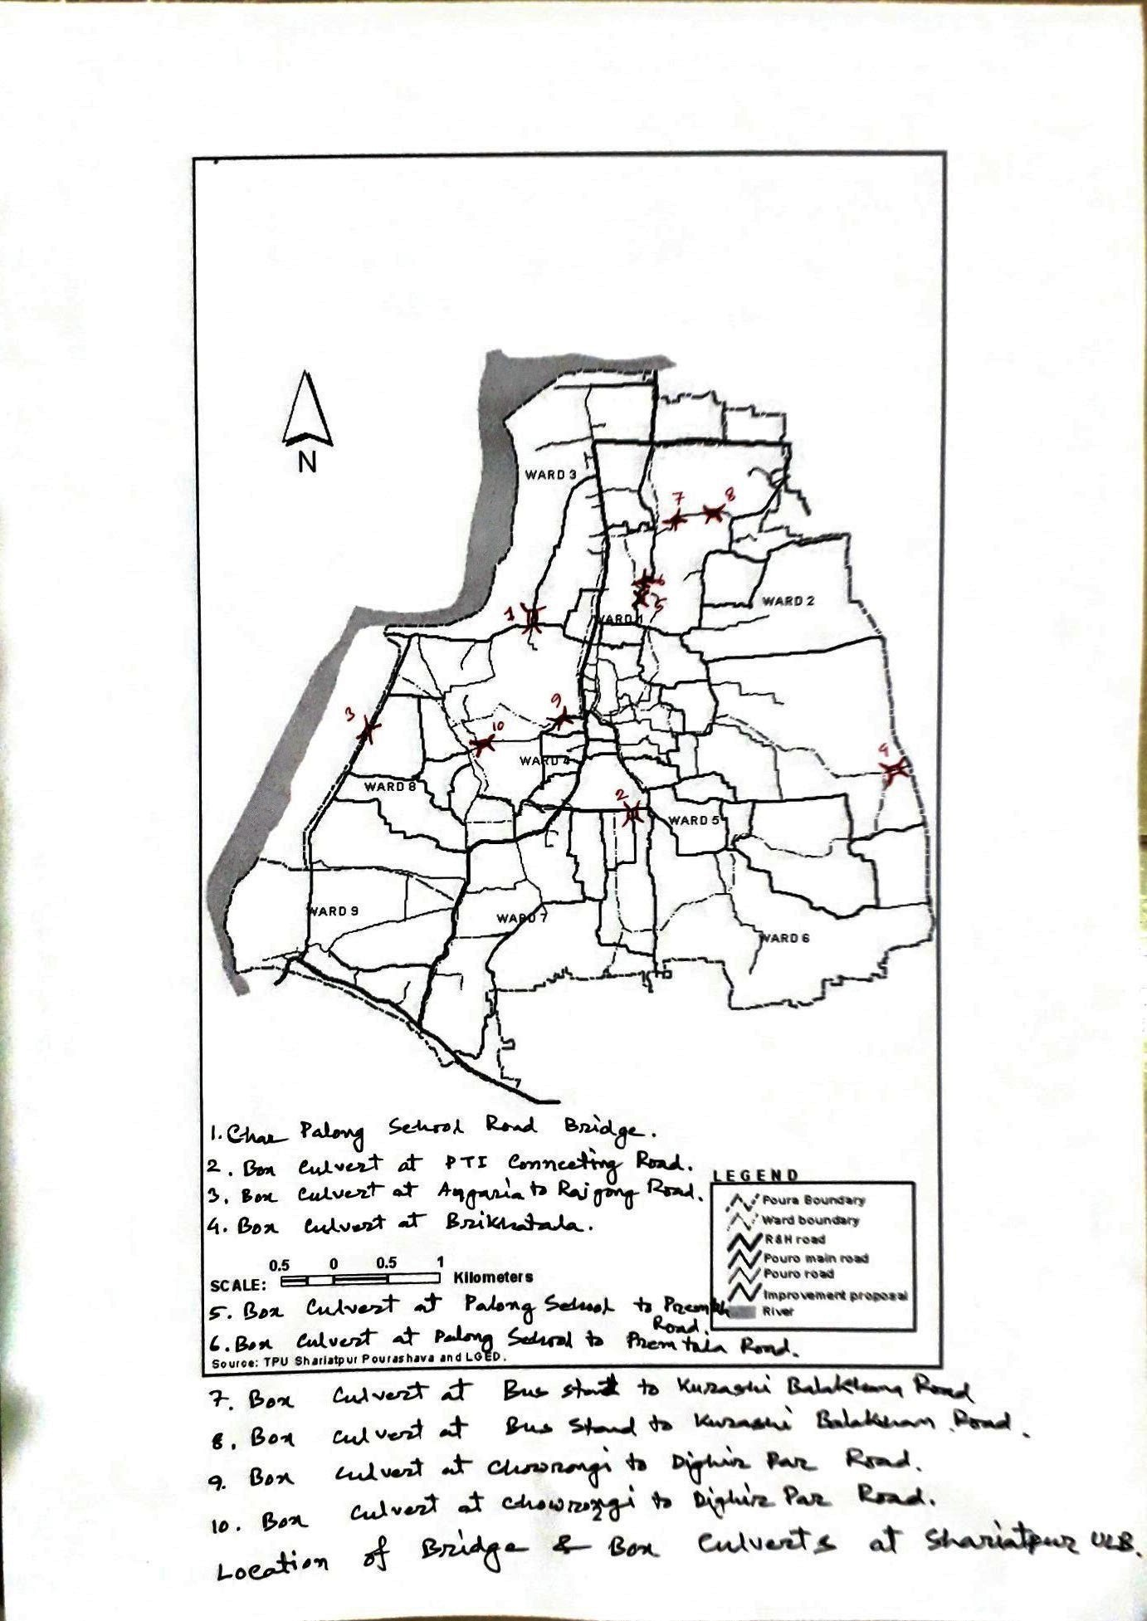

Figure 2.1.1: Location Map of the Subproject Site

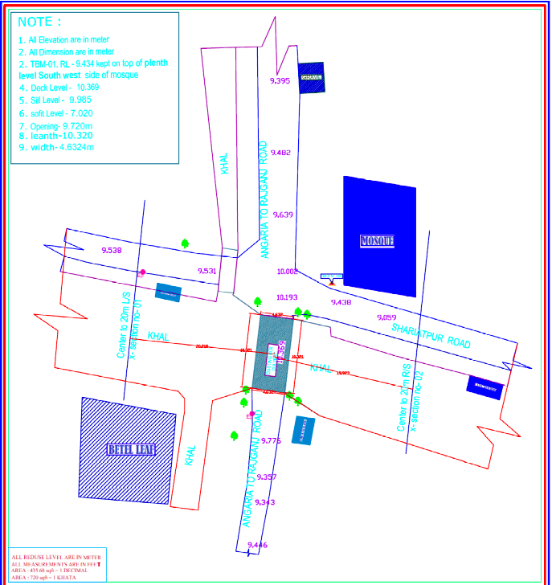

Figure 2.1.2: Lay-Out Plan of the Proposed Culvert at Angaria Bazar to Rajganj Bazar Road

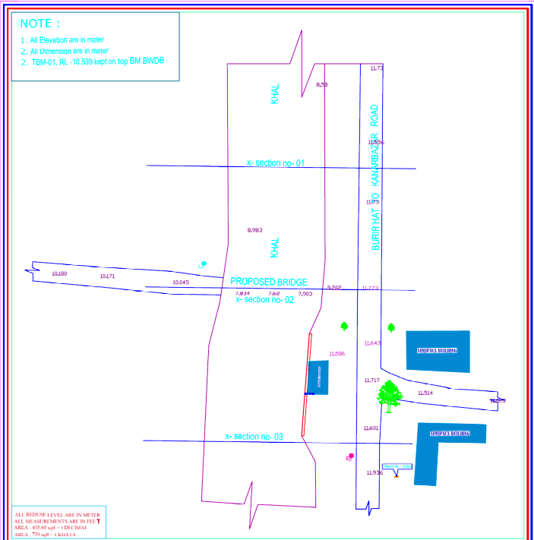

Figure 2.1.3: Lay-Out Plan of the Proposed Culvert at Brikhatala

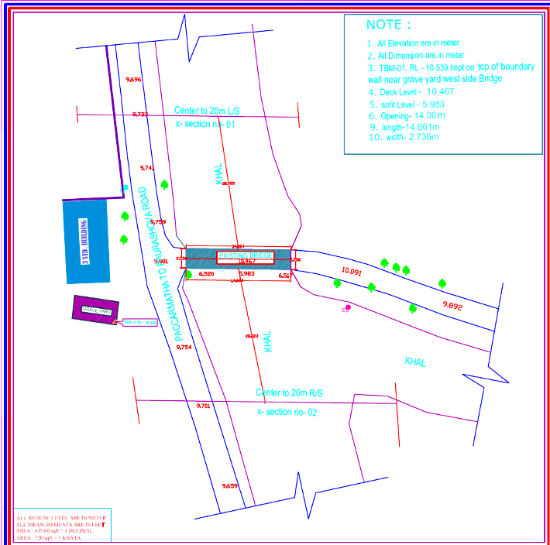

Figure 2.1.4: Lay-Out Plan of the Proposed Culvert at PTI Complex Connecting Road

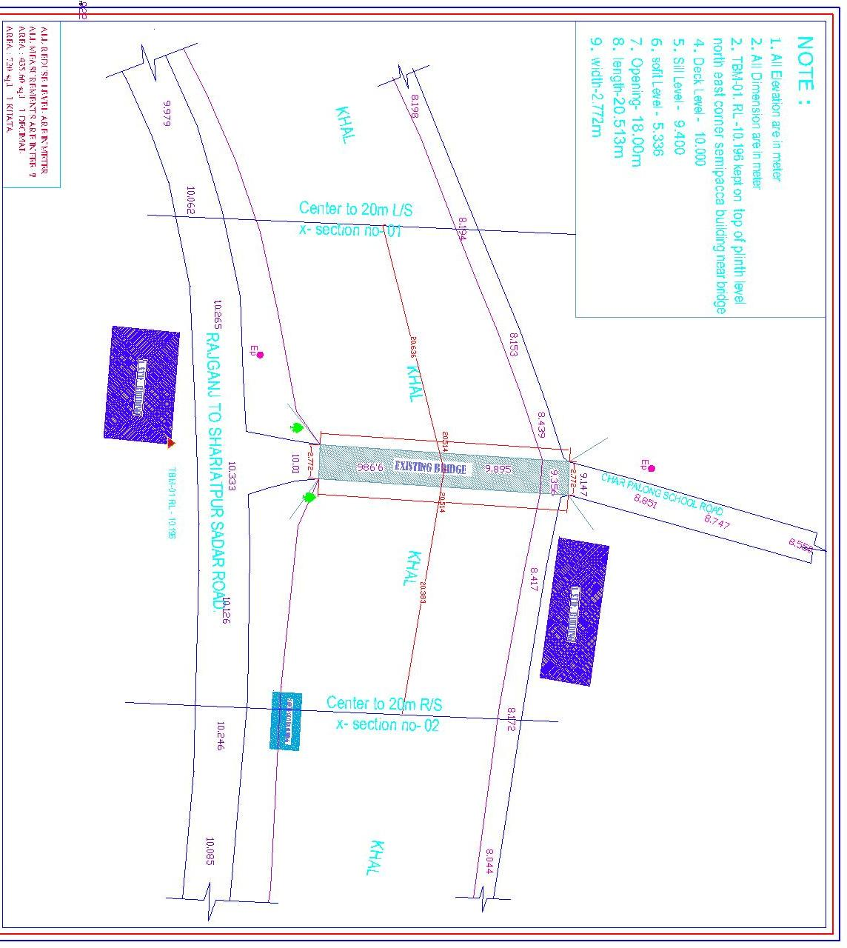
Figure 2.1.5: Lay-Out Plan of the Proposed RCC Bridge at Charpalong School Road

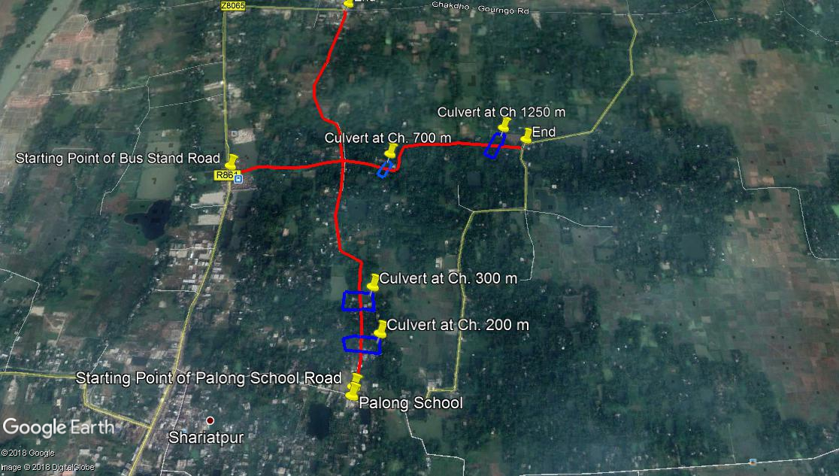

Figure 2.1.6: Topographic Features of the Culverts at Bus Stand and Palong School Road

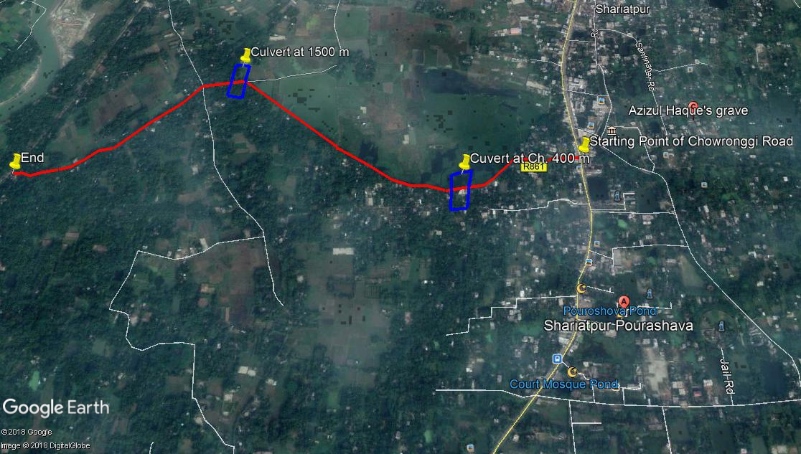
Figure 2.1.7: Topographical Features of the of the Culverts at Chowrongi Road

Current Situation, Proposed Intervention and Need for the Subproject

At present, Shariatpur is category A type Pourashava. The subproject is located at wards no 1, 2, 3, 4, 5, 6 and 8 under Shariatpur Pourashava. Existing two RCC bridges with one Bamboo bridge and seven culverts are situated in seven different wards such as Bridge of PTI Complex Connecting Road at ward no 5, Bridge of Char Palong School Road at ward no 6, Bamboo Bridge of Brikhatala at ward no 3 and Culvert of Angaria Bazar to Rajgonj Bazar Road at ward no 8, Culvert of Palong School to Premtala Road at ward no 1, Culvert of Bus Stand to Kurashi Balakhana Road at wards no 2 and 3, Culvert of Chowrongi to Shornogosh Dighir Par Road at wards no 4 and 8.The important features of the subproject area includes: Graveyard, Mosque, boundary wall, house fence with tin and bamboo, houses, shop, khal, bill, trees, bamboo bushes and bushes. The khal has proper flow especially in the rainy season. These bridges and culvert connect various important road of the Pourashava that helps to create better road network in the Pourashava area.
The existing bridges and culverts are badly damaged. Therefore, it interrupts safety traffic operation. In addition, dissimilarity of the level between the road and existing bridges and culverts creates trouble for the non-motorized vehicles and three wheelers to cross the bridges and culverts. Also, at present, the local people use narrow Bamboo Bridge to cross the khal from highway at Brikhatala which is very risky especially for the children, women and aged people. The local people informed that, this bamboo bridge is only functional at dry season, especially when water level goes down. Every year during monsoon period, this bamboo bridge is very risky because it is not so wide. Hence, the people of South Atong and adjacent people of center area of the Pourashava have been suffering tremendously to reach the main area of Shariatpur Pourashava to meet their daily necessities easily. Hence, to ensure safety movement of the vehicles and pedestrians, reconstruction of the existing bridges, culverts and approach roads (286 m at north side of the Char Palong School Road Bridge and 161 m at east side of the PTI Complex Connecting Road Bridge) are urgently needed.
The existing damaged bridges (at PTI Complex Connecting Road and Char Palong School Road), Bamboo Bridge (at Brikhatala) and damaged culverts (at seven different places) will be demolished and new nine RCC Box Culverts and a bridge at Char Palong School Road will be constructed. The size of the 1-vent proposed culverts at Ch. 200m of Char Palong School to Premtala Road is 4.0*3.205 m, at Ch. 300m of Palong School to Premtala Road is 3.50 m* 2.430 m, at Ch. 1250 m of Bus Stand to Kurashi Balakhana Road and at Ch. 1500 m of Chowrongi to Shornogosh Dighir Par Road is 4.00 m* 4.270 m. The size of 2-vent proposed culverts at Angaria Bazar to Rajgonj Bazar Road is 3.6* 4.0 m, at Ch. 700 m of Bus Stand to Kurashi Balakhana Road is 3.50 m* 2.430 m, at Ch. 400 m of Chowrongi to Shornogosh Dighir Par Road is 3.50 m* 3.270 m. The size of 5-vent proposed culverts at PTI Complex Connecting Road is 3.6*4.0 m, at Brikhatala Road is 4.0* 3.6 m. The length of the proposed bridge at Char Palong School Road is 21 m. The existing condition and inspection of the proposed site is further elaborated in the following Photographs 2.2.1, 2.2.2, 2.2.3, 2.2.4, 2.2.5 and 2.2.6.
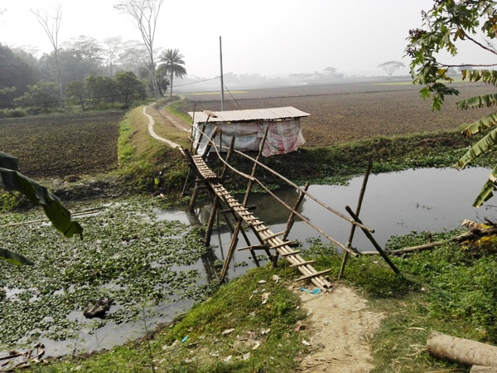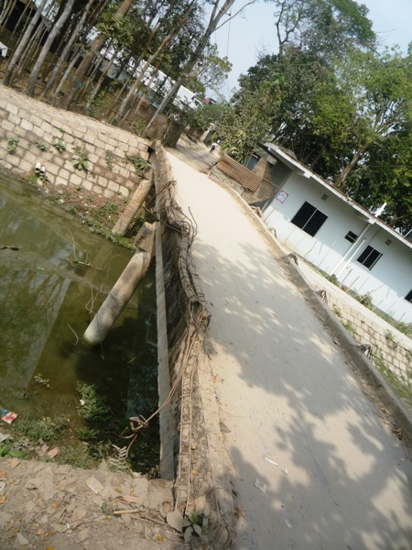

Photographs 2.2.1: Current Situation of the Bamboo Bridge at Brikhatala and Bridge at Char Palong School Road

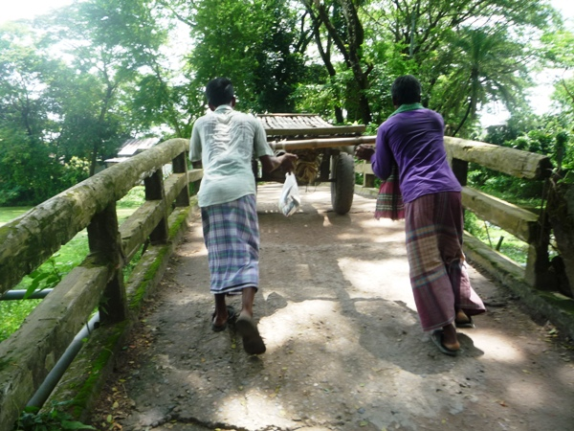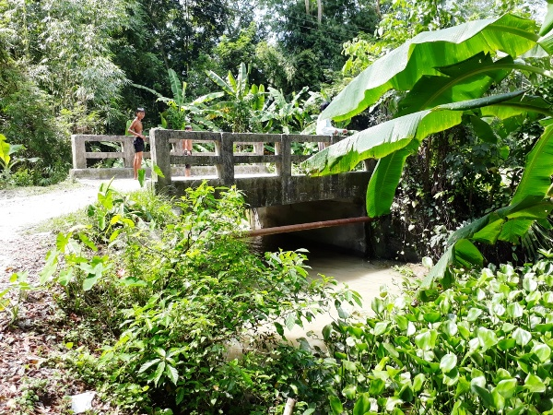

Photographs 2.2.2: Current Situation of the Culverts at PTI Complex Connecting Road and Angaria Bazar to Rajgonj Bazar Road

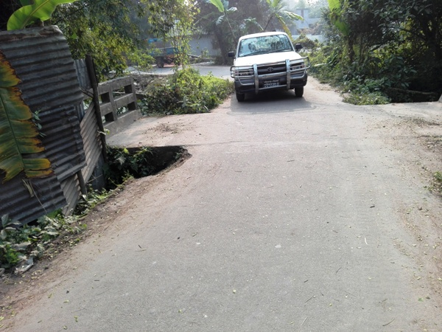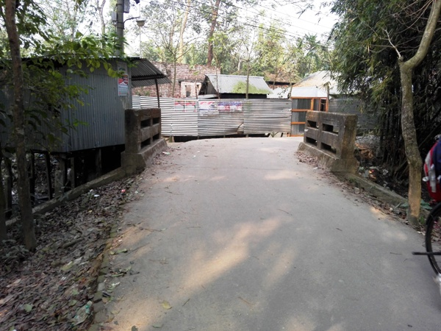

Photographs 2.2.3: Current Situation of the Culverts at Palong School to Premtala Road

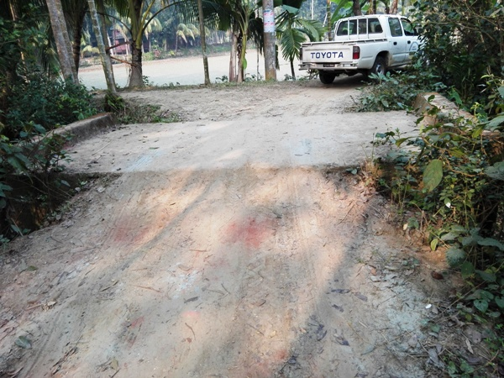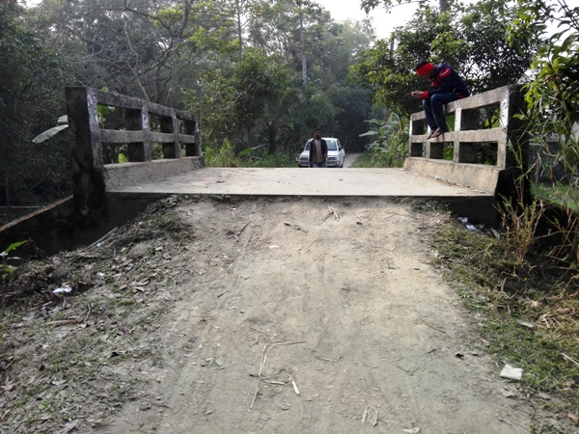

Photographs 2.2.4: Current Situation of the Culverts at Bus Stand to Kurashi Balakhana Road

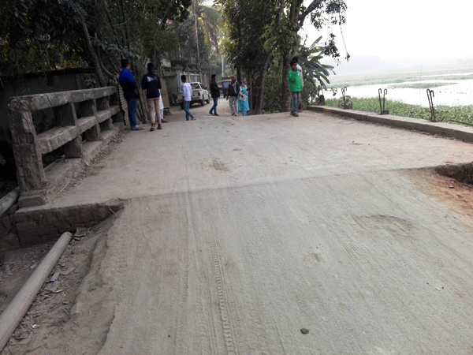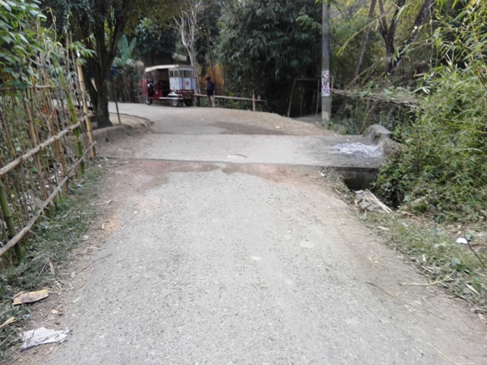

Photographs 2.2.5: Current Situation of the Culverts at Chowrongi to Shornogosh Dighir Par Road

Envisaged Subproject Activities and Implementation Process

The general activities of the subproject includes: construction of the semi-pucca site office, construction of the labor shed and relocation of the electrical poles for access road.
Specific activities for RCC Box Culvert:
- Grubbing work by removing of existing foundation;
- Making earthen ring/cross bundh of required height and width to prevent water from entering in the working area;
- Earth work in excavation of foundation of structures by Long Boom hydraulic excavator;
- Pumping and bailing out of water from the interior of any foundation enclosure of work site;
- Single layer brick flat soling in foundation;
- Plain cement concrete work in foundation;
- Back filling behind wing walls and with selected granular material;
- Brick work as a parapet wall on the culverts
- Manufacturing and supplying plain cement concrete blocks;
- Laying single layer CC blocks of different sizes on slope of embankment;
- Construction of temporary diversion road.

Specific activities for RCC Bridge:
- Earth work in excavation of foundation of structures by Long Boom hydraulic excavator;
- Pumping and bailing out of water from the interior of any foundation enclosure of work site;
- Placing of the polythene sheet for foundation work;
- Single layer brick flat soling in foundation;
- Plain cement concrete work in foundation;
- Boring for cast-in-situ piles to the required depth and specified diameter with driving temporary steel casing;
- Welding for construction of cast-in-situ bored pile;
- Breaking of the head of hardened cast-in-situ bored pile/pre-cast piles;
- Manufacturing, supplying and fitting & fixing MS shoe at RCC pre-cast pile tip;
- Back filling behind abutments, wing walls and retaining walls with selected granular material;
- Flush pointing to brick wall;
- Manufacturing and supplying plain cement concrete blocks;
- Laying single layer CC blocks of different sizes on slope of embankment;
- Laying natural additive treated woven type double warp plain weave jute geo-textile;
- Painting the vertical end of faces of posts, wheel, guard, railing, rail post, parapet wall, kilometer post, road name, plate, guide post, traffic signs etc;
- Making earthen ring/ cross bundh of required height;
- Fitting and fixing steel-laminated elastomeric/Neoprene bearings,
- Laying wearing course on deck slab of bridge;
- Fixing rainwater down pipes;
- Construction of temporary diversion road.

Specific activities for BC Road:
- Site clearing work;
- Preparation of the hard bed by scarifying and loosening of the existing top;
- Earth work in box cutting;
- Sand filling on the road bed;
- Brick on end edging;
- Compacted aggregates and sub-base course;
- Providing prime coat;
- Lying pre-mixed dense bituminous surfacing.

Specific activities for Street Light:

- Assembling, fitting, fixing, installation,
- Testing and commissioning of the GI pole;
- Fitting and fixing energy meter board;
- Earthling the electrical installation with GI pipe;
- Fixing insulator,
- Erection of tubular pole;
- Fixing of the overhead conductor;
- Fixing of the wire rack;
- Fixing and installation of the switch board;
- Fixing of the water tight street light with aluminum reflector.

The materials to be used for the key activities: bricks, brick chips, stone chips, reinforcement bar, admixture, bearing pad, sand, cement, concrete, paint, laying pre-mixed dense bituminous surfacing and installation of street light etc.
The major equipment to be used for the implementation of the subproject: long-boom hydraulic excavator, brick breaking machine, pile rig for boring, concrete mixer machine, vibrator machine, MS sheet, steel cutter, steel shutter, steel drum rollers, pneumatic multiple tire roller, dump truck, water tanker, pump, generator and measuring device.

Category of the Subproject
For RCC Box Culverts, Bridge and Approach Roads
- According to ECR 1997: Green □ Orange A □ Orange B □ √ Red □ Not Listed □
- According to WB Classification: Category B □√ Category C □
The overall anticipated adverse impact due to the subproject intervention is limited and site specific. Considering the environmental impact which is anticipated as insignificant, this subproject can be considered as Orange B as per ECR-97. According to the WB classification, it can be classified as Category B.
For Street Light
- According to ECR 1997: Green □√ Orange A □ Orange B □ Red □ Not Listed □
- According to WB classification: Category B □ Category C □ √

Considering the environmental impacts, the street light can be considered as Green category as per ECR-97. According to the WB classification, it can be classified as Category C.

Subproject Schedule
The tentative schedule of construction of the subproject is:
(a) Subproject Duration (months) :12 months
(b) Tentative Start Date : 22 July 2018
(c) Tentative Completion Date : 21 July 2019

The daily construction hours will normally include regular working time. However, daily working hours may vary based on the on-site condition. The detailed work program will be prepared by the contractor with the assistance of the PIU-Pourashava. Then it will be shared with the PMU, LGED and DSM consultants. In addition, the detailed work program will also be shared with the Bank as per requirement.

Baseline ANALYSIS OF THE ENVIRONMENTAL CONDITION

Physical Environment

Important Environmental and Infrastructural Features

During site visit the environmental and infrastructural features within the subproject area were collected. Conditional survey has also been conducted for designing the subproject. Hence, the survey data is also used for preparing the report. The environmental and infrastructural features listed within four directions of the existing bridges and culvert, two sides of approach roads in Table 3.1.1.
Table 3.1.1: Major Environmental and Infrastructural Features
Bridge at PTI Complex Connecting Road
Side/ Direction | Major Environmental Features
North | Khal, bushes, aquatic plant (adjacent and below the bridge)
South | Khal, bushes, aquatic plant (adjacent and below the bridge)
East | Road, houses, electric pole, trees
West | Pakarmatha to Pourashava Road, boundary wall, house, Graveyard, electric pole, trees
Bridge at Char Palong School Road
Side/ Direction | Major Environmental Features
North | Char Palong School Road, lamp post, houses, trees
South | Rajganj to Shariatpur Sadar Road, houses, fence of tin, shops, electric pole, trees
East | Khal (adjacent and below the bridge)
West | Khal (adjacent and below the bridge)
Bamboo Bridge at Brikhatala
Side/ Direction | Major Environmental Features
North | Khal (adjacent and below the bamboo bridge),
South | Khal (adjacent and below the bamboo bridge),
East | Burir Hat to Kanar Bazar Road, house, trees, electric pole
West | Earthen road, open agricultural field, trees, electric pole
Culvert at Angaria Bazar to Rajgonj Bazar Road
Side/ Direction | Major Environmental Features
North | Angaria Bazar to Rajganj Bazar Road, Shariatpur Road, Mosque, Graveyard, khal, trees, house, bushes
South | Angaria Bazar to Rajganj Bazar Road, khal, trees, house, bushes, electric pole
East | Khal, bushes (adjacent and below the culvert)
West | Khal, bushes (adjacent and below the culvert)
Side/ Direction | Major Environmental Features
Culvert at Char Palong School to Premtala Road, at Ch 0+ 200 m
North | Main road, residential houses, fence of tin, bushes, trees
South | Main road, residential houses, bushes, trees
East | Khal, residential houses, bushes, trees (adjacent and below to the culvert and within 20 m from the existing culvert)
West | Khal, residential houses, bushes, trees ( adjacent and below to the culvert and within 20 m from the existing culvert)
Culvert at Char Palong School to Premtala Road, at Ch 0+ 300 m
North | Main road, residential houses, tin shed shop, fence of tin, trees
South | Main road, residential houses, trees
East | Khal, residential houses, bamboo bushes, trees (adjacent and below to the culvert and within 20 m from the existing culvert)
West | Khal, residential houses, bushes, trees (adjacent and below to the culvert and within 20 m from the existing culvert)
Culvert at Bus Stand to Kurashi Balakhana Road, at Ch 0+ 700 m
North | Khal, bushes, trees (adjacent and below to the culvert and within 20 m from the existing culvert)
South | Khal, bushes, trees (adjacent and below to the culvert and within 20 m from the existing culvert)
East | Earthen road, bushes, trees
West | Earthen road, bushes, trees
Culvert at Bus Stand to Kurashi Balakhana Road, at Ch 1+ 250 m
North | Khal, bushes, houses, trees (adjacent and below to the culvert and within 20 m from the existing culvert)
South | Khal, houses, open field, bushes, trees (adjacent and below to the culvert and within 20 m from the existing culvert)
East | Earthen road, bushes, trees
West | Earthen road, bushes, trees
Culvert at Chowrongi to Shornogosh Dighir Par Road, at Ch 0+ 400 m
North | Bill, aquatic trees, bushes (adjacent to the culvert and within 20 m from the existing culvert)
South | Khal, trees(adjacent and below to the culvert and within 20 m from the existing culvert)
East | Main road, houses, house fence and boundary, shop, trees
West | Main road, houses, tin fence, bamboo bushes, trees
Culvert at Chowrongi to Shornogosh Dighir Par Road, at Ch 1+ 500 m
North | Bill, aquatic trees, bamboo bushes and bushes, trees (adjacent to the culvert and within 20 m from the existing culvert)
South | Khal, trees, bushes, trees, shop(adjacent and below to the culvert and within 20 m from the existing culvert)
East | Main road, houses, house fence, trees
West | Main road, houses, house fence, trees
Chainage (m) | Left | Right | Major Environmental Features
Approach Road at West Side of the Bridge at Char Palong School Road (Ch.0-286 m)
0 -100 | √ |  | Trees, semi pucca and tin-shed houses, house fence, electric pole
0 -100 |  | √ | Trees, residential houses with different structures, tin fence, electric pole
100-200 | √ |  | Home stead area, house fence, various trees, electric pole
100-200 |  | √ | House fence with tin, bamboo and boundary wall, various trees, home stead area, electric pole
200-286 | √ |  | Houses with various structures, trees
200-286 |  | √ | Electric pole, trees, houses
Approach Road at East Side of the Bridge at PTI Complex Connecting Road (Ch.0-161 m)
0-100 | √ |  | Residential area, trees, electric pole, house fence
0-100 |  | √ | Fence with various structures, trees, electric pole, houses
100-161 | √ |  | Homestead area, trees, electric pole, house boundary with tin and brick
100-161 |  | √ | Residential area, trees, electric pole, house fence
** Note: There is no electrical pole and GI pole to be re-located for the implementation of the subproject. These are busy roads with the motorized and non-motorized traffic. Due to demolition of the existing culvert, the normal traffic will be affected. Hence, diversion road is required to maintain the normal traffic during construction phase. It should also be noted that to maintain the normal water flow in the khal, 2-3 pipe will be placed beneath the diversion road.

Geology, Topography, and Soils

The topographical feature of the Shariatpur Pourashava area is undulating and low lying area. The elevation of the Pourashava ranges from 1.2 m to 11.0 m PWD. Geology is composed of Tidal Deltaic Floodplain. Shariatpur Pourashava lays the active floodplain of the Ganges and the adjoining meander floodplain. Soil developed in seasonally flooded alluvium containing lime in part or all of the upper 125 cm and with dark grey topsoil. Usually, there are continuous dark grey gleans. Generally, these soils are well oxidized within subsoil pads and below the upper dark layers. The central area of the municipality contains land comprised of soil on artificially slightly raised platform. According to BNBC (2006), Bangladesh has three seismic zones with moderate and low seismic activity. The Pourashava falls in Zone III.

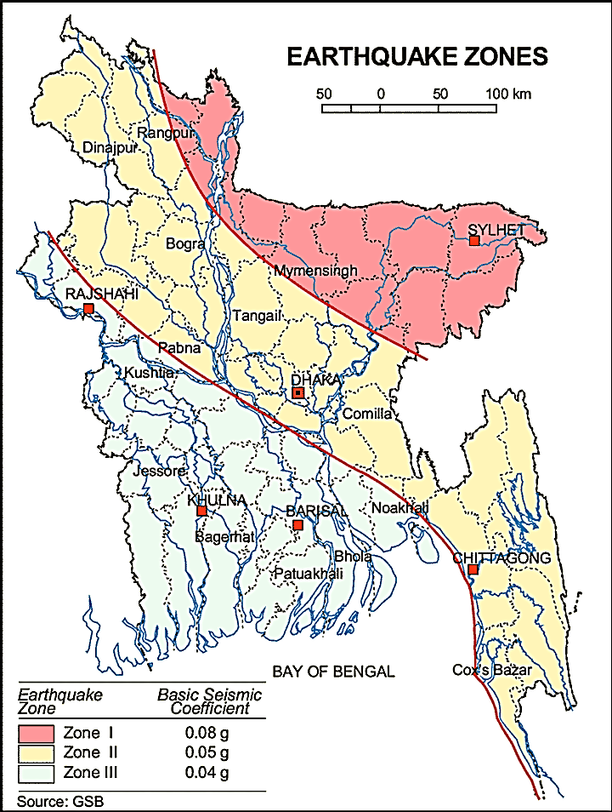

Figure 3.1.1: Location of Shariatpur in Earthquake Zone Map of Bangladesh

Climate and Meteorology

The climate of the subproject area can be described as Tropical Monsoon. It is characterized by warm, humid summers and cool, dry winters. From November to March, it is dry and cool while from April to May it is extremely hot during the pre-monsoon season. From June to October, the monsoon season is warm, cloudy, and wet. The warmest month is April, the coolest is January, the wettest is July and the driest is January.
The minimum temperature was 10.9°C in 2010 and maximum temperature was 42.4°C in 2010. The minimum humidity was 65.8% in 2010 and the maximum humidity was 79.8% in 2011.The average annual rainfall is around 1330 mm. The peak rainfall months in Shariatpur are June, and July. About 92.26% of the total annual rainfall occurs in the period from May through October. The highest annual rainfall during the last ten years (2008–11) was 1659 mm in 2008, and the lowest was 890 mm in 2010.
According to the statistics of wind data from the Bangladesh Meteorological Department Climate Division, wind direction changes by month. Nevertheless, the northwest, south, and northeast winds are predominant. The monthly average wind speed as recorded in Shariatpur Met Station is mostly remains in the range of 5 –10.4 knots/ hr. Nevertheless, in the winter months it remains in the range of 3.3-7.4 knots/hour. The highest daily average speed is recorded as 18 knots/ hr in the month of April, 1999 in the north direction. Maximum monthly speed of wind is found to occur in the period of Mar – Apr reaching a maximum 0f 18.5 knots per hour. Table 3.1.2 shows the key meteorological data from 2008 to 2011.
Table 3.1.2: Temperature, Rainfall and Humidity during 2008-2011
Years | Temperature(centigrade) |  |  | Rainfall (millimeter) | Humidity (%)
Years | Maximum |  | Minimum | Rainfall (millimeter) | Humidity (%)
2008 | 34.2 | 11.6 |  | 1659 | 79.0
2009 | 35.1 | 13.8 |  | 1169 | 79.0
2010 | 42.4 | 10.9 |  | 890 | 65.8
2011 | 23.8 | 13.9 |  | 1603 | 79.8

The construction works can be influenced by the climatic condition and meteorological components like humidity, temperature, sudden rainfall, and wind speed. During high winds, there might be possibility of quick spreading of dust generated from the construction activities. It is very risky to work during rain and in high winds because it increases injury risks. Furthermore, work under high temperature and excess humidity is extremely difficult and may create dehydration problem.

Water Resources (Surface Water, Ground Water and Rain Water Harvesting)

All subproject sites is located over the natural khal where water is available round the year. It is the main source of the surface water for the subproject area. This khal influence the hydrology of the municipality. Shariatpur Pourashava belongs to the hydro-geological unit II Holocene Deltaic and Flood Plains. Ground water is available at shallow depth. Groundwater is the main source of potable water in the subproject area. Groundwater is not saline and normally arsenic and iron free. The local people do not use rain water harvesting system.

Flooding, Water Logging and Drainage Pattern

According to previous data of this area, this area is affected in severe flood events of 1988, 1998, 2004 and 2007. There are surface water bodies such as natural khal in the subproject area. In order to map, this Pourashava is normal flood prone area.The subproject area has not generally subjected to water logging problems. During continuous heavy rain, delay discharge of storm water causes water congestion.

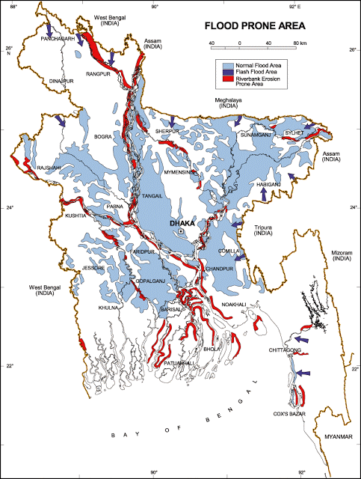

Figure 3.1.2: Location of Shariatpur Pourashava in Flood Zone Map of Bangladesh
Air Quality and Dust

The degradation of the air quality is mainly from windblown dust and emission from the vehicles. Improper disposal of the solid wastes also spread bad odor which causes air quality degradation. During construction phase concrete mixer machine, vibrator machine, hydraulic excavator and vehicles used for transportation activities may degrade the air quality.

Noise Level

Noise is generated mainly from the vehicles movement and hydraulic horn. Noise is also generated due to public gathering. During construction phase concrete mixer machine, vibrator machine, hydraulic excavator and vehicles used for transportation activities may create temporary noise nuisance within the subproject boundary.
Solid Waste Management

The Pourashava has not any structured dumping yard of its own. The Pourashava people normally dump the collected solid wastes at roadside open spaces. Currently, the vacant place near Ruma Cinema Hall is used as a dumping ground by the Pourashava. This is simply open dumping to a specific location. In recent times, the municipalities provide services for household waste collection from door to door and dump at the vacant place near Ruma Cinema Hall. The generated wastes due to construction activities will be dumped at the vacant place near Ruma Cinema Hall.

Biotic Environment

Flora and Fauna

In the subproject area, major roadside tree includes: Koroi, Banana, Date, and Coconut. The common local birds such as Crow, Sparrow, Bulbuli, Tuntuni, Shalik and Guest Bird at Bill beside Chowrongi road during winter season were found during the site visit.

Socio-economic and Socio-cultural Environment

Land Use, Status of Housing and Built-up Infrastructure
The land use pattern in the subproject area consists of mixed land-use pattern. The important features of the subproject area includes: Paccarmatha to Pourashava Road, Burirhat to Kanar Bazar Road, Char Palong Road, Angaria Bazar to Rajganj Bazar Road, Shariatpur Road, Graveyard, Mosque, boundary wall, houses, khal, trees and bushes. Existing two RCC bridges with one Bamboo bridge and seven culverts are present over khal.
Beneficiary Population
The subproject is situated within the jurisdiction of the ward number 01, 02, 03, 04, 05, 06 and 08.Considering the ward population about 38,000 people will benefit directly and many others indirectly.

Education
In the subproject area, literacy among the population is about 62.5%. This is higher than the national average (51.8%). The literacy rate among males (64.7%) is still more than females (60.2). (Ref: Population and Housing Census 2011).

Tribal Communities
There is no indigenous or tribal people settlement in the subproject area. Hence, no measures needed for the indigenous peoples’ safeguard.

Land Acquisition

Private land acquisition is not needed. For site clearing, there is no need demolition work. However, land acquisition is not issues for the implementation of this subproject. In addition, the MGSP social experts will evaluate the applicable social issues and corresponding mitigation measures will be given accordingly.
Principal Livelihoods and Economic Activities
The subproject area is inhabited by the mixed occupational people. In the Pourashava area, major income comes from business, enterprises, small trades, private sector jobs, and government jobs in the town.
Cultural Heritage and Protected Areas
There are no protected areas and no important cultural or historical sites identified in the subproject area. The local cultural structures are religious spots such as Mosque, school, and play grounds.
Social Conflicts and Development Activities

The local people welcome the subproject and there is no conflicts between the local communities regarding subproject implementation.

ENVIRONMENTAL SCREENING

Environmental Screening (ES) for the subproject has been conducted with the purpose of fulfilling the requirements of Government (GOB) and World Bank (WB) for the preparation of subproject appraisal. Environmental Screening Checklist, as adopted in Appendix C of the Environmental Management Framework (EMF) of the MGSP, was administered for identifying the impacts and their extents.
The screening data and information for the proposed RCC Bridge, RCC Box Culverts, Approach Roads and Street Light have been formulated and are shown in below.
1) Potential environmental impact during construction phase:
(a) Ecological impacts:
10
- Felling of trees Significant □ Moderate □ Minor □√ Number of trees
- Clearing of vegetation Significant □ Moderate □ Minor □√
- Potential impact on species of
aquatic (i.e., water) environment Significant □ Moderate □ Minor □√

There are 10 trees to be felled down due to construction of the culverts, bridge and two approach roads. Clearing of the vegetation is considered as minor because culverts, bridge and approach roads (286 m and 161 m) will be constructed at the same locations where very few aquatic vegetation needs to be cleared. Considering the felling of trees and the amount of clearing of vegetation, ecological impact is minor. Due to site clearing for construction work, aquatic plant (water hyacinth) needs to be cleared for some culverts. The culverts construction activity will be executed in very limited area especially in dry season with low water level. The construction work will be completed with the minimum time. For bridge construction, to maintain the normal water flow in the khal, cast-in-situ pile work, foundation work and wing wall will be constructed section wise. If needed, under the earthen ring bundh 2-3 pipes will be placed to maintain the water flow for all culverts and bridge construction. The works that need to be performed at aquatic environment is limited. Hence, the anticipated impact on the aquatic environment due to the construction activity is minor. Based on the analysis, the overall ecological impact is considered as minor.
- Physicochemical impacts:
- Noise pollution Significant □ Moderate □√ Insignificant □
- Air pollution Significant □ Moderate □√ Insignificant □
- Drainage congestion Very likely □ Likely □ Unlikely □√
- Water pollution Significant □ Moderate □ Insignificant □ √
- Pollution from solid/ construction wastes Significant □ Moderate □√ Insignificant □
- Water logging Significant □ Moderate □ Insignificant □√
The length of the proposed culverts and bridge is small. Nearby residential houses are very few which about 20m to 50m far from the construction sites. The length of the approach road is only 447m. The construction work will be completed with the minimum time. Hence, overall impact on noise and air due to subproject activities is anticipated as moderate. The subproject activities such as cast-in-situ pile work, using of the concrete mixer machine, vibrator machine, asphalt plant and movement of the subproject vehicles may generate noise. However, it is anticipated that it will be limited and within the tolerable limit. Black smoke emission from concrete mixer machine, vibrator machine, hydraulic excavator etc. may degrade the air quality. However, well maintained equipments and proper handling of the equipments will minimize the impacts on the air quality. The subproject activities do not have any likely impact on water congestion and water logging problem. Bailing-out of water for execution of the activities will be performed as per requirement. The generated wastes due to the subproject activities may degrade the quality of the surrounding environment especially water body if not properly collected and disposed-off. The subproject does not have any likely adverse impact on the topography, climate, soils & regional hydrology.
- Socio-economic impacts:
- Traffic congestion Very likely □ Likely □√ Unlikely □
- Health and safety Significant □ Moderate □√ Insignificant □
- Impact on archaeological and historical Significant □ Moderate □ Insignificant □√
- Employment generation Significant □ Moderate □√ Insignificant □

Demolition of the existing culverts and bridge will have impacts on the pedestrians and traffic movement. However, prior to the construction work to be started, earthen diversion roads will be constructed to maintain normal traffic operation. Hence, the subproject activities do not have severe impacts on the local traffic. The culverts, bridge and approach road construction do not require heavy machineries and complex procedure. Hence, it is anticipated that health and safety risks will be moderate. However, careless workmanship during boring and cast-in-situ pile works may cause severe health hazard. If safety gear is entirely used by the workers, anticipated health and safety risk will be minimum. There is no real historical site at the subproject area. The subproject will have positive social impact by generating employment opportunity.
2) Potential environmental impact during operational phase:
(d) Ecological impacts:
- Potential impact on species of aquatic Significant □ Moderate □ Minor □√
(i.e., water) environment
The anticipated impact on the aquatic environment is insignificant due to operation of the culverts and bridge.
(e) Physicochemical impacts:
- Potential air quality and noise level Improvement □ No-improvement □ Deterioration □√
- Drainage congestion Improvement □ Minor Improvement □√ No Impact □
- Risk of Water pollution Significant □ Moderate □ Minor □√
- Pollution from solid waste Improvement □ No-improvement □ Minor □√

After completion, increased traffic volume may degrade the air quality and noise level due to black smoke emission and un-due use of hydraulic horn from vehicles. The bridge and culverts will divert water from one side to another side. Thus, it will indirectly improve drainage facilities in the subproject area.
(f) Socio-economic impacts:
- Traffic Improvement □√ No-improvement □ Adverse □
- Safety Improvement □√ No-improvement □ Adverse □
- Employment generation Significant □ Moderate □√ Minor □

The subproject will have significant positive impact after completion. It will enhance transport facilities and traffic safety.
3) Summary of the Possible Environmental Impacts of the Subproject:
10 nos. of trees will be felled down which will be the main reason of ecological impact. There will be temporary negative impacts on physico-chemical environment. Nevertheless, these impacts are manageable if mitigation measures are taken according to EMP.
The wastes generated due to the construction activities should be properly collected and disposed in a designated dumping site. The inputs that may affect the environment will be mainly at construction phase. Moreover, mitigation measures will be taken according to the EMP for minimizing the environmental pollution.
Using of the pile rig, cutter machine and other mechanical equipment may cause potential safety risks. Hence, safety concern is an important issue during construction phase that should be considered properly. This subproject will have positive impacts in terms of the generation of the employment and business activities by supplying construction materials and equipment. However, it has significant positive social impacts.

Specific impact, mitigation AND enhancement measures

The likely impacts of the subproject are mainly caused by the activities required for the implementation of the subproject, and materials, resources and equipment to be used to perform the activities. This section describes some specific impacts due to the subproject activities and their mitigation measures.

The likely impacts of the subproject are mainly caused by the activities required for the implementation of the subproject, materials, resources and equipment to be used to perform the activities. This section describes some specific impacts due to the subproject activities and their mitigation measures.

  - Site Clearing, Dismantle, Excavation and Earth Work

The subproject works includes earth excavation and earth filling especially for approach roads. These works lead dust blowing, improper disposal of the wastes, noise and vibration which may disturb the local people.

Mitigation Measures

- Proper care will be taken by the contractor during site clearing work, excavation work, earth work and disposal work to avoid any undue disturbances to the nearby people;
- Cover exposed earth works and other wastes materials with fabric;
- Disposal of soil and construction wastes to designated dump site at the vacant place near abandoned Ruma Cinema Hall;
- Avoid loss of the topsoil for the earth work.

  - Ecological Impact and Enhancement Work

The overall ecological impact due to the subproject implementation is minor because there are 10 numbers of small size trees (in terms of length and diameter) to be felled down. In addition, few aquatic plants (Water hyacinth) need to be cleared at proposed culverts and bridge location. However, measure is taken to enhance ecological condition in the subproject area.
Enhancement Measures

- Tree plantation to compensate the felled down trees and to enhance the ecological condition-preferably local fruits, flowers, medicinal and ornamental trees at both sides of the access road (PTI Complex access road and Char Palong access road) where space is available- preferably Mango, Jackfruit, Jam, Palm Tree, Neem, Krisnachura, Bokul, Shimul, Mahogany, (including protection, fencing and conservation during project defect liability period) - 25 nos. of the trees;
- Planting trees will enhance the ecological balance of the area after their successful growth.
  - Pollution from the Storage of Construction Materials
Dumping of the construction spoils, including accidental leakage of the oil, grease, and fuel in equipment yards is a significant hazard. Storm water may carry these substances during rain. Thus, both surface and groundwater might be polluted from these contaminants. Air pollution and dust may affect the nearby settlement which is generated from fine aggregate such as sand and loose dry soil.

Mitigation Measures

- Safe transport, storage, and disposal provisions for the construction materials, and the equipment have to be carried out in order to avoid the accidental spillage and loss;
- Maintain adequate moisture content of soil and sand during transportation, compaction and handling;
- Carry the materials especially loose soil and sand with adequate cover;
- Fuels, lubricants, and other hazardous materials should store over raised platforms and not directly on the ground;
- Disposal of un-used soils and construction wastes designated dump site at the vacant place near abandoned Ruma Cinema Hall;
- The playgrounds of the educational institutions should not use as a stockyard or work campsite.

  - Air Quality and Dust
During the construction phase, air pollutants will be emitted from the equipment and construction vehicles are expected to remain low. There are very few residential houses are located near subproject site. Hence, it will have very limited impacts in the nearby residential area. Limited dust generation and black smoke emission from the equipment and construction vehicles may temporarily disturb the workers. The overall impacts, however, are expected to remain very low.
Mitigation Measures

- When dust is visible water should be sprayed to control the dust;
- Maintain adequate moisture content of sand for handling, transportation, and compaction;
- Avoid use of dust generating equipment which produce significant amount of particulate matter far from the local residents;
- Ensure that all subproject vehicles are in good operating condition.

  - Noise and Vibration

Noise and vibration may be generated due to cast-in-situ pile work at Char Palong Bridge, from the movement of the subproject vehicles, using of concrete mixer machine and vibrator machine etc. It may temporarily disturb the nearby people. Since, there are very few residential houses are located near subproject site, it will have very limited impacts in the nearby residential area. The impacts are anticipated to be limited and within the tolerable limit.
Mitigation Measures

- Transportation of the construction materials have to be carried during the scheduled times, and mainly during the day;
- Casting work should be performed during the scheduled times;
- Avoid use of rod cutter, concrete mixer machine and vibrator machine at night.

  - Water Quality

There is no remarkable sources of the water pollution have been found at the subproject area. The water quality may deteriorate if the construction materials, sand, construction wastes, effluent from the work camps, and food wastes are dumped in the low land and khal.
Mitigation Measures

- Proper construction management including waste management as well as training of the operators and other workers should provide to avoid pollution of the water bodies;
- Construction wastes will dispose properly (not in water bodies or lowland), for which contractor will be responsible;
- Construction wastes will dispose properly at the designated dumping site at the vacant place near abandoned Ruma Cinema Hall, for which contractor will be responsible.

  - Occupational Health and Safety

The most important risks associated with the construction activities are listed below:
- Exposure to the sunlight- workers are being exposed to the sun for long hours;
- Exposure to the high temperature, and humidity for a long time resulting in dehydration;
- Contact with the hazardous substances and wastes pose risks of the infections and diseases;
- Risk of the poor air quality due to dust;
- Risk of the collision (traffic);
- Risks from the head loads for carrying materials;
- Risks of using of the machinery in motion such as rod cutter;
- Risk associated to the sudden bad weather working conditions;
- Risk associated due to haphazard work by the workers.
General Requirements for the Workers’ Health and Safety

The key salient features of the general requirements for the workers’ health and safety stated is presented in Table 5.7.1.
Table 5.7.1: General Requirements for the Workers Health and Safety

Issues | Requirements
Health and Hygiene | - Cleanliness at the site premises and workers living places and at the Labor Shed;  - Arrangement of the proper ventilation and temperature at the Labor Shed;  - Protection against dust and furnace by using of the nose masks and covering of the head and body;  - Proper disposal of the wastes and effluents;  - Provision of the adequate latrines and separate toilets for the women;  - Sufficient dustbins for the solid waste management system.  - The labor shed shall be with the facilities like; mosquito nets, cooking arrangement, water supply, waste bins, lighting etc.  - Potable water supply for drinking and other purposes
Safety and First Aid Box | - Using of the personal protective equipment (helmet, gloves, ear plug, goggles, nose mask, safety boots);  - Precautions during work on or near machineries in motion;  - Head loads are prohibited;  - First aid facilities should be provided and maintained;  - Ensure first aid box with the necessary medicine at the labor shed;  - The first aid kit should include adhesive bandages, regular strength pain medication, gauze, and low grade disinfectant.
Compensation for Accidents at Work | - Contractors will bear medical treatment costs. If any severe accidents such as loss of hands, legs or loss of working ability or any case of death needs compensation-(the amount of the compensation should be fixed considering the type of accidents).
Dust and Fumes | - For any dust, fumes, or other impurities likely to be injurious to the workers, effective measures shall be taken to prevent their accumulation and its inhalation by the workers.
Overcrowding | - No labor room should be overcrowded.
Latrines and Urinals | - Sufficient latrines shall be provided;  - Latrines shall be maintained in clean and sanitary condition;  - Latrines shall be adequately lighted and ventilated.
Disposal of Wastes and Effluents | - Proper disposal system for the solid waste and effluent is required;  - Waste bins must be provided by the contractor at labor shed.

  - Impacts on Social Environment and Common Property Resources

Through comprehensive study, it is revealed that impacts are expected not to be severe and to be largely manageable. The following Table 5.8.1 presents impacts on socio-economic environment and common property resources.
Table 5.8.1: Impacts on Social Environment and Common Property Resources
Social Components | Impacts on IECs | Impact Significance
Community Perception | The local community people welcome this subproject and there is no visible objection from them. | Significant (+ve)
Employment and Business Opportunity | Community feels happy because generally the local contractor will be engaged for the construction works which will create work opportunity for the skilled and non-skilled labor. The subproject will create business opportunity for the equipment and materials suppliers’. | Significant (+ve)
Community Order and Security | This subproject activity does not create any severe security problems to the local community and community people. | Minor  (-ve)
Possible damage to existing infrastructure and facilities | Degradation of the existing road by the construction equipment/vehicles used in this subproject. | Minor  (-ve)
New infrastructure and facilities | Construction of new bridge and road will enhance municipality infrastructure facilities. | Significant (+ve)
Labor Habitat | Most of the labors will stay at the Labor shed which will have impacts on the environment relates to the generation of the solid wastes, effluent, and water consumption. | Moderate  (-ve)
Health Care | Workers may suffer from the dehydration problems, and other health hazards. | Minor  (-ve)
Accident | In case of road accidents by the vehicles to be used for the transportation may have serious negative impact. | Significant  (-ve)

Mitigation Measures

- Conduct dissemination with the local community about the subproject details;
- Continue liaison with the community leaders in order to maintain the community support;
- Engage local contractor and local people as much as possible for positive perception of the local community;
- Follow traffic rules to avoid any accidents;
- Transportation and mobilization of the equipments and construction materials avoiding peak hours and scheduled time;
- Ensure first aid facilities and effective use of personal protective equipments where applicable.

  - Labor Influx and Anticipated Impacts

The labor force and associated goods and services required for the construction of infrastructure civil works under this subproject cannot be fully supplied locally. The migration to and temporary settlement of laborers in the subproject, referred to as labor influx, carries an array of potentially positive and negative impacts in terms of demands on public infrastructure, utilities, housing and sustainable resource management and the strain on social dynamics.
Labor influx effects on host communities include positive impacts such as:

- The subproject activities will generate work opportunities for the local people and supplying of the construction materials, equipment, food and other necessary stuffs to the campsite;
- Improved infrastructure and public service access and availability whereby subproject investment catalyzes larger allocation of resources to a region, stimulating the development or expansion of infrastructure and public services.

Critical negative social risks include:
- Increase in criminal activity and alcohol and drug abuse, domestic violence, political attachment and violence, smuggling and robbery etc;
- Increase in gender-based violence, including eve teasing, sexual harassment etc;
- Increases in communicable diseases, including respiratory problems, diarrheal diseases, vector-borne diseases (e.g., malaria), and sexually transmitted infections (e.g., HIV/AIDS, syphilis, gonorrhea, hepatitis B);
- Conflicts arising from increased demand on existing infrastructure, services, and utilities, including transportation, health, education, water and sanitation, waste management, public utilities and community, religious, and recreational facilities and loss of land for access routes.

The general environmental impacts of labor influx include pressure on the natural resources such as using of the water, electricity, other fuel for cooking, loss of land for the labor establishment, depletion of the water supply, sewage and waste water generation, degradation of the air quality, waste generation, increased demands on the local energy and resources and noise pollution effects. The number of local and migrated people involved in the subproject activities can be only identified in the construction phase. Hence, these specific impacts will be quantified during construction work and environmental assessment report will be modified accordingly. However, the following safeguard measures are recommended to avoid any risk of labor influx:

- Inform local people about the subproject activities;
- Liaison with the community leaders in order to get community support;
- Engage local people as much as possible to minimize workers from outsiders;
- Monitor workers attitude and behavioral matter;
- Monitor the workers movement for avoiding any unexpected social activities (robbery, crime, political attachment and conflicts, drugs abuse);
- Inform and use local administration to get support if needed;
- Inform local utilities service providers (such as for new electricity connection REB or any other department);
- Ensure effective use of natural resources such as water, electricity, fuel, wood etc.

  - Impacts on Traffic Movement

At present, different culverts and bridges at various roads are used by different vehicles which are not huge numbers. On the other hand, the existing earthen road at Bus Stand Road and existing earthen road of west side of Bamboo Bridge at Brikhatala are not good enough for the motorized vehicles compared to other roads. Few rickshaws, bicycle users and bikers use the approach road especially in the dry season. Hence, the subproject activities do not have any likely impacts on the local traffic system.
During construction phase, interruption of the traffic movement and impact on the local traffic system due to the subproject activities will be monitored closely. Then separate traffic management plan will be provided if required. However, the following safeguard measures are recommended to minimize the impacts associated to the traffic movement:

- Inform local people about the subproject activities;
- Inspire local people to use connecting and diversion roads;
- Ensure schedule deliveries of material/ equipment during off-peak hours;
- Place traffic sign/cautionary sign to avoid undue traffic congestion and associated traffic control measures to limit possible disruption;
- The place of construction works should be fenced off with fences if required and should be isolated from general public access and marked with signs to ensure safe movement.

Environmental Management Plan (EMP)

The purpose of the Environmental Management Plan (EMP) is to ensure that the activities are undertaken in a responsible and non-detrimental manner. The EMP will guide the environmentally sound construction of the subproject and ensure efficient lines of communication between the Project Management Unit (PMU, LGED), Project Implementation Unit (PIU) of Shariatpur Pourashava, DSM, and the contractors.

Access to Information
The environmental assessment report should be translated into Bengali and disseminated locally. The copies of the report (both in English and Bengali) will be sent to all the concerned personnel responsible for subproject implementation. It will also be made available to the public. The final assessment report will also be uploaded in the LGED website and the World Bank website after approval.

Grievance Redress Mechanism
The project-specific Grievance Redress Mechanism (GRM) has been established by the PIU of Shariatpur Pourashava to receive, evaluate, and facilitate the solution of APs concerns, complaints and grievances concerning the social and environmental performance of the subproject. The GRM is aimed to provide a time-bound and transparent mechanism to voice and resolve social and environmental concerns linked to the subproject.
The grievance mechanism is related to resolve the risks and adverse impacts of the subproject. It addresses APs’ concerns and complaints promptly, using an understandable and transparent process that is also gender responsive, and culturally appropriate. It is readily accessible to all segments of the affected people at no costs and without retribution. The mechanism should not impede access to the country’s judicial or administrative remedies. The affected people will be appropriately informed about the mechanism.
LGED has its own Grievance Redress Procedure (GRP), which it operates to address any dissatisfaction and complaints by the local people regarding its activities. This procedure is being applied to address any complaints or grievances through negotiations with the community leaders and representatives of the APs during implementation of the MGSP.

Grievance Redress Committee (GRC)
The discussions and negotiations will be conducted by the PIU of Shariatpur Pourashava and will be involved the APs and Grievance Redress Committee (GRC) headed by The Mayor. With the facilitation of DSM, the Mayor nominated the GRC members and included representative from the Government Agencies, local NGO, and Civil Society. The GRC has been formed and established at Shariatpur Pourashava. The grievance box has already been delivered to the Pourashava to receive complaints. The grievance response focal point is available at Pourashava for instant response to an aggrieved person. It will receive written complaints or suggestions, and produce them to the GRC for hearing and resolution. The GRC includes the following key members.
Table 6.2.1.1: List of GRC committee members
No | GRC Member Name | GRC Designation | Self Position
1 | Rafiqul Islam | Chairman | Mayor, Shariatpur Pourashava
2 | Laxmi Kanta Haldar | Member Secretary | Executive Engineer, Shariatpur Pourashava
3 | Shohag Hawladar | Member | Assistant Commissioner, Shariatpur
4 | Alamgir Hossain Khan | Member | Assistant Teacher, Palong Tulashar Govt. High School, Shariatpur.
5 | Sayed Bakaullah | Member | Director, Polli Unnayan Foundation
6 | Alamgir Hossain Bepari | Member | Civil Society Representative
7 | Female Ward councilor | Member | Related Female Ward Councilor (Reserved Seat)
8 | Ward councilor | Member | Related Ward Councilor
9 | Shafiqul Islam | Focal Point | Assistant Engineer, Shariatpur Pourashava

Grievance Resolution Process
All complaints and suggestions will be received formally in the Pourashava Office by the GRC Member Secretary. A sample Grievance Redress Form has been prepared and sent to the GRC and Shariatpur Pourashava prior to the implementation of the subproject.
An intake register has been maintained at the office of the Member Secretary of Shariatpur Pourashava. Member Secretary takes the details of the grievances in the intake register for documentation and ensures impartiality, fairness, and transparency. The intake register has data and information columns including (i) Case no., (ii) Date of receipt, (iii) name, type of complaint, grievance, (iv) father’s name, husband’s name, (v) sex, (vi) complete address of the person raising the complaint, grievance, (vii) main objection (loss of land, property, or entitlement), (viii) detailed complaint story and (ix) expectation with documentary evidence and previous records of similar grievances, etc.
No GRC members are allowed to contact the aggrieved persons in advance. Rather, the concerned persons are informed to attend the formal hearings at an appointed date. The GRC committee will sit for hearing the complaints of the aggrieved persons. The GRC will record salient points presented by the aggrieved person and will examine documentary evidence submitted during informal hearings. A resolution register will be maintained by the Member Secretary at the Shariatpur Pourashava Office. The resolution register will contain (i) serial no., (ii) case no., (iii) name of complaint, (iv) complaint story and expectation, (v) date of hearing, (vi) date of field investigation (if any), (vii) results of hearing and field investigation, (viii) decision of GRC, (ix) progress (pending, solved) and (x) agreement or commitments. Closing register will keep records such as, (i) serial no., (ii) case no., (iii) name of complaint, (iv) decision and response to complaints, (v) mode and medium of communication, (vi) date of closing, (vi) confirmation of complainant’s satisfaction and (vii) management actions to avoid recurrence.
The GRC will decide within 30 days of receiving a complaint. There will also be an appeals procedure where, if a person is dissatisfied with the ruling of the GRC, he or she or a representative may attend their next meeting to present the case again. The committee will then reconsider the case in private, after which their decision is final. If the appellant is still not satisfied, then GRC will refer the complaint with the minutes of the hearings to the PD-LGED for further review. If the case at this level is again found unacceptable by the aggrieved person/s, PD, LGED will advise the Pourashava to drop the subproject. Shariatpur Pourashava should also publish the outcome of cases on public notice boards. All costs involved in resolving the complaints (meetings, consultations, communication, and information dissemination) will be borne by the Pourashava.
Based on consensus, this procedure will help to resolve issues or conflicts amicably and quickly, saving the aggrieved persons from having to resort to expensive, time consuming legal action. The procedure will however, not pre-empt a person’s right to go to the courts of law.

Institutional Arrangement for Environmental Safeguard Compliance
In the institutional arrangement procedure, Project Director, Team Leader/Deputy Team Leader will directly involve. The PD and TL/DTL would be supported by DSM Environmental Safeguard Specialist and Social Management Specialist. The Pourashava Officials, especially engineers, would be responsible for supporting the construction supervision with the facilitation of DSM consultants. The civil works contractors will implement the environmental mitigation measures.
The PMU, with the help of Environmental Safeguard Specialist and Social Safeguard Specialist will submit the monthly monitoring reports on Environmental and Social Compliances to the World Bank.

PD-MGSP

TL/DTL-DSM

Environmental Safeguard Specialist-DSM

Social Management Specialist-DSM

Senior Municipal Engineer-DSM

Junior Environmental Specialist-DSM

Assistant Municipal Engineer-DSM

Social Management Officer-DSM
Pourashava Representative/ Focal Point/ Engineer

Contractor
Figure 6.3.1: Environmental and Social Management Team (Tentative)

Capacity Building
A demonstration training program has already been conducted by the PMU and DSM in Comilla region to build the capability of the PMU, PIUs and DSM field staffs. Similar capacity building workshop will also be conducted in the Narayanganj region to develop the capability of the PMU, PIUs and DSM field staffs. This workshop will be conducted by the PMU and DSM Consultants. The participants from the Shariatpur Pourashava will attend in this training program. Under this training program PMU and DSM will organize an introductory course for the training of the Shariatpur Pourashava officials, preparing them on: (i) Environmental Screening, (ii) EMP Implementation, including environmental monitoring requirements related to mitigation measures; and (iii) taking immediate action to remedy unexpected adverse impacts or ineffective mitigation measures found during the course of the implementation. The contractor should be also included in the training program to enhance the Environmental awareness and orientation among the workers. A detailed training manual has already been developed by the Environmental Safeguard Specialist prior to the demonstration training program in Comilla region. Hence, the existing manual will be reviewed and modification will be done as per requirement.

Emergency Response and Disaster Management
Disaster management can be defined as the organization and management of
resources and responsibilities for dealing with all humanitarian aspects of emergencies, in particular the preparedness, response and recovery to lessen the impact of disasters. Emergency Preparedness Planning (EPP) and Contingency Planning (CP) are the processes of disaster management plan for developing strategies, arrangements, and procedures to address the humanitarian needs of those adversely affected by the crisis. There are four main types of disasters, namely: Natural disasters, Environmental Emergencies, Complex Emergencies, and Pandemic Emergencies.
For MGSP activities, Shariatpur Pourashava would identify the immediate needs, prioritize the tasks, and identify resource requirements to address the humanitarian needs of those adversely affected by the crisis.

Environmental Management Action Plan
The activity wise anticipated environmental impacts and corresponding mitigation measures have been outlined in Table 6.6.1 and Table 6.6.2

Table 6.6.1: Anticipated Environmental Impacts during Construction Phase and Corresponding Mitigation and Enhancement Measures
Activity / Issues |  | Potentials Impacts | Proposed Mitigation and Enhancement Measures |  |  | Responsible Parties
Construction and operation of labor shed for the workers (Workforce and labor shed management ) |  | - Generation of sewage and solid waste may cause environmental pollution in the surrounding area | - Construction of sanitary latrine at the labor shed (consider 15 person for one toilet, separate toilet for male and female);  - Erection of “no litter” sign, provision of waste bins/cans (separate waste bins for organic and inorganic wastes );  - Ensure wastes (solid wastes and other forms of the waste) disposal at the vacant place near abandoned Ruma Cinema Hall |  |  | Contractor  Monitoring-  Primarily by Pourashava  Secondarily by PMU,LGED  and DSM  Contractor  Monitoring-  Primarily by Pourashava  Secondarily by PMU,LGED  and DSM  Contractor  Monitoring  Primarily by Pourashava  Secondarily by PMU,LGED  and DSM
 |  | - Health of workers | - Conduct formal and unofficial discussion to increase awareness about hygiene practices among the workers;  - Ensure availability and access to first-aid equipment and medical supplies for the workers.
 |  | - Possible development of labor camp into permanent settlement | - Contractor to remove labor camp at the completion of contract.
 |  | - Outside labor force causing negative impact on health and social well-being of local people | - Ensure that contractor employ local work force to provide work opportunity to the local people and conduct formal and unofficial awareness program for the health and social well-being of the local people.
General construction work |  | - Drainage congestion and flooding | - Ensure provision for adequate drainage of storm water if needed;  - Use pipe drain to continue the water flow;  - Ensure provision for pumping of congested water if needed;  - Ensure adequate monitoring of drainage effects, especially if construction works are carried out during the wet season.
 |  | - Air pollution | - Check regularly and ensure that all the subproject vehicles and equipment are in good operating condition;  - Ensure contractor spray water on dry surfaces/ unpaved to reduce dust generation;  - Maintain adequate moisture content of the sand;  - Ensure contractor sprinkle water and cover stockpiles of loose materials (e.g., fine aggregates);  - Inform local people about the subproject activities and potential impact;  - Cover loaded truck used for carrying sand with tarpaulin/other suitable material to prevent the spreading by air blown.
 |  | - Traffic congestion, effect on traffic and pedestrian safety | - Ensure schedule deliveries of materials/ equipment during off-peak hours;  - Place traffic sign/cautionary sign to avoid undue traffic congestion if required;  - Shifting of the existing bamboo shako at convenient nearby area so that the local people can cross the river during construction period.
 |  | - Noise pollution | - Check and maintenance the equipment properly;  - Avoid using of construction equipment such as concrete mixer machine, pile driving equipment (pile rig, winch machine), vibrator machine that produce excessive noise at night;  - Avoid prolonged exposure to noise (produced by equipment) by the workers;  - Regulate use of horns and avoid un-due use of hydraulic horns by subproject vehicles;  - Inform local people about the subproject activities and potential impact.
 |  | - Felling of trees, clearing of vegetation and ecological disturbances | - 25 nos. of the trees will be planted at the both sides of the approach road to enhance the ecological condition.
 |  | - Destruction of aquatic habitat | - Avoid complete closing of the river channel that affects reproduction of aquatic species;  - Ensure that developmental waste and work design does not create any problem for the movement and breading of aquatic species;  - Keep noise level (from equipment) to a minimum level (as a certain fauna and flora are very sensitive to loud noise);  - Any illegal discharge of waste water, leaked oil shall be prohibited.
 |  | - Accidents | - Conduct formal and informal discussion for creating awareness about the accident;  - Provides PPEs and ensure using of the personal protective equipment by the workers.
 |  | - Spills and leaks of oil, toxic chemicals | - Proper handling of lubricating oil and fuel so that it does not fall on the soil;  - Collection and proper disposal of spills;  - Refueling and fuel tank should not be placed on the ground directly.
All construction works |  | - Beneficial impact on employment generation | - Employ local people in the subproject activities as much as possible;  - Give priority to poor people living within subproject area in subproject related works (e.g., excavation and other works, which do not require skilled manpower).
 |  | - General degradation of the environment | - Ensure environmental enhancement measures- tree plantation and cautionary sign will be provided.
Environmental impacts due to the key construction activities and corresponding mitigation measures for the RCC Culverts and Bridge
Excavation/Earth work |  | - Generation of loose and clay soil due to the earth excavation work | - Disposal of soil and construction wastes at the vacant place near abandoned Ruma Cinema Hall;  - Cover exposed dry loose soil with fabric.
 |  | - Accidents | - Carefully handle of the hydraulic excavator;
 |  | - Air pollution | - Regular maintenance of the equipment;
Sand filling /Back filling work |  | - Air and dust pollution affecting nearby settlement | - Maintain adequate moisture content of soil and sand during transportation, compaction and handling;  - Carry the materials especially loose soil and sand with adequate cover.
Cutting and welding of the reinforcement |  | - Noise pollution due to rod cutter and welding machine if any | - Avoid using of rod cutter and wielding machine at night;  - Avoid prolonged exposure to noise (produced by equipment) by workers.
 |  | - Potential health and safety risks from rod cutter and welding machine if any | - Ensure use of the personal protective equipment’s (helmet, goggles, gloves, safety boot);  - Availability and access to first-aid equipment and medical supplies in case of any accidents.
Cast-in-situ pile work |  | - Possible accident, noise pollution and mud generation | - Carefully operation of the equipment’s;  - Ensure using of the safety gear;  - Proper collection and disposal of the generated mud due to drilling work.
RCC (reinforcement cement concrete) work |  | - Air pollution due to black smoke emission from concrete mixer machine and vibrator machine | - Regular maintenance of the concrete mixer and vibrator machine to avoid any black smoke emission.
 |  | - Noise nuisance from concrete mixer machine and vibrator machine | - Avoid operation of the concrete mixer and vibrator machine at night;  - RCC work should be avoided at schooling time;  - Inform local people about casting work and potential impacts.
Environmental impacts due to the key construction activities and corresponding mitigation measures for the construction of BC approach road
Excavation/Earth work |  | - Generation of loose soil due to the earth excavation work. | - Cover exposed earth works with fabric;  - Disposal of soil and construction wastes at the vacant place near abandoned Ruma Cinema Hall;
 |  | - Accidents due to careless use of hydraulic excavator | - Operate the hydraulic excavator carefully.
 |  | - Air pollution | - Regular maintenance of the equipment to avoid black smoke emission.
ISG (Improved Sub grade)/ Sand filling |  | - Air and dust pollution affecting nearby settlements | - Maintain adequate moisture content of soil during transportation, compaction and handling;  - Carry the materials especially loose soil and sand with adequate cover.
Setting up and operation of asphalt plant |  | - Possible degradation of the air quality by the suspended particles and increase of the noise level from asphalt plant affecting nearby settlements; | - Locate plant away from residential settlements;  - Consider use of emulsified bitumen.
 |  | - Possible water pollution (surface and groundwater) by bitumen and solvents; | - Avoid spills and proper collection and disposal of the generated spills.
 |  | - Possible preparation of the bitumen in open air and using of charcoal and wood as fuel | - Strictly prohibit bitumen preparation in the open air and use of charcoal and wood as fuel.
Environmental impacts due to the key construction activities and corresponding mitigation measures for the street light
Activity/Issues | Potential Impacts |  |  | Proposed Mitigation and Enhancement Measures
Setting up the pole and electrical connection | - Potential health and safety risks. |  |  | - Inform the local authority to switch off power during connection;  - Ensure use of the PPEs.
Source of electricity and equipment | - Reduce of resource i.e. use of electricity; |  |  | - Provision of renewable energy (solar panel electrification) and use of environmental friendly equipment (LED bulb rather than CFL bulb).

Table 6.6.2: Anticipated environmental Impacts during operation phase and corresponding mitigation and enhancement measures
Activity/Issues | Potential Impacts | Proposed Mitigation and Enhancement Measures | Responsible Parties
Operation of RCC bridge | - Ecological impacts including destruction of aquatic habitat | - Preservation of aquatic habitats by preventing entry of sediments into the water body. | Monitoring-  by  Pourashava
Operation of the BC approach road | - Increase traffic speed and accidents;  - Possible traffic congestion due to movement of increased traffic vehicles;  - Possible road damage due to movement of heavy vehicles. | - Better traffic management;  - Control heavy traffic movement that may exceed load carrying capacity of the road. | Monitoring-  by  Pourashava
Operation of the BC approach road | - Increased air and noise pollution affecting surrounding areas | - Better traffic management is needed. | Monitoring-  by  Pourashava
Operation and maintenance for street light | - Accidents due to collapse of the arms, electric bulbs and pole | - Monthly checking and maintenance of the arms, switch box, electric bulbs if needed;  - Provision of automatic shut-down the switch, lamps during thunder storm and other natural disasters. | Monitoring-  by  Pourashava
Operation and maintenance for street light | - Traffic congestion, traffic problems for maintenance works | - Schedule deliveries of materials/ equipment during off-peak hours. | Monitoring-  by  Pourashava

6.7 Environmental Monitoring Plan

Environmental Monitoring Plan for this subproject will help to evaluate the extent and severity of environmental impacts against the predicted impact and the performance of environmental protection measures. The following Table 6.7.1 has been prepared for the key environmental indicators.

Table 6.7.1: Matrix Table of Monitoring Plan (Visual observation during construction phase)
Monitored Parameter/ Issues | Monitoring Method/ Key Aspects | Location of Monitoring | Period & Monitoring Frequency
Safety orientation and training of workers | Frequency of training & orientation of workers for safety | Subproject site | - Once in a month  - Reporting: Once in a month
Personal Protective Equipment | Ensure every single person involved in the activities wear and use safety equipment | Subproject site | - Daily  - Reporting: Once in a month
Worker’s health | Monitoring process of worker’s health | Subproject site | - Daily  - Reporting: Once in a month
Sanitation & drinking water facility to the workers | Availability of safe drinking water and sanitation to the workers | Subproject site | - Daily  - Reporting: Once in a month
Incident record and reporting | Documented record of all incident, accident, its remedial process | Subproject site | - Daily  - Reporting: Once in a month
Site security/ Fencing at the site | Isolation of site from general access by fencing, restriction of the un-authorized entry in the site. | Subproject site | - Daily  - Reporting: Once in a month
Bulletin/ announcement boards/ prohibition signs | Visible in good condition or not | Subproject site | - Daily  - Reporting: Once in a month
Equipment /vehicles | Switched-off diesel engines when not in use;  Search any possible leakage;  Fuelling. | Subproject site | - Daily  - Reporting: Once in a month
Dust | Dust is visible or not | Subproject site | - Daily  - Reporting: Once in a month
Oily waste generation and disposal | Quantity of oily waste, storage and disposal | Subproject site | - Daily  - Reporting: Once in a week
Solid waste generation | Quantity of solid wastes and disposal | Subproject site | - Daily  - Reporting: Once in a month
Gender equity | No discrimination regarding payment | Subproject site | - Daily  - Reporting: Once in a month
Child labor | No child will be engaged in the activities | Subproject site | - Daily  - Reporting: Once in a month
Handling of hazardous materials | Fuelling, storage, operation | Subproject site | - Daily  - Reporting: Once in a month

In addition, a comprehensive Environmental Compliance Monitoring checklist has been enclosed in Appendix-I.

6.8 Cost of Environmental Enhancement Works in BOQ

Considering the environmental impacts and their mitigation measures for this subproject, several items are included in the BOQ to address these issues. The estimated cost for implementing the EMP is elaborated in Table 6.8.1.
Table 6.8.1: Environmental Management Budget in Bill of Quantity
Item No. | Description of the Works | Unit Rate (BDT) | Quantity | Costs (Tk)
eme-1 | Dust suppression measures by water spraying throughout the construction period in and around the subproject sites, uncovered aggregates and loose materials such as stockpiles of the sands, excavated earth and unpaved access road etc. | LS | − | 25,000.00
eme-5 | Prevention of the spillage, leakage of the polluting materials-detailed procedure will be discussed in the EMP | LS | − | 10,000.00
eme-6 | Temporary campsite wastes disposal facility during the construction period (collection, transportation and dumping of the wastes at vacant place near abandoned Ruma Cinema Hall): 2 nos. (1 no. for the organic wastes and 1 no. for the inorganic wastes disposal facility | 20,000.00 | 2.00 | 40,000.00
eme-7 | Campsite water supply facilities: Preferably 1 no. of the tube well at the labor campsite (depending on the site condition, DSM consultant will assist the contractor for selecting the option) | 20,000.00 | 1.00 | 20,000.00
eme-8 | Campsite sanitation facilities: 2 nos. of the toilets preferably sanitary toilets at the labor campsite (1 no. for women and 1 no. for men) | 20,000.00 | 2.00 | 40,000.00
eme-9 | Providing safety gear packages like hand gloves, spectacles for eye protection, ear plug, helmets, masks, visible jacket, safety shoes for at least 25 workers and 10 visitors | 3,000.00 | 35.00 | 105,000.00
eme-9 | One first aid box with necessary accessories & medicines (Contractor will provide additional medicines, saline etc. as per requirement throughout the construction period) | 2,500.00 | 1.00 | 2,500.00
eme-11 | Tree plantation to compensate the felled down trees and to enhance the ecological condition-preferably local fruits, flowers, medicinal and ornamental trees at both sides of the access road (PTI Complex access road and Char Palong access road) where space is available- preferably Mango, Jackfruit, Jam, Palm Tree, Neem, Krisnachura, Bokul, Shimul, Mahogany, (including protection, fencing and conservation during project defect liability period) - 25 nos. of the trees | 1,000.00 | 25.00 | 25,000.00
eme-14 | Cautionary signs -12 nos. (as per guide lines and specifications that will be mentioned in the EMP) | 2,500.00 | 12.00 | 30,000.00
 | Total |  |  | 297,500.00

After approval to revise the cost estimate has lengthy complex procedure. Hence, as per project EMF, PMU suggestion and experience from other LGED projects, adequate budget has been allocated for the environmental management for the mitigation and enhancement measures. The subproject activities have temporary and localized negative impact on noise level during construction phase due to movement of the subproject vehicles and equipments. Hence, budget includes analytical monitoring for noise level. For solid waste management adequate waste bins will be installed. The budget for labor shed, and site office construction is included in the civil works items. Therefore, it is not included in the environmental budget. It should be noted that the contractor will be paid as per actual work done.

6.9 Environmental Codes of Practice

This section identifies and specifies environmental management guidelines and practices to be followed by the contractor for sustainable management of all environmental issues. The Contractor shall carry out the subproject related activities as specified in contract agreement. Shariatpur Pourashava shall ensure that contractor take due responsibility to mitigate those negative impacts. Environmental awareness creation, particularly about the direct construction impacts and for the health, pollution and safety issues will be Contractor’s responsibility. Clauses that may be incorporated in the tender documents are:
- ECoP-1 (Overall Environmental Protection): Contractor shall take all steps to protect environment and avoid causing all types of public nuisances during implementation;
- ECoP-2 (Labor shed Management): Contractor shall maintain the work camp and construction sites in clean and tidy conditions and shall ensure standard facilities;

- ECop-3 (Workforce Environment): Contractor shall engage local people as much as possible where applicable and ensure prohibition of the child labor (less than 18 years) and aged labor (more than 65 years) in heavy works;
- ECoP-4 (Waste Management): Contractor shall be responsible for the safe transportation and disposal of the wastes generated due to the subproject activities;

- ECoP- 5 (Workers Health and Safety): Contractor shall be responsible for providing personal protective equipments and first aid facilities as per requirements;

- ECoP-6 (Compensation for Accidents): Contractor shall bear medical treatment costs for any accidents. If any severe accidents such as loss of hands, legs or loss of working ability or any case of death needs compensation- (the amount of the compensation should be fixed considering the type of accidents);

- ECoP-7 (Implementation of the Mitigation Measures): Contractor shall responsible for the implementation of the mitigation measures mentioned in the EMP;

- ECoP-8 (Spill Prevention, Fuels and Hazardous Substances Management): Contractor shall take preventive measures for spill prevention and fuels and hazardous substances management;

- ECoP-9 (Restoration of the Facilities): The contractor on completion of the contract shall remove the equipment, surplus materials, and rubbish and temporary structures of all types and shall leave sites in clean condition to the satisfaction of Pourashava and local people.

7 PUBLIC Consultation and participation

7.1 Methodology

In the context of preparing the Environmental Assessment (EA), participatory public consultation was conducted for this subproject. The Pourashava Mayor, Officials, Engineers and local individuals as well as LGED and Consultant participants participated. Informal Focus Group Discussions (FGD) and a formal CIP were conducted involving the participants. In addition, walk-through informal group consultations and individual interviews were also held. The local communities were informed about the subproject intervention including their benefits. Suggestions made by the participants were listed and incorporated in the EMP accordingly.
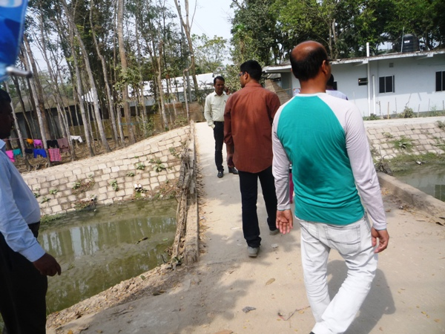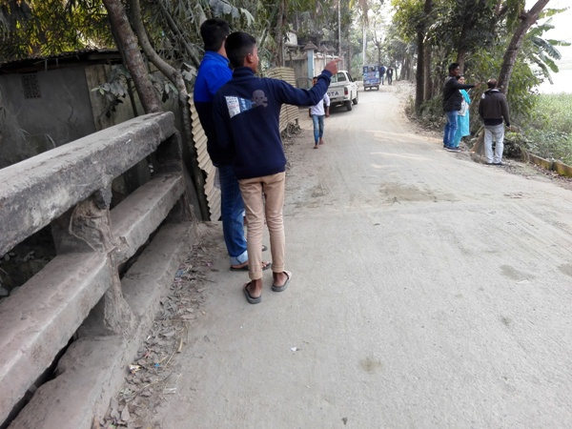

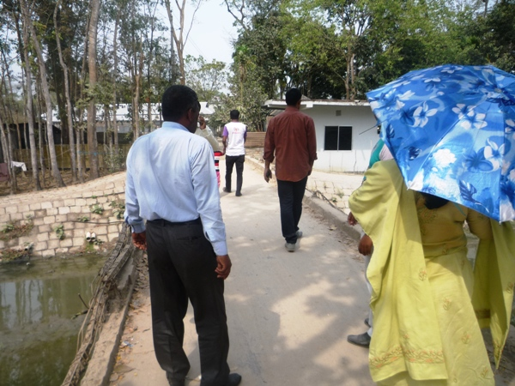

Photographs 7.1.1: DSM Consultant Team with Pourashava Representatives inspected the proposed Culverts and Bridge

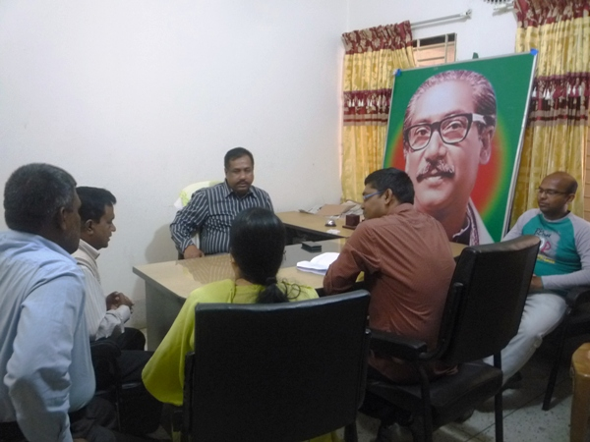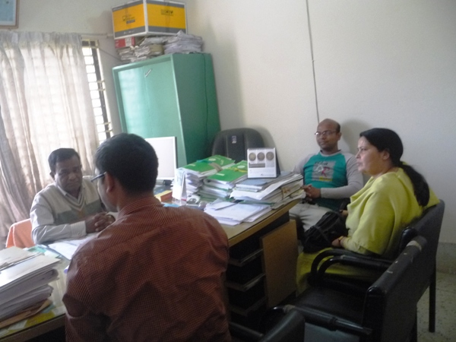

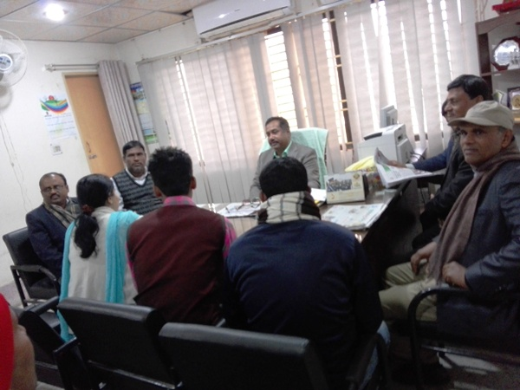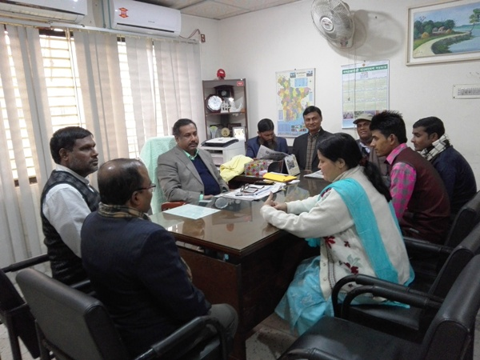

Photographs 7.1.2: Consultation Meeting at subproject sites with Pourashava Officials and Consultants Participants

7.2 Issues Raised by the Participants

The participants raised the issues related to the infrastructure development of Shariatpur Pourashava. The anticipated environmental and social impacts due to construction works have also been raised and discussed. The participants also discussed about the potential benefit from the subproject.

7.3 Feedback, Suggestions, and Recommendations of the Participants

The participants were presented with feedback, suggestions, and recommendations listed below:
- The FGD results confirmed that an improved communication network is needed for future development of Shariatpur Pourashava.;
- Most of the participants expressed that the number of subproject that have been selected for each financial year is insufficient;
- The participants stated that the public water supply facilities, sanitation facilities, and access road are not adequate;
- The participants stated that construction works should be scheduled properly;
- Local people also showed expectation for the increased opportunities for employment for unskilled or semi-skilled labor in the construction work;
- Local people expressed that construction of new bridges will assist for the development of the peripheral road network in the Shariatpur Pourashava.

8 Conclusions and Recommendations

This study assists to understand the initial environmental impacts due to the subproject as well as to formulate the applicable mitigation and monitoring plans. Based on the environmental assessment, all possible environment aspects have been adequately assessed and necessary mitigation measures have been formulated to minimize the adverse impacts.
The overall conclusion is that if the mitigation, compensation, and enhancement measures are entirely implemented, there will be no significant negative environmental impacts as a result of location, design, construction, and or operation of the proposed subproject.
The conclusions of the environmental assessment can be summarized as follows:
- The short-term negative impacts that may come such as air quality, noise, solid waste, occupational health and safety will be minimized through the mitigation measures;
- The subproject will create employment for the workforce who live in the vicinity of the construction site and will provide them a short-term economic gain.
A few key recommendations are outlined below:
- All mitigation, compensation, and enhancement measures proposed in this report should be followed by the concern authorities for implementing the subproject;
- The environmental management and monitoring plan proposed in this report also needs to be followed;
- Regular monitoring by Pourashava, PMU (LGED) and DSM consultants is needed;
- The contractor will ensure using of the PPEs by the workers where applicable;
- The contractor is responsible for the proper disposal of the generated wastes materials from the subproject sites and campsite;
- The EMP shall be made binding on contractor operating the site, and will be included in the contractual clauses;
- Due to changing circumstances during the construction phase if any, there might be minor adaptation needed for environmental, health and safety issues.

9 REFERENCE

Shariatpur Pourashava Master Plan: 2011-2031 Urban Area Plan

Shariatpur Pourashava at a glance

Environmental Assessment Volume 1: Overall Environmental Assessment [Draft Final Report], September 2013. Municipal Governance and Services Project (MGSP), Local Government Engineering Department (LGED) and Bangladesh Municipal Development Fund (BMDF), Ministry of Local Government, Rural Development and Cooperatives, Government of the People's Republic of Bangladesh.

Environmental Assessment Volume 2: Environmental Management Framework (EMF) [Draft Final Report], September 2013. Municipal Governance and Services Project (MGSP), Local Government Engineering Department (LGED) and Bangladesh Municipal Development Fund (BMDF), Ministry of Local Government, Rural Development and Cooperatives, Government of the People's Republic of Bangladesh.

Appendix
Appendix 1: Environmental Monitoring Checklist

Local Government Engineering Department

Municipal Governance Services Project (MGSP)

Environmental Compliance Monitoring Form
Part A: General Subproject Information

Subproject Name | 1. a) Construction of RCC Box Culvert at Palong School to Premtala Road at Ch. 0+200m (CIP NO-11);  1. b) Construction of RCC Box Culvert at Palong School to Premtala Road at Ch. 0+300m (CIP NO-11);  2. a) Construction of RCC Box Culvert at Bus Stand to Kurashi Balakhana Road at Ch. 0+700m (CIP NO-09);  2. b) Construction of RCC Box Culvert at Bus Stand to Kurashi Balakhana Road at Ch. 1+250m (CIP NO-09);  3. a) Construction of RCC Box Culvert at Chowrongi to Shornogosh Dighir Par Road at Ch. 0+400m (CIP NO-19);  3. b) Construction of RCC Box Culvert at Chowrongi to Shornogosh Dighir Par Road at Ch. 1+500m (CIP NO-19);  4. a) Construction of 21m RCC Bridge at Char Palong School Road (CIP NO-43);  4.b) Construction of 21m RCC Bridge Approach road at Char Palong School Road;  5. a) Construction of 5 vent 3.6x4.0 RCC Box Culvert at PTI Complex Connecting Road;  5. b) Construction of 5 vent 4.0x3.6 RCC Box Culvert at Brikhatala;  5. c) Construction of 2 vents 3.6x 4.0 RCC Box Culvert at Angaria Bazar to Rajganj Bazar Road at Ch. 2250m;  5. d) Street light for 21m RCC Bridge at Char Palong School Road.
Package No. | MGSP/SHA/2017-18/W-05
ULB Name | Shariatpur Pourashava
Approved Estimated Cost in BDT
Contract Amount in BDT
Contractor Name
Date of Commencement
Target Date of Completion
Physical Progress (%)
Financial Progress (%)
Person Responsible (PIU)
(Name, Designation &Phone) for the Overall Subproject Management

Person Responsible (DSM)
(Name, Designation &Phone) for the Overall Subproject Management

Form Completed by
(Name, Designation &Phone)
Overall Environmental Description of the Subproject

Part B: Design, Preparation, and Legal Requirements
Environmental Concerns (PMU, PIU & DSM)  (Name, Designation & Phone) | PMU-
 | PIU-
 | DSM-
Subproject Category | DoE-BD- | WB-
Environmental Clearance Received? | Yes | No
EA Required? | Yes | No
EA Prepared and Delivered? | Yes | No
EMP Prepared & Delivered Separately? | Yes | No
Items and Cost of EMP Implementation Included in the Contract? | Yes | No
EMP Included in the Procurement Documents? | Yes | No
Inspection Schedule/Last Inspection/Monitoring by  PMU Environmental Concerns | Date-
 | Key findings-
Inspection Schedule/Last Inspection/Monitoring by  PIU Environmental Concerns | Date-
 | Key findings-
Inspection Schedule/Last Inspection/Monitoring by  DSM Environmental Safeguard Specialist/Jr. Environmental Specialist | Date-
 | Key findings-

Part C: Key Environmental Impacts
The Subproject Results in any of the following Impacts? | Yes | No | NA | If yes, is the impact (give observation)
 |  |  |  | Significant | Moderate | Minor
Felling of the trees
Clearing of the vegetation that increase the risk of increased soil degradation or erosion
Disturbance of the terrestrial and or aquatic specifies
Noise pollution
Air pollution
Adverse effects on the quantity or quality of the surface water or groundwater
Production or increase the production of the solid waste
Drainage congestion
Water logging that increases the risk of the water related diseases
Traffic congestion
Public safety

Part D: Work Place Environment and Gender Equity
The Subproject Results in any of the following Impacts? | Yes | No | NA | Observations
Does the contractor pay to the workers regularly?
Is there any discrepancy between the male and female workers regarding the wages or salary for the same works?
Is the contractor complying with the GOB labor law concerning the hiring of the workers?
Does the contractor engage women labors and does the project have suitable works for them?
Does the contractor engage child labor (less than 18 years) and aged people (more than 65 years old)?
Does the contractor force to the workers for the completion of the works?
Do the workers involve with the political activities, crime, drugs addiction and other forms of unwanted activities?
Are construction camps adequately equipped with water supply, sanitary toilets, washing facilities and facilities for waste collection and storage?
Has separate sanitation facilities been provided for women at work camps and the construction site?

Part E: Potential Impacts, Mitigation Measures, and Monitoring Indicator Mentioned in the EMP
Activity / Issues |  | Potentials Impacts | Proposed Mitigation and Enhancement Measures |  |  | Responsible Parties
Construction and operation of labor shed for the workers (Workforce and labor shed management ) |  | - Generation of sewage and solid waste may cause environmental pollution in the surrounding area | - Construction of sanitary latrine at the labor shed (consider 15 person for one toilet, separate toilet for male and female);  - Erection of “no litter” sign, provision of waste bins/cans (separate waste bins for organic and inorganic wastes );  - Ensure wastes (solid wastes and other forms of the waste) disposal at the vacant place near abandoned Ruma Cinema Hall |  |  | Contractor  Monitoring-  Primarily by Pourashava  Secondarily by PMU,LGED  and DSM  Contractor  Monitoring-  Primarily by Pourashava  Secondarily by PMU,LGED  and DSM  Contractor  Monitoring  Primarily by Pourashava  Secondarily by PMU,LGED  and DSM
 |  | - Health of workers | - Conduct formal and unofficial discussion to increase awareness about hygiene practices among the workers;  - Ensure availability and access to first-aid equipment and medical supplies for the workers.
 |  | - Possible development of labor camp into permanent settlement | - Contractor to remove labor camp at the completion of contract.
 |  | - Outside labor force causing negative impact on health and social well-being of local people | - Ensure that contractor employ local work force to provide work opportunity to the local people and conduct formal and unofficial awareness program for the health and social well-being of the local people.
General construction work |  | - Drainage congestion and flooding | - Ensure provision for adequate drainage of storm water if needed;  - Use pipe drain to continue the water flow;  - Ensure provision for pumping of congested water if needed;  - Ensure adequate monitoring of drainage effects, especially if construction works are carried out during the wet season.
 |  | - Air pollution | - Check regularly and ensure that all the subproject vehicles and equipment are in good operating condition;  - Ensure contractor spray water on dry surfaces/ unpaved to reduce dust generation;  - Maintain adequate moisture content of the sand;  - Ensure contractor sprinkle water and cover stockpiles of loose materials (e.g., fine aggregates);  - Inform local people about the subproject activities and potential impact;  - Cover loaded truck used for carrying sand with tarpaulin/other suitable material to prevent the spreading by air blown.
 |  | - Traffic congestion, effect on traffic and pedestrian safety | - Ensure schedule deliveries of materials/ equipment during off-peak hours;  - Place traffic sign/cautionary sign to avoid undue traffic congestion if required;  - Shifting of the existing bamboo shako at convenient nearby area so that the local people can cross the river during construction period.
 |  | - Noise pollution | - Check and maintenance the equipment properly;  - Avoid using of construction equipment such as concrete mixer machine, pile driving equipment (pile rig, winch machine), vibrator machine that produce excessive noise at night;  - Avoid prolonged exposure to noise (produced by equipment) by the workers;  - Regulate use of horns and avoid un-due use of hydraulic horns by subproject vehicles;  - Inform local people about the subproject activities and potential impact.
 |  | - Felling of trees, clearing of vegetation and ecological disturbances | - 25 nos. of the trees will be planted at the both sides of the approach road to enhance the ecological condition.
 |  | - Destruction of aquatic habitat | - Avoid complete closing of the river channel that affects reproduction of aquatic species;  - Ensure that developmental waste and work design does not create any problem for the movement and breading of aquatic species;  - Keep noise level (from equipment) to a minimum level (as a certain fauna and flora are very sensitive to loud noise);  - Any illegal discharge of waste water, leaked oil shall be prohibited.
 |  | - Accidents | - Conduct formal and informal discussion for creating awareness about the accident;  - Provides PPEs and ensure using of the personal protective equipment by the workers.
 |  | - Spills and leaks of oil, toxic chemicals | - Proper handling of lubricating oil and fuel so that it does not fall on the soil;  - Collection and proper disposal of spills;  - Refueling and fuel tank should not be placed on the ground directly.
All construction works |  | - Beneficial impact on employment generation | - Employ local people in the subproject activities as much as possible;  - Give priority to poor people living within subproject area in subproject related works (e.g., excavation and other works, which do not require skilled manpower).
 |  | - General degradation of the environment | - Ensure environmental enhancement measures- tree plantation and cautionary sign will be provided.
Environmental impacts due to the key construction activities and corresponding mitigation measures for the RCC Culverts and Bridge
Excavation/Earth work |  | - Generation of loose and clay soil due to the earth excavation work | - Disposal of soil and construction wastes at the vacant place near abandoned Ruma Cinema Hall;  - Cover exposed dry loose soil with fabric.
 |  | - Accidents | - Carefully handle of the hydraulic excavator;
 |  | - Air pollution | - Regular maintenance of the equipment;
Sand filling /Back filling work |  | - Air and dust pollution affecting nearby settlement | - Maintain adequate moisture content of soil and sand during transportation, compaction and handling;  - Carry the materials especially loose soil and sand with adequate cover.
Cutting and welding of the reinforcement |  | - Noise pollution due to rod cutter and welding machine if any | - Avoid using of rod cutter and wielding machine at night;  - Avoid prolonged exposure to noise (produced by equipment) by workers.
 |  | - Potential health and safety risks from rod cutter and welding machine if any | - Ensure use of the personal protective equipment’s (helmet, goggles, gloves, safety boot);  - Availability and access to first-aid equipment and medical supplies in case of any accidents.
Cast-in-situ pile work |  | - Possible accident, noise pollution and mud generation | - Carefully operation of the equipment’s;  - Ensure using of the safety gear;  - Proper collection and disposal of the generated mud due to drilling work.
RCC (reinforcement cement concrete) work |  | - Air pollution due to black smoke emission from concrete mixer machine and vibrator machine | - Regular maintenance of the concrete mixer and vibrator machine to avoid any black smoke emission.
 |  | - Noise nuisance from concrete mixer machine and vibrator machine | - Avoid operation of the concrete mixer and vibrator machine at night;  - RCC work should be avoided at schooling time;  - Inform local people about casting work and potential impacts.
Environmental impacts due to the key construction activities and corresponding mitigation measures for the construction of BC approach road
Excavation/Earth work |  | - Generation of loose soil due to the earth excavation work. | - Cover exposed earth works with fabric;  - Disposal of soil and construction wastes at at the vacant place near abandoned Ruma Cinema Hall;
 |  | - Accidents due to careless use of hydraulic excavator | - Operate the hydraulic excavator carefully.
 |  | - Air pollution | - Regular maintenance of the equipment to avoid black smoke emission.
ISG (Improved Sub grade)/ Sand filling |  | - Air and dust pollution affecting nearby settlements | - Maintain adequate moisture content of soil during transportation, compaction and handling;  - Carry the materials especially loose soil and sand with adequate cover.
Setting up and operation of asphalt plant |  | - Possible degradation of the air quality by the suspended particles and increase of the noise level from asphalt plant affecting nearby settlements; | - Locate plant away from residential settlements;  - Consider use of emulsified bitumen.
 |  | - Possible water pollution (surface and groundwater) by bitumen and solvents; | - Avoid spills and proper collection and disposal of the generated spills.
 |  | - Possible preparation of the bitumen in open air and using of charcoal and wood as fuel | - Strictly prohibit bitumen preparation in the open air and use of charcoal and wood as fuel.
Environmental impacts due to the key construction activities and corresponding mitigation measures for the street light
Activity/Issues | Potential Impacts |  |  | Proposed Mitigation and Enhancement Measures
Setting up the pole and electrical connection | - Potential health and safety risks. |  |  | - Inform the local authority to switch off power during connection;  - Ensure use of the PPEs.
Source of electricity and equipment | - Reduce of resource i.e. use of electricity; |  |  | - Provision of renewable energy (solar panel electrification) and use of environmental friendly equipment (LED bulb rather than CFL bulb).
Prepared by- Signature- Date-
Copies to 1. PIU
2. SME
3. AME
4. Jr. ES

