
GOVERNMENT OF THE PEOPLE’S REPUBLIC OF BANGLADESH
Local Government Engineering Department (LGED)

Local Government Division

Ministry of Local Government, Rural Development, and Cooperatives

Environmental MaNAGEMENT PLAN

Name of the Subproject: Construction of Leisure cum Business Center at Panchuria under Gopalganj Pourashava, Gopalganj

Package No: MGSP/GOP/2017-18/W-07

Gopalganj Pourashava, Gopalganj

Municipal Governance and Services Project (MGSP)

Design, Supervision, and Management (DSM) Consultancy Services
Joint Venture of  Hifab International AB, Sweden  AQUA Consultant and Associates Ltd., Bangladesh |   
TABLE OF CONTENTS
 |  |  | Page
1.0 |  | SUBPROJECT DESCRIPTION | 1-8
 | 1.1 | Subproject Background | 1
 | 1.2 | Subproject Setting | 2
 | 1.3 | Current Situation, Proposed Intervention and Need for the Subproject | 4
 | 1.4 | Envisaged Subproject Activities and Implementation Process | 6
 | 1.5 | Category of the Subproject | 7
 | 1.6 | Subproject Schedule | 8
2.0 |  | ENVIRONMENTAL SCREENING | 9-11
3.0 |  | SPECIFIC IMPACT, MITIGATION AND ENHANCEMENT MEASURES | 12-20
 | 3.1 | Demolition of the Existing Structure and Demolition Wastes Disposal | 12
 | 3.2 | Earth Excavation, Trenching and Foundation work | 13
 | 3.3 | Pollution from the Construction Materials | 14
 | 3.4 | Air Quality and Dust | 14
 | 3.5 | Noise and Vibration | 15
 | 3.6 | Occupational Health and Safety | 15
 | 3.7 | Impacts on Social Environment and Common Property Resources | 16
 | 3.8 | Labor Influx and Anticipated Impacts | 17
 | 3.9 | Impacts on Traffic Movement | 19
 | 3.10 | Drainage Congestion | 19
4.0 |  | RECOMMENDED MITIGATION AND ENHANCEMENT MEASURES | 21-27
5.0 |  | ENVIRONMENTAL MONITORING PLAN | 28
6.0 |  | ENVIRONMENTAL MANAGEMENT BUDGET | 29
7.0 |  | ENVIRONMENTAL CODES OF PRACTICE | 31
8.0 |  | CONCLUSIONS AND RECOMMENDATIONS | 32
9.0 |  | REFERENCES | 33
APPENDIX
Appendix 1: Environmental Monitoring Checklist |  |  | 34

LIST OF TABLES
Table 3.6.1 | General Requirements for the Workers Health and Safety
Table 3.7.1 | Impacts on Social Environment and Common Property Resources
Table 4.1 | Anticipated Environmental Impacts during Construction Phase and Corresponding Mitigation and Enhancement Measures
Table 4.2 | Anticipated Environmental Impacts during Operation Phase and Corresponding Mitigation and Enhancement Measures
Table 5.1 | Matrix Table of Monitoring Plan (Visual observation during construction phase)
Table 6.1 | Environmental Management Budget

LIST OF FIGURES
Figure 1.2.1 | Location Map of the Subproject Site
Figure 1.2.2 | Lay-out Plan of the Subproject Site
Figure 1.2.3 | Topographic Features of the Subproject Site with Influence Area

LIST OF PhotoGraphs
Figure 1.3.1 | Current Situation of the Subproject Site
Figure 1.3.2 | DSM Consultant Team with Pourashava Representatives inspected the Proposed Market

ABBREVIATIONS

BDT | Bangladeshi Taka
BOQ | Bill of Quantity
CC | Cement Concrete
DSM | Design, Supervision, and Management
EA | Environmental Assessment
ECR | Environmental Conservation Rules
EMP | Environmental Management Plan
EPP | Emergency Preparedness Planning
ES | Environmental Screening
GoB | Government of Bangladesh
LGED | Local Government Engineering Department
MGSP | Municipal Governance and Services Project
PD | Project Director
PMU | Project Management Unit
RCC | Reinforcement Cement Concrete
WB | World Bank

SUBPROJECT DESCRIPTION

Subproject Background

Gopalganj Pourashava is situated at Gopalganj District. It was declared as a Pourashava in the year of 1972. The Pourashava area is 13.82 sq km. At present, this is A type Pourashava with the present population of 1, 14,950. The Pourashava has only 1 auditorium, 1 public hall and 3 shopping center. Presently, there is one community center under construction of MGSP project. But, there is no modernise business center. Hence, under MGSP Gopalganj Pourashava demands construction of Leisure cum Business Center in the central Pourashava area.

Under this subproject, the Old Building (two storied building) and kitchen market will be demolished and a four storied business center will be constructed. The significant features of the subproject are stated below:

Name of the Subproject: | Construction of Leisure Cum Business Center at Panchuria under Gopalganj Pourashava
Package No.: | MGSP/GOP/2017-18/W-07
District Name: | Gopalganj
ULB Name: | Gopalganj Pourashava
Jurisdiction Area: | Ward number 7
Structural Design Option: | Four storied building with sanitary, water supply, electrical and other associated works
Wards Population: | About 51,346 as per as per Pourashava information
Tribal People: | No tribal people settlement found in the subproject area
Land Acquisition: | No private land acquisition is required
Estimated Cost: | 200. 413 million BDT
Subproject Duration: | 12 Months
Tentative Start Date: | 04 September 2018
Tentative Completion Date: | 03 September 2019
For the preparation of the subproject appraisal, environmental screening has been performed. According to that screening, an environmental management plan is required. Hence, this environmental management plan is prepared to meet the regularity requirement. This plan simplifies the anticipated impacts and corresponding mitigation measures for easy understanding of the personnel responsible for the subproject implementation. Therefore, this study only includes key contents that are appropriate.

Subproject Setting

The subproject site is situated within the jurisdiction area of the Gopalganj Pourashava Ward no. 07. The location map, lay-out plan, and topographic feature of the subproject are shown in Figure 1.2.1, Figure 1.2.2 and Figure 1.2.3.

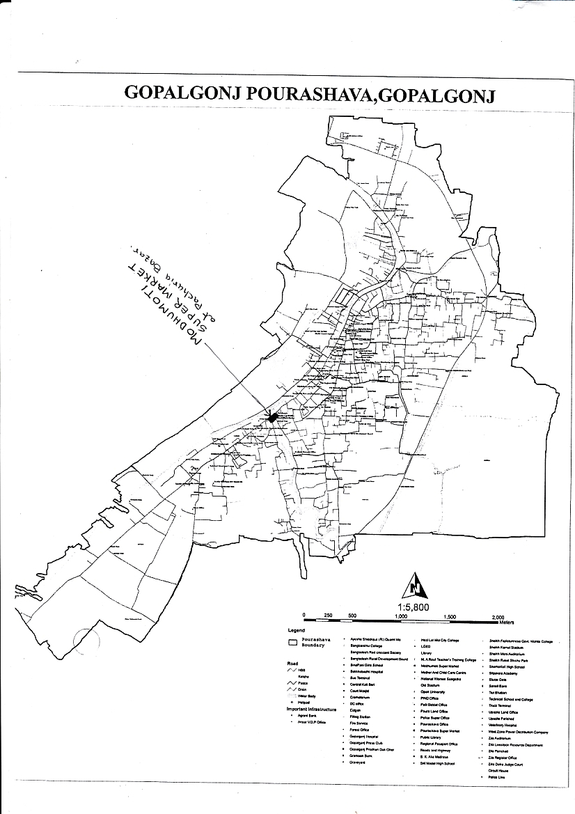

Figure 1.2.1: Location Map of the Subproject Site

Figure 1.2.2: Lay-out Plan of the Subproject Site
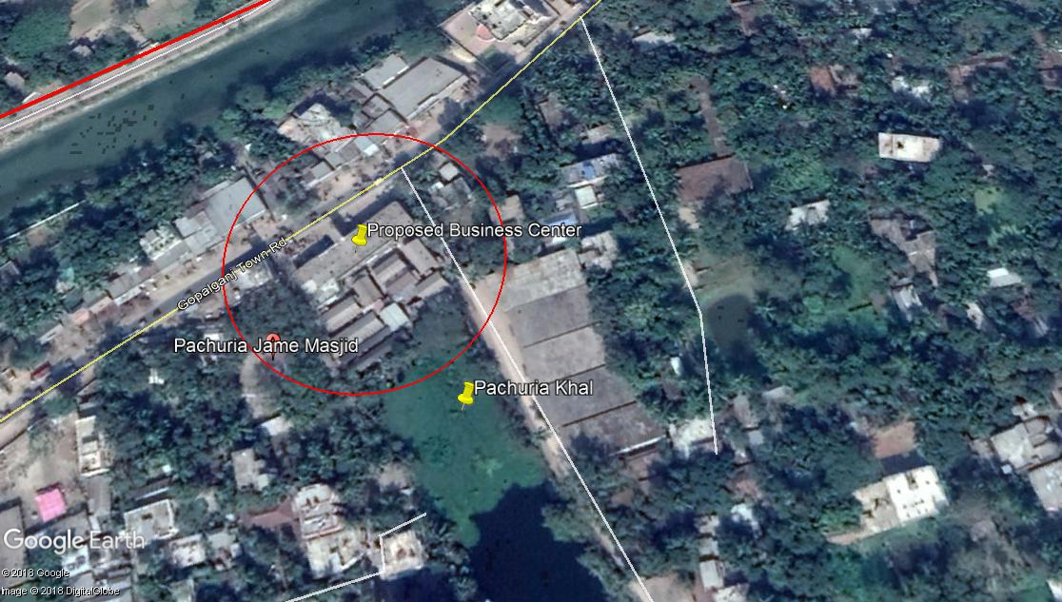

Figure 1.2.3: Topographic Features of the Subproject Site with Influence Area
The subproject site is situated at the built-up and central area of the municipality. During the site visit, the detailed environmental and infrastructural features listed around the subproject site. The major findings of the site visit are given below:

Side/ Direction | Major Environmental and Infrastructural Features
North | Banga Bandhu Road, pucca, semi pucca and tin shed shops(furniture,metal, sound system, workshops etc.), tree (kadom, coconut, koroi)
South | Panchuria khal, trees ( koroi, coconut)
East | District Commandar Karjalay,food storage, road
West | Road, Panchuria Wabda Jame Mosque, mobile tower, boundary wall, trees(mehagany, supari, mango)

Current Situation, Proposed Intervention and Need for the Subproject

The proposed site is located in the prime and valuable developed area. The land use pattern consists of commercial and residential areas. The subproject site and its influence area cover Banga Bandhu Road, District Commandar Karjalay, Panchuria Wabda Jame Mosque, food storage, Panchuria Khal and kitchen market etc.
At present, two storied partially damaged building is used for various shops (stationary, medicine, studio, electronic, rice, money transfer office, tailors etc.), doctor chambers, Bhuiya and Janani diagnostic center, Agrani Bank LTD. The existing tin shed structures are used as kitchen market. Due to enhancement of the financial ability, the community people demands Leisure Cum Business Center with various urban facilities such as shop, showroom, café,restaurant etc. The business center is proposed with the following facilities: water supply, drainage and sanitation facilities, indoor and outdoor lighting system, installation of the trash bin, car parking facilities, etc.

The total land area of the proposed market is about 43 katha (31,018 sft/2,881 sq.m). It is planned to provide parking area with 50 numbers of cars, office room, store room, electromechanical room, meter room, generator room and fire control room at different places in the basement. In the design, it is proposed to allocate 17 various shops at the ground floor, 16 shops, office and bank at the first floor, 40 shops and cafe at the second floor, office space/showroom, restaurant, kitchen, open kitchen, space for varieties shops at the third floor. Adequate space for lobby has been allocated in the design of the floor plan. There is adequate green zone in each floor except basement. Roof is designed with rain water harvesting facilities and over head water tank. In addition, the shaded area over the void at roof can be used for smoke zone. Two lifts and two common stair cases at each floor have been included in the design. The disable people can use lift from the semi-basement. Escalator will also be installed for the convenient movement of the users. Fire fighting facilities will be placed adjacent to this stair case. Washzone with separate toilet facilities of male and female as well as disable people at each floor have been included in the design. The design also includes adequate water supply, sanitation facilities, drainage and waste disposal facilities. The shops owners will carry out interior decorations as per their requirement. The existing condition and inspection of the proposed site is further elaborated in the following Photographs 1.3.1 and 1.3.2.
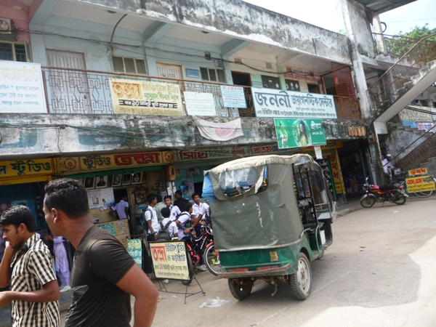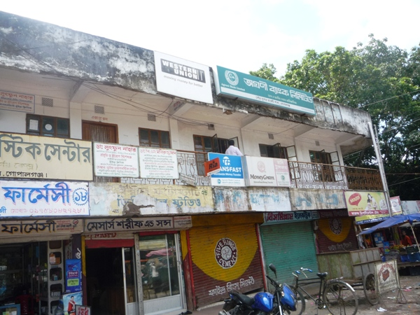
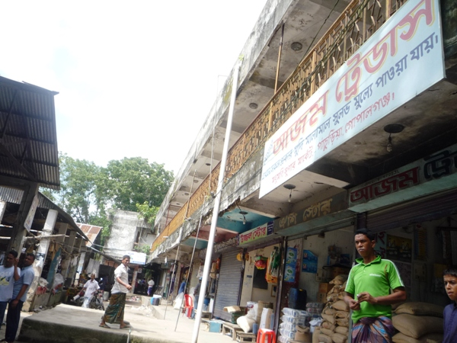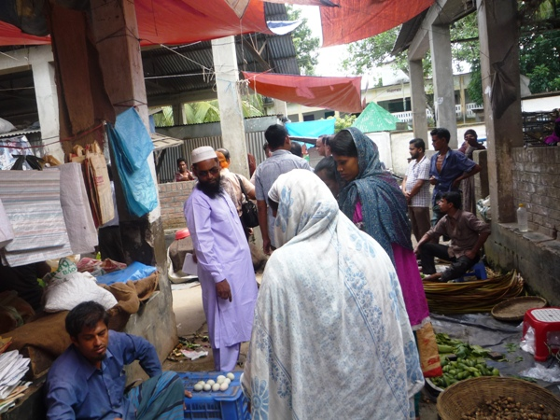
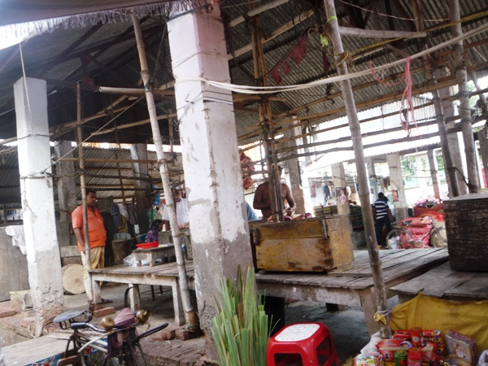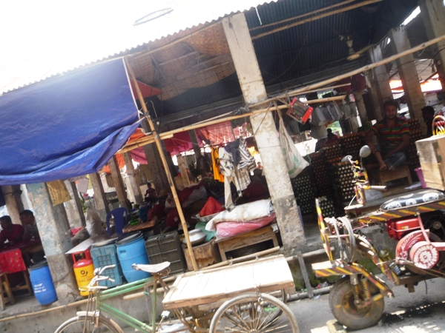

Photographs 1.3.1: Current Situation of the Subproject Site
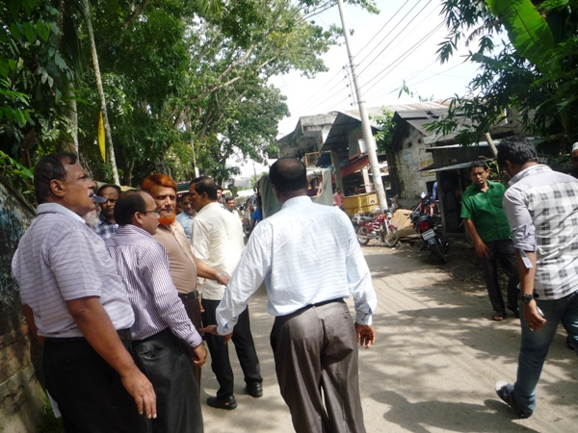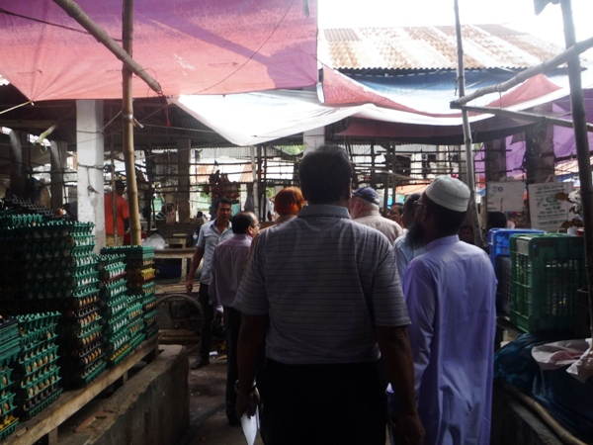

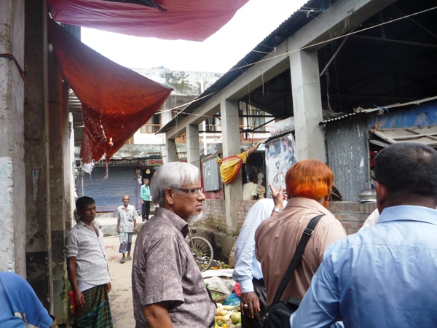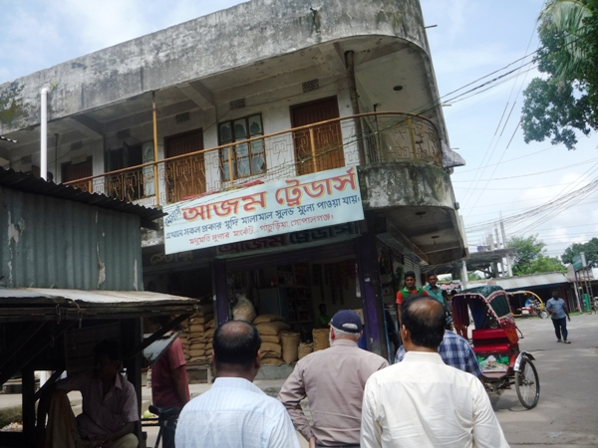

Photographs 1.3.2: DSM Consultant Team with Pourashava Representatives inspected the Proposed Market

Envisaged Subproject Activities and Implementation Process

The general activities of the subproject includes: construction of the semi-pucca site office and construction of the labor shed.

Specific activities for four storied building:
- Site clearing work;
- Providing lay-out;
- Cast-in-situ pile foundation;
- Earthwork in excavation of foundation trenches;
- Earth filling work as per requirement;
- Compaction of earth;
- Fabrication, binding, bending of the ribbed or deformed bar;
- Mass reinforcement cements concrete work in grade beam, beam, and column and slab construction;
- Single layer brick flat soling in ground floor;
- Brick work in facing super structure;
- Fancy and ornamental screen work;
- Preparation of the door and window frames with seasoned wood;
- Fitting and fixing of the window and door with accessories;
- Fitting and fixing of the glazed tiles;
- Fitting and fixing of the unglazed tiles;
- Plastering work;
- Distempering with ready mixed synthetic polyvinyl distemper;
- Painting work;
- Fixing of the railing;
- Construction of the toilets;
- Construction of the septic tank and soak well;
- Construction of the water tank;
- Beautification work;
- Fitting and fixing of the plumbing and electrical accessories etc;
- Installation of the waste bins;
- Tree plantation work as environmental enhancement work.
The materials and resources to be used for the key activities: soil in earth work, sand, stone chips, brick chips, glass, cement, bricks, concrete, tiles, reinforcement, sanitary and electrical accessories.
The major equipment to be used for the implementation of the subproject: sand driven pile, wooden drag, roof hoist, ladder, hammer, steel/ concrete hammer, excavator, concrete mixer machine, mechanical vibrator machine, MS sheet, steel cutter, steel shutter and dump truck.

Category of the Subproject
- According to ECR 199 : Green □ Orange □ A √ Orange B □ Red □ Not Listed □
- According to WB classification : Category B □ Category C □√

In ECR-97, in general sense multi-storied commercial building is included in the Orange-B category subproject. However, DoE defines more than 10 storied building as the multi-storied building (Reference: Environmental Impact Assessment (EIA) for construction of DoE Office Building under Clean Air and Sustainable Environment Project (CASE). This four storied building will be constructed at the developed land which has less impact on ecological and physicochemical environment both construction and operation phase.
In the Project EMF, it is noted that this subproject building can classify as Orange A and or Orange B as per ECR-97 depending on assessment of impact. Considering the environmental impacts which is low and site specific, primarily this subproject can consider as Orange-A category as per ECR-97. Considering the anticipated impacts, it can classify as Category C according to the WB classification.

Subproject Schedule
The tentative schedule of construction of the subproject is:
(a) Subproject Duration (months) :12 months
(b) Tentative Start Date : 04 September 2018
(c) Tentative Completion Date : 03 September 2019

The daily construction hours will normally include regular working time. However, daily working hours may vary based on the on-site condition. The detailed work program will be prepared by the contractor with the assistance of the PIU-Pourashava. Then it will be shared with the PMU, LGED and DSM consultants. In addition, the detailed work program will also be shared with the Bank as per requirement.

ENVIRONMENTAL SCREENING

Environmental Screening (ES) for the subproject has been conducted with the purpose of fulfilling the requirements of Government (GOB) and World Bank (WB) for the preparation of subproject appraisal. Environmental Screening Checklist, as adopted in Appendix C of the Environmental Management Framework (EMF) of the MGSP, was administered for identifying the impacts and their extents.
The screening data for the Leisure cum Business Center have been formulated and are shown in below:
(1) Potential Environmental Impact during Construction Phase:
(a) Ecological Impacts:
3
- Felling of the trees Significant □ Moderate □ Minor □√ Number of trees
- Clearing of the vegetation Significant □ Moderate □ Minor □√
- Potential impact on species of Significant □ Moderate □ Minor □√
aquatic (i.e., water) environment
The proposed building will be constructed at the developed land. Hence, there are only 3 trees will be felled down and no vegetation will be cleared for the implementation of the subproject. Furthermore, the subproject activities do not have any likely impact on the aquatic environment except throwing of the waste materials generated from construction activities in the Panchuria Khal. Therefore, the anticipated impact on the ecological environment due the subproject activities is minor.
- Physicochemical Impacts:

- Noise pollution Significant □ Moderate □√ Insignificant □
- Air pollution Significant □ Moderate □ Insignificant □ √
- Drainage congestion Very likely □ Likely □ √ Unlikely □
- Water pollution Significant □ Moderate □ Insignificant □√
- Pollution from solid/ construction wastes
Significant □ Moderate □√ Insignificant □
- Water logging Significant □ Moderate □ Insignificant □√
Transportation of the equipments, materials and mobilization of the equipments may degrade the air quality and noise level in the subproject area. During construction phase using of the pilling machine, steel cutter, welding machine, drilling machine, concrete mixer and vibrator machine etc. may create localized and temporary noise nuisance. However, there is a buffer zone between the proposed site and residential houses. Since the activities do not require heavy equipments and no massive activities needed for the completion of the work, it is anticipated that noise & air pollution will be minor and will be limited within the subproject boundary. Removing of the existing structure will generate solid wastes if not properly collected, re-used and disposed-off. Construction activities will also generate solid wastes that have temporary and localized impacts on the surrounding environment if not properly re-used or disposed-off. Improper handling and stockpile of the waste materials may degrade the aesthetic value. Anticipated impact on the drainage congestion & water logging due to the subproject activities will be insignificant because pumping facilities will be there for pumping out of the storm water. Primarily, the subproject will have no adverse impact on the other physicochemical components.
- Socio-economic Impacts:
- Traffic congestion Very likely □ Likely □√ Unlikely □
- Health and safety Significant □ Moderate □√ Insignificant □
- Impact on archaeological
and historical Significant □ Moderate □ Insignificant □√
- Employment generation Significant □√ Moderate □ Insignificant □
Though, it is limited; however, during construction period, vehicles movements for carrying construction materials and mobilization of the equipment have likely impacts on the local traffic system. Any road side materials storage and any work on the road may create traffic congestion. The subproject will have negative impact in health and safety during construction phase due to likely accidents from the construction activities. Careless activities during removing of the existing structures and using of the welding machine, drill machine, steel cutter, concrete mixer, vibrator machine etc. may create accidents. The subproject has significant positive impact by generating employment opportunity for the local people.
2) Potential Environmental Impact during Operational Phase:
(d) Ecological Impacts:
- Potential impact on species of the aquatic Significant □ Moderate □ Minor □√
(i.e., water) environment
The anticipated impact on the aquatic environment during operation phase is minor because septic tank with soak well will be used for generated waste water and sewage management.
(e) Physicochemical Impacts:
- Potential air quality Significant □ Moderate □ √ Insignificant □
- Noise level Significant □ Moderate □√ Insignificant □
- Drainage congestion Improvement □ Improvement □√ No Impact □
- Waste water disposal Significant □ Moderate □ Minor □√
- Pollution from solid wastes Significant □ Moderate □ Insignificant□√

During operation phase, public gathering and possible use of loud speaker may create noise nuisance to the users and shoppers. In addition, night time operation of the shops and restaurant may generate noise nuisance to the adjacent area. Installation of the trash bins will minimize the environmental degradation due to improper disposal of solid wastes. However, if the trash bins will not be used properly and not emptied regularly and wastes are thrown here and there, it may pollute the surrounding environment. In addition, septic tank with soak well will be used for generated waste water and sewage management which will minimize environmental degradation. New surface drain will enhance drainage facilities.
(f) Socio-economic Impacts:
- Traffic Significant □ Moderate □ Minor □ √
- Safety Issue (fire hazard, short-circuit etc) Significant □ Moderate □√ Minor □
- Employment generation Significant □√ Moderate □ Minor □

It has significant positive impact by providing job & business activities and community interaction. Though, it is limited; however, it may create traffic congestion due to improper parking of the vehicles and ignoring of the traffic rules. Possible accidents due to fire hazards, short-circuit, earth quake and social risks due to robbery, pick-pocketing, eve teasing etc. have negative socio-economic impacts.
3) Summary of the Possible Environmental Impacts of the Subproject:
From the above study, it seems that the ecological impact is minor. The construction activities may degrade the air quality and noise level. In addition, solid wastes generation from the construction activities may temporary degrade the quality of the surrounding environment. Improper storage of the construction materials, un-used soils, debris and other forms of the waste materials due to construction activities may create hazard for the local people and the workers and degrade the aesthetic value. During construction phase, possible failure of the equipment such as roof waist, pile rig may create severe accidents to the workers. Hence, occupational health and safety risk should be considered properly. It is noted that the subproject does not require any heavy equipment, complex procedure and massive activities. Hence, the anticipated impact on physicochemical components is mainly site specific and limited within the subproject boundary.
During operation phase, due to public gathering and possible use of loud speaker may create noise nuisance to the users and shoppers. Wastes disposal and waste water and sewage management should be considered properly. This subproject has positive impacts in terms of the generation of the employment opportunities due to construction activities, supplying of the materials at construction phase and by providing business activities at operation phase. Furthermore, to resist earth quake impact, the design and construction work will follow BNBC Code-1993.

Specific impact, mitigation AND enhancement measures

The likely impacts of the subproject are mainly caused by the activities required for the implementation of the subproject, materials, resources and equipment to be used to perform the activities. This section describes some specific impacts due to the subproject activities and their mitigation measures.

Demolition of the Existing Structure and Demolition Wastes Disposal

Under this subproject, the abandoned structure will be demolished.The hazards and environmental impacts associated with demolition works are mainly function of location of the structures, type of structures, method of demolition, the area of building being demolished, amount of solid wastes, dust and traffic being generated and duration of the demolition work.
There is a buffer zone between the abandoned building and adjacent structures. Hence, demolition work needs simple procedure and commonly used manual equipments-hammer with mechanical drill machine and steel cutter.Therefore, this is not massive demolition work and anticipated impacts are not severe. The generated solid wastes and dust will be less. In addition, demolition materials such as corrugated iron sheet, reinforcement, debris, wooden door, and window are reusable. Importantly, the demolition work will require less time (even lesser than 15 days).
The anticipated impact due to demolition of the existing building is not severe. However, potential environmental impacts in connection with demolition works are taken seriously and corresponding mitigation measures are formulated adequately. The potential environmental impacts in connection with demolition works are: noise & vibration, dust, traffic congestion, generation of demolition wastes including corrugated iron sheet, door, windows, wood, metal frames, concrete, debris & reinforcement and visual & aesthetic impacts.
Mitigation Measures

- Electric power and all utility services if exist should be shut off within the structure before demolition works to be started;
- Wooden and metal window & door and other furniture should be relocated for re-use;
- Site should be fenced and screened to protect site from strong winds and to contain dust;
- Proper location of equipment and machinery on site;
- Ensure use of the personal protective equipments where applicable;
- Ensure careful operation of the machineries and equipments;
- Demolition work should be started from roof and then side brick wall;
- Demolition work should avoid at schooling time and at night time and should follow normal working hour;
- The demolition works shall be taken not any nuisance by the way of noise, dust and vibration to the surrounding environment;
- Ensure re-use of the materials and disposal of the wastes materials at the dumping site at the the Manikda;
- No wastes materials and debris shall be burned on the site;
- No encroachment of demolition wastes on adjacent road side area and any private property;
- Cover the exposed loose wastes with fabric.

Earth Excavation, Trenching and Foundation work

The key activities associated to the footing foundation-earth excavation, trenching, cutting and welding of the reinforcement, placing of the reinforcement ring into the trenching and RCC work for the foundation etc. have environmental impacts on the physicochemical components. The anticipated impacts due to footing foundation works are:

- Noise pollution due to use of concrete mixer machine, vibrator machine, steel cutter and welding machine;
- Muddy water and clay may generate due to earth excavation and trenching work;
- Potential occupational health and safety risks and accidents from mixer machine, steel cutter, vibrator and welding machine;
- Air pollution due to black smoke emission from diesel based concrete mixer machine and vibrator machine.
Mitigation Measures

- RCC work should avoid at schooling time and at night time and should follow normal working hour;
- In case of muddy water and mud, establishment of pucca tank (two chambers) to collect muddy water and mud;
- Re-use of the mud and clay for filling work if applicable and disposal of the mud in the at the dumping site at the Manikda;
- Avoid using of steel cutter, wielding machine, concrete mixer machine, vibrator machine at night;
- Avoid prolonged exposure to noise (produced by equipment) by workers;
- Ensure use of the personal protective equipment’s (helmet, goggles, gloves, ear plug, safety boot);
- Availability and access to first-aid equipment and medical supplies in case of any accidents;
- Carefully operation of the steel cutter, wielding machine, concrete mixer machine, vibrator machine;
- Regular maintenance of the concrete mixer and vibrator machine to avoid any black smoke emission.

Pollution from the Construction Materials

Dumping of the construction spoils, including accidental leakage of the oil, grease, and fuel in equipment yards is a significant hazard. Surface water and soil quality might be polluted from these contaminants. Even the people to be engaged for the construction activities might endanger the physical and human habitats of the area.
Mitigation Measures
- Safe transport, storage, and disposal of the construction materials, and the equipment have to be carried out in order to avoid the accidental spillage and loss;
- Fuels, lubricants, and other hazardous materials should store over raised platforms and not directly on the ground;
- Maintain adequate moisture content of soil and sand during transportation, compaction and handling;
- Carry the materials especially loose soil and sand with adequate cover;
- Disposal of soil and construction wastes at the dumping site at the Manikda.

Air Quality and Dust

During construction phase, air pollutants will be emitted from the equipment, subproject activities and construction vehicles are expected to remain low. Local residents in the vicinity of the work sites will be temporarily disturbed by the limited dust pollution. The overall impacts, however, are expected to remain low.
Mitigation Measures
- Water should be sprayed at the work site and camp site area for dust control. Ensure sprinkle and cover stockpiles of the loose materials (e.g., fine aggregates);
- Maintain adequate moisture content of soil and sand for transportation, compaction and handling;
- Avoid use of dust generating equipment (which produce significant amount of particulate matter) far from the local residents;
- Ensure that all subproject vehicles are in good operating condition.

Noise and Vibration

Noise and vibration caused by the equipment, subproject activities and movement of the construction vehicles may temporarily disturb nearby environment though the impacts are anticipated to be limited within the subproject boundary.
Mitigation Measures

- Transportation of the construction materials have to be carried during the scheduled times, and mainly during the day in off-peak time;
- If needed and applicable, all powered mechanical equipment and machineries will be fitted with noise abating gear such as mufflers for effective sound reduction.

Occupational Health and Safety

The most important risks associated with the construction activities are listed below:
- Risks of using of the machineries in motion such as steel cutter, glass cutter, tiles cutter etc;
- Risk of falling from the height during chipping, plastering work, painting work etc;
- Risk from drop down of the materials from the height during chipping, plastering work, painting work etc;
- Risk from mechanical failure of the equipments;
- Risk from the traffic collision or accidents during operation of the equipment such as hydraulic excavator, steel cutter, welding machine, vibrator machine and vehicles movement for the transportation activities of the subproject;
- Risks from head loads for carrying soil, construction materials and construction equipment;
- Risk associated to the sudden bad weather working conditions such as storm, thunder storm and earth quake etc.
- Exposure to the sunlight- workers are being exposed to the sun for long hours;
- Exposure to the high temperature, and humidity for a long time resulting in dehydration;
- Contact with the hazardous substances and wastes pose risks of the infections and diseases.

Requirements for the Workers’ Health and Safety
The key salient features of the general requirements for the workers’ health and safety stated are presented in Table 3.6.1.

Table 3.6.1: General Requirements for the Workers Health and Safety
Issues | Requirements
Site fencing, ladder, scaffolding and pulley | - Site should be fenced and screened to protect site from strong winds and to contain dust;  - Ladder should be placed if needed and scaffolding should be provided for the site protection work and for chipping, plastering, painting etc;  - Provide jute netting for avoiding any drop down of the materials to the ground;  - Use mechanical equipments such as pulley for the lifting of the materials to the roof and other floors.
Health and Hygiene | - Cleanliness at the site premises and workers living places and at the Labor Shed;  - Arrangement of the proper ventilation and temperature at the Labor Shed;  - Protection against dust and furnace by using of the nose masks and covering of the head and body;  - Proper disposal of the wastes and effluents;  - Provision of the adequate latrines and separate toilet for the women;  - Sufficient dustbins for the solid waste management system.
Safety and First Aid Box | - Using of the personal protective equipment (helmet, gloves, ear plug, goggles, nose mask, safety boots);  - Precautions during work on or near machineries in motion;  - Head loads are prohibited;  - Ensure first aid box;  - First aid facilities should be provided and maintained;  - The first aid kit should include adhesive bandages, regular strength pain medication, gauze, and low grade disinfectant.
Compensation for Accidents at Work | - Contractors will bear medical treatment costs. If any severe accidents such as loss of hands, legs or loss of working ability or any case of death needs compensation-(the amount of the compensation should be fixed considering the type of accidents).
Dust and Fumes | - For any dust, fumes, or other impurities likely to be injurious to the workers, effective measures shall be taken to prevent their accumulation and its inhalation by the workers.
Overcrowding | - No labor room should be overcrowded.
Latrines and Urinals | - Sufficient latrines shall be provided;  - Latrines shall be maintained in clean and sanitary condition;  - Latrines shall be adequately lighted and ventilated.
Disposal of Wastes and Effluents | - Proper disposal system for the solid waste and effluent is required.

Impacts on Social Environment and Common Property Resources

Through comprehensive study, it is revealed that impacts are expected not to be severe and to be largely manageable. The following Table 3.7.1 presents impacts on socio-economic environment and common property resources.

Table 3.7.1: Impacts on Social Environment and Common Property Resources
Social Components | Impacts on IECs | Impact Significance
Community Perception | The local community people welcome this subproject and there is no visible objection from them. | Significant (+ve)
Employment and Business Opportunity | Community feels happy because generally the local contractor will be engaged for the construction works which will create work opportunity for the skilled and non-skilled labor. The subproject will create business opportunity for the equipment and materials suppliers. | Significant (+ve)
Community Order and Security | This subproject activity does not create any severe security problems to the local community and community people. | Minor  (-ve)
Possible damage to infrastructure and facilities | Possible damage of the existing road infrastructure by the construction equipment and vehicles used in this subproject. | Minor  (-ve)
New infrastructure and facilities | Construction of community center will provide new infrastructure facilities. | Moderate  (+ve)
Landscape and Aesthetics | This subproject activity temporarily will degrade landscape and aesthetics values of the subproject area to a limited extent. | Minor  (-ve)
Labor Habitat | It is anticipated that the outsider workers will stay at the Labor shed which will have impacts on the environment relates to the generation of the solid wastes, effluent, and water consumption. | Moderate  (-ve)
Health Care | Workers may suffer from the dehydration problems, respiratory problem, and other health hazards. | Minor  (-ve)
Accident | In case of road accidents by the vehicles to be used for the transportation and possible accidents from subproject activities may have serious negative impact. | Significant  (-ve)

Mitigation Measures
- Conduct dissemination with the local community about the subproject details;
- Continue liaison with the community leaders in order to maintain the community support;
- Engage local contractor and local people as much as possible for positive perception of the local community;
- Follow traffic rules to avoid any accidents;
- Transportation and mobilization of the equipment and construction materials avoiding peak hours and scheduled time;
- Ensure first aid facilities and effective use of personal protective equipment where applicable.

Labor Influx and Anticipated Impacts

The labor force and associated goods and services required for the construction of infrastructure civil works under this subproject cannot be fully supplied locally. The migration to and temporary settlement of laborers in the subproject, referred to as labor influx, carries an array of potentially positive and negative impacts in terms of demands on public infrastructure, utilities, housing and sustainable resource management and the strain on social dynamics.
Labor influx effects on host communities include positive impacts such as:

- The subproject activities will generate work opportunities for the local people and supplying of the construction materials, equipment, food and other necessary stuffs to the campsite;
- Improved infrastructure and public service access and availability whereby subproject investment catalyzes larger allocation of resources to a region, stimulating the development or expansion of infrastructure and public services.

Critical negative social risks include:
- Increase in criminal activity and alcohol and drug abuse, domestic violence, political attachment and violence, smuggling and robbery etc;
- Increase in gender-based violence, including eve teasing, sexual harassment etc;
- Increases in communicable diseases, including respiratory problems, diarrheal diseases, vector-borne diseases (e.g., malaria), and sexually transmitted infections (e.g., HIV/AIDS, syphilis, gonorrhea, hepatitis B);
- Conflicts arising from increased demand on existing infrastructure, services, and utilities, including transportation, health, education, water and sanitation, waste management, public utilities and community, religious, and recreational facilities and loss of land for access routes.

The general environmental impacts of labor influx include pressure on the natural resources such as using of the water, electricity, other fuel for cooking, loss of land for the labor establishment, depletion of the water supply, sewage and waste water generation, degradation of the air quality, waste generation, increased demands on the local energy and resources and noise pollution effects. The number of local and migrated people involved in the subproject activities can be only identified in the construction phase. Hence, these specific impacts will be quantified during construction work and environmental management plan will be modified accordingly. However, the following safeguard measures are recommended to avoid any risk of labor influx:

- Inform local people about the subproject activities;
- Liaison with the community leaders in order to get community support;
- Engage local people as much as possible to minimize workers from outsiders;
- Monitor workers attitude and behavioral matter;
- Monitor the workers movement for avoiding any unexpected social activities (robbery, crime, political attachment and conflicts, drugs abuse);
- Inform and use local administration to get support if needed;
- Inform local utilities service providers (such as for new electricity connection REB or any other department);
- Ensure effective use of natural resources such as water, electricity, fuel, wood etc.

Impacts on Traffic Movement

Due to transportation of the materials and equipments, the subproject will have temporary negative impact in traffic congestion during movement of the vehicles and equipment. However, it is anticipated that the subproject activities do not have any severe impact on the local traffic system because movement of the vehicles and equipment will be only for a short time and as per requirement. The on-site subproject activities do not have any impact on the local traffic system during construction phase. Furthermore, the subproject is situated on the Pourashava road beside the Pourashava complex and main road, that’s why traffic congestion is not a major issue. However, during operation phase, improper and roadside parking may create localized traffic congestion.
The following safeguard measures are recommended to minimize the impacts associated to the traffic movement:

- Inform local people about the subproject activities;
- Inspire local people to use connecting and diversion roads;
- Ensure schedule deliveries of material/ equipment during off-peak hours;
- Place traffic sign/cautionary sign to avoid undue traffic congestion and associated traffic control measures to limit possible disruption;
- The stack yards and at the place of construction works should be fenced off with fences and should be isolated from general public access and marked with signs to ensure safe movement;
- Avoid any material storage and any work on the road side area.

Drainage Congestion

Construction of the proposed four storied building could create adverse impact on temporary drainage congestion especially during monsoon period due to excavation of earth from the foundation trench. In addition, drainage congestion resulting in to stagnant water or local flooding also may be occurred in the places such as construction yard and labor’s camp. In fact, the drainage system on the surrounding of the proposed building area can be affected by construction activities.

Mitigation Measures
- Temporary storm water drainage congestion in the proposed building area due to rainwater should be removed by pumping from the foundation trench;
- Drainage congestion at the labor camp and construction yard should be removed by temporary earth or brick drain;
- Alternative temporary surface drain close and inside the boundary should be provided to connect with the existing drain;
In the detailed design, peripheral surface drainage system should be included.

RECOMMENDED MITIGATION AND ENHANCEMENT MEASURES

The activities wise anticipated environmental impacts and corresponding mitigation measures have been outlined in Table 4.1 and Table 4.2.
Table 4.1: Anticipated environmental impacts during construction phase and corresponding mitigation and enhancement measures
Activity / Issues | Potentials Impacts | Proposed Mitigation and Enhancement Measures | Responsible Parties
Construction and operation of labor shed for the workers (Workforce and labor shed management) | - Generation of sewage and solid waste may degrade quality of the surrounding environment | - Construction of sanitary latrine considering 15 persons for one toilet at the labor shed and separate toilet for male and female;  - Erection of “no litter” sign, provision of waste bins/cans (introduce separate waste bins for organic and inorganic wastes);  - Ensure wastes (solid wastes and other forms of the wastes) disposal at the Manikda dumping site. | Contractor  Monitoring-  Primarily by Gopalganj Pourashava  Secondarily by  PMU, LGED and DSM
 | - Health of workers | - Conduct formal and unofficial discussion to increase awareness about hygiene practices among the workers;  - Ensure availability and access to first-aid equipment and medical supplies for the workers.
 | - Possible development of labor camp into permanent settlement | - Contractor to remove labor camp at the completion of contract.
 | - Outside labor force causing negative impact on health and social well-being of local people | - Ensure that contractor employ local work force to provide work opportunity to the local people and conduct formal and unofficial awareness program for the health and social well-being of the local people.
General construction works | - Air pollution | - Check regularly and ensure that all the subproject vehicles and equipment are in good operating condition;  - Ensure contractor spray water on dry surfaces of the compound and adjacent area regularly to reduce dust generation;  - Maintain adequate moisture content of sand for transportation, handling and storage;  - Ensure contractor sprinkle and cover stockpiles of loose materials (e.g., fine aggregates). | Contractor  Monitoring-  Primarily by Gopalganj Pourashava  Secondarily by  PMU, LGED and DSM  Contractor  Monitoring-  Primarily by  Gopalganj Pourashava  Secondarily by  PMU, LGED and DSM
General construction works | - Drainage congestion and flooding | - Adequate provision of storm water drainage and provision of the pumping-out the storm water and drain-out water from the bore holes during pile work if needed.
General construction works | - Traffic congestion, effect on traffic and pedestrian safety | - Ensure schedule deliveries of materials/ equipment during off-peak hours;  - Place traffic sign to avoid undue traffic congestion and associated traffic control measures to limit possible disruption;  - Inform the local people about the subproject activities;  - Avoid roadside storage of construction material.
General construction works | - Noise pollution | - Check and maintenance the equipment properly;  - Avoid using of construction equipment producing excessive noise at night;  - Avoid prolonged exposure to noise (produced by equipment) by the workers;  - Regulate use of horns and avoid un-due use of hydraulic horns by subproject vehicles.  - Avoid night time to perform activities that may generate noise nuisance such as cast-in-situ pile work, casting work, welding work, drilling work, rod cutting etc.
General construction works | - Water and soil pollution | - Prevent discharge of fuel, lubricants, chemicals, and wastes into adjacent water bodies, low lands and soil.
General construction works | - Accidents | - Site should be fenced-off for site safety and access control;  - Any unauthorized entry to the site should be strictly prohibited;  - Conduct formal and informal discussion for creating awareness about the accident;  - Provide personal protective equipment (PPEs) and ensure using of the PPEs by the workers;  - Regular checking of the mechanical equipment such as roof hoist, pile rig, winch, hydraulic excavator, vibrator machine, concrete mixer machine, rod cutter, drill machine, hammer etc.  - Provision of jute netting to avoid any undue fall down of the construction materials to the ground;  - Ensure using of the safety belts during chipping, plastering, painting, glass fitting etc.
General construction works | - Spills and leaks of oil, toxic chemicals and soil pollution | - Place polythene at the ground to prevent discharge of fuel, lubricants, paints, chemicals and wastes in the soil;  - Use jute netting to prevent possible drop down of the cemented materials to the ground;  - Place polythene at the ground to collect cemented materials for brick work, plastering work, glass fitting work etc. ;  - Proper collection and disposal of the spills.
All construction works | - Beneficial impact on employment generation | - Employ local people in the subproject activities as much as possible;  - Give priority to poor people living within subproject area in subproject works (e.g., excavation and other works) which do not require skilled manpower.
All construction works | - General degradation of the environment | - Ensure environmental enhancement measures-20 trees will be planted to enhance ecological condition and for beautification work;  - Ensure environmental enhancement measures, such as traffic and cautionary signs.
Environmental impact due to the demolition of existing structure and corresponding mitigation measures
Tin shed structure/semi-pucca structure demolition work | - Potential health and safety risk and accidents due to removing of tin shed structure | - Electric power and all services should be shut off before demolition work to be started;  - Site should be fenced-off for site safety;  - Ensure use of the personal protective equipment where applicable;  - Ensure careful operation of the machineries and equipment; | Contractor  Monitoring-  Primarily by  Gopalganj Pourashava  Secondarily by  PMU, LGED and DSM
Tin shed structure/semi-pucca structure demolition work | - Generation of solid and construction wastes and noise nuisance due to demolishing peripheral and internal brick wall | - Demolition work should avoid night time and should follow normal working hour;  - Ensure re-use of the materials (use tin for fencing the construction site and bricks could be used for making brick chips) and disposal of the wastes materials at the Manikda dumping site;  - No wastes materials and debris shall be burned on the site;  - No encroachment of demolition wastes on adjacent road side area and any private property;  - Cover the exposed loose wastes with much fabric.
Pucca structure demolition work | - Potential health and safety risk and accidents due to demolition of the pucca structure | - Electric power and all services should be shut off before demolition work to be started;  - Proper placement of equipment and machinery on site;  - Ensure use of the personal protective equipment where applicable;  - Ensure careful operation of the machineries and equipment.
Pucca structure demolition work | - Generation of solid and construction wastes and noise nuisance due to demolishing of the pucca structure | - Wooden and metal window & door and other furniture should be relocated for re-use;  - Ensure use of the personal protective equipment where applicable;  - Ensure careful operation of the machineries and equipment;  - Demolition work should be started from roof and then side brick wall;  - Demolition work should avoid night time and should follow normal working hour;  - Ensure re-use of the materials and disposal of the wastes materials at the Manikda dumping site;  - No wastes materials and debris shall be burned on the site;  - No encroachment of demolition wastes on adjacent road side area and any private property;  - Cover the exposed loose wastes with much fabric.
Pucca structure demolition work |  |  | Contractor  Monitoring-  Primarily by Gopalganj Pourashava  Secondarily by  PMU, LGED and DSM
Environmental impact due to the cast in situ Pile work and corresponding mitigation measures
Boring Work | - Muddy water and clay generation | - Establishment of pucca tank (two chambers) to collect muddy water and mud;  - Disposal of the mud at Manikda dumping site and re-use of the mud and clay for filling work if applicable.
Boring Work | - Noise pollution due to rig machine | - Boring work should avoid night time and should follow normal working hour;  - Avoid prolonged exposure to noise (produced by equipment) by workers.
Boring Work | - Air pollution due to black smoke emission from diesel based rig machine | - Regular maintenance of the diesel based rig machine to avoid any black smoke emission.
Boring Work | - Potential health safety and accidents due to boring work | - Carefully operation of the rig machine;  - Ensure proper joint between two reinforcement rings (pile case) to avoid any possible damage.
Fabrication and Reinforcement concrete work for Piling activities | - Potential occupational health and safety risks and accidents from steel cutter, welding machine | - Carefully operation of the steel cutter, rig machine and winch machine;  - Ensure use of the personal protective equipment’s (helmet, goggles, gloves, ear plug, safety boot);  - Availability and access to first-aid equipment and medical supplies in case of any accidents.
 | - Noise pollution due to pile work by using rig machine, concrete mixer machine and vibrator machine and winch machine. | - RCC work should avoid at night time and should follow normal working hour;  - Avoid using of steel cutter, wielding machine, concrete mixer machine and vibrator machine at night.
 | - Air pollution due to black smoke emission from diesel based concrete mixer machine and vibrator machine. | - Regular maintenance of the concrete mixer and vibrator machine to avoid any black smoke emission.
Environmental impact due to the key construction activities for super-structure and corresponding mitigation measures
Earth excavation and pile head dismantle work, site clearing work etc. | - Generation of solid and construction wastes;  - Generation of loose soil. | - Cover exposed loose soil, construction debris etc. before disposal;  - Disposal of un-used soils and construction wastes at Manikda dumping site.
 | - Health and safety issue and possible accidents | - Operate the hammer carefully for the dismantle work;  - Ensure effective use of the personal protective equipment;  - Monitor the demolition of pile cap work etc closely to avoid any possible accidents.
Sand filling/ Back filling work | - Air and dust pollution affecting nearby settlements | - Maintain adequate moisture content of soil and sand during transportation, compaction and handling;  - Carry the materials especially loose soil and sand with adequate cover.
Cutting, welding of the reinforcement and shuttering work | - Noise Pollution | - Avoid using of rod cutter and wielding machine at night. | Contractor  Monitoring-  Primarily by  Gopalganj Pourashava  Secondarily by  PMU, LGED and DSM
Cutting, welding of the reinforcement and shuttering work | - Health and Safety | - Ensure use of the PPEs;  - Availability and access to first-aid equipment and medical supplies.
RCC (reinforcement concrete) work | - Air pollution due to black smoke emission from concrete mixer machine and vibrator machine | - Regular maintenance of the concrete mixer and vibrator machine.
RCC (reinforcement concrete) work | - Noise pollution | - Avoid operation of the concrete mixer and vibrator machine at night;  - RCC work should be carried-out at regular working hour.
Chipping, plastering, painting and glass fitting etc | - Possible health and safety issues such as fall down from the height | - Use ladder/scaffolding, safety belts, helmet and other safety equipments;  - Use jute netting to avoid fall down of the materials during chipping, plastering, painting and glass fitting work.
Fitting and fixing of the sanitary and electrical accessories;  Setting up electrical connection | - Potential health and safety risks due to drill machine and hammer. | - Ensure use of the PPEs as per requirement.
Installation of the lift and escalator | - Potential health and safety risks due to electrical short circuit and careless activities by the workers. | - Ensure use of the PPEs as per requirement.
Environmental impact on Health safety and prone to accidents due to construction activities and corresponding mitigation measures
Subproject activities such as demolition work, cast-in-situ pile work, RCC work, installation of lift, escalator etc. and other work | - Potential health and safety risks and site security during demolition work, cast-in-situ pile work and other major works | - Ensure site fencing and use of ladder, scaffolding and pulley;  - Site should be fenced-off for site safety and access control;  - Ladder should be placed and scaffolding should be provided for the site protection work and for chipping, plastering, painting etc;  - Provide jute netting for avoiding any drop down of the materials to the ground;  - Use mechanical equipments such as roof hoist for the lifting of the materials to the roof and other floors. | Contractor  Monitoring-  Primarily by  Gopalganj Pourashava  Secondarily by  PMU, LGED and DSM

Table 4.2: Anticipated Environmental Impacts during Operational Phase and Corresponding Mitigation and Enhancement Measures
Activity/Issues | Potential Impacts | Proposed Mitigation and Enhancement Measures | Responsible Parties
Air quality degradation | - Black smoke emission from the vehicles and dust may degrade the air quality | - Proper maintenance of the vehicles to avoid black smoke emission;  - Sprinkle of water at the market premises and adjacent area. | Monitoring  Primarily by  Gopalganj Pourashava
Noise Nuisance | - Market activities at night may generate noise nuisance to the adjacent area;  - Use of loud speaker for playing music at restaurant and advertisement of the products by the shoppers for attracting customers and public gathering may create noise nuisance to the market users and shoppers;  - Undue use of the hydraulic horns by the vehicles may create noise nuisance. | - Ensure effective traffic management and create awareness to avoid undue use of the horns;  - Pourashava should fix the closing time of the market to avoid any late night activities;  - Regulate use of the loud speaker at restaurant for playing music and advertisement of the products. | Monitoring  Primarily by  Gopalganj Pourashava
Wastes generation | - Possible degradation of the environment due to improper disposal of the wastes | - Introduce waste bins at market premises;  - Waste bins should be emptied regularly;  - Kitchen wastes, food wastes, other forms of wastes should be dumped at designated dump site at Manikda. | Monitoring  Primarily by  Gopalganj Pourashava
Traffic congestion | - Increase and improper parking of the vehicles may create traffic congestion | - Ensure effective traffic management and create awareness to avoid undue use of the horns;  - Use car parking zone for the proper parking of the vehicles. | Monitoring  Primarily by  Gopalganj Pourashava
Possible accidents and social safety risks due to fire hazard, short-circuit and eve teasing. | - Fire hazard, short-circuit and earth quake etc. may create accidents and safety risks;  - Possible social risks due to eve teasing, robbery, pick pocketing etc | - Use fire extinguisher and ensure emergency exit;  - Conduct programs for awareness rising of the community people to minimize eve teasing, pick-pocketing, robbery etc.;  - Do not touch electrical appliances with wet hands;  - Do not use faulty or malfunctioning electrical products;  - Place a leaflet of cautionary measures in front of the entrance for the awareness of the users. | Monitoring  Primarily by  Gopalganj Pourashava
Waste water/sewage disposal | - Improper disposal and leakage of sewage may degrade the surrounding environment. | - Separate sewer lines for kitchen, bath room and toilet facilities;  - Provision of septic tank system and soak pit. | Monitoring  Primarily by  Gopalganj Pourashava
Fecal sludge management | - Possible bad odor and environmental degradation due to improper collection of fecal sludge from septic tank and soak pit & improper handling, transportation and disposal of the fecal sludge. | - Regular maintenance and cleaning of the septic tank and soak pit;  - Ensure use of closed container/vacuum tanker with sucker machine for the collection of fecal sludge from the septic tank;  - Disposal of the sludge at the existing dump site and place the other waste materials over the sludge to minimize bad odor;  - Use the fecal sludge treatment plant if any located in the nearby area for the treatment, re-use and disposal. | Monitoring  Primarily by  Gopalganj Pourashava

Environmental Monitoring Plan

Environmental Monitoring Plan for this subproject will help to evaluate the extent and severity of environmental impacts against the predicted impact and the performance of environmental protection measures. The following Table 5.1 has been prepared for the key environmental indicators.

Table 5.1: Matrix Table of Monitoring Plan (Visual observation during construction phase)
Monitored Parameter/ Issues | Monitoring Method/ Key Aspects | Location of Monitoring | Period & Monitoring Frequency
Safety orientation and training of workers | Frequency of training & orientation of workers for safety | Subproject site | - Once in a month  - Reporting: Once in a month
Personal Protective Equipment | Ensure every single person involved in the activities wear and use safety equipment | Subproject site | - Daily  - Reporting: Once in a month
Worker’s health | Monitoring process of worker’s health | Subproject site | - Daily  - Reporting: Once in a month
Sanitation & drinking water facility to the workers | Availability of safe drinking water and sanitation to the workers | Subproject site | - Daily  - Reporting: Once in a month
Incident record and reporting | Documented record of all incident, accident, its remedial process | Subproject site | - Daily  - Reporting: Once in a month
Site security/ Fencing at the site | Isolation of site from general access by fencing, restriction of the un-authorized entry in the site. | Subproject site | - Daily  - Reporting: Once in a month
Bulletin/ announcement boards/ prohibition signs | Visible in good condition or not | Subproject site | - Daily  - Reporting: Once in a month
Equipment /vehicles | Switched-off diesel engines when not in use;  Search any possible leakage;  Fuelling. | Subproject site | - Daily  - Reporting: Once in a month
Dust | Dust is visible or not | Subproject site | - Daily  - Reporting: Once in a month
Oily waste generation and disposal | Quantity of oily waste, storage and disposal | Subproject site | - Daily  - Reporting: Once in a week
Solid waste generation | Quantity of solid wastes and disposal | Subproject site | - Daily  - Reporting: Once in a month
Gender equity | No discrimination regarding payment | Subproject site | - Daily  - Reporting: Once in a month
Child labor | No child will be engaged in the activities | Subproject site | - Daily  - Reporting: Once in a month
Handling of hazardous materials | Fuelling, storage, operation | Subproject site | - Daily  - Reporting: Once in a month

In addition, a comprehensive Environmental Compliance Monitoring checklist has been enclosed in Appendix-I.

Environmental MANAGEMENT BUDGET

Considering the environmental impacts and their mitigation measures for the subproject, several items are included in the BOQ for the environmental management. Table 6.1 presents the estimated cost for the environmental management.
Table 6.1: Environmental Management Budget

Item No. | Description of the Works | Unit | Qty | Unit Rate (BDT) | Amount (BDT)
eme-1 | Dust suppression measures by water spraying throughout the construction period in and around the subproject site, uncovered aggregates and loose materials such as stockpiles of the sand, excavated earth, construction wastes etc. and overall construction works as per requirement | LS | − | − | 20,000.00
eme-5 | Prevention of the spillage and leakage of the polluting materials (Detailed procedure will be given in the EMP) | LS | − | − | 5,000.00
eme-6 | Campsite wastes disposal facility during the construction period (collection, transportation and dumping of the wastes at the Manikda dumping site): 2 nos. (1 no. for the organic wastes and 1 no. for the inorganic wastes disposal facility) | Nos. | 2.00 | 20,000.00 | 40,000.00
eme-7 | Campsite water supply facilities: Preferably 1 no. of tube well at the labor campsite (Depending on the site condition, DSM consultant will assist the contractor for selecting the option) | Nos. | 1.00 | 20,000.00 | 20,000.00
eme-8 | Campsite sanitation facilities: 2 nos. of the toilets preferably sanitary toilets at the labor campsite (1 no. for women and 1 no. for men) | Nos. | 2.00 | 20,000.00 | 40,000.00
eme-9 | Providing safety gear packages like hand gloves, spectacles for eye protection, ear plug, helmets, masks, visible jacket, safety shoes for at least 30 persons (20 workers and 10 visitors) | Set | 30.00 | 3,000.00 | 90,000.00
eme-9 | One first aid box with necessary accessories (contractor is responsible for providing necessary medicines, saline as per requirement during construction period) | Set | 1.00 | 2,500.00 | 2,500.00
eme-11 | Tree plantation for the compensation of the felled down trees, ecological enhancement and beautification work- preferably local fruits, flowers, medicinal and ornamental trees- (including protection and conservation during project defect liability period)- tree plantation detailed will be given in the EMP- 20 nos. of the trees | Nos. | 20.00 | 1,000.00 | 20,000.00
eme-14 | Cautionary signs-4 nos. (Detailed specifications will be given in the EMP) | Nos. | 4.00 | 2,500.00 | 10,000.00
eme-15 | Installation of the waste bins (location and detailed design will be given in the EMP)-6 nos. | Nos. | 6.00 | 8,000.00 | 48,000.00
 | Total |  |  |  | 295,500.00

After approval to revise the cost estimate has lengthy complex procedure. Hence, as per project EMF, PMU suggestion and experience from other LGED projects, adequate budget has been allocated for the environmental management for the mitigation and enhancement measures. The budget for labor shed and site office construction is included in the civil works items. Therefore, it is not included in the environmental budget. It should be noted that the contractor will be paid as per actual work done.

Environmental Codes of Practice

This section identifies and specifies environmental management guidelines and practices to be followed by the contractor for sustainable management of all environmental issues. The Contractor shall carry out the subproject related activities as specified in contract agreement. Gopalganj Pourashava shall ensure that contractor take due responsibility to mitigate those negative impacts. Environmental awareness creation, particularly about the direct construction impacts and for the health, pollution and safety issues will be Contractor’s responsibility. Clauses that may be incorporated in the tender documents are:
- ECoP-1 (Overall Environmental Protection): Contractor shall take all steps to protect environment and avoid causing all types of public nuisances during implementation;
- ECoP-2 (Labour shed Management): Contractor shall maintain the work camp and construction sites in clean and tidy conditions and shall ensure standard facilities;

- ECop-3(Workforce Environment): Contractor shall engage local people as much as possible where applicable and ensure prohibition of the child labour (less than 18 years) and aged labor (more than 65 years) in heavy works;
- ECoP-4 (Waste Management): Contractor shall be responsible for the safe transportation and disposal of the wastes generated due to the subproject activities;

- ECoP- 5 (Workers Health and Safety): Contractor shall be responsible for providing personal protective equipments and first aid facilities as per requirements;

- ECoP-6 (Compensation for Accidents): Contractor shall bear medical treatment costs for any accidents. If any severe accidents such as loss of hands, legs or loss of working ability or any case of death needs compensation- (the amount of the compensation should be fixed considering the type of accidents);

- ECoP-7 (Implementation of the Mitigation Measures): Contractor shall responsible for the implementation of the mitigation measures mentioned in the EMP;

- ECoP-8 (Spill Prevention, Fuels and Hazardous Substances Management): Contractor shall take preventive measures for spill prevention and fuels and hazardous substances management;

- ECoP-9 (Restoration of the Facilities): The contractor on completion of the contract shall remove the equipment, surplus materials, and rubbish and temporary structures of all types and shall leave sites in clean condition to the satisfaction of Pourashava and local people.

CONCLUSIONS and Recommendations

The leisure cum business center subproject involves medium size construction activities and some disturbance during construction and operation may take place. Though, due to implementation of the subproject the anticipated ecological impact is very less. Hence, the anticipated impact is mainly on the physicochemical components during construction and operation phase. With good construction management and appropriate design and management during operation these impacts will be kept to a minimum.
A few key recommendations are outlined below:
- The Pourashava should inform the local people about the subproject intervention regularly;
- The construction work should be followed structured work program;
- The Pourashava will ensure availability of the EMP at subproject site during construction phase;
- All mitigation and enhancement measures proposed in this report need to be followed;
- Visual and analytical monitoring should be carried-out as per EMP and with the facilitation of the DSM consultant;
- Contractor will ensure availability of the PPEs and first-aid, water supply and sanitation facilities to the workers;
- Contractor will monitor the workers behavioral matter to avoid any undue issues associated to the labor influx.

REFERENCE

Gopalganj Pourashava Master Plan: 2011-2031 Urban Area Plan

Gopalganj Pourashava at a glance

Environmental Assessment Volume 1: Overall Environmental Assessment [Draft Final Report], September 2013. Municipal Governance and Services Project (MGSP), Local Government Engineering Department (LGED) and Bangladesh Municipal Development Fund (BMDF), Ministry of Local Government, Rural Development and Cooperatives, Government of the People's Republic of Bangladesh.

Environmental Assessment Volume 2: Environmental Management Framework (EMF) [Draft Final Report], September 2013. Municipal Governance and Services Project (MGSP), Local Government Engineering Department (LGED) and Bangladesh Municipal Development Fund (BMDF), Ministry of Local Government, Rural Development and Cooperatives, Government of the People's Republic of Bangladesh.

Appendix
Appendix 1: Environmental Monitoring Checklist

Local Government Engineering Department

Municipal Governance Services Project (MGSP)

Environmental Compliance Monitoring Form

Part A: General Subproject Information

Subproject Name | Construction of Leisure Cum Business Center at Panchuria under Gopalganj Pourashava
Package No. | MGSP/GOP/2017-18/W-07
ULB Name | Gopalganj Pourashava
Approved Estimated Cost in BDT
Contract Amount in BDT
Contractor Name
Date of Commencement
Target Date of Completion
Physical Progress (%)
Financial Progress (%)
Person Responsible (PIU)
(Name, Designation &Phone) for the Overall Subproject Management

Person Responsible (DSM)
(Name, Designation &Phone) for the Overall Subproject Management

Form Completed by
(Name, Designation &Phone)
Overall Environmental Description of the Subproject

Part B: Design, Preparation, and Legal Requirements
Environmental Concerns (PMU, PIU & DSM)  (Name, Designation & Phone) | PMU-
 | PIU-
 | DSM-
Subproject Category | DoE-BD- | WB-
Environmental Clearance Received? | Yes | No
EA Required? | Yes | No
EA Prepared and Delivered? | Yes | No
EMP Prepared & Delivered Separately? | Yes | No
Items and Cost of EMP Implementation Included in the Contract? | Yes | No
EMP Included in the Procurement Documents? | Yes | No
Inspection Schedule/Last Inspection/Monitoring by  PMU Environmental Concerns | Date-
 | Key findings-
Inspection Schedule/Last Inspection/Monitoring by  PIU Environmental Concerns | Date-
 | Key findings-
Inspection Schedule/Last Inspection/Monitoring by  DSM Environmental Safeguard Specialist/Jr. Environmental Specialist | Date-
 | Key findings-

Part C: Key Environmental Impacts
The Subproject Results in any of the following Impacts? | Yes | No | NA | If yes, is the impact (give observation)
 |  |  |  | Significant | Moderate | Minor
Felling of the trees
Clearing of the vegetation that increase the risk of increased soil degradation or erosion
Disturbance of the terrestrial and or aquatic specifies
Noise pollution
Air pollution
Adverse effects on the quantity or quality of the surface water or groundwater
Production or increase the production of the solid waste
Drainage congestion
Water logging that increases the risk of the water related diseases
Traffic congestion
Public safety

Part D: Work Place Environment and Gender Equity
The Subproject Results in any of the following Impacts? | Yes | No | NA | Observations
Does the contractor pay to the workers regularly?
Is there any discrepancy between the male and female workers regarding the wages or salary for the same works?
Is the contractor complying with the GOB labor law concerning the hiring of the workers?
Does the contractor engage women labors and does the project have suitable works for them?
Does the contractor engage child labor (less than 18 years) and aged people (more than 65 years old)?
Does the contractor force to the workers for the completion of the works?
Do the workers involve with the political activities, crime, drugs addiction and other forms of unwanted activities?
Are construction camps adequately equipped with water supply, sanitary toilets, washing facilities and facilities for waste collection and storage?
Has separate sanitation facilities been provided for women at work camps and the construction site?

Part E: Potential Impacts, Mitigation Measures, and Monitoring Indicator Mentioned in the EMP
Activity / Issues | Potentials Impacts | Proposed Mitigation and Enhancement Measures | Responsible Parties
Construction and operation of labor shed for the workers (Workforce and labor shed management) | - Generation of sewage and solid waste may degrade quality of the surrounding environment | - Construction of sanitary latrine considering 15 persons for one toilet at the labor shed and separate toilet for male and female;  - Erection of “no litter” sign, provision of waste bins/cans (introduce separate waste bins for organic and inorganic wastes);  - Ensure wastes (solid wastes and other forms of the wastes) disposal at the Manikda dumping site. | Contractor  Monitoring-  Primarily by Gopalganj Pourashava  Secondarily by  PMU, LGED and DSM
 | - Health of workers | - Conduct formal and unofficial discussion to increase awareness about hygiene practices among the workers;  - Ensure availability and access to first-aid equipment and medical supplies for the workers.
 | - Possible development of labor camp into permanent settlement | - Contractor to remove labor camp at the completion of contract.
 | - Outside labor force causing negative impact on health and social well-being of local people | - Ensure that contractor employ local work force to provide work opportunity to the local people and conduct formal and unofficial awareness program for the health and social well-being of the local people.
General construction works | - Air pollution | - Check regularly and ensure that all the subproject vehicles and equipment are in good operating condition;  - Ensure contractor spray water on dry surfaces of the compound and adjacent area regularly to reduce dust generation;  - Maintain adequate moisture content of sand for transportation, handling and storage;  - Ensure contractor sprinkle and cover stockpiles of loose materials (e.g., fine aggregates). | Contractor  Monitoring-  Primarily by Gopalganj Pourashava  Secondarily by  PMU, LGED and DSM  Contractor  Monitoring-  Primarily by  Gopalganj Pourashava  Secondarily by  PMU, LGED and DSM
General construction works | - Drainage congestion and flooding | - Adequate provision of storm water drainage and provision of the pumping-out the storm water and drain-out water from the bore holes during pile work if needed.
General construction works | - Traffic congestion, effect on traffic and pedestrian safety | - Ensure schedule deliveries of materials/ equipment during off-peak hours;  - Place traffic sign to avoid undue traffic congestion and associated traffic control measures to limit possible disruption;  - Inform the local people about the subproject activities;  - Avoid roadside storage of construction material.
General construction works | - Noise pollution | - Check and maintenance the equipment properly;  - Avoid using of construction equipment producing excessive noise at night;  - Avoid prolonged exposure to noise (produced by equipment) by the workers;  - Regulate use of horns and avoid un-due use of hydraulic horns by subproject vehicles.  - Avoid night time to perform activities that may generate noise nuisance such as cast-in-situ pile work, casting work, welding work, drilling work, rod cutting etc.
General construction works | - Water and soil pollution | - Prevent discharge of fuel, lubricants, chemicals, and wastes into adjacent water bodies, low lands and soil.
General construction works | - Accidents | - Site should be fenced-off for site safety and access control;  - Any unauthorized entry to the site should be strictly prohibited;  - Conduct formal and informal discussion for creating awareness about the accident;  - Provide personal protective equipment (PPEs) and ensure using of the PPEs by the workers;  - Regular checking of the mechanical equipment such as roof hoist, pile rig, winch, hydraulic excavator, vibrator machine, concrete mixer machine, rod cutter, drill machine, hammer etc.  - Provision of jute netting to avoid any undue fall down of the construction materials to the ground;  - Ensure using of the safety belts during chipping, plastering, painting, glass fitting etc.
General construction works | - Spills and leaks of oil, toxic chemicals and soil pollution | - Place polythene at the ground to prevent discharge of fuel, lubricants, paints, chemicals and wastes in the soil;  - Use jute netting to prevent possible drop down of the cemented materials to the ground;  - Place polythene at the ground to collect cemented materials for brick work, plastering work, glass fitting work etc. ;  - Proper collection and disposal of the spills.
All construction works | - Beneficial impact on employment generation | - Employ local people in the subproject activities as much as possible;  - Give priority to poor people living within subproject area in subproject works (e.g., excavation and other works) which do not require skilled manpower.
All construction works | - General degradation of the environment | - Ensure environmental enhancement measures-20 trees will be planted to enhance ecological condition and for beautification work;  - Ensure environmental enhancement measures, such as traffic and cautionary signs.
Environmental impact due to the demolition of existing structure and corresponding mitigation measures
Tin shed structure/semi-pucca structure demolition work | - Potential health and safety risk and accidents due to removing of tin shed structure | - Electric power and all services should be shut off before demolition work to be started;  - Site should be fenced-off for site safety;  - Ensure use of the personal protective equipment where applicable;  - Ensure careful operation of the machineries and equipment; | Contractor  Monitoring-  Primarily by  Gopalganj Pourashava  Secondarily by  PMU, LGED and DSM
Tin shed structure/semi-pucca structure demolition work | - Generation of solid and construction wastes and noise nuisance due to demolishing peripheral and internal brick wall | - Demolition work should avoid night time and should follow normal working hour;  - Ensure re-use of the materials (use tin for fencing the construction site and bricks could be used for making brick chips) and disposal of the wastes materials at the Manikda dumping site;  - No wastes materials and debris shall be burned on the site;  - No encroachment of demolition wastes on adjacent road side area and any private property;  - Cover the exposed loose wastes with much fabric.
Pucca structure demolition work | - Potential health and safety risk and accidents due to demolition of the pucca structure | - Electric power and all services should be shut off before demolition work to be started;  - Proper placement of equipment and machinery on site;  - Ensure use of the personal protective equipment where applicable;  - Ensure careful operation of the machineries and equipment.
Pucca structure demolition work | - Generation of solid and construction wastes and noise nuisance due to demolishing of the pucca structure | - Wooden and metal window & door and other furniture should be relocated for re-use;  - Ensure use of the personal protective equipment where applicable;  - Ensure careful operation of the machineries and equipment;  - Demolition work should be started from roof and then side brick wall;  - Demolition work should avoid night time and should follow normal working hour;  - Ensure re-use of the materials and disposal of the wastes materials at the Manikda dumping site;  - No wastes materials and debris shall be burned on the site;  - No encroachment of demolition wastes on adjacent road side area and any private property;  - Cover the exposed loose wastes with much fabric.
Pucca structure demolition work |  |  | Contractor  Monitoring-  Primarily by Gopalganj Pourashava  Secondarily by  PMU, LGED and DSM
Environmental impact due to the cast in situ Pile work and corresponding mitigation measures
Boring Work | - Muddy water and clay generation | - Establishment of pucca tank (two chambers) to collect muddy water and mud;  - Disposal of the mud at Manikda dumping site and re-use of the mud and clay for filling work if applicable.
Boring Work | - Noise pollution due to rig machine | - Boring work should avoid night time and should follow normal working hour;  - Avoid prolonged exposure to noise (produced by equipment) by workers.
Boring Work | - Air pollution due to black smoke emission from diesel based rig machine | - Regular maintenance of the diesel based rig machine to avoid any black smoke emission.
Boring Work | - Potential health safety and accidents due to boring work | - Carefully operation of the rig machine;  - Ensure proper joint between two reinforcement rings (pile case) to avoid any possible damage.
Fabrication and Reinforcement concrete work for Piling activities | - Potential occupational health and safety risks and accidents from steel cutter, welding machine | - Carefully operation of the steel cutter, rig machine and winch machine;  - Ensure use of the personal protective equipment’s (helmet, goggles, gloves, ear plug, safety boot);  - Availability and access to first-aid equipment and medical supplies in case of any accidents.
 | - Noise pollution due to pile work by using rig machine, concrete mixer machine and vibrator machine and winch machine. | - RCC work should avoid at night time and should follow normal working hour;  - Avoid using of steel cutter, wielding machine, concrete mixer machine and vibrator machine at night.
 | - Air pollution due to black smoke emission from diesel based concrete mixer machine and vibrator machine. | - Regular maintenance of the concrete mixer and vibrator machine to avoid any black smoke emission.
Environmental impact due to the key construction activities for super-structure and corresponding mitigation measures
Earth excavation and pile head dismantle work, site clearing work etc. | - Generation of solid and construction wastes;  - Generation of loose soil. | - Cover exposed loose soil, construction debris etc. before disposal;  - Disposal of un-used soils and construction wastes at Manikda dumping site.
 | - Health and safety issue and possible accidents | - Operate the hammer carefully for the dismantle work;  - Ensure effective use of the personal protective equipment;  - Monitor the demolition of pile cap work etc closely to avoid any possible accidents.
Sand filling/ Back filling work | - Air and dust pollution affecting nearby settlements | - Maintain adequate moisture content of soil and sand during transportation, compaction and handling;  - Carry the materials especially loose soil and sand with adequate cover.
Cutting, welding of the reinforcement and shuttering work | - Noise Pollution | - Avoid using of rod cutter and wielding machine at night. | Contractor  Monitoring-  Primarily by  Gopalganj Pourashava  Secondarily by  PMU, LGED and DSM
Cutting, welding of the reinforcement and shuttering work | - Health and Safety | - Ensure use of the PPEs;  - Availability and access to first-aid equipment and medical supplies.
RCC (reinforcement concrete) work | - Air pollution due to black smoke emission from concrete mixer machine and vibrator machine | - Regular maintenance of the concrete mixer and vibrator machine.
RCC (reinforcement concrete) work | - Noise pollution | - Avoid operation of the concrete mixer and vibrator machine at night;  - RCC work should be carried-out at regular working hour.
Chipping, plastering, painting and glass fitting etc | - Possible health and safety issues such as fall down from the height | - Use ladder/scaffolding, safety belts, helmet and other safety equipments;  - Use jute netting to avoid fall down of the materials during chipping, plastering, painting and glass fitting work.
Fitting and fixing of the sanitary and electrical accessories;  Setting up electrical connection | - Potential health and safety risks due to drill machine and hammer. | - Ensure use of the PPEs as per requirement.
Installation of the lift and escalator | - Potential health and safety risks due to electrical short circuit and careless activities by the workers. | - Ensure use of the PPEs as per requirement.
Environmental impact on Health safety and prone to accidents due to construction activities and corresponding mitigation measures
Subproject activities such as demolition work, cast-in-situ pile work, RCC work, installation of lift, escalator etc. and other work | - Potential health and safety risks and site security during demolition work, cast-in-situ pile work and other major works | - Ensure site fencing and use of ladder, scaffolding and pulley;  - Site should be fenced-off for site safety and access control;  - Ladder should be placed and scaffolding should be provided for the site protection work and for chipping, plastering, painting etc;  - Provide jute netting for avoiding any drop down of the materials to the ground;  - Use mechanical equipments such as roof hoist for the lifting of the materials to the roof and other floors. | Contractor  Monitoring-  Primarily by  Gopalganj Pourashava  Secondarily by  PMU, LGED and DSM
Prepared by- Signature- Date-
Copies to 1. PIU
2. SME
3. AME
4. Jr. ES

