
GOVERNMENT OF THE PEOPLE’S REPUBLIC OF BANGLADESH
Local Government Engineering Department (LGED)

Local Government Division

Ministry of Local Government, Rural Development, and Cooperatives

Environmental Assessment (EA) REPORT

Name of the Subproject: Construction of Fancy Charming Bridge on the Mora Modhumoti Lake at the Point of Kuadanga under Goplaganj Pourashava, Gopalganj

Package No: MGSP/GOP/2018-19/W-08

Gopalganj Pourashava, Gopalganj

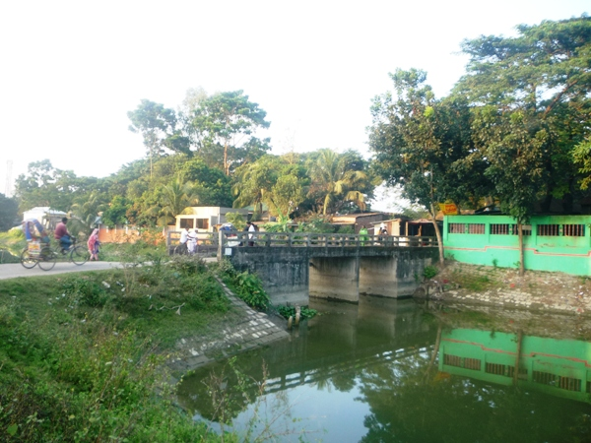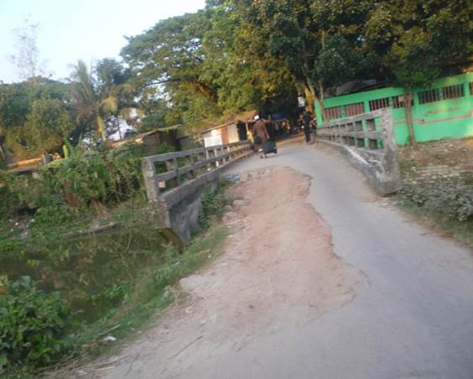

Municipal Governance and Services Project (MGSP)

Design, Supervision, and Management (DSM) Consultancy Services

Joint Venture of  Hifab International AB, Sweden  AQUA Consultant and Associates Ltd., Bangladesh |   
TABLE OF CONTENTS
 |  |  |  | Page
1.0 |  | INTRODUCTION |  | 1-3
 | 1.1 | Subproject Background |  | 1
 | 1.2 | Objectives of the Study |  | 2
 | 1.3 | Scope and Methodology of the Study |  | 2
2.0 |  | SUBPROJECT DESCRIPTION |  | 4-8
 | 2.1 | The Study Area |  | 4
 | 2.2 | Current Situation, Proposed Intervention and Need for the Subproject |  | 6
 | 2.3 | Envisaged Subprojects Activities and Implementation Process |  | 7
 | 2.4 | Category of the Subproject |  | 8
 | 2.5 | Subproject Schedule |  | 8
3.0 |  | BASELINE ANALYSIS OF ENVIRONMENTAL CONDITION |  | 9-14
 | 3.1 | Physical Environment |  | 9
 | 3.2 | Biotic Environment |  | 13
 | 3.3 | Socio-economic and Socio-cultural Environment |  | 13
4.0 |  | ENVIRONMENTAL SCREENING |  | 15-17
5.0 |  | SPECIFIC IMPACT, MITIGATION AND ENHANCEMENT MEASURES |  | 18-24
 | 5.1 | Site Clearing, Excavation and Earth Work |  | 18
 | 5.2 | Ecological Impact and Enhancement Work |  | 18
 | 5.3 | Pollution from the Storage of Construction Materials |  | 19
 | 5.4 | Air Quality and Dust |  | 19
 | 5.5 | Noise and Vibration |  | 19
 | 5.6 | Water Quality |  | 20
 | 5.7 | Occupational Health and Safety |  | 20
 | 5.8 | Impacts on Social Environment and Common Property Resources |  | 21
 | 5.9 | Labor Influx and Anticipated Impacts |  | 22
 | 5.10 | Impacts on Traffic Movement |  | 24
6.0 |  | ENVIRONMENTAL MANAGEMENT PLAN |  | 25-35
 | 6.1 | Access to Information |  | 25
 | 6.2 | Grievance Redress Mechanism |  | 25
 |  | 6.2.1 | Grievance Redress Committee (GRC) | 25
 |  | 6.2.2 | Grievance Resolution Process | 26
 | 6.3 | Institutional Arrangement for Safeguard Compliances |  | 27
 | 6.4 | Capacity Building |  | 28
 | 6.5 | Emergency Response and Disaster Management |  | 28
 | 6.6 | Environmental Management Action Plan |  | 29
 | 6.7 | Environmental Monitoring Plan |  | 33
 | 6.8 | Environmental Management Budget |  | 34
 | 6.9 | Environmental Codes of Practice |  | 35
7.0 |  | PUBLIC CONSULTATION AND PARTICIPATION |  | 36-38
 | 7.1 | Methodology |  | 36
 | 7.2 | Issues Raised by the Participants |  | 37
 | 7.3 | Feedback, Suggestions and Recommendations of the Participants |  | 37
8.0 |  | CONCLUSIONS AND RECOMMENDATIONS |  | 40
9.0 |  | Reference |  | 41
APPENDIX
 |  | Appendix I: Environmental Monitoring Checklist |  | 42

LIST OF TABLES
Table 3.1.1 | Major Environmental and Infrastructural Features
- Table 3.1.2 | Temperature, Rainfall and Humidity during 2008-2011
Table 5.7.1 | General Requirements for the Workers Health and Safety
Table 5.8.1 | Impacts on Social Environment and Common Property Resources
Table 6.2.1.1 | List of GRC Committee Members
Table 6.6.1 | Anticipated Environmental Impacts during Construction Phase and Corresponding Mitigation and Enhancement Measures
Table 6.6.2 | Anticipated Environmental Impacts during Operational Phase and Corresponding Mitigation and Enhancement Measures
Table 6.7.1 | Matrix Table of Monitoring Plan (Visual observation during construction phase)
Table 6.8.1 | Environmental Management Budget in Bill of Quantity

LIST OF FIGURES
Figure 2.1.1 | Location Map of the Subproject Site at Kuadanga
Figure 2.1.2 | Lay Out Plan of the Subproject Site
Figure 2.1.3 | Topographic Features of the Kuadanga Bridge

LIST OF PHOTOGRAPHS
Photographs 2.2.1 | Current Situation of the Existing Bridge at Kuadanga
Photographs 7.1.1 | DSM Consultant Team with Pourashava Representatives inspected the Proposed Bridge
Photographs 7.1.2 | Consultation Meeting at subproject sites with Pourashava Officials and Consultants Participants

ABBREVIATIONS

AP persons (AP’s) | Affected Person
BDT | Bangladeshi Taka
BOQ | Bill of Quantity
CC | Cement Concrete
CIP | Capital Investment Plan
CP | Contingency Planning
DSM | Design, Supervision, and Management
EA | Environmental Assessment
ECR | Environmental Conservation Rules
EMP | Environmental Management Plan
EPP | Emergency Preparedness Planning
ES | Environmental Screening
FGD | Focal Group Discussion
GoB | Government of Bangladesh
GRC | Grievance Redress Committee
GRM | Grievance Redress Mechanism
GRP | Grievance Redress Procedure
LGED | Local Government Engineering Department
MGSP | Municipal Governance and Services Project
PD | Project Director
PMU | Project Management Unit
RCC | Reinforcement Cement Concrete
RP | Relevant Reports
TL | Team Leader
WB | World Bank
XEN | Executive Engineer

1 INTRODUCTION

1.1 Subproject Background

Gopalganj Pourashava is situated at Gopalganj District. It was declared Pourashava in the year of 1972. The Pourashava area is 13.82 sq km. This is A type Pourashava with the present population of 1, 14,950. The Pourashava has 47.70 km pucca road, 4 km HBB road, 10 km brick soling road, 10 km WBM road and 17.23 km earthen road. The total pucca drain is 21 km and 17 km earthen. Also, 297 m bridge, 66 m culvert and 1205 street lights are present in this Pourashava.

In the Gopalganj Pourashava, the existing infrastructure facilities are not adequate to meet the present demand. Inefficient transport management greatly contributes to the problems in transportation system in Gopalganj Pourashava. It is noted that pedestrians are significant road users within the Pourashava. However, in the assessed roads in all intersections, pedestrians are often forced to share the same road ways with vehicular traffic due to lack of planned development of road network which is essential to meet the emergent demand. Without adequate infrastructure and services provision, it would be difficult to turn urban centers as environmentally congenial livable places. Hence, this subproject directly will contribute for the infrastructure development of the Pourashava.

The subproject includes the following components: Fancy Charming Bridge with Arch, Cables, Abutments and Wing wall.

The significant features of the subproject are stated below:
Name of the Subproject : | Construction of Fancy Charming Bridge on the Mora Modhumoti Lake at the Point of Kuadanga under Goplaganj Pourashava, Gopalganj
Package No. : | MGSP/GOP/2018-19/W-08
District Name : | Gopalganj
Pourashava Name : | Gopalganj Pourashava
Ward Number : | 1
Structural Design Option : | Fancy Charming Bridge with Arch, Cables, Abutments and Wing wall
Ward Population : | About 8,424
Tribal People : | No tribal settlement people found in the subproject area
Land Acquisition : | Gopalganj Pourashava owned. So, land acquisition is not required
Estimated Cost : | 42.703 million BDT
Subproject Duration : | 12 months
Tentative Start Date : | 05 December 2018
Tentative Completion Date : | 04 December 2019

Objectives of the Study

The general objective of this study is to determine the major environmental impacts succeeding from execution of the subproject and to recommend mitigation measures to avoid or reduce adverse environmental impacts and to enhance positive impacts. The specific objectives include:
- To assess the existing environmental conditions of the subproject site and its influence area;
- To identify and assess impacts resulting from the subproject during its construction phase and operation phase;
- To develop a environmental management plan with recommendations for mitigating impacts and enhance positive impacts;
- To summarize environmental monitoring requirements.

Scope and Methodology of the Study

The subproject appraisal is included environmental screening for all the subproject components. According to that screening, environmental assessment is required to fulfill the regulatory requirement for RCC Fancy Charming Bridge with Arch. Hence, this environmental assessment is prepared to meet the regularity requirement of this subproject. The study methodology covered the following activities:

- Desktop Study;
- Field Investigations and Data Collection;
- Data Analysis and Report Writing.

Desktop Study
The desktop study involved:
- Initial meetings with client, stakeholders to discuss the proposed subproject;
- Collection and review of the baseline data, maps, reports and other relevant information;
- Review of the relevant existing legislation, regulation and policies;
- Understand the anticipated technical processes that may affect the environment.

Field Investigation and Data Collection
A team of the consultants made a field investigation to the proposed site. Field investigations involved mainly site walks at the subproject areas for identification of the environmental components to be affected due to the subproject intervention.
The following key tasks were performed during the field visit:
- Taking photographs of the significant aspects to assist in describing the baseline environmental conditions of the subproject area;
- Interviews with representatives of the relevant Pourashava officials and beneficiary and affected people within the subproject influence zone;
- Obtaining relevant documents from Pourashava and local people within the subproject influence zone;
- Verifying information and data collected during the desktop study and to collect new information.

Data Analysis and Report Writing
The data and information collected from all the sources (literature review, secondary and primary data, public consultation) were analyzed to describe the existing environmental setting of the subproject area, to identify the potential positive and negative impacts of the proposed subproject, as well as to provide preliminary suggestions for mitigation measures. Finally, this environmental assessment report has been prepared.

SUBPROJECT DESCRIPTION

The Study Area

The subproject site is situated within the jurisdiction area of the Gopalganj Pourashava Ward no. 01. The location map, lay-out plans, and topographic features of the subproject are shown in Figure 2.1.1, Figure 2.1.2 and Figure 2.1.3.
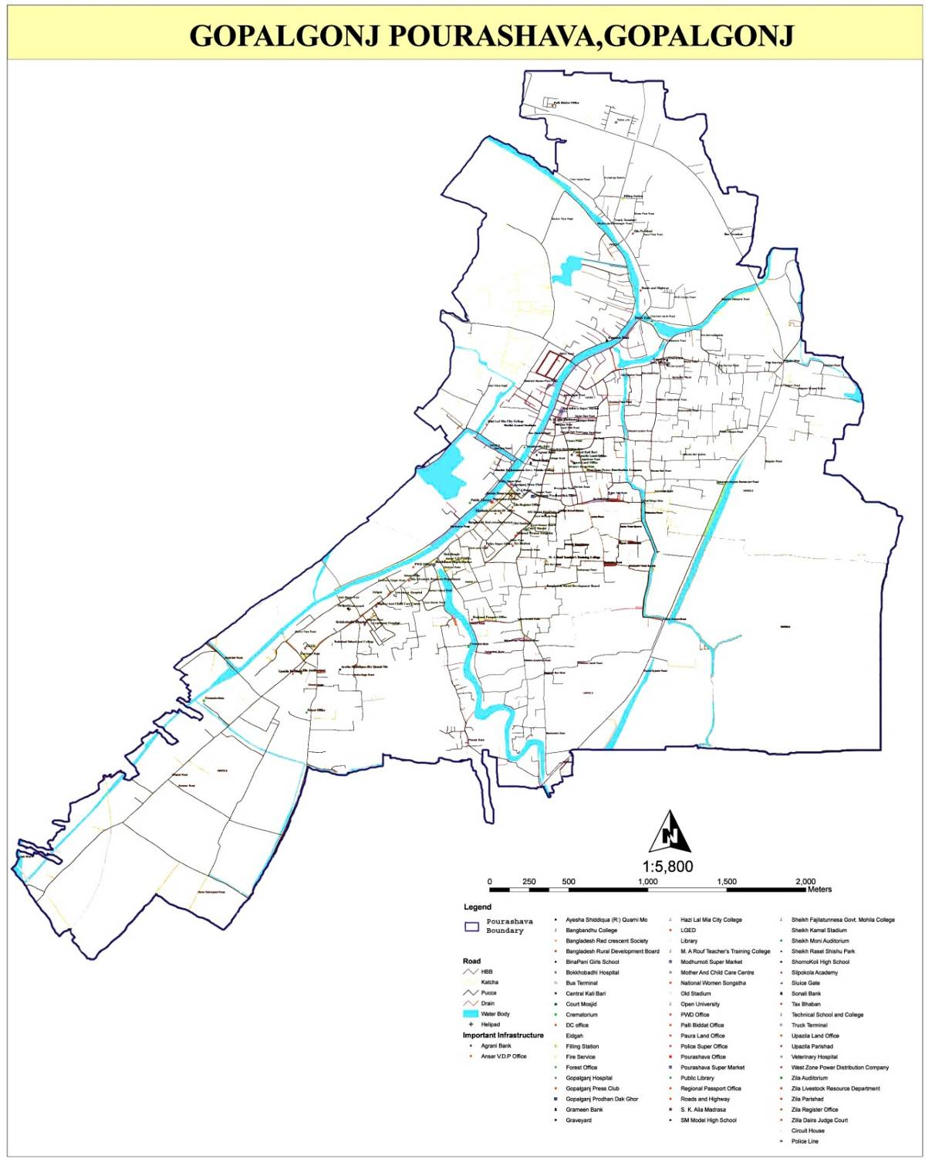

Location of Kuadanga Bridge

Figure 2.1.1: Location Map of the Subproject Site at Kuadanga

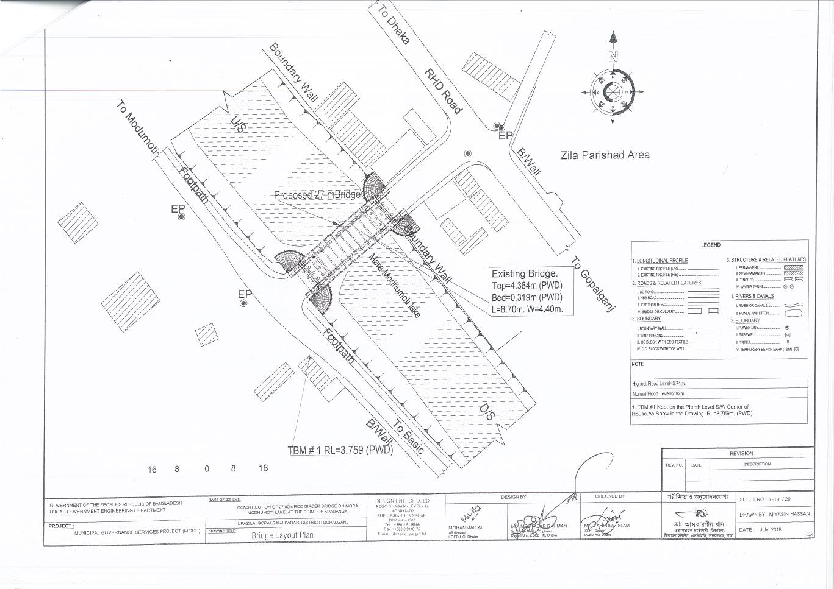

Figure 2.1.2: Lay-Out Plan of the Subproject Site

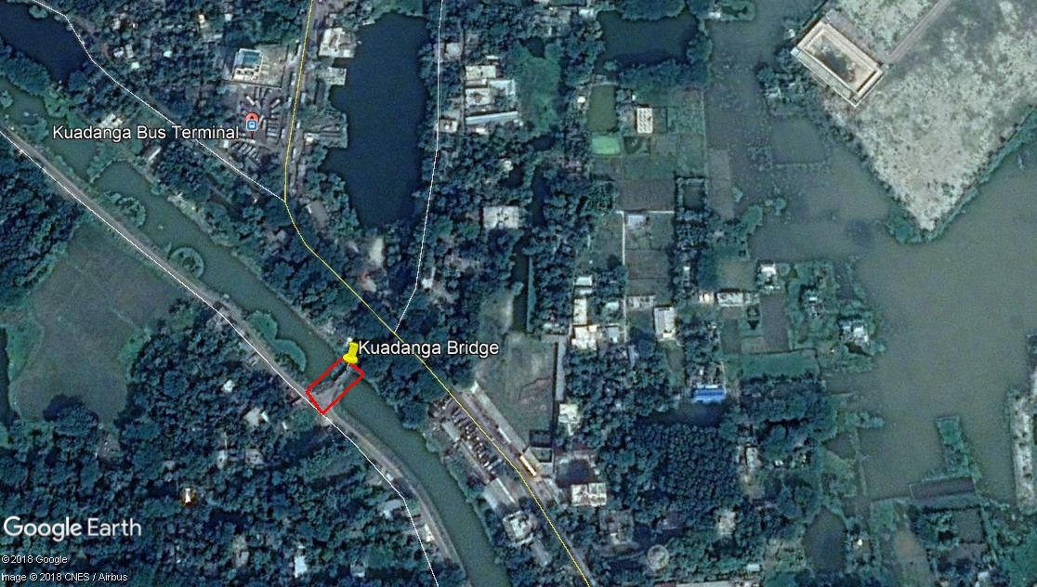
Figure 2.1.3: Topographical Features of the Kuadanga Bridge

Current Situation, Proposed Intervention and Need for the Subproject

At present, Gopalganj is category A type Pourashava. The subproject is located at wards no 1 under Gopalganj Pourashava. The existing damaged bridge will be demolished and new RCC Girder Bridge with cables, abutments and wing wall at point of Kuadanga will be constructed. The existing length and width of the bridge is 8.70 m and 4.40 m. The length of the proposed bridge at point of Kuadanga is 27 m. This bridge has two options of arch which width is 0.6 m and the width of bracing is 7.7 m. The existing condition and inspection of the proposed site is further elaborated in the following Photographs 2.2.1.
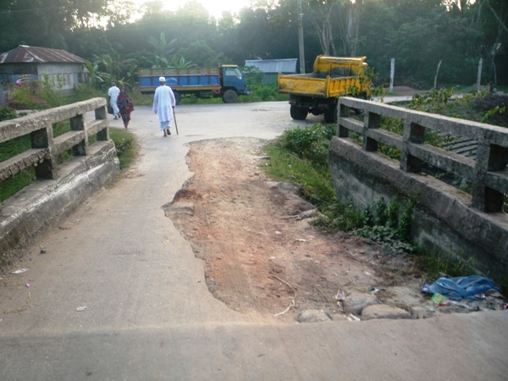

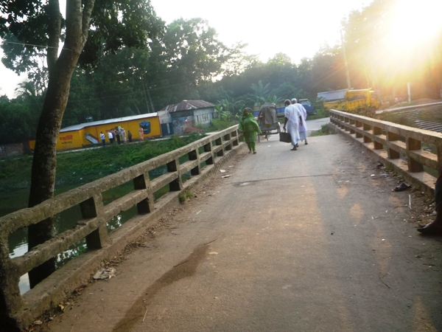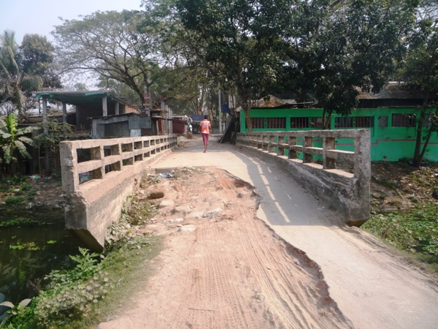

Photographs 2.2.1: Current Situation of the Existing Bridge at Kuadanga

Envisaged Subproject Activities and Implementation Process

The general activities of the subproject includes: construction of the semi-pucca site office, construction of the labor shed and relocation of the electrical poles for access road.
Specific activities for RCC Bridge:
- Earth work in excavation of foundation of structures by Long Boom hydraulic excavator;
- Pumping and bailing out of water from the interior of any foundation enclosure of work site;
- Placing of the polythene sheet for foundation work;
- Single layer brick flat soling in foundation;
- Plain cement concrete work in foundation;
- Boring for cast-in-situ piles to the required depth and specified diameter with driving temporary steel casing;
- Welding for construction of cast-in-situ bored pile;
- Breaking of the head of hardened cast-in-situ bored pile/pre-cast piles;
- Manufacturing, supplying and fitting & fixing MS shoe at RCC pre-cast pile tip;
- Back filling behind abutments, wing walls and retaining walls with selected granular material;
- Flush pointing to brick wall;
- Manufacturing and supplying plain cement concrete blocks;
- Laying single layer CC blocks of different sizes on slope of embankment;
- Laying natural additive treated woven type double warp plain weave jute geo-textile;
- Painting the vertical end of faces of posts, wheel, guard, railing, rail post, parapet wall, kilometer post, road name, plate, guide post, traffic signs etc;
- Making earthen ring/ cross bundh of required height;
- Fitting and fixing steel-laminated elastomeric/Neoprene bearings,
- Laying wearing course on deck slab of bridge;
- Fixing rainwater down pipes;
- Construction of temporary diversion road.

The materials to be used for the key activities: bricks, brick chips, stone chips, reinforcement bar, admixture, bearing pad, sand, cement, concrete, rainwater pipe, paint etc.
The major equipment to be used for the implementation of the subproject: Long-boom hydraulic excavator, brick breaking machine, pile rig for boring, concrete mixer machine, vibrator machine, MS sheet, steel cutter, steel shutter, steel drum rollers, pneumatic multiple tire roller, dump truck, water tanker, pump, generator and measuring device.

Category of the Subproject
For RCC Arch Bridge
- According to ECR 1997: Green □ Orange A □ Orange B □ √ Red □ Not Listed □
- According to WB Classification: Category B □√ Category C □
The overall anticipated adverse impact due to the subproject intervention is limited and site specific. Considering the environmental impact which is anticipated as insignificant, this subproject can be considered as Orange B as per ECR-97. According to the WB classification, it can be classified as Category B.

Subproject Schedule
The tentative schedule of construction of the subproject is:
(a) Subproject Duration (months) : 12 months
(b) Tentative Start Date : 05 December 2018
(c) Tentative Completion Date : 04 December 2019

The daily construction hours will normally include regular working time. However, daily working hours may vary based on the on-site condition. The detailed work program will be prepared by the contractor with the assistance of the PIU-Pourashava. Then it will be shared with the PMU, LGED and DSM consultants. In addition, the detailed work program will also be shared with the Bank as per requirement.

Baseline ANALYSIS OF THE ENVIRONMENTAL CONDITION

Physical Environment

Important Environmental and Infrastructural Features

During site visit the environmental and infrastructural features within the subproject area were collected. Conditional survey has also been conducted for designing the subproject. Hence, the survey data is also used for preparing the report. The environmental and infrastructural features listed within four directions of the existing bridge in Table 3.1.1.
Table 3.1.1: Major Environmental and Infrastructural Features
Bridge at Kuadanga over Mora Modhumoti Lake
Side/ Direction | Major Environmental Features
North | Boundary wall, houses, shops, trees
South | Road, footpath, electric pole, house, trees
East | Modhumoti Lake (adjacent and below the bridge)
West | Modhumoti Lake (adjacent and below the bridge)

** Note: There is no electrical pole need to be re-located for the implementation of the subproject. Due to demolition of the existing bridge, the normal traffic will be affected. Hence, diversion road is required to maintain the normal traffic during construction phase. It should also be noted that to maintain the normal water flow in the lake, 2-3 pipe will be placed beneath the diversion road.

Geology, Topography, and Soils

Topographically Gopalganj Pourashava is flat and gentle sloping. Geology of Gopalganj Pourashava is composed of Tidal Deltaic Floodplain. Gopalganj Pourashava lays the active floodplain of the Ganges and the adjoining meander floodplain. Soil developed in seasonally flooded alluvium containing lime in part or all of the upper 125 cm and with dark grey topsoil, usually there are continuous dark grey gleans as well. Generally these soils are well oxidized within subsoil pads and below the upper dark layers, usually pale brown or olive brown with few too many mottles. The town may be considered to contain land comprised of soil on artificially slightly raised platform (From the source of Muksudpur Pourashava which is one Pourashava of Gopalganj). According to BNBC (2006), Bangladesh has three seismic zones with moderate and low seismic activity. The Pourashava falls in Zone III.

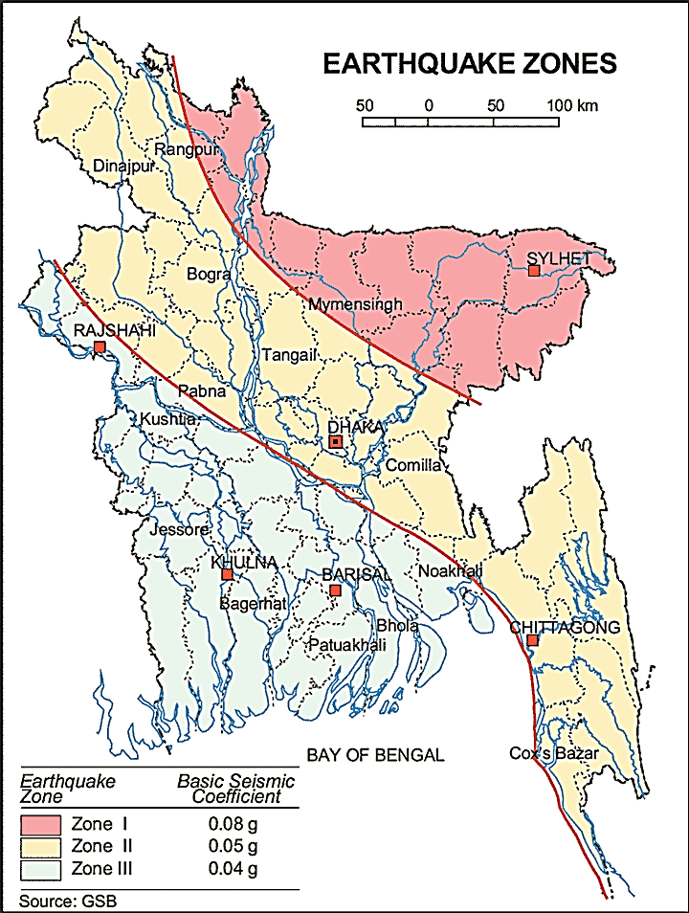

Figure 3.1.1: Location of Gopalganj in Earthquake Zone Map of Bangladesh

Climate and Meteorology

There is no meteorological station at Gopalganj Pourashava. Hence, area specific meteorological data is not available. Gopalganj Pourashava is close to Faridpur District. Hence, meteorological data for Faridpur District is used for this study.
The climate of the subproject area can be described as Tropical Monsoon. It is characterized by warm, humid summers and cool, dry winters. From November to March, it is dry and cool while from April to May it is extremely hot during the pre-monsoon season. From June to October, the monsoon season is warm, cloudy, and wet. The warmest month is April, the coolest is January, the wettest is July and the driest is January.
2011 was considered minimum temperature year which was 8.6°C and maximum temperature was shown in 2009 that was 37.4°C. The humidity was shown 63.8% in 2010 which was low whereas the highest humidity was 79.0% in 2008. The peak rainfall months in Faridpur are June, and July. About 92.26% of the total annual rainfall occurs in the period from May through October. The highest annual rainfall during the last four years (2008–11) was 1834 mm in 2008, and 587mm was the lowest rainfall which was occurred in 2010. Table 3.1.2 shows the key meteorological data from 2008 to 2011.

Table 3.1.2: Temperature, Rainfall and Humidity during 2008-2011
Years | Temperature(centigrade) |  |  | Rainfall (millimeter) | Humidity (%)
Years | Maximum |  | Minimum | Rainfall (millimeter) | Humidity (%)
2008 | 35.2 | 9.6 |  | 1834 | 79.0
2009 | 37.4 | 11.4 |  | 1224 | 75.0
2010 | 34.7 | 8.7 |  | 587 | 63.8
2011 | 23.3 | 8.6 |  | 1620 | 78.0

According to the statistics of wind data from the Bangladesh Meteorological Department Climate Division, wind direction changes by month. The northwest, south, and northeast winds are predominant.
The construction works can be influenced by the climatic condition and meteorological components like humidity, temperature, sudden rainfall, and wind speed. During high winds, there might be possibility of quick spreading of dust generated from the construction activities. It is very risky to work during rain and in high winds because the possibility of getting injury increases. Furthermore, work under high temperature and excess humidity is extremely difficult and may create dehydration problem.

Water Resources (Surface Water, Ground Water and Rain Water Harvesting)

The subproject site is located over the Mora Modhumoti Lake where water is available round the year. It is the main source of the surface water for the subproject area. This khal influence the hydrology of the municipality. Gopalganj Pourashava belongs to the hydro-geological unit II Holocene Deltaic and Flood Plains. Ground water is available at shallow depth. Groundwater is the main source of potable water in the subproject area. Groundwater is not saline and normally arsenic and iron free. The local people do not use rain water harvesting system.
Flooding, Water Logging and Drainage
According to previous data, this area is not affected in severe flood events of 1988, 1998, 2004 and 2007. Gopalganj Pourashava is free from external flooding. Flooding in the monsoon season normally starts from June to October. As per flood zoning map, Gopalganj Pourashava falls under normal flood zone. Structured and functional drainage system in this area is basically absent. Therefore, the drain is being filled up and the land floods when it rains heavily. However, Gopalganj Pourashava is subjected to internal water logging problem due to delay discharge of the storm water during monsoon season.

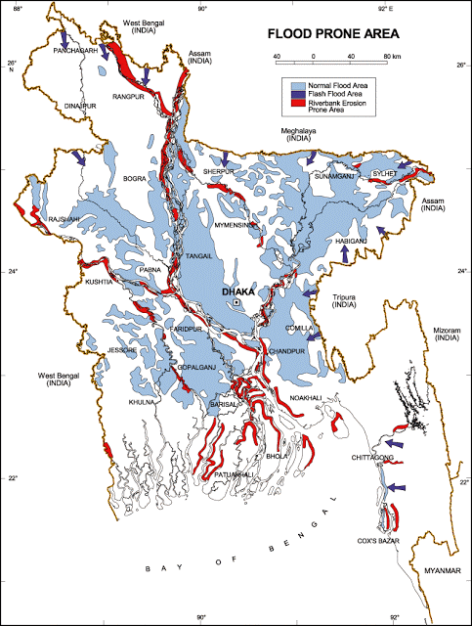

Figure 3.1.2: Location of Gopalganj Pourashava in Flood Zone Map of Bangladesh
Air Quality and Dust

The degradation of the air quality is mainly from windblown dust and emission from the vehicles. The rough surfaces of the road generate dust during vehicles movement. Improper disposal of the solid wastes also spread bad odor which causes air quality degradation. During construction phase black smoke emission from mechanical compactor, hydraulic excavator and vehicles used for transportation activities may degrade the air quality.
Noise Level
Noise is generated mainly from the vehicles movement and hydraulic horn. As it central area of the Pourashava, the noise is generated due to public gathering. During construction phase mechanical compactor, hydraulic excavator and vehicles used for transportation activities may create temporary noise nuisance within the subproject boundary.

Solid Waste Management

Condition of solid waste management at Gopalganj Pourashava is another part to give attention for the Poura authority because in some wards within the Pourashava, people are not getting this facility in proper way. They are suffering much in this concern. Gopalganj Pourashava generates a massive quantity of solid waste everyday from various sources. In the absence of any specific rule and criteria for placing the dustbins, most of the household don’t use the dustbin properly. As a result, they dispose their waste on roads, drain sides, low-lying areas or individual’s backyards. Basically all wastes are being dumped in a low-lying suburban area. Practically, there is no well organized solid waste management/disposal system in the Pourashava. This Pourashava has only one dumping ground which is the vacant place of Manikda. Hence, the generated wastes due to construction activities will be dumped at this same place of the Pourashava.

Biotic Environment

Flora and Fauna

There are some road side planted trees include Koroi, Banana, Coconut, Mahogany, Papaya and Mango. The common local birds such as Doel, Shalik, Kite, Owl, Crow, Tuntuni, Bulbuli, and Cuckoo in Bengali were found during the site visit.

Socio-economic and Socio-cultural Environment

Land Use, Status of Housing and Built-up Infrastructure
The land use pattern in the subproject area consists of mixed land-use pattern. The important features of the subproject area includes: Bangabandhu Road, residential houses, different shops, offices, boundary wall, trees and Mora Modhumati Lake.
Beneficiary Population
The subproject is situated within the jurisdiction of the ward number 01.Considering the ward population about 8,824 people will benefit directly and many others indirectly.

Education
In the Pourashava area, literacy among the population is about 78.6%. This is higher than the national average (51.8%). The literacy rate among males (81.0) is still more than females (76.1). (Ref: Population and Housing Census 2011).

Tribal Communities
There is no indigenous or tribal people settlement in the subproject area. Hence, no measures needed for the indigenous peoples’ safeguard.

Land Acquisition

Private land acquisition is not needed. For site clearing, there is no need demolition work. However, land acquisition is not issues for the implementation of this subproject. In addition, the MGSP social experts will evaluate the applicable social issues and corresponding mitigation measures will be given accordingly.
Principal Livelihoods and Economic Activities
The subproject area is inhabited by the mixed occupational people. In the Pourashava area, major income comes from business, enterprises, small trades, private sector jobs, and government jobs in the town.
Cultural Heritage and Protected Areas
During site visit it was observed that there is no protected and important cultural or historical site in the subproject influence area.
Social Conflicts and Development Activities

The local people welcome the subproject and there is no conflicts between the local communities regarding subproject implementation.

ENVIRONMENTAL SCREENING

Environmental Screening (ES) for the subproject has been conducted with the purpose of fulfilling the requirements of Government (GOB) and World Bank (WB) for the preparation of subproject appraisal. Environmental Screening Checklist, as adopted in Appendix C of the Environmental Management Framework (EMF) of the MGSP, was administered for identifying the impacts and their extents.
The screening data and information for the proposed RCC Arch Bridge have been formulated and are shown in below.
1) Potential environmental impact during construction phase:
(a) Ecological impacts:
6
- Felling of trees Significant □ Moderate □ Minor □√ Number of trees
- Clearing of vegetation Significant □ Moderate □ Minor □√
- Potential impact on species of
aquatic (i.e., water) environment Significant □ Moderate □ Minor □√

There are 6 trees to be felled down due to construction of the bridge. Clearing of the vegetation is considered as minor because bridge will be constructed at the same locations where very few aquatic vegetation needs to be cleared. Considering the felling of trees and the amount of clearing of vegetation, ecological impact is minor. The bridge construction activity will be executed in very limited area especially in dry season with low water level. The construction work will be completed with the minimum time. For bridge construction, to maintain the normal water flow in the lake, cast-in-situ pile work, foundation work and wing wall will be constructed section wise. If needed, under the earthen ring bundh 2-3 pipes will be placed to maintain the water flow for bridge construction. The works that need to be performed at aquatic environment is limited. Hence, the anticipated impact on the aquatic environment due to the construction activity is minor. Based on the analysis, the overall ecological impact is considered as minor.
- Physicochemical impacts:
- Noise pollution Significant □ Moderate □√ Insignificant □
- Air pollution Significant □ Moderate □√ Insignificant □
- Drainage congestion Very likely □ Likely □ Unlikely □√
- Water pollution Significant □ Moderate □ Insignificant □ √
- Pollution from solid/ construction wastes Significant □ Moderate □√ Insignificant □
- Water logging Significant □ Moderate □ Insignificant □√
The length of the proposed bridge is not so high. Nearby residential houses are very few at the construction site. The construction work will be completed with the minimum time. Hence, overall impact on noise and air due to subproject activities is anticipated as moderate. The subproject activities such as cast-in-situ pile work, using of the concrete mixer machine, vibrator machine and movement of the subproject vehicles may generate noise. However, it is anticipated that it will be limited and within the tolerable limit. Black smoke emission from concrete mixer machine, vibrator machine, hydraulic excavator etc. may degrade the air quality. However, well maintained equipments and proper handling of the equipments will minimize the impacts on the air quality. The subproject activities do not have any likely impact on water congestion and water logging problem. Bailing-out of water for execution of the activities will be performed as per requirement. The generated wastes due to the subproject activities may degrade the quality of the surrounding environment especially water body if not properly collected and disposed-off. The subproject does not have any likely adverse impact on the topography, climate, soils & regional hydrology.
- Socio-economic impacts:
- Traffic congestion Very likely □ Likely □√ Unlikely □
- Health and safety Significant □ Moderate □√ Insignificant □
- Impact on archaeological and historical Significant □ Moderate □ Insignificant □√
- Employment generation Significant □ Moderate □√ Insignificant □

Demolition of the existing bridge will have impacts on the pedestrians and traffic movement. However, prior to the construction work to be started, earthen diversion roads will be constructed to maintain normal movement. Hence, the subproject activities do not have severe impacts on the local traffic. The bridge construction does not require heavy machineries and complex procedure. Hence, it is anticipated that health and safety risks will be moderate. However, careless workmanship during boring and cast-in-situ pile works may cause severe health hazard. If safety gear is entirely used by the workers, anticipated health and safety risk will be minimum. There is no real historical site at the subproject area. The subproject will have positive social impact by generating employment opportunity.
2) Potential environmental impact during operational phase:
(d) Ecological impacts:
- Potential impact on species of aquatic Significant □ Moderate □ Minor □√
(i.e., water) environment
The anticipated impact on the aquatic environment is insignificant due to operation of the bridge.
(e) Physicochemical impacts:
- Potential air quality and noise level Improvement □ No-improvement □ Deterioration □√
- Drainage congestion Improvement □ Minor Improvement □√ No Impact □
- Risk of Water pollution Significant □ Moderate □ Minor □√
- Pollution from solid waste Improvement □ No-improvement □ Minor □√

After completion, increased traffic volume may degrade the air quality and noise level due to black smoke emission and un-due use of hydraulic horn from vehicles. The bridge will divert water from one side to another side properly. Thus, it will improve tidal flow at the bridge position in the Modhumoti Lake.
(f) Socio-economic impacts:
- Traffic Improvement □√ No-improvement □ Adverse □
- Safety Improvement □√ No-improvement □ Adverse □
- Employment generation Significant □ Moderate □√ Minor □

The subproject will have significant positive impact after completion. It will enhance transport facilities and traffic safety.
(3) Summary of the possible environmental impacts of the subproject:
6 nos. of trees will be felled down which will be the main reason of ecological impact. There will be temporary negative impacts on physico-chemical environment. Nevertheless, these impacts are manageable if mitigation measures are taken according to EMP.
The wastes generated due to the construction activities should be properly collected and disposed in a designated dumping site. The inputs that may affect the environment will be mainly at construction phase. Moreover, mitigation measures will be taken according to the EMP for minimizing the environmental pollution.
Using of the pile rig, cutter machine and other mechanical equipment may cause potential safety risks. Hence, safety concern is an important issue during construction phase that should be considered properly. This subproject will have positive impacts in terms of the generation of the employment and business activities by supplying construction materials and equipment. However, it has significant positive social impacts.

Specific impact, mitigation AND enhancement measures

The likely impacts of the subproject are mainly caused by the activities required for the implementation of the subproject, and materials, resources and equipment to be used to perform the activities. This section describes some specific impacts due to the subproject activities and their mitigation measures.

The likely impacts of the subproject are mainly caused by the activities required for the implementation of the subproject, materials, resources and equipment to be used to perform the activities. This section describes some specific impacts due to the subproject activities and their mitigation measures.

  - Site Clearing, Dismantle, Excavation and Earth Work

The subproject works includes earth excavation, earth filling and dismantling of existing bridge. These works lead dust blowing, improper disposal of the wastes, noise and vibration which may disturb the local people.

Mitigation Measures

- Proper care will be taken by the contractor during site clearing work, excavation work, earth work and disposal work to avoid any undue disturbances to the nearby people;
- Cover exposed earth works and other wastes materials with fabric;
- Disposal of soil and construction wastes to designated dump site at the vacant place near Manikda;
- Avoid loss of the topsoil for the earth work.

  - Ecological Impact and Enhancement Work

The overall ecological impact due to the subproject implementation is minor because there are 6 numbers of small size trees (in terms of length and diameter) to be felled down. In addition, few aquatic plants (Water hyacinth) need to be cleared at proposed culverts and bridge location. However, measure is taken to enhance ecological condition in the subproject area.
Enhancement Measures

- Tree plantation to compensate the felled down trees and enhance the ecological condition in the subproject area- preferably local fruits, flowers, medicinal and ornamental trees-Mango, Jam, Jackfruit, Kathbadam, Mahanoy, Neem, Krisnachura, Jarul, Shimul, Polash, Sonalu, Bokul, Kadom (including protection, fencing and conservation during project defect liability period): Preferably at lake side area beside footpath where space is available-15 nos. of trees.
- Planting trees will enhance the ecological balance of the area after their successful growth.
  - Pollution from the Storage of Construction Materials
Dumping of the construction spoils, including accidental leakage of the oil, grease, and fuel in equipment yards is a significant hazard. Both surface and groundwater might be polluted from these contaminants. Air pollution and dust may affect the nearby settlement which is generated from fine aggregate such as sand and vehicles.
Mitigation
- Safe transport, storage, and disposal of the construction materials and the equipment have to be carried out in order to avoid the accidental spillage and loss;
- Maintain adequate moisture content of soil and sand during transportation, compaction and handling;
- Carry the materials especially loose soil and sand with adequate cover.
- Fuels, lubricants, and other hazardous materials should store over raised platforms and not directly on the ground;
- The playgrounds of the educational institutions should not use as a stockyard or work campsite.
  - Air Quality and Dust
During the construction phase, air pollutants will be emitted from the equipment and construction vehicles are expected to remain low. There are very few residential houses are located near subproject site. Hence, it will have very limited impacts in the nearby residential area. Limited dust generation and black smoke emission from the equipment and construction vehicles may temporarily disturb the workers. The overall impacts, however, are expected to remain very low.
Mitigation Measures

- When dust is visible water should be sprayed to control the dust;
- Maintain adequate moisture content of sand for handling, transportation, and compaction;
- Avoid use of dust generating equipment which produce significant amount of particulate matter far from the local residents;
- Ensure that all subproject vehicles are in good operating condition.

  - Noise and Vibration

Noise and vibration may be generated due to cast-in-situ pile work for Bridge, from the movement of the subproject vehicles, using of concrete mixer machine and vibrator machine etc. It may temporarily disturb the nearby people. Since, there are very few residential houses are located near subproject site, it will have very limited impacts in the nearby residential area. The impacts are anticipated to be limited and within the tolerable limit.
Mitigation Measures

- Transportation of the construction materials have to be carried during the scheduled times, and mainly during the day;
- Casting work should be performed during the scheduled times;
- Avoid use of rod cutter, concrete mixer machine and vibrator machine at night.

  - Water Quality

There is no remarkable sources of the water pollution have been found. The water quality may deteriorate if the construction materials, construction wastes, effluent from work camps, and food waste are dumped in low land, and open place. During rain, the storm water may carry these substances and discharge to the nearby water bodies.
Mitigation
- Proper construction management including waste management as well as training of the operators and other workers should provide to avoid pollution of the water bodies;
- Construction waste will dispose properly (not in water bodies or lowland), for which contractor will be responsible.

  - Occupational Health and Safety

The most important risks associated with the construction activities are listed below:
- Exposure to the sunlight- workers are being exposed to the sun for long hours;
- Exposure to the high temperature, and humidity for a long time resulting in dehydration;
- Contact with the hazardous substances and wastes pose risks of the infections and diseases;
- Risk of the poor air quality due to dust;
- Risk of the collision (traffic);
- Risks from the head loads for carrying materials;
- Risks of using of the machinery in motion such as rod cutter;
- Risk associated to the sudden bad weather working conditions;
- Risk associated due to haphazard work by the workers.
General Requirements for the Workers’ Health and Safety

The key salient features of the general requirements for the workers’ health and safety stated is presented in Table 5.7.1.
Table 5.7.1: General Requirements for the Workers Health and Safety

Issues | Requirements
Health and Hygiene | - Cleanliness at the site premises and workers living places and at the Labor Shed;  - Arrangement of the proper ventilation and temperature at the Labor Shed;  - Protection against dust and furnace by using of the nose masks and covering of the head and body;  - Proper disposal of the wastes and effluents;  - Provision of the adequate latrines and separate toilets for the women;  - Sufficient dustbins for the solid waste management system.  - The labor shed shall be with the facilities like; mosquito nets, cooking arrangement, water supply, waste bins, lighting etc.  - Potable water supply for drinking and other purposes
Safety and First Aid Box | - Using of the personal protective equipment (helmet, gloves, ear plug, goggles, nose mask, safety boots);  - Precautions during work on or near machineries in motion;  - Head loads are prohibited;  - First aid facilities should be provided and maintained;  - Ensure first aid box with the necessary medicine at the labor shed;  - The first aid kit should include adhesive bandages, regular strength pain medication, gauze, and low grade disinfectant.
Compensation for Accidents at Work | - Contractors will bear medical treatment costs. If any severe accidents such as loss of hands, legs or loss of working ability or any case of death needs compensation-(the amount of the compensation should be fixed considering the type of accidents).
Dust and Fumes | - For any dust, fumes, or other impurities likely to be injurious to the workers, effective measures shall be taken to prevent their accumulation and its inhalation by the workers.
Overcrowding | - No labor room should be overcrowded.
Latrines and Urinals | - Sufficient latrines shall be provided;  - Latrines shall be maintained in clean and sanitary condition;  - Latrines shall be adequately lighted and ventilated.
Disposal of Wastes and Effluents | - Proper disposal system for the solid waste and effluent is required;  - Waste bins must be provided by the contractor at labor shed.

  - Impacts on Social Environment and Common Property Resources

Through comprehensive study, it is revealed that impacts are expected not to be severe and to be largely manageable. The following Table 5.8.1 presents impacts on socio-economic environment and common property resources.
Table 5.8.1: Impacts on Social Environment and Common Property Resources
Social Components | Impacts on IECs | Impact Significance
Community Perception | The local community people welcome this subproject and there is no visible objection from them. | Significant (+ve)
Employment and Business Opportunity | Community feels happy because generally the local contractor will be engaged for the construction works which will create work opportunity for the skilled and non-skilled labor. The subproject will create business opportunity for the equipment and materials suppliers’. | Significant (+ve)
Community Order and Security | This subproject activity does not create any severe security problems to the local community and community people. | Minor  (-ve)
Possible damage to existing infrastructure and facilities | Degradation of the existing road by the construction equipment/vehicles used in this subproject. | Minor  (-ve)
New infrastructure and facilities | Construction of new bridge and road will enhance municipality infrastructure facilities. | Significant (+ve)
Labor Habitat | Most of the labors will stay at the Labor shed which will have impacts on the environment relates to the generation of the solid wastes, effluent, and water consumption. | Moderate  (-ve)
Health Care | Workers may suffer from the dehydration problems, and other health hazards. | Minor  (-ve)
Accident | In case of road accidents by the vehicles to be used for the transportation may have serious negative impact. | Significant  (-ve)

Mitigation Measures

- Conduct dissemination with the local community about the subproject details;
- Continue liaison with the community leaders in order to maintain the community support;
- Engage local contractor and local people as much as possible for positive perception of the local community;
- Follow traffic rules to avoid any accidents;
- Transportation and mobilization of the equipments and construction materials avoiding peak hours and scheduled time;
- Ensure first aid facilities and effective use of personal protective equipments where applicable.

  - Labor Influx and Anticipated Impacts

The labor force and associated goods and services required for the construction of infrastructure civil works under this subproject cannot be fully supplied locally. The migration to and temporary settlement of laborers in the subproject, referred to as labor influx, carries an array of potentially positive and negative impacts in terms of demands on public infrastructure, utilities, housing and sustainable resource management and the strain on social dynamics.
Labor influx effects on host communities include positive impacts such as:

- The subproject activities will generate work opportunities for the local people and supplying of the construction materials, equipment, food and other necessary stuffs to the campsite;
- Improved infrastructure and public service access and availability whereby subproject investment catalyzes larger allocation of resources to a region, stimulating the development or expansion of infrastructure and public services.

Critical negative social risks include:
- Increase in criminal activity and alcohol and drug abuse, domestic violence, political attachment and violence, smuggling and robbery etc;
- Increase in gender-based violence, including eve teasing, sexual harassment etc;
- Increases in communicable diseases, including respiratory problems, diarrheal diseases, vector-borne diseases (e.g., malaria), and sexually transmitted infections (e.g., HIV/AIDS, syphilis, gonorrhea, hepatitis B);
- Conflicts arising from increased demand on existing infrastructure, services, and utilities, including transportation, health, education, water and sanitation, waste management, public utilities and community, religious, and recreational facilities and loss of land for access routes.

The general environmental impacts of labor influx include pressure on the natural resources such as using of the water, electricity, other fuel for cooking, loss of land for the labor establishment, depletion of the water supply, sewage and waste water generation, degradation of the air quality, waste generation, increased demands on the local energy and resources and noise pollution effects. The number of local and migrated people involved in the subproject activities can be only identified in the construction phase. Hence, these specific impacts will be quantified during construction work and environmental assessment report will be modified accordingly. However, the following safeguard measures are recommended to avoid any risk of labor influx:

- Inform local people about the subproject activities;
- Liaison with the community leaders in order to get community support;
- Engage local people as much as possible to minimize workers from outsiders;
- Monitor workers attitude and behavioral matter;
- Monitor the workers movement for avoiding any unexpected social activities (robbery, crime, political attachment and conflicts, drugs abuse);
- Inform and use local administration to get support if needed;
- Inform local utilities service providers (such as for new electricity connection REB or any other department);
- Ensure effective use of natural resources such as water, electricity, fuel, wood etc.

  - Impacts on Traffic Movement

At present, the fancy charming arch bridge over Mora Modhumati Lake is used by different vehicles which are not huge numbers. Few rickshaws, bicycle users and bikers can use this bridge. Hence, the subproject activities do not have any likely impacts on the local traffic system.
During construction phase, interruption of the traffic movement and impact on the local traffic system due to the subproject activities will be monitored closely. Then separate traffic management plan will be provided if required. However, the following safeguard measures are recommended to minimize the impacts associated to the traffic movement:

- Inform local people about the subproject activities;
- Inspire local people to use connecting and diversion roads;
- Ensure schedule deliveries of material/ equipment during off-peak hours;
- Place traffic sign/cautionary sign to avoid undue traffic congestion and associated traffic control measures to limit possible disruption;
- The place of construction works should be fenced off with fences if required and should be isolated from general public access and marked with signs to ensure safe movement.

Environmental Management Plan (EMP)

The purpose of the Environmental Management Plan (EMP) is to ensure that the activities are undertaken in a responsible and non-detrimental manner. The EMP will guide the environmentally sound construction of the subproject and ensure efficient lines of communication between the Project Management Unit (PMU, LGED), Project Implementation Unit (PIU) of Gopalganj Pourashava, DSM, and the contractors.

Access to Information
The environmental assessment report should be translated into Bengali and disseminated locally. The copies of the report (both in English and Bengali) will be sent to all the concerned personnel responsible for subproject implementation. It will also be made available to the public. The final assessment report will also be uploaded in the LGED website and the World Bank website after approval.

Grievance Redress Mechanism
The project-specific Grievance Redress Mechanism (GRM) has been established by the PIU of Gopalganj Pourashava to receive, evaluate, and facilitate the solution of APs concerns, complaints and grievances concerning the social and environmental performance of the subproject. The GRM is aimed to provide a time-bound and transparent mechanism to voice and resolve social and environmental concerns linked to the subproject.
The grievance mechanism is related to resolve the risks and adverse impacts of the subproject. It addresses APs’ concerns and complaints promptly, using an understandable and transparent process that is also gender responsive, and culturally appropriate. It is readily accessible to all segments of the affected people at no costs and without retribution. The mechanism should not impede access to the country’s judicial or administrative remedies. The affected people will be appropriately informed about the mechanism.
LGED has its own Grievance Redress Procedure (GRP), which it operates to address any dissatisfaction and complaints by the local people regarding its activities. This procedure is being applied to address any complaints or grievances through negotiations with the community leaders and representatives of the APs during implementation of the MGSP.

Grievance Redress Committee (GRC)
The discussions and negotiations will be conducted by the PIU of Gopalganj Pourashava and will be involved the APs and Grievance Redress Committee (GRC) headed by The Mayor. With the facilitation of DSM, the Mayor nominated the GRC members and included representative from the Government Agencies, local NGO, and Civil Society. The GRC has been formed and established at Gopalganj Pourashava. The grievance box has already been delivered to the Pourashava to receive complaints. The grievance response focal point is available at Pourashava for instant response to an aggrieved person. It will receive written complaints or suggestions, and produce them to the GRC for hearing and resolution. The GRC includes the following key members.
Table 6.2.1.1: List of GRC committee members
No | GRC Member Name | GRC Designation | Self Position
1 | Mayor, Gopalganj Pourashava | Chairman | Mayor, Gopalganj Pourashava
2 | Executive Engineer, Gopalganj Pourashava | Member Secretary | Executive Engineer, Gopalganj Pourashava
3 | Assistant Commissioner | Member | Assistant Commissioner DC office
4 | Md. Mahe Alam | Member | Head Teacher Sharnokoli High School
5 | Md.Sazzad Ahmed | Member | S,G,S Gopalganj
6 | Md. Rafiqul islam Mintu | Member | Civil Society Representative
7 | Female Ward Councilor | Member | Related Female Ward Councilor (Reserved Seat)
8 | Ward Councilor | Member | Related Ward Councilor
9 | Sheikh Saidul Haque | Focal Point | Assistant Engineer, Gopalganj Pourashava

Grievance Resolution Process
All complaints and suggestions will be received formally in the Pourashava Office by the GRC Member Secretary. A sample Grievance Redress Form has been prepared and sent to the GRC and Gopalganj Pourashava prior to the implementation of the subproject.
An intake register has been maintained at the office of the Member Secretary of Gopalganj Pourashava. Member Secretary takes the details of the grievances in the intake register for documentation and ensures impartiality, fairness, and transparency. The intake register has data and information columns including (i) Case no., (ii) Date of receipt, (iii) name, type of complaint, grievance, (iv) father’s name, husband’s name, (v) sex, (vi) complete address of the person raising the complaint, grievance, (vii) main objection (loss of land, property, or entitlement), (viii) detailed complaint story and (ix) expectation with documentary evidence and previous records of similar grievances, etc.
No GRC members are allowed to contact the aggrieved persons in advance. Rather, the concerned persons are informed to attend the formal hearings at an appointed date. The GRC committee will sit for hearing the complaints of the aggrieved persons. The GRC will record salient points presented by the aggrieved person and will examine documentary evidence submitted during informal hearings. A resolution register will be maintained by the Member Secretary at the Gopalganj Pourashava Office. The resolution register will contain (i) serial no., (ii) case no., (iii) name of complaint, (iv) complaint story and expectation, (v) date of hearing, (vi) date of field investigation (if any), (vii) results of hearing and field investigation, (viii) decision of GRC, (ix) progress (pending, solved) and (x) agreement or commitments. Closing register will keep records such as, (i) serial no., (ii) case no., (iii) name of complaint, (iv) decision and response to complaints, (v) mode and medium of communication, (vi) date of closing, (vi) confirmation of complainant’s satisfaction and (vii) management actions to avoid recurrence.
The GRC will decide within 30 days of receiving a complaint. There will also be an appeals procedure where, if a person is dissatisfied with the ruling of the GRC, he or she or a representative may attend their next meeting to present the case again. The committee will then reconsider the case in private, after which their decision is final. If the appellant is still not satisfied, then GRC will refer the complaint with the minutes of the hearings to the PD-LGED for further review. If the case at this level is again found unacceptable by the aggrieved person/s, PD, LGED will advise the Pourashava to drop the subproject. Gopalganj Pourashava should also publish the outcome of cases on public notice boards. All costs involved in resolving the complaints (meetings, consultations, communication, and information dissemination) will be borne by the Pourashava.
Based on consensus, this procedure will help to resolve issues or conflicts amicably and quickly, saving the aggrieved persons from having to resort to expensive, time consuming legal action. The procedure will however, not pre-empt a person’s right to go to the courts of law.

Institutional Arrangement for Environmental Safeguard Compliance
In the institutional arrangement procedure, Project Director, Team Leader/Deputy Team Leader will directly involve. The PD and TL/DTL would be supported by DSM Environmental Safeguard Specialist and Social Management Specialist. The Pourashava Officials, especially engineers, would be responsible for supporting the construction supervision with the facilitation of DSM consultants. The civil works contractors will implement the environmental mitigation measures.
The PMU, with the help of Environmental Safeguard Specialist and Social Safeguard Specialist will submit the monthly monitoring reports on Environmental and Social Compliances to the World Bank.

PD-MGSP

TL/DTL-DSM

Environmental Safeguard Specialist-DSM

Social Management Specialist-DSM

Senior Municipal Engineer-DSM

Junior Environmental Specialist-DSM

Assistant Municipal Engineer-DSM

Social Management Officer-DSM
Pourashava Representative/ Focal Point/ Engineer

Contractor
Figure 6.3.1: Environmental and Social Management Team (Tentative)

Capacity Building
A demonstration training program has already been conducted by the PMU and DSM in Comilla region to build the capability of the PMU, PIUs and DSM field staffs. Similar capacity building workshop will also be conducted in the Narayanganj region to develop the capability of the PMU, PIUs and DSM field staffs. This workshop will be conducted by the PMU and DSM Consultants. The participants from the Gopalganj Pourashava will attend in this training program. Under this training program PMU and DSM will organize an introductory course for the training of the Gopalganj Pourashava officials, preparing them on: (i) Environmental Screening, (ii) EMP Implementation, including environmental monitoring requirements related to mitigation measures; and (iii) taking immediate action to remedy unexpected adverse impacts or ineffective mitigation measures found during the course of the implementation. The contractor should be also included in the training program to enhance the Environmental awareness and orientation among the workers. A detailed training manual has already been developed by the Environmental Safeguard Specialist prior to the demonstration training program in Comilla region. Hence, the existing manual will be reviewed and modification will be done as per requirement.

Emergency Response and Disaster Management
Disaster management can be defined as the organization and management of
resources and responsibilities for dealing with all humanitarian aspects of emergencies, in particular the preparedness, response and recovery to lessen the impact of disasters. Emergency Preparedness Planning (EPP) and Contingency Planning (CP) are the processes of disaster management plan for developing strategies, arrangements, and procedures to address the humanitarian needs of those adversely affected by the crisis. There are four main types of disasters, namely: Natural disasters, Environmental Emergencies, Complex Emergencies, and Pandemic Emergencies.
For MGSP activities, Gopalganj Pourashava would identify the immediate needs, prioritize the tasks, and identify resource requirements to address the humanitarian needs of those adversely affected by the crisis.

Environmental Management Action Plan
The activity wise anticipated environmental impacts and corresponding mitigation measures have been outlined in Table 6.6.1 and Table 6.6.2

Table 6.6.1: Anticipated Environmental Impacts during Construction Phase and Corresponding Mitigation and Enhancement Measures
Activity / Issues | Potentials Impacts | Proposed Mitigation and Enhancement Measures | Responsible Parties
Construction and operation of labor shed for the workers (Workforce and labor shed management ) | - Generation of sewage and solid waste may cause environmental pollution in the surrounding area | - Construction of sanitary latrine at the labor shed (consider 15 person for one toilet, separate toilet for male and female);  - Erection of “no litter” sign, provision of waste bins/cans (separate waste bins for organic and inorganic wastes );  - Ensure wastes (solid wastes and other forms of the waste) disposal at the Manikda. | Contractor  Monitoring-  Primarily by Pourashava  Secondarily by PMU,LGED  and DSM  Contractor  Monitoring-  Primarily by Pourashava  Secondarily by PMU,LGED  and DSM  Contractor  Monitoring  Primarily by Pourashava  Secondarily by PMU, LGED and DSM
 | - Health of workers | - Conduct formal and unofficial discussion to increase awareness about hygiene practices among the workers;  - Ensure availability and access to first-aid equipment and medical supplies for the workers.
 | - Possible development of labor camp into permanent settlement | - Contractor to remove labor camp at the completion of contract.
 | - Outside labor force causing negative impact on health and social well-being of local people | - Ensure that contractor employ local work force to provide work opportunity to the local people and conduct formal and unofficial awareness program for the health and social well-being of the local people.
General construction work | - Drainage congestion and flooding | - Ensure provision for adequate drainage of storm water if needed;  - Ensure provision for pumping of congested water if needed;  - Ensure adequate monitoring of drainage effects, especially if construction works are carried out during the monsoon season.
General construction work | - Air pollution | - Check regularly and ensure that all the subproject vehicles and equipment are in good operating condition;  - Ensure contractor spray water on dry surfaces/ unpaved to reduce dust generation;  - Maintain adequate moisture content of the sand;  - Ensure contractor sprinkle water and cover stockpiles of loose materials (e.g., fine aggregates);  - Inform local people about the subproject activities and potential impact;  - Cover loaded truck used for carrying sand with tarpaulin/other suitable material to prevent spreading by air blown.
General construction work | - Traffic congestion, effect on traffic and pedestrian safety | - Ensure schedule deliveries of materials/ equipment during off-peak hours;  - Place traffic sign/cautionary sign to avoid undue traffic congestion if required;  - Shifting of the existing bamboo shako at convenient nearby area to maintain pedestrian movement;  - Construction of diversion road before demolition of the bridge and culverts to maintain traffic movement.
General construction work | - Noise pollution | - Check and maintenance the equipment properly;  - Avoid using of construction equipment such as concrete mixer machine, pile driving equipment (pile rig, winch machine), vibrator machine that produce excessive noise at night;  - Avoid prolonged exposure to noise (produced by equipment) by the workers;  - Regulate use of horns and avoid un-due use of hydraulic horns by subproject vehicles;  - Inform local people about the subproject activities and potential impact.
General construction work | - Felling of trees, clearing of vegetation and ecological disturbances | - 15 nos. of the trees will be planted at lake side area beside footpath where space is available to enhance the ecological condition.
General construction work | - Disturbances to the aquatic environment | - Avoid complete closing of the channel that affects reproduction of aquatic species;  - Any illegal discharge of waste water, leaked oil shall be prohibited.
General construction work | - Accidents | - Conduct formal and informal discussion for creating awareness about the accident;  - Provides PPEs and ensure using of the personal protective equipment by the workers.
General construction work | - Spills and leaks of oil, toxic chemicals | - Proper handling of lubricating oil and fuel so that it does not fall on the soil;  - Collection and proper disposal of spills;  - Refueling and fuel tank should not be placed on the ground directly.
All construction works | - Beneficial impact on employment generation | - Employ local people in the subproject activities as much as possible;  - Give priority to poor people living within subproject area in subproject works (e.g., excavation and other works, which do not require skilled manpower);
All construction works | - General degradation of the environment | - Ensure environmental enhancement measures- tree plantation and cautionary sign will be provided.
Environmental impacts due to the key construction activities and corresponding mitigation measures for the RCC Bridge
Excavation/Earth work | - Generation of loose and clay soil due to the earth excavation work | - Disposal of soil and construction wastes at the Manikda;  - Cover exposed dry loose soil with fabric.
Excavation/Earth work | - Accidents | - Carefully handle of the hydraulic excavator;
Excavation/Earth work | - Air pollution | - Regular maintenance of the equipment;
Sand filling /Back filling work | - Air and dust pollution affecting nearby settlement | - Maintain adequate moisture content of soil and sand during transportation, compaction and handling;  - Carry the materials especially loose soil and sand with adequate cover.
Cutting and welding of the reinforcement | - Noise pollution due to rod cutter and welding machine if any | - Avoid using of rod cutter and wielding machine at night;  - Avoid prolonged exposure to noise (produced by equipment) by workers.
Cutting and welding of the reinforcement | - Potential health and safety risks from rod cutter and welding machine if any | - Ensure use of the personal protective equipment’s (helmet, goggles, gloves, safety boot);  - Availability and access to first-aid equipment and medical supplies in case of any accidents.
Cast-in-situ pile work | - Possible accident, noise pollution and mud generation | - Carefully operation of the equipment’s;  - Ensure using of the safety gear;  - Proper collection and disposal of the generated mud due to drilling work.
RCC (reinforcement cement concrete) work | - Air pollution due to black smoke emission from concrete mixer machine and vibrator machine | - Regular maintenance of the concrete mixer and vibrator machine to avoid any black smoke emission.
RCC (reinforcement cement concrete) work | - Noise nuisance from concrete mixer machine and vibrator machine | - Avoid operation of the concrete mixer and vibrator machine at night;  - RCC work should be avoided at schooling time;  - Inform local people about casting work and potential impacts.

Table 6.6.2: Anticipated environmental Impacts during operation phase and corresponding mitigation and enhancement measures
Activity/Issues | Potential Impacts | Proposed Mitigation and Enhancement Measures | Responsible Parties
Operation of RCC bridge | - Ecological impacts including destruction of aquatic habitat | - Preservation of aquatic habitats by preventing entry of sediments into the water body. | Monitoring  Primarily by Pourashava

6.7 Environmental Monitoring Plan

Environmental Monitoring Plan for this subproject will help to evaluate the extent and severity of environmental impacts against the predicted impact and the performance of environmental protection measures. The following Table 6.7.1 has been prepared for the key environmental indicators.

Table 6.7.1: Matrix Table of Monitoring Plan (Visual observation during construction phase)
Monitored Parameter/ Issues | Monitoring Method/ Key Aspects | Location of Monitoring | Period & Monitoring Frequency
Safety orientation and training of workers | Frequency of training & orientation of workers for safety | Subproject site | - Once in a month  - Reporting: Once in a month
Personal Protective Equipment | Ensure every single person involved in the activities wear and use safety equipment | Subproject site | - Daily  - Reporting: Once in a month
Worker’s health | Monitoring process of worker’s health | Subproject site | - Daily  - Reporting: Once in a month
Sanitation & drinking water facility to the workers | Availability of safe drinking water and sanitation to the workers | Subproject site | - Daily  - Reporting: Once in a month
Incident record and reporting | Documented record of all incident, accident, its remedial process | Subproject site | - Daily  - Reporting: Once in a month
Site security/ Fencing at the site | Isolation of site from general access by fencing, restriction of the un-authorized entry in the site. | Subproject site | - Daily  - Reporting: Once in a month
Bulletin/ announcement boards/ prohibition signs | Visible in good condition or not | Subproject site | - Daily  - Reporting: Once in a month
Equipment /vehicles | Switched-off diesel engines when not in use;  Search any possible leakage;  Fuelling. | Subproject site | - Daily  - Reporting: Once in a month
Dust | Dust is visible or not | Subproject site | - Daily  - Reporting: Once in a month
Oily waste generation and disposal | Quantity of oily waste, storage and disposal | Subproject site | - Daily  - Reporting: Once in a week
Solid waste generation | Quantity of solid wastes and disposal | Subproject site | - Daily  - Reporting: Once in a month
Gender equity | No discrimination regarding payment | Subproject site | - Daily  - Reporting: Once in a month
Child labor | No child will be engaged in the activities | Subproject site | - Daily  - Reporting: Once in a month
Handling of hazardous materials | Fuelling, storage, operation | Subproject site | - Daily  - Reporting: Once in a month

In addition, a comprehensive Environmental Compliance Monitoring checklist has been enclosed in Appendix-I.

6.8 Cost of Environmental Enhancement Works in BOQ

Considering the environmental impacts and their mitigation measures for this subproject, several items are included in the BOQ to address these issues. The estimated cost for implementing the EMP is elaborated in Table 6.8.1.
Table 6.8.1: Environmental Management Budget in Bill of Quantity
Item No. | Description of the Works | Unit Rate (BDT) | Qty (Number) | Amount (BDT)
eme-1 | Dust suppression measures by water spraying throughout the construction period in and around the subproject sites, uncovered aggregates and loose materials such as stockpiles of the sand, excavated earth etc. | Lumpsum |  | 15,000.00
eme-5 | Prevention of the spillage and leakage of the polluting materials (Detailed procedure will be given in the EMP) | Lumpsum |  | 5,000.00
eme-6 | Campsite wastes disposal facility during the construction period (collection, transportation and dumping of the wastes at the dumping site beside Manikda): 2 nos (1 no. for the organic wastes and 1 no. for the inorganic wastes disposal facility) | 20,000.00 | 2.00 | 40,000.00
eme-7 | Campsite water supply facilities: Preferably 1 no. of tube well at the labor campsite (Depending on the site condition, DSM consultant will assist the contractor for selecting the option) | 20,000.00 | 1.00 | 20,000.00
eme-8 | Campsite sanitation facilities: 2 nos. of the toilets preferably sanitary toilets at the labor campsite (1 no. for women and 1 no. for men) | 20,000.00 | 2.00 | 40,000.00
eme-9 | a) Providing safety gear packages like hand gloves, spectacles for eye protection, ear plug, helmets, masks, visible jacket, safety shoes for at least 25 persons (20 workers and 5 visitors) | 3,000.00 | 25.00 | 75,000.00
eme-9 | b) One first aid box with necessary accessories (contractor is responsible for providing necessary medicines, saline as per requirement during construction period) | 2,500.00 | 1.00 | 2,500.00
eme-11 | Tree plantation to compensate the felled down trees and enhance the ecological condition in the subproject area- preferably local fruits, flowers, medicinal and ornamental trees-Mango, Jam, Jackfruit, Kathbadam, Mahanoy, Neem, Krisnachura, Jarul, Shimul, Polash, Sonalu, Bokul, Kadom (including protection, fencing and conservation during project defect liability period): Preferably at lake side area beside footpath where space is available-15 nos. of trees | 750.00 | 15.00 | 11,250.00
eme-14 | Cautionary signs-2 nos. (Detailed specifications will be given in the EMP) | 2,500.00 | 2.00 | 5,000.00
 | Total |  |  | 213,750.00

After approval to revise the cost estimate has lengthy complex procedure. Hence, as per project EMF, PMU suggestion and experience from other LGED projects, adequate budget has been allocated for the environmental management for the mitigation and enhancement measures. The subproject activities have temporary and localized negative impact on noise level during construction phase due to movement of the subproject vehicles and equipments. Hence, budget includes analytical monitoring for noise level. For solid waste management adequate waste bins will be installed. The budget for labor shed, and site office construction is included in the civil works items. Therefore, it is not included in the environmental budget. It should be noted that the contractor will be paid as per actual work done.

6.9 Environmental Codes of Practice

This section identifies and specifies environmental management guidelines and practices to be followed by the contractor for sustainable management of all environmental issues. The Contractor shall carry out the subproject related activities as specified in contract agreement. Gopalganj Pourashava shall ensure that contractor take due responsibility to mitigate those negative impacts. Environmental awareness creation, particularly about the direct construction impacts and for the health, pollution and safety issues will be Contractor’s responsibility. Clauses that may be incorporated in the tender documents are:
- ECoP-1 (Overall Environmental Protection): Contractor shall take all steps to protect environment and avoid causing all types of public nuisances during implementation;
- ECoP-2 (Labor shed Management): Contractor shall maintain the work camp and construction sites in clean and tidy conditions and shall ensure standard facilities;

- ECop-3 (Workforce Environment): Contractor shall engage local people as much as possible where applicable and ensure prohibition of the child labor (less than 18 years) and aged labor (more than 65 years) in heavy works;
- ECoP-4 (Waste Management): Contractor shall be responsible for the safe transportation and disposal of the wastes generated due to the subproject activities;

- ECoP- 5 (Workers Health and Safety): Contractor shall be responsible for providing personal protective equipments and first aid facilities as per requirements;

- ECoP-6 (Compensation for Accidents): Contractor shall bear medical treatment costs for any accidents. If any severe accidents such as loss of hands, legs or loss of working ability or any case of death needs compensation- (the amount of the compensation should be fixed considering the type of accidents);
- ECoP-7 (Implementation of the Mitigation Measures): Contractor shall responsible for the implementation of the mitigation measures mentioned in the EMP;

- ECoP-8 (Spill Prevention, Fuels and Hazardous Substances Management): Contractor shall take preventive measures for spill prevention and fuels and hazardous substances management;
- ECoP-9 (Restoration of the Facilities): The contractor on completion of the contract shall remove the equipment, surplus materials, and rubbish and temporary structures of all types and shall leave sites in clean condition to the satisfaction of Pourashava and local people.

7 PUBLIC Consultation and participation

7.1 Methodology

In the context of preparing the Environmental Assessment (EA), participatory public consultation was conducted for this subproject. The Pourashava Mayor, Officials, Engineers and local individuals as well as LGED and Consultant participants participated. Informal Focus Group Discussions (FGD) and a formal CIP were conducted involving the participants. In addition, walk-through informal group consultations and individual interviews were also held. The local communities were informed about the subproject intervention including their benefits. Suggestions made by the participants were listed and incorporated in the EMP accordingly.
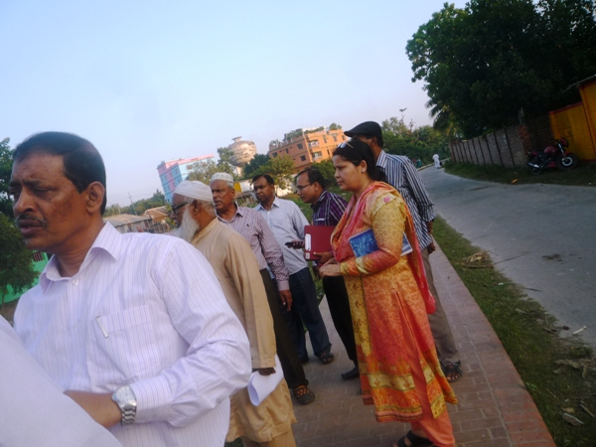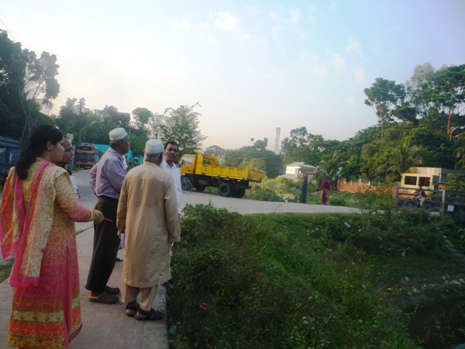

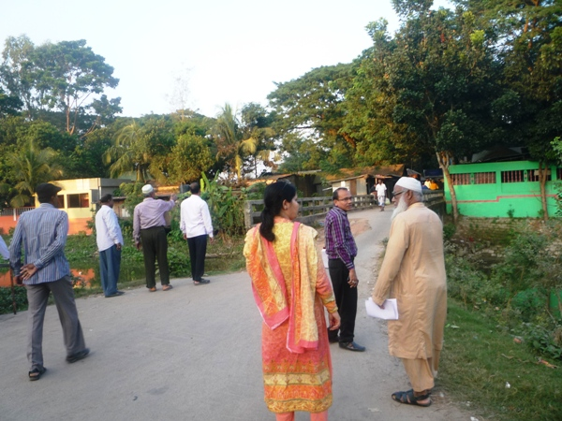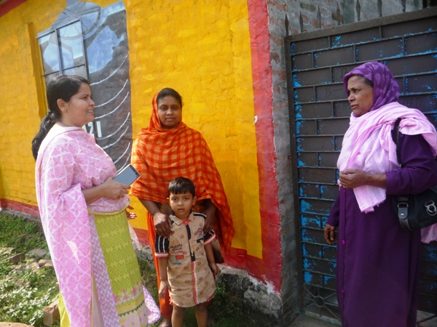

Photographs 7.1.1: DSM Consultant Team with Pourashava Representatives inspected the proposed Bridge

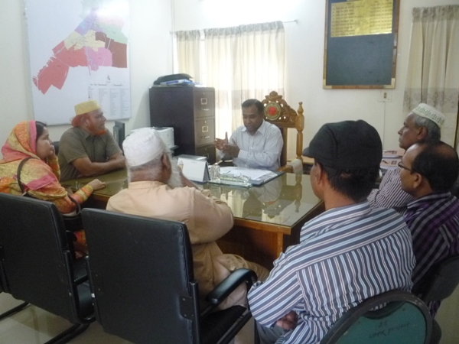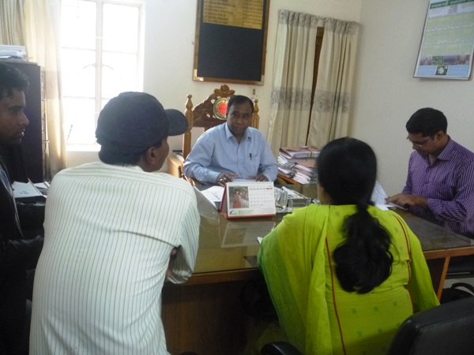

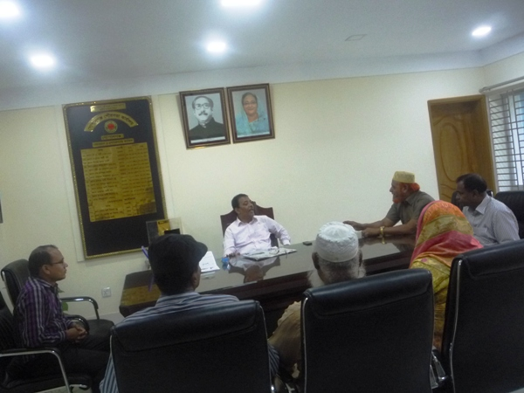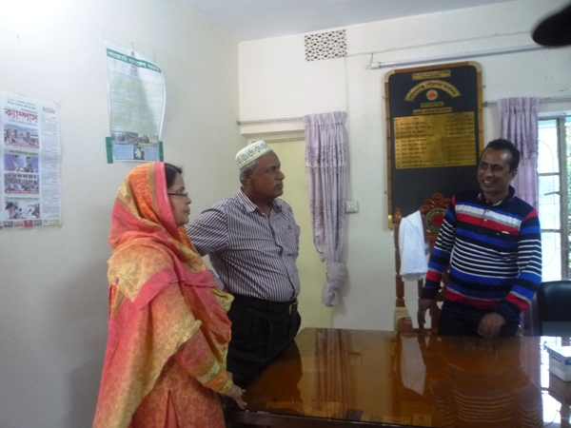

Photographs 7.1.2: Consultation Meeting at subproject sites with Pourashava Officials and Consultants Participants

7.2 Issues Raised by the Participants

The participants raised the issues related to the infrastructure development of Gopalganj Pourashava. The anticipated environmental and social impacts due to construction works have also been raised and discussed. The participants also discussed about the potential benefit from the subproject.

7.3 Feedback, Suggestions, and Recommendations of the Participants

The participants were presented with feedback, suggestions, and recommendations listed below:
- All participants discussed with Mayor about the benefits, obstacle and solution of the Mora Modhumoti Lake Excavation.
- The mayor of the Pourashava stated that multipurpose kitchen market at old bazaar is necessary for this Pourashava;
- The participants also addressed children park is needed for recreation.
- This Pourashava has not structural dumping site for proper solid waste management, it is needed for the Pourashava that is proposed by the mayor.
- The FGD results confirmed that an improved communication network, drainage facility, is needed for future development of Gopalganj Pourashava;
- Most of the participants stated that the number of subproject that have been selected for each financial year is insufficient;
- The participants stated that the public water supply facilities, sanitation facilities, drainage system is not adequate;

8 Conclusions and Recommendations

This study assists to understand the initial environmental impacts due to the subproject as well as to formulate the applicable mitigation and monitoring plans. Based on the environmental assessment, all possible environment aspects have been adequately assessed and necessary mitigation measures have been formulated to minimize the adverse impacts.
The overall conclusion is that if the mitigation, compensation, and enhancement measures are entirely implemented, there will be no significant negative environmental impacts as a result of location, design, construction, and or operation of the proposed subproject.
The conclusions of the environmental assessment can be summarized as follows:
- The short-term negative impacts that may come such as air quality, noise, solid waste, occupational health and safety will be minimized through the mitigation measures;
- The subproject will create employment for the workforce who live in the vicinity of the construction site and will provide them a short-term economic gain.
A few key recommendations are outlined below:
- All mitigation, compensation, and enhancement measures proposed in this report should be followed by the concern authorities for implementing the subproject;
- The environmental management and monitoring plan proposed in this report also needs to be followed;
- Regular monitoring by Pourashava, PMU (LGED) and DSM consultants is needed;
- The contractor will ensure using of the PPEs by the workers where applicable;
- The contractor is responsible for the proper disposal of the generated wastes materials from the subproject sites and campsite;
- The EMP shall be made binding on contractor operating the site, and will be included in the contractual clauses;
- Due to changing circumstances during the construction phase if any, there might be minor adaptation needed for environmental, health and safety issues.

9 REFERENCE

Gopalganj Pourashava Master Plan: 2011-2031 Urban Area Plan

Gopalganj Pourashava at a glance

Environmental Assessment Volume 1: Overall Environmental Assessment [Draft Final Report], September 2013. Municipal Governance and Services Project (MGSP), Local Government Engineering Department (LGED) and Bangladesh Municipal Development Fund (BMDF), Ministry of Local Government, Rural Development and Cooperatives, Government of the People's Republic of Bangladesh.

Environmental Assessment Volume 2: Environmental Management Framework (EMF) [Draft Final Report], September 2013. Municipal Governance and Services Project (MGSP), Local Government Engineering Department (LGED) and Bangladesh Municipal Development Fund (BMDF), Ministry of Local Government, Rural Development and Cooperatives, Government of the People's Republic of Bangladesh.

Appendix
Appendix 1: Environmental Monitoring Checklist

Local Government Engineering Department

Municipal Governance Services Project (MGSP)

Environmental Compliance Monitoring Form
Part A: General Subproject Information

Subproject Name | Construction of Fancy Charming Bridge on the Mora Modhumoti Lake at the Point of Kuadanga under Goplaganj Pourashava, Gopalganj
Package No. | MGSP/GOP/2018-19/W-08
ULB Name | Gopalganj Pourashava
Approved Estimated Cost in BDT
Contract Amount in BDT
Contractor Name
Date of Commencement
Target Date of Completion
Physical Progress (%)
Financial Progress (%)
Person Responsible (PIU)
(Name, Designation &Phone) for the Overall Subproject Management

Person Responsible (DSM)
(Name, Designation &Phone) for the Overall Subproject Management

Form Completed by
(Name, Designation &Phone)
Overall Environmental Description of the Subproject

Part B: Design, Preparation, and Legal Requirements
Environmental Concerns (PMU, PIU & DSM)  (Name, Designation & Phone) | PMU-
 | PIU-
 | DSM-
Subproject Category | DoE-BD- | WB-
Environmental Clearance Received? | Yes | No
EA Required? | Yes | No
EA Prepared and Delivered? | Yes | No
EMP Prepared & Delivered Separately? | Yes | No
Items and Cost of EMP Implementation Included in the Contract? | Yes | No
EMP Included in the Procurement Documents? | Yes | No
Inspection Schedule/Last Inspection/Monitoring by  PMU Environmental Concerns | Date-
 | Key findings-
Inspection Schedule/Last Inspection/Monitoring by  PIU Environmental Concerns | Date-
 | Key findings-
Inspection Schedule/Last Inspection/Monitoring by  DSM Environmental Safeguard Specialist/Jr. Environmental Specialist | Date-
 | Key findings-

Part C: Key Environmental Impacts
The Subproject Results in any of the following Impacts? | Yes | No | NA | If yes, is the impact (give observation)
 |  |  |  | Significant | Moderate | Minor
Felling of the trees
Clearing of the vegetation that increase the risk of increased soil degradation or erosion
Disturbance of the terrestrial and or aquatic specifies
Noise pollution
Air pollution
Adverse effects on the quantity or quality of the surface water or groundwater
Production or increase the production of the solid waste
Drainage congestion
Water logging that increases the risk of the water related diseases
Traffic congestion
Public safety

Part D: Work Place Environment and Gender Equity
The Subproject Results in any of the following Impacts? | Yes | No | NA | Observations
Does the contractor pay to the workers regularly?
Is there any discrepancy between the male and female workers regarding the wages or salary for the same works?
Is the contractor complying with the GOB labor law concerning the hiring of the workers?
Does the contractor engage women labors and does the project have suitable works for them?
Does the contractor engage child labor (less than 18 years) and aged people (more than 65 years old)?
Does the contractor force to the workers for the completion of the works?
Do the workers involve with the political activities, crime, drugs addiction and other forms of unwanted activities?
Are construction camps adequately equipped with water supply, sanitary toilets, washing facilities and facilities for waste collection and storage?
Has separate sanitation facilities been provided for women at work camps and the construction site?

Part E: Potential Impacts, Mitigation Measures, and Monitoring Indicator Mentioned in the EMP
Activity / Issues | Potentials Impacts | Proposed Mitigation and Enhancement Measures | Responsible Parties
Construction and operation of labor shed for the workers (Workforce and labor shed management ) | - Generation of sewage and solid waste may cause environmental pollution in the surrounding area | - Construction of sanitary latrine at the labor shed (consider 15 person for one toilet, separate toilet for male and female);  - Erection of “no litter” sign, provision of waste bins/cans (separate waste bins for organic and inorganic wastes );  - Ensure wastes (solid wastes and other forms of the waste) disposal at the Manikda. | Contractor  Monitoring-  Primarily by Pourashava  Secondarily by PMU,LGED  and DSM  Contractor  Monitoring-  Primarily by Pourashava  Secondarily by PMU,LGED  and DSM  Contractor  Monitoring  Primarily by Pourashava  Secondarily by PMU, LGED and DSM
 | - Health of workers | - Conduct formal and unofficial discussion to increase awareness about hygiene practices among the workers;  - Ensure availability and access to first-aid equipment and medical supplies for the workers.
 | - Possible development of labor camp into permanent settlement | - Contractor to remove labor camp at the completion of contract.
 | - Outside labor force causing negative impact on health and social well-being of local people | - Ensure that contractor employ local work force to provide work opportunity to the local people and conduct formal and unofficial awareness program for the health and social well-being of the local people.
General construction work | - Drainage congestion and flooding | - Ensure provision for adequate drainage of storm water if needed;  - Ensure provision for pumping of congested water if needed;  - Ensure adequate monitoring of drainage effects, especially if construction works are carried out during the monsoon season.
General construction work | - Air pollution | - Check regularly and ensure that all the subproject vehicles and equipment are in good operating condition;  - Ensure contractor spray water on dry surfaces/ unpaved to reduce dust generation;  - Maintain adequate moisture content of the sand;  - Ensure contractor sprinkle water and cover stockpiles of loose materials (e.g., fine aggregates);  - Inform local people about the subproject activities and potential impact;  - Cover loaded truck used for carrying sand with tarpaulin/other suitable material to prevent spreading by air blown.
General construction work | - Traffic congestion, effect on traffic and pedestrian safety | - Ensure schedule deliveries of materials/ equipment during off-peak hours;  - Place traffic sign/cautionary sign to avoid undue traffic congestion if required;  - Shifting of the existing bamboo shako at convenient nearby area to maintain pedestrian movement;  - Construction of diversion road before demolition of the bridge and culverts to maintain traffic movement.
General construction work | - Noise pollution | - Check and maintenance the equipment properly;  - Avoid using of construction equipment such as concrete mixer machine, pile driving equipment (pile rig, winch machine), vibrator machine that produce excessive noise at night;  - Avoid prolonged exposure to noise (produced by equipment) by the workers;  - Regulate use of horns and avoid un-due use of hydraulic horns by subproject vehicles;  - Inform local people about the subproject activities and potential impact.
General construction work | - Felling of trees, clearing of vegetation and ecological disturbances | - 15 nos. of the trees will be planted at lake side area beside footpath where space is available to enhance the ecological condition.
General construction work | - Disturbances to the aquatic environment | - Avoid complete closing of the channel that affects reproduction of aquatic species;  - Any illegal discharge of waste water, leaked oil shall be prohibited.
General construction work | - Accidents | - Conduct formal and informal discussion for creating awareness about the accident;  - Provides PPEs and ensure using of the personal protective equipment by the workers.
General construction work | - Spills and leaks of oil, toxic chemicals | - Proper handling of lubricating oil and fuel so that it does not fall on the soil;  - Collection and proper disposal of spills;  - Refueling and fuel tank should not be placed on the ground directly.
All construction works | - Beneficial impact on employment generation | - Employ local people in the subproject activities as much as possible;  - Give priority to poor people living within subproject area in subproject works (e.g., excavation and other works, which do not require skilled manpower);
All construction works | - General degradation of the environment | - Ensure environmental enhancement measures- tree plantation and cautionary sign will be provided.
Environmental impacts due to the key construction activities and corresponding mitigation measures for the RCC Bridge
Excavation/Earth work | - Generation of loose and clay soil due to the earth excavation work | - Disposal of soil and construction wastes at the Manikda;  - Cover exposed dry loose soil with fabric.
Excavation/Earth work | - Accidents | - Carefully handle of the hydraulic excavator;
Excavation/Earth work | - Air pollution | - Regular maintenance of the equipment;
Sand filling /Back filling work | - Air and dust pollution affecting nearby settlement | - Maintain adequate moisture content of soil and sand during transportation, compaction and handling;  - Carry the materials especially loose soil and sand with adequate cover.
Cutting and welding of the reinforcement | - Noise pollution due to rod cutter and welding machine if any | - Avoid using of rod cutter and wielding machine at night;  - Avoid prolonged exposure to noise (produced by equipment) by workers.
Cutting and welding of the reinforcement | - Potential health and safety risks from rod cutter and welding machine if any | - Ensure use of the personal protective equipment’s (helmet, goggles, gloves, safety boot);  - Availability and access to first-aid equipment and medical supplies in case of any accidents.
Cast-in-situ pile work | - Possible accident, noise pollution and mud generation | - Carefully operation of the equipment’s;  - Ensure using of the safety gear;  - Proper collection and disposal of the generated mud due to drilling work.
RCC (reinforcement cement concrete) work | - Air pollution due to black smoke emission from concrete mixer machine and vibrator machine | - Regular maintenance of the concrete mixer and vibrator machine to avoid any black smoke emission.
RCC (reinforcement cement concrete) work | - Noise nuisance from concrete mixer machine and vibrator machine | - Avoid operation of the concrete mixer and vibrator machine at night;  - RCC work should be avoided at schooling time;  - Inform local people about casting work and potential impacts.
Prepared by- Signature- Date-
Copies to 1. PIU
2. SME
3. AME
4. Jr. ES

