INTRODUCTION

Subproject Background

Rangpur City Corporation was established in the year of 2012. The City Corporation has an area of 203.19 sq. km. The present population of the City Corporation is 795556. At present, the City Corporation has 1427.44 km road among these 67.59 % kutcha, 28.43 % pucca and 3.98% semi pucca road. In addition, City Corporation has 65 nos. culvert and 28 nos. bridge [Source: rpcc.gov.bd /statistics]. The existing infrastructure facility especially at the rural part of Rangpur City Corporation is not adequate to meet the present demand. Additionally, increasing population demands new infrastructure and improvement of the existing infrastructure. Hence, as a new City Corporation, Rangpur requires rapid and continuous infrastructure development. Hence, this subproject will significantly contribute infrastructure development of Rangpur City Corporation.

This subproject includes the following components: BC Road, RCC Box Culvert and Road Protection Work at Nagor Mirgonj Raghu Bazar to Anondapath Primary School Road. The major features of the subproject are mentioned below:

Name of the Subproject | a) Rehabilitation of Road from Nagor Mirgonj Raghu Bazar to Anondapath Primary School at Pirgasa Road by Bituminous Carpeting (Ch.0-6300m);  b) Construction of 7 nos. single vent 2mx1.6m at Ch. 552m, Ch.2600m, Ch.3200m, Ch.3380m, Ch.4340m, Ch.4930m and Ch.6150m respectively, 3 nos. single vent 3mx2m, at Ch.2098m, Ch.2700m and 3780m respectively, double vent 3mx2m at Ch.3550, three vent 3.5mx3.5m at Ch.5200m.
Package No. | MGSP/RCC/2017-2018/W-11
District Name | Rangpur
ULB Name | Rangpur City Corporation
Jurisdiction Area | Ward Number 32 and 33
Structural Design  Option | BC Road, Culvert and Road Protective wall
Beneficiary Population | About 40,000 as per City Corporation Officials
Tribal People | No tribal people settlement found in the subproject area
Land Acquisition | Mostly City Corporation owned; No private land acquisition is needed
Estimated Cost | 108.578 million in BDT
Subproject Duration | 18 Months
Tentative Start Date | 19 December, 2017
Tentative Completion Date | 18 June, 2019

Objectives of the Study

The general objective of this study is to determine the major environmental impacts succeeding from execution of the subproject and to recommend mitigation measures to avoid or reduce adverse environmental impacts and to enhance positive impacts. The specific objectives include:
- To assess the existing environmental conditions of the subproject site and its influence area;
- To identify and assess impacts resulting from the subproject during its construction phase and operation phase;
- To develop a environmental management plan with recommendations for mitigating impacts and enhance positive impacts;
- To summarize environmental monitoring requirements.

Scope and Methodology of the Study

The subproject appraisal is included environmental screening for all the subproject components. According to environmental screening environmental assessment is required to fulfill the regulatory requirement for this subproject. The study methodology comprised the following activities:

- Desktop Study;
- Field Investigations and Data Collection;
- Data Analysis and Report Writing.

Desktop Study
The desktop study involved:
- Initial meetings with client, stakeholders to discuss the proposed subproject;
- Collection and review of the baseline data, maps, reports and other relevant information;
- Review of the relevant existing legislation, regulation and policies;
- Understand the anticipated technical processes that may affect the environment.

Field Investigation and Data Collection

A team of the consultants made a field investigation to the proposed site. Field investigations involved mainly site walks within the subproject area and the neighboring areas that may be affected by the subproject.

The following key tasks were performed during the field visit:
- Taking photographs of the significant aspects to assist in describing the baseline environmental conditions of the subproject area;
- Interviews with representatives of the relevant City Corporation officials and beneficiary and affected people within the subproject influence zone;
- Obtaining relevant documents from City Corporation and local people within the subproject influence zone;
- Verifying information and data collected during the desktop study and to collect new information.

Data Analysis and Report Writing
The data and information collected from all the sources (literature review, secondary and primary data, public consultation) were analyzed to describe the existing environmental setting of the subproject area, to identify the potential positive and negative impacts of the proposed subproject, as well as to provide preliminary suggestions for mitigation measures. Finally, this environmental assessment report has been prepared.

SUBPROJECT DESCRIPTION

The Study Area

The subproject site is located within the jurisdiction of wards no. 32 and 33 of Rangpur City Corporation. The subproject area goes through entirely in the rural part of the City Corporation. The subproject is mostly located in the existing right of way and City Corporation owned land. There are no protected areas, mangroves, or estuaries in or near the subproject location. The Location Map, Topographic Features and Lay-out plan of the subproject are shown in Figure 2.1.1, Figure 2.1.2 and Figure 2.1.3.
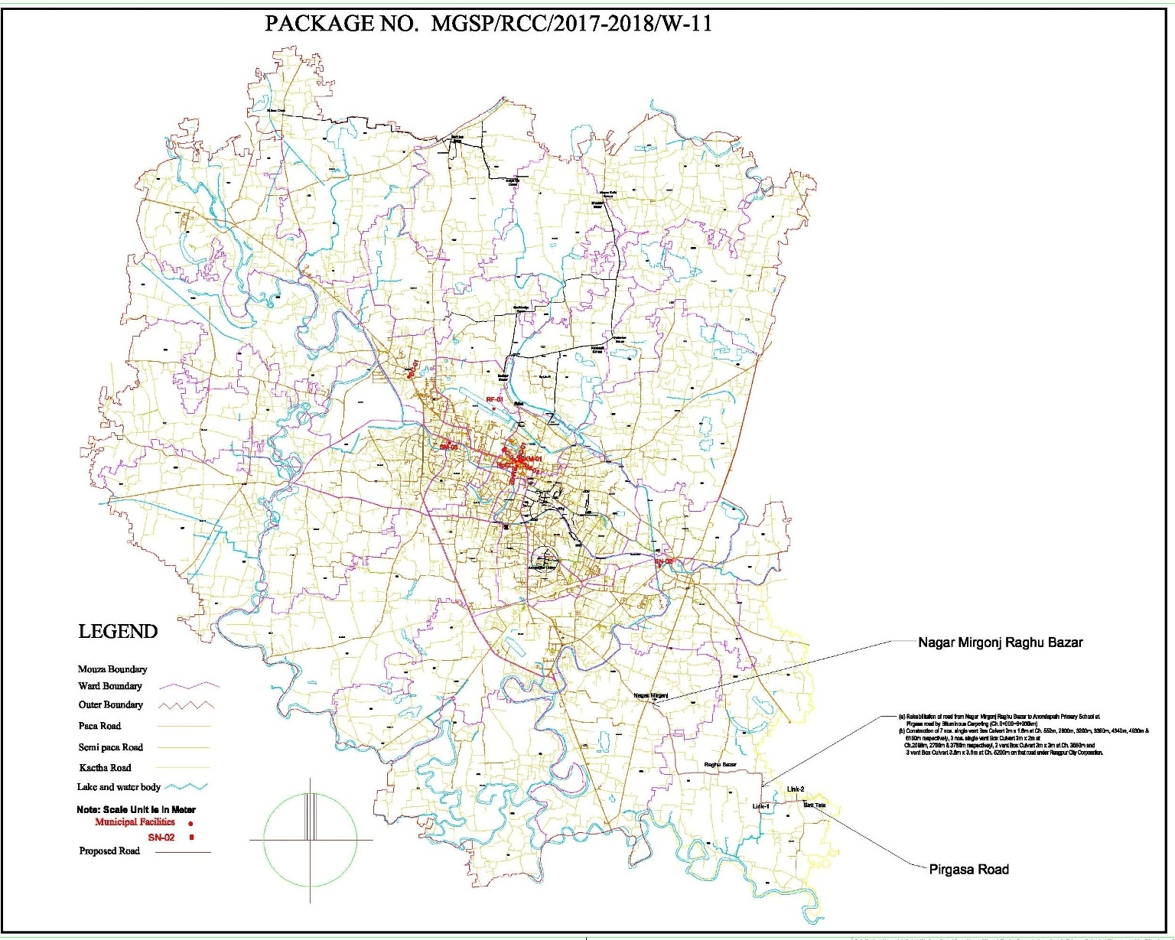
Figure 2.1.1: Location Map of the Subproject Site

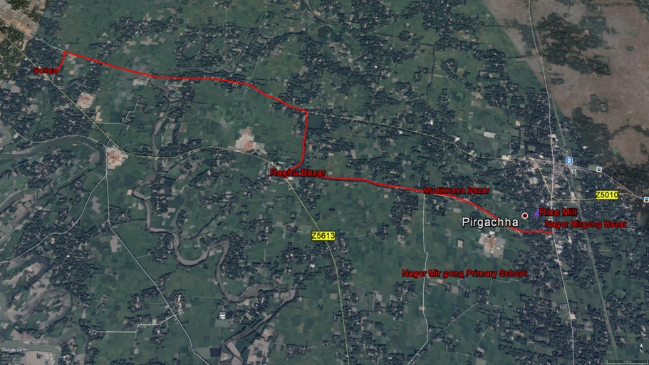
Figure 2.1.2: Topographic Feature of the Subproject Site

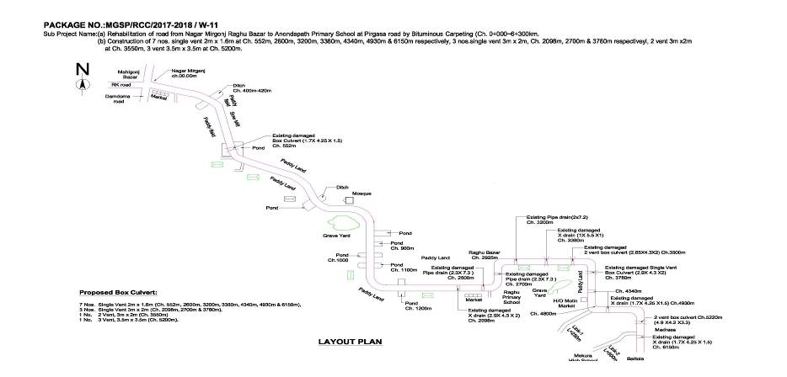

Figure 2.1.3: Layout Plan of the Subproject Site

Current Situation, Proposed Intervention and Need for the Subproject
The subproject is situated at the rural area of the City Corporation which is the key agricultural hubs (Rice, Potato). Basically, this area is renowned as potato cultivated area. The built-up infrastructures include road side tin-shed, semi-pucca and pucca residential houses, educational institutes, shops, rice mill, saw mill, etc.

From Nagor Mirgonj Primary School to Raghu Bazar, the existing road is bituminous carpeting. Remaining part of the existing road is earthen. Importantly, most of the section of the existing BC road is badly damaged. The pot holes on the road surface retain storm water. From site visit it is revealed that, earthen road generates uneven muddy surface during rainy season. In addition, existing road is very narrow. Undulation of the road surface, pot holes, uneven muddy surface and narrow road width interrupt vehicles movement. As a result, local people have been suffering to transport their agricultural products (Rice, Potato) to Bazar area. Furthermore, during monsoon stagnant storm water on the undulated road surface restricts free movement of the pedestrians and reduces pedestrians’ safety. To provide normal traffic operation, pedestrian safety and accelerating the urbanization process BC road will be constructed with widening of the existing road.
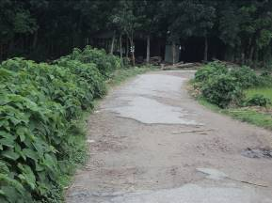
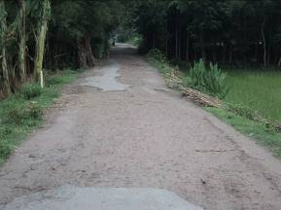
The existing culverts are badly damaged. Hence, it interrupts normal traffic movement. Therefore, the existing culverts will be demolished and new culverts will be constructed. Seven number of single vent 2m x 1.6m RCC box culverts will be constructed at Ch. 552m, Ch.2600m, Ch.3200m, Ch.3380m, Ch.4340m, Ch.4930m and Ch.6150m respectively and three number of single vent 3mx2m box culverts will be constructed at Ch.2098m, Ch.2700m and 3780m respectively. In addition, 3m x2m double vent box culvert at Ch.3550m and three vent 3.5mx3.5m box culverts at Ch.5200m will be constructed. Furthermore, road protection work is needed at different segments of the road especially near low lands and ponds side. Hence, total 1413m road protection wall at different segments will be constructed by driving precast 3m RCC pile @1 m interval. The brick masonry wall covers the space between two RCC piles. The present situation of the subproject site is further elaborated in the following Photographs 2.2.1 (a) and Photographs 2.2.1(b)

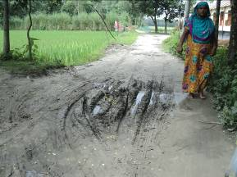
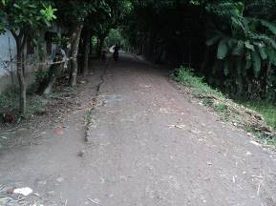
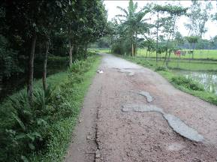

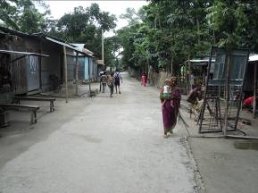

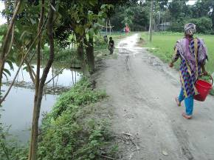
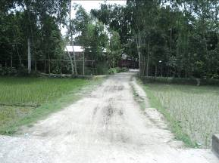

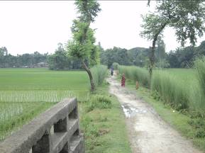
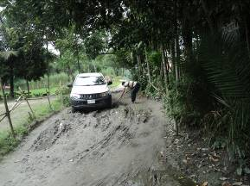

Photographs 2.2.1(a): Current Situation of the existing BC Road and Earthen Road
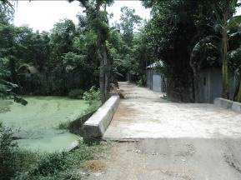
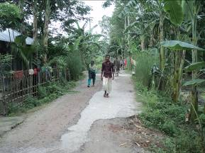

Photographs 2.2.1(b) Current Situation of the existing Culverts

Justification of Selection of this Subproject

Based on CIP, Rangpur City Corporation prepared the priority list of the subprojects. The PMU and DSM Consultant have inspected the site as a part of the reconnaissance survey. After site inspection, it is revealed that the overall anticipated environmental impact due to the subproject implementation is not significant. Though, the subproject intervention has significant impacts on the ecological environment due to felling of the 1213 trees. However, provision is being made for the re-plantation of the 4200 nos. of trees under this subproject to compensate the ecological imbalance to be caused due to felling of the trees and to enhance the ecological condition in the subproject area.

The subproject site is mostly located on the existing right of way and City Corporation owned land. Hence, private land acquisition is not an issue for subproject implementation. After construction, this road has significant positive impacts by providing improved transport facilities. On the contrary, after construction the proposed culverts will provide smooth traffic operation. In addition, the road protection wall will increase the stability of the road. Hence, considering the expected benefits that will derive, the subproject is selected for implementation.

Envisaged Subproject Activities and Implementation Process

The general activities for the subproject includes: construction of the semi-pucca site office, construction of the labor shed, relocation of the electric poles and site clearing work.

The key activities for BC Road include:

- Dismantling of the damaged sub-base and base course works;
- Clearing and grubbing works;
- Earth work in box cutting;
- Earth filling work;
- Sand filling on the road bed;
- Mechanical compaction;
- Brick on edging;
- Compacted stone aggregate base course;
- Providing prime coat;
- Laying pre-mixed dense bituminous surfacing wearing course.

The key activities of the RCC Box Culvert and Road Protection Wall include:

- Dismantling of the existing culverts;
- Earth work in box cutting;
- Mechanical compaction;
- Laying of Polythene sheet;
- Cement Concrete work;
- Fabrication of the ribbed or deformed bar reinforcement;
- Reinforced cement concrete work.

The materials and resources to be used for the key activities: soil in earth work, sand, stone chips, cement, reinforcement, diesel, MS sheet, steel shutter, electricity and water.
The major equipment to be used for the implementation of the subproject: hydraulic excavator, concrete mixer machine, steel cutter, mechanical vibrator machine, mechanical compaction machine, steel drum rollers, pneumatic multiple tire roller, dump truck, water tanker, pump, asphalt plant, rubber tire roller, paver.

Baseline ANALYSIS OF THE ENVIRONMENTAL CONDITION

Physical Environment

Important Environmental and Infrastructural Features

During site visit the environmental and infrastructural features within the subproject area were collected. Conditional survey has also been conducted for designing the subproject. The survey data is also used for preparing the report. The environmental and infrastructural features listed within 100 m of the both sides of the road from the center line considering 100 m longitudinal interval from Nagar Mirgonj to Anadapath Primary School via Raghu Bazar at Pirgasa road (Ch.0-6300m) Table 3.1.1.

Table 3.1.1: Major Environmental and Infrastructural Features of Nagar Mirgonj to Anadapath Primary School via Raghu Bazar Road
Chainage (m) | Left | Right | Major Environmental and Infrastructural Features
Nagar Mirgonj to Anadapath Primary School via Raghu Bazar
0-100** | √ |  | Nagar Pirgong Primary School, trees, shops, Nur Kinder Garden, vegetation, agricultural land, tea stole, salon, electric pole
0-100** |  | √ | Shops, Anower Digital Studio, Nur Kinter Garden, Yasmin Rice Mill, vegetation, agricultural land and electric pole
100-200 | √ |  | Homestead area (Semi-pucca and Tin-shed), trees, agricultural land, saw mill, ponds
100-200 |  | √ | Agricultural land, homestead area (semi-pucca and tin-shed), vegetation, electric pole
200-300 | √ |  | Bamboo bushes, homestead area (tin shed), trees, pond, electric pole
200-300 |  | √ | Homestead area, pond, agricultural land, vegetation
300-400 | √ |  | Homestead area (Pucca, Semi-pucca and Tin-shed), agricultural land, vegetation, pond
300-400 |  | √ | Homestead area (semi-pucca and Tin-shed), ditch, agricultural land, trees
400-500 | √ |  | Homestead area (tin-shed), trees, agricultural land
400-500 |  | √ | Homestead area (semi-pucca and tin shed residents), pond, agricultural land
500-600 | √ |  | Agricultural land, homestead area (semi-pucca and tin shed residents), pond, electric pole
500-600 |  | √ | Homestead area (semi-pucca and tin shed residents), pond, mosque
600-700 | √ |  | Amin varieties, Azizul store, Rana Store, agricultural land, planted trees ( Mango, Lemon, Betel nut, Jolpai), tin shed residents, boundary wall
600-700 |  | √ | Agricultural land, trees, electric pole, homestead area (semi-pucca, and tin-shed), graveyard
700-800 | √ |  | Pond, agricultural land, trees, tin-shed residents, morich tal, low land, vegetation
700-800 |  | √ | Agricultural land, trees, tin-shed residents, banana tal, low land, vegetation
800-900 | √ |  | Planted trees (Kath Badam, Jam, Mango, Jackfruits, Litchi), pond, homestead area (tin-shed), shops, bamboo fence
800-900 |  | √ | Open space, trees, boundary wall, electric pole, pond, homestead area (tin-shed), Colocasia esculanta land
900-1000 | √ |  | Pond, Eid-gah, trees, agricultural field, road side vegetation
900-1000 |  | √ | Tin shed residents. trees, boundary wall, Kendur Jame mosque,
1000-1100 | √ |  | Pond, tin shed residents, planted trees (Mahogany, Coconut, Plum, Mango, Jack fruits, Betel Nut), agricultural field, ditch
1000-1100 |  | √ | Agricultural land, trees, tin shed residents,
1100-1200** | √ |  | Chatal, Mudikhana Bazar, shops, Medicine Corner, trees
1100-1200** |  | √ | Mudikhana Bazar, shops, workshop, bamboo fence, open space
1200-1300 | √ |  | Bamboo bushes, tin shed and semi pucca and tin shed residents,
1200-1300 |  | √ | Agricultural land, trees, graveyard, homestead area (tin-shed), tin fence
1300-1400 | √ |  | Homestead area (tin shed) trees, agricultural land
1300-1400 |  | √ | Trees, pond, agricultural land
1400-1500 | √ |  | Provati Mukto Skaout Institute, ditch, trees, agricultural land, bamboo bushes
1400-1500 |  | √ | Trees, pond, planted banana tal, agricultural land, tin shed residents
1500-1600 | √ |  | Boundary wall, homestead area (tin shed residents), electric pole, trees
1500-1600 |  | √ | Trees, boundary wall, homestead area (tin shed residents)
1600-1700 | √ |  | Agricultural land, trees, homestead area (semi-pucca, pucca, tin shed), pond, boundary wall
1600-1700 |  | √ | Agricultural land, tree, homestead area (tin-shed, katcha), boundary wall, electric pole
1700-1800 | √ |  | Trees, boundary wall, homestead area (tin shed residents)
1700-1800 |  | √ | Trees, boundary wall, homestead area (tin shed residents)
1800-1900 | √ |  | Homestead area (tin shed,), agricultural land, trees, bamboo fence
1800-1900 |  | √ | Homestead area (tin shed), agricultural land, boundary wall, trees, pond
1900-2000 | √ |  | Homestead area (tin shed), agricultural land, boundary wall, aquaculture pond
1900-2000 |  | √ | Homestead area (tin shed, semi-pucca), agricultural land, boundary wall, trees
2000-2100 | √ |  | Agricultural land, trees, bamboo bushes, vegetation, electrical pole, low land, tin shed residents
2000-2100 |  | √ | Agricultural land, trees, pond, vegetation, tin shed residents
2100-2200 | √ |  | Agricultural land, tin shed residents, vegetation
2100-2200 |  | √ | Agricultural land, tin shed residents, planted trees (Mango, Mahogany, Betel nut, Lemon, Jack fruits)
2200-2300 | √ |  | Agricultural lands, trees, electric pole, tin shed residents
2200-2300 |  | √ | Homestead area (tin shed, katcha), agricultural land, trees, vegetation, pond
2300-2400 | √ |  | Agricultural lands, trees, pond
2300-2400 |  | √ | Agricultural land, trees, electric pole, homestead area (Semi-pucca, Tin shed), boundary wall
2400-2500 | √ |  | Agricultural lands, trees, pond
2400-2500 |  | √ | Agricultural land, trees, vegetation
2500-2600 | √ |  | Homestead area (tin shed,), agricultural land, trees, bamboo fence
2500-2600 |  | √ | Homestead area (tin shed), agricultural land, boundary wall, trees, pond
2600-2700 | √ |  | Homestead area (tin shed), agricultural land, boundary wall, aquaculture pond
2600-2700 |  | √ | Homestead area (tin shed, semi-pucca), agricultural land, boundary wall, trees
2700-2800 | √ |  | Homestead area (Katcha, and tin shed), agricultural land, trees
2700-2800 |  | √ | Agricultural land, bamboo bushes, trees, vegetation, vegetable garden
2800-2900 | √ |  | Agricultural land, homestead area (tin shed), pond, mosque
2800-2900 |  | √ | Agricultural land, trees, homestead area (tin shed)
2900-3000** | √ |  | Raghu Bazar, shops, Adi-merit Care, varieties shops, trees, salon, boundary wall
2900-3000** |  | √ | Dud Shongroho Kendra, shops, Jelpin varieties, studio, Roghu Govt. Primary School, workshops, boundary wall, pond
3000-3100** | √ |  | Azizullah Uchha Bidalloy, Kitnashok Shops, workshops, tin shed residents, trees
3000-3100** |  | √ | Workshops, Khabar Hotel, Homeo Hall, trees
3100-3200** | √ |  | Shops, trees, electric pole, agricultural land, pucca, semi-pucca and tin shed residents
3100-3200** |  | √ | AB decorator, agricultural land, trees, pond, connecting road, tin shed varieties shops
3200-3300 | √ |  | Homestead area (tin shed), agricultural land, trees, vegetation
3200-3300 |  | √ | Homestead area (tin shed), agricultural land, trees, vegetation
3300-3400 | √ |  | Homestead area (tin shed), agricultural land, trees
3300-3400 |  | √ | Homestead area (tin shed), ponds, trees, trees
3400-3500 | √ |  | Homestead area (tin shed), ditch, boundary wall, agricultural land, trees
3400-3500 |  | √ | Homestead area (semi pucca, tin shed), pond, boundary wall, trees
3500-3600 | √ |  | Homestead area (semi pucca, tin shed), agricultural land, trees
3500-3600 |  | √ | Homestead area (tin shed), pond, graveyard, planted trees (Jambura, Mango, Lemon, Jack fruits, Akashi)
3600-3700 | √ |  | Homestead area (semi pucca, tin shed), agricultural land, trees, vegetation
3600-3700 |  | √ | Agricultural land, homestead area (semi pucca, tin shed), trees, vegetation
3700-3800 | √ |  | Agricultural land, homestead area (semi pucca, tin shed), trees, vegetation, bamboo bushes, pond
3700-3800 |  | √ | Agricultural land, homestead area (tin-shed), trees, vegetation, low land
3800-3900 | √ |  | Agricultural land, homestead area (tin-shed), trees, vegetation, ponds
3800-3900 |  | √ | Agricultural land, homestead area (tin-shed), trees, vegetation, low land, bamboo fence
3900-4000 | √ |  | Pond, homestead area (tin-shed), trees, planted banana trees, vegetables land
3900-4000 |  | √ | Agricultural land, homestead area (semi-pucca, pucca), trees, connecting earthen road
4000-4100 | √ |  | Agricultural land, homestead area (tin shed), trees, connecting earthen road, banana land
4000-4100 |  | √ | Electric pole, homestead area (tin shed), trees, pond, vegetation coverage
4100-4200 | √ |  | Agricultural land, trees, homestead area (tin shed and semi pucca), road side vegetation
4100-4200 |  | √ | Agricultural land, trees, homestead area (tin shed and semi pucca), road side vegetation, irrigation pump
4200-4300 | √ |  | Agricultural land, trees, homestead area (tin shed and semi pucca), road side vegetation
4200-4300 |  | √ | Ditch, agricultural land, trees, homestead area (tin shed and semi pucca), road side vegetation, pond
4300-4400 | √ |  | Agricultural land, trees, homestead area (tin shed and semi pucca), road side vegetation
4300-4400 |  | √ | Agricultural land, trees, pond, homestead area (tin shed and semi pucca), road side vegetation, low land
4400-4500 | √ |  | Agricultural land, trees, homestead area (tin shed and semi pucca), road side vegetation, pond
4400-4500 |  | √ | Agricultural land, trees, homestead area (tin shed and semi pucca), road side vegetation
4500-4600 | √ |  | Agricultural land, trees, homestead area (tin shed and semi pucca), road side vegetation,
4500-4600 |  | √ | Agricultural land, trees, homestead area (tin shed), road side vegetation, planted banana trees, vegetable garden
4600-4700 | √ |  | Agricultural land, trees, homestead area (tin shed and semi pucca), road side vegetation
4600-4700 |  | √ | Agricultural land, trees, homestead area (tin shed), road side vegetation, pond
4700-4800 | √ |  | Agricultural land, trees, homestead area (tin shed and semi pucca), road side vegetation, pond
4700-4800 |  | √ | Agricultural land, trees, homestead area (tin shed and semi pucca), road side vegetation,
4800-4900 | √ |  | Homestead area (Semi-pucca, tin-shed), low land, tin made fence, trees, road side vegetation
4800-4900 |  | √ | Agricultural land, trees, homestead area (tin shed and semi pucca), road side vegetation, pond
4900-5010 | √ |  | Agricultural land, trees, pond, homestead area (tin shed), road side vegetation,
4900-5010 |  | √ | Mosque, trees, pond, homestead area (tin shed), road side vegetation,
5100-5200 | √ |  | API Tika Dan Kendra, homestead area (tin shed, semi pucca), trees, road side vegetation, agricultural land
5100-5200 |  | √ | Agricultural land, trees, pond, homestead area (tin shed), road side vegetation,
5200-5300 | √ |  | Agricultural land, trees, pond, homestead area (tin shed), road side vegetation,
5200-5300 |  | √ | Agricultural land, pond, homestead area (tin shed), road side vegetation, trees, connecting road
5300-5400 | √ |  | Agricultural land, trees, pond, homestead area (tin shed), bamboo fence, planted flower garden, road side vegetation,
5300-5400 |  | √ | Agricultural land, trees, homestead area (tin shed), road side vegetation,
5400-5500 | √ |  | Agricultural land, pond, homestead area (tin shed), road side vegetation, trees
5400-5500 |  | √ | Agricultural land, trees, homestead area (tin shed), road side vegetation, irrigation pump
5500-5600 | √ |  | Agricultural land, homestead area (tin shed), road side vegetation, trees,
5500-5600 |  | √ | Agricultural land, trees, homestead area (tin shed), road side vegetation,
5600-5700 | √ |  | Agricultural land, homestead area (tin shed), road side vegetation, pond, trees, shop
5600-5700 |  | √ | Agricultural land, trees, homestead area (tin shed), connecting road
5700-5800 | √ |  | Agricultural land, trees, homestead area (tin shed), vegetation
5700-5800 |  | √ | Fazil madrasah, homestead area (pucca, semi pucca and tin shed), agricultural land, trees
5800-5900 | √ |  | Mosque, kinder garden, trees, homestead area (tin shed), pond, vegetation
5800-5900 |  | √ | Agricultural land, trees, homestead area (tin shed), road side vegetation, connecting road
5900-6000 | √ |  | Agricultural land, trees, pond, homestead area (tin shed), road side vegetation,
5900-6000 |  | √ | Agricultural land, trees, homestead area (tin shed), road side vegetation, irrigation pump
6000-6100 | √ |  | Agricultural land, road side vegetation, trees, homestead area (tin shed),
6000-6100 |  | √ | Low land, agricultural land, trees, vegetation, homestead area (tin shed), connecting road
6100-6200 | √ |  | Agricultural land, trees, pond, homestead area (tin shed), road side vegetation,
6100-6200 |  | √ | Agricultural land, trees, pond, homestead area (tin shed), road side vegetation,
6200-6300 | √ |  | Agricultural land, trees, ponds, homestead area (tin shed),
6200-6300 |  | √ | Agricultural land, trees, homestead area (tin shed)

** Denotes Chainage having bazar area. There are 48 numbers of the electrical poles at different Chainage to be re-located for the implementation of the subproject.

Geology, Topography, and Soils

Rangpur City Corporation is a land of mixed topography. The present urbanized and developed areas and the levees of the Ghaghat River are comparatively higher elevation. The area lies in Earthquake Zone 3 according to the seismic map of Bangladesh (BNBC, 1993). Geologically it is a terrace from one to ten meters above the adjacent floodplains. Two characteristic geological units cover RCC, namely, alluvial soil (80%) of Teesta River basin and the remaining is Barind soil. The Barind soil is the oldest sediment exposed in the area. The major geographic units of the city are: the high land or terrace, the low land or floodplain, depressions, and abandoned channels. Low lying swamps and marshes located in and around the area are other major topographic features.

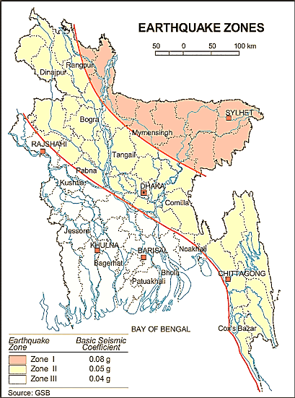

Figure 3.1.1: Location of Rangpur City Corporation (red circle) at Earthquake Zoning Map

Climate and Meteorology

The climate of the subproject area can be described as Tropical Monsoon. It is characterized by the warm, humid summers and cool and dry winters. However, generally the weather is sub-tropical, with a warm climate all the year round. The annual average temperature varies maximum 32.3°C to minimum 11°C and the average annual rainfall is 2931 mm. Rangpur City Corporation is colder than other City Corporations, nevertheless has a similar pattern of rainfall.

Figure 3.1.2: Average Minimum and Maximum Temperature in Rangpur City Corporation (Source: BMD)
Figure 3.1.3: Monthly Average Rainfall in Rangpur City Corporation (Source: BMD)
According to the statistics of the wind data from the Bangladesh Meteorological Department Climate Division, wind direction changes by month. Nevertheless, the northwest, south, and northeast winds are predominant.
The construction works can be influenced by the climatic condition and meteorological components like humidity, temperature, sudden rainfall, and wind speed. High winds can enhance quick spreading of the generated dust. It is very risky working under rain and in high winds because the possibility of getting injury increases. Furthermore, work under high temperature and excess humidity may create health hazards like dehydration problem.

Water Resources (Surface Water, Ground Water, and Rain Water)

There are ponds and ditches in the subproject area. Groundwater is the main source of potable water in the subproject area. Deep groundwater is not saline and normally arsenic (<0.01mg/l) and iron free (Source: Rangpur City Corp- Master Plan). Local people typically use deep tube-well water for drinking and other domestic purposes. Salinity problems are not visible. Rain water harvesting system is not common in and around the subproject area.

Flooding, Water Logging, and Drainage Pattern

In adequate drainage network, natural siltation, absence of proper outlets, disposal of solid waste into the drains causes blockage in the drainage system which create water logging. Recently, the authority has undertaken subproject of the tertiary drain construction which are under implementation. According to the historical data, the subproject area is not affected in severe flood events after the year 1988.

Air Quality and Dust
Air quality data is not available from secondary sources. Air seems to be clean. However, in dry season dust is generated due to vehicles movement and windblown dust causes air pollution. In addition, black smoke emission from the vehicles degrades the quality of the air. There are no remarkable sources of air pollution such as heavy industries observed in the subproject area except an auto rice mill.

Noise Level

Noise is not a major impediment for the quality of the environment in the subproject area. Vehicles such as rickshaws, trolleys, pick-up, trucks, motor cycles, mini trucks, and private cars generally move on the road during day and night. These vehicles generate noise in the subproject area. However, they are within the tolerable limits in most cases. There are no other perceptible sources of noise generation such as heavy factories or industries were found near the subproject area.

Solid Waste Management

Solid waste collection system is available in the older part of the city. House to house collection through community participation is also available. As per information from City Corporation Officials, an average 12 tons of solid wastes are collected per day and dumped in open dumping ground through 6 vehicles. Home collection is carried-out by 46 vans while citizens dump households waste in 49 road side bins. In non-core part of the city households waste are mostly used as kitchen fuel or feed for domestic pets. The residues are dumped into family pit. (Source: Rangpur City Corp- Master Plan)

Biotic Environment

Flora and Fauna
There is no natural or man-made forest in the City Corporation area. Homestead planted trees and road side trees are main trees here. Planted trees show a slow declining trend, mainly due to urbanization. Terrestrial plants were found during site visit within the subproject area.
Natural plants -herbs, shrubs, and grasses are major components of ecological environment. In the subproject area, the floral species are dominated by the fruit plants and wooden plants. The trees are mainly: Coconut, Jackfruit, Mango, Korai, Akashi, Mahogany, Jambura, Kath Badam, Lemon, Plum, Beatle-nut, Sishu, Kodom, Papaya, Guava, Rain-tree, Black berry, Date tree, Krisnochura, Bokul, Amra, Tetul, Jambira, Bel, and Plam. The natural water bodies (ponds and ditches) are the worthy habitat of the aquatic flora and fauna. Lots of common local birds were found during the site visit. The common local birds includes: Tiya, Moina, Ghugu, Choroi, Shalik, Crow, and Dowel.

Socio-economic and Socio-cultural Environment

Land Use, Status of Housing and Built-up Infrastructure
The proposed road goes through medium densely populated area and consists of mixed land–used pattern (residential and agricultural area with few commercial activities at bazar). The road side built-up infrastructure includes pucca, semi-pucca and tin-shed houses, shops, rice mill, educational institutes, and religious institute. Most of the section there are agricultural lands at both sides of the proposed road where crops and vegetables are growing abundantly. In fact, the subproject area is renowned for cultivation of potato.

Beneficiary Population
This subproject goes through the Wards number 32 and 33. As per information by the municipality, considering the wards’ population about 40,000 people will be benefited directly and many others indirectly.

Education
In the subproject area, literacy among the population is about 61.00%. This is higher than the national average (51.8%). The literacy rate among males (58.00) is still less than females (64.00). (Population and Housing Census, 2011).

Tribal Communities

There is no indigenous or tribal people settlement in the subproject area. Therefore, there is no measure needed for indigenous peoples’ safeguard.

Land Acquisition and Resettlement

Private land acquisition is not needed. Under this subproject, the existing road width will be increased to 6.0 m. For site clearing, road side seven tin shed shops at Raghu Bazar and Nagor Mirgonj will be removed. In addition, most of the sections of proposed road need widening works to meet design criteria. Hence, few roads side homesteads area (yards) and road side agricultural lands at different segments need to be filled up for road widening work. The City Corporation Authority has consulted with the local people especially owners of these structures and agricultural land. The beneficiaries have no objection regarding the implementation of the subproject. With considering the benefits of the subproject, the owners of the road-side agricultural lands agreed to donate their lands for the greater interest of the people. In this regard, an agreement has been signed by the City Corporation Authority and the owners of these structures and agricultural lands. They agreed to remove their structures, and cut- down of the trees by own cost. However, in case of any objection from the affected person, the DSM will investigate the actual situation. Then, measures will be taken as per rules.

Principal Livelihoods and Economic Activities
The subproject area is now inhabited by the mixed occupational people. Most of the people are engaged in the traditional professional activities relate to agriculture, land ownership, small business. Presently, some people are engaged in private sector and government jobs in the town.

Cultural Heritage and Protected Areas
There are no protected areas and no important cultural or historical sites identified in the subproject influence area.

Social Conflicts and Development Activities
There are no visible conflicts between the local communities regarding the subproject implementation. The local people welcome the subproject. There are some ongoing subprojects under City Corporation funded by government and different donor agencies. However, there is no visible conflict between these donors and agencies.

ENVIRONMENTAL SCREENING

Environmental Screening Checklist, as adopted in Appendix C of the Environmental Management Framework (EMF) of the MGSP, was administered for identifying the impacts and their extents.
The screening data for the BC Road and Culverts at Nagar Mirgonj Raghu Bazar Road have been formulated and are shown in below.
(1) Potential environmental impact during construction phase:
(a) Ecological impacts:
1213
- Felling of trees Significant □√ Moderate □ Minor □ Number of tress
- Clearing of vegetation Significant □√ Moderate □ Minor □
- Potential impact on species of Significant □ Moderate □√ Minor □
aquatic (i.e., water) environment
The major trees to be felled down are: Guava, Jhika, Neem, Mango, Jackfruit, Koroi, Akashi, Plum, Rain Tree, Betel nut, Tetul, Palm Tree, Jambura, Date Tree, Kath Badam, Shimul, Mahogany, Kodom and Coconut etc. Most of the trees to be felled down are medium to small size considering length and diameter. In addition, there is no tree to be felled down bring religious and heritage importance. Considering the number of trees to be felled down, the ecological impact is considered as significant. At different segments of the road there is road side natural growing vegetation. Though, the intensity of the vegetation coverage is not uniform. However, considering the road length clearing of the vegetation is considered as significant. In addition, anticipated impact on species of aquatic environment is moderate because throwing of the wastes materials, accidental leakage and spillage of oil and greases of subproject vehicles into the road side ditches, pond, low land and agricultural land may pollute the aquatic environment.

- Physicochemical impacts:

- Noise pollution Significant □ Moderate □ √ Insignificant □
- Air pollution Significant □ Moderate □ √ Insignificant □
- Drainage congestion Very likely □ Likely □ Unlikely □√
- Water pollution Significant □ Moderate □ Insignificant □ √
- Pollution from solid/ construction wastes Significant □ Moderate □√ Insignificant □
- Water logging Significant □ Moderate □ Insignificant □ √

The subproject will have impacts on noise and air quality during construction phase due to mobilization of the equipment, vehicles movement for the transportation of the materials, hydraulic excavator, brick breaking machine, mechanical compaction machine, paver, asphalt plant, concrete mixer machine, vibrator machine etc. The construction work will be performed section wise. Hence, it is anticipated that the impacts will not be severe, temporary and site specific. The generated dust during construction activities especially due to earth filling for road widening may temporarily disturb the local people if measures are not taken. The generated construction wastes, un-suitable materials and solid wastes may degrade the adjacent pond water if not properly collected and disposed and thrown in to the pond and low land. Improper collection and disposal of the generated wastes materials also may degrade the quality of the surrounding environment and degrade the landscape value. The anticipated water logging problem during construction period is minor because space is available at both sides of the road for drain-out the storm water.

- Socio-economic impacts:
- Traffic congestion Very likely □ Likely □ Unlikely □√
- Health and safety Significant □ Moderate □√ Insignificant □
- Impact on archaeological and historical Significant □ Moderate □ Insignificant □√
- Employment generation Significant □√ Moderate □ Insignificant □

From Mirgonj Primary School to Raghu Bazar, the motorized traffic is few. In addition, the existing road condition especially the earthen portion is not good enough for the movement of the motorized vehicles. Hence, the subproject activities do not have any adverse impact on the motorized traffic volume. The road construction work will be performed section wise. Hence, non-motorized vehicles such as By-cycle, Rickshaw etc. and pedestrians can use the road during construction. Hence, it is anticipated that the subproject intervention has limited impact on the local traffic system. The construction work will follow simple procedure with traditional equipment’s. Hence, anticipated impact on health and safety is moderate. There is no archaeological and historical site within the influence area. The subproject has positive impact by generating work opportunities for the local people and supplying of the construction materials, equipment’s, food and other necessary stuffs to the campsite.

(2) Potential environmental impact during operational phase:
(d) Ecological impacts:

- Potential impact on species of aquatic Significant □ Moderate □√ Minor □
(i.e., water) environment
The road component does not have any impact on the aquatic environment during operational phase.
(e) Physicochemical impacts:
- Potential air quality and noise level Improvement □ No-improvement □ Deterioration □√
- Drainage congestion Improvement □√ Minor Improvement □ No Impact □
- Risk of Water pollution Significant □ Moderate □√ Minor □
- Pollution from solid waste Improvement □ No-improvement □ Minor □√

After construction, the improved road will increase motorized vehicles which may degrade the air quality and noise level due to black smoke emission and un-due use of hydraulic horn from the vehicles. The new road will minimize stagnation of the storm water on the road surface. The road component does not have any impact for degradation of the water quality.

(f) Socio-economic impacts:
- Traffic Improvement □√ No-improvement Adverse □
- Safety Improvement □√ No-improvement Adverse □
- Employment generation Significant □ Moderate □ Minor □ √

The new road will enhance transport facilities after construction. In addition, new road prevents the accumulation of the stagnant water on the road surface. Consequently, it will enhance safety traffic operation. The new road will minimize the frequency of the maintenance for the first three to five years after construction.

(3) Summary of Possible Environmental Impacts of the Subproject

From the above study, it seems that the ecological impact due to the subproject implementation is significant due to felling of the 1213 trees and clearing of the road side vegetation. However, the overall negative environmental impacts are moderate. The subproject has temporarily negative impacts on physicochemical parameter (air quality, noise level, and pollution from solid wastes) during construction phase. Nevertheless, the impacts will be temporary, localized and limited and fundamentally manageable through the appropriate mitigation measures. The generated solid wastes due to the activities should be properly handled and disposed in a designated dump site. The labor shed and stack yard should be located in a designated place.

Furthermore, safety concerns should be considered properly for both the construction and operation phases to avoid any potential safety risks. This subproject will have positive impacts in terms of generation of employment and business activities due to supplying materials and equipment’s.

Specific impact, mitigation, AND enhancement measures
This subproject includes construction of BC Road, Culverts and Road Protective Work. The possible impacts are mainly caused by the key activities to be performed for the implementation of the subproject, raw materials and equipment to be needed for execution of the subproject activities. This section describes some specific impacts due to the subproject activities and their mitigation measures.

  - Dismantle Work, Site Clearing, Excavation and Earth Work

The road improvement work includes dismantle of the existing bituminous pavement and RCC box culverts, clearing of the wastes materials generated due to dismantle work, earth excavation and earth filling work for the BC road, RCC box culvert and road protection work. These works lead dust blowing, improper disposal of the wastes, noise and vibration (especially due to driving of the RCC post/pile, dismantle work of the culvert) which may disturb the local people.

Mitigation Measures

- Proper care will be taken by the contractor during dismantle work, excavation work, earth work and disposal work to avoid any undue disturbances to the nearby people;
- Cover exposed earth works with fabric;
- Disposal of soil and construction wastes at the City Corporation recommended dump site at Nafnia;
- Avoid loss of the topsoil for the earth work.

  - Tree Felling, Clearing of the Vegetation and Ecological Impact

There are 1213 nos. of planted trees (Guava, Jhika, Neem, Mango, Jackfruit, Koroi, Akashi, Plum, Rain Tree, Betel nut, Tetul, Plam, Jambura, Khejur, Kath Badam, Shimul, Mahogany, Kodom and Coconut etc.) will be felled down and road side vegetation (herb, shrubs, bushes) will be cleared due to implementation of this subproject.

Mitigation Measures

- Depending on the space availability 4200 nos. of trees will be planted to compensate the felled down trees and to enhance the ecological condition, at both sides of the road where space is available and anywhere City Corporation owned suitable places within the influence area of the subproject-preferably local fruits, flowers, medicinal and ornamental trees-Mango, Jackfruit, Jam, Kathbadam, Tetul (5 nos.), Palm Tree, Neem, Amloki, Horitoki, Bohera, Sonalu, Jarul, Polash, Krisnachura, Bokul, Kadam, Shimul, Debdaru, Mahogany, Satim, Koroi, Rain Tree, Shal etc;
- Planting trees will enhance the ecological balance of the area after their successful growth.

  - Pollution from the Construction Materials
Dumping of the construction spoils, including accidental leakage of the oil, grease, and fuel in equipment yards is a significant hazard. Surface water (ponds, ditches) and soil quality (agricultural land) might be polluted from these contaminants. Air pollution and dust may affect the nearby settlement which is generated from fine aggregate such as sand and vehicles.

Mitigation Measures

- Safe transport, storage, and disposal of the construction materials, and the equipment have to be carried out in order to avoid the accidental spillage and loss;
- Maintain adequate moisture content of soil and sand during transportation, compaction and handling;
- Carry the materials especially loose soil and sand with adequate cover;
- Fuels, lubricants, and other hazardous materials should store over raised platforms and not directly on the ground;
- Disposal of un-used soils and construction wastes at Nafnia dump site;
- The playgrounds of the educational institutions should not use as a stockyard or work campsite.

  - Air Quality and Dust
During the construction phase, air pollutants will be emitted from the equipment and construction vehicles are expected to remain low. Local residents in the vicinity of the work sites will be temporarily disturbed by the limited dust pollution that may generate from the construction activities. The overall impacts, however, are expected to remain low.
Mitigation Measures

- When dust is visible water should be sprayed to control the dust;
- Maintain adequate moisture content of soil and sand for transportation, compaction, bed preparation, backfilling and handling;
- Avoid use of dust generating equipment which produce significant amount of particulate matter far from the local residents;
- Ensure that all subproject vehicles are in good operating condition.

  - Noise and Vibration

Noise and vibration caused by the equipment and movement of the construction vehicles may temporarily disturb nearby people. In this subproject, sensitive areas like roadside houses, mosques, madrasha, schools and shops are likely to be affected from the generated noise, though the impacts are anticipated to be limited and within the limit.
Mitigation Measures

- Transportation of the construction materials have to be carried during the scheduled times, and mainly during the day;
- Casting of the RCC work for culverts and pre cast RCC pile should be performed during the scheduled times;
- Avoid use of steel cutter, concrete mixer machine and vibrator machine at night;
- If applicable and needed, all powered mechanical equipment and machineries will be fitted with noise abating gear such as mufflers for effective sound reduction.

  - Water Quality

There are no remarkable sources of the water pollution have been found at the subproject area. The water quality may deteriorate if the construction materials, sand, construction wastes, effluent from the work camps, and food wastes are dumped in the road side low lands, ditches, agricultural lands and ponds.
Mitigation Measures

- Proper construction management including waste management as well as training of the operators and other workers should provide to avoid pollution of the water bodies;
- Construction wastes will dispose properly (not in water bodies or lowland), for which contractor will be responsible;
- Construction wastes will dispose properly at Nafnia dump site (not in the water bodies or lowland), for which contractor will be responsible.

  - Occupational Health and Safety

The most important risks associated with the construction activities are listed below:
- Exposure to the sunlight- workers are being exposed to the sun for long hours;
- Exposure to the high temperature, and humidity for a long time resulting in dehydration;
- Contact with the hazardous substances and wastes pose risks of the infections and diseases;
- Risk of the poor air quality due to dust;
- Risk of the collision (traffic);
- Risks from the head loads for carrying materials;
- Risks of using of the machinery in motion such as steel cutter;
- Risk associated to the sudden bad weather working conditions;
- Risk associated due to haphazard work by the workers.

General Requirements for the Workers’ Health and Safety
The key salient features of the general requirements for the workers’ health and safety stated is presented in Table 5.7.1.
Table 5.7.1: General Requirements for the Workers Health and Safety
Issues | Requirements
Health and Hygiene | - Cleanliness at the site premises and workers living places and at the Labor Shed;  - Arrangement of the proper ventilation and temperature at the Labor Shed;  - Protection against dust and furnace by using of the nose masks and covering of the head and body;  - Proper disposal of the wastes and effluents;  - Provision of the adequate latrines and separate toilets for the women;  - Sufficient dustbins for the solid waste management system.
Safety and First Aid Box | - Using of the personal protective equipment (helmet, gloves, goggles, nose mask, safety boots);  - Precautions during work on or near machineries in motion;  - Head loads are prohibited;  - First aid facilities should be provided and maintained;  - Ensure first aid box with the necessary medicine at the labor shed;  - The first aid kit should include adhesive bandages, regular strength pain medication, gauze, and low grade disinfectant.
Compensation for Accidents at Work | - Contractors will bear medical treatment costs. If any severe accidents such as loss of hands, legs or loss of working ability or any case of death needs compensation- (the amount of the compensation should be fixed considering the type of accidents).
Dust and Fumes | - For any dust, fumes, or other impurities likely to be injurious to the workers, effective measures shall be taken to prevent their accumulation and its inhalation by the workers.
Overcrowding | - No labor room should be overcrowded.
Latrines and Urinals | - Sufficient latrines shall be provided;  - Latrines shall be maintained in clean and sanitary condition;  - Latrines shall be adequately lighted and ventilated.
Disposal of Wastes and Effluents | - Proper disposal system for the solid waste and effluent is required;  - Waste bins must be provided by the contractor at labor shed.

  - Impacts on Social Environment and Common Property Resources

Through comprehensive study, it is revealed that impacts are expected not to be severe and to be largely manageable. The following Table 5.8.1 presents impacts on socio-economic environment and common property resources.
Table 5.8.1: Impacts on Social Environment and Common Property Resources
Social Components | Impacts on IECs | Impact Significance
Community Perception | The local community people welcome this subproject and there is no visible objection from them. | Significant (+ve)
Employment and Business Opportunity | Community feels happy because generally the local contractor will be engaged for the construction works which will create work opportunity for the skilled and non-skilled labor. The subproject will create business opportunity for the equipment and materials suppliers’. | Significant (+ve)
Community Order and Security | This subproject activity does not create any severe security problems to the local community and community people. | Minor  (-ve)
Possible damage to existing infrastructure and facilities | Degradation of the existing road infrastructure by the construction equipment/vehicles used in this subproject. | Minor  (-ve)
New infrastructure and facilities | Construction of new road and drain will enhance municipality infrastructure facilities. | Significant (+ve)
Labor Habitat | Most of the labors will stay at the Labor shed which will have impacts on the environment relates to the generation of the solid wastes, effluent, and water consumption. | Moderate  (-ve)
Health Care | Workers may suffer from the dehydration problems, and other health hazards. | Minor  (-ve)
Accident | In case of road accidents by the vehicles to be used for the transportation may have serious negative impact. | Significant  (-ve)

Mitigation Measures

- Conduct dissemination with the local community about the subproject details;
- Continue liaison with the community leaders in order to maintain the community support;
- Engage local contractor and local people as much as possible for positive perception of the local community;
- Follow traffic rules to avoid any accidents;
- Transportation and mobilization of the equipments and construction materials avoiding peak hours and scheduled time;
- Ensure first aid facilities and effective use of personal protective equipments where applicable.

Labor Influx and Anticipated Impacts

The labor force and associated goods and services required for the construction of infrastructure civil works under this subproject cannot be fully supplied locally. The migration to and temporary settlement of laborers in the subproject, referred to as labor influx, carries an array of potentially positive and negative impacts in terms of demands on public infrastructure, utilities, housing and sustainable resource management and the strain on social dynamics.
Labor influx effects on host communities include positive impacts such as:

- The subproject activities will generate work opportunities for the local people and supplying of the construction materials, equipments, food and other necessary stuffs to the campsite;

- Improved infrastructure and public service access and availability whereby subproject investment catalyzes larger allocation of resources to a region, stimulating the development or expansion of infrastructure and public services.

Critical negative social risks include:
- Increase in criminal activity and alcohol and drug abuse, domestic violence, political attachment and violence, smuggling and robbery etc;
- Increase in gender-based violence, including eve teasing, sexual harassment etc;
- Increases in communicable diseases, including respiratory problems, diarrheal diseases, vector-borne diseases (e.g., malaria), and sexually transmitted infections (e.g., HIV/AIDS, syphilis, gonorrhea, hepatitis B);
- Conflicts arising from increased demand on existing infrastructure, services, and utilities, including transportation, health, education, water and sanitation, waste management, public utilities and community, religious, and recreational facilities and loss of land for access routes.
The general environmental impacts of labor influx include pressure on the natural resources such as using of the water, electricity, other fuel for cooking, loss of land for the labor establishment, depletion of the water supply, sewage and waste water generation, degradation of the air quality, waste generation, increased demands on the local energy and resources and noise pollution effects. The number of local and migrated people involved in the subproject activities can be only identified in the construction phase. Hence, these specific impacts will be quantified during construction work and environmental assessment report will be modified accordingly. However, the following safeguard measures are recommended to avoid any risk of labor influx:

- Inform local people about the subproject activities;
- Liaison with the community leaders in order to get community support;
- Engage local people as much as possible to minimize workers from outsiders;
- Monitor workers attitude and behavioral matter;
- Monitor the workers movement for avoiding any unexpected social activities (robbery, crime, political attachment and conflicts, drugs abuse);
- Inform and use local administration to get support if needed;
- Inform local utilities service providers (such as for new electricity connection REB or any other department);
- Ensure effective use of natural resources such as water, electricity, fuel, wood etc.

Impacts on Traffic Movement

From Ch. 0 to 2925m, the existing BC road is damaged and not suitable for movement of the motorized vehicles. Inadequate road width and damaged portion of the earthen road also does not permit movement of the motorized vehicles. Hence, presently volume of the motorized vehicle is very few in the subproject road.
The road construction work will be performed section wise. Hence, non-motorized vehicles such as By-cycle, Rickshaw etc. and pedestrian’s can use the road during construction. There are alternative and connecting road in the influence area of the subproject that will be used by the local people during construction. Considering the motorized traffic volume, it is anticipated that the subproject activities do not have any adverse impact on the motorized traffic volume.
During construction phase, interruption of the local traffic system due to the subproject activities will be monitored closely. Then separate traffic management plan will be provided if required. However, the following safeguard measures are recommended to minimize the impacts associated to the traffic movement:

- Inform local people about the subproject activities;
- Inspire local people to use connecting and alternative roads;
- Ensure schedule deliveries of material/ equipment during off-peak hours;
- Place traffic sign/cautionary sign to avoid undue traffic congestion and associated traffic control measures to limit possible disruption;
- The place of construction works should be fenced off with fences if required and should be isolated from general public access and marked with signs to ensure safe movement.

- Environmental ManagementPlan (EMP)

The purpose of the Environmental Management Plan (EMP) is to ensure that the activities are undertaken in a responsible and non-detrimental manner. The EMP will guide the environmentally sound construction of the subproject and ensure efficient lines of communication between the PMU (LGED), Rangpur City Corporation, DSM and the contractors.
  - Access to Information

The environmental assessment report should be translated into Bengali and disseminated locally. The copies of the report (both in English and Bengali) will be sent to all the concerned personnel responsible for subproject implementation. It will also be made available to the public. The final assessment report will also be uploaded in the LGED website and the World Bank website after approval.
  - Grievance Redress Mechanism

The project-specific Grievance Redress Mechanism (GRM) has been established at Rangpur City Corporation to receive, evaluate, and facilitate the solution of APs concerns, complaints, and grievances concerning the social and environmental performance of the subproject. The GRM aimed to provide a time-bound and transparent mechanism to voice and resolve social and environmental concerns linked to the subproject.
The grievance mechanism is related to resolve the risks and adverse impacts of the subproject. It addresses APs’ concerns and complaints promptly, using an understandable and transparent process that is also gender responsive, and culturally appropriate. It is readily accessible to all the segments of the affected people at no costs and without retribution. The mechanism should not impede access to the country’s judicial or administrative remedies. The affected people will be appropriately informed about the mechanism.
LGED has its own Grievance Redress Procedure (GRP), which it operates to address any dissatisfaction and complaints by the local people regarding its activities. This procedure is being applied to address any complaints or grievances through negotiations with the community leaders and representatives of APs during implementation of the MGSP.

    - Grievance Redress Committee (GRC)

The discussions and negotiations will be conducted by the Project Implementation Unit (PIU) of Rangpur City Corporation, and will be involved the APs and Grievance Redress Committee (GRC) headed by the City Mayor. With the facilitation of DSM, the City Mayor nominated the GRC members and included representative from Government Agencies, local

NGO and Civil Society. The GRC has been formed and established at Rangpur City Corporation. A complaints box has already been provided in the City Corporation Office. The grievance response focal point is available at Rangpur City Corporation for instant response to an aggrieved person. The Focal Point will collect the written complaints or suggestions from the box, and produce them to the GRC for hearing and resolution. The GRC members are as follows:
Table 6.2.1.1: List of GRC Committee Members
SL. No. | GRC Members Name | GRC Designation | Position
1. | Sharfuddin Ahmed | Chairman | Mayor, Rangpur City Corporation
2. | Md. Liton Sarker | Member | Assistant Commissioner, Deputy Commissioner office, Rangpur
3. | Sufiya Khanom | Member | Head Teacher, Mistripara, C.T COR. High School
4. | Md. Mahabubul Haque | Member | Project Coordinator, ESDO, Rangpur
5. | Md. Moazzem Hossain Mithu | Member | Social Worker, Jummapara, Rangpur
6 | Most. Hasna Banu | Member | Councilor (Reserved Seat-8), Rangpur City Corporation
7 | Md. Touhidul Islam | Member | Councilor, Ward No: 20, Rangpur City Corporation
8 | Md. Amdad Hossain | Member Secretary | Superintending Engineer, Rangpur City Corporation

    - Grievance Resolution Process

All complaints and suggestions will be received formally in the City Corporation Office by the GRC Member Secretary. A sample Grievance Redress Form has been prepared and sent to Rangpur City Corporation prior to the implementation of the subproject.
An intake register will be maintained at the Office of the Member Secretary. Member Secretary will record the details of the grievances in the intake register for documentation and ensure impartiality, fairness, and transparency. The intake register will have data and information columns including (i) Case no., (ii) date of receipt, (iii) name, type of complaint, grievance, (iv) father’s name, husband’s name, (v) sex, (vi) complete address of the person raising the complaint, grievance, (vii) main objection (loss of land, property, or entitlement), (viii) detailed complaint story, (ix) expectation with documentary evidence and previous records of similar grievances, etc.
No GRC members are allowed to contact the aggrieved persons in advance. Rather, the concerned persons are informed to attend the formal hearings at an appointed date. The GRC committee will sit for hearing the complaints of the aggrieved persons. The GRC will record salient points presented by the aggrieved person and will examine documentary evidence submitted during informal hearings. A resolution register will be maintained by the Member Secretary at the Rangpur City Corporation office. The resolution register will contain (i) serial no., (ii) case no., (iii) name of complaint, (iv) complaint story and expectation, (v) date of hearing, (vi) date of field investigation (if any), (vii) results of hearing and field investigation, (viii) decision of GRC, (ix) progress (pending, solved) and (x) agreement or commitments. Closing register will keep records such as, (i) serial no., (ii) case no., (iii) name of complaint, (iv) decision and response to complaints, (v) mode and medium of communication, (vi) date of closing, (vi) confirmation of complaintant’s satisfaction, and (vii) management actions to avoid recurrence.
The GRC will decide within 30 days of receiving a complaint. There will also be an appeals procedure where, if a person is dissatisfied with the ruling of the GRC, he or she or a representative may attend their next meeting to present the case again. The committee will then reconsider the case in private, after which their decision is final. If the appellant is still not satisfied, he or she has the right to take the case to the public courts. Rangpur City Corporation should also publish the outcome of the cases on the public notice boards. All costs involved in resolving the complaints (meetings, consultations, communication, and information dissemination) will be borne by the Rangpur City Corporation.
Based on consensus, this procedure will help to resolve issues or conflicts amicably and quickly, saving the aggrieved persons from having to resort to expensive, time consuming legal action. The procedure will however, not pre-empt a person’s right to go to the courts of the law.
  - Institutional Arrangement for the Safeguard Compliances

In the institutional arrangement procedure, Project Director, Team Leader/Deputy Team Leader will directly involve. The PD and TL/DTL would be supported by an environmental safeguard specialist and social management specialist. The City Corporation Officials, especially members of infrastructure improvement sections, would be responsible for supporting the construction supervision as well as environment and social management with the facilitation of the DSM consultants. The civil works contractors will implement these environmental mitigation measures.
The PMU (LGED), with the facilitation of environment and social management specialist, will submit the monthly and quarterly progress reports on environmental and social compliances to the World Bank.
PD-MGSP
TL/DTL-DSM
Environmental Safeguard Specialist-DSM
Social Management Specialist-DSM
Senior Municipal Engineer-DSM
Junior Environmental Specialist-DSM
Assistant Municipal Engineer-DSM
Social Management Officer-DSM
City Corporation
Engineer/Focal Point
Contractor
Figure 6.3.1: Environmental and Social Management Team (Tentative)
  - Capacity Building

A demonstration training program has already been conducted by PMU and DSM Consultants at Comilla City Corporation on 16 May 2016. Similar capacity building workshop will also be conducted in the Rangpur Zone to develop the capability of the PMU, City Corporation Officials and DSM field staffs. This workshop will be conducted by the PMU and DSM Consultants. The training program will include introductory course for the training of the City Corporation Officials and DSM field staffs, preparing them on: (i) Environmental screening, (ii) EMP implementation, including environmental monitoring requirements related to the mitigation measures; and (iii) Taking immediate action to remedy unexpected adverse impacts or ineffective mitigation measures found during the course of the implementation. The contractor should be also included in the training program to enhance the Environmental awareness and orientation among the workers.
A detailed training manual has already been developed by the Environmental Safeguard Specialist and Social Management Specialist prior to the demonstration training program in Comilla region. Hence, the existing manual will be reviewed and modification will be done as per requirement.

  - Emergency Response and Disaster Management
Disaster management can be defined as the organization and management of
resources and responsibilities for dealing with all humanitarian aspects of emergencies, in particular the preparedness, response, and recovery to lessen the impact of disasters. Emergency Preparedness Planning (EPP) and Contingency Planning (CP) are the processes of disaster management plan for developing strategies, arrangements, and procedures to address the humanitarian needs of those adversely affected by the crisis. There are four main types of disasters, namely: Natural disasters, Environmental Emergencies, Complex Emergencies, and Pandemic Emergencies.
For MGSP activities, City Corporation officials would identify the immediate needs, prioritize the tasks, and identify resource requirements to address the humanitarian needs of those adversely affected by the crisis.

  - Environmental Management Action Plan

The environmental management action plan has been outlined in Table 6.6.1 and 6.6.2. The mitigation measures as well as monitoring program of the EMP are also incorporated in the environmental management action plan.

Table 6.6.1 Anticipated Environmental Impacts during Construction Phase and Corresponding Mitigation and Enhancement Measures (EMP Table)
Activity / Issues | Potentials Impacts | Proposed Mitigation and Enhancement Measures |  | Responsible Parties
Construction and operation of labor shed for the workers (Workforce and labor shed management) | Generation of sewage and solid waste may cause surrounding environmental pollution | - Construction of sanitary latrine (considering 15 person for one toilet) at the labor shed and separate toilet for women;  - Introduce separate waste bins for organic and inorganic waste materials at labor shed (at least one bin for organic and one for inorganic);  - Ensure re-use of the solid wastes and other forms of the wastes materials that are suitable for re-use to improve the road shoulder;  - Ensure wastes (solid wastes and other forms of the waste) disposal at Nafnia dump site. |  | Contractor  Monitoring Primarily by  City Corporation  Secondarily by PMU,  LGED and DSM  Contractor  Monitoring Primarily by  City Corporation  Secondarily by PMU,  LGED and DSM
 | Health of workers | - Conduct formal and unofficial discussion to increase awareness about hygiene practices among the workers;  - Ensure availability and access to PPEs, first-aid equipment (at least one first aid box for one labor shed) and medical supplies for the workers.
 | Possible development of labor camp into permanent settlement | - Contractor to remove labor camp at the completion of contract.
 | Outside labor force causing negative impact on health and social well-being of local people | - Ensure that contractor employ local work force to provide work opportunity to the local people and conduct formal and unofficial awareness program for the health and social well-being of the local people.
General construction works | Air pollution | - Check regularly and ensure that all the subproject vehicles and equipment are in good operating condition;  - Ensure contractor spray water on dry surfaces/ unpaved to reduce dust generation;  - Maintain adequate moisture content of the sand used for bed preparation and backfilling;  - Ensure contractor sprinkle water and cover stockpiles of loose materials (e.g., fine aggregates);  - Inform local people about the subproject activities and potential impact.  - Ensure contractor avoid use of equipment such as brick breaking machine at subproject site far from the local residents, which produce significant amount of particulate matter and noise;
General construction works | Traffic congestion, effect on traffic and pedestrian safety | - Ensure schedule deliveries of materials/ equipment during off-peak hours;  - Place traffic sign/cautionary sign at the particular section of the road and at road intersection to avoid undue traffic congestion;  - Inform local people about subproject activities and inspire them to use connecting and alternative road during construction.
General construction works | Noise pollution | - Check and maintenance the equipment properly;  - Avoid using of construction equipment such as concrete mixer machine, vibrator machine that produce excessive noise at night;  - Avoid prolonged exposure to noise (produced by equipment) by the workers;  - Regulate use of horns and avoid un-due use of hydraulic horns by subproject vehicles;  - Inform local people about the subproject activities and potential impact.  - Dismantle work and Pile driving work should be avoided during Night time nearby the residents.
General construction works | Water and soil pollution | - Prevent discharge of fuel, lubricants, chemicals, and wastes into adjacent ponds, paddy lands and low lands.
General construction works | Felling of trees, clearing of vegetation and ecological disturbances | - 4200 nos. of trees will be planted to compensate the felled down trees, at both sides of the road where space is available and anywhere City Corporation owned suitable places within the influence area of the subproject-preferably local fruits, flowers, medicinal and ornamental trees-Mango, Jackfruit, Jam, Kathbadam, Tetul (5 nos.), Palm Tree, Neem, Amloki, Horitoki, Bohera, Sonalu, Jarul, Polash, Krisnachura, Bokul, Kadam, Shimul, Debdaru, Mahogany, Satim, Koroi, Rain Tree, Shal etc.
General construction works | Accidents | - Conduct formal and informal discussion for creating awareness about the accident;  - Provide personal protective equipment’s (PPEs) as per provision made in the environmental management budget and ensure using of the PPEs by the workers where applicable.
General construction works | Spills and leaks of oil, toxic chemicals | - Proper handling of lubricating oil and fuel so that it does not fall on the soil and road side agricultural land;  - Collection and disposal of spills.
All construction works | Beneficial impact on employment generation | - Employ local people in the subproject activities as much as possible;  - Give priority to poor people living in the subproject area in subproject related works (e.g. excavation and other works, which do not require skilled manpower).
All construction works | General degradation of the environment | - Ensure environmental enhancement measures by tree plantation and placing cautionary sign.
Environmental impacts due to the key construction activities and corresponding mitigation measures for the BC Road
Dismantle work for existing BC road/ Excavation/ Earth work | Generation of solid & construction wastes due to the dismantle works of the existing pavement; |  | - Cover exposed loose dry soil and wastes materials before disposal;  - Ensure re-use of the solid wastes and other forms of the wastes materials that are suitable for re-use to improve the road shoulder;  - Disposal of un-used soil, unsuitable materials and construction wastes at the designated Nafnia dump site. | Contractor  Monitoring  Primarily by  City Corporation  Secondarily by PMU,  LGED and DSM
Dismantle work for existing BC road/ Excavation/ Earth work | Generation of loose soil due to the earth excavation work.
Filling of land for road widening /ISG (Improved Sub grade) | Air and dust pollution affecting nearby settlements |  | - Maintain adequate moisture content of soil during transportation, compaction and handling;  - Carry the materials especially loose soil and sand with adequate cover;  - Avoid use of equipment which produce significant amount of particulate matter.
Setting up and operation of asphalt plant for BC Road | Possible degradation of the air quality by the suspended particles and increase of the noise level from asphalt plant affecting nearby settlements; |  | - Locate plant away from residential settlements;  - Consider use of emulsified bitumen.
Setting up and operation of asphalt plant for BC Road | Possible water pollution by bitumen and solvents; |  | - Avoid spills and proper collection and disposal of the generated spills.
Setting up and operation of asphalt plant for BC Road | Possible preparation of the bitumen in open air and using of charcoal and wood as fuel |  | - Strictly prohibit bitumen preparation in the open air and use of charcoal and wood as fuel.
Environmental impacts due to the key construction activities and corresponding mitigation measures for the RCC Box Culverts and Road Protective Work
Dismantle work of existing culverts/ Excavation/Earth Work | Generation of solid & construction wastes due to the dismantle works of the existing culverts. |  | - Cover exposed loose dry soil and wastes materials before disposal;  - Ensure re-use of the solid wastes and other forms of the wastes materials that are suitable for re-use to improve the road shoulder;  - Disposal of un-used soil, unsuitable materials and construction wastes at Nafnia dump site. | Contractor  Monitoring  Primarily by  City Corporation  Secondarily by PMU, LGED and DSM
Dismantle work of existing culverts/ Excavation/Earth Work | Generation of loose and clay soil due to the earth excavation work.
Dismantle work of existing culverts/ Excavation/Earth Work | Accidents from careless use of hydraulic excavator and hammer if needed |  | - Operate the hydraulic excavator carefully;  - Operate the hummer carefully for the dismantle work.
Dismantle work of existing culverts/ Excavation/Earth Work | Air pollution due to black smoke emission from excavator |  | - Regular maintenance of the equipment.
Sand filling/Back filling work | Air and dust pollution affecting nearby settlements |  | - Maintain adequate moisture content of soil and sand during transportation, and handling;  - Use cover for carrying sand and soil.
Cutting & welding of the reinforcement | Noise pollution due to steel cutter and welding machine if any |  | - Avoid using of rod cutter and wielding machine at night;  - Avoid prolonged exposure to noise (produced by equipment) by workers.
Cutting & welding of the reinforcement | Potential health and safety risks from steel cutter and welding machine if any |  | - Ensure use of the personal protective equipment’s (helmet, goggles, gloves, safety boot) during cutting and welding of the reinforcement;  - Availability and access to first-aid equipment and medical supplies in case of any accidents.
RCC (reinforcement cement concrete) work | Air pollution due to black smoke emission from concrete mixer machine and vibrator machine |  | - Regular maintenance of the concrete mixer and vibrator machine to avoid any black smoke emission.
RCC (reinforcement cement concrete) work | Noise nuisance from concrete mixer machine and vibrator machine |  | - Avoid operation of the concrete mixer and vibrator machine at night;  - RCC work should be avoided at schooling time;  - Inform local people about casting work and potential impacts.
Driving of RCC small pile for road protective work | Accident from Careless driving of Pre-cast RCC pile |  | - Operate the hydraulic hammer carefully;
Driving of RCC small pile for road protective work | Potential health and safety risks from driving hammer |  | - Availability and access to first-aid equipment and medical supplies in case of any accidents.  - Ensure use of the personal protective equipment’s

Table 6.6.2.Anticipated Environmental Impacts during Operation Phase and Corresponding Mitigation and Enhancement Measures (EMP Table)

Activity/Issues | Potential Impacts | Proposed Mitigation and Enhancement Measures | Responsible Parties
Operation of the road | Increased air and noise pollution affecting surrounding areas | - Improved road may increase the traffic volume. Hence, effective traffic management is needed;  - Better traffic management and avoid movement of heavy loaded vehicles that may exceed the load carrying capacity of the road. | Primarily by  City Corporation  Secondarily by  PMU, LGED
Operation of the road | Possible road damage by movement of heavy loaded vehicles |  | Primarily by  City Corporation  Secondarily by  PMU, LGED
Operation of the road | Increase traffic speed and accidents |  | Primarily by  City Corporation  Secondarily by  PMU, LGED
Operation of the road | Increased traffic congestion due to increased traffic volume |  | Primarily by  City Corporation  Secondarily by  PMU, LGED
Operation of box culverts | Blockage under the culverts due to disposal of solid waste/ debris | - Creation of awareness; Stop throwing of the wastes materials in to the low-land ditches and ponds by the community people.  - Regular maintenance / cleaning both side of the culverts; | Primarily by  City Corporation  Secondarily by  PMU, LGED

  - Environmental Monitoring Plan

Environmental Monitoring Plan will help to evaluate the extent and severity of environmental impacts against the predicted impact and the performance of environmental protection measures. The following Table 6.7.1 has been prepared for the key environmental indicators.

Table 6.7.1: Matrix Table of Monitoring Plan (Visual and observation during construction phase)
Monitored Parameter/ Issues | Monitoring method/ Key aspects | Location of monitoring | Period & Monitoring Frequency
Safety orientation and training of workers | Frequency of training and orientation of workers for safety | Subproject site | - Once in a month  - Reporting: Once in a month
Personal protective equipment and safety equipment | Ensure workers to wear and use safety equipment | Subproject site | - Daily  - Reporting: Once in a month
Worker’s health | Monitoring process of worker’s health | Subproject site | - Daily  - Reporting: Once in a month
Sanitation & drinking water facility to the workers | Availability of safe drinking water and sanitation to the workers | Subproject site | - Daily  - Reporting: Once in a month
Incident record & reporting | Documented record of all incident, and accident | Subproject site | - Daily  - Reporting: Once in a month
Site security | Isolation of site from general access | Subproject site | - Daily  - Reporting: Once in a month
Bulletin/ announcement boards/ prohibition signs | Visible in good condition or not | Subproject site | - Daily  - Reporting: Once in a month
Equipment / vehicles | Switched-off diesel engines/ equipment when not in use;  Search any possible leakage;  Fuelling. | Subproject site | - Daily  - Reporting: Once in a month
Dust | Dust is visible or not | Subproject site | - Daily  - Reporting: Once in a month
Oil waste generation and disposal | Quantity of oily waste, storage and disposal | Subproject site | - Daily  - Reporting: Once in a week
Solid waste generation | Quantity of solid wastes and disposal | Subproject site | - Daily  - Reporting: Once in a month
Drainage facilities at labor shed | Provision of open /closed surface drainage at camp site and stack yard | Subproject site | - Monthly  - Reporting: Once in a month
Gender equity | No discrimination regarding payment between male and female workers | Subproject site | - Daily  - Reporting: Once in a month
Child labor | No child will be engaged in the activities | Subproject site | - Daily  - Reporting: Once in a month
Handling of hazardous materials | Fuelling, storage, and operation | Subproject site | - Daily  - Reporting: Once in a month
In addition, a comprehensive Environmental Compliance Monitoring checklist has been preparing that is enclosed in Appendix-I.
  - Cost of Environmental Enhancement Works in BOQ

Considering the environmental impacts and their mitigation measures for this subproject, several items are included in the BOQ to address these issues. The estimated cost for implementing the EMP is elaborated in Table 6.8.1
Table 6.8.1: Environmental Measurement Budget
Item No. | Description of the Items | Costs (Tk)
eme-1 | a) Dust suppression measures by water spraying throughout the construction period in and around the subproject sites, uncovered aggregates and loose materials such as stockpiles of the sands, excavated earth etc. | 20,000.00
eme-1 | b) Dust suppression measures for BC road by water sprinkling (it includes water sprinkling for overall BC road construction works) | 20,000.00
eme-5 | Prevention of the spillage and leakage of the polluting materials (Detailed procedure will be given in the EMP) | 5,000.00
eme-6 | Campsite wastes disposal facility during the construction period (collection, transportation, and dumping of the wastes at Nafnia dumping site: 2 nos (1 no. for the organic wastes and 1 no. for the inorganic wastes disposal facility) | 40,000.00
eme-7 | Campsite water supply facilities: Preferably 1 no. of tube well at the labor campsite (Depending on the site condition, DSM consultant will assist the contractor for selecting the option) | 20,000.00
eme-8 | Campsite sanitation facilities: 2 nos. of the toilets preferably sanitary toilets at the labor campsite (1 no. for women and 1 no. for men) | 40,000.00
eme-9 | Providing safety gear packages like hand gloves, spectacles for eye protection, helmets, masks, visible jacket, rubber shoes for at least 20 person and one first aid box | 60,000.00
eme-11 | Tree plantation to compensate the felled down trees and to enhance the ecological condition-preferably local fruits, flowers, medicinal and ornamental trees-Mango, Jackfruit, Jam, Kathbadam, Tetul (5 nos.), Palm Tree, Neem, Amloki, Horitoki, Bohera, Sonalu, Jarul, Polash, Krisnachura, Bokul, Kadam, Shimul, Debdaru, Mahogany, Satim, Koroi, Rain Tree, Shal (including protection, fencing and conservation during project defect liability period-fencing as per drawing): at both sides of the road where space is available and anywhere City Corporation owned suitable places within the subproject influence area- 4200 nos. of the trees. | 4,200,000.00
eme-14 | Cautionary signs- 4 nos. | 10,000.00
 | Total | 4,415,000.00

After approval to revise the cost estimate has lengthy complex procedure. Hence, as per project EMF, PMU suggestion and experience from other LGED projects, adequate budget has been allocated for the environmental management for the mitigation and enhancement measures. The subproject activities such as earth work, sand filling, black smoke emission from the subproject vehicles & equipment, preparation of bitumen mix etc. may degrade the air quality in the subproject area. In addition, mechanical compactor, hydraulic excavator, asphalt plant, drum truck, paver, concrete mixer machine, vibrator and subproject vehicles may generate noise nuisance to the surrounding area. For this subproject, there is no provision of the analytical monitoring because air, noise and waste water quality data from the previous subproject (MGSP/RCC/2016-2017/W7) can be used as a baseline data to evaluate the impacts.
From the site investigation, primarily it is revealed that space is available at both sides of the road from Ch. 0 to 6300m. Hence, to compensate the felled down trees and to enhance the ecological condition in the influence area and as a whole to meet the City Corporation demand, adequate budget for tree plantation is included. However, during implementation changing circumstances may reduce the space for tree plantation. Under this circumstance, the number of trees to be planted will be reduced and trees will be planted depending on the actual space availability. The budget for labor shed and site office construction is included in the civil works items. Therefore, it is not included in the environmental budget. It should be noted that the contractor will be paid as per actual work done.

Public Consultation and participation

  - Methodology

In the context of preparing the Environmental Assessment (EA), participatory public consultation was conducted for the subproject. The City Corporation Mayor, Officials, Engineers and local individuals as well as LGED and Consultant participants participated. Informal Focus Group Discussions (FGD) and a formal CIP were conducted involving the participants. In addition, walk-through informal group consultations and individual interviews were also held. The local communities were informed about the subproject intervention including their benefits. Suggestions made by the participants were listed and incorporated in the EMP accordingly.
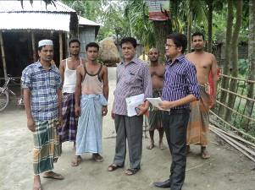
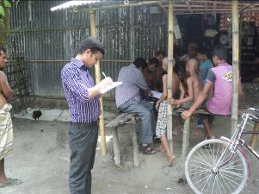

Photographs 7.1.1: Consultant Team visited the site with City Corporation official

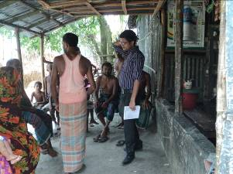
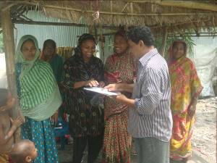
Photographs 7.1.2: Consultation Meeting at Subproject Site

  - Issues Raised by the Participants

The participants raised the issues related to the infrastructure development of Rangpur City Corporation. The anticipated environmental and social impacts due to construction works have also been raised and discussed. The participants also discussed about the potential benefit from the subproject.
  - Feedback, Suggestions, and Recommendations of the Participants

The participants were presented with feedback, suggestions, and recommendations listed below:
- The FGD results confirmed that an improved communication network is needed for future development of Rangpur City Corporation;
- Most of the participants expressed that the number of subproject that have been selected for each financial year is insufficient;
- The participants stated that the public water supply facilities, sanitation facilities, and access road are not adequate;
- The participants stated that construction works should be scheduled properly;
- Local people also showed expectation for the increased opportunities for the employment for unskilled or semi-skilled labor in the construction work.

Conclusions and Recommendations

The subproject intervention has significant ecological impact due to felling of the 1213 number of the trees and clearing of the huge road side vegetation. However, depending on the space availability and City Corporation demand provision is being made for the plantation of 4200 trees to compensate the felled down trees and to enhance the ecological condition in the subproject area. The adverse impacts on the physicochemical components such as air quality, noise level, traffic congestion, solid waste generation etc will be localized and limited within the subproject boundary. It is also anticipated that the overall adverse impacts due to the subproject activities is manageable through mitigation measures. In fact, the anticipated impacts due to the subproject activities are relatively minor in comparison to the significant benefits that will derive due to the implementation of the subproject.
A few key recommendations are outlined below:
- A copy of the EMP shall be kept on-site during the construction period at all times;
- The environmental management and monitoring plan proposed in this report needs to be followed;
- The contractor is responsible for the proper disposal of the generated wastes materials from the subproject sites and Campsite;
- Contractor will ensure availability of the PPEs to the workers;
- Contractor will monitor behavioral matter of the workers to avoid any undue risks related to labor influx;
- City Corporation will inform and encourage the local people for using of the diversion and connecting roads;
- The consultation process should be continued during subproject implementation to ensure that stakeholders are fully engaged in the subproject;
- Equipment should be checked by the City Corporation engineer and DSM consultant prior to work;
- Proper maintenance by the contractor is needed during project liability period.

References

- Website: rpcc.gov.bd /statistics
- Master Plan: Rangpur City Corporation
- Bangladesh Meteorological Department
- GoB (1997), Environmental Conservation Rules 1997
- Environmental Assessment Volume 1: Overall Environmental Assessment [Draft Final Report], September 2013. Municipal Governance and Services Project (MGSP), Local Government Engineering Department (LGED) And Bangladesh Municipal Development Fund (BMDF), Ministry of Local Government, Rural Development and Cooperatives, Government of the People's Republic of Bangladesh;
- Environmental Assessment Volume 2: Environmental Management Framework (EMF) [Draft Final Report], September 2013. Municipal Governance and Services Project (MGSP), Local Government Engineering Department (LGED) And Bangladesh Municipal Development Fund (BMDF), Ministry of Local Government, Rural Development and Cooperatives, Government of the People's Republic of Bangladesh;
- Bangladesh National Building Code, 19993;
- Population and housing census, 2011.

APPENDIX

Appendix- I: Environmental Monitoring Checklist

