
GOVERNMENT OF THE PEOPLE’S REPUBLIC OF BANGLADESH
Local Government Engineering Department (LGED)

Local Government Division

Ministry of Local Government, Rural Development and Cooperatives

Environmental Assessment (EA) REPORT

Name of the Subproject: Construction of Road and Drain from Paira Chattar to RCCI School.
Package No: MGSP/RCC/2017-18/W-13

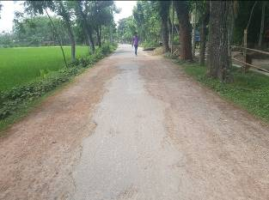
Rangpur City Corporation, Rangpur.
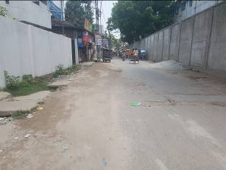

Municipal Governance and Services Project (MGSP)
Design, Supervision, and Management (DSM) Consultancy Services
Joint Venture of  Hifab International AB, Sweden  AQUA Consultant and Associates Ltd., Bangladesh |  |  |   

TABLE OF CONTENTS
 |  |  | Page No.
1.0 | INTRODUCTION |  | 1-3
 | 1.1 | Subproject Background | 1
 | 1.2 | Objectives of the Study | 1
 | 1.3 | Scope and Methodology of the Study | 2
2.0 | SUBPROJECT DESCRIPTION |  | 4-9
 | 2.1 | The Study Area | 4
 | 2.2 | Current Situation, Proposed Intervention and Need For the Subproject | 7
 | 2.3 | Justification of Selection of this Subproject | 8
 | 2.4 | Envisaged Subproject Activities and Implementation Process | 8
 | 2.5 | Category of the Subproject | 9
 | 2.6 | Subproject Schedule | 9
3.0 | BASELINE ANALYSIS OF ENVIRONMENTAL CONDITION |  | 10-18
 | 3.1 | Physical Environment | 10
 | 3.2 | Biotic Environment | 17
 | 3.3 | Socio-economic and Socio-cultural Environment | 17
4.0 | ENVIRONMENTAL SCREENING |  | 19-21
5.0 | SPECIFIC IMPACT, MITIGATION AND ENHANCEMENT MEASURES |  | 22-28
 | 5.1 | Dismantle Work, Site Clearing, Excavation and Earth Work | 22
 | 5.2 | Tree Felling, Clearing of the Vegetation and Ecological Impact | 22
 | 5.3 | Pollution from the Construction Materials | 23
 | 5.4 | Air Quality and Dust | 23
 | 5.5 | Noise and Vibration | 23
 | 5.6 | Water Quality | 24
 | 5.7 | Occupational Health and Safety | 24
 | 5.8 | Impacts on Social Environment and Common Property Resources | 25
 | 5.9 | Labor Influx and Anticipated Impacts | 26
 | 5.10 | Impacts on Traffic Movement | 27
6.0 | ENVIRONMENTAL MANAGEMENT PLAN |  | 29-42
 | 6.1 | Access to Information | 29
 | 6.2 | Grievance Redress Mechanism | 29
 |  | 6.2.1 Grievance Redress Committee (GRC) | 29
 |  | 6.2.2 Grievance Resolution Process | 30
 | 6.3 | Institutional Arrangement for Safeguard Compliances | 31
 | 6.4 | Capacity Building | 32
 | 6.5 | Emergency Response and Disaster Management | 32
 | 6.6 | Environmental Management Action Plan | 33
 | 6.7 | Environmental Monitoring Plan | 39
 | 6.8 | Cost of Environmental Enhancement Works in BOQ | 40
 | 6.9 | Environmental Codes of Practice | 41
7.0 | PUBLIC CONSULTATION AND PARTICIPATION |  | 43-44
 | 7.1 | Methodology | 43
 | 7.2 | Issues Raised by the Participants | 44
 | 7.3 | Feedback, Suggestions and Recommendations of the Participants | 44
8.0 | CONCLUSIONS AND RECOMMENDATIONS |  | 45
9.0 REFERENCES
APPENDIX
Appendix I: Lay-out Plan of the Subproject
Appendix II: Environmental Monitoring Checklist

LIST OF TABLES
Table 3.1.1 | Major Environmental and Infrastructural Features of Paira Chatter to Rail Gate Moar.
Table 5.7.1 | General Requirements for the Workers Health and Safety
Table 5.8.1 | Impacts on Social Environment and Common Property Resources
Table 6.2.1.1 | List of GRC committee members
Table 6.6.1 | Anticipated Environmental Impacts during Construction Phase and Corresponding Mitigation and Enhancement Measures
Table 6.6.2 | Anticipated Environmental Impacts during Operational Phase and Corresponding Mitigation and Enhancement Measures
Table 6.7.1 | Matrix Table of Monitoring Plan (Visual observation during construction phase)
Table 6.8.1 | Environmental Measurement Budget

LIST OF FIGURES
Figure 2.1.1 | Location Map of the Subproject Site
Figure 2.1.2 | Topographic Features of the Subproject site
Figure 3.1.1 | Location of Rangpur City Corporation in Earthquake Zoning Map
Figure 3.1.2 | Average Minimum and Maximum Temperature in Rangpur City Corporation
Figure 3.1.3 | Monthly Average Rainfall in Rangpur City Corporation
Figure 6.3.1 | Environmental and Social Management Team (Tentative)

LIST OF PHOTOGRAPHS
Photographs 2.2.1 | Currents Situation of the Subproject Road and Drain
Photographs 2.2.2 | Current Situation of the Outfall
Photographs 7.1.1 | Consultation Meeting with City Corporation Officials and Councilors at City Corporation.
Photographs 7.1.2 | Consultation Meeting at Subproject Site

ABBREVIATIONS

AP (AP’s) | Affected Person
BDT | Bangladeshi Taka
BOQ | Bill of Quantity
CC | Cement Concrete
CIP | Capital Investment Plan
CP | Contingency Planning
DSM | Design, Supervision, and Management
EA | Environmental Assessment
ECR | Environmental Conservation Rules
EMP | Environmental Management Plan
EPP | Emergency Preparedness Planning
ES | Environmental Screening
FGD | Focal Group Discussion
GoB | Government of Bangladesh
GRC | Grievance Redress Committee
GRM | Grievance Redress Mechanism
GRP | Grievance Redress Procedure
LGED | Local Government Engineering Department
MGSP | Municipal Governance and Services Project
PD | Project Director
PMU | Project Management Unit
RCC | Reinforcement Cement Concrete
RP | Relevant Reports
TL | Team Leader
ULB | Urban Local Body
WB | World Bank
XEN | Executive Engineer

INTRODUCTION

Subproject Background

Rangpur City Corporation was established in the year of 2012. The City Corporation has an area of 203.19 sq. km. The present population of the City Corporation is 795556. At present, the City Corporation has 1427.44 km road among these 67.59 % katcha, 28.43 % pucca and 3.98% semi pucca road. There are 153.52 km drains, where secondary drain is 36.04 km and tertiary drain is 17.48 km. In addition, City Corporation has 65 nos. culvert and 28 nos. bridge [Source: rpcc.gov.bd /statistics]. The existing infrastructure facility especially at the rural part of Rangpur City Corporation is not adequate to meet the present demand. Additionally, increasing population demands new infrastructure and improvement of the existing infrastructure. Hence, as a new City Corporation, Rangpur requires rapid and continuous infrastructure development. Hence, this subproject will significantly contribute infrastructure development of Rangpur City Corporation.

This subproject includes the following components: BC Road, RCC Drain at Paira Chattar to RCCI School Road. The major features of the subproject are mentioned below:

Name of the Subproject | (a) Rehabilitation of Road from Paira Chattar to RCCI School by Bituminous Carpeting (Ch.0-4050m);  (b) Construction of Drain from Paira Chattar to RCCI School (Ch.700-1675m).
Package No. | MGSP/RCC/2017-2018/W-13
District Name | Rangpur
ULB Name | Rangpur City Corporation
Jurisdiction Area | Ward Number 23, 25 and 30
Structural Design  Option | BC Road and RCC Drain
Beneficiary Population | About 70,000 as per City Corporation Officials
Tribal People | No tribal people settlement found in the subproject area
Land Acquisition | Mostly City Corporation owned; no private land acquisition is needed
Estimated Cost | 79.594 Million (BDT)
Subproject Duration | 12Months
Tentative Start Date | 19 November, 2018
Tentative Completion Date | 18 November, 2019

Objectives of the Study

The general objective of this study is to determine the major environmental impacts succeeding from execution of the subproject and to recommend mitigation measures to avoid or reduce adverse environmental impacts and to enhance positive impacts. The specific objectives include:
- To assess the existing environmental conditions of the subproject site and its influence area;
- To identify and assess impacts resulting from the subproject during its construction phase and operation phase;
- To develop a environmental management plan with recommendations for mitigating impacts and enhance positive impacts;
- To summarize environmental monitoring requirements.

Scope and Methodology of the Study

The study methodology comprised the following activities:

- Desktop Study;
- Field Investigations and Data Collection;
- Data Analysis and Report Writing.

Desktop Study
The desktop study involved:
- Initial meetings with client, stakeholders to discuss the proposed subproject;
- Collection and review of the baseline data, maps, reports and other relevant information;
- Review of the relevant existing legislation, regulation and policies;
- Understand the anticipated technical processes that may affect the environment.

Field Investigation and Data Collection

A team of the consultants made a field investigation to the proposed site. Field investigations involved mainly site walks within the subproject area and the neighboring areas that may be affected by the subproject.

The following key tasks were performed during the field visit:
- Taking photographs of the significant aspects to assist in describing the baseline environmental conditions of the subproject area;
- Interviews with representatives of the relevant City Corporation officials and beneficiary and affected people within the subproject influence zone;
- Obtaining relevant documents from City Corporation and local people within the subproject influence zone;
- Verifying information and data collected during the desktop study and to collect new information.

Data Analysis and Report Writing
The data and information collected from all the sources (literature review, secondary and primary data, public consultation) were analyzed to describe the existing environmental setting of the subproject area, to identify the potential positive and negative impacts of the proposed subproject, as well as to provide preliminary suggestions for mitigation measures. Finally, this environmental assessment report has been prepared.

SUBPROJECT DESCRIPTION

The Study Area

The subproject site is located within the jurisdiction of wards no. 23, 25 and 30 of Rangpur City Corporation. The subproject is mostly located on the existing right of way and City Corporation owned land. There are no protected areas, mangroves, or estuaries in or near the subproject location. The Location Map and Topographic Features of the subproject are shown in Figure 2.1.1 and Figure 2.1.2.

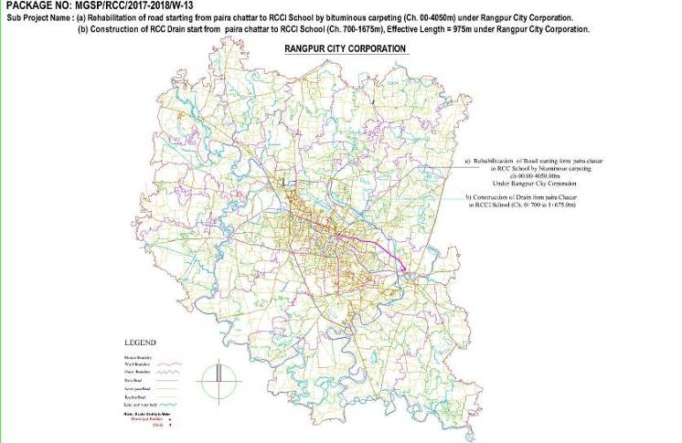

Figure 2.1.1: Location Map of the Subproject Site
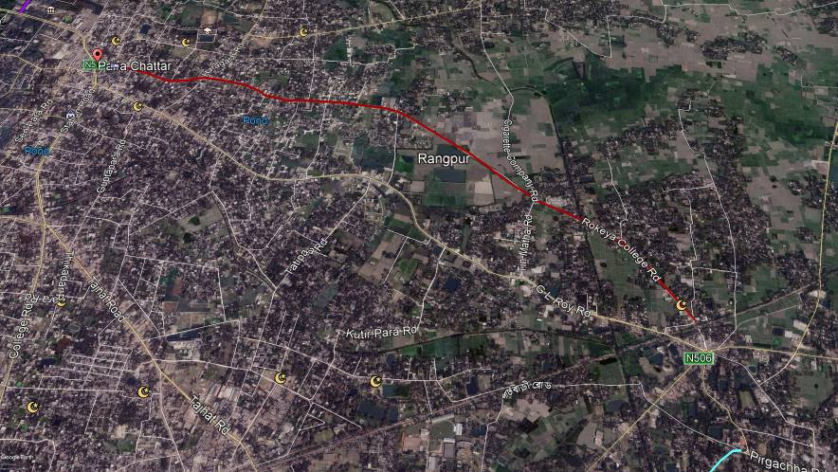

Figure 2.1.2: Topographic Features of the Subproject

Current Situation, Proposed Intervention and Need for the Subproject

The subproject area consists of mixed land use patterns of commercial, residential and agricultural where first 700m is entirely commercial hub with Bank, shops, office etc. There are educational institutes (RCCI, Govt. Begum Rokeya School, Oxbridge School and College, and Kindergarten), branches of Govt. and Private Banks (Rupali Bank, AL Arafa Islami Bank, AB Bank, Pubali Bank, Agrani Bank, Basic Bank), varieties shops & restaurant, healthcare services and residential houses.

Proposed road starts from Paira Chattar (Ch.00m) and end at Rail Gate Moar near Shat Rasta Moar (Ch.4050m). The subproject area goes through Purbo Shalbon, Bottola Para, and Khashbag area of the City Corporation. Existing road width is not uniform in all sections. From Ch. 0-700m, average road width is about 12-15m. While from Indrar Moar to Rail Gate Moar, average road width is 4- 4.5m. The existing road is damaged due to absent of wearing course. Due to exposed base course, there are pot holes at some places. In addition, exposed road surface without bituminous carpeting generate dust and create discomfort situation for the road users and adjacent residents.

In fact, the damaged road demands rehabilitation work to meet the existing traffic demand and to cope with increasing demand. From Ch.0-700m, the existing road will be improved without widening. But rest of the portion, the paved width will be increased to 5.5m.

There is a functional drain except Ch. 700-1675m. Hence, due to discontinuity of the existing drain, it cannot properly discharge the storm water. Therefore, after rainfall road side area gets flooded especially at Ch. Ch. 700-1675m. As a result, smooth traffic flow as well as pedestrian movement is hampered. To complete the drainage network of the existing drain and to minimize the water logging problem from Indrar Moar to Boishaki Moar (Ch.700-1675m), RCC drain with cover slab is proposed. Storm water will be discharged in to the Shamasundori Khal. The existing condition of the subproject road and drain and outfall are further elaborated in the following Photographs 2.2.1 & Photograph 2.2.2.

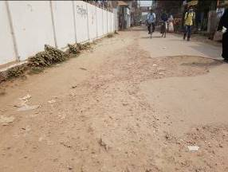
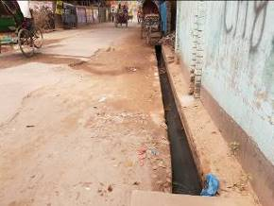

Photograph 2.2.1: Currents Situation of the Proposed Road and Drain
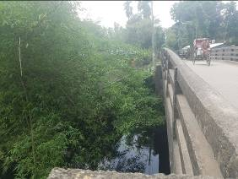
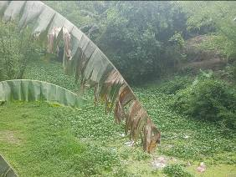

Photograph 2.2.2: Current Situation of the Outfall

Justification of Selection of this Subproject

The subproject road has significant importance because one end is connected with core area of City Corporation and other end is connected with adjacent union road. Hence, this subproject has been considered as priority subproject in the CIP. PMU representative, and DSM consultant visited the subproject site to assess the site condition. From the site visit, it is revealed that this road is very much inconvenience for the movement of the motorized vehicles. The subproject is located mostly in the right of way. Since the City Corporation is owned the subproject. Hence, land acquisition is not an issue for implementation of this subproject. From the site inspection, it is also revealed that roadside built-up infrastructure will not be severely affected by the implementation of the subproject. After completion, the road subproject will provide uniform width. By eliminating pot holes and providing smooth road surface it will provide better, easy and safe movement facilities for the travelers.

On the contrary, after construction the drain will enhance drainage facilities in the subproject area. The subproject has significant benefit to the community people. Hence, considering the benefits that will derive, the subproject has been selected for implementation.

Envisaged Subproject Activities and Implementation Process

The general activities for the subproject includes: construction of the semi-pucca site office, construction of the labor shed, relocation of the electric poles and site clearing works.

The key activities of the RCC Drain include:

- Earth work in excavation of the foundation;
- Pumping and bailing out of water as per requirement;
- Lying of polythene sheet;
- Sand filling for the preparing foundation bed;
- Plain cement concrete work in foundation;
- Manufacturing CC blocks;
- Fabrication of the ribbed or deformed bar & Reinforced cement concrete work.

The key activities for BC Road include:

- Dismantling of the damaged sub-base and base course works;
- Clearing and grubbing works;
- Earth work in box cutting & Earth filling work;
- Sand filling on the road bed & Mechanical compaction;
- Brick on edging;
- Compacted stone aggregate base course;
- Providing prime coat;
- Laying pre-mixed dense bituminous surfacing wearing course.

The materials and resources to be used for the key activities: soil in earth work, sand, stone chips, cement, reinforcement, diesel, MS sheet, steel shutter, bitumen, electricity and water.
The major equipment to be used for the implementation of the subproject: hydraulic excavator, concrete mixer machine, steel cutter, mechanical vibrator machine, mechanical compaction machine, steel drum rollers, pneumatic multiple tire roller, dump truck, water tanker, pump, asphalt plant, rubber tire roller, paver.

Category of the Subproject

For BC Road and RCC Drain
- According to ECR 1997: Green □ Orange□ A Orange B □√ Red □ Not Listed □
- According to WB classification: Category B □√ Category C □
In the Project EMF, RCC drain is categorized as Orange A or Orange B depends on environmental impact. In the Project EMF, road is categorized as Orange B. considering the anticipated environmental impacts, primarily BC Road and RCC drain, can consider as Orange-B category as per ECR-97. According to the WB classification, it can classify as Category B.

Subproject Schedule

The tentative schedule of construction of the subproject is:
(a) Subproject Duration (months) :12 months
(b) Tentative Start Date : 19 November, 2018
(c) Tentative Completion Date : 18 November, 2018
The daily construction hours will normally include regular working time. However, daily working hours may vary based on the on-site condition. The detailed work program will be prepared by the contractor with the assistance of the PIU. Then it will be shared with the PMU, LGED and DSM consultants. In addition, the detailed work program will also be shared with the Bank as per requirement.

Baseline ANALYSIS OF THE ENVIRONMENTAL CONDITION

Physical Environment

Important Environmental and Infrastructural Features

During site visit environmental and infrastructural features within the subproject area were collected. Conditional survey has also been conducted for designing the subproject. The survey data is also used for preparing the report. The environmental and infrastructural features listed within 100 m of the both sides of the road from the center line considering 100 m longitudinal interval from Paira Chatter to Rail Gate Moar (Length-4050m) are shown in Table 3.1.1.

Table 3.1.1: Major Environmental and Infrastructural Features of Paira Chatter to Rail Gate Moar
Chainage (m) | Left | Right | Major Environmental and Infrastructural Features
Paira Chattar to RCCI School (Ch. 0-4050m)
0-100 | √ |  | Arafa Islami Bank, Joy Press, Liza, Shadaron Bima Corporation, Popular Life Insurance, Rupali Bank , Varieties Shops, Electric pole, Drain
0-100 |  | √ | Boishaki Misti, AB Bank, Progoti Insurance, IDLC, Pubali Bank, Haque Printing, City Bank, Varieties Shops, Basic bank, Agrani Bank.
100-200 | √ |  | Varieties Shop, Alom Press, Police Super Office, Khaleq Hotel and Restaurant, Electric Pole, Restaurant, National Party Office, Tea stole, Boundary wall, Pucca, Semi-pucca and Tin shed Residents, Drain
100-200 |  | √ | Hena Electronics, Pucca, Semi-pucca and Tin shed Residents, Boundary wall, Electric Pole, Trees
200-300 | √ |  | Uttar Trading, Mashers Vai Vai Trading, Pucca, Semi-pucca and Tin-shed Residential and Commercial Structure, Electric Pole, Trees, Boundary wall, Drain,
200-300 |  | √ | Boundary Wall, Pucca, Semi-pucca and Tin-shed Residential and Commercial and Residential Structure, Mosque, trees
300-400 | √ |  | Post Office, Rangpur Govt. College, Segment Printers, Pucca, Semi-pucca and Tin-shed Residential and Commercial Structure, Electric Pole, Trees, Boundary wall, Drain,
300-400 |  | √ | Regional Food Controller Office, Custom Vat Office, Boundary Wall, Pucca , Semi-pucca and Tin-shed Residential and Commercial and Residential Structure, trees
400-500 | √ |  | Janata Garments, Tuli Bosraloy, Pucca, Semi-pucca and Tin-shed Residential and Commercial Structure, Electric Pole, Trees, Boundary wall, Drain,
400-500 |  | √ | Boundary Wall, Pucca , Semi-pucca and Tin-shed Residential and Commercial and Residential Structure, trees
500-600 | √ |  | Pucca, Semi-pucca and Tin-shed Residential and Commercial Structure, Electric Pole, Trees, Boundary wall, Brick Drain, Connecting Road towards Hargacha
500-600 |  | √ | Oxbridge International School, Boundary Wall, Pucca , Semi-pucca and Tin-shed Residential and Commercial and Residential Structure, trees
600-700 | √ |  | Shomaj Sheba Office, Pucca, Semi-pucca and Tin-shed Residential and Commercial Structure, Electric Pole, Trees, Boundary wall, Brick Drain,
600-700 |  | √ | Boundary Wall, Pucca , Semi-pucca and Tin-shed Residential and Commercial and Residential Structure, trees
700-800 | √ |  | Hasan Store, Atik Laundry, Pucca, Semi-pucca and Tin-shed Residents, Open Space, Trees, Electric Pole
700-800 |  | √ | Rangpur Photocopy, Boundary Wall, Tress, Pucca, Semi-pucca and Tin-shed Commercial and Residents Structure
800-900 | √ |  | Prime Islami Life Insurance Company LTD., Varieties Shops, Salon, Pucca, Semi-pucca and Tin-shed Residents and Commercial structure, Trees, Brick Drain,
800-900 |  | √ | Govt. Begum Rokeya College, Boundary Wall, Varieties Shops, Trees, Electric Pole
900-1000 | √ |  | Six Season, Boundary wall, Tress, Pucca, Semi-pucca and Tin-shed Commercial and Residents Structure
900-1000 |  | √ | Pucca, Semi-pucca and Tin-shed Commercial and Residents Structure, Boundary wall, Trees, Electrical Pole, Brick Drain
1000-1100 | √ |  | Pucca, Semi-pucca and Tin-shed Commercial and Residents Structure, Boundary wall, Trees, Electrical Pole, Brick Drain
1000-1100 |  | √ | Pucca, Semi-pucca and Tin-shed Commercial and Residents Structure, Boundary wall, Trees, Electrical Pole, Brick Drain
1100-1200 | √ |  | Dust Bin, Pucca, Semi-pucca and Tin-shed Commercial and Residents Structure, Boundary wall, Trees, Electrical Pole, Brick Drain
1100-1200 |  | √ | Mosque, Brick Drain, Pucca, Semi-pucca and Tin-shed Commercial and Residents Structure, Boundary wall, Trees, Electrical Pole,
1200-1300 | √ |  | Pucca, Semi-pucca and Tin-shed Commercial and Residents Structure, Boundary wall, Trees, Electrical Pole, Brick Drain
1200-1300 |  | √ | Musa Collection, Insaf Enterprise, Credit Unioner Jatio Protistan, Doctor Chamber, Boundary Wall
1300-1400 | √ |  | Pucca, Semi-pucca and Tin-shed Commercial and Residents Structure, Boundary wall, Trees, Electrical Pole
1300-1400 |  | √ | Pucca, Semi-pucca and Tin-shed Residents Structure, Boundary wall, Trees, Electrical Pole
1300-1400 | √ |  | Pucca, Semi-pucca and Tin-shed Residents Structure, Boundary wall, Trees, Electrical Pole
1300-1400 |  | √ | Pucca, Semi-pucca and Tin-shed Residents Structure, Boundary wall, Trees, Electrical Pole
1400-1500 | √ |  | Boundary wall, Trees, Electrical Pole , Pucca, Semi-pucca and Tin-shed Commercial and Residents Structure,
1400-1500 |  | √ | Pucca, Semi-pucca and Tin-shed Residents Structure, Boundary wall, Trees, Electrical Pole
1500-1600 | √ |  | Pucca, Semi-pucca and Tin-shed Residents Structure, Boundary wall, Trees, Electrical Pole, Damaged Brick Drain
1500-1600 |  | √ | Boundary wall, Trees, Electrical Pole, Pucca, Semi-pucca and Tin-shed Residents Structure, Boundary wall, Trees, Electrical Pole
1600-1700 | √ |  | Pucca, Semi-pucca and Tin-shed Residents Structure, Boundary wall, Trees, Electrical Pole, RCC drain
1600-1700 |  | √ | Pucca, Semi-pucca and Tin-shed Residents Structure, Boundary wall, Trees, Electrical Pole
1700-1800 | √ |  | Habib Studio, Dighi Pharmacy, Trees, Pucca, Semi-pucca and Tin-shed Residents Structure, Boundary wall, Trees, Electrical Pole, RCC Drain
1700-1800 |  | √ | Varieties Shops, Pucca, Semi-pucca and Tin-shed Residents Structure, Boundary wall, Trees, Electrical Pole
1800-1900 | √ |  | Boundary Wall, Pucca, Semi-pucca and Tin-shed Residents Structure, Boundary wall, Trees, Electrical Pole
1800-1900 |  | √ | RCCI School, Pucca, Semi-pucca and Tin-shed Residents Structure, Boundary wall, Trees, Electrical Pole
1900-2000 | √ |  | Boundary wall, Trees, Electrical Pole ,Varieties Shops, Pucca, Semi-pucca and Tin-shed Residents Structure, RCC Drain
1900-2000 |  | √ | Varieties Shops, Pucca, Semi-pucca and Tin-shed Residents Structure, Boundary wall, Trees, Electrical Pole
2000-2100 | √ |  | Open Space, Sheikh Ongan Uccha Biddaloy, Housing Jame Mosque, Pucca , semi-pucca and Tin Shed Residents
2000-2100 |  | √ | Open Space, Pucca, Semi-pucca and Tin-shed Residents Structure, Boundary wall, Trees, Electrical Pole, Agricultural Field,
2100-2200 | √ |  | Varieties Shops, Pucca, Semi-pucca and Tin-shed Residents Structure, Boundary wall, Trees, Electrical Pole
2100-2200 |  | √ | Varieties Shops, Pucca, Semi-pucca and Tin-shed Residents Structure, Boundary wall, Trees, Electrical Pole, RCC Drain, Agricultural Field,
2200-2300 | √ |  | Nobinogor Jame Mosque, Trees, Pucca, Semi-pucca and Tin-shed Residents Structure, Boundary wall, Electric Pol, Agricultural Field,
2200-2300 |  | √ | Open space, Agricultural Field, Pucca, Semi-pucca and Tin-shed Residents Structure, Boundary wall, Electric Pole, RCC Drain
2300-2400 | √ |  | Agricultural Field, Electric Pole, Pucca, Semi-pucca and Tin-shed Residents Structure, Boundary wall, RCC Drain
2300-2400 |  | √ | Boundary Wall, Stationary Shops, Pucca, Semi-pucca and Tin-shed Residents Structure, Boundary wall,
2400-2500 | √ |  | Agricultural Field, Low Land, Trees, Pucca, Semi-pucca and Tin-shed Residents Structure, Boundary wall, RCC Drain
2400-2500 |  | √ | Agricultural Field, Slum Area, Trees, Pucca, Semi-pucca and Tin-shed Residents Structure, Boundary wall,
2500-2600 | √ |  | Agricultural Field, Low Land, Trees, Pucca, Semi-pucca and Tin-shed Residents Structure, Boundary wall, RCC Drain, Vegetation Coverage
2500-2600 |  | √ | Agricultural Field, Slum Area, Trees, Pucca, Semi-pucca and Tin-shed Residents Structure, Boundary wall, Vegetation Coverage
2600-2700 | √ |  | Agricultural Field, Low Land, Trees, Pucca, Semi-pucca and Tin-shed Residents Structure, Boundary wall, RCC Drain
2600-2700 |  | √ | Agricultural Field, Slum Area, Trees, Pucca, Semi-pucca and Tin-shed Residents Structure, Boundary wall, Vegetation Coverage
2700-2800 | √ |  | Pond, Agricultural Field, Low Land, Trees, Pucca, Semi-pucca and Tin-shed Residents Structure, Boundary wall, RCC Drain
2700-2800 |  | √ | Boundary wall, Agricultural Field, Slum Area, Trees, Pucca, Semi-pucca and Tin-shed Residents Structure,
2800-2900 | √ |  | Agricultural Field, Low Land, Trees, Pucca, Semi-pucca and Tin-shed Residents Structure, Boundary wall, RCC Drain, Vegetation Coverage
2800-2900 |  | √ | Madrasah, Agricultural Field, Slum Area, Trees, Pucca, Semi-pucca and Tin-shed Residents Structure, Boundary wall,
2900-3000 | √ |  | Agricultural Field, Low Land, Trees, Pucca, Semi-pucca and Tin-shed Residents Structure, Boundary wall, Vegetation Coverage
2900-3000 |  | √ | Pond, low land Agricultural Field, Trees, Pucca, Semi-pucca and Tin-shed Residents Structure, Boundary wall, RCC Drain,
3000-3100 | √ |  | Shamasundori Khal, Boundary wall, Agricultural Field, Low Land, Trees, Pucca, Semi-pucca and Tin-shed Residents Structure, Vegetation Coverage
3000-3100 |  | √ | Shamasundori Khal, Boundary wall, Agricultural Field, Slum Area, Trees, Pucca, Semi-pucca and Tin-shed Residents Structure, RCC Drain
3100-3200 | √ |  | Agricultural Field, Low Land, Trees, Pucca, Semi-pucca and Tin-shed Residents Structure, Boundary wall, RCC Drain, Vegetation Coverage
3100-3200 |  | √ | Varieties Shops, Trees, Pucca, Semi-pucca and Tin-shed Residents Structure, Boundary wall,
3200-3300 | √ |  | Agricultural Field, Trees, Pucca, Semi-pucca and Tin-shed Residents Structure, Boundary wall, Vegetation Coverage
3200-3300 |  | √ | Pond, Trees, Pucca, Semi-pucca and Tin-shed Residents Structure, Boundary wall,
3300-3400 | √ |  | Vegetation Coverage, Agricultural Field, Trees, Pucca, Semi-pucca and Tin-shed Residents Structure, Boundary wall, Vegetation Coverage
3300-3400 |  | √ | Pucca, Semi-pucca and Tin-shed Residents Structure, Boundary wall,, Varieties Shops, Trees,
3400-3500 | √ |  | Pond, Connecting Road, Agricultural Field, Trees, Pucca, Semi-pucca and Tin-shed Residents Structure, Boundary wall, Vegetation Coverage
3400-3500 |  | √ | Shops, Trees, Pucca, Semi-pucca and Tin-shed Residents Structure, Boundary wall,
3500-3600 | √ |  | Electric Pole, Open Space, Semi-pucca and Pucca Residents,
3500-3600 |  | √ | Agricultural Filed, Open Space, Electric Pole
3600-3700 | √ |  | Agricultural Filed, Boundary wall, Semi-pucca and Pucca Residents,
3600-3700 |  | √ | Electric Pole, Semi-pucca and Pucca Residents,, Boundary Wall
3700-3800 | √ |  | Boundary Wall, Electric pole, Semi-pucca and Pucca Residents,,
3700-3800 |  | √ | Pond, Graveyard, Semi-pucca and Pucca Residents, Khashbag Govt. Primary School, Mosque
3800-3900 | √ |  | Connecting Road, Pucca, Semipucca and Tin shed Residents, Electric Pole
3800-3900 |  | √ | Pucca, Semipucca and Tin shed Residents, Boundary wall
3900-4000 | √ |  | Electric Pole, Boundary Wall. Pucca, Semipucca and Tin shed Residents,
3900-4000 |  | √ | Electric Pole, Boundary Wall. Pucca, Semipucca and Tin shed Residents,
4000-4050 | √ |  | Boundary Wall, Semipucca and Tin shed Residents
4000-4050 |  | √ | Electric Pole, Shop, Boundary Wall, Semipucca and Tin shed Residents

Geology, Topography and Soils

Rangpur City Corporation is a land of mixed topography. The present urbanized and developed areas and the levees of the Ghaghat River are comparatively higher elevation. The area lies in Earthquake Zone 3 (shown in Figure 3.1.1) according to the seismic map of Bangladesh (Ref: BNBC, 1993). Geologically it is a terrace from one to ten meters above the adjacent floodplains. Two characteristic geological units cover RCC, namely, alluvial soil (80%) of Teesta River basin and the remaining is Barind soil. The Barind soil is the oldest sediment exposed in the area. The major geographic units of the city are: the high land or terrace, the low land or floodplain, depressions, and abandoned channels. Low lying swamps and marshes located in and around the area are other major topographic features.
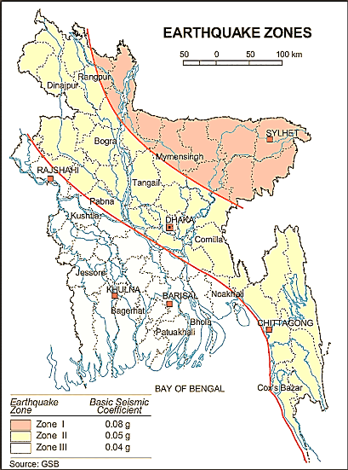

Figure 3.1.1: Location of Rangpur City Corporation (red circle) at Earthquake Zoning Map

Climate and Meteorology

The climate of the subproject area can be described as Tropical Monsoon. It is characterized by the warm, humid summers and cool and dry winters. However, generally the weather is sub-tropical, with a warm climate all the year round. The annual average temperature varies maximum 32.3°C to minimum 11°C and the average annual rainfall is 2931 mm. Rangpur City Corporation is colder than other City Corporations; nevertheless, has a similar pattern of rainfall.
Average minimum and maximum temperature of Rangpur City Corporation is shown in Figure 3.1.2. Monthly average rainfall of Rangpur City Corporation is shown in Figure 3.1.3.

Figure 3.1.2: Average Minimum and Maximum Temperature of Rangpur City Corporation (Source: BMD)
Figure 3.1.3: Monthly Average Rainfall of Rangpur City Corporation (Source: BMD)
According to the statistics of the wind data from the Bangladesh Meteorological Department Climate Division, wind direction changes by month. Nevertheless, the northwest, south, and northeast winds are predominant.
The construction works can be influenced by the climatic condition and meteorological components like humidity, temperature, sudden rainfall, and wind speed. High winds can enhance quick spreading of the generated dust. It is very risky working under rain and in high winds because the possibility of getting injury increases. Furthermore, work under high temperature and excess humidity may create health hazards like dehydration problem.

Water Resources (Surface Water, Ground Water and Rain Water)

There are Shamasundori Khal, ponds and ditches in the subproject area. Groundwater is the main source of potable water in the subproject area. Deep groundwater is not saline and normally arsenic (<0.01mg/l) and iron free (Source: DPHE). Local people typically use deep tube-well water for drinking and other domestic purposes. Salinity problems are not visible. Rain water harvesting system is not common in and around the subproject area.

Flooding, Water Logging, and Drainage Pattern

In adequate drainage network, natural siltation, absence of proper outlets, disposal of solid waste into the drains causes blockage in the drainage system which create water logging. Recently, the authority has undertaken subproject of the tertiary drain construction which are under implementation. According to the historical data, the subproject area is not affected in severe flood events after the year 1988.

Air Quality and Dust
Air quality data is not available from secondary sources. Air seems to be clean. However, in dry season dust is generated due to vehicles movement and windblown dust causes air pollution. In addition, black smoke emission from the vehicles degrades the quality of the air. There are no remarkable sources of air pollution such as heavy industries observed in the subproject area.

Noise Level

Noise is not a major impediment for the quality of the environment in the subproject area. Vehicles such as rickshaws, trolleys, pick-up, trucks, motor cycles, mini trucks, and private cars generally move on the road during day and night. These vehicles generate noise in the subproject area. However, they are within the tolerable limits in most cases. There are no other perceptible sources of noise generation such as heavy factories or industries were found near the subproject area.

Solid Waste Management

Solid waste collection system is available in the older part of the city. House to house collection through community participation is also available. As per information from City Corporation Officials, an average 12 tons of solid wastes are collected per day and dumped in open dumping ground through 6 vehicles. Home collection is carried-out by 46 vans while citizens dump households waste in 49 road side bins. In non-core part of the city households waste are mostly used as kitchen fuel or feed for domestic pets. The residues are dumped into family pit. (Source: Rangpur City Corp- Master Plan)

Biotic Environment

Flora and Fauna
The subproject area is rich with terrestrial and aquatic flora. However, most of the terrestrial floras are in the homestead area. All homesteads are usually covered by wide variety of both native and exotic species of the trees. Both sides of the road are covered by natural and planted trees from Ch.1200 to 4050m. Along the road alignment common planted local trees include; Mango (Mangifera indica), Jackfruits (Artocarpus heterophyllus), Bokul (Mimusops eleng), Jarul (Lagerstroemia speciosa), Mahagony (Swietenia macrophylla), Coconut (Cocos nucifera), Banana (Musa paradisiacal), Supari (Areca catechu), Eucalyptus (Eucalyptus teritocornis) Akashi (Acacia auriculiformis). In the subproject area, from Ch.1100-3500m (approximately) at both sides of the road there area agricultural filed at different segment where rice and seasonal vegetation is growing abundantly. Furthermore, at the bank of the low land, ponds, and road side area there are diversify natural grown vegetation.
There are common local birds such as Dowel (Copsychus saularis), Crow (Corvus splendens), Shalik (Acridotheres fuscus), Choroi (Passer domesticus), Bok (Mesophoyx intermedia), Bulbuli (Pycnonotus barbatus) and Tuntuni (Orthotomus sutorius) etc. were found during the site visit. As per information by the local people, migratory birds are also found in the winter season on the paddy land.

Socio-economic and Socio-cultural Environment

Land Use, Status of Housing and Built-up Infrastructure
The proposed road goes through medium densely populated area and consists of mixed land–used pattern (residential, agricultural and commercial area). The road side built-up infrastructure includes pucca, semi-pucca and tin-shed houses, shops, Branch of Govt. and Private Banks, NGO Offices, educational institutes, healthcare services and religious institute. Most of the section there are agricultural lands at both sides of the proposed road where crops and vegetables are growing abundantly.

Beneficiary Population
This subproject is situated within the Wards number 23, 25 and 30. As per information by the municipality, considering the wards’ population about 70,000 people will be benefited directly and many others indirectly.

Education
In the subproject area, literacy among the population is about 61.00%. This is higher than the national average (51.8%). The literacy rate among males (58.00) is still less than females (64.00). (Ref: Population and Housing Census 2011).

Tribal Communities

There is no indigenous or tribal people settlement in the subproject area. Therefore, there is no measure needed for indigenous peoples’ safeguard.

Land Acquisition and Resettlement

There are 20 nos. of tin shed houses (squatter house) at Ch. 2200m (approximately). Due to site clearing work for extension of the paved width, these house need to be removed. Rangpur City Corporation will relocate them to the new places prior to the commencement of the work.
Principal Livelihoods and Economic Activities
The subproject area is now inhabited by the mixed occupational people. Most of the people are engaged in the traditional professional activities relate to agriculture, land ownership, small business. Presently, some people are engaged in private sector and government jobs in the town.

Cultural Heritage and Protected Areas
There are no protected areas and no important cultural or historical sites identified in the subproject influence area.

Social Conflicts and Development Activities
The local people welcome the subproject and there is no conflicts between the local communities regarding subproject implementation.

ENVIRONMENTAL SCREENING

Environmental Screening Checklist, as adopted in Appendix C of the Environmental Management Framework (EMF) of the MGSP, was administered for identifying the impacts and their extents.
The screening data for the BC Road and RCC Drain have been formulated and are shown in below.
(2) Potential environmental impact during construction phase:

- Ecological impacts:
121
- Felling of trees Significant □ Moderate □ √ Minor □ Number of trees
- Clearing of vegetation Significant □ Moderate □ Minor □√
- Potential impact on species of Significant □ Moderate □ Minor □ √
Aquatic (i.e., water) environment
Total 121 numbers of roadside naturally grown and planted trees need to be cut down to construct new BC road. Major trees to be cut down are: Koroi, Mango, Neem, Jackfruit, Mahogany, Coconut, Jamrul, Dumur, Rain-tree etc. There is no tree to be felled down has religious and cultural importance. In addition, the trees to be felled down are small to medium size. Amount of the vegetation need to be cleared due to the subproject is insignificant. In addition, anticipated impact on species of aquatic environment is minor because except throwing of the wastes materials into the ditches, the subproject does not have any impact on the aquatic environment. Considering the tree felling, ecological impact is considered as moderate.
- Physicochemical impacts:

- Air Pollution Significant □ Moderate □√ Insignificant □
- Noise Pollution Significant □ Moderate □√ Insignificant □
- Drainage Congestion Very likely □ Likely □ √ Unlikely □
- Water Pollution Significant □ Moderate □√ Insignificant □
- Pollution from solid/ construction wastes Significant □ Moderate □√ Insignificant□
- Water logging Significant □ Moderate □ Insignificant□ √

The subproject will have impacts on noise and air quality during construction phase due to mobilization of the equipment, vehicles movement for the transportation of the materials, using of the hydraulic excavator, mechanical compaction machine, paver, asphalt plant, concrete mixer machine, vibrator machine etc. The construction work will be performed section wise. Hence, it is anticipated that the overall impacts on noise and air quality will be moderate, temporary and limited within the subproject boundary. The generated dust and black smoke emission from the equipment during construction activities may disturb the local people if proper measures are not taken. Improper collection and disposal of the generated wastes materials may degrade the quality of the surrounding environment and degrade the aesthetic value. Pumping facilities will be provided for pumping out of the storm water if required. So, anticipated water logging and drainage congestion during construction period is minor. The subproject will have no adverse impact on the topography, climate, soils and regional hydrology.

- Socio-economic impacts:

- Traffic congestion Very likely □ Likely □ √ Unlikely □
- Health and safety Significant □ Moderate □√ Insignificant □
- Impact on archaeological and historical Significant □ Moderate □ Insignificant □√
- Employment generation Significant □ Moderate □ √ Insignificant □

Though it is temporary and site specific; however, the construction activities will have likely negative impact on local traffic system. However, the local people and traffic can use connecting and alternative roads that will diversify the traffic volume and will minimize traffic impact. The construction work will follow simple procedure with commonly used equipment. Therefore, impact on health and safety is anticipated as moderate. There is no archaeological and historical site within the influence area. The subproject will have positive impacts by generating employment opportunities for the local people and creating business opportunity of supplying construction materials, equipment, food and other necessary staffs to the work camp.

(3) Potential Environmental Impact during Operational Phase:
- Ecological impacts:

- Potential impact on species of aquatic Significant □ Moderate □ Minor □√
(i.e., water) environment
The road component does not have any likely impact on the aquatic environment during operation. Though, the drain is designed for storm water; however, the storm water may carry washed-out materials, pollutants from any sources that may disturb the aquatic environment of the outfall.

- Physicochemical impacts:

- Potential air quality Improvement □ No-improvement □ Deterioration □√
- Potential noise level Improvement □ No-improvement □ Deterioration □√
- Drainage congestion Improvement □√ Minor Improvement □ No Impact □
- Risk of water pollution Significant □ Moderate □ Minor □√
- Pollution from solid waste Improvement □ No-improvement □ Minor □√

During operation phase, improved and widened road may increase traffic volume. This may degrade the air quality and noise level due to black smoke emission and un-due use of hydraulic horn from the vehicles. The wastewater to be discharged may degrade the water quality of the outfall, if it carries pollutants. The new drain after construction will reduce water logging problem. The covered drain also will reduce throwing of the waste materials in to the drain. This will reduce drain water pollution. Consequently, spreading of the bad odor will be minimized.

- Socio-economic impacts:

- Traffic Improvement □√ No-improvement □ Adverse □
- Safety Improvement □√ No-improvement □ Adverse □
- Employment generation Significant □ Moderate □ Minor □√

After completion, the subproject road will enhance transport facilities in the subproject area. The new drain will reduce drainage congestion and water logging problem in the subproject area. The new drain will also reduce stagnation of the water on the road. Thus, it will enhance road safety. The new road will minimize the frequency of the maintenance for the first three to five years after construction.

(4) Summary of the Possible Environmental Impacts of the Subproject:
The subproject site is not located any environmentally sensitive area. Due to site clearing work, there are 121 trees need to be felled down. However, the ecological imbalance to be caused due to cut down of the trees will be compensated by the plantation of the trees. The subproject activities will have adverse impacts on physicochemical impacts. However, it is anticipated that the impact is not severe and limited within the subproject boundary. The wastes generated due to the construction activities should be properly collected and disposed in a designated dumping site. Some earthwork will be involved for the road construction work; however, no agricultural productive soil will be used for the purpose. The inputs that may affect the environment will be mainly at construction phase. Moreover, mitigation measures will be taken according to the EMP for minimizing the environmental pollution.
Safety concern is an important issue for both the construction and operation phases that should be considered properly. This subproject will have positive impacts in terms of the generation of the employment and business activities by supplying construction materials and equipment. However, it has significant positive social impacts.

Specific impact, mitigation, AND enhancement measures
This subproject includes construction of BC Road, RCC Drain Work. The possible impacts are mainly caused by the key activities to be performed for the implementation of the subproject, raw materials and equipment to be needed for execution of the subproject activities. This section describes some specific impacts due to the subproject activities and their mitigation measures.

  - Dismantle Work, Site Clearing, Excavation and Earth Work
The road improvement work includes dismantle of the existing bituminous pavement and brick drain, clearing of the wastes materials generated due to dismantle work, earth excavation and earth filling work for the BC road and RCC Drain. These works lead dust blowing, improper disposal of the wastes, noise and vibration which may disturb the local people.

Mitigation Measures

- Proper care will be taken by the contractor during dismantle work, excavation work, earth work and disposal work to avoid any undue disturbances to the nearby people;
- Cover exposed earth works with fabric;
- Disposal of soil and construction wastes at the City Corporation recommended dump site at Nasnia;
- Avoid loss of the topsoil for the earth work.

  - Tree Felling, Clearing of the Vegetation and Ecological Impact

There are 121 nos. of planted trees (Koroi, Mango, Neem, Jackfruit, Mahogany, Coconut, Jamrul, Dumur, Rain-tree etc.) will be felled down and road side vegetation (herb, shrubs, bushes) will be cleared due to implementation of this subproject.

Mitigation Measures

- 250 nos. of trees will be planted to compensate the felled down trees, at both sides of the Paira Chattar BTI RCCI School Road where space is available and anywhere City Corporation owned suitable places within the influence area of the subproject-preferably local fruits, flowers, medicinal and ornamental trees- Mango, Jackfruit, Jam, Kathbadam, Chalta, Krisnachura, Bokul, Jarul, Polash, Kadom, Shimul, Neem, Arjun, Amloki, Horitoki, Bohera, Mahogany, Palm Tree, Chambal, Rain Tree, Shil koroi, Satim etc.
- Planting trees will enhance the ecological balance of the area after their successful growth.

  - Pollution from the Construction Materials
Dumping of the construction spoils, including accidental leakage of the oil, grease, and fuel in equipment yards is a significant hazard. Surface water (Shamasundori Cannel, ponds, ditches) and soil quality (agricultural land) might be polluted from these contaminants. Air pollution and dust may affect the nearby settlement which is generated from fine aggregate such as sand and vehicles.

Mitigation Measures

- Safe transport, storage, and disposal of the construction materials, and the equipment have to be carried out in order to avoid the accidental spillage and loss;
- Maintain adequate moisture content of soil and sand during transportation, compaction and handling;
- Carry the materials especially loose soil and sand with adequate cover;
- Fuels, lubricants, and other hazardous materials should store over raised platforms and not directly on the ground;
- Disposal of un-used soils and construction wastes at Nasnia dump site;
- The playgrounds of the educational institutions should not use as a stockyard or work campsite.

  - Air Quality and Dust
During the construction phase, air pollutants will be emitted from the equipment and construction vehicles are expected to remain low. Local residents in the vicinity of the work sites will be temporarily disturbed by the limited dust pollution that may generate from the construction activities. The overall impacts, however, are expected to remain low.
Mitigation Measures

- When dust is visible water should be sprayed to control the dust;
- Maintain adequate moisture content of soil and sand for transportation, compaction, bed preparation, backfilling and handling;
- Avoid use of dust generating equipment which produce significant amount of particulate matter far from the local residents;
- Ensure that all subproject vehicles are in good operating condition.

  - Noise and Vibration

Noise and vibration caused by the equipment and movement of the construction vehicles may temporarily disturb nearby people. In this subproject, sensitive areas like roadside houses, mosques, madrasha, schools and shops are likely to be affected from the generated noise, though the impacts are anticipated to be limited and within the limit.

Mitigation Measures

- Transportation of the construction materials have to be carried during the scheduled times, and mainly during the day;
- Casting of the RCC work for RCC drain should be performed during the scheduled times;
- Avoid use of steel cutter, concrete mixer machine and vibrator machine at night;
- If applicable and needed, all powered mechanical equipment and machineries will be fitted with noise abating gear such as mufflers for effective sound reduction.

  - Water Quality

There is no remarkable sources of the water pollution have been found at the subproject area. The water quality may deteriorate if the construction materials, sand, construction wastes, effluent from the work camps, and food wastes are dumped in the road side Shamasundori Khal, low lands, ditches, agricultural lands and ponds.
Mitigation Measures

- Proper construction management including waste management as well as training of the operators and other workers should provide to avoid pollution of the water bodies;
- Construction wastes will dispose properly (not in water bodies or lowland), for which contractor will be responsible;
- Construction wastes will dispose properly at Nasnia dump site (not in the water bodies or lowland), for which contractor will be responsible.

  - Occupational Health and Safety

The most important risks associated with the construction activities are listed below:
- Exposure to the sunlight- workers are being exposed to the sun for long hours;
- Exposure to the high temperature, and humidity for a long time resulting in dehydration;
- Contact with the hazardous substances and wastes pose risks of the infections and diseases;
- Risk of the poor air quality due to dust;
- Risk of the collision (traffic);
- Risks from the head loads for carrying materials;
- Risks of using of the machinery in motion such as steel cutter;
- Risk associated to the sudden bad weather working conditions;
- Risk associated due to haphazard work by the workers.

General Requirements for the Workers’ Health and Safety
The key salient features of the general requirements for the workers’ health and safety stated is presented in Table 5.7.1.
Table 5.7.1: General Requirements for the Workers Health and Safety
Issues | Requirements
Health and Hygiene | - Cleanliness at the site premises and workers living places and at the Labor Shed;  - Arrangement of the proper ventilation and temperature at the Labor Shed;  - Protection against dust and furnace by using of the nose masks and covering of the head and body;  - Proper disposal of the wastes and effluents;  - Provision of the adequate latrines and separate toilets for the women;  - Sufficient dustbins for the solid waste management system.
Safety and First Aid Box | - Using of the personal protective equipment (helmet, gloves, goggles, nose mask, safety boots);  - Precautions during work on or near machineries in motion;  - Head loads are prohibited;  - First aid facilities should be provided and maintained;  - Ensure first aid box with the necessary medicine at the labor shed;  - The first aid kit should include adhesive bandages, regular strength pain medication, gauze, and low grade disinfectant.
Compensation for Accidents at Work | - Contractors will bear medical treatment costs. If any severe accidents such as loss of hands, legs or loss of working ability or any case of death needs compensation-(the amount of the compensation should be fixed considering the type of accidents).
Dust and Fumes | - For any dust, fumes, or other impurities likely to be injurious to the workers, effective measures shall be taken to prevent their accumulation and its inhalation by the workers.
Overcrowding | - No labor room should be overcrowded.
Latrines and Urinals | - Sufficient latrines shall be provided;  - Latrines shall be maintained in clean and sanitary condition;  - Latrines shall be adequately lighted and ventilated.
Disposal of Wastes and Effluents | - Proper disposal system for the solid waste and effluent is required;  - Waste bins must be provided by the contractor at labor shed.

  - Impacts on Social Environment and Common Property Resources

Through comprehensive study, it is revealed that impacts are expected not to be severe and to be largely manageable. The following Table 5.8.1 presents impacts on socio-economic environment and common property resources.
Table 5.8.1: Impacts on Social Environment and Common Property Resources
Social Components | Impacts on IECs | Impact Significance
Community Perception | The local community people welcome this subproject and there is no visible objection from them. | Significant (+ve)
Employment and Business Opportunity | Community feels happy because generally the local contractor will be engaged for the construction works which will create work opportunity for the skilled and non-skilled labor. The subproject will create business opportunity for the equipment and materials suppliers’. | Significant (+ve)
Community Order and Security | This subproject activity does not create any severe security problems to the local community and community people. | Minor  (-ve)
Possible damage to existing infrastructure and facilities | Degradation of the existing road infrastructure by the construction equipment/vehicles used in this subproject. | Minor  (-ve)
New infrastructure and facilities | Construction of new road and drain will enhance municipality infrastructure facilities. | Significant (+ve)
Labor Habitat | Most of the labors will stay at the Labor shed which will have impacts on the environment relates to the generation of the solid wastes, effluent, and water consumption. | Moderate  (-ve)
Health Care | Workers may suffer from the dehydration problems, and other health hazards. | Minor  (-ve)
Accident | In case of road accidents by the vehicles to be used for the transportation may have serious negative impact. | Significant  (-ve)

Mitigation Measures

- Conduct dissemination with the local community about the subproject details;
- Continue liaison with the community leaders in order to maintain the community support;
- Engage local contractor and local people as much as possible for positive perception of the local community;
- Follow traffic rules to avoid any accidents;
- Transportation and mobilization of the equipment and construction materials avoiding peak hours and scheduled time;
- Ensure first aid facilities and effective use of personal protective equipment where applicable.

Labor Influx and Anticipated Impacts

The labor force and associated goods and services required for the construction of infrastructure civil works under this subproject cannot be fully supplied locally. The migration to and temporary settlement of laborers in the subproject, referred to as labor influx, carries an array of potentially positive and negative impacts in terms of demands on public infrastructure, utilities, housing and sustainable resource management and the strain on social dynamics.
Labor influx effects on host communities include positive impacts such as:

- The subproject activities will generate work opportunities for the local people and supplying of the construction materials, equipment, food and other necessary stuffs to the campsite;

- Improved infrastructure and public service access and availability whereby subproject investment catalyzes larger allocation of resources to a region, stimulating the development or expansion of infrastructure and public services.

Critical negative social risks include:

- Increase in criminal activity and alcohol and drug abuse, domestic violence, political attachment and violence, smuggling and robbery etc;
- Increase in gender-based violence, including eve teasing, sexual harassment etc;
- Increases in communicable diseases, including respiratory problems, diarrheal diseases, vector-borne diseases (e.g., malaria), and sexually transmitted infections (e.g., HIV/AIDS, syphilis, gonorrhea, hepatitis B);
- Conflicts arising from increased demand on existing infrastructure, services, and utilities, including transportation, health, education, water and sanitation, waste management, public utilities and community, religious, and recreational facilities and loss of land for access routes.
The general environmental impacts of labor influx include pressure on the natural resources such as using of the water, electricity, other fuel for cooking, loss of land for the labor establishment, depletion of the water supply, sewage and waste water generation, degradation of the air quality, waste generation, increased demands on the local energy and resources and noise pollution effects. The following safeguard measures are recommended to avoid any risk of labor influx:

- Inform local people about the subproject activities;
- Liaison with the community leaders in order to get community support;
- Engage local people as much as possible to minimize workers from outsiders;
- Monitor workers attitude and behavioral matter;
- Monitor the workers movement for avoiding any unexpected social activities (robbery, crime, political attachment and conflicts, drugs abuse);
- Inform and use local administration to get support if needed;
- Inform local utilities service providers (such as for new electricity connection REB or any other department);
- Ensure effective use of natural resources such as water, electricity, fuel, wood etc.

Impacts on Traffic Movement
The construction activities will have likely negative impact on local traffic system. However, the local people and traffic can use connecting and alternative roads that will diversify the traffic volume and will minimize traffic impact.
In addition, road construction work will be performed section wise. Hence, non-motorized vehicles such as By-cycle, Rickshaw etc. and pedestrians can use the road during construction. Moreover, currently motorized vehicles movement on this road is very few due to bad condition. Considering the motorized traffic volume, it is anticipated that the subproject activities do not have any adverse impact on the local traffic system.
During construction phase, interruption of the local traffic system due to the subproject activities will be monitored closely. Then separate traffic management plan will be provided if required. However, the following safeguard measures are recommended to minimize the impacts associated to the traffic movement:

- Inform local people about the subproject activities;
- Inspire local people to use connecting and alternative roads;
- Ensure schedule deliveries of material/ equipment during off-peak hours;
- Place traffic sign/cautionary sign to avoid undue traffic congestion and associated traffic control measures to limit possible disruption;
- The place of construction works should be fenced off with fences if required and should be isolated from general public access and marked with signs to ensure safe movement.

- Environmental ManagementPlan (EMP)

The purpose of the Environmental Management Plan (EMP) is to ensure that the activities are undertaken in a responsible and non-detrimental manner. The EMP will guide the environmentally sound construction of the subproject and ensure efficient lines of communication between the PMU (LGED), Rangpur City Corporation, DSM and the contractors.
  - Access to Information

The environmental assessment report should be translated into Bengali and disseminated locally. The copies of the report (both in English and Bengali) will be sent to all the concerned personnel responsible for subproject implementation. It will also be made available to the public. The final assessment report will also be uploaded in the LGED website and the World Bank website after approval.
  - Grievance Redress Mechanism

The project-specific Grievance Redress Mechanism (GRM) has been established at Rangpur City Corporation to receive, evaluate, and facilitate the solution of APs concerns, complaints, and grievances concerning the social and environmental performance of the subproject. The GRM aimed to provide a time-bound and transparent mechanism to voice and resolve social and environmental concerns linked to the subproject.
The grievance mechanism is related to resolve the risks and adverse impacts of the subproject. It addresses APs’ concerns and complaints promptly, using an understandable and transparent process that is also gender responsive, and culturally appropriate. It is readily accessible to all the segments of the affected people at no costs and without retribution. The mechanism should not impede access to the country’s judicial or administrative remedies. The affected people will be appropriately informed about the mechanism.
LGED has its own Grievance Redress Procedure (GRP), which it operates to address any dissatisfaction and complaints by the local people regarding its activities. This procedure is being applied to address any complaints or grievances through negotiations with the community leaders and representatives of APs during implementation of the MGSP.

    - Grievance Redress Committee (GRC)

The discussions and negotiations will be conducted by the Project Implementation Unit (PIU) of Rangpur City Corporation, and will be involved the APs and Grievance Redress Committee (GRC) headed by the City Mayor. With the facilitation of DSM, the City Mayor nominated the GRC members and included representative from Government Agencies, local

NGO, and Civil Society. The GRC has been formed and established at Rangpur City Corporation. A complaints box has already been provided in the City Corporation Office. The grievance response focal point is available at Rangpur City Corporation for instant response to an aggrieved person. The Focal Point will collect the written complaints or suggestions from the box, and produce them to the GRC for hearing and resolution. The GRC members are as follows:
Table 6.2.1.1: List of GRC Committee Members
SL. No. | GRC Members Name | GRC Designation | Position
1. | Md. Mustafizur Rahman | Chairman | Mayor, Rangpur City Corporation
2. | Md. Liton Sarker | Member | Assistant Commissioner, Deputy Commissioner office, Rangpur
3. | Sufiya Khanom | Member | Head Teacher, Mistripara, C.T COR. High School
4. | Md. Mahabubul Haque | Member | Project Coordinator, ESDO, Rangpur
5. | Md. Moazzem Hossain Mithu | Member | Social Worker, Jummapara, Rangpur
6 | Most. Hasna Banu | Member | Councilor (Reserved Seat-8), Rangpur City Corporation
7 | Md. Touhidul Islam | Member | Councilor, Ward No: 20, Rangpur City Corporation
8 | Md. Amdad Hossain | Member Secretary | Superintending Engineer, Rangpur City Corporation

    - Grievance Resolution Process

All complaints and suggestions will be received formally in the City Corporation Office by the GRC Member Secretary. A sample Grievance Redress Form has been prepared and sent to Rangpur City Corporation prior to the implementation of the subproject.
An intake register will be maintained at the Office of the Member Secretary. Member Secretary will record the details of the grievances in the intake register for documentation and ensure impartiality, fairness, and transparency. The intake register will have data and information columns including (i) Case no., (ii) date of receipt, (iii) name, type of complaint, grievance, (iv) father’s name, husband’s name, (v) sex, (vi) complete address of the person raising the complaint, grievance, (vii) main objection (loss of land, property, or entitlement), (viii) detailed complaint story, (ix) expectation with documentary evidence and previous records of similar grievances, etc.
No GRC members are allowed to contact the aggrieved persons in advance. Rather, the concerned persons are informed to attend the formal hearings at an appointed date. The GRC committee will sit for hearing the complaints of the aggrieved persons. The GRC will record salient points presented by the aggrieved person and will examine documentary evidence submitted during informal hearings. A resolution register will be maintained by the Member Secretary at the Rangpur City Corporation office. The resolution register will contain (i) serial no., (ii) case no., (iii) name of complaint, (iv) complaint story and expectation, (v) date of hearing, (vi) date of field investigation (if any), (vii) results of hearing and field investigation, (viii) decision of GRC, (ix) progress (pending, solved) and (x) agreement or commitments. Closing register will keep records such as, (i) serial no., (ii) case no., (iii) name of complaint, (iv) decision and response to complaints, (v) mode and medium of communication, (vi) date of closing, (vi) confirmation of complaintant’s satisfaction, and (vii) management actions to avoid recurrence.
The GRC will decide within 30 days of receiving a complaint. There will also be an appeals procedure where, if a person is dissatisfied with the ruling of the GRC, he or she or a representative may attend their next meeting to present the case again. The committee will then reconsider the case in private, after which their decision is final. If the appellant is still not satisfied, then GRC will refer the complaint with the minutes of the hearings to the PD-LGED for further review. If the case at this level is again found unacceptable by the aggrieved person/s, PD, LGED will advise the City Corp. to drop the subproject. Rangpur City Corporation should publish the outcome of cases on public notice boards. All costs involved in resolving the complaints (meetings, consultations, communication, and information dissemination) will be borne by the PIU.

Based on consensus, this procedure will help to resolve issues or conflicts amicably and quickly, saving the aggrieved persons from having to resort to expensive, time consuming legal action. The procedure will however, not pre-empt a person’s right to go to the courts of the law.
  - Institutional Arrangement for the Safeguard Compliances

In the institutional arrangement procedure, Project Director, Team Leader/Deputy Team Leader will directly involve. The PD and TL/DTL would be supported by an environmental safeguard specialist and social management specialist. The City Corporation Officials, especially members of infrastructure improvement sections, would be responsible for supporting the construction supervision as well as environment and social management with the facilitation of the DSM consultants. The civil works contractors will implement these environmental mitigation measures.
The PMU (LGED), with the facilitation of environment and social management specialist, will submit the monthly and quarterly progress reports on environmental and social compliances to the World Bank.
PD-MGSP
TL/DTL-DSM
Environmental Safeguard Specialist-DSM
Social Management Specialist-DSM
Senior Municipal Engineer-DSM
Junior Environmental Specialist-DSM
Assistant Municipal Engineer-DSM
Social Management Officer-DSM
City Corporation
Engineer/Focal Point
Contractor
Figure 6.3.1: Environmental and Social Management Team (Tentative)
  - Capacity Building

A series of training program has already been conducted by the PMU and DSM to build the capability of the PMU, PIUs and DSM field staffs. Under this training program, PMU and DSM will organize an introductory course for training the participants on: (i) Environmental Screening, (ii) EMP Implementation, including environmental monitoring requirements related to mitigation measures; and (iii) taking immediate action to remedy unexpected adverse impacts or ineffective mitigation measures found during the course of the implementation. A separate training program for the contractor has also been conducted to enhance the Environmental awareness. A detailed training manual has already been developed by the Environmental Safeguard Specialist. Hence, the existing manual will be reviewed and modification will be done as per requirement for the next training program.

  - Emergency Response and Disaster Management
Disaster management can be defined as the organization and management of
resources and responsibilities for dealing with all humanitarian aspects of emergencies, in particular the preparedness, response, and recovery to lessen the impact of disasters. Emergency Preparedness Planning (EPP) and Contingency Planning (CP) are the processes of disaster management plan for developing strategies, arrangements, and procedures to address the humanitarian needs of those adversely affected by the crisis. There are four main types of disasters, namely: Natural disasters, Environmental Emergencies, Complex Emergencies, and Pandemic Emergencies.
For MGSP activities, City Corporation Officials would identify the immediate needs, prioritize the tasks, and identify resource requirements to address the humanitarian needs of those adversely affected by the crisis.

  - Environmental Management Action Plan

The environmental management action plan has been outlined in Table 6.6.1 and 6.6.2. The mitigation measures as well as monitoring program of the EMP are also incorporated in the environmental management action plan.

Table 6.6.1 Anticipated Environmental Impacts during Construction Phase and Corresponding Mitigation and Enhancement Measures
Activity / Issues | Potentials Impacts | Proposed Mitigation and Enhancement Measures | Responsible Parties
Construction and operation of labor shed for the workers (Workforce and labor shed management ) | - Generation of sewage and solid waste may cause environmental pollution in the surrounding area | - Construction of sanitary latrine at the labor shed (consider 15 person for one toilet, separate toilet for male and female);  - Ensure provision of waste bins (separate waste bins for organic and inorganic wastes );  - Ensure wastes (solid wastes and other forms of the waste) disposal near Nasnia dumping site. | Contractor  Monitoring-  Primarily by City Corporation  Secondarily by  PMU,LGED and DSM  Contractor  Monitoring-  Primarily by City Corporation  Secondarily by  PMU,LGED and DSM  Contractor  Monitoring-  Primarily by City Corporation  Secondarily by  PMU,LGED and DSM  Contractor  Monitoring-  Primarily by City Corporation  Secondarily by  PMU, LGED and DSM
 | - Health of workers | - Conduct formal and unofficial discussion to increase awareness about hygiene practices among the workers;  - Ensure availability and access to first-aid equipment and medical supplies for the workers;  - Comply with requirements of Government of Bangladesh labor law of 2006 and all applicable laws and standards on worker’s Health and Safety.
 | - Possible development of labor camp into permanent settlement | - Contractor to remove labor camp at the completion of contract.
 | - Outside labor force causing negative impact on health and social well-being of the local people | - Ensure that contractor employ local work force to provide work opportunity to the local people and conduct formal and unofficial awareness program for the health and social well-being of the local people.
General construction work | - Drainage congestion and flooding | - Ensure provision for adequate drainage of storm water if needed;  - Ensure provision for pumping of congested water if needed;  - Ensure adequate monitoring of drainage effects, especially if construction works are carried out during the wet season;  - Ensure select place for the storage of soils and other construction materials to avoid disturbance of natural drainage.
General construction work | - Air pollution | - Check regularly and ensure that all the subproject vehicles and equipment are in good operating condition;  - Ensure contractor spray water on dry surfaces/ unpaved to reduce dust generation;  - Ensure contractor sprinkle water and cover stockpiles of loose materials (e.g., fine aggregates);  - Inform local people about the subproject activities and potential impact.
General construction work | - Traffic congestion, effect on traffic and pedestrian safety | - Ensure schedule deliveries of materials/ equipment during off-peak hours;  - Place traffic sign/cautionary sign to avoid undue traffic congestion if required;  - Inform the local people about the subproject activities;  - Inspire local people for using of the connecting roads during construction period.  - Avoid the road side storage of materials.
General construction work | - Noise pollution | - Check and maintenance the equipment properly;  - In front of the road side educational institute, residents construction work should be performed at holiday and or during break time;  - Avoid using of construction equipment such as concrete mixer machine, vibrator machine that produce excessive noise at night;  - Avoid prolonged exposure to noise (produced by equipment) by the workers;  - Regulate use of horns and avoid un-due use of hydraulic horns by subproject vehicles;  - Inform local people about the subproject activities and potential impact.
General construction work | - Felling of trees, clearing of vegetation and ecological disturbances | - 250 nos. of the trees will be planted at the both sides of the Paira Chattar BTI RCCI School Road where space is available to compensate the felled down trees and to enhance the ecological condition.
General construction work | - Accidents | - Conduct formal and informal discussion for creating awareness about the accident;  - Provides PPEs and ensure using of the personal protective equipment by the workers.
General construction work | - Spills and leaks of oil, toxic chemicals | - Refueling and fuel tank should not be placed on the ground directly;  - Proper handling of lubricating oil and fuel so that it does not fall on the soil;  - Place plane sheet/dry wood and polythene beneath the fuel tank, diesel engine used for vibrator machine, concrete mixer machine etc.
All construction works | - Beneficial impact on employment generation | - Employ local people in the subproject activities as much as possible;  - Give priority to poor people living within subproject area in subproject related works (e.g., excavation and other works, which do not require skilled manpower);
All construction works | - General degradation of the environment | - Ensure environmental enhancement measures- tree plantation and cautionary sign will be provided.  - In cautionary signs-text should be written in Bengali and English;  - In cautionary signs-front size should be big so that it can be visible from at least 200m distance;  - Cautionary signs should be placed at strategic points.
Environmental impacts due to the key construction activities and corresponding mitigation measures for the RCC Drain with cover slab
Dismantling work (Existing brick drain if required) for site clearing and excavation work | - Generation of loose and clay soil due to the earth excavation work. | - Cover exposed loose dry soil and wastes materials before disposal;  - Disposal of soil and construction wastes at existing dumping site near Nasnia.
 | - Generation of loose soil due to the earth excavation work and earth work. | - Cover expose construction wastes and loose dry soil with fabric;  - Disposal of soil and construction wastes at Nasnia dumping site;  - Ensure reuse of generated solid waste if possible.
 | - Accidents from careless use of hydraulic excavator and hammer | - Carefully handle of the hydraulic excavator and hammer if needed.
 | - Possible damage of road side infrastructure due to earth excavation for drain construction. | - Ensure drum sheet palisading work for shallow depth to stabilize the structure;  - Ensure plunk palisading work for shallow depth to stabilize the structure;  - Bolly drive for deep depth construction works.
 | - Air pollution due to black smoke emission from excavator. | - Regular maintenance of the equipment.
Sand filling /Back filling work | - Air and dust pollution affecting nearby settlement and worker | - Maintain adequate moisture content of soil and sand during transportation, compaction and handling;  - Carry the materials especially loose soil and sand with adequate cover;  - Ensure use mask for the associate workers.
Cutting and welding of the reinforcement | - Noise pollution due to rod cutter and welding machine if any | - Avoid using of rod cutter and wielding machine at night;  - Avoid prolonged exposure to noise (produced by equipment) by workers.
Cutting and welding of the reinforcement | - Potential health and safety risks from rod cutter and welding machine if any | - Ensure use of the personal protective equipment’s (helmet, goggles, gloves, safety boot);  - Availability and access to first-aid equipment and medical supplies in case of any accidents.
RCC (reinforcement cement concrete) work | - Air pollution due to black smoke emission from concrete mixer machine and vibrator machine | - Regular maintenance of the concrete mixer and vibrator machine to avoid any black smoke emission.
RCC (reinforcement cement concrete) work | - Noise nuisance from concrete mixer machine and vibrator machine | - Avoid operation of the concrete mixer and vibrator machine at night;  - RCC work should be avoided at schooling time;  - Inform local people about casting work and potential impacts.
Environmental impacts due to the key construction activities and corresponding mitigation measures for the construction of BC Road
Dismantle Work (Existing damaged BC Road) Excavation/ Earth work | - Generation of solid and construction waste due to the dismantle works | - Cover exposed loose dry soil and wastes materials before disposal;  - Disposal of soil and construction wastes at existing dumping site.
 | - Generation of loose soil due to the earth excavation work and earth work. | - Cover expose construction wastes and loose dry soil with fabric;  - Disposal of soil and construction wastes at Nasnia dumping site  - Ensure reuse of generated solid waste if possible.
 | - Accidents | - Operate hydraulic excavator for excavation and hammer for dismantle work carefully.
 | - Air and dust pollution affecting nearby settlements | - Regular maintenance of the excavator equipment to avoid black smoke emission.
ISG (Improved Sub grade)/ Sand filling for the road widening | - Air and dust pollution affecting nearby settlements and workers | - Maintain adequate moisture content of soil during transportation, compaction and handling;  - Carry the materials especially loose soil and sand with adequate cover;  - Ensure use of mask to the associates workers.
Setting up and operation of asphalt plant | - Possible degradation of the air quality by the suspended particles and increase of the noise level from asphalt plant affecting nearby settlements; | - Locate plant away from residential settlements;  - Consider use of emulsified bitumen.
Setting up and operation of asphalt plant | - Possible water pollution (surface and groundwater) by bitumen and solvents; | - Avoid spills and proper collection and disposal of the generated spills.
Setting up and operation of asphalt plant | - Possible preparation of the bitumen in open air and using of charcoal and wood as fuel | - Strictly prohibit bitumen preparation in the open air and use of charcoal and wood as fuel.

Table 2: Anticipated environmental impacts during operation phase and corresponding mitigation and enhancement measures
Activity/Issues | Potential Impacts | Proposed Mitigation and Enhancement Measures | Responsible Parties
Operation and maintenance of the BC road | - Increase traffic speed and accidents;  - Possible traffic congestion due to movement of increased traffic vehicles;  - Possible road damage due to movement of heavy vehicles. | - Better traffic management;  - Control heavy traffic movement that may exceed load carrying capacity of the road. | Monitoring  by  City Corporation
Operation and maintenance of the BC road | - Increased air and noise pollution affecting surrounding areas | - Better traffic management is needed. | Monitoring  by  City Corporation
Operation and maintenance for drain | - Pollution of downstream water body due to disposal of polluted water from the drain | - Ensure installation of septic tank by the household people in all establishment;  - Avoid connecting sanitation facilities to storm drain. | Monitoring  by  City Corporation
Operation and maintenance for drain | - Possible backflow of the drain water due to blockage in the drain | - Proper maintenance and cleaning of the drain and outfall on regular basis. | Monitoring  by  City Corporation
Operation and maintenance for drain | - Throwing of the wastes in to the drainage system | - Awareness program for the community people should be taken to increase knowledge about improper waste disposal and its impact. | Monitoring  by  City Corporation

  - Environmental Monitoring Plan

Environmental Monitoring Plan will help to evaluate the extent and severity of environmental impacts against the predicted impact and the performance of environmental protection measures. The following Table 6.7.1 has been prepared for the key environmental indicators.

Table 6.7.1: Matrix Table of Monitoring Plan (Visual observation during construction phase)
Monitored Parameter/ Issues | Monitoring method/ Key aspects | Location of monitoring | Period & Monitoring Frequency
Safety orientation and training of workers | Frequency of training and orientation of workers for safety | Subproject site | - Once in a month  - Reporting: Once in a month
Personal protective equipment and safety equipment | Ensure workers to wear and use safety equipment | Subproject site | - Daily  - Reporting: Once in a month
Worker’s health | Monitoring process of worker’s health | Subproject site | - Daily  - Reporting: Once in a month
Sanitation & drinking water facility to the workers | Availability of safe drinking water and sanitation to the workers | Subproject site | - Daily  - Reporting: Once in a month
Incident record & reporting | Documented record of all incident, and accident and remedial measures | Subproject site | - Daily  - Reporting: Once in a month
Site security | Isolation of site from general access | Subproject site | - Daily  - Reporting: Once in a month
Bulletin/ announcement boards/ prohibition signs | Visible in good condition or not | Subproject site | - Daily  - Reporting: Once in a month
Equipment / vehicles | Switched-off diesel engines/ equipment when not in use;  Search any possible leakage;  Fuelling. | Subproject site | - Daily  - Reporting: Once in a month
Dust | Dust is visible or not | Subproject site | - Daily  - Reporting: Once in a month
Oil waste generation and disposal | Quantity of oily waste, storage and disposal | Subproject site | - Daily  - Reporting: Once in a week
Solid waste generation | Quantity of solid wastes and disposal | Subproject site | - Daily  - Reporting: Once in a month
Drainage facilities at labor shed | Provision of open /closed surface drainage at camp site and stack yard | Subproject site | - Monthly  - Reporting: Once in a month
Gender equity | No discrimination regarding payment between male and female workers | Subproject site | - Daily  - Reporting: Once in a month
Child labor | No child will be engaged in the activities | Subproject site | - Daily  - Reporting: Once in a month
Handling of hazardous materials | Fuelling, storage, and operation | Subproject site | - Daily  - Reporting: Once in a month
In addition, a comprehensive Environmental Compliance Monitoring checklist has been preparing that is enclosed in Appendix-I.
  - Cost of Environmental Enhancement Works in BOQ

Considering the environmental impacts and their mitigation measures for this subproject, several items are included in the BOQ to address these issues. The estimated cost for implementing the EMP is elaborated in Table 6.8.1
Table 6.8.1: Environmental Measurement Budget

Item No. | Description of the Works | Unit Rate (BDT) | Qty (Number) | Amount (BDT)
eme-1 | a) Dust suppression measures by water spraying throughout the construction period in and around the subproject sites, uncovered aggregates and loose materials such as stockpiles of the sand, excavated earth etc. | Lumpsum | - | 10,000.00
eme-1 | b) Dust suppression measures for BC road by water sprinkling (it includes water sprinkling for overall BC road construction works that includes-ISG, WBM, ASG and sub-grade) | Lumpsum | - | 20,000.00
eme-5 | Prevention of the spillage and leakage of the polluting materials | Lumpsum | - | 5,000.00
eme-6 | Campsite wastes disposal facility during the construction period (collection, transportation and dumping of the wastes at Nasnia dumping site): 2 nos. (1 no. for the organic wastes and 1 no. for the inorganic wastes disposal facility) | 20,000.00 | 2.00 | 40,000.00
eme-7 | Campsite water supply facilities: Preferably 1 no. of tube well at the labor campsite (Depending on the site condition, DSM consultant will assist the contractor for selecting the option) | 20,000.00 | 1.00 | 20,000.00
eme-8 | Campsite sanitation facilities: 2 nos. of the toilets preferably sanitary toilets at the labor campsite (1 no. for women and 1 no. for men) | 20,000.00 | 2.00 | 40,000.00
eme-9 | a) Providing safety gear packages like hand gloves, spectacles for eye protection, ear plug, helmets, masks, visible jacket, safety shoes for at least 40 persons (30 workers and 10 visitors) | 3,000.00 | 40.00 | 120,000.00
eme-9 | b) One first aid box with necessary accessories (contractor is responsible for providing necessary medicines, saline as per requirement during construction period) | 2,500.00 | 1.00 | 2,500.00
eme-11 | Tree plantation to compensate the felled down trees and enhance the ecological condition in the subproject area- preferably local fruits, flowers, medicinal and ornamental trees-Mango, Jackfruit, Jam, Kathbadam, Chalta, Krisnachura, Bokul, Jarul, Polash, Kadom, Shimul, Neem, Arjun, Amloki, Horitoki, Bohera, Mahogany, Palm Tree, Chambal, Rain Tree, Shil koroi, Satim (including protection, fencing and conservation during project defect liability period): Preferably at both sides of the Paira Chattar BTI RCCI School Road where space is available -250 nos. of the trees (fencing as per LGED rate schedule 5.26.14) (Tree plantation and fencing detailed will be given in the EMP. Contractors will also be instructed by the consultant and PIU prior to the tree plantation work) | 750.00 | 250.00 | 187,500.00
eme-14 | Cautionary signs-4 nos. | 2,500.00 | 4.00 | 10,000.00
 | Total |  |  | 455,000.00

After approval to revise the cost estimate has lengthy complex procedure. Hence, as per project EMF, PMU suggestion and experience from other LGED projects, adequate budget has been allocated for the environmental management for the mitigation and enhancement measures. For this subproject, there is no provision of the analytical monitoring because air, noise and waste water quality data from the subproject (MGSP/RCC/2016-2017/W7) can be used as a baseline data to evaluate the impacts.
To enhance the ecological condition, adequate budget for tree plantation is included. The budget for labor shed and site office construction is included in the civil works items. Therefore, it is not included in the environmental budget. It should be noted that the contractor will be paid as per actual work done.

Environmental Codes of Practice

This section identifies and specifies environmental management guidelines and practices to be followed by the contractor for sustainable management of all environmental issues. The Contractor shall carry out the subproject related activities as specified in contract agreement. Rangpur City Corporation shall ensure that contractor take due responsibility to mitigate those negative impacts. Environmental awareness creation, particularly about the direct construction impacts and for the health, pollution and safety issues will be Contractor’s responsibility. Clauses that may be incorporated in the tender documents are:
- ECoP-1 (Overall Environmental Protection): Contractor shall take all steps to protect environment and avoid causing all types of public nuisances during implementation;

- ECoP-2 (Labor shed Management): Contractor shall maintain the work camp and construction sites in clean and tidy conditions and shall ensure standard facilities;

- ECop-3(Workforce Environment): Contractor shall engage local people as much as possible where applicable and ensure prohibition of the child labor (less than 18 years) and aged labor (more than 65 years) in heavy works;
- ECoP-4 (Waste Management): Contractor shall be responsible for the safe transportation and disposal of the wastes generated due to the subproject activities;

- ECoP- 5 (Workers Health and Safety): Contractor shall be responsible for providing personal protective equipments and first aid facilities as per requirements;

- ECoP-6 (Compensation for Accidents): Contractor shall bear medical treatment costs for any accidents. If any severe accidents such as loss of hands, legs or loss of working ability or any case of death needs compensation- (the amount of the compensation should be fixed considering the type of accidents);

- ECoP-7 (Implementation of the Mitigation Measures): Contractor shall responsible for the implementation of the mitigation measures mentioned in the EMP;

- ECoP-8 (Spill Prevention, Fuels and Hazardous Substances Management): Contractor shall take preventive measures for spill prevention and fuels and hazardous substances management;

- ECoP-9 (Restoration of the Facilities): The contractor on completion of the contract shall remove the equipment, surplus materials, and rubbish and temporary structures of all types and shall leave sites in clean condition to the satisfaction of City Corporation and local people.

Public Consultation and participation

  - Methodology

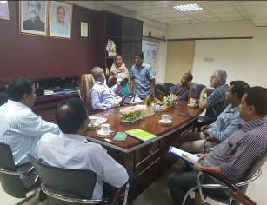
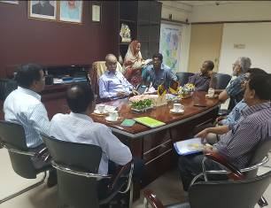
In the context of preparing the Environmental Assessment (EA), participatory public consultation was conducted for the subproject. The City Corporation Mayor, Officials, Engineers and local individuals as well as LGED and Consultant participants participated (Photographs 7.1.1). Informal Focus Group Discussions (FGD) and a formal CIP were conducted involving the participants. In addition, walk-through informal group consultations and individual interviews were also held. The local communities were informed about the subproject intervention including their benefits. Suggestions made by the participants were listed and incorporated in the EMP accordingly.

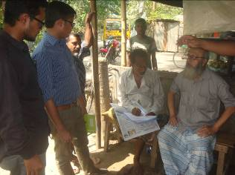
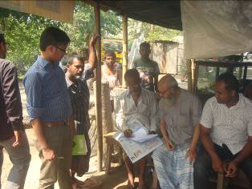
Photographs 7.1.1: Consultation Meeting with City Corporation Officials and Councilors at City Corporation
Photographs 7.1.2: Consultation Meeting at Subproject Site

  - Issues Raised by the Participants

The participants raised the issues related to the infrastructure development of Rangpur City Corporation. The anticipated environmental and social impacts due to construction works have also been raised and discussed. The participants also discussed about the potential benefit from the subproject.
  - Feedback, Suggestions, and Recommendations of the Participants

The participants were presented with feedback, suggestions, and recommendations listed below:
- The FGD results confirmed that an improved communication network is needed for future development of Rangpur City Corporation;
- Most of the participants expressed that the number of subproject that have been selected for each financial year is insufficient;
- The participants stated that the public water supply facilities, sanitation facilities, and access road are not adequate;
- The participants stated that construction works should be scheduled properly;
- Local people also showed expectation for the increased opportunities for the employment for unskilled or semi-skilled labor in the construction work.

Conclusions and Recommendations

Under this subproject 250 trees will be planted to compensate the felled down trees and to enhance the ecological condition in the subproject area. The adverse impacts on the physicochemical components such as air quality, noise level, traffic congestion, solid waste generation etc. will be localized and limited within the subproject boundary. It is also anticipated that the overall adverse impacts due to the subproject activities is significantly manageable through mitigation measures. In fact, the anticipated impacts due to the subproject activities are relatively minor in comparison to the significant benefits that will derive due to the implementation of the subproject.
A few key recommendations are outlined below:
- A copy of the EMP shall be kept on-site during the construction period at all times;
- The environmental management and monitoring plan proposed in this report needs to be followed;
- The contractor is responsible for the proper disposal of the generated wastes materials from the subproject sites and campsite;
- Contractor will ensure availability of the PPEs to the workers;
- Contractor will monitor behavioral matter of the workers to avoid any undue risks related to labor influx;
- City Corporation will inform and encourage the local people for using of the diversion and connecting roads;
- The consultation process should be continued during subproject implementation to ensure that stakeholders are fully engaged in the subproject;
- Equipment should be checked by the City Corporation engineer and DSM consultant prior to work;
- Proper maintenance by the contractor is needed during project liability period.

Reference

Rangpur City Corporation Master Plan;

Environmental Assessment Volume 1: Overall Environmental Assessment [Draft Final Report], September 2013. Municipal Governance and Services Project (MGSP), Local Government Engineering Department (LGED) and Bangladesh Municipal Development Fund (BMDF), Ministry of Local Government, Rural Development and Cooperatives, Government of the People's Republic of Bangladesh;

Environmental Assessment Volume 2: Environmental Management Framework (EMF) [Draft Final Report], September 2013. Municipal Governance and Services Project (MGSP), Local Government Engineering Department (LGED) and Bangladesh Municipal Development Fund (BMDF), Ministry of Local Government, Rural Development and Cooperatives, Government of the People's Republic of Bangladesh;

Geological Survey of Bangladesh, 1978. Earthquake Zoning Map;

Bangladesh Meteorological Department, Flood Zoning Map;

Population and Housing Census, 2011, National Volume-II: Union Statistics;
7. DPHE

APPENDIX

Appendix- I: Layout Plan of the Subproject Site

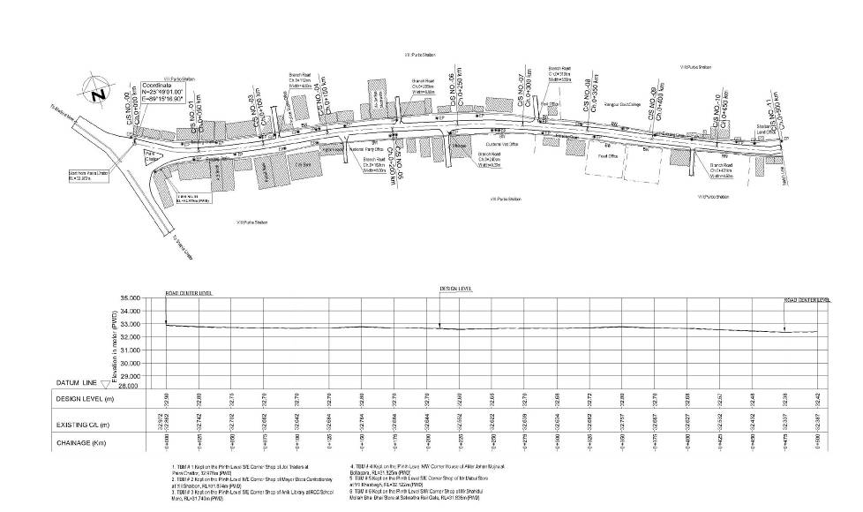

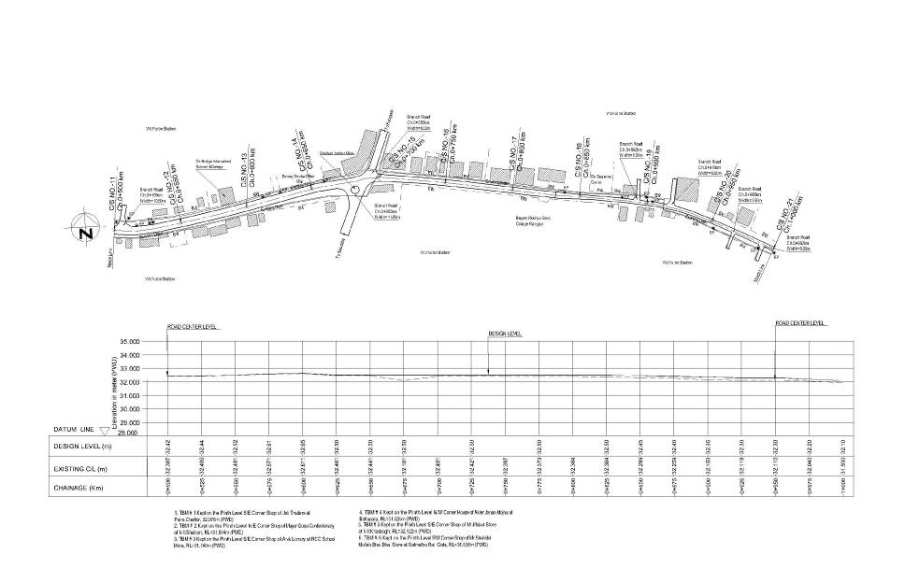
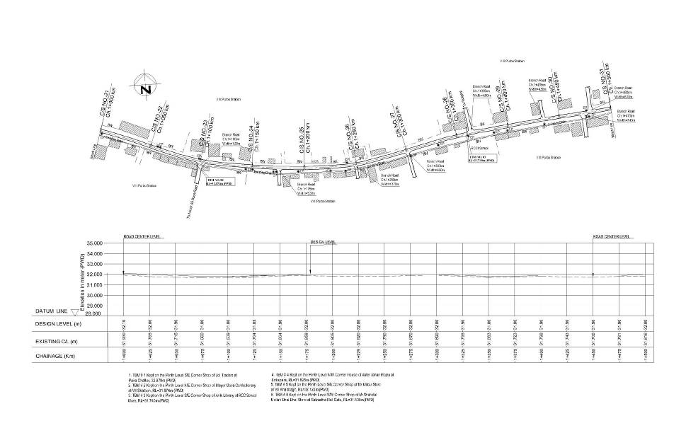
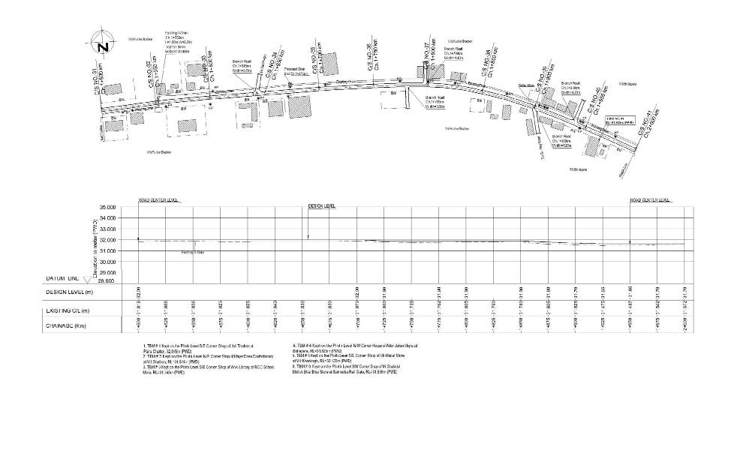
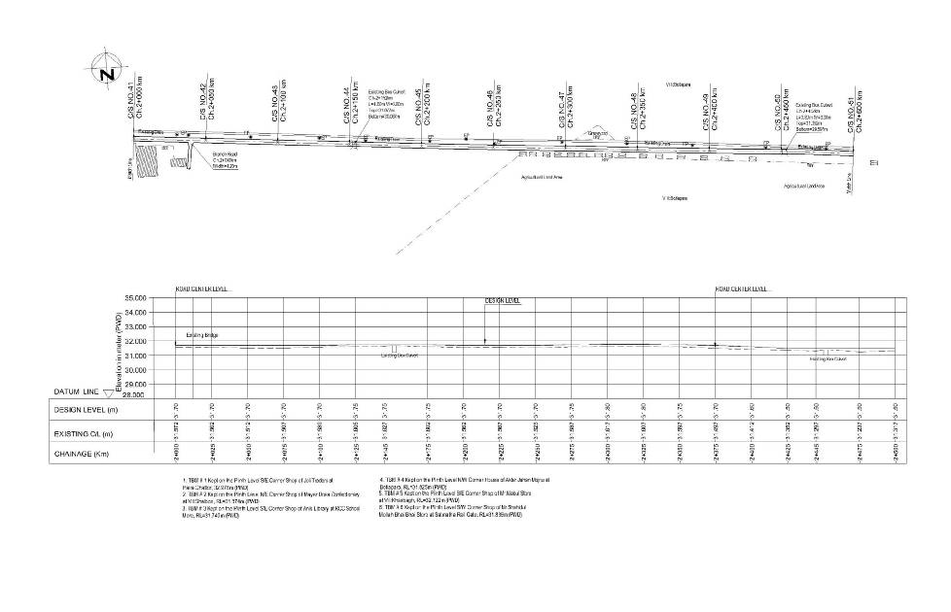
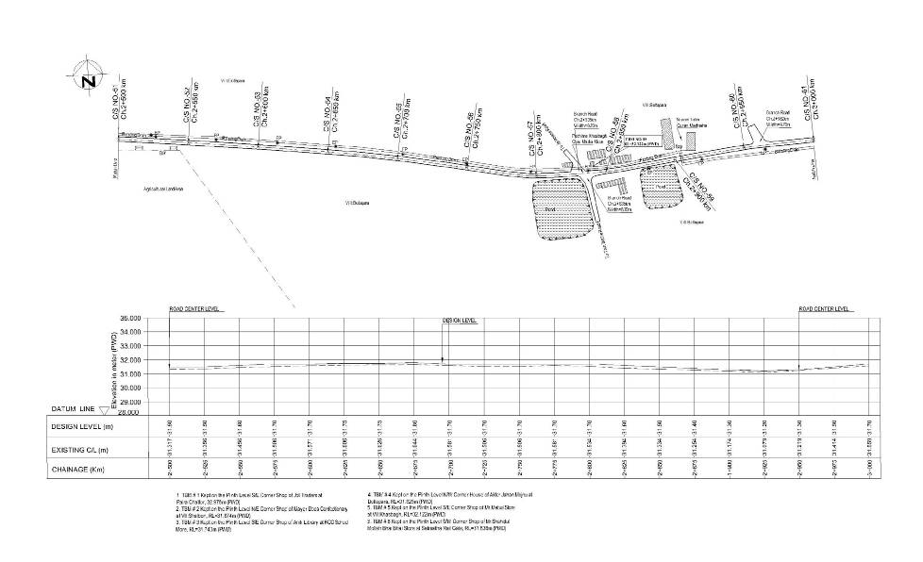

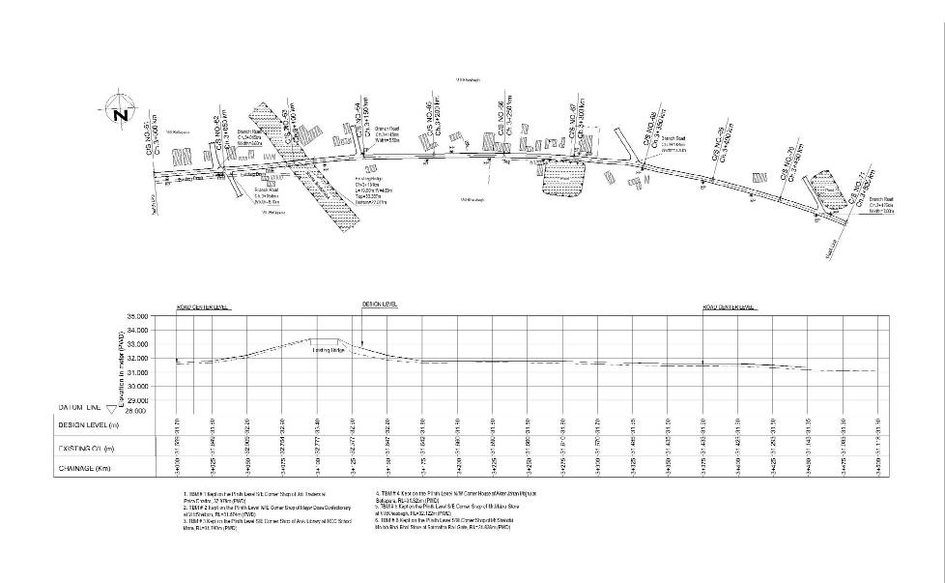
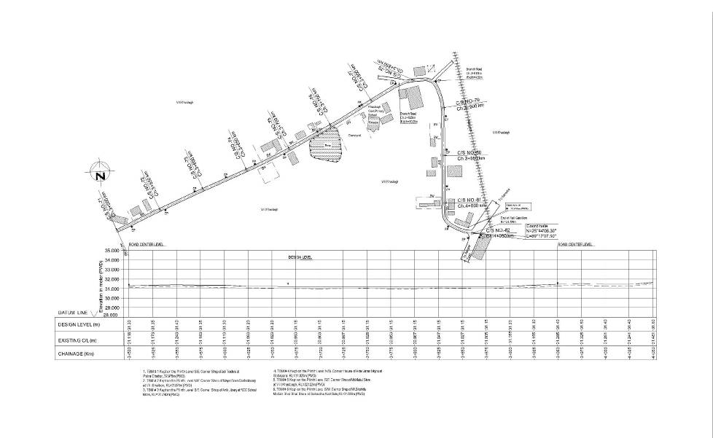

Appendix- II: Environmental Monitoring Checklist

Local Government Engineering Department

Municipal Governance and Services Project (MGSP)

Environmental Compliance Monitoring Form

Part A: General Subproject Information

Subproject Name | (a) Rehabilitation of Road from Paira Chattar to RCCI School by Bituminous Carpeting (Ch.0-4050m);  (b) Construction of Drain from Paira Chattar to RCCI School (Ch.700-1675m).
Package No. | MGSP/RCC/2017-18/W-13
ULB Name | Rangpur City Corporation City Corporation
Approved Estimated Cost in BDT
Contract Amount in BDT
Contractor Name
Date of Commencement
Target Date of Completion
Physical Progress (%)
Financial Progress (%)
Person Responsible (PIU)
(Name, Designation &Phone) for the Overall Subproject Management

Person Responsible (DSM)
(Name, Designation &Phone) for the Overall Subproject Management

Form Completed by
(Name, Designation &Phone)
Overall Environmental Description of the Subproject

Part B: Design, Preparation, and Legal Requirements
Environmental Concerns (PMU, PIU & DSM)  (Name, Designation & Phone) | PMU-
 | PIU-
 | DSM-
Subproject Category | DoE-BD- | WB-
Environmental Clearance Received? | Yes | No
EA Required? | Yes | No
EA Prepared and Delivered? | Yes | No
EMP Prepared & Delivered Separately? | Yes | No
Items and Cost of EMP Implementation Included in the Contract? | Yes | No
EMP Included in the Procurement Documents? | Yes | No
Inspection Schedule/Last Inspection/Monitoring by  PMU Environmental Concerns | Date-
 | Key findings-
Inspection Schedule/Last Inspection/Monitoring by  PIU Environmental Concerns | Date-
 | Key findings-
Inspection Schedule/Last Inspection/Monitoring by  DSM Environmental Safeguard Specialist/Jr. Environmental Specialist | Date-
 | Key findings-

Part C: Key Environmental Impacts
The Subproject Results in any of the following Impacts? | Yes | No | NA | If yes, is the impact (give observation)
 |  |  |  | Significant | Moderate | Minor
Felling of the trees
Clearing of the vegetation that increase the risk of increased soil degradation or erosion
Disturbance of the terrestrial and or aquatic specifies
Noise pollution
Air pollution
Adverse effects on the quantity or quality of the surface water or groundwater
Production or increase the production of the solid waste
Drainage congestion
Water logging that increases the risk of the water related diseases

Traffic congestion
Public safety

Part D: Work Place Environment and Gender Equity

The Subproject Results in any of the following Impacts? | Yes | No | NA | Observations
Does the contractor pay to the workers regularly?

Is there any discrepancy between the male and female workers regarding the wages or salary for the same works?

Is the contractor complying with the GOB labor law concerning the hiring of the workers?

Does the contractor engage women labors and does the project have suitable works for them?

Does the contractor engage child labor (less than 18 years) and aged people (more than 65 years old)?

Does the contractor force to the workers for the completion of the works?

Do the workers involve with the political activities, crime, drugs addiction and other forms of unwanted activities?

Are construction camps adequately equipped with water supply, sanitary toilets, washing facilities and facilities for waste collection and storage?

Has separate sanitation facilities been provided for women at work camps and the construction site?
Do the laborers load heavy items on their heads or shoulders?

Has the contractor undertaken an awareness program for the sexually transmitted diseases especially for HIV-AIDS and other infectious diseases like TB?

Are first aid kits readily available for the workers at the job site along with the instructions for use?

Are supervisors or other site personnel trained in the basic first aid emergency response measures?

Has the contractor provided necessary safety equipment to the workers and training for use?

Part E: Potential Impacts, Mitigation Measures, and Monitoring Indicator Mentioned in the EMP
Activity/  Issues | Potential Impacts | Proposed Mitigation and Enhancement Measures | Monitoring Method | Monitoring Frequency | Implementation Status (Yes/No /NA) | Impact significance if not implemented |  |  |  | Remarks
 |  |  |  |  |  | Major | Moderate | Minor | No | Remarks
Construction and operation of labor shed for the workers (Workforce and labor shed management) | Generation of sewage and solid waste may cause water/ environmental pollution | - Construction of sanitary latrine at the labor shed (consider 15 person for one toilet, separate toilet for male and female);  - Ensure provision of waste bins (separate waste bins for organic and inorganic wastes );  - Ensure wastes (solid wastes and other forms of the waste) disposal near Nasnia dumping site.
 | Health of workers | - Conduct formal and unofficial discussion to increase awareness about hygiene practices among the workers;  - Ensure availability and access to first-aid equipment and medical supplies for the workers;  - Comply with requirements of Government of Bangladesh labor law of 2006 and all applicable laws and standards on worker’s Health and Safety.
 | Possible development of labor camp into permanent settlement | - Contractor to remove labor camp at the completion of contract.
 | Outside labor force causing negative impact on health and social well-being of local people | - Ensure that contractor employ local work force to provide work opportunity to the local people and conduct formal and unofficial awareness program for the health and social well-being of the local people.
General construction  works | Drainage congestion and flooding | - Ensure provision for adequate drainage of storm water if needed;  - Ensure provision for pumping of congested water if needed;  - Ensure adequate monitoring of drainage effects, especially if construction works are carried out during the wet season;  - Ensure select place for the storage of soils and other construction materials to avoid disturbance of natural drainage.
General construction  works | Air pollution | - Check regularly and ensure that all the subproject vehicles and equipment are in good operating condition;  - Ensure contractor spray water on dry surfaces/ unpaved to reduce dust generation;  - Ensure contractor sprinkle water and cover stockpiles of loose materials (e.g., fine aggregates);  - Inform local people about the subproject activities and potential impact.
General construction  works | Traffic congestion, effect on traffic and pedestrian safety | - Ensure schedule deliveries of materials/ equipment during off-peak hours;  - Place traffic sign/cautionary sign to avoid undue traffic congestion if required;  - Inform the local people about the subproject activities;  - Inspire local people for using of the connecting roads during construction period.  - Avoid the road side storage of materials.
General construction  works | Noise pollution | - Check and maintenance the equipment properly;  - In front of the road side educational institute, residents construction work should be performed at holiday and or during break time;  - Avoid using of construction equipment such as concrete mixer machine, vibrator machine that produce excessive noise at night;  - Avoid prolonged exposure to noise (produced by equipment) by the workers;  - Regulate use of horns and avoid un-due use of hydraulic horns by subproject vehicles;  - Inform local people about the subproject activities and potential impact.
General construction  works | Water and soil pollution | - Prevent discharge of fuel, lubricants, chemicals, and wastes into adjacent khal, ponds, paddy lands and low land.
General construction  works | Felling of trees, clearing of vegetation and ecological disturbances | - 250 nos. of the trees will be planted at the both sides of the Paira Chattar BTI RCCI School Road where space is available to compensate the felled down trees and to enhance the ecological condition.
General construction  works | Accidents | - Conduct formal and informal discussion for creating awareness about the accident;  - Provide personal protective equipment (PPEs) as per provision made in the environmental management budget and ensure using of the PPEs by the workers where applicable.
General construction  works | Spills and leaks of oil, toxic chemicals | - Proper handling of lubricating oil and fuel so that it does not fall on the soil and water body;  - Collection and proper disposal of spills;  - Refueling and storage of fuel tank should not be placed on the ground directly.
All construction works | Beneficial impact on employment generation | - Employ local people in the subproject activities as much as possible;  - Give priority to poor people living in the subproject area in subproject related works (e.g., excavation and other works, which do not require skilled manpower).
All construction works | General degradation of the environment | - Ensure environmental enhancement measures by tree plantation and placing cautionary sign.
Measures for the BC road
Dismantle Work (Existing damaged BC Road) Excavation/ Earth work | Generation of solid and construction waste due to the dismantle works; | - Cover exposed loose dry soil and wastes materials before disposal;  - Disposal of soil and construction wastes at existing dumping site.
 | Generation of loose soil due to the earth excavation work and earth work. | - Cover expose construction wastes and loose dry soil with fabric;  - Disposal of soil and construction wastes at Nasnia dumping site  - Ensure reuse of generated solid waste if possible.
 | Accidents | - Operate hydraulic excavator for excavation and hammer for dismantle work carefully.
 | Air and dust pollution affecting nearby settlements | - Regular maintenance of the excavator equipment to avoid black smoke emission.
ISG (Improved Sub grade)/ Sand filling | Air and dust pollution affecting nearby settlements and workers | - Maintain adequate moisture content of soil during transportation, compaction and handling;  - Carry the materials especially loose soil and sand with adequate cover;  - Ensure use of mask to the associates workers.
Setting up and operation of asphalt plant for BC road | Possible degradation of the air quality by the suspended particles and increase of the noise level from asphalt plant affecting nearby settlements; | - Locate plant away from residential settlements;  - Consider use of emulsified bitumen.
Setting up and operation of asphalt plant for BC road | Possible water pollution by bitumen and solvents; | - Avoid spills and proper collection and disposal of the generated spills.
Setting up and operation of asphalt plant for BC road | Possible preparation of the bitumen in open air and using of charcoal and wood as fuel | - Strictly prohibit bitumen preparation in the open air and use of charcoal and wood as fuel.
Measures for the RCC Drain with Cover Slab
Dismantling work (Existing brick drain if required) for site clearing and excavation work | Generation of loose soil due to the earth excavation work and earth work. | - Cover expose construction wastes and loose dry soil with fabric;  - Disposal of soil and construction wastes at Nasnia dumping site;  - Ensure reuse of generated solid waste if possible.
 | Accidents from careless use of hydraulic excavator and hammer | - Carefully handle of the hydraulic excavator and hammer if needed.
 | Possible damage of road side infrastructure due to earth excavation for drain construction. | - Ensure drum sheet palisading work for shallow depth to stabilize the structure;  - Ensure plunk palisading work for shallow depth to stabilize the structure;  - Bolly drive for deep depth construction works.
 | Air pollution due to black smoke emission from excavator. | - Regular maintenance of the equipment.
Sand filling/Back filling work for the drain | Air and dust pollution affecting nearby settlement and worker | - Maintain adequate moisture content of soil and sand during transportation, compaction and handling;  - Carry the materials especially loose soil and sand with adequate cover;  - Ensure use mask for the associate workers.
Cutting & welding of the reinforcement for RCC drain | Noise pollution due to rod cutter and welding machine if any | - Avoid using of rod cutter and wielding machine at night;  - Avoid prolonged exposure to noise (produced by equipment) by workers.
Cutting & welding of the reinforcement for RCC drain | Potential health and safety risks from rod cutter and welding machine if any | - Ensure use of the personal protective equipment’s (helmet, goggles, gloves, safety boot);  - Availability and access to first-aid equipment and medical supplies in case of any accidents.
RCC (reinforcement cemented concrete) work | Air pollution due to black smoke emission from concrete mixer machine and vibrator machine | - Regular maintenance of the concrete mixer and vibrator machine to avoid any black smoke emission.
RCC (reinforcement cemented concrete) work | Noise nuisance from concrete mixer machine and vibrator machine | - Avoid operation of the concrete mixer and vibrator machine at night;  - RCC work should be avoided at schooling time;  - Inform local people about casting work and potential impacts.

Prepared by- Signature- Date-
Copies to 1. PIU
2. SME
3. AME
4. Jr. ES

