INTRODUCTION

Subproject Background

Saidpur Pourashava was established in the year of 1958. It was upgraded to A-class Pourashava in the year of 1997. The Pourashava covers an area of 53.04 square kilometer. The current population of Saidpur Pourashava is about 1,27,104. At present, Saidpur Pourashava has about 81.54 km drains (katcha and pucca). (Source: Saidpur Pourashava Master Plan). In addition, Saidpur Pourashava has about 127 km road (Bituminous Carpeting Road-97.53km, CC Road-3.60km, brick flat soling-13.70km and non-paved road-12.13 km). Furthermore, Saidpur Pourashava has 4430 light posts. (Source: At a glance of Saidpur Pourashava)

In Saidpur Pourashava, the current infrastructure situation is in vulnerable state. The substandard road and drainage network cannot cope with the growing demand. Hence, planned development of road and drainage network with street light is essential to meet the emergent demand. Therefore, this subproject under the Municipal Governance Services Project (MGSP) is actively contributing infrastructures development of the Saidpur Pourashava.

This subproject includes the following components: BC Road, RCC Drain, Box Culvert and Street Light. The significant features of the subproject are mentioned below:
Name of the Subproject : | Construction of Road from Patchmatha Moar to Slaughter House by Bituminous Carpeting including RCC Drain, Box Culvert and Street Light
Package No. : | MGSP/SAD/2016-2017/W-05
District Name : | Nilphamari
ULB Name : | Saidpur Pourashava
Jurisdiction Area : | Ward no. 10 and 11
Structural Design Option : | BC Road, RCC Drain, Box Culvert and Street Light
Wards Population : | About 20,000 as per information by the Pourashava Officials
Tribal People : | No tribal people settlement found in the subproject area
Land Acquisition : | Saidpur Pourashava owned. So, private land acquisition is not required
Estimated Cost : | 39.722 million BDT million BDT
Subproject Duration : | 12 Months
Tentative Start Date : | 15 October 2017
Tentative Completion Date : | 14 October 2018

Objectives of the Study

The general objective of this study is to determine the major environmental impacts succeeding from execution of the subproject and to recommend mitigation measures to avoid or reduce adverse environmental impacts and to enhance positive impacts. The specific objectives include:
- To assess the existing environmental conditions of the subproject site and its influence area;
- To identify and assess impacts resulting from the subproject during its construction phase and operation phase;
- To develop a environmental management plan with recommendations for mitigating impacts and enhance positive impacts;
- To summarize environmental monitoring requirements.

Scope and Methodology of the Study

The subproject appraisal is included environmental screening for all the subproject components. According to that screening, no further environmental assessment is required for the street light. Nevertheless, environmental assessment is required to fulfill the regulatory requirement for BC Road, RCC Drain and Box Culvert. Hence, this report is mainly included BC Road, RCC Drain and Box Culvert. However, in the EMP table mitigation measures for street light are also included. The study methodology comprised the following activities:

Desktop Study

The desktop study involved:
- Initial meetings with client and stakeholders to discuss about the proposed subproject, including subproject activities;
- Collection and review of the baseline data, maps, reports and other relevant information on the existing environmental and social conditions of the subproject area;
- Review of the relevant existing legislation, regulation and policies;
- Understand the anticipated technical processes that may affect the environment.

Field Investigation and Data Collection
A team of the consultants made a field investigation to the proposed site. Field investigations involved mainly site walks within the subproject area and the neighboring areas that may be affected by the subproject. The following key tasks were performed during the field visit:
- Taking photographs of the significant aspects to describe the baseline environmental conditions of the subproject area;
- Interviews with representatives of the Pourashava Officials, beneficiary and affected people within the subproject influence zone;
- Verifying information and data collected during the desktop study and to collect new information that may have been important in the assessment of the impacts and design of the mitigation measures.

Data Analysis and Report Writing
The data and information collected from all the sources (literature review, secondary and primary data, public consultation) were analyzed to describe the existing environmental setting of the subproject area, to identify the potential positive and negative impacts of the proposed subproject, as well as to provide preliminary suggestions for mitigation measures. Finally, this environmental assessment report has been prepared.

SUBPROJECT DESCRIPTION

The Study Area
The subproject is situated within the jurisdiction of the ward number 10 and 11. The subproject site is located at the existing right of way. The layout plan and topographic feature of the subproject is shown in Figure 2.1.1 and Figure 2.1.2.
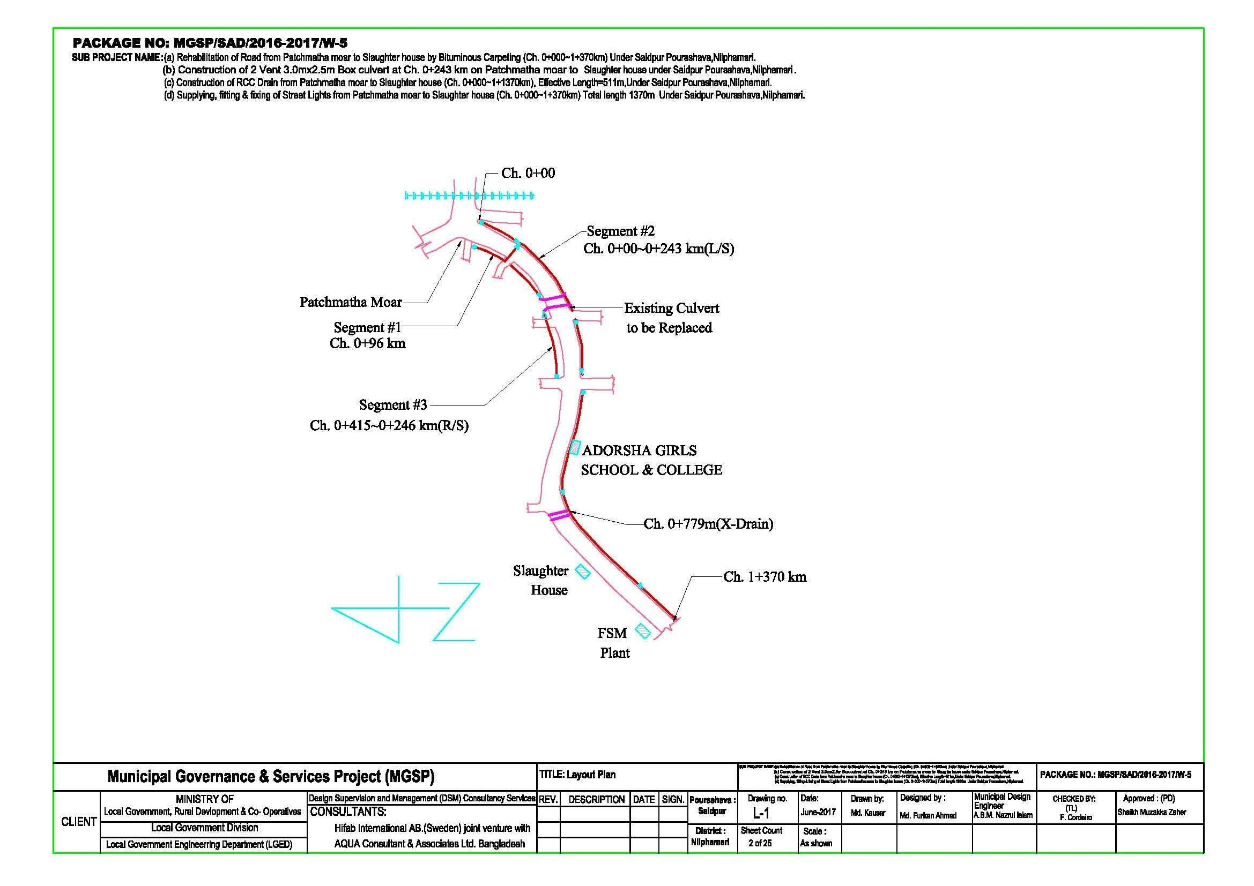

Figure 2.1.1: Layout Plan of the Subproject
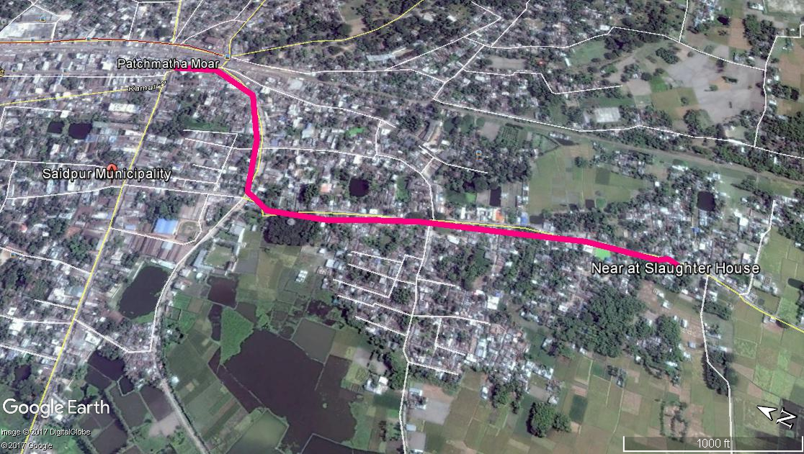

Figure 2.1.2: Topographic Feature of the Subproject Site

Current Situation, Proposed Intervention and Need for the Subproject

From Ch. 0 to 779m, the existing bituminous carpeting road is partially damaged. From, Ch. 779 to 1370m, the existing road is earthen. Average width of the right of way varies from 8.50m to 13.00m. Average crest width of the existing road varies from 5.00 to 8.00m. The proposed road width is 8m. Hence, adequate land is available because the proposed road and drain will be constructed on the existing right of way. From the site investigation, it is revealed that normal traffic operation is interrupted due to damaged road. In addition, stagnant storm water in the pot holes interrupts pedestrian’s movement during rainy season. In the dry season, rough and dusty surfaces on earthen road generate dust which creates discomfort felling of the road users. Hence, widening and road improvement is necessary for the normal traffic operation.
On the other hand, there are existing brick and earthen drains at different sections of the road. However, the existing drains are discontinuous and non-functional. Due to discontinuity, the existing brick drains and earthen drains are not functioning properly and cannot develop a complete drainage network. In the rainy season, due to heavy rainfall the drain water accumulated on the road surface and road side houses and low land. Hence, in the subproject area water logging causes environmental degradation and public health hazard. Hence, RCC drain with cover slab will be constructed at right side of the road from Ch.0-412m and from Ch.0-96m at the left side of the road.
On the contrary, the existing culvert is badly damaged. Consequently, it interrupts traffic movement for the motorized and non-motorized vehicles. The vehicles cross the culvert with risk. Therefore, widening and replacing of the existing box culvert is necessary. Hence, 2 Vent 3m x 2.5m x 10m box culvert will be constructed at Ch.243m. Furthermore, from Ch.605-740m at the right side of the road, palisading is needed for the road protection work.
In addition, the existing street light in different segments of the road is not sufficient which are mostly non-functional. Hence, it interrupts pedestrians and traffic safety at night. Therefore, fixing of the street light is needed which will be fixed at one side of the road. The existing condition of the site is further elaborated in the following Photographs 2.2.1.

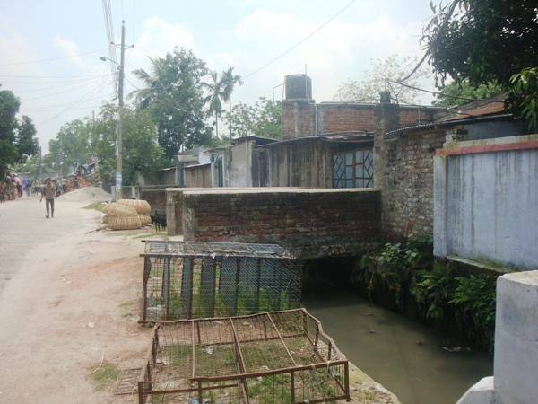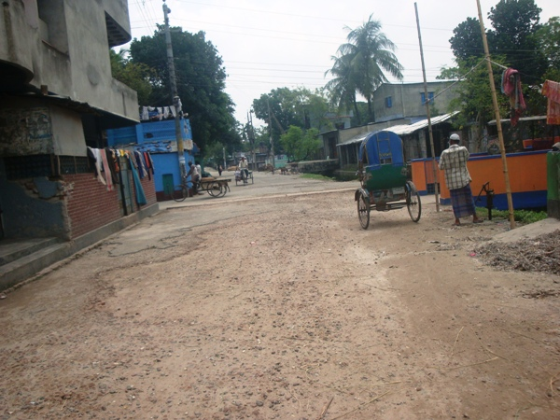

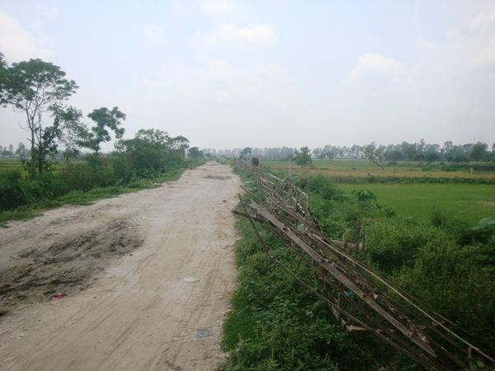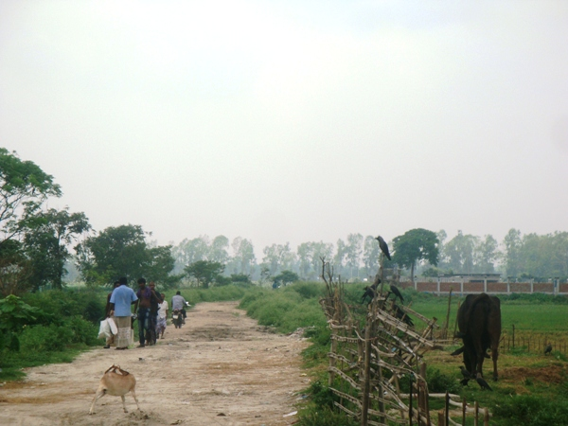

Photographs 2.2.1: Present Situation of the Subproject Site

The storm water will be discharged in the Khorkhoria Khal. The existing condition of the outfall is further elaborated by the Photographs 2.2.2.
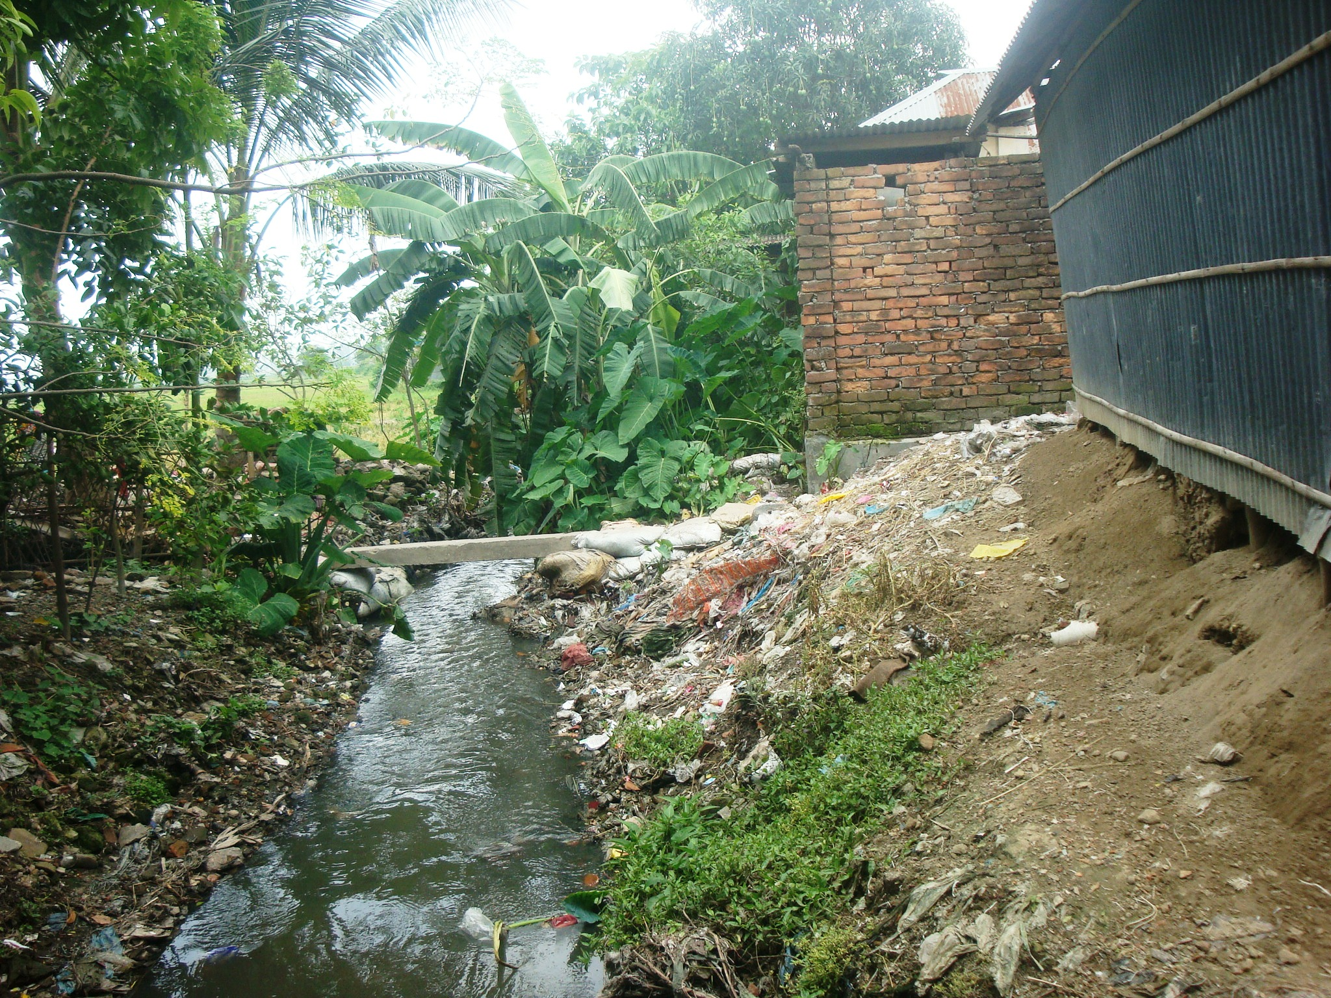
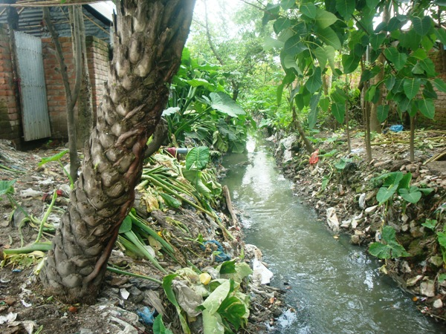

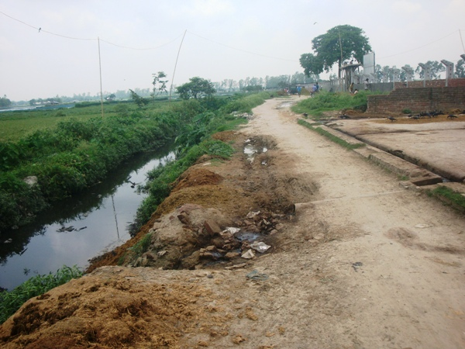

Photographs 2.2.2: Present Situation of the Outfall

Justification of Selection of this Subproject

Based on CIP, Saidpur Pourashava prepared the priority list of the subprojects. The PMU and DSM team have inspected the site as a part of the reconnaissance survey. After site inspection, it is revealed that the anticipated impacts due to the subproject implementation will not be severe. Hence, considering the low environmental and social impacts due to this subproject implementation, this subproject has been selected. The subproject site is mostly located at the existing right of way. In addition, Pourashava is owned the land. Hence, land acquisition is not an issue for subproject implementation. After completion, the subproject has significant benefit to the community people. Hence, considering the benefit that will derive after construction, this subproject has been selected.

Envisaged Subproject Activities and Implementation Process

The general activities for the subproject includes: construction of the semi-pucca site office, construction of the labor shed, relocation of the electric poles and site clearing works.

The key activities of the RCC Drain and Box culvert include:
- Earth work in excavation of the foundation;
- Pumping and bailing out of water as per requirement;
- Lying of polythene sheet;
- Sand filling for the preparing foundation bed;
- Plain cement concrete work in foundation;
- Manufacturing CC blocks;
- Fabrication of the ribbed or deformed bar;
- Reinforced cement concrete work.

The key activities for BC Road include:

- Dismantling of the damaged sub-base and base course works;
- Clearing and grubbing works;
- Earth work in box cutting;
- Earth filling work;
- Sand filling on the road bed;
- Mechanical compaction;
- Brick on edging;
- Compacted stone aggregate base course;
- Providing prime coat;
- Laying pre-mixed dense bituminous surfacing wearing course.

The key activities for Street Light:

- Assembling, fitting, fixing, installation, testing and commissioning of the GI pole;
- Erection of tubular pole;
- Earthling the electrical installation;
- Fixing of the wire rack;
- Fixing of the overhead conductor;
- Providing, fixing and fitting of the water tight street light;
- Fitting and fixing main and sub-main switch with fuse;
- Supplying and fitting of sub-distribution board.

The materials and resources to be used for the key activities: soil in earth work, sand, stone chips, cement, reinforcement, diesel, MS sheet, steel shutter, electricity and water.
The major equipment to be used for the implementation of the subproject: hydraulic excavator, concrete mixer machine, steel cutter, mechanical vibrator machine, mechanical compaction machine, steel drum rollers, pneumatic multiple tire roller, dump truck, water tanker, pump, asphalt plant, rubber tire roller, paver.

Baseline ANALYSIS OF THE ENVIRONMENTAL CONDITION

Physical Environment

Important Environmental and Infrastructural Features
The important environmental features have been identified during site visit within influence area of the subproject. Moreover, the conditional survey has been performed. Hence, the survey data is also used for identification of the major environmental features. The detailed environmental features listed considering the 100 m Chainage from Patchmatha Moar to Slaughter House (Ch. 0 to 1370 m). The key findings of the site inspection and investigation are given in Table 3.1.1.

Table 3.1.1: Major Environmental and Infrastructural Features
Chainage (m) | Left | Right | Major Environmental and Infrastructural Features
0-100 | √ |  | Stationary shops, electric pole, Rani Pharmacy, mangsher dokan, pucca and semi-pucca residents
0-100 |  | √ | Foler Dokan, Fresh Dental, stationary shops, electric pole, mangsher dokan, pucca and semi-pucca residents, Uzzal Mike Service, Rupali Bank
100-200 | √ |  | Mridha Pharmacy, Mangsher Dokan, electric poles, stationary shops, tea stole, kola hati
100-200 |  | √ | Kola hati, tea stall, meat shops, electric pole, katcha bazar, semi-pucca and pucca residents.
200-300 | √ |  | Saidpur Modern Toilet, Rahmotia Aiorbedik Chikitshaloy, kacha bazar, semi-pucca residents, trees
200-300 |  | √ | Taj Community Center, bazar, semi-pucca residents, boundary wall, electric pole, trees
300-400 | √ |  | Pucca and semi –pucca residents, trees, boundary wall, stationary shops
300-400 |  | √ | Pucca and semi –pucca residents, trees, boundary wall
400-500 | √ |  | Boundary wall, pucca and semi –pucca residents, trees
400-500 |  | √ | Boundary wall, electric pole, pucca and semi pucca structure (residents), prince tailors
500-600 | √ |  | Stationary shops, pucca and semi pucca structure (residents), boundary wall, and electric pole.
500-600 |  | √ | Boundary wall, trees, brick drain, electric pole, pucca and semi pucca structure (residents).
600-700 | √ |  | Boundary wall, trees, brick drain, electric pole, pucca and semi pucca structure (residents).
600-700 |  | √ | Boundary wall, trees, brick drain, electric pole, pucca and semi pucca structure (residents).
700-800 | √ |  | Pucca and semi pucca structure (residents), boundary wall, trees, electric pole
700-800 |  | √ | Pucca and semi pucca structure (residents), boundary wall, trees, electric pole
800-900 | √ |  | Saidpur Adorsho Uccha Biddaloy, boundary wall, open space, tress, pucca and semi-pucca structure (residents).
800-900 |  | √ | Pond, pucca and semi-pucca structure(residents), trees, electric pole
900-1000 | √ |  | Pucca and semi-pucca structure (residents),Grammen Shakti, trees, electric pole
900-1000 |  | √ | Rickshaw Garage, salon, electric pole, stationary shops.
1000-1100 | √ |  | Semi-pucca and tin shed residents, ditches, boundary wall, electric pole, agricultural land
1000-1100 |  | √ | Semi-pucca and tin shed residents, boundary wall, electric pole, agricultural land
1100-1200 | √ |  | Semi-pucca and tin shed residents, boundary wall, electric pole, agricultural land
1100-1200 |  | √ | Semi-pucca and tin shed residents, ditches, boundary wall, electric pole, agricultural land
1200-1300 | √ |  | Semi-pucca and tin shed residents, boundary wall, electric pole, agricultural land
1200-1300 |  | √ | Semi-pucca and tin shed residents, boundary wall, electric pole, agricultural land
1300-1370 | √ |  | Agricultural land , trees
1300-1370 |  | √ | Agricultural land , trees

** Note: There are 23 electric poles and 4 telephone poles need to be re-located for the implementation of the subproject.

Geology, Topography, and Soils

The landscape condition of the subproject area is level upland like other areas of Saidpur. The elevation of land is ranging from 51.57-55.79 m PWD. Geology of Saidpur Pourashava belongs to Gravelly Sand (Alluvial Fan deposited sediments). The geology of the area can be attributed to Quaternary alluvial sequence which is a part of Tista floodplain. This deposition has resulted in a complex array of coarse sand and gravel channel-fills followed by intercalated finer sediment layers of alluvial and deltaic floodplain aquifers. The sedimentary environment has changed from braided streams and mean-daring rivers to floodplains making deposition of granular layers and finer silty sediments. General soil types predominantly include grey floodplain soils and non calcareous brown floodplain soils. According to BNBC (2006), Bangladesh has three seismic zones with moderate and low seismic activity. The Pourashava falls in Zone II.

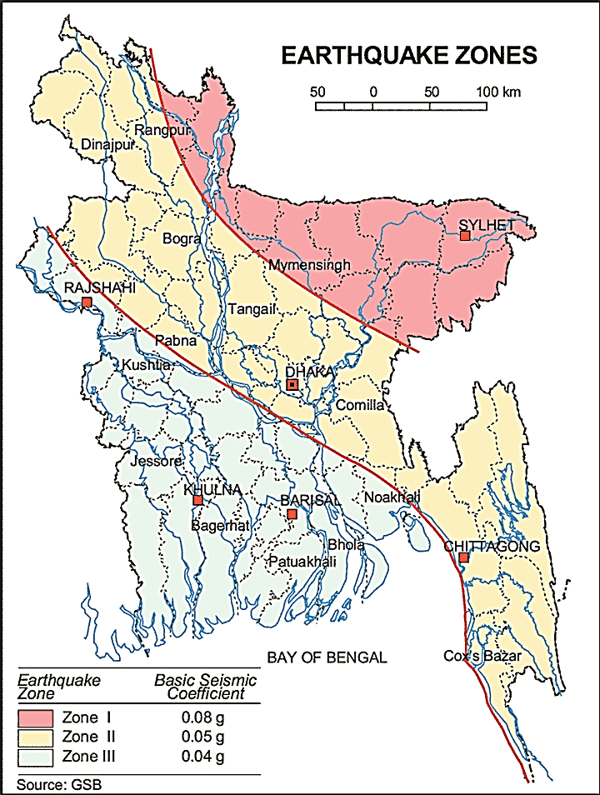

The green circle denotes the Saidpur Pourashava

Figure 3.1.1: Location of Saidpur Pourashava in Earthquake Zones Map of Bangladesh

Climate and Meteorology

The climate of the subproject area can be described as hot, wet and humid tropical climate. It is characterized by warm, humid summers and cool, dry winters. From November to March, it is dry and cool while from April to May it is extremely hot during the pre-monsoon season. From June to October, the monsoon season is warm, cloudy, and wet. The warmest month is April, the coolest is January, the wettest is July and the driest is January.

The minimum temperature was 9.3°C in 2011 and maximum temperature was 33.1°C in 2010. The minimum humidity was 63.4% in 2010 and the maximum humidity was 77.4% in 2011.The average annual rainfall is around 1842 mm. The peak rainfall months in Saidpur are June, and July. About 92% of the total annual rainfall occurs in the period from May through October. The highest annual rainfall during the last ten years (2008–11) was 2140 mm in 2009, and the lowest was 1526 mm in 2010.

According to the statistics of wind data from the Bangladesh Meteorological Department Climate Division, wind direction changes by month. Nevertheless, the northwest, south, and northeast winds are predominant. The monthly average wind speed as recorded in Rangpur Met Station is mostly remaining in the range of 2.3 – 5.3 knots/ hr. But in the winter months it remains in the range of 2.3-4 knots/hour. Table 3.1.2 shows the key meteorological data from 2008 to 2011.

Table 3.1.2: Temperature, rainfall, humidity during 2008-2011
Years | Temperature(centigrade) |  | Rainfall (millimeter) | Humidity (%)
Years | Maximum | Minimum | Rainfall (millimeter) | Humidity (%)
2008 | 32.2 | 10.0 | 1881 | 71.0
2009 | 33.0 | 12.3 | 2140 | 77.0
2010 | 33.1 | 10.2 | 1526 | 63.4
2011 | 21.2 | 9.3 | 1821 | 77.4
The construction works can be influenced by the climatic condition and meteorological components like humidity, temperature, sudden rainfall, and wind speed. During high winds, dust generated from the construction activities may spread quickly. It is very risky to work under rain and in high winds because the possibility of risk and accident increases. Furthermore, work under high temperature and excess humidity creates health hazards like dehydration problem.

Water Resources(Surface Water, Ground Water, and Rain Water)
Khorkhoria Khal is situated in the subproject area. Except, ponds and ditches there is no significant water body in the subproject area.
Groundwater is the main source of potable water in the subproject area. Deep groundwater is not saline and normally arsenic (<0.01mg/l) and iron free. Local people typically use deep tube-well water for drinking and other domestic purposes. Salinity problems are not visible. Rain water harvesting system is not common in and around the subproject area.
Flooding, Water Logging and Drainage
Saidpur Pourashava is not normally affected by external floods and or flash floods. The drainage system of the Pourashava is not adequate and non-functional. In addition, the maintenance of the existing drainage system is not satisfactory. People throw and dispose wastes in the drains. Therefore, the drain is being filled up. The poor conditions of the drains cause overflows when it rains heavily and spread bad smell and serves as a breeding ground for mosquitoes. According to the flood zoning map of Bangladesh, this area lies in the flood free area.

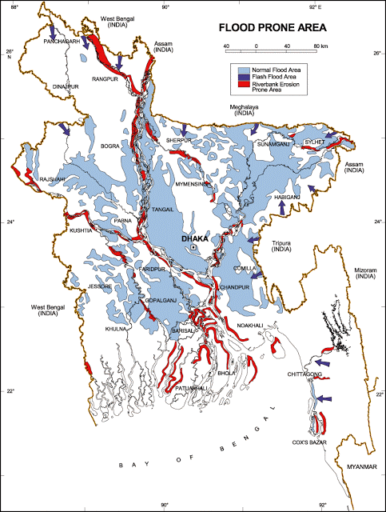

The green circle denotes the Saidpur Pourashava

Figure 3.1.2: Location of Saidpur Pourashava in Flood Zone Map of Bangladesh
Air Quality and Dust
Air quality data is not available from secondary sources. Air seems to be clean. However, in dry season dust is generated due to vehicles movement and windblown dust causes air pollution. In addition, black smoke emission from the vehicles degrades the quality of the air. There are no remarkable sources of air pollution such as heavy industries observed in the subproject area.
Noise Level
Ambient noise level data is not available. From the site investigation, it is revealed that the main sources of noise are vehicles. Vehicles such as trolleys, pick-up, trucks, motor cycles, mini trucks, and private cars generally move on the road during day and night. These vehicles generate noise in the subproject area. There are 4-5 flights from Dhaka to Saidpur every day. It also temporarily causes noise disturbances to the local people. During construction phase, concrete mixer machine, vibrator machine, asphalt plant and steel cutter may generate noise.

Solid Waste Management
Practically, there is no well structured solid waste management/disposal system in the Pourashava. The people of the poor community accumulate their solid waste in their own yard, where it decomposes. There is no proper conservancy set up in the Pourashava yet. From the site investigation, it is revealed that mass people are still dumping wastes in vacant low lands. Therefore, improper solid waste disposal by the community people creates severe public health hazards and environmental degradation to a great extent.

Biotic Environment
Flora and Fauna
There are some road side planted trees include Mango, Jackfruits, Coconut, Betel nut, Neem, Koroi in the subproject area were found during site visit.
The common local birds such as Crow, Shalik, and Choroi were found during the site visit.

Socio-economic and Socio-cultural Environment

Land Use, Status of Housing and Built-up Infrastructure
The subproject area covers commercial, agricultural and residential area. The road side built-up infrastructure includes pucca, semi-pucca and tin-shed houses, shops, school, bank, swiper colony, katcha bazar, and Mosque.

Beneficiary Population

The subproject site is situated within the 10 and 11. As per information by the municipality, considering the ward population about 20000 people will benefit directly and many others indirectly.

Education

In the Pourashava area, literacy among the population is about 54.6%. This is higher than the national average (51.8%). The literacy rate among males (57.4) is still more than females (51.6). (Ref: Population and Housing Census 2011).

Tribal Communities

There is no indigenous or tribal people settlement live in the subproject area. Therefore, there are no measures needed for indigenous peoples’ safeguard.

Land Acquisition and Resettlement

No private land acquisition is needed because the road and drain will be constructed on the existing right of way. From Ch. 740 to 840m, with the permission from Pourashava Officials, the sweepers constructed tin-shed houses adjacent to the roadside area. Hence, for site clearing work, removing of the existing four road side tin shed houses are needed. The Pourashava will clear the site amicably with the owners of the houses prior to the works. In addition, the Pourashava is planning to develop a residential zone for the sweepers in Pourashava own land. The MGSP social experts also will evaluate the anticipated social issues regarding the subproject intervention and measures will be given accordingly.
Principal Livelihoods and Economic Activities
The subproject area is now inhabited by the mixed occupational people where major income comes from non-farm activities such as business, and enterprises. Presently, a significant number of people work in small trades, private sector jobs, and government jobs in the town.
Cultural Heritage and Protected Areas
There is no protected area and historical sites identified in the subproject area.
Social Conflicts and Development Activities
There are no visible conflicts between the local communities regarding the subproject implementation. There are some ongoing subprojects under Pourashava funded by government and different donor agencies. However, there is no visible conflict between these donors and agencies.

ENVIRONMENTAL SCREENING

Environmental Screening Checklist, as adopted in Appendix C of the Environmental Management Framework (EMF) of the MGSP, was administered for identifying the impacts and their extents.
The screening data for the BC Road, RCC Drain and allied works have been formulated and are shown in below.
- Potential environmental impact during construction phase:

- Ecological impacts:
Nil

- Felling of trees Significant □ Moderate □ Minor □√ Number of trees
- Clearing of vegetation Significant □ Moderate □ Minor □√
- Potential impact on species of
aquatic (i.e., water) environment Significant □ Moderate □ Minor □√
The proposed road and drain will be constructed on the existing right of way and mostly developed land. In addition, brick drain exists in most of the section. Hence, there is no tree to be felled down and clearing of the vegetation is needed. Therefore, the overall ecological impact is insignificant due to the subproject implementation.
- Physicochemical impacts:

- Noise pollution Significant □ Moderate □ √ Insignificant □
- Air pollution Significant □ Moderate □ √ Insignificant □
- Drainage congestion Very likely □ Likely □ Unlikely □√
- Water pollution Significant □ Moderate □ Insignificant □ √
- Pollution from solid/ construction wastes Significant □ Moderate □√ Insignificant □
- Water logging Significant □ Moderate □ Insignificant □√

The subproject will have impacts on noise and air quality during construction phase due to mobilization of the equipment, vehicles movement for the transportation of the materials, using of hydraulic excavator, mechanical compaction machine, paver, asphalt plant, concrete mixer machine, vibrator machine etc. The construction work will be performed section wise. Hence, it is anticipated that the overall impacts will be moderate, temporary and site specific. However, near Saidpur Adorsho Uccha Biddaloy and residential houses, the noise nuisance may be significant due to concrete mixer and vibrator machine for drain construction. The generated dusts during construction activities may temporary disturb the local people if measures are not taken. The generated construction wastes, un-suitable materials and solid wastes may degrade the surrounding environment. Improper collection and disposal of the generated wastes materials also may degrade the aesthetic and landscape value. The anticipated water logging problem during construction period is minor because storm water will be pumped-out if required.
- Socio-economic impacts:

- Traffic congestion Very likely □ Likely □√ Unlikely □
- Health and safety Significant □ Moderate □ √ Insignificant □
- Impact on archaeological and historical Significant □ Moderate □ Insignificant □√
- Employment generation Significant □ Moderate □√ Insignificant □
During construction, the subproject activities may interrupt normal traffic movement and free movement of the pedestrians especially near Patchmatha Moar. During drain construction work, it does not need closing of the entire road. Except motorized vehicles people can use the road during drain construction. The width of the proposed road also will permit movement of the motorized vehicles. In addition, the local people can use existing connecting and diversion road during road construction work. Hence, it is anticipated that the subproject activities do not have severe impact on the traffic movement. The construction work will follow simple procedure with commonly used equipments. Hence, anticipated impact on health and safety is moderate. There is no archaeological and historical site within the influence area. The subproject has positive impact by generating work opportunities for the local people and supplying of the construction materials, equipments, food and other necessary stuffs to the campsite.
2) Potential environmental impact during operational phase:
- Ecological impacts:

- Potential impact on species of aquatic Significant □ Moderate □ Minor □√
(i.e., water) environment
The road component does not have any impact on the aquatic environment during operational phase. The drain is designed for storm water only. Hence, anticipated ecological impact is insignificant. However, the storm water may carry washed-out materials, pollutants from any sources that may disturb the aquatic environment of the outfall.
- Physicochemical impacts:

- Potential air quality and noise level Improvement □ No improvement □ Deterioration □√
- Drainage congestion Improvement □√ Minor Improvement □ No Impact □
- Risk of Water pollution Significant □ Moderate □ Minor □√
- Pollution from solid wastes Improvement □√ No-improvement □ Insignificant □

The new road will increase the motorized traffic volume which may degrade the air quality and noise level due to black smoke emission and un-due use of hydraulic horn from the vehicles. The road component does not have any impact on the water quality during operation phase. However, the new road and drain will reduce stagnation of storm water on the road surface. The drain component does not have any impact on noise during operation. The new drain will minimize drainage congestion & water logging problem in the subproject area. The storm water to be discharged through the drain may degrade the water quality of the outfall if carry pollutants from any sources. The covered drain will minimize throwing of the waste materials in to the drain and will reduce spreading of the bad odor from the drain.
- Socio-economic impacts:

- Traffic Improvement □ √ No-improvement □ Adverse □
- Safety Improvement □ √ No-improvement □ Adverse □
- Employment generation Significant □ Moderate □ Minor □√
The new road will enhance transport facilities after construction. After construction, the drain will connect with the existing drain and will complete the drainage network. In addition, new drain and road prevents the accumulation of the storm water on the road surface. Consequently, it will enhance safety traffic operation. The new road will minimize the frequency of the maintenance for the first three to five years after construction.
(3) Summary of Possible Environmental Impacts of the Subproject
From the above study, it seems that the ecological impact due to the subproject implementation is minor. The subproject has negative impacts on air quality, noise level, and pollution from solid wastes during construction phase. Nevertheless, the impacts will be temporary, localized and limited within the subproject boundary and fundamentally manageable through the appropriate mitigation measures. The generated solid wastes due to the activities should be properly handled and disposed in a designated dump site. The labor shed and stack yard should be located in a designated place. Furthermore, safety concerns should be considered properly for both the construction and operation phases to avoid any potential safety risks. This subproject will have positive impacts in terms of generation of employment and business activities due to supplying materials and equipments.
The anticipated environmental impact for the installation of the street light is insignificant. However, it has significant positive social impacts after installation. Short circuit and improper electrical connection of the street light may cause potential health and safety risk.

Specific impact, mitigation, AND enhancement measures

From the environmental study, the probable impacts of the subproject are mainly caused by the key activities required for the implementation of the subproject, raw materials and equipment to be used for the execution of the activities. This section describes some specific impacts due to the subproject activities and their mitigation measures.

  - Dismantle Work, Site Clearing, Excavation and Earth Work

The road improvement work includes dismantle of the existing bituminous pavement, clearing of the wastes materials due to dismantle work, earth excavation and earth filling work. The drain construction work consists of earth excavation, earth filling, back filling, cutting and removal of the unsuitable materials. These works lead dust blowing, improper disposal of the wastes, noise and vibration which may disturb the local people.

Mitigation Measures

- Careful operation of the hydraulic excavator if used to avoid any undue disturbances to the roadside residents;
- Cover the exposed earth with fabric;
- Quick disposal of the wastes at the Pourashava designated dumping site at Dolagash and or Vagra.

Tree Felling, Clearing of Vegetation and Ecological Impact

The proposed road and drain will be constructed on the existing right of way and mostly developed land. In addition, brick drain exists in most of the section. Hence, there is no tree to be felled down and clearing of the vegetation is needed. Therefore, the overall ecological impact is insignificant due to the subproject implementation. However, to enhance the ecological condition in the subproject area 700 nos. of trees will be planted.
Enhancement Measures

- 700 nos. of trees will be planted-preferably local fruits, flowers, medicinal and ornamental trees-Mango, Jackfruit, Jam, Kathbadam, Coconut, Palm Tree, Neem, Arjun, Amloki, Horitoki, Bohera, Sonalu, Jarul, Polash, Krisnachura, Kadom, Bokul, Debdaru, Mahogany, Rain Tree, Shil Koroi, Akashi: at both sides of the Patchmatha Moar to slaughter house from Ch. 0 to 1370m where space is available and anywhere Pourashava owned suitable places within the subproject influence area.

Pollution from the Construction Materials

Dumping of the construction spoils, including accidental leakage of the oil, grease, and fuel in equipment yards is a significant hazard. Surface water and soil quality might be polluted from these contaminants. Even the people to be engaged for the construction activities might endanger the physical and human habitats of the area.

Mitigation Measures

- Safe transport, storage, and disposal of the construction materials, and the equipment have to be carried out in order to avoid the accidental spillage and loss;
- Fuels, lubricants, and other hazardous materials should store over raised platforms and not directly on the ground;
- The playgrounds of the educational institutions should not use as a stockyard or work camp.

Air Quality and Dust

During construction phase, air pollutants will be emitted from the equipment and construction vehicles are expected to remain low. Local residents in the vicinity of the work sites will be temporarily disturbed by the limited dust pollution. The overall impacts, however, are expected to remain low.

Mitigation Measures

- Water should be sprayed at the work site for dust control.
- Ensure sprinkle and cover stockpiles of loose materials (e.g., fine aggregates);
- Maintain adequate moisture content of soil and sand for transportation, compaction and handling;
- Avoid use of dust generating equipment which produce significant amount of particulate matter far from the local residents;
- Ensure all subproject vehicles are in good operating condition.

Noise and Vibration

Noise and vibration caused by the equipment and movement of the construction vehicles may temporarily disturb nearby residents. In this subproject, sensitive areas like roadside houses, educational institutes and shops are likely to be affected from the noise, though the impacts are anticipated to be limited.

Mitigation Measures

- Transportation of the construction materials have to be carried during the scheduled times, and mainly during the day;
- If needed and applicable, all powered mechanical equipment and machineries will be fitted with noise abating gear such as mufflers for effective sound reduction.

Water Quality

The water quality may deteriorate if the construction materials, construction wastes, effluent from work camps, and food waste are dumped in the roadside water body and low land.

Mitigation Measures

- Proper construction management including waste management as well as training of the operators and other workers should provide to avoid pollution of the water bodies;
- Construction waste will dispose properly (not in the ditch, ponds or khal) for which contractor will be responsible.

Occupational Health and Safety

The most important risks associated with the construction activities are listed below:
- Exposure to the sunlight- workers are being exposed to the sun for long hours;
- Exposure to the high temperature, and humidity for a long time resulting in dehydration;
- Contact with the hazardous substances and wastes pose risks of the infections and diseases;
- Risk from the traffic collision or accidents during operation of the equipment such as hydraulic excavator and vehicles movement for the transportation activities of the subproject;
- Risks from head loads for carrying soil, construction materials and construction equipment;
- Risk associated to the sudden bad weather working conditions such as storm, thunder storm and earth quake etc.

General Requirements for the Workers’ Health and Safety

The key salient features of the general requirements for the workers’ health and safety stated are presented in Table 5.7.1.

Table 5.7.1: General Requirements for the Workers Health and Safety
Issues | Requirements
Health and Hygiene | - Cleanliness at the site premises and workers living places and at the Labor Shed;  - Arrangement of the proper ventilation and temperature at the Labor Shed;  - Protection against dust and furnace by using of the nose masks and covering of the head and body;  - Proper disposal of the wastes and effluents;  - Provision of the adequate latrines and separate toilets for the women;  - Sufficient dustbins for the solid waste management system.
Safety and First Aid Box | - Using of the personal protective equipment (helmet, gloves, goggles, nose mask, safety boots);  - Precautions during work on or near machineries in motion;  - Head loads are prohibited;  - First aid facilities should be provided and maintained;  - Ensure first aid box;  - The first aid kit should include adhesive bandages, regular strength pain medication, gauze, and low grade disinfectant.
Compensation for Accidents at Work | - Contractors will bear medical treatment costs. If any severe accidents such as loss of hands, legs or loss of working ability or any case of death needs compensation-(the amount of the compensation should be fixed considering the type of accidents).
Dust and Fumes | - For any dust, fumes, or other impurities likely to be injurious to the workers, effective measures shall be taken to prevent their accumulation and its inhalation by the workers.
Overcrowding | - No labor room should be overcrowded.
Latrines and Urinals | - Sufficient latrines shall be provided;  - Latrines shall be maintained in clean and sanitary condition;  - Latrines shall be adequately lighted and ventilated.
Disposal of Wastes and Effluents | - Proper disposal system for the solid waste and effluent is required.

Impacts on Social Environment and Common Property Resources
Through comprehensive study, it is revealed that impacts are expected not to be severe and to be largely manageable. The following Table 5.8.1 presents impacts on socio-economic environment and common property resources.
Table 5.8.1: Impacts on Social Environment and Common Property Resources
Social Components | Impacts on IECs | Impact Significance
Community Perception | The local community people welcome this subproject and there is no visible objection from them. | Significant (+ve)
Employment and Business Opportunity | Community feels happy because generally the local contractor will be engaged for the construction works which will create work opportunity for the skilled and non-skilled labor. The subproject will create business opportunity for the equipment and materials suppliers’. | Significant (+ve)
Community Order and Security | This subproject activity does not create any severe security problems to the local community and community people. | Minor  (-ve)
Possible damage to infrastructure and facilities | Possible damage of the existing road infrastructure by the construction equipment and vehicles used in this subproject. | Minor  (-ve)
New infrastructure and facilities | Improvement of the existing road will enhance infrastructure facilities. | Moderate (+ve)
Agriculture and Land Use | No direct impact on agriculture however, it could affect the adjacent land to a very limited extent. | Minor  (-ve)
Landscape and Aesthetics | This subproject activity temporarily will degrade landscape and aesthetics values of the subproject area to a limited extent. | Minor  (-ve)
Labor Habitat | Most of the labors will stay at the Labor Shed which will have impacts on the environment relates to the generation of the solid wastes, effluent, and water consumption. | Moderate  (-ve)
Health Care | Workers may suffer from the dehydration problems, respiratory problem, and other health hazards. | Minor  (-ve)
Accident | In case of road accidents by the vehicles to be used for the transportation may have serious negative impact. | Significant  (-ve)

Mitigation Measures

- Conduct dissemination with the local community about the subproject details;
- Continue liaison with the community leaders in order to maintain the community support;
- Engage local contractor and local people as much as possible for positive perception of the local community;
- Follow traffic rules to avoid any accidents;
- Transportation and mobilization of the equipments and construction materials avoiding peak hours and scheduled time;
- Ensure first aid facilities and effective use of personal protective equipments where applicable

Labor Influx and Anticipated Impacts

The labor force and associated goods and services required for the construction of infrastructure civil works under this subproject cannot be fully supplied locally. The migration to and temporary settlement of laborers in the subproject, referred to as labor influx, carries an array of potentially positive and negative impacts in terms of demands on public infrastructure, utilities, housing and sustainable resource management and the strain on social dynamics.
Labor influx effects on host communities include positive impacts such as:

- The subproject activities will generate work opportunities for the local people and supplying of the construction materials, equipments, food and other necessary stuffs to the campsite;

- Improved infrastructure and public service access and availability whereby subproject investment catalyzes larger allocation of resources to a region, stimulating the development or expansion of infrastructure and public services.

Critical negative social risks include:

- Increase in criminal activity and alcohol and drug abuse, domestic violence, political attachment and violence, smuggling and robbery etc;
- Increase in gender-based violence, including eve teasing, sexual harassment etc;
- Increases in communicable diseases, including respiratory problems, diarrheal diseases, vector-borne diseases (e.g., malaria), and sexually transmitted infections (e.g., HIV/AIDS, syphilis, gonorrhea, hepatitis B);
- Conflicts arising from increased demand on existing infrastructure, services, and utilities, including transportation, health, education, water and sanitation, waste management, public utilities and community, religious, and recreational facilities and loss of land for access routes.

The general environmental impacts of labor influx include pressure on the natural resources such as using of the water, electricity, other fuel for cooking, loss of land for the labor establishment, depletion of the water supply, sewage and waste water generation, degradation of the air quality, waste generation, increased demands on the local energy and resources and noise pollution effects. The number of local and migrated people involved in the subproject activities can be only identified in the construction phase. Hence, these specific impacts will be quantified during construction work and environmental assessment report will be modified accordingly. However, the following safeguard measures are recommended to avoid any risk of labor influx:

- Inform local people about the subproject activities;
- Liaison with the community leaders in order to get community support;
- Engage local people as much as possible to minimize workers from outsiders;
- Monitor workers attitude and behavioral matter;
- Monitor the workers movement for avoiding any unexpected social activities (robbery, crime, political attachment and conflicts, drugs abuse);
- Inform and use local administration to get support if needed;
- Inform local utilities service providers (such as for new electricity connection REB or any other department);
- Ensure effective use of natural resources such as water, electricity, fuel, wood etc.

Impacts on Traffic Movement

During drain construction work, it does not need closing of the entire road. Except motorized vehicles people can use the road during drain construction. The width of the proposed road also will permit movement of the motorized vehicles. In addition, the local people can use existing connecting and diversion road during road construction work. Hence, it is anticipated that the subproject activities do not have severe impact on the traffic movement. However, during construction phase, the subproject activities may interrupt normal traffic movement and free movement of the pedestrians especially near Patchmatha Moar.
During construction phase, interruption of the traffic movement and impact on the local traffic system due to the subproject activities will be monitored closely. Then separate traffic management plan will be provided if required. However, the following safeguard measures are recommended to minimize the impacts associated to the traffic movement:

- Inform local people about the subproject activities;
- Inspire local people to use connecting and diversion roads;
- Ensure schedule deliveries of material/ equipment during off-peak hours;
- Place traffic sign/cautionary sign to avoid undue traffic congestion and associated traffic control measures to limit possible disruption;
- The place of construction works should be fenced off with fences if required and should be isolated from general public access and marked with signs to ensure safe movement.

Environmental Management Plan (EMP)

The purpose of the Environmental Management Plan (EMP) is to ensure that the activities are undertaken in a responsible and non-detrimental manner. The EMP will guide the environmentally sound construction of the subproject and ensure efficient lines of communication between PMU (LGED), PIU (Saidpur Pourashava), DSM, and the contractors.

Access to Information

The environmental assessment report should be translated into Bengali and disseminated locally. The copies of the report (both in English and Bengali) will be sent to the concerned personnel responsible for subproject implementation. It will also be made available to the public. The final assessment report will also be uploaded in the LGED website and the World Bank website after approval.

Grievance Redress Mechanism

The project-specific Grievance Redress Mechanism (GRM) has been established at Saidpur Pourashava to receive, evaluate, and facilitate the solution of APs concerns, complaints, and grievances concerning the social and environmental performance of the subproject. The GRM aimed to provide a time-bound and transparent mechanism to voice and resolve social and environmental concerns linked to the subproject.
The grievance mechanism is related to resolve the risks and adverse impacts of the subproject. It addresses APs’ concerns and complaints promptly, using an understandable and transparent process that is also gender responsive, and culturally appropriate. It is readily accessible to all the segments of the affected people at no costs and without retribution. The mechanism should not impede access to the country’s judicial or administrative remedies. The affected people will be appropriately informed about the mechanism.
LGED has its own Grievance Redress Procedure (GRP), which it operates to address any dissatisfaction and complaints by the local people regarding its activities. This procedure is being applied to address any complaints or grievances through negotiations with the community leaders and representatives of APs during implementation of the MGSP.

Grievance Redress Committee (GRC)

The discussions and negotiations will be conducted by the Project Implementation Unit (PIU) of Saidpur Pourashava, and will be involved the APs and Grievance Redress Committee (GRC) headed by the Pourashava Mayor. With the facilitation of DSM, the Pourashava Mayor nominated the GRC members and included representative from Government Agencies, local NGO, and Civil Society. The GRC has been formed and established at Saidpur Pourashava. A complaints box has already been provided in the Pourashava Office. The grievance response focal point is available at Saidpur Pourashava for instant response to an aggrieved person. The Focal Point will collect the written complaints or suggestions from the box, and produce them to the GRC for hearing and resolution. The GRC members are as follows:
Table 6.2.1.1: List of GRC committee members
SL. No. | GRC Members Name | GRC Designation | Position
1. | Md. Amzad Hossain Sarker | Chairman | Mayor, Saidpur Pourashava
2. | Md. Ayub Ali | Member secretary | Executive Engineer, Saidpur Pourashava
3. | Ahamed Mahbub-Ul- Islam | Member | A.C. Land, Saidpur Upazila
4. | Md. Anowarul Islam | Member | Headmaster, Saidpur Pilot high school
5. | Md. Mahab-ul Alam | Member | Head Executive, Sharp NGO
6. | Md. Ruhul Alam | Member | Representative of Civil society
7. | Female word Councilor  (Project related) | Member | To be nominated
8. | Elected Word Councilor  (Project related) | Member | To be nominated

6.2.2 Grievance Resolution Process

All complaints and suggestions will be received formally in the Pourashava Office by the GRC Member Secretary. A sample Grievance Redress Form has been prepared and sent to Saidpur Pourashava prior to the implementation of the subproject.
An intake register will be maintained at the office of the Member Secretary. Member Secretary will record the details of the grievances in the intake register for documentation and ensure impartiality, fairness, and transparency. The intake register will have data and information columns including (i) Case no., (ii) Date of receipt, (iii) name, type of complaint, grievance, (iv) father’s name, husband’s name, (v) sex, (vi) complete address of the person raising the complaint, grievance, (vii) main objection (loss of land, property, or entitlement), (viii) detailed complaint story, (ix) expectation with documentary evidence and previous records of similar grievances, etc.
No GRC members are allowed to contact the aggrieved persons in advance. Rather, the concerned persons are informed to attend the formal hearings at an appointed date. The GRC committee will sit for hearing the complaints of the aggrieved persons. The GRC will record salient points presented by the aggrieved person and will examine documentary evidence submitted during informal hearings. A resolution register will be maintained by the Member Secretary at the Saidpur Pourashava Office. The resolution register will contain (i) serial no., (ii) case no., (iii) name of complaint, (iv) complaint story and expectation, (v) date of hearing, (vi) date of field investigation (if any), (vii) results of hearing and field investigation, (viii) decision of GRC, (ix) progress (pending, solved) and (x) agreement or commitments. Closing register will keep records such as, (i) serial no., (ii) case no., (iii) name of complaint, (iv) decision and response to complaints, (v) mode and medium of communication, (vi) date of closing, (vi) confirmation of complainant's satisfaction, and (vii) management actions to avoid recurrence.
The GRC will decide within 30 days of receiving a complaint. There will also be an appeals procedure where, if a person is dissatisfied with the ruling of the GRC, he or she or a representative may attend their next meeting to present the case again. The committee will then reconsider the case in private, after which their decision is final. If the appellant is still not satisfied, he or she has the right to take the case to the public courts. Saidpur Pourashava should also publish the outcome of cases on public notice boards. All costs involved in resolving the complaints (meetings, consultations, communication, and information dissemination) will be borne by Saidpur Pourashava.
Based on consensus, this procedure will help to resolve issues or conflicts amicably and quickly, saving the aggrieved persons from having to resort to expensive, time consuming legal action. The procedure will however, not pre-empt a person’s right to go to the courts of law.

Institutional Arrangement for Safeguard Compliance
In the institutional arrangement procedure, Project Director, and Team Leader/ Deputy Team Leader will directly involve. The PD, TL/DTL would be supported by DSM Environmental Safeguard Specialist and Social Management Specialist. The Pourashava Officials, especially engineers, would be responsible for supporting the construction supervision with the facilitation of DSM consultants. The civil works contractors will implement the environmental mitigation measures.
The PMU (LGED), with the facilitation of Environmental Safeguard Specialist and Social Management Specialist, will submit the monthly and quarterly progress reports on Environmental and Social Compliances to World Bank.
PD-MGSP
TL/DTL-DSM
Environmental Safeguard Specialist-DSM
Social Management Specialist-DSM
Senior Municipal Engineer-DSM
Junior Environmental Specialist-DSM
Assistant Municipal Engineer-DSM
Social Management Officer-DSM
Pourashava Representative/ Focal Point/ Asst. Engineer

Contractor

Figure 6.3.1: Environmental and Social Management Team (Tentative)

Capacity Building
A demonstration training program has already been conducted by PMU (LGED) and DSM Consultants at Comilla City Corporation on 16 May 2016. Similar capacity building workshop will also be conducted by PMU and DSM Consultants in the Rangpur region for the capacity building. This workshop will be conducted by the PMU (LGED) and DSM Consultants. The participants from the Saidpur Pourashava will attend this training program. Under this training program, PMU and DSM will organize an introductory course for the training and preparing the participants on: (i) Environmental Screening, (ii) EMP Implementation, including environmental monitoring requirements related to mitigation measures; and (iii) taking immediate action to remedy unexpected adverse impacts or ineffective mitigation measures found during the course of the implementation. The contractor should be also included in the training program to enhance the Environmental awareness and orientation among the workers before deploying to the work sites in order to achieve the expected standards. A detailed training manual has already been developed by the Environmental Safeguard Specialist and Social Management Specialist prior to the demonstration training program in Comilla Region. Hence, the existing manual will be reviewed and modification will be done as per requirement.

Emergency Response and Disaster Management

Disaster management can be defined as the organization and management of
resources and responsibilities for dealing with all humanitarian aspects of emergencies, in particular the preparedness, response, and recovery to lessen the impact of disasters. Emergency Preparedness Planning (EPP) and Contingency Planning (CP) are the processes of disaster management plan for developing strategies, arrangements, and procedures to address the humanitarian needs of those adversely affected by the crisis. There are four main types of disasters, namely: Natural disasters, Environmental Emergencies, Complex Emergencies, and Pandemic Emergencies.
For MGSP activities, Saidpur Pourashava would identify the immediate needs, prioritize the tasks, and identify resource requirements to address the humanitarian needs of those adversely affected by the crisis.

Environmental Management Action Plan
The activity wise anticipated environmental impacts and corresponding mitigation measures have been outlined in Table 6.6.1 and 6.6.2.

Table 6.6.1: Anticipated Environmental Impacts during Construction Phase and Corresponding Mitigation and Enhancement Measures (EMP Table)
Activity / Issues |  | Potentials Impacts | Proposed Mitigation and Enhancement Measures |  | Responsible Parties
Construction and operation of labor shed for the workers (Workforce and labor shed management ) |  | - Generation of sewage and solid waste may cause water/ environmental pollution | - Construction of sanitary latrine (considering 15 person for one toilet) at the labor shed and separate toilet for women;  - Introduce separate waste bins for organic and inorganic waste materials at camp site;  - Ensure re-use of the waste materials to improve the shoulder of the earthen road and proper disposal of the generated un-suitable materials. |  | Contractor  Monitoring-  Primarily by the Pourashava  Secondarily by the (PMU) LGED and DSM
 |  | - Health of workers | - Conduct formal and unofficial discussion to increase awareness about hygiene practices among the workers;  - Ensure availability and access to first-aid equipment’s (one first aid box) and necessary medical supplies for the workers.
 |  | - Possible development of labor camp into permanent settlement | - Contractor to remove labor camp at the completion of the contract.
 |  | - Outside labor force causing negative impact on health and social well-being of local people | - Ensure that contractor employ local work force to provide work opportunities to the local people and conduct formal and unofficial awareness program for the health and social well being of the local people.
General construction works |  | - Drainage congestion and flooding | - Ensure provision for adequate drainage of storm water if needed;  - Ensure provision for pumping of congested water if needed;  - Ensure adequate monitoring of drainage effects, especially if construction works are carried out during the wet season. |  | Contractor  Monitoring-  Primarily by the Pourashava  Secondarily by the (PMU) LGED and DSM  Contractor  Monitoring-  Primarily by the Pourashava  Secondarily by the (PMU) LGED and DSM
 |  | - Air pollution | - Check regularly and ensure that all subproject vehicles are in good operating condition;  - Ensure contractor spray water on dry surfaces/ unpaved roads regularly to reduce dust generation;  - Maintain adequate moisture content of the sand used for bed preparation and backfilling;  - Ensure contractor maintain adequate moisture content of the soil used for bed preparation during transportation if any, compaction and handling.
 |  | - Traffic congestion, effect on traffic and pedestrian safety | - Ensure schedule deliveries of materials/ equipment during off-peak hours;  - Place traffic sign/ cautionary sign to avoid undue traffic congestion.
 |  | - Noise pollution | - In front of the road side educational institute, construction work should be performed at holiday and or during break time;  - Check and maintenances the equipments properly;  - Avoid using of construction equipment’s producing excessive noise at night;  - Regulate use of horns and avoid use of hydraulic horns in the subproject vehicles.
 |  | - Water and soil pollution | - Prevent discharge of fuel, lubricants, chemicals, and wastes into adjacent pond and low lands.
 |  | - Accidents | - Conduct formal and informal discussion for creating awareness about the accidents;  - Provide personal protective equipment’s and ensure using of the PPEs by the worker.
 |  | - Spills and leaks of oil, toxic  chemicals | - Proper handling of lubricating oil and fuel so that it does not fall on the soil and road side land;  - Collection and proper disposal of spills.
All construction works |  | - Beneficial impact on employment generation | - Employ local people in the subproject activities as much as possible;  - Give priority to poor people within the subproject area in the subproject related works (e.g.; excavation and other works, which do not require skilled labor).
 |  | - Possible damage of road side infrastructure due to earth excavation for drain construction | - Ensure drum sheet palisading work for shallow depth to stabilize the structure;  - Ensure plunk palisading work for shallow depth to stabilize the structure;  - Bolly drive for deep depth construction works.
 |  | - General degradation of the  environment | - Ensure environmental enhancement measures by placing cautionary sign;  - Ensure environmental enhancement measures by adequate road side tree plantation.
Environmental impacts due to the key construction activities and corresponding mitigation measures for the BC road
Dismantle work / Excavation/Earth work/ | - Generation of solid and construction waste due to the dismantle works;  - Generation of loose soil due to the earth excavation work and earth work. |  | - Cover expose construction wastes and loose dry soil with fabric;  - Ensure re-use of the waste materials to improve the shoulder of the earthen road and proper disposal of the generated un-suitable materials. | Contractor  Monitoring-  Primarily by the  Pourashava  Secondarily by the PMU(LGED) and DSM
IGS (improve sub grade) /sand filling | - Air and dust pollution affecting nearby settlement |  | - Maintain adequate moisture content of the soil during construction transportation, compaction and handling;  - Carry the materials especially loose soil and sand with adequate cover.
Setting up and operation of asphalt plant | - Possible degradation of the air quality by the suspended particles and increase of the noise level from asphalt plant affecting nearby settlements. |  | - Locate plant away from residential settlements;  - Consider use of emulsified bitumen.
Setting up and operation of asphalt plant | - Possible water pollution (surface and ground water) by bitumen and solvents. |  | - Avoid spills and proper collection and disposal of the generated spills.
Setting up and operation of asphalt plant | - Possible preparation of the bitumen in open air and using of charcoal and wood as fuel. |  | - Strictly prohibit bitumen preparation in the open air and use of charcoal and wood as fuel.
Environmental impact due to the key construction activities and corresponding mitigation measures for the RCC drain and allied work
Excavation/ /Dismantle work/site clearing |  | - Generation of solid & construction wastes;  - Generation of loose soil. | - Exposed earth works with mulch fabric and cover;  - Ensure re-use of the waste materials to improve the shoulder of the earthen road and proper disposal of the generated un-suitable materials. |  | Contractor  Monitoring-  Primarily by the  Pourashava  Secondarily by the (PMU) LGED and DSM
 |  | - Accidents | - Operate the hydraulic excavator carefully;  - Operate the hummer carefully for the dismantle work.
Sand filling/Back filling work |  | - Air and dust pollution affecting nearby settlement | - Maintain adequate moisture content of soil and sand during transportation, compaction and handling.  - Carry the materials especially loose soil and sand with adequate cover.
Cutting & welding of the reinforcement |  | - Noise pollution due to steel cutter and welding machine if any | - Avoid using of steel cutter and wielding machine at night;  - Avoid prolonged exposure to noise (produced by equipment) by workers.
 |  | - Potential health and safety risks from steel cutter and welding machine if any | - Ensure use of the personal protective equipment’s (helmet, goggles, gloves, safety boot);  - Availability and access to first-aid equipment and medical supplies in case of any accidents.
RCC (reinforcement concrete) work |  | - Air pollution due to black smoke emission from concrete mixer machine and vibrator machine | - Regular maintenance of the concrete mixer and vibrator machine to avoid any black smoke emission.  - Avoid operation of the concrete mixer and vibrator machine at night;  - RCC work should be avoided at schooling time;  - Inform local people about casting work and potential impacts.
 |  | - Noise nuisance from concrete mixer machine and vibrator machine
Environmental impacts due to the key construction activities and corresponding mitigation measures for the Street Light
Setting up the pole and electrical connection |  | - Potential health and safety risk | - Inform the local authority to switch off power during connection;  - Ensure use of the PPEs.
Source of electricity and equipment |  | - Reduce of resource i.e., use of electricity | - Provision of renewable energy (solar panel electrification)and use of environmental friendly bulb ( LED bulb rather than CFL bulb)
Table 6.6.2: Anticipated Environmental Impacts during Operation Phase and Corresponding Mitigation and Enhancement Measures (EMP Table)
Activity/Issues | Potential Impacts | Proposed Mitigation and Enhancement Measures | Responsible Parties
Operation of the road | - Increased air and noise pollution affecting surrounding areas | - Improved road may increase the traffic volume. Hence, effective traffic management is needed;  - Better traffic management and avoid movement of heavy loaded vehicles that may exceed the load carrying capacity of the road. | Primarily by the  Pourashava  Secondarily by the  PMU, LGED
Operation of the road | - Possible road damage by movement of heavy loaded vehicles |  | Primarily by the  Pourashava  Secondarily by the  PMU, LGED
Operation of the road | - Increase traffic speed and accidents |  | Primarily by the  Pourashava  Secondarily by the  PMU, LGED
Operation of the road | - Increased traffic congestion due to increased traffic volume |  | Primarily by the  Pourashava  Secondarily by the  PMU, LGED
Operation of the drain | - Pollution of downstream water body due to disposal of polluted water from the drain | - Ensure installation of septic tank by the household people in all establishment;  - Avoid connecting sanitation facilities to storm drain. | Primarily by the  Pourashava  Secondarily by the  PMU, LGED
Operation of the drain | - Possible backflow of the drain water due to blockage in the drain | - Proper maintenance and cleaning of the drain and outfall on regular basis. | Primarily by the  Pourashava  Secondarily by the  PMU, LGED
Operation of the drain | - Throwing of the wastes in to the drainage system | - Awareness program for the community people should be taken to increase knowledge about improper waste disposal and its impact. | Primarily by the  Pourashava  Secondarily by the  PMU, LGED
Operation and maintenance of the street light | Accidents due to collapse of the arms, electric bulbs and pole | - Monthly checking and maintenance of the arms, switch box, electric bulbs if needed;  - Provision of automatic shut-down the switch, lamps during thunder storm and other natural disasters. | Primarily by the  Pourashava  Secondarily by the  PMU, LGED
Operation and maintenance of the street light | Traffic congestion, traffic problems for maintenance works | - Schedule deliveries of materials/ equipment’s during off-peak hours

Environmental Monitoring Plan

Environmental Monitoring Plan for this subproject will help to evaluate the extent and severity of environmental impacts against the predicted impact and the performance of environmental protection measures. The following Table 6.7.1 has been prepared for the key environmental indicators.

Table 6.7.1: Matrix Table of Monitoring Plan (Visual and observation during construction phase)
Monitored Parameter/ Issues | Monitoring Method/ Key Aspects | Location of Monitoring | Period & Monitoring Frequency
Safety orientation & training of workers | Frequency of training & orientation of workers for safety | Subproject site | - Once in a month  - Reporting: Once in a month
Personal Protective Equipment | Ensure every single person involved in the activities wear and use safety equipment | Subproject site | - Daily  - Reporting: Once in a month
Worker’s health | Monitoring process of worker’s health | Subproject site | - Daily  - Reporting: Once in a month
Sanitation & drinking water facility to the workers | Availability of safe drinking water and sanitation to the workers | Subproject site | - Daily  - Reporting: Once in a month
Incident record & reporting | Documented record of all incident, accident, its remedial process | Subproject site | - Daily  - Reporting: Once in a month
Site security | Isolation of site from general access | Subproject site | - Daily  - Reporting: Once in a month
Bulletin/ announcement boards/ prohibition signs | Visible in good condition or not | Subproject site | - Daily  - Reporting: Once in a month
Equipment /vehicles | -Switched-off diesel engines when not in use;  -Search any possible leakage;  -Fuelling. | Subproject site | - Daily  - Reporting: Once in a month
Dust | Dust is visible or not | Subproject site | - Daily  - Reporting: Once in a month
Oil waste generation and disposal | Quantity of oily waste, storage and disposal | Subproject site | - Daily  - Reporting: Once in a week
Solid waste generation | Quantity of solid wastes and disposal | Subproject site | - Daily  - Reporting: Once in a month
Drainage facilities | Provision of open /closed surface drainage | Subproject site | - Monthly  - Reporting: Once in a month
Gender equity | No discrimination regarding payment | Subproject site | - Daily  - Reporting: Once in a month
Child labor | No child will be engaged in the activities | Subproject site | - Daily  - Reporting: Once in a month
Handling of hazardous materials | Fuelling, storage, operation | Subproject site | - Daily  - Reporting: Once in a month

In addition, a comprehensive Environmental Compliance Monitoring checklist has been preparing that is enclosed in Appendix-I.

Environmental Management Budget

Considering the environmental impacts and their mitigation measures for this subproject, several items are included in the BOQ for environmental management. The estimated cost for environmental management is elaborated in Table 6.8.1.
Table 6.8.1: Environmental Management Budget
Item No. | Description of the Items | Costs (Tk.)
eme-1 | a) Dust suppression measures by water spraying throughout the construction period in and around the subproject sites, uncovered aggregates and loose materials such as stockpiles of the sands, excavated earth etc. | 15,000.00
eme-1 | b) Dust suppression measures for BC road by water sprinkling (it includes water sprinkling for overall BC road construction works). | 5,000.00
eme-5 | Prevention of the spillage and leakage of the polluting materials (Detailed procedure will be given in the EMP) | 5,000.00
eme-6 | Campsite wastes disposal facility during the construction period (collection, transportation, and dumping of the wastes at authorized at designed dumping site: 2 nos (1 no. for the organic wastes and 1 no. for the inorganic wastes disposal facility) | 40,000.00
eme-7 | Campsite water supply facilities: Preferably 1 no. of tube well at the labor campsite (Depending on the site condition, DSM consultant will assist the contractor for selecting the option) | 20,000.00
eme-8 | Campsite sanitation facilities: 2 nos. of the toilets preferably sanitary toilets at the labor campsite (1 no. for women and 1 no. for men) | 40,000.00
eme-9 | Providing safety gear packages like hand gloves, spectacles for eye protection, helmets, masks, visible jacket, rubber shoes for at least 15 person and one first aid box | 47,500.00
eme-11 | Tree plantation to enhance the ecological condition-preferably local fruits, flowers, medicinal and ornamental trees-Mango, Jackfruit, Jam, Kathbadam, Coconut, Palm Tree, Neem, Arjun, Amloki, Horitoki, Bohera, Sonalu, Jarul, Polash, Krisnachura, Kadom, Bokul, Debdaru, Mahogany, Rain Tree, Shil Koroi, Akashi (including protection, fencing and conservation during project defect liability period-fencing as per drawing) :at both sides of the Patchmatha Moar to slaughter house from Ch. 0 to 1370m where space is available and anywhere Pourashava owned suitable places within the subproject influence area- 700 nos. of the trees @ 3m c/c | 700,000.00
eme-14 | Cautionary signs- 4 nos. | 10,000.00
 | Total | 882,500.00

After approval to revise the cost estimate has lengthy complex procedure. Hence, as per project EMF, PMU suggestion and experience from other LGED projects, adequate budget has been allocated for the environmental management for the mitigation and enhancement measures. The subproject activities such as earth work, sand filling, black smoke emission from the subproject vehicles & equipment, preparation of bitumen mix etc. may degrade the air quality in the subproject area. In addition, mechanical compactor, hydraulic excavator, asphalt plant, drum truck, paver, concrete mixer machine, vibrator and subproject vehicles may generate noise nuisance to the surrounding area. For this subproject, there is no provision of the analytical monitoring because air, noise and waste water quality data from the previous subproject (MGSP/SAD/2015-2016/W3) can be used as a baseline data to evaluate the impacts.
To enhance the ecological condition, adequate budget for tree plantation is included. The budget for labor shed and site office construction is included in the civil works items. Therefore, it is not included in the environmental budget. It should be noted that the contractor will be paid as per actual work done.

Public Consultation and participation

Methodology

In the context of preparing the Environmental Assessment (EA), participatory public consultation was conducted. The Pourashava Mayor, Officials, Engineers and Local Individuals as well as LGED and Consultant Participants participated. Informal Focus Group Discussions (FGD) and a formal CIP were conducted involving the participants. In addition, walk-through informal group consultations were also held. The local communities were informed about subproject interventions including their benefits. Suggestions made by the participants were listed and incorporated in the EMP accordingly.
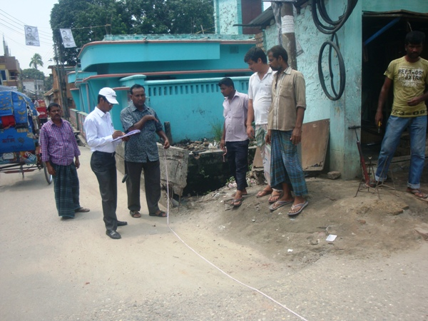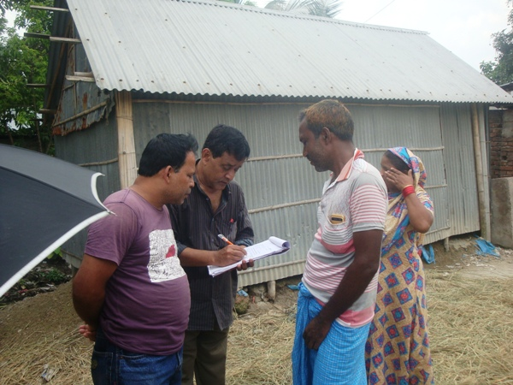

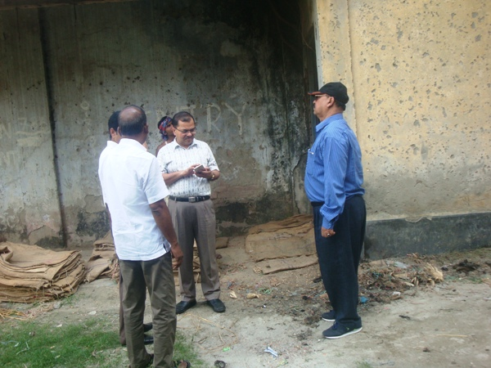

Photographs 7.1.1: Consultant Team Visited the Site with the Pourashava and PMU Representatives

Issues Raised by the Participants

The participants raised the issues related to the infrastructure development of Saidpur Pourashava. They emphasized on the subproject selection for the future development and also discussed about the procedure for the quality construction work. In the FGD, the participants discussed the requirements of the infrastructure development of Saidpur Pourashava through a list of the subprojects.

Feedback, Suggestions, and Recommendations of the Participants

The participants were presented with feedback, suggestions, and recommendations listed below:
- The FGD results confirmed that an improved communication network, drainage facility, and solid waste management is needed for future development of Saidpur Pourashava;
- Most of the participants stated that the number of subproject that have been selected for each financial year is insufficient;
- The Mayor and other Pourashava Officials emphasis for the construction of the Poura Office Building;
- The Mayor of the Pourashava stated that recreation centre like children park is necessary for this Pourashava;
- The participants stated that the public water supply facilities, sanitation facilities, and drainage system is not adequate;
- The participants also addressed the solid waste management issue to reduce environmental and public health hazards.

Conclusions and Recommendations

The environmental impacts of all the elements of the subproject have been assessed. The anticipated impact on the ecological environment is minor. However, plantation of the 700 numbers of trees will enhance the ecological condition in the subproject area. The anticipated impacts on the physicochemical components will be mainly at the subproject site and limited within the subproject boundary. However, impacts are highly manageable through implementation of the applicable mitigation measures formulated in the EMP.

A few key recommendations are outlined below:
- A copy of the EMP should be available at subproject site during construction phase;
- Regular monitoring by Pourashava, PMU (LGED) and DSM consultants is needed;
- The contractor will ensure using of the PPEs by the workers where applicable;
- Regular monitoring by Pourashava is needed to avoid any illegal households and toilets connection in to the drain;
- The contractor is responsible for the proper disposal of the generated wastes materials from the subproject site and Campsite;
- Contractor will monitor the workers behavioral matter to avoid any undue issue due to labor influx;
- Planted trees should be properly maintenance by the contractor during project defect liability period;
- During construction phase contractor will ensure water supply, sanitation, first aid etc. facilities for the workers.

It should be noted that environmental assessment report is a live document. Hence, due to changing circumstances during the construction phase if any, there might be minor adaptation needed for environmental, health and safety issues.

APPENDIX

Appendix- I: Environmental Monitoring Checklist

