

GOVERNMENT OF THE PEOPLE’S REPUBLIC OF BANGLADESH
Local Government Engineering Department (LGED)
Local Government Division

Ministry of Local Government, Rural Development and Cooperatives

Environmental Assessment (EA) REPORT

Subproject Name: Construction of RCC Drain and BC Road from West Choumatha to Nut Mondir via Sub Registry Office.

Package No: MGSP/GOB/2018-2019/W-07

Gobindaganj Pourashava, Gaibandha
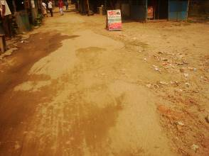
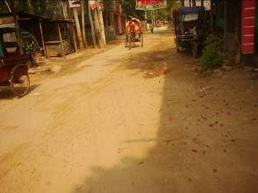

Municipal Governance and Services Project (MGSP)
Design, Supervision, and Management (DSM) Consultancy Services

Joint Venture of  Hifab International AB, Sweden  AQUA Consultant and Associates Ltd., Bangladesh |  |  |   

TABLE OF CONTENTS
 |  |  |  | Page
1.0 |  | INTRODUCTION |  | 1-3
 | 1.1 | Subproject Background |  | 1
 | 1.2 | Objectives of the Study |  | 2
 | 1.3 | Scope and Methodology of the Study |  | 2
2.0 |  | SUBPROJECT DESCRIPTION |  | 4-10
 | 2.1 | The Study Area |  | 8
 | 2.2 | Current Situation and Need for the Subproject |  | 9
 | 2.3 | Justification of Selection of this Subproject |  | 9
 | 2.4 | Envisaged Subprojects Activities and Implementation Process |  | 9
3.0 |  | BASELINE ANALYSIS OF ENVIRONMENTAL CONDITION |  | 11-17
 | 3.1 | Physical Environment |  | 11
 | 3.2 | Biotic Environment |  | 15
 | 3.3 | Socio-economic and Socio-cultural Environment |  | 16
4.0 |  | ENVIRONMENTAL SCREENING |  | 18-20
5.0 |  | SPECIFIC IMPACT, MITIGATION AND ENHANCEMENT MEASURES |  | 21-27
 | 5.1 | Dismantle Work, Site Clearing, Excavation Work and Earth Work |  | 21
 | 5.2 | Tree Feeling and Ecological Impact |  | 21
 | 5.3 | Pollution from the Construction Materials |  | 21
 | 5.4 | Air Quality and Dust |  | 22
 | 5.5 | Noise and Vibration |  | 22
 | 5.6 | Water Quality |  | 23
 | 5.7 | Occupational Health and Safety |  | 23
 | 5.8 | Impacts on Social Environment and Common Property Resources |  | 24
 | 5.9 | Labor Influx and Anticipated Impacts |  | 25
 | 5.10 | Impacts on Traffic Movement |  | 26
6.0 |  | ENVIRONMENTAL MANAGEMENT PLAN |  | 28-41
 | 6.1 | Access to Information |  | 28
 | 6.2 | Grievance Redress Mechanism |  | 28
 |  | 6.2.1 | Grievance Redress Committee (GRC) | 28
 |  | 6.2.2 | Grievance Resolution Process | 29
 | 6.3 | Institutional Arrangement for Safeguard Compliances |  | 30
 | 6.4 | Capacity Building |  | 31
 | 6.5 | Emergency Response and Disaster Management |  | 31
 | 6.6 | Environmental Management Action Plan |  | 32
 | 6.7 | Environmental Monitoring Plan |  | 38
 | 6.8 | Environmental Management Budget |  | 39
7.0 |  | PUBLIC CONSULTATION AND PARTICIPATION |  | 42-43
 | 7.1 | Methodology |  | 42
 | 7.2 | Issues Raised by the Participants |  | 42
 | 7.3 | Feedback, Suggestions and Recommendations of the Participants |  | 43
8.0 |  | CONCLUSIONS AND RECOMMENDATIONS |  | 44
APPENDIX
 |  | Appendix I: Environmental Monitoring Checklist |  | 45

LIST OF TABLES
Table 3.1.1 | Major Environmental and Infrastructural Features from West Choumatha to Chandpur Kholshi Damaged Bridge
Table 5.7.1 | General Requirements for the Workers Health and Safety
Table 5.8.1 | Impacts on Social Environment and Common Property Resources
Table 6.2.1.1 | List of GRC Committee Members
Table 6.6.1 | Anticipated Environmental Impacts during Construction Phase and Corresponding Mitigation and Enhancement Measures
Table 6.6.2 | Anticipated Environmental Impacts during Operational Phase and Corresponding Mitigation and Enhancement Measures
Table 6.7.1 | Matrix Table of Monitoring Plan (Visual observation during construction phase)
Table 6.8.1 | Environmental Management Budget

LIST OF FIGURES
Figure 2.1.1 | Location Map of the Subproject Site
Figure 2.1.2 | Lay Out Plan of the Subproject Site
Figure 2.1.3 | Topographical Features of the Subproject Site
Figure 3.1.1 | Earthquake Zones of Bangladesh (Source: GSB)
Figure 3.1.2 | Average High/Low Temperature for Gobindaganj (during 2000 to 2012)
Figure 3.1.3 | Average Annual Rainfall for Gobindagonj
Figure 3.1.4 | Location of Gobindaganj (Red circle) in Flood Zone Map of Bangladesh
Figure 6.3.1 | Environmental and Social Management Team (Tentative)

LIST OF PHOTOGRAPHS
Photograph 2.2.1 | Current Situation of the Subproject Site
Photograph 2.2.2 | Current Situation of the Outfall
Photograph 7.1.1 | Consultation meeting at subproject site with Pourashava officials local peoples and ward councilors.

ABBREVIATIONS

AP persons (AP’s) | Affected Person
BDT | Bangladeshi Taka
BOQ | Bill of Quantity
CC | Cement Concrete
CIP | Capital Investment Plan
CP | Contingency Planning
DSM | Design, Supervision, and Management
EA | Environmental Assessment
ECR | Environmental Conservation Rules
EMP | Environmental Management Plan
EPP | Emergency Preparedness Planning
ES | Environmental Screening
FGD | Focal Group Discussion
GoB | Government of Bangladesh
GRC | Grievance Redress Committee
GRM | Grievance Redress Mechanism
GRP | Grievance Redress Procedure
LGED | Local Government Engineering Department
MGSP | Municipal Governance and Services Project
PD | Project Director
PMU | Project Management Unit
RCC | Reinforcement Cement Concrete
RP | Relevant Reports
TL | Team Leader
WB | World Bank
XEN | Executive Engineer

INTRODUCTION

Subproject Background

Gobindaganj Pourashava is situated at Gobindaganj Upazila under Gaibandha District. Gobindaganj declared as a Pourashava in the year of 1998. The Pourashava covers an area of 14.58 sq. km. At present, it is A type Pourashava having total population of 38,415 [Source: Population & Housing Census, 2011]. The Pourashava has only 9 km drains which are mainly concentrated in the core Pourashava area.

Like other Pourashava, the development scenario of Gobindaganj Pourashava shows a very critical situation. Most of the drains are narrow in width and unplanned. In addition, there is no integrated drainage network in the Pourashava. Hence, existing infrastructure facilities are not adequate to meet the present demand. [Source: Gobindaganj Master Plan]. Therefore, this subproject will significantly contribute infrastructure development in the Pourashava area.

This subproject includes the following two components: RCC drain with cover slab and BC Road. The significant features of the subproject are stated below:
Name of the Subproject : | (a) Rehabilitation of Bituminous Carpeting Road from West Choumatha to Nut Mondir via Sub Registry Office Ch.00-500m.  (b) Construction of RCC Drain starting from West Choumatha to Chandpur kholshi damaged Bridge via Sub Registry Office Ch. 00-1100m.
Package No. : | MGSP/GOB/2018-19/W-07
District Name : | Gaibandha
ULB Name : | Gobindaganj Pourashava
Jurisdiction Area : | Ward number 2 and 4
Structural Design Option : | RCC Drain and BC Road
Beneficiary Population : | About 30,000 as per information by the Pourashava
Tribal People : | No tribal people settlement found in the subproject area
Land Acquisition : | Gobindaganj Pourashava owned. So, land acquisition is not required.
Estimated Cost : | 42.941 million BDT
Subproject Duration : | 12 months
Tentative Start Date : | 23 February 2019
Tentative Completion Date : | 22 February 2020

Objectives of the Study

The general objective of this study is to determine the major environmental impacts succeeding from execution of the subproject and to recommend mitigation measures to avoid or reduce adverse environmental impacts and to enhance positive impacts. The specific objectives include:
- To assess the existing environmental conditions of the subproject site and its influence area;
- To identify and assess impacts resulting from the subproject during its construction phase and operation phase;
- To develop a environmental management plan with recommendations for mitigating impacts and enhance positive impacts;
- To summarize environmental monitoring requirements.

Scope and Methodology of the Study

The subproject appraisal is included environmental screening for all the subproject components. According to that screening, environmental assessment is required to fulfill the regulatory requirement for RCC Drain and BC Road. Hence, this environmental assessment is prepared to meet the regularity requirement of this subproject. The study methodology comprised the following activities:
- Desktop Study;
- Field Investigations and Data Collection;
- Data Analysis and Report Writing.

Desktop Study
The desktop study involved:
- Initial meetings with client, stakeholders to discuss the proposed subproject, including subproject activities;
- Collection and review of the baseline data, maps, reports and other relevant information;
- Review of the relevant existing legislation, regulation and policies;
- Understand the anticipated technical processes that may affect the environment.

Field Investigation and Data Collection
The following key tasks were performed during the field visit:
- Taking photographs of the significant aspects to assist in describing the baseline environmental conditions of the subproject area;
- Interviews with representatives of the relevant Pourashava officials, beneficiary and affected people within the subproject influence zone;
- Obtaining relevant documents from the Pourashava and local people within the subproject influence zone;
- Verifying information and data collected during the desktop study and to collect new information.

Data Analysis and Report Writing
The data and information collected from all the sources (literature review, secondary and primary data, public consultation) were analyzed to describe the existing environmental setting of the subproject area, to identify the potential positive and negative impacts of the proposed subproject, as well as to provide preliminary suggestions for mitigation measures. Finally, this environmental assessment report has been prepared.

SUBPROJECT DESCRIPTION

The Study Area

The subproject sites are located within the jurisdiction of ward number 2 and 4 of Gobindaganj Pourashava. There is no protected areas in or near the subproject site. The geographic co-ordinate of starting point and end point of proposed subproject site is latitude 25° 8'15.43"N, longitude 89°23'1.82"E and latitude 25° 8'45.16"N, longitude 89°23'4.65"E respectively. The location map, layout plan and topographical features of the proposed subproject are shown in Figure 2.1.1, Figure 2.1.2 and Figure 2.1.3.
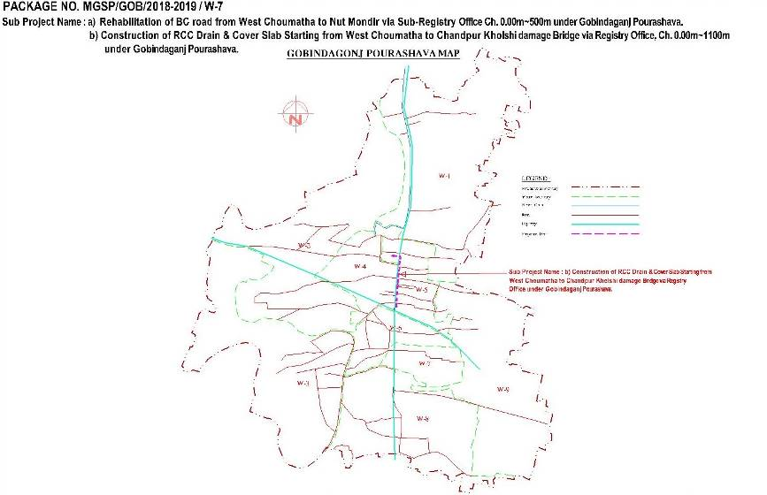

Figure 2.1.1: Location map of the subproject site
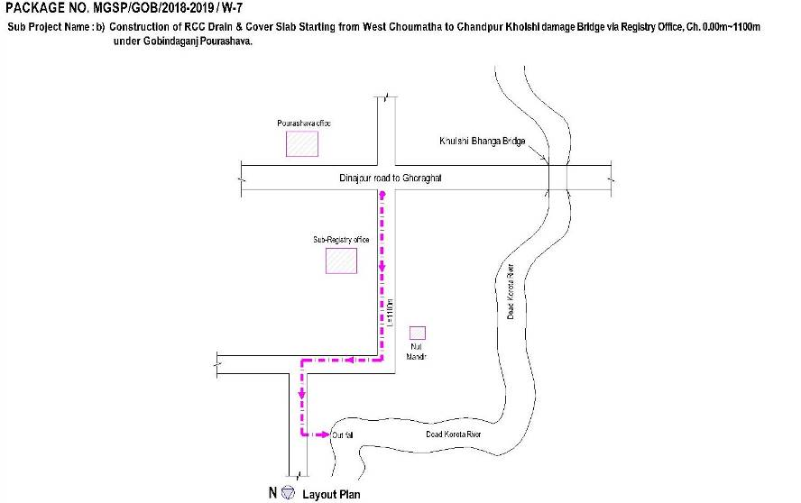
Figure 2.1.2: Lay out plan of the subproject site
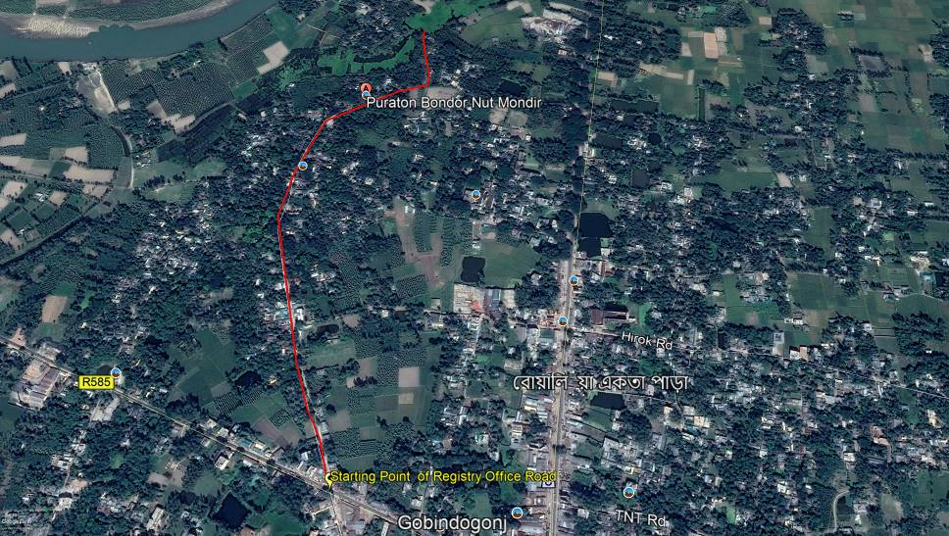
Figure 2.1.3: Topographical features of the subproject site

Current Situation, Proposed Intervention and Need for the Subproject

Proposed road starts from West Choumatha (adjacent to the Ghoraghat Dinajpur Road) and ends at Chandpur kholshi damaged bridge. This road passes through Gobindagonj Nut Mondir and Registry Office area. This is an important road because adjacent to the subproject villages and unions (Shibpur, Sordarhat, Fulbari and Rakha Buruj) peoples are using this road to reach the Gobindagonj Sador.

From Ch. 0 to 200m (Approximately), the existing bituminous carpeting road is partially damaged. But remaining portion is badly damaged. Average paved width varies from 4.5 to 5.0m. The proposed road width is 6m. From the site investigation, it is revealed that normal traffic operation is interrupted due to damaged road. In addition, stagnant storm water in the pot holes interrupts pedestrian’s movement during rainy season. In the dry season, rough and dusty surfaces on damaged road generate dust which creates discomfort felling of the road users. Hence, widening and road improvement is necessary for the normal traffic operation. Considering the demand and its needs BC road is being proposed from West Choumatha (adjacent to the Ghoraghat Dinajpur Road) to near TMSS office (Ch.0-500m).

In the subproject area, there is no drainage system. Therefore, during monsoon storm water retain on the road and adjacent to the houses where road side open space is not available. This stagnant condition hasten damages of BC road. In addition, water logging causes environmental degradation and public health hazard. Hence, RCC drain with cover slab will be constructed from West Choumatha to Chandpur kholshi damaged Bridge. This drain will be connected with Korotoa. The current situation of the subproject is further addressed in the following Photographs 2.2.1and 2.2.2.
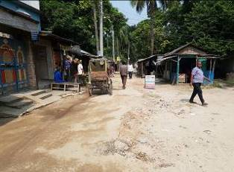
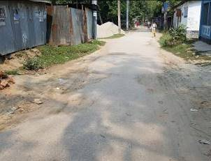

Photographs 2.2.1: Current situation of the subproject site
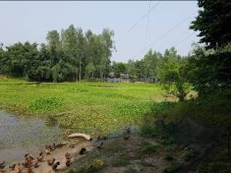
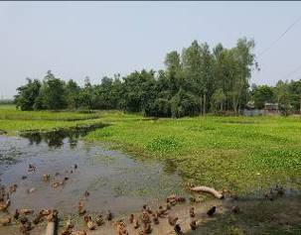
Photographs 2.2.2: Current situation of the outfall

Justification of Selection of this Subproject

The proposed subproject has significant importance for the Pourashava. The proposed road will make safe, easy and smooth connection with core area of municipality. Hence, this subproject has been considered as priority subproject in the CIP. PMU representative, and DSM consultant visited the subproject site to assess the site condition.

From the site visit, it is revealed that this road is very much inconvenience for the movement of the motorized vehicles. The subproject site is located mostly on the right of way. Adequate space is available at both sides of the road which is owned by Pourashava. Hence, private land acquisition is not an issue for implementation of this subproject. From the site inspection, it is also revealed that roadside built-up infrastructure will not be severely affected due to the implementation of the subproject.

After construction, the new drain will develop a complete drainage network. Hence, this drain will reduce the water logging problem in the subproject area. Due to functional drain, the subproject area will get better environment. Consequently, public health hazard will be minimized because drainage system prevents the accumulation of the stagnant water, which encourages mosquitoes to breed. Hence, considering the benefits that will derive, the subproject is selected for implementation.

Envisaged Subproject Activities and Implementation Process

The general activities for the subproject includes: construction of the semi-pucca site office, construction of the labor shed, relocation of the electric poles, telephone poles and GI poles and site clearing & grubbing works.

Specific activities for RCC Drain
- Earth work in excavation of the foundation;
- Pumping and bailing out of water as per requirement;
- Sand filling for the preparing foundation bed;
- Laying polythene sheet;
- Plain cement concrete work in foundation;
- Manufacturing CC blocks;
- Fabrication of the ribbed or deformed bar;
- Reinforced cement concrete work.

Specific activities for BC Road:
- Site clearing work;
- Preparation of the hard bed by scarifying and loosening of the existing top;
- Earth work in box cutting;
- Sand filling on the road bed;
- Brick on end edging;
- Compacted aggregates and sub-base and base course;
- Providing prime coat;
- Lying pre-mixed dense bituminous surfacing.

The materials and resources to be used for the key activities of the subproject includes: soil in earth work, sand, bricks, stone chips, cement, concrete, reinforcement, bitumen, kerosene, diesel, and water.

The major equipment to be used for the implementation of the subproject: hydraulic excavator, concrete mixer machine, mechanical vibrator machine, mechanical compaction machine, MS sheet, steel cutter, steel shutter, steel drum rollers, dump truck, water tanker, pump, asphalt plant and rubber tire roller.

Baseline ANALYSIS OF THE ENVIRONMENTAL CONDITION

Physical Environment

Important Environmental and Infrastructural Features
The detailed environmental and infrastructural features have been collected during the site visit. The conditional survey has also been performed for designing of the subproject. Hence, data from conditional survey is also incorporated in the screening report. Effort has been given for listing the major environmental and infrastructural features within 100 m of the both sides from the center line of the road at 100m longitudinal intervals from West Choumatha to Chandpur Kholshi Damaged Bridge (Ch. 0-1100m). The key environmental and infrastructural features are given in the following Table:
Table 3.1.1: Major Environmental and Infrastructural Features from West Choumatha to Chandpur Kholshi Damaged Bridge
Chainage (m) | Left | Right | Major Environmental and Infrastructural Features
West Choumatha to Chandpur Kholshi Damaged Bridge (Ch. 0-1100m)
0-100 | √ |  | Tea Stall, Rice Shops, Gaibandha Zila Shorak Poribohon Malik Somite, A. R Plus Community Center, Pouro Upo kor Komishonerer Karzaloy, Pucca, Semi-pucca and Tin shed structure of Residents, Electric Pole, Trees;
0-100 |  | √ | Shops, Mushers Mehera Traders, Pucca, Semi-pucca and Tin shed structure of Houses, Planted Trees, Faruk Traders, Fatema Monjil, Low land, Agricultural Field;
100-200 | √ |  | Pucca, Semi-pucca and Tin shed Structure Houses, Electric Pole, Low land, Agricultural Field;
100-200 |  | √ | Jineous Private Coaching, TMSS Office, HEED Bangladesh, Brick Drain, Success Printers Center, Pucca, Semi-pucca and Tin-shed Residents, Electric Pole, Trees;
200-300 | √ |  | Pucca, Semi-pucca and Tin-shed Residents, Boundary Wall, Electric Pole, Trees;
200-300 |  | √ | Low Land, Agricultural Field, Pucca, Semi-pucca and Tin-shed Residents, Boundary Wall, Electric Pole;
300-400 | √ |  | Sub Registry Office, Pucca, Semi-pucca and Tin-shed, Shops, Khabar Hotel, Residential Structure, Electric pole, Trees;
300-400 |  | √ | Under Constructed Registry Office Building, Low land, Agricultural Field Semipucca and Pucca Residents;
400-500 | √ |  | Shopno Nir Digital Studio, Shops, Pucca Semi-pucca and Tin-shed Residents, Electric Pole;
400-500 |  | √ | Pond, Connecting Road, Khabar Hotel, Tin shed, Pucca and Semipucca Residents, Trees;
500-600 | √ |  | Tin Fences, Trees, Boundary Wall, Tin shed, Pucca and Semipucca Residents, Electric Pole;
500-600 |  | √ | Graveyard, Mosque, Tin shed, Pucca and Semipucca Residents, Electric Pol;
600-700 | √ |  | Tin Fence, Boundary Wall, Pucca, Semi-pucca and Tin-shed Residents, Trees, Electric Pole;
600-700 |  | √ | Planted Trees (Mahogany, Rain Tree and Koroi), Jillu Store, Shops, Semipucca and Tin shed Houses;
700-800 | √ |  | Connecting Road, Shops, Planted Trees, Pucca, Semi-pucca and Tin-shed Residents, Electric Pole;
700-800 |  | √ | Modhumoti Child Care Kindergarten, Banana Bushes, Electric Pole, Boundary Wall, Tress, Semi-pucca and Tin-shed Residents;
800-900 | √ |  | Varieties Shops, Tin Fence, Pucca, Semipucca and Tin shed Residents, Electric pole, Nut Mondir, Trees;
800-900 |  | √ | Gobindagonj Govt. Primary School, Low land, Pond, Trees, Tin shed and Semipucca Houses, Electric pole;
900-1000 | √ |  | Udoyon Bhabon, Semipucca and Tin shed Houses, Vegetation coverage Trees, Electric pole;
900-1000 |  | √ | Low land, Vegetation Coverage, Semipucca and Tin shed Houses, Trees, Low land, Electric pole,
1000-1100 | √ |  | Maya Kunjo, Boundary Wall, Semipucca and Tin Shed Residents, Trees,
1000-1100 |  | √ | Agricultural Field, Trees, Low land, Planted Trees, Semipucca and Tin shed Houses

Geology, Topography and Soils

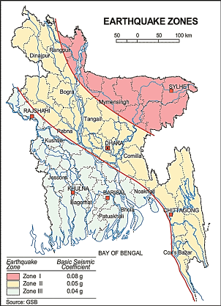
This Pourashava is almost flat in topographic nature and comparatively lower elevation at western and southern part. Geological condition of Gobindaganj Pourashava partially belongs to geological characteristics of the Barind area. Aquifers below the Red Clay are safe from Arsenic pollution. According to Geological Survey Bangladesh (GSB) the Pourashava falls in medium intensity seismic zone (Zone-II).

The purple Circle denotes Gobindaganj Pourashava

Figure 3.1.1: Earthquake Zones of Bangladesh (Source: GSB)

Climate and Meteorology

This subproject area has a tropical climate. Most of the rainfall is in summer season and monsoon period while the winter has very little. The climate is considered as Aw according to the Köppen-Geiger climate classification. The average temperature in Gobindaganj is 25.3 °C. The average annual rainfall is 1901 mm. The least amount of rainfall (average is 4mm) occurs in December. The maximum rainfall (average is 405 mm) occurs in July. The variation in the precipitation between the driest and wettest months is 401 mm. Figure 3.1.2 and Figure 3.1.3 shows the temperature and precipitation data of Gobindaganj (BMD. 2013).
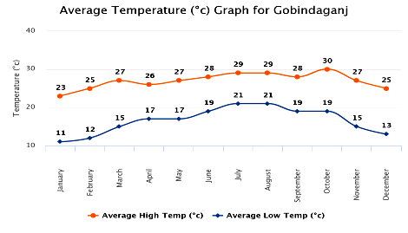
Figure 3.1.2: Average High/Low Temperature for Gobindaganj (during 2000 to 2012)
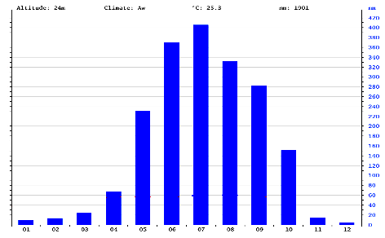
Figure 3.1.3: Average Annual Rainfall for Gobindagonj
The construction work can be influenced by the climatic condition and meteorological components like rainfall, temperature and wind speed. It is very risky to work under rain because the possibility of getting injury increases. In case of high wind, the generated dust due to construction activities may spread quickly. Furthermore, work under high temperature and excess humidity may create dehydration problem.

Water Resources

Rain water is the main source of surface water. Different types of water bodies such as river, ponds, ditches, khals etc. are accumulating this rain water. In addition, Korotoa River flows along the proposed road from Ch. 800-1100m. Groundwater is the main source of potable water in the subproject area. Local people typically use hand tube-well water for drinking and other domestic purposes. There is no piped water supply system in the Pourashava area. At present, using of individual deep tube-well with pumping and water supply facilities at household level is increasing. There is high iron and little arsenic contamination problem in the ground water in few area of the Pourashava is reported by the inhabitants.

Flooding, Water Logging and Drainage Pattern

About 9.02 km pucca drain is functional in the built-up area of the Pourashava which is only concentrated in the core area. There is no katcha drain in the Pourashava area. From the field observation and information by the local people it is evident that Pourashava inhabitants suffer due to water logging problem in the rainy season from June to October. Water logging aggravates road condition of the Pourashava as well. According to the flood zoning map of Bangladesh, this area is considered as normal flood area.
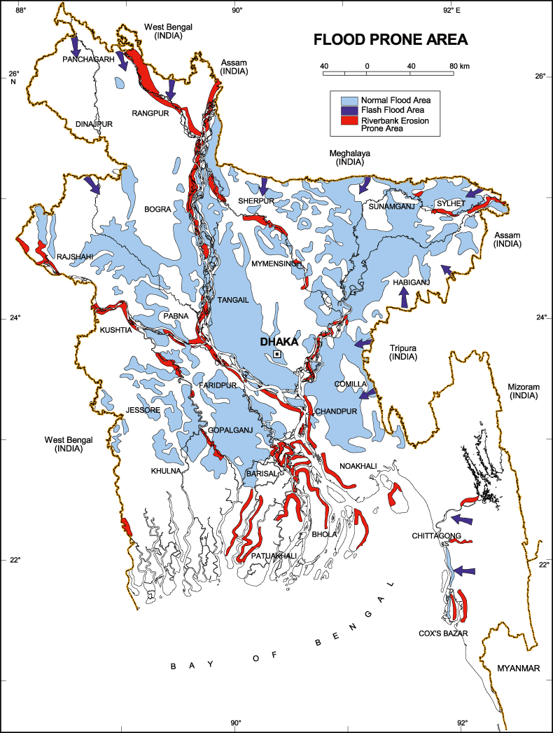

Figure 3.1.4: Location of Gobindaganj (Red Circle) in Flood Zone Map of Bangladesh

Air Quality and Dust

In the subproject area, degradation of the air quality is mainly due to emission from the vehicles. The windblown dust also causes air quality degradation. The dusty and rough surfaces of the road also generate dust during vehicle movement. Open burning of the wastes materials and roadside disposal of the wastes cause also air quality degradation. The subproject activities may degrade the air quality of the subproject area though the impacts are anticipated to be insignificant.

Noise Level

Noise level data is not available. From the field visit it found that, noise generated due to the vehicle movement and hydraulic horns. In the subproject activities, mixer machine, vibrator machine, mechanical compaction machine, rod cutter, hydraulic excavator, asphalt plant may create localized noise nuisance though the impacts are anticipated to be within the tolerable limits. In addition loud speaker for announcing advertisements by mike especially for regular cinema show and horn from motorized vehicle create noise nuisance.

Sanitation

There is no site specific data for sanitation. However, according to sanitary condition in the Pourashava area it is observed that people are using water sealed latrines with septic tank (19%), water seal slab latrine (58%). About 23% households are still using unhygienic latrines. There are 3 public toilets in the Pourashava.

Solid Waste Management

During site visit and information by the local people, it is evident that the Pourashava faces challenges for the effective solid waste management. At present, Pourashava authority provides 13 dustbins which are pucca dustbin. In addition, Pourashava authority provides 1 garbage truck and 7 vans to collect waste from households and bazar area. Collected wastes are dumped beside the Motijheel which is located at ward no 6. Improper dumping of the households waste in adjacent low laying vacant lands by the households still is a common scenario in the Pourashava. The local people also informed that, the households throw their solid wastes into nearby drain.

Biotic Environment

Flora and Fauna

In the subproject area, there are swamps and ponds. In addition, Korotoa River flows along the proposed road from Ch. 800-1100m. As per information by the local peoples, these water bodies are acting as important watering area for local wildlife as well as habitat area for various species of frogs and water snake.

There is no manmade or natural forest in or around the subproject site. However, in the subproject area, homesteads and roadside plantation, natural vegetation, and agricultural crops are the greenery setting. The common natural native species of trees are found in the subjected area. Major planted trees include - Banana, Koroi, Mahogany, Jolpai, Boroi, Ata, kodom, Krishnochura, tulshi, Jackfruit, Bokul, Polash, Mango, Rain tree, Betel nut, Lichu, Gova, Eucalyptus, Mehedi, Akashi, Coconut, and Neem etc.

There are common local birds such as Shalik, Choroi, Bok, Dowel, Crow, Tiya, Bulbuli and Tuntuni etc. were found during the site visit. Within the subproject influence area, there is no historical site. However, the educational institutes and religious institutes of the subproject area bring cultural values to the local community. The local inhabitants also addressed migratory birds are coming in the winter season.

Socio-economic and Socio-cultural Environment

Land Use, Status of Housing and Built-up Infrastructure

Like other Pourashava in Bangladesh, the land use pattern in the subproject area consists of mixed land-use pattern-residential, agricultural and administrative area. The road side built-up infrastructure includes pucca, semi-pucca and tin-shed houses, shops, community center, sub registry office, NGO (TMSS, HEAD etc.), Pouro Upo kor Komishonerer Karzaloy, Gaibandha Zila Shorak Poribohon Malik Somite, school, and mosque. In the different segment of the road, there are agricultural lands where rice, sugarcane and banana are cultivated. The built-up structures are mainly pucca, and semi-pucca. There is no industrial activity within the subproject area.

Beneficiary Population

The subproject covers the jurisdiction of the ward number 2 and 4. As per information by the municipality, about 30,000 people will benefit directly and many others indirectly.

Education

People of Gobindaganj Pourashava mostly attained primary and secondary level education. 42.58 % of male and 21.84% female population are educated. Literacy rate is 64.42% at Gobindaganj Pourashava. Percentage of illiterate is about 36% where 23.22% are female and 12.36% male.

Tribal Communities

There is no indigenous or tribal people settlement in the subproject area. Therefore, there are no measures needed for indigenous peoples’ safeguard.

Land Acquisition

The Gobindaganj Pourashava is the owner of the land. Consequently, the land acquisition is not required. In addition, the MGSP social experts will evaluate the social issues regarding the subproject intervention and measures will be given accordingly.
Principal Livelihoods and Economic Activities

The subproject area is inhabited by the mixed occupational people. In the Pourashava area, major income comes from business, enterprises, small trades, private sector jobs, and government jobs in the town.
Cultural Heritage and Protected Areas

During site visit it was observed that there is no protected and important cultural or historical site in the subproject influence area. However, the educational institutes and religious institutes of the subproject area bring cultural values to the local community.

Social Conflicts and Development Activities

The local people welcome the subproject and there is no conflicts between the local communities regarding subproject implementation.

ENVIRONMENTAL SCREENING

Environmental Screening Checklist, as adopted in Appendix C of the Environmental Management Framework (EMF) of the MGSP, was administered for identifying the impacts and their extents. The screening data and information designed for the RCC cover drain have been formulated and are shown in below.
The screening data for the RCC Drain and BC Road, have been formulated and are shown in below:

(1) Potential environmental impact during construction phase:

- Ecological impacts:
17
- Felling of trees Significant □ Moderate □ Minor □√ Number of trees
- Clearing of vegetation Significant □ Moderate □ Minor □√
- Potential impact on species of Significant □ Moderate □ Minor □√
aquatic (i.e., water) environment

Major trees to be felled down are: Mango (2), Mahogany (3), Rain tree (4), Betel Nut (8) etc. There is no tree to be felled down bring religious and heritage importance. However, the trees to be felled down will have no significant economic value because most of them are small in size. Intensity of the vegetation coverage at both sides of the road is not uniform since it goes through developed area. So, clearing of the road side vegetation is considered as minor. In addition, anticipated impact on species of aquatic environment is minor because except throwing of the wastes materials into the ponds, swamps and river, the subproject does not have any impact on the aquatic environment. Considering the number of trees to be felled down, the ecological impact is considered as minor.
- Physicochemical impacts:
- Air pollution Significant □ Moderate □√ Insignificant □
- Noise pollution Significant □ Moderate □√ Insignificant □
- Drainage congestion Very likely □ Likely □ Unlikely □ √
- Water pollution Significant □ Moderate □√ Insignificant □
- Pollution from solid/ construction wastes Significant □ Moderate □√ Insignificant □
- Water logging Significant □ Moderate □ Insignificant □ √

The subproject will have impacts on noise and air quality during construction phase due to mobilization of the equipment, vehicles movement for the transportation of the materials, using of hydraulic excavator, mechanical compaction machine, paver, asphalt plant, concrete mixer machine, vibrator machine etc. The construction work will be performed section wise. Hence, it is anticipated that the overall impacts on noise and air quality will be moderate, temporary and limited within the subproject boundary. There are road side Mosque, Madrasa, Mondir, Residents etc. Hence, anticipated impacts on noise and air quality will be significant for this particular section if measures are not taken properly. The generated dust during construction activities may disturb the local people during construction period. The generated construction wastes, un-suitable materials and solid wastes may degrade the adjacent water bodies if not properly collected and disposed and thrown into the water bodies. Improper collection and disposal of the generated wastes materials also may degrade the quality of the surrounding environment and degrade the aesthetic value. The anticipated water logging and drainage congestion during construction period is minor because pumping facilities will be provided for pumping out the storm water if required.

- Socio-economic impacts:

- Traffic congestion Very likely □ Likely □ Unlikely □√
- Health and safety Significant □ Moderate □√ Insignificant □
- Impact on archaeological and historical Significant □ Moderate □ Insignificant □√
- Employment generation Significant □ Moderate □ √ Insignificant □

During drain construction work, it does not need closing of the entire road. So, construction of drain will have minor impact on traffic. But construction of road will restrict the free movement of the motorized vehicles. Hence, construction work will be performed section wise. In addition, currently this road are not usually used for motorized vehicle due to its bad condition and construction a bridge on Korotoa River. Moreover, local people can use alternative road during construction period. Hence, it is anticipated that the subproject intervention does not have severe impact on the traffic movement. The construction work will follow simple procedure with commonly used equipment. Therefore, impact on health and safety is anticipated as moderate. There is no archaeological and historical site within the influence area. However, there is Nut Mondir adjacent to the road, it may be affected by losing aesthetic beauty from dust pollution. Hence, before construction at this particular place Nut Mondir should be cover-up by tarpaulin or polythene.The subproject will have positive impacts by generating employment opportunities for the local people and creating business opportunity of supplying construction materials, equipment, food and other necessary staffs to the work camp.
(2) Potential Environmental Impact during Operational Phase:

(d) Ecological impacts:

- Potential impact on species of aquatic Significant □ Moderate □ Minor □√
(i.e., water) environment

The drain is designed for discharging the storm water. Hence, anticipated impact on the aquatic environment due to the operation of the drain is likely minor. However, if the drain carries pollutants from any sources, it may degrade the quality of the aquatic environment.

(e) Physicochemical impacts:

- Potential air quality Improvement □ No-improvement □ Deterioration □√
- Potential noise level Improvement □ No-improvement □ Deterioration □√
- Drainage congestion Improvement □√ Minor Improvement □ No Impact □
- Risk of water pollution Significant □ Moderate □ Minor □√
- Pollution from solid waste Improvement □ No-improvement □ Minor □√

Increased traffic volume due to improved road may degrade the air quality and noise level due to black smoke emission and un-due use of hydraulic horn from the vehicles. The drain component does not have any impact on noise. The new drain will minimize drainage congestion & water logging problem. The storm water to be discharged through the drain may degrade the water quality of the outfall if carry pollutants from any sources. The covered drain will minimize throwing of the waste materials in to the drain and will reduce spreading of the bad odor from the drain.

(f) Socio-economic impacts:

- Traffic Improvement □√ No-improvement Adverse □
- Safety Improvement □√ No-improvement Adverse □
- Employment generation Significant □ Moderate □ Minor □ √

The new road will enhance transport facilities after construction. In addition, new road prevents the accumulation of the stagnant water on the road surface. Consequently, it will enhance safety traffic operation. The new road will minimize the frequency of the maintenance for the first three to five years after construction.

(3) Summary of the Possible Environmental Impacts of the Subproject:
From the above study, it seems that ecological impact due to implementation of this subproject is minor. However, the ecological imbalance to be caused due to the subproject implementation and to enhance the ecological condition in the subproject area, adequate tree will be planted under this subproject.
The subproject activities will have adverse impacts on physicochemical impacts. However, it is anticipated that the impact is not severe and limited within the subproject boundary. The wastes generated due to the construction activities should be properly collected and disposed in a designated dumping site. Some earthwork will be involved for the road construction work; however, no agricultural productive soil will be used for the purpose. The inputs that may affect the environment will be mainly at construction phase. Moreover, mitigation measures will be taken according to the EMP for minimizing the environmental pollution.
Using of the steel cutter machine and hammer may cause potential safety risks. Safety concern is an important issue for both the construction and operation phases that should be considered properly. This subproject will have positive impacts in terms of the generation of the employment and business activities by supplying construction materials and equipment. However, it has significant positive social impacts.

Specific impact, mitigation, AND enhancement measures
From the environmental study, the probable impacts of the subproject are mainly caused by the key activities required for the implementation of the subproject, raw materials and equipment to be used for the execution of the activities. This section describes some specific impacts due to the subproject activities and their mitigation measures.

Dismantle Work, Site Clearing, Excavation Work and Earth Work

The road improvement work includes dismantle of existing bituminous pavement, clearing of the wastes materials generated due to dismantle work, earth excavation and earth filling work. The drain construction work consists of earth excavation, earth filling, back filling and cutting and removal of the unsuitable materials. These works lead dust blowing, improper disposal of the wastes, noise and vibration which may disturb the local people.
Mitigation Measures

- Proper care will be taken by the contractor as well as the Gobindagong Pourashava, during dismantle, excavation, soil work and back filling so that this activity does not disturb the nearby establishment.
- Cover the exposed dry loose soil with fabric to avoid any dust generation;
- Avoid loss of the topsoil for the earth filling work;
- Disposal of soil and construction wastes to designated dump site at dumping site at vacant place near Old Union Parishad.

Tree Felling and Ecological Impact
There are 17 numbers of planted roadside trees will be felled down due to implementation of this subproject.
Mitigation Measures

- 50 numbers of trees to be planted to compensate the felled down trees and to enhance ecological condition. Trees to be planted at Sub Registry Para Road - Mango, Jackfruit, Jam, Kathbadam, Krisnachura, Bohera, Bokul, Jarul, Kadom, Hortoki, Neem, Mahogany, Rain Tree,
- Planting trees and vegetation will enhance the ecological balance of the area after their successful growth.

Pollution from the Construction Materials
Dumping of the construction spoils, including accidental leakage of the oil, grease, and fuel in equipment yards is a significant hazard. Storm water may carry these substances during rain. Thus, both surface and groundwater might be polluted from these contaminants. Air pollution and dust may affect the nearby settlement which is generated from fine aggregate such as sand and loose dry soil.
Mitigation Measures

- Safe transport, storage, and disposal of the construction materials, and the equipment have to be carried out in order to avoid the accidental spillage and loss;
- Maintain adequate moisture content of soil and sand during transportation, compaction and handling;
- Use tarpaulins or polythene to cover sand and loose soil when carried on trucks;
- Fuels, lubricants, and other hazardous materials should store over raised platforms and not directly on the ground.

Air Quality and Dust
During the construction phase, air pollutants will be emitted from the equipment and construction vehicles are expected to remain low. Local residents in the vicinity of the work sites will be temporarily disturbed by the limited dust pollution. The overall impacts, however, are expected to remain low.
Mitigation Measures

- Water should be sprayed to control the dust, which is the main way to suppress dust at the worksite. Ensure sprinkle and cover stockpiles of loose materials (e.g., fine aggregates);
- Maintain adequate moisture content of soil and sand for transportation, compaction, bed preparation, backfilling and handling;
- Avoid use of dust generating equipment which produce significant amount of particulate matter far from the local residents;
- Ensure that all subproject vehicles are in good operating condition.

Noise and Vibration
Noise and vibration caused by the equipment and movement of the construction vehicles may temporarily disturb nearby residents. In this subproject, sensitive areas like roadside residents, NGO offices, shops, clinics, private hospitals, educational institutes, mosque to be affected from the noise, though the impacts are anticipated to be limited.
Mitigation Measures

- Transportation of the construction materials have to be carried during the scheduled times, and mainly during the day;
- If needed, all powered mechanical equipment such as hydraulic excavator and machineries will be fitted with noise abating gear such as mufflers for effective sound reduction;
- Avoid using of the steel cutter at night;
- Avoid using of the concrete mixer and vibrator machine at night and schooling time.

Water Quality
There is no remarkable sources of the water pollution have been found. The water quality may deteriorate if the construction materials such as loose soil, sand, construction waste, effluent from work camps, and food waste are dumped in the roadside low land, pond and Korotoa River.
Mitigation Measures

- Proper construction management including waste management as well as training of the operators and other workers should provide to avoid pollution of the water bodies;
- Construction waste will dispose properly (not in water bodies or lowland), for which contractor will be responsible.

Occupational Health and Safety
The most important risks associated with the construction activities are listed below:
- Exposure to the sunlight- workers are being exposed to the sun for long hours;
- Exposure to the high temperature, and humidity for a long time resulting in dehydration;
- Contact with the hazardous substances and wastes pose risks of the infections and diseases;
- Risk of the poor air quality due to the dust;
- Risk of the collision (traffic) during mobilization of the equipment and transportation of the equipment;
- Risks from head loads for carrying soil, construction materials and construction equipment;
- Risks of the using of the machineries in motion;
- Risk associated to the sudden bad weather working conditions.
General Requirements for the Workers’ Health and Safety
The key salient features of the general requirements for the workers’ health and safety stated are presented in Table 5.7.1.

Table 5.7.1: General Requirements for the Workers Health and Safety
Issues | Requirements
Health and Hygiene | - Cleanliness at the site premises and workers living places and at the Labor Sheds;  - Arrangement of the proper ventilation and temperature at the Labor Sheds;  - Protection against dust and furnace by using of the nose masks and covering of the head and body;  - Proper disposal of the wastes and effluents;  - Introduce waste bins for the solid waste management system.
Safety and First Aid Box | - Using of the personal protective equipment (helmet, gloves, goggles, nose mask, safety boots);  - Precautions during work on or near machineries in motion;  - Head loads are prohibited;  - First aid facilities should be provided and maintained;  - The first aid kit should include adhesive bandages, regular strength pain medication, gauze, and low grade disinfectant.
Compensation for Accidents at Work | - Contractors will bear medical treatment costs. If any sever accidents such as loss of hands, legs or loss of working ability or any case of death needs compensation-(the amount of the compensation should be fixed considering the type of accidents).
Dust and Fumes | - For any dust, fumes, or other impurities likely to be injurious to the workers, effective measures shall be taken to prevent their accumulation and its inhalation by the workers.
Overcrowding | - No labor room should be overcrowded.
Latrines and Urinals | - Sufficient latrines shall be provided;  - Latrines shall be maintained in clean and sanitary condition;  - Latrines shall be adequately lighted and ventilated.
Disposal of Wastes and Effluents | - Proper disposal system for the solid waste and effluent is required;  - Waste bins must be provided by the contractor at labor shed.

Impacts on Social Environment and Common Property Resources
Through comprehensive study, it is revealed that impacts are expected not to be severe and to be largely manageable. The following Table 5.8.1 presents impacts on socio-economic environment and common property resources.
Table 5.8.1: Impacts on Social Environment and Common Property Resources
Social Components | Impacts on IECs | Impact Significance
Community Perception | The local community people welcome this subproject and there is no visible objection from them. | Significant (+ve)
Employment and Business Opportunity | Community feels happy because generally the local contractor will be engaged for the construction works which will create work opportunity for the skilled and non-skilled labor. The subproject will create business opportunity for the equipment and materials suppliers’. | Significant (+ve)
Community Order and Security | This subproject activity does not create any severe security problems to the local community and community people. | Minor  (-ve)
Possible damage to existing infrastructure and facilities | Degradation of the existing road infrastructure by the construction equipment/vehicles used in this subproject. | Minor  (-ve)
New infrastructure and facilities | Improvement of the existing road and construction of new drain will increase municipality infrastructure facilities. | Moderate  (+ve)
Labor Habitat | The labors will stay at the Labor shed which will have impacts on the environment relates to the generation of the solid wastes, effluent, and water consumption. | Moderate  (-ve)
Health Care | Workers may suffer from the dehydration problems, respiratory problem, and other health hazards. | Minor  (-ve)
Accident | In case of road accidents by the vehicles to be used for the transportation may have serious negative impact. | Significant  (-ve)

Mitigation Measures

- Conduct dissemination with the local community about the subproject details;
- Continue liaison with the community leaders in order to maintain the community support;
- Engage local contractor and local people as much as possible for positive perception of the local community;
- Follow traffic rules to avoid any accidents;
- Transportation and mobilization of the equipments and construction materials avoiding peak hours and scheduled time;
- Ensure first aid facilities and effective use of personal protective equipments where applicable.

Labor Influx and Anticipated Impacts

The labor force and associated goods and services required for the construction of infrastructure civil works under this subproject cannot be fully supplied locally. The migration to and temporary settlement of laborers in the subproject, referred to as labor influx, carries an array of potentially positive and negative impacts in terms of demands on public infrastructure, utilities, housing and sustainable resource management and the strain on social dynamics.

Labor influx effects on host communities include positive impacts such as:

- The subproject activities will generate work opportunities for the local people and supplying of the construction materials, equipments, food and other necessary stuffs to the campsite;

- Improved infrastructure and public service access and availability whereby subproject investment catalyzes larger allocation of resources to a region, stimulating the development or expansion of infrastructure and public services.

Critical negative social risks include:

- Increase in criminal activity and alcohol and drug abuse, domestic violence, political attachment and violence, smuggling and robbery etc;
- Increase in gender-based violence, including eve teasing, sexual harassment etc;
- Increases in communicable diseases, including respiratory problems, diarrheal diseases, vector-borne diseases (e.g., malaria), and sexually transmitted infections (e.g., HIV/AIDS, syphilis, gonorrhea, hepatitis B);
- Conflicts arising from increased demand on existing infrastructure, services, and utilities, including transportation, health, education, water and sanitation, waste management, public utilities and community, religious, and recreational facilities and loss of land for access routes.

The general environmental impacts of labor influx include pressure on the natural resources such as using of the water, electricity, other fuel for cooking, loss of land for the labor establishment, depletion of the water supply, sewage and waste water generation, degradation of the air quality, waste generation, increased demands on the local energy and resources and noise pollution effects. The number of local and migrated people involved in the subproject activities can be only identified in the construction phase. Hence, these specific impacts will be quantified during construction work and environmental assessment report will be modified accordingly. However, the following safeguard measures are recommended to avoid any risk of labor influx:

- Inform local people about the subproject activities;
- Liaison with the community leaders in order to get community support;
- Engage local people as much as possible to minimize workers from outsiders;
- Monitor workers attitude and behavioral matter;
- Monitor the workers movement for avoiding any unexpected social activities (robbery, crime, political attachment and conflicts, drugs abuse);
- Inform and use local administration to get support if needed;
- Inform local utilities service providers (such as for new electricity connection REB or any other department);
- Ensure effective use of natural resources such as water, electricity, fuel, wood etc.

Impacts on Traffic Movement

The traffic congestion due to drain construction is less because it does not require closing of the entire road. But, construction of road will restrict the free movement of the motorized vehicles. Hence, construction work will be performed section wise. In addition, currently this road are not usually used for motorized vehicle due to its bad condition and construction a bridge on Korotoa River. Even local people can use alternative road during construction period. Thus, it is anticipated that, the subproject intervention does not have severe impact on the traffic movement.

During construction phase, interruption of the traffic movement due to the subproject activities will be monitored closely. Then separate traffic management plan will be provided if required. However, the following safeguard measures are recommended to minimize the impacts associated to the traffic movement:

- Inform local people about the subproject activities;
- Inspire local people to use connecting and diversion roads;
- Ensure schedule deliveries of material/ equipment during off-peak hours;
- Place traffic sign/cautionary sign to avoid undue traffic congestion and associated traffic control measures to limit possible disruption;
- The place of construction works should be fenced off with fences if required and should be isolated from general public access and marked with signs to ensure safe movement.

Environmental Management Plan (EMP)

The purpose of the Environmental Management Plan (EMP) is to ensure that the activities are undertaken in a responsible and non-detrimental manner. The EMP will guide the environmentally sound construction of the subproject and ensure efficient lines of communication between the Project Management Unit (PMU, LGED), Project Implementation Unit (PIU) of Gobindaganj Pourashava, DSM, and the contractors.

Access to Information

The environmental assessment report should be translated into Bengali and disseminated locally. The copies of the report (both in English and Bengali) will be sent to all the concerned personnel responsible for subproject implementation. It will also be made available to the public. The final assessment report will also be uploaded in the LGED website and the World Bank website after approval.

Grievance Redress Mechanism
The project-specific Grievance Redress Mechanism (GRM) has been established by the PIU of Gobindaganj Pourashava to receive, evaluate, and facilitate the solution of APs concerns, complaints and grievances concerning the social and environmental performance of the subproject. The GRM is aimed to provide a time-bound and transparent mechanism to voice and resolve social and environmental concerns linked to the subproject.
The grievance mechanism is related to resolve the risks and adverse impacts of the subproject. It addresses APs’ concerns and complaints promptly, using an understandable and transparent process that is also gender responsive, and culturally appropriate. It is readily accessible to all segments of the affected people at no costs and without retribution. The mechanism should not impede access to the country’s judicial or administrative remedies. The affected people will be appropriately informed about the mechanism.
LGED has its own Grievance Redress Procedure (GRP), which it operates to address any dissatisfaction and complaints by the local people regarding its activities. This procedure is being applied to address any complaints or grievances through negotiations with the community leaders and representatives of the APs during implementation of the MGSP.

Grievance Redress Committee (GRC)
The discussions and negotiations will be conducted by the PIU of Gobindaganj Pourashava and will be involved the APs and Grievance Redress Committee (GRC) headed by The Mayor. With the facilitation of DSM, the Mayor nominated the GRC members and included representative from the Government Agencies, local NGO, and Civil Society. The GRC has been formed and established at Gobindaganj Pourashava. The grievance box has already been delivered to the Pourashava to receive complaints. The grievance response focal point will be available at Pourashava for instant response to an aggrieved person. It will receive written complaints or suggestions, and produce them to the GRC for hearing and resolution. The GRC includes the following key members.
Table 6.2.1.1: List of GRC committee members
Sl. No. | GRC Members Name | GRC Designation | Position
1 | Md. Ataur Rahman Sarker | Chairman | Mayor, Gobindaganj Pourashava
2 | Md. Rafiqul Islam | Member Secretary | Executive Engineer, Gobindaganj Pourashava
3 | Sujon Kumar kar | Member | Upazila Engineer, Gobindaganj
4 | Ms. Minakhi Rani Saha | Member | Teacher, Bordhonkuthi Govt. Primary School, Gobindagonj
5 | A.K.M Amirul Islam | Member | Executive Director, Toroni Gram unnayon Shongstha, Mohimagonj Road, Gobindagonj
6 | Md. Sanowar Hossan Akond | Member | Political Leader
7 | Project Related Ward Councilor (Female) | Member | Councilor
8 | Project Related Ward Councilor (Male) | Member | Councilor

Grievance Resolution Process
All complaints and suggestions will be received formally in the Pourashava Office by the GRC Member Secretary. A sample Grievance Redress Form has been prepared and sent to the GRC and Gobindaganj Pourashava prior to the implementation of the subproject.
An intake register will be maintained at the office of the Member Secretary of Gobindaganj Pourashava. Member Secretary will record the details of the grievances in the intake register for documentation and ensure impartiality, fairness, and transparency. The intake register will have data and information columns including (i) Case no., (ii) Date of receipt, (iii) name, type of complaint, grievance, (iv) father’s name, husband’s name, (v) sex, (vi) complete address of the person raising the complaint, grievance, (vii) main objection (loss of land, property, or entitlement), (viii) detailed complaint story and (ix) expectation with documentary evidence and previous records of similar grievances, etc.
No GRC members are allowed to contact the aggrieved persons in advance. Rather, the concerned persons are informed to attend the formal hearings at an appointed date. The GRC committee will sit for hearing the complaints of the aggrieved persons. The GRC will record salient points presented by the aggrieved person and will examine documentary evidence submitted during informal hearings. A resolution register will be maintained by the Member Secretary at the Gobindaganj Pourashava Office. The resolution register will contain (i) serial no., (ii) case no., (iii) name of complaint, (iv) complaint story and expectation, (v) date of hearing, (vi) date of field investigation (if any), (vii) results of hearing and field investigation, (viii) decision of GRC, (ix) progress (pending, solved) and (x) agreement or commitments. Closing register will keep records such as, (i) serial no., (ii) case no., (iii) name of complaint, (iv) decision and response to complaints, (v) mode and medium of communication, (vi) date of closing, (vi) confirmation of complainant’s satisfaction and (vii) management actions to avoid recurrence.
The GRC will decide within 30 days of receiving a complaint. There will also be an appeals procedure where, if a person is dissatisfied with the ruling of the GRC, he or she or a representative may attend their next meeting to present the case again. The committee will then reconsider the case in private, after which their decision is final. If the appellant is still not satisfied, he or she has the right to take the case to the public courts. Gobindaganj Pourashava should also publish the outcome of cases on public notice boards. All costs involved in resolving the complaints (meetings, consultations, communication, and information dissemination) will be borne by the Pourashava.
Based on consensus, this procedure will help to resolve issues or conflicts amicably and quickly, saving the aggrieved persons from having to resort to expensive, time consuming legal action. The procedure will however, not pre-empt a person’s right to go to the courts of law.

Institutional Arrangement for Environmental Safeguard Compliance
In the institutional arrangement procedure, Project Director, Team Leader/Deputy Team Leader will directly involve. The PD and TL/DTL would be supported by DSM Environmental Safeguard Specialist and Social Management Expert. The Pourashava Officials, especially engineers, would be responsible for supporting the construction supervision with the facilitation of DSM consultants. The civil works contractors will implement the environmental mitigation measures.
The PMU, with the help of Environmental Safeguard Specialist and Social Safeguard Specialist will submit the monthly monitoring reports on Environmental and Social Compliances to the World Bank.

PD-MGSP

TL/DTL-DSM

Environmental Safeguard Specialist-DSM

Social Management Specialist-DSM

Senior Municipal Engineer-DSM

Junior Environmental Specialist-DSM

Assistant Municipal Engineer-DSM

Social Management Officer-DSM
Pourashava Representative/ Focal Point/ Engineer

Contractor
Figure 6.3.1: Environmental and Social Management Team (Tentative)

Capacity Building
A demonstration training program has already been conducted by the PMU and DSM in Comilla region to build the capability of the PMU, PIUs and DSM field staffs. Similar capacity building workshop will also be conducted in the Rangpur region to develop the capability of the PMU, PIUs and DSM field staffs. This workshop will be conducted by the PMU and DSM Consultants. The participants from the Gobindaganj Pourashava will attend in this training program. Under this training program PMU and DSM will organize an introductory course for the training of the Gobindaganj Pourashava officials, preparing them on: (i) Environmental Screening, (ii) EMP Implementation, including environmental monitoring requirements related to mitigation measures; and (iii) taking immediate action to remedy unexpected adverse impacts or ineffective mitigation measures found during the course of the implementation. The contractor should be also included in the training program to enhance the Environmental awareness and orientation among the workers. A detailed training manual has already been developed by the Environmental Safeguard Specialist prior to the demonstration training program in Comilla region. Hence, the existing manual will be reviewed and modification will be done as per requirement.

Emergency Response and Disaster Management
Disaster management can be defined as the organization and management of
resources and responsibilities for dealing with all humanitarian aspects of emergencies, in particular the preparedness, response and recovery to lessen the impact of disasters. Emergency Preparedness Planning (EPP) and Contingency Planning (CP) are the processes of disaster management plan for developing strategies, arrangements, and procedures to address the humanitarian needs of those adversely affected by the crisis. There are four main types of disasters, namely: Natural disasters, Environmental Emergencies, Complex Emergencies, and Pandemic Emergencies.
For MGSP activities, Gobindaganj Pourashava would identify the immediate needs, prioritize the tasks, and identify resource requirements to address the humanitarian needs of those adversely affected by the crisis.

Environmental Management Action Plan
The activity wise anticipated environmental impacts and corresponding mitigation measures have been outlined in Table 6.6.1 and Table 6.6.2.

Table 6.6.1: Anticipated Environmental Impacts during Construction Phase and Corresponding Mitigation and Enhancement Measures (EMP Table)
Activity / Issues | Potentials Impacts | Proposed Mitigation and Enhancement Measures | Responsible Parties
Construction and operation of labor shed for the workers (Workforce and labor shed management ) | - Generation of sewage and solid waste may cause environmental pollution in the surrounding area | - Construction of sanitary latrine (considering 15 person for one toilet) at the labor shed and separate toilet for women;  - Introduce separate waste bins for organic and inorganic waste materials at camp site;  - Ensure wastes (solid wastes and other forms of the waste) disposal at vacant place of abandoned old union Parishad. | Contractor  Monitoring-  Primarily by Pourashava  Secondarily by PMU, LGED and DSM
 | - Health of workers | - Conduct formal and unofficial discussion to increase awareness about hygiene practices among the workers;  - Ensure availability and access to first-aid equipment and medical supplies for the workers.
 | - Possible development of labor camp into permanent settlement | - Contractor to remove labor camp at the completion of contract.
 | - Outside labor force causing negative impact on health and social well-being of local people | - Ensure that contractor employ local work force to provide work opportunity to the local people and conduct formal and unofficial awareness program for the health and social well-being of the local people.
General construction works | - Drainage congestion and flooding | - Ensure provision for adequate drainage of storm water, if needed;  - Ensure provision for pumping of congested water, if needed;  - Ensure adequate monitoring of drainage effects, especially if construction works are carried out during the wet season.  - Ensure select place for the storage of soils and other construction materials to avoid disturbance of natural drainage.  - Dispose of construction materials and equipment appropriately so that they do not impede the local drainage. | Contractor  Monitoring-  Primarily by Pourashava  Secondarily by PMU, LGED and DSM  Contractor  Monitoring-  Primarily by Pourashava  Secondarily by PMU, LGED and DSM
General construction works | - Air pollution | - Check regularly and ensure that all the subproject vehicles and equipment are in good operating condition;  - Ensure contractor spray water on dry surfaces/ unpaved to reduce dust generation;  - Ensure contractor sprinkle water and cover stockpiles of loose materials (e.g., fine aggregates);  - Inform local people about the subproject activities and potential impact;
General construction works | - Traffic congestion, effect on traffic and pedestrian safety | - Place traffic sign to avoid undue traffic congestion and associated traffic control measures to limit possible disruption;  - Inform the local people about the subproject activities;  - Avoid roadside storage of construction material;  - Place traffic sign/cautionary sign to avoid undue traffic congestion;  - Inspire local people for using of the connecting roads during construction period.
General construction works | - Noise pollution | - Check and maintenance the equipment properly;  - Avoid using of construction equipment such as concrete mixer machine, vibrator machine that produce excessive noise at night;  - Avoid prolonged exposure to noise (produced by equipment) by the workers;  - Regulate use of horns and avoid un-due use of hydraulic horns by subproject vehicles;  - Inform local people about the subproject activities and potential impact.
General construction works | - Felling of trees, clearing of vegetation and ecological disturbances | - 50 no of local fruits, flowers, medicinal and ornamental trees will be replanted to compensate the felling trees, at both side of the Sub Registry Para Road where space is available.
General construction works | - Accidents | - Conduct formal and informal discussion for creating awareness about the accident;  - Provides PPEs and ensure using of the personal protective equipment by the workers  - Maintain the register to record accidental events if occur;
General construction works | - Water and soil pollution | - Prevent discharge of fuel, lubricants, chemicals, and wastes into adjacent water bodies (Korotoa River, ponds, and low land or ditches).
General construction works | - Spills and leaks of oil, toxic chemicals | - Proper handling of lubricating oil and fuel so that it does not fall on the soil;  - Collection and proper disposal of spills;  - Refueling and storage of fuel tank should not be placed on the ground directly.  - Ensure use of polythene or wooden platform below the refueling tank and storage of fuel tank.
All construction works | - Beneficial impact on employment generation | - Employ local people in the subproject activities as much as possible;  - Give priority to poor people living within subproject area in subproject related works (e.g., excavation and other works, which do not require skilled manpower).
All construction works | - General degradation of the environment | - Ensure environmental enhancement measures- tree plantation and cautionary sign will be provided;  - Ensure complain box to collect the complaints from the affected person due to subproject activities;  - Front size of cautionary sign to be large and shall be visible from 200m distance;  - Placing of the cautionary sign in the strategic point such as road intersection;  - For notification of construction activities, at least two signs shall be put up for each road, one close to the point of carriageway begins, and another will put on the end of the carriageway.
Environmental impact due to the key construction activities and corresponding mitigation measures for the RCC Drain
Excavation Work/Earth work | - Generation of loose and clay soil due to the earth excavation work. | - Cover exposed loose dry soil and wastes materials before disposal;  - Disposal of soil and construction wastes at vacant place of abandoned old union Parishad. | Contractor  Monitoring-  Primarily by Pourashava  Secondarily by PMU, LGED and DSM
Excavation Work/Earth work | - Accidents from careless use of hydraulic excavator | - Carefully handle of the hydraulic excavator.
Excavation Work/Earth work | - Possible damage of road side infrastructure due to earth excavation for drain construction. | - Ensure drum sheet palisading work for shallow depth to stabilize the structure;  - Ensure plunk palisading work for shallow depth to stabilize the structure;  - Bolly drive for deep depth construction works.
Excavation Work/Earth work | - Air pollution due to black smoke emission from excavator. | - Regular maintenance of the equipment.
Sand filling /Back filling work | - Air and dust pollution affecting nearby settlement and worker | - Maintain adequate moisture content of soil and sand during transportation, compaction and handling;  - Carry the materials especially loose soil and sand with adequate cover;  - Ensure use of mask for the associates’ worker.
Cutting and welding of the reinforcement | - Noise pollution due to rod cutter and welding machine if any | - Avoid using of rod cutter and wielding machine at night;  - Avoid prolonged exposure to noise (produced by equipment) by workers.
Cutting and welding of the reinforcement | - Potential health and safety risks from rod cutter and welding machine if any | - Ensure use of the personal protective equipment’s (helmet, goggles, gloves, safety boot);  - Availability and access to first-aid equipment and medical supplies in case of any accidents.
RCC (reinforcement cemented concrete) work | - Air pollution due to black smoke emission from concrete mixer machine and vibrator machine | - Regular maintenance of the concrete mixer and vibrator machine to avoid any black smoke emission.
RCC (reinforcement cemented concrete) work | - Noise nuisance from concrete mixer machine and vibrator machine | - Avoid operation of the concrete mixer and vibrator machine at night;  - RCC work should be avoided at schooling time;  - Inform local people about casting work and potential impacts.
Environmental impacts due to the key construction activities and corresponding mitigation measures for the BC Road |  |  | Contractor  Monitoring-  Primarily by Pourashava  Secondarily by PMU, LGED and DSM
Dismantle work/ Excavation/Earth work | - Generation of solid and construction waste due to the dismantle works;  - Generation of loose soil due to the earth excavation work and earth work. | - Cover expose construction wastes and loose dry soil with fabric;  - Ensure wastes (solid wastes and other forms of the waste that are not suitable for re-use) disposal at vacant place of abandoned old union Parishad.
IGS (improve sub grade) /sand filling | - Air and dust pollution affecting nearby settlement | - Maintain adequate moisture content of the soil during construction transportation, compaction and handling;  - Carry the materials especially loose soil and sand with adequate cover.
Setting up and operation of asphalt plant | - Possible degradation of the air quality by the suspended particles and increase of the noise level from asphalt plant affecting nearby settlements. | - Locate plant away from residential settlements;  - Consider use of emulsified bitumen.
Setting up and operation of asphalt plant | - Possible water pollution (surface and ground water) by bitumen and solvents. | - Avoid spills and proper collection and disposal of the generated spills.
Setting up and operation of asphalt plant | - Possible preparation of the bitumen in open air and using of charcoal and wood as fuel. | - Strictly prohibit bitumen preparation in the open air and use of charcoal and wood as fuel.
Table 6.6.2: Anticipated Environmental Impacts during Operational Phase and Corresponding Mitigation and Enhancement Measures (EMP Table)
Activity / Issues | Potentials Impacts | Proposed Mitigation and Enhancement Measures | Responsible Parties
Operation and maintenance of the road | - Increased air and noise pollution affecting surrounding areas | - Improved road may increase the traffic volume. Hence, effective traffic management is needed;  - Better traffic management and avoid movement of heavy loaded vehicles that may exceed the load carrying capacity of the road. | Primarily by  Pourashava
Operation and maintenance of the road | - Possible road damage by movement of heavy loaded vehicles |  | Primarily by  Pourashava
Operation and maintenance of the road | - Increase traffic speed and accidents |  | Primarily by  Pourashava
Operation and maintenance of the road | - Increased traffic congestion due to increased traffic volume |  | Primarily by  Pourashava
Operation of the RCC drain | - Pollution of downstream water body due to disposal of polluted water from the drain | - Ensure installation of septic tank by the household people in all establishment;  - Avoid connecting sanitation facilities to storm drain. | Primarily by  Pourashava
Operation of the RCC drain | - Possible backflow of the drain water due to blockage in the drain | - Proper maintenance and cleaning of the drain and outfall on regular basis. | Primarily by  Pourashava
Operation of the RCC drain | - Throwing of the wastes in to the drainage system | - Awareness program for the community people should be taken to increase knowledge about improper waste disposal and its impact. | Primarily by  Pourashava

Environmental Monitoring Plan

Environmental Monitoring Plan for this subproject will help to evaluate the extent and severity of environmental impacts against the predicted impact and the performance of environmental protection measures. The following Table 6.7.1 has been prepared for the key environmental indicators.
Table 6.7.1: Matrix Table of Monitoring Plan (Visual observation during construction phase)
Monitored Parameter/ Issues | Monitoring method/ Key aspects | Location of monitoring | Period & Monitoring Frequency
Safety orientation & training of workers | Frequency of training & orientation of workers for safety | Sub-project site | - Once in a month  - Reporting: Once in a month
Personal Protective Equipment and safety equipment | Ensure every single person involved in the activities wear and use safety equipment | Sub-project site | - Daily  - Reporting: Once in a month
Worker’s health | Monitoring process of worker’s health | Sub-project site | - Daily  - Reporting: Once in a month
Sanitation & drinking water facility to the workers | Availability of safe drinking water and sanitation to the workers | Sub-project site | - Daily  - Reporting: Once in a month
Incident record & reporting | Documented record of all incident, accident, near misses and its remedial process | Sub-project site | - Daily  - Reporting: Once in a month
Site security | Isolation of site from general access | Sub-project site | - Daily  - Reporting: Once in a month
Bulletin/ announcement boards/ prohibition signs | Visible in good condition or not | Sub-project site | - Daily  - Reporting: Once in a month
Equipment /vehicles | - Switched-off diesel engines when not in use;  - Search any possible leakage;  - Fuelling. | Sub-project site | - Daily  - Reporting: Once in a month
Dust | Dust is visible or not | Sub-project site | - Daily  - Reporting: Once in a month
Oil waste generation and disposal | Quantity of oily waste, storage and disposal | Sub-project site | - Daily  - Reporting: Once in a week
Solid waste generation | Quantity of solid wastes and disposal | Sub-project site | - Daily  - Reporting: Once in a month
Drainage facilities | Provision of open /closed surface drainage | Sub-project site | - Monthly  - Reporting: Once in a month
Gender equity | No discrimination regarding payment | Sub-project site | - Once in a month  - Reporting: Once in a month
Child labor | No child will be engaged in the activities | Sub-project site | - Daily  - Reporting: Once in a month
Handling of hazardous materials | Fuelling, storage, operation | Sub-project site | - Daily  - Reporting: Once in a month
In addition, a comprehensive Environmental Compliance Monitoring checklist has been enclosed in Appendix-I.

Environmental Management Budget

Considering the environmental impacts and their mitigation measures for this subproject, several items are included in the BOQ for environmental management. The estimated cost for environmental management budget is elaborated in Table 6.8.1.
Table 6.8.1: Environmental Measurement Budget
Item No. | Description of the Works | Unit Rate (BDT) | Qty (Number) | Amount (BDT)
eme-1 | a) Dust suppression measures by water spraying throughout the construction period in and around the subproject sites, uncovered aggregates and loose materials such as stockpiles of the sand, excavated earth etc. | Lumpsum |  | 10,000.00
eme-1 | b) Dust suppression measures for BC road by water sprinkling (it includes water sprinkling for overall BC road construction works that includes-ISG, WBM, ASG and sub-grade) | Lumpsum |  | 10,000.00
eme-5 | Prevention of the spillage and leakage of the polluting materials (Detailed procedure will be given in the EMP) | Lumpsum |  | 5,000.00
eme-6 | Campsite wastes disposal facility during the construction period (collection, transportation and dumping of the wastes at vacant place of old union parishad): 2 nos. (1 no. for the organic wastes and 1 no. for the inorganic wastes disposal facility) | 20,000.00 | 2.00 | 40,000.00
eme-7 | Campsite water supply facilities: Preferably 1 no. of tube well at the labor campsite (Depending on the site condition, DSM consultant will assist the contractor for selecting the option) | 20,000.00 | 1.00 | 20,000.00
eme-8 | Campsite sanitation facilities: 2 nos. of the toilets preferably sanitary toilets at the labor campsite (1 no. for women and 1 no. for men) | 20,000.00 | 2.00 | 40,000.00
eme-9 | a) Providing safety gear packages like hand gloves, spectacles for eye protection, ear plug, helmets, masks, visible jacket, safety shoes for at least 35 persons (25 workers and 10 visitors) | 3,000.00 | 35.00 | 105,000.00
eme-9 | b) One first aid box with necessary accessories (contractor is responsible for providing necessary medicines, saline as per requirement during construction period) | 2,500.00 | 1.00 | 2,500.00
eme-11 | Tree plantation to compensate the felled down trees and enhance the ecological condition in the subproject area- preferably local fruits, flowers, medicinal and ornamental trees-Mango, Jackfruit, Jam, Kathbadam, Krisnachura, Bohera, Bokul, Jarul, Kadom, Hortoki, Neem, Mahogany, Rain Tree, including protection, fencing and conservation during project defect liability period): Preferably at both sides of the Sub Registry Para Road where space is available and or anywhere Pourashava owned suitable places in the subproject influence area- 50nos. of the trees (fencing as per LGED rate schedule 5.26.14). Contractors will also be instructed by the consultant and PIU prior to the tree plantation work) | 750.00 | 50.00 | 37,500.00
eme-14 | Cautionary signs-4 nos. (Detailed specifications will be given in the EMP) | 2,500.00 | 4.00 | 10,000.00
 | Total |  |  | 280,000.00

After approval to revise the cost estimate has lengthy complex procedure. Hence, as per project EMF, PMU suggestion and experience from other LGED projects, adequate budget has been allocated for the environmental management for the mitigation and enhancement measures. The subproject activities such as earth work, sand filling, black smoke emission from the subproject vehicles & equipment, preparation of bitumen mix etc. may degrade the air quality in the subproject area. In addition, mechanical compactor, hydraulic excavator, asphalt plant, drum truck, paver and subproject vehicles generate noise nuisance to the surrounding area. For this subproject, there is no provision of the analytical monitoring because air, noise and waste water quality data from the previous subproject (MGSP/GOB/2015-2016/W2) can be used as a baseline data to evaluate the impacts.
To compensate the felled trees and to enhance the ecological condition, adequate budget for tree plantation is also included. The budget for labor shed and site office construction is included in the civil works items. Therefore, it is not included in the environmental budget. It should be noted that the contractor will be paid as per actual work done.

Environmental Codes of Practice

This section identifies and specifies environmental management guidelines and practices to be followed by the contractor for sustainable management of all environmental issues. The Contractor shall carry out the subproject related activities as specified in contract agreement. Gobindagonj Pourashava shall ensure that contractor take due responsibility to mitigate those negative impacts. Environmental awareness creation, particularly about the direct construction impacts and for the health, pollution and safety issues will be Contractor’s responsibility. Clauses that may be incorporated in the tender documents are:
- ECoP-1 (Overall Environmental Protection): Contractor shall take all steps to protect environment and avoid causing all types of public nuisances during implementation;
- ECoP-2 (Labor shed Management): Contractor shall maintain the work camp and construction sites in clean and tidy conditions and shall ensure standard facilities;

- ECop-3 (Workforce Environment): Contractor shall engage local people as much as possible where applicable and ensure prohibition of the child labor (less than 18 years) and aged labor (more than 65 years) in heavy works;
- ECoP-4 (Waste Management): Contractor shall be responsible for the safe transportation and disposal of the wastes generated due to the subproject activities;

- ECoP- 5 (Workers Health and Safety): Contractor shall be responsible for providing personal protective equipments and first aid facilities as per requirements;

- ECoP-6 (Compensation for Accidents): Contractor shall bear medical treatment costs for any accidents. If any severe accidents such as loss of hands, legs or loss of working ability or any case of death needs compensation- (the amount of the compensation should be fixed considering the type of accidents);

- ECoP-7 (Implementation of the Mitigation Measures): Contractor shall responsible for the implementation of the mitigation measures mentioned in the EMP;

- ECoP-8 (Spill Prevention, Fuels and Hazardous Substances Management): Contractor shall take preventive measures for spill prevention and fuels and hazardous substances management;

- ECoP-9 (Restoration of the Facilities): The contractor on completion of the contract shall remove the equipment, surplus materials, and rubbish and temporary structures of all types and shall leave sites in clean condition to the satisfaction of Pourashava and local people.

Public Consultation and participation

Methodology

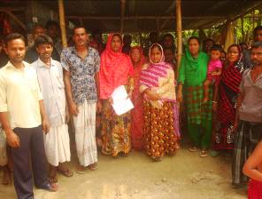
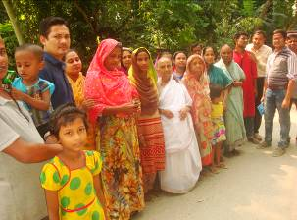
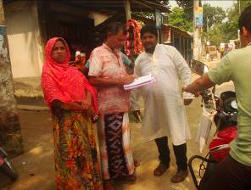
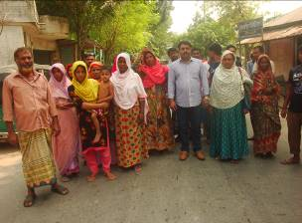
In the context of preparing the Environmental Assessment (EA), participatory public consultation was conducted in the subproject site. The Pourashava Mayor, Officials, Engineers and local individuals as well as LGED and Consultant participants participated (Photograph-7.1.1). Informal Focus Group Discussions (FGD) and a formal CIP were conducted involving the participants. In addition, walk-through informal group consultations were also held. The local communities were informed about subproject interventions including their benefits. Suggestions made by the participants were listed and incorporated in the EMP accordingly.

Photographs 7.1.1: Consultation meeting at subproject site with Pourashava officials local peoples and ward councilors.

Issues Raised by the Participants

The participants raised the issues related to the infrastructure development of Gobindaganj Pourashava. They emphasized on the subproject selection for the future development. They also discussed about the procedure for the quality construction work. In the FGD, the participants discussed the requirements for the future infrastructure development through a list of the subprojects. The DSM consultant raised the issue for the effective implementation of the EMP during construction phase. The Pourashava Officials agreed that they will provide full support for the effective implementation of the EMP.

Feedback, Suggestions and Recommendations of the Participants

The participants were presented with feedback, suggestions, and recommendations listed below:
- The participants emphasized on addressing environmental issues in the construction period;
- Construction works should be scheduled properly and the quality of construction work should be improved;
- The FGD results confirmed that an improved communication network, drainage facility, solid waste management, water treatment plant and water supplying system, sewerage treatment plant and sanitation facilities, slaughter house, recreational facilities, health and sports facilities and educational institutions are needed for future development of Gobindaganj Pourashava;
- In the group discussion for the future development of Gobindaganj Pourashava the participants demands (a) Green City, (b) Hygienic City, and (c) Sustainable infrastructure development;
- Local people also showed strong expectation for the increased opportunities for employment for unskilled or semi-skilled labor in the construction work;
- Most of the participants stated that the number of subproject that have been selected for each financial year is insufficient;
- The participants also addressed the solid waste management issue to reduce environmental and public health hazards.

Conclusions and Recommendations

The environmental impacts of all the elements of the subproject have been assessed. All potential impacts were identified in relation to design and location, construction, and operation phases. The overall conclusion is that if the mitigation, compensation and enhancement measures are entirely implemented, there will be no considerable negative environmental impacts as a result of location, design, construction and or operation of the proposed subproject.

A few key recommendations are outlined below:

- EMP should be available in the site during construction phase;
- Regular field visit by PMU, DSM and Pourashava is needed for the effective implementation of the EMP;
- Equipment should be checked by the Pourashava engineer and DSM consultant prior to work;
- Proper maintenance is needed for the planted trees by the contractor during project defect liability period;
- To minimize occupational health and safety risks, it is highly recommended to adapt mechanical system where appropriate;
- First aid box with relevant medicine should be available at site;
- The contractor is responsible for the proper disposal of the generated wastes materials from the subproject sites and campsite;
- Contractor will ensure availability of the PPEs to the workers;
- Contractor will monitor behavioral matter of the workers to avoid any undue risks related to labor influx;
- The EMP shall be made binding on contractor operating the site, and will be included in the contractual clauses.

It should be noted that environmental assessment report is a live document. Hence, due to changing circumstances during the construction phase if any, there might be minor adaptation needed for environmental, health and safety issues.

APPENDIX

Appendix- I: Environmental Monitoring Checklist

Local Government Engineering Department

Municipal Governance Services Project (MGSP)

Environmental Compliance Monitoring Form

Part A: General Subproject Information

Subproject Name | (a) Rehabilitation of Bituminous Carpeting Road from West Choumatha to Nut Mondir via Sub Registry Office Ch.00-500m.  (b) Construction of RCC Drain starting from West Choumatha to Chandpur kholshi damaged Bridge via Sub Registry Office Ch. 00-1100m.
Package No. | MGSP/GOB/2018-19/W-07
ULB Name | Gobindaganj Pourashava
Approved Estimated Cost in BDT
Contract Amount in BDT
Contractor Name
Date of Commencement
Target Date of Completion
Physical Progress (%)
Financial Progress (%)
Person Responsible (PIU)
(Name, Designation &Phone) for the Overall Subproject Management

Person Responsible (DSM)
(Name, Designation &Phone) for the Overall Subproject Management

Form Completed by
(Name, Designation &Phone)
Overall Environmental Description of the Subproject

Part B: Design, Preparation, and Legal Requirements
Environmental Concerns (PMU, PIU & DSM)  (Name, Designation & Phone) | PMU-
 | PIU-
 | DSM-
Subproject Category | DoE-BD- | WB-
Environmental Clearance Received? | Yes | No
EA Required? | Yes | No
EA Prepared and Delivered? | Yes | No
EMP Prepared & Delivered Separately? | Yes | No
Items and Cost of EMP Implementation Included in the Contract? | Yes | No
EMP Included in the Procurement Documents? | Yes | No
Inspection Schedule/Last Inspection/Monitoring by  PMU Environmental Concerns | Date-
 | Key findings-
Inspection Schedule/Last Inspection/Monitoring by  PIU Environmental Concerns | Date-
 | Key findings-
Inspection Schedule/Last Inspection/Monitoring by  DSM Environmental Safeguard Specialist/Jr. Environmental Specialist | Date-
 | Key findings-

Part C: Key Environmental Impacts
The Subproject Results in any of the following Impacts? | Yes | No | NA | If yes, is the impact (give observation)
 |  |  |  | Significant | Moderate | Minor
Felling of the trees
Clearing of the vegetation that increase the risk of increased soil degradation or erosion
Disturbance of the terrestrial and or aquatic specifies
Noise pollution
Air pollution
Adverse effects on the quantity or quality of the surface water or groundwater
Production or increase the production of the solid waste

Drainage congestion
Water logging that increases the risk of the water related diseases
Traffic congestion
Public safety

Part D: Work Place Environment and Gender Equity
The Subproject Results in any of the following Impacts? | Yes | No | NA | Observations
Does the contractor pay to the workers regularly?

Is there any discrepancy between the male and female workers regarding the wages or salary for the same works?

Is the contractor complying with the GOB labor law concerning the hiring of the workers?

Does the contractor engage women labors and does the project have suitable works for them?

Does the contractor engage child labor (less than 18 years) and aged people (more than 65 years old)?

Does the contractor force to the workers for the completion of the works?

Do the workers involve with the political activities, crime, drugs addiction and other forms of unwanted activities?

Are construction camps adequately equipped with water supply, sanitary toilets, washing facilities and facilities for waste collection and storage?

Has separate sanitation facilities been provided for women at work camps and the construction site?
Do the laborers load heavy items on their heads or shoulders?

Has the contractor undertaken an awareness program for the sexually transmitted diseases especially for HIV-AIDS and other infectious diseases like TB?

Are first aid kits readily available for the workers at the job site along with the instructions for use?

Are supervisors or other site personnel trained in the basic first aid emergency response measures?

Has the contractor provided necessary safety equipment to the workers and training for use?

Part E: Potential Impacts, Mitigation Measures, and Monitoring Indicator Mentioned in the EMP
Activity/  Issues | Potential Impacts | Proposed Mitigation and Enhancement Measures | Monitoring Method | Monitoring Frequency | Implementation Status (Yes/No /NA) | Impact significance if not implemented |  |  |  | Remarks
 |  |  |  |  |  | Major | Moderate | Minor | No | Remarks
Construction and operation of labor shed for the workers (Workforce and labor shed management) | Generation of sewage and solid waste may pollute surrounding environment | - Construction of sanitary latrine at the labor shed (consider 15 person for one toilet and separate toilet for male & female);  - Erection of “no litter” sign, provision of waste bins/cans (separate bins for organic and inorganic wastes);  - Ensure wastes (solid wastes and other forms of the waste) disposal at the vacant place near abandoned Old Union Parishad;
 | Health of workers | - Conduct formal and unofficial discussion to increase awareness about hygiene practices among the workers;  - Ensure availability and access to first-aid equipment and medical supplies for the workers.
 | Possible development of labor camp into permanent settlement | - Contractor to remove labor camp at the completion of contract.
 | Outside labor force causing negative impact on health and social well-being of local people | - Ensure that contractor employ local work force to provide work opportunity to the local people and conduct formal and unofficial awareness program for the health and social well-being of the local people.
General construction  Works  General construction  works | Drainage congestion and flooding | - Ensure provision for adequate drainage of storm water, if needed;  - Ensure provision for pumping of congested water, if needed;  - Ensure adequate monitoring of drainage effects, especially if construction works are carried out during the wet season.  - Ensure select place for the storage of soils and other construction materials to avoid disturbance of natural drainage.  - Dispose of construction materials and equipment appropriately so that they do not impede the local drainage.
General construction  Works  General construction  works | Air pollution | - Check regularly and ensure that all the subproject vehicles and equipment are in good operating condition;  - Ensure contractor spray water on dry surfaces/ unpaved to reduce dust generation;  - Ensure contractor sprinkle water and cover stockpiles of loose materials (e.g., fine aggregates);  - Inform local people about the subproject activities and potential impact;
General construction  Works  General construction  works | Traffic congestion, effect on traffic and pedestrian safety | - Place traffic sign to avoid undue traffic congestion and associated traffic control measures to limit possible disruption;  - Inform the local people about the subproject activities;  - Avoid roadside storage of construction material;  - Place traffic sign/cautionary sign to avoid undue traffic congestion;  - Inspire local people for using of the connecting roads during construction period.
General construction  Works  General construction  works | Noise pollution | - Check and maintenance the equipment properly;  - Avoid using of construction equipment such as concrete mixer machine, vibrator machine that produce excessive noise at night;  - Avoid prolonged exposure to noise (produced by equipment) by the workers;  - Regulate use of horns and avoid un-due use of hydraulic horns by subproject vehicles;  - Inform local people about the subproject activities and potential impact.
General construction  Works  General construction  works | Water and soil pollution | - Prevent discharge of fuel, lubricants, chemicals, and wastes into adjacent water bodies (Korotoa River, ponds, and low land or ditches).
General construction  Works  General construction  works | Accidents | - Conduct formal and informal discussion for creating awareness about the accident;  - Provides PPEs and ensure using of the personal protective equipment by the workers  - Maintain the register to record accidental events if occur;
General construction  Works  General construction  works | Felling of trees, clearing of vegetation and ecological disturbances | - 50 no of local fruits, flowers, medicinal and ornamental trees will be replanted to compensate the felling trees, at both side of the Sub Registry Para Road where space is available.
General construction  Works  General construction  works | Spills and leaks of oil, toxic chemicals | - Proper handling of lubricating oil and fuel so that it does not fall on the soil;  - Collection and proper disposal of spills;  - Refueling and storage of fuel tank should not be placed on the ground directly.  - Ensure use of polythene or wooden platform below the refueling tank and storage of fuel tank.
All construction works | Beneficial impact on employment generation | - Employ local people in the subproject activities as much as possible;  - Give priority to poor people living within subproject area in subproject related works (e.g., excavation and other works, which do not require skilled manpower).
All construction works | - General degradation of the environment | - Ensure environmental enhancement measures- tree plantation and cautionary sign will be provided;  - Ensure complain box to collect the complaints from the affected person due to subproject activities;  - Front size of cautionary sign to be large and shall be visible from 200m distance;  - Placing of the cautionary sign in the strategic point such as road intersection;  - For notification of construction activities, at least two signs shall be put up for each road, one close to the point of carriageway begins, and another will put on the end of the carriageway.
Specific Activities for RCC Drain
Excavation/Earth work | - Generation of loose and clay soil due to the earth excavation work. | - Cover exposed loose dry soil and wastes materials before disposal;  - Disposal of soil and construction wastes at vacant place of abandoned old union Parishad.
Excavation/Earth work | - Accidents from careless use of hydraulic excavator | - Carefully handle of the hydraulic excavator.
Excavation/Earth work | - Possible damage of road side infrastructure due to earth excavation for drain construction. | - Ensure drum sheet palisading work for shallow depth to stabilize the structure;  - Ensure plunk palisading work for shallow depth to stabilize the structure;  - Bolly drive for deep depth construction works.
Excavation/Earth work | - Air pollution due to black smoke emission from excavator. | - Regular maintenance of the equipment.
Sand filling /Back filling work | - Air and dust pollution affecting nearby settlement and worker | - Maintain adequate moisture content of soil and sand during transportation, compaction and handling;  - Carry the materials especially loose soil and sand with adequate cover;  - Ensure use of mask for the associates’ worker.
Cutting and welding of the reinforcement | - Noise pollution due to rod cutter and welding machine if any | - Avoid using of rod cutter and wielding machine at night;  - Avoid prolonged exposure to noise (produced by equipment) by workers.
Cutting and welding of the reinforcement | - Potential health and safety risks from rod cutter and welding machine if any | - Ensure use of the personal protective equipment’s (helmet, goggles, gloves, safety boot);  - Availability and access to first-aid equipment and medical supplies in case of any accidents.
RCC (reinforcement cemented concrete) work | - Air pollution due to black smoke emission from concrete mixer machine and vibrator machine | - Regular maintenance of the concrete mixer and vibrator machine to avoid any black smoke emission.
RCC (reinforcement cemented concrete) work | - Noise nuisance from concrete mixer machine and vibrator machine | - Avoid operation of the concrete mixer and vibrator machine at night;  - RCC work should be avoided at schooling time;  - Inform local people about casting work and potential impacts.
Specific Activities for BC Road
Dismantle work/ Excavation/Earth work | - Generation of solid and construction waste due to the dismantle works;  - Generation of loose soil due to the earth excavation work and earth work. | - Cover expose construction wastes and loose dry soil with fabric;  - Ensure wastes (solid wastes and other forms of the waste that are not suitable for re-use) disposal at vacant place of abandoned old union Parishad.
IGS (improve sub grade) /sand filling | - Air and dust pollution affecting nearby settlement | - Maintain adequate moisture content of the soil during construction transportation, compaction and handling;  - Carry the materials especially loose soil and sand with adequate cover.
Setting up and operation of asphalt plant | - Possible degradation of the air quality by the suspended particles and increase of the noise level from asphalt plant affecting nearby settlements. | - Locate plant away from residential settlements;  - Consider use of emulsified bitumen.
Setting up and operation of asphalt plant | - Possible water pollution (surface and ground water) by bitumen and solvents. | - Avoid spills and proper collection and disposal of the generated spills.
Setting up and operation of asphalt plant | - Possible preparation of the bitumen in open air and using of charcoal and wood as fuel. | - Strictly prohibit bitumen preparation in the open air and use of charcoal and wood as fuel.

Prepared by- Signature- Date-

Copies to 1. PIU
2. SME
3. AME
4. Jr. ES

