INTRODUCTION

Subproject Background

Tangail Pourashava is situated at Tangail Upazila under Tangail District. Tangail declared as a Pourashava in the year of 1887. The Pourashava covers an area of 35.22 sq. km. At present, it is A type Pourashava having total population of 1, 67,412 (Population and Housing Census, 2011). The Pourashava consists of total 254.35 km road network in and around the Pourashava boundary (among them 127.75 km BC, 18.30 km RCC, 2.13 km HBB, 2.63 km brick soling and 103.72 km katcha). In addition, the Pourashava has 25 km brick drain, 9.18 km RCC drain, 22.23 km primary drain and 23.68 km katcha drain. (Source: Pourashava Website). From the current infrastructure situation, it is revealed that further urban facilities for township development are necessary. Therefore, this subproject significantly will contribute infrastructure development in the Pourashava area.

This subproject includes the following three components: BC Road, RCC Drain and Street Lighting work. The significant features of the subproject are stated below:
Name of the Subproject : | a) Improvement of Milk vita Road from New Bus Terminal R&H Road to Kandila R&H Road Ch. 0 + 000 to 1+180 & Link Road 500m Aula Kalighar to LGED Moar (Total length 1680m);  b) Construction of RCC Drain in Milk vita Road from New Bus Terminal R&H Road to Kandila R&H Road Ch. 0+000 to 1+180m & Link Road 500m Daula Kalighar to LGED Moar (Effective length 1598m);  c) Construction of RCC Drain from Deldouar Road Baparipara Moar to Commitment Coaching Center (Thanapara) via Bukhari Mosque Ch. 0+000 to 0+800m (Total length 800m);  d) Supplying, fitting & fixing of street lights in Milk vita Road from New Bus Terminal R&H Road to Kandila R&H Road Ch. 0+000 to 1+180m & link Road 500m Daula Kalighar to LGED Moar, (Total length 1680m).
Package No. : | MGSP/TAN/2017-2018/W-11
District Name : | Tangail
ULB Name : | Tangail Pourashava
Jurisdiction Area : | Ward numbers 1, 12 and 13
Structural Design  Option : | BC Road, RCC Drain and Street Light
Beneficiary Population : | About 45,000 as per information by the Pourashava Officials
Tribal People : | No tribal people settlement found in the subproject area
Land Acquisition : | Tangail Pourashava owned. So, private land acquisition is not required.
Estimated Cost : | 86.459 million BDT
Subproject Duration : | 12 Months
Tentative Start Date : | 25 April, 2018
Tentative Completion Date : | 24 April, 2019

Objectives of the Study

The general objective of this study is to determine the major environmental impacts succeeding from execution of the subproject and to recommend mitigation measures to avoid or reduce adverse environmental impacts and to enhance positive impacts. The specific objectives include:
- To assess the existing environmental conditions of the subproject site and its influence area;
- To identify and assess impacts resulting from the subproject during its construction phase and operation phase;
- To develop a environmental management plan with recommendations for mitigating impacts and enhance positive impacts;
- To summarize environmental monitoring requirements.

Scope and Methodology of the Study

For the preparation of the subproject appraisal, environmental screening has been performed for all the subproject components. According to that screening, no further environmental assessment is required for the street lighting works. However, environmental assessment is required to fulfill the regulatory requirement for BC Road and RCC Drain. Hence, environmental assessment report is mainly focused on BC Road and RCC Drain. However, in the EMP mitigation measures for street light are also included. The study methodology comprised the following activities:
- Desktop Study;
- Field Investigations and Data Collection;
- Data Analysis and Report Writing.

Desktop Study
The desktop study involved:
- Initial meetings with client, stakeholders to discuss the proposed subproject, including subproject activities;
- Collection and review of the baseline data, maps, reports and other relevant information;
- Review of the relevant existing legislation, regulation and policies;
- Understand the anticipated technical processes that may affect the environment.

Field Investigation and Data Collection
The following key tasks were performed during the field visit:
- Taking photographs of the significant aspects to assist in describing the baseline environmental conditions of the subproject area;
- Interviews with representatives of the relevant Pourashava officials, beneficiary and affected people within the subproject influence zone;
- Obtaining relevant documents from the Pourashava and local people within the subproject influence zone;
- Verifying information and data collected during the desktop study and to collect new information.

Data Analysis and Report Writing
The data and information collected from all the sources (literature review, secondary and primary data, public consultation) were analyzed to describe the existing environmental setting of the subproject area, to identify the potential positive and negative impacts of the proposed subproject, as well as to provide preliminary suggestions for mitigation measures. Finally, this environmental assessment report has been prepared.

SUBPROJECT DESCRIPTION

The Study Area

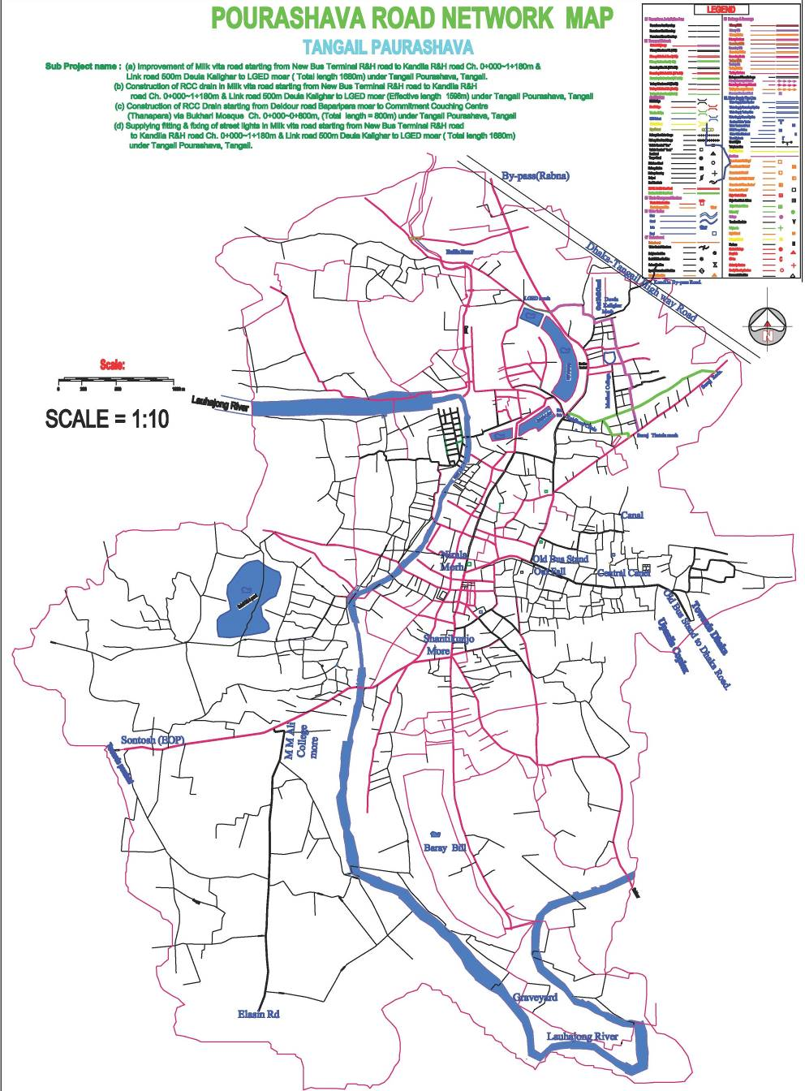
The subproject components are located at the Ward number 1, 12 & 13 of Tangail Pourashava. There is no protected area in or near the subproject location. The Milk Vita road starts near New Bus Stand (Latitude 24°16'35.26"N and Longitude 89°55'11.69"E) and ends near Kandail at Dhaka -Tangail Highway (Latitude 24°16'39.24"N and Longitude 89°55'12.34"E). The link road connects with Tangail Mymensingh Road. On the other hand, drain of Bhukhari Mosque Road starts from Tangail Delduar Road (Latitude 24°14'21.04"N and Longitude 89°54'55.53"E) and ends at Commitment Coaching Center Moar near Thanapara (Latitude 24°14'34.17"N and Longitude 89°55'9.33"E). The Base Map, Layout Plan and Topographical Features of this subproject are shown in Figure 2.1.1, 2.1.2, 2.1.3 & 2.1.4.

Figure 2.1.1: Base Map of the Subproject Sites
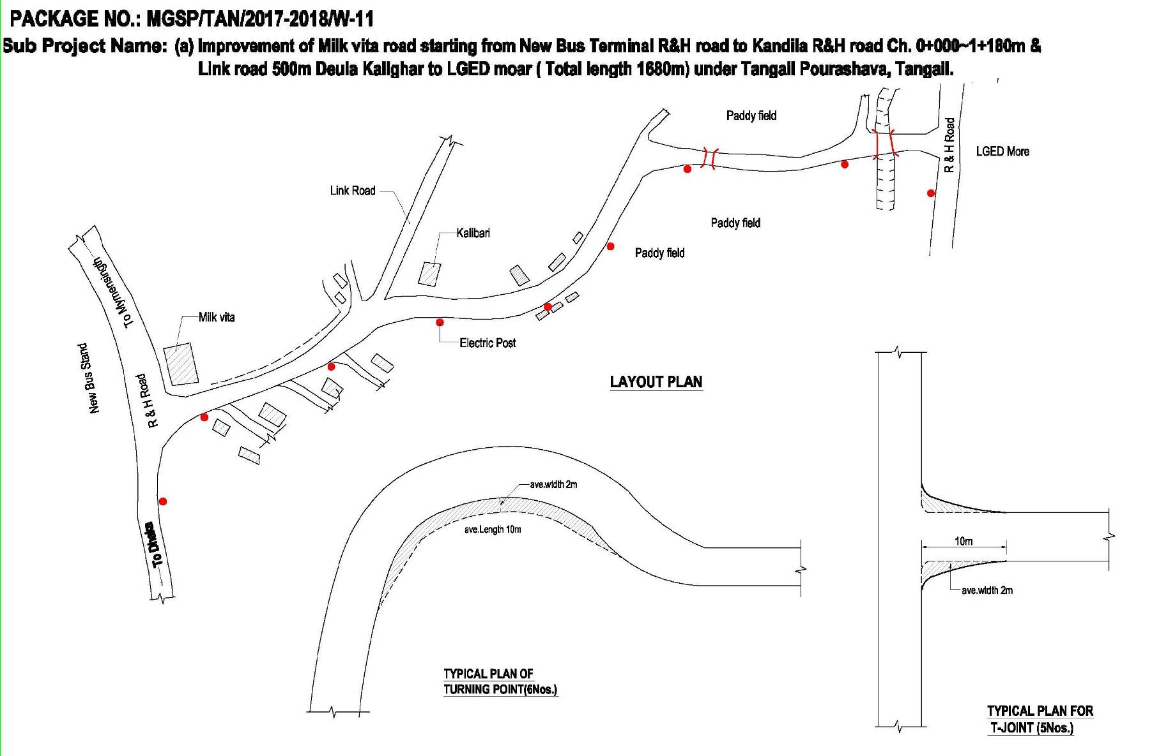

Figure 2.1.2: Layout plan of the Milk Vita Road (from New Bus Terminal R&H Road to Kandila R&H Road)
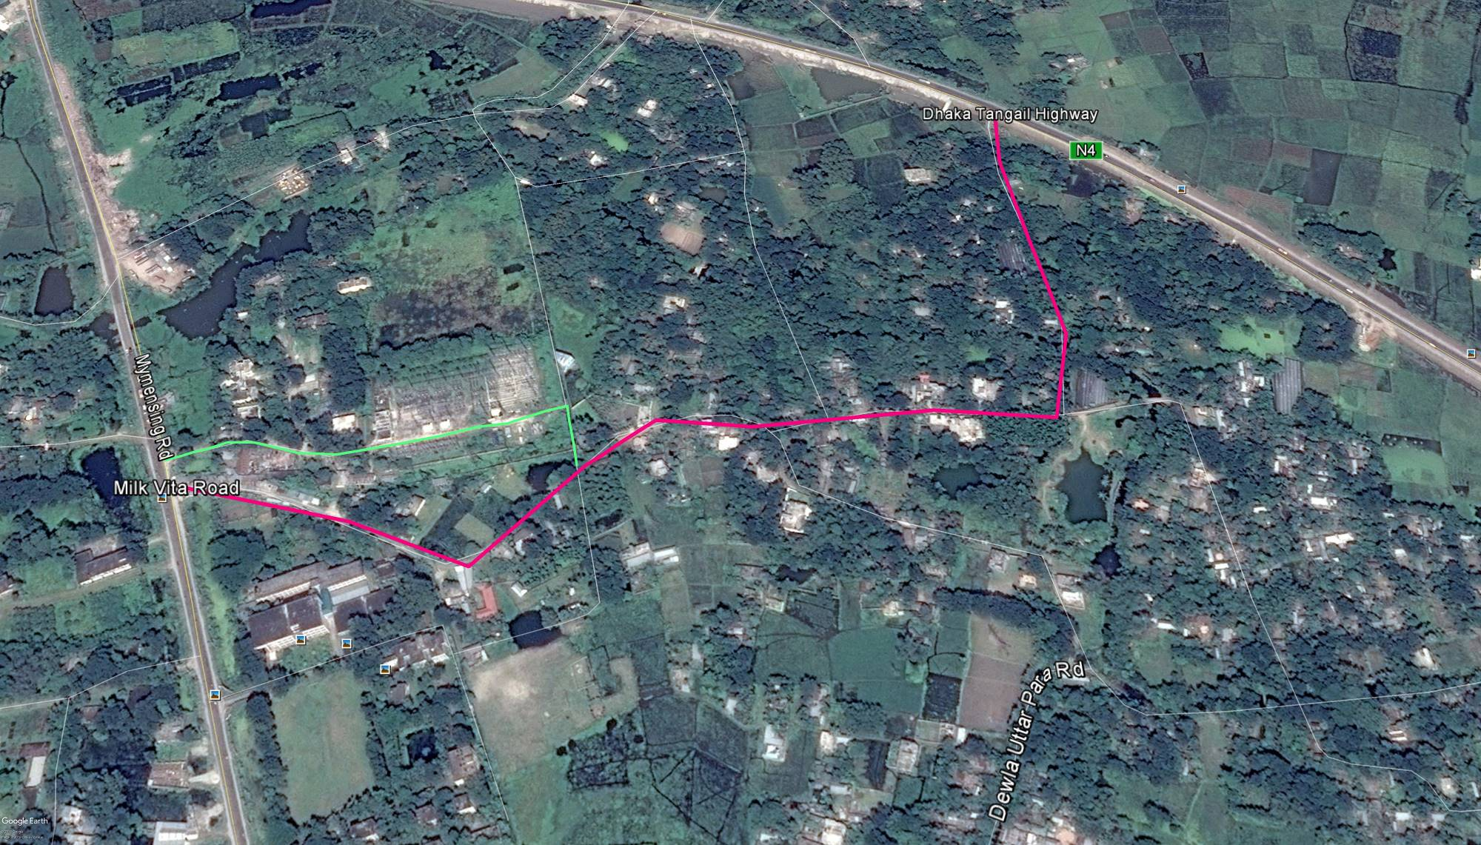
Figure 2.1.3: Topographical Features of the Milk Vita Road (from New Bus Terminal R&H Road to Kandila R&H Road)

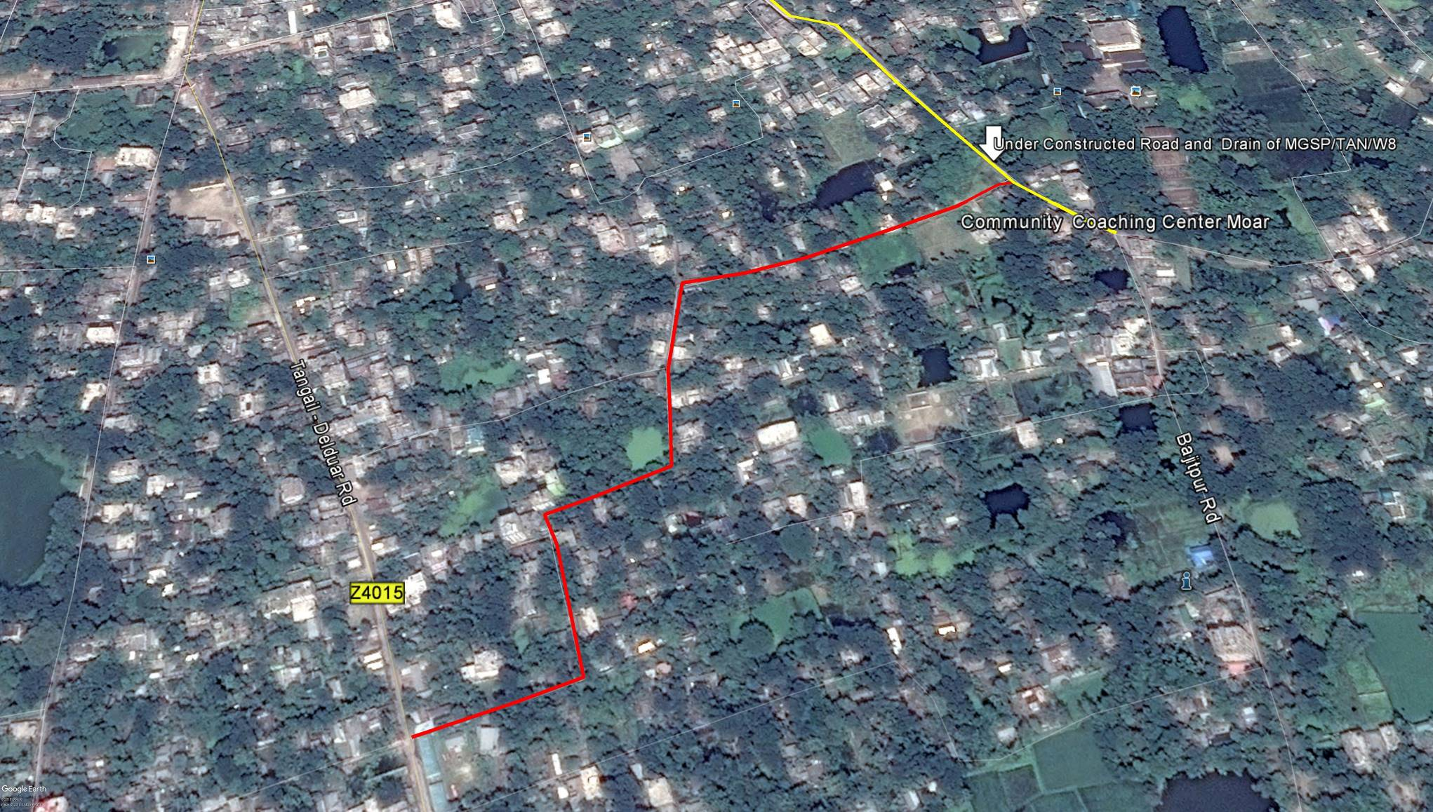

Figure 2.1.4: Topographical Features of the Subproject Drain (from Delduar Road to Baparipara Moar via Bukhari Mosque)

Current Situation, Proposed Intervention and Need for the Subproject

Mostly, Milk Vita Road goes through residential area. However, last 150m at Dewla Bazar and starting point of Link Road (100m) cover commercial area. There is paddy land at middle portion of the proposed road.
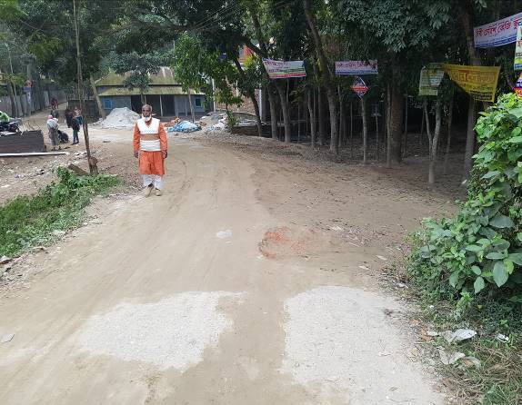
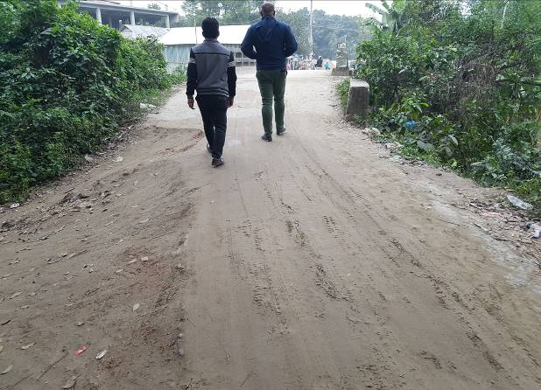
The subproject road starts from Tangail New Bus Terminal (near Milk Vita) and ends at Dhaka -Tangail Highway (Kandila R&H Road). On the other hand, link road is connected with Tangail Mymensingh Highway Road. At present, the existing road is damaged in most of the sections which hampers the normal traffic operation. The existing road is also narrow (average road width varies from 4 to 4.5m). Moreover, due to movement of the heavy vehicles, the elevation at the edges of the road goes down than the middle of the road. Consequently, the road surface is very much uneven. Thus, during movement of the small engine vehicles such as three wheelers are facing very much trouble. Due to bad condition, presently the motorized vehicles movement is not huge. But after completion it can be used as by pass road to reach the New Bus Stand. Thus, after completion the traffic volume on the main road will be minimized. Hence, widening and road improvement is necessary for the normal traffic operation. To improve the transportation facilities, the existing bituminous carpeting road (Ch.0-1180m) and link road (500m) will be demolished and replaced by new BC pavement. The current situation of the subproject road is shown in Figure 2.2.1.

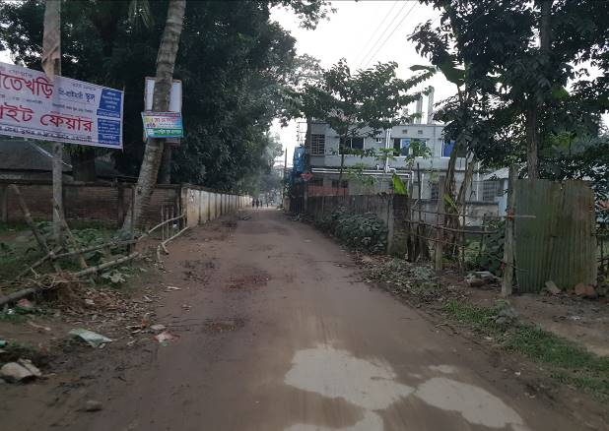
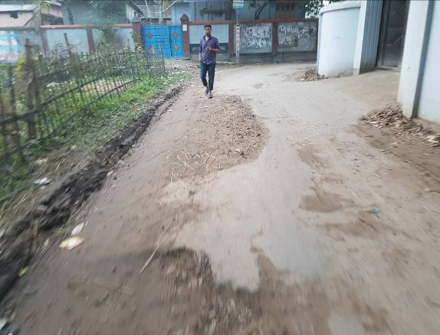

Figure 2.2.1: Current Situation of the Subproject Road (Tangail Bus Stand to Dhaka-Tangail Highway)
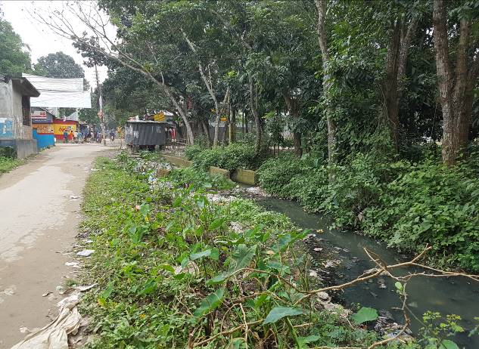
In the subproject area, there is no drainage facility. Hence, storm water creates water logging problem. From Ch. 0 to 1180 m and at link road 500 m length, stagnation of water on the road surface damages the road. As a result, smooth traffic flow and pedestrian movement is hampered. To improve the situation, RCC drain is needed for drainage facility. Therefore, RCC drain with cover slab will be constructed at right side of the road (Ch. 0-1180 m) and left side of the link road. It is noted that, cover slab of the drain will be constructed at the road level to use as a part of the carriage way for the vehicles. The storm water will be discharged into the dewla Khal at different Chainage which will be used as outfall. The current situation of the outfall is shown in Figure 2.2.2.
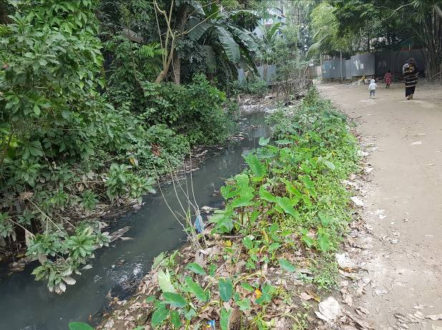
Figure 2.2.2: Current Situation of the Outfall
On the contrary, Delduar Road to Baparipara Moar via Bukhari Mosque Road totally goes through residential area. However, there is no proper drainage facility in this area. Most of the sections of this road have brick drain except Ch.150-200m and Ch. 625-650m. The existing drain is damaged in the most of the section. The drain is non-functional and inadequate in dimension. In addition, the existing drain is blocked by debris, polythene and household waste. Consequently, stagnant storm water spreads bad odor in the subproject area which degrade the surrounding environment. During monsoon period the drain water overflows and inundate the road and nearby residents. Therefore, local community has been suffering due to water logging problem. To facilitate the drainage facility, RCC drain with cover slab has been proposed at the right side of the road from Ch.0-650m and at the left side of the road from Ch.650-810m. The proposed drain will be connected with the under construction drain (Package: MGSP/TAN/2016-2017W8) at Victoria Road to Alia Madrasha via Keya Cinema Hall and City Bank to Adi Textile Mill. The current situation of the drain from Delduar Road to Baparipara Moar via Bukhari Mosque is shown in Figure 2.2.3.

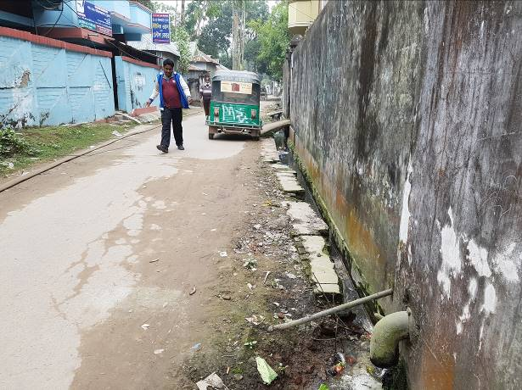
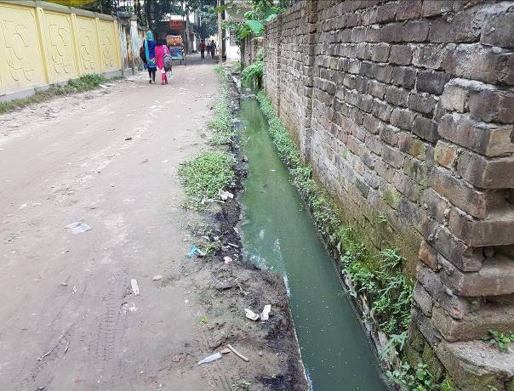

Figure 2.2.3: Current Situation of the Drain from Delduar Road to Baparipara Moar via Bukhari Mosque

Furthermore, absent of the street light hampers the normal traffic operation and pedestrian movement at night. Hence, fixing of the street light is also required for improved transport and pedestrian facilities. Therefore, street light will be fixed at one side of the road from Ch. 0-1180m and at link road at 30m interval.

Justification of Selection of this Subproject

The Pourashava prepared the priority list of subprojects as per CIP. The consultant’s team inspected the sites to evaluate the site condition. Based on the site conditions, the consultants recommended the subproject which has low environmental and social negative impacts. Since, Tangail Pourashava is owned the land. Hence, private land acquisition is not an issue for implementation of this subproject. There is no severe adverse impact on the road side built environment due to the subproject implementation.
After completion, the road will provide uniform width. By eliminating pot holes and providing smooth surface, it will provide better, easy and safe traffic movement. In addition, after construction it will be used as by pass road and will minimize the traffic volume on the main road. Furthermore, street lighting will ensure safe movement of the pedestrians and non-motorized vehicles at night. The drain will reduce water logging problem. In fact, the subproject has significant benefits to the community people. Considering the benefits that will derive, the subproject has been selected for implementation.

Envisaged Subproject Activities and Implementation Process

The general activities of the subproject includes: construction of the semi-pucca site office, construction of the labor shed and relocation of the electric poles and site clearing works.

The key activities of the RCC Drain include:
- Earth work in excavation of the foundation;
- Pumping and bailing out of water as per requirement;
- Sand filling for the preparing foundation bed;
- Laying polythene sheet;
- Plain cement concrete work in foundation;
- Manufacturing CC blocks;
- Fabrication of the ribbed or deformed bar;
- Reinforced cement concrete work.

The key activities for BC Road include:

- Dismantling of the damaged sub-base and base course works;
- Clearing and grubbing works;
- Earth work in box cutting;
- Earth filling work;
- Sand filling on the road bed;
- Mechanical compaction;
- Brick on edging;
- Compacted stone aggregate base course;
- Providing prime coat;
- Laying pre-mixed dense bituminous surfacing wearing course.
The key activities for Street Light:
- Assembling, fitting, fixing, installation, testing and commissioning of the GI pole;
- Erection of tubular pole;
- Earthing the electrical installation;
- Fixing of the wire rack;
- Fixing of the overhead conductor;
- Providing, fixing and fitting of the water tight street light;
- Fitting and fixing main and sub-main switch with fuse;
- Supplying and fitting of sub-distribution board.

The materials and resources to be used for the key activities: soil in earth work, sand, stone chips, cement, reinforcement, diesel, MS sheet, steel shutter, electricity and water.
The major equipment to be used for the implementation of the subproject: hydraulic excavator, concrete mixer machine, steel cutter, mechanical vibrator machine, mechanical compaction machine, steel drum rollers, pneumatic multiple tire roller, dump truck, water tanker, pump, asphalt plant, rubber tire roller and paver.

Category of the Subproject

For BC Road and RCC Drain
- According to ECR 1997 : Green □ Orange□ A Orange B □√Red □ Not Listed □
- According to WB classification: Category B □√ Category C □

Considering the environmental impacts, the road and drain can be considered as Orange B as per ECR-97. According to the WB classification, it can be classified as Category B project.
For Street Light
- According to ECR 1997 : Green □√ Orange A □ Orange B □ Red □ Not Listed □
- According to WB classification: Category B □ Category C □ √

Considering the environmental impacts, the street light can be considered as Green category as per ECR-97. According to the WB classification, it can be classified as Category C.

Subproject Schedule

The tentative schedule of construction of the subproject is:
(a) Subproject duration (months): 12 Months
(b) Tentative start date : 25 April, 2018
(c) Tentative completion date : 24 April, 2019
The daily construction hours will normally include regular working time. However, daily working hours may vary based on the on-site condition. The detailed work program will be prepared by the contractor with the assistance of the PIU. Then it will be shared with the PMU, LGED and DSM consultants. In addition, the detailed work program will also be shared with the Bank as per requirement.

Baseline ANALYSIS OF THE ENVIRONMENTAL CONDITION

Physical Environment

Important Environmental and Infrastructural Features

The major environmental and infrastructural features in the subproject area have been collected from the field investigation. Conditional survey has also been conducted for designing the subprojects. Hence, the survey data is also used for preparing the report. Effort has been given for listing the major environmental and infrastructural features within 100 m of the both sides from the center line of the road at 100m longitudinal intervals from New Bus Terminal R&H road to Kandila R&H road (Ch. 0 to 1180m) and link-500m and from Deldouar road Baparipara moar to Commitment coaching center (Thanapara) via Bukhari Mosque Ch. 0+000 to 0+800m are given in Table 3.1.1 and Table 3.1.2.

Table 3.1.1: Major Environmental and Infrastructural Features from New Bus Terminal R&H Road to Kandila R&H Road (Ch. 0 to 1180m) and link-500m
Chainage (m) | Left | Right | Major Environmental and Infrastructural Features
New Bus Terminal R&H road to Kandila R&H road (Ch.0-1180m)
0-100 | √ |  | Banana shops, boundary wall, vegetation coverage, panted trees (Mango, Jackfruits, Jam, Neem, Akashi, Kath Badam, Mahagony), pucca and semi pucca shops and houses, electric pole.
0-100 |  | √ | Tin shed, pucca and semi pucca shops and houses, electric pole, Nusrat telecom, shohan store, salon, link road, Reza Homeo Hall
100-200 | √ |  | Boundary wall, tin shed, pucca and semi-pucca residents, electric pole, and vegetation coverage, planted trees (Mango, Jackfruits, Jam, Neem, Akashi, Kath Badam, and Mahagony).
100-200 |  | √ | Shodor Police Fari, stationary shops, open space, connecting road, workshop, trees
200-300 | √ |  | Shops, Dewla Moar, Sayem Traders, connecting road towards LGED Road, Modina electric, temple, pond, pucca and semi-pucca shops
200-300 |  | √ | Stationary shops, boundary wall, trees, pucca, semi-pucca and tin shed residents, tin fence
300-400 | √ |  | Tin fence, electric pole, ASHA NGO, planted trees (Jackfruits, Mango, Jam, Supari, Neem), dewla khal
300-400 |  | √ | Shuvo Barra office, Baby Cherish K.G School, Boundary wall, Razu Traders, GAK, Dewla branch, electric pole, tin shed, semi pucca and pucca residents, tin fence
400-500 | √ |  | Pucca and semi pucca and tin sheds shops and houses, low land, open space, connecting road, electric pole,
400-500 |  | √ | Pond, trees, glossary shops, pucca, semi pucca and tin shed residents, Monzu departmental store, electric pole
500-600 | √ |  | Link road, paddy lands, electric pole, tin shed and semi pucca residents
500-600 |  | √ | Stationary shops, open space, paddy lands, pucca and tin shed residents,
600-700 | √ |  | Pucca and semi pucca residents, electric pole, trees, paddy lands
600-700 |  | √ | Pucca and semi pucca residents, electric pole, trees, paddy lands
700-800 | √ |  | Pucca and semi pucca shops and residents, boundary wall, electric pole, paddy land
700-800 |  | √ | Boundary wall, trees, pucca, semi pucca and tin shed residents, paddy land, tin fence,
800-900 | √ |  | Pucca ,semi pucca and tin shed residents, electric pole, trees, paddy land
800-900 |  | √ | Electric pole, tress, boundary wall, pucca ,semi pucca and tin shed residents, low land
900-1000 | √ |  | Tin fence, shops, semi pucca and tin shed residents, electric pole, boundary wall
900-1000 |  | √ | Tin fence, trees, stationary shops, semi pucca and tin shed residents, paddy land
1000-1100 | √ |  | Pucca and semi pucca shops and residents, boundary wall, electric pole, dewla khal, vegetation coverage, planted trees( Mahagony, Akashi, Mango)
1000-1100 |  | √ | Workshops, pucca and semi pucca shops and residents, dewla khal, vegetation coverage
1100-1180 | √ |  | Kandalia bazar, auto station, Moti banijo vandar, Meshers Limon Lizon Traders, electric pole, stationary shops,
1100-1180 |  | √ | Kandalia bazar, Talukder bosraloy and gas house, hotel, decorator, poultry shops, varieties shops
Link Road: LGED Moar to Kalibar Mondir (Ch.0-500m)
0-100 | √ |  | Shapla Nursing Home, New Ma Medical Home, Sitab Thai Glass house, stationary shops, mobile tower, electric pole, shihab enterprise, salon
0-100 |  | √ | Parents Medical Home, stationary shops, electric pole , boundary wall, BGS Vocational Training Center, Rice Mill,
100-200 | √ |  | Tin shed , semi pucca shops and houses, trees, open space, boundary wall
100-200 |  | √ | Electric pole, Tin shed , semi pucca shops and houses, trees, open space, boundary wall
200-300 | √ |  | Pucca , semi pucca and tin shed residents, trees, boundary wall, open space,
200-300 |  | √ | Boundary wall, pucca , semi pucca and tin shed residents, Ayesha Siddique Mohila Madrasa, electric pole
300-400 | √ |  | Vegetation coverage, pucca, semi pucca and tin shed residents, boundary wall, dewla khal
300-400 |  | √ | Electric pole, vegetation coverage, pucca, semi pucca and tin shed residents, boundary wall
400-500 | √ |  | Boundary wall, pucca, semipucca and tin shed residents, open space, trees, dewla khal, shops, vegetation coverage
400-500 |  | √ | Pucca, semipucca and tin shed residents, trees, tin fence, electric pole, vegetation coverage

Furthermore 43 electric poles need to be re-located for the implementation of the subproject.
Table 3.1.2: Major Environmental and Infrastructural Features from Deldouar road Baparipara moar to Commitment coaching center (Thanapara) via Bukhari Mosque (Ch. 0+000 to 0+800m)
Chainage (m) | Left | Right | Major Environmental and Infrastructural Features
Deldouar road Baparipara moar to Commitment coaching center via Bukhari Mosque (Ch. 0+000 to 0+800m)
0-100 | √ |  | Stationary shop (Rahman Enterprise), boundary wall, electric pole, Unique Oral Dental, pucca, semi pucca and tin shed residents.
0-100 |  | √ | Kakoli Kuthir, R.K. Villa, tin shed, pucca and semi pucca houses, electric pole, boundary wall, brick drain, trees, tin fence
100-200 | √ |  | Boundary wall, tin shed, pucca and semi-pucca residents, electric pole, stationary shop, tin fence
100-200 |  | √ | Tin shed, pucca and semi-pucca residents, boundary wall, open space, brick drain, stationary wall
200-300 | √ |  | Boundary wall, tin shed, pucca and semi-pucca residents, ditch, trees
200-300 |  | √ | Bhukhari Mosque, boundary wall, trees, pucca, semi-pucca and tin shed residents, tin fence, connecting road
300-400 | √ |  | Mahida Bhabon, boundary wall, trees, electric pole, pucca, semi-pucca and tin shed residents
300-400 |  | √ | Brick drain, boundary wall, electric pole, tin shed, semi pucca and pucca residents, tin fence
400-500 | √ |  | Pucca and semi pucca and tin sheds and houses, electric pole, boundary wall, trees
400-500 |  | √ | Darul Ulum Kamil Madrasa, pucca, semi pucca and tin shed residents, electric pole, boundary wall, brick drain, trees
500-600 | √ |  | Boundary wall, stationary shops, pucca, semi pucca and tin shed residents, electric pole,
500-600 |  | √ | Boundary wall, pucca, semi pucca and tin shed residents, electric pole, brick wall
600-700 | √ |  | Alhaz Villa, Razu store, Mamun store, R.P. Nari Udokta Office pucca and semi pucca residents, electric pole, trees, boundary wall ,brick drain
600-700 |  | √ | Holy Faith Public School and Teaching Center, pucca and semi pucca residents, electric pole, trees,
700-800 | √ |  | Thanapara Jame Mosque, Meshers ILMA Enterprise, Foyzul Ulum Madrasa, Pucca and semi pucca shops and residents, boundary wall, electric pole, brick drain, pucca ,semi-pucca and tin shed residents
700-800 |  | √ | Iqra Juniors Abashiq School, Shuvo Medical, pucca, semi-pucca residents, summon furniture house, Anawer store, SAM English Learning Home.

Furthermore 11 electric poles and 2 TNT pole need to be re-located for the implementation of the subproject.

Geology, Topography and Soils

Soils are mixture of sandy and silty alluvium which occupies most char land. Overall silty deposits are more extensive than sandy deposits. Raw sand and silt deposits usually are bare or carry sparse grasses, herbs and woody plants. Organic matter content is low (< to 1.7%), neutral to moderately alkaline in reaction. Soils are clay (87%) loamy (13%) and sandy (<1%). Organic matter content is low (<1-5%). pH ranging from 4.5-7.8. The general soil classification of Bangladesh is shown in Figure 3.1.1.
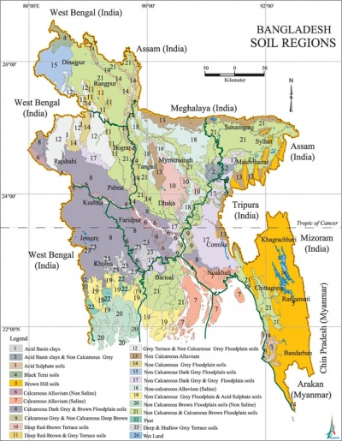

Figure 3.1.1: General Soil classification of Bangladesh (Bangladesh Soil Resource Development Institute)

The area lies in the earthquake Zone 2 (intermediate level of seismic intensity) (shown in Figure 3.1.2) according to the seismic map of Bangladesh (GSB, 1978).

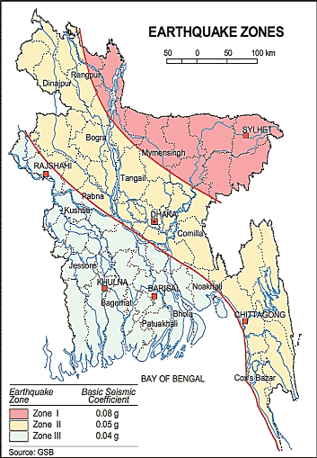

Figure 3.1.2: Earthquake Zones Map and Soil Region Map of Bangladesh

Climate and Meteorology

Tangail has a tropical climate. In winter, there is much less rainfall than in summer. The average temperature is 25.5 °C. Mean annual rainfall is about 1500mm. June has a mean rainfall exceeding 300mm. According to the statistics of wind data from the Bangladesh Meteorological Department Climate Division, wind direction changes by month. Nevertheless, the northwest, south, and northeast winds are predominant. Table 3.1.3 shows the average annual key meteorological data.
Table 3.1.3: Average Annual Temperature and Rainfall Data
 | Jan | Feb | Mar | April | May | Jun | Jul | Aug | Sep | Oct | Nov | Dec
Avg. Temperature (°C) | 18.3 | 20.8 | 25.3 | 28.6 | 28.8 | 28.4 | 28.5 | 28.5 | 28.6 | 27.3 | 23.3 | 19.9
Min. Temperature (°C) | 11.7 | 13.6 | 18.2 | 22.3 | 24.2 | 25.3 | 25.9 | 26.1 | 25.8 | 23.6 | 17.9 | 13.6
Max. Temperature (°C) | 25 | 28.1 | 32.5 | 35 | 33.5 | 31.6 | 31.1 | 31 | 31.5 | 31 | 28.7 | 26.2
Avg. Temperature (°F) | 64.9 | 69.4 | 77.5 | 83.5 | 83.8 | 83.1 | 83.3 | 83.3 | 83.5 | 81.1 | 73.9 | 67.8
Min. Temperature (°F) | 53.1 | 56.5 | 64.8 | 72.1 | 75.6 | 77.5 | 78.6 | 79.0 | 78.4 | 74.5 | 64.2 | 56.5
Max. Temperature (°F) | 77.0 | 82.6 | 90.5 | 95.0 | 92.3 | 88.9 | 88.0 | 87.8 | 88.7 | 87.8 | 83.7 | 79.2
Precipitation / Rainfall (mm) | 11 | 20 | 41 | 91 | 235 | 349 | 351 | 316 | 262 | 167 | 25 | 4

The construction works can be influenced by the climatic condition and meteorological components like humidity, temperature, sudden rainfall, and wind speed. During high winds, there might be possibility of quick spreading of dust generated from the construction activities. It is very risky to work during rain and in high winds because the possibility of getting injury increases. Furthermore, work under high temperature and excess humidity is extremely difficult, and may create health hazards.

Water Resources

In the subproject area, major water bodies include, Dewla Khal, ponds, and ditches. Ground water is usually available by tube well. Groundwater is the main source of potable water in the subproject area. The groundwater (mainly shallow aquifer) is contaminated by arsenic (As) in some areas. Local people typically use deep tube-well water for drinking and other domestic purposes ( Master Plan, 2020-2031).

Flooding, Water Logging and Drainage Pattern

This area is affected in historical severe flood events such as 1988, 1998 and 2004. This area is situated on the Active Brahmaputra–Jamuna Floodplain zone and flooding from river water overflow is a common phenomenon. Due to continuous heavy rain and delay discharge of storm water, this area is subjected to water logging problem. Inundation within the Pourashava area is experienced in the months of June to September when major rainfall occurs. According to Bangladesh Meteorological Department (BMD) flood zoning map, this area lies in the normal flood area.

Air Quality and Dust

Ambient air quality data have not been found. Air seems to be clean. However, due to poor maintenance of the road especially during dry season dust generates from the moving vehicles and windblown dust cause air pollution. In addition, black smoke emission from the non-combustion engine vehicles degrades the quality of the air. There are no remarkable sources of the air pollution such as heavy and small industries. No brick field observed during site visit.
Noise Level

Noise is not a major impediment for the quality of the environment in the subproject area. From the field visit it is found that, noise generated due to the vehicle movement and Bazar area. Vehicles such as trolleys, pick-up, motor cycles, CNG, rickshaws are major sources of noise. In the subproject activities, using of steel cutter, welding machine, concrete mixer machine and vibrator machine etc. may generate noise. However, it is anticipated that generated noise from the subproject activities will be within the tolerable limits.
Sanitation

The sanitation system in the Pourashava is not satisfactory. According to the DPHE, most of the toilets and septic tank has illegal connection to the nearby drains, ditches or ponds. The Pourashava has taken initiative to improve sanitation system through underground sewerage and strict regulation on katcha latrine. Awareness of the community people is also necessary for improving sanitation system. Improved low-cost sanitary system can be encouraged in low-income areas.
Solid Waste Management

Solid waste management is a crucial problem for the Pourashava. The Tangail Pourashava does not have sufficient capability to introduce effective waste management system. Narrowness of roads in few areas and lack of local collection sites, create problem for the effective solid waste management. Particularly, in informal areas due to narrow roads the garbage trucks cannot enter for removal and transhipment of the garbage. In most places, there is no road side open space for locating garbage bins. The local people also dump solid wastes in the vacant lowland, open space near to the houses and road side area (Master Plan 2020-2031).

Biotic Environment
Flora and Fauna

This subproject area is full of natural flora (aquatic plants and terrestrial herbs, shrubs and trees) and fauna (mainly birds and few animals). In the subproject area, paddy is the main crop. The local people cultivate paddy two times (Aman and Boro).

The common natural native species of trees are found in the subproject area. The trees are mainly: Jackfruit (Artocarpus heterophyllus), Mango (Mangifera indica), Mahagony (S. mahagony), Betel Nut (Areca catechu), Kathbadam (Terminalia catappa), Coconut (Cocos nucifera), Papaya (Carica papaya), Guava (Psidium guajava), Rain Tree (Samanea saman), and Date Tree (Phoenix paludosa). There are some common local birds- Choroi (Passer domesticus), Bok (Mesophoy xintermedia), Crow (Corvus splendens), Shalik (Acridotheres fuscus), and Tuntuni (Orthotomus sutorius) in the subproject area.

Socio-economic and Socio-cultural Environment

Land Use, Status of Housing and Built-up Infrastructure

The subproject area mainly covers residential and commercial area. The agricultural land is also available at roadside area in the middle portion of the proposed road. The road side built-up infrastructure includes pucca, semi-pucca and tin-shed houses, NGO offices, shops, rice mill, Shapla Naursing Home, educational institutes, and religious institute (temple, mosque). There is no industrial activity within the subproject area.

Beneficiary Population

The subproject covers the jurisdiction of the ward number 1, 12 and 13. As per information by the municipality, about 45,000 people will benefit directly and many others indirectly.

Education

People of Tangail Pourashava mostly attained primary and secondary level education. 75.7 % of male and 67.8% female population are educated. Literacy rate is 71.8% at Tangail Pourashava (Population and Housing Census, 2011).

Tribal Communities

There is no indigenous or tribal people settlement in the subproject area. Therefore, there are no measures needed for indigenous peoples’ safeguard.

Land Acquisition and Resettlement

Private land acquisition is not needed. However, at different section of the Milk Vita Road removing of the roadside houses, shops, boundary wall are needed due to site clearing work and road widening. On the contrary, at Bukhari Mosque Road few road side brick boundary wall needs to be removed. The Pourashava is committed to clear the site amicably with the owners of the structures prior to the works. However, in case of any objection from the affected persons, the DSM will investigate the actual situation. Then, measures will be taken as per rules.
Principal Livelihoods and Economic Activities
The subproject area is inhabited by the mixed occupational people. In the Pourashava area, major income comes from business, enterprises, small trades, private sector jobs, and government jobs in the town.

Cultural Heritage and Protected Areas

There is no protected and important cultural or historical site in the subproject influence area. However, there are religious centers and educational institutes which convey the cultural value for the community people.
Social Conflicts and Development Activities

The local people welcome the subproject and there is no conflict between the local communities regarding the subproject implementation.

ENVIRONMENTAL SCREENING

Environmental Screening Checklist, as adopted in Appendix C of the Environmental Management Framework (EMF) of the MGSP, was administered for identifying the impacts and their extents.
The screening data for the BC Road and RCC Drain have been formulated and are shown in below.
- Potential environmental impact during construction phase:

- Ecological impacts:
1193
- Felling of trees Significant □√ Moderate □ Minor □ Number of trees
- Clearing of vegetation Significant □ Moderate □ Minor □√
- Potential impact on species of
Aquatic (i.e., water) environment Significant □ Moderate □ Minor □√
Due to implementation of the subproject total 119 numbers of trees will be felled down. The major trees to be felled down are: Mango, Mahogany, Jackfruits, Betel nut, Jam, Kathbadam, Rain tree, Mehedy etc. Most of the trees to be felled down are big to medium size. There is no tree to be felled down bring religious and heritage importance. However, from the economical point of view, the trees to be felled down have socio-economic impacts. There is road side natural growing vegetation at different segment of the road. But the intensity of the vegetation coverage is not uniform. Therefore, impact on clearing of vegetation is considered as minor. Anticipated impact on species of aquatic environment is minor because except throwing of the wastes materials in to the road side water bodies (ponds, ditches and Dewla Khal) the subproject intervention does not have any impact on the aquatic environment. Though, impact on clearing of vegetation and aquatic environment is minor but considering the number of trees to be felled down, overall ecological impact is considered as significant.
- Physicochemical impacts:

- Noise pollution Significant □ Moderate □ √ Insignificant □
- Air pollution Significant □ Moderate □ √ Insignificant □
- Drainage congestion Very likely □ Likely □ √ Unlikely □
- Water pollution Significant □ Moderate □ Insignificant □ √
- Pollution from solid/ construction wastes Significant □ Moderate □√ Insignificant □
- Water logging Significant □ Moderate □ Insignificant □√
The subproject will have impacts on noise and air quality during construction phase due to mobilization of the equipment, vehicles movement for the transportation of the materials, using of hydraulic excavator, brick breaking machine, mechanical compaction machine, paver, asphalt plant, concrete mixer machine, vibrator machine etc. The construction work will be performed section wise. Hence, it is anticipated that the overall impact on noise and air quality will be moderate, temporary and site specific. However, there are road side Madrasa, School, Coaching centers, NGO Office, Temple. Hence, anticipated impact on noise and air quality will be significant for this particular section if measures are not taken properly. The generated dust during construction activities may temporarily disturb the local people if measures are not taken. The generated construction wastes, un-suitable materials and solid wastes may degrade the surrounding environment. Improper collection and disposal of the generated wastes materials also may degrade the aesthetic and landscape value. There is sufficient open space to drain out the storm water. In addition, pumping facilities will be there to drain-out storm water if required. Hence, the anticipated water logging problem is minor for the construction period.
- Socio-economic impacts:

- Traffic congestion Very likely □ Likely □√ Unlikely □
- Health and safety Significant □ Moderate □ √ Insignificant □
- Impact on archaeological and historical Significant □ Moderate □ Insignificant □√
- Employment generation Significant □ Moderate □√ Insignificant □

Due to bad condition, presently this road does not permit movement of the heavy vehicles. However, few three wheelers, auto bikes, rickshaw, and motor bike use this road. There are adequate alternative road which will diversify the traffic during construction period. Hence, the subproject activities do not have any severe impact on the local traffic system. The construction work will follow simple procedure with commonly used equipment. Hence, anticipated impact on health and safety is moderate. There is no archaeological and historical site within the influence area. The subproject has positive impact by generating work opportunities for the local people and supplying of the construction materials, equipment, food and other necessary stuffs to the campsite.
2) Potential environmental impact during operational phase:
(d) Ecological impacts:
- Potential impact on species of aquatic Significant □ Moderate □ √ Minor □
(i.e., water) environment
In the operational phase, the road component does not have any likely impact on the aquatic environment. Though, the drain is designed for storm water only. However, the storm water may carry washed-out materials, pollutants from any sources that may disturb the aquatic environment of the outfall. Hence, the anticipated impact on the aquatic environment due to operation of the drain is considered as moderate.

- Physicochemical impacts:

- Potential air quality and noise level Improvement □ No improvement□ Deterioration □√
- Drainage congestion Improvement □√ Minor Improvement □ No Impact □
- Risk of Water pollution Significant □ Moderate □ Minor □√
- Pollution from solid wastes Improvement □√ No-improvement □ Insignificant □
At operation phase, improved and widened road may increase traffic volume. This may degrade the air quality and noise level due to black smoke emission and un-due use of hydraulic horn from the vehicles. In the operational phase, drain component does not have any likely impact on noise. However, the cover drain restricts the throwing of the wastes in to the drain. The cover drain will also minimize spreading of the bad odor. The new drain will minimize drainage congestion and water logging problem. The storm water to be discharged through the drain may degrade the water quality of the outfall if the drain water will carry pollutants from any sources.

(f) Socio-economic impacts:
- Traffic Improvement □ √ No-improvement □ Adverse □
- Safety Improvement □ √ No-improvement □ Adverse □
- Employment generation Significant □ Moderate □ Minor □√

After completion, this road will improve the transport facilities. By providing uniform pavement, it will also enhance traffic safety. The new drain will reduce water logging problem. By reducing environmental hazards caused by water logging problem, it will provide better environment to the community people. The new road with street light will enhance business activities and pedestrians’ safety at night.

(3) Summary of the possible environmental impacts of the subproject:

From the above study, it seems that the ecological impact due to the subproject implementation is significant. However, adequate trees will be planted to compensate the ecological imbalance. The subproject has negative impacts on air quality, noise level, and pollution from solid wastes during construction phase. Nevertheless, the impacts will be temporary, localized and limited within the subproject boundary and fundamentally manageable through the appropriate mitigation measures. The generated solid wastes due to the activities should be properly handled and disposed-off in a designated dump site. The labor shed and stack yard should be located in a designated place.

Furthermore, safety concerns should be considered properly for both the construction and operation phases to avoid any potential safety risks. This subproject will have positive impacts in terms of generation of employment and business activities due to supplying of the materials and equipment’s.

The anticipated environmental impact for the installation of the street light is insignificant. However, it has significant positive social impacts after installation. Short circuit and improper electrical connection of the street light may cause potential health and safety risk.

Specific impact, mitigation AND enhancement measures
From the environmental study, the likely impacts of the subproject are mainly caused by the key activities required for the implementation of the subproject, raw materials and equipment to be used for the execution of the activities. This section describes some specific impacts due to the subproject activities and their mitigation measures.

Dismantle Work, Site Clearing, Excavation Work and Earth Work
The road improvement work consists of dismantling of the existing BC road, earth excavation, removal of the un-used materials etc. The drain construction work consists of dismantling of existing damaged brick drain, earth excavation, earth filling, back filling and removal of the unsuitable materials. These works lead dust blowing, construction waste generation, noise and vibration which disturb the local people.
Mitigation Measures

- Proper care will be taken by the contractor during dismantle work, excavation, earth work and back filling so that this activity does not disturb the nearby establishment.
- Avoid loss of the topsoil for the earth filling work;
- Cover the exposed dry loose soil with fabric to avoid any dust generation;
- Disposal of soil and construction wastes at designated dump site near Rabna bypass.

Tree Felling, Clearing of the Vegetation and Ecological Impact
There are 119 numbers of planted roadside trees will be felled down due to implementation of this subproject while insignificant amount of road side vegetation need to be cleared.
Mitigation Measures

- At Both side of the Milkvita Road 238 no of local fruits, flowers, medicinal and ornamental trees will be replanted to compensate the felling trees;
- Planting trees will enhance the ecological balance of the area after their successful growth.

Pollution from the Construction Materials
Dumping of the construction spoils, including accidental leakage of the oil, grease, and fuel in equipment yards is a significant hazard. Storm water may carry these substances during rain. Thus, both surface and groundwater might be polluted from these contaminants. Air pollution and dust may affect the nearby settlement which is generated from fine aggregate such as sand and loose dry soil.
Mitigation Measures

- Safe transport, storage, and disposal of the construction materials, and the equipment have to be carried out in order to avoid the accidental spillage and loss;
- Maintain adequate moisture content of soil and sand during transportation, compaction and handling;
- Use tarpaulins or polythene to cover sand and loose soil when carried on trucks;
- Fuels, lubricants, and other hazardous materials should store over raised platforms and not directly on the ground.

Air Quality and Dust
During the construction phase, air pollutants will be emitted from the equipment and construction vehicles are expected to remain low. Local residents in the vicinity of the work sites will be temporarily disturbed by the limited dust pollution. The overall impacts, however, are expected to remain low.
Mitigation Measures

- Water should be sprayed to control the dust, which is the main way to suppress dust at the worksite. Ensure sprinkle and cover stockpiles of loose materials (e.g., fine aggregates);
- Maintain adequate moisture content of soil and sand for transportation, compaction, bed preparation, backfilling and handling;
- Avoid use of dust generating equipment which produce significant amount of particulate matter far from the local residents;
- Ensure that all subproject vehicles are in good operating condition.

Noise and Vibration
Noise and vibration caused by the equipment and movement of the construction vehicles may temporarily disturb nearby residents. The sensitive areas like roadside residents, office, shops, educational institute could be affected from the noise, though the impacts are anticipated to be limited.
Mitigation Measures

- Transportation of the construction materials have to be carried during the scheduled times, and mainly during the day;
- If needed, all powered mechanical equipment will be fitted with noise abating gear such as mufflers for effective sound reduction;
- Avoid using of the steel cutter at night;
- Avoid using of the concrete mixer and vibrator machine at night and schooling time.

Water Quality
There are road side ditches, ponds and Dewla Khal. The water quality may deteriorate if the construction materials such as loose soil, sand, construction waste, effluent from work camps, and food waste are dumped in the roadside water bodies (ditches, ponds and Dewla Khal).
Mitigation Measures

- Proper construction management including waste management as well as training of the operators and other workers should provide to avoid pollution of the water bodies;
- Construction waste will dispose properly (not in water bodies or lowland), for which contractor will be responsible.

Occupational Health and Safety
The most important risks associated with the construction activities are listed below:
- Exposure to the sunlight- workers are being exposed to the sun for long hours;
- Exposure to the high temperature, and humidity for a long time resulting in dehydration;
- Contact with the hazardous substances and wastes pose risks of the infections and diseases;
- Risk of the poor air quality due to the dust;
- Risk of the collision (traffic) during mobilization of the equipment and transportation of the equipment;
- Risks from head loads for carrying soil, construction materials and construction equipment;
- Risks of the using of the machineries in motion;
- Risk associated to the sudden bad weather working conditions.
General Requirements for the Workers’ Health and Safety
The key salient features of the general requirements for the workers’ health and safety stated are presented in Table 5.7.1.
Table 5.7.1: General Requirements for the Workers Health and Safety
Issues | Requirements
Health and Hygiene | - Cleanliness at the site premises and workers living places and at the Labor Shed;  - Arrangement of the proper ventilation and temperature at the Labor Shed;  - Protection against dust and furnace by using of the nose masks and covering of the head and body;  - Proper disposal of the wastes and effluents;  - Introduce waste bins for the solid waste management system.
Safety and First Aid Box | - Using of the personal protective equipment (helmet, gloves, goggles, nose mask, safety boots);  - Precautions during work on or near machineries in motion;  - Head loads are prohibited;  - First aid facilities should be provided and maintained;  - The first aid kit should include adhesive bandages, regular strength pain medication, gauze, and low grade disinfectant.
Compensation for Accidents at Work | - Contractors will bear medical treatment costs. If any severe accidents such as loss of hands, legs or loss of working ability or any case of death needs compensation-(the amount of the compensation should be fixed considering the type of accidents).
Dust and Fumes | - For any dust, fumes, or other impurities likely to be injurious to the workers, effective measures shall be taken to prevent their accumulation and its inhalation by the workers.
Overcrowding | - No labor room should be overcrowded.
Latrines and Urinals | - Sufficient latrines shall be provided;  - Latrines shall be maintained in clean and sanitary condition;  - Latrines shall be adequately lighted and ventilated.
Disposal of Wastes and Effluents | - Proper disposal system for the solid waste and effluent is required;  - Waste bins must be provided by the contractor at labor shed.

Impacts on Social Environment and Common Property Resources
Through comprehensive study, it is revealed that impacts are expected not to be severe and to be largely manageable. The following Table 5.8.1 presents impacts on socio-economic environment and common property resources.
Table 5.8.1: Impacts on Social Environment and Common Property Resources
Social Components | Impacts on IECs | Impact Significance
Community Perception | The local community people welcome this subproject and there is no visible objection from them. | Significant (+ve)
Employment and Business Opportunity | Community feels happy because generally the local contractor will be engaged for the construction works which will create work opportunity for the skilled and non-skilled labor. The subproject will create business opportunity for the equipment and materials suppliers’. | Significant (+ve)
Community Order and Security | This subproject activity does not create any severe security problems to the local community and community people. | Minor  (-ve)
Possible damage to existing infrastructure and facilities | Degradation of the existing road and drain infrastructure by the construction equipment/vehicles used in this subproject. | Minor  (-ve)
New infrastructure and facilities | Improvement of the existing road and construction of new drain will increase municipality infrastructure facilities. | Moderate  (+ve)
Labor Habitat | The labors will stay at the Labor shed which will have impacts on the environment relates to the generation of the solid wastes, effluent, and water consumption. | Moderate  (-ve)
Health Care | Workers may suffer from the dehydration problems, respiratory problem, and other health hazards. | Minor  (-ve)
Accident | In case of road accidents by the vehicles to be used for the transportation may have serious negative impact. | Significant  (-ve)
Mitigation Measures

- Conduct dissemination with the local community about the subproject details;
- Continue liaison with the community leaders in order to maintain the community support;
- Engage local contractor and local people as much as possible for positive perception of the local community;
- Follow traffic rules to avoid any accidents;
- Transportation and mobilization of the equipments and construction materials avoiding peak hours and scheduled time;
- Ensure first aid facilities and effective use of personal protective equipments where applicable.

Labor Influx and Anticipated Impacts

The general environmental impacts of labor influx include pressure on the natural resources such as using of the water, electricity, other fuel for cooking, loss of land for the labor establishment, depletion of the water supply, sewage and waste water generation, degradation of the air quality, waste generation, increased demands on the local energy and resources and noise pollution effects. The number of local and migrated people involved in the subproject activities will be identified in the construction phase. Hence, these specific impacts will be quantified during construction work and environmental assessment report will be updated. However, few safeguard measures related to labor influx have been discussed under the section “Specific measures and guidelines for the key social issues”.

Impacts on Traffic Movement

The motorized traffic volume is very few in the subproject road due to bad condition. The traffic congestion due to drain construction work is comparatively less because it does not require closing of the entire road during construction period. During construction period the pedestrians, cycle rider, biker can use the road. In addition, the Pourashava authority will inform local people for using of the motorized vehicles such as private car, pick-up etc. in the connecting and other adjacent road during construction period. Though, it is limited; however, the subproject activities will have likely impact on the local traffic system by restriction of the free movement of the pedestrians, cycle rider, biker etc.

During construction phase, interruption of the traffic movement and impact on the local traffic system due to the subproject activities will be monitored closely. Then separate traffic management plan will be provided if required. However, the following safeguard measures are recommended to minimize the impacts associated to the traffic movement:
- Inform local people about the subproject activities;
- Inspire local people to use connecting and diversion roads;
- Ensure schedule deliveries of material/ equipment during off-peak hours;
- Place traffic sign/cautionary sign to avoid undue traffic congestion and associated traffic control measures to limit possible disruption;
- The place of construction works should be fenced off with fences and should be isolated from general public access and marked with signs to ensure safe movement.

Environmental Management Plan (EMP)

The purpose of the Environmental Management Plan (EMP) is to ensure that the activities are undertaken in a responsible and non-detrimental manner. The EMP will guide the environmentally sound construction of the subproject and ensure efficient lines of communication between the Project Management Unit (PMU, LGED), Project Implementation Unit (PIU) of Tangail Pourashava, DSM, and the contractors.

Access to Information
The environmental assessment report should be translated into Bengali and disseminated locally. The copies of the report (both in English and Bengali) will be sent to all the concerned personnel responsible for subproject implementation. It will also be made available to the public. The final assessment report will also be uploaded in the LGED website and the World Bank website after approval.

Grievance Redress Mechanism
The project-specific Grievance Redress Mechanism (GRM) has been established by the PIU of Tangail Pourashava to receive, evaluate, and facilitate the solution of APs concerns, complaints and grievances concerning the social and environmental performance of the subproject. The GRM is aimed to provide a time-bound and transparent mechanism to voice and resolve social and environmental concerns linked to the subproject.
The grievance mechanism is related to resolve the risks and adverse impacts of the subproject. It addresses APs’ concerns and complaints promptly, using an understandable and transparent process that is also gender responsive, and culturally appropriate. It is readily accessible to all segments of the affected people at no costs and without retribution. The mechanism should not impede access to the country’s judicial or administrative remedies. The affected people will be appropriately informed about the mechanism.
LGED has its own Grievance Redress Procedure (GRP), which it operates to address any dissatisfaction and complaints by the local people regarding its activities. This procedure is being applied to address any complaints or grievances through negotiations with the community leaders and representatives of the APs during implementation of the MGSP.

Grievance Redress Committee (GRC)
The discussions and negotiations will be conducted by the PIU of Tangail Pourashava and will be involved the APs and Grievance Redress Committee (GRC) headed by The Mayor. With the facilitation of DSM, the Mayor nominated the GRC members and included representative from the Government Agencies, local NGO, and Civil Society. The GRC has been formed and established at Tangail Pourashava. The grievance box has already been delivered to the Pourashava to received complaints. The grievance response focal point will be available at Pourashava for instant response to an aggrieved person. It will receive written complaints or suggestions, and produce them to the GRC for hearing and resolution. The GRC includes the following key members.
Table 6.2.1.1: List of GRC committee members
SL. No. | GRC Members Name | GRC Designation | Position
1. | Mr. Md. Jamilur Rahman Miron | Chairman | Mayor, Tangail Pourashava, Tangail
2. | Mr. Mirza Arif | Member Secretary | Executive Engineer, Tangail Pourashava, Tangail
3. | Begum Nafisa Katter | Member | Assistant Commissioner, Tangail.
4. | Mr. Ananda Mohan De | Member | Principal, Bibekananda School & College, Tangail
5. | Mr. Chairman/Director | Member | Social Advancement thru Unity (SETU), Tangail
6. | Mr. Md. Animus Rahman Anis | Member | Freedom Fighter, Tangail Pourashava, Tangail
7. | Project Related Word Councilor (Female) | Member | Councilor, Tangail Pourashava, Tangail
8. | Project Related Word Councilor (Male) | Member | Councilor, Tangail Pourashava, Tangail

Grievance Resolution Process
All complaints and suggestions will be received formally in the Pourashava Office by the GRC Member Secretary. A sample Grievance Redress Form has been prepared and sent to the GRC and Tangail Pourashava prior to the implementation of the subproject.
An intake register will be maintained at the office of the Member Secretary of Tangail Pourashava. Member Secretary will record the details of the grievances in the intake register for documentation and ensure impartiality, fairness, and transparency. The intake register will have data and information columns including (i) Case no., (ii) Date of receipt, (iii) name, type of complaint, grievance, (iv) father’s name, husband’s name, (v) sex, (vi) complete address of the person raising the complaint, grievance, (vii) main objection (loss of land, property, or entitlement), (viii) detailed complaint story and (ix) expectation with documentary evidence and previous records of similar grievances, etc.
No GRC members are allowed to contact the aggrieved persons in advance. Rather, the concerned persons are informed to attend the formal hearings at an appointed date. The GRC committee will sit for hearing the complaints of the aggrieved persons. The GRC will record salient points presented by the aggrieved person and will examine documentary evidence submitted during informal hearings. A resolution register will be maintained by the Member Secretary at the Tangail Pourashava Office. The resolution register will contain (i) serial no., (ii) case no., (iii) name of complaint, (iv) complaint story and expectation, (v) date of hearing, (vi) date of field investigation (if any), (vii) results of hearing and field investigation, (viii) decision of GRC, (ix) progress (pending, solved) and (x) agreement or commitments. Closing register will keep records such as, (i) serial no., (ii) case no., (iii) name of complaint, (iv) decision and response to complaints, (v) mode and medium of communication, (vi) date of closing, (vi) confirmation of complainant’s satisfaction and (vii) management actions to avoid recurrence.
The GRC will decide within 30 days of receiving a complaint. There will also be an appeals procedure where, if a person is dissatisfied with the ruling of the GRC, he or she or a representative may attend their next meeting to present the case again. The committee will then reconsider the case in private, after which their decision is final. If the appellant is still not satisfied, then GRC will refer the complaint with the minutes of the hearings to the PD-LGED for further review. If the case at this level is again found unacceptable by the aggrieved person/s, PD, LGED will advise the Pourashava to drop the subproject. Tangail Pourashava should publish the outcome of cases on public notice boards. All costs involved in resolving the complaints (meetings, consultations, communication, and information dissemination) will be borne by the PIU.
Based on consensus, this procedure will help to resolve issues or conflicts amicably and quickly, saving the aggrieved persons from having to resort to expensive, time consuming legal action. The procedure will however, not pre-empt a person’s right to go to the courts of law.

Institutional Arrangement for Environmental Safeguard Compliance
In the institutional arrangement procedure, Project Director, Team Leader/Deputy Team Leader will directly involve. The PD and TL/DTL would be supported by DSM Environmental Safeguard Specialist and Social Management Specialist. The Pourashava Officials, especially engineers, would be responsible for supporting the construction supervision with the facilitation of DSM consultants. The civil works contractors will implement the environmental mitigation measures.
The PMU, with the help of Environmental Safeguard Specialist and Social Safeguard Specialist will submit the monthly monitoring reports on Environmental and Social Compliances to the World Bank.

PD-MGSP

TL/DTL-DSM

Environmental Safeguard Specialist-DSM

Social Management Specialist-DSM

Senior Municipal Engineer-DSM

Junior Environmental Specialist-DSM

Assistant Municipal Engineer-DSM

Social Management Officer-DSM
Pourashava Representative/ Focal Point/ Engineer

Contractor
Figure 6.3.1: Environmental and Social Management Team (Tentative)

Capacity Building
A demonstration training program has already been conducted by the PMU and DSM in Comilla region to build the capability of the PMU, PIUs and DSM field staffs. Similar capacity building workshop will also be conducted in the Rangpur region to develop the capability of the PMU, PIUs and DSM field staffs. This workshop will be conducted by the PMU and DSM Consultants. The participants from the Tangail Pourashava will attend this training program. Under this training program, PMU and DSM will organize an introductory course for the training of the Tangail Pourashava officials, preparing them on: (i) Environmental Screening, (ii) EMP Implementation, including environmental monitoring requirements related to mitigation measures; and (iii) taking immediate action to remedy unexpected adverse impacts or ineffective mitigation measures found during the course of the implementation. The contractor should be also included in the training program to enhance the Environmental awareness and orientation among the workers. A detailed training manual has already been developed by the Environmental Safeguard Specialist prior to the demonstration training program in Comilla region. Hence, the existing manual will be reviewed and modification will be done as per requirement.

Emergency Response and Disaster Management
Disaster management can be defined as the organization and management of
resources and responsibilities for dealing with all humanitarian aspects of emergencies, in particular the preparedness, response and recovery to lessen the impact of disasters. Emergency Preparedness Planning (EPP) and Contingency Planning (CP) are the processes of disaster management plan for developing strategies, arrangements, and procedures to address the humanitarian needs of those adversely affected by the crisis. There are four main types of disasters, namely: Natural Disasters, Environmental Emergencies, Complex Emergencies, and Pandemic Emergencies.
For MGSP activities, Tangail Pourashava would identify the immediate needs, prioritize the tasks, and identify resource requirements to address the humanitarian needs of those adversely affected by the crisis.

Environmental Management Action Plan
The activity wise anticipated environmental impacts and corresponding mitigation measures have been outlined in Table 6.6.1 and Table 6.6.2.

Table 6.6.1: Anticipated Environmental Impacts during Construction Phase and Corresponding Mitigation and Enhancement Measures
Activity/Issues | Potential Impacts | Proposed Mitigation and Enhancement Measures | Responsible Parties
Construction and operation of labor shed for the workers | - Generation of sewage and solid waste may cause water and environmental pollution in the subproject area. | - Construction of sanitary latrine (considering 15 person for one toilet) at the labor shed and separate toilet for women;  - Introduce separate waste bins for organic and inorganic waste materials at camp site;  - Ensure wastes (solid wastes and other forms of the waste) disposal near Rabna bypass dumping site. | Contractor  Monitoring Primarily by Pourashava  Secondarily by PMU  LGED and DSM
Construction and operation of labor shed for the workers | - Health of the workers | - Comply with requirements of Government of Bangladesh labor law of 2006 and all applicable laws and standards on worker’s Health and Safety.  - Conduct formal and unofficial discussion to increase awareness about hygiene practices among the workers;  - Ensure availability and access to first-aid equipment’s (one first aid box) and necessary medical supplies for the workers.
Construction and operation of labor shed for the workers | - Possible development of labor camp into permanent settlement | - Contractor to remove labor camp at the completion of the contract.
Construction and operation of labor shed for the workers | - Outside labor force causing  negative impact on health and  social well-being of local people | - Ensure that contractor employ local work force to provide work opportunities to the local people and conduct formal and unofficial awareness program for the health and social well being of the local people.
General construction work | - Drainage congestion and flooding | - Ensure provision for adequate drainage of storm water if needed;  - Ensure provision for pumping of congested water if needed;  - Ensure adequate monitoring of drainage effects, especially if construction works are carried out during the wet season.  - Ensure select place for the storage of soils and other construction materials to avoid disturbance of natural drainage.  - Dispose of construction materials and equipment appropriately so that they do not impede the local drainage. | Contractor  Monitoring Primarily by Pourashava  Secondarily by PMU LGED and DSM  Contractor  Monitoring Primarily by Pourashava  Secondarily by PMU,  LGED and DSM
General construction work | - Air pollution | - Check regularly and ensure that all the subproject vehicles are in good operating condition;  - Ensure contractor spray water on dry surfaces/ unpaved roads regularly to reduce dust generation;  - Maintain adequate moisture content of the sand used for bed preparation and backfilling;  - Ensure contractor sprinkle water and cover stockpiles of loose materials (e.g., fine aggregates);  - Inform local people about the subproject activities and potential impact.
General construction work | - Traffic congestion, effect on traffic and pedestrian safety | - Ensure schedule deliveries of material/ equipment during off-peak hours;  - Place traffic sign and cautionary sign to avoid undue traffic congestion;  - Inform local people about the subproject activities;  - Inspire local people for using the connecting and diversion road during construction;  - Follow section wise construction work and follow road intersection for road safety;
General construction work | - Noise pollution | - In front of the road side educational institute, residents construction work should be performed at holiday and or during break time;  - Check and maintenances the equipment’s properly;  - Avoid using of construction equipment’s producing excessive noise at night;  - Regulate use of horns and avoid use of hydraulic horns in the subproject vehicles.
General construction work | - Water and soil pollution | - Prevent discharge of fuel, lubricants, chemicals, and wastes in the road side area and at stack yard.
General construction work | - Felling of Trees, clearing of  vegetation | - 238 no of local fruits, flowers, medicinal and ornamental trees will be replanted to compensate the felling trees, at both sides of Milk Vita Road where space is available and anywhere Pourashava owned suitable places within the subproject influence area.
General construction work | - Accidents | - Conduct formal and informal discussion for creating awareness about the accidents;  - Provide personal protective equipment’s and ensure using of the PPEs by the worker.
General construction work | - Spills and leaks of oil, toxic  chemicals | - Proper handling of lubricating oil and fuel so that it does not fall on the soil and road side land;  - Collection and proper disposal of spills.
All construction works | - Beneficial impact on employment generation | - Employ local people in the subproject activities as much as possible;  - Give priority to poor people within the subproject area in the subproject related works (e.g.; excavation and other works, which do not require skilled labor).
All construction works | - General degradation of the  environment | - Ensure environmental enhancement measures, such as 238 nos. of the trees plantation and by placing cautionary sign.
All construction works | - Possible complaints and suggestion from the local people and stakeholder about the subproject activities | - Use existing grievance resister and complaints box that has been already delivered in the Pourashava
Environmental impacts due to the key construction activities and corresponding mitigation measures for the BC road
Dismantle work/ Excavation/Earth work/ | - Generation of solid and construction waste due to the dismantle works;  - Generation of loose soil due to the earth excavation work and earth work. | - Cover expose construction wastes and loose dry soil with fabric;  - Disposal of soil and construction wastes at dumping site near Rabna bypass.  - Ensure reuse of generated solid waste if possible.
Dismantle work/ Excavation/Earth work/ | - Accidents | - Operate hydraulic excavator for excavation and hammer for dismantle work carefully.
Dismantle work/ Excavation/Earth work/ | - Air and dust pollution affecting nearby settlements | - Regular maintenance of the excavator equipment to avoid black smoke emission.
IGS (improve sub grade) /sand filling | - Air and dust pollution affecting nearby settlement and on-site worker | - Maintain adequate moisture content of the soil during construction transportation, compaction and handling;  - Carry the materials especially loose soil and sand with adequate cover.  - Ensure use of masks for construction workers if dust content is high.
Setting up and operation of asphalt plant | - Possible degradation of the air quality by the suspended particles and increase of the noise level from asphalt plant affecting nearby settlements. | - Locate plant away from residential settlements;  - Consider use of emulsified bitumen.
Setting up and operation of asphalt plant | - Possible water pollution (surface and ground water) by bitumen and solvents. | - Avoid spills and proper collection and disposal of the generated spills.
Setting up and operation of asphalt plant | - Possible preparation of the bitumen in open air and using of charcoal and wood as fuel. | - Strictly prohibit bitumen preparation in the open air and use of charcoal and wood as fuel.
Environmental impacts due to the key construction activities and corresponding mitigation measures for the RCC drain
Dismantle work/ Excavation/Earth work if any | - Generation of solid and construction waste;  - Generation of loose soil due to the earth excavation work. | - Cover expose construction wastes and loose dry soil with fabric;  - Ensure wastes (solid wastes and other forms of the waste) disposal near Rabna bypass dumping site. | Contractor  Monitoring Primarily by Pourashava  Secondarily by PMU,  LGED and DSM  Contractor  Monitoring Primarily by Pourashava  Secondarily by PMU,  LGED and DSM
Dismantle work/ Excavation/Earth work if any | - Accident | - Operate the hydraulic excavator carefully;  - Operate the hummer carefully for the dismantle work.
Dismantle work/ Excavation/Earth work if any | - Air pollution due to black smoke emission from excavator | - Regular maintenance of the equipment to avoid black smoke emission.
Dismantle work/ Excavation/Earth work if any | - Possible damage of road side infrastructure due to earth excavation for drain construction | - Ensure drum sheet palisading work for shallow depth to stabilize the structure;  - Ensure plunk palisading work for shallow depth to stabilize the structure;  - Bolly drive for deep depth construction works.
Sand filling /Back filling work for the drain | - Air and dust pollution affecting nearby settlement | - Maintain adequate moisture content of soil and sand during transportation, compaction and handling.  - Carry the materials especially loose soil and sand with adequate cover.
Cutting and welding of the reinforcement | - Noise pollution due to rod cutter and welding machine if any | - Avoid using of rod cutter and wielding machine at night;  - Avoid prolonged exposure to noise (produced by equipment) by workers.
Cutting and welding of the reinforcement | - Potential health and safety risks from rod cutter and welding machine if any | - Ensure use of the personal protective equipment’s (helmet, goggles, gloves, safety boot);  - Availability and access to first-aid equipment and medical supplies in case of any accidents.
RCC (reinforcement cemented concrete) work | - Air pollution due to black smoke emission from concrete mixer machine and vibrator machine | - Regular maintenance of the concrete mixer and vibrator machine to avoid any black smoke emission.
RCC (reinforcement cemented concrete) work | - Noise nuisance from concrete mixer machine and vibrator machine | - Avoid operation of the concrete mixer and vibrator machine at night;  - RCC work should be avoided at schooling time;  - Inform local people about casting work and potential impacts.
RCC (reinforcement cemented concrete) work | - Air pollution due to black smoke emission from concrete mixer machine and vibrator machine | - Regular maintenance of the concrete mixer and vibrator machine to avoid any black smoke emission.
RCC (reinforcement cemented concrete) work | - Health hazard may occur due to spread out of dust and cement material during mixing of aggregate | - Ensure use of masks for construction workers if required.  - Ensure saturated fine material i.e sand before dispose into the mixture machine if possible
Environmental impacts due to the key construction activities and corresponding mitigation measures for the Street light
Setting up the pole and electrical connection | - Potential health and safety risk | - Inform the local authority to switch off power during connection;  - Ensure use of the PPEs.
Source of electricity and equipment | - Reduce of resource i.e., use of electricity | - Provision of renewable energy (solar panel electrification)and use of environmental friendly bulb ( LED bulb rather than CFL bulb)
Table 6.6.2: Anticipated Environmental Impacts during Operational Phase and Corresponding Mitigation and Enhancement Measures
Activity / Issues | Potentials Impacts | Proposed Mitigation and Enhancement Measures | Responsible Parties
Operation of the BC road | - Increase in traffic speed and accidents;  - Increased traffic congestion due to movement of increased number of vehicles;  - Damage to road by movement of heavy vehicles; spillage of water to bitumen road surface. | - Improved road may increase the traffic volume. Hence, effective traffic management is needed;  - Better traffic management and avoid movement of heavy loaded vehicles that may exceed the load carrying capacity of the road. | Monitoring  Primarily by  Pourashava
Operation of the BC road | - Increased air and noise pollution affecting surrounding areas | - Traffic management, increased vehicle inspection. | Monitoring  Primarily by  Pourashava
Operation of the RCC drain | - Pollution of downstream water body due to disposal of polluted water from the drain | - Ensure installation of septic tank by the household people in all establishment;  - Stop connecting sanitation facilities to storm drain directly. | Monitoring  Primarily by  Pourashava
Operation of the RCC drain | - Blockage in the drain due to disposal of solid waste/debris | - Creation of awareness, introduce SWM system and install and maintenance cover in open manholes;  - Regular maintenance / cleaning of the drain;  - Stop throwing of the wastes materials in to the drain by the community people. | Monitoring  Primarily by  Pourashava
Operation of the RCC drain | - Possible backflow of water due to blockage in the drain and at outfall | - Proper maintenance and cleaning of the drain and outfall on regular basis. | Monitoring  Primarily by  Pourashava
Operation and maintenance for street light | - Accident due to collapse of the arms, electric bulbs and poles | - Monthly checking and maintenance of the arms, switch box, electric bulbs;  - Provision of automatic shut-down the switch, lamps during thunder storm and other natural disasters. | Monitoring  Primarily by  Pourashava
Operation and maintenance for street light | - Traffic congestion, traffic problems for maintenance works | - Schedule deliveries of materials/ equipment during off-peak hours. | Monitoring  Primarily by  Pourashava

Environmental Monitoring Plan

Environmental Monitoring Plan for this subproject will help to evaluate the extent and severity of environmental impacts against the predicted impact and the performance of environmental protection measures. The following Table 6.7.1 has been prepared for the key environmental indicators.
Table 6.7.1: Matrix Table of Monitoring Plan (Visual observation during construction phase)
Monitored Parameter/ Issues | Monitoring method/ Key aspects | Location of monitoring | Period & Monitoring Frequency
Safety orientation & training of workers | Frequency of training & orientation of workers for safety | Subproject site | - Once in a month  - Reporting: Once in a month
Personal Protective Equipment and safety equipment | Ensure every single person involved in the activities wear and use safety equipment | Subproject site | - Daily  - Reporting: Once in a month
Worker’s health | Monitoring process of worker’s health | Subproject site | - Daily  - Reporting: Once in a month
Sanitation & drinking water facility to the workers | Availability of safe drinking water and sanitation to the workers | Sub-project site | - Daily  - Reporting: Once in a month
Incident record & reporting | Documented record of all incident, accident, near misses and its remedial process | Subproject site | - Daily  - Reporting: Once in a month
Site security | Isolation of site from general access | Subproject site | - Daily  - Reporting: Once in a month
Bulletin/ announcement boards/ prohibition signs | Visible in good condition or not | Subproject site | - Daily  - Reporting: Once in a month
Equipment /vehicles | Switched-off diesel engines when not in use;  Search any possible leakage;  Fuelling. | Subproject site | - Daily  - Reporting: Once in a month
Dust | Dust is visible or not | Subproject site | - Daily  - Reporting: Once in a month
Oil waste generation and disposal | Quantity of oily waste, storage and disposal | Subproject site | - Daily  - Reporting: Once in a week
Solid waste generation | Quantity of solid wastes and disposal | Subproject site | - Daily  - Reporting: Once in a month
Drainage facilities | Provision of open /closed surface drainage | Subproject site | - Monthly  - Reporting: Once in a month
Gender equity | No discrimination regarding payment | Subproject site | - Once in a month  - Reporting: Once in a month
Child labour | No child will be engaged in the activities | Subproject site | - Daily  - Reporting: Once in a month
Handling of hazardous materials | Fuelling, storage, operation | Subproject site | - Daily  - Reporting: Once in a month
In addition, a comprehensive Environmental Compliance Monitoring checklist has been enclosed in Appendix-I.

Environmental Management Budget

Considering the environmental impacts and their mitigation measures for this subproject, several items are included in the BOQ for environmental management. The estimated cost for environmental management budget is elaborated in Table 6.8.1.
Table 6.8.1: Environmental Measurement Budget
Item No. | Description of the Works | Unit Rate (BDT) | Qty (Number) | Amount (BDT)
eme-1 | a) Dust suppression measures by water spraying throughout the construction period in and around the subproject sites, uncovered aggregates and loose materials such as stockpiles of the sand, excavated earth etc. | Lumpsum |  | 15,000.00
eme-1 | b) Dust suppression measures for BC road by water sprinkling (it includes water sprinkling for overall BC road construction works that includes-ISG, WBM, ASG and sub-grade) | Lumpsum |  | 20,000.00
eme-5 | Prevention of the spillage and leakage of the polluting materials | Lumpsum |  | 10,000.00
eme-6 | Campsite wastes disposal facility during the construction period (collection, transportation and dumping of the wastes at authorized dumping site near Rabna Bypass Road: 2 nos (1 no. for the organic wastes and 1 no. for the inorganic wastes disposal facility) | 20,000.00 | 2.00 | 40,000.00
eme-7 | Campsite water supply facilities: Preferably 1 no. of tube well at the labor campsite (Depending on the site condition, DSM consultant will assist the contractor for selecting the option) | 20,000.00 | 1.00 | 20,000.00
eme-8 | Campsite sanitation facilities: 3 nos. of the toilets preferably sanitary toilets at the labor campsite (1 no. for women and 2 nos. for men) | 20,000.00 | 3.00 | 60,000.00
eme-9 | a) Providing safety gear packages like hand gloves, spectacles for eye protection, ear plug, helmets, masks, visible jacket, safety shoes for at least 45 persons (35 workers and 10 visitors) | 3,000.00 | 45.00 | 135,000.00
eme-9 | b) One first aid box with necessary accessories (contractor is responsible for providing necessary medicines, saline as per requirement during construction period) | 2,500.00 | 1.00 | 2,500.00
eme-11 | Tree plantation to compensate the felled down trees- preferably local fruits, flowers, medicinal and ornamental trees-Mango, Jackfruit, Jam, Kathbadam, Neem, Jarul, Krisnachura, Bokul, Mahogany (including protection, fencing and conservation during project defect liability period): Preferably at both sides of Milk Vita Road where space is available and anywhere Pourashava owned suitable places within the subproject influence area- 238 nos. of the trees | 750.00 | 238.00 | 178,500.00
eme-14 | Cautionary signs-6 nos. | 2,500.00 | 6.00 | 15,000.00
 | Total |  |  | 496,000.00

After approval to revise the cost estimate has lengthy complex procedure. Hence, as per project EMF, PMU suggestion and experience from other LGED projects, adequate budget has been allocated for the environmental management for the mitigation and enhancement measures. In this package there is no provision for analytical monitoring. To compensate the felled down trees and to enhance the ecological condition, adequate budget for tree plantation is also included. The budget for labor shed and site office construction is included in the civil works items. Therefore, it is not included in the environmental budget. It should be noted that the contractor will be paid as per actual work done.

Environmental Codes of Practice

- ECoP-1 (Overall Environmental Protection): Contractor shall take all steps to protect environment and avoid causing all types of public nuisances during implementation;
- ECoP-3 (Labor shed Management): Contractor shall maintain the work camp and construction sites in clean and tidy conditions and shall ensure standard facilities;

- ECop-4 (Workforce Environment): Contractor shall engage local people as much as possible where applicable and ensure prohibition of the child labor (less than 18 years) and aged labor (more than 65 years) in heavy works;
- ECoP-5 (Waste Management): Contractor shall be responsible for the safe transportation and disposal of the wastes generated due to the subproject activities;

- ECoP- 6 (Workers Health and Safety): Contractor shall be responsible for providing personal protective equipments and first aid facilities as per requirements;

- ECoP-7 (Compensation for Accidents): Contractor shall bear medical treatment costs for any accidents. If any severe accidents such as loss of hands, legs or loss of working ability or any case of death needs compensation- (the amount of the compensation should be fixed considering the type of accidents);

- ECoP-8 (Implementation of the Mitigation Measures): Contractor shall responsible for the implementation of the mitigation measures mentioned in the EMP;

- ECoP-9 (Spill Prevention, Fuels and Hazardous Substances Management): Contractor shall take preventive measures for spill prevention and fuels and hazardous substances management;

- ECoP-10 (Restoration of the Facilities): The contractor on completion of the contract shall remove the equipment, surplus materials, and rubbish and temporary structures of all types and shall leave sites in clean condition to the satisfaction of Pourashava and local people.

Public Consultation and participation

Methodology

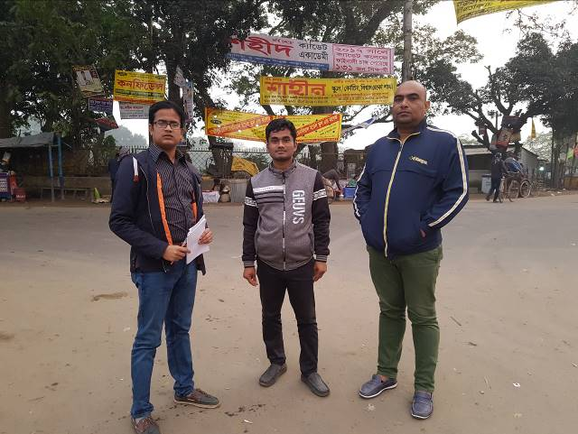
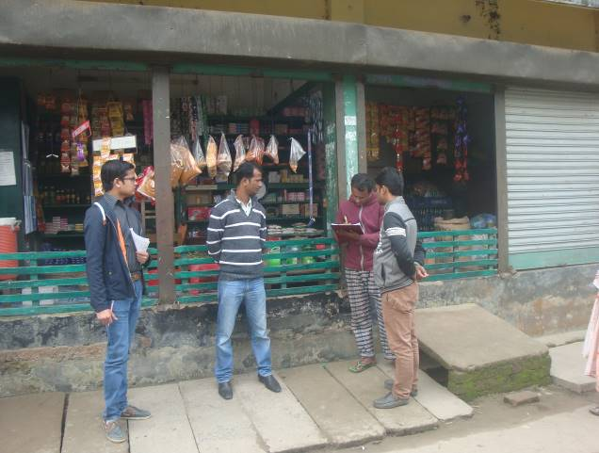
In the context of preparing the Environmental Assessment (EA), participatory public consultation was conducted. The Pourashava Mayor, Officials, Engineers and local individuals as well as LGED and Consultant participants participated. Informal Focus Group Discussions (FGD) and a formal CIP were conducted involving the participants. In addition, walk-through informal group consultations were also held. The local communities were informed about the subproject interventions including their benefits. Suggestions made by the participants were listed and incorporated in the EMP accordingly.

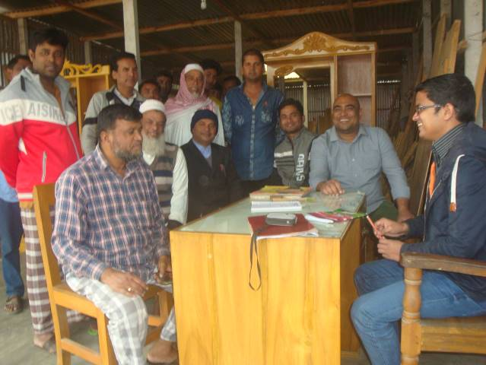
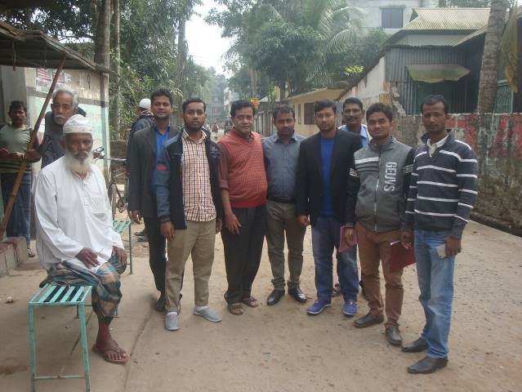
Photographs 7.1.1: Consultant Team Visited the Sites with the Tangail Pourashava Representatives
Photographs 7.1.2: Consultation Meeting at Subproject Site with Pourashava Officials and Consultants Participants

Issues Raised by the Participants

The participants raised the issues related to the infrastructure development of Tangail Pourashava. They emphasized on the subproject selection for the future development and also discussed about the procedure for the quality construction work. In the FGD, the participants discussed the requirements for the Pourashava future development through a list of the subprojects.

Feedback, Suggestions, and Recommendations of the Participants

The participants were presented with feedback, suggestions, and recommendations listed below:
- The local people emphasized that construction work should create minimum adverse impact on the environment;
- In the group discussion for the future development of Tangail Pourashava the participants demands (a) Planned and green municipality, (b) Planned hygienic and enhanced municipality, (c) Echo-friendly technology base industrial neighborhood;
- The participants stated that the public water supply facilities, sanitation facilities, drainage congestion and access road is not adequate;
- The FGD results confirmed that an improved communication network, drainage facility, solid waste management, water treatment plant and water supplying system, sewerage treatment plant and sanitation facilities, recreational facilities and health and sports facilities are needed for future development of Tangail Pourashava;
- Local people also believed that the importance of the area would be elevated and various economic activities would be started in the area after the subproject implementation;
- Local people also showed strong expectation for the increased opportunities for employment for the local labor in the construction work.

Conclusions and Recommendations

The conclusions of the environmental assessment can be summarized as follows:
- The impacts will be mainly at the subproject site during construction phase;
- The short-term negative impacts on the physico-chemical components such as noise, air, solid wastes, and occupational health and safety etc. will be minimized through the mitigation measures;
- The subproject has positive social impacts in both the construction and operation phases;
The overall conclusion is that if the mitigation, compensation, and enhancement measures are entirely implemented, there will be no significant negative environmental impacts.

A few key recommendations are outlined below:
- A copy of the EMP shall be kept on-site during the construction period;
- The environmental management and monitoring plan proposed in this report needs to be followed;
- Planted trees should be properly maintenance by the contractor during project defect liability period;
- Pourashava Officials will ensure no illegal households toilets connection in the drain during operation phase;
- To avoid any siltation and blockage in the drain and outfall, regular maintenance of the drain is needed;
- Contractor shall monitor the workers movement for avoiding any unexpected social activities (robbery, crime, political attachment and conflicts, taking drugs);
- Pourashava and contractor shall strictly monitor to avoid any risks from labor influx;
- The EMP shall be made binding on contractor operating the site, and will be included in the contractual clauses.

It should be noted that environmental assessment report is a live document. Hence, due to changing circumstances during the construction phase if any, there might be minor adaptation needed for environmental, health and safety issues.

Reference

Tangail Pourashava Master Plan: 2011-2031 Urban Area Plan;

Web Site: Tangail Pourashava http://www.tangailpourashava.gov.bd/;

Environmental Assessment Volume 1: Overall Environmental Assessment [Draft Final Report], September 2013. Municipal Governance and Services Project (MGSP), Local Government Engineering Department (LGED) and Bangladesh Municipal Development Fund (BMDF), Ministry of Local Government, Rural Development and Cooperatives, Government of the People's Republic of Bangladesh;

Environmental Assessment Volume 2: Environmental Management Framework (EMF) [Draft Final Report], September 2013. Municipal Governance and Services Project (MGSP), Local Government Engineering Department (LGED) and Bangladesh Municipal Development Fund (BMDF), Ministry of Local Government, Rural Development and Cooperatives, Government of the People's Republic of Bangladesh;

Geological Survey of Bangladesh, 1978. Earthquake Zoning Map;

Bangladesh Meteorological Department, Flood Zoning Map;

Population and Housing Census, 2011, National Volume-II: Union Statistics.

APPENDIX

Appendix- I: Environmental Monitoring Checklist

