INTRODUCTION

Subproject Background

Comilla City Corporation was established in the year of 2011. The City Corporation covers an area of 53.04 square kilometer. The current population of Comilla City Corporation is about 500,000. At present Comilla City Corporation has 482 km road which includes 197 km BC road, 60 km CC road, 16 km RCC road, 55 km brick flat soling road and 154 km earthen road. The Comilla City Corporation has 177.14 km drain which includes 65.50 km pucca and 105.46 km earthen drain. Presently, Comilla City Corporation has 279 nos. of functional culverts to divert drainage water. (Source: Comilla City Corporation website).

With the increasing population and rapid urbanization, Comilla City Corporation requires continuous infrastructure development. This subproject includes the following components: Bituminous Carpeting road, RCC drain, RCC culverts, RCC road protection wall and street light.

The significant features of the subproject are mentioned below:
Name of the Subproject: | Construction of Bituminous Carpeting Road from Kachua-Chowmohoni at Lacsam Road to Eid-gah Moar at Dhaka-Chittagong Highway (Ch. 0-2915 m) including RCC drain, road protection wall, culverts and street light under Comilla City Corporation, Comilla.
Package No.: | MGSP/CCC/2016-17/W-9
District Name: | Comilla
ULB Name: | Comilla City Corporation
Jurisdiction Area: | Ward no. 22 and 1 No. Bijoypur Union Parishad (Sultanpur and Haratoli Village)
Structural Design Option: | BC Road, RCC drain, Culverts, Road Protection work and Street light
Beneficiary Population: | About 25,000 as per information by the City corporation Officials
Tribal People: | No tribal people settlement found in the subproject area
Land Acquisition: | No private land acquisition is needed.
Estimated Cost: | 52.957 million BDT
Subproject Duration: | 12 Months
Tentative Start Date: | 09 August, 2017
Tentative Completion Date: | 08 August, 2018

Objectives of the Study

The aim of the study is to examine the environmental impacts due to construction and operation of the subproject and formulate the environmental management plan to minimize the negative impacts and enhance the positive impacts.
The specific objectives include:
- To assess the existing environmental conditions of the subproject site and its adjacent areas in order to establish a baseline framework against which potential environmental impacts due to implementation of the subproject would be compared;
- To identify and assess impacts resulting from the subproject during its construction phase and operation phase;
- To develop a rational environmental management plan with recommendations for mitigating adverse impacts and enhancing positive impacts and outlining environmental monitoring requirements both during construction and operational phase of the subproject.

Scope and Methodology of the Study

The subproject appraisal is included environmental screening for all the subproject components. According to that screening, no further environmental assessment is required for the street light. However, environmental assessment is required to fulfill the regulatory requirement for BC road, RCC drain, RCC culverts and RCC road protection wall. Hence, environmental assessment report is mainly focused on road and drain including culverts & road protection wall. However, in the EMP table mitigation measures for the street light are also included. The study methodology comprised the following activities:

Desktop Study
The desktop study involved:

- Initial meetings with client, stakeholders to discuss the proposed subproject, including subproject activities;
- Collection and review of the baseline data, maps, reports and other relevant information on the existing environmental and social conditions of the subproject area;
- Review of the relevant existing legislation, regulation and policies;
- Understand the anticipated technical processes that may affect the environment.

Field Investigation and Data Collection
A team of the consultants made a field investigation to the proposed site and field investigations involved mainly site walks within the subproject area and the neighboring areas that may be affected by the subproject. The following key tasks were performed during the field visit:
- Taking photographs of the significant aspects to assist in describing the baseline environmental conditions of the subproject area;
- Interviews with representatives of the relevant City Corporation officials, within the subproject area and interested and affected people within the subproject influence zone;
- Obtaining relevant documents from the City Corporation and local people within the subproject influence zone;
- Verifying information and data collected during the desktop study and to collect new information that may have been important in the assessment of the impacts and design of the mitigation measures.

Data Analysis and Report Writing
The data and information collected from all the sources (literature review, secondary and primary data, public consultation) were analyzed to describe the existing environmental setting of the subproject area, to identify the potential positive and negative impacts of the proposed subproject, as well as to provide preliminary suggestions for mitigation measures. Finally, this environmental assessment report has been prepared.

Subproject Description

The Study Area
The subproject is located at South-West Corner of Comilla City Corporation beside Dhaka-Chittagong National Highway. From Ch. 0 to 1700 m, the proposed road is situated within the jurisdiction of the ward no. 22. From Ch. 1700 to 2915m, the proposed road is situated within the jurisdiction of 1 no. Bijoypur Union Parishad (mainly goes through Sultanpur and Haratoli Village). Comilla City Corporation partly includes the Union Parishad Road to develop a road network by connecting Comilla Lacsam Road and Laxmipur to Dhaka-Chittagong Highway. The location map, topographical features and layout plan of the subproject are shown in Figure 2.1.1, Figure 2.1.2 and Figure 2.1.3.
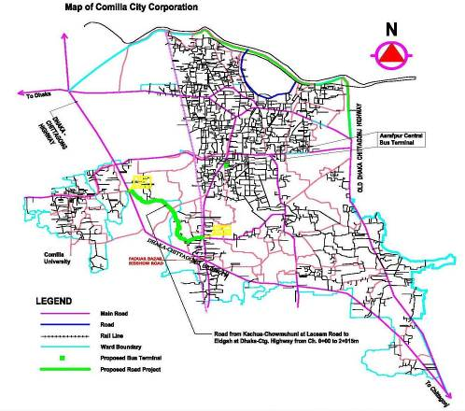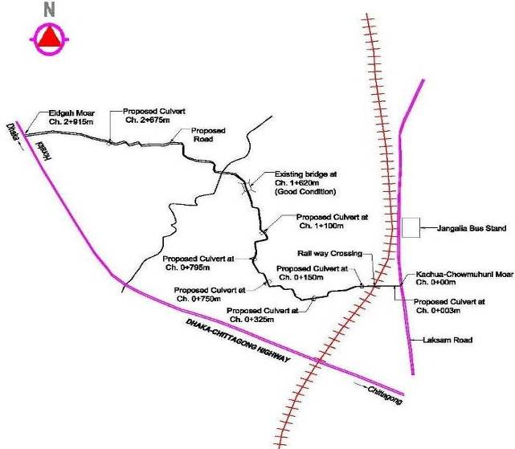
Figure 2.1.1: Location Map of the Subproject
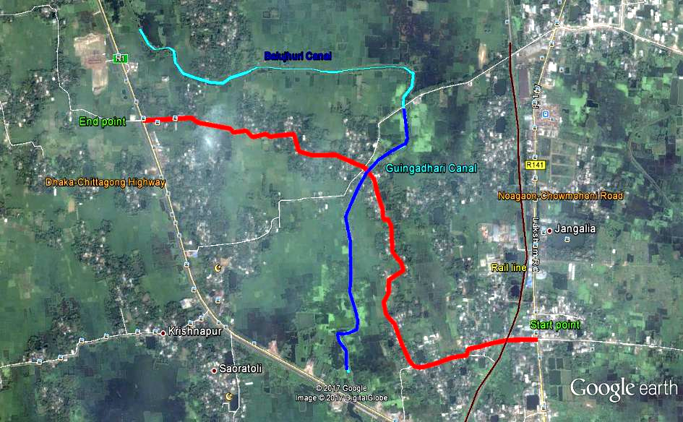
Figure 2.1.2: Topographical Features of the Subproject
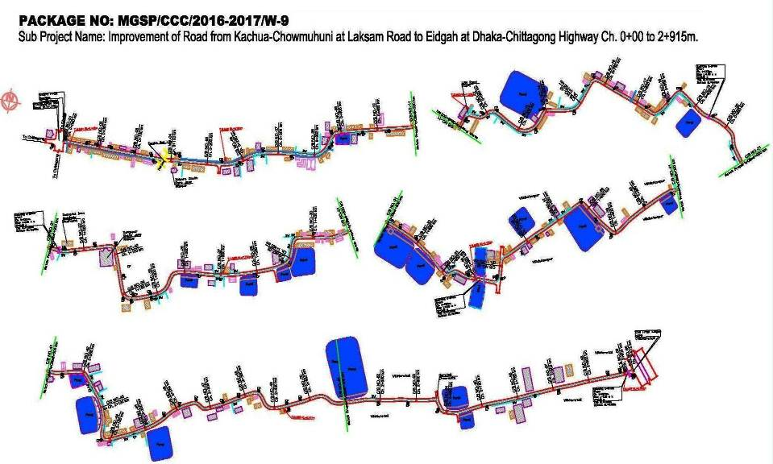
Figure 2.1.3: Layout Plan of the Subproject

Current Situation, Proposed Intervention and Need for the Subproject

The proposed road starts from Kachua Chowmohoni Zero Point Moar at Lacsam-Comilla Highway and ends at Eid-gah Road at Laxmipur to Dhaka-Chittagong Highway. In the first portion, the subproject area is semi-urban. Rest portion of the road, mainly goes through agricultural lands where crops and vegetables are growing abundantly. The built-up infrastructures include road side pucca, semi-pucca and katcha residential houses, shops, school and other educational institutions and local market.
The existing road width varies from 3.6 to 7.0m in different segments. The existing bituminous carpeting is badly damaged in most of the sections that interrupts the normal traffic movement. Hence, improvement of the road is required with road protection wall and culvert. The length of the proposed road is 2915m. The width of the proposed BC road is 6m.
In the subproject area, the drainage facility is inappropriate and inadequate. Hence, storm and backflow water from the discontinuous, narrow and damaged brick and earthen drain creates water logging problem. In addition, stagnant storm water on the road surface damages the bituminous carpeting and hampers the normal traffic operation. To improve the situation RCC drain (at Ch. 150-350m) and 7 nos. of RCC culverts (at Ch. 1m, 150m, 325m, 750m, 795m, 1100m and 2675m) will be constructed to complete the drainage network for better drainage facility and divert water from one side to another side and drain out the storm water to nearby low land and khals.
In the subproject area, natural canal (Guingadhari Canal), ponds, ditches are located adjacent to the road. Hence, road protection work is also needed to protect the road from subsidence and erosion. Furthermore, absent of the street light hampers the normal traffic operation at night. Therefore, fixing of the street light is needed for improved traffic operation at night. The current situation of the subproject site is further elaborated in the following Photographs 2.2.1.

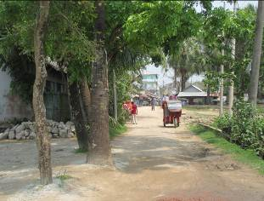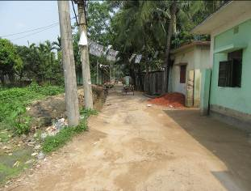
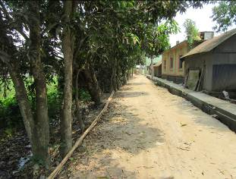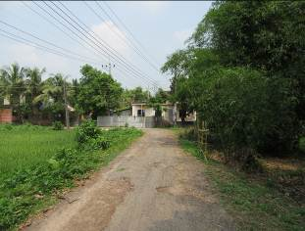
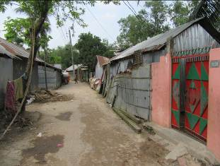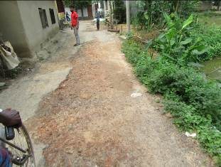
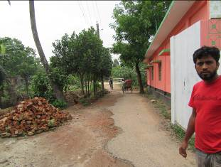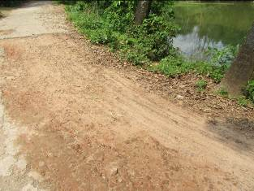
Photographs 2.2.1: Current Situation of the subproject Road

Justification of Selection of this Subproject

The City Corporation prepared the priority subproject list as per CIP. The consultant inspected the site conditions and recommended the subproject having low environmental and social negative impacts. To implement this subproject the road side built infrastructure will not be severely disturbed. In addition, private land acquisition is not an issue for implementation of this subproject. The City Corporation mostly owned the subproject road. To develop a road network, the City Corporation partly includes 1 no. Bijoypur Union Parishad road. However, City Corporation makes an MOU with the Union Parishad for the development work.
The proposed subproject ‘Kachua - Chowmohoni at Lacsam Road to Eid-gah at Dhaka-Chittagong Highway’ will improve the transport facilities and build a road network. This road will reduce traffic congestion in the Lacsam-Comilla Highway, Paduar Bazar, Bishwa Road and central area of the Comilla City Corporation. The improved road will definitely have a positive impact of the business transaction and proceeds. The new drain will reduce the drainage congestion and water logging problem. The culvert will divert storm water from one side to another side (drain out the storm water to nearby low land and khals). The road protective works will protect the road from erosion and subsidence. Street light will increase security in municipal areas and to increase the quality of life. Street lighting also rallies safety for drivers, riders and pedestrians. Hence, considering the potential benefits after completion this subproject has been selected.

Envisaged Subproject Activities and Implementation Process

The general activities for the subproject includes: construction of the semi-pucca site office, construction of the labor shed, relocation of the electric poles and site clearing works.

The key activities of the RCC Drain include:

- Earth work in excavation of the foundation;
- Pumping and bailing out of water as per requirement;
- Lying of polythene sheet;
- Sand filling for the preparing foundation bed;
- Plain cement concrete work in foundation;
- Manufacturing CC blocks;
- Fabrication of the ribbed or deformed bar;
- Reinforced cement concrete work.

The key activities for BC Road include:

- Dismantling of the damaged sub-base and base course works;
- Clearing and grubbing works;
- Earth work in box cutting;
- Earth filling work;
- Sand filling on the road bed;
- Mechanical compaction;
- Brick on edging;
- Compacted stone aggregate base course;
- Providing prime coat;
- Laying pre-mixed dense bituminous surfacing wearing course;
- Tree plantation.

The key activities of RCC culverts and RCC road protection wall includes:

- Earth work in excavation of the foundation;
- Pumping and bailing out of water as per requirement;
- Lying of polythene sheet if required;
- Sand filling for the preparing foundation bed as per requirement;
- Plain cement concrete work in foundation;
- Fabrication of the ribbed or deformed bar;
- Reinforced cement concrete work.

Street Light:

- Assembling, fitting, fixing, installation, testing and commissioning of the GI pole;
- Fitting and fixing energy meter ;
- Earthling the electrical installation;
- Fixing insulator;
- Erection of tubular pole;
- Fixing of the overhead conductor;
- Fixing of the wire rack;
- Fixing and installation of the switch board;
- Providing, fitting and fixing of the water tight street light.

The materials and resources to be used for the key activities: Soil in earth work, sand, bricks, stone chips, cement, concrete, reinforcement, bitumen, diesel, water, GI poles and other associate accessories for lighting facilities.

The major equipment to be used for the implementation of the subproject: hydraulic excavator, concrete mixer, mechanical vibrator, mechanical compactor, steel cutter, steel shutter, steel drum rollers, pneumatic multiple tire roller, dump truck, water tanker, pump, asphalt plant, rubber tire roller, and paver.

Baseline ANALYSIS OF THE ENVIRONMENTAL CONDITION

Physical Environment

Environmental and Infrastructural Features
The environmental features within the subproject area have been collected by field investigation. Conditional survey has also been performed for designing of the subproject. Hence, the survey data is also used for preparation of the report. The findings of the site inspection and investigation from Kachua-Chowmohoni at Lacsam Road to Eid-gah Moar at Dhaka-Chittagong Highway (Ch. 0-2915 m) are given in Table 3.1.1.
Table 3.1.1: Major Environmental and Infrastructural Features
Chainage (m) | Left | Right | Major Environmental and Infrastructural Features
0-100 | √ |  | Kachua zero point Moar, different types of semi-pucca and tin-shed shops at Bazar area (<1m from road crest), existing damaged and narrow brick drain, common planted trees (Banana, Palm, Kodom, Rain tree, Mahogany, Mango, Berry, Coconut, Betel-nut), electric poles, tin-shed homestead area (3-4m far), electric poles
0-100 |  | √ | Different types of semi-pucca and tin-shed shops at Bazar area (<1m from road crest), existing damaged and narrow brick drain, common planted trees (Apple Wood, Palm, Rain-tree, Mahogany, Mango, Jackfruit and Coconut)
100-200 | √ |  | Rail line, shops and homestead area (tin-shed, semi-pucca and structure; within 5m) vacant and low land, RCC drain, common planted trees (Rain-tree, Mahogany, Mango, Berry, Jackfruit, Coconut, Betel-nut, Neem, Palm and Horitoki), natural vegetation (herbs, shrubs), agricultural field, pond/ditch, electric poles
100-200 |  | √ | Deyara Mosque, rail line, semi-pucca shops and homestead area (pucca and semi-pucca within 5m), graveyard, common planted trees (Rain-tree, Mahogany, Mango, Jackfruit and Coconut) , boundary wall, electric pole
200-300 | √ |  | Homestead area (tin shed, semi-pucca and pucca structures within 5m), common planted trees (Rain-tree, Mahogany, Jackfruit, Coconut, Betel-nut), natural vegetation (herbs, shrubs), pond, electric poles
200-300 |  | √ | Homestead area (pucca and semi-pucca structures within 5m), graveyard, common planted trees (Rain-tree, Mahogany, Mango, Jackfruit and Coconut), boundary wall, electric pole
300-400 | √ |  | Homestead area (tin shed, semi-pucca and pucca structures within 5m), common planted trees (Mango, Berry, Betel-nut, Coconut, Pakoir Tree, Acacia tree, Palm, Neem), natural vegetation (herbs, shrubs-bamboo bushes), graveyard, electric poles
300-400 |  | √ | Homestead area (pucca and semi-pucca structures within 5m), RCC drain, ditch, boundary wall, common planted trees (Banana, Guava, Jackfruit, Coconut, Palm), boundary wall, electric pole, transformer
400-500 | √ |  | Homestead area (semi-pucca and pucca structures within 5m), common planted trees (Mango, Jackfruit, Betel-nut, Coconut, Palm), natural vegetation (herbs, shrubs-bamboo bushes), graveyard, electric pole
400-500 |  | √ | Homestead area (tin-shed, pucca and semi-pucca structures within 5m), RCC drain, boundary wall, common planted trees (Guava, Jackfruit, Coconut, Betel-nut, Palm), boundary wall, electric poles
500-600 | √ |  | Bamboo bushes, homestead area (tin-shed, pucca and semi-pucca structures within 5m), Graveyard, common planted trees (Mango, Jackfruit, Betel-nut, Coconut, Palm, Chalta), Electric poles, pond
500-600 |  | √ | Homestead area (tin-shed and semi-pucca structures within 5m), common planted trees (Mango, Banana, Palm), low land, boundary wall, RCC drain, waterlogged low-land, agricultural field
600-700 | √ |  | Pond, wetland, water-logged low land, cross drain common planted vegetation and aquatic vegetation (water hyacinth), Kalkeshia
600-700 |  | √ | Homestead area (tin shed, pucca and semi-pucca structures), RCC drain, culvert, common planted trees (Berry, Lemon, Papaya)
700-800 | √ |  | Homestead area (tin-shed, pucca and semi-pucca structures within 5m), RCC drain, electric poles, common planted trees (Mango, Berry, Jackfruit, Coconut)
700-800 |  | √ | common planted trees (Mango, Jackfruit, Amra, Guava), agricultural field, wet land
800-900 | √ |  | Homestead area (tin-shed, pucca and semi-pucca structures within 5m), common planted, electric poles
800-900 |  | √ | Homestead area (pucca and semi-pucca structures with in 5m), common planted trees (Mango, Jackfruit, Coconut, Betel-nut, Palm)
900-1000 | √ |  | Paddy field, electric poles, roadside vegetation, cross drain, Daoutaul Imam Academia Madrasha
900-1000 |  | √ | Low land, brick drain, pond, boundary wall, common planted vegetation (Pakoir tree, Banyan tree, Mango, Jackfruit, Coconut, Bamboo)
1000-1100 | √ |  | Low land, paddy field, electric poles, Palm, Banana and Katchu
1000-1100 |  | √ | Durgapur Shahe Jame Mosque, common planted trees (Mahogany, Mango, Jackfruit, Coconut, Betel-nut, Douwa, Kamini, Eucalyptus, Guava, Palm, Jambura), graveyard, electric pole
1100-1200 | √ |  | Pond, paddy field (10-15m), trees, roadside homestead are (tin shed, semi-pucca and pucca), electric pole
1100-1200 |  | √ | Pond, trees, roadside homestead are (semi-pucca and pucca), electric poles
1200-1300 | √ |  | Mosque, paddy field (3-5 m), common planted trees, homestead area (tin-shed and semi-pucca roadside) electric poles
1200-1300 |  | √ | Ponds, common planted tress (Mango, Berry, Jackfruit, Banana, Rain Tree and Pulm), electric pole
1300-1400 | √ |  | Common planted trees, homestead area (tin-shed and semi-pucca roadside) electric poles
1300-1400 |  | √ | Ponds, common planted tress (Mango, Berry, Jackfruit, Banana, Rain-tree, Coconut, Betel-nut and Pulm), electric pole
1400-1500 | √ |  | Road side homestead area (semi-pucca and tin-shed),common planted trees, electric pole
1400-1500 |  | √ | Pond, shops, common planted trees (Gub, Acacia and so on)
1500-1600 | √ |  | Electric poles, homestead area (tin shed, semi-pucca and pucca structure)
1500-1600 |  | √ | Ponds, wet land, aquatic vegetation
1600-1700 | √ |  | Brick drain, RCC bridge, common planted trees (Palm, Jackfruit, Mango, Akashi, Mahogany), Guingadhari Canal, electric poles
1600-1700 |  | √ | Boundary wall, shops, homestead areas, common planted trees (Mahogany, Acacia, Shisso, Jackfruit)
1700-1800 | √ |  | Mosque, pond, common planted trees (Mango, Mahogany, Coconut, Betel nut), Bamboo bushes, boundary wall
1700-1800 |  | √ | Electric pole, homestead area (pucca and tin-shed), tined shops, common planted trees (Acacia, Mahogany, Jackfruit, Palm)
1800-1900 | √ |  | Steel workshop, boundary wall, homestead area (tin-shed, semi-pucca), paddy field,
1800-1900 |  | √ | Pond, wetland, vegetated area (terrestrial and aquatic vegetation), paddy field
1900-2000 | √ |  | Homestead areas (tin-shed, semi-pucca and pucca), brick drain, household common planted fruit trees
1900-2000 |  | √ | Mosque, grave yard, pond, common planted trees
2000-2100 | √ |  | Homestead area (semi-pucca and pucca), septic tank, link road (HBB), natural vegetation and ornamental trees
2000-2100 |  | √ | Ponds, electric poles, homestead areas (pucca structure), link road (HBB), natural vegetation
2100-2200 | √ |  | Homestead area (semi-pucca and pucca), natural vegetation and ornamental trees, electric pole
2100-2200 |  | √ | Pond, electric pole, homestead areas (pucca structure), natural vegetation and common planted trees
2200-2300 | √ |  | Paddy field, common planted trees (Mango, Jackfruit, homestead area, electric pole
2200-2300 |  | √ | Paddy field, electric pole, boundary wall, shop, homestead area (pucca, semi-pucca)
2300-2400 | √ |  | Paddy field, common planted trees (Mango, Jackfruit, homestead area, electric pole
2300-2400 |  | √ | Paddy field, electric pole, boundary wall, shop, homestead area (pucca, semi-pucca)
2400-2500 | √ |  | Pond, common planted trees, homestead area, electric poles, paddy field
2400-2500 |  | √ | Paddy field, boundary wall, roadside natural vegetation, electric poles
2500-2600 | √ |  | Pond, paddy field, boundary wall,
2500-2600 |  | √ | Electric pole, paddy field, common planted trees, homestead area
2600-2700 | √ |  | Pond, Paddy field, common planted trees, homestead area, electric pole
2600-2700 |  | √ | Bamboo bushes, pond, common planted vegetation, electric pole, pump house
2700-2800 | √ |  | Paddy field, common planted trees, pucca house, barren land
2700-2800 |  | √ | Boundary wall, electric poles, homestead area, paddy field, common planted trees
2800-2915 | √ |  | Paddy field, common planted trees, homestead area (semi-pucca and pucca houses), electric poles
2800-2915 |  | √ | Electric poles, homestead areas (semi-pucca and pucca), common planted wooden trees, ditches, paddy field, pond

There are 30 numbers of electrical and telephone poles to be re-located for the implementation of the subproject.

Geology, Topography, and Soils

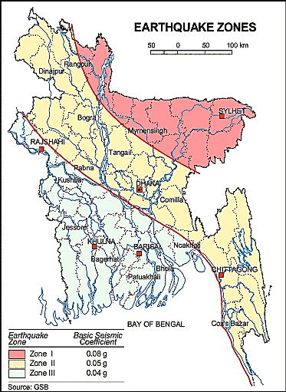
The topographical feature of the Comilla City Corporation is not uniform. It has a mixed topography. The city corporation area has laid in medium to highland. It includes substantial areas more than 5 meters above sea-level. Besides the hilly tracks, most of Comilla City Corporation is a flat plain area known as alluvium land with both hard and granular sandy or clayey silts and sloping gently to the south and southeast. The soil is light to medium gray, fine sandy to clayey silt. Soils are poorly stratified; average grain size decreases away from main channel. These soils are slightly acidic or neutral. Soaking capacity is not that good. The area lies in the earthquake Zone 2 according to the seismic map of Bangladesh (Ref: BNBC, 1993).

The circle denotes the Comilla City Corporation

Figure 3.1.1: Location of Comilla City Corporation in Earthquake Zone Map of Bangladesh

Climate and Meteorology

The climate of the Comilla City Corporation can be described as Tropical Monsoon. It is characterized by warm, humid summers and cool, and dry winters. From November to March, it is dry and cool while from April to May it is extremely hot during the pre-monsoon season. From June to October, the monsoon season is warm, cloudy, and wet. The warmest month is April, the coolest is January, the wettest is July and the driest is January.
This area is distinctive as tropical-subtropical sub-humid climate. The maximum mean temperature observed in Comilla City Corporation is about 25-32°C between May-August, with the minimum temperatures of between 12-15°C in January as shown in Figure 3.1.2. Annual average rainfall is about 2430 mm. Monthly precipitation records clearly show a distinct dry and rainy season in Figure 3.1.3.
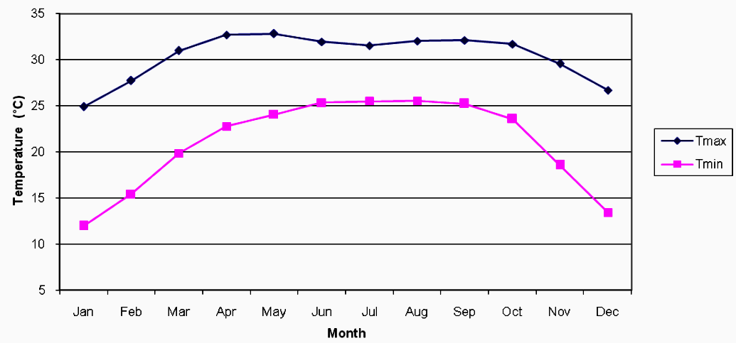
Source: BMD (Bangladesh Meteorological Department)
Figure 3.1.2: Average Minimum and Maximum Temperate in Comilla City Corporation

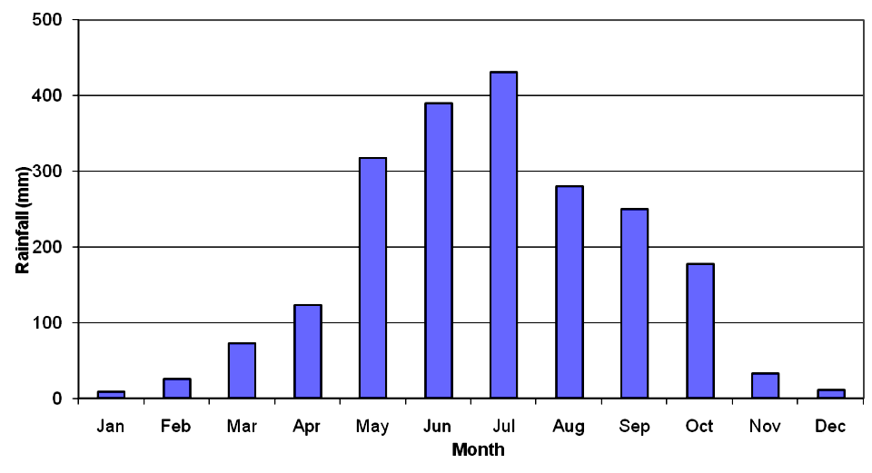
Source: BMD (Bangladesh Meteorological Department)
Figure 3.1.3: Average Rainfall in Comilla City Corporation

According to the statistics of the wind data from the Bangladesh Meteorological Department Climate Division, wind direction changes by month. Nevertheless, the northwest, south, and northeast winds are predominant. This area experiences wind speeds low to medium (ES, 2005).

Water Resources (Surface Water, Ground Water and Rainwater Harvesting)

The River Gomoty and canals (Guingadhari canal, Balujhuri canal and Katakhal) are the main sources of surface water in the City Corporation area. In the subproject area, Guingadhari canal, ponds and ditches are functioning as surface water sources. For cultivation people use canal water. Hence, for the construction works the surface water can use where appropriate.
Groundwater is the main source of potable water in the subproject area. Deep groundwater is not saline. Local people typically use deep tube-well water for drinking and other domestic purposes. According to the BADC groundwater zoning map, groundwater table in Comilla region varies from 5.3 to 7.6 meter below ground level.
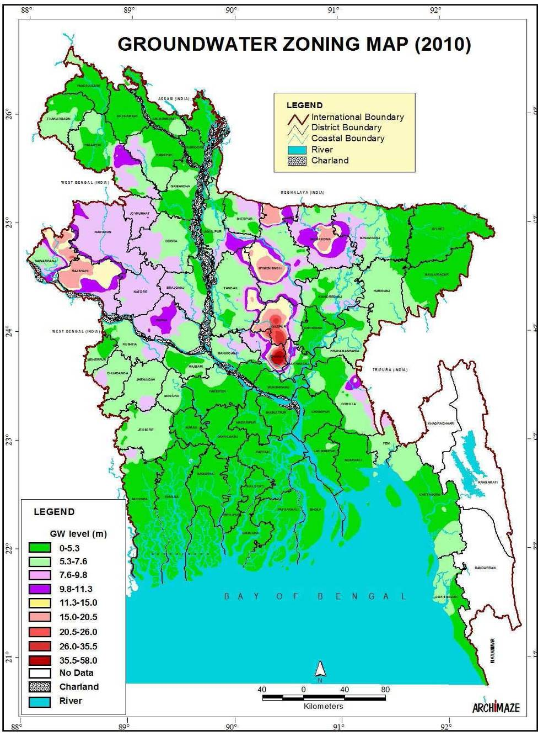
Figure 3.1.6: Location of Comilla City Corporation in Groundwater Zoning Map of Bangladesh (Source: BADC)

Flooding, Water Logging and Drainage Pattern

Comilla City Corporation is situated on the bank of River Gomoty. There is a flood protection embankment on the North Side of the City which protects the inhabitants from river flooding. The drainage network of Comilla City Corporation is not good enough. There are areas which are annually inundated by water logging for significant duration. There are some secondary drains carry storm water and domestic waste water to the ultimate outfall either Rivers or Khal. The subproject area is situated at the middle of the Comilla where Guingadhari Canal, ditches and ponds are functioning as natural drainage system. For the built-up area new drains are needed for proper draining of the storm water.

Air Quality and Dust

In the subproject area, degradation of the air quality is mainly due to emission from the vehicles. The windblown dust also causes air quality degradation. The dusty and rough surfaces of the road also generate dust during vehicle movement. Open burning of the wastes materials and roadside disposal of the wastes cause air quality degradation. The subproject activities may degrade the air quality of the subproject area though the impacts are anticipated to be insignificant.

Noise Level

In the subproject area, noise is mainly generated from the moving vehicles and hydraulic horns. In the subproject activities, mixer machine, vibrator machine, mechanical compaction machine, steel cutter, hydraulic excavator, asphalt plant may create localized noise nuisance though the impacts are anticipated to be insignificant and within the tolerable limits.
Solid Waste Management

The City Corporation has designated dumping site at Moilakhola, Jhakuni Para. The collected solid wastes are transported by the garbage trucks to the landfill site. Due to lack of awareness about waste disposal by the community people, Comilla City Corporation faces challenges proper disposal of the solid wastes. The local people informed that due to habitual problem they throw their solid wastes into the vacant lowland, khals and drains. Therefore, improper solid waste disposal by the community people creates severe public health hazards and environmental degradation.

Biotic Environment

Flora and Fauna

The common natural native species of vegetation are found in the subjected area. The road side planted trees include Mango, Berry, Jackfruit, Amloki, Rain Tree, Mahogany, Jackfruit, Coconut, Betel-nut, Palm tree, Date tree, Neem, Pulm, Guava, Amra, Jambura, Lemon, Kamranga, Sonalu, Krisnachura, Jarul, Banyan (Pakoir) Tree and Horitoki. There is huge natural growth aquatic and terrestrial vegetation (herbs and shrubs) both sides of the proposed road. In the subproject area, agricultural practices (paddy cultivation) are common. Other crops and seasonal vegetables also cultivated in the agricultural land and homestead garden. The natural surfaces water bodies (khals, ponds, ditches) are the worthy habitat for the aquatic animals.
Wild animals and endangered faunal (Jackal, Mongoose) species were found. The common local birds such as Doel, Shalik, Chil, Pecha, Kak, Tuntuni, Bulbuli, Kokil and Dove were found in the subproject area. The Balujhuri and Katakhal are not formally used for fish cultivation. Nevertheless, some natural fish species exist in these canals and road side ponds and ditches as per information by the local people. The local inhabitants also informed that migratory birds are coming in the winter season.

Socio-economic and Socio-cultural Environment

Land Use Pattern, Status of Housing and Built-up Infrastructure

In the first portion of the road, the built infrastructure includes mainly semi-pucca and tin-shed residential houses, and few business facilities for instance roadside tin shed and semi-pucca shops. There is no industrial activity in the subproject area. Most of the roadside lands are used for agricultural purposes.

Beneficiary Population

This road goes through mainly Ward number 22 of Comilla City Corporation and partly from 1 no. Bijoypur Union Parishad. As per information by the municipality, considering the wards population about 25,000 people will be benefited directly and many others indirectly.

Education

In the subproject area, literacy among the population is about 64.9%. This is higher than the national average (51.8%). Literacy rate among males (66.5%) is still higher than females (63.3%). (Ref: Population and Housing Census 2011).

Tribal Communities

There is no indigenous or tribal people settlement in the subproject area. Therefore, there is no measure needed for indigenous peoples’ safeguard.
Cultural Heritage and Protected Areas

Within the influence area of the subproject, there is no protected area and no important cultural or historical sites identified during the field visit.

ENVIRONMENTAL SCREENING

Environmental Screening Checklist, as adopted in Appendix C of the Environmental Management Framework (EMF) of the MGSP, was administered for identifying the impacts and their extents.
The screening data and information for the BC Road with RCC Drain, RCC Culverts and RCC road protection wall have been formulated and are shown in below.
(1) Potential Environmental Impact during Construction Phase:
(a) Ecological Impacts:
575
- Felling of trees Significant □√ Moderate □ Minor □ Number of trees
- Clearing of vegetation Significant □ Moderate □√ Minor □
- Potential impact on species of Significant □ Moderate □√ Minor □
aquatic (i.e., water) environment
Major trees to be felled down are: Palm tree, Apple wood tree, Mango, Jackfruit, Rain-tree, Neem, Mahogany, Akashi, Mango, Coconut, Pakoir tree (types of Banyan tree) and Date Tree. There is no tree to be felled down bring religious and heritage importance. However, the trees to be felled down have significant economic value because most of them are medium size considering length and diameter. Vegetation coverage is not similar in all sections of the road. However, clearing of the road side vegetation, bushes, herbs and shrubs also have ecological impacts which is considered as moderate. In addition, anticipated impact on species of aquatic environment is minor because except throwing of the wastes materials in to the Guingadhari canal, ponds and ditches, the subproject does not have any impact on the aquatic environment. Considering the number of trees to be felled down, the ecological impact is considered as significant.
- Physicochemical Impacts:
- Noise and Air pollution Significant □ Moderate □√ Insignificant □
- Drainage congestion Very likely □ Likely □ Unlikely □ √
- Water pollution Significant □ Moderate □√ Insignificant □
- Pollution from solid/ construction wastes Significant □ Moderate □√ Insignificant □
- Water logging Significant □ Moderate □ Insignificant □ √
The subproject will have impacts on noise and air quality during construction phase due to mobilization of the equipment, vehicles movement for the transportation of the materials, hydraulic excavator, brick breaking machine, mechanical compaction machine, paver, asphalt plant, concrete mixer machine, vibrator machine etc. The construction work will be performed section wise. Hence, it is anticipated that the impacts will be temporary, site specific and not significant. It should be noted that near home stead area, Deyara Mosque and other establishment the generated noise may have significant impact. The generated dust during construction activities may disturb the local people if measures are not taken. The generated construction wastes, un-suitable materials and solid wastes may degrade the adjacent Canal and pond water if not properly collected and disposed and thrown in to the pond and low land. Improper collection and disposal of the generated wastes also may degrade the quality of the surrounding environment and degrade the landscape value. The anticipated water logging problem during construction period is minor because space is available at both sides of the road for drain-out the storm water. In addition, pumping facilities will be provided to drain-out the storm water if required.
- Socio-economic Impacts:
- Traffic congestion Very likely □ Likely □√ Unlikely □
- Health and safety Significant □ Moderate □√ Insignificant □
- Impact on archaeological and historical Significant □ Moderate □ Insignificant □√
- Employment generation Significant □√ Moderate □ Insignificant □
During construction, the subproject will have localized negative impact in traffic congestion. However, the local people can use connecting roads that will reduce traffic congestion. The construction work will follow simple procedure with commonly used equipment. Hence, anticipated impact on health and safety is moderate. There is no archeological and historical site within the influence area. Hence, the anticipated impact on socio-economic impacts due to subproject activities is insignificant. The subproject has significant positive impact by generating work opportunities for the local people and supplying of the construction materials, equipment, food and other necessary stuffs to the campsite.
(2) Potential Environmental Impact during Operational Phase:
(d) Ecological Impacts:
- Potential impact on species of aquatic Significant □ Moderate □√ Minor □
(i.e., water) environment
The road component does not have any impact on the aquatic environment during operation. Though, the drain is designed for storm water only. However, the storm water may carry washed-out materials, pollutants from any sources that may disturb the aquatic environment of the outfall.
(e) Physicochemical Impacts:
- Potential air quality Improvement □ No-improvement □ Deterioration □√
- Potential noise level Improvement □ No-improvement □ Deterioration □√
- Drainage congestion Improvement □√ Minor Improvement □ No Impact □
- Risk of water pollution Significant □ Moderate □√ Minor □
- Pollution from solid waste Improvement □ No-improvement □ Minor □√
After completion, due to improve road traffic volume may increase. Consequently, air quality and noise level may be degraded due to black smoke emission and hydraulic horn from the vehicles. The drain component does not have any impact on the noise. The new drain will minimize drainage congestion & water logging problem. The new drain also minimizes throwing of the waste materials and spreading of the bad odor from the drain. The storm water to be discharged through the drain may degrade the water quality of the outfall and adjacent water bodies if carry pollutants from any sources.
(f) Socio-economic Impacts:
- Traffic Improvement □√ No-improvement □ Adverse □
- Safety Improvement □√ No-improvement □ Adverse □
- Employment generation Significant □ Moderate □√ Minor □
After completion, this road will be used as bypass road. The new road will facilitate easy and direct communication for the users to arrive Dhaka-Chittagong Highway from Kachua-Chowmohoni, avoiding the traffic congestion at Paduar Bazar and Bishwa Road Moar. People from the adjacent Union Parishad also will get benefit from this road. The three wheelers such as CNG, battery operated rickshaw-van and non-motorized vehicles can use this road. Hence, this road will be an income generating source for the unemployed people. The new road will minimize the frequency of the maintenance for three to five years after completion.

3) Summary of Possible Environmental Impacts of the Subproject
From the above study, it seems that the subproject have significant ecological impacts due to tree felling. Development of the BC road and RCC drain with other works may temporary affect the roadside water bodies due to construction activities. The physicochemical components will be disturbed due to the subproject activities during the construction phase. The wastes generated due to the construction activities should be properly collected and disposed in a designated site. There is no adverse impact is anticipated at operational stage. However, air quality and noise level may be deteriorated due to vehicles emission and horns.
Safety concern is an important issue for both the construction and operation phases that should be considered properly. The socio-economic aspect mainly includes health and safety and employment generation. This subproject will have positive impacts in terms of the generation of the employment and business activities by supplying construction materials and equipment.
The anticipated environmental impact for the installation of the street light is insignificant. However, it has significant positive social impacts. Short circuit and improper electrical connection of the street light may cause potential health and safety risk.

Specific impact, mitigation, AND enhancement measures

The likely impacts of the subproject are mainly caused by the activities required for the implementation of the subproject, and materials, resources and equipment to be used to perform the activities.
This section describes some specific impacts due to the subproject activities and their mitigation measures.

Dismantle Work, Excavation Work and Earth Work

The road improvement work includes dismantle of existing bituminous pavement, clearing of the wastes materials generated due to dismantle work, earth excavation and earth filling work. The drain construction work consists of dismantling of existing brick drain, earth excavation, earth filling, back filling and cutting and removal of the unsuitable materials. Construction of culverts and road protection wall works also includes earth excavation, earth filling and clearing of the unsuitable materials. These works lead dust blowing, improper disposal of the wastes, noise and vibration which may disturb the local people.

Mitigation Measures

- Proper care will be taken by the contractor during dismantle work, excavation work, earth work and disposal work to avoid any undue disturbances to the nearby people;
- Avoid loss of the topsoil for the earth filling work;
- Cover the exposed earth works with fabric;
- Disposal of soil and construction wastes at Moilakhola, Jhakuni Para dumping site.

Tree Felling and Ecological Impact

There are 575 planted trees (Palm tree, Apple wood tree, Mango, Jackfruit, Rain-tree, Neem, Mahogany, Akashi, Mango, Coconut, Pakoir tree (types of Banyan tree) and Date Tree) will be felled down and road side vegetation will be cleared due to implementation of this subproject.
Mitigation Measures

- 1000 nos. of indigenous species of medicinal and timber trees, local fruits, flowers and ornamental trees - Mango, Jackfruit, Jam, Apple Wood Tree, Neem, Amloki, Horitoki, Bohera, Arjun, Sonalu, Jarul, Polash, Krisnachura, Bokul, Debdaru, Kadam, Mahogany, Segun, Satim, Rain Tree, Akashi and Banyan trees will be replanted to compensate the ecological imbalance to be caused due to felled down of the trees. The trees will be planted at the both sides of the road where space is available and subproject influence area.
- Planting many trees will enhance the ecological condition of the area after their successful growth.

Pollution from the Construction Materials

Dumping of the construction spoils, including accidental leakage of the oil, grease, and fuel in equipment yards is a significant hazard. Surface water and soil quality might be polluted from these contaminants. Even the people to be engaged for the construction activities might endanger the physical and human habitats of the area.
Mitigation Measures

- Safe transport, storage, and disposal provisions for the construction materials, and the equipment have to be carried out in order to avoid the accidental spillage and loss;
- Maintain adequate moisture content of soil and sand during transportation, compaction and handling;
- Carry the materials especially loose soil and sand with adequate cover;
- Fuels, lubricants, and other hazardous materials should store over raised platforms and not directly on the ground;
- Disposal of soil and construction wastes at Moilakhola, Jhakuni Para.

Air Quality and Dust

During construction phase, air pollutants will be emitted from the equipment and construction vehicles are expected to remain low. Local residents in the vicinity of the work sites will be temporarily disturbed by the limited dust pollution. The overall impacts, however, are expected to remain low.
Mitigation Measures

- Water should be sprayed at the work site for dust control. Ensure sprinkle and cover stockpiles of the loose materials (e.g., fine aggregates);
- Maintain adequate moisture content of soil and sand for transportation, compaction and handling;
- Avoid use of dust generating equipment (which produce significant amount of particulate matter) far from the local residents;
- Ensure that all subproject vehicles are in good operating condition.

Noise and Vibration

Noise and vibration caused by the equipment and movement of the construction vehicles may temporarily disturb nearby residents. In this subproject, sensitive areas like roadside residents and shops are likely to be affected from the noise, though the impacts are anticipated to be limited.
Mitigation Measures

- Transportation of the construction materials have to be carried during the scheduled times, and mainly during the day;
- If needed, all powered mechanical equipment and machineries will be fitted with noise abating gear such as mufflers for effective sound reduction.

Water Quality

The water quality may deteriorate if the construction materials, sand, construction wastes, effluent from the work camps, and food wastes are dumped in the roadside ditches, ponds and in the Guingadhari canal.
Mitigation Measures

- Proper construction management including waste management as well as training of the operators and other workers should provide to avoid pollution of the water bodies;
- Construction wastes will dispose properly (not in water bodies or lowland), for which contractor will be responsible;
- Construction wastes will dispose properly at dump site at Moilakhola, Jhakuni Para (not in the water bodies or lowland), for which contractor will be responsible.

Occupational Health and Safety

The most important risks associated with the construction activities are listed below:
- Exposure to the sunlight- workers are being exposed to the sun for long hours;
- Exposure to the high temperature, and humidity for a long time resulting in dehydration;
- Contact with the hazardous substances and wastes pose risks of the infections and diseases;
- Risk from the traffic collision or accidents during operation of the equipment such as hydraulic excavator, steel cutter and vehicles movement for the transportation activities of the subproject;
- Risks from head loads for carrying soil, construction materials and construction equipment;
- Risks of using of the machineries in motion such as steel cutter;
- Risk associated to the sudden bad weather working conditions such as storm, thunder storm and earth quake etc.

General Requirements for the Workers’ Health and Safety
The significant features of the general requirements for the workers’ health and safety stated are presented in Table 5.7.1.

Table 5.7.1: General Requirements for the Workers Health and Safety
Issues | Requirements
Health and Hygiene | - Cleanliness at the site premises and workers living places and at the Labor Shed;  - Arrangement of the proper ventilation and temperature at the Labor Shed;  - Protection against dust and furnace by using of the nose masks and covering of the head and body;  - Proper disposal of the wastes and effluents;  - Provision of the adequate latrines and separate toilet for the women;  - Sufficient dustbins for the solid waste management system.
Safety and First Aid Box | - Using of the personal protective equipment (helmet, gloves, goggles, nose mask, safety boots);  - Precautions during work on or near machineries in motion;  - Head loads are prohibited;  - First aid facilities should be provided and maintained;  - Ensure first aid box;  - The first aid kit should include adhesive bandages, regular strength pain medication, gauze, and low grade disinfectant.
Compensation for Accidents at Work | - Contractors will bear medical treatment costs. If any severe accidents such as loss of hands, legs or loss of working ability or any case of death needs compensation-(the amount of the compensation should be fixed considering the type of accidents).
Dust and Fumes | - For any dust, fumes, or other impurities likely to be injurious to the workers, effective measures shall be taken to prevent their accumulation and its inhalation by the workers.
Overcrowding | - No labor room should be overcrowded.
Latrines and Urinals | - Sufficient latrines shall be provided;  - Latrines shall be maintained in clean and sanitary condition;  - Latrines shall be adequately lighted and ventilated.
Disposal of Wastes and Effluents | - Proper disposal system for the solid waste and effluent is required.

Impacts on Social Environment and Common Property Resources

Through comprehensive study, it is revealed that impacts are expected not to be severe and to be largely manageable. The following Table 5.8.1 presents impacts on socio-economic environment and common property resources.
Table 5.8.1: Impacts on Social Environment and Common Property Resources
Social Components | Impacts on IECs | Impact Significance
Community Perception | The local community people welcome this subproject and there is no visible objection from them. | Significant (+ve)
Employment and Business Opportunity | Community feels happy because the subproject will create work opportunity for the local people for the skilled and non-skilled labor. The subproject will create business opportunity for the equipment and materials suppliers. | Significant (+ve)
Community Order and Security | This subproject activity does not create any severe security problems to the local community and community people. | Minor  (-ve)
Possible damage to infrastructure and facilities | Possible damage of the existing road infrastructure by the construction equipment and vehicles used in this subproject. | Minor  (-ve)
New infrastructure and facilities | Improvement of the existing road, drain, culverts, road protection wall and street light will enhance infrastructure facilities. | Moderate  (+ve)
Agriculture and Land Use | No direct impact on agriculture however, it could affect the adjacent land to a very limited extent. | Minor  (-ve)
Landscape and Aesthetics | This subproject activity temporarily will degrade landscape and aesthetics values of the subproject area to a limited extent. | Minor  (-ve)
Labor Habitat | Most of the labors will stay at the Labor shed which will have impacts on the environment relates to the generation of the solid wastes, effluent, and water consumption. | Moderate  (-ve)
Health Care | Workers may suffer from the dehydration problems, respiratory problem, and other health hazards. | Minor  (-ve)
Accident | In case of road accidents by the vehicles to be used for the transportation may have serious negative impact. | Significant  (-ve)

Mitigation Measures

- Conduct dissemination with the local community about the subproject details;
- Continue liaison with the community leaders in order to maintain the community support;
- Engage local contractor and local people as much as possible for positive perception of the local community;
- Follow traffic rules to avoid any accidents;
- Transportation and mobilization of the equipments and construction materials avoiding peak hours and scheduled time;
- Ensure first aid facilities and effective use of personal protective equipments where applicable.

Labor Influx and Anticipated Impacts

The labor force and associated goods and services required for the construction of infrastructure civil works under this subproject cannot be fully supplied locally. The migration to and temporary settlement of laborers in the subproject, referred to as labor influx, carries an array of potentially positive and negative impacts in terms of demands on public infrastructure, utilities, housing and sustainable resource management and the strain on social dynamics.
Labor influx effects on host communities include positive impacts such as:

- The subproject activities will generate work opportunities for the local people and supplying of the construction materials, equipment, food and other necessary stuffs to the campsite;
- Improved infrastructure and public service access and availability whereby subproject investment catalyzes larger allocation of resources to a region, stimulating the development or expansion of infrastructure and public services.
Critical negative social risks include:
- Increase in criminal activity and alcohol and drug abuse, domestic violence, political attachment and violence, smuggling and robbery etc;
- Increase in gender-based violence, including eve teasing, sexual harassment etc;
- Increases in communicable diseases, including respiratory problems, diarrheal diseases, vector-borne diseases (e.g., malaria), and sexually transmitted infections (e.g., HIV/AIDS, syphilis, gonorrhea, hepatitis B);
- Conflicts arising from increased demand on existing infrastructure, services, and utilities, including transportation, health, education, water and sanitation, waste management, public utilities and community, religious, and recreational facilities and loss of land for access routes.

The general environmental impacts of labor influx include pressure on the natural resources such as using of the water, electricity, other fuel for cooking, loss of land for the labor establishment, depletion of the water supply, sewage and waste water generation, degradation of the air quality, waste generation, increased demands on the local energy and resources and noise pollution effects. The number of local and migrated people involved in the subproject activities can be only identified in the construction phase. Hence, these specific impacts will be quantified during construction work and environmental assessment report will be modified accordingly. However, the following safeguard measures are recommended to avoid any risk of labor influx:

- Inform local people about the subproject activities;
- Liaison with the community leaders in order to get community support;
- Engage local people as much as possible to minimize workers from outsiders;
- Monitor workers attitude and behavioral matter;
- Monitor the workers movement for avoiding any unexpected social activities (robbery, crime, political attachment and conflicts, drugs abuse);
- Inform and use local administration to get support if needed;
- Inform local utilities service providers (such as for new electricity connection REB or any other department);
- Ensure effective use of natural resources such as water, electricity, fuel, wood etc.

Impacts on Traffic Movement

The subproject activities will interrupt free movement of the pedestrians and non-motorized vehicles during construction phase. Since the volume of the motorized traffic is not huge for this road. Hence, the subproject activities do not have any severe impact on the motorized vehicles. However, the subproject activities have negative impact on the local traffic during construction phase due to inadequate connecting and diversion roads.
During construction phase, interruption of the traffic movement and impact on the local traffic system due to the subproject activities will be monitored closely. Then separate traffic management plan will be provided if required. However, the following safeguard measures are recommended to minimize the impacts associated to the traffic movement:

- Inform local people about the subproject activities;
- Inspire local people to use connecting and diversion roads;
- Ensure schedule deliveries of material/ equipment during off-peak hours;
- Place traffic sign/cautionary sign to avoid undue traffic congestion and associated traffic control measures to limit possible disruption;
- The place of construction works should be fenced off with fences if required and should be isolated from general public access and marked with signs to ensure safe movement.

Environmental Management Plan (EMP)

The purpose of the Environmental Management Plan (EMP) is to ensure that the activities are undertaken in a responsible and non-detrimental manner. The EMP will guide the environmentally sound construction of the subproject and ensure efficient lines of communication between the PMU (LGED), Comilla City Corporation, DSM and the contractors.

Access to Information

The environmental assessment report should be translated into Bengali and disseminated locally. The copies of the report (both in English and Bengali) will be sent to all the concerned personnel responsible for subproject implementation. It will also be made available to the public. The final assessment report will also be uploaded in LGED website and World Bank website after approval.

Grievance Redress Mechanism
The project-specific Grievance Redress Mechanism (GRM) will be established at Comilla City Corporation to receive, evaluate and facilitate the solution of APs concerns, complaints and grievances concerning the social and environmental performance of the subproject. The GRM aimed to provide a time-bound and transparent mechanism to voice and resolve social and environmental concerns linked to the subproject.
The grievance mechanism is related to resolve the risks and adverse impacts of the subproject. It addresses APs’ concerns and complaints promptly, using an understandable and transparent process that is also gender responsive, and culturally appropriate. It should be readily accessible to all segments of the affected people at no costs and without retribution. The mechanism should not impede access to the country’s judicial or administrative remedies. The affected people will be appropriately informed about the mechanism.
LGED has its own Grievance Redress Procedure (GRP), which it operates to address any dissatisfaction and complaints by the local people regarding its activities. This procedure is being applied to address any complaints or grievances through negotiations with the community leaders and representatives of the APs during implementation of the MGSP.

Grievance Redress Committee (GRC)
The discussions and negotiations will be conducted by the Project Implementation Unit (PIU) of Comilla City Corporation and will be involved the APs and Grievance Redress Committee (GRC) headed by the City Corporation Mayor. With the facilitation of DSM, the City Corporation Mayor nominated the GRC members and included representative from Government Agencies, local NGO and Civil Society. The GRC has been formed and established at Comilla City Corporation. A complaints box has already been provided for the City Corporation Office. The grievance response focal point is available at City Corporation Office for instant response to an aggrieved person. The Focal Point will collected written complaints or suggestions from the box, and produces them to the GRC for hearing and resolution. The GRC members are as follows.
Table 6.2.1.1: List of GRC Committee Members
SL. | GRC Members Name | GRC Designation | Position
1. | Mr. Md. Monirul Hoque Sakhoo | Chairman | Honorable Mayor, Comilla City Corporation, Comilla
2. | Mr. SK. Md. Noorullah | Member Secretary | Superintend Engineer
3. | Mr. Md. Mamunur Rashid | Member | Assistant Director
4. | Mr. Adv. Golam Kibria | Member | Principal of Star lead Kinder Garden
5. | Mrs. Salma Akhter | Member | Executive Director of “Sristee Samaj Kollan Sangatha”
6. | Mr. Abdur Rouf Chowdhury Faruk | Member
7. | Mr. Kazi Golam Kibria | Member | Councilor, Ward no. 01
8. | Mr. Md. Moslem Uddin | Member | Councilor, Ward no. 04
9. | Mr. Md. Anower Hossen Khokon | Member | Councilor, Ward no. 16
10 | Mrs. Kawsara Begum Sumi | Member | Councilor, Ward no. 01, 02 and 03.

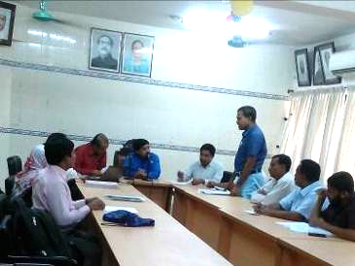
Photographs 6.2.1.1: Meeting at Comilla City Corporation for the formation of Grievance Redress Committee

Grievance Resolution Process
All complaints and suggestions will be received formally in the City Corporation Office by the GRC Member Secretary. A sample Grievance Redress Form has been prepared and already sent to Comilla City Corporation.
An intake register will be maintained at the office of the Member Secretary. Member Secretary will record the details of the grievances in the intake register for documentation and ensure impartiality, fairness, and transparency. The intake register will have data and information columns including (i) Case no., (ii) Date of receipt, (iii) name, type of complaint, grievance, (iv) father’s name, husband’s name, (v) sex, (vi) complete address of the person raising the complaint, grievance, (vii) main objection (loss of land, property, or entitlement), (viii) detailed complaint story, (ix) expectation with documentary evidence and previous records of similar grievances, etc.
No GRC members are allowed to contact the aggrieved persons in advance. Rather, the concerned persons are informed to attend the formal hearings at an appointed date. The GRC committee will sit for hearing the complaints of the aggrieved persons. The GRC will record salient points presented by the aggrieved person and will examine documentary evidence submitted during informal hearings. A resolution register will be maintained by the Member Secretary at the City Corporation Office. The resolution register will contains (i) serial no., (ii) case no., (iii) name of complaint, (iv) complaint story and expectation, (v) date of hearing, (vi) date of field investigation (if any), (vii) results of hearing and field investigation, (viii) decision of GRC, (ix) progress (pending, solved) and (x) agreement or commitments. Closing register will keep records such as, (i) serial no., (ii) case no., (iii) name of complaint, (iv) decision and response to complaints, (v) mode and medium of communication, (vi) date of closing, (vi) confirmation of complainant’s satisfaction, and (vii) management actions to avoid recurrence.
The GRC will decide within 30 days of receiving a complaint. There will also be an appeals procedure where, if a person is dissatisfied with the ruling of the GRC, he or she or a representative may attend their next meeting to present the case again. The committee will then reconsider the case in private, after which their decision is final. If the appellant is still not satisfied, he or she has the right to take the case to the public courts. A person will also be responsible in the PMU to record of all the grievance cases and examine these for recurring complaints and solutions, as well as to incorporate these complainants in the relevant reports. LGED and Comilla City Corporation should also publish the outcome of cases on public notice boards. All costs involved in resolving the complaints (meetings, consultations, communication and information dissemination) will be borne by the PIU of Comilla City Corporation.
Based on consensus, this procedure will help to resolve issues or conflicts amicably and quickly, saving the aggrieved persons from having to resort to expensive, time consuming legal action. The procedure will however, not pre-empt a person’s right to go to the courts of law.

Institutional Arrangement for Safeguard Compliance
In the institutional arrangement procedure, Project Director, Team Leader/Deputy Team Leader will directly involve. The PD, TL/DTL would be supported by DSM Environmental Safeguard Specialist and Social Management Expert. The City Corporation Officials, especially members of Infrastructure Improvement Section, would be responsible for supporting the construction supervision as well as environmental and social management with the facilitation of DSM consultants. The civil works contractors will implement the environmental mitigation measures.
The PMU, with the facilitation of Environmental Safeguard Specialist and Social Management Specialist will submit the monthly and quarterly progress reports on Environmental and Social Compliances to World Bank.
PD-MGSP
TL/DTL-DSM
Environmental Safeguard Specialist-DSM
Social Management Specialist-DSM
Senior Municipal Engineer-DSM
Junior Environmental Specialist-DSM
Assistant Municipal Engineer-DSM
Social Management Officer-DSM

City Corporation Representative /Engineer/Focal point

Contractor
Figure 6.3.1: Environmental and Social Management Team (Tentative)

Capacity Building
A demonstration training program has already been conducted by PMU and DSM in Comilla City Corporation to build the capability of the PIUs concern and DSM field staffs. Participants from Comilla City Corporation were attended. Under the demonstration training program, PMU and DSM organized an introductory course for training the Comilla City Corporation and other Pourashava Officials, preparing them on: (i) Environmental Screening, (ii) EMP Implementation, including environmental monitoring requirements related to mitigation measures; and (iii) taking immediate action to remedy unexpected adverse impacts or ineffective mitigation measures to be found during the course of the implementation.
A separate capacity building workshop should be conducted for the Comilla City Corporation Officials, members of Infrastructure Improvement Section and DSM Consultants. The contractor should be also included in the training program to enhance the Environmental awareness and orientation among the workers. A detailed training manual has already been developed by the Environmental Safeguard Specialist and Social Management Expert prior to the demonstration training program in Comilla region. Hence, the existing manual will be reviewed and modification will be done as per requirement.
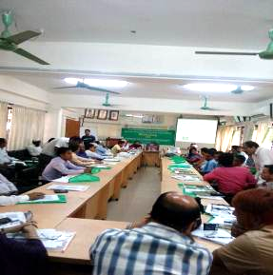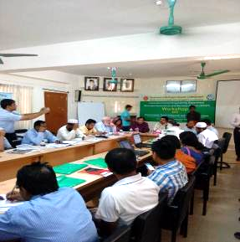
Photographs 6.4.1: Demonstration Capacity Building Workshop for Comilla region at Comilla City Corporation

Emergency Response and Disaster Management
Disaster management can be defined as the organization and management of
resources and responsibilities for dealing with all humanitarian aspects of emergencies, in particular the preparedness, response, and recovery to lessen the impact of disasters. Emergency Preparedness Planning (EPP) and Contingency Planning (CP) are the processes of disaster management plan for developing strategies, arrangements and procedures to address the humanitarian needs of those adversely affected by the crisis. There are four main types of disasters, namely: Natural disasters, Environmental Emergencies, Complex Emergencies, and Pandemic Emergencies.

For subproject activities, Comilla City Corporation would identify the immediate needs, prioritize the tasks and identify resource requirements to address the humanitarian needs of those adversely affected by the crisis.

Environmental Management Action Plan
The activity wise anticipated environmental impacts and corresponding mitigation measures have been outlined in Table 6.6.1 and 6.6.2.
Table 6.6.1: Anticipated Environmental Impacts during Construction Phase and Corresponding Mitigation and Enhancement Measures (EMP Table)
Activity / Issues | Potentials Impacts | Proposed Mitigation and Enhancement Measures | Responsible Parties
Construction and operation of labor shed for workers | - Generation of sewage and solid waste may cause degradation of the surrounding environment | - Construction of sanitary latrine considering 15 persons for one toilet at the labor shed and separate toilet for male and female;  - Erection of “no litter” sign, provision of waste bins (introduce separate waste bins for organic and inorganic wastes);  - Ensure wastes (solid wastes and other forms of wastes) disposal at the Jhakuni para/ Moilakhola dumping site. | Contractor  Monitoring-  Primarily by  City Corporation  Secondarily by PMU, LGED and DSM
Construction and operation of labor shed for workers | - Health of workers | - Conduct formal and unofficial discussion to increase awareness about hygiene practices among the workers;  - Ensure availability and access to first-aid equipment and medical supplies for the workers.
Construction and operation of labor shed for workers | - Possible development of labor camp into permanent settlement | - Contractor to remove labor camp at the completion of contract.
Construction and operation of labor shed for workers | - Outside labor force causing negative impact on health and social well-being of local people | - Ensure that contractor employ local work force to provide work opportunity to the local people and conduct formal and unofficial awareness program for the health and social well-being of the local people.
General construction works | - Drainage congestion and flooding | - Ensure provision for adequate drainage of storm water if needed;  - Ensure provision for pumping of congested water if needed;  - Ensure adequate monitoring of drainage effects, especially if construction works are carried out during the wet season. | Contractor  Monitoring-  Primarily by  City Corporation  Secondarily by PMU, LGED and DSM  Contractor  Monitoring-  Primarily by  City Corporation  Secondarily by PMU, LGED and DSM  Contractor  Monitoring-  Primarily by  City Corporation  Secondarily by PMU, LGED and DSM
General construction works | - Air pollution | - Check regularly and ensure that all the subproject vehicles are in good operating condition;  - Ensure contractor spray water on dry surfaces regularly to reduce dust generation;  - Maintain adequate moisture content of the soil and sand used for transportation, ISG, bed preparation, compaction and backfilling;  - Ensure contractor sprinkle and cover stockpiles of loose materials (e.g., fine aggregates);  - Ensure contractor avoid use of equipment at site and far from the local residents, which produce significant amount of particulate matter.
General construction works | - Traffic congestion, effect on traffic and pedestrian safety | - Ensure schedule deliveries of materials/ equipment during off-peak hours;  - Place traffic sign/cautionary sign to avoid undue traffic congestion and associated traffic control measures to avoid possible disruption;  - Inform the local people about the subproject activities.
General construction works | - Noise pollution | - In front of the road side educational institute, construction work should be performed after school and or in holiday;  - Check and maintenance the equipment properly;  - Avoid using of construction equipment producing excessive noise at night;  - Regulate use of horns and avoid undue use of hydraulic horns in subproject vehicles.
General construction works | - Water and soil pollution | - Prevent discharge of fuel, lubricants, chemicals, and wastes into adjacent water bodies (Guingadhari Canal, ponds, drains, irrigation springs and ditches).
General construction works | - Felling of trees, clearing of vegetation and ecological disturbances | - 1000 nos. of indigenous species of medicinal and inherent species of timber trees will be replanted to compensate the felling trees--replant the trees at the both sides of the road where space is available and subproject influence area.
General construction works | - Accidents | - Conduct formal and informal discussion for creating awareness about the accidents;  - Provide PPEs and ensure using of the personal protective equipment by the workers.
General construction works | - Spills and leaks of oil, toxic chemicals | - Proper handling of lubricating oil and fuel so that it does not fall on the soil and water body;  - Collection, proper treatment, and disposal of the spills.
All construction works | - Beneficial impact on employment generation | - Employ local people in the subproject activities as much as possible;  - Give priority to poor people living within project area in subproject related works (e.g., excavation and other works, which do not require skilled manpower).
All construction works | - General degradation of the environment | - Ensure environmental enhancement measures such as - tree plantation, landscaping, traffic/ cautionary sign will be provided.
Environmental impacts due to the key construction activities and corresponding mitigation measures for the BC road
Dismantle work/ Excavation/ Earth work/ | - Generation of solid and construction wastes due to the dismantle works;  - Generation of loose soil due to the earth excavation work. | - Cover exposed earth works with fabric;  - Disposal of soil and construction wastes at Jhakuni para/ Moilakhola dump site.
ISG (Improved Sub grade)/ Sand filling | - Air and dust pollution affecting nearby settlements | - Maintain adequate moisture content of soil during transportation, compaction and handling;  - Carry the materials especially loose soil and sand with adequate cover.
Setting up and operation of asphalt plant | - Possible degradation of the air quality by the suspended particles and increase of the noise level from asphalt plant affecting nearby settlements; | - Locate plant away from residential settlements;  - Consider use of emulsified bitumen.
Setting up and operation of asphalt plant | - Possible water pollution by bitumen and solvents; | - Avoid spills and proper collection and disposal of the generated spills.
Setting up and operation of asphalt plant | - Possible preparation of the bitumen in open air and using of charcoal and wood as fuel. | - Strictly prohibit bitumen preparation in the open air and use of charcoal and wood as fuel.
Environmental impacts due to the key construction activities and corresponding mitigation measures for the RCC drain, RCC culverts and RCC road protection wall
Dismantle of the existing drains/ Excavation work for the drain, culverts, road protection wall | - Generation of solid & construction wastes due to the dismantle works;  - Generation of debris and sediments/ clay soil due to the earth excavation work. | - Disposal of soil and construction wastes at Jhakuni para/ Moilakhola dumping site;  - Cover exposed earth works with fabric. | Contractor  Monitoring-  Primarily by  City Corporation  Secondarily by PMU, LGED and DSM  Contractor  Monitoring-  Primarily by  City Corporation  Secondarily by PMU, LGED and DSM
 | - Possible damage of road side infrastructure due to earth excavation for drain construction | - Ensure drum sheet palisading work for shallow depth to stabilize the structure;  - Ensure plunk palisading work for shallow depth to stabilize the structure;  - Ensure bolly drive or similar protective works to stabilize the structure.
 | - Accidents | - Operate the hydraulic excavator carefully;  - Operate the hammer carefully for the dismantle work.
 | - Air pollution | - Regular maintenance of the equipment to avoid black smoke emission.
Back filling work for drain, culverts and road protection wall | - Air and dust pollution affecting nearby settlements | - Maintain adequate moisture content of soil during transportation, compaction and handling;  - Carry the materials especially loose soil and sand with adequate cover.
Cutting and welding of the reinforcement | - Noise pollution due to rod cutter and welding machine if any | - Avoid using of steel cutter and wielding machine at night;  - Avoid prolonged exposure to noise (produced by equipment) by workers.
Cutting and welding of the reinforcement | - Potential health and safety risks from rod cutter and welding machine if any | - Ensure use of the personal protective equipment’s (helmet, goggles, gloves, safety boot);  - Availability and access to first-aid equipment and medical supplies in case of any accidents.
RCC (reinforcement concrete) work | - Air pollution due to black smoke emission from concrete mixer machine and vibrator machine | - Regular maintenance of the concrete mixer and vibrator machine to avoid any black smoke emission.
RCC (reinforcement concrete) work | - Noise nuisance from concrete mixer machine and vibrator machine | - Avoid operation of the concrete mixer and vibrator machine at night;  - RCC work should be avoided at schooling time;  - Inform local people about casting work and potential impacts.
Environmental impacts due to the key construction activities and corresponding mitigation measures for the street light
Setting up the pole and electrical connection | - Potential health and safety risks; | - Inform the local authority to switch off power during connection;  - Ensure use of the PPEs.
Source of electricity and equipment | - Reduce of resource i.e. use of electricity. | - Provision of renewable energy (solar panel electrification) and use of environmental friendly equipment (LED bulb rather than CFL bulb).

Table 6.6.2: Anticipated Environmental Impacts during Operational Phase and Corresponding Mitigation and Enhancement Measures (EMP Table)
Activity / Issues | Potentials Impacts | Proposed Mitigation and Enhancement Measures | Responsible Parties
Operation of the BC road | - Increase in traffic speed and accidents;  - Increased traffic congestion due to movement of increased number of vehicles;  - Damage to road by movement of heavy vehicles; spillage of water to bitumen road surface. | - Better traffic management;  - Avoid movement of heavy loaded vehicles that may exceed the load carrying capacity of the road;  - Avoiding spillage of water on road from vehicles carrying fish/ fresh produce (through monitoring, creation of awareness). | Monitoring-  Primarily by  City Corporation  Secondarily by PMU, LGED
Operation of the BC road | - Increased air and noise pollution affecting surrounding areas | - Traffic management, increased vehicle inspection
Operation of drain | - Pollution of downstream water body due to disposal of polluted water from the drain | - Ensure installation of septic tank by the household people in all establishment;  - Stop connecting sanitation facilities to storm drain directly.
Operation of drain | - Blockage in the drain due to disposal of solid waste/ debris | - Creation of awareness; stop throwing of the wastes materials in to drain by the community people;  - Regular maintenance / cleaning of drain.
Operation of drain | - Possible backflow of water through drainage canal causing water logging | - Proper maintenance and cleaning of the drain at regular basis;
Operation of drain | - Possible degradation of the water quality | - Raising awareness among the beneficiaries, "Do not through solid waste and plastics into the water body".
Operation and maintenance for street light | - Accident due to collapse of the arms, electric bulbs and poles; | - Monthly checking and maintenance of the arms, switch box, electric bulbs; if needed;  - Provision of automatic shut-down the switch, lamps during thunder storm and other natural disasters.
Operation and maintenance for street light | - Traffic congestion, traffic problems for maintenance works; | - Schedule deliveries of materials/ equipment during off-peak hours;
Operation and maintenance for street light | - Beneficial impact on employment generation for maintenance works. | - Engage local people for the maintenance activities.

Environmental Monitoring Plan

Environmental Monitoring Plan will help to evaluate the extent and severity of environmental impacts against the predicted impact and the performance of environmental protection measures. The following Table 6.7.1 has been prepared for the key environmental indicators.

Table 6.7.1: Matrix Table of Monitoring Plan (Visual and observation at construction phase)
Monitored Parameter/ Issues | Monitoring method/ Key aspects | Location of monitoring | Period & Monitoring Frequency
Safety orientation & training of workers | - Frequency of training & orientation of workers for safety | Subproject site | - Once in a month  - Reporting: Once in a month
Personal Protective Equipment and safety equipment | - Ensure every single person involved in the activities wear and use safety equipment | Subproject site | - Daily  - Reporting: Once in a month
Worker’s health | - Monitoring process of worker’s health | Subproject site | - Daily  - Reporting: Once in a month
Sanitation & drinking water facility to the workers | - Availability of safe drinking water and sanitation to the workers | Subproject site | - Daily  - Reporting: Once in a month
Incident record & reporting | - Documented record of all incident, accident, near misses and its remedial process | Subproject site | - Daily  - Reporting: Once in a month
Site security | - Isolation of site from general access | Subproject site | - Daily  - Reporting: Once in a month
Bulletin/ announcement boards/ prohibition signs | - Visible in good condition or not | Subproject site | - Daily  - Reporting: Once in a month
Equipment /vehicles | - Switched-off diesel engines when not in use;  - Search any possible leakage;  - Fuelling. | Subproject site | - Daily  - Reporting: Once in a month
Dust | - Dust is visible or not | Subproject site | - Daily  - Reporting: Once in a month
Oil waste generation and disposal | - Quantity of oily waste, storage and disposal | Subproject site | - Daily  - Reporting: Once in a week
Solid waste generation | - Quantity of solid wastes and disposal | Subproject site | - Daily  - Reporting: Once in a month
Drainage facilities | - Provision of open /closed surface drainage | Subproject site | - Monthly  - Reporting: Once in a month
Gender equity | - No discrimination regarding payment | Subproject site | - Daily  - Reporting: Once in a month
Child labor | - No child will be engaged in the activities | Subproject site | - Daily  - Reporting: Once in a month
Handling of hazardous materials | - Fuelling, storage, operation | Subproject site | - Daily  - Reporting: Once in a month
In addition, a comprehensive Environmental Compliance Monitoring checklist has been enclosed in Appendix-I.

Environmental Management Budget

Considering the environmental impacts and their mitigation measures for this subproject, several items are included in the BOQ for environmental budget. The estimated cost for implementing the EMP is elaborated in Table 6.8.1.
Table 6.8.1: Environmental Management Budget
Item No. | Description of Item | Costs (Tk)
eme-1 | - Dust suppression measures by water spraying throughout the construction period in and around the subproject site, uncovered aggregates and loose materials such as stockpiles of the sands, excavated earth etc. | 15,000.00
eme-1 | - Dust suppression measures for BC road by water sprinkling (it includes water sprinkling for overall BC road construction works that includes-ISG, WBM, ASG and subgrade) | 10,000.00
eme-5 | Prevention of the spillage, leakage of the polluting materials (Lump sum) | 5,000.00
eme-6 | Wastes disposal facility for the Labor shed during the construction period (collection, transportation, and dumping of the wastes at authorized dumping site at Jhakuni Para: 2 nos. (1 no. for the organic wastes and 1 no. for the inorganic wastes disposal facility) | 40,000.00
eme-7 | Water supply facilities (for the Labor shed and work site):1 no. tube well at the Labor shed (depending on the site condition the contractor will select the option) | 20,000.00
eme-8 | Sanitation facilities (at the Labor shed): 2 nos. toilets preferably portable toilets (1 no. for women and 1 no. for men) | 40,000.00
eme-9 | Providing safety gear packages like hand gloves, spectacles for eye protection, helmets, masks, visible jacket, rubber shoes for at least 20 persons and one first aid box | 62,500.00
eme-11 | Tree plantation (where space is available at both sides of the road and anywhere suitable places in the influence area of the subproject) to compensate the felled trees preferably local fruits, flowers, medicinal and ornamental trees-Mango, Jackfruit, Jam, Apple Wood Tree, Neem, Amloki, Horitoki, Bohera, Arjun, Sonalu, Jarul, Polash, Krisnachura, Bokul, Debdaru, Kadam, Mahogany, Segun, Satim, Rain Tree, Akashi, Banyan Tree (including protection, fencing and conservation during project defect liability period-fencing as per drawing) 1000 nos. of the trees @ 3m c/c | 1,00,0000.00
eme-14 | Cautionary signs (detailed design will be given prior to the works)- 4 nos. | 10,000.00
 | Total | 1,202,500.00

After approval to revise the cost estimate has lengthy complex procedure. Hence, as per project EMF, PMU suggestion and experience from other LGED projects, adequate budget has been allocated for the environmental management for the mitigation and enhancement measures. The subproject activities such as earth work, sand filling, black smoke emission from the subproject vehicles & equipment, preparation of bitumen mix etc. may degrade the air quality in the subproject area. In addition, mechanical compactor, hydraulic excavator, mixer machine, vibrator machine, asphalt plant, drum truck, paver and subproject vehicles generate noise nuisance to the surrounding area. For this subproject, there is no provision of the analytical monitoring for air quality and noise level because air quality and noise data from the previous subproject (MGSP/CCC/2016-2017/W8) can be used as a baseline data to evaluate the impacts.
To compensate the felled down trees and to enhance the ecological condition, adequate budget for tree plantation is also included. The budget for labor shed and site office construction is included in the civil works items. Therefore, it is not included in the environmental budget. It should be noted that the contractor will be paid as per actual work done.

Public Consultation and participation

Methodology

In the context of preparing the Environmental Assessment (EA), participatory public consultation was conducted in the subproject site. The City Corporation Mayor, Officials, Engineers and local individuals as well as LGED and Consultant participants participated. Informal Focus Group Discussions (FGD) and a formal CIP were conducted involving the participants. In addition, walk-through informal group consultations were also held. The local communities were informed about subproject interventions including their benefits. Suggestions made by the participants were listed and incorporated in the EMP accordingly.
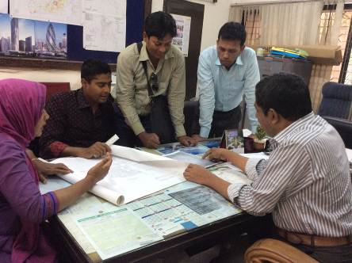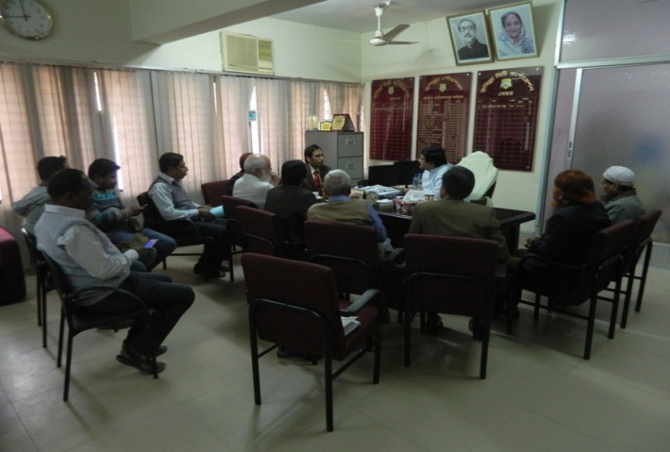
Photographs 7.1.1: Consultation Meeting at Comilla City Corporation with Mayor, other Officials, WB and DSM Consultants Participants
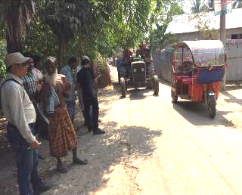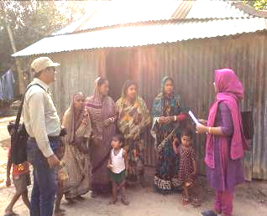
Photographs 7.1.2: Consultant Team Visited the Sites with City Corporation Representatives

Issues Raised by the Participants

The participants raised the issues related to the infrastructure development of Comilla City Corporation. They emphasized on the subproject selection for the future development and also discussed about the procedure for the quality construction work. In the FGD, the participants discussed the requirements for the City Corporation's future development through a list of the subprojects. The participants also emphasized on minimization of the environmental impacts during construction phase.

Feedback, Suggestions, and Recommendations of the Participants

The participants were presented with feedback, suggestions, and recommendations listed below:
- The FGD results confirmed that an improved communication network is needed for future development of Southern part of Comilla City Corporation;
- The participants stated that the water supply facilities, sanitation facilities, and access road is inadequate;
- The participants suggested City Corporation Officials to ensure quality construction works by the contractors;
- The participants also suggested that construction works should be scheduled properly to avoid any undue disturbances to the nearby people;
- The participants stated that the construction work should be performed following the EMP to minimize air quality degradation, noise level and solid waste generation;
- The participants emphasized on the capacity building workshops to enhance knowledge.

Conclusions and Recommendations

This study has described in details the existing environmental conditions of the subproject area. This study has identified the significant environmental impacts that may be generated during the construction and operational phases of the subproject. The effort has been given for identifying possible sources of the environmental impacts through details investigation of the subproject site, key subproject activities and assigned equipments to be used for the subproject activities. From the study it is revealed that the subproject intervention has significant ecological impact due to felling of the 575 trees. However, 1000 trees will be planted to compensate the felled down trees. From the comprehensive study it has been also revealed that impacts are expected to be largely manageable, if they are acknowledged and addressed with appropriate mitigation measures-such measures are also included in this report. However, a few key recommendations, as outlined below.
- EMP should be available at the subproject site during construction period;
- Regular field visit by PMU, DSM and City Corporation is needed for the effective implementation of the EMP;
- All mitigation, compensation, and enhancement measures should be followed as per EMP;
- Monitoring should be conducted as per EMP;
- An efficient line of communication between the PMU (LGED), City Corporation, DSM and the contractors is needed;
- To minimize occupational health and safety risks, it is highly recommended to adapt mechanical system where appropriate;
- Contractor will ensure availability of the PPEs for the workers;
- Contractor will ensure first aid box, water supply and sanitation facilities for the workers;
- Contractor will monitor the workers behavioral matter to avoid any undue issues related to labor influx;
- Planted trees should be properly maintenance by the contractor during project liability period.
It should be noted that environmental assessment report is a live document. Hence, due to changing circumstances during the construction phase if any, there might be minor adaptation needed for environmental, health and safety issues.

APPENDIX

Appendix I: Environmental Monitoring Checklist

