SUBPROJECT DESCRIPTION

Subproject Background

Comilla City Corporation was established in the year of 2011. The City Corporation covers an area of 53.04 square kilometer. The current population of Comilla City Corporation is about 500,000. (Source: Comilla City Corporation website)

With the increasing population and rapid urbanization, Comilla City Corporation requires continuous infrastructure development. Hence, as a part of the road infrastructure development work, this subproject under MGSP is actively contributing Infrastructure development of Comilla City Corporation by providing road safety. Under this subproject, road protection wall will be constructed from Race Course to Old Dhaka-Chittagong Highway by the side of Race Course Khal.

The significant features of the subproject are mentioned below:
Name of the Subproject: | Construction of Road Protection Wall from Race Course to Old Dhaka-Chittagong Highway (Ch. 0+000 to 0+900m)
Package No.: | MGSP/CCC/2016-17/W-10
District Name: | Comilla
ULB Name: | Comilla City Corporation
Jurisdiction Area: | Ward Number 3
Structural Design Option: | Road Protection Wall
Beneficiary Population: | About 30,000 as per information by the City corporation
Tribal People: | No tribal people settlement found in the subproject area
Land Acquisition: | No land acquisition is needed.
Estimated Cost: | 31.652 million in BDT
Subproject Duration: | 6 Months
Tentative Start Date: | 14 October 2017
Tentative Completion Date: | 13 April 2018

For the preparation of subproject appraisal, environmental screening has been performed. According to that screening, an environmental management plan is required. Hence, this environmental management plan is prepared to meet the regularity requirement. This plan simplifies the impact assessment and mitigation measures for easy understanding of the personnel responsible for the subproject implementation. Therefore, this study only includes key contents that are appropriate.

The Study Area

The subproject site is situated within the jurisdiction of the Ward no. 3. The starting point of the subproject is located at Race Course and end point is located at Dhaka-Chittagong Highway. The study area is mostly built-up and developed area. The location map and topographic view of the subproject are shown in Figure 1.2.1 and Figure 1.2.2.
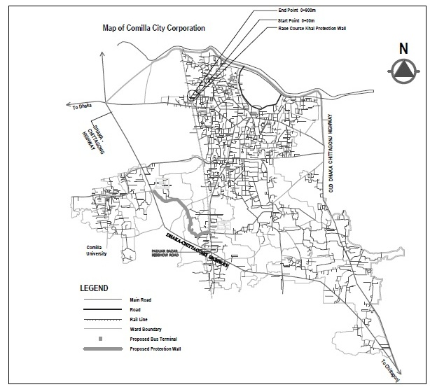
Figure 1.2.1: Location Map of the Subproject
The subproject area is fundamentally built-up and central area of the municipality. From Jautala to Kather Pul box culvert the road goes through the residential & commercial area, where different Govt. and Non-Govt. agencies, educational institutions and religious centers including semi-pucca, pucca and tin-shed structures dominate other features.

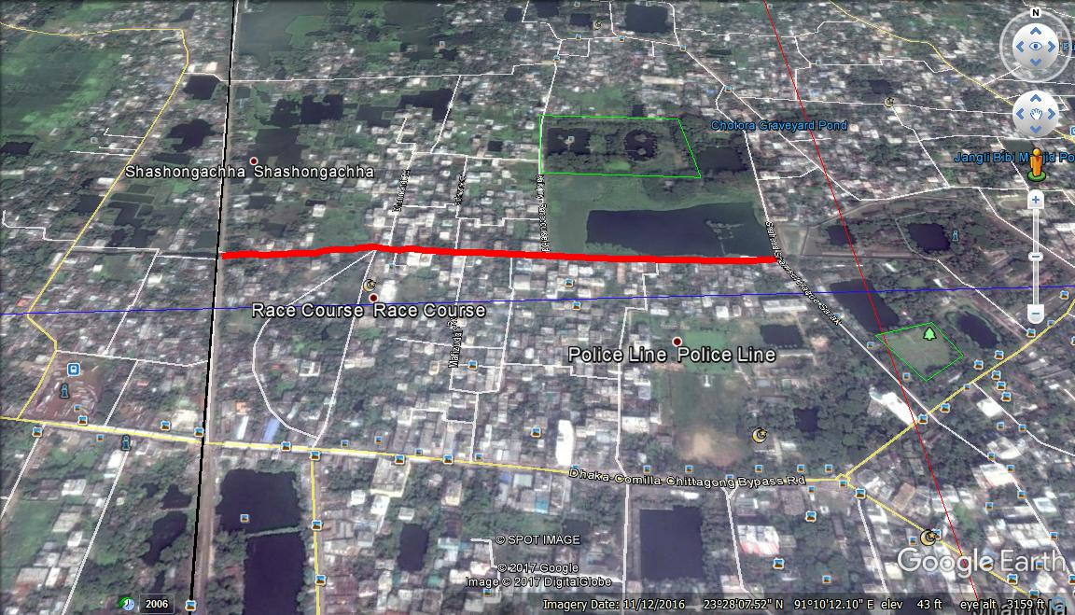

Figure 1.2.2: Topographic View of the Subproject

Current Situation, Proposed Intervention and Need for the Subproject

The Race Course Khal is one of the largest canals aligned from east side toward west side of Comilla City Corporation. Jautala culvert near Abdul Gofur’s house is located beside the Race Course Khalpar Road. Storm and domestic water as well as waste water from the market area discharge in to this canal. During rainy season, flood water overflows and erodes the right side of the roadway embankment. Bank erosion of this Khal is very common. Bank erosion damages the soft shoulder which causes pavement failure of the Khalpar Road. The failure of the pavement increases the maintenance cost. The failure of the pavement also fills up the canal. It reduces the discharge carrying capacity of the Khal. This causes water logging problem in the nearby area. On the other hand, traffic congestion takes place due to water logging on the road particularly in the rainy season.

RCC and drum sheet palisading was constructed in some stretches at the side of the canal but it fails to protect the bank. Therefore, it interrupts normal traffic operation and pedestrians’ safety. The situation is more vulnerable due to throwing of the solid wastes by the local people in the canal.

A set of activities aimed for strengthening and protecting the Race Course Khal Bank. RCC retaining wall is not suitable for this subproject. Construction of the base of the retaining wall requires excavation along the bank of the canal. This may cause slides in roadway embankment resulting interruption to the traffic flow. On the other hand, it is not possible to bailing out of the water from any particular section of this Khal to prepare working place.
To avoid this situation, it is proposed to drive precast piles along canal bank. RCC tie beam from top of each precast pile will be provided up to the 250mm dia small auger bored RCC peg at the rate of 3m c/c. Precast RCC plunk will be driven along piles at canal bank to protect the roadway embankment. In addition, stainless steel railing over retaining wall will be provided for pedestrian and traffic safety.

The existing condition of the subproject site is further elaborated from the following Photographs 1.3.1.
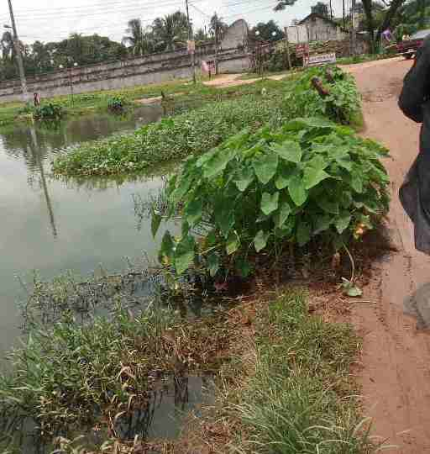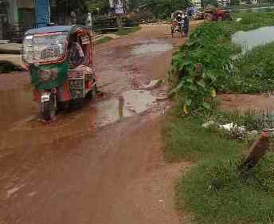

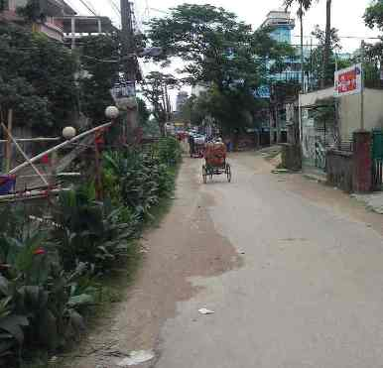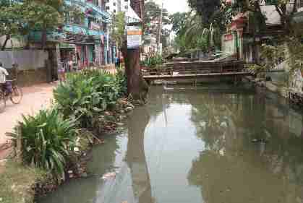

Photographs 1.3.1: Present Situation of the Subproject Site

Race Course Khalpar Road is very important because it passes through a densely populated area of Comilla City Corporation. Many offices, NGOs, educational institutions, and inhabitants around the area will benefit due to easy access to their establishments. If the Khal bank is protected, the durability of the Khalpar Road will be increased.

After completion of the construction work, trees will be planted at the suitable locations. This will improve the environmental condition of the area. Furthermore, it is planned to provide numerous waste collection bins in the market area beside the canal protection work so that people can dispose their solid wastes there. This will reduce throwing of the wastes materials in to the Khal.

Envisaged Subproject Activities and Implementation Process

The general activities for the subproject includes: construction of the semi-pucca site office, construction of the labor shed, relocation of the electric poles, telephone poles and GI poles and site clearing & grubbing works.
The key activities of the road protection work include:

- Earth excavation work;
- Sand filling on the preparation of the foundation bed;
- Laying polythene sheet;
- Single layer brick flat soling;
- Plain cement concrete work;
- Brick work;
- Sand filling behind brick work;
- Boring for 250mm dia cast-in-situ pile;
- Fabrication of the ribbed or deformed bar;
- Reinforced cement concreting work for cast-in-situ pile work;
- Driving of the precast piles;
- Casting work for grade beam;
- Stainless steel pipe on protection wall as railing.

The materials to be used for the key activities: soil in earth work, sand, bricks, bricks chips, stone chips, cement, reinforcement bar, stainless steel pipe.
The major equipments to be used for the implementation of the subproject: concrete mixer machine, mechanical vibrator machine, dump truck, steel cutter.
The total length of the proposed road protection wall is 900m. The precast 6m pile will be driven at 3 m c/c. The size of the RCC tie beam is 200mm × 200mm. With the plaster, the thickness of the brick wall is 250mm.

ENVIRONMENTAL SCREENING

Environmental Screening (ES) for the subproject have been conducted with the purpose of fulfilling the requirements of GOB and WB. ES ensures that environmental issues are properly identified in terms of extent of the impacts. Environmental Screening Checklist, as adopted in Appendix C of the Environmental Management Framework of the MGSP, was administered for identifying the impacts and their extents.
The screening data and information for the road protection wall have been formulated and are shown in below.
(1) Potential environmental impact during construction phase:
- Ecological impacts:
Nil
- Felling of trees Significant □ Moderate □ Minor □√ Number of trees
- Clearing of vegetation Significant □ Moderate □ Minor □√
- Potential impact on species of Significant □ Moderate □ Minor □√
aquatic (i.e., water) environment
There is no tree to be felled down. In addition, vegetation coverage is not significant. Hence, clearing of the vegetation is minor. Since, the road protection wall will be constructed at the road side area. Hence, subproject activities do not have any direct impact on the aquatic environment. Therefore, anticipated impact on species of aquatic environment is also minor.
- Physicochemical impacts:

- Noise Significant □ Moderate □√ Insignificant □
- Air pollution Significant □ Moderate □ Insignificant □√
- Drainage congestion Very likely □ Likely □ Unlikely □ √
- Water pollution Significant □ Moderate □ Insignificant □ √
- Pollution from solid/ construction wastes Significant □ Moderate □ Insignificant □√
- Water logging Significant □ Moderate □ Insignificant □√
The precast pile will be driven for road protection work. Hence, it has impact on the noise. However, it is anticipated that generated noise due to pile driving work will be limited in the subproject boundary. The subproject activities do not have any significant impact on the other physicochemical parameters.
- Socio-economic impacts:

- Traffic congestion Very likely □ Likely □√ Unlikely □
- Health and safety Significant □ Moderate □√ Insignificant □
- Impact on archaeological and historical Significant □ Moderate □ Insignificant □√
- Employment generation Significant □√ Moderate □ Insignificant □

The precast pile will be driven for road protection wall and road protection wall will be constructed at the road side area. Hence, the subproject activities do not have any impact on the traffic congestion because it will not create any obstacle for the normal traffic. The construction work will follow simple procedure with commonly used equipment. Hence, anticipated impact on health and safety is moderate. There is no archaeological and historical site within the influence area. The subproject has positive impact by generating work opportunities for the local people and supplying of the construction materials, equipment, food and other necessary stuffs to the campsite.

(2) Potential environmental impact during operational phase:
(d) Ecological impacts:
- Potential impact on species of aquatic Significant □ Moderate □ Minor □√
(i.e., water) environment
The subproject does not have an impact on the aquatic environment during operation phase.
(e) Physicochemical impacts:
- Potential air quality and noise level Improvement □ No-improvement □ No Impact □√
- Drainage congestion Improvement □√ Minor Improvement □ No Impact □
- Risk of water pollution Significant □ Moderate □ Minor □√
- Pollution from solid waste Improvement □ No-improvement □ Minor □√
The subproject will minimize throwing of the waste materials in to the Khal. Thus, it will reduce environmental degradation caused by dumping of the wastes materials in the khal.
(f) Socio-economic impacts:
- Traffic Improvement □√ No-improvement Adverse □
- Safety Improvement □√ No-improvement Adverse □
- Employment generation Significant □ Moderate □ Minor □ √
After construction, the road protection wall will protect the road from erosion and subsidence. Consequently, it will enhance safety traffic operation and pedestrians’ movement.
(3) Summary of possible environmental impacts of the subproject:
The overall ecological impact due to the subproject implementation is minimal. The subproject has minimal impacts on the physico-chemical components. However, the subproject has considerable positive impacts on the socio-economic components by generation of the employment and the business activities for the local people. Nevertheless, safety concerns should be considered properly for the construction phases to avoid any potential safety risks.

RECOMMENDED MITIGATION AND ENHANCEMENT MEASURES

The activities wise anticipated environmental impacts and corresponding mitigation measures have been outlined in Table 3.1.
Table 3.1: Anticipated Environmental Impacts during construction phase and corresponding mitigation and enhancement measures (EMP Table)
Activity / Issues | Potentials Impacts | Proposed Mitigation and Enhancement Measures | Responsible Parties
Construction and operation of labor shed for workers | - Generation of sewage and solid waste; water/ environmental pollution | - Construction of sanitary latrine considering 15 persons for one toilet at the labor shed and separate toilet for male and female;  - Erection of “no litter” sign, provision of waste bins (introduce separate waste bins for organic and inorganic wastes);  - Ensure wastes (solid wastes and other forms of the wastes) disposal at the dumping site of Moilakhola Jhakuni Para. | Contractor  Monitoring-  Primarily by  City Corporation  Secondarily by PMU, LGED and DSM
Construction and operation of labor shed for workers | - Health of workers | - Conduct formal and unofficial discussion to increase awareness about hygiene practices among the workers;  - Ensure availability and access to first-aid equipment and medical supplies for the workers.
Construction and operation of labor shed for workers | - Possible development of labor camp into permanent settlement | - Contractor to remove labor camp at the completion of contract.
Construction and operation of labor shed for workers | - Outside labor force causing negative impact on health and social well-being of local people | - Ensure that contractor employ local work force to provide work opportunity to the local people and conduct formal and unofficial awareness program for the health and social well being of the local people.
General construction works | - Drainage congestion and flooding | - Ensure provision for pumping of congested water, if needed. | Contractor  Monitoring-  Primarily by  City Corporation  Secondarily by PMU, LGED and DSM  Contractor  Monitoring-  Primarily by  City Corporation  Secondarily by PMU, LGED and DSM
General construction works | - Air pollution | - Check regularly and ensure that all the subproject vehicles are in good operating condition;  - Ensure contractor spray water on dry surfaces regularly to reduce dust generation;  - Maintain adequate moisture content of soil and sand for transportation, compaction, bed preparation, backfilling and handling;  - Ensure contractor sprinkle and cover stockpiles of loose materials (e.g., fine aggregates).
General construction works | - Traffic congestion, effect on traffic and pedestrian safety | - Ensure schedule deliveries of materials/ equipment during off-peak hours;  - Place traffic/ cautionary sign to avoid undue traffic congestion and accidents;
General construction works | - Noise pollution | - Check and maintenance the equipment properly;  - Avoid using of construction equipment producing excessive noise at night;  - Regulate use of horns and avoid undue use of hydraulic horns in subproject vehicles.
General construction works | - Water and soil pollution | - Prevent discharge of fuel, lubricants, chemicals, and wastes into adjacent water bodies if any.
General construction works | - Accidents | - Conduct formal and informal discussion for creating awareness about the accidents;  - Provide PPEs and ensure using of the personal protective equipment by the workers.
General construction works | - Spills and leaks of oil, toxic chemicals | - Proper handling of lubricating oil and fuel so that it does not fall on the soil;  - Collection, proper treatment, and disposal of the spills.
All construction works | - Beneficial impact on employment generation | - Employ local people in the subproject activities as much as possible;  - Give priority to poor people living within project area in subproject related works (e.g., excavation and other works, which do not require skilled manpower).
All construction works | - General degradation of the environment | - Ensure environmental enhancement measures, such as traffic/ direction signs and cautionary signs.
Environmental impacts due to the key construction activities and corresponding mitigation measures for the RCC Works
Excavation / pile driving work | - Generation of loose and clay soil due to the earth excavation work | - Disposal of soil and construction wastes at the dumping site at Moilakhola Jhakuni Para.
Excavation / pile driving work | - Accidents | - Operate the machineries such as pile rig, drill machine etc. carefully;  - Operate the hammer carefully for the dismantle work.
Sand filling / Back filling work | - Air and dust pollution affecting nearby settlement | - Maintain adequate moisture content of soil and sand during transportation, compaction and handling;  - Carry the materials especially loose soil and sand with adequate cover.
Fabrication of the ribbed or deformed bar | - Health and safety and noise | - Ensure use of the PPEs;  - Use the hammer and other equipment carefully.
Cutting and welding of the reinforcement | - Noise pollution | - Avoid using of rod cutter and wielding machine at night;  - Avoid prolonged exposure to noise (produced by equipment’) by workers.
Cutting and welding of the reinforcement | - Health and Safety | - Ensure use of the PPEs;  - Availability and access to first –aid equipment and medical supplies
RCC work for piles, grade beam and column | - Air pollution | - Regular maintenance of the concrete mixer and vibrator machine.
RCC work for piles, grade beam and column | - Noise pollution | - Avoid operation of the concrete mixer and vibrator machine at night.

Environmental Monitoring Plan

Environmental Monitoring Plan will help to evaluate the extent and severity of environmental impacts against the predicted impact and the performance of environmental protection measures. The following Table 4.1 and Table 4.2 have been prepared for the key environmental indicators.
Table 4.1: Matrix Table of Monitoring Plan (Visual and observation during construction phase)
Monitored Parameter/ Issues | Monitoring method/ Key aspects | Location of monitoring | Period & Monitoring Frequency
Safety orientation & training of workers | Frequency of training & orientation of workers for safety | Sub-project site | - Once in a month  - Reporting: Once in a month
Personal Protective Equipment and safety equipment | Ensure every single person involved in the activities wear and use safety equipment | Sub-project site | - Daily  - Reporting: Once in a month
Worker’s health | Monitoring process of worker’s health | Sub-project site | - Daily  - Reporting: Once in a month
Sanitation & drinking water facility to the workers | Availability of safe drinking water and sanitation to the workers | Sub-project site | - Daily  - Reporting: Once in a month
Incident record & reporting | Documented record of all incident, accident, near misses and its remedial process | Sub-project site | - Daily  - Reporting: Once in a month
Site security | Isolation of site from general access | Sub-project site | - Daily  - Reporting: Once in a month
Bulletin/ announcement boards/ prohibition signs | Visible in good condition or not | Sub-project site | - Daily  - Reporting: Once in a month
Equipment /vehicles | - Switched-off diesel engines when not in use;  - Search any possible leakage;  - Fuelling. | Sub-project site | - Daily  - Reporting: Once in a month
Dust | Dust is visible or not | Sub-project site | - Daily  - Reporting: Once in a month
Oil waste generation and disposal | Quantity of oily waste, storage and disposal | Sub-project site | - Daily  - Reporting: Once in a week
Solid waste generation | Quantity of solid wastes and disposal | Sub-project site | - Daily  - Reporting: Once in a month
Drainage facilities | Provision of open /closed surface drainage | Sub-project site | - Monthly  - Reporting: Once in a month
Gender equity | No discrimination regarding payment | Sub-project site | - Once in a month  - Reporting: Once in a month
Child labor | No child will be engaged in the activities | Sub-project site | - Daily  - Reporting: Once in a month
Handling of hazardous materials | Fuelling, storage, operation | Sub-project site | - Daily  - Reporting: Once in a month

Table 4.2: Matrix Table of Monitoring Plan (Analytical Monitoring during construction phase)
Monitored Parameter/ Issues | Monitoring method /Key aspects | Location of monitoring | Period & Monitoring Frequency
Noise level | - Through digital instruments. | Project site | - Three times during construction phase;  - Reporting: Once in a month and immediately after measurement
In addition, a comprehensive Environmental Compliance Monitoring checklist has been prepared that is enclosed in Appendix-1.

Environmental MANAGEMENT BUDGET

Considering the environmental impacts and their mitigation measures for the subproject, several items are included in the BOQ for the environmental management. Table 5.1 presents the estimated cost for the environmental management.
Table 5.1: Environmental Management Budget
Item No. | Description of the Items | Costs (Tk)
eme-1 | Dust suppression measures by water spraying throughout the construction period in and around the subproject site if necessary and at stack yards for uncovered stockpiles of the aggregates and loose materials such as sands as per requirement. | 10,000.00
eme-3 | Noise level measurement- it can be measured from the recognized environmental survey company, public institute/ university three times during construction phase (Actual monitoring time and location will be decided by the DSM-Environmental Safeguard Specialist depending on the specific activities). | 15,000.00
eme-5 | Prevention of the spillage and leakage of the polluting materials (Detailed procedure will be given in the EMP) | 5,000.00
eme-6 | Campsite wastes disposal facility during the construction period (collection, transportation, and dumping of the wastes at authorized dumping site at Jhakuni Para: 2 nos (1 no. for the organic wastes and 1 no. for the inorganic wastes disposal facility) | 40,000.00
eme-7 | Campsite water supply facilities: Preferably 1 no. of tube well at the labor campsite (Depending on the site condition, DSM consultant will assist the contractor for selecting the option) | 20,000.00
eme-8 | Campsite sanitation facilities: 2 nos. of the toilets preferably sanitary toilets at the labor campsite (1 no. for women and 1 no. for men) | 40,000.00
eme-9 | Providing safety gear packages like hand gloves, spectacles for eye protection, helmets, masks, visible jacket, rubber shoes for at least 15 person and one first aid box | 47,500.00
eme-14 | Cautionary signs- 2 nos. | 5,000.00
MGSP-22 | Fabrication, supplying, fitting and fixing of the street waste bins as specified in the provided drawing & design-18 number of waste bins | 144,000.00
 | Total | 326,500.00

After approval to revise the cost estimate has lengthy complex procedure. Hence, as per project EMF, PMU suggestion and experience from other LGED projects, adequate budget has been allocated for the environmental management for the mitigation and enhancement measures. In the subproject activities, pile driving work and using of concrete mixer machine, mechanical vibrator and subproject vehicles may generate temporarily noise nuisance to the surrounding area. Hence, budget includes analytical monitoring for noise level. It is anticipated that the subproject activities do not have any significant impact on the air quality. Hence, this budget does not include analytical monitoring for the air quality. The budget for labor shed and site office construction is included in the civil works items. Therefore, it is not included in the environmental budget. It should be noted that the contractor will be paid as per actual work done.

CONCLUSIONS and Recommendations

The subproject activities do not have any adverse impact on the ecological and aquatic environment. During the construction phase, the subproject activities have localized and limited impacts on the physico-chemical components such as air quality, noise level and solid waste generation. However, it is anticipated that the impacts are significantly manageable through appropriate mitigation measures. Additionally, installation of the waste bins will significantly reduce throwing of the waste materials in to the Khal.
A few key recommendations are outlined below:

- City Corporation will ensure availability of the EMP at the site;
- Regular supervision by DSM consultants, City Corporation Officials and PMU, LGED is needed;
- Formal and informal consultation should be carried-out by PMU, LGED, DSM team, City Corporation Officials and Contractors regularly;
- Personal protective equipments and first-aid box with relevant medicine should be available at site office;
- Workforce environment and labor shed management should be monitored regularly.

Appendix 1: Environmental Monitoring Checklist

