INTRODUCTION

Subproject Background

Feni Pourashava is an old municipality of the South-eastern corner of Bangladesh, was established at 3rd October, 1958. At present, Feni Pourashava is "A" grade Pourashava. The Pourashava covers an area of 27.20 square kilometer (Feni Pourashava: At a glance). The current population of Feni Pourashava is about 1, 56,971 (Source: BBS 2011). Feni Pourashava has 236.55 km road network (including 91.25 km BC road, 54.50 km CC road, 26.00 km HBB & soling road, 8.24 km MES road and 13.56 km RHD road and 30.50 km katcha road. Feni Pourashava has 117.75 km drain network which includes 38.75 km RCC drain, 130.00 km brick drain and 49.00 km earthen drain (Feni Pourashava: At a glance). With the increasing population and rapid urbanization, Feni Pourashava requires continuous infrastructure development.

Under this subproject, RCC drain with cover slab (total length is 3730m ) will be constructed at Master Para and Bamon Pukur Road side, West side of Trunk Road including Link drain and South Side of Feni - Noakhali Road (Mohipal Bus Terminal to Panchgachi Khal). The name of the subproject is - (a) Construction of RCC Drain at Master Para and Bamon Pukur Road side; Part I: In front of Feni Jail Khana - Kanon Cinema Hall - Bentu Hazari Gymnasium Road, Ch. 0+00 to 0+250m; Part II: In front of Feni Pourashava to Master Para Road, Ch. 0+00 to +100m; Part III: Master Para Road and Bamon Pukur Road side (Shafiq Villa to Railway culvert), Ch. 0+00 to 0+410m; Part IV: Ramtara Shishu Park - Moulavi Bazar - Master Rafiqul Islam Road side drains up to Railway culvert, Ch. 0+00 to 0+350m and Part V: Rail line to Dhamdhama Khal, Ch. 0+00 to 0+150m, (Total length 1260m); (b) Construction of RCC drain at West side of Trunk Road including Link (Part I - Main drain: Ch. 0+00 to 0+900m, Part II - Link 1: Ch. 0+00 to 0+390m and Part III - Link 2: Ch. 0+00 to 0+075m; total length 1365m) and (c) Construction of RCC Drain at South Side of Feni - Noakhali Road (Mohipal Bus Terminal to Panchgachi Khal), Ch. 0+00 to 1+105m under Feni Pourashava. The significant features of the subproject are mentioned below:
Name of the Subproject: | - Construction of RCC Drain at different segments of Master Para and Bamon Pukur Road side, Total length 1260m;  - Construction of RCC drain at West side of Trunk Road including Link drain, Total length 1265m and  - Construction of RCC Drain at South Side of Feni - Noakhali Road (Mohipal Bus Terminal to Panchgachi Khal), Total length 1105m
Subproject Package No.: | MGSP/FNI/2016-2017/W-05
District Name: | Feni
ULB Name: | Feni Pourashava
Jurisdiction Area: | Ward Number 1, 2,13 and 18
Structural Design Option: | RCC cover Drain
Beneficiary Population: | About 27,881 (Source: Feni Pourashava Population and housing census, 2011)
Tribal People: | No tribal people settlement found in the subproject area
Land Acquisition: | No land acquisition is needed.
Estimated Cost: | 100.12 million BDT
Subproject Duration: | 12 months
Tentative Start Date: | 1 October, 2017
Tentative Completion Date: | 30 September, 2018

Objectives of the Study
The aim of the study is to examine the environmental impacts due to construction and operation of the subproject and formulate the environmental management plan to minimize the negative impacts and enhance the positive impacts.
The specific objectives include:
- To assess the existing environmental conditions of the subproject site and its adjacent areas in order to establish a baseline framework against which potential environmental impacts due to implementation of the subproject would be compared;

- To identify and assess impacts resulting from the subproject during its construction phase and operation phase;

- To develop a rational environmental management plan with recommendations for mitigating adverse impacts and enhancing positive impacts and outlining environmental monitoring requirements both during construction and operational phase of the subproject.

Scope and Methodology of the Study
The subproject appraisal is included environmental screening for the drain components. According to the screening environmental assessment is required to fulfill the regulatory requirement for RCC Drains with cover slab.

The study methodology comprised the following activities:
- Desktop study
- Field Investigation and Data Collection
- Data Analysis and Report Writing

Desktop Study
The desktop study involved:
- Initial meetings with client, stakeholders to discuss the proposed subproject, including subproject activities;
- Collection and review of the baseline data, maps, reports and other relevant information on the existing environmental and social conditions of the subproject area;
- Review the relevant existing legislation, regulation and policies;
- Understand the anticipated technical processes that may affect the environment.

Field Investigation and Data Collection

A team of the consultants made a field investigation to the proposed site. Field investigations involved mainly site walks within the subproject area and the neighboring areas that may be affected by the subproject. The following key tasks were performed during the field visit:
- Taking photographs of the significant aspects to assist in describing the baseline environmental conditions of the subproject area;
- Interviews with representatives of the relevant Pourashava officials, within the subproject area and interested and affected people within the subproject influence area;

- Obtaining relevant documents from the Pourashava and local people within the subproject influence area;

- Verifying information and data collected during the desktop study and to collect new information that may have been important in the assessment of the impacts and design of the mitigation measures.

Data Analysis and Report Writing
The data and information collected from all the sources (literature review, secondary and primary data, public consultation) were analyzed to describe the existing environmental setting of the subproject area, to identify the potential positive and negative impacts of the proposed subproject, as well as to provide preliminary suggestions for mitigation measures. Finally, this environmental assessment report has been prepared.

Subproject Description

The Study Area
The subproject is located in the Feni Pourashava within the Jurisdiction area of the Ward number 1, 2, 13 &18. This subproject comprises development of 3730m RCC drain at (a) Master Para and Bamon Pukur Road side at different segments; (b) West side of Trunk Road and (c) South side of Feni-Noakhali Road. The location map, topographical features and layout plan of the subproject are shown in Figure 2.1.1, Figure 2.1.2 and Figure 2.1.3 respectively.
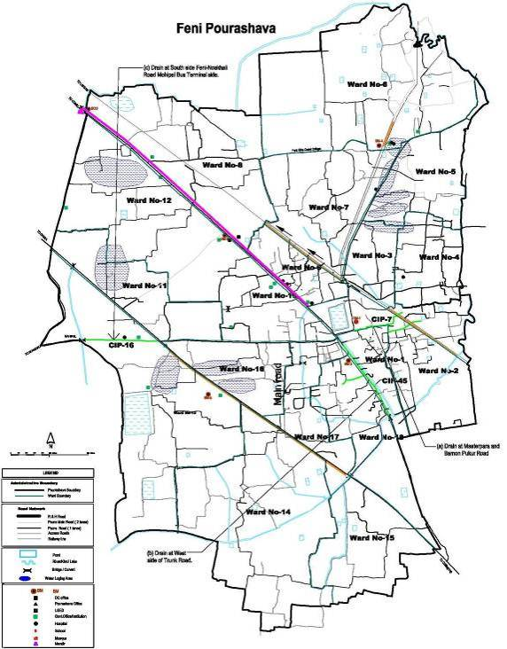
Figure 2.1.1: Location Map of the Subproject
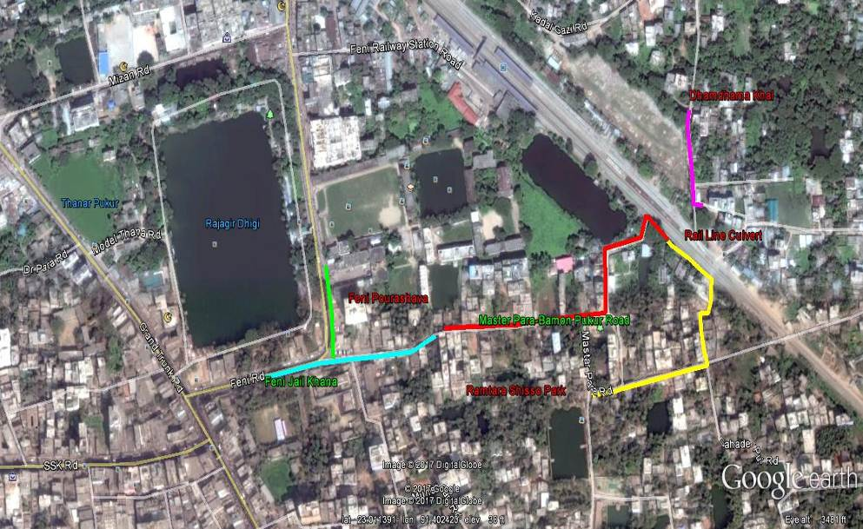
Figure 2.1.2 (a): Topographical Features of the Subproject at different segments of Master Para and Bamon Pukur Road side
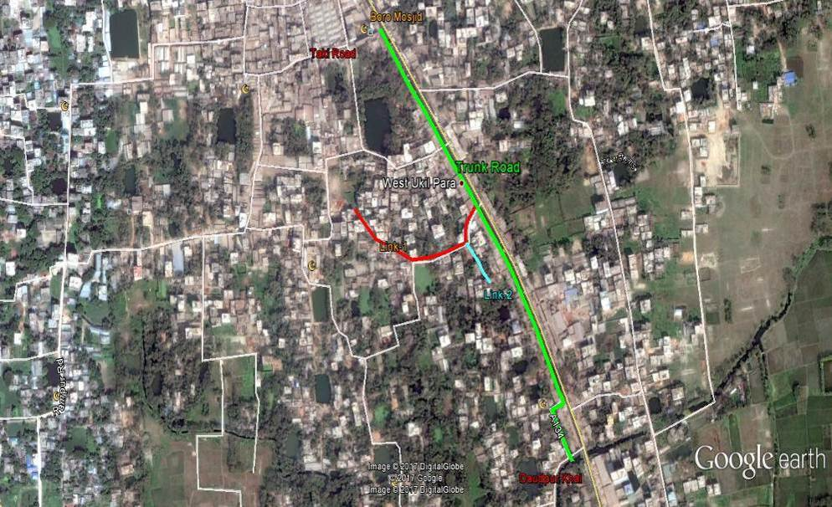
Figure 2.1.2 (b): Topographical Features of the Subproject at West side of Trunk Road
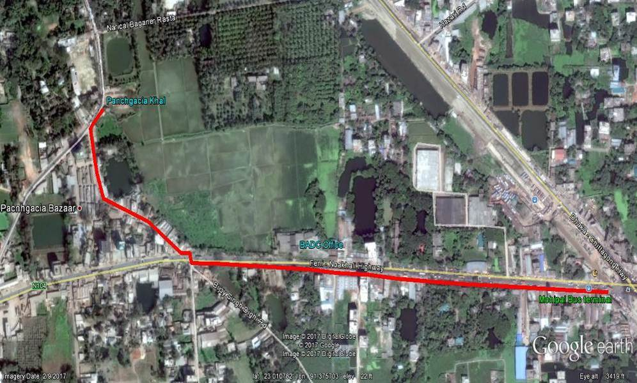
Figure 2.1.2 (c): Topographical Features of the Subproject at South side of Feni-Noakhali Road
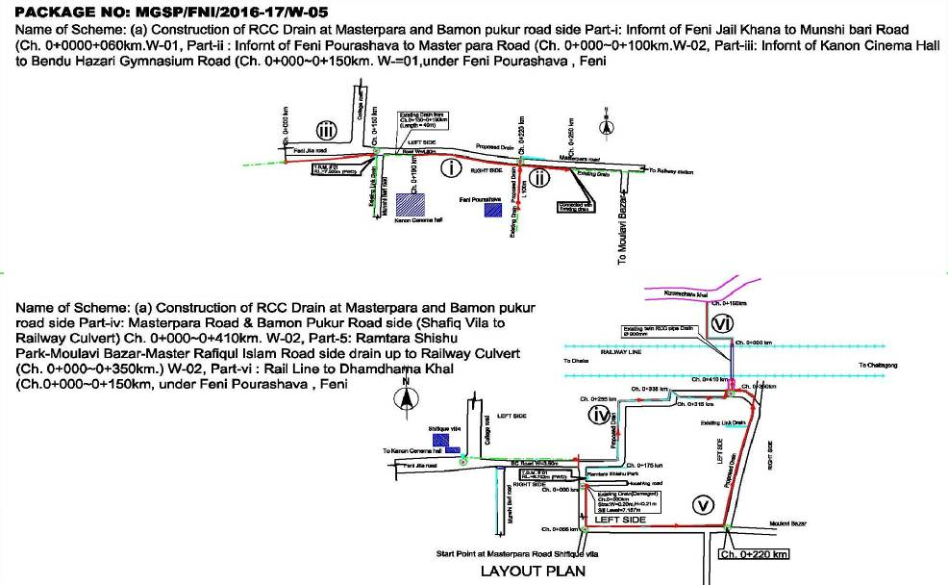
Figure 2.1.3 (a): Layout Plan of the Subproject at different segments of Master Para and Bamon Pukur Road side
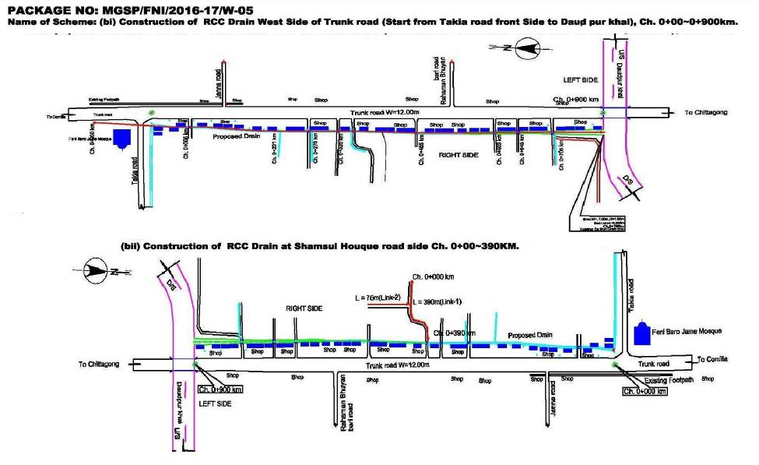
Figure 2.1.3 (b): Layout Plan of the Subproject at West side of Trunk Road
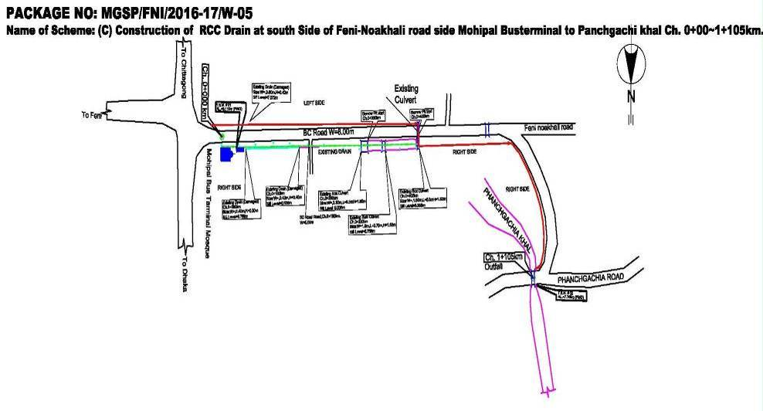
Figure 2.1.3 (c): Layout Plan of the Subproject at South Side of Feni-Noakhali Road

Current Situation, Proposed Intervention and Need for the Subproject
The subproject area is basically urban area of the Pourashava. The subproject area is densely populated. The built-up infrastructure includes mainly pucca, semi-pucca and tin-shed residential houses and shops, educational institutions, industries, religious centers (Mosques and Temple), rail station, crowded bus stand, slum area, hospital and health care center, trade and commerce (Bank and Bima), community center, business centers (market and bazar, hotel and restaurant). There are agricultural lands on the road sides of the Feni -Noakhali Road at BADC compound near Panchgachi Bazar.
In the subproject area, the drainage facility is inadequate, non-functional and inappropriate. At Master Para and Bamon Pukur Road side area, the existing brick drains with cover slab, RCC drain with cover slab and earthen drains are almost silted-up by debris. The existing drains are also narrow in width. The waste water through this proposed drain will be discharged in the Dhamdhama Khal.
In most of the sections, at west side of Trunk Road (from Takia Road to Daudpur Khal), there are earthen drain and brick drain without cover slab. From Ch. 0-200m, the existing brick drain is with cover slab. From Ch. 200-670m, the existing brick drain is open and blocked due to disposal of the solid wastes. From Ch. 670-900, the existing drain is earthen. Furthermore, at link road (Shamsul Haq Road) from Ch. 0-390m, the existing brick and earthen drains are discontinuous. The proposed link drain connects with the main drain at Ch. 380m. The waste water through this proposed drain will be discharged in the Daudpur Khal.
At South side of Feni-Noakhali Road, the drainage facility is also inadequate and inappropriate. There are existing brick drains with cover slab and earthen drains at different segments on both sides of the Feni-Noakhali Road from Mohipal Bus stoppage to Panchgachi Bazar. From Ch.0 to 250m, at south side the existing brick drains are narrow, discontinuous and damaged. From Ch. 250-400m, the existing earthen drain is discontinuous (some areas the old earthen drain is silted-up). Furthermore, from Ch. 400-700m the south side existing drains are RCC and brick drains with cover slab. From Ch. 700-750m, the south side existing drain is earthen drain. At Ch. 750m the proposed drain will cross the Feni-Noakhali main road. From Ch. 750-1110m some areas consists non-functional brick drain. The waste water from the proposed drain will be discharged in the Panchgachi Khal. Hence, Panchgachi Khal is the outfall of this drain.
In the monsoon period, heavy and continuous precipitation causes delay discharge of the storm water. Consequently, water logging occurs in the subproject area. In addition, the stagnant water damages the road surface. As a result smooth traffic flow is hampered. To improve the drainage congestion, construction of new RCC drain is needed. The current situation of the subproject site is further elaborated in the following Photographs 2.2.1.
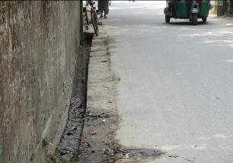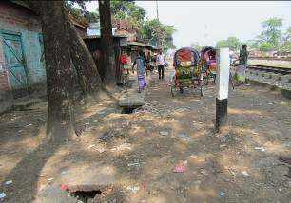
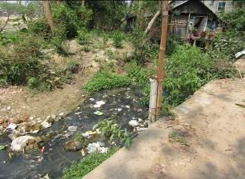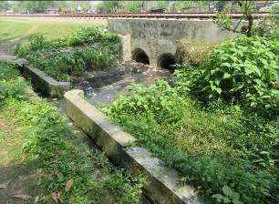
Photographs 2.2.1(a): Current Situation of Subproject at Master Para and Bamon Pukur Road
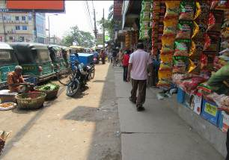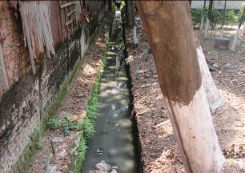

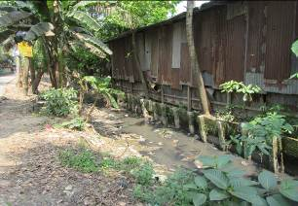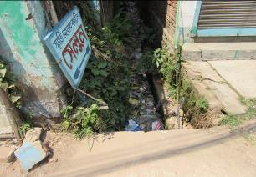
Photographs 2.2.1(b): Current Situation of Subproject at West side of Trunk road
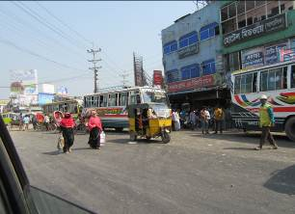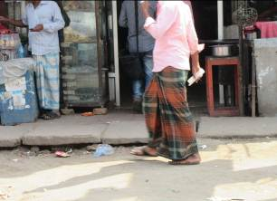
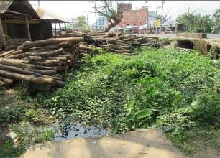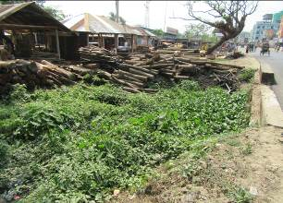
Photographs 2.2.1(c): Current Situation of Subproject at South side of Feni-Noakhali Road
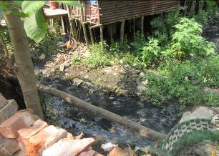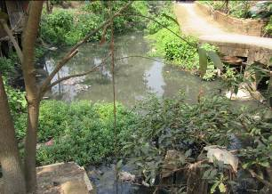
Photographs 2.2.2 (a): Current Situation of the Outfall at Dhamdhama Khal
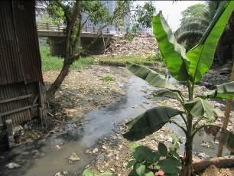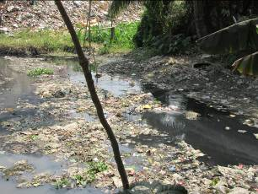
Photographs 2.2.2 (b): Current Situation of the Outfall at Daudpur Khal
Photographs 2.2.2 (c): Current Situation of the Outfall at Panchgachi Khal

Justification of Selection of this Subproject
With the facilitation of PMU, WB and DSM Consultants, the Pourashava prepared the CIP list. According to the CIP list, Feni Pourashava prepared the priority list of the subprojects considering the demand and requirement. As a part of the reconnaissance survey, PMU Officials and DSM consultants’ visited and evaluated the existing site condition of the subproject.
From the environmental screening it is revealed that the ecological impacts due to this subproject will not be significant, though 50 numbers of trees to be felled down. The subproject has adverse impacts on the physicochemical environment. However, it is anticipated that the adverse impact is not significant and limited in the subproject boundary. The Pourashava authority has consulted with the beneficiaries. The beneficiaries have no objection regarding the implementation of the subproject. Considering the significant potential benefits that will derive after completion, the local community demands and welcome this subproject.
It should be noted that 250 numbers of tress will be planted under this subproject to compensate the ecological impact caused by the subproject and to enhance the ecological condition. In addition, adequate and appropriate mitigation measures will be formulated in the EMP to minimize the adverse impacts. In fact, this subproject will be designed and implemented considering the standard measures to safeguard environment. Consequently, the environmental impacts associated with the construction activities will be relatively minor in comparison to the significant environmental benefits resulting from subproject operation.

Envisaged Subproject Activities and Implementation Process
The general activities of the subproject: construction of the semi-pucca site office, construction of the labor shed, and relocation of the electric poles and site clearing works.

The key activities of the RCC Drain with cover slab:
- Earth work in excavation of the foundation;
- Pumping and bailing out of water as per requirement;
- Lying of polythene sheet;
- Sand filling for the preparing foundation bed;
- Plain cement concrete work in foundation;
- Manufacturing and placing of CC blocks;
- Fabrication of the ribbed or deformed bar;
- Reinforced cement concrete work.

The materials and resources to be used for the key activities: Soil in earth work, sand, bricks, stone chips, cement, concrete, reinforcement, bitumen, diesel, water, GI poles and other associate accessories for lighting works.

The major equipment to be used for the implementation of the subproject: hydraulic excavator, concrete mixer, mechanical vibrator, mechanical compactor, steel cutter, steel shutter, steel drum rollers, pneumatic multiple tire roller, dump truck, water tanker, pump, asphalt plant, rubber tire roller, and paver.

Baseline ANALYSIS OF THE ENVIRONMENTAL CONDITION

Physical Environment

Environmental and Infrastructural Features
The major environmental and infrastructural features in the subproject area have been collected from the field investigation. DSM survey team has also performed the conditional survey. Hence, the survey data is also used for preparation of the report. The findings of the site inspection and investigation at (a) Master Para and Bamon Pukur Road side from "In front of Feni Jail Khana to Dhamdhama Khal" at different segments (Part-1: Ch. 0-250m, Part-2: Ch. 0-100m, Part-3: Ch. 0-410m, Part-4: Ch. 0-350m and Part-v: Ch. 0-150m), (b) West side of Trunk Road including Link from Takia Road to Daudpur Khal (Ch. 0-900m with Link-1: Ch. 0-390m and Link-2: Ch. 0-75m) and (c) South Side of Feni - Noakhali Road (Mohipal Bus Terminal to Panchgachi Khal, Ch. 0+00 to 1+105m) is listed. Effort has been given for getting major environmental and infrastructural features within 100 m of both sides from the centre of the road at 100 m longitudinal intervals. The major environmental and infrastructural features are given below Table 3.1.1.
Table 3.1.1 (a): Major Environmental and Infrastructural Features at Master Para and Bamon Pukur Road side in different segments
Chainage (m) | Left | Right | Major Environmental and Infrastructural Features (Adjacent to road and 10-15m from the edge of the road)
Part I: In front of Feni Jail Khana - Kanon Cinema Hall - Bentu Hazari Gymnasium Road, Ch. 0-250m
0-100 | √ |  | Liberation war monument for the Martyr, Five star restaurant and Chinese, verities shops, link road to Pourashava, A. Kuddus filling station, existing RCC drain with footpath and RCC drain with cover slab, Appayan Afroz tower, semi-pucca and pucca homestead area, shopping center, common planted trees
0-100 |  | √ | Feni Central Jail, RCC drain with footpath, road beautification corner, link road, tin-shed and semi-pucca varieties shops, Canon cinema hall, homestead area, common planted trees
100-250 | √ |  | Sri Sri Guru chakra Mondir, tin-shed, semi-pucca and pucca structures for homestead and verities shops (musical shop, grocery stores), multi storied building, common planted trees (Mango, Rain-tree, Coconut, Guava, Mahogany, Palm tree, Krisnachura)
100-250 |  | √ | Multi-storied building, homestead and shops (Barbara shop, grocery shop etc) are basically tin-shed, pucca and semi-pucca structural pattern, dental clinic, waste bin, vacant space, brick drain, electric pole, common planted trees (Mango, Guava, Coconut, Sheuli, Shefali, Bagan-bilash), HH connecting road
Part II: In front of Feni Pourashava to Master Para Road, Ch. 0-100m
0-100 | √ |  | Feni Govt. college, Feni Pourashava Bhaban, varieties shops, Poura market, landscaping and beautification trees, vacant place, Appayan Afroz tower, shopping center, A. Kuddus Filling station, existing RCC drain
0-100 |  | √ | Zila Parishad Mosque and Madrasa, Old rain tree, Liberation war monument for the Martyr, Five star restaurant and Chinese, common planted trees
Part III: Master Para Road and Bamon Pukur Road side (Shafiq Villa to Railway culvert), Ch. 0-410m
0-100 | √ |  | Electric pole, tin fence, open space, link road, brick drain (10m), pucca and semi-pucca structures, common planted trees (Mango, Betel-nut)
0-100 |  | √ | Waste bin, link road, tin-shed, semi-pucca, multi-storied tower, vacant land, existing brick drain, common planted trees (Mango, Jackfruit, Coconut, Papaya, Amra, Betel-nut, Mahogany)
100-200 | √ |  | Existing brick drain, silted up earthen drain, pucca and semi-pucca structures, common planted trees (Mango, Jam, Chalta, Jarul)
100-200 |  | √ | Home of Ex-MP Joinal Hazari with full of vegetation (all sorts of fruits and flowers), Ramtara Children Park, link road
200-300 | √ |  | Homestead connecting road, railway station, tin-shed, semi-pucca and pucca structures for houses and shops, multistoried building, staff quarter
200-300 |  | √ | Staff quarter, Zila Parishad, link road, Master Para Zila Parishad staff quarter Jame Mosque, common planted trees (Sazna, Mango, Coconut, Jackfruit, Bagan-bilash)
300-410 | √ |  | Railway staff quarter, rail line, railway culvert, Bamon Pukur pond, semi-pucca and pucca structures for houses and shops, common planted trees (Mango, Jackfruit, Coconut, Papaya, Amra, Betel-nut, Mahogany)
300-410 |  | √ | Culvert (pass-out water channel/diversion), pucca and semi-pucca structures for house, tin-shed commercial zone, common tress are mainly fruit trees, rail line, earthen drain, brick boundary wall
Part IV: Ramtara Shishu Park - Moulavi Bazar - Master Rafiqul Islam Road side drains up to Railway culvert, Ch. 0-350m
0-100 | √ |  | Boundary wall, pond, low-land ditches, brick drain, waste bin, common planted trees (Mango, Berry, Shil-Korai, Mahogany, Gub, Dumur, Coconut, Jackfruit, Joba etc.)
0-100 |  | √ | Ex-MP Joinal Hazari's house with full of vegetation coverage including common planted trees (Mango, Berry, Shil-Korai, Mahogany, Betel-nut, Coconut, Jackfruit etc.), verities shops (laundry, electric), pond, link road, boundary wall
100-200 | √ |  | Boundary wall, pond, low-land ditches, brick drain, waste bin, common planted trees (Mango, Berry, Shil-Korai, Mahogany, Gub, Dumur, Coconut, Jackfruit, Joba etc.)
100-200 |  | √ | Fenced homestead area with full of vegetation coverage including common planted trees (Mango, Berry, Shil-Korai, Mahogany, Betel-nut, Coconut, Jackfruit etc.), semi-pucca and pucca shops, link road, boundary wall
200-350 | √ |  | Link road, tin-shed, semi-pucca and pucca structures for homestead area and commercial activities, railway culverts, Moulavi bazar, rail line, cross drain, railway culvert
200-350 |  | √ | Link road, straight road to Sahadebpur, tin-shed, semi-pucca and pucca structures for homestead area and commercial activities, railway culverts, Barbara shop, Steel shop, Moulavi bazar, rail line, cross drain, railway culvert
Part V: Rail line to Dhamdhama Khal, Ch. 0-150m
0-150 | √ |  | Rail line, RCC cross drain, existing RCC open drain and earthen drain, waste-bin, common planted trees and natural vegetation (Kalkeshia, Banana, Kafrul), railway vacant place, electric pole
0-150 |  | √ | Link roads, rail-line slum, shops, pucca, semi-pucca and tin-shed, RCC culvert, Dhamdhama Khal, Common planted trees (Mango, Berry, Coconut, Shiris, Rain-tree, Betel-nut, Banana, Ata)
Table 3.1.1 (b): Major Environmental and Infrastructural Features at West side of Trunk Road
Chainage (m) | Left | Right | Major Environmental and Infrastructural Features (Adjacent to road and 10-15m from the edge of the road)
Main Road (Trunk road west side) to Daudpur Khal (Ch. 0-900m)
0-100 | √ |  | Main road (Trunk road), Varieties shops, market
0-100 |  | √ | Feni Boro Mosque, Link BC road (Takia road), Varieties shops (pucca and semi-pucca), Kalibari Mondir, Existing brick drain with cover slab, illegal temporary and permanent shops, Pharmacy, Kalibari market
100-200 | √ |  | Main road (Trunk road), Shevron diagnostic and clinic, Madrasa, Standard bank, Feni Model High School, varieties shops
100-200 |  | √ | Pharmacy, Upazila Land office, Rajbari Gate market, Varieties shops (flower and spare motor parts shops)
200-300 | √ |  | Main road (Trunk road), Al-Ahad Eye Hospital, Varieties shops, Dutch Bangla Bank, Feni Central School, Restaurant
200-300 |  | √ | Steel workshop, Furniture shop, Link road, Common planted trees (Neem, Berry, Mango, Jackfruit, Coconut, Betel-nut, Mahaneem) and naturally grown vegetation, Dustbin
300-400 | √ |  | Main road (Trunk road), Varieties shops
300-400 |  | √ | Pucca and Semi-pucca houses, house hold connecting road, Tiles shops, Vital Research Unit-1, Link road
400-500 | √ |  | Main road (Trunk road), Miftaul-Ulum Madrasa, Shops
400-500 |  | √ | Varieties shops (Hardware shop, steel furniture shop, repairing shop), house hold connecting road, Kadom tree
500-600 | √ |  | Main road (Trunk road), B. Com Rahman Bhuiyan Bari, Star line Auto major flour and auto rice mill, food and beverage, Shops
500-600 |  | √ | Smriti community center, common planted fruit trees
600-700 | √ |  | Main road (Trunk road), Star line Auto major flour and auto rice mill, food and beverage, Trees
600-700 |  | √ | Jahan Ara Complex, house hold connecting road, Link road, furniture shop, trees (Shil Korai, Kodom, Dumur), Barbara shop, ditch, low-land, pond, tin-shed structure, earthen drain
700-800 | √ |  | Main road (Trunk road), Feni Public School, Old trees (Rain tree, Shil Korai)
700-800 |  | √ | Link road, earthen drain, trees (Akashi), culvert
800-900 | √ |  | Earthen drain, Trees (Dumur, Rain-tree, Mandar, Betel-nut, Kalkeshia, Coconut, Palm, Ata, Kodom and other natural vegetation), Rampur Hazari Road, Tin shed shops
800-900 |  | √ | Tin shed, pucca and semi-pucca houses, trees (Mahogany, betel-nut, Banana)
Link 1: Shamsul Haq Road side Ch. 0+00 to 0+390m
0-100 | √ |  | Brick drain, Transformer, graveyard, houses (Elias Bhuiyan, Sultan villa), Child Haven Pre-cadet Institute, Vital Research Hospital, cross drain, TNT pole
0-100 |  | √ | Cross drain, Link road, Mosque, graveyard, trees, Pucca , tin shed and multistoried houses, Power Gym, beauty parlor, tailoring shop
100-200 | √ |  | B/W, Trees, pond, semi-pucca and pucca houses
100-200 |  | √ | Temporary bamboo fence, common local fruits garden, Boundary wall, HH connecting road, Baitul Aman Jame Mosque, Furniture workshop, brick drain,
200-300 | √ |  | Saowdagor bari road, B/W, lowland, natural vegetation, link road, semi-pucca and pucca structure, Elias Bhuiyan house
200-300 |  | √ | B/W, open space, trees
300-390 | √ |  | Semi-pucca houses, open space, trees
300-390 |  | √ | Tin-shed and semi-pucca houses, brick drain, trees
Link 2: Shamsul Haq Road side Ch. 0+00 to 0+75m
0-75 | √ |  | Semi-pucca houses, trees
0-75 |  | √ | Tin-shed and semi-pucca houses, brick drain, trees

Table 3.1.1 (c): Major Environmental and Infrastructural Features at South side of Feni-Noakhali Road
Chainage (m) | Left | Right | Major Environmental and Infrastructural Features (Adjacent to road and 10-15m from the edge of the road)
South Side of Feni - Noakhali Road (Mohipal Bus Terminal to Panchgachi Khal), Ch. 0- 1105m
0-100 | √ |  | Hotel Midway (residents), restaurant, Anam Sweets and Biryani house, electric poles, pucca, semi-pucca and tin-shed structures, verities shops, Mohipal zero point, market, existing brick drain with cover slab
0-100 |  | √ | Mosque, existing brick drain with cover slab, verities shops, Bus terminal, ticket counter, common planted trees
100-200 | √ |  | Hotel, Restaurant, Gausia hotel, Sweets and Biryani house, electric poles, pucca, semi-pucca and tin-shed structures for verities shops, market, existing brick drain with cover slab
100-200 |  | √ | Semi-pucca, pucca and tin-shed homestead area, semi-pucca shops, CNG and automobiles workshop, electric poles, common planted trees (Mango, Rain-tree, Mahogany)
200-300 | √ |  | Existing brick and earthen drain, electric poles, pucca, semi-pucca and tin-shed structures for verities shops, market, homestead area
200-300 |  | √ | Semi-pucca, pucca and tin-shed structures (homestead area and shops), CNG and automobiles workshop, electric poles, common planted trees (Mango, Rain-tree, Mahogany, Shil-korai, Kath Badam, Kodom, Palm, coconut), Star line tower
300-400 | √ |  | Existing earthen drain, electric pole, Govt. Commerce college, transformers, common planted trees (Coconut, Mango, Beetle-nut, Jam , Jackfruit, Apple wood, Neem etc), tin-shade structures for shops (tea stall, grocery shops), homestead area
300-400 |  | √ | Star-line tower, tin-shade and semi-pucca structures for shops (tea stall, daily needs and grocery shops), common planted trees, existing RCC drain with cover slab
400-500 | √ |  | Existing brick drain, Circuit house road, transformers, common planted trees (Coconut, Mango, Neem, Palm tree, Apple wood etc), tin-shade structures for shops (tea stall, grocery shops), homestead area, primary school,
400-500 |  | √ | Zila Ansar Academy, tin-shade and semi-pucca structures for shops (tea stall, daily needs and grocery shops), common planted trees, existing RCC drain with cover slab
500-600 | √ |  | Existing RCC drain, Magistrate colony, electric poles, common planted trees (Coconut, Mango, Guava, Jackfruit, Rain tree, Shil-Korai, Beetle-nut etc), tin-shade structures for shops (tea stall, CNG workshop), homestead area
500-600 |  | √ | Prova center, tin-shade and semi-pucca structures for shops (tea stall, CNG workshop), common planted trees, RCC drain with cover slab
600-700 | √ |  | Existing RCC drain, electric poles, common planted trees (Coconut, Mango, Guava, Jackfruit etc), tin-shade structures for shops (tea stall, CNG workshop), homestead area
600-700 |  | √ | Tin-shade and semi-pucca structures for shops (tea stall, CNG workshop), common planted trees, existing RCC drain with cover slab, BADC
700-800 | √ |  | Culvert (pass-out water channel/diversion), saw-mill, aged Rain tree, died palm tree, tin-shed, pucca and semi-pucca structure, water hyacinth, earthen drain, naturally grown vegetation
700-800 |  | √ | Culvert (pass-out water channel/diversion), Rain tree, natural grown vegetation and trees, common planted trees, BADC- experimental paddy field, pucca structure, earthen drain, electric poles, transformer, brick boundary wall
800-900 | √ |  | Varieties shops in bazar area (semi-pucca, pucca and tin-shed), Panchgachi bazar area, electric poles, transformers, trees
800-900 |  | √ | Varieties shops in bazar area (semi-pucca and tin-shed), natural vegetation, low-wet land, trees, non-functional brick drain, BADC
900-1000 | √ |  | Varieties shops in bazar area (tin-shed), Panchgachi bazar area, existing brick drain, electric poles, transformers
900-1000 |  | √ | Varieties shops in bazar area (semi-pucca and tin-shed), trees, natural vegetation, Panchgachi Khal, low-wet land, non-functional brick drain
1000-1105 | √ |  | Varieties shops in bazar area (semi-pucca and tin-shed), Panchgachi bazar area, existing brick drain, existing cross drain, electric poles, transformers
1000-1105 |  | √ | Varieties shops in bazar area (semi-pucca, pucca and tin-shed), trees, natural vegetation, Panchgachi Khal, low, wet land

Geology, Topography, and Soils

Feni Pourashava lays the active floodplain of the Feni and Muhuri River and the adjoining meander floodplain. The area is influenced by diurnal tidal cycles and the tidal fluctuations vary depending on seasons, being pronounced during the monsoon season. Geology of Feni Pourashava is composed of Tidal Deltaic Floodplain. The topographical feature of the Feni Pourashava area is undulating and low lying area. The subproject area represents an extensive flat, coastal and delta land, characterized by flat land and low relief with few undulations. Local differences in elevation generally vary below 1m with only a very gentle slope. The presence of organic matter in the soil is moderate. The soils are basically non-saline. The area lies in the earthquake Zone- 2 according to the seismic map of Bangladesh (GSB, 1978).
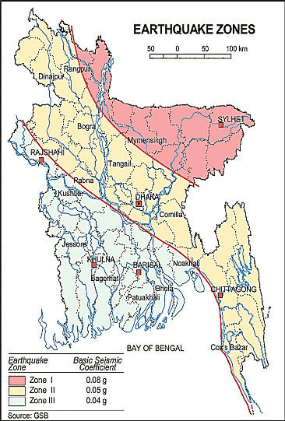

The blue circle denotes the Feni Pourashava

Figure 3.1.1: Location of Feni Pourashava in Earthquake Zone Map of Bangladesh

Climate and Meteorology

The area signifies the tropical climate with high rainfall during monsoon period. Meteorological conditions of the area are more or less similar to the southern part of the country with respect to temperature, rainfall, and humidity.
The climate of the subproject area can be described as Tropical Monsoon. It is characterized by warm, humid summers and cool, dry winters. The warmest month is April, the coolest is January, the wettest is July and the driest is January. The inter-annual variation in temperature is quite low (0.5 - 1ºC) compared to the inter-seasonal one (8 - 10ºC). Based on the monthly variation, four distinct periods of temperature may be distinguished in the year (Table 3.1.2).

Table 3.1.2: Seasonal climatic conditions in the subproject area
Months | Characteristics
December-February | Relatively cool period with temperatures averaging 20ºC with low peaks of less than 15º C.
March-June | Corresponding to the summer with longer sunshine hour's high temperature ± 33ºC.
July-October | Corresponding to the rainy season with low temperatures averaging 25ºC.
October-November | Corresponding to the end of the rainy season with relatively high temperatures ± 30ºC

The average annual rainfall is around 3,000 mm and around 70% to 80% of the rain falls during the rainy season from April to October. The highest annual rainfall during the last ten years (2002–11) was 3192 mm in 2007, and the lowest was 2,300 mm in 2005. The minimum temperature was 11.4°C in 2008 and maximum temperature was 33.6°C in 2011. The minimum humidity was 66.4% in 2010 and the maximum humidity was 79.3% (Bangladesh Meteorological Department).
According to the statistics of wind data from the Bangladesh Meteorological Department Climate Division, wind direction changes by month, Nevertheless, the northwest, south, and northeast winds are predominant. Table 3.1.3 shows the key meteorological data from 2008 to 2011.
Table 3.1.3: Temperature, rainfall, humidity at Feni Pourashava during 2008-2011
Years | Temperature (centigrade) |  | Rainfall (millimeter) | Humidity (%)
Years | Maximum | Minimum | Rainfall (millimeter) | Humidity (%)
2008 | 33.6 | 11.6 | 2881 | 79.0
2009 | 33.2 | 15.7 | 3284 | 79.0
2010 | 32.5 | 11.7 | 2018 | 66.4
2011 | 24.2 | 11.4 | 3192 | 79.3
Source: Bangladesh Meteorological Department
The construction works can be influenced by the climatic condition and meteorological components like humidity, temperature, sudden rainfall, and wind speed. High winds can enhance quick spreading of the generated dust. It is very risky working under rain and in high winds because the possibility of getting injury increases. Furthermore, work under high temperature and excess humidity may create health hazards like dehydration problem.

Hydrology (Surface Water and Ground Water)

Some ponds and ditches are located adjacent to the subproject site. Surface water in the ponds and ditches is less saline but alkaline in nature. Though, it is within the acceptable limit for drinking, nevertheless treatment is needed before drinking. Salinity problems are not commonly visible. However, these ponds and ditches water can be used both for the domestic & agricultural purposes and construction works. Rain water harvesting system is not common in and around the subproject area.
Groundwater is the main source of potable water in the subproject area. Deep groundwater is not saline and is slightly acidic to alkaline, however; within the acceptable limit set by BSTI (6.4-7.4) for drinking water. The groundwater (mainly shallow aquifer) is contaminated by arsenic (As) and iron (Fe). Local people typically use deep tube-well water for drinking and other domestic purposes.

Flooding, Water Logging and Drainage Pattern

As per flood zoning map of Bangladesh (Bangladesh Meteorological Department), this area is considered as a flood free zone. However, this area is affected in historical flood events such as 1988, and 1998. The subproject area is not generally subjected to water logging problems. The present drainage system is not adequate and functional due to blockage in the drain. Due to continuous heavy rain, delay discharge of storm water causes water logging problem in the subproject area
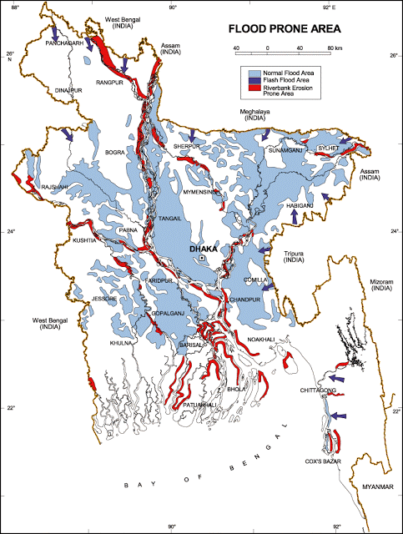
Figure 3.1.2: Location of Feni Pourashava in Flood Zone Map of Bangladesh

Air Quality and Dust

Ambient air quality data have not been found. Air seems to be clean. However, in the subproject area, degradation of the air quality is mainly due to emission from the vehicles. The dusty and rough surfaces of the road also generate dust during vehicle and pedestrian movement. Open burning of the wastes materials and roadside disposal of the wastes cause also air quality degradation. The subproject activities may degrade the air quality of the subproject area though the impacts are anticipated to be insignificant.

Noise Level

Noise is one of the important issues for the quality of the environment in the subproject area. In the subproject area, noise is mainly generated from the moving vehicles, undue use of horns and crowded people in the Bazar area. The rail station is very close from Bamon Pukur and Master Para Road. Hence, moving trains create noise nuisance to the nearby area. Vehicles such as trolleys, pick-up, trucks, motor cycles, CNG, rickshaws and private cars are frequently passes through the road. These vehicles generate noise in the subproject area. However, they are tolerable limits in most cases. Furthermore, in the subproject activities, mixer machine, vibrator machine, mechanical compaction machine, steel cutter, hydraulic excavator may create localized noise nuisance though the impacts are anticipated to be within the tolerable limits.
Solid Waste Management

The Feni Pourashava has a designated dumping site at road side vacant place near Dewangonj. The collected solid wastes are transported by the garbage trucks to the dumping site. Due to lack of awareness about waste disposal by the community people, Feni Pourashava faces challenges for proper disposal of the solid wastes. The local people informed that due to habitual problem they throw their solid wastes into the vacant lowland, khals and drains. Therefore, improper solid waste disposal by the community people creates severe public health hazards and environmental degradation.

Biotic Environment

Flora and Fauna

The influence area of the subproject is full of natural flora (aquatic plants and terrestrial herbs, shrubs and trees) and fauna (birds, animals). The common natural native species of trees are found in the subproject area. The trees are mainly: Shiris, Shil-Korai, Rain Tree, Mahogany, Coconut, Beatle-nut, Palm Tree and common local fruit trees such as- Jackfruit, Mango, Berry, Guava, Lotkon, Dumur, Lemon, Ata, Dumur, Kaw etc. The natural water bodies (such as Dhamdhama Khal, Daudpur Khal, and Panchgachi Khal, road side ponds and marshy wetlands) and ditches are the worthy habitat for the aquatic flora and fauna. Lots of common local birds- such as Crow, Doel, Shalik, Hawk, Crow, Sparrow, Bulbuli, Cuckoos, Tia, Parrot, Chil, Dove and Water Fowl etc. were found during the site visit. Some endangered (IUCN 3.1) Mongooses (Herpestes javanicus palustris, Ghose, 1965) red listed extinct species Mongoose were found during the site visit at Panchgachi Khal adjacent marshy wetland. Migratory birds are also available in the BADC low-land and experimental paddy field during winter season.

Socio-economic and Socio-cultural Environment

Land Use Pattern, Status of Housing and Built-up Infrastructure

The subproject area mostly consists of medium to high densely populated residential area. The built-up infrastructure includes mainly pucca, semi-pucca and tin-shed residential houses and shops, educational institutions, industries, religious centers (Mosques and Temple), rail station, crowded bus stand, slum area, hospital and health care center, trade and commerce (Bank and Bima), community center, business centers (market and bazar, hotel and restaurant). At Panchgachi Khal adjacent area (BADC compound) roadside lands are used for agricultural purposes.

Beneficiary Population

The subproject area covers jurisdiction area of the ward 1, 2, 13 and 18 of Feni Pourashava. As per information by the municipality, about 27, 881 people (Source: Feni Pourashava Ward no. 1, 2, 13 and 18 - Population and housing census, 2011) will be benefited directly and many others indirectly.

Education

In the subproject area, literacy among the population is about 68%. This is higher than the national average (61.5%) [UNESCO, 2015]. Literacy rate among males is still higher than females. (Ref: Population and Housing Census 2011).

Tribal Communities

There is no indigenous or tribal people settlement in the subproject influence area. Therefore, there is no measure needed for indigenous peoples’ safeguard.

Land Acquisition and Resettlement

Private land acquisition is not needed. For site clearing, few road side tin shed, semi-pucca and pucca structures and boundary wall and fencing need to be removed partially and or completely. The Pourashava authority has consulted with the owners of these structures. The local people and owners of those structures have no objection regarding the implementation of the subproject. An agreement has been signed by the Pourashava and the local people regarding the subproject implementation. The local people agreed to remove their structures for their benefit. However, in case of any objection from the affected person, the DSM will investigate the actual situation. Then, measures will be taken as per rules.

Principal Livelihoods and Economic Activities
The subproject area is now inhabited by the mixed occupational people where major income comes from non-farm activities such as small business, enterprises, Government and non-government job, transport vehicle ownership and operation.
Cultural Heritage and Protected Areas

Within the influence area of the subproject, no real historical sites identified. Religious center (such as Mosques and Temple), community centers, educational institutions, bus terminal and train station and bazars bring cultural value for the community people.

ENVIRONMENTAL SCREENING

Environmental Screening Checklist, as adopted in Appendix C of the Environmental Management Framework (EMF) of the MGSP, was administered for identifying the impacts and their extents.
The screening data and information for the RCC drain with cover slab at different segments of Master Para and Bamon Pukur Road side (Part I: Feni Jail Khana - Bentu Hazari Gymnasium Road, Part II: Feni Pourashava to Master Para Road, Part III: Master Para Road and Bamon Pukur Road side, Part IV: Ramtara Shishu Park - Master Rafiqul Islam Road side drains up to Railway culvert and Part V: Rail line to Dhamdhama Khal) have been formulated and are shown in below.
(1) Potential environmental impact during construction phase:
(a) Ecological impacts:
50
- Felling of trees Significant □ Moderate □√ Minor □ Number of trees
- Clearing of vegetation Significant □ Moderate □ Minor □√
- Potential impact on species of Significant □ Moderate □ Minor □√
aquatic (i.e., water) environment
The subproject site is situated in the developed urban area. However, some roadside naturally grown and planted trees will be felled down at different chainage. Major trees to be felled down are: Coconut, Rain tree, Betel nut, Banana, Palm tree, Dumur, Ata, Kadom, Mandar etc. There is no tree to be felled down bring religious and heritage importance. However, the trees to be felled down have ecological impacts and socio-economic impacts. Intensity of vegetation coverage is not uniform and significant due to the existing drain and developed urban area of Feni Pourashava. So clearing of the vegetation is considered as minor. However, vegetation coverage is significant from Ch. 600-800m and Ch. 1050-1105m at South side of Feni-Noakhali road. Hence, clearing of vegetation is significant at this particular section. Anticipated impact on the species of aquatic environment is also minor because except throwing of the waste materials into the existing water bodies, the subproject activities do not have any direct impact on the aquatic environment. Considering number of trees to be felled down, ecological impact is considered as moderate.
- Physicochemical impacts:
- Noise and Air pollution Significant □ Moderate □ √ Insignificant □
- Drainage congestion Very likely □ Likely □ Unlikely □√
- Water pollution Significant □ Moderate □ Insignificant □√
- Pollution from solid/ construction wastes Significant □ Moderate □√ Insignificant □
- Water logging Significant □ Moderate □ Insignificant □√
The subproject will have undesirable impacts on noise and air quality during construction phase due to mobilization of the equipment, vehicles movement for the transportation of the materials, using of hydraulic excavator, mechanical compaction machine, concrete mixer machine, vibrator machine etc. The construction work will be performed section wise. Hence, it is anticipated that the overall impacts on noise and air quality will be temporary and limited within the subproject boundary. The subproject area is the core urban area of the Pourashava. The proposed drain with and around its influence area consist of road side residential areas, religious centers, Govt. and non-Govt. agencies, educational institutions (schools and college), hospital and health care center, bus terminal, bazar areas, trade and business centers etc. Hence, anticipated impacts on noise and air quality will be significant for this particular section if measures are not taken properly. The generated dusts during construction activities may temporary disturb the local people if measures are not taken. The generated construction wastes, un-suitable materials and solid wastes may degrade the adjacent ponds, natural canals (Dhamdhama Khal, Daudpur Khal and Panchgachi Khal), road side ditches and wetlands, if not properly collected and disposed. It also may degrade the quality of the surrounding environment and degrade the aesthetic value. The anticipated water logging and drainage congestion during construction period is minor because space is available at most sections of the road for drain-out the storm water, except Link-1: Ch. 0-390m at West side of Trunk road drain and Ch. 800-1105m at South side of Feni Noakhali road drain. Hence, provision will be there for pumping out the storm water if required.
- Socio-economic impacts:
- Traffic congestion Very likely □ Likely □ √ Unlikely □
- Health and safety Significant □ Moderate □√ Insignificant □
- Impact on archaeological and historical Significant □ Moderate □ Insignificant □√
- Employment generation Significant □√ Moderate □ Insignificant □

Since the subproject area is busy and developed urban area. Therefore, the subproject activities have likely impact on the traffic congestion due to restriction of the free movement of the motorized vehicles during construction phase. Hence, the construction work should be performed section wise with keeping provision for normal traffic operation. The local people can use the connecting roads. Hence, using of the connecting road will diversify the traffic volume. The pedestrians, cycle rider, biker can easily use the road at construction period. The medium to heavy motorized vehicles can use the alternative road during drain construction work. In addition, the Pourashava authority will inform local people to use connecting and other adjacent road during construction period to avoid any traffic congestion. In addition, the traffic signs and cautionary sign will be used to minimize traffic congestion and to control the traffic. The construction work will follow simple procedure with commonly used equipment. Hence, anticipated impact on health and safety is moderate. There is no archaeological and historical site within the influence area. The subproject has positive impact by generating work opportunities for the local people and supplying of the construction materials, equipment, food and other necessary stuffs to the campsite.
(2) Potential environmental impact during operational phase:
(d) Ecological impacts:
- Potential impact on species of aquatic Significant □ Moderate □√ Minor □
(i.e., water) environment
The waste water from the drain may degrade the water quality of the outfall if carries pollutants. Though, the drain is designed for storm water only. However, the storm water may carry washed-out materials, pollutants from any sources that may disturb the aquatic environment of the outfalls (Dhamdhama Khal, Daudpur Khal and Panchgachi Khal).
(e) Physicochemical impacts:
- Potential air quality Improvement □√ No-improvement □ Deterioration □
- Potential noise level Improvement □ Minor Improvement □ No Impact □√
- Drainage congestion Improvement □√ Minor Improvement □ No Impact □
- Risk of Water pollution Significant □ Moderate □√ Minor □
- Pollution from solid waste Improvement □ No-improvement □ Minor □√
The new drain will minimize drainage congestion and water logging problem. Thus, it will provide better environment to the community people. The covered drain will minimize spreading of the bad odor from the drain. The storm water to be discharged through the drain may degrade the water quality of the outfall if carry pollutants from any sources. The covered drain will reduce throwing of the waste materials into the drain.
(f) Socio-economic impacts:
- Traffic Improvement □√ No-improvement □ Adverse □
- Safety Improvement □√ No-improvement □ Adverse □
- Employment generation Significant □ Moderate □ Minor □√

The subproject has significant positive impacts on the socio-economic environment. After construction, the drain will complete the drainage network. Thus, it will reduce water logging problem in the subproject area. In addition, new drain prevents the accumulation of the stagnant water on the road surface. Consequently, it will enhance safety traffic operation and pedestrian's movement.
(3) Summary of Possible Environmental Impacts of the Subproject
The overall ecological impact due to the subproject implementation is not significant. However, the subproject has adverse impacts on the physicochemical components especially on air, noise and solid wastes. Nevertheless, it is anticipated that the adverse impact is not significant and limited in the subproject boundary. The subproject activities may degrade the air quality and noise level to a limited extent. The wastes generated due to the construction activities should be properly collected and disposed in a designated dumping site. The inputs that may affect the environment will be mainly at construction phase and limited within the subproject boundary. Moreover, mitigation measures will be taken according to the EMP for minimizing the air, dust, and noise pollution.
Furthermore, the socio-economic feature mainly includes health and safety and employment generation. Safety concerns should be considered properly for both the construction and operation phases to avoid any potential safety risks. This subproject will have positive impacts in terms of generation of employment and business activities due to supplying of the materials and equipment.

Specific impact, mitigation, AND enhancement measures

The likely impacts of the subproject are mainly caused by the activities required for the implementation of the subproject, and materials, resources and equipment to be used to perform the activities.
This section describes some specific impacts due to the subproject activities and their mitigation measures.

Dismantle Work, Site Clearing, Excavation Work and Earth Work
The drain construction work includes- dismantle of existing brick and RCC drain, clearing of the wastes materials generated due to dismantle work, earth excavation, earth filling work, back filling and cutting and removal of the unsuitable materials. These works lead dust blowing, improper disposal of the wastes, noise and vibration which may disturb the local people.
Mitigation Measures
- Proper care will be taken by the contractor during dismantle work, excavation work, earth work and disposal work to avoid any undue disturbances to the nearby people;
- Avoid loss of the topsoil for the earth filling work;
- Cover the exposed earth works with much fabric;
- Disposal of soil and construction wastes at the designated dump site at the road side vacant place near Dewangonj Canal.

Tree Felling, Clearing of the Vegetation and Ecological Impact
There are 50 planted trees such as Coconut, Rain tree, Betel nut, Banana, Palm tree, Dumur, Ata, Kadom, and Mandar Tree will be felled down and road side vegetation will be cleared due to implementation of this subproject.
Mitigation Measures
- 250 nos. of the trees (as per Municipal Governance and Service Project, common practicing about compensating the ecological imbalance the ratio is 1:5 of the felled down trees depending on space/land availability) will be planted to compensate the ecological imbalance to be caused due to felled down of the trees;
- The trees will be planted at both sides of the Mohipal Bus Terminal to Panchgachi Khal road (considering Ch. 200 to 750m, where space is available and anywhere Pourashava owned suitable places within the subproject influence area) – Mango, Jackfruit, Jam, Kathbadam, Coconut, Palm Tree, Neem, Arjun, Amloki, Horitoki, Bohera, Sonalu, Jarul, Polash, Krisnachura, Bokul, Debdaru, Mahogany, Rain Tree, Shil Koroi, Segun;
- Planting many trees will enhance the ecological condition of the area after their successful growth.

Pollution from the Construction Materials
Dumping of the construction spoils, including accidental leakage of the oil, grease, and fuel in equipment yards is a significant hazard. Surface water and soil quality might be polluted from these contaminants. Even the people to be engaged for the construction activities might endanger the physical and human habitats of the area.
Mitigation Measures
- Safe transport, storage, and disposal of the construction materials, and the equipment have to be carried out in order to avoid the accidental spillage and loss;
- Fuels, lubricants, and other hazardous materials should store over raised platforms and not directly on the ground;
- Maintain adequate moisture content of soil and sand during transportation, compaction and handling;
- Carry the materials especially loose soil and sand with adequate cover;
- Disposal of soil and construction wastes at the designated dump site at the road side vacant place near Dewangonj Canal as dumping site.

Air Quality and Dust
During construction phase, air pollutants will be emitted from the equipment and construction vehicles are expected to remain low. Local residents in the vicinity of the work sites will be temporarily disturbed by the limited dust pollution. The overall impacts, however, are expected to remain low.
Mitigation Measures
- Water should be sprayed at the work site and camp site area for dust control;
- Ensure sprinkle and cover stockpiles of the loose materials (e.g., fine aggregates);
- Maintain adequate moisture content of soil and sand for transportation, compaction and handling;
- Avoid use of dust generating equipment (which produce significant amount of particulate matter) far from the local residents;
- Ensure that all subproject vehicles are in good operating condition.

Noise and Vibration
Noise and vibration caused by the equipment and movement of the construction vehicles may temporarily disturb nearby residents. In this subproject, sensitive areas like roadside residents, educational institutes, religious centers and health care centers are likely to be affected by noise nuisance, though the impacts are anticipated to be limited.
Mitigation Measures
- Transportation of the construction materials have to be carried during the scheduled times, and mainly during the day in off-peak time;
- If needed, all powered mechanical equipment and machineries will be fitted with noise abating gear such as mufflers for effective sound reduction.

Water Quality
The water quality may deteriorate if the construction materials, sand, construction wastes, effluent from the work camps and food wastes are dumped in the khals (Dhamdhama khal, Daudpur Khal and Panchgachi Khal) roadside ditches, ponds and low-land, seasonal wetlands etc.
Mitigation Measures
- Proper construction management including waste management as well as training of the operators and other workers should provide to avoid pollution of the water bodies;
- Construction wastes will dispose properly (not in water bodies or lowland), for which contractor will be responsible;
- Construction wastes will dispose properly at the designated dumping site at the road side vacant place near Dewangonj Canal.

Occupational Health and Safety
The most important risks associated with the construction activities are listed below:
- Exposure to the sunlight- workers are being exposed to the sun for long hours;
- Exposure to the high temperature, and humidity for a long time resulting in dehydration;
- Contact with the hazardous substances and wastes, risks of the infections and diseases;
- Risk from the traffic collision or accidents during operation of the equipment such as hydraulic excavator, steel cutter and vehicles movement for the transportation activities of the subproject;
- Risks from head loads for carrying soil, construction materials and construction equipment;
- Risks of using of the machineries in motion such as steel cutter;
- Risk associated to the sudden bad weather working conditions such as storm, thunder storm and earth quake etc.

General Requirements for the Workers’ Health and Safety
The key salient features of the general requirements for the workers’ health and safety stated are presented in Table 5.7.1.

Table 5.7.1: General Requirements for the Workers Health and Safety
Issues | Requirements
Health and Hygiene | - Cleanliness at the site premises and workers living places and at the Labor Shed;  - Arrangement of the proper ventilation and temperature at the Labor Shed;  - Protection against dust and furnace by using of the nose masks and covering of the head and body;  - Proper disposal of the wastes and effluents;  - Provision of the adequate latrines and separate toilet for the women;  - Sufficient dustbins for the solid waste management system.
Safety and First Aid Box | - Using of the personal protective equipment (helmet, gloves, goggles, nose mask, safety boots);  - Precautions during work on or near machineries in motion;  - Head loads are prohibited;  - Ensure first aid box;  - First aid facilities should be provided and maintained;  - The first aid kit should include adhesive bandages, regular strength pain medication, gauze, and low grade disinfectant.
Compensation for Accidents at Work | - Contractors will bear medical treatment costs. If any severe accidents such as loss of hands, legs or loss of working ability or any case of death needs compensation - (the amount of the compensation should be fixed considering the type of accidents).
Dust and Fumes | - For any dust, fumes, or other impurities likely to be injurious to the workers, effective measures shall be taken to prevent their accumulation and its inhalation by the workers.
Overcrowding | - No labor room should be overcrowded.
Latrines and Urinals | - Sufficient latrines shall be provided;  - Latrines shall be maintained in clean and sanitary condition;  - Latrines shall be adequately lighted and ventilated.
Disposal of Wastes and Effluents | - Proper disposal system for the solid waste and effluent is required.

Impacts on Social Environment and Common Property Resources
Through comprehensive study, it is revealed that impacts are expected not to be severe and to be largely manageable. The following Table 5.8.1 presents impacts on socio-economic environment and common property resources.
Table 5.8.1: Impacts on Social Environment and Common Property Resources
Social Components | Impacts on IECs | Impact Significance
Community Perception | The local community people welcome this subproject and there is no visible objection from them. | Significant (+ve)
Employment and Business Opportunity | Community feels happy because generally the local contractor will be engaged for the construction works which will create work opportunity for the skilled and non-skilled labor. The subproject will create business opportunity for the equipment and materials suppliers. | Significant (+ve)
Community Order and Security | This subproject activity does not create any severe security problems to the local community and community people. | Minor  (-ve)
Possible damage to infrastructure and facilities | Possible damage of the existing road infrastructure by the construction equipment and vehicles used in this subproject. | Minor  (-ve)
New infrastructure and facilities | Improvement of the existing road will enhance infrastructure facilities. | Moderate  (+ve)
Agriculture and Land Use | No direct impact on agriculture however, it could affect the adjacent land to a very limited extent. | Minor  (-ve)
Landscape and Aesthetics | This subproject activity temporarily will degrade landscape and aesthetics values of the subproject area to a limited extent. | Minor  (-ve)
Labor Habitat | It is anticipated that the outsider workers will stay at the Labor shed which will have impacts on the environment relates to the generation of the solid wastes, effluent, and water consumption. | Moderate  (-ve)
Health Care | Workers may suffer from the dehydration problems, respiratory problem, and other health hazards. | Minor  (-ve)
Accident | In case of road accidents by the vehicles to be used for the transportation may have serious negative impact. | Significant  (-ve)

Mitigation Measures

- Conduct dissemination with the local community about the subproject details;
- Continue liaison with the community leaders in order to maintain the community support;
- Engage local contractor and local people as much as possible for positive perception of the local community;
- Follow traffic rules to avoid any accidents;
- Transportation and mobilization of the equipments and construction materials avoiding peak hours and scheduled time;
- Ensure first aid facilities and effective use of personal protective equipments where applicable.

Labor Influx and Anticipated Impacts
The labor force and associated goods and services required for the construction of infrastructure civil works under this subproject cannot be fully supplied locally. The migration to and temporary settlement of laborers in the subproject, referred to as labor influx, carries an array of potentially positive and negative impacts in terms of demands on public infrastructure, utilities, housing and sustainable resource management and the strain on social dynamics.
Labor influx effects on host communities include positive impacts such as:

- The subproject activities will generate work opportunities for the local people and supplying of the construction materials, equipment, food and other necessary stuffs to the campsite;
- Improved infrastructure and public service access and availability whereby subproject investment catalyzes larger allocation of resources to a region, stimulating the development or expansion of infrastructure and public services.

Critical negative social risks include:
- Increase in criminal activity and alcohol and drug abuse, domestic violence, political attachment and violence, smuggling and robbery etc;
- Increase in gender-based violence, including eve teasing, sexual harassment etc;
- Increases in communicable diseases, including respiratory problems, diarrheal diseases, vector-borne diseases (e.g., malaria), and sexually transmitted infections (e.g., HIV/AIDS, syphilis, gonorrhea, hepatitis B);
- Conflicts arising from increased demand on existing infrastructure, services, and utilities, including transportation, health, education, water and sanitation, waste management, public utilities and community, religious, and recreational facilities and loss of land for access routes.

The general environmental impacts of labor influx include pressure on the natural resources such as using of the water, electricity, other fuel for cooking, loss of land for the labor establishment, depletion of the water supply, sewage and waste water generation, degradation of the air quality, waste generation, increased demands on the local energy and resources and noise pollution effects. The number of local and migrated people involved in the subproject activities can be only identified in the construction phase. Hence, these specific impacts will be quantified during construction work and environmental assessment report will be modified accordingly. However, the following safeguard measures are recommended to avoid any risk of labor influx:

- Inform local people about the subproject activities;
- Liaison with the community leaders in order to get community support;
- Engage local people as much as possible to minimize workers from outsiders;
- Monitor workers attitude and behavioral matter;
- Monitor the workers movement for avoiding any unexpected social activities (robbery, crime, political attachment and conflicts, drugs abuse);
- Inform and use local administration to get support if needed;
- Inform local utilities service providers (such as for new electricity connection REB or any other department);
- Ensure effective use of natural resources such as water, electricity, fuel, wood etc.

Impacts on Traffic Movement
The traffic congestion due to drain construction is less because it does not require closing of the entire road. The pedestrians, cycle rider, biker can use the road during drain construction work. In addition, the existing road width is adequate. Therefore, it is anticipated that the subproject does not have any severe impact on the local traffic movement. In addition, to minimize the impact subproject activities will be performed section wise. The Pourashava will encourage local people for using of the connecting and diversion road which will diversify the traffic and will reduce the negative impact on the local traffic system.
During construction phase, interruption of the traffic movement and impact on the local traffic system due to the subproject activities will be monitored closely. Then separate traffic management plan will be provided if required. However, the following safeguard measures are recommended to minimize the impacts associated to the traffic movement:

- Inform local people about the subproject activities;
- Inspire local people to use connecting and diversion roads;
- Ensure schedule deliveries of material/ equipment during off-peak hours;
- Place traffic sign/cautionary sign to avoid undue traffic congestion and associated traffic control measures to limit possible disruption;
- The place of construction works should be fenced off with fences if required and should be isolated from general public access and marked with signs to ensure safe movement.

Environmental Management Plan (EMP)

The purpose of the Environmental Management Plan (EMP) is to ensure that the activities are undertaken in a responsible and non-detrimental manner. The EMP will guide the environmentally sound construction of the subproject and ensure efficient lines of communication between the Project Management Unit (PMU, LGED), Project Implementation Unit (PIU of Feni Pourashava), DSM consultants and the contractors.

Access to Information
The environmental assessment report should be translated into Bengali and disseminated locally. The copies of the report (both in English and Bengali) will be sent to all the concerned personnel responsible for subproject implementation. It will also be made available to the public. The final assessment report will also be uploaded in the LGED website and the World Bank website after approval.

Grievance Redress Mechanism
The project-specific Grievance Redress Mechanism (GRM) will be established at Feni Pourashava to receive, evaluate and facilitate the solution of APs concerns, complaints and grievances concerning the social and environmental performance of the subproject. The GRM aimed to provide a time-bound and transparent mechanism to voice and resolve social and environmental concerns linked to the subproject.
The grievance mechanism is related to resolve the risks and adverse impacts of the subproject. It addresses APs’ concerns and complaints promptly, using an understandable and transparent process that is also gender responsive, and culturally appropriate. It is readily accessible to all segments of the affected people at no costs and without retribution. The mechanism should not impede access to the country’s judicial or administrative remedies. The affected people will be appropriately informed about the mechanism.
LGED has its own Grievance Redress Procedure (GRP), which it operates to address any dissatisfaction and complaints by the local people regarding its activities. This procedure is being applied to address any complaints or grievances through negotiations with the community leaders and representatives of the APs during implementation of the MGSP.

Grievance Redress Committee (GRC)
The discussions and negotiations will be conducted by the Project Implementation Unit (PIU) of Feni Pourashava and will be involved the APs and Grievance Redress Committee (GRC) headed by the Pourashava Mayor. With the facilitation of DSM, the Pourashava Mayor nominated the GRC members and included representative from Government Agencies, local NGO and Civil Society. The GRC has been formed and established at Feni Pourashava. A complaints box will be provided in the Pourashava Office. The grievance response focal point is available at Pourashava Office for instant response to an aggrieved person. The Focal Point will collect written complaints or suggestions from the box, and produces them to the GRC for hearing and resolution. The GRC members are as follows.
Table 6.2.1.1: List of GRC Committee Members
SL. | GRC Members Name | GRC Designation | Position
1. | Mr. Hazi Alauddin | Chairman | Mayor, Feni Pourashava, Feni.
2. | Mr. Md. Azizul Hoque | Member Secretary | Executive Engineer, Feni Pourashava, Feni.
3. | Mr. Md. Raselul Kader | Member | AC (Land), Feni Sadar, Feni.
4. | Mrs. Hosneara Begum | Member | Head Master, Feni Govt. Pilot High School
5. | Mr. Raihan Miah | Member | Manager, BRAC, Feni.
6. | Mr. ASM Anowarul Karim Faruk | Member | Advocate, Feni Judge Court, Feni.
7. | Mrs. Ferdous Ara Monju | Member | Councilor, Reserve Ward, Feni Pourashava
8. | Mr. Mohammad Manik | Member | Councilor, General Ward, Feni Pourashava
9. | Mr. Md. Zakir Uddin | Focal Point | Assistant Engineer, Feni Pourashava, Feni.

Grievance Resolution Process
All complaints and suggestions will be received formally in the Feni Pourashava Office by the GRC Member Secretary. A sample Grievance Redress Form will be prepared and sent to Feni Pourashava.
An intake register will be maintained at the office of the Member Secretary. Member Secretary will record the details of the grievances in the intake register for documentation and ensure impartiality, fairness, and transparency. The intake register will have data and information columns including (i) Case no., (ii) Date of receipt, (iii) name, type of complaint, grievance, (iv) father’s name, husband’s name, (v) sex, (vi) complete address of the person raising the complaint, grievance, (vii) main objection (loss of land, property, or entitlement), (viii) detailed complaint story, (ix) expectation with documentary evidence and previous records of similar grievances, etc.
No GRC members are allowed to contact the aggrieved persons in advance. Rather, the concerned persons are informed to attend the formal hearings at an appointed date. The GRC committee will sit for hearing the complaints of the aggrieved persons. The GRC will record salient points presented by the aggrieved person and will examine documentary evidence submitted during informal hearings. A resolution register will be maintained by the Member Secretary at the Pourashava Office. The resolution register will contains (i) serial no., (ii) case no., (iii) name of complaint, (iv) complaint story and expectation, (v) date of hearing, (vi) date of field investigation (if any), (vii) results of hearing and field investigation, (viii) decision of GRC, (ix) progress (pending, solved) and (x) agreement or commitments. Closing register will keep records such as, (i) serial no., (ii) case no., (iii) name of complaint, (iv) decision and response to complaints, (v) mode and medium of communication, (vi) date of closing, (vi) confirmation of complainant’s satisfaction, and (vii) management actions to avoid recurrence.
The GRC will decide within 30 days of receiving a complaint. There will also be an appeals procedure where, if a person is dissatisfied with the ruling of the GRC, he or she or a representative may attend their next meeting to present the case again. The committee will then reconsider the case in private, after which their decision is final. If the appellant is still not satisfied, he or she has the right to take the case to the public courts. Feni Pourashava should also publish the outcome of cases on public notice boards. All costs involved in resolving the complaints (meetings, consultations, communication and information dissemination) will be borne by the PIU of Feni Pourashava.
Based on consensus, this procedure will help to resolve issues or conflicts amicably and quickly, saving the aggrieved persons from having to resort to expensive, time consuming legal action. The procedure will however, not pre-empt a person’s right to go to the courts of law.

Institutional Arrangement for Safeguard Compliance
In the institutional arrangement procedure, Project Director, Team Leader will directly involve. The PD and TL would be supported by DSM Environmental Safeguard Specialist and Social Management Specialist. The Pourashava Officials, especially members of Infrastructure Improvement Section, would be responsible for supporting the construction supervision as well as environmental and social management with the facilitation of DSM consultants. The civil works contractors will implement the environmental mitigation measures.
The PMU, with the facilitation of Environmental Safeguard Specialist and Social Management Specialist will submit the monthly and quarterly progress reports on Environmental and Social Compliances to World Bank.

PD - MGSP

TL - DSM
Environmental Safeguard Specialist-DSM
Social Management Specialist-DSM
Senior Municipal Engineer-DSM
Junior Environmental Specialist-DSM
Assistant Municipal Engineer-DSM
Social Management Officer-DSM
Pourashava Representative / Engineer /Focal Point

Contractor

Figure 6.3.1: Environmental and Social Management Team (Tentative)

Capacity Building
A demonstration training program has already been conducted by PMU, LGED and DSM in Comilla City Corporation to build the capability of the PIUs concern and DSM field staffs. Participants from Feni Pourashava were attended. Under the demonstration training program, PMU and DSM organized an introductory course for training the Feni Pourashava, Comilla City Corporation and other Pourashava Officials, preparing them on: (i) Environmental Screening, (ii) EMP Implementation, including environmental monitoring requirements related to mitigation measures; and (iii) taking immediate action to remedy unexpected adverse impacts or ineffective mitigation measures to be found during the course of the implementation.
A separate capacity building workshop should be conducted for the Feni Pourashava Officials, members of Infrastructure Improvement Section and DSM field staffs. The contractor should be also included in the training program to enhance the Environmental awareness and orientation among the workers. A detailed training manual has already been developed by the Environmental Safeguard Specialist and Social Management Specialist prior to the demonstration training program in Comilla region. Hence, the existing manual will be reviewed and modification will be done as per requirement.

Emergency Response and Disaster Management
Disaster management can be defined as the organization and management of
resources and responsibilities for dealing with all humanitarian aspects of emergencies, in particular the preparedness, response, and recovery to lessen the impact of disasters. Emergency Preparedness Planning (EPP) and Contingency Planning (CP) are the processes of disaster management plan for developing strategies, arrangements and procedures to address the humanitarian needs of those adversely affected by the crisis. There are four main types of disasters, namely: Natural disasters, Environmental Emergencies, Complex Emergencies, and Pandemic Emergencies.
For subproject activities, Feni Pourashava would identify the immediate needs, prioritize the tasks and identify resource requirements to address the humanitarian needs of those adversely affected by the crisis.

Environmental Management Action Plan
The activity wise anticipated environmental impacts and corresponding mitigation measures have been outlined in Table 6.6.1 and 6.6.2.
Table 6.6.1: Anticipated Environmental Impacts during Construction Phase and Corresponding Mitigation and Enhancement Measures (EMP Table)
Activity / Issues | Potentials Impacts | Proposed Mitigation and Enhancement Measures | Responsible Parties
Construction and operation of labor shed for workers | - Generation of sewage and solid waste may cause water/ environmental pollution | - Construction of sanitary latrine considering 15 persons for one toilet at the labor shed and separate toilet for male and female;  - Erection of “no litter” sign, provision of waste bins (introduce separate waste bins for organic and inorganic wastes);  - Ensure wastes (solid wastes and other forms of the wastes) disposal at the road side vacant place near Dewangonj Canal. | Contractor  Monitoring-  Primarily by  Feni Pourashava  Secondarily by PMU, LGED and DSM
Construction and operation of labor shed for workers | - Health of workers | - Conduct formal and unofficial discussion to increase awareness about hygiene practices among the workers;  - Ensure availability and access to first-aid equipment and medical supplies for the workers.
Construction and operation of labor shed for workers | - Possible development of labor camp into permanent settlement | - Contractor to remove labor camp at the completion of contract.
Construction and operation of labor shed for workers | - Outside labor force causing negative impact on health and social well-being of local people | - Ensure that contractor employ local work force to provide work opportunity to the local people and conduct formal and unofficial awareness program for the health and social well-being of the local people.
General construction works | - Drainage congestion and flooding | - Ensure provision for adequate drainage of storm water, if needed;  - Ensure provision for pumping of congested water if needed;  - Ensure adequate monitoring of drainage effects, especially if construction works are carried out during the wet season. | Contractor  Monitoring-  Primarily by  Feni Pourashava  Secondarily by PMU, LGED and DSM  Contractor  Monitoring-  Primarily by  Feni Pourashava  Secondarily by PMU, LGED and DSM  Contractor  Monitoring-  Primarily by  Feni Pourashava  Secondarily by PMU, LGED and DSM
General construction works | - Air pollution | - Check regularly and ensure that all the subproject vehicles are in good operating condition;  - Ensure contractor spray water on dry surfaces regularly to reduce dust generation;  - Maintain adequate moisture content of soil and sand for transportation, compaction, bed preparation, backfilling and handling;  - Ensure contractor sprinkle and cover stockpiles of loose materials (e.g. fine aggregates).
General construction works | - Traffic congestion, effect on traffic and pedestrian safety | - Ensure schedule deliveries of materials/ equipment during off-peak hours;  - Place traffic/ cautionary sign and flag man to avoid undue traffic congestion and accidents;  - Construction work should be performed section wise;  - Inform the local people about the subproject activities;  - Provision of alternative and connecting road for Light and non-motorized vehicles to avoid undue traffic congestion and accidents.
General construction works | - Noise pollution | - In front of the road side educational institutes, Govt. and Non-Govt agencies and religious center; construction work should be performed after school and office time or in holiday and also avoid the prayer time;  - Check and maintenance the equipment properly;  - Avoid using of construction equipment producing excessive noise at night;  - Regulate use of horns and avoid undue use of hydraulic horns in subproject vehicles.
General construction works | - Water and soil pollution | - Prevent discharge of fuel, lubricants, chemicals, and wastes into adjacent water bodies (Dhamdhama Khal, Daudpur Khal, and Panchgachi Khal, ponds, ditches, wetlands and seasonal springs).
General construction works | - Felling of trees, clearing of vegetation and ecological disturbances | - 250 nos. of trees will be planted to compensate the felled down trees preferably local fruits, flowers, medicinal and ornamental trees-Mango, Jackfruit, Jam, Kathbadam, Coconut, Palm Tree, Neem, Arjun, Amloki, Horitoki, Bohera, Sonalu, Jarul, Polash, Krisnachura, Bokul, Debdaru, Mahogany, Rain Tree, Shil Koroi and Segun.
General construction works | - Accidents | - Conduct formal and informal discussion for creating awareness about the accidents;  - Provide PPEs and ensure using of the personal protective equipment by the workers.
General construction works | - Spills and leaks of oil, toxic chemicals | - Proper handling of lubricating oil and fuel so that it does not fall on the soil;  - Collection, proper treatment, and disposal of the spills.
All construction works | - Beneficial impact on employment generation | - Employ local people in the subproject activities as much as possible;  - Give priority to poor people living within project area in subproject related works (e.g., excavation and other works, which do not require skilled manpower).
All construction works | - General degradation of the environment | - Ensure environmental enhancement measures, such as plantation, traffic/ direction signs and cautionary signs.
Environmental impacts due to the key construction activities and corresponding mitigation measures for the RCC Drain with Cover slab
Dismantle work / Site clearing work/ Excavation / Earth work | - Generation of loose and clay soil due to the earth excavation work | - Disposal of soil and construction wastes at the road side vacant place near Dewangonj Canal;  - Cover exposed dry loose soil with fabric.
Dismantle work / Site clearing work/ Excavation / Earth work | - Accidents | - Carefully handle of the hydraulic excavator;  - Carefully using the hammer and manual equipment at dismantling activity.
Dismantle work / Site clearing work/ Excavation / Earth work | - Possible damage of road side infrastructure due to earth excavation for drain construction | - Ensure drum sheet palisading work for shallow depth to stabilize the structure;  - Ensure plunk palisading work for shallow depth to stabilize the structure;  - Bolly drive for deep depth construction works.
Dismantle work / Site clearing work/ Excavation / Earth work | - Air pollution | - Regular maintenance of the equipment.
Sand filling / Back filling work for the drain | - Air and dust pollution affecting nearby settlement | - Maintain adequate moisture content of soil and sand during transportation, compaction and handling;  - Carry the materials especially loose soil and sand with adequate cover;
Cutting and welding of the reinforcement | - Noise pollution due to rod cutter and welding machine if any | - Avoid using of steel cutter and wielding machine at night;  - Avoid prolonged exposure to noise (produced by equipment) by workers.
Cutting and welding of the reinforcement | - Potential health and safety risks from steel cutter and welding machine if any | - Ensure use of the personal protective equipment’s (helmet, goggles, gloves, safety boot);  - Availability and access to first-aid equipment and medical supplies in case of any accidents.
RCC (reinforcement concrete) work for RCC Drain | - Air pollution due to black smoke emission from concrete mixer machine and vibrator machine | - Regular maintenance of the concrete mixer and vibrator machine to avoid any black smoke emission.
RCC (reinforcement concrete) work for RCC Drain | - Noise nuisance from concrete mixer machine and vibrator machine | - Avoid operation of the concrete mixer and vibrator machine at night;  - RCC work should be avoided at schooling time;  - Inform local people about the casting work and potential impacts.
Table 6.6.2: Anticipated Environmental Impacts during Operational Phase and Corresponding Mitigation and Enhancement Measures (EMP Table)
Activity / Issues | Potentials Impacts | Proposed Mitigation and Enhancement Measures | Responsible Parties
Operation of RCC drain | - Pollution of downstream water body due to disposal of polluted water from the drain | - Ensure installation of septic tank by the household people in all establishment;  - Stop connecting sanitation facilities to storm drain directly. | Monitoring-  Primarily by  Feni Pourashava  Secondarily by PMU, LGED
Operation of RCC drain | - Possible backflow of water due to blockage in the drain and at outfall | - Proper maintenance and cleaning of the drain and outfall on regular basis.
Operation of RCC drain | - Possible degradation of the water quality | - Raising awareness among the beneficiaries, "Do not through solid waste, plastics and sanitary waste into the water body";

Environmental Monitoring Plan
Environmental Monitoring Plan will help to evaluate the extent and severity of environmental impacts against the predicted impact and the performance of environmental protection measures. The following Table 6.7.1 has been prepared for the key environmental indicators.

Table 6.7.1: Matrix Table of Monitoring Plan (Visual and observation at construction phase)
Monitored Parameter/ Issues | Monitoring method/ Key aspects | Location of monitoring | Period & Monitoring Frequency
Safety orientation & training of workers | Frequency of training and orientation of workers for safety | Subproject site | - Once in a month  - Reporting: Once in a month
Personal Protective Equipment and safety equipment | Ensure every single person involved in the activities wear and use safety equipment | Subproject site | - Daily  - Reporting: Once in a month
Worker’s health | Monitoring process of worker’s health | Subproject site | - Daily  - Reporting: Once in a month
Sanitation & drinking water facility to the workers | Availability of safe drinking water and sanitation to the workers | Subproject site | - Daily  - Reporting: Once in a month
Incident record & reporting | Documented record of all incident, accident and its remedial process | Subproject site | - Daily  - Reporting: Once in a month
Site security | Isolation of site from general access | Subproject site | - Daily  - Reporting: Once in a month
Bulletin/ announcement boards/ prohibition signs | Visible in good condition or not | Subproject site | - Daily  - Reporting: Once in a month
Equipment /vehicles | - Switched-off diesel engines when not in use;  - Search any possible leakage;  - Fuelling. | Subproject site | - Daily  - Reporting: Once in a month
Dust | Dust is visible or not | Subproject site | - Daily  - Reporting: Once in a month
Oil waste generation and disposal | Quantity of oily waste, storage and disposal | Subproject site | - Daily  - Reporting: Once in a week
Solid waste generation | Quantity of solid wastes and disposal | Subproject site | - Daily  - Reporting: Once in a month
Drainage facilities | Provision of open /closed surface drainage | Subproject site | - Monthly  - Reporting: Once in a month
Gender equity | No discrimination regarding payment | Subproject site | - Daily  - Reporting: Once in a month
Child labor | No child will be engaged in the activities | Subproject site | - Daily  - Reporting: Once in a month
Handling of hazardous materials | Fuelling, storage, operation | Subproject site | - Daily  - Reporting: Once in a month

In addition, a comprehensive Environmental Compliance Monitoring checklist has been enclosed in Appendix-I.

Environmental Management Budget
Considering the environmental impacts and their mitigation measures for this subproject, several items are included in the BOQ for environmental budget. The estimated cost for implementing the EMP is elaborated in Table 6.8.1.
Table 6.8.1: Environmental Management Budget
Item No. | Description of Item | Costs (Tk)
Item No. | ENVIRONMENTAL MITIGATION AND ENHANCEMENT WORKS | Costs (Tk)
eme-1 | Dust suppression measures by water spraying throughout the construction period in and around the subproject sites, uncovered aggregates and loose materials such as stockpiles of the sands, excavated earth etc. | 20,000.00
eme-5 | Prevention of the spillage, and leakage of the polluting materials (Lump sum) | 5,000.00
eme-6 | Campsite wastes disposal facility during the construction period (collection, transportation, and dumping of the wastes at authorized dumping site at roadside vacant place near Dewangonj Canal: 2 nos (1 no. for the organic wastes and 1 no. for the inorganic wastes disposal facility) | 40,000.00
eme-7 | Campsite water supply facilities: Preferably 1 no. of tube well at the labor campsite (Depending on the site condition, DSM consultant will assist the contractor for selecting the option) | 20,000.00
eme-8 | Campsite sanitation facilities: 2 nos. of the toilets preferably sanitary toilets at the labor campsite (1 no. for women and 1 no. for men) | 40,000.00
eme-9 | Providing safety gear packages like hand gloves, spectacles for eye protection, helmets, masks, visible jacket, rubber shoes for at least 20 person and one first aid box | 62,500.00
eme-11 | Tree plantation to compensate the felled down trees- preferably local fruits, flowers, medicinal and ornamental trees-Mango, Jackfruit, Jam, Kathbadam, Coconut, Palm Tree, Neem, Arjun, Amloki, Horitoki, Bohera, Sonalu, Jarul, Polash, Krisnachura, Bokul, Debdaru, Mahogany, Rain Tree, Shil Koroi, Segun (including protection, fencing and conservation during project defect liability period-fencing as per drawing): at both sides of the Mohipal Bus Terminal to Panchgachi Khal Road from Ch. 200 m to 750m and anywhere Pourashava owned suitable places within the subproject influence area- 250 nos. of the trees @ 3m c/c | 2,50,000.00
eme-14 | Cautionary signs- 8 nos | 20,000.00
 | Total | 457,500.00

After approval to revise the cost estimate has lengthy complex procedure. Hence, as per project EMF, PMU suggestion and experience from other LGED projects, adequate budget has been allocated for the environmental management for the mitigation and enhancement measures. The subproject activities such as earth work, sand filling, black smoke emission from the subproject vehicles and equipment may degrade the air quality in the subproject area. In addition, mechanical compactor, hydraulic excavator, mixer machine, vibrator machine, and subproject vehicles generate noise nuisance to the surrounding area. For this subproject, there is no provision of the analytical monitoring for air and water quality and noise level because air and water quality and noise data from the previous subproject (MGSP/FNI/2016-2017/W4) can be used as a baseline data to evaluate the impacts.
To compensate the felled down trees and to enhance the ecological condition, adequate budget for tree plantation is also included. The budget for labor shed and site office construction is included in the civil works items. Therefore, it is not included in the environmental budget. It should be noted that the contractor will be paid as per actual work done.

Public Consultation and participation

Methodology
In the context of preparing the Environmental Assessment (EA), participatory public consultation was conducted in the subproject site. The Pourashava Mayor and councilors, Officials, Engineers and local individuals as well as LGED and Consultant participants participated. Informal Focus Group Discussions (FGD) and a formal CIP were conducted involving the participants. In addition, walk-through informal group consultations were also held. The local communities were informed about subproject interventions including their benefits. Suggestions made by the participants were listed and incorporated in the EMP accordingly.

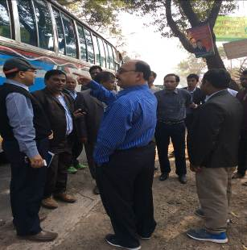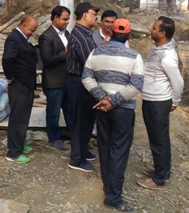
Photographs 7.1.1: Consultant Team Visited the Subproject sites with Pourashava Officials, DSM Consultants and PMU representatives

Issues Raised by the Participants
The participants raised the issues related to the infrastructure development of Feni Pourashava. They emphasized on the subproject selection for the future development and also discussed about the quality construction work. In the FGD, the participants discussed the requirements for the future development of Feni Pourashava.

Feedback, Suggestions, and Recommendations of the Participants
The participants were presented with feedback, suggestions, and recommendations listed below:
- The FGD results confirmed that an improved drainage network is needed for future development and relief from water logging and drainage congestion of Feni Pourashava;
- The participants stated that the water supply facilities and sanitation facilities is inadequate;
- The participants suggested Pourashava Officials to ensure quality construction works by the contractors;
- The participants also suggested that construction works should be scheduled properly to avoid any undue disturbances to the nearby people;
- The participants stated that the construction work should be performed following the EMP to minimize the adverse impacts;
- The participants emphasized on the capacity building workshops to enhance knowledge.

Conclusions and Recommendations

The ecological impact due to the subproject implementation is moderate. However, 250 nos. of trees will be planted to compensate the felled down trees and to enhance the ecological condition of the subproject area. The anticipated environmental impacts are mainly in construction phase. The construction activities will follow simple procedure with commonly used equipments. The construction work will be performed section wise. Hence, the anticipated impacts on the physicochemical components will be temporary and limited within the subproject boundary.
To minimize the adverse impacts, mitigation measures and monitoring program have been formulated. The overall conclusion is that effective implementation of the EMP will significantly minimize the adverse impact caused by the subproject activities. It should be noted that due to changing circumstances during the construction phase if any, there might be minor adaptation needed for environmental, health and safety issues.
A few key recommendations are outlined below:

- The environmental management and monitoring plan recommended in this report needs to be followed;
- EMP should be available in the site during construction phase;
- Regular field visit by PMU, DSM and Pourashava is needed for the effective implementation of the EMP;
- Proper maintenance is needed for the planted trees by the contractor during project defect liability period;
- To minimize occupational health and safety risks, it is highly recommended to adapt mechanical system where appropriate;
- First aid box with relevant medicine should be available at site.

References

এক নজরে পৌরসভা _ ফেনী সদর উপজেলা _ ফেনী সদর উপজেলা.htm

Bangladesh Meteorological Department, 2012. Climate data for Feni District.

GoB (1997), Environmental Conservation Rules 1997.

Environmental Assessment Volume 1: Overall Environmental Assessment [Draft Final Report], September 2013. Municipal Governance and Services Project (MGSP), Local Government Engineering Department (LGED) And Bangladesh Municipal Development Fund (BMDF), Ministry of Local Government, Rural Development and Cooperatives, Government of the People's Republic of Bangladesh.

Environmental Assessment Volume 2: Environmental Management Framework (EMF) [Draft Final Report], September 2013. Municipal Governance and Services Project (MGSP), Local Government Engineering Department (LGED) And Bangladesh Municipal Development Fund (BMDF), Ministry of Local Government, Rural Development and Cooperatives, Government of the People's Republic of Bangladesh.

Geological Survey of Bangladesh, 1978. Earthquake Zoning Map.

Bangladesh Meteorological Department, Flood zoning Map.

International Union for conservation of Nature. http://en.wikipedia.org/wiki/IUCN_Red_List.

Population and housing census, 2011, National Volume-II: Union Statistics.

UNESCO, 2015. https://en.wikipedia.org/wiki/List_of_countries_by_literacy_rate.

APPENDIX

Appendix I: Environmental Monitoring Checklist

