SUBPROJECT DESCRIPTION

Subproject Background

Chakoria Pourashava is situated at Cox's Bazar District. Chakoria Pourashava established on December 14, 1994. At present, Chakoria is A type Pourashava. The Pourashava covers an area of 15.33 sq. km as per Chakoria Pourashava Master Plan. As per Census 2011, population of Chakoria Pourashava is 48,262. Infrastructures and physical development are not attained significantly in the Chakoria Pourashava. In addition, the existing condition of the kitchen market necessitates construction of new building and vertical extension of the South side. Hence, this subproject will significantly contribute infrastructural and physical development of the Chakoria Pourashava.

This subproject includes construction of a four storied new Kitchen Market and vertical extension of the South side (1st floor) of the existing Kitchen Market (wholesale market) with RCC access road. The significant features of the subproject are stated below:

Name of the Subproject : | Construction of a new Kitchen Market including vertical extension of South side (1st floor) of existing Whole Sale Market under Chakoria Pourashava, Cox's Bazar.
Package No. : | MGSP/CHO/2016-2017/W-03
District Name : | Cox’s Bazar
ULB Name : | Chakoria Pourashava
Jurisdiction Area : | Ward number 8
Structural Design Option : | Four storied new kitchen market and vertical extension of South side (1st floor) of existing whole sale market with sanitary, water supply, electrical and other associated works and RCC access road
Wards Population : | About 18,000 as per information by the Pourashava Officials
Tribal People : | No tribal people settlement found in the subproject area
Land Acquisition : | No private land acquisition is required
Estimated Cost : | 74.732 million BDT
Subproject Duration : | 12 Months
Tentative Start Date : | 1st October 2017
Tentative Completion Date : | 30th September 2018

For the preparation of subproject appraisal, environmental screening has been performed. According to that screening, an environmental management plan is required. Hence, this environmental management plan is prepared to meet the regularity requirement. This plan simplifies the anticipated impacts and corresponding mitigation measures for easy understanding of the personnel responsible for the subproject implementation. Therefore, this study only includes key contents that are appropriate.

Subproject Setting

The subproject site is situated within the jurisdiction of the Ward no. 08 at Chakoria Pourashava. The lay-out plan, site analysis and topographic features of the subproject are shown in Figure 1.2.1, Figure 1.2.2 and Figure 1.2.3.

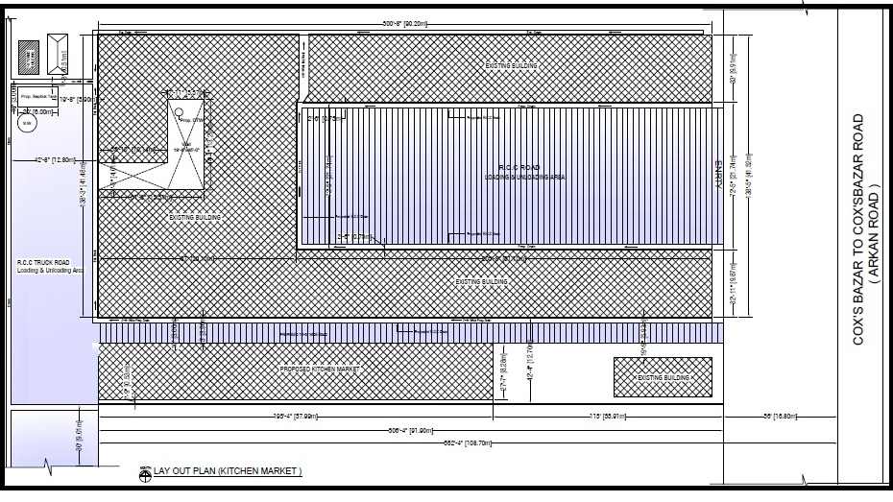Figure 1.2.1: Lay-out Plan of the Kitchen Market

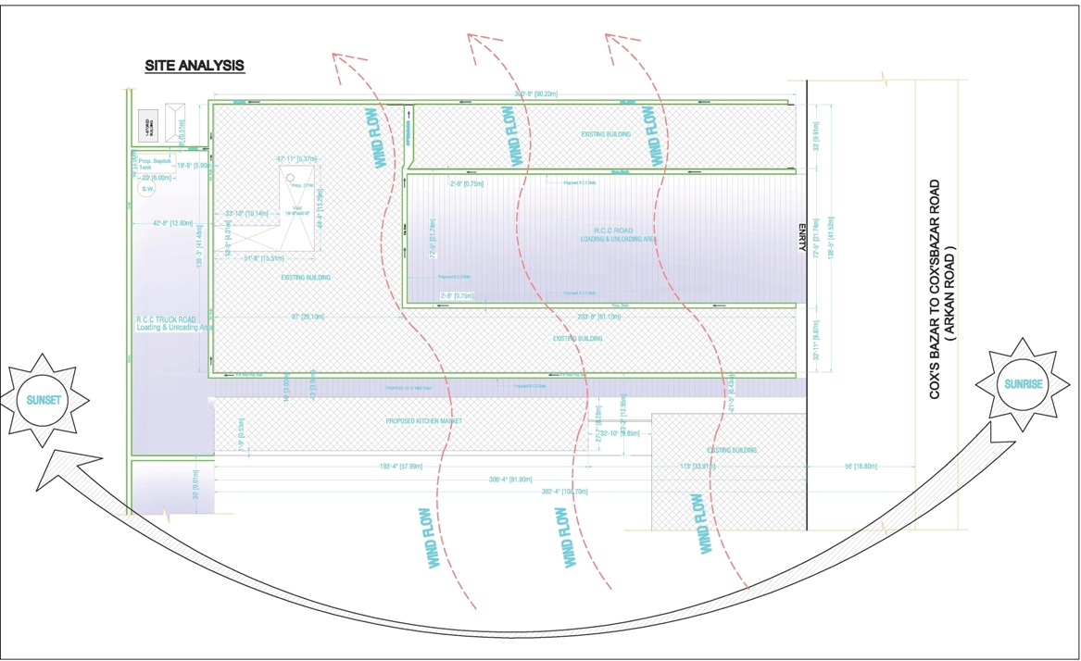

Figure 1.2.2: Site Analysis and Wind Flow Direction at the Subproject Site

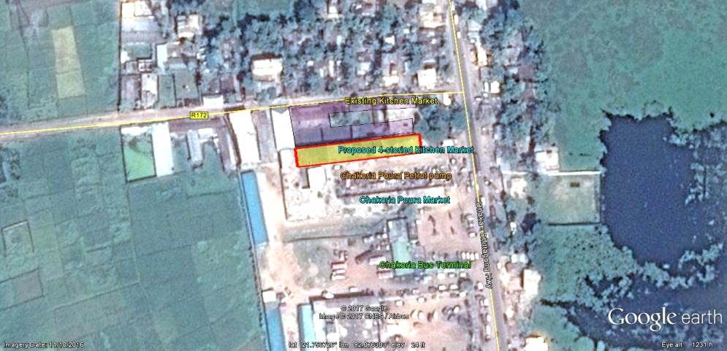
Figure 1.2.3: Topographic Features of the Subproject Site

The subproject site is situated at the built-up and central area of the municipality. During the site visit, the detailed environmental and infrastructural features listed around the subproject site. The major findings of the site visit are given below:

Side/ Direction | Major Environmental and Infrastructural Features
North | BC Link road, Settlements
South | Poura market, earthen drain, brick boundary wall, car washing center, Bus terminal
East | Chittagong-Cox's Bazar highway, Chakoria Poura filling station
West | Wholesale shops, link BFS road, RCC drain, low elevated agricultural land

Current Situation, Proposed Intervention and Need for the Subproject

In the Pourashava area, the existing kitchen market (fish, vegetables and other daily goods) is located at the North side of Chakoria Girls High School Road at Ward no-02. The Chakoria Girls High School Road is narrow in width and busy area due to educational institutions, offices and trade and commerce activities. Consequently, due to presence of kitchen market normal traffic operation is interrupted at the Chakoria Girls High School Road. Due to over crowd around the existing Katcha bazar (kitchen market); particularly at the morning the students of nearby Chakoria Girls High School and other educational institutions feel troublesomeness on the way to their schools and institutes. Some temporary sellers seat on the narrow road side area which aggravates the traffic problem and reduce normal movement of the pedestrians and vehicles.

Moreover, proper water supply and drainage system is not available in the existing kitchen market. In addition, the shopkeepers throw vegetable wastes, feathers and unsalable parts of chickens, fishes and meats, packing materials and waste water on road side area which causes environmental pollution in the surrounding area. Hence, the Pourashava wants to relocate this daily retail market adjacent to the Pourashava wholesale market in the Pourashava owned vacant land.

On the other hand, the existing old kitchen market (retail market) at Ward no. 08 is used for wholesale market. All the imported and exported materials stored and disburse from here. This market is very essential for the wholesale sellers; nonetheless the space of the existing whole sale market building is inadequate. In addition, there are no water supply and sanitation facilities available. Hence, the existing condition of the wholesale-kitchen market is necessitates to construct of new building and vertical extension of the south side of the existing wholesale market.

The existing area of the subproject site is 3724 sq. m. (for newly constructed kitchen market the area is 2124 sq. m. and and vertically extension of old whole sale market is 1600 sq. m.). The plinth area (maximum ground coverage) of the proposed newly kitchen market is 805.8 sq. m (dimension is 8.5 x 94.8 m). The facilities will be provided at proposed kitchen market includes: Construction of new kitchen market building, toilet facilities improvement, provision of water supply, drainage and sanitation facilities, indoor and outdoor lighting system, trash bin installation around the kitchen market area, loading and unloading facilities for vegetable, fish etc. and suitable sales platform for vegetable, fish, chicken etc.

The existing condition of the site is further elaborated in the following Photographs 1.3.1.
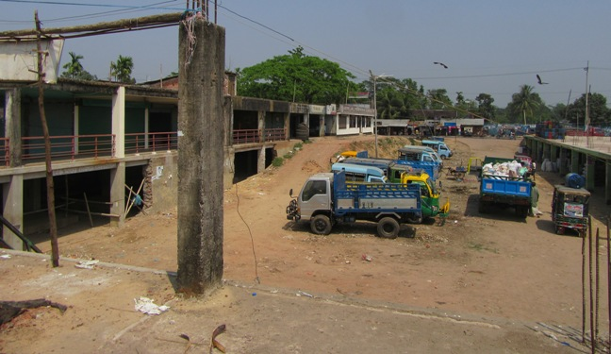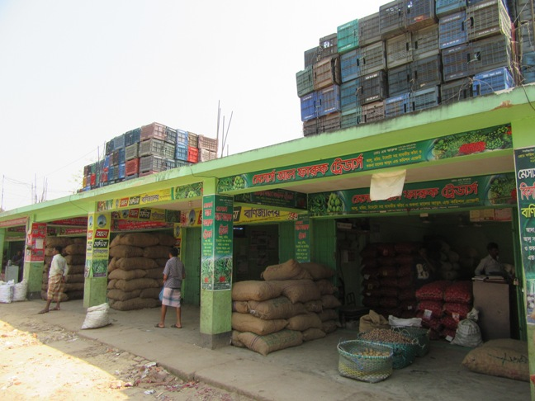
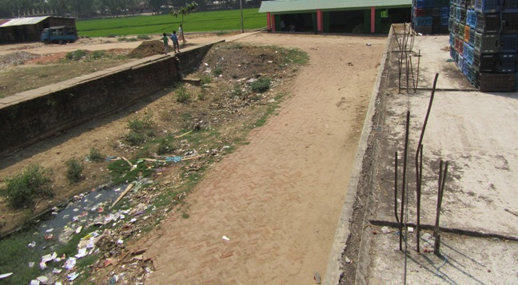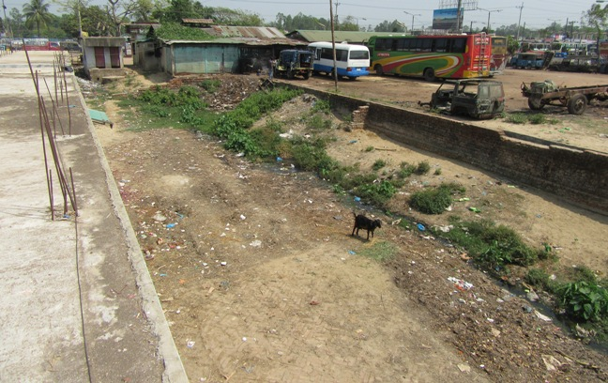

Photographs 1.3.1: Current Situation of the Subproject Site

Envisaged Subproject Activities and Implementation Process
The general activities for the subproject includes: construction of the semi-pucca site office and construction of the labor shed. The major specific activities include:
- Site clearing work;
- Providing lay-out;
- Earthwork in excavation of foundation trenches;
- Cast-in-situ pile work;
- Demolition of pile cap;
- Sand filling in trenches;
- Earth filling work as per requirement;
- Compaction of earth;
- Fabrication, binding, bending of the ribbed or deformed bar;
- Mass reinforcement cements concrete work in grade beam, beam, and column and slab construction;
- Single layer brick flat soling in ground floor;
- Brick work in facing super structure;
- Fancy and ornamental screen work;
- Preparation of the door and window frames with seasoned wood;
- Fitting and fixing of the window and door with accessories;
- Fitting and fixing of the glazed tiles;
- Fitting and fixing of the unglazed tiles;
- Plastering work;
- Distempering with ready mixed synthetic polyvinyl distemper;
- Painting work;
- Fixing of the railing;
- Construction of the toilets and rest room;
- Construction of the septic tank and soak well;
- Construction of the water tank:
- Beautification work;
- Fitting and fixing of the plumbing and electrical accessories etc;
- Tree plantation work as environmental enhancement work.
The materials and resources to be used for the key activities: soil in earth work, sand, stone chips, glass, cement, bricks, concrete, tiles, reinforcement, sanitary and electrical accessories.
The major equipments to be used for the implementation of the subproject: Pile rig, wooden drag, roof hoist, ladder, steel / concrete hammer, concrete mixer machine, mechanical vibrator machine, MS sheet, steel cutter, steel shutter etc.

ENVIRONMENTAL SCREENING

Environmental Screening (ES) for the subproject has been conducted with the purpose of fulfilling the requirements of Government (GOB) and World Bank (WB) for the preparation of subproject appraisal. Environmental Screening Checklist, as adopted in Appendix C of the Environmental Management Framework (EMF) of the MGSP, was administered for identifying the impacts and their extents.
The screening data and information have been formulated and are shown in below.
i) Potential Environmental Impact during Construction Phase:
(a) Ecological Impacts:
Nil
- Felling of the trees Significant □ Moderate □ Minor □√ Number of trees
- Clearing of the vegetation Significant □ Moderate □ Minor □√
- Potential impact on species of Significant □ Moderate □ Minor □√
aquatic (i.e., water) environment
The proposed kitchen market will be constructed besides the existing whole-sale market and rehabilitated and vertically extended on existing whole-sale market. For newly construction, the ground space which is used for construction work is semi-paved and bounded by brick wall, BFS road and existing kitchen market shops boundary. The construction works do not have impact on ecology. There is no tree to be felled down and no vegetation will be cleared for the new kitchen market. In addition, activities require for rehabilitation and vertical extension of the existing building do not have any ecological impact because there is no tree will be felled down and no vegetation will be cleared. Furthermore, there will be no impact on aquatic species at construction phase. Hence, ecological impact is minor.
- Physicochemical Impacts:
- Noise pollution Significant □ Moderate □√ Insignificant □
- Air pollution Significant □ Moderate □√ Insignificant □
- Drainage congestion Very likely □ Likely □ Unlikely □√
- Water pollution Significant □ Moderate □ Insignificant □√
- Pollution from solid/ construction wastes Significant □ Moderate □√ Insignificant □
- Water logging Significant □ Moderate □ Insignificant □√
The subproject will have temporary and localized negative impact on noise and air quality during construction phase due to using of heavy equipment, pilling machine, welding and drilling machine, concrete mixer and vibrator machine etc. Construction activities also will generate solid wastes that have temporary and localized impacts on the surrounding environment. Excavated earth due to excavation for foundation work may block the nearby areas and may create temporary drainage congestion and disturbances to the users of the adjacent existing whole-sale market. Primarily, the subproject will have no adverse impact on the other physicochemical components.
- Socio-economic Impacts:
- Traffic congestion Very likely □ Likely □√ Unlikely □
- Health and safety Significant □ Moderate □√ Insignificant □
- Impact on archaeological and historical Significant □ Moderate □ Insignificant □√
- Employment generation Significant □√ Moderate □ Insignificant □

The subproject will have temporary negative impact in health and safety during construction phase due to likely accidents from the construction activities. At construction phase, vehicles movement for carrying construction materials and mobilization of the equipments may create temporary traffic congestion. However, it has significant positive impact by generating employment opportunity for the local people.
ii) Potential Environmental Impact during Operational Phase:
- Ecological Impacts:
- Potential impact on species of the aquatic Significant □ Moderate □ Minor □√
(i.e., water) environment
The waste water from the kitchen market (from fish and vegetable), marginally may degrade the water quality of the existing drain and ultimately the outfall if it carries pollutants, toxic elements and nutrients. Excess nutrients (Nitrogen and Phosphorus) may disturb the aquatic environment of the outfall and creates algal bloom.
(e) Physicochemical Impacts:
- Potential air quality Significant □ Moderate □ Insignificant □√
- Noise level Significant □ √ Moderate □ Insignificant □
- Drainage congestion Improvement □√ Minor Improvement □ No Impact □
- Waste water disposal Significant □ Moderate □√ Minor □
- Pollution from solid wastes, vegetable Significant □ Moderate □√ No Impact □
wastes and other sorts of market wastes
During operation phase, public gathering at daily product/ Katcha bazar purchasing area and possible use of loud speaker from varieties store to attract the buyer may create severe noise nuisance to the users and shoppers. Since the residential area is far from the proposed kitchen market; operation of the kitchen market does not have any impact on the residential area. Wastes generated from kitchen market at operational phase may pollute the surrounding environment. The vegetable wastes and biodegradable wastes may spread odor to the nearby area and users, if it is not properly managed. Waste water generated from fish and meat processing unit may create environmental degradation if it is not properly managed.
(f) Socio-economic Impacts:
- Traffic Significant □ Moderate □√ Minor □
- Safety Issue (fire hazard, Short-circuit etc) Significant □ Moderate □√ Minor □
- Employment generation Significant □√ Moderate □ Minor □
It has significant positive impact by providing job & business activities and community interaction. During operation phase, it may create traffic congestion and possible accidents and social safety net due to fire hazard, short-circuit and other vulnerability.
iii) Summary of the Possible Environmental Impacts of the Subproject:
From the above study, it seems that the ecological impact is minor. The construction activities may degrade the air quality and noise level. In addition, solid wastes generation from the construction activities may temporary pollute the surrounding environment. Improper storage of the construction materials and stockpiles of the un-used soils, construction debris, and other forms of the wastes materials may create localized hazard for the local people. However, the anticipated impact on physicochemical components is mainly site specific and limited within the subproject boundary. During construction phase, possible failure of the mechanical equipment may create severe accidents to the workers.
During operation phase, due to public gathering and possible using of loud speaker to attract buyers may create severe noise nuisance to the users and shoppers. On the contrary, beautification work such as tree plantation will enhance the ecological condition. Wastes generation due to kitchen market activities is one of the key issues which should be handled and disposed-off properly by placing waste bins. This subproject has positive impacts in terms of the generation of the employment opportunities due to construction activities, supplying of the materials at construction phase and by providing business activities at operation phase.

Specific impact, mitigation AND enhancement measures

The likely impacts of the subproject are mainly caused by the activities required for the implementation of the subproject, and materials, resources and equipment to be used to perform the activities. This section describes some specific impacts due to the subproject activities and their mitigation measures.

Cast in Situ Pile Work

The key activities associated to the cast-in-situ pile work: boring work, cutting and welding of the reinforcement, placing of the pile reinforcement ring into the bore hole and RCC work for pile casting and demolition of the pile head etc. have environmental impacts on the physicochemical components. The anticipated impacts due to cast-in-situ pile works are:

- Noise pollution due to use of rig machine, winch machine, concrete mixer machine, vibrator machine, steel cutter and welding machine;
- Muddy water and clay generation due to boring work;
- Potential occupational health and safety risks and accidents from steel cutter, welding machine, rig machine, and winch machine;
- Air pollution due to black smoke emission from diesel based rig machine, concrete mixer machine and vibrator machine.
Mitigation Measures
- Boring work and RCC work should avoid at schooling time and at night time and should follow normal working hour;
- Establishment of pucca tank (two chambers) to collect muddy water and mud;
- Disposal of the mud at Zidda Bazar dumping site and re-use of the mud and clay if possible;
- Avoid using of steel cutter, wielding machine, concrete mixer machine, vibrator machine, rig machine and winch machine at night;
- Avoid prolonged exposure to noise (produced by equipment) by workers;
- Ensure use of the personal protective equipment’s (helmet, goggles, gloves, safety boot);
- Availability and access to first-aid equipment and medical supplies in case of any accidents;
- Carefully operation of the steel cutter, rig machine and winch machine;
- Ensure proper joint between two reinforcement rings to avoid any possible damage;
- Avoid operation of the concrete mixer and vibrator machine at night;
- Regular maintenance of the concrete mixer and vibrator machine to avoid any black smoke emission.

Excavation Work and Filling Work

The substructure includes excavation work, filling work and compaction work and clearing of the un-used materials. These works may lead dust blowing, improper disposal of the wastes, noise and vibration which may disturb the surrounding environment.
Mitigation Measures
- Proper care will be taken by the contractor during excavation work, filling work, compaction work and disposal work to avoid any undue disturbances to the environment;
- Cover the exposed earth works with fabric;
- Disposal of soil and construction wastes at Zidda Bazar dumping site.

Pollution from the Construction Materials

Dumping of the construction spoils, including accidental leakage of the oil, grease, and fuel in equipment yards is a significant hazard. Surface water and soil quality might be polluted from these contaminants. Even the people to be engaged for the construction activities might endanger the physical and human habitats of the area.
Mitigation Measures
- Safe transport, storage, and disposal of the construction materials, and the equipment have to be carried out in order to avoid the accidental spillage and loss;
- Fuels, lubricants, and other hazardous materials should store over raised platforms and not directly on the ground;
- Maintain adequate moisture content of soil and sand during transportation, compaction and handling;
- Carry the materials especially loose soil and sand with adequate cover;
- Disposal of soil and construction wastes at Zidda Bazar dumping site.

Air Quality and Dust

During construction phase, air pollutants will be emitted from the equipment, subproject activities and construction vehicles are expected to remain low. Local residents in the vicinity of the work sites will be temporarily disturbed by the limited dust pollution. The overall impacts, however, are expected to remain low.
Mitigation Measures
- Water should be sprayed at the work site and camp site area for dust control. Ensure sprinkle and cover stockpiles of the loose materials (e.g., fine aggregates).
- Maintain adequate moisture content of soil and sand for transportation, compaction and handling;
- Avoid use of dust generating equipment (which produce significant amount of particulate matter such as asphalt plant) far from the local residents;
- Ensure that all subproject vehicles are in good operating condition.

Noise and Vibration

Noise and vibration caused by the equipment, subproject activities and movement of the construction vehicles may temporarily disturb nearby environment though the impacts are anticipated to be limited and within the subproject boundary.
Mitigation Measures

- Transportation of the construction materials have to be carried during the scheduled times, and mainly during the day in off-peak time.

Occupational Health and Safety

The most important risks associated with the construction activities are listed below:
- Risks of using of the machineries in motion such as steel cutter, glass cutter etc;
- Risk of falling from the height during chipping, plastering work, painting work etc;
- Risk from drop down of the materials from the height during chipping, plastering work, painting work etc;
- Risk from mechanical failure of the equipments such as pile rig and winch machine;
- Risk from the traffic collision or accidents during operation of the equipment such as hydraulic excavator, steel cutter, pile rig, winch machine, welding machine, and vehicles movement for the transportation activities of the subproject;
- Risks from head loads for carrying soil, construction materials and construction equipment;
- Risk associated to the sudden bad weather working conditions such as storm, thunder storm and earth quake etc.
- Exposure to the sunlight- workers are being exposed to the sun for long hours;
- Exposure to the high temperature, and humidity for a long time resulting in dehydration;
- Contact with the hazardous substances and wastes pose risks of the infections and diseases.

Requirements for the Workers’ Health and Safety
The key salient features of the general requirements for the workers’ health and safety stated are presented in Table 3.6.1.

Table 3.6.1: General Requirements for the Workers Health and Safety
Issues | Requirements
Site fencing, ladder, scaffolding and pulley | - Site should be fenced and screened to protect site from strong winds and to contain dust;  - Ladder should be placed and scaffolding should be provided for the site protection work and for chipping, plastering, painting etc;  - Provide jute netting for avoiding any drop down of the materials to the ground;  - Use mechanical equipments such as pulley for the lifting of the materials to the roof and other floors.
Health and Hygiene | - Cleanliness at the site premises and workers living places and at the Labor Shed;  - Arrangement of the proper ventilation and temperature at the Labor Shed;  - Protection against dust and furnace by using of the nose masks and covering of the head and body;  - Proper disposal of the wastes and effluents;  - Provision of the adequate latrines and separate toilet for the women;  - Sufficient dustbins for the solid waste management system.
Safety and First Aid Box | - Using of the personal protective equipment (helmet, gloves, goggles, nose mask, safety boots);  - Precautions during work on or near machineries in motion;  - Head loads are prohibited;  - Ensure first aid box;  - First aid facilities should be provided and maintained;  - The first aid kit should include adhesive bandages, regular strength pain medication, gauze, and low grade disinfectant.
Compensation for Accidents at Work | - Contractors will bear medical treatment costs. If any severe accidents such as loss of hands, legs or loss of working ability or any case of death needs compensation-(the amount of the compensation should be fixed considering the type of accidents).
Dust and Fumes | - For any dust, fumes, or other impurities likely to be injurious to the workers, effective measures shall be taken to prevent their accumulation and its inhalation by the workers.
Overcrowding | - No labor room should be overcrowded.
Latrines and Urinals | - Sufficient latrines shall be provided;  - Latrines shall be maintained in clean and sanitary condition;  - Latrines shall be adequately lighted and ventilated.
Disposal of Wastes and Effluents | - Proper disposal system for the solid waste and effluent is required.

Impacts on Social Environment and Common Property Resources

Through comprehensive study, it is revealed that impacts are expected not to be severe and to be largely manageable. The following Table 3.7.1 presents impacts on socio-economic environment and common property resources.

Table 3.7.1: Impacts on Social Environment and Common Property Resources
Social Components | Impacts on IECs | Impact Significance
Community Perception | The local community people welcome this subproject and there is no visible objection from them. | Significant (+ve)
Employment and Business Opportunity | Community feels happy because generally the local contractor will be engaged for the construction works which will create work opportunity for the skilled and non-skilled labor. The subproject will create business opportunity for the equipment and materials suppliers. | Significant (+ve)
Community Order and Security | This subproject activity does not create any severe security problems to the local community and community people. | Minor  (-ve)
Possible damage to infrastructure and facilities | Possible damage of the existing road infrastructure by the construction equipment and vehicles used in this subproject. | Minor  (-ve)
New infrastructure and facilities | Construction of community center will provide new infrastructure facilities. | Moderate  (+ve)
Landscape and Aesthetics | This subproject activity temporarily will degrade landscape and aesthetics values of the subproject area to a limited extent. | Minor  (-ve)
Labor Habitat | It is anticipated that the outsider workers will stay at the Labor shed which will have impacts on the environment relates to the generation of the solid wastes, effluent, and water consumption. | Moderate  (-ve)
Health Care | Workers may suffer from the dehydration problems, respiratory problem, and other health hazards. | Minor  (-ve)
Accident | In case of road accidents by the vehicles to be used for the transportation and possible accidents from subproject activities may have serious negative impact. | Significant  (-ve)

Mitigation Measures

- Conduct dissemination with the local community about the subproject details;
- Continue liaison with the community leaders in order to maintain the community support;
- Engage local contractor and local people as much as possible for positive perception of the local community;
- Follow traffic rules to avoid any accidents;
- Transportation and mobilization of the equipments and construction materials avoiding peak hours and scheduled time;
- Ensure first aid facilities and effective use of personal protective equipments where applicable.

Labor Influx and Anticipated Impacts

The labor force and associated goods and services required for construction of infrastructure civil works under this subproject cannot be fully supplied locally. The migration to and temporary settlement of laborers in the subproject, referred to as labor influx, carries an array of potentially positive and negative impacts in terms of demands on public infrastructure, utilities, housing and sustainable resource management and the strain on social dynamics.

Labor influx effects on host communities include positive impacts such as:

- The subproject activities will generate work opportunities for the local people and supplying of the construction materials, equipments, food and other necessary stuffs to the campsite;
- Improved infrastructure and public service access and availability whereby subproject investment catalyzes larger allocation of resources to a region, stimulating the development or expansion of infrastructure and public services.

Critical negative social risks include:

- Increase in criminal activity and alcohol and drug abuse, domestic violence, political attachment and violence, smuggling and robbery etc;
- Increase in gender-based violence, including eve teasing, sexual harassment etc;
- Increases in communicable diseases, including respiratory problems, diarrheal diseases, vector-borne diseases (e.g., malaria), and sexually transmitted infections (e.g., HIV/AIDS, syphilis, gonorrhea, hepatitis B);
- Conflicts arising from increased demand on existing infrastructure, services, and utilities, including transportation, health, education, water and sanitation, waste management, public utilities and community, religious, and recreational facilities and loss of land for access routes.
The general environmental impacts of labor influx include pressure on the natural resources such as using of the water, electricity, other fuel for cooking, loss of land for the labor establishment, depletion of the water supply, sewage and waste water generation, degradation of the air quality, waste generation, increased demands on the local energy and resources and noise pollution effects. The number of local and migrated people involved in the subproject activities can be only identified in the construction phase. Hence, these specific impacts will be quantified during construction work and environmental assessment report will be modified accordingly. However, the following safeguard measures are recommended to avoid any risk of labor influx:

- Inform local people about the subproject activities;
- Liaison with the community leaders in order to get community support;
- Engage local people as much as possible to minimize workers from outsiders;
- Monitor workers attitude and behavioral matter;
- Monitor the workers movement for avoiding any unexpected social activities (robbery, crime, political attachment and conflicts, drugs abuse);
- Inform and use local administration to get support if needed;
- Inform local utilities service providers (such as for new electricity connection REB or any other department);
- Ensure effective use of natural resources such as water, electricity, fuel, wood etc.

Impacts on Traffic Movement

Due to transportation of the materials and equipments, the subproject will have likely temporary negative impact in traffic congestion during movement of the vehicles and equipment. However, it is anticipated that the subproject activities do not have any severe impact on the local traffic system because movement of the vehicles and equipment will be only for a short time and as per requirement. The on-site subproject activities do not have any impact on the local traffic system during construction phase. However, during operation phase, improper and roadside parking may create localized traffic congestion.
During construction phase, interruption of the traffic movement and impact on the local traffic system due to the subproject activities will be monitored closely. Then separate traffic management plan will be provided if required. However, the following safeguard measures are recommended to minimize the impacts associated to the traffic movement:

- Inform local people about the subproject activities;
- Inspire local people to use connecting and diversion roads;
- Ensure schedule deliveries of material/ equipment during off-peak hours;
- Place traffic sign/cautionary sign to avoid undue traffic congestion and associated traffic control measures to limit possible disruption;
- The place of construction works should be fenced off with fences if required and should be isolated from general public access and marked with signs to ensure safe movement.

RECOMMENDED MITIGATION AND ENHANCEMENT MEASURES

The activities wise anticipated environmental impacts and corresponding mitigation measures have been outlined in Table 4.1 and Table 4.2.
Table 4.1: Anticipated Environmental Impacts during Construction Phase and Corresponding Mitigation and Enhancement Measures (EMP Table)
Activity / Issues | Potentials Impacts | Proposed Mitigation and Enhancement Measures | Responsible Parties
Construction and operation of labor shed for the workers (Workforce and labor shed management) | - Generation of sewage and solid waste may cause water/ environmental pollution | - Construction of sanitary latrine/septic tank system at the labor shed;  - Erection of “no litter” sign, provision of waste bins/cans;  - Ensure wastes (solid wastes and other forms of the wastes) disposal at Zidda Bazar dumping site. | Contractor  Monitoring-  Primarily by  Pourashava  Secondarily by PMU, LGED and DSM
 | - Extraction of materials can disrupt natural land contours;  - Significant amount of gravel, sand and cement may cause localized changes in topography and land forms | - Prepare list of approved quarry sites and sources of materials;  - Utilize readily available sources of materials;  - Borrow areas and quarries (if these are being opened up exclusively for the subproject) must comply with environmental requirements as applicable.
 | - Health of workers | - Comply with requirements of Government of Bangladesh Labor law of 2006 and all applicable laws and standards on worker's Health and Safety;  - Conduct formal and unofficial discussion to increase awareness about hygiene practices among the workers;  - Ensure availability and access to first-aid equipment and medical supplies for the workers.
 | - Community health and safety: work will impede the access of business in limited cases. Poor safety signage and lack of barriers at work site and trenches may create hazard to nearby existing kitchen market users | - Provide safety signage at all sites visible to public;  - Provide safety barriers near any trenches and cover trenches with planks during non-work hours;  - Contractor's activities and movement of staff will be restricted to designated construction areas;  - Location of batching plants and crushers shall be located at least 100m away from the nearest community preferably in the downwind direction;  - Under no circumstances may open areas be used as a toilet facility;  - Use small mechanical excavators to attain faster trenching progress.
 | - Possible development of labor camp into permanent settlement | - Contractor to remove labor camp at the completion of contract.
 | - Outside labor force causing negative impact on health and social well-being of local people | - Ensure that contractor employ local work force to provide work opportunity to the local people and conduct formal and unofficial awareness program for the health and social well-being of the local people.
General construction works | - Air pollution | - Check regularly and ensure that all the subproject vehicles are in good operating condition;  - Ensure contractor spray water on dry surfaces of the compound and adjacent area regularly to reduce dust generation;  - Maintain adequate moisture content of sand for transportation, handling and storage;  - Ensure contractor sprinkle and cover stockpiles of loose materials (e.g., fine aggregates). | Contractor  Monitoring-  Primarily by  Pourashava  Secondarily by PMU, LGED and DSM  Contractor  Monitoring-  Primarily by  Pourashava  Secondarily by PMU, LGED and DSM  Contractor  Monitoring-  Primarily by  Pourashava  Secondarily by PMU, LGED and DSM
General construction works | - Traffic congestion, effect on traffic and pedestrian safety | - Ensure schedule deliveries of material/ equipment during off-peak hours;  - Avoid road side storage of the construction materials;  - Place cautionary sign for the pedestrian safety.
General construction works | - Noise pollution | - Check and maintenance the equipment properly;  - Avoid using of construction equipment producing excessive noise at night;  - Avoid undue use of hydraulic horns by the subproject vehicles.
General construction works | - Water logging during rain | - Adequate provisions of storm water drainage and provision of the pumping-out/bailing out of the storm water if needed.
General construction works | - Accidents | - Conduct formal and informal discussion for creating awareness about the accident;  - Provides PPEs and ensure using of the personal protective equipment by the workers;  - Regular checking of the mechanical equipments such as roof hoist, pile rig, vibrator machine, concrete mixer machine, rod cutter, drill machine, hammer etc.  - Provision of jute netting to avoid any undue fall down of the construction materials;  - Ensure using of the safety belts during chipping, plastering, painting, glass fitting etc.
General construction works | - Spills and leaks of oil, toxic chemicals and soil pollution | - Prevent discharge of fuel, lubricants, chemicals, and wastes into soil;  - Use jute netting to prevent possible drop down of the cemented materials to the ground;  - Collection and disposal of spills.
All construction works | - Beneficial impact on employment generation | - Employ local people in the project activities as much as possible;  - Give priority to poor people living within project area in subproject related works (e.g., excavation and other works, which do not require skilled manpower);
All construction works | - General degradation of the environment | - Ensure environmental enhancement measures - 25 trees will be planted to enhance ecological condition and beautification.
Environmental impact due to the key construction activities and corresponding mitigation measures
Site clearing / pile driving work | - Generation of solid and construction wastes;  - Generation of loose soil. | - Cover exposed loose soil, construction debris etc. before disposal;  - Disposal of un-used soils and construction wastes at Zidda Bazar dumping site.
Site clearing / pile driving work | - Accidents | - Operate the machineries such as pile rig, drill machine etc. carefully;  - Operate the hammer carefully for the dismantle work.
Sand filling / Back filling work | - Air and dust pollution affecting nearby settlements | - Maintain adequate moisture content of soil and sand during transportation, compaction and handling;  - Carry the materials especially loose soil and sand with adequate cover.
Cutting, welding of the reinforcement and shuttering work | - Noise Pollution | - Avoid using of rod cutter and wielding machine at night.
Cutting, welding of the reinforcement and shuttering work | - Health and Safety | - Ensure use of the PPEs;  - Availability and access to first-aid equipment and medical supplies.
RCC (reinforcement concrete) work | - Air pollution due to black smoke emission from concrete mixer machine and vibrator machine | - Regular maintenance of the concrete mixer and vibrator machine.
RCC (reinforcement concrete) work | - Noise pollution | - Avoid operation of the concrete mixer and vibrator machine at night;  - RCC work should be carried-out at regular working hour.
Chipping, plastering, painting and glass fitting etc. | - Possible health and safety issues such as fall down from the height | - Use ladder/scaffolding, safety belts, helmet and other safety equipments;  - Use jute netting to avoid fall down of the materials during chipping, plastering, painting and glass fitting work.
- Fitting and fixing of the sanitary and electrical accessories;  - Setting up electrical connection | - Potential health and safety risks due to drill machine and hammer | - Ensure use of the PPEs as per requirement.
Environmental impact due to the key construction activities and corresponding mitigation measures for RCC Road
Dismantle work/ Excavation work | - Generation of solid & construction wastes due to the dismantle works;  - Generation of loose soil due to the earth excavation work. | - Cover exposed loose soil, construction debris etc. before disposal;  - Disposal of un-used soils and construction wastes at Zidda Bazar dumping site.
Dismantle work/ Excavation work | - Accidents | - Operate the hammer carefully for the dismantle work if needed.
Sand filling | - Air and dust pollution affecting nearby settlements | - Maintain adequate moisture content of soil during transportation, compaction and handling;  - Carry the materials especially loose soil and sand with adequate cover.
Cutting & welding of the reinforcement for RCC road | - Noise Pollution | - Avoid using of steel cutter and wielding machine at night;  - Avoid prolonged exposure to noise (produced by equipment) by workers.
Cutting & welding of the reinforcement for RCC road | - Health and Safety | - Ensure use of the PPEs;  - Availability and access to first-aid equipment and medical supplies.
RCC work for RCC road | - Air pollution due to black smoke emission | - Regular maintenance of the concrete mixer and vibrator machine.
RCC work for RCC road | - Noise pollution | - Avoid operation of the concrete mixer and vibrator machine at night.

Table 4.2: Anticipated Environmental Management Plan (EMP Table) at Operational phase of the Kitchen Market

Activity/Issues | Potential Impacts | Proposed Mitigation and Enhancement Measures | Responsible Parties
Air quality degradation | - Black smoke emission, dust from the vehicles and bad odor from the wastes materials may degrade the air quality | - Ensure effective traffic management;  - To avoid any likely bad odor generated from the waste materials, ensure effective waste management facilities. | Monitoring  primarily by Pourashava  secondarily by PMU, LGED
Noise Nuisance | - Use of hydraulic horns by the vehicles may create noise nuisance;  - Use of loud speaker and overcrowd may create noise nuisance | - Ensure effective traffic management and create awareness to avoid undue use of horns;  - Ensure limited use of loudspeaker.
Wastes generation | - Possible degradation of the environment due to improper disposal of the vegetables wastes. | - Introduce waste bins at Kitchen Market;  - Biodegradable wastes (vegetable, chicken, beef, fishes and other rotten wastes) and other forms of solid wastes should be dumped at designated dump site at Zidda Bazar.
Traffic congestion | - Increase and improper parking of the vehicles may create traffic congestion | - Ensure effective traffic management;  - Use car parking zone for the proper parking of the guest vehicles.
Possible accidents and social safety net due to fire hazard, short-circuit and eve teasing. | - Fire hazard, short-circuit and earth quake etc. may create accidents and safety risks;  - Possible social vandalism due to eve teasing, robbery, pick pocketing etc | - Use fire extinguisher and ensure emergency exit;  - Conduct programs for awareness rising of the community people to minimize social vandalism.
Waste water/ sewage disposal | - Improper disposal and leakage of sewage may degrade the surrounding environment | - Separate sewer lines for bath room and toilet facilities;  - Provision of septic tank system and soak pit for the toilets.

Environmental Monitoring Plan

Environmental Monitoring Plan for this subproject will help to evaluate the extent and severity of environmental impacts against the predicted impact and the performance of environmental protection measures. The following Table 5.1 and Table 5.2 have been prepared for the key environmental indicators.

Table 5.1: Matrix Table of Monitoring Plan (Visual and observation during construction phase)
Monitored Parameter/ Issues | Monitoring Method/ Key Aspects | Location of Monitoring | Period & Monitoring Frequency
Safety orientation and training of workers | Frequency of training & orientation of workers for safety | Subproject site | - Once in a month  - Reporting: Once in a month
Personal Protective Equipment | Ensure every single person involved in the activities wear and use safety equipment | Subproject site | - Daily  - Reporting: Once in a month
Worker’s health | Monitoring process of worker’s health | Subproject site | - Daily  - Reporting: Once in a month
Sanitation & drinking water facility to the workers | Availability of safe drinking water and sanitation to the workers | Subproject site | - Daily  - Reporting: Once in a month
Incident record and reporting | Documented record of all incident, accident, its remedial process | Subproject site | - Daily  - Reporting: Once in a month
Site security/ Fencing at the site | Isolation of site from general access by fencing, restriction of the un-authorized entry in the site. | Subproject site | - Daily  - Reporting: Once in a month
Bulletin/ announcement boards/ prohibition signs | Visible in good condition or not | Subproject site | - Daily  - Reporting: Once in a month
Equipment /vehicles | -Switched-off diesel engines when not in use;  -Search any possible leakage;  -Fuelling. | Subproject site | - Daily  - Reporting: Once in a month
Dust | Dust is visible or not | Subproject site | - Daily  - Reporting: Once in a month
Oily waste generation and disposal | Quantity of oily waste, storage and disposal | Subproject site | - Daily  - Reporting: Once in a week
Solid waste generation | Quantity of solid wastes and disposal | Subproject site | - Daily  - Reporting: Once in a month
Gender equity | No discrimination regarding payment | Subproject site | - Daily  - Reporting: Once in a month
Child labor | No child will be engaged in the activities | Subproject site | - Daily  - Reporting: Once in a month
Handling of hazardous materials | Fuelling, storage, operation | Subproject site | - Daily  - Reporting: Once in a month

Table 5.2: Matrix Table of Monitoring Plan (Analytical Monitoring during construction phase)
Monitored Parameter / Issues | Monitoring Method/Key Aspects | Location of Monitoring | Period & Monitoring Frequency
Air quality | - Visually-black smoke;  - Sampling;  - Analysis at laboratory;  - Data analysis of merits determination by using quality standards;  - Through digital instruments. | Subproject site | - Once during construction period;  - Reporting: Immediately after analysis and once in a month as a regular basis
Noise level | - Through digital noise level meter | Subproject site | - Three times during construction period;  - Reporting: Immediately after measurement and once in a month as a regular basis.

In addition, a comprehensive Environmental Compliance Monitoring checklist has been preparing that is enclosed in Appendix-I.

Environmental MANAGEMENT BUDGET

Considering the environmental impacts and their mitigation measures for the subproject, several items are included in the BOQ for the environmental management. Table 6.1 presents the estimated cost for the environmental management.
Table 6.1: Environmental Management Budget
Item No. | Description of the Items | Costs (Tk)
eme-1 | Dust suppression measures by water spraying throughout the construction period in and around the subproject site, uncovered aggregates and loose materials such as stockpiles of the sands, excavated earth etc. | 20,000.00
eme-2 | Air quality (SPM, CO, SO₂, NO₂ and HC) measurement- it can be measured from the recognized environmental survey company, public institute/ university once during construction phase (Actual monitoring time and location will be decided by the DSM-Environmental Safeguard Specialist depending on the specific activities). | 50,000.00
eme-3 | Noise level measurement- it can be measured from the recognized environmental survey company, public institute/ university three times during construction phase (Actual monitoring time and location will be decided by the DSM-Environmental Safeguard Specialist depending on the specific activities). | 15,000.00
eme-5 | Prevention of the spillage, leakage of the polluting materials | 5,000.00
eme-6 | Camp site wastes disposal facility during construction period (collection, transportation and dumping of the wastes preferably at Zidda Bazar dumping site): 2 nos (1 no. for the organic wastes and 1 no. for the inorganic wastes disposal facility) | 40,000.00
eme-7 | Water supply facilities (for the labor shed and work site): Preferably 1 no. of tube well (depending on the site condition, DSM-Environmental Safeguard Specialist will assist the contractor for selecting the option) | 20,000.00
eme-8 | Sanitation facilities (at the labor shed): 2 nos. of the toilets preferably sanitary toilets (1 no. for women and 1 no. for men) | 40,000.00
eme-9 | Providing safety gear packages like hand gloves, spectacles for eye protection, helmets, masks, visible jacket, safety boots for at least 16 person and one first aid box | 50,000.00
eme-11 | Tree plantation as ecological enhancement work preferably local flowers and medicinal trees- Neem, Sonalu, Jarul, Polash, Krisnachura, and Bokul (including protection, fencing and conservation during project defect liability period-fencing as per drawing): at peripheral area where space is available- 25 nos. of the trees | 25,000.00
eme-14 | Cautionary signs - 4 nos. | 10,000.00
eme-15 | Installation of waste bins as per drawing-15 number of waste bins | 1,20,000.00
 | Total | 3,95,500.00

After approval to revise the cost estimate has lengthy complex procedure. Hence, as per project EMF, PMU suggestion and experience from other LGED projects, adequate budget has been allocated for the environmental management for the mitigation and enhancement measures. The subproject activities have temporary and localized negative impact on noise, and air quality during construction phase due to movement of the subproject vehicles and equipments. Hence, budget includes analytical monitoring for air quality and noise level. For solid waste management adequate waste bins will be installed. The budget for labor shed, and site office construction is included in the civil works items. Therefore, it is not included in the environmental budget. It should be noted that the contractor will be paid as per actual work done.

CONCLUSIONS and Recommendations

The ecological impact due to this subproject is very less. The anticipated impact is mainly on the physicochemical components during construction and operation phase. Since there is no adjacent residential area; hence, the anticipated impact will be limited and significantly manageable through mitigation measures. The overall conclusion is that if the mitigation and enhancement measures are implemented effectively, there will be no significant negative environmental impacts as a result of location, design, construction, and/or operation of the proposed kitchen market.
A few key recommendations are outlined below:
- The Pourashava will ensure availability of the EMP at subproject site during construction phase;
- The Pourashava should inform the local people about the subproject intervention regularly;
- The construction work should be followed structured work program;
- All mitigation and enhancement measures proposed in this report need to be followed;
- Visual and analytical monitoring should be carried-out as per EMP and with the facilitation of the DSM consultant;
- Contractor will ensure first-aid, water supply and sanitation facilities to the workers;
- Contractor will ensure availability of the PPEs to the workers;
- Contractor will monitor the workers behavioral matter to avoid any undue issues associated to the labor influx.

APPENDIX
Appendix 1: Environmental Monitoring Checklist

