
GOVERNMENT OF THE PEOPLE’S REPUBLIC OF BANGLADESH
Local Government Engineering Department (LGED)

Local Government Division

Ministry of Local Government, Rural Development, and Cooperatives

Environmental MaNAGEMENT PLAN

Name of the Subproject: Construction of Community Center at Sitakunda Pourashava
Package No: MGSP/SIT/2017-18/W-04

Sitakunda Pourashava, Chittagong
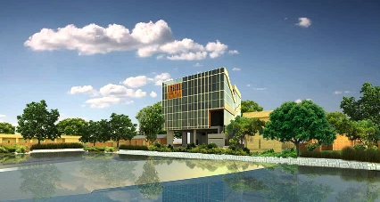

Municipal Governance and Services Project (MGSP)
Design, Supervision, and Management (DSM) Consultancy Services
Joint Venture of  Hifab International AB, Sweden  AQUA Consultant and Associates Ltd., Bangladesh |   

TABLE OF CONTENTS
 |  |  | Page
1.0 |  | SUBPROJECT DESCRIPTION | 1-8
 | 1.1 | Subproject Background | 1
 | 1.2 | The Study Area | 2
 | 1.3 | Current Situation, Proposed Intervention and Need for the Subproject | 6
 | 1.4 | Envisaged Subproject Activities and Implementation Process | 6
 | 1.5 | Category of the Subproject | 7
 | 1.6 | Subproject Schedule | 8
2.0 |  | ENVIRONMENTAL SCREENING | 9-11
3.0 |  | SPECIFIC IMPACT, MITIGATION AND ENHANCEMENT MEASURES | 12-20
 | 3.1 | Demolition of the Existing Structure and Demolition Wastes Disposal | 12
 | 3.2 | Tree Felling, Clearing of the Vegetation and Ecological Impact | 13
 | 3.3 | Cast in Situ Pile Work | 13
 | 3.4 | Pollution from the Construction Materials | 14
 | 3.5 | Air Quality and Dust | 14
 | 3.6 | Noise and Vibration | 15
 | 3.7 | Occupational Health and Safety | 15
 | 3.8 | Impacts on Social Environment and Common Property Resources | 16
 | 3.9 | Labor Influx and Anticipated Impacts | 17
 | 3.10 | Impacts on Traffic Movement | 19
 | 3.11 | Drainage Congestion | 19
4.0 |  | RECOMMENDED MITIGATION AND ENHANCEMENT MEASURES | 21-25
5.0 |  | ENVIRONMENTAL MONITORING PLAN | 26
6.0 |  | ENVIRONMENTAL MANAGEMENT BUDGET | 27
7.0 |  | ENVIRONMENTAL CODES OF PRACTICE | 28
8.0 |  | CONCLUSIONS AND RECOMMENDATIONS | 29
9.0 |  | REFERENCES | 30
APPENDIX
Appendix I: Environmental Monitoring Checklist |  |  | 31

LIST OF TABLES
Table 3.7.1 | General Requirements for the Workers Health and Safety
Table 3.8.1 | Impacts on Social Environment and Common Property Resources
Table 4.1 | Anticipated Environmental Impacts during Construction Phase and Corresponding Mitigation and Enhancement Measures
Table 4.2 | Anticipated Environmental Impacts during Operation Phase and Corresponding Mitigation and Enhancement Measures
Table 5.1 | Matrix Table of Monitoring Plan (Visual Observation during Construction Phase)
Table 6.1 | Environmental Management Budget

LIST OF FIGURES

Figure 1.2.1 | Major Environmental Features and Infrastructures Adjacent to Subproject Boundary
Figure 1.2.2 | Location of the Subproject
Figure 1.2.3 | Lay-out Plan of the Existing Structures
Figure 1.2.4 | Lay-out Plan of the Proposed Structures
Figure 1.2.5 | Topographical Features of the Subproject Boundary with Influence Area

LIST OF Photographs
Photographs 1.3.1 | Current situation of the Subproject Site

ABBREVIATIONS

BDT | Bangladeshi Taka
BOQ | Bill of Quantity
CC | Cement Concrete
DSM | Design, Supervision, and Management
EA | Environmental Assessment
ECR | Environmental Conservation Rules
EMP | Environmental Management Plan
EPP | Emergency Preparedness Planning
ES | Environmental Screening
GoB | Government of Bangladesh
LGED | Local Government Engineering Department
MGSP | Municipal Governance and Services Project
PD | Project Director
PMU | Project Management Unit
RCC | Reinforcement Cement Concrete
WB | World Bank

INTRODUCTION

Subproject Background

Sitakunda Pourashava is situated at Chittagong District. It is established as a Pourashava in the year of 1998. This is B Type Pourashava with present population of 43,555. The Pourashava covers an area of 27.96 sq. km (At a glance: Sitakunda Pourashava). Rapid urbanization requires new infrastructure facilities in the Pourashava area. At present, there is no modern community center with advanced facilities in the Pourashava. For marriage ceremony, birthday, seminar /workshop or other events a well-designed community center is required. Hence, under MGSP Sitakunda Pourashava demands construction of 4 storied community center in the central Pourashava area. This subproject will be an income generating source of the Pourashava.

The key features of the subproject include:
Name of the Subproject : | - Construction of Community Center at Sitakunda Pourashava
Package No. : | MGSP/SIT/2017-18/W-04
District Name : | Chittagong
ULB Name : | Sitakunda Pourashava
Jurisdiction Area : | Wards number 9
Structural Design Option : | Four storied community center with sanitary, water supply, electrical and other associated works
Beneficiary Population : | About 52,000 as per information given by the Pourashava
Tribal People : | No tribal people settlement found in the subproject area
Land Acquisition : | No private land acquisition is needed
Estimated Cost : | 44.78 million BDT
Subproject Duration : | 12 months
Tentative Start Date : | 01 March, 2018
Tentative Completion Date : | 28 February, 2019

For the preparation of subproject appraisal, environmental screening has been performed. According to that screening, an environmental management plan is required. Hence, this environmental management plan is prepared to meet the regularity requirement. This plan simplifies the anticipated impacts and corresponding mitigation measures for easy understanding of the personnel responsible for the subproject implementation. Therefore, this study only includes key contents that are appropriate.

The Study Area

This subproject site is situated within the jurisdiction of ward no. 6 under Mohadevpur Mouza. The subproject is located at the core area of the Pourashava and it is sited opposite to Lal Dighi bounded by the Sitakunda Pourashava and Sitakunda Govt. Adarsha School. Major environmental and infrastructural features adjacent to the subproject are shown in Figure 1.2.1.
Main Road
Pourashava Road
N
School
Lal Dighi
Mosque
Pourashava Building
Subproject site - Old Union Parishad Building
Figure 1.2.1: Major Environmental Features and Infrastructures Adjacent to Subproject Boundary (Schematic Presentation)
The location map, lay-out plan, and topographic features of the subproject are shown in Figure 1.2.2, Figure 1.2.3, Figure 1.2.4 and Figure 1.2.5.
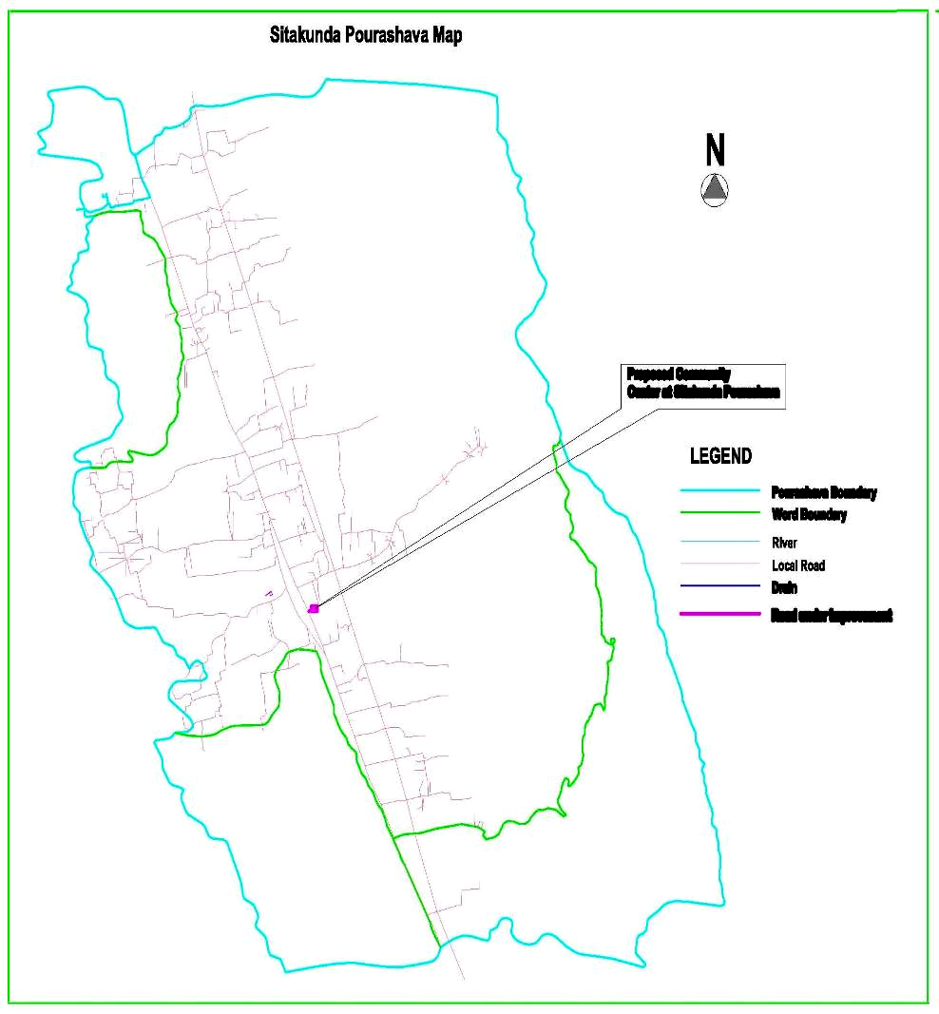
Figure 1.2.2: Location Map of the Subproject
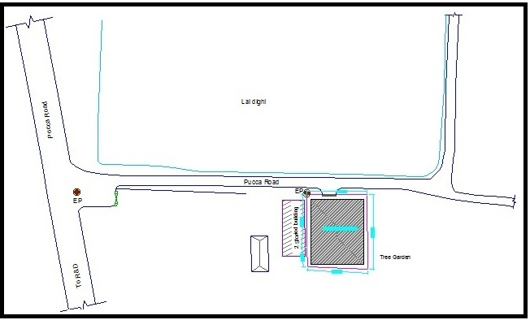
Figure 1.2.3: Lay-out Plan of the Existing Structures

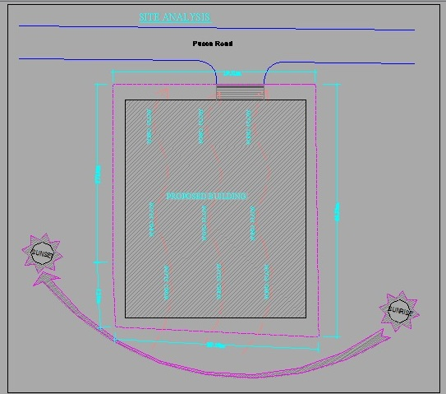
Figure 1.2.4: Lay-out Plan of the Proposed Structures
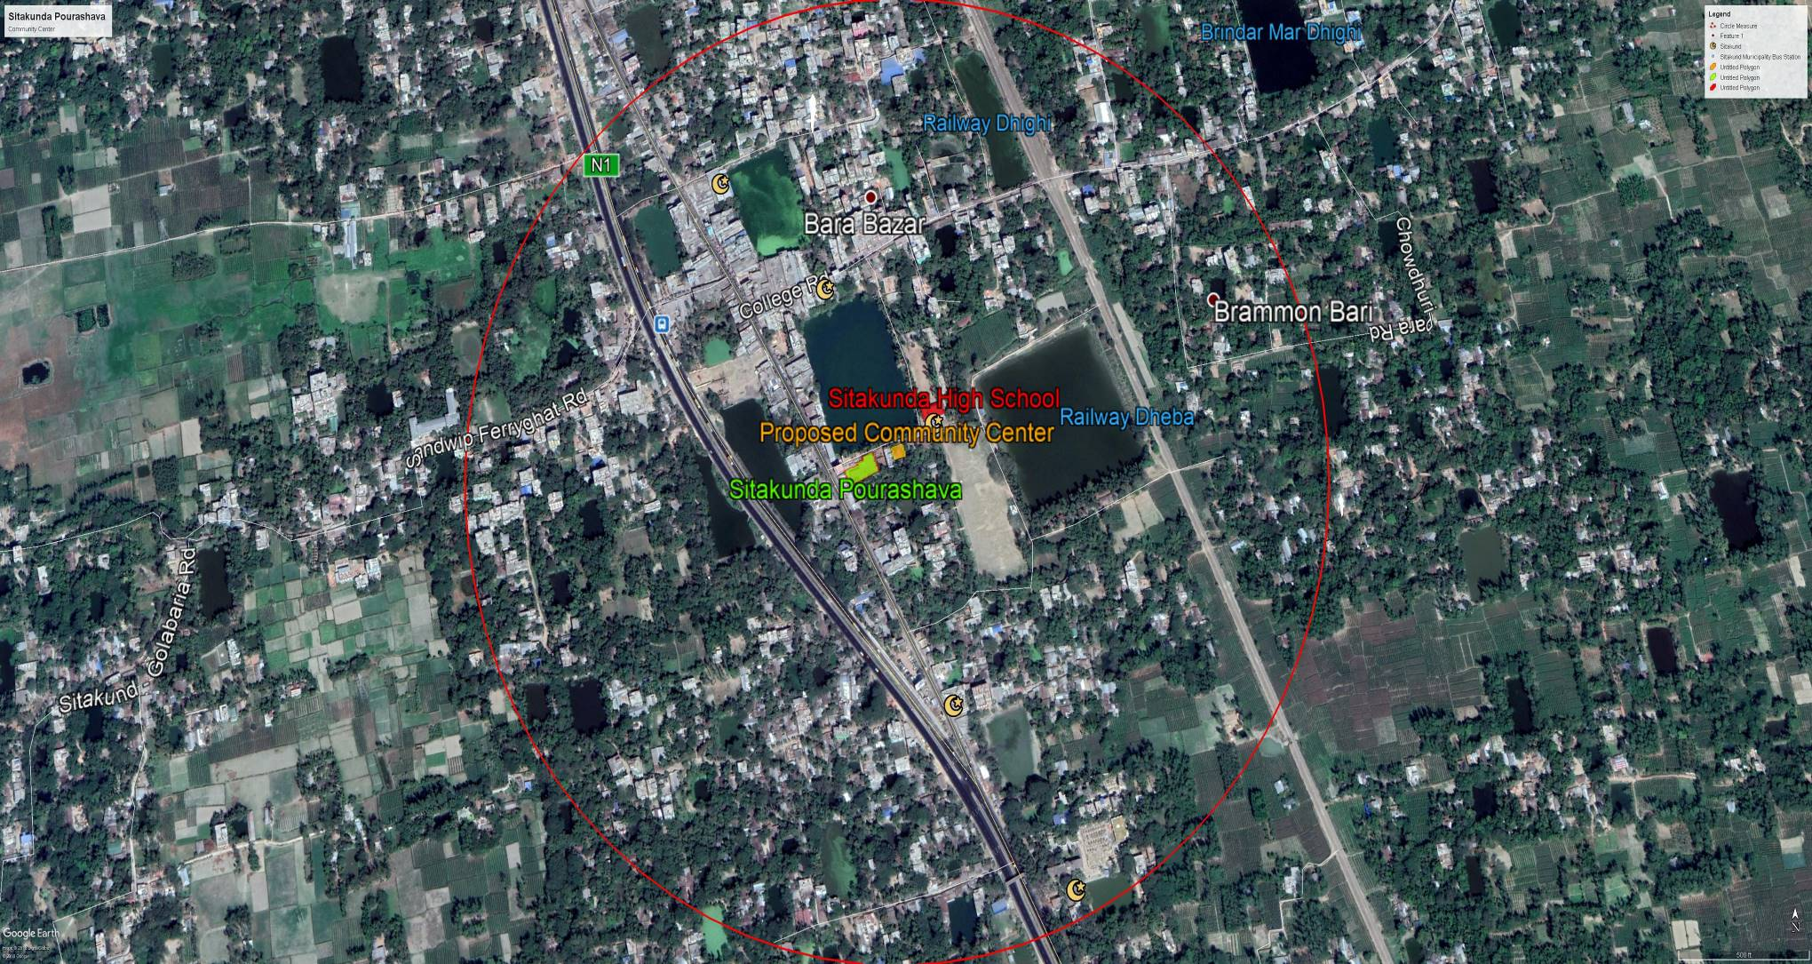
Figure 1.2.5: Topographical Features of the Subproject Boundary with Influence Area

Current Situation, Proposed Intervention and Need for the Subproject

There is an abandoned building (known as Old Sitakunda Union Parishad Office) in the proposed site. After declaration as a Pourashava, this abandoned Union Parishad building was used as Pourashava building for administrative purposes. After construction of the new Poura Bhaban, the Pourashava Office has been shifted and declared it as abandoned structure.
Under this subproject, the abandoned Union Parishad Office building will be demolished and a four storied community center will be constructed. The existing area of the subproject site is 476sq.m (total land area). The maximum ground coverage is 458sq.m. The proposed community center will be four storied building with periphery drain and connecting small ramp to the Pourashava Road. In the design- ground floor (level-1) of community center is allocated for car parking, mechanical / generator room, kitchen, water pump room and toilet. Septic tank and RCC reservoir will also be located in the ground floor. Two stair cases are proposed for the building, one for general use and another for service use. 1st floor (level -2) is allocated for multipurpose hall room, a small stage, service room, toilet for male and female as well as change room. 2nd floor (level -3) is allocated for multipurpose hall room, service room, toilet for male and female as well as change room for female. 3rd floor (level -4) is proposed as rest house. Two VIP Suites and three guest rooms with attached toilet and verandah are proposed in the third floor. A sitting lounge and dinning space will be part of the rest house. The current situation of the proposed subproject site (community center) is further elaborated in the following Photograph 1.3.1.
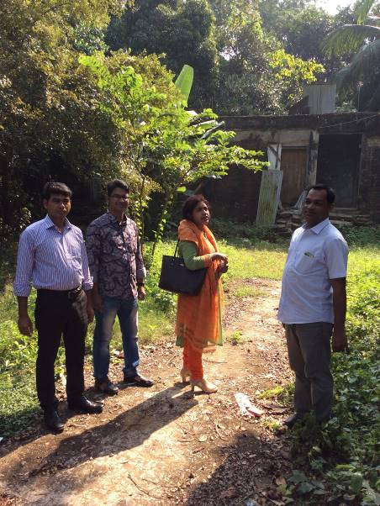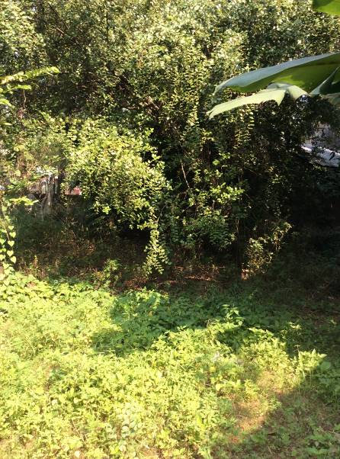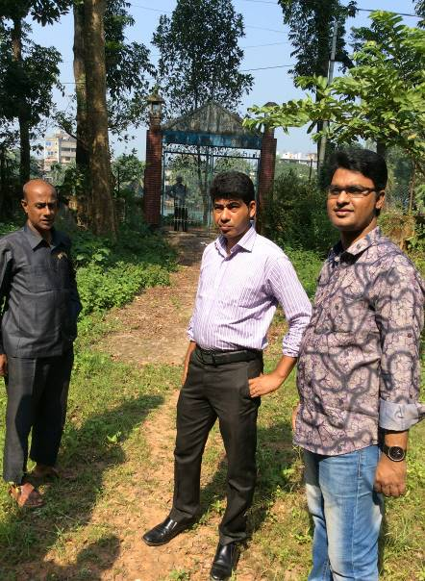
Photographs 1.3.1: Current Situation of the Subproject Site

Envisaged Subproject Activities and Implementation Process
The general activities for the subproject includes: construction of the semi-pucca site office and construction of the labor shed. The major specific activities include:
- Site clearing work;
- Providing lay-out;
- Earthwork in excavation of foundation trenches;
- Cast-in-situ pile work;
- Demolition of pile cap;
- Sand filling in trenches;
- Earth filling work as per requirement;
- Compaction of earth;
- Fabrication, binding, bending of the ribbed or deformed bar;
- Mass reinforcement cements concrete work in grade beam, beam, and column and slab construction;
- Single layer brick flat soling in ground floor;
- Brick work in facing super structure;
- Fancy and ornamental screen work;
- Preparation of the door and window frames with seasoned wood;
- Fitting and fixing of the window and door with accessories;
- Fitting and fixing of the glazed tiles;
- Fitting and fixing of the unglazed tiles;
- Plastering work;
- Distempering with ready mixed synthetic polyvinyl distemper;
- Painting work;
- Fixing of the railing;
- Construction of the toilets and rest room;
- Construction of the septic tank and soak well;
- Construction of the water tank:
- Beautification work;
- Fitting and fixing of the plumbing and electrical accessories etc;
- Tree plantation work as environmental enhancement work.
The materials and resources to be used for the key activities: soil in earth work, sand, stone chips, glass, cement, bricks, concrete, tiles, reinforcement, sanitary and electrical accessories.
The major equipments to be used for the implementation of the subproject: Pile rig, wooden drag, roof hoist, ladder, steel / concrete hammer, concrete mixer machine, mechanical vibrator machine, MS sheet, steel cutter, steel shutter etc.

Category of the Subproject

- According to ECR 1997: Green □ Orange A □√ Orange B □ Red □ Not Listed □
- According to WB classification: Category B □ Category C □√

In the Project EMF, it is noted that community center can classify as Orange A and Orange B as per ECR-97 depending on assessment of impact. Considering the environmental impacts which is anticipated as low and very much site specific, primarily this subproject can consider as Orange-A category as per ECR-97. According to the WB classification, it can classify as Category C.

Subproject Schedule

The tentative schedule of construction of the subproject is:
(a) Sub-project duration : 12 Months
(b) Tentative start date : 01 March, 2018
(c) Tentative completion date : 28 February, 2019

The daily construction hours will normally include regular working time. However, daily working hours may vary based on the on-site condition. The detailed work program will be prepared by the contractor with the assistance of the PIU-Pourashava. Then it will be shared with the PMU, LGED and DSM consultants. In addition, the detailed work program will also be shared with the Bank as per requirement.

ENVIRONMENTAL SCREENING

Environmental Screening Checklist as adopted in Appendix C of the Environmental Management Framework (EMF) of the MGSP was administered for identifying the impacts and their extents (Environmental Assessment: Volume-1 and 2, 2013).
The screening data and information have been formulated and are shown in below.
(i) Potential Environmental Impact during Construction Phase:
(a) Ecological Impacts:
25
- Felling of the trees Significant □ Moderate □ Minor □√ Number of trees
- Clearing of the vegetation Significant □ Moderate □ Minor □√
- Potential impact on species of Significant □ Moderate □ Minor □√
aquatic (i.e., water) environment
Some planted trees and naturally grown vegetation will be cleared due to site clearing. Major trees to be felled down are: Coconut, Betel-nut, Kamranga, Pulm tree, Guava, Mango and Jackfruit and Pakoir tree. There is no trees to be felled down which brings religious and cultural heritage. The overall ecological impact is considered as minor. Anticipated impact on the species of aquatic environment is also minor because except throwing of the waste materials into Lal Dighi, the subproject activities do not have any likely impact on the aquatic environment.
- Physicochemical Impacts:

- Noise pollution Significant □ Moderate □ Insignificant □ √
- Air pollution Significant □ Moderate □ Insignificant □ √
- Drainage congestion Very likely □ Likely □ √ Unlikely □
- Water pollution Significant □ Moderate □ Insignificant □√
- Pollution from solid/ construction wastes Significant □ Moderate □ Insignificant □√
- Water logging Significant □ Moderate □ Insignificant □√
The subproject will have temporary and localized negative impact on noise and air quality during construction phase due to movement of the subproject vehicles and equipment and using of welding and drilling machine, pile rig, winch machine, concrete mixer and vibrator machine etc. The anticipated impact on noise is considered as minor because except cast-in-situ pile work, other subproject activities may not generate significant noise. In addition, there are no adjacent residential houses. Hence, it is anticipated that the subproject activities do not have any severe impact on the local people due to noise. It is also anticipated that the subproject activities do not have any severe impact on the air quality if measures are taken. Construction activities also will generate solid wastes that have temporary and localized impacts on the surrounding environment. The anticipated water logging and drainage congestion during construction period is minor because pumping facilities will be there to drain-out storm water if required. Primarily, the subproject will have no adverse impact on the other physicochemical components.
- Socio-economic Impacts:

- Traffic congestion Very likely □ Likely □√ Unlikely □
- Health and safety Significant □ Moderate □√ Insignificant □
- Impact on archaeological and historical Significant □ Moderate □ Insignificant □√
- Employment generation Significant □√ Moderate □ Insignificant □

Due to transportation of the materials and equipments, the subproject will have temporary negative impact in traffic congestion during movement of the vehicles and equipment. However, it is anticipated that the subproject activities do not have any severe impact on the local traffic system because movement of the vehicles and equipment will be only for a short time and as per requirement. Furthermore, the subproject is situated on the Pourashava road beside the Pourashava complex and main road, that’s why traffic congestion is not a major issue. Again, none of the subproject activities require heavy equipments. Demolition of the single storied pucca building, cast-in-situ pile work will be performed with the conventional equipments and skilled labor. Hence, anticipated impact on health and safety is considered as moderate. However, in case of any accident such as falling from the height during brick work, plastering work, painting work, glass fitting work etc. may cause severe impact on health and safety. There is no archaeological and historical site within the influence area. The subproject has positive impact by generating work opportunities for the local people and supplying of the construction materials, equipments, food and other necessary stuffs to the campsite.

(ii) Potential Environmental Impact during Operational Phase:
(d) Ecological Impacts:
- Potential impact on species of the Significant □ Moderate □ Minor □√
aquatic (i.e., water) environment
The proposed community center will be constructed with proper drainage facility. Septic tank with soak well will also be constructed for sewage and waste water management. Hence, ecological impact as well as potential impact on species of the aquatic environment is minor.
(e) Physicochemical Impacts:
- Potential air quality Significant □ Moderate □ Insignificant □√
- Noise level Significant □ Moderate □ Insignificant □√
- Drainage congestion Improvement □ Minor Improvement □ Insignificant □√
- Waste water disposal Significant □ Moderate □ Minor □√
- Pollution from solid wastes Significant □ Moderate □ Insignificant □√
During operation phase, black smoke emissions from the increasing vehicles may degrade the air quality of the subproject area. The moving vehicles on the rough surface of the road may also generate dust in and around the subproject area. Use of loud speaker and crowded people may create noise nuisance and may disturb the local people at night. Solid wastes mainly generated from kitchen (kitchen wastes, food wastes, and other forms of the solid wastes) during operation phase may pollute the surrounding environment if not properly collected and disposed-off.
(f) Socio-economic Impacts:
- Traffic Significant □ Moderate □ Minor □√
- Safety Issue Significant □ Moderate □√ Minor □
- Employment generation Significant □ Moderate □√ Minor □

During operational phase, possible accidents due to fire hazard and short-circuit and social vandalism may hamper the social safety risks. Improper and roadside parking may create traffic congestion. It has significant positive impact by creating new work opportunities, business facilities and by reducing communication gap among people and so on. The Pourashava will get revenue from this subproject.
(iii) Summary of the Possible Environmental Impacts of the Subproject:
From the above study, it seems that there is no severe adverse impact on the environment due to this subproject implementation. The impact is mainly at the construction site and limited within the subproject boundary. The ecological impact is minor. The construction activities may degrade the air quality and noise level. In addition, solid wastes generation from the construction activities may temporarily pollute the surrounding environment. Improper storage of the construction materials and stockpiles of the un-used soils, construction debris, and other forms of the wastes materials may degrade surrounding environment. In addition, possible failure of the mechanical equipments such as falling of the roof hoist, ladder, scaffolding, and pile rig may create severe accidents to the workers.
During operation phase, black smoke emission and dust from the vehicles may degrade the air quality and noise level. Playing loud speaker and gathering of the people may create noise nuisance to the community people at night. On the contrary, beautification work such as tree plantation will enhance the ecological condition. Wastes generation due to community center activities is one of the key issues which should be handled and disposed-off properly. This subproject has positive impacts in terms of the generation of the work opportunities due to construction activities, supplying of the materials and arranging various programs at community center. This community center will be an income generating source of the Pourashava. The Pourashava can use this revenue for other development works.

Specific impact, mitigation AND enhancement measures

The likely impacts of the subproject are mainly caused by the activities required for the implementation and operation of the subproject, materials, resources and equipment to be used to perform the activities. This section describes some specific impacts due to the subproject activities and their mitigation measures.

Demolition of the Existing Structure and Demolition Wastes Disposal

Under this subproject, the abandoned Union Parishad Office building will be demolished. The hazards and environmental impacts associated with demolition works are mainly function of-location of the structures, type of structures, method of demolition, the area of building being demolished, amount of solid wastes, dust and traffic being generated and duration of the demolition work.
There is a buffer zone between the existing structures and residential area. In fact, the proposed site is located far from the residential area. Hence, demolition work needs simple procedure and commonly used manual equipments-hammer with mechanical drill machine and steel cutter. Therefore, this is not massive demolition work and anticipated impacts are not severe. The generated solid wastes and dust will be very less. In addition, demolition materials such as reinforcement, debris, wooden door, and window are reusable. Importantly, the demolition work will require very less time (even lesser than 1 month).
The anticipated impact due to demolition of the existing pucca building is not severe. However, potential environmental impacts in connection with demolition works are taken seriously and corresponding mitigation measures are formulated adequately. The potential environmental impacts in connection with demolition works are: noise & vibration, dust, traffic congestion, generation of demolition wastes including door, windows, wood, metal frames, concrete, debris & reinforcement and visual & aesthetic impacts.
Mitigation Measures

- Electric power and all services if exist should be shut off within the structure before demolition work to be started;
- Wooden and metal window & door and other furniture should be relocated for re-use;
- Site should be fenced and screened to protect site from strong winds and to contain dust;
- Proper location of equipment and machinery on site;
- Ensure use of the personal protective equipments where applicable;
- Ensure careful operation of the machineries and equipments;
- Demolition work should be started from roof and then side brick wall;
- Demolition work should avoid at schooling time and at night time and should follow normal working hour;
- The demolition works shall be taken not any nuisance by the way of noise, dust and vibration to the surrounding environment;
- Ensure re-use of the materials and disposal of the wastes materials at designated dumping site at Ponthisilla Sheikh Para;
- No wastes materials and debris shall be burned on the site;
- No encroachment of demolition wastes on adjacent road side area and any private property;
- Cover the exposed loose wastes with much fabric.

Tree Felling, Clearing of the Vegetation and Ecological Impact

There are 25 planted and naturally grown trees such as Coconut, Betel-nut, Kamranga, Pulm tree, Guava, Mango and Jackfruit and Pakoir tree will be felled down and vegetation will be cleared due to implementation of this subproject.
Mitigation Measures
- Depending on the space availability, 35 nos. of the trees will be planted to compensate the felled down trees;
- Tree plantation - preferably local fruits, flowers, medicinal and ornamental trees (Mango, Jackfruit, Jam, Kathbadam, Neem, Amloki, Sonalu, Jarul, Polash, Krisnachura, Bokul, Mahogany) at the periphery of the proposed site where space is available;
- Planting many trees will enhance the ecological condition of the area after their successful growth.

Cast in Situ Pile Work

The key activities associated to the cast-in-situ pile work-boring work, cutting and welding of the reinforcement, placing of the pile reinforcement ring into the bore hole and RCC work for pile casting and demolition of the pile head etc. have environmental impacts on the physicochemical components. The anticipated impacts due to cast-in-situ pile works are:

- Noise pollution due to use of rig machine, winch machine, concrete mixer machine, vibrator machine, steel cutter and welding machine;
- Muddy water and clay generation due to boring work;
- Potential occupational health and safety risks and accidents from steel cutter, welding machine, rig machine and winch machine;
- Air pollution due to black smoke emission from diesel based rig machine, concrete mixer machine and vibrator machine.
Mitigation Measures
- Boring work and RCC should avoid at schooling time and at night time and should follow normal working hour;
- Establishment of pucca tank (two chambers) to collect muddy water and mud;
- Disposal of the mud at Ponthisilla Sheikh Para dumping site and re-use of the mud and clay for filling work if applicable;
- Avoid using of steel cutter, wielding machine, concrete mixer machine, vibrator machine, rig machine and winch machine at night;
- Avoid prolonged exposure to noise (produced by equipment) by workers;
- Ensure use of the personal protective equipment’s (helmet, goggles, gloves, safety boot);
- Availability and access to first-aid equipment and medical supplies in case of any accidents;
- Carefully operation of the steel cutter, rig machine and winch machine;
- Ensure proper joint between two reinforcement rings to avoid any possible damage;
- Avoid operation of the concrete mixer and vibrator machine at night;
- Regular maintenance of the concrete mixer and vibrator machine to avoid any black smoke emission.

Pollution from the Construction Materials

Dumping of the construction spoils, including accidental leakage of the oil, grease, and fuel in equipment yards is a significant hazard. Surface water and soil quality might be polluted from these contaminants. Even the people to be engaged for the construction activities might endanger the physical and human habitats of the area.
Mitigation Measures
- Safe transport, storage, and disposal of the construction materials, and the equipment have to be carried out in order to avoid the accidental spillage and loss;
- Fuels, lubricants, and other hazardous materials should store over raised platforms and not directly on the ground;
- Maintain adequate moisture content of soil and sand during transportation, compaction and handling;
- Carry the materials especially loose soil and sand with adequate cover;
- Disposal of soil and construction wastes at designated dumping site at Ponthisilla Sheikh Para.

Air Quality and Dust

During construction phase, air pollutants will be emitted from the equipment, subproject activities and construction vehicles are expected to remain low. Local residents in the vicinity of the work sites will be temporarily disturbed by the limited dust pollution. The overall impacts, however, are expected to remain low.
Mitigation Measures
- Water should be sprayed at the work site and camp site area for dust control. Ensure sprinkle and cover stockpiles of the loose materials (e.g., fine aggregates);
- Maintain adequate moisture content of soil and sand for transportation, compaction and handling;
- Avoid use of dust generating equipment (which produce significant amount of particulate matter) far from the local residents;
- Ensure that all subproject vehicles are in good operating condition.

Noise and Vibration

Noise and vibration caused by the equipment, subproject activities and movement of the construction vehicles may temporarily disturb nearby environment though the impacts are anticipated to be limited within the subproject boundary.
Mitigation Measures
- Transportation of the construction materials have to be carried during the scheduled times, and mainly during the day in off-peak time;
- If needed, all powered mechanical equipment and machineries will be fitted with noise abating gear such as mufflers for effective sound reduction.

Occupational Health and Safety

The most important risks associated with the construction activities are listed below:
- Risks of using of the machineries in motion such as steel cutter, glass cutter, tiles cutter etc;
- Risk of falling from the height during chipping, plastering work, painting work etc;
- Risk from drop down of the materials from the height during chipping, plastering work, painting work etc;
- Risk from mechanical failure of the equipments such as pile rig and winch machine;
- Risk from the traffic collision or accidents during operation of the equipment such as hydraulic excavator, steel cutter, pile rig, winch machine, welding machine, and vehicles movement for the transportation activities of the subproject;
- Risks from head loads for carrying soil, construction materials and construction equipment;
- Risk associated to the sudden bad weather working conditions such as storm, thunder storm and earth quake etc.
- Exposure to the sunlight- workers are being exposed to the sun for long hours;
- Exposure to the high temperature, and humidity for a long time resulting in dehydration;
- Contact with the hazardous substances and wastes pose risks of the infections and diseases.

Requirements for the Workers’ Health and Safety
The key salient features of the general requirements for the workers’ health and safety stated are presented in Table 3.7.1.

Table 3.7.1: General Requirements for the Workers Health and Safety
Issues | Requirements
Site fencing, ladder, scaffolding and pulley | - Site should be fenced and screened to protect site from strong winds and to contain dust;  - Ladder should be placed and scaffolding should be provided for the site protection work and for chipping, plastering, painting etc;  - Provide jute netting for avoiding any drop down of the materials to the ground;  - Use mechanical equipments such as pulley for the lifting of the materials to the roof and other floors.
Health and Hygiene | - Cleanliness at the site premises and workers living places and at the Labor Shed;  - Arrangement of the proper ventilation and temperature at the Labor Shed;  - Protection against dust and furnace by using of the nose masks and covering of the head and body;  - Proper disposal of the wastes and effluents;  - Provision of the adequate latrines and separate toilet for the women;  - Sufficient dustbins for the solid waste management system.
Safety and First Aid Box | - Using of the personal protective equipment (helmet, gloves, goggles, nose mask, safety boots);  - Precautions during work on or near machineries in motion;  - Head loads are prohibited;  - Ensure first aid box;  - First aid facilities should be provided and maintained;  - The first aid kit should include adhesive bandages, regular strength pain medication, gauze, and low grade disinfectant.
Compensation for Accidents at Work | - Contractors will bear medical treatment costs. If any severe accidents such as loss of hands, legs or loss of working ability or any case of death needs compensation-(the amount of the compensation should be fixed considering the type of accidents).
Dust and Fumes | - For any dust, fumes, or other impurities likely to be injurious to the workers, effective measures shall be taken to prevent their accumulation and its inhalation by the workers.
Overcrowding | - No labor room should be overcrowded.
Latrines and Urinals | - Sufficient latrines shall be provided;  - Latrines shall be maintained in clean and sanitary condition;  - Latrines shall be adequately lighted and ventilated.
Disposal of Wastes and Effluents | - Proper disposal system for the solid waste and effluent is required.

Impacts on Social Environment and Common Property Resources

Through comprehensive study, it is revealed that impacts are expected not to be severe and to be largely manageable. The following Table 3.8.1 presents impacts on socio-economic environment and common property resources.

Table 3.8.1: Impacts on Social Environment and Common Property Resources
Social Components | Impacts on IECs | Impact Significance
Community Perception | The local community people welcome this subproject and there is no visible objection from them. | Significant (+ve)
Employment and Business Opportunity | Community feels happy because generally the local contractor will be engaged for the construction works which will create work opportunity for the skilled and non-skilled labor. The subproject will create business opportunity for the equipment and materials suppliers. | Significant (+ve)
Community Order and Security | This subproject activity does not create any severe security problems to the local community and community people. | Minor  (-ve)
Possible damage to infrastructure and facilities | Possible damage of the existing road infrastructure by the construction equipment and vehicles used in this subproject. | Minor  (-ve)
New infrastructure and facilities | Construction of community center will provide new infrastructure facilities. | Moderate  (+ve)
Landscape and Aesthetics | This subproject activity temporarily will degrade landscape and aesthetics values of the subproject area to a limited extent. | Minor  (-ve)
Labor Habitat | It is anticipated that the outsider workers will stay at the Labor shed which will have impacts on the environment relates to the generation of the solid wastes, effluent, and water consumption. | Moderate  (-ve)
Health Care | Workers may suffer from the dehydration problems, respiratory problem, and other health hazards. | Minor  (-ve)
Accident | In case of road accidents by the vehicles to be used for the transportation and possible accidents from subproject activities may have serious negative impact. | Significant  (-ve)

Mitigation Measures
- Conduct dissemination with the local community about the subproject details;
- Continue liaison with the community leaders in order to maintain the community support;
- Engage local contractor and local people as much as possible for positive perception of the local community;
- Follow traffic rules to avoid any accidents;
- Transportation and mobilization of the equipment and construction materials avoiding peak hours and scheduled time;
- Ensure first aid facilities and effective use of personal protective equipment where applicable.

Labor Influx and Anticipated Impacts

The labor force and associated goods and services required for the construction of infrastructure civil works under this subproject cannot be fully supplied locally. The migration to and temporary settlement of laborers in the subproject, referred to as labor influx, carries an array of potentially positive and negative impacts in terms of demands on public infrastructure, utilities, housing and sustainable resource management and the strain on social dynamics.
Labor influx effects on host communities include positive impacts such as:

- The subproject activities will generate work opportunities for the local people and supplying of the construction materials, equipment, food and other necessary stuffs to the campsite;
- Improved infrastructure and public service access and availability whereby subproject investment catalyzes larger allocation of resources to a region, stimulating the development or expansion of infrastructure and public services.

Critical negative social risks include:
- Increase in criminal activity and alcohol and drug abuse, domestic violence, political attachment and violence, smuggling and robbery etc;
- Increase in gender-based violence, including eve teasing, sexual harassment etc;
- Increases in communicable diseases, including respiratory problems, diarrheal diseases, vector-borne diseases (e.g., malaria), and sexually transmitted infections (e.g., HIV/AIDS, syphilis, gonorrhea, hepatitis B);
- Conflicts arising from increased demand on existing infrastructure, services, and utilities, including transportation, health, education, water and sanitation, waste management, public utilities and community, religious, and recreational facilities and loss of land for access routes.

The general environmental impacts of labor influx include pressure on the natural resources such as using of the water, electricity, other fuel for cooking, loss of land for the labor establishment, depletion of the water supply, sewage and waste water generation, degradation of the air quality, waste generation, increased demands on the local energy and resources and noise pollution effects. The number of local and migrated people involved in the subproject activities can be only identified in the construction phase. Hence, these specific impacts will be quantified during construction work and environmental management plan will be modified accordingly. However, the following safeguard measures are recommended to avoid any risk of labor influx:

- Inform local people about the subproject activities;
- Liaison with the community leaders in order to get community support;
- Engage local people as much as possible to minimize workers from outsiders;
- Monitor workers attitude and behavioral matter;
- Monitor the workers movement for avoiding any unexpected social activities (robbery, crime, political attachment and conflicts, drugs abuse);
- Inform and use local administration to get support if needed;
- Inform local utilities service providers (such as for new electricity connection REB or any other department);
- Ensure effective use of natural resources such as water, electricity, fuel, wood etc.

Impacts on Traffic Movement

Due to transportation of the materials and equipments, the subproject will have likely temporary negative impact in traffic congestion during movement of the vehicles and equipment. However, it is anticipated that the subproject activities do not have any severe impact on the local traffic system because movement of the vehicles and equipment will be only for a short time and as per requirement. The on-site subproject activities do not have any impact on the local traffic system during construction phase. Furthermore, the subproject is situated on the Pourashava road beside the Pourashava complex and main road, that’s why traffic congestion is not a major issue. However, during operation phase, improper and roadside parking may create localized traffic congestion.
The following safeguard measures are recommended to minimize the impacts associated to the traffic movement:
- Inform local people about the subproject activities;
- Inspire local people to use connecting and diversion roads;
- Ensure schedule deliveries of material/ equipment during off-peak hours;
- Place traffic sign/cautionary sign to avoid undue traffic congestion and associated traffic control measures to limit possible disruption;
- The stack yards and at the place of construction works should be fenced off with fences and should be isolated from general public access and marked with signs to ensure safe movement;
- Avoid any material storage and any work on the road side area.

Drainage Congestion

Construction of the proposed 4 storied building could create adverse impact on the existing drainage system through impedance to natural flow conditions. Temporary drainage congestion could occur especially during monsoon period due to excavation of earth from the foundation trench. In addition, drainage congestion resulting in to stagnant water or local flooding also may be occurred in the places such as construction yard and labor’s camp. In fact, the drainage system on the surrounding of the proposed building area can be affected by construction activities.

Mitigation Measures
- Temporary storm water drainage congestion in the proposed building area due to rainwater should be removed by pumping from the foundation trench;
- Drainage congestion at the labor camp and construction yard should be removed by temporary earth or brick drain;
- Alternative temporary surface drain close and inside the boundary should be provided to connect with the existing drain;
- In the detailed design, peripheral surface drainage system should be included.

RECOMMENDED MITIGATION AND ENHANCEMENT MEASURES

The activities wise anticipated environmental impacts and corresponding mitigation measures have been outlined in Table 4.1 and Table 4.2.
Table 4.1: Anticipated Environmental Impacts during Construction Phase and Corresponding Mitigation and Enhancement Measures
Activity / Issues | Potentials Impacts | Proposed Mitigation and Enhancement Measures | Responsible Parties
Construction and operation of labor shed for the workers (Workforce and labor shed management) | - Generation of sewage and solid waste may degrade quality of the surrounding environment | - Construction of sanitary latrine considering 15 persons for one toilet at the labor shed and separate toilet for male and female;  - Erection of “no litter” sign, provision of waste bins/cans (introduce separate waste bins for organic and inorganic wastes);  - Ensure wastes (solid wastes and other forms of the wastes) disposal at designated dumping site at Ponthisilla Sheikh Para. | Contractor  Monitoring-  Primarily by  Pourashava  Secondarily by PMU, LGED and DSM
 | - Health of workers | - Conduct formal and unofficial discussion to increase awareness about hygiene practices among the workers;  - Ensure availability and access to first-aid equipment and medical supplies for the workers.
 | - Possible development of labor camp into permanent settlement | - Contractor to remove labor camp at the completion of contract.
 | - Outside labor force causing negative impact on health and social well-being of local people | - Ensure that contractor employ local work force to provide work opportunity to the local people and conduct formal and unofficial awareness program for the health and social well-being of the local people.
General construction works | - Air pollution | - Check regularly and ensure that all the subproject vehicles and equipment are in good operating condition;  - Ensure contractor spray water on dry surfaces of the compound and adjacent area regularly to reduce dust generation;  - Maintain adequate moisture content of sand for transportation, handling and storage;  - Ensure contractor sprinkle and cover stockpiles of loose materials (e.g., fine aggregates). | Contractor  Monitoring-  Primarily by  Pourashava  Secondarily by PMU, LGED and DSM  Contractor  Monitoring-  Primarily by  Pourashava  Secondarily by PMU, LGED and DSM  Contractor  Monitoring-  Primarily by  Pourashava  Secondarily by PMU, LGED and DSM  Contractor  Monitoring-  Primarily by  Pourashava  Secondarily by PMU, LGED and DSM
General construction works | - Drainage congestion and flooding | - Adequate provision of storm water drainage and provision of the pumping-out the storm water and drain-out water from the bore holes during pile work if needed.
General construction works | - Traffic congestion, effect on traffic and pedestrian safety | - Ensure schedule deliveries of materials/ equipment during off-peak hours;  - Place traffic sign to avoid undue traffic congestion and associated traffic control measures to limit possible disruption;  - Inform the local people about the subproject activities.
General construction works | - Noise pollution | - Check and maintenance the equipment properly;  - Avoid using of construction equipment producing excessive noise at night;  - Avoid prolonged exposure to noise (produced by equipment) by the workers;  - Regulate use of horns and avoid un-due use of hydraulic horns by subproject vehicles.  - Avoid schooling time to perform activities that may generate noise nuisance such as cast-in-situ pile work.
General construction works | - Water and soil pollution | - Prevent discharge of fuel, lubricants, chemicals, and wastes into adjacent water bodies, low lands and soil.
General construction works | - Felling of trees, clearing of vegetation and ecological disturbances | - Depending on space availability 50 trees will be planted under this subproject to compensate the felled down trees and beautification work at proposed community center compound.
General construction works | - Accidents | - Conduct formal and informal discussion for creating awareness about the accident;  - Provide personal protective equipment (PPEs) and ensure using of the PPEs by the workers;  - Regular checking of the mechanical equipments such as roof hoist, pile rig, winch, hydraulic excavator, vibrator machine, concrete mixer machine, rod cutter, drill machine, hammer etc.  - Provision of jute netting to avoid any undue fall down of the construction materials to the ground;  - Ensure using of the safety belts during chipping, plastering, painting, glass fitting etc.
General construction works | - Spills and leaks of oil, toxic chemicals and soil pollution | - Prevent discharge of fuel, lubricants, chemicals, and wastes into soil;  - Use jute netting to prevent possible drop down of the cemented materials to the ground;  - Proper collection and disposal of the spills.
All construction works | - Beneficial impact on employment generation | - Employ local people in the subproject activities as much as possible;  - Give priority to poor people living within subproject area in subproject works (e.g., excavation and other works) which do not require skilled manpower.
All construction works | - General degradation of the environment | - Ensure environmental enhancement measures-30 trees will be planted to enhance ecological condition and for beautification work;  - Ensure environmental enhancement measures, such as traffic and cautionary signs.
Environmental impact due to the key construction activities and corresponding mitigation measures
Dismantle work /site clearing and pile work | - Generation of solid and construction wastes;  - Generation of loose soil | - Cover exposed loose soil, construction debris etc. before disposal;  - Disposal of un-used soils and construction wastes at designated dumping site at Ponthisilla Sheikh Para.
Dismantle work /site clearing and pile work | - Health and safety issue and possible accidents | - Regular checking of the equipment- pile rig, winch, drill machine, hammer etc.  - Operate the machineries such as pile rig, winch, drill machine etc. carefully;  - Operate the hammer carefully for the dismantle work;  - Ensure effective use of the personal protective equipments;  - Use jute netting to prevent possible spreading of the generated wastes to the ground;  - Monitor the demolition work, cast-in-situ pile work, demolition of pile cap work etc closely to avoid any possible accidents.
Sand filling / Back filling work | - Air and dust pollution affecting nearby settlements | - Maintain adequate moisture content of soil and sand during transportation, compaction and handling;  - Carry the materials especially loose soil and sand with adequate cover.
Cutting, welding of the reinforcement and shuttering work | - Noise Pollution | - Avoid using of rod cutter and wielding machine at night.
Cutting, welding of the reinforcement and shuttering work | - Health and Safety | - Ensure use of the PPEs;  - Availability and access to first-aid equipment and medical supplies.
RCC (reinforcement concrete) work | - Air pollution due to black smoke emission from concrete mixer machine and vibrator machine | - Regular maintenance of the concrete mixer and vibrator machine.
RCC (reinforcement concrete) work | - Noise pollution | - Avoid operation of the concrete mixer and vibrator machine at night;  - RCC work should be carried-out at regular working hour.
Chipping, plastering, painting and glass fitting etc. | - Possible health and safety issues such as fall down from the height | - Use ladder/scaffolding, safety belts, helmet and other safety equipments;  - Use jute netting to avoid fall down of the materials during chipping, plastering, painting and glass fitting work.
- Fitting and fixing of the sanitary and electrical accessories;  - Setting up electrical connection | - Potential health and safety risks due to drill machine and hammer. | - Ensure use of the PPEs as per requirement.

Table 4.2: Anticipated Environmental Impacts during Operational Phase and Corresponding Mitigation and Enhancement Measures
Activity/Issues | Potential Impacts | Proposed Mitigation and Enhancement Measures | Responsible Parties
Air quality degradation | - Black smoke emission and dust from the vehicles may degrade the air quality | - Ensure effective traffic management;  - Sprinkle of water at adjacent area of the community center. | Monitoring  Primarily by Pourashava  Monitoring  Primarily by Pourashava
Noise Nuisance | - Use of hydraulic horns by the vehicles may create noise nuisance;  - Use of loud speaker and overcrowded during events may create noise nuisance to the nearby area at night. | - Ensure effective traffic management and create awareness to avoid undue use of horns;  - Regulate use of the loud speaker within 10.30 PM. at night;  - Avoid use loud speaker during prayer time.
Wastes generation | - Possible degradation of the environment due to improper disposal of the wastes. | - Introduce waste bins at community center;  - Kitchen wastes, food wastes, other forms of wastes should be dumped at designated dump site at Manikda.
Drainage congestion | - Due to lack maintenance, the surface drain can be silted-up which may cause drainage congestion | - Periodic and regular cleaning of the surface drain by the Pourashava from their operation and maintenance program;  - Avoid throwing/dumping of the wastes materials in to the drain.
Traffic congestion | - Increase and improper parking of the vehicles may create traffic congestion | - Ensure effective traffic management;  - Use car parking zone for the proper parking of the guest vehicles.
Possible accidents and social safety risk due to fire hazard, short-circuit and eve teasing. | - Fire hazard, short-circuit and earth quake etc. may create accidents and safety risks;  - Possible social vandalism due to eve teasing, robbery, pick pocketing etc | - Use fire extinguisher and ensure emergency exit;  - Conduct programs for awareness rising of the community people to minimize social vandalism.
Waste water / sewage disposal | - Improper disposal and leakage of sewage may degrade the surrounding environment. | - Separate sewer lines for kitchen, bath room and toilet facilities;  - Provision of septic tank system with soak pit.
Fecal sludge management | - Possible bad odor and environmental degradation due to improper collection of fecal sludge from septic tank & improper handling, transportation and disposal of the fecal sludge. | - Ensure use of closed container/vacuum tanker with sucker machine for the collection of fecal sludge from the septic tank;  - Disposal of the sludge at the existing dump site and place the other waste materials over the sludge to minimize bad odor;  - Use the fecal sludge treatment plant if any located in the nearby area for the treatment, re-use and disposal.

Environmental Monitoring Plan

Environmental Monitoring Plan for this subproject will help to evaluate the extent and severity of environmental impacts against the predicted impact and the performance of environmental protection measures. The following Table 5.1 has been prepared for the key environmental indicators.

Table 5.1: Matrix Table of Monitoring Plan (Visual Observation during Construction Phase)
Monitored Parameter/ Issues | Monitoring Method/ Key Aspects | Location of Monitoring | Period & Monitoring Frequency
Safety orientation and training of workers | Frequency of training & orientation of workers for safety | Subproject site | - Once in a month  - Reporting: Once in a month
Personal Protective Equipment | Ensure every single person involved in the activities wear and use safety equipment | Subproject site | - Daily  - Reporting: Once in a month
Worker’s health | Monitoring process of worker’s health | Subproject site | - Daily  - Reporting: Once in a month
Sanitation & drinking water facility to the workers | Availability of safe drinking water and sanitation to the workers | Subproject site | - Daily  - Reporting: Once in a month
Incident record and reporting | Documented record of all incident, accident, its remedial process | Subproject site | - Daily  - Reporting: Once in a month
Site security/ Fencing at the site | Isolation of site from general access by fencing, restriction of the un-authorized entry in the site. | Subproject site | - Daily  - Reporting: Once in a month
Bulletin/ announcement boards/ prohibition signs | Visible in good condition or not | Subproject site | - Daily  - Reporting: Once in a month
Equipment /vehicles | -Switched-off diesel engines when not in use;  -Search any possible leakage;  -Fuelling. | Subproject site | - Daily  - Reporting: Once in a month
Dust | Dust is visible or not | Subproject site | - Daily  - Reporting: Once in a month
Oily waste generation and disposal | Quantity of oily waste, storage and disposal | Subproject site | - Daily  - Reporting: Once in a week
Solid waste generation | Quantity of solid wastes and disposal | Subproject site | - Daily  - Reporting: Once in a month
Gender equity | No discrimination regarding payment | Subproject site | - Daily  - Reporting: Once in a month
Child labor | No child will be engaged in the activities | Subproject site | - Daily  - Reporting: Once in a month
Handling of hazardous materials | Fuelling, storage, operation | Subproject site | - Daily  - Reporting: Once in a month

In addition, a comprehensive Environmental Compliance Monitoring checklist has been enclosed in Appendix-I.

Environmental MANAGEMENT BUDGET

Considering the environmental impacts and their mitigation measures for the subproject, several items are included in the BOQ for the environmental management. Table 6.1 presents the estimated cost for the environmental management.
Table 6.1: Environmental Management Budget
Item No. | Description of the Works | Unit | Qty | Unit Rate (BDT) | Amount (BDT)
eme-1 | Dust suppression measures by water spraying throughout the construction period in and around the subproject site, uncovered aggregates and loose materials such as stockpiles of the sand, excavated earth, construction wastes etc. and overall construction works as per requirement | LS | − | − | 25,000.00
eme-5 | Prevention of the spillage and leakage of the polluting materials | LS | − | − | 5,000.00
eme-6 | Campsite wastes disposal facility during the construction period (collection, transportation, and dumping of the wastes at designated dumping site at Ponthisilla Sheikh Para: 2 nos (1 no. for the organic wastes and 1 no. for the inorganic wastes disposal facility) | Nos. | 2.00 | 20,000.00 | 40,000.00
eme-7 | Campsite water supply facilities: Preferably 1 no. of tube well at the labor campsite (Depending on the site condition, DSM consultant will assist the contractor for selecting the option) | Nos. | 1.00 | 20,000.00 | 20,000.00
eme-8 | Campsite sanitation facilities: 2 nos. of the toilets preferably sanitary toilets at the labor campsite (1 no. for women and 1 no. for men) | Nos. | 2.00 | 20,000.00 | 40,000.00
eme-9 | Providing safety gear packages like hand gloves, spectacles for eye protection, helmets, masks, visible jacket, safety shoes for at least 35 persons (25 workers and 10 visitors) | Set | 35.00 | 3,000.00 | 105,000.00
eme-9 | One first aid box with necessary accessories (contractor is responsible for providing necessary medicines, saline as per requirement during construction period) | Set | 1.00 | 2,500.00 | 2,500.00
eme-11 | Tree plantation for beautification work- preferably local fruits, flowers, medicinal and ornamental trees- (including protection and conservation during project defect liability period) | Nos. | 35.00 | 750.00 | 26,250.00
eme-14 | Cautionary signs-4 nos. | Nos. | 4.00 | 2,500.00 | 10,000.00
eme-15 | Installation of the waste bins at the ground (at the front side) | Nos. | 6.00 | 8,000.00 | 48,000.00
 | Total |  |  |  | 273,750.00

After approval to revise the cost estimate has lengthy complex procedure. Hence, as per project EMF, PMU suggestion and experience from other LGED projects, adequate budget has been allocated for the environmental management for the mitigation and enhancement measures. The budget for labor shed and site office construction is included in the civil works items. Therefore, it is not included in the environmental budget. It should be noted that the contractor will be paid as per actual work done.

Environmental Codes of Practice

This section identifies and specifies environmental management guidelines and practices to be followed by the contractor for sustainable management of all environmental issues. The Contractor shall carry out the subproject related activities as specified in contract agreement. Sitakunda Pourashava shall ensure that contractor take due responsibility to mitigate those negative impacts. Environmental awareness creation, particularly about the direct construction impacts and for the health, pollution and safety issues will be Contractor’s responsibility. Clauses that may be incorporated in the tender documents are:
- ECoP-1 (Overall Environmental Protection): Contractor shall take all steps to protect environment and avoid causing all types of public nuisances during implementation;
- ECoP-2 (Labor shed Management): Contractor shall maintain the work camp and construction sites in clean and tidy conditions and shall ensure standard facilities;

- ECop-3 (Workforce Environment): Contractor shall engage local people as much as possible where applicable and ensure prohibition of the child labor (less than 18 years) and aged labor (more than 65 years) in heavy works;
- ECoP-4 (Waste Management): Contractor shall be responsible for the safe transportation and disposal of the wastes generated due to the subproject activities;

- ECoP- 5 (Workers Health and Safety): Contractor shall be responsible for providing personal protective equipments and first aid facilities as per requirements;

- ECoP-6 (Compensation for Accidents): Contractor shall bear medical treatment costs for any accidents. If any severe accidents such as loss of hands, legs or loss of working ability or any case of death needs compensation- (the amount of the compensation should be fixed considering the type of accidents);

- ECoP-7 (Implementation of the Mitigation Measures): Contractor shall responsible for the implementation of the mitigation measures mentioned in the EMP;

- ECoP-8 (Spill Prevention, Fuels and Hazardous Substances Management): Contractor shall take preventive measures for spill prevention and fuels and hazardous substances management;

- ECoP-9 (Restoration of the Facilities): The contractor on completion of the contract shall remove the equipment, surplus materials, and rubbish and temporary structures of all types and shall leave sites in clean condition to the satisfaction of Pourashava and local people.

CONCLUSIONS and Recommendations

There are 25 trees will be felled down due to implementation of the subproject. However, based on the space availability 35 trees will be planted to compensate the felled down trees. The impacts on the physicochemical environment will be mainly at construction phase and will be limited within the subproject boundary. The subproject has significant positive impacts on the socio-economic environment in the operation phase.
A few key recommendations are outlined below:
- The Pourashava should inform the local people about the subproject intervention regularly;
- The construction work should be followed structured work program;
- The Pourashava will ensure availability of the EMP at subproject site during construction phase;
- All mitigation and enhancement measures proposed in this report need to be followed;
- Monitoring should be carried-out as per EMP and with the facilitation of the DSM consultant;
- Contractor will ensure availability of the PPEs and first-aid, water supply and sanitation facilities to the workers;
- Contractor will monitor the workers behavioral matter to avoid any undue issues associated to the labor influx;
- The EMP shall be made binding on contractor operating the site, and will be included in the contractual clauses;
- Due to changing circumstances during the construction phase if any, there might be minor adaptation needed for environmental, health and safety issues.

REFERENCE

Sitakunda Pourashava: At a glance;

Environmental Assessment Volume 1: Overall Environmental Assessment [Draft Final Report], September 2013. Municipal Governance and Services Project (MGSP), Local Government Engineering Department (LGED) and Bangladesh Municipal Development Fund (BMDF), Ministry of Local Government, Rural Development and Cooperatives, Government of the People's Republic of Bangladesh;

Environmental Assessment Volume 2: Environmental Management Framework (EMF) [Draft Final Report], September 2013. Municipal Governance and Services Project (MGSP), Local Government Engineering Department (LGED) and Bangladesh Municipal Development Fund (BMDF), Ministry of Local Government, Rural Development and Cooperatives, Government of the People's Republic of Bangladesh.

Appendix
Appendix - I: Environmental Monitoring Checklist
Local Government Engineering Department

Municipal Governance and Services Project (MGSP)

Environmental Compliance Monitoring Form
Part A: General Subproject Information

Subproject Name | Construction of Community Center at Sitakunda Pourashava
Package No. | MGSP/SIT/2017-18/W-04
ULB Name | Sitakunda Pourashava
Approved Estimated Cost in BDT
Contract Amount in BDT
Contractor Name
Date of Commencement
Target Date of Completion
Physical Progress (%)
Financial Progress (%)
Person Responsible (PIU)
(Name, Designation &Phone) for the Overall Subproject Management
Person Responsible (DSM)
(Name, Designation &Phone) for the Overall Subproject Management
Form Completed by
(Name, Designation &Phone)
Overall Environmental Description of the Subproject

Part B: Design, Preparation, and Legal Requirements
Environmental Concerns (PMU, PIU & DSM)  (Name, Designation & Phone) | PMU-
 | PIU-
 | DSM-
Subproject Category | DoE-BD- | WB-
Environmental Clearance Received? | Yes | No
EA Required? | Yes | No
EA Prepared and Delivered? | Yes | No
EMP Prepared & Delivered Separately? | Yes | No
Items and Cost of EMP Implementation Included in the Contract? | Yes | No
EMP Included in the Procurement Documents? | Yes | No
Inspection Schedule/Last Inspection/Monitoring by  PMU Environmental Concerns | Date-
 | Key findings-
Inspection Schedule/Last Inspection/Monitoring by  PIU Environmental Concerns | Date-
 | Key findings-
Inspection Schedule/Last Inspection/Monitoring by  DSM Environmental Safeguard Specialist/Jr. Environmental Specialist | Date-
 | Key findings-

Part C: Key Environmental Impacts
The Subproject Results in any of the following Impacts? | Yes | No | NA | If yes, is the impact (give observation)
 |  |  |  | Significant | Moderate | Minor
Felling of the trees
Clearing of the vegetation that increase the risk of increased soil degradation or erosion
Disturbance of the terrestrial and or aquatic specifies
Noise pollution
Air pollution
Adverse effects on the quantity or quality of the surface water or groundwater
Production or increase the production of the solid waste
Drainage congestion
Water logging that increases the risk of the water related diseases
Traffic congestion
Public safety

Part D: Work Place Environment and Gender Equity
The Subproject Results in any of the following Impacts? | Yes | No | NA | Observations
Does the contractor pay to the workers regularly?
Is there any discrepancy between the male and female workers regarding the wages or salary for the same works?
Is the contractor complying with the GOB labor law concerning the hiring of the workers?
Does the contractor engage women labors and does the project have suitable works for them?
Does the contractor engage child labor (less than 18 years) and aged people (more than 65 years old)?
Does the contractor force to the workers for the completion of the works?
Do the workers involve with the political activities, crime, drugs addiction and other forms of unwanted activities?
Are construction camps adequately equipped with water supply, sanitary toilets, washing facilities and facilities for waste collection and storage?
Has separate sanitation facilities been provided for women at work camps and the construction site?

Part E: Potential Impacts, Mitigation Measures, and Monitoring Indicator Mentioned in the EMP
Activity/  Issues | Potential Impacts | Proposed Mitigation and Enhancement Measures | Monitoring Method | Monitoring Frequency | Implementation Status (Yes/No /NA) | Impact significance if not implemented |  |  |  | Remarks
 |  |  |  |  |  | Major | Moderate | Minor | No | Remarks
Construction and operation of labor shed for the workers (Workforce and labor shed management) | - Generation of sewage and solid waste may degrade quality of the surrounding environment | - Construction of sanitary latrine considering 15 persons for one toilet at the labor shed and separate toilet for male and female;  - Erection of “no litter” sign, provision of waste bins/cans (introduce separate waste bins for organic and inorganic wastes);  - Ensure wastes (solid wastes and other forms of the wastes) disposal at designated dumping site at Ponthisilla Sheikh Para.
 | - Health of workers | - Conduct formal and unofficial discussion to increase awareness about hygiene practices among the workers;  - Ensure availability and access to first-aid equipment and medical supplies for the workers.
 | - Possible development of labor camp into permanent settlement | - Contractor to remove labor camp at the completion of contract.
 | - Outside labor force causing negative impact on health and social well-being of local people | - Ensure that contractor employ local work force to provide work opportunity to the local people and conduct formal and unofficial awareness program for the health and social well-being of the local people.
General construction works | - Drainage congestion and flooding | - Adequate provision of storm water drainage and provision of the pumping-out the storm water and drain-out water from the bore holes during pile work if needed.
General construction works | - Traffic congestion, effect on traffic and pedestrian safety | - Ensure schedule deliveries of materials/ equipment during off-peak hours;  - Place traffic sign to avoid undue traffic congestion and associated traffic control measures to limit possible disruption;  - Inform the local people about the subproject activities.
General construction works | - Air pollution | - Check regularly and ensure that all the subproject vehicles and equipment are in good operating condition;  - Ensure contractor spray water on dry surfaces of the compound and adjacent area regularly to reduce dust generation;  - Maintain adequate moisture content of sand for transportation, handling and storage;  - Ensure contractor sprinkle and cover stockpiles of loose materials (e.g., fine aggregates).
General construction works | - Noise pollution | - Check and maintenance the equipment properly;  - Avoid using of construction equipment producing excessive noise at night;  - Avoid prolonged exposure to noise (produced by equipment) by the workers;  - Regulate use of horns and avoid un-due use of hydraulic horns by subproject vehicles;  - Avoid schooling time to perform activities that may generate noise nuisance such as cast-in-situ pile work.
General construction works | - Water and soil pollution | - Prevent discharge of fuel, lubricants, chemicals, and wastes into adjacent water bodies, low lands and soil.
General construction works | - Felling of trees, clearing of vegetation and ecological disturbances | - Depending on space availability 50 trees will be planted under this subproject to compensate the felled down trees and beautification work at proposed community center compound.
General construction works | - Accidents | - Conduct formal and informal discussion for creating awareness about the accident;  - Provide personal protective equipment (PPEs) and ensure using of the PPEs by the workers;  - Regular checking of the mechanical equipment such as roof hoist, pile rig, winch, hydraulic excavator, vibrator machine, concrete mixer machine, rod cutter, drill machine, hammer etc.  - Provision of jute netting to avoid any undue fall down of the construction materials to the ground;  - Ensure using of the safety belts during chipping, plastering, painting, glass fitting etc.
General construction works | - Spills and leaks of oil, toxic chemicals and soil pollution | - Prevent discharge of fuel, lubricants, chemicals, and wastes into soil;  - Use jute netting to prevent possible drop down of the cemented materials to the ground;  - Proper collection and disposal of the spills.
All construction works | - Beneficial impact on employment generation | - Employ local people in the subproject activities as much as possible;  - Give priority to poor people living within subproject area in subproject works (e.g., excavation and other works) which do not require skilled manpower.
All construction works | - General degradation of the environment | - Ensure environmental enhancement measures-30 trees will be planted to enhance ecological condition and for beautification work;  - Ensure environmental enhancement measures, such as traffic and cautionary signs.
Environmental impact due to the key construction activities and corresponding mitigation measures
Dismantle work /site clearing and pile work | - Generation of solid and construction wastes;  - Generation of loose soil | - Cover exposed loose soil, construction debris etc. before disposal;  - Disposal of un-used soils and construction wastes at designated dumping site at Ponthisilla Sheikh Para.
 | - Health and safety issue and possible accidents | - Regular checking of the equipment- pile rig, winch, drill machine, hammer etc.  - Operate the machineries such as pile rig, winch, drill machine etc. carefully;  - Operate the hammer carefully for the dismantle work;  - Ensure effective use of the personal protective equipment;  - Use jute netting to prevent possible spreading of the generated wastes to the ground;  - Monitor the demolition work, cast-in-situ pile work, demolition of pile cap work etc closely to avoid any possible accidents.
Sand filling / Back filling work | - Air and dust pollution affecting nearby settlements | - Maintain adequate moisture content of soil and sand during transportation, compaction and handling;  - Carry the materials especially loose soil and sand with adequate cover.
Cutting, welding of the reinforcement and shuttering work | - Noise Pollution | - Avoid using of rod cutter and wielding machine at night.
 | - Health and Safety | - Ensure use of the PPEs;  - Availability and access to first-aid equipment and medical supplies.
RCC (reinforcement concrete) work | - Air pollution due to black smoke emission from concrete mixer machine and vibrator machine | - Regular maintenance of the concrete mixer and vibrator machine.
 | - Noise pollution | - Avoid operation of the concrete mixer and vibrator machine at night;  - RCC work should be carried-out at regular working hour.
Chipping, plastering, painting and glass fitting etc. | - Possible health and safety issues such as fall down from the height | - Use ladder/scaffolding, safety belts, helmet and other safety equipments;  - Use jute netting to avoid fall down of the materials during chipping, plastering, painting and glass fitting work.
- Fitting and fixing of the sanitary and electrical accessories;  - Setting up electrical connection | - Potential health and safety risks due to drill machine and hammer. | - Ensure use of the PPEs as per requirement.
Prepared by- Signature- Date-
Copies to 1. PIU
2. SME
3. AME
4. Jr. ES

