
GOVERNMENT OF THE PEOPLE’S REPUBLIC OF BANGLADESH
Local Government Engineering Department (LGED)

Local Government Division

Ministry of Local Government, Rural Development and Cooperatives

Environmental Assessment (EA) REPORT

Name of the Subproject: Improvement of Khamar Bari (Ch.0+00 to 0+650m) Road and Nunochara to ECO Park (Ch.0+807 to 1+507m) Road with RCC retaining wall

Package No: MGSP/SIT/ 2017-18/W-05

Sitakunda Pourashava, Chittagong

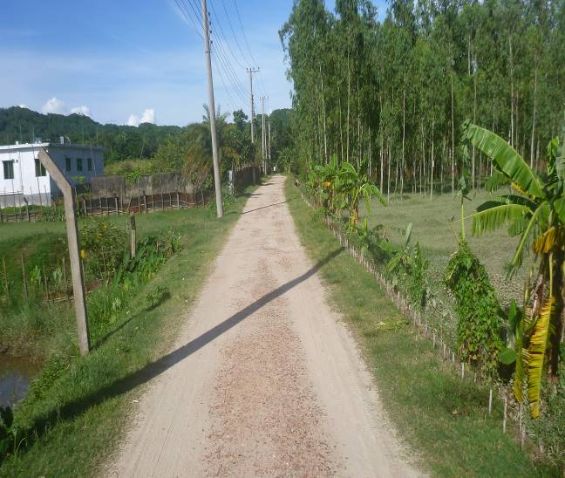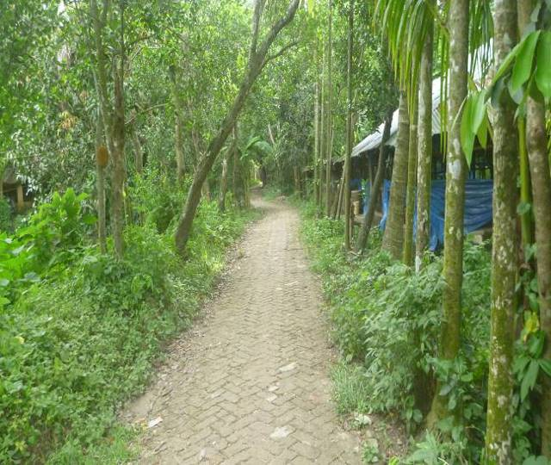

Municipal Governance and Services Project (MGSP)
Design, Supervision and Management (DSM) Consultancy Services
Joint Venture of  Hifab International AB, Sweden  AQUA Consultant and Associates Ltd., Bangladesh |   
TABLE OF CONTENTS

 |  |  |  |  | Page No.
1.0 |  | INTRODUCTION |  |  | 1-3
 | 1.1 | Subproject Background |  |  | 1
 | 1.2 | Objectives of the Study |  |  | 1
 | 1.3 | Scope and Methodology of the Study |  |  | 2
2.0 |  | SUBPROJECT DESCRIPTION |  |  | 4-13
 | 2.1 | The Study Area |  |  | 4
 | 2.2 | Current Situation, Proposed Intervention and Need for the Subproject |  |  | 9
 | 2.3 | Justification of Selection of the Subproject |  |  | 11
 | 2.4 | Envisaged Subproject Activities and Implementation Process |  |  | 12
 | 2.5 | Category of the Subproject |  |  | 13
 | 2.6 | Subproject Schedule |  |  | 13
3.0 |  | BASELINE ANALYSIS OF ENVIRONMENTAL CONDITION |  |  | 14-22
 | 3.1 | Physical Environment |  |  | 14
 | 3.2 | Biotic Environment |  |  | 20
 | 3.3 | Socio-economic and Socio-cultural Environment |  |  | 21
4.0 |  | ENVIRONMENTAL SCREENING |  |  | 23-25
5.0 |  | SPECIFIC IMPACT, MITIGATION AND ENHANCEMENT MEASURES |  |  | 26-32
 | 5.1 | Dismantle Work, Site Clearing, Excavation Work and Earth Work |  |  | 26
 | 5.2 | Tree Felling, Clearing of the Vegetation and Ecological Impact |  |  | 26
 | 5.3 | Pollution from the Construction Materials |  |  | 27
 | 5.4 | Air Quality and Dust |  |  | 27
 | 5.5 | Noise and Vibration |  |  | 27
 | 5.6 | Water Quality |  |  | 28
 | 5.7 | Occupational Health and Safety |  |  | 28
 | 5.8 | Impacts on Social Environment and Common Property Resources |  |  | 29
 | 5.9 | Labor Influx and Anticipated Impacts |  |  | 30
 | 5.10 | Impacts on Traffic Movement |  |  | 31
6.0 |  | ENVIRONMENTAL MANAGEMENT PLAN |  |  | 33-45
 | 6.1 | Access to Information |  |  | 33
 | 6.2 | Grievance Redress Mechanism |  |  | 33
 |  | 6.2.1 | Grievance Redress Committee (GRC) |  | 33
 |  | 6.2.2 | Grievance Resolution Process |  | 34
 | 6.3 | Institutional Arrangement for Environmental Safeguard Compliances |  |  | 35
 | 6.4 | Capacity Building |  |  | 36
 | 6.5 | Emergency Response and Disaster Management |  |  | 36
 | 6.6 | Environmental Management Action Plan |  |  | 37
 | 6.7 | Environmental Monitoring Plan |  |  | 43
 | 6.8 | Cost of Environmental Enhancement Works in BOQ |  |  | 44
 | 6.9 | Environmental Codes of Practice |  |  | 45
7.0 |  | PUBLIC CONSULTATION AND PARTICIPATION |  |  | 46-47
 | 7.1 | Methodology |  |  | 46
 | 7.2 | Issues Raised by the Participants |  |  | 46
 | 7.3 | Feedback, Suggestions and Recommendations of the Participants |  |  | 46
8.0 |  | CONCLUSIONS AND RECOMMENDATIONS |  |  | 48
9.0 |  | REFERENCES |  |  | 49
APPENDIX
Appendix I: Environmental Monitoring Checklist |  |  |  | 50

LIST OF TABLES

Table 3.1.1 (a) | Major Environmental and Infrastructural Features for BC road at Khamar Bari Road (Ch. 0-650m)
Table 3.1.1 (b) | Major Environmental and Infrastructural Features for RCC road at Nunochara to ECO Park Road including RCC retaining wall from Ch.0+807 to 1+507m
Table 5.7.1 | General Requirements for the Workers Health and Safety
Table 5.8.1 | Impacts on Social Environment and Common Property Resources
Table 6.2.1.1 | List of GRC Committee Members
Table 6.6.1 | Anticipated Environmental Impacts during Construction Phase and Corresponding Mitigation and Enhancement Measures (EMP Table)
Table 6.6.2 | Anticipated Environmental Impacts during Operational Phase and Corresponding Mitigation and Enhancement Measures (EMP Table)
Table 6.7.1 | Matrix Table of Monitoring Plan (Visual and observation during construction phase)
Table 6.8.1 | Environmental Measurement Budget

LIST OF FIGURES

Figure 2.1.1 | Location Map of the Subproject sites
Figure 2.1.2 (a) | Topographical Features of the proposed Khamar Bari Road with influence area
Figure 2.1.2 (b) | Topographical Features of the proposed Nunochara to Eco Park Road with influence area
Figure 2.1.3 (a) | Layout Plan of the Proposed Khamar Bari Road
Figure 2.1.3 (b) | Layout Plan of the Proposed Nunochara to Eco Park Road
Figure 3.1.1 | Location of Sitakunda Pourashava in Earthquake zoning map of Bangladesh
Figure 3.1.2 | Average Minimum and Maximum Temperate in Sitakunda Pourashava (2000-2016)
Figure 3.1.3 | Average Precipitation in Sitakunda Pourashava (2000-2016)
Figure 3.1.4 | Location of Sitakunda Pourashava in Flood zone Map of Bangladesh
Figure 6.3.1 | Environmental and Social Management Team (Tentative)

LIST OF PHOTOGRAPHS

Photographs 2.2.1(a) | Current Situation of the Khamar Bari Road
Photographs 2.2.1(b) | Current Situation of the Nunochara to Eco-Park Road
Photograph 7.1.1: | Participation Meeting at Sitakunda Pourashava

ABBREVIATIONS

AP (AP’s) | Affected Person
BDT | Bangladeshi Taka
BMD | Bangladesh Meteorological Department
BOQ | Bill of Quantity
CC | Cement Concrete
CIP | Capital Investment Plan
CP | Contingency Planning
DSM | Design, Supervision, and Management
EA | Environmental Assessment
ECR | Environmental Conservation Rules
EMP | Environmental Management Plan
EPP | Emergency Preparedness Planning
ES | Environmental Screening
FGD | Focal Group Discussion
GoB | Government of Bangladesh
GRC | Grievance Redress Committee
GRM | Grievance Redress Mechanism
GRP | Grievance Redress Procedure
IIS | Infrastructure Improvement Section
LGED | Local Government Engineering Department
MGSP | Municipal Governance and Services Project
PD | Project Director
PMU | Project Management Unit
RCC | Reinforcement Cement Concrete
RP | Relevant Reports
TL | Team Leader
ULB | Urban Local Body
WB | World Bank
XEN | Executive Engineer

INTRODUCTION

Subproject Background
Sitakunda Pourashava is situated at Chittagong District. It is established as a Pourashava in the year of 1998. This is B Type Pourashava with present population of 43,555. The Pourashava covers an area of 27.96 sq. km (Sitakunda Pourashava: At a glance). Rapid urbanization requires new infrastructure facilities in the Pourashava area. The Pourashava has 89.05 km road which includes Pucca Road, HBB Road and Katcha Road (Sitakunda Pourashava Master Plan). Rapid urbanization and increasing traffic volume in the Pourashava area demand improved road communication. Hence, this subproject directly will contribute for the infrastructure development of the Pourashava.

This subproject includes: BC Road and RCC pavement with RCC retaining wall and culvert at Khamar Bari (Ch. 0-650m) Road and Nunochara to ECO Park (Ch. 807-1507m) Road. The significant features of the subproject are mentioned below:
Name of the Subproject : | a) Improvement of Khamar Bari Road from Ch.0+00 to 0+650m;  b) Improvement of Nunochara to ECO Park Road including RCC retaining wall from Ch.0+807 to 1+507m.
Package No. : | MGSP/SIT/2017-2018/W5
District Name : | Chittagong
ULB Name : | Sitakunda Pourashava
Jurisdiction Area : | Ward number 1 and 6
Structural Design Option : | BC Road, RCC pavement, RCC retaining wall and RCC culverts work
Beneficiary Population : | More than 10,000 as per information of Sitakunda Pourashava
Tribal People : | No tribal people settlement found in the subproject area
Land Acquisition : | No land acquisition is required
Estimated Cost : | 24.413 million BDT
Subproject Duration : | 12 Months
Tentative Start Date : | 1st November, 2018
Tentative Completion Date : | 31st October, 2019

Objective of the Study
The aim of the study is to examine the environmental impacts due to construction and operation of the subproject and formulate the environmental management plan to minimize the negative impacts and enhance the positive impacts.
The specific objectives include:
- To assess the existing environmental conditions of the subproject site and its adjacent areas in order to establish a baseline framework against which potential environmental impacts due to implementation of the subproject would be compared;

- To identify and assess impacts resulting from the subproject during its construction phase and operation phase;

- To develop a rational environmental management plan with recommendations for mitigating adverse impacts and enhancing positive impacts and outlining environmental monitoring requirements both during construction and operational phase of the subproject.

Scope and Methodology of the Study
For the preparation of the subproject appraisal, environmental screening has been performed for all the subproject components. According to the screening, environmental assessment is required to fulfill the regulatory requirement of this subproject. The study methodology comprised the following activities:
- Desktop Study;
- Field Investigations and Data Collection;
- Data Analysis and Report Writing.

Desktop Study

The desktop study involved:
- Initial meetings with client, stakeholders to discuss the proposed subproject, including subproject activities;
- Collection and review of the baseline data, maps, reports and other relevant information on the existing environmental and social conditions of the subproject area;
- Review the relevant existing legislation, regulation and policies;
- Understand the anticipated technical processes that may affect the environment.

Field Investigation and Data Collection

A team of the consultants made a field investigation to the proposed site. Field investigations involved mainly site walks within the subproject area and the neighboring areas that may be affected by the subproject. The following key tasks were performed during the field visit:
- Taking photographs of the significant aspects to assist in describing the baseline environmental conditions of the subproject area;
- Interviews with representatives of the relevant Pourashava officials, within the subproject area and interested and affected people within the subproject influence area;
- Obtaining relevant documents from the Pourashava and local people within the subproject influence area;
- Verifying information and data collected during the desktop study and to collect new information that may have been important in the assessment of the impacts and design of the mitigation measures.

Data Analysis and Report Writing

The data and information collected from all the sources (literature review, secondary and primary data, public consultation) were analyzed to describe the existing environmental setting of the subproject area, to identify the potential positive and negative impacts of the proposed subproject, as well as to provide preliminary suggestions for mitigation measures. Finally, this environmental assessment report has been prepared.

SUBPROJECT DESCRIPTION

The Study Area
The subproject sites are situated at peri-urban area of Sitakunda Pourashava. The location map, topographical features and layout plan of this subproject are shown in Figure 2.1.1, Figure 2.1.2 and Figure 2.1.3.
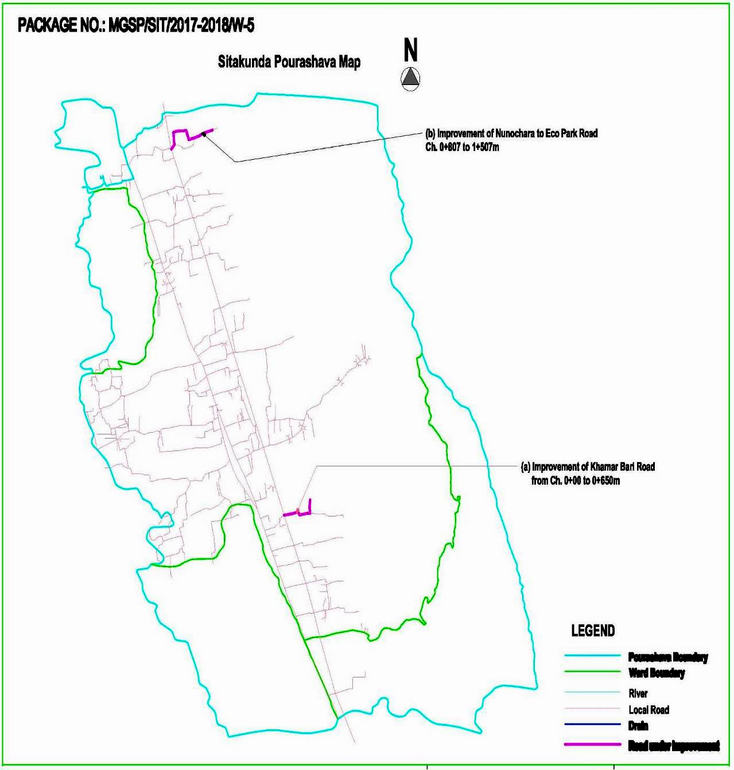
Figure 2.1.1: Location Map of the Subproject sites
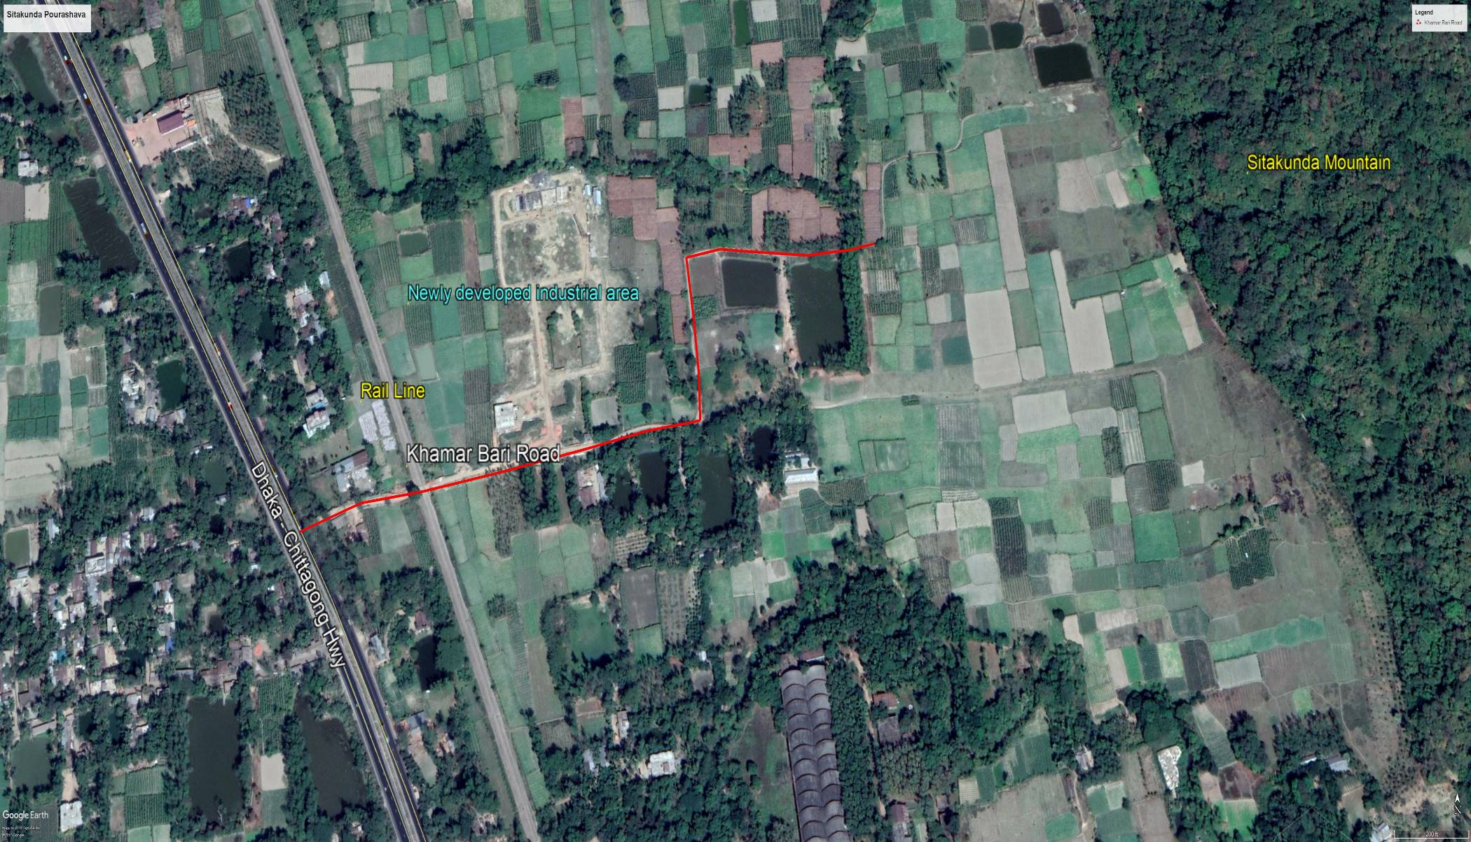
Figure 2.1.2 (a): Topographical Features of the proposed Khamar Bari Road with influence area

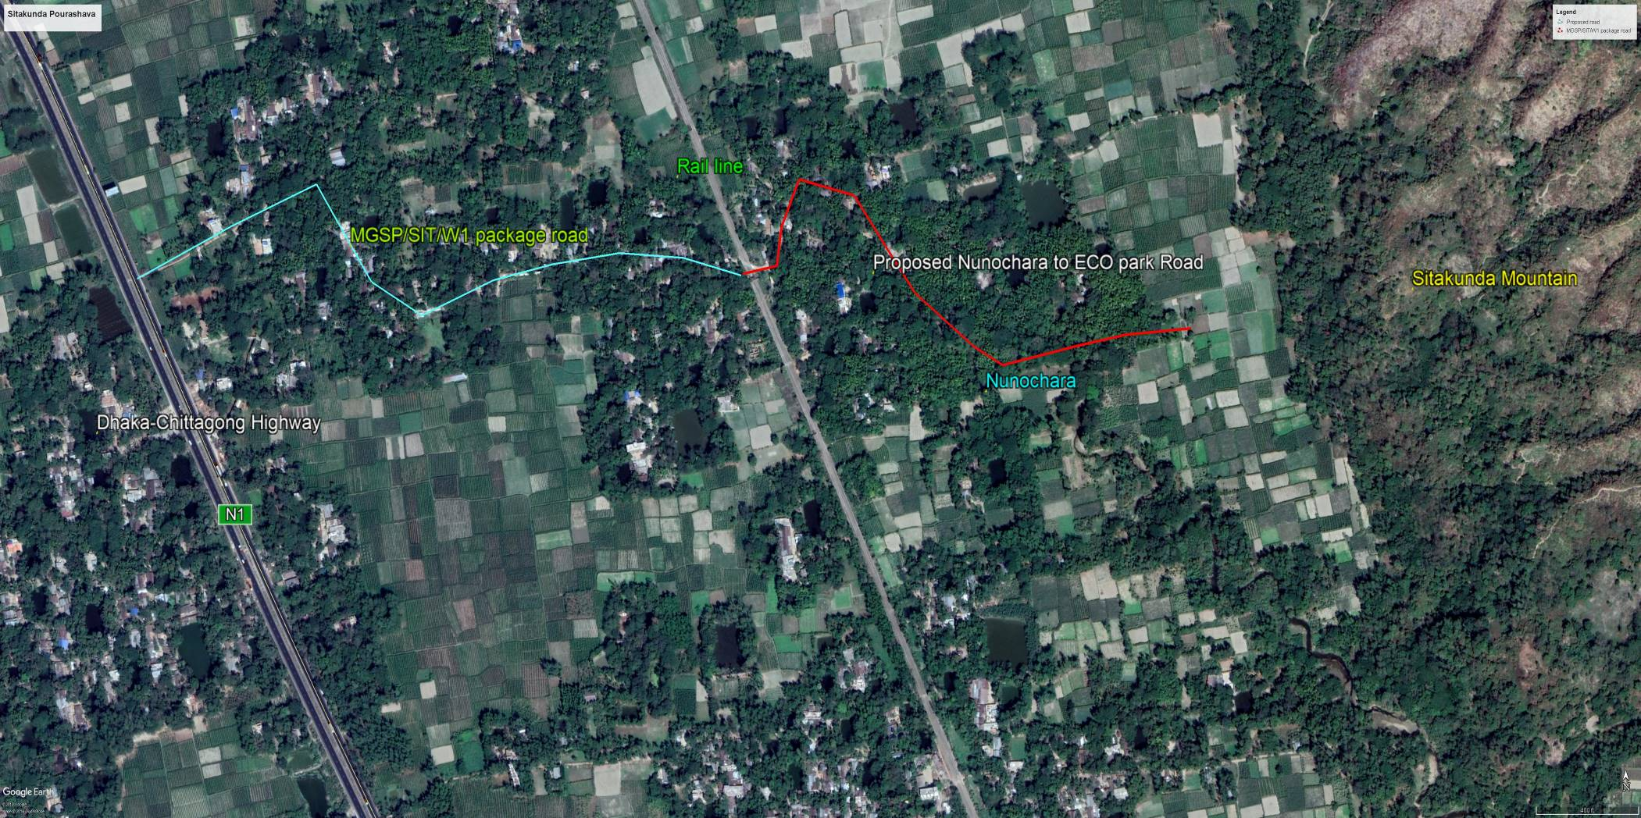
Figure 2.1.2 (b): Topographical Features of the proposed Nunochara to Eco Park Road with influence area

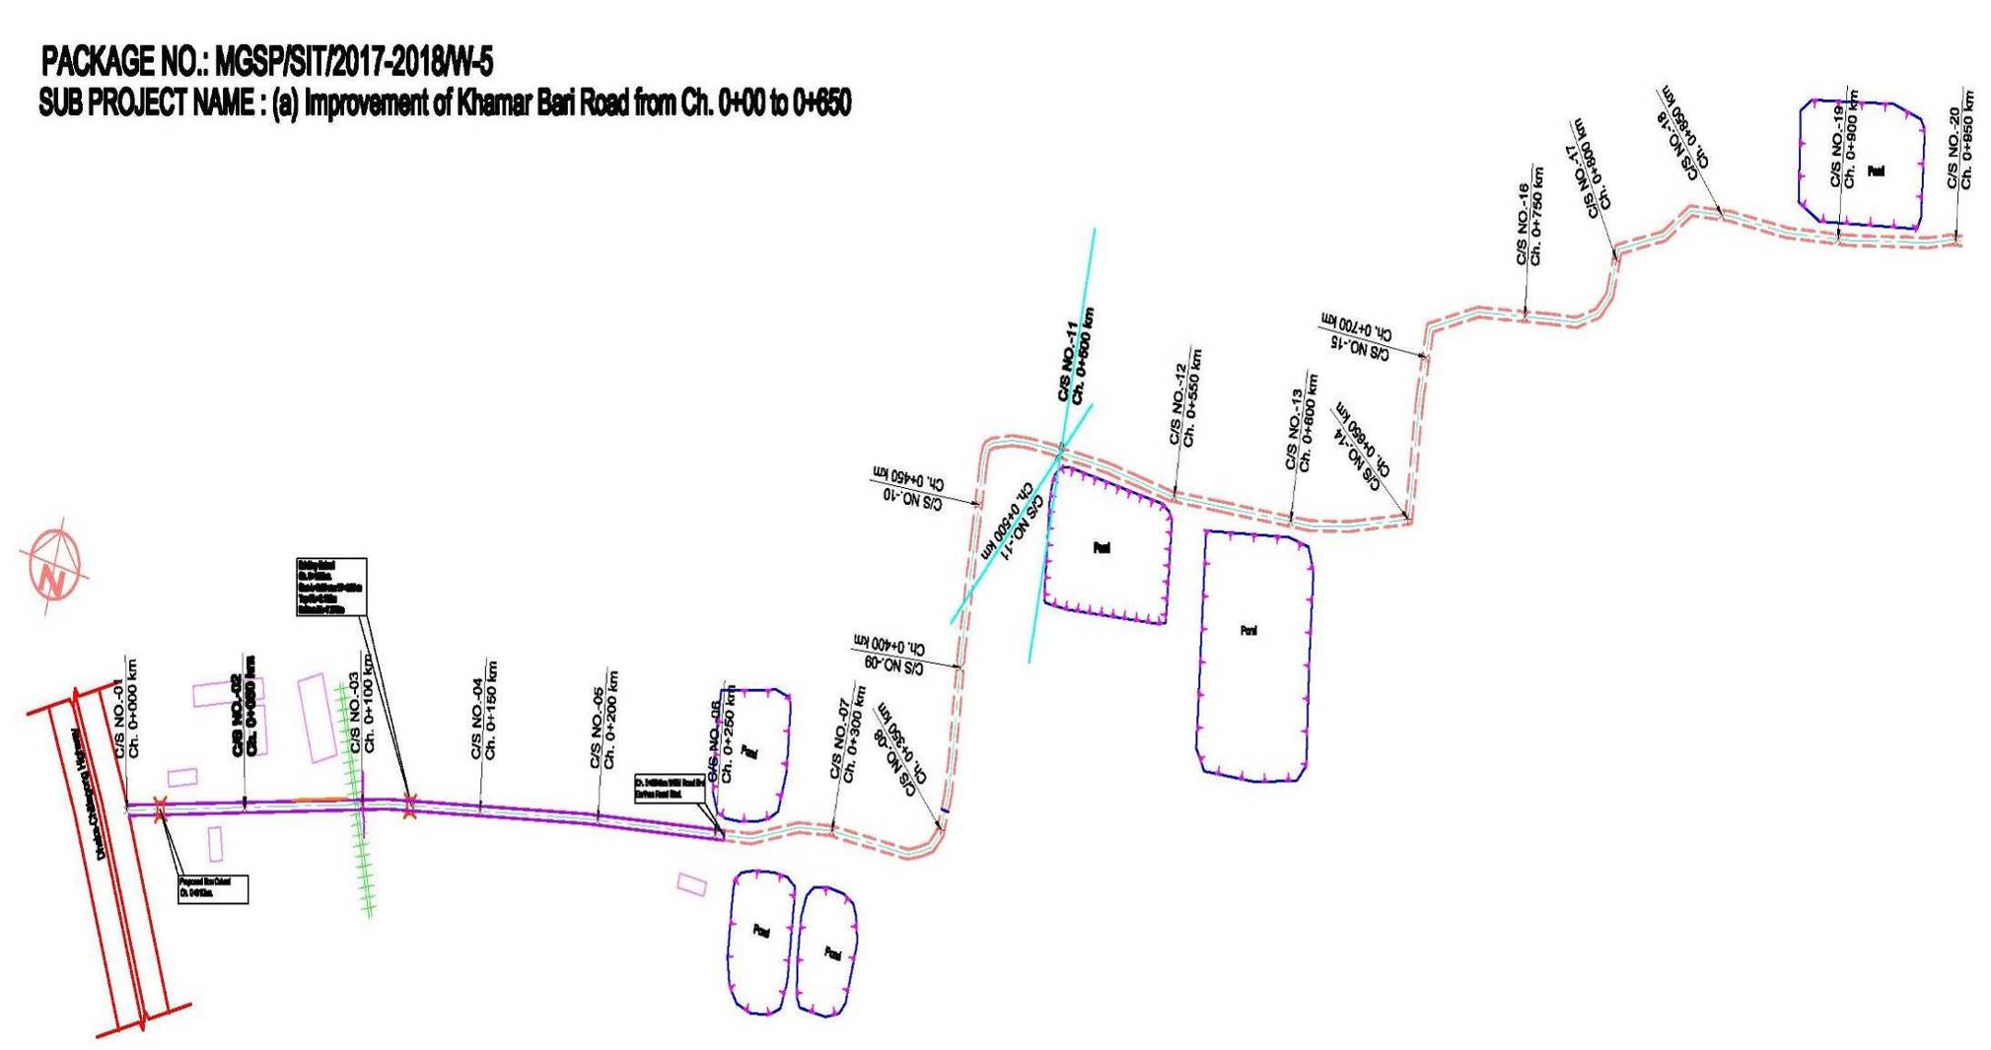
Figure 2.1.3 (a): Layout Plan of the Proposed Khamar Bari Road

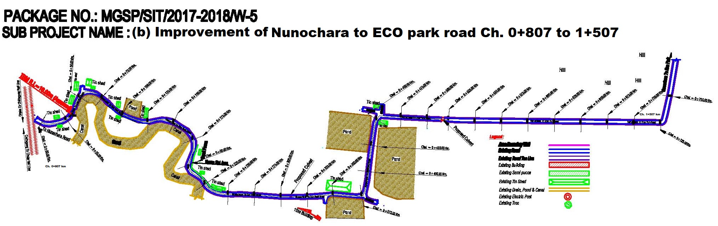
Figure 2.1.3 (b): Layout Plan of the Proposed Nunochara to Eco Park Road

Current Situation, Proposed Intervention and Need for the Subproject
The proposed Khamar Bari Road (Ch. 0-650m) starts from Dhaka- Chittagong Highway and ends at the village after Pourashava boundary (near Albion Pharmaceuticals). The Nunochara to ECO Park Road (Ch. 807-1507m) starts from Nunochara (just crossing the rail line) and ends at Pourashava last boundary towards Sitakunda Mountain within the jurisdiction of the ward no. 06 and 01 respectively of Sitakunda Pourashava. The 1st part of the road (from Ch. 0-807m) has been constructed under MGSP/SIT/W01 package. The built-up infrastructures include road side pucca, semi-pucca structures for industries and tin-shed and katcha structures for residential houses. Residential area at the right side (Ch. 200-400m), industrial infrastructures for different industries (i.e. Albion medicine factory) at left side placed along the proposed Khamar Bari Road. Furthermore, residential area found at both sides of the proposed Nunochara to Eco-park road (Ch. 807-1250m). A “Pahari Chora” named Nunochara is located at the right side of the proposed road. Nunochara flows at right of the proposed road from Ch. 807-1250m. Agricultural practices were found during site visit. The existing road is used for carrying raw materials and finished products of the pharmaceuticals. Furthermore, agricultural goods like grain and vegetables are transported to kitchen market as well as local markets and shops.

The proposed Khamar Bari Road will be developed by replacing the existing WBM (water bond macadam) and earthen road to new BC pavement. The existing road from Ch. 0-250m consists of 6m pavement width of WBM, sub-base and improved subgrade. The bituminous carpeting is absent on the road surface. The crest width of this segment varies from 6.0-7.0m. Moreover, from Ch. 254-650m, the crest width of earthen road varies from 4.0-4.5m. Considering the poor condition of the pavement with a narrow width, it is necessary to improve the road from Dhaka -Chittagong Highway up to Albion Pharmaceuticals. For better traffic movement and carrying of the industrial products from newly developed industries, the proposed Khamar-Bari Road (Ch. 0-650m) with average 5.0-6.0m paved width is considered.

The proposed portion of Nunochara to Eco-park Road is narrow (average crest width 3.0-3.2m) and will be developed by replacing the existing HBB (Herring brick bond) and earthen road to new RCC pavement. Soil erosion occurred at roadside area due to water current from Nunochara, flash flood and drain-out of the storm water from the upper land at monsoon. Therefore, RCC retaining wall is proposed at right side (Ch. 810-860, Ch. 896-956m, Ch. 979-1006 and Ch. 1121-1154m) and at left side (Ch. 871-887m). The total length of retaining wall is 186m. Two existing culverts for diverting the storm water from inland to Nunochara are in poor condition. To replace the damaged culverts, 1mx1m two culverts are being proposed at Ch. 1050m and Ch. 1296m. For better traffic movement and carrying goods from Nunochara area to Pourashava, road improvement is needed. The proposed 700m road with paved width 3.0 m and a crest width 5 m which will provide an easy and smooth flow of traffic.

The present situation of the subproject road is further elaborated in the following Photographs 2.2.1.
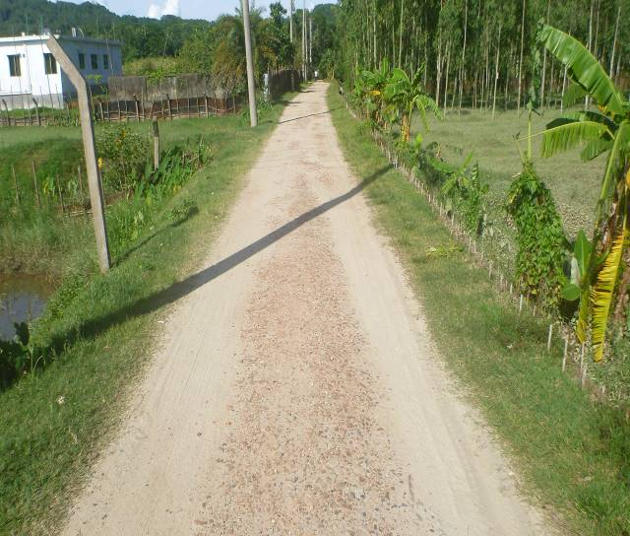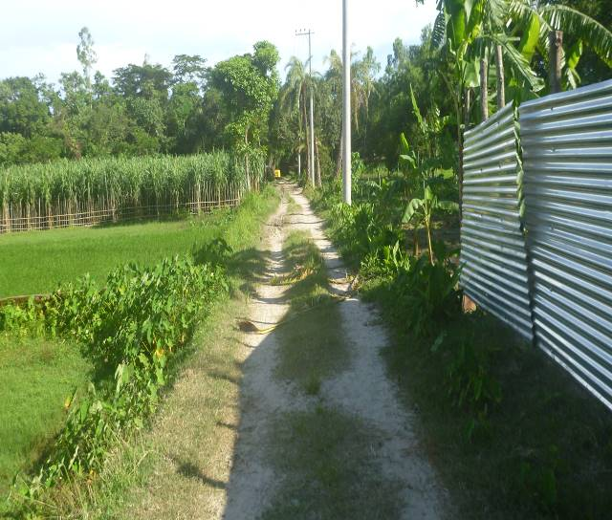
Photographs 2.2.1 (a): Current Situation of the Khamar Bari Road
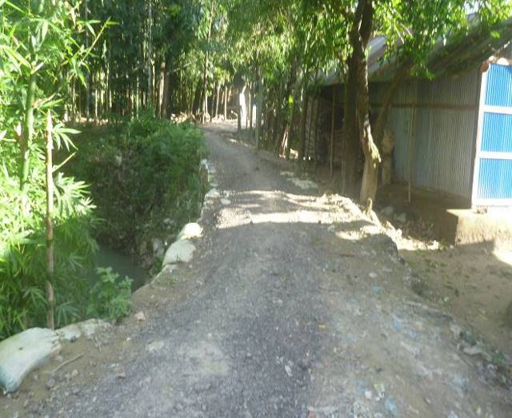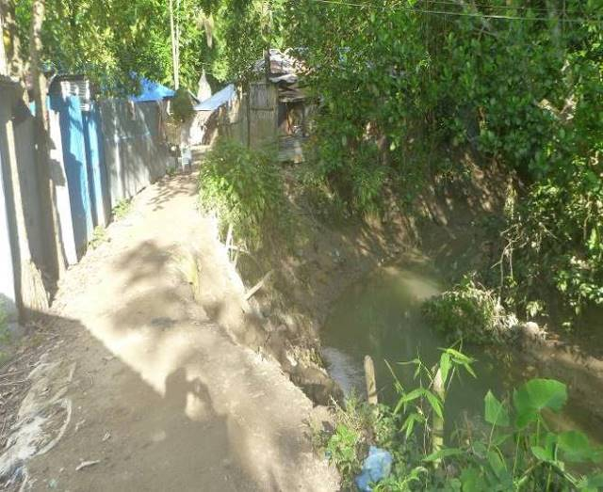
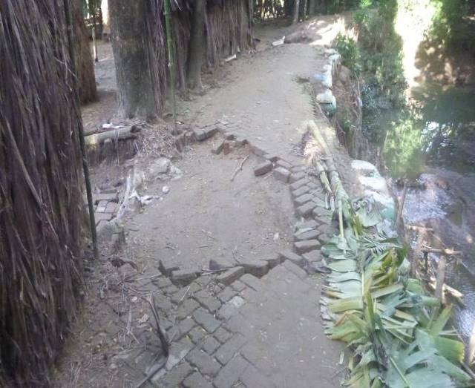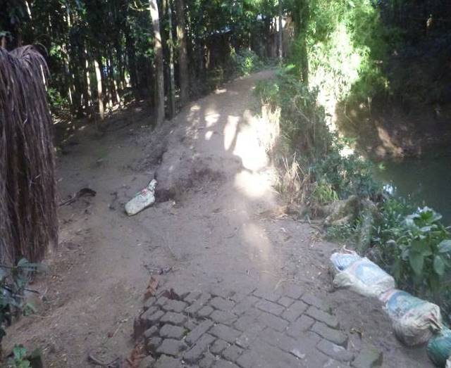
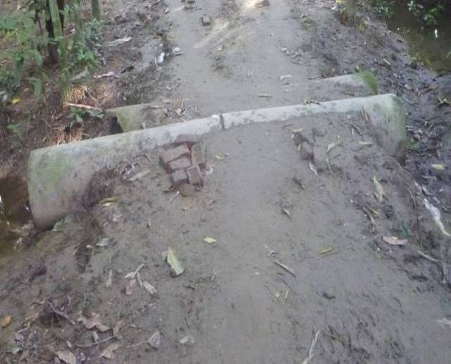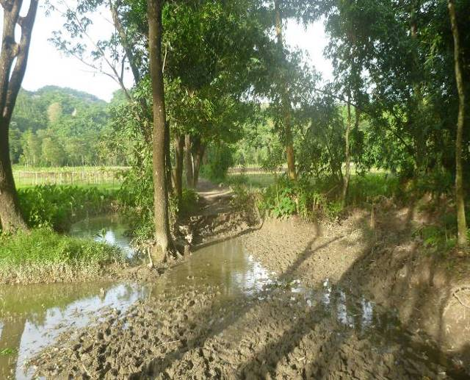
Photographs 2.2.1 (b): Current Situation of the Nunochara to Eco-Park Road

Justification of Selection of this Subproject
With the facilitation of PMU, WB and DSM Consultants, the Pourashava prepared the CIP list. According to the CIP list, Sitakunda Pourashava prepared the priority list of the subprojects considering the demand and requirement. As a part of the reconnaissance survey, PMU Officials and DSM consultants’ visited and evaluated the existing site condition of the subproject.

This area is enriching bio-diversified zone of Bangladesh. Road side tree felling and vegetation clearing will be moderately affected by the subproject implementation. However, with the time being this environmental impact will be enhanced as per mitigation measures mentioned in the EMP and natural process. The built-up infrastructures and agricultural lands will not be severely affected by the implementation of this subproject. In addition, the anticipated social issues will be investigated by Social Safeguard Team and mitigation measures will be taken accordingly. Furthermore, land acquisition is not an issue for implementation of the subproject, because Sitakunda Pourashava owned the land.

After completion, this subproject (roads with allied works) will improve the transport facilities and improve the existing road network of Sitakunda Pourashava. The improved road will definitely have a positive impact of the business transaction and proceeds. Agriculture goods and industrial products can be carried easily to nearby area which will open new trade and commerce to local people. This will also create employment opportunities for the local people. The retaining wall will protect the road and nearby settlement from undulation, erosion and subsidence occurred by Nunochara at monsoon season. The culverts will divert storm water from inland to natural water body and reduce the temporary drainage congestion & water-logging problem in the subproject area. Consequently, the local people will get better environment. As per information by the Sitakunda Pourashava, considering the wards population (Ward 1 and 6) more than 10,000 people will be benefited directly and many others indirectly. Considering the significant potential benefits that will derive after completion, the local community demands and welcome this subproject.

Envisaged Subproject Activities and Implementation Process
The general activities of the subproject includes: construction of the semi-pucca site office, construction of the labor shed, site clearing and grubbing work, relocation of the electric poles and tree plantation work.

The key activities of the BC Road include:

- Dismantling of the damaged sub-base and base course works and wearing surface of existing CC road;
- Earth work in box cutting;
- Earth filling work;
- Sand filling on the road bed;
- Mechanical compaction;
- Brick on edging;
- brick masonry work;
- Compacted stone aggregate base course;
- Providing prime coat;
- Laying pre-mixed dense bituminous surfacing wearing course.
The key activities for RCC Road include:

- Dismantling of the wearing surface of the existing HBB road;
- Earth work in box cutting;
- Sand filling on the road bed;
- Mechanical compaction;
- Brick on edging;
- Compacted stone aggregate base course;
- Plain cement concrete work in foundation;
- Fabrication of the ribbed or deformed bar;
- Reinforced cement concrete work.
The key activities of the RCC Box Culvert and Road Protection Wall include:

- Dismantling of the existing culverts and clearing works;
- Earth work in box cutting;
- Mechanical compaction;
- Laying of Polythene sheet;
- Cement Concrete work;
- Fabrication of the ribbed or deformed bar reinforcement;
- Reinforced cement concrete work.

The materials and resources to be used for the key activities: soil in earth work, sand, stone chips, brick chips, cement, concrete, reinforcement, bitumen, kerosene, diesel, electricity, water and other associate accessories.

The major equipment to be used for the implementation of the subproject: hydraulic excavator, concrete mixer machine, steel cutter, mechanical vibrator machine, mechanical compaction machine, MS sheet, steel shutter, boulders, steel drum rollers, pneumatic multiple tire roller, dump truck, water tanker, pump, asphalt plant, rubber tire roller, paver.

Category of the Subproject
The environmental impacts due to the subproject intervention are mainly site specific, limited within the subproject boundary and significantly manageable through the appropriate mitigation measures.
For BC roads, RCC pavement, RCC culverts and retaining wall
- According to ECR 1997 : Green □ Orange A □ Orange B □√ Red □ Not Listed □
- According to WB classification : Category B □√ Category C □
In the Project EMF, local road is categorized as Orange B. Hence, considering the anticipated environmental impacts (which is mainly site specific and limited within the subproject boundary), primarily this subproject road with culverts and retaining wall can consider as Orange - B category as per ECR-97. According to the WB classification, it can classify as Category B.

Subproject Schedule
The tentative schedule of construction of the subproject is:
(a) Subproject duration (months) :12 months
(b) Tentative start date : November 01, 2018
(c) Tentative completion date : October 31, 2019
The daily construction hours will normally include regular working time. However, daily working hours may vary based on the on-site condition. The detailed work program will be prepared by the contractor with the assistance of the PIU. Then it will be shared with the PMU, LGED and DSM consultants. In addition, the detailed work program will also be shared with the Bank as per requirement.

BASELINE ANALYSIS OF THE ENVIRONMENTAL CONDITION

Physical Environment

Important Environmental and Infrastructural Features

During site visit, the environmental and infrastructural features within the subproject area were collected. Conditional survey has also been conducted for designing the subproject. Hence, the survey data is also used for preparing the report. The major environmental and infrastructural features listed for BC road and RCC pavement with RCC retaining wall and culvert works at Khamar Bari (Ch. 0-650m) Road and Nunochara to ECO Park (Ch. 807-1507m) Road within 100m of the both sides from the center line of the road at 100 m longitudinal intervals. The key findings of the site visit are given below.

Table 3.1.1 (a): Major Environmental and Infrastructural Features for BC road at Khamar Bari Road (Ch. 0-650m)
Chainage (m) | Left | Right | Major Environmental and Infrastructural Features
Khamar Bari Road Ch. 0+00 - 0+650m
0-100 | √ |  | Dhaka-Chittagong highway, RCC culvert, silted-up canal, electric poles, petrol pump, pucca and semi-pucca infrastructure for residence, boundary wall, tin fence, wooden made road protection wall, ditch, low wet land with full of natural grown vegetation (Kalmi, Helencha, Colocasia, hyacinth, different herbs and shrubs), common planted trees (Debdaru, Betel-nut, Acacia, Jackfruit, Bamboo, Banana, Mango, Mahogany) and naturally grown shrubs, road side vegetation
0-100 |  | √ | Tin shed shops (furniture making and processing shop), electric poles, earthen road, saw-mill, rail line, low wet land with full of natural grown vegetation (Kalmi, Helencha, Colocasia, hyacinth, different herbs and shrubs), silted-up canal, brick protection wall, common planted trees (Betel-nut, Acacia, Jackfruit, Rain tree, Segun, Garjan, Gamari, Date tree), agricultural field
100-200 | √ |  | Rail line, pucca infrastructure for industry, low wet land with full of natural grown vegetation, culvert, electric poles, boundary wall, tin fence, WBM road, common planted trees, ditch, road side herbs and shrubs
100-200 |  | √ | Rail line, common planted trees, low wet land with full of natural grown vegetation (Kalmi, Helencha, Colocasia, hyacinth, different herbs and shrubs), ditch, Acacia tree garden, boundary wall, RCC retaining wall, agricultural field
200-300 | √ |  | Pucca infrastructure for industry, low wet land with full of natural grown vegetation, electric poles, boundary wall, tin fence, WBM road, earthen road, common planted trees, ditch, abundant road side naturally grown vegetation (different herbs and shrubs i.e. Lajjabati lata, weeds and grass, Colocasia), agricultural land
200-300 |  | √ | Tin shed and katcha infrastructure for residential area, RCC house hold connecting bridge, common planted trees (Bamboo, Neem, Sajna, Mahogany, Gub, naturally grown mountain trees, Tula, Acacia, Mango, Jackfruit, Rain tree, Coconut, Betel-nut), Pahari Chora,
300-400 | √ |  | Pucca infrastructure for industry, low wet land with full of natural grown vegetation, electric poles, boundary wall, tin fence, WBM road, earthen road, common planted trees, ditch, abundant road side naturally grown vegetation (different herbs and shrubs i.e. Lajjabati lata, weeds and grass, Colocasia), agricultural land
300-400 |  | √ | Tin shed and katcha infrastructure for residential area, RCC house hold connecting bridge, common planted trees (Bamboo, Neem, Sajna, Mahogany, Gub, naturally grown mountain trees, Tula, Acacia, Mango, Jackfruit, Rain tree, Coconut, Betel-nut), Pahari Chora,
400-500 | √ |  | Tin fence, industrial area, low wet land, ditch, electric poles, common planted trees (Pulm, Mango, Acacia, commercially cultivated Banana garden), agricultural field (Paddy, Sugarcane and vegetables - Sotthi)
400-500 |  | √ | Low wet land, Sitakunda mountain, common planted trees (Segun, Garjan, Gamari, Neem, Date, Mango, Jackfruit, Satim), agricultural field (paddy, sugarcane and vegetables), ditch
500-650 | √ |  | Pond, ditch, electric poles, common planted trees, agricultural field (Paddy, Sugarcane, Betel leaf field, commercially cultivated Banana garden and vegetables - Sotthi), Sitakunda mountain
500-650 |  | √ | Low wet land, Sitakunda mountain, common planted trees (Segun, Garjan, Gamari, Neem, Date, Mango, Jackfruit, Satim), agricultural field (paddy, sugarcane and vegetables), ditch, pond

Table 3.1.1 (b): Major Environmental and Infrastructural Features for RCC road at Nunochara to ECO Park Road including RCC retaining wall from Ch.0+807 to 1+507m
Chainage (m) | Left | Right | Major Environmental and Infrastructural Features
Khamar Bari Road Ch. 0+00 - 0+650m
807-907 | √ |  | Rail line, electric pole, tin shed and katcha infrastructure for residence, earthen household connecting road, tin fence, common planted trees (Gub, Betel nut, Banana, Mango, Acacia, Kamranga, Jam, Coconut, Jackfruit) and natural grown vegetation i.e. (Bamboo bushes and different species of shrubs, herbs), katcha road
807-907 |  | √ | Pahari Chora, road side and edge of the Chora naturally grown vegetation is abundant, tin shed and katcha infrastructure for residence, common planted trees (Mahogany, Betel nut, Gub, Mango, Kamranga, Jam, Jackfruit) and natural grown vegetation i.e. (Bamboo bushes and different species of shrubs, herbs and trees)
907-1007 | √ |  | Electric pole, tin shed and katcha infrastructure for residence, tin fence, common planted trees (Gub, Betel nut, Banana, Mango, Acacia, Kamranga, Jam, Coconut, Jackfruit, Rain tree, Dumur, Ashfall) and natural grown vegetation i.e. (Bamboo bushes and different species of shrubs, herbs), katcha road
907-1007 |  | √ | Pahari Chora, road side and edge of the Chora naturally grown vegetation is abundant, tin shed and katcha infrastructure for residence, tin fence, common planted trees (Mahogany, Betel nut, Gub, Mango, Kamranga, Jam, Jackfruit, Rain tree, Tentul, Date tree) and natural grown vegetation i.e. (Bamboo bushes and different species of shrubs, herbs and trees)
1007-1107 | √ |  | Electric pole, tin shed and katcha infrastructure for residence, common planted trees (Gub, Betel nut, Banana, Mango, Mahogany, Acacia, Kamranga, Jam, Coconut, Jackfruit, Rain tree, Dumur, Ashfall) and natural grown vegetation i.e. (Bamboo bushes and different species of shrubs, herbs), HBB road
1007-1107 |  | √ | Pahari Chora, road side and edge of the Chora naturally grown vegetation is abundant, common planted trees (Mahogany, Betel nut, Gub, Mango, Kamranga, Jam, Jackfruit, Rain tree, Tentul, Date tree) and natural grown vegetation i.e. (Bamboo bushes and different species of shrubs, herbs and trees)
1107-1207 | √ |  | Electric pole, tin shed, pucca and semi-pucca infrastructure for residence, common planted trees (Gub, Betel nut, Banana, Mango, Acacia, Kamranga, Jam, Coconut, Jackfruit, Rain tree, Dumur, Ashfall, Mahogany, Guava, Gamari, Segun) and natural grown vegetation i.e. (Bamboo bushes and different species of shrubs, herbs and trees), HBB road
1107-1207 |  | √ | Pahari Chora, road side and edge of the Chora naturally grown vegetation is abundant, common planted trees (Mahogany, Betel nut, Gub, Mango, Kamranga, Jam, Jackfruit, Rain tree, Gamari, Garjan, Segun) and natural grown vegetation i.e. (Bamboo bushes and different species of shrubs, herbs and trees)
1207-1307 | √ |  | Electric pole, tin shed and Katcha infrastructure for residence, common planted trees (Gub, Betel nut, Banana, Mango, Acacia, Kamranga, Jam, Coconut, Jackfruit, Rain tree, Dumur, Gamari, Garjan, Mahogany, Segun) and natural grown vegetation i.e. (Bamboo bushes and different species of shrubs, herbs and trees), HBB road
1207-1307 |  | √ | Pahari Chora, road side and edge of the Chora naturally grown vegetation is abundant, common planted trees (Mahogany, Betel nut, Gub, Mango, Kamranga, Jam, Jackfruit, Rain tree, Gamari, Garjan, Segun) and natural grown vegetation i.e. (Bamboo bushes and different species of shrubs, herbs and trees)
1307-1407 | √ |  | Pipe culvert, ditch, poultry farm, tube-well, tin shed, semi-pucca and Katcha infrastructure for residence, common planted trees (Gub, Betel nut, Jambura, Lemon, Bel, Mango, Kamranga, Jam, Coconut, Mahogany, Jackfruit, Rain tree, Gamari, Garjan, Segun) and natural grown vegetation i.e. (different species of shrubs, herbs and trees), HBB road, road side vegetation coverage is huge
1307-1407 |  | √ | Ditch, Pourashava 01 no. ward councilor house, pucca and semi-pucca infrastructure for residence, pond, road side naturally grown vegetation is abundant, common planted trees (Mahogany, Betel nut, Gub, Mango, Kamranga, Jam, Jackfruit, Rain tree, Gamari, Garjan, Segun, Sajna, Jambura, Bel, Palm) and natural grown vegetation i.e. (different species of shrubs, herbs and trees)
1407-1507 | √ |  | Pond, ditch, agricultural field for paddy and vegetable cultivation, semi-pucca and tin shed infrastructure for residence, culvert, common planted trees (Betel nut, Mango, Rain tree, Gub, Coconut, Mahogany, Jackfruit, Rain tree, Gamari, Garjan, Segun)
1407-1507 |  | √ | Pond, common planted trees (Mahogany, Betel nut, Gub, Mango, Jackfruit, Rain tree, Gamari, Garjan, Segun, Sajna, Jambura, Bel, Palm, Jambura) and natural grown vegetation i.e. (different species of shrubs, herbs and trees), agricultural field for paddy and vegetable cultivation, tin shed shop

Geology, Topography and Soils

The Pourashava situated on an unbroken flat land of alluvial deposits. The topographical feature of the Sitakunda Pourashava area is undulating and low lying area. Geology of Sitakunda Pourashava is composed of a thick sedimentary sequence of sandstone, shale and siltstone. The exposed sedimentary rock sequences except limestone, 6,500 meters thick in an average, provide no difference in overall lithology of Chittagong and Chittagong Hill Tracts. The Sitakunda fold is an elongated, asymmetrical, box-type double plunging anticline. This is an area prone to cyclones and storm surges. Sitakunda was affected by cyclones in 1960, 1963, 1970, 1988, 1991, 1994 and 1997. The cyclones of 29 May 1963, 12 November 1970, 29 April 1991 made landfall. The intra-deltaic coastline is very close to the tectonic interface of the Indian and Burmese plates, as well as the active Andaman–Nicobar fault system, and is often capable of generating tsunamis. (Sitakunda Pourashava Master Plan). According to Geological Survey Bangladesh (GSB, 1978) the Pourashava area falls in medium intensity seismic zone (Zone-II).
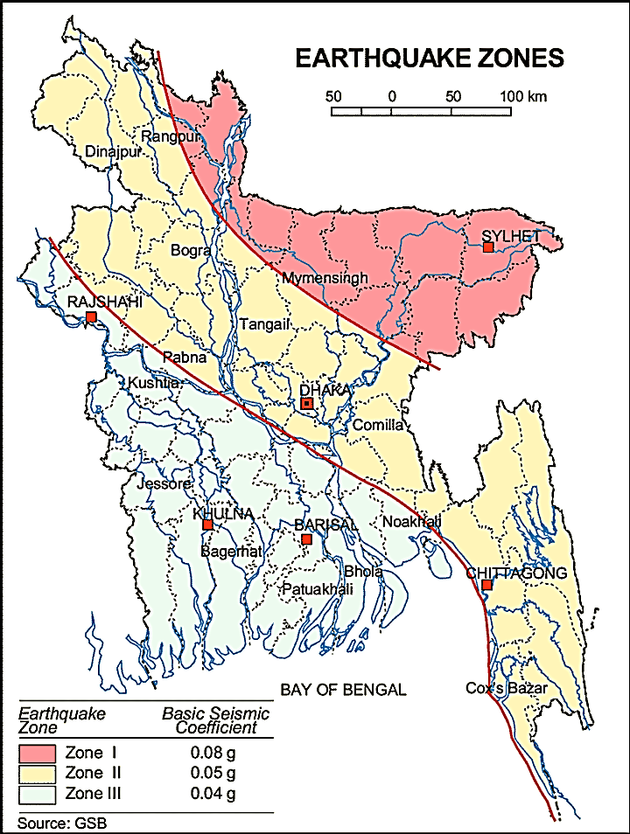
The purple Circle denote Sitakunda Pourashava

Figure 3.1.1: Location of Sitakunda Pourashava in Earthquake zoning map of Bangladesh

Climate and Meteorology

The climate of the subproject area can be described as Tropical Monsoon. It is characterized by warm, humid summers and cool, dry winters. Annual average temperature is between 32.5°C and 13.5°C, with an annual rainfall of 2,687 millimeters / 106 in (BMD, 2016). Along with Chittagong and Hathazari, in June 2007 Sitakunda was badly affected by mudslides caused by heavy rainfall combined with the recent practice of hill-cutting. The mean annual wind speed recorded in Sitakunda between 1991 and 2001 was 1.8 knots (2 mph), as measured by the wind monitoring station built as part of a wind energy exploration project jointly run by the Local Government Engineering Department and the Bangladesh Center for Advanced Studies. A small 300-watt wind turbine, built by the government, provides electricity to fish farms.
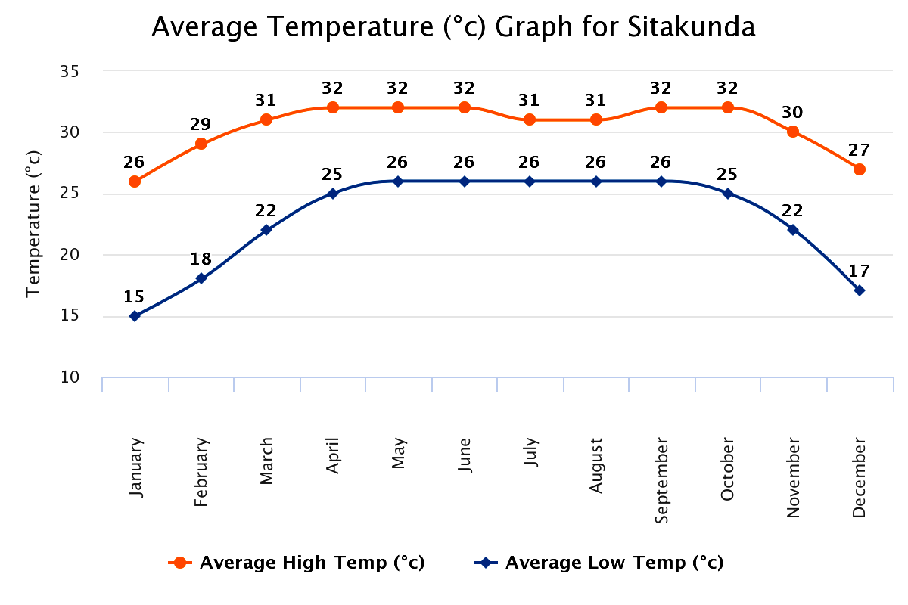
Figure 3.1.2: Average Minimum and Maximum Temperate in Sitakunda Pourashava (2000-2016)

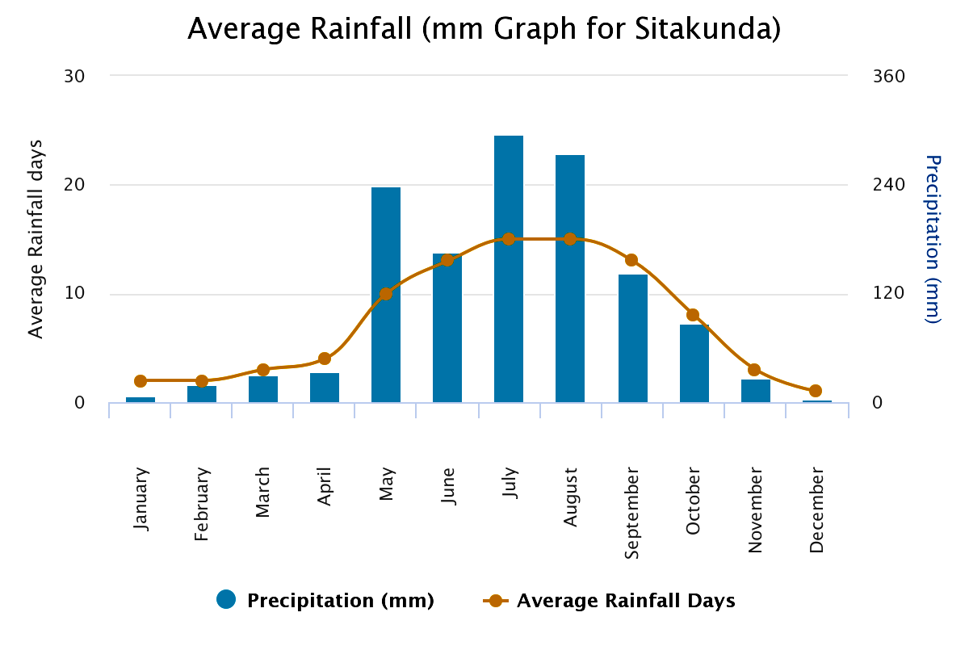
Figure 3.1.3: Average Precipitation in Sitakunda Pourashava (2000-2016)

Hydrology (Surface Water and Ground Water)

There are some surface water bodies such as Pahari Chara, ponds, ditches, low wet lands etc. along the road alignment. Surface water in the river near to Sitakunda Pourashava is saline. However, this river water can be used both for the domestic purposes and construction works. (Sitakunda Pourashava Master Plan).
Sitakunda Pourashava belongs to the hydro-geological unit II Holocene Deltaic and Flood Plains. Ground water is available here in plenty and water table does not go beyond suction limit throughout the year. Groundwater is the main source of potable water in the subproject area. Deep groundwater is not saline and normally arsenic and iron free. (Sitakunda Pourashava Master Plan). Local people typically use deep tube-well water for drinking and other domestic purposes. Salinity problems are not commonly visible. Rain water harvesting system is not common in and around the subproject area.

Flooding, Water Logging and Drainage Pattern

According to previous data, this area is affected in severe flood events of 1988, 1998, and 2004. Though Pourashava lies below the level of high tide, it is free from tidal effects due to an embankment. But the Pourashava area is frequently affected by the flash flood due to its geological settings. The subproject area is habitually facing temporary water logging and flash flood because of Sitakunda Mountain during heavy rainfall at monsoon season.
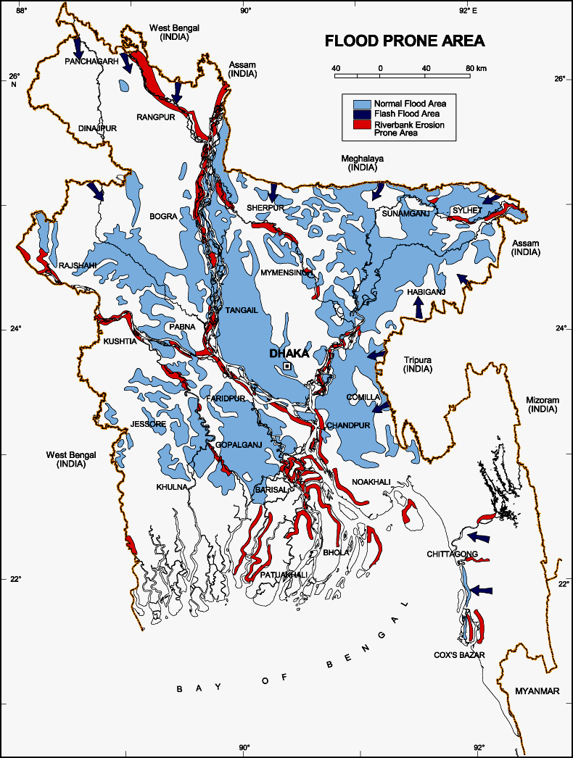
Figure 3.1.4: Location of Sitakunda Pourashava in Flood zone Map of Bangladesh (BMD, 2016)

Air Quality and Dust

Ambient air quality data have not been found. Air seems to be clean. However, due to poor maintenance of the road especially from the damaged bituminous section dust is generated during the movement of the vehicles. The windblown dust causes air pollution. (Sitakunda Pourashava Master Plan).
Noise Level

Noise level data is not available. The major causes for noise in the subproject area are the vehicle movement (motor cycles, pick-up, mini-trucks, CNG rickshaw and auto-rickshaws), playing of loud-speaker and mass people gathering (for advertising of products and political, social and religious aspects) and local market. This is a common experience of the urban population that noise poses a threat to the ill / physically weak people health and nerves.
Solid Waste Management

With the increase population and rapid urbanization, it is natural that generation of solid waste will also increase. If these wastes are not properly managed, it can have detrimental effects on the environmental quality. So, collection and management of solid waste is a great challenge for the Pourashava authority. Presently, the Pourashava authority has structured solid waste management system. The Pourashava allocated a dump site at Ponthisilla Sheikhpara near Pourashava kitchen market. The municipality provide service for household waste collection from door to door and dump at Ponthisilla Sheikhpara.

Biotic Environment
Flora and Fauna

This subproject area is full of natural vegetation (terrestrial and aquatic herbs, shrubs, bunches of bamboos and trees-common indigenous trees and planted fruit and wooden trees) and birds. In and around the subproject area, agricultural practice was found abundantly during site visit. Paddy is the main crop and other crops and seasonal vegetables also cultivated in the agricultural land and homestead garden.
The proposed road is fully covered by road side naturally grown vegetation (bunches of bamboo, herbs, shrubs and common indigenous and mountain trees), commercially planted tree species and fruit trees. The common species of trees (Acacia, Bamboo, Mango, Rain-tree, Mahogany, Banana, Coconut, Betel nut, Jackfruit, Pulm, Kamranga, Berry, Sajna, Palm, Tula, Segun, Gub, Garjan, Gamari, Neem, Satim, Date trees, Guava, Tentul, Jambura, Lemon, Bel, Sishu, Dumur etc.) are found in the subproject area. The natural water bodies (Pahari Chora, Nunochara, ponds, low wet lands, seasonal springs and ditches) are the worthy habitat for the aquatic animals. There are common local birds (Crow, Sparrow, Chil, Doel, Dove, Parrot, etc) were found during the site visit.

Socio-economic and Socio-cultural Environment

Land Use Pattern, Status of Housing and Built-up Infrastructure

The subproject areas are mixed zone of urban and peri-urban area with residential and agricultural zone. The road side infrastructures are mainly residential houses (pucca, semi-pucca, tin shed and katcha), shops, bazars and religious institutes. At Khamar Bari Road industrial activities are developed. Pahari Chara flows on the right side of the proposed roads.

Beneficiary Population

As per information by the Sitakunda Pourashava considering the wards population more than 10,000 people (Population and housing census, 2011) will be benefited directly and many others indirectly.

Education

In the subproject area, literacy rate is higher (61%) than the total average (51.8%) of country. The literacy rate for male (62.7%) is higher than female (59.3%). (Population and Housing Census, 2011).

Tribal Communities

There is no indigenous or tribal people settlement in the subproject area. Therefore, there is no measure needed for indigenous peoples’ safeguard.

Land Acquisition and Resettlement

Private land acquisition is not needed. For site clearing, few roadside boundary wall and fencing need to be removed partially and or completely. The Pourashava authority has consulted with the owners of these structures. The local people and owners of those structures have no objection regarding the implementation of the subproject. An agreement has been signed by the Pourashava and the local people regarding the subproject implementation. The local people agreed to remove their structures for their benefit. However, in case of any objection from the affected person, the DSM will investigate the actual situation. Then, measures will be taken as per rules.

Principal Livelihoods and Economic Activities

The subproject area is now inhabited by the mixed occupational people where major income comes from farm (agricultural activities) and non-farm activities such as small business, enterprises, transport vehicle ownership and operation.
Cultural Heritage and Protected Areas

Within the influence area of the subproject, no real historical sites were identified. Considering the subproject area and its influence zone; religious centers (such as Mosques, temples), educational institutions and local bazar bring cultural values to the community people.

ENVIRONMENTAL SCREENING

Environmental Screening Checklist, as adopted in Appendix C of the Environmental Management Framework (EMF) of the MGSP, was administered for identifying the impacts and their extents. The screening data and information designed for the BC and RCC road with RCC retaining wall and allied works have been formulated and are shown in below. (Environmental Assessment: Volume-1 and 2, 2013)
The screening data and information for the BC road at Khamar Bari Road and RCC Road with RCC retaining wall and box culverts at Nunochara to ECO Park Road are shown in below.
(1) Potential environmental impact during construction phase:

(a) Ecological impacts:
1700
- Felling of trees Significant □√ Moderate □ Minor □ Number of trees
- Clearing of vegetation Significant □ Moderate □√ Minor □
- Potential impact on species of Significant □ Moderate □ Minor □√
aquatic (i.e., water) environment
Major trees to be felled down are: Acacia, Mango, Pulm, Betel-nut, Gub, Garjan, Gamari, Neem, Satim, Rain Tree, Mahogany, Kamranga, Jackfruit, Coconut, Palm tree and Date tree. There is no tree to be felled down bring religious and heritage importance. Most of them are small to medium size considering length and diameter. In addition, road side vegetation of the proposed road is abundant and uniform in all sections, except at Ch. 0-250m of the left side at Khamar Bari Road. At right side (Ch. 150-350m), a Pahari Chora is sited along the road side with full of natural vegetation. Moreover, at the right side of Nunochara to Eco-Park Road (Ch. 807-1250m), a Pahari Chora (Nunochara) is sited along the road with full of natural vegetation. So, clearing of the road side naturally grown species of vegetation-bushes, herbs and shrubs have ecological impacts. In addition, anticipated impact on species of aquatic environment is minor because except throwing of the wastes materials in to the road side water bodies (Nunochara, Pahari Chora, ditch, low wet land, pond and seasonal springs), the subproject activities do not have likely impacts on the aquatic environment. Based on the analysis especially considering the number trees to be felled down, the overall ecological impact is considered as significant.
- Physicochemical impacts:

- Noise pollution Significant □ Moderate □√ Insignificant □
- Air pollution Significant □ Moderate □√ Insignificant □
- Drainage congestion Very likely □ Likely □ √ Unlikely □
- Water pollution Significant □ Moderate □ Insignificant □√
- Pollution from solid/ construction wastes Significant □ Moderate □√ Insignificant □
- Water logging Significant □ Moderate □ Insignificant □√
The subproject will have temporary and localized negative impacts on noise and air quality during construction phase due to mobilization of the equipment, vehicles movement for the transportation of the materials, using of hydraulic excavator, mechanical compaction machine, concrete mixer machine, vibrator machine, paver, asphalt plant etc. The construction work will be performed section wise. Hence, it is anticipated that the impacts will be temporary, site specific and not significant. It should be noted that, road side residential area may be significantly affected by generated noise and dust due to subproject activities, if measures are not taken appropriately. The generated construction wastes, un-suitable materials and solid wastes may degrade the adjacent water bodies if not properly collected and disposed and thrown into the road side water bodies. Improper collection and disposal of the generated wastes materials also may degrade the quality of the surrounding environment and degrade the aesthetic & landscape value. The anticipated water logging problem during construction period is minor because space is available at both sides of the road for drain-out the storm water. In addition, pumping facilities will be provided to drain-out the storm water if required.
- Socio-economic impacts:

- Traffic congestion Very likely □ Likely □√ Unlikely □
- Health and safety Significant □ Moderate □√ Insignificant □
- Impact on archaeological and historical Significant □ Moderate □ Insignificant □√
- Employment generation Significant □√ Moderate □ Insignificant □
Though it is insignificant; however, during construction, the subproject will have localized impact in traffic congestion. This road is not so busy with the motorized vehicles. Furthermore, the local inhabitants can use alternative road at construction period which will continue the traffic flow. The construction work will follow simple procedure with commonly used equipment. Hence, anticipated impact on health and safety is moderate. However, using of the personal protective equipment by the workers will significantly reduce any occupational health and safety risks. There is no archeological and historical site within the influence area. Hence, the anticipated impact on socio-economic impacts due to subproject activities is significant by generating work opportunities for the local people and supplying of the construction materials, equipment, food and other necessary stuffs to the campsite.
(2) Potential environmental impact during operational phase:

- Ecological impacts:

- Potential impact on species of aquatic Significant □ Moderate □ Minor □√
(i.e., water) environment
This subproject road does not have any impact on the aquatic environment during operation.
- Physicochemical impacts:

- Potential air quality Improvement □ No-improvement □ Deterioration □√
- Potential noise level Improvement □ No-improvement □ Deterioration □√
- Drainage congestion Improvement □√ Minor Improvement □ No Impact □
- Risk of Water pollution Significant □ Moderate □ Minor □√
- Pollution from solid waste Improvement □ No-improvement □ Minor □√
After completion due to improved road, traffic volume may increase. Consequently, air quality and noise level may be degraded due to black smoke emission and hydraulic horn from the vehicles. The new road will minimize water stagnation on road surface. It will provide better environment to the community people. RCC culverts will divert storm water from left side to right side Nunochara.
(f) Socio-economic impacts:

- Traffic Improvement □√ No-improvement □ Adverse □
- Safety Improvement □√ No-improvement □ Adverse □
- Employment generation Significant □√ Moderate □ Minor □
After completion, this road will enhance road network of the Pourashava. The motorized and non-motorized vehicles can use this road for carrying of agricultural goods and industrial products. Road side shops and business facilities will be increased which will accelerate the work opportunity for the local people. Hence, this road will be an income generating source for the local inhabitants. The new road will minimize the frequency of the maintenance for three to five years after completion. The retaining wall will protect the road from unwanted erosion. Consequently, new road with allied works will enhance safety traffic operation and pedestrians’ movement.

(3) Summary of Possible Environmental Impacts of the Subproject

From the above study, it seems that the subproject have adverse impacts on ecology due to tree felling and clearing of the vegetation. Development of the BC road and construction of the RCC road, culverts and retaining wall may temporary affect the roadside water bodies due to construction activities. The physicochemical components will be disturbed due to the subproject activities during the construction phase. The subproject activities may degrade the air and noise level to a limited extent. The inputs that may affect the environment will be mainly at construction phase and limited within the subproject boundary. Nevertheless, the impacts will be temporary & localized and limited & fundamentally manageable through the appropriate mitigation measures. The generated solid wastes due to the subproject activities should be properly collected and disposed in a designated dumping site. The labor shed and stack yard should be located in a designated place.

At operation stage, the physic-chemical components such as air quality and noise level may be deteriorated due to vehicles emission and horns. Furthermore, safety concern is an important issue for both the construction and operation phases that should be considered properly to avoid any potential safety risks. This subproject will have positive impacts in terms of the generation of the employment opportunities and business activities by supplying construction materials and equipment at construction phase and by providing extended business activities at operation phase.

Specific impact, mitigation, AND enhancement measures
The likely impacts of the subproject are mainly caused by the activities required for the implementation of the subproject, and materials, resources and equipment to be used to perform the activities.
This section describes some specific impacts due to the subproject activities and their mitigation measures.

Dismantle Work, Site Clearing, Excavation Work and Earth Work

The road improvement work with road protection wall and culverts consists of dismantle of the existing road, site clearing work (clearing of the wastes materials generated due to dismantle work and removal of the unsuitable materials) and earth work (earth excavation, earth filling work, back filling etc.). These works lead dust blowing, improper disposal of the wastes, noise and vibration which may disturb the local people.
Mitigation Measures

- Proper care will be taken by the contractor during dismantle work, excavation work, earth work and disposal work to avoid any undue disturbances to the nearby people;
- Avoid loss of the topsoil for the earth filling work;
- Cover the exposed earth works with fabric;
- Disposal of soil and construction wastes at the designated dump site at Ponthisilla Sheikhpara.

Tree Feeling, Clearing of the Vegetation and Ecological Impact

There are 170 numbers of planted and naturally grown roadsides trees (Acacia, Mango, Pulm, Betel-nut, Gub, Garjan, Gamari, Neem, Satim, Rain tree, Mahogany, Kamranga, Jackfruit, Coconut, Palm tree and Date tree) will be felled down and roadside vegetation will be cleared due to implementation of this subproject.
Mitigation and Enhancement Measures

- Considering the space availability 250 nos. of the local fruits, flowers, medicinal and ornamental trees will be planted to compensate the ecological imbalance to be caused due to felled down of the trees;
- The trees will be planted preferably at both sides of the proposed Khamar Bari Road and any other suitable places in and around the subproject area where space is available and the trees are – Mango, Jam, Jackfruit, Kathbadam, Kamranga, Gub, Bel, Mahogany, Shil Koroi, Rain tree, Segun, Satim, Garjan, Gamari, Babla, Neem, Arjun, Amloki, Horitoki, Bohera, Krisnachura, Polash, Jarul, Sonalu, Kadom, Palm Tree etc;
- Planting many trees will enhance the ecological condition of the area after their successful growth.

Pollution from the Construction Materials

Dumping of the construction spoils, including accidental leakage of the oil, grease, and fuel in equipment yards is a significant hazard. Both surface & ground water and soil quality might be polluted from these contaminants. Air pollution and dust may affect the nearby settlement which is generated from fine aggregate and vehicles. Even the people to be engaged for the construction activities might endanger the physical and human habitats of the area.
Mitigation Measures

- The playgrounds and yard of the educational institutions should not use as a stockyard or work camp;
- Safe transport, storage, and disposal of the construction materials, and the equipment have to be carried out in order to avoid the accidental spillage and loss;
- Fuels, lubricants, and other hazardous materials should store over raised platforms and not directly on the ground;
- Maintain adequate moisture content of soil and sand during transportation, compaction and handling;
- Carry the materials especially loose soil and sand with adequate cover;
- Disposal of soil and construction wastes at the designated dump site at Ponthisilla Sheikhpara.

Air Quality and Dust

During construction phase, air pollutants will be emitted from the equipment and construction vehicles are expected to remain low. Local residents in the vicinity of the work sites will be temporarily disturbed by the limited dust pollution. The overall impacts, however, are expected to remain low.
Mitigation Measures

- Water should be sprayed at the work site and camp site area for dust control;
- Ensure sprinkle and cover stockpiles of the loose materials (e.g., fine aggregates);
- Maintain adequate moisture content of soil and sand for transportation, compaction, bed preparation, backfilling and handling;
- Avoid use of dust generating equipment (which produce significant amount of particulate matter) far from the local residents;
- Ensure that all subproject vehicles are in good operating condition.

Noise and Vibration

Noise and vibration caused by the equipment and movement of the construction vehicles may temporarily disturb nearby residents. In this subproject, sensitive areas like roadside residents, educational institutes and religious centers are likely to be affected by noise nuisance, though the impacts are anticipated to be limited.
Mitigation Measures

- Transportation of the construction materials have to be carried during the scheduled times, and mainly during the day in off-peak time;
- If applicable and needed, all powered mechanical equipment and machineries will be fitted with noise abating gear such as mufflers for effective sound reduction.

Water Quality

The water quality may deteriorate if the construction materials, sand, construction wastes, effluent from the work camps and food wastes are dumped in the adjacent water bodies like roadside Pahari Chara (Nunochara and other Chara), ditches, ponds and low-land, seasonal wetlands etc.
Mitigation Measures

- Proper construction management including waste management as well as training of the operators and other workers should provide to avoid pollution of the water bodies;
- Construction waste will dispose properly (not in water bodies or lowland), for which contractor will be responsible.
- Construction wastes will dispose properly at the designated dumping site at Ponthisilla Sheikhpara.

Occupational Health and Safety

The most important risks associated with the construction activities are listed below:

- Exposure to the sunlight- workers are being exposed to the sun for long hours;
- Exposure to the high temperature, and humidity for a long time resulting in dehydration;
- Contact with the hazardous substances and wastes pose risks of the infections and diseases;
- Risk of the poor air quality due to the dust;
- Risk of the collision (traffic);
- Risks from head loads for carrying soil, construction materials and construction equipment;
- Risks of the using of the machineries in motion;
- Risk associated to the sudden bad weather working conditions.
General Requirements for the Workers’ Health and Safety
The key salient features of the general requirements for the workers’ health and safety stated are presented in Table 5.7.1.

Table 5.7.1: General Requirements for the Workers Health and Safety
Issues | Requirements
Health and Hygiene | - Cleanliness at the site premises and workers living places and at the Labor Shed;  - Arrangement of the proper ventilation and temperature at the Labor Shed;  - Protection against dust and furnace by using of the nose masks and covering of the head and body;  - Proper disposal of the wastes and effluents;  - Introduce waste bins for the solid waste management system.
Safety and First Aid Box | - Using of the personal protective equipment (helmet, gloves, goggles, nose mask, safety boots);  - Precautions during work on or near machineries in motion;  - Head loads are prohibited;  - First aid facilities should be provided and maintained;  - The first aid kit should include adhesive bandages, regular strength pain medication, gauze, and low grade disinfectant.
Compensation for Accidents at Work | - Contractors will bear medical treatment costs. If any sever accidents such as loss of hands, legs or loss of working ability or any case of death needs compensation-(the amount of the compensation should be fixed considering the type of accidents).
Dust and Fumes | - For any dust, fumes, or other impurities likely to be injurious to the workers, effective measures shall be taken to prevent their accumulation and its inhalation by the workers.
Overcrowding | - No labor room should be overcrowded.
Latrines and Urinals | - Sufficient latrines shall be provided;  - Latrines shall be maintained in clean and sanitary condition;  - Latrines shall be adequately lighted and ventilated.
Disposal of Wastes and Effluents | - Proper disposal system for the solid waste and effluent is required;  - Waste bins must be provided by the contractor at labor shed.

Impacts on Social Environment and Common Property Resources

Through comprehensive study, it is revealed that impacts are expected not to be severe and to be largely manageable. The following Table 5.8.1 presents impacts on socio-economic environment and common property resources.
Table 5.8.1: Impacts on Social Environment and Common Property Resources
Social Components | Impacts on IECs | Impact Significance
Community Perception | The local community people welcome this subproject and there is no visible objection from them. | Significant (+ve)
Employment and Business Opportunity | Community feels happy because the construction works will create work opportunity for the local people for the skilled and non-skilled labor. The subproject will create business opportunity for the equipment and materials suppliers’. | Significant (+ve)
Community Order and Security | This subproject activity does not create any severe security problems to the local community and community people. | Minor  (-ve)
Possible damage to existing infrastructure and facilities | Degradation of the existing road infrastructure by the construction equipment/vehicles used in this subproject. | Minor  (-ve)
New infrastructure and facilities | Improvement of the existing road will increase municipality infrastructure facilities. | Moderate  (+ve)
Labor Habitat | Most of the labors will stay at the Labor sheds which will have impacts on the environment relates to the generation of the solid wastes, effluent, and water consumption. | Moderate  (-ve)
Health Care | Workers may suffer from the dehydration problems, respiratory problem, and other health hazards. | Minor  (-ve)
Accident | In case of road accidents by the vehicles to be used for the transportation may have serious negative impact. | Significant  (-ve)

Mitigation Measures

- Conduct dissemination with the local community about the subproject details;
- Continue liaison with the community leaders in order to maintain the community support;
- Engage local contractor and local people as much as possible for positive perception of the local community;
- Follow traffic rules to avoid any accidents;
- Transportation and mobilization of the equipments and construction materials avoiding peak hours and scheduled time;
- Ensure first aid facilities and effective use of personal protective equipments where applicable.

Labor Influx and Anticipated Impacts
The labor force and associated goods and services required for the construction of infrastructure civil works under this subproject cannot be fully supplied locally. The migration to and temporary settlement of laborers in the subproject, referred to as labor influx, carries an array of potentially positive and negative impacts in terms of demands on public infrastructure, utilities, housing and sustainable resource management and the strain on social dynamics.
Labor influx effects on host communities include positive impacts such as:

- The subproject activities will generate work opportunities for the local people and supplying of the construction materials, equipment, food and other necessary stuffs to the campsite;
- Improved infrastructure and public service access and availability whereby subproject investment catalyzes larger allocation of resources to a region, stimulating the development or expansion of infrastructure and public services.

Critical negative social risks include:
- Increase in criminal activity and alcohol and drug abuse, domestic violence, political attachment and violence, smuggling and robbery etc;
- Increase in gender-based violence, including eve teasing, sexual harassment etc;
- Increases in communicable diseases, including respiratory problems, diarrheal diseases, vector-borne diseases (e.g., malaria), and sexually transmitted infections (e.g., HIV/AIDS, syphilis, gonorrhea, hepatitis B);
- Conflicts arising from increased demand on existing infrastructure, services, and utilities, including transportation, health, education, water and sanitation, waste management, public utilities and community, religious, and recreational facilities and loss of land for access routes.

The general environmental impacts of labor influx include pressure on the natural resources such as using of the water, electricity, other fuel for cooking, loss of land for the labor establishment, depletion of the water supply, sewage and waste water generation, degradation of the air quality, waste generation, increased demands on the local energy and resources and noise pollution effects. The following safeguard measures are recommended to avoid any risk of labor influx:

- Inform local people about the subproject activities;
- Liaison with the community leaders in order to get community support;
- Engage local people as much as possible to minimize workers from outsiders;
- Monitor workers attitude and behavioral matter;
- Monitor the workers movement for avoiding any unexpected social activities (robbery, crime, political attachment and conflicts, drugs abuse);
- Inform and use local administration to get support if needed;
- Inform local utilities service providers (such as for new electricity connection REB or any other department);
- Ensure effective use of natural resources such as water, electricity, fuel, wood etc.

Impacts on Traffic Movement

The movement of the motorized vehicle is very few especially for heavy vehicle. At present, few light motorized vehicles (Electric bike and Rickshaw-van, CNG rickshaw, motorcycle, mini-pick-up etc.) are using these roads. The local inhabitants can use alternative road at construction period which will continue the traffic flow. The alternative and connecting roads are adequate to diversify the traffic volume. Hence, during construction, the subproject will have negligible impact in traffic congestion. In addition, to minimize the impact subproject activities will be performed section wise. However, construction work will restrict free movement of the pedestrians, bicycle, rickshaw etc.
During construction phase, interruption of the traffic movement and impact on the local traffic system due to the subproject activities will be monitored closely. Then separate traffic management plan will be provided if required. However, the following safeguard measures are recommended to minimize the impacts associated to the traffic movement:

- Inform local people about the subproject activities;
- Inspire local people to use connecting and diversion roads;
- Ensure schedule deliveries of material/ equipment during off-peak hours;
- Place traffic sign/cautionary sign to avoid undue traffic congestion and associated traffic control measures to limit possible disruption;
- The place of construction works should be fenced off with fences if required and should be isolated from general public access and marked with signs to ensure safe movement.

Environmental Management Plan (EMP)

The purpose of the Environmental Management Plan (EMP) is to ensure that the activities are undertaken in a responsible and non-detrimental manner. The EMP will guide the environmentally sound construction of the subproject and ensure efficient lines of communication between the Project Management Unit (PMU, LGED), Project Implementation Unit (PIU) of Sitakunda Pourashava, DSM, and the contractors.

Access to Information

The environmental assessment report should be translated into Bengali and disseminated locally. The copies of the report (both in English and Bengali) will be sent to all the concerned field offices of the LGED and Sitakunda Pourashava. It will also be made available to the public. The final assessment report will also be uploaded in the LGED website and the World Bank website after approval.

Grievance Redress Mechanism

The project-specific Grievance Redress Mechanism (GRM) will be established at Sitakunda Pourashava to receive, evaluate and facilitate the solution of APs concerns, complaints and grievances concerning the social and environmental performance of the subproject. The GRM aimed to provide a time-bound and transparent mechanism to voice and resolve social and environmental concerns linked to the subproject.
The grievance mechanism is related to resolve the risks and adverse impacts of the subproject. It addresses APs’ concerns and complaints promptly, using an understandable and transparent process that is also gender responsive, and culturally appropriate. It is readily accessible to all segments of the affected people at no costs and without retribution. The mechanism should not impede access to the country’s judicial or administrative remedies. The affected people will be appropriately informed about the mechanism.
LGED has its own Grievance Redress Procedure (GRP), which it operates to address any dissatisfaction and complaints by the local people regarding its activities. This procedure is being applied to address any complaints or grievances through negotiations with the community leaders and representatives of the APs during implementation of the MGSP.

Grievance Redress Committee (GRC)

The discussions and negotiations will be conducted by the Project Implementation Unit (PIU) of Sitakunda Pourashava and will involve the APs and Grievance Redress Committee (GRC) headed by the Pourashava Mayor. With the facilitation of the DSM, the Pourashava Mayor nominated the GRC members and included representative from the Government representatives, local NGO, and Civil Society. The GRC has been formed and established at Sitakunda Pourashava. A complaints box has already been provided in the Pourashava Office. The grievance response focal point is available at Pourashava Office for instant response to an aggrieved person. The Focal Point will collect written complaints or suggestions from the box, and produces them to the GRC for hearing and resolution. The GRC members are as follows.
Table 6.2.1.1: List of GRC committee members
Sl. No. | GRC Members Name | GRC Designation | Position
1 | Md. Bodiul Alam | Chairman | Mayor, Sitakunda Pourashava
2 | Md. Nurn Nabi | Member Secretary | Assistant Engineer
3 | Md. Rahul Amin | Member | Asst. Commissioner, Land, Sitakunda Pourashava
4 | Engr Md Sha Alam | Member | Local Private Engineer.
5 | Md Nasir Uddin | Member | NGO Worker
6 | Mrs, Anwara Begum | Member | Reserve Counselor
7 | Mrs, Zakara Begum | Member | Reserve Counselor
8 | Mrs, Zesmin Akther | Member | Reserve Counselor
9 | Md Nurn Nabi | Focal Point | Assistant Engineer

Grievance Resolution Process

All complaints and suggestions will be received formally in the Sitakunda Pourashava Office by the GRC Member Secretary. A sample Grievance Redress Form will be prepared and sent to Sitakunda Pourashava.
An intake register will be maintained at the office of the Member Secretary. Member Secretary will record the details of the grievances in the intake register for documentation and ensure impartiality, fairness, and transparency. The intake register will have data and information columns including (i) Case no., (ii) Date of receipt, (iii) name, type of complaint, grievance, (iv) father’s name, husband’s name, (v) sex, (vi) complete address of the person raising the complaint, grievance, (vii) main objection (loss of land, property, or entitlement), (viii) detailed complaint story, (ix) expectation with documentary evidence and previous records of similar grievances, etc.
No GRC members are allowed to contact the aggrieved persons in advance. Rather, the concerned persons are informed to attend the formal hearings at an appointed date. The GRC committee will sit for hearing the complaints of the aggrieved persons. The GRC will record salient points presented by the aggrieved person and will examine documentary evidence submitted during informal hearings. A resolution register will be maintained by the Member Secretary at the Pourashava Office. The resolution register will contain (i) serial no., (ii) case no., (iii) name of complaint, (iv) complaint story and expectation, (v) date of hearing, (vi) date of field investigation (if any), (vii) results of hearing and field investigation, (viii) decision of GRC, (ix) progress (pending, solved) and (x) agreement or commitments. Closing register will keep records such as, (i) serial no., (ii) case no., (iii) name of complaint, (iv) decision and response to complaints, (v) mode and medium of communication, (vi) date of closing, (vi) confirmation of complainant’s satisfaction and (vii) management actions to avoid recurrence.
The GRC will decide within 30 days of receiving a complaint. There will also be an appeals procedure where, if a person is dissatisfied with the ruling of the GRC, he or she or a representative may attend their next meeting to present the case again. The committee will then reconsider the case in private, after which their decision is final. If the appellant is still not satisfied, then GRC will refer the complaint with the minutes of the hearings to the PD-LGED for further review. If the case at this level is again found unacceptable by the aggrieved person/s, PD, LGED will advise the Pourashava to drop the subproject. Sitakunda Pourashava should publish the outcome of cases on public notice boards. All costs involved in resolving the complaints (meetings, consultations, communication, and information dissemination) will be borne by the PIU.
Based on consensus, this procedure will help to resolve issues or conflicts amicably and quickly, saving the aggrieved persons from having to resort to expensive, time consuming legal action. The procedure will however, not pre-empt a person’s right to go to the courts of law.

Institutional Arrangement for Environmental Safeguard Compliance

In the institutional arrangement procedure, Project Director (PD), Team Leader (TL)/Deputy Team Leader will directly involve. The PD and TL/DTL would be supported by DSM Environmental Safeguard Specialist and Social Management Specialist. The Pourashava Officials, especially members of Infrastructure Improvement Section, would be responsible for supporting the construction supervision as well as environmental and social management with the facilitation of DSM consultants. The civil works contractors will implement the environmental mitigation measures.
The PMU, with the facilitation of Environmental Safeguard Specialist and Social Management Specialist will submit the monthly and quarterly progress reports on Environmental and Social Compliances to the World Bank.

PD-MGSP

TL/DTL-DSM

Environmental Safeguard Specialist-DSM

Social Management Specialist-DSM

Senior Municipal Engineer-DSM

Junior Environmental Specialist-DSM

Assistant Municipal Engineer-DSM

Social Management Officer-DSM
Pourashava Representative/ Focal Point/ Asst. Engineer

Contractor
Figure 6.3.1: Environmental and Social Management Team (Tentative)

Capacity Building

A series of training program has already been conducted by the PMU and DSM to build the capability of the PMU, PIUs and DSM field staffs. Under this training program, PMU and DSM will organize an introductory course for training the participants on: (i) Environmental Screening, (ii) EMP Implementation, including environmental monitoring requirements related to mitigation measures; and (iii) taking immediate action to remedy unexpected adverse impacts or ineffective mitigation measures found during the course of the implementation. A separate training program for the contractor has also been conducted to enhance the Environmental awareness. A detailed training manual has already been developed by the Environmental Safeguard Specialist. Hence, the existing manual will be reviewed and modification will be done as per requirement for the next training program.

Emergency Response and Disaster Management

Disaster management can be defined as the organization and management of
resources and responsibilities for dealing with all humanitarian aspects of emergencies, in particular the preparedness, response and recovery to lessen the impact of disasters. Emergency Preparedness Planning (EPP) and Contingency Planning (CP) are the processes of disaster management plan for developing strategies, arrangements, and procedures to address the humanitarian needs of those adversely affected by the crisis. There are four main types of disasters, namely: Natural Disasters, Environmental Emergencies, Complex Emergencies, and Pandemic Emergencies.
For MGSP activities, Sitakunda Pourashava would identify the immediate needs, prioritize the tasks, and identify resource requirements to address the humanitarian needs of those adversely affected by the crisis.

Environmental Management Action Plan

The activity wise anticipated environmental impacts and corresponding mitigation measures have been outlined in Table 6.6.1 and Table 6.6.2.

Table 6.6.1: Anticipated Environmental Impacts during Construction Phase and Corresponding Mitigation and Enhancement Measures
Activity / Issues | Potentials Impacts | Proposed Mitigation and Enhancement Measures | Responsible Parties
Construction and operation of labor shed for the workers (Workforce and labor shed management) | Generation of sewage and solid waste may degrade quality of the adjacent water bodies and surrounding environment | - Construction of sanitary latrine considering 15 persons for one toilet at the labor shed and separate toilet for male and female;  - Ensure provision of waste bins (introduce separate waste bins for organic and inorganic wastes);  - Ensure wastes (solid wastes and other forms of wastes) disposal at Ponthisilla Sheikhpara. | Contractor  Monitoring-  Primarily by Pourashava  Secondarily by PMU, LGED and DSM
 | Health of workers | - Conduct formal and unofficial discussion to increase awareness about hygiene practices among the workers;  - Ensure availability and access to first-aid equipment and medical supplies for the workers.
 | Possible development of labor camp into permanent settlement | - Contractor to remove labor camp at the completion of contract.
 | Outside labor force causing negative impact on health and social well-being of local people | - Ensure that contractor employ local work force to provide work opportunity to the local people and conduct formal and unofficial awareness program for the health and social well-being of the local people.
General construction works | Drainage congestion and flooding | - Ensure provision for adequate drainage of storm water if needed;  - Ensure provision for pumping of congested water if needed;  - Ensure adequate monitoring of drainage effects, especially if construction works are carried out during the wet season. | Contractor  Monitoring-  Primarily by Pourashava  Secondarily by PMU, LGED and DSM  Contractor  Monitoring-  Primarily by Pourashava  Secondarily by PMU, LGED and DSM
General construction works | Air pollution | - Check regularly and ensure that all the subproject vehicles are in good operating condition;  - Ensure contractor spray water on dry surfaces regularly to reduce dust generation;  - Maintain adequate moisture content of the soil and sand used for transportation, bed preparation and compaction;  - Ensure contractor sprinkle and cover stockpiles of loose materials (e.g., fine aggregates);  - Ensure contractor avoid use of equipment at site and far from the local residents, which produce significant amount of particulate matter.
General construction works | Traffic congestion, effect on traffic and pedestrian safety | - Ensure schedule deliveries of materials/ equipment during off-peak hours;  - Place traffic/ cautionary sign to avoid undue traffic congestion and accidents;  - Inform the local people about the subproject activities.
General construction works | Noise pollution | - In front of the subproject adjacent ecologically sensitive area i.e., Sitakunda Eco-park, construction work such as use of brick breaking machine should not use);  - In front of the residents, religious centers & subproject adjacent ecologically sensitive area, construction work should not be performed at night & prayer time;  - Check and maintenance the equipment properly;  - Avoid using of construction equipment producing excessive noise at night;  - Regulate use of horns and avoid undue use of hydraulic horns in subproject vehicles.
General construction works | Water and soil pollution | - Prevent discharge of fuel, lubricants, chemicals and wastes into adjacent water bodies like Pahari Chora, Nunochara, ponds, ditches, low wet land and seasonal springs.
General construction works | Felling of trees, clearing of vegetation and ecological disturbances | - 250 nos. of trees will be planted to compensate the felled down trees preferably local fruits, timber, medicinal and ornamental trees at both sides of the Khamar bari road and any other suitable places in and around the subproject area where space is available.
General construction works | Accidents | - Conduct formal and informal discussion for creating awareness about the accidents;  - Provide PPEs and ensure using of the personal protective equipment by the workers.
General construction works | Spills and leaks of oil, toxic chemicals | - Refueling and fuel tank should not be placed on the ground directly;  - Proper handling of lubricating oil and fuel so that it does not fall on the soil;  - Place plane sheet/dry wood and polythene beneath the fuel tank, diesel engine used for vibrator machine, concrete mixer machine etc.
All construction  works | Beneficial impact on employment generation | - Employ local people in the subproject activities as much as possible;  - Give priority to poor people living within subproject area in subproject related works (e.g., excavation and other works, which do not require skilled manpower).
All construction  works | Possible complaints and suggestion from the local people and stakeholder about the subproject activities | - Use existing grievance registrar and complaints box that has been already delivered in the Pourashava.
All construction  works | General degradation of the environment | - Ensure environmental enhancement measures such as tree plantation and traffic / cautionary sign.  - In cautionary signs-text should be written in Bengali and English;  - In cautionary signs-front size should be big so that it can be visible from at least 200m distance;  - Cautionary signs should be placed at strategic points such as road intersection.
Environmental impact due to the key construction activities and corresponding mitigation measures for RCC and BC road
Excavation/ Earth work/ Dismantle work | Generation of solid and construction wastes due to the dismantle works;  Generation of loose soil due to the earth excavation work. | - Cover exposed earth works with fabric/tarpaulin;  - Disposal of soil and construction wastes at Ponthisilla Sheikhpara. | Contractor  Monitoring-  Primarily by Pourashava  Secondarily by PMU, LGED and DSM
Excavation/ Earth work/ Dismantle work | Accidents | - Carefully handle of the hydraulic excavator.
Excavation/ Earth work/ Dismantle work | Air pollution | - Regular maintenance of the equipment.
ISG (Improved Sub grade)/ Sand filling | Air and dust pollution affecting nearby settlements | - Maintain adequate moisture content of soil during transportation, compaction and handling;  - Carry the materials especially loose soil and sand with adequate cover.
Cutting and welding of the reinforcement | Noise pollution due to rod cutter and welding machine if any | - Avoid using of rod cutter and wielding machine at night;  - Avoid prolonged exposure to noise (produced by equipment) by workers.
Cutting and welding of the reinforcement | Potential health and safety risks from rod cutter and welding machine if any | - Ensure use of the personal protective equipment’s (helmet, ear plug, goggles, gloves, safety boot);  - Availability and access to first-aid equipment and medical supplies in case of any accidents.
RCC (reinforcement concrete) work | Air pollution due to black smoke emission from concrete mixer machine and vibrator machine | - Regular maintenance of the concrete mixer and vibrator machine to avoid any black smoke emission.
RCC (reinforcement concrete) work | Noise nuisance from concrete mixer machine and vibrator machine | - Avoid operation of the concrete mixer and vibrator machine at night;  - RCC work should be avoided at schooling time;  - Inform local people about casting work and potential impacts.
Setting up and operation of asphalt plant | Possible degradation of the air quality by the suspended particles and increase of the noise level from asphalt plant affecting nearby settlements; | - Locate plant away from residential settlements;  - Consider use of emulsified bitumen.
Setting up and operation of asphalt plant | Possible water pollution by bitumen and solvents; | - Avoid spills and proper collection and disposal of the generated spills.
Setting up and operation of asphalt plant | Possible preparation of the bitumen in open air and using of charcoal and wood as fuel | - Strictly prohibit bitumen preparation in the open air and use of charcoal & wood as fuel.
Environmental impacts due to the key construction activities and corresponding mitigation measures for RCC box culvert and road protection wall
Excavation/ Dismantle/ Pile driving work | Generation of solid and construction wastes due to the dismantle works;  Generation of loose soil due to the earth excavation work. | - Cover exposed earth works with fabric;  - Disposal of soil and construction wastes at Ponthisilla Sheikhpara. | Contractor  Monitoring-  Primarily by Pourashava  Secondarily by PMU, LGED and DSM
Excavation/ Dismantle/ Pile driving work | Accidents | - Carefully handle of the hydraulic excavator.
Excavation/ Dismantle/ Pile driving work | Air pollution | - Regular maintenance of the equipment.
Back filling work for culvert and road protection | Air and dust pollution affecting nearby settlements | - Maintain adequate moisture content of soil during transportation, compaction and handling;  - Carry the materials especially loose soil and sand with adequate cover.
Cutting and welding of the reinforcement | Noise pollution due to rod cutter and welding machine if any | - Avoid using of rod cutter and wielding machine at night;  - Avoid prolonged exposure to noise (produced by equipment) by workers.
Cutting and welding of the reinforcement | Potential health and safety risks from rod cutter and welding machine if any | - Ensure use of the personal protective equipment’s (helmet, goggles, gloves, safety boot);  - Availability and access to first-aid equipment and medical supplies in case of any accidents.
RCC (reinforcement concrete) work | Air pollution due to black smoke emission from concrete mixer machine and vibrator machine | - Regular maintenance of the concrete mixer and vibrator machine to avoid any black smoke emission.
RCC (reinforcement concrete) work | Noise nuisance from concrete mixer machine and vibrator machine | - Avoid operation of the concrete mixer and vibrator machine at night;  - RCC work should be avoided at schooling time;  - Inform local people about casting work and potential impacts.

Table 6.6.2: Anticipated Environmental Impacts during Operational Phase and Corresponding Mitigation and Enhancement Measures
Activity / Issues | Potentials Impacts | Proposed Mitigation and Enhancement Measures | Responsible Parties
Operation of the road | -Increase in traffic speed and accidents;  -Increased traffic congestion due to movement of increased number of vehicles;  -Damage to road by movement of heavy vehicles; spillage of water to bitumen road surface. | - Better traffic management;  - Avoid movement of heavy loaded vehicles that may exceed the load carrying capacity of the road;  - Avoiding spillage of water on road from vehicles through monitoring, creation of awareness. | Monitoring-  Primarily by  Pourashava  Secondarily by PMU, LGED
Operation of the road | Increased air and noise pollution affecting surrounding areas | - Traffic management, increased vehicle inspection
Operation of culverts | Blockage of the water passing passage due to disposal of solid waste/ debris | - Regular maintenance / cleaning at both sides of the culverts and beneath the culverts.

Environmental Monitoring Plan

Environmental Monitoring Plan for this subproject will help to evaluate the extent and severity of environmental impacts against the predicted impact and the performance of environmental protection measures. The following Table 6.7.1 has been recommended for the key environmental indicators.
Table 6.7.1: Matrix Table of Monitoring Plan (Visual observation during construction phase)
Monitored Parameter/ Issues | Monitoring method/ Key aspects | Location of monitoring | Period & Monitoring Frequency
Safety orientation & training of workers | Frequency of training and orientation of workers for safety | Sub-project site | - Once in a month  - Reporting: Once in a month
Personal Protective Equipment and safety equipment | Ensure every single person involved in the activities wear and use safety equipment | Sub-project site | - Daily  - Reporting: Once in a month
Worker’s health | Monitoring process of worker’s health | Sub-project site | - Daily  - Reporting: Once in a month
Sanitation & drinking water facility to the workers | Availability of safe drinking water and sanitation to the workers | Sub-project site | - Daily  - Reporting: Once in a month
Incident record & reporting | Documented record of all incident, accident, near misses and its remedial process | Sub-project site | - Daily  - Reporting: Once in a month
Site security | Isolation of site from general access | Sub-project site | - Daily  - Reporting: Once in a month
Bulletin/ announcement boards/ prohibition signs | Visible in good condition or not | Sub-project site | - Daily  - Reporting: Once in a month
Equipment /vehicles | -Switched-off diesel engines when not in use;  -Search any possible leakage;  -Fuelling. | Sub-project site | - Daily  - Reporting: Once in a month
Dust | Dust is visible or not | Sub-project site | - Daily  - Reporting: Once in a month
Oil waste generation and disposal | Quantity of oily waste, storage and disposal | Sub-project site | - Daily  - Reporting: Once in a week
Solid waste generation | Quantity of solid wastes and disposal | Sub-project site | - Daily  - Reporting: Once in a month
Drainage facilities | Provision of open /closed surface drainage if needed | Sub-project site | - Monthly  - Reporting: Once in a month
Gender equity | No discrimination regarding payment | Sub-project site | - Once in a month  - Reporting: Once in a month
Child labor | No child will be engaged in the activities | Sub-project site | - Daily  - Reporting: Once in a month
Handling of hazardous materials | Fuelling, storage, operation | Sub-project site | - Daily  - Reporting: Once in a month

In addition, a comprehensive Environmental Compliance Monitoring checklist has been preparing that is enclosed in Appendix-I.

Cost of Environmental Enhancement Works in BOQ

Considering the environmental impacts and their mitigation measures for this subproject, several items are included in the BOQ for environmental management. The estimated cost for environmental management budget is elaborated in Table 6.8.1.
Table 6.8.1: Environmental Measurement Budget
Item No. | Description of the Works | Unit | Qty | Unit Rate (BDT) | Amount (BDT)
eme-1 | a) Dust suppression measures by water spraying throughout the construction period in and around the subproject sites, uncovered aggregates and loose materials such as stockpiles of the sand, excavated earth etc. | LS | − | − | 10,000.00
eme-1 | b) Dust suppression measures for BC road by water sprinkling (it includes water sprinkling for overall BC road construction works that includes-ISG, WBM, ASG and sub-grade) | LS | − | − | 5,000.00
eme-5 | Prevention of the spillage and leakage of the polluting materials | LS | − | − | 5,000.00
eme-6 | Campsite wastes disposal facility during the construction period (collection, transportation, and dumping of the wastes at designated dumping site at Ponthisilla Sheikhpara: 2 nos. (1 no. for the organic wastes and 1 no. for the inorganic wastes disposal facility) | Nos. | 2.00 | 20,000.00 | 40,000.00
eme-7 | Campsite water supply facilities: Preferably 1 no. of tube well at the labor campsite (Depending on the site condition, DSM consultant will assist the contractor for selecting the option) | Nos. | 1.00 | 20,000.00 | 20,000.00
eme-8 | Campsite sanitation facilities: 2 nos. of the toilets preferably sanitary toilets at the labor campsite (1 no. for women and 1 no. for men) | Nos. | 2.00 | 20,000.00 | 40,000.00
eme-9 | a) Providing safety gear packages like hand gloves, spectacles for eye protection, ear plug, helmets, masks, visible jacket, safety shoes for at least 30 persons (20 workers and 10 visitors) | Set | 30.00 | 3,000.00 | 90,000.00
eme-9 | b) One first aid box with necessary accessories (contractor is responsible for providing necessary medicines, saline as per requirement during construction period) | Set | 1.00 | 2,500.00 | 2,500.00
eme-11 | Tree plantation to compensate the felled down trees and enhance the ecological condition in the subproject area- preferably local fruits, timber, medicinal and ornamental trees - Mango, Jam, Jackfruit, Kathbadam, Kamranga, Gub, Bel, Mahogany, Shil Koroi, Rain tree, Segun, Satim, Garjan, Gamari, Babla, Neem, Arjun, Amloki, Horitoki, Bohera, Krisnachura, Polash, Jarul, Sonalu, Kadom, Palm Tree (including protection, fencing and conservation during project defect liability period): Preferably at both sides of the Khamar bari road and any other suitable places in and around the subproject area where space is available -250 nos. of the trees | Nos. | 250.00 | 750.00 | 187,500.00
eme-14 | Cautionary signs-4 nos. | Nos. | 4.00 | 10,000.00 | 15,000.00
 | Total |  |  |  | 410,000.00
After approval to revise the cost estimate has lengthy complex procedure. Hence, as per project EMF, PMU suggestion and experience from other LGED projects, adequate budget has been allocated for the environmental management for the mitigation and enhancement measures.
For this subproject, there is no provision of the analytical monitoring because air, noise and waste water quality data from the previous subproject (MGSP/SIT/2015-2016/W2) can be used as a baseline data to evaluate the impacts.
To compensate the felled down trees and to enhance the ecological condition, adequate budget for tree plantation is also included. The budget for labor shed and site office construction is included in the civil works items. Therefore, it is not included in the environmental budget. It should be noted that the contractor will be paid as per actual work done.

Environmental Codes of Practice

- ECoP-1 (Overall Environmental Protection): Contractor shall take all steps to protect environment and avoid causing all types of public nuisances during implementation;
- ECoP-3 (Labor shed Management): Contractor shall maintain the work camp and construction sites in clean and tidy conditions and shall ensure standard facilities;
- ECop-4 (Workforce Environment): Contractor shall engage local people as much as possible where applicable and ensure prohibition of the child labor (less than 18 years) and aged labor (more than 65 years) in heavy works;
- ECoP-5 (Waste Management): Contractor shall be responsible for the safe transportation and disposal of the wastes generated due to the subproject activities;
- ECoP- 6 (Workers Health and Safety): Contractor shall be responsible for providing personal protective equipment and first aid facilities as per requirements;
- ECoP-7 (Compensation for Accidents): Contractor shall bear medical treatment costs for any accidents. If any severe accidents such as loss of hands, legs or loss of working ability or any case of death needs compensation- (the amount of the compensation should be fixed considering the type of accidents);
- ECoP-8 (Implementation of the Mitigation Measures): Contractor shall responsible for the implementation of the mitigation measures mentioned in the EMP;
- ECoP-9 (Spill Prevention, Fuels and Hazardous Substances Management): Contractor shall take preventive measures for spill prevention and fuels and hazardous substances management;
- ECoP-10 (Restoration of the Facilities): The contractor on completion of the contract shall remove the equipment, surplus materials, and rubbish and temporary structures of all types and shall leave sites in clean condition to the satisfaction of Pourashava and local people.

Public Consultation and participation

Methodology

In the context of formulating the Environmental Assessment (EA), participatory public consultation was conducted in the subproject site. The Pourashava Mayor, Officials, Engineers and local individuals as well as LGED and Consultant participants participated (Photograph 7.1.1). Informal Focus Group Discussions (FGD) and a formal CIP were conducted involving the participants. In addition, walk-through informal group consultations and individual interviews were also held. The local communities were informed about subproject interferences including their benefits. Suggestions made by the participants were listed and incorporated in the EMP accordingly.
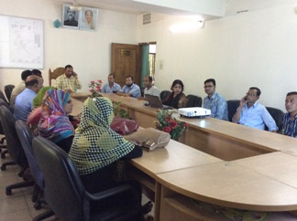

Photograph 7.1.1: Participation Meeting at Sitakunda Pourashava

Issues Raised by the Participants

The participants raised the issues related to the infrastructure development of Sitakunda Pourashava. They emphasized on the subproject selection for the future development and also discussed about the procedure for the quality construction work. In the FGD, the participants discussed the requirements for the future infrastructure development through a list of the subprojects. The major environmental problems in the Sitakunda Pourashava are related to sanitation and drainage system, road communication, solid waste management, monitoring water and land pollution. Water logging and flash flood in the low lying areas within the Pourashava area is another major problem.

Feedback, Suggestions, and Recommendations of the Participants

The participants were presented with feedback, suggestions, and recommendations listed below:
- The FGD results confirmed that an improved communication network, drainage facility, solid waste management, water treatment plant and water supplying system, sewerage treatment plant and sanitation facilities, recreational facilities, health and sports facilities and educational institutions are needed for future development of Sitakunda Pourashava;
- Local people also believed that the importance of the area would be elevated and various economic activities would be started in the area after the subproject implementation;
- Most of the participants expressed that the number of subprojects that have been selected for each financial year is insufficient;
- Local people also showed strong expectation for the increased opportunities for employment for unskilled or semi-skilled labor in the construction work;
- They emphasized for the Planned, Environmental friendly and Green Sitakunda Pourashava, for this they are asking for improve road network, safe drinking water, enhanced drainage and solid waste management system, designated slaughter house, designated graveyard and buried place;
- The participants also addressed about the better infrastructural facilities like as Bazar and market, Park and recreational center, Playground and Stadium, Educational institution, Medical facilities, EPZ and IT center;
- The participants stated that the public water supply facilities, sanitation facilities and access road is not adequate;
- The participants also addressed the solid waste management issue to reduce environmental and public health hazards.

Conclusions and Recommendations

The subproject intervention has significant ecological impact due to felling of trees. However, to compensate the felled down trees and to enhance the ecological condition, adequate tree plantation work is included in the design of the subproject. The adverse impacts on the physicochemical components will be localized and limited within the subproject boundary. It is also anticipated that the adverse impacts are largely manageable if proper mitigation, compensation and enhancement measures will be entirely implemented. In fact, the anticipated impacts due to the subproject activities are relatively minor in comparison to the significant benefits that will derive due to the implementation of the subproject.

A few key recommendations are outlined below:
- EMP should be available in the site during construction phase;
- Regular field visit by PMU, DSM and Pourashava is needed for the effective implementation of the EMP;
- Equipment should be checked by the Pourashava engineer and DSM consultant prior to work;
- To minimize occupational health and safety risks, it is highly recommended to adapt mechanical system where appropriate;
- Contractor will ensure availability of the PPEs to the workers;
- First aid box with relevant medicine should be available at site;
- The contractor is responsible for the proper disposal of the generated wastes materials from the subproject sites and Campsite;
- Inform the local inhabitants about the subproject activities and safety measures would be taken for the pedestrian and traffic movement;
- Contractor will monitor behavioral matter of the workers to avoid any undue risks related to labor influx;
- Proper maintenance is needed for the planted trees by the contractor during project defect liability period.

It should be noted that environmental assessment report is a live document. Hence, due to changing circumstances during the construction phase if any, there might be minor adaptation needed for environmental, health and safety issues.

References

Sitakunda Pourashava: At a glance; Pourashava Information Portal, Sitakunda Pourashava, Sitakunda, Chittagong.

Sitakunda Pourashava Master Plan: 2011-2031; Urban Area Plan of Sitakunda Pourashava, Sitakunda, Chittagong.

GoB (1997), Environmental Conservation Rules 1997.

Environmental Assessment Volume 1: Overall Environmental Assessment [Draft Final Report], September 2013. Municipal Governance and Services Project (MGSP), Local Government Engineering Department (LGED) and Bangladesh Municipal Development Fund (BMDF), Ministry of Local Government, Rural Development and Cooperatives, Government of the People's Republic of Bangladesh.

Environmental Assessment Volume 2: Environmental Management Framework (EMF) [Draft Final Report], September 2013. Municipal Governance and Services Project (MGSP), Local Government Engineering Department (LGED) and Bangladesh Municipal Development Fund (BMDF), Ministry of Local Government, Rural Development and Cooperatives, Government of the People's Republic of Bangladesh.

Geological Survey of Bangladesh, 1978. Earthquake Zoning Map.

Bangladesh Meteorological Department (BMD), 2016.

Population and housing census, 2011, National Volume-II: Union Statistics.

APPENDIX

Appendix - I: Environmental Monitoring Checklist

Local Government Engineering Department

Municipal Governance and Services Project (MGSP)

Environmental Compliance Monitoring Form

Part A: General Subproject Information
Subproject Name | a) Improvement of Khamar Bari Road from Ch.0+00 to 0+650m  b) Improvement of Nunochara to ECO Park Road including RCC retaining wall from Ch.0+807 to 1+507m
Package No. | MGSP/SIT/2017-18/W-06
ULB Name | Sitakunda Pourashava
Approved Estimated Cost in BDT
Contract Amount in BDT
Contractor Name
Date of Commencement
Target Date of Completion
Physical Progress (%)
Financial Progress (%)
Person Responsible (PIU)
(Name, Designation &Phone) for the Overall Subproject Management

Person Responsible (DSM)
(Name, Designation &Phone) for the Overall Subproject Management

Form Completed by
(Name, Designation &Phone)
Overall Environmental Description of the Subproject

Part B: Design, Preparation, and Legal Requirements
Environmental Concerns (PMU, PIU & DSM)  (Name, Designation & Phone) | PMU-
 | PIU-
 | DSM-
Subproject Category | DoE-BD- | WB-
Environmental Clearance Received? | Yes | No
EA Required? | Yes | No
EA Prepared and Delivered? | Yes | No
EMP Prepared & Delivered Separately? | Yes | No
Items and Cost of EMP Implementation Included in the Contract? | Yes | No
EMP Included in the Procurement Documents? | Yes | No
Inspection Schedule / Last Inspection / Monitoring by PMU Environmental Concerns | Date-
 | Key findings-
Inspection Schedule / Last Inspection / Monitoring by PIU Environmental Concerns | Date-
 | Key findings-
Inspection Schedule / Last Inspection / Monitoring by DSM Environmental Safeguard Specialist / Jr. Environmental Specialist | Date-
 | Key findings-

Part C: Key Environmental Impacts
The Subproject Results in any of the following Impacts? | Yes | No | NA | If yes, is the impact (give observation)
 |  |  |  | Significant | Moderate | Minor
Felling of the trees
Clearing of the vegetation that increase the risk of increased soil degradation or erosion
Disturbance of the terrestrial and or aquatic specifies
Noise pollution
Air pollution
Adverse effects on the quantity or quality of the surface water or groundwater
Production or increase the production of the solid waste
Drainage congestion
Water logging that increases the risk of the water related diseases
Traffic congestion
Public safety

Part D: Work Place Environment and Gender Equity
The Subproject Results in any of the following Impacts? | Yes | No | NA | Observations
Does the contractor pay to the workers regularly?
Is there any discrepancy between the male and female workers regarding the wages or salary for the same works?
Is the contractor complying with the GOB labor law concerning the hiring of the workers?
Does the contractor engage women labors and does the project have suitable works for them?
Does the contractor engage child labor (less than 18 years) and aged people (more than 65 years old)?
Does the contractor force to the workers for the completion of the works?
Do the workers involve with the political activities, crime, drugs addiction and other forms of unwanted activities?
Are construction camps adequately equipped with water supply, sanitary toilets, washing facilities and facilities for waste collection and storage?
Has separate sanitation facilities been provided for women at work camps and the construction site?
Do the laborers load heavy items on their heads or shoulders?
Has the contractor undertaken an awareness program for the sexually transmitted diseases especially for HIV-AIDS and other infectious diseases like TB?
Are first aid kits readily available for the workers at the job site along with the instructions for use?
Are supervisors or other site personnel trained in the basic first aid emergency response measures?
Has the contractor provided necessary safety equipment to the workers and training for use?

Part E: Potential Impacts, Mitigation Measures, and Monitoring Indicator Mentioned in the EMP
Activity/  Issues | Potential Impacts | Proposed Mitigation and Enhancement Measures | Monitoring Method | Monitoring Frequency | Implementation Status (Yes/ No / NA) | Impact significance if not implemented |  |  |  | Remarks
 |  |  |  |  |  | Major | Moderate | Minor | No
Construction and operation of labor shed for the workers (Workforce and labor shed management) | Generation of sewage and solid waste may degrade quality of the adjacent water bodies and surrounding environment | - Construction of sanitary latrine considering 15 persons for one toilet at the labor shed and separate toilet for male and female;  - Erection of “no litter” sign, provision of waste bins (introduce separate waste bins for organic and inorganic wastes);  - Ensure wastes (solid wastes and other forms of wastes) disposal at Ponthisilla Sheikhpara.
 | Health of workers | - Conduct formal and unofficial discussion to increase awareness about hygiene practices among the workers;  - Ensure availability and access to first-aid equipment and medical supplies for the workers.
 | Possible development of labor camp into permanent settlement | - Contractor to remove labor camp at the completion of contract.
 | Outside labor force causing negative impact on health and social well-being of local people | - Ensure that contractor employ local work force to provide work opportunity to the local people and conduct formal and unofficial awareness program for the health and social well-being of the local people.
General construction works | Drainage congestion and flooding | - Ensure provision for adequate drainage of storm water if needed;  - Ensure provision for pumping of congested water if needed;  - Ensure adequate monitoring of drainage effects, especially if construction works are carried out during the wet season.
General construction works | Air pollution | - Check regularly and ensure that all the subproject vehicles are in good operating condition;  - Ensure contractor spray water on dry surfaces regularly to reduce dust generation;  - Maintain adequate moisture content of the soil and sand used for transportation, bed preparation and compaction;  - Ensure contractor sprinkle and cover stockpiles of loose materials (e.g., fine aggregates);  - Ensure contractor avoid use of equipment at site and far from the local residents, which produce significant amount of particulate matter.
General construction works | Traffic congestion, effect on traffic and pedestrian safety | - Ensure schedule deliveries of materials/ equipment during off-peak hours;  - Place traffic/ cautionary sign to avoid undue traffic congestion and accidents;  - Inform the local people about the subproject activities.
General construction works | Noise pollution | - In front of the road side residents and subproject adjacent ecologically sensitive area i.e., Sitakunda Eco-park, construction work should not be performed;  - Check and maintenance the equipment properly;  - Avoid using of construction equipment producing excessive noise at night;  - Regulate use of horns and avoid undue use of hydraulic horns in subproject vehicles.
General construction works | Water and soil pollution | - Prevent discharge of fuel, lubricants, chemicals and wastes into adjacent water bodies like Pahari Chora, Nunochara, ponds, ditches, low wet land and seasonal springs.
General construction works | Felling of trees, clearing of vegetation and ecological disturbances | - 250 nos. of trees will be planted to compensate the felled down trees preferably local fruits, timber, medicinal and ornamental trees at both sides of the Khamar bari road and any other suitable places in and around the subproject area where space is available.
General construction works | Accidents | - Conduct formal and informal discussion for creating awareness about the accidents;  - Provide PPEs and ensure using of the personal protective equipment by the workers.
General construction works | Spills and leaks of oil, toxic chemicals | - Proper handling of lubricating oil and fuel so that it does not fall on the soil and water body;  - Collection, proper treatment, and disposal of the spills.
All construction  works | Beneficial impact on employment generation | - Employ local people in the subproject activities as much as possible;  - Give priority to poor people living within subproject area in subproject related works (e.g., excavation and other works, which do not require skilled manpower).
All construction  works | Possible complaints and suggestion from the local people and stakeholder about the subproject activities | - Use existing grievance registrar and complaints box that has been already delivered in the Pourashava.
All construction  works | General degradation of the environment | - Ensure environmental enhancement measures such as tree plantation and traffic / cautionary sign.
- For BC road, RCC Pavement, RCC box culverts and road protection wall
Excavation/ Earth work/ Dismantle work | Generation of solid and construction wastes due to the dismantle works;  Generation of loose soil due to the earth excavation work. | - Cover exposed earth works with fabric/tarpaulin;  - Disposal of soil and construction wastes at Ponthisilla Sheikhpara.
Excavation/ Earth work/ Dismantle work | Accidents | - Carefully handle of the hydraulic excavator.
Excavation/ Earth work/ Dismantle work | Air pollution | - Regular maintenance of the equipment.
ISG (Improved Sub grade)/ Sand filling for road and Back filling work for retaining wall and culverts | Air and dust pollution affecting nearby settlements | - Maintain adequate moisture content of soil during transportation, compaction and handling;  - Carry the materials especially loose soil and sand with adequate cover.
Cutting and welding of the reinforcement | Noise pollution due to rod cutter and welding machine if any | - Avoid using of rod cutter and wielding machine at night;  - Avoid prolonged exposure to noise (produced by equipment) by workers.
Cutting and welding of the reinforcement | Potential health and safety risks from rod cutter and welding machine if any | - Ensure use of the personal protective equipment’s (helmet, goggles, gloves, safety boot);  - Availability and access to first-aid equipment and medical supplies in case of any accidents.
RCC (reinforcement concrete) work | Air pollution due to black smoke emission from concrete mixer machine and vibrator machine | - Regular maintenance of the concrete mixer and vibrator machine to avoid any black smoke emission.
RCC (reinforcement concrete) work | Noise nuisance from concrete mixer machine and vibrator machine | - Avoid operation of the concrete mixer and vibrator machine at night;  - RCC work should be avoided at schooling time;  - Inform local people about casting work and potential impacts.
Setting up and operation of asphalt plant | Possible degradation of the air quality by the suspended particles and increase of the noise level from asphalt plant affecting nearby settlements; | - Locate plant away from residential settlements;  - Consider use of emulsified bitumen.
Setting up and operation of asphalt plant | Possible water pollution by bitumen and solvents; | - Avoid spills and proper collection and disposal of the generated spills.
Setting up and operation of asphalt plant | Possible preparation of the bitumen in open air and using of charcoal and wood as fuel | - Strictly prohibit bitumen preparation in the open air and use of charcoal & wood as fuel.

Prepared by- Signature- Date-
Copies to 1. PIU
2. SME
3. AME
4. Jr. ES

