INTRODUCTION

Subproject Background

Mirsharai is a newly created Pourashava of Chittagong Zila. It was established in 2001 with an area of 10.49 sq.km. The total population of the Pourashava as enumerated in 2011 census is 16218 of which 7695 are males and 8523 are females. The literacy rate of the Pourashava is 60.1%. It consists of 9 Wards and 27 mahallahs (Population and housing census, 2011).

Mirsharai Pourashava is B Type Pourashava. Infrastructures and physical development are not attained significantly in the Pourashava. The Pourashava has 35 km pucca road, 10 km semi-pucca road and 5 km katcha road. The drainage system includes 1132.32 pucca and katcha drains and 17.55km khals & rivers. (Mirsharai Pourashava Master Plan: 2011-2031). Like other municipality in Bangladesh, rapid urbanization of Mirsharai Pourashava requires improved infrastructure. Hence, this subproject is a continuation of the infrastructure development of the Mirsharai Pourashava. This subproject (Package: MGSP/MIR/2017-2018/W05) includes construction of BC roads and RCC pavement. The subproject site is situated within the jurisdiction of the Ward no. 03, 06, 07 and 08 no. Wards of Mirsharai Pourashava and partly Bottol Village under 9 no. Mirsharai Union Parishad.

The significant features of the subproject are mentioned below:
Name of the Subproject: | a) Construction of Muktizoddha Shafiul Alam Road Ch. 0-630m;  b) Construction of Mukim Bhuiyan Road remaining portion by BC Ch. 0-350m;  c) Construction of Bashir Ullah Munshi Road Ch. 0-720m ;  d) Construction of Bukshi Jamadar Road Ch.0-552m, culvert at Ch. 57m (3.mx1.5m) and Link Ch. 0-236m;  e) Construction of Ram Mondal Road starting from House of Anam Master to Moulana Abdul Latif Road Ch. 0-1050m.
Package No.: | MGSP/MIR/2017-18/W-05
District Name: | Chittagong
ULB Name: | Mirsharai Pourashava
Jurisdiction Area: | Ward no. 03, 06, 07 and 08 of Mirsharai Pourashava
Structural Design Option: | BC and RCC Road and RCC culvert
Beneficiary Population: | About 9,000 as per information by Population and housing census, 2011
Tribal People: | No tribal people settlement found in the subproject area
Land Acquisition: | No private land acquisition is needed.
Estimated Cost: | 40.539 million BDT
Subproject Duration: | 12 Months
Tentative Start Date: | 07 September, 2018
Tentative Completion Date: | 06 September, 2019

Objectives of the Study

The aim of the study is to examine the environmental impacts due to construction and operation of the subproject and formulate the environmental management plan to minimize the negative impacts and enhance the positive impacts.
The specific objectives include:
- To assess the existing environmental conditions of the subproject site and its adjacent areas in order to establish a baseline framework against which potential environmental impacts due to implementation of the subproject would be compared;
- To identify and assess impacts resulting from the subproject during its construction phase and operation phase;
- To develop a rational environmental management plan with recommendations for mitigating adverse impacts and enhancing positive impacts and outlining environmental monitoring requirements both during construction and operational phase of the subproject.

Scope and Methodology of the Study

According to the environmental screening, environmental assessment is required to fulfill the regulatory requirement for the subproject. The study methodology comprised the following activities:

Desktop Study
The desktop study involved:

- Initial meetings with client, stakeholders to discuss the proposed subproject, including subproject activities;
- Collection and review of the baseline data, maps, reports and other relevant information on the existing environmental and social conditions of the subproject area;
- Review of the relevant existing legislation, regulation and policies;
- Understand the anticipated technical processes that may affect the environment.

Field Investigation and Data Collection
A team of the consultants made a field investigation to the proposed site and field investigations involved mainly walking within the subproject area and the adjoining areas that may be affected by the subproject. The following key tasks were performed during the field visit:
- Taking photographs of the significant aspects to assist in describing the baseline environmental conditions of the subproject area;
- Interviews with representatives of the Mirsharai Pourashava officials, within the subproject area and interested and affected people within the subproject influence zone;
- Obtaining relevant documents from the Mirsharai Pourashava and local people within the subproject influence zone;
- Verifying information and data collected during the desktop study and to collect new information that may have been important in the assessment of the impacts and design of the mitigation measures.

Data Analysis and Report Writing
The data and information collected from all the sources (literature review, secondary and primary data, public consultation) were analyzed to describe the existing environmental setting of the subproject area, to identify the potential positive and negative impacts of the proposed subproject, as well as to provide preliminary suggestions for mitigation measures. Finally, this environmental assessment report has been prepared.

Subproject Description

The Study Area
The subprojects are located at different Wards of Mirsharai Pourashava. The Muktizoddha Shafiul Alam Road (Ch. 0-630m), Mukim Bhuiyan Road (Ch. 0-350m), Bashir Ullah Munshi Road (Ch. 0-720m), Bukshi Jamadar Road (Ch.0-552m) with link road and Ram Mondal Road starting from House of Anam Master to Moulana Abdul Latif Road (Ch. 0-1050m), are situated within the jurisdiction of the wards no. 03, 06, 07 and 08 No. Wards of Mirsharai Pourashava and partly Bottol Village under 9 no. Mirsharai Union Parishad. The location map, topographical features and layout plan of the subproject are shown in Figure 2.1.1, Figure 2.1.2 and Figure 2.1.3.
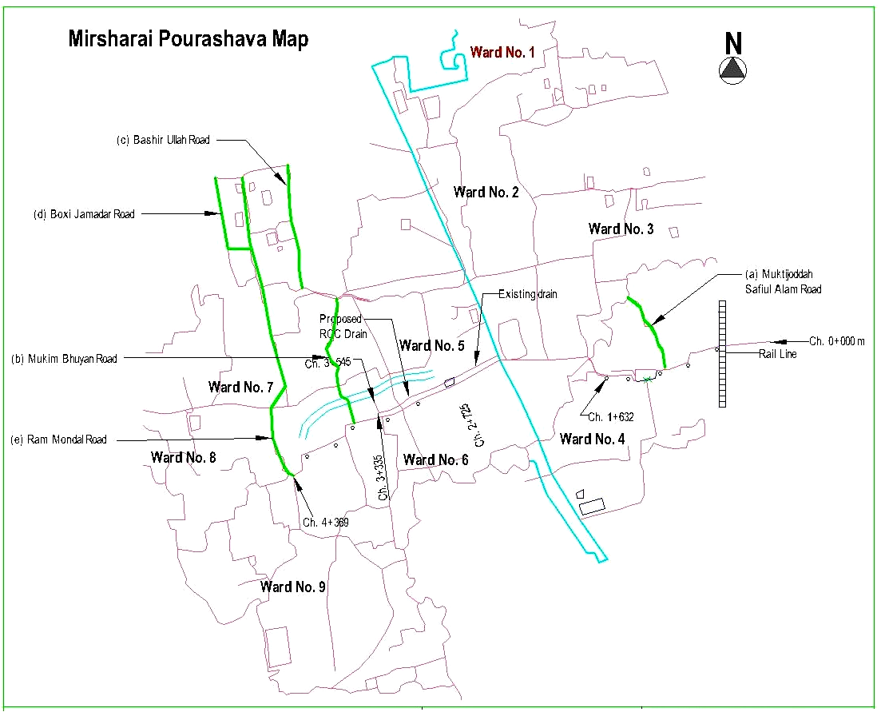
Figure 2.1.1: Location Map of the Subproject site
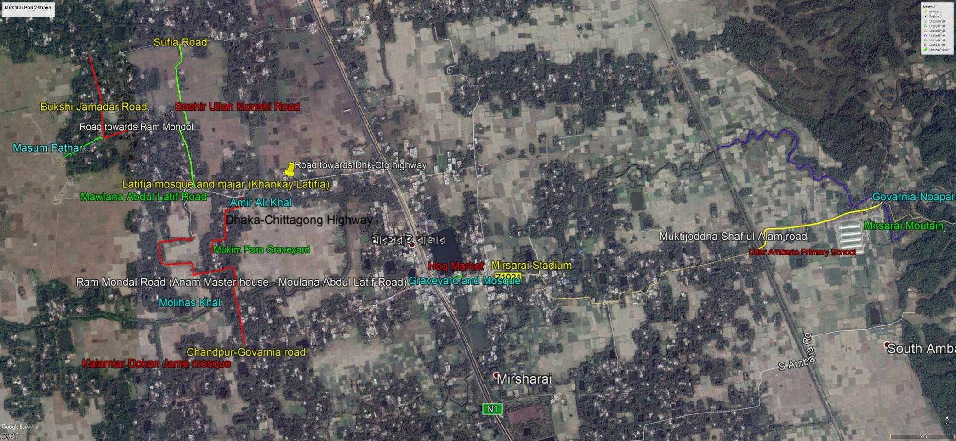
Figure 2.1.2: Topographical Features of the Subproject area

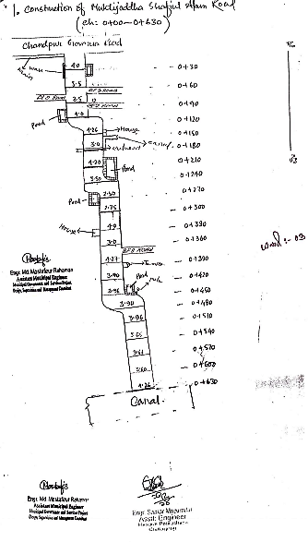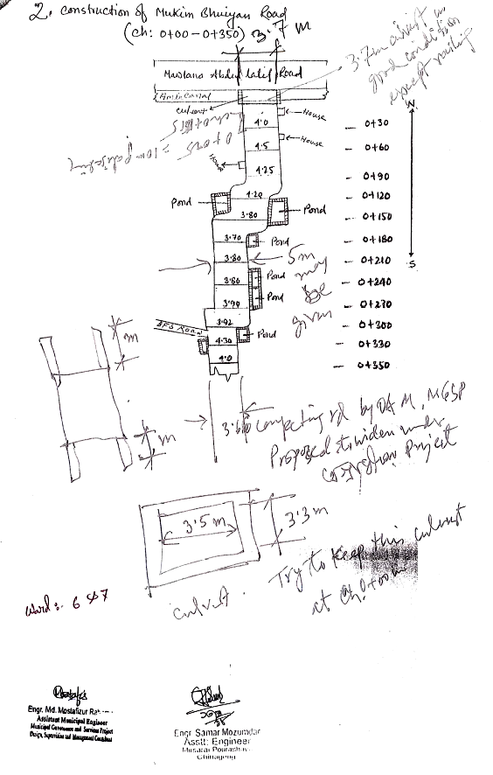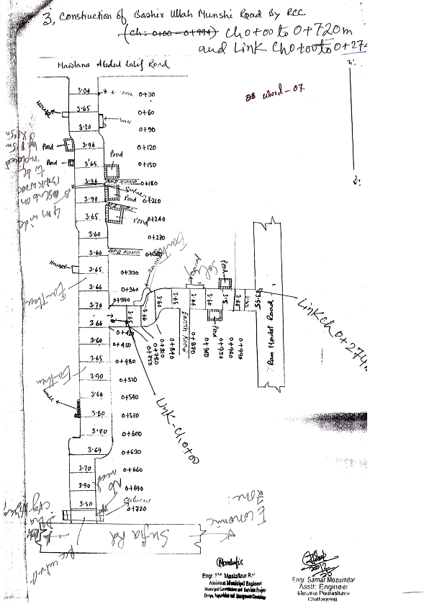
Figure 2.1.3 (i): Layout Plan of the Subproject (a) Muktizoddha Shafiul Alam Road, (b) Mukim Bhuiyan Road and (c) Bashir Ullah Munshi Road

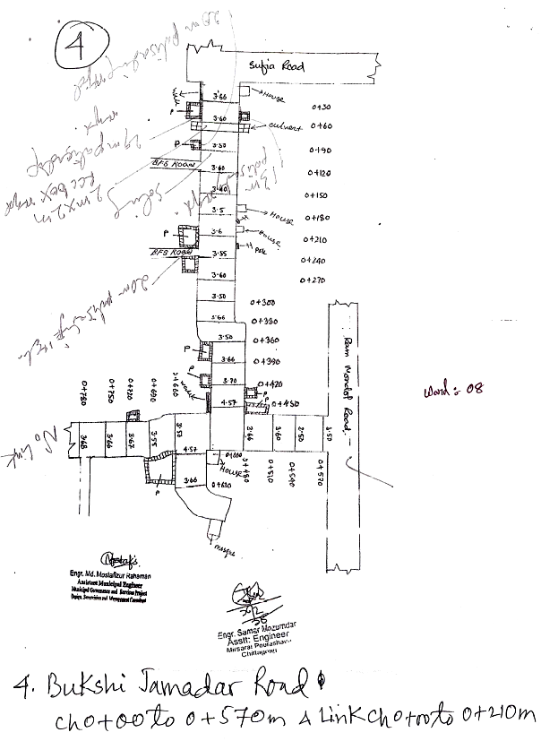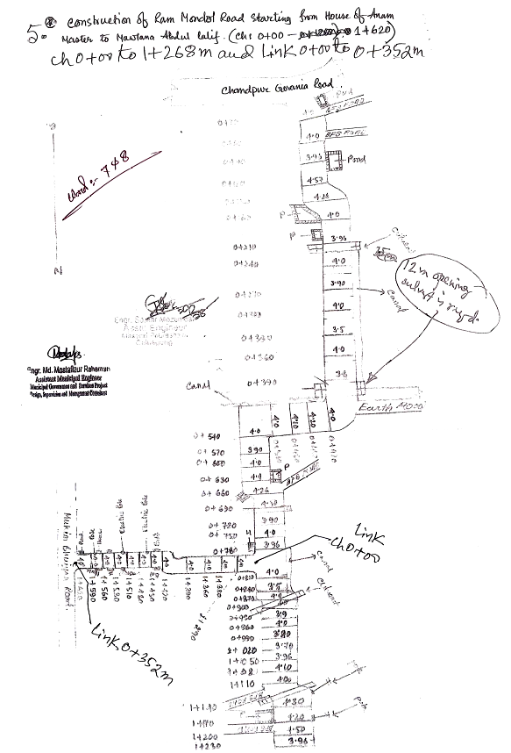
Figure 2.1.3 (ii): Layout Plan of the Subproject (d) Bukshi Jamadar Road and (e) Ram Mondal Road

Current Situation, Proposed Intervention and Need for the Subproject

The proposed subproject includes roads (BC roads and RCC pavement) and RCC culvert at Muktizoddha Shafiul Alam Road, Mukim Bhuiyan Road, Bashir Ullah Munshi Road, Bukshi Jamadar Road with link road and Ram Mondal Road starting from House of Anam Master to Moulana Abdul Latif Road. The subproject areas are mainly peri-urban area of Mirsharai Pourashava. The built-up infrastructures include road side pucca, semi-pucca, pucca, tin-shed and katcha residential houses, educational institutions, religious center (Mosques, Latifia Mosque and Majar, Kali-Mandir) and local markets. Agricultural lands at both sides of the proposed roads where crops (mainly Boro paddy) and vegetables are growing abundantly. Road sides are covered with naturally grown vegetation like bamboo and cane, Dumur and Dutura and natural weeds. The seasonal wetland / Beel locally known as “Masum Pathar” is the biggest Beel of Mirsharai Pourashava which exists at the end of the link road of Bukshi Jamadar Road. The proposed roads will be used for carrying goods like crops and vegetables for the kitchen market, local markets in and around the Pourashava area.

The proposed Muktizoddha Shafiul Alam Road (Ch. 0-630m) starts from Chandpur- Govania Road and ends at Govania Canal also known as Govania-Noapara Khal. After crossing the Canal, the subproject road continues up to Noapara - the rapidly growing area of Mirsharai Pourashava. The crest width of the road varies from 3.0-4.27m. The existing road from Ch. 0-330m is HBB type and rest part is earthen. There are pot holes at various locations of the HBB surface. The earthen part of the road is mostly damaged and undulated. Considering the current situation of the road which is badly damaged and narrow, it is necessary to improve the road by RCC pavement with 4m width.

Furthermore, the proposed Mukim Bhuiyan Road starts from Mawlana Abdul Latif Road and ends near a graveyard at Mukim Para. The existing road is bituminous carpeting (crest width varies from 3.60-4.25m). The existing water bodies such as pond at both sides of the proposed road (at right side: Ch. 10-30m, Ch. 220-250m, Ch. 270-290m and Ch. 310-336m at right side and Ch. 65-85m, Ch. 125-131m, Ch. 150-180m and Ch. 292-320m at left side) and irrigational canal at Ch. 180-210m which necessitate road protection work at these locations. Most of the road surfaces are worn out and lack of smooth surface. Undulations, potholes and edge cracks are found at various segments on the road surface. Moreover, this condition creates hassle for traffic movement and inconvenience for the road users. Considering the bad surface condition of the road with a narrow width, it is necessary to improve the road. Hence, the proposed Mukim Bhuiyan Road (Ch.0-350m) will be constructed by BC pavement with 4m width.

The proposed Bashir Ullah Munshi Road (Ch. 0-720m), starts from the Mawlana Abdul Latif Road and ends at Sufia Road. The existing Bashir Ullah Munshi Road is brick flat soling (BFS) from Ch. 0-300m and remaining part (Ch. 300-720m) is earthen. The crest width varies from 3.30-3.39m. The BFS part of the road is undulated and missing of bricks in several places. The earthen portion is also badly damaged for traffic movements. During monsoon and rainy days, the pedestrians also face trouble due to slippery and muddy surface. Due to bad road condition, the motorized vehicles are very few at Bashir Ullah Munshi road. There are ponds at left side (Ch. 30-60m, Ch. 125-140m, Ch. 177-188m and Ch. 555-587m) and right side (Ch. 145-159m, Ch. 450-480m and Ch. 492-510m). To ensure the road stability, road protection work is needed at these particular sections. Considering the poor surface condition of the road with a narrow width, it is necessary to improve the road by BC pavement with 4m width.

The proposed Bukshi Jamadar Road starts from Sufia Road and ends at Ram Mondal Road with 1 vent RCC culvert. This subproject also includes a link road (Ch. 0-236m) starts at Ch. 0+450m. Both main and link roads are brick flat soling (BFS). The crest width of the main road varies from 3.30m to 3.66m. The BFS part of the road is undulated and missing of bricks in several places. Due to bad road condition, the motorized vehicles are very few at Bukshi Jamadar Road. During monsoon, the bad condition of the road also creates trouble for the movement of the pedestrians. In addition, the existing water bodies like pond at different Chainage of proposed road; at right side (Ch. 23-53m, Ch. 80-100m, Ch. 120-140m and Ch. 265-285m) and left side (Ch. 435-455m, Ch. 525-535m and Link road Ch. 148-173m) alignment of Bukshi Jamadar road. To ensure the road stability, road protection work is needed at these particular sections. Considering the poor surface condition of the road with narrow width, it is necessary to improve the road by BC pavement with 4m width. 1 vent 3.0x1.5m culvert at Ch. 57m will also be constructed replacing the existing brick lined culvert.

The proposed Ram Mondal Road (Ch. 0 - 1050m) starts from the house of Anam Master at Mondal Para and ends at Moulana Abdul Latif Road. The existing road from Ch. 0 - 180m is HBB, Ch. 180 - 390m is BFS, Ch. 390 - 480m is earthen and Ch. 480 - 1050m is HBB. The crest width of roads varies from 3.50m to 4.50m. Due to bad road condition, the motorized vehicles are very few at Ram Mondal Road. During monsoon, the bad condition of the road also creates trouble for the movement of the pedestrians. There are ponds at right side (Ch. 170-180m, Ch. 190-210m, Ch. 400-430, Ch. 650-665m, Ch. 860-876m and Ch. 910-930m) and left side (Ch. 340-360m, Ch. 395-405m and Ch. 840-850m). To ensure the road stability, road protection work is needed at these particular sections. Considering the poor surface condition of the road with narrow width, it is necessary to improve the road by BC pavement with 4m width.
The current situation of the subproject sites are further elaborated in the following Photographs 2.2.1.
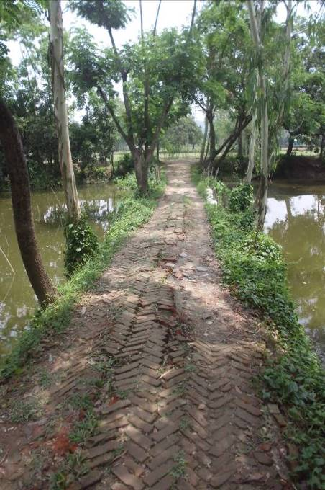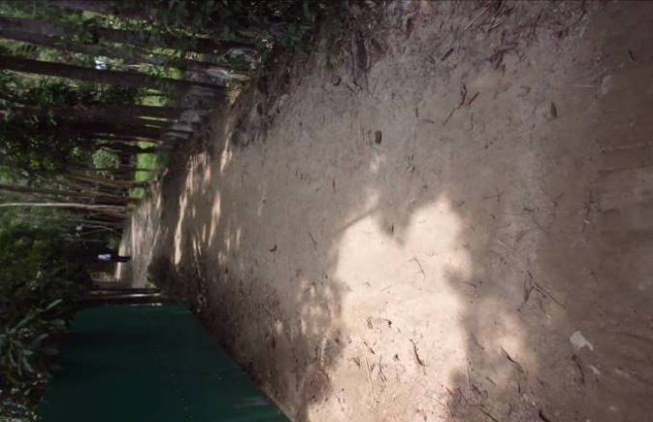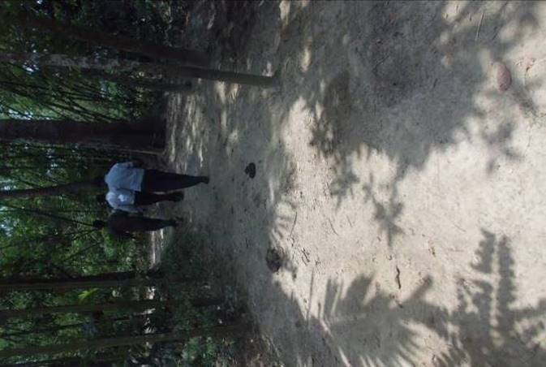
Photographs 2.2.1 (a): Current situation of the subproject site at Muktizoddha Shafiul Alam Road
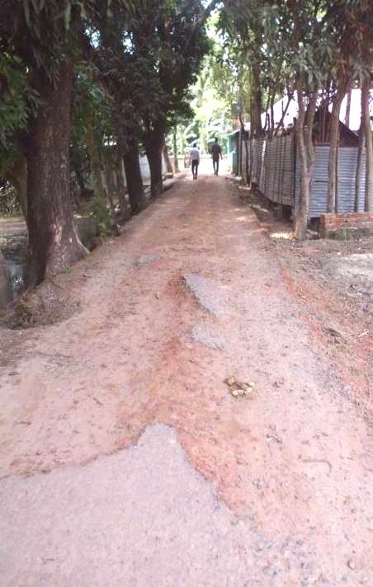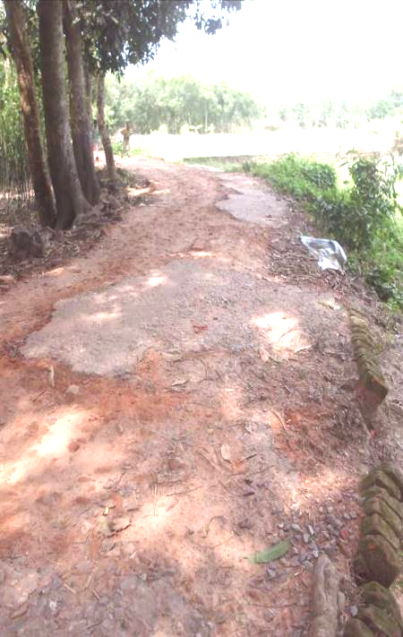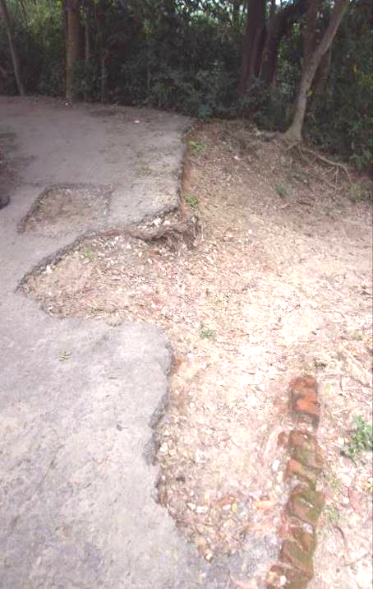
Photographs 2.2.1 (b): Current situation of the subproject site at Mukim Bhuiyan Road

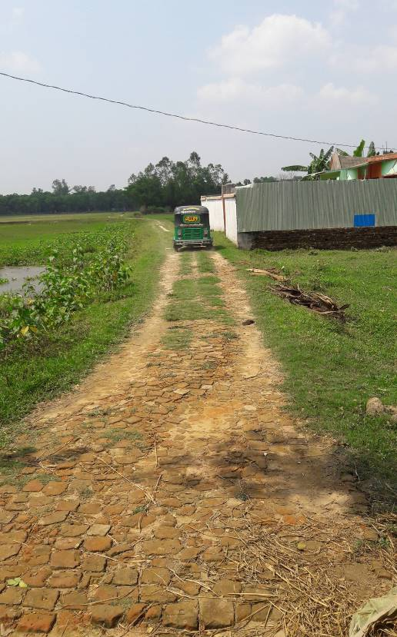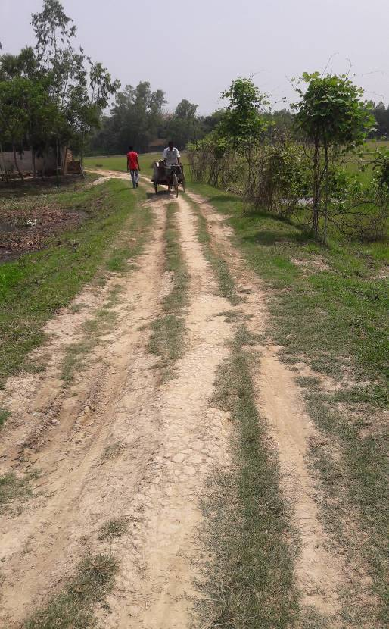
Photographs 2.2.1 (c): Current situation of the subproject site at Bashir Ullah Munshi Road
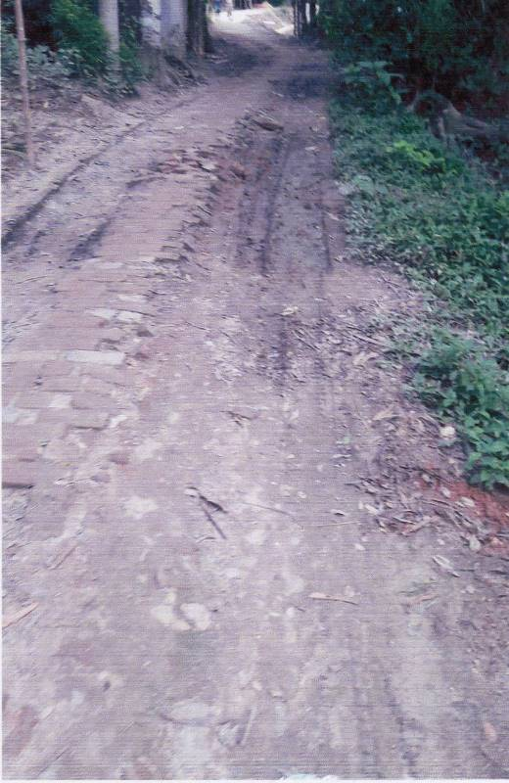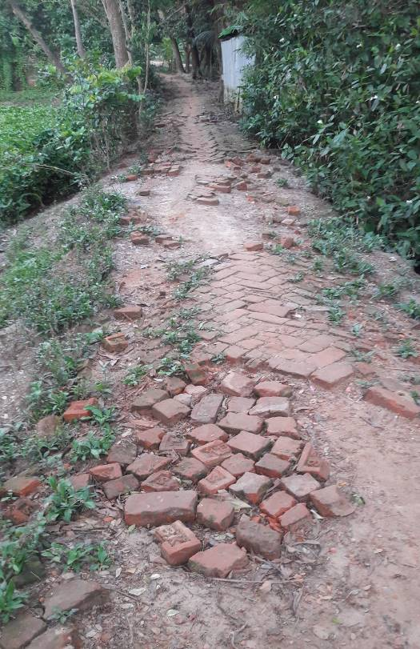
Photographs 2.2.1 (d): Current situation of the subproject site at Bukshi Jamadar Road
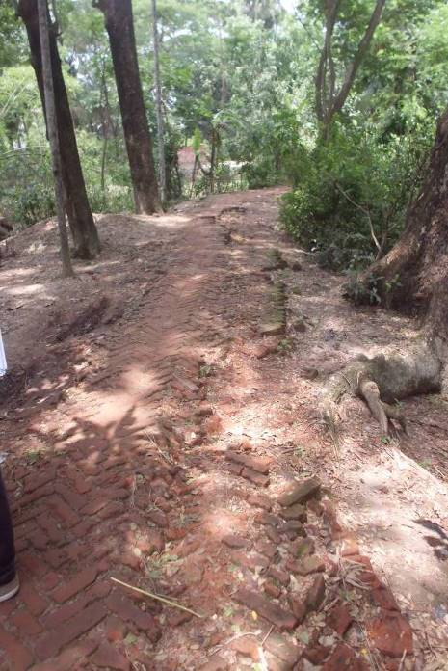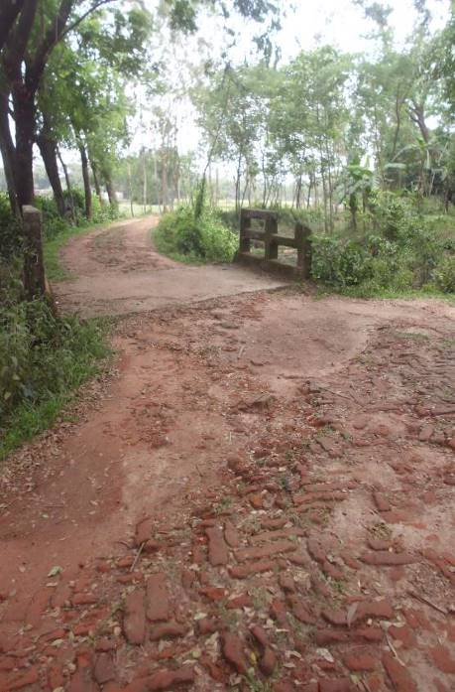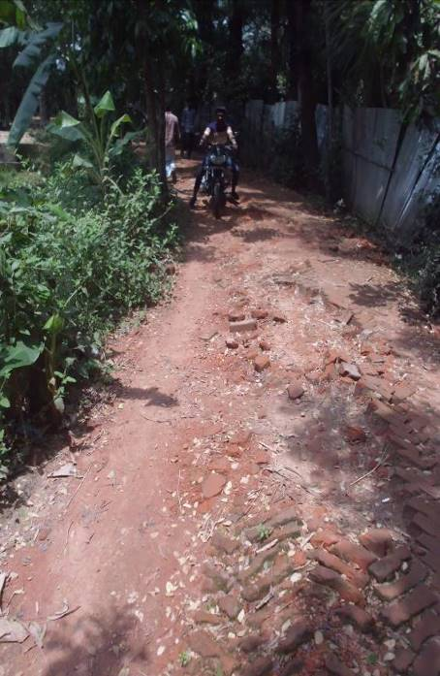
Photographs 2.2.1 (e): Current situation of the subproject site at Ram Mondal Road

Justification of Selection of this Subproject

The Pourashava prepared the priority subproject list as per CIP. The consultant inspected the site conditions and recommended the subproject having low environmental and social negative impacts. To implement this subproject the road side built infrastructure will not be severely disturbed. In addition, private land acquisition is not an issue for implementation of this subproject. The Mirsharai Pourashava owned the subproject road.
The proposed subproject components will enhance the communication structure of Mirsharai Pourashava-such as improve transport facilities by reconstruction of BC and RCC pavements. After completion, the subproject has significant benefits to the community people. It will provide normal traffic operation for the motorized and non-motorized vehicles. By eliminating rough surface and potholes, the road will also reduce potential traffic accidents. It will also reduce travel time and enhance road communication in the neighboring areas. The new culvert will provide risk free traffic movement and diverting water from inland to low-land and water bodies to eliminate temporary water logging. Thus, the local people will get better environment by reducing public health hazards. Hereafter, considering the potential benefits after completion this subproject has been selected.

Envisaged Subproject Activities and Implementation Process

The general activities for the subproject includes: construction of the semi-pucca site office, construction of the labor shed, relocation of the electric poles and site clearing works and tree plantation works for ecological enhancing and beautification.

The key activities for BC Road include:

- Dismantling of the damaged sub-base and base course works;
- Clearing and grubbing works;
- Earth work in box cutting;
- Earth filling work;
- Sand filling on the road bed;
- Mechanical compaction;
- Brick on edging;
- Compacted base course;
- Providing prime coat;
- Laying pre-mixed dense bituminous surfacing wearing course.

The key activities for RCC Road include:

- Clearing and grubbing works;
- Earth work in box cutting;
- Earth filling work;
- Sand filling on the road bed;
- Mechanical compaction;
- Plain cement concrete work in foundation;
- Manufacturing CC blocks;
- Fabrication of the ribbed or deformed bar;
- Reinforced cement concrete work.

The key activities for RCC Culvert include:

- Dismantling of the existing structure;
- Earth work in excavation of the foundation;
- Sand filling in foundation trenches;
- Mass concrete work in foundation;
- Fabrication of the ribbed or deformed bar reinforcement
- Reinforced cement concrete work.

The materials and resources to be used for the key activities: Soil in earth work, sand, bricks, brick and stone chips, cement, concrete, reinforcement, bitumen, kerosene, diesel, water.

The major equipment to be used for the implementation of the subproject: hydraulic excavator, concrete mixer, mechanical vibrator, mechanical compactor, MS sheet, steel cutter, steel shutter, steel drum rollers, pneumatic multiple tire roller, dump truck, water tanker, pump, asphalt plant, rubber tire roller, and paver.

Category of the Subproject
For BC roads and RCC pavement with allied works

- According to ECR 1997 : Green □ Orange A □ Orange B □√ Red □ Not Listed □
- According to WB classification : Category B □√ Category C □

Considering the environmental impacts, this subproject can be considered as Orange B as per ECR-97. According to the WB classification, it can be classified as Category B.

Subproject Schedule
The tentative schedule of construction of the subproject is:
(a) Subproject duration (months) :12 months
(b) Tentative start date : September 07, 2018
(c) Tentative completion date : September 06, 2019
The daily construction hours will normally include regular working time. However, daily working hours may vary based on the on-site condition. The detailed work program will be prepared by the contractor with the assistance of the PIU. Then it will be shared with the PMU, LGED and DSM consultants. In addition, the detailed work program will also be shared with the Bank as per requirement.

Baseline ANALYSIS OF THE ENVIRONMENTAL CONDITION

Physical Environment

Environmental and Infrastructural Features
The environmental features within the subproject area have been collected by field investigation. Conditional survey has also been performed for designing of the subproject. Hence, survey data is also used for preparation of the report. The findings of the site inspection and investigation (considering the 100m longitudinal intervals within 100m of both sides from the center of the road) are given in Table 3.1.1 (a), Table 3.1.1 (b), Table 3.1.1 (c), Table 3.1.1 (d) and Table 3.1.1 (e).
Table 3.1.1 (a): Major Environmental and Infrastructural Features at Muktizoddha Shafiul Alam Road Ch. 0 - 630m
Chainage (m) | Left | Right | Major Environmental and Infrastructural Features
Muktizoddha Shafiul Alam Road (Ch. 0+00 - 0+630m)
0-100 | √ |  | Uttar Ambaria Govt. primary school, ext. RCC drain, Chandpur - Govania BC road, ditch, ponds, common planted trees (Rain tree, Acacia, Dumur, Mango, Mahogany, Debdaru, Mango, Mandar, Baiduli, Coconut, Betel-nut, Segun), damaged HBB road, link (household) HBB road, bamboo fence, residential area (semi-pucca and tin shed structures)
0-100 |  | √ | Ponds, residential area (semi-pucca, pucca and tin shed structures), boundary wall, electric poles, common planted trees (Rain tree, Acacia, Mango, Mahogany, Segun, Berry, Jackfruit, Coconut, Betel-nut), bamboo fence
100-200 | √ |  | Open land, electric pole, seasonal low wet land, residential area (semi-pucca and tin shed structures), canal, culvert, common planted trees (Rain tree, Acacia, Mahogany, Mango, Jackfruit, Segun, Date tree, Coconut, Betel-nut, Berry), natural grown vegetation (bamboo, cane)
100-200 |  | √ | Ponds, common planted trees (Pulm, Mango, Mahogany, Rain-tree, Date tree and Palm tree) and naturally grown vegetation, low wet land, vacant land, agricultural land (vegetable cultivation and paddy field), irrigational canal/water source, residential area (semi-pucca and tin shed structures), canal
200-300 | √ |  | Ponds, electric pole, seasonal low wet land, residential area (semi-pucca and tin shed structures), common planted trees (Rain tree, Acacia, Mahogany, Mango, Jackfruit, Coconut, Betel-nut and other common fruits trees), homestead flower garden, naturally grown vegetation and commercially developed wooden tree garden
200-300 |  | √ | Ponds, common planted trees (Mango, Rain tree, Mahogany, Acacia, Palm, Coconut, Betel-nut, Segun, Berry) and naturally grown vegetation (Bamboo and cane), agricultural land including paddy field and vegetable cultivation, irrigational water source, Mirsharai mountain
300-400 | √ |  | Common planted trees, residential areas (pucca, semi-pucca structures), tin fence, household connecting earthen road, privately/commercially planted wooden tree garden (Acacia and Mahogany), Kali Mandir (temple), ditches, Govania-Noapara Khal
300-400 |  | √ | Poultry farm, naturally grown vegetation (bamboo and cane), common planted trees, residential areas (pucca and tin shed structures), earthen road, open space, privately/commercially planted wooden tree garden (Acacia and Mahogany)
400-500 | √ |  | Common planted trees, residential areas (pucca, semi-pucca structures), tin fence, homestead vegetable garden, household connecting earthen road, privately/commercially planted wooden tree garden (Acacia and Mahogany), Govania-Noapara Khal
400-500 |  | √ | Poultry farm, road side naturally grown vegetation, common planted trees, earthen road, open space, agricultural land including paddy filed and vegetable cultivation, electric pole
500-630 | √ |  | Common planted trees, residential areas (pucca, semi-pucca and tin shed structures), culvert, open space, with privately/ commercially tree plantation (wooden tree mainly- Acacia, Rain tree and Mahogany), tin fence, homestead vegetable garden, electric pole and transformers, naturally grown vegetation, Govania-Noapara Khal
500-630 |  | √ | Common planted trees (Bokul, Dumur, Banyan, Tula, Mango, Betel-nut, Jhir tree, Segun), agricultural land including paddy filed and vegetable cultivation, electric pole, open space, naturally grown vegetation (bamboo and cane), Govania-Noapara Khal
Table 3.1.1 (b): Major Environmental and Infrastructural Features at Mukim Bhuiyan Road remaining portion by BC Ch. 0 - 350m
Chainage (m) | Left | Right | Major Environmental and Infrastructural Features
Mukim Bhuiyan Road (Ch. 0+00 - 0+350m)
0-100 | √ |  | Amir Ali khal, Abdul Latif road retaining wall (under construction work-MGSP package W2), residential area (semi-pucca, pucca, tin shed infrastructures), boundary wall, tin fence, Ebadat-khana, agricultural land including paddy field and vegetable cultivation, common planted trees (Mango, Jackfruit, Rain tree, Mahogany, Acacia, Coconut, Betel-nut), natural grown vegetation (cane), ponds, Latifia mosque and Majar
0-100 |  | √ | Amir Ali khal, under construction Abdul Latif road retaining wall (MGSP package W2), residential area (semi-pucca, pucca, tin shed infrastructures), ponds, culvert, common planted trees
100-200 | √ |  | Common planted trees (Mango, Jackfruit, Rain tree, Mahogany, Acacia, Coconut, Betel-nut), ponds, naturally grown vegetation, damaged BC road, agricultural field, ditches, irrigation canal
100-200 |  | √ | Ponds, tin fence, residential area (semi-pucca, pucca, tin shed infrastructures), Common planted trees (Mango, Jackfruit, Rain tree, Mahogany, Acacia, Coconut, Betel-nut, Tula), open space
200-350 | √ |  | Common planted trees, ponds, naturally grown vegetation, damaged BC road
200-350 |  | √ | Pond, tin fence, residential area (semi-pucca, pucca, tin shed infrastructures), Common planted trees (Mango, Jackfruit, Rain tree, Mahogany, Acacia, Coconut, Betel-nut, Tula), open space

Table 3.1.1 (c): Major Environmental and Infrastructural Features at Bashir Ullah Munshi Road Ch. 0 - 720m
Chainage (m) | Left | Right | Major Environmental and Infrastructural Features
Bashir Ullah Munshi Road (Ch. 0+00 - 0+720m)
0-100 | √ |  | Common planted trees (Date tree, Pulm tree, Kafolla tree, Acacia, Mango, Rain tree, Mahogany, Jackfruit), naturally grown vegetation, open space, low land, boundary wall, commercially Acacia tree planted garden, tin shed residential area, electric pole
0-100 |  | √ | Low wet land, ditch, residential area (pucca, semi-pucca and tin shed structures), boundary wall, common planted trees (Rain tree, Ashot, Amra, Acacia, Mango, Jackfruit, Mahogany), naturally grown vegetation, full of water hyacinth, tin fence, pond
100-200 | √ |  | Common planted trees (Date tree, Pulm tree, Kafolla tree, Acacia, Mango, Rain tree, Mahogany, Jackfruit), naturally grown vegetation (Bamboo), boundary wall, tin shed residential area, electric pole, open space, low wet land, pond, ditch, household connecting road
100-200 |  | √ | Seasonal spring, agricultural land on Beel area, ditch, culvert, residential area (pucca, semi-pucca and tin shed structures), boundary wall, tin fence, common planted trees (Rain tree, Ashot, Amra, Acacia, Mango, Jackfruit, Mahogany), naturally grown vegetation (bamboo, cane), full of water hyacinth, pond, household connecting earthen road
200-300 | √ |  | Common planted trees (Date tree, Pulm tree, Kafolla tree, Acacia, Mango, Rain tree, Mahogany, Jackfruit), naturally grown vegetation (Bamboo), boundary wall, tin shed residential area, electric pole, open space, low wet land, pond, ditch, household connecting road, pond
200-300 |  | √ | Shop, seasonal spring, agricultural land on Beel area, ditch, irrigational water source (well/canal), culvert, common planted trees (Rain tree, Ashot, Amra, Acacia, Mango, Jackfruit, Mahogany), naturally grown vegetation (bamboo, cane), full of water hyacinth, pond
300-400 | √ |  | Common planted trees, naturally grown vegetation, electric pole, link BFS road, pond, agricultural land, low wet land, open field, link road towards Ram Mondal road
300-400 |  | √ | Tin fence, residential area (tin shed and pucca structures), common planted trees, ditches, pond, seasonal spring, agricultural land on Beel area, earthen road, tube well, electric pole, open field
400-500 | √ |  | Seasonal spring, agricultural land on Beel area, common planted trees, electric pole
400-500 |  | √ | Seasonal spring, agricultural land on Beel area, common planted trees, electric pole, commercially vegetable cultivated area, naturally grown vegetation, commercially/privately planted tree (Rain tree, Acacia)
500-600 | √ |  | Seasonal spring, agricultural land on Beel area, common planted trees, electric pole
500-600 |  | √ | Seasonal spring, agricultural land on Beel area, boundary wall, residential area (pucca structures), pond, ditches with full of hyacinth, graveyard, commercially Acacia tree planted garden, common planted trees, Palm tree and natural grown vegetation
600-720 | √ |  | Seasonal spring, agricultural land on Beel area, common planted trees, electric pole, mobile signal tower, Palm tree
600-720 |  | √ | Seasonal spring, agricultural land on Beel area, ditches with full of hyacinth, boundary wall, common planted trees (Bokul tree, Palm tree), culvert, ditch, water hyacinth and natural grown vegetation
Table 3.1.1 (d): Major Environmental and Infrastructural Features at Bukshi Jamadar Road Ch.0 - 552m and Link Ch. 0 - 236m
Chainage (m) | Left | Right | Major Environmental and Infrastructural Features
Bukshi Jamadar Road (Ch. 0+00 - 0+552m)
0-100 | √ |  | Sufia road, damaged HBB road, boundary wall, residential area (semi-pucca and tin shed structures), common planted trees (Mango, Mahogany, Coconut, Betel-nut, Rain tree, Acacia), pond, tin fence, low wet land, seasonal spring or Beel
0-100 |  | √ | Boundary wall, common planted trees (Betel-nut, Rain tree, Mango, Acacia, Date tree), pond, residential area (semi-pucca and tin shed structures), electric pole, culvert, naturally grown vegetation (Cane), low wet land, canal
100-200 | √ |  | Naturally grown vegetation (Cane), open space, low wet land, seasonal spring, ponds, common planted trees (Mango, Mahogany, Coconut, Betel-nut, Rain tree, Acacia), residential area (semi-pucca, pucca and tin shed structures), electric pole
100-200 |  | √ | Tin fence, boundary wall, ponds, ditches, common planted trees (Betel-nut, Rain tree, Mango, Acacia, Date tree), tin shed residential area, naturally grown vegetation (bamboo and cane), household connecting road
200-300 | √ |  | Boundary wall, electric pole, transformer, residential area (semi-pucca, tin shed and katcha structures), common planted trees, irrigational pond, agricultural land including paddy field and vegetable cultivation
200-300 |  | √ | Residential area (semi-pucca, pucca, tin shed and katcha structures), ponds, tin fence, boundary wall, ditches, common planted trees, household connecting road
300-400 | √ |  | Agricultural land including paddy field and vegetable cultivation, low wet land, electric pole, common planted trees, residential area (semi-pucca and tin shed structures), open space
300-400 |  | √ | Tin fence, pond, residential area (semi-pucca, pucca and tin shed structures), common planted trees, ditches, naturally grown vegetation, electric pole, commercially developed wooden tree garden (Acacia), open space
400-500 | √ |  | Agricultural land, ditches, low wet land, electric pole, common planted trees, naturally grown vegetation, residential area (semi-pucca, pucca and tin shed structures), tin fence
400-500 |  | √ | Tin fence, pond, tin shed shops, residential area (semi-pucca, pucca and tin shed structures), common planted trees, ditches, naturally grown vegetation, electric pole, agricultural land
500-552 | √ |  | Agricultural land, ditches, low wet land, electric pole, common planted trees, naturally grown vegetation, residential area (semi-pucca, pucca and tin shed structures), tin fence
500-552 |  | √ | Agricultural land, pond, residential area (semi-pucca and tin shed structures), common planted trees, ditches, naturally grown vegetation, electric pole,
Link Ch.0+00 - 0+210m
0-100 | √ |  | Pond, Mosque, residential area (pucca, semi-pucca and tin shed structures), common planted trees, existing brick drain, tin fence, naturally grown vegetation
0-100 |  | √ | Residential area (semi-pucca and tin shed structures), ditches, damaged HBB, electric pole, common planted trees, naturally grown vegetation
100-236 | √ |  | Ditch, naturally grown vegetation (bamboo and cane), common planted trees, tin fence, residential area (semi-pucca and tin shed structures), pond, Masum Pathar (Beel area/seasonal spring/one season agriculture-paddy)
100-236 |  | √ | Masum Pathar (Beel area/seasonal spring/one season agriculture-paddy), residential area (semi-pucca and tin shed structures), pond, tin fence, naturally grown vegetation (bamboo and cane), common planted trees
Table 3.1.1 (e): Major Environmental and Infrastructural Features at Ram Mondal Road from House of Anam Master to Moulana Abdul Latif Road Ch. 0 - 1050m
Chainage (m) | Left | Right | Major Environmental and Infrastructural Features
Ram Mondal Road starting from House of Anam Master to Moulana Abdul Latif Road
0-100 | √ |  | Kalamiar Dokan Jame mosque, Chandpur-Govania road, ponds, bamboo fences, common planted trees, household connecting HBB road, semi-pucca, pucca and tin shed infrastructures for residents
0-100 |  | √ | Tin fence, graveyard, boundary wall, HBB road, common planted trees and naturally grown vegetation, ditches, semi-pucca, pucca and tin shed infrastructures for residents
100-200 | √ |  | Kalamiar Dokan Jame mosque, Chandpur-Govania road, ponds, bamboo fences, common planted trees, household connecting HBB road, semi-pucca, pucca and tin shed infrastructures for residents
100-200 |  | √ | Tin fence, graveyard, boundary wall, HBB road, common planted trees and naturally grown vegetation, ponds, ditches, semi-pucca, pucca and tin shed infrastructures for residents
200-300 | √ |  | Chara, agricultural land including paddy field and vegetable cultivation, open space, low land, common planted trees (Rain tree, Mahogany, Mango, Date tree, Palm tree) and naturally grown vegetation (mainly Cane bush)
200-300 |  | √ | Chara, agricultural land including paddy field and vegetable cultivation, naturally grown vegetation (mainly Cane bush), bamboo fence, irrigation canal, HBB road
300-400 | √ |  | Chara, agricultural land including paddy field and vegetable cultivation, open space, low land, common planted trees (Rain tree, Mahogany, Mango, Date tree, Palm tree) and naturally grown vegetation (mainly Cane bush), Molihas khal with full of water hyacinth
300-400 |  | √ | Chara, agricultural land including paddy field and vegetable cultivation, naturally grown vegetation (mainly Cane bush), bamboo fence, irrigation canal, Molihas khal with full of water hyacinth, HBB road, earthen road
400-500 | √ |  | Earthen road, agricultural field, common planted trees and natural grown vegetation, ditch
400-500 |  | √ | Molihas khal with full of water hyacinth, common planted trees, pond, naturally grown vegetation, Hindu community burial place
500-600 | √ |  | Earthen road, agricultural field, common planted trees and natural grown vegetation, ditch, pond
500-600 |  | √ | Molihas khal with full of water hyacinth, common planted trees, pond, naturally grown vegetation
600-700 | √ |  | HBB road, ponds, common planted trees, HH connecting culvert, Chara, tin-shed and semi-pucca residential structures, ponds, natural grown vegetation, bamboo
600-700 |  | √ | Pond, agricultural field, vegetable garden, common planted trees, natural grown vegetation, shops
700-800 | √ |  | HBB road, ponds, common planted trees, HH connecting culvert, Chara, tin-shed and semi-pucca residential structures, ponds, natural grown vegetation, bamboo, electric pole, transformer, Moth
700-800 |  | √ | Pond, agricultural field, vegetable garden, common planted trees, natural grown vegetation, shops, ditches, irrigation canal
800-900 | √ |  | Chara, HH connecting culvert, boundary wall, link road, common planted trees, natural grown vegetation, link earthen road
800-900 |  | √ | Agricultural field, common planted trees, natural grown vegetation, ditches, irrigation canal
900-1050 | √ |  | Agricultural field, common planted trees, natural grown vegetation, ditch
900-1050 |  | √ | Ponds, common planted trees, naturally grown vegetation, semi-pucca, tin shed and tin shed structures, tin fences, damaged culvert

Geology, Topography, and Soils

The topographical feature of the Mirsharai Pourashava is not uniform. It has a mixed topography. The elevation of Mirsharai Pourashava varies from 3.3m to 12.1m PWD. The area is occupied by grey, heavy silty clay loams on the ridges and clays in the basins. Non-calcareous Gray Floodplain soils and Acid Basin Clays are the major components of the general soil types. Organic matter content of the soil is moderate. Soil reaction ranges from strongly acidic to neutral. Fertility level is medium to high with low Phosphorus (P) and high Zinc (Zn) content. The area lies in the earthquake Zone 2 according to the seismic map of Bangladesh (GSB, 1978).

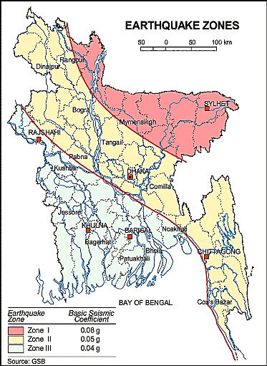
The green circle denotes Mirsharai Pourashava
Figure 3.1.1: Location of Mirsharai Pourashava in Earthquake Zone Map of Bangladesh

Climate and Meteorology
According to Köppen and Geiger, the climate is classified as Tropical Monsoon. The Mirsharai Pourashava lies in the South-Eastern climate zone of the country and shows three main seasons: the Southwest Monsoon, Northeast Monsoon and Hot Season. The Southwest Monsoon: May to October- 90% of the annual rainfall occurs during this period and relative humidity is high. The Northeast Monsoon: It lasts from November to March. The Hot Season: This hottest season extend from about late March to May. (https://en.climate-data.org). The highest daily temperatures generally occur at this time. There is no meteorological station at the Mirsharai Pourashava. Meteorological station at Sitakunda is the nearest to Mirsharai. Hence, Meta data collected from Sitakunda Station is used. According to Bangladesh Meteorological Department (BMD, 2016) average annual rainfall of the Mirsharai is 2540 mm. The temperature data is shown in the Table 3.1.2.

Table 3.1.2: Monthly Temperature Data
Month | Jan | Feb | Mar | Apr | May | Jun | Jul | Aug | Sep | Oct | Nov | Dec | Yearly Avg.
Monthly  max (º C) | 26.6 | 28.0 | 32.5 | 32.4 | 32.4 | 31.2 | 30.4 | 31.3 | 31.5 | 32.7 | 29.1 | 27.4 | 30.5
Monthly Minimum (º C) | 11.2 | 14.6 | 18.3 | 24.0 | 26.9 | 25.9 | 25.6 | 25.5 | 25.5 | 24.5 | 21.0 | 13.5 | 21.3
Normal  max (º C) | 26.3 | 28.4 | 30.8 | 31.9 | 32.0 | 31.0 | 30.3 | 30.8 | 31.4 | 31.6 | 30.1 | 27.3 | 30.2
Normal Mean | 19.3 | 21.7 | 25.4 | 27.8 | 28.4 | 28.3 | 27.8 | 28.1 | 28.3 | 27.6 | 24.6 | 20.7 | 25.6
Normal Min (º C) | 12.2 | 15.0 | 19.9 | 23.6 | 24.7 | 25.5 | 25.3 | 25.4 | 25.2 | 23.5 | 19.1 | 14.0 | 21.1

The meteorological components like humidity, temperature, sudden rainfall, and wind speed influence the subproject construction activities. High wind speed causes quick spreading of the dust. Rainfall interrupts the progress of the construction work. Furthermore, work under high temperature and excess humidity may create dehydration problem.

Water Resources (Surface Water, Ground Water and Rainwater Harvesting)

There are eight Khal named Molihas Khal, Amir Khal, Beel Kore Khal, Darogar ban Chara, Gobonia Khal, Kumaria khal, Mohamaya Khal and Uttar Talbaria Khal pass through Mirsharai Pourashava. These khals influence the regional hydrology. In the Pourashava area, surface water is not suitable for drinking. Nevertheless, khal water is good enough for irrigation and other household activities except drinking. In the subproject influence area, natural and man-made water bodies like khal (Govania-Noapara Khal, Molihas Khal, Amir Ali Khal), ponds, ditches, Beel area/seasonal spring (Masum Pathar), low wetlands and irrigational water sources are available.
Mirsharai Pourashava is included in the hydro-geological unit VI of Holocene Coastal Plains. The area is covered by finer grained aquifers and a moderate silty to silty-clayey cover resulting in reduced percolation rates and lower permeability within the aquifers. The aquifers are thick and can produce higher amount of water. Except for locally occurring higher content of iron, the ground water in the area is good. (DPHE). Rain water harvesting is not commonly visible.

Flooding, Water Logging and Drainage Pattern

The drainage system of Mirsharai Pourashava includes various types of the drains. Several Khals, ponds and ditches are the main water bodies in the Pourashava area which are functional as a natural drainage system. Pucca drains are mainly concentrated in the central area of the municipality. The overall drainage system in the Pourashava area is inadequate and non-functional. As a result, the subproject area faces temporary water logging problem during rainy season.
Mirsharai Pourashava generally experiences two types of flooding, such as pre-monsoon flash floods, and monsoon season floods. The pre-monsoon season is characterized by unstable weather conditions including the occurrence of intense tropical depressions and “nor’ westers (Kalbaaishakhi)” which generates heavy local rainfall. Flooding in the monsoon season normally lasts from June to September.

Air Quality and Dust

Ambient air quality data have not been found. Air seems to be clean because there are no remarkable sources of the air pollution were found during field investigation. Motor vehicle fuel combustion process and house hold fuel combustion process emit smog that degrades the air quality. However, their effect is insignificant in the study area. The windblown dust is also responsible for the air quality degradation though their effect is insignificant.

Noise Level

Ambient noise level data is not available. There is no remarkable source of the noise in the subproject area. Due to bad road condition, motorized traffic is also few. Hence, traffic induced noise is also insignificant in the study area.
Solid Waste Management

Like other municipality, collection and management of solid waste is a great challenge for the Mirsharai Pourashava Authority. The low lying areas and vacant lands are used by the local people as a dump site. However, a substantial amount of solid waste generated daily are not collected and disposed-off which eventually find their way into roadside drains or canal and vacant places. Thus, improper solid waste disposal have detrimental effects on the environmental quality in the subproject area. There is no structured solid waste management system in the Pourashava. However, Mirsharai Pourashava has a dump site near Ambaria Govt. Primary School.

Biotic Environment

In the subproject area, homestead and roadside vegetation are in good condition. Homestead gardens abound with timber and fruit trees and vegetable species. The Mirsharai Mountain is within the subproject influence area. Diversified floral and faunal species are available in the subproject and its surrounding area. The major floral species in the subproject area include: Mahogany, Segun, Bokul, Tula Tree, Koroi, Acacia, Rain Tree, Mango, Jackfruit, Berry, Coconut, Betel-nut, Shil-Koroi, Amra, Ashot, Debdaru, Pulm, Palm, Date Tree, Baiduli, Pakoir, Banyan tree, Dumur, Kafolla, Mandar etc. The naturally grown bamboo, Cane and Dutura are also available in the road side and subproject influence area. Water hyacinth and aquatic plant species are available in the water bodies. Furthermore, on the bank of the canal and ditches lots of local varieties of grass, bamboo bunches and canes are available. The wetland and agricultural field are the worthy habitat for the aquatic flora and fauna. Lots of common local birds were found during the site visit. The common local birds such as Egret, Doel, Shalik, Kite, Crow, Tuntuni, Bulbuli, Parrot, Dove, Holdey bird, Bou Kotha Kao and Cuckoo were found during the site visit. Migratory birds are also available in the harvested paddy field and seasonal wetlands during winter season. There are no wild animals and endangered faunal species in the subproject area during site visit.

Socio-economic and Socio-cultural Environment

Land Use Pattern, Status of Housing and Built-up Infrastructure

The Pourashava center and its surrounding areas are predominately rural. It has not attained its true urban character yet. However, Pourashava is rapidly transforming into an urban area. Currently, agricultural land is dominating the commercial areas and residential areas. The Chittagong Highway crosses the subproject road. There are some shops, few residential houses and school are located near the crossing point.

Beneficiary Population

The subproject covers the jurisdiction area of the wards number 3, 6, 7 and 8. As per information by the municipality, considering the wards’ population about 9,000 people will benefit directly and many others indirectly.

Education

In the Pourashava area, literacy among the population is about 58.90%. This is higher than the national average (51.8%). The literacy rate among males (61.1%) is more than females (56.70%). (Population and Housing Census, 2011).

Tribal Communities

There is no indigenous or tribal people settlement in the subproject area. Therefore, there is no measure needed for indigenous peoples’ safeguard.
Cultural Heritage and Protected Areas

Within the influence area of the subproject, there is no protected area and no important cultural or historical sites were identified.

ENVIRONMENTAL SCREENING

Environmental Screening Checklist, as adopted in Appendix C of the Environmental Management Framework (EMF) of the MGSP, was administered for identifying the impacts and their extents. (Environmental Assessment: Volume-1 and 2, 2013).
The screening data and information for the BC and RCC Roads have been formulated and are shown in below.
(1) Potential Environmental Impact during Construction Phase:
(a) Ecological Impacts:
450
- Felling of trees Significant □√ Moderate □ Minor □ Number of trees
- Clearing of vegetation Significant □ Moderate □√ Minor □
- Potential impact on species of Significant □ Moderate □ Minor □√
aquatic (i.e., water) environment
Major trees to be felled down are: Mahogany, Rain Tree, Acacia, Mango, Jackfruit, Coconut, Betel nut, Date, Palm, Pulm, Pakoir Tree (types of Banyan tree) and local varieties of trees. There is no tree to be felled down bring religious and heritage importance. In addition, the trees to be felled down are mostly small to medium size considering length and diameter. Vegetation coverage is similar in all sections of the road. Hence, clearing of the road side naturally grown vegetation-bushes (Bamboo and Cane), herbs and shrubs have ecological impacts. Though it is limited; however, throwing of the waste materials in to the road side water bodies (seasonal springs, ponds, ditches, Govania-Noapara Khal, Molihas Khal, Amir Ali Khal and low wet land) have impacts on the aquatic environment. Based on the analysis, the overall ecological impact is considered as moderate.
- Physicochemical Impacts:
- Noise and Air pollution Significant □ Moderate □√ Insignificant □
- Drainage congestion Very likely □ Likely □√ Unlikely □
- Water pollution Significant □ Moderate □ Insignificant □√
- Pollution from solid/ construction wastes Significant □ Moderate □√ Insignificant □
- Water logging Significant □ Moderate □ Insignificant □ √
The subproject will have temporary and localized negative impacts on noise and air quality during construction phase due to mobilization of the equipment, vehicles movement for the transportation of the materials, using of hydraulic excavator, steel cutter, mechanical compaction machine, concrete mixer machine, vibrator machine etc. The construction work will be performed section wise. Hence, it is anticipated that the impacts will be temporary, site specific and insignificant. It should be noted that, road side houses and religious centers may be significantly affected by generated noise and black smoke emission if measures are not taken properly. The generated dust during construction activities may disturb the local people if measures are not taken. The generated construction wastes, un-suitable materials and solid wastes may degrade the adjacent water bodies if not properly collected and disposed and thrown into the road side water bodies. Improper collection and disposal of the generated wastes materials also may degrade the quality of the surrounding environment and degrade the aesthetic value. The anticipated water logging problem during construction period is minor because space is available at both sides of the road for drain-out the storm water. In addition, pumping facilities will be provided to drain-out the storm water if required.
- Socio-economic Impacts:
- Traffic congestion Very likely □ Likely □√ Unlikely □
- Health and safety Significant □ Moderate □√ Insignificant □
- Impact on archaeological and historical Significant □ Moderate □ Insignificant □√
- Employment generation Significant □√ Moderate □ Insignificant □
Due to bad condition of the existing road network, only non-motorized vehicles use this road. In fact, this road is not so busy for traffic operation. During construction period, it will have likely impacts on the local traffic due to restriction of the free movement of the road users. However, the local people can use alternative road for traffic movement that will continue the traffic flow. In addition, construction work will require less time because of shorter length. Hence, during construction, the subproject will have insignificant impact on traffic congestion. The construction work will follow simple procedure with commonly used equipment. Hence, anticipated impact on health and safety is moderate. However, using of the personal protective equipment by the workers will significantly reduce any occupational health and safety risks. There is no archeological and historical site within the influence area. The subproject has significant positive impact by generating work opportunities for the local people and supplying of the construction materials, equipment, food and other necessary stuffs to the campsite.
(2) Potential Environmental Impact during Operational Phase:
(d) Ecological Impacts:
- Potential impact on species of aquatic Significant □ Moderate □ Minor □√
(i.e., water) environment
The subproject does not have any impact on the aquatic environment during operation.
(e) Physicochemical Impacts:
- Potential air quality Improvement □ No-improvement □ Deterioration □√
- Potential noise level Improvement □ No-improvement □ Deterioration □√
- Drainage congestion Improvement □ Minor Improvement □√ No Impact □
- Risk of water pollution Significant □ Moderate □ Minor □√
- Pollution from solid waste Improvement □ No-improvement □ No Impact □√
After completion, due to improve road traffic volume may increase. Consequently, air quality and noise level may be degraded due to black smoke emission and hydraulic horn from the vehicles. The new road will minimize water stagnation on road surface. The RCC culvert will divert water from inland to low-land water body to keep the area free from temporary water logging.

(f) Socio-economic Impacts:
- Traffic Improvement □√ No-improvement □ Adverse □
- Safety Improvement □√ No-improvement □ Adverse □
- Employment generation Significant □ Moderate □√ Minor □
After completion, the subproject roads will enhance transport facilities. The new road will provide opportunity to the local people for using CNG, battery operated rickshaw-van, pick-up and non-motorized vehicles for communicating and transportation of goods. It will enhance safety traffic operation and pedestrian’s movement by eliminating pot holes and providing smooth road surface.

3) Summary of Possible Environmental Impacts of the Subproject
From the above study, it seems that the subproject has ecological impacts due to tree felling and clearing of the vegetation. The subproject activities may degrade the air quality and noise level to some extent. The inputs that may affect the environment will be mainly at construction phase and limited within the subproject boundary. Hence, the impacts will be temporary and localized and fundamentally manageable through the appropriate mitigation measures. The generated solid wastes due to the subproject activities should be properly collected and disposed in a designated dumping site. The labor shed and stack yard should be located in a designated place.
Safety concern is an important issue for both the construction and operation phases that should be considered properly to avoid any potential safety risks. This subproject will have positive impacts in terms of the generation of the employment opportunities and business activities by supplying construction materials and equipment at construction phase and by providing business activities and maintenance work at operation phase.

Specific impact, mitigation, AND enhancement measures

The likely impacts of the subproject are mainly caused by the activities required for the implementation of the subproject, and materials, resources and equipment to be used to perform the activities.
This section describes some specific impacts due to the subproject activities and their mitigation measures.

Dismantle Work, Excavation Work and Earth Work

The road improvement work includes dismantle of existing bituminous pavement, HBB and BFS roads, clearing of the wastes materials generated due to dismantle work, earth excavation and earth filling work. Construction of culvert work also includes earth excavation, earth filling and clearing of the unsuitable materials. These works lead dust blowing, improper disposal of the wastes, noise and vibration which may disturb the local people.

Mitigation Measures

- Proper care will be taken by the contractor during dismantle work, excavation work, earth work and disposal work to avoid any undue disturbances to the nearby people;
- Avoid loss of the topsoil for the earth filling work;
- Cover the exposed earth works with fabric/tarpaulin;
- Disposal of soil and construction wastes at vacant place near Ambaria.

Tree Felling, Clearing of the Vegetation and Ecological Impact

There are only 450 nos. of planted trees (Mahogany, Rain Tree, Acacia, Mango, Jackfruit, Coconut, Betel nut, Date, Palm, Pulm, Pakoir Tree) and local varieties of trees will be felled down and road side vegetation will be cleared due to implementation of this subproject.

Mitigation Measures

- 900 nos. of indigenous species of fruits, flowers, medicinal and ornamental trees, preferably - Mango, Jackfruit, Jam, Apple Wood, Krisnachura, Sonalu, Shimul, Polash, Jarul, Bokul, Kadam, Neem, Amloki, Horitoki, Bohera, Kath Badam, Tetul, Jolpai, Arjun, Mahogany, Rain tree, Segun, Chambal, Palm tree, Banyan tree, Pakoir tree will be replanted to compensate the ecological imbalance to be caused due to felled down of the trees and to enhance beautification and landscaping and as well as meeting the Pourashava demand for tree plantation. The trees will be planted both sides of the road at different Chainage where space is available;
- Planting many trees will enhance the ecological condition of the area after their successful growth.

Pollution from the Construction Materials

Dumping of the construction spoils, including accidental leakage of the oil, grease, bitumen, and fuel in equipment yards is a significant hazard. Surface water and soil quality might be polluted from these contaminants. Even the people to be engaged for the construction activities might endanger the physical and human habitats of the area.
Mitigation Measures

- Safe transport, storage, and disposal provisions for the construction materials, and the equipment have to be carried out in order to avoid the accidental spillage and loss;
- Maintain adequate moisture content of soil and sand during transportation, compaction and handling;
- Carry the materials especially loose soil and sand with adequate cover;
- Fuels, lubricants, and other hazardous materials should store over raised platforms and not directly on the ground;
- Disposal of soil and construction wastes at vacant place near Ambaria.

Air Quality and Dust

During construction phase, air pollutants will be emitted from the equipment and construction vehicles are expected to remain low. Local residents in the vicinity of the work sites will be temporarily disturbed by the limited dust pollution. The overall impacts, however, are expected to remain low.
Mitigation Measures

- Water should be sprayed at the work site for dust control. Ensure sprinkle and cover stockpiles of the loose materials (e.g., fine aggregates);
- Maintain adequate moisture content of soil and sand for transportation, compaction, backfilling and handling;
- Avoid use of dust generating equipment (which produce significant amount of particulate matter) far from the local residents;
- Ensure that all subproject vehicles are in good operating condition.

Noise and Vibration

Noise and vibration caused by the equipment and movement of the construction vehicles may temporarily disturb nearby residents. In this subproject, sensitive areas like roadside residents, educational institutions and religious centers are likely to be affected from the noise, though the impacts are anticipated to be limited.
Mitigation Measures

- Transportation of the construction materials have to be carried during the scheduled times, and mainly during the day;
- If needed, all powered mechanical equipment and machineries will be fitted with noise abating gear such as mufflers for effective sound reduction.

Water Quality

The water quality may deteriorate if the construction materials, sand, construction wastes, effluent from the work camps, and food wastes are dumped in the roadside natural canals, ditches, ponds, irrigation canal and seasonal spring.
Mitigation Measures

- Proper construction management including waste management as well as training of the operators and other workers should provide to avoid pollution of the water bodies;
- Construction wastes will dispose properly (not in water bodies or lowland), for which contractor will be responsible;
- Construction wastes will dispose properly at dump site at vacant place near Ambaria (not in the water bodies or lowland), for which contractor will be responsible.

Occupational Health and Safety

The most important risks associated with the construction activities are listed below:
- Exposure to the sunlight- workers are being exposed to the sun for long hours;
- Exposure to the high temperature, and humidity for a long time resulting in dehydration;
- Contact with the hazardous substances and wastes pose risks of the infections and diseases;
- Risk from the traffic collision or accidents during operation of the equipment such as hydraulic excavator, steel cutter and vehicles movement for the transportation activities of the subproject;
- Risks from head loads for carrying soil, construction materials and construction equipment;
- Risks of using of the machineries in motion such as steel cutter;
- Risk associated to the sudden bad weather working conditions such as storm, thunder storm and earth quake etc.

General Requirements for the Workers’ Health and Safety
The significant features of the general requirements for the workers’ health and safety stated are presented in Table 5.7.1.

Table 5.7.1: General Requirements for the Workers Health and Safety
Issues | Requirements
Health and Hygiene | - Cleanliness at the site premises and workers living places and at the Labor Shed;  - Arrangement of the proper ventilation and temperature at the Labor Shed;  - Protection against dust and furnace by using of the nose masks and covering of the head and body;  - Proper disposal of the wastes and effluents;  - Provision of the adequate latrines and separate toilet for the women;  - Sufficient dustbins for the solid waste management system.
Safety and First Aid Box | - Using of the personal protective equipment (helmet, gloves, goggles, nose mask, safety boots);  - Precautions during work on or near machineries in motion;  - Head loads are prohibited;  - First aid facilities should be provided and maintained;  - Ensure first aid box;  - The first aid kit should include adhesive bandages, regular strength pain medication, gauze, and low grade disinfectant.
Compensation for Accidents at Work | - Contractors will bear medical treatment costs. If any severe accidents such as loss of hands, legs or loss of working ability or any case of death needs compensation-(the amount of the compensation should be fixed considering the type of accidents).
Dust and Fumes | - For any dust, fumes, or other impurities likely to be injurious to the workers, effective measures shall be taken to prevent their accumulation and its inhalation by the workers.
Overcrowding | - No labor room should be overcrowded.
Latrines and Urinals | - Sufficient latrines shall be provided;  - Latrines shall be maintained in clean and sanitary condition;  - Latrines shall be adequately lighted and ventilated.
Disposal of Wastes and Effluents | - Proper disposal system for the solid waste and effluent is required.

Impacts on Social Environment and Common Property Resources

Through comprehensive study, it is revealed that impacts are expected not to be severe and to be largely manageable. The following Table 5.8.1 presents impacts on socio-economic environment and common property resources.
Table 5.8.1: Impacts on Social Environment and Common Property Resources
Social Components | Impacts on IECs | Impact Significance
Community Perception | The local community people welcome this subproject and there is no visible objection from them. | Significant (+ve)
Employment and Business Opportunity | Community feels happy because the subproject will create work opportunity for the local people for the skilled and non-skilled labor. The subproject will create business opportunity for the equipment and materials suppliers. | Significant (+ve)
Community Order and Security | This subproject activity does not create any severe security problems to the local community and community people. | Minor  (-ve)
Possible damage to infrastructure and facilities | Possible damage of the existing road infrastructure by the construction equipment and vehicles used in this subproject. | Minor  (-ve)
New infrastructure and facilities | Improvement of the existing road, drain, culverts, road protection wall and street light will enhance infrastructure facilities. | Moderate  (+ve)
Agriculture and Land Use | No direct impact on agriculture however, it could affect the adjacent land to a very limited extent. | Minor  (-ve)
Landscape and Aesthetics | This subproject activity temporarily will degrade landscape and aesthetics values of the subproject area to a limited extent. | Minor  (-ve)
Labor Habitat | Most of the labors will stay at the Labor shed which will have impacts on the environment relates to the generation of the solid wastes, effluent, and water consumption. | Moderate  (-ve)
Health Care | Workers may suffer from the dehydration problems, respiratory problem, and other health hazards. | Minor  (-ve)
Accident | In case of road accidents by the vehicles to be used for the transportation may have serious negative impact. | Significant  (-ve)

Mitigation Measures

- Conduct dissemination with the local community about the subproject details;
- Continue liaison with the community leaders in order to maintain the community support;
- Engage local contractor and local people as much as possible for positive perception of the local community;
- Follow traffic rules to avoid any accidents;
- Transportation and mobilization of the equipments and construction materials avoiding peak hours and scheduled time;
- Ensure first aid facilities and effective use of personal protective equipments where applicable.

Labor Influx and Anticipated Impacts

The labor force and associated goods and services required for the construction of infrastructure civil works under this subproject cannot be fully supplied locally. The migration to and temporary settlement of laborers in the subproject, referred to as labor influx, carries an array of potentially positive and negative impacts in terms of demands on public infrastructure, utilities, housing and sustainable resource management and the strain on social dynamics.
Labor influx effects on host communities include positive impacts such as:
- The subproject activities will generate work opportunities for the local people and supplying of the construction materials, equipment, food and other necessary stuffs to the campsite;
- Improved infrastructure and public service access and availability whereby subproject investment catalyzes larger allocation of resources to a region, stimulating the development or expansion of infrastructure and public services.
Critical negative social risks include:
- Increase in criminal activity and alcohol and drug abuse, domestic violence, political attachment and violence, smuggling and robbery etc;
- Increase in gender-based violence, including eve teasing, sexual harassment etc;
- Increases in communicable diseases, including respiratory problems, diarrheal diseases, vector-borne diseases (e.g., malaria), and sexually transmitted infections (e.g., HIV/AIDS, syphilis, gonorrhea, hepatitis B);
- Conflicts arising from increased demand on existing infrastructure, services, and utilities, including transportation, health, education, water and sanitation, waste management, public utilities and community, religious, and recreational facilities and loss of land for access routes.

The general environmental impacts of labor influx include pressure on the natural resources such as using of the water, electricity, other fuel for cooking, loss of land for the labor establishment, depletion of the water supply, sewage and waste water generation, degradation of the air quality, waste generation, increased demands on the local energy and resources and noise pollution effects. The following safeguard measures are recommended to avoid any risk of labor influx:

- Inform local people about the subproject activities;
- Liaison with the community leaders in order to get community support;
- Engage local people as much as possible to minimize workers from outsiders;
- Monitor workers attitude and behavioral matter;
- Monitor the workers movement for avoiding any unexpected social activities (robbery, crime, political attachment and conflicts, drugs abuse);
- Inform and use local administration to get support if needed;
- Inform local utilities service providers (such as for new electricity connection REB or any other department);
- Ensure effective use of natural resources such as water, electricity, fuel, wood etc.

Impacts on Traffic Movement

The subproject activities will interrupt free movement of the pedestrians and vehicles during construction phase. However, in the subproject area, alternative routes are available and the construction works will be performed section-wise. Though, construction activities likely impacted on the traffic movement because of local people can use the alternate connecting road.
During construction phase, interruption of the traffic movement and impact on the local traffic system due to the subproject activities will be monitored closely. Then separate traffic management plan will be provided if required. However, the following safeguard measures are recommended to minimize the impacts associated to the traffic movement:

- Inform local people about the subproject activities;
- Inspire local people to use connecting and diversion roads;
- Ensure schedule deliveries of material/ equipment during off-peak hours;
- Place traffic sign/cautionary sign to avoid undue traffic congestion and associated traffic control measures to limit possible disruption;
- The place of construction works should be fenced off with fences if required and should be isolated from general public access and marked with signs to ensure safe movement.

Environmental Management Plan (EMP)

The purpose of the Environmental Management Plan (EMP) is to ensure that the activities are undertaken in a responsible and non-detrimental manner. The EMP will guide the environmentally sound construction of the subproject and ensure efficient lines of communication between the PMU (LGED), Mirsharai Pourashava, DSM and the contractors.

Access to Information

The environmental assessment report should be translated into Bengali and disseminated locally. The copies of the report (both in English and Bengali) will be sent to all the concerned personnel responsible for subproject implementation. It will also be made available to the public. The final assessment report will also be uploaded in LGED website and World Bank website after approval.

Grievance Redress Mechanism
The project-specific Grievance Redress Mechanism (GRM) will be established at Mirsharai Pourashava to receive, evaluate and facilitate the solution of APs (aggrieved persons) concerns, complaints and grievances concerning the social and environmental performance of the subproject. The GRM aimed to provide a time-bound and transparent mechanism to voice and resolve social and environmental concerns linked to the subproject.
The grievance mechanism is related to resolve the risks and adverse impacts of the subproject. It addresses APs’ concerns and complaints promptly, using an understandable and transparent process that is also gender responsive and culturally appropriate. It should be readily accessible to all segments of the affected people at no costs and without retribution. The mechanism should not impede access to the country’s judicial or administrative remedies. The affected people will be appropriately informed about the mechanism.
LGED has its own Grievance Redress Procedure (GRP), which it operates to address any dissatisfaction and complaints by the local people regarding its activities. This procedure is being applied to address any complaints or grievances through negotiations with the community leaders and representatives of the APs during implementation of the MGSP.

Grievance Redress Committee (GRC)
The discussions and negotiations will be conducted by the Project Implementation Unit (PIU) of Mirsharai Pourashava and will be involved the APs and Grievance Redress Committee (GRC) headed by the Pourashava Mayor. With the facilitation of DSM, the Pourashava Mayor nominated the GRC members and included representative from Government Agencies, local NGO and Civil Society. The GRC has been formed and established at Mirsharai Pourashava. A complaints box has already been provided in the Pourashava Office. The grievance response focal point is available at Pourashava Office for instant response to an aggrieved person. The Focal Point will collect written complaints or suggestions from the box, and produces them to the GRC for hearing and resolution. The GRC members are as follows:
Table 6.2.1.1: Grievance Redress Committee (GRC) Members List
SL. | GRC Members Name | GRC Designation | Position
1. | Md. Giasuddin | Chairman | Mayor, Mirsharai Pourashava.
2. | Samar Mozumdar | Member Secretary | Assistant Engineer, Mirsharai Pourashava.
3. | Ajgor Ali | Member | Assistant Commissioner(Land), Mirsharai, Chittagong
4. | Prof. Nizamuddin | Member | Professor, Braierhat College, Mirsharai.
5. | Bishojid Ghosh | Member | Area Coordinator, PROSHIKA, Mirsharai.
6. | Master M. Giasuddin | Member | Principal, Mirsharai Kindergarten.
7. | Ferdous Ara Laki | Member | Reserve Councilor, Ward No. 7, 8, 9.
8. | Kabir Ahamed (Sutto) | Member | Councilor, Ward No. 2.

Grievance Resolution Process
All complaints and suggestions will be received formally in the Pourashava Office by the GRC Member Secretary. A sample Grievance Redress Form has been prepared and already sent to Mirsharai Pourashava.
An intake register will be maintained at the office of the Member Secretary. Member Secretary will record the details of the grievances in the intake register for documentation and ensure impartiality, fairness, and transparency. The intake register will have data and information columns including (i) Case no., (ii) Date of receipt, (iii) name, type of complaint, grievance, (iv) father’s name, husband’s name, (v) sex, (vi) complete address of the person raising the complaint, grievance, (vii) main objection (loss of land, property, or entitlement), (viii) detailed complaint story, (ix) expectation with documentary evidence and previous records of similar grievances, etc.
No GRC members are allowed to contact the aggrieved persons in advance. Rather, the concerned persons are informed to attend the formal hearings at an appointed date. The GRC committee will sit for hearing the complaints of the aggrieved persons. The GRC will record salient points presented by the aggrieved person and will examine documentary evidence submitted during informal hearings. A resolution register will be maintained by the Member Secretary at the Pourashava Office. The resolution register will contains (i) serial no., (ii) case no., (iii) name of complaint, (iv) complaint story and expectation, (v) date of hearing, (vi) date of field investigation (if any), (vii) results of hearing and field investigation, (viii) decision of GRC, (ix) progress (pending, solved) and (x) agreement or commitments. Closing register will keep records such as, (i) serial no., (ii) case no., (iii) name of complaint, (iv) decision and response to complaints, (v) mode and medium of communication, (vi) date of closing, (vi) confirmation of complainant’s satisfaction, and (vii) management actions to avoid recurrence.

The GRC will decide within 30 days of receiving a complaint. There will also be an appeals procedure where, if a person is dissatisfied with the ruling of the GRC, he or she or a representative may attend their next meeting to present the case again. The committee will then reconsider the case in private, after which their decision is final. If the appellant is still not satisfied, then GRC will refer the complaint with the minutes of the hearings to the PD-MGSP, LGED for further review. If the case at this level is again found unacceptable by the aggrieved person/s, PD will advise the Pourashava to drop the subproject. Mirsharai Pourashava should also publish the outcome of the cases on the public notice boards. All costs involved in resolving the complaints (meetings, consultations, communication, and information dissemination) will be borne by the Mirsharai Pourashava.

Institutional Arrangement for Safeguard Compliance
In the institutional arrangement procedure, Project Director (PD) and Team Leader (TL)/Deputy Team leader will directly involve. The PD and TL/DTL would be supported by DSM Environmental Safeguard Specialist and Social Management Specialist. The Pourashava Officials, especially members of Infrastructure Improvement Section, would be responsible for supporting the construction supervision as well as environmental and social management with the facilitation of DSM consultants. The civil works contractors will implement the environmental mitigation measures.
The PMU, with the facilitation of Environmental Safeguard Specialist and Social Management Specialist will submit the monthly and quarterly progress reports on Environmental and Social Compliances to World Bank.

PD - MGSP

TL/DTL - DSM
Environmental Safeguard Specialist-DSM
Social Management Specialist-DSM
Senior Municipal Engineer-DSM
Junior Environmental Specialist-DSM
Assistant Municipal Engineer-DSM
Social Management Officer-DSM
Pourashava Representative / Engineer /Focal Point

Contractor
Figure 6.3.1: Environmental and Social Management Team (Tentative)

Capacity Building
A regional demonstration training program has already been conducted by PMU, LGED and DSM in Comilla City Corporation to build the capability of the PIUs concern and DSM field staffs. Participants from Mirsharai Pourashava were attended. Under the demonstration training program, PMU and DSM organized an introductory course for training the Mirsharai Pourashava, Comilla City Corporation and other Pourashava Officials, preparing them on: (i) Environmental Screening, (ii) EMP Implementation, including environmental monitoring requirements related to mitigation measures; and (iii) taking immediate action to remedy unexpected adverse impacts or ineffective mitigation measures to be found during the course of the implementation.
A separate capacity building workshop should be conducted for the Mirsharai Pourashava Officials, members of Infrastructure Improvement Section and DSM field staffs. The contractor should be also included in the training program to enhance the environmental awareness and orientation among the workers. A detailed training manual has already been developed by the Environmental Safeguard Specialist and Social Management Specialist. Hence, the existing manual will be reviewed and modification will be done as per requirement.

Emergency Response and Disaster Management
Disaster management can be defined as the organization and management of
resources and responsibilities for dealing with all humanitarian aspects of emergencies, in particular the preparedness, response, and recovery to lessen the impact of disasters. Emergency Preparedness Planning (EPP) and Contingency Planning (CP) are the processes of disaster management plan for developing strategies, arrangements and procedures to address the humanitarian needs of those adversely affected by the crisis. There are four main types of disasters, namely: Natural disasters, Environmental Emergencies, Complex Emergencies, and Pandemic Emergencies.

For subproject activities, Mirsharai Pourashava would identify the immediate needs, prioritize the tasks and identify resource requirements to address the humanitarian needs of those adversely affected by the crisis.

Environmental Management Action Plan
The activity wise anticipated environmental impacts and corresponding mitigation measures have been outlined in Table 6.6.1 and 6.6.2.
Table 6.6.1: Anticipated Environmental Impacts during Construction Phase and Corresponding Mitigation and Enhancement Measures
Activity / Issues | Potentials Impacts | Proposed Mitigation and Enhancement Measures | Responsible Parties
Construction and operation of labor shed for workers | - Generation of sewage and solid waste may degrade quality of the adjacent water bodies and surrounding environment | - Construction of sanitary latrine at the labor shed (considering 15 persons for one toilet and separate toilet for male and female);  - Ensure provision of waste bins (introduce separate waste bins for organic and inorganic wastes);  - Ensure wastes (solid wastes and other forms of the waste) disposal at vacant place near Ambaria. | Contractor  Monitoring-  Primarily by  Pourashava  Secondarily by PMU,LGED  and DSM
Construction and operation of labor shed for workers | - Health of workers | - Conduct formal and unofficial discussion to increase awareness about hygiene practices among the workers;  - Ensure availability and access to first-aid equipment and medical supplies for the workers.
Construction and operation of labor shed for workers | - Possible development of labor camp into permanent settlement | - Contractor to remove labor camp at the completion of contract.
Construction and operation of labor shed for workers | - Outside labor force causing negative impact on health and social well-being of local people | - Ensure that contractor employ local work force to provide work opportunity to the local people and conduct formal and unofficial awareness program for the health and social well-being of the local people.
General construction works | - Drainage congestion and flooding | - Ensure provision for adequate drainage of storm water if needed;  - Ensure provision for pumping of congested water if needed;  - Ensure adequate monitoring of drainage effects, especially if construction works are carried out during the wet season. | Contractor  Monitoring-  Primarily by  Pourashava  Secondarily by PMU,LGED  and DSM  Contractor  Monitoring-  Primarily by  Pourashava  Secondarily by PMU,LGED  and DSM  Contractor  Monitoring-  Primarily by  Pourashava  Secondarily by PMU,LGED  and DSM
General construction works | - Air pollution | - Check regularly and ensure that all the subproject vehicles are in good operating condition;  - Ensure contractor spray water on dry surfaces regularly to reduce dust generation;  - Maintain adequate moisture content of the soil and sand to be used during transportation, ISG, bed preparation, compaction and backfilling;  - Ensure contractor sprinkle and cover stockpiles of loose materials (e.g., fine aggregates);  - Ensure contractor avoid use of equipment at site and far from the local residents, which produce significant amount of particulate matter.
General construction works | - Traffic congestion, effect on traffic and pedestrian safety | - Ensure schedule deliveries of materials/ equipment during off-peak hours;  - Place traffic/ cautionary sign to avoid undue traffic congestion and accidents;  - Inform the local people about the subproject activities.
General construction works | - Noise pollution | - In front of the road side sensitive infrastructures such as religious centers, construction work should be performed considering the prayer time;  - Check and maintenance the equipment properly;  - Avoid using of construction equipment producing excessive noise at night;  - Regulate use of horns and avoid undue use of hydraulic horns in subproject vehicles.
General construction works | - Water and soil pollution | - Prevent discharge of fuel, lubricants, chemicals and wastes into adjacent water bodies like ponds, ditches and seasonal springs.
General construction works | - Felling of trees, clearing of vegetation and ecological disturbances | - 900 nos. of trees will be planted to compensate the felled down trees preferably local fruits, flowers, medicinal and ornamental trees - Mango, Jackfruit, Jam, Apple Wood, Krisnachura, Sonalu, Shimul, Polash, Jarul, Bokul, Kadam, Neem, Amloki, Horitoki, Bohera, Kath Badam, Tetul, Jolpai, Arjun, Mahogany, Rain Tree, Segun, Chambal, Palm Tree, Banyan Tree, Pakoir Tree at the both sides of the proposed roads where space is available.
General construction works | - Accidents | - Conduct formal and informal discussion for creating awareness about the accidents;  - Provide PPEs and ensure using of the personal protective equipment by the workers.
General construction works | - Spills and leaks of oil, toxic chemicals | - Refueling and fuel tank should not be placed on the ground directly;  - Proper handling of lubricating oil and fuel so that it does not fall on the soil;  - Place plane sheet/dry wood and polythene beneath the fuel tank, diesel engine used for vibrator machine, concrete mixer machine etc.
All construction works | - Beneficial impact on employment generation | - Employ local people in the subproject activities as much as possible;  - Give priority to poor people living within subproject area in subproject related works (e.g., excavation and other works, which do not require skilled manpower).
All construction works | - Possible complaints and suggestion from the local people and stakeholder about the subproject activities | - Use existing grievance registrar and complaints box that has been already delivered in the Pourashava.
All construction works | - General degradation of the environment | - Ensure environmental enhancement measures such as tree plantation and traffic/cautionary sign.  - In cautionary signs-text should be written in Bengali and English;  - In cautionary signs-front size should be big so that it can be visible from at least 200m distance;  - Cautionary signs should be placed at strategic points such as road intersection.
Environmental impacts due to the key construction activities and corresponding mitigation measures for the BC and RCC road
Dismantle work/ Excavation/ Earth work/ | - Generation of solid and construction wastes due to the dismantle works;  - Generation of loose soil due to the earth excavation work. | - Disposal of soil and construction wastes at designated dumping site at vacant place near Ambaria;  - Cover exposed dry loose soil with fabric/tarpaulin.
Dismantle work/ Excavation/ Earth work/ | - Accidents | - Carefully handle of the hammer and other equipment to be used for dismantles and site clearing work.
Dismantle work/ Excavation/ Earth work/ | - Air pollution | - Regular maintenance of the equipment.
ISG (Improved Sub grade)/ Sand filling | - Air and dust pollution affecting nearby settlements | - Maintain adequate moisture content of soil during transportation, compaction and handling;  - Carry the materials especially loose soil and sand with adequate cover.
Cutting and welding of the reinforcement | - Noise pollution due to rod cutter and welding machine if any | - Avoid using of rod cutter and wielding machine at night;  - Avoid prolonged exposure to noise (produced by equipment) by workers.
Cutting and welding of the reinforcement | - Potential health and safety risks from rod cutter and welding machine if any | - Ensure use of the personal protective equipment’s (helmet, ear plug, goggles, gloves, safety boot);  - Availability and access to first-aid equipment and medical supplies in case of any accidents.
RCC (reinforcement  concrete) work | - Air pollution due to black smoke emission from concrete mixer machine and vibrator machine | - Regular maintenance of the concrete mixer and vibrator machine to avoid any black smoke emission.
RCC (reinforcement  concrete) work | - Noise nuisance from concrete mixer machine and vibrator machine | - Avoid operation of the concrete mixer and vibrator machine at night;  - RCC work should be avoided at schooling time;  - Inform local people about casting work and potential impacts.
Setting up and operation of asphalt plant | - Possible degradation of the air quality by the suspended particles and increase of the noise level from asphalt plant affecting nearby settlements; | - Locate plant away from residential settlements;  - Consider use of emulsified bitumen.
Setting up and operation of asphalt plant | - Possible water pollution by bitumen and solvents; | - Avoid spills and proper collection and disposal of the generated spills.
Setting up and operation of asphalt plant | - Possible preparation of the bitumen in open air and using of charcoal and wood as fuel | - Strictly prohibit bitumen preparation in the open air and use of charcoal and wood as fuel.
Environmental impacts due to the key construction activities and corresponding mitigation measures for the Culvert
Excavation/ Dismantle work | - Generation of solid and construction wastes due to the dismantle works;  - Generation of debris and sediments/ clay soil due to the earth excavation work. | - Disposal of soil and construction wastes at designated dumping site at vacant place near Ambaria;  - Cover exposed dry loose soil with fabric/tarpaulin. | Contractor  Monitoring-  Primarily by  Pourashava  Secondarily by PMU,LGED  and DSM
Excavation/ Dismantle work | - Accidents | - Operate the hydraulic excavator carefully;  - Operate the hammer carefully for dismantling.
Excavation/ Dismantle work | - Air pollution | - Regular maintenance of the equipment to avoid black smoke emission.
Back filling work for culverts | - Air and dust pollution affecting nearby settlements | - Maintain adequate moisture content of soil during transportation, compaction and handling;  - Carry the materials especially loose soil and sand with adequate cover.
Cutting and welding of the reinforcement | - Noise pollution due to rod cutter and welding machine if any | - Avoid using of rod cutter and wielding machine at night;  - Avoid prolonged exposure to noise (produced by equipment) by workers.
Cutting and welding of the reinforcement | - Potential health and safety risks from rod cutter and welding machine if any | - Ensure use of the personal protective equipment’s (helmet, goggles, gloves, safety boot);  - Availability and access to first-aid equipment and medical supplies in case of any accidents.
RCC (reinforcement concrete) work | - Air pollution due to black smoke emission from concrete mixer machine and vibrator machine | - Regular maintenance of the concrete mixer and vibrator machine to avoid any black smoke emission.
RCC (reinforcement concrete) work | - Noise nuisance from concrete mixer machine and vibrator machine | - Avoid operation of the concrete mixer and vibrator machine at night;  - RCC work should be avoided at schooling and prayer time;  - Inform local people about casting work and potential impacts.

Table 6.6.2: Anticipated Environmental Impacts during Operational Phase and Corresponding Mitigation and Enhancement Measures
Activity / Issues | Potentials Impacts | Proposed Mitigation and Enhancement Measures | Responsible Parties
Operation of the BC and RCC road | - Increase in traffic speed and accidents;  - Increased traffic congestion due to movement of increased number of vehicles;  - Damage to road by movement of heavy vehicles; spillage of water to bitumen road surface. | - Better traffic management;  - Avoid movement of heavy loaded vehicles that may exceed the load carrying capacity of the road;  - Avoiding spillage of water on road from vehicles carrying fish/ fresh produce (through monitoring, creation of awareness). | Monitoring-  Primarily by  Pourashava
Operation of the BC and RCC road | - Increased air and noise pollution affecting surrounding areas | - Traffic management, increased vehicle inspection | Monitoring-  Primarily by  Pourashava
Operation of culvert | - Blockage of passage due to disposal of solid waste/ debris | - Creation of awareness; stop throwing of the wastes materials near the culvert by the community people.  - Regular maintenance / cleaning both sides of the culvert. | Monitoring-  Primarily by  Pourashava

Environmental Monitoring Plan

Environmental Monitoring Plan will help to evaluate the extent and severity of environmental impacts against the predicted impact and the performance of environmental protection measures. The following Table 6.7.1 has been prepared for the key environmental indicators.

Table 6.7.1: Matrix Table of Monitoring Plan (Visual observation at construction phase)
Monitored Parameter/ Issues | Monitoring method/ Key aspects | Location of monitoring | Period & Monitoring Frequency
Safety orientation & training of workers | - Frequency of training & orientation of workers for safety | Subproject site | - Once in a month  - Reporting: Once in a month
Personal Protective Equipment and safety equipment | - Ensure every single person involved in the activities wear and use safety equipment | Subproject site | - Daily  - Reporting: Once in a month
Worker’s health | - Monitoring process of worker’s health | Subproject site | - Daily  - Reporting: Once in a month
Sanitation & drinking water facility to the workers | - Availability of safe drinking water and sanitation to the workers | Subproject site | - Daily  - Reporting: Once in a month
Incident record & reporting | - Documented record of all incident, accident and its remedial process | Subproject site | - Daily  - Reporting: Once in a month
Site security | - Isolation of site from general access | Subproject site | - Daily  - Reporting: Once in a month
Bulletin/ announcement boards/ prohibition signs | - Visible in good condition or not | Subproject site | - Daily  - Reporting: Once in a month
Equipment /vehicles | - Switched-off diesel engines when not in use;  - Search any possible leakage;  - Fuelling. | Subproject site | - Daily  - Reporting: Once in a month
Dust | - Dust is visible or not | Subproject site | - Daily  - Reporting: Once in a month
Oil waste generation and disposal | - Quantity of oily waste, storage and disposal | Subproject site | - Daily  - Reporting: Once in a week
Solid waste generation | - Quantity of solid wastes and disposal | Subproject site | - Daily  - Reporting: Once in a month
Drainage facilities | - Provision of open /closed surface drainage | Subproject site | - Monthly  - Reporting: Once in a month
Gender equity | - No discrimination regarding payment | Subproject site | - Daily  - Reporting: Once in a month
Child labor | - No child will be engaged in the activities | Subproject site | - Daily  - Reporting: Once in a month
Handling of hazardous materials | - Fuelling, storage, operation | Subproject site | - Daily  - Reporting: Once in a month
In addition, a comprehensive Environmental Compliance Monitoring checklist has been enclosed in Appendix-I.

Environmental Management Budget

Considering the environmental impacts and their mitigation measures for this subproject, several items are included in the BOQ for environmental budget. The estimated cost for implementing the EMP is elaborated in Table 6.8.1.
Table 6.8.1: Environmental Management Budget
Item No. | Description of the Works | Unit | Qty | Unit Rate (BDT) | Amount (BDT)
eme-1 | (a) Dust suppression measures by water spraying throughout the construction period in and around the subproject site, uncovered aggregates and loose materials such as stockpiles of the sand, excavated earth, construction wastes etc. and overall construction works as per requirement | LS | − | − | 7,500.00
eme-1 | (b) Dust suppression measures for BC road by water sprinkling (it includes water sprinkling for overall BC road construction works) | LS | − | − | 12,500.00
eme-5 | Prevention of the spillage and leakage of the polluting materials | LS | − | − | 5,000.00
eme-6 | Campsite wastes disposal facility during the construction period (collection, transportation and dumping of the wastes at designated dumping site at vacant place near Ambaria: 2 nos. (1 no. for the organic wastes and 1 no. for the inorganic wastes disposal facility) | Nos. | 2.00 | 20,000.00 | 40,000.00
eme-7 | Campsite water supply facilities: Preferably 1 no. of tube well at the labor campsite (Depending on the site condition, DSM consultant will assist the contractor for selecting the option) | Nos. | 1.00 | 20,000.00 | 20,000.00
eme-8 | Campsite sanitation facilities: 2 nos. of the toilets preferably sanitary toilets at the labor campsite (1 no. for women and 1 no. for men) | Nos. | 2.00 | 20,000.00 | 40,000.00
eme-9 | Providing safety gear packages like hand gloves, spectacles for eye protection, ear plug, helmets, masks, visible jacket, safety shoes for at least 25 persons (15 workers and 10 visitors) | Set | 25.00 | 3,000.00 | 75,000.00
eme-9 | One first aid box with necessary accessories (contractor is responsible for providing necessary medicines, saline as per requirement during construction period) | Set | 1.00 | 2,500.00 | 2,500.00
eme-11 | Tree plantation to compensate the felled down trees at both sides of the road where space is available-preferably local fruits, flowers, medicinal and ornamental trees- (including protection and conservation during project defect liability period- fencing as per drawing)-Mango, Jackfruit, Jam, Apple Wood, Krisnachura, Sonalu, Shimul, Polash, Jarul, Bokul, Kadam, Neem, Amloki, Horitoki, Bohera, Kath Badam, Tetul, Jolpai, Arjun, Mahogany, Rain Tree, Segun, Chambal, Palm Tree, Banyan Tree, Pakoir Tree- 900 nos. of the trees (DSM consultant and PIU Official will assist contractor prior to the tree plantation) | Nos. | 900.00 | 750.00 | 675,000.00
eme-14 | Cautionary signs- 10 nos. | Nos. | 5.00 | 2,500.00 | 12,500.00
 | Total |  |  |  | 890,000.00
After approval to revise the cost estimate has lengthy complex procedure. Hence, as per project EMF, PMU suggestion and experience from other LGED projects, adequate budget has been allocated for the environmental management for the mitigation and enhancement measures. The subproject activities such as earth work, sand filling, black smoke emission from the subproject vehicles & equipment, preparation of bitumen mix etc. may degrade the air quality in the subproject area. In addition, mechanical compactor, hydraulic excavator, mixer machine, vibrator machine, asphalt plant, drum truck, paver and subproject vehicles generate noise nuisance to the surrounding area. For this subproject, there is no provision of the analytical monitoring for air quality and noise level because air quality and noise data from the previous subproject (MGSP/MIR/2015-2016/W2) can be used as a baseline data to evaluate the impacts.
To compensate the felled down trees and to enhance the ecological condition and landscaping, adequate budget for tree plantation is also included. The budget for labor shed and site office construction is included in the civil works items. Therefore, it is not included in the environmental budget. It should be noted that the contractor will be paid as per actual work done.

Environmental Codes of Practice
- ECoP-1 (Overall Environmental Protection): Contractor shall take all steps to protect environment and avoid causing all types of public nuisances during implementation;
- ECoP-3 (Labor shed Management): Contractor shall maintain the work camp and construction sites in clean and tidy conditions and shall ensure standard facilities;
- ECop-4 (Workforce Environment): Contractor shall engage local people as much as possible where applicable and ensure prohibition of the child labor (less than 18 years) and aged labor (more than 65 years) in heavy works;
- ECoP-5 (Waste Management): Contractor shall be responsible for the safe transportation and disposal of the wastes generated due to the subproject activities;
- ECoP- 6 (Workers Health and Safety): Contractor shall be responsible for providing personal protective equipment and first aid facilities as per requirements;
- ECoP-7 (Compensation for Accidents): Contractor shall bear medical treatment costs for any accidents. If any severe accidents such as loss of hands, legs or loss of working ability or any case of death needs compensation- (the amount of the compensation should be fixed considering the type of accidents);
- ECoP-8 (Implementation of the Mitigation Measures): Contractor shall responsible for the implementation of the mitigation measures mentioned in the EMP;
- ECoP-9 (Spill Prevention, Fuels and Hazardous Substances Management): Contractor shall take preventive measures for spill prevention and fuels and hazardous substances management;
- ECoP-10 (Restoration of the Facilities): The contractor on completion of the contract shall remove the equipment, surplus materials, and rubbish and temporary structures of all types and shall leave sites in clean condition to the satisfaction of Pourashava and local people.

Public Consultation and participation

Methodology

In the context of preparing the Environmental Assessment (EA), participatory public consultation was conducted in the subproject site. The Pourashava Officials, Engineers and local individuals as well as LGED and Consultant participants participated. Informal Focus Group Discussions (FGD) and a formal CIP were conducted involving the participants. In addition, walk-through informal group consultations were also held. The local communities were informed about subproject interventions including their benefits. Suggestions made by the participants were listed and incorporated in the EMP accordingly.
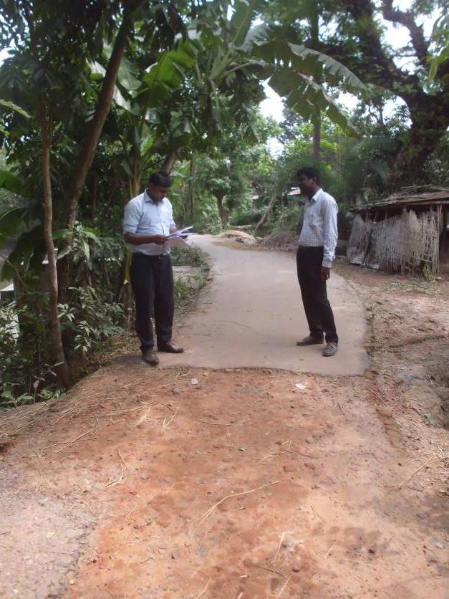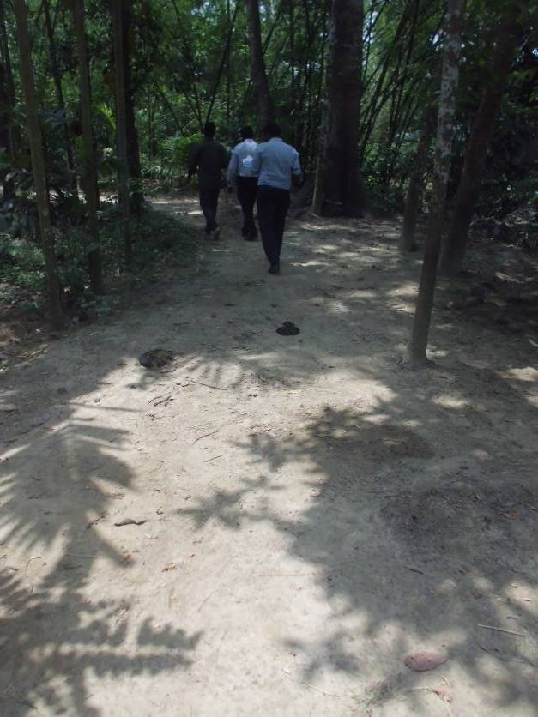
Photographs 7.1.1: Consultant Team Visited the Sites with Pourashava Representatives

Issues Raised by the Participants

The participants raised the issues related to the infrastructure development of Mirsharai Pourashava. They emphasized on the subproject selection for the future development and also discussed about the procedure for the quality construction work. In the FGD, the participants discussed the requirements for the Pourashava future development through a list of the subprojects. The participants also emphasized on minimization of the environmental impacts during construction phase.

Feedback, Suggestions, and Recommendations of the Participants

The participants were presented with feedback, suggestions, and recommendations listed below:
- The FGD results confirmed that an improved communication network, drainage facility, and water treatment plant is needed for future development of Mirsharai Pourashava;
- The participants suggested Pourashava Officials to ensure quality construction works by the contractors;
- The participants stated that the construction work should be performed following the EMP to minimize air quality degradation, noise level and solid waste generation;
- The participants emphasized on the capacity building workshops to enhance knowledge;
- The participants also suggested that construction works should be scheduled properly to avoid any undue disturbances to the nearby people.

Conclusions and Recommendations

This study has described in details the existing environmental conditions of the subproject area. The effort has been given for identifying possible sources of the environmental impacts through details investigation of the subproject site, key subproject activities and assigned equipments to be used for the subproject activities. From the comprehensive study it has been revealed that impacts are expected to be largely manageable, if they are acknowledged and addressed with appropriate mitigation measures-such measures are also included in this report. However, a few key recommendations, as outlined below.
- Contractor will ensure implementation of the EMP properly as a part of the contract;
- EMP should be available at the subproject site during construction period;
- All mitigation, compensation, and enhancement measures should be followed as per EMP;
- Regular field visit and monitoring by PMU, DSM and Mirsharai Pourashava is needed for the effective implementation of the EMP;
- An efficient line of communication between the PMU (LGED), Mirsharai Pourashava, DSM and the contractors is needed;
- Contractor will ensure availability of the PPEs and first aid box, water supply and sanitation facilities for the workers;
- Contractor will monitor the workers behavioral matter to avoid any undue issues related to labor influx;
- To minimize occupational health and safety risks, it is highly recommended to adapt mechanical system where appropriate;
- Planted trees should be properly maintenance by the contractor during project liability period.
It should be noted that environmental assessment report is a live document. Hence, due to changing circumstances during the construction phase if any, there might be minor adaptation needed for environmental, health and safety issues.

APPENDIX

Appendix I: Environmental Monitoring Checklist

Population and housing census, 2011, National Volume-3: Urban Area Report, Bangladesh Bureau of Statistics, August 2014.
Mirsharai Pourashava Master Plan: 2011-2031, Local Government Division, March, 2015.
Geological Survey of Bangladesh, 1978. Earthquake Zoning Map
Geological Survey of Bangladesh, 1978. Earthquake Zoning Map
Bangladesh Meteorological Department, 2016. Climate data for Sitakunda, Chittagong, Bangladesh.
Department of Public Health and Engineering
Population and housing census, 2011, National Volume-3: Urban Area Report, Bangladesh Bureau of Statistics, August 2014.
Environmental Assessment Volume 1: Overall Environmental Assessment [Draft Final Report], September 2013. Municipal Governance and Services Project (MGSP), Local Government Engineering Department (LGED) and Bangladesh Municipal Development Fund (BMDF), Ministry of Local Government, Rural Development and Cooperatives, Government of the People's Republic of Bangladesh; Environmental Assessment Volume 2: Environmental Management Framework (EMF) [Draft Final Report], September 2013. Municipal Governance and Services Project (MGSP), Local Government Engineering Department (LGED) and Bangladesh Municipal Development Fund (BMDF), Ministry of Local Government, Rural Development and Cooperatives, Government of the People's Republic of Bangladesh.

