INTRODUCTION

Subproject Background

Patiya Pourashava was established in the year of 1990. This is A Type Pourashava with present population of about 62,450. The Pourashava covers an area of 10.36 sq. km. The drainage system includes 5.50 km RCC/Brick Lined Drains, 105.46 km earthen drains and 4 nos. of Canal (Source: Patiya Pourashava). Urbanization process decreases the retention area for runoff, consequently adversely affected the drainage system during rainy season. Hence, the existing drainage system in the municipality necessitates the new drain. Furthermore, street light is needed for providing safety for the drivers, riders, and pedestrians at night time.
This subproject includes BC and RCC Road, RCC Drain and Street Light. The significant features of the subproject are mentioned below:
Name of the Subproject | a. Construction of Road from Taltoli at Chittagong-Cox's Bazar Highway to Barua Building (Ch 0+00 to 1+230m);  b. Construction of RCC drain at right side of Road from Taltoli at Chittagong-Cox's Bazar Highway to Barua Building Outfall (Ch 0+00 to 0+510m);  c. Construction of RCC drain at left side of Road from Taltoli at Chittagong-Cox's Bazar Highway to Barua Building Outfall (Ch 0+00 to 1+230m);  d. Construction of RCC drain at Jonab Ali Road from Gopal Bari to Chan Khali Khal (Ch 0+000 to 0+650m);  e. Construction of RCC drain (Link 1) from Mara Khal to Jonab Ali Road (Ch 0+000 to 0+045 m).
Package No. | MGSP/PAT/ 2016-2017/W-03
District Name | Chittagong
ULB Name | Patiya Pourashava
Jurisdiction Area | Ward Number 2 and 3
Structural Design Option | BC and RCC Road, RCC Drain with footpath and Street Light
Beneficiary Population | About 11,200 As per information by the Pourashava Officials
Tribal People | No tribal people settlement found in the subproject area
Land Acquisition | No land acquisition is needed
Estimated Cost | 98.48 million in BDT
Subproject Duration | 15 Months
Tentative Start Date | 1st September, 2017
Tentative Completion Date | 30th November, 2018

Objectives of the Study

The general objective of this study is to determine the major environmental impacts succeeding from execution of the subproject and to recommend mitigation measures to avoid or reduce adverse environmental impacts and to enhance positive impacts. The specific objectives include:
- To assess the existing environmental conditions of the subproject site and its influence area;
- To identify and assess impacts resulting from the subproject during its construction phase and operation phase;
- To develop a environmental management plan with recommendations for mitigating impacts and enhance positive impacts;
- To summarize environmental monitoring requirements.

Scope and Methodology of the Study

The subproject appraisal is included environmental screening for all the subproject components. According to that screening, no further environmental assessment is required for the street light. Nevertheless, environmental assessment is required to fulfill the regulatory requirement for BC and RCC road and RCC Drain with footpath. Hence, this report is mainly included BC and RCC road and RCC Drain with footpath. However, in the EMP table mitigation measures for street light are also included. The study methodology comprised the following activities:
- Desktop Study;
- Field Investigations and Data Collection;
- Data Analysis and Report Writing.

Desktop Study
The desktop study involved:
- Initial meetings with client, stakeholders to discuss the proposed subproject;
- Collection and review of the baseline data, maps, reports and other relevant information;
- Review of the relevant existing legislation, regulation and policies;
- Understand the anticipated technical processes that may affect the environment.

Field Investigation and Data Collection
A team of the consultants made a field investigation to the proposed site. Field investigations involved mainly site walks within the subproject area and the neighboring areas that may be affected by the subproject. The following key tasks were performed during the field visit:
- Taking photographs of the significant aspects to assist in describing the baseline environmental conditions of the subproject area;
- Interviews with representatives of the relevant Pourashava Officials, beneficiary and affected people within the subproject influence zone;
- Verifying information and data collected during the desktop study and to collect new information that may have been important in the assessment of the impacts and design the mitigation measures.

Data Analysis and Report Writing
The data and information collected from all the sources (literature review, secondary and primary data, public consultation) were analyzed to describe the existing environmental setting of the subproject area, to identify the potential positive and negative impacts of the proposed subproject, as well as to provide preliminary suggestions for mitigation measures. Finally, this environmental assessment report has been prepared.

SUBPROJECT DESCRIPTION

The Study Area

The subproject site is situated within the jurisdiction of the ward number 2 and 3. The location map, topographical view and layout plan for the subproject are shown in Figure 2.1.1, Figure 2.1.2 and Figure 2.1.3.
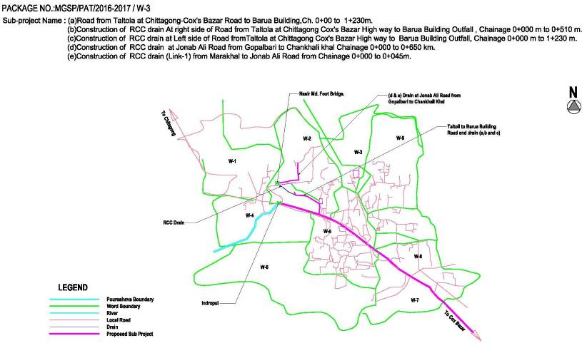
Figure 2.1.1: Location Map of the Subproject
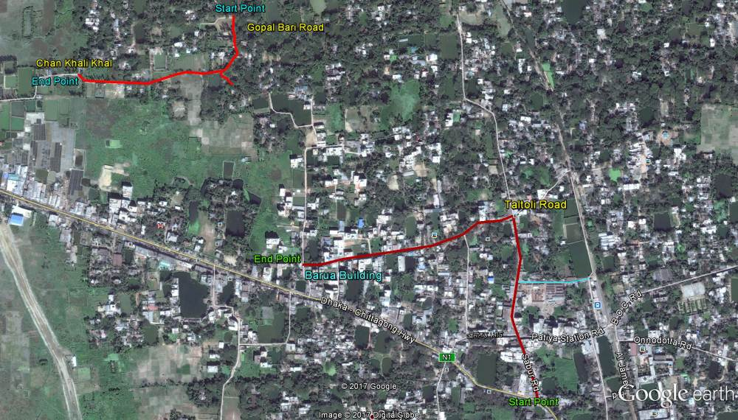
Figure 2.1.2: Topographic View of the Subproject
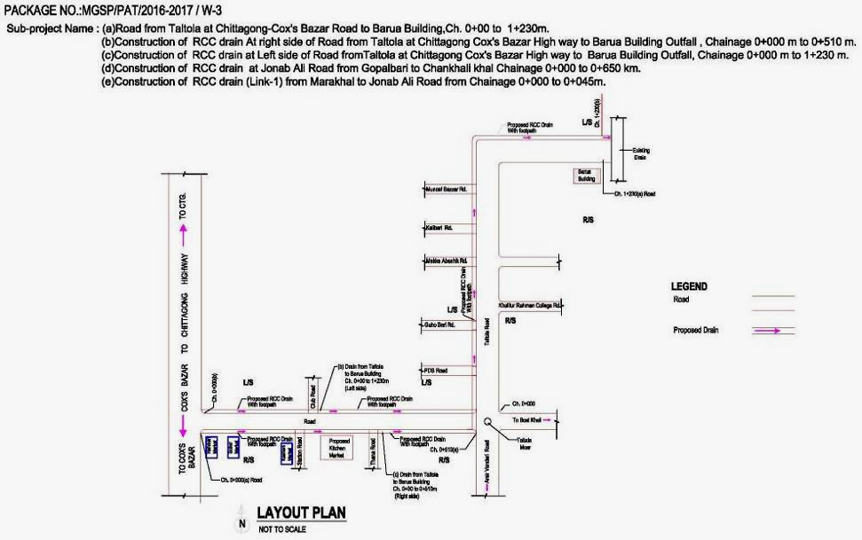
Figure 2.1.3 (a): Layout Plan for the Subproject (Taltoli Chowki to Barura Building)
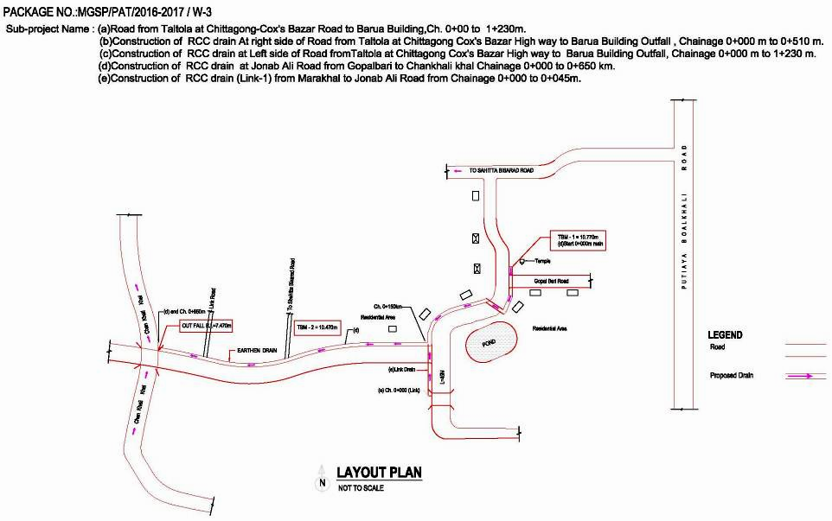
Figure 2.1.3 (b): Layout Plan for the Subproject (Jonab Ali to Chan Khali Khal)

Current Situation, Proposed Intervention and Need for the Subproject
The road from Taltoli to Barua Building is located in a densely populated urban area where road side built-up infrastructures includes shops, markets, temple, mosque, schools, colleges, bazar etc. Jonab Ali road is located in a semi-urban area which is medium densely populated. The road side built-up infrastructures include mostly katcha, tin-shed and semi-pucca structures, school and mosque.
The existing bituminous carpeting road from Taltoli to Barua Building is badly damaged. Most of the sections of the BC road are worn-out and lack of a smooth surface. From Ch. 0 to 525m, the crest width is 7.5m to 8m. From Ch. 525 to 745 m, the crest width ranges from 4.5 to 6.5m. From 745 to 1230m the crest width is 4.5 to 7.5m. Hence, the existing road width is not uniform. During season, the stagnant storm water damages the road surface which interrupts traffic movement. To improve the situation BC and RCC road will be constructed from Chittagong-Cox's Bazar Highway to Barua Building (Ch. 0-1230m). From Ch. 0-750m and Ch. 1050-1230m the proposed road will be BC road. From Ch. 750 to 1050m, the road level is lower than other sections of the road. Consequently, during rainy days in monsoon period water is accumulated at this section. Hence, RCC road is proposed for the Chainage 750 to 1050m.

In the subproject area, the drainage facility is inadequate and inappropriate. Hence, storm water and backflow from the narrow and silted-up brick drain creates water logging in the subproject area. At monsoon season, excessive storm water due to heavy and continuous rainfall cause delay discharge of the storm water from the subproject area. Consequently, drainage congestion and water logging problem occurs and cause major environmental and public health hazards in the subproject area. To improve the situation and proper draining out of storm water, RCC drains with footpath will be constructed from Chittagong-Cox's Bazar Highway to Barua Building (Ch. 0-1230m) at left side and Chittagong-Cox's Bazar Highway to Taltoli road (Ch. 0-525m) at right side. The right side drain will be connected with left side drain at Ch. 525m by a cross drain. The storm water of the proposed drain with footpath will be primarily discharged in the Beel near Barua building. Finally, the storm water of the proposed drain will be discharged in the Chan Khali Khal. Furthermore, RCC open drain (with cover slab near household entrance and connecting with link road) will be constructed from Gopal Bari Road to Chan Khali Khal. The Link drain (Ch. 0-45m) from the Mara khal will be connected with the proposed drain by a cross drain at Jonab Ali Road.
Moreover, absent of the street light hampers the night time normal traffic operation. Therefore, fixing of the street light is also needed for traffic operation at night. The street light will be fixed both side of the road at 30m interval from Chittagong-Cox's Bazar Highway to Barura Building (Ch. 0-1230m). This subproject has significant benefit to the community people after completion. Therefore, for priority basis this subproject can consider for the implementation.
The existing condition of the subproject site and Chan Khali Khal is further elaborated in the following Photographs 2.2.1 and Photographs 2.2.2.
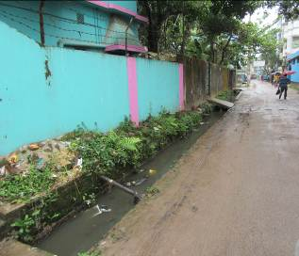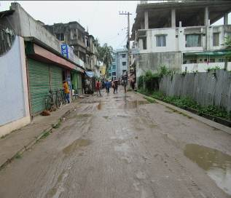
Photographs 2.2.1(a): Current Situation of Subproject Site at Taltoli Chowki to Barura Building

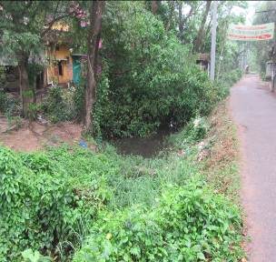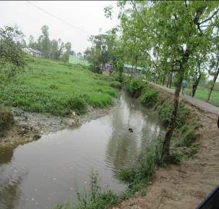
Photographs 2.2.1(b): Current Situation of Subproject Site at Gopal Bari road to Chan Khali Khal

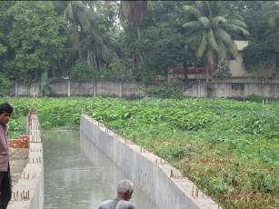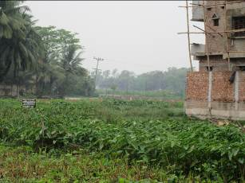
Photographs 2.2.2 (a): Current Situation of the Outfall at Barura Building
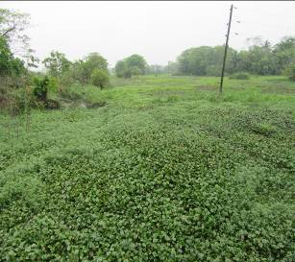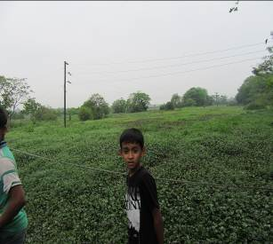

Photographs 2.2.2 (b): Current Situation of the Outfall at Chan Khali Khal

Justification of Selection of the Subproject

The Pourashava prepared the priority list of the subprojects as per CIP. The DSM consultant team has inspected and evaluated existing site condition of those subprojects. After site investigation, DSM team recommended the subproject having low environmental and social negative impacts. To implement this subproject, road side trees and built-up infrastructures will not be severely affected. In addition, private land acquisition is not an issue for implementation of this subproject.
After completion, by eliminating pot holes and providing wide and smooth road surface, the road will provide better, easy and safe movement facilities for the travelers. The new drains will also improve the drainage facilities by minimizing water logging problem. Consequently, the local people will get better environment. The street light will improve the quality of life. In considering the expected benefits that will derive, the subproject is selected for implementation.

Envisaged Subproject Activities and Implementation Process

The general activities for the subproject includes: construction of the semi-pucca site office, construction of the labor shed, relocation of the electric poles and site clearing works.

The key activities of the RCC Drain include:
- Earth work in excavation of the foundation;
- Pumping and bailing out of water as per requirement;
- Lying of polythene sheet;
- Sand filling for the preparing foundation bed;
- Plain cement concrete work in foundation;
- Manufacturing CC blocks;
- Fabrication of the ribbed or deformed bar;
- Reinforced cement concrete work.

The key activities for BC Road include:
- Dismantling of the damaged sub-base and base course works;
- Clearing and grubbing works;
- Earth work in box cutting;
- Earth filling work;
- Sand filling on the road bed;
- Mechanical compaction;
- Brick on edging;
- Compacted stone aggregate base course;
- Providing prime coat;
- Laying pre-mixed dense bituminous surfacing wearing course.

The key activities of the RCC Road include:
- Dismantling of the damaged sub-base and base course works;
- Earth work in box cutting;
- Mechanical compaction;
- Polythene sheet laying work;
- Manufacturing CC blocks;
- Fabrication of the ribbed or deformed bar reinforcement;
- Reinforced cement concrete work.

The key activities of the Street Light include:
- Assembling, fitting, fixing, installation, testing and commissioning of the GI pole;
- Fitting and fixing energy meter ;
- Earthling the electrical installation;
- Fixing insulator;
- Erection of tubular pole;
- Fixing of the overhead conductor;
- Fixing of the wire rack;
- Fixing and installation of the switch board;
- Providing, fitting and fixing of the water tight street light.

The materials and resources to be used for the key activities: Soil in earth work, sand, bricks, stone chips, cement, concrete, reinforcement, bitumen, diesel, water, GI poles and other associate accessories for lighting facilities.

The major equipment to be used for the implementation of the subproject: hydraulic excavator, concrete mixer, mechanical vibrator, mechanical compactor, steel cutter, steel shutter, steel drum rollers, pneumatic multiple tire roller, dump truck, water tanker, pump, asphalt plant, rubber tire roller and paver.

Baseline ANALYSIS OF THE ENVIRONMENTAL CONDITION

Physical Environment

Important Environmental and Infrastructural Features
The detailed environmental and infrastructural features within the subproject influence area have been collected by field investigation. The conditional survey has been performed for the designing of the road and drain. Hence, survey data is also used for identification of the environmental and infrastructural features. The detailed environmental features listed within the 100 m of the both sides from the center line of the road at 100m longitudinal intervals from Chittagong-Cox's Bazar Highway (Taltoli Chowki) to Barua Building (Ch. 0 to 1230 m) and Gopal Bari Road to Chan Khali Khal-Nasir Mohammad Siddique Bridge (Ch. 0-650m with Link drain from Mara Khal to Janab Ali Road Ch. 0-45m).The key findings are given in Table 3.1.1 and 3.1.2 correspondingly.
Table 3.1.1: Major Environmental and Infrastructural Features from Chittagong-Cox's Bazar Highway (Taltoli Chowki) to Barua Building
Chainage (m) | Left | Right | Major Environmental and Infrastructural Features (Adjacent to road and 10-15m from the edge of the road)
0-100 | √ |  | Tin-shed, pucca and semi-pucca shops, Banks (Brac bank and Islami bank), existing brick drain, electric poles
0-100 |  | √ | Rahman market, Sobur Market, Tin-shed and semi-pucca shops, existing brick drain
100-200 | √ |  | Tin-shed, pucca and semi-pucca shops, Banks (First security bank, Agrani Bank and Mercantile Bank), existing brick drain, club road, electric poles
100-200 |  | √ | Kashem market, Tin-shed and semi-pucca shops, existing brick drain, station road, Alam plaza
200-300 | √ |  | Tin-shed, pucca and semi-pucca shops, existing brick drain, Grameen Bank
200-300 |  | √ | Go-hat, Katcha bazar, Proposed kitchen market area, existing brick drain, Thana hat road, electric poles,
300-400 | √ |  | Cinema hall, Saw-mill, Tin-shed and semi-pucca shops, pond, common planted trees (Mahogany, Rain-tree, Mango) on the edge of the pond, TNT pole
300-400 |  | √ | Tin-shed, pucca and semi-pucca shops, existing brick drain, Thana hat road, electric poles,
400-500 | √ |  | Tin-shed, pucca and semi-pucca shops, ponds, common planted trees (Mahogany, Rain-tree, Mango) on the edge of the pond
400-500 |  | √ | TNT poles, boundary wall, semi-pucca and tin-shed homestead area, common planted trees (Mahogany, Rain-tree, Mango, Jackfruit, Jam, Guava),open space
500-600 | √ |  | Pond, TNT office, existing brick drain, Saw-mill, common planted trees, electric poles
500-600 |  | √ | Semi-pucca and tin-shed shops and homestead area, Barbara shop, Link to Amir Vandari road, link to Boodkhali road, electric pole
600-700 | √ |  | Existing brick drain, Semi-pucca and tin-shed shops and homestead area, pucca structure for house, Link to PDB road, pond, common planted trees
600-700 |  | √ | Semi-pucca and tin-shed shops and homestead area, pucca structure for house, Abdur Rahman Girls school, electric poles, boundary wall, common planted trees
700-800 | √ |  | Pucca and Semi-pucca shops, Existing brick drain, Semi-pucca, pucca and tin-shed homestead area, link road to Guho Bari road, common planted trees, electric poles
700-800 |  | √ | Semi-pucca and tin-shed structure for shops and homestead area and pucca structure for houses, Sri Sri Ram Krishno Mission (Sheba Srom), boundary wall, common planted trees, Khalilur Rahman College, Link road
800-900 | √ |  | Pond, electric poles, existing brick drain, Pucca and Semi-pucca shops and homestead area, open space, Company Villa
800-900 |  | √ | Cambrian school, boundary wall, Pucca and Semi-pucca shops and houses, waste bins
900-1000 | √ |  | Macca residential area, existing brick drain, boundary wall, link road, Pucca and Semi-pucca houses, semi-pucca and tin-shed shops
900-1000 |  | √ | Boundary wall, electric poles, Pucca and Semi-pucca houses, open space, common planted trees(Mango, Mahogany, Rain-tree, Guava, Jam, Jackfruit, Betel-nut, Coconut)
1000-1100 | √ |  | Kalibari road, Sadek tower, common planted trees, electric poles, Pucca and Semi-pucca houses and shops, common planted trees, boundary wall,
1000-1100 |  | √ | Existing brick drain, Pucca and Semi-pucca houses, semi-pucca and tin-shed shops, common planted trees (Mango, Mahogany, Rain-tree, Guava, Jam, Jackfruit, Jamrul, Betel-nut, Coconut)
1100-1230 | √ |  | Electric poles, boundary wall, Muncef Bazar Road, Semi-pucca and tin-shed shops, Homestead area (Semi-pucca, Pucca, Tin-shed), trees (Mango, Rain-tree, Mahogany, Jam, Jackfruit, Korai, Betel-nut, Coconut)
1100-1230 |  | √ | Tin-shed shops and houses, semi-pucca and pucca houses, common planted trees (Mango, Rain-tree, Mahogany, Jam, Jackfruit, Korai, Guava, Papaya, Coconut, Betel-nut), open space, wet land with full of hyacinth

Table 3.1.2: Major Environmental and Infrastructural Features from Gopal Bari Road to Chan Khali Khal with Link drain from Mara Khal to Janab Ali Road
Chainage (m) | Left | Right | Major Environmental and Infrastructural Features (Adjacent to road and 10-15m from the edge of the road)
Gopal-Bari Road to Chan Khali Khal (Ch. 0-650m)
0-100 | √ |  | Gopal Bari Link road, Electric poles, ponds, ditches, boundary wall with metal gate, pucca and semi-pucca houses, common planted trees (Rain-tree, Mango, jackfruit, Mahogany, Kadam, Tentul), bushes, herbs, shrubs, naturally grown densely vegetation (Kalkeshia, bamboo, benth)
0-100 |  | √ | Low land, pond, Suchakri-Dandi Primary school, Semi-pucca and tin-shed homestead area, common planted trees (Mango, Rain-tree, Mahogany, Guava, Debdaru, Betel-nut, Acacia)
100-200 | √ |  | Earthen Link road, Electric poles, ponds, ditches, pucca and semi-pucca houses, common planted trees (Rain-tree, Mango, jackfruit, Mahogany, Kadam, Tentul, Banana), bushes (bamboo and benth), herbs, shrubs, naturally grown densely vegetation
100-200 |  | √ | Low land, pond, semi-pucca, pucca and tin-shed homestead area, semi-pucca shops (tailoring, grocery and daily needs shops),electric poles, tin fence, common planted trees (Chatim, Mango, Rain-tree, Mahogany, Betel-nut, Acacia), bunches of bamboo
200-300 | √ |  | Homestead area, ponds, Jonab Ali road name plate, bamboo fencing, electric pole, trees (Neem, Mahogany, Mango, Rain-tree), natural vegetation, paddy field, electric pole
200-300 |  | √ | Homestead area (Pucca and semi-pucca houses), boundary wall, Cultivable land, Bamboo fencing, pond, ditches, low-land, common planted trees (Neem, Mahogany, Mango, Rain-tree, Wood nut, Acacia, Betel-nut, Coconut, Banana, Guava, Jam)
300-400 | √ |  | Homestead area, low land, trees (Mahogany, Mango, Rain-tree, Coconut, Betel-nut), natural vegetation, paddy field, electric pole
300-400 |  | √ | Homestead area (Pucca, semi-pucca and tin-shed houses), Mosque, Cultivable land, pond, ditches, low-land, common planted trees (Pakoir (Banyan tree), Mahogany, Mango, Rain-tree, Jackfruit, Acacia, Betel-nut, Coconut, Banana), naturally grown vegetation, link road
400-500 | √ |  | Homestead area (Tin-shed, semi-pucca), common planted trees (Acacia, Mahogany, Mango, Betel-nut, Coconut, Date palm tree), pond, ditches, water hyacinth, low land, naturally grown vegetation on road side and low land areas, paddy field
400-500 |  | √ | Homestead area (Semi-permanent, permanent and tin-shed), Trees, electric poles,
500-650 | √ |  | Trees, low land, wet land, existing RCC drain, Khal, Nasir Mohammad bridge
500-650 |  | √ | Homestead area (tin-shed and semi-pucca houses),Agricultural land, Trees, tin-fence, ditches, water hyacinth, low land, naturally grown vegetation on road side, Chan Khali Khal, wet land
Link 1- from Mara khal to Jonab Ali Road (Ch. 0-45m)
0-45 | √ |  | Mara Khal, common planted trees
0-45 |  | √ | Common planted trees, open space

Geology, Topography, and Soils

The subproject area is situated at an unbroken flat land of alluvial deposits. Geology of Patiya Pourashava is composed of a thick sedimentary sequence of sandstone, shale and siltstone. These sediments are probably of fluviatile origin through some of the even-bedded siltstones and shales of considerable lateral extent of shallow marine beds. Most of the agriculture land is clay soil and clay soil often contains iron and aluminum hydroxides. This is an area prone to cyclones and storm surges. Patiya Pourashava was affected by cyclones in 1960, 1963, 1970, 1988, 1991, 1994 and 1997. According to BNBC (2006), Bangladesh has three seismic zones with moderate and low seismic activity. The Pourashava falls in Zone II.

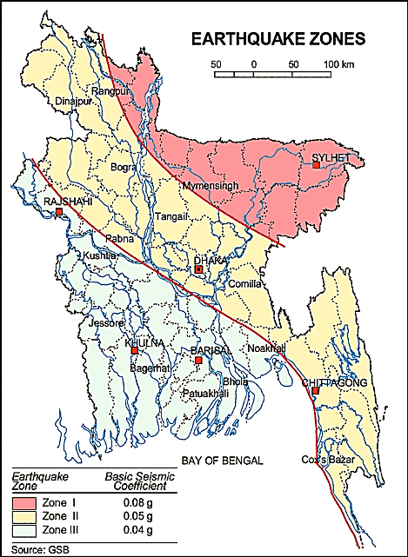
Figure 3.1.1: Location of Patiya Pourashava in Earthquake Zone Map of Bangladesh

Climate and Meteorology
There is no meteorological station at Patiya Pourashava. Hence, area specific data is not available. Hence, meteorological data from Chittagong Station is used for this study for having idea.
Seasonal variation of temperature in Chittagong is not significant. Monthly average minimum and maximum temperatures for the period 2008-2014 for Chittagong are given in Table 3.1.3 and 3.1.4 (data obtained from Bangladesh Meteorological Department).
Table 3.1.3: Monthly minimum and average minimum temperature during Jan 2008 to Dec 2014

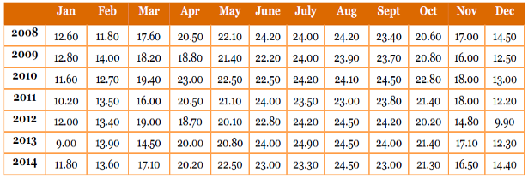
Table 3.1.4: Monthly maximum and average maximum temperature during Jan 2008 to Dec 2014

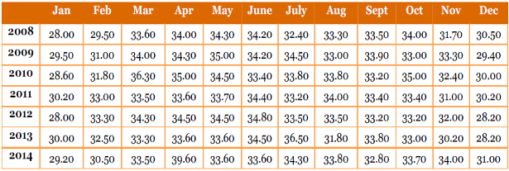
The data shows that the monthly minimum (average) temperature at Chittagong varies between 9.00 ⁰C and 24.50 ⁰C and maximum temperature varies between 28.00⁰C and 36.50⁰C. The minimum and maximum temperature data indicates that December to February months are relatively cooler and March to May are relatively hotter months.
The average monthly rainfall data for Chittagong (obtained from BMD) is provided in Table 3.1.5 below. The data shows that rainy season in Chittagong mainly prevail from June to September. The average monthly rainfall in Chittagong for the period Jan 2005 to Dec 2014 varied between 0 mm in the month of December and January to 1268 mm in the month of June. The rainfall follows the general climate pattern with the highest rainfall in the summer from April to October and minimum rainfall in the winter from November to March.
Table 3.1.5: Monthly total and 10 years average monthly rainfall during Jan 2005 to Dec 2014

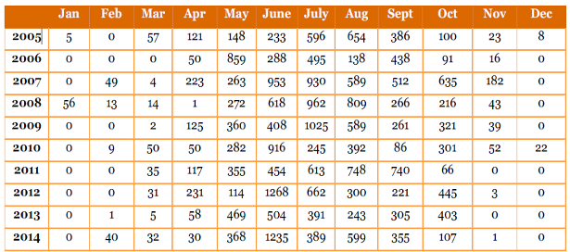

Water Resources (Surface Water, Ground Water and Rain Water Harvesting)

Hydrology of Patiya Pourashava is almost similar with the coastal plains of Chittagong presents a complicated interaction of fresh water flow from the upstream, the tides and tidal flows from the Bay of Bengal. A number of natural canals (Indropul Khal, Chan Khali Khal), ponds, ditches, irrigation drains and wetlands are other fresh surface water sources in the subproject influence area. Tropical Cyclones, storm surge affects Patiya Pourashava almost every year (Source: Patiya Pourashava Master Plan). Main sources of drinking water of Patiya Pourashava are deep tube well, and shallow tube wells.

Flooding, Water Logging and Drainage Pattern

Water logging problems found in different parts of the Pourashava. Water logging occurs during monsoon and duration of the water logging is 3-7 days. It occurs between June to November every year during heavy rain. Beside this, heavy rainfall causes water logging in the eastern parts of the Pourashava. (Source: Patiya Pourashava Master Plan).
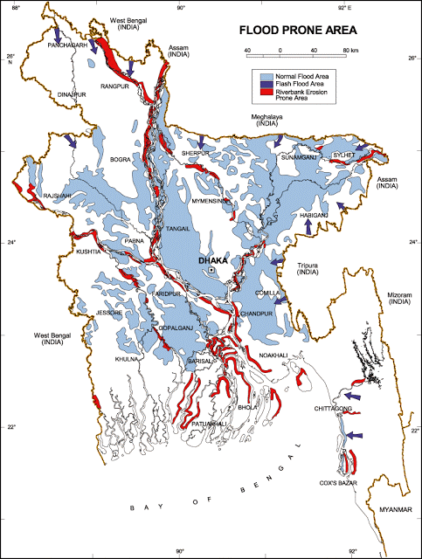
The black circle denotes the Patiya Pourashava
Figure 3.1.2: Location of Patiya Pourashava in Flood zone Map of Bangladesh
Air Quality and Dust
Ambient air quality data have not been found. In the subproject area, motor vehicles fuel combustion process is the main sources for the air quality degradation. Dust is generated during the movement of the vehicles which also degrades air quality. In addition, the windblown dust causes air pollution.
Noise Level
Noise is generated mainly from the vehicle movement, and hydraulic horn. Vehicles such as bus, rickshaws, trolleys, pick-up, trucks, motor cycles, mini trucks, and private cars are major contributor for noise nuisance. During construction phase, hydraulic excavator, vibrator machine and vehicles used for transportation activities may create temporary noise nuisance within the subproject boundary.
Solid Waste Management
The Pourashava has a dump site at Ward No. 7 at Bahuli beside Chittagong-Cox's Bazar main road (North side vacant place). Nevertheless, there is no provision of organized solid waste disposal system in the Pourashava. Hence, collection and disposal of solid waste is a great challenge for the Pourashava Authority. A substantial amount of generated solid wastes are not collected and disposed-off properly. Consequently, these solid wastes find their way into roadside drains and low land.

Biotic Environment

This subproject influence area is full of natural flora (aquatic plants and terrestrial herbs, shrubs and trees) and fauna (birds and other animal species). Paddy is the main crops in the subproject influence area. Other crops and seasonal vegetables are also cultivated in the agricultural land and homestead garden. The common natural native species of trees are found which mainly include: Jackfruit, Mango, Shil-Korai, Mahogany, Ata, Coconut, Beatle-nut, Palm, Sofeda, Papaya, Guava, Rain-tree, Banyan Tree and Date Tree. The natural water bodies (such as Chan Khali Khal, marshy wetlands, seasonal springs), ponds and ditches are the worthy habitat for the aquatic flora and fauna. The local birds Doel, Kak, Moyna, Choroi, King Fisher, Shalik, Bulbuli, Tia, Tota, Ghugu, and Dahuk etc were found during site visit. Migratory birds are also available in the harvested paddy field and seasonal wetlands (Beel area near Barua Building) during winter season. Some red listed extinct species Jackal and Mongoose were found during the site visit.

Socio-economic and Socio-cultural Environment

Land Use, Status of Housing and Built-up Infrastructure

The subproject area consists of mixed land use of built-up area with few road side houses, market, shops, educational institutes (schools, colleges), religious centers (Mosques, temples) and commercial & financial organization (Bank, Bima etc).

Beneficiary Population

This subproject goes through the Wards number 2 and 3. As per information by the municipality, considering the ward population about 11,200 people will benefit directly and many others indirectly.
Education

The literacy among the population is about 54.90%. This is higher than the national average 51.8%. Literacy rate for the male (57.3%) is higher than female (52.5%) (Ref: Population and Housing Census, 2011).
Tribal Communities

There is no indigenous or tribal people settlement found in the subproject area. Therefore, no measures needed for the indigenous peoples’ safeguard.

Land Acquisition and Resettlement

The proposed road and drain will be constructed at the existing right of way. Pourashava owned the land, so private land acquisition is not needed. Furthermore, the roadside Pourashava land is encroached and the encroacher built road side structures. For site clearing, few road side structures such as tin shed fencing, brick boundary wall, tin shed, semi-pucca and pucca shops and houses need to be removed and some portions need to be demolished. The Pourashava authority has consulted with the owners of these structures. The beneficiaries have no objection regarding the implementation of the subproject. In this regard an agreement has been signed by the Pourashava Authority and the owners of these structures. They agreed to remove their structures and demolition of the boundary wall by own cost for the benefit of the Pourashava.
Principal Livelihoods and Economic Activities

The subproject area is now inhabited by the mixed occupational people. Most of the people are engaged in the traditional professional activities relate to agriculture, land ownership, small business and salt processing business. People also engage in government and non-government jobs.
Cultural Heritage and Protected Areas

Except Sri Sri Ram Krishno Mission (Sheba Srom) and House of Abdul Karim Sahitto Bisharod, there are no protected areas and no important cultural or historical sites identified in the subproject influence area.
Social Conflicts and Development Activities

The local people welcome the subproject and there is no visible conflict between the local communities regarding the subproject implementation.

ENVIRONMENTAL SCREENING
Environmental Screening Checklist, as adopted in Appendix C of the Environmental Management Framework (EMF) of the MGSP, was administered for identifying the impacts and their extents.
The screening data and information for the Road (RCC and BC road) and RCC drain with footpath from Taltoli at Chittagong-Cox's Bazar Highway to Barua Building have been formulated and are shown in below.
(1) Potential environmental impact during construction phase:
(a) Ecological impacts:
25
- Felling of trees Significant □ Moderate □√ Minor □ Number of trees
- Clearing of vegetation Significant □ Moderate □ Minor □√
- Potential impact on species of Significant □ Moderate □ Minor □√
aquatic (i.e., water) environment
Major trees to be felled down are: Mahogany, Mango, Coconut, Jackfruit, Papaya, Guava, Rain Tree, Betel nut etc. There is no tree to be felled down bring religious and heritage importance. Since road side vegetation is very minor; so impact due to clearing of the road side vegetation is considered as minor. In addition, anticipated impact on species of aquatic environment is also considered as minor because except throwing of the waste materials in to the ponds, ditches and wetlands; the subproject does not have any impact on the aquatic environment. Considering the number of trees to be felled down, the overall ecological impact is considered as moderate.
- Physicochemical impacts:
- Noise pollution Significant □ Moderate □ √ Insignificant □
- Air pollution Significant □ Moderate □ √ Insignificant □
- Drainage congestion Very likely □ Likely □ Unlikely □√
- Water pollution Significant □ Moderate □ Insignificant □√
- Pollution from solid/ construction wastes Significant □ Moderate □ Insignificant □√
- Water logging Significant □ Moderate □ Insignificant □√
The subproject will have impacts on noise and air quality during construction phase due to mobilization of the equipment, vehicles movement for the transportation of the materials, and using of hydraulic excavator, mechanical compaction machine, paver, asphalt plant, concrete mixer machine, vibrator machine etc. The construction work will be performed section wise. Hence, it is anticipated that the overall impacts on noise is not severe, temporary and site specific. However, the generated noise may significantly disturb the local people adjacent to the residential houses, educational and religious institutes if measures are not taken properly. The generated dusts during construction activities may temporary disturb the local people if measures are not taken properly. The generated construction wastes, un-suitable materials and solid wastes may degrade the adjacent ponds and ditches if those are not properly collected and disposed and thrown in to the ponds, ditches and wet land. Improper collection and disposal of the generated wastes also may degrade the quality of the surrounding environment and degrade the landscape value. The anticipated water logging problem during construction period is minor because pumping facilities will be provided to drain-out the storm water.

- Socio-economic impacts:
- Traffic congestion Very likely □ Likely □ √ Unlikely □
- Health and safety Significant □ Moderate □√ Insignificant □
- Impact on archaeological and historical Significant □ Moderate □ Insignificant □√
- Employment generation Significant □√ Moderate □ Insignificant □

The motorized traffic is few. Hence, the anticipated impact on the traffic congestion due to the subproject activities is minor. However, the construction activities will restrict the free movement of the pedestrians. Though it is limited, however; the subproject will have likely impact on the local traffic movement. The local people can use existing connecting and diversion road which will diversify the traffic movement and will reduce the negative impact on traffic. The construction work will follow simple procedure with commonly used equipments. Hence, anticipated impact on health and safety is moderate. The Ram Krishno Ashrom is situated at Ch. 700m of the proposed road. However, the anticipated impact on Ram Krishno Ashrom due to subproject activities is insignificant because it is not adjacent to the road. The subproject has positive impact by generating work opportunities for the local people and supplying of the construction materials, equipments, food and other necessary stuffs to the campsite.
(2) Potential environmental impact during operational phase:
(d) Ecological impacts:
- Potential impact on species of aquatic Significant □ Moderate □√ Minor □
(i.e., water) environment
The road component does not have any impact on the species of aquatic environment. Though, the drain is designed for storm water only. However, the storm water may carry washed-out materials, pollutants from any sources that may disturb the aquatic environment of the outfall. Hence, anticipated impact on species of aquatic environment due to the drain component is considered as moderate.
(e) Physicochemical impacts:
- Potential air quality and noise level Improvement □ No-improvement □ Deterioration □√
- Drainage congestion Improvement □√ Minor Improvement □ No Impact □
- Risk of Water pollution Significant □ Moderate □√ Minor □
- Pollution from solid waste Improvement □ No-improvement □ Minor □√
After completion improved road may increase traffic volume. Consequently, due to black smoke emission and hydraulic horn from the vehicles may degrade the air quality and noise level. The drain component does not have any impact on noise during operation phase. The new drain will minimize drainage congestion & water logging problem. The storm water to be discharged through the drain may degrade the water quality of the outfall (the waste water of drain may degrade the physico-chemical condition and disturb the ecological balance of the wetland as well as Chan Khali Khal), if storm water carries pollutants from any sources.
(f) Socio-economic impacts:
- Traffic Improvement □√ No-improvement □ Adverse □
- Safety Improvement □√ No-improvement □ Adverse □
- Employment generation Significant □ Moderate □√ Minor □

After completion, this road will enhance the internal road networking system in and around the Pourashava. The three wheelers, CNG, battery operated rickshaw-van and non-motorized vehicles can use this road by avoiding Chittagong-Cox's Bazar Highway. Thus, it will provide new route and enhance safety traffic operation. The new road will minimize the frequency of the maintenance. New road side shops and business facilities will be increased which will accelerate the work opportunity of the local people.
The screening data and information for the RCC drain at Jonab Ali Road from Gopal Bari to Chan Khali Khal including Street Light have been formulated and are shown in below.
(3) Potential environmental impact during construction phase:
- Ecological impacts:
65
- Felling of trees Significant □ Moderate □√ Minor □ Number of trees
- Clearing of vegetation Significant □ Moderate □ Minor □ √
- Potential impact on species of Significant □ Moderate □ Minor □√
aquatic (i.e., water) environment
Major trees to be felled down are: Mahogany, Koroi, Mango, Coconut, Jackfruits, Rain Tree, Betel nut, and Pakoir etc. There is no tree to be felled down bring religious and heritage importance. There is natural vegetation (herbs and shrubs) in most sections of the road. However, the impact due to clearing of the road side vegetation is considered as minor for drain construction work because the intensity of vegetation coverage is not uniform in all sections. Additionally, drain construction work does not require clearing of the whole road side vegetation. Anticipated impact on species of aquatic environment is also considered as minor because during construction phase the subproject activities do not have any impact on the species of aquatic environment. However, throwing of the generated waste materials by the workers in the roadside ponds, and ditches may degrade the quality of the aquatic environment. Considering the number and types of trees to be felled down, the ecological impact is considered as moderate.
- Physicochemical impacts:
- Noise pollution Significant □ Moderate □ Insignificant □√
- Air pollution Significant □ Moderate □ Insignificant □√
- Drainage congestion Very likely □ Likely □ Unlikely □√
- Water pollution Significant □ Moderate □ Insignificant □√
- Pollution from solid/ construction wastes Significant □ Moderate □ Insignificant □√
- Water logging Significant □ Moderate □ Insignificant □√
The subproject will have impacts on noise and air quality during construction phase due to mobilization of the equipment, vehicles movement for the transportation of the materials, using of hydraulic excavator, mechanical compaction machine, concrete mixer machine, vibrator machine etc. The construction work will be performed section wise. Hence, it is anticipated that the overall impacts on noise and air quality will be insignificant, temporary and limited within the subproject boundary. From Ch. 0 to 650m, there are road side school and residential areas. Hence, anticipated impact on noise will be significant for this particular section if measures are not taken properly. Though it is limited, however; the generated dust during construction activities may temporarily disturb the local people if measures are not taken. The generated construction wastes, un-suitable materials and solid wastes may degrade the adjacent canal, ponds, wetlands, Beel, and ditches water if not properly collected and disposed and thrown in to the water bodies. Improper collection and disposal of the generated wastes materials also may degrade the quality of the surrounding environment and degrade the aesthetic and landscape value. The major works for the drain will be performed mainly in the dry season. The anticipated water logging and drainage congestion during construction period is minor. In addition, provision will be there for pumping out the storm water if required.
- Socio-economic impacts:
- Traffic congestion Very likely □ Likely □√ Unlikely □
- Health and safety Significant □ Moderate □√ Insignificant □
- Impact on archaeological and historical Significant □ Moderate □ Insignificant □√
- Employment generation Significant □√ Moderate □ Insignificant □
The traffic congestion due to drain construction is comparatively less because it does not require closing of the entire road. This is peri-urban area of the Pourashava where the motorized traffic is very few. Hence, the anticipated impact on the traffic congestion due to the subproject activities is minor. The pedestrians, cycle rider, biker can use the road during drain construction work. In addition, the Pourashava authority will inform local people about subproject activities and inspire them to use diversion and connecting road. Furthermore, traffic signs will be provided in the particular section to ensure the traffic safety and minimize the traffic congestion. The construction work will follow simple procedure with commonly used equipment. Hence, anticipated impact on health and safety is moderate. There is no archaeological and historical site within the influence area. The subproject has positive impact by generating work opportunities for the local people and supplying of the construction materials, equipment, food and other necessary stuffs to the campsite.
(4) Potential environmental impact during operational phase:
- Ecological impacts:
- Potential impact on species of aquatic Significant □ Moderate □√ Minor □
(i.e., water) environment
The waste water from the drain may degrade the water quality of the outfall if carries pollutants. Though, the drain is designed for storm water only. However, the storm water may carry washed-out materials, pollutants from any sources that may disturb the aquatic environment of the outfall. Hence, anticipated impact on species of aquatic environment due to drain component is considered as moderate.
(e) Physicochemical impacts:
- Potential air quality Improvement □√ No-improvement □ Deterioration □
- Noise level Improvement □√ No-improvement □ Deterioration □
- Drainage congestion Improvement □√ Minor Improvement □ No Impact □
- Risk of Water pollution Significant □ Moderate □√ Minor □
- Pollution from solid waste Improvement □ No-improvement □ Minor □√
The new drain will minimize drainage congestion and water logging problem. Thus, it will provide better environment to the community people. The storm water to be discharged through the drain may degrade the water quality of the outfall if carry pollutants from any sources. The drain will reduce throwing of the waste materials and siltation into the drain.
(f) Socio-economic impacts:
- Traffic Improvement □√ No-improvement □ Adverse □
- Safety Improvement □√ No-improvement □ Adverse □
- Employment generation Significant □ Moderate □ Minor □ √
After completion, the drain will enhance the drainage network of the Pourashava and removing drainage congestion. In addition, new drain prevents the accumulation of the stagnant water on the road surface.
5) Summary of Possible Environmental Impacts of the Subproject
From the above study, it seems that the ecological impact due to the subproject implementation is moderate due to the felling of the 90 trees. The overall negative environmental impacts are also moderate. The subproject has negative impacts on air quality, noise level, and pollution from solid wastes during construction phase. Nevertheless, the impacts will be temporary, localized and limited and fundamentally manageable through the appropriate mitigation measures. The generated solid wastes due to the subproject activities should be properly handled and disposed in a designated dump site. The labor shed and stack yard should be located in a designated place.
Safety concern is an important issue for both the construction and operation phases that should be considered properly. The socio-economic aspect mainly includes health and safety and employment generation. This subproject will have positive impacts in terms of the generation of the employment and business activities by supplying construction materials and equipment.
The anticipated environmental impact for the installation of the street light is insignificant. However, it has significant positive social impacts. Short circuit and improper electrical connection of the street light may cause potential health and safety risk.

Specific impact, mitigation AND enhancement measures

From the environmental study, the probable impacts of the subproject are mainly caused by the key activities required for the implementation of the subproject, raw materials and equipment to be used for the execution of the activities. This section describes some specific impacts due to the subproject activities and their mitigation measures.

Dismantle Work, Site Clearing, Excavation Work and Earth Work
The road improvement work consists of dismantling of the existing BC road, earth excavation, removal of the un-used materials etc. The drain construction work consists of earth excavation, earth filling, back filling and removal of the unsuitable materials. These works lead dust blowing, waste generation, noise and vibration which can disturb the local people.
Mitigation Measures

- Proper care will be taken by the contractor as well as the Patiya Pourashava, during dismantle, excavation, soil work and back filling so that this activity does not disturb the nearby establishment.
- Cover the exposed dry loose soil with fabric to avoid any dust generation;
- Disposal of un-used soil and construction wastes at Bahuli dump site beside Chittagong-Cox's Bazar main road (North side vacant place) at ward No-7.

Tree Felling, Clearing of the Vegetation and Ecological Impact
90 numbers of trees will be felled down due to implementation of this subproject. In addition, road side vegetation needs to be cleared for road and drain construction work which also has ecological impact.
Mitigation Measures

- 450 numbers of trees to be planted to compensate the felled down trees and to enhance ecological condition. Trees to be planted at both sides of the Jonab Ali Road from Ch. 0 - 650m, preferably local fruits, flowers, medicinal and ornamental trees (e.g. Mango, Jackfruit, Jam, Neem, Amloki, Horitoki, Bohera, Arjun, Sonalu, Jarul, Polash, Krisnachura, Bokul, Debdaru, Mahogany, Rain Tree, Palm Tree, Koroi, Segun, Gamari and Gorjon);
- Planting trees and vegetation will enhance the ecological balance of the area after their successful growth.

Pollution from the Construction Materials
Dumping of the construction spoils, including accidental leakage of the oil, grease, and fuel in equipment yards is a significant hazard. Storm water may carry these substances during rain. Thus, both surface and groundwater might be polluted from these contaminants. Air pollution and dust may affect the nearby settlement which can generate from uncovered sand and loose dry soil.
Mitigation Measures

- Safe transport, storage, and disposal of the construction materials, and the equipment have to be carried out in order to avoid the accidental spillage and loss;
- Maintain adequate moisture content of soil and sand during transportation, compaction and handling;
- Use tarpaulins or polythene to cover sand and loose soil when carried on trucks;
- Fuels, lubricants, and other hazardous materials should store over raised platforms and not directly on the ground.

Air Quality and Dust
During the construction phase, air pollutants will be emitted from the equipment and construction vehicles are expected to remain low. Local residents in the vicinity of the work sites will be temporarily disturbed by the limited dust pollution. The overall impacts, however, are expected to remain low.
Mitigation Measures

- Water should be sprayed to control the dust, which is the main way to suppress dust at the worksite. Ensure sprinkle and cover stockpiles of loose materials (e.g., fine aggregates);
- Maintain adequate moisture content of soil and sand for transportation, compaction, bed preparation, backfilling and handling;
- Avoid use of dust generating equipment which produce significant amount of particulate matter far from the local residents;
- Ensure that all subproject vehicles are in good operating condition.

Noise and Vibration
Noise and vibration caused by the equipment and movement of the construction vehicles may temporarily disturb nearby residents. In this subproject, sensitive areas like roadside residents, office, shops to be affected from the noise, though the impacts are anticipated to be limited.
Mitigation Measures

- Transportation of the construction materials have to be carried during the scheduled times, and mainly during the day;
- If applicable and needed, all powered mechanical equipment such as hydraulic excavator and machineries will be fitted with noise abating gear such as mufflers for effective sound reduction;
- Avoid using of the steel cutter at night;
- Avoid using of the concrete mixer and vibrator machine at night and schooling time.

Water Quality
There is no remarkable sources of the water pollution have been found. The water quality may deteriorate if the construction materials such as loose soil, sand, construction waste, effluent from work camps, and food waste are dumped in roadside ponds, ditches, subproject adjacent Canals and wetlands.
Mitigation Measures

- Proper construction management including waste management as well as training of the contractor and other workers should provide to avoid pollution of the water bodies;
- Construction waste will dispose properly (not in water bodies or lowland), for which contractor will be responsible.

Occupational Health and Safety
The most important risks associated with the construction activities are listed below:
- Exposure to the sunlight- workers are being exposed to the sun for long hours;
- Exposure to the high temperature, and humidity for a long time resulting in dehydration;
- Contact with the hazardous substances and wastes pose risks of the infections and diseases;
- Risk of respiratory problem due to the dust;
- Risk due to collision (traffic);
- Risks from head loads for carrying soil, construction materials and construction equipment;
- Risks from machineries in motion;
- Risk associated to the sudden bad weather working conditions.
General Requirements for the Workers’ Health and Safety
The key salient features of the general requirements for the workers’ health and safety stated are presented in Table 5.7.1.

Table 5.7.1: General Requirements for the Workers Health and Safety
Issues | Requirements
Health and Hygiene | - Cleanliness at the site premises and workers living places and at the Labor Shed;  - Arrangement of the proper ventilation and temperature at the Labor Shed;  - Protection against dust and furnace by using of the nose masks and covering of the head and body;  - Proper disposal of the wastes and effluents;  - Provision of the adequate latrines and separate toilets for the women;  - Sufficient dustbins for the solid waste management system.
Safety and First Aid Box | - Using of the personal protective equipment (helmet, gloves, goggles, nose mask, safety boots);  - Precautions during work on or near machineries in motion;  - Head loads are prohibited;  - First aid facilities should be provided and maintained;  - Ensure one first aid box for every one hundred workers;  - The first aid kit should include adhesive bandages, regular strength pain medication, gauze, and low grade disinfectant.
Compensation for Accidents at Work | - Contractors will bear medical treatment costs. If any severe accidents such as loss of hands, legs or loss of working ability or any case of death needs compensation-(the amount of the compensation should be fixed considering the type of accidents).
Dust and Fumes | - For any dust, fumes, or other impurities likely to be injurious to the workers, effective measures shall be taken to prevent their accumulation and its inhalation by the workers.
Overcrowding | - No labor room should be overcrowded.
Latrines and Urinals | - Sufficient latrines shall be provided;  - Latrines shall be maintained in clean and sanitary condition;  - Latrines shall be adequately lighted and ventilated.
Disposal of Wastes and Effluents | - Proper disposal system for the solid waste and effluent is required.  - Waste bins must be provided by the contractor at labor shed.

Impacts on Social Environment and Common Property Resources
Through comprehensive study, it is revealed that impacts are expected not to be severe and to be largely manageable. The following Table 5.8.1 presents impacts on socio-economic environment and common property resources.
Table 5.8.1: Impacts on Social Environment and Common Property Resources
Social Components | Impacts on IECs | Impact Significance
Community Perception | The local community people welcome this subproject and there is no visible objection from them. | Significant (+ve)
Employment and Business Opportunity | Community feels happy because generally the local contractor will be engaged for the construction works which will create work opportunity for the skilled and non-skilled labor. The subproject will create business opportunity for the equipment and materials suppliers’. | Significant (+ve)
Community Order and Security | This subproject activity does not create any severe security problems to the local community and community people. | Minor  (-ve)
Possible damage to infrastructure and facilities | Possible damage of the existing road infrastructure by the construction equipment and vehicles used in this subproject. | Minor  (-ve)
New infrastructure and facilities | Improvement of the existing road and drain will enhance infrastructure facilities. | Moderate  (+ve)
Labor Habitat | Most of the labors will stay at the Labor sheds which will have impacts on the environment relates to the generation of the solid wastes, effluent, and water consumption. | Moderate  (-ve)
Health Care | Workers may suffer from the dehydration problems, respiratory problem, and other health hazards. | Minor  (-ve)
Accident | Road accidents by the vehicles to be used for the transportation may have serious negative impact. | Moderate  (-ve)
Mitigation Measures

- Conduct dissemination with the local community about the subproject details;
- Continue liaison with the community leaders in order to maintain the community support;
- Engage local contractor and local people as much as possible for positive perception of the local community;
- Follow traffic rules to avoid any accidents;
- Transportation and mobilization of the equipments and construction materials avoiding peak hours and scheduled time;
- Ensure first aid facilities and effective use of personal protective equipments where applicable.

Labor Influx and Anticipated Impacts

The labor force and associated goods and services required for the construction of infrastructure civil works under this subproject cannot be fully supplied locally. The migration to and temporary settlement of laborers in the subproject, referred to as labor influx, carries an array of potentially positive and negative impacts in terms of demands on public infrastructure, utilities, housing and sustainable resource management and the strain on social dynamics.
Labor influx effects on host communities include positive impacts such as:

- The subproject activities will generate work opportunities for the local people and supplying of the construction materials, equipment, food and other necessary stuffs to the campsite;
- Improved infrastructure and public service access and availability whereby subproject investment catalyzes larger allocation of resources to a region, stimulating the development or expansion of infrastructure and public services.

Critical negative social risks include:
- Increase in criminal activity and alcohol and drug abuse, domestic violence, political attachment and violence, smuggling and robbery etc;
- Increase in gender-based violence, including eve teasing, sexual harassment etc;
- Increases in communicable diseases, including respiratory problems, diarrheal diseases, vector-borne diseases (e.g., malaria), and sexually transmitted infections (e.g., HIV/AIDS, syphilis, gonorrhea, hepatitis B);
- Conflicts arising from increased demand on existing infrastructure, services, and utilities, including transportation, health, education, water and sanitation, waste management, public utilities and community, religious, and recreational facilities and loss of land for access routes.

The general environmental impacts of labor influx include pressure on the natural resources such as using of the water, electricity, other fuel for cooking, loss of land for the labor establishment, depletion of the water supply, sewage and waste water generation, degradation of the air quality, waste generation, increased demands on the local energy and resources and noise pollution effects. The number of local and migrated people involved in the subproject activities can be only identified in the construction phase. Hence, these specific impacts will be quantified during construction work and environmental assessment report will be modified accordingly. However, the following safeguard measures are recommended to avoid any risk of labor influx:

- Inform local people about the subproject activities;
- Liaison with the community leaders in order to get community support;
- Engage local people as much as possible to minimize workers from outsiders;
- Monitor workers attitude and behavioral matter;
- Monitor the workers movement for avoiding any unexpected social activities (robbery, crime, political attachment and conflicts, drugs abuse);
- Inform and use local administration to get support if needed;
- Inform local utilities service providers (such as for new electricity connection REB or any other department);
- Ensure effective use of natural resources such as water, electricity, fuel, wood etc.

Impacts on Traffic Movement

The traffic congestion due to drain construction is comparatively less because it does not require closing of the entire road. The pedestrians, cycle rider, biker can use the road during drain construction work. On the other hand, the motorized traffic is few. Hence, the anticipated impact on the motorized traffic due to the road construction is minor. However, the construction activities will restrict the free movement of the pedestrians which has likely impact on the local traffic movement. The local people can use existing connecting and diversion road which will diversify the traffic and will reduce the negative impact on the local traffic system.

During construction phase, interruption of the traffic movement and impact on the local traffic system due to the subproject activities will be monitored closely. Then separate traffic management plan will be provided if required. However, the following safeguard measures are recommended to minimize the impacts associated to the traffic movement:

- Inform local people about the subproject activities;
- Inspire local people to use connecting and diversion roads;
- Ensure schedule deliveries of material/ equipment during off-peak hours;
- Place traffic sign/cautionary sign to avoid undue traffic congestion and associated traffic control measures to limit possible disruption;
- The place of construction works should be fenced off with fences if required and should be isolated from general public access and marked with signs to ensure safe movement.

Environmental Management Plan (EMP)

The purpose of the Environmental Management Plan (EMP) is to ensure that the activities are undertaken in a responsible and non-detrimental manner. The EMP will guide the environmentally sound construction of the subproject and ensure efficient lines of communication between the PMU (LGED), Patiya Pourashava, DSM and the contractors.

Access to Information

The environmental assessment report should be translated into Bengali and disseminated locally. The copies of the report (both in English and Bengali) will be sent to all the concerned personnel responsible for subproject implementation. It will also be made available to the public. The final assessment report will also be uploaded in LGED website and World Bank website after approval.

Grievance Redress Mechanism

The project-specific Grievance Redress Mechanism (GRM) has already been established at Patiya Pourashava to receive, evaluate and facilitate the solution of APs concerns, complaints and grievances concerning the social and environmental performance of the subproject. The GRM aimed to provide a time-bound and transparent mechanism to voice and resolve social and environmental concerns linked to the subproject.
The grievance mechanism is related to resolve the risks and adverse impacts of the subproject. It addresses APs’ concerns and complaints promptly, using an understandable and transparent process that is also gender responsive and culturally appropriate. It should be readily accessible to all segments of the affected people at no costs and without retribution. The mechanism should not impede access to the country’s judicial or administrative remedies. The affected people will be appropriately informed about the mechanism.
LGED has its own Grievance Redress Procedure (GRP), which it operates to address any dissatisfaction and complaints by the local people regarding its activities. This procedure is being applied to address any complaints or grievances through negotiations with the community leaders and representatives of the APs during implementation of the MGSP.

6.2.1 Grievance Redress Committee (GRC)

The discussions and negotiations will be conducted by the Project Implementation Unit (PIU) of Patiya Pourashava and will be involved the APs and Grievance Redress Committee (GRC) headed by the Pourashava Mayor. With the facilitation of DSM, the Pourashava Mayor nominated the GRC members and included representative from Government Agencies, local NGO and Civil Society. The GRC has been formed and established at Patiya Pourashava. A complaints box has been provided in the Pourashava Office. The grievance response focal point is available at Pourashava Office for instant response to an aggrieved person. The Focal Point will collect written complaints or suggestions from the box, and produces them to the GRC for hearing and resolution. The GRC members are as follows:

Table 6.2.1.1: Grievance Redress Committee (GRC) Member List
No | GRC Member Name | GRC Designation | Self Position
1 | Prof. Harunur Rashid | Chairman | Mayor, Patiya Pourashava
2 | Md. Tariqul Islam | Member Secretary | Executive Engineer
3 | Mr. Goutom Baduoi | Member | Asstt. Commission (Land)
4 | Avizit Barua Manu | Member | Prof. Khalilur Rahman College
5 | Shah Alam Khukon | Member | Chief Executive Sheba (NGO)
6 | Alhaj Abul Kashem | Member | Representative of Soshil Society
7 | Councilors (Women) | Member | Ward 1, 2 3
8 | Councilors | Member | Ward 1-9
9 | Mijanur Rahman Khandaker | Focal point | Asstt. Engr. Patiya Pourashava

6.2.2 Grievance Resolution Process

All complaints and suggestions will be received formally in the Pourashava Office by the GRC Member Secretary. A sample Grievance Redress Form has been prepared and already sent to Patiya Pourashava.
An intake register will be maintained at the Office of the Member Secretary. Member Secretary will record the details of the grievances in the intake register for documentation and ensure impartiality, fairness and transparency. The intake register will have data and information columns including (i) Case no., (ii) date of receipt, (iii) name, type of complaint, grievance, (iv) father’s name, husband’s name, (v) sex, (vi) complete address of the person raising the complaint, grievance, (vii) main objection (loss of land, property, or entitlement), (viii) detailed complaint story, (ix) expectation with documentary evidence and previous records of similar grievances, etc.
No GRC members are allowed to contact the aggrieved persons in advance. Rather, the concerned persons are informed to attend the formal hearings at an appointed date. The GRC committee will sit for hearing the complaints of the aggrieved persons. The GRC will record salient points presented by the aggrieved person and will examine documentary evidence submitted during informal hearings. A resolution register will be maintained by the Member Secretary at the Pourashava office. The resolution register will contain (i) serial no., (ii) case no., (iii) name of complaint, (iv) complaint story and expectation, (v) date of hearing, (vi) date of field investigation (if any), (vii) results of hearing and field investigation, (viii) decision of GRC, (ix) progress (pending, solved) and (x) agreement or commitments. Closing register will keep records such as, (i) serial no., (ii) case no., (iii) name of complaint, (iv) decision and response to complaints, (v) mode and medium of communication, (vi) date of closing, (vi) confirmation of complaintants satisfaction, and (vii) management actions to avoid recurrence.
The GRC will decide within 30 days of receiving a complaint. There will also be an appeals procedure where, if a person is dissatisfied with the ruling of the GRC, he or she or a representative may attend their next meeting to present the case again. The committee will then reconsider the case in private, after which their decision is final. If the appellant is still not satisfied, he or she has the right to take the case to the public courts. Patiya Pourashava should also publish the outcome of cases on public notice boards. All costs involved in resolving the complaints (meetings, consultations and communication and information dissemination) will be borne by Patiya Pourashava.
Based on consensus, this procedure will help to resolve issues or conflicts amicably and quickly, saving the aggrieved persons from having to resort to expensive, time consuming legal action. The procedure will however, not pre-empt a person’s right to go to the courts of law.

Institutional Arrangement for the Safeguard Compliances

In the institutional arrangement procedure, Project Director and Team Leader will directly involve. The PD and TL would be supported by DSM Environmental Safeguard Specialist and Social Management Specialist. The Pourashava Officials, especially engineers, would be responsible for supporting the construction supervision as well as environmental and social management with the facilitation of DSM consultants. The civil works contractors will implement the environmental mitigation measures.
The PMU, LGED with the facilitation of Environmental Safeguard Specialist and Social Management Specialist will submit the monthly and quarterly progress reports on Environmental and Social compliances to the World Bank.

PD - MGSP

TL - DSM
Environmental Safeguard Specialist-DSM
Social Management Specialist-DSM
Senior Municipal Engineer-DSM
Junior Environmental Specialist-DSM
Assistant Municipal Engineer-DSM
Social Management Officer-DSM
Pourashava Representative / Engineer /Focal Point

Contractor
Figure 6.3.1: Environmental and Social Management Team (Tentative)

Capacity Building
A demonstration training program has already been conducted by PMU, LGED and DSM in Comilla City Corporation to build the capability of the PIUs concern and DSM field staffs. Participants from Patiya Pourashava were attended. Under the demonstration training program, PMU and DSM organized an introductory course for training the Patiya Pourashava, Comilla City Corporation and other Pourashava Officials, preparing them on: (i) Environmental Screening, (ii) EMP Implementation, including environmental monitoring requirements related to mitigation measures; and (iii) taking immediate action to remedy unexpected adverse impacts or ineffective mitigation measures to be found during the course of the implementation.
A separate capacity building workshop should be conducted for the Patiya Pourashava Officials, members of Infrastructure Improvement Section and DSM field staffs. The contractor should be also included in the training program to enhance the Environmental awareness and orientation among the workers. A detailed training manual has already been developed by the Environmental Safeguard Specialist and Social Management Specialist prior to the demonstration training program in Comilla region. Hence, the existing manual will be reviewed and modification will be done as per requirement.

Emergency Response and Disaster Management

Disaster management can be defined as the organization and management of
resources and responsibilities for dealing with all humanitarian aspects of emergencies, in particular the preparedness, response, and recovery to lessen the impact of disasters. Emergency Preparedness Planning (EPP) and Contingency Planning (CP) are the processes of disaster management plan for developing strategies, arrangements and procedures to address the humanitarian needs of those adversely affected by the crisis. There are four main types of disasters, namely: Natural disasters, Environmental Emergencies, Complex Emergencies, and Pandemic Emergencies.
For subproject activities, Patiya Pourashava would identify the immediate needs, prioritize the tasks and identify resource requirements to address the humanitarian needs of those adversely affected by the crisis.

Environmental Management Action Plan

The activity wise anticipated environmental impacts and corresponding mitigation measures have been outlined in Table 6.6.1 and 6.6.2.

Table 6.6.1 Anticipated Environmental Impacts during Construction Phase and Corresponding Mitigation and Enhancement Measures (EMP Table)
Activity / Issues | Potentials Impacts |  | Proposed Mitigation and Enhancement Measures | Responsible Parties
Construction and operation of labor shed for workers | - Generation of sewage and solid waste may cause environmental pollution of the surrounding area |  | - Construction of sanitary latrine considering 15 persons for one toilet at the labor shed and separate toilet for male and female;  - Erection of “no litter” sign, provision of waste bins (introduce separate waste bins for organic and inorganic wastes);  - Ensure wastes (solid wastes and other forms of the wastes) disposal at Bahuli beside Chittagong-Cox's Bazar main road (North side vacant place) at ward No-7. | Contractor  Monitoring-  Primarily by  Patiya Pourashava  Secondarily by PMU, LGED and DSM
Construction and operation of labor shed for workers | - Health of workers |  | - Conduct formal and unofficial discussion to increase awareness about hygiene practices among the workers;  - Ensure availability and access to first-aid equipment and medical supplies for the workers.
Construction and operation of labor shed for workers | - Possible development of labor camp into permanent settlement |  | - Contractor to remove labor camp at the completion of contract.
Construction and operation of labor shed for workers | - Outside labor force causing negative impact on health and social well-being of local people |  | - Ensure that contractor employ local work force to provide work opportunity to the local people and conduct formal and unofficial awareness program for the health and social well-being of the local people.
General construction works | - Drainage congestion and flooding |  | - Ensure provision for adequate drainage of storm water, if needed;  - Ensure provision of adequate diversion channel, if required;  - Ensure provision for pumping of congested water if needed;  - Ensure adequate monitoring of drainage effects, especially if construction works are carried out during the wet season. | Contractor  Monitoring-  Primarily by  Patiya Pourashava  Secondarily by PMU, LGED and DSM  Contractor  Monitoring-  Primarily by  Patiya Pourashava  Secondarily by PMU, LGED and DSM
General construction works | - Air pollution |  | - Check regularly and ensure that all the subproject vehicles are in good operating condition;  - Ensure contractor spray water on dry surfaces regularly to reduce dust generation;  - Maintain adequate moisture content of soil and sand for transportation, compaction, bed preparation, backfilling and handling;  - Ensure contractor sprinkle and cover stockpiles of loose materials (e.g., fine aggregates).
General construction works | - Traffic congestion, effect on traffic and pedestrian safety |  | - Ensure schedule deliveries of materials/ equipment during off-peak hours;  - Place traffic/ cautionary sign to avoid undue traffic congestion and accidents;  - Inform the local people about the subproject activities.
General construction works | - Noise pollution |  | - In front of the road side educational institutes (schools and colleges) and religious centers (mosque and temple) construction work especially noise generating work such as casting work should be performed after school and or in holiday;  - Check and maintenance the equipment properly;  - Avoid using of construction equipment producing excessive noise at night;  - Regulate use of horns and avoid undue use of hydraulic horns in subproject vehicles.
General construction works | - Water and soil pollution |  | - Prevent discharge of fuel, lubricants, chemicals, and wastes into adjacent water bodies (ponds, Chan Khali Khal, ditches, wetlands and seasonal springs).
General construction works | - Felling of trees, clearing of vegetation and ecological disturbances |  | - 450 nos. of trees will be planted to compensate the felled down trees preferably local fruits, flowers, medicinal and ornamental trees - Mango, Jackfruit, Jam, Neem, Amloki, Horitoki, Bohera, Arjun, Sonalu, Jarul, Polash, Krisnachura, Bokul, Debdaru, Mahogany, Rain tree, Palm tree, Korai, Segun, Gamari and Gorjon. Replanting the trees at the both sides of the Jonab Ali road (Gopal Bari road to Chan Khali khal) from Ch. 0 to 650m, where space is available.
General construction works | - Destruction of aquatic habitat |  | - Avoid throw wastes and construction materials to adjacent water bodies that affects quality of water and destruction of habitat of aquatic species;  - Ensure that developmental waste and work design does not create any problem for the movement and breading of aquatic species.
General construction works | - Accidents |  | - Conduct formal and informal discussion for creating awareness about the accidents;  - Provide PPEs and ensure using of the personal protective equipment by the workers.
General construction works | - Spills and leaks of oil, toxic chemicals |  | - Proper handling of lubricating oil and fuel so that it does not fall on the soil;  - Collection, proper treatment, and disposal of the spills.
All construction works | - Beneficial impact on employment generation |  | - Employ local people in the subproject activities as much as possible;  - Give priority to poor people living within project area in subproject related works (e.g., excavation and other works, which do not require skilled manpower).
All construction works | - General degradation of the environment |  | - Ensure environmental enhancement measures, such as plantation, traffic/ direction signs and cautionary signs.
All construction works | - Impacts on Ram Krishna Ashrom such as possible color change of outer and front side due to dust by black smoke emission; if any. |  | - Cover the outer and front wall of the Ashrom to reduce dust and to avoid any color change due to dust, black smoke if any.
Environmental impacts due to the key construction activities and corresponding mitigation measures for the BC Road
Dismantle work/ Excavation/ Earth work | - Generation of solid & construction wastes due to the dismantle works;  - Generation of loose soil due to the earth excavation work. |  | - Cover exposed earth works with fabric;  - Disposal of soil and construction wastes at Bahuli beside Chittagong-Cox's Bazar main road (North side vacant place) at ward No-7. | Contractor  Monitoring-  Primarily by  Patiya Pourashava  Secondarily by PMU, LGED and DSM  Contractor  Primarily by  Patiya Pourashava  Secondarily by PMU, LGED and DSM  Contractor  Monitoring-  Primarily by  Patiya Pourashava  Secondarily by PMU, LGED and DSM
ISG (Improved Sub grade) | - Air and dust pollution affecting nearby settlements |  | - Maintain adequate moisture content of soil during transportation, compaction and handling;  - Carry the materials specially loose soil and sand with adequate cover;  - Avoid use of equipment such as stone crushers at site, which produce significant amount of particulate matter.
Setting up and operation of asphalt plant | - Possible degradation of air quality by the suspended particles and increase noise level from asphalt plant affecting nearby settlements; |  | - Locate plant away from residential settlements;  - Consider use of emulsified bitumen.
Setting up and operation of asphalt plant | - Possible water pollution by bitumen and solvents; |  | - Avoid spills and proper collection and disposal of the generated spills.
Setting up and operation of asphalt plant | - Possible preparation of the bitumen in open air and using of charcoal and wood as fuel |  | - Strictly prohibit bitumen preparation in the open air and use of charcoal and wood as fuel.
Environmental impacts due to the key construction activities and corresponding mitigation measures for the RCC Road
Dismantle work/ Excavation/ Earth work | - Generation of solid & construction wastes due to the dismantle works;  - Generation of loose soil due to the earth excavation work. |  | - Cover exposed earth works with fabric;  - Disposal of soil and construction wastes at Bahuli beside Chittagong-Cox's Bazar main road (North side vacant place) at ward No-7.
Dismantle work/ Excavation/ Earth work | - Accidents |  | - Operate the hammer carefully for the dismantle work if needed.
Sand filling | - Air and dust pollution affecting nearby settlements |  | - Maintain adequate moisture content of soil during transportation, compaction and handling;  - Carry the materials especially loose soil and sand with adequate cover.
Cutting & welding of the reinforcement for RCC road | - Noise Pollution |  | - Avoid using of steel cutter and wielding machine at night;  - Avoid prolonged exposure to noise (produced by equipment) by workers.
Cutting & welding of the reinforcement for RCC road | - Health and Safety |  | - Ensure use of the PPEs;  - Availability and access to first-aid equipment and medical supplies.
RCC work for RCC road | - Air pollution due to black smoke emission |  | - Regular maintenance of the concrete mixer and vibrator machine.
RCC work for RCC road | - Noise pollution |  | - Avoid operation of the concrete mixer and vibrator machine at night.
Environmental impacts due to the key construction activities and corresponding mitigation measures for the RCC Drain with Footpath
Excavation and Dismantle work for RCC drain and RCC box culvert | - Generation of solid & construction wastes due to the dismantle works;  - Generation of debris & sediments/ clay due to the earth excavation. |  | - Disposal of soil and construction wastes at Bahuli beside Chittagong-Cox's Bazar main road (North side vacant place) at ward No-7.  - Cover exposed earth works with fabric.
 | - Accidents |  | - Operate the hydraulic excavator carefully;  - Operate the hammer carefully for the dismantle work.
 | - Possible damage of road side infrastructure due to earth excavation for drain construction |  | - Ensure drum sheet palisading work for shallow depth to stabilize the structure;  - Ensure plunk palisading work for shallow depth to stabilize the structure;  - Bolly drive for deep depth construction works.
 | - Air pollution |  | - Regular maintenance of the equipment to avoid black smoke emission.
Back filling for RCC drain | - Air and dust pollution affecting nearby settlement |  | - Maintain adequate moisture content of soil and sand during transportation, compaction and handling;  - Carry the materials especially loose soil and sand with adequate cover.
Cutting & welding of the reinforcement for RCC work | - Noise pollution due to rod cutter and welding machine if any |  | - Avoid using of steel cutter and wielding machine at night;  - Avoid prolonged exposure to noise (produced by equipment) by workers.
Cutting & welding of the reinforcement for RCC work | - Potential health and safety risks from rod cutter and welding machine if any |  | - Ensure use of the personal protective equipment’s (helmet, goggles, gloves, safety boot);  - Availability and access to first-aid equipment and medical supplies in case of any accidents.
RCC (reinforcement concrete) work for RCC Drain with Footpath | - Air pollution due to black smoke emission from concrete mixer machine and vibrator machine |  | - Regular maintenance of the concrete mixer and vibrator machine to avoid any black smoke emission.
 | - Noise nuisance from concrete mixer machine and vibrator machine |  | - Avoid operation of the concrete mixer and vibrator machine at night;  - RCC work should be avoided at schooling time;  - Inform local people about casting work and potential impacts.
Environmental impacts due to the key construction activities and corresponding mitigation measures for the street light
Setting up the pole and electrical connection | - Potential health and safety risks | - Inform the local authority to switch off power during connection;  - Ensure use of the PPEs.
Source of electricity and equipment | - Reduce of resource i.e. use of electricity | - Provision of renewable energy (solar panel electrification) and use of environmental friendly equipment (LED bulb rather than CFL bulb).

Table 6.6.2: Anticipated Environmental Impacts during Operational Phase and Corresponding Mitigation and Enhancement Measures (EMP Table)
Activity / Issues | Potentials Impacts | Proposed Mitigation and Enhancement Measures | Responsible Parties
Operation of the BC and RCC road | - Increase in traffic speed and accidents;  - Increased traffic congestion due to movement of increased number of vehicles;  - Damage to road by movement of heavy vehicles; spillage of water to bitumen road surface. | - Better traffic management;  - Avoiding spillage of water on road from vehicles carrying fish/ fresh produce (through monitoring, creation of awareness). | Monitoring-  Primarily by  Patiya Pourashava  Secondarily by PMU, LGED
Operation of the BC and RCC road | - Increased air and noise pollution affecting surrounding areas | - Better Traffic management and vehicle inspection.
Operation of RCC drain | - Pollution of downstream water body due to disposal of polluted water from the drain | - Ensure installation of septic tank by the household people in all establishment;  - Stop connecting sanitation facilities to storm drain directly.
Operation of RCC drain | - Possible backflow of water through drainage canal causing water logging | - Proper maintenance and cleaning of the drain and outfall (khals/canals, lowland ditches) on regular basis.
Operation of RCC drain | - Possible degradation of the water quality | - Raising awareness among the beneficiaries, "Do not through solid waste, plastics and sanitary waste into the water body".
Operation and maintenance for street light | - Accident due to collapse of the arms, electric bulbs and poles; | - Monthly checking and maintenance of the arms, switch box, electric bulbs; if needed;  - Provision of automatic shut-down the switch, lamps during thunder storm and other natural disasters.
Operation and maintenance for street light | - Traffic congestion, traffic problems for maintenance works; | - Schedule deliveries of materials/ equipment during off-peak hours;
Operation and maintenance for street light | - Beneficial impact on employment generation for maintenance works. | - Engage local people for the maintenance activities.

Environmental Monitoring Plan

Environmental Monitoring Plan for this subproject will help to evaluate the extent and severity of environmental impacts against the predicted impact and the performance of environmental protection measures. The following Table 6.7.1 and Table 6.7.2 have been prepared for the key environmental indicators.

Table 6.7.1: Matrix Table of Monitoring Plan (Visual and observation during construction phase)
Monitored Parameter/ Issues | Monitoring method/ Key aspects | Location of monitoring | Period & Monitoring Frequency
Safety orientation & training of workers | - Frequency of training & orientation of workers for safety | Subproject site | - Once in a month  - Reporting: Once in a month
Personal Protective Equipment and safety equipment | - Ensure every single person involved in the activities wear and use safety equipment | Subproject site | - Daily  - Reporting: Once in a month
Worker’s health | - Monitoring process of worker’s health | Subproject site | - Daily  - Reporting: Once in a month
Sanitation & drinking water facility to the workers | - Availability of safe drinking water and sanitation to the workers | Subproject site | - Daily  - Reporting: Once in a month
Incident record & reporting | - Documented record of all incident, accident, its remedial process | Subproject site | - Daily  - Reporting: Once in a month
Site security | - Isolation of site from general access | Subproject site | - Daily  - Reporting: Once in a month
Bulletin/ announcement boards/ prohibition signs | - Visible in good condition or not | Subproject site | - Daily  - Reporting: Once in a month
Equipment /vehicles | - Switched-off diesel engines when not in use;  - Search any possible leakage;  - Fuelling. | Subproject site | - Daily  - Reporting: Once in a month
Dust | - Dust is visible or not | Subproject site | - Daily  - Reporting: Once in a month
Oil waste generation and disposal | - Quantity of oily waste, storage and disposal | Subproject site | - Daily  - Reporting: Once in a week
Solid waste generation | - Quantity of solid wastes and disposal | Subproject site | - Daily  - Reporting: Once in a month
Drainage facilities | - Provision of open /closed surface drainage | Subproject site | - Monthly  - Reporting: Once in a month
Gender equity | - No discrimination regarding payment | Subproject site | - Daily  - Reporting: Once in a month
Child labor | - No child will be engaged in the activities | Subproject site | - Daily  - Reporting: Once in a month
Handling of hazardous materials | - Fuelling, storage, operation | Subproject site | - Daily  - Reporting: Once in a month

Table 6.7.2: Matrix Table of Monitoring Plan (Analytical Monitoring during construction phase)
Monitored Parameter/ Issues | Monitoring Method/Key Aspects | Location of Monitoring | Period & Monitoring Frequency
Waste Water quality | - Sampling;  - Analysis at laboratory;  - Data analysis and merits determination by using quality standards. | Subproject site | - Once during construction period;  - Reporting: Once in a month based on field inspection & immediately after laboratory analysis.
Noise level | - Through digital instruments | Subproject site | - Twice during construction period  - Reporting: Once in a month based on field inspection & immediately after noise level measurement.
Air Quality | - Visually-black smoke;  - Sampling;  - Analysis at laboratory;  - Data analysis of merits determination by using quality standards;  - Through digital instruments. | Subproject site | - Once at construction phase;  - Reporting: Once in a month and immediately after measurement

In addition, a comprehensive Environmental Compliance Monitoring checklist has been preparing that is enclosed in Appendix-I.

Environmental Management Budget

Considering the environmental impacts and their mitigation measures for this subproject, several items are included in the BOQ for environmental budget. The estimated cost for implementing the EMP is elaborated in Table 6.8.1.
Table 6.8.1: Environmental Measurement Budget
Item No. | Description of the Items | Costs (Tk)
eme-1 | a) Dust suppression measures by water spraying throughout the construction period in and around the subproject sites, uncovered aggregates and loose materials such as stockpiles of the sands, excavated earth etc. | 15,000.00
 | b) Dust suppression measures for BC road by water sprinkling (it includes water sprinkling for overall BC road construction works that includes-ISG, WBM, ASG and subgrade) | 5,000.00
eme-2 | Air quality (SPM, PM₁₀, PM_{2.5}) measurement. It can be measured from the recognized environmental survey company, public institute/ university once during construction phase for BC Road, and overall construction activities | 30,000.00
eme-3 | Noise level measurement- it can be measured from the recognized environmental survey company, public institute/ university two times during construction phase for BC Road, RCC Road, RCC drain and overall construction activities | 10,000.00
eme-4 | Waste water quality (pH, BOD₅, and NH₃) measurement. It can be measured from the recognized environmental survey company, public institute/ university once during construction period for waste water at source and waste water at outfall for drain | 60,000.00
eme-5 | Prevention of the spillage, leakage of the polluting materials (Lump sum) | 5,000.00
eme-6 | Wastes disposal facility from the labor shed during the construction period (collection, transportation, and dumping of the wastes at authorized dumping site at Bahuli Bazar: 2 nos (1 no. for the organic wastes and 1no. for the inorganic wastes disposal facility) | 40,000.00
eme-7 | Water supply facilities (for the labor shed and work sites):1 no. of tube well at the labor shed (depending on the site condition, the contractor will select the option) | 20,000.00
eme-8 | Sanitation facilities (at the labor shed): 2 nos. of the toilets preferably portable toilets (1 no. for women and 1 no. for men) | 40,000.00
eme-9 | Providing safety gear packages like hand gloves, spectacles for eye protection, helmets, masks, visible jacket, rubber shoes for at least 15 person and one first aid box | 47,500.00
eme-11 | Tree plantation to compensate the felled down trees preferably local fruits, flowers, medicinal and ornamental trees-Mango, Jackfruit, Jam, Neem, Amloki, Horitoki, Bohera, Arjun, Sonalu, Jarul, Polash, Krisnachura, Bokul, Debdaru, Mahogany, Rain Tree, Palm Tree, Koroi, Segun, Gamari and Gorjon (including protection, fencing and conservation during project defect liability period-fencing as per drawing): at both sides of the Jonab Ali Road from Ch. 0 to 650 m- 450 nos. of the trees @ 3m c/c | 4,50,000.00
eme-14 | Cautionary signs (detailed design will be given prior to the works)- 4 nos. | 10,000.00
 | Total | 732,500.00

After approval to revise the cost estimate has lengthy complex procedure. Hence, as per project EMF, PMU suggestion and experience from other LGED projects, adequate budget has been allocated for the environmental management for the mitigation and enhancement measures. The subproject activities such as earth work, sand filling, black smoke emission from the subproject vehicles & equipment, preparation of bitumen mix etc. may degrade the air quality in the subproject area. In addition, mechanical compactor, hydraulic excavator, asphalt plant, drum truck, paver and subproject vehicles generate noise nuisance to the surrounding area. Hence, the budget includes analytical monitoring for air and noise level. The budget also includes provision for laboratory analysis of waste water in order to assess the quality of waste water to be discharged. To compensate the felled trees and to enhance the ecological condition, adequate budget for tree plantation is also included. The budget for labor shed and site office construction is included in the civil works items. Therefore, it is not included in the environmental budget. It should be noted that the contractor will be paid as per actual work done.

Public Consultation and participation

Methodology

In the context of preparing the Environmental Assessment (EA), participatory public consultation was conducted in the subproject site. The Pourashava Mayor, Officials, Engineers, and local individuals as well as LGED and Consultant participants participated. Informal Focus Group Discussions (FGD) and a formal CIP were conducted involving the participants. In addition, walk-through informal group consultations were also held. The local communities were informed about subproject interventions including their benefits. Suggestions made by the participants were listed and incorporated in the EMP accordingly.
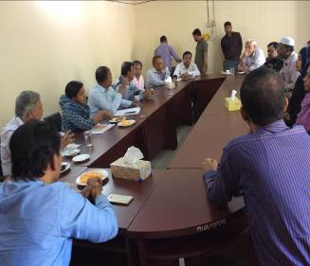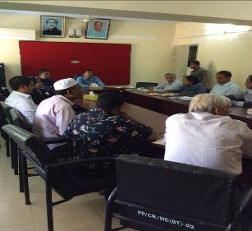
Photographs 7.1.1: Consultation Meeting at Patiya Pourashava with Pourashava Mayor, Officials and Consultants Participants
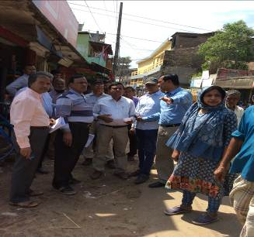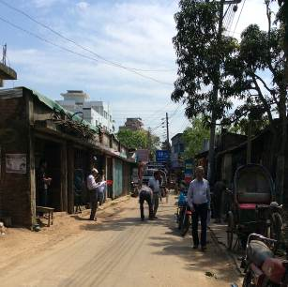
Photographs 7.1.2: Consultant Team visited the sites with the Pourashava Representatives

Issues Raised by the Participants

The participants raised the issues related to infrastructure development of Patiya Pourashava. In the CIP and FGD, the participants discussed about the requirements for the Pourashava's future development through a list of the subprojects.

Feedback, Suggestions, and Recommendations of the Participants

The participants’ feedback, suggestions, and recommendations listed below:
- The FGD results confirmed that an improved road and drainage network to be needed for future development of Patiya Pourashava;
- The participants suggested that the subproject should be inclusive such as road, drain and street light can consider for the same road;
- The participants also suggested that canal excavation subproject, dumping station subproject should be considered;
- The Pourashava officials stated that the allocated budget should be increased because the number of subprojects that have been selected for each financial year is insufficient.

Conclusions and Recommendations

The environmental impacts of all the elements of the subproject have been assessed. All potential impacts were identified in relation to design and location, construction, and operation phases. The overall conclusion is that if the mitigation, compensation and enhancement measures are entirely implemented, there will be no considerable negative environmental impacts due to implementation of the subproject. Furthermore, planting 450 trees will enhance the ecological condition in the subproject area.

A few key recommendations are outlined below:
- A copy of the EMP shall be kept on-site during the construction period at all times;
- The environmental management and monitoring plan proposed in this report also needs to be followed;
- Contractor will ensure availability of the PPEs to the workers;
- Contractor will monitor behavioral matter of the workers to avoid any undue risks related to labor influx;
- Pourashava will inform and encourage the local people for using of the diversion and connecting roads;
- A specific training program should be carried out for Pourashava staffs to deliver overall facts for environmental safeguards;
- Regular site visit should be conducted for the effective implementation of the EMP;
- Field visit, document checks, and interviews with workers and beneficiaries should be continued and any requirements for corrective action will be reported to the LGED and WB;
- The consultation process should be continued during subproject implementation to ensure that stakeholders are fully engaged in the subproject;
- Equipment should be checked by the Pourashava engineer and DSM consultant prior to work.

It should be noted that environmental assessment report is a live document. Hence, due to changing circumstances during the construction phase if any, there might be minor adaptation needed for environmental, health and safety issues.

APPENDIX

Appendix I: Environmental Monitoring Checklist

