INTRODUCTION

Subproject Background

Patiya Pourashava was established in the year of 1990. This is A Type Pourashava with present population of about 55,323. The Pourashava covers an area of 10.36 sq. km (Patiya Pourashava web site). The drainage system includes 5.50 km RCC/Brick Lined Drains, 105.46 km earthen drains and 4 nos. of Canal (Patiya Pourashava web site).
Infrastructures and physical development are not attained significantly in the Patiya Pourashava. Especially, drainage system is not adequate. Urbanization process also decreases the retention area for runoff. Hence, during rainy season, delay discharge of the storm runoff causes water logging problem in the subproject area. Hence, the existing drainage system necessitates new drain. Furthermore, street light is needed for providing safety for the drivers, riders, and pedestrians at night time. Therefore, this subproject includes construction of RCC drain with footpath and beautification works including street light at both sides of Chittagong-Cox’s Bazar Main Road from Indropul to Shachand Aulia Mazar Gate.
3200 m drain is under construction at both sides of Chittagong-Cox’s Bazar Main Road from Indropul to Shachand Aulia Mazar Gate (first part) by MGSP funding. This proposed 2nd part (which will start from AC Land Office at left side and Kalibari Road at right side to Indropul Khal) is necessary for completion of the drainage network. The proposed drain at left side of the road will be connected with an existing canal near “Today Community Centre” and the right side drain will be connected with Indropul Khal. The significant features of the subproject are mentioned below:
Name of the Subproject | Construction of RCC Drain and Footpath at both sides of Chittagong-Cox’s Bazar Main Road from Indropul to Shachand Aulia Mazar Gate with Beautification works (2nd part) Ch. 0+000 - Ch. 1+100m at left side and Ch. 0+000 - Ch. 1+425m at right side
Package No. | MGSP/PAT/ 2017-18/W-06
District Name | Chittagong
ULB Name | Patiya Pourashava
Jurisdiction Area | Ward Number 2, 3, 4 and 5
Structural Design Option | RCC Drain with Footpath and Street Light
Beneficiary Population | Considering the population of jurisdiction area of the subproject, about 25,000 people will be benefited directly and many others indirectly.
Tribal People | No tribal people settlement found in the subproject area
Land Acquisition | No land acquisition is needed
Estimated Cost | 83.69 million in BDT
Subproject Duration | 12 months
Tentative Start Date | 1st September, 2018
Tentative Completion Date | 31st August, 2019

Objectives of the Study

The general objective of this study is to determine the major environmental impacts succeeding from execution of the subproject and to recommend mitigation measures to avoid or reduce adverse environmental impacts and to enhance positive impacts. The specific objectives include:
- To assess the existing environmental conditions of the subproject site and its influence area in order to establish a baseline framework against which potential environmental impacts due to implementation of the subproject would be compared;
- To determine and evaluate the impacts resulting from the subproject activities during its construction phase and operation phase;
- To develop a environmental management plan with recommendations for mitigating impacts and enhance positive impacts;
- To develop a rational environmental management plan with recommendations for mitigating adverse impacts and enhancing positive impacts and outlining environmental monitoring requirements both during construction and operational phase of the subproject.

Scope and Methodology of the Study

The subproject appraisal is included environmental screening for the subproject components. According to that screening, no further environmental assessment is required for the lighting works. Nevertheless, environmental assessment is required to fulfill the regulatory requirement for RCC drain with footpath. Hence, this report is mainly included RCC drain with footpath. However, in the EMP table mitigation measures for street light are also included. The study methodology comprised the following activities:
- Desktop Study;
- Field Investigations and Data Collection;
- Data Analysis and Report Writing.

Desktop Study
The desktop study involved:
- Initial meetings with client, stakeholders to discuss the proposed subproject, including subproject activities;
- Collection and review of the baseline data, maps, reports and other relevant information on the existing environmental and social conditions of the subproject area;
- Review of the relevant existing legislation, regulation and policies;
- Understand the anticipated technical processes that may affect the environment.
Field Investigation and Data Collection
A team of the consultants made a field investigation to the proposed site. Field investigations involved mainly site walks within the subproject and its adjoining areas that may be affected by the subproject. The following key tasks were performed during the field visit:
- Taking photographs of the significant aspects to assist in describing the baseline environmental conditions of the subproject area;
- Interviews with representatives of the Patiya Pourashava officials; beneficiary and affected people within the subproject influence area;
- Obtaining relevant documents from the Pourashava and local inhabitants within the subproject influence area;
- Verifying information and data collected during the desktop study and to collect new information that may have been important in the assessment of the impacts and design the mitigation measures.

Data Analysis and Report Writing

The data and information collected from all the sources (literature review, secondary and primary data, public consultation) were analyzed to describe the existing environmental setting of the subproject area, to identify the potential positive and negative impacts of the proposed subproject, as well as to provide preliminary suggestions for mitigation measures. Finally, this environmental assessment report has been prepared.

SUBPROJECT DESCRIPTION

The Study Area

The subproject site is situated within the jurisdiction of the ward number 2, 3, 4 and 5 of the Patiya Pourashava. The proposed drain will be constructed at both sides of the Chittagong-Cox’s Bazar Main Road start from Indropul to Shachand Aulia Mazar Gate (2nd Part) (AC land office at left side, Ch. 0 - 1100m and Kalibari Road at right side, Ch. 0 - 1425m to Indropul Khal). The location map, topographical features and layout plan of the subproject are shown in Figure 2.1.1, Figure 2.1.2 and Figure 2.1.3.
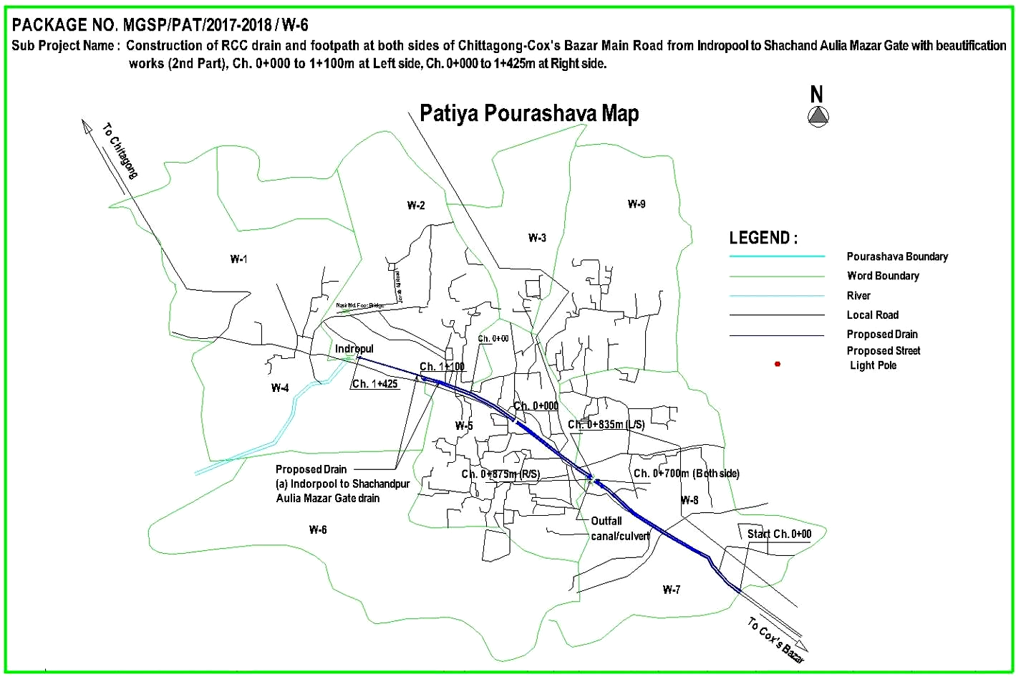
Figure 2.1.1: Location Map of the Proposed RCC Drain with Footpath and Beautification Work at Patiya Pourashava
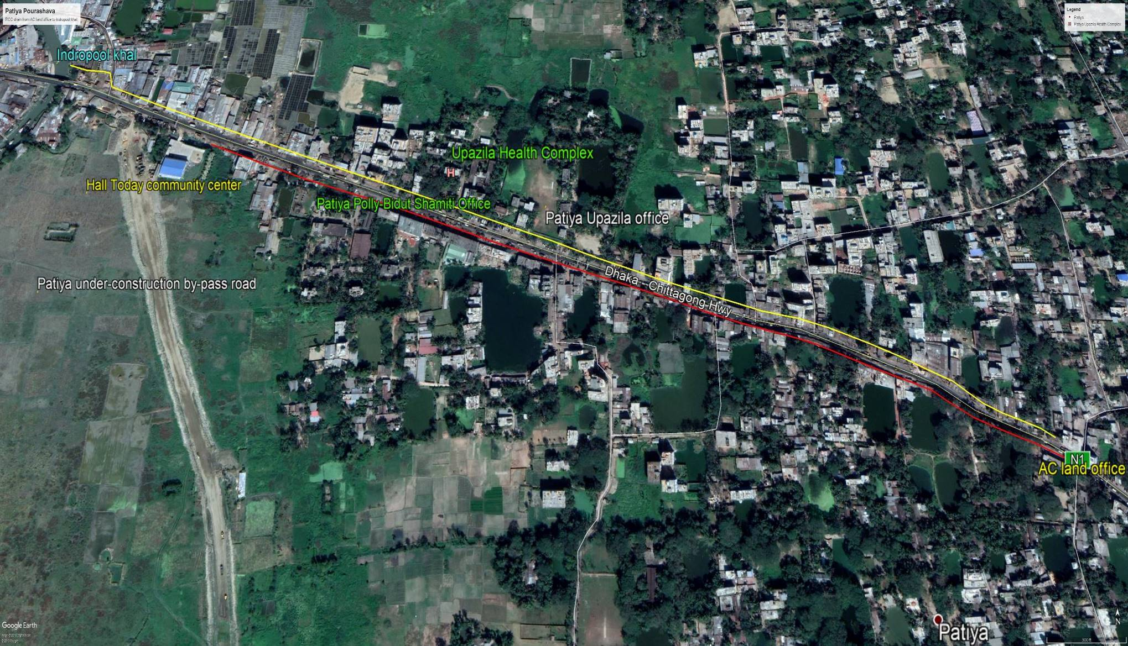
Figure 2.1.2: Topographic Features of the Proposed Subproject with influence Area

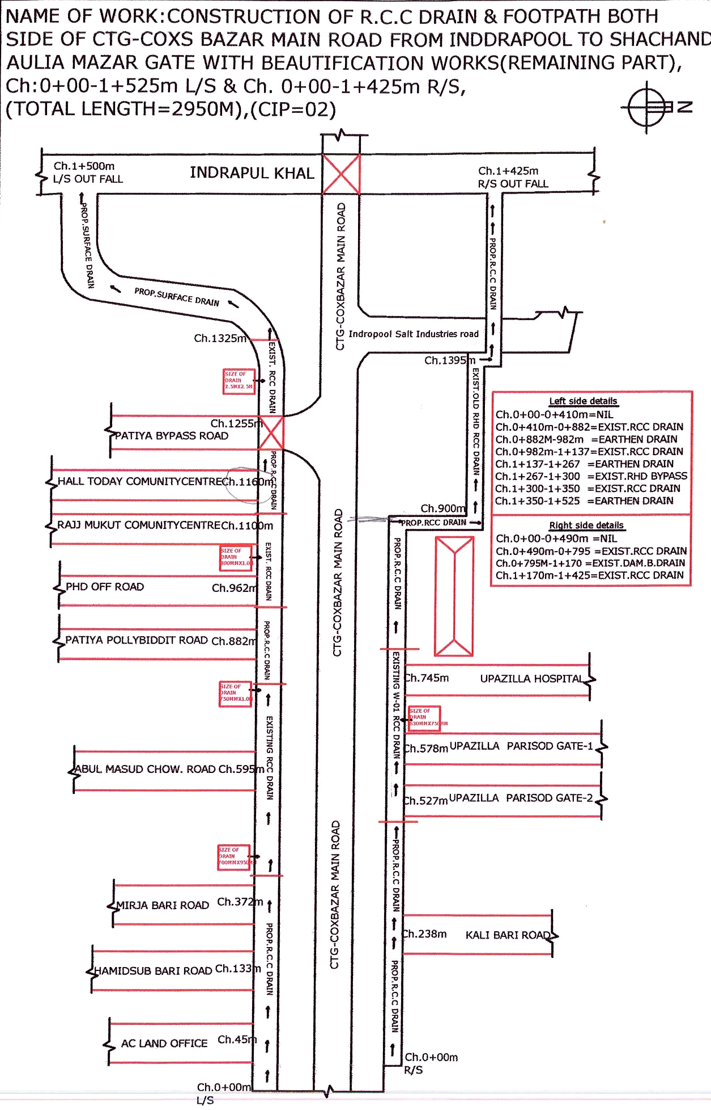
Figure 2.1.3: Lay-out Plan of the Proposed RCC Drain with Footpath

Current Situation, Proposed Intervention and Need for the Subproject
In the subproject area, the major roadside built-up infrastructures includes tin-shed, semi-pucca and pucca educational institutions, religious centers, shops, local market, Bazar, government and non-government agencies, local administrative organization, health center, Bank-Bima etc.
In the subproject area, the drainage facility is inadequate. The existing drains at different segments of the Chittagong-Cox’s Bazar Main Road are not functioning properly. At left side from AC Land Office to Majibari Road, there is no drain. At rest part, the existing RCC and earthen drain is damaged and silted-up. At right side from Kalibari Road to Upazila Parishad and Salt Industry Road to Indropul Khal, there are no drains. From Upazila Parishad Office to Upazila Hospital, the existing RCC open drain is damaged and in inadequate dimension. Furthermore, due to non-functional outfall, this section is more vulnerable to drain out storm water. Consequently, water logging and drainage congestion create major environmental and public health hazard in the subproject area. In addition, stagnant water damages the road surface and creates traffic congestion. Hence, a well-designed drain with footpath is essential at both sides of the road to complete the drainage network.
Moreover, absence of the street light hampers the normal traffic operation at night. Therefore, fixing of the street light is also needed for traffic operation at night. The street light will be fixed at both sides of the road at 30m interval.
The existing condition of the subproject site and Indropul Khal (proposed outfall) is further elaborated in the following Photographs 2.2.1 and Photographs 2.2.2.
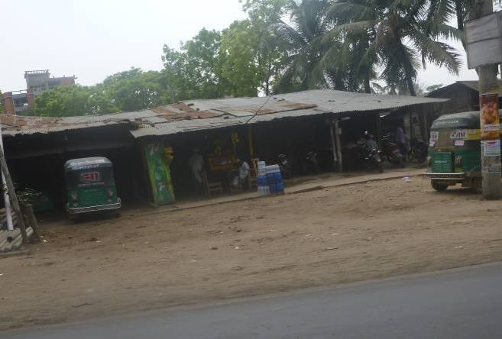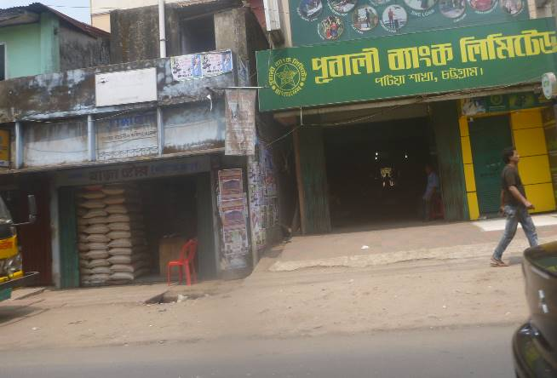
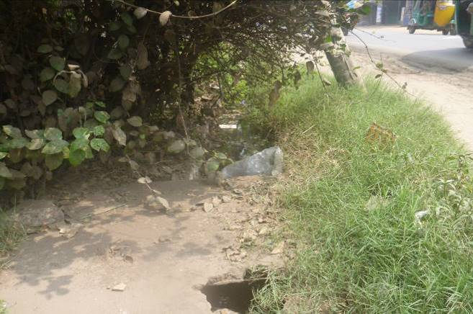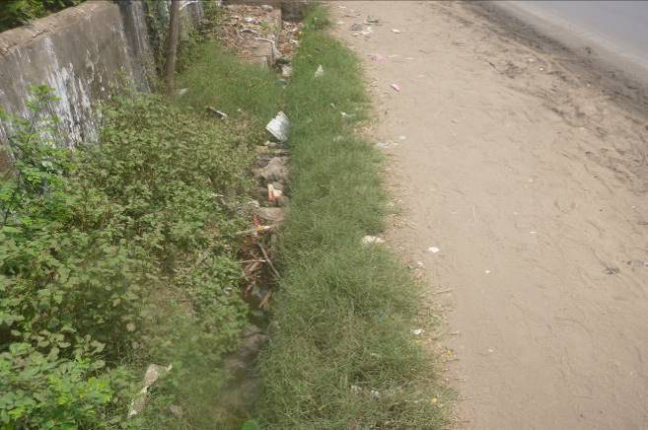
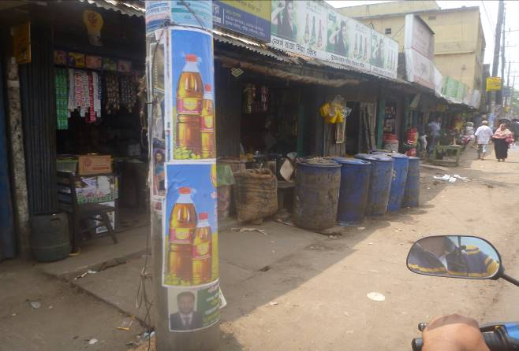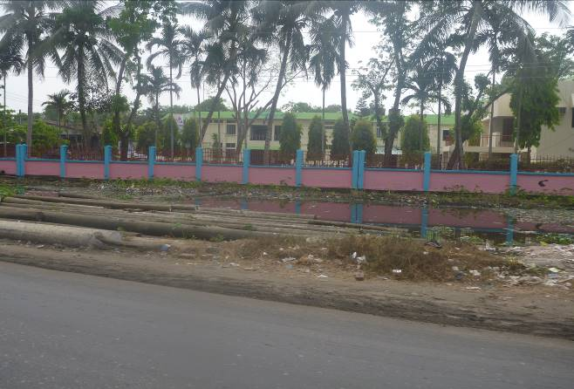
Photographs 2.2.1: Current Situation of the Exiting Drains at the Subproject Area

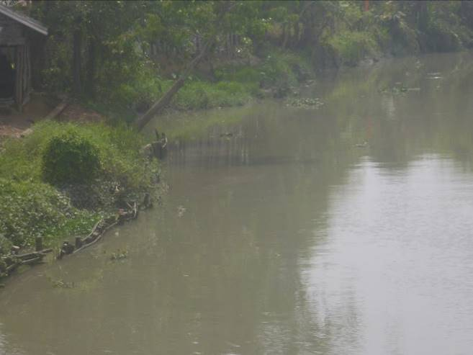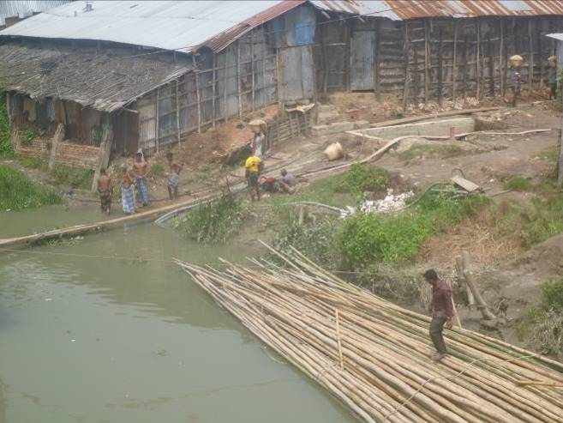
Photographs 2.2.2: Current Situation of the Indropul Khal (Proposed Outfall)

Justification of Selection of the Subproject

With the facilitation of PMU, WB and DSM Consultants, the Pourashava prepared the CIP list. According to the CIP list, Patiya Pourashava prepared the priority list of the subprojects considering the demand and requirement. As a part of the reconnaissance survey, PMU Officials and DSM consultants’ visited and evaluated the existing site condition of the subproject.
From the environmental screening it is revealed that the ecological impacts due to this subproject will not be significant. Furthermore, adverse impacts on the physicochemical environment are not significant and limited in the subproject boundary. The Pourashava Authority has consulted with the beneficiaries. The beneficiaries have no objection regarding the implementation of the subproject.
After completion, the subproject will improve the drainage facilities by minimizing water logging and drainage congestion. Consequently, the local people will get better environment. The street light will improve the quality of life. Considering the expected benefits that will derive, the subproject has been selected for implementation.

Envisaged Subproject Activities and Implementation Process

The general activities of the subproject: construction of the semi-pucca site office, construction of the labor shed, and relocation of the electric poles and site clearing works. The key activities of the RCC drain with foot path and street light are mentioned below.
RCC Drain with Footpath:
- Dismantling of the damaged brick drain;
- Earth work in excavation of the foundation;
- Pumping and bailing out of water as per requirement;
- Lying of polythene sheet;
- Mechanical compaction;
- Plain cement concrete work in foundation;
- Manufacturing and placing of CC blocks;
- Fabrication of the ribbed or deformed bar;
- Reinforced cement concrete work.
Street Light:
- Assembling, fitting, fixing, installation, testing and commissioning of the GI pole;
- Fitting and fixing energy meter ;
- Earthling the electrical installation;
- Fixing insulator;
- Erection of tubular pole;
- Fixing of the overhead conductor;
- Fixing of the wire rack;
- Fixing and installation of the switch board;
- Providing, fitting and fixing of the water tight street light.

The materials and resources to be used for the key activities: soil in earth work, sand, stone chips, reinforcement, diesel, cement, electricity, water, GI poles and other associate accessories for lighting works.

The major equipment to be used for the implementation of the subproject: excavator, concrete mixer, diesel engine, steel cutter, steel shutter and mechanical vibrator, ladder and light fixing equipment.

Category of the Subproject
For RCC Drain
- According to ECR 1997 : Green □ Orange A □ Orange B □√ Red □ Not Listed □
- According to WB classification : Category B □√ Category C □
In the Project EMF, RCC drain is categorized as Orange A or Orange B depends on environmental impact. Hence, considering the anticipated environmental impact (which is mainly site specific, limited within the subproject boundary and significantly manageable through the appropriate mitigation measures), primarily RCC drain can consider as Orange-B category as per ECR-97. According to the WB classification, it can classify as Category B.
For Street light
- According to ECR 1997 : Green □√ Orange A □ Orange B □ Red □Not Listed □
- According to WB classification : Category B □ Category C □√
Considering the environmental impacts, the street light can be considered as Green category as per ECR-97. According to the WB classification, it can be classified as Category C.

Subproject Schedule
The tentative schedule of construction of the subproject is:
(a) Subproject duration (months) :12 months
(b) Tentative start date : September 1, 2018
(c) Tentative completion date : August 31, 2019
The daily construction hours will normally include regular working time. However, daily working hours may vary based on the on-site condition. The detailed work program will be prepared by the contractor with the assistance of the PIU. Then it will be shared with the PMU, LGED and DSM consultants. In addition, the detailed work program will also be shared with the Bank as per requirement.

Baseline ANALYSIS OF THE ENVIRONMENTAL CONDITION

Physical Environment

Important Environmental and Infrastructural Features
The detailed environmental and infrastructural features within the subproject influence area have been collected by field investigation. The conditional survey has been performed for the designing of the drain and street lighting work. Hence, survey data is also used for identification of the environmental and infrastructural features. The detailed environmental features listed considering 100 m of the both sides from the center line of the Chittagong - Cox’s Bazar Road at 100m longitudinal intervals from AC land office at left side (Ch. 0-1100m) and Kalibari at right side (Ch. 0-1425m) to Indropul Khal. The key findings are given in Table 3.1.1.
Table 3.1.1: Major Environmental and Infrastructural Features
Chainage (m) | Left | Right | Major Environmental and Infrastructural Features
Indropul to Shachand Aulia Mazar Gate
0-100 | √ |  | End of W2 Package drain, Patiya officers club, AC-land office, pond, semi-pucca infrastructure, common planted trees (Debdaru, Mahogany, Coconut)
0-100 |  | √ | End of W2 Package drain, Khawja Community center, Gazi convention hall, pucca shops and markets, electric pole, semi-pucca and tin-shed infrastructures, common planted trees, Shampurna beauty parlor
100-200 | √ |  | Pucca, semi-pucca and tin-shed infrastructures for shops, engineering workshop, grocery shop, bedding store, Ray Shilpaloy, Momota clinic, First Security Islamic Bank Ltd. ATM booth
100-200 |  | √ | Pucca, semi-pucca and tin shed infrastructure for residents and road-side varieties shops, electric pole, common planted trees, transformers
200-300 | √ |  | Patiya Model public school, common planted trees, 2 storied building for market including varieties shops, local kitchen market, electric pole
200-300 |  | √ | Patiya Sri Sri Kali Bari Mandir, Suchakri-Dandi housing society, Patiya Moitra Co-operative limited, Walton plaza, Pubali bank, common planted trees, pucca, semi-pucca and tin shed infrastructure for residents and road-side varieties shops, transformer and electric poles
300-400 | √ |  | Local market and bazar, pucca, semi-pucca and tin shed infrastructures for residents and road side shops, common planted trees, electric pole
300-400 |  | √ | Whole sale and retail bazar for daily necessary products (kitchen market), Sukur Ali Muncef Jame mosque and road-side graveyard, Renesa Computer Technical Institute, Muncef bari pond, pucca, semi-pucca and tin shed infrastructure for residents and road-side varieties shops, common planted trees and electric poles
400-500 | √ |  | Local market, pucca, semi-pucca and tin shed infrastructures for residents and road side shops, common planted trees, electric pole, abandoned semi-pucca RHD building, Sub-register office
400-500 |  | √ | Patiya central hospital, road side tin fence vacant land use for scarp materials business, local sanitary equipment and product stockyard, Ramjan computer, Holly Child kindergarten, RHD abandoned semi-pucca structure on road-side, pucca, semi-pucca and tin shed infrastructure for residents and road-side varieties shops, common planted trees and electric poles
500-600 | √ |  | Market, pucca, semi-pucca and tin shed infrastructures for residents and road side shops, common planted trees, electric pole, Fulkoli pastry shop, Neuron diagnostic center, computer world
500-600 |  | √ | Patiya Upazila complex, electric poles, common planted trees, existing RCC open drain, semi-pucca, tin shed structures for road side varieties shops, pond, ditches, road side vegetation
600-700 | √ |  | Market, pucca, semi-pucca and tin shed infrastructures for residents and road side shops, common planted trees, electric pole, Samsung gallery, Mega door and furniture
600-700 |  | √ | Patiya Upazila complex, electric poles, common planted trees, playground, Upazila election commission office, ditches, road side vegetation, pucca, semi-pucca and tin shed structures
700-800 | √ |  | Pucca multi-storied structure for market place including varieties shops (furniture-Regal, Otobi; Jewelry; Parlor), Chevron health care center, electric pole, Royal community center, the Metro lab, Grameen Bank, Makka hotel and birani house, common planted trees
700-800 |  | √ | Patiya health complex, pucca, semi-pucca and tin shed structures, common planted trees, ditches, road side vegetation, electric poles, RCC open drain, transformer
800-900 | √ |  | Ditches, Patiya Polly-Biddut Shamiti, boundary wall, common planted trees with ornamental trees on Polly-Biddut premises, naturally grown vegetation on the bank of the ditches, Chevron, pucca, semi-pucca, tin shed structures, electric pole, transformers, varieties shop market
800-900 |  | √ | Pucca, semi-pucca and tin shed infrastructure for residents, office compound and road-side varieties shops, RHD office stockyard (vehicles), common planted trees, electric poles, transformers
900-1000 | √ |  | Open vacant land, common planted and naturally grown trees, ditches, low wet land, agricultural field, power supply station, RHD office, boundary wall, semi-pucca, tin shed structures for office and shops
900-1000 |  | √ | Pucca, semi-pucca and tin shed infrastructure for residents and road-side varieties shops, common planted trees, electric poles, transformers
1000-1100 | √ |  | Rajmukut community center, semi-pucca, pucca, tin shed, katcha structures, electric poles, saw-mill, wood-log shop and varieties shops, agricultural field, common planted trees and naturally grown vegetation, kazi-office, Raisa community hall, boundary wall, open vacant space
1000-1100 |  | √ | Pucca, semi-pucca and tin shed infrastructure for residents, road-side varieties shops and salt processing industries, common planted trees, electric poles, transformers
1100-1200 | √ |  | Hall Today Community center, Patiya bypass road, under constructing RCC road cross drain, common planted trees and naturally grown vegetation, agricultural field, construction site base camp (The Real Builders) surrounded by tin fence, semi-pucca, pucca, tin shed & katcha structures, electric poles, transformer, natural canal connecting to Indropul khal
1100-1200 |  | √ | Pucca, semi-pucca and tin shed infrastructure for residents, road-side varieties shops and salt processing industries, common planted trees, electric poles, transformers
1200-1300 | √ |  | Agricultural field, natural canal connecting to Indropul khal, poultry farm, semi-pucca and tin shed structures for salt industries, electric poles, common planted trees and naturally grown vegetation on the bank of the canal and at the edge of the agricultural field
1200-1300 |  | √ | Salt Industry road, number of salt industries (i.e. MS Islamabad salt refinery industry), semi-pucca, pucca, tin shed structure, damage RCC drain, bamboo fence, verities shops (i.e. restaurant, tea stall, snack shop)
1300-1425 | √ |  | Agricultural field, natural canal connecting to Indropul khal, poultry farm, semi-pucca, pucca and tin shed structures for salt industries, electric poles, common planted trees and naturally grown vegetation on the bank of the canal and at the edge of the agricultural field, Indropul khal
1300-1425 |  | √ | Salt Industry road, number of salt refinery industries, katcha and tin shed structures, common planted trees and naturally grown vegetation, electric pole, transformers, damaged road, Indropul khal

Geology, Topography and Soils

The subproject area is situated on an unbroken flat land of alluvial deposits. Geology of Patiya Pourashava is composed of a thick sedimentary sequence of sandstone, shale and siltstone. These sediments are probably of fluviatile origin through some of the even-bedded siltstones and shales of considerable lateral extent of shallow marine beds. Most of the agriculture land is clay soil and clay soil often contains iron and aluminum hydroxides. This is an area prone to cyclones and storm surges. Patiya Pourashava was affected by cyclones in 1960, 1963, 1970, 1988, 1991, 1994 and 1997. According to GSB (1978), Bangladesh has three seismic zones with high, moderate and low seismic activity. The Pourashava falls in Zone II.
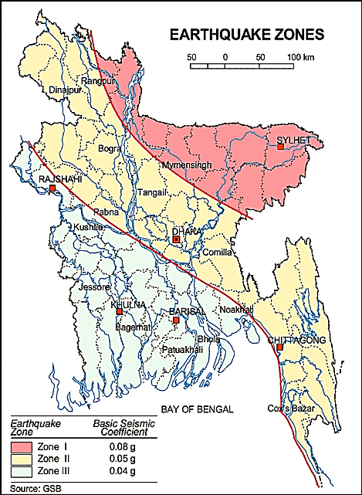
Figure 3.1.1: Location of Patiya Pourashava in Earthquake Zone Map of Bangladesh

Climate and Meteorology
There is no meteorological station at Patiya Pourashava. As a result, area specific data is not available. However, Chittagong meteorological station is very close to Patiya Pourashava. Therefore, meteorological data from Chittagong Station is used for this study.
Seasonal variation of temperature in Chittagong is not significant. Monthly average minimum and maximum temperatures for the period 2008-2014 for Chittagong are given in Table 3.1.2 and 3.1.3 (BMD, 2015).
Table 3.1.2: Monthly minimum and average minimum temperature during Jan 2008 to Dec 2014

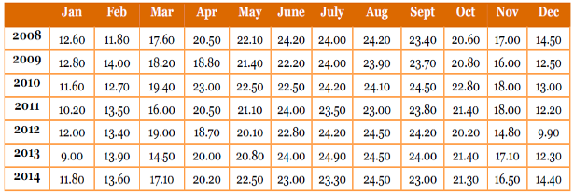
Table 3.1.3: Monthly maximum and average maximum temperature during Jan 2008 to Dec 2014

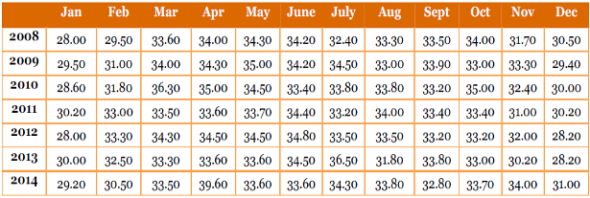
The data shows that the monthly minimum (average) temperature at Chittagong varies between 9.00 ⁰C and 24.50 ⁰C and maximum temperature varies between 28.00⁰C and 36.50⁰C. The minimum and maximum temperature data indicates that December to February months are relatively cooler and March to May are relatively hotter months.
The average monthly rainfall data for Chittagong (BMD, 2015) is provided in Table 3.1.4 below. The data shows that rainy season in Chittagong mainly prevail from June to September. The average monthly rainfall in Chittagong for the period Jan 2005 to Dec 2014 varied between 0 mm in the month of December and January to 1268 mm in the month of June. The rainfall follows the general climate pattern with the highest rainfall in the summer from April to October and minimum rainfall in the winter from November to March.
Table 3.1.4: Monthly total and 10 years average monthly rainfall during Jan 2005 to Dec 2014

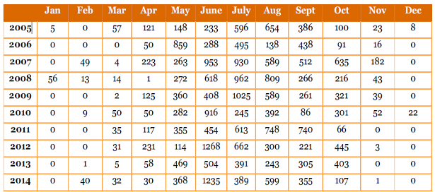

Water Resources (Surface Water, Ground Water and Rain Water Harvesting)

Hydrology of Patiya Pourashava is almost similar with the coastal plains of Chittagong presents a complicated interaction of fresh water flow from the upstream, tides and tidal flows from the Bay of Bengal. Indropul Khal, Chan Khali Khal, ponds, ditches and wetlands are other fresh surface water sources in the subproject influence area. Tropical Cyclones, storm surge and other meteorological effect are occurred from the sea that affects Patiya Pourashava as well (Patiya Pourashava Master Plan). Main sources of drinking water of Patiya Pourashava are deep tube well and shallow tube wells.

Flooding, Water Logging and Drainage Pattern

Water logging problems found in different parts of the Pourashava. Water logging occurs during monsoon and duration of the water logging is 3-7 days. It occurs between June to November every year during heavy rain. Beside this, heavy rainfall causes water logging in the eastern parts of the Pourashava. The Pourashava is free from flood due to hilly areas (Patiya Pourashava Master Plan).

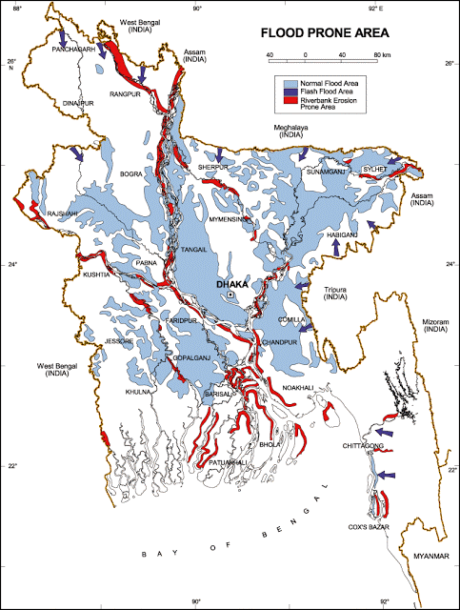
The black circle denotes Patiya Pourashava
Figure 3.1.2: Location of Patiya Pourashava in Flood zone Map of Bangladesh
Air Quality and Dust
Ambient air quality data have not been found. In the subproject area, black smoke emission from the vehicles is the main sources for the air quality degradation. Dust is generated during the movement of the vehicles which also degrades air quality. In addition, the windblown dust causes air pollution.
Noise Level
Noise is generated mainly from the vehicle movement, hydraulic horn, loudspeaker using at market and bazar areas. Vehicles such as buses, rickshaws, trolleys, pick-up, trucks, motor cycles, mini trucks, and private cars are major contributor for noise nuisance. During construction phase, hydraulic excavator, vibrator machine and vehicles used for transportation activities may create temporary noise nuisance within the subproject boundary.
Solid Waste Management
The Pourashava has a dump site at Ward No. 7 at Bahuli beside Chittagong-Cox's Bazar Main Road (North side vacant place). Nevertheless, there is no provision of organized solid waste disposal system in the Pourashava. Hence, collection and disposal of solid waste is a great challenge for the Pourashava Authority. A substantial amount of daily generated solid wastes are not collected and disposed-off properly. Consequently, these solid wastes find their way into roadside drains and low land.

Biotic Environment

There are natural and man-made water bodies like khals (Indropul khal and its connecting other khals), ponds, ditches and wetlands in the subproject influence area. In the subproject area, the floral species include: Mahogany, Koroi, Akashi, Rain-tree, Mango, Jackfruit, Coconut, Betel-nut, Shil-Koroi, Debdaru, Date Tree, Palm Tree, Dumur, Kafolla, Mandar etc. Water hyacinth and aquatic plant species are available in the water bodies. On the bank of the canal and ditches, there are lots of grasses and Colocasia. The wetland and agricultural field at the left side from Ch. 1100m to Indropul Khal is the worthy habitat for the aquatic flora and fauna. Lots of common local birds were found during the site visit. The common local birds such as Doel, Shalik, Kite, Crow, Tuntuni, Bulbuli, Parrot and Cuckoo were found during the site visit. Migratory birds are also available in the harvested paddy field and seasonal wetlands during winter season. There are no wild animals and endangered faunal species in the subproject area.

Socio-economic and Socio-cultural Environment

Land Use, Status of Housing and Built-up Infrastructure

The subproject area is core part of the Pourashava (beside the Chittagong-Cox’s Bazar highway) and fully built-up area with road side houses, market, shops, educational institutes (schools, colleges), religious centers (Mosques, temples) and commercial & financial organization (Bank, Bima etc), industries.

Beneficiary Population

This subproject goes through the Wards number 2, 3, 4 and 5 of Patiya Pourashava. As per information by the municipality, considering the ward population about 25,000 (Population and housing census, 2011) people will benefit directly and many others indirectly.
Education

The literacy among the population is about 54.90%. This is higher than the national average 51.8%. Literacy rate for the male (57.3%) is higher than female (52.5%) (Population and Housing Census, 2011).
Tribal Communities

There is no indigenous or tribal people settlement found in the subproject area. Therefore, no measures needed for the indigenous peoples’ safeguard.

Land Acquisition and Resettlement

At different segments, the road side shops and other structures need to be removed for site clearing work. The Pourashava Authority has already consulted with the stakeholders. The shop owners willingly agreed to remove the shops prior to the commencement of the works. Hence, the existing shops will be removed through an amicable settlement between the Pourashava and shop owners. A NOC (no objection certificate) from Roads & Highways Department has already been collected for the construction of drain at RHD owned road under Package 2. It is also noted that in case of any objection from the stakeholders, affected persons and community people, DSM will investigate the actual situation. Then, measures will be taken as per rules.
Principal Livelihoods and Economic Activities
The subproject area is now inhabited by the mixed occupational people where major income comes from non-farm activities such as small business and trading, enterprises, Government and non-government job, transport vehicle ownership and operation.
Cultural Heritage and Protected Areas
There are no protected areas and no important cultural or historical sites identified in the subproject influence area. Furthermore, educational institutions and religious center bring cultural values to the community people.

ENVIRONMENTAL SCREENING

Environmental Screening (ES) for the subproject has been conducted with the purpose of fulfilling the requirements of Government (GOB) and World Bank (WB) for the preparation of subproject appraisal. Environmental Screening Checklist, as adopted in Appendix C of the Environmental Management Framework (EMF) of the MGSP, was administered for identifying the impacts and their extents.
The screening data and information have been formulated and are shown in below.
(1) Potential Environmental Impact during Construction Phase:
(a) Ecological Impacts:
13
- Felling of trees Significant □ Moderate □ Minor □√ Number of trees
- Clearing of vegetation Significant □ Moderate □ Minor □√
- Potential impact on species of Significant □ Moderate □ Minor □√
aquatic (i.e., water) environment
RCC drains with footpath and beautification work will be performed at Chittagong-Cox’s Bazar Highway (road side area) and developed land. Hence, only 13 number of trees (Mahogany, Mango, Jackfruits, Coconut and Betel nut etc) need to be cut down for site clearing work. There is no tree to be felled down bring religious and heritage importance. Intensity of road side vegetation is minor. Hence, impact due to clearing of the road side vegetation is considered as minor. In addition, anticipated impact on species of aquatic environment is also considered as minor because except throwing of the wastes and construction materials in to Indropul khal, ponds, ditches and wetlands; the subproject does not have any likely impact on the aquatic environment during construction phase. From the above analysis, the overall ecological impact is considered as minor.
- Physicochemical Impacts:
- Noise and Air pollution Significant □ Moderate □√ Insignificant □
- Drainage congestion Very likely □ Likely □√ Unlikely □
- Water pollution Significant □ Moderate □ Insignificant □√
- Pollution from solid/ construction wastes Significant □ Moderate □√ Insignificant □
- Water logging Significant □ Moderate □ Insignificant □√
The subproject will have temporary and localized negative impacts on noise and air quality during construction phase due to mobilization of the equipment, vehicles movement for the transportation of the materials, using of hydraulic excavator, mechanical compaction machine, concrete mixer machine, vibrator machine etc. The construction work will be performed section wise. Hence, it is anticipated that the overall impacts on noise and air quality will be moderate, temporary and limited within the subproject boundary. There are road side educational institutions, religious, health centers and residential areas. Hence, anticipated impacts on noise at these particular sections will be significant if measures are not taken properly. The generated dust and wastes during construction activities may temporarily disturb the local people if measures are not taken. The generated construction wastes, un-suitable materials and solid wastes may degrade the water of adjacent canal, ponds, wetlands, and ditches if not properly collected and disposed and thrown in to the water bodies. Improper collection and disposal of the generated wastes also may degrade the quality of the surrounding environment and degrade the aesthetic and landscape value. The anticipated water logging and drainage congestion during construction period is minor because water bodies are available at the road side area for draining-out the storm water. In addition, provision will be there for pumping out the storm water if required.
- Socio-economic Impacts:
- Traffic congestion Very likely □ Likely □√ Unlikely □
- Health and safety Significant □ Moderate □√ Insignificant □
- Impact on archaeological and historical Significant □ Moderate □ Insignificant □√
- Employment generation Significant □√ Moderate □ Insignificant □
The drain will be constructed at road side area of Chittagong-Cox’s Bazar Highway which is very busy. Due to absent of traffic management, vehicles movement for carrying construction materials and mobilization of the equipment may create temporary traffic congestion in the subproject area. Though, movement of the vehicles and equipment will be only for a short time and as per requirement; however, the Pourashava is responsible for traffic management during construction phase particularly in the bazar area. In addition, any material storage on the road and any activities on the carriage way will be avoided. Furthermore, the construction work should be performed section wise to minimize any adverse impact on local traffic.
None of the subproject activities require heavy equipment. In addition, the Pourashava authority will inform local people about the subproject activities. The construction work will follow simple procedure with commonly used equipment. Hence, anticipated impact on health and safety is moderate. However, using of the personal protective equipment by the workers will significantly reduce any occupational health and safety risks. There is no archaeological and historical site within the influence area. The subproject has positive impact by generating work opportunities for the local people and supplying of the construction materials, equipment, food and other necessary stuffs to the campsite.
(2) Potential Environmental Impact during Operational Phase:
(d) Ecological Impacts:
- Potential impact on species of aquatic Significant □ Moderate □√ Minor □
(i.e., water) environment
The waste water from the drain may degrade the water quality of the outfall if carries pollutants. Though, the drain is designed for storm water only. However, the storm water may carry washed-out materials, pollutants from any sources that may disturb the aquatic environment of the outfall. Hence, anticipated impact on species of aquatic environment is considered as moderate.
(e) Physicochemical Impacts:
- Potential air quality Improvement □√ Moderate □ Insignificant □
- Potential noise level Improvement □ No-improvement □ No Impact □√
- Drainage congestion Improvement □√ Minor Improvement □ No Impact □
- Risk of water pollution Significant □ Moderate □√ Minor □
- Pollution from solid waste Improvement □ No-improvement □ Minor □√
and other sorts of wastes
The new drain will minimize drainage congestion and water logging problem. Thus, it will provide better environment to the community people. The covered drain will minimize spreading of the bad odor from the drain. The storm water to be discharged through the drain may degrade the water quality of the outfall if carry pollutants from any sources. The covered drain will reduce throwing of the waste materials into the drain.

(f) Socio-economic Impacts:
- Traffic Improvement □√ No-improvement □ Adverse □
- Safety Improvement □√ No-improvement □ Adverse □
- Employment generation Significant □ Moderate □ Minor □√
The subproject has significant positive impacts on the socio-economic environment. After completion, the drain will complete the drainage network and will minimize water logging problem. In addition, new drain prevents the accumulation of the stagnant water on the road surface. Consequently, it will enhance safety traffic operation and pedestrians’ movement.

3) Summary of Possible Environmental Impacts of the Subproject
From the above study, it seems that the ecological impact is minor and insignificant. The subproject activities may degrade the air and water quality and noise level to a limited extent. The inputs that may affect the environment will be mainly at construction phase and limited within the subproject boundary. Nevertheless, the impacts will be temporary and localized and limited and fundamentally manageable through the appropriate mitigation measures. The generated solid wastes due to the subproject activities should be properly collected and disposed in a designated dumping site. The labor shed and stack yard should be located in a designated place.
The anticipated environmental impact for the installation of the street light is insignificant. However, it has significant positive social impacts. Short circuit and improper electrical connection of the street light may cause potential health and safety risk.
Furthermore, safety concerns should be considered properly for the construction phase to avoid any potential safety risks. This subproject has positive impacts in terms of the generation of the employment opportunities due to construction activities, supplying of the materials at construction phase and by providing business activities and maintenance work at operation phase.

Specific impact, mitigation, AND enhancement measures

The likely impacts of the subproject are mainly caused by the activities required for the implementation of the subproject, and materials, resources and equipment to be used to perform the activities.
This section describes some specific impacts due to the subproject activities and their mitigation measures.

Dismantle Work, Site Clearing, Excavation Work and Earth Work
The drain construction work includes - dismantle of existing brick drain, clearing of the wastes materials generated due to dismantle work, earth excavation, earth filling work, back filling and cutting and removal of the unsuitable materials. These works lead dust blowing, improper disposal of the wastes, noise and vibration which may disturb the local people.
Mitigation Measures

- Proper care will be taken by the contractor as well as the Patiya Pourashava, during dismantle, excavation, soil work and back filling so that this activity does not disturb the nearby establishment.
- Cover the exposed dry loose soil with fabric/tarpaulin to avoid any dust generation;
- Disposal of unused soil and construction wastes to designated dump site at Bahuli beside Chittagong-Cox's Bazar main road (North side vacant place) at ward No-7.

Tree Felling, Clearing of the Vegetation and Ecological Impact
Total 13 numbers of trees (Mahogany, Mango, Jackfruits, Coconut and Betel nut etc) will be felled down due to implementation of this subproject. Road side vegetation also needs to be cleared for site clearing work.
Mitigation Measures

- 40 numbers of trees to be planted to compensate the felled down trees preferably local fruits, flowers, medicinal and ornamental trees at the left side of the Chittagong-Cox’s Bazar Main Road (Ch. 1100-1400m), where space is available;
- Planting trees and vegetation will enhance the ecological balance of the area after their successful growth.

Pollution from the Construction Materials
Dumping of the construction spoils, including accidental leakage of the oil, grease, and fuel in equipment yards is a significant hazard. Surface water and soil quality might be polluted from these contaminants. Even the people to be engaged for the construction activities might endanger the physical and human habitats of the area.
Mitigation Measures
- Safe transport, storage, and disposal of the construction materials, and the equipment have to be carried out in order to avoid the accidental spillage and loss;
- Maintain adequate moisture content of soil and sand during transportation, compaction and handling;
- Use tarpaulins or polythene to cover sand and loose soil when carried on trucks;
- Fuels, lubricants, and other hazardous materials should store over raised platforms and not directly on the ground.
- Carry the materials especially loose soil and sand with adequate cover;
- Disposal of soil and construction wastes at the designated dump site at Bahuli beside Chittagong-Cox's Bazar Main Road (North side vacant place) at ward No-7.

Air Quality and Dust
During the construction phase, air pollutants will be emitted from the equipment and construction vehicles are expected to remain low. Local residents in the vicinity of the work sites will be temporarily disturbed by the limited dust pollution. The overall impacts, however, are expected to remain low.
Mitigation Measures

- Water should be sprayed to control the dust, which is the main way to suppress dust at the worksite;
- Ensure sprinkle and cover stockpiles of loose materials (e.g., fine aggregates);
- Maintain adequate moisture content of soil and sand for transportation, compaction, backfilling and handling;
- Avoid use of dust generating equipment which produce significant amount of particulate matter far from the local residents;
- Ensure that all subproject vehicles are in good operating condition.

Noise and Vibration
Noise and vibration caused by the equipment and movement of the construction vehicles may temporarily disturb nearby residents. In this subproject, sensitive areas like roadside residents, educational institutes, religious centers and health care centers are likely to be affected by noise nuisance, though the impacts are anticipated to be limited.
Mitigation Measures

- Transportation of the construction materials have to be carried during the scheduled times, and mainly during the day in off-peak time;
- If needed, all powered mechanical equipment such as hydraulic excavator and machineries will be fitted with noise abating gear such as mufflers for effective sound reduction;
- Avoid using of the rod cutter at night;
- Avoid using of the concrete mixer and vibrator machine at night and schooling time.

Water Quality
The water quality may deteriorate if the construction materials, sand, construction wastes, effluent from the work camps and food wastes are dumped in the Indropul Khal, roadside ditches, ponds and low-land etc.
Mitigation Measures

- Proper construction management including waste management as well as training of the operators and other workers should provide to avoid pollution of the water bodies;
- Construction waste will dispose properly (not in water bodies or lowland), for which contractor will be responsible.
- Construction wastes will dispose properly at the designated dumping site at Bahuli beside Chittagong-Cox's Bazar main road (North side vacant place) at ward No-7.

Occupational Health and Safety
The most important risks associated with the construction activities are listed below:
- Exposure to the sunlight- workers are being exposed to the sun for long hours;
- Exposure to the high temperature, and humidity for a long time resulting in dehydration;
- Contact with the hazardous substances and wastes pose risks of the infections and diseases;
- Risk of respiratory problem due to the dust;
- Risk from the traffic collision or accidents during operation of the equipment such as hydraulic excavator, steel cutter and vehicles movement for the transportation activities of the subproject;
- Risks from head loads for carrying soil, construction materials and construction equipment;
- Risks of using of the machineries in motion such as steel cutter;
- Risk associated to the sudden bad weather working conditions such as storm, thunder storm and earth quake etc.
General Requirements for the Workers’ Health and Safety
The key salient features of the general requirements for the workers’ health and safety stated are presented in Table 5.7.1.

Table 5.7.1: General Requirements for the Workers Health and Safety
Issues | Requirements
Health and Hygiene | - Cleanliness at the site premises and workers living places and at the Labor Shed;  - Arrangement of the proper ventilation and temperature at the Labor Shed;  - Protection against dust and furnace by using of the nose masks and covering of the head and body;  - Proper disposal of the wastes and effluents;  - Provision of the adequate latrines and separate toilet for the women;  - Sufficient dustbins for the solid waste management system.
Safety and First Aid Box | - Using of the personal protective equipment (helmet, gloves, goggles, nose mask, safety boots);  - Precautions during work on or near machineries in motion;  - Head loads are prohibited;  - Ensure first aid box;  - First aid facilities should be provided and maintained;  - The first aid kit should include adhesive bandages, regular strength pain medication, gauze, and low grade disinfectant.
Compensation for Accidents at Work | - Contractors will bear medical treatment costs. If any severe accidents such as loss of hands, legs or loss of working ability or any case of death needs compensation-(the amount of the compensation should be fixed considering the type of accidents).
Dust and Fumes | - For any dust, fumes, or other impurities likely to be injurious to the workers, effective measures shall be taken to prevent their accumulation and its inhalation by the workers.
Overcrowding | - No labor room should be overcrowded.
Latrines and Urinals | - Sufficient latrines shall be provided;  - Latrines shall be maintained in clean and sanitary condition;  - Latrines shall be adequately lighted and ventilated.
Disposal of Wastes and Effluents | - Proper disposal system for the solid waste and effluent is required;  - Waste bins must be provided by the contractor at labor shed.

Impacts on Social Environment and Common Property Resources
Through comprehensive study, it is revealed that impacts are expected not to be severe and to be largely manageable. The following Table 5.8.1 presents impacts on socio-economic environment and common property resources.
Table 5.8.1: Impacts on Social Environment and Common Property Resources
Social Components | Impacts on IECs | Impact Significance
Community Perception | The local community people welcome this subproject and there is no visible objection from them. | Significant (+ve)
Employment and Business Opportunity | Community feels happy because generally the local contractor will be engaged for the construction works which will create work opportunity for the skilled and non-skilled labor. The subproject will create business opportunity for the equipment and materials suppliers. | Significant (+ve)
Community Order and Security | This subproject activity does not create any severe security problems to the local community and community people. | Minor  (-ve)
Possible damage to infrastructure and facilities | Possible damage of the existing road infrastructure by the construction equipment and vehicles used in this subproject. | Minor  (-ve)
New infrastructure and facilities | Improvement of the existing drain will enhance drainage facilities. | Moderate  (+ve)
Agriculture and Land Use | No direct impact on agriculture however, it could affect the adjacent land to a very limited extent. | Minor  (-ve)
Landscape and Aesthetics | This subproject activity temporarily will degrade landscape and aesthetics values of the subproject area to a limited extent. | Minor  (-ve)
Labor Habitat | It is anticipated that the outsider workers will stay at the Labor shed which will have impacts on the environment relates to the generation of the solid wastes, effluent, and water consumption. | Moderate  (-ve)
Health Care | Workers may suffer from the dehydration problems, respiratory problem, and other health hazards. | Minor  (-ve)
Accident | In case of road accidents by the vehicles to be used for the transportation may have serious negative impact. | Significant  (-ve)
Mitigation Measures

- Conduct dissemination with the local community about the subproject details;
- Continue liaison with the community leaders in order to maintain the community support;
- Engage local contractor and local people as much as possible for positive perception of the local community;
- Follow traffic rules to avoid any accidents;
- Transportation and mobilization of the equipment and construction materials avoiding peak hours and scheduled time;
- Ensure first aid facilities and effective use of personal protective equipment where applicable.

Labor Influx and Anticipated Impacts

The labor force and associated goods and services required for the construction of infrastructure civil works under this subproject cannot be fully supplied locally. The migration to and temporary settlement of laborers in the subproject, referred to as labor influx, carries an array of potentially positive and negative impacts in terms of demands on public infrastructure, utilities, housing and sustainable resource management and the strain on social dynamics.
Labor influx effects on host communities include positive impacts such as:

- The subproject activities will generate work opportunities for the local people and supplying of the construction materials, equipment, food and other necessary stuffs to the campsite;
- Improved infrastructure and public service access and availability whereby subproject investment catalyzes larger allocation of resources to a region, stimulating the development or expansion of infrastructure and public services.

Critical negative social risks include:
- Increase in criminal activity and alcohol and drug abuse, domestic violence, political attachment and violence, smuggling and robbery etc;
- Increase in gender-based violence, including eve teasing, sexual harassment etc;
- Increases in communicable diseases, including respiratory problems, diarrheal diseases, vector-borne diseases (e.g., malaria), and sexually transmitted infections (e.g., HIV/AIDS, syphilis, gonorrhea, hepatitis B);
- Conflicts arising from increased demand on existing infrastructure, services, and utilities, including transportation, health, education, water and sanitation, waste management, public utilities and community, religious, and recreational facilities and loss of land for access routes.

The general environmental impacts of labor influx include pressure on the natural resources such as using of the water, electricity, other fuel for cooking, loss of land for the labor establishment, depletion of the water supply, sewage and waste water generation, degradation of the air quality, waste generation, increased demands on the local energy and resources and noise pollution effects. The number of local and migrated people involved in the subproject activities can be only identified in the construction phase. The following safeguard measures are recommended to avoid any risk of labor influx:

- Inform local people about the subproject activities;
- Liaison with the community leaders in order to get community support;
- Engage local people as much as possible to minimize workers from outsiders;
- Monitor workers attitude and behavioral matter;
- Monitor the workers movement for avoiding any unexpected social activities (robbery, crime, political attachment and conflicts, drugs abuse);
- Inform and use local administration to get support if needed;
- Inform local utilities service providers (such as for new electricity connection REB or any other department);
- Ensure effective use of natural resources such as water, electricity, fuel, wood etc.

Impacts on Traffic Movement
The drain will be constructed at road side area of Chittagong-Cox’s Bazar Highway. This is busy road with adequate road width. There is no work will be performed on the carriage way. The vehicles movement for the construction activities will be only for a short time. Hence, it is anticipated that the subproject does not have any severe impact on the local traffic movement. In fact, proper traffic management by the Pourashava especially at Bazar area will minimize any adverse impact on the local traffic system.
During construction phase, interruption of the traffic movement and impact on the local traffic system due to the subproject activities will be monitored closely. Then separate traffic management plan will be provided if required. However, the following safeguard measures are recommended to minimize the impacts associated to the traffic movement:
- Inform local people about the subproject activities;
- Inspire local people to use connecting and diversion roads;
- Ensure schedule deliveries of material/ equipment during off-peak hours;
- Any material storage on the road and any activities on the carriage way should be avoided;
- Place traffic sign/cautionary sign to avoid undue traffic congestion and associated traffic control measures to limit possible disruption;
- Subproject activities will be performed section wise.

Environmental Management Plan (EMP)

The purpose of the Environmental Management Plan (EMP) is to ensure that the activities are undertaken in a responsible and non-detrimental manner. The EMP will guide the environmentally sound construction of the subproject and ensure efficient lines of communication between the PMU (LGED), Patiya Pourashava, DSM and the contractors.

Access to Information

The environmental assessment report should be translated into Bengali and disseminated locally. The copies of the report (both in English and Bengali) will be sent to all the concerned personnel responsible for subproject implementation. It will also be made available to the public. The final assessment report will also be uploaded in LGED website and World Bank website after approval.

Grievance Redress Mechanism

The project-specific Grievance Redress Mechanism (GRM) will be established at Patiya Pourashava to receive, evaluate and facilitate the solution of APs (aggrieved persons) concerns, complaints and grievances concerning the social and environmental performance of the subproject. The GRM aimed to provide a time-bound and transparent mechanism to voice and resolve social and environmental concerns linked to the subproject.
The grievance mechanism is related to resolve the risks and adverse impacts of the subproject. It addresses APs’ concerns and complaints promptly, using an understandable and transparent process that is also gender responsive and culturally appropriate. It should be readily accessible to all segments of the affected people at no costs and without retribution. The mechanism should not impede access to the country’s judicial or administrative remedies. The affected people will be appropriately informed about the mechanism.
LGED has its own Grievance Redress Procedure (GRP), which it operates to address any dissatisfaction and complaints by the local people regarding its activities. This procedure is being applied to address any complaints or grievances through negotiations with the community leaders and representatives of the APs during implementation of the MGSP.

6.2.1 Grievance Redress Committee (GRC)

The discussions and negotiations will be conducted by the Project Implementation Unit (PIU) of Patiya Pourashava and will be involved the APs and Grievance Redress Committee (GRC) headed by the Pourashava Mayor. With the facilitation of DSM, the Pourashava Mayor nominated the GRC members and included representative from Government Agencies, local NGO and Civil Society. The GRC has been formed and established at Patiya Pourashava. A complaints box will be provided in the Pourashava Office. The grievance response focal point is available at Pourashava Office for instant response to an aggrieved person. The Focal Point will collect written complaints or suggestions from the box, and produces them to the GRC for hearing and resolution. The GRC members are as follows:

Table 6.2.1.1: Grievance Redress Committee (GRC) Member List
No | GRC Member Name | GRC Designation | Self Position
1 | Prof. Harunur Rashid | Chairman | Mayor, Patiya Pourashava
2 | Md. Tariqul Islam | Member Secretary | Executive Engineer, Patiya Pourashava
3 | Mr. Goutom Baduoi | Member | Asstt. Commissioner (Land)
4 | Avizit Barua Manu | Member | Prof. Khalilur Rahman College
5 | Shah Alam Khukon | Member | Chief Executive, Sheba (NGO)
6 | Alhaj Abul Kashem | Member | Representative of Soshil Society
7 | Councilors (Women) | Member | Ward 1, 2 3
8 | Councilors | Member | Ward 1-9
9 | Mijanur Rahman Khandaker | Focal point | Asstt. Engr., Patiya Pourashava

6.2.2 Grievance Resolution Process

All complaints and suggestions will be received formally in the Pourashava Office by the GRC Member Secretary. A sample Grievance Redress Form has been prepared and already sent to Patiya Pourashava.
An intake register will be maintained at the Office of the Member Secretary. Member Secretary will record the details of the grievances in the intake register for documentation and ensure impartiality, fairness and transparency. The intake register will have data and information columns including (i) Case no., (ii) date of receipt, (iii) name, type of complaint, grievance, (iv) father’s name, husband’s name, (v) sex, (vi) complete address of the person raising the complaint, grievance, (vii) main objection (loss of land, property, or entitlement), (viii) detailed complaint story, (ix) expectation with documentary evidence and previous records of similar grievances, etc.
No GRC members are allowed to contact the aggrieved persons in advance. Rather, the concerned persons are informed to attend the formal hearings at an appointed date. The GRC committee will sit for hearing the complaints of the aggrieved persons. The GRC will record salient points presented by the aggrieved person and will examine documentary evidence submitted during informal hearings. A resolution register will be maintained by the Member Secretary at the Pourashava office. The resolution register will contain (i) serial no., (ii) case no., (iii) name of complaint, (iv) complaint story and expectation, (v) date of hearing, (vi) date of field investigation (if any), (vii) results of hearing and field investigation, (viii) decision of GRC, (ix) progress (pending, solved) and (x) agreement or commitments. Closing register will keep records such as, (i) serial no., (ii) case no., (iii) name of complaint, (iv) decision and response to complaints, (v) mode and medium of communication, (vi) date of closing, (vi) confirmation of complaintants satisfaction, and (vii) management actions to avoid recurrence.
The GRC will decide within 30 days of receiving a complaint. There will also be an appeals procedure where, if a person is dissatisfied with the ruling of the GRC, he or she or a representative may attend their next meeting to present the case again. The committee will then reconsider the case in private, after which their decision is final. If the appellant is still not satisfied, then GRC will refer the complaint with the minutes of the hearings to the PD-MGSP for further review. If the case at this level is again found unacceptable by the aggrieved person/s, PD will advise the Pourashava to drop the subproject. Patiya Pourashava should publish the outcome of cases on public notice boards. All costs involved in resolving the complaints (meetings, consultations and communication and information dissemination) will be borne by Patiya Pourashava.
Based on consensus, this procedure will help to resolve issues or conflicts amicably and quickly, saving the aggrieved persons from having to resort to expensive, time consuming legal action. The procedure will however, not pre-empt a person’s right to go to the courts of law.

Institutional Arrangement for the Safeguard Compliances

In the institutional arrangement procedure, Project Director and Team Leader will directly involve. The PD and TL would be supported by DSM Environmental Safeguard Specialist and Social Management Specialist. The Pourashava Officials, especially engineers, would be responsible for supporting the construction supervision as well as environmental and social management with the facilitation of DSM consultants. The civil works, contractors will implement these environmental mitigation measures.
The PMU, LGED with the assist of Environmental Safeguard Specialist and Social Management Specialist, will submit the monthly and quarterly progress reports on Environmental and Social compliances to the World Bank.

PD - MGSP

TL - DSM
Environmental Safeguard Specialist-DSM
Social Management Specialist-DSM
Senior Municipal Engineer-DSM
Junior Environmental Specialist-DSM
Assistant Municipal Engineer-DSM
Social Management Officer-DSM
Pourashava Representative / Engineer /Focal Point

Contractor
Figure 6.3.1: Environmental and Social Management Team (Tentative)

Capacity Building
A series of training program has been conducted for the ULB concerns, contractors and DSM field staffs. A regional demonstration training program has also been conducted by PMU (LGED) and DSM Consultants at Comilla City Corporation on 16 May 2016. Participants from Patiya Pourashava were attended. Under the training program, PMU and DSM organized an introductory course for training the participants and preparing them on: (i) Environmental Screening, (ii) EMP Implementation, including environmental monitoring requirements related to mitigation measures; and (iii) taking immediate action to remedy unexpected adverse impacts or ineffective mitigation measures to be found during the course of the implementation.
A separate capacity building workshop should be conducted for the Patiya Pourashava Officials, members of Infrastructure Improvement Section and DSM field staffs. The contractor should be also included in the training program to enhance the environmental awareness and orientation among the workers.
A detailed training manual has already been developed by the Environmental Safeguard Specialist and Social Management Specialist prior to the demonstration training program in Comilla region. Hence, the existing manual will be reviewed and modification will be done as per requirement.

Emergency Response and Disaster Management

Disaster management can be defined as the organization and management of
resources and responsibilities for dealing with all humanitarian aspects of emergencies, in particular the preparedness, response, and recovery to lessen the impact of disasters. Emergency Preparedness Planning (EPP) and Contingency Planning (CP) are the processes of disaster management plan for developing strategies, arrangements and procedures to address the humanitarian needs of those adversely affected by the crisis. There are four main types of disasters, namely: Natural disasters, Environmental Emergencies, Complex Emergencies, and Pandemic Emergencies.
For subproject activities, Patiya Pourashava would identify the immediate needs, prioritize the tasks and identify resource requirements to address the humanitarian needs of those adversely affected by the crisis.

Environmental Management Action Plan

The activity wise anticipated environmental impacts and corresponding mitigation measures have been outlined in Table 6.6.1 and 6.6.2.

Table 6.6.1 Anticipated Environmental Impacts during Construction Phase and Corresponding Mitigation and Enhancement Measures
Activity / Issues | Potentials Impacts | Proposed Mitigation and Enhancement Measures | Responsible Parties
Construction and operation of labor shed for the workers (Workforce and labor shed management) | - Generation of sewage and solid waste may degrade quality of the adjacent water bodies and surrounding environment | - Construction of sanitary latrine at the labor shed (considering 15 persons for one toilet and separate toilet for male and female);  - Ensure provision of waste bins (introduce separate waste bins for organic and inorganic wastes);  - Ensure wastes (solid wastes and other forms of the wastes) disposal at Bahuli beside Chittagong-Cox's Bazar main road (North side vacant place) at ward No-7. | Contractor  Monitoring-  Primarily by  Pourashava  Secondarily by PMU,LGED  and DSM
 | - Health of workers | - Conduct formal and unofficial discussion to increase awareness about hygiene practices among the workers;  - Ensure availability and access to first-aid equipment and medical supplies for the workers.
 | - Possible development of labor camp into permanent settlement | - Contractor to remove labor camp at the completion of contract.
 | - Outside labor force causing negative impact on health and social well-being of local people | - Ensure that contractor employ local work force to provide work opportunity to the local people and conduct formal and unofficial awareness program for the health and social well-being of the local people.
General construction work | - Drainage congestion and flooding | - Ensure provision for adequate drainage of storm water, if needed;  - Ensure provision of adequate diversion channel, if required;  - Ensure provision for pumping of congested water if needed;  - Ensure adequate monitoring of drainage effects, especially if construction works are carried out during the wet season. | Contractor  Monitoring-  Primarily by  Pourashava  Secondarily by PMU,LGED  and DSM  Contractor  Monitoring-  Primarily by  Pourashava  Secondarily by PMU,LGED  and DSM
General construction work | - Air pollution | - Check regularly and ensure that all the subproject vehicles are in good operating condition;  - Ensure contractor spray water on dry surfaces regularly to reduce dust generation;  - Maintain adequate moisture content of soil and sand for transportation, compaction, bed preparation, backfilling and handling;  - Ensure contractor sprinkle and cover stockpiles of loose materials (e.g., fine aggregates).
General construction work | - Traffic congestion, effect on traffic and pedestrian safety | - Ensure schedule deliveries of materials/ equipment during off-peak hours;  - Place traffic/ cautionary sign to avoid undue traffic congestion and accidents;  - Ensure proper traffic management;  - Inform the local people about the subproject activities.
General construction work | - Noise pollution | - In front of the road side sensitive infrastructures i.e., educational institutes, religious centers, medical & health care centers; construction work should be performed after school and or in holiday and considering the prayer time;  - Check and maintenance the equipment properly;  - Avoid using of construction equipment producing excessive noise at night;  - Regulate use of horns and avoid undue use of hydraulic horns in subproject vehicles.
General construction work | - Water and soil pollution | - Prevent discharge of fuel, lubricants, chemicals and wastes into adjacent water bodies such as ponds, Indropul Khal, ditches and wetlands.
General construction work | - Felling of trees, clearing of vegetation and ecological disturbances | - 40 nos. of trees will be planted to compensate the felled down trees preferably local fruits, flowers, medicinal and ornamental trees at the left side of the Chittagong-Cox’s Bazar main road where space is available.
General construction work | - Accidents | - Conduct formal and informal discussion for creating awareness about the accidents;  - Provide PPEs and ensure using of the personal protective equipment by the workers.
General construction work | - Spills and leaks of oil, toxic chemicals | - Refueling and fuel tank should not be placed on the ground directly;  - Proper handling of lubricating oil and fuel so that it does not fall on the soil;  - Place plane sheet/dry wood and polythene beneath the fuel tank, diesel engine used for vibrator machine, concrete mixer machine etc.
All construction works | - Beneficial impact on employment generation;  - Possible complaints and suggestion from the local people and stakeholder about the subproject activities;  - General degradation of the environment. | - Employ local people in the subproject activities as much as possible;  - Give priority to poor people living within subproject area in subproject works (e.g., excavation and other works, which do not require skilled manpower);  - Use existing grievance registrar and complaints box that has been already delivered in the Pourashava;  - Ensure environmental enhancement measures such as tree plantation and traffic/cautionary sign during construction phase.  - In cautionary signs-text should be written in Bengali and English;  - In cautionary signs-front size should be big so that it can be visible from at least 200m distance;  - Cautionary signs should be placed at strategic points such as road intersection. | Contractor  Monitoring-  Primarily by  Pourashava  Secondarily by PMU,LGED  and DSM  Contractor  Monitoring-  Primarily by  Pourashava  Secondarily by PMU,LGED  and DSM
Environmental impacts due to the key construction activities and corresponding mitigation measures for the RCC Drain
Dismantle work / Excavation / Earth work | - Generation of loose and clay soil due to the earth excavation work | - Disposal of soil and construction wastes at Bahuli beside Chittagong-Cox's Bazar main road (North side vacant place) at ward No-7;  - Cover exposed dry loose soil with fabric.
Dismantle work / Excavation / Earth work | - Accidents | - Carefully handle of the hydraulic excavator.
Dismantle work / Excavation / Earth work | - Possible damage of road side infrastructure due to earth excavation for drain construction | - Ensure drum sheet palisading work for shallow depth to stabilize the structure;  - Ensure plunk palisading work for shallow depth to stabilize the structure;  - Bolly drive for deep depth construction works.
Dismantle work / Excavation / Earth work | - Air pollution | - Regular maintenance of the equipment.
Sand filling / Back filling work for the drain | - Air and dust pollution affecting nearby settlement | - Maintain adequate moisture content of soil and sand during transportation, compaction and handling.  - Carry the materials especially loose soil and sand with adequate cover.
Cutting and welding of the reinforcement | - Noise pollution due to rod cutter and welding machine if any | - Avoid using of rod cutter and wielding machine at night;  - Avoid prolonged exposure to noise (produced by equipment) by workers.
Cutting and welding of the reinforcement | - Potential health and safety risks from rod cutter and welding machine if any | - Ensure use of the personal protective equipment’s (helmet, goggles, gloves, safety boot);  - Availability and access to first-aid equipment and medical supplies in case of any accidents.
RCC (reinforcement concrete) work for RCC Drain | - Air pollution due to black smoke emission from concrete mixer machine and vibrator machine | - Regular maintenance of the concrete mixer and vibrator machine to avoid any black smoke emission.
RCC (reinforcement concrete) work for RCC Drain | - Noise nuisance from concrete mixer machine and vibrator machine | - Avoid operation of the concrete mixer and vibrator machine at night;  - RCC work should be avoided at schooling time;  - Inform local people about casting work and potential impacts.
Environmental impacts due to the key construction activities and corresponding mitigation measures for Street light
Setting up the pole and electrical connection | - Potential health and safety risks | - Inform the local authority to switch off power during connection;  - Ensure use of the PPEs.
Source of electricity and equipment | - Reduce of resource i.e. use of electricity | - Provision of renewable energy (solar panel electrification) and use of environmental friendly equipment (LED bulb rather than CFL bulb).

Table 6.6.2: Anticipated Environmental Impacts during Operational Phase and Corresponding Mitigation and Enhancement Measures
Activity/Issues | Potential Impacts | Proposed Mitigation and Enhancement Measures | Responsible Parties
Operation of RCC drain | - Pollution of downstream water body due to disposal of polluted water from the drain | - Ensure installation of septic tank by the household people in all establishment;  - Stop connecting sanitation facilities to storm drain directly. | Monitoring-  Primarily by  Pourashava
Operation of RCC drain | - Possible backflow of water due to blockage in the drain and siltation in the outfall | - Proper maintenance and cleaning of the drain and outfall on regular basis. | Monitoring-  Primarily by  Pourashava
Operation of RCC drain | - Possible degradation of the water quality | - Raising awareness among the beneficiaries, "Do not through solid waste, plastics and sanitary waste into the water body". | Monitoring-  Primarily by  Pourashava
Operation and maintenance for street light | - Accident due to collapse of the arms, electric bulbs and poles; | - Monthly checking and maintenance of the arms, switch box, electric bulbs; if needed;  - Provision of automatic shut-down the switch, lamps during thunder storm and other natural disasters. | Monitoring-  Primarily by  Pourashava
Operation and maintenance for street light | - Traffic congestion, traffic problems for maintenance works; | - Schedule deliveries of materials/ equipment during off-peak hours; | Monitoring-  Primarily by  Pourashava
Operation and maintenance for street light | - Beneficial impact on employment generation for maintenance works. | - Engage local people for the maintenance activities. | Monitoring-  Primarily by  Pourashava

Environmental Monitoring Plan

Environmental Monitoring Plan will help to evaluate the extent and severity of environmental impacts against the predicted impact and the performance of environmental protection measures. The following Table 6.7.1 has been prepared for the key environmental indicators.

Table 6.7.1: Matrix Table of Monitoring Plan (Visual observation during construction phase)
Monitored Parameter/ Issues | Monitoring Method/ Key Aspects | Location of Monitoring | Period & Monitoring Frequency
Safety orientation & training of workers | - Frequency of training & orientation of workers for safety | Subproject site | - Once in a month  - Reporting: Once in a month
Personal Protective Equipment and safety equipment | - Ensure every single person involved in the activities wear and use safety equipment | Subproject site | - Daily  - Reporting: Once in a month
Worker’s health | - Monitoring process of worker’s health | Subproject site | - Daily  - Reporting: Once in a month
Sanitation & drinking water facility to the workers | - Availability of safe drinking water and sanitation to the workers | Subproject site | - Daily  - Reporting: Once in a month
Incident record & reporting | - Documented record of all incident, accident, its remedial process | Subproject site | - Daily  - Reporting: Once in a month
Site security | - Isolation of site from general access | Subproject site | - Daily  - Reporting: Once in a month
Bulletin/ announcement boards/ prohibition signs | - Visible in good condition or not | Subproject site | - Daily  - Reporting: Once in a month
Equipment /vehicles | - Switched-off diesel engines when not in use;  - Search any possible leakage;  - Fuelling. | Subproject site | - Daily  - Reporting: Once in a month
Dust | - Dust is visible or not | Subproject site | - Daily  - Reporting: Once in a month
Oil waste generation and disposal | - Quantity of oily waste, storage and disposal | Subproject site | - Daily  - Reporting: Once in a week
Solid waste generation | - Quantity of solid wastes and disposal | Subproject site | - Daily  - Reporting: Once in a month
Drainage facilities | - Provision of open /closed surface drainage | Subproject site | - Monthly  - Reporting: Once in a month
Gender equity | - No discrimination regarding payment | Subproject site | - Daily  - Reporting: Once in a month
Child labor | - No child will be engaged in the activities | Subproject site | - Daily  - Reporting: Once in a month
Handling of hazardous materials | - Fuelling, storage, operation | Subproject site | - Daily  - Reporting: Once in a month

In addition, a comprehensive Environmental Compliance Monitoring checklist has been enclosed in Appendix-II.

Environmental Management Budget
Considering the environmental impacts and their mitigation measures for this subproject, several items are included in the BOQ for environmental budget. The estimated cost for implementing the EMP is elaborated in Table 6.8.1.
Table 6.8.1: Environmental Measurement Budget
Item No. | Description of the Works | Unit | Qty | Unit Rate (BDT) | Amount (BDT)
eme-1 | Dust suppression measures by water spraying throughout the construction period in and around the subproject site, uncovered aggregates and loose materials such as stockpiles of the sand, excavated earth, construction wastes etc. and overall construction works as per requirement | LS | − | − | 20,000.00
eme-5 | Prevention of the spillage and leakage of the polluting materials | LS | − | − | 5,000.00
eme-6 | Campsite wastes disposal facility during construction period (collection, transportation, and dumping of the wastes preferably at designated dumping site at Bahuli of Ward No-07: 2 nos. (1 no. for the organic wastes and 1 no. for the inorganic wastes disposal facility) | Nos. | 2.00 | 20,000.00 | 40,000.00
eme-7 | Campsite water supply facilities: Preferably 1 no. of tube well at the labor campsite (Depending on the site condition, DSM consultant will assist the contractor for selecting the option) | Nos. | 1.00 | 20,000.00 | 20,000.00
eme-8 | Campsite sanitation facilities: 2 nos. of the toilets preferably sanitary toilets at the labor campsite (1 no. for women and 1 no. for men) | Nos. | 2.00 | 20,000.00 | 40,000.00
eme-9 | Providing safety gear packages like hand gloves, spectacles for eye protection, ear plug, helmets, masks, visible jacket, safety shoes for at least 30 persons (20 workers and 10 visitors) | Set | 30.00 | 3,000.00 | 90,000.00
eme-9 | One first aid box with necessary accessories (contractor is responsible for providing necessary medicines, saline as per requirement during construction period) | Set | 1.00 | 2,500.00 | 2,500.00
eme-11 | Tree plantation for compensation of the felled down trees - preferably local fruits, flowers, medicinal and ornamental trees- (including protection and conservation during project defect liability period) - 40 nos. of the trees (DSM consultant and PIU Official will assist contractor prior to the tree plantation) | Nos. | 40.00 | 750.00 | 30,000.00
eme-14 | Cautionary signs-4 nos. | Nos. | 4.00 | 2,500.00 | 10,000.00
eme-15 | Installation of the waste bins -25 nos. (DSM consultant and PIU Officials will assist contractor prior to the installation of the waste bins). | Nos. | 25.00 | 8,000.00 | 200,000.00
 | Total |  |  |  | 457,500.00
After approval to revise the cost estimate has lengthy complex procedure. Hence, as per project EMF, PMU suggestion and experience from other LGED projects, adequate budget has been allocated for the environmental management for the mitigation and enhancement measures. For this subproject, there is no provision of the analytical monitoring for air and water quality and noise level because air and water quality and noise data from the previous subproject (MGSP/PAT/W2 and W3) can be used as a baseline data to evaluate the impacts.
To compensate the felled trees and to enhance the ecological condition, adequate budget for tree plantation is also included. The budget for labor shed and site office construction is included in the civil works items. Therefore, it is not included in the environmental budget. For providing solid waste management facility, adequate budget is included for road side waste bins. The design of the waste bins is enclosed in the Appendix-I. It should be noted that the contractor will be paid as per actual work done.

Environmental Codes of Practice
- ECoP-1 (Overall Environmental Protection): Contractor shall take all steps to protect environment and avoid causing all types of public nuisances during implementation;
- ECoP-3 (Labor shed Management): Contractor shall maintain the work camp and construction sites in clean and tidy conditions and shall ensure standard facilities;
- ECop-4 (Workforce Environment): Contractor shall engage local people as much as possible where applicable and ensure prohibition of the child labor (less than 18 years) and aged labor (more than 65 years) in heavy works;
- ECoP-5 (Waste Management): Contractor shall be responsible for the safe transportation and disposal of the wastes generated due to the subproject activities;
- ECoP- 6 (Workers Health and Safety): Contractor shall be responsible for providing personal protective equipment and first aid facilities as per requirements;
- ECoP-7 (Compensation for Accidents): Contractor shall bear medical treatment costs for any accidents. If any severe accidents such as loss of hands, legs or loss of working ability or any case of death needs compensation- (the amount of the compensation should be fixed considering the type of accidents);
- ECoP-8 (Implementation of the Mitigation Measures): Contractor shall responsible for the implementation of the mitigation measures mentioned in the EMP;
- ECoP-9 (Spill Prevention, Fuels and Hazardous Substances Management): Contractor shall take preventive measures for spill prevention and fuels and hazardous substances management;
- ECoP-10 (Restoration of the Facilities): The contractor on completion of the contract shall remove the equipment, surplus materials, and rubbish and temporary structures of all types and shall leave sites in clean condition to the satisfaction of Pourashava and local people.

Public Consultation and participation

Methodology

In the context of preparing the Environmental Assessment (EA), participatory public consultation was conducted. The Pourashava Mayor, Officials, Engineers, and local individuals as well as LGED and Consultant participants participated (Photographs 7.1.1). Informal Focus Group Discussions (FGD) and a formal CIP were conducted involving the participants. In addition, walk-through informal group consultations were also held. The local communities were informed about subproject interventions including their benefits. Suggestions made by the participants were listed and incorporated in the EMP accordingly.
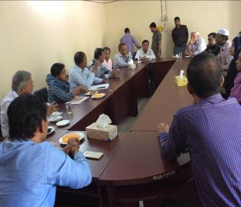
Photographs 7.1.1: Consultation Meeting at Patiya Pourashava with Pourashava Mayor, Officials and Consultants Participants
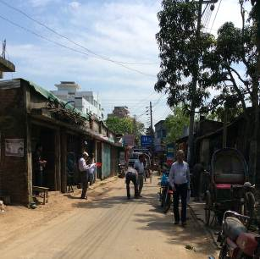
Photographs 7.1.2: Consultant Team visited the sites with the Pourashava Representatives

Issues Raised by the Participants

The participants raised the issues related to infrastructure development of Patiya Pourashava. In the CIP and FGD, the participants discussed about the requirements for the Pourashava future development through a list of the subprojects.

Feedback, Suggestions and Recommendations of the Participants

The participants’ feedback, suggestions, and recommendations listed below:
- The FGD results confirmed that an improved road and drainage network to be needed for future development of Patiya Pourashava;
- The participants suggested that the subproject should be inclusive such as road, drain and street light can consider for the same road;
- The participants also suggested that canal excavation subproject, dumping station, kitchen market and community center subproject should be considered;
- The Pourashava officials stated that the allocated budget should be increased because the number of subprojects that have been selected for each financial year is insufficient;
- The participants stated that the subprojects should be implemented following the environmental safeguard measures.

Conclusions and Recommendations

The environmental impacts of all the elements of the subproject have been assessed. All potential impacts were identified in relation to design and location, construction, and operation phases. The overall conclusion is that if the mitigation, compensation and enhancement measures are entirely implemented, there will be no considerable negative environmental impacts as a result of location, design, construction and or operation of the proposed subproject.

A few key recommendations are outlined below:
- A copy of the EMP shall be kept on-site during the construction period at all times
- The environmental management and monitoring plan proposed in this report also needs to be followed;
- A specific training program should be carried out for Pourashava staffs to deliver overall facts for environmental safeguards;
- Regular site visit should be conducted for the effective implementation of the EMP;
- Field visit, document checks, and interviews with workers and beneficiaries should be continued and any requirements for corrective action will be reported to the LGED and WB;
- The consultation process should be continued during subproject implementation to ensure that stakeholders are fully engaged in the subproject;
- Equipment should be checked by the Pourashava engineer and DSM consultant prior to work.

It should be noted that environmental assessment report is a live document. Hence, due to changing circumstances during the construction phase if any, there might be minor adaptation needed for environmental, health and safety issues.

References

Patiya Pourashava Website. http://patiyapourashava.gov.bd/about-pourashava/.

Geological Survey of Bangladesh, 1978. Earthquake Zoning Map.

Bangladesh Meteorological Department, 2015. Climate data for Chittagong District.

Patiya Pourashava Master Plan, 2013.

GoB (1997), Environmental Conservation Rules 1997.

Environmental Assessment Volume 1: Overall Environmental Assessment [Draft Final Report], September 2013. Municipal Governance and Services Project (MGSP), Local Government Engineering Department (LGED) and Bangladesh Municipal Development Fund (BMDF), Ministry of Local Government, Rural Development and Cooperatives, Government of the People's Republic of Bangladesh.

Environmental Assessment Volume 2: Environmental Management Framework (EMF) [Draft Final Report], September 2013. Municipal Governance and Services Project (MGSP), Local Government Engineering Department (LGED) and Bangladesh Municipal Development Fund (BMDF), Ministry of Local Government, Rural Development and Cooperatives, Government of the People's Republic of Bangladesh.

Population and housing census, 2011, National Volume-II: Union Statistics.

APPENDIX
Appendix-I: Design of the Waste Bins
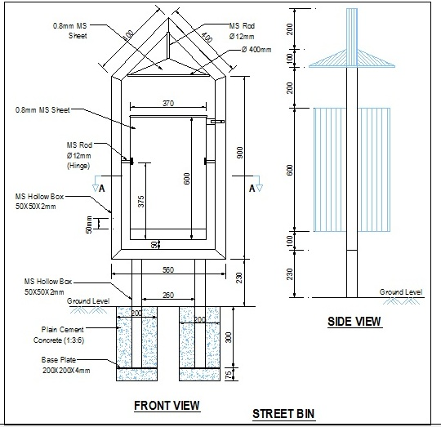
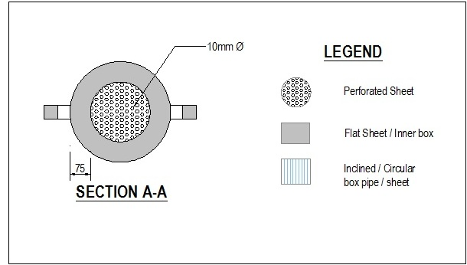

Appendix II: Environmental Monitoring Checklist

