
GOVERNMENT OF THE PEOPLE’S REPUBLIC OF BANGLADESH
Local Government Engineering Department (LGED)

Local Government Division

Ministry of Local Government, Rural Development and Cooperatives

Environmental Assessment (EA) REPORT

Name of the Subproject: Construction of BC Road from Gumutia bridge to Faruk Master house, Construction of RCC Drain from Taher Sarder house to Chargupat via Basu pathan More and Construction of RCC Box culvert near old cattle market at Nasirnagar road

Package No: MGSP/MDP/2018-2019/W-05

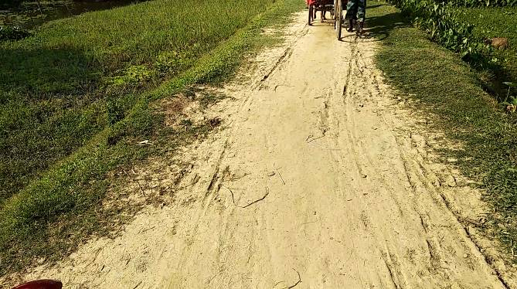
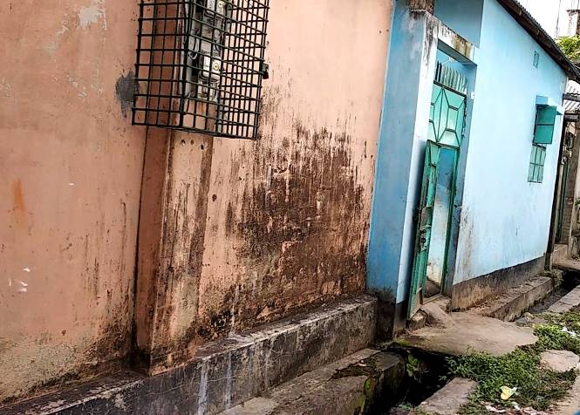
Madhabpur Pourashava, Habiganj

Municipal Governance and Services Project (MGSP)
Design, Supervision, and Management (DSM) Consultancy Services
Joint Venture of  Hifab International AB, Sweden  AQUA Consultant and Associates Ltd., Bangladesh |   

TABLE OF CONTENTS

 |  |  |  | Page No.
1.0 |  | INTRODUCTION |  | 1-3
 | 1.1 | Subproject Background |  | 1
 | 1.2 | Objectives of the Study |  | 2
 | 1.3 | Scope and Methodology of the Study |  | 2
2.0 |  | SUBPROJECT DESCRIPTION |  | 4-11
 | 2.1 | The Study Area |  | 4
 | 2.2 | Current Situation, Proposed Intervention and Need for the Subproject |  | 7
 | 2.3 | Justification of Selection of the Subproject |  | 10
 | 2.4 | Envisaged Subproject Activities and Implementation Process |  | 10
3.0 |  | BASELINE ANALYSIS OF ENVIRONMENTAL CONDITION |  | 12-19
 | 3.1 | Physical Environment |  | 12
 | 3.2 | Biotic Environment |  | 18
 | 3.3 | Socio-economic and Socio-cultural Environment |  | 18
4.0 |  | ENVIRONMENTAL SCREENING |  | 20-22
5.0 |  | SPECIFIC IMPACT, MITIGATION AND ENHANCEMENT MEASURES |  | 23-29
 | 5.1 | Dismantle Work, Site Clearing, Excavation Work and Earth Work |  | 23
 | 5.2 | Tree Felling, Clearing of Vegetation and Ecological Impact |  | 23
 | 5.3 | Pollution from the Construction Materials |  | 23
 | 5.4 | Air Quality and Dust |  | 24
 | 5.5 | Noise and Vibration |  | 24
 | 5.6 | Water Quality |  | 25
 | 5.7 | Occupational Health and Safety |  | 25
 | 5.8 | Impacts on Social Environment and Common Property Resources |  | 26
 | 5.9 | Labor Influx and Anticipated Impacts |  | 27
 | 5.10 | Impacts on Traffic Movement |  | 29
6.0 |  | ENVIRONMENTAL MANAGEMENT PLAN |  | 30-
 | 6.1 | Access to Information |  | 30
 | 6.2 | Grievance Redress Mechanism |  | 30
 |  | 6.2.1 | Grievance Redress Committee (GRC) | 30
 |  | 6.2.2 | Grievance Resolution Process | 31
 | 6.3 | Institutional Arrangement for Safeguard Compliances |  | 32
 | 6.4 | Capacity Building |  | 33
 | 6.5 | Emergency Response and Disaster Management |  | 33
 | 6.6 | Environmental Management Action Plan |  | 34
 | 6.7 | Environmental Monitoring Plan |  | 40
 | 6.8 | Environmental Management Budget |  | 41
7.0 |  | PUBLIC CONSULTATION AND PARTICIPATION |  | 43-
 | 7.1 | Methodology |  | 43
 | 7.2 | Issues Raised by the Participants |  | 43
 | 7.3 | Feedback, Suggestions and Recommendations of the Participants |  | 43
8.0 |  | CONCLUSIONS AND RECOMMENDATIONS |  | 45
9.0 |  | REFERENCES |  | 46
APPENDIX 47-64
Appendix I: Environmental Monitoring Checklist |  |  |  | 48-64

LIST OF TABLES
Table 3.1.1 | Major Environmental and Infrastructural Features at the road from Gumutia Bridge to Faruk Master House (Ch. 0-985m)
Table 3.1.2 | Major Environmental and Infrastructural Features at the Road from Taher Sarder house to Chargupat via Basu pathan More (00+00~0+440 m) and the Box Culvert at Nasirnagar Road
Table 5.7.1 | General Requirements for the Workers Health and Safety
Table 5.8.1 | Impacts on Social Environment and Common Property Resources
Table 6.2.1. | List of GRC committee members
Table 6.6.1 | Anticipated Environmental Impacts during Construction Phase and Corresponding Mitigation and Enhancement Measures
Table 6.6.2 | Anticipated Environmental Impacts during Operational Phase and Corresponding Mitigation and Enhancement Measures (EMP Table)
Table 6.7.1 | Matrix Table of Monitoring Plan (Visual and observation during construction phase)
Table 6.8.1 | Environmental Measurement Budget

LIST OF FIGURES
Figure 2.1.1 | Location Map of the Subproject
Figure 2.1.2 | Layout Plan of the Subproject component (Gumutia- Faruq Master House Road)
Figure 2.1.3 | Topographical View of the Subproject
Figure 3.1.1 | Soil regions of Bangladesh
Figure 3.1.2 | Earthquake zones of Bangladesh
Figure 3.1.3 | Location of Madhabpur Pourashava in the Flood Zoning Map of Bangladesh
Figure 6.3.1 | Environmental and Social Management Team (Tentative)

LIST OF PHOTOGRAPHS
Photographs 2.2.1 | Current Situation of the Subproject Sites
Photographs 2.2.2 | Current Situation of the Outfall
Photographs 7.1.1 | Consultation Meeting with Pourashava Officials and Local Individuals at Subproject Sites

ABBREVIATIONS
AP (AP’s) | Affected Person
BDT | Bangladeshi Taka
BOQ | Bill of Quantity
CC | Cement Concrete
CIP | Capital Investment Plan
CP | Contingency Planning
DSM | Design, Supervision, and Management
EA | Environmental Assessment
ECR | Environmental Conservation Rules
EMP | Environmental Management Plan
EPP | Emergency Preparedness Planning
ES | Environmental Screening
FGD | Focal Group Discussion
GoB | Government of Bangladesh
GRC | Grievance Redress Committee
GRM | Grievance Redress Mechanism
GRP | Grievance Redress Procedure
IIS | Infrastructure Improvement Section
LGED | Local Government Engineering Department
MGSP | Municipal Governance and Services Project
PD | Project Director
PMU | Project Management Unit
RCC | Reinforcement Cement Concrete
RP | Relevant Reports
TL | Team Leader
ULB | Urban Local Body
WB | World Bank
XEN | Executive Engineer

Introduction

Subproject Background
Madhabpur Pourashava is located in the Southern part of Habiganj District. Madhabpur Pourashava was established in the year of 1997. At present, Madhabpur is A type Pourashava. It has an area of 7.88 sq. km. The present population of Madhabpur Pourashava is about 21,930. The Pourashava has 50 km road. Among these, 15.34km katcha road, 4.86 km semi-pucca road, and rest 17.73 km pucca road. It has 6.42 km manmade drain among which 5.51 km pucca drain. (Source: Pourashava Master Plan)
Like other Pourashava in Bangladesh, the current infrastructure of Madhabpur Pourashava is also in vulnerable state. The existing road network is not adequate to meet the present demand. Additionally, damaged and narrow road aggravates the traffic problem. Most importantly, most of the roads are earthen. Madhabpur Pourashava also faces severe water logging during rainy season due to inadequate drains and encroachment of the existing drainage network. The existing drains are also not functional due to insufficient capacities, and blockage. In the Pourashava, the existing street light is not adequate. Hence, new infrastructure development such as road, drain, culvert is essential to cope with the demand and improve the situation.

This subproject includes the following components: BC Road, RCC drain and RCC Box Culvert. The significant features of the subproject are stated below:
Name of the Subproject: | (a) Construction of Bituminous Carpeting Road starting from Gumutia bridge to Faruk Master house with link to Mosque (Ch. 00+000 – 00+985, link Ch.00+00 – 00+060);  (b) Construction RCC Drain from Taher Sarder house to Chargupat via Basu pathan More (00+00~0+440);  (c) Construction of RCC Box culvert near old cattle market at Nasirnagar;
Package No. : | MGSP/MDP/2018-2019/W-05
District Name : | Habiganj
ULB Name : | Madhabpur Pourashava
Jurisdiction area : | Wards nos. 3, 4, 5 and 7
Design Option : | BC Road, RCC Drain and RCC Box Culvert
Beneficiary Population : | About 60,000
Tribal People : | No tribal people settlement found in the subproject area
Land Acquisition : | Land acquisition is not required.
Estimated Cost : | BDT 30.74 Million
Subproject Duration : | 12 Months
Tentative Start Date : | 26 December, 2018
Tentative Completion Date : | 25 December, 2019

Objectives of the Study

The general objective of this study is to determine the major environmental impacts succeeding from execution of the subproject and to recommend mitigation measures to avoid or reduce adverse environmental impacts and to enhance positive impacts. The specific objectives include:
- To assess the existing environmental conditions of the subproject site and its influence area;
- To identify and assess impacts resulting from the subproject during its construction phase and operation phase;
- To develop an environmental management plan with recommendations for mitigating impacts and enhance positive impacts;
- To summarize environmental monitoring requirements.

Scope and Methodology of the Study

The subproject appraisal included environmental screening for all the subproject components. According to that screening, environmental assessment is required to fulfill the regulatory requirement for BC Road, RCC Drain and RCC Box Culvert. The study methodology comprised the following activities:

Desktop Study

The desktop study involved:

- Initial meetings with client and stakeholders to discuss about the proposed subproject including subproject activities;
- Collection and review of the baseline data, maps, reports and other relevant information on the existing environmental and social conditions of the subproject area;
- Review of the relevant existing legislation, regulation and policies;
- Understanding the anticipated technical processes that may affect the environment.

Field Investigation and Data Collection

A team of the consultants made a field investigation to the proposed site. Field investigations involved mainly site walks within the subproject area and the neighboring areas that may be affected by the subproject. The following key tasks were performed during the field visit:
- Taking photographs of the significant aspects to describe the baseline environmental conditions of the subproject area;
- Interviews with representatives of the Pourashava Officials, within the subproject area and interested and affected people within the subproject influence zone;
- Verifying information and data collected during the desktop study and to collect new information that may be important in the assessment of the impacts and design of the mitigation measures.

Data Analysis and Report Writing
The data and information collected from all the sources (literature review, secondary and primary data, public consultation) were analyzed to describe the existing environmental setting of the subproject area, to identify the potential positive and negative impacts of the proposed subproject, as well as to provide preliminary suggestions for mitigation measures. Finally, after analyzing all the data, this environmental assessment report has been prepared.

SUBPROJECT DESCRIPTION

The Study Area

The subproject covers the jurisdiction area of the Ward number 3, 4, 5 and 7 of Madhabpur Pourashava. The Location Map, Lauout Plan and Topographical View of this subproject are shown in Figure 2.1.1, 2.1.2 and 2.1.3
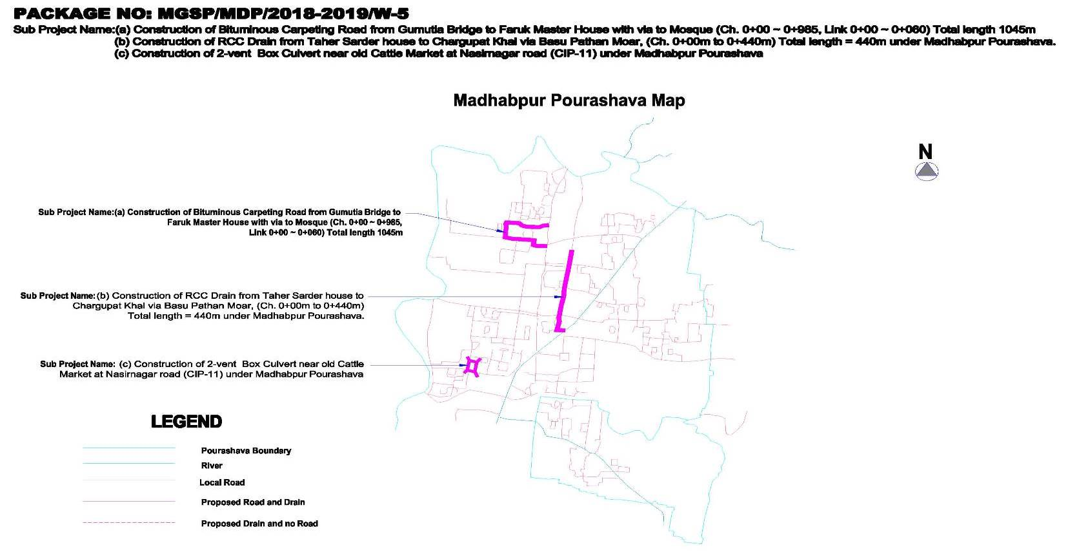

Figure 2.1.1: Location Map of the Subproject
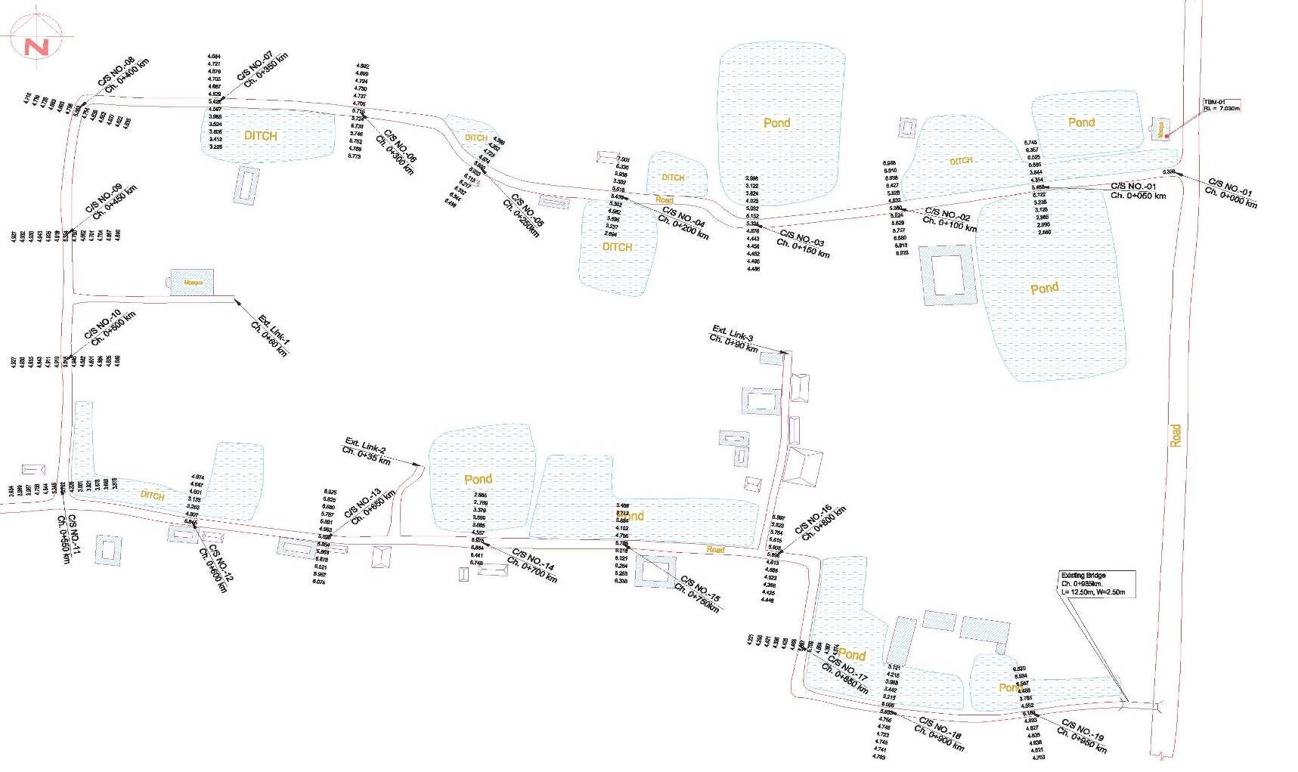

Figure 2.1.2: Layout Plan of the Subproject component (Gumutia-Faruq Master House Road)
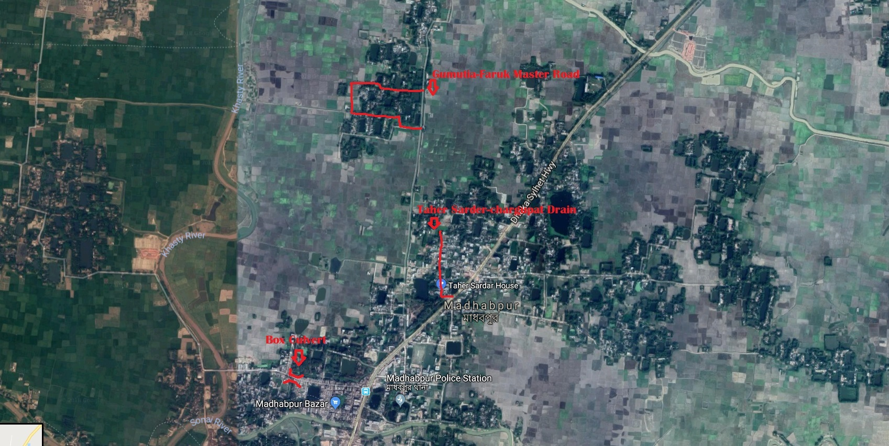
Figure 2.1.3: Topographic View of the Subproject

Current Situation, Proposed Intervention and Need for the Subproject

The subproject components are located in rural residential area as well as commercial area.
Proposed BC road will start from Faruk Master house and will end at Gumutia bridge at the junction of Gudampara road which is in the construction stage at present. There is an existing HBB road from Ch. 885-985 m. The HBB road is badly damaged and scraped at most places. Rest of the existing road is earthen. Existing road width is between 3 to 4 meters. The earthen road becomes muddy during rainy season and becomes extremely hazardous for pedestrians and vehicles to move on the road due to slippery surface. This is one of the main roads connecting surrounding area with the core Pourashava. So, when this road becomes unusable during rainy season, it creates huge disturbance in the daily lives of the local people due to difficulty in communication. Moreover, narrow width of the road makes it difficult for even two vehicles to pass side by side. There is also a 60m link road at the left side at Ch. 350m of the main road which is also earthen. The link road ends at Gumutia Jame Mosque. There is a pipe culvert at Ch. 0m and a slab culvert at Ch. 985m. Both of the culverts are damaged. To mitigate these problems a BC road from Ch. 0-985m has been proposed. Two RCC box culverts of size 2-2.5X3.3 has also been proposed in place of the existing two damaged culverts. A total of 130m palisading at Ch.00+760 -00+790 (right side) and at Ch.00+850 -00+950 (left side) has been proposed to protect the road from collapsing into ponds. Three cross drains will also be constructed.
Proposed RCC drain will start from Taher Sardar house and will end at Chargupat. It will go through Basu pathan more at midpoint. At present, there is an existing brick drain from Ch. 0m to Ch. 120m. The brick drain is very narrow and extensively damaged. It is insufficient to drain out storm water during rainy season. Consequently, storm water stagnates on the road and makes the road unusable to pedestrians and vehicles. Local people badly suffer due to water logging. Moreover, the narrow width of the existing road (3m on average) makes the situation difficult. So, an RCC drain will be constructed at the left side of the road with road level cover slab from Ch. 0m to Ch. 440m. There will be two outfalls for the proposed drain. Both of the outfalls are existing drain which discharges into the Sonai River. The outfalls are at Ch. 120m and at Ch. 440m.
At present, there is an existing culvert on the canal near cattle market on Madhabpur to Nasirnagar road. The culvert is badly damaged. Brick abutment and wing walls are also badly damaged with several cracks. The road connects the Madhabpur upazilla with the Nasirnagar upazilla; so, huge number of vehicles including heavy vehicles move on this road every day. The culvert may collapse at any time due to its poor condition. To prevent dangerous accidents, a 2 vent 3.3m box culvert has been proposed in place of the existing culvert. The box culvert will have 8m approach road at both sides of the culvert.
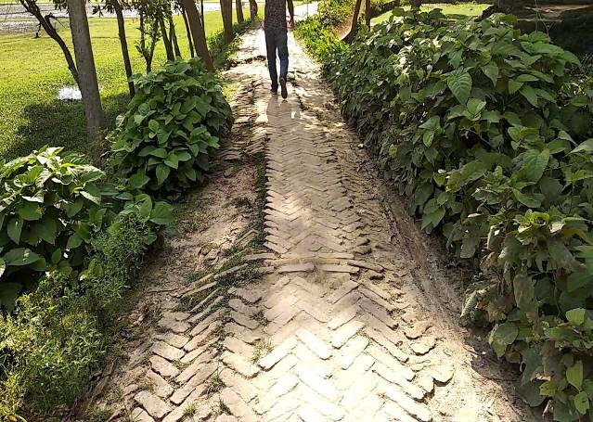
The existing site condition is further exhibited in the following Photographs 2.2.1.
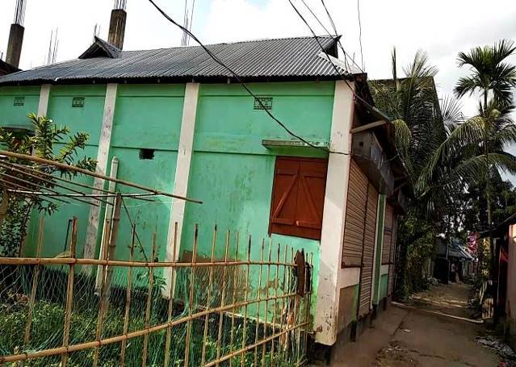

Photographs 2.2.1: Current Situation of the Subproject Sites
The Taher Sarder house to Chargupat Drain will discharge into two existing drains, one at midpoint and the other at the end of the drain near Chargupat which are ultimately discharged into the Sonai River.
The existing condition of the outfalls is shown in the Photographs 2.2.2.
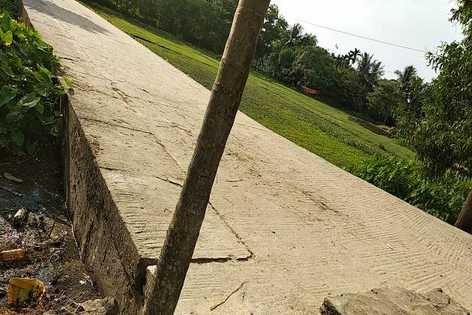
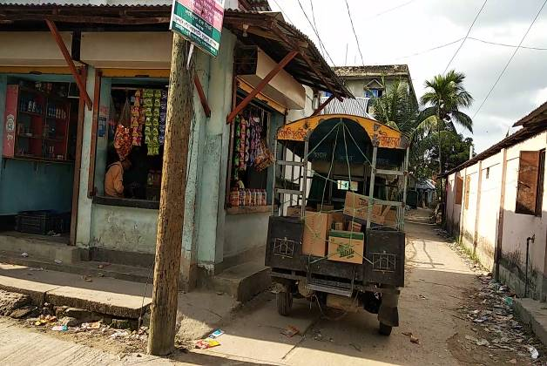

Photographs 2.2.2: Current Situation of the outfalls (Existing Drain)

Justification of Selection of this Subproject

According to the CIP list, Madhabpur Pourashava prepared the priority list of the subprojects considering the demand and requirement. As a part of the reconnaissance survey, PMU Officials and DSM consultants’ visited and evaluated the existing site condition of the subproject.
From the environmental screening it is revealed that the ecological impacts due to this subproject will be moderate. The subproject has adverse impacts on the physicochemical environment. However, it is anticipated that the adverse impact is not significant and limited within the subproject boundary. The Pourashava authority has consulted with the beneficiaries. The beneficiaries have no objection regarding the implementation of the subproject. Considering the significant potential benefits that will derive after completion, the local community demands and welcome this subproject.

Envisaged Subproject Activities and Implementation Process

The general activities of the subproject includes: construction of the semi-pucca site office, construction of the labor shed and relocation of the electrical poles.
Specific activities for BC Road:
- Site clearing work;
- Preparation of the hard bed by scarifying and loosening of the existing top;
- Earth work in box cutting;
- Sand filling on the road bed;
- Brick on end edging;
- Compacted aggregates and sub-base course;
- Providing prime coat;
- Lying pre-mixed dense bituminous surfacing.

Specific activities of the RCC Drain with Cover Slab include:
- Earth work in excavation for the foundation;
- Pumping and bailing out of water as per requirement;
- Sand filling for the preparation of foundation bed;
- Plain cement concrete work in foundation;
- Manufacturing CC blocks;
- Fabrication of the ribbed or deformed bar;
- Reinforced cement concrete work.

The materials to be used for the key activities: bricks, brick chips, stone chips, reinforcement bar, admixture, sand, cement, concrete.
The major equipment to be used for the implementation of the subproject: Brick breaking machine, concrete mixer machine, vibrator machine, MS sheet, steel cutter, steel shutter, steel drum rollers, pneumatic multiple tire roller, dump truck, water tanker, pump, generator and measuring device. The tentative schedule of construction of the subproject is:
(a) Subproject Duration (Months) : 12 Months
(b) Tentative Start Date : 26 December, 2018
(c) Tentative Completion Date : 25 December, 2019

The daily construction hours will normally include regular working time. However, daily working hours may vary based on the on-site condition.

Baseline ANALYSIS OF THE ENVIRONMENTAL CONDITION

Physical Environment

Important Environmental and Infrastructural Features

During site visit the environmental and infrastructural features within the subproject area were collected. Conditional survey has also been conducted for designing the subproject. Hence, survey data is also used for preparing the report. The environmental and infrastructural features listed within 100 m of the both sides of the roads from the center line considering 100 m longitudinal interval. The major environmental and infrastructural features of the subproject are shown in table 3.1.1 and 3.1.2.
Table 3.1.1: Major Environmental and Infrastructural Features at the road from Gumutia Bridge to Faruk Master House (Ch. 0-985m)
Chainage | Left | Right | Major Environmental and Infrastructural Features at the road from Gumutia Bridge to Faruk Master House (Ch. 0-985m)
0-100 | √ |  | Trees, vegetation, pond
0-100 |  | √ | Trees, vegetation, ditch with water hyacinths
100-200 | √ |  | Semi pucca houses
100-200 |  | √ | Open space, trees, vegetation, pucca and semi-pucca houses, swamp
200-300 | √ |  | Swamp with vegetation, trees, open space
200-300 |  | √ | Swamp, trees, vegetation, open space
300-400 | √ |  | Connecting road to the Gumutia Jame Masjid, paddy lands, swamp
300-400 |  | √ | Paddy lands
400-500 | √ |  | Marshland, trees, vegetation, paddy lands
400-500 |  | √ | Pucca, semi-pucca and tin-shed infrastructures, trees, vegetation, paddy lands
500-600 | √ |  | Pucca, semi-pucca and tin-shed infrastructures, trees, vegetation
500-600 |  | √ | Pucca, semi-pucca and tin-shed infrastructures, trees, vegetation
600-700 | √ |  | Pond, tin-shed residential houses, connecting road
600-700 |  | √ | Pucca, semi-pucca and tin-shed infrastructures
700-800 | √ |  | Connecting road, tin-shed residential houses, pond, trees, vegetation, BURO office (NGO),
700-800 |  | √ | Pond, trees, vegetation, pucca residential house,
800-900 | √ |  | Trees, vegetation, low lands, marshland
800-900 |  | √ | Trees, vegetation, low lands, marshland
900-985 | √ |  | Gumutia khal, Gumutia primary school, pond, trees, vegetation, low lands
900-985 |  | √ | Gumutia khal, farm lands, trees, vegetation, low lands
Major Environmental and Infrastructural Features at the Link Road towards the Gumutia Jame Mosque (0-60m)
0-60 | √ |  | Paddy lands
0-60 |  | √ | Paddy lands, trees

Table 3.1.2: Major Environmental and Infrastructural Features at the Road from Taher Sarder house to Chargupat via Basu pathan More (00+00~0+440 m) and the Box Culvert at Nasirnagar Road
Chainage | Left | Right | Major Environmental and Infrastructural Features at the Road from Taher Sarder house to Chargupat via Basu pathan More (00+00~0+440 m)
0-100 | √ |  | pucca and semi-pucca houses, trees
0-100 |  | √ | pucca and semi-pucca houses, trees, ditch
100-200 | √ |  | pucca and semi-pucca houses, trees
100-200 |  | √ | pucca and semi-pucca houses, trees, ditch, mosque
200-300 | √ |  | Connecting road, pucca and semi-pucca houses, trees, open space
200-300 |  | √ | Connecting road, pucca and semi-pucca houses, trees
300-400 | √ |  | pucca and semi-pucca houses, trees
300-400 |  | √ | pucca and semi-pucca houses, trees
400-440 | √ |  | pucca and semi-pucca houses, trees
400-440 |  | √ | pucca and semi-pucca houses, trees
Major Environmental and Infrastructural Features around the box culvert
Side/Direction |  |  | Major Environmental Features
North |  |  | Canal
South |  |  | Canal, Pashu hospital
East |  |  | Madhabpur puran bazar/cattle market
West |  |  | Shabuzbag

Geology, Topography, and Soils

The subproject area is situated near Sonai River-Bank. The soil of Madhabpur Pourashava typically is non-calcareous dark grey floodplain soils. Non-calcareous dark grey floodplain soils occur extensively on the Old Brahmaputra and old Meghna estuarine floodplain. Silt loam and silty clay loam are predominant on the Meghna estuarine floodplain and in the Tista meander floodplain, whereas silty clays and heavy clays are extensive on the Old Brahmaputra floodplain. The majority of these soils are Eutric Gleysols. (FAO-UNDP, 1988-History of Soil Research in Bangladesh).

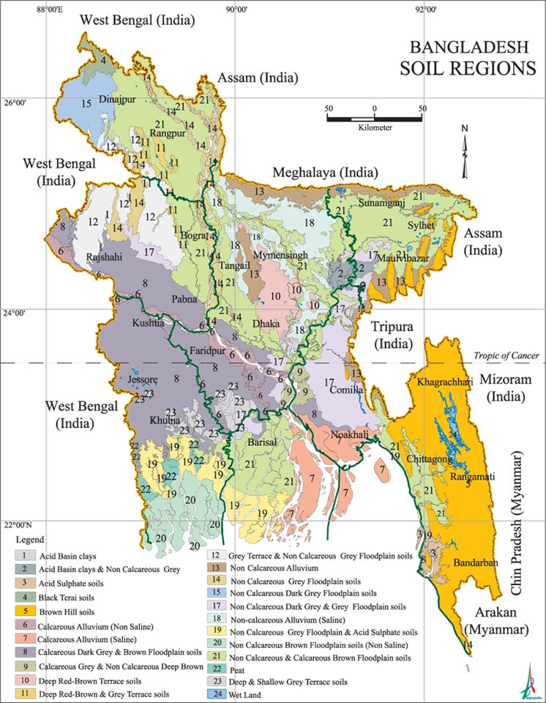

Figure 3.1.1: Soil regions of Bangladesh

According to earthquake zoning map of Bangladesh, Madhabpur falls in Zone-1 which is the most vulnerable earthquake region of Bangladesh. Zone-1 inhabits nature-on-the-move. Tectonic shifts continue to lift the highlands and depress the deepest-flooding ‘haor’ basins (GSB, 1978). The earthquake zoning map of Bangladesh is shown in Figure 3.1.2.

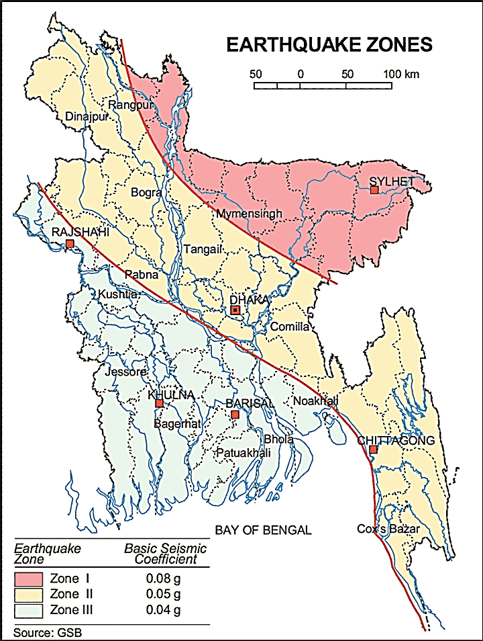

Figure 3.1.2: Earthquake zones of Bangladesh

Climate and Meteorology

Madhabpur has a tropical climate and except heavy rainfall, the climate is much like other parts of the country. The mean annual rainfall is 3880 mm with the heaviest occurring during June-July period.
The cool and dry winter (December-February) is followed by a hot and showery pre-monsoon period (March-May), and then the relatively cooler but very wet monsoon season, (June-September). This is followed by a transitional humid and showery period up to the beginning of the winter. Madhabpur is not affected by cyclones which periodically devastate coastal districts, but squally winds accompanying thunderstorms in March-May and in September-November often cause damages.
In summer (March-May) mean temperature is approximately 26.6°C with extreme minima and maxima ranging between 12.2°C to 40.6°C, while the winter mean is 19.7°C. June to September is the period of the true monsoon but humid conditions continues up to early October. The average temperature is 26°C to 33°C and extreme maxima about 37.8°C during the monsoon period. From mid October to late February, the weather is dry and relatively cool. The average temperature is between 18°C to 21°C, with extreme minima and maxima ranging between 5.6°C and 32.8°C.
Local meteorological station is situated in Sylhet. Hence, rainfall data of Madhabpur Pourashava has been collected from the regional meteorological station. It presents the highest annual rainfall was recorded in 2000 which was 4692 mm with monthly rainfall of 391mm. In this time period, the lowest rainfall recorded in 1999 was 3334mm with average monthly rainfall of 277.84 mm. (Source: Pourashava Master Plan)
The construction works can be influenced by the climatic condition and meteorological components like humidity, temperature, sudden rainfall, and wind speed. High winds can enhance quick spreading of the generated dust. It is very risky working under rain and in high winds because the possibility of getting injury increases. Furthermore, work under high temperature and excess humidity may create health hazards like dehydration problem.
The construction works can be influenced by the climatic condition and meteorological components like humidity, temperature, sudden rainfall, and wind speed. During high winds, dust generated from the construction activities may spread quickly. It is very risky to work under rain and in high winds because the possibility of getting injury increases. Furthermore, work under high temperature and excess humidity may create health hazards like dehydration problem.

Hydrology (Surface Water, Ground Water and Rain Water Harvesting)

Madhabpur Pourashava is located within Sylhet (Surma-Kushiyara) Basin is a part of Meghna Basin which is the smallest, unpredictable and chaotic basins by hydraulic means. Surface water of ponds, canals and river at Madhabpur is fresh and free from salinity. In the subproject area, Sonai River and Boalia Khal are major surface water sources. Ground water level found at Madhabpur Pourashava was 3.65 - 4.27m at dry season. Groundwater of Madhabpur has excessive of Iron (Fe) and Arsenic (As) (Source: DPHE, Madhabpur, 2009).

Flooding, Water Logging and Drainage Pattern

Flash flood occurs at Madhabpur Pourashava in one or more time in every two or four years interval and is caused by heavy rains. Last flood occurred at Madhabpur Pourashava in the year of 2008. There is water logging problem at Madhabpur Pourashava. Duration of water logging is 5-7 days and it mainly occurs between June and November every year. Though in Madhabpur Pourashava, the natural drainage system (khals, water bodies) is active but illegal encroachment and blockage of the water bodies due to the unauthorized and unplanned waste dumping creates water logging problem. Location of Madhabpur Pourashava in the flood zoning map of Bangladesh is shown in Figure 3.1.3.
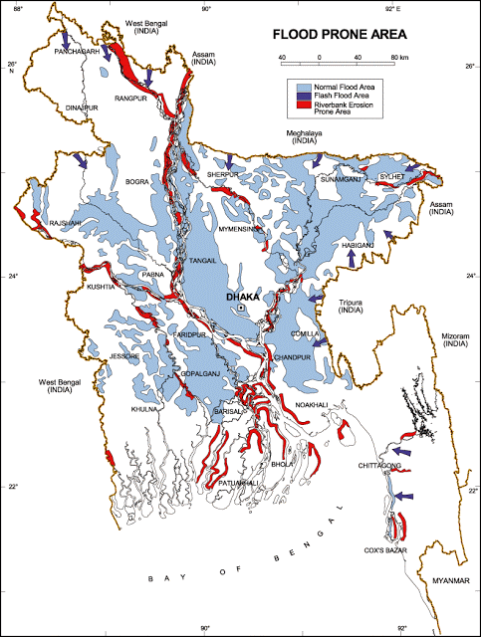

Figure 3.1.3: Location of Madhabpur Pourashava in the Flood Zoning Map of Bangladesh
Air Quality and Dust
Ambient air quality data have not been found. As Madhabpur Pourashava is a small town having no industrial activities other than saw mill and vehicular traffic, it is almost free from air pollution. In the subproject roads, the dusty and rough surfaces generate windblown dust. In addition, improper disposal of the solid wastes spread objectionable bad odor in air.

Noise Level
Noise level seems low in the subproject area. During construction phase, concrete mixer machine, vibrator machine, hydraulic excavator and vehicles used for transportation activities may create temporary noise nuisance within the subproject boundary.
Solid Waste Management
There is no formal dustbin in this Pourashava. One waste collection truck and two push carts are used to collect solid waste which is inadequate. Hence, the local people dump their solid wastes in the road side drains, open space or roads adjacent to their houses, low lying areas, in khals and ditches. There is also awareness among the community people. Therefore, improper solid waste disposal creates severe public health hazards and degrading the quality of living environment. Currently, the vacant place near Gabtali, Katiara is used as a Pourashava designated dumping site for household wastes (solid and kitchen waste).

Biotic Environment

Flora and Fauna
The subproject area is full of natural floral and faunal diversity. There are planted trees along the road include Mango, Jackfruit, Banana, Coconut, Betel nut, Koroi, Mahogany and many others. The natural aquatic plants and flora make greenish lash ending portion of the subproject area. Bengali names of some commonly found birds include Chorui, Doel, Masranga, Finge, Kath thokra, Ghugu , Shalik, Chil, Baz, Pecha, Tia, Bok, Kak, Tuntuni, Bulbuli, Kokil (Cuckoo), Dahuk, Pankouri, Bee eater, Bat.

Socio-economic and Socio-cultural Environment

Land Use, Status of Housing and Built-up Infrastructure

The Gumutia Bridge to Faruk Master House road is located in a rural area surrounded by agricultural lands. While Taher Sarder House to Chargupat Drain is located in a residential area. The Box Culvert at Nasirnagar road is located near Madhabpur Bazar which is a commercial area. The built-up infrastructure in the subproject influence area mainly includes pucca, semi-pucca and tin-shed houses and shops.

Beneficiary Population

The subproject covers the jurisdiction area of the ward number 3, 4, 5 and 7. As per information by the municipality, considering the wards’ population about 60,000 people will be benefitted directly and many others indirectly.

Education

Literacy among the population is about 34.4%, which is lower than the national average (51.8%). The literacy rate among males (36%) is more than females (32.8%). [Population and Housing Census 2011]

Tribal Communities

There is no indigenous or tribal people settlement in the subproject area. Therefore, there are no measures needed for indigenous peoples’ safeguard.

Land Acquisition and Resettlement

Private land acquisition is not needed.
Principal Livelihoods and Economic Activities
Economic activity is the lifeblood of any urban center. The subproject area is now inhabited by the mixed occupational people where the major income comes from non-farm activities such as business, enterprises, jobs, transport vehicle ownership and operation. Presently, a significant number of people work in the small trades, private sector jobs and government jobs in the Pourashava area, and transport operations. Madhabpur bazar which is located at the middle of Pourashava is a largest wholesale market.

Cultural Heritage and Protected Areas
During site visit it was observed that there is no protected and important cultural or historical site in the subproject influence area.
Social Conflicts and Development Activities
The local people welcome the subproject and there is no conflicts between the local communities regarding subproject implementation.

ENVIRONMENTAL SCREENING

Environmental Screening Checklist, as adopted in Appendix C of the Environmental Management Framework (EMF) of the MGSP, was administered for identifying the impacts and their extents.
The screening data for the BC Roads, RCC Drain and RCC Box Culvert have been formulated and are shown in below:
(1) Potential environmental impact during construction phase:

- Ecological impacts:
208
- Felling of trees Significant □ Moderate □ √ Minor □ Number of trees
- Clearing of vegetation Significant □ Moderate □ √ Minor □
- Potential impact on species of Significant □ Moderate □ Minor □ √
aquatic (i.e., water) environment

Many roadside naturally grown and planted trees need to be cut down to construct the BC road. Trees to be cut down to construct the drain and the box culvert are very few. Major trees to be cut down are: Mango, Jackfruit, Mahogany, Coconut, Koroi, Rain-tree, Chalta, Kadam, Guava, Jam etc. Large amount of vegetation is also needed to be cleared due to the road construction. Anticipated impact on species of aquatic environment is minor because except throwing of the wastes materials into the roadside ditches, swamps and paddy lands the subproject does not have any impact on the aquatic environment. Considering all the effects, ecological impact is considered as significant.
- Physicochemical impacts:

- Noise pollution Significant □ Moderate □ √ Insignificant □
- Air pollution Significant □ Moderate □ √ Insignificant □
- Drainage congestion Very likely □ Likely □ Unlikely □√
- Water pollution Significant □ Moderate □ Insignificant □ √
- Pollution from solid/ construction wastes Significant □ Moderate □ √ Insignificant □
- Water logging Significant □ Moderate □ Insignificant □ √

The subproject will have impacts on noise and air quality during construction phase due to mobilization of the equipment, vehicles movement for the transportation of the materials, using of hydraulic excavator, mechanical compaction machine, paver, asphalt plant, concrete mixer machine, vibrator machine etc. The construction work will be performed section wise. The Gumutia to Faruq Master House Road is located in a sparsely populated area. Hence, it is anticipated that the overall impacts on noise and air quality will be moderate, temporary and limited within the subproject boundary. The generated dust and black smoke emission from the equipment during construction activities may disturb the local people. Improper collection and disposal of the generated wastes materials may degrade the quality of the surrounding environment and degrade the aesthetic value. Anticipated water logging and drainage congestion during construction period at the Gumutia to Faruq Master House Road is minor as the road is surrounded by low lands, paddy fields and ditches.

- Socio-economic impacts:

- Traffic congestion Very likely □ Likely □√ Unlikely □
- Health and safety Significant □ Moderate □√ Insignificant □
- Impact on archaeological and historical Significant □ Moderate □ Insignificant □√
- Employment generation Significant □ Moderate □ √ Insignificant □

Though it is temporary and site specific; however, the construction activities will have likely negative impact on local traffic system. However, during construction work, using of connecting roads may help reduce traffic congestion. In addition, construction work will be performed section wise to minimize traffic congestion. A temporary diversion road should be constructed during the construction of the box culvert. The construction work will follow simple procedure with commonly used equipment. Hence, anticipated impact on health and safety is moderate. There is no archaeological and historical site within the influence area. The subproject will have positive impacts by generating employment opportunities for the local people and creating business opportunity of supplying construction materials, equipment, food and other necessary stuffs to the work camp.
(2) Potential Environmental Impact during Operational Phase:
- Ecological impacts:

- Potential impact on species of aquatic Significant □ Moderate □ Minor □ √
(i.e., water) environment
The road component does not have any likely impact on the aquatic environment during operation. Though, the drain is designed for storm water; however, the storm water may carry washed-out materials, pollutants from any sources that may disturb the aquatic environment of the outfall. Operation of the box culvert will not have any impact on aquatic species.
- Physicochemical impacts:

- Potential air and noise quality Improvement □ No-improvement □ Deterioration □√
- Drainage congestion Improvement □ √ No Improvement □ Deterioration □
- Risk of Water pollution Significant □ Moderate □ √ Minor □
- Pollution from solid waste Improvement □ Minor improvement □ Minor □√

During operation phase, improved and widened road may increase traffic volume. This may degrade the air quality and noise level due to black smoke emission and un-due use of hydraulic horn from the vehicles. Water logging due to the uneven earthen road holding rainwater will significantly reduce. During operation of the RCC drain, covered drain will reduce throwing of the waste materials in to the drain. This will reduce drain water pollution. Consequently, spreading of the bad odor will be minimized. The wastewater to be discharged may degrade the water quality of the outfall, if it carries pollutants. The new drain after construction will reduce water logging problem. Operation of the box culvert will have no impact on air or noise quality and drainage congestion. People using the box culvert may dump solid wastes directly into the canal under the culvert. This may block the canal.

- Socio-economic impacts:

- Traffic Improvement □√ No-improvement Adverse □
- Safety Improvement □√ No-improvement Adverse □
- Employment generation Significant □ Moderate □ Minor □ √

After completion, this road will improve the transport facilities of this rural area. By providing uniform pavement, it will also enhance traffic safety. Construction of BC road in place of the earthen road will save pedestrians and vehicles from accidents due to slippery surface during rainy season. Newly constructed drain will improve drainage facilities and prevent the accumulation of the stagnant water on the road surface. This will reduce wearing of the road surface. Consequently, it will enhance traffic safety. The new box culvert will decrease the threat of impending collapse and thus increase safety. It will also accommodate more heavy traffics. Traffic congestion will also be reduced due to increase in width.

(3) Summary of Possible Environmental Impacts of the Subproject:

The ecological impact for implementation of this subproject is moderate. There will be temporary negative impacts on physico-chemical environment (air and noise quality) during construction for using of construction equipment. Nevertheless, these impacts are manageable if mitigation measures are taken according to EMP.
The wastes generated due to the construction activities should be properly collected and disposed in a designated dumping site. Some earthwork will be involved for the construction work; however, no agricultural productive soil will be used for the purpose. The inputs that may affect the environment will be mainly at construction phase. Moreover, mitigation measures will be taken according to the EMP for minimizing the environmental pollution.
Using of the excavator and any other mechanical equipment may cause potential safety risks. Safety concern is an important issue for both the construction and operation phases that should be considered properly. This subproject will have positive impacts in terms of the generation of the employment and business activities by supplying construction materials and equipment. However, it has significant positive social impacts.

Specific impact, mitigation, AND enhancement measures

From the environmental study, the probable impacts of the subproject are mainly caused by the key activities required for the implementation of the subproject, raw materials and equipment to be used for the execution of the activities. This section describes some specific impacts due to the subproject activities and their mitigation measures.

Dismantle Work, Site Clearing, Excavation Work and Earth Work
The road improvement and drain construction work consists of dismantle works, site clearing, earth excavation, earth filling, back filling and removal of the unsuitable materials. These works lead dust blowing, construction waste generation, noise and vibration which disturb the local people.
Mitigation Measures

- Proper care will be taken by the contractor as well as Madhabpur Pourashava, during dismantle works, site clearing works, excavation, soil work and back filling so that this activity does not disturb the nearby establishment.
- Cover the exposed dry loose soil with fabric to avoid any dust generation;
- Disposal of unused soil and other construction wastes to designated dumping site at Katiyara.

Tree Felling, Clearing of Vegetation and Ecological Impact
208 numbers of trees are to be felled down during implementation of the project. However, 450 nos. of the trees will be planted at two sides of the Gumutia Bridge to Faruk Master House Road to compensate the felled trees, cleared vegetation and to enhance the ecological condition.
Mitigation Measures

- 450 nos. of trees will be planted to enhance the ecological condition (preferably local fruits, flowers, medicinal and ornamental trees-Mango, Jackfruit, Jam, Kathbadam, Chalta, Neem, Amloki, Horitoki, Arjun, Krisnachura, Sonalu, Jarul, Polash, Bokul, Mahogany, Rain Tree, Koroi, Palm Tree, Chambal, Satim, Banyan Tree at two sides of the Gumutia Bridge to Faruk Master House Road where space is available.
- Planting trees will enhance the ecological balance of the subproject area after their successful growth.

Pollution from the Construction Materials
Dumping of the construction spoils, including accidental leakage of the oil, grease and fuel in equipment yards is a significant hazard. Storm water may carry these substances during rain. Thus, both surface and groundwater might be polluted from these contaminants. Air pollution and dust may affect the nearby settlement which is generated from fine aggregate such as sand and loose dry soil.
Mitigation Measures

- Safe transport, storage, and disposal of the construction materials, and the equipment have to be carried out in order to avoid the accidental spillage and loss;
- Maintain adequate moisture content of soil and sand during transportation, compaction and handling;
- Use tarpaulins or polythene to cover sand and loose soil when carried on trucks;
- Fuels, lubricants, and other hazardous materials should be stored over raised platforms and not directly on the ground.

Air Quality and Dust
During the construction phase, air pollutants will be emitted from the equipment and construction vehicles are expected to remain low. Local residents in the vicinity of the work sites will be temporarily disturbed by the limited dust pollution. The overall impacts, however, are expected to remain low.
Mitigation Measures

- Water should be sprayed to control the dust, which is the main way to suppress dust at the worksite;
- Ensure sprinkle and cover stockpiles of loose materials (e.g., fine aggregates);
- Maintain adequate moisture content of soil and sand for transportation, compaction, bed preparation, backfilling and handling;
- Avoid use of dust generating equipment which produce significant amount of particulate matter far from the local residents;
- Ensure that all subproject vehicles are in good operating condition.

Noise and Vibration
Noise and vibration caused by the equipment and movement of the construction vehicles may temporarily disturb nearby residents. In this subproject, sensitive areas like roadside houses, educational institutes and shops are likely to be affected from the noise, though the impacts are anticipated to be limited.
Mitigation Measures

- Transportation of the construction materials have to be carried during the scheduled times, and mainly during the day;
- If needed, all powered mechanical equipment such as hydraulic excavator and machineries will be fitted with noise abating gear such as mufflers for effective sound reduction;
- Avoid using of the steel cutter at night;
- Avoid using of the concrete mixer and vibrator machine at night and schooling time.

Water Quality
The water quality may deteriorate if the construction materials such as loose soil, sand, construction waste, effluent from work camps and food wastes are dumped in roadside water body and low land.
Mitigation Measures

- Proper construction management including waste management as well as training of the operators and other workers should be provided to avoid pollution of the water bodies;
- Construction wastes should be disposed of properly (not in the ditch, water bodies or lowland), for which contractor will be responsible;
- Regular cleaning of the drains is required to prevent drain water pollution. Dumping of solid wastes into the drains directly should be prevented by creating awareness among the local people.

Occupational Health and Safety
The most important risks associated with the construction activities are listed below:
- Exposure to the sunlight- workers are being exposed to the sun for long hours;
- Exposure to the high temperature, and humidity for a long time resulting in dehydration;
- Contact with the hazardous substances and wastes pose risks of the infections and diseases;
- Risk from the traffic collision or accidents during operation of the equipment such as hydraulic excavator and vehicles movement for the transportation activities of the subproject;
- Risks from head loads for carrying soil, construction materials and construction equipment;
- Risk associated to the sudden bad weather working conditions such as storm, thunder storm and earth quake etc.

General Requirements for the Workers’ Health and Safety
The key salient features of the general requirements for the workers’ health and safety stated are presented in Table 5.7.1.

Table 5.7.1: General Requirements for the Workers Health and Safety
Issues | Requirements
Health and Hygiene | - Cleanliness at the site premises and workers living places and at the Labor Shed;  - Arrangement of the proper ventilation and temperature at the Labor Shed;  - Protection against dust by using of the nose masks and covering of the head and body;  - Proper disposal of the wastes and effluents;  - Provision of the adequate latrines and separate toilets for the women;  - Sufficient dustbins for the solid waste management system.
Safety and First Aid Box | - Using of the personal protective equipment (helmet, gloves, goggles, nose mask, safety boots);  - Precautions during work on or near machineries in motion;  - Head loads are prohibited;  - First aid facilities should be provided and maintained;  - Ensure one first aid box for every one hundred workers;  - The first aid kit should include adhesive bandages, regular strength pain medication, and gauze and low grade disinfectant.
Compensation for Accidents at Work | - Contractors will bear medical treatment costs. If any severe accidents such as loss of hands, legs or loss of working ability or any case of death needs compensation-(the amount of the compensation should be fixed considering the type of accidents).
Dust and Fumes | - For any dust, fumes, or other impurities likely to be injurious to the workers, effective measures shall be taken to prevent their accumulation and its inhalation by the workers.
Overcrowding | - No labor room should be overcrowded.
Latrines and Urinals | - Sufficient latrines shall be provided;  - Latrines shall be maintained in clean and sanitary condition;  - Latrines shall be adequately lighted and ventilated.
Disposal of Wastes and Effluents | - Proper disposal system for the solid waste and effluent is required.  - Waste bins must be provided by the contractor at labor shed.

Impacts on Social Environment and Common Property Resources
Through comprehensive study, it is revealed that impacts are expected not to be severe and to be largely manageable. The following Table 5.8.1 presents impacts on socio-economic environment and common property resources.

Table 5.8.1: Impacts on Social Environment and Common Property Resources
Social Components | Impacts on IECs | Impact Significance
Community Perception | The local community people welcome this subproject and there is no visible objection from them. | Significant (+ve)
Employment and Business Opportunity | Community feels happy because generally the local contractor will be engaged for the construction works which will create work opportunity for the skilled and non-skilled labor. The subproject will create business opportunity for the equipment and materials suppliers’. | Significant (+ve)
Community Order and Security | This subproject activity does not create any severe security problems to the local community and community people. | Minor  (-ve)
Possible damage to infrastructure and facilities | Possible damage of the existing road infrastructure by the construction equipment and vehicles used in this subproject. | Minor  (-ve)
New infrastructure and facilities | Construction of the new road and box culvert and improvement of the existing drain will enhance infrastructure facilities. | Moderate  (+ve)
Agriculture and Land Use | No direct impact on agriculture however, it could affect the adjacent land to a very limited extent. | Minor  (-ve)
Landscape and Aesthetics | This subproject activity temporarily will degrade landscape and aesthetics values of the subproject area to a limited extent. | Minor  (-ve)
Labor Habitat | Most of the laborers will stay at the Labor sheds which will have impacts on the environment relates to the generation of the solid wastes, effluent, and water consumption. | Moderate  (-ve)
Health Care | Workers may suffer from the dehydration problems, respiratory problem, and other health hazards. | Minor  (-ve)
Accident | Road accidents by the vehicles to be used for the transportation may have serious negative impact. | Significant  (-ve)

Mitigation Measures

- Conduct dissemination with the local community about the subproject details;
- Continue liaison with the community leaders in order to maintain the community support;
- Engage local contractor and local people as much as possible for positive perception of the local community;
- Follow traffic rules to avoid any accidents;
- Transportation and mobilization of the equipment and construction materials avoiding peak hours and scheduled time;
- Ensure first aid facilities and effective use of personal protective equipment where applicable.

Labor Influx and Anticipated Impacts

The labor force and associated goods and services required for the construction of infrastructure civil works under this subproject cannot be fully supplied locally. The migration to and temporary settlement of laborers in the subproject, referred to as labor influx, carries an array of potentially positive and negative impacts in terms of demands on public infrastructure, utilities, housing and sustainable resource management and the strain on social dynamics.
Labor influx effects on host communities include positive impacts such as:

- The subproject activities will generate work opportunities for the local people and supplying of the construction materials, equipment, food and other necessary stuffs to the campsite;

- Improved infrastructure and public service access and availability whereby subproject investment catalyzes larger allocation of resources to a region, stimulating the development or expansion of infrastructure and public services.

Critical negative social risks include:

- Increase in criminal activity and alcohol and drug abuse, domestic violence, political attachment and violence, smuggling and robbery etc;
- Increase in gender-based violence, including eve teasing, sexual harassment etc;
- Increases in contagious diseases, including respiratory problems, diarrheal diseases, vector-borne diseases (e.g., malaria), and sexually transmitted infections (e.g., HIV/AIDS, syphilis, gonorrhea, hepatitis B);
- Conflicts arising from increased demand on existing infrastructure, services, and utilities, including transportation, health, education, water and sanitation, waste management, public utilities and community, religious, and recreational facilities and loss of land for access routes.

The general environmental impacts of labor influx include pressure on the natural resources such as using of the water, electricity, other fuel for cooking, loss of land for the labor establishment, depletion of the water supply, sewage and waste water generation, degradation of the air quality, waste generation, increased demands on the local energy and resources and noise pollution effects. The number of local and migrated people involved in the subproject activities can be only identified in the construction phase. Hence, these specific impacts will be quantified during construction work and environmental assessment report will be modified accordingly. However, the following safeguard measures are recommended to avoid any risk of labor influx:

- Inform local people about the subproject activities;
- Liaison with the community leaders in order to get community support;
- Engage local people as much as possible to minimize workers from outside;
- Monitor workers attitude and behavioral matter;
- Monitor the workers movement for avoiding any unexpected social activities (robbery, crime, political attachment and conflicts, drugs abuse);
- Inform and use local administration to get support if needed;
- Inform local utilities service providers (such as for new electricity connection REB or any other department);
- Ensure effective use of natural resources such as water, electricity, fuel, wood etc.

Impacts on Traffic Movement

There will be some hindrance in communication during the construction of the BC road. However, motor vehicles rarely use the road, so traffic congestion in the road is not anticipated. The traffic congestion due to drain construction is less because it does not require closing of the entire road. The pedestrians, cycle rider, biker can use the road during drain construction work. During drain construction work, generally motorized vehicles will be likely affected due the activities. However, the volume of the motorized vehicles is less. During the construction of the Box culvert, a diversion road will be created for alternative passing over the canal. Hence, the diversion and connecting road in the influence area of the subproject will diversify the motorized traffic. Hence, the subproject activities will not cause any severe adverse impact on the traffic congestion. In addition, to minimize the restriction of the traffic movement, construction work will be performed section wise.
During construction phase, interruption of the traffic movement and impact on the local traffic system due to the subproject activities will be monitored closely. Then separate traffic management plan will be provided if required. However, the following safeguard measures are recommended to minimize the impacts associated to the traffic movement:

- Inform local people about the subproject activities;
- Inspire local people to use connecting and diversion roads;
- Ensure schedule deliveries of material/ equipment during off-peak hours;
- Place traffic sign/cautionary sign to avoid undue traffic congestion and associated traffic control measures to limit possible disruption;
- The place of construction works should be fenced off with fences if required and should be isolated from general public access and marked with signs to ensure safe movement.

Environmental Management Plan (EMP)

The purpose of the Environmental Management Plan (EMP) is to ensure that the activities are undertaken in a responsible and non-detrimental manner. The EMP will guide the environmentally sound construction of the subproject and ensure efficient lines of communication between the PMU (LGED), PIU (Madhabpur Pourashava), DSM and the contractors.

Access to Information
The environmental assessment report should be translated into Bengali and disseminated locally. The copies of the report (both in English and Bengali) will be sent to all the concerned personnel responsible for subproject implementation. It will also be made available to the public. The final assessment report will also be uploaded in the LGED website and World Bank website after approval.

Grievance Redress Mechanism
The project-specific Grievance Redress Mechanism (GRM) has been established at Madhabpur Pourashava to receive, evaluate and facilitate the solution of APs concerns, complaints, and grievances concerning the social and environmental performance of the subproject. The GRM aimed to provide a time-bound and transparent mechanism to voice and resolve social and environmental concerns linked to the subproject.
The grievance mechanism is related to resolve the risks and adverse impacts of the subproject. It addresses APs’ concerns and complaints promptly, using an understandable and transparent process that is also gender responsive, and culturally appropriate. It is readily accessible to all segments of the affected people at no costs and without retribution. The mechanism should not impede access to the country’s judicial or administrative remedies. The affected people will be appropriately informed about the mechanism.
LGED has its own Grievance Redress Procedure (GRP), which it operates to address any dissatisfaction and complaints by the local people regarding its activities. This procedure is being applied to address any complaints or grievances through negotiations with the community leaders and representatives of the APs during implementation of the MGSP.

Grievance Redress Committee (GRC)
The discussions and negotiations will be conducted by the Project Implementation Unit (PIU) of Madhabpur Pourashava, and will involve the APs and Grievance Redress Committee (GRC) headed by the Mayor. With the facilitation of DSM, the Mayor nominated the GRC members and included representative from Government Agencies, local NGO and Civil Society. The GRC has been formed and established at Madhabpur Pourashava. A complaints box has been provided at the Pourashava Office. The grievance response Focal Point is available at Pourashava for instant response to an aggrieved person. The Focal Point will receive written complaints or suggestions from the box, and produce them to the GRC for hearing and resolution. The GRC members are as follows:
Table 6.2.1: List of GRC committee members
No. | GRC Member Name | GRC Designation | Self-Position
1 | Mr. Hirendra Lal Shaa | Chairman | Mayor, Madhabpur Pourashava
2 | Mr. Md. Rafiqul Islam | Member | Asstt. Comissioner (Land) Local Admin. Madhabpur
3 | Mr. Musa Miah | Member | Head Master, Premdamoi Girls’ High School.
4 | Manager. BRAC. | Member | NGO Representative
5 | Md. Sukomol Ray. | Member | NGO Representative of Civil Society.
6 | Mr. Babul Khan | Member | Ward Councilor General Ward-03
7 | Mr. Abul Bashar | Member | Ward Councilor General Ward-04
8 | Mr. Lal Miya | Member | Ward Councilor General Ward-05
9 | Mr. Aujit Kumar Pal | Member | Ward Councilor General Ward-07
10 | Mrs. Israt Jahan Doly | Member | Female Ward Councior (Ward-3, 4 and 5)
11 | Mrs. Shopna Pal | Member | Female Ward Councior (Ward-6, 7 and 8)
12 | Mr. Shahidul Islam | Focal Person | Asstt. Engr. Madhabpur Pourashava

Grievance Resolution Process
All complaints and suggestions will be received formally in the Pourashava Office by the GRC Member Secretary. A sample Grievance Redress Form has been prepared and sent to Madhabpur Pourashava prior to the implementation of the subproject.
An intake register will be maintained at the office of the Member Secretary. Member Secretary will record the details of the grievances in the intake register for documentation and ensure impartiality, fairness, and transparency. The intake register will have data and information columns including (i) Case no., (ii) Date of receipt, (iii) name, type of complaint, grievance, (iv) father’s name, husband’s name, (v) sex, (vi) complete address of the person raising the complaint, grievance, (vii) main objection (loss of land, property, or entitlement), (viii) detailed complaint story, (ix) expectation with documentary evidence and previous records of similar grievances etc.
No GRC members are allowed to contact the aggrieved persons in advance. Rather, the concerned persons are informed to attend the formal hearings at an appointed date. The GRC committee will sit for hearing the complaints of the aggrieved persons. The GRC will record salient points presented by the aggrieved person and will examine documentary evidence submitted during informal hearings. A resolution register will be maintained by the Member Secretary at Pourashava Office. The resolution register will contain (i) serial no., (ii) case no., (iii) name of complaint, (iv) complaint story and expectation, (v) date of hearing, (vi) date of field investigation (if any), (vii) results of hearing and field investigation, (viii) decision of GRC, (ix) progress (pending, solved) and (x) agreement or commitments. Closing register will keep records such as, (i) serial no., (ii) case no., (iii) name of complaint, (iv) decision and response to complaints, (v) mode and medium of communication, (vi) date of closing, (vi) confirmation of complainant’s satisfaction, and (vii) management actions to avoid recurrence.
The GRC will decide within 30 days of receiving a complaint. There will also be an appeals procedure where, if a person is dissatisfied with the ruling of the GRC, he or she or a representative may attend their next meeting to present the case again. The committee will then reconsider the case in private, after which their decision is final. If the appellant is still not satisfied, he or she has the right to take the case to the Project Director. Madhabpur Pourashava should also publish the outcome of cases on public notice boards. All costs involved in resolving the complaints (meetings, consultations, communication, and information dissemination) will be borne by the Madhabpur Pourashava.
Based on consensus, this procedure will help to resolve issues or conflicts amicably and quickly, saving the aggrieved persons from having to resort to expensive, time consuming legal action. The procedure will however, not pre-empt a person’s right to go to the courts of law.

Institutional Arrangement for Safeguard Compliance
In the institutional arrangement procedure, Project Director, Team Leader/Deputy Team Leader will be involved directly. The PD, TL/DTL would be supported by DSM Environmental Safeguard Specialist and Social Management Expert. The Pourashava Officials, especially engineers, would be responsible for supporting the construction supervision as well as environmental and social management with the facilitation of DSM consultants. The civil works contractors will implement these environmental mitigation measures.
The PMU, with the help of Environmental Safeguard Specialist and Social Management Expert, will submit the monthly and quarterly progress reports on Environmental and Social Compliances to World Bank.

PD-MGSP
TL/DTL-DSM
Environmental Safeguard Specialist-DSM
Social Management Expert-DSM
Senior Municipal Engineer-DSM
Junior Environmental Specialist-DSM
Assistant Municipal Engineer-DSM
Social Management Officer-DSM
Focal Point/Asst. Engineer
Contractor

Figure 6.3.1: Environmental and Social Management Team (Tentative)

Capacity Building
A demonstration training program has already been conducted by PMU (LGED) and DSM Consultants at Comilla City Corporation on 16 May 2016. Similar capacity building workshop will also be conducted by PMU and DSM Consultants in the Sylhet region for the capacity building. This workshop will be conducted by the PMU (LGED) and DSM Consultants. The participants from the Madhabpur Pourashava will attend this training program. Under this training program, PMU and DSM will organize an introductory course for the training and preparing the participants on: (i) Environmental Screening, (ii) EMP Implementation, including environmental monitoring requirements related to mitigation measures; and (iii) taking immediate action to remedy unexpected adverse impacts or ineffective mitigation measures found during the course of the implementation. The contractor should be also included in the training program to enhance the Environmental awareness and orientation among the workers before deploying to the work sites in order to achieve the expected standards.
A detailed training manual has already been developed by the Environmental Safeguard Specialist and Social Management Specialist prior to the demonstration training program in Comilla Region. Hence, the existing manual will be reviewed and modification will be done as per requirement.

Emergency Response and Disaster Management
Disaster management can be defined as the organization and management of
resources and responsibilities for dealing with all humanitarian aspects of emergencies, in particular the preparedness, response, and recovery to lessen the impact of disasters. Emergency Preparedness Planning (EPP) and Contingency Planning (CP) are the processes of disaster management plan for developing strategies, arrangements, and procedures to address the humanitarian needs of those adversely affected by the crisis. There are four main types of disasters, namely: Natural disasters, Environmental Emergencies, Complex Emergencies and Pandemic Emergencies.
For MGSP activities, Madhabpur Pourashava would identify the immediate needs, prioritize the tasks and identify resource requirements to address the humanitarian needs of those adversely affected by the crisis.

Environmental Management Action Plan
The activity wise anticipated environmental impacts and corresponding mitigation measures have been outlined in Table 6.6.1.

Table 6.6.1: Anticipated Environmental Impacts during Construction Phase and Corresponding Mitigation and Enhancement Measures
Activity / Issues |  | Potentials Impacts |  | Proposed Mitigation and Enhancement Measures |  | Responsible Parties
Construction and operation of labor shed for the workers (Workforce and labor shed management ) |  | - Generation of sewage and solid waste may cause environmental pollution in the surrounding area |  | - Construction of sanitary latrine at the labor shed (consider 15 person for one toilet, separate toilet for male and female);  - Erection of “no litter” sign, provision of waste bins/cans (separate waste bins for organic and inorganic wastes );  - Ensure wastes (solid wastes and other forms of the waste) disposal at the designated dumping site at Katiyara. |  | Contractor  Monitoring-  Primarily by Pourashava  Secondarily by PMU,LGED  and DSM  Contractor  Monitoring-  Primarily by Pourashava  Secondarily by PMU,LGED  and DSM  Contractor  Monitoring-  Primarily by Pourashava  Secondarily by PMU,LGED  and DSM  Contractor  Monitoring-  Primarily by Pourashava  Secondarily by PMU,LGED  and DSM
 |  | - Health of workers |  | - Conduct formal and unofficial discussion to increase awareness about hygiene practices among the workers;  - Ensure availability and access to first-aid equipment and medical supplies for the workers.
 |  | - Possible development of labor camp into permanent settlement |  | - Contractor to remove labor camp at the completion of contract.
General construction work |  | - Drainage congestion and flooding |  | - Ensure provision for adequate drainage of storm water if needed;  - Ensure provision for pumping of congested water if needed;  - Ensure adequate monitoring of drainage effects, especially if construction works are carried out during the wet season.
 |  | - Air pollution |  | - Check regularly and ensure that all the subproject vehicles and equipment are in good operating condition;  - Ensure contractor spray water on dry surfaces/ unpaved surfaces regularly to reduce dust generation;  - Maintain adequate moisture content of soil and sand for transportation, backfilling and handling;  - Ensure contractor sprinkle water and cover stockpiles of loose materials (e.g., fine aggregates);  - Inform local people about the subproject activities and potential impact;  - Cover loaded truck used for carrying sand with tarpaulin/other suitable material to prevent the spreading by wind.
 |  | - Traffic congestion, effect on traffic and pedestrian safety |  | - Ensure schedule deliveries of materials/ equipment during off-peak hours;  - Place traffic sign/cautionary sign to avoid undue traffic congestion if required;  - Construction of temporary earthen diversion road so that local people and vehicles can cross the canal during construction period.
 |  | - Outside labor force causing negative impact on health and social well-being of local people |  | - Ensure that contractor employ local work force to provide work opportunity to the local people and conduct formal and unofficial awareness program for the health and social well-being of the local people.
 |  | - Noise pollution |  | - Check and maintenance of the equipment properly;  - Avoid using of construction equipment such as concrete mixer machine, vibrator machine that produce excessive noise at night;  - Avoid prolonged exposure to noise (produced by equipment) by the workers;  - Regulate use of horns and avoid un-due use of hydraulic horns by subproject vehicles;  - Inform local people about the subproject activities and potential impact.
 |  | - Felling of trees, clearing of vegetation and ecological disturbances |  | - 450 nos. of the trees will be planted at two sides of the Gumutia Bridge to Faruk Master House Road to compensate the felled trees, cleared vegetation and to enhance the ecological condition.
 |  | - Accidents |  | - Conduct formal and informal discussion for creating awareness about the accident;  - Provides PPEs and ensure using of the personal protective equipment by the workers.
 |  | - Spills and leaks of oil, toxic chemicals |  | - Proper handling of lubricating oil and fuel so that it does not spill on the soil;  - Collection and proper disposal of spills;  - Refueling and fuel tank should not be placed on the ground directly.
All construction works |  | - Beneficial impact on employment generation |  | - Employ local people in the subproject activities as much as possible;  - Give priority to poor people living within subproject area in subproject related works (e.g., excavation and other works, which do not require skilled manpower).
 |  | - General degradation of the environment |  | - Ensure environmental enhancement measures- tree plantation and cautionary signs will be provided.
Environmental impacts due to the key construction activities and corresponding mitigation measures for the construction of BC road
Dismantle works/Excavation/Earth work |  | - Generation of solid and construction wastes due to the dismantle works;  - Generation of loose soil due to the earth excavation work. |  | - Cover exposed earth works with fabric;  - Disposal of soil and construction wastes at Katiyara.
 |  | - Accidents due to careless use of hydraulic excavator |  | - Operate the hydraulic excavator carefully.
 |  | - Air pollution |  | - Regular maintenance of the equipment to avoid black smoke emission.
ISG (Improved Sub grade)/ Sand filling |  | - Air and dust pollution affecting nearby settlements |  | - Maintain adequate moisture content of soil during transportation, compaction and handling;  - Carry the materials especially loose soil and sand with adequate cover.
Setting up and operation of asphalt plant |  | - Possible degradation of the air quality by the suspended particles and increase of the noise level from asphalt plant affecting nearby settlements; |  | - Locate plant away from residential settlements;  - Consider use of emulsified bitumen.
 |  | - Possible water pollution (surface and groundwater) by bitumen and solvents; |  | - Avoid spills and proper collection and disposal of the generated spills.
 |  | - Possible preparation of the bitumen in open air and using of charcoal and wood as fuel |  | - Strictly prohibit bitumen preparation in the open air and use of charcoal and wood as fuel.
Environmental impacts due to the key construction activities and corresponding mitigation measures for the RCC drain and Box Culvert
Activity/Issues | Potential Impacts |  | Proposed Mitigation and Enhancement Measures
Dismantle work /Excavation/ Earth work | - Generation of solid & construction wastes due to the dismantle works;  - Generation of debris & sediments/ clay due to the earth excavation. |  | - Disposal of soil and construction wastes at designated dumping site at Katiyara;  - Cover exposed dry loose soil with fabric.
Dismantle work /Excavation/ Earth work | - Accidents |  | - Operate the hydraulic excavator carefully;
Dismantle work /Excavation/ Earth work | - Air pollution |  | - Regular maintenance of the equipment to avoid black smoke emission.
Back filling/Sand filling | - Air and dust pollution affecting nearby settlements |  | - Maintain adequate moisture content of soil during transportation, compaction and handling;  - Carry the materials especially loose soil and sand with adequate cover.
Cutting & welding of the reinforcement | - Noise Pollution |  | - Avoid using of steel cutter and welding machine at night;
Cutting & welding of the reinforcement | - Health and Safety |  | - Ensure use of the PPEs (helmets, goggles, gloves, safety boots);  - Availability and access to first-aid equipment and medical supplies.
RCC (reinforcement concrete) work | - Air pollution due to black emission |  | - Regular maintenance of the concrete mixer and vibrator machine.
RCC (reinforcement concrete) work | - Noise pollution |  | - Avoid operation of the concrete mixer and vibrator machine at night;  - RCC work should be avoided at schooling time;  - Inform local people about casting work and potential impacts.

Table 6.6.2: Anticipated Environmental Impacts during Operational Phase and Corresponding Mitigation and Enhancement Measures (EMP Table)

Activity/Issues | Potential Impacts | Proposed Mitigation and Enhancement Measures | Responsible Parties
Operation of the BC road | - Increase in traffic speed and accidents;  - Possible traffic congestion due to movement of increased traffic vehicles;  - Possible road damage due to movement of heavy vehicles. | - Better traffic management;  - Control heavy traffic movement that may exceed load carrying capacity of the road. | Monitoring  Primarily by  Madhabpur Pourashava
Operation of the BC road | - Increased air and noise pollution affecting surrounding areas | - Better traffic management is needed. | Monitoring  Primarily by  Madhabpur Pourashava
Operation of RCC drain | - Pollution of downstream water body due to disposal of polluted water from the drain | - Ensure installation of septic tank by the household people in all establishment;  - Stop connecting sanitation facilities to storm drain directly. | Monitoring  Primarily by  Madhabpur Pourashava
Operation of RCC drain | - Possible backflow of water through drainage canal causing water logging | - Proper maintenance and cleaning of the drain and outfall on regular basis;  - Regular maintenance/cleaning the drain. | Monitoring  Primarily by  Madhabpur Pourashava
Operation of RCC drain | - Possible degradation of the water quality | - Raising awareness among the beneficiaries, "Do not through solid waste, plastics and sanitary waste into the water body". | Monitoring  Primarily by  Madhabpur Pourashava

Environmental Monitoring Plan

Environmental Monitoring Plan for this subproject will help to evaluate the extent and severity of environmental impacts against the predicted impact and the performance of environmental protection measures. The following Table 6.7.1 has been prepared for the key environmental indicators.

Table 6.7.1: Matrix Table of Monitoring Plan (Visual and observation during construction phase)
Monitored Parameter/ Issues | Monitoring method/ Key aspects | Location of monitoring | Period & Monitoring Frequency
Safety orientation & training of workers | Frequency of training & orientation of workers for safety | Subproject site | - Once in a month  - Reporting: Once in a month
Personal Protective Equipment and safety equipment | Ensure every single person involved in the activities wear and use safety equipment | Subproject site | - Daily  - Reporting: Once in a month
Worker’s health | Monitoring process of worker’s health | Subproject site | - Daily  - Reporting: Once in a month
Sanitation & drinking water facility to the workers | Availability of safe drinking water and sanitation to the workers | Subproject site | - Daily  - Reporting: Once in a month
Incident record & reporting | Documented record of all incident, accident, near misses and its remedial process | Subproject site | - Daily  - Reporting: Once in a month
Site security | Isolation of site from general access | Subproject site | - Daily  - Reporting: Once in a month
Bulletin/ announcement boards/ prohibition signs | Visible in good condition or not | Subproject site | - Daily  - Reporting: Once in a month
Equipment /vehicles | Switched-off diesel engines when not in use;  Search any possible leakage;  Fuelling. | Subproject site | - Daily  - Reporting: Once in a month
Dust | Dust is visible or not | Subproject site | - Daily  - Reporting: Once in a month
Oil waste generation and disposal | Quantity of oily waste, storage and disposal | Subproject site | - Daily  - Reporting: Once in a week
Solid waste generation | Quantity of solid wastes and disposal | Subproject site | - Daily  - Reporting: Once in a month
Drainage facilities | Provision of open /closed surface drainage | Subproject site | - Monthly  - Reporting: Once in a month
Gender equity | No discrimination regarding payment | Subproject site | - Daily  - Reporting: Once in a month
Child labor | No child will be engaged in the activities | Subproject site | - Daily  - Reporting: Once in a month
Handling of hazardous materials | Fuelling, storage, operation | Subproject site | - Daily  - Reporting: Once in a month
In addition, a comprehensive Environmental Compliance Monitoring checklist has been prepared and is enclosed in Appendix-I.

Environmental Management Budget

Considering the environmental impacts and their mitigation measures for this subproject, several items are included in the BOQ to address these issues. The estimated cost for environmental management is elaborated in Table 6.8.1.
Table 6.8.1: Environmental Measurement Budget
Item No. | Description of the Works | Unit Rate (BDT) | Qty (Number) | Amount  (BDT)
eme-1 | (a) Dust suppression measures by water spraying throughout the construction period in and around the subproject site, uncovered aggregates and loose materials such as stockpiles of the sand, excavated earth, construction wastes etc. and overall construction works as per requirement | LS |  | 10,000.00
eme-1 | (b) Dust suppression measures for BC road by water sprinkling (it includes water sprinkling for overall BC road construction works) | LS |  | 10,000.00
eme-5 | Prevention of the spillage and leakage of the polluting materials (Detailed procedure will be given in the EMP) | LS |  | 5,000.00
eme-6 | Camp site wastes disposal facility during construction period (collection, transportation and dumping of the wastes at designated dumping site at Katiyara): 2 nos (1 no. for the organic wastes and 1 no. for the inorganic wastes disposal facility) | 20,000.00 | 2.00 | 40,000.00
eme-7 | Campsite water supply facilities: Preferably 1 no. of tube well at the labor campsite (Depending on the site condition, DSM consultant will assist the contractor for selecting the option) | 20,000.00 | 1.00 | 20,000.00
eme-8 | Campsite sanitation facilities: 2 nos. of the toilets preferably sanitary toilets at the labor campsite (1 no. for women and 1 no. for men) | 20,000.00 | 2.00 | 40,000.00
eme-9 | Providing safety gear packages like hand gloves, spectacles for eye protection, ear plug, helmets, masks, visible jacket, safety shoes for at least 35 persons (25 workers and 10 visitors) | 3,000.00 | 20.00 | 60,000.00
eme-9 | One first aid box with necessary accessories (contractor is responsible for providing necessary medicines, saline as per requirement during construction period) | 2,500.00 | 1.00 | 2,500.00
eme-11 | Tree plantation for the compensation of the felled down trees and to enhance ecological condition in the subproject area at both sides of the road where space is available (mainly space is available from Anondi More to Fultola Road-preferably local fruits, flowers & ornamental and medicinal trees- (including protection and conservation during project defect liability period- fencing as per drawing) - Mango, Jackfruit, Jam, Tetul, Krisnachura, Sonalu, Shimul, Polash, Jarul, Bokul, Kadam, Neem, Amloki, Horitoki, Bohera, Jolpai, Chalta, Kath Badam, Arjun, Mahogany, Palm Tree- 450 nos. of the trees | 750.00 | 450.00 | 337,500.00
eme-14 | Cautionary signs-6 nos. (Detailed specifications will be given in the EMP and as per drawing) | 2,500.00 | 6.00 | 15,000.00
 | Total |  |  | 540,000.00

After approval to revise the cost estimate has lengthy complex procedure. Hence, as per project EMF, PMU (LGED) suggestion and experience from other LGED projects, adequate budget has been allocated for the environmental management for the mitigation and enhancement measures. For this subproject, there is no provision of the analytical monitoring for air quality and noise level because air quality and noise data from the previous subproject can be used as a baseline data to evaluate the impacts.
To enhance the ecological condition adequate budget for tree plantation is included. The budget for labor shed and site office construction is included in the civil works items. Therefore, it is not included in the environmental budget. It should be noted that the contractor will be paid as per actual work done.

Public Consultation and participation

Methodology

In the context of preparing the Environmental Assessment (EA), participatory public consultation was conducted in the subproject site. The Pourashava Mayor, Officials, Engineers, and local individuals as well as LGED and Consultant participants participated. Informal Focus Group Discussions (FGD) and a formal CIP were conducted involving the participants. In addition, walk-through informal group consultations were also held. The local populations were informed about subproject interventions including their benefits. Recommendations made by the participants were listed and incorporated in the EMP accordingly.
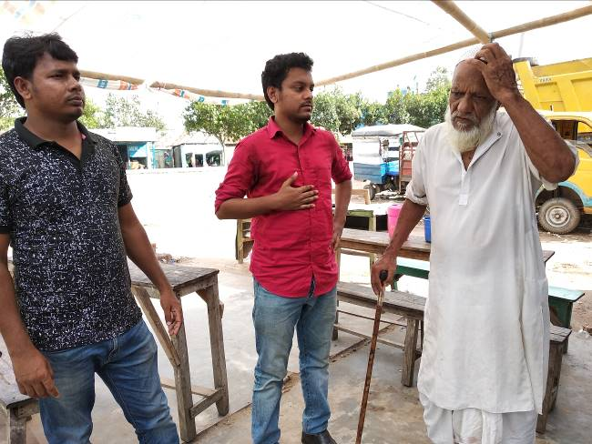
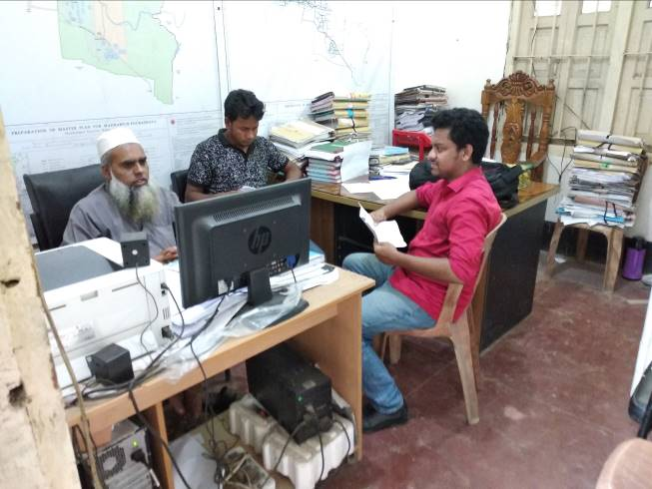
Photographs 7.1.1: Consultation Meeting with Pourashava Officials and Local Individuals at Subproject Sites

Issues Raised by the Participants

The participants raised the issues related to the infrastructure development of Madhabpur Pourashava. In the CIP and FGD, the participants discussed about the infrastructure requirements for the future development of Madhabpur Pourashava.

Feedback, Suggestions and Recommendations of the Participants

The participants were presented with feedback, suggestions, and recommendations listed below:
- The FGD results confirmed that an improved communication network, drainage facility, solid waste management, water treatment plant and sewerage treatment plant is needed for future development of Madhabpur Pourashava;
- The participants stated that public water supply facilities, sanitation facilities, drainage congestion and access road is not adequate;
- The participants stated that construction works should be scheduled properly;
- The participants discussed about the environmental and social issues to be addressed prior to the subproject implementation.
To encourage participation, regular consultations are recommended with beneficiary communities to share subproject related information and to provide a feedback mechanism for these communities to voice their concerns and issues in all stages of the subproject. The DSM consultants and PMU, LGED will be responsible to carry out continued consultation with and information dissemination to the key stakeholders.

Conclusions and Recommendations

The subproject intervention has moderate impacts on ecological environment. In addition, the subproject intervention has impacts on physicochemical components and socio-economic environment. However, from the study it is revealed that the anticipated impacts on physicochemical components and socio-economic environment are not significant. Most of the individual elements of the subproject involve simple construction and operation, so impacts will be mainly localized and limited within the subproject boundary. Most of the predicted impacts are associated with the construction process which is invasive. Hence, the impacts are largely manageable through mitigation measures. Mitigation will be assured by a program of environmental monitoring to ensure that all measures are implemented, and will determine whether the environment is protected. It will include observations on and off-site, document checks and interviews with workers and beneficiaries. Any requirements for corrective action will be reported to the PMU, LGED and WB.
This study formulates well-structured EMP. This EMP will assist Pourashava Officials, PMU-LGED, contractor and DSM personnel in mitigating the environmental impacts, and guide them in the environmentally sound execution of the proposed subproject. A copy of the EMP shall be kept on-site during the construction period at all times. The EMP shall be made binding on contractor operating the site, and will be included in the contractual clauses.
It should be noted that environmental assessment report is a live document. Hence, due to changing circumstances during the construction phase if any, there might be minor adaptation needed for environmental, health and safety issues.

References

Madhabpur Pourashava Master Plan

Bangladesh Meteorological Department (BMD)

Environmental Assessment Volume 1: Overall Environmental Assessment [Draft Final Report], September 2013. Municipal Governance and Services Project (MGSP), Local Government Engineering Department (LGED) and Bangladesh Municipal Development Fund (BMDF), Ministry of Local Government, Rural Development and Cooperatives, Government of the People's Republic of Bangladesh

Environmental Assessment Volume 2: Environmental Management Framework (EMF) [Draft Final Report], September 2013. Municipal Governance and Services Project (MGSP), Local Government Engineering Department (LGED) and Bangladesh Municipal Development Fund (BMDF), Ministry of Local Government, Rural Development and Cooperatives, Government of the People's Republic of Bangladesh

Geological Survey of Bangladesh, 1978: Earthquake Zoning Map

Bangladesh Meteorological Department (BMD), Flood zoning Map

Bangladesh Soil Resource Development Institute: Map of Bangladesh Soil Region

BBS, 2011: Population and housing census, National Volume-II: Union Statistics
- FAO-UNDP, 1988-History of Soil Research in Bangladesh

APPENDIX

Appendix- I: Environmental Monitoring Checklist
Local Government Engineering Department

Municipal Governance Services Project (MGSP)

Environmental Compliance Monitoring Form
Part A: General Subproject Information

Subproject Name | (a) Construction of Bituminous Carpeting Road starting from Gumutia bridge to Faruk Master house with link to Mosque (Ch. 00+000 – 00+985, link Ch.00+00 – 00+060);  (b) Construction RCC Drain from Taher Sarder house to Chargupat via Basu pathan More (00+00~0+440);  (c) Construction of RCC Box culvert near old cattle market at Nasirnagar;
Package No. | MGSP/MDP/2018-2019/W-5
ULB Name | Madhabpur Pourashava
Approved Estimated Cost in BDT
Contract Amount in BDT
Contractor Name
Date of Commencement
Target Date of Completion
Physical Progress (%)
Financial Progress (%)
Person Responsible (PIU)
(Name, Designation &Phone) for the Overall Subproject Management

Person Responsible (DSM)
(Name, Designation &Phone) for the Overall Subproject Management

Form Completed by
(Name, Designation &Phone)
Overall Environmental Description of the Subproject

Part B: Design, Preparation, and Legal Requirements
Environmental Concerns (PMU, PIU & DSM)  (Name, Designation & Phone) | PMU-
 | PIU-
 | DSM-
Subproject Category | DoE-BD- | WB-
Environmental Clearance Received? | Yes | No
EA Required? | Yes | No
EA Prepared and Delivered? | Yes | No
EMP Prepared & Delivered Separately? | Yes | No
Items and Cost of EMP Implementation Included in the Contract? | Yes | No
EMP Included in the Procurement Documents? | Yes | No
Inspection Schedule/Last Inspection/Monitoring by  PMU Environmental Concerns | Date-
 | Key findings-
Inspection Schedule/Last Inspection/Monitoring by  PIU Environmental Concerns | Date-
 | Key findings-
Inspection Schedule/Last Inspection/Monitoring by  DSM Environmental Safeguard Specialist/Jr. Environmental Specialist | Date-
 | Key findings-

Part C: Key Environmental Impacts
The Subproject Results in any of the following Impacts? | Yes | No | NA | If yes, is the impact (give observation)
 |  |  |  | Significant | Moderate | Minor
Felling of the trees
Clearing of the vegetation that increase the risk of increased soil degradation or erosion
Disturbance of the terrestrial and or aquatic specifies
Noise pollution
Air pollution
Adverse effects on the quantity or quality of the surface water or groundwater
Production or increase the production of the solid waste

Drainage congestion
Water logging that increases the risk of the water related diseases

Traffic congestion
Public safety

Part D: Work Place Environment and Gender Equity
The Subproject Results in any of the following Impacts? | Yes | No | NA | Observations
Does the contractor pay to the workers regularly?

Is there any discrepancy between the male and female workers regarding the wages or salary for the same works?

Is the contractor complying with the GOB labor law concerning the hiring of the workers?

Does the contractor engage women labors and does the project have suitable works for them?

Does the contractor engage child labor (less than 18 years) and aged people (more than 65 years old)?

Does the contractor force to the workers for the completion of the works?

Do the workers involve with the political activities, crime, drugs addiction and other forms of unwanted activities?

Are construction camps adequately equipped with water supply, sanitary toilets, washing facilities and facilities for waste collection and storage?

Has separate sanitation facilities been provided for women at work camps and the construction site?
Do the laborers load heavy items on their heads or shoulders?

Has the contractor undertaken an awareness program for the sexually transmitted diseases especially for HIV-AIDS and other infectious diseases like TB?

Are first aid kits readily available for the workers at the job site along with the instructions for use?

Are supervisors or other site personnel trained in the basic first aid emergency response measures?

Has the contractor provided necessary safety equipment to the workers and training for use?

Part E: Potential Impacts, Mitigation Measures, and Monitoring Indicator Mentioned in the EMP
Activity/  Issues | Potential Impacts | Proposed Mitigation and Enhancement Measures | Monitoring Method | Monitoring Frequency | Implementation Status (Yes/No /NA) |  | Impact significance if not implemented |  |  |  |  |  |  | Remarks
 |  |  |  |  |  |  | Major | Moderate |  | Minor |  | No
Construction and operation of labor shed for the workers (Workforce and labor shed management ) | - Generation of sewage and solid waste may cause water/ environmental pollution | - Construction of sanitary latrine at the labor shed (consider 15 person for one toilet, separate toilet for male and female);  - Erection of “no litter” sign, provision of waste bins/cans (separate waste bins for organic and inorganic wastes );  - Ensure wastes (solid wastes and other forms of the waste) disposal at the designated dumping site at Katiyara.
 | - Health of workers | - Conduct formal and unofficial discussion to increase awareness about hygiene practices among the workers;  - Ensure availability and access to first-aid equipment and medical supplies for the workers.
 | - Possible development of labor camp into permanent settlement | - Contractor to remove labor camp at the completion of contract.
 | - Outside labor force causing negative impact on health and social well-being of local people | - Ensure that contractor employ local work force to provide work opportunity to the local people and conduct formal and unofficial awareness program for the health and social well-being of the local people.
General construction works | - Drainage congestion and flooding | - Ensure provision for adequate drainage of storm water if needed;  - Ensure provision for pumping of congested water if needed;  - Ensure adequate monitoring of drainage effects, especially if construction works are carried out during the wet season.
General construction works | - Air pollution | - Check regularly and ensure that all the subproject vehicles and equipment are in good operating condition;  - Ensure contractor spray water on dry surfaces/ unpaved surfaces regularly to reduce dust generation;  - Maintain adequate moisture content of soil and sand for transportation, backfilling and handling;  - Ensure contractor sprinkle water and cover stockpiles of loose materials (e.g., fine aggregates);  - Inform local people about the subproject activities and potential impact;  - Cover loaded truck used for carrying sand with tarpaulin/other suitable material to prevent the spreading by wind.
General construction works | - Traffic congestion, effect on traffic and pedestrian safety | - Ensure schedule deliveries of materials/ equipment during off-peak hours;  - Place traffic sign/cautionary sign to avoid undue traffic congestion if required;  - Construction of temporary earthen diversion road so that local people and vehicles can cross the canal during construction period.
General construction works | - Noise pollution | - Check and keep maintenance of the equipment properly;  - Avoid using of construction equipment such as concrete mixer machine, pile driving equipment (pile rig, winch machine), vibrator machine that produce excessive noise at night;  - Avoid prolonged exposure to noise (produced by equipment) by the workers;  - Regulate use of horns and avoid un-due use of hydraulic horns by subproject vehicles;  - Inform local people about the subproject activities and potential impact.
General construction works | - Water and soil pollution | - Prevent discharge of fuel, lubricants, chemicals, and wastes into adjacent water bodies (ponds and low land ditches) and soil.
General construction works | - Accidents | - Conduct formal and informal discussion for creating awareness about the accident;  - Provides PPEs and ensure using of the personal protective equipment by the workers.
General construction works | - Felling of trees, clearing of vegetation and ecological disturbances | - 450 nos. of the trees will be planted at two sides of the Gumutia Bridge to Faruk Master House Road to compensate the felled trees, cleared vegetation and to enhance the ecological condition.
General construction works | - Spills and leaks of oil, toxic chemicals | - Proper handling of lubricating oil and fuel so that it does not fall on the soil;  - Collection and proper disposal of spills;  - Refueling and fuel tank should not be placed on the ground directly.
All construction works | - Beneficial impact on employment generation  - General degradation of the environment | - Employ local people in the subproject activities as much as possible;  - Give priority to poor people living within subproject area in subproject related works (e.g., excavation and other works, which do not require skilled manpower);  - Ensure environmental enhancement measures- plantation and cautionary signs will be provided.
Specific activities for BC Road
- Dismantle works/Excavation/Earth work | - Generation of loose soil due to the earth excavation work. | - Cover exposed earth works with fabric;  - Disposal of soil and construction wastes at Katiyara.
- Dismantle works/Excavation/Earth work | - Accidents due to careless use of hydraulic excavator | - Operate the hydraulic excavator carefully.
- Dismantle works/Excavation/Earth work | - Air pollution | - Regular maintenance of the equipment to avoid black smoke emission.
- ISG (Improved Sub grade)/ Sand filling | - Air and dust pollution affecting nearby settlements | - Maintain adequate moisture content of soil during transportation, compaction and handling;  - Carry the materials especially loose soil and sand with adequate cover.
- Setting up and operation of asphalt plant | - Possible degradation of the air quality by the suspended particles and increase of the noise level from asphalt plant affecting nearby settlements; | - Locate plant away from residential settlements;  - Consider use of emulsified bitumen.
- Setting up and operation of asphalt plant | - Possible water pollution (surface and groundwater) by bitumen and solvents; | - Avoid spills and proper collection and disposal of the generated spills.
- Setting up and operation of asphalt plant | - Possible preparation of the bitumen in open air and using of charcoal and wood as fuel | - Strictly prohibit bitumen preparation in the open air and use of charcoal and wood as fuel.
Specific activities for RCC Drain and Box Culvert
- Excavation and Dismantle work | - Generation of solid & construction wastes due to the dismantle works;  - Generation of debris & sediments/ clay due to the earth excavation. | - Disposal of soil and construction wastes at designated dumping site at Katiyara;  - Cover exposed dry loose soil with fabric.
- Excavation and Dismantle work | - Accidents | - Operate the hydraulic excavator carefully;
- Excavation and Dismantle work | - Air pollution | - Regular maintenance of the equipment to avoid black smoke emission.
- Back filling/Sand filling | - Air and dust pollution affecting nearby settlements | - Maintain adequate moisture content of soil during transportation, compaction and handling;  - Carry the materials especially loose soil and sand with adequate cover.
- Cutting & welding of the reinforcement | - Noise Pollution | - Avoid using of steel cutter and welding machine at night;
- Cutting & welding of the reinforcement | - Health and Safety | - Ensure use of the PPEs (helmets, goggles, gloves, safety boots);  - Availability and access to first-aid equipment and medical supplies.
- RCC (reinforcement concrete) work | - Air pollution due to black emission | - Regular maintenance of the concrete mixer and vibrator machine.
- RCC (reinforcement concrete) work | - Noise pollution | - Avoid operation of the concrete mixer and vibrator machine at night;  - RCC work should be avoided at schooling time;  - Inform local people about casting work and potential impacts.

Prepared by- Signature- Date-
Copies to 1. Madhabpur Pourashava
2. SME
3. AME
4. Jr. ES

