****

**Local Government Division**

**Local Government Engineering Department**

**Municipal Governance and Services Project (MGSP)**

**IDA Credit No: 5339-BD**

**Social Management Plan**

**Package No: MGSP/GOB/2016-17/W-03**

**Name of Subproject:**

**Construction of RCC drain and providing Street Light on Gobindaganj PouraBhaban-Khulshi vanga bridge**

**Components:**

a) Construction of RCC Drain with cover slab staring from GobindagonjPouraBhaban to Kholshivanga Bridge via Thana moar. Including link-1,75m & link-2,45m (Ch. 1+215km and Ch. 1+635 to 2+330km, Total effective length 2030m)

b) Supply, fitting & fixing of Street lights from GobindagonjpouraBhavan to Kholshivanga Bridge via Thana moar.Ch. 0+000 to 2+ 330 km including link-1, Length 75m and link-2, length 45m (total length 2450m, GobindagonjPourashava of Garibaldi District.

|  |  |
| --- | --- |
| **E:\Picture gallery\Pic(GOB) package W-3\DSC07800.JPG** | **E:\Picture gallery\Pic(GOB) package W-3\DSC07778.JPG** |

**Design, Supervision, and Management (DSM) Consultancy Services**



**Joint Venture of**

***Hifab International AB, Sweden***

***AQUA Consultant & Associates Ltd., Bangladesh***



**23 April -2017**

**GobindagonjPourashava**

**Gobindagonj, Gaibandha**

**Table of Contents**

|  |  |  |
| --- | --- | --- |
| **SL No** | **Contents** | **Page. No** |
|  | Abbreviations | 3 |
| 1. | INTRODUCTION | 4 |
| 1.1 | Project Background | 4 |
| 1.2 | Legal and Policy Framework | 4 |
| 1.3 | Subproject Description | 5 |
| 1.4 | Social Management Plan | 6 |
| 2. | Description of Subproject Area | 7 |
| 2.1 | Brief Profile of GobindagonjPourashava | 7 |
| 2.2 | Historical and Cultural Heritage Sites | 10 |
| 2.3 | The Subproject Location and Area Profile | 10 |
| 2.4 | Beneficiary Communities and Affected Persons | 11 |
| 2.5 | Gender and Vulnerability | 11 |
| 3. | Social Impact Assessment | 12 |
| 3.1 | Benefits of the Subproject | 12 |
| 3.2 | Social Screening and Safeguard Compliance Issue | 12 |
| 4. | Consultation and Community Participation | 13 |
| 4.1 | Stakeholder Analysis | 13 |
| 4.2 | Consultation and Participation Methodology | 13 |
| 4.3 | Consultation Outcomes – Issues, Concerns and Recommendations | 13 |
| 5.0 | Social Management for Site Selection and Design | 13 |
| 5.1 | Subproject Selection Process”. | 13 |
| 5.2 | Subproject Design Process | 14 |
| 5.3 | Grievance Redress Mechanism | 14 |
| 5.4 | Implementation Arrangement | 15 |
| 6. | Conclusions on Social Management Plan (SMP) | 15 |
| Photographs | |  |
| 1. | Gobindagonjpouoshava location area map | 9 |
| 2. | Subproject layout plan | 13 |
| 3 | Old & damage drains | 11 |
| 4 | Community consultation | 13 |
| 6 | Subproject selection (meeting) | 14 |
| FIGUR |  |  |
| 1 | SUB project Estimated cost | 06 |
| 2. | At a glanced of Gobindagonjpouroshava | 07 |
| ANNEXURE | |  |
| 1. | Agreement provided by shops kipper | 16-18 |
| 2. | **The LGED Gaibanda provided land ownership certificate Gobandagonjpouroshava.** | 19 |
| 3 | Social screening Report | 20 |
| 4. |  |  |

**Abbreviations**

|  |  |
| --- | --- |
| ARP | Abbreviated Resettlement Plan |
| BMDF | Bangladesh Municipal Development Fund |
| CBO | Community Based Organization |
| CC | Cement Concrete |
| CIP | Capital Investment Plan |
| CUL | Compensation-Under-Law |
| DC | Deputy Commissioner |
| DLAC | District Land Acquisition Committee |
| DUTP | Dhaka Urban Transport Project |
| GoB | Government of Bangladesh |
| GRC | Grievance Redress Committee |
| GRM | Grievance Redress Mechanism |
| HCG | House Construction Grant |
| HTG | House Transfer Grant |
| IDA | International Development Association |
| IP | Indigenous People |
| IPP | Indigenous Peoples Plan |
| KII | Key Informants Interviews |
| FGD | Focus Group Discussion |
| LGD | Local Government Division |
| LGED | Local Government Engineering Department |
| M& S | Management &Supervision |
| MGSP | MunicipalGoverna0nceandServicesProject |
| MOLGRDC | Ministry of Local Government, Rural Development & Cooperatives |
| MSP | Municipal Services Project |
| MSL | Mean sea Level |
| NGO | Non-governmental Organization |
| PAH | Project Affected Household |
| PAP | Project Affected Person |
| PMU | Project Management Unit |
| RCC | Reinforced Concrete Cement |
| RP | Resettlement Pan |
| SIA | Social Impact Assessment |
| SMP | Social Management Plan |
| SSS | Social Safeguards Specialist |
| TLCC | Town Level Coordination Committee |
| ULB | Urban Local Body |
| WB | World Bank |
| WC | Ward Committee |

**1. INTRODUCTION**

**1.1Project Background**

The Government of Bangladesh, through the Local Government Engineering Department (LGED) and Bangladesh Municipal Development Fund (BMDF) is implementing the Municipal Governance and Services Project (MGSP). The project aims to improve municipal governance and basic urban services in participating ULBs. Two physical components of the project include (i) Municipal Governance and Basic Urban Services Improvement (Component 1) to provide financial support to 26 pre-identified urban local bodies (ULBs) including municipalities and city corporations, and demand-based sub-credits to eligible ULBs for basic urban services improvement investment costs. The project cost is BDT **2, 470, 93.92** lakh to be finance at 80:20 IDA loan to GOB contribution. LGED is implementing the Component 1 while BMDF is implementing component 2 of the project.

LGED is supporting the 26 pre-selected ULBs for investments in development and rehabilitation of Road, Bridge, Box-culvert, Pedestrians bridge, street light, Traffic Control, Bus terminal, Truck terminal, Boat landing Jetty, Drain, Retaining wall, Kitchen market, Cattle market, slaughter house, Public toilet, Solid waste management, Sweeper colony, Park, Community Centre and Whole sale market. LGED is financing through (i) base allocation based on population category of ULBs; (ii) performance-based allocation and (iii) operations and maintenance support on a declining basis over the project period.

The component interventions have largely been developed for construction and rehabilitation within existing available land owned by the ULBs and acquisition of land has been avoided in the social screening process. Removal of some obstruction and relocation of some business were involved in case of some sub project for unavoidable circumstances.

The MGSP did not avoid taking up of sub project in area inhabited by tribal peoples and instead ensure their inclusion and participation where applicable. The ULBs addressed the removal of obstructionand in most cases the land entirely belongs to the ULB. In some instances, land of other GOB agencies like the BWDB,R &H or other local government like adjoining UP is needed and in such cases the ULB ensured getting such land by mutual understanding and proper documentation. Relocation of business and removal of obstructions were resolved by consultation and agreement with the concerned PAPS and these are properly documented. Thus land acquisition, population displacement and tribalpeople’sissues have been addressed following the country’s following the country’s legal framework and **the World Bank policy on soci**al safeguards.

**1.2 Legal and Policy Framework**

For the subproject preparation and implementation, the World Bank’s Operational Policy (OP) on Involuntary Resettlement (OP 4.12) and on Indigenous Peoples (OP 4.10) have beentriggered to the project. A Social Management Framework (SMF) has been adopted by LGED for the project that meets the requirements of the country’s legal frameworks in Bangladesh “The Acquisition and Requisition of Immovable Property, Ordinance, 1982” and the Bank requirements including OP 4.12 and OP 4.10. The SMF also requires that subprojects are prepared ensuring inclusion, participation, transparency, and social accountability. Subprojects are prepared by respective ULBs in a process complying with the SMF requirements. LGED reviews the subproject proposals for technical, engineering, environmental, social development, and safeguards compliance before allocation of the financing to the ULBs.

As a matter of policy Social Management Plans (SMP) will be prepared and implemented for subprojects with no land acquisition or involuntary displacement of people, while Resettlement Action Plans (RAP) andTribal Peoples Plans (TPP) will beprepared for implementation for subprojects involving population displacement and tribal peoples’ issues.

**1.3 Subproject Description**

Gobindagonj Pourashava has identified and designed for improvement of RCC drains and providing street light in the pourashava areas. The components of the subprojectare:

a) Construction of RCC Drain with cover slab staring from Gobindagonj PouraBhabanto Kholshivanga Bridge via Thana moar.Including link-1,75m & link-2,45m (Ch. 1+215km and Ch. 1+635 to 2+330km, Total effective length 2030m)

b) Supply, fitting & fixing of Street lights from GobindagonjpouraBhavan to Kholshivanga Bridge via Thana moar. Ch. 0+000 to 2+ 330km including link-1, Length 75m and link-2, length 45m (total length 2450m, GobindagonjPourashava of Garibaldi District

**Description of Component a: RCC drain**

This subproject is very important toGobindagonjpourashava. Total effective length of the drain is 2020m. Of the total length of the drain from pourabhaban to Khulshivanga bridge is 2330m. Of this length 420m drainfrom Dhaka –Rangpur highways to AbulMakar shop of Chasok para (wards no.2) has been constructed by the use of Bangladesh Climate Change Trust Fund (BCCTF). Excluding this 420m the remaining 1910m (in wards number from 6 /7via 5 to 2) will be constructed under the sub project with cover slabs. To this will be added two link drains of length 120m making total length of the sub project drain will be 2030 m. The drain will be on the south side of the road with four road crossings at intersections, one crossing BograRabgpur highway near Thana moar, two crossing poura roads and last one near Chasok para crossing pourasova road.

In the proposed length there is no drain from PouraBhaban to T&T moar where new drain will be constructed. From T&T moar to Thana moar existing old drain is brick wall drain which is damaged. So, to have good drainage with connection to outfall at Khulshivangabridge completely new RCC drain will be constructed with cover slab. The existing road is Bitumen’s carpeting (BC) with 3-5m pavement width. Crest width will be increased to minimum 6.0m crest width with drain and the drain slab will be strong enough for movement of vehicles including bus and truck.

From T&T moar to thana moar, front side of 15 shops like tea stall, paan(betel leave) shop, grocery, fruits shop, mobile phone service center etc. All of the shopkeepers are pourashava tenants and they agreed to remove the obstruction (extended part of the shops) as the land belongs to the pourasova and services center’s Gobindagonj pourashava leaseholders as because project areas land are belongs to pourashava.

Regarding the land ownership this subproject alignment, the land belongs to the LGED, Gaibanda District. The LGED Gaibanda already given approval letter to Gobindagonj Pouroshava for construction of RCC drain and cover slabs dated on 12/03/2017 memo no: 496(2).

For smooth implementation of the sub project as per desired design front side of these needs these shops will be removed. The owners of the shops have agreed to remove the obstacles willingly without any compensation. The shops are situated on pouroshava land and also extended to pourasova land by encroachment. An agreement has been signed in this regard. (Attached below)

The sub project will also require relocating 27 electric poles and cutting 78 trees (Jackfruit, Rain tree, Betel nut, coconut and Mango) trees before the start of construction. As per Pourasova authorities statement the small obstacles will be removed immediately.

Beside the existing road several educational institutions like Gobindagonj College, many schools Madrasah and about150 shops of different types, NGO office, clinics etc are located. Near about 20,000 people will benefit from this sub project drain. Different types of vehicles like car, rickshaw, bus, CNG Besides the above different Cares, Bus (Mohamagonj & Ghoraghat–Dinajpurroad) Truck, CNG driven baby taxi, battery operated three wheeler auto, tractor trailer etc. use this road.

**Description of Component b: Street Light**

This component will supply streetlight with fitting & fixing from Gobindagonj poura Bhavan to Kholshivanga Bridge via Thana moar. Ch. 0+000 to 2+ 330 km including link-1, Length 75m and link-2, length 45m (total length 2450 m).

The Supplying, Fitting & Fixing of Street will improve safety of movement during night time for the town dwellers and other users of the road. Women and children will have more comfortable mobility in the town.

**Sub project cost**

**FIGURE-1:**The proposed length of, RCC drain and street lights to be developed and estimated cost for the subprojects is given below.

|  |  |  |  |
| --- | --- | --- | --- |
| **S.L** | **Subproject** | **Length** | **Estimated Cost (BTD)** |
| a | Construction of RCC Drain with cover slab staring from GobindagonjPouraBhaban to Koshivanga Bridge via Thana moar.Including link-1,75m & link-2,45m (Ch. 1+215km and Ch. 1+635 to 2+330km, Total effective length 2030m) | 2030 | **70,87,647.64** |
| b | Supply, fitting & fixing of Street lights from GobindagonjpouraBhavan to Kholshivanga Bridge via Thana moar Ch. 0+000 to 2+ 330km including link-1, Length 75m and link-2, length 45m (total length 2450m, GobindagonjPourashava of Garibaldi District. | 2450 | **4,702,216.05** |
| Total = | |  | 75,572,863.70 |

**1.4 Social Management Plan**

This Social Management Plan (SMP) has identified the subprojects and managed social concerns in the process of subproject design and implementation. Initially, the subproject proposals included a social screening report along with impact assessment. After reviewing the social screening report by Social Unit of DSM, the subprojects proposals are submitted to the PMU office. Social team of the DSM has carried out a series of site visits and consulted with the ULB officials, stakeholders and a section of the beneficiary communities through interview and participation & consultation meetings. The social screening findings and consultation and proceeding of meetings were validated through the social survey and consultation.

The purpose of preparing this SMP is to demonstrate an all-inclusive consultative process in selection and design of the subproject as well as to provide guidance for social development and safeguards compliance in the implementation process.

The SMP contains a description of the subproject areas, social screening and impacts, consultation process adopted during identification and design, and consultation plan for implementation stage, impact mitigation measures, grievance resolution process, and implementation arrangements and monitoring and evaluation.

GabindagonjPourashava will ensure participation of the communities and grievance resolution in the process of implementation of the subprojects.

**2. Description of Subproject Area**

**2.1 Brief Profile of Gobindaganj Pourashava**

Gobindaganj, the largest Upazila of Gaibandha District in respect of area, household andpopulation started functioning as thana headquarters in 1912. It is said that in the long past Bhim, theindependent king of North Bengal came to the present place with a big statue of the GodGobinda and set up it over there. Subsequently, a trading center was developed in and aroundthe place. It was updgraded to Upazila in the 1980s during Ershad regime. The name of upazilaand of the town might have derived after the name of the God Gobinda.

GobindaganjPourashava was established on 23rd February in 1998. It is situated in GobindaganjUpazila under the district of Gaibandha (RangpurDivision). It is upgraded into B' ClassPourashava which is now the administrative headquarters of GobindaganjUpazila. GobindaganjPourashava with an area of 14.58 sq km and is bounded by Fulbari Union on the north and east,Kamardanga union on the south, and Gumaniganj Union on the west.

As per the Bangladesh Population Census 2011, the population of GobindaganjPourashava is38,415 and of them 193,62 are male and 19,052 are female and the population density is 2,635 persq km. Total number of holding in the area is 7,415. According to Bangladesh Population Census2011 (published in 2012), the population of GobindaganjPourashava is 38,415 among them50.40% are male and 49.60% female, total no. of household is 9,718, population density is 1,118per sq km.

**FIGURE-2:**

**GobindoganjPaurashavaAt a glance**

|  |  |  |  |  |  |  |  |  |  |  |
| --- | --- | --- | --- | --- | --- | --- | --- | --- | --- | --- |
| *General Information* | | | | | | | | | | |
| *Area* | | | | | | | | | *::* | *14.58 Square KM.* |
| *Wards* | | | | | | | | |  | *9* |
| *Population*  *Population Growth Rate*  *Household No*  *Population Density*  *Major Status*  *Main Income Source :* | | | | | | | | |  | 38,415 M 19,353 F 190,62 (2011)  *1.50%*  *9,718*  *2,635*  *20% Migrated People*  *Agricultural labor 22%, Small business 36%, large business 15%, Service 12%,others 15%* |
| *Tax* | | | | | | | | | | | |
| *Number of Holding for paura Tax payment* | | | |  | | | | | | *6,692* | |
| *Market* | | | | | | | | | | | |
| *Katcha Bazars* | |  | | | | | | | | *3* | |
| *Shopping Complex* | |  | | | | | | | | *3* | |
| *Own Shops* | |  | | | | | | | | *1.000* | |
| *Communication* | | | | | | | | | | | |
| *Pucca Roads*  *Semi-pucca Roads*  *Katcha roads* | | |  | | | | | | | *9.49km*  *10.27mm*  *32.13km* | |
| *Water Supply* | | | | | | | | | | | |
| *Total Number of tube wells* | | |  | | | | | | | *770 Nos* | |
| *Own tube well*  *community tube well*  *Neighboring household tube well*  *Bathing and other purpose* | | |  | | | | | | | *60%*  *20%*  *20%*  *Tube well and Pond water* | |
| *Street Lighting* | | | | | | | | | | | |
| *Street Lights* |  | | | | | | | | | *800* | |
| *Drainage System* | | | | | | | | | | | |
| *Pucca and katcha drain* |  | | | | | | | | | *28.04km* | |
| *Ponds/ ditches* |  | | | | | | | | | *10 Nos* | |
| *Natural drainage system( Khals/ rivers):* |  | | | | | | | | | *2.5km* | |
| *Public Health* | | | | | | | | | | | |
| *Pucca sanitary toilet* | | | | | | | |  | | *87%* | |
| *Katcha latrine* | | | | | | | |  | | *11.0%* | |
| *No sanitary toilets*  *Sanitary including Ring Slab toilets*  *Health Complex* | | | | | | | |  | | *2.0%*  *87%*  *1* | |
| *Private Clinic* | | | | | | | |  | | *6* | |
| *Community Clinic*  *Family Planning Centre*  *Maternity clinic* | | | | | | | |  | | *1*  *1*  *1* | |
| *Different Infrastructure* | | | | | | | | | | | |
| *Govt Offices*  *Non- Govt Organizations*  *Bank Branches*  *Insurance Company Offices*  *Public Library* | | | | |  | | | | | *38*  *39*  *12*  *7*  *1* | |
| *Religious* | | | | | | | | | | | |
| *Mosques* | | | | |  | | | | | *72* | |
| *Temples*  *Eidgahs*  *Muslims*  *Hindu*  *Buddha* | | | | |  | | | | | *14*  *18*  *80.0%*  *18.0%*  *2.0%* | |
| *Education* | | | | | | | | | | | |
| *College* | | |  | | | | | | | *3* | |
| *High School*  *Girl’s High school*  *Model School and College* | | |  | | | | | | | *4*  *1*  *1* | |
| *Madrashas* | | |  | | | | | | | *4* | |
| *Govt Primary Schools*  *Municipal School* | | |  | | | | | | | *10*  *No* | |
| *Kinder Garten School* | | |  | | | | | | | *17* | |
| *Recreation* | | | | | | | | | | | |
| *Club and cultural Organizations* | | | | | |  | | | | *5* | |
| *Beautiful Places* | | | | | | | | | | | |
| *Motighill, Kutibari Ward No-06*  *BordhankuthiRajbari, Ward No-09*  *Nut Mondir, Ward No-06* | | | | | | | | | | | |
| *Household Incomeper month* | | | | | | | | | | | |
| *0-2000*  *2001-5000*  *5001-10000*  *10001-20000*  *20001* | |  | | | | | | | | *6%*  *30%*  *32%*  *23%*  *9%* | |
| *Existing Land Use* | | | | | | | | | | | |
| *Agriculture*  *Circulation Network*  *Commercial*  *Community Service*  *Education and Research*  *Government Services*  *Industrial*  *Miscellaneous /Other*  *Mixed Use*  *Non Government Services*  *Residential*  *Service Activity*  *Transport and Communication*  *Urban Green Space*  *Vacant Land*  *Water body* | | | | | | |  | | | *60.5%*  *1.5%*  *0.5%*  *0.20%*  *0.25%*  *0.25%*  *0.05%*  *0.15%*  *0.05 %*  *0.05%*  *18.0%*  *0.15%*  *0.05%*  *0.05%*  *0.05%*  *18.20%* | |

**Photo:Gobindaganj**Pourashava Package Location Area Map

**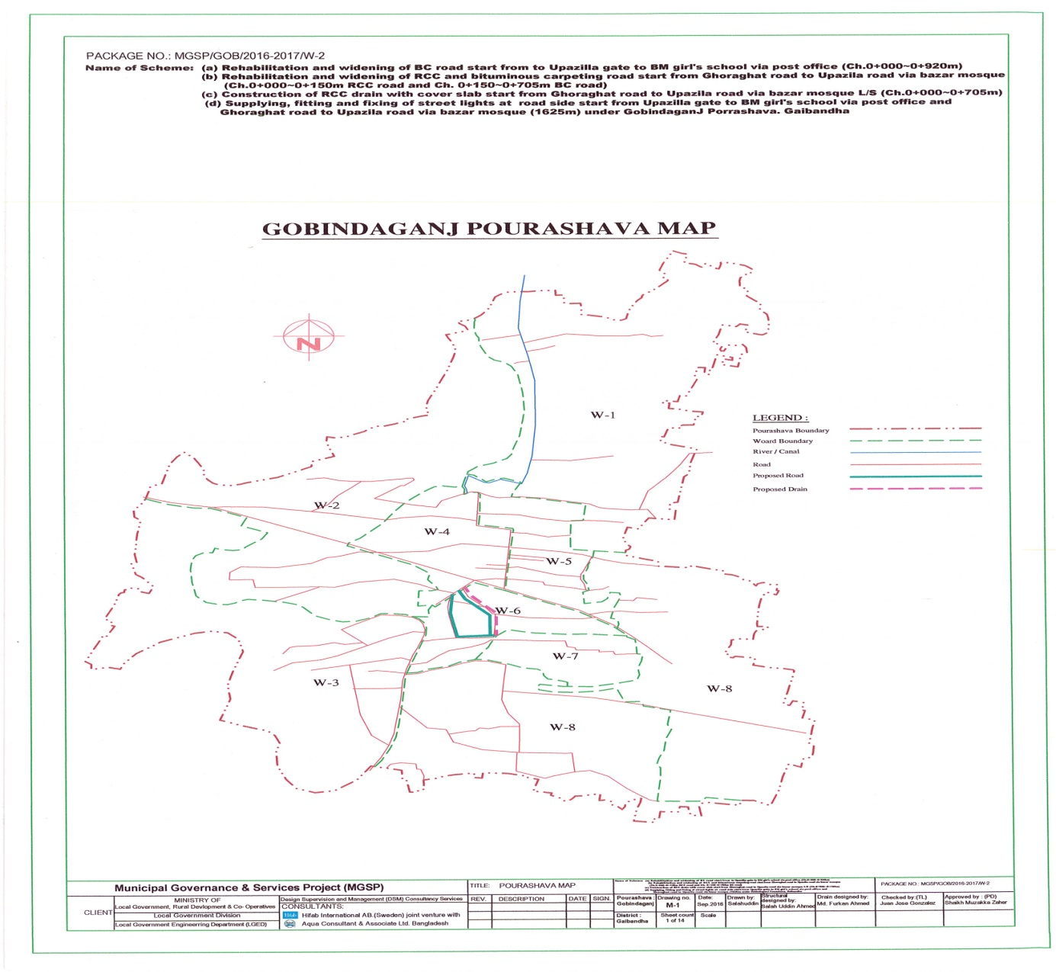**

**b) Subproject layout plan.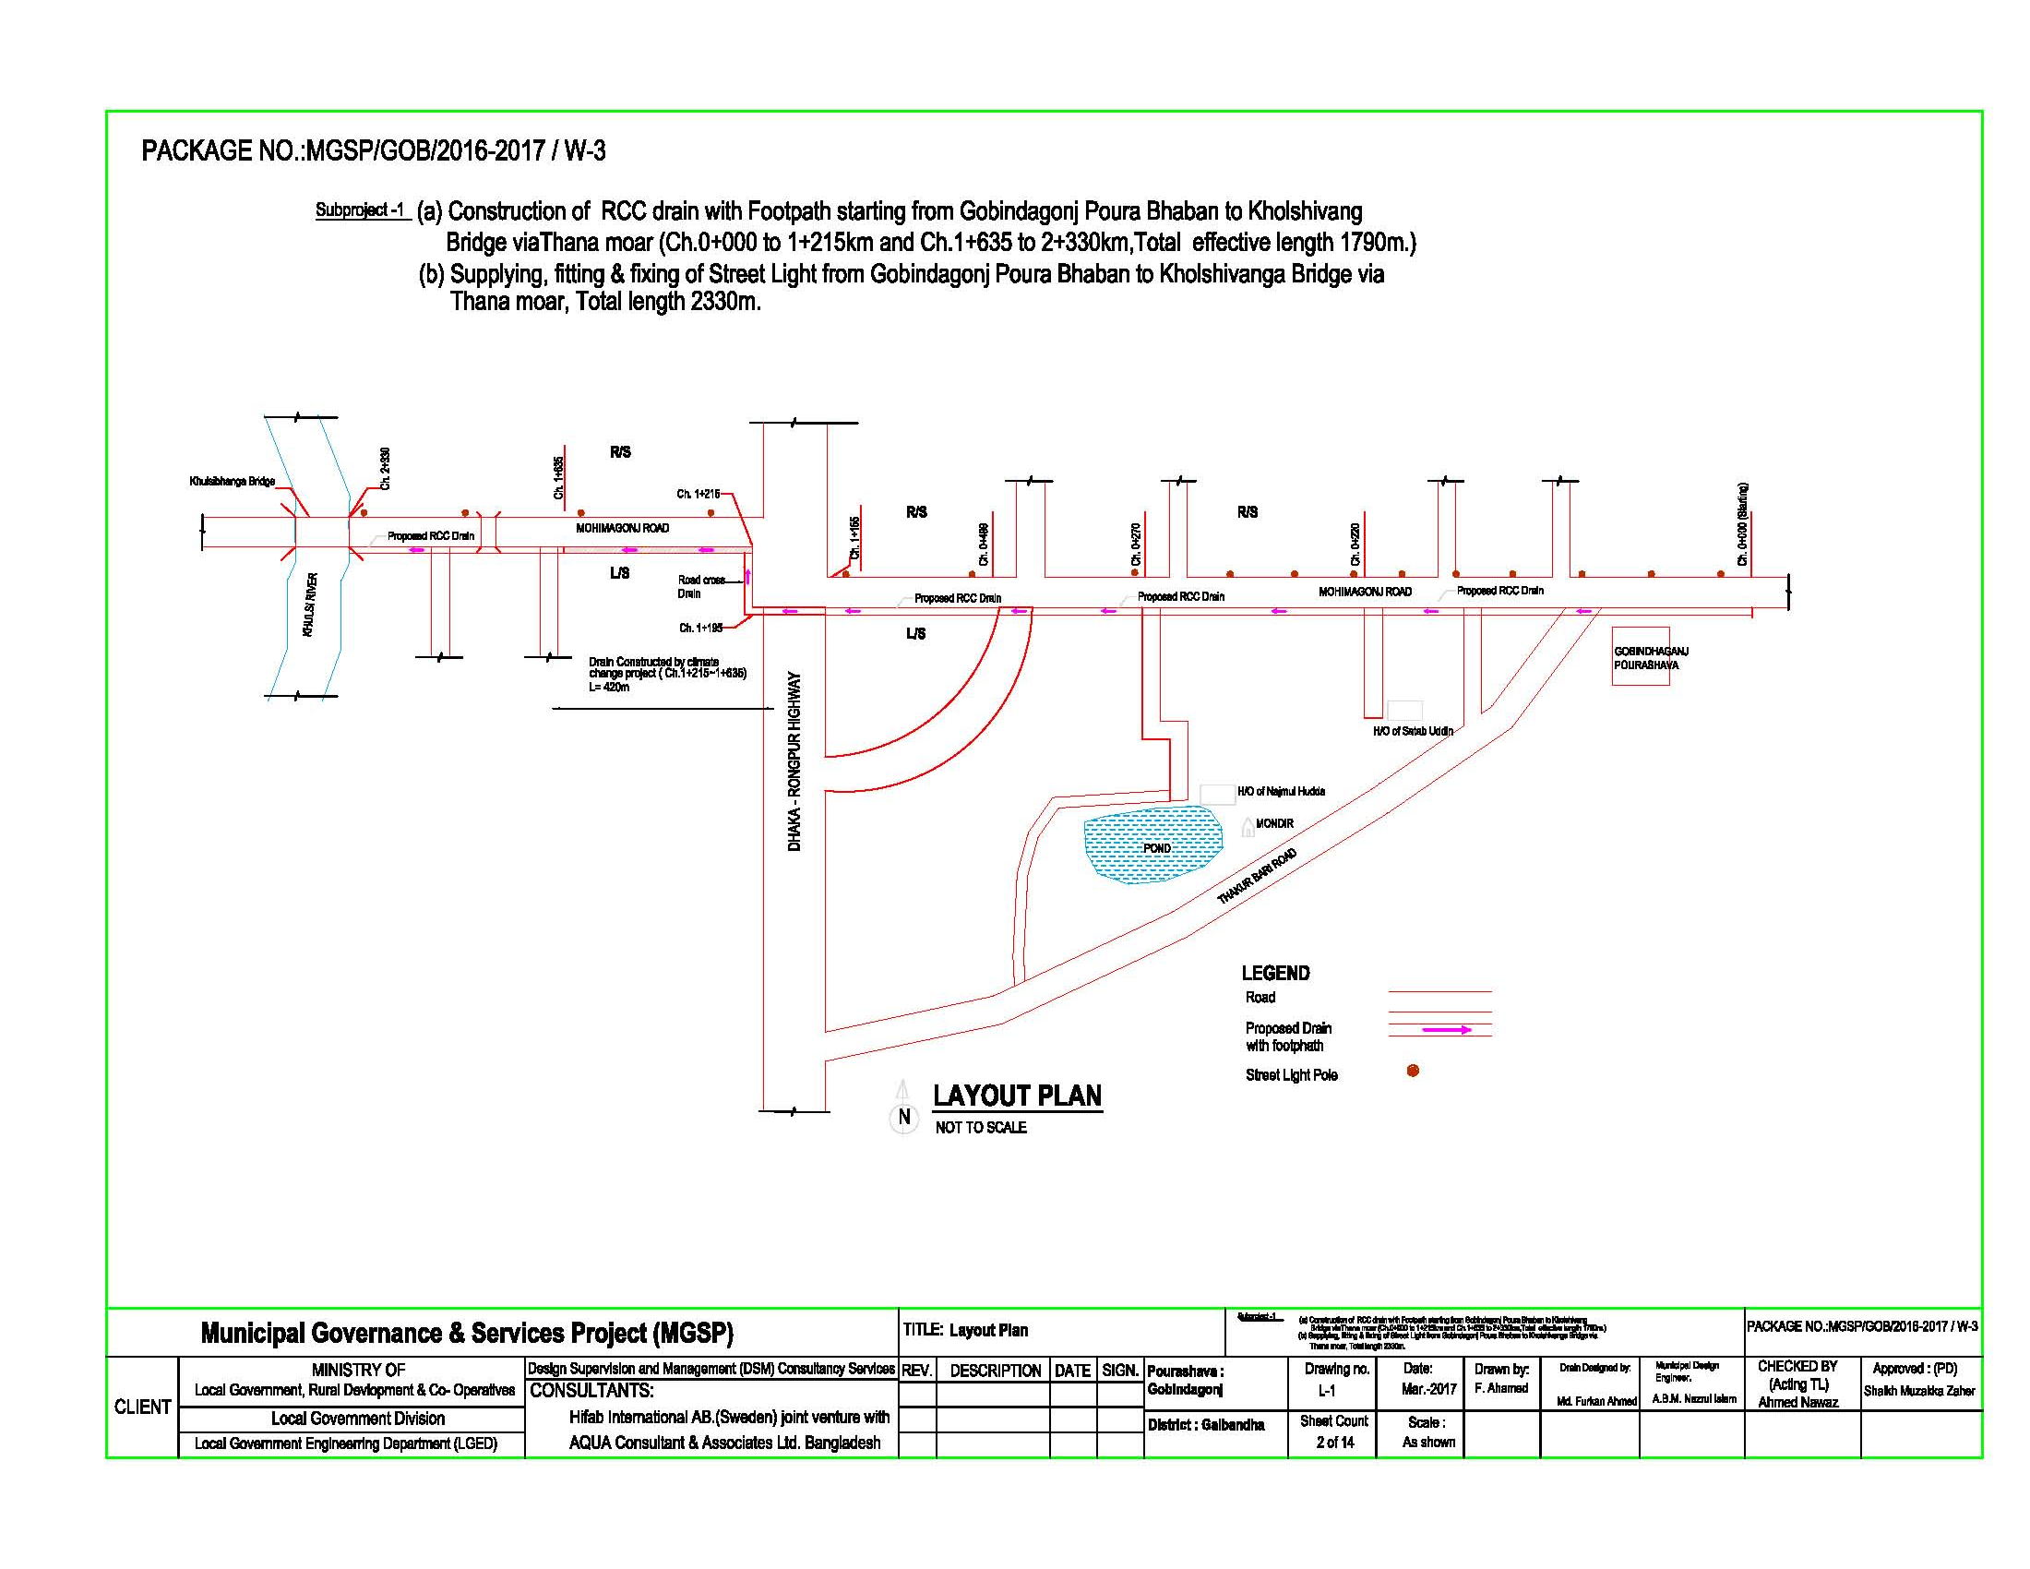2.2 Historical and Cultural Heritage Sites**

There are some archaeological and relics like remnants of the old Zamindar Bari within theGobindaganjPourashava. During the War of Liberation the resistance movement of Gobindaganjbegan on 27 March 1971 when the student and general public tried to destroy the KatakhaliBridge on the river Karatoa. In resisting a Pak Military convoy coming from Rangpur seven freedom fighters lost their lives including Abdul Mannan (Sports Secretary of SM Hall, Rajshahi University), BabulMahanta andBabuDatta. After this incident the Pak Army set on fire nearbyvillages of Katakhal Bridge. There is a mass grave at Katakhali.These cultural heritages are not affected by the sub project.

**2.3 The Subproject Location and Area Profile**

The subproject component are

1. Construction of RCC Drain with cover slab staring from GobindagonjPouraBhaban to Kholshivanga Bridge via Thana moar.(Total Effective length 2030m)

(b) **)** Supply, fitting & fixing of Street lights from GobindagonjpouraBhavan to Kholshivanga Bridge via Thana moar. GobindagonjPourashava of Garibaldi District.(Total length 2450m)

This subproject is a very important project of Gobindagonjpourashava. Total effective length of the drain is 2030m while effective length of street lighting is 2050m.

Regarding the land ownership this subproject alignment, the land belongs to the LGED, Gaibanda District. The LGED Gaibanda already given approval letter to GobindagonjPouroshava for construction of RCC drain and cover slabs dated on 12/03/2017 memo no: 496(2).

**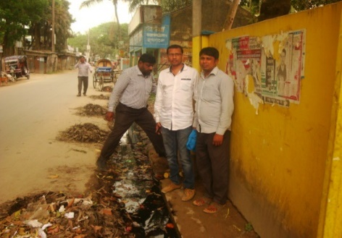**

Beside the existing road several educational institutions like Gobindagonj College, many schools Madrasah and about150 shops of different types, NGO office, clinics etc are located. Near about 20,000 people will benefit from this sub project drain. Different types of vehicles like car, rickshaw, bus, CNG Besides the above different Cares, Bus (Mohamagonj&Ghoraghat –Dinajpur road) Truck, CNG driven baby taxi, battery operated three wheeler auto, tractor trailer etc. use this road.

**2.4 Beneficiary Communities Affected Persons**

The existing road is used by near about 20,000 of local people including students of Gobindagonj College, school &Madrasha, sugar mail workers, business men, labors, people of other wards and adjoining village. Both men and women and children will be benefited by the drain and street lights. Four wards of the pourasova will be benefited by the sub project which is about one half of the paurasova.

The population census of the country 2011 shows that only two tribal households with 6 persons live in the paurasova. But the santal population of the total Upazila is 3,351 of which 92% are Santal. The santal population of the Upazila use the paurasova roads as it is located midway of their house to work place.

For smooth implementation of the sub project as per desired design front side of these needs these hops will be removed. The owners of the shops have agreed to remove the obstacles willingly without any compensation. The shops are situated on pouroshava land and also extended to pourasova land by encroachment. An agreement has been signed in this regard.

The sub project will also requires relocating 27 electric poles and cutting 78 trees (Jackfruit, Rain tree, Betel nut, coconut and Mango) trees before the start of construction. As per Pourasova authorities statement thesmall obstacles will be removed immediately.

**2.5 Gender and Vulnerability**

Gender and vulnerability analysis have been considered in social impact assessment of the subprojects. This has focused gender and vulnerability based on findings from specific queries during social screening and community consultation. The quantitative and qualitative analysis has brought out sex disaggregated data and issues related to gender vulnerability, needs, constraints, and priorities as well as understanding whether there is a potential for inequitable risks, benefits and opportunities relating to gender and vulnerability.

Based on the social analysis, specific interventions inclusion and participation encourages gender mainstreaming in the project cycle. Gender equity and empowerment will be ensured through encouraging participation of men and women equitably in the project cycle. The community participation and consultation also encourages gender mainstreaming in the subprojects influence areas. After subprojects implementation, there are positive impacts for the vulnerable women; especially those who are small traders, landless, marginal farmers, etc. and can sell their household products. These subprojects will create job creation and livelihoods. In addition, it will also increase the mobility of road and drain users. Due to the fact, gender and vulnerability has been taken into account and ensures the gender equity in the subprojects implementation.

While the drainage part of the sub project will benefit both male and female equitably, the street lighting part will benefit women and children in particular through improved safety of movement after sunset.

**3. Social Impact Assessment**

**3.1 Benefits of the Subproject**

After identification of the subproject through CIP, the PMU of the project with the assistance of DSM consultants has completed social screening and socio-economic impact assessment for the drains, cover slabs and fixing street light. This subproject will be used for both inter-town and intra-town movement. The increase in property values in the nearby area and improved business opportunity will benefit the general public as well as the affected shopkeepers.

The transport users, transport operators and pedestrian will have time and cost savings and increasing working hours, hence higher income earning opportunity. The student including girl students will have longer study hours for time saving and safer movement in the evening.

**3.2. Social Screening and Safeguard Compliance Issues**

After selection of the subproject components, the Pourashava with the assistance of DSM Consultants has completed a social screening for the subproject using an inclusive and participatory approach.

GobindaganjPourashava has ensured the implementation of subprojectsfollowingsocially inclusive and gender friendly approach. According to engineering design, implementation of these subproject components will be carried out within the existing right-of-way. A few shopkeepers affected will willingly remove the obstruction created on the pourasova road as they are also benefited and will have better business opportunity. The DSM, PMU and the paurasova will monitor compliance of the relevant issues ensuring that these are not just pledges to satisfy the project authority but really they are meant and complied properly.

**Results from the social screening are given below.**

* No additional public or private lands will be required for the subproject outside the existing right of way.
* No private, public, community, or cultural properties of any kind or service delivery facilities are affected.
* Preparation of RAP will not be required for implementing the subproject.
* Agricultural or industrial productivity will not be hampered by the proposed subproject areas.
* Front side of some shops currently obstructing mobility will be removed willingly as the PAPs will also be benefited for improved business opportunity for themselves.

The outcomes of social screening also confirmed that local people across the subproject areas are positive about its implementation.

**4. Consultation and Community Participation**

**4.1 Stakeholder Analysis**

As part of the overall assessment, the subproject identified the key stakeholders of the proposed subprojects areas and assessed the power relationship as well as influence and interests of stakeholders involved in the development work of the subprojects. Key stakeholders for subproject under MGSP have been identified in consultation with the Mayor,Councilors and officials of Gobindaganj Pourashava, local administration, civil society and local people of the towns, representatives of business associations and local contractors engaged ininfrastructure development. Both males and females will benefit directly and indirectly by the improvement of this RCC drains, cover slabs and fixing streetlight fitting..Their suggestions /feedbacks and directions from stakeholder consultations and meetings were noted and reflected while preparation of subproject list and designing of the sub project interventions.

**4.2. Consultation and Participation Meeting**

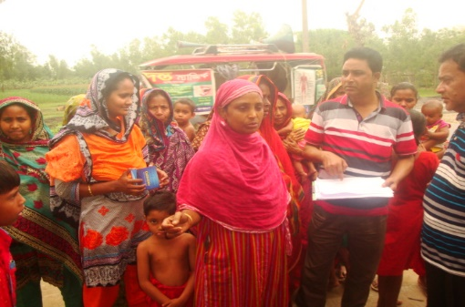The participatory public consultations were conducted in the subprojects areas. Key Informant Interviews (KII) andFocus Group Discussion (FGD) were conducted involving the participants of the Gobindaganj Pourashava Mayor, Councilors, Pourashava Officials, representatives of local Communities and civil society members as well as the representative of local LGED office and the consultant team.

A walk-through informal group consultation with the local communities was also held. Through this participation and consultation meeting, the local communities were informed about subprojects implementation and benefits. Suggestions and recommendations made by the participants are incorporated in the SMP accordingly. The photographs of consultation meeting atchasok para womanists are explained importance of drains.

Figure Community consultation meeting at Chasok para.

**4.3 Consultation Outcomes – Issues, Concerns, and Recommendations**

The participants raised their issues related to subprojects improvement which mainly includes RCC drains and street lights. Feedback, suggestions and recommendations by the participants are listed below.

* Construction works should be scheduled properly and the quality of construction work should be improved;
* By engaging women workers their direct income from the project will be ensured
* Social safeguard compliance issues have been ensured through the inclusive participation of subproject beneficiaries as well as PAPsand this will continue throughout the implementation process.

**5.0 Social Management for Site Selection and Design**

**5.1 Subproject Selection Process**

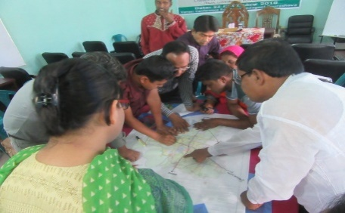MGSP in coordination with concerned ULB functionaries- Mayor, Councilors, local administration, and civil society members followed participatory approach in all stages of subprojectselection. All concerned stakeholders including concerned Ward Councilors and Woman Ward Councilor participated actively in the selection process. The Moreover, representatives of TLCC and WC from the Pourashava have contributed in the subproject selection process with an analysis of the inclusiveness of the selection process.

At the time of selecting these subprojects, Social Screening and Focused Group Discussion (FGD) with Gobindaganj Pourashava urban communities, local administration, traders, buyers, and sellers were conducted by the Gobindaganj Pourashava officials and Consultants from DSM. Views and opinions of these consultations were to explain the subprojects objectives and sought feedback from the participants to maximize the social and economic benefits as well as to minimize the adverse impacts of the subprojects.

Figure Sub project selection group discussion at pouroshva office

**5.2 Subproject Design Process**

After final selection of the subproject, the engineering part of the DSM Consultant designed the proposed subprojectcomponents (drainand street lights) und. The subproject will be located on the Pourshava’s own land. Despite the inclusion and participatory consultations, if any person has a grievance relating to the implementation of the subproject, the Pourashava has a GRC established to mitigate.

The Consultant interviewed stakeholders and beneficiaries of the subprojects areas before the design. The Consultant and Pourashava officials conducted a number of consultation meetings in the subprojects areas discussing the implementation procedures and mitigation measures, if any, required to be taken in implementing the proposed subprojects.

**5.3. Grievance Redress Mechanism (GRM):**

GRM has already been operational for GobindaganjPourashava. Accordingly, thePourashava has formed Grievance Redress Committee (GRC) to handle any grievance raised due to implementation of the sub-projects. The committee is headed by the Mayor of the ULB and consists of 7 members. The committee will answer to subproject-related queries and address complaints and grievances about any irregularities in application of the guidelines adopted for assessment and mitigation of social and environmental impacts.Based on consensus, the procedure will help to resolve issues/conflicts amicably and quickly without resorting to any expensive, time-consuming legal actions. It will ensure proper presentation of complaints and grievances, as well as impartial hearings and transparent decisions.

Gobindoganj Pourashava has already appointed Focal Point of GRC who is at the level of Assistant Engineer level. The Mayor of the Gobindoganj Pourashava is the Chairman of the GRC. This GRC at the Pourashava level has the responsibility to disclose the subproject implementation before the civil works starts.

**Structure of the GRC Committee:**

|  |  |
| --- | --- |
| **Person** | **Status** |
| ULB Mayor | Convener |
| Representative of Local Administration | Member |
| Teacher from a Local Educational Institution | Member |
| Representative of a Local NGO | Member |
| Representative of Civil Society | Member |
| Female Ward Councilor | Member |
| Head of Engineering Section of ULB | Member Secretary |

**5.4 Implementation Arrangement:**

DSM has initially completed social screening for the subproject and there are nomajor problems for the improvement of subprojects in regard to social safeguard issues. One minor problem noted is that front side of some shops will be affected. The PAPs have been consulted, a list of affected shopkeepers prepared and the ULB has a written agreement with the PAPs that they will remove the obstacles willingly and without compensation.

Accordingly, the PMU, MGSP has issued the award letter against the subproject following all required procurement procedures. The GobindoganjPourashava has the responsibility to implement the subproject timely in close coordination with the PMU and also with the technical assistance of the DSM. Engineering section of Pourashava and local representative of the Consultancy team will ensure quality of the construction work. In addition, Consultant team from the Head Quarters will ensure close monitoring of the implementation of subproject. In the implementation process, Social safeguard Team will ensure monitoring of social safeguard management before civil work starts and during construction so that the communities will not be affected and any loss involved to communities is minimized. In addition, before civil work starts, the Pourashava will make the video filmed and also social screening.

**6. Conclusions on Social Management Plan (SMP):**

The sub project will have positive impact on employment, agricultural development, creation of better business environment, marketing of agricultural products and promoting education facilities. Besides transport network, drainage condition will improve. All these factors will have incremental value of land, property, housing and holding tax valuation of the paurasova will increase. Therefore, implementations of the proposed subproject is demanded by the community and recommended.

It is confirmed that additional land will not be required. But there are front side of some shops encroached to paurasova road will be affected. These need to be removed. The paurasova reported that the PAPs agreed to remove these obstructions willingly and without compensation.

This report has been prepared following filled up questionnaire and checklist which follow:

**ANNEXURE-1Agreementfor Obstacle remove certificates provided by Shops kippers (3 pages)**

.

**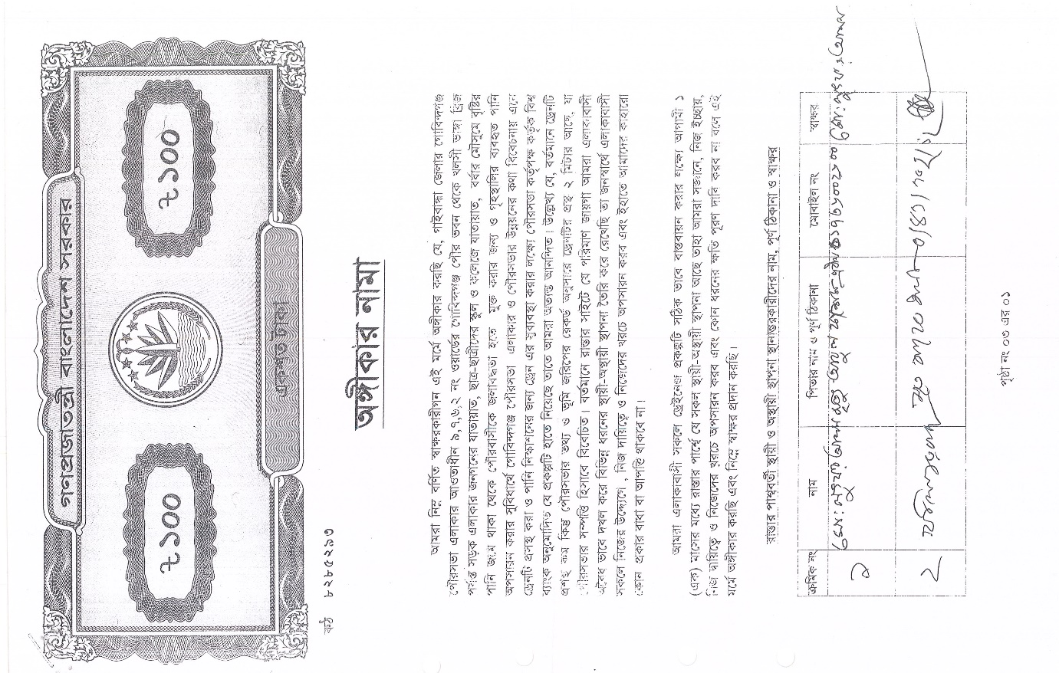**

**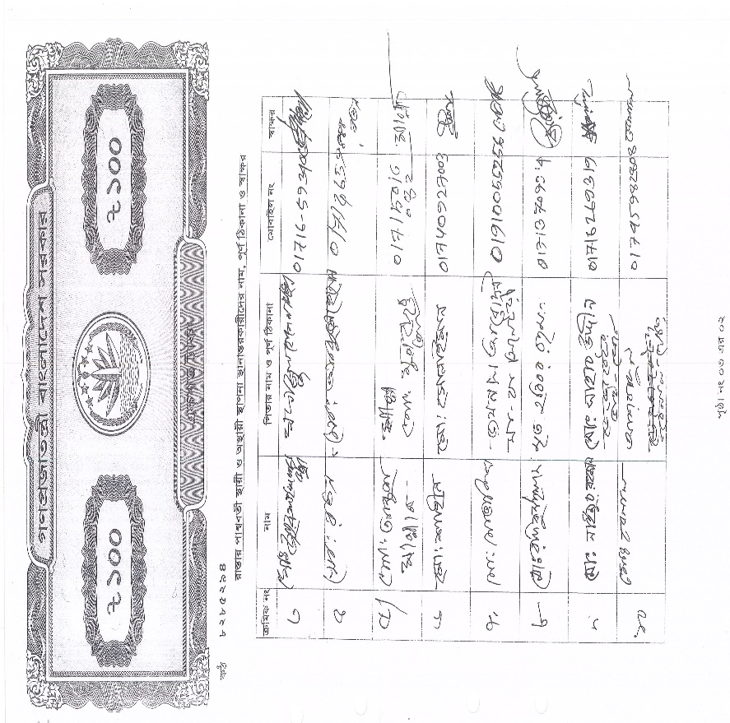**

**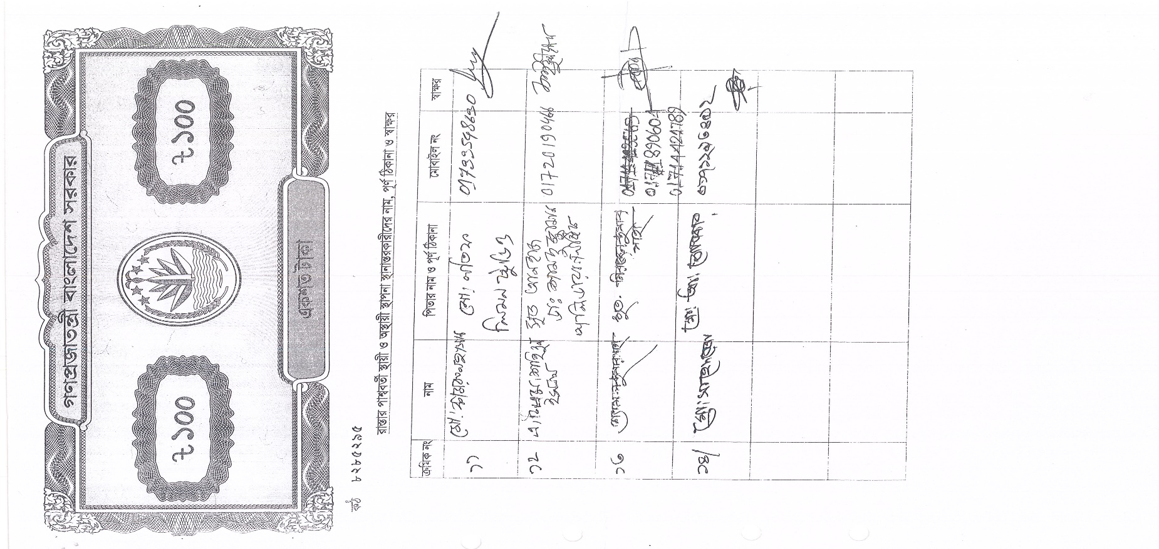**

**Annex-2. The LGED Gaibanda provided land ownership certificate Gobandagonjpouroshava.**

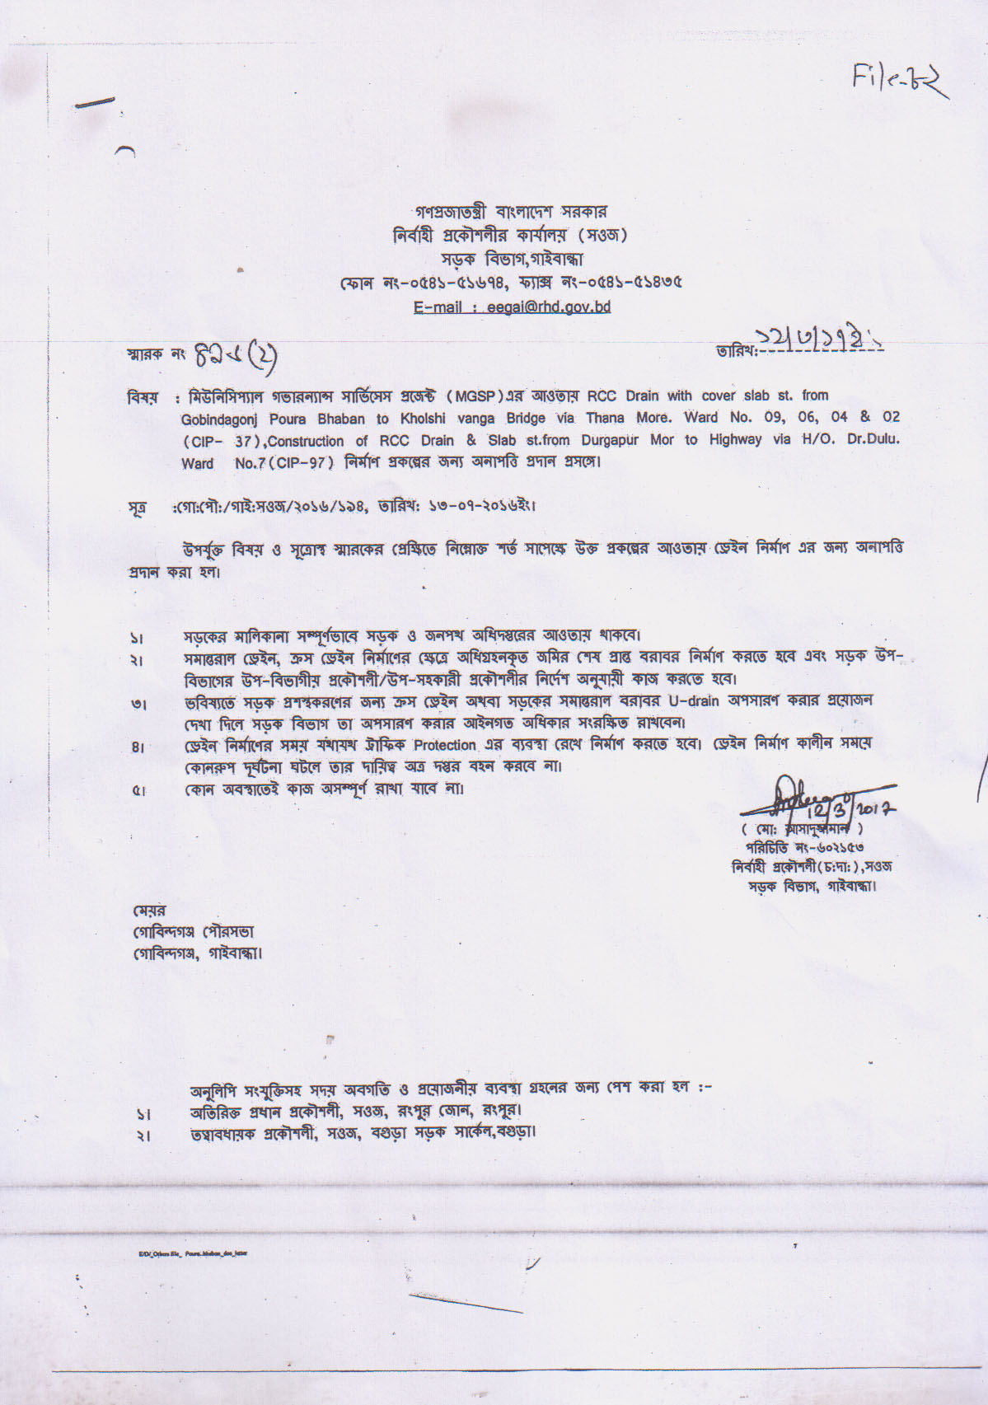

**Annex -3. Social Screening Report**

**Local Government Engineering Department (LGED)**

**Municipal Governance and Services Project (MGSP)**

**Agaragaon, Dhaka-1207**

**SOCIAL SAFEGUARDS SCREENING OF SUBPROJECTS**

**REVIEW and EVALUATION**

**Social Screening Report**

**Package No**: **MGSP/GOB/ 2016-17/W-3**

**Name of Subproject**:

**Construction of RCC drain and providing Street Light on GobindaganjPouraBhaban-Khulshivangabridge**

**Sub project components:**

a) Construction of RCC Drain with cover slab staring from GobindagonjPouraBhaban to Kholshivanga Bridge via Thana moar including link-1, length 75m and link-2,lenghth 45m .(Total effective length 2030,)

b) Supply, fitting & fixing of Street lights from GobindagonjpouraBhavan to Kholshivanga Bridge via Thana moar.Including link-1, length 75m and link-2, length 45m (Total effective length: 2450m) GobindagonjPourashava of Garibaldi District.

|  |  |
| --- | --- |
| **C:\Users\HP\Desktop\SAD +GOB Picture\DSC07819.JPG** | C:\Users\HP\AppData\Local\Packages\Microsoft.Windows.Photos_8wekyb3d8bbwe\TempState\ShareCache\DSC07827.JPG |
| **C:\Users\HP\AppData\Local\Packages\Microsoft.Windows.Photos_8wekyb3d8bbwe\TempState\ShareCache\DSC07796.JPG** | **C:\Users\HP\Desktop\SAD +GOB Picture\DSC07786.JPG** |

**6 April 2017**

**GobindagonjPoursshava**

**Gobindagonj ,Gaibanda**

***Design, Supervision and Management (DSM) Consultancy Service***

***Annex 8.A***

**FORM 1: SOCIAL SAFEGUARDS SCREENING OF SUBPROJECTS**

**REVIEW and EVALUATION**

**Name of Subproject: Construction of RCC drain, Widening of Road and Providing Street Light in GobindagongPourasova of Gaibanda district**

**Component -1**

a) Construction of RCC Drain with cover slab staring from GobindagonjPouraBhaban to Kholshivanga Bridge via Thana moar.Including link-1, length 75m and link-2, length 45m (Total effective length: 2030m)

b) Supply, fitting & fixing of Street lights from GobindagonjpouraBhavan to Kholshivanga Bridge via Thana moar .Including link-1, length 75m and link-2, length 45m (Total length 2450m)

**Description of subproject**

This subproject is very important to Gobindagonjpourashava. Total effective length of the drain is 2020m. Of the total length of the drain from pourabhaban to Khulshivanga bridge is 2330m. Of this length 420m drain from Dhaka –Rangpur highways to AbulMakar shop of Chasok para (wards no.2) has been constructed by the use of Bangladesh Climate Change Trust Fund (BCCTF). Excluding this 420m the remaining 1910 m (in wards number from 6 /7via 5 to 2) will be constructed under the sub project with cover slabs. To this will be added two link drains of length 120m making total length of the sub project drain will be 2030m. The drain will be on the south side of the road with four road crossings at intersections, one crossing BograRabgpur highway near Thana moar, two crossing poura roads and last one near Chasok para crossing pourasova road.

The second component will supply streetlight with fitting & fixing from GobindagonjpouraBhavan to Kholshivanga Bridge via Thana moar. Ch. 0+000 to 2+ 330km including link-1, Length 75m and link-2, length 45m (total length 2450m).

Regarding the land ownership this subproject alignment, the land belongs to the LGED, Gaibanda District. The LGED Gaibanda already given approval letter to GobindagonjPouroshava for construction of RCC drain and cover slabs dated on 12/03/2017 memo no: 496(2).

The sub project will also require relocating 27 electric poles and cutting 78 trees (Jackfruit, Rain tree, Betel nut, coconut andMango) trees before the start of construction. As per Pourasova authorities statement thesmall obstacles will be removed immediately.

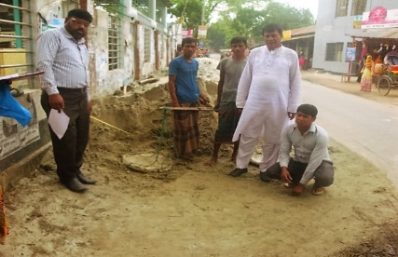As per Gobindagonjpourashava. CIP-37 this sub project will include construction of RCC Drain with cover slab and street light from GobindagonjPouraBhabanto Kholshivanga Bridge. Length of work of the drain is 2030m and the length of street lighting is 2450m.

The drain will be constructed along the south side of the road propose drains will be one sided & cover slab with four road crossings including one crossing of inter-district highway (Gobindagan—Dinajpur).

Figure Starting location of subproject PouraSonapara)

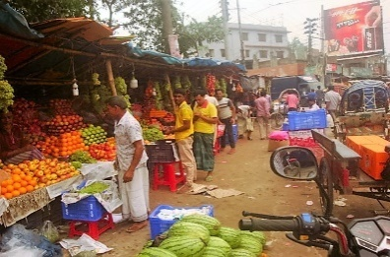This subproject belong to the LGED, Gaibanda District and they have already given permission to GobindagonjPouroshava for RCC drain construction along this road. (LGED Gaibanda Memo # 496(2) dated on **12/03/2017)**.

For smooth implementation of the sub project as per desired design front side of some shops need to bebe removed. The shops (tin fence cement floor) are situated on pouroshava land and also extended to pourasova land by encroachment. The involved shopkeepers have agreed in writing to remove the obstacles willingly without any compensation.

Figure .Furit shops needs to be shift (thanamoar)

In addition, there are some floating fruit vendors (west sides of Dhaka-Rangpur highways & before the BCCTF drain) need to move to another adjoining place to be provided by the paurosaova for the construction period and thereafter they will move to original place. Also, about 27 electrics poles have to be relocated and it is required to fell 78 trees (Jackfruit, Rain tree, Beetle net, coconut and Mango) trees. The paurasova ensured that these obstacles will be removed before the construction starts and that a tree plantation and caring program will be implemented.

The existing roadalong which the drain will be constructed is used by the students of Gobindagonjcollege, several schools &Madrasha. Sugar mill workers, business men and huge number of local peoples, children, women, GOB & NGO workers and labors etc use the road round the clock. Various types of vehicles like car, bus (Mohimagonj&Ghoraghat -Dinajpurbus services), mini-bus, rickshaw, auto rickshaw, battery operated three wheeler auto, truck and tractor trailer etc. use this road. It is so crowded that it often faces traffic jam particularly at thanamoar.

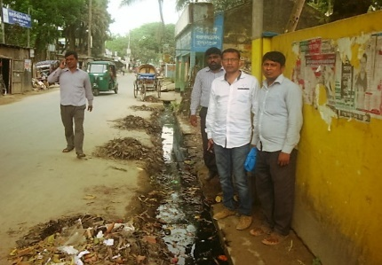The existing drain is damaged and has some missing links. It’s drainage capacity is limited. Since heavy vehicles are using the road in some parts width will be jus 6.0m with drain, it should be strong enough so that even movement of truck will not damagedit. One of the four crossings is on the highway and its load bearing capacity should be high and suited to inter district bus and truck movement.

Figure Existing road &old drains

**Date of Social Screening: 06/04/2017**

**2. INTRODUCTION:**

According to Project guidelines, LGED has adopted “Social Management Framework (SMF)” and “Grievance Redress Mechanisms (GRM)” following WB’s Operational Policy (OP 4.12, 4.10 and 4.11) and the Acquisition and Requisition of Immovable Property Ordinance, 1982(Ordinance II of 1982 of GOB), Pourashava Act 2009 and City Corporation Act 2009. The SMF and GRM contain detailed guidelines and Principles for mitigating losses of different types of property (land and non-land) that might have been caused by the programme of land acquisition and mitigating complaints, if any.

The screening process confirmed that, in this subproject, there is no need for land acquisition, hence no need for preparing RAP.

To initiate screening exercise for the sub project, a questionnaire was designed to facilitate the assessment of the current situation of Social Management related issues of concerned subprojects in 22 Municipalities and 4 City Corporations under Municipal Governance and Services Project (MGSP). The information collected by this questionnaire helped to assess the initial Social Management needs quickly and ensured that the relevant social concerns are addressed. This helped the PMU to approve subprojects in the earliest possible time.

This screening also enabled the best effective assessment of social matters in any ULB level and it has been completed as accurately as possible based on factual evidences**.**

**3. OBJECTIVES AND GOALS:**

The primary objective of this Social Screening is to check that relevant social issues are properly identified and remedial measures indicated so that sub projects involving unmanageable social risks are screened, hence the PMU can decided which ones to include or exclude which ones should have further documents prepared like SIMP.

**4. STRATEGY OF SOCIAL SCREENING:**

The Social Screening is based on a collection of primary data and information through conducting field survey for the subproject. A structured questionnaire was already designed in the Social Management Framework and given to the field officials for obtaining necessary primary data relating to social issues in connection with losses of land and any kind of assets for the subproject implementation. Further information was obtained through field visits and interviews with relevant stakeholders to capture collective opinions and feedback by using “Focus Group Discussion (FGD)”and “Key Informant Interviews (KII)”.

**5. TEAM COMPOSITION:**

The Social Screening analysis based on the received documents on subproject related social safeguards aspects from the ULB was conducted by following members:

1. Md. A.B. Siddique Social Management Officer, DSM, Rangpur, Zone
2. Md. Abdul Quddus khan, Senior Municipal Engineer-1, DSM, Rangpur Zone
3. Md. Abdulla –Al Mamun, Sub- Assistant Engineer, Gobindagonja, Pourashava.
4. Eng. . . .A. M. Rabbi-Assistant Municipal Engineer, Gobindagonj, Pourashava

**5.1 From ULB representatives**

a) Md. Shaharul Islam Councilor ward no: 2

b) Ripon Talukdar Councilor ward no-5

c) GovidurRahamana Councilor Ward no-7

**6. METHODOLOGY OF SOCIAL SCREENING REPORT ON SUBPROJECT:**

Subproject screening was carried out as per Social Management Framework of MGSP with the use of a prescribed social screening format. The concerned Social Management Officer and Senior Municipal Engineer, Assistant Municipal Engineer, Sub-Assistant Engineer conducted the social screening and the concerned Councilors of the paurasova participated in it. The screening was based on participatory consultation with the local people using Focus Group Discussion (FGD) and Hot Spot (on the spot) consultation with different categories of local people who are aware of local situation and needs of the subproject area.

Focus of the screening includes social safeguard compliance issues such as losses of land, displacement of population, stakeholder participation, income, gender, vulnerability and presence of tribal people etc.The field visit reports on social screening were prepared by the Social Management Officer and the Social Management Specialist has reviewed the reports. The DSM ensured that anybody in the subproject area will not be adversely affected or deprived due to the implementation of the subproject, and the PAPs (if any) are not forcibly evicted. However, it was found that in many instances, the PAPs vacate willingly often without compensation but in some cases with compensation. .

ULB and Consultants jointly ensured the consultation with the communities, infrastructure users, elected public representatives, local administration, teachers, businessmen, NGOs, social workers, and civil society members.

**7. Subproject Interventions:** ULB will take necessary steps regarding implementation of the subproject. Based on the sub project physical design and the SMP/SIMP payment to PAPs, if necessary,will be made by the PMU. The PMU will also ensure, together with the DSM and the ULB the compliance monitoring of the social concerns noted in the screening report and the SMP/ SIMP. After completion this procedure, then PMU will authorize physical work of the subproject.

Response from the community is absolutely positive for implementation of this subproject widely due to better communication and economic growth.

**8. KEY FINDINGS**

**8.1 LAND REQUIREMENTS:**

Based on the Social Screening from the field, it is confirmed that there is no needfor land acquisition and preparing RAP.

**8.2 HOMESTEAD AND OTHER NON-LAND ASSETS:**

It is noticed that no land in the sub project alignment belongs to private citizens. The concerned road belongs to the LGED. In some section, the drain will be located beside the national and regional highways and at one point, the drain has to cross Dhaka Rangpur national highway. The R&H department has given written consent to construct the drain with the direction their engineers.

Social Screening results demonstrated that no private homesteads or business premises and buildings are expected to be affected. However, front side some shops extended to the LGED road will be affected. The affected shopkeepers are paurasova tenants and agreed in writing to remove the obstacles without any compensation.

**8.3 INCOME LOSS/ BUSINESS LOSS:**

It has been observed that no businesses or trading activities would be displaced by the sub project. The affected shopkeepers noted under section 8.2 above will continue business at the same shops. However, some floating shop vendors will need to move temporarily during construction to another place already identified by the paurasova in consultation with the involved vendors.

The proposed subproject works are not expected to affect any community groups’ access to any resources that are used for livelihood purposes. None of the community facilities like schools, cemeteries, mosques, hospitals, temples, or other religious, cultural and historical properties are going to be affected.

**8.4 INDIGENOUS PEOPLE (IP), ADHIBASHI, and MARGINALIZED POPULATION:**

There is no Indigenous, Adhibashi and marginalized population that will be affected during subproject intervention and implementation. The survey did not find any Indigenous, Adhibashi or marginalized population living beside the sub project. Within paurasova area only two tribal households are living. However, in the entire upazila883 adibasihouseholds, mainly of santal tribe are living and many of them are sugar mill employee using the road and other facilities of the paurasova. They will be immensely benefited by the sub project and their inclusion is ensured through participatory consultation process. The DSM team noted during the screening that

* Adibasi communities are not adversely affected by the sub project
* Local IPs and Adhibashi organizations hasbeen involved in the participatory process where through NGO/ civil society.

**9. CONCLUSIONS AND RECOMMENDATIONS:**

It is safely confirmed for the marginalized population that no land will be required and no private, public, community, or cultural property as well as mini-commercial activities will be affected. But needs to 27 electrics poles relocated, 78 tree cutting, about 15 small shops & services center front space with fence remove including 8-9 temporary fruits shops shifting. The authorities of pourashava are agree the mentioned obstaclewill overcome immediately as because maximum land belongs to the pouroshava. So the proposed interventions are not expected to pose significant negative social impact. The transportation system may have positive impact on employment, agricultural development, creation of better business environment, marketing of agricultural products and promoting education facilities. All these factors have incremental value on socio-economic aspects in general and social aspects in particular. GD (Group Discussion) and sheet of attendance are available with Social Screening Reports. Therefore, implementations of the proposed subprojects are safely and highly recommended.

This report has been prepared following filled up questionnaire and checklist which follow.

**FORM1: SOCIAL SAFEGUARDS SCREENING OF SUBPROJECTS**

**REVIEW and EVALUATION**

**Name of Subproject: Construction of RCC drain, Widening of Road and Providing Street Light in Gobindagong Pourasova of Gaibanda district**

**NameofSubproject:**

a) Construction of RCC Drain with cover slab staring from Gobindagonj PouraBhaban to Kholshivanga Bridge via Thana moar.Including link-1, length 75m and link-2, length 45m (Total effective length: 2030 m)

b) Supply, fitting & fixing of Street lights from Gobindagonjpoura Bhavan to Kholshivanga Bridge via Thana moar .Including link-1, length 75 m and link-2, length 45 m (Total length 2450 m)

**Package No: MGSP /GOB/2016-17/W-3. Dated: 6/4/2017**

**I. Checklist for Exclusion**

|  |  |  |
| --- | --- | --- |
| 1) Subproject requires land acquisition and/or population displacement that can be compensated for or resettled | [ ] Yes | [√] No |
| 2) Subproject affects mosques, temples, graveyards and cremation grounds, and Other places/objects of religious, cultural and historical significance. | [ ] Yes | [√]No |
| 3) Subproject threatens cultural tradition and ways of life of tribal peoples; severely restrict their access to common property resources and livelihood activities. | [ ] Yes | [√] No |
| 4) Communities have objections on subproject interventions on social and environmental issues those cannot be resolved through design alternatives. | [ ] Yes | [√] No |
| **II. Resettlement Impacts** | | |
| In respect of the social impacts and community concerns, is there a need to,  Undertake an in-depth social impact assessment study? | [ ] Yes | [√ ] No |
| Prepare a Resettlement Action Plan? | [ ] Yes | [√]No |
| **III. Impacts on Tribal Peoples** | | |
| In respect of the social impacts on tribal peoples and their concerns, is there a need to,  Undertake an in-depth impact assessment study? | [ ] Yes | [√] No |
| Prepare a Tribal Peoples Plan? | [ ] Yes | [√]No |

**On behalf of the DSM Consultant, the attached filled out format has been reviewed and evaluated by:**

**Decision on selection**: **[**√**] recommended for selection [ ] recommended for exclusion**

**Prepared by*: Md. A.B. Siddique*** Designation: Social Management Officer, MGSP, LGED

Signature: 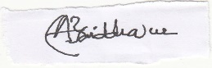 Date: 6.04.2017

**Reviewed by*: Dr. M. Maniruzzaman***Designation: Social Management Specialist, MGSP, LGED

Signature: Date: 6.4.2017

A social screening report will be prepared for each subproject covering methodology, participants’ analysis, community agreements &their concerns/suggestions, &summary of impacts and mitigation requirement.

**FORM 1: SCREENING FORM FOR SOCIAL SAFEGUARDS ISSUES**

1. **Identification**
2. *Name of ULB: GobindagonjPourashava District: Gaibanda*

*2, Ward/Mahalla: Ward No. 2, 5, and 7*

1. *Name of subproject / spot*

**Subproject -1**

aConstruction of RCC Drain with cover slab staring from GobindagonjPouraBhaban to Kholshivanga Bridge via Thana moar.(Total effective length : 2030)

b) Supply, fitting & fixing of Street lights from GobindagonjpouraBhavan to Kholshivanga Bridge via Thana moar.(Total length effective length: 2450 m)

*Project component: Drain with cover slabs & streetlight.*

1. **Brief description of the physical works**:

This subproject is located at ward no.7, 5 & 2 of GabindagonjPourashava. Under this subproject 2030km long drain will be constructed. There will be cover slab on the road which will be used as footpath for safe movement for users. These subproject is one of the most important constructions of the GobindagonjPourashava. In this location situated Sador police office, health service, clinic & Delta life insurance office, GobindagonjPourabhaban ,semi commercial areas, sales & services centers, electronic goods shops, fruits sales shops, cycle/motor bike repairing graze & hardware’s, maximum areas are exclusively residential. Moreover different types of professional walks to these localities by this road. Bus, truck, rickshaw, auto-rickshaw always move through this road. Due to insufficient drainage system, this road face water logging. The condition becomes more severe in the rainy season. For this reason, people could not take the full advantage of this road. The existing old drains of both sides which is very insufficient comparing with the requirement. That’s why after construction of the proposed drain, it will be helpful to the people and the businessmen of this area. Finally establish a well smart strong drainage networks over the pouroshava town through connecting with existing drains networks. Actually construction of drain by the side of this road, footpath on the drain and streetlight fixing will be very useful for the local residents by removing all obstacles.

.

**5. Screening Date(s):** 06.04.2016

**B.** **Participation in Screening:**

**6. Names of Consultants’ representatives who screened the subproject:**

1. ***: Dr. M. Maniruzzaman .***Designation: Social Management Specialist, MGSP, LGED
2. Md. A.B.Siddique Social Management Officer, DSM, Rangpur Zone
3. Md.Abdul Quddus khan, Senior Municipal Engineer-1, DSM, Rangpur Zone

7. **Names of ULB officials participated in screening**:

1. Md. Abdulla –Al Mamun , Sub- Assistant Engineer, Gobindagonja, Pourashava.
2. Engr .A. M. Rabbi-Assistant Municipal Engineer, Gobindagonj, Pourashava

*8. WLCC members, NGOs, community groups/CBOs participated in screening: Yes, copy enclosed for information.*

*9. Would-be affected persons participated in screening: N/A*

**C. Land Requirements & Ownership:** No.

|  |  |  |
| --- | --- | --- |
| *10. Will there be a need for additional lands to carry out the intended works under this contract?* | [ ] yes | [√ ] No |

*11. If ‘Yes’, what will the additional lands be used for? (Indicate all that apply): N/A*

[ ] road widening [ ] curve correction [ ] construction/expansion of physical structure

[ ] strengthening narrow eroding road section between high and low lands [ ] others (Mention):

*12. If ‘Yes’, the required lands presently belong to (Indicate all that apply): N/A*

[ ] ULB [ ] Government Land

[ ] Private Citizens [ ] Others (Mention):

**D. Current Land Use & Potential Impacts**

*13. If the required lands belong to Private Citizens, they are currently used for (Indicate all that apply):N/A*

[ ] Agriculture Number of households using the lands: Few users

[ ] Residential purposes Number of households using them: -------

[ ] Commercial purposes Number of persons using them: Shops:

[ ] Other Uses (Mention): few **U**sers:

Land does not belong to private citizen.

*14. If the required lands belong to ULB and/or other Government agencies, they are currently used for (Indicate all that apply): N/A*

[ ] Agriculture Number of persons/households using the lands:

**[ ]** Residential purposes Number of households living on them:

**[ ]** Commercial purposes Number of persons using them:

**[ ] Other Uses (Mention):**

*15. How many of the present users have lease agreements with any government agencies? None*

*16. Number of private homesteads that would be affected on private lands: None*

*Entirely requiring relocation……………………. Partially but can still live on present homestead*

*17. Number of business premises/buildings that would be affected on private lands: None.*

Entirely and will require relocation: # Of businesses housed in them: **.**

Partially, but can still use the premises: # Of businesses housed in them:

*18. Residential households will be affected on ULB’s own and & public lands: None*

*Entirely affected* and will require relocation: No. of these structures:

No. of structures built with brick, RCC, & other expensive and durable materials:

No. of structures built with inexpensive salvageable materials (bamboo, GI sheets, etc:

*Partially affected*, but can still live on the present homestead: No.of these structures

No. of structures built with brick, RCC, & other expensive and durable materials:

No. of structures built with inexpensive salvageable materials (bamboo, GI sheets, etc):

*19. No. of business premises that would be affected on ULB’s own & other public lands: None*

*Entirely affected* and will require relocation: No. of these structures:

No. of businesses housed in these structures:

No. of persons presently employed in the above businesses.

No. of these structures built with brick, RCC, & other durable materials:

No. of structure built with inexpensive salvageable materials (bamboo, GI sheets, etc):

*Partially affected*, but can still stay in the present no. of these structures:

No. of businesses housed in these structures:

No. of persons presently employed in these businesses:

No. of these structures built with brick, RCC, & other durable materials:

No. of structure built with inexpensive salvageable materials (bamboo, GI sheets, etc):

*20. None of businesses/trading activities that would be displaced from make-shift structures on the road, and other areas/spots: None*

*21. Do the proposed subproject works affect any community groups’ access to any resources that are used for livelihood purposes? [ ] Yes [√] No*

*22. If ‘Yes’, description of the resources: N/A*

*23. Do the proposed works affect community facilities like school, cemetery, mosque, temple, or others that are of religious, cultural and historical significance? [ ] Yes [√ ] No.  
 24. If ‘Yes’, description of the facilities: N/A.  
 25. Describe any other impacts that have not been covered in this questionnaire? No.  
 26. Describe alternatives, if any, to avoid or minimize use of additional lands: N/A*

**E. ADDITIONAL INFORMATION ON TRIBAL PEOPLE**

(This section must be filled in if subprojects are located in areas that are also inhabited by tribal peoples)

*27. Names of tribal community members and organizations who participated in screening: N/A*

*28. Have the tribal community and the would-be affected TPs been made aware of the potential positive and negative impacts and consulted for their feedback and inputs?*

**Name of Subproject: Construction of RCC drain, Widening of Road and Providing Street Light in GobindagongPourasova of Gaibanda district**

[ ] Yes [√] No

Has there been a broad-based community consensus on the proposed works?

[ ] Yes [√] No

*29. Total number of would-be affected tribal households: N/A****.***

*30. The would-be affected tribal households have the following forms of rights to the required lands: N/A*

[ ] Legal: No. of households:

[ ] Customary: No. of households:

[ ] Lease agreements with any GOB agencies: No. of households:

[ ] Others (Mention): No. of households:

*31. Does the subproject affect any objects that are of religious and cultural significance to the IPs?*

[ ] Yes [√] No

**G.32. If ‘Yes’, description of the objects:** N/A.

*33. The following are the three main economic activities of the would-be affected tribal households:*

a. N/A

b. N/A

c. N/A

*34. Social concerns expressed by tribal communities/organizations about the works proposed under the subproject: N/A*

*35. The tribal community and organizations perceive the social outcomes of the subproject: N/A***On behalf of the DSM Consultant, the attached filled out format has been reviewed and evaluated by:**

**Decision on selection [**√**] recommended for selection [] recommended for exclusion**

***Prepared by :Md.A.B.Siddique***Designation: Social Management Officer, MGSP, LGED

Signature:  Date: 05.04.2017

***Reviewed by: Dr.M.Maniruzzaman*** .Designation: Social Management Specialist, MGSP, and LGED

Signature: Date:

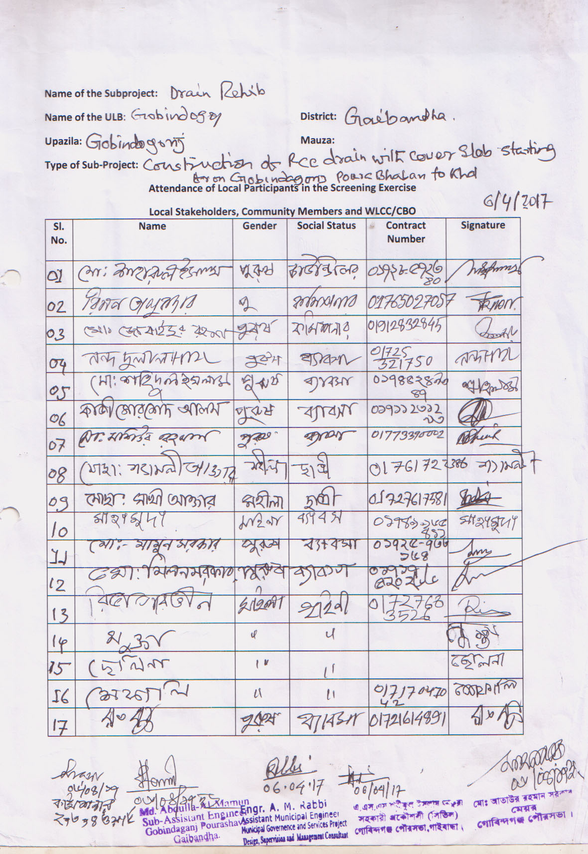

Annex: 01. LGED, Gaibanda provided NOC for RCC drain construction to Gobindagonjpouroshava.

