

**Local Government Division**

**Local Government Engineering Department**

**Municipal Governance and Services Project (MGSP)**

**IDA Credit No: 5339-BD**

**Report on Social Management Plan**

**Package No: MGSP/GOB/2017-18/W-4**

**Name of Subproject:**

**a) Construction of 38 m long RCC Girder Bridge on Korotoa(dead Korotoa) River at Chandpur Kholshi under Gobindagonj Pourashava, Gaibandha.**

**b) Construction of 48 nm long RCC Girder Bridge on Korotoa(dead Korotoa) River at Kalikadoba under Gobindagonj Pourashava, Gaibandha.**

**c.)** **Construction of approach road by bituminous carpeting for 38 m RCC Girder bridge on Korotoa(dead kotrotoa) River at Chandpur Kholshi (Ch. 0+ 000 to 0+050 m & 0+088 to 0+210 m) under Gobindagonj Pourashava, Gaibandha**

**d.)** **Construction of approach road by bituminous carpeting for 48 m RCC Girder bridge on Korotoa(dead Korotoa) River at kalikadoba (Ch. 0+ 000 to 0+394 m & 0+442 to 0+700 m) under Gobindagonj Pourashava, Gaibandha**

**e) Supply ,fitting & fixing of Streetlight from Chandpur Kholshi Primary School to Nut Mondir Moar via RCC Girder Bridge Ch .0+000 to 0 +219 m ( Total length 219) under Gobindagonj Pourashava.Gaibandh.**

**f) Supply ,fitting & fixing of Streetlight from kalikadoba Primary School to Gorastan para Mosque via RCC Girder Bridge Ch .0+000 to 0 +700 m ( Total length 700) under Gobindagonj Pourashava. Gaibandh**

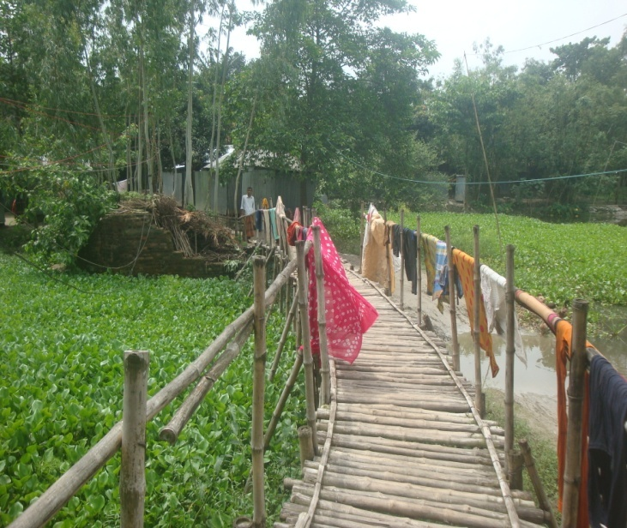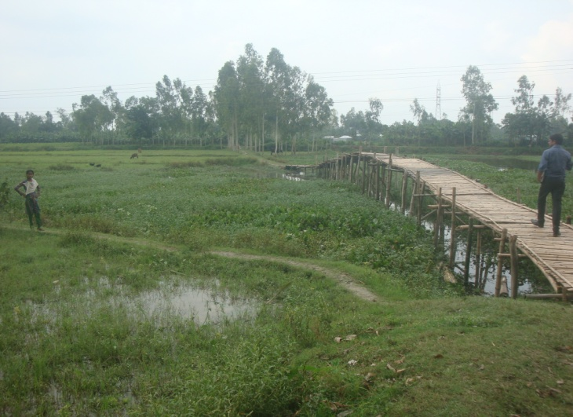

** Design, Supervision, and Management (DSM) Consultancy Services**

**Joint Venture of**

*** Hifab International AB, Sweden***

***AQUA Consultant & Associates Ltd., Bangladesh***

**August -2017**

**Gobindaganj Pourashava**

**Gaibandha**

**Table of Contents**

|  |  |  |
| --- | --- | --- |
| **SL No** | **Contents** | **Page. No** |
| 0 | Executive Summary | 4 |
| 1. | Introduction | 5 |
| 1.1 | Project Background | 5 |
| 1.2 | Legal and Policy Framework | 5 |
| 1.3 | Subproject Description | 6 |
| 1.4 | Social Management Plan | 9 |
| 2. | Description of Subproject Area | 9 |
| 2.1 | Brief Profile of GobindaganjPourashava | 14 |
| 2.2 | Historical and Cultural Heritage Sites | 14 |
| 2.3 | The Subproject Location and Area Profile | 14 |
| 2.4 | Beneficiary Communities and Affected Persons | 15 |
| 2.5 | Gender and Vulnerability | 15 |
| 3. | Social Impact Assessment | 15 |
| 3.1 | Benefits of the Subproject | 15 |
| 3.2 | Social Screening and Safeguard Compliance Issue | 15 |
| 4. | Consultation and Community Participation | 16 |
| 4.1 | Stakeholder Analysis | 16 |
| 4.2 | Consultation and Participation Meeting | 16 |
| 4.3 | Consultation Outcomes – Issues, Concerns and Recommendations | 16 |
| 5.0 | Social Management for Site Selection and Design | 16 |
| 5.1 | Subproject Selection Process”. | 16 |
| 5.2 | Subproject Design Process | 17 |
| 5.3 | Grievance Redress Mechanism | 17 |
| 5.4 | Implementation Arrangement | 17 |
| 6. | Conclusions on Social Management Plan (SMP) | 18 |
| **Photographs** | |  |
| 1. | Subproject layout plan | 12-13 |
| 2. | Present condition of existing bamboo bridge at Chandpur | 6 |
| 3 | Present condition of existing bridge at kalkadoba | 7 |
| 4 | Community consultation meeting | 16 |
| **FIGUR** |  |  |
| 1 | SUB project Estimated cost | 8 |
| 2. | At a glanced of Gobindaganj Pourashava | 10 |
| **ANNEXURE** | |  |
| 1. | Agreement between PAPs and ULB | 19-21 |
| 2. | Social screening Report (a ,c & e) | 1-14 pages |
| 3 | Social screening Report (b, d & f) | 1-14 pages |

**Abbreviations**

|  |  |
| --- | --- |
| ARP | Abbreviated Resettlement Plan |
| BMDF | Bangladesh Municipal Development Fund |
| LAP | Land Acquisition Plan |
| CBO | Community Based Organization |
| RCC | Reinforce Cement Concrete |
| SHE | SherpurPourashava |
| CIP | Capital Investment Plan |
| CUL | Compensation-Under-Law |
| DC | Deputy Commissioner |
| DLAC | District Land Acquisition Committee |
| DUTP | Dhaka Urban Transport Project |
| GoB | Government of Bangladesh |
| GRC | Grievance Redress Committee |
| GRM | Grievance Redress Mechanism |
| HCG | House Construction Grant |
| HTG | House Transfer Grant |
| IDA | International Development Association |
| IP | Indigenous People |
| IPP | Indigenous Peoples Plan |
| KII | Key Informants Interviews |
| FGD | Focus Group Discussion |
| LGD | Local Government Division |
| LGED | Local Government Engineering Department |
| M& S | Management &Supervision |
| MGSP | Municipal Governance and Services Project |
| MOLGRDC | Ministry of Local Government, Rural Development & Cooperatives |
| MSP | Municipal Services Project |
| MSL | Mean sea Level |
| NGO | Non-governmental Organization |
| PAH | Project Affected Household |
| PAP | Project Affected Person |
| PMU | Project Management Unit |
| RAP | Resettlement Action Plan |
| RCC | Reinforced Concrete Cement |
| RP | Resettlement Pan |
| SIA | Social Impact Assessment |
| SMP | Social Management Plan |
| SSS | Social Safeguards Specialist |
| TLCC | Town Level Coordination Committee |
| ULB | Urban Local Body |
| WB | World Bank |
| WC | Ward Committee |

**EXECUTIVE SUMMARY**

Gobindhagonj Pourashava is C Category Pourashava having 14.58 sq. areas. The ULB is densely populated having 9 administrative wards which area also underserved in all development considerations. The subproject has been selected considering the needs of the locality which is priority as CIP of Gobindhagonj Pourashava.

The Social Management Plan (SMP) of the Subproject under Gobindhagonj Pourashava was developed through inclusive participation of all level stakeholders and using participatory approach. The SMP includes two social screening against two bridges. The subproject comprises interventions proposed as per **CIP-21 and CIP -50** of the Gobindhagonj Pourashava.

The sub project will benefit three of the 9 administrative wards of the Gobindhagonj Pourashava (Wards 2, 3 and 8). According to engineering design, implementation of this subproject will be carried out within the existing right-of-way hence no LA is involved and no RAP is required.

***Total cost of the subproject is Taka*: 59,933,019.57 BDT.**

***Main Purposes of the subproject***

To improve safe communication networks construction 81 m long two bridge, 619 m approach road located in three wards. Presently there is a bamboo foot bridge requiring change of bamboo twice a year. It is very difficult and risky to cross the canal by Bamboo Bridge.

**Anticipated Impacts:**

The subproject will benefit 2, 3 & 8 wards of the Gobindhagonj Pourashava. About, 50,000 people of the three wards will be benefited for construction the bridge and approach road.

There are obstacles in this proposed subproject area and 24 of PAPs will be affected. The subproject will need cutting of 55 trees. (Mango, Jackfruit, Akashmani and Eucalyptus)

The local stakeholders are supportive of the subproject hence it is recommended to include it under MGSP.

**1. Introduction**

***1.1 Project Background***

The Government of Bangladesh, through the Local Government Engineering Department (LGED) and Bangladesh Municipal Development Fund (BMDF) is implementing the Municipal Governance and Services Project (MGSP). The project aims to improve municipal governance and basic urban services in participating ULBs. Two physical components of the project include (i) Municipal Governance and Basic Urban Services Improvement (Component 1) to provide financial support to 26 pre-identified urban local bodies (ULBs) including municipalities and city corporations, and demand-based sub-credits to eligible ULBs for basic urban services improvement investment costs. The project cost is BDT 2, 470, 93.92 lakh to be finance at 80:20 IDA loan to GOB contribution. LGED is implementing the Component 1 while BMDF is implementing component 2 of the project.

LGED is supporting the 26 pre-selected ULBs for investments in development and rehabilitation of Road, Bridge, Box-culvert, Pedestrians bridge, street light, Traffic Control, Bus terminal, Truck terminal, Boat landing Jetty, Drain, Retaining wall, Kitchen market, Cattle market, slaughter house, Public toilet, Solid waste management, Sweeper colony, Park, Community Centre and Whole sale market. LGED is financing through (i) base allocation based on population category of ULBs; (ii) performance-based allocation and (iii) operations and maintenance support on a declining basis over the project period.

The component interventions have largely been developed for construction and rehabilitation within existing available land owned by the ULBs and acquisition of land has been avoided in the social screening process. Removal of some obstruction and relocation of some business were involved in case of some sub project for unavoidable circumstances.

The MGSP did not avoid taking up of sub project in area inhabited by tribal peoples and instead ensure their inclusion and participation where applicable. The ULBs addressed the removal of obstruction and in most cases the land entirely belongs to the ULB. In some instances, land of other GOB agencies like the BWDB, R &H or other local government like adjoining UP is needed and in such cases the ULB ensured getting such land by mutual understanding and proper documentation. Relocation of business and removal of obstructions were resolved by consultation and agreement with the concerned PAPS and these are properly documented. Thus land acquisition, population displacement and tribal people’s issues have been addressed following the country’s following the country’s legal framework and the World Bank policy on social safeguards.

***1.2 Legal and Policy Framework***

For the subproject preparation and implementation, the World Bank’s Operational Policy (OP) on Involuntary Resettlement (OP 4.12) and on Indigenous Peoples (OP 4.10) have been triggered to the project. A Social Management Framework (SMF) has been adopted by LGED for the project that meets the requirements of the country’s legal frameworks in Bangladesh “The Acquisition and Requisition of Immovable Property, Ordinance, 1982” and the Bank requirements including OP 4.12 and OP 4.10. The SMF also requires that subprojects are prepared ensuring inclusion, participation, transparency, and social accountability. Subprojects are prepared by respective ULBs in a process complying with the SMF requirements. LGED reviews the subproject proposals for technical, engineering, environmental, social development, and safeguards compliance before allocation of the financing to the ULBs.

As a matter of policy Social Management Plans (SMP) will be prepared and implemented for subprojects with no land acquisition or involuntary displacement of people, while Resettlement Action Plans (RAP) and Tribal Peoples Plans (TPP) will be prepared for implementation for subprojects involving population displacement and tribal peoples’ issues.

***1.3 Subproject Description***

**a) Construction of 38 m long RCC Girder Bridge on Korotoa(dead Korotoa) River at Chandpur Kholshi under Gobindagonj Pourashava, Gaibandha.**

**c.)** **Construction of approach road by bituminous carpeting for 38 m RCC Girder bridge on Korotoa(dead Korotoa) River at Chandpur Kholshi (Ch. 0+ 000 to 0+050 m & 0+088 to 0+219 m) under Gobindagonj Pourashava, Gaibandha**

**e) Supply ,fitting & fixing of Streetlight from Chandpur Kholshi Primary School to Nut Mondir Moar via RCC Girder Bridge Ch .0+000 to 0 +219 m ( Total length 219) under Gobindagonj Pourashava.Gaibandh.**

This subproject is an important construction work of Gobindagonj Pourashava to be implemented in the ward numbers 2. The proposed bridge will be constructed on the Korotoa River for establishing better intra communication between Poura town with the ward no 2 located at village of Chandpur kholshi and Chalkgobida under Gobindagonj Pourashava. The existing connectivity is a bamboo foot bridge constructed and maintained by Gobindagonj Pourashava.

The required land for bridge construction belongs to the Gobindagonj Pourashava including existing CC pavement approach roadThe west bank of Korotoa river have210 mlong CC road and this road is old, damage, undulation and many wholes (Ch. 0+ 000 to 0+050 m & 0+090 to 0+210 m) and east bank have well structure BC road (Constructed by the used of local LGED fund) So proposed 210 m long approach BC road along with 40 m long RCC

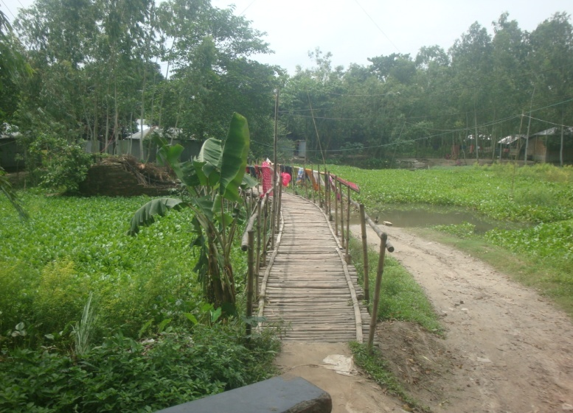Girder Bridge will be constructed. The existing bamboo bridge is old, damage and it is very risky to cross the canal using this bridge. In the rainy season and flood time it is very difficult for women, children elderly peoples, student’s traders, farmers and sick peoples to cross the canal. Due to not having bridge ,vehicles coming from the twon have to stop in east side of the canal. Rickshaws coming from the west side cannot go to the main town and must stops besides the canal. The bridge will therefore remove the difficulty of movement.The subproject connects residential and commercial areas. Beside the approach road there are have several shops like grocery, stationary and tea stall and one Mosque and one GPS . About 20,000 peoples comprising businessmen, students, children, women, teachers and services holders will benefit from the use this bridge. The bridge and approaches roads will be used by all types of transports like, rickshaw-van, CNG driven baby taxi and battery operated three wheeler auto pickup , microbus and lorries .

Figure 1 Present condition of existing bamboo bridge at Chandpur

During the screening works the DSM and ULB team noted all existing facts & features of proposed subproject areas including difficulties as well as scopes and opportunities. During social screening the DSM team has been as following.

* There are 04 private house tin roofs with fence and wooden poles vertical parts are encroachment in Pourashava land. So need shift back (Agreement attached annex-1). Will need cutting about of 15 trees.

After construction of this bridge with approach road the ward 2 of Gobindagonj Pourashava will have better transport network. It will minimize difficulties in movement for vehicle & people, will save travel time and cost and reduce traffic congestion for working as a localized by pass regional road. It will improve market linkage, rural –urban link and therefore will provide opportunity to market agriculture and other produce. At the one side, the producers will get better price and consumers will get commodities of better quality at lower price. Further it will contribute to increased business opportunities, employment, income, living standard and reduce poverty. For the bridge, movement will be safer for all categories of people including women, children, elderly persons and disabled. Business economic the subproject will improve access to education, health and administrative services.

The sub project bridge and approaches are all located on ULB,s own land there is no need for land acquisition . So it is not necessary to prepare RAP. Also there is no need for voluntary dispossession as no property is affected.

Construction of the proposed bridges and approaches will help saving travel time for the one ward as well as of people of adjoining wards peoples.

**Description of Subproject**

b) **Construction of 48 m long RCC Girder Bridge on Korotoa (dead Korotoa) River at Kalikadoba under Gobindagonj Pourashava, Gaibandha.**

**d.)** **Construction of approach road by bituminous carpeting for 48 m RCC Girder bridge on Korotoa(dead Korotoa) River at kalikadoba (Ch. 0+ 000 to 0+394 m & 0+442 to 0+700 m) under Gobindagonj Pourashava, Gaibandha**

**f) Supply ,fitting & fixing of Streetlight from kalikadoba Primary School to Gorastan para Mosque via RCC Girder Bridge Ch .0+000 to 0 +700 m ( Total length 700) under Gobindagonj Pourashava. Gaibandh**

This subproject is an important construction work of Gobindagonj Pourashava to be implemented in the ward numbers 3 & 8. The proposed bridge will be constructed on the Korotoa River for establishing better intra communication between Poura town with the ward no 3 & 8 located at village of kalikadoba and Gorstan para under Gobindagonj Pourashava. The existing connectivity is a bamboo foot bridge constructed and maintained by Gobindagonj Pourashava.

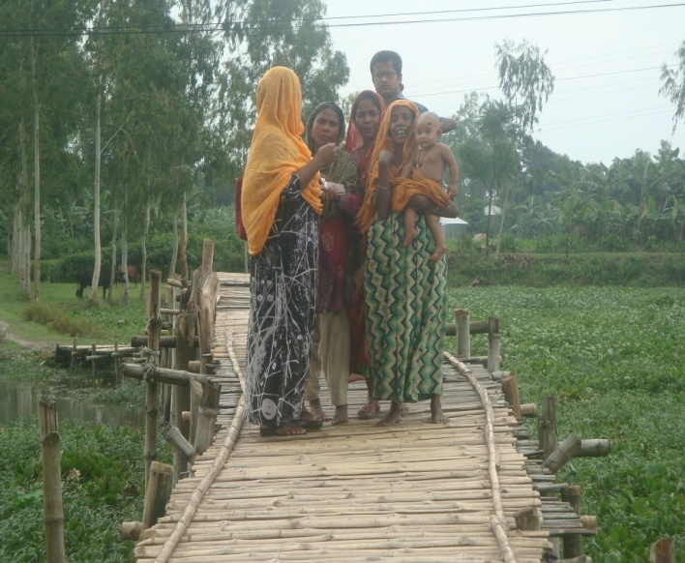 The required land for bridge construction belongs to the Gobindagonj Pourashava including existing earthen approach roadThe east bank of Korotoa river have394 mlong earthen road and west bank is 256 m long earthen road (**Ch. 0+ 000 to 0+394 m& 0+442 to 0+700 m)** So proposed 394 m & 256 long approach BC road along with 50 m long RCC Girder Bridge will be constructed

The existing bamboo bridge is old, damage and it is very risky to cross the canal using this bridge. In the rainy season and flood time it is very difficult for women, children elderly peoples, student’s traders, farmers and sick peoples to cross the canal.Due to not having bridge ,vehicles coming from the twon have to stop in wast side of the canal. Rickshaws coming from the east side cannot go to the main town and must stops besides the canal. The bridge will therefore remove the difficulty of movement.

The subproject connects residential and commercial areas. Beside the approach road there are have one Mosque and agricultural field (Banana cultivation). About 30,000 peoples comprising businessmen, students, children, women, teachers and services holders will benefit from the use this bridge. The bridge and approaches roads will be used by all types of transports like, rickshaw-van, CNG driven baby taxi and battery operated three wheeler auto, pickup, microbus and Lorries.

Figure 2 Present condition of existing bridge at Kalkadoba

During the screening works the DSM and ULB team noted all existing facts & features of proposed subproject areas including difficulties as well as scopes and opportunities. During social screening the DSM team has been as following.

* There are 16 farmer plots at kalikadoba approach road and Gorastan para 04-farmer is encroachment in Pourashava land. So need removal these obstacles and shift back.( Agreement & NOC attached annex-1)
* To construction of subproject need felling about 40 trees (Eucalyptus, Mango and banana bunch).

After construction of this bridge with approach road the ward 3 & 8 of Gobindagonj Pourashava will have better transport network. It will minimize difficulties in movement for vehicle & people, will save travel time and cost and reduce traffic congestion for working as a localized by pass regional and high ways road. It will improve market linkage, rural –urban link and therefore will provide opportunity to market agricultural and other produce. At the one side, the producers will get better price and consumers will get commodities of better quality at lower price. Further it will contribute to increased business opportunities, employment, income, living standard and reduce poverty. For the bridge, movement will be safer for all categories of people including women, children, elderly persons and disabled. Besides economic the subproject will improve access to education, health and administrative services.

The sub project bridge and approaches are all located on ULB,s own land there is no need for land acquisition . So it is not necessary to prepare RAP. Also there is no need for voluntary dispossession as no property is affected.

Construction of the proposed bridges and approaches will help saving travel time for the one ward as well as of people of adjoining wards peoples.

**Sub project cost**

The proposed length of, RCC drain and street lights to be developed and estimated cost for the subprojects are given below.

| **S.L#** | **Subproject** | **Length (m)** | **Estimated Cost (BTD)** |
| --- | --- | --- | --- |
| 1 | Construction of 38 m long RCC Girder Bridge on Korotoa(dead Korotoa) River at Chandpur Kholshi under Gobindagonj Pourashava, Gaibandha | 38 m | 23,010,582.42 |
| 2 | Construction of 48 m long RCC Girder Bridge on Korotoa(dead Korotoa) River at Kalikadoba under Gobindagonj Pourashava, Gaibandha | 48 m | 19,306,917.03 |
| 3 | Construction of approach road by bituminous carpeting for 38 m RCC Girder bridge on Korotoa(dead Korotoa) River at Chandpur Kholshi (Ch. 0+ 000 to 0+050 m & 0+088 to 0+219 m) under Gobindagonj Pourashava, Gaibandha | 219 m | 3,019,424.06 |
| 4 | Construction of approach road by bituminous carpeting for 48 m RCC Girder bridge on Korotoa(dead Korotoa) River at kalikadoba (Ch. 0+ 000 to 0+394 m & 0+442 to 0+700 m) under Gobindagonj Pourashava, Gaibandha | 700 m | 12,402,121.31 |
| 5 | Supply, fitting & fixing of Streetlight from Chandpur Kholshi Primary School to Nut Mondir Moar via RCC Girder Bridge Ch .0+000 to 0 +219 m ( Total length 219) under Gobindagonj Pourashava.Gaibandh. | 219 m | 628,226.84 |
| 6 | Supply, fitting & fixing of Streetlight from kalikadoba Primary School to Gorastan para Mosque via RCC Girder Bridge Ch .0+000 to 0 +700 m (Total length 700) under Gobindagonj Pourashava. Gaibandh | 700 m | 1,565,747.90 |
|  | Package Total Taka : BDT |  | **59,933,019.57** |

***1.4 . Social Management Plan***

This Social Management Plan (SMP) has identified the subprojects and managed social concerns in the process of subproject design and implementation. Initially, the subproject proposals included a social screening report along with impact assessment. After reviewing the social screening report by Social Unit of DSM, the subprojects proposals are submitted to the PMU office. Social team of the DSM has carried out a series of site visits and consulted with the ULB officials, stakeholders and a section of the beneficiary communities through interview and participation & consultation meetings. The social screening findings and consultation and proceeding of meetings were validated through the social survey and consultation.

The purpose of preparing this SMP is to demonstrate an all-inclusive consultative process in selection and design of the subproject as well as to provide guidance for social development and safeguards compliance in the implementation process.

The SMP contains a description of the subproject areas, social screening and impacts, consultation process adopted during identification and design, and consultation plan for implementation stage, impact mitigation measures, grievance resolution process, and implementation arrangements and monitoring and evaluation.

Gobindaganj Pourashava will ensure participation of the communities and grievance resolution in the process of implementation of the subprojects.

**2 Description of Subproject Area**

***2.1 Brief Profile of GobindaganjPourashava***

Gobindaganj, the largest Upazila of Gaibandha District in respect of area, household and population started functioning as thana headquarters in 1912. It is said that in the long past Bhim, the independent king of North Bengal came to the present place with a big statue of the GodGobinda and set up it over there. Subsequently, a trading center was developed in and aroundthe place. It was upgraded to Upazila in the 1980s during Ershad regime. The name of upazilaand of the town might have derived after the name of the GodGobinda.

Gobindaganj Pourashava was established on 23rd February in 1998. It is situated in Gobindaganj Upazila under the district of Gaibandha (RangpurDivision). It is upgraded into B' Class Pourashava which is now the administrative headquarters of Gobindaganj Upazila. GobindaganjPourashava with an area of 14.58 sq km and is bounded by Fulbari Union on the north and east,Kamardha union on the south, and Gumaniganj Union on the west.

As per the Bangladesh Population Census 2011, the population of Gobindaganj Pourashava is 38,415 and of them 193,62 are male and 19,052 are female and the population density is 2,635 per sq km. Total number of holding in the area is 7,415. According to Bangladesh Population Census 2011 (published in 2012), the population of Gobindaganj Pourashava is 38,415 among them 50.40% are male and 49.60% female, total no. of household is 9,718, population density is 1,118 per sq km.

**FIGURE-2:**

**Gobindaganj Pourashava**

**At a glance**

|  |  |  |  |  |  |  |  |  |  |  |
| --- | --- | --- | --- | --- | --- | --- | --- | --- | --- | --- |
| General Information | | | | | | | | | | |
| Area | | | | | | | | | :: | 14.58 Square KM. |
| Wards | | | | | | | | |  | 9 |
| Population  Population Growth Rate  Household No  Population Density  Major Status  Main Income Source : | | | | | | | | |  | 38,415 M 19,353 F 190,62 (2011)  1.50%  9,718  2,635  20% Migrated People  Agricultural labor 22%, Small business 36%, large business 15%, Service 12%, others 15% |
| Tax | | | | | | | | | | |
| Number of Holding for paura Tax payment | | | |  | | | | | | 6,692 |
| Market | | | | | | | | | | |
| Katcha Bazars | |  | | | | | | | | 3 |
| Shopping Complex | |  | | | | | | | | 3 |
| Own Shops | |  | | | | | | | | 1.000 |
| Communication | | | | | | | | | | |
| Pucca Roads  Semi-pucca Roads  Katcha roads | | |  | | | | | | | 9.49 km  10.27 m m  32.13 km |
| Water Supply | | | | | | | | | | |
| Total Number of tube wells | | |  | | | | | | | 770 No’s |
| Own tube well  community tube well  Neighboring household tube well  Bathing and other purpose | | |  | | | | | | | 60%  20%  20%  Tube well and Pond water |
| Street Lighting | | | | | | | | | | |
| Street Lights |  | | | | | | | | | 800 |
| Drainage System | | | | | | | | | | |
| Pucca and katcha drain |  | | | | | | | | | 28.04km |
| Ponds/ ditches |  | | | | | | | | | 10 Nos |
| Natural drainage system( Khals/ rivers): |  | | | | | | | | | 2.5km |
| Public Health | | | | | | | | | | |
| Pucca sanitary toilet | | | | | | | |  | | 87% |
| Katcha latrine | | | | | | | |  | | 11.0% |
| No sanitary toilets  Sanitary including Ring Slab toilets  Health Complex | | | | | | | |  | | 2.0%  87%  1 |
| Private Clinic | | | | | | | |  | | 6 |
| Community Clinic  Family Planning Centre  Maternity clinic | | | | | | | |  | | 1  1  1 |
| Different Infrastructure | | | | | | | | | | |
| Govt Offices  Non- Govt Organizations  Bank Branches  Insurance Company Offices  Public Library | | | | |  | | | | | 38  39  12  7  1 |
| Religious | | | | | | | | | | |
| Mosques | | | | |  | | | | | 72 |
| Temples  Eidgahs  Muslims  Hindu  Buddha | | | | |  | | | | | 14  18  80.0%  18.0%  2.0% |
| Education | | | | | | | | | | |
| College | | |  | | | | | | | 3 |
| High School  Girl’s High school  Model School and College | | |  | | | | | | | 4  1  1 |
| Madrashas | | |  | | | | | | | 4 |
| Govt Primary Schools  Municipal School | | |  | | | | | | | 10  No |
| Kinder Garten School | | |  | | | | | | | 17 |
| Recreation | | | | | | | | | | |
| Club and cultural Organizations | | | | | |  | | | | 5 |
| Beautiful Places | | | | | | | | | | |
| Motighill, Kutibari Ward No-06  BordhankuthiRajbari, Ward No-09  Nut Mondir, Ward No-06 | | | | | | | | | | |
| Household Incomeper month | | | | | | | | | | |
| 0-2000  2001-5000  5001-10000  10001-20000  20001 | |  | | | | | | | | 6%  30%  32%  23%  9% |
| Existing Land Use | | | | | | | | | | |
| Agriculture  Circulation Network  Commercial  Community Service  Education and Research  Government Services  Industrial  Miscellaneous /Other  Mixed Use  Non Government Services  Residential  Service Activity  Transport and Communication  Urban Green Space  Vacant Land  Water body | | | | | | |  | | | 60.5%  1.5%  0.5%  0.20%  0.25%  0.25%  0.05%  0.15%  0.05 %  0.05%  18.0%  0.15%  0.05%  0.05%  0.05%  18.20% |

**Subproject layout plan.**

**Chandpur Kholshi**

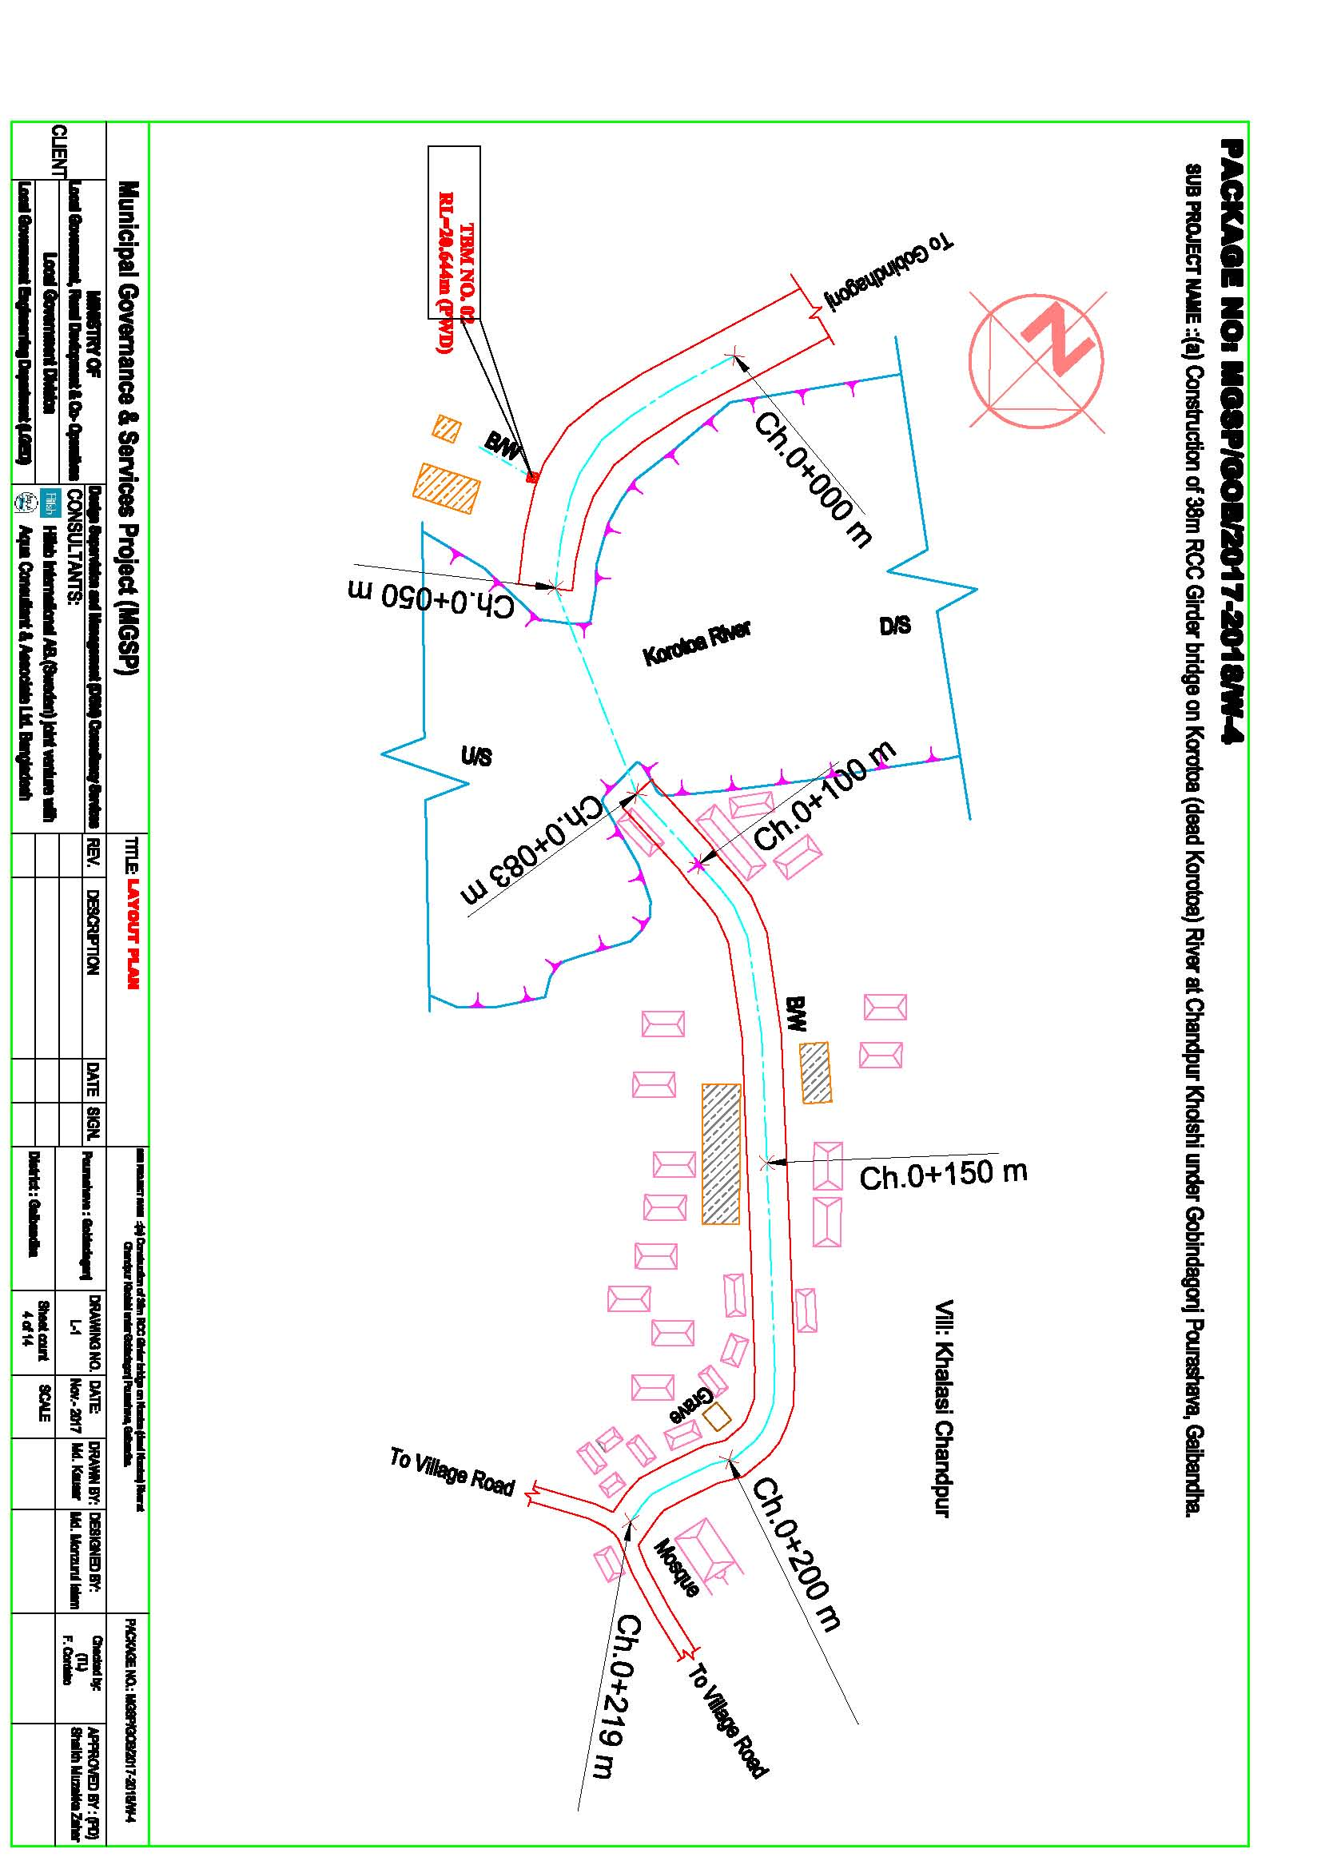

***Kalkadoba Bridge***

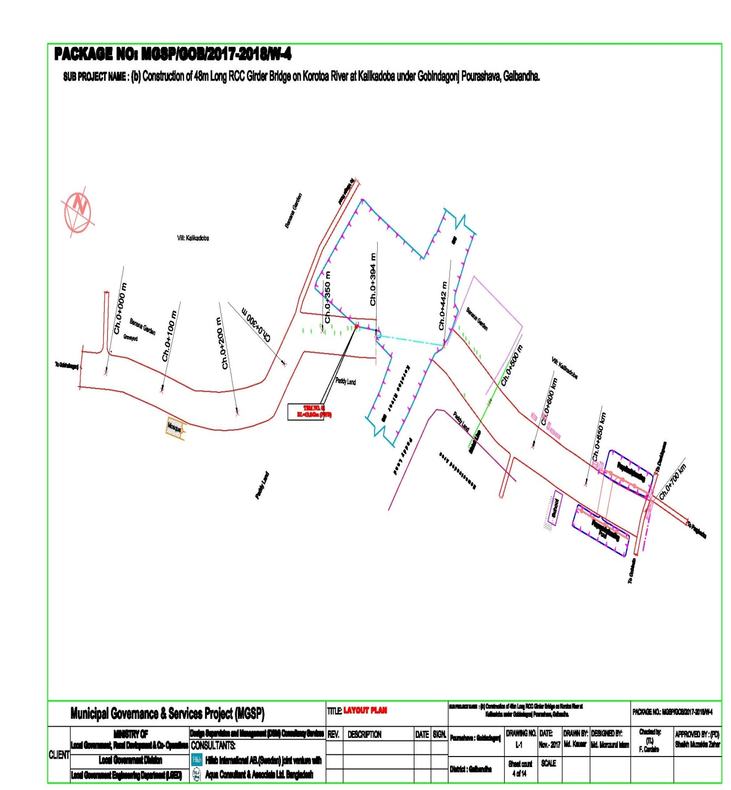

***2.2 Historical and Cultural Heritage Sites***

There are some archaeological and relics like remnants of the old Zamindar Bari within the Gobindaganj Pourashava. During the War of Liberation, the resistance movement of Gobindaganj began on 27 March 1971 when the student and general public tried to destroy the Katakhali Bridge on the river Karotoa. In resisting a Pak Military convoy coming from Rangpur seven freedom fighters lost their lives including Abdul Mannan (Sports Secretary of SM Hall, Rajshahi University), Babul Mahanta and Babu Datta. After this incident the Pak Army set on fire nearby villages of Katakhali Bridge. There is a mass grave at Katakhali. These cultural heritages are not affected by the sub project.

***2.3 The Subproject Location and Area Profile***

The subproject components are approaches and bridge

**a) Construction of 33 m long RCC Girder Bridge on Korotoa River at Chandpur Kholshi under Gobindagonj Pourashava, Gaibandha.**

**c.)** **Construction of approach road by bituminous carpeting for 33 m RCC Girder bridge on Korotoa River at Chandpur Kholshi (Ch. 0+ 000 to 0+050 m & 0+083 to 0+210 m) under Gobindagonj Pourashava, Gaibandha**

**The subproject components are**

**d.)** **Construction of 48 m long RCC Girder Bridge on Korotoa River at Kalikadoba under Gobindagonj Pourashava, Gaibandha.**

**d.)** **Construction of approach road by bituminous carpeting for 48 m RCC Girder bridge on Korotoa River at kalikadoba (Ch. 0+ 000 to 0+394 m & 0+442 to 0+700 m) under Gobindagonj Pourashava, Gaibandha**

This subproject is a very important project of Gobindaganj Pourashava. Total effective length of the two bridge (48+33) =81 m long and approaches roads is 829 m long.

The lands of bridge is belongs to the Gobindhagonj Pourashava and these subproject is located wards no 2, 3 & 8. Beside the existing approaches roads several educational institutions like two Government Primary school, two Mosque and several types of shops of NGO office( Fishery foundation) etc are located. Near about 50,000 people will benefit from this sub project. Different types of vehicles like car, rickshaw, bus, CNG driven baby taxi, battery operated three wheelers, auto, mini trucks trailer etc. use this road. So recommended to implement this sub project construction immediately.

***2.4 Beneficiary Communities Affected Persons***

The existing earthen road, bridge is used by near about 50,000 of local people including students of Gobindaganj school & Madrasa, business men, labors, people of other wards and adjoining village. Both men and women and children will be benefited by the bridge and approaches road. Three wards of the pourashava will be benefited by the sub project which is about one third of the pourashava.

The population census of the country 2011 shows that only two tribal households with 6 persons live in the pourashava. But the santal population of the total Upazila is 3,351 of which 92% is Santali.

For smooth implementation of the sub project as per desired design four private house tin roof & fence and 20 farmers’ plots will be affected. The owners of the private house agreed to remove and famer’s plots shift back willingly without any compensation. The private are situated on pourashava land and also extended to pourashava land by encroachment and 20 farmers plots are provided approach road additional without any compensation An agreement has been signed in this regard. (agreement are attached annex-1)

The sub project will also requires cutting of 49 trees (Eucalyptus, Zicka and Mango) trees before the start of construction. As per Pourashava authorities statement the small obstacles will be removed immediately.

***2.5 Gender and Vulnerability***

Gender and vulnerability analysis have been considered in social impact assessment of the subprojects. This has focused gender and vulnerability based on findings from specific queries during social screening and community consultation. The quantitative and qualitative analysis has brought out sex disaggregated data and issues related to gender vulnerability, needs, constraints, and priorities as well as understanding whether there is a potential for inequitable risks, benefits and opportunities relating to gender and vulnerability.

Based on the social analysis, specific interventions inclusion and participation encourages gender mainstreaming in the project cycle. Gender equity and empowerment will be ensured through encouraging participation of men and women equitably in the project cycle. The community participation and consultation also encourages gender mainstreaming in the subprojects influence areas. After subprojects implementation, there are positive impacts for the vulnerable women; especially those who are small traders, landless, marginal farmers, etc. and can sell their household products. These subprojects will create job creation and livelihoods. In addition, it will also increase the mobility of road and drain users. Due to the fact, gender and vulnerability has been taken into account and ensures the gender equity in the subprojects implementation.

While the drainage part of the sub project will benefit both male and female equitably, the street lighting part will benefit women and children in particular through improved safety of movement after sunset.

**3. Social Impact Assessment**

***3.1 Benefits of the Subproject***

After identification of the subproject through CIP, the PMU of the project with the assistance of DSM consultants has completed social screening and socio-economic impact assessment for the drains, cover slabs and fixing street light. This subproject will be used for both inter-town and intra-town movement. The increase in property values in the nearby area and improved business opportunity will benefit the general public as well as the affected shopkeepers.

The transport users, transport operators and pedestrian will have time and cost savings and increasing working hours, hence higher income earning opportunity. The student including girl students will have longer study hours for time saving and safer movement in the evening.

***3.2. Social Screening and Safeguard Compliance Issues***

After selection of the subproject components, the Pourashava with the assistance of DSM Consultants has completed a social screening for the subproject using an inclusive and participatory approach.

Gobindaganj Pourashava has ensured the implementation of subprojects following socially inclusive and gender friendly approach. According to engineering design, implementation of these subproject components will be carried out within the existing right-of-way. A few shopkeepers affected will willingly remove the obstruction created on the pourashava road as they are also benefited and will have better business opportunity. The DSM, PMU and the pourashava will monitor compliance of the relevant issues ensuring that these are not just pledges to satisfy the project authority but really they are meant and complied properly.

**Results from the social screening are given below.**

* No additional public or private lands will be required for the subproject outside the existing right of way.
* No private, public, community, or cultural properties of any kind or service delivery facilities are affected.
* Preparation of RAP will not be required for implementing the subproject.
* Agricultural or industrial productivity will not be hampered by the proposed subproject areas.
* Front side of 04 private houses and 20 farmers’ plots currently obstructing mobility will be removed willingly as the PAPs will also be benefited for improved business opportunity for themselves.

The outcomes of social screening also confirmed that local people across the subproject areas are positive about its implementation.

**4 .Consultation and Community Participation**

***4.1. Stakeholder Analysis***

As part of the overall assessment, the subproject identified the key stakeholders of the proposed subprojects areas and assessed the power relationship as well as influence and interests of stakeholders involved in the development work of the subprojects. Key stakeholders for subproject under MGSP have been identified in consultation with the Mayor, Councilors and officials of Gobindaganj Pourashava, local administration, civil society and local people of the towns, representatives of business associations and local contractors engaged in infrastructure development. Both males and females will benefit directly and indirectly by the improvement of this RCC Girder bridges and approaches roads.Their suggestions /feedbacks and directions from stakeholder consultations and meetings were noted and reflected while preparation of subproject list and designing of the sub project interventions.

***4.2. Consultation and Participation Meeting***

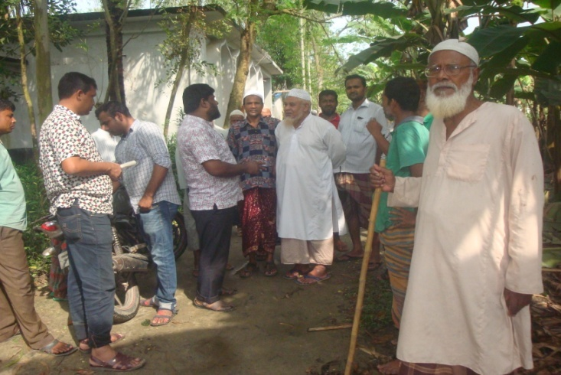The participatory public consultations were conducted in the subprojects areas. Key Informant Interviews (KII) and Focus Group Discussion (FGD) were conducted involving the participants of the Gobindaganj Pourashava Mayor, Councilors, Pourashava Officials, representatives of local Communities and civil society members as well asthe representative of local LGED office and the consultant team. A walk-through informal group consultation with the local communities was also held. Through this participation and consultation meeting, the local communities were informed about subprojects implementation and benefits. Suggestions and recommendations made by the participants are incorporated in the SMP accordingly. The photographs of consultation meeting at Gorstein para are explained importance of bridge and approach road.

Figure 3 Community consultation at Gorstein para

***4.3 Consultation Outcomes – Issues, Concerns, and Recommendations***

The participants raised their issues related to subprojects improvement which mainly includes RCC drains and street lights. Feedback, suggestions and recommendations by the participants are listed below.

* Construction works should be scheduled properly and the quality of construction work should be improved;
* By engaging women workers their direct income from the project will be ensured
* Social safeguard compliance issues have been ensured through the inclusive participation of subproject beneficiaries as well as PAPsand this will continue throughout the implementation process.

**5. Social Management for Site Selection and Design**

***5.1 Subproject Selection Process***

MGSP in coordination with concerned ULB functionaries- Mayor, Councilors, local administration, and civil society members followed participatory approach in all stages of subproject selection. All concerned stakeholders including concerned Ward Councilors and Woman Ward Councilor participated actively in the selection process. The Moreover, representatives of TLCC and WC from the Pourashava have contributed in the subproject selection process with an analysis of the inclusiveness of the selection process.

At the time of selecting these subprojects, Social Screening and Focused Group Discussion (FGD) with Gobindaganj Pourashavaurban communities, local administration, traders, buyers, and sellers were conducted by the Gobindaganj Pourashava officials and Consultants from DSM. Views and opinions of these consultations were to explain the subprojects objectives and sought feedback from the participants to maximize the social and economic benefits as well as to minimize the adverse impacts of the subprojects.

***5.2 Subproject Design Process***

After final selection of the subproject, the engineering part of the DSM Consultant designed the proposed subproject components (drain and street lights) und. The subproject will be located on the Pourshava’s own land. Despite the inclusion and participatory consultations, if any person has a grievance relating to the implementation of the subproject, the Pourashava has a GRC established to mitigate.

The Consultant interviewed stakeholders and beneficiaries of the subprojects areas before the design. The Consultant and Pourashava officials conducted a number of consultation meetings in the subprojects areas discussing the implementation procedures and mitigation measures, if any, required to be taken in implementing the proposed subprojects.

***5.3. Grievance Redress Mechanism (GRM):***

GRM has already been operational for Gobindaganj Pourashava. Accordingly, the Pourashava has formed Grievance Redress Committee (GRC) to handle any grievance raised due to implementation of the sub-projects. The committee is headed by the Mayor of the ULB and consists of 7 members. The committee will answer to subproject-related queries and address complaints and grievances about any irregularities in application of the guidelines adopted for assessment and mitigation of social and environmental impacts. Based on consensus, the procedure will help to resolve issues/conflicts amicably and quickly without resorting to any expensive, time-consuming legal actions. It will ensure proper presentation of complaints and grievances, as well as impartial hearings and transparent decisions.

Gobindaganj Pourashava has already appointed Focal Point of GRC who is at the level of Assistant Engineer level. The Mayor of the Gobindaganj Pourashava is the Chairman of the GRC. This GRC at the Pourashava level has the responsibility to disclose the subproject implementation before the civil works starts.

**Structure of the GRC Committee:**

|  |  |
| --- | --- |
| **Person** | **Status** |
| ULB Mayor | Convener |
| Representative of Local Administration | Member |
| Teacher from a Local Educational Institution | Member |
| Representative of a Local NGO | Member |
| Representative of Civil Society | Member |
| Female Ward Councilor | Member |
| Head of Engineering Section of ULB | Member Secretary |

***5.4 Implementation Arrangement:***

DSM has initially completed social screening for the subproject and there are no major problems for the improvement of subprojects in regard to social safeguard issues. One minor problem noted is that front side of some shops will be affected. The PAPs have been consulted; a list of affected shopkeepers prepared and the ULB has a written agreement with the PAPs that they will remove the obstacles willingly and without compensation.

Accordingly, the PMU, MGSP has issued the award letter against the subproject following all required procurement procedures. The Gobindaganj Pourashava has the responsibility to implement the subproject timely in close coordination with the PMU and also with the technical assistance of the DSM. Engineering section of Pourashava and local representative of the Consultancy team will ensure quality of the construction work. In addition, Consultant team from the Head Quarters will ensure close monitoring of the implementation of subproject. In the implementation process, Social safeguard Team will ensure monitoring of social safeguard management before civil work starts and during construction so that the communities will not be affected and any loss involved to communities is minimized. In addition, before civil work starts, the Pourashava will make the video filmed and also social screening.

**6. Conclusions on Social Management Plan (SMP):**

The sub project will have positive impact on employment, agricultural development, creation of better business environment, marketing of agricultural products and promoting education facilities. Besides transport network, drainage condition will improve. All these factors will have incremental value of land, property, housing and holding tax valuation of the pourashava will increase. Therefore, implementations of the proposed subproject is demanded by the community and recommended.

It is confirmed that additional land will not be required. But there are front side of some shops encroached to pourashava road will be affected. These need to be removed. The pourashava reported that the PAPs agreed to remove these obstructions willingly and without compensation.

This report has been prepared following filled up questionnaire and checklist which follow:

**ANNEXURE-1. Agreement for Obstacle removes NOC provided by farmers and private house owners (3 pages)**

