

**Local Government Division**

**Local Government Engineering Department**

**Municipal Governance and Services Project (MGSP)**

**IDA Credit No: 5339-BD**

**Report on Social Management Plan**

**Package No: MGSP/RAN/2017- 2018/ W-13**

**Social Management Plan**

**Rangpur City Corporation**

**Name of Subproject***:*

a)Rehabilitation of Road starting from paira Chattar to RCCI School by Bituminous carpeting (Ch.00-4050 m) under Rangpur City Corporation

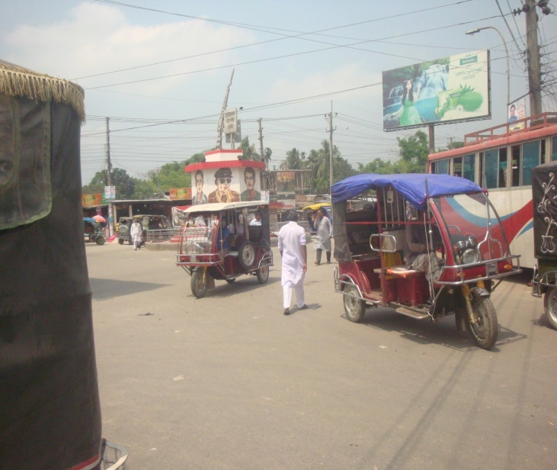 b) Construction of Drain from Paira Chattar to RCCI school ( Ch .0+700 to 1+825 m) under Rangpur City Corporation .

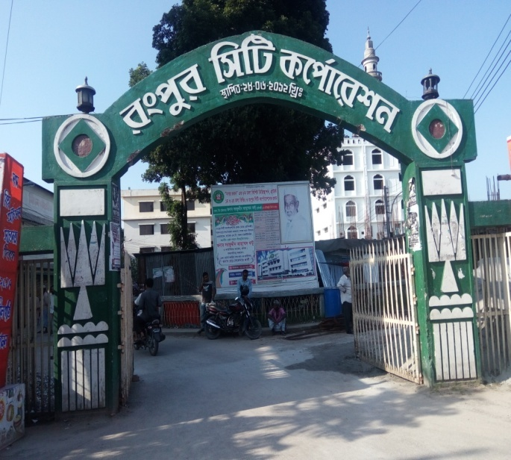**Design, Supervision, and Management (DSM) Consultancy Services**

**Joint Venture of *Hifab International AB, Sweden and***

***AQUAAQUA Consultant & Associates Ltd., Bangladesh***

***APRIL 2018***

**Rangpur City Corporation**

***RaNGPUR.***

**Table of Content (W-13)**

|  |  |  |
| --- | --- | --- |
| **No** | **Contents** | **Page. No** |
| 1. | Executive Summary | 1 |
| 1 | Introduction | 2 |
| 1.1 | Project Background | 2 |
| 1.2 | Legal and Policy Framework | 2 |
| 1.3 | Brief Description of Subproject | 3 |
| 1.4 | Social Management Plan | 3 |
| 2. | Description of Subproject Area | 4 |
| 2.1 | Brief Profile of Rangpur City Corporation | 4 |
| 2.2 | The Subproject Location and Area Profile | 8 |
| 2.3 | Historical and Cultural Heritage Sites | 9-10 |
| 2.4 | Beneficiary Communities and Affected Persons | 10 |
| 2.5 | Gender and Vulnerability | 11 |
| 3. | Social Impact Assessment | 11 |
| 3.1 | Benefits of the Subproject | 11 |
| 3.2 | Social Screening and Safeguard Compliance Issue | 12 |
| 4. | Consultation and Community Participation | 12 |
| 4.1 | Stakeholder Analysis | 12 |
| 4.2 | Consultation and Participation plan for subproject | 13 |
| 4.3 | Consultation Outcomes – Issues, Concerns and Recommendations | 13 |
| 5.0 | Social Management Plan for site selection and design | 13 |
| 5.1 | Subproject Selection Process”. | 13 |
| 5.2 | Subproject Design Process | 13 |
| 5.3. | Grievance Redress Mechanism (GRM) | 14 |
| 5.4 | Implementation Arrangement | 14 |
| 6 | Conclusions on Social Management Plan (SMP) | 15 |
| **Photograph/Figure** | |  |
| 1 | Subproject Estimated cost | 3 |
| 2 | At a Glance of Rangpur City Corporation | 5 |
| 3 | Community consultation at Mahiganj Bazar | 13 |
| 4 | Sub Project layout. | 7 |
| 5 | At glance of Rangpur City corroboration | 6 |
| **ANNEXURE** | |  |
| 1 | *Social screening Report* | 12 pages |

**Abbreviations**

|  |  |
| --- | --- |
| ARP | Abbreviated Resettlement Plan |
| BMDF | Bangladesh Municipal Development Fund |
| LAP | Land Acquisition Plan |
| CBO | Community Based Organization |
| CC | Cement Concrete |
| RCC | Rangpur City Corporation |
| CIP | Capital Investment Plan |
| CUL | Compensation-Under-Law |
| DC | Deputy Commissioner |
| DALY | District Land Acquisition Committee |
| DUTP | Dhaka Urban Transport Project |
| GoB | Government of Bangladesh |
| GRC | Grievance Redress Committee |
| GRAM | Grievance Redress Mechanism |
| HCG | House Construction Grant |
| HTG | House Transfer Grant |
| IDA | International Development Association |
| IP | Indigenous People |
| IPP | Indigenous Peoples Plan |
| KII | Key Informants Interviews |
| FGD | Focus Group Discussion |
| LGD | Local Government Division |
| LGED | Local Government Engineering Department |
| M& S | Management &Supervision |
| MGSP | Municipal Governance and Services Project |
| MOGRDC | Ministry of Local Government, Rural Development & Cooperatives |
| MSP | Municipal Services Project |
| MSL | Mean sea Level |
| NGO | Non-governmental Organization |
| PAH | Project Affected Household |
| PAP | Project Affected Person |
| PMU | Project Management Unit |
| RCC | Reinforced Concrete Cement |
| RP | Resettlement Pan |
| SIA | Social Impact Assessment |
| SMP | Social Management Plan |
| SSS | Social Safeguards Specialist |
| TLCC | Town Level Coordination Committee |
| ULB | Urban Local Body |
| WB | World Bank |
| WC | Ward Committee |

RAP Resettlement Action Plan

**EXECUTIVE SUMMARY**

Rangpur City Corporation is big Corporation having an area of 203.19 sq k.m . The ULB is densely populated with 33 administrative wards which are also underserved in all development considerations. The subproject has been selected considering the needs of the locality which is priority as (CIP-B-1) of Rangpur City Corporation (RCC).

The Social Management Plan (SMP) of the Subproject under Rangpur City Corporation was developed through inclusive participation of all level stakeholders and using participatory approach. The subproject area is located in one segment hence one social screening report has been prepared.. The subproject comprises interventions proposed as per CIP-B-1) of the Rangpur City Corporation. The sub project will benefit three of the 33 administrative wards of the RCC (Wards 23, 25 & 30). According to engineering design, implementation of this subproject will be carried out within the existing right-of-way hence no LA is involved and no RAP is required. Present condition of the road & drain is BC & 975 totally absent. The BC road is old, damaged and narrow with undulation, worn-out and has many potholes on the surface. Due to the absent of drain stayed water-logged during the rainy season.

***Total cost of the subproject is Taka*: 87,131,747.93**

***Purpose of the subproject***

To improve overall Rangpur City Corporation road networks through construction of 4050 m road and 1825 m long drain with cover slabs covering three of the 23,25 and 30 municipal wards of the Rangpur City Corporation.

**Anticipated Impacts:**

The subproject will benefit directly benefiting about 10,000 people of the three wards (23, 25 & 30) by rehabilitation of the road and drain reconstruction.

There are no obstacles in the sub project areas in addition; the subproject will need shifting of 05 electric poles and felling of about 121 trees (mango, coconut, jackfruit, koroi, betel nut and eucalyptus).

The City Corporation and the local communities are positive of its implementation. It is therefore recommended to implement the project as a subproject of the MGSP.

**1. INTRODUCTION**

**1.1. Project Background**

The Government of Bangladesh, through the Local Government Engineering Department (LGED) and Bangladesh Municipal Development Fund (BMDF) is implementing the Municipal Governance and Services Project (MGSP). The project aims to improve municipal governance and basic urban services in participating ULBs. Two physical components of the project include (i) Municipal Governance and Basic Urban Services Improvement (Component 1) to provide financial support to 26 pre-identified urban local bodies (ULBs) comprising 22 municipalities and four city corporations, and demand-based sub-credits to eligible ULBs for basic urban services improvement investment costs (component 2). Total project cost **is BDT 2, 470, 93.92 lakh to be** financed at 80:20 IDA loan to GOB contribution. LGED is implementing the Component 1 while BMDF is implementing component 2 of the project.

LGED is supporting the 26 pre-selected ULBs for investments in development and rehabilitation of Road, Bridge, Box-culvert, pedestrians bridge, street light, Road Safety, Bus terminal, Truck terminal, Boat landing Jetty, Drain, Retaining wall, Kitchen market, Cattle market, slaughter house, Public toilet, Solid waste management, Sweeper colony, Park, Community Centre and Whole sale market. LGED is financing through (i) base allocation based on population category of ULBs; (ii) performance-based allocation and (iii) operations and maintenance support on a declining basis over the project period.

The component interventions have largely been developed for construction and rehabilitation within existing available land owned by the ULBs and acquisition of land has been avoided in the screening process. Removal of some obstruction and relocation of some businesses were involved in case of some sub projects for unavoidable circumstances. The MGSP did not avoid taking-up of sub projects in areas inhabited by tribal peoples and instead ensured their inclusion and participation where applicable. The ULBs addressed the removal of obstructions and in most cases the land entirely belongs to the ULB. In some instances, land of other GOB agencies like the BWDB, R&H, Railway or other local government like adjoining UP is needed and in such cases the ULB ensured getting such land by mutual understanding and proper documentation of such understanding. Relocation of business and removal of obstructions were resolved by consultation and agreement with the concerned PAPs and these are properly documented. Thus land acquisition, population displacement and tribal people’s issues have been addressed following the country’s legal framework and the World Bank policy on social safeguards.

**1.2 Legal and Policy Framework**

Given the approach of subproject preparation and implementation, the World Bank’s Operational Policy (OP) on Involuntary Resettlement (OP 4.12) and on Indigenous Peoples (OP, 4.10) triggered to the project. A Social Management Framework (SMF) has been adopted by LGED for the project that meets the requirements of the country’s legal frameworks in Bangladesh “The Acquisition and Requisition of Immovable Property, Ordinance, 1982” and the Bank requirements including OP 4.12 and OP 4.10. The SMF also requires that subprojects are prepared ensuring inclusion, participation, transparency, and social accountability. Subprojects are prepared by respective ULBs in a process complying with the SMF requirements. LGED reviews the subproject proposals for technical, engineering, environmental, social development and safeguards compliance before allocation of the financing to the ULBs.

Social Management Plans (SMP) will be prepared and implemented for subprojects with no land acquisition or involuntary displacement of people, while Resettlement Action Plans (RAP) and Tribal Peoples Plans (TPP) ) will be prepared for implementation for subprojects involving population displacement and tribal peoples’ issues.

**1.3. Brief Description of Subproject**

**Subproject No. MGSP/RAN/2017-18/W-13**

**a) Rehabilitation of Road starting from Paira Chattar to RCCI School by Bituminous Carpeting (CIP-B -1) &Ch.00-4050 m) under Rangpur City Corporation.**

**b) Construction of Drain from Paira Chattar to RCCI School ( Ch 0+700-1825 m) under Rangpur City Corporation.( Please see details in screening report)**

**The proposed subproject and its estimated costs are given in the following table**.

| **SL #** | **Subprojects** | **Length (m)** | **Estimated Cost (BDT)** | **Remarks** |
| --- | --- | --- | --- | --- |
| a | Rehabilitation of Road starting from Paira Chattar to RCCI School by Bituminous Carpeting (CIP-B -1) &Ch.00-4050 m) under Rangpur City Corporation**.** | 4050 | **63,348,906.59** |  |
| b | Construction of Drain from Paira Chattar to RCCI School ( Ch 0+700 to 1+ 825 m) under Rangpur City Corporation | 1825 m | **23,782,841.34** |  |
|  | Total |  | **87,131,747.93** |  |

**1.4 Social Management Plan**

This Social Management Plan (SMP) has been prepared for the identification and managing social concerns in the process of subproject design and implementation. Initially, each subproject component included a social screening report. After reviewing the social screening report by Social Unit of DSM, this subproject proposal is submitted to the PMU office. Social team of the DSM has carried out a site visit and consulted with the Rangpur City Corporation officials, stakeholders (down to the ward level) and cross section of the beneficiary communities through interview, participation and consultation meeting. The social screening findings from the consultation method and proceedings were further validated through the social survey and consultation.

The purpose of preparing this SMP is to demonstrate an all-inclusive consultative process in selection and design of the subproject as well as to provide guidance for social development and safeguards compliance in the implementation process.

The SMP contains a description of the subproject area, social screening and impacts, consultation process adopted during identification and design, and consultation plan for implementation stage, impact mitigation measures, grievance resolution process and implementation arrangements, monitoring& evaluation.

RCC authority will ensure participation of the communities and grievance resolution in the process of implementation of the subprojects.

**2. Description of Subproject Area**

**2.1. Brief Profile of Rangpur City Corporation**

Rangpur is one of the major cities of Bangladesh and the main urban area of [Rangpur Division.](https://en.wikipedia.org/wiki/Rangpur_Division) Rangpur was declared a district headquarters on 16 December 1769, and established as a municipality in 1869, making it one of the oldest municipalities in Bangladesh. The municipal office building was erected in 1892 under the precedence Raja Janaki Ballav Sen, Chairman of the municipality. In 1890, the "Shyama sundori khal" was excavated for improvement of drainage facility in the town.

The RCC is located in the north western Rangpur division of Bangladesh. Recently established public university of Bangladesh named "Begum Rokeya University is located in the southern part of the city. Previously, Rangpur was the headquarters of *Greater Rangpur* district. Later the Greater Rangpur district was split into the Rangpur, Kurigram, Nilphamari, Lalmonirhat, and Gaibandha districts.

Formerly a district town, Rangpur is now the divisional headquarters comprising eight districts of greater Rangpur and Dinajpur in the northwestern part of the country. Rangpur division was created in 2010 and it has been a City Corporation since 2012. Despite being a divisional city, Rangpur is still a rural town. Until mid-1990s when the Jamuna Bridge was constructed, very little economic development took place around it, mainly because of the yearly flooding which still remains a constraint to development.

Rangpur City, covering an area of around 203 square kilometers, lies on the bank of the river Ghaghat. Population of the Rangpur municipality as of 2011 is 579,012 with population density of 2,815 per sq km. Rangpur is an administrative town and has concentration of educational institutions such as newly established Begum Rokeya University and a century old Carmichael College. It has several other educational institutions like Rangpur Government College, Cadet College and Medical College. It has good potential to grow as a city of agricultural industries and a number of large corporations have established such enterprises like one owned by the PRAN-Group. It has good number of cold storages. Huge number of people from the adjoining rural areas comes to the City Corporation area during the non-working season of agriculture (September-November after the T- Aman crop is planted and from March-April after the boro crop is planted) in search of work. Improvement of this infrastructure under the subproject will increase commercial and economic activities in this area and will also boost other socio-economic activities in the City Corporation. Moreover, health and sanitation of the local community people will improve

**Rangpur City Corporation**

**at a Glance**

|  |  |  |  |  |  |  |  |  |  |  |  |  |  |  |  |
| --- | --- | --- | --- | --- | --- | --- | --- | --- | --- | --- | --- | --- | --- | --- | --- |
| |  |  |  | | --- | --- | --- | | **General Information** | | | | Area | : | 203.19 Square K.M. | | Ward | : | 33 No’s | | Population  Population Growth Rate  Household No  Population Density  Major Status  Main Income Source : | : | 5,79,012 (in 2011)  5.45  124764 (in 2011)  2814.83 Person Per sq. km (in 2011)  0 migrated people  Business 0%, Service 0%, others 0% | |  |  |  |
|  |  |  |  |

|  |  |  |
| --- | --- | --- |
| **Tax** | | |
| Holding Tax | : | 39544 No’s |
| **Market** | | |
| Market | : | 25 No’s |
| Shopping Complex | : | 07 No’s |
| Own Shops | : | 13 No’s |
| **License** | | |
| Trade License | : | 10181 No’s |
| Rickshaw License | : | 2253 No’s |
| **Communication** | | |
| Road | : | 1427 Km |
| a) Bituminous | : | 570 Km |
| b) CC | : | 33 Km |
| c) RCC | : | 15 Km |
| d) Brick Flat Soling | : | 3 Km |
| e) Nonpaved Road | : | 806.0 Km |
| Culvert | : | 1115 No’s |
| Road intersection | : | 35 No’s |
| Bridge | : | 135 No’s |
| Footpath | : | 6 Km |
| **Water Supply** | | |
| Overhead Tank | : | 05 No’s |
| Capacity | : | 6,80,000 Liter/tank |
| Deep Tube well | : | 11 No’s |
| Pipe Line | : | 157 Km |
| House Connection | : | 5,500 No’s |
| Street Hydrant | : | 100 No’s |
| Pump Station/ house | : | 11 No’s |
| Arsenic Status | : | Within acceptable limit |
| Pumping Hour | : | 8 Hour |
| **Street Lighting** | | |
| Electricity Line | : | 400 Km |
| Light Post ­ | : | 10,000 No’s |
| Tube Light Point | : | N/A |
| Energy Savings Light Point | : | 10,000 No’s |
| Meter/ Switch Point | : | 120 No’s |
| **Vehicle** | | |
| Garbage Truck | : | 25 No’s |
| Trucktor | : | N/A |
| Bulldozer | : | N/A |
| Jeep | : | 10 No’s |
| Motorcycle | : | 23 No’s |
| Hydraulic Beam Lifter | : | 2 No’s |
| Road Roller (4 ton – 6 ton) | : | 2 No’s |
| Road Roller (8 ton – 10 ton) | : | 4 No’s |
| Excavator (8 Cft) | : | N/A. |
| Bulldozer | : | N/A. |
| **Drainage System** | | |
| Drain | : | 1,102 Km |
| a) RCC/ Brick Lined Drain | : | 153,53 km |
| b) Earthen Drain | : | 967 Km |
| Canal | : | 79.19 Km |
| **Public Health** | | |
| Public Toilet | : | 12 No’s |
| Sanitary Latrine | : | 200 No’s |
| Dustbin | : | 150 No’s |
| Sanitary Land field | : | 1 No’s |
| EPI Centre Permanent- | : | 120 No’s |
| Temporary - | : | 60 No’s |
| Hospital | : | 3 No’s |
| Clinic (TB) | : | 1 No’s |
| Maternity Clinic | : | 10 No’s |
| Private Clinic | : | 186 No’s |
| Diabetic Hospital | : | 1 No |
| **UPPRP Project** | | |
| Community Centre | : | 2 No |
| Total Urban Community | : | 57 Nos. |
| Total Community Family | : | 13000 |
| Total Community Member | : | 63212 |
| Total Sanitary Latrine | : | 600 |
| Total Road with Footpath | : | 450 km |
| Drain | : | 370 km |
| Improved cooking | : | N/A |
| **UPHSDP Project** | | |
| Nagar MatriSadan | : | 01 No |
| Nagar Health Centre | : | 03 No’s |
| Satellite Clinic | : | 09 Nos. |
| **Religious Institution** | | |
| Mosque | : | 1114 |
| Eidghah | : | 85 |
| Temple | : | 213 |
| Graveyard | : | 984 |
| Burning Ghat | : | 03 |
| Church | : | 02 |
| Buddhist Temple | : | N/A |
| Orphanage | : | 06 |
| **Law &Order** | | |
| Police Station | : | 01 |
| Police Fari | : | 03 |
| Judge court  RAB office | :  : | 01  02 |
| **Education** | | |
| Public University | : | 01 |
| Private University | : | 02 |
| Govt College | : | 03 |
| Private College | : | 25 |
| Cadet College | : | 01 |
| Public Medical College | : | 01 |
| Private Medical College | : | 02 |
| Art College | : | 0 |
| Law College | : | 01 |
| Homoeopathic Medical College | : | 01 |
| Public Polytechnic Institute | : | 01 |
| Public Engineering Survey Institute | : | 0 |
| Private Polytechnic Institute | : | 03 |
| Madrasha | : | 240 |
| Teachers Training College | : | 01 |
| Govt High School | : | 02 |
| Non-Govt High School | : | 52 |
| Govt Primary School | : | 202 |
| Kinder Garten School | : | 140 |
| **Recreation** | | |
| Park | : | 03 |
| Zoo | : | 01 |
| Cinema Hall | : | 03 |
| Stadium | : | 01 |
| Auditorium | : | 02 |
| Gymnasium | : | 01 |
| Recreation Club | : | 0 |
| **Communication** | | |
| Railway Station | : | 01 |
| Bus Station | : | 02 |
| Ferry Ghat | : | 0 |
| T & T Office | : | 01 |
| GPO | : | 01 |
| Post Office | : | 08 |

**Figure: 1 Layout plan –Drain (W -13)**

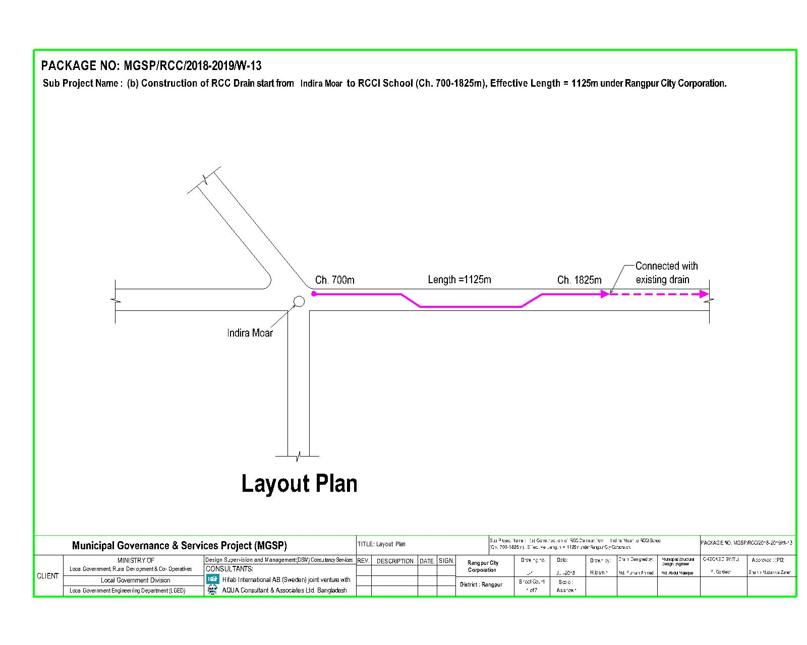

**2.2. The Subproject Location and Area Profile**

**Name of Subproject Components***:*

a)Rehabilitation of Road starting from paira Chattar to RCCI School by Bituminous carpeting (Ch.00-4050 m) under Rangpur City Corporation

b) Construction of Drain from Paira Chattar to RCCI school ( Ch .0+700-1825 m) under Rangpur City Corporation

The sub project components noted above have several educational institutions, mosques, clinic, haat/ Bazar, several shops and these will all be benefited by the subproject interventions comprising improvement of road. This subproject benefited areas are mainly residential and commercial. The roads to be provided drainage facilities and have a variety of commercial enterprises like grocery shops, medicine shops, rice, vegetables, fish, poultry feed, tea stall, restaurant and other necessary shops etc.

Various types of vehicles like mini truck, car, micro, motor bike, battery operated three wheeler auto, CNG operated three wheeler baby taxi, tractor trailer, rickshaw, rickshaw van and motor bike etc. will benefit from the subproject. Also modern vehicles like car, jeep, pick-up and Lorries will be using the road. The pedestrians, particularly women, children, elderly people will use the road more comfortably and safely.

**2.3 Historical and Cultural Heritage Sites:**

Under the Rangpur City Corporation, there are lots of historical and Archaeological heritage sites from British period to 1971. A few of them are as follows:

Archaeological heritage and relics Tajhat Rajbari, Keramatia Mosque, Dimlaraj Kali Mandir, Shree Shree Karunamaye Kali Mandir, Rangpur Museum, Rangpur Town Hall, Rangpur Public Library, Pareshnath Mandir at Mahiganj, tomb of the noted Islamic thinker MaulanaKeramat Ali Jainpuri, tomb of Shah Jalal Bokheri at Mahiganj, tomb of Ismail Ghazi at Kataduar, carmichael college Building, home stead of roquiah SakhawatHossain at Pairabandh and ZilaPerished Building etc.

1. **Tajhat Palace:**

Tajhat Palace is located at Tajhat, the southern end of Rangpur city. The place is situated three km on the south–east outskirts of the town of Rangpur. Probably this place was built by Maha Raja Kumar Gopal Lal Ray in the beginning of the 20th century. The palace was Zamindar house (house of feudal king) and was used as High Court building during 1984 to 1991. In 2004, it was largely renovated and converted to a museum which hosts a collection of Blackstone Hindu carvings, calligraphic art from the Mughal period and other objects d'art and coins from the area on display. The palace was declared as a protected monument by the department of archaeology recognizing its outstanding archaeological value.

**B) Raja Man Singh a commander of the Mughal Emperor**

Rangpur was conquered by the army of Raja Man Singh a commander of the Mughal emperor, Akbarin 1575, but it was not until 1686 that it was fully integrated into the Mughal Empire. Names of places like Mughalbasa (literal meaning being a locality of the Mughals), and Mughalhat (literal meaning a "local market" organized by the Mughals) bear testimony to the Mughal Association and past of Rangpur and its hinterland. Later on, Rangpur passed under the control of "Sarker" of Ghoraghat. During the period of the British East India Company, the Sannyasi Rebellion took place. Rangapur Ghoraghat has been mentioned in the Riyaz-us-Salatin. During the early period of the company rule fakir-sannyasi resistance and peasant rebellion were held in Rangpur.

**C) Carmichael College**

Carmichael College is one of the oldest colleges in Bangladesh established in 1916 and built during the Raj era, is located in Rangpur. The main attraction of this college is its administrative building (which houses the Bangla department). It is a white two-storied building designed in the style of the buildings of Cambridge University of UK. It is also familiar with its huge campus and natural beauty.

**D) Rokeya Memorial Rokeya memorial in pairabondh**

A museum and women's training centre was established in Pairabondh, the birth place of famous Begum Rokeya. It is half an hour drive away from Rangpur city located at village Pairabond in Mithapukur Upazila.

**E) Town Hall**

There is an ancient auditorium named 'Town Hall' at the center of the city, where different cultural programs are held

**F) Jadu Nibash**This is located in Radhaballav, next to the Rangpur Government College. This is the Home of Late Mashiur Rahman Jadu Mia. It is an ancient house, about hundred years old. The house was probably built and owned by Raja Gopal Lal Rai Bahadur at the same time that the Rangpur District Council, Rangpur Town Hall and the famous Tajhat Palace buildings were built.

### G) Rangpur Zoo

Rangpur Central Zoo is one of the main amusement and recreation spot of Rangpur city. With an area of 20.27 acre of lush green trees and grasses, the Rangpur zoo is located east side of Hanuman-tola road beside police-line, not far from Rangpur district Administration office. The Zoo has 193 individual animals of 28 species. Many wild animals are available to attract the visitors. A few of them are The Bengal tiger, African lion, Black Panther, Rhinoceros, Leopard, Hippopotamus, Peacocks, Alligators, Turtles, Spotted Deer, different kinds of Birds, Snakes and so on.

The Rangpur zoo was built in the 1989 and opened for visitors in 1992. Bangladesh University of Engineering Technology (BUET) completed a digital survey and feasibility study of "Dhaka and Rangpur Zoo Modernization Project" to upgrade the facilities to international standard.

### H) Binodon Uddyan

"Binodon Uddyan" is a massive park located in the middle of the city. A Shishu Park (children's park), lake and a large restaurant are situated inside of this park. The mini Tajmahal located there is a latest attraction.

### I) Deowan Bari Jamindaar Bari

The Deowan Bari Jamindaar Bari was built by Foni Bhuson Mojumdar. Foni Bhuson Mijumdar was the son of Landlord Radharomon and mother KusumKumari Devi who was the second wife of Radharomon. He was born in 1892. This landlord house is a small 2 storied building. But the main gate of the house is like a Mughal Castle-gate. After ban of the Real estate tenancy practices in 1952 the house was auctioned. The property was purchased by one Nosor Ghatial who hailed from Kurigram. Now there is a school and some business centers. It is located at Deowan Bari road in Rangpur near the town.

### J) Chiclivata

Near the stadium, there is a very beautiful place called 'Chiclivata' surrounding by many lakes and rice fields.

**2.4. Beneficiary Communities and Affected Persons**

The proposed road will improve the road condition and ensure safe movement of the city dwellers . As a result people will be able to move easily during the rainy season. Local transports like rickshaw, rickshaw van, battery driven three wheeler auto and CNG driven baby taxi and diesel operated tractor trailers (Bhotbhoti) will move conveniently besides buses, covered van, cars, micro buses, pickup van and other local transports.

This part of the town is quickly growing residential cum commercial area. About 40,000 people will be benefited by the subproject infrastructure road. They will use the road to meet the needs of job holders, students, children & women. People of two wards will (32 & 33) mainly benefit from the sub project. In addition, people of other wards of the town and the adjoining others wards will use the road. The proposed road will reduce traffic conjunction and safe movement of pedestrians and city dwellers. This is very densely populated area. It is noted here that there is no presence of tribal people in the subprojects influence areas.

**2.5. Gender and Vulnerability**

Gender and vulnerability analysis have been considered in social impact assessment of subprojects. This has focused gender and vulnerability based on findings from specific queries during social screening and community consultation. The quantitative and qualitative analysis has brought out sex disaggregated data and issues related to discrimination by gender vulnerability, needs, constraints and priorities as well as understanding whether there is a potential for inequitable risks, benefits and opportunities relating to gender and vulnerability. Based on the social analysis specific interventions inclusion and participation encourages gender mainstreaming in the project cycle. Gender equity and empowerment will be ensured through encouraging participation of men and women equitably in the project cycle. The community participation and consultation also encourages gender mainstreaming in the subproject influence areas.

After subprojects implementation there might have positive impacts for the vulnerable women; especially those who are small traders, landless, marginal farmers, etc. and can sell their household products. These subprojects will create job creation and livelihoods. In addition, it will also increase the mobility of road users. Due to the fact, gender and vulnerability has been taken into account and ensures the gender equity in the subprojects implementation.

**3. Social Impact Assessment**

**3.1 Benefits of the Subproject**

This subproject is to be used for both intra-town and inter-town movement. It will improve traffic network and drainage system, reduce water logging will be reduced leading to improved stability of the road at lowering maintenance cost. From the point of view of social benefits, it will enhance commercial/economic activities, will provide direct and indirect employment opportunity and contribute to poverty reduction. Also it will improve access to market, health service, educational institutions, financial institutions and other basic urban services. Due to improved transport network, property value of adjoining area will increase substantially, rent will increase and this will eventually contribute to increase revenue earning for the City Corporation. In the two wards of the RCC, the subproject interventions will benefit about 40,000 people which is about 8% of the city population as of 2011.

Moreover, the transport users, transport operators and pedestrians will have time and cost savings and increasing working hours, hence higher income earning opportunity. The students will have longer study hours for time saving and safer movement in the evening. Businessman will benefit from better management of their business.

**3.2 Social Screening and Safeguard Compliance Issue**

After identification of the subproject and its inclusion in the CIP, the PMU with the assistance of the DSM Consultants has completed social screening and socio-economic impact assessment for the proposed road development work of Rangpur City Corporation. The DSM Consultants have completed the social screening using an inclusive and participatory approach.

The Rangpur City Corporation will ensure implementation of the subproject following socially inclusive and gender friendly approach. According to engineering design, implementation of the subprojects will be carried out within the existing right-of-way.

Results from the social screening are given below.

* No additional public or private lands will be required for the subprojects outside the existing right of way.
* The sub project will not affect access to common property resources for any community. It will also have no negative impact on cultural property of any kind.
* Preparation of RAP will not be required for implementing the subproject as no LA is involved.
* Agricultural or industrial productivity will be enhanced by the proposed subproject.
* The outcomes of social screening also confirmed that local people across the subproject area are positive about its implementation.
* Seven temporary shops made of tin roof and bamboo poles and crop production of 93 farmers will be affected. All of the 100 PAPs are encroachers to the RCC road area to increase their plot size and shop area and have agreed in writing to remove obstacles and vacate the encroached area willingly and without compensation.

**4. Consultation and Community Participation**

**4.1. Stakeholder Analysis**

According to BBS 2011, (Collected from Municipal Authority) the total population of Rangpur City Corporation was 579,012 among which 295,395 are male and 283,617 are female. People belonging to all income groups- living in higher, higher-middle, lower-middle, and expected that lower income groups in the City Corporation area will benefit from the subproject interventions. Both males and females living in the Rangpur City Corporation and adjoining rural areas will be directly benefited by the construction of RCC road with drain and provision of street light.

As a part of the overall assessment, the involved in the development work of the subprojects. Key stakeholders for subprojects under MGSP were subproject identified the key stakeholders of the proposed subprojects area and assessed the power relationships as well as influence and interests of stakeholders identified in consultation with the Mayor and officials of Rangpur City Corporation, civil society and local people of the concerned wards, representatives of business associations and local contractors etc. Suggestions and comments of all local stakeholders were noted and reflected in the SMP while designing subproject interventions.

**4.2. Consultation and Participation plan for subproject**

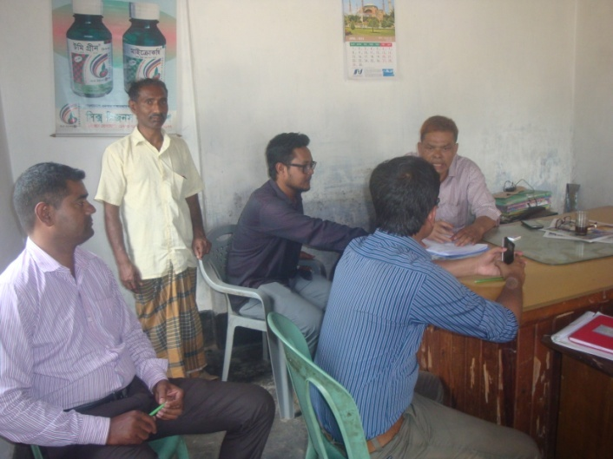Participatory public consultations were conducted in the subprojects area. Key Informant Interviews (KII) and Group Discussion (GD) were conducted involving the participants of Rangpur City Corporation Mayor, Councilors, City Corporation officials, representatives of local communities and civil society members as well as representative of local LGED office and consultant team.

Photographs: Community consultation at Mahagani Bazar

A walk-through informal group consultation with the local communities was also held. Through this participation and consultation meeting, the local communities were informed about subprojects implementation process and benefits. Suggestion and recommendations made by the participants are incorporated in the SMP accordingly.

**4.3. Consultation Outcomes – Issues, Concerns, and Recommendations**

The participants raised their issues related to subprojects improvement which mainly road. Feedback, suggestions and recommendations by the participants are listed below.

* Construction works should maintain work schedule properly and the quality of construction work must be maintained strictly and rights of the female workers have to be addressed properly..
* Engagement of female labor force willing to work will be preferred to enhance gender role in development together with ensuring their participation in project design, implementation and monitoring stages.
* Any problem arising out of labor influx will be carefully handled by the ULB and mitigation measures taken.

**5. Social Management for site Selection and design.**

**5.1. Subproject Selection Process**

MGSP in coordination with Rangpur City Corporation elected functionaries, local administration, relevant stakeholders, community members, road users and civil society members followed the participatory approach in different stages of subprojects selection following inclusion, consultation and participation methods. Female Ward Councilors participated actively in the selection process. Moreover, the representatives of TLCC and Ward Councilors from the City Corporation have contributed in the subprojects selection process with an analysis of the inclusiveness of the selection process.

At the time of selecting these subprojects, Social Screening and Group Discussion (GD) with urban communities, local administration, traders, buyers, and sellers were conducted by the Rangpur City Corporation officials and Consultants from DSM. Views and opinions of these consultations were to explain the subproject objectives and sought feedback from the participants to maximize the social and economic benefits as well as to minimize the adverse impacts of the subprojects.

**5.2. Subproject Design Process**

After final selection of the subprojects, the DSM Consultant designed the proposed subproject interventions. These subproject components will be constructed using City Corporation’s own land. Despite the inclusion and participatory consultations, if any person has a grievance relating to the implementation of the subprojects, the City Corporation will mitigate it.

The Consultant interviewed stakeholders and beneficiaries of the subprojects areas before the design. The Consultant and City Corporation officials conducted a number of consultation meetings in the subprojects areas discussing the implementation procedures and mitigation measures, if any, required to be taken in implementing the proposed subproject.

**5.3 Grievance Redress Mechanism (GRM):**

GRM has already been operationalzed for Rangpur City Corporation. Accordingly, this City Corporation has formed Grievance Redress Committee (GRC) to handle any grievance raised due to implementation of the subprojects. The committee is headed by the Mayor of the City Corporation and consists of total 7 members. The committee will resolve subproject-related issues, answer to queries and address complaints and grievances about any irregularities in application of the guidelines adopted for assessment and mitigation of social and environmental impacts. Based on consensus, the procedure will help to resolve issues/conflicts amicably and quickly without resorting to any expensive, time-consuming legal actions. It will ensure proper presentation of complaints and grievances, as well as impartial hearings and transparent decisions.

Rangpur City Corporation has already appointed focal Point of GRC who is at the level of Assistant Engineer. S/he will be assisted by the Social Development Officer of the MGSP.

The Mayor of the Rangpur City Corporation is the Chairman of the GRC. This GRC at the City Corporation level is responsible to disclose the subprojects implementation before civil works starts.

**Structure of the GRC Committee:**

|  |  |
| --- | --- |
| **Person** | **Status** |
| ULB Mayor | Convener |
| Representative of Local Administration | Member |
| Teacher from a Local Educational Institution | Member |
| Representative of a Local NGO | Member |
| Representative of Civil Society | Member |
| Female Ward Councilor | Member |
| Head of Engineering Section of ULB | Member Secretary |

**5.4 Implementation Arrangement:** DSM has initially completed social screening for the subprojects and there is no such potential problem for implementing the subprojects regarding social safeguard issues. Accordingly, PMU, MGSP has issued the award letter against the subproject following all required procurement procedures. Rangpur City Corporation has the responsibility to implement the subprojects timely in close coordination with the PMU of the project and also with the technical assistance of DSM. Engineering section of City Corporation and local representative of consultancy team will ensure the quality construction work of the subprojects. In addition, Consultant team from Head Quarters DSM will ensure close monitoring of the implementation of the subproject components. In the implementation process, Social Safeguard Team will ensure monitoring of social safeguard management before civil works start. During construction, the communities will not be affected and the project will minimize the loss of communities. In addition, before civil works start, the Rangpur City Corporation will make the video filmed and also social screening.

**6. Conclusions on Social Management Plan (SMP)**

The subproject will improve road and connectivity and established drain networks in three wards of the RCC providing more convenient and stable road connectivity in the RCC area and adjoining rural areas. About 70,000 people of three wards and many others of adjoining areas will be benefited. Implementation of the subproject will need felt down about 121 tree and relocated 05 electric poles.