**Local Government Division**

**Local Government Engineering Department**

**Municipal Governance and Services Project (MGSP)**

**IDA Credit No: 5339-BD**

**Report on Social Management Plan**

**Package No: MGSP/RAN/2016- 2017/ W-09**

**Report on Social Management Plan**

**Name of Subproject***:*

1. Rehabilitation of Road from BurirhatEdgah to MonoharbShukanchaki (Ch.0+000-3+730km)
2. Construction of 3mx2mx8m box culvert on BurirhatEdgah to MonoharShukanchaki Road at Ch.1 500km,2+100km,2+565km,2+590km & 2+905km (6nos).Including 1.5mx1.5mx8m cross drain at Ch.1+895km,3+580km & 3+720km (3nos.) with wing wall parallel to Road
3. Rehabilitation of road from Burirhat Jute Mill to Harati (Ch.0+200 to 1+700km).
4. Construction of RCC drain from Burirhat Jute Mill to Harati(Ch.0+000 to 2+400km)
5. 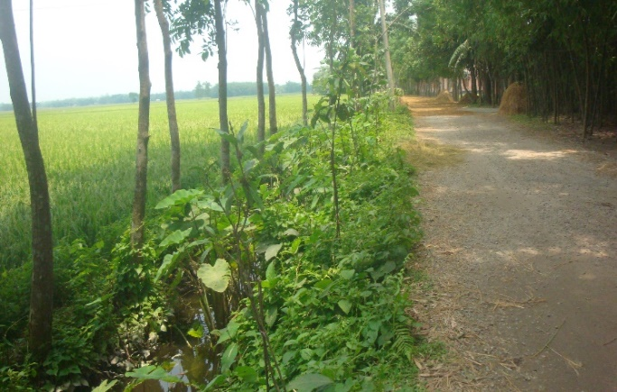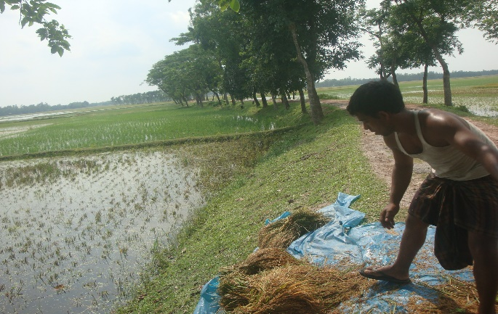 Supplying, Fitting& fixing of Street lights starting from Burirhat Jute Mill to Harati (Ch.0+000-1+700km

Design, Supervision, and Management (DSM) Consultancy Services

Joint Venture of *Hifab International AB, Sweden and*

*AQUA Consultant & Associates Ltd., Bangladesh*

**May, 2017**

**Rangpur City Corporation, Rangpur.**

**Table of Content**

|  |  |  |
| --- | --- | --- |
| **No** | **Contents** | **Page. No** |
| 1. | INTRODUCTION | 1 |
| 1.1 | Project Background | 1 |
| 1.2 | Legal and Policy Framework | 1 |
| 1.3 | Brief Description of Subproject | 2 |
| 1.4 | Social Management Plan | 5 |
| 2. | Description of Subproject Area | 6 |
| 2.1 | Brief Profile of Rangpur City Corporation | 6 |
| 2.2 | The Subproject Location and Area Profile | 11 |
| 2.3 | Historical and Cultural Heritage Sites | 11 |
| 2.4 | Beneficiary Communities and Affected Persons | 13 |
| 2.5 | Gender and Vulnerability | 14 |
| 3. | Social Impact Assessment | 14 |
| 3.1 | Benefits of the Subproject | 14 |
| 3.2 | Social Screening and Safeguard Compliance Issue | 14 |
| 4. | Consultation and Community Participation | 15 |
| 4.1 | Stakeholder Analysis | 15 |
| 4.2 | Consultation and Participation plan for subproject | 15 |
| 4.3 | Consultation Outcomes – Issues, Concerns and Recommendations | 15 |
| 5.0 | Social Management Plan for site selection and design | 16 |
| 5.1 | Subproject Selection Process”. | 16 |
| 5.2 | Subproject Design Process | 16 |
| 5.3. | Grievance Redress Mechanism (GRM) | 16 |
| 5.4 | Implementation Arrangement | 17 |
| 6 | Conclusions on Social Management Plan (SMP) | 17 |
| **Photograph/Figure** | |  |
| 1 | Subproject Estimated cost | 5 |
| 1. | Present condition of the road | 2& 4 |
| 3 | Sub Project layout. | 9 |
| 4 | At glance of Rangpur City corroboration | 7 |
| **ANNEXURE** | |  |
| 1. | Mayor letter on Landownership ( City corporation letter ) | 18-19 |
| 2. | Agreement between PAPS & City Corporation ( three pages) | 20 |
| 3 | Social Screening Report and attendance ( a , b) | 1-13 |
| 4 | *Social screening Report and attendance (c,d& e)* | 1-15 |

**Abbreviations**

|  |  |
| --- | --- |
| ARP | Abbreviated Resettlement Plan |
| BMDF | Bangladesh Municipal Development Fund |
| LAP | Land Acquisition Plan |
| CBO | Community Based Organization |
| CC | Cement Concrete |
| RCC | Rangpur City Corporation |
| CIP | Capital Investment Plan |
| CUL | Compensation-Under-Law |
| DC | Deputy Commissioner |
| DLAC | District Land Acquisition Committee |
| DUTP | Dhaka Urban Transport Project |
| GoB | Government of Bangladesh |
| GRC | Grievance Redress Committee |
| GRM | Grievance Redress Mechanism |
| HCG | House Construction Grant |
| HTG | House Transfer Grant |
| IDA | International Development Association |
| IP | Indigenous People |
| IPP | Indigenous Peoples Plan |
| KII | Key Informants Interviews |
| FGD | Focus Group Discussion |
| LGD | Local Government Division |
| LGED | Local Government Engineering Department |
| M& S | Management &Supervision |
| MGSP | MunicipalGoverna0nceandServicesProject |
| MOLGRDC | Ministry of Local Government, Rural Development & Cooperatives |
| MSP | Municipal Services Project |
| MSL | Mean sea Level |
| NGO | Non-governmental Organization |
| PAH | Project Affected Household |
| PAP | Project Affected Person |
| PMU | Project Management Unit |
| RCC | Reinforced Concrete Cement |
| RP | Resettlement Pan |
| SIA | Social Impact Assessment |
| SMP | Social Management Plan |
| SSS | Social Safeguards Specialist |
| TLCC | Town Level Coordination Committee |
| ULB | Urban Local Body |
| WB | World Bank |
| WC | Ward Committee |

RAP Resettlement Action Plan

**1. INTRODUCTION**

**1.1Project Background**

The Government of Bangladesh, through the Local Government Engineering Department (LGED) and Bangladesh Municipal Development Fund (BMDF) is implementing the Municipal Governance and Services Project (MGSP). The project aims to improve municipal governance and basic urban services in participating ULBs. Two physical components of the project include (i) Municipal Governance and Basic Urban Services Improvement (Component 1) to provide financial support to 26 pre-identified urban local bodies (ULBs) including municipalities and city corporations, and demand-based sub-credits to eligible ULBs for basic urban services improvement investment costs. Total project cost **is BDT 2, 470, 93.92 lakh to be** financed at 80:20 IDA loan to GOB contribution. LGED is implementing the Component 1 while BMDF is implementing component 2 of the project.

LGED is supporting the 26 pre-selected ULBs for investments in development and rehabilitation of Road, Bridge, Box-culvert, Pedestrians bridge, street light, Traffic Control, Bus terminal, Truck terminal, Boat landing Jetty, Drain, Retaining wall, Kitchen market, Cattle market, slaughter house, Public toilet, Solid waste management, Sweeper colony, Park, Community Centre and Whole sale market. LGED is financing through (i) base allocation based on population category of ULBs; (ii) performance-based allocation and (iii) operations and maintenance support on a declining basis over the project period.

The component interventions have largely been developed for construction and rehabilitation within existing available land owned by the ULBs and acquisition of land has been avoided in the screening process. Removal of some obstruction and relocation of some businesses were involved in case of some sub projects for unavoidable circumstances. The MGSP did not avoid taking-up of sub projects in areas inhabited by tribal peoples and instead ensured their inclusion and participation where applicable. The ULBs addressed the removal of obstructions and in most cases the land entirely belongs to the ULB. In some instances, land of other GOB agencies like the BWDB, R&H or other local government like adjoining UP is needed and in such cases the ULB ensured getting such land by mutual understanding and proper documentation. Relocation of business and removal of obstructions were resolved by consultation and agreement with the concerned PAPs and these are properly documented. Thus land acquisition, population displacement and tribal people’s issues have been addressed following the country’s legal framework and the World Bank policy on social safeguards.

**1.2 Legal and Policy Framework**

Given the approach of subproject preparation and implementation, the World Bank’s Operational Policy (OP) on Involuntary Resettlement (OP 4.12) and on Indigenous Peoples (OP 4.10) triggered to the project. A Social Management Framework (SMF) has been adopted by LGED for the project that meets the requirements of the country’s legal frameworks in Bangladesh “The Acquisition and Requisition of Immovable Property, Ordinance, 1982” and the Bank requirements including OP 4.12 and OP 4.10. The SMF also requires that subprojects are prepared ensuring inclusion, participation, transparency, and social accountability. Subprojects are prepared by respective ULBs in a process complying with the SMF requirements. LGED reviews the subproject proposals for technical, engineering, environmental, social development, and safeguards compliance before allocation of the financing to the ULBs.

Social Management Plans (SMP) will be prepared and implemented for subprojects with no land acquisition or involuntary displacement of people, while Resettlement Action Plans (RAP) and Tribal Peoples Plans (TPP) ) will be prepared for implementation for subprojects involving population displacement and tribal peoples’ issues.

**1.3Brief Description of Subproject**

**Package No. MGSP/RAN/2016-17/W-09**

a)Rehabilitation of Road from BurirhatEdgah to MonoharbShukanchaki (Ch.0+000-3+730km)

b)Construction of 3mx2mx8m box culvert on BurirhatEdgah to MonoharShukanchaki Road at Ch.1+500km,2+100km,2+565km,2+590km & 2+905km (6nos).Including 1.5mx1.5mx8m cross drain at Ch.1+895km,3+580km & 3+720km (3nos.) with wing wall parallel to Road

c) Rehabilitation of road from Burirhat Jute Mill to Harati (Ch.0+200 to 1+700km).

d) Construction of RCC drain from Burirhat Jute Mill to Harati(Ch.0+000 to 2+400km)

e) Supplying, Fitting& fixing of Street lights starting from Burirhat Jute Mill to Harati (Ch.0+000-1+700km

a)Rehabilitation of Road from BurirhatEidgah to MonoharbShukanchaki (Ch.0+000-3+730km)

b)Construction of 3mx2mx8m box culvert on BurirhatEdgah to MonoharShukanchaki Road at Ch.1+500km,2+100km,2+565km,2+590km & 2+905km (6nos).Including 1.5mx1.5mx8m cross drain at Ch.1+895km,3+580km & 3+720km (3nos.) with wing wall parallel to Road

This is an important sub project and is located in the north part & semi urban areas of Rangpur City Corporation under ward **no 2**. It starts from BurirhatEidgah field to (Gangacharaupazila road) and ends at MonoharShukanChaki (Ch.0+000 to 3+730m) and is connected with Shukanchakihaat.

The proposed subproject is an existing road for improvement and is located in the exclusively residential areas. Both sides of the road in the semi urban part have crop land and different types of crops like paddy, maize and jute are cultivated. The edges of road have 750 number of trees (Mango, Jackfruit, Black berry, Rain tree and bamboo bunch, Mahogany, Koroi ( Lebbeck) , Betel nut, Tamarind, Litchi and Akashmani).

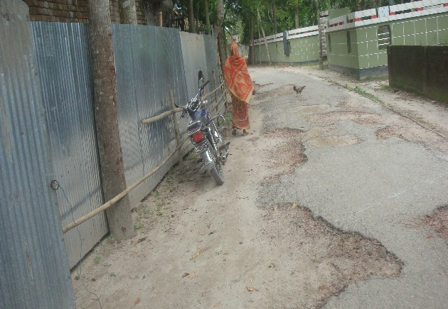The present condition of the proposed sub project is BC road with width of 3.2 to 3.5 m. It is damaged for over used & lack of proper maintenance. The maximum surface areas of the road are worn-out and have many holes on road surface. The road has 5 culverts and 3- cross drains in different locations which are old and damaged. This is why local transports liketruck, covered van, microbus, rickshaw-van, CNG driven baby taxi, Ox-cart and battery auto movement is difficult. Also, passenger movement is difficult during the rainy season.

Figure Road Condition at Monohar para

Considering the above situation it is required to improve this road to reduce traffic congestion. It will improve movement of pedestrians. During the screening, the DSM team meet local community leaders, city mayor, councilors, City Corporation Engineers, teachers, students, farmers, traders, public and private sector employees, NGOs, children, women and civil society representatives. About 25,000 people of the area will be benefited by the sub project. Improvement of the proposed road will help travel time saving for the city dwellers as well as of people of GangacharaUpazila and two important haats near the town will be benefited.

Construction of the road following DSM design will need increasing width by earth-filling of about 5m wide from Ch.400m to 3300m. As per city cooperation statement land of the existing road and of proposed expansion part belongs to the city cooperation. Regarding this, the RCC provided a letter to the DSM. (Copy of the letter attached at annex-1.)

The sub project construction will require removing boundary wall of a private house and boundary tin-fence of two more houses (Ch.12m to 32m and 3200 to 3300m) and . Also felling of about 750 trees and shifting of 8 electric poles will be needed. An agreement has been signed with the involved PAPs (agreement with PAPs attached annex-2)

**c) Rehabilitation of road from Burirhat Jute Mill to Harati (Ch.0+200 to 1+700km).**

**d) Construction of RCC drain from Burirhat Jute Mill to Harati(Ch.0+000 to 2+400km)**

**e) Supplying, Fitting& fixing of Street lights starting from Burirhat Jute Mill to Harati (Ch.0+000-1+700km**

This sub project is very important work of Rangpur City Corporation under ward number 6. The proposed alignment starts from Burirhat high school and ends at BahadursinhachowrastaJame Masjid (Ch.0+200 to 1+700km). The existing road width is 4.5 to 5 m and is bituminous carpeting road. Both sides of the road have enough spaces for construction of 6m wide of proposed road. The required land of road belongs to Rangpur City Corporation received from Uttam&Pursoram unions of GangacharaUpazila. These two unions have been added to Rangpur City Corporation in 2012.

The new RCC drain construction alignment is proposed along both sides of the Burirhat Jute Mill to Harati (Ch.0+200 to 1+700km) road in ward 6. Its outfall is at Kayagile cannel. This is one side drains and crossed 4 times in different locations.

In the Jute mill to high school (Ch.0+200m) and BahadursinhaChowrastaJame Masjid to Kayagil Bridge (Ch.1720 to 2400m) there is an earthen drain besides paddy field.

The rest area has existing drains, it’s is old and damaged and water discharge capacity is inadequate.

This subproject area is mixed commercial (Ch. 0 to 800m) and residential and has a big cattle market and kitchen market at Burirhat area. The Rangpur city cooperation yearly earned BDT: 1 5 lac from the two markets as lease value. Besides this, the locality has two milk collection &selling center operated by the PRAN group &Aroang and several types of shops (fertilizer, poultry feed whole sale ,medicine shops, hardware store, tea stall, fast food & restaurants), Burirhat high school & Government Primary School (GPS) and post office are located here.

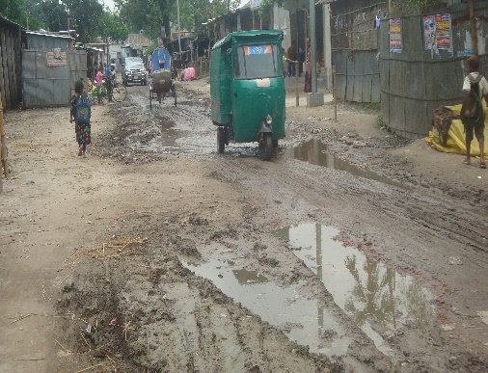About 30,000 people comprising businessmen, students, children and women, agricultural product sellers, teachers and services holders use this road. Various types of transport like truck, trolley, covered van, microbus, rickshaw-van, CNG driven baby taxi, ox-cart and battery operated three wheeler auto movement are using this road but the road condition is damaged. Moreover movement of pedestrian gets difficult during rainy season due to water-logging.

Figure:Burirhat road condition

At this time there is no proper drainage system and overall road condition is very much vulnerable and risky. Besides this, street light are also insufficient. So the implementation of this sub project is very much important for Rangpur City Corporation.

During social screening seen some obstacle’s as per following ways.

* About 20 various types shops (Ch.200 to 400m) will be affected as the extended front steps are encroached to the city corporation land. The shops belong to the city corporation and the shopkeepers are tenants of the city corporation paying monthly rent. (agreement with PAPs attached annex-2)
* In last part of the drain (Ch.2250 m to 2400m) water flows through an earthen drain beside the paddy land of farmers. Part of the earthen drain alignment is encroached by farmer (Rashid Mahmud). This obstacle should be removed.
* The sub project needs shifting 09 electrics poles and cutting of 200 trees (Mango, Jackfruit, Rain tree, Bamboo bunch, Mahogany, Koroi*Lebbeck*Zika and Akashmani).

The sub project includes provision of street light in the above mentioned proposed road which will improve pedestrian’s safety, will improve overall visibility for the vehicle drivers and thereby will contribute to reducing accident. This will have positive contribution to volume of trade in the nearby markets.

**The proposed subproject and its estimated costs are given in the following table**.

| **Sl** | **Subprojects** | **Length (m)** | **Estimated Cost (BDT)** | **Remarks** |
| --- | --- | --- | --- | --- |
| A | Rehabilitation of Road from BurirhatEidgah to MonoharbShukanchaki (Ch.0+000-3+730km | 3730m | 50,551,800.17 | Road |
| b | Construction of 3mx2mx8m box culvert on BurirhatEdgah to MonoharShukanchaki Road a Ch.1+500km,2+100km,2+565km,2+590km & 2+905km (6nos).Including 1.5mx1.5mx8m cross drain at Ch.1+895km,3+580km & 3+720km (3nos.) with wing wall parallel to Road | 3720 | 8,251,141.63 | Culvert & cross drains |
| C | Rehabilitation of road from Burirhat Jute Mill to Harati (Ch.0+200 to 1+700km). | 1700 | 19,832,480.13 | Road |
| d | Construction of RCC drain from Burirhat Jute Mill to Harati(Ch.0+000 to 2+400km) | 2400m | 69,342,480.13 | RCC drain |
|  | Supplying, Fitting& fixing of Street lights starting from Burirhat Jute Mill to Harati (Ch.0+000-1+700km | 1700m | 3,313,651.76 | Street light |
|  |  |  | 151,291,947.18 |  |

**1.4 Social Management Plan**

This Social Management Plan (SMP) has been prepared for the identification of subproject and managing social concerns in the process of subproject design and implementation. Initially, the subproject proposal includes a social screening report including the impact assessment. After reviewing the social screening report by Social Unit of DSM, this subproject proposal is submitted to the PMU office. Social team of the DSM has carried out a site visit and consulted with the Rangpur City Corporation officials, stakeholders and a section of the beneficiary communities through interview, participation and consultation meeting. The social screening findings from the consultation method and proceedings were further validated through the social survey and consultation.

The purpose of preparing this SMP is to demonstrate an all-inclusive consultative process in selection and design of the subproject as well as to provide guidance for social development and safeguards compliance in the implementation process.

The SMP contains a description of the subproject area, social screening and impacts, consultation process adopted during identification and design, and consultation plan for implementation stage, impact mitigation measures, grievance resolution process, and implementation arrangements, and monitoring and evaluation.

RCC authority will ensure participation of the communities and grievance resolution in the process of implementation of the subprojects.

**2. Description of Subproject Area**

**2.1 Brief Profile of Rangpur City Corporation**

Rangpur is one of the major cities in Bangladesh and [RangpurDivision.](https://en.wikipedia.org/wiki/Rangpur_Division)Rangpur was declared a district headquarters on 16 December 1769, and established as a municipality in 1869, making it one of the oldest municipalities in Bangladesh. The municipal office building was erected in 1892 under the precedence Raja JanakiBallav, Sen. Chairman of the municipality. During the period of 1890, "Shyamasundarikhal" was excavated for improvement of the town. The Municipality is located in the north western part of Bangladesh. A Recently established public university of Bangladesh named "Begum Rokeya University, Rangpur" is situated in the southern part of the city. Previously, Rangpur was the headquarters of *Greater Rangpur* district. Later the Greater Rangpur district was broken down into the Rangpur, Kurigram, Nilphamari, Lalmonirhat, and Gaibandha districts. In the great Rangpur region, little economic development took place until the 90s, mainly because of the yearly flooding the region used to see before the making of the Teesta Barrage. Coal is found near this district. There is a large military cantonment in the town.

Rangpur town is the divisional headquarters. The soil composition is mainly alluvial soil (80%) of the teesta River basin, and the remaining is brained soil. The temperature ranges from 32 degrees Celsius to 11 degrees Celsius, and the annual rainfall averages 2931 mm. Rangpur town, covering an area of around 28 square kilometers, lies on the bank of the Ghaghatriver, and was turned into a municipality back in 1869. The population of the Rangpur municipality as of 2006 is 251,699, with 52% male and 48% female, and the literacy rate is 54.6%. Establishment of Rangpur City Corporation, as Divisional City is now under way after the establishment of Rangpur Division in January 2010.

Rangpur City Corporation established in 2012. It is well-known for its commercial and industrial activities. This City Corporation is located in the northern part of Bangladesh. Rangpur City Corporation is very famous for industrial activities of Pran RFL Group, a very famous group of companies of Bangladesh. Consequently, a huge number of workers live in this area. Beside this, people living rural areas adjacent to this City Corporation are very poor. These poor people generally come to the City Corporation during non-working season of agriculture (September-November after the aman crop is planted and from March-April after the boro crop is planted) in search of work.

Improvement of this infrastructure under the subproject will increase commercial and economic activities in this area and will also boost other socio-economic activities in the City Corporation. Moreover, health and sanitation of the local community people will improve.

Northern regions of the country accommodate about one quarter of the total population of the country. This produces a substantial amount of cereal crops. Rangpur division, formed with old greater Rangpur and Dinajpur districts, has a surplus in rice production and other cash crops like potato, oilseed, and tobacco. The prime city of the division is Rangpur town which has been upgraded to a city corporation. It is one of the oldest municipalities of the country. It is not only famous for its academic establishments like Carmichael College,Rangpur Government College, Begum Rokeya College, Rangpur Medical College, Rangpur Cadet College, and Begum Rokeya University, but it has also an industrial base. The importance of Rangpur has increased substantially as the headquarters of the Rangpur Division. The jurisdiction of the city has also been extended from about 40 sq.km. to about 200 sq.km. However, no development plan exists to guide the physical development. The upgrading the town into a city corporation has necessitated preparation of a Master Plan for planned development of this newly established city corporation. In this backdrop, Local Government Engineering Department, under its District Town Infrastructure Development Project has taken the initiative to prepare a physical Master Plan, Urban Area Plan, and Detailed Area Plan to guide and control urban growth of the city. These places will provide the citizens an environment which benefits modern living.

**At a Glance of Rangpur City Corporation**

|  |  |  |  |  |  |  |  |  |  |  |  |  |  |  |  |
| --- | --- | --- | --- | --- | --- | --- | --- | --- | --- | --- | --- | --- | --- | --- | --- |
| |  |  |  | | --- | --- | --- | | **General Information** | | | | Area | : | 203.19 Square K.M. | | Ward | : | 33 Nos | | Population  Population Growth Rate  Household No  Population Density  Major Status  Main Income Source : | : | 5,79,012 (in 2011)  5.45  124764 (in 2011)  2814.83 Person Per sq km (in 2011)  0 migrated people  Business 0%, Service 0%, others 0% | |  |  |  |
|  |  |  |  |

|  |  |  |
| --- | --- | --- |
| **Tax** | | |
| Holding Tax | : | 39544 No’s |
| **Market** | | |
| Market | : | 25 No’s |
| Shopping Complex | : | 07 No’s |
| Own Shops | : | 13 No’s |
| **License** | | |
| Trade License | : | 10181 No’s |
| Rickshaw License | : | 2253 No’s |
| **Communication** | | |
| Road | : | 1427 Km |
| a) Bituminous | : | 570 Km |
| b) CC | : | 33 Km |
| c) RCC | : | 15 Km |
| d) Brick Flat Soling | : | 3 Km |
| e) Nonpaved Road | : | 806.0 Km |
| Culvert | : | 1115 Nos |
| Road intersection | : | 35 Nos |
| Bridge | : | 135 Nos |
| Footpath | : | 6 Km |
| **Water Supply** | | |
| Overhead Tank | : | 05 No’s |
| Capacity | : | 6,80,000 Liter/tank |
| Deep Tube well | : | 11 No’s |
| Pipe Line | : | 157 Km |
| House Connection | : | 5,500 No’s |
| Street Hydrant | : | 100 Nos |
| Pump Station/ house | : | 11 Nos |
| Arsenic Status | : | Within acceptable limit |
| Pumping Hour | : | 8 Hour |
| **Street Lighting** | | |
| Electricity Line | : | 400 Km |
| Light Post ­ | : | 10,000 No’s |
| Tube Light Point | : | N/A |
| Energy Savings Light Point | : | 10,000 No’s |
| Meter/ Switch Point | : | 120 No’s |
| **Vehicle** | | |
| Garbage Truck | : | 25 No’s |
| Trucktor | : | N/A |
| Bulldozer | : | N/A |
| Jeep | : | 10 Nos |
| Motorcycle | : | 23 Nos |
| Hydraulic Beam Lifter | : | 2 Nos |
| Road Roller (4 ton – 6 ton) | : | 2 No’s |
| Road Roller (8 ton – 10 ton) | : | 4 No’s |
| Excavator (8 Cft) | : | N/A. |
| Bulldozer | : | N/A. |
| **Drainage System** | | |
| Drain | : | 1,102 Km |
| a) RCC/ Brick Lined Drain | : | 153,53km |
| b) Earthen Drain | : | 967 Km |
| Canal | : | 79.19 Km |
| **Public Health** | | |
| Public Toilet | : | 12 No’s |
| Sanitary Latrine | : | 200 No’s |
| Dustbin | : | 150 No’s |
| Sanitary Land field | : | 1 No’s |
| EPI Centre Permanent- | : | 120 No’s |
| Temporary - | : | 60 No’s |
| Hospital | : | 3 No’s |
| Clinic (TB) | : | 1 No’s |
| Maternity Clinic | : | 10 No’s |
| Private Clinic | : | 186 No’s |
| Diabetic Hospital | : | 1 No |
| **UPPRP Project** | | |
| Community Centre | : | 2 No |
| Total Urban Community | : | 57 Nos. |
| Total Community Family | : | 13000 |
| Total Community Member | : | 63212 |
| Total Sanitary Latrine | : | 600 |
| Total Road with Footpath | : | 450km |
| Drain | : | 370km |
| Improved cooking | : | N/A |
| **UPHSDP Project** | | |
| Nagar MatriSadan | : | 01 No |
| Nagar Health Centre | : | 03 No’s |
| Satellite Clinic | : | 09 Nos. |
| **Religious Institution** | | |
| Mosque | : | 1114 |
| Eidghah | : | 85 |
| Temple | : | 213 |
| Graveyard | : | 984 |
| Burning Ghat | : | 03 |
| Church | : | 02 |
| Buddhist Temple | : | N/A |
| Orphanage | : | 06 |
| **Law &Order** | | |
| Police Station | : | 01 |
| Police Fari | : | 03 |
| Judge court  RAB office | :  : | 01  02 |
| **Education** | | |
| Public University | : | 01 |
| Private University | : | 02 |
| Govt College | : | 03 |
| Private College | : | 25 |
| Cadet College | : | 01 |
| Public Medical College | : | 01 |
| Private Medical College | : | 02 |
| Art College | : | 0 |
| Law College | : | 01 |
| Homoeopathic Medical College | : | 01 |
| Public Polytechnic Institute | : | 01 |
| Public Engineering Survey Institute | : | 0 |
| Private Polytechnic Institute | : | 03 |
| Madrasha | : | 240 |
| Teachers Training College | : | 01 |
| Govt High School | : | 02 |
| Non-Govt High School | : | 52 |
| Govt Primary School | : | 202 |
| Kinder Garten School | : | 140 |
| **Recreation** | | |
| Park | : | 03 |
| Zoo | : | 01 |
| Cinema Hall | : | 03 |
| Stadium | : | 01 |
| Auditorium | : | 02 |
| Gymnasium | : | 01 |
| Recreation Club | : | 0 |
| **Communication** | | |
| Railway Station | : | 01 |
| Bus Station | : | 02 |
| Ferry Ghat | : | 0 |
| T & T Office | : | 01 |
| GPO | : | 01 |
| Post Office | : | 08 |

Figure: 2: Subproject layout plan (PW-9) **in Rangpur City Corporation.**

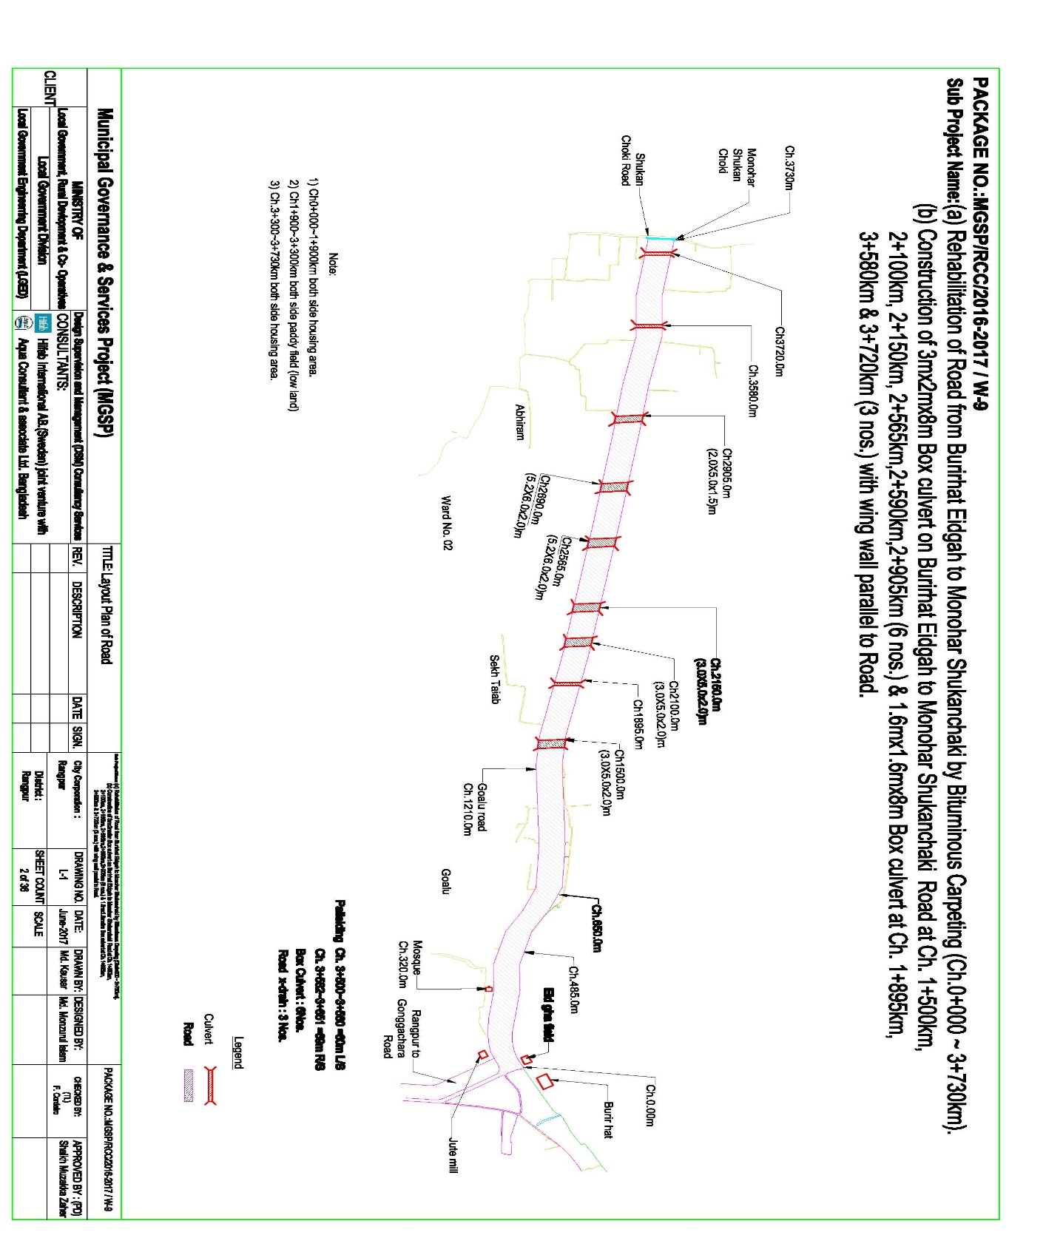

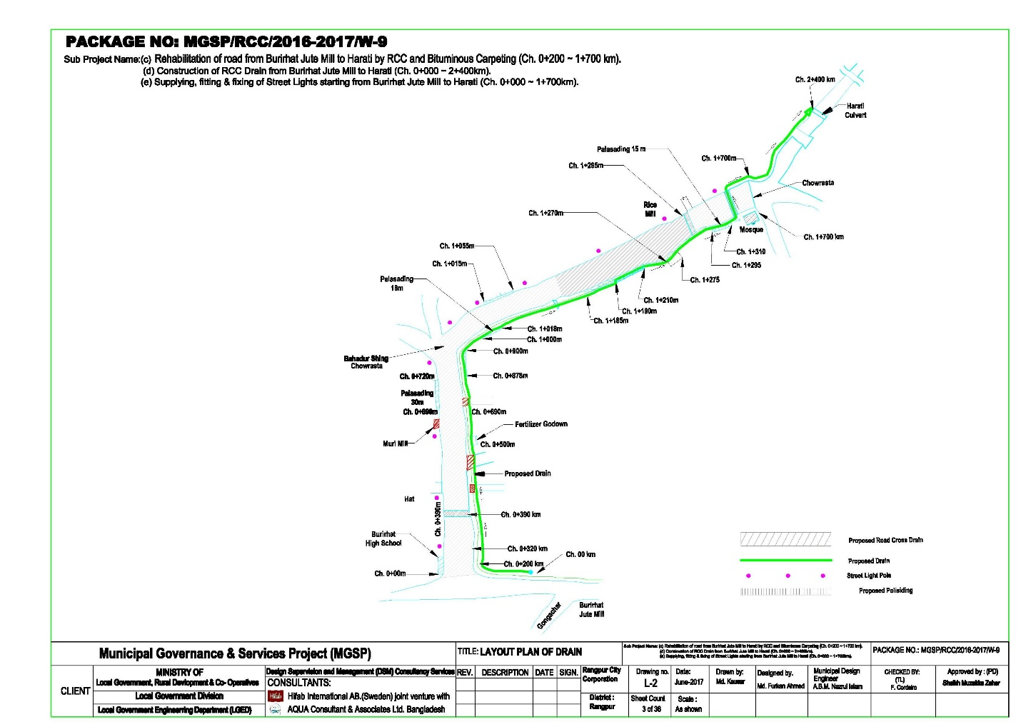

**2.2 The Subproject Location and Area Profile**

The identified sub project for improvement the road with drain and street light covers commercial and residential areas. During the field visit for social screening, the DSM team found about 20 shops (extended front spaces) in Ch.200 to 400m and private house boundary wall ( one brick and two tin –fence ( Ch. 12 to 32 and 3200 to 3300m) will require removing. More over in the last part of earthen drains alignment is encroached by one farmers. These obstructions will be removed by the concerned shopkeepers, house owners and farmers willing ling and without compensation. Agreement will be signed between the PAPs and the City Corporation and attached (Annex-2)

**2.3 Historical and Cultural Heritage Sites:**

Under the Rangpur City Corporation, there are lots of historical and Archaeological heritage from British regime to know which are as follows:

Archaeological heritage and relics TajhatRajbari, Keramatia Mosque, Dimlaraj Kali Mandir, Shree ShreeKarunamaye Kali Mandir, Rangpur Museum, Rangpur Town Hall, Rangpur Public Library, PareshnathMandir at Mahiganj, tomb of the noted Islamic thinker MaulanaKeramat Ali Jainpuri, tomb of Shah Jalal Bokheri at Mahiganj, tomb of Ismail Ghazi at Kataduar, carmichael college Building, home stead of roquiahsakhawathossain at Pairabandh and ZilaParishad Building etc.

1. Tajhat Palace:

Tajhat Palace is located at Tajhat, the southern end of Rangpur city. It was the earlier high court building established in 1984 called the Tajhat, a former Zamindar’s palace. After the end of the British Raj, the building was abandoned and decayed rapidly, although it was used for a few years as a courthouse during the 1980s. In 2004, it was largely restored and turned into a museum which hosts a collection of Blackstone Hindu carvings, calligraphic art from the Mughal period and other objects d'art and coins from the area on display. Due to lack of funding, the museum is sometimes closed.

The place is situated three km on the south–east outskirts of the town of Rangpur. Probably this place was built by Maha Raja Kumar Gopal Lal Ray in the beginning of the 20th century from 1984 to 1991. The palace was used as a Rangpur high Court branch of the Bangladesh Supreme court in 1995. The palace was declared as a protected monument by the department of archaeology recognizing its outstanding archaeological value. The government of Bangladesh decided to shift the Rangpur museum here in 2002. Accordingly, the palace is being partly used as Rangpur museum since 2005.

**B) Raja Man Singh a commander of the Mughal Emperor**

Rangpur was conquered by the army of Raja Man Singh a commander of the Mughal emperor, Akbar in 1575, but it was not until 1686 that it was fully integrated into the Mughal Empire. Names of places like Mughalbasa(literal meaning being a locality of the Mughals), and Mughalhat(literal meaning a "local market" organized by the Mughals) bear testimony to the Mughal Association and past of Rangpur and its hinterland. Later on, Rangpur passed under the control of "Sarker" of Ghoraghat. During the period of the British East India Company, the Sannyasi Rebellion took place.RangapurGhoraghat has been mentioned in the Riyaz-us-Salatin. During the early period of the company rule fakir-sannyasi resistance and peasant rebellion were held in Rangpur.

**C) Carmichael College**

Carmichael College is one of the old colleges in Bangladesh established in 1916 and built during the Raj era, is located in Rangpur. The main attraction of this college is its administrative building (which houses the Bangla department). It is a white two-storied building designed in the style of the buildings of Cambridge University of UK. It is also familiar with its huge campus and natural beauty.

### D) Rokeya Memorial

Rokeya memorial in pairabondhA museum and women's training centre was established in Pairabondh, the birth place of famous Begum Rokeya. It is half an hour drive away from Rangpur city.

### E) Town Hall

There is an ancient auditorium named 'Town Hall' at the centre of the city, where different cultural programs are held.

### F) JaduNibash

Located in Radhaballav next to the Rangpur Government College. Home of Late Mashiur Rahman Jadu Mia. It is an ancient house, about hundred years old. The house was probably built and owned by Raja Gopal LalRaiBahadur at the same time that the Rangpur District Council, Rangpur Town Hall and the famous Tajhat Palace buildings were built.

### G) Rangpur Zoo

Rangpur Central Zoo is one of the main amusement and recreation spot of Rangpur city. With an area of 20.27 acre of lush green trees and grasses, the Rangpur zoo is located east side of Hanuman-tola road beside police-line, not far from Rangpur district Administration office. The Zoo has 193 individual animals of 28 species. Many wild animals are available to attract the visitors. A few of them are The Bengal tiger, African lion, Black Panther, Rhinoceros, Leopard, Hippopotamus, Peacocks, Alligators, Turtles, Spotted Deer, different kinds of Birds, Snakes and so on.

The Rangpur zoo was built in the 1880s. Bangladesh University of Engineering Technology (BUET) completed a digital survey and feasibility study of "Dhaka AndRangpur Zoo Modernization Project" to upgrade the facilities to international standard.

### H) BinodonUddyan

"BinodonUddyan" is a massive park located in the middle of the city. A Shishu Park (children's park), lake and a large restaurant are situated inside of this park. The mini Tajmahal also latest attraction.

### I) Deowan Bari Jamindaar Bari

The Deowan Bari Jamindaar Bari was built by FonivusonMojumdar. FonivusonMijumdar was the son of Landlord Radharomon and mother KusumKumari Devi who was the second wife of Radharomon. He was born in 1892. This landlord house is a small 2 storied building. but the main gate of the house is like a Mughal Castle – gate. After ban of the Real estate tenancy practices in 1952 the house was auctioned. The property was purchased by one NosorGhatial who hailed from Kurigram. Now there is a school and some business centres. It is located at Deowan Bari road in Rangpur near the town.

### J) Chiclivata

Near the stadium, there is a very beautiful place called 'Chiclivata' surrounding by many lakes and rice fields.

### Other Places

The town is known as Green town for its beautiful garden and Green Park throughout the town. There is a large military cantonment in the town.

**2.4 Beneficiary Communities and Affected Persons**

The proposed road and drains will develop traffic network and remove water logging. As a result people will be able to move easily during the rainy season. Local transports like rickshaw, rickshaw van, battery driven three wheeler auto and CNG driven baby taxi and diesel operated tractor trailers (Bhotbhoti) will move conveniently besides buses, covered van, cars, micro buses, pickup van and Lorries.

This part of the town is quickly growing residential cum commercial area. About 55,000 people will be benefited by the subproject infrastructure (widened road, drain and street light). They will use the road to meet the needs of job holders, students, children & women. People of two wards will (2& 6) mainly benefit from the sub project. In addition, people of other wards of the town and the adjoining Upazilas (Rangpur city Gangcharaupzila) will use the road for easy connectivity to Rangpurtown. The proposed road will improve connectivity with the main two haat.

.

This is very densely populated area. It is noted here that there is no presence of tribal people in the subprojects influence areas.

**2.5Gender and Vulnerability**

Gender and vulnerability analysis have been considered in social impact assessment of subprojects. This has focused gender and vulnerability based on findings from specific queries during social screening and community consultation. The quantitative and qualitative analysis has brought out sex disaggregated data and issues related to discrimination by gender vulnerability, needs, constraints, and priorities as well as understanding whether there is a potential for inequitable risks, benefits and opportunities relating to gender and vulnerability. Based on the social analysis, specific interventions inclusion and participation encourages gender mainstreaming in the project cycle. Gender equity and empowerment will be ensured through encouraging participation of men and women equitably in the project cycle. The community participation and consultation also encourages gender mainstreaming in the subproject influence areas.

After subprojects implementation, there are positive impacts for the vulnerable women; especially those who are small traders, landless, marginal farmers, etc. and can sell their household products. These subprojects will create job creation and livelihoods. In addition, it will also increase the mobility of drains users. Due to the fact, gender and vulnerability has been taken into account and ensures the gender equity in the subprojects implementation.

**3. Social Impact Assessment**

**3.1 Benefits of the Subproject**

After identification of subproject through CIP, PMU of the project with the assistance of DSM Consultants has completed social screening and socio-economic impact assessment for the road, drain, cover slab and streetlight of Rangpur City Corporation. This subproject is predominantly used for inter-town and intra-town movement. It will improve traffic network and drainage system as well as to reduce road accident and to reduce water logging. From the point of view of social benefits it will enhance commercial/economic activities, direct/indirect employment opportunity and poverty reduction. Also it will improve access to health service, educational institution. For improved transport network, property value of adjoining area will increase substantially, rent will increase and this will eventually contribute to increased revenue earning for the City Corporation.

**3.2 Social Screening and Safeguard Compliance Issue**

After selection of the subprojects from the CIP list, the City Corporation with the assistance of DSM Consultants has completed a social screening for the subprojects using an inclusive and participatory approach.

Rangpur City Corporation has ensured the implementation of subprojects followingsocially inclusive and gender friendly. According to engineering design, implementation of the subprojects will be carried out within the existing right-of-way.

Results from the social screening are given below.

* No additional public or private lands will be required for the subprojects outside the existing right of way.
* The sub project will not affect access to common property resources for any community. It will also have any negative impact on cultural property of any kind.
* Preparation of RAP will not be required for implementing the subproject as no LA is involved.
* Agricultural or industrial productivity will not be hampered by the proposed subproject areas.

The outcomes of social screening also confirm that local people across the subprojects are positive about its implementation.

**4. Consultation and Community Participation**

**4.1 Stakeholder Analysis**

According to BBS 2011, (Collected from Municipal Authority) the total population of Rangpur City Corporation was 5,79,012 among which 2,95,395 male and 2,83,617 female in the context of present demographic composition of Rangpur City Corporation, people live in higher, higher-middle, lower-middle, and lower income groups in the City Corporation area. Both males and females living in the Rangpur City Corporation, in general, and adjacent to the subproject area, in particular will directly be benefited by the construction of BC approach road and RCC Bridges.

As a part of the overall assessment, the subprojects identified the key stakeholders of the proposed subprojects areas and assessed the power relationships as well as influence and interests of stakeholders involved in the development work of the subprojects. Key stakeholders for subprojects under MGSP were identified in consultation with the Mayor and officials of Rangpur City Corporation, civil society and local people of towns, representatives of business associations, and local contractors etc. Suggestions and direction of all local stakeholders were noted and reflected in the SMP while designing subproject interventions.

**4.2 Consultation and Participation plan for subproject**

The participatory public consultations were conducted in the subprojects area. Key Informant Interviews (KII), Informal Group Discussion (GD) were conducted involving the participants of Rangpur City Corporation Mayor, Councilors, City corporation officials, representatives of local communities and civil society members as well as representative of local LGED office and consultant team.

A walk-through informal group consultation with the local communities was also held. Through this participation and consultation meeting, the local communities were informed about subprojects implementation and benefits.Suggestion and recommendations made by the participants are incorporated in the SMP accordingly. The photographs of the consultation meetings are seen.

**4. 3. Consultation Outcomes – Issues, Concerns, and Recommendations**

The participants raised their issues related to subprojects improvement which mainly two lane road ,RCC drains and streetlight.. Feedback, suggestions and recommendations by the participants are listed below.

* Construction works should be scheduled properly and the quality of construction work should be maintained strictly.
* Be engaging female labor force gender issues has been partially addressed
* Social safe guard compliance issues have been ensured through the inclusive participation of subprojects beneficiaries in subprojects implementation.

**5. Social Management for site Selection and design.**

**5.1. Subproject Selection Process**

MGSP in coordination with concerned Rangpur City Corporation elected functionaries, local administration, relevant stakeholders, community members, road users and civil society members followed the participatory approach in different stages of subprojects selection following inclusion, consultation and participation methods. Female Ward Councilors participated actively in the selection process. Moreover, the representatives of TLCC and WC from the City Corporation have contributed in the subprojects selection process with an analysis of the inclusiveness of the selection process.

At the time of selecting these subprojects, Social Screening and Group Discussion (GD) with Rangpur City Corporation urban communities, local administration, traders, buyers, and sellers were conducted by the Rangpur City Corporation officials and Consultants from DSM. Views and opinions of these consultations were to explain the subproject objectives and sought feedback from the participants to maximize the social and economic benefits as well as to minimize the adverse impacts of the subprojects.

**5.2. Subproject Design Process**

After final selection of the subprojects, the DSM Consultant designed the proposed subprojects (Drains, Partly Portion of Footpath and streetlight) under Rangpur City Corporation. These subprojects constructed under the City Corporationown land.Despite the inclusion and participatory consultations, if any person has a grievance relating to the implementation of the subprojects, the City Corporation has mitigated it.

The Consultant interviewed stakeholders and beneficiaries of the subprojects areas before the design. The Consultant and City Corporation officials conducted a number of consultation meetings in the subprojects areas discussing the implementation procedures and mitigation measures, if any, required to be taken in implementing the proposed subproject.

**5.3.3. Grievance Redress Mechanism (GRM):**

GRM had already operationalized for Rangpur City Corporation. Accordingly, this City Corporation has formed Grievance Redress Committee (GRC) to handle any grievance raised due to implementation of the subprojects. The committee will be headed by the Mayor of the City Corporation and consist of 7 members. The committee will answer to subproject-related queries and address complaints and grievances about any irregularities in application of the guidelines adopted for assessment and mitigation of social and environmental impacts.Based on consensus, the procedure will help to resolve issues/conflicts amicably and quickly without resorting to any expensive, time-consuming legal actions. It will ensure proper presentation of complaints and grievances, as well as impartial hearings and transparent decisions.

Rangpur City Corporation has already appointed focal Point of GRC who is at the level of Assistant Engineer. But he will also act Social Development Officer for the MGSP subprojects implementation in their City Corporation. The Mayor of the Rangpur City Corporation is the Chairman of the GRC. This GRC at the City Corporation level is responsible to disclose the subprojects implementation before civil works starts.

**Structure of the GRC Committee:**

|  |  |
| --- | --- |
| **Person** | **Status** |
| ULB Mayor | Convener |
| Representative of Local Administration | Member |
| Teacher from a Local Educational Institution | Member |
| Representative of a Local NGO | Member |
| Representative of Civil Society | Member |
| Female Ward Councilor | Member |
| Head of Engineering Section of ULB | Member Secretary |

**5.4 Implementation Arrangement:** DSM has initially completed social screening for the subprojects and there is no problem for implementing the subprojects regarding social safeguard issues. Accordingly, PMU, MGSP has issued the award letter against the subproject following all required procurement procedures. Rangpur City Corporation has the responsibility to implement the subprojects timely in close coordination with the PMU of the project and also with the technical assistance of DSM. Engineering section of City Corporation and local representative of Consultancy team will ensure the quality construction work of the subprojects. In addition, Consultant team from Head Quarter DSM will ensure close monitoring of the implementation of the subproject components. In the implementation process, Social Safeguard Team will ensure monitoring of social safeguard management before civil works start. During construction, the communities will not be affected and the project will minimize the loss of communities. In addition, before civil works start, the Pourashava will make the video filmed and also social screening.

**6. Conclusions on Social Management Plan (SMP)**

The subproject will improve road connectivity in the RCC area and with the adjoining Gangachara Upazila.

Implementation of the subproject will need removal of one boundary wall and two tin-fences of three private houses and front steps of 20 shops. It will also require re-occupying agricultural land of one farmer encroached to RCC earthen drain. Agreement has been signed with these PAPs and it is agreed that the PAPs will remove obstacles willingly and without asking for any compensation.

Improvement of the proposed road will help travel time saving for the city dwellers as well as of people of Gangachara Upazila and two important haats near the town will be benefited.

**City Corporation letter Annex-1.**

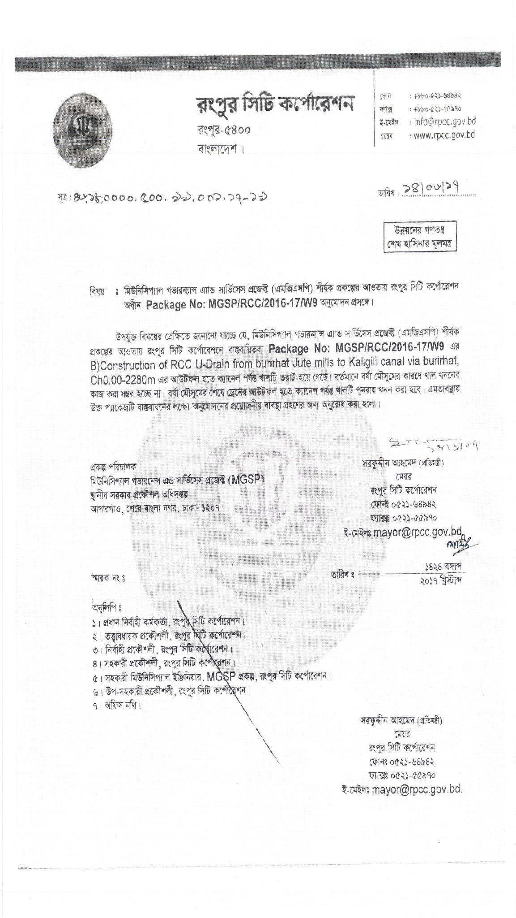

**Agreement between PAPs &City Corporation –Annex-2.(three pages)**

