

**Local Government Division**

**Local Government Engineering Department**

**Municipal Governance and Services Project (MGSP)**

**IDA Credit No: 5339-BD**

***Report on Social Management Plan***

**Package No: MGSP/SHE/2017-18/W-7**

***Sherpur Pourashava, Bogra***

**Name of Subproject:**

1. **Construction of drain starts from National Highway (Nandigram bus stand) to Darkipara moar (Ch.0+000 to 330 m) under Sherpur Pourashava .Bogra.**
2. **Development of Graveyard at Ward no.1 and 7 under Sherpur Pourashava .Bogra.**
3. 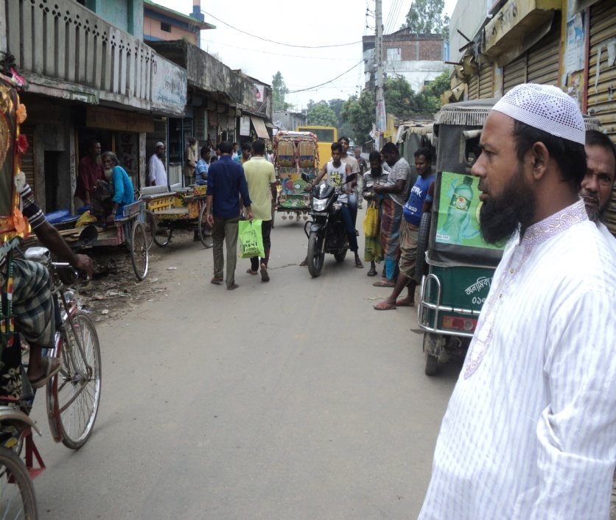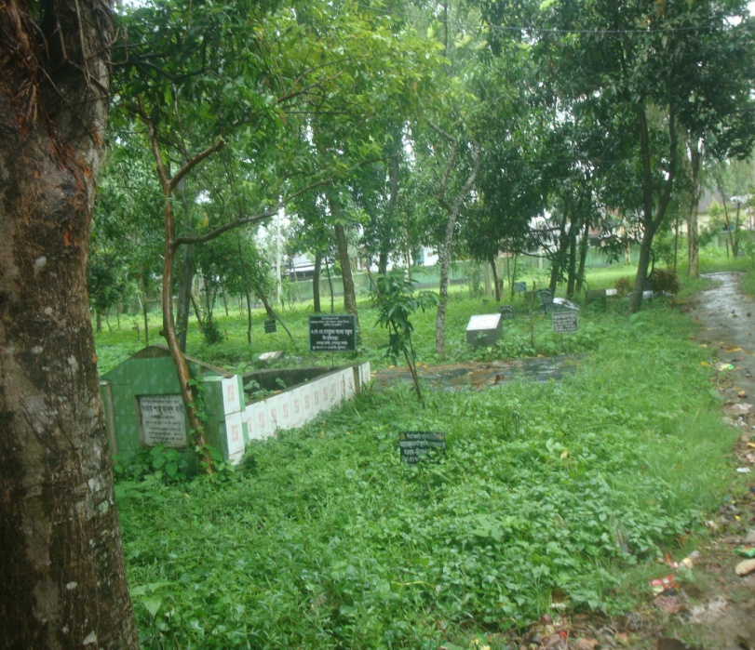**Supply, fitting and fixing of Streetlights in Graveyard at Ward no 1 & 7 under Sherpur Pourashava. Bogra (Total length 1015 .39 m).**

**Design, Supervision, and Management (DSM) Consultancy Services**



**Joint Venture of *Hifab International AB, Sweden and***



***AQUA Consultant & Associates Ltd., Bangladesh***

***July 2017***

***Sherpur Pourashava, Bogra***

**Table of content**

| **No** | **Contents** | **Page. No** |
| --- | --- | --- |
| 1. | Executive Summary | 0 |
| 1.1 | Introduction Project Background | 1 |
| 1.2 | Legal and Policy Framework | 1 |
| 1.3 | Subproject Description | 1 |
| 1.4 | Social Management Plan | 3 |
| 2. | Description of Subproject Area | 4 |
| 2.1 | Brief Profile of SherpurPourashava | 4 |
| 2.2 | Historical and Cultural Heritage Sites | 9 |
| 2.3 | The Subproject Location and Area Profile | 9 |
| 2.4 | Beneficiary Communities and Affected Persons | 9 |
| 2.5 | Gender and Vulnerability | 9 |
| 3. | Social Impact Assessment | 9 |
| 3.1 | Benefits of the Subproject | 9 |
| 3.2 | Social Screening and Safeguard Compliance Issue | 10 |
| 4. | Consultation and Community Participation | 10 |
| 4.1 | Stakeholder Analysis | 10 |
| 4.2 | Consultation and Participation Plan | 10 |
| 4.3 | Consultation Outcomes – Issues, Concerns and Recommendations | 11 |
| 5.0 | Social Management for Site Selection and Design | 11 |
| 5.1 | Subproject Selection Process”. | 11 |
| 5.2 | Subproject Design Process | 11 |
| 5.3 | Grievance Redress Mechanism (GRM) | 11 |
| 5.4 | Implementation Arrangement | 12 |
| 6. | Conclusions on Social Management Plan (SMP) | 12 |
| **FIGURE/Photograph** | |  |
| 1. | At a glance SherpurPourashava | 4 |
| 2 | Subproject Estimated cost | 3 |
| 3 | Package Location Map in SherpurPourashava. | 7 |
| 4. | Photograph on Drain condition at Nandigram | 7 |
| 5 | Photograph on Side view of Existing Graveyards | 2 |
| 6 | Layout of drains | 7 |
| 7 | Layout of Graveyard ward -1 | 8 |
| 8 | Layout of Graveyard ward -7 | 8 |
| 6 | Photograph on community consultation at bus terminal. | 10 |
| **ANNEXUR**E | |  |
| 1. | Social Screening report (a.) | 1-13  ( 13 pages) |
| 2. | Social Screen report( b & c) | ( 10 pages) |

**Abbreviations**

|  |  |
| --- | --- |
| ARP | Abbreviated Resettlement Plan |
| BMDF | Bangladesh Municipal Development Fund |
| LAP | Land Acquisition Plan |
| CBO | Community Based Organization |
| RCC | Reinforce Cement Concrete |
| SHE | SherpurPourashava |
| CIP | Capital Investment Plan |
| CUL | Compensation-Under-Law |
| DC | Deputy Commissioner |
| DLAC | District Land Acquisition Committee |
| DUTP | Dhaka Urban Transport Project |
| GoB | Government of Bangladesh |
| GRC | Grievance Redress Committee |
| GRM | Grievance Redress Mechanism |
| HCG | House Construction Grant |
| HTG | House Transfer Grant |
| IDA | International Development Association |
| IP | Indigenous People |
| IPP | Indigenous Peoples Plan |
| KII | Key Informants Interviews |
| FGD | Focus Group Discussion |
| LGD | Local Government Division |
| LGED | Local Government Engineering Department |
| M& S | Management &Supervision |
| MGSP | Municipal Governance and Services Project |
| MOLGRDC | Ministry of Local Government, Rural Development & Cooperatives |
| MSP | Municipal Services Project |
| MSL | Mean sea Level |
| NGO | Non-governmental Organization |
| PAH | Project Affected Household |
| PAP | Project Affected Person |
| PMU | Project Management Unit |
| RAP | Resettlement Action Plan |
| RCC | Reinforced Concrete Cement |
| RP | Resettlement Pan |
| SIA | Social Impact Assessment |
| SMP | Social Management Plan |
| SSS | Social Safeguards Specialist |
| TLCC | Town Level Coordination Committee |
| ULB | Urban Local Body |
| WB | World Bank |
| WC | Ward Committee |

**EXECUTIVE SUMMARY**

Sherpur Pourashva is A Category Pourashva having 10.995 sq. km area. The ULB is densely populated having 9 administrative wards which are also underserved in all development considerations. The subproject has been selected considering the needs of the locality which is priority as CIP of Sherpur Pourashva.

The Social management Plan (SMP) of the Subproject under Sherpur Pourashava was developed through inclusive participation of all level stakeholders and using participatory approach. A total of one social screening was conducted against for one component. The subproject comprises interventions proposed as per CIP-1 & CIP-4 of the Sherpur Pourashava. The sub project will benefit one of the 9 administrative wards of the RCC (Wards 08). According to engineering design, implementation of this subproject will be carried out within the existing right-of-way hence no LA is involved and no RAP is required.

***Total cost of the subproject is Taka*: 21,508,488.57**

***Main Purposes of the subproject***

To construction Sherpur Pourashava drain and graveyards considering all need base facilities covered three wards and adjoining wards. Present condition of drain is old, damaged, and inadequate of water discharge capacity and surrounding environment is unhygienic and unsafe. During the rainy season, water logging takes place all over the road and creates unhygienic and vulnerable situation. On the other hand both graveyards are old, less spaces, damp brick boundary walls and overall situation are dark and bushy. So peoples faced difficulties for bury the dead body.

**Anticipated Impacts:**

The subproject will benefit three wards out of the 9 wards of Sherpur. About 60,000 people of the three wards and adjoining wards will be benefited for improved mentioned structures.

A total of 2 shopkeepers will be affected. The PAPs are temporary leaseholder of Sherpur Pourashava. They have agreed in writing to Shift back and without compensation until construction of proposed drain or it will resolve by ULB their own initiatives. In addition, the subproject will need 55 tree fell out.

**1. INTRODUCTION**

**1. Project Background**

The Government of Bangladesh, through the Local Government Engineering Department (LGED) and Bangladesh Municipal Development Fund (BMDF) is implementing the Municipal Governance and Services Project (MGSP). The project aims to improve municipal governance and basic urban services in participating ULBs. Two physical components of the project include (i) Municipal Governance and Basic Urban Services Improvement (Component 1) to provide financial support to 26 pre-identified urban local bodies (ULBs) including municipalities and city corporations, and demand-based sub-credits to eligible ULBs for basic urban services improvement investment costs. Total project cost **is BDT 2, 470, 93.92 lakh to be** financed at 80:20 IDA loan to GOB contribution. LGED is implementing the Component 1 while BMDF is implementing component 2 of the project.

LGED is supporting the 26 pre-selected ULBs for investments in development and rehabilitation of Road, Bridge, Box-culvert, Pedestrians bridge, street light, Traffic Control, Bus terminal, Truck terminal, Boat landing Jetty, Drain, Retaining wall, Kitchen market, Cattle market, slaughter house, Public toilet, Solid waste management, Sweeper colony, Park, Community Centre and Whole sale market. LGED is financing through (i) base allocation based on population category of ULBs; (ii) performance-based allocation and (iii) operations and maintenance support on a declining basis over the project period.

The component interventions have largely been developed for construction and rehabilitation within existing available land owned by the ULBs and acquisition of land has been avoided in the screening process. Removal of some obstruction and relocation of some businesses were involved in case of some sub projects for unavoidable circumstances. The MGSP did not avoid taking-up of sub projects in areas inhabited by tribal peoples and instead ensured their inclusion and participation where applicable. The ULBs addressed the removal of obstructions and in most cases the land entirely belongs to the ULB. In some instances, land of other GOB agencies like the BWDB, R&H or other local government like adjoining UP is needed and in such cases the ULB ensured getting such land by mutual understanding and proper documentation. Relocation of business and removal of obstructions were resolved by consultation and agreement with the concerned PAPs and these are properly documented. Thus land acquisition, population displacement and tribal people’s issues have been addressed following the country’s legal framework and the World Bank policy on social safeguards.

**1.2 Legal and Policy Framework**

Given the approach of subproject preparation and implementation, the World Bank’s Operational Policy (OP) on Involuntary Resettlement (OP 4.12) and on Indigenous Peoples (OP 4.10) triggered to the project. A Social Management Framework (SMF) has been adopted by LGED for the project that meets the requirements of the country’s legal frameworks in Bangladesh “The Acquisition and Requisition of Immovable Property, Ordinance, 1982” and the Bank requirements including OP 4.12 and OP 4.10. The SMF also requires that subprojects are prepared ensuring inclusion, participation, transparency, and social accountability. Subprojects are prepared by respective ULBs in a process complying with the SMF requirements. LGED reviews the subproject proposals for technical, engineering, environmental, social development, and safeguards compliance before allocation of the financing to the ULBs.

Social Management Plans (SMP) will be prepared and implemented for subprojects with no land acquisition or involuntary displacement of people, while Resettlement Action Plans (RAP) andTribal Peoples Plans (TPP) will be prepared for implementation for subprojects involving population displacement and tribal peoples’ issues.

**1.3. Description of sub project**

**a) Construction of drain starts from National Highway (Nandigram bus stand) to Darkipara moar (Ch.0+000 to 330 m) under Sherpur Pourashava .Bogra.**

. This subproject component is an important construction work of Sherpur Pourashava under ward number 7**.** The proposed alignment starts from Nandigram bus stand (Near central Mosque) of Sherpur town and ends at Darkipara moar (Ch.0+000-0+330 m). The existing road width is 4.5 to 5 m and it is a bituminous carpeting road. The required land for drainage improvement belongs to Sherpur Pourashva. Its outfall is at Darkipara moar on W-3 MGSP new drain. This is a one side drain with cover slab. The existing brick drain (Ch. 150 m to 300 m ) is discontinuous, old and damaged and its water discharge capacity is inadequate. There are no drains in the 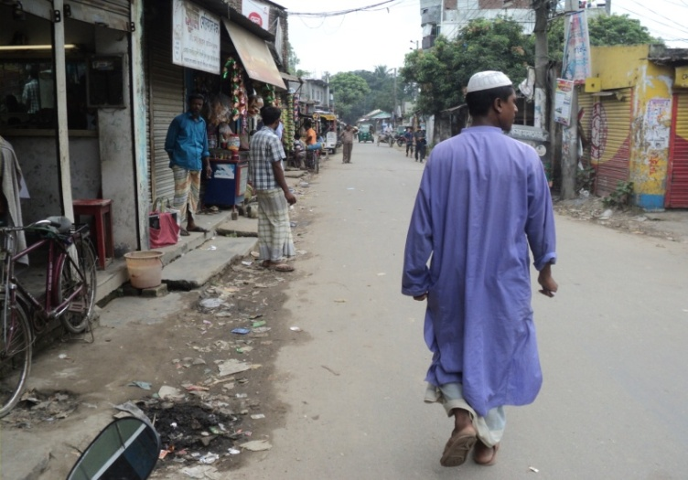remaining parts of the road. This subproject is located in residential and commercial area. Besides this road, there are several types of shops like grocery shops, stationary shops, Medicine, shop, tea stall, welding workshop, Sherpur Police Outpost and local NGO office beside this road. About 6000 people comprising businessmen, students, children, women, teachers and service holders will benefit from the subproject for improved drainage system.

Figure Existing drain condition of Nandigram

Various types of transport like, rickshaw-van, CNG driven baby taxi and battery operated three wheeler auto are using this road but poor drainage causes frequent damage to the road. Moreover movement of pedestrian gets difficult during rainy season due to prolonged water-logging. During the screening work the DSM and ULB team noted absence of proper drainage system and poor condition of the existing drain. So, implementation of this sub project is very important for Sherpur Pourashava.

During social screening the DSM team has seen some obstacles as following:

* The sub project construction will require removing front steps of two semi pucca shops (Ch.0 to 30 m). These obstacles should be removed and shopkeepers agreed to remove willingly without compensation. These
* To construction of component needs shifting 06 electrics poles and cutting of 8 trees (Mango and Mahogany).

**b) Development of 2 nos Pourashava Graveyard at Ward no.1 and 7 under Sherpur Pourashava .Bogra.**

**c) Supply, fitting and fixing of Streetlights in Graveyard at Ward no 1 & 7 under Sherpur Pourashava. Bogra (Total length 1015 .39 m ).**

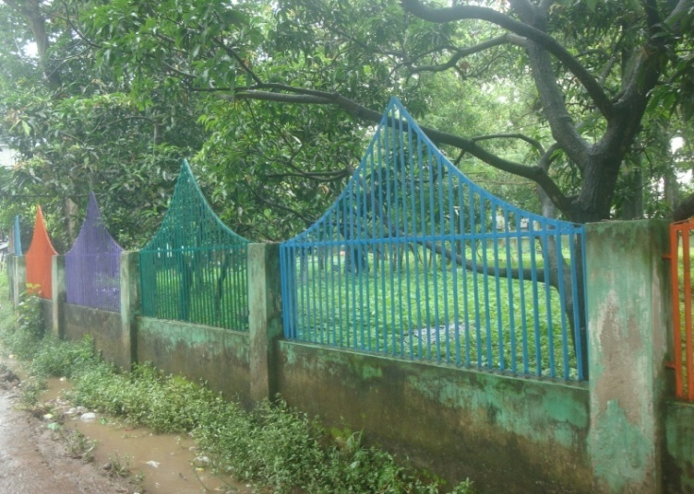This subproject component comprises two important construction works of Sherpur Pourashava under ward number 1 & 7**.** There are two Graveyards in two wards which need to be developed. The proposed graveyards are located at Ulipur & Hajipur in ward no 1 and town colony and in ward no 7. These were established in 1860. Most part of the graveyards has been filled and many graves have pucca fencing. Some parts of the grave yards are still vacant.

Figure . Side view of existing graveyard

Some parts of the graveyards have brick wall but not of proper height and some parts do not have any wall. The existing walls are very old & damaged. The existing internal roads inside the graves are narrow, damaged and there is lack of drainage system. In rainy season all graveyards become water-logged. So people face difficulty to bury the dead body. The graveyards also need some sheds to keep dead body before burial. Moreover there is no internal lighting system in the graveyards. The grave yards are covered with many old trees making the area dark and bushy.

Considering these situation and respect of local demand, creation of new spaces in the graveyards the Sherpur Pourashava proposed development of two graveyards (area 7730.47 sq.km and 6677.39 sq. km respectively).

The development works will be earth filling for raising the height of graveyards, construction of internal road, open sheds, boundary wall construction and internal drainage system and connect the drain with MGSP W-3 drain adding. **1015. 39** m long streetlight. Staring the development works needs to be dismantling/ removing of old structures and cutting of 47 trees.

This subproject is located exclusively in residential area. About 60000 para people will be benefited from the use

of these graveyards. During the screening work the DSM and ULB team noted all facts & figures and assessed scope and opportunities of this sub project which is very important for Sherpur Pourashava

**Sub project Estimated cost**

|  |  |  |  |
| --- | --- | --- | --- |
| **SL #** | **Name of the Scheme** | **Length (m)** | **Estimated Cost (BDT)** |
| a | Construction of drain starts from National Highway (Nandigram bus stand) to Darkipara moar (Ch.0+000 to 330 m) under Sherpur Pourashava .Bogra. | 330 | 8,376,118.99 |
| b | Development of 2 nos Pourashava Graveyard at Ward no.1 and 7 under Sherpur Pourashava .Bogra. |  | 11,020,216.29 |
| c | Supply, fitting and fixing of Streetlights in Graveyard at Ward no 1 & 7 under Sherpur Pourashava. Bogra (Total length 1015 .39 m). | 1015.39 | 2.112,153.28 |
|  | **Total** |  | **21,508,488.57** |

**1.4 Social Management Plan**

This Social Management Plan (SMP) has been prepared for the sub projects described in section 1.3 for identifying and managing social concerns in the process of subprojects design and implementation. The subproject proposals include a social screening report along with impact assessment and social management planning document. The Design, Supervision, and Management consultant reviewed the social screening report and social management plan and have submitted them with the subprojects proposals. The social team of the DSM has carried out several site visits and consulted the SherpurPaurashava and the beneficiary communities. The social screening findings and consultation method and proceedings were validated through the site survey and consultation.

The purpose of preparing this SMP is to demonstrate the all-inclusive consultative process in selection and design of the sub projects as well as to provide guidance for social development and safeguards compliance in the implementation process.

The SMP ensures a description of the subprojects areas, social screening and impacts, consultation process adopted during identification and design, and consultation plan for implementation stage, impact mitigation measures, grievance resolution process, and implementation arrangements, and monitoring and evaluation.

Sherpu Paurashava will ensure participation of the communities and grievance resolution in the process of implementation of the subproject.

**2. Description of Subproject Area**

**2.1 Brief Profile of SherpurPourashava**

As per the Local Government (Pourashava) Act 2009, the Paurashavas in Bangladesh are categorized mainly into A, B, and C classes based mainly on annual income or revenue earning of the Pourashava.Sherpur is an A-category Pourashava with an area of 10.995 sq. km. The pourasova was established in 1876. It has 9 wards and its total population is 26,141.It is bounded on the north by BograSadarUpazila, on the east by DhunatUpazila, on the south Raiganj and TarashUpazilas and on the west Nandigram and Singra Upazila.

SherpurPourashava is the urban center in the SherpurUpazila of Bogra District. In fact, it is not much known about origin of the name of the Pourashava. The Upazila occupies an area of 296.27 sq. km. It is located 24°32' and 24°44' north latitudes and between 89°20' and 89°33' east longituds.Bogra region is characterized by high and low lands.

Sherpur is located within the flood plain of Korotoa River. The Korotoais of hydrographical importance of the area, which are 'More or less moribund. During the rainy season, these MoribundRivers act as excellent drainage channels discharging of a large volume of water and have a strong current.

The town center of the Pourashava is comparatively elevated and not subject to annual flooding. Flooding in the area usually occurs due to the over flow of the River Korotoa. There exist a small number of kharis (canal), ditches and depression are located within the Pourashava. These depressions serve as catchment basin and help in reducing the flood intensity and also mitigate the flood damages during and after heavy rainfall in the monsoon period.

**Figure 1: At a glance Sherpur Pourashava**

***Bogra***

|  |  |  |
| --- | --- | --- |
| ***General Information*** | | |
| *Area* | *:* | 10.995 Sq.km |
| *Wards* | *:* | 09 no’s |
| *Population*  *Households*  *Population Density*  *Main Income Sources* | *:*  *:*  *:*  *:*  *:* | 26,141  6,885  4,905  Business |

|  |  |  |
| --- | --- | --- |
| ***Tax*** | | |
| *Holding Tax number* | *:* | 5050**( Taka 2542300)** |

|  |  |  |
| --- | --- | --- |
| ***Market*** | | |
| *Markets* | *:* | 04 |
| *Shopping Complexes* | *:* | Nil |
| *Private Shops* | *:* | 08 |

|  |  |  |
| --- | --- | --- |
| ***License*** | | |
| *Trade Licenses number* | *:* | 1394 |
| *Rickshaw Licenses* | *:* | **150** |

|  |  |  |
| --- | --- | --- |
| ***Communication Infrastructure. km*** | | |
| *Road* | *:* |  |
| *a) Bituminous* | *:* | 10.40 |
| *b) CC* | *:* | 1.500 |
| *c) RCC* | *:* | .50 |
| *d) Brick Flat Soling* | *:* | 4.00 |
| *e) Nonpaved Roads* | *:* | 10 |
| *Culverts m* | *:* | 101 |

|  |  |  |
| --- | --- | --- |
| ***Street Lighting*** | | |
| *Electricity Line* | *:* |  |
| *Light Posts* | *:* | 808.00 |
| *Tube Light Points* | *:* | Nil |
| *Energy Savings Light Point s* | *:* | 808 |
| *Meter or Switch Points* | *:* | 05 |

|  |  |  |
| --- | --- | --- |
| ***Vehicle*** | | |
| *Garbage Trucks* | *:* | 04 |
| *Tractor* | *:* | Nil |
| *Bulldozers* | *:* | Nil |
| *Jeeps* | *:* | 01 |
| *Motorcycles* | *:* | 02 |
| *Hydraulic Beam Lifters* | *:* | 01 |
| *Road Rollers (4 ton – 6 ton)* | *:* | 02 |
| *Road Rollers (8 ton – 10 ton)* | *:* | 01 |

|  |  |  |
| --- | --- | --- |
| ***Drainage System*** | | |
| *Drain* | *:* |  |
| *a) RCC or Brick Lined Drains* | *:* | 2,000.00 M |
| *b) Earthen Drains* | *:* | 5,000. |

|  |  |  |
| --- | --- | --- |
| ***Public Health*** | | |
| ***Public Toilets*** | ***:*** | **02** |
| ***Sanitary Latrines*** | ***:*** | **Nil** |
| ***Dustbins*** | ***:*** | **Nil** |
| ***Sanitary Land fill*** | ***:*** | **Nil** |
| ***EPI Centre Permanents*** | ***:*** | **09** |
| ***Temporary*** | ***:*** | **Nil** |
| ***Hospitals*** | ***:*** | **01** |
| ***Clinics (TB)*** | ***:*** | **Nil** |
| ***Maternity Clinics*** | ***:*** | **Nil** |
| ***Private Clinics*** | ***:*** | **09** |
| ***Diabetic Hospitals*** | ***:*** | **Nil** |

|  |  |  |
| --- | --- | --- |
| ***UPPRP Project*** | | |
| *Community Centers* | *:* | N.A |
| *Total Urban Communities* | *:* |  |
| *Total Community Families* | *:* |  |
| *Total Community Members* | *:* |  |
| *Total Community Deepest* | *:* |  |
| *Total Sanitary Latrines* | *:* |  |
| *Total Roads with Footpaths* | *:* |  |
| *Drains* | *:* |  |
| *Improved cooking* | *:* |  |
| ***UPHSDP Project*** | | |
| *Nagar MatriSadan* | *:* | N.A |
| *Nagar Health Centrse* | *:* |  |
| *Satellite Clinics* | *:* |  |
| *Religious Institutions* | | |
| *Mosques* | *:* | 20 |
| *Eidghahs* | *:* | 11 |
| *Temples* | *:* | 15 |
| *Graveyards* | *:* | 3 |

|  |  |  |
| --- | --- | --- |
| ***Law &Order*** | | |
| *Police Stations* | *:* | 01 |
| *Police Farris* | *:* | Nil |
| *Judge court* | *:* | Nil |

|  |  |  |
| --- | --- | --- |
| ***Education services*** | | |
| *Public University* | *:* | Nil |
| *Private University* | *:* | Nil |
| *Govt Colleges* | *:* | 01 |
| *Private Colleges* | *:* | 01 |
| *Cadet College* | *:* | Nil |
| *Public Medical College* | *:* | Nil |
| *Private Medical Colleges* | *:* | Nil |
| *Art College* | *:* | Nil |
| *Law Colleges* | *:* | Nil |
| *Homoeopathic Medical College* | *:* | Nil |
| *Public Polytechnic Institute* | *:* | 01 |
| *Public Engineering Survey Institute* | *:* | Nil |
| *Private Polytechnic Institutes* | *:* | Nil |
| *Madrasahs* | *:* | 02 |
| *Teachers Training Colleges* | *:* | Nil |
| *Govt High Schools* | *:* | Nil |
| *Non-Govt High Schools* | *:* | 03 |
| *Govt Primary Schools* | *:* | 06 |

|  |  |  |
| --- | --- | --- |
| ***Recreation*** | | |
| *Park* | *:* | Nil |
| *Zoo* | *:* | 01 |
| *Cinema Halls* | *:* | Nil |
| *Stadium* | *:* | Nil |
| *Auditorium* | *:* | Nil |
| *Gymnasiums* | *:* | Nil |
| *Recreation Clubs* | *:* | Nil |

|  |  |  |
| --- | --- | --- |
| ***Communication*** | | |
| *Bus Stations* | *:* | 01 |
| *Ferry Ghat* | *:* | Nil |
| *T & T Office* | *:* | 01 |
| *GPO* | *:* | Nil |
| *Post Offices* | *:* | 01 |

Figure: 2 **Package Location Map in Sherpur Pourashava.**

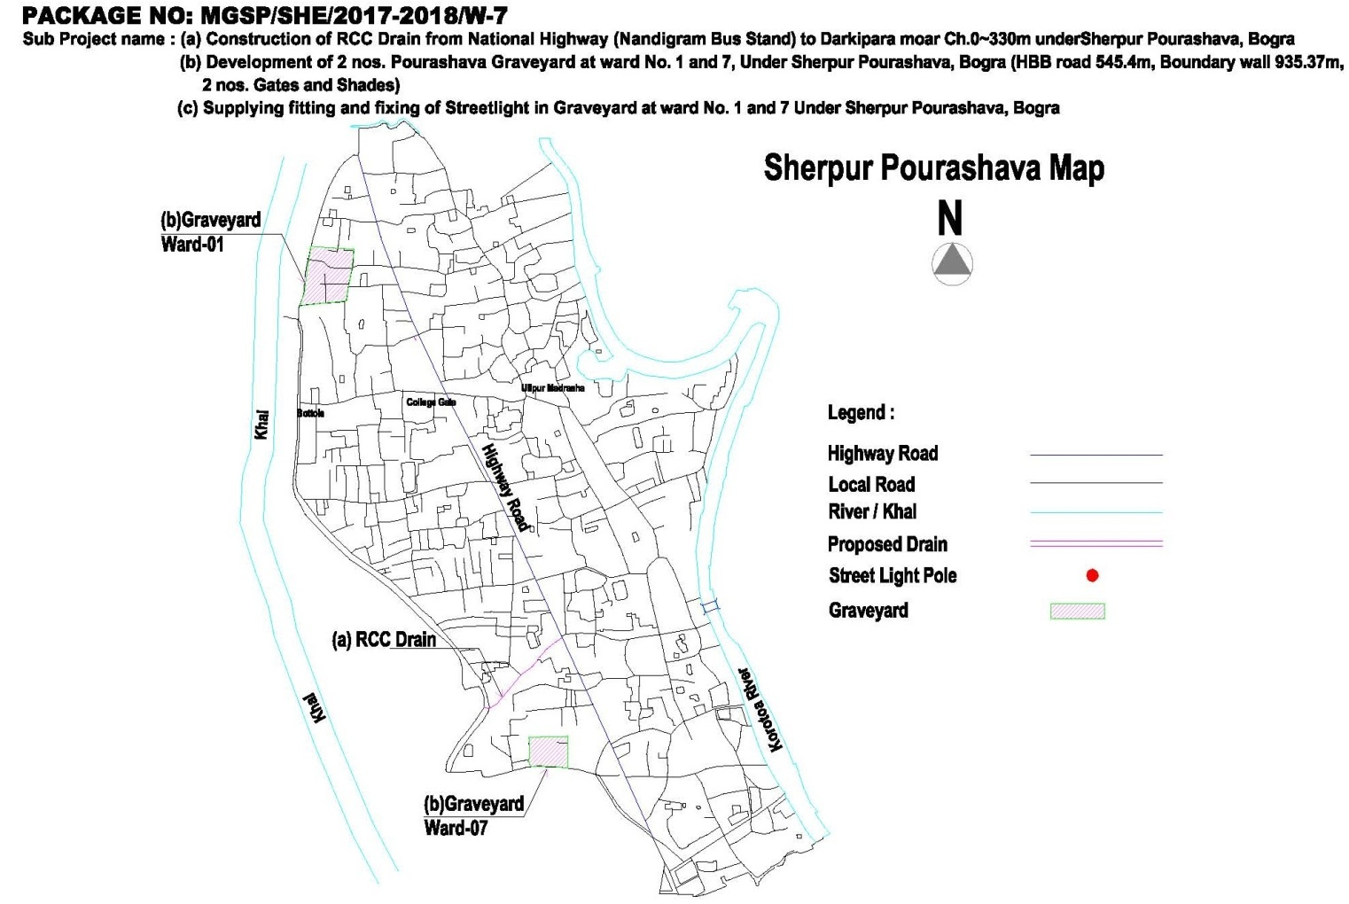

1. Figure: 1 Subproject layout plan **Construction of drain starts from National Highway (Nandigram bus stand) to Darkipara moar (Ch.0+000 to 330 m) under Sherpur Pourashava .Bogra.**

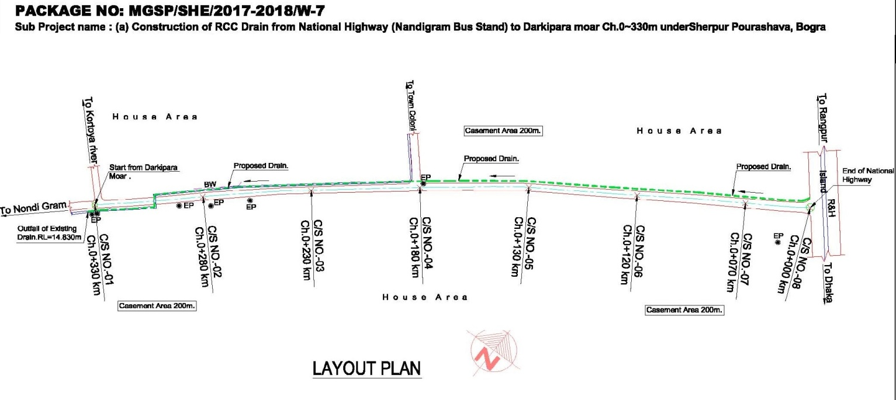

**Development of Graveyard at Ward no-1.**

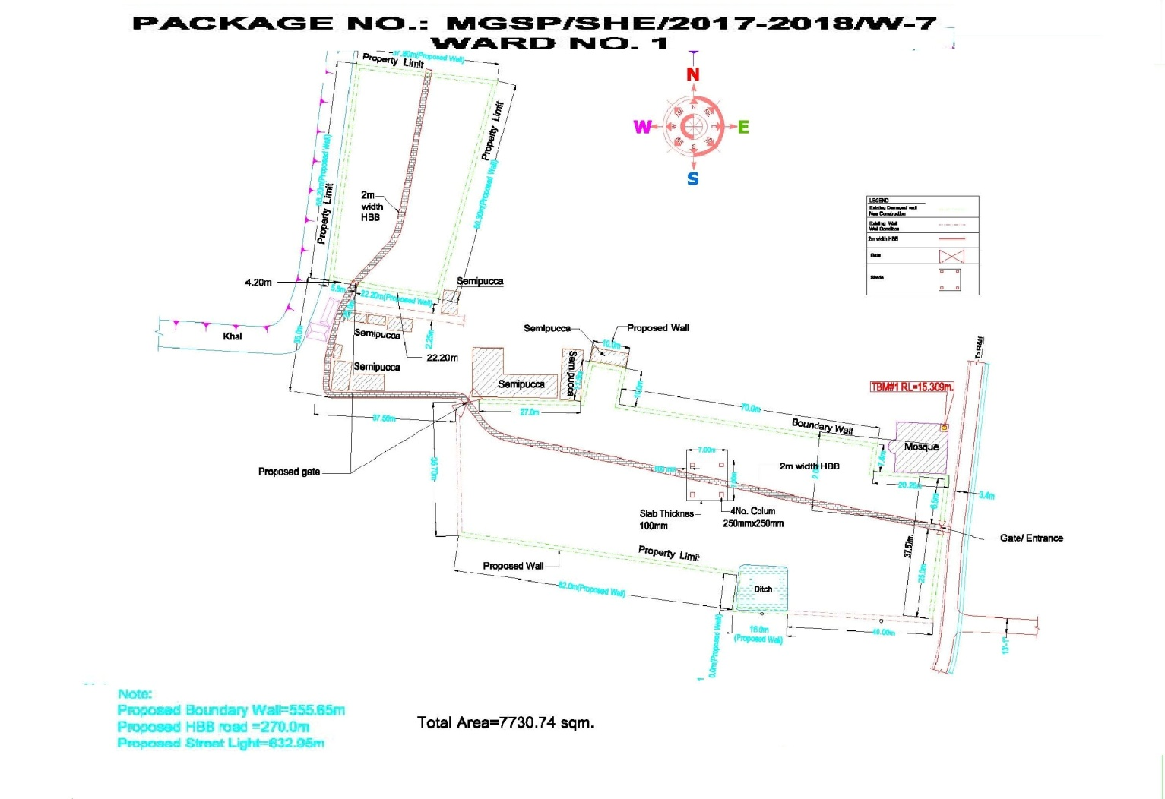

**Development of Graveyard at Ward 7 under Sherpur Pourashava .Bogra.**

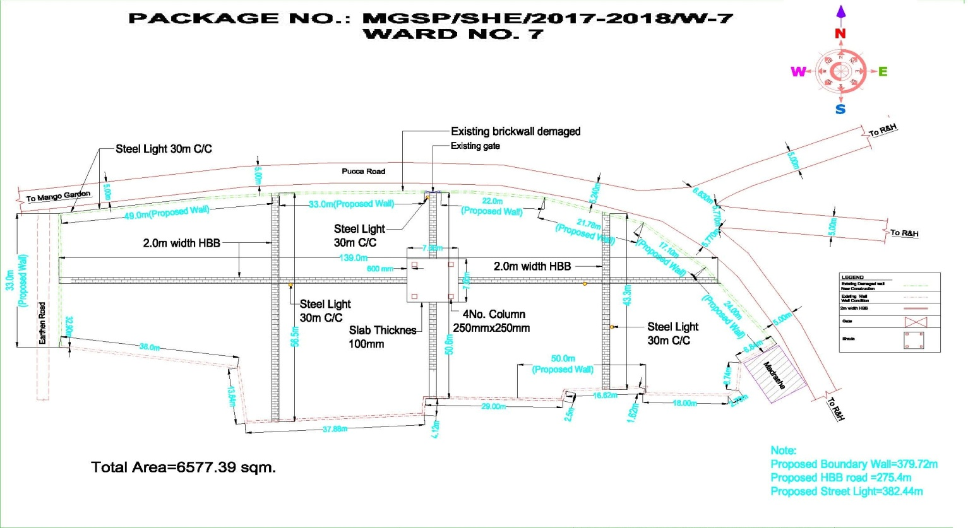

**2.2 Historical and Cultural Heritage Sites:**

In sherpur, there is a famous milk product which is popularly known sweet Cards. As the Sherpur is beside Dhaka-Bogra-Rangpur-Dinajpur National Highway. So this place is renowned for milk processing and sell these products locally and send those to Dhaka wholesale markets.

As I know that there is no archaeological heritage in the Pourashava location.

**2.3 TheSubproject Location and Area Profile**

This identified subproject for improvement the graveyards street light and drain covers commercial & residential areas. During field visit for the social screening, the DSM team not found obstacles. So no needs agreement signed between the PAPs and the ULB.

**2.4 Beneficiary Communities and Affected Persons**

The kitchen drain ,Graveyards is very much important subproject of Sherpur Pourashva. This will make a greater positive impact of Sherpur Pourashava. It plays a big Income Generating Activities (IGA) & new jobs creating sources for Sherpur Pourashava. After completion of the subproject about 66,000 peoples will be benefited from this subproject.. The para peoples will get safely use the graveyards avoiding hazard situation. More over the Sherpur Pourashava will earned revenues from the graveyards. On the other hands business men can transports their products safely and security condition.

This is very densely populated area. It is noted here that there is no presence of tribal people in the subproject influence areas.

**2.5 Gender and Vulnerability**

Gender and vulnerability analysis have been considered in social impact assessment of subproject components. This has focused gender and vulnerability based on findings from specific queries during social screening and community consultation. The quantitative and qualitative analysis has brought out sex disaggregated data and issues related to discrimination by gender vulnerability, needs, constraints, and priorities as well as understanding whether there is a potential for inequitable risks, benefits and opportunities relating to gender and vulnerability. Based on the social analysis, specific interventions inclusion and participation encourages gender mainstreaming in the project cycle. Gender equity and empowerment will be ensured through encouraging participation of men and women equitably in the project cycle. The community participation and consultation also encourages gender mainstreaming in the subprojectcomponents influence areas. After subproject components implementation, there are positive impacts for the vulnerable women; especially those who are small traders, landless, marginal farmers, etc. and can sell their household products. These subproject will create job opportunity. In addition, it will also increase the mobility of drains user. Due to the fact gender and vulnerability has been taken into account and ensures the gender equity in the subproject implementation.

**3. Social Impact Assessment**

**3.1 Benefits of the Subproject**

After identification of subproject components through CIP, PMU of the project with the assistance of DSM Consultants has completed social screening and socio-economic impact assessment against construction of drain & graveyards with streetlight. The increase business opportunity nearby area essentially represents a capitalization of the access cost savings value in a regional or national economic.

From view of social benefits about 6000 families able to get sustainable business facilities over the year for long time. Moreover respective ULB earned additional regional employment generation opportunities from Graveyards**.**

The peoples will get safe dead body grave facilities avoiding problems and businessman will management their business avoiding prolong water logging condition.

**3.2 Social Screening and Safeguard Compliance Issue**

After selection of the subprojects from the CIP list, the ULB with the assistance of DSM Consultants has completed a social screening for the subprojects using an inclusive and participatory approach.

Sherpur pouroshava has ensured the implementation of subprojects following socially inclusive and gender friendly. According to engineering design, implementation of the subprojects will be carried out within the existing right-of-way.

Result from the social screening are given below.

* No additional public or private lands will be required for subprojects outside the existing right way.
* The subproject will not affect access to common property resources for any community. It will also have any negative impact on cultural property of any kind.
* Preparation of RAP (Resettlement Action Plan) will not be required for implementing the subproject as no LA is involved.
* Agricultural or industrial productivity will not be hampered for the subproject area.

The outcomes of social screening also confirm that local people across the subproject are positive about its implementation..

**4. Consultation and Community Participation**

**4.1 Stakeholder Analysis**

According to BBS 2011, (Collected from Municipal Authority) the total population of SherpurPourashava was 26141 among which 13098 males and 13043 females in the context of present demographic composition of SherpurPourashava, people live in higher, higher-middle, lower-middle, and lower income groups in the Municipal area. Both males and females living in the SherpurPourashava, in general, and adjacent to the subprojects areas, in particular will directly be benefited by the construction drain and graveyardsconsidering all facilities.

As a part of the overall assessment, the subprojects identified the key stakeholders of the proposed subprojects areas and assessed the power relationships as well as influence and interests of stakeholders involved in the development work of the subprojects. Key stakeholders for subprojects under MGSP were identified in consultation with the Mayor and officials of Sherpur Pouroshava, civil society and local people of towns, representatives of business associations, and local contractors etc. Suggestions and direction of all local stakeholders were noted and reflected in the SMP while designing subproject interventions.

**4.2. Consultation and Participation Plan**

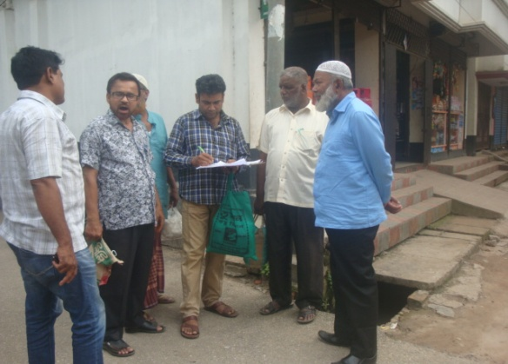The participatory public consultations were conducted in the subprojects areas. Key Informant Interviews (KII) and Group Discussions were conducted involving the participants of the SherpurPourashava Mayor,

Figure . Community consultation at Bus terminal

Officials, and civil society members as well as LGED and the consultant team. A walk-through informal group consultation was also held. The local communities were informed about subprojects interventions including their benefits. Suggestions and recommendations made by the participants are incorporated in the SMP accordingly. The Photographs of the consultation meeting are seen.

**4.3. Consultation Outcomes – Issues, Concerns, and Recommendations**

The participants raised their issues related to infrastructure development which mainly includes road, drains, footpath, and street light. Feedback, suggestions, and recommendation by the participants are listed below.

Key Informant Interviews (KII) and Group Discussions result confirmed that an improved RCC drain with cover slab, footpath, Roads and street lights is needed for the future development of the SherpurPourashava.

* Social safeguard compliance issues have been ensured through the inclusive participation of subprojects beneficiaries in subproject implementation.
* By engaging female labor force gender issues has been partially addressed.
* Construction works should be scheduled properly and the quality of construction work should be maintained strictly.

**5.0 Social Management for Site Selection and Design**

**5.1 Subprojects Selection Process**

MGSP in coordination with concerned Sherpur Pouroshava elected functionaries, local administration, relevant stakeholders, community members, road users and civil society members followed the participatory approach in different stages of subprojects selection following inclusion, consultation and participation methods. Female Ward Councilors participated actively in the selection process. Moreover, the representatives of TLCC and WC from the Pourashava have contributed in the subprojects selection process with an analysis of the inclusiveness of the selection process.

At the time of selecting these subprojects, Social Screening and Group Discussion (GD) with Sherpur Pouroshava urban communities, local administration, traders, buyers, sellers were conducted by the Sherpur Pouroshava officials and Consultants from DSM. Views and opinions of these consultations were to explain the subproject objectives and sought feedback from the participants to maximize the social and economic benefits as well as to minimize the adverse impacts of the subprojects.

**5.2. Subproject Design Process**

.After final selection of the subprojects, the DSM Consultant designed the proposed subprojects (Construction of RCC drains cover slabs, development of Graveyards and streetlight) under Sherpur Pouroshava. These subprojects constructed under the Sherpur Pouroshava land. Despite the inclusion and participatory consultations, if any person has a grievance relating to the implementation of the subprojects, the Sherpur Pouroshava has mitigated it.

The Consultant interviewed stakeholders and beneficiaries of the subprojects areas before the design. The Consultant and Sherpur Pouroshava officials conducted a number of consultation meetings in the subprojects areas discussing the implementation procedures and mitigation measures, if any, required to be taken in implementing the proposed subproject.

**5.3. Grievance Redress Mechanism (GRM):** GRM has already operationalzed for SherpurPourashava. Accordingly, this Pourashava has formed Grievance Redress Committee (GRC) to handle any grievance raised due to implementation of the sub-projects. The committee will be headed by the Mayor of the SherpurPourashava and consist of 7 members. The committee will answer to subproject-related queries and address complaints and grievances about any irregularities in application of the guidelines adopted for assessment and mitigation of social and environmental impacts. Based on consensus, the procedure will help to resolve issues/conflicts amicably and quickly without resorting to any expensive, time-consuming legal actions. It will ensure proper presentation of complaints and grievances as well as impartial hearings and transparent decisions.

SherpurPourashava has already appointed Focal Point of GRC who is at the level of Assistant Engineer. The Mayor of the SherpurPourashava is the Chairman of the GRC. This GRC at the Pourashava level is responsible to disclose the subprojects implementation before civil works start.

**Structure of the GRC Committee:**

|  |  |
| --- | --- |
| **Person** | **Status** |
| ULB Mayor | Convener |
| Representative of Local Administration | Member |
| Teacher from a Local Educational Institution | Member |
| Representative of a Local NGO | Member |
| Representative of Civil Society | Member |
| Female Ward Councilor | Member |
| Head of Engineering Section of ULB | Member Secretary |

**5.4 Implementation Arrangement:**

DSM has initially completed social screening for the subprojects and there is no problem for implementing the subprojects regarding social safeguard issues. Accordingly, PMU, MGSP has issued the award letter against the subproject following all required procurement procedures. Sherpur pourashava has the responsibility to implement the subprojects timely in close coordination with the PMU of the project and also with the technical assistance of DSM. Engineering section of Sherpur Pourashava and local representative of Consultancy team will ensure the quality construction work of the subprojects. In addition, Consultant team from Head Quarter DSM will ensure close monitoring of the implementation of the subproject components. In the implementation process, Social Safeguard Team will ensure monitoring of social safeguard management before civil works start. During construction, the communities will not be affected and the project will minimize the loss of communities. In addition, before civil works start, the Pourashava will make the video filmed and also social screening.

**6. Conclusions on Social Management Plan (SMP):**

The DSM in consultation with SherpurPourashava has conducted social screening and subsequently prepared the Social Management Plan (SMP) for subproject. According to SMP, PMU plans to disclose the vulnerable communities and subprojects users in the subprojects locations on Social Safeguard Issues for their empowerment and ability to mitigate the complaints amicably and successfully. To protect their livelihoods, daily trading, income, dropout of education of their children, and other income generating activities, this Social Management Plan will be followed strictly and carefully for subprojects.

The sub project interventions will have positive impact and there is no need for LA or RAP. However, front steps of two shops are affected. The ULB has already removed the obstacles through change drains alignment. There are no other social issues.

**Annex:-1. a .Screening report of Construction of RCC Drain from National Highway (Nandigram bus stand) to Darkipara moar (Ch.0+000 to 0+330 m) under Sherpur Pourashava. Sherpur Pourashava. Bogra**

**Annex- 2. b ).** **Development of Graveyard at Ward no’s 1 and 7 under Sherpur Pourashava. Bogra**

**c)Supply Fitting and fixing of streetlights in Graveyard at ward no. 1 & 7 under Sherpur Pourashava. Bogra (Total length 1015.39).**