**Local Government Division**

**Local Government Engineering Department**

**Municipal Governance and Services Project (MGSP)**

**IDA Credit No: 5339-BD**

**Report on Social Management Plan**

**Package No: MGSP/TAN/2018-19/W-17**

**Name of Subproject:**

a) Rehabilitation of Thana para BSCIC road staring from Shantikunja moar to commitment coaching moar by Bituminous carpeting road (Ch,0-410 m)

b) Construction of RCC drain at Thana para BSCIC road starting from Shantikunja moar to commitment coaching moar (Ch,0-260 m) .

c) Construction of RCC drain starting from Tangail bypass to Sontosh Science & Technology via Victoria road & main road under Tangail Pourashava (Ch,0-745 m)

d). Rehabilitation of Pocchim Akur Takur para housing area road by Bituminous carpeting under Tangail Pourashava (Ch.0+000-0+960 m)

e) Construction of RCC drain at pocchim Akur Takur para housing area road under Tangail Pourashava (Ch.0+000-0+1020 m)

f) Improvement of road starting from Sabalia Bottola to Borai bill by Bituminous carpeting under TangailPourashava ( Ch.0+000-0+550 m)

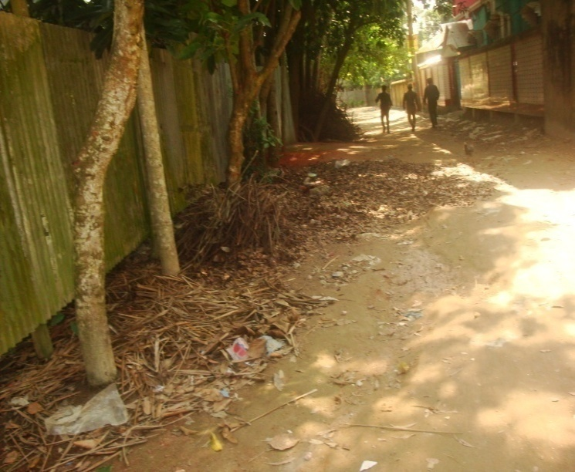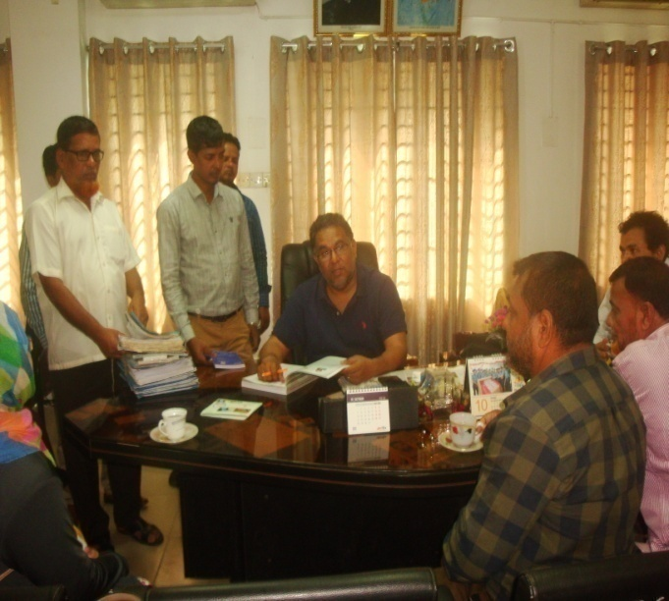g) Construction of RCC drain starting from Sabalia Bottola to Borai bill by Bituminous carpeting under TangailPourashava (Ch.0+000-0+620 m)

**Design, Supervision, and Management (DSM) Consultancy Services**



Joint Venture of *Hifab International AB, Sweden and*

*AQUA Consultant & Associates Ltd., Bangladesh*

**NOVEMBER 2018,**

**Tangail Pourashava. TANGAIL.**

**TABLE OF CONTENT**

|  |  |  |
| --- | --- | --- |
| **No** | **Contents** | **Page. No** |
| 1 | Executive Summary | 3 |
| 1. | Introduction | 4 |
| 1.1 | Project Background | 4 |
| 1.2 | Legal and Policy Framework | 4 |
| 1.3 | Subproject Description | 5 |
| 1.4 | Social Management Plan | 5 |
| 2. | Description of Subproject Area | 6 |
| 2.1 | Brief Profile of Tangail Pourashava | 6 |
| 2.2 | Historical and Cultural Heritage Sites | 16 |
| 2.3 | The Subproject Location and Area Profile | 16 |
| 2.4 | Beneficiary Communities and Affected Persons | 16 |
| 2.5 | Gender and Vulnerability | 17 |
| 3. | Social Impact Assessment | 17 |
| 3.1 | Benefits of the Subproject | 17 |
| 3.2 | Social Screening and Safeguard Compliance Issue | 17 |
| 4. | Consultation and Community Participation | 18 |
| 4.1 | Stakeholder Analysis | 18 |
| 4.2 | Consultation and Participation plan for subproject | 18 |
| 4.3 | Consultation Outcomes – Issues, Concerns and Recommendations | 18 |
| 5.0 | Social Management for Site Selection and Design | 19 |
| 5.1 | Subproject Selection Process”. | 19 |
| 5.2 | Subproject Design Process | 19 |
| 5.3 | Implementation Arrangement | 20 |
| 6. | Conclusions on Social Management Plan (SMP) | 20 |
| **Photograph /Figure** | |  |
| 1. | Tangail Pourashava Bhaban | 6 |
| 2. | Subproject Location Map of Tangail Pourashava | 11 |
| 3. | Project layout plan. Package No: W-17 | 12-12 |
| 4 | Community consultation | 18 |
| 5 | Subproject Estimated cost | 5-6 |
| 6 | At a glance of Tangail Pourashava | 7 |
| **ANNEXURE** | |  |
| 1 | **May letter to seeks written approval from RHD Tangail** | 22 |
| 2. | Social Screening Reports( a-f) | **1-17 pages** |

**Abbreviations**

|  |  |
| --- | --- |
| ARP | Abbreviated Resettlement Plan |
| BMDF | Bangladesh Municipal Development Fund |
| LAP | Land Acquisition Plan |
| CBO | Community Based Organization |
| CC | Cement Concrete |
| TAN | Tangail Pourashava |
| CIP | Capital Investment Plan |
| CUL | Compensation-Under-Law |
| DC | Deputy Commissioner |
| DLAC | District Land Acquisition Committee |
| DUTP | Dhaka Urban Transport Project |
| GoB | Government of Bangladesh |
| GRC | Grievance Redress Committee |
| GRM | Grievance Redress Mechanism |
| HCG | House Construction Grant |
| HTG | House Transfer Grant |
| IDA | International Development Association |
| IP | Indigenous People |
| IPP | Indigenous Peoples Plan |
| KII | Key Informants Interviews |
| FGD | Focus Group Discussion |
| LGD | Local Government Division |
| LGED | Local Government Engineering Department |
| M& S | Management &Supervision |
| MGSP | Municipal Governance and Services Project |
| MOLGRDC | Ministry of Local Government, Rural Development & Cooperatives |
| MSP | Municipal Services Project |
| MSL | Mean sea Level |
| NGO | Non-governmental Organization |
| PAH | Project Affected Household |
| PAP | Project Affected Person |
| PMU | Project Management Unit |
| RCC | Reinforced Concrete Cement |
| RP | Resettlement Pan |
| SIA | Social Impact Assessment |
| SMP | Social Management Plan |
| SSS | Social Safeguards Specialist |
| TLCC | Town Level Coordination Committee |
| ULB | Urban Local Body |
| WB | World Bank |
| WC | Ward Committee |

RAP Resettlement Action Plan

**EXECUTIVE SUMMARY**

Tangail Pourashava is A Category Pourashava having 32 sq.km areas. The ULB is densely populated having 18 administrative wards which area also underserved in all development considerations. The subproject has been selected considering the needs of the locality which is priority as CIP of Tangail Pourashava.

The Social management Plan (SMP) of the Subproject under Tangail Pourashava was developed through inclusive participation of all level stakeholders and using participatory approach. The SMP includes one social screening report against one SMP report. The subproject comprises interventions proposed as per **CIP** of the Tangail Pourashava.

The sub project will benefit three wards of the 18 administrative wards of the Tangail Pourashava (Wards. 3, 15 and 17). According to engineering design, implementation of this subproject will be carried out within the existing right-of-way hence no LA is involved and no RAP is required.

***Total cost of the subproject is Taka*: 104,496,425.85**

To improve safe communication networks construction 1920 m long road, 2645 m long RCC drain located in three wards. The existing road is BC old and damaged drains are discontinuous also old, damage and street light is totally none functioning. It is very difficult and risky to use the roads.

**Anticipated Impacts:**

The subproject will benefit 3, 15 and 17 wards of the Tangail Pourashava. About **50,000** people of the three wards will be benefited for construction the road and drains.

There are no obstacles were not found in these proposed subproject areas.The local stakeholders are supportive of the subproject hence it is recommended to include it under MGSP. But for the bypass road drain construction ( Sl # C) needs RHD written consent from RHD Tangail. In this connection Mayor has forwarded a request letter to RHD Tangail. (Mayor Letter is attached). The ULB will send a copy to PMU in later.

**1. INTRODUCTION**

**1.1Project Background**

The Government of Bangladesh, through the Local Government Engineering Department (LGED) and Bangladesh Municipal Development Fund (BMDF) is implementing the Municipal Governance and Services Project (MGSP). The project aims to improve municipal governance and basic urban services in participating ULBs. Two physical components of the project include (i) Municipal Governance and Basic Urban Services Improvement (Component 1) to provide financial support to 26 pre-identified urban local bodies (ULBs) including municipalities and city corporations, and demand-based sub-credits to eligible ULBs for basic urban services improvement investment costs. Total project cost is BDT 2, 470, 93.92 lakh to be financed at 80:20 IDA loan to GOB contribution. LGED is implementing the Component 1 while BMDF is implementing component 2 of the project.

LGED is supporting the 26 pre-selected ULBs for investments in development and rehabilitation of Road, Bridge, Box-culvert, Pedestrians bridge, street light, Traffic Control, Bus terminal, Truck terminal, Boat landing Jetty, Drain, Retaining wall, Kitchen market, Cattle market, slaughter house, Public toilet, Solid waste management, Sweeper colony, Park, Community Centre and Whole sale market. LGED is financing through (i) base allocation based on population category of ULBs; (ii) performance-based allocation and (iii) operations and maintenance support on a declining basis over the project period.

The component interventions have largely been developed for construction and rehabilitation within existing available land owned by the ULBs and acquisition of land has been avoided in the screening process. Removal of some obstruction and relocation of some businesses were involved in case of some sub projects for unavoidable circumstances. The MGSP did not avoid taking-up of sub projects in areas inhabited by tribal peoples and instead ensured their inclusion and participation where applicable. The ULBs addressed the removal of obstructions and in most cases the land entirely belongs to the ULB. In some instances, land of other GOB agencies like the BWDB, R&H or other local government like adjoining UP is needed and in such cases the ULB ensured getting such land by mutual understanding and proper documentation. Relocation of business and removal of obstructions were resolved by consultation and agreement with the concerned PAPs and these are properly documented. Thus land acquisition, population displacement and tribal people’s issues have been addressed following the country’s legal framework and the World Bank policy on social safeguards.

**1.2 Legal and Policy Framework**

Given the approach of subproject preparation and implementation, the World Bank’s Operational Policy (OP) on Involuntary Resettlement (OP 4.12) and on Indigenous Peoples (OP 4.10) triggered to the project. A Social Management Framework (SMF) has been adopted by LGED for the project that meets the requirements of the country’s legal frameworks in Bangladesh “The Acquisition and Requisition of Immovable Property, Ordinance, 1982” and the Bank requirements including OP 4.12 and OP 4.10. The SMF also requires that subprojects are prepared ensuring inclusion, participation, transparency, and social accountability. Subprojects are prepared by respective ULBs in a process complying with the SMF requirements. LGED reviews the subproject proposals for technical, engineering, environmental, social development, and safeguards compliance before allocation of the financing to the ULBs.

As a matter of policy, Social Management Plans (SMP) will be prepared and implemented for subprojects with no land acquisition or involuntary displacement of people, while Resettlement Action Plans (RAP) andTribal Peoples Development Plans (TPDP) will be prepared for implementation for subprojects involving population displacement and tribal peoples’ issues.

**1.3. Brief Description of Subproject:**

a) Rehabilitation of Thana para BSCIC road staring from Shantikunja moar to commitment coaching moar by Bituminous carpeting road (Ch,0-410 m)

b) Construction of RCC drain at Thana para BSCIC road starting from Shantikunja moar to commitment coaching moar (Ch,0-260 m) .

c) Construction of RCC drain starting from Tangail bypass to Sontosh Science & Technology via Victoria road & main road under Tangail Pourashava (Ch,0-745 m) d). Rehabilitation of Pocchim Akur Takur para housing area road by Bituminous carpeting under Tangail Pourashava (Ch.0+000-0+960 m)

e) Construction of RCC drain at pocchim Akur Takur para housing area road under Tangail Pourashava (Ch.0+000-0+1020 m)

f) Improvement of road starting from Sabalia Bottola to Borai bill by Bituminous carpeting under TangailPourashava ( Ch.0+000-0+550 m)

g) Construction of RCC drain starting from Sabalia Bottola to Borai bill by Bituminous carpeting under TangailPourashava (Ch.0+000-0+620 m)

(As per ULB statement RHD consent will collect from RHD, Tangail office and the ULB will forward a copy to PMU. In this regard Mayor already sent request letter to RHD Tangail, this letter is attached in annex-02.)

**Table: 1.The proposed subproject to be developed and estimated cost for the subproject is given below:**

|  |  |  |  |
| --- | --- | --- | --- |
| **Sl.#** | **Name of the Scheme** | **Length (m)** | **Estimated Cost (BDT)** |
| a | Rehabilitation of Thana para BSCIC road staring from Shantikunja moar to commitment coaching moar by Bituminous carpeting road (Ch,0-410 m) | 410 m | **6,441,720.04** |
| b. | Construction of RCC drain at Thana para BSCIC road starting from Shantikunja moar to commitment coaching moar (Ch,0-260 m) . | 260 m | **5,873,512.28** |
| c | Construction of RCC drain starting from Tangail bypass to Sontosh Science & Technology via Victoria road & main road under Tangail Pourashava (Ch,0-745 m) | 745 m | **20,567,099.85** |
| d | . Rehabilitation of Pocchim Akur Takur para housing area road by Bituminous carpeting under Tangail Pourashava (Ch.0+000-0+960 m) | 960 m | **23,800,160.61** |
| e | Construction of RCC drain at pocchim Akur Takur para housing area road under Tangail Pourashava (Ch.0+000-0+1020 m) | 1020 m | **22817,422.09** |
| f | Improvement of road starting from Sabalia Bottola to Borai bill by Bituminous carpeting under TangailPourashava ( Ch.0+000-0+550 m) | 550 m | **7,294,381.53** |
| g | Construction of RCC drain starting from Sabalia Bottola to Borai bill by Bituminous carpeting under TangailPourashava (Ch.0+000-0+620 m) | 620 m | **17,702,129.45** |
|  | = Package Total |  | **104,496,425.85** |

**1.4 Social Management Plan**

This Social Management Plan (SMP) has been prepared for the identification of subprojects and managing social concerns in the process of subprojects design and implementation. Initially, the subproject proposals include a social screening report along with impact assessment. After reviewing the social screening report by Social Unit of DSM, these subproject proposals are submitted to the PMU office. Social team of the DSM has carried out a site visit and consulted with the Tangail Pourashava officials, stakeholders and a section of the beneficiary communities through interview and participation & consultation meeting. The social screening findings and consultation method and proceedings were validated through the social survey and consultation.

The purpose of preparing this SMP is to demonstrate the all-inclusive consultative process in selection and design of the subproject as well as to provide guidance for social development and safeguards compliance in the implementation process.

The SMP contains a description of the subproject areas, social screening and impacts, consultation process adopted during identification and design, and consultation plan for implementation stage, impact mitigation measures, grievance resolution process, and implementation arrangements, and monitoring and evaluation.

Tangail Pourashava will ensure participation of the communities and grievance resolution in the process of implementation of the subprojects.

**2. Description of Subproject Area**

**2.1 Brief Profile of Tangail Pourashava**

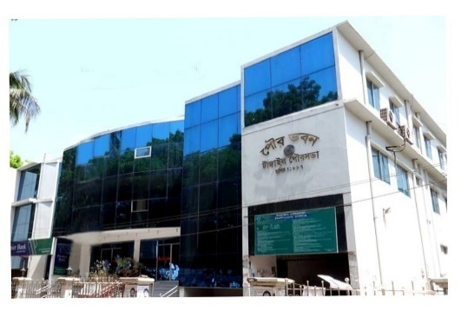Tangail Paurashava is located in the Tangail Sadar Upazila. It is located in the south-eastern part of Tangail Sadar Thana and has been developed by the side of Louhajanga River. Tangail Sadar Upazila is bounded by Kalihati Upazila on the north, Nagarpur and Delduar Upazilas on the south, Basail Upazila on the east, Belkuchi and Chauhali Upazilas on the west. The main rivers are Jamuna, Dhaleshwari, and Louhajang. On the globe, Tangail Paurashava lies on 24015’ north latitude and 89055’ east longitude and is 95 km away from the Dhaka City. Dhaka-Rajshahi and Dhaka-Jamalpur highways pass through the Paurashava and the river Louhajang, a distributory of the Jamuna flows through the town dividing it into two parts.

Paurashava was established on 1 July 1887 with an area of 31.99 sq. km. including 18 wards and 34 mouzas.

The Paurashava was a part of former “Atia”porgana (revenue sub district of Munghal and British period). Present Tangail has been formed through silt deposit by the massive Jamuna River. A tribal community called gharo lives in this district but mainly in Madhupur Upazila, about 50 kms east of the pourasova. The Santosh Zamindar Bari and Karatia Zamindar Bari, house and grave of the people’s leader Maulana Abdul Hamid Khan Vasani and handloom industry of Bazitpur are a few of the remarkable. Tangail Paurashava like most other towns of Bangladesh developed in an unplanned and haphazard way. Planned development is visible only in the government owned headquarters of the district. Therefore, providing service facilities is difficult in most part of the town. The flow direction of Lohajong River is north to south. The river has strong flow during the monsoon and floods the town almost every year. In unusual high floods, one or two every ten to 20 years may flood the town with 0.5 to 1.0m deep water for a couple of weeks. But the river has created an opportunity to good drainage.

Population of Tangail pourashava as per 2011 Census is 167,412 and population density is 5,233 per sqkm. At present, the most densely populated area is Ward No. 1 where improving roads and drain is difficult. In the periphery of the pourashava, there are still open spaces and agricultural area to accommodate increasing population. Present population growth rate of the town is 1.97%.The area considered for structure planning is larger than the town area prescribed through the official Gazette Notification of the government (about 32 sq.km as of 2011). The reason for the difference is the master plan of the Pourashava desiring expansion of the town considering the recent trend and growth.

**Tangail Pourashava**

**At a Glance**

|  |  |  |  |  |
| --- | --- | --- | --- | --- |
| **General Information** | | | | |
| Area | : | | 31.99 Sq. km. | |
| Ward | : | | 18 | |
| Population  Population Growth Rate  Household No  Population Density  Major Status  Main Income Source : | : | | 16,74,12 (in 2011)  1.97%  26,740 (in 2011)  5,233 Person Per sq km (in 2011)  20% migrated people  Business 35.32%, Service 24.42%, others 40.26%. | |
| **Tax** | | | | |
| Holding Tax | | : | | Tk.2,29,94,430/=(current Demand) |
| **Market** | | | | |
| Poura Market | : | | 14 | |
| Bazar | : | | 3 | |
| Shopping Complex | : | | - | |
| Own Shops | : | | 910 | |
| **License** | | | | |
| Trade License | : | | 5,780 no’s | |
| Rickshaw License | : | | 4,800 no’s | |
| Auto Rickshaw License |  | | 1,488 no’s | |
| **Communication** | | | | |
| Road | : | | 352.53 Km | |
| a) Bituminous | : | | 174.32 Km | |
| b) CC | : | | 43.17 Km | |
| c) RCC | : | | 10 Km | |
| d) Brick Flat Soling | : | | 13.76 Km | |
| e) Nonpaved Road | : | | 145.28 Km | |
| Culvert | : | | 63 | |
| Road intersection | : | | 36 | |
| Bridge | : | | 45 | |
| Footpath | : | | 322.82 Km | |
| **Water Supply** | | | | |
| Overhead Tank | : | | 3 | |
| Capacity | : | | 680,000 Liter(Per Number) | |
| Deep Tube well | : | | 9 | |
| Pipe Line | : | | 130 Km | |
| House Connection | : | | 10,000 | |
| Street Hydrant | : | | 21 | |
| Pump Station | : | | 21 | |
| Arsenic Status | : | | Within acceptable limit | |
| Pumping Hour | : | | 16 Hour, supply 6 hour | |
| **Street Lighting** | | | | |
| Electricity Line | : | | 309 Km | |
| Light Post | : | | 5,800 | |
| Tube Light Point | : | | - | |
| Energy Savings Light Point | : | | 5,800 | |
| Meter/ Switch Point | : | | 10 | |
| **Vehicle** | | | | |
| Garbage Truck | : | | 6 | |
| Tractor | : | | 1 | |
| Jeep | : | | 4 | |
| Motorcycle | : | | 4 | |
| Hydraulic Beam Lifter | : | | 2 | |
| Road Roller (4 ton – 6 ton) | : | | 4 | |
| Road Roller (8 ton – 10 ton) | : | | 5 | |
| **Drainage System** | | | | |
| Drain | : | | 195.41 Km | |
| a) RCC/ Brick Lined Drain | : | | 49.91.44 Km | |
| b) Earthen Drain | : | | 145.5 Km | |
| Canal | : | | 23.65 Km | |
| **Public Health** | | | | |
| Public Toilet | : | | 10 | |
| Sanitary Latrine | : | | 11,256 | |
| Dustbin | : | | 58 | |
| EPI Centre Permanent- | : | | 3 | |
| Temporary - | : | | 48 | |
| Hospital | : | | 1 | |
| Clinic (TB) | : | | 1 | |
| Maternity Clinic | : | | 1 | |
| Private Clinic | : | | 14 | |
| Diabetic Hospital | : | | 1 | |
| **UPPRP Project** | | | | |
| Community Centre | : | | 4 | |
| Total Urban Community | : | | 59 | |
| Total Community Family | : | | 10,000 | |
| Total Community Member | : | | 40,300 | |
| Total Community Deep-set | : | | - | |
| Total Sanitary Latrine | : | | 1,200 | |
| Total Road with Footpath | : | | 12 km | |
| Drain | : | | 7km | |
| **UPHSDP Project** | | | | |
| Nagar Matri Sadan | : | | 2 | |
| Nagar Health Centre | : | | 4 | |
| Satellite Clinic | : | | 2 | |
| Religious Institution | | | | |
| Mosque | : | | 135 | |
| Eidghah | : | | 7 | |
| Temple | : | | 56 | |
| Graveyard | : | | 8 | |
| Burning Ghat | : | | 2 | |
| Orphanage | : | | 2 | |
| **Law &Order** | | | | |
| Police Station | : | | 1 | |
| Police Fari | : | | 1 | |
| Judge court | : | | 1 | |
| **Education** | | | | |
| Public University | : | | 1 | |
| Govt .College | : | | 3 | |
| Private College | : | | 7 | |
| Public Medical College | : | | 1 | |
| Law College | : | | 1 | |
| Homoeopathic Medical College | : | | 1 | |
| Public Polytechnic Institute | : | | 1 | |
| Private Polytechnic Institute | : | | 4 | |
| Madrasha | : | | 53 | |
| Teachers Training College | : | | 1 | |
| Govt High School | : | | 4 | |
| Non-Govt High School | : | | 14 | |
| Govt Primary School | : | | 37 | |
| Kinder Garten School | : | | 39 | |
| **Recreation** | | | | |
| Cinema Hall | : | | 2 | |
| Stadium | : | | 1 | |
| Auditorium | : | | 1 | |
| Recreation Club | : | | 1 | |
| **Communication** | | | | |
| T & T Office | : | | 1 | |
| GPO | : | | 1 | |
| Post Office | : | | 7 | |
| **Beautiful Places** | | | | |
| 1. PouraUddan. : 1 | | | | |
| 2. DC Lake. : 1 | | | | |
| 3. Santosh Jamidar Bari. : 1 | | | | |
| 4. Tangail Stadium. : 1 | | | | |

**Fig 1: Subproject Location map.**

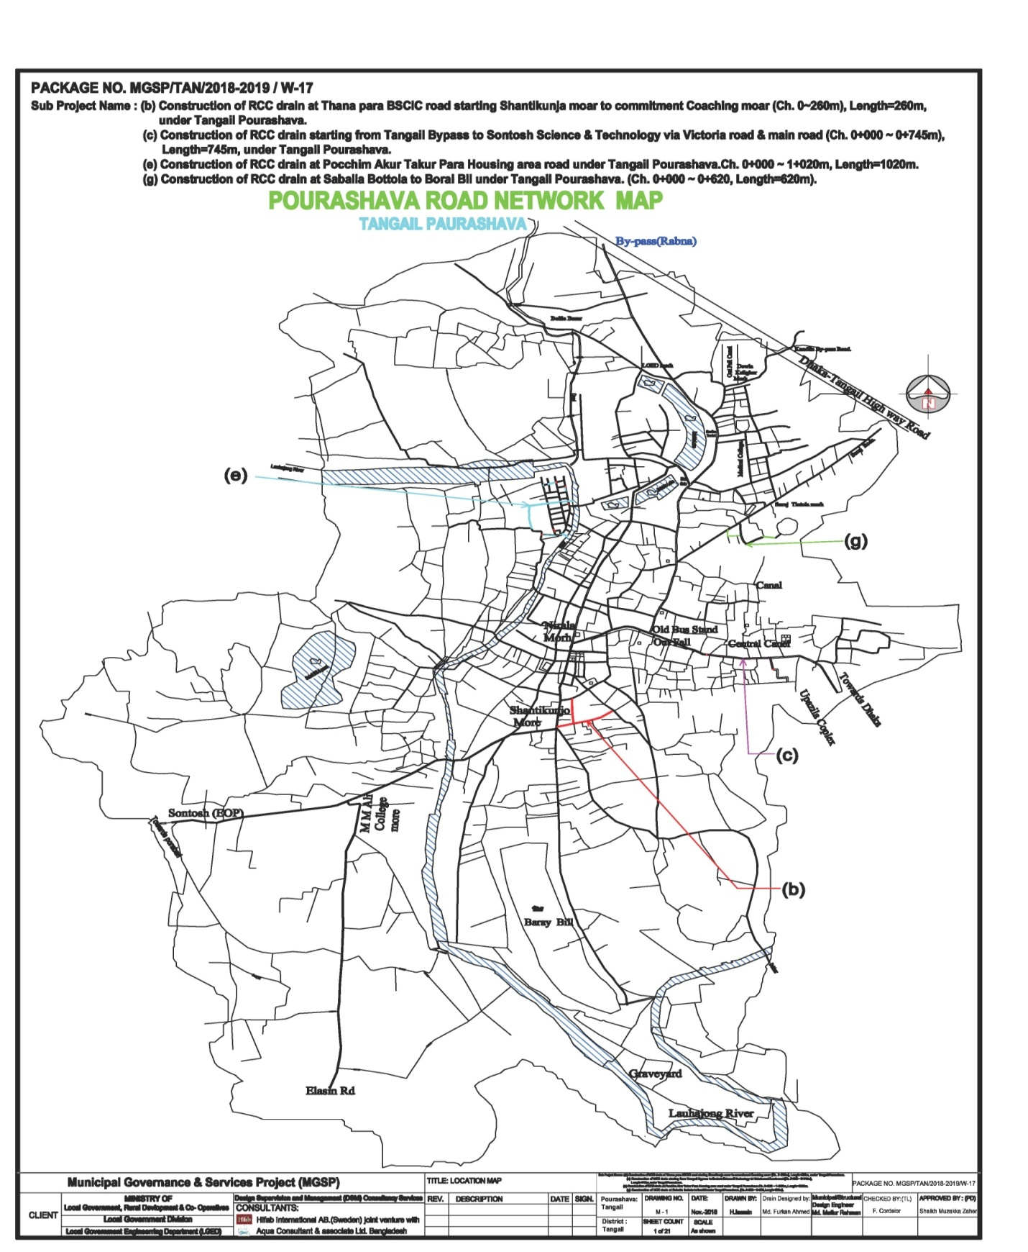

Fig 2: **Project lay out plan of Package W-17 ( road and drain lay out)**

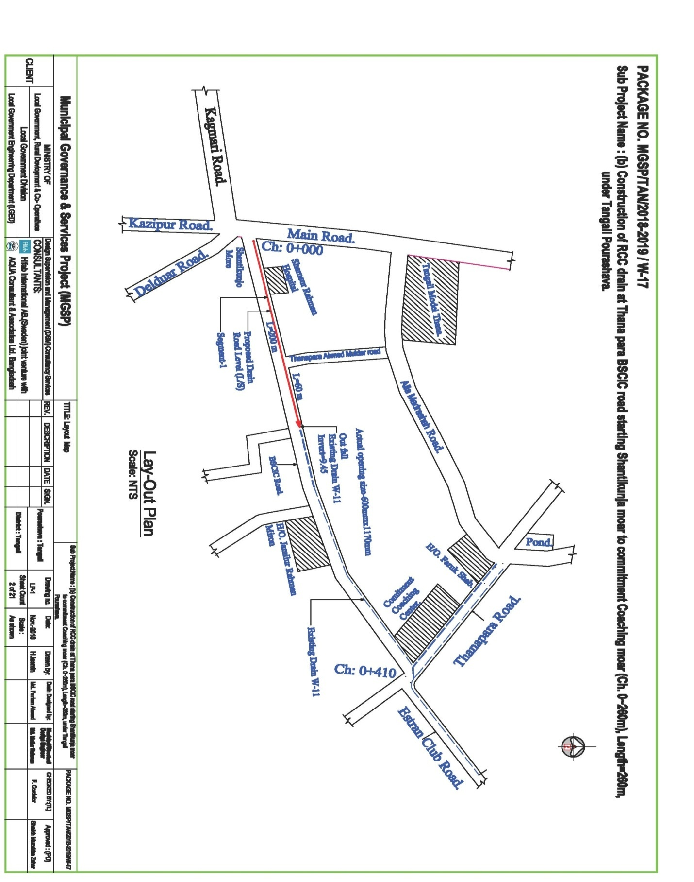

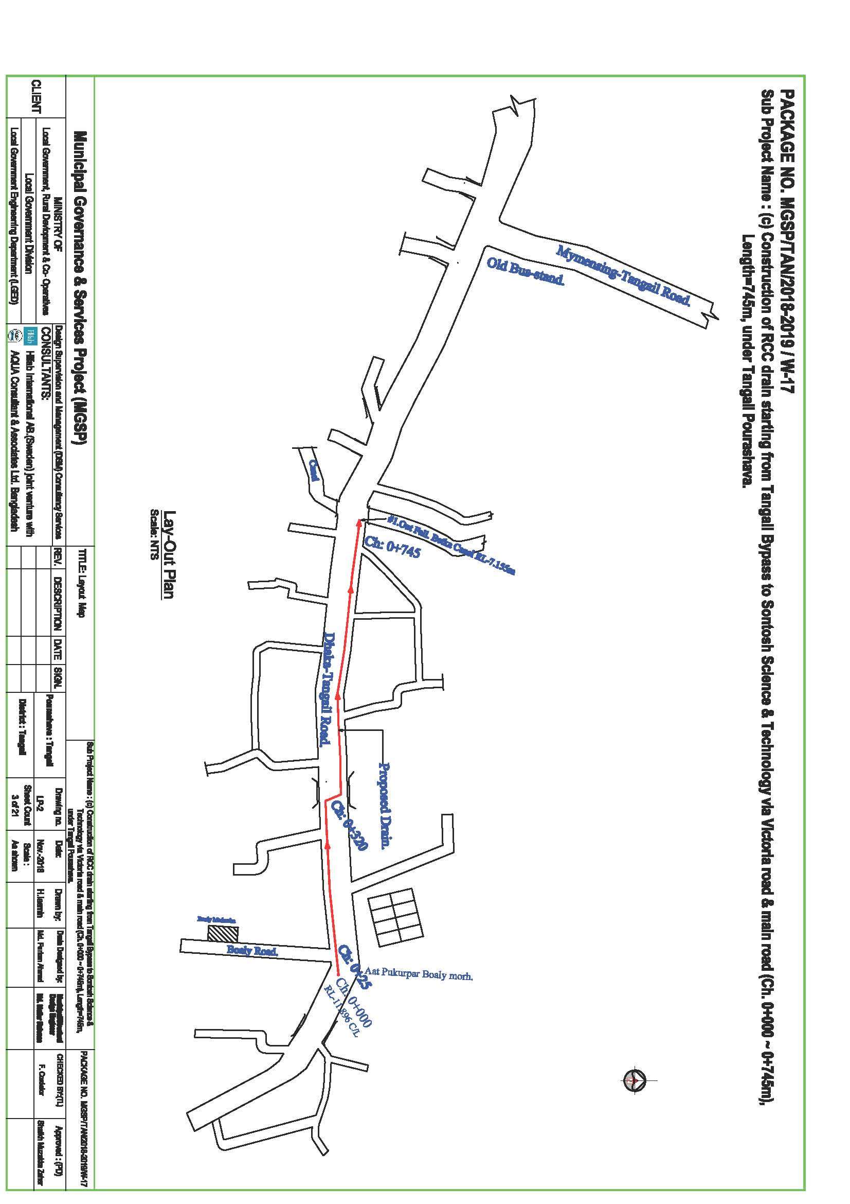

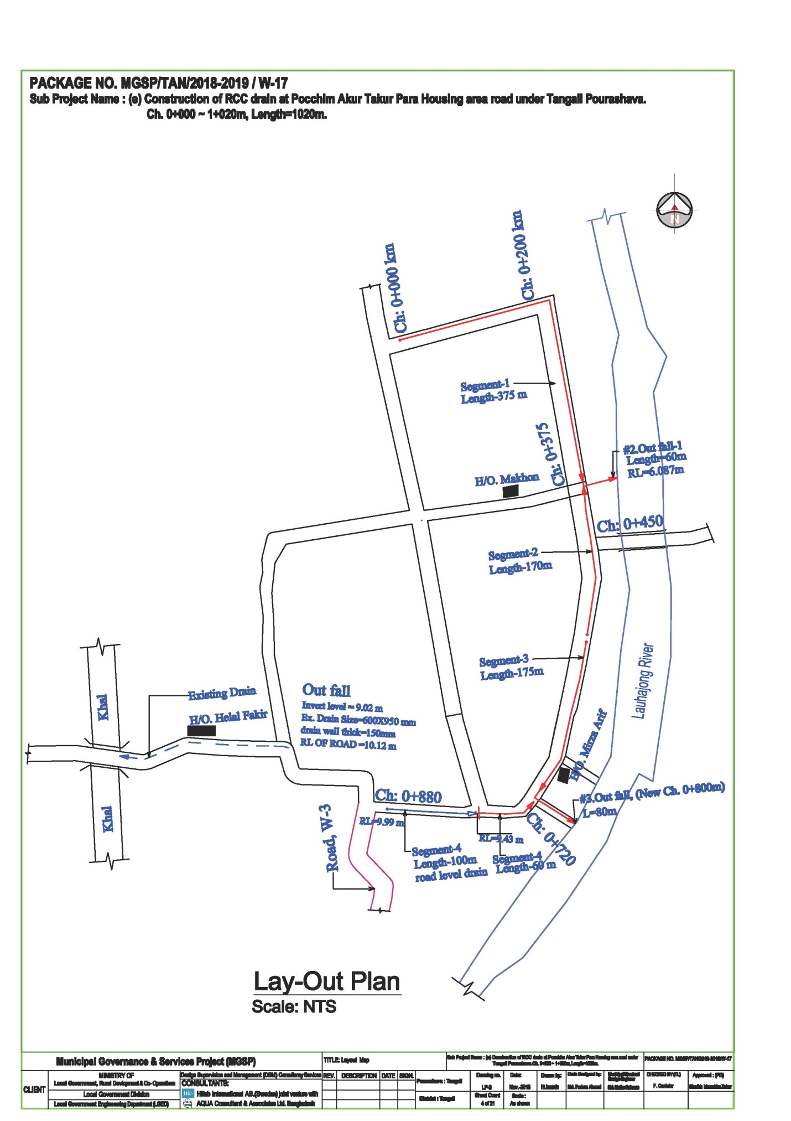

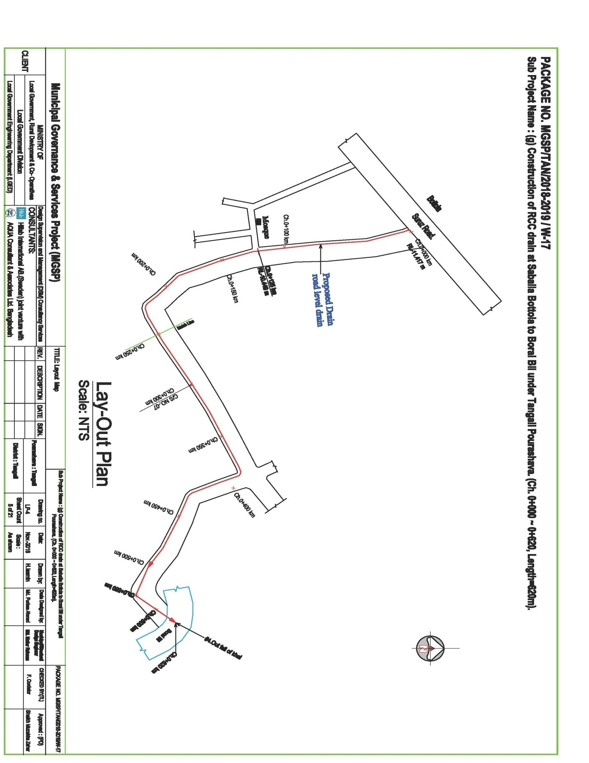

**2.2 Historical and Cultural Heritage Sites:**

Tangail town of Tangail Zila is situated about 100 km. north of Dhaka City and also about 100 km. west of Mymenshing Town where Louhajong River brings down water of Louhajang river into it. The Santosh Zamindar Bari and Karatia Zamindar Bari, house and grave of the great people’s leader Maulana Abdul Hamid Khan Vasani and the handloom industry of Bazitpur are a few of the many remarkable Archaeological and cultural Heritages of Tangail. The renowned Kumudini College is another remarkable establishment of the Paurashava that attracts students from nation-wide.

Recreational facilities like Cinema Hall, Stadium, Park, and Picnic spot, etc. are included in this category. One Park, one stadium and two cinema halls are the recreational facilities for the Paurashava inhabitants.

The components presented in the following table are the heritages of the Tangail Pouurashava. These establishments have been established during the past two centuries.

|  |
| --- |
| **Structure Name** |
| House and grave of great political leader of Moulana Abdul Hamid Khan Bhasani |
| Santosh Zamindar Bari |
| Karatia Zamindar Bari |
| Bazitpur hand loom industry |
| Kumudini College |

**2.3 The Subproject Location and Area Profile**

This identified subproject for improvement the road, drain cover slabs/footpath, covers commercial & partly residential areas. During field visit for the social screening, the DSM team does not found obstruction on the existing road & drain sides. The subproject road and drains sides land belongs to the Tangail Pourashava but bypass proposed drain location land belong to the RHD Tangail. The RHD authority will provide a written consent letter for construction the drain to the Tangail ULB immediately. As per ULB statement RHD consent will collected from RHD, Tangail office and the ULB will forward a copy to PMU. In this regard Mayor already sent request letter to RHD Tangail; this letter is attached in annex-02.

**2.4 Beneficiary Communities and Affected Persons**

The proposed road drains and streetlights will develop traffic network and remove water logging. As a result people will be able to move easily during the rainy season. Local transports like rickshaw, rickshaw van, battery driven three wheeler autos and CNG driven baby taxi and diesel operated tractor trailers (Bhotbhoti) will move conveniently besides buses, cars, micro buses, pickup van and Lorries.

This part of the town is quickly growing residential cum commercial area. About **50,000** people will be benefited by the subproject infrastructure (widened road, drain and street light). They will use the road to meet the needs of job holders, students, children & women. People of three wards will (**3, 15 &17)** mainly benefit from the sub project. In addition, people of other wards of the town and the adjoining Upazila (Deldowar) will use the road for easy connectivity to Tangail town.

The proposed milk vita road will improve connectivity with to the Tangail new bus terminal, Dhaka -Tangail National High ways and Tangail –Mymenshing road.

Due to implementation of this subproject, total no of 55,000 populations in the Pourashava will be directly benefited. People who visit Tangail Pourashava and handloom industry will be immensely benefited, saving travel time and avoiding traffic congestion.

**2.5 Gender and Vulnerability**

Gender and vulnerability analysis have been considered in social impact assessment of subprojects. This has focused gender and vulnerability based on findings from specific queries during social screening and community consultation. The quantitative and qualitative analysis has brought out sex disaggregated data and issues related to discrimination by gender vulnerability, needs, constraints, and priorities as well as understanding whether there is a potential for inequitable risks, benefits and opportunities relating to gender and vulnerability. Based on the social analysis, specific interventions inclusion and participation encourages gender mainstreaming in the project cycle. Gender equity and empowerment will be ensured through encouraging participation of men and women equitably in the project cycle. The community participation and consultation also encourages gender mainstreaming in the subproject influence areas. After subprojects implementation, there are positive impacts for the vulnerable women; especially those who are small traders, landless, marginal farmers, etc. and can sell their household products. These subprojects will create job creation and livelihoods. In addition, it will also increase the mobility of drains users. Due to the fact, gender and vulnerability has been taken into account and ensures the gender equity in the subprojects implementation.

**3. Social Impact Assessment**

**3.1. Benefits of the Subproject**

This subprojectwill be used for both inter-town and intra-town movement. It will improve traffic network and drainage system as well as to reduce road accident and to reduce water logging. From the point of view of social benefits it will enhance commercial/economic activities, direct/indirect employment opportunity and poverty reduction. Also, it will improve access to health service, educational institutions and handloom market. For improved transport network, property value of adjoining area will increase substantially, rent will increase and this will eventually contribute to increased revenue earning for the pourashava.

**3.2. Social Screening and Safeguard Compliance Issue**

After selection of these subprojects, the Pourashava with the assistance of DSM Consultants has completed a social screening for the subprojects using an inclusive and participatory approach.

Tangail Pourashava has ensured designing of the subproject following socially inclusive and gender friendly methods. According to engineering design, implementation of these subprojects will be carried out within the existing right-of-way.

Results from the social screening are given below.

* No additional public or private lands will be required for the subprojects outside the existing right of way.
* The sub project will not affect access to common property resources for any community. It will also have any negative impact on cultural property of any kind.
* Preparation of RAP will not be required for implementing the subprojects as no LA is involved.
* Agricultural or industrial productivity will not be hampered by the proposed subproject areas.
* Handloom industry in particular will flourish further.

The outcomes of social screening also confirmed that local people across the subprojects are positive about its implementation.

**4. Consultation and Community Participation**

**4.1. Stakeholder Analysis**

According to BBS, Population Census, 2011 total population of Tangail Pourashava was 167,412 among which 84,741 are male and 82,671 are female. People of both pourashava area and adjoining rural area will be directly benefited by the improvement of road, drain and street light.

As a part of overall assessment, the project identified the key stakeholders of the proposed subproject areas and assessed the power relationships as well as influence and interests of various stakeholder groups involved in the subprojects. Key stakeholders for subprojects under MGSP were identified in consultation with the mayor, councilors and pourashava officials, district administration, civil society and local people of the town, representative of business associations and local contractors etc. Suggestions and directions of all local stakeholders were noted and reflected in the SMP while designing the subproject interventions.

**4.2. Consultation and Participation Plan for the subproject**

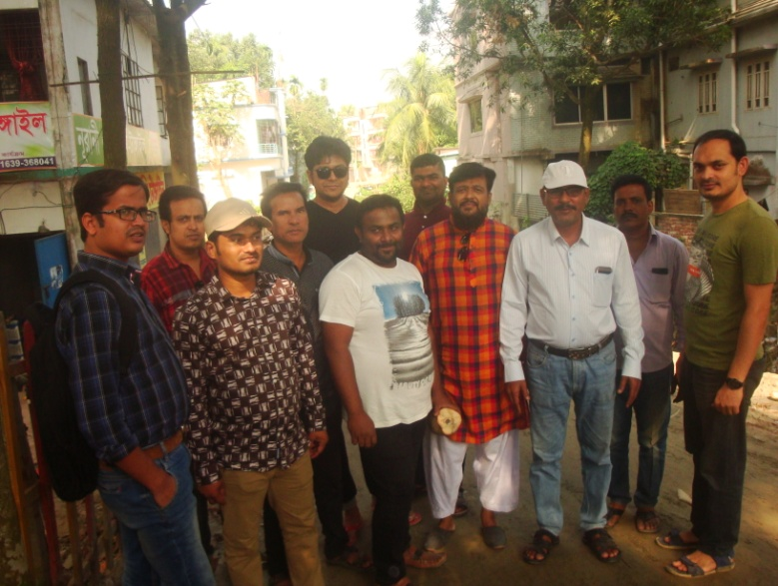A series of participatory public consultations were conducted in the subprojects area. Key Informant Interviews (KII) and Group Discussion (GD) were also conducted involving the participants of the Tangail, Pourashava Mayor, Councilors, Pourashava Officials, representatives of local Communities and civil society members as well as there representative of local LGED office and the consultant team.A walk-through informal group consultation with the local communities was also held. Through the participation and consultation meeting, local communities were informed about subprojects implementation, the SMF, draft SMP and screening report and probable benefits of the project were discussed with them. Suggestions and recommendations made by the participants are incorporated in the SMP accordingly. The photographs of the consultation meetings are seen.

Photographs:. Community consultation at bypass area

**4.3. Consultation Outcomes – Issues, Concerns, and Recommendations**

The participants raised their issues related to subprojects improvement which are mainly drains. Feedback, suggestions and recommendations by the participants are listed below.

* Construction works should be scheduled properly and the quality of construction work should be maintained strictly;
* By engaging female labor force gender issues has been partially addressed
* Social safeguard compliance issues has been ensured through the inclusive participation of subprojects beneficiaries in subprojects implementation

**5.0 Social Management for Site Selection and Design**

**5.1 Subproject Selection Process**

MGSP in coordination with concerned Tangail Pourashava elected functionaries, local administration, relevant stakeholders, community members, road users and civil society members followed the participatory approach in different stages of subprojects selection following inclusion, consultation and participation methods. Female Ward Councilors participated actively in the selection process. Moreover, the representatives of TLCC and WC from the Pourashava have contributed in the subprojects selection process with an analysis of the inclusiveness of the selection process.

At the time of selecting these subprojects, Social Screening and Group Discussion (GD) with Tangail Pourashava urban communities, local administration, traders, buyers, and sellers were conducted by the Tangail Pourashava officials and Consultants from DSM. Views and opinions of these consultations were to explain the subproject objectives and sought feedback from the participants to maximize the social and economic benefits as well as to minimize the adverse impacts of the subprojects.

**5.2. Subproject Design Process**

After final selection of the subprojects, the DSM Consultant designed the proposed subprojects (Drains with cover slabs,, road and streetlight) under Tangail Pourashava. These subprojects constructed under the Pourshava’s own land. Despite the inclusion and participatory consultations, if any person has a grievance relating to the implementation of the subprojects, the Pourashava has mitigated it.

The Consultant interviewed stakeholders and beneficiaries of the subprojects areas before the design. The Consultant and Pourashava officials conducted a number of consultation meetings in the subprojects areas discussing the implementation procedures and mitigation measures, if any, required to be taken in implementing the proposed subproject.

**5.3 Grievance Redress Mechanism (GRM):** GRM has already been operationalzed for Tangail Pourashava. Accordingly, this Pourashava has formed Grievance Redress Committee (GRC) to handle any grievance raised due to implementation of the sub-projects. The committee will be headed by the Mayor of the Tangail Pourashava and consist of 7 members. The committee will answer to subproject-related queries and address complaints and grievances about any irregularities in application of the guidelines adopted for assessment and mitigation of social and environmental impacts. Based on consensus, the procedure will help to resolve issues/conflicts amicably and quickly without resorting to any expensive, time-consuming legal actions. It will ensure proper presentation of complaints and grievances as well as impartial hearings and transparent decisions.

Tangail Pourashava has already appointed Focal Point of GRC who is at the level of Assistant Engineer. The Mayor of the Tangail Pourashava is the Chairman of the GRC. This GRC at the Pourashava level is responsible to disclose the subprojects implementation before civil works start.

**Structure of the GRC Committee:**

|  |  |
| --- | --- |
| **Person** | **Status** |
| ULB Mayor | Convener |
| Representative of Local Administration | Member |
| Teacher from a Local Educational Institution | Member |
| Representative of a Local NGO | Member |
| Representative of Civil Society | Member |
| Female Ward Councilor | Member |
| Head of Engineering Section of ULB | Member Secretary |

**5.4 Implementation Arrangement:** DSM has initially completed social screening for the subprojects and there is no problem for implementing the subprojects regarding social safeguard issues. Accordingly, PMU, MGSP has issued the award letter against the subproject following all required procurement procedures. Tangail Pourashava has the responsibility to implement the subprojects timely in close coordination with the PMU of the project and also with the technical assistance of DSM. Engineering section of Pourashava and local representative of Consultancy team will ensure the quality construction work of the subprojects. In addition, Consultant team from Head Quarter DSM will ensure close monitoring of the implementation of the subproject components. In the implementation process, Social Safeguard Team will ensure monitoring of social safeguard management before civil works start. During construction, the communities will not be affected and the project will minimize the loss of communities. In addition, before civil works start, the Pourashava will make the video filmed and also social screening.

**6. Conclusions on Social Management Plan (SMP):**

The subproject interventions- improved road, drain cover slabs/footpaths will enhance commercial/economic activities, direct/indirect employment opportunity and poverty reduction. Also, it will improve access to health service, educational institutions and handloom market. For improved transport network, property value of adjoining area will increase substantially, rent will increase and this will eventually contribute to increased revenue earning for the pourashava. The drains will reduce water-logging and increase stability of the road and contribute to reduced maintenance cost. The cover slabs/footpaths will contribute to safe movement of pedestrians as well as of vehicles.

Implementation of the subproject needs collection written consent /approval from RHD,Tangail for construction of drains besides the bypass road and also relocated 35 electric poles followed all procedures. The ULB will take necessary steps for maintaining the mentioned issues and attached in SMP accordingly. In view of above, the Tangail Pourashava has finally selected this subproject to implement and to strictly follow the SMP.

**Annex-01. Mayor letter to seek written approval from RHD Tangail.**

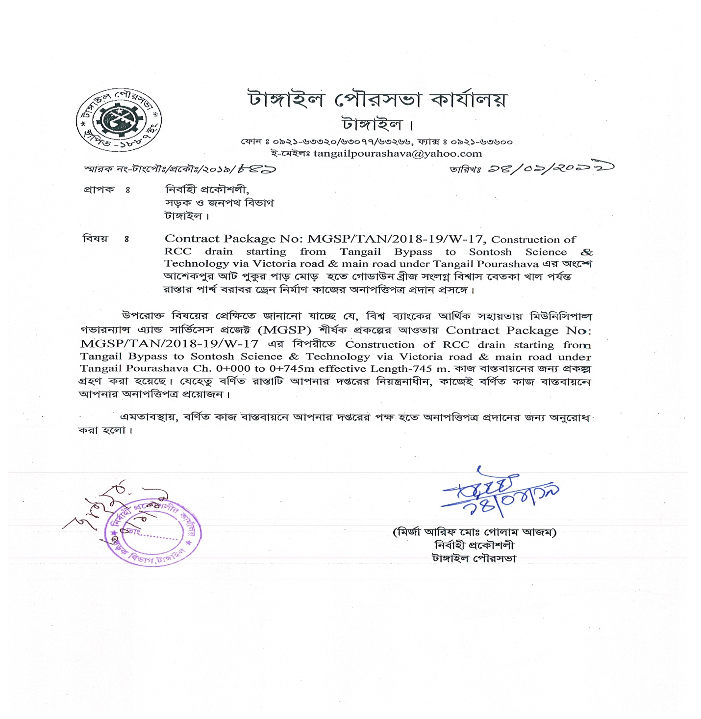

**Annex’s-2.. Social Screening report: (a,b,c,d,e ,f & g)**