

**Local Government Division**

**Local Government Engineering Department**

**Municipal Governance and Services Project (MGSP)**

**IDA Credit No: 5339-BD**

**Report on Social Management Plan**

**Package No: MGSP/TAN/2016-17/W-06**

**Name of Subproject:** Improvement and Widening of Stand road starting from Baby stand road to Tangail –Mymensing road via Battla Bazaar with RCC drain and street light

1. Improvement and Widening of Stand road starting from Baby stand road to Tangail –Mymensing road via Battla Bazaar by Bituminous Carpeting Ch.0+000 to 2+500 m including 3links (Total length 3400 m)
2. Construction of RCC drains with footpath starting from Baby stand road to Tangail –Mymensing road via Battla Bazaar by Bituminous Carpeting Ch.0+000 to 2+500m.including 3 links ( Total length 3781)
3. 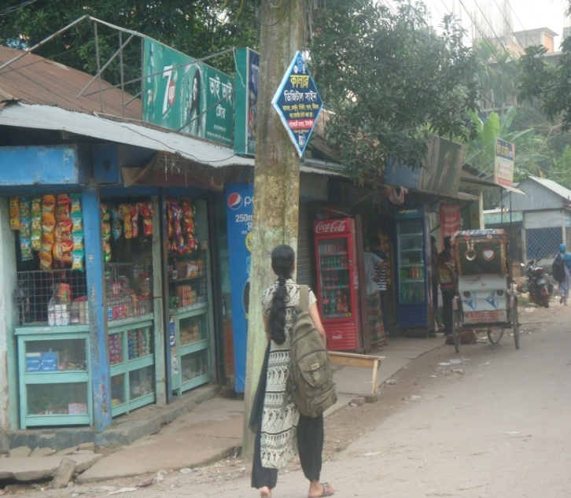Supplying ,fitting and fixing of Street lights starting from starting from Baby stand road to Tangail –Mymensing road via Battla Bazaar Ch.0+000 to 2+500 m including 3 links (Total length 3400 m)

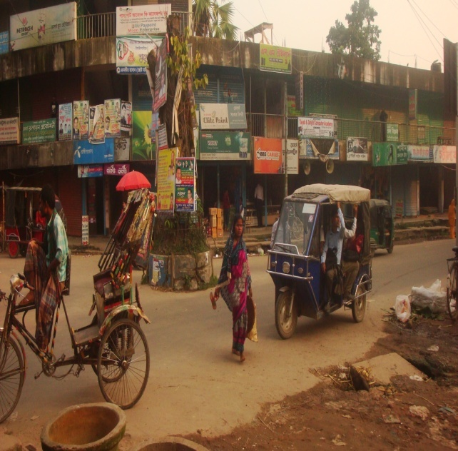

**Design, Supervision, and Management (DSM) Consultancy Services**



Joint Venture of *Hifab International AB, Sweden and*

* AQUA Consultant & Associates Ltd., Bangladesh*

**February 2017**

**TangailPourashava**

**TANGAIL**

**Table of content**

|  |  |  |
| --- | --- | --- |
| **No** | **Contents** | **Page. No** |
| 1. | INTRODUCTION | 4 |
| 1.1 | Project Background | 4 |
| 1.2 | Legal and Policy Framework | 4 |
| 1.3 | Brief Description of subproject | 5 |
| 1.4 | Social Management Plan | 5 |
| 2. | Description of Subproject Area | 6 |
| 2.1 | Brief Profile of TangailPourashava | 6 |
| 2.2 | Historical and Cultural Heritage Sites | 11 |
| 2.3 | The Subproject Location and Area Profile | 11 |
| 2.4 | Beneficiary Communities and Affected Persons | 11 |
| 2.5 | Gender and Vulnerability | 11 |
| 3. | Social Impact Assessment | 12 |
| 3.1 | Benefits of the Subproject | 12 |
| 3.2 | Social Screening and Safeguard Compliance Issue | 13 |
| 4. | Consultation and community participation | 13 |
| 4.1 | Stakeholder Analysis | 13 |
| 4.2 | Consultation and Participation plan for the subproject | 13 |
| 4.3 | Consultation Outcomes – Issues, Concerns and Recommendations | 13 |
| 5.0 | Social Management for Site Selection and Design | 14 |
| 5.1 | Subproject Selection Process”. | 14 |
| 5.2 | Subproject Design Process | 14 |
| 5.3 | Graveness’ redress Mechanism | 14 |
| 5.4 | Implementation Arrangement | 15 |
| 6. | Conclusions on Social Management Plan (SMP) | 15 |
| Photograph | |  |
| 1. | Subproject Estimated cost | 5 |
| 2. | Photograph on Tangail Pourashava Bhaban | 6 |
| 3 | At a glance of Tangail Pourashava | 7-10 |
| 4. | Project layout package No: W-06 | 10 |
| 4 | Community consultation meeting | 13 |
| ANNEXURE | |  |
| 1. | **Mayor letter on no obstacles remove** | 15-16 |
|  | **Social screening report** | 17-29 |

**Abbreviations**

|  |  |
| --- | --- |
| ARP | Abbreviated Resettlement Plan |
| BMDF | Bangladesh Municipal Development Fund |
| LAP | Land Acquisition Plan |
| CBO | Community Based Organization |
| CC | Cement Concrete |
| TAN | TangailPourashava |
| CIP | Capital Investment Plan |
| CUL | Compensation-Under-Law |
| DC | Deputy Commissioner |
| DLAC | District Land Acquisition Committee |
| DUTP | Dhaka Urban Transport Project |
| GoB | Government of Bangladesh |
| GRC | Grievance Redress Committee |
| GRM | Grievance Redress Mechanism |
| HCG | House Construction Grant |
| HTG | House Transfer Grant |
| IDA | International Development Association |
| IP | Indigenous People |
| IPP | Indigenous Peoples Plan |
| KII | Key Informants Interviews |
| FGD | Focus Group Discussion |
| LGD | Local Government Division |
| LGED | Local Government Engineering Department |
| M& S | Management &Supervision |
| MGSP | MunicipalGoverna0nceandServicesProject |
| MOLGRDC | Ministry of Local Government, Rural Development & Cooperatives |
| MSP | Municipal Services Project |
| MSL | Mean sea Level |
| NGO | Non-governmental Organization |
| PAH | Project Affected Household |
| PAP | Project Affected Person |
| PMU | Project Management Unit |
| RCC | Reinforced Concrete Cement |
| RP | Resettlement Pan |
| SIA | Social Impact Assessment |
| SMP | Social Management Plan |
| SSS | Social Safeguards Specialist |
| TLCC | Town Level Coordination Committee |
| ULB | Urban Local Body |
| WB | World Bank |
| WC | Ward Committee |

RAP Resettlement Action Pla

**1. INTRODUCTION**

**1.1Project Background**

The Government of Bangladesh, through the Local Government Engineering Department (LGED) and Bangladesh Municipal Development Fund (BMDF) is implementing the Municipal Governance and Services Project (MGSP). The project aims to improve municipal governance and basic urban services in participating ULBs. Two physical components of the project include (i) Municipal Governance and Basic Urban Services Improvement (Component 1) to provide financial support to 26 pre-identified urban local bodies (ULBs) including municipalities and city corporations, and demand-based sub-credits to eligible ULBs for basic urban services improvement investment costs. Total project cost **is BDT 2, 470, 93.92 lakh to be** financed at 80:20 IDA loan to GOB contribution. LGED is implementing the Component 1 while BMDF is implementing component 2 of the project.

LGED is supporting the 26 pre-selected ULBs for investments in development and rehabilitation of Road, Bridge, Box-culvert, Pedestrians bridge, street light, Traffic Control, Bus terminal, Truck terminal, Boat landing Jetty, Drain, Retaining wall, Kitchen market, Cattle market, slaughter house, Public toilet, Solid waste management, Sweeper colony, Park, Community Centre and Whole sale market. LGED is financing through (i) base allocation based on population category of ULBs; (ii) performance-based allocation and (iii) operations and maintenance support on a declining basis over the project period.

The component interventions have largely been developed for construction and rehabilitation within existing available land owned by the ULBs and acquisition of land has been avoided in the screening process. Removal of some obstruction and relocation of some businesses were involved in case of some sub projects for unavoidable circumstances. The MGSP did not avoid taking-up of sub projects in areas inhabited by tribal peoples and instead ensured their inclusion and participation where applicable. The ULBs addressed the removal of obstructions and in most cases the land entirely belongs to the ULB. In some instances, land of other GOB agencies like the BWDB, R&H or other local government like adjoining UP is needed and in such cases the ULB ensured getting such land by mutual understanding and proper documentation. Relocation of business and removal of obstructions were resolved by consultation and agreement with the concerned PAPs and these are properly documented. Thus land acquisition, population displacement and tribal people’s issues have been addressed following the country’s legal framework and the World Bank policy on social safeguards.

**1.2 Legal and Policy Framework**

Given the approach of subproject preparation and implementation, the World Bank’s Operational Policy (OP) on Involuntary Resettlement (OP 4.12) and on Indigenous Peoples (OP 4.10) triggered to the project. A Social Management Framework (SMF) has been adopted by LGED for the project that meets the requirements of the country’s legal frameworks in Bangladesh “The Acquisition and Requisition of Immovable Property, Ordinance, 1982” and the Bank requirements including OP 4.12 and OP 4.10. The SMF also requires that subprojects are prepared ensuring inclusion, participation, transparency, and social accountability. Subprojects are prepared by respective ULBs in a process complying with the SMF requirements. LGED reviews the subproject proposals for technical, engineering, environmental, social development, and safeguards compliance before allocation of the financing to the ULBs.

As a matter of policy, Social Management Plans (SMP) will be prepared and implemented for subprojects with no land acquisition or involuntary displacement of people, while Resettlement Action Plans (RAP) andTribal Peoples Development Plans (TPDP) will be prepared for implementation for subprojects involving population displacement and tribal peoples’ issues.

**1.3Brief Description of Subproject:**

The subproject is very much important of construction Tangail pouroshava its starts from Baby stand road (connect to Tangail –Nagarpur-Aricha road and ends Tangail –Mymensingh high way. These subproject covered improvement and Widening of road, construction RCC drain and streetlights under the wards nos. 1,6,11 & 16. As per pourashava report the expected beneficiaries is 50,000 as well as dwellers/visitors of adjacent wards of Tangail pouroshava.

The present condition of the proposed sub project road is a BC road and it is damaged for use by loaded traffic and lack of proper maintenance. The maximum surface area is of the road are worn-out and have many holes on the surface. More over the width of road is not enough to fulfill the demand of desired traffic for respective wards citizen.

The existing drain is brick drain and is poor damaged and narrow. Hence water discharge capacity is inadequate. Besides the above, street lighting is inadequate. Both sides of the road have several types of shops, one kacca bazaar, various types of government offices, medical college, many educational institutes, teacher training college, eidgha field, stadium, bus terminal, park and bazar. etc.

Considering the above situation the Tangail pouroshava proposed implementation the subproject need to relocate 61 electric poles and 22 tree cutting.

Regarding the removing the obstacles about 15/20 temporary shops tin-roof and bamboo poles need to be remove as because there were construction extended in pourashava land. Against it mayor provided written consent letter on removing obstacles ( Letter attached annex-01) It will also need shifting 61 electric and T&T poles and felling of 22 trees.

**The proposed subproject estimated cost as per below:**

|  |  |  |  |
| --- | --- | --- | --- |
| **Sl.No** | **Name of the Scheme** | **Length (m)** | **Estimated Cost (BDT)** |
| a | Improvement and Widening of Stand road starting from Baby stand road to Tangail –Mymensing road via Battla Bazaar by Bituminous Carpeting Ch.0+000 to 2+500 m including 3links (Total length 3400m) | 3400 m | 41,733,097.58 |
| b. | Construction of RCC drains with footpath starting from Baby stand road to Tangail –Mymensing road via Battla Bazaar by Bituminous Carpeting Ch.0+000 to 2+500 m .including 3 links ( Total length 3781) | 3781 m | 63,164,234.30 |
| c | Supplying ,fitting and fixing of Street lights starting from starting from Baby stand road to Tangail –Mymensing road via Battla Bazaar Ch.0+000 to 2+500 m including 3 links (Total length 3400 m) | 3400 m | 6,354,716.17 |
|  | Total |  | **111,252,048.04** |

**1.4 Social Management Plan**

This Social Management Plan (SMP) has been prepared for the identification relevant social concerns and managing them in the process of subprojects design and implementation. Initially, the subproject proposals include a social screening report along with impact assessment. After reviewing the social screening report by Social Unit of DSM,these subproject proposals are submitted to the PMU office. Social team of the DSM has carried out a site visit and consulted ULB officials and cross section of the beneficiary communities through interview and participation & consultation meetings. The social screening findings and consultation method and proceedings were validated through the social survey and consultation.

The purpose of preparing this SMP is to demonstrate the all-inclusive consultative process in selection and design of the subproject as well as to provide guidance for social development and safeguards compliance in the implementation process.

The SMP contains a description of the subproject areas, social screening and impacts, consultation process adopted during identification and design, and consultation plan for implementation stage, impact mitigation measures, grievance resolution process, and implementation arrangements, and monitoring and evaluation.

The concerned ULB will ensure participation of the communities and grievance resolution in the process of implementation of the subprojects.

**2. Description of Subproject Area**

**2.1 Brief Profile of Tangail Pourashava**

Tangail Paurashava is located in the Tangail Sadar Upazila. It is located in the south-eastern part of Tangail Sadar Thana and has been developed by the side of Louhajanga River. Tangail Sadar Upazila is bounded by Kalihati Upazila on the north, Nagarpur and Delduar Upazilas in the south, Basail Upazila in the east, Belkuchi and Chauhali Upazilas in the west. The main rivers are Jamuna, Dhaleshwari, and Louhajang. On the globe, Tangail Paurashava lies on 24015’ north latitude and 89055’ east longitude and is 95 km away from the Dhaka City. Dhaka-Rajshahi and Dhaka-Jamalpur highways pass through the Paurashava and the river Louhajang, a distributary of the Jamuna flows through the town dividing it into two parts.

Paurashava was established on 1 July 1887 with an area of 31.99 sq. km. including 18 wards and 34 mouzas.

The Paurashava was a part of former “Atia”porgana (revenue sub district of Munghal and British period). Present Tangail has been formed through silt deposit by the massive Jamuna River. A tribal community called gharo lives in this district but mainly in Madhupur Upazila, about 50 kms east of the pourasova.

The Santosh Zamindar Bari and KaratiaZamindar Bari, house and grave of the people’s leader Maulana Abdul Hamid Khan Vasani and handloom industry of Bazitpur are a few of the remarkable Archaeological and cultural Heritages of Tangail.

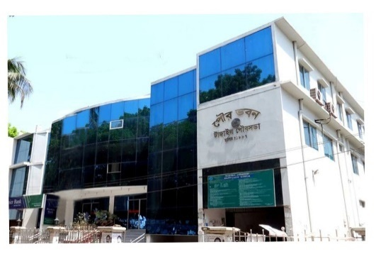Tangail Paurashava like most other towns of Bangladesh developed in an unplanned and haphazard way. Planned development is visible only in the government owned headquarters of the district. Therefore, providing service facilities is difficult in most part of the town.

The flow direction of Lohajong River is north to south. The river has strong flow during the monsoon and floods the town almost every year. In unusual high floods, one or two every ten to 20 years may flood the town with 0.5 to 1.0m deep water for a couple of weeks. But the river has created an opportunity to good drainage.

Population of Tangail pourasova as per 2011 Census is 167,412 and population density is 5,233 per sqkm. At present, the most densely populated area is Ward No. 1 where improving roads and drain is difficult. In the periphery of the pourasova, there are still open spaces and agricultural area to accommodate increasing population. Present population growth Rate of the town is 1.97%.The area considered for structure planning is larger than the town area prescribed through the official Gazette Notification of the government (about 32 sq.km as of 2011). The reason for the difference is the master plan of the paorasova desiring expansion of the town considering the recent trend and growth.

Tangail Paura bhaban

**TangailPourashava**

**At a Glance**

|  |  |  |  |  |  |
| --- | --- | --- | --- | --- | --- |
| **General Information** | | | | | |
| Area | : | | 31.99 Square K.M. | | |
| Ward | : | | 18 | | |
| Population  Population Growth Rate  Household No  Population Density  Major Status  Main Income Source : | : | | 167,412 (in 2011)  1.97%  26,740 (in 2011)  5,233 Person Per sq km (in 2011)  20% migrated people  Business 35.32%, Service 24.42%, others 40.26%. | | |
| **Tax** | | | | |
| Holding Tax | | : | | Tk.2,29,94,430/=(current Demand) |
| **Market** | | | | | |
| PouroMarket | : | | 14 | | |
| Bazar | : | | 3 | | |
| Shopping Complex | : | | - | | |
| Own Shops | : | | 910 | | |
| **License** | | | | | |
| Trade License | : | | 5,780 no’s | | |
| Rickshaw License | : | | 4,800 no’s | | |
| Auto Rickshaw License |  | | 1,488 no’s | | |
| **Communication** | | | | | |
| Road | : | | 352.53 Km | | |
| a) Bituminous | : | | 174.32 Km | | |
| b) CC | : | | 43.17 Km | | |
| c) RCC | : | | 10 Km | | |
| d) Brick Flat Soling | : | | 13.76 Km | | |
| e) Nonpaved Road | : | | 145.28 Km | | |
| Culvert | : | | 63 | | |
| Road intersection | : | | 36 | | |
| Bridge | : | | 45 | | |
| Footpath | : | | 322.82 Km | | |
| **Water Supply** | | | | | |
| Overhead Tank | : | | 3 | | |
| Capacity | : | | 680,000 Liter(Per Number) | | |
| Deep Tube well | : | | 9 | | |
| Pipe Line | : | | 130 Km | | |
| House Connection | : | | 10,000 | | |
| Street Hydrant | : | | 21 | | |
| Pump Station | : | | 21 | | |
| Arsenic Status | : | | Within acceptable limit | | |
| Pumping Hour | : | | 16 Hour, supply 6 hour | | |
| **Street Lighting** | | | | | |
| Electricity Line | : | | 309 Km | | |
| Light Post | : | | 5,800 | | |
| Tube Light Point | : | | - | | |
| Energy Savings Light Point | : | | 5,800 | | |
| Meter/ Switch Point | : | | 10 | | |
| **Vehicle** | | | | | |
| Garbage Truck | : | | 6 | | |
| Tractor | : | | 1 | | |
| Jeep | : | | 4 | | |
| Motorcycle | : | | 4 | | |
| Hydraulic Beam Lifter | : | | 2 | | |
| Road Roller (4 ton – 6 ton) | : | | 4 | | |
| Road Roller (8 ton – 10 ton) | : | | 5 | | |
| **Drainage System** | | | | | |
| Drain | : | | 195.41 Km | | |
| a) RCC/ Brick Lined Drain | : | | 49.91.44 Km | | |
| b) Earthen Drain | : | | 145.5 Km | | |
| Canal | : | | 23.65 Km | | |
| **Public Health** | | | | | |
| Public Toilet | : | | 10 | | |
| Sanitary Latrine | : | | 11,256 | | |
| Dustbin | : | | 58 | | |
| EPI Centre Permanent- | : | | 3 | | |
| Temporary - | : | | 48 | | |
| Hospital | : | | 1 | | |
| Clinic (TB) | : | | 1 | | |
| Maternity Clinic | : | | 1 | | |
| Private Clinic | : | | 14 | | |
| Diabetic Hospital | : | | 1 | | |
| **UPPRP Project** | | | | | |
| Community Centre | : | | 4 | | |
| Total Urban Community | : | | 59 | | |
| Total Community Family | : | | 10,000 | | |
| Total Community Member | : | | 40,300 | | |
| Total Community Deep-set | : | | - | | |
| Total Sanitary Latrine | : | | 1,200 | | |
| Total Road with Footpath | : | | 12 km | | |
| Drain | : | | 7km | | |
| **UPHSDP Project** | | | | | |
| Nagar MatriSadan | : | | 2 | | |
| Nagar Health Centre | : | | 4 | | |
| Satellite Clinic | : | | 2 | | |
| Religious Institution | | | | | |
| Mosque | : | | 135 | | |
| Eidghah | : | | 7 | | |
| Temple | : | | 56 | | |
| Graveyard | : | | 8 | | |
| Burning Ghat | : | | 2 | | |
| Orphanage | : | | 2 | | |
| **Law &Order** | | | | | |
| Police Station | : | | 1 | | |
| Police Fari | : | | 1 | | |
| Judge court | : | | 1 | | |
| **Education** | | | | | |
| Public University | : | | 1 | | |
| Govt .College | : | | 3 | | |
| Private College | : | | 7 | | |
| Public Medical College | : | | 1 | | |
| Law College | : | | 1 | | |
| Homoeopathic Medical College | : | | 1 | | |
| Public Polytechnic Institute | : | | 1 | | |
| Private Polytechnic Institute | : | | 4 | | |
| Madrasah | : | | 53 | | |
| Teachers Training College | : | | 1 | | |
| Govt High School | : | | 4 | | |
| Non-Govt High School | : | | 14 | | |
| Govt Primary School | : | | 37 | | |
| Kinder Garten School | : | | 39 | | |
| **Recreation** | | | | | |
| Cinema Hall | : | | 2 | | |
| Stadium | : | | 1 | | |
| Auditorium | : | | 1 | | |
| Recreation Club | : | | 1 | | |
| **Communication** | | | | | |
| T & T Office | : | | 1 | | |
| GPO | : | | 1 | | |
| Post Office | : | | 7 | | |
| **Beautiful Places** | | | | | |
| 1. PouraUddan. : 1 | | | | | |
| 2. DC Lake. : 1 | | | | | |
| 3. Santosh Jamidar Bari. | | | | | |
| 4. Tangail Stadium. | | | | | |

**Figure: Project lay out plan Package W-6.**



**2.2 Historical and Cultural Heritage Sites:**

The following table shows cultural heritages of the Tangail Pouurashava. These establishments have been established during the past two centuries.

|  |
| --- |
| **Structure Name** |
| House and grave of great political leader of Moulana Abdul Hamid Khan Bhasani |
| Santosh Zamindar Bari |
| KaratiaZamindar Bari |
| BazitpurHand loom industry |
| Kumudini College |

**2.3 The Subproject Location and Area Profile**

This identified subproject for improvement the road with drain and street light covers commercial & residential areas.

In this subproject, the total population of this densely populated area is 25,640 (Ref:BBS-2011) but expected beneficiaries is around 50,000 as per pourashava report and they will be benefited after construction of this road with drain, footpath & street light under wards no. 11, 6, 16 & 1 as well as dwellers/visitors of adjacent words of Tangail Pourashava.

**2.4 Beneficiary Communities and Affected Persons**

The proposed road will develop traffic network and remove water logging. As a result people will be able to move easily during the rainy season. Local transports like rickshaw, rickshaw van, battery driven three wheeler auto and CNG driven baby taxi and diesel operated tractor trailers (Bhotbhoti) will move conveniently besides buses, cars, micro buses, pickup van and Lorries.

The benefited areas are wars 1, 6 and 16 of the paurasova. This part of the town is quickly growing residential cum commercial area. Besides the inhabitants of these wards, people who visit Tangail pourashava and handloom industry will be immensely benefited, saving travel time and avoiding traffic congestion.

Implementation of the subproject will require removal of 5 boundary walls and five fences of a total of ten houses. Removing tin-roof and fence of five shops is also required. So, 15 households or about 75 persons will be affected.

**2.5 Gender and Vulnerability**

Gender and vulnerability analysis have been considered in social impact assessment of subprojects. This has focused gender and vulnerability based on findings from specific queries during social screening and community consultation. The quantitative and qualitative analysis has brought out sex disaggregated data and issues related to discrimination by gender vulnerability, needs, constraints, and priorities as well as understanding whether there is a potential for inequitable risks, benefits and opportunities relating to gender and vulnerability. Based on the social analysis, specific interventions inclusion and participation encourages gender mainstreaming in the project cycle. Gender equity and empowerment will be ensured through encouraging participation of men and women equitably in the project cycle. The community participation and consultation also encourages gender mainstreaming in the subproject influence areas. After subprojects implementation, there are positive impacts for the vulnerable women; especially those who are small traders, landless, marginal farmers, etc. and can sell their household products. These subprojects will create job creation and livelihoods. In addition, it will also increase the mobility of drains users. Due to the fact, gender and vulnerability has been taken into account and ensures the gender equity in the subprojects implementation.

The subproject will be specifically beneficial to women and children for street lights will improve safe movement after sunset.

**3. Social Impact Assessment**

**3.1. Benefits of the Subproject**

After identification of subproject through CIP, PMU of the project with the assistance of DSM Consultants has completed social screening and socio-economic impact assessment for the road, drain, footpath and streetlight of Tangail Pourashava. This subproject is predominantly used for inter-town and intra-town movement. It will improve traffic network and drainage system as well as to reduce road accident and to reduce water logging. From the point of view of social benefits it will enhance commercial/economic activities, direct/indirect employment opportunity and will help poverty reduction. Also it will improve access to health service, educational institutions and handloom market. For improved transport network, property value of adjoining area will increase substantially, rent will increase and this will eventually contribute to increased revenue earning for the paurasova.

**3.2. Social Screening and Safeguard Compliance Issue**

After selection of these subproject, the Pourashava with the assistance of DSM Consultants has completed a social screening for the subprojects using an inclusive and participatory approach.

Tangail Pourashava has ensured designing of the subproject following socially inclusive and gender friendly methods. According to engineering design, implementation of these subprojects will be carried out within the existing right-of-way.

Results from the social screening are given below.

* No additional public or private lands will be required for the subprojects outside the existing right of way.
* The sub project will not affect access to common property resources for any community. It will also have any negative impact on cultural property of any kind.
* Preparation of RAP will not be required for implementing the subprojects as no LA is involved.
* Agricultural or industrial productivity will not be hampered by the proposed subproject areas.
* Handloom industry in vicinity of the paurasova in particular will flourish further.

The outcomes of social screening also confirmed that local people across the subprojects are positive about its implementation.

**4. Consultation and Community Participation**

**4.1 Stakeholder Analysis**

According to BBS 2011, (Collected from Municipal Authority) the total population of Tangail Pourashava was 167,412 among which 84,741 male and 82,671 female. Both males and females are living in the Tangail Pourashava, in general, and adjacent to the subproject area, in particular will directly be benefited by the improvement of drains, footpath and street light.

As a part of overall assessment, the project identified the key stakeholders of the proposed subproject areas and assessed the power relationships as well as influence and interests of stakeholders involved in the development work of the subprojects. Key stakeholders for subprojects under MGSP were identified in consultation with the mayor, councilors and paurasova officials, district administration, civil society and local people of the town, representative of business associations and local contractors etc. Suggestions and directions of all local stakeholders were noted and reflected in the SMP while designing subproject interventions.

**4.2 Consultation and Participation Plan for the subproject**

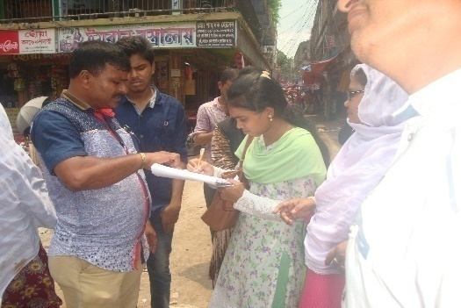The participatory public consultations were conducted in the subprojects areas. Key Informant Interviews (KII) and Group Discussion (GD) were conducted involving the participants of the Tangail, Pourashava Mayor, Councilors, Pourashava Officials, representatives of local Communities and civil society members as well as the representative of local LGED office and the consultant team.

A walk-through informal group consultation with the local communities was also held. Through this participation and consultation meeting, the local communities were informed about subprojects implementation and benefits. Suggestions and recommendations made by the participants are incorporated in the SMP accordingly. The photographs of the consultation meetings are seen.

Figure Community consultation at Battla bazar

**4.3 Consultation Outcomes – Issues, Concerns, and Recommendations**

The participants raised their issues related to subprojects improvement which are mainly drains. Feedback, suggestions and recommendations by the participants are listed below.

* Construction works should be scheduled properly and the quality of construction work should be maintained strictly;
* By engaging female labor force gender issues will be addressed
* Social safeguard compliance issues has been ensured through the inclusive participation of subprojects beneficiaries in subprojects implementation

**5.0 Social Management for Site Selection and Design**

**5.1 Subproject Selection Process**

MGSP in coordination with concerned Tangail Pourashava elected functionaries, local administration, relevant stakeholders, community members, road users and civil society members followed the participatory approach in different stages of subprojects selection following inclusion, consultation and participation methods. Female Ward Councilors participated actively in the selection process. Moreover, the representatives of TLCC and WC from the Pourashava have contributed in the subprojects selection process with an analysis of the inclusiveness of the selection process.

At the time of selecting these subprojects, Social Screening and Group Discussion (GD) with Tangail Pourashava urban communities, local administration, traders, buyers, and sellers were conducted by the Tangail Pourashava officials and Consultants from DSM. Views and opinions of these consultations were to explain the subproject objectives and sought feedback from the participants to maximize the social and economic benefits as well as to minimize the adverse impacts of the subprojects.

**5.2. Subproject Design Process**

After final selection of the subprojects, the DSM Consultant designed the proposed subprojects (Drains, Partly Portion of Footpath and streetlight) under Tangail Pourashava. The subproject will be constructed under the Pourshava’s own land. Despite the inclusion and participatory consultations, if any person has a grievance relating to the implementation of the subprojects, the Pourashava will mitigate it.

The Consultant interviewed stakeholders and beneficiaries of the subprojects areas before the design. The Consultant and Pourashava officials conducted a number of consultation meetings in the subprojects areas discussing the implementation procedures and mitigation measures, if any, required to be taken in implementing the proposed subproject.

**5.3 Grievance Redress Mechanism (GRM):** GRM has already been operationalzed for Tangail Pourashava. Accordingly, this Pourashava has formed Grievance Redress Committee (GRC) to handle any grievance raised due to implementation of the sub-projects. The committee will be headed by the Mayor of the Tangail Pourashava and consist of 7 members. The committee will answer to subproject-related queries and address complaints and grievances about any irregularities in application of the guidelines adopted for assessment and mitigation of social and environmental impacts. Based on consensus, the procedure will help to resolve issues/conflicts amicably and quickly without resorting to any expensive, time-consuming legal actions. It will ensure proper presentation of complaints and grievances as well as impartial hearings and transparent decisions.

Tangail Pourashava has already appointed Focal Point of GRC who is at the level of Assistant Engineer. The Mayor of the Tangail Pourashava is the Chairman of the GRC. This GRC at the Pourashava level is responsible to disclose the subprojects implementation before civil works start.

**Structure of the GRC Committee:**

|  |  |
| --- | --- |
| **Person** | **Status** |
| ULB Mayor | Convener |
| Representative of Local Administration | Member |
| Teacher from a Local Educational Institution | Member |
| Representative of a Local NGO | Member |
| Representative of Civil Society | Member |
| Female Ward Councilor | Member |
| Head of Engineering Section of ULB | Member Secretary |

**5.4 Implementation Arrangement:** DSM has initially completed social screening for the subprojects and there is no problem for implementing the subprojects regarding social safeguard issues. Accordingly, PMU, MGSP has issued the award letter against the subproject following all required procurement procedures. Tangail Pourashava has the responsibility to implement the subprojects timely in close coordination with the PMU of the project and also with the technical assistance of DSM. Engineering section of Pourashava and local representative of Consultancy team will ensure the quality construction work of the subprojects. In addition, Consultant team from Head Quarter DSM will ensure close monitoring of the implementation of the subproject components. In the implementation process, Social Safeguard Team will ensure monitoring of social safeguard management before civil works start. During construction, the communities will not be affected and the project will minimize the loss of communities. In addition, before civil works start, the Pourashava will make the video filmed and also social screening.

**6. Conclusions on Social Management Plan (SMP):**

PMU in the specific field site consultation with the elected functionaries of Tangail Pourashava has finally selected this subproject. Accordingly, DSM in consultation with Tangail Pourashava has conducted social screening and subsequently prepared the Social Management Plan (SMP) for subproject. Accordingly, the PMU plans to disclose the SMP particularly to inform vulnerable communities, likely affected persons and subprojects users in the subprojects locations on Social Safeguard Issues for their empowerment and ability to mitigate the complaints amicably and successfully. To protect their livelihoods, daily trading, income, dropout of education of their children, and other income generating activities, this Social Management Plan will be followed strictly and carefully for subproject.

**The SMP confirms that there is no need of LA and RAP. The ULB will ensure that the site is free of obstacles.**

**Annex -01 Mayor Letter on no obstruction**



** Annex-02**

**Local Government Engineering Department (LGED)**

**Municipal Governance and Services Project (MGSP)**

**Agaragaon, Dhaka-1207**

**SOCIAL SAFEGUARDS SCREENING OF SUBPROJECTS**

**REVIEW and EVALUATION**

**Social Screening Report**

**Package No**: MGSP/TAN/2016-17/W-06

**Name of Subproject:**

Improving Stand Road from Baby Stand to Tangail Mymensingh Road with RCC drain and Street Light

**Components:**

(a) Improvement and Widening of Stand road starting from Baby Stand to Tangail-Mymenshing road via Battala Bazaar by Bituminous Carpeting Ch. 0+000 to 2+500 m including 3 links ( Total length 3400 m.)

(b) Construction of RCC drain with footpath start from Baby stand to Tangail-Mymensing road via Battala Bazaar Ch. 0+000 to 2+500m including 3 links (Total length 3781 m.)

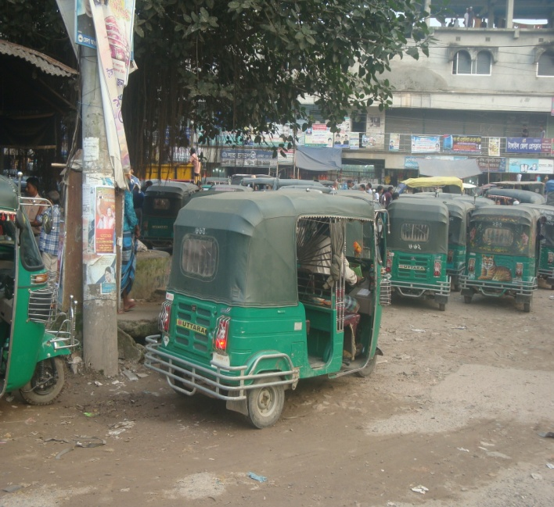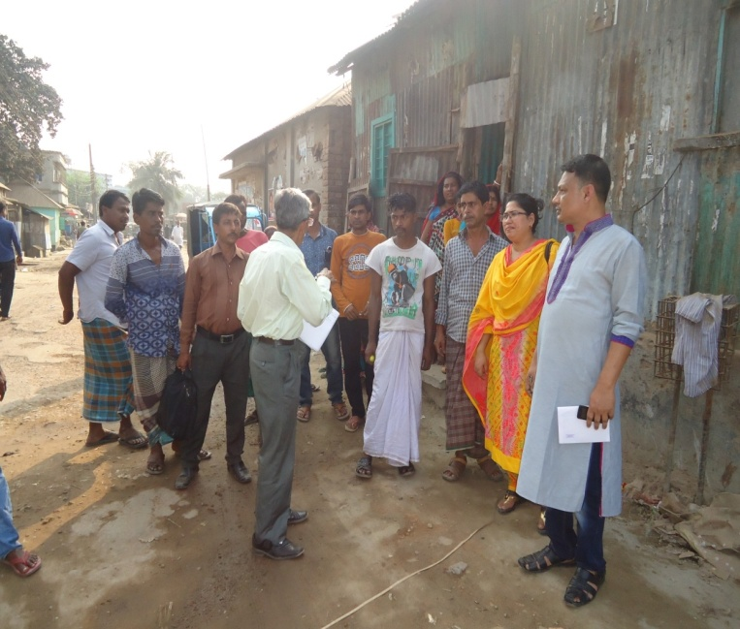(c) Supplying, fitting and fixing of Street Lights starting from Baby stand to Tangail-Mymensing road via Battala Bazaar Ch. 0+000 to 2+500 m including 3 links (Total length 3400 m.)

**February-2017**

**Tangail Pourashava.**

**Tangail.**

**FORM 1: SOCIAL SAFEGUARDS SCREENING OF SUBPROJECTS**

**REVIEW and EVALUATION**

**Description of subproject**:

a) Improvement and Widening of Stand road starting from Babystand road to Tangail-Mymensing road via Battala Bazaar by Bituminous Carpeting Ch. 0+000 to 2+500 m including 3 links (Total length 3400 m.)

b) Construction of RCC drain with footpath start from Baby stand to Tangail-Mymensing road via Battala Bazaar Ch. 0+000 to 2+500 m including 3 links (Total length 3781 m.)

c) Supplying, fitting and fixing of Street Lights starting from Baby stand to Tangail-Mymenshing road via Battala Bazaar Ch. 0+000 to 2+500 m including 3 links (Total length 3400 m.)

The subproject comprises improvement of stand road by widening with drain, footpath and street light. It will benefit both commercial and residential area.

During field visit for social screening, DSM social team found **15/20 obstacles** on the existing road. Presently available pavement width is 4.5 which will be increased to 6.0 to 7.5 m with drain. The obstacles are 15/20 tin-fences and bamboo poles of temporary shops at kandapara moar to college para moar and kutcha bazaar under subproject areas. The obstacles are on the pouroshava land and are their encroached. As per Pourashava Mayor & Councilors and shopkeepers statement all obstacles will remove willinginly and without compensation

Before finalizing design and starting implementation of the road, the concerned pourashava will have to do the remove of mentioned shops fences and poles in consultation with the PAPs.

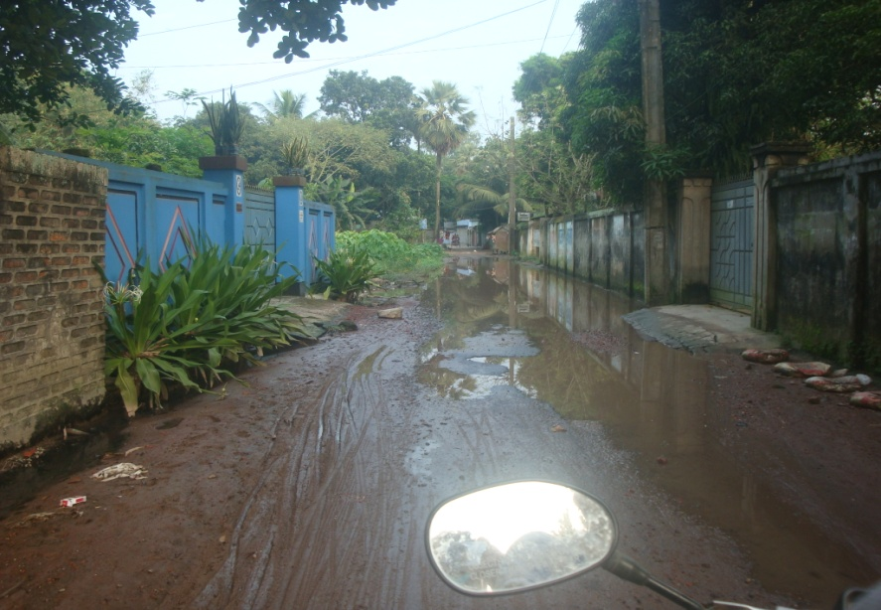The above mentioned project is very important but this is Damaged and undulation BC road with many pot holes. It is also a town by-pass road. At starting point it connects to Tangail-Nagarpur-Aricha road and ending point connects to Tangail-Mymenshing highway & New bus terminal. The western part of this road is Maulana Vasani Science & Technology University, Water supply office, Tangail Park Bazar, Tangail Stadium, Central Eidgah, Gymnasium, Vasani Hall (Town Hall), Weather office, Tangail Model Primary School and Louhajang River. At eastern part of this road Tangail main road, Sweeper colony, Brothel, Teacher’s Training College, Bindubashini Gov’t Boy’s High school, Land office, Sheikh Fazilatunnesa Women’s College, Press Club. North side of this road is District Head Quarter, Tangail Medical College Hospital, and Bus Terminal. But the existing width is not enough to fulfill the demand of desired traffic for Pouro citizen. For this purpose widening is necessary of this road.

There is no sufficient drainage service beside this road. For this this reason water logging is the main problem of this pourashava. Beside this proposed subproject street light are also insufficient. So the implementation of this sub-project is very important for Tangail Pourashava. If this road could be reconstructed it will serve as by-pass road of Tangail Pourashava. So a huge number of people and their agricultural and other products enter into Tangail Pourashava by using this road. After completion the mentioned project local people can move frequently towards towns, markets, hat bazaar, School & College. It is also bypass road for new bus terminal.

Figure Insufficient drains at college para moar

In this subproject, the total population of this densely populated area is 25,640 (Ref :BBS-2011) but expected beneficiaries is around 50,000 as per pourashava report and they will be benefited after construction of this road with drain, footpath & street light under wards no. 11, 6, 16 & 1 as well as dwellers/visitors of adjacent words of Tangail Pourashava.

Hence, this proposed construction of road with drain needs adopting necessary action as per design following World Bank policy certainly. It will improve the internal drainage system as well as remove water congestion of the area under this area resulting safe and secured pedestrian movement. This construction will bring better and sustainable living.

Under this subproject, there is a scope of pourashava to remove the obstacles in the following way:

* Pourashava will take into account for construction of the subproject in different locations within the pourashava’s land and in consultation meeting with the residential households at the locations it is found that no land acquisition is required. So there is no question of RAP preparation.
* Pourashava will take necessary actions to remove 22 nos. of trees and replace 61 nos. of polls (Elec. and T&T) to implement the subproject in negotiation with the concerned authorities.

**Date of Social Screening: 22.2.2017 ( 25/9/2017)**

**2. INTRODUCTION:**

This questionnaire is designed to facilitate the assessment of the current situation of social issues related subprojects in 22 Municipalities and 4 City Corporations under Municipal Governance and Services Project (MGSP). The information collected by this questionnaire will help to assess the initial social management needs quickly and ensure related subprojects are approved in the earliest possible time.

This screening will enable the best effective assessment of social matters and it has been completed as accurately as possible based on factual material.

**3. OBJECTIVES AND GOALS:**

The primary objective of this Social Screening is to improve accessibility in subproject areas and strengthen institutional capacity of the ULB for designing and implementing sustainable subprojects and ensure potential social safeguards compliance issues in addition to ensuring quality of construction. The social screening and SMP preparation takes into consideration of the World Bank OP 4.12, 4.11 and OP 4.10.

**4. STRATEGY OF SOCIAL SCREENING:**

The Social Screening is based on a collection of primary data and information while conducting field survey for the subproject. A well-structured questionnaire was already designed in the Social Management Framework and given to the field officials for obtaining necessary primary data relating to social issues in connection with losses of land and any kind of assets for the subproject implementation. Further information was obtained through field visits and interviews with relevant stakeholders to capture collective opinions and feedback by using “Group Discussion (GD)”and “Key Informant Interviews (KII)”.

**5. TEAM COMPOSITION:**

The Social Screening analysis based on the received documents on subproject related social safeguards aspects from the ULB was conducted by following members:

1. A.H.Md. Fazlul Kabir. SMO, Rangpur Zone DSM, MGSP, LGED.
2. Md. Abdul Quddus Khan, Sr. Municipal Engr, Rangpur Zone DSM, MGSP, LGED
3. Mr. Shibbir Ahamed Azmi (Zami) Asstt. Engr. Tangail Pourashava,
4. Mirza Arif Md.Golam Azam Executive Engineer Tangail Pourashva
5. Mr. Md. Abdul Matin, Asstt. Municipal Engineer, DSM, Tangail Pourashava, MGSP, LGED,
6. Mr. Md. Safikul Haque Shamim, Councilor, Ward no. 6, Tangail Pourashava,
7. Mrs. Hosne Ara Beauty, Councilor, Ward no. 16,17, 18, Tangail Pourashava
8. Tanvir asan Ferdouse Councilor , Ward no : 01 Tangail Pourashava

**6. METHODOLOGY OF SOCIAL SCREENING REPORT ON SUBPROJECT:**

Subproject screening was carried out as per Social Management Framework of MGSP prescribed social screening format by the concerned Social Management Officer and Senior Municipal Engineer with the direct assistance of officials of the Tangail Pourashava, followed by participatory consultation with the local people using Group Discussion including Hot Spot consultation with different categories of people who are aware about local situation and needs such as subproject users.

The Social Screening is based on a collection of primary data and information duly conducting field surveys. Well-structured questionnaires are already designed in the Social Management Framework of MGSP and have been supplied to the field officials for obtaining necessary primary data relating to social safeguard compliance issues such as losses of land, displacement of population, income, gender and vulnerability, tribal peoples, and loss of any kind of assets. The field visit reports on social screening were prepared by the Social Management Officer and the Social Management Specialist has reviewed the reports. We are concerned and ensured that anybody in the subproject area will not be adversely affected due to the implementation of the subproject.

Tangail Pourashava and Consultants have jointly ensured that consultations are held with urban communities, road users, elected public representatives, local administration, teachers, businessmen, NGOs, social workers, and civil society members.

**7. Subproject Interventions** will take necessary steps regarding implementation of the subprojects. It is confirmed that the subproject does not involve land acquisition and preparing RAP. After completion of the tender procedures, the PMU will authorize implementing physical works of the subproject.

**8. KEY FINDINGS**

**8.1 LAND REQUIREMENTS:**

Based on the Social Screening, there is no need of alignment change and no question of widening the road for the selected subproject.

**8.2 HOMESTEAD AND OTHER NON-LAND ASSETS:**

It is noticed that no land belongs to private citizens and no lease agreements with any government agencies will be required under this subproject. Social Screening results demonstrated that no private homesteads or business premises and buildings are expected to be relocated. However, boundary wall of five houses and tin-fence boundary of five more houses will be affected which will be removed willingly and without compensation by the PAPs.

**8.3 INCOME LOSS/ BUSINESS LOSS:**

It has been observed that no businesses or trading activities would be displaced permanently or from make-shift structures on the road. However, tin-roof and tin-fence of five shops need removal. The PAPs will remove the obstacles willingly moving the shop backward to own area from the ULB road and no compensation is needed for this.

The proposed subproject works are not expected to affect any community groups’ access to any resources that are used for livelihood purposes. None of the community facilities like schools, cemeteries, mosques, hospitals, temples, or other religious, cultural and historical properties are going to be affected.

**8.4 INDIGENOUS PEOPLE (IP), ADHIBASHI, and MARGINALIZED POPULATION:**

There is no Indigenous, Adhibashi and marginalized population that will be affected during subproject intervention and implementation. The survey team did not find any Indigenous, Adhibashi or marginalized population living in the subproject area.

**9. CONCLUSIONS AND RECOMMENDATIONS:**

The transportation system will have positive impact on employment, creation of better business environment, marketing of products and promoting education facilities. All these factors have incremental value on socio-economic aspects in general and social aspects in particular. During construction, DSM will ensure and follow the social management plan strictly. The proposed interventions are not expected to pose significant negative social impact.

It was found through the social screening that there are five, five boundary walls and five tin-fences and five temporary shops requiring removal from the road alignment to make it minimum 6.0m wide. Following inclusive participation and consultation meeting with the community people, all the 5 shop owners and other ten PAPs will move their shops and boundary wall/ fences from their existing places. The ULB with the assistance of DSM consultants will mitigate all these problems in implementing the subproject.

Therefore, implementations of the proposed subprojects are safely and highly recommended.

This report has been prepared following filled up questionnaire and checklist which follow.

**FORM1: SOCIAL SAFEGUARD SCREENING OF SUBPROJECTS**

**REVIEW and EVALUATION**

**Name of Subproject**:

(a) Improvement and Widening of Stand road starting from Babystand road to Tangail-Mymenshing road via Battala Bazaar by Bituminous Carpeting Ch. 0+000 to 2+500 m including 3 links ( Total length 3400 m.),

b) Construction of RCC drain with foothpath start from Babystand to Tangail-Mymensing road via Battala Bazaar Ch. 0+000 to 2+500m including 3 links ( Total length 3781 m.),

c) Supplying, fitting and fixing of Street Lights starting from Baby stand to Tangail-Mymensing road via Battala Bazaar Ch. 0+000 to 2+500 m including 3 links (total length 3400 m.)

Name of District: Tangail Name of ULB: Tangail Pourashava,

|  |  |  |
| --- | --- | --- |
| 1) Subproject requires land acquisition and/or population displacement that can be compensated for or resettled | [ ]Yes | [√] No |
| 2) Subproject affects mosques, temples, graveyards and cremation grounds, and other places/objects of religious, cultural and historical significance. | [ ] Yes | [√]No |
| 3) Subproject threatens cultural tradition and ways of life of tribal peoples; severely restrict their access to common property resources and livelihood activities. | [ ] Yes | [√] No |
| 4) Communities have objections on subproject interventions on social and environmental issues those cannot be resolved through design alternatives. | [ ] Yes | [√] No |
| **II. Resettlement Impacts** | | |
| In respect of the social impacts and community concerns, is there a need to,  Undertake an in-depth social impact assessment study? | [ ] Yes | [√ ] No |
| Prepare a Resettlement Action Plan? | [ ]Yes | [√]No |
| **III. Impacts on Tribal Peoples** | | |
| In respect of the social impacts on tribal peoples and their concerns, is there a need to, Undertake an in-depth impact assessment study? | [ ] Yes | [√] No |
| Prepare a Tribal Peoples Plan? | [ ]Yes | [√]No |

**On behalf of the DSM Consultant, the attached filled out format has been reviewed and evaluated by:**

**Decision on selection**: **[**√**] recommended for selection [ ] recommended for exclusion**

**Prepared by** ***:*** ***A.H.Md. Fazlul Kabir*** Designation: Social Management Officer, MGSP, LGED

Signature:  Date: 22.2.2017

**Reviewed by*: Dr. M. Maniruzzaman*** Designation: Social Management Specialist, MGSP, LGED



Signature:

Date: 25. 9. 2017

A social screening report will be prepared for each subproject covering methodology, participants’ analysis, community agreements & their concerns/suggestions, &summary of impacts and mitigation requirement.

**FORM 1: SCREENING FORM FOR SOCIAL SAFEGUARDS ISSUES**

1. **Identification :**
2. *Name of ULB:* Tangail Pourashava,  *District:* Tangail

*Ward/Mahalla: nos. 1,6,11 & 16*

*Name of subproject / spot screened:*

a) Improvement and Widening of Stand road starting from Babystand road to Tangail-Mymensing road via Battala Bazaar by Bituminous Carpeting Ch. 0+000 to 2+500 m including 3 links ( Total length 3400m.)

b) Construction of RCC drain with footpath start from Babystand to Tangail- Mymensing road via Battala Bazaar Ch. 0+000 to 2+500 m including 3 links ( Total length 3781 m.)

c) Supplying, fitting and fixing of Street Lights starting from Babystand to Tangail- Mymensing road via Battala Bazaar Ch. 0+000 to 2+500 m including 3 links ( Total length 3400 m.)

*Project component: Road, Drain, Footpath & Street light.*

**Brief description of the physical works**:

To introduce town by-pass road as better road net work and improve drainage system as well as to reduce road accident and to reduce water logging this subproject is going to be constructed of Tangail pourashava.

This widening of road with drain will be safe and secured by implementing the proposed work. After construction of this road, the socio economic condition of this area will be improved. Also it will remove environmental pollution, reduce travel time and cost. This improvement will bring better living and rapid sustainable economic development with disciplined urbanization expected.

**5. Screening Date(s): 22.2.2017(25/9/17)**

**B. Participation in Screening:**

**6. Names of Consultants’ representatives who screened the subproject:**

a. Md. Monzurul Islam, Pavement Design Eng. DSM, MGSP, LGED.

b. Md. Furkan Ahmed, Drainage Design Eng. DSM, MGSP, LGED.

c. A.H.Md. Fazlul Kabir, SMO, Rangpur Zone DSM, MGSP, LGED.

d. Md. Abdul Quddus Khan, Sr. Municipal Engr, Rangpur Zone DSM, MGSP, LGED

e. Mirza Arif Md. Golam Azam Executive Engineer Tangail Pourashava

f. Shibbir Ahamaed Azmi Assistant Engineer Tangal Pourashava

g. Mr. Md. Abdul Matin, Asstt. Municipal Engineer, DSM, Tangail Pourashava, MGSP, LGED

h. Mrs. Hosne Ara Beauty, Councilor, Ward no. 16,17, 18, Tangail Pourashava

I.) Tanvir asan Ferdouse Councilor, Ward no: 01 Tangail Pourashava

*8.WLCC members, NGOs, community groups/CBOs participated in screening: Yes, copy enclosed for information Would-be affected persons participated in screening: N/A*

**C. Land Requirements & Ownership:**

No.

|  |  |  |
| --- | --- | --- |
| *10. Will there be a need for additional lands to carry out the intended works under this contract?* | [ ]yes | [√ ] No |

*11. If ‘Yes’, what will the additional lands be used for? (Indicate all that apply): N/A*

[ ]road widening [ ] curve correction [ ] construction/expansion of physical structure

[ ] strengthening narrow eroding road section between high and low lands [ ] others (Mention):

*12. If ‘Yes’, the required lands presently belong to (Indicate all that apply): N/A*

[ ] ULB [ ] Government Land

[ ] Private Citizens [ ] Others (Mention):

**D. Current Land Use & Potential Impacts**

*13. If the required lands belong to Private Citizens, they are currently used for (Indicate all that apply):N/A*

[ ] Agriculture Number of households using the lands:

[ ] Residential purposes Number of households using them:

[ ] Commercial purposes Number of persons using them: Shops:

[ ] Other Uses (Mention): few **U**sers:

Land does not belong to private citizen.

*14. If the required lands belong to ULB and/or other Government agencies, they are currently used for (Indicate all that apply): N/A*

[ ] Agriculture Number of persons/households using the lands:

**[ ]** Residential purposes Number of households living on them:

**[ ]** Commercial purposes Number of persons using them: No. of shops:

**[ ] Other Uses (Mention):**

*15. How many of the present users have lease agreements with any government agencies? None*

*16. Number of private homesteads that would be affected on private lands: None*

*Entirely requiring relocation……………………. Partially but can still live on present homestead*

*17. Number of business premises/buildings that would be affected on private lands: None.*

Entirely and will require relocation: # Of businesses housed in them: **.**

Partially, but can still use the premises: # Of businesses housed in them:

*18. Residential households will be affected on ULB’s own and & public lands: None*

*Entirely affected* and will require relocation: No. of these structures:

No. of structures built with brick, RCC, & other expensive and durable materials:

No. of structures built with inexpensive salvageable materials (bamboo, GI sheets, etc:

*Partially affected*, but can still live on the present home stead: No of these structures: 10

No. of structures built with brick, RCC, & other expensive and durable materials:

No. of structures built with inexpensive salvageable materials (bamboo, GI sheets, etc): 10

*19. No. of business premises that would be affected on ULB’s own & other public lands: None*

*Entirely affected* and will require relocation: No. of these structures:

No. of businesses housed in these structures:

No. of persons presently employed in the above businesses.

No. of these structures built with brick, RCC, & other durable materials:

No. of structure built with inexpensive salvageable materials (bamboo, GI sheets, etc):

*Partially affected*, but can still stay in the present no. of these structures:

No. of businesses housed in these structures: 5

No. of persons presently employed in these businesses: 5

No. of these structures built with brick, RCC, & other durable materials:

No. of structure built with inexpensive salvageable materials (bamboo, GI sheets, etc): 5

*20. None of businesses/trading activities that would be displaced from make-shift structures on the road, and other areas/spots: None*

*21. Do the proposed subproject works affect any community groups’ access to any resources that are used for livelihood purposes? [ ] Yes [√] No*

*22. If ‘Yes’, description of the resources: N/A*

*23. Do the proposed works affect community facilities like school, cemetery, mosque, temple, or others that are of religious, cultural and historical significance? [ ] Yes [√ ] No.*

*24. If ‘Yes’, description of the facilities: N/A.*

*25. Describe any other impacts that have not been covered in this questionnaire? No.*

*26. Describe alternatives, if any, to avoid or minimize use of additional lands: N/A*

**E. ADDITIONAL INFORMATION ON TRIBAL PEOPLE**

(This section must be filled in if subprojects are located in areas that are also inhabited by tribal peoples)

*27. Names of tribal community members and organizations who participated in screening: N/A*

*28. Have the tribal community and the would-be affected TPs been made aware of the potential positive and negative impacts and consulted for their feedback and inputs?*

[ ] Yes [√] No

Has there been a broad-based community consensus on the proposed works?

[ ] Yes [√] No

*29. Total number of would-be affected tribal households: N/A****.***

*30. The would-be affected tribal households have the following forms of rights to the required lands: N/A*

[ ] Legal: No. of households:

[ ] Customary: No. of households:

[ ] Lease agreements with any GOB agencies: No. of households:

[ ] Others (Mention): No. of households:

*31. Does the subproject affect any objects that are of religious and cultural significance to the IPs?*

[ ] Yes [√] No

**G.32. If ‘Yes’, description of the objects:** N/A.

*33. The following are the three main economic activities of the would-be affected tribal households:*  a. N/A, b. N/A, c. N/A

*34. Social concerns expressed by tribal communities/organizations about the works proposed under the subproject: N/A*

*35. The tribal community and organizations perceive the social outcomes of the subproject: N/A*

**On behalf of the DSM Consultant, the attached filled out format has been reviewed and evaluated by:**

**Decision on selection [**√**] recommended for selection [] recommended for exclusion**

***Prepared by:***

***A.H.Md. Fazlul Kabir.*** Designation: Social Management Officer, MGSP, LGED



Signature: Date: 22.2.2017.

***Reviewed by:***

***Dr. M. Maniruzzaman***, Designation: Social Management Specialist, MGSP, LGED

Signature: Date: 25.9.2017

**Local participant’s attendance sheet (two pages)**



