**Local Government Division**

**Local Government Engineering Department**

**Municipal Governance and Services Project (MGSP)**

**IDA Credit No: 5339-BD**

**Report on Social Management Plan**

**Package No: MGSP/TAN/2016-17/W-07**

**Name of Subproject:**

a)Improvement and Widening of Dighulla Road starting from main road to Shakrail Bottola (councilor House) by Bituminous Carpeting. (Ch0.0+000to 2+010km) and link-1, stating from college para moar to H/O Adul Hossain length 425m (Total length 2276m including 2x3.5mx3.5 m box culvert (8 m length).

b)Construction of RCC drains with footpath in Dighulla Shakrail Road starting from main road to Shakrail Bitola Ch.0+000 to 2+010km,link-1: length 425 and link-2: length 350m.(Total length 2675m).

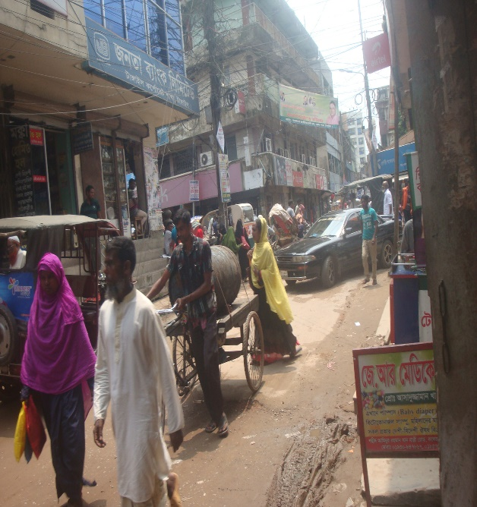c)Supplying ,fitting and fixing of Street lights of road starting from main road to Councilor House with link-1 & 2 (Total length 2435m)

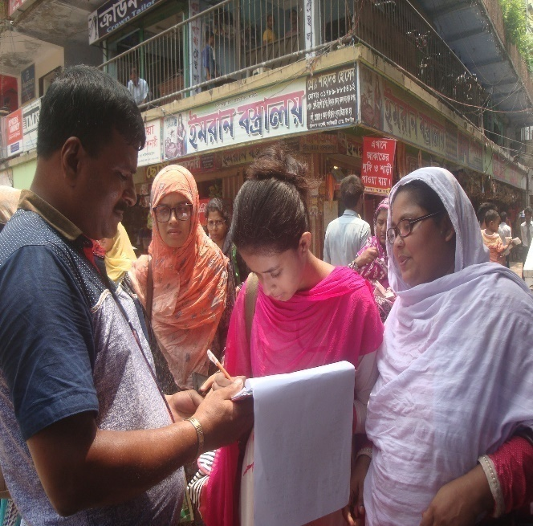

**Design, Supervision, and Management (DSM) Consultancy Services**



Joint Venture of *Hifab International AB, Sweden and*

* AQUA Consultant & Associates Ltd., Bangladesh*

**June 2017**

**Tangail Pourashava**

**TANGAIL**

**Table of content**

|  |  |  |
| --- | --- | --- |
| **No** | **Contents** | **Page. No** |
| 1. | Introduction | 3 |
| 1.1 | Project Background | 3 |
| 1.2 | Legal and Policy Framework | 3 |
| 1.3 | Subproject Description | 4 |
| 1.4 | Social Management Plan | 4 |
| 2. | Description of Subproject Area | 5 |
| 2.1 | Brief Profile of Tangail Pourashava | 5 |
| 2.2 | Historical and Cultural Heritage Sites | 11 |
| 2.3 | The Subproject Location and Area Profile | 12 |
| 2.4 | Beneficiary Communities and Affected Persons | 12 |
| 2.5 | Gender and Vulnerability | 12 |
| 3. | Social Impact Assessment | 13 |
| 3.1 | Benefits of the Subproject | 13 |
| 3.2 | Social Screening and Safeguard Compliance Issue | 13 |
| 4. | Consultation and Community Participation | 13 |
| 4.1 | Stakeholder Analysis | 13 |
| 4.2 | Consultation and Participation plan for subproject | 14 |
| 4.3 | Consultation Outcomes – Issues, Concerns and Recommendations | 14 |
| 5.0 | Social Management for Site Selection and Design | 14 |
| 5.1 | Subproject Selection Process”. | 14 |
| 5.2 | Subproject Design Process | 15 |
| 5.3 | Necessity of GRC | 15 |
| 5.4 | Implementation Arrangement | 16 |
| 6. | Conclusions on Social Management Plan (SMP) | 16 |
| Photograph /Figure | |  |
| 1. | Tangail Pourashava Bhaban | 5 |
| 2. | Package Location Map of Tangail Pourashava | 9-10 |
| 3. | Project layout package No: W-07 | 10-11 |
| 4 | Community consultation | 14 |
| 5 | Subproject Estimated cost | 4 |
| 6 | At a glance of Tangail Pourashava | 6-9 |
| ANNEXURE | |  |
| 1. | Agreement between PAPs & ULB | 16-19 |
| 2. | Social Screening Report. | 20-30 |

**Abbreviations**

|  |  |
| --- | --- |
| ARP | Abbreviated Resettlement Plan |
| BMDF | Bangladesh Municipal Development Fund |
| LAP | Land Acquisition Plan |
| CBO | Community Based Organization |
| CC | Cement Concrete |
| TAN | Tangail Pourashava |
| CIP | Capital Investment Plan |
| CUL | Compensation-Under-Law |
| DC | Deputy Commissioner |
| DLAC | District Land Acquisition Committee |
| DUTP | Dhaka Urban Transport Project |
| GoB | Government of Bangladesh |
| GRC | Grievance Redress Committee |
| GRM | Grievance Redress Mechanism |
| HCG | House Construction Grant |
| HTG | House Transfer Grant |
| IDA | International Development Association |
| IP | Indigenous People |
| IPP | Indigenous Peoples Plan |
| KII | Key Informants Interviews |
| FGD | Focus Group Discussion |
| LGD | Local Government Division |
| LGED | Local Government Engineering Department |
| M& S | Management &Supervision |
| MGSP | Municipal Governance and Services Project |
| MOLGRDC | Ministry of Local Government, Rural Development & Cooperatives |
| MSP | Municipal Services Project |
| MSL | Mean sea Level |
| NGO | Non-governmental Organization |
| PAH | Project Affected Household |
| PAP | Project Affected Person |
| PMU | Project Management Unit |
| RCC | Reinforced Concrete Cement |
| RP | Resettlement Pan |
| SIA | Social Impact Assessment |
| SMP | Social Management Plan |
| SSS | Social Safeguards Specialist |
| TLCC | Town Level Coordination Committee |
| ULB | Urban Local Body |
| WB | World Bank |
| WC | Ward Committee |

RAP Resettlement Action Plan

**1. INTRODUCTION**

**1.1Project Background**

The Government of Bangladesh, through the Local Government Engineering Department (LGED) and Bangladesh Municipal Development Fund (BMDF) is implementing the Municipal Governance and Services Project (MGSP). The project aims to improve municipal governance and basic urban services in participating ULBs. Two physical components of the project include (i) Municipal Governance and Basic Urban Services Improvement (Component 1) to provide financial support to 26 pre-identified urban local bodies (ULBs) including municipalities and city corporations, and demand-based sub-credits to eligible ULBs for basic urban services improvement investment costs. Total project cost is BDT 2, 470, 93.92 lakh to be financed at 80:20 IDA loan to GOB contribution. LGED is implementing the Component 1 while BMDF is implementing component 2 of the project.

LGED is supporting the 26 pre-selected ULBs for investments in development and rehabilitation of Road, Bridge, Box-culvert, Pedestrians bridge, street light, Traffic Control, Bus terminal, Truck terminal, Boat landing Jetty, Drain, Retaining wall, Kitchen market, Cattle market, slaughter house, Public toilet, Solid waste management, Sweeper colony, Park, Community Centre and Whole sale market. LGED is financing through (i) base allocation based on population category of ULBs; (ii) performance-based allocation and (iii) operations and maintenance support on a declining basis over the project period.

The component interventions have largely been developed for construction and rehabilitation within existing available land owned by the ULBs and acquisition of land has been avoided in the screening process. Removal of some obstruction and relocation of some businesses were involved in case of some sub projects for unavoidable circumstances. The MGSP did not avoid taking-up of sub projects in areas inhabited by tribal peoples and instead ensured their inclusion and participation where applicable. The ULBs addressed the removal of obstructions and in most cases the land entirely belongs to the ULB. In some instances, land of other GOB agencies like the BWDB, R&H or other local government like adjoining UP is needed and in such cases the ULB ensured getting such land by mutual understanding and proper documentation. Relocation of business and removal of obstructions were resolved by consultation and agreement with the concerned PAPs and these are properly documented. Thus land acquisition, population displacement and tribal people’s issues have been addressed following the country’s legal framework and the World Bank policy on social safeguards.

**1.2 Legal and Policy Framework**

Given the approach of subproject preparation and implementation, the World Bank’s Operational Policy (OP) on Involuntary Resettlement (OP 4.12) and on Indigenous Peoples (OP 4.10) triggered to the project. A Social Management Framework (SMF) has been adopted by LGED for the project that meets the requirements of the country’s legal frameworks in Bangladesh “The Acquisition and Requisition of Immovable Property, Ordinance, 1982” and the Bank requirements including OP 4.12 and OP 4.10. The SMF also requires that subprojects are prepared ensuring inclusion, participation, transparency, and social accountability. Subprojects are prepared by respective ULBs in a process complying with the SMF requirements. LGED reviews the subproject proposals for technical, engineering, environmental, social development, and safeguards compliance before allocation of the financing to the ULBs.

As a matter of policy, Social Management Plans (SMP) will be prepared and implemented for subprojects with no land acquisition or involuntary displacement of people, while Resettlement Action Plans (RAP) andTribal Peoples Development Plans (TPDP) will be prepared for implementation for subprojects involving population displacement and tribal peoples’ issues.

**1.3Brief Description of Subproject:**

1. Improvement and Widening of Dighulla Road starting from main road to Shakrail Bottola (councilor House) by Bituminous Carpeting. (Ch0.0+000to 2+010km) and link-1, stating from college para moar to H/O Adul Hossain length 425m( Total length 2276m including 2x3.5mx3.5 m box culvert (8 m length).
2. Construction of RCC drains with footpath in Dighulla Shakrail Road starting from main road to Shakrail Bottola Ch.0+000 to 2+010km,link-1: length 425 and link-2: length 350m.(Total length 2675m).
3. Supplying ,fitting and fixing of Street lights of road starting from main road to Councilor House with link-1 & 2 (Total length 2435m)

**The proposed subproject to be developed and estimated cost for the subproject is given below:**

|  |  |  |  |
| --- | --- | --- | --- |
| **Sl.No** | **Name of the Scheme** | **Length (m)** | **Estimated Cost (BDT)** |
| a | Improvement and Widening of Dighulla Road starting from main road to Shakrail (councilor House) Bottola by Bituminous Carpeting. (Ch0.0+000to 2+010km) and link-1, stating from college para moar to H/O Adul Hossain length 425m(2276m) | 2276 | 31,987,891.04 |
| b. | Construction of 2x3.5x3.5m box culvert on Dighulla Shakrail road at Ch.1+ 858m(length 8m ) | 8 | 2,578,575.65 |
| c | Construction of RCC drains with footpath from i Ch.0+000 to 2+010km at Dighulia Shakrail road starting from main road to Shakrail ( Total length 2675m) | 2675 | 62,968,779.56 |
| d | Supplying ,fitting and fixing of Street lights pole of Dighulia Shakrail road starting from main road to Shakrail Bottola (Total length 2435m) | 2435 | 4,685,181.83 |
|  | Total |  | 102,220,428.08 |

**1.4 Social Management Plan**

This Social Management Plan (SMP) has been prepared for the identification of subprojects and managing social concerns in the process of subprojects design and implementation. Initially, the subproject proposals include a social screening report along with impact assessment. After reviewing the social screening report by Social Unit of DSM, these subproject proposals are submitted to the PMU office. Social team of the DSM has carried out a site visit and consulted with the Tangail Pourashava officials, stakeholders and a section of the beneficiary communities through interview and participation & consultation meeting. The social screening findings and consultation method and proceedings were validated through the social survey and consultation.

The purpose of preparing this SMP is to demonstrate the all-inclusive consultative process in selection and design of the subproject as well as to provide guidance for social development and safeguards compliance in the implementation process.

The SMP contains a description of the subproject areas, social screening and impacts, consultation process adopted during identification and design, and consultation plan for implementation stage, impact mitigation measures, grievance resolution process, and implementation arrangements, and monitoring and evaluation.

Tangail Pourashava will ensure participation of the communities and grievance resolution in the process of implementation of the subprojects.

**2. Description of Subproject Area**

**2.1 Brief Profile of Tangail Pourashava**

Tangail Paurashava is located in the Tangail Sadar Upazila. It is located in the south-eastern part of Tangail Sadar Thana and has been developed by the side of Louhajanga River. Tangail Sadar Upazila is bounded by Kalihati Upazila on the north, Nagarpur and Delduar Upazilas on the south, Basail Upazila on the east, Belkuchi and Chauhali Upazilas on the west. The main rivers are Jamuna, Dhaleshwari, and Louhajang. On the globe, Tangail Paurashava lies on 24015’ north latitude and 89055’ east longitude and is 95 km away from the Dhaka City. Dhaka-Rajshahi and Dhaka-Jamalpur highways pass through the Paurashava and the river Louhajang, a distributory of the Jamuna flows through the town dividing it into two parts.

Paurashava was established on 1 July 1887 with an area of 31.99 sq. km. including 18 wards and 34 mouzas.

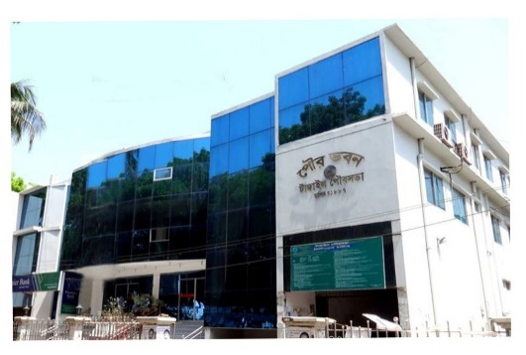The Paurashava was a part of former “Atia” porgana (revenue sub district of Munghal and British period). Present Tangail has been formed through silt deposit by the massive Jamuna River. A tribal community called gharo lives in this district but mainly in Madhupur Upazila, about 50 kms east of the pourasova. The Santosh Zamindar Bari and Karatia Zamindar Bari, house and grave of the people’s leader Maulana Abdul Hamid Khan Vasani and handloom industry of Bazitpur are a few of the remarkable Archaeological and cultural Heritages of Tangail.

Photograph: Pourashava Bhaban

Tangail Paurashava like most other towns of Bangladesh developed in an unplanned and haphazard way. Planned development is visible only in the government owned headquarters of the district. Therefore, providing service facilities is difficult in most part of the town.

The flow direction of Lohajong River is north to south. The river has strong flow during the monsoon and floods the town almost every year. In unusual high floods, one or two every ten to 20 years may flood the town with 0.5 to 1.0m deep water for a couple of weeks. But the river has created an opportunity to good drainage.

Population of Tangail paurashava as per 2011 Census is 167,412 and population density is 5,233 per sq km. At present, the most densely populated area is Ward No. 1 where improving roads and drain is difficult. In the periphery of the pourashava, there are still open spaces and agricultural area to accommodate increasing population. Present population growth

Rate of the town is 1.97%.The area considered for structure planning is larger than the town area prescribed through the official Gazette Notification of the government (about 32 sq.km as of 2011). The reason for the difference is the master plan of the paurashava desiring expansion of the town considering the recent trend and growth.

**Tangail Pourashava**

**At a Glance**

|  |  |  |  |  |
| --- | --- | --- | --- | --- |
| **General Information** | | | | |
| Area | : | | 31.99 Square K.M. | |
| Ward | : | | 18 | |
| Population  Population Growth Rate  Household No  Population Density  Major Status  Main Income Source : | : | | 16,74,12 (in 2011)  1.97%  26,740 (in 2011)  5,233 Person Per sq km (in 2011)  20% migrated people  Business 35.32%, Service 24.42%, others 40.26%. | |
| **Tax** | | | | | |
| Holding Tax | | : | | Tk.2,29,94,430/=(current Demand) | |
| **Market** | | | | |
| Pouro Market | : | | 14 | |
| Bazar | : | | 3 | |
| Shopping Complex | : | | - | |
| Own Shops | : | | 910 | |
| **License** | | | | |
| Trade License | : | | 5,780 no’s | |
| Rickshaw License | : | | 4,800 no’s | |
| Auto Rickshaw License |  | | 1,488 no’s | |
| **Communication** | | | | |
| Road | : | | 352.53 Km | |
| a) Bituminous | : | | 174.32 Km | |
| b) CC | : | | 43.17 Km | |
| c) RCC | : | | 10 Km | |
| d) Brick Flat Soling | : | | 13.76 Km | |
| e) Nonpaved Road | : | | 145.28 Km | |
| Culvert | : | | 63 | |
| Road intersection | : | | 36 | |
| Bridge | : | | 45 | |
| Footpath | : | | 322.82 Km | |
| **Water Supply** | | | | |
| Overhead Tank | : | | 3 | |
| Capacity | : | | 680,000 Liter(Per Number) | |
| Deep Tube well | : | | 9 | |
| Pipe Line | : | | 130 Km | |
| House Connection | : | | 10,000 | |
| Street Hydrant | : | | 21 | |
| Pump Station | : | | 21 | |
| Arsenic Status | : | | Within acceptable limit | |
| Pumping Hour | : | | 16 Hour, supply 6 hour | |
| **Street Lighting** | | | | |
| Electricity Line | : | | 309 Km | |
| Light Post | : | | 5,800 | |
| Tube Light Point | : | | - | |
| Energy Savings Light Point | : | | 5,800 | |
| Meter/ Switch Point | : | | 10 | |
| **Vehicle** | | | | |
| Garbage Truck | : | | 6 | |
| Tractor | : | | 1 | |
| Jeep | : | | 4 | |
| Motorcycle | : | | 4 | |
| Hydraulic Beam Lifter | : | | 2 | |
| Road Roller (4 ton – 6 ton) | : | | 4 | |
| Road Roller (8 ton – 10 ton) | : | | 5 | |
| **Drainage System** | | | | |
| Drain | : | | 195.41 Km | |
| a) RCC/ Brick Lined Drain | : | | 49.91.44 Km | |
| b) Earthen Drain | : | | 145.5 Km | |
| Canal | : | | 23.65 Km | |
| **Public Health** | | | | |
| Public Toilet | : | | 10 | |
| Sanitary Latrine | : | | 11,256 | |
| Dustbin | : | | 58 | |
| EPI Centre Permanent- | : | | 3 | |
| Temporary - | : | | 48 | |
| Hospital | : | | 1 | |
| Clinic (TB) | : | | 1 | |
| Maternity Clinic | : | | 1 | |
| Private Clinic | : | | 14 | |
| Diabetic Hospital | : | | 1 | |
| **UPPRP Project** | | | | |
| Community Centre | : | | 4 | |
| Total Urban Community | : | | 59 | |
| Total Community Family | : | | 10,000 | |
| Total Community Member | : | | 40,300 | |
| Total Community Deep-set | : | | - | |
| Total Sanitary Latrine | : | | 1,200 | |
| Total Road with Footpath | : | | 12 km | |
| Drain | : | | 7km | |
| **UPHSDP Project** | | | | |
| Nagar Matri Sadan | : | | 2 | |
| Nagar Health Centre | : | | 4 | |
| Satellite Clinic | : | | 2 | |
| Religious Institution | | | | |
| Mosque | : | | 135 | |
| Eidghah | : | | 7 | |
| Temple | : | | 56 | |
| Graveyard | : | | 8 | |
| Burning Ghat | : | | 2 | |
| Orphanage | : | | 2 | |
| **Law &Order** | | | | |
| Police Station | : | | 1 | |
| Police Fari | : | | 1 | |
| Judge court | : | | 1 | |
| **Education** | | | | |
| Public University | : | | 1 | |
| Govt .College | : | | 3 | |
| Private College | : | | 7 | |
| Public Medical College | : | | 1 | |
| Law College | : | | 1 | |
| Homoeopathic Medical College | : | | 1 | |
| Public Polytechnic Institute | : | | 1 | |
| Private Polytechnic Institute | : | | 4 | |
| Madrasah | : | | 53 | |
| Teachers Training College | : | | 1 | |
| Govt High School | : | | 4 | |
| Non-Govt High School | : | | 14 | |
| Govt Primary School | : | | 37 | |
| Kinder Garten School | : | | 39 | |
| **Recreation** | | | | |
| Cinema Hall | : | | 2 | |
| Stadium | : | | 1 | |
| Auditorium | : | | 1 | |
| Recreation Club | : | | 1 | |
| **Communication** | | | | |
| T & T Office | : | | 1 | |
| GPO | : | | 1 | |
| Post Office | : | | 7 | |
| **Beautiful Places** | | | | |
| 1. Poura Uddan. : 1 | | | | |
| 2. DC Lake. : 1 | | | | |
| 3. Santosh Jamidar Bari. | | | | |
| 4. Tangail Stadium. | | | | |

**Photograph**: 2 **Package Location Map of Tangail Pourashava.**

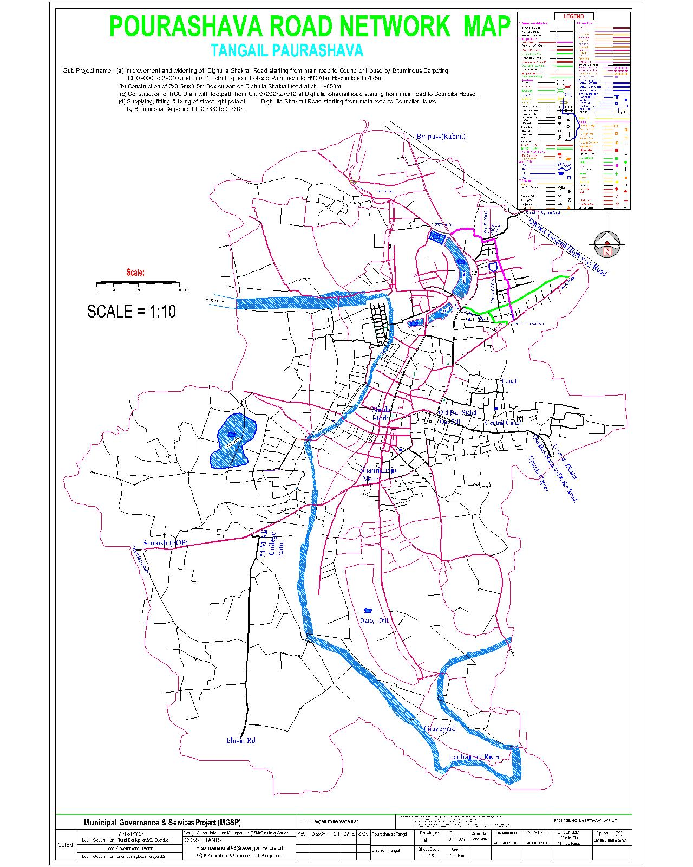

b) Photograph: 1. Project lay out plan Package W-7.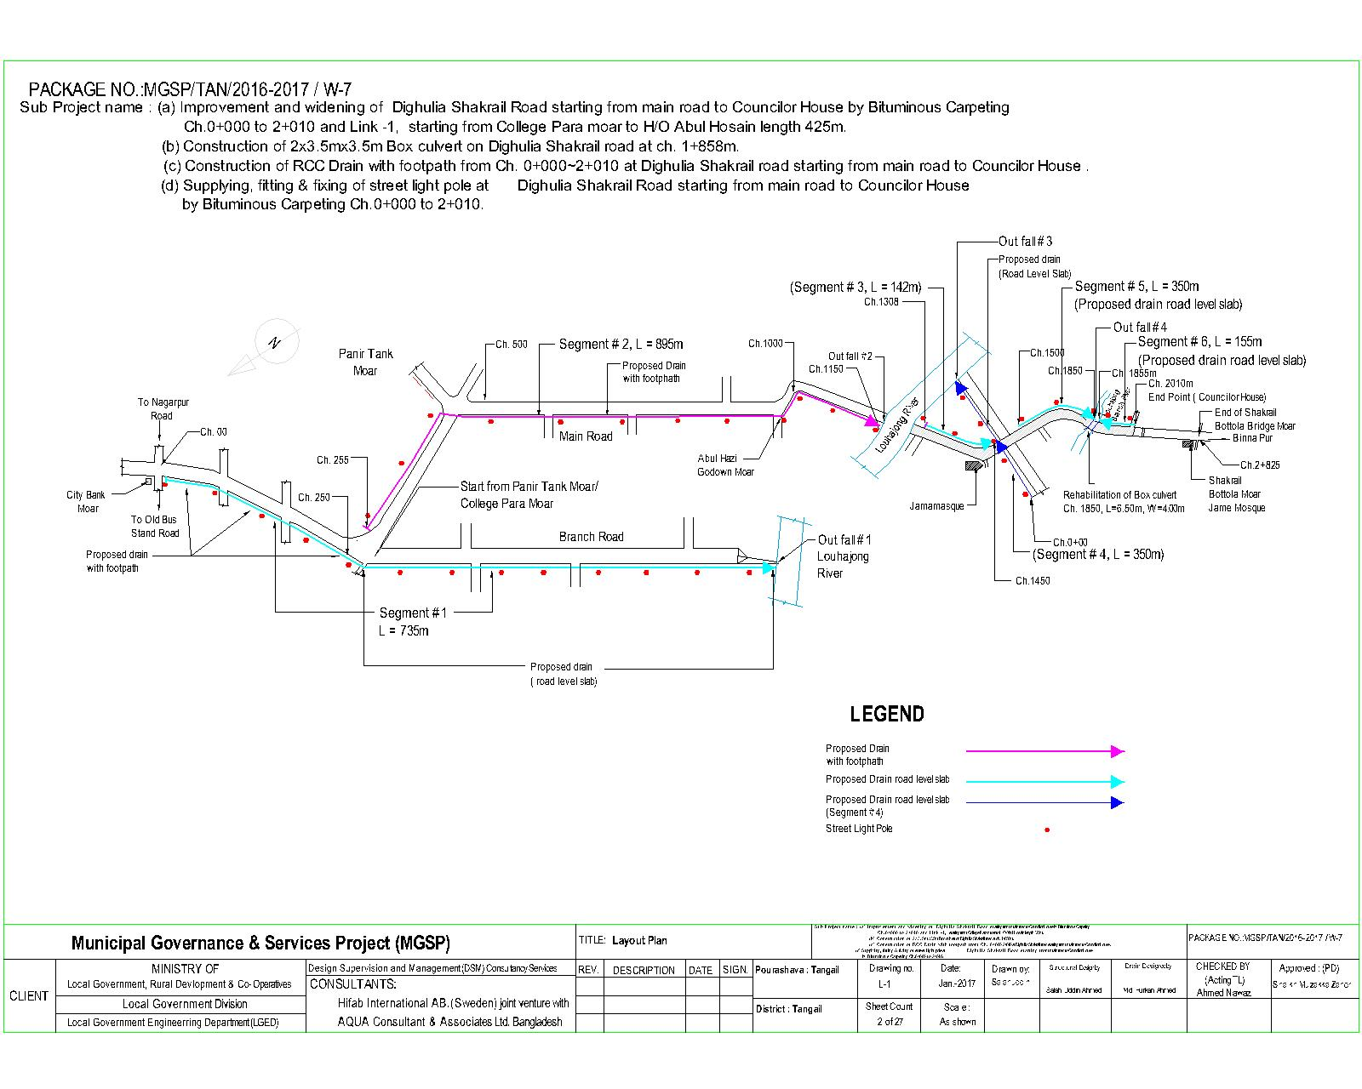

**2.2 Historical and Cultural Heritage Sites:**

Tangail town of Tangail Zila is situated about 100 km. north of Dhaka City and also about 100 km. west of Mymenshing Town where Louhajong River brings down water of Louhajang river into it. The Santosh Zamindar Bari and Karatia Zamindar Bari, house and grave of the great people’s leader Maulana Abdul Hamid Khan Vasani and the handloom industry of Bazitpur are a few of the many remarkable Archaeological and cultural Heritages of Tangail. The renowned Kumudini College is another remarkable establishment of the Paurashava that attracts students from nation-wide.

Recreational facilities like Cinema Hall, Stadium, Park, and Picnic spot, etc. are included in this category. One Park, one stadium and two cinema halls are the recreational facilities for the Paurashava inhabitants.

The components presented in the following table are the heritages of the Tangail Pouurashava. These establishments have been established during the past two centuries.

|  |
| --- |
| **Structure Name** |
| House and grave of great political leader of Moulana Abdul Hamid Khan Bhasani |
| Santosh Zamindar Bari |
| Karatia Zamindar Bari |
| Bazitpur loom industry |
| Kumudini College |

**2.3 The Subproject Location and Area Profile**

This identified subproject for improvement the road with drain and street light covers commercial &residential areas. During field visit for the social screening, the DSM team found 05 shops (extended front spaces) in ch 0 to 50m and from ch 0-425m linked part boundary walls of 18 houses and a Masjid kutubkhana and front part of a squatter house need to be rebuilt and shifted back. These obstructions will be removed by the concerned shopkeepers, house owners and mosque committee willingly and without compensation. Agreement will be signed between the PAPs and the ULB and this will be attached to the report (attached at Annex-1).

**2.4 Beneficiary Communities and Affected Persons**

The proposed road will develop traffic network and remove water logging. As a result people will be able to move easily during the rainy season. Local transports like rickshaw, rickshaw van, battery driven three wheeler auto and CNG driven baby taxi and diesel operated tractor trailers (Bhotbhoti) will move conveniently besides buses, cars, micro buses, pickup van and Lorries.

This part of the town is quickly growing residential cum commercial area. About 25,000 people will be benefited by the subproject infrastructure (widened road, drain and street light). They will use the road to meet the needs of job holders, students, children & women. People of three wards will (4, 5, parts of 6) mainly benefit from the sub project. In addition, people of other wards of the town and the adjoining Upazilas (Tangail Sadar, Deldowar, and Nagarpur) will use the road for easy connectivity to Tangail town.

The proposed road will improve connectivity with the main market to Tangail town and Chouhali Upazila (Opposite of Jumna River).

Due to implementation of this subproject, total no of 25,000 populations in the central part of the pourashava will be directly benefited. People who visit Tangail Pourashava and handloom industry will be immensely benefited, saving travel time and avoiding traffic congestion.

**2.5 Gender and Vulnerability**

Gender and vulnerability analysis have been considered in social impact assessment of subprojects. This has focused gender and vulnerability based on findings from specific queries during social screening and community consultation. The quantitative and qualitative analysis has brought out sex disaggregated data and issues related to discrimination by gender vulnerability, needs, constraints, and priorities as well as understanding whether there is a potential for inequitable risks, benefits and opportunities relating to gender and vulnerability. Based on the social analysis, specific interventions inclusion and participation encourages gender mainstreaming in the project cycle. Gender equity and empowerment will be ensured through encouraging participation of men and women equitably in the project cycle. The community participation and consultation also encourages gender mainstreaming in the subproject influence areas. After subprojects implementation, there are positive impacts for the vulnerable women; especially those who are small traders, landless, marginal farmers, etc. and can sell their household products. These subprojects will create job creation and livelihoods. In addition, it will also increase the mobility of drains users. Due to the fact, gender and vulnerability has been taken into account and ensures the gender equity in the subprojects implementation.

**3. Social Impact Assessment**

**3.1. Benefits of the Subproject**

After identification of subproject through CIP, PMU of the project with the assistance of DSM Consultants has completed social screening and socio-economic impact assessment for the road, drain, footpath and streetlight of Tangail Pourashava. This subproject is used for both inter-town and intra-town movement. It will improve traffic network and drainage system as well as to reduce road accident and to reduce water logging. From the point of view of social benefits it will enhance commercial/economic activities, direct/indirect employment opportunity and poverty reduction. Also, it will improve access to health service, educational institutions and handloom market. For improved transport network, property value of adjoining area will increase substantially, rent will increase and this will eventually contribute to increased revenue earning for the pourashava.

**3.2. Social Screening and Safeguard Compliance Issue**

After selection of these subprojects, the Pourashava with the assistance of DSM Consultants has completed a social screening for the subprojects using an inclusive and participatory approach.

Tangail Pourashava has ensured designing of the subproject following socially inclusive and gender friendly methods. According to engineering design, implementation of these subprojects will be carried out within the existing right-of-way.

Results from the social screening are given below.

* No additional public or private lands will be required for the subprojects outside the existing right of way.
* The sub project will not affect access to common property resources for any community. It will also have any negative impact on cultural property of any kind.
* Preparation of RAP will not be required for implementing the subprojects as no LA is involved.
* Agricultural or industrial productivity will not be hampered by the proposed subproject areas.
* Handloom industry in particular will flourish further.

The outcomes of social screening also confirmed that local people across the subprojects are positive about its implementation.

**4. Consultation and Community Participation**

**4.1. Stakeholder Analysis**

According to BBS, Population Census, 2011 total population of Tangail Pourashava was 167,412 among which 84,741 are male and 82,671 are female. People of both paurashava area and adjoining rural area will be directly benefited by the improvement of road, drain, footpath and street light.

As a part of overall assessment, the project identified the key stakeholders of the proposed subproject areas and assessed the power relationships as well as influence and interests of various stakeholder groups involved in the subprojects. Key stakeholders for subprojects under MGSP were identified in consultation with the mayor, councilors and pourashava officials, district administration, civil society and local people of the town, representative of business associations and local contractors etc. Suggestions and directions of all local stakeholders were noted and reflected in the SMP while designing the subproject interventions.

**4.2. Consultation and Participation Plan for the subproject**

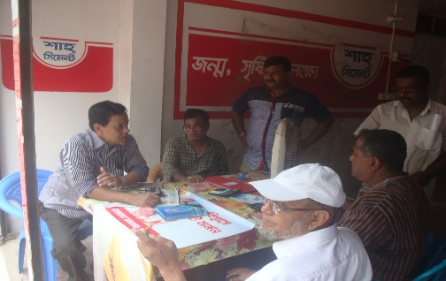A series of participatory public consultations were conducted in the subprojects area. Key Informant Interviews (KII) and Group Discussion (GD) were also conducted involving the participants of the Tangail, Pourashava Mayor, Councilors, Pourashava Officials, representatives of local Communities and civil society members as well as the representative of local LGED office and the consultant team.

A walk-through informal group consultation with the local communities was also held. Through the participation and consultation meeting, local communities were informed about subprojects implementation, the SMF, draft SMP and screening report and probable benefits of the project were discussed with them. Suggestions and recommendations made by the participants are incorporated in the SMP accordingly. The photographs of the consultation meetings are seen.

Photograph 4 community consultations at college moar.

**4.3. Consultation Outcomes – Issues, Concerns, and Recommendations**

The participants raised their issues related to subprojects improvement which are mainly drains. Feedback, suggestions and recommendations by the participants are listed below.

* Construction works should be scheduled properly and the quality of construction work should be maintained strictly;
* By engaging female labor force gender issues has been partially addressed
* Social safeguard compliance issues has been ensured through the inclusive participation of subprojects beneficiaries in subprojects implementation

**5.0 Social Management for Site Selection and Design**

**5.1 Subproject Selection Process**

MGSP in coordination with concerned Tangail Pourashava elected functionaries, local administration, relevant stakeholders, community members, road users and civil society members followed the participatory approach in different stages of subprojects selection following inclusion, consultation and participation methods. Female Ward Councilors participated actively in the selection process. Moreover, the representatives of TLCC and WC from the Pourashava have contributed in the subprojects selection process with an analysis of the inclusiveness of the selection process.

At the time of selecting these subprojects, Social Screening and Group Discussion (GD) with Tangail Pourashava urban communities, local administration, traders, buyers, and sellers were conducted by the Tangail Pourashava officials and Consultants from DSM. Views and opinions of these consultations were to explain the subproject objectives and sought feedback from the participants to maximize the social and economic benefits as well as to minimize the adverse impacts of the subprojects.

**5.2. Subproject Design Process**

After final selection of the subprojects, the DSM Consultant designed the proposed subprojects (Drains, Partly Portion of Footpath and streetlight) under Tangail Pourashava. These subprojects constructed under the Pourshava’s own land. Despite the inclusion and participatory consultations, if any person has a grievance relating to the implementation of the subprojects, the Pourashava has mitigated it.

The Consultant interviewed stakeholders and beneficiaries of the subprojects areas before the design. The Consultant and Pourashava officials conducted a number of consultation meetings in the subprojects areas discussing the implementation procedures and mitigation measures, if any, required to be taken in implementing the proposed subproject.

**5.3 Grievance Redress Mechanism (GRM):** GRM has already been operationalzed for Tangail Pourashava. Accordingly, this Pourashava has formed Grievance Redress Committee (GRC) to handle any grievance raised due to implementation of the sub-projects. The committee will be headed by the Mayor of the Tangail Pourashava and consist of 7 members. The committee will answer to subproject-related queries and address complaints and grievances about any irregularities in application of the guidelines adopted for assessment and mitigation of social and environmental impacts. Based on consensus, the procedure will help to resolve issues/conflicts amicably and quickly without resorting to any expensive, time-consuming legal actions. It will ensure proper presentation of complaints and grievances as well as impartial hearings and transparent decisions.

Tangail Pourashava has already appointed Focal Point of GRC who is at the level of Assistant Engineer. The Mayor of the Tangail Pourashava is the Chairman of the GRC. This GRC at the Pourashava level is responsible to disclose the subprojects implementation before civil works start.

**Structure of the GRC Committee:**

|  |  |
| --- | --- |
| **Person** | **Status** |
| ULB Mayor | Convener |
| Representative of Local Administration | Member |
| Teacher from a Local Educational Institution | Member |
| Representative of a Local NGO | Member |
| Representative of Civil Society | Member |
| Female Ward Councilor | Member |
| Head of Engineering Section of ULB | Member Secretary |

**5.4 Implementation Arrangement:** DSM has initially completed social screening for the subprojects and there is no problem for implementing the subprojects regarding social safeguard issues. Accordingly, PMU, MGSP has issued the award letter against the subproject following all required procurement procedures. Tangail Pourashava has the responsibility to implement the subprojects timely in close coordination with the PMU of the project and also with the technical assistance of DSM. Engineering section of Pourashava and local representative of Consultancy team will ensure the quality construction work of the subprojects. In addition, Consultant team from Head Quarter DSM will ensure close monitoring of the implementation of the subproject components. In the implementation process, Social Safeguard Team will ensure monitoring of social safeguard management before civil works start. During construction, the communities will not be affected and the project will minimize the loss of communities. In addition, before civil works start, the Pourashava will make the video filmed and also social screening.

**6. Conclusions on Social Management Plan (SMP):**

The subproject interventions- improved road, footpath, drain and streetlight will enhance commercial/economic activities, direct/indirect employment opportunity and poverty reduction. Also, it will improve access to health service, educational institutions and handloom market. For improved transport network, property value of adjoining area will increase substantially, rent will increase and this will eventually contribute to increased revenue earning for the pourashava. The drains will reduce water-logging and increase stability of the road and contribute to reduced maintenance cost. The streetlight and footpath will contribute to safe movement of pedestrians as well as of vehicles.

Implementation of the subproject involves removal of boundary walls of **18 encroacher** private houses, one boundary of kutubkhana of mosque and a tin-roof squatter house. Also, there is needed to break front stair steps of five shops who are also encroachers. The PAPs have signed agreement with the ULB to vacate ULB land voluntarily without any compensation. However, the ULB will help financially to move the squatter house a bit back in the same plot belonging to the ULB. These will not require any funding from the MGSP.

In view of above, the Tangail Pourashava has finally selected this subproject to implement and to strictly follow the SMP.

**Annex-1. Agreement between PAPS & ULB (Three pages)**

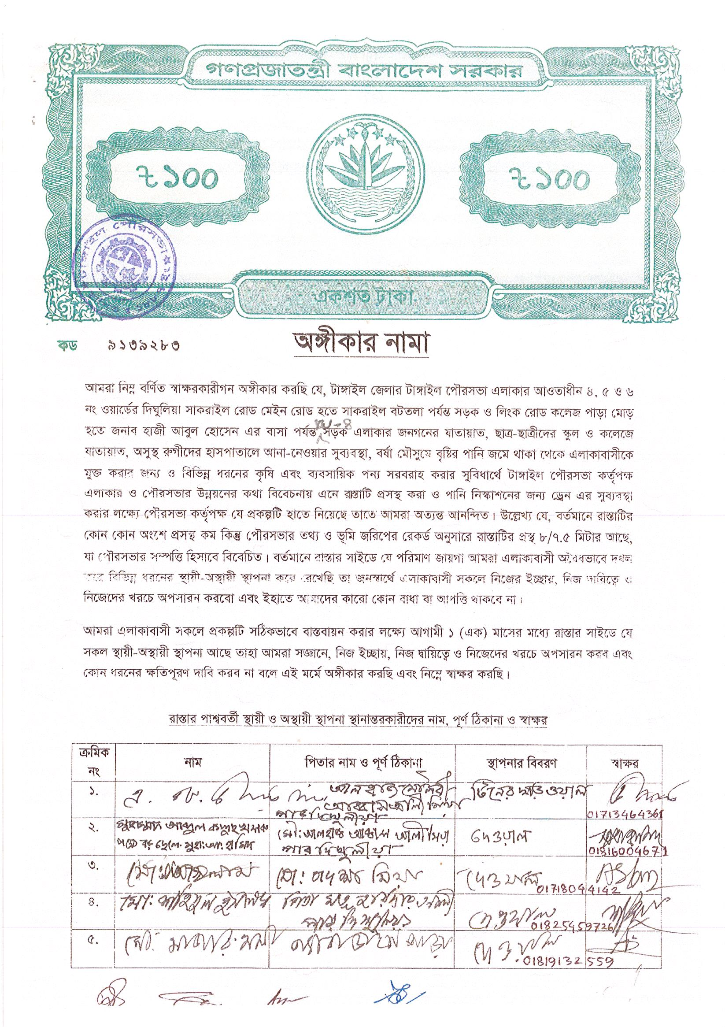

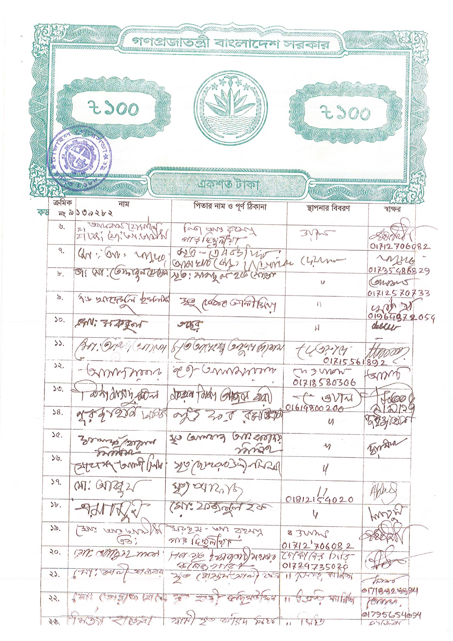

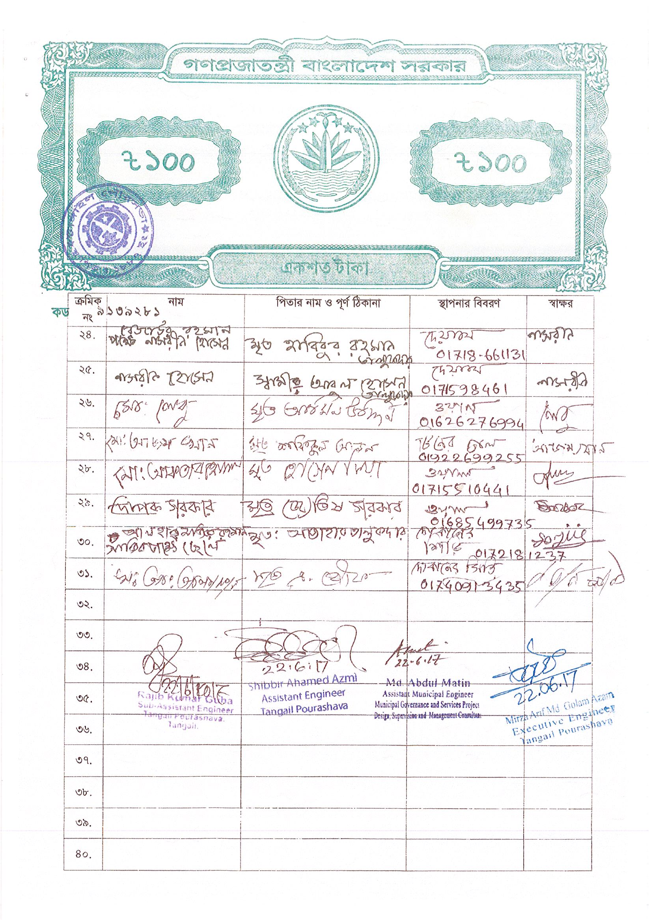



**Annex-2**

**Local Government Engineering Department (LGED)**

**Municipal Governance and Services Project (MGSP)**

**Agaragaon, Dhaka-1207**

**SOCIAL SAFEGUARDS SCREENING OF SUBPROJECTS**

**REVIEW and EVALUATION**

**Social Screening Report**

**Package No**: MGSP/TAN/2016-17/W-07

**Name of Subproject:** Improvement of DighuliaShakrail Road with RCC drain, footpath and street light

(a) Improvement and Widening of DighuliaShakrailRoad starting from main road to Councilor House by Bituminous Carpeting (Ch. 0+000 to 2+010km ) and link–1, starting from College Para moar to H/O Abul Hossain length425m.

(b) Construction of RCC Drains in Dighulia Shakrail Road Ch. 0+000 to 2+010km link-1: length425m and Link-2: Length 350m.

(c)Supplying, fitting and fixing of Street lights of road starting from main road to Councilor House with link-1 & 2 (Total length 2785 m).

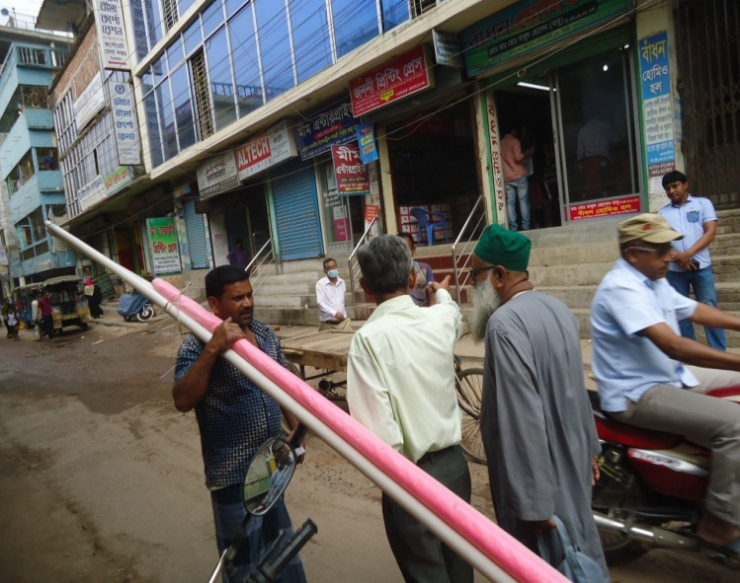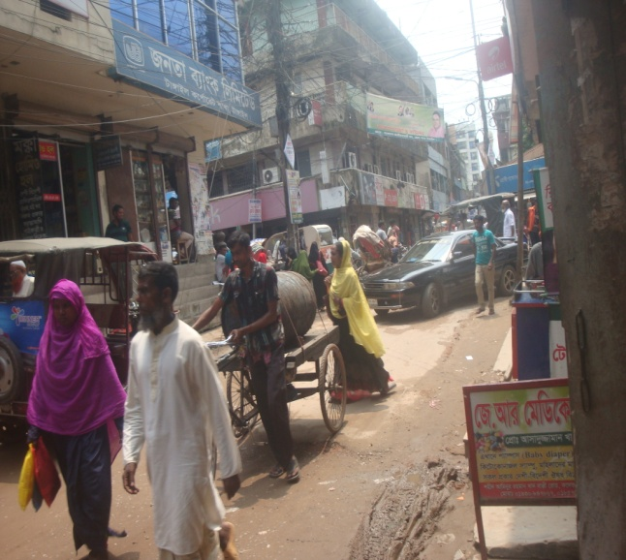

***June -2017***

***Tangail Pourashava.***

***Tangail***

**FORM 1: SOCIAL SAFEGUARDS SCREENING OF SUBPROJECTS**

**REVIEW and EVALUATION**

**1. Description of subproject**:

**Name of Subproject:**

(a) Improvement and Widening of DighuliaShakrail Road starting from main road to Councilor House by Bituminous Carpeting (Ch. 0+000 to 2+010km ) and link–1, starting from College Para moar to H/O Abul Hossain length 425m.

(b) Construction of RCC Drains and footpath in DighuliaShakrail Road Ch. 0+000 to 2+010km link-1: length 425m. and Link-2: Length 350m.

(c) Supplying, fitting and fixing of Street lights of road starting from main road to Councilor House with link-1 & 2 (Total length 2785 m).

The subproject comprising three schemes but located in the same area aims improvement and widening of Dighulia-Shakrail road with drain, footpath and street lights. It will benefit both commercial and residential areas.It connects the main road starting at Amghat Road crossing where a branch of Janata Bankis located and at its ending point there is a culvert on the right side of the proposed road.

During social screening and site visits following obstacles were found, all on pourashva land:

1. Front side of five markets from chainage 0 to 50 m on both sides. Four of them are two storied and buildings and the last one is a one storied building. The five markets are pucca shopping centers belonging to five owners. One of the four two storied buildings has a branch of Janata Bank. The owners agreed in to remove the obstacles willingly and without compensation.
2. Five houses are located in chainage 895 to 1150.m. Two houses are pucca and other three are semi-pucca. Front boundary walls of five houses need to be demolished and rebuilt. The owners agreed to remove the obstacles willingly and without compensation.
3. In link-1 from ch 0 to 425m boundary wall 20 houses need to demolished and rebuilt. One of the 20 PAPs is a squatter who built a tin fenced house on the pourashava road. The squatter agreed to rebuild the house moving it back in the vacant land of pourashava willingly and without compensation. Other 19 are encroachers and have agreed to move back the wall at own cost, willingly and without compensation.

It was also noted that a 51 m bridge under implementation by the Improvement of Urban Infrastructure Development Project (IUIDP) remains incomplete and progress as of August 12, 2017 was 40% although completion date expired in Feb 2017. Presently rickshaws pass using a narrow bamboo bridge.

Present population of the benefited area is 17,463 (BBS-2011) and yearly growth rate is 3.27. But expected number of beneficiaries is around 50,000 as per pourashava report and they will be benefited after construction of this road with drain, & street lights. The benefited areas are under wards no. 4, 5 & 6, as well as dwellers/visitors of adjacent words and surrounding areas of Tangail Pourashava.

The mentioned subproject is very important but this road is Damaged and undulated BC road. At starting point it is connected to Tangail-Nagarpur-Aricha (Main road) road and its ending point is Shakrail main road. Both sides of this road are residential and commercial areas. The western part of this road is Shakrail Bazaar, Dainna-Baghil-Hugra Union Perished. At eastern part of this road is Tangail main road.

There is no proper drainage system beside this road. For this reason water logging is the main problem of this pourashava. Beside this, Street Lights are also insufficient. So the implementation of this sub-project is very important for Tangail pourashava. A huge number of people and their agricultural products enter into Tangail Pourashava by using this road. After completion the mention project local people can move frequently towards towns, markets, hat bazaar, School & College etc.

The sub project will improve road condition, drainage system and remove water congestion of the area. The provision of street light will improve road safety for the passengers and vehicular traffic. This will improve safe movement of children and women in particular after sunset.

Under this subproject, there is a scope of pourashava to remove the obstacles in the following way:

* Pourashava will take into account for construction of the subproject in different locations within the Pourashava land and in consultation meeting with the residential households at the locations it is found that no land acquisition is required. So there is no need of RAP. The PAPs who are encroachers will vacate the Pourashava land voluntarily without compensation while there is just one squatter house which will be moved backward in the same location with assistance of the ULB but without spending MGSP fund. So, there is no need of preparing SIMP.
* Shifting of about 75 electric and T&T poles will be needed.

**Date of Social Screening: 14.06.2017**

**2. INTRODUCTION:**

The MGSP designed a structured questionnaire to facilitate the assessment of the current situation and social issues related to implementation of subprojects in 22 Municipalities and 4 City Corporations. The information collected by this questionnaire will help to assess the initial social management needs quickly and ensure that the concerned subprojects are approved in the earliest possible time.

This screening will enable best effective assessment of social matters in TANGAIL and it has been completed as accurately as possible based on factual information.

**3. OBJECTIVES AND GOALS:**

The primary objective of this Social Screening is to check that relevant social issues are properly identified and remedial measures indicated so that sub projects involving unmanageable social risks are screened, hence the PMU can decide which ones to include or exclude which ones should have further documents prepared like SIMP or RAP.

**4. STRATEGY OF SOCIAL SCREENING:**

The Social Screening is based on a collection of primary data and information while conducting field survey for the subproject. A well-structured questionnaire was already designed in the Social Management Framework and given to the field officials for obtaining necessary primary data relating to social issues in connection with losses of land and any kind of assets for the subproject implementation. Further information was obtained through field visits and interviews with relevant stakeholders to capture collective opinions and feedback by using Group Discussion (GD) and Key Informant Interviews (KII).

**5. TEAM COMPOSITION:**

The Social Screening analysis is based on the documents received from the UL Bon subproject related to social safeguards aspects. It was conducted by following members:

1. Md. A. B. Siddique, SMO, Rangpur Zone DSM, MGSP, LGED.
2. Mr. Mirza Arif MdGolam Azam, Executive Engineer, TangailPourashava
3. Mr. Shibbir Ahamed Azmi (Zami) Assistant Engineer .TangailPourashava,
4. Mr. Md. Abdul Matin, Assistant. Municipal Engineer, DSM, TangailPourashava, MGSP, LGED,
5. Mr. Rajib Kumar Guha, SAE, Tangail Pourashava

**6. METHODOLOGY OF SOCIAL SCREENING REPORT ON SUBPROJECT:**

Subproject screening was carried out as per Social Management Framework of MGSP prescribed social screening format by the concerned Social Management Officer and Senior Municipal Engineer with the direct assistance of officials of the Tangail Pourashava,following a participatory consultation process. It applied tools like Group Discussion, Hot Spot consultation and KII with different categories of people who are aware about local situation and needs such as subproject users.

The Social Screening is based on a collection of primary data and information duly conducted by field surveys. Structured questionnaires were already designed in the Social Management Framework of MGSP and have been supplied to the field officials for obtaining necessary primary data relating to social issues in connection with social safeguard compliance. The issues included losses of land, displacement of population, income, gender and vulnerability, tribal peoples, access to common property resources by tribal/ vulnerable communities. The field visit reports on social screening were prepared by the Social Management Officer and the Social Management Specialist has reviewed the reports. We are concerned and have ensured that anybody in the subproject area requiring physical or economic relocation is consulted and facilitated to make informed decision either agreeing or disagreeing to vacate or to reach negotiated settlement to move willingly with or without compensation.

TangailPourashava elected representatives, pourashava engineers and DSM consultants have jointly ensured that effective consultation was carried out with concerned peoples including those from vulnerable communities/ weaker segments. Consultations were held with urban communities, infrastructure users, elected public representatives, local administration, teachers, businessmen, NGOs, social workers, and civil society organizations etc.

**7. Subproject Interventions:** The sub project will take necessary steps regarding implementation of the subproject. Based on design, the ULB and the DSM will identify PAPs, make their inventory and will produce documentation of agreements on negotiated settlement using legal stamps, where necessary. It is confirmed that RAP will not be required as land acquisition and physical relocation are not involved.

**8. KEY FINDINGS**

**8.1 LAND REQUIREMENTS:**

Based on the Social Screening, there is no need of alignment change and there is no need for LA. Available right of way belonging to the ULB as seen on the mauza map is wide enough to accommodate all proposed interventions.

**8.2 HOMESTEAD AND OTHER NON-LAND ASSETS:**

It is noticed that no land belongs to private citizens and noULB or khas land used for sub project have any legal leaseholders.

**8.3 INCOME LOSS/ BUSINESS LOSS:**

It has been observed that no businesses or trading activities would be displaced from make-shift structures on the road and drain etc. The proposed subproject works are not expected to affect any community groups’ access to any resources that are used for livelihood purposes. None of the community facilities like schools, cemeteries, mosques, hospitals, temples, or other religious, cultural and historical properties are going to be affected. However, five markets (about 15 shops owned by five owners), 18 boundary wall of private houses/mosque encroached to the Pourashva land and one squatter house need a few feet backward shift to own land or in one case Pourashva vacant land of the 18 boundary walls, one wall belongs to a mosque affecting its kutubkhana. The ULB will deal this issue by negotiated settlement.

**8.4 INDIGENOUS PEOPLE (IP), ADHIBASHI, and MARGINALIZED POPULATION:**

There is no Indigenous, Adhibashiand marginalized population that will be affected during subproject intervention and implementation. The survey team did not find any Indigenous, Adhibashior marginalized population in the sub project area.

**9. CONCLUSIONS AND RECOMMENDATIONS:**

The sub project will have tremendous impact on the improvement of the transportation system. For the sub project area, the road will connect Dhaka Aricha highway and Chouhali of Sirajganj district to Tangail town by a shorter link. This will have positive impact on employment, creation of better business environment, marketing of products and promoting education facilities. This will have important contribution to improved drainage system of the town, will provide safe movement facility for lighting and will benefit about 50,000 people. All these factors have incremental value on socio-economic aspects in general and social aspects in particular. Therefore, implementations of the proposed subprojects are safely and highly recommended.

It was found through the social screening that about markets and boundary wall of houses a mosque will need moving back. The PAPs have agreed to remove obstacles willingly and without compensation. There is no need of RAP and SIMP. The ULB will provide documentation of agreement with the PAPs.

This report has been prepared following filled up questionnaire and checklist which follow.

**FORM: 1 SOCIAL SAFEGUARD SCREENING OF SUBPROJECTS**

**REVIEW and EVALUATION**

**Name of Subproject:**

(a) Improvement and Widening of DighuliaShakrail Road starting from main road to Councilor House by Bituminous Carpeting (Ch. 0+000 to 2+010km ) and link–1, starting from College Para moar to H/O Abul Hossain length 425m.

(b) Construction of RCC Drains in Dighulia Shakrail Road Ch. 0+000 to 2+010km link-1: length 425m. and Link-2: Length 350m.

(c) Supplying, fitting and fixing of Street lights of road starting from main road to Councilor House with link-1 & 2 (Total length 2785 m).

Name of District: Tangail Name of ULB: Tangail Pourashava,

|  |  |  |
| --- | --- | --- |
| 1) Subproject requires land acquisition and/or population displacement that need to be compensated for or resettled | [ ]Yes | [√] No |
| 2) Subproject affects mosques, temples, graveyards and cremation grounds, and other places/objects of religious, cultural and historical significance. | [ ] Yes | [√]No |
| 3) Subproject threatens cultural tradition and ways of life of tribal peoples; severely restrict their access to common property resources and livelihood activities. | [ ] Yes | [√] No |
| 4) Communities have objections on subproject interventions on social and environmental issues those cannot be resolved through design alternatives. | [ ] Yes | [√] No |
| **II. Resettlement Impacts** | | |
| In respect of the social impacts and community concerns, is there a need to,  Undertake an in-depth social impact assessment study? | [ ] Yes | [√ ] No |
| Prepare a Resettlement Action Plan? | [ ]Yes | [√]No |
| **III. Impacts on Tribal Peoples** | | |
| In respect of the social impacts on tribal peoples and their concerns, is there a need to, Undertake an in-depth impact assessment study? | [ ] Yes | [√] No |
| Prepare a Tribal Peoples Plan? | [ ]Yes | [√]No |

**On behalf of the DSM Consultant, the attached filled out format has been reviewed and evaluated by:**

**Decision on selection**: **[**√**] recommended for selection [ ] recommended for exclusion**

**Prepared by** : Md .A. B. Siddique Designation: Social Management Officer, MGSP, LGED

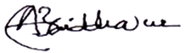Signature: Date: 14/6/2017

** Reviewed by *: Dr. M. Maniruzzama.*** Designation: Social Management Specialist, MGSP, LGED

Signature: Date: 14/6/2017

**FORM 1: SCREENING FORM FOR SOCIAL SAFEGUARDS ISSUES**

1. **Identification :**
2. ***Name of ULB:* Tangail Pourashava, *District:* Tangail**

*Ward/Mahalla: nos.* ***4, 5 & 6***

***2. Name of Sub Project***

(a) Improvement and Widening of Dighulia Shakrail Road starting from main road to Councilor House by Bituminous Carpeting (Ch. 0+000 to 2+010km ) and link–1, starting from College Para moar to H/O Abul Hossain length 425m.

(b) Construction of RCC Drains in Dighulia Shakrail Road Ch. 0+000 to 2+010km link-1: length 425m. and Link-2: Length 350m.

(c) Supplying, fitting and fixing of Street lights of road starting from main road to Councilor House with link-1 & 2 (Total length 2785 m).

***3. Sub project components***

(a), (b), (c) as above

**4. Brief description of the physical works**:

This identified subproject for improvement and widening of Dighulia-Shakrail road with drain, footpath and street lights. It benefits both commercial and residential area. It connects main road starting at Amghat Rd where a branch of Janata Bank and at its ending point there is a culvert on the right side.

**5. Screening Date(s):** 14/06/2017

**B. Participation in Screening:**

**6. Names of Consultants’ representatives who screened the subproject:**

***A )Dr. M. Maniruzzaman***, Designation: Social Management Specialist, MGSP, LGED

b) Md. A. B. Siddique, SMO, Rangpur Zone DSM, MGSP, LGED.

c) Md. Abdul Quddus khan, Senior Municipal Engineer-1 DSM Rangpur Zone.

**7. Name of ULB representatives in screening**

a)Mr. Md. Abdul Matin, Assistant. Municipal Engineer, DSM, TangailPourashava, MGSP, LGED

b)Mr. Mirza Arif Md Golam Azam, Executive Engineer, Tangail Pourashava

c) Mr. Shibbir Ahamed Azmi (Zami) Assistant Engineer TangailPourashava,

d) Mr. Md. Abdul Matin, Assistant. Municipal Engineer, DSM, TangailPourashava, MGSP, LGED,

e) Mr. Rajib Kumar Guha, SAE, Tangail Pourashava

***8. WLCC members, NGOs, community groups/CBOs participated in screening: Yes,*** *copy enclosed for information Would-be affected persons participated in screening:*

***9. Would be affected persons participated in the screening: Yes, list attached***

**C. Land Requirements & Ownership:**

No.

|  |  |  |
| --- | --- | --- |
| *10. Will there be a need for additional lands to carry out the intended works under this contract?* | [ ]yes | [√ ] No |

*11. If ‘Yes’, what will the additional lands be used for? (Indicate all that apply): N/A*

[ ] road widening [ ] curve correction [ ] construction/expansion of physical structure

[ ] strengthening narrow eroding road section between high and low lands [ ] others (Mention):

*12. If ‘Yes’, the required lands presently belong to (Indicate all that apply): N/A*

[ ] ULB [ ] Government Land

[ ] Private Citizens [ ] Others (Mention):

**D. Current Land Use & Potential Impacts**

*13. If the required lands belong to Private Citizens, they are currently used for (Indicate all that apply):N/A*

[ ] Agriculture Number of households using the lands:

[ ] Residential purposes Number of households using them:

[ ] Commercial purposes Number of persons using them: Shops:

[ ] Other Uses (Mention): few **U**sers:

Land does not belong to private citizen.

*14. If the required lands belong to ULB and/or other Government agencies, they are currently used for (Indicate all that apply): N/A*

[ ] Agriculture Number of persons/households using the lands:

**[ ]** Residential purposes Number of households living on them:

**[ ]** Commercial purposes Number of persons using them: No. of shops:

**[ ] Other Uses (Mention):**

*15. How many of the present users have lease agreements with any government agencies? None*

*16. Number of private homesteads that would be affected on private lands: None*

*Entirely requiring relocation……………………. Partially but can still live on present homestead*

*17. Number of business premises/buildings that would be affected on private lands: None.*

Entirely and will require relocation: # Of businesses housed in them: **.**

Partially, but can still use the premises: # Of businesses housed in them:

*18. Residential households will be affected on ULB’s own and & public lands: None*

*Entirely affected* and will require relocation: No. of these structures:

No. of structures built with brick, RCC, & other expensive and durable materials:

No. of structures built with inexpensive salvageable materials (bamboo, GI sheets, etc:

*Partially affected*, but can still live on the present homestead :No of these structures

No. of structures built with brick, RCC, & other expensive and durable materials:

No. of structures built with inexpensive salvageable materials (bamboo, GI sheets, etc):

*19. No. of business premises that would be affected on ULB’s own& other public lands: None*

*Entirely affected* and will require relocation: No. of these structures:

No. of businesses housed in these structures:

No. of persons presently employed in the above businesses.

No. of these structures built with brick, RCC, & other durable materials:

No. of structure built with inexpensive salvageable materials (bamboo, GI sheets, etc):

*Partially affected*, but can still stay in the present no. of these structures:

No. of businesses housed in these structures:

No. of persons presently employed in these businesses:

No. of these structures built with brick, RCC, & other durable materials:

No. of structure built with inexpensive salvageable materials (bamboo, GI sheets, etc):

*20. None of businesses/trading activities that would be displaced from make-shift structures on the road, and other areas/spots: None*

*21. Do the proposed subproject works affect any community groups’ access to any resources that are used for livelihood purposes? [ ] Yes [√] No*

*22. If ‘Yes’, description of the resources: N/A*

23. Do the proposed works affect community facilities like school, cemetery, mosque, temple, or others that are of religious, cultural and historical significance? [ ] Yes [√ ] No.

*24. If ‘Yes’, description of the facilities: N/A.*

*25. Describe any other impacts that have not been covered in this questionnaire? No.*

*26. Describe alternatives, if any, to avoid or minimize use of additional lands: N/A*

**E. ADDITIONAL INFORMATION ON TRIBAL PEOPLE**

(This section must be filled in if subprojects are located in areas that are also inhabited by tribal peoples)

*27. Names of tribal community members and organizations who participated in screening: N/A*

*28. Have the tribal community and the would-be affected TPs been made aware of the potential positive and negative impacts and consulted for their feedback and inputs?*

[ ] Yes [√] No

Has there been a broad-based community consensus on the proposed works?

[ ] Yes [√] No

*29. Total number of would-be affected tribal households: N/A****.***

*30. The would-be affected tribal households have the following forms of rights to the required lands: N/A*

[ ] Legal: No. of households:

[ ] Customary: No. of households:

[ ] Lease agreements with any GOB agencies: No. of households:

[ ] Others (Mention): No. of households:

*31. Does the subproject affect any objects that are of religious and cultural significance to the IPs?*  [ ] Yes [√] No

**G.32. If ‘Yes’, description of the objects:** N/A.

*33. The following are the three main economic activities of the would-be affected tribal households:*  a. N/A, b. N/A, c. N/A

*34. Social concerns expressed by tribal communities/organizations about the works proposed under the subproject: N/A*

*35. The tribal community and organizations perceive the social outcomes of the subproject: N/A*

**On behalf of the DSM Consultant, the attached filled out format has been reviewed and evaluated by:**

**Decision on selection [**√**] recommended for selection [] recommended for exclusion**

***Prepared by:***

***Md. A. B. Siddique*** Designation: Social Management Officer, MGSP, LGED

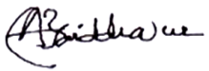

Signature: Date: 4/06/17.

***Reviewed by:***

***Dr. M. Maniruzzaman***, Designation: Social Management Specialist, MGSP, LGED



Signature: Date: 14/06/2017

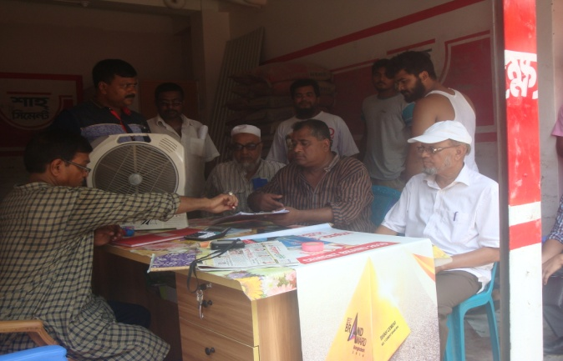**Participation and Consultation meeting for sub projects**: A Participation and Consultation meeting was held in the subproject site to carry out the feasibility of the specific subproject.

Consultations with communities and other stakeholders have been used as a two-way communication to provide information about the subproject and obtain feedback from the communities on subproject approach, design and implementation. Consultations were carried out through open meetings and key informant interviews (KII). From the meeting it is justified spontaneously that this specific subproject is feasible and very important for the economic development of the communities which in turn will be implemented.

Photographs. Community consultation at college road

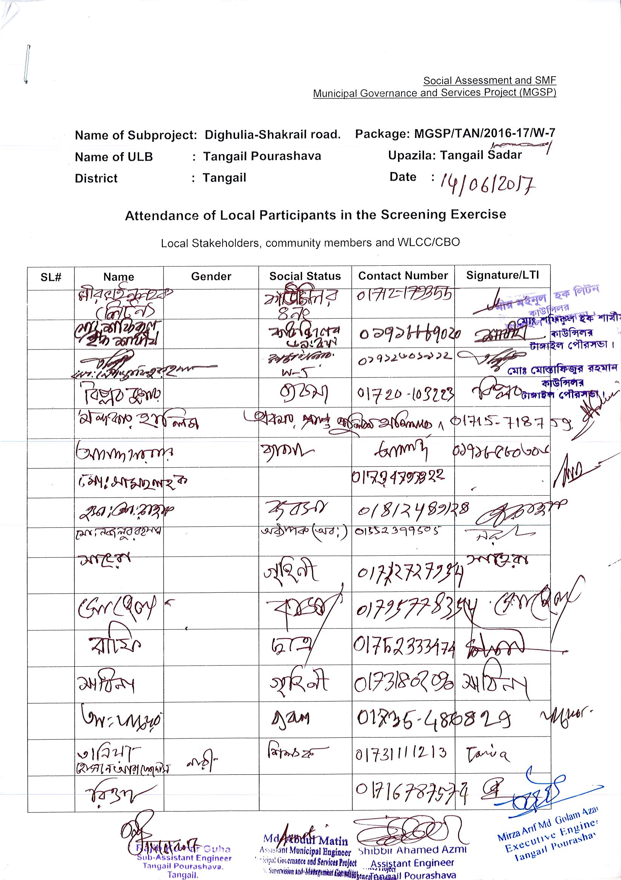**Local Participant’s attendance sheet of Tangail Pourashava**