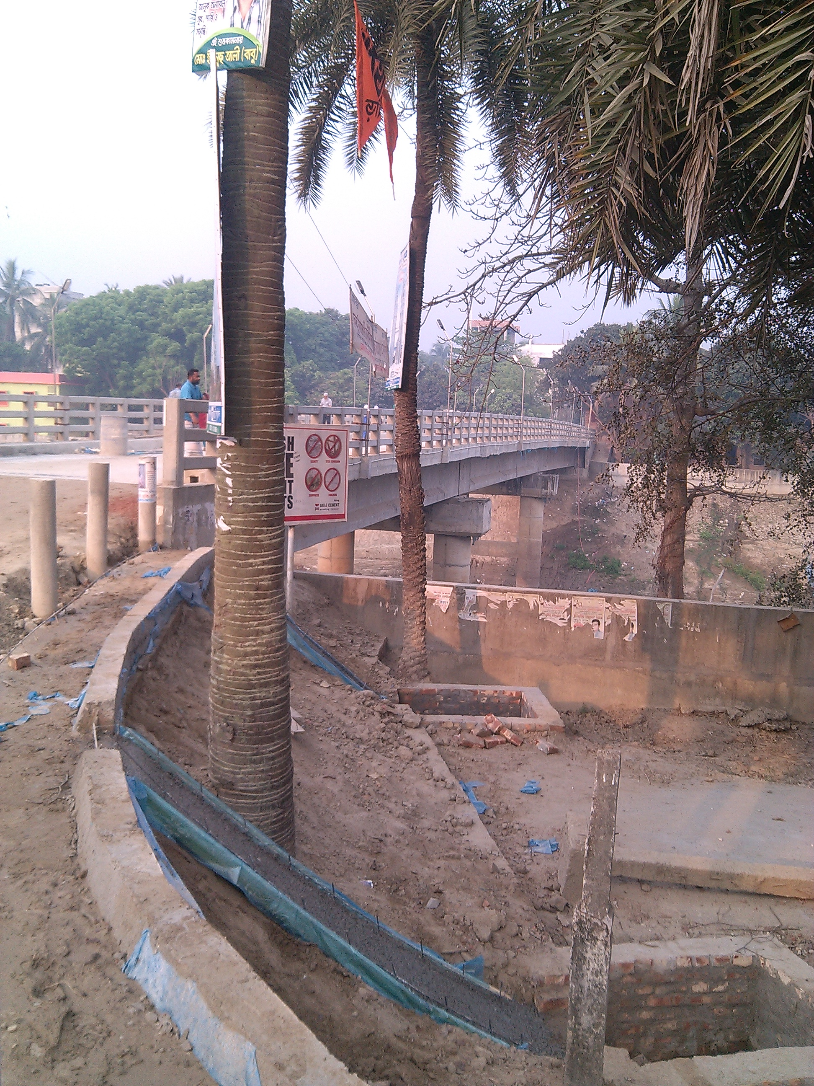
On going work of 72m PC Girder Bridge on Uttra Primary School-BDR Camp Road.

